USDA Foreign Agricultural Service
GAIN Report

Global Agriculture Information Network
Template Version 2.09

Required Report - Public distribution
Date: 2/29/2008
GAIN Report Number: NA8001
NA8001
Netherlands Antilles
HRI Food Service Sector
Annual Report
2008

Approved by:
Sarah Hanson, Director
Caribbean Basin
Prepared by:
Omar Gonzalez, Marketing Specialist

Report Highlights:
This report provides a road map to assist U.S. exporters of consumer-oriented agricultural products and fish and seafood products entering the estimated $150 million food service market in the Netherlands Antilles. In 2007 the United States exported $60.8 million in consumer oriented and seafood products to the Netherlands Antilles of which an estimated 60-70 percent is channeled to the food service sector. Although the United States faces competition in this market, the weakened U.S. dollar and moderate growth in tourism should continue to provide excellent market opportunities for U.S. suppliers.

Includes PSD Changes: No
Includes Trade Matrix: No
Annual Report
Miami ATO [C11]
[NA]
SECTION I. MARKET SUMMARY

The Netherlands Antilles (N.A.), also known as the Dutch Caribbean, is composed of five islands which in turn are divided into two separate groups given their geographic location. The first group is composed of Curacao and Bonaire, which are located just north of the Venezuelan coast. The other group, which includes Sint Maarten, Saba, and St. Eustatius, is located just east of the U.S. Virgin Islands. It is important to note that part of the island of Sint Maarten is shared with France, and is known as Saint Martin. Interestingly, the Netherlands Antilles will cease to exist as a single dependency of the Kingdom of the Netherlands in December of 2008. Instead, Bonaire, St. Eustatius and Saba are to become public entities (municipalities) of the Netherlands, while Curacao and St. Maarten are seeking autonomy within the Kingdom, similar to the current status of Aruba.

The hotel, restaurant, and institutional (HRI) food service market of the N.A. is reflective of the diverse and dynamic population of the islands and the large influx of visitors from around the world. Overall, the hotels and restaurants cater to a full range of customers and offer international and traditional menus. Following is a brief description of each island’s food service market.

Island | Hotels | Restaurants | Institutions
Bonaire | Some hotels have restaurants and perhaps a bar, and resorts have fully equipped kitchens. Low budget customers. | Most restaurants offer local fresh seafood. Meat lovers can enjoy Argentinean beef and vegetarians can enjoy the abundance of fresh Venezuelan produce. | One hospital and one geriatric home.
Curacao | Large-scale resorts are located east and west of the capital city of Willemstad, while smaller hotels are located in the southwest part of the island. Medium to high budget customers. | An abundance of international cuisine - Indonesian, French, Dutch, Swiss, Indian, Italian, and Swedish. There are many U.S. fast food chains present in this market. | Four hospitals, seven geriatric homes and one prison. One dozen catering companies.
Saba | Small inns and guesthouses. Low budget customers. | Quality and diverse menu - serving fresh seafood and Caribbean specialties and an extensive selection of wines. | One hospital, one geriatric home and a couple of small catering companies.
St. Eustatius | Modest accommodations for low budget customers. | Most restaurants are very modest and specialize in West Indian food. | One hospital and one geriatric home.
St. Maarten | Most hotels are located in Simpson Bay and in the heart of Phillipsburg, where shops and eateries abound.  Medium to high budget customers. | Approx. 400 restaurants on this dual nation island. High international culinary reputation with many high-end restaurants and some fast food franchises. Nicknamed the “Gourmet Capital of the Caribbean.” | One hospital, one geriatric home, and one prison. Few catering companies.

According to the latest data available from the N.A. Central Bureau of Statistics, the food service market in the Netherlands Antilles consists of 1,123 units. The largest food service concentrations are located in Curacao and St. Maarten. Hotels make up 65 percent of the HRI food service market share, followed by restaurants at 33 percent, and institutions at 2 percent. The latest data indicate that the Netherlands Antilles’ hotel and restaurant sub-markets were valued at $103 million dollars (188 million guilders) in 2003, a 9 percent growth from 2002. There is no data available on the institutions sub-market value and growth.

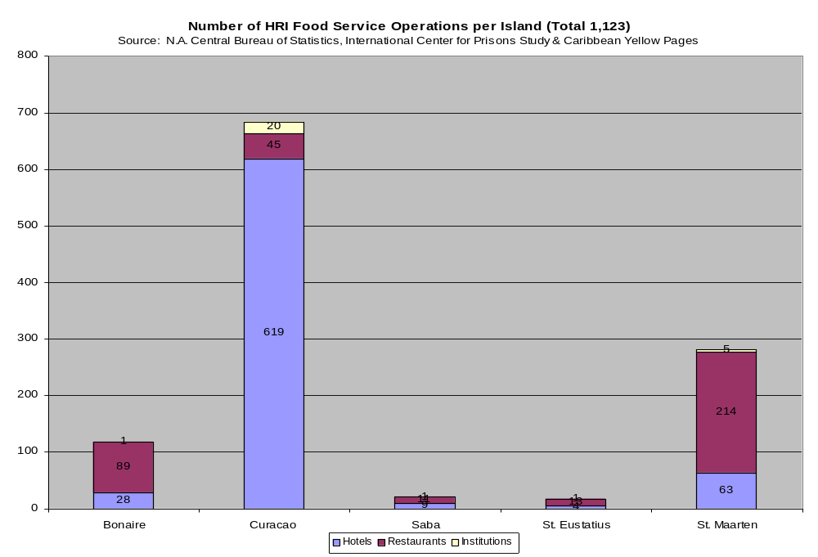
Tourism, offshore finance, and petroleum refining are the basis of this region’s economy. Gross domestic product (GDP) for the Netherlands Antilles was $3.3 billion in 2007 – a 2.6 percent increase from 2006. The islands benefit from a high per capita income and a well-developed infrastructure compared with other countries in the region.

Tourism remains the pillar of the Netherlands Antilles’ economy. While Europe remains the largest source of tourists, the opening of charter flight connections with Boston, Chicago and Toronto has boosted the number of tourists from the U.S. and Canada. A slowing U.S. economy, however, could result in tapering off of tourism arrivals in the near future.
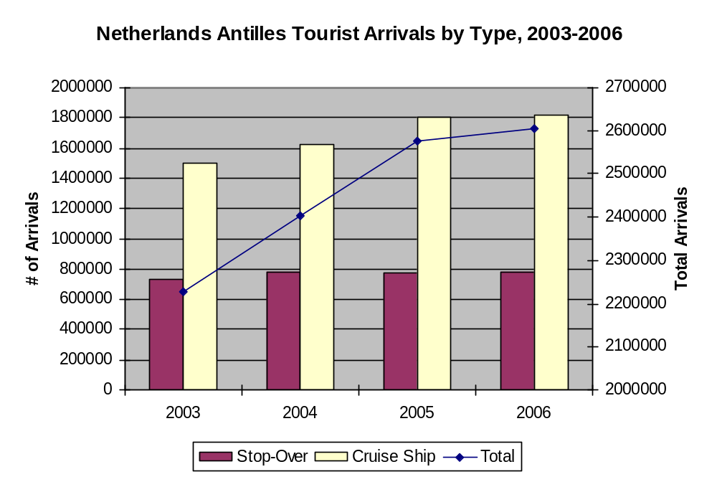
Source: Caribbean Tourism Organization.

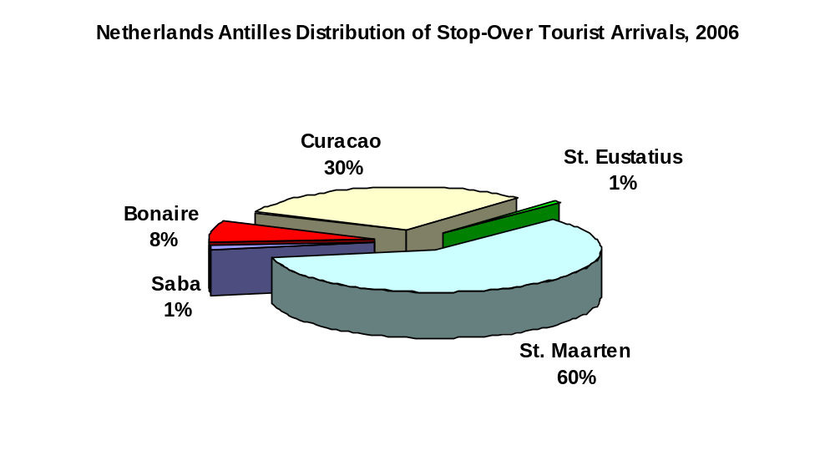
Source: Caribbean Tourism Organization.

Given very limited land resources (a mere 37 square miles are arable) and inadequate water supplies in many cases, agricultural production is practically non-existent. Agricultural activities contribute less than 1 percent to GDP and employ less than 1 percent of the total workforce. Consequently, the N.A. relies on imports of food products to satisfy its food needs. According to the latest UN data (2003) the N.A. imported $150 million of consumer-oriented agricultural products (97 percent), and edible fish and seafood products (3 percent) destined for the food service sector. According to U.S. trade data, in 2007 the United States exported $60.8 million in consumer oriented and seafood products to the N.A. of which an estimated 60-70 percent goes to the food service sector.
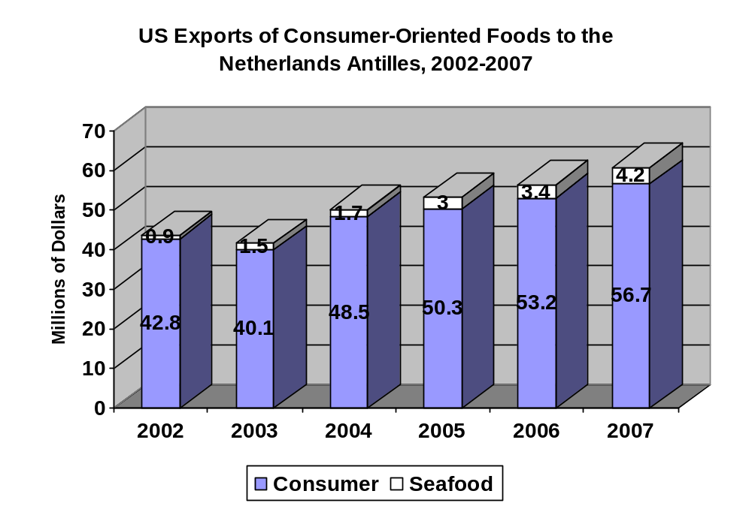
Source: U.S. Bureau of the Census data.

The following table illustrates some of the key market advantages and challenges facing U.S. exporters.

Market Advantages | Market Challenges
With only minute agricultural production, the islands are dependent on imports to satisfy their food needs. | Given the small fragmented nature of this island market, orders tend to be small and import volumes vary significantly between high and low tourist seasons.
Approximately 2.6 million tourists visit the islands annually, of which roughly one third are stop-over tourists who drive demand for consumer-oriented foods and seafood. | The population of the islands is a mere 223,652 (July 2007 estimate), and a growing percentage of the most productive population is migrating to the Netherlands each year. Thus, demand for food products remains overly dependent on tourism.
Proximity to the islands is a major competitive advantage for the U.S. | There can be cheaper transportation rates from Europe than from the United States.
Major U.S. brands are well established. The U.S. has a market share of 29 percent and 28 percent in the food and seafood segments, respectively. | The islands also have strong cultural, economic, and political ties with the Netherlands, the U.S.’s main competitor in this market. The Netherlands has a 31 percent and 21 percent market share in the food and seafood segments, respectively.
Three of the islands (St. Maarten, Saba, and St. Eustatius) are duty free. | St. Maarten, Saba, and St. Eustatius are subject to hurricanes from July to October, which may lead to temporary declines in tourism and food demand.
The N.A. GDP was $3.3 billion in 2007, exhibiting real growth of 2.6 percent from the previous year. Real GDP growth is expected to range between a healthy 2.3 and 2.5 percent over the next 5 years. | The impending political changes add a degree of uncertainty to the overall economic outlook for this market.
A weakened dollar is making U.S. products more competitive. | Despite the large presence of U.S. products in the market, many Chefs in these islands are European trained, and therefore maintain a strong preference for European products.

SECTION II. ROAD MAP FOR MARKET ENTRY

A. ENTRY STRATEGY

Given the small size of most individual orders, most U.S. food products exported to the Caribbean are channeled through consolidators. Importers/distributors in the N.A. which account for the lion’s share of sales to the HRI food service sector all have their own consolidators in the United States, particularly in South Florida. When importers decide on a product purchase, they will simply require delivery to their U.S. consolidator who is very familiar with exporting to the N.A. Therefore, the best method for U.S. suppliers to enter the food service market in the region is via local importers/distributors which offer faster and wider access to the food service market. Food service companies buy an estimated 84 percent of their food and seafood products from importers/distributors while local manufacturers supply 11 percent and 5 percent of food service companies import products directly. In essence, importers/distributors have the bargaining power in the market and intermediate between suppliers and buyers.

B. MARKET STRUCTURE

The following chart illustrates how products are passed from U.S. exporters to the various food service sub-markets.

U.S. Manufacturer

U.S. Consolidator

Local Importer

Hotel, Restaurant, & Institution

C. SUB-SECTOR PROFILES

The following tables provide information on the different HRI food service sub-sectors with the purpose of providing a general idea of each segment. This information is partial and is not intended to necessarily reflect each segment in its entirety.

- Hotel and Resorts

Company Name | Yearly  Purchases | Number of Outlets | Location | Purchasing Agent(s)
Sonesta | $ 11,000,000 | 1 | St. Maarten | Local Importer (80%)  Manufacturer (20%)
Breezes | $ 3,150,000 | 1 | St. Maarten | Local Importer (60%)  U.S. Consolidator (30%)  Manufacturer (10%)
Tamarind | $540,000 | 1 | St. Maarten | Local Importer (40%)  U.S. Consolidator (30%)  Manufacturer (30%)
Marriott | $955,000 | 1 | Curacao | Local Importer (60%)  U.S. Consolidator (40%)
Hilton | $630,000 | 1 | Curacao | U.S. Consolidator (100%)
Kura Hulanda | $ 435,000 | 1 | Curacao | U.S. Consolidator (80%)  Local Importer (20%)
Plaza Resort | NA | 1 | Bonaire | Local Importer (100%)

2. Restaurants
Company Name | Yearly  Purchases | Number of Outlets | Location | Purchasing Agent(s)
Hanabi Japanese Restaurant | $ 354,000 | 1 | St. Maarten | Local Importer (100%)
Laguna Ristorante | $ 410,000 | 1 | St. Maarten | Local Importer (80%)  Manufacturer (20%)
Paris Bristo | $ 116,000 | 1 | St. Maarten | Local Importer (100%)
La Romance | $ 1,310,000 | 1 | St. Maarten | Local Importer (100%)
Subway | $700,000 | 7 | St. Maarten | U.S. Consolidator (100%)
Restaurant de Gouverneur | NA | 1 | Curacao | Local Importer (80%)  Manufacturer (20%)
Seasons | $470,000 | 1 | Curacao | U.S. Consolidator (60%)  Local Importer (20%) Manufacturer (20%)
Rainforest Restaurant | $102,000 | 1 | St. Eustatius | Local Importer (80%)  Manufacturer (20%)
Redez-Vous Restaurant | $ 53,000 | 1 | Bonaire | Local Importer (100%)

3. Institutions
Company Name | Yearly  Purchases | Number of Outlets | Location | Purchasing Agent(s)
Goddart Catering Group | $ 1,350,000 | 1 | St. Maarten | U.S. Consolidator (80%)  Local Importer (20%)
Eddy's Gourmandises Catering | $51,000 | 1 | Bonaire | Local Importer (100%)
Joshara Snack & Catering | $ 87,000 | 1 | St. Eustatius | Local Importer (100%)
Dynasty Catering Services | $ 1,980,000 | 1 | Curacao | Local Importer (100%)

SECTION III. COMPETITION

The many ties between the U.S. and the Netherlands Antilles affect the quality perception and demand for a variety of products. The majority of food service managers and their customers place a great deal of importance on the origin of food and its ingredients. Overall, food service managers and their customers rank the quality of food from the United States as the highest among competing countries, followed by the Kingdom of the Netherlands. Nonetheless, many of the chefs in food service establishments are of European origin and European trained and thus they are very accustomed to European products. Thus, introducing new U.S. products to the sector often entails changing the mindset of Chefs and demonstrating the quality of U.S. products. The following charts illustrate the overall competitive situation facing U.S. exporters.

- Consumer Oriented Agricultural Products

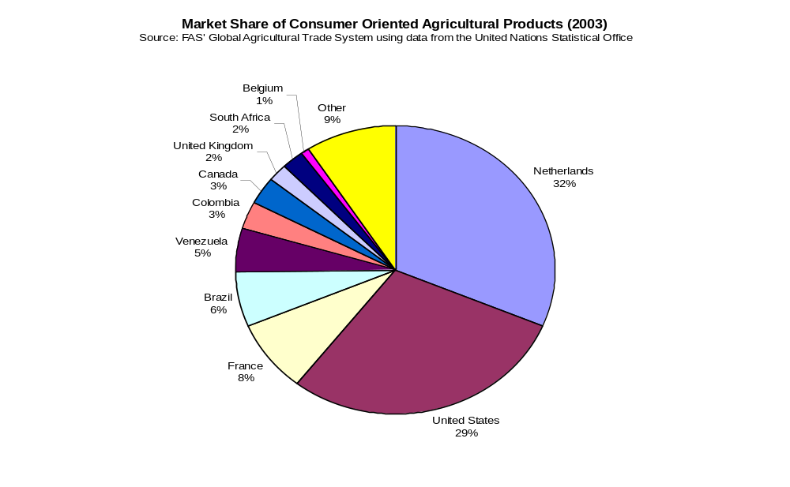

Product Category | Major Supply Sources
Snack Foods (Excl. Nuts)  Sales Value:  $6,311 | 1. Netherlands (41%)  2. Columbia (8%)  3. USA is a Medium Supplier (24%)
Breakfast Cereals & Pancake Mix  Sales Value:  $809 | 1. Netherlands (21%)  2. Costa Rica (5%)  3. USA is a  Major Supplier (57%)
Red Meats, Fresh/Chilled/Frozen  Sales Value:  $10,539 | 1. Brazil (27%)  2. Netherlands (19%)  3. USA is a  Minor Supplier (9%)
Red Meats, Prepared/Preserved  Sales Value:  $ 6,562 | 1. Netherlands (31%)  2. France (9%)  3. USA is a  Major Supplier (33%)
Poultry Meat  Sales Value:  $9,151 | 1. Brazil (47%)  2. Netherlands (2%)  3. USA is a  Major Supplier (46%)
Dairy Products (Excl. Cheese)  Sales Value:  $8,094 | 1. Netherlands (36%)  2. France (17%)  3. USA is a  Minor Supplier (11%)
Cheese  Sales Value:  $11,784 | 1. Netherlands (73%)  2. France (12%)  3. USA is a  Minor Supplier (3%)
Eggs & Products  Sales Value:  $388,000 | 1. Venezuela (24%)  2. France (1%)  3. USA is a  Major Supplier (73%)
Fresh Fruit  Sales Value:  $4,007,000 | 1. Venezuela (57%)  2. Dominica (13%)  3. USA is a  Minor Supplier (3%)
Fresh Vegetables  Sales Value:  $9,415,000 | 1. Netherlands (34%)  2. France (10%)  3. USA is a  Major Supplier (43%)
Processed Fruit & Vegetables  Sales Value:  $9,398,000 | 1. Netherlands (41%)  2. Canada (5%)  3. USA is a  Major Supplier (34%)
Fruit & Vegetable Juices  Sales Value:  $5,721,000 | 1. Netherlands (23%)  2. Canada (17%)  3. USA is a  Major Supplier (37%)
Tree Nuts  Sales Value:  $672,000 | 1. Australia (29%)  2. Singapore (17%)  3. USA is a  Major Supplier (30%)
Wine & Beer  Sales Value:  $19,037,000 | 1. Netherlands (44%)  2. France (14%)  3. USA is a  Minor Supplier (14%)
Nursery Products & Cut Flowers  Sales Value:  $1,578,000 | 1. Colombia (47%)  2. Netherlands (29%)  3. USA is a  Minor Supplier (4%)
Pet Foods (Dog & Cat Food)  Sales Value:  $2,891,000 | 1. Netherlands (17%)  2. Brazil (4%)  3. USA is a  Major Supplier (82%)
Other Consumer-Oriented Products  Sales Value:  $39,356,000 | 1. Netherlands (24%)  2. France (11%)  3. USA is a  Major Supplier (44%)

B. Edible Fish & Seafood Products

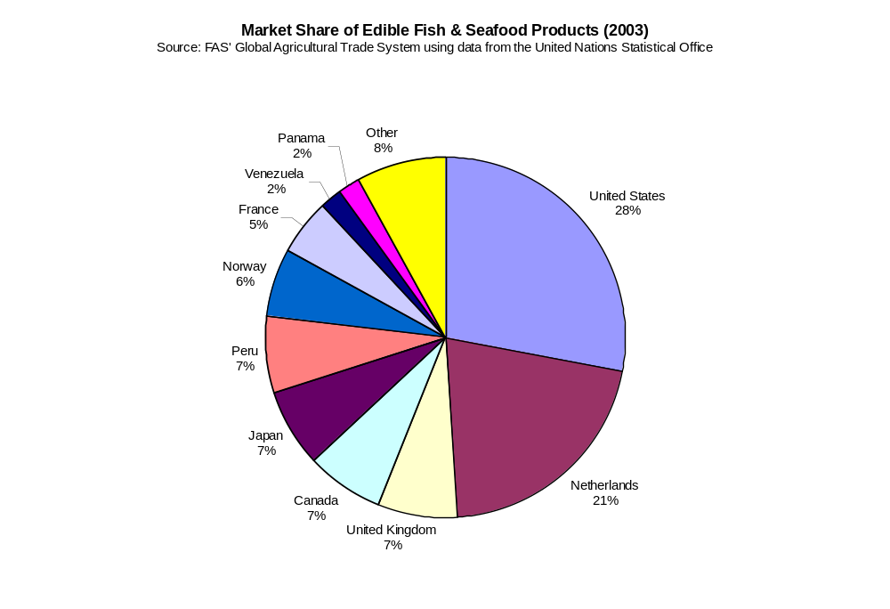

Product Category | Major Supply Sources
Salmon  Sales Value:  $389,000 | 1. Panama (26%)  2. Netherlands (23%)  3. USA is a  Medium Supplier (20%)
Surimi  Sales Value:  $37,000 | 1. Guyana (27%)  2. USA is a  Major Supplier (73%)
Crustaceans  Sales Value:  $817,000 | 1. Netherlands (9%)  2. Venezuela (7%)  3. USA is a  Major Supplier (73%)
Groundfish & Flatfish  Sales Value:  $1,777,000 | 1. Netherlands (29%)  2. Japan (21%)  3. USA is a  Minor Supplier (11%)
Molluscs  Sales Value:  $383,000 | 1. Netherlands (29%)  2. France (9%)  3. USA is a  Major Supplier (62%)
Other Fishery Products  Sales Value:  $1,750,000 | 1. Peru (19%)  2. Netherlands (17%)  3. USA is a  Medium Supplier (15%)

SECTION IV. BEST PRODUCT PROSPECTS

The following charts illustrate the best product prospects for U.S. exporters entering the Netherlands Antilles food service market.

Products Present in Market Which Have Good Sales Potential

Product Category | US Exports, 2007  ($ mill) | % Change  06-07 | 5 Yr. Avg. Annual Growth
Red Meats, fresh/chilled/frozen | $3.57 | 70.5 | 39.9
Red Meats, prepared/preserved | $1.52 | 4.8 | 3.4
Processed Fruit & Vegetables | $7.9 | 119.9 | 1.0
Fruit & Vegetable Juices | $3.5 | 4.6 | 10.4
Wine & Beer | $4.9 | -0.7 | 24.6
Other Consumer-Oriented Products | $16.3 | 14.7 | 8.8
Seafood Products | $4.2 | 24.5 | 72.7

Products Not Present in Significant Quantities But Which Have Good Sales Potential

Product Category | US Exports, 2007  ($ mill) | % Change  06-07 | 5 Yr. Avg. Annual Growth
Breakfast Cereals | $0.943 | 28.8 | 9.2
Eggs & Products | $0.564 | 163.6 | 124.6
Fresh Fruit | $0.523 | 84.2 | 75.1

SECTION V. POST CONTACT AND FURTHER INFORMATION

A. For more information on the Netherlands Antilles and a list of importers for your U.S. product, please contact:

Caribbean Basin Agricultural Trade Office
Foreign Agricultural Service
United States Department of Agriculture

909 SE 1st Ave., Suite 720
Miami, FL 33131
T: (305) 536-5300
F: (305) 536-7577
E-mail: atocaribbeanbasin@usda.gov

Please visit our website for more reports and information on the Netherlands Antilles and other Caribbean Islands:
http://www.cbato.fas.usda.gov, click on “U.S. Exporters”

B. Other Sources of Information on the Netherlands Antilles:

United States Consulate General
Willemstad, Curacao

P.O. Box 158, J.B. Gorsiraweg 1,
Phone: 011-599(9)-461-3066
Fax: 011-599(9)-461-6489
E-mail: acscuracao@state.gov
Website: http://www.amcongencuracao.an/

Curacao Chamber of Commerce & Industry
P.O. Box 10
Kaya Junior Salas 1
Curacao, Netherlands Antilles
T: 011-599(9)-461-1451, 461-3918
F: 011-599(9)-461-5652
E-mail: management@curacao-chamber.an
Website: http://www.curacao-chamber.an

Curacao Hospitality and Tourism Association
P.O. Box 6115
Kurason di Komersio
Kaya Junior Salas 1
Curacao, Netherlands Antilles
T: 011-599(9)-465-1005
F: 011-599(9)-465-1052
E-mail: info@chata.org
Website: www.chata.org

St. Maarten Hospitality & Trade Association
P.O. Box 486
Phillisburg St. Maarten NA
T: 011-599-542-0108
F: 011-599-542-0107
E-mail: info@shta.com
Website: www.shta.com

Bonaire Hotel & Tourism Association
Kaya Gob. N. Debrot #67
Office 201, P.O. Box 385
Bonaire NA
T: 011-599-717-5134
F: 011-599-717-8534
E-mail: info@bonhata.org
Website: www.infobonaire.com

