USDA Foreign Agricultural Service
GAIN Report

Global Agriculture Information Network
Template Version 2.09

Required Report - public distribution
Date: 6/27/2005
GAIN Report Number: NA5001
NA5001
Netherlands Antilles
HRI Food Service Sector
Country Report
2005

Approved by:
Paul Hoffman, Director
Caribbean Basin ATO
Prepared by:
Vladimir Diaz, M.S. Marketing Management, Johns Hopkins University, Baltimore, MD

Report Highlights:
This report provides an important road map to assist U.S. exporters of consumer-oriented agricultural products, and fish and seafood products entering the $150 million food service market in the Netherlands Antilles. This report summarizes key market developments, provides market opportunity, competitive threat analysis, identifies distribution channels, provides sub-sector profiles, describes the competitive situation and best products prospects.

Includes PSD Changes: No
Includes Trade Matrix: No
Annual Report
Abidjan [IV1]
[NA]
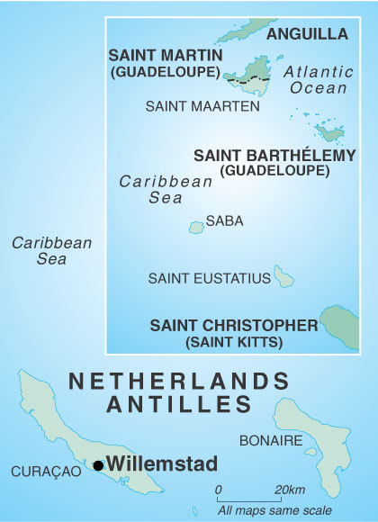

SECTION I. MARKET SUMMARY

The Netherlands Antilles’ hotel, restaurant, and institutional (HRI) food service market consists of the total purchases and sales of consumer-oriented agricultural products, and edible fish and seafood products via hotels, restaurants, and institutions in the islands of Curacao, Bonaire, Saba, St. Eustatius, and St. Maarten. This region’s food service market is reflective of its diverse and dynamic population and its visitors from around the world. Overall, the hotels and restaurants in the islands cater to a full range of customers and offer international and traditional menus. Following is a brief description of each island’s food service market.

Island | Hotels | Restaurants | Institutions
Bonaire | Some hotels have restaurants and perhaps a bar, and resorts have fully equipped kitchens. Low budget customers. | Most restaurants offer local fresh seafood – especially snapper, wahoo, and dorado. Furthermore, meat lovers can enjoy Argentinean beef and vegetarians can enjoy the abundance of fresh Venezuelan produce. | One hospital and one geriatric home.
Curacao | Large-scale resorts are located east and west of the capital city of Willemstad, while smaller hotels are located in the southwest part of the island. Medium to high budget customers. | An abundance of international cuisine - Indonesian, French, Dutch, Swiss, Indian, Italian, and Swedish.  There are many U.S. fast food chains present in this market. | Four hospitals, seven geriatric homes and one prison. One dozen catering companies.
Saba | Small inns and guesthouses. Low budget customers. | Quality and diverse menu - serving fresh seafood and Caribbean specialties and an extensive selection of wines. | One hospital and one geriatric home. A couple of small catering companies.
St. Eustatius | Modest accommodations for low budget customers. | Most restaurants are very modest and specialize in West Indian food. | One hospital and one geriatric home.
St. Maarten | Most hotels are located in Simpson Bay and in the heart of Phillipsburg, where shops and eateries abound.  Medium to high budget customers. | High international culinary reputation and mostly high-end restaurants with some franchised fast-food restaurants. | One hospital, one geriatric home, and one prison. Few catering companies.

The food service market in the Netherlands Antilles consists of 1,123 units. The largest food service concentrations are located in Curacao and St. Maarten. Hotels make up 65 percent of the HRI food service market share, followed by restaurants at 33 percent, and institutions at 2 percent. In 2003, the Netherlands Antilles’ hotel and restaurant sub-markets were valued at $103 million dollars (188 million guilders), a 9 percent growth from 2002. There is no data available on the institutions sub-market value and growth.
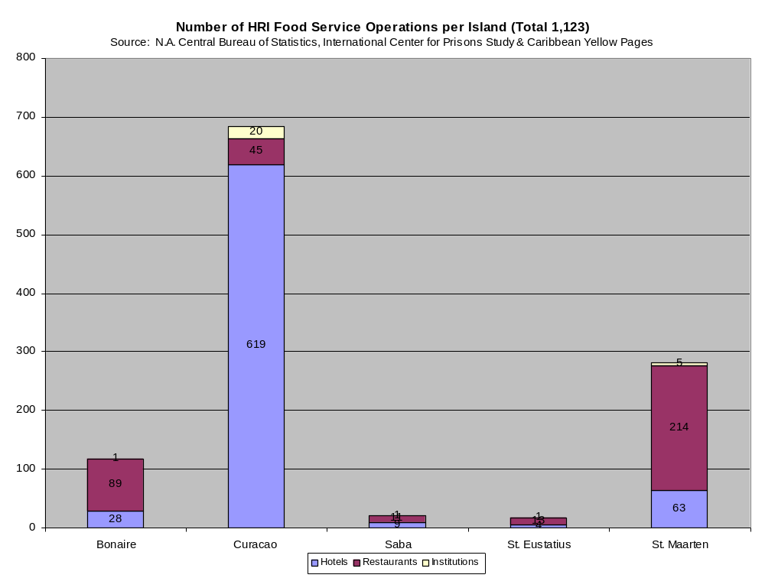

Tourism, offshore finance, and petroleum refining are the basis of this region’s economy. Gross domestic product (GDP) for the Netherlands Antilles was $2.8 billion in 2003 – a 1.4 percent increase from 2002. The agricultural sector contributes less than 1 percent to the region’s GDP and employs less than 1 percent of the total workforce. Moreover, food and agricultural output indices declined from 144 in 1999 to 133 from 2003 – the lowest in the past five years. Annual inflation averaged 2.3 percent from 1998 to 2002, and declined to .4 percent in 2003, which is in line with the pickup in the economy. Food experienced the highest inflation rate in 2003 as food prices rose to 2.1 percent, fueled by the stronger euro. Even though GDP of the Netherlands Antilles has grown slightly in the past few years, the islands benefit from a high per capita income and a well-developed infrastructure compared with other countries in the region.

Tourism remains the pillar of the Netherlands Antilles’ economy. Like all other Caribbean tourism destinations, the Netherlands Antilles suffered from falling tourism demand following the September 11th 2001 terrorist attacks on the U.S. However, tourist numbers and cruise ship arrivals recovered in 2003, reaching their highest levels since 1998. While Europe remains the largest source of tourists, the opening of charter flight connections with Boston, Chicago and Toronto has boosted the number of tourists from the U.S. and Canada.

The Netherlands Antilles is heavily dependent on food imports due to the scarcity of arable land, poor soil quality, inadequate water supplies, and an unsuitable climate. The Antillean terrain is generally hilly and volcanic, of which only 10 percent is arable land, and no permanent crops are present in the region. In 2003, the Netherlands Antilles imported $150 million of consumer-oriented agricultural products (97 percent), and edible fish and seafood products (3 percent) destined for the food service sector - a 9 percent from decline from 1999. Imports from the United States to the Netherlands Antilles have experienced a similar trend. Over the past five years, consumer-oriented agricultural products have experienced a 9 percent decline, while edible fish and seafood product have experienced 13 percent increase. (Please note that estimates for total world trade may underestimate actual levels since data is not available for every country.)

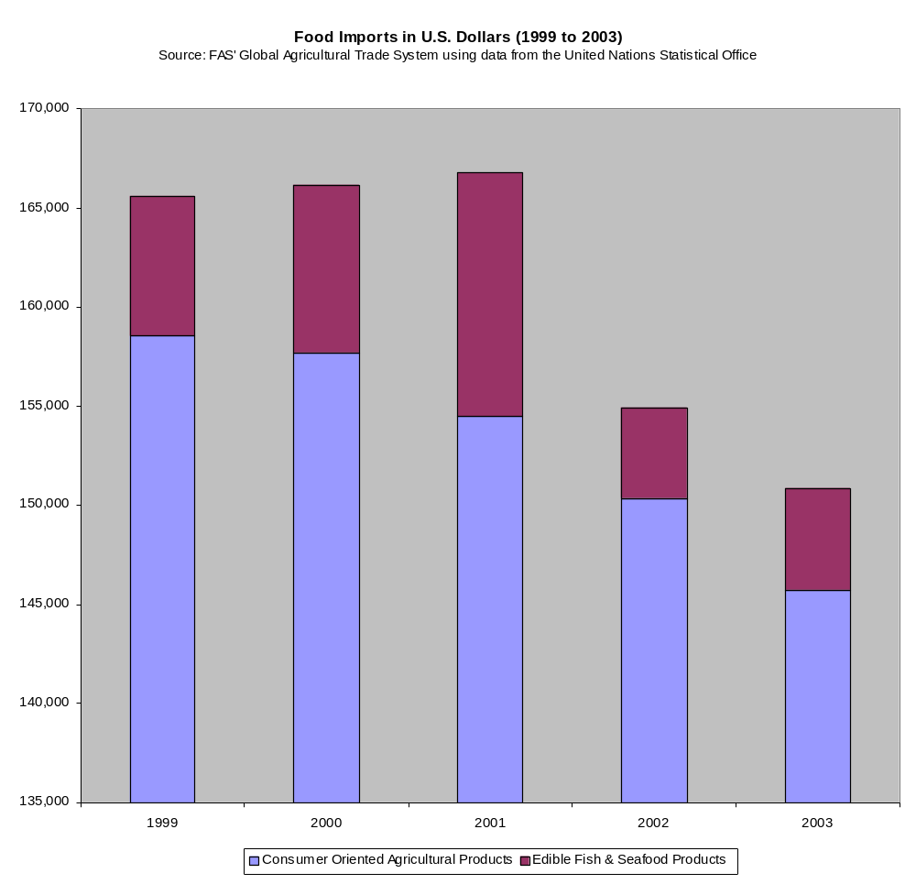
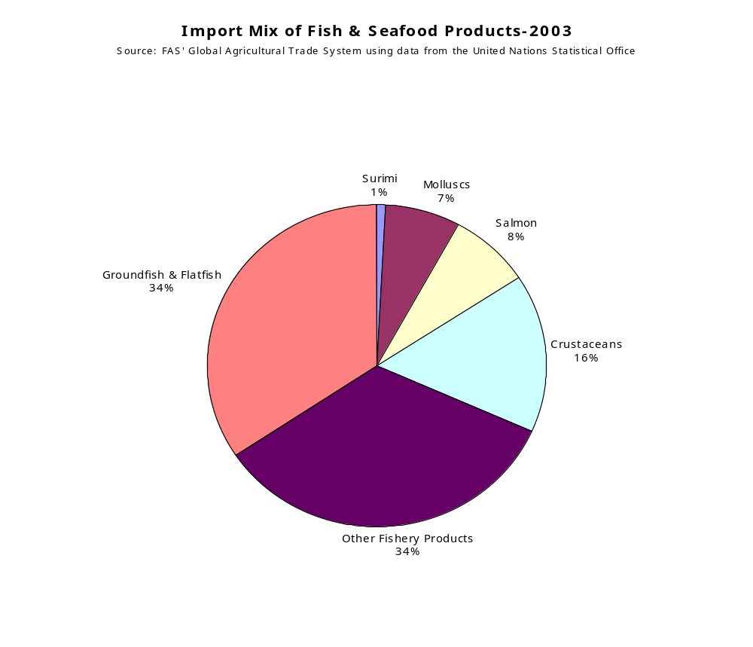

The following table illustrates the market advantages (strengths and opportunities) and market challenges (weaknesses and threats) facing U.S. exporters.

Market Advantages | Market Challenges
Proximity to the islands is a major competitive advantage for the U.S. | U.S. exports to the Netherlands Antilles have declined by 33 percent since 1999.
High frequency of shipments to the Netherlands Antilles has driven shipping cost down. | The Kingdom of the Netherlands, the U.S.’s main competitor in the Netherlands Antilles’ market, has a 31 percent and 21 percent market share in the food and seafood segments, respectively.
U.S. has a market share of 29 percent and 28 percent in the food and seafood segments, respectively. | Saba, St. Eustatius, and St. Maarten are subject to hurricanes from July to October, which may lead to decline in tourism and demand for food.
Major U.S. brands are well established in the Netherlands Antilles | About 5 percent of the most productive population is migrating to the Netherlands every year.
U.S. producers are among the lowest cost producers in the world – enabling brands to compete on price. | The Netherlands Antilles has colony-colonizer relationship with the Netherlands as well as common policy and regional trading block.
The U.S. agricultural system is one of the most efficient in the world, enabling exporters to deliver consistent, high quality products | Tariffs are typically higher for products produced locally.
The Netherlands Antilles GDP was $2.9 billion in 2003, increasing by 1.4 percent from the previous year. | Unemployment rates are high.
The tourism industry is growing, and the hotel and restaurant sub-markets have shown increased value from 181 million guilders in 1999 to 188 million guilders in 2003. | Legislation to increase tariffs has been submitted to Parliament.

SECTION II. ROAD MAP FOR MARKET ENTRY

A. ENTRY STRATEGY

The best method for U.S. suppliers to enter the food service market in the region is via local consolidators. Consolidators offer many advantages to U.S. exporters, including faster and wider access to the food service market, and less transportation, inventory, warehousing, and storage problems. Food service companies buy 84 percent of their food and seafood products from consolidators while local manufacturers supply 11 percent and 5 percent of food service companies import products directly. In essence, wholesalers have the bargaining power in the market and intermediate between suppliers and buyers.

B. MARKET STRUCTURE

The following chart illustrates how products are passed from U.S. exporters to the various food service sub-markets.

U.S. Manufacturer

U.S. Consolidator

Local Importer

Hotel, Restaurant, & Institution

C. SUB-SECTOR PROFILES

1. Hotel and Resorts
Company Name | Yearly  Purchases | Number of Outlets | Location | Purchasing Agent(s)
Sonesta | $ 11,000,000 | 1 | St. Maarten | Local Importer (80%)  Manufacturer (20%)
Breezes | $ 3,150,000 | 1 | St. Maarten | Local Importer (60%)  U.S. Consolidator (30%)  Manufacturer (10%)
Tamarind | $540,000 | 1 | St. Maarten | Local Importer (40%)  U.S. Consolidator (30%)  Manufacturer (30%)
Marriott | $955,000 | 1 | Curacao | Local Importer (60%)  U.S. Consolidator (40%)
Hilton | $630,000 | 1 | Curacao | U.S. Consolidator (100%)
Kura Hulanda | $ 435,000 | 1 | Curacao | U.S. Consolidator (80%)  Local Importer (20%)
Plaza Resort | NA | 1 | Bonaire | Local Importer (100%)
Habour Village | $ 131,000 | 1 | Bonaire | Local Importer (100%)
Old Gin House | NA | 1 | St. Eustatius | Local Importer (100%)

2. Restaurants
Company Name | Yearly  Purchases | Number of Outlets | Location | Purchasing Agent(s)
Hanabi Japanese Restaurant | $ 354,000 | 1 | St. Maarten | Local Importer (100%)
Laguna Ristorante | $ 410,000 | 1 | St. Maarten | Local Importer (80%)  Manufacturer (20%)
Paris Bristo | $ 116,000 | 1 | St. Maarten | Local Importer (100%)
La Romance | $ 1,310,000 | 1 | St. Maarten | Local Importer (100%)
Subway | $700,000 | 7 | St. Maarten | U.S. Consolidator (100%)
Restaurant de Gouverneur | NA | 1 | Curacao | Local Importer (80%)  Manufacturer (20%)
Seasons | $470,000 | 1 | Curacao | U.S. Consolidator (60%)  Local Importer (20%) Manufacturer (20%)
Rainforest Restaurant | $102,000 | 1 | St. Eustatius | Local Importer (80%)  Manufacturer (20%)
Redez-Vous Restaurant | $ 53,000 | 1 | Bonaire | Local Importer (100%)

3. Institutions
Company Name | Yearly  Purchases | Number of Outlets | Location | Purchasing Agent(s)
Goddart Catering Group | $ 1,350,000 | 1 | St. Maarten | U.S. Consolidator (80%)  Local Importer (20%)
Eddy's Gourmandises Catering | $51,000 | 1 | Bonaire | Local Importer (100%)
Joshara Snack & Catering | $ 87,000 | 1 | St. Eustatius | Local Importer (100%)
Dynasty Catering Services | $ 1,980,000 | 1 | Curacao | Local Importer (100%)

SECTION III. COMPETITION

The following charts illustrate the overall competitive situation facing U.S. exporters.

- Consumer Oriented Agricultural Products
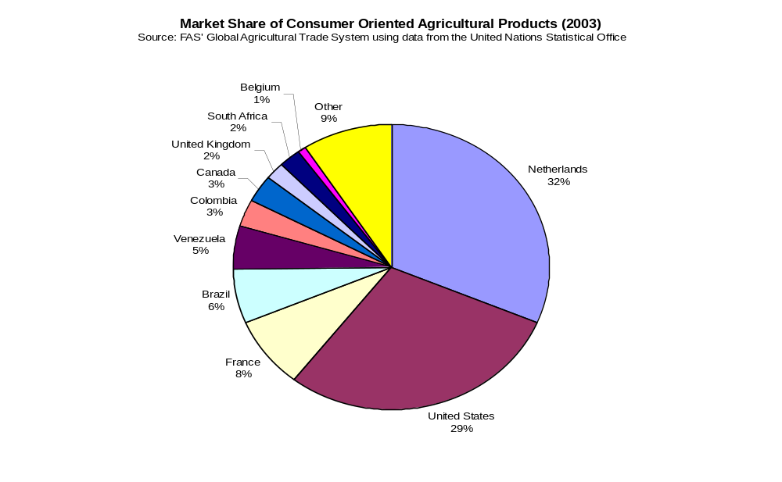

Product Category | Major Supply Sources
Snack Foods (Excl. Nuts)  Sales Value:  $6,311 | 1. Netherlands (41%)  2. Columbia (8%)  3. USA is a Medium Supplier (24%)
Breakfast Cereals & Pancake Mix  Sales Value:  $809 | 1. Netherlands (21%)  2. Costa Rica (5%)  3. USA is a  Major Supplier (57%)
Red Meats, Fresh/Chilled/Frozen  Sales Value:  $10,539 | 1. Brazil (27%)  2. Netherlands (19%)  3. USA is a  Minor Supplier (9%)
Red Meats, Prepared/Preserved  Sales Value:  $ 6,562 | 1. Netherlands (31%)  2. France (9%)  3. USA is a  Major Supplier (33%)
Poultry Meat  Sales Value:  $9,151 | 1. Brazil (47%)  2. Netherlands (2%)  3. USA is a  Major Supplier (46%)
Dairy Products (Excl. Cheese)  Sales Value:  $8,094 | 1. Netherlands (36%)  2. France (17%)  3. USA is a  Minor Supplier (11%)
Cheese  Sales Value:  $11,784 | 1. Netherlands (73%)  2. France (12%)  3. USA is a  Minor Supplier (3%)
Eggs & Products  Sales Value:  $388,000 | 1. Venezuela (24%)  2. France (1%)  3. USA is a  Major Supplier (73%)
Fresh Fruit  Sales Value:  $4,007,000 | 1. Venezuela (57%)  2. Dominica (13%)  3. USA is a  Minor Supplier (3%)
Fresh Vegetables  Sales Value:  $9,415,000 | 1. Netherlands (34%)  2. France (10%)  3. USA is a  Major Supplier (43%)
Processed Fruit & Vegetables  Sales Value:  $9,398,000 | 1. Netherlands (41%)  2. Canada (5%)  3. USA is a  Major Supplier (34%)
Fruit & Vegetable Juices  Sales Value:  $5,721,000 | 1. Netherlands (23%)  2. Canada (17%)  3. USA is a  Major Supplier (37%)
Tree Nuts  Sales Value:  $672,000 | 1. Australia (29%)  2. Singapore (17%)  3. USA is a  Major Supplier (30%)
Wine & Beer  Sales Value:  $19,037,000 | 1. Netherlands (44%)  2. France (14%)  3. USA is a  Minor Supplier (14%)
Nursery Products & Cut Flowers  Sales Value:  $1,578,000 | 1. Colombia (47%)  2. Netherlands (29%)  3. USA is a  Minor Supplier (4%)
Pet Foods (Dog & Cat Food)  Sales Value:  $2,891,000 | 1. Netherlands (17%)  2. Brazil (4%)  3. USA is a  Major Supplier (82%)
Other Consumer-Oriented Products  Sales Value:  $39,356,000 | 1. Netherlands (24%)  2. France (11%)  3. USA is a  Major Supplier (44%)

B. Edible Fish & Seafood Products

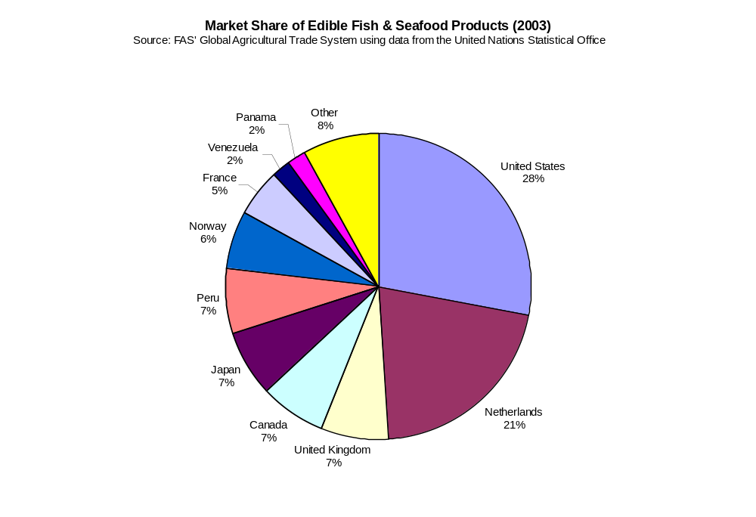

Product Category | Major Supply Sources
Salmon  Sales Value:  $389,000 | 1. Panama (26%)  2. Netherlands (23%)  3. USA is a  Medium Supplier (20%)
Surimi  Sales Value:  $37,000 | 1. Guyana (27%)  2. USA is a  Major Supplier (73%)
Crustaceans  Sales Value:  $817,000 | 1. Netherlands (9%)  2. Venezuela (7%)  3. USA is a  Major Supplier (73%)
Groundfish & Flatfish  Sales Value:  $1,777,000 | 1. Netherlands (29%)  2. Japan (21%)  3. USA is a  Minor Supplier (11%)
Molluscs  Sales Value:  $383,000 | 1. Netherlands (29%)  2. France (9%)  3. USA is a  Major Supplier (62%)
Other Fishery Products  Sales Value:  $1,750,000 | 1. Peru (19%)  2. Netherlands (17%)  3. USA is a  Medium Supplier (15%)

C. CULTURAL, ADMINISTRATIVE, GEOGRAPHIC, & ECONOMIC (CAGE) DISTANCE FRAMEWORK

The cultural, administrative, geographic, and economic distance between the United States and the Netherlands Antilles has a strong impact on the food service market.

The cultural ties between the U.S. and the Netherlands Antilles affect the quality perception and demand for a variety of products. The majority of food service managers and their customers place a great deal of importance on the origin of food and its ingredients. Overall, food service managers and their customers rank the quality of food from the United States as the highest among competing countries, followed by the Kingdom of the Netherlands.

The administrative ties between the U.S. and the Netherlands Antilles also affect the food service market. In general, government involvement is low due to the minor role agriculture plays in the Netherlands Antilles’ economy. While tariffs are applied in Curacao and Bonaire, the other three islands that makeup the region does not have custom duties and operate as free ports. However, extra duties may be imposed on certain locally grown agricultural products, and excise duties are levied on alcoholic beverages.

The geographic distance between the U.S. and the Netherlands Antilles is the determinant factor in increasing or declining trade between the two nations. The CAGE Distance Framework shows a favorable trade benefit for the United States despite the fact that the Kingdom of the Netherlands and the Netherlands Antilles has a colony-colonizer relationship, common policy, and common regional trading block. The United States is only 1,190 kilometers away from the Netherlands Antilles, while the Kingdom of the Netherlands is 4,780 kilometers away. This contributes to a positive trade increase of 400 percent between the United States and the Netherlands Antilles. Moreover, it is important to note here that the Netherlands Antilles is currently seeking independence from the Kingdom of the Netherlands while strengthening its relations with other Caribbean countries. Recently, the Netherlands Antilles was granted observer status at the Association of Caribbean Community. However, the region’s ties with the European Union exclude the Netherlands Antilles from Free Trade Area of the Americas, and the lack of economies of scale inhibit the islands’ participation in the Caribbean Trade Initiative.

Finally, as the region’s average income level increases, the economic distance between the U.S. and the Netherlands Antilles highly impacts the demand for high-cost foods.

SECTION IV. BEST PRODUCT PROSPECTS

The following charts illustrate the best product prospects for U.S. exporters entering the Netherlands Antilles food service market.

Products Present in Market Which Have Good Sales Potential

Product Category | 2003 Imports
Other Consumer-Oriented Products | $39,356,000
Wine & Beer | $19,037,000
Cheese | $11,784,000
Red Meats, Fresh/Chilled/Frozen | $10,539,000
Fresh Vegetables | $9,415,000
Processed Fruit & Vegetables | $9,398,000
Poultry Meat | $9,151,000
Dairy Products (Excl. Cheese) | $8,094,000

Products Not Present in Significant Quantities But Which Have Good Sales Potential

Product Category | 2003 Imports
Red Meats, Prepared/Preserved | $6,562,000
Snack Foods (Excl. Nuts) | $6,311,000
Fruit & Vegetable Juices | $5,721,000
Fresh Fruit | $4,007,000
Pet Foods (Dog & Cat Food) | $2,891,000
Groundfish & Flatfish | $1,777,000
Other Fishery Products | $1,750,000
Nursery Products & Cut Flowers | $1,578,000
Crustaceans | $817,000
Breakfast Cereals & Pancake Mix | $809,000
Tree Nuts | $672,000
Salmon | $389,000
Eggs & Products | $388,000
Molluscs | $383,000
Surimi | $37,000

SECTION V. POST CONTACT AND FURTHER INFORMATION

A. For more information on the Netherlands Antilles and a list of importers for your U.S. product, please contact:

Caribbean Basin Agricultural Trade Office
Foreign Agricultural Service
United States Department of Agriculture

909 SE 1st Ave., Suite 720
Miami, FL 33131
Phone: (305) 536-5300
Fax: (305) 536-7577
E-mail: cbato@cbato.net

Paul Hoffman, Director
E-mail: paul@cbato.net
Omar González, Deputy Director
E-mail: omar@cbato.net
Graciela Juelle, Marketing Assistant
E-mail: grace@cbato.net

Please visit our website for more reports and information on the Netherlands Antilles and other Caribbean Islands:
http://www.cbato.fas.usda.gov, click on “U.S. Exporters”

B. Other Sources of Information on the Netherlands Antilles:

United States Consulate General
Willemstad, Curacao

P.O. Box 158, J.B. Gorsiraweg 1,
Phone: 011-599(9)-461-3066
Fax: 011-599(9)-461-6489
E-mail: info@amcongencuracao.an
Website: http://curacao.usconsulate.gov/General_info.htm

CURACAO

Chamber of Commerce & Industry

P.O. Box 10
Kaya Junior Salas 1
Curacao, Netherlands Antilles

Phone: 011-599(9)-461-1451
Fax: 011-599(9)-461-5652
E-mail: management@curacao-chamber.an
Website: http://www.curacao-chamber.an

Curacao Hospitality and Tourism Association

P.O. Box 6115
Kurason di Komersio
Kaya Junior Salas 1
Curacao, Netherlands Antilles

Phone: 011-599(9)-465-1005
Fax: 011-599(9)-465-1052
Website: www.chata.org

