

August 4, 2008
Apri

VAMC shuttle riders can beat the skyrocketing prices of gas
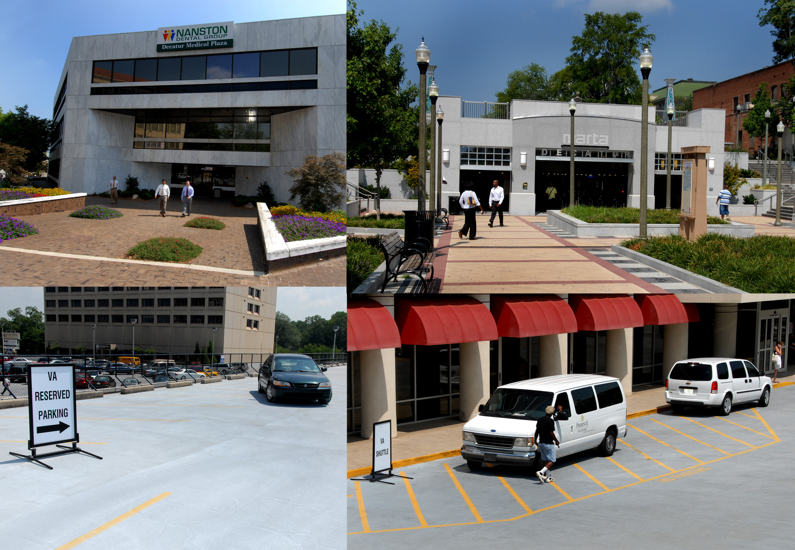
Convenient and timely, VAMC’s shuttle service provides
an excellent option for employees.

With gas near $4 a gallon, Atlanta commuters are forced to pay the high prices or find alternative sources of transportation. At Atlanta VAMC, the Phoenix Shuttle provides an excellent option that more employees may wish to consider to offset rising gas costs.
Vincent Covington, acting CFO, said the shuttle service provides a convenient and timely alternative to the high cost of driving his car. Covington said he began using the service about two months ago but wished he had started sooner.
“I certainly think it's something more VAMC employees should be thinking about to reduce the financial, mental, and physical stress associated with long commutes.”
The Phoenix Shuttle runs Monday through Friday from 5:30 am to 6:30 pm with pickup points at the north entrance of the employee parking deck, the

See Shuttle on page 2

News Briefs
The computer based panic alarm system is operational-The panic alarm can be activated by double clicking theon your desktop or by pressing both Ctrl keys (at the same time) on your keyboard. Employees should not test the alarm system, but are encouraged to use the panic alarm only in the event of an actual emergency. Please be careful not to accidentally activate this system as it could pull officers away from an actual emergency. We are working with staff from IT to move this system into our CBOCs as well.
Incidents/Accidents on VA Property-Please report all incidents/accidents that occur on VA property to VA Police at ext 7641. There is no statute of limitations for reporting incidents/accidents that occur on VA Property.
Voluntary Leave Transfer Program – The following are approved participants in the VLTP and are eligible to receive annual leave donations: Primary Care –Michelle Pough, Denise Reed.EMS- Robert Wingo, Milton Ferrell.
Health Administration Service-Carol Mabry. Surgical-John Robinson. Medical & Specialty Care-Erica Jowers. Atlanta Vet Center-Anita Salamon. Police-Bobby Keener.
Patient Care-Deborah Spencer, Linda Freeman.
If you wish to make a leave donation, call Freida Philpotts at ext 6306 or Marie Robinson at ext. 4376 to complete form OF-630A.
Car pool/vanpool -The easiest way to connect with others in your area who wish to car pool or vanpool from near your home to near your place of business is through:
https://www.myridesmart.com/html/index.htm
You can register and receive a list of persons who live near you and have similar commutes. For more information, contact Steve Sherwood, Energy Manager, at ext. 6101.



Shuttle from page one

Administration Lease One Building, the Decatur Clinic, and the nearby MARTA station.
“You can take the MARTA to Decatur, walk about a half block to the Admin Lease One Building or Decatur Clinic, catch the shuttle and arrive at the Atlanta VA Medical Center in about 20 minutes,” Covington said.
The Phoenix Shuttle became even more attractive for VAMC employees, according to Police Chief Jeff Garrett, when the MARTA station was added as a pickup point on August 4. “Our employees can now take the shuttle directly from the MARTA station in Decatur to any of the other three pick up points.”

Chief Garrett pointed out another advantage of using the shuttle. “We could definitely ease our parking situation if more employees parked their vehicles in one of the 99 parking spaces located at the Decatur Clinic and took advantage of riding the shuttle to and from the main campus.” Covington said he expects the number of Phoenix Shuttle riders to increase as gas prices continue to rise and more people find out about the service. "When you combine the rising price of gasoline with the time spent sitting in traffic and the wear and tear on the car, using the Phoenix Shuttle makes a lot of sense.”

VAMC and Morehouse School of Medicine recognize residents
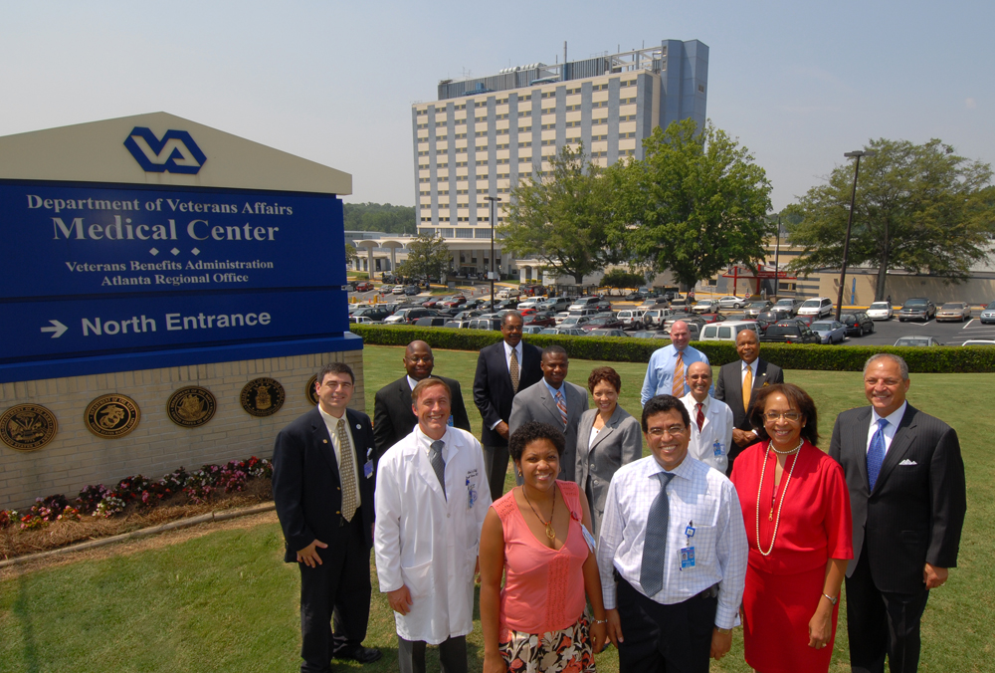
The leadership of Atlanta VAMC and Morehouse School of Medicine gather to recognize MSM psychiatry residents – Dr. Reyna Gilmore and Dr. Zehzaa Mikhaeil – who recently started their internships at VAMC.
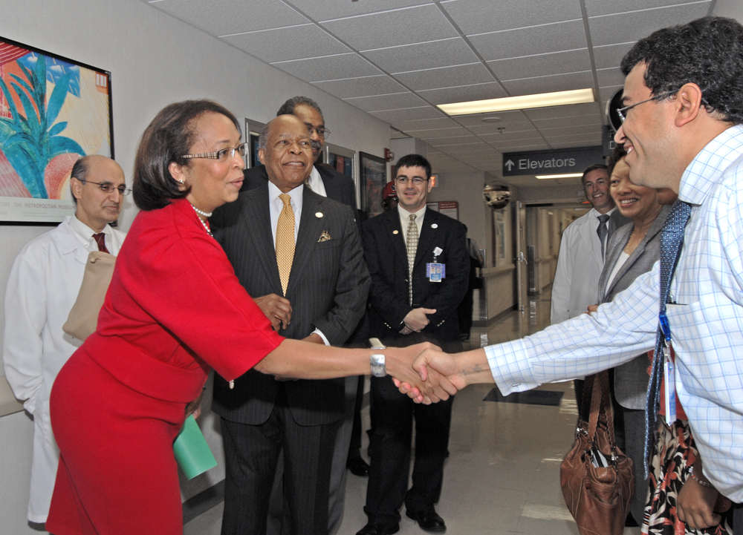
MSM’s Dr. Eve J. Higginbotham, Dean and Senior Vice President for Academic Affairs, greets Dr. Zehzaa Mikhaeil.
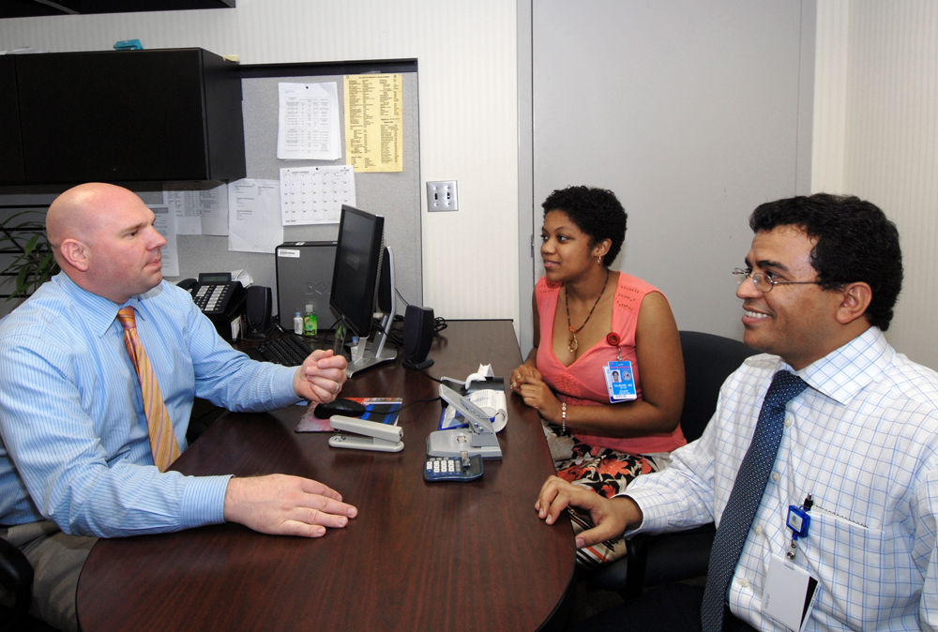
Atlanta VAMC’s Dr. David Purselle provides helpful guidance to Dr. Reyna Gilmore and Dr. Zehzaa Mikhaeil.

Dr. John E. Maupin Jr., Morehouse School of Medicine (MSM) President, and other senior officials from the medical school recently gathered at Atlanta VAMC to recognize two MSM psychiatry residents who started their internships at VAMC earlier in July.
“This is a great day and we thank the Atlanta VA Medical center for making this possible,” Dr. Maupin said.

Calling it a historic occasion, the President of the Morehouse School of Medicine Dr. John E, Maupin Jr. and other senior leaders from the college visited Atlanta VAMC recently to recognize the two Morehouse psychiatry residents who started their internships at VAMC earlier last month.

