Simple and Inexpensive FPGA-based Fast Time Resolving Acquisition Board
Technical Description, Installation and Operation Manual

Abstract
This document describes how to build and operate a Fast Time Resolving Acquisition Board for real-time recording and/or statistical processing of electrical pulses, such as these generated by Single-Photon Counting Detectors (SPADs). This Board connects to a standard PC via USB-2 cable and can be used in popular data acquisition programs such as LabView.

Introduction

The growing interest in research and applications of photon-counting technology is evident. More and more research laboratories use single photon technologies for various applications, such as quantum communication and computing, single-molecule monitoring, precision measurements, etc. Meeting the demand for engineers and researchers with experience in single photon detection and statistical methods requires including simple photon-counting experiments in undergraduate laboratory courses. To implement even a simple photon-counting test bench, one needs to heavily invest in not only SPAD detectors, but also expensive photon counting hardware and software. Even more troubling is the fact that most commercial solutions known to the author provide proprietary (as opposed to open source) software, which makes it difficult to adapt these solutions to custom needs, especially when real-time data processing is needed.
The main principles of development of this board are:
- Easy assembly, installation and operation
- Extremely low cost
- Open Source software and FPGA firmware
- Immediate connectivity to LabView
These principles provide a fast learning curve with an immediately useful device for simple photon counting (or any pulse counting) applications. At the same time, it allows more advanced users to accommodate unique applications, without spending too much time developing the board-to-PC interface.

Description

The board detects “signal” TTL pulses on 4 channels and timestamps the arrival of their leading (positive) edges. The timestamps are driven by either the board’s own internal clock with 6.94 ns increments (i.e. at 144 MHz) or can be driven by an external clock with up to 6.78 ns increments (i.e. 160 MHz), which is enough to lock the pulse timestamping to twice the repetition rate of typical ps and fs Ti:Saph lasers. After timestamping, the board transmits the collected data via a USB-2 port to the computer. The peak transfer rate observed is >8 MB/s (corresponding to >2 million counts per second), but it is only limited by the speed of the PC used. The information then is processed and/or recorded to the hard drive in real time by the driver and is available (also in real time) to the end user. The number of time stamping channels can be easily increased, by modification of the FPGA firmware.
The board uses an Altera Cyclone II FPGA and a Cypress USB-2 chip. The software was developed and tested on Xylo-EM FPGA development board. It also could be used on a Saxo FPGA development board (with limited functionality). The board is commercially available, costs less than $200 and is the principle expense of the project.

Table 1: Physical Characteristics
Parameter | Value
Computer interface | USB-2
Operating System | Windows 2000, XP
Computer Configuration | Any (Tests run on P4 2.8 Mhz, 1 GB ram)
Architecture | Open Source
Time counter reset (start) channel | 1
Number of time stamping (stop) channels | 4 (or more, after firmware modifications)
Time stamp increment (internal clock) | 6.94ns (144MHz clock)
Minimal timestamp increment (external) | <6.5ns (>160MHz clock)
Board deadtime | None
Event threshold level (start, stop, clock) | TTL (<1.6 V, positive edge, not adjustable)
Highest USB data transfer rate | >2 10⁶ Hz (PC dependent)
Estimated cost | <$250
Estimated assembly and installation time | 4 h

Table 2: Parts list
Part | Quantity
Xylo-EM FPGA development board | 1 ea.
Generic Electronics Box 3”x2”x6” (min) | 1 ea.
USB-2 cable | 1 ea.
BNC connectors | 6 ea. (or more)
BNC cable | 2 ft.
Plastic mounting screws, bolts | As necessary

Assembly and installation

Assembly

This manual assumes that Xylo-EM FPGA development board is used. For a different board, changes in firmware and assembly are necessary.

Step 1: Mount the BNC connectors on the box as shown in fig. 1a.
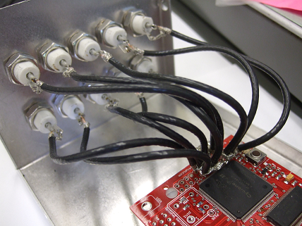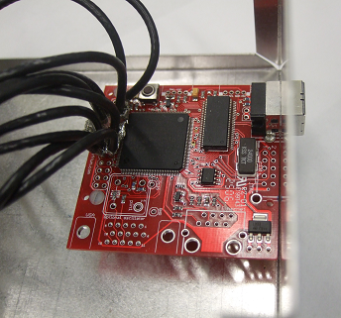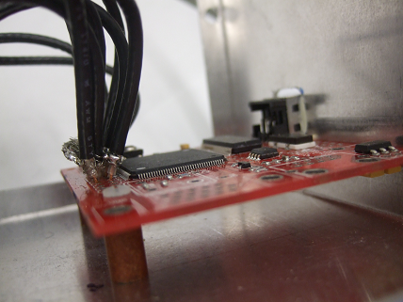
Fig. 1. a) mounting BNC connectors; b) mounting the board, top view; c) mounting the board, side view.

Step 2: Mount the FPGA test board to the box as shown in Figs. 1b, c. Make sure that USB connector is accessible from the outside of the box.
Step 3: Solder BNC connectors to FPGA pins with short (3-4”) BNC cable pieces. Make sure that all pieces are of the same length. Refer to table 3.

Table 3: List of BNC inputs
Pin | Purpose
70 | Detector (stop) 1
73 | Detector (stop) 2
79 | Detector (stop) 3
92 | Detector (stop) 4
97 | Clear the counter (start)
88 | External clock
Note: pins 93, 100, 101 (and many others) could be also wired in the similar way for future extensions and/or debugging.

Connecting the board

Note: it is important that all electrical connections are done while the board is not powered up (i.e. not connected to the PC via USB).
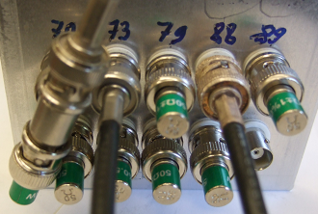
Fig 2. Proper termination of used and unused pins.

Step 1: If an external clock will be used, connect an external clock source to pin 88. Connect appropriate input channels to signal sources. It is important to match the impedance to 50 Ohm at least at one of line ends to avoid multiple reflections. In Fig 2, a source of pin 70 is assumed to be a TTL input and is 50 ohm terminated at FPGA. Other sources, such as pins 73 and 88 are terminated at the source. Note: some commercial detectors produce a digital output of < 3.5 V. If these SPADS are used termination at either end would bring the signal below the threshold voltage. One possible solution is to use extremely short (<1 ft) cables between a SPAD and an FPGA and avoid terminators. One can also use simple comparators, set comparators voltage to about 1V and the output at TTL level. One could use a stand-alone FPGA test board that simply translates input to output with a short cable connecting it to a SPAD, and then connect the two FPGA boards via a terminated BNC cable.

Step 2: Terminate all unused inputs on board, as shown in Fig. 2.

Software installation

Step 1: Driver installation. You will need “FX2_USB.inf” and “FX2_USB.sys” driver files from the board’s start-up kit.
Connect the board to a computers USB2 port and wait for windows to detect the board and start the Hardware Update Wizard (Fig. 2). Direct the wizard to the directory with “FX2_USB.inf” and “FX2_USB.sys” driver files and ignore a warning about windows certification of a driver (if issued). Refer to Fig. 3.

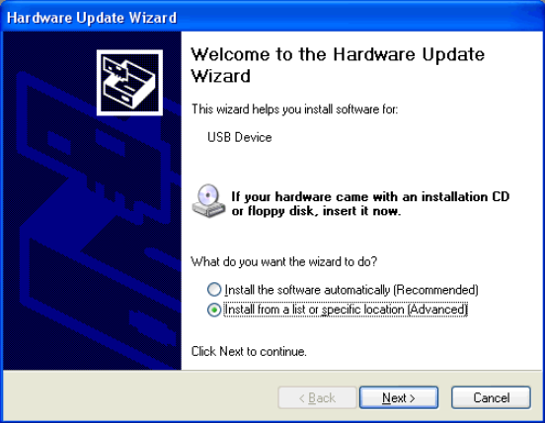
Fig. 3. Step 1 of software installation process.

Step 2: Configuring the board. Open FPGAconf.exe, available from your board’s start-up kit. Select Xylo-EM from menu “Boards” as a target board. Then, in the “Options” menu, set FX2 speed to 48 MHz. Refer to illustration (Fig. 4).
Provide a path to FPGA Time Resolving Acquisition Board firmware: the appropriate .rbf file from this distribution and configure FPGA with the selected .rbf file (click “Configure FPGA” button). The successful completion of this step ensures that the FPGA board is installed correctly and is ready to be used in a Time Resolving Acquisition Board mode.
Step 3: Testing the installation. The simplest way to test the installation is to use the LabView example fpgatest.vi, provided in this package. It can be used with any .rbf firmware. The program tests that electronic events are properly recorded by the board, received by a PC and made available to an end LabView user. The receipt and initial processing of data are handled by a stand-alone dll. This test is successful if the electronic events statistics is correctly displayed by a vi.
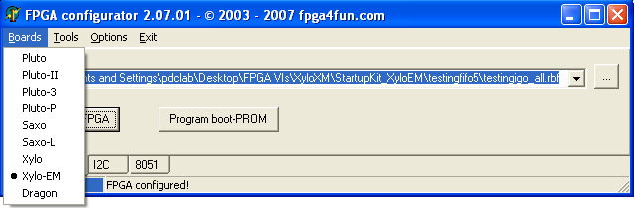
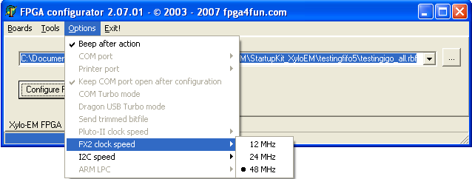
Fig. 4. Step 2 of software installation process. Setting up the configuration program.

If the test fails, unplug a USB cable, wait for 10-20 seconds and plug it back in. Repeat steps 2 and 3. If this does not help, the PC needs to be restarted. Repeat steps 2 and 3. If test fails again, check all the connections. It is recommended to use commercial function generators instead of real signal sources for debugging.

Operation

There are several default modes of operation. The operation mode can be changed by loading the board with an appropriate pre-compiled firmware (.rbf file). Using an FPGA configurator, select the .rbf file corresponding to the mode of operation of choice and click “Configure FPGA” button. This procedure has to be done after every off-on power cycle to a board. The following table for default modes of operation. Advanced users are encouraged to make custom firmware modifications, and share them with the project core, however, custom firmware is not supported by this project.

Table 4: Available operation modes
Operation mode | Firmware file
Internal clock timestamping 144MHz | internal.rbf
External clock timestamping | external.rbf
External clock, doubled | external_x2.rbf

Note that because of an external clock capability, this board can easily synchronize to the experiment, and thus reduce timing jitter. In some cases, the synch signal produced by the electronics is not TTL, and therefore has to be converted to TTL.

LabView interface

In this section we will discuss basic operation modes using standard existent software from the viewpoint of LabView integration. The basic example of operating the board, fpgatest.vi, covers all important stages of communication, and can be used for various design extensions.

The LabView interface, fpga_dll.dll is written in C++ and interfaces to LabView vi’s via calls to external dll functions. For convenience and compatibility, these function calls are encapsulated in vi’s and should be called from users programs.

fpga_init.vi:
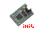
This function initializes the communication protocol between the computer and the board. It returns a handle to the communication channel to be used for all subsequent operations with the board. On error, it reports an internal driver error number for debugging.
Inputs: none
Outputs: device handle, error message

fpga_interface.vi:
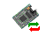
This function communicates with the board, acquires statistical measures of events (correlations) and allows writing a raw file of all events to a hard disk for the purposes of further statistical analysis. Please refer to the appropriate section below for file format.
Inputs:
handle_in: the output of fpga_init.vi
fpga_runs: how many times the dll should query the board before returning the execution to labview. It is recommended to keep this number high enough to ensure that all real-time data makes it to the PC, but low enough so that the custom labview application keeps a comfortable update rate.
fpga_command: one of the following integers
0: no change (continue in either acquisition or idle modes)
1: clear the timestamping counter (same as a start event)
2: stop acquisition
4: start acquisition
save a clickfile: save the events in the external text file
click file name: a text string with the path to the file and the file name. If the file with the same name exists, it will be appended.
Outputs:
handle_out: “returns” the handle to the system. Can be used for sequential calls to this and other board vi’s.
error: reports on an error encountered during communication (if any)
stats: an array of statistical data about detected events. Refer to the table for the information provided. Note that one can write their own module that analyses the acquired events in real time. This function could replace the default in the driver. This procedure is described later.

Table 5: Statistical data provided by fpga_interface.vi by default
Offset | Meaning
0 | Single events: Channel 1
1 | Single events: Channel 2
2 | Single events: Channel 3
3 | Single events: Channel 4
4 | Coincidence events: Channels 1&2
5 | Coincidence events: Channels 1&3
6 | Coincidence events: Channels 1&4
7 | Coincidence events: Channels 2&3
8 | Coincidence events: Channels 2&4
9 | Coincidence events: Channels 3&4
10 | Coincidence events: Channels 1,2&3
11 | Coincidence events: Channels 1,2&4
12 | Coincidence events: Channels 1,3&4
13 | Coincidence events: Channels 2,3&4
14 | Coincidence events: Channels 1,2,3&4
Note: Coincidence events are defined as events that occurred during one and the same clock cycle.

fpga_close.vi:
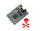
This function closes the communication protocol, but leaves the mode of the board (either acquisition or idle) unchanged. It is recommended to switch the board to idle by calling an fpga_interface vi with an appropriate command during the previous communication.
Inputs: handle_in
Outputs: none

Data Format

Events, positive edges at the input channels crossing the threshold, are timestamped by the counter that counts clock ticks. Therefore, one timestamping increment corresponds to 1/f_{clock}. If one or more events have occurred within a time bin, the information about this time bin is stored in a 4 byte word. This information indicates which channel or channels recorded an event and the number of a time bin. Refer to the table for the description of each bit.

Table 6: Data format
Bit: | 31 | 30 | 29 | 28 | 27 | 26-0
Meaning: | Counter cleared (by either “start” event, PC instruction or overfilling) | Event @ ch. 4 | Event @ ch. 3 | Event @ ch. 2 | Event @ ch. 1 | Timestamp

Therefore, one 4 byte word stores information on one or more events occurring at the “same” time.

The LabView interface has an option to record the timestamped data in a file, as discussed earlier. The data is stored as a series of 4 byte words in hexadecimal format, separated by a dot, <byte3>.<byte2>.<byte1>.<byte0> (i.e. much like the IP addresses). Byte 3 is the highest byte and consists of bits 31 to 24, and Byte 0 is the lowest byte and consists of bits 7 to 0 (see the table above). After the history file is written, a user application can process the data in an off-line mode.

Real-Time Data Access (advanced)

Users may want to develop a custom real-time data processing routine. To do so, one needs a C/C++ compiler. The easiest way to access real-time data is to write a function that would substitute the default real time processing routine (that calculates coincidences). Users can add a function into the source of a dll LabView driver (fpga_dll.cpp) with any name (say “foo”), and update
#define REALTIME_FUNCTION correlate
with the name of the function they written:
#define REALTIME_FUNCTION foo
The function must be declared as:
void foo ( unsigned char * data_in, int data_length, int *stats)
where data_in is an array of recorded events, 4 bytes are used per one event; data_length is the length of the array in bytes (divide by 4 to get number of events) and stats is an array of integers, with foo’s output. The pointer to zeroth element of stats array will be passed to LabView. The LabView code needs to know the length of this array in advance.

Further improvements (roadmap)

- Extend the number of input signal lines (stops)
- Increase the raw USB2 peak transfer rate by taking advantage of SDRAM of Xylo-EM.
- Implement and use a dynamic protocol that adjusts the number of bits transmitted as a function of data rate (i.e. reduces byte counts for higher rates and vice versa) to further increase transfer rate
- The highest frequency of the test board to clock timestamps is estimated 396 MHz (i.e. 2.52 ns). Device and implement the timestamping routine to approach this frequency.

