STATEMENT OF ANDY KERR
THE LARCH COMPANY
CONSULTANT TO THE SODA MOUNTAIN WILDERNESS COUNCIL

BEFORE THE

SENATE ENERGY AND NATURAL RESOURCES COMMITTEE SUBCOMMITTEE ON PUBLIC LANDS AND FORESTS

REGARDING THE

“CASCADE-SISKIYOU NATIONAL MONUMENT VOLUNTARY AND EQUITABLE GRAZING CONFLICT RESOLUTION ACT”

FEBRUARY 27, 2008

With towering fir forests, sunlit oak groves, wildflower-strewn meadows, and steep canyons, the Cascade-Siskiyou National Monument is an ecological wonder, with biological diversity unmatched in the Cascade Range. This rich enclave of natural resources is a biological crossroads – the interface of the Cascade, Klamath, and Siskiyou ecoregions, in an area of unique geology, biology, climate, and topography…. The monument is home to a spectacular variety of rare and beautiful species of plants and animals, whose survival in this region depends upon its continued ecological integrity.”

Proclamation Establishing the Cascade-Siskiyou National Monument
June 9, 2000 (Attachment 1)

My name is Andy Kerr. I am a consultant to the Soda Mountain Wilderness Council on matters relating to the proposed Soda Mountain Wilderness, as well as livestock grazing and other issues in the Cascade-Siskiyou National Monument. I am filling in today in place of Dave Willis, who has contracted the flu.

The Klamath-Siskiyou ecoregion in southwest Oregon and northwest California is the most botanically diverse coniferous forest in North America, if not the world—a veritable Noah’s Ark of botanical diversity. The ecoregion is relatively undeveloped and relatively high elevation. It serves as a land bridge between the Cascade Mountains and the Great Basin, and it genetically connects the mountainous Klamath-Siskiyous with the rest of the West. The Cascade-Siskiyou National Monument area is the ecological loading dock for the botanically diverse Klamath-Siskiyou ark—that is the scientific object of interest for which the monument was proclaimed. And that is why the monument Proclamation refers to the area as “an ecological wonder” and “a biological crossroads.”
The Cascade-Siskiyou Monument’s Proclamation states that the area “is home to a spectacular variety of rare and beautiful species of plants and animals whose survival in this region depends upon its continued ecological integrity.”

Thank you, Chairman Wyden and Senator Smith, for introducing S. 2379, the Cascade-Siskiyou National Monument Voluntary and Equitable Grazing Conflict Resolution Act. If enacted into law, this legislation will improve ecological and watershed protection and restoration within the national monument. The legislation includes three major components:

1. designation of the Soda Mountain Wilderness;
2. a land exchange to consolidate public ownership in the monument and enhance monument values; and
3. voluntary and equitable resolution of the inherent incompatibility of livestock grazing in one of our nation’s premier wild areas.

All three components are politically inter-dependent and all three further the purposes for which the Cascade-Siskiyou National Monument was established.

The Soda Mountain Wilderness

One of the most striking features of the Western Cascades in this area is Pilot Rock, located near the southern boundary of the monument. The rock is a volcanic plug, a remnant of a feeder vent left after a volcano eroded away, leaving an outstanding example of the inside of a volcano. Pilot Rock has sheer, vertical basalt faces up to 400 feet above the talus slope at its base, with classic columnar jointing created by the cooling of its andesite composition.

Proclamation Establishing the Cascade-Siskiyou National Monument
June 9, 2000

Background materials about the proposed Soda Mountain Wilderness are attached to this statement (Attachment 2).

• The proposed Soda Mountain Wilderness is:

- at the intersection of many divergent ecosystems and landscapes, including the Siskiyou and Cascade mountain ranges, the Oregon Desert, California chaparral, and High Cascade and coastal westside forests;

- home to ten rare, threatened or endangered species, including northern spotted owl, Greene’s Mariposa lily, Genter’s fritillary, Ashland thistle, pygmy monkey flower, clustered lady’s slipper, green-flowered wild ginger and Siskiyou fritillary;

- host to ~7 miles of the Pacific Crest National Scenic Trail;

- renowned for one of the highest diversities of butterflies in the country (120+ species);

- noted for one of the highest diversities of mollusk species in the country;

- habitat for Jenny Creek redband trout, western pond turtle, elk, black bear, bobcat, golden eagle, goshawk, prairie falcon, and peregrine falcon;

- critical deer winter range (“best of the last” in the region);

- remarkably botanically diverse; and

- home to Pilot Rock (elev. 5,910’), a columnar basalt landmark visible from throughout the region.

• Major tree species in the proposed wilderness include Douglas-fir, ponderosa pine, Oregon white oak, California black oak, incense cedar, western juniper, bigleaf maple, sugar pine, madrone, Douglas hawthorn, shining and arroyo willows, mock-orange, Douglas-spirea, Oregon ash, white alder, black cottonwood, birch leaf mountain mahogany, and quaking aspen.

Establishing the Soda Mountain Wilderness would benefit current and future generations of Oregonians.

• Congress has designated backcountry Wilderness in numerous other national parks and monuments.

• Designating the wilderness would conflict with few, if any, commodity or other uses. The proposed wilderness is:

* entirely federal public land (no private inholdings);

* ~23,000 acres entirely within the 53,000-acre Cascade-Siskiyou National Monument in Oregon (already dedicated to non-commodity purposes);

* already withdrawn from potential mineral development (per CSNM proclamation; and there are no historic mineral claims);

* would not conflict with livestock grazing (grazing would be eliminated via voluntary grazing lease retirement);

* already closed to off-road vehicles (per CSNM proclamation);

* already closed to commercial logging (per CSNM proclamation); and

* is little-used by mountain bikers (the CSNM proclamation closed the former Schoheim Jeep “Road” to all “mechanized” vehicles and the CSNM management plan closes most of the remainder of the trails in the area to mechanized use).

• Designating the Soda Mountain Wilderness would have no effect on the Northwest Forest Plan.

• The proposed Soda Mountain Wilderness includes:

* Oregon Gulch Research Natural Area (1,056 acres);
* Scotch Creek Research Natural Area (1,800 acres);
* Pacific Crest National Scenic Trail (~7 miles); and
* a BLM-Recommended Wilderness Area endorsed by President George H.W. Bush (6,447 acres).

• Wilderness designation is favored by editorials published by the Ashland Daily Tidings, Medford Mail-Tribune, Eugene Register-Guard and the Portland Oregonian.

The Rowlett Land Exchange

All Federal lands and interests in lands within the boundaries of this monument are hereby appropriated and withdrawn from all forms of entry, location, selection, sale, or leasing or other disposition under the public land laws, including but not limited to withdrawal from location, entry, and patent under the mining laws, and from disposition under all laws relating to mineral and geothermal leasing, other than by exchange that furthers the protective purposes of the monument. (emphasis added)

Proclamation Establishing the Cascade-Siskiyou National Monument
June 9, 2000

Background information about the proposed Rowlett Land Exchange is attached to this statement (Attachment 3). In summary, the proposed land exchange:

• is in the public interest;
• furthers the purposes for which the national monument was established;
• adds approximately two-thirds of a mile of essential spawning habitat for the Jenny Creek redband trout in Keene Creek and Lincoln Creek to the national monument (the trout is an object of biological interest identified in the monument proclamation).
• would protect the very scenic and highly visible Keene Creek Canyon;
• has the added benefit of retiring livestock grazing on the Box R Allotment.

The parcel sought for public ownership is generally forested and is contiguous with BLM land to the north.

Grazing Lease Retirement

The Secretary of the Interior shall study the impacts of livestock grazing on the objects of biological interest in the monument with specific attention to sustaining the natural ecosystem dynamics. Existing authorized permits or leases may continue with appropriate terms and conditions under existing laws and regulations. Should grazing be found incompatible with protecting the objects of biological interest, the Secretary shall retire the grazing allotments pursuant to the processes of applicable law. Should grazing permits or leases be relinquished by existing holders, the Secretary shall not reallocate the forage available under such permits or for livestock grazing purposes unless the Secretary specifically finds, pending the outcome of the study, that such reallocation will advance the purposes of the proclamation. (emphasis added)

Proclamation Establishing the Cascade-Siskiyou National Monument
June 9, 2000

The Cascade-Siskiyou National Monument Voluntary and Equitable Grazing Conflict Resolution Act provides that—if eligible lessees voluntarily relinquish their interest in federal public land livestock grazing in and near the national monument—the federal government will compensate them and permanently close the allotments, or portions thereof, to livestock grazing.

To local public lands ranchers, the proposed grazing lease retirement program is the most important component of this legislation. The Soda Mountain Wilderness Council supports a fair and equitable way to end livestock grazing in and near the national monument.

Grazing lease retirement in and near the national monument is ecologically imperative, economically rational, fiscally prudent, socially just and politically pragmatic.

Proclamation-Required Grazing Impacts Study

The monument proclamation states:

The Secretary of the Interior shall study the impacts of livestock grazing on the objects of biological interest in the monument with specific attention to sustaining the natural ecosystem dynamics…. Should grazing be found incompatible with protecting the objects of biological interest, the Secretary shall retire the grazing allotments pursuant to the processes of applicable law.

The government grazing studies are complete, as are additional studies by the National Center for Conservation Science and Policy. The scientific findings are clear: livestock grazing is incompatible with the protection of objects of biological interest and sustaining natural ecosystem dynamics in the monument. (See Attachment 4 for a summary of the grazing impact studies.) To conservationists, the language of the proclamation is clear: if continued livestock grazing conflicts with protecting monument values, the former must end.

However, BLM is likely to have a different view. The agency will probably seek to modify the grazing leases by limiting the intensity, duration, timing, frequency and/or method of livestock grazing in an attempt to both preserve objects of biological interest in the monument and continue livestock grazing. New grazing restrictions would render continued grazing more costly and difficult, and perhaps untenable, in the monument.

“Permanent” Grazing Lease Retirement

The proclamation also states:

Should grazing permits or leases be relinquished by existing holders, the Secretary shall not reallocate the forage available under such permits or for livestock grazing purposes unless the Secretary specifically finds, pending the outcome of the study, that such reallocation will advance the purposes of the proclamation.

This language provides for grazing lease retirement, but it does not necessarily mandate permanent lease retirement. The modification of grazing leases to reduce grazing impacts in the monument will be controversial—and interminable. Congress should make clear that, if grazing lessees voluntarily waive their interest in their federal grazing leases, domestic livestock should never again darken the door of the loading dock to nature’s ark.

Congressional Policy for Voluntary Grazing Permit/Lease Retirement in Extraordinary Circumstances

Congress has authorized and funded voluntary grazing permit/lease retirement in extraordinary circumstances in the past (see Attachment 5). Congress has compensated ranchers for the loss of federal grazing permits/leases in a national park, a bombing range, and a unit of the National Landscape Conservation System:

• Capitol Reef National Park, Utah
• Juniper Butte Bombing Range, Idaho
• Steens Mountain Cooperative Management and Protection Area, Oregon

The possibility of continued grazing in the Cascade-Siskiyou National Monument is at least as extraordinary as the examples of Congressionally authorized permit/lease retirement cited here.

In addition, for more than 50 years, whenever the Department of Defense has taken public lands for national security purposes, a statute has required that the Department compensate any affected grazing permittee/lessee for lost grazing privileges. The military has also bought out federal grazing permits/leases on public land to mitigate for harm caused to endangered species from military activities on military reservations.

To Pay or Not to Pay?

In other cases, Congress has only provided that grazing permits/leases voluntarily relinquished to the federal government would be permanently retired—Congress did not provide compensation to participating ranchers. In these cases, a third party compensated the ranchers. The Soda Mountain Wilderness Council believes that it is fair and just for Congress to pay grazing lessees who voluntarily waive their interests in grazing leases in and near the Cascade-Siskiyou National Monument. While munificent to the affected ranchers, it still cheaper for the taxpayers—considering the amount of ongoing subsidies, defending against future litigation, and other costs associated with continued grazing.

How Much to Pay?

S. 2379 would compensate participating lessees at a rate of $300/AUM. While this amount is above market value, it is comparable to replacement value of the lost forage. When a car is totaled, the insurance company pays the owner market value. When a hurricane or a flood wipes out a house, the insurance company pays replacement value. The choice between market value and replacement value is based on the likelihood of occurrence of the associated event. Cars are totaled far more often than houses. The federal government rarely cancels federal grazing leases. Voluntary grazing lease retirement is a rare event.

A Fair and Just Act

Many of the families that have ranched in and near the Cascade-Siskiyou National Monument have done so for generations. With the monument proclamation, the federal government has changed the rules on this group of public lands ranchers. Some would like to reconfigure their operations to rely solely on private land; others are near (or past) retirement. It’s not just a business for them, but a way of life. Voluntary lease retirement would allow each ranching family to realize their own goals.

Conclusion

“The Soda Mountain area is more than just botanically interesting; it is an important link for migration, dispersion, and the process of evolution in the Northwest.”

Dr. Tom Atzet, U.S. Forest Service
Southwest Oregon Area Ecologist
March 22, 1994

Senator Smith, with the cooperation of Senator Wyden, has crafted S. 2379 in a way that can work for the local conservation and livestock grazing communities. The legislation furthers the public interest and the purposes for which the Cascade-Siskiyou National Monument was established. Enactment of S. 2379 will enhance the protection and restoration of a botanically diverse ecoregion that serves as a loading dock to the Klamath-Siskiyou ark. The legislation is fair to ranchers and it will benefit future generations of Oregonians and all Americans.

Thank you.

Andy Kerr
The Larch Company
1213 Iowa Street
Ashland, OR 97520
541/201-0053
andykerr@andykerr.net
Attachment 1
Proclamation Establishing the Cascade-Siskiyou National Monument

June 9, 2000

BY THE PRESIDENT OF THE UNITED STATES OF AMERICA

A PROCLAMATION

With towering fir forests, sunlit oak groves, wildflower-strewn meadows, and steep canyons, the Cascade-Siskiyou National Monument is an ecological wonder, with biological diversity unmatched in the Cascade Range. This rich enclave of natural resources is a biological crossroads -- the interface of the Cascade, Klamath, and Siskiyou ecoregions, in an area of unique geology, biology, climate, and topography.

The monument is home to a spectacular variety of rare and beautiful species of plants and animals, whose survival in this region depends upon its continued ecological integrity. Plant communities present a rich mosaic of grass and shrublands, Garry and California black oak woodlands, juniper scablands, mixed conifer and white fir forests, and wet meadows. Stream bottoms support broad-leaf deciduous riparian trees and shrubs. Special plant communities include rosaceous chaparral and oak-juniper woodlands. The monument also contains many rare and endemic plants, such as Greene's Mariposa lily, Gentner's fritillary, and Bellinger's meadowfoam.

The monument supports an exceptional range of fauna, including one of the highest diversities of butterfly species in the United States. The Jenny Creek portion of the monument is a significant center of fresh water snail diversity, and is home to three endemic fish species, including a long-isolated stock of redband trout. The monument contains important populations of small mammals, reptile and amphibian species, and ungulates, including important winter habitat for deer. It also contains old growth habitat crucial to the threatened Northern spotted owl and numerous other bird species such as the western bluebird, the western meadowlark, the pileated woodpecker, the flammulated owl, and the pygmy nuthatch.

The monument's geology contributes substantially to its spectacular biological diversity. The majority of the monument is within the Cascade Mountain Range. The western edge of the monument lies within the older Klamath Mountain geologic province. The dynamic plate tectonics of the area, and the mixing of igneous, metamorphic, and sedimentary geological formations, have resulted in diverse lithologies and soils. Along with periods of geological isolation and a range of environmental conditions, the complex geologic history of the area has been instrumental in producing the diverse vegetative and biological richness seen today.

One of the most striking features of the Western Cascades in this area is Pilot Rock, located near the southern boundary of the monument. The rock is a volcanic plug, a remnant of a feeder vent left after a volcano eroded away, leaving an outstanding example of the inside of a volcano. Pilot Rock has sheer, vertical basalt faces up to 400 feet above the talus slope at its base, with classic columnar jointing created by the cooling of its andesite composition.

The Siskiyou Pass in the southwest corner of the monument contains portions of the Oregon/California Trail, the region's main north/south travel route first established by Native Americans in prehistoric times, and used by Peter Skene Ogden in his 1827 exploration for the Hudson's Bay Company.

Section 2 of the Act of June 8, 1906 (34 Stat. 225, 16 U.S.C. 431), authorizes the President, in his discretion, to declare by public proclamation historic landmarks, historic and prehistoric structures, and other objects of historic or scientific interest that are situated upon the lands owned or controlled by the Government of the United States to be national monuments, and to reserve as a part thereof parcels of land, the limits of which in all cases shall be confined to the smallest area compatible with the proper care and management of the objects to be protected.

WHEREAS it appears that it would be in the public interest to reserve such lands as a national monument to be known as the Cascade-Siskiyou National Monument:

NOW, THEREFORE, I, WILLIAM J. CLINTON, President of the United States of America, by the authority vested in me by section 2 of the Act of June 8, 1906 (34 Stat. 225, 16 U.S.C. 431), do proclaim that there are hereby set apart and reserved as the Cascade-Siskiyou National Monument, for the purpose of protecting the objects identified above, all lands and interests in lands owned or controlled by the United States within the boundaries of the area described on the map entitled "Cascade-Siskiyou National Monument" attached to and forming a part of this proclamation. The Federal land and interests in land reserved consist of approximately 52,000 acres, which is the smallest area compatible with the proper care and management of the objects to be protected.

All Federal lands and interests in lands within the boundaries of this monument are hereby appropriated and withdrawn from all forms of entry, location, selection, sale, or leasing or other disposition under the public land laws, including but not limited to withdrawal from location, entry, and patent under the mining laws, and from disposition under all laws relating to mineral and geothermal leasing, other than by exchange that furthers the protective purposes of the monument.

There is hereby reserved, as of the date of this proclamation and subject to valid existing rights, a quantity of water sufficient to fulfill the purposes for which this monument is established. Nothing in this reservation shall be construed as a relinquishment or reduction of any water use or rights reserved or appropriated by the United States on or before the date of this proclamation.

The commercial harvest of timber or other vegetative material is prohibited, except when part of an authorized science-based ecological restoration project aimed at meeting protection and old growth enhancement objectives. Any such project must be consistent with the purposes of this proclamation. No portion of the monument shall be considered to be suited for timber production, and no part of the monument shall be used in a calculation or provision of a sustained yield of timber. Removal of trees from within the monument area may take place only if clearly needed for ecological restoration and maintenance or public safety.

For the purpose of protecting the objects identified above, the Secretary of the Interior shall prohibit all motorized and mechanized vehicle use off road and shall close the Schoheim Road, except for emergency or authorized administrative purposes.

Lands and interests in lands within the proposed monument not owned by the United States shall be reserved as a part of the monument upon acquisition of title thereto by the United States.

The Secretary of the Interior shall manage the monument through the Bureau of Land Management, pursuant to applicable legal authorities (including, where applicable, the Act of August 28, 1937, as amended (43 U.S.C. 1181a-1181j)), to implement the purposes of this proclamation.

The Secretary of the Interior shall prepare, within 3 years of this date, a management plan for this monument, and shall promulgate such regulations for its management as he deems appropriate. The management plan shall include appropriate transportation planning that addresses the actions, including road closures or travel restrictions, necessary to protect the objects identified in this proclamation.

The Secretary of the Interior shall study the impacts of livestock grazing on the objects of biological interest in the monument with specific attention to sustaining the natural ecosystem dynamics. Existing authorized permits or leases may continue with appropriate terms and conditions under existing laws and regulations. Should grazing be found incompatible with protecting the objects of biological interest, the Secretary shall retire the grazing allotments pursuant to the processes of applicable law. Should grazing permits or leases be relinquished by existing holders, the Secretary shall not reallocate the forage available under such permits or for livestock grazing purposes unless the Secretary specifically finds, pending the outcome of the study, that such reallocation will advance the purposes of the proclamation.

The establishment of this monument is subject to valid existing rights.

Nothing in this proclamation shall be deemed to enlarge or diminish the jurisdiction of the State of Oregon with respect to fish and wildlife management.

Nothing in this proclamation shall be deemed to revoke any existing withdrawal, reservation, or appropriation; however, the national monument shall be the dominant reservation.

Warning is hereby given to all unauthorized persons not to appropriate, injure, destroy, or remove any feature of this monument and not to locate or settle upon any of the lands thereof.

IN WITNESS WHEREOF, I have hereunto set my hand this ninth day of June, in the year of our Lord two thousand, and of the Independence of the United States of America the two hundred and twenty-fourth.

/s/ WILLIAM J. CLINTON
Attachment 2
The Proposed Soda Mountain Wilderness

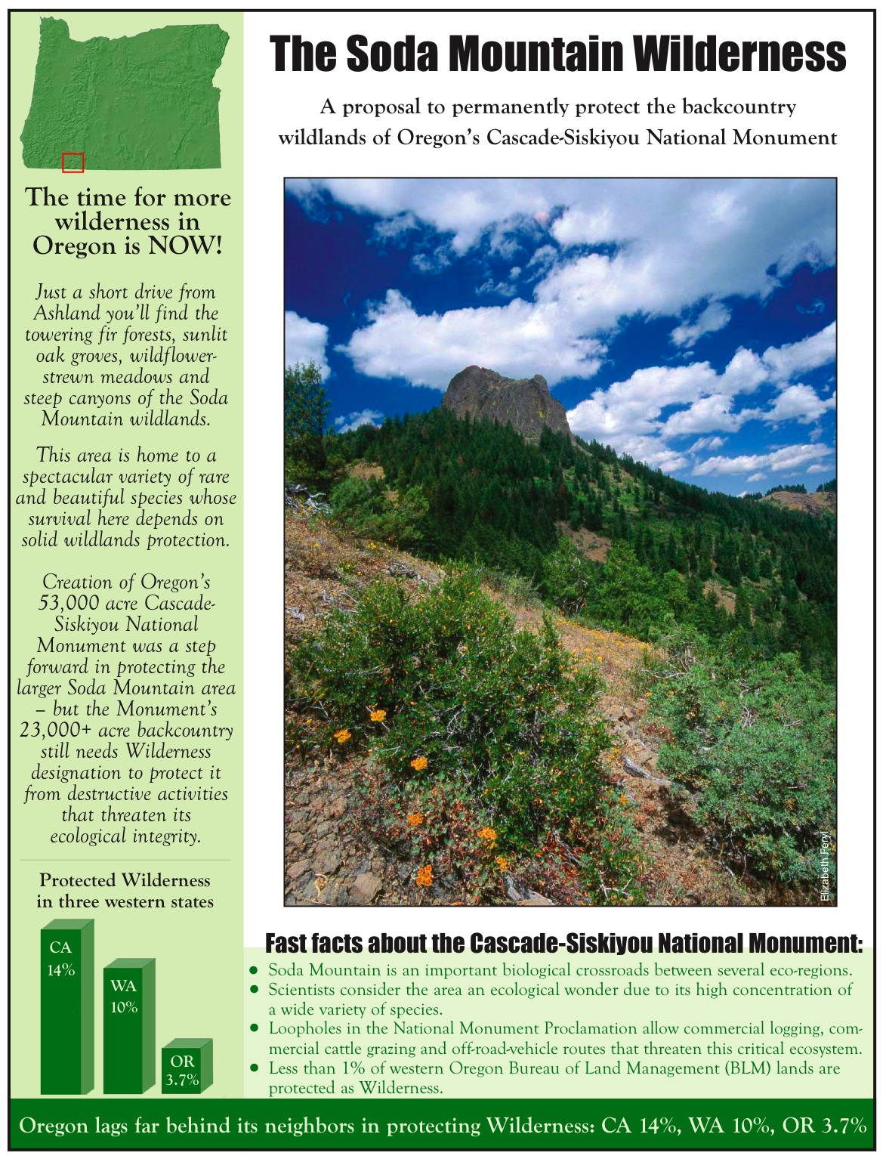
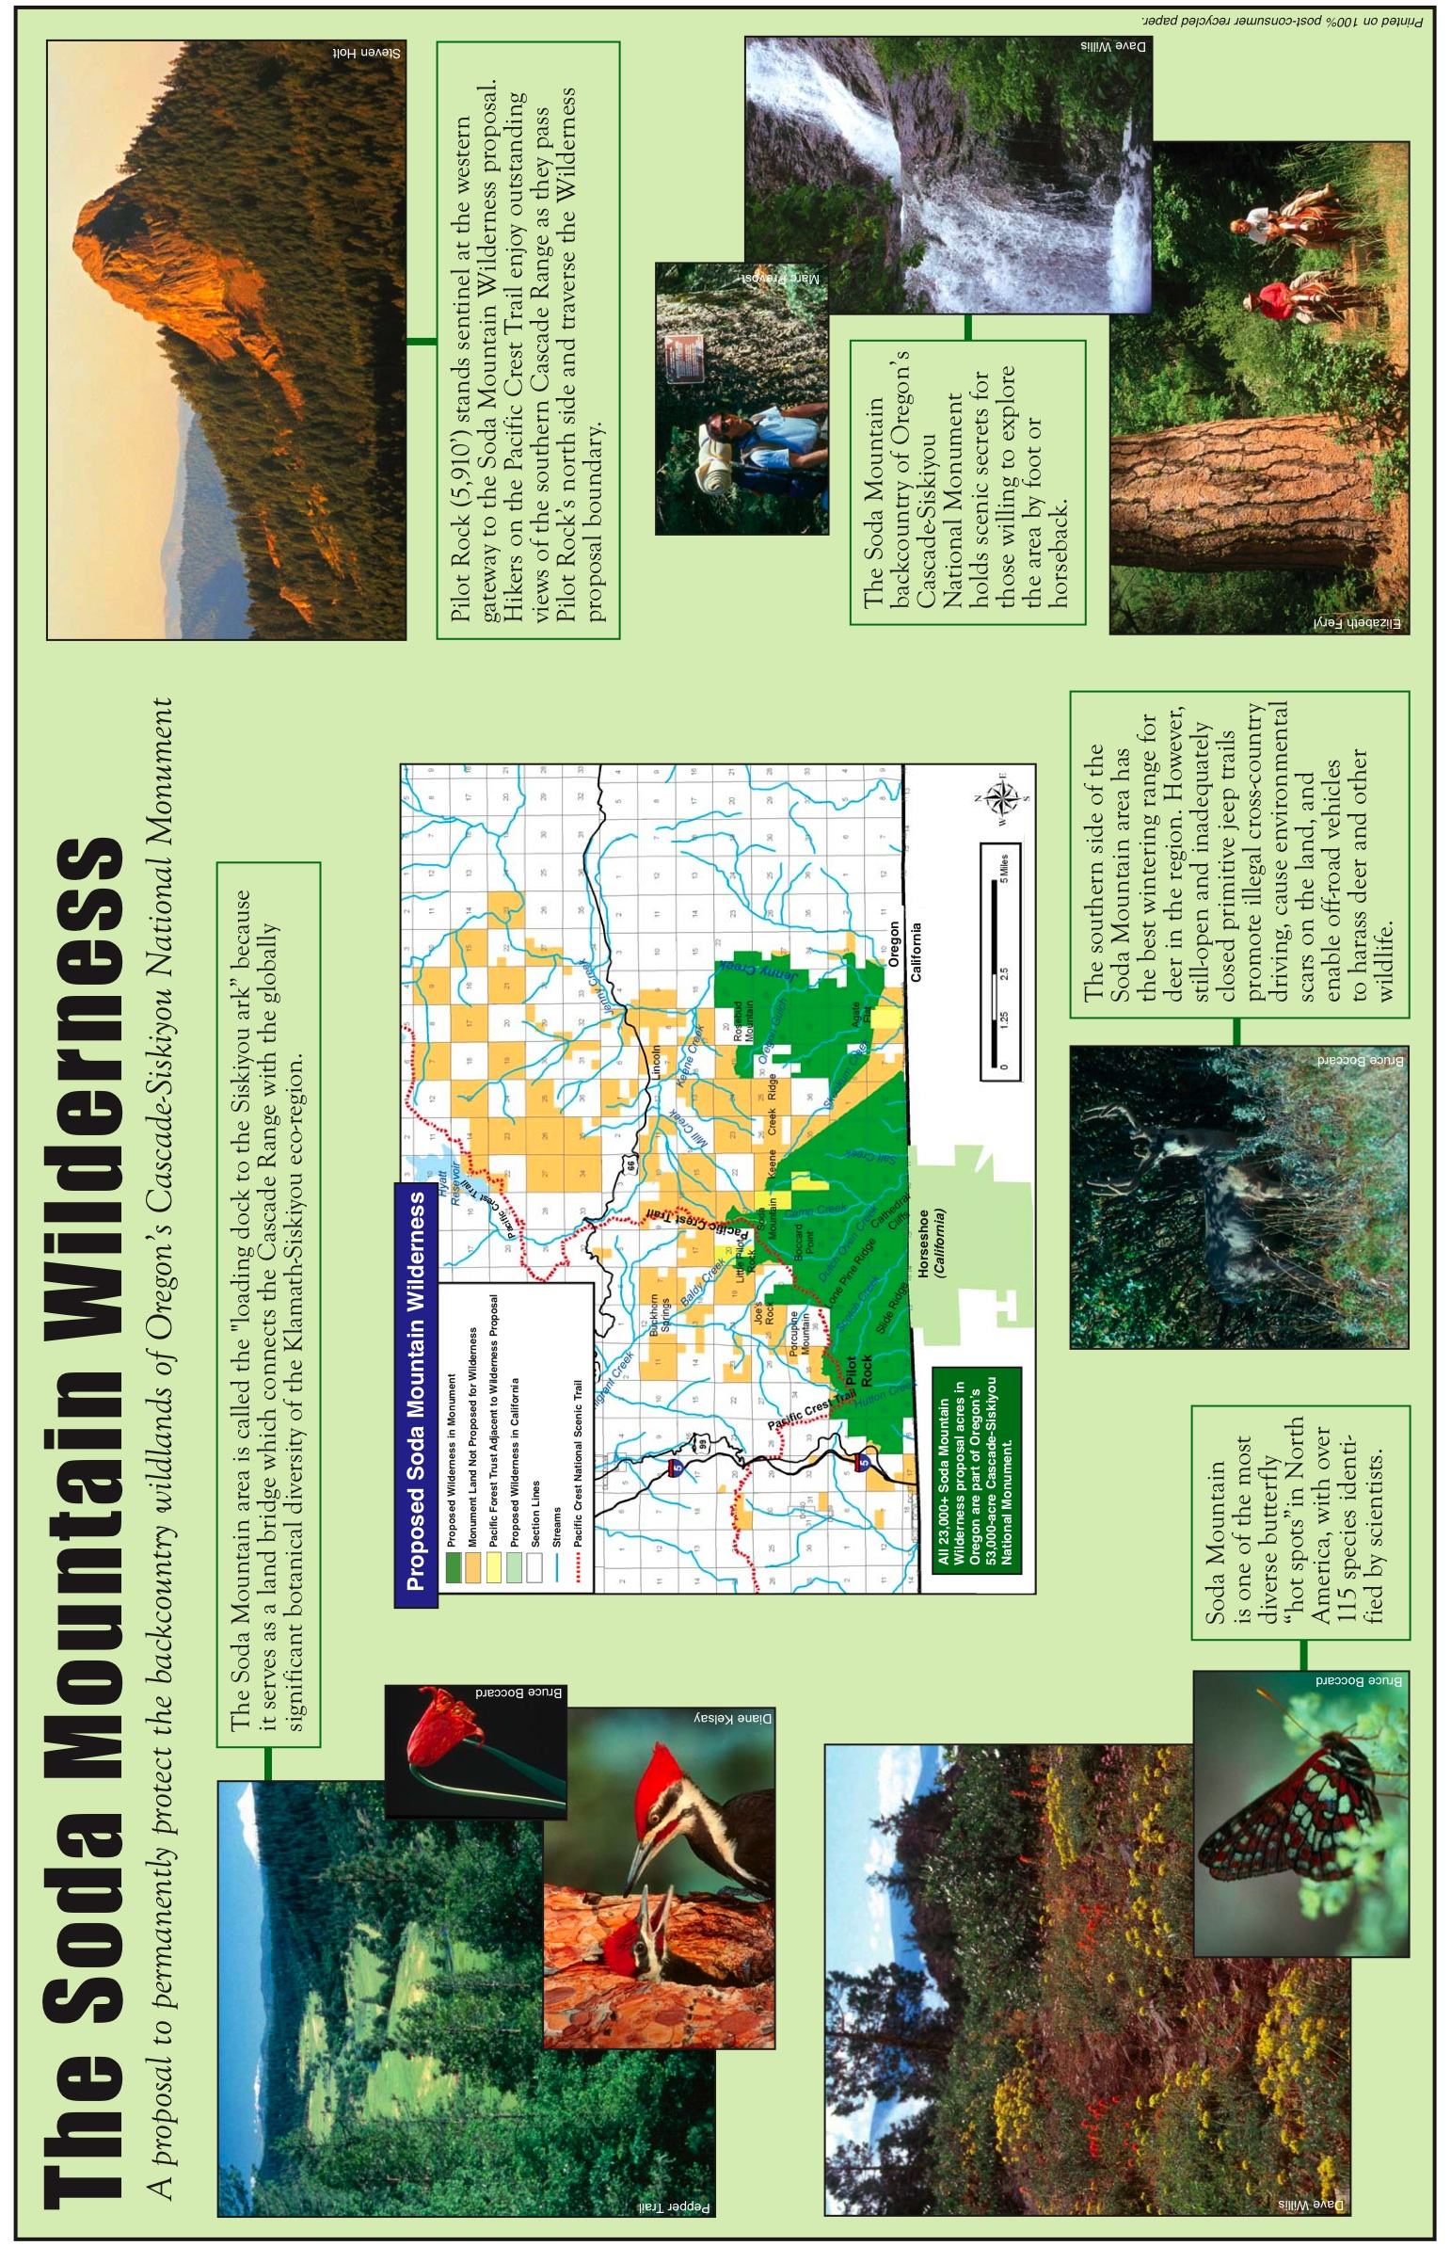

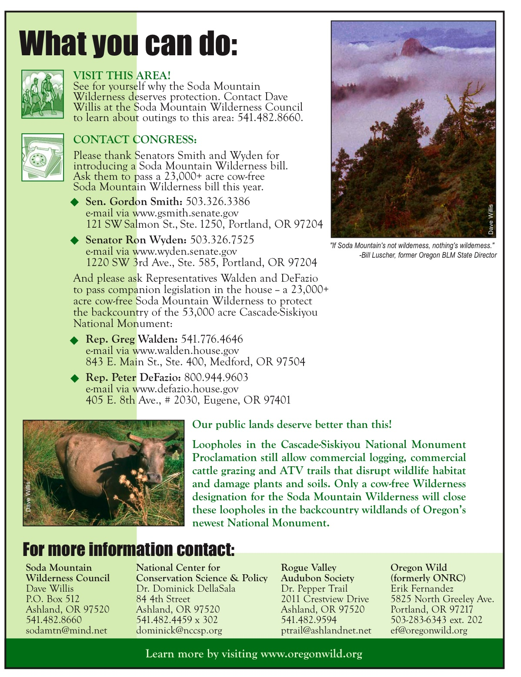
Attachment 3
Proposed Rowlett Land Exchange

The two similarly sized parcels are less than two miles apart and within the exterior boundary of the national monument. The exchange would further the public interest and the purposes of the national monument. Following is a written summary of the exchange and a map prepared by the Bureau of Land Management at the request of Senator Smith, as well as aerial photos of the two parcels (note: photos are of different scales).

Offered Parcel (Rowlett to BLM)

Size: 44.41 Acres

Location: NE ¼, NW ¼, Section 18, Township 40 South, Range 4 East, Willamette Meridian. Jackson County Tax Lot 40R4E 1100, Parcel 3.

Resource Summary: Approximately two-thirds of a mile of spawning habitat in Keene Creek and Lincoln Creek for Jenny Creek redband trout (an object of biological interest identified in the monument proclamation). Contains a highly scenic Keene Creek Canyon. The parcel offered for exchange is generally forested and contiguous with BLM land to the north.

Market Value: $16,872 based on Jackson County “Real Market Value” of $33,064 for 87.03 acres in tax lot (2006 data). This value doesn’t factor in value as a potential home site (80-acre minimum in this area), if the parcel was not split as is currently proposed. In addition, the quarry (shale for the taking without crushing) on adjacent Parcel 2 is not valued in this estimate.

Selected Parcel (BLM to Rowlett)

Size: 46.39 acres

Location: NW ¼, NE ¼, Section 5, Township 40 South, Range 40 East, Willamette Meridian. Jackson County Tax Lot 40R4E 3300, Lot 2.

Resource Summary: Approximately one-third forested. Approximately 0.1 mile of Beaver Creek flows through the parcel. Approximately 10% is leased from BLM by area rancher for agriculture. The parcel is surrounded by property owned by Rowlett. There is no public access.

Market Value: Unknown as Jackson County does not appraise federal land.

All information subject to verification, expansion and/or correction.

Prepared by: Andy Kerr, The Larch Company, at the request of Soda Mountain Wilderness Council, February 2008.

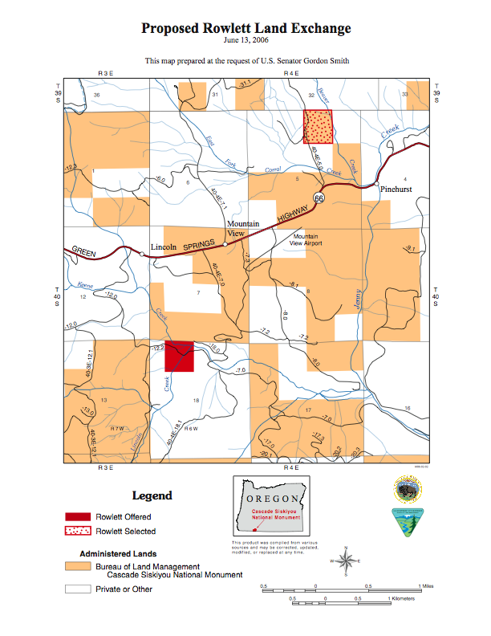

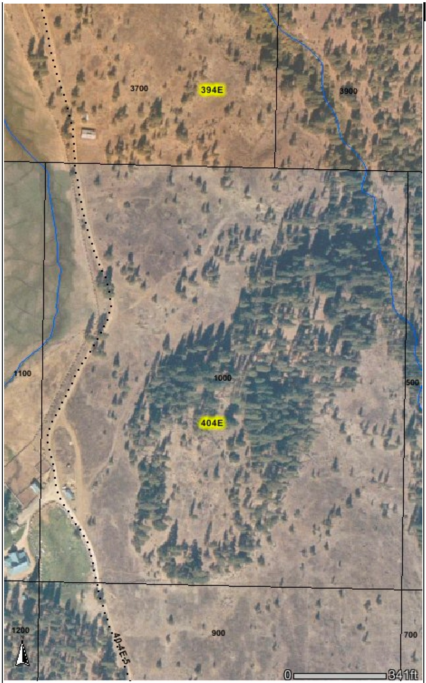

Tax Lot 1000 is currently BLM land totally surrounded by Rowlett property with no public access. Approximately 0.1 miles of Beaver Creek flows through BLM parcel. Rowlett’s Resort headquarters and other outbuildings can be seen at lower left. Rowlett has long held an agricultural lease from BLM for the land in the parcel west of the road (dotted line).

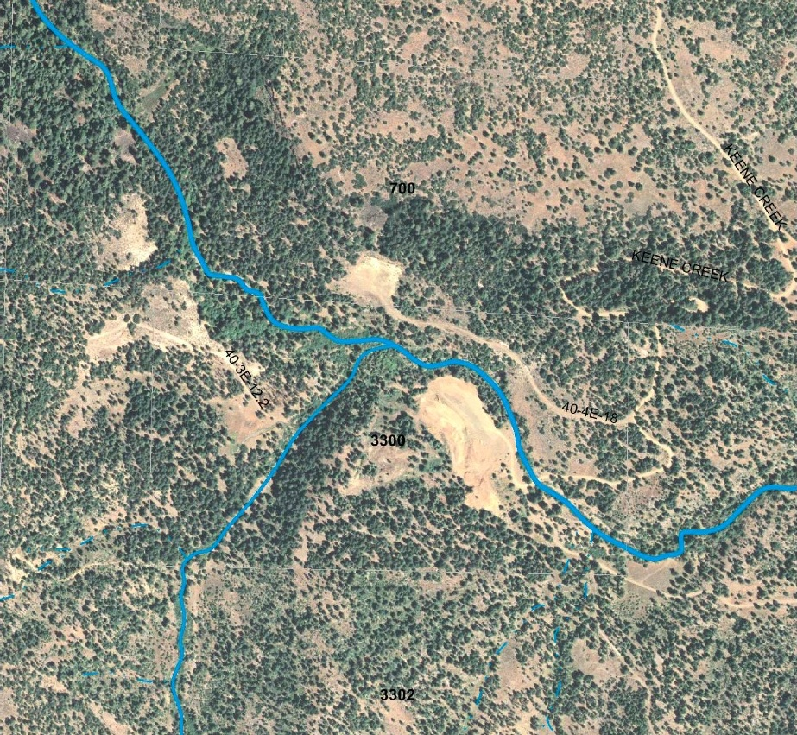

Rowlett is offering the west half of Tax Lot 3300 (outline of ~80-acre rectangle discernable by vegetation change [“3300” is in center of parcel]). Approximately two-thirds of a mile of spawning habitat on Keene Creek (flowing from upper left corner to eastern edge of map) and Lincoln Creek (flowing from lower left corner into Keene Creek) for Jenny Creek redband trout (an object of biological interest in the monument proclamation). Contains a highly scenic canyon along Keene Creek. The parcel is generally forested and is contiguous with BLM land to the north (Tax Lot 700). The east half of Rowlett’s Tax Lot 3300 is an active quarry.

Attachment 4
Summary of the Science on Grazing Impacts in the Cascade-Siskiyou National Monument

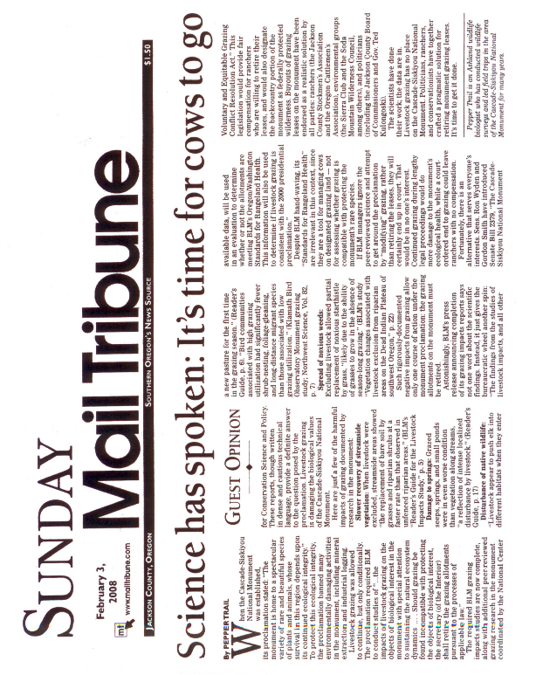
Attachment 5
Federal Payments to Retire Federal Grazing Permits

Congress has appropriated funds to compensate federal grazing permittees to retire their grazing permits on numerous occasions. Since 1948, the Department of Defense has routinely compensated federal grazing permittees/lessees for lost grazing privileges when it appropriates federal public lands for military purposes. In 1998, Congress enacted a specific provision of law to purchase public lands grazing permits when it expanded a bombing range in Idaho. Congress also authorized grazing permit buyout in a national park in Utah that equitably resolved decades of grazing conflicts in the park.

Federally funded voluntary grazing permit buyout is:

• Ecologically Imperative. Removing domestic livestock from federal public lands will assist the recovery of threatened and endangered species; improve water quality and quantity; increase big game on public lands, including elk, deer, bighorn sheep, bison and pronghorn; promote recovery of western riparian areas; improve forest health; aid restoration of natural fire regimes; increase biological diversity, especially bird species; reduce soil erosion; and stem the spread of invasive weeds.

• Economically Rational. Measured in acres per cow rather than cows per acre, livestock grazing on federal public lands in the West is more a lifestyle choice than a rational economic activity. Most public lands ranches have a negative to 3% nominal return on investment, which fails even to keep pace with inflation. The average acre of private grazing land in the East is 82 times more productive than an average acre of Bureau of Land Management land in the West.

• Fiscally Prudent. The federal taxpayers spend $17.50 dollars for every dollar received from grazing fees.

• Socially Just. Decades ago, many fewer people used public lands for recreation and other purposes and science and the public were unaware of grazing conflicts with native species, ecosystems and watersheds. Livestock grazing was encouraged on public lands. Today, livestock grazing often conflicts with other uses of public lands and environmental protection. Society has changed the rules for public lands ranching. Grazing permittees deserve support to transition out of the public lands livestock industry.

• Politically Pragmatic. Rather than produce more studies of grazing conflicts, more intensified range management to mitigate the conflicts, or more litigation, the simple solution is to compensate federal grazing permit holders to voluntarily relinquish their grazing permits back to the federal government. A recent survey indicates that half of public lands ranchers in Nevada would be interested in grazing permit buyout.

Federally Funded Grazing Permit Buyout Examples

Capitol Reef National Park, Utah • Livestock grazing in Capitol Reef National Park had been controversial even since before the park was established in 1971. Disputes over a phase-out of existing grazing permits helped ignite the “sagebrush rebellion,” and prompted Congressional action to ensure continued grazing in the park for decades. Various legislation guaranteed current permit holders grazing privileges inside the park, first for the remaining term of their permit, and then another ten years, and later for the lifetime of the current permit holders and their children. Permittees were allowed to graze, trail and/or water their livestock throughout much of the park, regardless of conflicts with recreation or conservation of park resources. At one point Congress requested the National Academy of Sciences to conduct a study of grazing impacts in the park, only to cancel the study five years later. After decades of conflict—and sixteen years after the Park Service first recommended ending grazing inside the park—grazing permittees finally agreed to sell, and the Park Service agreed to buy and retire, grazing permits for allotments inside the park. The Utah Congressional delegation supported the National Park Service initiative to compensate ranchers and retire the grazing permits (the Senate Committee on Appropriations memorialized the deal in 1988). The Park Service retired seventy percent of the grazed area inside the park over the next several years. However, as the value of grazing permits increased, the Park Service was gradually priced out of the market (the Park Service was limited to a maximum payout of $52/AUM). In 1998/1999 two permits for the 11,688 acre Cathedral Allotment, the last active allotment in the northern third of the park, came on the market. Unable to meet the asking price for the Cathedral permits, the Service approached the Grand Canyon Trust about paying the permittee the difference between his asking price and what the Service could legally pay. The Trust agreed. With the retirement of the Cathedral permits, only two permits for grazing in the park remain.

Juniper Butte Bombing Range, Idaho • In 1998 Congress expanded the Juniper Butte Bombing Range for the Air Force onto BLM lands in the Owyhee Canyonlands in Idaho. Congress directed the Secretary of the Air Force to “conclude and implement agreements” with grazing permittees with grazing permits in the expanded bombing range “to provide appropriate consideration, including future grazing arrangements” for their lost public lands grazing privileges.

Responding to the Congressional directive, the Air Force first paid Rancher A $650,000 for 1,252 permitted animal unit months (AUMs) on the BLM’s Juniper Draw Allotment that became part of the expanded Juniper Butte Bombing Range, which amounts to $519.17/permitted AUM. Second, the Air Force paid Rancher B $325,000 to vacate 780 permitted AUMs on the BLM’s Clover Crossing Allotment (outside the bombing range), which is $416.67/permitted AUM. Rancher A was then given use of the 780/permitted AUMs on the Clover Crossing Allotment that Rancher B was paid to relinquish. Thus, in fact, Rancher A only “lost” the use of 472 permitted AUMs with the expansion of the bombing range, for which he received $650,000, which is actually $1,377.12/permitted AUM. Since that time, the Air Force, purportedly to reduce the threat of wildfire, has authorized Rancher A to again graze the Juniper Draw allotment inside the bombing range—and has authorized a higher level of grazing than when the allotment was administered by BLM.

Steens Mountain Cooperative Management and Protection Area, Oregon • In 2000, Congress authorized the end of livestock grazing on approximately 100,000 acres in the Steens Mountain Wilderness. Congress in essence paid to retire grazing on the allotments by approving several land exchanges and cash payments intended to make the affected livestock operators whole. The rate per AUM is undeterminable because the grazing permit buyouts were associated with the land exchanges and other payments.

Taylor Grazing Act Department of Defense Grazing Permit Buyout • Since 1948 federal law has mandated that the government compensate federal grazing permittees when their grazing privileges are reduced or eliminated for military purposes.

Whenever use for war or national defense purposes of the public domain or other property owned by or under the control of the United States prevents its use for grazing, persons holding grazing permits or licenses and persons whose grazing permits or licenses have been or will be canceled because of such use shall be paid out of the funds appropriated or allocated for such project such amounts as the head of the department or agency so using the lands shall determine to be fair and reasonable for the losses suffered by such persons as a result of the use of such lands for war or national defense purposes. Such payments shall be deemed payment in full for such losses. Nothing contained in this section shall be construed to create any liability not now existing against the United States.

Endangered Species Mitigation • In addition, in recent years the Department of Defense has purchased and retired federal grazing permits/leases in the Mojave Desert as mitigation for military activities that affect the threatened desert tortoise. Military permit/lease buyout has occurred both on lands that were previously public but have since become military reservations (see above) and also on nearby public lands within the range of the imperiled tortoise.

The Proclamation Establishing the Cascade Siskiyou National Monument is included here as Attachment 1.
Establishment of the Cascade-Siskiyou National Monument, Proclamation No. 7318, 65 Fed. Reg. 37249, 37251 (June 9, 2000).
NPLGC. “Grazing Impacts on Threatened and Endangered Species” (factsheet), www.publiclandsranching.org/htmlres/PDF/FS_Cows_v_Endangered_Species.PDF.
NPLGC. “Livestock and Water” (factsheet), www.publiclandsranching.org/htmlres/PDF/FS_Cows_v_Water.PDF; G. Wuerthner. 2002. Guzzling the West’s Water: Squandering a Public Resource at Public Expense. Pages 195-197 in G. Wuerthner and M. Matteson (eds.). Welfare Ranching: The Subsidized Destruction of the American West. Island Press. Covelo, CA (available at www.publiclandsranching.org/htmlres/PDF/wr_Guzzling_Water.PDF).
NPLGC. “Livestock versus Wildlife” (factsheet), www.publiclandsranching.org/htmlres/FS_Cows_v_Wildlife.PDF.
NPLGC. “Livestock and Water” (factsheet), www.publiclandsranching.org/htmlres/PDF/FS_Cows_v_Water.PDF; J. Boone Kauffman. 2002. Lifeblood of the West: Riparian Zones, Biodiversity, and Degradation by Livestock. Pages 175-176 in G. Wuerthner and M. Matteson (eds.). Welfare Ranching: The Subsidized Destruction of the American West. Island Press. Covelo, CA; A. J. Belsky, A. Matzke, S. Uselman. 2002. What the River Once Was: Livestock Destruction of Waters and Wetlands. Pages 179-182 in G. Wuerthner and M. Matteson (eds.). Welfare Ranching: The Subsidized Destruction of the American West. Island Press. Covelo, CA; S. Fouty. 2002. Cattle and Streams: Piecing Together a Story of Change. Pages 185-187 in G. Wuerthner and M. Matteson (eds.). Welfare Ranching: The Subsidized Destruction of the American West. Island Press. Covelo, CA.
NPLGC. “Livestock Major Factor in Unhealthy Forests,” www.publiclandsranching.org/htmlres/cows_and_forests.htm.
NPLGC. “Livestock Grazing's Contribution to Fire Hazard,” www.publiclandsranching.org/htmlres/cows_and_fire.htm.
NPLGC. “Livestock Grazing: Impact on Birds,” www.publiclandsranching.org/htmlres/cows_and_birds.htm.
Wuerthner, G. 2002. The Soil’s Living Surface: Biological Crusts. Pages 199-200 in G. Wuerthner and M. Matteson (eds.). Welfare Ranching: The Subsidized Destruction of the American West. Island Press. Covelo, CA.
NPLGC. “Livestock and Alien Weeds” (factsheet), www.publiclandsranching.org/htmlres/cows_and_weeds.htm; A. J. Belsky and J. L. Gelbard. 2000. Livestock Grazing and Weed Invasions in the Arid West (white paper). Oregon Natural Desert Association. Bend, OR (available at www.onda.org/library/papers/WeedReport.pdf).
Bartlett, E. T., L. A. Torell, N. R. Rimbey, et al. 2002. Valuing grazing on public land. J. Range Manage. 55(5): 427 (citing multiple references).
GAO. 1988. Public rangelands: some riparian areas restored but widespread improvement will be slow. RCED-88-105. General Accounting Office. Washington, DC: 12.
Rogers, P. 1999. Cash cows. San Jose Mercury News (Nov. 7, 1999): 3S.
The net annual direct and indirect cost of the federal grazing program is $140 million, while only about $8 million is returned to the U.S. Treasury from grazing fees. Government Accountability Office. 2005. Livestock grazing: federal expenditures and receipts vary depending on the agency and the purpose of the fee charged. GAO-05-869. Government Accountability Office. Washington, DC.
van Kooten, G. C., R. W. Thomsen, T. Hobby. 2006. Resolving range conflict in Nevada? Buyouts and other compensation alternatives. Rev. Agric. Econ. 28(4): 529.
Frye, B. J. 1998. From Barrier to Crossroads: An Administrative History of Capitol Reef National Park, Utah. Vol. II, chap. 12. Cultural Resources Selections. National Park Service, Intermountain Region. Denver, CO (available at www.nps.gov/archive/care/resources/admin%20history/adhit.htm).
16 U.S.C. §§ 273b-c.
Id.
16 U.S.C.A. § 2736 nt., Pub. Law 97-341.
Frye (1998); 16 U.S.C. §§ 273b-c.
Pub. Law 97-341 (1982).
Pub. Law 100-446 (1988).
Frye (1998).
Department of the Interior and Related Agencies Appropriations Bill, 1989. Sen. Rept. 100-410 (100th Cong., 2nd Sess.) (July 6, 1988): 26 (“The Committee is aware of an agreement in 1987 between the National Park Service and the Utah congressional delegation which allowed the Park Service to use existing funds to purchase, on a willing-seller basis, those grazing permits which the Park Service believes are environmentally disruptive to park resources. Subsequently, the Committee has learned that grazing permit holders in those environmentally sensitive areas have agreed to sell their permits and eliminate grazing. * * * The Committee supports the compromise between the National Park Service and the Utah delegation and believes it constitutes a solution which will allow the Park Service to better utilize appropriated funds in the future as a result.”).
Frye (1998).
Pub. Law 105-261 § 2907.
Nokkentved, N. S. “Air Force compensates Bracket: Agreement worth nearly $1 million.” Times-News (Twin Falls, ID) (October 6, 1998); and N. S. “Air Force won’t say how it calculated compensation.” Times-News (Twin Falls, ID) (October 11, 1998).
16 U.S.C. § 460nnn (Pub. Law 106-399).
43 U.S.C. § 315q.

