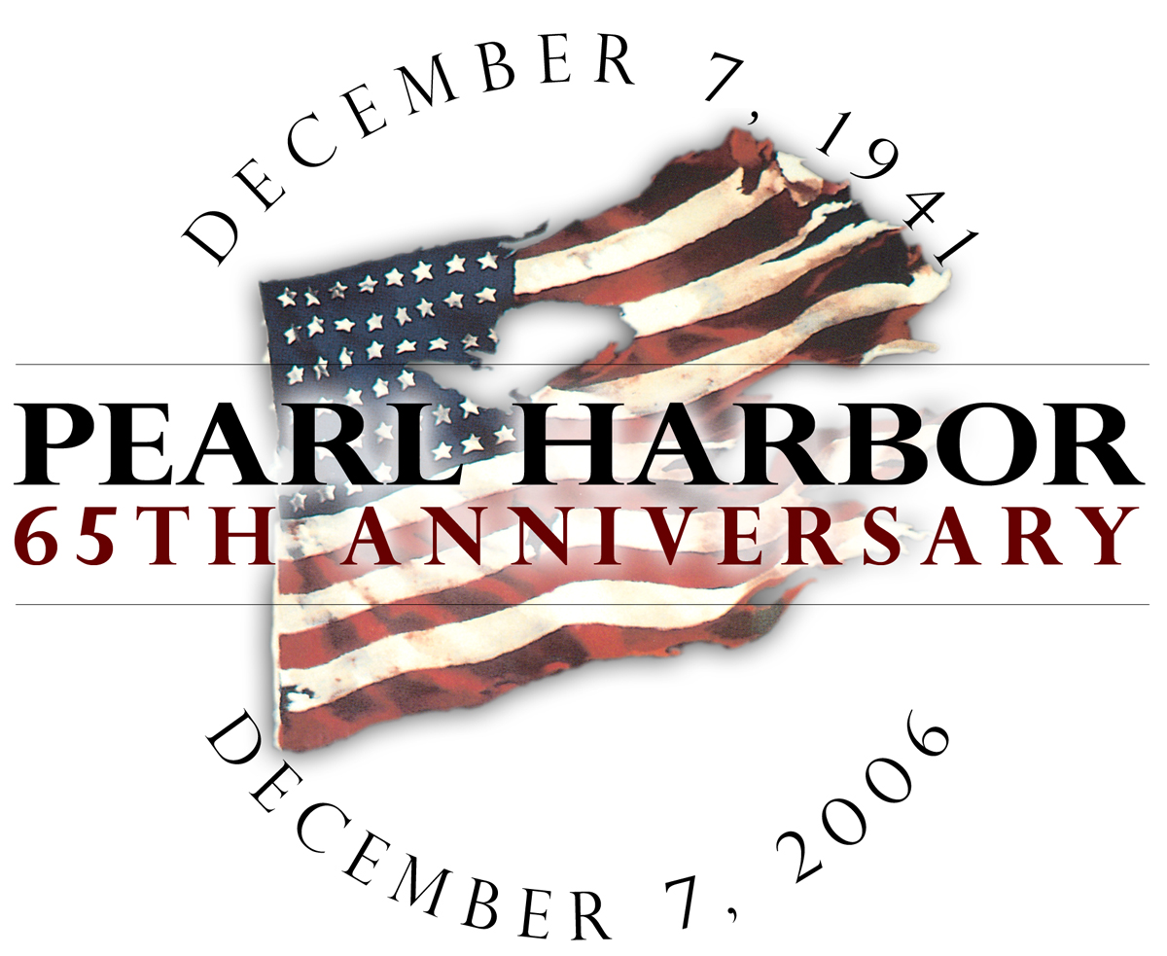

Media Contacts:
Lisa Ontai
National Park Service
Arizona Memorial Museum Association

Cell: 808-375-9352
Email: ontai@pixi.com

Pearl Harbor 65th Anniversary
Pearl Harbor Experts

Resource List

Arroyo, Ernie  203-378-2353 | Mr. Arroyo is the president of the Pearl Harbor History Associates. Over the last thirty years, he has made a personal commitment to the study of Pearl Harbor and its related documents. Mr. Arroyo recently published one of the most complete photo essays on the Pearl Harbor attack in a book titled Pearl Harbor.
Borch, Col. Fred (Ret.)  919-645-1400 (work) | Frederic L. Borch III is the Regimental Historian and Archivist for the U.S. Army Judge Advocate General’s Corps. He was charged with the investigation into the Kimmel and Short inquiry by Under Secretary of Defense Dorn. He co-authored a definitive work on the Kimmel/Short controversy: Kimmel, Short and Pearl Harbor: The Final Report Revealed, which was published by the Naval Institute Press in 2005.
Burbank, Jennifer  808-422-2771, 123 | Jennifer Burbank is a National Park Service Interpretive Ranger at the USS Arizona Memorial. She began her Park Service career in 1997 at Redwood National and State Parks. Currently, Jennifer is the Park Dive Officer with the USS Arizona Underwater Cultural Resource Team.
Burlingame, Burl  808-753-6742 | Mr. Burlingame is a writer for the Honolulu Star-Bulletin. Over the years he has been engaged in the writing of aviation history. He also has been interested in Japanese midget submarines and published a monumental work on that subject titled Advance Force Pearl Harbor.
Butowsky, Dr. Harry  202-354-2261 | Historian for the National Park Service in Washington, DC.,  Dr. Butowsky headed up the program for National Historic Landmarks and he was instrumental in conferring an NHL designation to the Opana Radar Site. Harry teaches at George Mason University and is an author of numerous publications including An American Family in World War II.
Dr. Stanley D.M. Carpenter  401-841-6521 | Dr. Carpenter is a Professor of Strategy and Policy and Official Historian of the U.S. Naval War College. He is an internationally renowned expert on Britain in the Age of Fighting Sail and the British Civil Wars. Dr. Carpenter has appeared frequently on the History Channel providing commentary on such things as the Battle of Britain and WWII.
Cressman, Robert  202-433-6773 (work)  301-942-3685 | Mr. Cressman is a historian with the Ships Histories Branch of the Naval Historical Center in Washington D.C. Mr. Cressman is considered one of the preeminent experts in WWII naval history and his outstanding publication, Steady Nerves and Stout Hearts, is a definitive study of what occurred to the air groups of the USS Enterprise on December 7, 1941.
DiVirgilio, John  808-387-1103 | Mr. DiVirgilio is a noted expert on the Japanese aerial attack on Pearl Harbor. He has interviewed a number of Japanese aviators and visited Japan several times to conduct his investigation. He also is an illustrator of note and has done studies of the damage done to battleships during the attack.
Goldstein, Dr. Donald  412-221-5241 | Dr. Goldstein is the preeminent authority on the Pearl Harbor attack and he is the instrumental force and author of Gordon Prange’s numerous works on Pearl Harbor. Dr. Goldstein is a professor of history at the University of Pittsburgh. His monumental contribution was producing At Dawn We Slept.
Jackson, Timothy  Naval War College  401-841-6521 | Director of the College of Distance Education, Mr. Jackson is a Professor of Strategy and Policy at the U.S. Naval War College. He oversees all aspects of the professional education of over 3,500 Officers of the Navy, Marine Corps, Army, Air Force and Coast Guard and senior Department of Defense civilians each year. A career Navy officer, Tim’s scholarship and publications focus on all aspects of WWII, particularly on WWII in the Pacific Theater.

Lundstrom, John  414-647-2605 | Mr. Lundstrom is the former curator of American and military history at the Milwaukee Public Museum. He served from 1967 to 2005 in that capacity. John is considered by many as one of the finest author and historian concerning naval aviation and strategy in the Pacific War. His book, The First Team, was a wonderful addition to the understanding of the early actions in the Pacific War. His current book is a biography of Admiral Jack Fletcher titled Black Shoe Carrier Admiral.
Martinez, Daniel  808-422-2771, 136 | He is currently the historian for the National Park Service at the USS Arizona Memorial. Mr. Martinez specializes in Pearl Harbor attack history and photos related to that event. He has written a number of articles regarding that experience.
Parshall,Jonathan  651-523-9304 | Jonathan Parshall is a noted naval historian and researcher. He was a consultant on the 1999 mission to the Midway battle site by Nauticos Corporation. Mr. Parshall is widely published on naval history in journals and magazines. He has appeared on Discovery Channel and is a historical advisor to the BBC. He maintains an award-winning website on the Japanese Imperial Navy (www.combinedfleet.com). His book, Shattered Sword: The Untold Story of the Battle of Midway is considered by critics to be one of the finest accounts of the Japanese side of that dramatic naval battle.
Preul, Don  410-626-8850 | Don Preul has been a professional model builder for the last 25 years. He is considered by his peers to be the finest craftsman of naval ships. Mr. Preul’s work may be viewed at many of the major naval museums in the country. One of the best examples of his craftsmanship is of the model of the Japanese carrier Akagi which is on display at the USS Arizona Memorial Visitor Center. This year, Mr. Preul completed a new model of the USS Arizona, which will be unveiled during the 65th Anniversary commemoration.
Seiden, Allen  808-734-4677 | A writer, photographer and Hawaiian archivist and historian, Allen Seiden has lived in Hawaii since 1974. He is a recipient two Ka’ahili awards for projects of cultural relevance from the State of Hawaii. His work has appeared in newspapers, magazines and books around the world. In 2001, Mr. Seiden authored From Fishponds: Pearl Harbor, a Complete Illustrated History.

Sekigawa, Brad  808-625-2578 | Mr. Sekigawa is considered one of the finest model builders in the state of Hawaii. He has provided model exhibits for the USS Arizona Memorial and other museum in the Hawaiian community. His current contribution is the aircraft used in the first wave attack that are currently part of the permanent exhibit of the aircraft carrier Akagi located at the USS Arizona Memorial Visitor Center.
Smith, Douglas  Naval War College  401-841-6521 (work) | Dr. Douglas V. Smith is a Professor of Strategy and Head of the Strategy and Policy Division at the U.S. Naval War College. He is a graduate of the U.S. Naval Academy, Naval Postgraduate School, and the Naval War College and holds a doctorate in military history from Florida State. Doug specializes in the naval history of WWII and in particular, the five carrier battles of the Pacific war.
Spain, William  Naval War College  401-841-6421 | Associate Dean of Academics, William R. “Bill” Spain, Col. USMC (Ret.) was previously the head of the Joint Military Operations Department at the U.S. Naval War College where he developed the course to include detailed study of campaigns of WWII. An expert on amphibious warfare, WWII and especially WWII in the Pacific, Dean Spain is one of America’s leading authorities on the Battle of Leyte.
Stillwell, Paul  410-544-5592 | Author and contributor to Naval History Magazine. Considered to be one of the finest naval historians, he authored Battleship Arizona and his current work, The USS Missouri.
Wenger, Mike  919-482-4533 | Mr. Wenger is considered by many as a scholar of the photographic history of World War II. His first publication of note was Pearl Harbor: The Way It Was. He has gone on to publish books on D-Day and the dropping of the atomic bombs on Japan.
White, Dr. Geoffrey  808-389-2378 (Cell) | Dr. White has been teaching at the East-West Center in Manoa for over 10 years. He has written a number of articles and conducted studies at the USS Arizona Memorial. He has been a consultant to the National Park Service on issues concerning visitation of both American and Japanese visitors. Geoff has also authored a publication on the Pacific Islander experience in World War II.

#####

