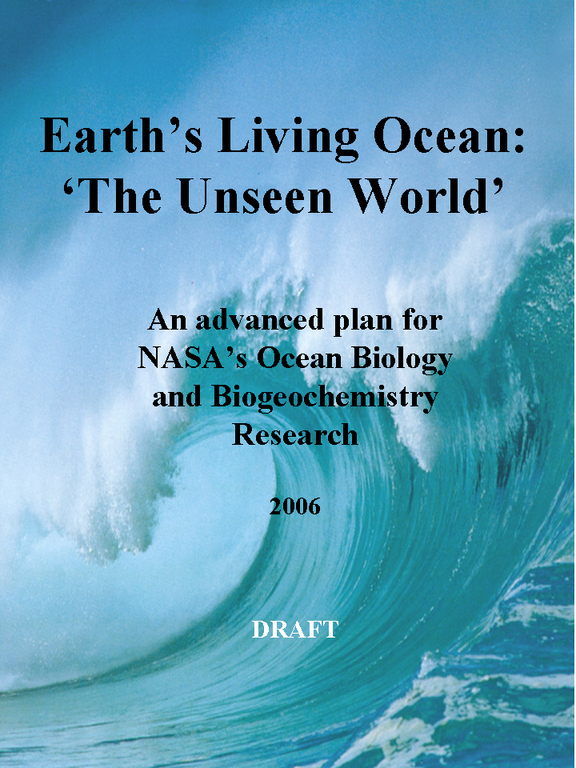
Priority Science Questions

- How are ocean ecosystems and the biodiversity they support influenced by climate and environmental variability and change, and how will these changes occur over time?

- How do carbon and other elements transition between ocean pools and pass through the Earth System, and how do biogeochemical fluxes impact the ocean and Earth's climate over time?

- How (and why) is the diversity and geographical distribution of coastal marine habitats changing, and what are the implications for the well-being of human society?

- How do hazards and pollutants impact the hydrography and biology of the coastal zone? How do they affect us, and can we mitigate their effects?

Dear Reader,

The advent of satellite oceanography in the late 1970's has given rise to a profound realization that our planet's ocean, covering 71% of the Earth's surface, plays a critical role in modifying weather and climate, and in sustaining life on Earth. Recent views of nearby planets lacking an ocean expose a stark contrast to our Earth's habitability. Satellite sensors have revolutionized our perceptions of the ocean environment and our understanding of the linkages among the ocean and other components of the Earth system, and they have revealed a diversity and complexity in ocean ecosystems that had not been appreciated through traditional oceanographic approaches. Further, the explosive growth of human populations along coastal margins now places increasing pressure on these dynamic ecosystems, modifying natural processes and, in many cases, putting life, health, and property at risk from hazards inherent to the ocean.

Despite this profound realization, the oceans remain largely unexplored, with many discoveries waiting to be made. The past three decades have given us only a brief glimpse of a constantly changing Earth system, in which natural and human factors interplay. We have learned that scientific observations from the vantage point of space help solve important problems. Advanced technologies and frequent, repeated satellite observations, as well as robust field and laboratory measurements of the ocean are essential to our ability to observe and predict changes.

NASA is leading national and international efforts to define future space technologies and missions. Satellite-based observations help connect ground-based observations, and serve to integrate regional and global Earth observing systems that are being designed and implemented. In turn, these ground observatories are critical to ensure the highest quality data can be derived from satellite sensors. In this spirit, NASA's Ocean Biology and Biogeochemistry (OBB) program scientist engaged the research community in an effort to develop advanced scenarios and strategies to address the important science questions yet to be answered by the program within the context of the vision of NASA’s Science Mission Directorate. A working group of experts summarized the state of the science and collected research community comments both electronically and during presentations at a series of national and international meetings.

This report is the product of these efforts. It outlines a strategy for NASA to lead in the scientific application of remote sensing technologies for the exploration and understanding of biological and biogeochemical processes of our oceans. The report addresses the interplay between chemistry and biology at the scale of the planet, the diversity and resilience of our coastal habitats, hazards that pose risks to the environment and to human communities, and how these processes feed back to global climate. This is a living document that will evolve as improvements in our understanding of ocean processes unfold and lead to an optimal strategy for supporting further science advances. The vision is to fully discover the mechanisms and interactions that sustain life on our ocean planet, as only NASA can.

Sincerely,

Paula Bontempi
Chair, Ocean Biology and Biogeochemistry Working Group (OBBWG)

Executive Summary

The Earth system is a delicate balance among the exchanges of energy, water, and materials from land, ocean, atmosphere, and ice. The oceans play a critical role in Earth’s climate, containing the most unexplored environment. Understanding the ecosystems, biogeochemistry, habitats, and hazards of our oceans in a varying and changing climate is critical for sustained life on Earth. NASA’s oceanographic research from space has revealed decadal-scale changes in the ocean biosphere. These discoveries raise new science questions that help define the course of the NASA Ocean Biology and Biogeochemistry (OBB) research program for the coming decades. The objectives of the next phase of research are to explore and seek understanding of the structure and variability of ocean ecosystems, biogeochemical cycling of carbon and other important elements, fragile habitats of our coastal zones, and the role of natural and anthropogenic hazards. This new phase includes research on the relationship between these topics and ecosystem health and services, human health, welfare, recreation, and commerce. Discoveries over the next quarter century of NASA’s research into the biological and biogeochemical functioning of the ocean will enable the formulation of effective strategies for assessing, adapting to, and managing climate change. NASA brings the unique vantage point of space-based observations and improved Earth System modeling capabilities to a national and international network of ground-based observations. From this scientific foundation, NASA, along with its national and international partners, must carefully formulate plans for space-based missions in support of these research objectives. The technologies and observational strategies proposed here promise to advance our understanding of our home planet in the coming decades. This understanding will help us protect the environment that surrounds us and our own health, and ultimately help ensure our survival on the only planet where we know life exists.

Over the past year and a half, a working group representing the ocean biology and biogeochemistry research community carefully developed the next set of science questions to guide NASA’s Ocean Biology and Biogeochemistry research program, and posed advanced observational scenarios and strategies to address these questions. The result includes a prioritized list of satellite missions required to implement these strategies over the next 25 years of NASA observations of the ocean biosphere. Comments from the broader research community were solicited widely, and responses were incorporated into this draft plan.

Four basic science questions were posed, covering different aspects of the NASA Ocean Biology and Biogeochemistry program. These four overarching questions address 1) marine ecosystems, 2) ocean biogeochemistry, 3) coastal habitats, and 4) hazards. Each topic addresses feedbacks related to humankind. These questions define the suite of geophysical observations needed to conduct the research, and the critical set and sequence of future sensors and missions required to implement a robust, yet viable integrated ocean observing strategy. The answer to these questions, with consideration of science and societal urgency, technology readiness, and supporting value for subsequent measurement components, leads to four recommended integrated mission themes:

- Separation of in-water constituents (e.g., organic and inorganic substances) in global waters, which advanced corrections for atmospheric effects on satellite ocean measurements
- High temporal and spatial resolution measurements of coastal phenomena and habitats
- Active assessments of plant physiology and the function of different groups of plants in aquatic ecosystems
- Environmental variability of the surface ocean, including the depth of the mixed layer

Specific strategies are recommended for each component over a 25 year time-frame, with immediate (1 – 5 years), near-term (5 – 10 years), and long-term (10 – 25 years) goals. Some of the mission themes require new technical milestones, while others are nearly ready to go. The following are proposed as the top NASA Ocean Biology and Biogeochemistry mission priorities:

- global hyperspectral imaging radiometer in sun synchronous orbit, focused on the accurate separation of in-water constituents and correction of the contribution of aerosols,
- global hyperspectral imaging radiometers in geostationary orbit, which will enable global and regional observations of dynamic and complex coastal and shelf processes and discrimination of in-water constituents on sub-daily time scales and at high spatial resolution (200 m or better) at nadir,
- multi-spectral, high spatial resolution imager to observe coastal habitats and ecosystems at unprecedented scales and accuracies,
- deployment of active approaches for probing plant physiology and functional composition from polar satellite orbit using laser technologies
- implementation of portable sensors on suborbital platforms
- development of new technologies for the assessment of ocean mixed layer depth from satellite orbit, and
- development of new technologies to obtain ocean particle profiles and aerosol column distributions.

This recommended set of missions requires that NASA continue the systematic, decadal scale sampling of ocean processes, the in situ validation of the satellite data products, full radiometric characterization of satellite sensors, and continual development of technologies for new satellite measurements, in situ sensors for vicarious calibration and data product validation, algorithm development, data processing, archive, and distribution. The long-term expectation is that a satellite and suborbital based observation network to assess biological stocks and rates is integrated with ground-based observatories and observing systems being developed by national and international entities, thus enabling the detailed assessment of processes that affect life on Earth on a wide variety of time and space scales.

The next step to enable visionary Earth System Science requires that NASA address the interplay between chemistry, biology, physics, and geology at the scale of the planet, in tight partnership with the national and international science, resource management, and other operational communities. It requires that we examine the diversity and resilience of our coastal habitats, that we study hazards that threaten the environment and our communities, and understand the feedbacks that affect global climate. This can only happen by a shared vision of support and focused collaboration on the research topics presented here. The goal is to fully discover the mechanisms and interactions that sustain life on our ocean planet for future generations, while inspiring the next generation of explorers as only NASA can.
Table of Contents

Earth’s Undiscovered World 7
Top Issues 8
Top-Order ‘State of the Science’ 10
Scientific Imperatives 12
How are Ocean Ecosystems and the Biodiversity they Support Influenced by Climate or Environmental Variability and Change, and How Will These Changes Occur over Time? 14
How do Carbon and Other Elements Transition between Ocean Pools and Pass through the Earth System, and How do These Biogeochemical Fluxes Impact the Ocean and Earth's Climate over Time? 18
How (and Why) is the Diversity and Geographical Distribution of Coastal Marine Habitats Changing, and What are the Implications for the Well-Being of Human Society? 23
How do Hazards and Pollutants Impact the Hydrography and Biology of the Coastal Zone? How do they affect us, and can we Mitigate their Effects? 28
Recommendations for an Integrated Living Ocean Program 32
Observational Strategies 36
Supporting In Situ & Space-Based Measurements 56
Systematic Observations 58
Research, Analysis and Modeling 59
Education 60
Essential Partnerships 61
Summary 64
Figure Credits 70
Table of Acronyms
Biological Oceanography and Biogeochemistry Working Group 72

Earth’s Undiscovered World

Earth is the living blue planet. Its functioning is only partially understood, but it remains the only planet we know that supports life. The vast oceans are critical to the habitability of Earth, covering 71% of its surface and creating 96% of its living environment. The oceans (and thus Earth) are profoundly affected by human and natural environmental changes. Daily human activities, especially along our coasts, interact in complex ways with the natural environment to change our surroundings. Many of these changes are accelerating, and their implications for the health of the planet, humans, and all other organisms extend far into the future. The enormous size and remoteness of the oceans has long hindered a thorough understanding of how and why our planet changes. This obstacle is being overcome through NASA’s pioneering programs that utilize the unique vantage point of space to routinely explore and study the Earth system. With these tools we can now discover the many secrets of our planet as never before. Understanding Earth’s oceans will ultimately allow us to better describe and predict Earth system mechanisms that are affected by natural and anthropogenic climate changes, and how these processes feed back on the overall Earth system over time. While the journey through space inspires exploration, the world beneath the ocean’s shimmering surface is even less familiar than the heavens above, and awaits our inquisition and imagination to yield unanticipated new insights on the functioning of our home planet.

The Earth system is a delicate balance among ocean, land, ice, and atmosphere. NASA’s oceanographic research from space over the past three decades has revealed synoptic, decadal-scale changes in the ocean biosphere. These discoveries raise new questions that now define the course of research for the coming three decades. From this scientific foundation, NASA must carefully formulate plans for requisite space-based missions. The resultant next phase of research will extend our understanding of how ocean ecosystems, elemental cycles, coastal habitats, and hazards influence Earth’s ecosystem health and services, human health, welfare, recreation, and commerce. NASA’s Ocean Biology and Biogeochemistry Research Program will also enable the formulation of effective strategies for assessing, adapting to, and managing climate change through space-based observations and improved Earth System modeling capabilities. This document is a blueprint for NASA’s space-based research of the Earth’s living ocean for the next 25 years.

Top Issues

Evolving Ecosystems
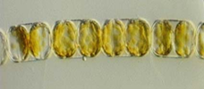
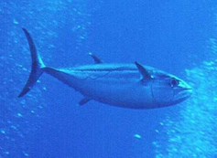
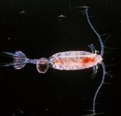
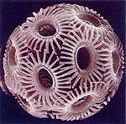
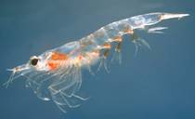
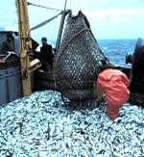
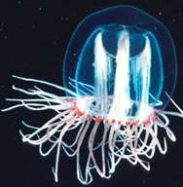
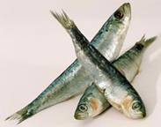
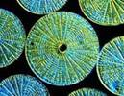
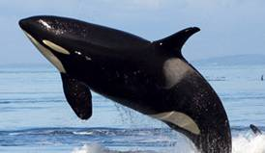
The oceans are teeming with life of various types and forms. From fish, birds, turtles, and whales to bacteria, phytoplankton, and zooplankton, the oceans support a wide diversity of living organisms. Size is one measure of diversity, and in the oceans organisms range over nearly eight orders of magnitude in size, from tiny marine viruses of ~0.1 micron in length, to the largest animal to have ever lived on Earth, the blue whale, at nearly 30 meters in length. The variety of ecological interactions among organisms is another measure of diversity. Ocean life is interconnected by complex food webs. These ecosystems are highly productive and resilient, and provide a wide assortment of services to humankind. We have grown to depend on these services to advance commerce and transportation, to derive food, and to recreate and sustain our culture. In an ever-changing world, how can we best understand and protect the trophic structure, productivity, and resilience of very large marine ecosystems of our planet?

Diverse life forms contribute to marine ecosystems.

Carbon Cycle and Biogeochemistry
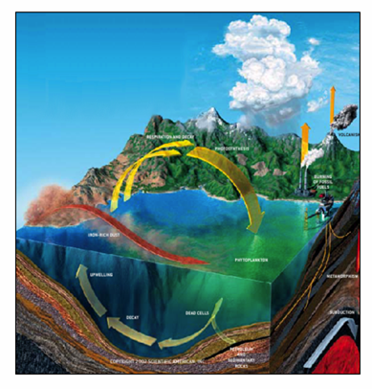
Life as we know it began in the ocean. More than four billion years later, ocean plants and animals continue to play a vital role in the sustenance of the biosphere and regulation of our climate. The transfer of carbon dioxide (CO₂) into organic material in the oceans by tiny, single-celled plants known as phytoplankton, the processing of other life-essential elements, and respiration, are keyed to environmental conditions and highly sensitive to climate variability. Through our actions, these elemental cycles are being profoundly altered. How can we quantify ocean biogeochemical cycles and predict their effects on the Earth System in the future?
Biological processes in the oceans are a critical component of Earth’s biogeochemical cycles. Carbon dioxide, methane, dimethyl sulfide, oxygen, nitrogen, and iron are all exchanged between the ocean, atmosphere, and land. Organic matter, formed by phytoplankton at the surface, is eventually buried in ocean sediments and is lost over geologic time scales ©David Fierstein 2002 www.davidiad.com
.

Fragile Habitats
The world’s coastal habitats constitute areas of intense human growth and commercial relevance. The resilience of these habitats is finite and coastal habitats are currently threatened by environmental change and direct human impacts. Recent changes include catastrophic degradation of global coral reef environments through ocean acidification and other environmental events, chronic beach contamination events, hypoxia in estuaries and the coastal ocean, and water quality degradation due to industrial, agricultural, and residential pollution. Human pressures include energy and agricultural influences that extend throughout Earth’s watersheds and feed into coastal zones. In the face of projected human population increases and associated consumption of natural resources, how can we best manage our precious coastal habitats for future generations?

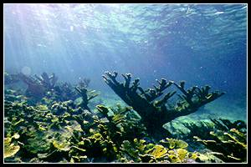

Hazards and Health
Recent events have illustrated the devastation and loss of human life, property, and commerce from environmental hazards that have impacted coastal zones. Supporting over one quarter of the globe’s population and nearly half of the U.S. population, coastal regions are increasingly vulnerable to both chronic and acute hazards. Coastal zone hazards include sea level rise, coastline erosion, flooding of low-lying areas, and plumes of noxious algae, toxins, pollutants, pathogens, and suspended matter. How can we best forecast, assess, and respond to the environmental hazards that shape our coasts and sustain the marine and human life dependent upon coastal resources?

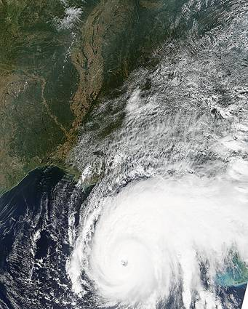
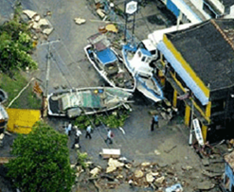
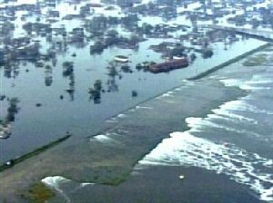

Top-Order ‘State of the Science’

Earth’s ocean is changing, whether one looks to the climate, fisheries, or coastal habitats for evidence. Prior to the 1970’s, ocean researchers’ basic understanding of the ocean was largely founded on ship-based studies, which yielded a coarse and incomplete picture of a dynamic, complex, and evolving ocean. With the launch of the Coastal Zone Color Scanner (CZCS) in 1978, NASA began providing a space-based view of the Earth’s ocean biosphere. Subsequent space-based NASA sensors made it possible to visualize global patterns in phytoplankton pigment (or chlorophyll) concentrations in space and time, and relate these observations to ocean surface temperature, wind, and circulation patterns. Finally, scientists had an unprecedented tool by which the Earth’s ocean biosphere could be comprehensively studied and monitored.

After the demise of the CZCS mission in 1985, a decade went by with no satellite observations of the ocean biosphere until the launch of the Ocean Color and Temperature Scanner (OCTS) in 1996 by the Japanese Aerospace Exploration Agency (JAXA, formerly the National Space Development Agency of Japan, NASDA). After the short life of the OCTS mission, NASA and Orbital Sciences Corporation’s SeaWiFS (Sea-viewing Wide Field-of-view Sensor) launched in 1997, while two MODIS (Moderate Resolution Imaging Spectroradiometer) sensors were launched in 1999 and 2002. These sensors have supported many significant scientific contributions. However, these missions are long beyond their planned prime lives, and have only a limited measurement capability.

Two important lessons have been learned from the history of ocean biology and biogeochemical measurements from space: a) gaps in observational time series such as occurred between the demise of CZCS and the launch of OCTS, severely impact our understanding of and ability to model ocean systems (ecology, biology, carbon cycling) and their role in the Earth System (as well as any impact for humans), and b) we now know the specific measurement requirements needed in future space-based measurements to overcome current limitations in our scientific knowledge of ocean processes.

Passive ocean color sensors, like CZCS, only observe the upper sun-lit surface layer of the ocean. However, when coupled with in situ observations and numerical models, these space-based observations provide a three-dimensional understanding of ocean processes, their complexity, and their interactions with other parts of the Earth system. Ocean remote sensing allows scientists to effectively ‘take the pulse’ of our living Earth. Combining different NASA satellite technologies has afforded new scientific insights on how ocean physics and biology are coupled. This laid the groundwork for comprehensive assessments of global ocean primary productivity, the process by which phytoplankton grow and fix carbon and thereby support nearly all ocean ecosystems. NASA’s technology has enabled the observation of changes in ocean plant biomass and productivity seasonally, annually, and even from day to day. This has led to the discovery of large-scale biological patterns associated with the dispersal of river water, the impacts of El Nino-Southern Oscillation events on changes in fisheries, and the influence of ocean biology on air-sea exchange of carbon dioxide.

Interdisciplinary research involving observations from various space-based and ground-based sensors continues to focus on linking data from terrestrial, aquatic, and atmospheric environments of the Earth to study biogeochemical cycling, ecology, climate variability and change, the solid Earth, and the water and energy cycle. NASA’s modeling, analysis, and prediction program (MAP) is focused on integrating interdisciplinary and multi-disciplinary NASA research efforts by supporting pioneering work on climate and ecological model development, as well as their linkage, to improve the nation’s ability to manage ecosystems. Continued exploration and research based on new measurements of Earth’s living ocean are essential to the goal of working with our international partners to manage global ocean ecosystems while better understanding and enabling adaptation to climate change.

Scientific Imperatives

Studying Ocean Biology and Biogeochemistry from Space
The oceans have a key role in the Earth System, particularly pertaining to climatic and environmental change. It cannot be overstated that the Earth is the “Ocean Planet” of our solar system. We now recognize that changes in the Earth System do not occur in an isolated fashion, but are largely coupled through relationships between land, ocean, and atmosphere. Satellite remote sensing has been instrumental in revealing this insight. The coastal margins, home to the majority of the human population, are subject to anthropogenic alterations that impact marine habitats and ecosystems, as well as the goods and services they provide. It is only through space-based observations, combined with complementary in situ and numerical modeling studies, that we can advance the understanding of ocean biology and biogeochemistry from local to global scales. While there remains considerable uncertainty about what specific changes will occur, continued population growth and human impacts together with natural cycles will lead to significant changes in our Earth System. A comprehensive space-based Earth observation program is necessary to assess and predict these changes and to responsibly manage our fragile resources and ecosystems. Biological and biogeochemical regimes in the upper ocean can respond to and therein be indicators of changes in Earth’s climate and local environmental processes. Ocean biology and biogeochemistry research is a critical link to physical oceanographic, land, and atmospheric observations, and must be intensively studied if NASA is to understand the comprehensive Earth System. Integration among research programs and science Focus Areas (http://science.hq.nasa.gov/earth-sun/science/) within Earth Science is essential to future discovery and research.

NASA’s Role
NASA's mission includes improving understanding of the oceans through cutting-edge research by implementing technological advances, space-borne global observing capabilities, and integrating new knowledge of the Earth system into predictive models. NASA’s ocean research programs encompass the sub-disciplines of Physical Oceanography and Ocean Biology and Biogeochemistry. NASA's ocean research and modeling activities span from global and coastal ocean scales, to the Great Lakes, and down to smaller lakes and rivers. Aspects of ocean modeling (e.g., global circulation, air/sea gas exchange, carbon cycle, ecology) are supported in partnership with the Modeling, Analysis, and Prediction Program. The Cryospheric Sciences Program supports research and modeling activities for the high-latitude ice-covered oceans. Ocean-relevant research is integrated with other aspects of the Earth system through NASA’s Interdisciplinary Science Program. All NASA research data are available to researchers worldwide.

Satellites provide the basic observations upon which most of NASA’s ocean research is based. However, there are synergies with local and global in situ observatories supported by other U.S. agencies, including the National Oceanic and Atmospheric Administration (NOAA), the National Science Foundation (NSF), the U. S. Navy, other U.S. agencies and international partners. Earth observing missions within NASA’s Science Mission Directorate fall into two general areas: systematic and exploratory. Calibration and validation activities based on in situ and laboratory observations, as well as focused oceanographic field studies ensure the quality, utility, and best use of climate and Earth System data records required for scientific research at NASA and science-based resource management efforts within other U.S. agencies.

NASA’s strength in oceanography has traditionally been in providing the global “blue water” view of the planet from space. However, there is a growing realization that remote sensing can also help us understand processes along the coast. These areas present growing societal and practical challenges, and they are connected to inland processes through rivers and the atmosphere. Understanding coastal processes requires the synoptic views possible only from high altitudes such as from aircraft and satellites. NASA seeks to aggressively address coastal ocean science questions by designing and implementing new missions for coastal seas and developing high-resolution coastal models that are nested within global-scale numerical models.

Understanding the ice-covered polar regions, which are highly vulnerable to changes in climate, is a high priority of NASA’s research activities. NASA has led the way in using satellite sensors to derive ice concentration, extent, temperature, and motion to understand high-latitude oceanographic processes, particularly in the context of climate changes in the Arctic and Antarctic areas. Our proposed new missions will further elucidate the relationships between ocean biogeochemistry and climate in the sensitive polar regions.

What is the optimal complement of missions our society requires to address critical gaps in knowledge? What new tools can NASA develop to support science-based ecosystem approaches to management? These and other questions can be traced to four fundamental underlying science questions. These questions are posed in the following sections, as are the strategies to address them. The questions are used to guide NASA in developing an ocean biology and biogeochemistry observing strategy for the next three decades. The four science questions are seamlessly linked with each other and support other national science plans, including NASA's interdisciplinary Earth Science Research Strategy.

How are Ocean Ecosystems and the Biodiversity they Support Influenced by Climate or Environmental Variability and Change, and How Will These Changes Occur over Time?

The Challenge
Ocean ecosystems are the living communities of plants, animals, and other biological components like bacteria embedded in the physical environment of the ocean. They function collectively as a unit. Ocean ecosystems provide important goods and services to society, such as fisheries, pharmaceuticals, and waste processing, as well as the biogeochemical cycling of important elements and gases critical for life on Earth. The health and productivity of ocean ecosystems is intricately linked to the overall health of the Earth. But, ocean ecosystems are not static in time and can be perturbed by natural and anthropogenic factors. We need to understand the impacts and feedbacks influencing our changing marine ecosystems, from small coastal reefs and beaches to the vast pelagic sea.

Overwhelmingly, the most important source of energy for oceanic food webs is that derived from the sun through the process of photosynthesis. Marine food webs use this energy from primary production to drive the cycle of life in the sea from which humankind benefits in what we call "ecosystem goods and services". Quantifying primary production (the net result of plant photosynthesis) and its variability is critical for understanding and observing ocean ecosystems.

The diverse community of plants and animals that comprise ocean ecosystems control the functioning of an ecosystem. Highly productive ocean ecosystems, such as coastal upwelling environments, tend to have food webs with fewer links between energy stored by primary producers and higher trophic levels, like fish and humans. Less productive, open ocean food webs are comparatively much more complex, with a wide diversity of plants and animals playing important roles in the cycling and recycling of energy and nutrients. Understanding this diversity - details of what types of animals and plants - is critical for devising effective strategies to manage marine resources and services, such as fisheries or carbon sequestration.

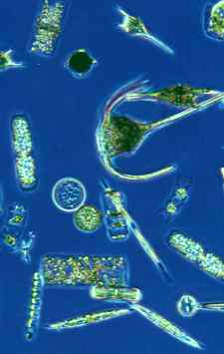
Ocean ecosystems can also be thought of as organic entities that interact with a dynamic physical environment. Changes in ocean currents, temperature, salinity, light, and chemical environments of the upper ocean often have critical roles on the structure, function, persistence and resilience of an ecosystem. Disturbances play a central role in ecosystem behavior and vary from episodic events, such as storms, to gradual changes, such as shifts in global ocean temperature or acidity (pH). Linking disturbance phenomenon to ecosystem changes represents a significant challenge for current and future generations of scientists.
A rich diversity of phytoplankton taxa is found in just a single drop of seawater.

What We Know and Need to Learn About Ocean Ecosystems

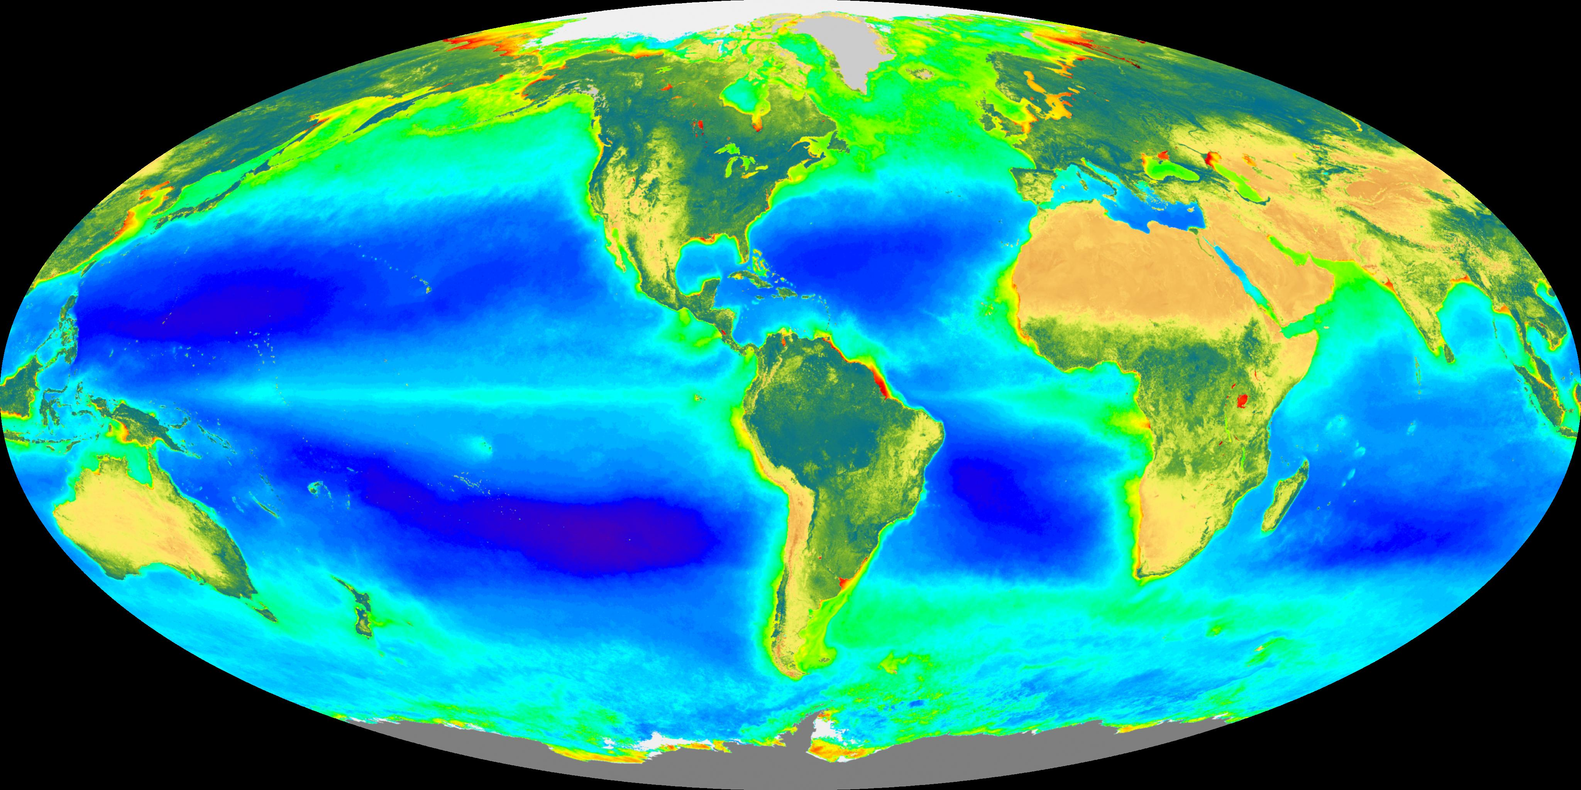
Satellite-based global distributions of ocean chlorophyll concentration and initial assessments of how they change in time have now been realized through three highly successful NASA missions: CZCS, SeaWiFS, and MODIS. These missions are all based on the concept that by accurately measuring small variations in the visible radiance reflected from the Earth, changes in ocean phytoplankton pigment concentrations or chlorophyll can be detected. Chlorophyll is found in all plants and is literally at the core of photosynthesis. Regions of the ocean with high chlorophyll concentrations are, to a first approximation, more productive than those with low concentrations. NASA's Ocean Biology and Biogeochemistry science community has developed the first-ever, space-based biogeographical analyses of ocean ecosystems, and is deeply engaged in studying their relation to the physical processes of the sea and their links to other parts of the Earth's system.
The Global Biosphere (September 97 - August 2000) Biosphere – Oceanic Chlorophyll concentration and SeaWiFS-derived land vegetation index

Using these missions to observe temporal changes in the chlorophyll distribution, we have learned how ocean ecosystems respond to environmental change. These changes can be rapid, driven by eddies and wind-driven upwelling, or they can happen at seasonal time scales in response to changes in the ocean's surface mixed layer or other seasonal phenomena. In the North Atlantic (Figure below), the northward progression of calm weather in the spring leads to a bloom of phytoplankton across the entire basin. Yet the process is not the same every year. Understanding and predicting why this process changes requires knowledge of the physical environment (see Mixed Layer Depth requirement below). From only a few years of such observations, it is already clear that oceanic ecosystems vary from year to year and from region to region. Studying long-term changes in the planet requires careful assessment of these year-to-year regional changes, to ensure recognition and interpretation of long-term trends.

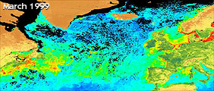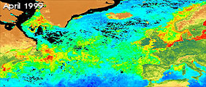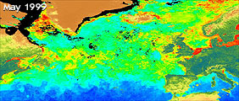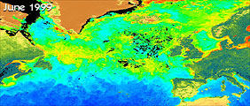
The progression of the North Atlantic Bloom during the months of spring and early summer of 1999 as seen in monthly SeaWiFS ocean color imagery. Note the northward progression of the bloom as seen in the elevated chlorophyll concentrations from March to June of 1999.

Assessing decadal-scale changes in the ocean's biosphere using the global CZCS, SeaWiFS, and MODIS chlorophyll concentrations has been hindered by significant differences in instrument characteristics and observations that necessitate incongruent processing strategies. The lesson learned from these experiences is that engineering is not enough to satisfy decadal-scale Earth system science questions. Along with technological developments, it is imperative to have a robust and consistent strategy for interrelating observations between missions.

Importantly, chlorophyll concentration is only one measure of one property of ocean ecosystems. It simply is not enough. To understand and predict change, we need to remotely assess the diversity of ecosystems, as well as their physiological status and productivity and how they function to provide goods and services to humankind. There will be limitations of what can be observed from space, but there is more to ocean ecosystems than simply a measure of "greenness”. Observing this will require new technologies and will present new challenges to overcome.

Next Steps

To develop a predictive understanding of global ocean ecosystem health, productivity, biodiversity, and trophic dynamics, we first need to observe these factors and processes, and develop conceptual models of how the system works. Remote techniques are the only viable tools we have to do this on global scales, because field observations from the ground are simply too costly and not synoptic. Making these measurements using remote technologies will require continued technical and scientific advances that build upon the knowledge accumulated since the 1970's.

First, we need to determine ecosystem biomass over ocean scales. The chlorophyll content of phytoplankton cells can change in response to light, temperature, and nutrient stresses. Non-living compounds like dissolved organic materials can also mask the signals of chlorophyll and effectively alter the color of the ocean. Accurate scientific assessments of phytoplankton biomass require understanding and routine observation of competing optical signals. All these observations must be accurate enough to enable the assessment of changes over timescales of decades.

Second, the biodiversity of ocean ecosystems must be quantified and monitored over time. To first order, this can be done by quantifying concentrations of important phytoplankton functional groups (e.g., diatoms, coccolithophorids, cyanobacteria (Trichodesmium sp.), etc.). Other relevant measures of community diversity are determinations of particle size spectra, abundances of different phytoplankton size classes and the relative contribution that non-living materials make to the absorption and scattering of light. We also need to develop the capability to predict the impact of these changes on higher trophic levels through ecosystem models.

Third, to understand how elements cycle within the oceans and how much food and energy can be provided by ocean ecosystems, we need to accurately assess marine primary production and monitor indices of ecosystem health. Models for assessing rates of productivity are available, but they have large uncertainties and lack reasonable predictive skill. A strategy is needed to implement the merging of satellite data into in situ observing systems, research observatories, and numerical models. In particular, novel space-based approaches that include lidar technologies are required to measure the physiological status and health of marine ecosystems.
The assessment and modeling of global ocean ecosystems and their change in time.
Understanding the relationship between animals, plants and other biological components and the physical environment of ocean ecosystems.
Ability to predict biodiversity and its influences on the stability and persistence of ocean ecosystems.
Quantification of the links between ocean ecosystem function and diversity and global cycles of elements.
Expected Accomplishments

Ocean ecosystems provide many important goods and services to humanity, including:
Cycling of globally important compounds (O, C, N, etc.),
Supporting commercial and recreational fisheries,
Providing nursery and breeding grounds for marine mammals,
Water purification through nutrient recycling, etc.
Healthy ecosystems provide these critical goods and services more readily and reliably than distressed or impacted ecosystems.
Promoting healthy ecosystems promotes a living legacy that we pass to our children.

Benefits for the Nation

Ecosystems are dynamic entities in an ever-changing ocean. To understand them, we must fully understand the physical environment in which they live and with which they interact. Satellite measurements of incident solar radiation and its spectral components, mixed layer depth, sea surface height, vector winds, sea surface temperature, and surface currents are all important complements to biologically-focused missions in a comprehensive ocean program aimed at understanding complex global marine ecosystems.

“The biodiversity is one of the bigger wealths of the planet, and nevertheless the least recognized as such.” - E. O. Wilson, 1992

How do Carbon and Other Elements Transition between Ocean Pools and Pass through the Earth System, and How do These Biogeochemical Fluxes Impact the Ocean and Earth's Climate over Time?

The Challenge

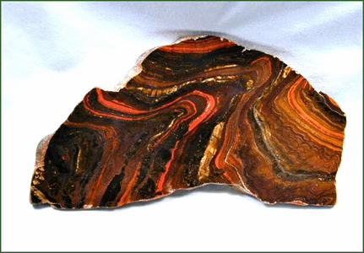
In the four billion years since their formation, the global oceans have played a prominent role in shaping the biosphere as we know it today. The geologic record attests to the ocean’s profound influence on Earth system cycling of chemical elements, with the first major biological signature being the banded iron formations deposited with the development of oxygen-generating photosynthesis in the Archaean oceans 3.2 to 2.8 billion years ago. But rich iron deposits are not the end of the story. Far more recently, imbalances in the formation and respiration of organic material in marine systems caused enrichment of carbon in the sediments that later developed into much of the petroleum deposits currently fueling our global economy. By examining the myriad elemental fluctuations deduced from our paleorecords, we begin to understand natural linkages and feedbacks between the Earth’s physical, chemical, and biological systems. The paleorecord, however, is not enough to predict short-term responses (10’s to 100’s of years) to the currently escalating rates of change. Consequently, a comprehensive suite of global observations is required to characterize ocean elemental cycles such that their evolution in the near future can be reliably detected and predicted.
Banded iron formations are a major biological signature.
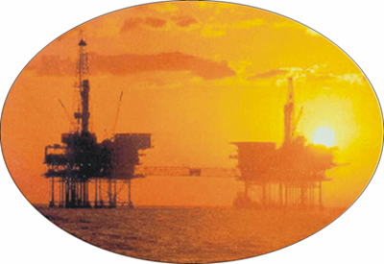
Global petroleum reserves were largely formed from marine carbon deposits
Key biogeochemical elements include carbon, oxygen, nitrogen, phosphorous, silicon, sulfur, and iron. Their cycling involves complex exchanges between multiple ocean reservoirs and between the ocean, atmosphere and land. While quantifying elemental standing stocks is essential, it is not enough. In all cases, information is also needed on transformation rates. These ‘rate’ terms may take the form of a physical process, such as the airborne deposition and upwelling of iron, or they may be a biological process such as photosynthesis. Fortunately, knowledge of a few rates and multiple stocks allows many of the missing pieces in elemental cycles to be worked out.

The carbon cycle is the most thoroughly studied of the ocean elemental cycles. Many components of the ocean carbon cycle have properties that allow their estimation from space, such as: total particulate organic carbon (POC), particulate inorganic carbon (PIC), dissolved inorganic carbon (DIC) [i.e., various groups use SST and Chlorophyll a to estimate pCO₂] and net primary production (NPP). Whereas others, including dissolved organic carbon (DOC) and phytoplankton carbon biomass, are not yet adequately constrained and await new missions with advanced satellite technologies. Still some carbon cycle attributes cannot be directly detected from space (e.g., export flux) and must be deduced from surface properties, field measurements, and models.

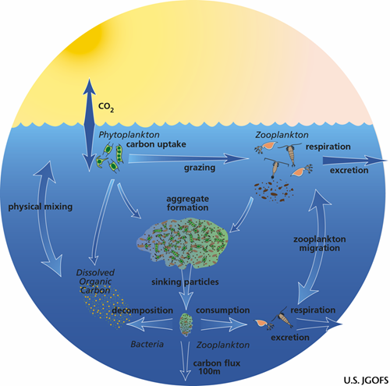
Each key ocean biogeochemical cycle is influenced by humans. In all cases, material transport from land to the oceans via rivers and estuarine input is important, but it is particularly critical for phosphorous and nitrogen cycles (roughly half of the ‘new’ nitrogen entering the oceans each year is now traceable to human sources). Atmosphere-ocean feedbacks are also prominent in elemental cycles, such as the carbon cycle through air-sea CO₂ exchange and the iron cycle through Aeolian dust deposition. Elemental cycles in the ocean are also tightly coupled to climate. An effective observational strategy for ocean biogeochemistry thus requires the integration of ocean-focused missions with supporting atmospheric and
The ocean carbon cycle is the most thoroughly studied of the elemental cycles.

terrestrial components.

What We Know and Need to Learn About Ocean Elemental Cycles

Following the launch of CZCS, phytoplankton chlorophyll concentration has been the primary property targeted by NASA’s ocean color missions. Technologies have largely focused on supporting ‘wavelength ratio’ algorithms derived empirically from field measurements and wholly reliant on the so-called ‘bio-optical assumption’, which assumes that all optically active constituents covary with chlorophyll in a globally consistent manner. From these measurements, our understanding of global phytoplankton dynamics, distributions, and responses to climate forcings has taken a quantum leap forward. In many respects, NASA’s ocean color missions provided the single greatest advance in biological oceanography during the 20th century. By viewing the oceans from space, we now estimate ocean productivity as roughly equal to terrestrial net production, although uncertainties around both estimates remain large (> 30% at a minimum). Ocean color data also improved our understanding of carbon cycling in coastal zones and over continental margins, allowed the first global quantification of colored dissolved organic matter (CDOM), and documented global ocean responses to El Niño-Southern Oscillation (ENSO) cycles. Time-series analyses have established that ocean biogeochemical cycles are not at steady state, contrary to assumptions held as truth for nearly 100 years. Some ocean features exhibit distinct trends linked to changes in sea surface temperature (SST) and ocean circulation.

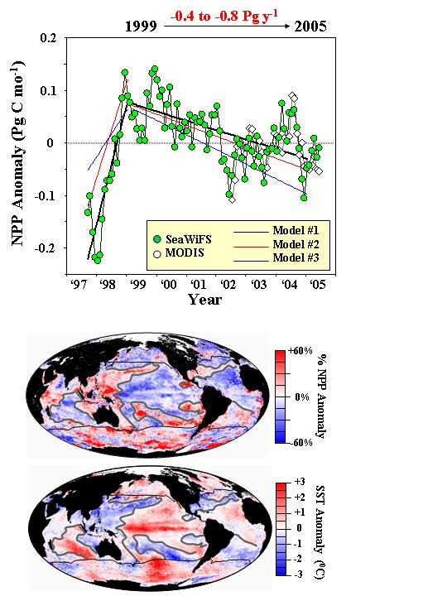
Along with the many great discoveries provided from satellite observations, we have also learned how very little we really did (and still do!) understand about the oceans. One thing that is clear is that the ‘bio-optical assumption’ is not universally valid. Consequently, we now know that an evolution in observational capabilities is necessary. Fortunately, paths for utilizing such new information are well underway, including the simultaneous separation of multiple in-water constituents through ‘spectral matching’ approaches, the derivation of particulate carbon pools through retrievals of light scattering coefficients, the detection of physiological variability through satellite-derived chlorophyll:carbon ratios, and the distinction of iron-limited populations through unique fluorescence characteristics.
Top: Changes in global ocean productivity (NPP) shown since 1997 as estimated using three different models and SeaWiFS and MODIS data.

Bottom: The relationship between 1999 to 2005 changes in NPP and SST is shown.

The past few decades have also witnessed significant advances in coupled ocean circulation-ecosystem models. These models provide a platform for implementing new functional relationships between physical and biological processes both on local and global scales. They also provide prognostic capabilities to forecast changes in ocean processes well into the future. Remote sensing data can contribute critical information for advancing coupled model performance, but in many cases the geophysical parameters derived from space are not directly matched to key model components. Through the expansion of ocean products enabled by new satellite observations, remote sensing can assume a more prominent role in future model development.

Next Steps

Quantifying, monitoring, and predicting changes in ocean elemental cycles and their interactions with atmospheric and terrestrial systems requires information on stock sizes and key transformation rates. Advanced ocean remote sensing missions must address atmospheric correction issues associated with absorbing aerosols, improve the separation of optically active in-water constituents, enable a broad-scale characterization of unique ecosystem conditions (e.g., separating iron- and nitrogen-limited waters), and provide appropriate space and time scale observations for interdisciplinary approaches to quantify elemental fluxes at the land-ocean interface.

As ocean remote sensing science evolves from simple empirical algorithms to higher-order spectral models, measurements must be made with higher accuracy and precision. Consequently, future observations must include extensive pre-launch sensor characterizations and post-launch calibration capabilities. Improved approaches for atmospheric correction of imagery will require information on absorbing aerosol type, thickness, and vertical distribution. New strategies are needed to improve corrections over coastal ‘bright waters’ as well, where water leaving radiance contributions can be significant in near-infrared atmospheric correction bands. In some cases, dedicated sensors for atmospheric measurements and integrated efforts between the ocean and atmospheric science communities will be necessary to realize ocean research goals.

While unparalleled water leaving radiance accuracies are fundamental to future remote sensing observations, they are not enough. Classic ‘ocean color’ bands were not optimized nor calibrated, for semi-analytic spectral algorithms and are not adequate for fully resolving the complexities of ocean water and optical properties. Enhanced measurement capabilities are necessary, both in spectral range and spectral resolution. Active approaches (i.e., lidar) can provide independent measures of critical elemental stocks. For example, lidar sub-surface light scattering profiles can yield important information on particle biomass abundance. Focused studies on the land-ocean interface and adjacent coastal waters will also require increased spatial resolution (<250 m).

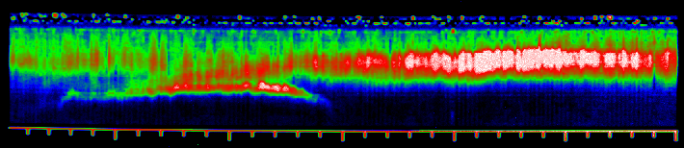
LIDAR track from offshore to onshore, near Wallops Island, VA. Note the entrainment of sediment in the current from the shoal. Courtesy of F. Hoge, http://aol.wff.nasa.gov/
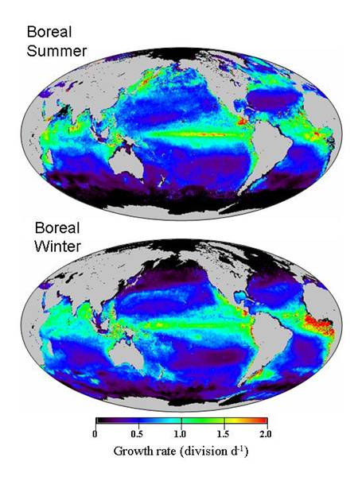
Phytoplankton growth rates based on satellite-derived chlorophyll:carbon ratios are shown.

Global, and more detailed regional, descriptions of key transformational rates is perhaps the greatest challenge in resolving elemental cycles. Observations of central physical forcings (e.g., dust deposition, incident light, mixed layer depth, SST, etc.) can function as a basis for mechanistic models of rate terms or simply may provide important supporting information. For the carbon cycle, the most accessible transformation rate is net primary production, but it requires the description of physiological variability. Passive remote sensing retrievals of phytoplankton chlorophyll:carbon ratios provide one approach to assessing physiological variability. Effectively implementing such an index requires additional information on regional differences in the nature of nutrient stress (e.g., iron vs. nitrogen).

Quantifying ocean elemental cycles, however, will require more information than can be gleaned from remote sensing data alone. Accordingly, all national and many international science agencies are developing programs to contribute uniquely to the problem. Integrating NASA’s effort with these concurrent efforts and field programs (e.g., the North American Carbon Program (NACP), the Ocean Research Interactive Observatory Networks (ORION), the National Ecological Observatory Network (NEON), and the Global Ocean Observing System (GOOS)) is essential to the success of the Ocean Biology and Biogeochemistry program. This interaction must entail not only shared observational capabilities and data sets, but also synergistic contributions to the development of Earth system models.
Quantification and trends in primary ocean carbon pools and primary production
Assessment of elemental transfer rates between pools and export from the surface photic zone
Characterization of plant growth constraints, responses to episodic events, and potential implications of future nutrient budgets
Assessment of links between alterations in the physical ocean environment and the pools and fluxes of key elements
Provision of specific remote sensing products central to the development of advanced ocean circulation-ecosystem prognostic models.

Expected Accomplishments

Current assessments indicate that the oceans absorb most anthropogenic carbon emissions, and play a dominant role in climate regulation and variability
Ocean elemental cycling directly impacts atmospheric chemistry and clears atmospheric pollution
Man-made nitrogen sources are now a dominant component of the ocean nitrogen cycle and we depend on marine organisms for processing vast quantities of our nutrient wastes
Agricultural practices and climate change alter vegetation cover and desertification and are linked to perturbations of ocean iron cycling through alterations in dust transport.
Improved assessments of carbon pools and rates to support a carbon-based economy, including accounting of caps, credits, and trades.

Benefits for the Nation

How (and Why) is the Diversity and Geographical Distribution of Coastal Marine Habitats Changing, and What are the Implications for the Well-Being of Human Society?

The Challenge

Coastal habitats are among the most complex and diverse environments on Earth, providing substantial socio-economic benefits. They extend from above the spring high tide-limit to shallow regions of the continental shelves, and include coastal watersheds, dunes and wooded coastal areas, beaches and cliffs, wetlands, estuaries, barrier islands, and shallow submerged lands like seagrass beds, kelp beds, and coral reefs. More than $1 trillion of the U.S.’s annual gross domestic product (GDP) is generated within the relatively narrow strip of land immediately adjacent to the coast. Services provided by coastal ecosystems include purification of water through nutrient recycling, sediment storage, shoreline protection, and supplying habitat and food for migratory and resident animals, as well as humans. Coastal habitats provide important biological and mineral resources for the pharmaceutical, oil, gas, and sand and gravel industries, and support key fisheries and maritime operations, including housing our ports. Every year, hundreds of millions of visitors flock to the Earth’s coasts to enjoy the many pleasures the ocean affords. Yet we still know little about the variety of coastal habitats and resources in them.
"Habitat" is the Latin word for "it inhabits". A habitat is an area that provides a group of organisms with adequate food, water, shelter and living space.

Human pressures, combined with changes in climate, threaten the sustainability of our coastal resources. Pollution, subsidence, sea level rise, development, and the building of structures that alter sediment flow all contribute to the threat. Land is being developed for housing at more than twice the rate of population growth, and poorly planned growth reduces and fragments fish and wildlife habitats and can alter sedimentation rates and flows. With the loss of the nation’s wetlands, shorelines are becoming more vulnerable to erosion, saltwater is intruding into freshwater environments, flooding is on the rise, water quality is being degraded, and wildlife habitat is being fragmented or lost. Fishing also exerts pressures on coastal habitats.

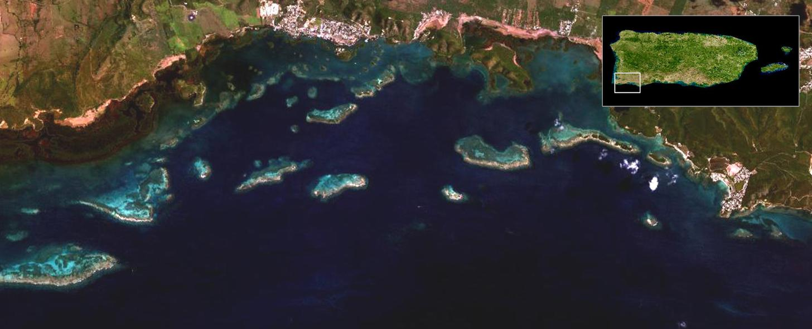

This image collected with the airborne NASA AVIRIS sensor shows a wide diversity in coastal habitats off southwestern Puerto Rico (image courtesy of James Goodman, University of Puerto Rico)

We can improve our way of life by managing our growth and by mitigating impacts of climate change. This requires understanding coastal habitats and how they are interconnected and linked to inland activities. The ecosystem-based management of coastal habitats is necessary and requires interdisciplinary scientific understanding and forward-looking technologies. NASA is the only agency capable of leading an accelerated research and advanced engineering program on coastal habitats, which require space-based technologies because of their extension along the edges of all continents and their important contribution to developing global coastal ocean observing systems.

What We Know and Need to Learn About Coastal Habitats
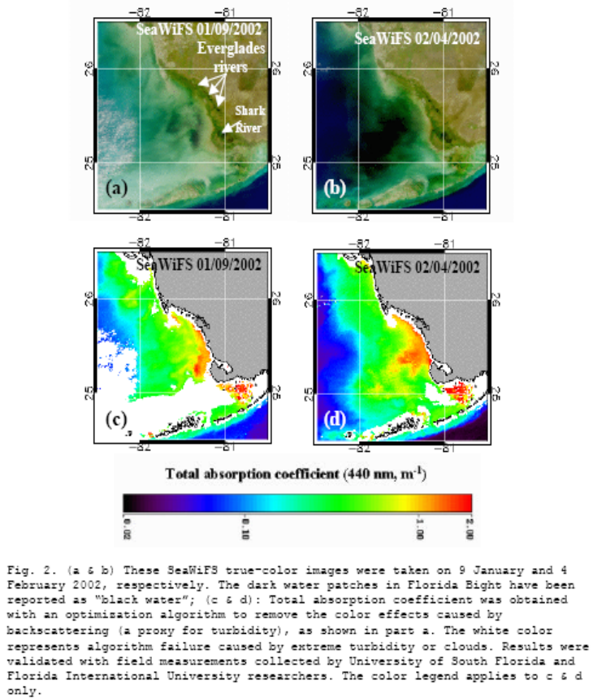
SeaWiFS images (a&b): true color image composites showing location of dark water; taken on 9 Jan and 4 Feb 2002. The dark water patches in Florida Bight have been reported as “black water”; (c&d): total absorption coefficient. The white color represents algorithm failure caused by extreme turbidity or clouds.

Coastal zones are exposed to storms, waves and currents, and inputs of sediment, nutrients and organic matter through rivers. Rivers integrate the effects of land use change across watersheds. Coastal lands may be submerged and exposed by the action of tides and wind-driven surges. These forces vary continuously leading to rapid changes in ocean temperature, salinity, nutrient load, light, bathymetry, bottom types and land run-off. This, in turn, leads to great variety in biological diversity and productivity of coastal habitats. These habitats harbor interconnected ecosystems where

ocean and air currents transfer energy, biogenic material (larvae, pathogens), sediments and other materials between components. While we are beginning to understand the complexity of coastal habitats, we have only just begun to predict rates of connectivity among habitats and their impacts.
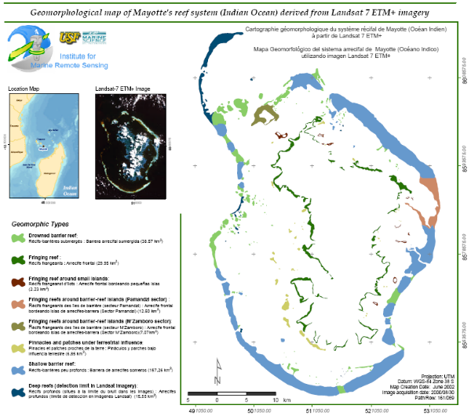
Benthic classifications of coral reefs off Mayotte in the Indian Ocean from Landsat 7 ETM+.
Traditional methods are inadequate to study the great variety of coastal habitats and their large geographic extent. Water depth is a defining habitat factor of these complex three dimensional environments, yet we have accurate bathymetric charts for only a small fraction of our nation's coastal waters. New potential exists for developing detailed bathymetric and benthic substrate maps for clear coastal waters from space-based and suborbital platforms using a combination of multispectral and lidar imaging technologies.

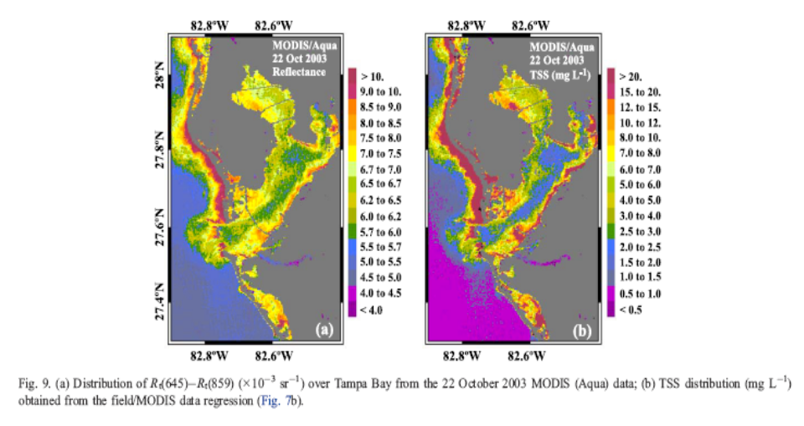
The very high productivity of many coastal waters reflects contributions from phytoplankton as well as macroalgae (e.g., kelp) and sea grasses, and is supported by frequent enrichments of nutrients and organic carbon from rivers and resuspension. Indeed the extent and character of freshwater inputs often defines coastal habitat type. The composition of organic materials, shallow and variably reflective benthic substrates, resuspended materials, and highly diverse aerosol distributions characteristic of coastal zones make retrievals of ocean properties from passive ocean color measurements difficult at best. The limited spectral measurements from the current suite of ocean color sensors are clearly inadequate for coastal zone remote sensing research. Fluorescence bands on the NASA MODIS sensors now provide some advantage for discriminating phytoplankton blooms from other colored phenomena, such as river plumes, and in combination with measurements in the near-ultraviolet (360 – 400 nm) may provide better descriptions of in-water constituents than currently available through traditional blue-green visible bands. These new developments further emphasize the importance of expanding observations in spectral range and resolution for applications in optically complex coastal waters.
(a): Distribution of reflectance, R_{t}(859)(x10⁻³sr⁻¹) over Tampa Bay from the 22 October 2003 MODIS (Aqua) data; (b): Total Suspended Solid TSS distribution (mg L⁻¹) obtained from the field/MODIS data regression

The riverine flux of water, sediment, nutrients and other materials to continental margins depends largely on the climatology of each watershed. These materials significantly impact coastal habitats, yet we still don't understand their timing, extent or the frequency of runoff events. Ultimately, it is critical that we understand the range of processes through which rivers, land and coastal habitats are coupled. To date, no comprehensive studies have examined the effects of watershed processes and oceanography on coastal habitats over continental or basin scales. Such efforts would require repeated synoptic assessments that allow discrimination between habitat elements.

Next Steps

A range of space-based observations, suborbital systems, and models need to be developed over the next 25 years to advance our understanding of coastal habitats. Foremost is the requirement to obtain frequent and synoptic observations of small-scale phenomena in both aquatic and adjacent land environments. Developing a workforce capable of processing and using these advanced observing technologies and products is also critical. Significant progress can be made by establishing effective links between research and decision-support tools for coastal managers and policy makers.

Coastal remote sensing presents significant technological challenges. A key issue is effective discrimination of biogeochemical constituents of the water and seafloor (e.g., colored dissolved organic matter, phytoplankton concentration and composition, suspended sediments, bottom type) and physical properties (e.g., temperature, salinity, wind, circulation, bathymetry, light attenuation). Changes in these properties must be resolved over long-term and short-term (daily to weekly) periods, at medium spatial resolution (10 to 100 m), and within the topographic and bathymetric regime of coastal habitats (watershed to about 20 m depth). Model development must proceed in parallel and at equivalent scales to the new observations. Together these advanced capabilities will lead to new understandings on linkages between lower and higher trophic levels, including living marine resources used commercially, for recreation, or cultural purposes. NASA's research on coastal habitats will contribute significantly to, and benefit from, efforts conducted through the National Science Foundation's ORION program and the coastal components of the Integrated Ocean Observing System (IOOS), the Climate Change Science Program (CCSP) and the Global Earth Observations System of Systems (GEOSS).

Historical oceanographic satellite sensors have limited utility in studying or monitoring coastal zones, in part because of their coarse ground resolution and limited spectral resolution and range. Refining ground resolution, expanding the spectral resolution and range, and addressing significant absorbing aerosol contamination issues together create an enormous challenge for accurately distinguish coastal ocean components and characteristics from remote sensing imagery. Landsat-class sensors (NASA’s Landsat, France’s SPOT, Space Imaging, Inc.’s Ikonos, GEOEye’s Quikbird, etc.) provide higher spatial resolution, but have limited sensitivity and are unable to detect the subtle changes in reflectance linked to the geophysical properties of interest.

While the problem is tractable, scientific advances in coastal aquatic environments will require innovative techniques and diverse approaches. An effective strategy must incorporate active and multispectral passive observations, and both global and local measurement capabilities. Advanced sensors require expanded capabilities beyond the NPOESS Preparatory Project (NPP) and National Polar-orbiting Operational Environmental Satellite System (NPOESS) missions, with an aim toward Landsat- or Advanced Spaceborne Thermal Emission and reflection Radiometer (ASTER)-class observation frequency and spatial resolution. Coastal observing capabilities include sensors that can dwell on dark targets or illuminate them with advanced lidar. Observations need to be consistent and calibrated, accessible, and well-documented.
Interdisciplinary scientific understanding of the coastal zone including human activities.
Develop a practical classification for coastal habitats and the valuation of ecosystems services
Quantify the distributions and biological diversity of coastal habitats and their changes
Assess of carbon and nutrient cycling and sequestration in coastal habitats
Identification of hot-spots of habitat diversity for use in setting priorities for restoration and conservation
Integration of coastal zone remote sensing with the GEOSS including IOOS and the ORION programs

Expected Accomplishments

Understanding the role of coastal habitats in human health and well-being
Assess impacts of inland nutrient, sediment, and pollutant inputs on coastal zones
Creation of decision-making tools for ecosystem-based management, sustainable resource use, conservation and restoration
Make observations in support of coastal management and ports operations
Help plan for coastal development and tourism

Benefits for the Nation

When it comes to managing our oceans, we're in shallow water.

- Admiral James D. Watkins, Chair, U.S. Commission on Ocean Policy, and career submarine officer

How do Hazards and Pollutants Impact the Hydrography and Biology of the Coastal Zone? How do they affect us, and can we Mitigate their Effects?

The Challenge

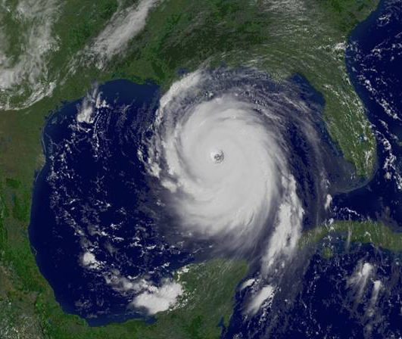
To date, environmental hazard monitoring has primarily focused on land-based hazards, such as volcanoes, droughts, floods, landslides, and fires, and their impacts on land surfaces. Environmental hazards, however, have tremendous impacts on the world’s oceans, the communities residing along coastlines and the economies they support. Recent years have witnessed record-breaking natural hazards impacting coastal zones. Worldwide, the number of intense Category 4 and 5 hurricanes has nearly doubled since the 1970s. The year 2005 marked a new record for the number of tropical cyclones forming in the Atlantic during a single year. Hurricane Wilma, which struck the Yucatan Peninsula in October 2005, was the most powerful storm ever observed with winds of 280 km/hr (175 mph). Hurricane Rita (Figure, left) had strengthened into the third most powerful hurricane on record before it weakened and struck the Texas/Louisiana border in September 2005. The tsunami that devastated over a dozen Asian nations in December 2004 resulted from one of the largest earthquake in recorded history. Large and infrequent or acute events alter the landscape of coastline, impact water quality, devastate coastal habitats, and greatly impact organisms within the coastal zone as well as communities residing along the coasts.

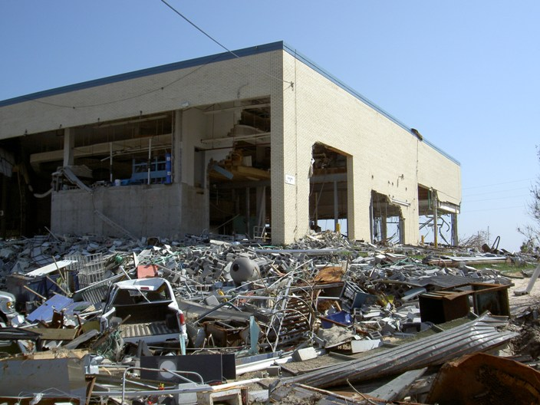

Hurricane Katrina resulted in the worst natural disaster in U.S. history (Photo: S. Lohrenz)

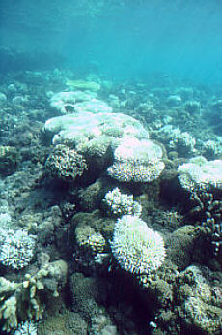
Although less dramatic, long-term changes to ocean properties are also hazardous to marine ecosystems. Chronic hazards include sea level rise and incremental changes to ocean sea surface temperature, pH, salinity, and nutrient composition. All of these long term hazards alter marine habitats and food webs in ways that can be measured. Changes in sea surface temperature (a remotely detected variable), for example, can impact upwelling processes that bring nutrients necessary for photosynthesis from depth to the sea surface. Uptake of anthropogenic CO₂ by the ocean changes seawater chemistry and projections indicate that the corresponding drop in surface ocean pH will be lower than it has been for more than five million years. Increased acidity will cause mortality in marine organisms that calcify, including coccolithophores, foraminiferans, reef-building corals and planktonic pteropod molluscs. Eutrophication of coastal waters by high nutrient loads in runoff already causes low oxygen zones that kill fish and other marine life and may be related to blooms of harmful algae. Chronic changes such as these result in permanent and potentially catastrophic changes to marine life.
Coral bleaching may increase globally with changes in pH..

What We Know and Need to Learn about Hazards and the Coastal Zone

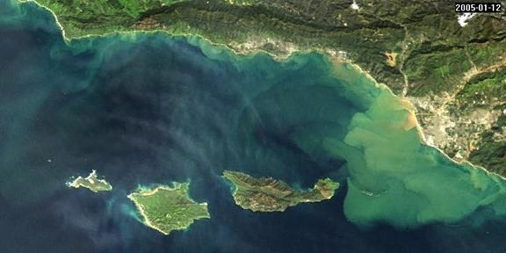
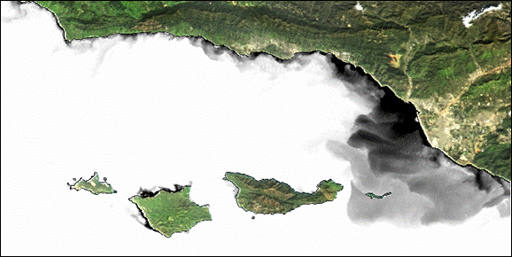
Many of the acute impacts of natural and anthropogenic hazards on coastal water quality and marine life occur from plumes of material either being re-suspended from the bottom or carried to the coast through runoff from land. The consequence of these transport processes is often a decline in the growth or diversity of marine life. Re-suspension of sediments in coastal harbors, for example, can release toxic matter that has adsorbed to the sediment, thereby increasing the load of toxic chemicals in the water column. Re-suspended material influences light penetration in the water column and can inhibit growth of photosynthetic algae and seaweeds. Redistributed sediments can interfere with shipping channels. Runoff from land also introduces a variety of toxins, including oil, into nearshore waters. Glacial meltwater plumes in polar regions can alter productivity and the phytoplankton composition of surface water, subsequently impacting entire food webs. Plumes of harmful algae and “red tides” (which may or may not be harmful) are increasing along the coasts in response to a variety of environmental stressors.
Sediment plumes occurring off of the coast of California during exceptional rainfall of 2005 from MODIS imagery A) “true-color; B) turbidity

Satellite data are currently being used to track the course of tropical storms and hurricanes and document resulting coastal erosion and sediment re-suspension events in coastal zones. However, these methods are qualitative and only show impacts that can be observed visually from a true color image, such as the apparent extent and duration of a sediment plume. Better methods are required to accurately estimate the composition and/or concentration of materials within plumes and their dispersion over time. Quantitative models are also needed to characterize impacts of hazardous plumes on coastal processes. Most approaches for estimating sediment concentrations are highly empirical and site-specific, cannot differentiate different sediment constituents, and are not reliable under extreme conditions. Research is needed to integrate the various relevant measurements needed to understand intense algal bloom development and the propensity of these blooms to produce toxins. As storm surges erode coastlines, we also need rapid-assessment methods to identify the amount of eroded material and depth of flooded inland areas. Modeling flood water properties will require an understanding of the water’s optical properties. Assessment of chronic hazards requires continuous observations that elucidate incremental changes in coastal conditions.

Chronic shifts in basin-scale productivity have been observed from satellite ocean color measurements. For example, warming of the Eurasian landmass has been linked to enhanced upwelling and satellite-derived phytoplankton biomass in the Arabian Sea. Nutrients concentrations (e.g., inorganic nitrate) and air-sea carbon fluxes have been monitored at the sea surface through satellite-derived climatologies of ocean basins. These studies typically use empirical relationships between satellite-derived products, such as sea surface temperature, chlorophyll, and wind speed, and other biogeochemical parameters of interest. However, both acute and chronic changes to the world’s oceans may significantly modify the relationships between these parameters. Large-scale changes in the oceans due to increased runoff of meltwater or increased warming, for example, may also cause the standard ocean color algorithms to become inaccurate.

Next Steps

Quantifying sea level rise, coastal erosion, and plumes of suspended material, dense algae, or toxins requires higher temporal, spatial, and spectral resolution imagery than currently available. New satellite retrieval algorithms are needed that are not merely site-specific empirical regressions, but instead can accurately determine the quantity and composition of suspended materials, as well as be used to make inferences about relevant indicators that cannot be measured remotely. Improved atmospheric correction approaches must be developed to deal with significant amounts of near-infrared reflectance and absorbing aerosols common over coastal regions. Integrated modeling and data assimilation efforts will be required to tie together in situ measurements and diverse remote sensing data, such as sea surface temperature, vector winds, bathymetry, and delineation of coastal fronts and other surface phenomena (e.g., using Synthetic Aperture Radar). Rapid-assessment methods are needed in order to monitor and respond to episodic events and hazards along our coasts. Sensors that can potentially monitor beneath cloud cover (e.g., suborbital surveys from unmanned aerial vehicles) will provide a critical link to hazard assessment and development of response and mitigation strategies.

Evaluating the impact of chronic hazards on marine ecosystems requires extensive and precise monitoring coupled with modeling efforts aimed at understanding how surface processes monitored from space can provide information on ocean chemistry, biology, and geology, both within the surface layer and at depth. Initial efforts have been undertaken to assess changes in ocean parameters due to alterations in the land, atmospheric, and oceanic environments from available satellite-derived products. However, the robustness of the empirical relationships used to estimate biogeochemical parameters has not been evaluated under different climate scenarios. A shift towards analytical approaches may allow us to infer changes in ocean biology and biogeochemistry better than empirical approaches. New satellite missions with enhanced spectral capabilities will be critical for advancing these efforts. Coupling in situ monitoring and ocean modeling with new satellite measurements will be necessary to address the chronic changes facing the ocean ecosystems. Collaborations with the National Science Foundation's ORION program and the coastal components of the IOOS and GEOSS may provide additional support for these efforts.

Identification of potential natural hazards affecting marine life and human communities.
Integrated modeling and data assimilation efforts to provide more accurate and timely forecasts of hazards
Quantification of short- and long-term physical and biological responses to hazards in the coastal watersAssessment of current algorithms and development of new approaches to remotely-derive biogeochemical parameters in response to chronic changes in the ocean environment.

Expected Accomplishments

Improved forecasting of acute and chronic natural and anthropogenic hazards, including large storms, tsunamis, toxic spills, and icebergs.
Provide critical knowledge needed for planning appropriate coastal development, design of nearshore structures to withstand wave and tidal surge, and improved disaster preparedness in coastal communities.
Improved understanding of how natural hazards impact and shape our coasts
Benefits for the Nation

Recommendations for an Integrated Living Ocean Program

The four core Science Questions encompass the foremost issues in ocean biology and biogeochemistry research. Within each, we have identified specific Next Steps that together constitute a broadly conceived program of measurements and supporting activities that will provide answers to the four science questions. The preceding section identified Observational Requirements for each question, many of which overlap multiple questions. For example, substantial progress can be made toward answering all four science questions by expanding the spectral range and wavelength resolution of global water leaving radiance measurements. These new data will allow separation of ecosystem components key to addressing all four science questions. Similarly, enhanced spatial (10 to 100 m ?) and temporal (sub-daily) resolution will contribute important information to answering these four science questions. Such overlaps allow the diversity of new measurement requirements to be consolidated into a tractable suite of seven specific Observational Strategies:

- Global Sun-synchronous Hyperspectral Imaging Radiometer
- Global Geostationary Hyperspectral Imaging Radiometers
- Multi-Spectral High Spatial Resolution Imager
- Portable Sensors from Suborbital Platforms
- Variable Fluorescence Lidar
- Mixed Layer Depth and Illumination Sensor
- Ocean Particle Profiler and Aerosol Column Distributions

Details on each of these observational strategies are provided in the following subsections, including recommended development activities for the immediate (1 – 5 years), near-term (5 – 10 years) and long-term (10 – 25 years) time frames.

Further, interdependencies exist among specific measurements. For example, the global and regional passive measurements of ocean radiances addressing all four science questions depend on coincident descriptions of atmospheric contributions to top-of-atmosphere radiances (including effects of aerosol type, thickness, and vertical distributions). Likewise, lidar-based surveys of subsurface particle scattering contribute little to the four science questions without coincident global ocean color data. Thus, the seven measurement capabilities listed above can be further packaged into a set of four overarching Mission Themes:

Recommended Mission Themes

- Global Separation of Optically Active and Ecosystem Components (advanced radiometry & aerosol characterization)  - High Spatial and Temporal Resolution Coastal | - Active Assessment of Plant Physiology and Composition  - Mixed Layer Depth

Each of these four Mission Themes represents a technology development line with a cohesive science focus and immediate, near-term, and long-term goals. A given Mission Theme can entail one or more sensors focused on the observational strategies listed above. Complementary aspects of the Mission Themes lead to a natural sequence in their execution, unfolding logically toward a complete observational capability. Thus, Science Questions identify Observational Requirements, which define Observational Strategies, which lead to Mission Themes, which define a recommended 25-year horizon of distinct Satellite Missions. This science-driven cascade from questions to missions is described in detail in the “Summary” section below.

To support the recommended 25-year plan, NASA must build on its existing infrastructure and expand its capabilities in a systematic manner that matches the progression of science goals of NASA’s mission. Given the multidisciplinary scope of this research, these activities will need to proceed in collaboration with other NASA Earth Science research programs, e.g., physical oceanography, terrestrial ecology and land cover, radiation sciences, and atmospheric composition, as well as other U.S. and international programs. In many cases, these other disciplines provide critical information for OBB satellite data processing, e.g., aerosol properties and spatial distributions. Indeed, more integrated measurement strategies are needed than what was realized in previous missions such as SeaWiFS and MODIS, as better integration will foster interdisciplinary science and information exchange. This was and still is a major goal of NASA Earth Observing System science (EOS), and new strategies for continuing this pursuit in an era of smaller missions must be conceived.

The elements of this broader program are detailed in this section and include:

- Observational Strategies (the seven listed above)
- Supporting Measurements, Research and Modeling
- Systematic Observations
- Education/Public Outreach

A successful program requires a balanced approach in each of these areas with mechanisms in place that allow developments to be integrated in a timely manner. For instance, future hyperspectral observations can only realize their scientific potential if the information systems, calibration, and validation capabilities (e.g., a comprehensive in situ program) are sufficiently robust and deployed. Furthermore, the observational systems envisioned, both satellite and in situ, often require technology developments that must be identified well in advance of when the on-orbit support systems are needed. The Mission Theme framework for future research in ocean biology and biogeochemistry must provide mechanisms for cross-talk between the four Themes, as well as the prioritization and sharing of resources, such as computational and field data systems. Similarly, activities of other NASA disciplines should be leveraged where appropriate and augmented if necessary to maximize the return on research investments (e.g., AERONET).

NASA’s Ocean Biology and Biogeochemistry Program has made great progress in Earth Science research over the past decade. Projects such as SeaWiFS, MODIS, and SIMBIOS have provided critical data sets and calibration and validation infrastructure. These missions and projects have also demonstrated how the international science communities can more effectively collaborate and use data from sensors in more interdisciplinary ways than previously envisioned (e.g., SeaWiFS data for terrestrial (NDVI) products). However, intersensor and interdisciplinary data fusion studies are rapidly having their full potential realized. At the same time, these projects are either completed (i.e., SIMBIOS) or beyond their prime mission lifetimes. Activities, approaches, and technologies developed to support these projects need to be revisited and revised if we are to further explore and understand the unseen world beneath the ocean’s surface. Scientists have learned much about the ocean’s role in the Earth System from previous and current on-orbit global missions, and seek to answer the next critical series of science questions using innovative technologies that will inspire the next generation of researchers.

NASA seeks to build upon lessons learned from past missions. For instance, SeaWiFS and MODIS were designed to focus on the global ocean and the sensors were indeed found to function best within open ocean environments. These missions also produced a limited set of validated products, particularly chlorophyll-a. A major obstacle for ocean science developments is that available on-orbit and in situ instruments are obsolete, representing technology designs that are now older than 15 years. In the time since the launch of these missions, requirements to make high quality observations in coastal and global regions have been articulated by the science community and paralleled by technology developments for both active and passive sensors. We can make such improvements possible. While systems for quasi-operational sensors such as the Visible Infrared Imager/Radiometer Suite (VIIRS) on NPP and NPOESS may maintain the existing chlorophyll-a time series, VIIRS is not designed to address many of the science questions now being posed by researchers. New measurements from both Low Earth Orbit (LEO) and Geostationary Earth Orbit (GEO) are necessary, and the time to begin mission planning is now, otherwise we face a gap in the climate data record due to poor planning. Science discipline partnering on missions (e.g., ocean biology and biogeochemistry and radiation sciences) is possible and advantageous, but care must be taken not to substantially compromise science requirements and sensor performance in the processing.

Advances in ocean remote sensing over the past two decades have been paralleled by advances in computational technologies and coupled models of atmospheric circulation, ocean biogeochemistry, and ocean dynamics. The supporting framework must enable partnering of the observational and modeling communities. Certainly, regional and global data can be used for model validation and data assimilation, and this is being pursued by the Global Modeling and Assimilation Office (GMAO) at NASA/GSFC, for instance. Additionally, the remote sensing science requirements and related field validation programs must be linked to requirements of the modeling community and can be augmented to provide additional data for model parameterizations. This is particularly important because of the difficulty in getting field data from many areas in the ocean, and requires the optimization of cruise planning and sampling for specific purposes.

Finally, the missions recommended here are the result of questions posed based upon decades of scientific research. Many critical components of the ocean system remain unexplored, and will remain so beyond what can be accomplished from space-based observations. This does not mean that the accumulation of this knowledge is any less important to the NASA Ocean Biology and Biogeochemistry program. Instead, it requires that robust field and laboratory research efforts (beyond the previously stated requirements of a calibration / validation program) be an integral part of the NASA OBB program. Emerging science questions will come from a thorough understanding of the ocean biosphere. In some cases, this is most expediently achieved from direct observations and experimentation in the field and laboratory, rather than from the remote views achieved from space.

In the following sections, the seven Observational Strategies are introduced along with timelines to address the measurement requirements for each of the four Mission Themes.
Together these provide a prioritized view of science-driven observational capabilities, and the future of our program. Of foremost importance is the immediate development and launch of an advanced global ocean mission with high spectral resolution capabilities from the ultraviolet to near-infrared and (a) dedicated instrument(s) for characterizing absorbing aerosols (composition, thickness, height). This highest priority mission supports advances under all four science questions in a global manner, should be succeeded by similar but advanced missions throughout the 25 year horizon of this mission plan, and defines the first Mission Theme identified above (Global Separation of Optically Active and Ecosystem Components). The second mission priority for OBB science is (are) sensor(s) enabling high spatial and temporal coverage of global coastal regions. Instrument development and launch for this Mission Theme should occur within the near-term (5 – 10 years) at the latest, if launches and platforms of opportunity are available or international coordination of sensors can occur. This global coastal-focused mission theme likewise entails sequence missions throughout the 25-year horizon and has a synergistic dependence on the global mission theme for information on absorbing aerosol distributions. The two remaining Mission Themes (Active Assessment of Plant Physiology and Composition and Mixed Layer Depth) are less well defined in technological approaches and requirements, and thus involve dedicated missions only in the long-term time frame (10 – 25 years). These mission themes are focused on key observations augmenting the two top priority themes to enable the most comprehensive answers to the four science questions. Their contributions are thus dependent on at least a simultaneous advanced global mission, and as stand-alone missions offer little toward addressing the OBB science questions.

Observational Strategies
- Global Hyperspectral Imaging Radiometer

Quantification of phytoplankton biomass and primary production has always been a central objective of satellite ocean color missions like SeaWiFS and MODIS. The essential derived biological product of these missions has been chlorophyll (water-leaving radiances are the basis for higher order products like chlorophyll). In the late 1970’s and early 1980’s, the CZCS mission demonstrated basic approaches for atmospheric correction and pigment quantification. However, the CZCS sensor did not have a band(s) below 443 nm, which would make it possible to separate colored dissolved organic matter (CDOM) and chlorophyll, nor did it have the NIR bands required for accurate atmospheric corrections. SeaWiFS and MODIS incorporated a 412 nm band to facilitate this separation, as well as additional bands in the NIR. Reasons for not including other bands further into the UV included difficulties in calibrating the bands (in the laboratory and on orbit) and in the atmospheric correction (an extrapolation of the aerosol correction from the NIR). In the intervening 15+ years, detector technology and data processing methodologies have matured to a point that these are no longer such major limitations. By moving further into the UV, the divergence of the CDOM and chlorophyll absorption spectra becomes greater, making accurate separation of these substances more reliable.

Molecular (Rayleigh radiance) and aerosol (particulate) scattering cause the atmosphere to contribute at least 90% of top of the atmosphere radiance over the ocean. This atmospheric contribution is also affected by absorption by gases (e.g., ozone and NO₂) and aerosols (e.g., dust, smoke, and urban pollution). SeaWiFS and MODIS have used measurements in the NIR (765/748 and 865) to estimate aerosol radiance in the visible bands (after modeling for the Rayleigh radiances). This technique assumes that there is zero subsurface ocean reflectance in the NIR. This assumption is invalid in turbid or optically shallow water (coastal regimes), requiring the reflectance to be modeled. Studies using MODIS bands at longer NIR wavelengths where the absorption by water is much greater (roughly ten times) have demonstrated that atmospheric corrections over turbid coastal waters are feasible in the 1200-1700 nm range.

As for the identification and correction of absorbing aerosols, no reliable method using the SeaWiFS and MODIS band sets has been developed to make accurate corrections without assuming a particular absorbing aerosol type and vertical distribution. Additional bands in the UV would be useful for at least flagging certain absorbing aerosols over the open ocean and a specific UV band at 317.5 nm would provide simultaneous ozone corrections. At present, high concentrations of dust and smoke are identified as clouds in the cloud masking, but low concentrations of dust, smoke, and pollution are not detected. Consequently, these conditions lead to erroneously low water-leaving radiances that are interpreted as high chlorophyll concentrations. Accurate atmospheric corrections are possible if aerosol properties are simultaneously measured with ocean color, including aerosol altitude and type. Advanced ocean missions must therefore include additional measurements beyond those of a radiometer, such as a profiling lidar, advanced polarimeter, or both.
Just as sensor technology has progressed, developments in marine optics and reflectance inversion algorithms have opened the door for a much broader suite of derived products. These new products map directly to requirements outlined above for our four Science Questions. Additional spectral information in the UV and visible (particularly between 555 and 665) not only allow for better separation of pigments, but also separation of phytoplankton functional groups such as carbon exporters (diatoms), nitrogen fixers (Trichodesmium sp.), calcium carbonate producers (coccolithophores), and the microbial loop organisms (Prochlorococcus sp.). The more spectral information provided to the inversion algorithms, the more accurate and diverse the retrievals of absorption and backscattering coefficients. Recent instrument design studies have shown that the SeaWiFS and MODIS multi-band designs cannot be easily expanded to meet both the new spectral requirements (especially between 300 and 800 nm) and the necessary design criteria specified in the box below. These broader mission criteria enable greater flexibility in implementing new retrieval algorithms and data processing methodologies post-launch, unlike the more restrictive fixed-band designs of SeaWiFS and MODIS. Spectral resolution of an advanced radiometer should be around 5 nm to allow flexibility in aggregation of data into 10-20 nm band widths from the UV through the visible. These broader bandwidth aggregations allow accurate characterization of key ocean constituents in global open ocean regions where absorption spectra have relatively broad features, while the higher-resolution capability enables detection of unique functional group properties and improved separation of constituents in optically complex global coastal regions. The enhanced spectral capabilities also enable derivation and optimization of fluorescence retrievals, which are particularly beneficial in quantifying phytoplankton chlorophyll biomass during phytoplankton blooms and in coastal waters. NIR aggregate bands of an advanced radiometer can be broader (20-50 nm), depending on the proximity of atmospheric absorption features, which improves SNRs.

The data collection strategy for an advanced global mission should allow downlink of the full spatial and spectral resolution data, rather than performing band aggregation or spatial sub-sampling on the spacecraft. Accordingly, high bandwidth downlinks and efficient lossless data compression will be necessary. High latitude ground station(s) can ameliorate data rate issues by providing several contacts per day. Temporal sampling requirements for missions like SeaWiFS and MODIS included “2-day” global coverage, meaning that all areas in the global ocean would be observed at least every other day (in the absence of cloud cover).

One other consideration for future sensors is the continuation of long time series, i.e., SeaWiFS, MODIS, VIIRS, etc., of key data products, e.g., water-leaving radiances and chlorophyll-a, which are consistent from mission to mission. While improvements in the chlorophyll-a product will continue, some future improvements may not be achievable using the SeaWiFS and MODIS bands, yet a “continuity” chlorophyll product is desirable for decadal change studies. In fact, the band differences between SeaWiFS and MODIS have resulted in some differences in the chlorophyll-a products. For example, MODIS does not have the 510 nm band that SeaWiFS has, resulting in different chlorophyll-a values at high concentrations where the SeaWiFS algorithm uses a 510/555 nm band ratio. A hyperspectral sensor would avoid this problem by allowing the multispectral sensor bands to be reconstructed, thus allowing the replication of historical products.

Proposed Requirements for a Global Hyperspectral Imaging Radiometer

- Low Earth obit, 2-day global coverage, noon/sun-synchronous polar orbit
- Minimum 20 aggregated wavebands 350-1400 nm, 5 nm resolution, +ozone band
- 1 km spatial resolution
- SNR from 1500:1 in UV to 500:1 in NIR
- +/-20º tilt to minimize sun glint contamination
- Polarization scrambler to minimize polarization sensitivity (tenths of a percent)
- Minimal & well-characterized spectral response (in-band and out-of-band)
- Minimal & well-characterized focal plane electronic cross-talk
- Minimal & well-characterized stray light
- Well-characterized response as a function of scan angle
- Sequential sampling to minimize image stripping
- No band saturation over bright targets
- Solar and lunar on-orbit calibration
- Complete sensor optical model
- Data system for near real-time data processing, distribution, algorithm evaluations, and periodic reprocessing
- Comprehensive calibration and validation

Proposed Implementation Timeline:

In this time frame, current (SeaWiFS, MODIS) and operational (NPP/VIIRS) ocean color mission will be providing water leaving radiances at the standard limited set of wavebands to support continuation of the historical chlorophyll record. None of these sensors satisfy the observational requirements to answer the four OBB science questions posed above. We recommend that an advanced Global Hyperspectral Imaging Radiometer be constructed and launched within this time period, or as soon as technologically possible. This instrument will provide important synergistic data for subsequent observational capabilities under other Mission Themes. For example, a global hyperspectral imager will have several requirements in its atmospheric correction procedures that a basic aerosol lidar or a scanning polarimeter (or preferably both) can solve. Aerosol measurement requirements of both the NASA OBB and atmospheric radiation programs should be reviewed to determine the feasibility of a joint mission, but if joint mission requirements are inconsistent (e.g., differing orbit requirements) than a dedicated ocean aerosol sensor(s) should be considered (e.g., aerosol lidar or polarimeter). Sensor and mission design concepts per above should be initiated and/or continued immediately to ensure that any low technical readiness levels components are identified and improvements for necessary technology development activities are made as necessary.
Immediate (1-5 years)

We expect a successful deployment of an advanced Global Hyperspectral Imaging Radiometer to occur within this period of time. Extensive research uses of this sensor are expected, in conjunction with NPP/VIIRS data. Towards the end of this period, launch of a second generation hyperspectral imager (with a scanning polarimeter and aerosol lidar) should occur and build upon successes of the first Global Hyperspectral Imaging Radiometer.

Near-term (5-10 years)
At this point, an advanced ocean color hyperspectral imager will have been flown successfully for at least 10 years. We would expect that at this time, technology would be ready to transition to operations phase and replace the MODIS-era instrumentation of the NPOESS/VIIRS program. Extensive planning and negotiations will be required to insure that transition of these technologies to the operational agencies does not interrupt the important time series.

Long-term (10-25 years)

- Geostationary Hyperspectral Imaging Radiometers
Coastal oceans play an important role in mediating exchange and transformation of materials between land and ocean ecosystems. Rates of primary production in coastal waters are often an order of magnitude higher than for open ocean waters and consequently can play an important role in global biogeochemical cycles of carbon and other elements. Recent work has shown that continental margins are responsible for greater than 40% of the carbon sequestration in the ocean. While the advanced global mission described above will provide much valuable information on coastal margin processes worldwide, critical deficiencies will still exist in our understanding of these processes due to inadequate observing capabilities, particularly at the interface of the oceanic, terrestrial and atmospheric domains. These deficiencies will be addressed by the following observational strategies
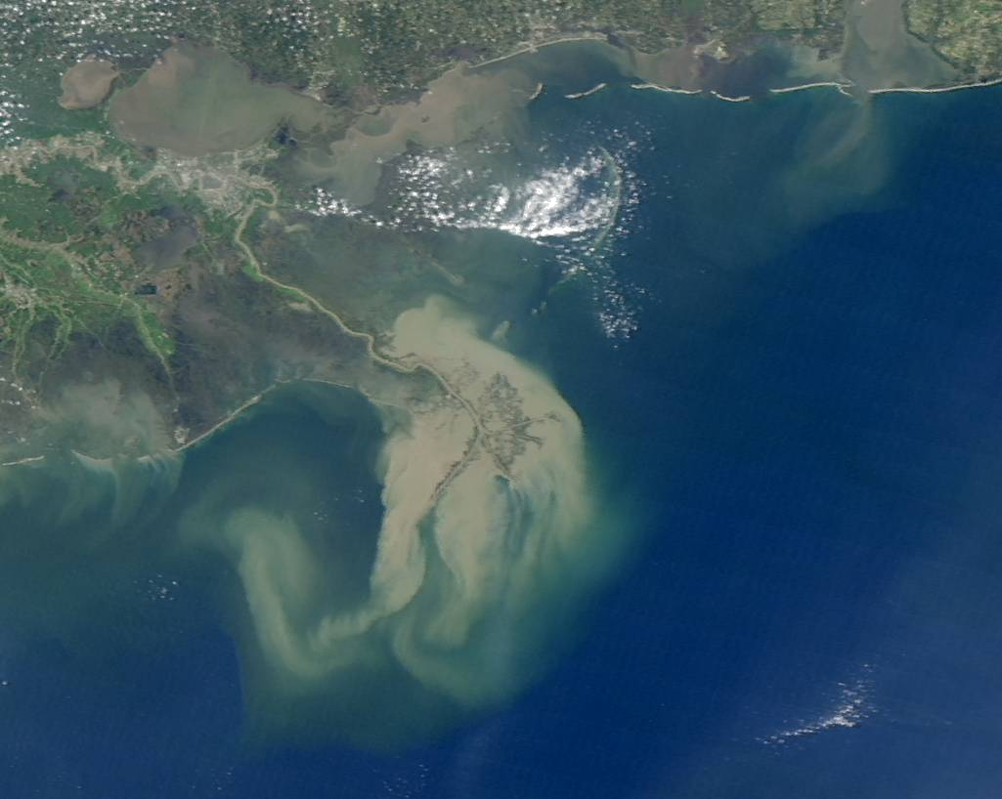
Coastal zones are difficult to observe as they exhibit extreme environmental heterogeneity in both space and time. Coastal processes and phenomena (e.g., tides, eddies, phytoplankton blooms) are dynamic and ephemeral, often exhibiting considerable variability on sub-diurnal time scales. Episodic forcing associated with wind, freshwater run-off, and interactions with mesoscale circulation features can exert profound impacts on coastal ecosystems on relatively short time scales. Temporal evolution of sporadic phenomena such as sediment resuspension and transport cannot be resolved with existing satellite capabilities. Multiple sensor-looks per day are required to capture these changes and, can additionally remove tidal aliasing and mitigate cloud cover issues.
MODIS Aqua image of the Mississippi River delta and surrounding region showing widely contrasting water types
The optical complexity of coastal waters necessitates innovative approaches to improve the ability to characterize biogeochemical distributions and processes in coastal regimes. Our ability to characterize change in the coastal oceans is limited by our capacity to distinguish the complex mixture of in-water optical constituents (including phytoplankton pigments, particulate and dissolved organic carbon, and total suspended matter (TSM)) and by difficulties associated with atmospheric correction issues that can be severe over coastal waters. River runoff, suspended sediments, colored dissolved organic matter (CDOM), phytoplankton blooms and shallow water bottom reflectance all add to the complexity of the optical signal in coastal waters. Detailed radiometric inversions are required to discriminate among these water column constituents in the face of the competing signals from atmospheric constituents (e.g., complex aerosols of continental origin). As detailed above for the advanced global mission, current ocean color sensors provide inadequate spectral range and resolution. Continuous spectral coverage from at least 350nm to 1050nm is required, providing crucial UV, SWIR and fluorescence bands, with a spectral sample of at least 5 nm.
In coastal environments, phytoplankton composition and food web structure can vary dramatically. Understanding for these ecosystems requires rigorous classification and quantification techniques for different phytoplankton functional groups, such a, diatoms, coccolithophorids, and cyanobacteria (e.g., Trichodesmium). Algorithms have been successfully used to retrieve unique phytoplankton absorption spectra from hyperspectral reflectance spectra and these methods have shown promise for discriminating and quantifying harmful algal blooms in coastal waters. Information about phytoplankton size structure can also be derived from absorption spectra.
Coastal ecosystems are also spatially complex. Coastal phenomena occur on scales of many tens of meters to many kilometers in horizontal extent. Such spatial scales cannot be adequately resolved with the current generation of ocean color satellite sensors, which generally have a ground resolution on the order of 1 km.
As such, in order to better assess, understand and predict natural and anthropogenic-driven variability in coastal zones, there is a need for dedicated regional/coastal missions with high temporal coverage (sub-diurnal), spectral resolution (>20 bands with narrow bandwidth) and spatial resolution (< 1km). An effective approach for remote observation of complex, rapidly evolving, coastal ocean biological and biogeochemical properties will necessarily involve a hierarchical approach involving multiple platforms and sensors, improved algorithms, data fusion, and integration of observations with data assimilation and numerical modeling.
With regard to the identified need for multiple platforms and sensors, a constellation of ocean imagers with complementary capabilities and specifications is required to adequately address the diverse requirements of the global coastal research and applied user communities; the temporal component may not be fully addressed by implementation of a global hyperspectral imaging radiometer, as above, simply due to revisit issues. In this context, an international constellation of geostationary (GEO) hyperspectral imaging radiometers is a crucial need to provide global coastal coverage with the necessary high temporal revisits. NASA envisions contributing a sensor/platform (alone or as part of a mission of opportunity partnership with another U.S. federal agency) to this international effort to provide coverage of the global coastal oceans, joining other regional efforts such as the planned Geostationary Ocean Colour Imager (GOCI) on the COMS-1 platform from South Korea. If it is not possible to work with the international research community and space agencies to entice the international space agencies planning GEO missions to coordinate the locations, orbits, and data distribution, then a key alternative would be a single geostationary sensor and mission with a precessing orbit would provide researchers the ability to study short duration (<1-5 day) processes in low and mid-latitude global waters.
The constellation of regional GEO ocean imagers in turn needs to be part of a broader constellation with LEO ocean imagers as also called for by this plan, with broad, lower resolution global ocean coverage provided by a LEO hyperspectral imaging radiometer as described above, and a very high spatial resolution coastal zone imager as described below . Leveraging the inherent capabilities of both LEO and GEO orbits, a constellation of this type would provide nested global, regional, and local coastal and open ocean coverage with both high spatial and temporal resolution. This crucial nested ocean observing capability needs to be quickly built out and then sustained over time (ensuring smooth transition from R&D to operational agencies), with different international partners contributing individual elements, coordinating standards and cal/val strategies, sharing data, and avoiding gaps/redundancies under the auspices of a Global Earth Observing System of Systems (GEOSS).

In this time frame, opportunities for obtaining geostationary hyperspectral imagery in coastal regions should be pursued as a constellation, through either planning and development of a stand-alone mission or else as missions of opportunity, through a partnership with other U.S. federal agencies or international space agencies. These efforts should be supported by global regional process studies and the development of improved algorithms and ecosystem models for coastal environments. Sensor and mission design concepts, as detailed in the box above, should be initiated or continued immediately to ensure that any low technical readiness level components are identified and improvements for necessary technology development activities are made as necessary.
Immediate (1-5 years)

Proposed Requirements for a Geostationary Hyperspectral Imaging Radiometer

- Spectral coverage from ~ 350nm to 1050nm with 1300nm goal on a single 2-D detector array
- Spectral sampling of 2 to 4 nm desired
- Complete regional coastal coverage (e.g., CONUS) 4 times per day minimum
- Regional repeats > 10 times per 6 hours.
- Event coverage at 15 minute intervals
- Spatial foot print 50 to 200 m NADIR with >1000 element swath
- Signal to noise ratio (SNR) 500-1500 minimum. SNR with image summing > 3000
- High dynamic range >14-bit digitization augmented with variable integration time.
- Sun glint avoidance; narrow FOV, advanced algorithms and flexible viewing times
- Cloud avoidance with flexible viewing times.
- Minimal polarization sensitivity/change < 0.2 %
- Minimal stray light with narrow FOV optics and low scatter gratings < 0.1%
- No image stripping or image latency
- Solar and lunar on-orbit calibration
- Geostationary orbit maximizes temporal coverage.

Proposed Implementation Timeline:

Successful deployment of Regional Geostationary Hyperspectral Imaging Radiometers by NASA (or in partnership with other U.S. federal agencies or international space agencies) should occur in this time frame with extensive research and end-user applications initiated. This contribution is intended to be part of a broader international constellation of geostationary ocean imagers that will provide high temporal revisits for global coastal waters.
Near-term (5-10 years)
Over this time period, a suite of several second-generation hyperspectral coastal ocean imagers in non-Low Earth Orbit (LEO) should be established, providing a constellation from which the evolving coastal ocean can be observed globally. This constellation of satellites could be deployed in a variety of orbit configurations including GEO and /or MEO, complementing ongoing global ocean imaging radiometers and a high spatial resolution coastal zone imagers situated in LEO.

Long-term (10-25 years)
- 3. Multi-Spectral High Spatial Resolution Imager
Nearshore ecosystems and habitats are at the boundary between land and ocean and are continuously subject to both natural and anthropogenic sources of change. Change in these nearshore environments can be caused by land-ocean interaction processes such as river runoff and coastal erosion and easily altered by human activities. Runoff from land can include a variety of toxins, including oil, into the nearshore waters. Re-suspension of sediments in coastal harbors, for example, can release toxic materials increasing the load of toxic chemicals in the water column. These materials can also influence light penetration in the water column inhibiting the growth of photosynthetic algae and seaweeds. Nearshore ecosystems are also unique as organisms can act to structure the environment and provide habitat for diverse communities. Examples of habitat forming species include coral reefs, kelp beds, mangrove swamps, algal mats and sea grass beds. Many of the same considerations presented here pertain to upland riparian habitats which are hydrologically connected to the coastal ocean.
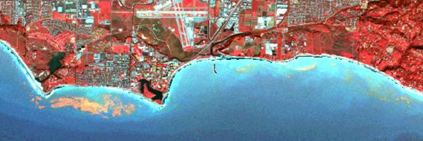
SPOT 5 false color 10 m composite image of the Santa Barbara coast near UC Santa Barbara from October 10, 2005. SPOT 5 green, red and NIR bands are used to construct the color composite image. The red-orange features in the nearshore waters are kelp canopy cover classified using the red and NIR bands. The light blue colors show reflections off the sandy bottom illustrating the use of this observational strategy for measuring bathymetric distributions and substrate type in optically shallow waters.

The remote assessment of nearshore environments is inherently difficult as the spatial scales over which these ecological communities and habitats are organized range from a couple of meters to many kilometers. To examine these processes, one must employ new tools made to deal with the difficulties involved with the passive measurements of ocean color, but now at spatial scales several hundred times smaller. One way to achieve these requirements is to implement a high spatial resolution, multi-spectral imager capable of achieving typical ocean color SNR levels. This high spectral resolution ocean color imagery would have many distinct wavebands from the UV through the NIR (including natural fluorescence bands), provide accurate atmospheric correction, high spatial resolution (to less than 10 m), allow rapid repeat coverage of a given site and the capability to follow a coastline (or river), stare at a given location and adjust its mission in response to clouds. These requirements provide a trade space from which future high spatial resolution ocean color missions will be developed.

Proposed Implementation Timeline:

Only moderate resolution imagery will be freely available over this time frame. High resolution imaging from commercial high spatial resolution sensors remains costly and beyond routine scientific use. The high resolution MODIS bands have some value for understanding nearshore environments, but they are relatively insensitive to changes in reflectance of coastal waters. Further, NPP/VIIRS, expected to be launched in the 2008-2009 time frame, will have a nadir ground resolution of ~750 m. With these resolutions, a potential exists for basic studies of suspended sediments, shallow bottom types, and sea surface temperature. Opportunities should be sought to use available high resolution commercial remote sensing data, such as SPOT, IKONOS, Quikbird, etc., for NASA research applications using a data-buy framework.

Immediate (1-5 years)

An advanced multi-spectral, high resolution global mission is envisioned late in this time frame and will have roughly 20 spectral bands from the violet to the NIR, with a few additional bands in the SWIR (or even the TIR). An effective approach must be developed as part of this effort to achieve research quality atmospheric corrections. Spatial scales should be better than 100 m for benthic habitat characterization at the community level, with 10 to 20 m resolution optimal. Swath widths would be no less than 100 km allowing regional scale sampling. This multi-spectral, high resolution global mission would provide global sampling and an ability to follow coastlines.

Near-term (5-10 years)

Long-term (10-25 years): A second generation hyperspectral imager and an ocean-aerosol lidar should be flown together. An additional aerosol sensor such as a polarimeter should be included to provide additional off-nadir estimates of aerosol characteristics and distributions.

Long-term (10-25 years)

4.Portable Sensors from Suborbital Platforms

Imagery with spatial resolution of meters or less is critical for mapping and tracking fine-scale features along coastal margins, including river plumes, flooded land regions, and seafloor features. Hazardous and episodic events require repeat sampling on the order of hours and not days or weeks, and require an imaging platform that can be used under cloud cover. Inland lakes, rivers, and coastal estuaries are also difficult to monitor at spatial scales available from space-based sensors. Sometimes, the most effective approach is not to sample from space orbiting platforms but from suborbital elevations.

Portable sensors flown on aircraft or unmanned aerial vehicles (UAV’s) provide a critical sampling niche distinct from satellite-borne sensors that is particularly well suited for coastal applications and ice research. NASA has long been the leader in developing and deploying sub-orbital remote sensing platforms. Airborne sensors can sample at fine spatial scales (meters), have minimal atmospheric correction issues due to low altitude flights, can operate under clouds and with nearly unlimited repeat coverage, and are effective platforms for high-resolution active sensors (e.g., lidar). UAV flight lines and scanning geometries can also be oriented to optimize retrievals (e.g., avoid sun glint) and their range can be greatly expanded by launching from ships. .

UAVs can be used to support weather forecasting, hazard and coastal water quality assessment, inland flooding, coastline topography mapping, and harbor and shipping lane management. Two different prototype sensors with demonstrated utility are coastal lidars and imaging spectroscopy. Portable coastal lidars are an important tool for mapping vertical and horizontal topographic features along the coastal zone at spatial resolutions far surpassing satellite-measurements. These lidars can also differentiate seafloor properties in shallow water based on bottom brightness and spatial roughness. Measurements made by NASA’s Experimental Advanced Airborne Research Lidar (EAARL) have an elevation accuracy of <10 cm and horizontal accuracy of 40 cm and have been successfully used to map bathymetric features, beach erosion, coral reefs, and coastal vegetation. EAARL is a prototype for portable lidar sensors that could be deployed along coastlines to monitor temporal events, such as beach erosion or breaching.

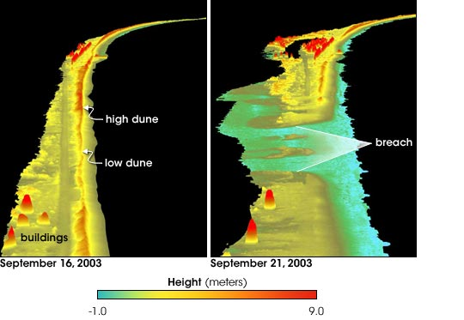
NASA’s Experimental Advanced Airborne Research Lidar shows where sand and buildings on Hatteras Island disappeared in the wake of Hurricane Isabel
Portable imaging spectrometers, such as NASA’s Airborne Visible/Infrared Imaging Spectrometer (AVIRIS) and the Portable Hyperspectral Imager for Low Light Spectroscopy (PHILLS), provide the ability to monitor dense algal blooms or red tides, bathymetry, and seafloor features. Imaging spectroscopy has powerful applications for both habitat and hazard monitoring in coastal regions. PHILLS-type sensors allow operation under low-light conditions and provide high signal-to-noise data over a wide dynamic range. PHILLS has been used to map shallow water bathymetry and bottom seagrass habitats in the Bahamas Banks both before and after Hurricane Floyd. The AVIRIS sensor was designed for land targets, but has also been successfully deployed in a variety of coastal regimes. For example, AVIRIS imagery has been successfully employed to study dense algal blooms or red tides in Monterey Bay.

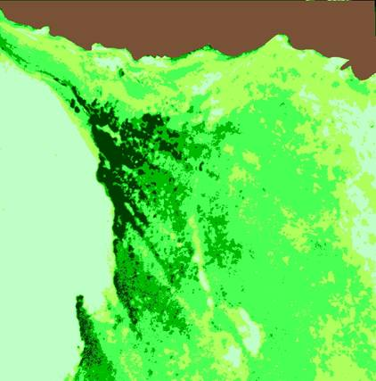
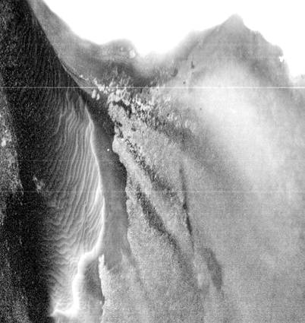
31 May 1999
A
B
Seagrass Leaf Area Index (LAI) and B) shallow water bathymetry 0-6 m estimated from the PHILLS sensor at Lee Stocking Island, Bahamas.

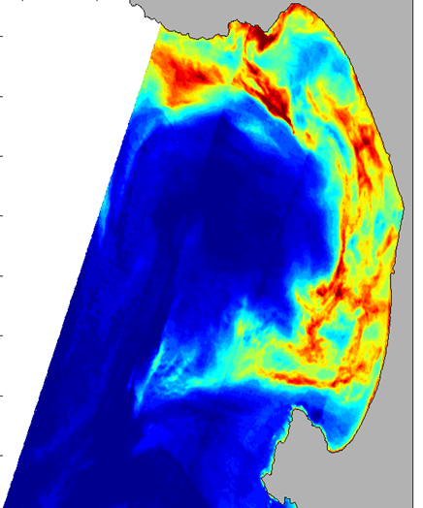
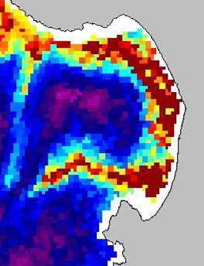
A dense algal bloom or red tide in Monterey Bay measured from C) SeaWiFS satellite imagery at 1 km resolution and D) AVIRIS airborne imager at 30 m resolution

D
C

Measurements from portable sensors flown from suborbital platforms will greatly enhance our ability to monitor and respond to changes in the dynamic and heavily populated coastal zone. Moreover, the fine-scale resolution will be critical for studying inland waterways and assessing the extent and depth of inland flooding. Repeat surveys on hourly or shorter time scales can aid in mitigating hazards or be useful for adaptive sampling of ship-based ocean or limnological research. The UAV platform will be portable and allow for aerial surveys with a variety of different detectors and sensors. This will facilitate development and testing of new sensor technology that could be considered for future satellite missions and algorithm development.

Proposed Implementation Timeline:

Continued development of airborne lidar and imaging systems for algorithm and technology improvement in coastal waters. Develop partnerships with science and technology groups at NASA to develop strategies for sub-orbital platforms for use in understanding habitats and hazards in coastal ecosystems.

Immediate (1-5 years)

UAV fleet development with portable sensors deployable throughout the globe at short notice to track hazardous spills, storm surges, changes in critical coastal habitats, red tides, and shipping lanes. Development activities include optimization algorithms for UAV deployment.
Long-term (10-25 years)
Develop and implement portable sensor technologies which can be deployed on Unmanned Aerial Vehicles (UAV). Deploy the prototype coastal ocean habitat / hazard UAV system.

Near-term (5-10 years)
- 5.Fluorescence Lidar
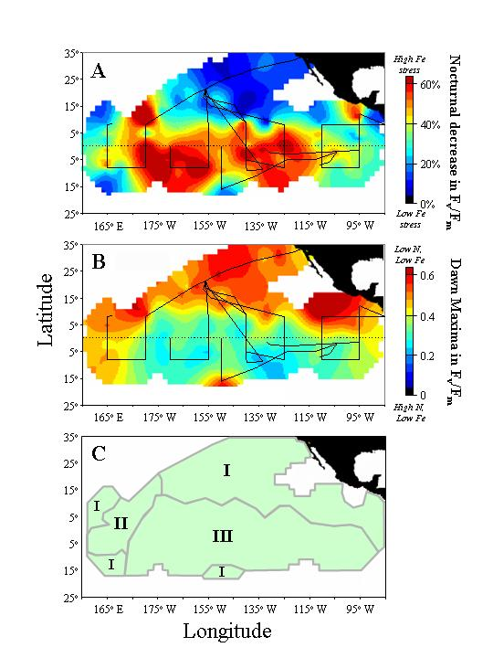
(panel A) Nocturnal decreases in Fv/Fm in the tropical Pacific. Warm values indicate iron limited populations. (panel B) Dawn values of Fv/Fm. Cool values correspond to iron limitation in the presence of high macronutrients. (panel C) Three physiological provinces defined by variable fluorescence.
Quantifying phytoplankton growth rates is an essential aspect of ocean productivity modeling. Unfortunately, phytoplankton growth rates are not directly detectable from space. However, changes in phytoplankton growth rate are associated with altered levels of ‘cell greenness’. This ‘greenness’ response appears to behave in a consistent manner under a variety of environmental conditions, although a few stresses create unique behaviors . One of these conditions is iron-limited growth in the presence of high macronutrient concentrations [e.g., High Nutrient, Low Chlorophyll (HNLC) environments]. In HNLC regions, phytoplankton respond to iron stress by over-expressing pigment synthesis and then binding these pigments into non-functional protein complexes that can later be used to rapidly create active photosynthetic units in the event that new available iron is encountered.

One consequence of the low-iron, high-macronutrient physiological response is that the enhanced pigment levels give phytoplankton a false appearance of high growth rates. This condition must therefore be accounted for in any remote sensing assessment of growth rate based on ‘greenness’ indices. A second consequence of this unique acclimation strategy is that the phytoplankton exhibit exceptionally high fluorescence yields (due to the photochemically incompetent nature of the special pigment-protein complexes). As a result, HNLC regions characteristically exhibit persistently low variable fluorescence values (F_{v}/F_{m}) and large nocturnal decreases in F_{v}/F_{m}. Remote sensing assessments of F_{v}/F_{m} can thereby provide a means for globally defining HNLC conditions, monitoring temporal shifts in physiological province boundaries, and establishing functional links between new iron inputs (e.g., dust deposition events) and ecosystem responses.

Variable fluorescence has been measured in the field for > 20 years and recently, through NASA support, has been successfully demonstrated from aircraft. For space-based applications, the ‘pump and probe’ technique employed for these airborne tests will need to be modified to reduce lidar energy demands and to meet eye safety requirements. Technological approaches for solving these issues are already under development.

Globally defining and monitoring physiological provinces through satellite variable fluorescence measurements will require distinguishing F_{v}/F_{m} values between 0.10 and 0.65 to ~0.05 units. Product spatial resolution requirements are coarse (10 to 30 km), allowing aggregation of multiple lidar returns to improve signal to noise ratios. Measurements should be conducted both at midnight and at dawn to determine maximal F_{v}/F_{m} and the relative nocturnal percent decrease in F_{v}/F_{m} (both critical diagnostics). This approach would require two satellites and would also provide information on the degree of midday light inhibition of photosynthetic electron transport. The excitation laser wavelength must penetrate a wide range of ocean waters (e.g., 532 nm from a Nd:Yg laser) and be effectively absorbed by chlorophyll. Simultaneous Raman measurements at 651 nm are also required for baseline signal calibration. Additional capabilities for detected fluorescence at high spectral resolution (1-2 nm) would expand the utility of the lidar measurements by allowing detection of specific phytoplankton groups through taxon-specific fluorescence features.

Proposed Implementation Timeline:
Modification of current pump-and-probe technique to enable space-based variable fluorescence at lower, eye-safe laser energies. Supporting research and analysis further investigating the physiological consequences and response to iron stress. Investigations using field F_{v}/F_{m} data and advanced satellite solar stimulated fluorescence data for roughly defining physiological regions.

Immediate (1-5 years)

High altitude airborne testing of new variable fluorescence technology in HNLC regions, oligotrophic waters, and turbid coastal regions with parallel field measurements to verify remotely retrieved values of F_{v}/F_{m} products. Studies should include both dawn and midnight F_{v}/F_{m} measurements.
Near-term (5-10 years)
Global lidar variable fluorescence mission to assess seasonal to inter-annual variations in physiological provinces. Measurements to be conducted using fixed nadir lidars on two satellite platforms with non-repeating orbits that yield global data at month- to seasonal time scales, with the first instrument focused on dawn F_{v}/F_{m} assessment and the second instrument focused on midnight sampling. The variable fluorescence mission must be conducted in parallel with an advanced ocean color mission, with a well-developed implementation plan for integrated global F_{v}/F_{m} information into model assessments of ocean net primary productivity.
Long-term (10-25 years)
- 6.Mixed Layer Depth and Illumination Sensor

For almost all of the open sea, the upper layer of the ocean is well mixed due to air-sea exchanges of buoyancy and momentum. Within this well mixed zone, the vertical distribution of all physical, chemical and biological variables are homogenized. Oceanographers refer to this zone as the mixed layer and its depth is called the mixed layer depth (MLD). Knowledge of the MLD is essential for many branches of oceanography as it controls the depth range over which air-sea exchanges of heat and momentum are averaged over and it controls the depth range over which organisms and chemical constituents are mixed. Values of MLD can range from practically nothing to more than 500 m and it can vary on time scales from hours to seasons. Of particular importance are the large changes in MLD associated with the seasonal cycle of heating and cooling. From mid-latitudes to high latitudes, mixed layer depths can vary from several meters to many hundreds of meters over the seasonal cycle. This alters the depth range over which biological and biogeochemical constituents are found in the upper ocean – and are sampled using satellite remote sensed technologies. Hence, knowledge of mixed layer depth and its temporal changes over all relevant space and time scales is critical for the NASA OBB program.

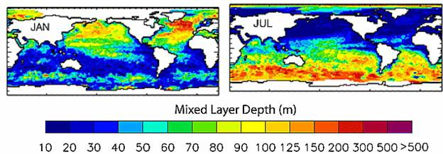
Monthly mean mixed layer depth climatology from hydrographic profile observations for January (left panel) and July (right panel). Analysis from de Boyer Montégut et al. [2004] (JGR-Oceans). Note that monthly mean MLD values range from 10 to more than 500 m.

Primary production cannot occur without light and there exist a host of other biological and biogeochemical processes that are similarly regulated by the flux and spectral quality of available light. The depth of the mixed layer – along with the optical clarity of the mixed layer and the light flux at the sea surface – are the first order determinants of the amount of light available to drive marine photoprocesses. Thus, the goal of assessment of mixed layer depth should be integrated with that for determining available light (both magnitude and spectral quality) that drives ocean biological and biogeochemical processes.

Primary production in the surface mixed layer is not simply a function of light level, but also light quality. This spectral dependence of a biogeochemical flux is even more important for photochemical reactions such as the production of many radiatively important trace gases (CO, DMS, CO₂, COS, etc.). For primary productivity, the spectral component is most important in the visible wavebands (PAR), while photochemical reactions are generally regulated by the flux of ultraviolet radiation. Energy budgets or ‘solar heating’ studies require knowledge of the entire solar spectrum and its diminishment within depth, including near infrared wavebands. Hence, the assessment of available radiation with the upper ocean mixed layer must consider the spectral quality of light.

Success in many of NASA’s Earth science objectives is dependent on the characterization of ocean mixed layer depths and their variability. This observational strategy aims to develop capabilities to assess mixed layer depth values and its variation over time and to determine mean light levels for this layer from the UV to NIR. The goal is to resolve MLD values and mixed layer light levels on horizontal scales of <10 km and temporal scales from daily to decadal. Achieving these objectives globally requires accurate knowledge of three data quantities: MLD, incident irradiance, and spectral light attenuation. The various approaches outlined below evolve from a synthesis of current remote sensing and field observations in a numerical modeling framework to the development of potentially new remote sensing technology.

Fortunately, two of the necessary pieces are already largely in place; global maps of incident light fluxes in the PAR and UV bands and models relating remote sensing products to the spectral transmission of solar radiation through the water column. Assimilation of field observations into data assimilation models of the physical ocean environment can provide a first order treatment of the third piece: MLD. Climatological assessments of mixed layer depth can be derived from hydrographic data and a capacity for determining MLD is well underway in development of operational oceanographic data systems. Another path involves the application of remotely sensed geophysical parameters (e.g., winds, heat fluxes, E-P, currents, SSH, SSS, etc) in the 1-D modeling of MLD. Here, 1-D mixed layer models are driven using appropriate air-sea exchange factors to obtain the time evolution of MLD driven only by remote sensing data sets. A difficulty remains that these data sources are not routinely synthesized to produce data products on the proper space and time scales. The synthesis of available data and forecast products is the first step in this observational strategy.

Alternatives for remotely assessing MLD have not been well investigated yet. Evaluating empirical relationships between MLD and biological (e.g., phytoplankton Chl:C ratios) or chemical (CDOM or other remote sensible photochemical products) stocks may be one way to get at MLD from space-based observations. Here, regional assessments of the dynamic relationships among particular ocean optical properties and mixed layer light levels are used to solve for the required mixed layer depth. New research is required to determine the validity and general applicability of this approach. This approach may involve active techniques for directly measuring MLD from space. For example, laser emission/excitation spectroscopy could be developed to determine upper ocean concentrations of rapidly evolving photochemical species. By knowing the light driven kinetics of this chemical species and examining differences in its concentrations at different times of day, estimates of MLD may be derived. Clearly, this is an area where technical advancements are needed.

Proposed Implementation Timeline:

Assess MLD and ML light by synthesizing operational oceanographic forecast fields (GODAE, FNOC, Mercator, etc.) and remote sensing data sets from NASA ocean color processing team and TOMS. Improve algorithms for incident solar fluxes and transmission of spectral irradiance to depth and direct assessment of MLD using remote optical means. Validate products using autonomously profiling float observations (i.e., PALACE floats).

Immediate (1-5 years)

Develop means for detecting mixed layer depth from space using changes in optical properties over time. Develop prototype for directly assessing MLD from space.
Near-term (5-10 years)
Implement flight model for directly assessing MLD from space.
Long-term (10-25 years)
- 7.Ocean Particle Profiler and Aerosol Column Distributions

Vertical changes in light scattering properties measured through the atmosphere and into the ocean from a space-based lidar can provide important new information for solving major ocean carbon and biogeochemistry science questions. Future missions targeting retrieval of geophysical parameters related to ocean elemental cycles through measurements of water-leaving radiances are critically dependent on accurate atmospheric corrections. Accounting for the contribution of absorbing aerosols to top-of-atmosphere radiances is particularly important and requires information on their vertical distributions as well as total optical thickness. Lidar measurements, both ground-based (e.g., Micropulse) and space-based (e.g., GLAS), have been shown to provide information on vertical aerosol structure at a resolution well beyond that necessary for ocean applications (<0.5 km). Lidar aerosol profiling measurements simultaneous with passive radiometric data will enable unsurpassed atmospheric corrections and consequently vastly improved ocean geophysical parameters.

In addition to aerosol assessments, lidar measurements can provide an independent, active measure of subsurface light scattering properties that can be utilized to constrain parameters in spectral matching models applied to passive radiometer data. Subsurface light scattering can be measured at 532 nm and 355 nm, the second and third doublings of a Nd:Yg laser. Demonstrations of the technique have been repeatedly conducted from airborne platforms and have also been accomplished from space during the 1994 LITE experiments on the Space Shuttle. For retrieval of light scattering coefficients (m⁻¹), subsurface profiles with a minimum of two distinct depths are necessary (additional depths preferable). Radiative transfer modeling and observational data indicate that with an 100 mJ eye-safe Nd:Yg laser at an altitude of 600 km, sufficient subsurface scattering values can be retrieved to >15 m in clear ocean waters and to 5 meters in turbid coastal waters. To cover this full range of optical conditions, therefore, space-based measurements will require 1 – 2 m vertical resolution and a lidar angle of incidence of 15º relative to nadir (to avoid detector saturation at the surface).

Proposed Implementation Timeline:

Integration of CALIPSO lidar aerosol data into global atmospheric transport models to derive global aerosol height fields. Application of these new aerosol data into advanced atmospheric correction model for MODIS data to demonstrate improvements in product retrievals. Theoretical and field based analysis of lidar subsurface profiling data for retrieval of particulate backscatter and/or particulate beam attenuation coefficients.

Immediate (1-5 years)

Addition of proof-of-concept nadir looking aerosol/subsurface lidar to advanced ocean color sensor platform. Development of tailored atmospheric transport model for application of lidar data into ocean color atmospheric correction model. Integration of retrieved in-water particle scattering coefficients into spectral matching algorithms. Possible addition of dedicated polarimeter to complement lidar atmosphere aerosol data and allow better spatial extrapolation of swath of advanced ocean color radiometer.
Near-term (5-10 years)
Global daily lidar coverage of atmospheric absorbing aerosols, to include height, column thickness, and aerosol properties (classes/composition). Measurement may entail advanced scanning lidar technology or series of multi-angle individual lidars. Aerosol data distributed across multiple ocean remote sensing programs to provide accurate atmospheric corrections for geostationary and polar orbiting measurements.

Long-term (10-25 years)

Supporting In Situ & Space-Based Measurements

Simply stated, the determination of ocean biological and biogeochemical quantities from low earth orbit has proven to be a difficult task. More than 90% of the passive optical signal measured on-orbit is derived from atmospheric scattering and is not the light emitted from the ocean. Hence, satellite ocean color observations need to accurately determine a very small ocean signal from a nearly overwhelming atmospheric one. Moreover, the signals associated with long-term trends can be very, very small making the accurate detection of long term changes especially difficult. Most of the proposed observational strategies, with the exception of suborbital surveys, involve delicate optical instruments that are launched into orbit by massive rockets and subjected to huge accelerations and vibrations and a hostile space environment. These factors compromise the validity of pre-launch calibrations for processing the resulting data streams.

Clearly, the proposed measurement strategies require an in situ observation program aimed at providing vicarious calibration of the orbiting instrumentation, validating the quality of the on-going observations and providing a path of improving the quality and utility of the space-based measurements. This requires an in situ observational program linked to the satellite-based science program and a calibration/validation (or cal/val) program similar to the SIMBIOS program conducted by NASA and its international partners. To contribute to this kind of cal/val activity, one must:

  - accurately sample relevant observables,
  - make these observations across a wide range of biological and biogeochemical provinces,
  - relate the in situ observations to known community measurement standards,
  - provide these in situ data to a centralized data center where the data sets are synthesized into global data sets and compared with satellite observations,
  - compare vicarious instrument calibration results with on-orbit methods (such as lunar or solar viewing) and
  - push the envelope of what can be measured and how well these observations can be made.

This requires continued investment in coordinated field observations, new instrumentation aimed to support present and future satellite observables, the production and dissemination of calibration standards for all investigators, and the free, open, and easy access of all data collected in support of the cal/val program.

The ocean biology and biogeochemistry program must insure that the proper context is available for assessing change. For example, ecosystems respond to ecological disturbances over scales ranging from hours to decades. We need to characterize and understand sources of disturbance simultaneously with our direct OBB measurements. This requires a host of supporting measurements that are traditionally used in other fields. Supporting space-based, physical oceanographic measurements include sea surface temperature, sea level, vector winds, surface waves and salinity. Similarly for NASA OBB investigators working in polar regions, knowledge of the extent, thickness and duration of sea ice and terrestrial ice sheets are extremely important for interpreting their data sets. In coastal environments, knowledge of nearshore bathymetry and land/ocean interactions are important. Some of these observations can be made from space or sub-orbital platforms (UAVs) using passive radiometry, Synthetic Aperture Radar (SAR) or lidar techniques. Other useful non-oceanographic, space-borne observations include aerosol distributions and composition, mineral dust deposition and greenhouse gas concentrations, such as carbon dioxide. Continuity of these important supporting measurements (as well as others not mentioned here in the interest of space) is extremely important to the NASA OBB program. A broad suite of in situ measurements are also needed to complement and extend the utility of these space-based measurements, particularly to characterize important ecological parameters which can not be measured directly from space, or else measures at depth. These are anticipated to be collected at least in part through ongoing GOOS/IOOS efforts as well as the developing ORION Program.

Table: Examples of Supporting Space-Based Measurements

Supporting Measurement | OBB Program Use | Existing & Planned Missions
Sea surface temperature | Oceanographic context | AVHRR, VIIRS, TMI
Sea surface height | Oceanographic context | JASON-1, GFO, ERS-2
Sea ice cover & thickness | Oceanographic context in polar regions | AMSR-E, RadarSat, ERS
Sea surface salinity | Oceanographic context | Aquarius
Vector winds | Wind forcing | QuikScat
River discharge and plume extent | Land-ocean interactions | SAR, Radar Altimetry
Atmospheric column CO₂ concentration | Air-sea CO₂ fluxes | OCO
Aerosol type & abundance distributions | Mineral dust abundances & deposition | MODIS, CALIPSO, GLORY
UV radiation | Ecosystem forcing,  Atmospheric correction | TOMS

Systematic Observations

Analyses of continuous, high quality time series of Earth observations are critical to detail natural or anthropogenic climate variability and change taking place within the Earth System. However, for these analyses to take place, careful mission planning is essential that embraces continuity of remotely-sensed observations for climate research, as well as sensor data inter-comparison and data product merging to produce and maintain continuous key product time series. Critical climate data products vary depending on the science questions being addressed, but stringent on-board and in situ calibration requirements (e.g., measurement errors) must be addressed for any remotely sensed property to be sufficient for climate research. Several space-based sensors currently meet these requirements for ocean biology and biogeochemical research, including SeaWiFS and MODIS on Aqua.

Both SeaWiFS and MODIS produce a phytoplankton chlorophyll data product, which has enabled improved understanding and prediction of phenomena such as the El Nino / Southern Oscillation events, which impacts fisheries throughout the Pacific. Other higher level data products, such as phytoplankton primary production, are also critical for understanding the long-term role of ocean biology in the global biogeochemical cycling of carbon and other elements within the earth system. Critical questions include:

- Which satellite-based data products must be maintained as systematic observations to create time-series records of essential ocean biology and biogeochemical variables?
- How do we ensure that a continued and overlapping sequence of space-based sensors are launched and operational such that an uninterrupted global data time-series is maintained beyond prime mission lifetime of the SeaWiFS and MODIS sensors?
- How will continuity of the new science-critical measurements proposed within this plan be achieved?

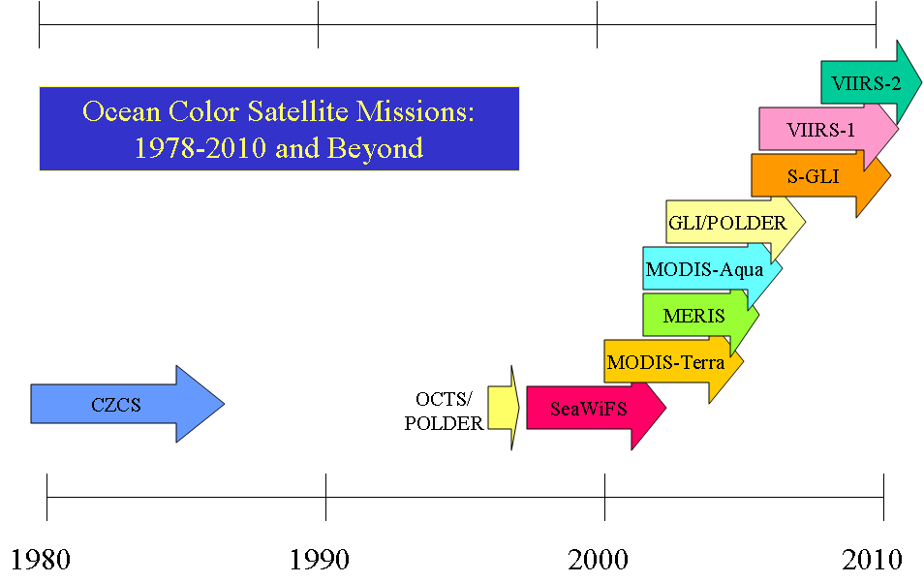
NASA has a responsibility to provide continuity of space-based research. This continuity is critical for oceanographers (and Earth scientists) if we are to continue our mission to understand and protect the home planet. Opportunities may be available with other U.S. Federal agencies, international space agency partners, and the commercial sector, but this budget and science planning must be carried out long in advance to prevent data gaps, something the ocean biology and biogeochemical research community now face. While VIIRS may provide continuity of the SeaWiFS-type biological observations beginning in the 2009 timeframe, the VIIRS data will not provide the next generation of space-based observations to address the science questions outlined in this plan.

A strategic plan must be in place to consider the continuity of space-based ocean biology and biogeochemical observations in parallel with other key property measurements of the Earth Science disciplines, including physical oceanography (sea surface temperature, sea surface height), atmospheric composition and radiation sciences (atmospheric temperature profiles), land cover/land use change (land surface temperature and terrestrial primary productivity), and others. While these measurements are critical to understanding processes in the open ocean and coastal areas, they are also primary observations for understanding atmospheric and terrestrial processes and must be maintained. Without them, our capability to understand and predict both natural and man-made events and impacts on a changing Earth will cease.

Research, Analysis and Modeling

The proposed future exploration of Earth’s oceans can lead to discoveries that enable basic research to address practical issues facing society today. Past decades of research based on measurements from historical missions have defined a path for the next generation of ocean biology and biogeochemical studies from space. Current sensors continue to contribute toward Earth System research questions, but they have limitations. It is NASA’s mission to facilitate research and planning to properly usher in the next generation of satellite sensors and inspire the next generation of researchers and explorers. Basic research in ocean biology and biogeochemistry at NASA, as well as interdisciplinary studies among other Earth Science fields has supported and led to the ideas contained in this plan.

Prior to a satellite being launched, funds are typically needed to characterize a sensor in the laboratory and ensure the behavior of the sensor on orbit will be understood by the mission operations team. While mission operations and data analysis funding is critical to make the raw sensor data usable by stakeholders, funds must be available to use the data in basic research by the broad science community. Analyses of space-based and in situ data must follow the launch of any satellite or sensor. Scientists should have the opportunity to diversify their research pursuits in order to enhance understanding and protection of the Earth. Funds should be available for sensor concept development and assessment prior to and during mission development. As data from an on orbit sensor are collected, quality controlled, and archived for analysis (including data product algorithm validation), an interface with the modeling community must exist to facilitate assimilation and modeling. This is particularly important within the Earth System Modeling Framework.

As NASA’s Modeling, Analysis, and Prediction program grows in scope, it is critical to ensure that the ecological, biogeochemical, climate and other modeling communities are aware of the ongoing efforts and have access to facilities to properly enable effective collaborations. Earth System Scientists must have a vision to develop both coastal and global ocean ecological and biogeochemical models, and link them to the a common framework to better understand the Earth System as a whole. At the same time, we must recognize the shortcomings in modeling parameters and address these knowledge gaps with new sensors and measurements, as proposed here. Only through carefully planned collaboration and funding profiles can the modeling community succeed in effectively using the future science measurements proposed in this plan.

Lastly, emphasizing measurements without a tightly coupled modeling component is a serious deficiency for any observational strategy. Many of the observables suggested in the previous sections (e.g., mixed layer depth, phytoplankton physiology) have direct counterparts in numerical models. These model estimates may be the result of a simple empirical relationship or one of many interacting components in a coupled ecosystem model, but they provide an important validation data set for testing observational data fields. In the very near future, data assimilation models will incorporate available satellite and other data to produce complete fields without time or space gaps for a wide variety of model variables. This will enable a wide array of science questions to be addressed using available satellite data. Further, data assimilation models may provide information better suited for resource managers and policy makers. This future requires a systematic and coordinated interdisciplinary approach to modeling ocean biological and biogeochemical processes.

Education/Public Outreach

The study of Ocean Biology and Biogeochemistry from space has yielded important and vital scientific evidence for coupling between biological and physical processes, between ocean and land, and between Earth systems and human societies. The Space Act that established NASA charged the agency with the responsibility to convey these discoveries to all public audiences. NASA’s goals for education across the agency are to:

- Contribute to the development of the science, technology, engineering and mathematics (STEM) workforce in disciplines needed to achieve NASA’s strategic goals through a portfolio of programs,
- Attract and retain students in STEM disciplines through a progression of educational opportunities for students, teachers, and faculty, and
- Build strategic partnerships and linkages between STEM formal and informal education providers that promote STEM literacy and awareness of NASA’s mission.

The complexity of the Earth as a System presents unique opportunities for STEM education that in many cases transcends the traditional approach of teaching disciplinary science, i.e., Chemistry, Biology, Physics, Geology, etc. Research in Earth System Science at NASA has become increasingly multidisciplinary as well as increasingly focused on the societal benefits of research results, demanding collaboration of experts not only in traditional sciences, but also in social sciences, computational sciences, informational technology, policy, etc. NASA must continue efforts to encourage teaching of Earth System Science at all levels of formal education, ensuring that students learn the nature and importance of interactions between ocean and atmosphere and between ocean and land margins, as well as how humans interact with and shape the Earth’s systems. Earth System Science provides many engaging examples of broader science concepts recommended in the National Science Education Standards, such a Constancy, Change, and Measurement, and Systems, Order and Organization. NASA must play a key role in converting Ocean Biology and Biogeochemistry knowledge into formal and informal education settings.

The space observation program outlined in this document calls for a comprehensive plan of hardware, observations, and models to provide the tools necessary for prediction of change and responsible management of ecosystems and resources. A qualified STEM workforce will be required for success of this plan. NASA must continue to engage students and all levels to the extent that many choose careers in STEM, while at the same time promoting opportunities for students in underserved populations to ensure that the diversity of the future workforce reflects national demographics.

Essential Partnerships

NASA will continue to engage the international ocean science community in developing and advancing priority science questions, articulating observing requirements, pursuing partnerships in space-based sensor development and measurement capabilities, and in in situ program planning and development, particularly vicarious calibration and data product validation activities. These efforts are facilitated through such mechanisms as the NASA science and measurement team meetings, as well through involvement with international planning and coordination efforts, such as the Coastal and Ocean Themes of the Integrated Global Observing Strategy (IGOS), as well as the International Ocean Color Coordinating Group (IOCCG).

NASA participates in and contributes to various U.S. programs and activities (e.g., Climate Change Science Program, U.S. Ocean Action Plan committees, U.S. Integrated Earth Observation System), which implementation of this plan will support. The National Oceanographic Partnership Program (NOPP) helps to ensure that these contributions are shared across other federal agencies as appropriate. Additionally, NASA likewise partners with other U.S. agencies to promote operational implementation of research and development capabilities and results as deemed beneficial in support of user needs (as discussed further below).

In this manner this plan does not represent a stand-alone vision. Implementation of this strategic plan will represent a significant contribution in both research and technology development by NASA to an overarching global ocean observing system, and furthermore as part of the emerging Global Earth Observing System of Systems (GEOSS). Fundamental scientific discoveries will result, as well as significant benefits to society. In this broader observing system context this plan will both complement and leverage other space and in situ-based components of these systems, and as such broad partnership opportunities abound as briefly highlighted below.

Ocean observing systems (including the Ocean Observatories Initiative (OOI) and the Integrated Ocean Observing System (IOOS)), will be part of the U.S. contribution to the Global Ocean Observing System (GOOS) and part of the GEOSS, by definition will need to consist of integrated observations from both in situ and remote assets. This OBB plan contains a vision for novel, science-driven biological and biogeochemical measurements of the open and coastal ocean from space that will support fundamental research as well as enable new and improved user-driven applications. As such, partnerships that help bridge the space-based research and operational domains and facilitate the transition of knowledge and capabilities between these communities are envisioned; likewise cross-cutting community partnerships that foster linkage of remote sensing and in situ observations.

In particular, these proposed OBB measurements will complement and help significantly extend, enhance, and refine planned global operational ocean color measurements from space (e.g., VIIRS on NPOESS), as well as provide a way forward for the next generation of operational sensors that will build on knowledge and insights gained from pathfinder research sensors. A transfer of capabilities from NASA to respective operational agencies could take place as part of a serial, phased progression (e.g., similar to the “JASON” model for ocean surface topography measurements). Similar needs, challenges and opportunities exist for both continuity and ongoing improvement of supporting calibration and validation capabilities. For example, operational entities could potentially play the primary role in maintaining proven, robust vicarious calibration systems to ensure calibration measurement continuity, while research partners could in turn pursue development of the next-generation systems that provide enhanced functionality and performance to the extent that planned calibration measurements are of interest to NASA’s research efforts – with these systems transitioned over time as they become mature technologies, supporting corresponding space-based measurements.

All of the space-based observational strategies put forward in this plan need to be considered as part of a collaborative international constellation of sensors/platforms that will improve our understanding of ocean biology and biogeochemistry. This is particularly true with the global hyperspectral imaging radiometer, coordination of which with international space agencies respective global radiometric efforts may provide higher spatial coverage of the global oceans, and therefore improve predictive models. With regard to the geostationary, hyperspectral imaging radiometer observing strategy, an international constellation of regionally-focused imagers is a crucial need in order to provide global coastal coverage with the necessary high temporal revisits (IGOS, 2006). NASA could contribute one or more sensors/platforms (alone or as part of a mission of opportunity partnership with another U.S. federal or international space agency) to an international global effort that will join other regional efforts such as the planned Geostationary Ocean Colour Imager (GOCI) on the COMS-1 platform from South Korea.

Crucial, nested ocean observing capabilities in partnership with the international space research community and space agencies needs to be quickly built out and then sustained over time (while ensuring smooth transition from research to operational agencies), with different national and international partners contributing individual elements, coordinating standards and calibration/validation strategies, sharing data, and avoiding measurement gaps/redundancies under the auspices of the GEOSS.

Moving beyond a strictly disciplinary focus, there are opportunities to partner with other Earth observing programs, particularly within NASA. For example, there are significant benefits (and cost savings) to be gained by working with NASA’s Terrestrial Ecology Program scientists toward implementation of a high resolution coastal imager that can also be used to provide accurate vegetation cover assessments or resolve functional type mixtures. Likewise, accurate measurement of aerosol properties is a crucial element in support of ocean biological and biogeochemical observations, affording partnering opportunities with the atmospheric science community. Finally, Synthetic Aperture Radar (SAR) can provide important geophysical and ecologically-relevant information for ocean studies, and as such these needs should be considered in conjunction with those of the solid Earth and cryospheric science communities toward development of a mission that can satisfy these multiple requirements.

Space-based measurements of the type identified in this plan will also complement, extend (i.e., provide synoptic overview), and benefit (e.g., through validation, sub-surface measures) from ocean in situ point observations acquired as part of the IOOS/GOOS and through the NSF research-driven Ocean Research Interactive Observatory Networks (ORION) program, particularly in complex, dynamic (e.g., coastal) regions. Coordinated integration and assimilation of the remote and in situ measurements will enable accurate, synoptic three-dimensional characterizations of the ocean, contributing to an improved understanding of global and coastal marine ecosystem dynamics and better assessments and predictions of climate variability and change.

Summary

Standing on the shore of our terrestrial home to gaze at a horizon across the sea, we can begin to comprehend the shear vastness of the global oceans and understand how they play such a pivotal role in the functioning of our biosphere, the Earth. Under the shimmering or wavy surface we see to the blackened depths of the abyss, there exists another world teaming with life that remains largely undiscovered, but upon which we utterly depend. From the large to the microscopic, the plants and animals of our contemporary oceans each represent a pinnacle in a four billion year old evolutionary competition, but our understanding of their unique characteristics and roles in complex marine ecosystems remains rudimentary at best. We nevertheless rely on this diversity of organisms for producing oxygen that we breathe, processing our wastes, cleaning the air, providing food and recreation, and regulating climate. Yet the collapse of ecosystems under increasing human pressures has made it abundantly clear that our marine resources have a very finite resilience. These changes and those occurring from natural environmental variability can have severe consequences on our economy and quality of life. Understanding functional relationships within the living ocean, along with ocean-land-atmosphere feedbacks, represents a major challenge to the science community and one to which NASA is particularly well poised to contribute greatly.

A primary goal of ocean biological science is the mechanistic understanding and prediction of change in marine ecosystems, thereby advancing descriptions of ocean biogeochemical cycles and enabling informed national policy, improving resource management practices, and decreasing threats to our economy, health, safety, and national security. The global ocean is chronically under-sampled by field-based measurements due to its enormous size, making space-based measurements acquired by NASA and other national and international agencies particularly vital. Since the launch of the first NASA ocean-color sensor, CZCS, satellite-derived ocean biology products have truly led to a ‘renaissance’ in our understanding of the global ocean. However, our scientific and technological capabilities and discoveries have greatly outpaced the evolution of satellite ocean sensors. We now find ourselves in the unfortunate position where achieving our national goals for ocean sciences is limited by obsolete observational capabilities. The 25-year vision of the Ocean Biology and Biogeochemistry Working Group is to address this issue head-on and to head toward a capacity to functionally relate environmental change to ecological variability through a new generation of ocean remote sensing missions such that the consequences of a prolonged alteration or a new environmental threat can be predicted.

Important events in ocean ecosystems occur on spatial scales ranging from a few meters to thousands of kilometers and on time scales of hours to decades. Accordingly, a comprehensive understanding of ecosystem dynamics and their consequences requires an integration of observations over a wide range of scales and from a diversity of platforms. Global and regional satellite-based observations are absolutely essential to successful ocean biology and biogeochemistry research program, as well as local scale observations made in the laboratory and field. These ground-based studies provide the functional relationships that form the foundation of mechanistic ecosystem models. Already, our understanding at this more fundamental process-oriented level challenges our remote sensing capabilities and calls for a new generation of satellites and sensors with greatly superior spectral range and resolution, a diversity of spatial and temporal capabilities, and integration of active and passive approaches that have cross-disciplinary applications with the terrestrial and atmospheric science communities.

In this document, we identify four central scientific questions as top priorities for NASA’s Ocean Biology and Biogeochemistry Program for the next 25 years. These four questions encompass outstanding research issues that are of fundamental scientific importance, relevant to the health, economy, and security of the nation, and are linked to ocean properties that can be detected from space, and thus amenable to advances through developments in new remote sensing tools.

The four priority science questions for the NASA OBB program are:
- How are ocean ecosystems and the biodiversity they support influenced by climate or environmental variability and change, and how will these changes occur over time?
- How do carbon and other elements transition between ocean pools and pass through the Earth System, and how do these biogeochemical fluxes impact the ocean and Earth's climate over time?
- How (and why) is the diversity and geographical distribution of coastal marine habitats changing, and what are the implications for the well-being of human society?
- How do hazards and pollutants impact the hydrography and biology of the coastal zone? How do they affect us, and can we mitigate their effects?

These top priority questions should guide basic research and observational objectives for ocean biology and biogeochemistry over the coming decades. Specific expected accomplishments and benefits to the Nation are outlined in this document for each top question and will be realized as new measurements yield new understanding.

While cutting edge satellite missions are clearly the centerpiece and unique contribution of NASA to Earth system science, it would be difficult to overstress the importance of developing a broad comprehensive research program that integrates remote sensing with multi-level ground-based observations and modeling. Here, we outline an ambitious plan of ocean science objectives and measurements that in a variety of cases challenge our technological capabilities and in all cases demand exceptional instrument characterization and calibration, along with algorithm development and ground based validation of derived geophysical parameters. Requisite to this program, therefore, is a network of supporting field and laboratory studies involving NASA-specific components and partnerships with other programs and agencies. The new generation of ocean remote sensing missions will deliver a suite of ecosystem and biogeochemical parameters carefully aligned with key variables of ocean biogeochemical and ecosystem models. Co-evolution of next generation models that fully utilize these new observations is thus an integral aspect of the 25-year plan, and includes significant investment in computational capabilities for testing modeled geophysical fields and predictions.

The grand success of the first ocean color sensors (CZCS, SeaWiFS, MODIS) is something NASA can be proud of, but it has had an important negative consequence: it has obfuscated the vision of the ocean science community and science agencies. ‘Ocean color’ has become synonymous with the limited set of measurement wavebands observed with these ‘first generation’ sensors and many are ready to ‘close the book’ on ocean remote sensing and transition the science to ‘operational’ status. Although we may have tapped the potential of this generation of sensors, we have just begun to scratch the surface of the rich information still waiting to be mined from ocean remote sensing measurements. The plan recommended here for new space-based ocean observations represents a maturation of ocean remote sensing science that learns from- and builds upon the capabilities of ‘first generation’ sensors and allows NASA to meet the emerging scientific challenges of coming decades.

The recommended plan involves a range of new measurements that build toward a complementary measurement capability and map to four observational components, each of which addresses one or more of the four top priority questions listed above. The four recommended mission themes are:
- Global separation of in-water constituents and advanced atmospheric corrections
- High resolution coastal measurements
- Plant physiology and functional composition
- Mixed layer depth

Specific strategies for each component over a 25 year time-frame are divided into immediate (1 – 5 years), near-term (5 – 10 years), and long-term (10 – 25 years) goals. These recommendations are based on science urgency, technology readiness, and supporting value for subsequent measurement components. Thus, the four overarching science questions of top priority define the suite of geophysical parameters needed, which in turn dictates a succinct set and sequence of future sensors and ocean missions outlined as observational measurement strategies. The resultant time-resolved matrix of recommended missions and their relation to science questions and societal benefits is illustrated in the table on page 66 and the figure on page 64.

Over the next five years, the highest priority next generation ocean science observing need is the development of a 2-instrument global mission focused on the accurate separation of in-water constituents and correction for aerosol contributions to top-of-atmosphere radiances. Such a mission addresses most of the urgent problems with current remote sensing technologies and will make a significant contribution toward addressing important aspects of all four top priority science questions (table, p. 69). The mission also has strong synergistic potential for contributing to science objectives within the terrestrial and atmospheric disciplines. (To address urgent issues for ocean remote sensing, the immediate launch of a single instrument satellite with an advanced global-coverage radiometer may be an effective strategy if budgeting does not currently permit a multi-sensor mission, with addition of an aerosols platform following at a later date). Follow-on global ocean-aerosol missions with advanced measurement capabilities over the 5 to 25 year time-frame will further address outstanding issues regarding monitoring and modeling of ecosystems and elemental cycles and will contribute supporting observations for more focused, parallel ocean missions.

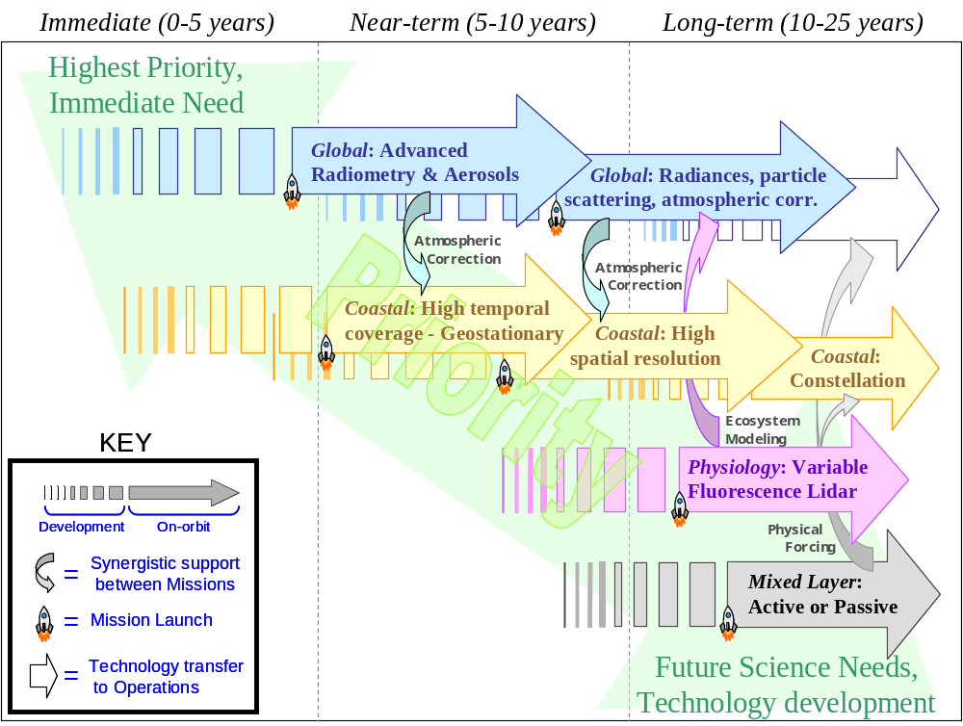

A constellation of at least three geostationary platforms and sensors on orbit are needed to survey biological and biogeochemical properties of global coastal waters, or, alternatively, a single geostationary sensor and mission with a precessing orbit would provide researchers the ability to study short duration (<1-5 day) processes in low and mid-latitude global waters. All geostationary sensors would require high temporal frequency, hyperspectral observations. In a constellation or precessing orbit, a hyperspectral imaging radiometer would resolve processes and phenomena and discriminate constituents on sub-daily time scales and at 200 m resolution (or better) at nadir, utilizing parallel Low-Earth-Orbit (LEO) aerosol distribution measurements for enhanced atmospheric correction. Significant progress toward this goal can be cost-effectively achieved in the next five to ten years either through NASA (1) developing a mission and observing strategy that would satisfy science requirements through the precessing orbit concept, (2) contributing a dedicated mission to an international constellation, or (3) leveraging a potential mission/platform of opportunity to an international constellation.

Third, there is a need for a multi-spectral high spatial resolution imager to observe coastal habitats and ecosystems on unprecedented scales and accuracies. This mission may occur either on a dedicated platform, via mission of opportunity or through a partnership within NASA or other U.S. agencies. A good opportunity is the NASA/USGS Landsat Data Continuity Mission (see the table on page 69). The deployment of newly developed portable sensors on UAV’s, to provide detailed information on nearshore coastal environments. In the 10 to 25 year timeframe, there is a need to develop a constellation of imaging spectrometers that will provide high spatial, temporal and spectral resolution visible spectral radiance observations of coastal zones from LEO, GEO, and/or MEO as well as sub-orbital platforms. These will leverage complementary aerosol distribution measurements as above for enhanced atmospheric corrections.

Also in the 10 to 25 year time frame, the recommended mission plan includes continued development and deployment of suborbital sensors and platforms, a sensor for measuring surface mixed layer depths and illumination, and a lidar mission focused on characterizing provincial distributions of specific growth limiting factors for phytoplankton. In both cases, substantial technological developments and prototype testing are required.

Ocean ecosystems, the habitats they occupy and create, and their biogeochemical cycles are extremely complex. Remote sensing alone will not unravel their secrets, dependencies, and feedbacks. A rigorous program of basic field and laboratory research operating in parallel with the new generation of ocean missions is essential. Synthesis of observational data and applications toward biospheric monitoring and prediction also requires substantial investments into advanced computing capabilities. Development of new measurement technologies are likewise accompanied by new requirements for computing, data storage, and distribution capabilities. Thus, each of the four observational components for ocean biology and biogeochemistry is accompanied by requirements for augmented ground-based observational, calibration-validation, and computing and modeling programs, along with educational activities.

Today we find ourselves standing on the threshold of profound breakthroughs in ocean biological sciences. Ushered in by the first generation ocean satellite missions, we have within the past decade realized major advances in our ability to resolve multiple in-water constituents from remote sensing data, related these to key components and rates within ocean ecosystems, and integrated this new information into advanced prognostic models. Over this same period, we have also seen tremendous technological developments that can enable the new measurements necessary to address the remaining top priority ocean science questions. Now we need to act. In the next 25 years, NASA can take the lead in creating new observational capabilities for ocean sciences that support our informed and careful stewardship of this blue planet. In doing so, we will make great strides toward lifting the veil on the ‘Unseen World’ and discover new knowledge of its functioning and how to better manage and protect this resource for future generations.
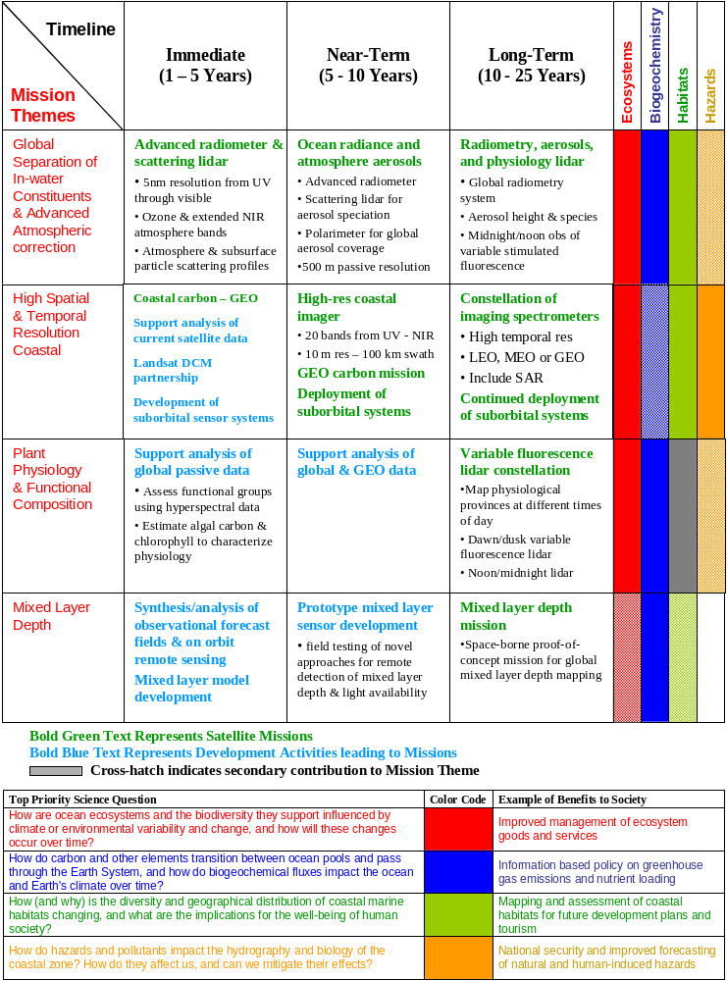

Figure Credits

*Figures within this draft volume are reproduced or utilized with permission of the author as specified below, or with permission pending from the author. Author’s refusal to grant permission for figure use or reproduction will result in the figure being immediately removed from this volume.

Pg 5 (top): Permission pending

Pg 5 (bottom): SCIENTIFIC AMERICAN, 08/2002. Permission pending

Pg 6 (top): http://shiftingbaselines.org/blog/archives/2004_11.html

Pg 6 (bottom): Permission pending

Pg 11: http://www.noc.soton.ac.uk/JRD/SCHOOL/mt/mt001b.html.

Pg 12: http://oceancolor.gsfc.nasa.gov/SeaWiFS/Gallery_Images/S19972442000244.L3m_CLI_CHLO.S19981821998212.L3m_MO_NDVI.moll.70W.jpg

Pg 13: http://disc.gsfc.nasa.gov/oceancolor/scifocus/oceanColor/nab.shtml

Pg 16 (top): Permission pending

Pg 16 (bottom): http://www.aosltd.com/

pg 17: http://www1.whoi.edu/general_info/gallery_modeling/index.html

pg 18: Behrenfeld: Unpublished Data

pg 19 (middle): Unpublished Data

pg 19 (bottom): M.J. Behrenfeld, E. Boss, D. A. Siegel & D. M. Shea 2005. Carbon-based ocean productivity and phytoplankton physiology from space. Global Biogeochem. Cycles, 19, GB1006, doi:10.1029/2004GB002299

pg 22: image courtesy of James Goodman, University of Puerto Rico

pg 23 (top): Results were validated with field measurements collected by University of South Florida and Florida International University researchers.

pg 23 (bottom): Results were validated with field measurements collected by University of South Florida and Florida International University researchers.

pg 24: Permission pending

Pg 27 (top): Permission pending

Pg 27 (bottom): Permission pending

Pg 28 (top): http://www.aims.gov.au/pages/about/communications/backgrounders/20020130-coral-bleaching.html

Pg 28 (bottom): (M. Kahru) http://spg.ucsd.edu/Satellite_Projects/MODIS_250m_data/MODIS_250m_data.htm)
(adapted from EDOCC, 2001)

Pg 39: Permission pending

Pg 42: "SPOT 5 10 m multispectral image of kelp cover produced by Kyle
Cavanaugh and David Siegel (UC Santa Barbara). SPOT data are copyrighted by
CNES 2005 and are distributed by Terra Image USA, LLC and SPOT IMAGE."

Pg 44: Images courtesy Asbury Sallenger and Amar Nayegandhi, USGS Center for Coastal and Watershed Studies, and Wayne Wright, NASA Wallops Flight Facility (http://www.nasa.gov/audience/foreducators/9-12/features/f_lidar.html)

Pg 45 (panel A,B): Dierssen, H.M., R.C. Zimmerman, R.A. Leathers, T.V. Downes, and C.O. Davis, Ocean color remote sensing of seagrass and bathymetry in the Bahamas Banks by high resolution airborne imagery, Limnol. Oceanogr., 48 (1, part 2), 444-455, 2003.

Pg 45 (panel C,D) Ryan, J., H.M. Dierssen, R.M. Kudela, C.A. Scholin, K.S. Johnson, J. Sullivan, A.M. Fischer, E. Rienecker, P. McEnaney, and F.P. Chavez, Coastal ocean physics and red tides: An example from Monterey Bay, California, Oceanography, 18 (2), 246-255, 2005.

Pg 47: Permission Pending

Pg 49: M.J. Behrenfeld, K. Worthington, Z. Kolber, R.M. Sherrell, F. Chavez, P. Strutton, M. McPhaden, D. Shea. 2006. Nutrient regulation of tropical Pacific Ocean productivity. Submitted.

Pg 54: Reproduced with permission from Dr. Watson Gregg, NASA Goddard Space Flight Center.

Table of Abbreviations & Acronyms
AERONET – Aerosol Robotic Network
ASTER - Advanced Spaceborne Thermal Emission and reflection Radiometer
AVIRIS - Airborne Visible/Infrared Imaging Spectrometer
CALIPSO - Cloud-Aerosol Lidar and Infrared Pathfinder Satellite Observation
CDOM – Colored dissolved organic material
CONUS – Continental Shelf f of the United States
CZCS - Coastal Zone Color Scanner
DOC - Dissolved Organic Carbon
EAARL - Experimental Advanced Airborne Research Lidar
ENSO - El Nino-Southern Oscillation
EOS - Earth Observing System
FOV – Field Of View
GDP – Gross Domestic Product
GEO - Geostationary Earth Orbit
GEOSS - Group on Earth Observations System of Systems
GLAS – Geoscience Laser Altimeter System
GMAO - Global Modeling and Assimilation Office
GOOS - Global Ocean Observing System
HNLC - High Nutrient, Low Chlorophyll
IOOS - Integrated Ocean Observing System
JAXA - Japanese Aerospace Exploration Agency
LEO - Low Earth Orbit
MEO – Medium Earth Orbit
MLD – Mixed Layer Depth
MAP - Modeling, Analysis and Prediction program
MODIS - Moderate Resolution Imaging Spectroradiometer
NACP - North American Carbon
NASA – National Aeronautics and Space Administration
NASDA - National Space Development Agency of Japan
NEON - National Ecological Observatory Network
NIR – Near Infrared
NOAA - National Oceanic and Atmospheric Administration
NOPP – National Oceanographic Partnership Program
NPOESS - National Polar-orbiting Operational Environmental Satellite System
NPP - NPOESS Preparatory Project
NPP - Net Primary Production
NSF - National Science Foundation
OBB – Ocean Biology and Biogeochemistry program
OCTS - Ocean Color and Temperature Scanner
ORION – Ocean Research Interactive Observatory Networks
PALACE - Profiling Autonomous LAgrangian Circulation Explorer
PAR – Photosynthetically Available Radiation
PHILLS - Portable Hyperspectral Imager for Low Light Spectroscopy
PIC - Particulate Inorganic Carbon
PIC - Particulate Organic Carbon
SAR - Synthetic Aperture Radar
SeaWiFS - Sea-viewing Wide Field-of-view Sensor
SIMBIOS - Sensor Intercomparison and Merger for Biological and Interdisciplinary Oceanic Studies
SNR – Signal to Noise Ratio
SPOT – Satellite Probatoire d’Observation de la Terre
SSH – Sea Surface Height
SSS - Sea Surface Salinity
SST - Sea Surface Temperature
STEM - Science, Technology, Engineering and Mathematics
SWIR – Short Wave Infrared Radiation
TIR – Thermal Infrared Radiation
TOMS – Total Ozone Mapping Sensor
TSM - Total Suspended Matter
UAV - Unmanned Aerial Vehicles
UV – Ultraviolet
VIIRS - Visible Infrared Imager/Radiometer Suite

Ocean Biology and Biogeochemistry Working Group

Michael Behrenfeld, Oregon State University
Paula Bontempi, NASA Headquarters
Heidi Dierssen, University of Connecticut – Avery Point
Paul DiGiacomo, NASA Jet Propulsion Laboratory*
Steven Lohrenz, University of Southern Mississippi
Charles McClain, NASA Goddard Space Flight Center
Frank Muller-Karger, University of South Florida
David Siegel, University of California – Santa Barbara

Thanks to:
Paula Coble, University of South Florida
Anthony Freeman, NASA Jet Propulsion Laboratory
Norman Nelson, University of California – Santa Barbara
Kari Risher, NASA Jet Propulsion Laboratory
James Yoder, Woods Hole Oceanographic Institution

*Currently at NOAA-NESDIS

Variable fluorescence is calculated as the change in fluorescence yield from an initial, dark adapted level (F_{o}) to a light saturated value (F_{m}), normalized to F_{m} (i.e., F_{v}/F_{m} = (F_{m}-F_{o})/F_{m}). Changes in F_{v}/F_{m} reflect changes in the efficiency of light utilization for photochemistry (i.e., photosynthesis). Nocturnal decrease in F_{v}/F_{m} result from respiratory electron transport in photosynthetic membranes and are exacerbated under iron limiting conditions due to insufficient concentrations of iron-dependent electron transport components.

