Solar and Wind Energy Resource Assessment

Draft User Guide for SWERA Geospatial Toolkit (GsT)

Introduction

Wind and solar energy are the fastest growing energy sources in the world because they are clean and renewable. Renewable energy sources are projected to balance the world’s energy demands in the face of dwindling conventional fossil energy resources. The Solar and Wind Energy Resource Assessment (SWERA) Geospatial Toolkit (GsT) is a map-based software application that can be used for decision making and policy analysis in addition to planning for future wind energy projects. The SWERA application utilizes Geographical Information Systems (GIS) to develop common scenarios to evaluate potential locations for solar or wind energy plants. The GsT has been tested and developed for use on the Windows 2000 and XP operating systems.

This document is intended to assist new SWERA GsT users with the program’s functionality. Additional information on solar and wind resource assessment data utilized in the toolkit can be obtained from the SWERA web site at http://swera.unep.net.

How to Use This Documentation

This document is intended to help a new user of the GsT get started. This document will walk the user through initial steps and how to execute the standard queries and produce visual and tabular results. Screenshots of the program are included to demonstrate the content. The numbered labels on some of the screenshots help to explain the steps described in that section.

Starting the SWERA Geospatial Toolkit

- Click the Start button on windows taskbar.
- Select Programs.
- Select SWERA GST (name may be different if you did not use the installation defaults).
- Click SWERA_GST (name may be different if you did not use the installation defaults).

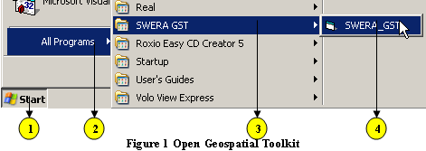

Load the Application
When the application starts, an initial screen showing the SWERA project countries is displayed. Click anywhere on this screen to load the application.

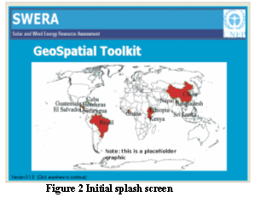

The initial interface appears as shown in Figure 3. The text in the left hand frame gives a general overview of initial data loading and query analysis procedures.

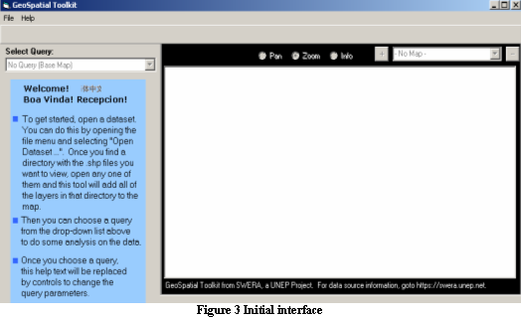

Load Data

This version of the GsT assumes that all files used for analysis are stored in a single folder on the local machine or on a network drive. The user can browse to this folder and load all the files available in that folder. If the files needed to run a query have not been loaded, the user will not be able to run the queries that need that data layer.

- Click on the File menu to display all drop down sub menus, as shown in Figure 4.
- Click on the Open Dataset menu item.

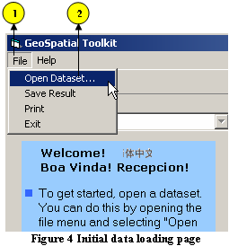

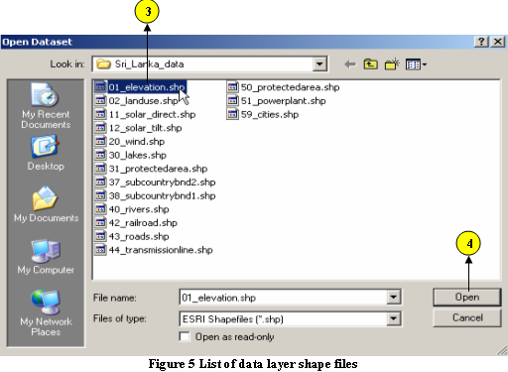

- Browse to the folder containing data layer files and select any one of the files by clicking on the file name, as shown in Figure 5
- Click Open to load all the files available in that folder to the Map View.

Figure 6 shows the initial map view after loading the data.

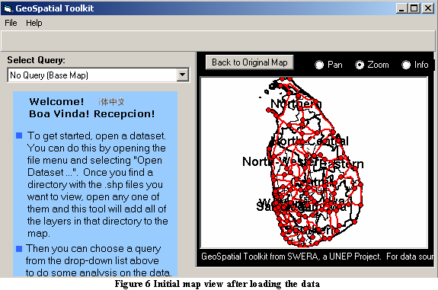

User Interface

This section of the document provides a brief explanation of all user interface components that the user will be using throughout this application. The numbers shown on the figure correspond to each section explained below.

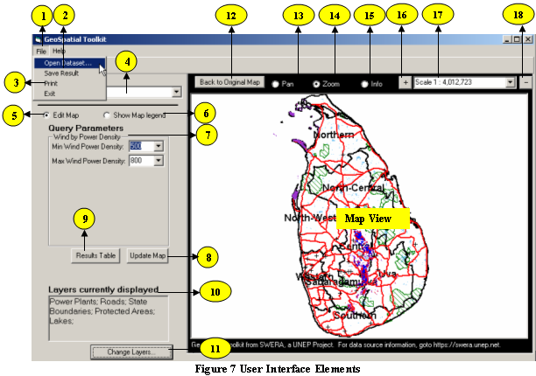

- Open Dataset

Refer ‘Load Data’ section above to see the explanation of this menu item.

- Save Result

The Save Result menu can be used to save the result of the query as a polygon
shapefile. This is normally a time consuming process. So, if the result set have
more than 50 features, then the user will be prompted to confirm whether to go
ahead with this operation. Now click ‘Yes’ to go ahead with the save operation.
This will open windows ‘Save As’ dialog box. Now browse to the directory where
the output file has to be saved and enter the output file name. Then click ‘Save’
button to save the result. Resulting shapefile will have an attribute field that list
the wind power density/solar resource value corresponding to each feature.

- Print

The Print menu helps the user to print the map and get a hard copy output. Click on this menu button to open a layout window. The layout window shows how the map, title, scalebar, and legend will be laid out on the printed map. Click on the ‘Print’ button to send the output to the default printer. In order send the map to a specific printer, use Printer’s properties and set that printer as default.

- Select Query

This is a drop-down list box showing all pre-defined queries used in this application. Each query listed here is discussed in detail in the query analysis section of this document.

- Edit Map

This option allows the user to choose a query. The user will then see a screen specific to that query. In other words, the Query Parameters will change depending on the type of query selected. .

- Show Map Legend

Select this option to view the legend associated with the map. All of the layers available to the user will be displayed.

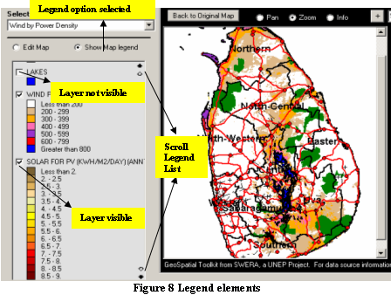

The check box at the left of the layer name indicates whether the layer is visible (checked) or not (unchecked). Toggle this check box on/off to control the visibility of any layer on the map.

The order of layers listed in the legend indicates the order of layers on the map. This means the top layer in the legend list will be the top layer on the map. The user can interactively change the order of layers. To do this, click the layer name. While holding the left mouse button down, drag the layer up or down the layer list and place it in the desired position. The map will automatically refresh to reflect the new layer order.

The small arrow heads seen on the top right and bottom right of the legend frame can be used to scroll up and down the legend list. The filled arrow is equivalent to a page down or page up, and the hollow arrow scrolls line by line.

- Query Parameters

All the parameters that are needed for the selected analysis will be listed here. Default settings are provided, but the users can modify the query parameters to reflect their analysis needs. The output of any analysis is based on the parameters selected or set here, so care must be taken to choose realistic combinations of query parameters. The Query Analysis section of this document will explain each query parameter used in the available analysis options.

- Update Map

The Update Map button is used to execute the query with the query parameters chosen. While the query is processing, the button will change to a Cancel button, allowing the user to cancel the query if they so choose. Upon successful completion, the resulting analysis will be drawn on the map.

- Results Table

The Results Table button is used to display an area summary of the analysis results in a tabular format. Initially this button is hidden from the user, and will become visible only after the successful completion of an analysis. Click on this button to see the result of the last query.

- Layers Currently Displayed

All currently visible layers on the map will be listed here. This additional information shows the visibility status of a layer without selecting the Show Map legend option.

- Change Layers

This Change Layers button is used to change the visibility status of a layer while the application is in Edit Map mode.
  - Click on this button to pop up a layer list form.
  - Toggle on/off the check box on left side of a layer to control its visibility.

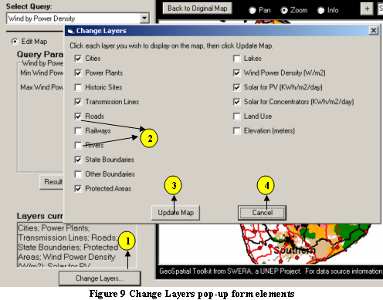

  - Click the Update Map button on the layer list form to update the layers currently displayed.
  - The Cancel button will close the layer list form and leave the status of the layers unchanged.

- Back to Original Map

Original map is the extent of the map that is visible after the initial loading of data. Usually this is set to the full extent of the country or the study area. During panning or zooming, the extent of the map visible on the screen will change. This button will allow the user to bring the map back to its original extent. This button is hidden when the map is at the full extent.

- Pan

This is an interactive tool that can be used to pan or move the map in any direction. To use this tool:
  - Select the Pan option. (Note: The cursor will turn into a hand symbol.)
  - Then click on the map, hold down the mouse button, and drag the mouse in any direction. The map will be panned in the indicated direction.

- Zoom

This is an interactive tool that can be used to zoom in or zoom out of the map view.

To use this tool to zoom in:
  - Select the Zoom option. (Note: The cursor will turn into a magnifying glass symbol.)
  - Then click on the map using left mouse button. This approach uses a fixed scale factor of 200% to zoom in to the map. The map will be centered at the mouse click location.
Note: If the user wants to zoom to a specific area on the map, keep the left or right mouse button down and drag a box around the area. Now the map will zoom to the envelope selected by the user.

To use this tool to zoom out:
- Select the Zoom option. (Note: The cursor will turn into a magnifying glass symbol.)
- Click on the map using right mouse button. This approach uses a fixed scale factor of 50% to zoom out of the map. The map will be centered at the mouse click location.

- Info

Sometimes it is useful for the user to see the attribute values related to the map layers used in their analysis. To do this,
  - Select the Info option. (Note: The cursor will turn into a Help symbol.)
  - Then click on any feature on a layer to list its attribute values. The attributes of features from all visible layers that are within a predefined tolerance limit will be listed in a new window. Because of this, it is easier to list feature attributes from polygon layers as compared to line or point layers. In order to get the attributes of any line or point layer, users will have to click as close as possible to the feature of interest. Attributes are listed on a new pop up form by layer name. Figure 10 shows sample output from the Info function.

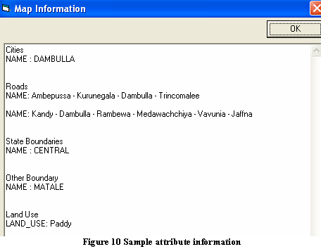

- Zoom In command (+)

Instead of using the Zoom option described previously, the user can click directly on the zoom in button (button with plus “+” sign). This will zoom in to the center of the map with a fixed scale factor of 200%.

- Map Scale

The value displayed on the scale bar indicates the scale of the map. the map scale changes during zoom in or zoom out operation.

- Zoom Out command (-)

Instead of using the Zoom option described previously, the user can click directly on the Zoom Out button (button with minus “-“sign). This will zoom out of the center the map with a fixed scale factor of 50%.

Wind and Solar Energy Analysis Queries

This part of the document guides the user through the potential queries to better understand how the GsT can be used. The best way to become familiar with any software application is by using it; we encourage you to play around with the parameters presented in each query.

Query Analysis

Seven specific queries can be used to identify the possible locations to harness wind or solar energy. Each of these queries is described here separately. The units used in this application are Watts/meter² (W/m²) for wind power density and kiloWatt-hour/m²/day (kWh/m²/day) for solar energy. Some of the queries performed on data layers that have large amount of data make take several minutes to complete the analysis. In such situations user will be given a warning before proceeding with the query analysis. Now the user has the option to either abort or continue with the query.

Query 1: No Query (Base Map)

This is the default option in the query list. When the user conducts an analysis the map gets updated with the query results. Selecting this option from the query list and clicking on the Update Map button will reset the map view, remove any layers generated from the previous analysis, and display the base map layers.

Query 2: Wind by Power Density

Wind energy is generally expressed in terms of wind power classes that range from 1 (the least) to 7 (the highest). Wind power classes are based on the average "wind power density" expressed in watts per square meter (W/m²). The wind power density range for each power class is shown in Table 1.

Table 1. Wind Power Class and Density at 50 m Above Ground Level
Wind Power Class | Wind Power Density  (W/m²) | Resource Potential  (Utility Scale)
1 | 0 - 200 | Poor
2 | 200 - 300 | Marginal
3 | 300 - 400 | Fair
4 | 400 - 500 | Good
5 | 500 - 600 | Excellent
6 | 600 - 800 | Outstanding
7 | > 800 | Superb

Wind power density is used as the key parameter in all the wind energy analysis queries. In this query, the user will be able to the select minimum and maximum wind power densities and view areas where wind power density falls within those selected classifications on the map.
Wind power density classifications shown in the table above are listed in the minimum and maximum wind power density Query Parameter list on the query form. But the users are also allowed to enter any other value between 0 and 10000 as minimum or maximum wind power density query parameter. The ‘Max’ value listed in the maximum wind power density dropdown list is equivalent to using 10000 as the parameter value.

- Select the ‘Wind by Power Density’ query from the Select Query dropdown list, as shown in Figure 11.

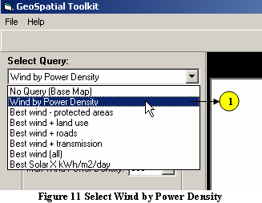

- Select or enter the minimum wind power density value in the Query Parameter list, as shown in Figure 12.
- Select or enter the maximum wind power density value in the Query Parameter list.
- Click the Update Map button to run the query and update the map view.

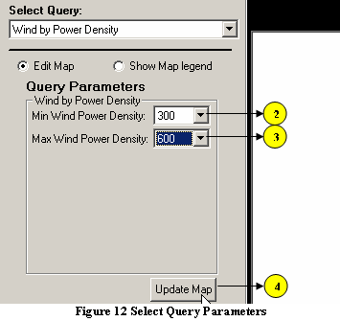

Figure 13 shows the updated map view of the sample data where wind power density is between 300 and 600 W/m². Use the Pan or Zoom options to view the map in more detail.

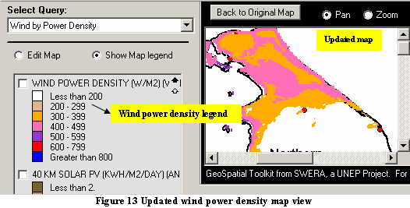

- Click on the Results Table button to see the area covered by the query. The pop up form will show the coverage area in sq. km for each power class. Figure 14 shows the result of this query.

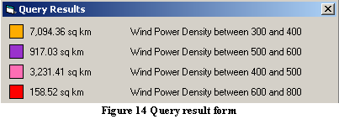

Query 3: Best Wind - Protected Areas

National forests, wild life sanctuaries and historical sites are generally considered areas protected from development. Users can use this query to find out the wind power density pattern outside of these areas. Note that the previous query does not restrict any area from the query, whereas here the protected areas will be excluded from the results.

- Select the ‘Best wind – protected areas’ query from the Select Query dropdown list, as shown in Figure 15.
- Select or enter the minimum wind power density value in the Query Parameter list.
- Select or enter the maximum wind power density value in the Query Parameter list

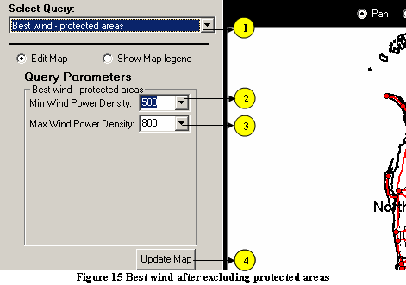

- Click the Update Map button to run the query and update the map view.
- Click on the Results Table button to see the area covered by the query. The pop up form will show the coverage area in sq. km for each power class. The following figure shows the result of this query.

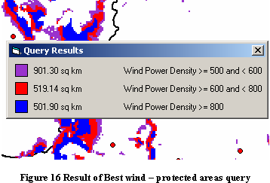

Query 4: Best Wind + Land Use

In this query, the user will select the minimum and maximum wind power densities and one or more land use categories from a list of unique categories contained within the land use data. This query analyzes the wind pattern for the wind power density between the selected values combined with all selected land uses.

- Select the ‘Best wind + land use’ Query from the Select Query dropdown list, as shown in Figure 17.
- Select or enter the minimum wind power density value in the Query Parameter list.
- Select or enter the maximum wind power density value in the Query Parameter list
- Select one or more land uses from the Land Use scroll down list.
(Note: To select more than one land use, press the Shift or Control key and select the desired land uses.)

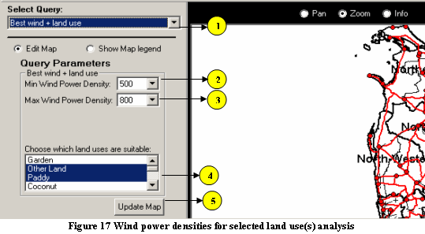

5. Click the Update Map button to run the query and update the map view.
- Click on the Results Table button to see the area covered by the query. The pop up form will show the coverage area in sq. km for each power class.

Figure 18 shows the updated map view, and result table for this analysis. Use the Pan
or Zoom options to view the map in more detail.
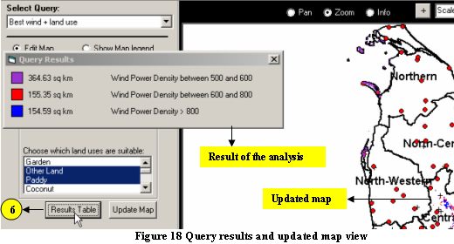

Query 5: Best Wind + Roads

In this query, the user can select the minimum and maximum wind power densities and enter a buffer distance from roads to analyze the wind patterns along road corridors. This type of query can be helpful in deciding the best possible location for wind energy facilities.

- Select the ‘Best wind + roads’ query from the Select Query dropdown list, as shown in Figure 19.

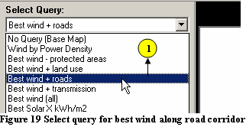

- Select or enter the minimum wind power density value in the Query Parameter list, as shown in Figure 20.

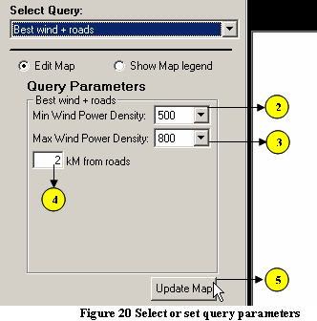
- Select or enter the maximum wind power density value in the Query Parameter list.
4. Enter the buffer distance from roads in kilometers.
5. Click the Update Map button to run the query and update the map view.
6. Click on the Results Table button to see the area covered by the query. The pop
up form will show the coverage area in sq. km for each power class. Figure 21 shows the new map view and results table for this query.
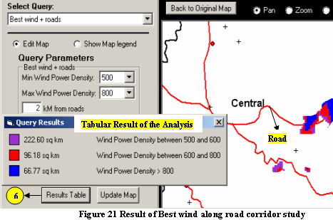

Query 6: Best Wind + Transmission

One factor that may influence the location of wind energy facilities is the existing energy demand in an area and the cost of energy delivery. Constructing new power plants near existing transmission lines can reduce the cost of energy transmission. One such scenario is evaluated in this query, where the user can select the minimum and maximum wind power densities and enter a buffer distance from transmission lines to analyze wind patterns along transmission corridors. This type of query can be helpful for identifying the possible locations for wind energy facilities.

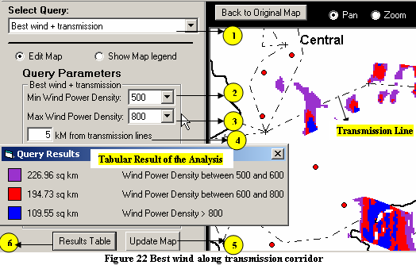

- Select the ‘Best wind + transmission’ query from the Select Query dropdown list, as shown in Figure 22.
- Select or enter the minimum wind power density value the Query Parameter list.
- Select or enter the maximum wind power density value in the Query Parameter list.
- Enter a buffer distance from transmission lines in kilometers.
- Click the Update Map button to run the query and update the map view.
- Click on the Results Table button to see the area covered by the query. The pop up form will show the coverage area in sq. km for each power class. Figure 22 shows the result of this query.

Query 7: Best Wind (all)

This is a more complex query where the user may use a combination of the query parameters previously presented to model a desired scenario.

- Select the ‘Best wind (all)’ query from the Select Query dropdown list, as shown in Figure 23.
- Select or enter the minimum wind power density value in the Query Parameter list.
- Select or enter the maximum wind power density value in the Query Parameter list.
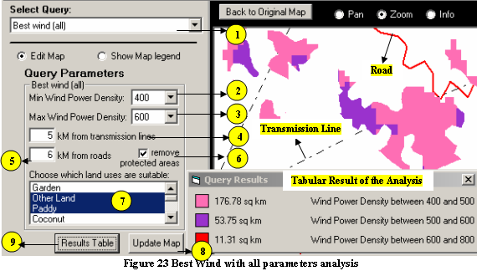

4. Enter a buffer distance from roads, in kilometers.
5. Enter a buffer distance from transmission lines, in kilometers.
6. Select one or more land use categories from the Land Use scroll down list.
(Note: To select more than one land use, press the Shift or Control key and select the desired land uses.)
- Check Remove Protected Areas to exclude protected areas from the analysis, or uncheck it to leave those areas in.
8. Click the Update Map button to run the query and update the map view.
9. Click on the Results Table button to see the area covered by the query. The pop up form will show the coverage area in sq. km for each power class.

Each of these parameters can be adapted to make them more or less limiting, at the user’s discretion. For instance, if distance to transmission lines is more important than distance to roads, the parameters could be set to 5 km from transmission lines and 25 km from roads. If land use is not a limiting factor, all land use categories can be selected.

Query 8: Best Solar X kWh/m²/day

Solar energy can be harnessed using either solar concentrators or photovoltaic cells technology. This query can help the user to conduct a detailed analysis for selecting the best possible places for setting up solar concentrators or photovoltaic cell plants.
Solar resource values from 2 to 9 are listed in the minimum and maximum solar resource Query Parameter list on the query form. But the users are also allowed to enter any other value between 0 and 10 as minimum or maximum solar resource query parameter.

- Select ‘Best Solar X kWh/m²/day query, as shown in Figure 24.
- Select or enter the minimum solar resource in Query Parameter list.
- Select or enter the maximum solar resource in Query Parameter list.
- Select the solar resource dataset to be used in the query from the ‘Choose which solar resource’ list.
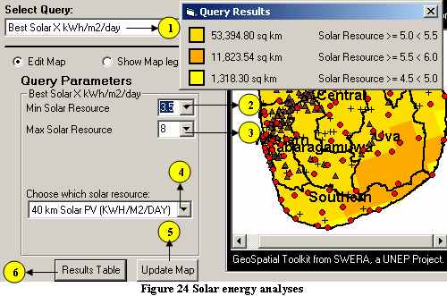

- Click the Update Map button to run the query and update the map view.
- Click on the Results Table button to see the area covered by the query. The pop up form will show the coverage area in sq. km for each 0.5 kWh/m²/day interval.

Dataset Description

This part of the document describes the datasets the GsT has been set up to use by default. Not all of the layers described here may be available for each country. Other data layers can be added into the GsT, provided they match the existing data parameters, but may not be usable in the queries.

Wind Resource

The wind resource data included in the GsT provides annual average wind power density (W/m²) and power class estimates at 50 m above ground level. The relationship between wind power density and power class is shown in Table 2. To minimize processing time, the wind resource data has been aggregated to 22 wind resource levels; class 1, classes 2 – 6 subdivided into 4 quartiles each, and class 7. This allows queries to be performed at a level finer than power class. The data may have been generated by the National Renewable Energy Laboratory (NREL), Risø National Laboratory, or the Brazilian Wind Energy Centre (CBEE).

Table 2. Wind Power Class and Density at 50 m Above Ground Level
Wind Power Class | Wind Power Density  (W/m²) | Resource Potential  (Utility Scale)
1 | 0 - 200 | Poor
2 | 200 - 300 | Marginal
3 | 300 - 400 | Fair
4 | 400 - 500 | Good
5 | 500 - 600 | Excellent
6 | 600 - 800 | Outstanding
7 | > 800 | Superb

Solar Resource

The solar resource data included in the GsT provides annual average solar insolation values (kWh/m²/day), and may also include monthly and seasonal values. The data may have been generated by NREL, the State University of New York/Albany, the German Aerospace Center (DLR) or the National Institute for Space Research (INPE). The spatial resolution of the data may vary from 10 km to 40 km, and the types of solar insolation data that could be included are direct normal, global horizontal, or flat plate tilted = latitude.

Elevation

The elevation data included in the GsT provides information on the terrain. If enhanced data for a country was not available, elevation data was extracted from a U.S. Geological Survey (USGS) GTOPO30 global dataset, with a spatial resolution of 1 km. All elevation values are in meters.

Land Use

The land use data included in the GsT provides information on the primary application an area is used for, i.e. forest, urban, wetland. If enhanced data for a country was not available, land use data was extracted from a USGS Global Land Use/Land Cover dataset, with a spatial resolution of 1 km.

Political Boundaries

The political boundaries in the GsT may include country boundary, province/state level boundaries, and district/county level boundaries. Wherever possible, the names of the political units will be included in the attributes. Province/state level boundaries are used for the initial labeling in the map view.

Transportation and Electric Infrastructure

The transportation data in the GsT may include roads (paved and unpaved) and railroads. The electric infrastructure data in the GsT may include transmission lines and power plants. These data are provided by country partners.

Potential Exclusions

The potential exclusions used in the GsT may include parks, wildlife areas, historic sites and cultural areas. At this time, only data representing potential area exclusions (i.e. park boundaries) are used to exclude resource in the GsT queries. These data are provided by country partners.

Other Reference Data

Other reference data in the GsT may include cities/villages, lakes, and rivers. These data are provided by country partners.

