National Fire Weather Report



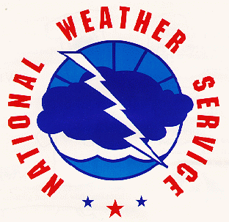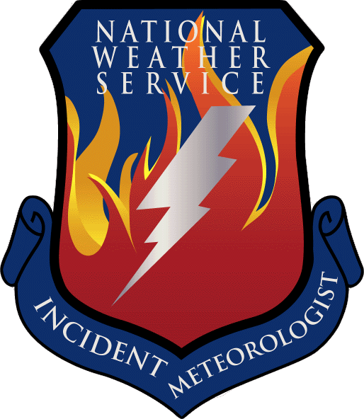

2007

By
Larry Van Bussum
National Fire Weather Operations Coordinator
National Weather Service Boise, ID

Contents

2007 IMET Summary 3
2007 IMET Dispatches 4
IMET Incident Response Summary 19
2007 Statistics 20
2007 Red Flag Warning Verification 25
AMRS Locations 26
ATMU Locations 27

IMET Summary 2007

The fire season for National Weather Service Incident Meteorologists (IMETs) started early with fires springing up in Florida and Georgia by mid-April. Large fires burned in the Okefenokee Swamp area of Georgia and Florida. IMET support for incidents in this area lasted from mid-April to mid-June.

The Southwest (Arizona and New Mexico) were quiet with respect to IMET dispatches in 2007 with only a handful of dispatches to this area.

In June, a large fire (the Angora Fire), took place near South Lake Tahoe resulting in costly damage. This was a sign of things to come for the Sierra Nevada and Southern California area later in the year.

Dry conditions and numerous lightning starts resulted in large complexes of fires scattered throughout the Great Basin (Utah, Nevada and Idaho) and Montana. IMETs supported fires in these areas from the beginning of July until the snows and rains moved into the area in mid-September.

In October and November large fires again raged in Southern California with the largest fires taking place near San Diego. This resulted in the evacuation of nearly 1 million people during the most critical fires in that area.

NWS IMETs also supported non-wildfire events in 2007, especially in the wake of the tornado that destroyed the city of Greensburg, KS. IMETs supported recovery operations in that area from mid-May through the end of June.

Overall, 2007 was the third busiest year on record in terms of IMET dispatches with 185 dispatches for the year. However, on average, the incidents lasted longer than in previous year. Thus the previous record for number of days and hours spent on incidents was broken in 2007. IMETs spent 1,947 days on incidents in 2007, breaking the old record of 1,920 days set just the year prior in 2006. There were 207 dispatches in 2006, so there were about 10% less dispatches, but slightly more time on each of the 2007 incidents. The average number of days spent on an incident in 2006 was 8.5 days. The average number of days spent on an incident in 2007 was 9.0 days, an increase of 6%. The trends in IMET dispatches and times spent on incidents indicate that the trend upwards will continue for the foreseeable future.

IMET Dispatches
2007

ATMU | IMET  NWS Office | Incident  Location, State | Dispatch | Return | Days

-- Davis Big Turnaround Complex 4/20/07 4/27/07 8 Tampa Bay Area, FL near Waycross, GA

-- Deese (T) 4/20/07 4/27/07 8
Jacksonville, FL

-- Hooper 5/4/07 5/17/07 14
Paducah, KY

-- Frantz (T) 5/4/07 5/11/07 8
Peachtree City, GA

-- Rothfuss (T) 5/11/07 5/17/07 7
Miami, FL

-- Manuel 5/15/07 5/29/07 15
Blacksburg, VA

-- Quagliariello 5/28/07 6/11/07 15
Charleston, SC

-- Davis 6/10/07 6/22/07 13
Tampa Bay Area, FL

-- Pendergrast Sweat Farm Rd Fire 4/24/07 5/7/07 14
Melbourne, FL near Waycross, GA

-- Quagliariello 5/5/07 5/20/07 16
Charleston, SC

-- Pendergrast 5/19/07 6/1/07 14
Melbourne, FL

-- Schneider (T) 5/22/07 5/24/07 3
Amarillo, TX

-- Pelton 5/30/07 6/13/07 15
Jackson, KY

-- Byrd 6/12/07 6/23/07 12
Jackson, MS

ATMU | IMET  NWS Office | Incident  Location, State | Dispatch | Return | Days

ID-01 Ruthford Naches Rx 2007 4/25/07 5/2/07 8
Portland, OR near Naches, WA

ID-01 Ruthford 5/7/07 5/19/07 13
Portland, OR

ID-01 Ruthford 5/22/07 5/25/07 4
Portland, OR

ID-03 Paulson Ham Lake Fire 5/7/07 5/20/07 14
Chanhassen, MN near Grand Marais, MN

ID-03 Morford (T) 5/8/07 5/16/07 9
Binghamton, NY

-- Edwards FL Bugaboo Fire 5/10/07 5/25/07 16
Jackson, KY near Sanderson, FL

-- Lynn 5/23/07 6/7/07 16
Peachtree City, GA

-- Petersen Greensburg FEMA 5/10/07 5/25/07 16
Pueblo, CO near Greensburg, KS

-- Ramey 5/23/07 6/4/07 13
Grand Junction, CO

-- Nester 6/3/07 6/14/07 12
Missoula, MT

-- Sowko 6/13/07 6/22/07 10
Cheyenne, WY

-- Hockenberry (T) 6/21/07 6/30/07 10
NWS HQ

-- Byrd BICY Complex 5/14/07 5/28/07 15
Jackson, MS near Sunniland, FL

-- Goudsward 5/26/07 6/6/07 12
Little Rock, AR

-- Stubblefield Promontory Fire 5/15/07 5/22/07 8
Flagstaff, AZ near Payson, AZ

-- Walbrun Bolli Fire 5/23/07 5/28/07 6
Monterey, CA near Shasta, CA
ATMU | IMET  NWS Office | Incident  Location, State | Dispatch | Return | Days

-- Jordan Highway Fire 5/24/07 5/27/07 4
Reno, NV near Reno, NV

-- Bean Goldledge Fire 6/4/07 6/8/07 5
Hanford, CA near Kernville, CA

-- Jordan Larsen Fire 6/6/07 6/10/07 5
Reno, NV near Coleville, CA

-- Hooper New Madrid SONS 6/18/07 6/22/07 5
Paducah, KY near Jefferson City, MO

-- Albanese Caribou Hills Fire 6/22/07 6/25/07 4
Anchorage, AK near Ninilchik, AK

-- Richmond 6/25/07 7/2/07 8
Fairbanks, AK

-- Curtis (T) 6/25/07 6/29/07 5
Juneau, AK

-- Wallmann Angora Fire 6/25/07 7/2/07 8
Reno, NV near South Lake Tahoe, CA

-- Church (T) 6/27/07 7/2/07 6
Missoula, MT

-- Decker Horse Creek Fire 6/26/07 7/3/07 8
Boise, ID near Alpine, WY

-- Walbrun White Fire 6/26/07 7/1/07 6
Monterey, CA near Rosamond, CA

-- Harrison Neola North Fire 6/30/07 7/11/07 12
Las Vegas, NV near Whiterocks, UT

-- Gettman Rancho Fire 7/1/07 7/4/07 4
Medford, OR near Santa Barbara, CA

-- Gilchrist Citadel Fire 7/3/07 7/8/07 6
Glasgow, MT near Cody, WY

-- Bird Chitty Fire 7/3/07 7/9/07 7
El Paso, TX near Hannagan Meadow, AZ

-- Wachter Oakridge #3 Fire 7/4/07 7/9/07 6
Albuquerque, NM Near Ganado, AZ
ATMU | IMET  NWS Office | Incident  Location, State | Dispatch | Return | Days

-- Thompson Zaca Fire 7/5/07 7/19/07 15
Oxnard, CA near Santa Ynez, CA

-- Balfour 7/18/07 7/25/07 8
San Diego, CA

-- Meyers (T) 7/19/07 7/24/07 6
Phoenix, AZ

-- Wallmann Antelope Complex 7/6/07 7/14/07 9
Reno, NV near Quincy, CA

-- Harty (T) 7/8/07 7/14/07 7
Hanford, CA

-- Smith Black Rock Gulch Fire 7/7/07 7/15/07 9
Sacramento, CA near St. George, UT

-- Chamberlain East Fork Fire 7/7/07 7/11/07 5
Grand Junction, CO near Fort Washakie, WY

-- Nagle Birdie Fire 7/7/07 7/14/07 8
San Angelo, TX near Flagstaff, AZ

-- Survick Red Bridge Fire 7/7/07 7/8/07 2
Pocatello, ID near Shoshone, ID

-- Ruthford Milford Flat Fire 7/8/07 7/16/07 9
Portland, OR near Milford, UT

-- Mehle (T) 7/11/07 7/16/07 6
Monterey, CA

-- Survick Mathis Fire 7/8/07 7/15/07 8
Pocatello, ID near Price, UT

-- Smith, B. (T) 7/10/07 7/15/07 6
Salt Lake City, UT

-- Bunnag Inyo Complex 7/8/07 7/12/07 5
Medford, OR near Independence, CA

-- Redman West Basin Fire 7/8/07 7/14/07 7
Boise, ID near Jackpot, NV

-- Decker Calamity Complex 7/9/07 7/15/07 7
Boise, ID near Seneca, OR
ATMU | IMET  NWS Office | Incident  Location, State | Dispatch | Return | Days

-- Carter Little Chopaka Fire 7/9/07 7/13/07 5
Spokane, WA near Oroville, WA

-- Bird Alambre Fire 7/9/07 7/14/07 6
El Paso, TX near Pan Tak, AZ

-- Nester Thomas Fire 7/9/07 7/11/07 3
Missoula, MT near Winnemucca, NV

-- Solomon Warm Springs Fire 7/9/07 7/12/07 4
Pendleton, OR near Weiser, ID

-- Prange Boulder Creek Fire 7/10/07 7/23/07 14
Seattle, WA near Silver City, ID

-- Jordan Egley Complex 7/11/07 7/24/07 14
Reno, NV near Riley, OR

-- Nester Balls Canyon Fire 7/12/07 7/16/07 5
Missoula, MT near Loyalton, CA

-- Gettman Elk Complex 7/13/07 7/26/07 14
Medford, OR near Happy Camp, CA

-- Lutz 7/23/07 8/5/07 14
Medford, OR

-- Chamberlain Salt Lick Fire 7/15/07 7/18/07 4
Grand Junction, CO near Pinedale, WY

ID-02 Tobin East Zone Complex 7/15/07 7/29/07 15
Spokane, WA near McCall, ID

ID-02 Szatanek (T) 7/17/07 7/24/07 8
HPC

-- Wilkinson 7/27/07 8/10/07 15
Jackson, MS

-- Redman 8/9/07 8/22/07 14
Boise, ID

-- Sowko 8/21/07 9/1/07 12
Cheyenne, WY

-- Meffert 8/30/07 9/12/07 14
Paducah, KY
ATMU | IMET  NWS Office | Incident  Location, State | Dispatch | Return | Days

-- Balfour East Zone Comple (cont) 9/10/07 9/24/07 15
San Diego, CA near McCall, ID

-- Solomon China-Back Complex 7/16/07 7/19/07 4
Pendleton, OR near Yreka, CA

-- Haner Ball Point Fire 7/16/07 7/23/07 8
Seattle, WA near The Dalles, OR

-- Hoenisch Ahorn Fire 7/16/07 7/29/07 14
Great Falls, MT near Augusta, MT

-- Goudsward 7/27/07 8/10/07 15
Little Rock, AR

-- Murdoch 8/8/07 8/23/07 16
Midland, TX

-- Zeltwanger 8/21/07 8/31/07 11
Aberdeen, SD

-- Lynn 8/30/07 9/10/07 12
Peachtree City, GA

-- Petersen 9/7/07 9/17/07 11
Pueblo, CO

-- Bunnag Fletcher Fire 7/16/07 7/21/07 6
Medford, OR near Alturas, CA

-- Wolf Rattlesnake Fire 7/17/07 8/1/07 16
Spokane, WA near Elk City, ID

-- Weishaar 7/30/07 8/14/07 16
Portland, OR

-- Evenson 8/11/07 8/23/07 13
Burlington, VT

-- Mehle (T) 8/16/07 8/27/07 12
Monterey, CA

-- Wallmann 8/22/07 9/6/07 16
Reno, NV

-- Pellerito (T) 8/30/07 9/8/07 10
Charleston, WV
ATMU | IMET  NWS Office | Incident  Location, State | Dispatch | Return | Days

-- Lipson Rattlesnake Fire (cont) 9/5/07 9/20/07 16
Riverton, WY near Elk City, ID

-- Harrison WSA Lightning Complex 7/17/07 8/1/07 16
Las Vegas, NV near Warm Springs, OR

-- Redman Monument Complex 7/17/07 7/31/07 15
Boise, ID near Monument, OR

-- Hooper Battle Creek Complex 7/18/07 8/2/07 16
Paducah, KY near Enterprise, OR

-- Bonk (T) 7/20/07 7/25/07 6
Pendleton, OR

-- Hockenberry (T) 7/24/07 7/29/07 6
NWS HQ

ID-02 Harris (T) 7/30/07 8/10/07 12
Fort Worth, TX

ID-02 Solomon 7/31/07 8/9/07 10
Pendleton, OR

-- Wachter Tunk Grade Fire 7/18/07 7/19/07 2
Albuquerque, NM near Omak, WA

-- Nagle Hepworth Complex 7/18/07 7/25/07 8
San Angelo, TX near Wells, NV

-- Moore Winecup Complex 7/18/07 7/29/07 12
Pueblo, CO near Jackpot, NV

-- Pieper (T) 7/20/07 7/26/07 7
El Paso, TX

-- Stubblefield Hawken Fire 7/18/07 7/22/07 5
Flagstaff, AZ Reno, NV

-- Carter Windy Ridge Fire 7/18/07 7/25/07 8
Spokane, WA near Metaline, WA

-- Harty (T) 7/19/07 7/25/07 7
Hanford, CA

ATMU | IMET  NWS Office | Incident  Location, State | Dispatch | Return | Days

ID-03 Survick Dakota Hill Fire 7/19/07 7/25/07 7
Pocatello, ID near Springdale, UT

ID-03 Struthwolf (T) 7/21/07 7/25/07 5
Salt Lake City, UT

-- Wachter Antelope Complex 7/20/07 7/25/07 6
Albuquerque, NM near Battle Mountain, NV

-- Nester Middle Fork Complex 7/20/07 7/31/07 12
Missoula, MT near Lowman, ID

-- Clapp (T) 7/26/07 7/31/07 6
Sacramento, CA

-- Edwards 7/30/07 8/13/07 15
Jackson, KY

-- Harty (T) 8/8/07 8/14/07 7
Hanford, CA

-- Paulson 8/11/07 8/17/07 7
Minneapolis, MN

-- Chamberlain Salt Creek Fire 7/20/07 7/29/07 10
Grand Junction, CO near Nephi, UT

-- Ruthford Cascade Complex 7/20/07 8/5/07 17
Portland, OR near Yellow Pine, ID

-- Decker 8/2/07 8/16/07 15
Boise, ID

-- Meyers 8/14/07 8/21/07 8
Phoenix, AZ

-- Burger Poe Cabin Fire 7/21/07 8/2/07 13
Eureka, CA near White Bird, ID

-- Franks 7/31/07 8/11/07 12
Wilmington, OH

-- Prange 8/10/07 8/19/07 10
Seattle, WA

ATMU | IMET  NWS Office | Incident  Location, State | Dispatch | Return | Days

-- Weishaar Rugby Fire 7/24/07 7/27/07 4
Portland, OR near Neihart, MT

-- Brenchley Owl Fire 7/24/07 8/5/07 13
Monterey, CA near Bozeman, MT

-- Wallmann Murphy Complex 7/24/07 7/30/07 7
Reno, NV near Twin Falls, ID

-- Stubblefield Trapper Ridge WFU 7/25/07 8/8/07 15
Flagstaff, AZ near Idaho City, ID

-- Harty (T) 7/31/07 8/8/07 9
Hanford, CA

-- Balfour Zaca Fire 7/29/07 8/13/07 16
San Diego, CA near Buellton, CA

-- Szatanek (T) 8/3/07 8/12/07 10
HPC

-- Thompson 8/12/07 8/27/07 16
Oxnard, CA

-- Sowko Mile Marker 124 Fire 7/30/07 8/7/07 9
Cheyenne, WY near Missoula, MT

-- Gilchrist Skyland Fire 8/1/07 8/15/07 15
Glasgow, MT near Whitefish, MT

-- Byrd 8/13/07 8/27/07 15
Jackson, MS

-- Lynn 8/25/07 8/30/07 6
Peachtree City, GA

-- Tobin Sawmill Complex 8/1/07 8/15/07 15
Spokane, WA near Missoula, MT

-- Morford (T) 8/7/07 8/16/07 10
Binghamton, NY

-- Wolf 8/14/07 8/29/07 16
Spokane, WA

-- Pelton 8/27/07 9/10/07 15
Jackson, KY
ATMU | IMET  NWS Office | Incident  Location, State | Dispatch | Return | Days

-- Chamberlain Sawmill Complex (cont) 9/9/07 9/14/07 6
Grand Junction, CO near Missoula, MT

-- Bunnag Chippy Creek Fire 8/3/07 8/17/07 15
Medford, OR near Kalispell, MT

-- Ramey 8/15/07 8/30/07 16
Grand Junction, CO

-- Manuel 8/28/07 9/10/07 14
Blacksburg, VA

-- Hoenisch Fool Creek Fire 8/3/07 8/15/07 13
Great Falls, MT near Choteau, MT

-- Jordan WSA Lightning Complex 8/4/07 8/18/07 15
Reno, NV near Warm Springs, OR

-- Weishaar 8/17/07 8/21/07 5
Portland, OR

-- Lipson Meriwether Fire 8/4/07 8/20/07 17
Riverton, WY near Helena, MT

-- Hooper Jocko Lakes Fire 8/6/07 8/20/07 15
Paducah, KY near Missoula, MT

-- Prochazka (T) 8/9/07 8/16/07 8
Houston, TX

-- Kubina (T) 8/16/07 8/24/07 9
Cleveland, OH

-- Paulson 8/18/07 8/25/07 8
Minneapolis, MN

-- Borsum 8/24/07 9/4/07 12
Billings, MT

ATMU | IMET  NWS Office | Incident  Location, State | Dispatch | Return | Days

-- Tonkin Zaca Fire – Richardson 8/6/07 8/20/07 15
Eureka, CA Zone
near New Cuyama, CA

-- Bean 8/19/07 9/3/07 16
Hanford, CA

-- Tonkin 9/2/07 9/7/07 6
Eureka, CA

-- Gettman Trout Meadows Fire 8/6/07 8/14/07 9
Medford, OR near La Grande, OR

-- Nester Shower Bath Fire 8/7/07 8/21/07 15
Missoula, MT near Challis, ID

-- Solomon 8/20/07 9/1/07 13
Pendleton, OR

-- Pellerito (T) 8/24/07 8/30/07 7
Charleston, WV

-- Carter Domke Lake Complex 8/8/07 8/20/07 13
Spokane, WA near Chelan, WA

-- Bonk (T) 8/9/07 8/22/07 14
Pendleton, OR

-- Tobin 8/20/07 8/31/07 12
Spokane, WA

-- Cerniglia (T) 8/24/07 8/31/07 8
Seattle, WA

-- Ruthford Spear Springs Fire 8/9/07 8/11/07 3
Portland, OR near Burns, OR

-- Jacobson Sleeper Lake Fire 8/9/07 8/23/07 15
Jackson, KY near Sault Ste Marie, MI

ATMU | IMET  NWS Office | Incident  Location, State | Dispatch | Return | Days

-- Hockenberry Landmark/Cascade 8/9/07 8/15/07 7
NWS HQ Complex
near Cascade, ID

-- Pieper 8/13/07 8/28/07 16
El Paso, TX

-- Messick 8/27/07 9/11/07 16
Pocatello, ID

-- Paulson 9/7/07 9/24/07 18
Minneapolis, MN

-- Survick Juniper Ranch Fire 8/9/07 8/13/07 5
Pocatello, ID near Burns Junction, OR

-- Wachter Rombo Mountain Fire 8/11/07 8/25/07 15
Albuquerque, NM near Darby, MT

-- Fish (T) 8/15/07 8/25/07 11
AK Reg HQ

-- Smith Colby Fire 8/11/07 8/14/07 4
Sacramento, CA near Mineral, CA

-- Harrison Tar Fire 8/12/07 8/16/07 5
Las Vegas, NV near Avenal, CA

-- Survick Mitchell Fire 8/13/07 8/25/07 13
Pocatello, ID near Holbrook, ID

-- Krohn Little Goose Fire 8/14/07 8/26/07 13
Boulder, CO near Sheridan, WY

-- Stubblefield Wicked Creek Fire 8/14/07 8/28/07 15
Flagstaff, AZ near Livingston, MT

-- Borsum Powder River Complex 8/15/07 8/20/07 6
Billings, MT near Ashland, MT

-- Edwards Columbine 1 Fire 8/15/07 8/21/07 7
Jackson, KY near Cody, WY

-- Lutz Ukiah Complex 8/17/07 8/28/07 12
Medford, OR near Ukiah, OR

ATMU | IMET  NWS Office | Incident  Location, State | Dispatch | Return | Days

-- Burger Black Cat Fire 8/17/07 8/31/07 15
Eureka, CA near Frenchtown, MT

-- Ruthford Irish Spring Fire 8/18/07 8/27/07 10
Portland, OR near Ironside, OR

-- Balfour Castle Rock Fire 8/19/07 9/2/07 15
San Diego, CA near Ketchum, ID

-- Baker (T) 8/21/07 9/2/07 13
Riverton, WY

-- Haner 8/31/07 9/11/07 12
Seattle, WA

-- Smith BBD Complex 8/19/07 8/24/07 6
Sacramento, CA near Dillon, MT

-- Moore BBD/Rat Creek Fire 8/24/07 9/7/07 15
Pueblo, CO near Wisdom, MT

-- Struthwolf (T) 8/24/07 9/6/07 14
Salt Lake City, UT

-- Krohn 9/5/07 9/16/07 12
Boulder, CO

-- Harty Vista Fire 8/24/07 8/27/07 4
Hanford, CA near Porterville, CA

-- Gettman Confluence Complex 8/30/07 9/8/07 10
Medford, OR near Challis, ID

CA-07 Van Bussum Grays Creek Fire 8/31/07 9/8/07 9
NWS HQ near Council, ID

CA-07 Franks 9/7/07 9/14/07 8
Cincinnati, OH

-- Lutz GW Fire 9/2/07 9/12/07 11
Medford, OR near Sisters, OR

-- Harty Krassel WFU 9/2/07 9/18/07 17
Hanford, CA near McCall, ID

-- Chamberlain Rombo Fire 9/2/07 9/7/07 6
Grand Junction, CO near Sula, MT
ATMU | IMET  NWS Office | Incident  Location, State | Dispatch | Return | Days

-- Walbrun Lazy Fire 9/3/07 9/10/07 8
Monterey, CA near Covelo, CA

-- Meyers North Fork Fire 9/4/07 9/9/07 6
Phoenix, AZ near Acton, CA

-- Brenchley Lick Fire 9/5/07 9/10/07 6
Monterey, CA near San Jose, CA

-- Solomon Moonlight Fire 9/5/07 9/19/07 15
Pendleton, OR near Greenville, CA

-- Tonkin 9/17/07 9/24/07 8
Eureka, CA

-- Redman Chief Parrish Fire 9/6/07 9/10/07 5
Boise, ID near Banks, ID

-- Pieper Manilla Creek Fire 9/14/07 9/21/07 8
El Paso, TX near Coulee Dam, WA

-- Bean Butler 2 Fire 9/16/07 9/25/07 10
Hanford, CA near Running Springs, CA

-- Meyers Angel Fire 9/16/07 9/19/07 4
Phoenix, AZ near Julian, CA

-- Balfour Witch Fire 10/21/07 11/5/07 16
San Diego, CA near Ramona, CA

-- Struthwolf (T) 10/24/07 10/30/07 7
Salt Lake City, UT

-- Bean Harris Fire 10/22/07 10/31/07 10
Hanford, CA near Potrero, CA

-- Thompson Sedgewick Fire 10/22/07 10/23/07 2
Oxnard, CA near Los Olivos, CA

-- Stubblefield Ranch Fire 10/22/07 10/26/07 5
Flagstaff, AZ near Castaic, CA

-- Meyers Grass Valley Fire 10/23/07 10/31/07 9
Phoenix, AZ near Lake Arrowhead, CA

-- Gettman Buckweed Fire 10/23/07 10/26/07 4
Medford, OR near Santa Clarita, CA
ATMU | IMET  NWS Office | Incident  Location, State | Dispatch | Return | Days

-- Jordan Rice Fire 10/23/07 10/29/07 7
Reno, NV near Temecula, CA

-- Thompson Santiago Fire 10/23/07 11/5/07 14
Oxnard, CA near Santa Ana, CA

-- Jordan 11/4/07 11/9/07 6
Reno, NV

-- Smith Poomacha Fire 10/24/07 11/2/07 10
Sacramento, CA near Pauma Valley, CA

-- Tonkin 11/2/07 11/9/07 8
Eureka, CA

-- Harty Slide Fire 10/30/07 11/10/07 13
Hanford, CA near San Bernardino, CA

-- Wachter Upper Frijoles RX Burn 11/5/07 11/15/07 11
Albuquerque, NM near Los Alamos, NM

IMET Incident Response Summary
YEAR | FIRES | ACRES | IMET DISPATCHES | IMET DAYS | IMET HOURS
1987 | 143,877 | 4,152,575 | 87 | 587 | 8,218
1988 | 154,573 | 7,398,889 | 123 | 912 | 12,768
1989 | 121,714 | 3,261,732 | 58 | 344 | 4,816
1990 | 122,763 | 5,452,874 | 42 | 264 | 3,696
1991 | 116,953 | 2,237,714 | 29 | 171 | 2,394
1992 | 103,830 | 2,457,665 | 42 | 261 | 3,654
1993 | 97,031 | 2,310,420 | 15 | 89 | 1,246
1994 | 114,049 | 4,724,014 | 117 | 954 | 13,356
1995 | 130,019 | 2,315,730 | 27 | 201 | 2,814
1996 | 115,025 | 6,701,390 | 106 | 781 | 10,934
1997 | 89,517 | 3,672,616 | 15 | 94 | 1,316
1998 | 81,043 | 2,329,709 | 94 | 951 | 13,314
1999 | 93,702 | 5,661,976 | 81 | 553 | 7,742
2000 | 122,827 | 8,422,237 | 204 | 1,565 | 21,910
2001 | 84,079 | 3,555,138 | 112 | 924 | 12,936
2002 | 88,458 | 6,937,584 | 174 | 1,490 | 20,860
2003 | 85,943 | 4,918,088 | 152 | 1,406 | 19,684
2004 | 77,534 | 6,790,692 | 91 | 662 | 9,268
2005 | 66,552 | 8,686,753 | 103 | 794 | 11,116
2006 | 96,385 | 9,873,745 | 207 | 1,920 | 26,880
2007 | 85,822 | 9,321,326 | 185 | 1,947 | 27,258
’87 - ’07 Average | 104,366 | 5,294,422 | 98 | 801 | 11,216
’98 - ‘07 Average | 88,235 | 6,649,725 | 140 | 1,221 | 17,097

There were 185 IMET dispatches in 2007, making 2007 the third busiest season in IMET history in terms of dispatches. In terms of IMET days and hours worked, 2007 was the busiest year on record.
Number of IMET days worked: 1,947 (new record)
Number of IMET hours worked: 27,258 (13.05 person-years) (new record)

2007 Statistics

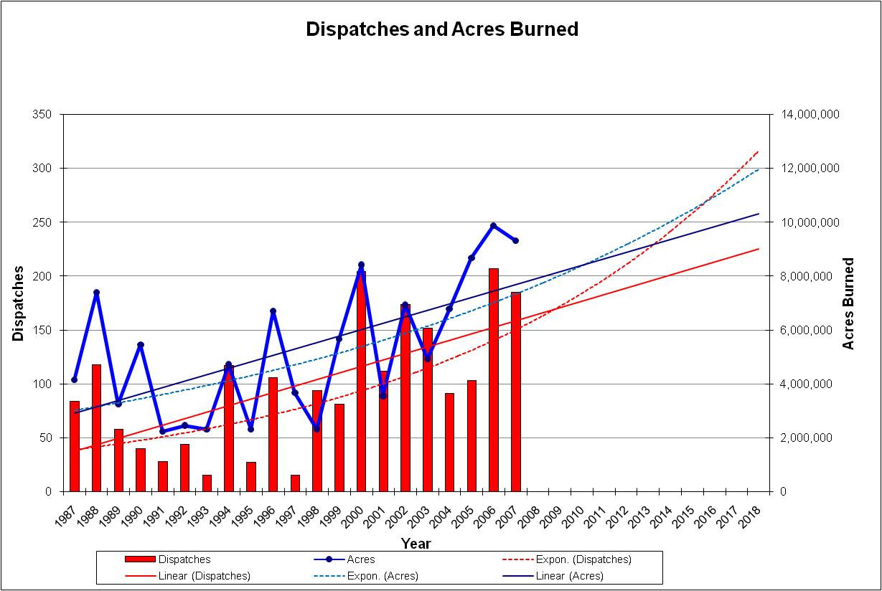

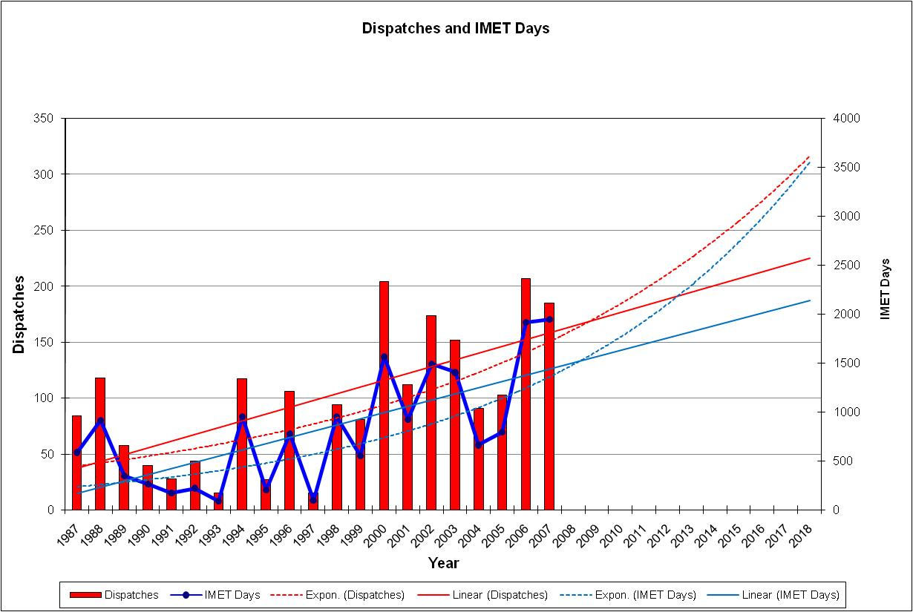

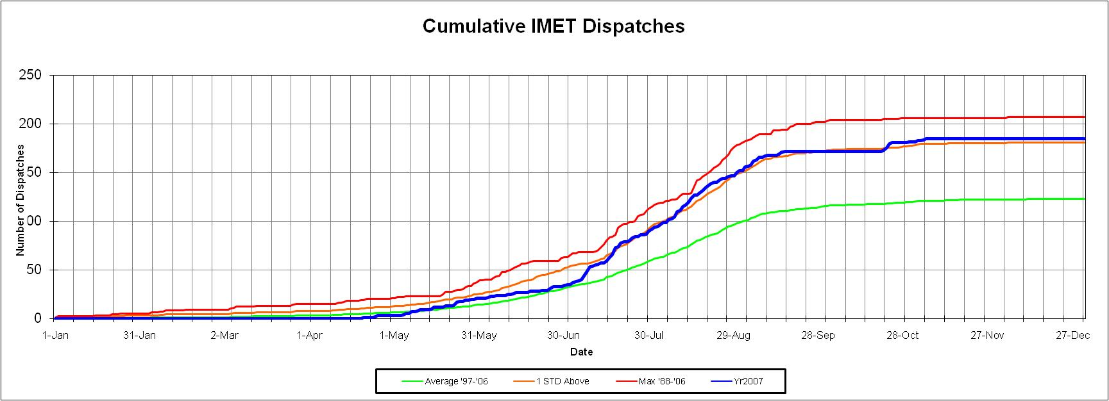

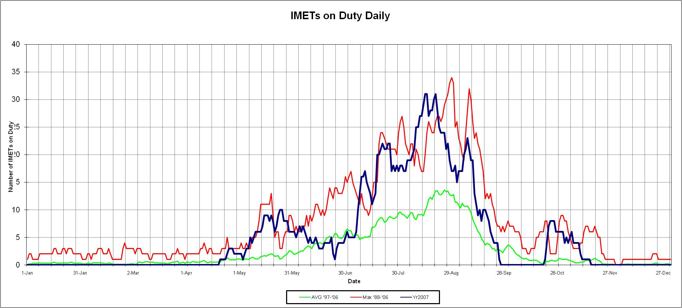

We are meeting or exceeding wildland fire agencies’ requirement in both distance and time. The agencies want the closest resource (within reason) and they want them onsite in 24 hours or less.

Average Distance From IMET Office to Fire: 471 miles
Median Distance From IMET Office to Fire: 315 miles
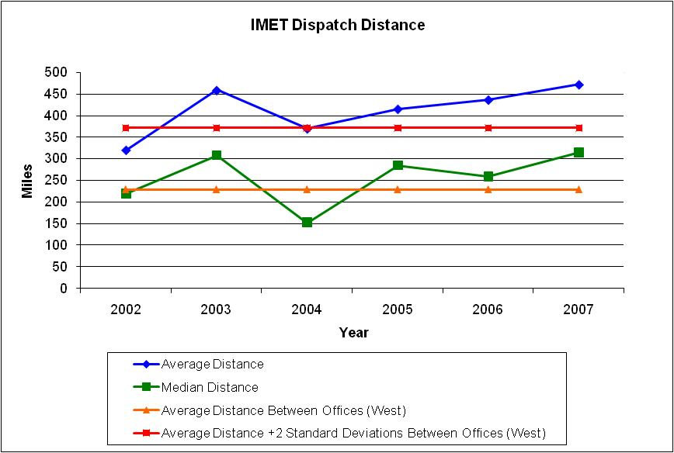

Average Time For IMET Dispatch: 14.3 hours
Overall Median Time for IMET Dispatch: 7.5 hours

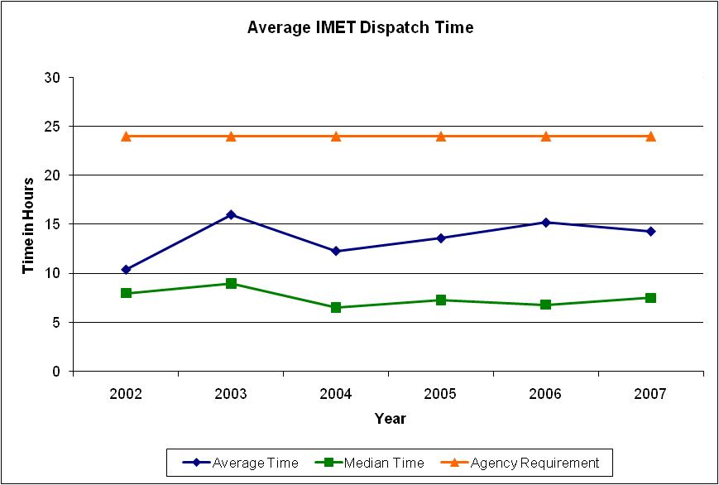

Average Number of Dispatches per IMET: 2.8 dispatches
Average Number of Days per Dispatch: 9.0 days

Number of Dispatch Requests Filled: 100%. Every request that was received by the National Fire Weather Operations Coordinator (NFWOC) in Boise was filled.
Number of Trainees completing training: 10 (1 in Alaska Region, 2 in Western Region, 3 in Southern Region, 2 in National Centers, 1 in Central Region and 1 in Eastern Region)

The majority of IMETs dispatched are from the Western Region. Western Region also has the most IMETs.
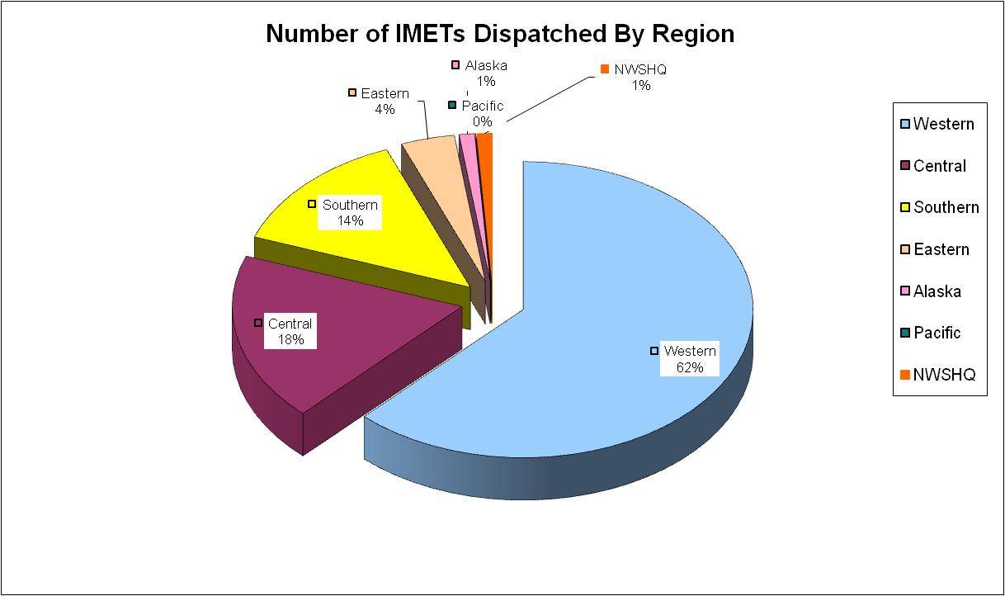

The majority of incidents over the previous 10 years were in Western Region.
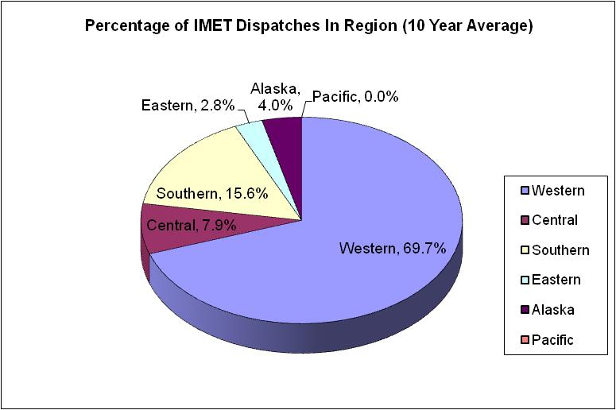

IMET Coverage Within Region 2007
- Western: 72% (111 of 155)
- Central: 69% (9 of 13)
- Southern: 60% (9 of 15)
- Eastern: no incidents
- Alaska: 100% (2 of 2)
- Pacific: no fires
IMET Coverage Outside of Region 2007
- Western: 7% (4)
- Central: 46% (25)
- Southern: 30% (16)
- Eastern: 13% (7)
- Alaska: 0% (0)
- Pacific: 0% (0)
- NWS HQ 4% (2)

Annual Peak IMET Dispatch Times
- Western Region: 29 July – 8 September
- Central Region: 15 Jun – 15 Jul, 15 Aug – 15 Sep
- Southern Region: 9 May – 18 July
- Eastern Region: 25 May – 4 Jul, 30 Oct – 29 Nov
- Alaska Region: 26 May – 12 August
- Pacific Region: None

- Nationally: 27 July – 8 September

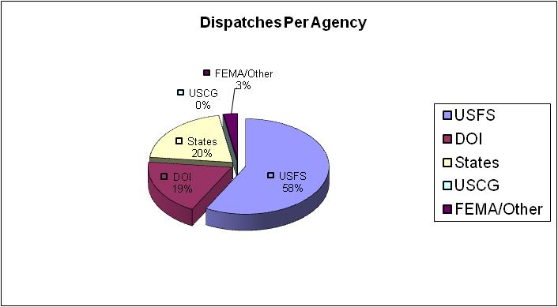

2007 National Red Flag Warning Verification

Region | POD | FAR | CSI | Lead Time (hrs) | Number RFWs Issued | Spot Forecasts
Western Region | 0.90 | 0.29 | 0.66 | 15.15 | 2,032 | 9,192
Central Region | 0.89 | 0.23 | 0.70 | 6.70 | 1,440 | 4,379
Eastern Region | 0.91 | 0.17 | 0.77 | 8.62 | 1,844 | 1,097
Southern Region | 0.93 | 0.17 | 0.78 | 16.24 | 14,083 | 4,245
Alaska Region | 0.98 | 0.28 | 0.71 | 8.09 | 146 | 261
Pacific Region | 0.80 | 0.00 | 0.80 | 7.00 | 4 | 181
National | 0.92 | 0.19 | 0.76 | 14.66 | 19,533 | 19,355

The national performance standard for 2007 was:
POD: 0.81
Lead Time: 8.30 hours

National five year averages:

POD | FAR | CSI | Lead Time | RFWs Issued | Spot Forecasts
0.89 | 0.21 | 0.72 | 12.07 | 13,796 | 16,608

The following are the recommended national performance standards:

Year | POD | Lead Time
2008 | 0.85 | 9.80
2009 | 0.86 | 9.85
2010 | 0.86 | 9.85
2011 | 0.87 | 9.90
2012 | 0.87 | 9.90



