

Executive Summary of
Evaluation Outcomes
Fiscal Year 2007

Office of Substance Abuse Prevention
Health Systems Bureau/Public Health Division

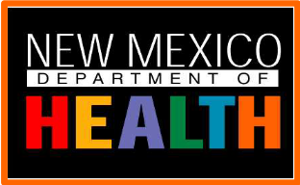

STATE OF NEW MEXICO

New Mexico Department of Health
Public Health Division
Health Systems Bureau
Office of Substance Abuse Prevention
Publication December 2008

For more information:
NMDOH/PHD
Office of Substance Abuse Prevention
(formerly Prevention Services Bureau of BHSD)
1190 St. Francis Drive, N3300
Santa Fe, New Mexico 87502
(505) 827-2601
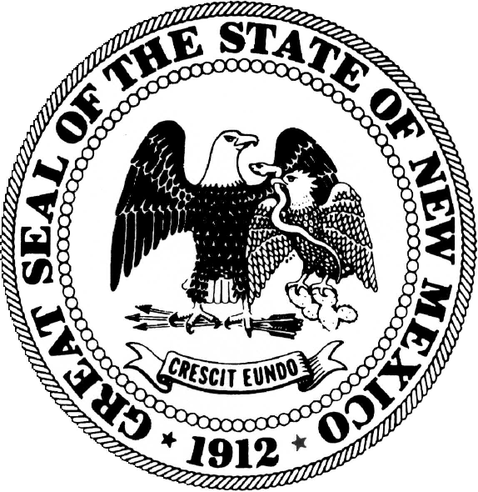

BILL RICHARDSON
GOVERNOR

NEW MEXICO
DEPARTMENT OF HEALTH

ALFREDO VIGIL, M.D.
SECRETARY

KRISTINE SUOZZI
DIRECTOR
PUBLIC HEALTH DIVISION

MARY ALTENBERG
CHIEF
HEALTH SYSTEMS BUREAU

DON MAESTAS, MSW
DIRECTOR
OFFICE OF SUBSTANCE ABUSE PREVENTION

Substance Abuse Prevention Evaluation Outcomes Fiscal Year 2007

Prevention Services Bureau
Behavioral Health Services Division

New Mexico Department of Health

Overview
New Mexico, and the nation, confront a major on-going crisis as citizens abuse substances. The personal, social, and financial costs of substance abuse are staggering. Treatment aims to reduce current addiction. But no amount of treatment can effectively address New Mexico’s addiction crisis. Only by preventing new addiction can the state’s substance abuse crisis be successfully alleviated. New Mexico’s prevention system seeks to reduce adolescent use before it leads to other problem behaviors or becomes an addiction, and to delay first time use by working with families and younger children. Age of onset, the first time a youth experiments with alcohol, tobacco, or other drugs, has been shown by extensive research to be the single most decisive predictor of future substance use and addiction.

Two decades of prevention practice and research nationwide have demonstrated that prevention can delay youth experimentation and reduce the prevalence of youth substance use. Successful outcomes such as these, across a state’s population, can substantially decrease future rates of adult addiction and the pain and suffering that adolescent use can create. New Mexico has built a prevention system that in recent years has demonstrated substantial successes. This report presents highlights of those successes for the fiscal year 2007.

The New Mexico Department of Health, Behavioral Health Services Division Prevention Services Bureau is dedicated to maintaining and improving a comprehensive State Substance Abuse Prevention System. The Prevention Services Bureau works diligently to enhance the capacity of community prevention providers in New Mexico to ensure the delivery of effective prevention services. These services are aimed at reducing alcohol, tobacco and other drug (ATOD) abuse. The successful local outcomes of New Mexico prevention programs are highlighted in this Executive Summary. The investment of state and federal dollars in the implementation of evidence-based prevention programs is producing positive outcomes for youth, families and communities in New Mexico.

Prevention programs funded by NMDOH/BHSD are available to a variety of populations in many different settings. Around the state, services are available to pregnant mothers, children 0-6, parents, guardians and grandparents. There are programs for preschool children, and students in elementary, middle and high school. Programs are available in youth centers, churches and community centers. Funding from NMDOH/BHSD also supports parenting and family programs, as well as community coalitions.

Prevention services are the first line of defense against substance abuse. As currently applied to substance abuse prevention in New Mexico, the Institute of Medicine model views prevention services on a continuum of care spanning from prevention to treatment to maintenance. The sole focus of prevention efforts is on decreasing the degree of individual/family/community vulnerability to related risk factors and increasing protective factors that can buffer individual, family or community vulnerability to risks of use. Prevention is further identified as a continuum of strategies according to the degree of risk of service populations:

- Universal strategies address the entire population with messages and programs aimed at preventing or delaying problem behaviors and emotional and/or behavioral disorders.

- Selective strategies serve subsets of the population who are deemed to be at risk for emotional and/or behavioral disorders such as children of alcoholics, dropouts, and students who are failing academically.

- Indicated strategies are designed to prevent the onset of emotional and behavioral disorders among those individuals identified as being high risk.

Two prevention frameworks, developed in the prevention research literature over the past two decades are emphasized by the NMDOH/BHSD. They are, the risk factor/protective factor framework and the youth development framework. As presented in Effective Prevention Programming in New Mexico (Office of the Governor and NMDOH, January 1999), the risk/protective framework stresses the importance of reducing risk factors and enhancing protective factors as identified through a community needs assessment. Conditions associated with greater potential for drug abuse are termed “risk factors.” Those conditions associated with reduced potential for abuse are called “protective factors.”

In this framework the emphasis is on providing youth with skills, opportunities for involvement, and recognition to help ensure that they form pro-social bonds and develop healthy beliefs and clear standards. This framework also applies to reducing risk factors and enhancing protective factors in environments that influence youth, such as families, schools, neighborhoods, and communities.

Youth development is the process through which adolescents seek and are assisted to meet their needs and build individual assets or competencies relevant to enabling them to become successful, confident and self-reliant adults. It is a framework that focuses on capabilities, strengths and developmental needs and views young people as resources. Programs that apply a youth development approach seek to build competencies in the physical, social, cognitive, vocational, and moral areas of a young person’s life. It is an ongoing process in which young people are engaged and invested. Youth development programs help youth to deal with the challenges of adolescence and prepare them for the independence and responsibilities of being parents, workers and citizens.

Many of New Mexico’s prevention contractors merge elements of these two frameworks into an approach that emphasizes development of youth, family, and community assets while simultaneously addressing risk factors of participating youth and families.

Prevention contractors are required to follow accepted Substance Abuse Prevention Standards, which include the following:

- conducting community needs assessments regarding local alcohol, tobacco and other drug issues;

- developing prevention plans with measurable goals and objectives based on the results of the needs assessment, utilizing data from the needs assessment and input from community members;

- utilizing multiple prevention strategies (information dissemination, education, identification and referral, community processes and environmental strategies) across multiple domains (community, school, family, peers, individuals) aimed at having a broader impact on the population receiving services;

- implementing evidence-based prevention services proven to impact variables associated with the abuse of alcohol, tobacco and other drugs;

- conducting rigorous, high-level outcome evaluation of prevention services in order to make necessary modifications and to demonstrate the effectiveness of the services.

The use of multiple strategies in multiple domains, combined with the use of evidence-based approaches and rigorous program outcome evaluation, has moved Prevention Services Bureau contractors into implementing proven and effective research-based substance abuse prevention services.

To date, there are five prevention programs developed in New Mexico, and funded through the NMDOH/BHSD that have received national recognition as Exemplary Substance Abuse Prevention Programs through a nation-wide competitive process sponsored by the National Prevention Network, the Center for Substance Abuse Prevention, and the Community Anti-Drug Coalitions of America. These exemplary prevention programs are:
- The Albuquerque Partnership (2000)
- Project Venture/National Indian Youth Leadership Project (2001)
- First Born Program/Gila Regional Medical Centers (2002)
- Connecting To Courage/Santa Fe Community College (2002), and
- Talking Talons Youth Leadership Program (2002).

BHSD STATEWIDE OUTCOME EVALUATION

Drug use among youth continues to be a national concern; recent data on drug use trends indicate that drug use has remained relatively stable between 1997 and 2003. Data from the National Household Survey on Drug Abuse and Health, 2006 (the most recent year of data available) suggests that while the level of drug use does not appear to be substantially increasing for marijuana, alcohol and cigarettes, there still remains a high prevalence of use among youth. One area of concern is the increase in use between 1999-2003 of any illicit drug among 12-17 year old Whites, Hispanics and Blacks. While there was a slight decrease for Whites and Blacks in 2003, Hispanic drug use continues to rise in 12-17 categories. In the 18-25 categories, Hispanic use is lower than Whites and Blacks; this is consistent in years 1997-2003. The prevalence of use among youth indicates a continued need to maintain, strengthen, and broaden the use of effective youth prevention programs. Preventative efforts to reduce the prevalence of drug use among diverse ethnic groups must continue to focus on the delivery of evidence based program models that improve resiliency and protective factors and decrease risk factors.

The field of Substance Abuse Prevention has made significant advances over the past decade to reduce and/or delay onset of substance abuse and related behaviors. Scientifically defensible prevention efforts reduce risks among youth. The Substance Abuse and Mental Health Services Administration’s Center for Center for Substance Abuse Prevention (CSAP) along with other researchers (Hawkins Catalano, 1993) has promoted a Web of Influence frame work for understanding the causes and correlates of substance abuse. The Web of Influence model has been equally important for designing prevention programs.

The Web of Influence
SUBSTANCE USE

Individual
Risk & Protective Factors

Peer
Association
Risk and Protective Factors
Society / Environment
Related Risk and Protective Factors
Family
Risk and Protective Factors
Community

Risk and Protective Factors
School/work
Related Risk and Protective Factors
Peer Association
Risk and Protective Factors

Factors that contribute to drug use include risk at the individual, peer, school, family and community conditions. The State of New Mexico Department of Health, Office of Substance Abuse Prevention (OSAP) formerly known as Behavioral Health Services Division or BHSD has effectively utilized a Web of Influence Model to implement a number of prevention initiatives across the state.

The 2006-2007 program years include these initiatives:

- 12-17 Prevention Programs
- The Pre-K through Sixth Grade Prevention Initiative
- State Incentive Grant (SIG) Enhancement: 0-6 Initiative
- Strategic Prevention Framework State Incentive Grant (SPF)
- Community Prevention Coalitions

The most recent available analysis of outcome evaluation data reported below, comes from program activities completed in FY 2007. Preliminary data results continue to show the effectiveness of New Mexico’s prevention efforts.

In 1999, the NM BHSD launched a comprehensive statewide prevention network with funding from the New Mexico State Incentive Grant (SIG). Nineteen programs in 1999 grew to over seventy programs at the end of fiscal year 2002. During fiscal year 2005, from July 1, 2004 to June 30, 2005, the NM BHSD awarded approximately $7.5 million to prevention programs throughout the state. Approximately $342,000 went to Coalition programs. About $2.5 million went to science-based programs for youth ages 12 to 17. A special black tar heroin initiative was allocated about $384,000. Programs for children in PreK-6 programs received approximately $2 million. A coalition driven organization working on a New Mexico-Mexico border project was awarded $94,000. Smoking prevention efforts received $900,000. One of the initial state goals at the onset of funding in 1998 was to leverage federal funding to increase prevention dollars. In fiscal year 2007 the BHSD funded prevention efforts with about $7.1 million dollars, almost double the original amount allocated to the first NM SIG programs.

New Mexico Evidence-Based Programs for 12-17 Years
Program Outcomes, FY 07

Covering most areas of the state and a diverse range of evidenced-based prevention programs, the NM BHSD programs for youth ages 12 to 17 remain the centerpiece of New Mexico’s ATODA prevention labors. These programs include nationally recognized efforts, such at Botvin Life Skills, and Project Venture, a locally developed model and practice that has now gained national recognition as an exemplary program.

Outcome data using a pre-post evaluation design were gathered at each of the 21 local 12-17 sites. Participants were evaluated at program entry and program exit. The statewide survey, Strategies for Success was used along with other local data collection tools. Using the Strategies for Success survey allows for comparing findings between last year and the current reporting period. In addition, it will be possible to aggregate data across more than one year.

The aggregated total sample of matched pairs for 12-17 programs was 2,142. Separate analysis was completed for male and female participants. Two age groups, 12-14 and 15-17 were also analyzed separately. Additionally, a separate analysis by ethnicity was completed for Hispanic, Native American and Anglo sub groups.

Substance Use for 12-17-Year-Old Respondents

Past 30-Day Use
Data (Ages 12-17) | Alcohol | Cigarette | Marijuana
National Household Survey on Drug Abuse and Health, 2003 | 17.7% | 12.2% | 7.9%
New Mexico 12-17, 2007  (past 30day—can get all) | 17% | 10.9% | 9%

Evaluation
State-of-the-art science based measures are used by the evaluation team across all sites allowing for aggregated statewide findings. The statewide evaluation of 12-17 science based outcomes consisted principally of a pre-test/post-test evaluation strategy. This is accomplished through the use of a standardized instrument, developed in New Mexico that includes self-reported measures of substance use and related behaviors. Known as the “Strategies for Success” evaluation instrument, the survey asks a series of questions about youth experimentation and patterns of current (past 30 day) alcohol, tobacco, and other illicit drug use. Findings revealed that in fact the participants of the 12-17 prevention programs are at high risk and in many cases had already initiated drug use. It is important to note, that the following findings do not reflect substance use patterns for all New Mexico youth, but rather, provide information about participants of the 12-17 programs.

Prevalence of drug use among New Mexico youth
The use of alcohol among New Mexico youth participants is somewhat high. For example, the life time use rate of any type of alcohol is 39.3% and current 30 day alcohol use is 14.4 %. The lifetime prevalence rate of cigarette use for New Mexico prevention youth participants is 26.4%.

It is important to mention that youth participants are not representative of all New Mexico youth. Often, youth who participate in OSAP Programs are selected because they have shown early signs and symptoms of behavioral problems, school failure or other discipline problems in the home as in previous years. It is safe to argue that OSAP prevention programs are targeting and recruiting youth who have experimented with alcohol, tobacco or other drugs, or in any way are at risk for future drug abuse.

Data from the 12-17 programs was collected at 23 sites utilizing the Strategies for Success. 12-17 program evaluators assessed participants at program entry and at program exit. Focused effort in data collection among evaluators produced a significant sample size for analysis.

Rigorous outcomes for 12-17programs sites have been analyzed for the following groups of participants:
- Separate analysis for male and female participants
- Separate analysis for two age groups including 12-14 and 15-17
- Separate analysis for ethnic sub groups (Hispanic, Native American, Anglo)

The first general set of outcome data analysis was performed for the entire 12-17 prevention program youth participant sample. The demographics table below provides information on all 12-17 prevention program youth, between the ages of 12-17, who were registered and who completed at least a baseline SFS tool. This includes information on 2,142 youth.

Outcomes
Although increases in drug use except for tobacco use were prevented, statistically significant negative changes in risk taking, intention to abstain, peer drug use, parental support and tolerance of drug use, adult drug use, and perceived availability were reported by the 12-14 year olds. The interventions appear to have prevented most ATOD use among both boys and girls of all ages. Surprisingly, girls showed small but statistically significant negative changes in risk and protective factors not evident among boys. These findings contrast with earlier studies of other samples showing girls’ risk factors to be lower. Finally, younger participants were at higher risk for drug use than older participants due to their beliefs and perceptions related to drug use, not in any ATOD use.

Prevention Group Findings
The results showed that 12-17 participants showed areas of improvement in resiliency factors and a decline in risk factors.

- The prevention group held constant on the behavior symptom checklist from baseline to post-test.
- Youth in the 12-17 prevention programs had an increase in risk taking behavior.

- The prevention group held constant in perceived harm of ATOD use.

- Intolerance of ATOD use decreased significantly.

Evaluation Results for the 2006-2007 Program Year Using a Comparison Group
Many New Mexico youth participating in evidence-based programs funded by OSAP for 12 to 17 year olds also participate in an evaluation study using a standardized evaluation instrument. The purpose of this evaluation initiative is to demonstrate that New Mexico’s funded evidence-based prevention programs are demonstrating a positive impact on the lives of youth who are in these programs. 2,142 youth completed this instrument, the “Strategies for Success,” both at program initiation and again at the end of their 2006-2007 programs. A similar data collection strategy has been used to collect comparison group data. Over a five-year period, approximately 400 youth in other communities who are not participating in these prevention programs have also completed this evaluation instrument near the beginning of each school year and again approximately six months later. Key measures of use are reported here, comparing the current year results with the average results of the comparison study from the past five years. The aggregation of results from each of the past five years creates a large comparison group, now roughly the same size as the number of program participants who participate in the evaluation study each year.

Past 30-day use of Alcohol

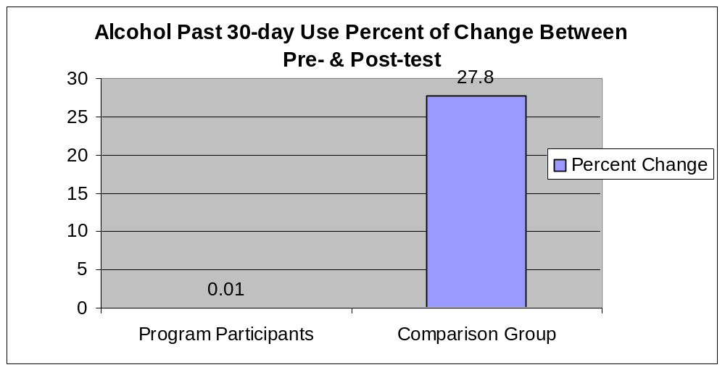

Program participants reported almost no new alcohol use at post-test (17) vs. pre-test (16.9), an increase in use of only .01%. The five-year comparison group cohort, on the other hand, reported an average increase in the rate of use across the five years of 27.8% (23.6 to 30.2). The range of self-reported use across the comparison group is relatively consistent across the five years, ranging from a low of 20.3 to a high of 25.2.

Past 30-day use of Marijuana
The program participant youth reported similar results for marijuana. At pre-test, the self-reported use rate was 9.1. At program completion, the reported use rate of marijuana was 9, a decrease of 0.1%.

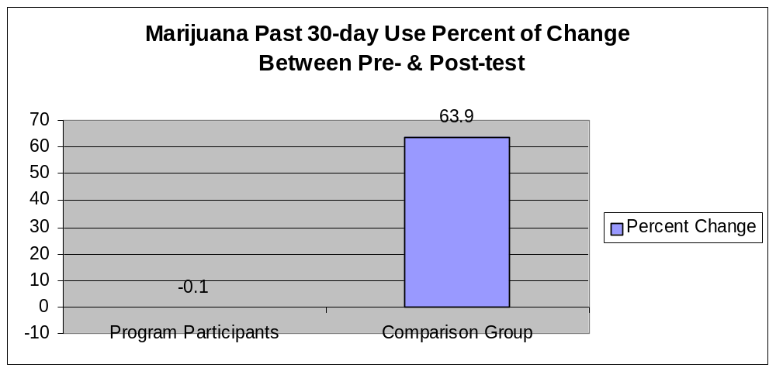
Comparison group participants reported an average pre-test use rate of 12.14, with an average increase over the five years in the rate of 7.76, which is a 63.9% increase in the rate of use. The self-reported use rates (pre-) for the five comparison group points range from 9.1 to 15.5.

Past 30-day use of Tobacco (Cigarettes)
Tobacco use increased in both the participant and the comparison groups. Among program participants, use increased from a rate of 15.2 to a rate of 17.4, an increase in the rate of 14.5%.

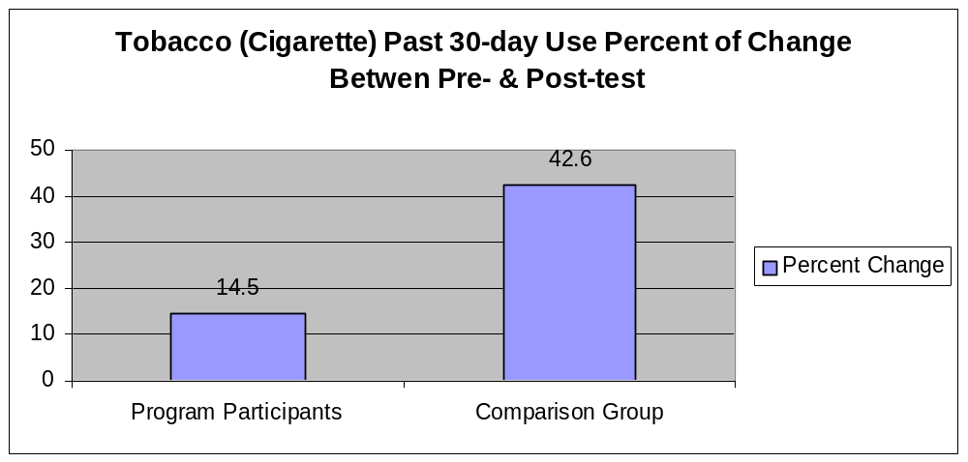

Among youth in the comparison group, use increased from an average baseline rate for the five-year period of 18.5 by an average of 7.9, a 42.6% increase. Self-reported use rates for the comparison group range from 11.9 to 25.1.

Past 30-day use of Other Illicit Drugs
The final analysis presented is for other illicit drug use (excluding marijuana). Among program participants, the self-reported rate of use decreased from 3.9 to 3.2, a decrease in the rate of 17.9%.

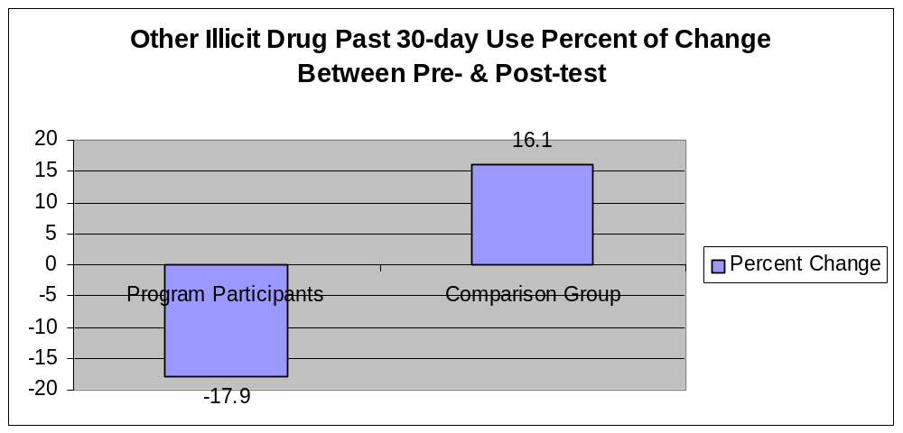

Among the comparison group, self-reported use of other illicit drugs increased from an average rate of 10.28 to one of 11.94, an increase of 16.1%. The range of use rates for this category demonstrates the most fluctuation of any substance category. That range is from 4.2 to 18, a quite substantial variation.

The change in the rates of use among program participants vs. the comparison group consistently demonstrates a substantial impact that is mediating, preventing, and sometimes reducing the use among adolescents.

Conclusions
Although increases in drug use except for tobacco use were prevented, statistically significant negative changes in risk taking, intention to abstain, peer drug use, parental support and tolerance of drug use, adult drug use, and perceived availability were reported by the 12-14 year olds. The interventions appear to have prevented most ATOD use among both boys and girls of all ages. Surprisingly, girls showed small but statistically significant negative changes in risk and protective factors not evident among boys. These findings contrast with earlier studies of other samples showing girls’ risk factors to be lower. Finally, younger participants were at higher risk for drug use than older participants due to their beliefs and perceptions related to drug use, not in any ATOD use.

Pre-K through 6th grade Initiative
As a result of the effective prevention programming and evaluation system, New Mexico Department of Health/Behavioral Health Services Division was awarded monies for an additional initiative in February 2004. This initiative, funded by the Substance Abuse and Mental Health Services Administration (SAMHSA)/Center for Substance Abuse Prevention (CSAP) focused on implementing evidence based substance abuse prevention programs directed at reducing risks and promoting resiliency and school preparedness. Participants include children ages 0 to 6, (NM SIG Enhancement: 0-6) inclusive of families and communities. Though the SAMHSA funding has now ended, OSAP continues to support programs providing services to youth in this age group and their families.

Service providers selected a variety of evidence-based curricula to implement in their communities. New service providers were added to this initiative; therefore training and technical assistance were provided. This is one of two programs nationwide funded to target this age group. Evaluation results are not yet available from this initiative.

Pre kindergarten through 6th grade programs also provide a full continuum of comprehensive community-based prevention services for individuals, families and communities, including Synar activities to reduce the sale of tobacco to minors. As appropriate, the contractor shall provide targeted evidence based prevention programs for youth who are not in need of treatment, and maintain fidelity of the selected evidence based programs. PreK-6 programs are aimed at directly impacting risk and resiliency factors in the targeted age group. These programs tend to involve both youth and their families.

Evaluation of the Pre-Kindergarten through 6th grade (PreK-6) Initiative of the BHSD involved a significant shift in design and approach, particularly given the age level of youth participants. BHSD contractors were asked to provide a comprehensive family approach to substance abuse prevention that included a parent intervention component. Each of these shifts in focus and age of target youth required the development of a new battery of evaluation tools that were piloted and implemented during the 2004 fiscal program year.

As with other BHSD evidence based prevention initiatives, a pre-test, post-test design without control groups was used with the intent to aggregate all youth, parent, and teacher outcome data for this year-end reporting. Local evaluators monitored and provided oversight at each of the 20 funded PreK-6 prevention sites and worked closely with the statewide evaluation team to provide timely data submission.

Youth below the 4th grade do not complete any written evaluation forms. Parent and teacher reports (n=480 matched pairs) are used as the basis for the evaluation of these younger children. Youth in the 5-6th grade age range (n=286 matched pairs) were administered the Youth Risk Survey which also included specific items on lifetime and current substance use.

Table 4
Demographic Information for prek-6 youth participants
Number of Parents (N=575)
Parent Gender
Male | 145 |  | 25.7%**
0-5 | 420 |  | 74.3%**
Age of Children
7-9 | 177 |  | 15.8%**
10-12 | 910 |  | 81.3%
13-15 | 32 |  | 2.9%

Gender
Male |  | 575 |  | 51.3%
Female |  | 546 |  | 48.7%

Pre/Post-Test Comparison
Overall, data results for this fourth year of the Pre-K-6 programs were positive.

Results include some of the following highlights:

- Family interaction exhibited a slight increase indicating that parents are improving how they interact with their child and their family. These findings suggest that PreK-6 grade Programs are having a positive effect on improving how parents communicate and interrelate with their children.
- Parent-child interaction had significant improvements over the intervention period. Parents’ abilities to positively interact and feel confident of their child’s affection and abilities improved substantially.

Data findings from the fourth year of the Pre-K-6 initiative are very promising for Pre-K-4th grade students and parents. The data finding indicate that program services for Pre-K-4th grade parent participants were effective in promoting positive changes in behaviors at home and the community, and much of this impact is likely the result of including parents in the substance abuse prevention effort.

0-6 Program Initiative
Overall the programs appear to have had an extraordinarily positive impact on participants. Protective factors, especially parenting skills, moved in a positive direction. Risk factors, especially negative parent child interaction, were reduced. Local evaluators reported parents indicated that the program helped them a lot. “They learned positive discipline methods and how to shape their children’s behavior in a pro-social direction without resorting to punishment and spanking.”

There was improvement in participants’ home environment. This finding indicates that after participating in the program the teen parents moved homes less often, their neighborhood was safer, their home was safer, their income was more stable, they were better able to provide nutritious meals for their child, had better hygiene and had reliable access to transportation, and were better at scheduling time for their child to play and study.”

There was very slight improvement in participants’ social support. This finding indicates that after participating in the program the teen parents had more positive interactions with friends and neighbors, were able to access more help from others when needing food, clothing or shelter, and were able to access more help with childcare, cooking, transportation, and housework. Some reported being able to take better care of their child, and reported the child’s father was more involved with the daily care of their child.

Findings for Hispanic and Native American Youth
OSAP prevention services have been provided to a wide range of youth who represent diverse populations. The following sets of analysis are intended to determine the benefits of prevention programming for Hispanic and Native American Youth. These separate analyses are important since there are few studies focusing on drug prevention for minority and rural youth.

Hispanic
The Strategies for Success (SFS) survey was used to assess and measure the effectiveness of services for Hispanic youth across the State of New Mexico. The SFS survey allows for the measure of significant findings between the pre and post test. In this survey participants were asked about personal perceptions of ATOD use, as well as past thirty day use.

Of the aggregate sample of participants which received services through 12-17 Prevention Programs in the State of New Mexico, Hispanic youth participants made up N=1,359. Of the total participants 49.0% were male and 51.0% female with 80.6% ages 12-14, and 19.5% ages 15-17.

Pre/Post-Test Comparison
- For Hispanic youth, only Marijuana use had a significant finding for past 30-day use, however not strong enough as no effect size. Findings based on means indicated that tobacco, alcohol, marijuana, and illicit drug use all slightly increased.

Hispanic Males
- Hispanic males were found to have a significant increase in impact of AOD use, although the effect size was small (_{p}²=.009).
- For Hispanic males, there were decreases in tobacco, alcohol and marijuana 30-day use, however not strong enough to render an effect size. Findings for illicit drug use remained the same.

For Hispanic males, there were decreases in tobacco, alcohol and marijuana 30-day use, however not strong enough to render an effect size. Findings for illicit drug use remained the same.

Hispanic Females
- Hispanic females had a significant increase in perceived harm of ATOD however no effect size.
- Hispanic females experienced decrease in impact of AOD use, but effect size was too small to document.
- Marijuana and illicit drug use for past 30-day use had a slight decrease while tobacco and alcohol had slight increase, all of these items had no effect size.

Native American
Analysis of the outcome evaluation data from the pre/post test instrument for this reporting period indicated that the evaluation instrument was highly reliable among Native American Youth (with the exception of 2 scales), meaning that the items in the instrument were well understood by Native American youth, and that they answered the questions honestly.

For the Native American youth an aggregate sample of N=414 was collected. Of the Native American participants 50% were male and 50% were female with 86% being of ages 12-14, and 14% of ages 15-17.

Pre/Post-Test Comparison
- Among Native American youth behavioral and adult ATOD use had a significant decrease.

Cornstalk Institute Program

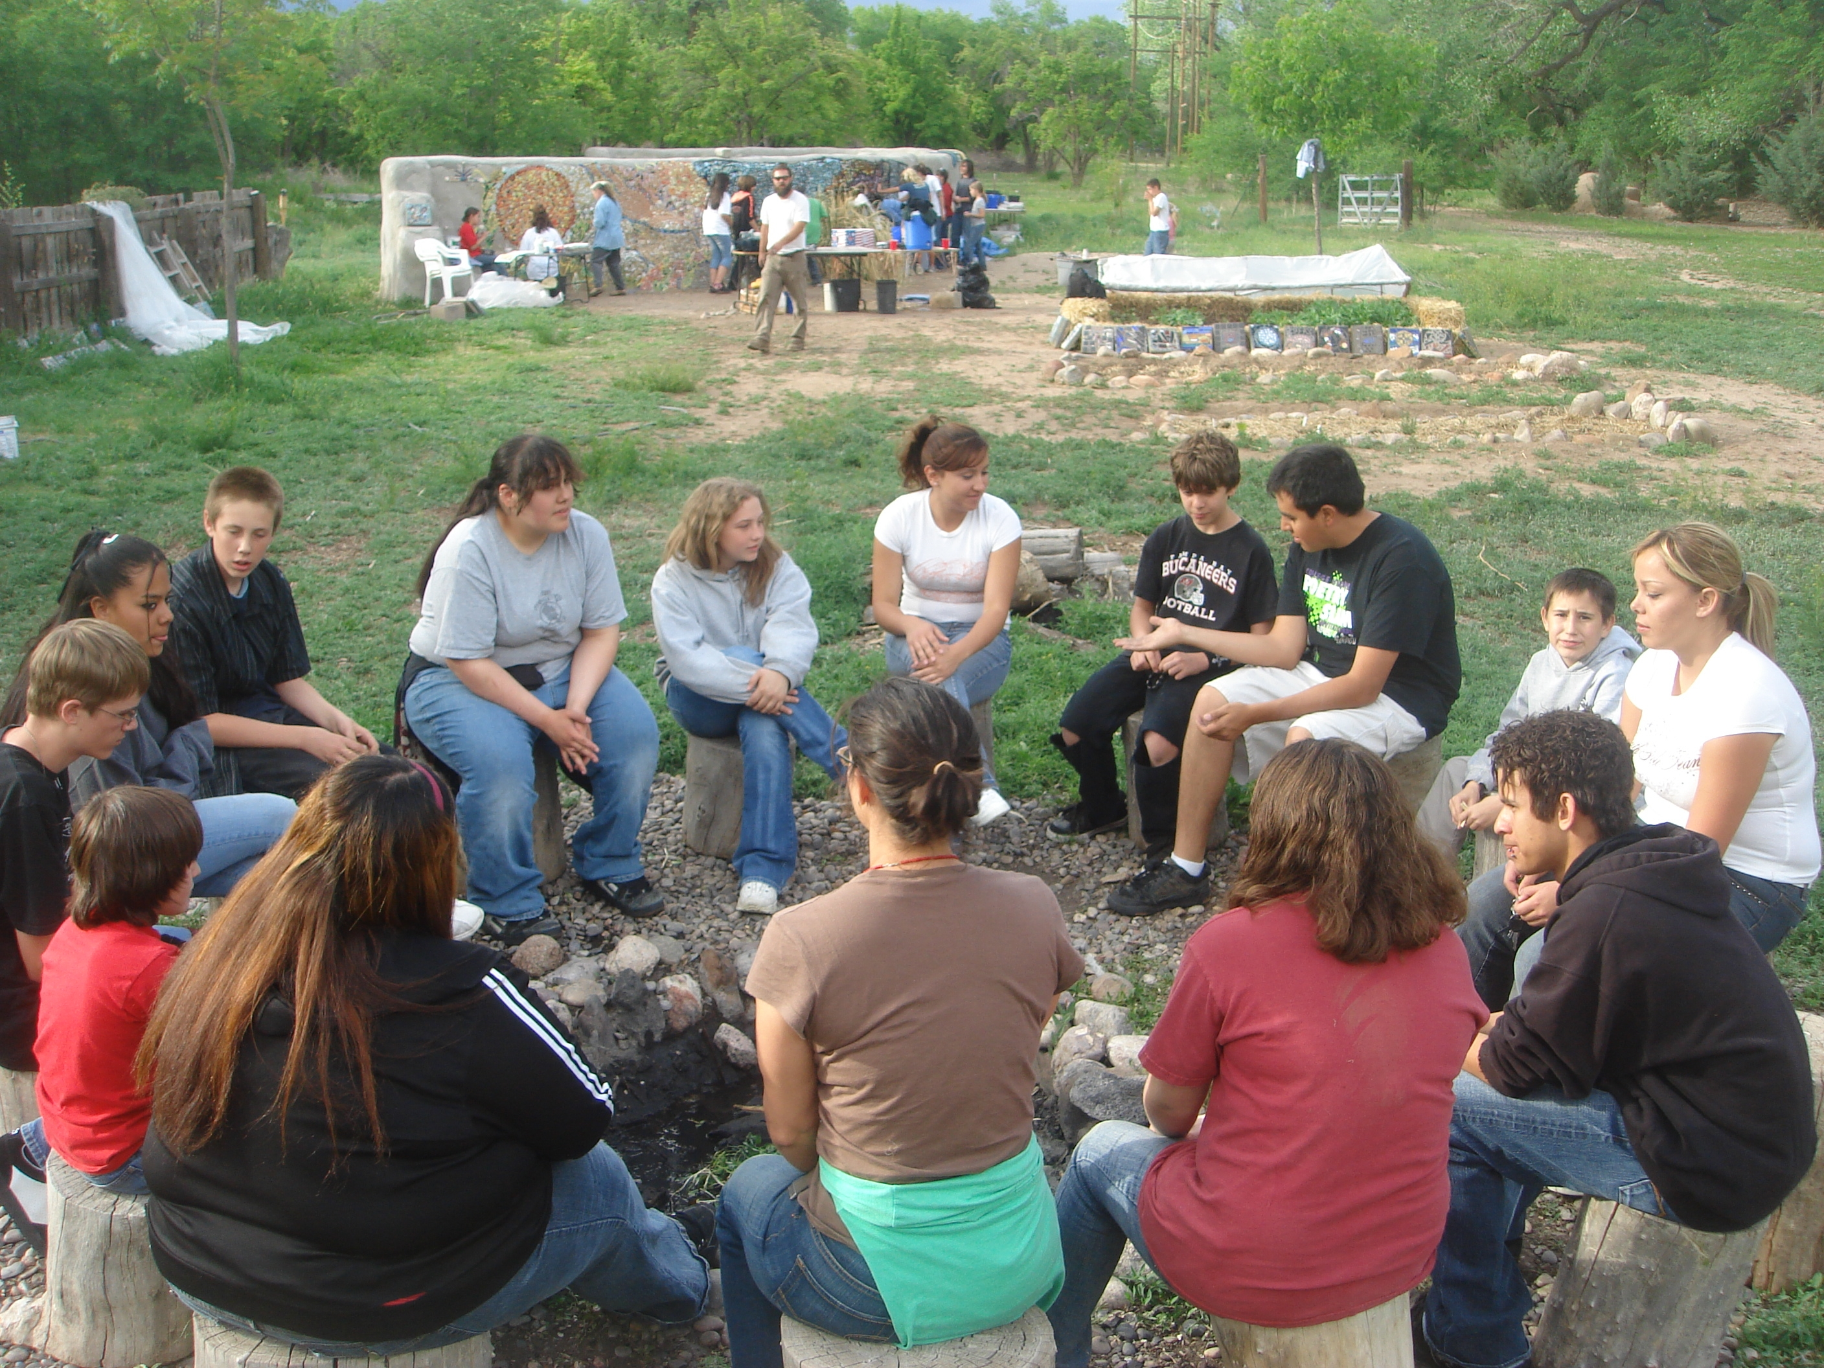

Fiscal Year 2007 Highlights of Outcomes from Community Prevention Programs
Research consistently demonstrates that the most successful prevention initiatives and most meaningful outcomes are produced by community projects that implement broad based activities that focus on multiple domains -- individual, family, school, peer, and community. The BHSD has supported strong coalition driven projects that implement programs designed to change one or more of the three major community level factors that influence substance abuse. Those factors include: community norms that are favorable to substance use, easy availability of substances both illegal and illicit, and policies, regulations and their enforcement (or lack thereof) that create favorable conditions for substance abuse.

All programs funded by the BHSD have been encouraged to implement environmental strategies that are designed to impact norms, availability or access to tobacco, alcohol and other drugs. The beginning section of the following program table highlights some of the activities and accomplishment during the 2007 Fiscal Year.

Office of Substance Abuse Prevention
Evaluation Outcomes 2007
* Coalitions: Page 18 *Youth 0-6 and Families: Page 21 *PreK-6th Grade Programs: Page 24
*12-17 Programs: Page 31

Community Based Program | Location | Program(s) implemented and Population served | Outcomes

COALITIONS
Albuquerque Partnership | Albuquerque;  South Valley, La Mesa, Trumbull Village, Barelas, Sawmill, Mountain View, Martinez Town & Santa Barbara, Adobe Acres, Valley Gardens, | Implementation of environmental strategies addressing issues of drug abuse, drug related crime, education, public safety and community development. The Albuquerque Partnerships works with several neighborhood associations and city groups in providing training, technical assistance and encouraging mobilization & positive development. | - Successful community organizing to halt expansion of Diamond Shamrock’s liquor retail outlet  - Closing of the Hot Spot “Fox’s Booze and Cruise” liquor establishment  - 26 Hot spots reported via Partnership in FY 2007; 14 of these have been resolved and file closed.  - Six presentations conducted by the Party Patrol at three schools reaching 900+ students  - Assisted the partner neighborhood associations (NA’s) with the development of their strategic plans for 2007  - Partnership staffs kept the pace of attending and/or being on the agendas of their 8 partner NA’s in each of the 4 quarters of FY2007  - SYNAR: 100% compliance by merchants in survey pool
Ayudantes Inc | San Miguel County, specifically Las Vegas | The agency works to offer high-quality, low cost mental health, substance abuse, and supportive services to help adolescents, adults and families rebuild family and community in San Miguel County | - Building of community capacity and collaboration with agencies, including: The City of Las Vegas, Samaritan House/Estrella Nativa, Somos Familia-Family Institute Inc., DWI Planning Council, NMHU Check Up To Go Program and the San Miguel County Health Council.  - 2 Ayudantes staff are members of the DWI council  - Collaboration with MADD in training to start MADD local chapter  - Successfully conducted merchant education and training of 33 retail tobacco outlets within the Las Vegas  and San Miguel County environments.  - Sponsored training of a Certified Prevention Specialist
Carlsbad Community Anti-Drug/Gang Coalition | Carlsbad & South Eddy County | To build and strengthen the capacity of the community to create a safe, healthy, and drug & gang/crime free environment. Includes serving as a catalyst to mobilize community efforts to reduce substance abuse and gang activity among youth, and adults over time, in Eddy County. | - National Night Out (NNO): This local observation of a national event is a project to develop an abiding interest in neighborhood safety and has fostered cooperation between the Coalition and Wise Eyes, the crime watch model used by local law enforcement.  - The Coalition supports and serves as fiscal agent for Peer Helpers, a suicide prevention program expanded to middle schools in Summer 2006; more than 70 Peer Helpers have been trained.  - Decrease in Reported Youth Meth Use: According to the Coalition-administered Communities That Care Student Survey.  - Increased knowledge of patterns of purchase via two retailer interviews  - Ongoing interest and active involvement of local juvenile authorities
Golden Spread Rural Frontier Coalition | Harding and Union counties | Golden Spread Rural Frontier Coalition; GSRFC provides planning, financing, and administrative services that incubate and support non-profit business and economic growth initiatives in Harding and Union counties. | - Developed a close working relationship with community, stakeholders, youth, and DOH.  - Continuing to build a strong foundation for the community in the prevention field and raising awareness of intervention needed for youth.  - Strategies and steps to develop a coalition framework: surveys, analysis, implementation, coalition meetings, involving stakeholders, and capacity building.  - Most significant progress made on reducing Easy Retail Access
Hands Across Cultures, Corp  Hands Across Cultures, Corp continued | Greater Espanola Valley, Rio Arriba County & Northern Santa Fe | Works in the Greater Espanola Valley, Rio Arriba County & Northern Santa Fe County on improving health initiatives. They work with high risk youth & their families, schools and the community at large. | - A community needs assessment was developed using multiple sources  - Coalition efforts have finally culminated in the passage of an excise tax increase for the County of Santa Fe.  - The coalition succeeded at involving youth in the coalition process in a meaningful way.  - Smoking Ban in Espanola, effective January 1, 2007, due to environmental strategies of the coalition for the past four years  - Spanapalooza for Youth Involvement, highly successful alcohol and drug free event.  - Coalition formally came together and resisted a new alcohol outlet in Abiquiu.  - Redistribution of Alcohol Tax dollars to a specific fund for Prevention  - SYNAR activities: This project year HACC has had 100% compliance in non-sales as evidenced through sting operations.
San Juan County Partnership | San Juan County, Farmington & Northwestern New Mexico | Local citizens concerned about several substance abuse related issues created an official organization (the partnership) to make a difference in the community. The SJCP acts as a resource and support for the community. All ages and groups are served by the Partnership although the emphasis is on working with youth. | - Community leaders convened to address the methamphetamines (meth) and gang issues in San Juan County during the past year; SJCP lead agency in creating a strategic plan.  - The advancement of positive social norms theory has been a major accomplishment during the past program year through connections with the San Juan Safe Communities Initiative(SJSCI), the Community Health Improvement Council, the DWI Planning Council and the Local Collaborative.  - The Creating Cultural Harmony Conference was well attended this year, but, more importantly, the tone of the conference was very positive and indeed celebratory  - SJCP has established a name and reputation in San Juan County as the leader in prevention and in managing community programs. SJCP is not just a participant at community forums, but is seen as a leader in helping to direct the future of San Juan County.  - Completed numerous GIS mapping presentations highlighting easy retail access in the eastern part of the county.  - SYNAR program had almost 100% merchant compliance; 1 of 29 vendors was non-compliant.

Community Based Program | Location | Program(s) implemented and Population served | Outcomes

0-6 Youth and Families
Counseling Associates Inc. | Roswell | The agency implements Parents As Teachers (PAT), an early childhood parent education and family support program serving 90 families throughout pregnancy until their child enters kindergarten. | - Results demonstrate clear positive change in the areas addressed by the program objectives.  - Parent satisfaction is very high as evidenced by observation (evaluator home visits), and eagerness of parents to become participants.  - A significant increase in Parenting Skills and a significant decrease in the Parent-Child Dysfunction Interaction has been shown.  - Parents reported a significant increase on scheduling time for the child to play and a significant increase in perception of themselves as a good parent.
The Counseling Center | Lincoln and Otero Counties | The agency provides Families that Care--Guiding Good Choices to 23 Lincoln County families. | - Parent's perceptions of their children's behavior problems improved substantially and statistically significantly  - Parent's perceptions of problems their children may have with school and learning also improved and was statistically significantly.  - Pyschosomatic problems, impulsivity, hyperactivity and anxiety decreased in parents’ point of view  - Increase in positive family interaction, positive parental attitudes, and positive parent-child interaction.
Excel Educational Enterprises | Albuquerque, South Broadway and Kirtland Addition neighborhoods | Effective Black Parenting &  Strengthening Multi-Ethnic Families  were the principle programs implemented, along with After-School K-6 Grade Alternative Activities and the  After-School Learning Center for 70 families. | Positive findings found for the total sample in the areas below:  - Protective factors increased in the Home Environment  - Social Services Utilization increased  - Parenting Skills increased  - Family Interaction increased  - Parent Child Dysfunctional Interaction decreased  - No increase in ATOD.
La Clinica del Pueblo de Rio Arriba | Rio Arriba County including the Espanola Valley, Abiquiu /Ojo Caliente, and the Chama Valley area including Gallina, Coyote, Tierra Amarilla, and Chama | The  Dare To Be You Program was implemented with parents of pre school age youth, 89 families total. | - The program showed a statistically significant positive increase in family interaction.  - Parents reported a significant increase in positive parental attitude, including control of their feelings and being good role models.  - Parents learned positive discipline methods and how to shape their children’s behavior in a pro-social direction without resorting to punishment and spanking.
Sandoval County Substance Abuse Prevention Program | Sandoval County (Cuba, Five Sandoval Indian Pueblo, Bernalillo) | The  Dare to Be You  Curriculum was used with 94 families with children ages 0-6 in Sandoval county, including the town of Bernalillo and the Pueblos of Cochiti & San Felipe.  Ten youth mentors (14-19) assist with the implementation of sessions. | - There were statistically significant increases in scores for Home Environment, Parenting, and Family Interaction.  - There was an increase in score approaching significance for Child Well Being and a reduction in score approaching significance for Parent Child Dysfunctional Interaction.  - A positive finding was revealed in that there was decrease for Adult GPRA 30 Day Use – Number of Days.  - Six out of the eight risk and protective factors revealing positive findings in the female group.  - The female group had statistically significant increase in Parenting Skills and Family Interaction, increases in scores approaching significance in Child Well Being and ATOD Perception of Risk, and a reduction in score approaching significance in Parent Child Dysfunctional Interaction.
Santa Fe Public Schools  Santa Fe Public Schools continued | Santa Fe | The Meld curriculum Para Nueva Familia with 31 teen mother, 6 teen fathers and 20 grandparents through the Santa Fe public schools. | - There was statistically significant improvement in participants’ parenting skills.  - Participants in the Meld Pre-natal and Parenting I classes gained knowledge about child development and parenting skills in fourteen of the twenty areas measures  - Parent child communication behaviors improved in nine out of twelve areas  - Parent discipline behaviors for parent with babies over 6 months improved in seven out of twelve areas  - Parent physical care behaviors improved in eight out of fourteen areas
Southern New Mexico Human Development, Inc. | Luna, Sierra, Doña Ana, and Socorro Counties | The Strengthening Families Program was implemented with 74 families. | - There were statistically significant increases in Risk and Protective Factor scores: Home Environment, Social Support, and Parenting Skills.  - Additionally, there were increases approaching significance for Social Services Utilization, Family Interaction and Child Well Being.  - Additional positive findings for the female group include statistically significant increases in scores in Social Support and Parenting Skills and increases in scores approaching significance in Social Services Utilization, Family Interaction, and ATOD Perception of Risk.

Snowboard Outreach Society
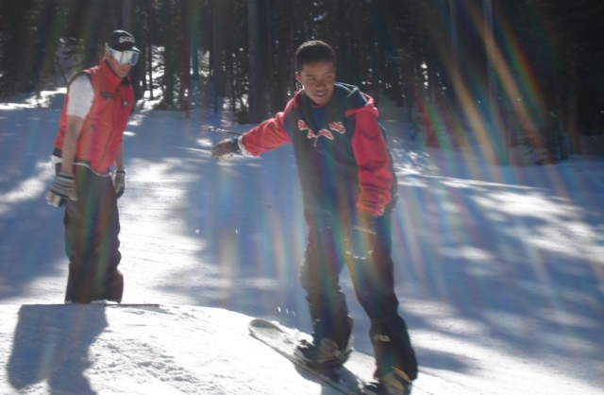

Community Based Program | Location |  | Program(s) Implemented and Populations served | Outcomes
Pre Kindergarten – 6th Grade
Colfax County Youth Empowerment Services |  | Colfax and Union Counties: De Moines, Eagle Nest, and Springer | The principle programs include community wide environmental planning and implementation of Dare To Be You and Synar. 182 students participated in the Dare to Be You program | Statistically significant findings were shown for the categories below:  - CRS Conduct Problem – Parent and Teacher Rating – Individual Domain  - CRS Hyperactivity Index – Parent Rating, Individual Domain  - CRS Hyperactivity – Teacher Rating, Individual Domain  - CRS Inattentive Passive – Teacher Rating, Individual Domain  - School Performance Grad , School Domain  - School Protective Factors, School Domain
Counseling Associates Inc.  Counseling Associates Inc. continued |  | Roswell area, & Hagerman | The  Botvin Life Skills  was used, including follow-up booster sessions with 113 students.  The  Dare To Be You  Curriculum was also used with 116 parents with preschool age children. | - Participants reported significant positive change on three scales: Accurate Knowledge about Use, Stress Knowledge, and Relaxation Skills.  - Girls reported significantly increased Decision-making Skills, Accurate Knowledge about Use, and Relaxation Skills.  - Boys reported a significant increase on the Friendship Skill scale.  Dare To Be You  The following items showed positive findings:  - Significantly increased Positive Family Interaction Scale  - Significantly increased Positive Parental Attitudes Scale  - Significantly reduced scores on the Parent-Child Dysfunctional Interaction Scale  - a significant increase in making plans to achieve personal goals  Women  - having increased their understanding of their child:  - a decrease in thinking that their child takes a lot of time to get used to new things  - a decrease in thinking that their child does not do things to make them feel good  Men  - a significant increase in Positive Parental Attitudes  Spanish-Speakers  - significant increase in ability to handle child’s destructive behavior  - a significant increase in appropriate developmental expectations
County of McKinley, New Mexico |  | Crownpoint and surrounding area | The Dare to be You program was implemented with 71 families | - Each of the three scales in the PreK Parent Survey changed in the desired direction from pre to post:  - Family Interaction  - Parental Attitudes  - Parent-Child Dysfunction  - Each was highly statistically significant for the total sample
Excel Educational Enterprises |  | Albuquerque, South Broadway and Kirtland Addition Areas | The  Effective Black Parenting  And  Strengthening Multi-Ethnic Families programs were used with 52 families | The following are significant and meaningful results of the program:  - Family Interaction increased  - Family attitudes increased toward the positive  - Parent child dysfunction decreased  - Youth hyperactivity, problem behavior and inattentiveness all decreased according to teacher surveys  - Both school performance and school attendance slightly increased  - Parent communication dramatically increased.
Farmington Municipal Schools |  | San Juan County served by Farmington School District | The Second Step program is implemented as a universal violence prevention program. It’s designed to reduce aggression and promote social competence in the 815 participating students and 58 families. | - Slight decrease in anxiety rating by parents  - Slight increase in school protective factors  - Decreases in marijuana and illicit drugs.  - No increase in 30 day tobacco or alcohol use.
La Clinica del Pueblo de Rio Arriba |  | Rio Arriba County including the Espanola Valley, Abiquiu /Ojo Caliente, and the Chama Valley area including Gallina, Coyote, Tierra Amarilla, and Chama | The  Dare To Be You Program was implemented primarily with parents of pre school age youth. However, we also offer the DTBY program to parents of children ages 5-11 years (133 served). | La Clinica has implemented the Dare to Be You Program in four northern Rio Arriba County for the past six years with positive results, including increase in:  - Family Interaction  - Parental Attitudes  - Parents were observed using methods and skills acquired through DTBY including positive discipline techniques.
Mescalero Apache Tribe |  | Mescalero Apache Reservation, Ruidoso area | The  Botvin Life Skills Training and the  Dare To Be You program were implemented with 228 3rd –6th grades students. | - Conduct problems on the teacher survey decreased (for group and boys)  - Hyperactivity teacher rating decreased (group overall and boys)  - Hyperactivity index decreased (group overall and boys)  - Parent communication, attitude toward ATOD, and perceived harm from ATOD increased in both groups  - Both groups reported slight decrease in ATOD use.  - Parents reported slight increase in family interaction and parental attitudes.  - 100% compliance by merchants in SYNAR pool
North Central Community Based Services |  | Chama & Northern Rio Arriba County | The  Botvin Life Skills and the Across Ages mentoring program were both used with 187 5th & 6th grade students.  The  Dare To Be You curriculum was used with 20 families with pre school age children. | - Parent communication increased for the overall group  - Tobacco use decreased for the overall group  - Perceived harm increased for the overall group.  - Parent communication increased for boys and girls.  - Tobacco use decreased for boys.  - Perceived harm increased for boys and girls.
Rio Rancho Public Schools |  | Rio Rancho | Dare to be You is implemented in three groups consisting of 86 families | Total Sample  - significantly increased Positive Parental Attitudes Scale  - significantly reduced scores on the Parent-Child Dysfunctional Interaction Scale  - a significant increase in the ability to handle child’s refusal to do housework  - a significant decrease in thinking that their efforts are not appreciated by their child  - increase in feeling good about their relationship with their child  - a significant increase in their perception of themselves as good parents  - Females shared an increased ability to make plans to achieve personal goals, which approached significance ()  - Men shared a significant decrease in hitting or spanking their children
Rocky Mountain Youth Corps |  | Taos County: Questa, Penasco, Taos | RMYC implemented a locally developed ‘promising program’—Protecting You, Protecting Me—to 104 students in the Taos area. Corps members mentor and tutor youth and design service learning projects. | - Students involved in this program did not engage in risky behavior (no substance use at all)  - Students had very low scores on the negative conduct, temperament, and behavior measures, and score high on school performance, attendance, and family measures.  - Youth’s perception of the dangers of substance use was very high.  - School performance (grades) increased.
Sandoval County Substance Abuse Prevention Program |  | Sandoval County | The  Dare to Be You  Curriculum was used with 58 in Sandoval county, including the town of Bernalillo and the Pueblos of Cochiti & San Felipe. | Sandoval County SAPP developed collaborative relationships with the Town of Bernalillo’s Even Start Program, public schools and other agencies and organizations which helped gain support for program implementation and have access to youth for the DTBY Program.
San Juan County Partnership |  | San Juan County | The Partnership implemented the Families and Schools Together (FAST) curriculum this program year. 224 students and 19 families received services in various schools in San Juan County and the Navajo Nation. | - FAST-Flyers were mailed to all parents of students in the school. Presentations were made to all students in the school. An article was written in the local newspaper. School counselor made personal phone calls to potential families.  - FAST-Increased recruitment efforts. Families attending were encouraged to bring in other families and movie tickets were offered.
Southern New Mexico Human Development |  | Luna, Sierra, Doña Ana, and Socorro Counties | The  Strengthening Families Program was used with 42 families. | - Three out of the six scales revealed positive findings for total sample: Impulsive-Hyperactive (statistically significant), Learning Problem and Hyperactivity Index.  - For the male sample, there was a statistically significant reduction in Anxiety and reductions approaching significance in Conduct Problem, Learning Problem, Psychosomatic problems, Impulsive-Hyperactive and Hyperactivity Index  - On the attendance scale, the female sample revealed a positive finding with an increase approaching significance.
Taos - Colfax Community Services  Taos-Colfax Community Services continued |  | Taos & Colfax Counties | The PATHS Program served 300 students in Taos county. The  Dare To Be You curriculum was used with 50 Headstart families and 150 youth in middle school in Colfax county. | Taos County  - There was a reduction approaching significance in Impulsive-Hyperactive.  - A statistically significant increase was revealed in School Grades.  - The male sample revealed a positive trend with a reduction approaching significance in Impulsive-Hyperactive.  Colfax County  - Based on parent reports for the total sample, all of the behavior rating scales revealed positive findings.  - For the total sample there was a statistically significant increase in score for School Protective Factors  - For the total sample, there were statistically significant increases in scores for Parent Communication and Family Cohesion & Adaptability.  - Positive findings for Youth ATOD use include a statistically significant increase in Perceived Harm and a reduction in score approaching significance in 30-Day Marijuana Use.
UNM - ACL Teen Centers |  | Acoma, Laguna, To’Hajillee, Cubero and Seboyeta Communities | The  Botvin Life Skills curriculum was  used with  elementary school students attending the Sky City Community School in Acoma, Laguna Elementary School in Laguna, To’hajiilee Community School, Cubero Elementary in Cubero and Seboyeta Elementary School | - For all participants, there was a statistically significant decrease in risk taking.  - For all participants, there was a significant increase in advertisement knowledge.  - For male participants, there was a statistically significant decrease in stress levels.
Youth Development Inc. |  | Valencia County, Los Lunas | The  Dare To Be You  Curriculum was used with forty (40) families living in Valencia County who have pre-school age children. | - There was a decrease in Parent-Child Dysfunctional Interaction.  These are participant comments about how program helped them:  - More patience.  - Enjoying children more.  - Not as much yelling. Learned to work with children.  - More calm.  - Controlling temper.  - Appreciate children more.  - Gave me more insight.  - Help me to understand kids better.  Comments about how program helped their children:  - Children don’t cry as much.  - Child is happier. Going to school regularly.  - More responsive.  - Child learning “time out”.  - Children are better behaved.  - Children listen more.  - Children are more helpful.  - Better communication with me.  - Less fighting among each other.  Recognizes choices.
North Central Community Based Services Program
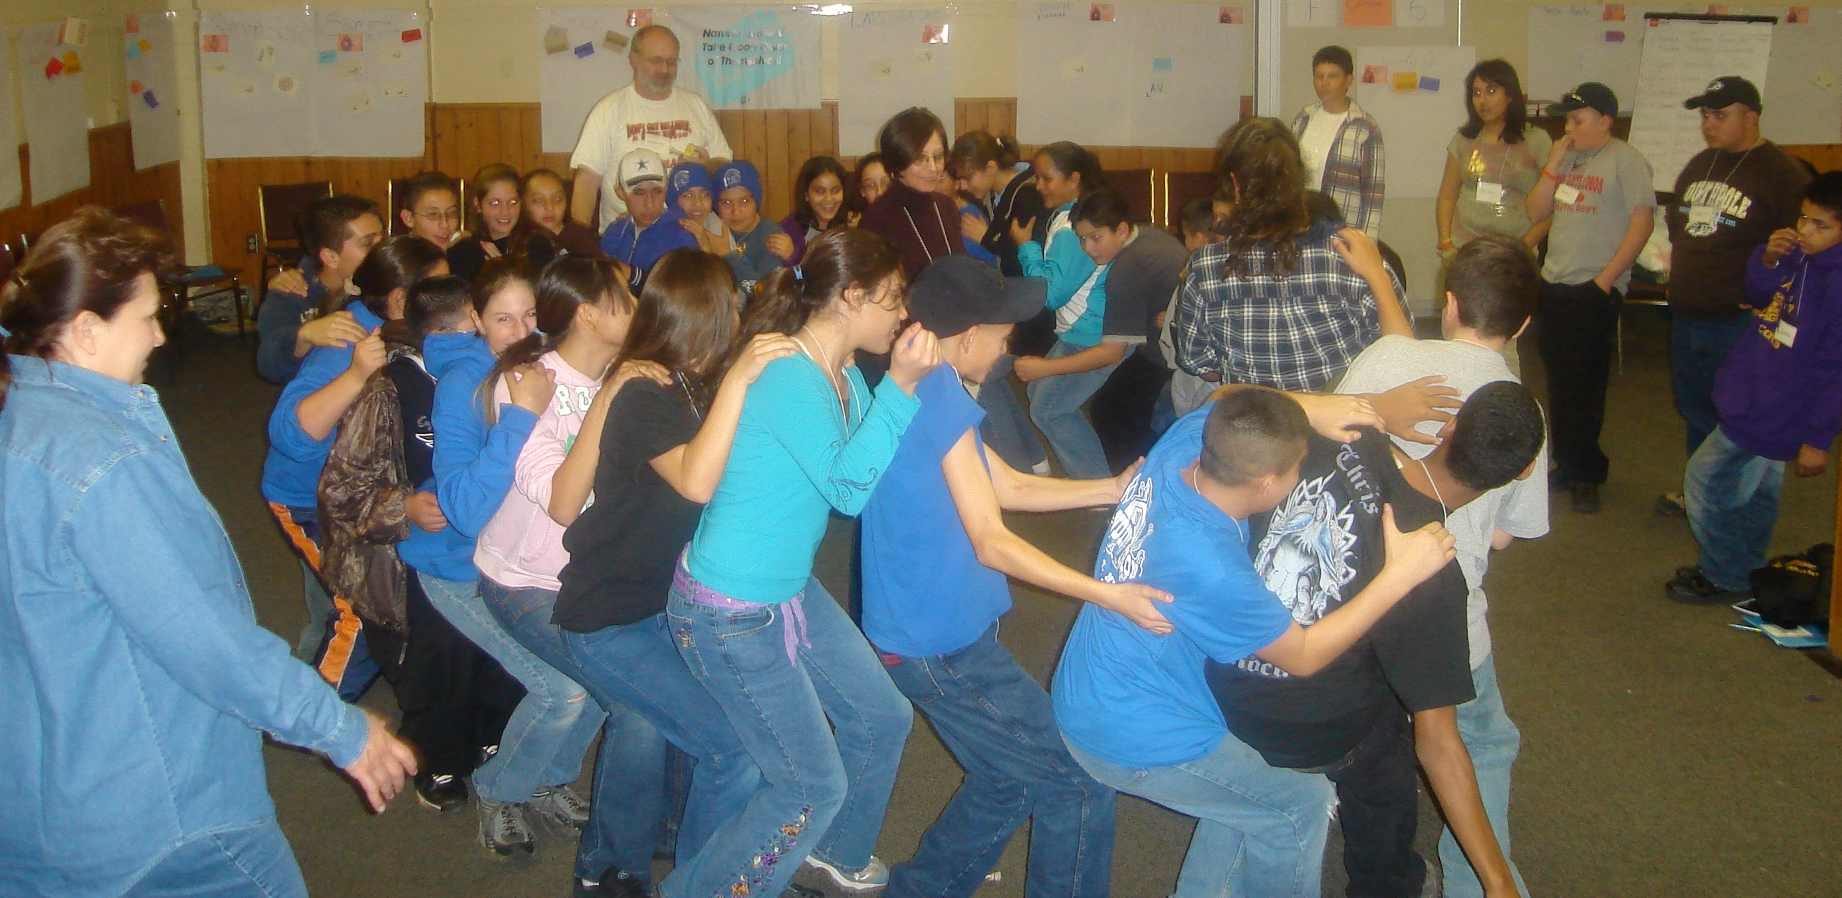

Community Based Program | Location | Program(s) Implemented and Populations served | Outcomes
12-17 year olds
Cornstalk Institute | Bernalillo County including Central Albuquerque and South Valley | The  Learning to Lead program was implemented with 125 youth from six schools in Albuquerque’s southwest neighborhoods. | - Decreases in aggressive behaviors and risk taking.  - Desired change in increased perception of harm of ATOD.  - Slight increase in intention to abstain from ATOD.  - Increase in parent support.  - Very low use of all substances; with minimal to no change in tobacco, alcohol, marijuana and illicit drug use for all ages.  - Decrease in past 30 day alcohol, tobacco and illicit drug use among 15-17 year olds.
Counseling Associates, Inc. | Roswell, Hagerman and Lake Arthur  Dexter | The program implemented the  Botvin Life Skills Training curriculum with 370 middle school students in Chaves County. | - There is a significant reduction in alcohol use at post-test.  - Girls who reported using more than one substance in their lifetime (a possible definition of high-risk) significantly reduced alcohol use.  - Boys reported significant increases on Intolerance of Use  - Boys reported significant decrease in Adult Use.  - Hispanic boys reported a significant increase in Perception of Harm.  Approaching Significance  - All students reported an increase in Perception of Harm  - All students reported an increase in Intolerance of Peer Use
The Counseling Center | Lincoln and Otero Counties | The agency provides Families that Care--Guiding Good Choices to 26 Lincoln County families. | For the group overall:  Statistically significant increase in perceived harm in ATOD use, indicating that students were more aware of the dangers related to drugs and alcohol.  - A positive change indicating that they felt less tolerant of ATOD use.  - Positive increase in perception of parent support  - Increase in parental intolerance of drug use.  - Very low use of tobacco.  - Zero use of marijuana
Excel Educational Enterprises | Albuquerque, South Broadway and Kirtland Addition neighborhoods | Effective Black Parenting &  Strengthening Multi-Ethnic Families  were the principle programs implemented, along with After-School K-6 Grade Alternative Activities and the  After-School Learning Center for 49 participants. | Total Sample:  - Symptom Behavior Checklist improved significantly among 12-14 year males.  - No significant increase in ATOD use among both age groups and both genders show that the program delivery is working to prevent substance abuse and working significantly to reduce negative behavioral symptoms.
First Nations Community Health Source | Albuquerque | The  Run to the Sun program was implemented drawing from the Project Venture Model, with 100 middle & high school students in Albuquerque’s South East Heights. | - No statistically significant increases in the use of tobacco products or alcohol.  - Approaching significance in the increased perception of harm from drugs from pre to post.  - Positive changes on the Behavior Symptoms Checklist scale (a measure of emotional distress) as well as on the Aggressive Behavior scale.  - Parents report feeling more empowered and that their children are more outgoing as a result of the program.
Hands Across Cultures Corp. | Espanola Valley Area | Project Success  was implemented in the Espanola and Pojoaque Valley Schools, and involved 124 students. | - Significant findings for the group, as a whole, included decreases in the percentage of youth reporting use of: alcohol, cigars, speed, downers, ecstasy, and inhalants.  - Male youth reported a decrease in the Behavioral Symptom Checklist representing a positive trend  - Tobacco use remained level from pretest to posttest  - Unlike prior years, the service population reported zero heroin, crack or steroid use at either pretest or posttest  - The program served twice as many students as contracted.
National Indian Youth Leadership Project | Gallup and McKinley counties | The  Project Venture program was implemented with 81 7th grade students. | Three measures showed positive findings and were statistically significant at post test:  - Perceived harm of substance use (small effect)  - Adult substance use (medium effect)  - Availability of drugs (large effect)  Five additional measures moved in the desired direction:  - Behavioral symptoms  - Risk taking  - Impact of substance use on one’s life  - Peer use  - Parental support  Additionally  - Use of all substances was very low  - Illicit drug use did decrease slightly
North Central Community Based Services | Northern Rio Arriba County | Across Ages Mentoring replication for grades 5-8 in three districts and  Too Good for Drugs  were implemented for 296 students  MAARI—Drug Free Communities was implemented with residents of northern Rio Arriba County | - The group as a whole had a decrease in disruptive behaviors.  - Increased attitude toward ATOD use, perceived harm from ATOD use in group overall.  - Decreased marijuana and illicit drug use for group overall.  - Family bonding increased for boys.  - Statistically significant increase in perceived harm from ATOD for boys.  - Girls reported no marijuana or tobacco use; boys reported decreased illicit drug use, marijuana use at zero.  - Girls reported that their grades increased slightly.  - Both boys and girls showed healthy connection to their parents.  - Parents reported decrease in psychosomatic problems
Pueblo of Isleta Project Venture | Pueblo of Isleta | The  Project Venture curriculum was implemented with 40 5th-6th grade students in the Pueblo. | For the group as a whole:  - ATOD use for all drug decreased  - Disruptive behaviors decreased  - School protective factor increased  - Attitude toward ATOD use increased (e.g. students, their parents and community felt it wrong)  - Perception of availability of ATOD decreased  - Perceived harm from ATOD increased.  For girls:  - Grades increased  - Family bonding increased  - Reported no use of any substance
Quay County Alcohol and Substance Abuse Prevention (ASAP) Coalition | Quay County-Tucumcari, Logan, San Jon, Nari Visa, and House | Project Towards No Drug Abuse (Project TND) and Project Northland are used in the San Jon, Logan, and Tucumcari Schools, Quay County with 137 students | - There was a positive finding with a statistically significant increase in Perceived Harm of ATOD Use  - Substances for which decreases in the percentage of youth reporting use from pretest to posttest were chewing tobacco, alcohol, cigar, hallucinogens, and inhalants.  - Positive findings for the female sample include a statistically significant increase in Perceived Harm of ATOD Use and a decreasing trend on the Behavioral Symptom Checklist  - Similar to the total sample, youth in the 12-14 age group revealed a positive finding with an increasing trend for Perceived Harm of ATOD Use  - Youth in the 15-7 year old sample showed a statistically significant increase in Intention to Abstain
Rocky Mountain Youth Corps | Taos County: Questa, Penasco, Taos | RMYC implemented a locally developed ‘promising program,’ the Youth Corps Model with middle school students. | Interviews with parents and teachers indicated positive results from the mentoring program.  Resiliency increased in group overall. And, the increase was significantly greater in participants who were particularly low at baseline.
Sandoval County Substance Abuse Prevention Program | Town of Bernalillo | The  Dare to Be You (221 youth), Reconnecting Youth (35 youth) and Too Good for Drugs and Violence (35 youth)  programs were used with 221 students  in Bernalillo and Cuba. | Dare to be You: Bernalillo Middle School  - Positive findings were shown to be statistically significant in: decrease in Aggressive Behavior, ATOD use scales, decrease on the Tobacco Use scale, decrease in aggressive behaviors; decrease in illicit drug use for female sample.  Dare To Be You: Cuba Middle School  - Positive trends indicated statistically significant findings in: decrease on the Alcohol Use, Adult ATOD Use and Availability of ATOD in male samples.  Reconnecting Youth and Too Good For Drugs  - Positive trend showing an increase in scores for Parent Support, Intention to Abstain for males; decrease in Alcohol Use, Illicit drugs (Female), marijuana use (males) and an increase in perceived harm.
Santa Fe Community College  Santa Fe Community College continued | Santa Fe County: Pojoaque, New Mexico (Pojoaque Valley Middle School) | The  Connecting to Courage Program was implemented with 136 youth between the ages of eleven and fourteen & 38 families. | - Parent Intolerance of Youth ATOD Use scale increased.  - Increase in scores in Intolerance of ATOD and a reduction in scores in Peer AOD Use.  Cohort 1:  - Group showed zero ATOD use at both pretest and posttest.  - 22.8% of the students participating in improved their grade point average (GPA) or their GPA remained the same.  Cohort 3:  - 58.8% of the students participating improved their grade point average (GPA) or their GPA remained the same.  - Cohort 3 students who received higher dosage of service had a slightly higher effectiveness then Cohort 1.  - There was no use of tobacco, marijuana, or other illicit drugs reported for the past 30-day period.  - The female sample revealed an increase in Intolerance of ATOD and a reduction in scores in Peer AOD Use.  - The male sample revealed an increase in Parent Intolerance of Youth ATOD Use.
Santa Fe Mountain Center | Espanola Valley, Rio Arriba county | The Project Venture program is used with 60 students in the Espanola schools. | - The female sample revealed an increase in scores approaching significance in Perceived Harm of ATOD Use and a reduction in scores approaching significance in Impact of AOD Use.  - The male revealed a positive finding for the male sample in the Intention to Abstain scale.  - There were no use of tobacco, alcohol, marijuana, or other illicit drugs reported for the past 30-day period; low use of alcohol was the only substance youth reported using in their lifetime.
Santa Fe Public Schools | Santa Fe | The  Botvin Life Skills program was implemented in Santa Fe Public School with all sixth grade classes, reaching over 1,000 students each year in 50 classes. | There was statistically significant improvement in:  - participants’ knowledge about marijuana and tobacco  - in participants’ decision making skills  - in participants’ ability to resist ATOD advertising  - in participants’ stress management skills.  - There was slight improvement in participants’ beliefs about the harm caused by ATOD use.  - Females perceived that their parents felt it was more wrong to use ATOD on the post-test compared to the pre-test.
San Juan County Partnership | San Juan County Schools between Shiprock & Aztec | Two programs were implemented this year: the Families & Schools Together (FAST) program served 11 families and the Botvin Life Skills program 213 youth. | - Participants have very low use rates. 76% of participants reported never using Tobacco, 82% never used alcohol and 97% never used inhalants.  - Slight increases in perception of harm of ATOD, intolerance of use and parent support.  - Slight decrease in past 30 day alcohol use  - No increase in past 30 day use of tobacco
Socorro Mental Health | Socorro | The  Reconnecting Youth program was implemented. | - Reduction for the students who reported using two or more substances in marijuana use approaching significance  - Slight reduction in risk taking  - Slight increase in parent support  - Slight increase in parent intolerance of youth ATOD use
Southern New Mexico Human Development  Southern New Mexico Human Development continued | Anthony and communities within 60 miles of the Mexico Border; Four Counties: Luna, Sierra, Doña Ana, and Socorro | The Reconnecting Youth program was implemented with 48 Youth ages 12-17 and the Strengthening Families Program was implemented with 72 families. | Strengthening Families  - There were increases in scores approaching significance for: School Performance, School Protective Factors , Family Cohesion & Adaptability, Perceived Harm, School Protective Factors (female), Family Cohesion & Adaptability (female)  - Reduction in score approaching significance for 30-Day Illicit Drug and 30-Day Marijuana, Conduct Problem, Learning, and Anxiety (male). Use was reduced to zero at posttest.  - Female youth revealed a similar pattern in that they shared two of the same type of findings with reductions in scores approaching significance in Conduct Problem and Anxiety, 30-Day Illicit Drug Use (female), reduction to zero 30-Day Marijuana Use  Reconnecting Youth  - Two positive trends were revealed with reductions in scores for Tobacco Use and Illicit Drug Use.  - There was no use of chewing tobacco, heroin, or methadone at either pretest or posttest  - On all other substances, there were decreases in the percentage of youth reporting use from pretest to posttest.  - Both groups revealed positive trends with reductions in Illicit Drug Use, and reductions in Adult ATOD Use, Tobacco Use, and Marijuana Use (males) and alcohol use (females).  - The Parent Support scale as the males revealed a positive trend with an increase in scores.
Talking Talons Youth Leadership Program | East Mountain, Tijeras, Edgewood & Moriarty areas | The  Talking Talons Youth Leadership program was implemented with 148 middle school students. | The TTYL prevention program is unlike any in the country. It utilizes a collection of live, injured, wild animals as teaching and inspirational tools and emphasizes science. The animals, around which the curriculum is built, and, more specifically, the attachment the students make with the animals, is one of the causal factors for social outcomes.  - Impact of ATOD Use was statistically significant for the entire group.
Taos Colfax Community Services | Colfax County | The  Dare To Be You curriculum was implemented with 5 classrooms serving 103 youth | - Positive findings in total sample: decreases in the percentage of youth reporting use of: chewing tobacco, cigar, pipe, hallucinogens, inhalants, and “other drugs”.  - There was one positive finding for the female sample in that there was a statistically significant reduction in Marijuana Use. The male sample also revealed a positive finding in that there was a reduction approaching significance in Illicit Drug Use.  - Youth in the 12-14 age group revealed two positive trends with reductions in scores approaching significance in Tobacco Use and Marijuana.
UNM – ACL Teen Centers | Acoma, To’Hajiilee, Laguna, Cubero and Seboyeta | The  Keeping Family Tradition program was used in conjunction with the DARE To Be You curriculum with middle school students, their parents and community members as well as the Botvin Life Skills Training program. The community focused environmental strategies through SYNAR were implemented. | Youth  - For males, a marked increase in the intention to abstain from drug use  - Increase in parent/youth communication  - Statistically significant increase in self concept  - Increase in youth developmental efficacy  - Marked increase in self esteem  Parent  - Reduction in parent harsh disciplinary behaviors  - Increase in parenting self concept  - Increase in parenting efficacy  - SYNAR- 100% compliance from merchant group

Five Sandoval Indian Pueblo Program at Mesa Verde
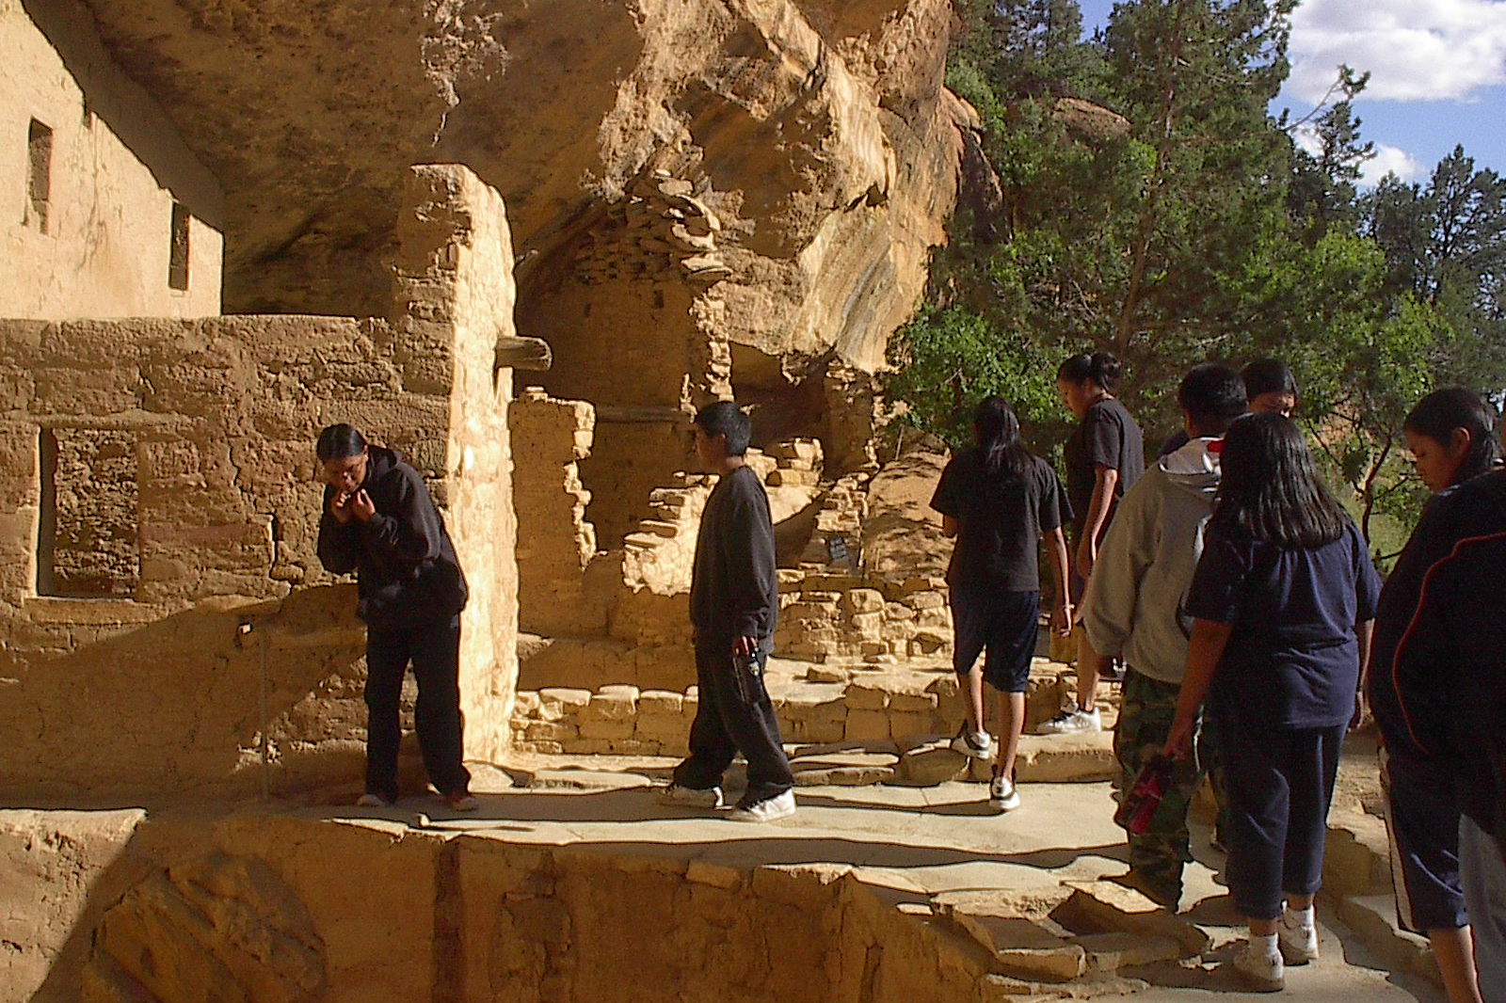
Reducing the Sale of Tobacco to Minors
The New Mexico Synar Illegal Tobacco Sales Reduction Effort
In FY 2007 the rate of illegal sales to minors was 10.3 percent. The following charts illustrate New Mexico’s success in keeping the rate below 20 percent for the past ten years.
Fiscal Year | Rate of Illegal Sales | Compliance Rate
FY 97 | 23% | 77%
FY 98 | 13.5% | 86.5%
FY 99 | 18.9% | 81.1%
FY 00 | 11.8% | 88.2%
FY 01 | 11.6% | 88.4%
FY 02 | 9.8% | 90.2%
FY03 | 14.8% | 85.2%
FY04 | 6.5% | 93.5%
FY05 | 7.7% | 92.3%
FY 06 | 9.3% | 90.7%
FY 07 | 10.3% | 89.7%

As illustrated, the rate of illegal sales has declined in the past ten years and has remained well below 20 percent. This is credited to consistent Synar merchant education along with statewide enforcement of the law, and to dedicated efforts by community coalitions, national and grassroots organizations addressing tobacco use and prevention, and to the Tobacco Use Prevention And Control Bureau’s (TUPAC’s) concurrent efforts towards tobacco use prevention and cessation.
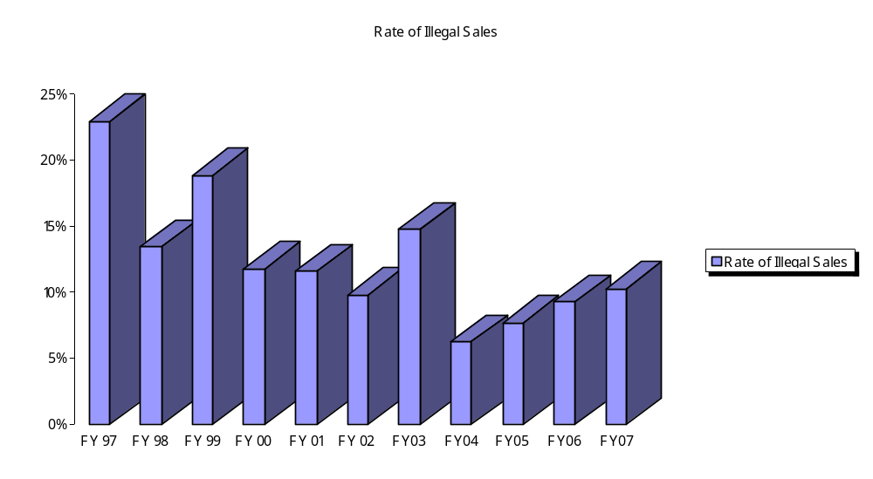
Successful implementation of the Synar Amendment is important for three reasons. First, it facilitates the reduction of both current and future health problems among adolescents by reducing retail access to tobacco products. Second, compliance with the law is consistent with the public’s support of measures to prevent the use of tobacco by young people and, specifically, efforts to discourage tobacco sales to minors. Third, Synar is an example of a highly effective environmental prevention effort that addresses policy, enforcement, responsible retail practices, and change in community norms resulting in the long-term restricted access to a very potent gateway drug.

The Synar effort consists of four major initiatives. They are as follows:

1. The Office of Substance Abuse Prevention (OSAP) contracted with community programs in FY 2007 and will continue to work with those programs in FY 2008 to conduct tobacco merchant education. Contractors are required to collaborate with law enforcement, local coalitions and other tobacco control groups to enhance efforts at reducing youth access to tobacco. OSAP provides training in all aspects of the Synar initiative to law-enforcement agencies and to community based programs and contractors.
2. OSAP continues a partnership with the New Mexico Department of Public Safety to train Special Investigations Division (SID) agents to conduct consummated buy operations that result in citations to the selling clerk. Extensive law-enforcement efforts assist in keeping the rate of sales of tobacco to minors below the required 20 percent. (SID also conducts merchant education in those areas of the state where no prevention contractor is present.)

- A non-consummated buy compliance survey is conducted by community programs and SID with a random sample of approximately 25% of all New Mexico youth accessible tobacco outlets to verify the effectiveness of the merchant education and enforcement efforts.

- The non-consummated buy compliance survey is evaluated by an external evaluator to determine the Synar violation rate charted previously. The non-compliance rate is reported to the Federal Substance Abuse and Mental Health Services Administration (SAMHSA) consistent with the Substance Abuse Prevention and Treatment Block Grant requirements. This rate must be maintained at less than 20% or penalties to the Block Grant funding may ensue.

Due to the sustained excellence of the Synar effort, coupled with numerous community and national organizations changing the norms of youth use of tobacco products, New Mexico enjoys one of the lowest sales-to-minors rates in the U.S.A. Responsible retailing is the result of citizens and retailers acting responsibly, enforcement of State law, and organized application of effective prevention policy on behalf of the youth of New Mexico.

Strategic Prevention Framework-State Incentive Grant (SPF-SIG)
Due to revenue shortages in the prevention field, Substance Abuse and Mental Health Services Administration (SAMHSA) began promoting a community centered approach in substance abuse prevention in 2004, the Strategic Planning Framework (SPF). This is a cyclical process includes the following steps 1) Assessment 2) Capacity 3) Planning 4) Implementation and 5) Evaluation. These steps are not necessarily done in the above order, the process is catered to individual communities; culturally competence and sustainability must also be incorporated into this framework. The following visuals are associated with the SPF:

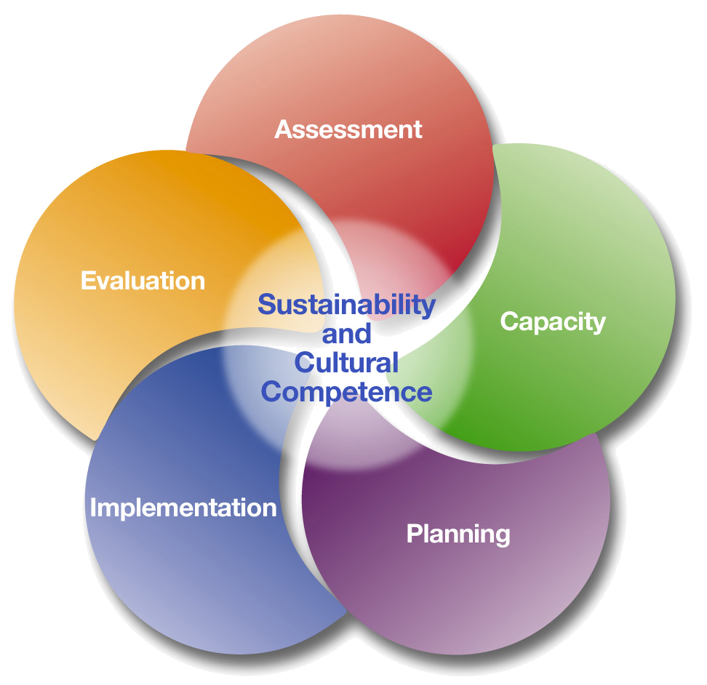
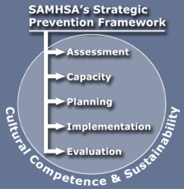
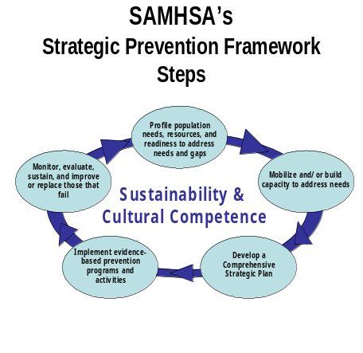

Other characteristics of the SPF are:
- Public health approach
- Data driven process
- Produce results related to substance abuse prevention
- Utilize programs and practices that are scientifically defensible
- Community based approaches
- Outcome based Logic Model

New Mexico was among the first states to be awarded a SPF-SIG; $2.3 million a year for five years. The SEW (State Epidemiological Workgroup) is a direct result of SPF-SIG. The role of the SEW is to determine state-specific indicators of substance-related consequences and determine patterns of consumption in NM. SEW gathered and analyzed data and finally summarized and published a report in the spring of 2005. Ultimately, the data that SEW gathered determined that an area of concern for NM was related to underage and binge drinking of 15 to 24 year olds. In comparison to other prevention programs in NM, the SPF-SIG works collectively with local and state providers as they focus on one problem area for the entire state. Consequently, the following logic model is recognized as the focus area in NM.

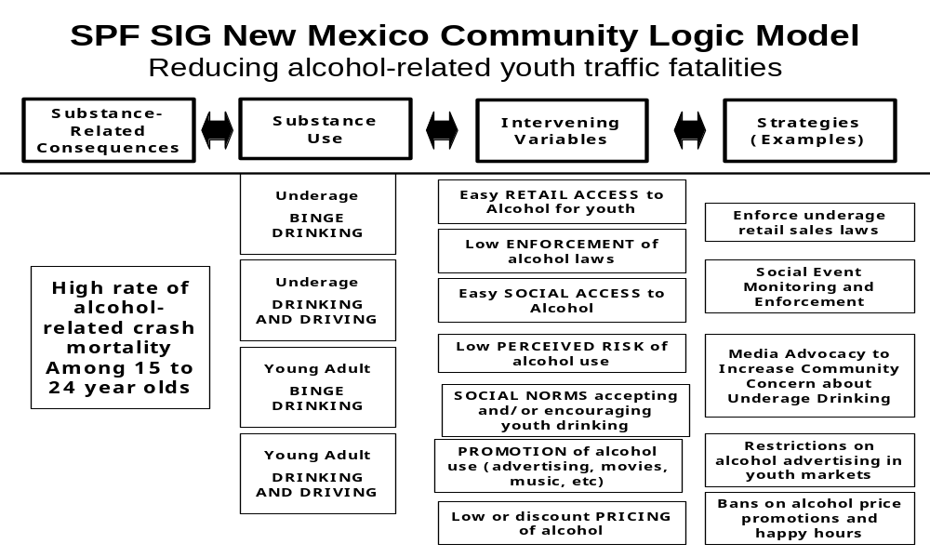
Excel Education Enterprises Program


