SUMMARY OF SAFETY AND EFFECTIVENESS DATA

- GENERAL INFORMATION

Device Generic Name: Implant Clip and Delivery System

Device Trade Name: PAS-Port® Proximal Anastomosis System

Applicant’s Name and Address: Cardica, Inc.
900 Saginaw Drive
Redwood City, CA 94063

510(K) Number: K030434

Date of Panel Recommendation: April 22, 2005

Date of Notice of Clearance to the Pending
Applicant:

- INDICATIONS FOR USE

The PAS-Port® System is intended to create an everting anastomosis between the aorta and an autologous vein graft.

- CONTRAINDICATIONS

The PAS-Port® Proximal Anastomosis System is contraindicated in:

- Patients with target vessels during conventional surgical anastomoses that would typically not be created due to the presence of palpable disease. Such determination may also be based upon echocardiographic demonstration of either mural (e.g. calcification) and/or intimal (e.g. plaque, exudates) disease.

- Patients with target vessels less than or equal to 18 mm in outside diameter and with wall thicknesses that would not be acceptable for a hand-sewn anastomosis.

- Patients with conduit vessels that would not typically be used for bypass grafting procedures.

- Patients with conduit vessels that have an outside diameter of less than 4.0 mm or greater than 6.0 mm, or with double wall thicknesses greater than 1.4 mm.

- WARNINGS AND PRECAUTIONS

See additional Warnings and Precautions in the PAS-Port® Proximal Anastomosis System Instructions for Use.

- DEVICE DESCRIPTION

The Cardica® PAS-Port® Proximal Anastomosis System is used to facilitate creation of proximal vein graft anastomoses to the aorta in CABG procedures. The Cardica® PAS-Port® System delivers an Implant designed to create an anastomosis between a large target vessel (e.g. aorta) and small caliber conduit (e.g. saphenous vein). The Implant is a self-closing stainless steel clip that creates a complete end-to-side anastomosis, which is functionally equivalent to a standard hand-sutured anastomosis. The PAS-Port® System is contained in a package that is designed to facilitate attachment of the conduit to the Implant, as well as to ensure that the conduit (after attachment to the System and before deployment) is kept moist and vital. The content of the tray consists of the Delivery Device, Cartridge with an Implant attached to its end, a Pull-Through Tool, and Poke-Through Tools.

The Implant
The Implant is made of 316 L medical grade Stainless Steel. The Implant contains nine barbed, inner flange tines, over which the vein graft is everted, and which are designed to penetrate and capture the vein graft (Figure 1). The Implant is initially configured in a compressed state. During deployment it expands and forms an inner and outer flange that secures it in place.

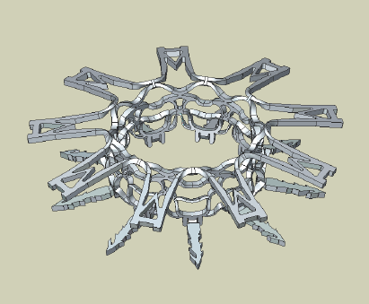
Figure 1: Deployed Implant

Delivery Device
The Delivery Device integrates the hole making mechanism and the Implant deployment system into a single device with a single user interface, where one continuous rotation of a knob completes the creation of a proximal anastomosis.

The Delivery Device contains a Cutter system, which is comprised of a spring-loaded cylindrical spinning Cutter, an Auger used to capture the cut section of the aortic wall, and an Introducer that secures the aortotomy during insertion of the Implant (Figure 2).

Figure 2: Delivery Device
(Inset: Cutter and Auger)
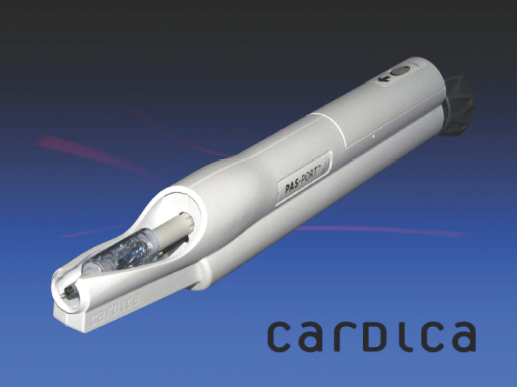
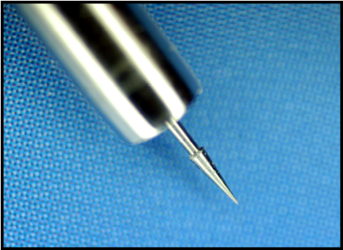
Principles of Operation

Vein Graft Loading
The graft conduit is harvested using standard techniques. Clips should not be used to occlude side branches. A gauge is provided to determine the inflated outer diameter of the conduit and the double wall thickness, which should be between 4 and 6 mm and no greater than 1.4 mm, respectively.

Conduit loading is accomplished in a 3 step process: The first step is to insert the conduit through the Cartridge and Implant with the help of a Pull-Through Tool (Figure 3-A); the end of the conduit attached to the Pull-Through Tool is cut off and discarded. The conduit is then everted over the Implant’s inner flange tines (Figure 3-B). In the last step a Poke-Through Tool is used to attach the conduit to the Implant (Figure 3-C). The recess surrounding the Cartridge and Implant is designed to be filled with a physiologic crystalloid solution, which ensures that the conduit is kept hydrated until the time of deployment (Figure 3-D). This loading process minimizes endothelial damage.

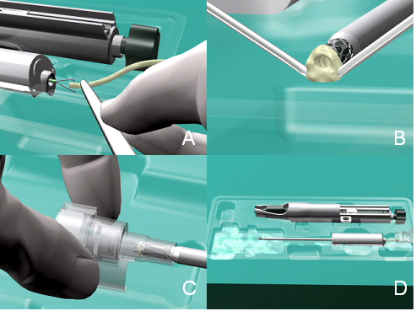
Figure 3: Conduit Loading

Creation of the Anastomosis
- Immediately before deployment, the Cartridge is inserted into the Delivery Device. The Delivery Device is prepared for deployment by moving the Safety Switch to the unlocked position. The Delivery Device is then positioned on the target vessel, ensuring firm contact between the Device and the adventitial surface of the target vessel. Deployment is accomplished through a continuous clock-wise rotation of the Knob on the Delivery Device. The rotation initiates and completes the aortotomy; a small section of the aortic wall is removed and secured within the device. Continued rotation completes the Implant deployment and separation from the Delivery Device (Figures 4 & 5). A soft bulldog clamp is then placed at the end of the conduit to prevent blood loss through the graft lumen according to general surgical practice.
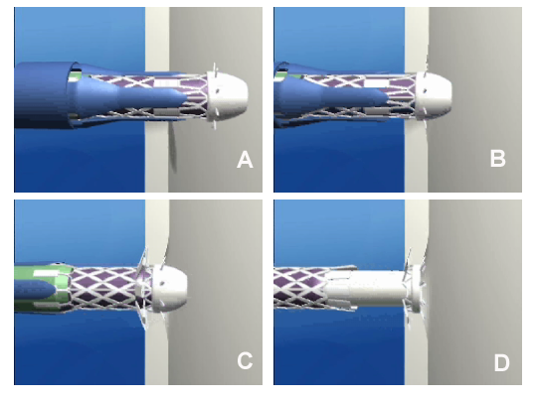
Figure 5: Lateral View of Deployment

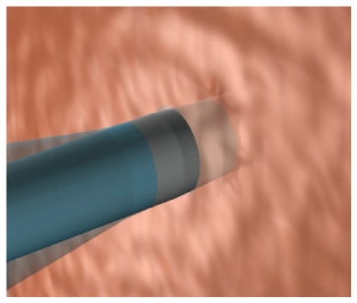
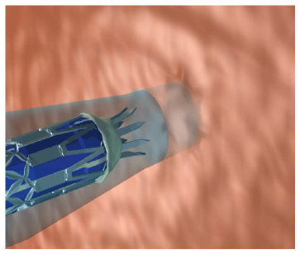
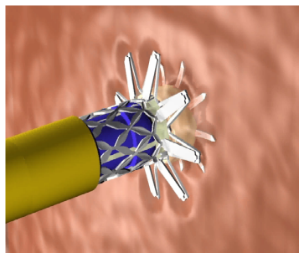
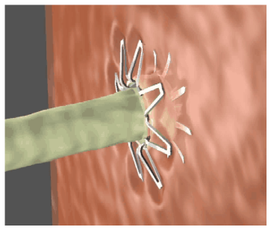
Figure 4: Exterior View of Aortotomy Creation and Implant Deployment

- The Implant’s inner and outer flanges compress the aortic wall. Stainless Steel becomes stiffer as its shape is changed and therefore the Implant is at its strongest configuration after deployment. This artistic rendering shows a profile view of the Implant with the graft attached to the aortic wall (Figure 6a). The everted section of the graft facilitates sealing by acting like a gasket. The implant has been successfully tested for fatigue life in a test environment simulating 10 years of implantation. The Implant’s inner flange tines that have pierced the everted vein graft are flush with the intimal surface of the aorta. There is no metal in the orifice of the graft and the design of the implant promotes a wide and patent lumen (Figure 6b).
Figure 6a: Lateral View of Anastomosis
Figure 6b: Internal View of Anastomosis
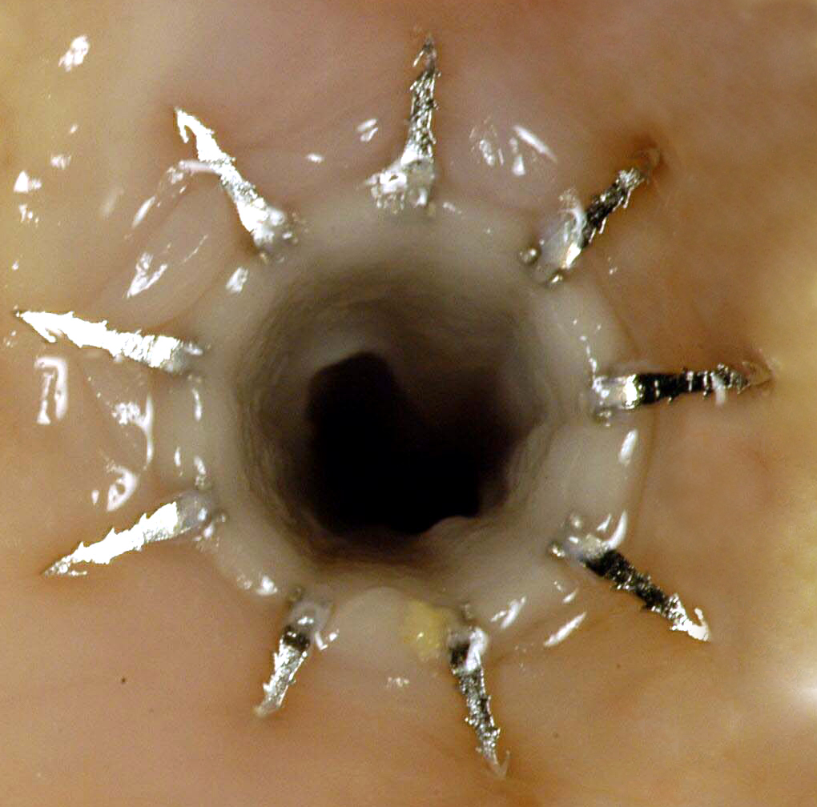
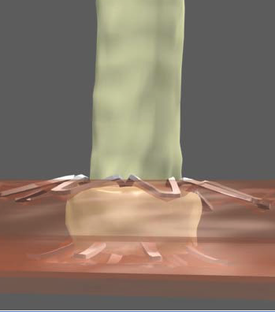

The design of the PAS-Port® System requires placement of the proximal anastomosis before the distal anastomosis can be completed. As per standard surgical practice, graft routing can be accomplished through careful selection of the anastomotic site on the target vessel, careful determination of appropriate graft length while the heart is engorged, and the placement of individual stay stitches along the course of the graft as deemed necessary. For conduits that target the left lateral wall of the heart, left posterior or left anterior sections of the myocardium, anastomoses should be placed on the lesser curvature or left lateral wall of the ascending target vessel or aortic arch. For conduits that target the right lateral or right posterior surface of the heart, anastomoses should be placed on the anterior surface of the ascending target vessel and can be routed to the left of or over the right atrial appendage.

The integrated design of this product allows rapid deployment in a non-clamped target vessel, such as the aorta, and may prove to be a valuable asset in beating heart surgery procedures. Key features of the PAS-Port® design are:

- Minimal trauma to endothelial surfaces during graft loading and implant deployment
- Minimal amount of foreign surfaces exposed to blood post deployment
- Large effective orifice of the anastomosis
- Low implant profile height that reduces the likelihood of graft kinking
- Secure attachment of implant to aortic wall
- Rapid and consistent creation of a proximal anastomosis

- ALTERNATIVE PRACTICES AND PROCEDURES

  - Description of Hand-sewn Technique for Creation of a Proximal Anastomosis
The gold standard for surgical bypass therapy is to use both venous and arterial grafts to bridge coronary lesions. For venous bypass grafting, a proximal anastomosis to the aorta and a distal anastomosis to a coronary target vessel must be performed by the surgeon.

Current techniques for performing a proximal anastomosis of a vein graft to the thoracic aorta have several limitations. The aorta must be clamped with partially or totally occluding vascular clamps to interrupt blood flow to the area of the aortic wall to which the vein will be anastomosed. Clamping of atheromatous plaques in the aortic wall may result in liberation of plaques and tissue fragments with a possible consequence of cerebral or distal organ emboli, which can result in organ dysfunction such as strokes, renal failure, or intestinal ischemia. In addition advanced aortic disease may limit areas suitable for clamping.

A conventional hand–sutured anastomosis is created via a process requiring a surgeon and an assistant. Eight to fourteen evenly–spaced sutures must be precisely placed around the periphery of a limp, thin–walled graft vessel to connect it to the patient’s clamped aorta. This process is time consuming and, therefore, increases time under anesthesia as well as time in the operating suite. Both of these factors have implications with respect to patient outcomes and procedural costs. Furthermore, hand-sutured anastomoses are dependent upon the particular anatomy of the patient and the skills of the surgeon.

  - Other anastomosis devices cleared by the FDA
To date there are a total of three devices cleared by the FDA for marketing within the US to facilitate creation of a proximal anastomosis in cardiac surgery. The predicate device for the PAS-Port® Proximal Anastomosis System is the Symmetry Connector from St. Jude Medical. This device consists of a Nitinol implant and its respective deployment system. In preparing for deployment, the surgeon attaches the graft to the implant. Then the aortotomy is created with a separate aortic cutter. The aortotomy is covered with a finger to prevent hemorrhage. In a final step the surgeon inserts the deployment tool into the aortotomy and releases the Nitinol implant. The system was cleared May 21, 2001 (K003446) based on European clinical trial data and has been used in the creation of more than 40,000 proximal anastomoses. In December, 2004, St. Jude Medical announced that the company would no longer distribute this product in the US.

The second product cleared in the US was the CorLink device developed by Bypass Inc. and distributed through Cardiovations, a J&J subsidiary. This product was cleared by the FDA December 26, 2001 (K011589) based on European clinical trial data. Similar to the Symmetry device this product consists of a Nitinol implant and its respective deployment system. The deployment system consists of a base tool into which an aortic cutter is placed to create the aortotomy. The aortic cutter is replaced by the delivery device for deployment of the implant. The base tool secures the aortotomy during tool transition and prevents hemorrhage.

The third product cleared by the FDA is the Spyder System, a product currently distributed by Medtronic. The system has been cleared in July 3, 2003 (K031623). The Spyder is a proximal anastomosis system that uses individual Nitinol clips to attach a graft to the aorta. The system consists of a separate aortic cutter and deployment tool. In order to create a proximal anastomosis, the surgeon attaches the graft to the deployment tool by everting the graft over the implants. Similar to the Symmetry Connector, the surgeon creates the aortotomy by manually spinning the aortic cutter. The cutter and the cut section of the aortic wall is then removed and the aortotomy is covered with a finger. In a final step the deployment tool is inserted into the aortotomy and the clips are released in an automated fashion by rotation of a knob at the end of the deployment tool. This complete proximal anastomosis system was cleared by the FDA using a single individual clip as the predicate (U-Clip) without the requirement for clinical trial data.

The PAS-Port® Proximal Anastomosis system is differentiated from the above listed devices by the fact that it is an integrated device that allows the surgeon to create the aortotomy and the implant deployment in one continuous rotation of a knob. In addition, the PAS-Port® implant is made of 316L Stainless Steel and the graft loading process has been designed to minimize graft handling and potential for graft damage prior to attachment to the aorta.

- MARKETING HISTORY

The PAS-Port® System has been marketed in Europe since March 2003 and in Japan since January 2004. As of February 2005, Cardica has successfully placed approximately 1900 PAS-Port® Systems in distribution since market release.

A multi-center, patient registry for the PAS-Port® System was conducted in five centers in Europe, which reported data on 95 patients implanted with 123 PAS-Port® devices between April 2003 and March 2004. The registry was designed to collect information on the performance of the delivery system during the formation of the anastomosis and also included a short–term clinical follow-up to assess for any device-related adverse events. There were no defined exclusion criteria; therefore, this registry was conducted in a patient population with significant underlying coronary artery disease, co-existing cardiac conditions, previous coronary interventions or surgery, and other comorbidities. There were no reports of re-operation for revision or bleeding associated with a PAS-Port® proximal anastomosis. Average clinical follow-up in these patients was at six months following surgery. Patients demonstrated a stable post-operative course with no patient mortality related to the PAS-Port® System and a low incidence of device-related adverse events.

Gummert et al from the Herzzentrum Leipzig in Germany will be presenting data at the 2005 annual meeting of the International Society for Minimally Invasive Cardiac Surgery describing results from a single center, prospective, randomized clinical trial in which the PAS-Port® Proximal Anastomosis System is compared to hand-sewn anastomoses in patients requiring coronary artery bypass. The primary outcome variable in this study is one year graft patency assessed by computed tomography (CT). Fifty-one patients were enrolled in the PAS-Port® treatment group and forty-six patients were enrolled in the hand-sewn anastomosis treatment group. Five patients in the hand-sewn group were converted to a PAS-Port® anastomosis due to presence of severely calcified aortas, which prevented clamping of the aorta to perform a hand-sewn proximal anastomosis. To date, 22 patients with PAS-Port® anastomoses have been evaluated by CT at 1 year resulting in a 100% 1-year patency rate.

- POTENTIAL ADVERSE EFFECTS OF THE DEVICE ON HEALTH

  - General risks associated with CABG surgery
General risks associated with performing a proximal anastomosis using conventional hand-sewn techniques include release of emboli resulting from aortotomy or clamping of the aorta; (neurological injury from emboli occurs in approximately 4% of CABG patients). Additionally, veins may become damaged during the preparation process which may result in chronic intimal hyperplasia leading to narrowing or occlusion of the graft vessel. Chronic changes in the anatomy of the vascular wall of a vein are a normal occurrence as a result of the vein being subjected to systemic pressure. Lastly, inter- and intra-individual variability in patient anatomy and surgeon skills in creating a hand-sewn proximal anastomosis can influence the anastomosis quality.

  - Risks specific to the PAS-Port® device
There have been no product specific risks introduced with the use of the PAS-Port Proximal Anastomosis System. The overall adverse event rate in the clinical trials of the PAS-Port Proximal Anastomosis System compares favorably to published data on patients following placement of hand-sewn saphenous vein graft anastomoses. The reported incidence of permanent neurological injury (stroke) seen in the clinical trials was below 1%. Additionally, there were no device-related re-operations required for bleeding or graft revision associated with a PAS-Port® anastomosis. Data from marketing feedback on distributed product continues to support these favorable results.

- SUMMARY OF PRE-CLINICAL STUDIES

  - In Vitro Product Testing
The PAS-Port® System was subjected to a rigorous set of in-vitro testing, which included comprehensive performance testing designed to ensure that the delivery device and implant met all functional requirements and performance specifications. This testing demonstrated that the PAS-Port® System met the product design specifications and is safe and effective for its intended use.

  - Animal Testing
The PAS-Port® System was subjected to in-vivo testing and results demonstrated that the PAS-Port® System performed proximal anastomoses with long-term outcomes at least as good as those obtained using standard hand-sewn techniques in the selected model and successfully met the criterion for the study.

  - Biocompatibility
The PAS-Port® System is comprised of a delivery device identified as limited contact duration (<24 hours), circulating blood contact, externally communicating device and an implantable clip. Biocompatibility testing methods of body-contacting and implantable materials for the PAS-Port® System were determined in accordance with ISO 10993-1, Biological Evaluation of Medical Devices, and applicable subparts. All materials used in the manufacture of the PAS-Port® System have been demonstrated to be biocompatible in that they are non-hemolytic, non-pyrogenic, nontoxic, non-thrombogenic, non-sensitizing, non-irritating, and biologically compatible for their intended use. In addition, Stainless Steel 316L is a material safely used in other marketed circulating blood implant devices, therefore, subchronic toxicity, genotoxicity, implantation, chronic toxicity, and carcinogenicity has previously been established for this material.

All test samples were processed in the same manner as finished product and sterilized using gamma irradiation. The biological tests were performed by independent laboratories following Good Laboratory Practice.

  - Sterilization
The PAS-Port® System is sterilized via cobalt 60 gamma irradiation with a minimum sterilization dose of 25 kGy. A Sterility Assurance Level (SAL) of 10⁻⁶ (whereby probability of sterilization failure is less than one in a million) is maintained. Dose audits of bioburden and sterility tests are conducted quarterly as required by standard. The sterilization facilities are certified for Radiation Sterilization Services in accordance with EN 552:1994 Sterilization of Medical Device - Validation and Routine Control Of Sterilization By Irradiation, and ISO 11137:1995 Sterilization of Health Care Products - Requirements For Validation And Routine Control - Radiation Sterilization.

  - Packaging and Shelf Life
The PAS-Port® System is sold individually or in “five-packs” and contains the delivery device and accessory tools. The packaging is designed to protect the device and accessories against inadvertent damage and to facilitate placement in the sterile field. The PAS-Port® System is placed in a set of trays, sealed in a pouch, enclosed in a carton, and then enclosed in a corrugate cardboard box for shipment and currently holds a 21-month shelf-life.

- SUMMARY OF CLINICAL STUDIES

Patients were enrolled in two separate clinical trials between June 17, 2002 and February 6, 2004. Both multi-center, prospective, non-randomized trials were conducted using protocols that had the same endpoints for evaluating safety and efficacy and the same follow-up schedule through six months. The studies were conducted at five sites in Europe, two of which enrolled patients in both clinical trials.

The clinical study population screened for enrollment in the two clinical studies consisted of patients referred to the investigator for multi-vessel coronary artery bypass grafting. Key study inclusion criteria included age > 18 and < 85 years, ejection fraction > 30%, creatinine of less than 200 mmol/L and the requirement for non-emergent bypass of at least one coronary artery. Exclusion criteria were previous CABG surgery, the preoperative need for an intra-aortic balloon counter pulsation, bleeding diathesis, a recent cerebrovascular accident and patients in NYHA IV.

Ninety-seven evaluable patients were successfully implanted with 109 PAS-Port® implants and discharged from the hospital. All patients who were not successfully implanted with the PAS-Port® device were successfully converted to a hand-sewn anastomosis without compromise to long-term outcome. There was a low incidence of peri-operative adverse events. None of the patients required a re-operation for complications associated with the PAS-Port® anastomosis, such as bleeding or early graft occlusion.

Clinical follow-up at three months was available on 94 PAS-Port® implanted patients (96.9%), at six months on 90 PAS-Port® implanted patients (92.8%) and at twelve months on 88 PAS-Port® implanted patients (90.7%). The original protocols called for follow-up at three and six months. The protocols were later amended to include a one or two year follow-up evaluation in order to meet FDA requirements for long term follow-up. Index graft patency was assessed angiographically prior to discharge and again at six months post-procedure. Angiograms were performed by the treating hospital. Copies of the angiograms were sent to a CORE laboratory for independent analysis and patency determination. Patency, per FDA guidance, was defined as freedom of >50% stenosis or occlusion.

The six-month angiographic patency rate in evaluable patients implanted with the PAS-Port® Proximal Anastomosis System exceeded 80% with 95% confidence at six months. Major adverse cardiac event rates remained low throughout 12 to 24 months of follow-up. Additionally, 93.6% of the patients evaluated at the long-term follow-up were negative for any evidence of myocardial ischemia. Patients with PAS-Port® index grafts have shown long-term stability of their clinical course. At 12 and 24 months, 99% of patients evaluated at six months and 100% of patients evaluated at 12 or 24 months were classified as NYHA I or II. The majority of patients (82%), were treated with Aspirin only. There were no reports of any device-related patient death, revascularization procedures, significant stenoses or occlusions in any index grafts at the longer-term follow-up.

- CONCLUSIONS DRAWN FROM STUDIES

In conclusion, the PAS-Port® Proximal Anastomosis System manufactured by Cardica, Inc. is secure, reliable, and effective for the treatment of patients undergoing coronary artery bypass grafting as evidenced by the low incidence of device related adverse events and a six-month index graft angiographic patency rate which exceeds the criteria of 80% with 95% confidence.

- PANEL RECOMMENDATION

- CDRH DECISION

- APPROVAL SPECIFICATION

