USDA Foreign Agricultural Service
GAIN Report

Global Agriculture Information Network
Template Version 2.09

Required Report - public distribution
Date: 7/31/2008
GAIN Report Number: IS8020
IS8018
Israel
FAIRS Country Report
Annual
2008

Approved by:
Chris Rittgers
U.S. Embassy, Cairo
Prepared by:
Gilad Shachar

Report Highlights:
In the current report the following sections have been updated:

- Banned Food Additives: E214-219, E128 (page 12)
- Pesticides and Other Contaminants (page 13)
- List of Israeli Draft Amendments for Dairy Products - Salty Cheese, Soft White Cheese and Fermented Milk Products (page 22)
- Import of Plants and Their Products (page 23)
- National Standard for Organically Grown Plants and Their Products (page 25)
- Botanical Names (page 25)

Includes PSD Changes: No
Includes Trade Matrix: No
Annual Report
Tel Aviv [IS1]
[IS]

Section I. Food Laws |  | Page 5
Section II. Labeling Requirements |  | Page 6
Section III. Food Additive Regulations |  | Page 11
Section IV. Pesticides and Other Contaminants |  | Page 12
Section V. Other Regulations and Requirements |  | Page 14
 | 1. Kashrut | Page 14
 | 2. New Food Procedure and Biotechnology Policy | Page 15
Section VI. Other Specific Standards |  | Page 16
 | 1. General | Page 16
 | 2. Nutritional Labeling | Page 17
Section VII. Copyright and/or Trademark Laws |  | Page 18
Section VIII. Import Procedures |  | Page 19
A. Import Documentation |  | Page 19
B. Import Requirement for Dairy Products |  | Page 22
C. Preserved Meat Products |  | Page 22
D. Import of Wine and Alcoholic Beverages |  | Page 22
E. Import of Plants and Their Products – Import  Permit |  | Page 23
F. Grain Import |  | Page 24
- Imports of Gelatin Made of Bovine or Other Products Containing Gelatin  - Organic Food and Agricultural Products  - Botanical Names  Annex 1: Government Regulatory Agency Contacts  Annex 2: New Food Registration Procedure |  | Page 24  Page 25  Page 25  Page 26  Page 27
 | Annex 3: Regular Products | Page 42
 | Annex 4: Non-Regular Products | Page 46
 | Annex 5: Food Import Procedures | Page 47
 | Annex 6: List of Israel Standards for Food Products (available in Hebrew only)  Annex 7: List of Israeli Standards for Food Products (available in English only) | Page 51  Page 62
 | Annex 8: Size of Hebrew Lettering Required on the Labels of Prepackaged Food | Page 63
 | Annex 9 - List of Vitamins, Minerals, and Free Amino Acids | Page 64
 | Annex 10: Additional Food Components and the Minimum Content Required to Enable Them to Be Included in the Nutritional Labeling (Contents per 100 Gr. Or 100 Ml of Net Content). | Page 65
 | Annex 11: Allowable Concentrations of Sodium in Various Foods | Page 64
 | Annex 12: Purity and Quality of Artificial Sweeteners | Page 66
 | Annex 13: Purity and Quality of non-High Intensity  Sweeteners | Page 67
 | Annex 14: Acids, Bases, and Reaction Regulators | Page 68
 | Annex 15: Sweetener Content Limits | Page 70
 | Annex 16: World Trade Organization (WTO) Enquiry Point | Page 71
 | Annex 17: Import Requirements for Dairy Products | Page 71
 | Annex 18: Import Of Intoxicating Beverages  Annex 19: List of Approved Plants, Seaweed & Mushrooms | Page 74  Page 86

Disclaimer

This report was prepared by the Office of Agricultural Affairs of the USDA/Foreign Agricultural Service in Tel Aviv, Israel for U.S. exporters of domestic food and agricultural products. While every possible care was taken in the preparation of this report, information provided may not be completely accurate either because policies have changed since its preparation, or because clear and consistent information about these policies was not available. It is highly recommended that U.S. exporters verify the full set of import requirements with their foreign customers, who are normally best equipped to research such matters with local authorities, before any goods are shipped. FINAL IMPORT APPROVAL OF ANY PRODUCT IS SUBJECT TO THE IMPORTING COUNTRY'S RULES AND REGULATIONS AS INTERPRETED BY BORDER OFFICIALS AT THE TIME OF PRODUCT ENTRY.

Section I. Food Laws

General Food Import Considerations

Israeli importers face two main considerations when selecting a particular product - quality and price. In the price range, American products are not always attractive, due to the high production costs in the U.S., and high transportation costs to Israel, relative to suppliers from near-by Europe and the Mediterranean basin. Transport costs from the United States are about the same as transportation costs from the Far East. From Europe, the costs are significantly lower, not to mention even closer countries such as Turkey, which competes with the United States for imports of dried fruit and nuts into Israel. The problem of transportation costs is less crucial when dealing with expensive products and materials, or with products with very high value-to-volume ratios such as spices, essences, flavorings, concentrates etc. The problem is also partially resolved when dealing with products that are eligible for tariff preferences as imports from the United States. This partially compensates for the high transport costs. US goods enjoy a 10-22 percent tariff advantage over European and third-world country suppliers on a broad range of processed and semi-processed foodstuffs.

Another subject to be considered is the issue of “kashrut”. Kosher certification is not a legal requirement for importing food into Israel. However, non-kosher products have a much smaller market, as most supermarkets and hotels refuse to carry them. Manufacturers who produce kosher products must be able to satisfy Israeli rabbinical supervisors that all ingredients and processes are kosher. According to the Law for Prevention of Fraud in Kashrut, only the Chief Rabbinate of Israel is authorized to determine and approve a product as kosher for consumption in Israel, or may authorize another supervisory body to act in its name. Here too United States products have an advantage as the kashrut certification issued by many American rabbis is recognized by Israel’s Chief Rabbinate. It is, however, quite simple for Israeli importers to send an Israeli rabbi to any supply source, thereby reducing the American advantage. In recent years, opportunity for non-kosher foods has been increasing as immigrants from the Former Soviet Union (FSU) now account for a significant share of purchasing power (15 percent).

Prohibited Imports

Israel, which is a signatory to the WTO Agreement, maintains relatively few restrictions on agricultural imports. However, U.S. meat exports face an especially difficult environment due to the enactment at the end of 1994 of a ban on all non-kosher meat and poultry imports except offals. The United States - Israel FTA of 1985 allows both countries the use of non-tariff restrictions or prohibitions on products from agricultural sub sectors, which are subject to agricultural policy considerations. The recent WTO accords do not. Instead WTO rules call for tariffication of administrative and technical barriers. Israel has removed most administrative barriers to United States imports but has retained high levies on sensitive products and imposes various constraints and barriers, for example, those pertaining to kosher certification, for meat and poultry.

The only other product prohibitions are targeted against internationally controlled substances and/or are designed to protect public morals, human, animal or plant health, or national security.

Section II. Labeling Requirements

Labeling and Marking Requirements

Israel has strict marking and labeling requirements, which frequently differ from those of other countries. It is recommended that United States exporters consult with their Israeli importer prior to shipping.

All imports into Israel must have a label indicating the country of origin, the name and address of the producer, the name and address of the Israeli importer, the contents, and the weight and volume in metric units. In all instances, Hebrew must be used; English may be added provided the printed letters are no larger than those in Hebrew. Nutritional labeling is compulsory on all packaged foods. Specific information on weights and measures standards is available from the Commissioner of Standards, Ministry of Industry and Trade, 30 Agron Street, Jerusalem 94190. As of September 1, 1998 weights and measures have become voluntary and no longer serve as a barrier to entry of foods packaged in avoirdupois units. However, where packaging is non- standard, the package must indicate the unit price of the product.

Marking should be done by printing, engraving, stamping, or any other means, on the package on the goods themselves. If marking is not possible, a label should be well sewn or stuck to the goods or package. Marking details should be clear, legible, easy to trace, and in a different color from the background in order to be clearly distinguishable. Printing dyes and other marking materials should not affect merchandise quality. The marking should not be blurred.

On a multi-layered package, the external layer should be marked. If the external layer is transparent, the marking should be done underneath that layer, provided it is still clear and legible. On a package containing sub packages, the labeling should specify: the number of sub packages, the net content of a sub package, and the overall net weight of the package. For products that tend to lose weight under regular marketing/commercial conditions, the maximum quantity of expected depletion should be mentioned.

Specific labeling regulations apply to some consumer goods, as well as fertilizers, insecticides, chemicals, pharmaceuticals, some food products, seeds, and alcoholic beverages. In addition, special packaging requirements apply to fruit, plants and meat. Outside and inside containers of dangerous articles, such as poisons, insecticides, drugs, reptiles, insects, bacteria should be clearly marked. For information on food labeling and packaging contact: Israel Ministry of Health, Food Control Administration, 12-14 Ha’Arba’a St., Tel Aviv 64739; Telephone: 972-3-6270100; Fax: 972-3-5619549.

Application of the Labeling Standard

The Standard sets requirements for labeling prepackaged food intended for retail sale, excluding unprocessed fruits and vegetables. It also sets the labeling requirements for prepackaged foods listed below, not intended for retail sale:

food for industrial processing and for repackaging;
-food in wholesale packaging;
-prepackaged food containing packaged sub units.

Where there is a contradiction between the requirements of Standard 1118 for prepackaged foods and the labeling requirements of the Special Standard which applies to a particular food or the labeling requirements in a Group Standard which applies to a particular group of foods, the requirements of the special Standard or of the group Standard shall take precedence.

All labels shall be accurate and not misleading and shall be capable of proof.
The label of the product shall not give indication of medicinal properties attributed to the food nor shall it state that the product’s use is likely to heal or prevent illness. However, see the section on nutritional labeling in Section F for special references to certain types of food.

Mandatory labeling information must be in Hebrew: such writing may be repeated in a foreign language provided that it includes all the required information and that it is identical in content to the Hebrew.

The size of the Hebrew letters and numbers on the label must be at least as large as indicated in Table 1 below. The size of the letters in the other language must not be larger than the size of the Hebrew letters. The size of the letters of the trade name shall not be larger than three times the size of the letters of the name of the food.

Food, which can be marketed in a number of forms, which are of significance to the consumer, shall be appropriately labeled: whole, sliced, crushed, segments, cubes, etc. The size of the letters of this labeling shall be at least half the size of that of the letters in the name of the product.

The Name of the Food

The label shall include the name of the food. If there are several words in the name of the food, all these words shall be written in the same size and with the same emphasis.

If there is a special Standard for the product, the name of the food shall be that name which appears in the special Standard.
In addition to the name of the food, it is permissible to also add a trade name. The size of Hebrew lettering required on labels, see Annex 6.

The Name of the Manufacturer, Importer, Marketer, and Packer

The label shall include a clear indication of the name of the manufacturer and his address. Alternatively, instead of indicating his name, the manufacturer may indicate in addition to his address, his registered trademark for the product, which he produces, on condition that the trademark includes letters and does not mislead concerning the nature of the product.

The labeling of an imported product, which is marketed in its original package, shall also include the name of the importer and his address.
It is permitted to indicate on the food the name and address of some other person instead of the name and address of the manufacturer of the food if that other person has taken all the necessary measures to ensure compliance with all the regulations relating to manufacture of the food, including constant control of the production, packaging, weighing, labeling, marketing, transport, and storage of the product. If the name of a person other than the manufacturer is indicated, the name of the manufacturer shall be noted in code.

Producer Country

Imported food shall be labeled with the name of the producer country. It is permitted not to indicate the producer country of imported products, which are used in the manufacture of food in Israel. For purposes of this paragraph, if only the packaging is changed, it will not be considered as manufacture.

Content

Labeling shall include the net content of the food in the package, by weight or by volume.

The content of liquid food shall be indicated in units of volume:
- Milliliters (ml) for a product containing less than 1000 ml;
- liters for a product containing 1000 ml or more.

The content of solid, semi-solid, or viscous food shall be designated by weight:

- grams (gr.) for a product containing less than 1000 grams;
- kilograms (kg) for a product containing 1000 grams or more.

The net content of a product packed in aerosol containers shall be marked in units of weight when the product is in a semi-solid or powdered state or marked in units of volume when the product is liquid.

It is prohibited to add alongside the units of volume or weight any adjective, which is likely to be misleading.

The content of food packed in liquid shall be indicated in units of weight and will state the content after draining as well as the net weight. When indicating the content after draining, the words “weight after draining...” shall be included.

On the composite package the number of units inside shall be marked as well as the net content of each packaged unit and the total net content.

For a product, which is liable to lose weight in regular commercial or marketing conditions due to storage or display for sale, the expected lesser content shall be indicated.

New Requirements Regarding Labeling of Package Content
The Ministry of Industry, Trade and Labor (MOITAL) published new requirements regarding labeling when the package weight of food and non–food product is reduced. Specifically, these requirements apply to products that were already sold in a defined, already known size, and the manufacturers or the sellers intended to reduce the weight or the content of the product in the package in order to remain competitive in the market. The new requirements were published after it was found that manufacturers and/or sellers were reducing the weight/content of the packages, but not changing the labeling of the package to reflect the new size.
According to the new requirements, the labeling on the package must be changed, mentioning clearly the new quantity. In addition, a special notification should be added:
“The package contains ……% less than the regular package”. The size of the letters of the notification on the package should be the same as the product’s name letters. It is the manufacturers’ or importers’ obligation to inform the retailers and the buyers about the change in the size of the packages.

If the notification on the package is unclear, it is the supplier’s obligation to supply the retailers with appropriate signs to be put on shelves. The manufacturer or the importer must also inform the customers about the change by advertising in the national media.

Ingredients and Food Additives

The contents shall be indicated for all ingredients, including water in descending order according to their relative weight in the food except for the following foods:

For dry food, which is to be reconstituted by the addition of water, it is permissible to indicate the ingredients in descending order of their relative content in the reconstituted product if the words “ingredients after reconstitution” are included.

If one of the ingredients is food to which an Israeli Standard applies, the name of the food shall be indicated in the list of ingredients as required in the applicable Standard and its ingredients shall not be listed. However, if coloring and preservatives have been added to the above food their presence shall be indicated in the list of ingredients of the labeled food.

A food product to which no Israel Standard applies shall be labeled with the percent of an ingredient that significantly affects the price of the product, if so required by the authorities.

Date

The date of manufacture or alternatively identification of the production lot as well as the last date for marketing shall be marked as indicated below:

Products whose shelf life is up to 60 days from the date of manufacture:

The date of manufacture shall be marked openly or in code (day and month or else day, month, and year). The last date for marketing shall be marked openly (day and month or else day, month and year).

Products whose shelf life is between 60-365 days from the date of manufacture:

The date of manufacture shall be marked openly or in code (day, month, and year). The last date for marketing shall be marked openly (day, month and year or month and year) if the date of manufacture is indicated in code. It is not required to indicate the last date for marketing if the date of manufacture is marked openly.

Products whose shelf life is longer than a year:

Either the date or the code (day, month and year) of the date of manufacture shall be indicated.
It is not required to indicate the last date for marketing.

The manufacturer shall determine the shelf life of the product and shall mark the dates accordingly. The length of the shelf life shall be determined in accordance with the nature of the product, the form of its packaging, and the recommended storage conditions assigning the product to one of the three groups of products according to the nature of the explicit marking of the date.

The manufacturing date indicated on the product is not to be changed except in the case where a mistake has been made in the marking and the product has still not left the plant for market.

Instructions for Storage, Transport, and Use

Instructions for storage, transport and use shall be included in the label when:
-the food has been cooled to a temperature of less than +8 degrees Centigrade or has been
frozen;
-there are special instructions for handling either before or after the package is opened;
-when the nature of the product demands it, for example the words “keep in a dry place”, “keep in a cool place”, “keep in the shade”, “do not refreeze after thawing” etc.
Choking Warning Labeling Required
On 18 September 2006 new regulations regarding choking warning labeling were announced by the Food Control Service with the Ministry of Health. The new regulations came into effect on 18 March, 2007 (see GAIN Report IS7007).
The regulations state that a warning must be marked in both Hebrew and Arabic on the following products intended for retail sale: nuts and seeds, with or without shells, popcorn, dried corn kernels for popcorn, spreads containing fragments of shelled nuts and sausages.
When these foodstuffs are sold by weight (not pre-packaged), the warning must be prominently and visibly displayed on an adhesive label attached to the packaging or alternatively printed on the packaging itself.
The warning must also be included in advertisements for the aforementioned foodstuffs.
Labeling Prepackaged Food, Which Is Not Intended For Retail Sale

Food used in industrial manufacture (including repackaging): the following items shall be marked on the package of food used in industrial manufacture:

-the name of the food;
-labeling which identifies the lot.
If required by the responsible authority, the manufacturer shall present the specifications of the food.

Note:

Despite what is stated above, the language of the labeling of food to be used in industrial production (including repackaging) may be not in Hebrew but rather in one of the following languages: English, French, German, Spanish, Italian instead of Hebrew.

Food in a Wholesale Package

The following items shall be marked on wholesale packages:
-the name of the food
-the name and address of the manufacturer as specified
-ingredients as specified
-the date as specified

Prepackaged food, which contains several packed units

The following items shall be marked on the package:

-the name of the food
-labeling which identifies the lot.
-number and size of retail units in the large package.

Sweeteners

(1) No person shall produce or market a food which contains any sweetener unless the sweetener is listed in column A of the Fifth Appendix below, the food is low calorie, and the amount of sweetener in it is not greater than the amount indicated beside each sweetener in column C.

(2) No person shall produce a sweetener, a non-high-intensity sweetening substance or food, which contains such substances unless –

(a) the sweetener meets the requirements for purity and quality as indicated alongside it in column B of the Second Appendix;

(b) the non-high-intensity sweetening substance meets the requirement for purity and quality as indicated alongside it in column B of the Fourth Appendix.

(C) if the product is a personal (tabletop) sweetener - it does not contain any food additive other than those listed in the Fifth Appendix;

Personal (Tabletop) Sweeteners

No person shall produce or market any personal (tabletop) sweetener unless it meets the following conditions;

(a) it is in its pure form or in a mixture with carbohydrates or food additives;

(b) it is packed in a packet weighing one gram (henceforth - packet) or in a container whose net weight is not more than 200 gr.;

- if it is in the form of a solution or powder - attached to its packaging there will be some implement for measuring the sweetener with a capacity equal to 5 gr. of sucrose.

Section III. Food Additive Regulations

The food additive regulations are based on "The Public Health Regulations (Food)
(Food Additives) 1997. A new full list of approved food additives was published by the Food Control Service (FCS) in 2001.
The basic ingredients and the additives must be marked with either their group or specific names except when the responsible authority has required that the specific name either of the basic ingredient or of the additive be used or when it has required some other identifying label concerning either the basic ingredients or the additives.

The group names for the basic ingredients and the additives shall be as follows:

Basic ingredients

-animal fats and oils
-vegetable fats and oils (if the fat is hardened, it shall be so stated)
-starches (except for modified starches)
-sugars
-vegetable protein
-animal protein
-flours
-alcohols
-herbs
-spices

Additives

-anti foaming agents -anti caking agents
-anti oxidants -bleaching agents
-food colorings -emulsifiers
-flavor and odor additives -ripening agents
-preservatives -stabilizers
-thickeners (including modified starches) -acidifiers
-gelling agents -whipping agents
-clarifying agents -leavening agents
-vitamins -neutralizers
-flavor enhancers -enzymes
-non-nutrient sweeteners -solvent residues

Food Additives Importation Guidance

In order to get a permit for the import food additives to Israel, the following documentation is required, in accordance with the Food Additive Regulation from 5/18/97:
1. Confirmation submitted by an approved authority that the production plant is under inspection.
2. Free Sale Certificate, submitted by an approved authority.
3. A Confirmation that the manufacturer is producing under Good Manufacturing Practice (GMP). Confirmation will be accepted only if submitted by an approved authority, or by an independent body that was approved by the Israeli Food Control Service (FCS) to submit GMP certificates.
4. Content - A certificate from the manufacturer listing the content of the capsule, including botanical names of the plants.
5. Analysis results - A document from an authorized laboratory, signed by the test executer, detailing the analysis results. In addition, microbiological test should be executed for the following products; food additives made of vegetative raw materials (leaves, dried plants and powders), plant extracts and food additives that include microorganisms.
6. Original label of the product.
7. Stability of the product - test results of the shelf life of the product, or an announcement made by the manufacturer that the claimed shelf life was determined on the basis of stability tests.

Banned Food Additives

In August 2007, the following food color additive was been totally forbidden for use in food products in Israel: E128(Red 2G).

Starting March 2009, the following food additives will be completely banned for use in food products in Israel: Propyl p-hydroxybenzoate E216, Sodium propyl p-hydroxybenzoate E217.

Starting December 2009, the following food additives will be banned for usage in food products in Israel: PARA-HYDROXY-BENZOATES (PHB): Ethyl p-hydroxybenzoate E214, Sodium ethyl p-hydroxybenzoate E215, Methyl p-hydroxybenzoate E218, Sodium methyl
p-hydroxybenzoate E219.
Source:http://www.efsa.europa.eu/EFSA/Scientific_Opinion/opinion_afc16_ej83_parabens_v2_en1,0.pdf

Section IV. Pesticides and Other Contaminants

The Plant Protection and Inspection Services (P.P.I.S.) publishes the “Israeli Directory of Pesticides” which lists pesticides registered in Israel under the Plant Protection Law of 1956, and the Regulation concerning the sale of pesticides, 1994.

The Pesticide Data Bank of the PPIS contains all the information regarding correct and safe ‎usage of the pesticides permissible for sale in Israel. The database is being updated 2-3 times per year.
PPIS Pesticide Site: http://www.hadbaraeng.moag.gov.il/hadbara/english/

The following information can be obtained through the data bank:‎
• Generic name of the active ingredient and its concentration
• Formulation
• Rats LD50‎
• Toxicity for fish, bees and birds
• Application specifications for the control of pests in various crops, including doses,
‎ volumes and harvest intervals
• Scientific names of the pests
• Maximum residue levels in food (MRL)‎
• Permissible combinations of pesticides for each crop

This list is based whenever appropriate on the Codex Alimentarius limits. The system used for the pesticide compounds is according to the IUPAC nomenclature.

During the last 10 years, the following pesticides have been totally forbidden for use in Israel: Ethylmercuric chloride, Methoxyethlmercuric Chloride, Dinitro-ortho-cresol (DNOC), Sodium arsenite, Pentachlorophenol, 2,4.5- trichloroacetic acid (2,4,5-T), Monocrothophos, Ethyl parathion, Chlorphenapyr.

Organic Pesticides

The PPIS are in charge of the approval and registration of preparations suitable for organic agriculture. Suitability is checked by an advisory committee to the General Director of the PPIS, in relation to the Israeli standard of fresh and processed organic produce from plant origin, and the EU Council Regulation (EEC) No. 2092/91.
All the inputs for organic agriculture (nutrients, plant protection products, and supplements for the organic food industry) have to be checked for compliance with the standard’s requirements.
To enter a substance for a review in the advisory committee for organic agriculture, the following documents must be submitted:
1. Identification of the substance and its ingredients.
2. Production method.
3. Products containing an animal ingredient must have a preliminary approval of the Veterinary Services of the Ministry of Agriculture.
Registration will be carried out according to the procedure described in “Registration and Licensing of Pesticides”
The following products have been approved for use in organic farming in Israel:
http://www.ppiseng.moag.gov.il/NR/rdonlyres/A173FD3D-70BF-4202-B2F8-0374FF6ABC14/1296/OrganicPesticidePublication.doc

The Israeli office responsible for pesticides is the Plant Protection and Inspection Services (PPIS), Pesticides Division with the Ministry of Agriculture and Rural Development.
Contact: Rina Ashkenazy, Head - Chemistry Department (Pesticides, Animal feed);
Tel: 972-3-9681562; Mobile: 972-50-6241709; Email: rinaa@moag.gov.il ;
Web Site: http://www.ppiseng.moag.gov.il/PpisEng/
Address: The Ministry of Agriculture and Rural Development - The Plant Protection and Inspection Services - P.O. Box 78, Bet Dagan 50250 ISRAEL.

Plant Disease Gallery

A gallery of documented plant diseases (mainly fungal) diagnosed at the Plant Disease Diagnostic Lab of the PPIS: http://www.ppis.moag.gov.il/ppis/plant_disease_gallery/

Insect Gallery
The Insect Gallery is a database with images, containing ecological, biological and systematic information on insects in Israel, particularly those considered agricultural pests. The Plant Disease Gallery is planned by the Plant Protection Diagnostic Service, Phytopathology Unit. http://www.ppis.moag.gov.il/ppis/insect_gallery/

Section V. Other Regulations and Requirements

1. Kashrut

Any food marked with the word “kosher” shall also be marked with the name and location of the person certifying the kashrut or the registered mark in Israel of the organization certifying the kashrut.

It is recommended to add to the word “kosher” the words “meat” “dairy” or Passover” “donations and tithes have been set aside” “free from suspicion of ‘orla’ or third year fruit”, “not from the Sabbatical year”, etc. According to the nature of the matter and on the authority of the person certifying the Kashrut.

Meat products, including poultry meat, which are not “kosher”, non-kosher fish products and products made from non-kosher fish shall be marked with the words “non-kosher”. It is illegal to import non-kosher meat, including poultry, to Israel.
The size of the letters in the word “kosher” shall not be smaller than the minimum size of letters of the name of the product as stipulated in Table 1 above. The size of the letters denoting the name and location of the person giving the certification shall not be smaller than the minimum size of the letters of the name of the manufacturer as stipulated in table 1.
Similar products, produced by one manufacturer, some of which contain the kashrut certification as noted in paragraphs 12.1 and 12.2 of the Regulation and some of which do not carry this marking, shall have conspicuously different labels. This requirement does not apply to those products, which are marked “Kosher for Passover”.

As Israeli law stipulates that the council of the Chief Rabbinate of Israel is the sole authority responsible for determining whether a product is kosher, exporters of kosher products should ensure through their importing agents, that their kosher certification is accepted by Israel’s Chief Rabbinate.

2. New Food Registration Procedure and Biotechnology Policy

In February 2006, the Israeli “New Food Committee” published new regulations for new food registration. It is expected that the registration of foods containing GMO ingredients will begin by the end of 2006. The new procedure deals with food registration and will not concern the labeling of modified food products.

The purpose of the new regulations is to establish a clear, orderly and systematic registration process for new food and updating the New Foods Register. Its purpose is also to provide information as to the designation of authority and operational responsibility (See Annex 2: New Food Registration Procedure).

Imported food products will be divided into two groups – food products already existing in the food market and new to the market food products. The procedures for each group will be as follows:

1. Already existing food products – The new food committee will issue a list of GMO agricultural varieties, which have been already imported to Israel (soybean, corn, canola, chicory and more). It is assumed that those varieties will be exempt from the registration procedure. However, the Israeli food committee has not yet decided finally on that. It is estimated that the committee will finish its discussions by the end of 2006.

2. For new food products which have not yet been registered, the importer must submit the following registration documents: Application to register a new food (Annex A), Legislative status of the new food (Annex B), and Additional requirements of new foods according to the type of new food (Annex C) (see pages 27-35).
The importer must submit annex B (page 29) accompanied by a risk assessment certificate. The Israeli Health Ministry have authorized the following institutions to carry out food risk assessments:
- The European Communities/EFSA
- USDA (FSIS)
- FDA
- Health Canada
- ANZFA – Australia and New Zealand Food Authority/
FSANZ Food Standards Australia New Zealand
- Japan – Department of Food Safety, Ministry of Health
- WHO/FAO CODEX ALIMENTARIUS Expert Committees

If the new food should be approved by at least two institutions on the List of Authorized Bodies, the application for a new food will be considered under paragraph 8.3.2 (a) (see page 30). If it does not, it will be considered under paragraph 8.3.2 (b) (see page 31).

Figure 1. Treatment of the registration of a new food.

EXAMINATION OF LEGAL STATUS – DOES IT HAVE 2 APPROVALS?
| |
YES | | NO
|---------→ New Food Committee ←--------------| | ^ V
| ^ CONSULTATION V V ^ V
RECOMMANDATION |<←< < < < < < < < |
| |
|_______________ |
|
| |
|
DIRECTOR’S DECISION
| |
AFFIRMATIVE ______ NEGATIVE ___
| | |
| | |
| | |
UPDATE NEW ------------ --------- NOTIFY -----------
FOOD REGISTRY APPLICANT

Section VI. Other Specific Standards

1. General

It is the declared policy of the Government of Israel to adopt international standards wherever possible, and to implement mandatory standards related only to safety, health, and the environment. In practice, however, many products are still subject to mandatory standards some of which were designed to favor domestic producers over importers. As in the case of plywood, these local standards often specify in terms of design rather than performance. The Israel plywood standard effectively excludes most United States plywood from the market.

The Standards Institution of Israel (SII) is the agency responsible for the development of most product standards, compliance testing, and certification of products and industry quality assurance systems. For further information, interested firms should contact: The Standards Institution of Israel, 42 Levanon Street, Tel Aviv 69977; Tel: 972-3-6465154;
Fax: 972-3-6419683. Email: General Information: vered@sii.org.il.
Web site: http://www.sii.org.il
Israel has not officially adopted ISO-9000 standards, although there is a growing preference for ISO-9000 standards among Israeli importers. This is especially important in the case of ingredients and raw materials destined for the production of export products.
In the past, most imported food products were subject to specified size (weight or volume) requirements which often excluded standard non-metric sizes used by United States companies. Late in 1998 the imposed metric weight and measure standards became voluntary, i.e. served as guidelines to manufacturers but ceased to be obligatory. It remains obligatory to denote on the package the contents in metric terms. Packages of a size which does not conform to the official standard must bear an indication of the unit cost of the product.

The Government of Israel requires that food and health products be registered with the Ministry of Health before they can be sold in the country. FDA approval for food and health care products is not mandatory, but Israeli importers prefer it as it accelerates the product registration process and import license approval. Product registration normally takes from
4-6 weeks if all documentation is in order.

2. Nutritional Labeling

Nutritional labeling of food is mandatory and should list the following values per 100 grams
or 100 milliliters of food content:

- Caloric value (kilo-calories per 100 gr. or 100 ml of net content);
- Protein content (grams per 100 gr. or 100 ml of net content)
- Carbohydrates (grams per 100 gr. or 100 ml of net content);
- Fat content (grams per 100 gr. or 100 ml of net content).
If the product label indicates the size of the portion and the number of portions, it is also permitted to indicate these nutritional values per serving portion.

For minimum content of other nutrients which allows its inclusion in the nutritional labeling See Annex 7.

The labeling of food using expressions which refer to its qualities in regard to: calories, fat, salt, and cholesterol content must be labeled as follows:

I Calories

Concerning the reduction of calories in a food product, two categories are defined:

1. Low Calories
- Reduced Calories

1. Low Calories

a. Non-alcoholic beverages, including concentrates and powders for the preparation of beverages containing not more than 20 calories per 100 ml of ready-to-drink beverage.

b. Food that is not non-alcoholic beverages, including milk products in which the amount of calories is not more than 40 per 100 gr./ml of food.

2. Reduced Calories. A food product which contains not more than 2/3 the caloric content of a product covered by a standard or order or regulation.

II Fat.
Concerning the reduction of fat in food products, three categories are defined:
1. Food Without Fat Or Fat Free. Food in which the amount of fat is not more than 0.5%.

2. Low Fat. Food in which the total amount of fat is not more than 2 grams of fat per 100 gr. or 100 ml of food.

3. Reduced Fat. A food which contains not more than 2/3 the fat contents of a product covered by a Standard or Order or Regulation. This requirement does not apply to food rich in fat such as: butter, margarine, peanut butter, and sesame paste.

III Salt (For labeling purposes, salt means sodium)

Concerning the reduction of sodium in food products, three categories are defined:

1. Without Salt or Salt Free. Food in which the amount of salt is no more than
0.5 percent.
2. Low Sodium. A food product in which the amount of sodium is not more than 100 mg of sodium per 100 gr. or ml of food.
3. Reduced Sodium. Food which contains not more than 1/4 the sodium content of a product covered by a standard or order or regulation and which contains more than 100 mg of sodium per 100 gr. or ml of food.

IV Cholesterol

Concerning the reduction of the amount of cholesterol in food products, three categories are defined:

1. Without Cholesterol or Cholesterol Free. A food product in which the amount of cholesterol is zero. In a laboratory test, deviation of up to 2.5 mg cholesterol per 100 gr. or ml of food will be permitted.

2. Low Cholesterol. A food product in which the amount of cholesterol is not more than 30 mg per 100 gr. or ml of food.

3. Reduced Cholesterol. A food product which contains not more than two-thirds of the cholesterol content in a food covered by a standard or order or regulation.

V General

The nutritional labeling of food products generally relates to 100 gr. or ml of food. If the package indicates the number of portions contained in it, the nutritional content may be shown on a per portion basis. If the producer’s instructions indicate that the product is to be diluted with water, the nutritional labeling shall be for 100 gr. or ml of food consumed.

For Full List of Israeli food standards see Annex 6 and 7.

Section VII. Copyright and/or Trademark Laws
Application

Any proprietor of a trademark used, or proposed to be used in Israel, may apply for registration of the mark. Collective marks and certification marks are also entitled to registration. Application may be made by the owner of the mark or by the owner’s agent. The agent must work in Israel and must present written authorization by the owner.
All applicants must present a local address for correspondence and contact, so that the Government of Israel generally advises foreign trademark owners to engage a local attorney to file their applications. The fee for a trademark application changes from time to time. At present it is approximately $175. The term of protection for a trademark is seven years. This may be renewed indefinitely for periods of 14 years on payment of fees.

Case law in Israel gives priority of registration to the first local user of the trademark. Every application for trademark registration must specify goods falling in one class only, according to the International Classification of Goods and Services (ICGS). Under the terms of the Paris Convention, one who has made an application to register a trade or service mark in another signatory country has a right to claim priority for registration of the same mark in Israel for the same use. An application for registration of the trademark claiming such priority must be made within six months from the date of the first application in a Convention country. A draft unfair competition law has been submitted for consideration. It contains a substantial section on trade secrets which aims to clarify ambiguities governing trade secrets as well as addressing appropriate remedies for their breech.

Enforcement

Injunction relief, damages and forfeiture or destruction of the competing wares, are all available remedies under Israeli civil law. Criminal sanctions include imprisonment for up to a year and a fine of the local currency equivalent of close to $5,000.

The Israel Patent and Trade Mark Office can supply information to interested parties on patents, registered designs and trademarks. Contact: Israel Patent and Trade Mark Office, P.O.Box 354, 91002, Jerusalem, Israel.

Need for a Local Attorney

United States companies should seek professional legal and/or accountancy advice whenever engaged in complicated contractual arrangements in Israel. Companies, who wish to establish an office, invest, or apply for Intellectual Property Rights (IPR) registration in Israel, should seek professional legal advice. Companies may also wish to seek legal assistance when encountering trade or payment problems. A list of local law firms is available from the Consular Section of the United States Embassy, Tel Aviv.

Section VIII. Import Procedure

See detailed procedures and requirements for food importation in Annex 5.
New procedures for food import were published recently. Imported products were divided into two groups - regular and non-regular products. (see Annex 3 and 4)

The procedures for the two groups are as follows:

Importer Registration:

1. The importer must fill out an application that he is a qualified importer, and he declares that he or someone on his behalf has a warehouse for the purpose of storage. This procedure is used for the two kinds of products.
2. An importer of regular products has to fill out the following certificate: Importer Statement.
3. Following the importer certificates filling, he will receive an official importer certificate from
the Israeli Food & Nutrition Services.

Product Registration:

1. Requires filing a preliminary application for authorization to import regular food products.
Non-Regular Products:

Importation of these kinds of products requires the following procedures:

1. See section 1- importer registration.
2. A preliminary application for authorization to import food products, and a border station
release application. The following certificates are required for the purpose of releasing the
food products from the border station:
a. original/copied official importer certificate.
b. original/copied food certificate.
c. shipment invoice.
d. gate pass certificate.
e. copy of the bill of lading and packing list.
f. copy of the import tax.

Import Licenses

All import licensing requirements for U.S. made consumer and industrial goods have been eliminated under the United States - Israel Free Trade Area Agreement (FTAA) of 1985 and World Trade Organization (WTO) agreements. Imported food items require the approval of the Ministry of Health’s Food Control Administration, which is also responsible for approval of labeling and packaging. All plant material (including dried fruits and nuts) requires import approval from the Plant Protection and Inspection Service. Unprocessed and unpackaged imported meat must be licensed by the Israel Veterinary Services (IVS) and originate in a plant which has been certified as approved by the IVS. Packaged meat and poultry for retail sale is subject to licensing by the Food Control Administration of the Ministry of Health. Israel law requires that all meat and poultry imports be certified kosher by the Rabbinical Council of the Chief Rabbinate or a body authorized by the Council. As an exception it is possible to import nonkosher beef offal. Israel’s veterinary authorities ban imports of bone-in beef from countries where there is a danger of transmitting Foot and Mouth Disease (FMD) or Bovine Spongiform Encephaly (BSE), also known as the Mad Cow Disease.

A) Import Documentation

1. Shipping documentation

United States exporters to Israel must follow United States Government requirements regarding export control documentation. The Israeli Customs Services prefer that exporters use their own commercial invoice forms containing all required information including name and address of supplier, general nature of the goods, country of origin of the goods, name and address of the customer in Israel, name of agent in Israel, terms, rate of exchange (if applicable), Israel import license number (if applicable), shipping information, and a full description of all goods in the shipment including shipping marks, quantity or measure, composition of goods (by percentage if mixed), H.S. tariff heading number, gross weight of each package, net weight of each package, total weight of shipment, price per unit as sold, and total value of shipment. The total value of the shipment includes packing, shipping, dock and agency fees, and insurance charges incurred in the exportation of the goods to Israel. The commercial invoice must be signed by the manufacturer, consignor, owner, or authorized agent. United States exporters should also double-check whether other documentation, including bill of lading and packing list, is required.
Fresh produce and seeds require a phytosanitary certificate (PC) issued by USDA/APHIS. Fresh and frozen meat and poultry products must be accompanied by an FSIS inspection certificate. The veterinary or phytosanitary requirements of the Israeli authorities are indicated on the import permit which must be obtained prior to contracting for the goods. Application for an import permit must be made by a resident of Israel.

2. United States Certificates of Origin for Exporting to Israel

In order to benefit from the provisions of the FTAA, a special “United States Certificate of Origin for Exporting to Israel” (CO) must be presented to Israel Customs. The certificate does not need to be notarized or stamped by a Chamber of Commerce if the exporter is also the manufacturer. Instead, the exporter should make the following declaration in box 11 of the certificate:
“The undersigned hereby declares that he is the producer of the goods covered by this certificate and that they comply with the origin requirements specified for those goods in the United States -Israel Free Trade Area Agreement for goods exported to Israel.”

The actual forms are printed by a number of commercial printing houses in the United States For further information on how to obtain them, United States exporters should contact the United States Department of Commerce Israel Desk Officer in Washington DC.

3. Approved Exporter Status

It is possible for exporters to apply for a blanket CO, or “Approved Exporter” status. An “approved exporter” needs only to present an invoice which substitutes for the CO, and which contains an “approved exporter” number and a declaration that the goods comply with the origin requirements. Certification and notarization are not necessary.

4. “Approved Exporter” Authorization Procedures

a) A manufacturer or exporter who wishes to become an “Approved Exporter” should complete a declaratory form and present it to: Export Department, Israel Customs Services, 32 Agron Street, P.O. Box 320, Jerusalem. Potential candidates are United States firms with total annual exports to Israel of at least $20 million who have an unblemished record with the Israel Customs Services.

b) Israel Customs will check whether the manufacturer or exporter complies with the criteria and grant approval for “Approved Exporter” status. The approved exporter will be given an identity number to be stamped on all invoices. The approval is valid for six months after which the exporter should receive an automatic extension from Israel Customs. Exporters who do not receive an automatic extension from Israel Custom, must terminate use of the approval.

5. Compliance Procedures for Approved Exporters

a) The “Approved Exporter” should stamp the invoice with the firm’s identity number and add the following declaration:

“The undersigned hereby declares that the goods listed in this invoice were prepared in the United States of America and they comply with the origin requirements specified for those goods in the United States - Israel Free Trade Area Agreement for goods exported to Israel.”
b) Invoices involving mixed goods: Separate invoices must be prepared for goods which do not comply with origin requirements and/or for which approval to operate as an “Approved Exporter” has not been granted.

B) Import Requirement for Dairy Products

All milk products and their substitutes are within the non-regular products group (see
annex 4). See annex 17 for import milk requirement.
Contact: Mr. Eli Gordon, milk specialist, Food & Nutrition Services, Tel: 972-3-6270100, Ext 112.

The Standards Institution of Israel (SII) has published the following draft amendments for comments:
Salty Cheeses – SI1361 (December 2007)
Soft White Cheese – SI115 (January 2008)
Fermented milk products – SI285 (December 2007)

A copy of the proposed draft amendments is available at the FAS post in Tel Aviv:
Email: agtelaviv@usda.gov

C) Preserved Meat Products

In June 2006, the Standards Institution of Israel published new standard for Minced meat and minced meat products (SI 1188). The new standard permits the selling of packed fresh minced meat in Israel. Till now it was permitted to sell only packaged frozen minced meat.

Import requirements for the imports of preserved meat products are detailed below.
The further documents should be submitted when applied for an import license:
1. Kosher certificate from the Chief Rabbinate of the State of Israel (excluding imports to the Palestinian Authority).
2. Product Composition
3. Test results: Net weight
Water percentage
Fat percentage
Protein percentage
Vacuum test
4. Preservative content
5. Incubation test for 7 days 55C and 14 days 35C.
6. Product code and explanation to the code.
7. LACFC document for each size of package, filled up by the producer.
8. Origin Certificate of the meat.
9. An approval that the slaughterhouse is inspected by an authorized authority.
10. Veterinary Health Certificate that also refers to residuals and heavy metals.
11. Additional requirements from Preserved Beef:
- Veterinary Health Certificate proving that the product is manufactured of cattle free of BSE.
- Approval as for the age of the slaughtered cattle.

D) Import of Wine and Alcoholic Beverages

See detailed regulations and requirements in Annex 16.
Note: Appendix 2 of Annex 16 details the laboratory tests needed, prior to submittance of import license.

E) Import of Plants and Their Products – Import Permit

Importing plants and plant products into Israel, either commercially or in passengers’ ‎personal baggage, is subject to permission by the Plant Protection and Inspection ‎
Services (PPIS) with the Ministry of Agriculture. ‎Permits are required for importing fresh produce, plants, plant products, seed, ‎propagation material, and biotic material
An import permit should be applied for on the proper form (according to import type), submitted to the Import Department of the PPIS at Bet Dagan, by mail or fax.
The application should be submitted 45 days before the required date of import.‎
Plants and plant products may not be brought into Israel ‎without a permit issued by PPIS.
Information regarding import permits, phytosanitary requirements and the proper way of filling the application, may be received from the contact person.‎
An Import Permit will be issued for an approved application.
The Permit will include the import terms for the specific product, additional importation terms, and requirements for ‎additional statements – all according to the PPIS decisions. The statements should appear in the health certificate accompanying the shipment from the country of origin. ‎
When ordering vegetal material from abroad, a copy of the Import Permit should be sent to the suppliers, so that they are able to comply with all the conditions specified in that Permit.‎
In case the application for Import Permit is denied, a denial letter will be sent, specifying the reasons for the decision.‎

Import Permit for fresh produce, plants and plant products
Application for Import Permit of plants (propagation material except seed, potted plants, etc.), fresh produce (fruits, vegetables, spices, flowers, ornamental branches), and plant products like dried flowers and ornamental branches, growth substrates, dry spices, nuts, etc., should be submitted on the proper form.

Import Permit for seed
An Import Permit for Seed is issued for seeds intended for growing and multiplication of:‎
• Vegetables
• Field crops
• Flowers
• Spices
• Trees
• Ornamental plants

Application should be submitted on an “Application for the Import of Seed” form.‎
When applying for the import of vegetables and field crops, the variety name must be ‎specified. An application for a variety that does not appear in the “List of Varieties ‎Permissible to be sold in Israel” must be approved first by the proper bodies – the Extension Service of the Ministry of Agriculture, and the Seed and Nursery Stock ‎Certification Service of the PPIS.‎
Import Permit for biotic material‎
The term “Biotic Material” includes invertebrate organisms (insects, nematodes, worms, etc.), microbes, fungi, viruses and soil.‎
The importation of such material is forbidden by the Plant Protection Law, Regulations for Importation of Plants – 1970, due to the risk involved of irreversible damage to man, to agriculture or to the environment. It is possible, however, to apply for a permit to import biotic material from a proven and reliable source, under restrictive conditions and in a limited amount, for purposes of research and development.‎ Application should be submitted on a special form.‎
F) Grain Import

The Plant Protection and Inspection Services (PPIS) published a list of procedures for the import of feed for animals:
The following certificates are required for the purpose of releasing the shipment from the border station: A) “Request to import feed for animals and its products” (PPIS certificate)
; B) Import Data: grain kind, name of the ship, country of origin, name of the importer and name of the producer; C) The shipment must be accompanied by a Quality and Health certificates which were issued by authorized foreign Laboratories. The certificates must contain the following: 1) Quality Requirements: Including label indicating the name of the product, percentage of wetness, net weight of the product, whole grains percentage, foreign material percentage; 2) Health Requirements: According to the National Maximum Residue Limits. This list is based whenever appropriate on the Codex Alimentarius limits. The health certificate should include the following data: level of pesticides, fungicides, steaming material, heavy metals, and radio activate radiation.
D) Certificate of origin; E) Importer Statement if the feed for animals is containing genetically modified organisms; F) Importer statement that he or someone on his behalf has a warehouse for the purpose of storage.
The quarantine inspector will check the shipment and the accompanied certificates at the port of entrance, and will test for aflatoxins. In addition, the inspector will send a sample of the shipment to the Plant Protection and Inspection Services (PPIS) laboratory for further examination. The shipment will be released after the inspector finishes all his tests. In case of missing certificates or unsuccessful test result, the shipment will be held back at the port for further assessment.

G) Imports of Gelatin Made of Bovine or Other Products Containing

Gelatin

- Import from countries which are highly unlikely to present a BSE risk: imports of gelatin and other products containing gelatin allowed under the Israeli Food Control Services regulations.

- For countries who are unlikely, but a BSE risk cannot be excluded. Import of gelatin and products containing gelatin allowed. However, a veterinary certificate is required which must state the following: the origin of the gelatin is cows that were not infected by BSE.

3. Gelatin Imports, and Products that Contain Gelatin, from Countries with a Risk for BSE
but it does not exist yet or exist in several cases: Gelatin imports from these countries
are possible under the following conditions:
- The gelatin manufacturing plant works under a HACCP inspection system.
- The shipment is accompanied by a Veterinary Health Certificate that contains the following:
- Approval that the bones, which were used as raw material are not bones of the skull, vertex, head, spine or vertebra, or a written approval that the gelatin was produced of hides of cows free of BSE.
- Approval that the manufacturing process of the gelatin contains the following steps:
  - Steam wash and fat removal,
  - Demineralization by acids,
  - Long treatment with Alkaline agents,
  - Sterilization (at 138°C for at least 4 seconds) or a different process that monitors the bacterial contamination level.
  - Labeling.

4. Import from countries with BSE risk confirmed at a high level is allowed under the following conditions:
• Veterinary certificate as mentioned in the previous paragraph 3/B.
• The origin of the gelatin was produced in a BSE free country.

5. No import of gelatin is allowed from Portugal and England.

H) Organic Food and Agricultural Products

The Israeli organic food market is valued at $50 million annually (including exports). Of the total local organic production, 80 percent ($40 million) is for export and the remainder for the local market. Recently the Israeli parliament approved an organic law (S.I. number- 1315). Official inspectors will inspect all organic food products. In addition, the local organic planted area and organic livestock will be inspected. Labeling of all organic food products is required.

In August 2006, the PPIS published the “National Standard for Organically Grown Plants and Their Products”
This Standard is an updated version of the Israeli Standard published in 2001. The standard applies only to organic produce of plant origin and is in compliance with EEC Regulation 2092/91 and its amendments. Its international compatibility enables the Israeli organic fresh and processed products to be in compliance with agreed international criteria and thus, guarantee safe and credible organic production for export and for the domestic market.

The updated Standard clearly defines the minimum requirements for organic produce and products of plant origin, and for their labeling with the word “organic” and with the organic logo. It also defines rules for the use of logos of Inspection Bodies accredited by the PPIS to control organic production in accordance with this Standard.
This Standard is an official and obligatory document, aimed at ensuring standardized implementation of the organic agriculture objectives by:
- Enhancing biological activity within farm systems;
- Preservation and improvement of soil fertility for future generations;
- Maintaining, as far as possible, a closed production cycle;
- Reduction of agriculture-caused environmental pollution;
- Minimizing the use of non-renewable natural resources;
- Protecting the natural environment and preserving it.

The Standard provides an efficient and recommended working tool for organic production designated for export as well as for the domestic market.

PPIS Organic Standard - http://www.moag.gov.il/NR/rdonlyres/9030C248-0339-493C-B47C-F60E1C8458DB/213/OrganicStandardPlantsEnglishAugust06.doc

I) Botanical Names

As part of the import procedure of import of plants and their products, a phytosanitary certificate is required. It is very important to use the correct botanical names.
Botanical Names - Hebrew-Latin-Common: http://www.ppiseng.moag.gov.il/NR/rdonlyres/398FC077-747F-4206-8397-47B5C4B1DA32/1155/PlantNamesOctober2004.pdf

Appendix I: Government Regulatory Agency Contacts

Food Control Service
Ministry of Health
12 Ha’arba’a St.
64739, Tel Aviv
Israel
Web site: http://www.health.gov.il/english/
Contact: Ms. Raya Boyarski
Tel: 972-3-6270112
Fax: 972-3-6270126
Director and Milk Products Import Specialist: Contact: Mr. Eli Gordon: Tel: 972-3-6270136

Israel Veterinary and Animal Health Services (IVAHS)
Web Site: http://www.vetserveng.moag.gov.il/vetserveng
Ministry of Agriculture
P.O. Box 12
50250, Bet Dagan
Israel
Contact: Dr. Moshe Chaimovich, Director. E-mail: mosheh@moag.gov.il
Tel: 972-3-9681614, 972-3-9690871
Fax: 972-3-9681641, 972-3-9681746
Import & Export Veterinary Division
Chief Import & Export Veterinary Officer Dr. Med. Vet. Roni Ozari
Tel: 972-3-9681649, Fax: 972-3-9605194. E-mail: ronio@moag.gov.il
Plant Protection & Inspection Service (PPIS)

P.O. Box 78
50250, Bet Dagan
Israel
Contact: Ms. Miriam Freund, Deputy Director
Tel: 972-3-9681561
Fax: 972-3-9681582
E-mail: miriamf@moag.gov.il
Web Site: www.ppis.moag.gov.il/PPIS/SiteEnglish/SiteinEnglish/

Standards Institution of Israel
42 H. Levanon St
69977, Tel Aviv
Israel
Web Site: www.sii.org.il
General Information: E-mail: vered@sii.org.il
Tel: 972-3-6465154
Fax: 972-3-6419683
Annex 2: New Food Registration Procedure

Ministry of Health Food Inspection Services Public Health Services

OFFICIAL WORK PROCEDURES

DATE: 22 December, 2005 Effective from: 19 February, 2006

- General
The following is designed to set out the procedures for registering a new food.
- Purpose
To organize the clear, orderly and systematic registration of a new food and the updating of the New Foods Register. This procedure creates proper rules and regulations for registering a new food. Its purpose is to provide information as to designation of authority and operational responsibility.
- Principles
- The Director, based on recommendations of the New Food Committee, decides whether to register a new food (Para 6.5 below)
- No document will be issued under the authority of the Food Inspection and Nutrition Services for a new food or for a food containing a new food ingredient, whether a permit, a license, preliminary authorization to import or their equivalents, in contradiction to these procedures.
- Users
  - The staff of the Food Inspection and Nutrition Services
  - The New Food Committee members (Para 6.5 below)
  - The Unit for Risk Assessment in Food and Nutrition (Para 6.6 below)
  - All applicants to register new foods
  - Anyone wishing to manufacture, to sell or to import a new food
- Scope
This procedure applies to the staffs of the Food Inspection and Nutrition Service and of the New Food Committee
- Definitions
6.1 New Food
Any food or ingredient (other than exceptions noted in paragraph 6.2) that has not been in significant use in Israel and belongs to one of the following groups:
6.1.1 Change in primary structure (A)
A food or food ingredient containing a new molecular structure or which has undergone an intentional change in its primary structure at the molecular level, including genetically modified organisms (GMO)
    - New source (B)
A food or ingredient that has been isolated or contains plants, animals, micro-organisms, fungi and algae (except enzymes), that does not have a lengthy history of safe human consumption
6.1.3 New Process (C)
A food or ingredient whose nutritional value, metabolism or undesirable material content level have changed significantly in a new manufacturing process (except cleaning and disinfections).
6.2 New food – exceptions
New food does not include nutritional additives or their ingredients, food additives, flavor and aroma enhancers, food cleaning and disinfecting processes and processing aids.
6.3 Registration of a new food
The procedure under which the Director registers a new food in the New Foods Registry.
  - New Foods Registry
A list, compiled by the Director of the Ministry of Health, of new foods that are allowed to be sold in Israel, and the conditions for their use. The list is updated periodically and is available for public inspection in the offices of the Food Inspection and Nutrition Services.
6.5 New Food Committee
A committee appointed by the Director and comprised of staff members of the Food
Inspection and Nutrition Services. The necessary quorum for passing a resolution, is the
presence of two-thirds of the committee membership.
  - Unit for the Assessment of Risk in Food and Nutrition
A unit in the Food Inspection and Nutrition Services that carries out risk assessments.
  - List of Authorized Bodies
The list of bodies or institutions throughout the world that are authorized by the Director to carry out food risk assessments is updated periodically:

- The European Communities/EFSA
- U.S.F.D.A./USDA (FSIS)
- Health Canada
- ANZFA – Australia and New Zealand Food Authority/
FSANZ Food Standards Australia New Zealand
- Japan – Department of Food Safety, Ministry of Health
- WHO/FAO CODEX ALIMENTARIUS Expert Committees
6.8 The Director
Director of the National Food Inspection and Nutrition Services or a person so authorized.

Statutory basis
7.1 Public Health Ordinance (Food) (New Version), 5743 – 1983
7.2 Commodities and Services Control Order (Food Quality),
5718 – 1958.
8. The Method
8.1 Initiative to register a new food
8.1.1 Any person, company or organization may apply to register a new food.

8.1.2 The staff of the Food Inspection and Nutrition Services is authorized to update the Registry of New Foods according to the progress of legislation in developed countries or as a result of new information abut a specific new food. (In relation to paragraph 8.4).

8.2 Details to be submitted in an application for registration of a new food
Applications for registration of new foods shall be sent by mail to The Director of the Food Inspection and Nutrition Services, 12 Ha’Arba’a St, 61203 Tel Aviv. P. O. Box 20301.
Applications shall contain the following:

8.2.1 Application to register a new food
a. An application form: “Request to Register a New Food”, Annex A.
b. Form “Legislative Status of a New Food” – Annex B.
c. Additional requirements regarding new foods, according to the type of food – Annex C.
8.3 Method of handling an application to register a new food

8.3.1 Within three weeks of receipt of the application, the secretary of the New Food Committee will inform the applicant of its receipt, and request the completion of any missing details as necessary.
8.3.2 Treatment of an application to register a new food.
Figure 1. Treatment of the registration of a new food.

EXAMINATION OF LEGAL STATUS – DOES IT HAVE 2 APPROVALS?
| |
YES | | NO
|---------→ New Food Committee ←--------------| | ^ V
| ^ CONSULTATION V V ^ V
RECOMMANDATION |<←< < < < < < < < |
| |
|_______________ |
|
|
|
|
DIRECTOR’S DECISION
| |
AFFIRMATIVE ______ NEGATIVE ___
| | |
| | |
| | |
UPDATE NEW ------------ --------- NOTIFY -----------
FOOD REGISTRY APPLICANT

The secretary of the New Food Committee shall check the legal status of the new food.

If the new food is approved by at least two institutions on the List of Authorized Bodies in paragraph 6.7 above, the application for a new food will be considered under paragraph 8.3.2 (a). If it does not, it will be considered under paragraph 8.3.2 (b).

8.3.2 (a) If the new food in the application conforms to the specifications in the list of authorized institutions:

a.1 The application will be sent for consideration by the New Food Committee.

a.2 The Committee will recommend to The Director to either approve or reject the application. In addition, the Committee may request additional information from the applicant, if required. Where doubt exists or in irregular cases, the Committee may send the application to the Unit of Risk Assessment in Food and Nutrition for its consideration.

a.3 The application to register new food will be treated according to The Director’s decision to register or to reject the new food.

a.3.1 If The Director decides to register the new food in Israel, he will notify the applicant in writing of the registration, and of the conditions, including the uses of the new food, required warnings and labeling requirements if they exist.

a.3.2 If The Director decides to reject the application, he will explain his reasons in writing to the applicant.

a.4 The New Food Registry will be updated accordingly.

a.5 The duration of the application treatment – up to six months from the day of its full submission, according to the legislative status of the new food.

8.3.2 (b) If the new food in the application does not fit the criterion of approval by two institutions on the List of Authorized Bodies, then

b.1 The New Food Committee will pass the application to the Unit for Risk Assessment in Food and Nutrition for its consideration.

b.2 The Unit for Risk Assessment in Food and Nutrition will recommend either to accept or to reject the new food. Its recommendation shall be passed to the New Food Committee that will proceed according to paragraphs a.2 – a.4.

b.3 The duration of the treatment of the application – up to one year from the submission of the complete application, according to the legislative status of the new food.

8.3.3 The secretary of the New Food Committee will publish the decision with respect to the registration of the new food according to paragraph 8.6.

  - Updating of the New Food Registry in instances when no new registration applications exist (para 8.1.2)
In those cases when a decision is made to update the Registry following receipt of new information on a specific new food, the handling of the updating of the Registry shall be as set out in paragraphs 8.3.2 and 8.3.3.
8.5 Criteria governing the addition of new foods to the New
Food Registry
A new food may be added to the New Food Registry under the following conditions:
- The new food must meet the safety requirements set out for food products.
- The new food and its manufacture must meet all requirements of the law.
- The new food must conform to specifications and standards of hygiene governing food.
- The new food must not mislead the consumer.
8.6 Publication of the New Food Registry updates
    - In the event of an updating of the Registry, notice should be sent to the Regional Ministry of Health Offices, the staff of the Food Inspection and Nutrition Services, the director of the Laboratory Division, the Manufacturers’ Association and the Federation of Chambers of Commerce. A notice should be posted on the Food Inspection and Nutrition Services’ website (URL – www.health.gov.il ).
    - The updated Registry shall be found at the offices of the Food Inspection and Nutrition Services.

8.7 Cancellation of the registration of a new food

8.7.1 The Director may cancel the registration of a new food in the Registry of New Foods:
a. In the event that information has been received indicating that the new food may endanger public health.
b. If the conditions and requirements appearing in the notice of registration are not met, including labeling requirements.
8.7.2 In the event that The Director decides to cancel the registration of a new food, he/she has the authority to halt its production, importation and sale, and to execute a recall, if necessary.

ANNEX A

APPLICATION TO REGISTER A NEW FOOD

The New Food Committee
The Food Inspection and Nutrition Services
Ministry of Health

A. Applicant’s Details

Name and position of applicant ___________________________

Name of company/organization ___________________________

I.D. No.______________ VAT No. / Company No. ____________

Address ______________________________________________

Fax: __________________

Phone: ________________

e-mail: _______________________________________________

Attach copies of applicant’s identity card, VAT registration certificate or Registrar of Companies certificate.

B. Certification of authenticity of documentation and signatures

I, _________________________________ , representing
Given name and surname

_________________________________, undertake and
Name of Organization

ensure with my signature that:

1. I am aware that presentation of false information and/or
concealment of relevant information are criminal acts.

2. All of the following information is submitted as an integral part of our application to the Food Inspection and Nutrition Services of the Ministry of Health for the registration of a new food or ingredient.
3. The information submitted is, to the best of my knowledge, complete and correct.

Date: __________________ Signature: ________________
* When there is more than one new ingredient in a given product, this document, and all other Annexes attached, should be completed for each new ingredient separately.

C. Application Details

Type of food/new ingredient

___ Plant ___ Animal ____ Micro organism

__ Funghi or algae ___ chemical compound or preparation

Groups

A. ___ Molecular transformation, including genetic (GMO)

B. ___ New source C. ___ New process

Name of new food ________________________________________

Description of new food, including information on the nature of the product, its development, its manufacture, preparation, packaging and storage.

Description of the main change (if there is one)

Description of the proposed use of the new food

Product formulation ______________________________________

ANNEX B

LEGISLATIVE STATUS OF THE NEW FOOD

A. Name of new food/ingredient _________________________________

Synonyms _________________________________________________

B. 1. Has undergone a risk assessment by an Authorized Body: yes/no

Name of body ___________________________ Year ______

Source in literature: ______________________________________

ADI/TDI etc. if any: _______________________________________

____ Documentation attached.

B. 2. Approved in the EU yes/no ____

Title of Directive __________________________________________

Page ____

____ Documentation attached.

B. 3. Approved in the U.S.A. yes/no ____

Source in literature _______________________________________

________________________________________________________

________________________________________________________

____ Documentation attached.

B. 4. Other approval
________________________________________________________

________________________________________________________

____ Documentation attached.

B. 5. Other approval
________________________________________________________

________________________________________________________

____ Documentation attached.

ANNEX C

ADDITIONAL REQUIREMENTS OF NEW FOODS ACCORDING TO THE TYPE OF NEW FOOD

A. CHANGE IN PRIMARY STRUCTURE – (SEE PARAGRAPH 6.1.1 OF OFFICIAL WORK PROCEDURE)

A1. GENETICALLY MODIFIED ORGANISM (GMO)

Definition; A Genetically Modified Organism – A plant, animal, micro organism, fungus or alga related to food or destined for human consumption, that has undergone genetic transformation by methods of genetic engineering.

1. Requirements in addition to two approvals provided by organizations on the List of Authorized Bodies. These should be attached to the application for registration in Israel of a genetically modified organism.

a. Description of the genetic transformation and its nature, in addition to full data on consumption and the possible effects on humans.

b. Professional literature on the results of experiments on the genetically engineered organism and its uses outside of Israel.

c. Details of the method proposed for detecting the genetically engineered organism in food, including a sample of the engineered material.

d. Additional data, as required by The Director, including tests in a recognized laboratory.

2. Additional requirements of items to be attached to the application form for a new food that has not received two approvals from the List of Authorized Bodies, or any approval at all.

- Description of the genetic transformation and its nature, in addition to full data on the possible effects on humans.
- A complete toxicology file.
- 1. In the case of an organism that was developed outside of Israel, a report on experiments with the GMO and its uses abroad.
2. In the case of an organism that was developed in Israel, a report on the experiments run on the GMO and on its uses in Israel. A license from the Director General of the Ministry of Agriculture according to section 7-a of the Seed Regulations (Engineered Plants and Organisms, 5762 – 2002).
- Details of the method proposed for detecting the genetically engineered organism in food, including a sample of the engineered material.
- Presentation of a permit, if one exists, from an authorized body (a government body in the country, that is legally authorized to issue such a permit) in countries in which the genetically engineered organism was approved for use and was found fit for human consumption. Any limitations on consumption should be noted.
- Additional data, as required by The Director, including tests in a recognized laboratory.

A2. NEW COMPOUNDS OR CHEMICAL PREPARATIONS

a. General information on the compounds and their technical specifications

a.1. Chemical name (according to the rules of nomenclature, if possible)
a.2. Trade name
a.3. CAS number, if it has one.
a.4. Compound characteristics, such as: structure, molecular weight, physical state, color etc.
a.5. Spectroscopic data
a.6. Degree of purity
a.7. Solubility
a.8 The nature of the compound, e.g. protein, fatty acid, sugar, etc.
a.9. Any other relevant data

b. Analytical method for identifying the compound in food

c. History of its use as a food or as a food ingredient in food in the world (if such a history exists)

c.1. Food products on the world market that contain the new compound
c.2. History of its medical use (if one exists)
c.3. Limitations on use and consumption (if they exist)
c.4. If no history was found on the use of the compound as a food or as a food ingredient, the applicant should note all information sources searched.

d. Known pharmacological effects (if any)

d.1. Active mechanism and symptoms of overexposure to the new compound.
d.2. The active ingredient or ingredients in the compound and their activity.
d.3. Interaction with medications.
d.4. Interaction with other materials in the environment, such as food ingredients.

B. A NEW SOURCE (SEE SECTION 6.1.2 OF OFFICIAL WORK PROCEDURE)

B1. PLANTS

a. Methods to ensure the plant’s identity and prevent contamination
a.1. Scientific name and synonyms (including genus and species,
family, division (phylum) and order)
a.2 Commercial name and synonyms
a.3 Other species also known by these names and that can create confusion.
a.4. Identification methods that can prevent confusion in the production of the product.
a.5 Plant parts intended for use as food or as ingredients.

b. Certificate of Free Sale (if there is one).

c. History of its use as a food or as an ingredient (if there is one).
c.1. Food products in the world market that contain the new ingredient.
c.2. History of medical use (if it exists).
c.3. Limitations on use and consumptions (if they exist).
c.4. If nothing was found on the history of its use as food or an ingredient, all sources of information checked should be noted in detail.

d. Known pharmacological effects
d.1 Activity mechanism and symptoms of overexposure to each ingredient.
d.2. Active ingredient or ingredients found in the product. For example, it is possible to cite ”Active principle and other chemical components” as appears in decisions of the Council of Europe (COE) to approve natural materials for foods.
d.3. Interactions with medication or other materials.

e. If the application refers to a concentrate or an essence, the following should also be referred to:
e.1. Description of the extraction process, including:
e.1.1 Solvents and other materials employed.
e.1.2 Environnemental conditions: temperature, pressure, etc.
e.2. Chemical analysis of the final essence, including
e.2.1 All materials and reagents employed in the extraction process
e.2.2 All active components of the raw material for the essence.

B2. ANIMALS

a. Methods to ensure identification of animals
a.1. Scientific name and synonyms (including species, genus, family, order, division)
a.2. Commercial name and synonyms
a.3 Other livestock species known by these same names (that might cause confusion)
a.4. Methods for differentiating among the various species, to prevent confusion
a.5. Description of the animal and designation of the parts intended for consumption

b. Certificate of Free Sale (if one exists)

c. History of its use as food or as a food ingredient
c.1. Food products in the world market that contain the new ingredient or are based on the animal.
c.2. Limitations on use and consumption (if they exist).
c.3. History of medical use (if it exists).
c.4. If nothing was found on the history of its use as food or an ingredient, all sources of information used should be set out in detail.

d. Known pharmacological effects
d.1 Activity mechanism and symptoms of overexposure to each new ingredient
d.2. Active ingredient or ingredients found in the product
d.3. Interactions with medication or other materials

B3 MICRO ORGANISMS OR FUNGHI OR ALGAE

(Note: The intention is to include any living organism that does not fall into the
definition of a plant or an animal but is related to food and is intended for
consumption.)

a. Methods to ensure the identification of the micro organism, fungus or alga
a.1 Scientific name (including species, genus, family, order and division)
a.2 Commercial name and synonyms
a.3 Please list “relatives” that serve as food, if any
a.4 Other species known by these same names (that might cause confusion)
a.5 Methods for differentiating among species to prevent possible confusion in the course of the production process

b. General information on the micro organism, fungus or alga
b.1 Requirements, such as environmental conditions, propagation, mortality.
b.2 Characteristics, such as morphology, gram staining, motility, pH resistance.
b.3 Methods for identification of the micro organism, fungus or alga in food.

c. History of its use as a food or food ingredient in the world (if it exists).
c.1 Food products on world markets that contain the micro organism, fungus or alga
c.2 History of its medical use (if any)
c.3 Limitations of use or consumption (if any)
c.4 If nothing was found on the history of its use as food or an ingredient, all sources of information used should be noted in detail.

d. Information on toxicity of the micro organism, fungus or alga
d.1 Toxicological or pathogenic effects of the micro organism, fungus or alga to mammals, including humans
d.2 Detailed list of all toxins (if any), including: type of toxin, toxicity level, when and where it is created and any other relevant information.

e. The status of the micro organism, fungus or alga
e.1 Please describe in detail the physical state of the micro organism, fungus or alga in the food, i.e. whether it is live, dead, or not found in the final product.
e.2 In the event that the micro organism, fungus or alga is live in the food, please note its concentration in the final product.
e.3 In the event that the micro organism, fungus or alga are alive in the food, please describe the potential for their survival or colonization in the intestines of mammals, including humans.
e.4 To the extent that there is beneficial activity for humans, please describe the active ingredient and its activity.
e.5 In the event that there is activity of technological importance, please describe the activity and the active ingredient.
e.6 Declaration as to the degree of cleanliness suitable for food.
e.7 The degree of purity of the culture and the steps required to maintain the purity of the culture source from contamination, including its genetic purity.

C. NEW PROCESS (SEE SECTION 6.1.3 OF THE PROCEDURE)

LIST OF PARTICIPANTS IN PREPARATION OF THE PROCEDURE

- Engineer Eli Gordon, Food Inspection and Nutrition Services

- Dr. Rina Versano, Food Inspection and Nutrition Services

- Dr. John Young, Food Inspection and Nutrition Services

- Dr. Yinon Yoni, Food Inspection and Nutrition Services

- Dr. Ziva Stahl, Food Inspection and Nutrition Services

- Engineer Anat Averbuch, Food Inspection and Nutrition Services

- Engineer Riva Gur Arie Sharon, Food Inspection and Nutrition Services

Annex 3: Regular Products (may change in the future)

Group | Description | Group | Description
1. White  Chocolate | 1.1 White chocolate with additions (almond, raisin, etc.). | 6. Candies | 6.1 Pressed  candies.
1. White  Chocolate | 1.2 White chocolate with cream. | 6. Candies | 6.2 Hard candies with flavors.
1. White  Chocolate | 1.3 White chocolate snack, with cream. | 6. Candies | 6.3 Hard candies filled with flavors.
1. White  Chocolate | White chocolate candy, with cream. | 6. Candies | 6.4 Hard candies filled with chewing gum.
2. Milk  Chocolate | 2.1 Milk chocolate. | 6. Candies | 6.5 Toffee with flavors.
2. Milk  Chocolate | 2.2 Milk chocolate with additions (almond, raisins, etc.). | 6. Candies | 6.6 Toffee filled with flavors.
2. Milk  Chocolate | 2.3 Milk chocolate snack, with cream. | 7. | Other confectionery
2. Milk  Chocolate | 2.4 Milk chocolate candy, with cream. | 8. | Beverage flavors
2. Milk  Chocolate | 2.5 Milk chocolate with cream. | 9. | Brown flavors
3. Acrid Chocolate | 3.1 Acrid chocolate | 10. | Dairy flavors
3. Acrid Chocolate | 3.2 Acrid chocolate with additions (almond, raisins, etc.) | 11. | Fruit flavors
3. Acrid Chocolate | 3.3 Acrid chocolate snack, with cream. | 12. | Meat flavors
3. Acrid Chocolate | 3.4 Acrid chocolate candy, with cream. | 13. | Mint flavors
3. Acrid Chocolate | 3.5 Acrid chocolate with cream. | 14. | Nuts flavors
4. Chewing  Gum | 4.1 Chewing gum with flavors | 15. | Tobacco flavors
4. Chewing  Gum | 4.2 Chewing gum filled in flavors | 16. | Vanilla flavors
5. Confectionery | Starched candies | 17. | Vegetables spices and herbs

Group | Description | Group | Description
18. Sugar | 18.1 White sugar | 31. Wafers | 31.1 Regular wafers
18. Sugar | 18.2 Brown sugar | 31. Wafers | 31.2 Coated wafers
18. Sugar | 18.3 Burnt sugar | 31. Wafers | 31.3 Filled wafers
19. | Cocoa powder | 31. Wafers | 31.4 Filled and coated wafers
20. | Mix for Ice cream (parve) | 32. | Crackers
21. | Sweet spreads (like Nutella) | 33. Biscuits | 33.1 Regular biscuits
22. Chocolate for cooking | 22.1 Regular Chocolate for cooking | 33. Biscuits | 31.2 Coated biscuits
22. Chocolate for cooking | 22.2 Chocolate for cooking with additions | 33. Biscuits | 31.3 Filled biscuits
22. Chocolate for cooking | 22.3 Chocolate for cooking with cream | 33. Biscuits | 31.4 Filled and coated biscuits
22. Chocolate for cooking | 22.4 Candy chocolate for cooking | 34. Pasta products | 34.1 Dried pasta, based on durum
22. Chocolate for cooking | 22.5 Snack chocolate for cooking | 34. Pasta products | 34.2 Dried pasta, based on wheat, without durum
23. Milk Chocolate for cooking | 23.1 Milk Chocolate for cooking | 35. Starch | 35.1 Wheat starch
23. Milk Chocolate for cooking | 23.2 Milk chocolate for cooking with additions | 35. Starch | 35.2 Corn starch
23. Milk Chocolate for cooking | 23.3 Milk Chocolate for cooking with cream | 35. Starch | 35.3 Potato starch
23. Milk Chocolate for cooking | 23.4 Candy milk chocolate for cooking | 36. Wheat and products | Wheat, Wheat flour, Matzot flour, Matzot, Wheat products
23. Milk Chocolate for cooking | 23.5 Snack milk chocolate for cooking | 37. Bread and products | 37.1 White bread
24. | Sweetening (like sorbitol) | 37. Bread and products | 37.2 Black bread
25. | Sweetening (like Aspartame) | 37. Bread and products | 37.2 Special bread
26. | Emulsifiers | 37. Bread and products | 37.3 Sabbath loaf, standard and sweet
27. | Emulsifying salts | 37. Bread and products | 37.4 Rolls and Bagels
28. | Firming agents | 37. Bread and products | 37.5 Muffins
29. | Flavor enhancers | 37. Bread and products | 37.6 Toasts
30. | Glazing agents | 37. Bread and products | 37.7 Croutons
 |  | 37. Bread and products | 37.8 Pastry flakes
 |  | 37. Bread and products | 37.9 Pitta (oriental bread)

Group | Description | Group | Description
38. Halvah | 38.1 Sesame halvah | 52. Desserts and powder for desserts | 52.1 Pudding mix, without gelatin
38. Halvah | 38.2 Sesame halvah with additions | 52. Desserts and powder for desserts | 52.2 Gels and powders
38. Halvah | 38.3 Other halvah | 53. Processed fruit and vegetables | 53.1 Dried fruits
38. Halvah | 38.4 Other coated halvah | 53. Processed fruit and vegetables | 53.2 Sweated fruits
39. Cookies | 39.1 Regular cookies | 53. Processed fruit and vegetables | 53.3 Dried vegetables
39. Cookies | 39.2 Filled cookies | 53. Processed fruit and vegetables | 53.4 Sweated vegetables
39. Cookies | 39.3 Coated cookies | 54. | 54.1 Canned fruits in syrup
39. Cookies | 39.4 Pizza | 55. Oiled/ salted/vinegary vegetables and fruits | 55.1 Canned fruit and vegetables in vinegar
39. Cookies | 39.5 Filled and coated cookies | 55. Oiled/ salted/vinegary vegetables and fruits | Canned fruit and vegetables in salt
39. Cookies | 39.6 Cakes | 55. Oiled/ salted/vinegary vegetables and fruits | Canned fruit and vegetables in oil
40. Yeasts | 40.1 Instant dried yeasts for baking | 56. Jams | 56.1 All kind of jams
40. Yeasts | 40.2 Other yeasts | 56. Jams | 56.2 Confiture
41. | Colors | 56. Jams | 56.3 Fruit dainty
42. | Flour treatment agents | 57. Sauces | 57.1 Vinegar
43. | Gelling agents | 57. Sauces | 57.2 Vinegary sauces
44. | Modified starches | 58. | Mustard
45. | Raising agents | 59. | Fillings and coating for cakes
46. | Stabilizers | 60. | Acidity regulators
47. | Enzymes | 61. | Anti foaming agents
48. Non alcoholic beverages | 48.1 soft drinks, carbonated | 62. | Preservatives
48. Non alcoholic beverages | 48.2 Soft drinks, non carbonated | 63. | Propellants
49. | Beer, till 0.5% alcohol | 64. Snacks | 64.1 Snacks with potatoes
50. Syrup | 50.1 Syrup with flavors | 64. Snacks | 64.2 Snacks with cereals
50. Syrup | 50.2 Fruit syrup | 64. Snacks | 64.3 Snacks with rise
50. Syrup | 50.3 Industrial syrup | 64. Snacks | 64.4 Snacks with dried fruits
50. Syrup | 50.4 Syrup for Ice cream, drinks. | 64. Snacks | 64.5 Snacks with nuts
51. | Powders for making drinks | 64. Snacks | 64.6 Snack with soy protein
 |  | 64. Snacks | 64.7 Granola snacks
 |  | 64. Snacks | 64.8 Snacks with corn
Group | Description | Group | Description
65. | Rise and products | 84. | Antioxidants
66. | Flavor and smell materials | 85. | Humectants
67. Coffee | Instant coffee, ground coffee | 86. | Acids
68. | Tea | 87. | Bulking agents
69. | Beans: Cocoa, soy, coffee | 88. | Foaming agents
70. | Cereals flour, without wheat | 89. | Thickeners
71. | Dried soy products | 90. Juices and nectars | 90.1 Juices
72. | Corn and products | 90. Juices and nectars | 90.2 Nectars
73. Spices | 73.1 Mixed spices | 91. Concentrates | From fruits
74. Fresh vegetables and fruits | 74.1 Fresh fruits
74. Fresh vegetables and fruits | 74.2 Fresh vegetables
75. Dried soups | 75.1 Dried soups with noodles
75. Dried soups | 75.2 Fried soups with rise.
75. Dried soups | 75.3 Dried soups with vegetables
76. Paste | Sesame oil (tahina), nut paste
77. Dishes | 77.1 Instant Noodles dish
77. Dishes | 77.2 Instant Rise dish
77. Dishes | 77.3 Instant cereals dish
78. Potato products | Instant potato powder
79. Oils | Vegetables oils
80. | Attar Oils
81. | Morning cereals
82. Nuts and Seeds | 82.1 All kinds of nuts
82. Nuts and Seeds | 82.2 All kinds of seeds
83. | Anti caking agents

Annex 4: Non-Regular Products (may change in the future)

Group
1. Milk products, and milk products substitutes (crops)
2. Meat and poultry products, and their substitutes (crops)
3. Fish products, and their substitutes (crops)
4 Food supplements: vitamins, minerals and herbs
5. Baby food
6. Eggs products
7. Canned food (under pH 4.5)
8. Gelatin products, including products that contain gelatin
9. Honey products
10. Other food products that have to be storage in low temperature
11. Mineral water
12. Mushroom products
13. The food and nutrition services have the final approval if they think
that other products are not regular
14. Food that was exported, but was returned to Israel.

Annex 5: Food Import Procedures

STATE OF ISRAEL

MINISTRY OF HEALTH FOOD CONTROL
TEL AVIV

IMPORTATION OF FOOD PRODUCTS

Applications to import food products will be accepted by mail only, addressed to the Ministry of Health, Food Control Administration, 14 Ha’arba’a St., Tel Aviv 61203.

The Food Control Administration will answer to importers’ questions by telephone only between 9:00 and 12:00 on Sundays, Tuesdays and Thursdays.

For imported food products and following items must be submitted to the Food Control Administration:

1. A photograph of a sample package as sold abroad.

2. Results of laboratory analysis in two copies:
a. Products for which an Official Standard or legal order exists.
Laboratory results must conform with the specifications of the Official Israel Standard or order.
b. Products for which there is no Official Standard or order.

Laboratory findings must conform with existing relevant general standards.
For example: the Official Standards for processed fruit or vegetables.

General Standards are:
IS 136 - tin cans
IS 143 - fruit or vegetable products preserved by heat treatment
IS 926 - fruit or vegetable products preserved with preservatives

Where a general standard for the product does not exist, laboratory findings must be produced in accordance with the composition of the product, including chemical and microbiological analyses.

The findings of the processor’s plant laboratory must refer to the production date of the production date of the product, and the analysis date must not be more than six months earlier than the date of submission of the application.

Supplementary analyses will be requested, where required.

In principle, the findings from either the plant laboratory abroad or a food laboratory in Israel may be submitted.

- For preserved food products with low acidity, i.e. pH 4.6 or higher, and with water activity (aw) of more than 0.85, a document detailing the production process must be produced (see Annex 4 attached).

3. Food supplements: vitamins, minerals and herbs.

a. Where the product name indicates a vitamin or mineral, e.g. Vitamin A, Vitamin C, Calcium, the product may be imported through the Pharmaceutical Department of the Ministry of Health.
b. A food product with added vitamins and/or minerals in Quantities of up to 2 RDA is considered a food product.
e.g. beer yeast - Vitamin B1 (3 mg Vitamin B1).
Quantity of Vitamin B1 - 1.5 mg - 1 RDA, 2 RDA - 3 mg.
A product such as rose hip or fish liver, for which no vitamin or quantity is indicated, is regarded as a food product.

c. A list of admissible herbs is available from the Food Control Administration. Israeli standards may be obtained from the Standards Institution, 42 Haim Levanon St., Tel Aviv,
Tel: 972-3- 646-5154. Regulations and orders may be obtained from stores selling legal publications.

No therapeutic properties should be attributed to food products.

No descriptive phrases should be indicated on the product e.g.: "pure," "high quality," etc.

4. When submitting an application requesting authorization to import food products, the
importer or his representative must fill in an application form (sample attached) in duplicate.

A separate application form must be filled in for each food product or identical group of products.

The purpose of the form is to allow follow-up of the import licensing procedure, as well as to ensure that all the requirements that apply to the importer have been met, including payment for the license.

The importer must attach a confirmation of payment when sending his application.

Payment is charged for each product.

Payment is at present $80 U.S. and is adjusted twice a year in accordance with the rise in the Consumers Price Index.

Payment must be made through the Postal Bank only, according to the following details:
Postal Bank account number: 0-03807-9.
Name of account: Ministry of Health, Food Control Administration, Jerusalem.

Import licenses that have lapsed must also be renewed only through the post, as stated above. The original payment slip and application form. This is continent on the food products for which the lapsed authorization was granted, not having undergone any change.

CLEARANCE OF IMPORTED FOOD PRODUCTS FROM QUARANTINE STATION.

The importer must submit the following documents to the quarantine station of the Ministry of Health in order to clear an imported food product:

a. Food import license, including all annexes, registered with the Food Control Administration.
b. Supplier’s invoice.
c. Customs entry form.
d. Results of laboratory analysis.

All food products imported into Israel must be accompanied by the processor’s laboratory analysis, referring directly to the imported consignment.
All laboratory results must be signed, with the name of the signatory and his position. The signatory must belong to the laboratory, or be a production or plant manager.

The results of the analysis must refer to the following findings:
Microbiological
Chemical/physical
Product safety, such as:
Pesticides
Heavy metals
color and mycotoxins
Organoleptic
Entomological
All depending on the products and taking into consideration the relevant standard, regulation or order.
All the laboratory results must be submitted to the quarantine station for purposes of clearing the consignment.

In the case of preserved and packaged food products that are coded, a document must be produced from the manufacturer explaining the code, with reference tot he name of the product, manufacturing plant and production date.

For preserved products having low acidity, i.e. pH 4.5 or more, and water activity (aw) of over 0.85, a document detailing the thermal treatment must be produced (see attached annex).

e. Label in Hebrew
A food product reaching Israel must be labeled in Hebrew, in accordance with the general standard regarding labeling of food products, IS 1145, in addition to any specific standard or regulation relating to the product.

Nutritional labeling of food products in mandatory in Israel, as stated in the Collection of Regulations 5524 dated 25.5.93.

Where an imported food product has received approval for labeling in the importer’s warehouse, as stated in the import license, a Hebrew label that will appear on the product must be presented a the quarantine station.

f. Confirmation from the manufacturing plant that the materials used for packaging of the food product meet the requirements of the European Community or the FDA in the United States of America.

g. Document attesting to radiation pollution, where required the import license.

h. Any other document stated in the "Remarks" item of the import license.

i. The quarantine station is entitled to analyze the imported food product in a recognized laboratory at the importer’s expense.

STATE OF ISRAEL

MINISTRY OF HEALTH FOOD CONTROL ADMINISTRATION
TEL AVIV

APPLICATION FOR AUTHORIZATION TO IMPORT FOOD PRODUCTS

Date: ________________

Name of Importer: ________________ Address: ___________________ Telephone:_________

Hereby requests prior authorization to import the following products:
Name of  Product | Raw  Material | Finished  Product | Type of  Packaging | Contents/  Drained  Weight | Manufacturer or Supplier | Country of Origin | Labels  Affixed
Through agent:_____________ Tel:__________ Receipt No. ___________ Amount: _________

- Make sure to fill in the name, address and telephone number of the importer on the form for the purpose of clarifications.
- Make sure to enter the name of the product in Hebrew and its commercial name.
- Make sure to enter the name of the exporter and the country of origin of the goods.
- Make sure to state the type of packaging and its weight (volume). In the case of preserved food products, the net weight and drained weight must be indicated.
- For finished products, the original packaging or a photograph thereof must be attached.
6. All the documents, including the application form, must be submitted in two separate copies.
- Make sure that the date of the analysis appears on the laboratory analysis and that
the analyses are signed by the person who conducted them and include a description
of his position. An unsigned document will not be accepted.
- A food product for which approval has been granted to affix a label in Israel and which
is found in marketing outlets to lack labels in Hebrew will have the approval cancelled.
- An addressed, unstamped envelope must be attached for receipt of return mail.

The above instructions in no way alter or derogate from existing instructions or any other law.
Material arriving that does not comply with the procedural instructions will be returned unhandled.

Import Department - Food Control Administration
Serial No. | Delivered to Engineer | Delivery Date | Approval No. | Remarks

- Price: $80 US for each product. An original receipt is required a proof of payment.

Annex 6: List of Israeli Standards for Food Products

Available in Hebrew only

CHAPTER 2 – MANDATORY STANDARDS FOR FOOD

“The list of mandatory standards appearing below reflects the official standards policy set out in the introduction to this publication
An additional list appears in the Consumer Protection Ordinance (Packaging and Labeling of Food Products), 5759 – 1998, published in Reshoot, the official gazette, Kovets Hatakanot 5938, dated 26 November, 1998.

These two lists, that complement each other, are legally mandatory. Accordingly, we call the attention of the users of this chapter 2 to the Consumer Protection Ordinance and to the periodic revisions that it undergoes.”
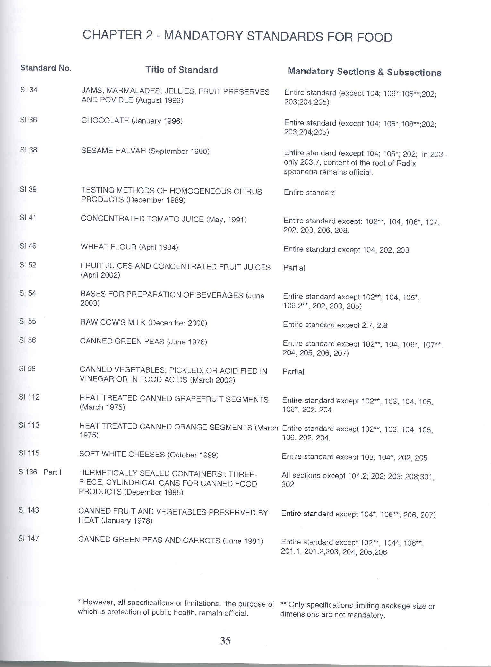
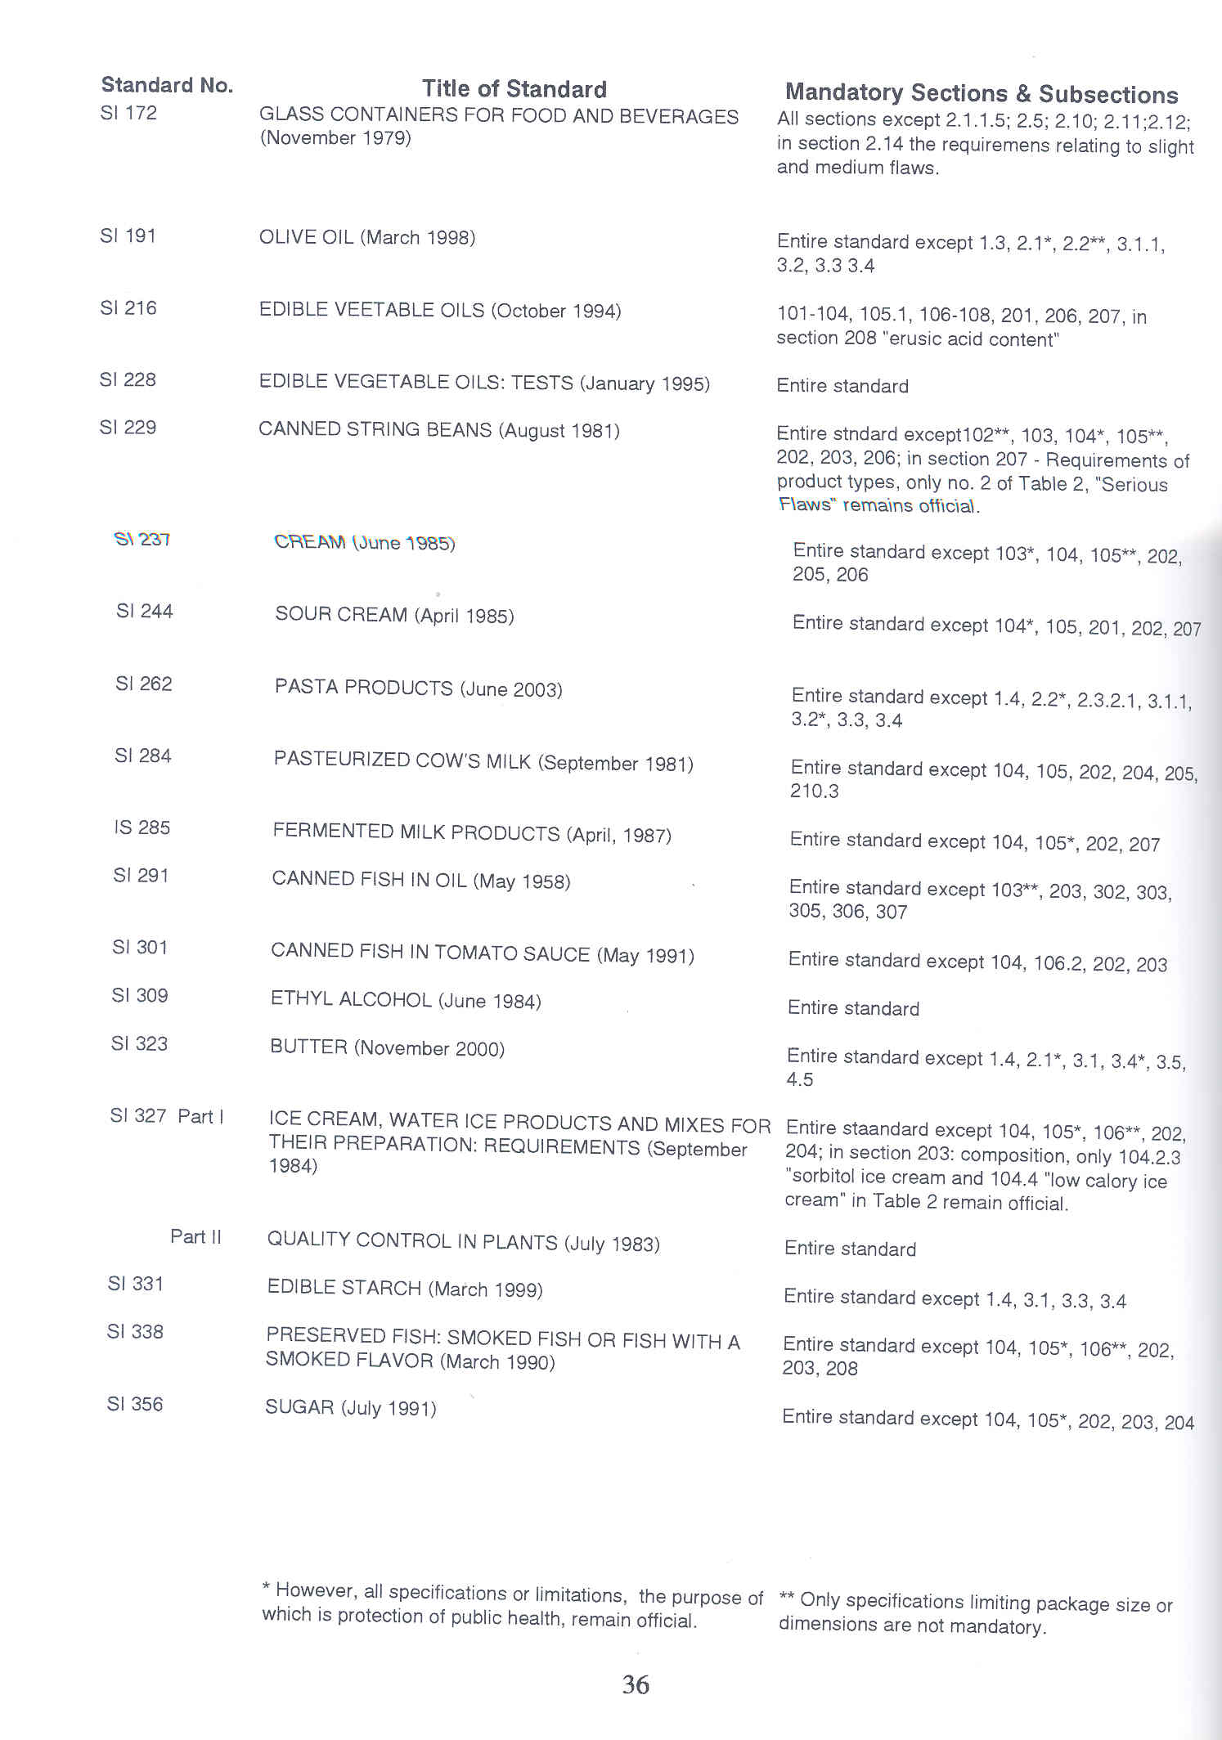
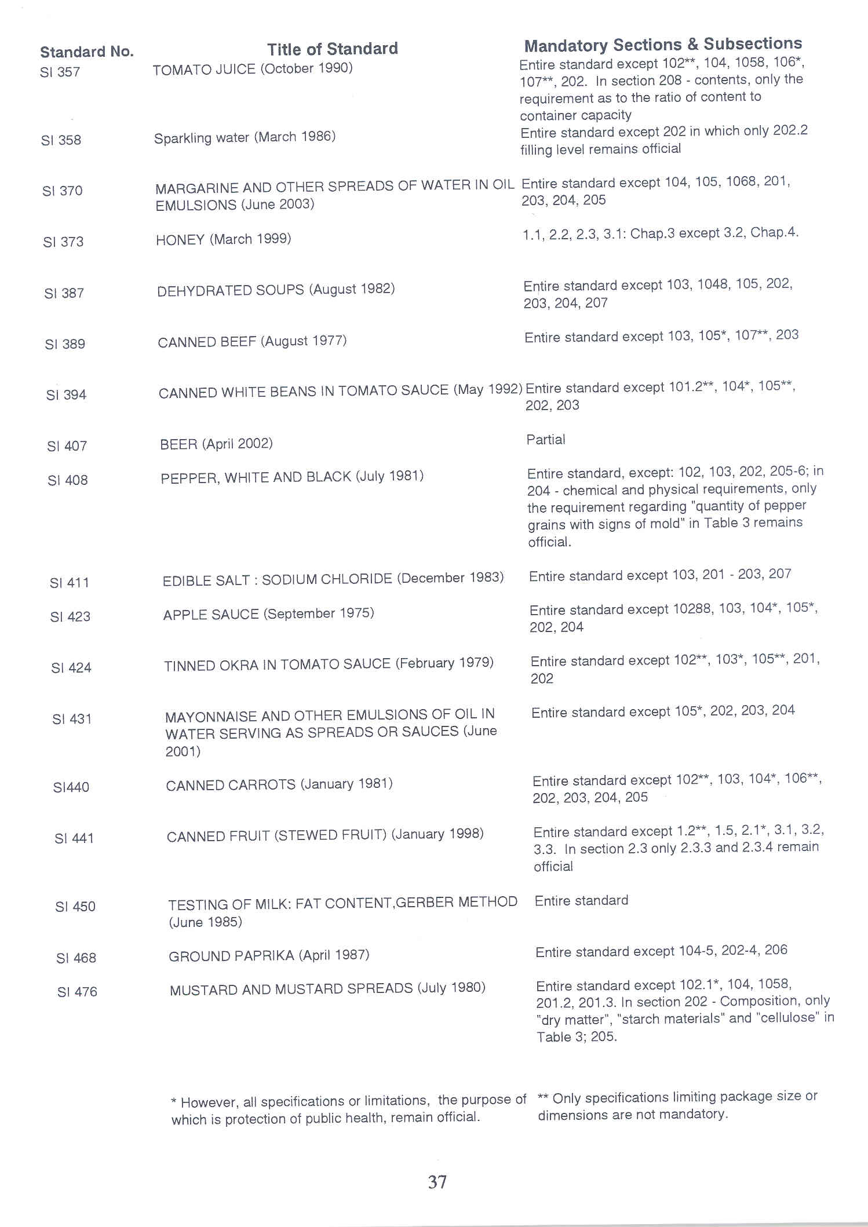
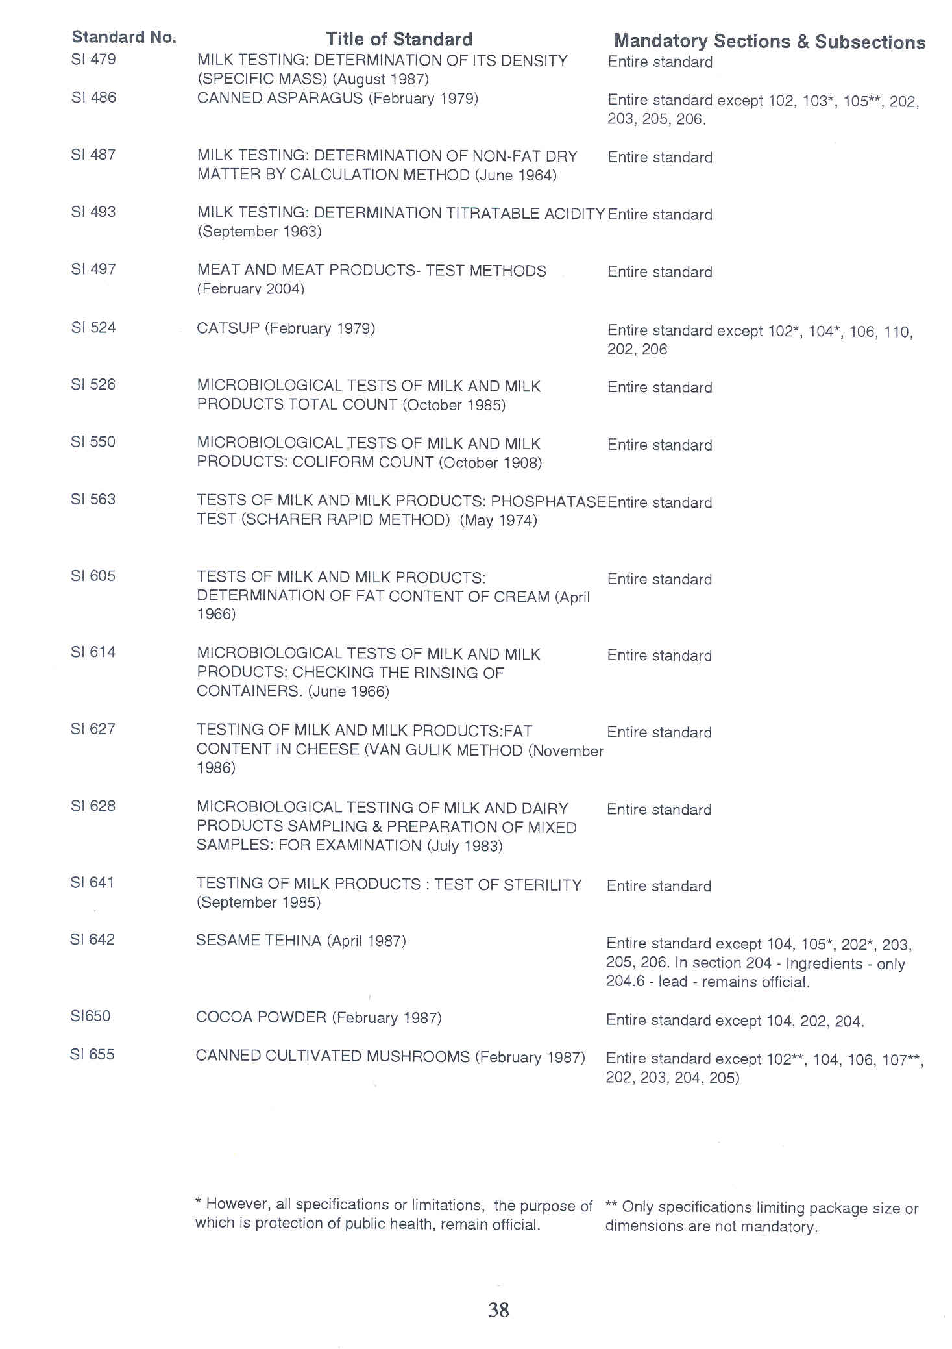
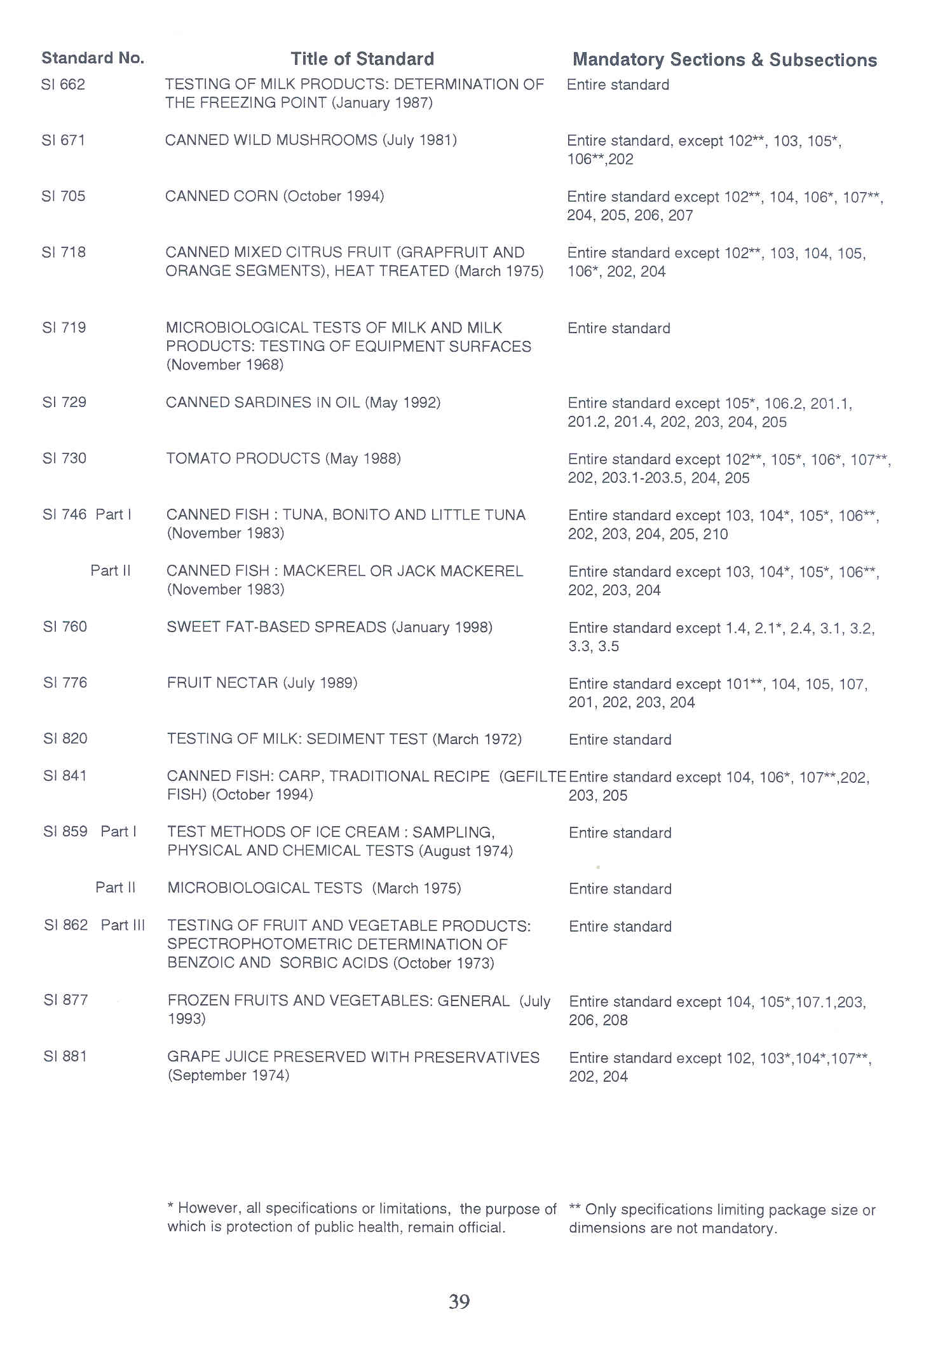
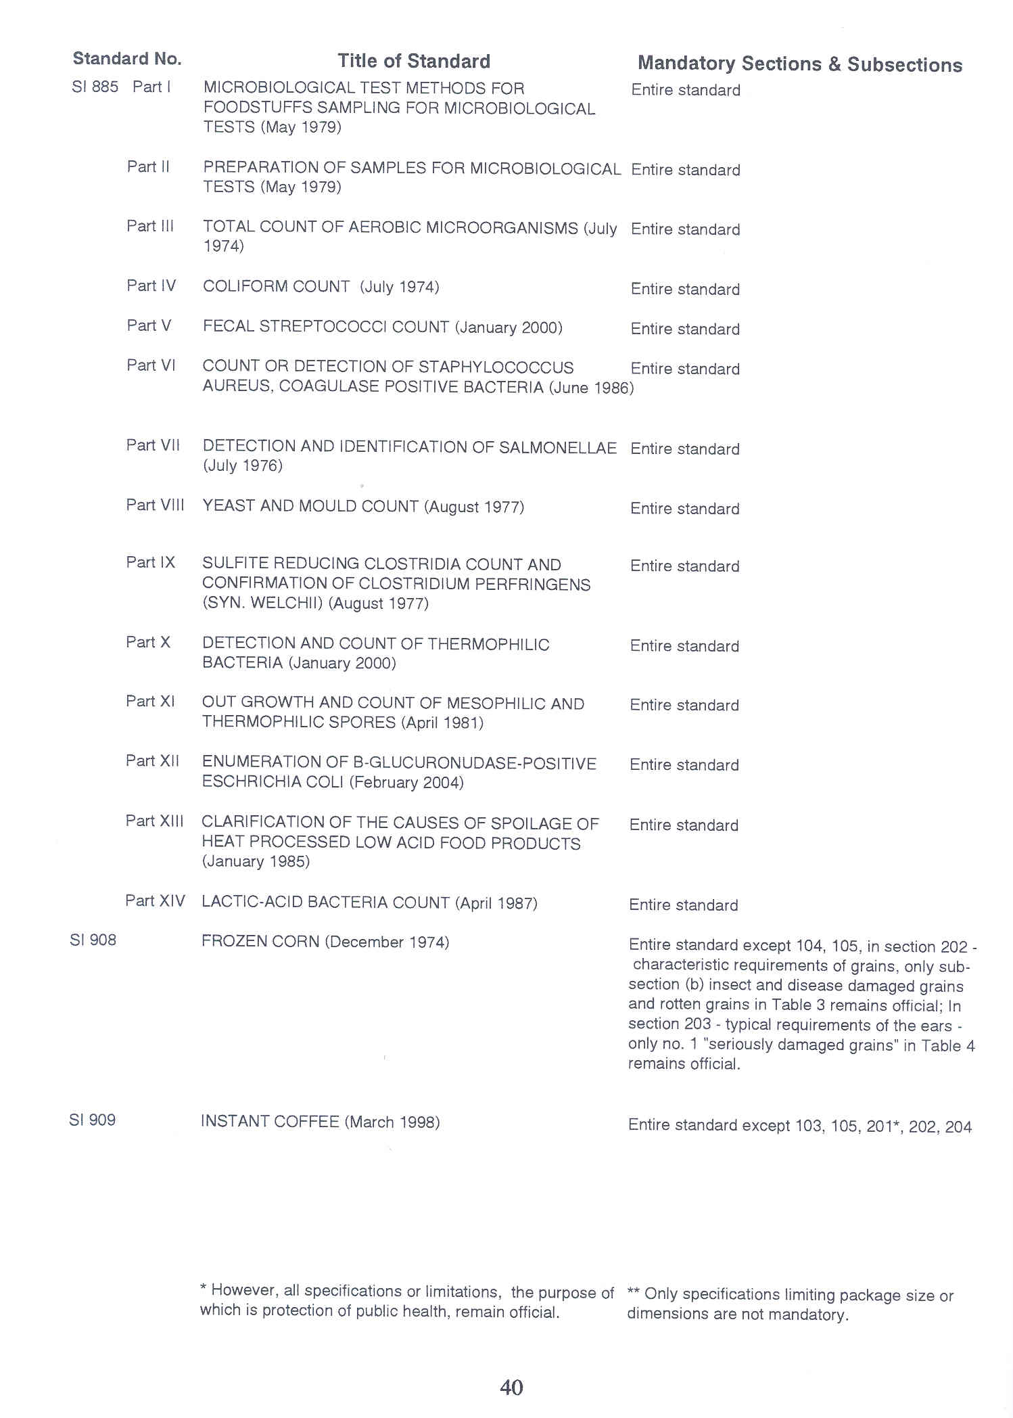
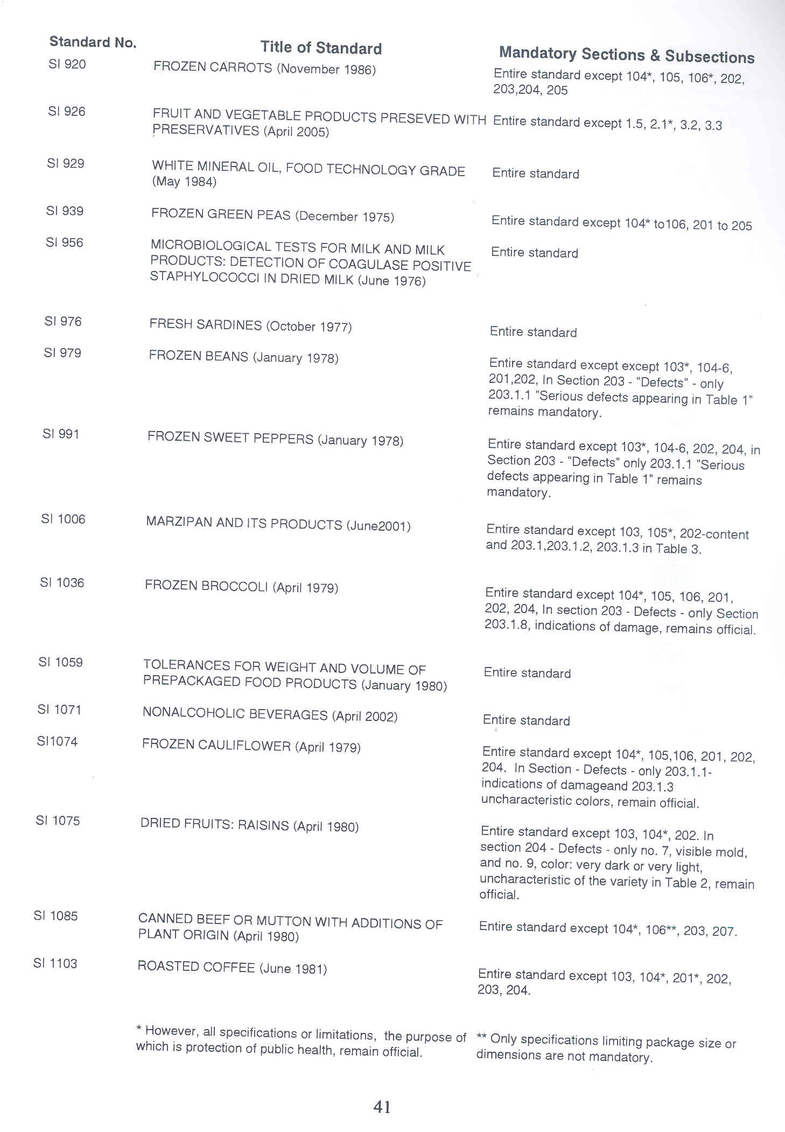
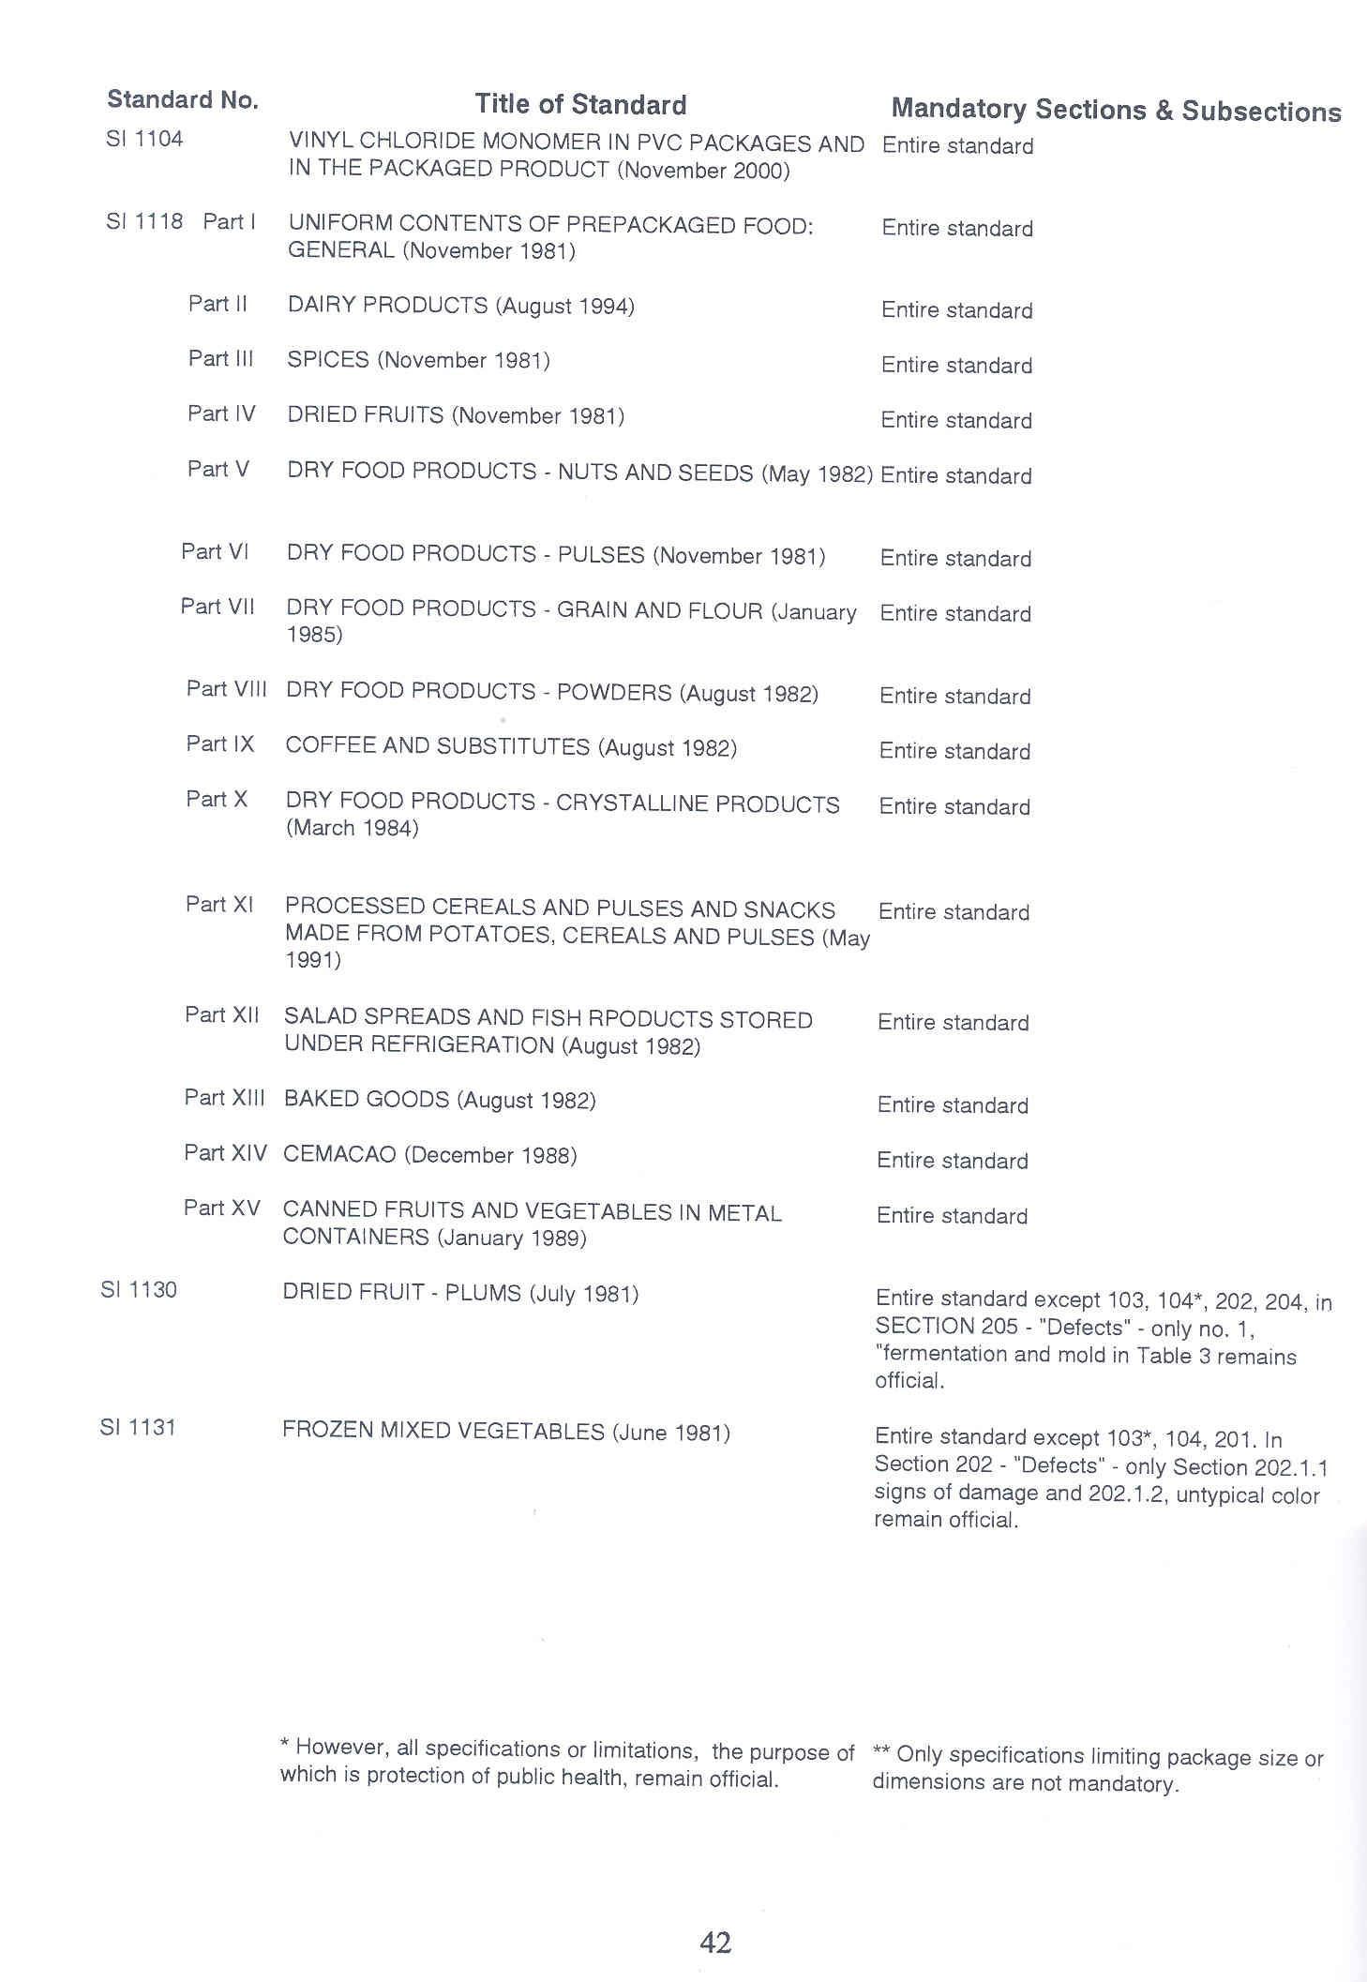
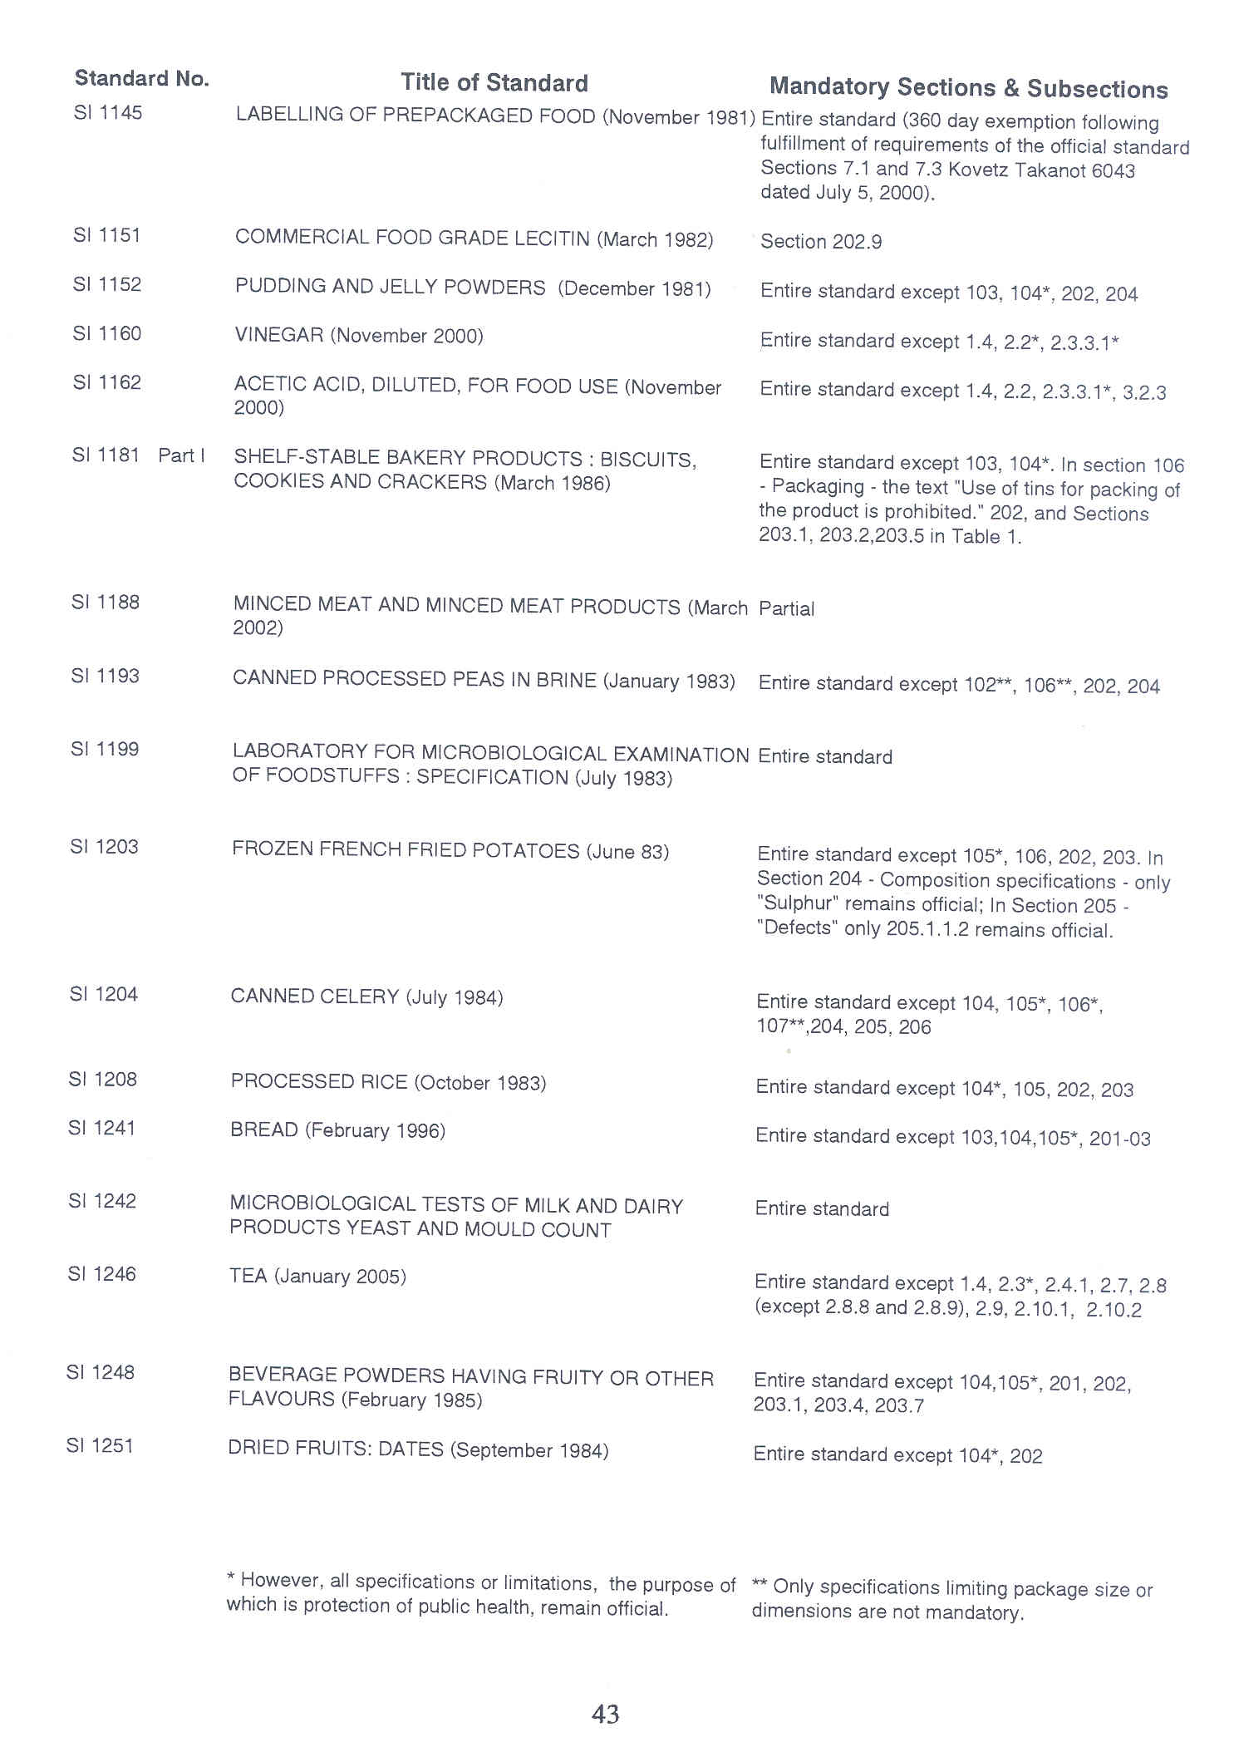
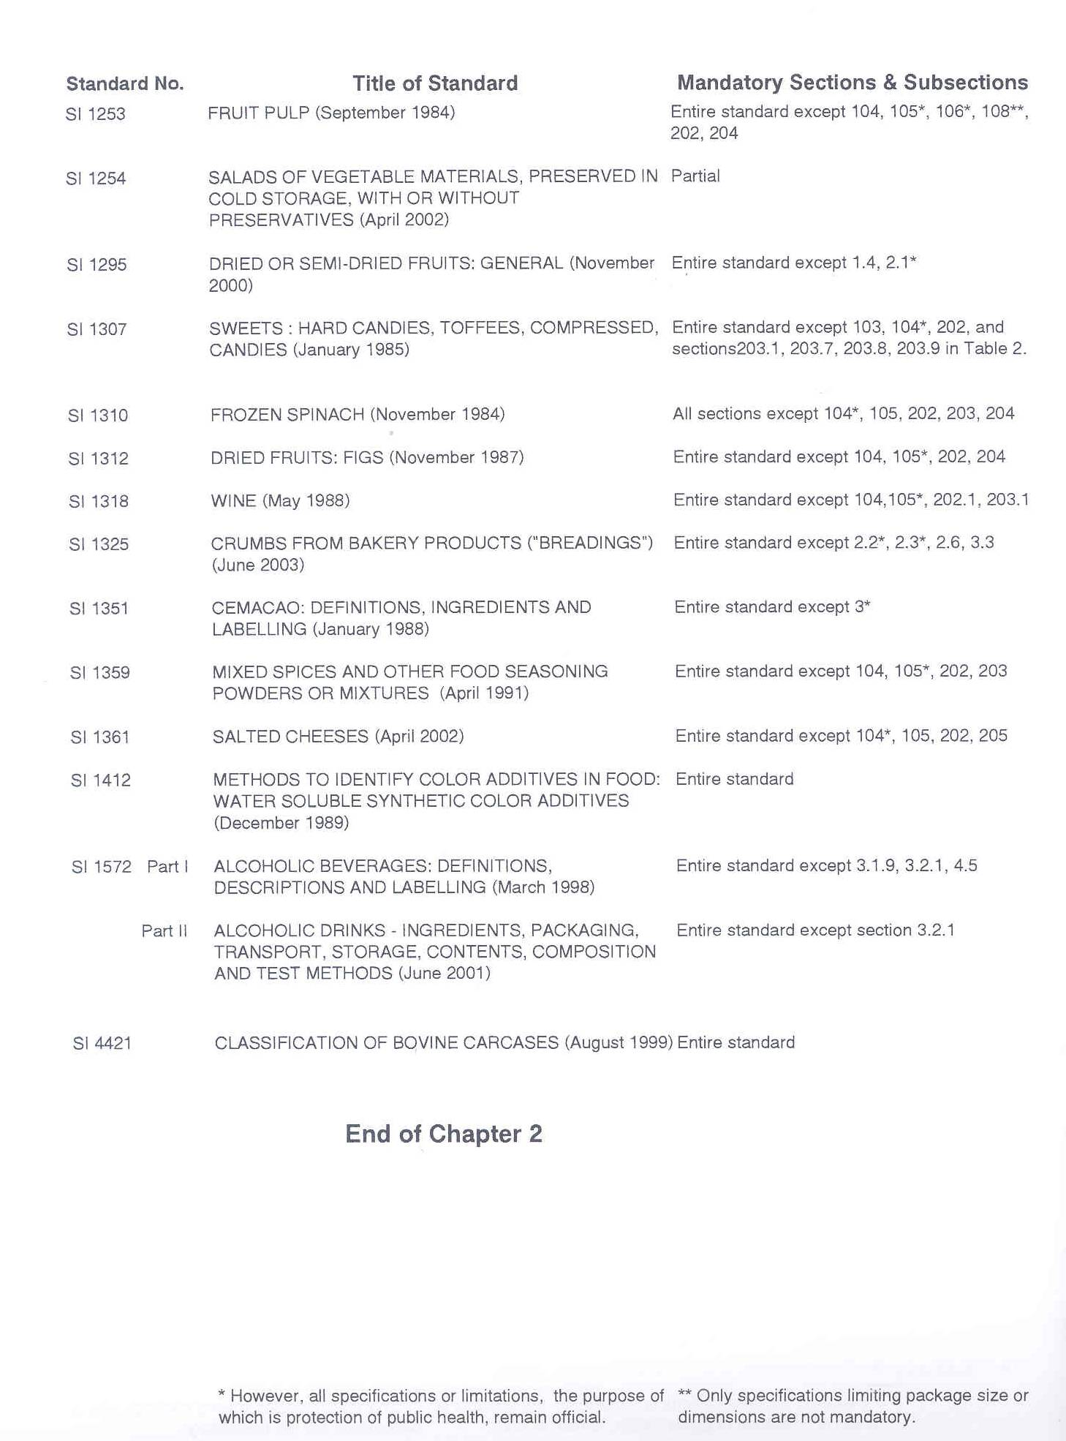
Annex 7: Israel Standards for Food Products

English translation available
S.I. No. | Issued  I  ISSUED  SSISSUUEDDDDD | Revised | Title | Price  Group
10.1 | 1967 | 1987 | Concentrated orange juice, pasteurized (AS 1976) (Official) | B
10.2 | 1967 | 1987 | Concentrated orange juice, preserved (AS 1976) (Official) | B
16.1 | 1967 | 1987 | Concentrated grapefruit juice, pasteurized (AS 1976) (Official) | B
16.2 | 1967 | 1987 | Concentrated grapefruit juice, preserved (AS 1976) (Official) | B
17 | 1967 | 1987 | Concentrated lemon juice, preserved (AS 1976) (Official) | B
56 | 1976 | 1995 | Canned green peas (AS 1983, 1988) (Official) | D
57 | 1975 |  | Edible Oils: sunflower oil (AS 1986) (Official) (Superseded by S.I 216)
112 | 1975 | 1995 | Canned grapefruit segments (AS 1979) (Official) | D
113 | 1975 | 1995 | Canned orange segments (AS 1979) (Official) | D
131 | 1974 | 1989 | Edible oils: cottonseed oil (AS 1986) (Official) (Superseded by S.I. 216)
167 | 1974 | 1989 | Edible oils: sesame seed oil (AS 1986) (Official) (Superseded by S.I. 216)
177 | 1955 |  | Glass jars for pasteurized preserves (AS 1990) | B
191 | 1970 | 1989 | Olive oil (AS 1986, 1987) (Official) | D
219 | 1975 | 1987 | Edible oils: Coconut oil (AS 1978) (Official) (Superseded by S.I. 216)
220 | 1974 | 1989 | Edible oils: Peanut oil (AS 1986) (Official) (Superseded by S.I. 216)
256 | 1957 |  | White bread (AS 1958, 1989) (Superseded by S.I. 1241)
263 | 1957 |  | Dark wheat bread (Superseded by S.I. 1241)
291 | 1958 | 1989 | Canned fish in oil (AS 1975) (Official) | C
297 | 1976 | 1987 | Canned melons (AS 1979) (Official) | C
304 | 1974 | 1989 | Edible oils: niger seed oil (Official) (Superseded by S.I. 216)
305 | 1974 | 1990 | Edible oils: safflower seed oil (AS 1986) (Official) (Superseded by S.I. 216)
315 | 1959 |  | Halah (Shabbat bread) (Superseded by S.I. 1241)
335 | 1975 | 1989 | Canned apricots (AS 1983) (Official) | C
360 | 1960 | 1987 | Canned guavas (AS 1978) (Official) | B
373 | 1970 | 1987 | Honey (AS 1973, 1981, 1987) (Official) | D

Annex 7: Israel Standards for Food Products (Cont.)

S.I. No. | Issued | Revised | Title | Price  Group
384 | 1973 | 1987 | Grape juice, heat preserved (AS 1990) (Official) | C
406 | 1964 |  | Fruit soda drinks (Superseded by S.I. 1071, Part 3)
407 | 1980 | 1990 | Beer (AS 1994) (Official) | E
423 | 1975 | 1995 | Apple Sauce (Official) | B
441 | 1975 | 1989 | Canned peaches (Official) | C
451 | 1962 |  | Mayonnaise spread (Superseded by S.I. 431)

Price List for English Translated Standards, $ U.S.

B - 12.64
C - 12.04
D - 18.84
E - 25.25

Exchange rate (July, 2007): $1 = 4.15 (New Israeli Shekel)

Annex 8: Size of Hebrew Lettering Required on the Labels
of Prepackaged Food

Content  (gr or ml) | Name of Food, Content | Name of Manufacturer, Importer, Marketer, Packer | Date | Ingredients, Address
up to 10 | 1.5 | 1.5 | 1.0 | 1.0
10+ to 25 | 1.5 | 1.5 | 1.0 | 1.0
25+ to 50 | 1.5 | 1.5 | 1.5 | 1.5
50+ to 250 | 2.0 | 1.5 | 1.5 | 1.5
250+ to 450 | 3.0 | 2.0 | 2.0 | 1.5
450+ to 900 | 3.0 | 2.0 | 2.0 | 1.5
above 900 | 4.0 | 2.0 | 2.0 | 1.5
Note: The lettering in other languages shall not be larger than for the Hebrew fonts.

Annex 9 - List of Vitamins, Minerals, and Free Amino Acids

VITAMINS | FREE L-AMINO ACIDS
Vitamin A | Alanine
Vitamin B 1 - Thiamine | Serine
Vitamin B 2 - Riboflavin | Cysteine
Niacin | Cystine
Pantothenic Acid | Aspartic Acid
Vitamin B 6 - Pyridoxine | Glutamic Acid
Biotin | Arginine
Folic Acid | Tyrosine
Vitamin B 12 - Cyanocobalamine | Histidine
Vitamin C - Ascorbic Acid | Proline
Vitamin D 2 - Calciferol or | Valine
Ergocalciferol | Leucine
Vitamin D 3 - Cholecalciferol | Isoleucine
Vitamin E (Compounds of Alpha-tocopherol) | Threonine
Vitamin K 1 | Methionine
 | Lysine, Phenylalanine
MINERALS  Iron  Calcium  Phosphorus  Iodine  Magnesium  Zinc  Copper  Sodium  Manganese  Potassium  Selenium  Molybdenum  Fluorine | Tryptophane  Glycine
Public Health Regulations (Food) (Dietetic Food and Sweeteners), 1987

Annex 10: Additional food components and the minimum
content required to enable them to be included in
the nutritional labeling (Contents per 100 gr or
100 ml of Net Content).

Ingredient | Units | Minimum Content of Nutrient Which Allows it to be Listed in the List of Ingredients. | Minimum Content of Nutrient Which Allows it to be Indicated on the Label Other Than in the List of Ingredients
Vitamin A | International Units | 100.00 | 800.00
Vitamin B 1 | mg | 0.03 | 0.30
Vitamin B 2 | mg | 0.03 | 0.30
Niacin | mg | 0.40 | 3.00
Vitamin C | mg | 1.00 | 15.00
Calcium | mg | 20.00 | 100.00
Iron | mf | 0.30 | 3.00

Annex 11: Allowable Concentrations of Sodium in Various Foods

Column A | Column B
1. Low Sodium  meat and fish product  milk powder  baked goods  canned vegetables  powders for preparing soups  salt substitutes | Largest Concentration of Sodium in mg per 100 gr  60  80  80  80  300 (and not more than 50 mg per portion)  1000
2. Low Calorie  non-alcoholic beverages  powders for preparing beverages  ice creams, except for ices packaged in units weighting less than 150 gr and sherbet  candies  chewing gum  powders for preparing soups  jam  ices and sherbets weighing less than 100 gr  milk products | Largest Concentration of  Calories per 100 gr or per 100 ml  15  15 (in ready to drink beverage)  100  150  100  20 (in soup ready to eat)  100  70  40

Annex 12: Purity and Quality of Artificial Sweeteners

Specifications for Degree of Purity and Quality of Artificial Sweeteners

Column A | Column B
Name of Sweetener | Degree of Purity and Quality  According to the BooSweetner  Following Edition and Page -
1.Saccharin | Saccharin  Edition 25, 1982, pp. 166-169  Calcium Saccharin  Edition 17, 1980, pp. 24 and 25  Sodium Saccharin  Edition 17, 1980, pp. 111-114  Potassium Saccharin  Edition 31/2, 1984, pp. 81-84
2.Cyclamate | Calcium Cyclamate  Edition 17, 1980, pp. 21-23  Sodium Cyclamate  Edition 19, 1980, pp. 109 and 110
3.Aspartame | Edition 17, 1980, pp. 10-12
4.Acesulfame-K | Edition 28, 1983, pp.3 and 4

Annex 13: Purity and Quality of non-High Intensity
Sweeteners

Specifications for Degree of Purity and Quality of non-High Intensity Sweeteners

Column A | Column B
Non-high intensity Sweetener | Degree of Purity and Quality
1. Sugar | Israel Standard 356, June 1978
2. Dextrose Anhydrous | Codex Standard 7-1981
3. Dextrose Monohydrous | Codex Standard 8-1981
4. Dried Glucose Syrup | Codex Standard 10-1981
5. Glucose Syrup | Israel Standard 443, July 1983
6. Lactose | Codex Standard 11-1981
7. Fructose | Codex Standard 102-1981
8. Powdered Dextrose | Codex Standard 54-1981
9. Malto-Dextrin, Dextrins | the Book, edition 19, pp.120, 121
10. Sorbitol | the Book, edition 34, pp. 213-216
11. Manitol | the Book, edition 37, pp. 77-80
12. Xylitol | the Book, edition 28, pp. 143-145
13. Maltitol | Per the Director’s instructions
14. Lactitol | the Book, edition 28, pp.60-63
15. Isomaltitol | the Book, edition 19, pp. 120, 121
16. Hydrogenated Glucose Syrups | the Book, edition 34, pp. 99-102

Annex 14: Acids, Bases, and Reaction Regulators

Acids, Bases, and Reaction Regulators
Acetric Acid
Citric Acid
Fumaric Acid
Glucono Delta-Lactone
Hydrochloric Acid
Lactic Acid
Malic Acid
Phosphoric Acid
Potassium Acid Tartrate
Sodium Bisulfate
Sulfuric Acid
Tartaric Acid
Calcium Phosphate, Tribasic
Calcium Silicate
Calcium Stearate
Cellulose, Microcrystalline
Cellulose Powdered
Kaolin
Magnesium Carbonate
Magnesium Hydroxide
Magnesium Stearate
Silicon Dioxide
Sodium Silica-aluminate
Magnesium Stearate
Silicon Dioxide
Sodium Silica- aluminate
Magnesium Silicate
Adipic Acid
Aluminum Ammonium Sulphate
Aluminum Potassium Sulfate
Aluminum Sodium Sulfate
Ammonium Carbonate
Ammonium Phosphate, Dibasic
Ammonium Phosphate, Monobasic
Calcium Citrate
Calcium Gluconate
Sodium Bicarbonate
Acids, Bases, and Reaction Regulators (continued)
L-Glycine
Calcium Hydroxide
Calcium Lactate
Calcium Phosphate, Monobasic
Calcium Pyrophosphate
Magnesium Oxide
Potassium Acid Tartrate
Potassium Citrate
Potassium Phosphate, Dibasic
Potassium Phosphate, Monobasic
Sodium Acetate
Sodium Acetate, Anhydrous
Sodium Acid Pyrophosphate
Sodium Citrate
Sodium Phosphate, Dibasic
Sodium Phosphate, Monobasic
Sodium Phosphate, Tribasic
Sodium Potassium Tartrate
Sodium Pyrophosphate
Sodium Sesquicarbonate
Succinic Acid

Crystallization-Inhibiting Substances
Silicon Dioxide
Calcium Orthophosphate

Emulsifiers and Stabilizers
Substances listed in the First and Second Appendices of the Public Health Regulations (Food) (Emulsifiers and Stabilizers in Food Products), 1966
Ethyl Alcohol
Glycerol
Stearic Acid
L-Leucine
Poly Ethylene-Glycol
PVP (Pyrolidone Vinyl Polymer)

In Solutions For Personal (Tabletop) Sweeteners Only
Benzoic Acid - up to 1000 parts/million
Para-Hydroxy Benzoic Acid - up to 1000 parts per million (ppm).

Annex 15: Sweetener Content Limits

Column A | Column B | Column C
Sweetener | ADI | Maximum amount of sweetener/100 ml per 100 gr of the product (items 1-6) maximum  amount of sweetener in a portion equivalent  to 5 gr Sucrose (item 5)
1. Saccharin | 2.5 mg/kg  body weight | 1. ready-to-drink non-alcoholic beverages - 4.4mg  2. ice cream - 17.5mg  3. candies and chewing gum - 8.5mg  4. jam - 8.5 mg  5. personal (tabletop) sweetener - 18mg  6. milk product - 8.5 mg
2. Cyclamate | 11 mg/kg body weight | 1.ready-to-drink non-alcoholic beverages - weight 19.3 mg  2. ice cream - 77 mg  3. candies and chewing gum - 38.5 mg  4. jam - 38.5 mg  5. personal (tabletop) sweetener - 150 mg  6. milk product - 38.5 mg
3. Aspartame | 40 mg/kg body weight | 1. ready-to-drink non-alcoholic beverages - 70mg  2. ice cream - 280 mg  3. candy and chewing gum - 140 mg  4. jam - 140 mg  5. personal (tabletop) sweetener - 18 mg  6. milk products - 140 mg
4. Ace-sulfame-K | 9 mg/kg body weight | 1. non-alcoholic beverages - 15.75 mg  2. ice cream - 63 mg  3. candy and chewing gum - 31.5 mg  4. jam - 31.5 mg  5. personal (tabletop) sweetener - 20 mg  6. milk products - 31.5 mg

Annex 16: World Trade Organization (WTO) Enquiry Point

Each member government is responsible for the notification procedures associated with agreement under the World Trade Organization (WTO). Examples here relate to the Sanitary, PhytoSanitary (SPS) and Technical Barriers to Trade (TBT) Agreements. WTO obligations include notifying to the WTO any trade-significant proposals which are not substantially the same as international standards, providing copies of the proposed regulation upon request, allowing time for comments, and also to provide upon request copies of other relevant documents on existing regulations related to food and agriculture. Information on the country’s regulations, standards and certification procedures can also be obtained through the Enquiry Point listed below:

Ms. Bernadette Golczewski- WTO Enquiry Point, Ministry of Industry, Trade and Labor
Email: Bernadette@moital.gov.il
Tel: 972-3-7101581/520, Fax: 972-3-7101585
76 Mazeh Street, Tel Aviv, Israel, 65789

Annex 17: Import Requirements for Dairy Products

As a reference, listed below are examples of customs documents, health certificates, permits, registrations, and additional information which may be required by customs, health or agriculture authorities for the import of United States dairy products into Israel.

I. DOCUMENTATION | III. INSPECTION & SAMPLING
Customs Documentation: | - Pre-Shipment INSPECTION in the United States.
Import Declaration | - Pre-Shipment TESTING by United States Laboratories.
Invoice or Pro-forma Invoice | Mandatory Testing upon entry
Packing List | Random Testing/Sampling upon entry
Import Certificates: | IV. PERMIT and REGISTRATION
APHIS Export Certificate | Import Permit / Import License
Certificate of Analysis | PRODUCT Registration or Approval
Certificate of Conformity | LABEL Registration or Approval
Certificate of Free Sale | U. S. DAIRY PLANT Registration or Approval
Certificate of Hazard Analysis Critical Control Points (HACCP) | V. SPECIAL / ADDITIONAL REQUIREMENTS
Certificate of Origin | Shelf - Life requirements
Health Certificate | Storage requirements
Halal Certificate | Transportation requirements
Kosher Certificate | Additional import requirements or procedures for PRODUCT SAMPLES.
Radiation - free Certificate | Additional requirements for dairy products as SPECIALTY FOODS
Other Country - Specific Certificates
Declaration regarding the existence of Inhibitors, pharmaceutical components, antibiotics, or pesticide residues.
II. ADDITIONAL DOCUMENTS REQUIREMENTS | VI. ISRAEL SPECIFIC REQUIREMENTS
Sample of Label (original label needed) | "U.S. Certificate of Origin for Exporting to Israel" (CO)
Ingredient List
Additive List
Description of Manufacturing Process Authorization/Certification/Notarization of Documents.

The government of Israel requires food products to be registered with the Ministry of Health before they can be sold in the country. United States Food and Drug Administration approval is not mandatory, but is preferred by Israeli importers as it accelerates the product registration process and import license approval. Product registration normally takes from 14 to 21 days if all documentation is in order.

All dairy products imported to Israel must be pasteurized and abide by all official standards and regulations of Israel. The following documents have to be presented.

1. List of ingredient including food additives, identified by their chemical name or respective E- number (as in the European Union).

2. Product label (original).

3. Certificate of analysis including chemical phosphates test and microbiological.

4. Declaration or analysis certificate regarding inhibitors, drug residues, antibiotics, pesticide residues, and preservatives (The only preservative allowed is sorbic acid up to 750ppm).

5. Certificate from the veterinary authorities, according to EEC. An APHIS Export Certificate, VS Form 16-4 (Attachment) stating that they come form herds free from foot- and- mouth disease.

6. Flow diagram of production, including technological process.

7. Certificate of GMP, HACCP, and/or any other quality control systems.

Other Documents:

1. Commercial Invoice.
Three copies are required. If more than on commodity is being imported in the same shipment then each must be described separately on the invoice or a separate commercial invoice must be used for each. The Israel Customs Services prefer that exporters use their own commercial invoice forms containing all required information including name and address of supplier, general nature of the goods, country of origin of the goods name and address if the customer in Israel, terms, rate of exchange (if applicable), shipping information, and a full description of all goods in the shipment including shipping market, quantity or measure, composition of goods (by percentage if mixed), tariff heading number, gross weight of each package, net weight of each package, total weight of shipment, price per unit as sold and total value of shipment. The total value of shipment includes packing shipping, dock and agency fees, and insurance charges incurred in the exportation of goods to Israel. The Commercial invoice must be signed by the manufacturer, consignor, owner, or authorized agent.

2. United States Certificate of Origin.
In order to benefit from the provision of the United States - Israel Trade Area Agreement
(FTAA), a special "United States Certificate of Origin for export to Israel" (CO) must be presented to Israel Customs. The certificate does not need to be notarized or stamped by a Chamber of Commerce if the exporter is also the manufacturer. Instead, the exporter should make the following declaration in the certificate:
"The undersigned hereby declares that he is the producer of the goods covered by this certificate and that they comply with the origin requirements specified for those goods in the United States - Israel Free Trade Agreement for good exported to Israel."

Actual CO forms are printed by a number of commercial printing houses in the United States, specializing in export document forms.

It is possible for exporter to apply for a blanket CO, or "Approved Exporter" status. An "approved exporter" is only required to present an invoice which substitutes the CO, and which contains an "approved exporter" number and a declaration that the goods comply with the origin requirements. Certificate and notarization are not necessary. A manufacturer or exporter who wishes to become an "Approved Exporter" should complete a declaratory form and present it to:

Export Department
Israel Customs Services
32 Agron Street
P. O. Box 320
Jerusalem

Potential candidates are Unites States firms with total annual exports to Israel of at least $20 million who have a clean recorded with the Israel Customs Service.

3. Kosher certification for dairy products is a commercial requirement. Supermarkets and most hotels will not stock products, which are not kosher. The competent authority for kosher certification is :
Chief Rabbinate of Israel
Head of Imports Division
Kashrut Department
Jerusalem
Tel: 972-2-624-3484
When exporting milk replaces or milk products used for animal fees to Israel, you must obtain the following certifications from APHIS:
1. Veterinary certificate stating that the products are free from food-and-mouth disease, pathogenic microorganisms, BSE and radioactive contamination.

2. Certification that the processing plant where the items are produced is under the direct supervision of APHIS Veterinary Services.

Annex 18: IMPORT OF INTOXICATING BEVERAGES

MINISTRY OF INDUSTRY AND COMMERCE
DIRECTOR-GENERAL’S CIRCULAR

IMPORT OF INTOXICATING BEVERAGES 2.5

1. Introduction

1 - A
For the purpose of import of intoxicating beverages to Israel, the importer must obtain a special permit from the Ministry of Industry and Trade for the import of intoxicating beverages, in accordance with the provisions of the Free Import Order, 1978. The requirement for a special permit for the import of intoxicating beverages was intended to protect the public health and to prevent beverage consumers from being misled.
1 - B
The purpose of this circular is to set forth the conditions and procedures for the granting of special permits for the import of intoxicating beverages.

2. General

2 - A
As a general rule, there are two principal stages in the process of import of intoxicating beverages. The first stage involves receipt of a special permit, prior to import, and requires the use of an “Application for Import License” (or “Application for Special Permit”) form. The second stage involves receipt of a permit for release of the merchandise, and requires the use of an “Examination and Release of Intoxicating Beverages” form.

2 - B
This circular, with regard to the type and quality of the examination required, distinguishes between the import of intoxicating beverages to Israel for the first time and the import of intoxicating beverages which have already been imported in the past. As a general rule, the import of intoxicating beverages for the first time requires the importer to produce certificates of origin from the manufacturer, whereas the import of intoxicating beverages which have been imported in the past does not require the importer to produce such certificates. In both cases, the importer is required to provide the Consumer Goods Administration in the Ministry of Industry and Trade with a certificate of examination by an approved laboratory, attesting to the fact that the beverage is not toxic and that it complies with all of the requirements of the law and of this circular. A certificate of examination is required both in the stage prior to the import and in the stage of release of the products from Customs.

2 - C
The Consumer Goods Administration is entitled to withhold the granting of the special permit, to suspend it after it has been given, or to cancel it, should it deem this necessary in order to ensure that no beverage is imported to Israel which does not comply with the requirements of the law and of this circular.

3. Definitions

3 - A “Intoxicating Beverages”
Beverages and potable alcohols of the types set forth in Chapter 22 of the Supplement to the Customs Tariff and Exemptions Ordinance, 1937, whose import is contingent upon a special permit pursuant to the Free Import Order, 1978.
Should the name of a certain beverage be mentioned in this circular, it shall be interpreted as set forth with regard to said beverage in IS 1318 – Wine, IS 407 – Beer, IS 309 – Ethyl Alcohol, or IS 1572 Part 1 – Alcoholic Beverages – Definitions, Descriptions and Marking.
A list of the laws applying to imported alcoholic beverages is appended to this circular as Appendix A.

3 - B “New Intoxicating Beverage”
An Intoxicating Beverage which has not yet been imported to Israel.

3 - C “Previously Imported Intoxicating Beverage”
An Intoxicating Beverage which has previously been lawfully imported to Israel.

3 - D “Certificate of Origin”
A permit from the competent authority in the country of production, verifying the country of cultivation of the original materials and the area of cultivation, if the latter is set forth on the Label of the beverage.

3 - E “Approved Laboratory”
A laboratory which has been approved by the Commissioner for Standardization, pursuant to Section 12 (a) of the Standards Law, 1953.

3 - F the “Administration”
The Consumer Goods Administration in the Ministry of Industry and Commerce.

3 - G “Competent Authority”
The Director of the Administration or anyone empowered for the purpose, pursuant to the Import and Export Ordinance [New Version], 1979, are in charge of granting of the permits and implementation of this circular.

3 - H “Label”
Any writing on the package, whether said writing is glued on, stamped on or applied in any other manner.

4. Conditions for Granting of a Special Permit Prior to Import An importer seeking to import Intoxicating Beverages to Israel shall submit to the Administration an application for a special permit, on an “Application for Import License” (or “Application for Special Permit”) form (MDF 5060)) along with the following documents:

* A certificate of examination by an Approved Laboratory, as set forth in Sections 4 - A,
4 - B and 4 - C of this circular, which sets forth the composition of the Intoxicating Beverage and attests to the fact that the beverage is not toxic and that it complies with all of the requirements of the law and of this circular. With regard to a Previously Imported Intoxicating Beverage – the certificate of examination shall state that its composition is identical to the known composition of the beverage as documented by the Approved Laboratory at the time of the first import of the beverage to Israel.

* The original documents which were submitted to the laboratory.

If the requirements of the law and of this circular are fulfilled, the importer shall be granted a special permit for the import of Alcoholic Beverages.

4 - A Laboratory Examination for a New Intoxicating Beverage

An importer seeking to obtain a certificate of examination for the purpose of receiving a special permit for the import of a New Intoxicating Beverage shall provide an Approved Laboratory with the following:

1) A sample of the beverage with regard to which the import permit is requested, in a container of the type in which the beverage is to be marketed to consumers. If the beverage is beer, the importer must produce 5 bottles/cans for each sample.

2) Three original Labels (separately or on the bottles).

3) Three labels in Hebrew.

4) Original documents issued by the manufacturer of the beverage, approved and verified
by the Competent Authority in the country of production, and including the following
details:
a) Analysis which sets forth the components listed in Appendix B of this circular, as well as the names, types and international identification numbers of the artificial coloring used in the production of the beverage, and the types and quantities of preservatives used in the production of the beverage.

b) A description of the production process.
c) A list of the original materials used in the production of the beverage.

d) If the beverage is wine, the areas of cultivation and the composition of the grape varieties used in the production of the wine shall be set forth in detail. Should a certain area of cultivation be listed on the Label, the importer shall provide a Certificate of Origin.
e) If the beverage is whiskey, brandy, tequila, cognac, ouzo or fruit distillates, the importer shall provide a Certificate of Origin issued by the Competent Authority in the country of production, which also sets forth the original materials and the production process (including the aging process).

5) Documents written in a foreign language (except for English and French) shall be submitted in Hebrew translation and shall be notarized.

4 - B Laboratory Examination for a Previously Imported Intoxicating Beverage

An importer seeking to obtain a certificate of examination for the purpose of receiving a special permit for the import of a Previously Imported Intoxicating Beverage shall provide an Approved Laboratory with the following:

1) A sample of the beverage with regard to which the import permit is requested, in a container of the type in which the beverage is to be marketed to consumers. If the beverage is beer, the importer must produce 5 bottles/cans for each sample.

2) Three original Labels (separately or on the bottles).

3) Three labels in Hebrew.

4) If the beverage is wine, the Approved Laboratory must be provided with a Certificate of Origin from the manufacturer as set forth in Section 4 - A, (4).

Documents written in a foreign language (except for English and French) shall be submitted in Hebrew translation and shall be notarized.

4 – C Examination in the Laboratory and Certificate of Examination

- An Approved Laboratory shall perform tests on Intoxicating Beverages as set forth in Appendix 2 of this circular.
- Upon conclusion of the examination, the Approved Laboratory shall produce a Certificate of Examination for the Intoxicating Beverage, which shall include the following details:

  - The composition of the Intoxicating Beverage.

  - Designation of whether the Intoxicating Beverage is toxic.
- Details with regard to the compatibility of the composition of the
Intoxicating Beverage with the requirements of the law and of this circular, including a detailed listing of any deviation.

- If the beverage is beer, and if its expiry date has passed or is about to fall
within 30 days, it must be clarified that no beer whose expiry date is about to fall within three months shall be released from Customs.

- With regard to a New Intoxicating Beverage: whether the composition of the
beverage is identical to the composition which was described by the manufacturer in the document submitted pursuant to Section 4 - A, (4) above, and if not, a detailed listing of the deviation from said composition and the required correction of the Label, provided the beverage is an Intoxicating Beverage as this term is defined in this circular.

f) With regard to a Previously Imported Intoxicating Beverage: whether the
composition of the beverage is identical to the known composition of the beverage
as documented at the time of the first import of the beverage to Israel.

5. Release of the Shipment from the Control of the Customs Authorities

Following the arrival of the shipment of Intoxicating Beverages in Israel, the manufacturer shall take action to have the shipment released from the control of the Customs authorities, according to the following rules:

5 - A
The manufacturer shall ensure that a representative of the Approved Laboratory which issued the Certificate of Examination during the stage prior to the import shall take samples of each brand name and submit them for examination. With regard to the import of a New Beverage, one sample shall be taken for each brand name. With regard to the import of a Previously Imported Beverage, three samples shall be taken for each brand name.

5 - B
The Approved Laboratory shall examine the composition of the Intoxicating Beverage of which said sample were taken, shall draw up a Certificate of Examination with respect thereto, in the format set forth in Section 4 - C above, and shall determine whether the composition of the beverage is identical to the composition in respect of which the special permit was issued during the stage prior to the import.

5 - C
The importer shall provide the Administration with the Certificate of Examination issued by the Approved Laboratory and with an “Examination and Release of Intoxicating Beverages” form (IC 70.032), including the documents required in accordance with said form: a copy of the bill of lading; a commercial invoice; a Certificate of Origin; a Label for the beverage, approved by the Administration within the framework of the special permit; and a copy of the special permit.

5 - D
Should the requirements of the law and of this circular be fulfilled, the importer shall be granted a permit for the release of the Intoxicating Beverage from the control of the Customs authorities, provided that the commodity examined is an Intoxicating Beverage as this term is defined in this circular. Should the commodity be another beverage, which is not an “Intoxicating Beverage”, the commodity shall be examined pursuant to the relevant applicable law. If the beverage is beer, an “Examination and Release of Intoxicating Beverages” form shall not be issued for beer whose expiry date has passed or is about to fall within 30 days.

6. “Green Track”

The Administration is entitled to approve the release of an Intoxicating Beverage from the control of the Customs authorities prior to the issue of the Certificate of Examination as required in Section 5, or to waive the issue of the Certificate of Examination, according to the rules set forth below:

6 - A
The Administration shall maintain a list of all of the importers of Intoxicating Beverages.

6 - B
The Administration is entitled to grant an importer of Intoxicating Beverages the status of “Recognized Importer” after said importer has brought to Israel at least ten shipments of Intoxicating Beverages on different dates, in a total quantity of at least ten cargo containers, over a period of at least one year, and has been found, on the basis of the cumulative experience, compliant with the provisions of the law and this circular. The Administration is entitled to grant an importer the status of “Recognized Importer” provided that said importer, prior to the publication of this circular, has been recognized by the Administration as a regular importer of Intoxicating Beverages which has complied with the requirements applicable to the import.

6 - C
The release of Intoxicating Beverages imported by a Recognized Importer from the control of the Customs authorities shall be implemented following the provision of an “Examination and Release of Intoxicating Beverages” form

6 - D
At the time of issue of the examination form, the Administration shall determine whether it is necessary for an Approved Laboratory to examine samples of the shipment. Within the framework of its decision, the Administration shall consider past experience with regard to the compliance of beverages of the same type with the requirements applicable thereto, the quantity of beverages of the same type which have been imported and examined, and the interval which has elapsed since the last examination of that type. Should the Administration decide that it is necessary for an Approved Laboratory to examine samples of the shipment, samples of each brand in the shipment shall be taken by a representative of the Approved Laboratory, who shall transfer them for examination as set forth in Section 5 - A above.

6 - E
Should the laboratory examination reveal that the Intoxicating Beverages which have been released from the control of the Customs authorities do not comply with the requirements of the law and this circular, the Administration shall issue an order for the cessation of marketing of the beverages, subject to the importer being given the right to state his case before the Administration.

6 - F
Should the Administration decide to order the cessation of marketing of the merchandise, the importer shall be required to immediately cease the marketing thereof and to collect the merchandise in an agreed place acceptable to the Administration, pending a decision as to what shall be done with it.

6 - G
Should the Administration decide to prevent or to terminate the marketing of the merchandise, the Administration shall approach a Court for the receipt of an order for confiscation, destruction or return of the shipment to its country of origin, as the Court shall decide.

6 - H
The Administration is entitled to revoke an importer’s status as a Recognized Importer, should it transpire that the importer misused said status or that the importer does not comply with the requirements of the law and of this circular, or when there is a real suspicion of the import of Intoxicating Beverages which do not comply with said requirements, in such a manner as to justify the performance of laboratory testing prior to release of the shipments from the control of the Customs authorities. The Administration is entitled to decide as stated above in a general manner or with regard to a specific shipment. Prior to such a decision by the Administration, the importer shall be given an opportunity to state his case before the Administration.

7. Applicability
This Director-General’s Circular shall enter into force as of the date of its publication in the Official Gazette.
(-)
Reuven Horesh
Director General
Jerusalem, 12 Kislev 5760

Appendix A (Section 3 of the Circular)

Laws Applying to the Import of Intoxicating Beverages

A. Israeli Legislation

1. National Health Ordinance (Food), 1935.
2. National Health Regulations (Food) (Coloring in Food), 1984.
3. Consumer Protection Law, 1981.
4. Consumer Protection Ordinance (Marking and Packaging of Food Products), 1999.
5. Standards Law, 1953, and Israel Standards IS 1318 – Wine, IS 407 – Beer, IS 309 – Ethyl Alcohol, or IS 1572 Part 1 – Alcoholic Beverages – Definitions, Descriptions and Marking.
6. Intoxicating Beverages Ordinance (Manufacture and Sale) [New Version].
7. Intoxicating Beverages Regulations.
8. Control of Products and Services Law, 1957.
9. Merchandise Marking Ordinance.
10. Import and Export Ordinance [New Version], 1979.
11. Free Import Order, 1978.

B. International Rules and Standards

1. The requirements of the Codex alimentarius.
2. Food Chemical Codex.

3. British Pharmacopoeia.
4. EEC Council Regulations No. 1576/89 – 1989, published in the Official Journal of European Communities No. L - 160 dated June 12, 1989, as these shall be in force from time to time, and other regulations and guidelines issued by the European Union with regard to intoxicating beverages.
5. Recueil des méthodes internationales d’analyse des vins et des moûts, Complément n 1 à l’édition officielle de juin 1990, Office International de la Vigne et du Vin.
6. Laws and circulars issued by the United States Department of the Treasury, Bureau of Alcohol, Tobacco and Firearms.
7. Laws, regulations, standards, quality requirements, and other legal provisions of the country of manufacture.
8. Other requirements of any institution which has been recognized by the Director-General of the Ministry of Industry and Commerce.

Appendix B (Section 4 of the Circular)
Laboratory Testing

A. Test methods:

1. Laboratory testing shall be conducted in accordance with the generally accepted professional criteria in the intoxicating beverages industry, according to the test methods set forth in the Israel Standard applicable to the beverage under test or in any other legislation.

2. In the absence of Israel Standards and Israeli legislation governing the test methods, the testing shall be carried out in accordance with generally accepted international test methods, or the test methods generally accepted in the country of manufacture. In particular, use shall be made of the test methods set forth in the following compendia:

(a) The test methods of the Office International de la Vigne et du Vin, as set forth in Recueil des méthodes internationales d’analyse des vins et des moûts.

(b) The test methods set forth in EEC Council Regulations No. 1576/89 – 1989, published in the Official Journal of European Communities No. L - 160 dated June 12, 1989, as these shall be in force from time to time, and other relevant regulations and guidelines issued by the European Union.

(c) The test methods set forth in the Test Book of the American Organization of Agricultural Chemists (A.O.A.C.), according to the most recent valid edition.

B. List of Chemical Tests for Intoxicating Beverages

(1) Tests for whiskey, cognac, brandy, slivovitz and rum

1. Effective (real) alcohol in % by volume.
2. Synthetic alcohol in % by volume.
3. Overall acidity
4. Fixed acidity } in milligrams of acetic acid per liter
5. Volatile acidity
6. Dry extract (dry material) in grams per liter
7. Overall sugar as reducing sugar in grams per liter

8. Methyl alcohol (methanol) in milligrams per liter
9. Non-alcoholic elements, in grams per 100 liters of 100% alcohol, including:
a. Volatile acids such as acetic acid
b. Aldehydes such as ethanal
c. Furforol
d. Esters (such as ethyl acetate)
e. Total high alcohols, including:
Propanol 1
Methyl 2 – propanol 2
Butanol 1
Methyl 2, butanol 1 and methyl 3, butanol 1
Total non-alcoholic coefficient

(2) Tests for liqueurs, cordials, cocktails and aperitifs

1. Alcohol in % by volume.
2. Total fat in grams per liter (milk fat)
3. Overall sugar as reducing sugar in grams per liter
4. Protein (about 25.6 X)
5. Acidity such as citric acid in grams per liter
6. Dry extract (dry material) in grams per liter
7. Ash in grams per liter
8. Color index
9. Methyl alcohol in milligrams per liter

(3) Tests for wines, dessert (sweet) wines, sparkling wines and sangria

1. Alcohol in % by volume.
2. Alcohol by weight (in grams per liter)
3. Specific weight 20/20
4. Volumetric mass
5. Specific weight of non-alcoholic distillate residue
6. Sugars: total expressed as reducing sugar
7. Reducing sugar (in grams per liter)
8. Sucrose (in grams per liter)
9. Polarization of polarimetric plane
10. Dry extract: Total according to densimetry (in grams per liter)
11. Less sugar (non-reducing extract) (in grams per liter)
12. Corrected (reduced extract) (in grams per liter)
13. Total acidity expressed as wine acid (in grams per liter)
14. Volatile acidity expressed as acetic acid (in grams per liter)
15. Fixed acidity expressed as wine acid (in grams per liter)
16. Tartaric acid (in grams per liter)
17. Malic acid (in grams per liter)
18. Citric acid (in grams per liter)
20. Sulfur dioxide, total (in grams per liter)
21. Sulfates expressed as (in grams per liter)
22. Glycerol (in grams per liter)
23. 2-3 butylene glycol (in grams per liter)
24. Preservatives: Benzoic acid (in grams per liter)
25. Sorbic acid (in grams per liter)
26. Ascorbic acid (in grams per liter)
27. Presence of whitener (Malvidin Diglucozide)
28. Precipitate index
29. Organoleptic test
30. Ash (in grams per liter)
31. Alkalinity of ash (in meq/L)
32. Potassium (in grams per liter)
33. Phosphorus expressed as (in grams per liter)
34. Analytic formula: dry alcohol (2) / reduced dry extract (13)
35. Total sugar
Polarization of polarimetric plane
36. Revlaine coefficient
37. Alcohol in % by volume (1) – fixed acidity (18)
38. Ash (30) / alkalinity (31)
39. Fixed acidity (18) / alcohol in % by volume (1)
40. Residual dry extract (in grams per liter)

Procedure for Importation of Wine

Import Department, Chief rabbinate of Israel

The Chief Rabbinate of Israel has published an official procedure or set of principles as a guide to the perplexed importer who seeks to import kosher wine into Israel. The guide, as set out in this publicly available document, provides a striking example of the Chief Rabbinate’s expertise in setting up technical barriers to trade (TBT). Careful examination of the implications of these instructions produces the inevitable conclusion that it is only possible to import wine from wineries which exclusively produce kosher products.
Following is an unofficial translation of the Chief Rabbinate’s guidelines.

Introduction

Production of kosher wine requires expertise and careful supervision of both the production process and any auxiliary ingredients employed in the process. Accordingly it has become necessary to introduce specific kashrut procedures to be followed by importers of wine to Israel.

In addition to the problems, which occur in the course of production, it is evident that lacunae also exist in the marketing of imported wine. These require the development of a clear-cut and uniform procedure for all importers and wineries.

A. The Import Department will not license importation of wine in bulk.

B. An importer of kosher wine must produce the following documents, in addition to completing the special application form for requesting permission to import (kosher wine T.F.).
1. Copies of all labels of the winery which are used outside of Israel for nonkosher
wines.
2. Copies of the proposed labels for the kosher wine.
3. A kashrut certificate from abroad, from the supervising rabbi, indicating:
filling dates; ingredient list and auxiliary materials used in the manufacture of the wine; description of the manufacturing process; a declaration by the kashrut supervisor that he has sole responsibility for the labels.

C. The brand name and name of the kosher wine ("the line") will under no circumstances be the same as that of the nonkosher labels. Decisions on this issue are at the sole discretion of the Import Department.

D. The Import Department will not issue import permits for kosher wine to an importer who also imports or markets nonkosher wine.
E. An importer of kosher wine will confirm that he does not store kosher and nonkosher wines in the same warehouse.

F. The importer of kosher wine will undertake to refrain from advertising kosher and nonkosher wines together.

Note: An importer who, for whatever reason, imports kosher wine without the direction and instruction of the Import Department, will bear the consequences of having his application rejected. Therefore, it is necessary to apply to the Import Department before contracting to import wine. The Chief Rabbinate can provide a list of kashrut supervision bodies and of rabbis who specialize in the production of kosher wine. We note here that in spite of their specialization, the Import Department will approve the wine only if it is certain that the supervisors acted according to the kashrut procedures of the Chief Rabbinate of Israel and according to the procedure shown above.

Annex 19: Lists of Approved Plants, Seaweed and Mushrooms

A) The following plants have been approved for use in food and food additives:
http://www.health.gov.il/Download/pages/Foodsimple0607.xls

B) The following Mushrooms have been approved for use in food and food additives:
http://www.health.gov.il/Download/pages/Mushroom_add.xls

C) The following Seaweed have been approved for use in food and food additives:
http://www.health.gov.il/Download/pages/SeaweedSimple.xls

We would like to clarify that the list of binding laws and rules is not a closed list. The Approved Laboratory must determine that the Intoxicating Beverage complies with all of the binding laws and rules, even if they do not appear in this Appendix. Thus, for example, amendments of laws and regulations which are published following the date of publication of this procedure shall be binding even if they were not yet updated in this Appendix.
We would like to clarify that the Approved Laboratory must determine that the Intoxicating Beverage complies with all of the binding laws and rules, even if they are not reflected in this section.

