“”
USDA Foreign Agricultural Service
GAIN Report

Template Version 2.08

Global Agriculture Information Network

Required Report - public distribution
Date: 11/17/2003
GAIN Report Number: FR3063
FR3063
France
Fishery Products
Annual
2003

Approved by:
Kurt Seifarth
U.S. Embassy
Prepared by:
Marie-Cécile Hénard

Report Highlights:
France is a net importer and a major consumer of seafood products in the European Union. In 2002, the best export opportunities for U.S. seafood products to France were for Alaskan pollack, surimi, lobster, scallops and salmon. In 2002, U.S. exports of Alaskan pollack fillets to France doubled, partially replacing Russian and Chinese products. The U. S. is France's leading supplier of live lobster, which is consumed mainly during the Holiday Season. The U.S. is France's leading supplier of surimi base, which is further processed in France. French surimi consumption and processing have boomed over the past ten years. France is the largest consumer of salmon in the EU. Alaskan salmon faces stiff competition on the French market from Norwegian, Scottish and Irish salmon. Finally, U.S. exports of frozen scallops to France have increased significantly over the past two years as demand continues to grow.

Includes PSD Changes: Yes
Includes Trade Matrix: Yes
Annual Report
Paris [FR1]
[FR]
Table of Contents
Executive Summary 3
Section I: Situation and Outlook 3
Section II: Statistical Tables 6
PS&D Tables 6
Trade Matrices 11
Salmon 11
Lobster 16
Scallops 18
Surimi 20
Monkfish 23
Dogfish 24
Tariff Tables 25
Section III: Production, Supply and Demand 28
Production 28
Total Fishery Products 28
Canned Fishery Products 28
Salmon 29
Groundfish 29
Lobster 30
Scallops 30
Surimi 30
Monkfish and Dogfish 31
Consumption 31
Total Fishery Products 31
Salmon 34
Groundfish Fillets 35
Lobster 35
Scallops 35
Surimi 36
Trade 36
Salmon 36
Groundfish Fillets 36
Lobster 37
Scallops 37
Surimi 38
Marketing 39
Trade Shows 39
U.S. Seafood Cooperators in France 41

Executive Summary

France is a net importer and a major consumer of seafood products in the European Union. In 2002, the best export opportunities for U.S. seafood products to France were for Alaskan pollack, surimi, lobster, scallops and salmon. In 2002, U.S. exports of Alaskan pollack fillets to France doubled, partially replacing Russian and Chinese products. The U. S. is France's leading supplier of live lobster, which is consumed mainly during the Holiday Season. The U.S. is France's leading supplier of surimi base, which is further processed in France. French surimi consumption and processing have boomed over the past ten years. France is the largest consumer of salmon in the EU. Alaskan salmon faces stiff competition on the French market from Norwegian, Scottish and Irish salmon. Finally, U.S. exports of frozen scallops to France have increased significantly over the past two years as demand continues to grow.

Section I: Situation and Outlook

France is a net importer of fishery products, because domestic production (including wild catch and aquaculture) is significantly lower than demand. France is a good market for seafood. With a large population (62 million) and high per capita consumption, French demand cannot be satisfied by domestic production. French per capita consumption is estimated at 27.5 kg per year, average EU per capita consumption is 23.4 kg and average world per capita consumption is 16.1 kg per year.

In 2002, French imports of seafood products totaled 3.33 billion euros and included the following:
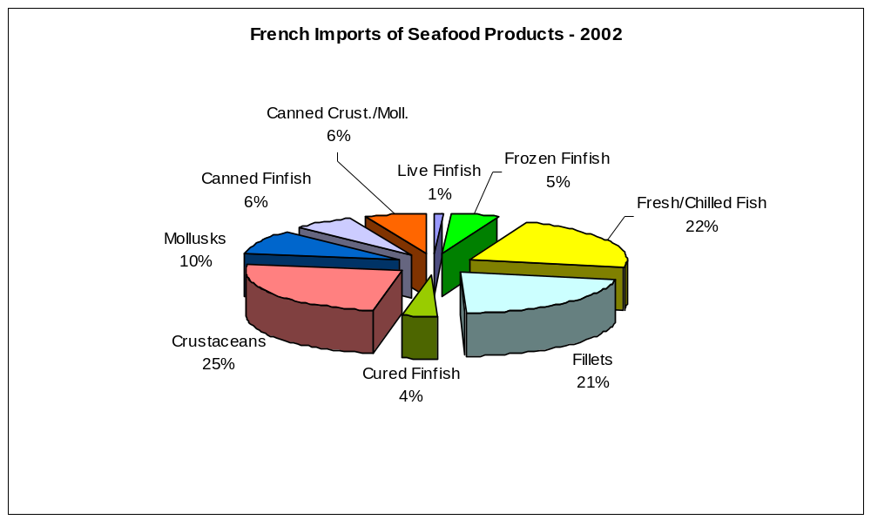

The United States is France’s fifth leading supplier of seafood products after the UK, Norway, Spain, and the Netherlands, which means that the United States is France’s leading seafood supplier outside of Europe. In 2002, the United States’ market share on the French market was 5.7%.

As indicated in the graphs below, the main categories of seafood products in quantity imported by France from the United States in 2002 were frozen Alaska pollack fillets, surimi base and frozen salmon. In terms of value, frozen Alaska pollack, fresh/live lobster, surimi base, frozen scallops and frozen salmon are the leading seafood categories exported by the United States to France in 2002.

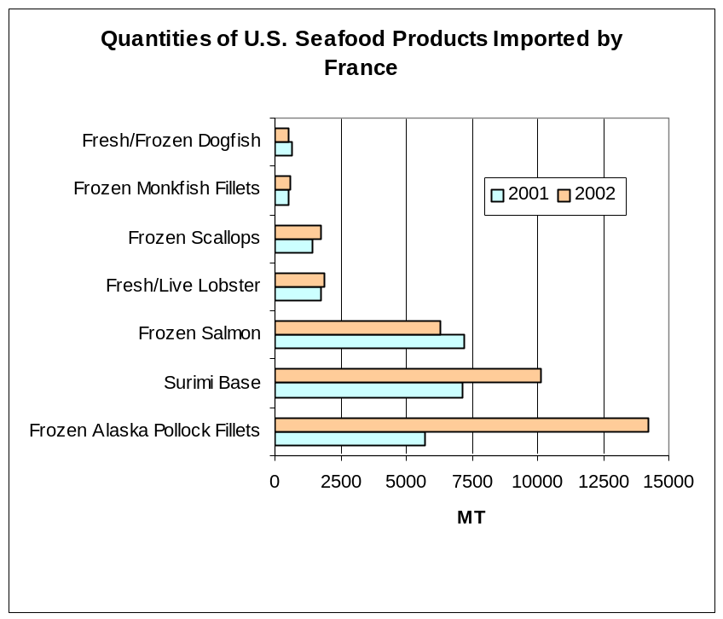

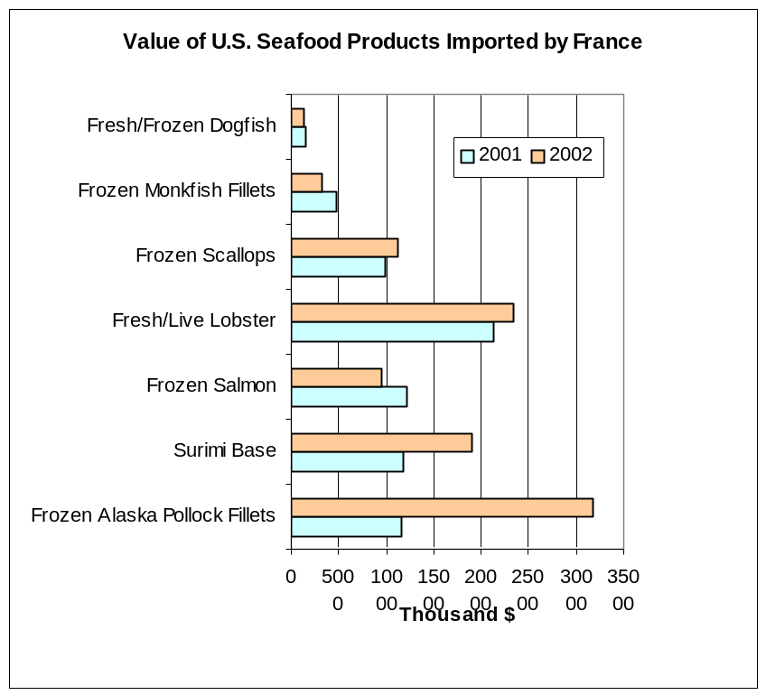

The French market for Alaska pollack fillets changed significantly in 2002, as U.S. exports doubled from 2001. American product replaced Russian market share, while the Russian product disappeared from the French market. U.S. exports also benefited from the decline in Chinese exports to France, resulting from the EU sanitary restrictions on seafood products from China. However, Chinese pollock fillets are back on the French market in 2003, which may hurt U.S. exports.

The United States is, by far, France’s leading supplier of live/fresh lobster, while Canada is France’s number one supplier of frozen lobster. Rock lobster is provided mainly by Cuba and the Bahamas. Lobster and rock lobster are considered festive products and their consumption is seasonal in France, most of it taking place during the Holiday season in December.

France is the largest European consumer of surimi, and the French surimi processing industry has significantly increased its production capacity in the past ten years to meet booming domestic demand. The United States is, by far, France’s leading supplier of surimi base, which is mainly made from Alaska pollack. Surimi base is processed, flavored and packaged in France by French companies.

France is the largest European market for salmon, which is the French consumer’s favorite fish. France is a mature and saturated market for salmon. Norway, Scotland and Ireland are the main suppliers of farm-raised salmon. This product competes with wild Alaska salmon. Price and supply seasonality are the drawbacks of Alaska salmon compared to farm-raised European salmon.

The increase in U.S. exports of frozen scallops started in 2001 and strengthened in 2002. During the first five months of 2003, U.S. exports to France continued to increase. This resulted from the increase in total French imports of scallops in the past few years, and the decline of Peruvian and Chinese exports. Also, the increased availability of scallops from the East coast scallops are increasingly price-competitive on the French market. There is potential for growth of U.S. market share for scallops on the French market.

Note: Websites of interest of the French fishery sector:

http://www.ofimer.fr
OFIMER is the French seafood board. Its website contains economic data on French fishery production, consumption and trade.

http://www.agriculture.gouv.fr
The website of the French Ministry of Agriculture, Food, Fisheries and Rural Affairs contains general information on French fisheries.

http://www.savourez-le-saumon.com
This website was created by the Norwegian, Scottish and Irish salmon promoters, and provide recipes with salmon.

Section II: Statistical Tables

PS&D Tables

PSD Table
Country | France
Commodity | Salmon, Whole/Eviscerated |  |  |  | (MT)
 | 2001 | Revised | 2002 | Estimate | 2003 | Forecast
 | USDA Official [Old] | Post Estimate [New] | USDA Official [Old] | Post Estimate [New] | USDA Official [Old] | Post Estimate [New]
Market Year Begin |  | 01/2001 |  | 01/2002 |  | 01/2003
Beginning Stocks | 32000 | 32000 | 32000 | 32000 | 31000 | 30000
Total Production | 2 | 2 | 2 | 1 | 0 | 0
Intra-EC Imports | 85500 | 92244 | 85500 | 90816 | 0 | 91500
Other Imports | 8000 | 8295 | 8000 | 7153 | 0 | 8000
TOTAL Imports | 93500 | 100539 | 93500 | 97969 | 0 | 99500
TOTAL SUPPLY | 125502 | 132541 | 125502 | 129970 | 31000 | 129500
Intra-EC Exports | 2800 | 5125 | 2800 | 7240 | 0 | 6000
Other Exports | 350 | 493 | 350 | 640 | 0 | 500
TOTAL Exports | 3150 | 5618 | 3150 | 7880 | 0 | 6500
Domestic Consumption | 86352 | 90923 | 87352 | 88090 | 0 | 89000
Other Use/Loss | 4000 | 4000 | 4000 | 4000 | 0 | 4000
TOTAL Utilization | 90352 | 94923 | 91352 | 92090 | 0 | 93000
Ending Stocks | 32000 | 32000 | 31000 | 30000 | 0 | 30000
TOTAL DISTRIBUTION | 125502 | 132541 | 125502 | 129970 | 0 | 129500

PSD Table
Country | France
Commodity | Groundfish, Fillets |  |  |  | (MT)
 | 2001 | Revised | 2002 | Estimate | 2003 | Forecast | UOM
 | USDA Official [Old] | Post Estimate [New] | USDA Official [Old] | Post Estimate [New] | USDA Official [Old] | Post Estimate [New]
Market Year Begin |  | 01/2001 |  | 01/2002 |  | 01/2003 | MM/YYYY
Beginning Stocks | 1000 | 1000 | 1000 | 1000 | 1000 | 1000 | (MT)
Total Production | 33000 | 38000 | 33000 | 38000 | 0 | 38000 | (MT)
Intra-EC Imports | 85500 | 91179 | 85500 | 83194 | 0 | 85000 | (MT)
Other Imports | 72500 | 80208 | 72500 | 72659 | 0 | 75000 | (MT)
TOTAL Imports | 158000 | 171387 | 158000 | 155853 | 0 | 160000 | (MT)
TOTAL SUPPLY | 192000 | 210387 | 192000 | 194853 | 1000 | 199000 | (MT)
Intra-EC Exports | 14500 | 15575 | 14500 | 13157 | 0 | 14000 | (MT)
Other Exports | 900 | 1114 | 900 | 1073 | 0 | 1100 | (MT)
TOTAL Exports | 15400 | 16689 | 15400 | 14230 | 0 | 15100 | (MT)
Domestic Consumption | 174600 | 191698 | 174600 | 178623 | 0 | 181900 | (MT)
Other Use/Loss | 1000 | 1000 | 1000 | 1000 | 0 | 1000 | (MT)
TOTAL Utilization | 175600 | 192698 | 175600 | 179623 | 0 | 182900 | (MT)
Ending Stocks | 1000 | 1000 | 1000 | 1000 | 0 | 1000 | (MT)
TOTAL DISTRIBUTION | 192000 | 210387 | 192000 | 194853 | 0 | 199000 | (MT)

PSD Table
Country | France
Commodity | Lobster |  |  |  | (MT)
 | 2001 | Revised | 2002 | Estimate | 2003 | Forecast
 | USDA Official [Old] | Post Estimate [New] | USDA Official [Old] | Post Estimate [New] | USDA Official [Old] | Post Estimate [New]
Market Year Begin |  | 01/2001 |  | 01/2002 |  | 01/2003
Beginning Stocks | 100 | 100 | 100 | 100 | 100 | 100
Total Production | 400 | 391 | 400 | 416 | 0 | 400
Intra-EC Imports | 2900 | 2919 | 2900 | 2672 | 0 | 2800
Other Imports | 6200 | 5915 | 6200 | 5549 | 0 | 5600
TOTAL Imports | 9100 | 8834 | 9100 | 8221 | 0 | 8400
TOTAL SUPPLY | 9600 | 9325 | 9600 | 8737 | 100 | 8900
Intra-EC Exports | 500 | 1106 | 500 | 508 | 0 | 700
Other Exports | 300 | 333 | 300 | 369 | 0 | 350
TOTAL Exports | 800 | 1439 | 800 | 877 | 0 | 1050
Domestic Consumption | 8699 | 7786 | 8700 | 7760 | 0 | 7750
Other Use/Loss | 1 | 0 | 0 | 0 | 0 | 0
TOTAL Utilization | 8700 | 7786 | 8700 | 7760 | 0 | 7750
Ending Stocks | 100 | 100 | 100 | 100 | 0 | 100
TOTAL DISTRIBUTION | 9600 | 9325 | 9600 | 8737 | 0 | 8900

PSD Table
Country | France
Commodity | Scallops |  |  |  | (MT)
 | 2001 | Revised | 2002 | Estimate | 2003 | Forecast
 | USDA Official [Old] | Post Estimate [New] | USDA Official [Old] | Post Estimate [New] | USDA Official [Old] | Post Estimate [New]
Market Year Begin |  | 01/2001 |  | 01/2002 |  | 01/2003
Beginning Stocks | 1600 | 1600 | 1500 | 1500 | 1500 | 1500
Total Production | 13000 | 16908 | 13000 | 19388 | 0 | 19000
Intra-EC Imports | 8000 | 9297 | 8000 | 7584 | 0 | 8000
Other Imports | 7500 | 8258 | 7500 | 9254 | 0 | 9000
TOTAL Imports | 15500 | 17555 | 15500 | 16838 | 0 | 17000
TOTAL SUPPLY | 30100 | 36063 | 30000 | 37726 | 1500 | 37500
Intra-EC Exports | 3100 | 4533 | 3100 | 4818 | 0 | 4700
Other Exports | 100 | 134 | 100 | 171 | 0 | 150
TOTAL Exports | 3200 | 4667 | 3200 | 4989 | 0 | 4850
Domestic Consumption | 25390 | 29886 | 25290 | 31227 | 0 | 31140
Other Use/Loss | 10 | 10 | 10 | 10 | 0 | 10
TOTAL Utilization | 25400 | 29896 | 25300 | 31237 | 0 | 31150
Ending Stocks | 1500 | 1500 | 1500 | 1500 | 0 | 1500
TOTAL DISTRIBUTION | 30100 | 36063 | 30000 | 37726 | 0 | 37500

PSD Table
Country | France
Commodity | Surimi |  |  |  | (MT)
 | 2001 | Revised | 2002 | Estimate | 2003 | Forecast
 | USDA Official [Old] | Post Estimate [New] | USDA Official [Old] | Post Estimate [New] | USDA Official [Old] | Post Estimate [New]
Market Year Begin |  | 01/2001 |  | 01/2002 |  | 01/2003
Beginning Stocks | 0 | 0 | 0 | 0 | 0 | 0
Total Production | 0 | 2000 | 0 | 2000 | 0 | 3000
Intra-EC Imports | 0 | 1128 | 0 | 83 | 0 | 100
Other Imports | 0 | 10019 | 0 | 14741 | 0 | 15000
TOTAL Imports | 0 | 11147 | 0 | 14824 | 0 | 15100
TOTAL SUPPLY | 0 | 13147 | 0 | 16824 | 0 | 18100
Intra-EC Exports | 0 | 968 | 0 | 324 | 0 | 350
Other Exports | 0 | 15 | 0 | 235 | 0 | 250
TOTAL Exports | 0 | 983 | 0 | 559 | 0 | 600
Domestic Consumption | 0 | 12164 | 0 | 16265 | 0 | 17500
Other Use/Loss | 0 | 0 | 0 | 0 | 0 | 0
TOTAL Utilization | 0 | 12164 | 0 | 16265 | 0 | 17500
Ending Stocks | 0 | 0 | 0 | 0 | 0 | 0
TOTAL DISTRIBUTION | 0 | 13147 | 0 | 16824 | 0 | 18100

Note: Data in the above PS&D were revised so that all data are for surimi base, and not prepared surimi products.

Trade Matrices

Salmon

Import Trade Matrix
Country | France
Commodity | Salmon, Whole/Eviscerated
Time period | Jan-Dec | Units: | MT
Imports for: | 2001 |  | 2002
U.S. | 7621 | U.S. | 6291
Others |  | Others
UK | 29029 | Denmark | 27750
Denmark | 26284 | UK | 26211
Sweden | 10890 | Sweden | 14010
Ireland | 9100 | Ireland | 9582
Germany | 11865 | Germany | 8177
Spain | 2260 | Spain | 2873
Belgium | 1262 | Netherlands | 1234
Netherlands | 1121 | Belgium | 840
Canada | 646 | Chile | 337
Chile | 71 | Canada | 214
Total for Others | 92528 |  | 91228
Others not Listed | 390 |  | 450
Grand Total | 100539 |  | 97969

Export Trade Matrix
Country | France
Commodity | Salmon, Whole/Eviscerated
Time period | Jan-Dec | Units: | MT
Exports for: | 2001 |  | 2002
U.S. | 0 | U.S. | 0
Others |  | Others
Spain | 1613 | Spain | 4270
Belgium | 1028 | Belgium | 1081
Germany | 902 | Germany | 463
Italy | 567 | Italy | 445
Total for Others | 4110 |  | 6259
Others not Listed | 1508 |  | 1621
Grand Total | 5618 |  | 7880
The most recent data available is for May 2003. The salmon import trade matrix for the January-May period is the following:

Import Trade Matrix
Country | France
Commodity | Salmon, Whole/Eviscerated
Time period | Jan-May | Units: | MT
Imports for: | 2002 |  | 2003
U.S. | 1987 | U.S. | 1704
Others |  | Others
Denmark | 10241 | UK | 10689
UK | 9826 | Denmark | 8082
Ireland | 4814 | Sweden | 7385
Sweden | 4555 | Ireland | 2581
Germany | 3297 | Germany | 1924
Spain | 1029 | Spain | 931
Netherlands | 454 | Netherlands | 347
Chile | 290 | Belgium | 159
Belgium | 173 | Canada | 158
Total for Others | 34679 |  | 32256
Others not Listed | 390 |  | 152
Grand Total | 37056 |  | 34112
Groundfish Fillets

Import Trade Matrix
Country | France
Commodity | Groundfish, Fillets
Time period | Jan-Dec | Units: | MT
Imports for: | 2001 |  | 2002
U.S. | 8653 | U.S. | 16886
Others |  | Others
Germany | 24312 | Germany | 21956
Netherlands | 20372 | Netherlands | 18036
China | 21028 | Denmark | 17009
Denmark | 19464 | China | 11731
UK | 10095 | UK | 9031
Russia | 8429 | Chile | 8877
Belgium | 8032 | Belgium | 6196
New Zealand | 6334 | Iceland | 6041
Iceland | 5668 | Spain | 6016
Spain | 5544 | New Zealand | 5234
Total for Others | 129278 |  | 110127
Others not Listed | 33456 |  | 28840
Grand Total | 171387 |  | 155853

Export Trade Matrix
Country | France
Commodity | Groundfish, Fillets
Time period | Jan-Dec | Units: | MT
Exports for: | 2001 |  | 2002
U.S. | 0 | U.S. | 0
Others |  | Others
Germany | 3295 | Germany | 2955
Belgium | 3262 | Belgium | 2681
Italy | 2693 | Italy | 1583
UK | 1945 | UK | 1386
Spain | 1592 | Spain | 1246
 |  | Denmark | 1032
Total for Others | 12787 |  | 10883
Others not Listed | 3902 |  | 3347
Grand Total | 16689 |  | 14230

French imports of Alaska Pollack frozen fillets and frozen meat:

French Imports  Frozen Alaska Pollack (MT) | CY 2001 |  | CY 2002
French Imports  Frozen Alaska Pollack (MT) | Frozen Fillets (03042085) | Frozen Meat (03049061) | Frozen Fillets (03042085) | Frozen Meat (03049061)
US | 5734 | 2175 | 14189 | 2632
China | 16903 | 1340 | 9848 | 827
Germany | 10471 | 566 | 9445 | 342
Russia | 8068 | 1096 | 3248 | 285
UK | 730 | 507 | 803 | 4
Denmark | 1252 | 167 | 580 | 4
Netherlands | 1527 | 0 | 476 | 237
Others
Total | 45178 | 5853 | 39033 | 4339
The most recent data available is for May 2003. The groundfish fillet import trade matrix for the January-May period is the following:

Import Trade Matrix
Country | France
Commodity | Groundfish, Fillets
Time period | Jan-May | Units: | MT
Imports for: | 2002 |  | 2003
U.S. | 7265 | U.S. | 5562
Others |  | Others
Germany | 10838 | Denmark | 9610
Netherlands | 7552 | Germany | 8144
Denmark | 7126 | Netherlands | 7862
China | 5244 | China | 7300
UK | 4195 | UK | 4447
Chile | 3346 | Spain | 3391
Iceland | 2692 | Chile | 3318
Belgium | 2528 | Belgium | 2735
New Zealand | 2348 | New Zealand | 2425
Spain | 2265 | Russia | 2351
Total for Others | 48134 |  | 51583
Others not Listed | 11685 |  | 15812
Grand Total | 67084 |  | 72957

French imports of Alaska Pollack frozen fillets and frozen meat in Jan-May 2002 and Jan-May 2003:

French Imports  Frozen Alaska Pollack (MT) | Jan-May 2002 |  | Jan-May 2003
French Imports  Frozen Alaska Pollack (MT) | Frozen Fillets (03042085) | Frozen Meat (03049061) | Frozen Fillets (03042085) | Frozen Meat (03049061)
US | 6484 | 1050 | 4337 | 832
China | 4291 | 549 | 6229 | 71
Germany | 4515 | 67 | 3527 | 363
Russia | 854 | 28 | 2152 | 841
UK | 523 | 4 | 977 | 0
Denmark | 347 | 4 | 344 | 33
Others | 513 | 1 | 142 | 0
Total | 17527 | 1703 | 17708 | 2140

Lobster

Import Trade Matrix
Country | France
Commodity | Lobster
Time period | Jan-Dec | Units: | MT
Imports for: | 2001 |  | 2002
U.S. | 2084 | U.S. | 2006
Others |  | Others
Canada | 2103 | Canada | 1690
Spain | 1278 | Spain | 1167
Bahamas | 685 | Bahamas | 857
UK | 680 | UK | 777
Ireland | 606 | Ireland | 434
Belgium | 255 | Belgium | 212
Cuba | 237 | Cuba | 194
Total for Others | 5844 |  | 5331
Others not Listed | 906 |  | 884
Grand Total | 8834 |  | 8221

Export Trade Matrix
Country | France
Commodity | Lobster
Time period | Jan-Dec | Units: | MT
Exports for: | 2001 |  | 2002
U.S. | 1 | U.S. | 9
Others |  | Others
Italy | 499 | Japan | 326
Japan | 273 | Spain | 118
Spain | 149 | Italy | 113
Luxemburg | 177 | Belgium | 94
Belgium | 113 | Germany | 81
Total for Others | 1211 |  | 732
Others not Listed | 227 |  | 163
Grand Total | 1439 |  | 904

The most recent data available is for May 2003. The lobster import trade matrix for the January-May period is the following:

Import Trade Matrix
Country | France
Commodity | Lobster
Time period | Jan-May | Units: | MT
Imports for: | 2002 |  | 2003
U.S. | 490 | U.S. | 436
Others |  | Others
Canada | 273 | Canada | 239
UK | 237 | Bahamas | 178
Ireland | 205 | UK | 161
Bahamas | 121 | Spain | 117
Spain | 96
Total for Others | 932 |  | 695
Others not Listed | 274 |  | 522
Grand Total | 1696 |  | 1653

Scallops

Import Trade Matrix
Country | France
Commodity | Scallops
Time period | Jan-Dec | Units: | MT
Imports for: | 2001 |  | 2002
U.S. | 1460 | U.S. | 1698
Others |  | Others
UK | 3973 | UK | 3419
Denmark | 3199 | Argentina | 2237
Chile | 1921 | Denmark | 1986
Canada | 1555 | Canada | 1885
Argentina | 1553 | Chile | 1621
Netherlands | 1397 | Netherlands | 1272
Peru | 715 | Peru | 652
New Zealand | 501 | Ireland | 483
Total for Others | 14814 |  | 13555
Others not Listed | 1281 |  | 1585
Grand Total | 17555 |  | 16838

Export Trade Matrix
Country | France
Commodity | Scallops
Time period | Jan-Dec | Units: | MT
Exports for: | 2001 |  | 2002
U.S. | 0 | U.S. | 0
Others |  | Others
Spain | 2440 | Spain | 2317
Italy | 1081 | Italy | 1629
Belgium | 451 | Belgium | 358
UK | 215 | Netherlands | 196
Germany | 164 | Germany | 113
Netherlands | 95 | UK | 99
Total for Others | 4446 |  | 4712
Others not Listed | 221 |  | 277
Grand Total | 4667 |  | 4989

The most recent data available is for May 2003. The scallop import trade matrix for the January-May period is the following:

Import Trade Matrix
Country | France
Commodity | Scallops
Time period | Jan-May | Units: | MT
Imports for: | 2002 |  | 2003
U.S. | 605 | U.S. | 732
Others |  | Others
UK | 1105 | UK | 1791
Argentina | 916 | Argentina | 1185
Netherlands | 668 | Chile | 688
Chile | 648 | Canada | 532
Denmark | 563 | Denmark | 434
New Zealand | 233 | Vietnam | 330
Peru | 231 | Peru | 312
Ireland | 236 | Netherlands | 287
Total for Others | 4600 |  | 5559
Others not Listed | 677 |  | 689
Grand Total | 5882 |  | 6980

Surimi

Import Trade Matrix
Country | France
Commodity | Surimi
Time period | Jan-Dec | Units: | MT
Imports for: | 2001 |  | 2002
U.S. | 7128 | U.S. | 10109
Others |  | Others
Thailand | 1748 | Chile | 3139
Belgium | 1657 | Belgium | 2837
Chile | 1448 | Thailand | 1512
South Korea | 1286 | South Korea | 1231
China | 1232 | Argentina | 586
Denmark | 1023 | China | 399
Argentina | 977 | Peru | 368
Peru | 327 | Canada | 309
 |  | Netherlands | 171
Total for Others | 9698 |  | 10552
Others not Listed | 408 |  | 249
Grand Total | 17234 |  | 20910

Export Trade Matrix
Country | France
Commodity | Surimi
Time period | Jan-Dec | Units: | MT
Exports for: | 2001 |  | 2002
U.S. | 0 | U.S. | 0
Others |  | Others
Spain | 2442 | Spain | 1484
UK | 143 | Lithuania | 173
 |  | UK | 152
Total for Others | 2585 |  | 1809
Others not Listed | 365 |  | 428
Grand Total | 2950 |  | 2237
French imports of surimi were broken down as follows in CY 2001 and CY 2002:

French Imports of Surimi | Surimi Base  03049005 |  | Prepared Surimi  16042005 |  | Total
French Imports of Surimi | CY 2001 | CY 2002 | CY 2001 | CY 2002 | CY 2001 | CY 2002
United States | 7127 | 10105 | 0 | 4 | 7128 | 10109
Chile | 1448 | 3139 | 0 | 0 | 1448 | 3139
Belgium | 38 | 25 | 1619 | 2812 | 1657 | 2837
Thailand | 19 | 237 | 1729 | 1275 | 1748 | 1512
South Korea | 0 | 0 | 1286 | 1231 | 1286 | 1231
Argentina | 977 | 586 | 0 | 0 | 977 | 586
China | 0 | 0 | 1232 | 399 | 1232 | 399
Peru | 326 | 368 | 1 | 0 | 327 | 368
Belgium |  |  |  | 2812
Others | 1212 | 364 | 227 | 549 | 1431 | 729
Total | 11147 | 14824 | 6094 | 6082 | 17234 | 20910

The most recent data available is for May 2003. The surimi import trade matrix for the January-May period is the following:

Import Trade Matrix
Country | France
Commodity | Surimi
Time period | Jan-May | Units: | MT
Imports for: | 2002 |  | 2003
U.S. | 4309 | U.S. | 3660
Others |  | Others
Chile | 1057 | Belgium | 1972
Belgium | 656 | Chile | 1789
South Korea | 523 | Thailand | 501
Thailand | 438 | South Korea | 391
China | 399 | Argentina | 299
Peru | 176
Total for Others | 3249 |  | 4952
Others not Listed | 222 |  | 347
Grand Total | 7780 |  | 8959

Monkfish

French Imports of Monkfish (Jan-Dec, MT) | 2001 | 2002
U.S. | 968 | 1250
UK | 3029 | 3849
Ireland | 798 | 652
Brazil | 253 | 341
Spain | 278 | 311
Others | 2152 | 894
Total | 7478 | 7297  7297

French Imports  Monkfish (MT) | Jan-May 2002 | Jan-May 2003
U.S. | 569 | 500
UK | 1753 | 1742
China | 88 | 360
Brazil | 92 | 231
Ireland | 236 | 214
Netherlands | 69 | 212
Spain | 64 | 191
Others | 160 | 537
Grand Total | 3031 | 3756

Dogfish

French Imports of Dogfish (Jan-Dec, MT) | 2001 | 2002
U.S. | 682 | 543
Canada | 779 | 916
UK | 1108 | 802
Spain | 423 | 588
Others | 1782 | 1651
Total | 4774 | 4500

French Imports  Dogfish (MT) | Jan-May 2002 | Jan-May 2003
U.S. | 174 | 44
UK | 395 | 504
Spain | 261 | 433
Canada | 320 | 346
Germany | 152 | 243
Others | 580 | 565
Grand Total | 1882 | 2135

Tariff Tables

Customs Codes Fresh/Frozen Whole Salmon | Tariffs 2003
03 02 12 | 2
03 02 19 | 8
03 03 11 | 2
03 03 19 | 2
03 03 22 | 2
03 03 29 | 9

Customs Codes  Groundfish Fillets | Tariffs 2003
03 04 10 13 | 2
03 04 10 15 | 12
03 04 10 17 | 12
03 04 10 19 | 9
03 04 10 31 | 18
03 04 10 33 | 18
03 04 10 35 | 18
03 04 10 38 | 18
03 04 10 91 | 8
03 04 10 97 | (*)
03 04 10 98 | (*)
03 04 20 13 | 2
03 04 20 15 | 12
03 04 20 17 | 12
03 04 20 19 | 9
03 04 20 21  to 03 04 20 43 | 7.5
03 04 20 45 | 18
03 04 20 51 | 15
03 04 20 53 | 15
03 04 20 55  to 03 04 20 73 | 7.5
03 04 20 75  to 03 04 20 85 | 15
03 04 20 87 | 7.5
03 04 20 88 | 15
03 04 20 91 | 7.5
03 04 20 95 | 15(**)

(*) Jan 1st-Feb 14, and June 16-Dec 31: TRQ of 34,000 MT, for reference priced :
03 02 40 00
03 03 50 00
03 04 10 97
03 04 10 98
03 04 90 22

(**)TRQ of 200 MT

Customs Codes  Lobster | Tariffs 2003
03 06 11 10 | 12.5
03 06 11 90 | 12.5
03 06 12 10 | 6
03 06 12 90 | 16
03 06 21 00 | 12.5
03 06 22 10 | 8
03 06 22 91 | 8
03 06 22 99 | 10

Customs Codes  Scallops | Tariffs 2003
03 07 21 00 | 8
03 07 29 10 | 8
03 07 29 90 | 8

Customs Codes  Surimi | Tariffs 2003
03 04 90 05 | 15
16 04 20 05 | 20

Customs Codes  Monkfish | Tariffs 2003
03 02 69 81 | 15
03 03 79 81 | 15
03 04 20 83 | 15
03 04 90 57 | 7.5

Customs Codes  Dogfish | Tariffs 2003
03 02 65 20 | 6
03 02 65 50 | 6
03 02 65 90 | 8
03 03 75 20 | 6
03 03 75 50 | 6
03 03 75 90 | 8
03 04 20 61 | 7.5
03 04 20 69 | 7.5

Section III: Production, Supply and Demand

Production

Total Fishery Products

The most recent complete data available on French seafood and aquaculture production from the French Ministry of Agriculture and Fisheries (MinAg) and the French Seafood board (OFIMER) is for 2001. It includes the following:

 | 2000 |  | 2001
 | Quantity (MT) | Value (million Euros) | Quantity (MT) | Value (million Euros)
Fresh Wild Catch Sold at Auction Markets | 293,983 | 684 | 307,981 | 704
Fresh Wild Catch not Sold at Auction Markets | 83,707 | 176 | 95,002 | 206
Aquaculture | 269,409 | 471 | 254,020 | 483
Frozen Wild Catch | 219,603 | 156 | 203,474 | 160
TOTAL | 866,702 | 1,487 | 860,477 | 1,552
Sources: OFIMER, MinAg

To date, only sales at auction markets are available for 2002. They included the following:

 | 2001 |  |  | 2002
 | Quantity (MT) | Value (million Euros) | Average Price (Euro per kg) | Quantity (MT) | Value (million Euros) | Average Price (Euro per kg)
Finfish | 231,965 | 533 | 2.30 | 217,632 | 525 | 2.41
Crustaceans | 10,502 | 64 | 6.14 | 10,431 | 69 | 6.59
Shellfish | 28,667 | 54 | 1.90 | 30,332 | 54 | 1.80
Cephalopods | 18,287 | 51 | 2.80 | 23,066 | 62 | 2.69
Source: OFIMER

Canned Fishery Products

France is a major producer of canned fishery products. As indicated in the following table, the major species canned in France are tuna, sardines and mackerel.

 | 2001 |  | 2002
 | Raw material used (whole fish equivalent, MT) | Processed Products (net weight, MT) | Raw material used (whole fish equivalent, MT) | Processed Products (net weight, MT)
Sardines | 18,328 | 10,798 | 15,774 | 9,956
Tuna | 43,031 | 47,653 | 39,960 | 43,005
Mackerel | 36,120 | 21,289 | 33,885 | 21,305
Other (incl. Herring, salmon, shellfish and other) | 4,594 | 8,408 | 6,241 | 9,187
Total | 102,073 | 88,148 | 95,860 | 83,453
Source: FIAC (French Federation for the Canning Industry)
http://www.adepale.org

Salmon

French salmon production is marginal. The only company currently producing farmed salmon is SaumonFrance Cherbourg, located in Normandy. The company belongs to the Norwegian group Inaq. In 2003, salmon production amounted to 400 MT, and 900 MT are expected in 2004. Most of the production is sold fresh, whole, salted and gutted. This salmon is sold at higher prices than the market average because it is very fresh.

While salmon production is marginal in France, there is a significant production of trout through aquaculture. Trout is the leading species produced in France by aquaculture. Salmon and trout products are in direct competition on the French market. Since salmon and trout belong to the same family (Salmonidae), the aspect and texture of their meat are close. Also, salmon and trout are both sold fresh and smoked on the French market. In 2001, French trout production amounted to 45,000 MT, which is significantly lower than the 100,600 MT of salmon imported.

Groundfish

According to the French Ministry of Agriculture, Food, Fisheries and Rural Affairs, the following quantities of groundfish were caught by French boats in 2000, 2001 and 2002:

 | 2000 |  | 2001 |  | 2002
 | Quantities Produced  (MT) | Sales Value (1,000 Euros) | Quantities Produced  (MT) | Sales Value (1,000 Euros) | Quantities Produced  (MT) | Sales Value (1,000 Euros)
Cod | 11,886 | 29,986 | 11,308 | 30,142 | 11,661 | 28,292
Haddock | 4,381 | 5,573 | 5,989 | 7,705 | 5,885 | 7,403
Pollack | 26,942 | 24,468 | 28,754 | 26,855 | 30,149 | 26,832
Whiting | 35,105 | 29,493 | 38,535 | 31,018 | 33,168 | 30,966
Hake | 11,637 | 45,756 | 10,000 | 38,528 | 13,585 | 50,174
TOTAL | 89,951 | 131,976 | 94,586 | 134,248 | 94,448 | 143,667

Lobster

According to the French MinAg, French production of lobster was the following in 2000, 2001 and 2002:

 | 2000 |  | 2001 |  | 2002
 | Quantities Produced  (MT) | Sales Value (1,000 Euros) | Quantities Produced  (MT) | Sales Value (1,000 Euros) | Quantities Produced  (MT) | Sales Value (1,000 Euros)
Lobster | 332 | 6,714 | 332 | 6,763 | 362 | 7,259
Rock Lobster | 72 | 2,284 | 59 | 2,117 | 54 | 1,967
TOTAL | 404 | 8,998 | 391 | 8,880 | 416 | 9,226

Scallops

French scallop production was the following:

Scallops | 2000 |  | 2001 |  | 2002
Scallops | Quantities Produced  (MT) | Sales Value (1,000 Euros) | Quantities Produced  (MT) | Sales Value (1,000 Euros) | Quantities Produced  (MT) | Sales Value (1,000 Euros)
in-shell scallops | 13,745 | 44,128 | 16,903 | 50,946 | 19,388 | 51,359
shelled equivalent | 2,201 |  | 2,486 |  | 2,851

Note: the conversion factor used to convert in-shell scallop production into shelled scallop production is 6.8.

Surimi

According to the French surimi development association (ADISUR), French domestic production of surimi continued to increase in 2002 to 35,600 MT (a 13% increase from 2002), responding to the growing domestic consumption, which was estimated at 39,400 MT. The following graph illustrates the continuing growth in both French domestic production and demand for surimi since 1994.

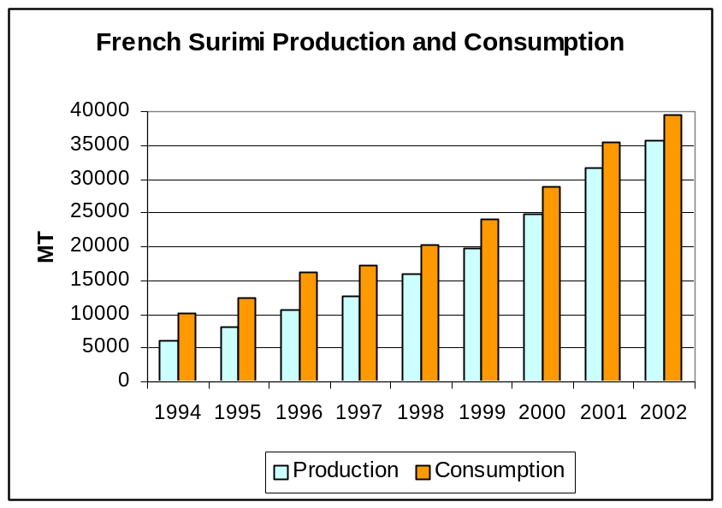

This information is available on ADISUR’s website: http://www.alesial.org/21.htm

Monkfish and Dogfish

According to the French MinAg, French production of monkfish and dogfish was the following in 2000, 2001 and 2002:

 | 2000 |  | 2001 |  | 2002
 | Quantities Produced  (MT) | Sales Value (1,000 Euros) | Quantities Produced  (MT) | Sales Value (1,000 Euros) | Quantities Produced  (MT) | Sales Value (1,000 Euros)
Monkfish | 13,056 | 62,703 | 13,566 | 61,540 | 15,376 | 68,632
Dogfish | 14,729 | 15,472 | 14,270 | 15,193 | 12,186 | 13,235

Consumption

Total Fishery Products

According to the French Seafood Board (OFIMER) and surveys conducted by the GIRA and SECODIP agencies on French food service and household seafood consumption, respectively, total consumption of seafood declined by 1% from 2001 to 2002. The decline suggests the BSE effect is fading as the French consumer’s fear of BSE had boosted seafood consumption in 2001.

The 1% decline in total seafood consumption in 2002 was mainly due to the 3% decline in household purchases, partially offset by the 5% increase in food service consumption. The following graph illustrates the trend in French seafood consumption in the HRI sector and by French households. Since 1998, food service consumption has accounted for 26.5% to 28-.5% of total seafood consumption.
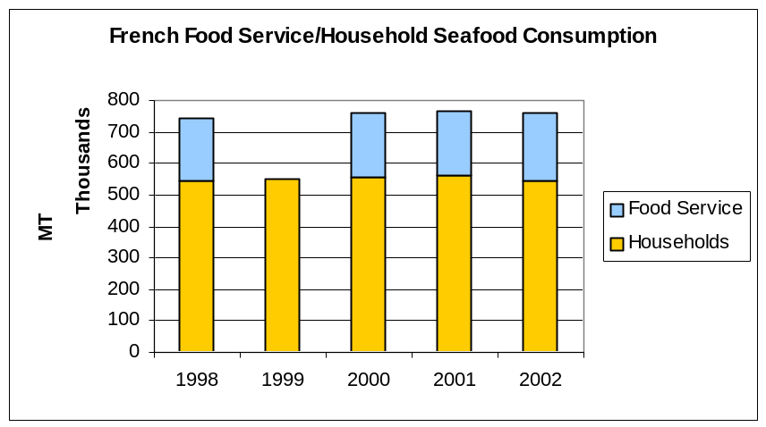
Note: HRI data was not available for 1999

According to OFIMER, French household and HRI consumption of total fishery products was broken down as follows in 2001 and 2002 (in MT):

 |  | Households 2002 |  | HRI 2002 |  | Total 2002 | Total 2001 (2)
 |  | Supermarkets | Other (1) | Hotels/Restaurants | Institutions | Total 2002 | Total 2001 (2)
Whole Finfish | Fresh | 28,979 | 21,990 | 23,900 | 1,765 | 76,633 | 80,322
Whole Finfish | Frozen | 2,609 | 0 | 5,400 | 965 | 8,974 | 9,417
Finfish Cuts | Fresh | 61,183 | 19,410 | 11,060 | 12,480 | 104,133 | 101,534
Finfish Cuts | Frozen | 61,281 | 0 | 17,450 | 52,170 | 130,901 | 123,662
Crustaceans | Fresh | 23,404 | 9,736 | 8,100 | 430 | 41,670 | 38,272
Crustaceans | Frozen | 10,113 | 0 | 4,030 | 1,700 | 15,843 | 16,384
Shellfish | Fresh | 45,027 | 31,818 | 41,495 | 2,200 | 120,539 | 135,295
Shellfish | Frozen | 3,976 | 0 | 7,280 | 2,600 | 13,856 | 13,601
Cephalopods | Fresh | 2,766 | 1,422 | 675 | 580 | 5,443 | 4,929
Cephalopods | Frozen | 2,314 | 0 | 780 | 1,700 | 4,794 | 5,691
Catering/Prepared Seafood | Fresh | 67,662 | 2,611 | 4,360 | 1,300 | 75,934 | 72,650
Catering/Prepared Seafood | Frozen | 39,977 | 0 | 2,155 | 4,030 | 46,162 | 45,334
Canned |  | 105,673 | 1,349 | 2,370 | 5,530 | 114,922 | 120,688
Total Fishery Products | Fresh | 161,359 | 84,375 | 85,230 | 17,455 | 348,418 | 360,352
Total Fishery Products | Catering/Prepared Seafood | 67,662 | 2,611 | 4,360 | 1,300 | 75,934 | 72,650
Total Fishery Products | Frozen | 120,269 | 0 | 37,095 | 63,165 | 220,529 | 214,089
Total Fishery Products | Canned | 105,673 | 1,349 | 2,370 | 5,530 | 114,922 | 120,688
Total Fishery Products | TOTAL | 454,962 | 88,336 | 129,055 | 87,450 | 759,803 | 767,779
Source: OFIMER, GIRA, SECODIP

Note (1): Other retailers than supermarkets include freezer centers, street markets, specialized fish shops and direct sales.
Note (2): For full detail of 2001 consumption, see report FR2068, dated 10/01/2002

In 2002, French seafood consumption was broken down as follows:

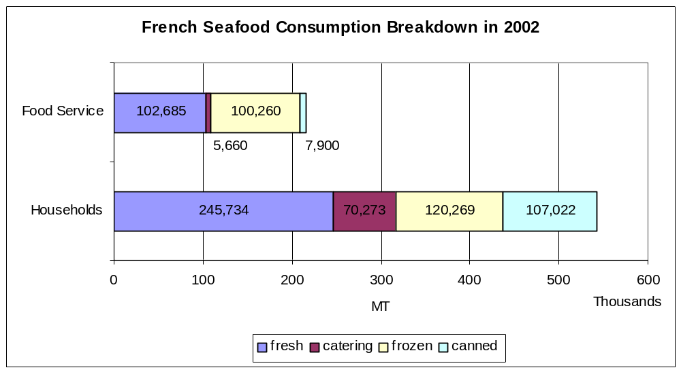

The market for frozen seafood products, which is of interest to U.S. exporters, represented 22% of French households purchases and 46% of food service purchases.

Salmon

France is the largest European consumer and importer of salmon. Salmon products (fresh, frozen, and processed) represent 10 percent of the volume of finfish consumed in France every year. French per capita consumption is 2 kilograms per year, whole salmon equivalent. The French principally consume salmon fresh or smoked.

In 2002, French household purchases of fresh and smoked salmon were stable in quantity and value from 2001, despite lower prices. This indicates that the French market for salmon is mature and saturated. In 2002, salmon represented 16% (215 million euros) of French household purchases of fresh finfish, in value, before cod (10%), whiting (7%), pollack (6%), sole (6%), and monkfish (5%). At the same time, salmon accounted for 75 percent (273 million euros) of French household purchases of smoked finfish, far ahead of smoked trout (0.9 percent). Finally, frozen salmon purchases in 2002 increased by 3% from 2001.

Most French household purchase salmon in supermarkets: in 2002 this represented 84% of the sales for a value of 175 million euros. Most of the Alaska salmon on the French market is sold in HRI sector.

The success of salmon on the French market is principally due to the price decline of the past decade, as a result of the increased salmon farming in Norway, Scotland and Ireland. In addition, salmon products sold on the French market are numerous, including various cuts (whole, steaks, fillets), and processing (fresh, frozen, smoked, marinated, carpaccio). Salmon products on the French market are therefore in direct competition with groundfish fillets, as well as meat and poultry cuts.

Groundfish Fillets

Groundfish fillets compete on the French market with salmon, poultry and meat cuts. Cod and pollack are the most popular species in French households, as indicated in the graph below:

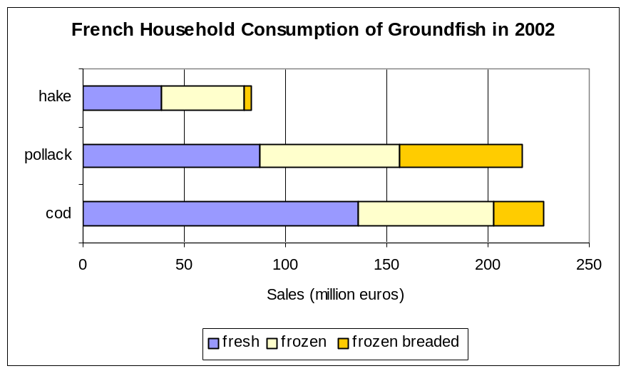

Of interest for U.S. exporters is frozen Alaska pollack, imports of which increased significantly in 2002. As indicated in the above graph, frozen products represented 60% of French households purchases of pollack in 2002. Sales of frozen pollack increased by 3% in 2002, while sales of frozen breaded pollack increased by 1%.

Lobster

Lobster is mainly consumed in the HRI sector in France, as it is a luxury product not often prepared at home. It is principally consumed in December during the Holiday Season. Canadian lobster and American lobster compete for French market, but U.S. lobster is mainly imported fresh, while Canadian lobster is principally imported frozen. In 2002, French household consumption of fresh lobster and rock lobster was 1,433 MT (an increase of 17% from 2001), for a value of 44 million euros (an increase of 22%).

Scallops

In France, the market for scallops is segmented into the fresh and the frozen markets. Fresh scallops go to the HRI sector (40 percent), supermarkets (30 percent), and specialized fish shops (30 percent). Fresh scallops are mainly consumed in December as a festive product. In 2002, French households purchased 5,499 MT of fresh in-shell scallops (up 4 percent from 2000) and 944 MT of fresh-shelled scallops (down 12 percent from 2000).

The total French market for frozen scallops is estimated at 75,000 MT in-shell scallop equivalent, i.e., 11,000 MT unshelled. Half of this is processed into prepared meals with scallops, a third is sold in supermarket chains, and the remainder is sold to the HRI sector.

Surimi

France is the largest European consumer of surimi, ahead of number 2 Spain. As indicated in the Production section of this report, French surimi consumption continues to increase significantly, and amounted to 39,430 MT in 2002. It included 24,564 MT purchased by French households, for a value of 191 million euros. Surimi sticks represent 75% of the household purchases.

Trade

Salmon

In 2002, French imports of salmon from the United States declined by 17%, and went back to their 2000 levels. In 2002, French imports of salmon from the United States included 90% frozen whole Pacific salmon (030319) and 10% frozen Sockeye salmon (030311). Part of the decline in U.S. shipments to France can be traced to U.S. tendency to offer whole salmon, while the French market demands fillets and cuts. The U.S. market share declined from 7.6% in 2001 to 6.4% in 2002. A slight decline was also recorded during the first five months of 2003 compared to the same period in 2002. In 2003, one French importer stated he plans to import a significant amount of fresh Alaska salmon to be sold in a major supermarket chain.

French imports from Denmark and Sweden that appear in the trade matrices are transshipments through these countries from Norway. Norwegian and Scottish products are the main competitors of U.S. salmon on the French market. There are also some direct shipments of salmon from Chile. In 2002, French salmon imports from Chile increased significantly, but Chile remained a marginal supplier to France compared to Norway, Scotland, Ireland and Alaska.

Groundfish Fillets

In 2002, French imports of groundfish fillets from the United States almost doubled, 84 percent of which were Alaska pollack fillets. The American product took over Russian market share. This resulted from the a change in Russian production practices from pollack fillets to headed and gutted pollack.

The jump in U.S. exports in 2002 also resulted from the decline in Chinese exports to France, resulting from veterinary/sanitary restrictions from the EU. However, the Chinese product is back on the EU and French markets for 2003, as the sanitary restrictions on Chinese seafood are now lifted: shipments of groundfish fillets from China increased by 40% in the first five months of 2003. Also, French imports of groundfish fillets from Russia have recovered significantly in Jan-May 2003. As a result, U.S. exports to France declined by 23% during that period, although the United States remained France’s fifth leading supplier of groundfish fillets.

Lobster

French imports of lobster in the trade matrix were broken down as follows in CY 2002:

 | Live/Fresh Lobster (030622) | Frozen Lobster (030612) | Frozen Rock Lobster (030611) | Live/Fresh Rock Lobster (030621) | TOTAL LOBSTER
Total | 3486 | 1209 | 2948 | 577 | 8220
United States | 1852 | 1 | 142 | 11 | 2006
Canada | 672 | 1018 | 0 | 0 | 1690
Spain | 3 | 2 | 1095 | 68 | 1168
Bahamas | 0 | 0 | 857 | 0 | 857
UK | 534 | 84 | 150 | 9 | 777
Ireland | 244 | 35 | 144 | 11 | 434
Belgium | 26 | 55 | 130 | 1 | 212
Cuba | 0 | 0 | 75 | 119 | 194

his table clearly indicates that the United States is, by far, the leading supplier of live and fresh lobster to France, while Canada is the number one supplier of frozen lobster to France. Frozen and live/fresh rock lobster are mainly supplied by the Bahamas and Cuba to France, either directly or through Spain.

American and Canadian lobsters are very price-competitive on the French market with lobster caught in France, the UK and Ireland.

Scallops

French imports of scallops in the trade matrix were broken down as follows in 2002 (in MT):

 | Live/Fresh Scallops  (030721) | Frozen Scallops (030729) | TOTAL SCALLOPS
Total | 2953 | 13873 | 16826
US | 40 | 1658 | 1698
UK | 2416 | 1001 | 3417
Argentina | 0 | 2236 | 2236
Denmark | 2 | 1983 | 1985
Canada | 38 | 1845 | 1883
Chile | 55 | 1568 | 1623
Netherlands | 202 | 1069 | 1271
Peru | 0 | 651 | 651
Ireland | 171 | 310 | 481

This table indicates that the United States is France’s fourth leading supplier of frozen scallops, after Argentina, Denmark, and Canada. In the past five years, U.S. exports of frozen scallops to France have boomed, as indicated in the graph below:

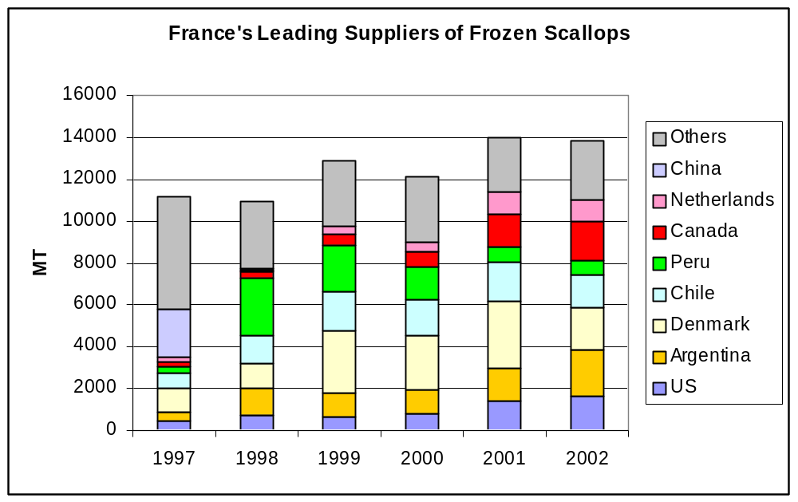

This graph indicates that since 1997, French imports of frozen scallops have gradually increased by almost 3,000 MT. Most of this increase has been filled by rising shipments from the United States, Argentina, Chile, and Canada. By contrast, Chinese products have disappeared from the French market, due to sanitary restrictions, and imports from Peru have declined significantly.

During the first five months of 2003, U.S. exports of frozen scallops to France continued to increase. The U.S. market share is growing on the good prices and availability of scallops on the East Coast of the United States.

Surimi

The United States is, by far, France’s leading supplier of surimi base, which is principally made from Alaska pollack.
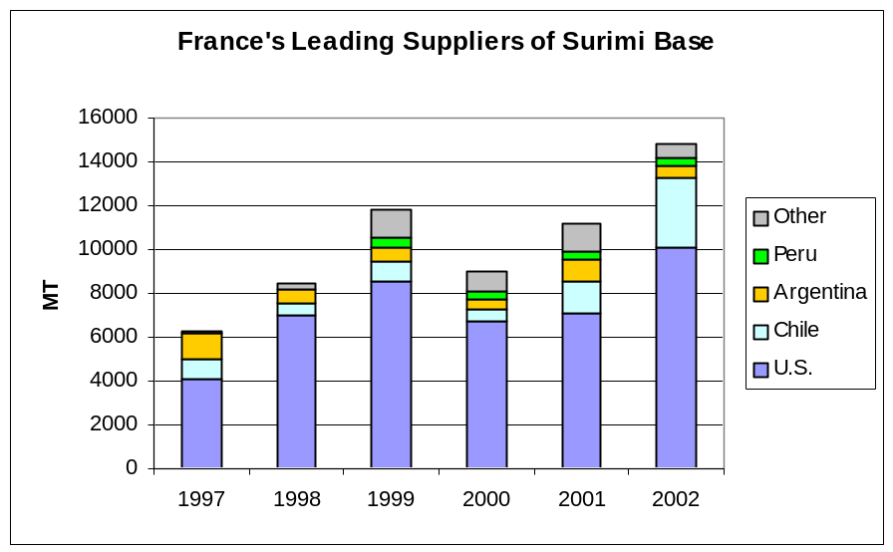
Surimi base imported by France from the United States is processed, flavored and packaged in France by French processors. However, there are no shipments of surimi preparations from the United States to France. The bulk of surimi preparations imported by France come from China, Thailand and South Korea, either directly or through Belgium.

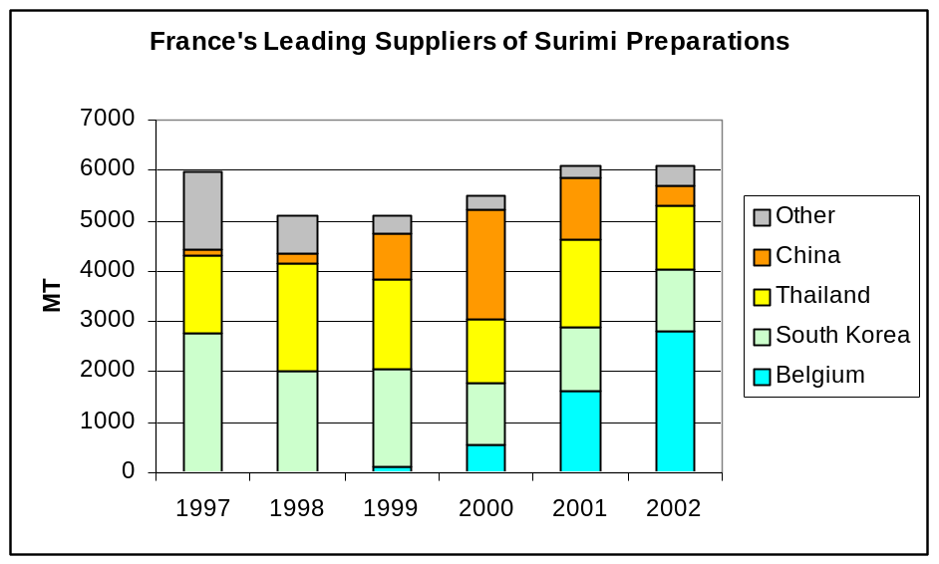

Although Lithuania and Estonia don’t directly appear in French import data, shipments of surimi preparations from these countries through Belgium took place in recent years. These were shipments from the Lithuanian company VICIUNAI, also present in Estonia, which is the world’s largest surimi processing plant: its surimi production capacity is estimated at 60,000 MT in 2003. VICIUNAI exports to Spain, Portugal and Italy. In France, to date, VICIUNAI products are limited to supermarket-branded products. These products are in direct competition with products sold under French brands and processed from U.S. surimi base.

Marketing

Trade Shows

- European Seafood Exposition, Brussels

The European Seafood Exposition is the leading seafood show in Europe. It takes place every year in Brussels, Belgium. The last ESE was held on May 6-8, 2003, and the next ESE will take place on May 4-6, 2004.
All information to participate is located at: http://www.euroseafood.com

FAS/Paris promotes seafood products in France through trade shows and marketing activities. The best way for a U.S. company to penetrate the French market is to participate in trade shows. FAS/Paris recommends the following trade shows which are USDA-endorsed and where U.S. companies participating in USDA’s Market Access Program (MAP) can be reimbursed up to 50 percent of their expenses if they join the U.S. Pavilion.

- SIAL (International Food Show), France

The International Food Show (SIAL) takes place every other year in Paris, France. It is the EU’s leading food show along with Germany’s ANUGA. In 2002, there were 5,240 exhibitors in total and 135,000 visitors at SIAL. Next SIAL will take place in 2004 on October 17-21. Information to participate is located at: http://www.sial.fr

SIAL is a USDA-endorsed show with U.S.A. Pavilions. To participate in the USA Pavilion at SIAL, please contact:

IMEX Management, Inc.
505 East Boulevard, Suite 200
Charlotte, NC 28203
Tel: 704 365 0041
Fax: 704 365 8426
Email: sial@imexmgt.com
Contact: François Gros

- SIRHA (International Hotel Catering and Food Trade Exhibition)

A USDA-endorsed show with a U.S. Pavilion.

SIRHA is the premier international forum for the Hotel, Restaurant, and Institution (HRI) Food Service Sector. It is also the international meeting place for Chefs and food professionals.

SIRHA showcases quality food and food ingredient products as well as foodservice equipment and industry innovation. This show, closely linked to Chicago's National Restaurant Association Trade Show, is also host to the world famous "Bocuse d'Or" and the World Pastry Cup culinary competitions.

In 2003, SIRHA had 1,540 exhibitors, including 234 exhibitors from 19 countries. There were 160,000 visitors including 6,300 international visitors from 75 countries and 650 journalists from all over the world.

Visitors at SIRHA are hotel/restaurant managers, caterers, wholesalers, distributors and importers from supermarkets and the food service and retail sectors.

To participate at SIRHA in January 2005, please contact:

Maria Nemeth-Ek/Sharon Cook
Trade Show Office
USDA - FAS
1400 Independence Ave., SW - Stop 1052
Room 4939 - South Building
Washington, D.C. 20250-1052
Tel: (202) 720 3623
Fax: (202) 690 4374
Email: nemeth@usda.gov
sharon.cook@usda.gov

or:

SEPELCOM
Marie-Odile Fondeur
Avenue Louise Bleriot - BP 87
69683 Chassieu Cedex
Tel: (33-4) 72 22 3241
Fax: (33-4) 72 22 3218
Email: mofondeur@sepelcom.com
Internet: www.sirha.com

U.S. Seafood Cooperators in France

The Alaska Seafood Marketing Institute (ASMI) promotes U.S. wild salmon, Alaska pollack and surimi in France. ASMI’s website is:
http://www.alaskaseafood.org
ASMI is represented in France by MARKONSULT
58, rue Pottier
78150 Le Chesnay
Tel: (33-1) 39 23 20 07
Fax: (33-1) 39 23 20 17
NMasson@Alaskaseafood.org

The American Seafood Institute (ASI) promotes U.S. seafood from the East coast, lobster, scallops, monkfish and dogfish.

ASI/Rhode Island Seafood
212, Main Street, Suite 3
Wakefield
RI 02879
Tel: (401) 364 6185
fax: (401) 789 9727

East Coast Seafood France SARL (U.S. lobster)
Dominique Moreau
1, rue de la Corderie
94586 Rungis Cedex
tel: (33-1) 49 78 92 54
fax: (33-1) 46 86 35 74
dmoreau@myseafood.com

FAS/Paris and the State Regional Trade Groups (SRTGs), i.e., SUSTA, WUSATA, Food-Export-USA and MIATCO conduct promotional activities for seafood products in France. For more information on these activities, please visit our website or contact FAS/Paris directly. For additional information on above trade shows and activities, please contact FAS/Paris at:

agparis@usda.gov
or visit our website at: http://www.amb-usa.fr/fas/hfas.htm

SUSTA Initiative:

The Southern US Trade Association (SUSTA) has recently launched a project to help Southern US seafood companies develop markets in Europe, and France in particular. The seafood species SUSTA is targeting are catfish, clams, conch, crab, crawfish, monkfish, oysters, scallops, shark, shrimp, spiny lobster, squid and trout. Interested U.S. exporters and French importers may contact:

Kara H. Smith
SUSTA European Seafood Initiative Project Manager
Taskforce Europe
J. v. Oldenbarneveltlaan 4
2582NN The Hague, Netherlands
tel. +31 (0) 70 322 8050
fax +31 (0) 70 322 8049
mobile +31 (0) 65157 8037
kara@taskforceeurope.com
http://www.taskforceeurope.com
http://www.susta.org

