5022.1TA
BELOW-THE-HOOK LIFTING DEVICE

Engineering Note Cover Page for MD-ENG-070

Lifting Device Numbers:
FNAL Site No/ |  | Div. Specific No. | 153 | Asset No.
 | If applicable |  | If applicable |  | If applicable
ASME B30.20 Group: [X ] Group I Structural and Mechanical Lifting Devices
(check one) [ ] Group II Vacuum Lifting Devices
[ ] Group III Magnets, Close Proximity Operated
[ ] Group IV Magnets, Remote Operated

Device Name or Description | Coil Lifting Turning Fixture for SM3 & VM Magnets

Device was | [ ] Purchased from a Commercial Lifting  Device Manufacturer. Mfg Name
(check all applicable) | [ X] Designed and Built at Fermilab
 | [X] Designed by Fermilab and Built by a  Vendor. Assy drawing number | Eng. Drawings: ME-121726 & MD - 407803
 | [ ] Provided by a User or other Laboratory
 | [ ] Other: Describe

Engineering Note Prepared by | Edward Chi | Date | January 21, 2005
Engineering Note Reviewed by |  | Date
Lifting Device Data:
Capacity | 13,000 lbs. (for 2 sets together)
Fixture Weight | 3,200 lbs. (for 2 sets together)
Service: [ X] normal [ ] heavy [ ] severe (refer to B30.20 for definitions)

Duty Cycle | _______ 8, 16 or 24 hour rating (applicable to groups III, and IV)
Inspections Frequency
Rated Load Test by FNAL (if applicable) |  |  | Date |  |  | Load
[ ] Check if Load Test was by Vendor and attach the certificate
Satisfactory Load Test Witnessed by:
Signature (of Load Test Witness)

Notes or Special Information:
See pages13 and 14 for rated load test procedures;
page 15 and page 16 for rated load test setup layout;
page 17 for rated load test site pictures if have any.
 | Fermilab

Particle Physics Division
Mechanical Department Engineering Note

Number: MD-ENG- 070 Date: January 21, 2005

Project Internal Reference:

Project: BTeV, SMTF

Title: Coil Lifting Turning Fixture for SM3 & VM Magnets

Author(s): Edward Chi

Reviewer(s):

Key Words: Coil, turning fixture, threaded rod, allowable stresses, welding
Sizes, eccentric force.

Abstract Summary:
The turning fixture is specially designed to lift the sm3 & VM coil (inner, middle and outer coil) vertically, and then turn it lying down horizontally, lift and move to the designated area. The turning fixture was originally designed on 1982, the new retrofit modifications enable the fixture to have multiple functions: turning, lifting and moving. For several critical areas, the working stresses of fixture structure and the threaded rod, the welding sizes have been presented for discussion and calculation per the related industrial specification and codes.

Applicable Codes:
“Allowable Stress Design”, AISC, 9th edition
“Below-the-Hook Lifting Devices”, ASME B30.20
“Structural Welding Code-Steel”, AWS D1.1-90
“Hilti North America Product Technical Guide”, 2002 edition
Design the Coil lifting Turning Fixture for SM3 & VM Magnets

Design Criteria and Assumptions:

Total design load:
Lifting capacity: P_{c} = 13,000 lbs; Fixture weight W_{f} = 3,200 lbs.
All plates: ASTM A36: F_{u} = 58 ksi, F_{y} = 36 ksi
All tubings: A500, Gr. B, F_{u} = 58 ksi, F_{y} = 46 ksi
All bolt materials: Grade 5 steel, F_{u} = 120 ksi
All weld materials: E70, where F_{u} = 70 ksi

Reference Drawings:
LE-407840, ME-121726, MD-407803, ME-407856

The fixture has designed to lift the coil vertically as shown on figure 1, and then turn to lay it down horizontally, lift and move the coil as shown on figure 2.

Y
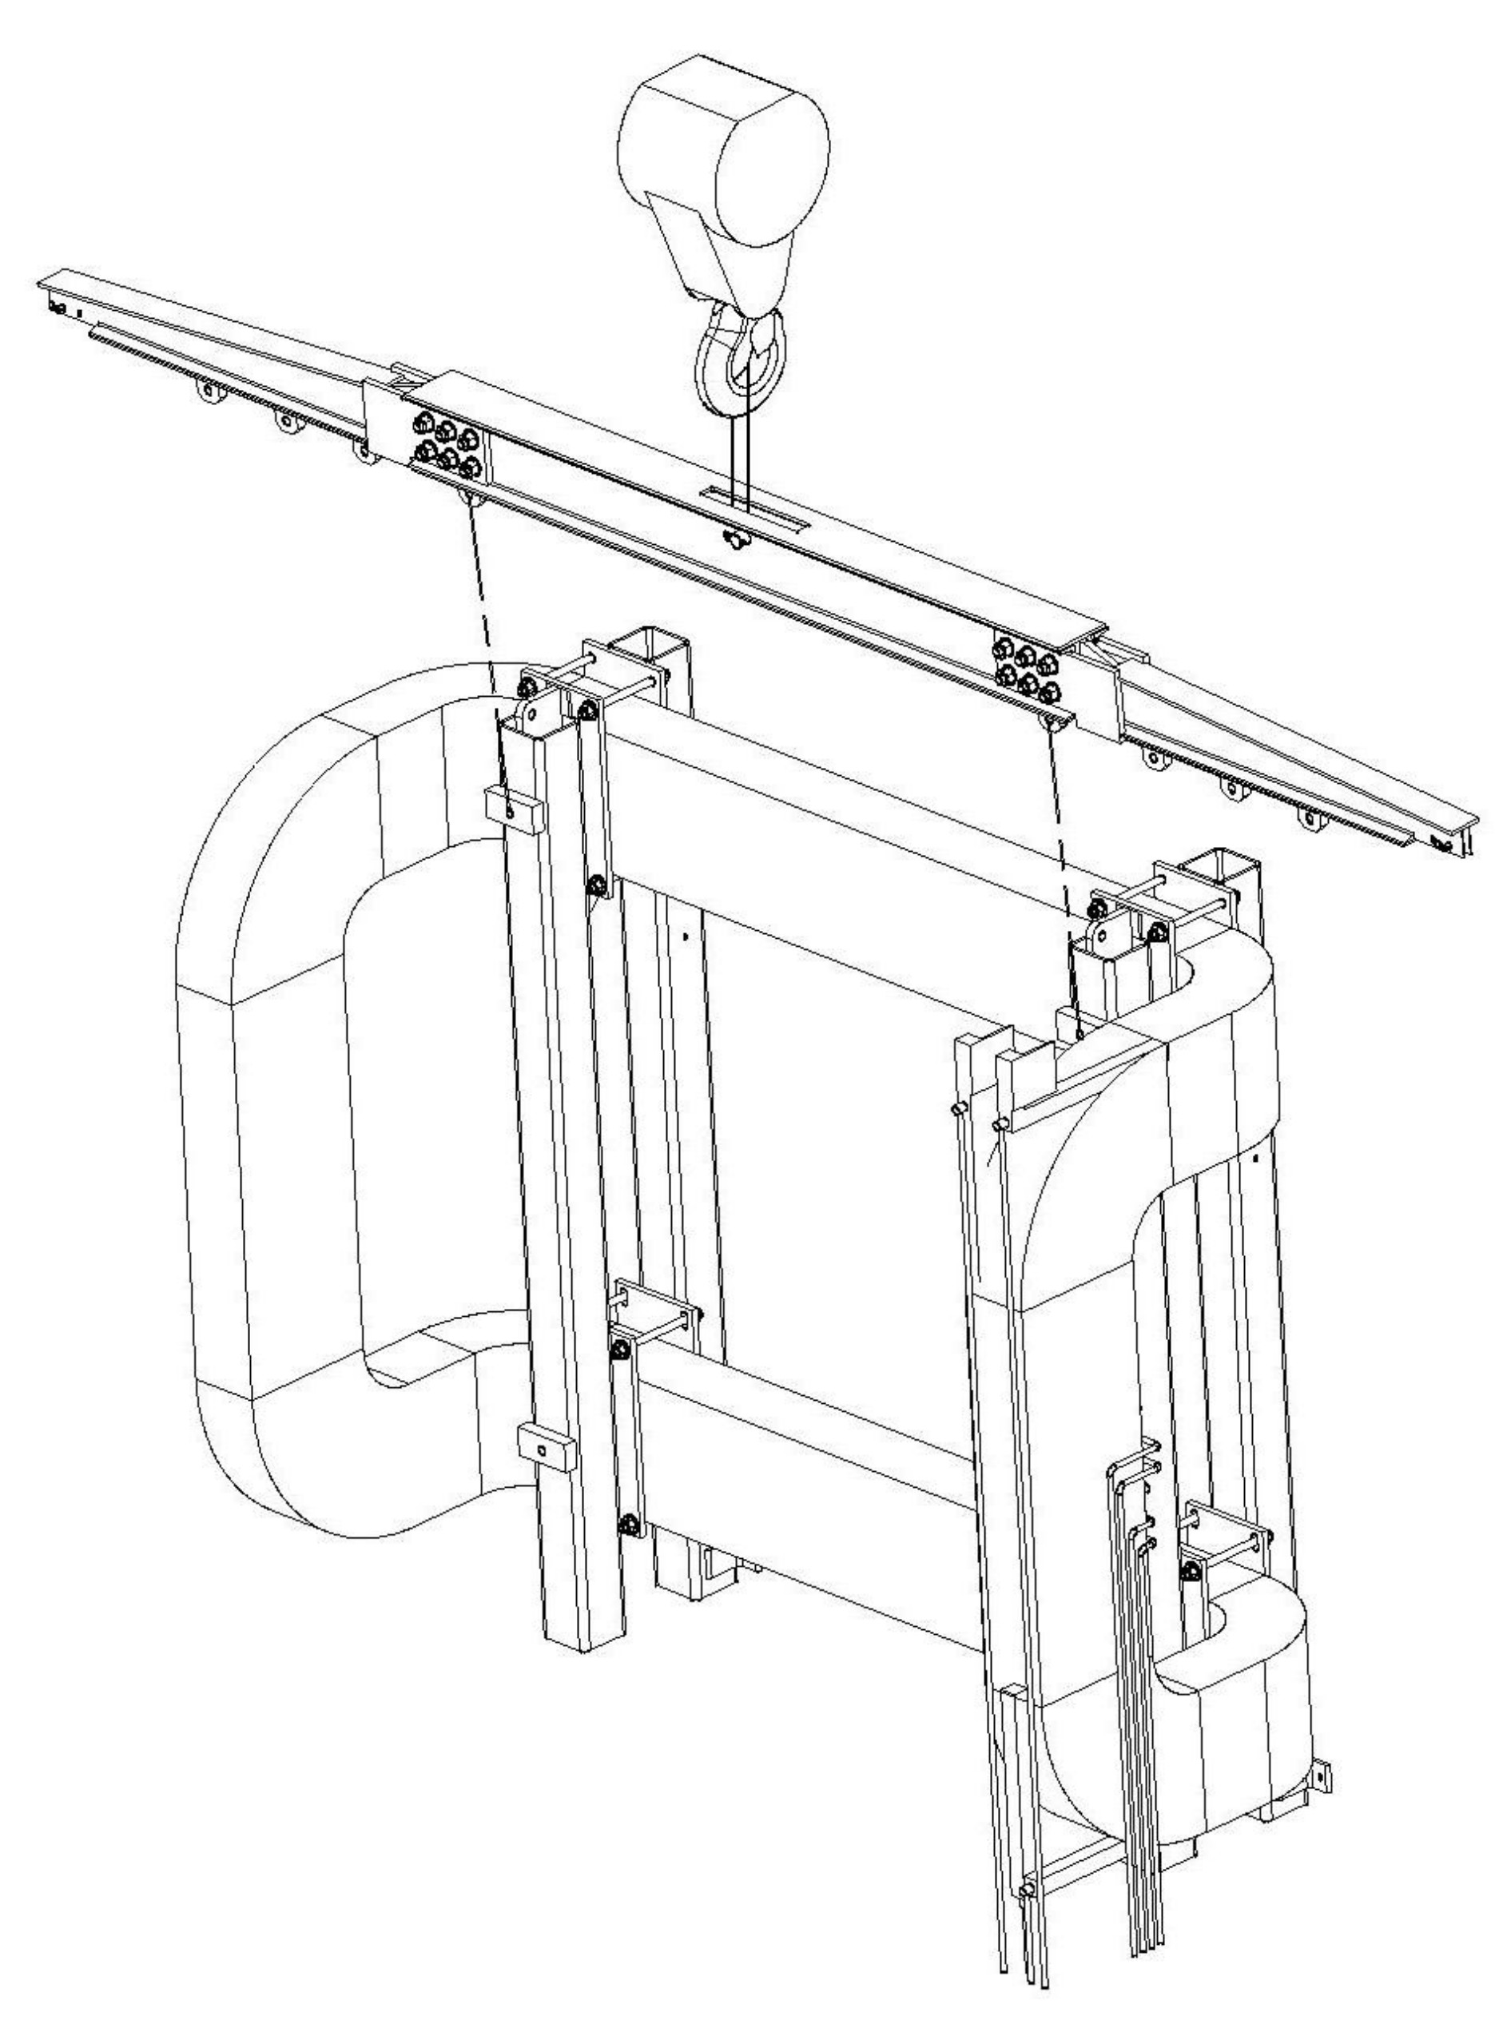
Z
X

Figure 1. Using the coil lifting turning fixture to lift the coil vertically
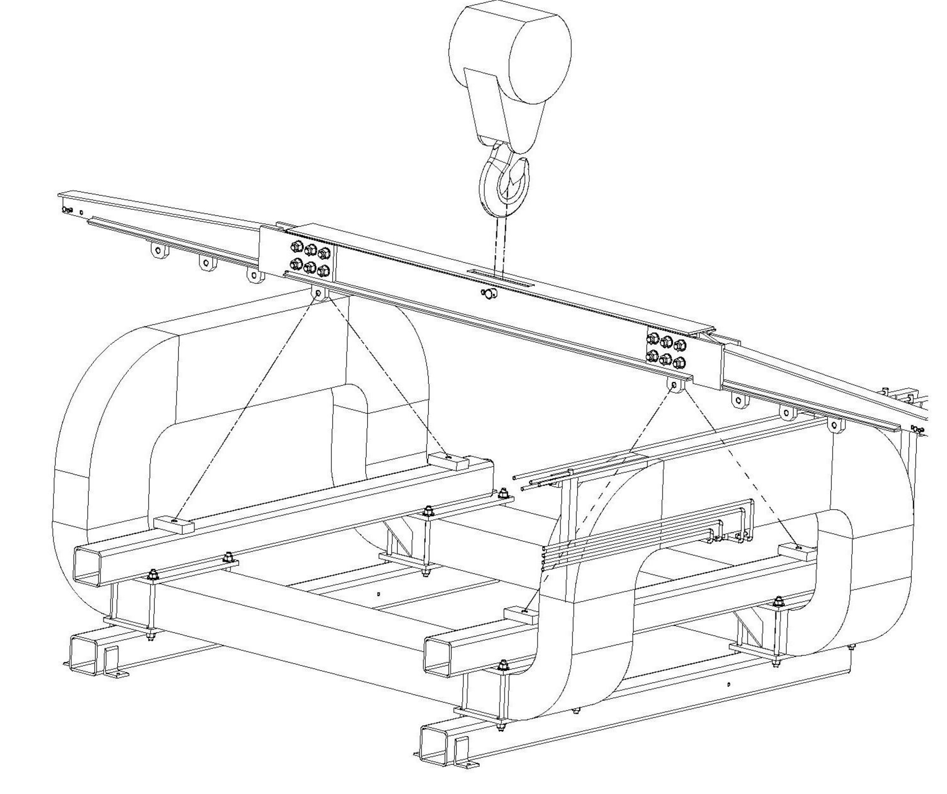

Figure 2. Using the coil lifting turning fixture to lift the coil horizontally

The turning fixture was designed on 1982 as shown on figure 3 of page 5. The modification was done this time as shown on figure 4 for the multiple usages: turning, lifting and moving.

The main modifications from the original design (version of 82) are:
- Redesign the lifting hole location when it lifts vertically as shown on figure 1. In order to create larger eccentric distance in z dir. between the center gravity of the coil with accessories and the lifting lug, the new lifting lug moved 5.25” in +z dir.
from the original location. The coil will turn along x axis (clockwise) when it is lifted in y dir. as shown on figure 1.

- The turning lifting fixture also has capability to lift the coil horizontally as shown on figure 2.

3. The turning fixture can hold the coil vertically with anchoring it to the heavy blocks
as shown on figure 5.

I. The discussion of the load condition of the fixture lifting vertically.

For simplicity, it is conservatively assumed that the whole weight of the coil was
supported by coil support plates (2) (see item #3 of drawing ME-121726). Assuming
beam fixed at one end, simple supported at other end, uniformly distribution load as
shown on case #12, page 2-299, part 2 of ASD, 9thedition.

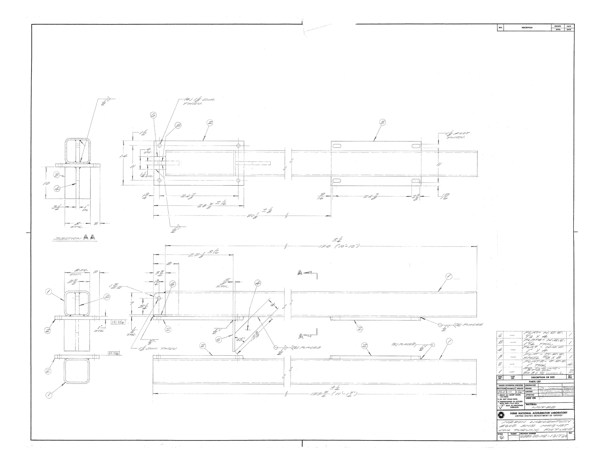
Figure 3. The coil turning fixture drawing of ME – 121726 dated on 02/04/1982

Where: L = 10” – 0.5(1.414 x 4”) = 7.2”
w = (13000# x 0.5)/7.2” = 903 lbs/inch
P_{t} : Total uniform load, = wL = 6,500 lbs.
R₁ = (3/8) P_{t}= 2,438 lbs.
R₂ = (5/8) P_{t}= 4,063 lbs @ the fixed end

So, M_{max} = (wL²) / 8
= (703 lbs/in x 7.2² in²) / 8
= 4,555 in-lbs. @ the fixed end.

In order to find the bending and shear stresses @ the most critical location, it is necessary to find out the geometrical property of the coil support plate at that location. Per drawing ME – 121726 (item #3), it is found that:

A_{area:} in cross section view, see section A-A of drawing ME-121726
= (8.0 x 0.625) in²
= 5.0 in²

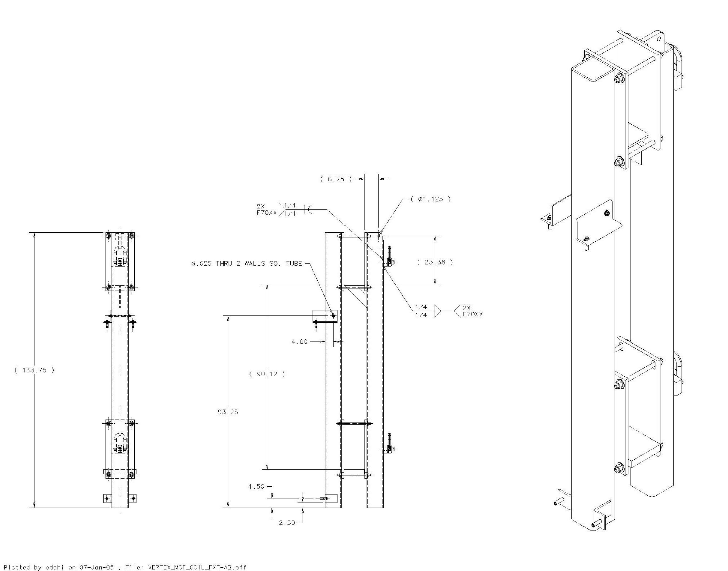

Figure 4. The modified coil turning lifting fixture.

I_{xx} = (8 x 0.625³) / 12 (in⁴)
= 0.1628 in⁴,
S_{xx} = 0.52 in³

The allowable stresses of the coil support plate:
F_{b} = F_{y} /3.0 = 12 ksi = F_{v} = F_{t}
(per section 20-1.2.2.2, ASME B30.20)

The computed working stresses:
f_{b} = M_{max} / S_{xx} = 4,555 in-lbs / 0.52 in³
= 8.76 ksi < F_{b} = 12 ksi
f_{v} = R₂ / A_{area} = 4,063 lbs / 5.0 in²
= 0.82 ksi < F_{v} = 12 ksi

The working stresses are satisfactory subject to the apply load.
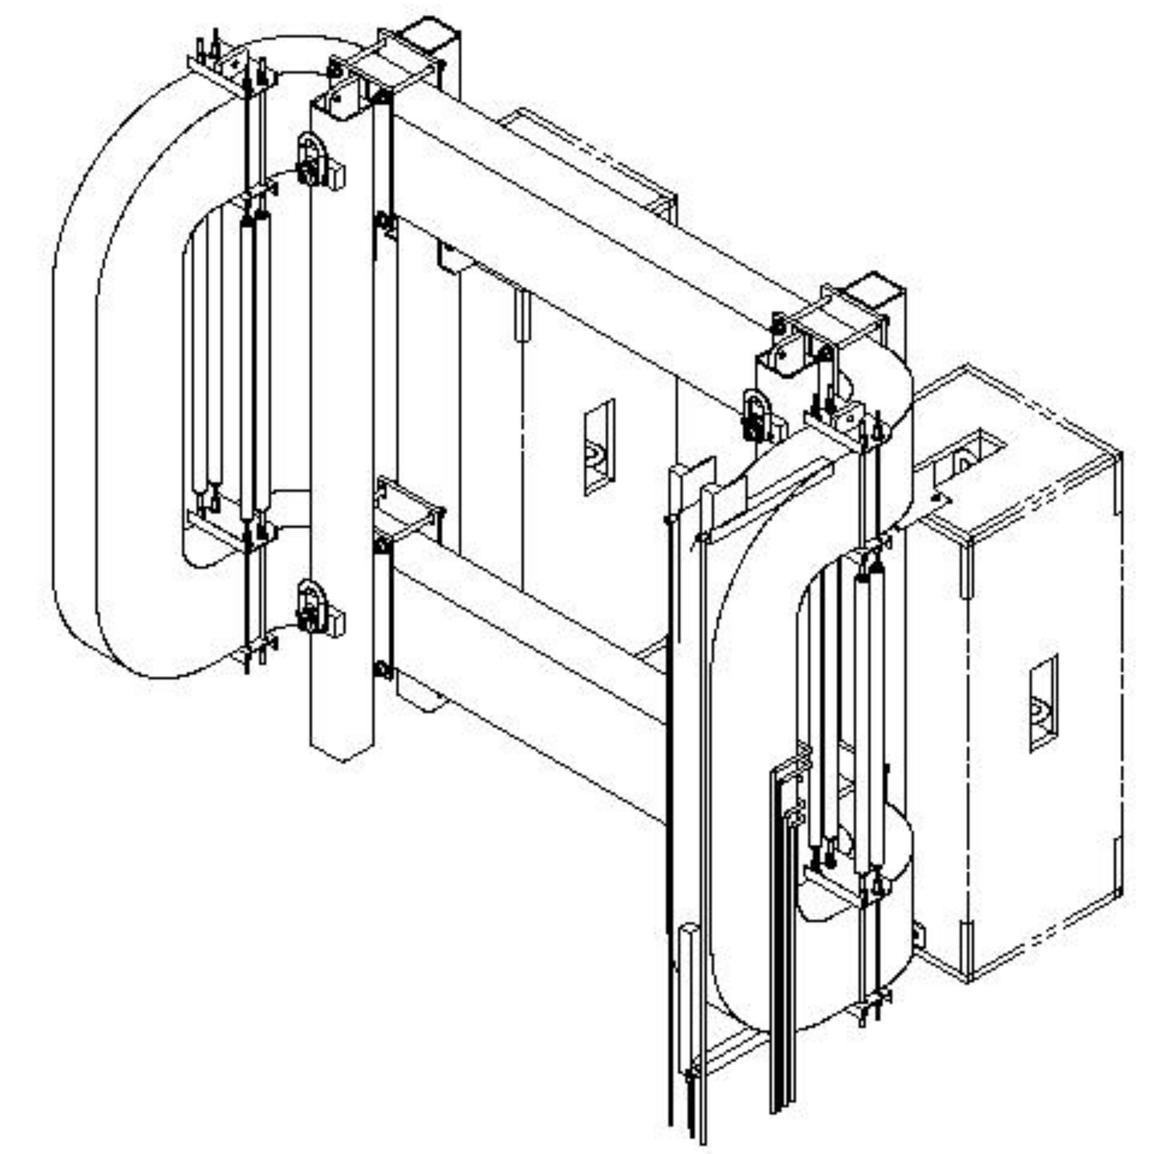

Figure 5. The coil turning fixture stands vertically with anchored to the shielding block B.

II. a) Find out the working stresses of the threaded rods for being subjected the forces
when the fixture with coil is lifted vertically first, and then is gradually turned to
horizontally.

a1). It is assuming that the coil is supported by the coil support plate as discussed on
part I when coil fixture lifting vertically. The vertical force P_{v} (weight of items #1
& #2 of drawing MD-407803, partial weight of the coil) applying to the rods
actually is resisted by the friction force F_{r}, where F_{r} = P_{c} * µ
Where P_{v} = 0.5 [weight of the coil + 0.5(weight of the turning fixture)]
= 0.5 (13,000 + 1,600) lbs.
= 7,300 lbs.
P_{c} = 0.75 A_{s} F_{p} Clamp load
A_{s} = 0.7854 [D_{n} – 0.9743/n]² stress area
= 0.7854 x (1 – 0.9743/8 )²
= 0.6057 in²
D_{n;} nominal diameter of the rod, 1.0 in
n: number of threads per inch, 8
F_{p} = 70% of the tensile strength
= 0.70 x 120 ksi (for grade 5 screw)
= 84 ksi
P_{c} = 0.75 x 0.6057 in² x 84 ksi
= 38 kip
µ: The coefficient of friction between the coil contact surface and the
mating surface from the turning fixture, conservatively assume that
µ = 0.1

So: F_{r} = P_{c} * µ = 38,000 lbs x 0.1
= 3,800 lbs per threaded rod
Per figure 4 or drawing MD-407803, it is found that there are 8 threaded rods, so the
total friction force F_{rt} to support the applying vertical load P_{v} is:

F_{rt} = 8 F_{r} = 8 x 3,800 lbs = 30,400 lbs > P_{v} = 7,300 lbs.

Applying only ~25% of the threaded rod’s clamping force will hold the coil and
the fixture vertically with coefficient of friction µ = 0.1.

a2). Compute the working load vs. the allowable load of the threaded rod when the
turning fixture lifting horizontally as shown on figure 2.

There are (16) 1”-8, UNC, grade 5 threaded rods to support the weight of the coil
and the lower half of the turning fixture (see dwg. MD-407803 for reference), per
page 4-3, part 4 of ASD, 9th edition, the allowable tensional load of the rod P_{tr}:

P_{tr} = 0.33F_{u}A_{n}
= 0.33 x 120 ksi x 0.7854 in²
= 31 kip, for the each thread rod
The total applying load P_{ay} = 2P_{y} = 14,600 lbs (for 16 threaded rod)
p_{tr} = P_{ay} / n
= 14,600 lbs / 16
= .92 kip < P_{tr} = 31 kip
Consider such big safety of factor, for simplicity, ignore some tensional
and compressive loads caused by the unsymmetrical loading.

The threaded rods are satisfactory to the subjected load.

b). Find the working stresses subject the axial load as shown on figure 5.

b1). Find out the critical force P_{cr} to cause the column to buckling:
P_{cr} = (Π²E) A_{g}/ (KL/r)²
= 479 kip > P_{v} = 7.3 kip
(see section 6.3, Steel Structures Design & Behavior, 3rd edition)
So there is no buckling under the current load condition.*

where: E = 29 x 10⁶ ksi, modulus of elasticity of the subjected member
A_{g}= 14.4 in², for 8” x 8” x 0.5” tubing gross cross-section area
L = 133.75 in, the length of the subjected member
K = 2.10, assuming effective length factor
r = 3.03 in, radius of gyration
*: Since the big value difference between P_{cr} and P_{y}, it ignores the
eccentric loading condition for simplicity, however, the calculation of f_{b} in
section I has included such eccentric load case.

b2). Find out the allowable stresses vs. the computed working stresses:

F_{a} = F_{y} [1- (KL/r)² / (2C_{c}²)] ÷ [5/3 + (3/8) x (KL/r)/ C_{c} - (KL/r)³/ 8C_{c}³]
= 16.63 ksi
(see eq. E2-1, Charter E, Part 5, ASD, 9th edition)
where: F_{a}: the allowable axial stress for the compressive member
KL/r = 92.7, the largest effective slenderness ratio
Cc = [(2Π²E) / F_{y}]^{1/2} = 111.55 > KL/r = 92.7
F_{y} = 46 ksi, yielding stress for tubing with ASTM A500, Gr. B

However, per section 20-1.2.2.2, ASME B30.20
F_{b} = F_{y} /3.0 = 15.33 ksi = F_{v} = F_{a}
Pick the less value one as allowable stress, so F_{a} = 15.33 ksi.
f_{a} = P_{y} / A_{g} = 7,300 lbs / 14.4 in²
= 0.51 ksi < F_{a} = 15.33 ksi,

The computed axial working stress is satisfactory subjecting the axial applying
force.

III. Computer the anchor bolt force f_{anchor} subjected the eccentric force.

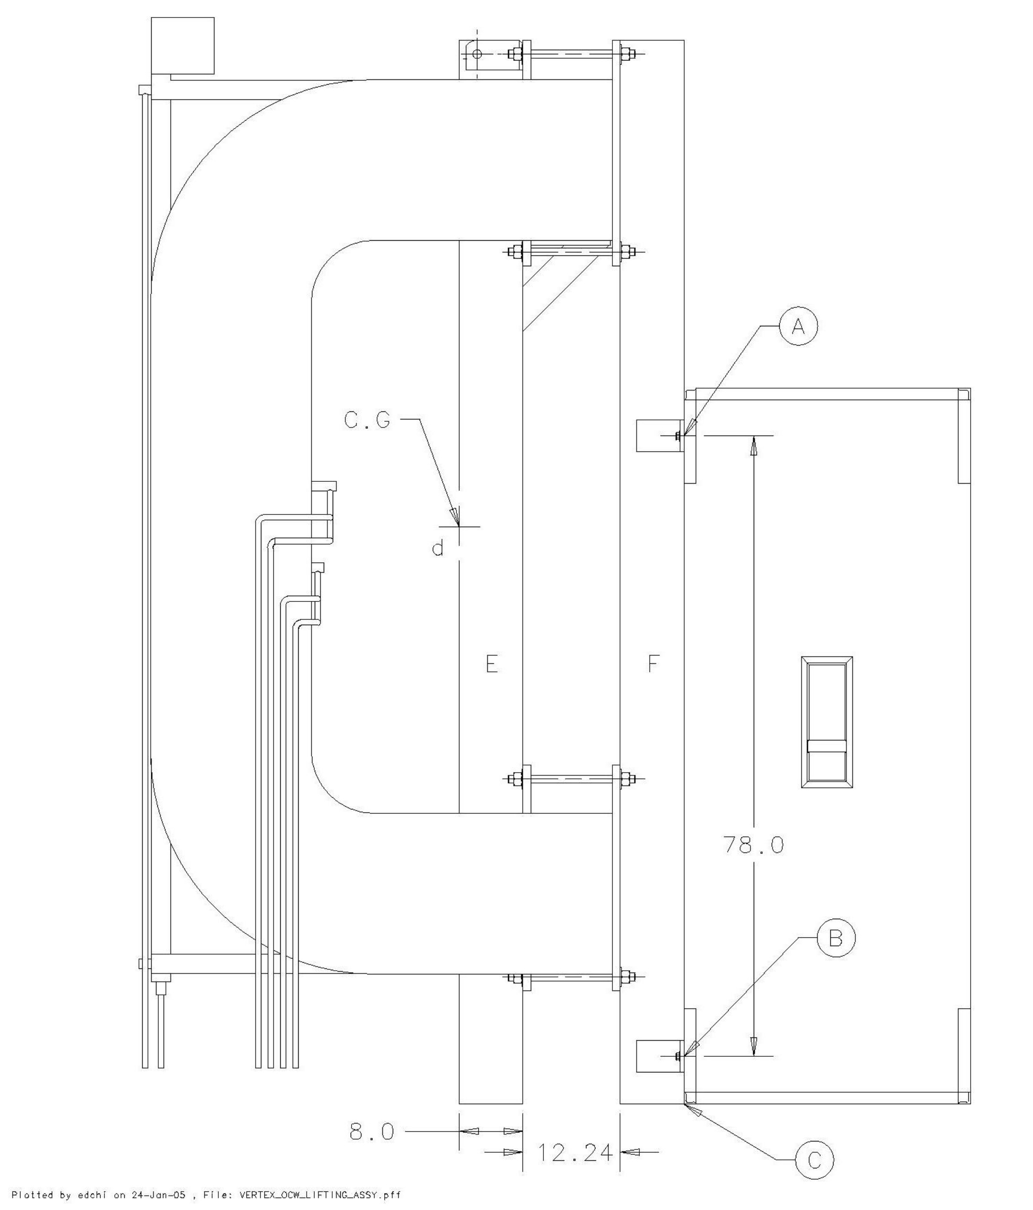

Figure 6. Coil and turning fixture stand vertically, and anchored with B block.
The discussion of the anchor bolt doesn’t belong the scope of the lifting fixture,
however, the process of the computation will help us further understand the nature of
the design.

Per side and top views of the drawing ME- 407856, it is found that the coil is
supported by (4) 8”x 8” tubing columns (i.e: the (2) outer columns (E) and (2) inner
columns (F)); the distance between the ctr. gravity to the central line between E
column and F column L_{z1} = 8” + 10.24”/2 = 13.12”; the distance between top and
bottom drop-in anchor bolt L_{ab} = 78.0” (see figure 6 as reference), the distance
between the anchor bolt A to location C of the bottom of the column L_{ac} = 84.0”.

The over-turn moment M_{ov} due to the eccentric force P_{yt} can be write as:
M_{ov} = L_{z1} x P_{yt}
= 13.12 in x 16,200 lbs = 212,544 in-lbs.
The moment M_{re} to resist the over-turn moment M_{ov} will be:
M_{re} = L_{ac} x f_{ant} = M_{ov}
So: f_{ant} = [(L_{z1} x P_{yt}) ÷ L_{ac}]/ n
= [(212,544 in-lbs) ÷ 84.0 in]/ 4
= 633 lbs < F_{at} = 1,135 lbs.

where: n = 4, number of the anchor bolt on the top surface of two B blocks.
F_{at} = 1,135 lbs, the allowable tensional load for ½” -13, UNC drop-in
HDI anchor bolt (per page 171, section 4.3.5, “Hilti
North America Product Technical Guide, 02 edition)
f_{ant:} the computed tension working load for drop-in anchor bolt.

For simplicity, the discussion has ignored the computation the anchoring force from
the 4 bottom bolts (@ B location) as shown on drawing ME-407856 and figure 6.

The current anchor bolts will generate enough resistant force to counter balance
the overturning eccentric force.

3. Weld Calculations:

The part (I) and part (II) of Figure 7 are the weld configuration for the two different welding places of the turning fixture respectively.

Part (I) is the welds of the coil support plate (see item #3 of drawing ME-121726 ), find the geometrical properties of the welds as shown on part (I) of figure 7:

where d = 0.625 inch, b = 8.0 inch
L = 2b = 16 in, length of the welds
I_{xx} = bd² / 2
= 1.5625 in³
S_{xx} = bd
= 5 in²

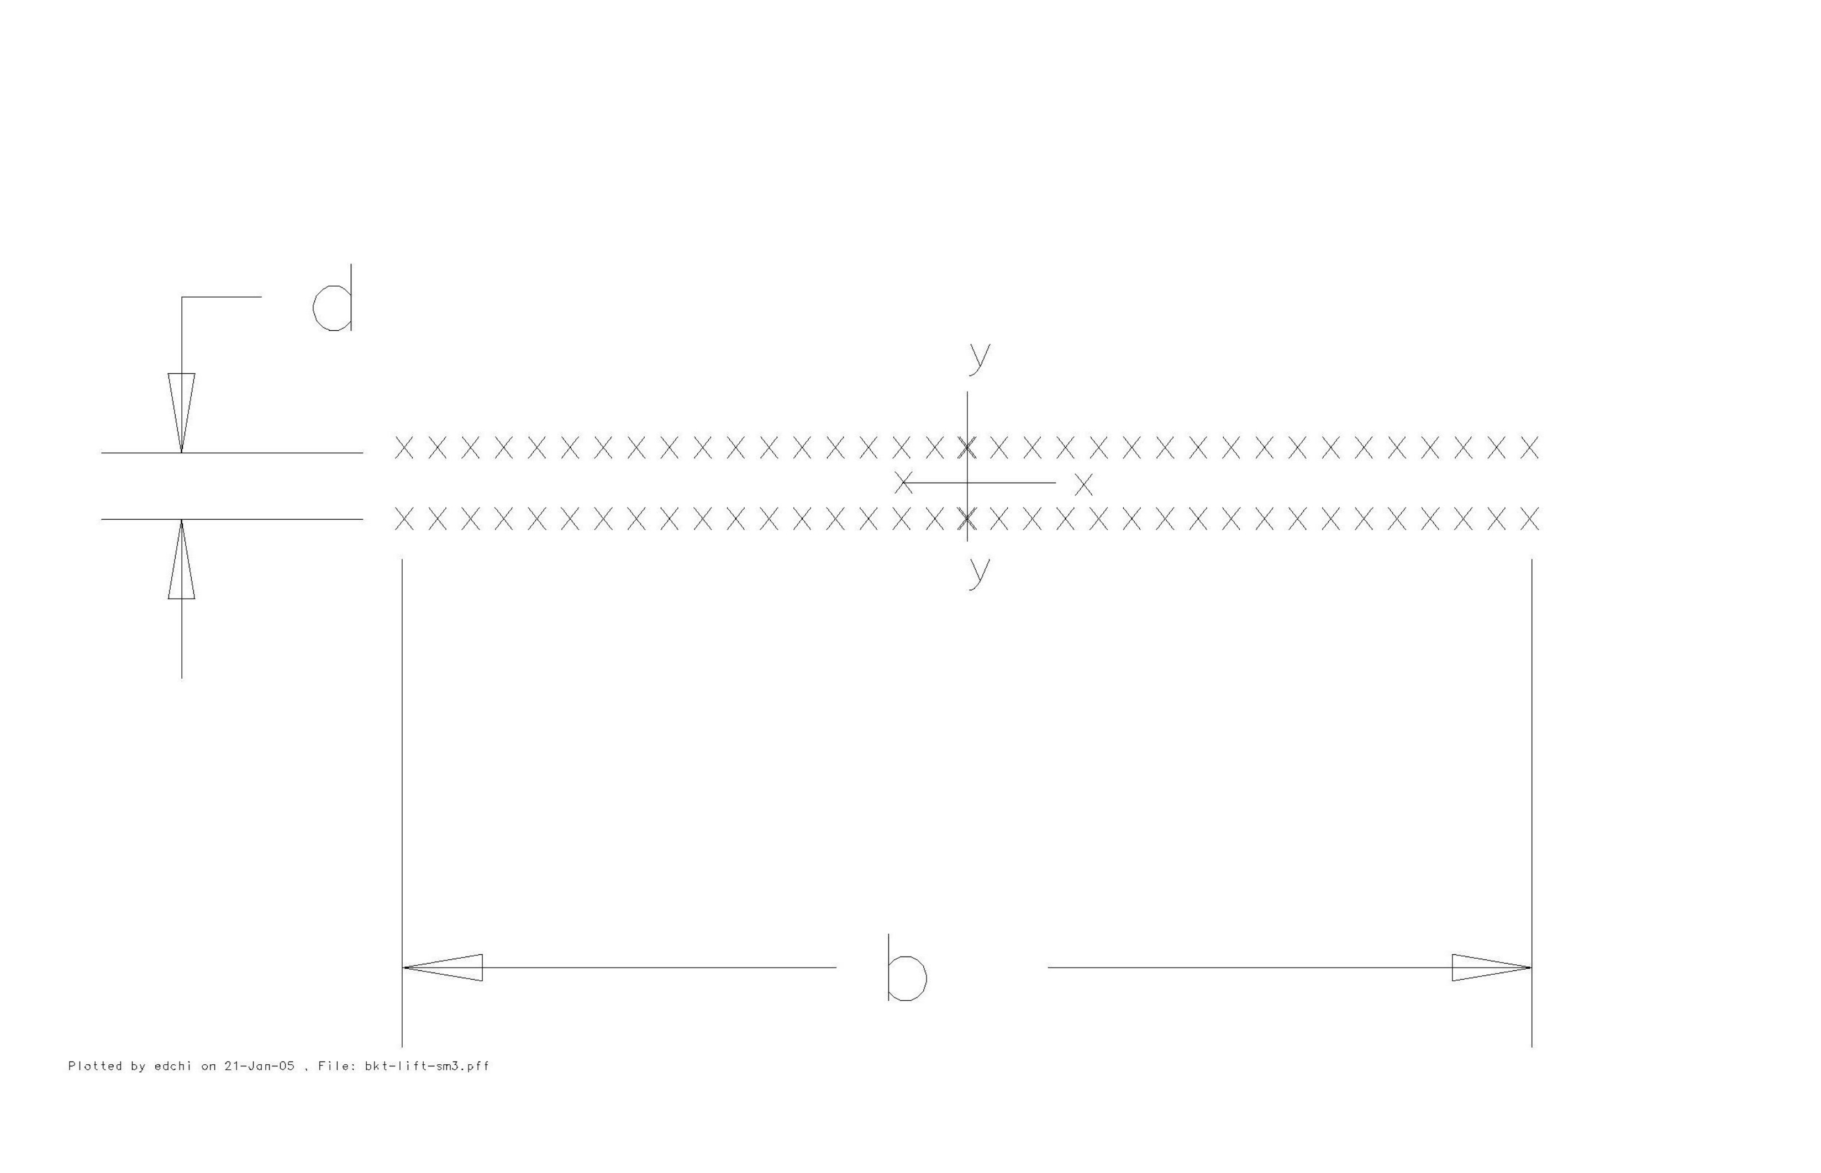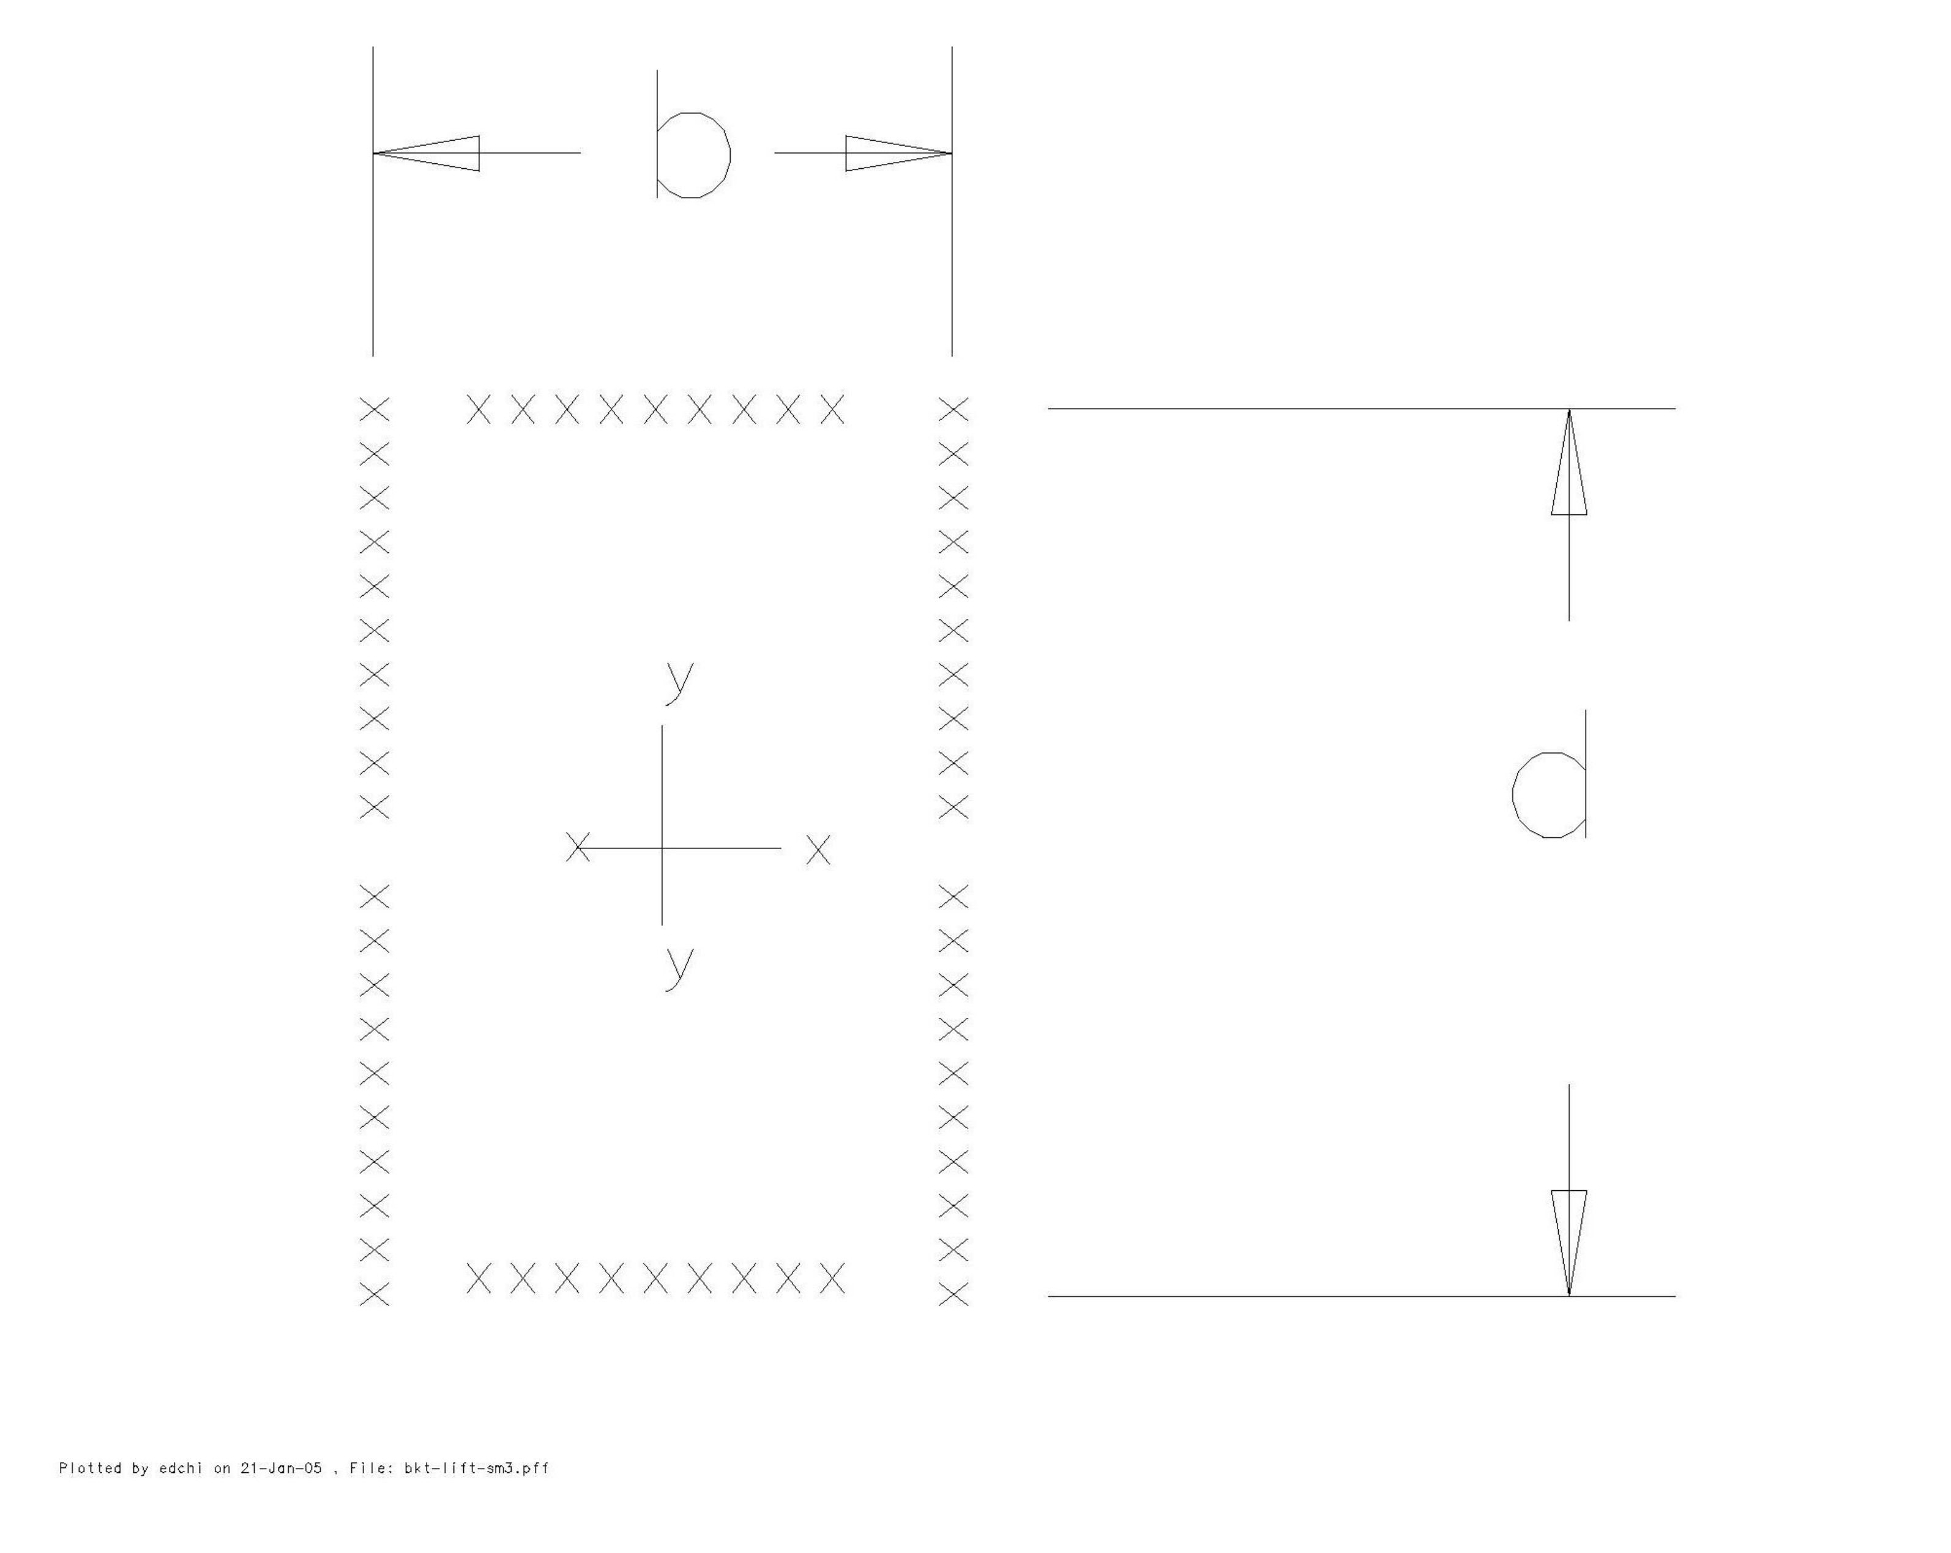

(I) (II)

Figure 7. The weld configuration for the two different welding location of the turning
fixture (treat as line with unit thickness).

The working load per unit length of the weld subject to the applying load can be found:
f_{b} = M_{max} / S_{xx} (see page 5, section I for the value M_{max} and R₂)
= 4,555 in-lbs ÷ 5 in²
= 911 lbs/in
f_{v} = R₂ / L
= 4,063 lbs ÷ 16 in
= 254 lbs/in
f_{r} = ( f_{b}² + f_{v}² )^{½}
= 946 lbs/in

To find the required weld size C_{I}:
All weld metals are E70,
Where: F_{u} = 70 ksi
The allowable stresses for the weld metals:
F_{t} = F_{v} = 0.30 F_{u} = 21 ksi

C_{I} = combined working load per unit length÷ (effective factor × allowable stress)
= (946 lbs/in) ÷ (0.707 x 21 ksi)
= 0.064 in < 0.5 in (the designated weld size in the area per drawing ME-121726)

Part (II) are the welds of the hoist flange (see item #11 of drawing MD-407803 ), find the geometrical properties of the welds as shown on part (II) of the figure 7:

where d = 4 inch, b = 6.0 inch
L = 2(b+d) = 20 in, length of the welds

The working load per unit length of the weld subject to the applying load can be found:

f_{v} = P_{yt} / L
= 8,100 lbs ÷ 20 in
= 405 lbs/in

where P_{yt} is the total applying load to the one hoist ring:
P_{yt} = 0.5(weight of the coil + weight of the turning fixture)
= 0.5 x (13,000 + 3,200) lbs.
= 8,100 lbs.

To find the required weld size C_{II}:
All weld metals are E70,
Where: F_{u} = 70 ksi
The allowable stresses for the weld metals:
F_{t} = F_{v} = 0.30 F_{u} = 21 ksi

C_{II} = working load per unit length÷ (effective factor × allowable stress)
= (405 lbs/in) ÷ (0.707 x 21 ksi)
= 0.028 in < 0.25 in (the designated weld size in the area per drawing MD-407803)

The designated weld sizes are satisfactory.

Conclusions:
The coil turning fixture has been designed per the related engineering codes after the calculations and discussions from several the most critical areas, such discussions were
approached by computing the working structural stresses; threaded rod and anchor bolt forces; and finally the weld sizes in terms the different applications.

Rated Load Test Procedures for SM3 Coil Turning Lifting Fixture

- Review the load test setups on figures 8 & 9 and the lifting fixture engineering
drawing MD-407803, call Edward Chi @x2879 for the questions.

2. Prepare and move the items to the designated area for the test:
a). Three B shield blocks
b). Two existing steel tubes:
One with sizes of 10” x 12” x ½” with 10’ in length,
Another one with sizes of 10” x 10” x ½” x 120”.
c). One timber block with sizes of 8” x 8” x 24”
d). 8 pieces of garden hose (~19” in length) – or equivalent, for threaded rod
protections.
e). 8 pieces of steel angles or equivalent parts for restricting the sling contact
area
f). Slings with spec. as shown on figures 8 & 9.
g).One hoist scale and (4) 1 ¼” -7, hoist rings.
f). (4) ~ 12” x 12” x 24” blocks as shown on figure 9.

I. For the vertical rated load test as shown on figure 8:

I1. Assemble all items per load test set up as shown on figure 8 of page 15, cross–
check the position per the test setup layout figure 8 and drawing MD-407803.
Gradually, uniformly tight (8) threaded rods, suggested torque value is about 190
ft-lbs.

I2. Lift up the assembled test fixture slowly, apply the slings per the test setup on
figure 8, make sure that both slings stay on the distance of 30” and 60” as shown
on the front view of figure 8.

I3. Gradually, slowly apply load through crane until the scale reading reaches 9,850
lbs, sustain such load up to 10 minutes, observe the fixture to see if there is any
irregular mechanical behavior.

I4. Take the pictures for the load test setup.

II. For the horizontal rated load test as shown on figure 9:

II1. Move the assembled turning fixture with 2 tubes to the designated location,
cross-check the position per the test setup layout of figure 9. Please pays special
attention to the location of 4 blocks underneath of the turning fixture.

II2. Lays down the turning fixture horizontally on the top of 4 blocks, adjust to the
position as shown on figure 9.

II3.Move 2 B blocks to the top of the (2) test tubs (10” x 10” x ½” & 10” x 12” x
½”), adjust to the position as shown on figure 9.

II4. Install (2) 1-1/4” – 7, hoist rings to the location as shown on drawing MD-
407803.

II5. Install rated slings between hoist rings and hoist scale per figure 9.

II6.Gradually, slowly apply load through crane until the scale reading reaches 9,850
lbs, sustain such load up to 10 minutes, observe the fixture to see if there is any
irregular mechanical behavior.

II7.Take the pictures for the load test setup.

3. Repeat the rated load test for another set of coil turning lifting fixture.

4. Fill out and sign the form 5022.1TA (page 1) as Load Test Witness

- Remove every item back in order one by one.

- Mark each set of the fixture as:
Number 153
Lifting Capacity: 6,500 lbs.
Fixture weight: 1,600 lbs.

7. Thanks for finish the project safely and successfully.

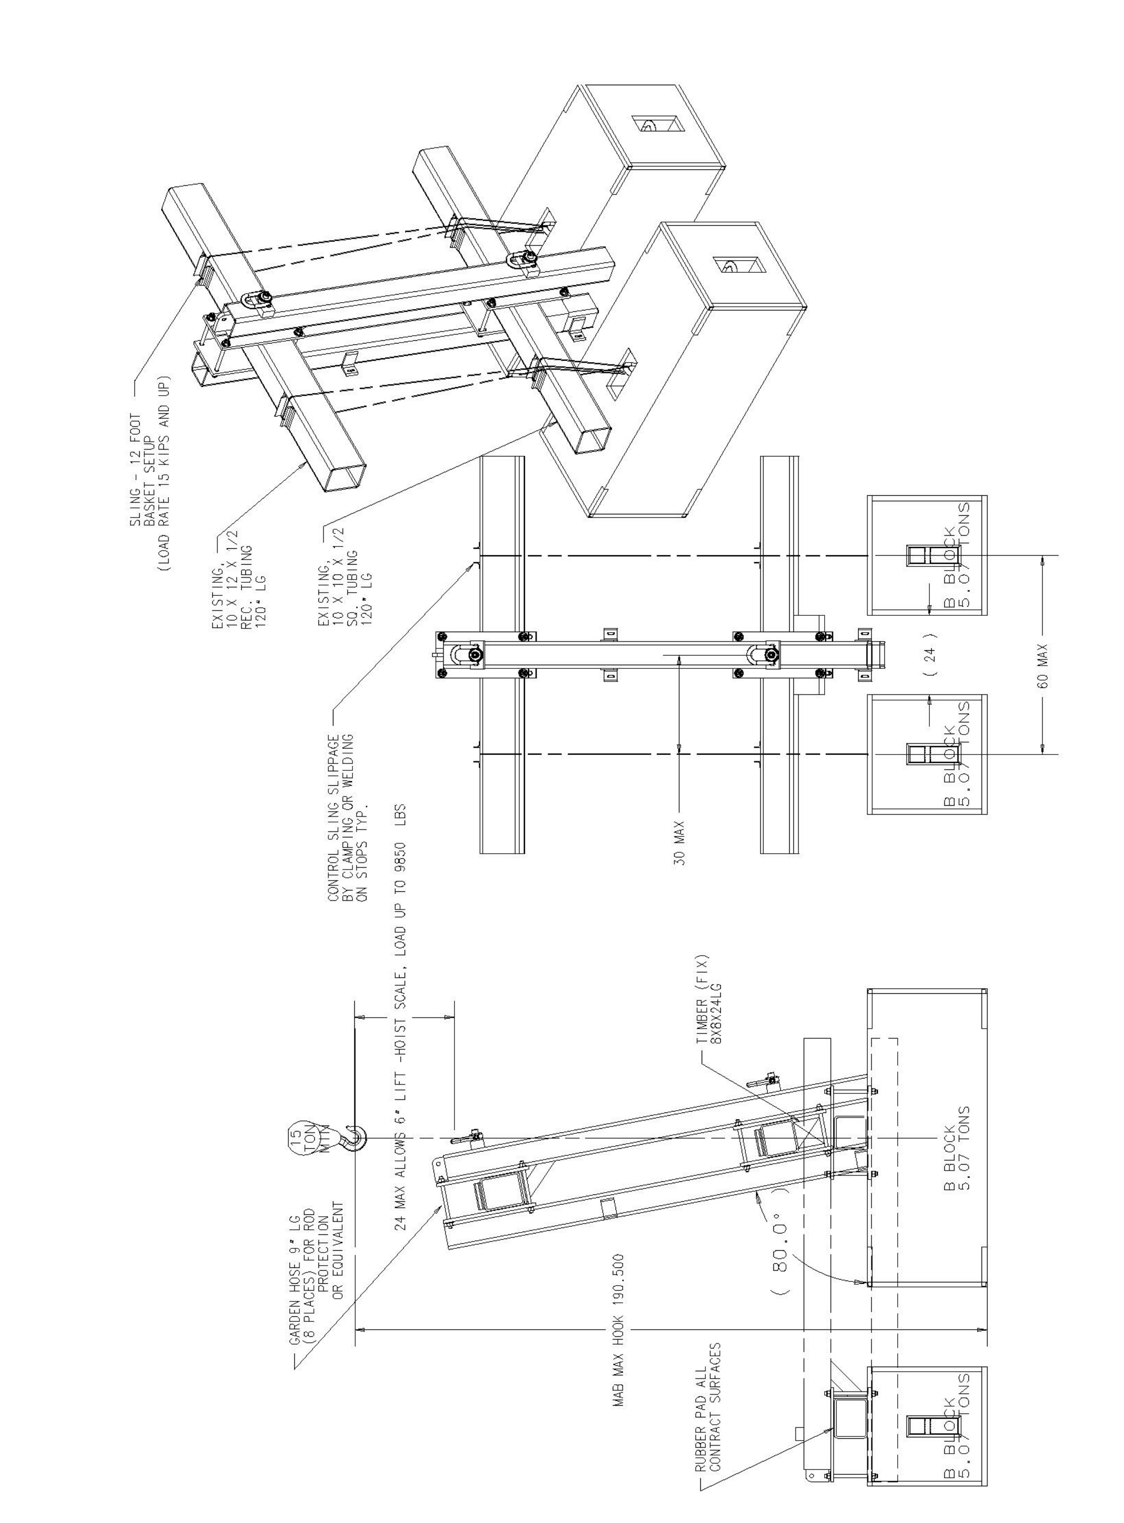

Figure 8. Vertical setup of the load test for the coil turning lifting fixture.
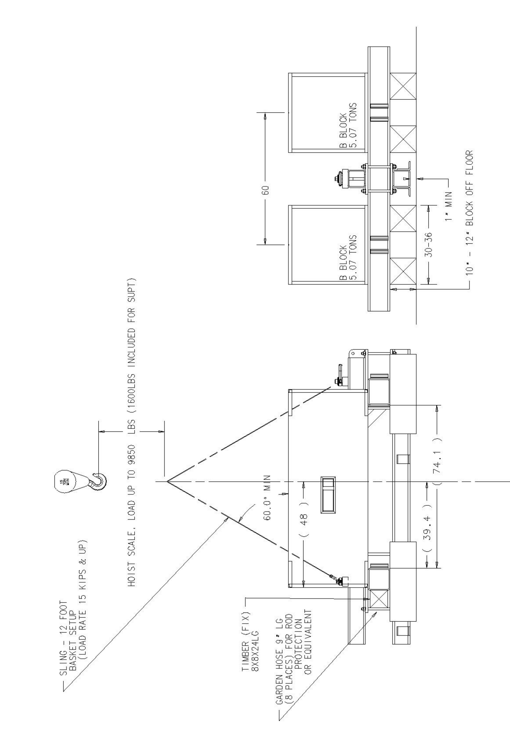

Figure 9. The horizontal setup of the load test for the coil turning lifting fixture.



