U.S. Department of the Interior

Interior Enterprise Architecture

Technical Reference Model
Version 2.0



October 15, 2003

Table of Contents
Executive Summary I-3
Introduction and Background I-5
Using the Interior Enterprise Architecture Technical Reference Model I-10
Maintaining the Interior Enterprise Architecture I-12
The Interior Enterprise Architecture Exception Process I-15
Chapter 1, Information Security 1-1
Chapter 2, Infrastructure 2-1
Chapter 3, Data Management 3-1
Chapter 4, Geospatial Technologies 4-1
Chapter 5, Application Development and Acquisition 5-1
Chapter 6, Platform 6-1
Chapter 7, Distributed Systems Management 7-1
Chapter 8, Records Management 8-1
Appendix A, Glossary A-1
Appendix B, List of Acronyms B-1
Appendix C, Overview of Populated Components by SRM Service Area C-1
Executive Summary

The Department of the Interior (Interior) is a decentralized, bureau-centric organization consisting of eight bureaus, a national business center, and several individual offices. Interior maintains a full-time staff of about 70,000 located at over 2,000 sites across the United States and its territories. A large number of sites are located in remote areas. As a result, information technology (IT) solutions have traditionally evolved in a separate and contained manner.

Many programs have requirements to share information with partners outside Interior, and have sometimes adopted partners' technological requirements. While a number of cross-bureau/partner and Interior-wide initiatives have taken place in recent years, the bulk of the current IT environment remains heterogeneous and fragmented. It consists chiefly of self-contained systems designed to meet the specific needs of individual bureaus operating independent, self-sufficient programs. The infrastructure reflects this diversity.

There is a growing demand for Interior to conduct its business differently. This new business model includes a need for: (1) coordinated service delivery across bureaus, (2) citizen-centric one stop shopping, (3) more planned and coordinated partnerships with external organizations, and (4) streamlined administrative business processes. Interior has a significant challenge to redesign its business approaches and processes. Moreover, its greatest challenge in the IT world is to implement an IT environment that supports this new business model by building the IT infrastructure needed to connect bureaus to each other and their customers, and to provide appropriate access to information from any place, at any time.

Interior is not alone in seeking to change the way it uses technology. Most agencies within the Federal government are trying to adapt to a changing environment while delivering on their mission. The Interior Enterprise Architecture (IEA) is a process that can be used to facilitate these necessary changes within the Department.

While there are a number of major pieces to the IEA (e.g., Business Reference Model, Data Reference Model), this document outlines the Technology Reference Model (TRM) that reflects the technical architecture.

To ensure success, Interior's technical architecture needs to:
- Be based on the strategic business direction of Interior as an enterprise;
- Be based on a planning process that supports strategic business planning as well as ongoing tactical decisions made when implementing systems;
- Involve bureau business managers as well as IT staff throughout the process;
- Provide strategic direction for making technology decisions without requiring wholesale and major changes to the current IT environment;
- Allow bureaus to share many IT infrastructure components without sacrificing responsiveness to the changing business needs of individual bureaus;
- Make the IT environment adaptable to quickly adjust to changes in the business environment;
- Have a governance process that supports the ongoing evolution of the architecture as well as its enforcement;
- Evolve in synch with changing business strategies; and
- Be implemented in a short amount of time to avoid analysis paralysis.

Questions regarding the Interior Enterprise Architecture should be directed to the Interior Chief Architect.

Introduction and Background

A primary focus of Enterprise Architecture (EA) is enabling an organization’s regular re-alignment of the business strategies and the IT resources employed to support these strategies. Among the tools used by EA are architecture models. The Department of the Interior is incorporating the models provided by the Office of Management and Budget (OMB) within its Interior Enterprise Architecture (IEA.)

The OMB Federal Enterprise Architecture (FEA) was created to facilitate efforts to transform the Federal Government into one that is citizen-centered, results oriented, and market-based. It is a business-based framework for Government-wide improvement. As illustrated below, the OMB FEA was constructed through five interrelated “reference models” designed to facilitate cross-agency analysis and the identification of duplicative investments, gaps, and opportunities for collaboration within and across Federal Agencies.
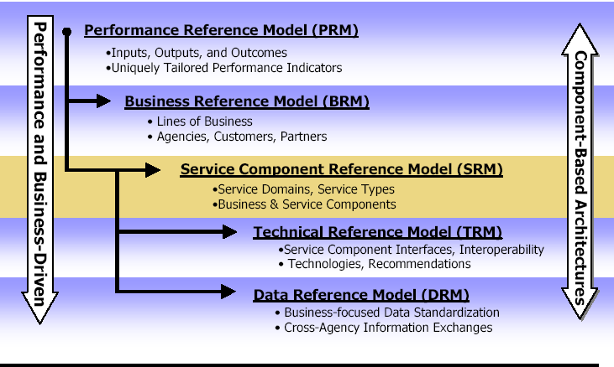

The five reference models in the OMB FEA include:
- The Business Reference Model (BRM) that describes the business lines, functions and sub-functions of the Federal Government independent of the agencies which perform them;
- The Performance Reference Model (PRM) that identifies the common set of general performance outcomes, metrics and indicators that Agencies will use to define, measure, and achieve program goals and objectives;
- The Data and Information Reference Model (DRM) that describes the data and information that support program and business line operations (The model will aid in describing the types of interactions and information exchanges that occur between the Federal Government and its customers, constituencies, and business partners.);
- The Service Component Reference Model (SRM) that is a business-driven, functional framework that classifies service components with respect to how they support business and/or performance objectives; and
- The Technical Reference Model (TRM) that provides a foundation to describe the standards, specifications, and technologies to support the delivery, exchange, and construction of business or service components and e-Gov solutions.

A more complete description of the OMB models can be found at the following address: (http://www.feapmo.gov/fea.asp).

While this document mostly covers the Interior TRM, the extensive integration between the SRM and the TRM requires a brief overview of the SRM. The SRM serves to identify and classify horizontal and vertical service components that support an agency and its IT investments and assets.

Specifically, the SRM was created to:
- Provide a framework that identifies service components and their relationships to the technology architecture of agencies across the Federal Government;
- Classify, categorize and recommend components for the reuse of business services and capabilities across the Federal Government;
- Define existing service components that may be leveraged outside agency boundaries;
- Align and leverage existing federal guidance and application/architecture recommendations;
- Support the 24 Presidential Priority E-Gov initiatives; and
- Evolve based on new services and components as they are discovered across industry and federal markets.

The Federal Enterprise Architecture Service Component Reference Model Version 1.0 is organized as a functional hierarchy, with Service Domains at the highest level followed by Service Types and Components.

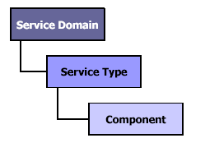

There are 7 Service Domains that provide a top-level categorization of the service capabilities and categories from a business perspective. These seven Service Domains are comprised of 28 Service Types that further categorize and define the capabilities of a Service Domain. The Service Types define the second level of detail that describe a business-oriented service. The next, and final, layer of the SRM is the Component level. These 164 Components represent the lower-level, logical “building blocks” of a business or application service component. The graphic below depicts the depth and breath of the FEA SRM.
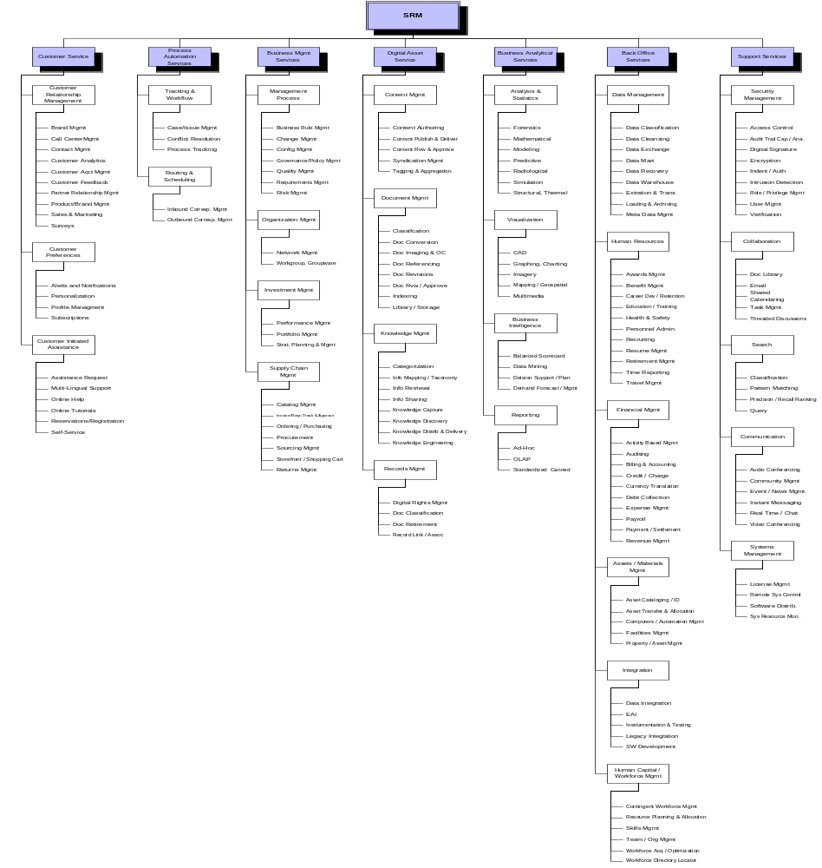

During this initial implementation of the FEA models, 77 of the 164 SRM components were populated with technical guidance and information captured from appropriate technical experts (e.g., SRM component = Network Management.) (An overview of all the populated components by SRM service area can be found in Appendix C.) Many of the remaining SRM components (e.g., Recruiting, benefits management, etc.) are better populated with guidance from business personnel and will be “fleshed out” during future updates to the architecture. The current populated SRM service components are supported by elements of the technical infrastructure reflected within the Technology Reference Model.

The TRM serves to outline the technology elements that collectively support the adoption and implementation of component-based architectures. The model provides the foundation to advance the re-use of technology and component services across the Federal Government through standardization. Aligning agency capital investments to the TRM leverages a common, standardized vocabulary, allowing inter-Agency and intra-Agency discovery, collaboration, and interoperability. Agencies, and the Federal Government, will benefit from economies of scale by identifying and re-using the best solutions and technologies to support their business functions, mission, and target architecture.

Specifically, the FEA TRM was created to:
- Create a government-wide reference model that unifies agency TRMs and existing e-Gov guidance;
- Focus technology standards, specifications, and recommendations on those that embrace the Internet and related approaches;
- Create a foundation that focuses heavily on the delivery and construction of service components and their interfaces; and
- Identify the layers of a Component-Based Architecture, the supporting technologies, and recommendations for each.

There are four (4) Service Areas within the TRM. They are:
- Service Access and Delivery - refers to the collection standard and specifications to support external access, exchange, and delivery of Service Components or capabilities. This area also includes the Legislative and Regulator requirements governing the access and usage of the specific Service Component;
- Service Platform & Infrastructure - refers to the collection of delivery and support platforms, infrastructure capabilities and hardware requirements to support the construction, maintenance, and availability of a Service Component or capabilities;
- Component Framework - refers to the underlying foundation, technologies, standards, and specifications by which Service Components are built, exchanged, and deployed across Component-Based, Distributed, or Service-Orientated Architectures; and
- Service Interface and Integration - refers to the collection of technologies, methodologies, standards, and specifications that govern how agencies will interface (both internally and externally) with a Service Component, as well as defines the methods by which components will interface and integrate with back office / legacy assets.
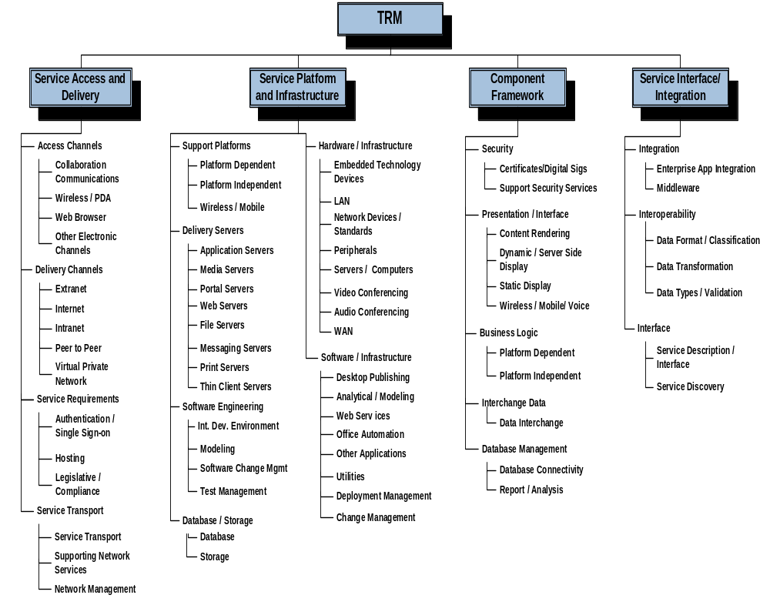The graphic below provides a visual overview of Interior’s TRM.

Using the Interior Enterprise Architecture Technical Reference Model
The eight technical architecture domains are:
- Information Security
- Infrastructure
- Data Management
- Geospatial Technologies
- Application Development and Acquisition
- Platform
- Distributed Systems Management
- Records Management

The focus of the Interior Enterprise Architecture is on providing guidance for IT issues and initiatives that are Interior-wide or multi-bureau in scope. Each of the eight domain teams of technical experts from Interior was instrumental in creating their chapter of the TRM.

If used correctly, the TRM will act as a catalyst for those looking to capitalize on its contents and better understand the full meaning of its guidance. This understanding will permit IT personnel to better engage non-IT organizations in discussions around tradeoffs and priorities within the proper governance structure (e.g., Management Initiatives Team (MIT), Information Technology Management Council)). The TRM (like the architecture itself) is not intended to be the “last word” (e.g., some automated checklist for product selection) but it is intended to be one of the “first words” to assure that Interior’s mission priorities and its IT priorities remain closely aligned.

Additionally, it is doubtful that a single TRM domain chapter can be used to address a substantive issue. More realistically, several architecture domains may need to be reviewed when addressing an important IT decision. For example, if Interior was considering the creation of a new Interior-wide reporting system that could be used by the general public, then the TRM chapters like Information Security, Application Development and Records Management might all need to be reviewed.

The IEA Exception Process for seeking exceptions to these requirements is outlined in the Maintaining the IEA section of this Introduction.

Domain Document (TRM) Contents

Introduction and background – Briefly describes the Domain and its areas of influence.

Architecture Principles – Based on the IEA Conceptual Architecture Principles, these domain principles define the rules for guiding IT decisions in this domain. For most domains, these are the design guidelines for implementing systems using these technology components. The domain principles also include justifications, or rationales for the principle, as well as the implications of that principle. These principles are key to making decisions about technology and product standards.

Technology Components– Each component of the domain is described. These descriptions will help readers begin to understand the technology areas.

Standards, Protocols, and Products– Each domain team, where appropriate, evaluated current technical standards, protocols, and products based upon their ability to meet the domain principles. This evaluation resulted in classifying the life cycle stage for these standards, protocols and products.

The classifications used were:

Life Cycle Definition/
Classifications Meaning

Preferred Product/standard of choice; support available; recommended.

Contained Develop solutions using these standards or products only if there are no suitable alternatives categorized as preferred; if a preferred product is available that will meet the requirements, plans should be developed to move from contained to preferred as soon as practical.

Obsolete Being phased out; (e.g., vendor support ending); plans should be developed to rapidly phase out and replace (often to avoid substantial risks).

Research Product/standard to be used in conjunction with technology research efforts only (e.g., testing, pilots).

Rejected Product/standard has been evaluated and found not to meet technical architecture needs.

Select Best Practices – Some domain teams provided additional guidance with select best practices. These recommendations are practical advice based upon either their own experiences or research from other public sector architecture efforts.

Maintaining the IEA
The Interior Enterprise Architecture is never completed. It is an ongoing process. During the development of the IEA, the participants recognized that there are gaps in the current technical environment that need to be filled to meet the strategic needs of Interior. For the IEA to be a meaningful tool for decision-making, the domain teams will need to continue to address these gaps.

Another component of maintaining the IEA is the enforcement of the architecture standards. The OCIO reviews compliance to the IEA via its responsibility for IT planning and IT procurement oversight. The key to administering this compliance role is good communications and planning. At times, there will be a need for exceptions to the architecture. The process for requesting an exception to the IEA principles and standards is outlined in the IEA Exception Process section at the end of this introduction.

To meet this need for maintaining the IEA, four groups are involved. The following is a description of the different groups and their roles.

Management Initiatives Team

The Management Initiatives Team (MIT) exists to ensure the alignment of IT with the business requirements of Interior and its bureaus. Additional responsibilities of the group include:

- Responsibility for prioritizing Interior-wide IT efforts in relation to business requirements;
- Responsibility for maintaining alignment between IT and business;
- Establishment of supporting policies to the CIO for Interior-wide infrastructure services to support the architecture;
- Functioning as final appeals authority for architecture exceptions; and
- Responsibility for maintaining appropriate linkages to corresponding processes (e.g., strategic planning, capital planning).

Information Technology Management Council

The Information Technology Management Council (ITMC) is responsible for the promotion, approval and enforcement of the technical standards. The Information Technology Management Council (ITMC) is made up of bureau senior IT management and is co-chaired by the Department’s Chief Information Officer (CIO) and a bureau CIO, on a rotating basis. Its membership is made up of senior bureau IT personnel. The ITMC approves domain team deliverables (e.g., design principles, product standards, best practices). Responsibilities also include:

- Functioning as technical liaisons for the Management Initiatives Team;
- Responsibility for assuring Interior-wide IT initiatives comply with technical architecture;
- Reviewing and approving technical products and standards aligned with the architecture;
- Responsibility for initial technical reviews of Interior-wide IT initiatives; and
- Responsibility for appropriate approval/ denial of exceptions to the architecture.

Architecture Review Board

The Architecture Review Board (ARB) is a standing board that serves the Interior Chief Information Officer (CIO) and Information Technology Management Council (ITMC) on issues related to technical compliance with the IEA. The ARB identifies and/or facilitates components for update to the IEA through liaison with standing Domain Architecture Teams (DATs). Responsibilities and activities include:

- Enhance and evolve the IEA
- Recommend establishment and disbandment of Domain Architecture Teams
- Review and recommend approval of technical products and standards proposed by the DATs for inclusion in the IEA
- Recommend resolutions to architecture and technological issues
- Develop and recommend priorities for approved IT initiatives
- Review requests for and recommend IEA and Technical Reference Model (TRM) waivers
- Technical liaison between the ITMC, the Interior Chief Architect, and the DATs
- Provide recommendations and reports to the ITMC

Interior Architecture Working Group

The Interior Architecture Working Group (IAWG) is chaired by the Interior Chief Architect and is comprised of bureau/office chief architects or other designees. The IAWG is:

- Bureau/office liaison between the Domain Architecture Teams (DATs), Interior Chief Architect, and the ITMC;
- Resource for supporting and communicating architecture benefits and requirements, and promoting alignment of Interior-level and bureau/office-level architectures;
- Responsible for coordinating within the bureau/office, along with the bureau/office CIO, on architecture issues;
- Responsible for coordinating DAT activities within the bureau/office, and ensuring DAT representatives present a unified bureau/office position on technical architecture issues; and

The above described architecture governance is a natural outgrowth of the architecture process and will continue to be fine-tuned as the IEA matures.

Domain Architecture Teams

The technical domain teams provide the knowledge and expertise required to develop the technical architectures and standards for the enterprise architecture process. Each team is composed of technical experts from throughout Interior. These teams are responsible for the development and maintenance of a Domain Architecture chapter of the TRM, including the domain specific deliverables (e.g., design principles, technical standards, products). The teams are expected to keep abreast of new technology and make recommendations on solutions to close gaps in the current environment. Additional responsibilities include:

- Responsibility for assuring domain architecture aligns with Interior-wide Conceptual Architecture;
- Function as a resource for ITMC for technical analysis during Interior-wide initiative reviews (e.g., ITMC “arms & legs”); and
- Function as a resource for the ITMC on significant updates/ changes occurring within the Domain.

The IEA Exception Process
An exception to the standards and guidance defined in the Interior Enterprise Architecture can be requested for several reasons.

- An initial architecture review is performed and non-compliance to the IEA is identified. The IT project lead can file a request for an exception to the architecture for the project. The exceptions will be addressed at regularly scheduled ITMC meetings.

- Once a project has been approved and the project is in an implementation phase, a bureau may find a need to deviate from the standards in the IEA for business reasons. This type of exception request would also cover procurement situations where a bureau is in the process of evaluating proposals to a request for proposal (RFP), statement of work (SOW), etc. A bureau can also request an expedited review if the situation warrants it and the ITMC will convene a meeting to review the request. Otherwise review will be scheduled for the next ITMC meeting.

A written request to the ITMC should document the justifications for the exceptions and the impact of granting versus not granting this request.

If an exception is not granted for the IT project, an appeal can be filed to the MIT. This appeal should be in writing and should state clearly the business reasons for granting the exception.

Questions regarding the Interior Enterprise Architecture should be directed to the Interior Chief Architect.

