PUBLIC NOTICE
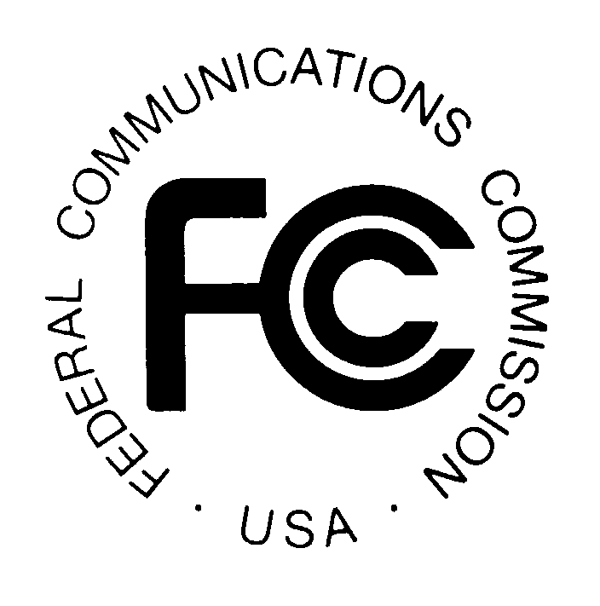

FEDERAL COMMUNICATIONS COMMISSION
445 12th Street, S.W.
WASHINGTON, D.C. 20554

News media information 202/418-0500 Fax-On-Demand 202/418-2830 Internet: http://www.fcc.gov, TTY: 202/418-2555

Released: March 20, 2000

CLARIFICATION ON BELL ATLANTIC-PENNSYLVANIA’S REQUEST FOR LIMITED MODIFICATION OF LATA BOUNDARIES TO PROVIDE EXPANDED LOCAL CALLING SERVICE BETWEEN BELL ATLANTIC-PENNSYLVANIA’S ULYSSES AND COUDERSPORT EXCHANGES AND FRONTIER COMMUNICATIONS’ GENESEE, SHINGLEHOUSE, AND MILPORT
EXCHANGES IN PENNSYLVANIA

File No. NSD-L-99-84

On October 25, 1999, Bell Atlantic-Pennsylvania (Bell Atlantic) filed a petition requesting modification of local access and transport area (LATA) boundaries to provide originating one-way, flat-rated expanded local calling service (ELCS) between Bell Atlantic’s Ulysses and Coudersport exchanges and Frontier Communications’ Genesee, Shinglehouse, and Milport exchanges in Pennsylvania. The FCC released a public notice on November 4, 1999 seeking comment on this request.

On February 29, 2000, Bell-Atlantic submitted a letter to the Commission clarifying its request of the original LATA modification request. That clarification reads as follows: Bell Atlantic is requesting that the FCC exercise its authority to modify LATA boundaries under 47 USC §153(25)(B) to permit Bell Atlantic to carry Frontier’s traffic across a LATA boundary in order to terminate it in Bell Atlantic Pennsylvania’s exchanges. This request provides one-way expanded local calling for Frontier customers in the Shinglehouse, Milport, Genesee exchanges into Bell Atlantics' Coudersport and Ulysses exchanges.

Copies of documents filed with the Commission may be obtained from the International Transcription Service (ITS), 445 12th Street, S.W., Suite CY-B400, Washington, D.C. 20554, (202) 314-3070. Documents are also available for review and copying at the FCC Reference Room, 445 12th Street, S.W., CY-A257, Washington, D.C., (202) 418-0270.

For further information contact Alan Thomas or Al McCloud of the Common Carrier Bureau, Network Services Division, at (202) 418-2320, TTY (202) 418-0484.

FEDERAL COMMUNICATIONS COMMISSION

