Quadrupole BPMs at the Accumulator.

Beam position detectors are the most popular tool in beam diagnostics. Most frequently used ones are electrostatic pick-ups sensing beam position in one of the transverse planes. Quadrupole BPM combines both x and y sensors at the same location. As it will be shown further, not only does this allow to do measurements in each plane, but also gains in ability to measure important nonlinear effects such as quadrupole oscillations.
Accumulator quad BPM is made of 2 pairs of electrostatic plates, see Figure 1. Plates are 1 m long and 1 cm wide. Distance between opposite plates is 2.27 cm.

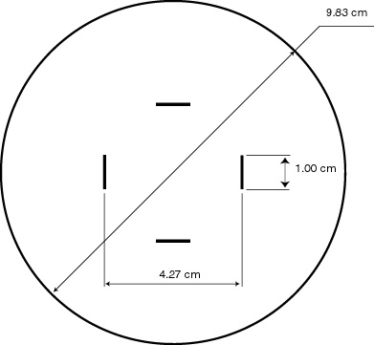

Figure 1. Geometry of the Accumulator Quadrupole pickup.

Plates are connected to the preamplifiers sitting right there on the vacuum chamber, see Figure 2. There are two such devices installed next to each other in sector 60, the normal one and the scew QBPM, the latter has sensing plates rotated 45 degrees around the beam axis.
The whole devices are mounted on the moving XY tables and their position may be controlled remotely with precision of better than 0.1 mm. The functions at the location of the normal QBPM are bx=24m, by=4m, Dx=0.26. Signals from each of 4 PA are sent via twisted pair lines up to building AP10 and connected there to the DATEL ADC card (4channels, PCI, 14 bit, 10MHz). The scew QBPM has not been used in these studies yet.

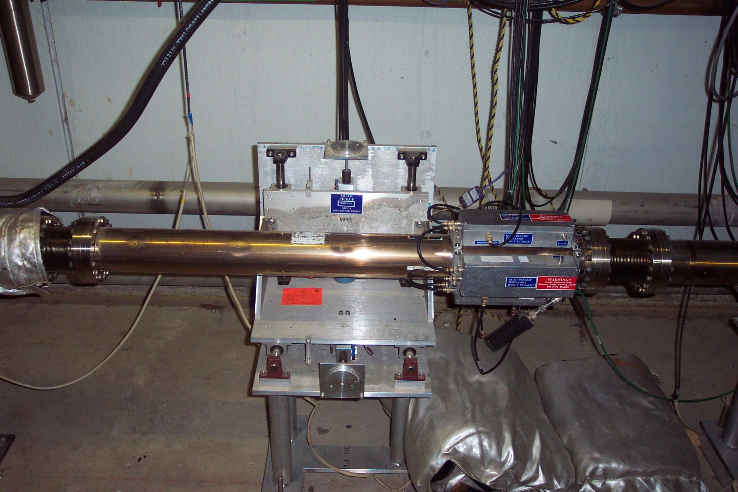

Figure 2. The QBPM in straight section 60 of Accumulator ring.
Signal combinations

A simple single pair pickup response is never exactly linear with the beam displacement. Leaving only first and second order terms we have:

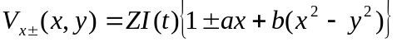 (1a)
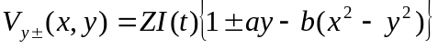 (1b)

where a and b are the pickup geometry parameters. Using 4 signals one can build combinations:

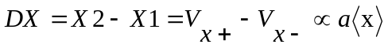 (2a)
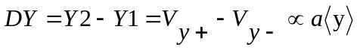 (2b)

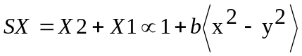
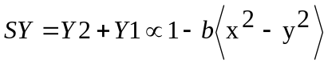 (3)

Combinations (2) are normally used in regular dipole pickups. Combinations 3 are not of a good use unless both are available at the same location. In case of a quadrupole pickup they are and combination

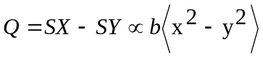 (4)

gives access to the nonlinear term of pickup response.
Ellipticity 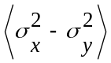 can be used to determine the beam size or to observe quadrupole oscillations of the beam size. More details about the technique will be given in following section.

Betatron mismatch.

The primary purpose of QBPM is measuring the betatron mismatch between the AP3 beam line and the Accumulator. In normalized coordinates

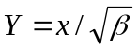
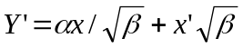

The phase diagram of the beam is represented by the circle as shown in Figure 3 (the dash-dotted line). Beam emittance is the area under this circle and is equal to (π times) square radius A. If beam coming from the beamline has emittance A² and both beta functions and its derivatives at the end of line and at injection point in the ring are equal, the phase diagram of this beam is the same circle and continues to be so as beam continues coasting in the ring.
If functions are not matched between beamline and the ring, we find its phase diagram being an ellipse (red trace). As moving in the ring all particles will rotate in circles around the center of the diagram with betatron frequency, and so will the whole ellips. It is clear in this case that the size of the beam will experience oscillations at double the betatron frequency (quadrupole oscillations). This holds only as long as motion of individual particles can be considered synchronous. That is not true for infinitely long time because each particle has its own betatron frequency, and eventually ellipse smears into a circle with radius equal to the largest half size of this ellipse. The final emittance becomes

A
A/λ
Y’
Aλ
Y

Figure 3. Matched and mismatched phase diagrams of injected beam.

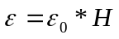, (5)

where 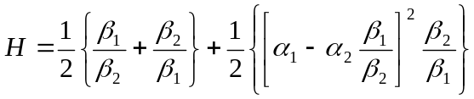,

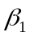, 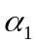- functions in the end of the beamline
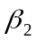, 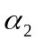- functions at the injection point in the ring

parameter determines how much ellipse is close to the circle, see Figure 3.

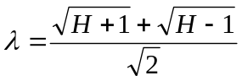

The amplitude of beam size oscillations is 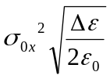

Initial ellipse is described by

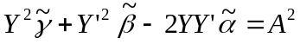 (6)

where 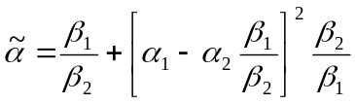, 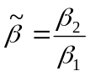,

Initial angle of ellipse can be determined from the phase of quadrupole oscillations. Combined with the amplitude of oscillations, it gives an unambiguous determination of α and β mismatch.
Two parameters are measured for quadrupole oscillations: the phase and the amplitude, this determines 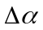 and 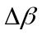.

Frequency content of the signal

Consider transverse motion (let’s take horizontal plane) of an individual particle. Particle position is a sum of 3 components:

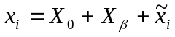

X₀ - orbit position ,
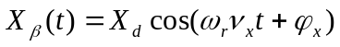 - coherent dipole motion ,
x_{i} -individual betatron motion with respect to the center of beam.

Putting this into (1a) and taking average over all particles in the beam we have

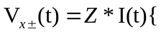 (7)
(I)
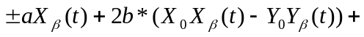 (II)
(III)

This expression is broken up into 3 parts for convenience. “” here corresponds to left and right (top and bottom) plates. Picking right signal combination one can effectively cancel contribution of symmetric or asymmetric components. Part (7-I) contains constant parameters, therefore it appears in signal as constant term and revolution harmonics. Looking at S0=SX+SY at revolution frequency and moving the beam center position one can find the value of b and the beam center position. Plotting DX the same way would give value of a. Combination Q can even be used to measure the beam size if electronics is calibrated at the level of better than 0.1%.
Part (7-II) contains linear amplitudes and mainly appears at betatron frequencies. DX and DY should give a clear dipole signal at betatron frequency.
Consequently, part (7-III) works at double betatron frequencies. It is clear that quadrupole signal combination Q is contributed by two sources, and in order to get a clear quadrupole oscillation one needs to either make the contribution of dipole motion negligibly small, or be able to subtract it from the full quadrupole signal.

Is subtraction necessary?

Presently the requirement posed on beam steering at injection is determined by mainly the operational constraints and is defined as “keeping the steering parameter below 0.4”. Translated into the dipole oscillations amplitude at the location of the QBPM it is 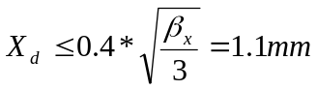.
This results in emittance dilution of

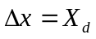, 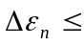2.0π, which is quite substantial amount and may be addressed in future. Until then, however, pure quadrupole oscillation signal may be observed without subtraction of the dipole component if it is bigger than that, or in our case,
bigger than 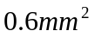. This would correspond to betatron emittance dilution of

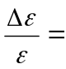0.04 for 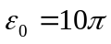 ,
hence limiting betatron mismatch measurement at 10-15%.

More about a signal of real beam

If V(t) is the signal induced on the pickup plates, then the end signal received from the DAQ is its convolution with the response function of the electronics

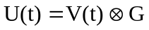

In frequency domain, we will present G(w) for convenience, as G=G₀g(w) with g(w) being the frequency response function and G₀ - the general scale constant. For further convenience we will hide some other constants into G₀, too. Remember that V(t) is a function of t described in eq.(7) Let’s consider part (7-I) in the simplest form 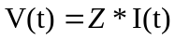, and I(t) is a periodic function 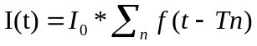, where 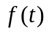 is a rectangular function. Also taking in mind that every particle has its own revolution frequency, one can easily find out that the end signal will look like
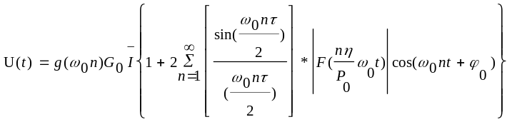 (8)

F(x) here is the Fourier transform for the momentum distribution function. For terms like (7-II):

→
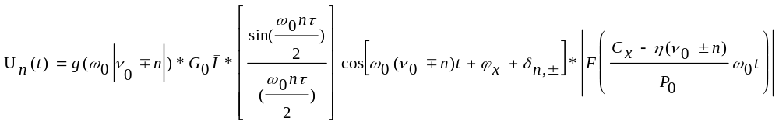
(9)

where
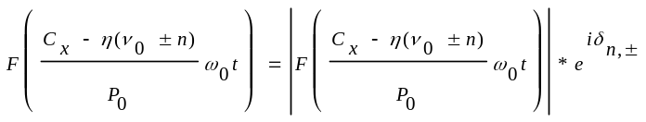 ,

Here we had to take into account chromaticity Cx. And similarly, decomposition into series for functions of the (7-III) type is

→
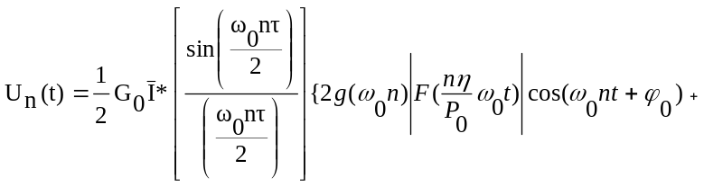
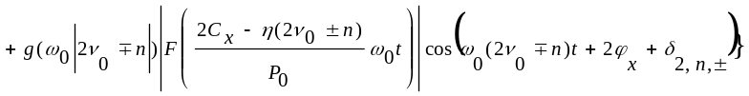 (10)

Obvious properties of F(x):

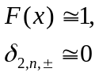 when x << 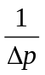

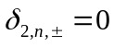 if f(p) is symmetric.

It can be clearly seen that at high chromaticity signal decays quickly due to beam decoherence. Another conclusion from equations 8-10 is that signal is strongly dominated by the common mode component (8). In order to suppress revolution harmonics in the signal, front end preamplifiers had been designed as the bandpass filters with maximum response at 90 kHz and 30 dB suppression at f₀.
Beam position based calibration

If beam is well centered in the pick-up, X₀=0, Y₀=0, then the common mode signal induced at all 4 plates is equal. This fact can be used to match the gains in channels g_{x1}, g_{x2}, g_{y1}, g_{y2}. One must however first determine this beam center position. This can be done with the position scans thanks to the moveable stands holding the QBPMs.
Figure 4 shows the horizontal position scan. Ideally parabola minimum would indicate position X₀=0, and DX line would cross 0 at this point if gains g_{x1}, g_{x2} are matched. However parabola minimum is not located exactly at X₀=0 if gains are not matched. Therefore we used iterative process: from DX at the position of parabola minimum both mismatch and parabola offset were estimated, correction was made to the electronics response and then curves were recalculated again. This process quickly converges and yields values of gain correction and geometric parameters a and b. Matching the gain between horizontal and vertical signals can be done requiring parabola minimum be equal to 1.

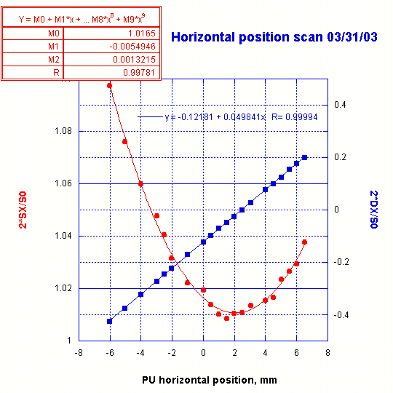

Figure 4. Beam position scan. a₀=0.0498, b₀=0.00132

The limitation of this method is that it gives both gain matching and geometric constants at the revolution frequency only. As a side output of these scans distance between core and extraction orbits was measured on shot lattice:
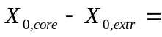3.5 mm , which leads to 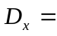0.26 m at the location of QBPM. In order to match gains at arbitrary frequency we were applying the generator signal to one of the channels while measuring response on orthogonal plates. Although this turned out to be an efficient and straightforward way of cross-calibration, it still lacks the absolute gain calibration and it suffers at revolution frequency because of filtering in preamplifiers.

Calculation of geometric parameters and their frequency dependence.

In case of infinite preamplifier input impedance beam with charge Q_{b} would induce potential at one of the plates

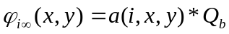

and when beam is exactly at the center, 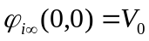

for small compared to aperture deviations of beam from the center, induced potential may be approximated as

geometric coefficients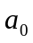, 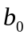 can be computed from the electrostatic model of BPM.
This was done using MERMAID program. Obtained response signal combinations DX and Q are shown in Figure 5 as functions of pick-up position.

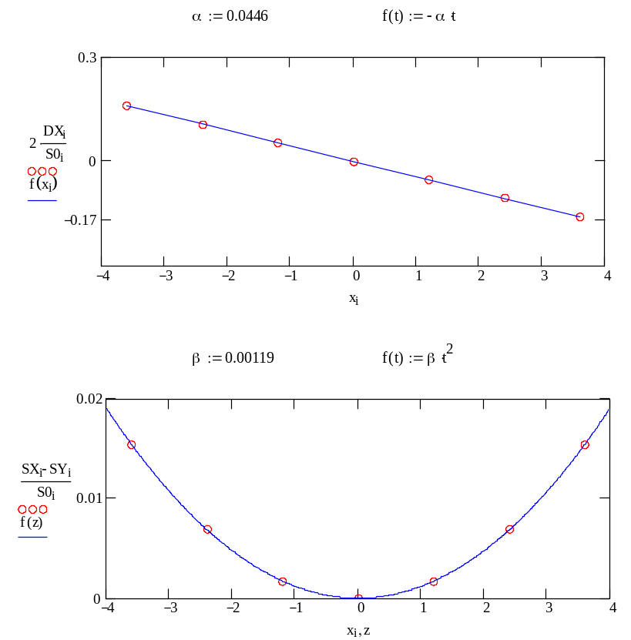

Figure 5. Induced signal on the plates as function of PU position.

Now let’s take into account the preamp’s impedance at finite frequency, see Figure 6.

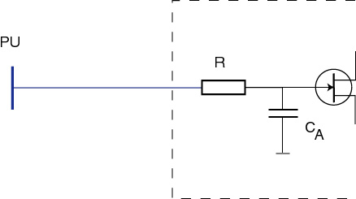

Figure 6. Input impedance of the QBPM preamplifier.

as 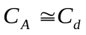, effective parallel capacitance significantly changes at low frequencies.

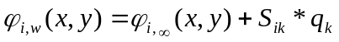,

where 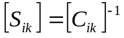, inverse capacitance matrix. Solving this equation yields:
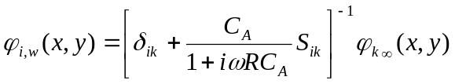 (11)

and coefficients a and b become frequency dependent.
The capacitance matrix was calculated in framework of the same program. Setting on the right plate such a charge that its potential is 1V (this is not necessary, and was done for convenience of computations only), see Figure 7, we calculate potential on other plates.

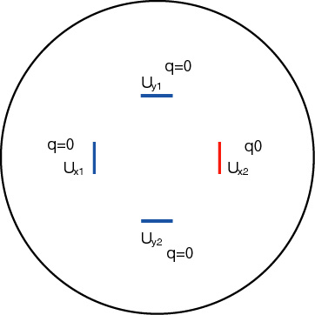

Figure 7. Computation of the cross-capacitance matrix.

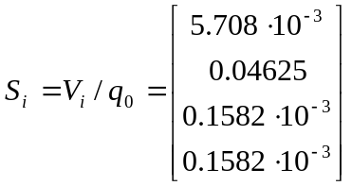

Now we can reconstruct the whole matrix using its symmetry:

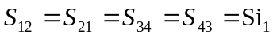
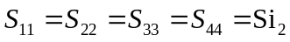

and now using eq. (11) we can calculate dependence a(f) and b(f), as shown in Figure 8.
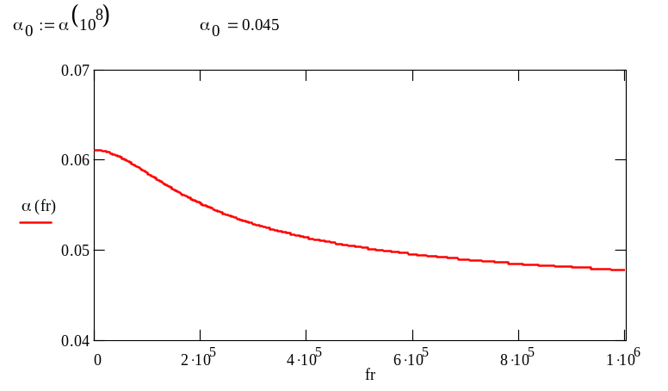

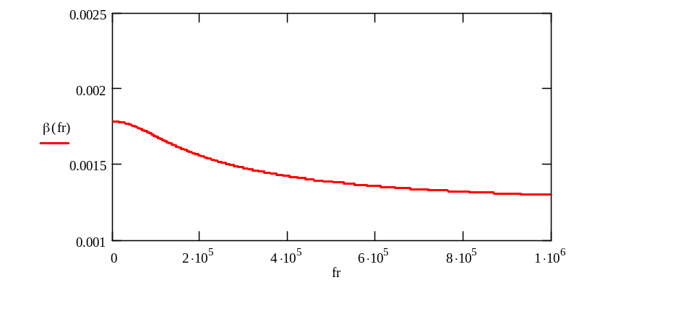
Figure 8. Calculated dependence a(f) and b(f)

The measured and calculated parameters are compared in Table 1. There is a very good agreement with the horizontal scan measurement. For reasons not yet fully understood at this moment vertical scan doesn’t agree very well with the horizontal one.

Table 1. The calculated and measured geometric parameters.

 | Model, f= | Model, f=f0 | Horz. meas. | Vert. meas.
a | 0.0450 | 0.0493 | 0.0498 | 0.0455
b | 0.00119 | 0.00135 | 0.00132 | 0.00146

Measurement of the quadrupole oscillations at lowered chromaticity.

As it has been pointed out earlier, quadrupole oscillations decohere quickly if the chromaticity is high. Unfortunately, this is the case for the extraction orbit in Accumulator. It is more important to keep chromaticity low on the core orbit where the beam lives for many hours rather than at extraction, where beam normally spends only minutes before being transferred to MI. With present range of multipole magnet strengths it is not possible to adjust chromaticity at both orbits at the same time.
Decoherence time for dipole and quadrupole motions is of the order of tens of revolutions. At present observation of such quick processes at injection is obscured by to phenomena: 1) charging the pick-up plates due to beam losses and slow dissipation of this charge, and 2) transition signal appearing as a result of step-like change in DC beam current. The lower filter band frequency, the longer this transition lasts. Both these issues are being addressed at the moment, in the meantime we made a dedicated measurement with lowered down chromaticity. Chromaticity at extraction orbit can be reduced by lowering current in octupole A:OCT10 by 40 Amps. This study was done without stack because during this time chromaticity at core orbit was high.
For the beginning we set up injection with a large dipole mismatch, so that the quadrupole signal is completely dominated by the dipole component, in order to see if we can successfully determine this component based on the dipole signal measured at single betatron frequency.
We can rewrite amplitudes of known signal combinations according to eq. (8-10):

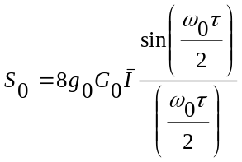 (12)
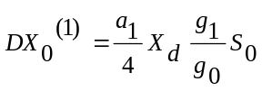 (13)
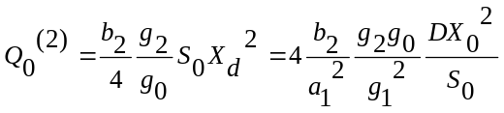 (14)

where 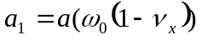, 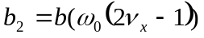, upperscript (1) and (2) in eq.(13) denote single and double betatron frequency. It seems convenient to tie amplitudes with parameter K_{f}, which can be independently determined from both measurements and calculations:

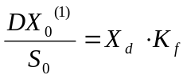, 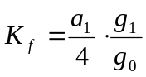
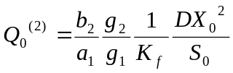

using parameters a, b calculated in previous sections, we expect the dipole term in the quadrupole signal to have the form:
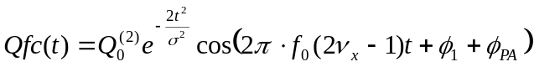

Here time decay constant and phase 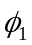 are taken from the dipole mode fit, and 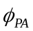 is the phase advance between single and double betatron frequency in the preamp response.

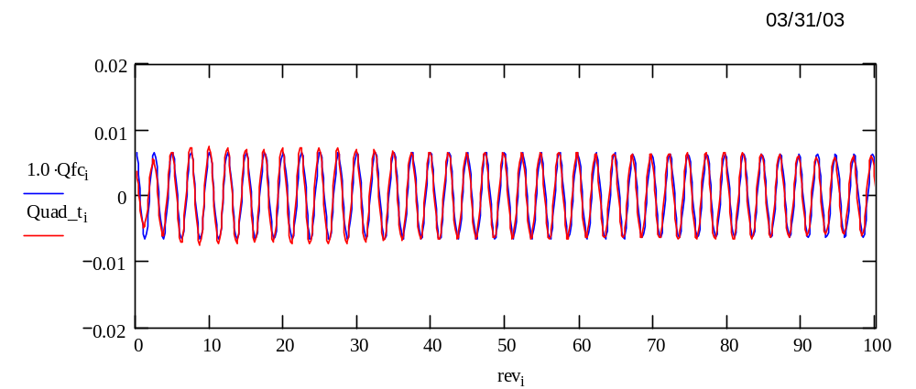
Figure 9. Measured and calculated dipole component in quadrupole signal

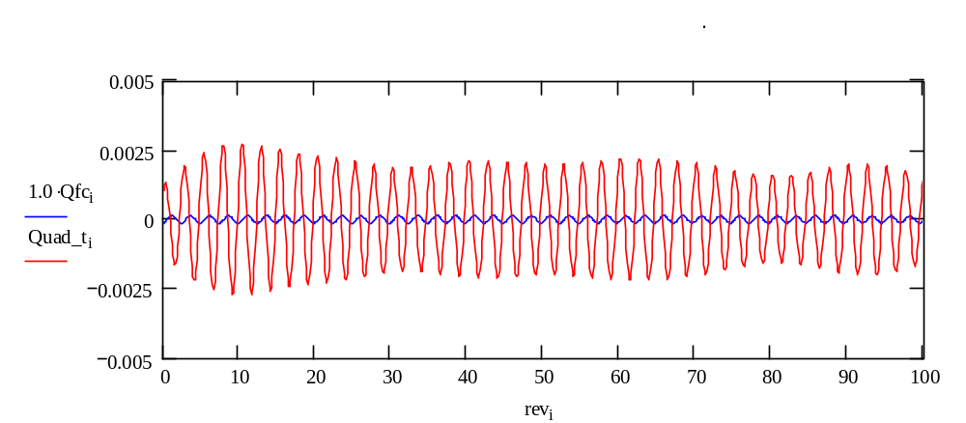

Figure 10. Pure quadrupole oscillation signal in absence of dipole component.
Both amplitude and phase of measured quadrupole signal agree very well with expected waveform calculated from the dipole signal.
Different beamline tuning when in contrary, steering error is very small, is shown in Figure 10. The dipole component is negligible and quadrupole oscillation signal is clearly seen although its amplitude is low. Parasitic components at revolution and betatron frequencies were removed from the Quad_t signal, this was done by filtering a broad region around double betatron frequency in FFT spectrum of Q signal combination and then deconverting this region back to time domain. This explains aliasing modulations of the signal sin-wave. Observed amplitude of quadrupole oscillation is consistant with the introduced betatron mismatch assuming 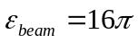 for injected Reverse proton beam, and corresponds to emittance growth of 50%. ADC sensitivity is not a limiting factor, however, because gain may be increased by a factor of 50 in preamplifier without yet reaching the limit of dynamic range in ADC.
Thermal noise of an input circuit is equivalent to 1/50 ADC LSB in 200 kHz band, and is not an issue without substantial increase of bandwidth.

Conclusions

In the studies performed with Quadrupole BPM at Accumulator ring it was demonstrated that quadrupole oscillation modes may be observed and measured using this instrument if chromaticity is low at extraction orbit. Mathematical model of the pick-up response and signal development shows reasonable agreement with the collected data.
In order to make this device serve operations, however, electronics needs to be modified in order to recognize quick developing signals.

