2008 KANSAS
SEVERE WEATHER AWARENESS WEEK
MARCH 10-14, 2008

TORNADO SAFETY DRILL TUESDAY, MARCH 11th
1:30 PM CDT

INFORMATION PACKET
National Weather Service



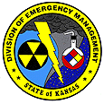

County Emergency Management Director,

The National Weather Service, the Kansas Emergency Management Association, and the Kansas Division of Emergency Management request your participation in “Kansas Severe Weather Awareness Week” activities from March 10 – 14, 2008. The annual statewide tornado drill will take place on Tuesday, March 11th at 1:30 pm CDT, with a backup date of Thursday, March 13th.

Enclosed is tornado and severe weather information that can be used for preparedness activities in your local jurisdiction. Feel free to duplicate and distribute this information as necessary.

2007 was another record breaking year for tornadoes in the state of Kansas. A total of 137 tornadoes occurred in the state and resulted in 14 fatalities, 82 injuries and millions of dollars in damage to homes, property and infrastructure. The 2007 total surpasses the previous record of 135 tornadoes set in 2005. In addition, numerous severe thunderstorms caused millions of dollars in damage to property and crops by producing damaging winds and large hail. Flooding and flash flooding was widespread in Kansas this year and caused millions of dollars in damage to private property and infrastructure.

Kansans live with the threat of severe weather year round. Kansas Severe Weather Awareness Week is the ideal time to prepare for severe weather. Families should practice their severe weather safety plan at home, work, school or other public locations that they frequent. They should develop a safety plan for times when they are participating in outdoor recreation activities, sporting events, or working outdoors. Each Kansan should know where to go should severe weather strike their location.

All Hazards NOAA Weather Radio is like having your personal tornado siren in your home or vehicle. We encourage Kansans to purchase a weather radio and have it programmed to their county and/or surrounding counties to receive severe weather warnings and information directly from the National Weather Service. Now is a great time to replace the back-up battery in your NOAA All Hazards Weather Radio so that you get severe weather information even if the power goes out.

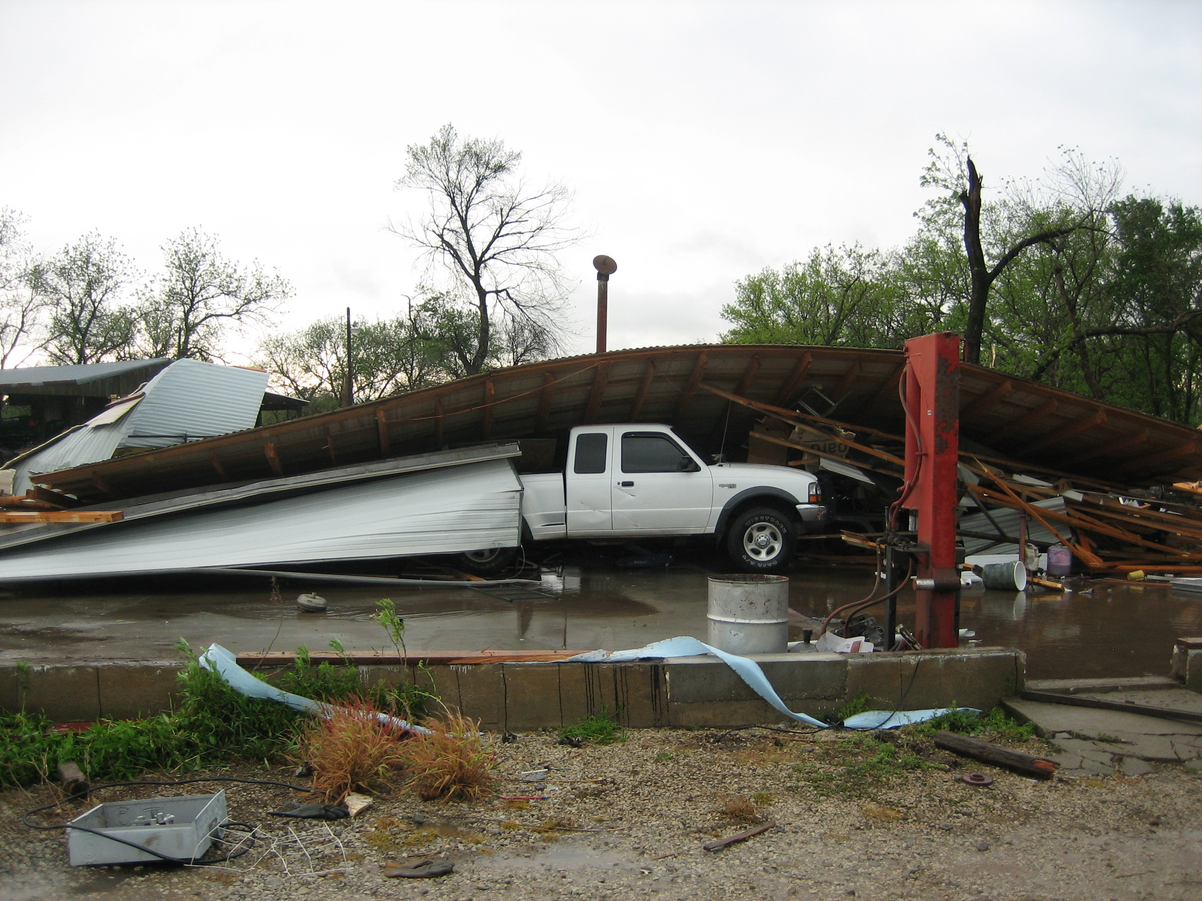
As always, the National Weather Service offices that serve the state of Kansas look forward to partnering with you and your staff to help Kansans prepare for severe weather. Please contact the Warning Coordination Meteorologist at your local office if you have any questions or comments regarding this packet. Visit our webpages for the latest forecasts and severe weather information.

www.weather.gov/topeka
www.weather.gov/wichita
www.weather.gov/dodgecity
www.weather.gov/goodland
www.weather.gov/kansascity
www.weather.gov/springfield
www.weather.gov/hastings

2007 Kansas Tornado Facts

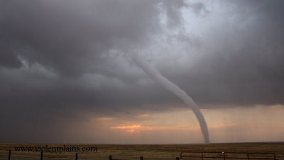
Tornadoes: 137 (80 above the 1950-2007 average of 57)

Deaths: 14 Injuries: 82

Longest Track: 34 miles (Sherman-Cheyenne Counties - March 28)

Strongest: EF5 (Greensburg, May 4)

Most in a county: 11 (Stafford)
March 28, 2007 near Sharon Springs in NW Kansas. Photo courtesy of Scott Currens
Days of occurrence: 22

Most in one day: 36 (May 5)

Most in one month: 77 (June)

Record Months: February (9), March (26), May (77)

First tornado of the year: February 23 (Meade County, 9:56 pm CST)

Last tornado of the year: September 28 (Gove County, 7:21 pm CDT)

----------------------------- 2007 Monthly Tornado Totals -------------------------
Month | Jan | Feb | Mar | Apr | May | Jun | Jul | Aug | Sep | Oct | Nov | Dec | Total
Total | 0 | 9 | 26 | 18 | 77 | 3 | 1 | 2 | 1 | 0 | 0 | 0 | 137 | 100%
EF5 | 0 | 0 | 0 | 0 | 1 | 0 | 0 | 0 | 0 | 0 | 0 | 0 | 1 | 1%
EF4 | 0 | 1 | 0 | 0 | 0 | 0 | 0 | 0 | 0 | 0 | 0 | 0 | 1 | 1%
EF3 | 0 | 0 | 1 | 0 | 3 | 0 | 0 | 0 | 0 | 0 | 0 | 0 | 4 | 3%
EF2 | 0 | 0 | 1 | 0 | 5 | 0 | 0 | 0 | 0 | 0 | 0 | 0 | 6 | 4%
EF1 | 0 | 2 | 6 | 5 | 19 | 0 | 0 | 0 | 0 | 0 | 0 | 0 | 32 | 23%
EF0 | 0 | 6 | 18 | 13 | 49 | 3 | 1 | 2 | 1 | 0 | 0 | 0 | 93 | 68%

Weak (EF0, EF1) tornadoes shaded green, strong (EF2, EF3) shaded yellow, violent (EF4, EF5) shaded red.

Yearly Summary: The number of Kansas tornadoes in 2007 set a new record with 137, surpassing the record of 135 set just two years prior. February, March and May of 2007 set new records for the number of tornadoes in each of those months. The EF5 tornado which struck Greensburg on May 4th was the first (E)F5 tornado in the country since May 3, 1999. One other violent tornado affected Kansas on February 28th. Ten strong tornadoes occurred in 2007, with 125 weak tornadoes.

Other Kansas Tornado Facts: May 5th produced 36 tornadoes in the state, falling just short of the all-time record of 39 tornadoes in one day set in June of 1992. Fourteen fatalities were reported in 2007, including 82 injuries. Thirteen of these fatalities occurred during the May 5th outbreak. 2007 is now ranked 6th highest in Kansas fatalities since reliable records began in 1950. Since the year 2000, 834 tornadoes have occurred in Kansas, which is greater than any decade since 1950.

KANSAS SEVERE WEATHER AWARENESS WEEK
MARCH 10 – 14, 2008
KANSAS TORNADO STATISTICS
by County
1950 - 2007
TORNADOES, FATALITIES, AND INJURIES

County Tor Fat Inj County Tor Fat Inj County Tor Fat Inj

Allen | 24 | 0 | 4
Anderson | 14 | 3 | 12
Atchison | 15 | 0 | 11
Barber | 26 | 0 | 2
Barton | 74 | 2 | 37
Bourbon | 16 | 0 | 7
Brown | 42 | 0 | 5
Butler | 61 | 28 | 225
Chase | 33 | 0 | 2
Chautauqua | 15 | 0 | 0
Cherokee | 34 | 4 | 41
Cheyenne | 37 | 0 | 0
Clark | 29 | 0 | 0
Clay | 33 | 1 | 31
Cloud | 43 | 1 | 8
Coffey | 19 | 0 | 5
Comanche | 29 | 0 | 2
Cowley | 50 | 77 | 291
Crawford | 33 | 4 | 43
Decatur | 40 | 0 | 5
Dickinson | 32 | 0 | 9
Doniphan | 17 | 0 | 2
Douglas | 34 | 1 | 48
Edwards | 33 | 0 | 6
Elk | 22 | 2 | 8
Ellis | 45 | 0 | 5
Ellsworth | 42 | 0 | 0
Finney | 74 | 1 | 39
Ford | 71 | 0 | 0
Franklin | 25 | 3 | 34
Geary | 16 | 0 | 3
Gove | 24 | 0 | 1
Graham | 33 | 0 | 0
Grant | 24 | 0 | 9
Gray | 29 | 0 | 3
Greeley | 29 | 0 | 0
Greenwood | 35 | 0 | 10
Hamilton | 20 | 0 | 1
Harper | 55 | 0 | 1
Harvey | 46 | 1 | 63
Haskell | 21 | 0 | 10
Hodgeman | 41 | 0 | 4
Jackson | 28 | 3 | 17
Jefferson | 39 | 0 | 101
Jewell | 30 | 0 | 1
Johnson | 31 | 4 | 12
Kearny | 30 | 0 | 0
Kingman | 44 | 0 | 1
Kiowa | 35 | 11 | 74
Labette | 31 | 1 | 29
Lane | 18 | 0 | 2
Leavenworth | 28 | 2 | 30
Lincoln | 27 | 0 | 2
Linn | 12 | 0 | 3
Logan | 18 | 0 | 0
Lyon | 39 | 6 | 217
McPherson | 41 | 1 | 16
Marion | 43 | 1 | 2
Marshall | 28 | 0 | 1
Meade | 43 | 0 | 0
Miami | 18 | 0 | 9
Mitchell | 42 | 0 | 5
Montgomery | 31 | 1 | 1
Morris | 28 | 0 | 7
Morton | 18 | 1 | 2
Nemaha | 30 | 0 | 1
Neosho | 28 | 0 | 4
Ness | 33 | 0 | 4
Norton | 19 | 0 | 0
Osage | 36 | 17 | 6
Osborne | 37 | 0 | 13
Ottawa | 24 | 2 | 9
Pawnee | 42 | 0 | 1
Phillips | 37 | 0 | 1
Pottawatomie | 29 | 0 | 5
Pratt | 56 | 1 | 8
Rawlins | 46 | 0 | 4
Reno | 66 | 0 | 20
Republic | 48 | 0 | 1
Rice | 39 | 0 | 6
Riley | 26 | 0 | 51
Rooks | 40 | 0 | 6
Rush | 28 | 0 | 8
Russell | 63 | 1 | 7
Saline | 27 | 0 | 66
Scott | 35 | 1 | 1
Sedgwick | 75 | 13 | 321
Seward | 32 | 0 | 15
Shawnee | 44 | 18 | 528
Sheridan | 20 | 0 | 0
Sherman | 91 | 0 | 0
Smith | 39 | 0 | 1
Stafford | 55 | 1 | 4
Stanton | 18 | 0 | 0
Stevens | 24 | 1 | 5
Sumner | 71 | 5 | 14
Thomas | 40 | 0 | 1
Trego | 45 | 5 | 101
Wabaunsee | 31 | 0 | 14
Wallace | 35 | 0 | 4
Washington | 31 | 2 | 12
Wichita | 21 | 3 | 4
Wilson | 13 | 0 | 0
Woodson | 12 | 0 | 8
Wyandotte | 9 | 2 | 36
Total | 3632 | 232 | 2809

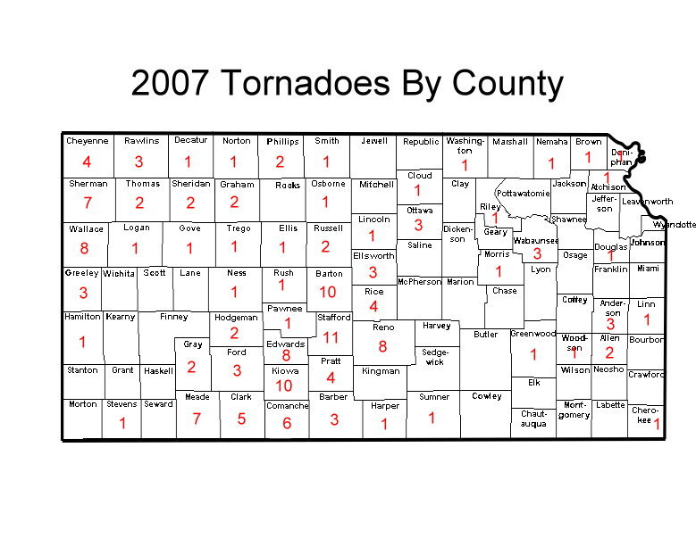
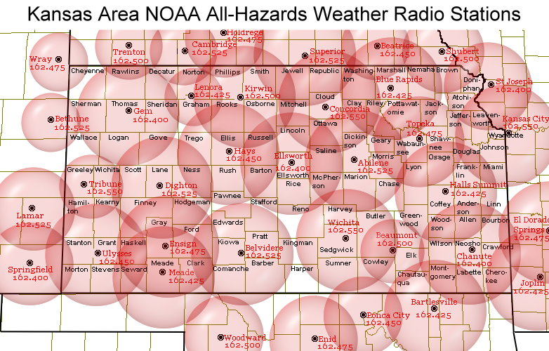

KANSAS SEVERE WEATHER AWARENESS WEEK
MARCH 10 -14, 2008
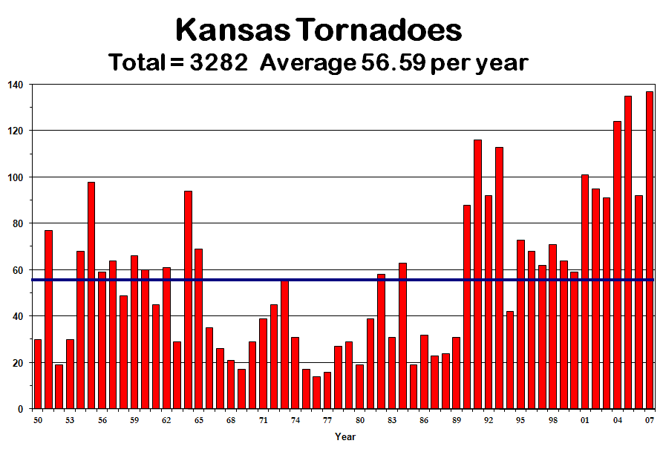

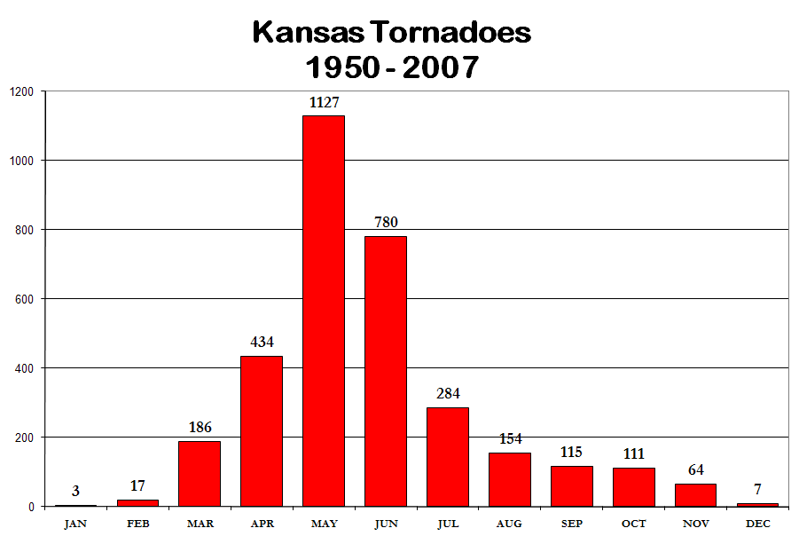
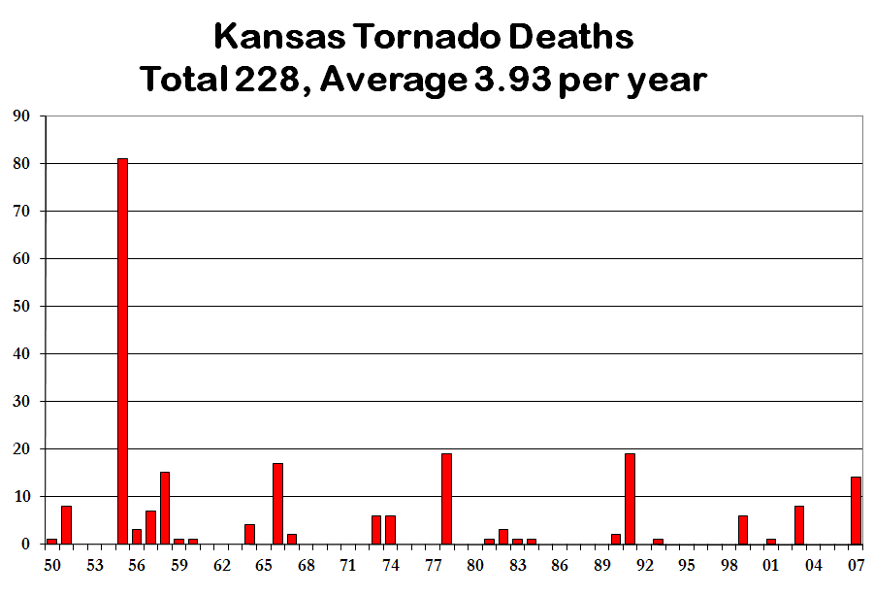

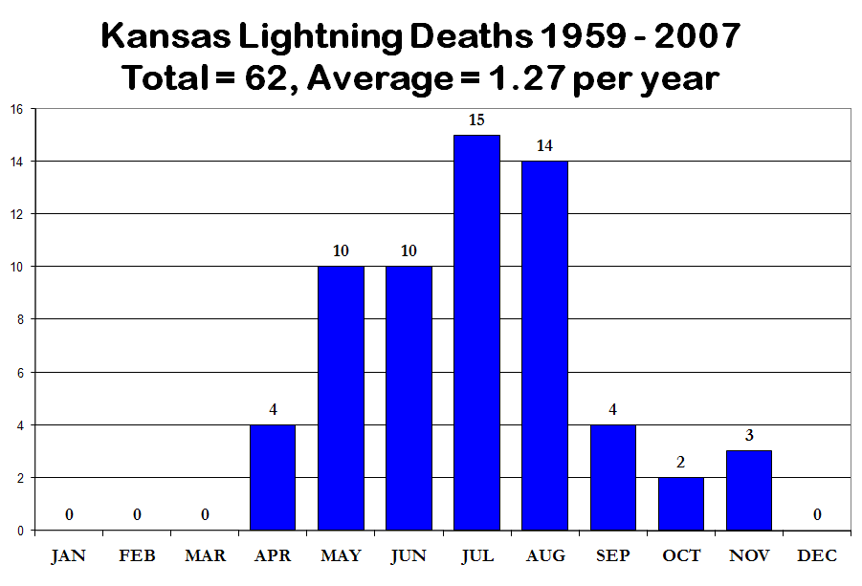
KANSAS SEVERE WEATHER AWARENESS WEEK
MARCH 10 – 14, 2008

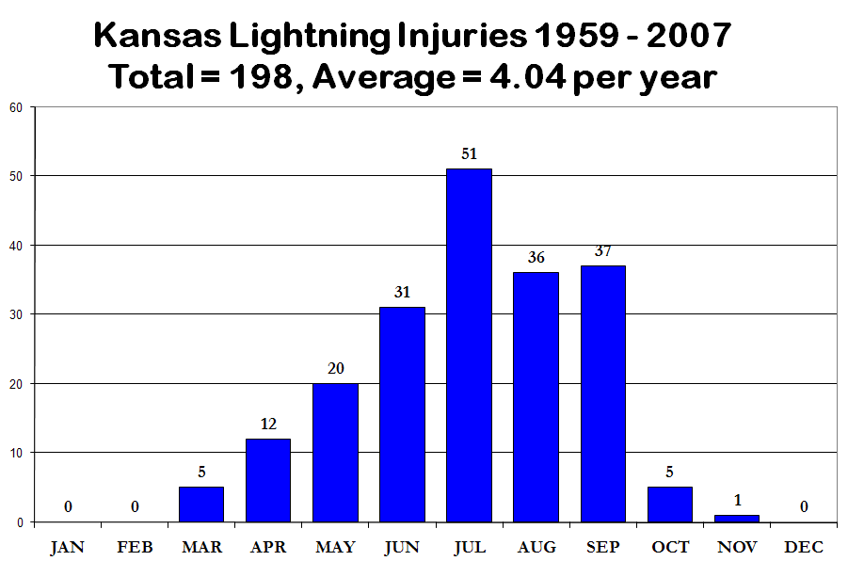

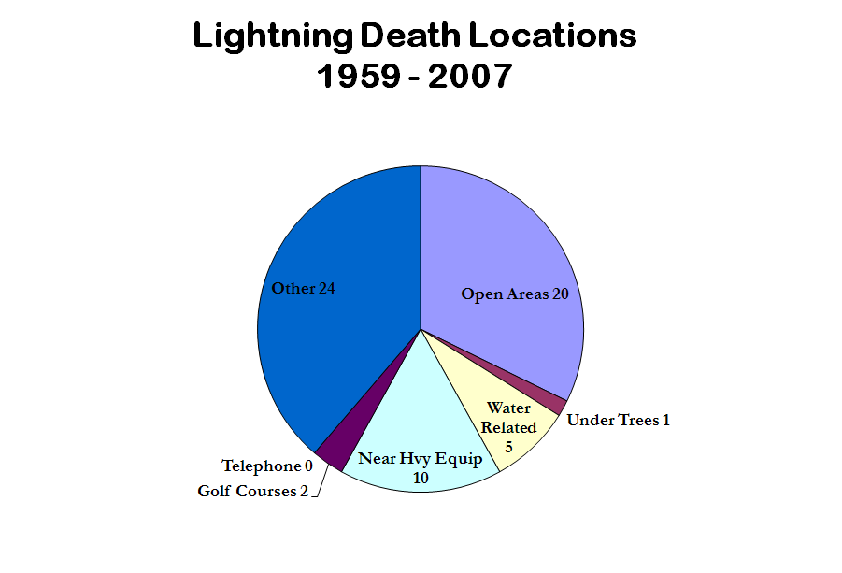
KANSAS SEVERE WEATHER AWARENESS WEEK
MARCH 10 – 14, 2008
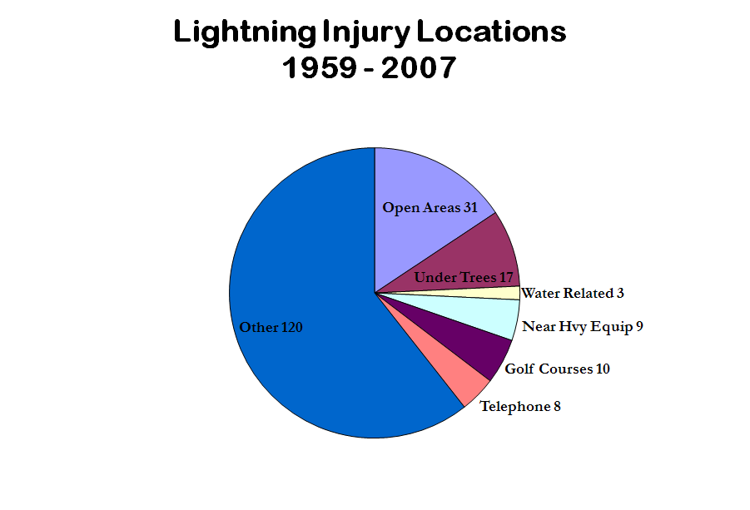
First Ever EF5 Tornado Destroys A Small Kansas Town

On May 4th, 2007, a monster tornado devastated the town of Greensburg, Kansas and surrounding countryside. It was the strongest recorded tornado since the May 3, 1999 Moore, Oklahoma twister. Despite a warning with 26 minutes of lead time, the town of around 1500 persons still lost 11 lives. Many of those died in basements. There were also 63 injuries reported. First responders arriving on the scene requested three refrigerated refer trucks thinking there would be hundreds of fatalities. Fate no doubt played a role in the relatively low loss of life given the situation.

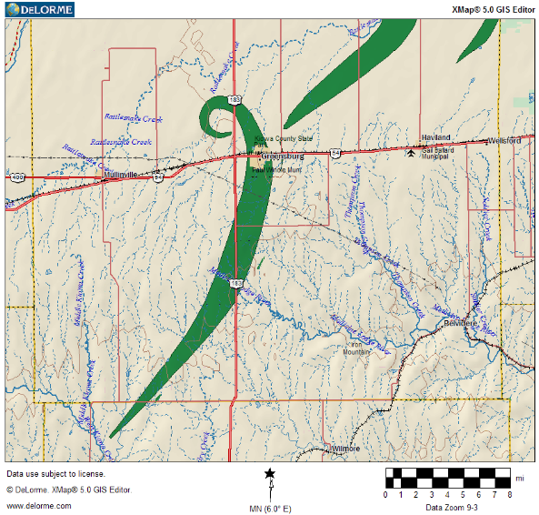
The killer tornado started in a neighboring county to the south and crossed into Kiowa County shortly after 9 PM CST. It curved north then northwest before making a complete loop northwest of Greensburg, travelling nearly 26 miles and was on the ground for a little over 1 hour.

As the tornado was in a stage of dissipating it turned northwest, west, south and then back east making a loop. This was documented on both high resolution Doppler radar and through the ground survey. Also, as the tornado was dissipating a new circulation quickly grew northeast of town.

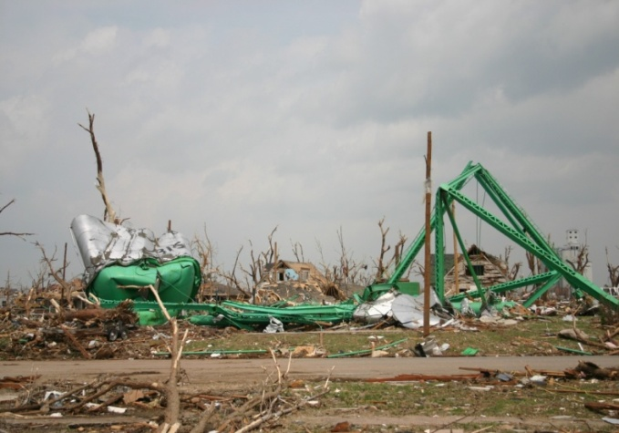
Ninety percent of the town was destroyed or heavily damaged. In Greensburg alone, 961 homes and businesses were destroyed and 216 received major damage. The tornado also destroyed a dozen homes and a church south of Greensburg, but did not cause injury there. Remarkably, the tornado took down the town’s only water tower…which also stood above the famous “hand dug well” and meteorite.

Outside of town, several oil storage tanks were destroyed causing an environmental concern.

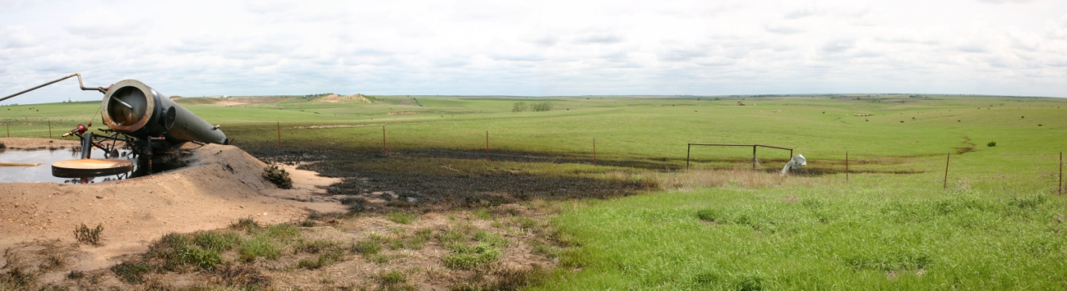

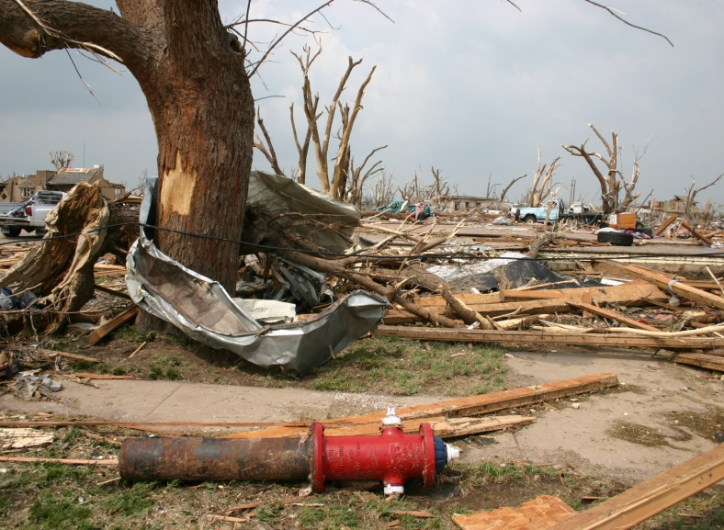
In the town of Greensburg, hazardous material was strewn everywhere. Even fire hydrants were displaced from their original locations. As of July 26th, debris was still not fully cleaned up. Two landfills were filled with debris from the town even though most of the debris was burned. Hundreds of thousands of dump truck loads were taken out. It was estimated that approximately 400,000 cubic yards of debris was removed.

The major highway running through town was closed for 1 full month. At one time, there was over 150 law enforcement officers (from all over the country) present. Military was called in for debris removal and rebuilding.

KANSAS SEVERE WEATHER AWARNESS WEEK
MARCH 10 – 14, 2008
07 Severe Weather Summary
Southwest Kansas
National Weather Service, Dodge City

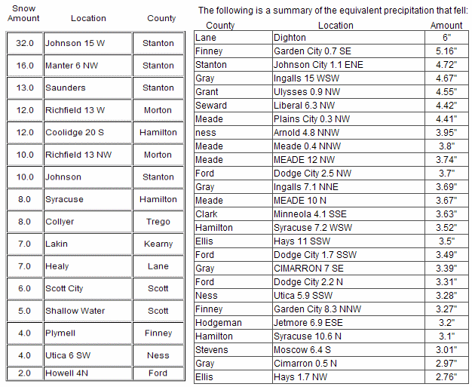

Crippling weather greeted the new year of 2007 as the remnants of a historic snow and ice storm left the area on New Year’s Eve. Snowfall of up to 32 inches fell near the Colorado border with huge drifts; up to 2 ½ inches of ice brought down electrical and communication towers; and the combination of rain, ice and snow brought up to 6 inches of moisture that would eventually cause widespread flooding. Power was out in some locations of rural Western Kansas until March!

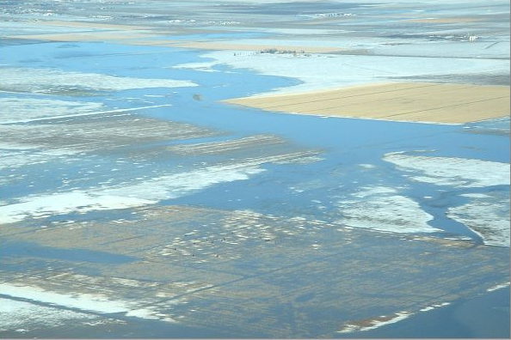
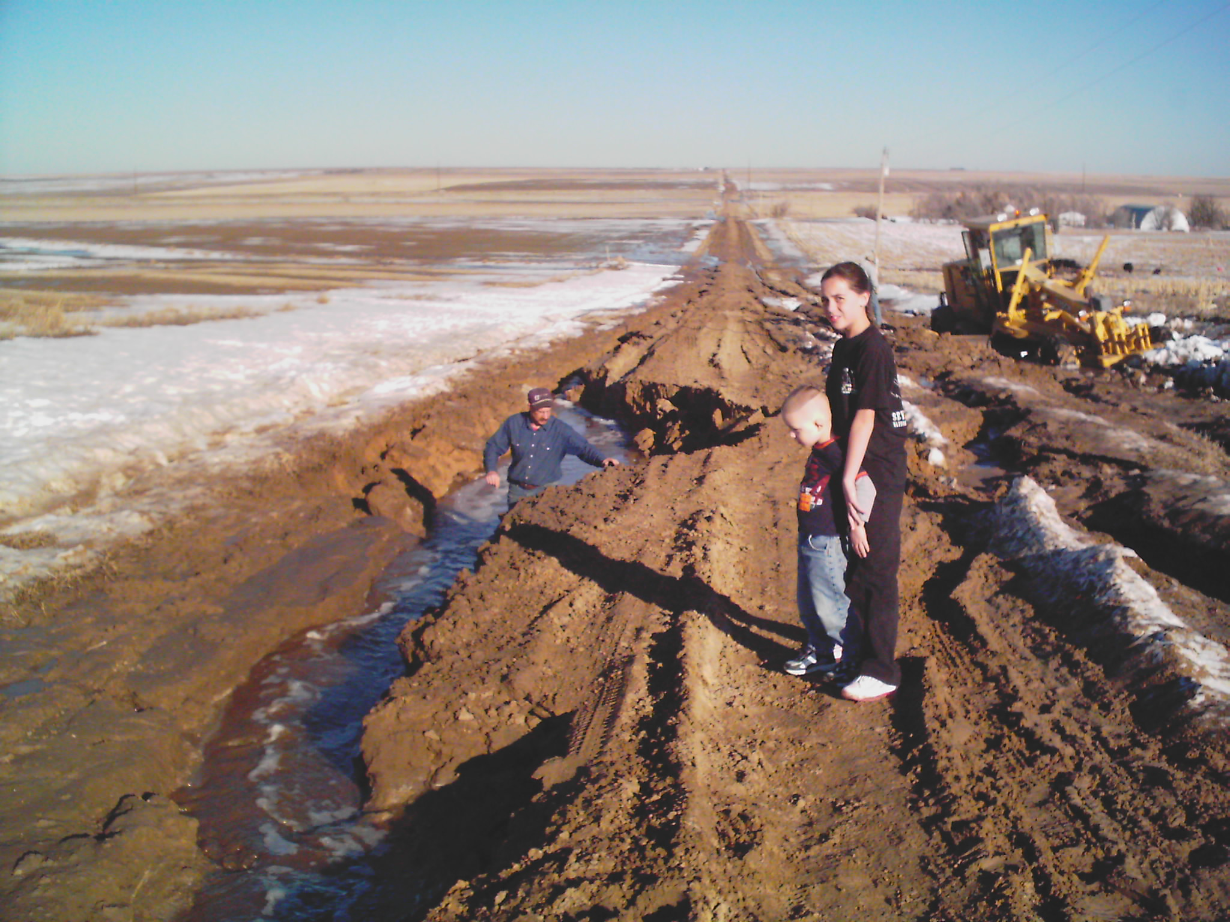
Late in February and into early March, the massive amount of ice and snow, coupled with saturated ground led to a tremendous amount of flooding in Stanton, Hamilton, Grant, Kearny, Finney, Lane and Scott counties. Millions of dollars in damage was done to county roads and a few structures. Many elderly farmers commented that they had NEVER witnessed so much water or flooding!

February also brought night-time tornadoes to southwest Kansas which produced damage and even left a bit of snow on the ground! Tornadoes in February in southwest Kansas have never been documented before. The twisters occurred late in the evening on the 23rd. Two tornadoes danced across the farmland of Meade, Gray and Ford counties. The strongest and longest lived tornado had its sights set on Dodge City but fortunately it dissipated before reaching the city of 30,000 plus. However, the tornado did produce EF1 damage southwest of town.

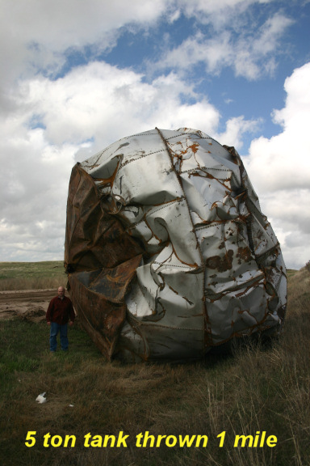
Tornadoes occurred again in March, this time in an outbreak of 9 twisters that caused significant damage during darkness on the 28th. The strongest, and longest tracked tornado, passed from west of Jetmore to west of Ness City. It had a path length of 29 miles and was ¾ of a mile wide. Fortunately, folks in the path of the tornadoes that night had ample warning and were able to take precautions to prevent injury or death. Although no human life was lost, there were approximately 90 head of cattle that perished along the path of the largest tornado. A dozen homes were either destroyed or received some damage. Over 150 power poles were taken down along with many miles of transmission lines. Some sheet metal debris from one farm was found over 30 miles away. Also, a 5 ton storage tank was thrown 1 mile!

The weather got even crazier in April. On Friday the 13th, a major snow storm struck much of western Kansas. The snow was also accompanied by quite a bit of cloud-to-ground lightning. The heaviest amount of snow reported was 15 inches near Ulysses. Ten to twelve inches was common from Stanton into Ford County. Snow drifts were 2 to 4 feet.

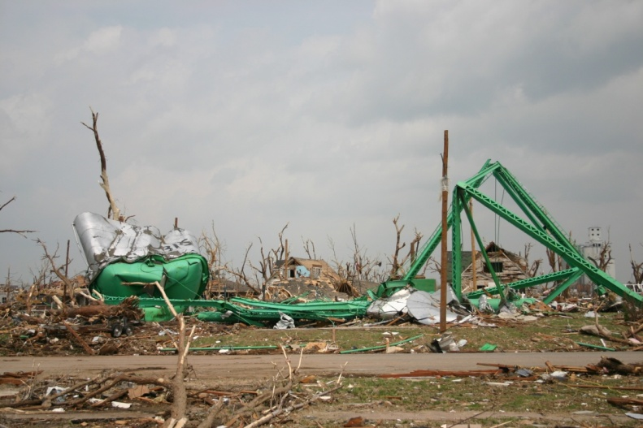
Could it have gotten worse? Indeed, it happened! May 4th, 2007 will go down as a historic day when the town of Greensburg in Kiowa County was nearly wiped off the face of the earth by an EF5 tornado, the strongest in a classification from 0 to 5. Unfortunately, 11 people perished in Greensburg with dozens injured, despite ample warning of 26 minutes. Fate surely played a role in the “relatively” low number of deaths given the sheer magnitude of the damage. Other killer tornadoes occurred with a death in Pratt County and a death in Stafford County reported. Some of these monsters were nearly 2 miles wide! In all, 12 tornadoes occurred on the 4th. There was also an environmental concern with the amount of toxic material that was moved around by the tornadoes, ranging from asbestos, to solvents, to crude oil. An oil storage tank south of Greensburg ruptured spilling many barrels of oil onto the surrounding land.

KANSAS SEVERE WEATHER AWARENESS WEEK
MARCH 10 – 14, 2008
Another outbreak followed the next day on the 5th of May when 17 tornadoes moved across nearly the same area. Fortunately, there were no deaths reported but there was more substantial damage. Unbelievably, another 3 tornadoes occurred on the 6th but this time a bit farther south and east.


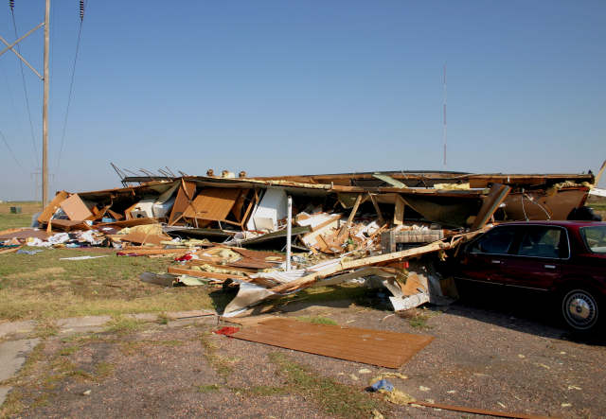
Other than typical summer heat and dryness, the weather was comparatively uneventful until August 20th when severe thunderstorms produced widespread down bursts, heavy rain and hail from Dighton to near Sublette. Sadly, one downburst rolled a trailer house in western Garden City, claiming the life of an elderly woman. Other downbursts caused considerable damage to the Holcomb high school, especially to the auditorium and gymnasium roof. Damage was around one million dollars there. Wind speeds in this area were estimated to be 90 to100 mph. As the storm complex rolled on south it produced considerable destruction along its path, taking out many sprinkler irrigation pivots, power poles, and trees and also did quite a bit of damage to the Sunflower Electric Power Corporation plant south of Holcomb. Damage was close to a million dollars there too. Other pivot sprinklers and damage to some mobile homes occurred on into Haskell County.

Other than becoming extremely dry during the end of summer and into the fall, there were a few daily temperature records set. In other words, it was just a typical summer.

The number of tornadoes in southwest Kansas this year was astonishing as 53 twisters were reported! This follows last year when 41 were observed and also in 2005 when there were 52 tornadoes reported. The average for a year in southwest Kansas is 14 and the average for the whole state of Kansas is around 55! Hopefully, the weather during 2008 will be much less eventful. But, we do need rain for crops, streams and lakes…just not accompanied by all the severe weather.

White, Wild, Windy and Wet Spring/Summer of 2007
By: Chris Bowman Meteorologist Intern &
Andy Kleinsasser, General Meteorologist

Once again, central, south-central and southeast Kansas lived up to its notorious reputation for severe weather in 2007. But instead of the expected high occurrence of tornadoes, large hail and damaging winds, very heavy rainfall and flooding “stole the show.” Not to say that tornadoes large, large hail and damaging winds didn’t occur, because they certainly did, especially during the month of May, and occasionally displayed quite a violent temper. Additionally, heavy snow and well below freezing temperatures affected portions of the area relatively late into the spring months.

While every significant weather event, regardless of magnitude, is treated with the utmost respect and importance by The National Weather Service, only the largest and most noteworthy events will be highlighted in this article. These highlights include (in chronological order): heavy April snowfall and early hard freeze, May 4-6th severe thunderstorms, and May 31-June 1st severe thunderstorms. The major flooding that occurred in May, June and July across portions of the area will be covered in another article.

Heavy April Snowfall and Early Hard Freeze

Early on April 5th, a backdoor cold front pushed southwestward into portions of central through southeast Kansas. This front stalled and interacted with an upper level system to develop a rather intense and narrow band of snow, stretching from Russell and Lincoln counties, southeastward across Saline, McPherson and Marion counties, and eventually losing steam across Greenwood and Elk counties. The heaviest accumulations (6 to 8 inches) occurred from southwest Saline County to southeast Marion County and encompassed the northeast two-thirds McPherson County.
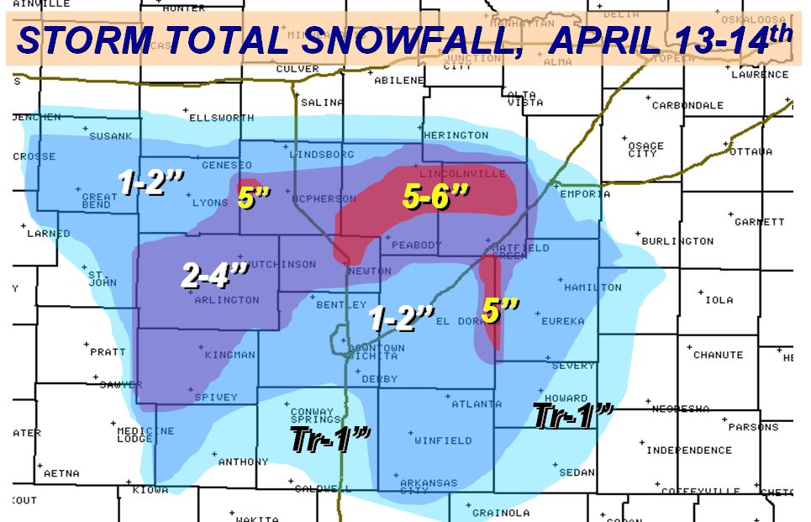
A 2nd powerful spring storm system moved through Kansas from the afternoon of April 13th to the early morning hours of April 14th. A 5 to 6-inch swath of heavy, wet snow blanketed northern Harvey through Chase Counties. Lesser amounts on the order of 2 to 4 inches blanketed areas from Kingman through Reno and McPherson Counties. 1 to 2 inches fell across Sedgwick County with Wichita’s Mid-Continent Airport setting a record for the latest measurable snowfall.

Between the two storms, several locations measured over 8 inches, and recorded their snowiest April on record. A few notable amounts include 11.3 inches at Hillsboro, 10.5 inches at McPherson, 10 inches at Cassoday, 10 inches at Marion Lake, 9.4 inches at Lindsborg, and 8.1 inches at Newton.
KANSAS SEVERE WEATHER AWARENES WEEK
MARCH 10 – 14, 2008
Furthermore, an unwelcomed late season Arctic blast plummeted nighttime temperatures into the 20s across central, south central and southeast Kansas April 4th through the 8th. Although readings rose above freezing during the daytime hours, the prolonged and bitter cold nighttime temperatures wreaked havoc on Kansas crops. The winter wheat crop was in the jointing stage of development, and thus suffered the most damage. Strangely, some fields received negligible freeze damage, while an adjacent field sustained extensive damage. Central Kansas crops, traditionally known as the heart of Kansas wheat production, felt the brunt of the freeze. Winter wheat crop damage from the Easter Weekend freeze is unknown, but estimates place it at hundreds of millions of dollars.

May 4th-6th Severe Thunderstorms

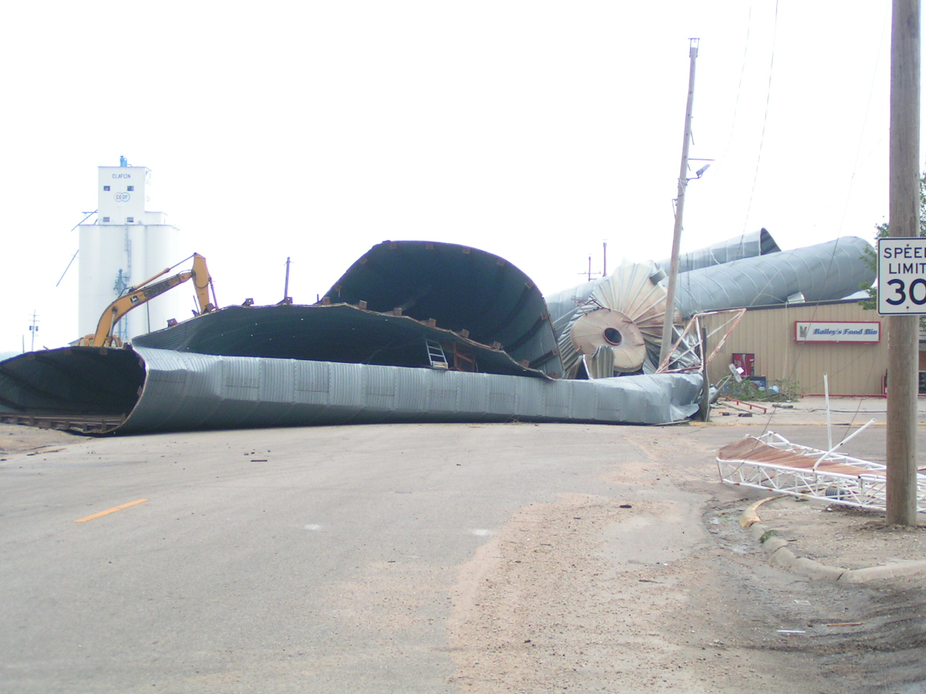
A stalled dryline across western and central Kansas produced several bouts of severe thunderstorms from very late in the day on May 4th through late in the day on May 6th, including the devastating Greensburg tornado. Twenty tornadoes occurred across Barton, Rice, Russell, Lincoln, Harper and Reno counties over the 3 day blight, as well as countless large hail and damaging wind reports. Fortunately, the tornadoes were rated as EF1 or EF0, meaning significant damage to well built structures did not occur. Most of the tornado and wind damage was limited to trees, outbuildings, barns, sheds and power lines. Well built structures such as homes and businesses did receive some damage, but was for the most part relatively minor. Barton county was hit particularly hard a few nights in a row, where 500 power poles including several large transmission lines were downed, causing at least 4.5 million dollars in damage. Additionally, a tornado destroyed five 100,000 bushel grain bins in Claflin, with two of them being flung onto the local Dillon's grocery store. Near the intersection of Highway 56 and 156, another tornado damaged several center pivot irrigation devices, and also damaged a gasoline pipeline terminal and specialized trailer company near the intersection of U.S. 56 and K-156. Portions of Ellsworth, Rice, Russell and Lincoln Counties were also hit hard by tornadoes and/or damaging straight-line winds.

May 31st –June 1st Severe Thunderstorms

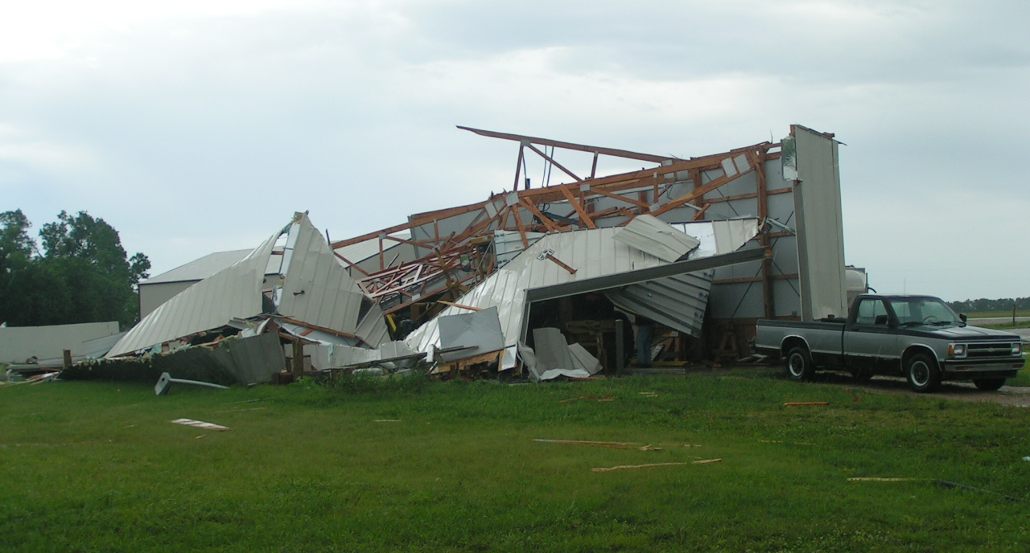
A strong upper level disturbance approached from the northwest and spawned a powerful squall line during the evening hours of May 31st. The squall line moved east to southeast across portions of central and south-central Kansas, producing large hail and high winds in its path. Extreme straight-line winds on the order of 90 to 100 mph ravaged the community of Moundridge in southeast McPherson County, inflicting a narrow swath of substantial damage. Three businesses and one residence received major damage. Numerous trees were uprooted across town. The damage path was relatively narrow, indicating an intense channel microburst. Three individuals received minor injuries.

As the first squall dissipated around midnight, a 2nd powerful squall line developed over south-central Kansas and moved east, producing high winds across portions of Sumner and Cowley Counties. Damage was rather widespread in and around Arkansas City, where damaging winds downed numerous trees and power lines/poles, and inflicted roof damage to several homes and businesses. Several grave stones at the local cemetery were damaged and 69 power poles and 24 transformers were damaged or destroyed across the Arkansas City area. In the vicinity of Geuda Springs, numerous trees and power poles/lines were downed, and several buildings and residences received major damage. The strong winds ripped off the roof of an old school gymnasium.

KANSAS SEVERE WEATHER AWARENESS WEEK
MARCH 10 – 14, 2008
Northwest Kansas Weather Summary – 2007
National Weather Service - Goodland, KS

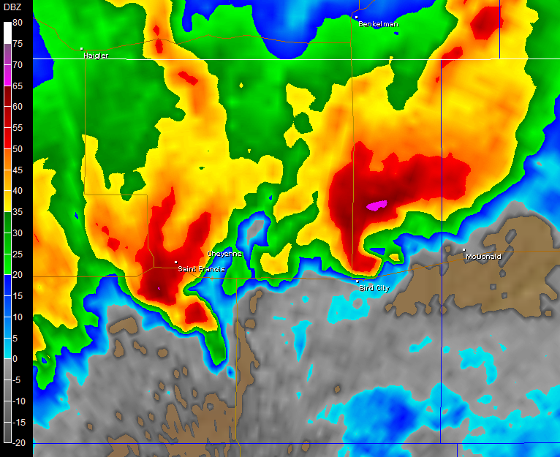
The 2007 severe weather season in northwest Kansas got off to a roaring start when a major tornado outbreak occurred on March 28th. Sixteen tornadoes developed during a 4-hour period beginning around 6:00 pm, including an EF2 tornado which remained on the ground for over an hour, covering 34 continuous miles. March 28th set a new record for number of tornadoes occurring in March. This was also the greatest number of tornadoes reported for any calendar day on record in northwest Kansas. Strong jet stream winds combined with favorable low level moisture resulted in a series of supercell thunderstorms which rolled north during the evening. This image shows a radar reflectivity display indicating two severe thunderstorms. The storm in the right half of the image is producing an EF2 tornado just east of Bird City, KS in Cheyenne County.

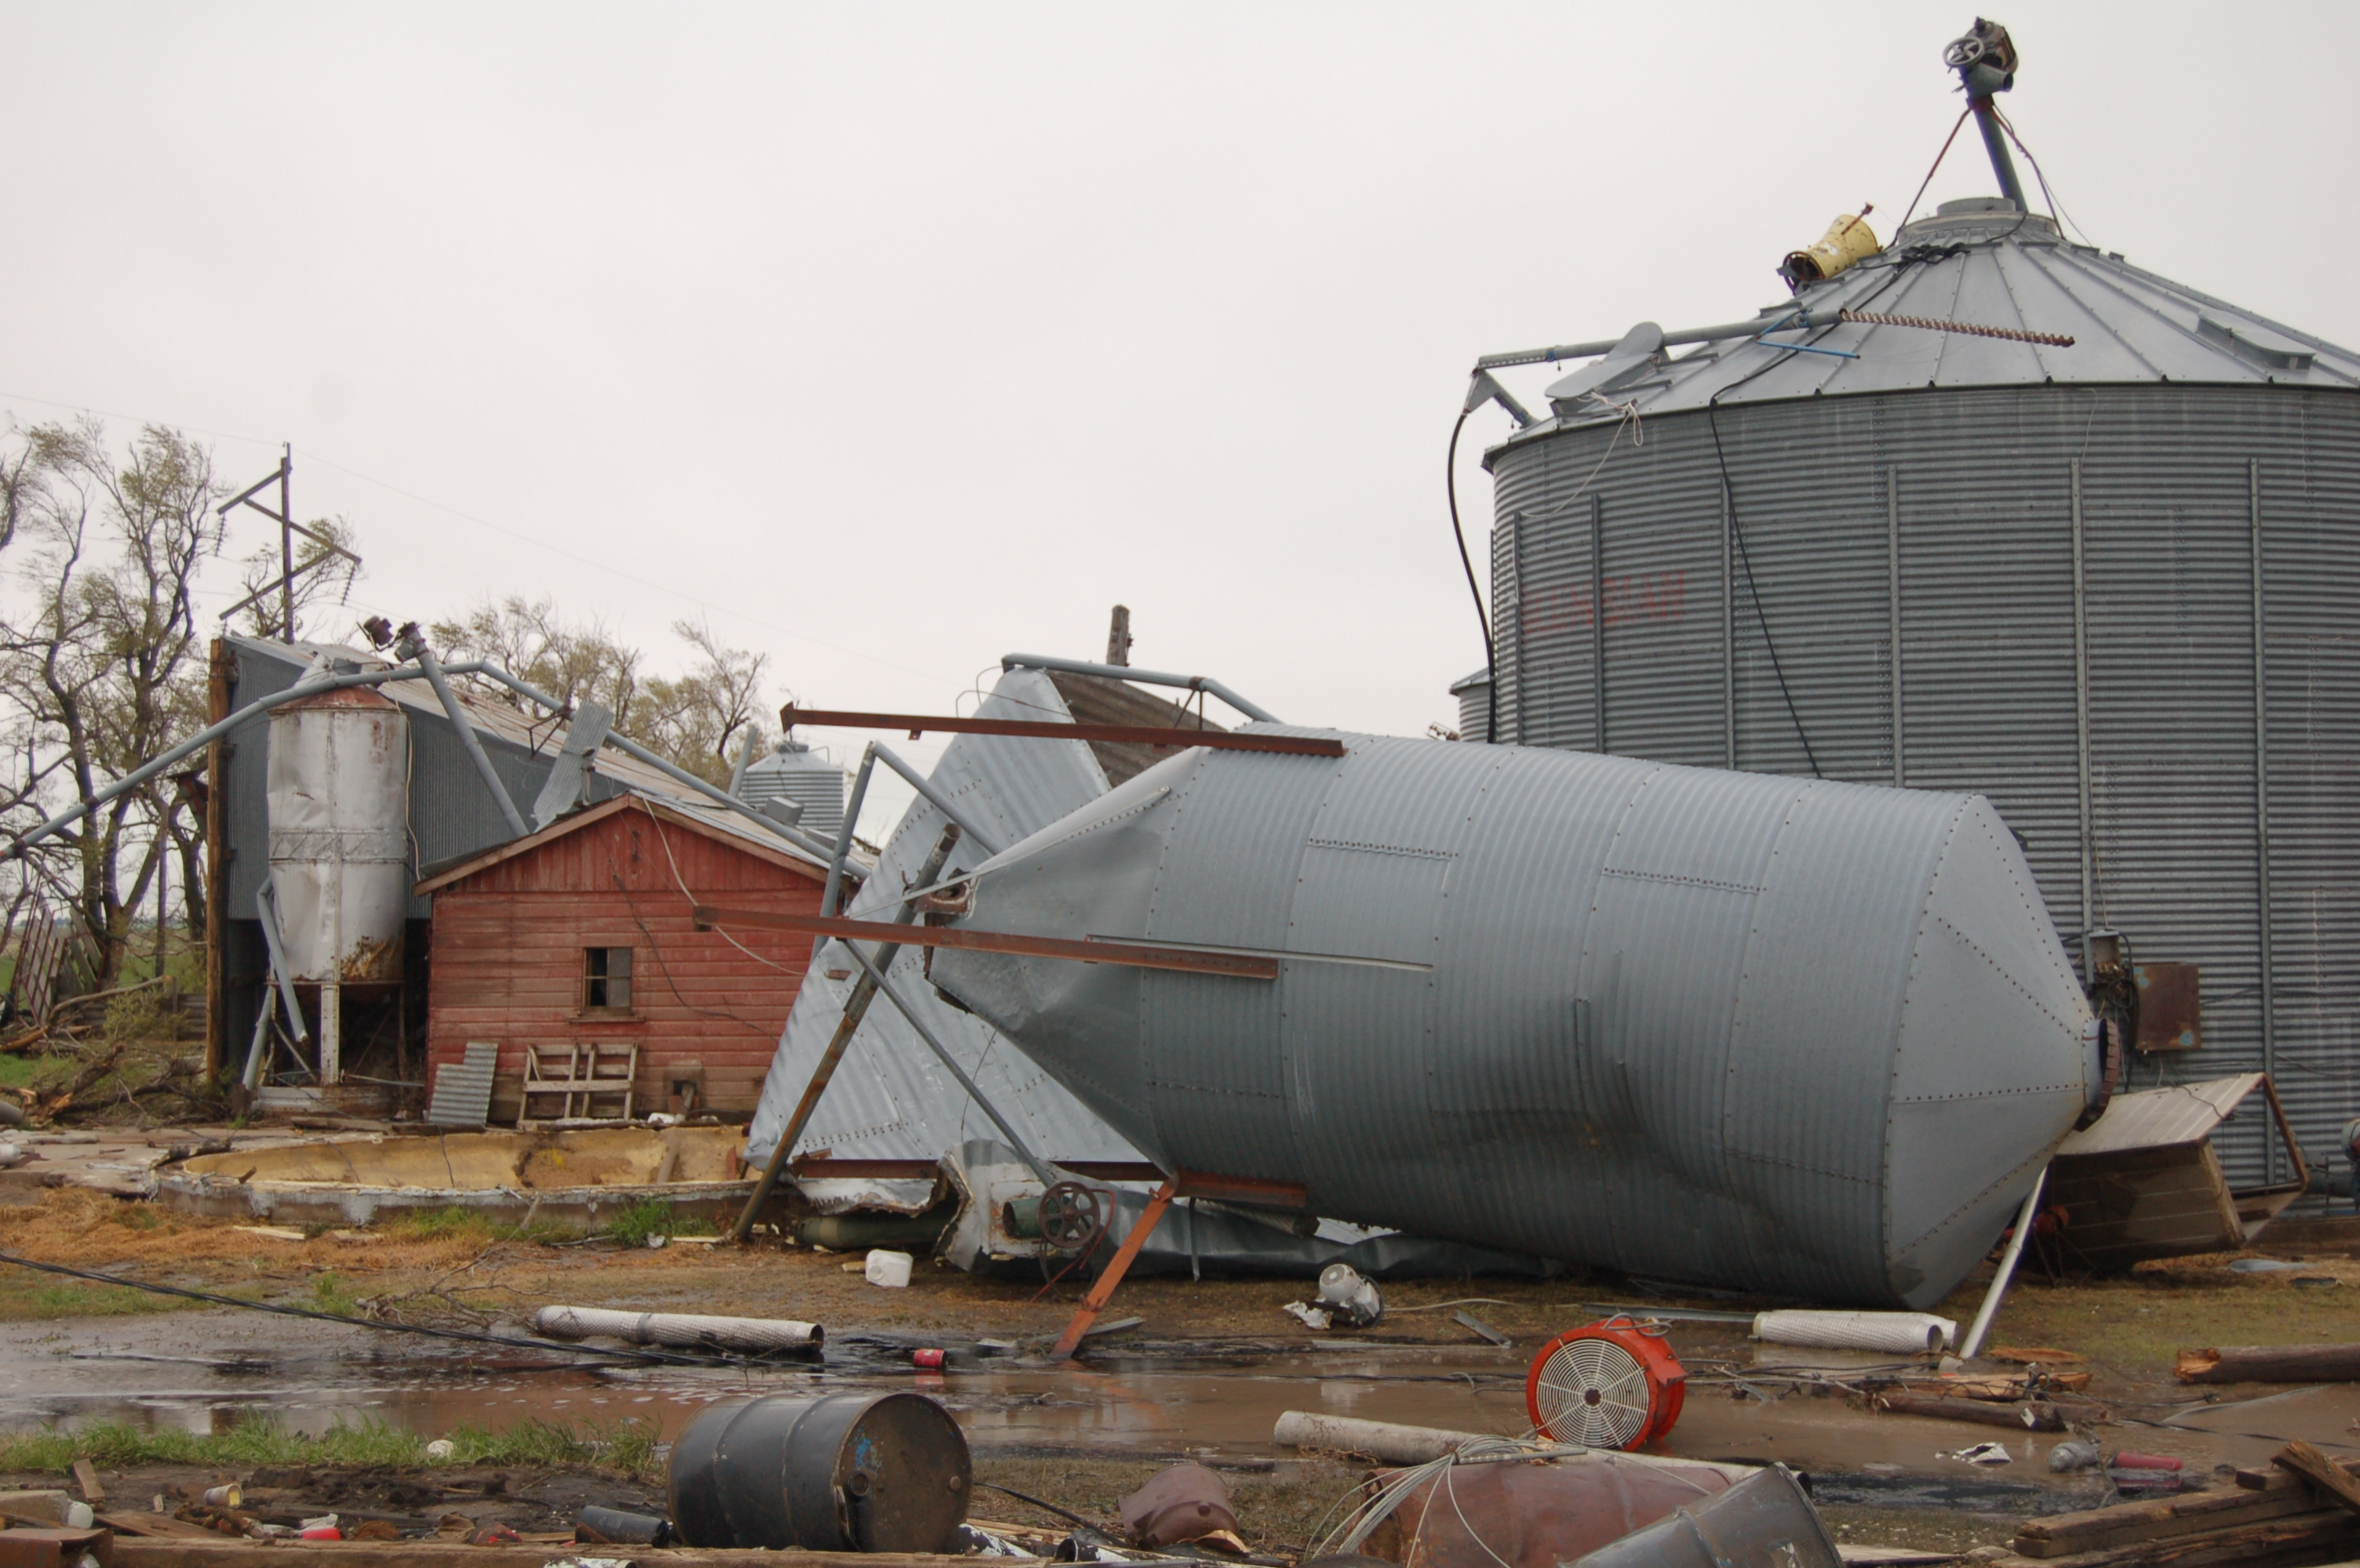
A few weeks after the March 28th outbreak, conditions again were favorable for severe weather, and on April 23rd, seven tornadoes were reported in northwest Kansas, including four EF1 tornadoes. One tornado remained on the ground for over 15 miles, severely damaging one home and numerous trees and outbuildings (see image at left). The large, slow-moving weather system which produced tornadoes on April 23rd lingered in the area, producing yet another round of severe weather on April 24th, including reports of flash flooding in Rawlins County where torrential rainfall of 5-6 inches occurred.

In May, it was the last week of the month which was the most noteworthy in terms of the number of severe weather reports. Law enforcement, storm spotters and chasers, and the public called in over 70 severe reports on May 22nd, the 29th and the 31st. The highlights included five tornadoes (all rated EF0 on the Enhanced Fujita Scale), flash flooding in Graham, Logan and Sherman counties, hail up to 2.5 inches in diameter in Graham County near St Peter, and damaging thunderstorm winds near 75 mph just east of Brewster in Thomas County.

June 19th was the standout day during that month when 26 reports of severe weather were logged, including an 18 minute duration tornado in Sheridan County near Tasco. Fortunately, the tornado was slow-moving and remained over open fields and there were no reports of damage. Many spotters reported hail to the size of golf balls on this day.

A heat burst occurred in Greeley County at Tribune around 7:00 am on August 22nd. Thunderstorm downdrafts produced severe wind gusts measured at 67 mph, while the air temperature rose from 77 degrees to 95 degrees just after daybreak. The dew point also plunged from 66 degrees to 34 degrees during the event. There was no known damage from the strong thunderstorm outflow winds.
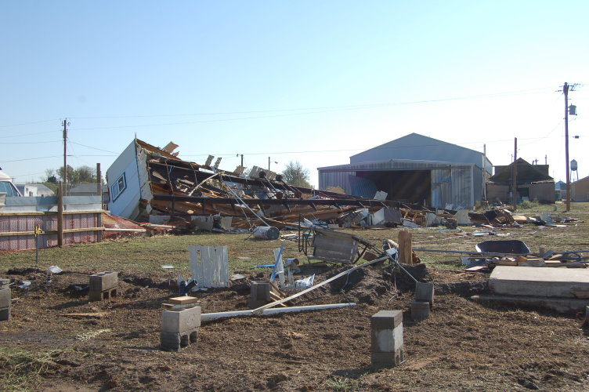
A severe downburst occurred on September 6th in McDonald in far western Rawlins County. Straight line winds estimated at 85 to 90 mph slammed into the west edge of McDonald during the early evening hours, causing significant damage to several structures. A trailer home was overturned and destroyed, but fortunately it was unoccupied when the storm hit (see image). A large storage garage nearby was also completely destroyed, and numerous other buildings suffered damage, including a large grain bin.

The last tornado report for the year in Kansas occurred on September 28th in Gove County. A weak (EF0) tornado was reported by spotters and law enforcement during the evening hours, associated with a large complex of severe thunderstorms.

The last severe thunderstorm report of the season occurred October 14th near the Nebraska border where nickel sized hail occurred in extreme northern Rawlins county during the early morning hours.

A total of 32 tornadoes were logged in 2007 in the Kansas counties served by the Goodland office. A record 56 tornadoes were reported in the Goodland office area of responsibility in 2007, which serves 3 Colorado, 3 Nebraska and 13 Kansas counties. The previous record was 42 tornadoes.

KANSAS SEVERE WEATHER AWARENESS WEEK
MARCH 10 – 14, 2008

North-Central Kansas 2007 Severe Weather Summary
By Steve Kisner, NWS Hastings, NE

The severe weather season started off during the first week of May. On May 4th, severe thunderstorms rumbled across north-central Kansas. The storms produced gusty winds and hail up to the size of quarters. There were also 2 tornadoes from the storms. The first twister briefly touched down southeast of Gaylord in Smith County. Luckily, it occurred in an open field where it only damaged a center pivot system. The other tornado occurred in Phillipsburg. The narrow twister damaged a few rooftops, a children’s outdoor play set, some fencing, uprooted trees and broke a few windows. The tornado was on the ground for about a half mile and was rated as an EF-1.

On the next day, May 5th, another round of storms brought severe weather in the form of hail and another tornado to parts of north-central Kansas. The tornado sat down about 3 miles south of Osborne and moved north. The twister finally lifted near the Smith-Osborne county line. This EF-2 tornado destroyed two mobile homes, damaged roofs, fences, cars and windows, and damaged 2 restaurants. The Pizza Hut sustained minor damage but the Circle Inn lost a large part of its roof, a couple of outside walls, and had substantial damage to the interior portion of the restaurant. Eleven people were injured by this tornado, luckily none were seriously injured.

The last tornado to occur this season happened on May 31st. A tornado briefly touched down just west of Prairie View in western Phillips County. The twister, rated EF-0, didn’t cause any damage but photos of it were featured in the local newspaper and on CNN news. The storms on the last day of May also produced hail up to baseballs in size along with 60 to 70 mph winds. Damage was noted in the Smith Center area, where a couple of outbuildings were destroyed and siding on several houses was damaged by the wind-driven hail. Crops north of Smith Center were also stripped or mowed down by the hail.

August started out wet when thunderstorms dumped heavy rains in Smith County. The storms produced 2 to 4 inches of rain that resulted in localized flooding. Water flowed across Highway 36 near Smith Center and there was street flooding in Lebanon. More storms on the 20th brought strong winds, hail and more heavy rains. The strong winds damaged a carport and another outbuilding in Agra and caused considerable tree damage in Beloit where several folks were without power for a time. The month ended with more heavy rain producing storms. On the 28th and 29th, thunderstorms produced 3 to 5 inches of rainfall that caused flash flooding in southern Rooks County. The flooding was in the Paradise Creek basin and impacted locations along Highway 18 from Palco to Codell. Water was nearly 5 feet deep on a county road east of Codell.

The severe weather season in north-central Kansas ended in the middle of October when on the 17th, storms brought hail, funnel clouds and heavy rains. In Phillipsburg, the storms produced nickel to golf ball sized hail and several funnel clouds. The local newspaper featured several photographs of the funnels that drifted over town. Luckily, they did not touch the ground or cause any damage. Rains of about 2 inches did cause some minor flooding in low lying areas

Extreme Southeast Kansas 2007 Severe Weather Summary
National Weather Service Springfield, MO

During the January 12th ice storm, portions of extreme southeast Kansas received a sleet pack that accumulated up to four inches in some locations. Following this ice storm, weather conditions were quiet through March and April. Only two episodes of marginally severe hail and two episodes of minor flooding occurred during those months.

Frequent waves of thunderstorms containing heavy rain during May, June and July caused significant flooding, nearly on a continuous basis for Cherokee County. As a matter of fact, there were several periods when both the Neosho River and Spring River experienced historical flooding. Only one tornado occurred during the year 2007. This tornado touched down two miles west of Weir. No damage occurred and the tornado was rated an EF-0.

On October 17th, a line of severe storms caused significant damage in the city of Baxter Springs. A National Weather Service storm survey revealed that wind speeds up to 85 mph had occurred over south and east sections of the city.

Finally, Cherokee County was hit by a major ice storm in early December 2007. Nearly 100% of the county experienced power outages as an inch and a half of ice accumulated on exposed objects. Numerous trees were damaged while power lines were downed.

KANSAS SEVERE WEATHER AWARENSS WEEK
MARCH 10 – 14, 2008
Extreme Northeast and East Central Kansas
Weather Summary – 2007
National Weather Service Pleasant Hill, MO

This past year saw a variety of hazardous weather, as is typical. However, 2007 was quieter than usual with very few large severe weather outbreaks.
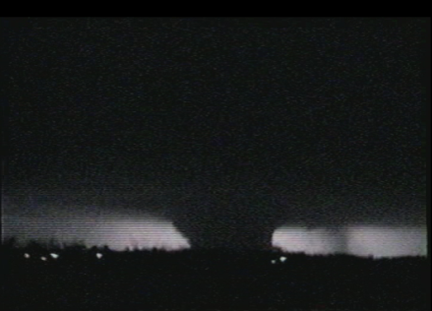
The season started off with a bang, as a strong low pressure system and attendant warm front lifted northeast out of Oklahoma during the late afternoon and early evening hours of February 28. The first EF4 tornado in the country occurred in Linn county near Blue Mound, KS. It touched down shortly before 7:30 pm and was on the ground for nearly 24 miles. The tornado rumbled across mainly rural Linn County, however it did destroy a home and several out buildings on a farm near Blue Mound. The system also went on to produce hail up to the size of baseballs and additional tornadoes as it moved east across central Missouri.

March was relatively quiet, however April was marked by weather extremes. Widespread frost and freezing temperatures occurred April 4th through the 10th. Low temperatures dropped into the upper teens and twenties. Trees and flowers which had budded or bloomed were severely damaged or destroyed. A late season snow storm hit Johnson, Linn and Miami counties with 1 to 3 inches of snow on April 14th. April also had its share of severe weather. Storm systems moved across east central Kansas into west central Missouri on April 25th and 27th. Numerous reports of hail and funnel clouds were received on both days in extreme east central Kansas. The storms went on to produce a brief tornado in far southwest Bates County the evening of the 27th.

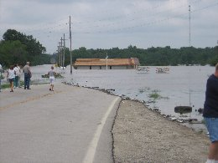
May and most of June were relatively quiet across extreme east central and northeast Kansas, however numerous rounds of heavy rainfall affected much of the lower Missouri River Valley between June 27 and July 1. This resulted in widespread flooding across the region. Some of the harder hit areas included locations along the Marais des Cygne River including Osawatomie and La Cygne, Kansas. Five day rainfall totals were extraordinary across Linn and Miami Counties.

Pleasanton Linn, KS 15.80”
Mound City Linn, KS 15.01”
La Cygne Linn, KS 14.90”
Trading Post Linn, KS 13.28”
Paola Miami, KS 9.86”
Osawatomie Miami, KS 8.70”

The rest of 2007 saw mainly isolated severe thunderstorms producing hail from 1 to 1.5 inches, wind gusts to around 60 mph and a few very brief tornado touchdowns across extreme portions of east central and northeast Kansas.

North Central Northeast and East Central Kansas 2007 Summary
National Weather Service Topeka, KS

The severe weather season got off to an early start in east central Kansas in 2007. On February 28, 2007 supercell thunderstorms developed rapidly in the early evening hours. The severe thunderstorms produced several rounds of severe weather in east central Kansas. Hail up to the size of golfballs was reported in Osage, Lyon, Coffey, and Franklin Counties. Three tornadoes occurred during the evening hours in Anderson County. The first tornado touched down briefly just west of Colony and was on the ground for just over one mile. It was rated an EF0 and no damage was observed. The same supercell produced another tornado that touched down just east of Colony. This tornado was on the ground for 9 miles and was rated a strong EF1. Along the 9 mile track of this tornado, damage to homes, outbuildings, trees and power lines was observed. Some of the most impressive damage was noted 3 miles northwest of Lone Elm, where a large, covered indoor riding arena was completely destroyed. The large metal building anchored by concrete footings was pulled out of the ground and thrown across a nearby road. People inside the arena escaped serious injury when the tornado struck. A third tornado touched down briefly just inside the Anderson County line before moving into Linn County. This tornado was rated an EF0 in Anderson County, but it became much stronger in Linn County.

Very cold late season temperatures occurred in April 2007. The passage of a cold front April 3rd drove cold arctic air into the Central Plains states, and forced temperatures to plummet to some of the coolest readings ever recorded during early April. Topeka and Concordia both saw their coldest ever April 4th through April 8th average temperatures. Record low maximum temperatures were recorded at Topeka, 38F degrees, and Concordia, 31F degrees on April 5th. Temperatures dipped down into the middle to upper teens overnight the 6th and the 7th across Northeast Kansas, which caused a hard freeze for much of Kansas. Early season crops, including wheat, alfalfa, berries, spinach, and apples were significantly damaged by the cold. Cool weather and below normal temperatures continued for the next week, and then a second round of very cold temperatures settled over far northeast and east central Kansas the weekend of the April 13th through the 15th. This cold snap followed on the heels of unseasonably warm temperatures in late March that caused crops, trees and shrubs to respond to the warm spring temperatures. The late spring freeze left many farmers out in the cold. The Kansas State Farm Services Agency reported that all 23 counties in the Topeka County Warning Area recorded a 30% or greater loss of the wheat and alfalfa crops.

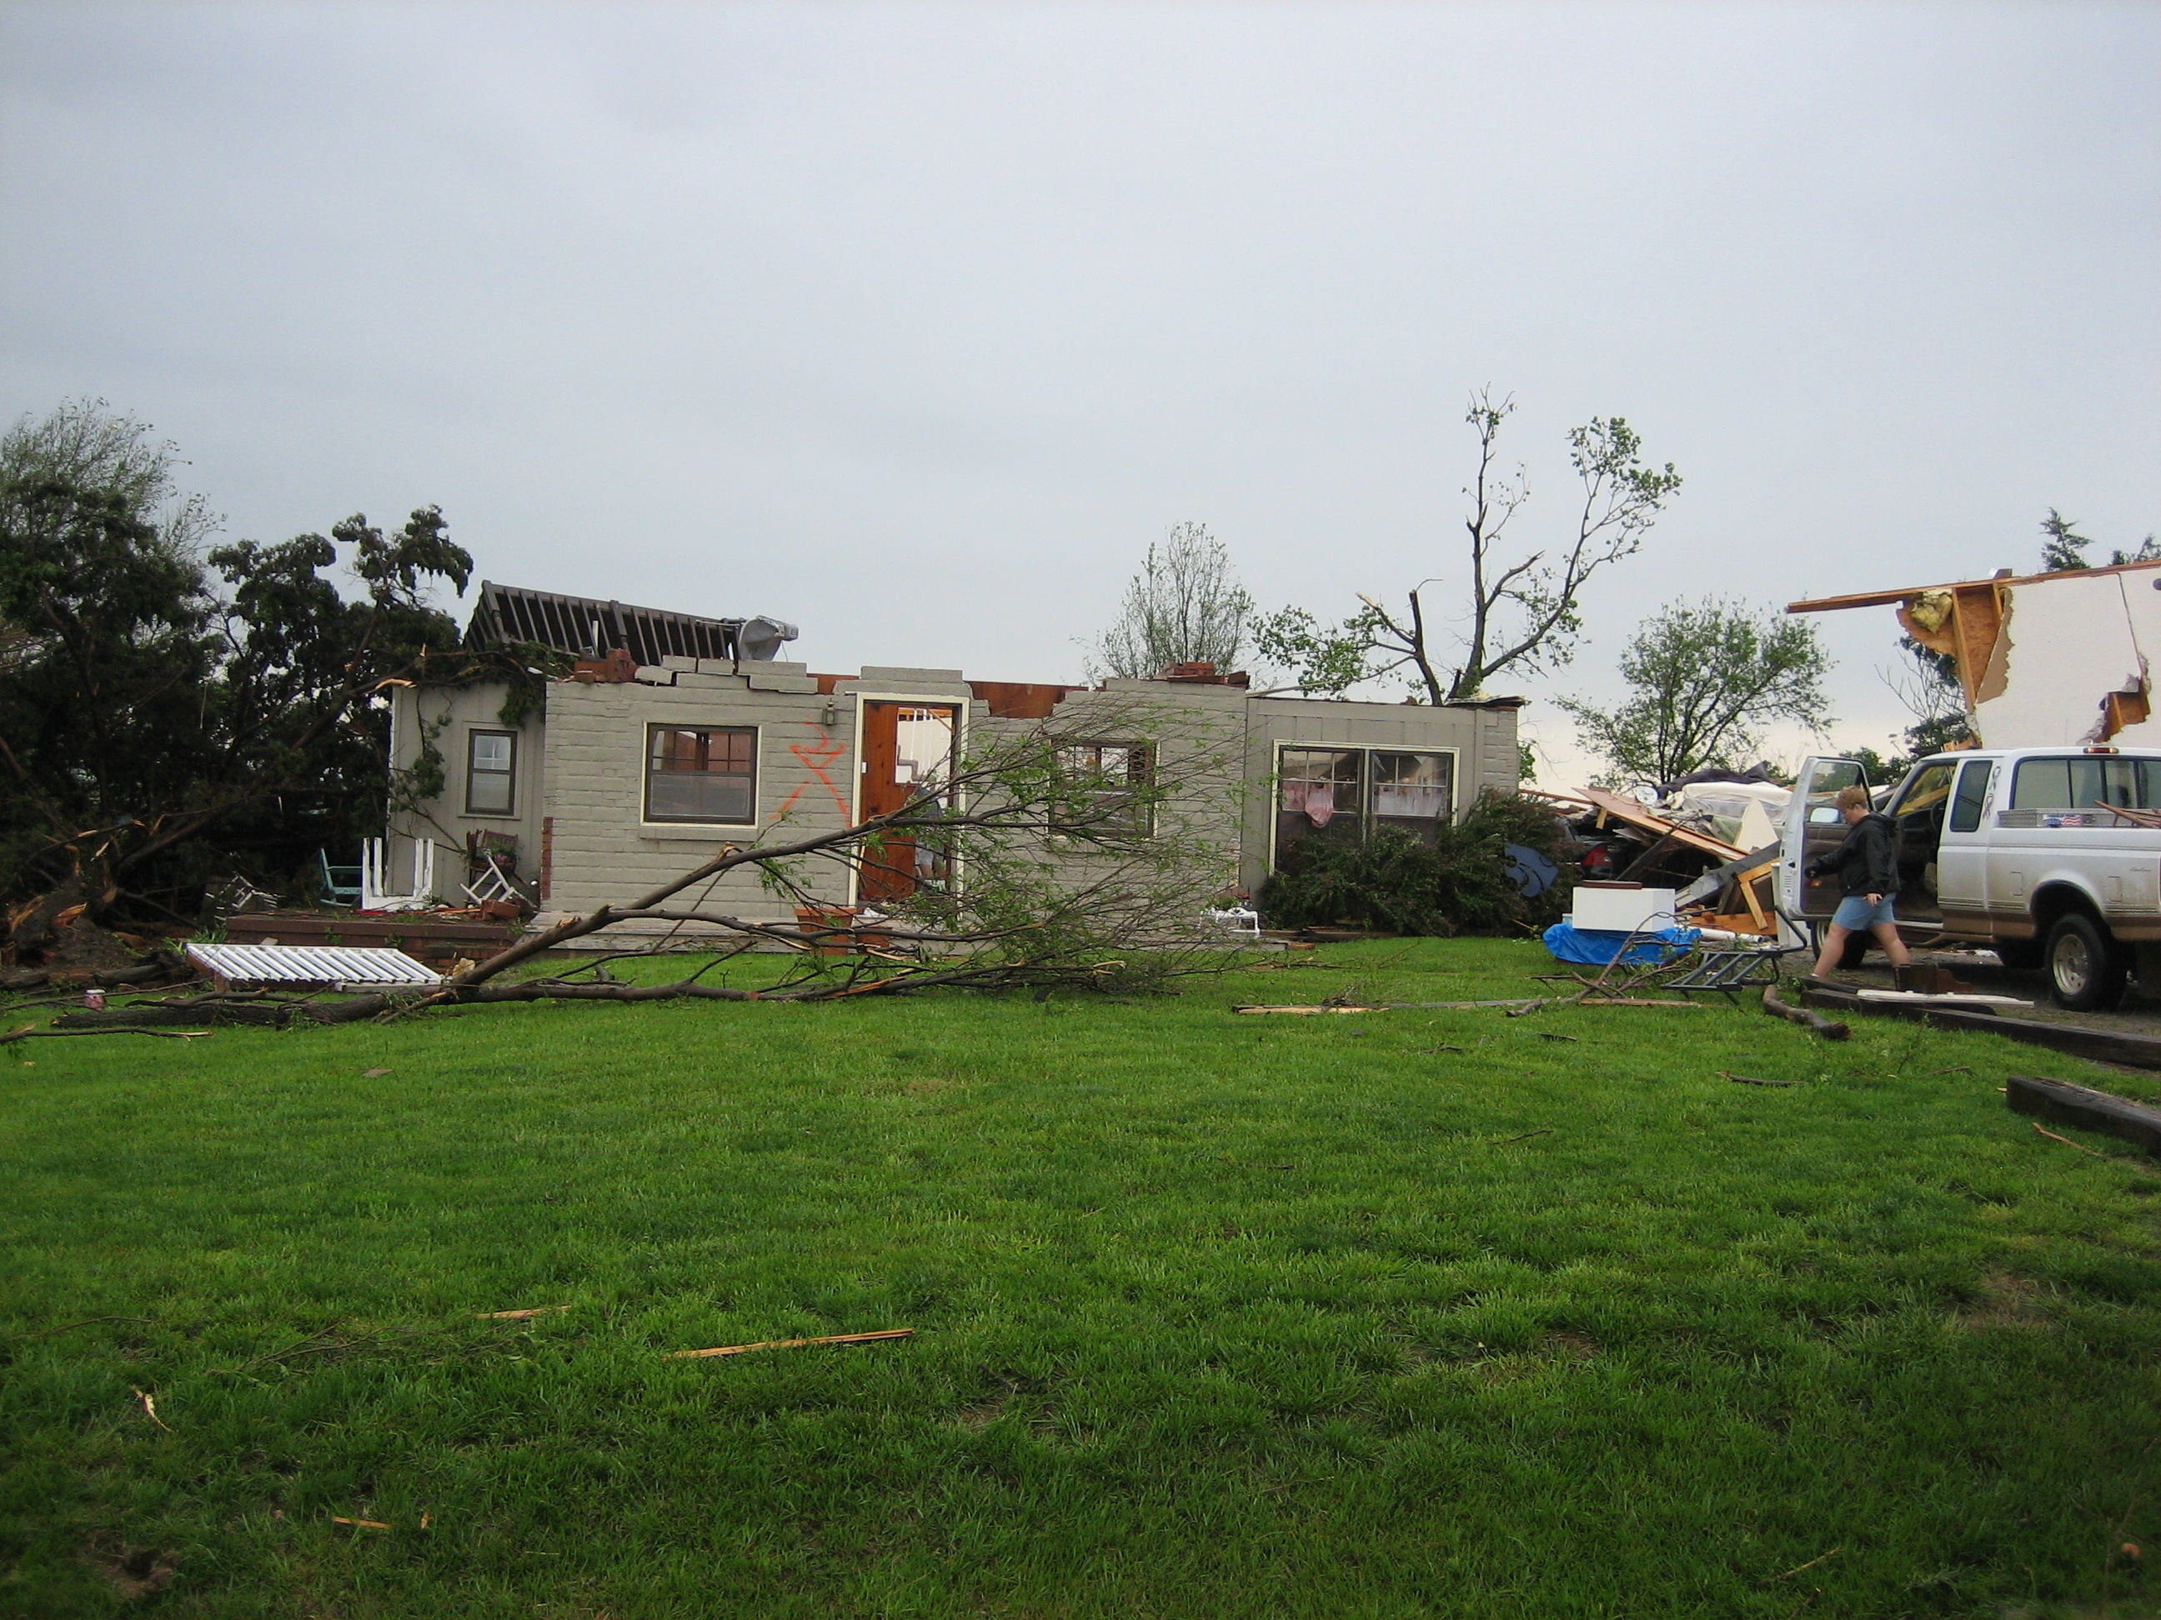
May 1st brought some severe weather to northeast Kansas with flash flooding and funnel clouds reported in Pottawatomie, Morris, Wabaunsee, Shawnee and Jefferson Counties. Unfortunately, this round of severe weather paled in comparison to what occurred just a few days later. An upper level low pressure system brought bouts of severe thunderstorms and heavy rains to the Topeka County Warning Area from the afternoon hours of Saturday, May 5th through Monday, May 7th.
KANSAS SEVERE WEATHER AWARENESS WEEK
MARCH 10 – 14, 2008
There was a series of tornadoes that affected portions of north central Kansas the night of Saturday, May 5th. Concurrently, a strong squall line pushed eastward across much of north central Kansas, bringing a widespread swath of damage through the area. The entire weekend was affected by round after round of strong thunderstorms and very heavy rainfall. Five tornadoes touched down on the night of May 5th across north central Kansas. Two of these were brief touchdowns that caused only minor damage and were rated EF0 on the Enhanced Fujita scale. Two were rated EF1, and the strongest was rated an EF2. The supercell thunderstorm that produced four of the five tornadoes the night of the 5th moved north through eastern Ottawa County between 11:30 and midnight, then became embedded in a squall line as it continued northward into eastern Cloud and western Washington Counties.

The EF2 tornado in eastern Ottawa County damaged or destroyed numerous homes, cabins, campers, outbuildings and small cottages along an 11 mile path just west of the State Fishing Lake. Tragically, this tornado was also responsible for five injuries and one fatality. One of the EF1 tornadoes that night touched down in Ottawa County before tracking to the north-northeast along a 7 mile path into southeastern Cloud County, just west of Miltonvale. The second EF1 of the night was a brief touchdown that hit a residence near the abandoned town of Enosdale in Washington County.

The second major event during the weekend was the squall line that produced extensive straight- line wind damage across much of north central Kansas. This squall line developed due to a merger of a few supercell thunderstorms over western Ottawa County around midnight, May 6th. The primary swath of damage began in Ottawa County and then continued northeast into Clay, Cloud, Washington, Marshall and Riley Counties. The squall line commonly produced winds in excess of 80 mph, with numerous farm buildings, grain bins, homes, trees, outbuildings and power poles sustaining significant damage. Some of the most concentrated damage occurred in Clay County, where 35 residences sustained damage.
The most widespread event of the weekend was the extensive flooding which affected almost all of northeast Kansas. From an area roughly along and southeast of a Minneapolis to Marysville line; and along and northwest of the Kansas Turnpike, locations received anywhere from 4 to 11 inches of rain during the 48-hr period of May 5th to May 7th. The heavy rainfall caused nearly every river basin in the area to rise above flood stage. In Topeka, significant flash flooding along the Shunganunga Creek stranded nearly 500 residents. Emergency personnel performed numerous water rescues before dawn on May 7th. The entire town of Wakarusa was inundated with floodwaters, leaving homes across the town virtually underwater. Several residents needed to be rescued from their rooftops. Significant flooding continued in northern Osage County where at one time Burlingame was completely isolated because water covered every road in or out of town.
After a break of several weeks, very heavy rain producing thunderstorms again rolled over a number of counties during the evening and early morning hours of May 23rd to May 24th. Dickinson County was hit hard for the second time in the month with significant flooding along the Smoky Hill River. Runoff caused several major streams and rivers to go above flood stage for several days. Rainfall totals were mostly in the two to four inch range; however, four to six inches were noted in parts of Marshall, Riley, Clay and Dickinson counties.
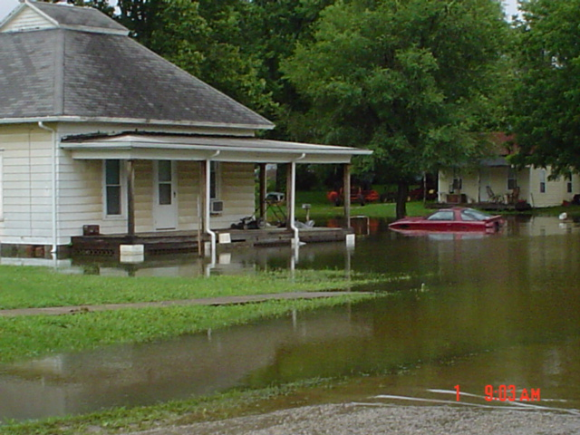
Flooding and flash flooding returned to east central Kansas in late June and continued into early July. A persistent upper level system anchored over the area for several days late in the month and dumped excessive rain on Osage, Franklin, Coffey and Anderson counties. Some parts of Douglas and Lyon counties also had some flooding and flash flooding. The highest rainfall amount reported was 20 inches in central Anderson County. However, 10 to 15 inches of rainfall was common across much of Coffey, Franklin and Osage counties. Record flooding occurred along the Pottawatomie Creek at both Scipio and Lane Kansas and at Quenemo and Pomona along the Marais des Cygnes. The flooding near Scipio appeared to be the worst since the 1850's. The flood gates in Ottawa were closed to protect the city from flooding along the Marais des Cygnes River although the crest was not a record there. The bridge that connects the north and south parts of Ottawa was covered with water and only the flood gates kept downtown Ottawa from flooding. Forty to fifty homes were evacuated in Franklin County. Several swift water rescues were done in Anderson and Coffey counties, some with the assistance of a black hawk helicopter.

A few more rounds of severe weather were observed during the late summer and early fall months. However, none of this severe weather impacted such a wide area as the flooding during May, June and July.

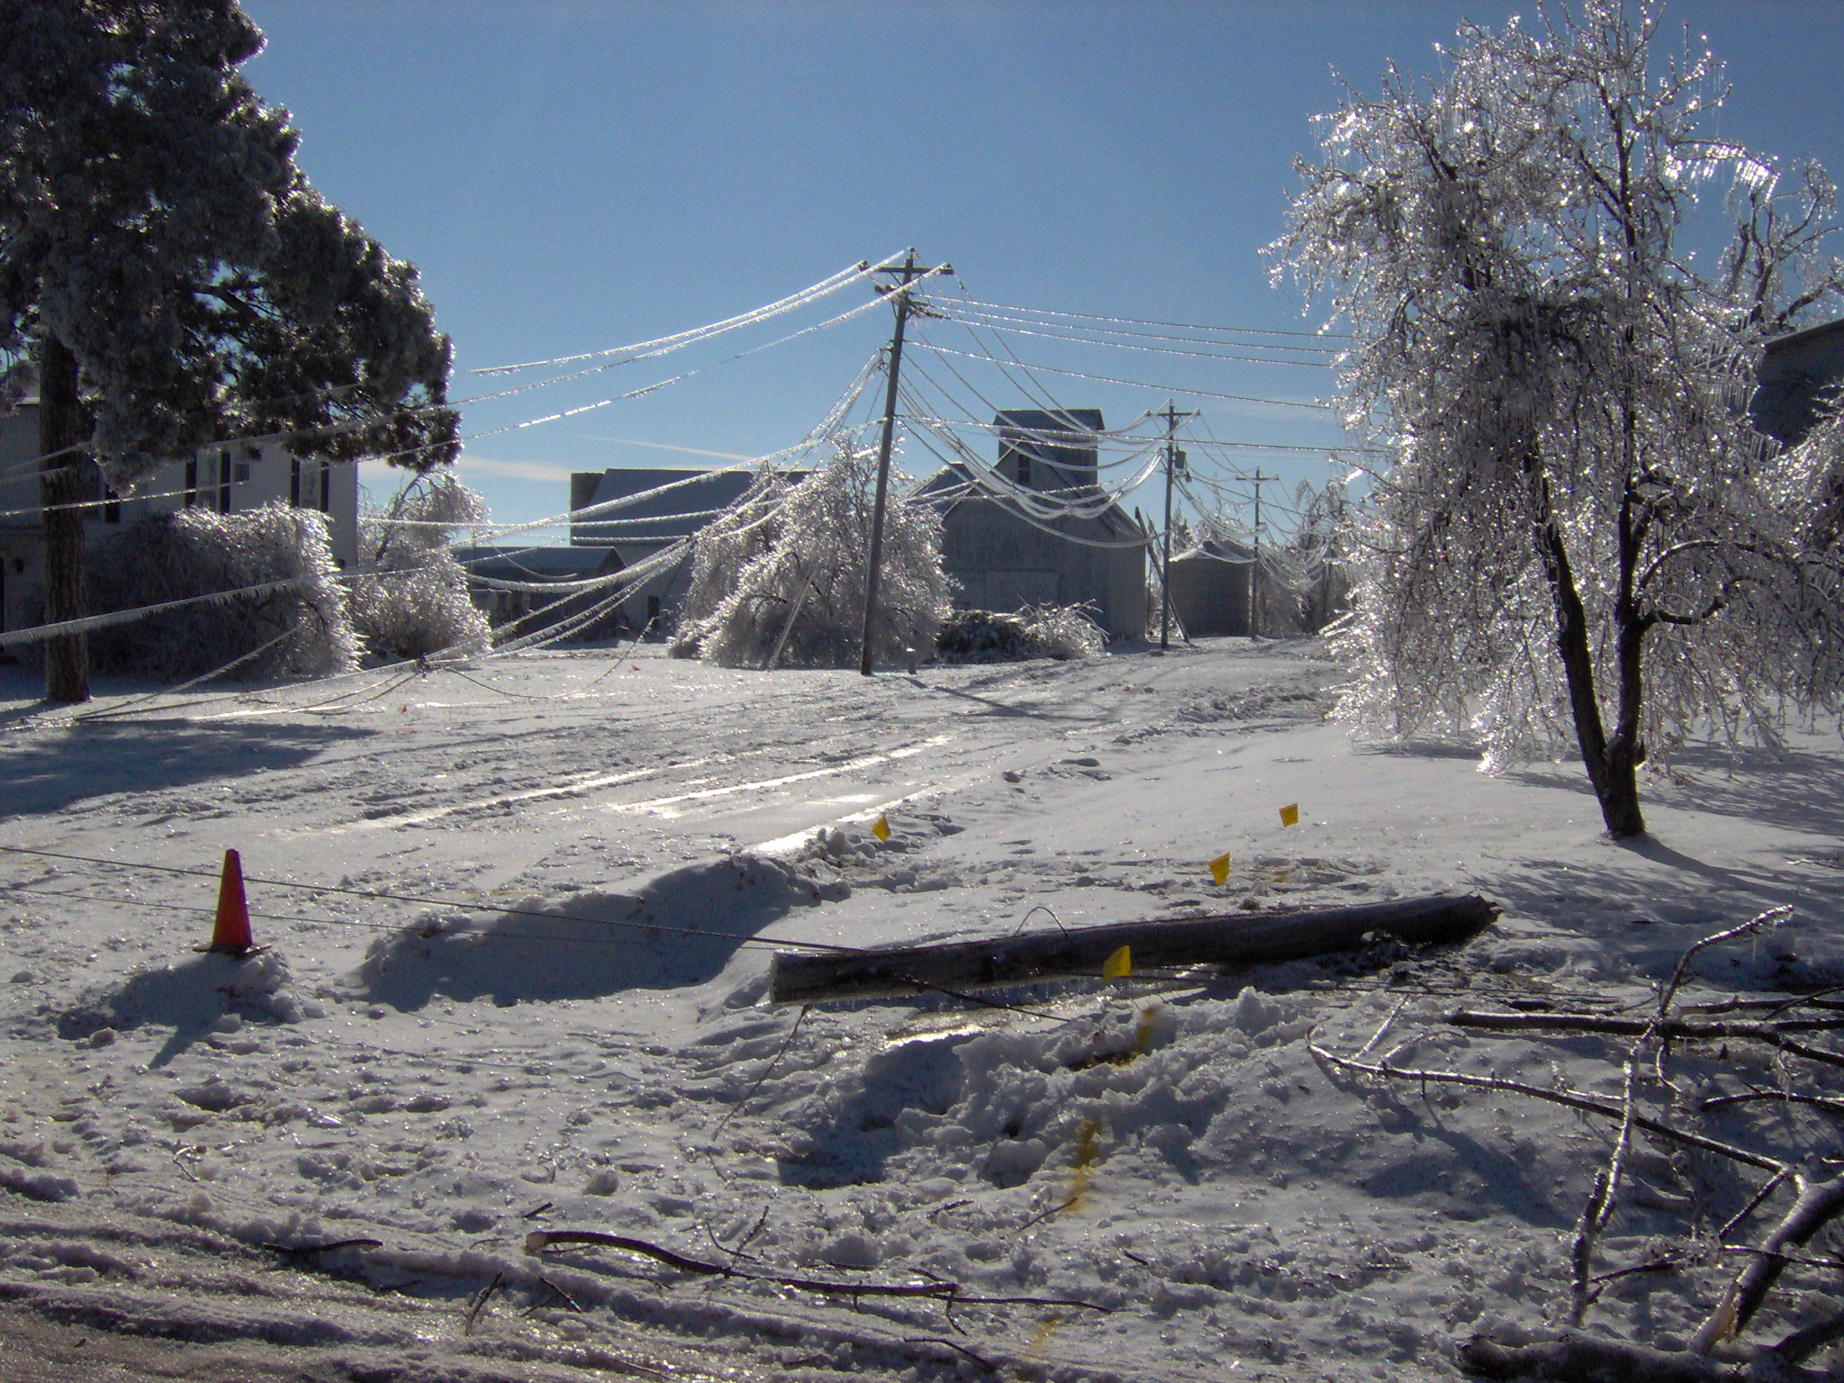
An ice storm crippled portions of north central, northeast and east central Kansas beginning the evening of December 10th and continuing through the 11th. Freezing rain deposited significant accumulations of ice on area power lines and trees. Area roadways were less susceptible to the icing conditions because roads were pre-treated and surface temperatures remained just below freezing. Damage to trees and power lines caused tens of thousands of residences and businesses to lose power for several days to weeks following the storm. Utility companies and debris removal crews worked for weeks following the storm to restore power, phone service, water and heat. The hardest hit areas were generally north of the I-35 turnpike from Emporia to Topeka and north of a Topeka to Lawrence line. Following on the heels of the ice storm, were additional snow storms that hampered clean-up and recovery efforts in the region.

KANSAS SEVERE WEATHER AWARENESS WEEK
MARCH 10 – 14, 2008
Tornado Safety
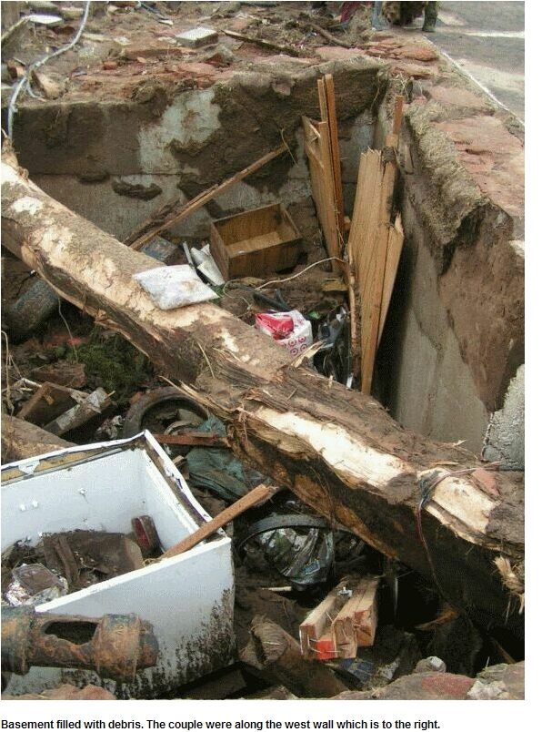
When it comes to tornado safety, there is not any fool proof measure that can guarantee your safety. However, by following the tips listed below, your chances of survival are greatly increased.

Before a tornado strikes:
- Look for approaching storms which:
  - May include a dark greenish tint
  - Contain large hail
  - Produce a loud roaring noise of rushing wind
- Monitor NOAA Weather Radio for the latest updates
Where to go when a tornado warning has been issued for your area:
- Indoors:
  - Go to a pre-designated shelter area such as a safe room, basement, storm cellar, or the lowest building level. If there is no basement, go to the center of an interior room on the lowest level (closet, interior hallway) away from corners, windows, doors, and outside walls. Put as many walls as possible between you and the outside. Get under a sturdy table and use your arms to protect your head and neck. Do not open windows.
- In a vehicle:
  - Your 1st option might be driving away from the danger. Notice the direction of movement of the tornado and drive at a right angle to a shelter. Remember to drive at a right angle, never try to outrun the tornado.
  - Otherwise, get out of your vehicle and Lie flat in a nearby ditch or depression and cover your head with your hands. Be aware of the potential for flooding.
  - Do not get under an overpass or bridge. You are safer in a low, flat location.
- In a trailer or mobile home:
  - Get out immediately and go to the lowest floor of a sturdy, nearby building or a storm shelter. Mobile homes, even if tied down, offer little protection from tornadoes.
If all else fails remember the word DUCK:
Down to the lowest level
Under something sturdy
Cover your head
Keep in shelter until the storm passes

Lightning - The Underrated Killer
In the United States, there are an estimated 25 million lightning flashes each year. During the past 30 years, lightning killed an average of 62 people per year. This ties the average of 62 deaths per year caused by tornadoes. Yet, because lightning usually claims only one or two victims at a time and does not cause mass destruction of property, it is underrated as a risk. While documented lightning injuries in the United States average about 300 per year, undocumented injuries are likely much higher.
- Watch for Developing Thunderstorms: Thunderstorms are most likely to develop on spring or summer days, but can occur year round. As the sun heats the air, pockets of warmer air start to rise and cumulus clouds form. Continued heating can cause these clouds to grow vertically into towering cumulus clouds, often the first sign of a developing thunderstorm.
- An Approaching Thunderstorm: When to Seek Safe Shelter: Lightning can strike as far as 10 miles from an area where it is raining. That's about the distance you can hear thunder. If you can hear thunder, you are within striking distance. Seek safe shelter immediately.
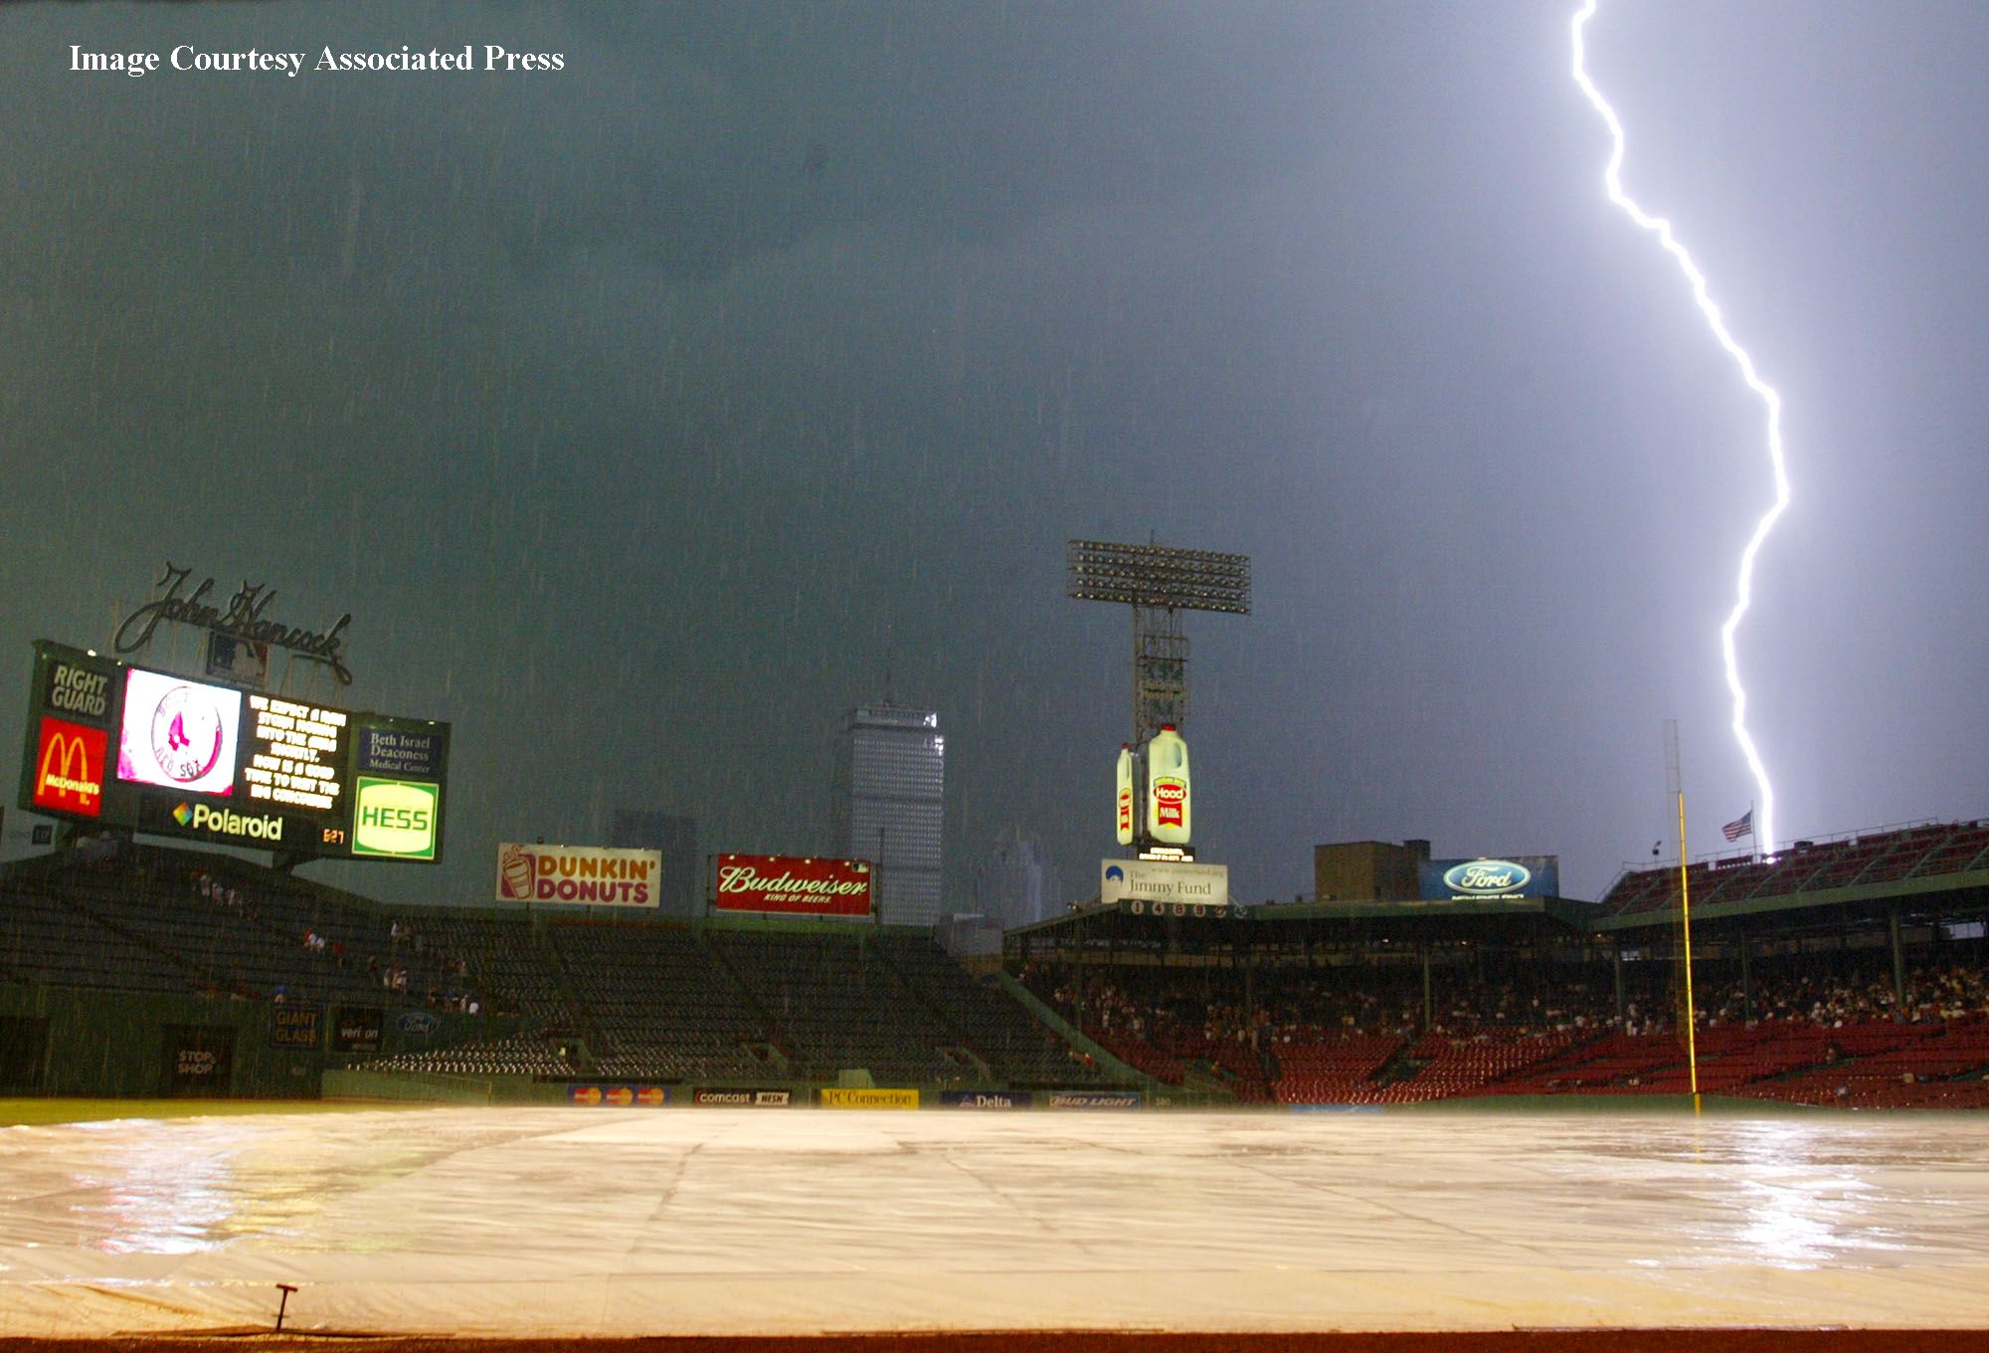
- Outdoor Activities: Minimize the Risk of Being Struck: Most lightning deaths and injuries occur in the summer. Where organized outdoor sports activities take place, coaches, camp counselors and other adults must stop activities at the first roar of thunder to ensure everyone time to get a large building or enclosed vehicle. Leaders of outdoors events should have a written plan that all staff are aware of and enforce.
- Indoor Activities: Things to Avoid: If you are inside a building, stay off corded phones, computers and other electrical equipment that put you in direct contact with electricity. Stay away from pools, indoor or outdoor, tubs, showers and other plumbing. Buy surge suppressors for key equipment. Install ground fault protectors on circuits near water or outdoors. When inside, wait 30 minutes after the last strike, before going out again.
- Helping a Lightning Strike Victim: If a person is struck by lightning, call 911 and get medical care immediately. Cardiac arrest and irregularities, burns, and nerve damage are common in cases where people are struck by lightning. However, with proper treatment, including CPR if necessary, most victims survive a lightning strike. You are in no danger helping a lightning victim. The charge will not affect you.
- Summary: Lightning is Dangerous! With common sense, you can greatly increase your safety and the safety of those you are with. At the first clap of thunder, go to a large building or fully enclosed vehicle and wait 30 minutes after the last clap of thunder to go back outside.

When Thunder Roars, Go Indoors!
KANSAS SEVERE WEATHER AWARENESS WEEK
MARCH 10 – 14, 2008
Flood Safety

Did you know that floods, especially flash foods, kill more people each year than any other weather phenomenon? And do you know why? Well, the main reason is that people underestimate the force and power of water. As little as six inches of fast moving water can sweep you off your feet and 18 to 24 inches of water is enough to float a car and carry it away. If you see a road barrier across a flooded roadway, then “Turn Around. Don’t Drown!” This is the National Weather Service’s motto. We want you to remember this if you encounter a situation where you see water covering a roadway. You will not know the depth of the water or know the condition of the road under the water. Did you also know that about 60 percent of all flood deaths result from people trying to cross flooded roads in vehicles when the moving water sweeps them away? So Turn Around. Don’t Drown! Don’t become one of the statistics.

Helpful safety rules to adhere to:

When heavy rains threaten, monitor NOAA Weather Radio or favorite news source for weather information. If flooding occurs, get to higher ground. Leave areas subject to flooding, such as dips, low spots and underpasses. Avoid areas already flooded. Do not attempt to cross flowing streams. Never drive through flooded roadways. Turn Around. Don’t Drown. If your vehicle is suddenly caught in rising water, leave it immediately and seek higher ground. Look for a floatation device. Be especially cautious at night when it is harder to see flood dangers.

Please report flooding to your local authorities or The National Weather Service. Finally, know when you are at risk. Keep abreast of the latest weather watches and warnings. Let caution and good sense be your guides. Remember, Turn Around. Don’t Drown!

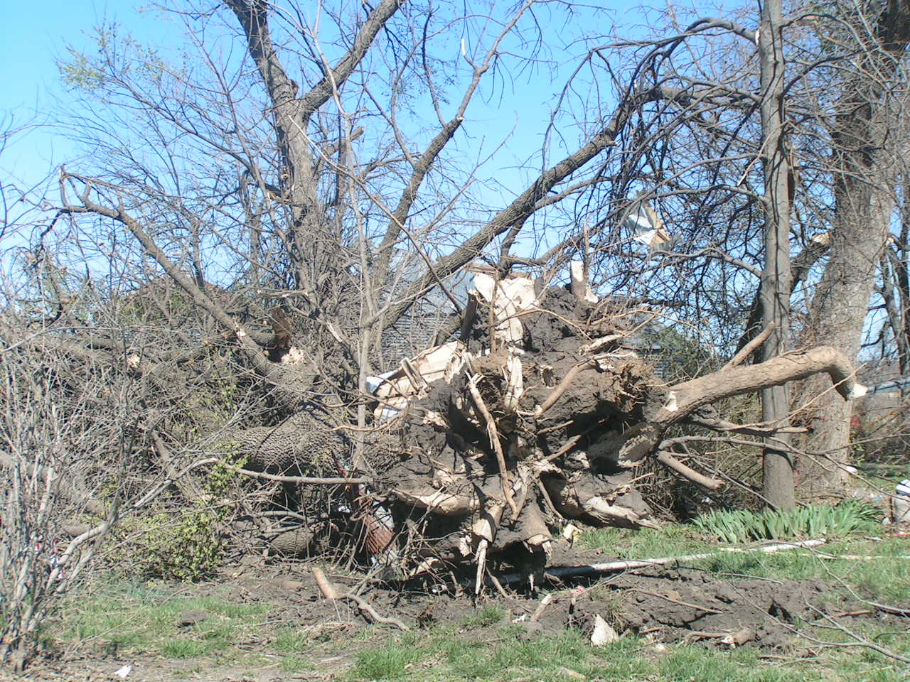
Damaging Thunderstorm Winds
Many times when storm damage occurs to buildings, trees or other objects, people automatically say it was a Tornado! The “glamour” of having a tornado seems to overwhelm scientific evidence and common sense. Although difficult for many to understand, in most years, thunderstorm winds cause more damage, and are more frequent than tornadoes. In addition, property and crop damage can be more severe from thunderstorm winds than from tornadoes. Thunderstorms winds can exceed 100 mph while the most common tornado winds are generally not this strong.
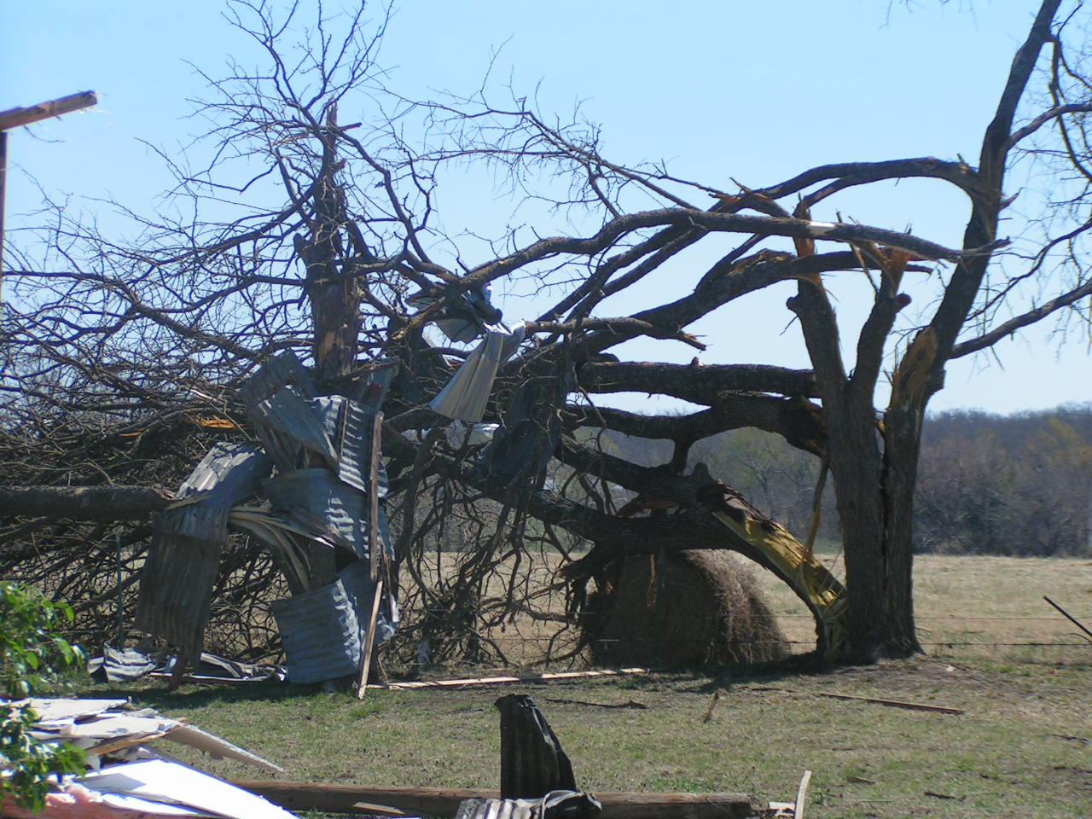
Thunderstorm winds come in many forms, sometimes from squall lines of thunderstorms and other times in the form of downburst winds. The most frequently encountered type of damaging straight-line wind in a thunderstorm is that associated with the leading edge of the rain-cooled outflow, known as the gust front. Although most thunderstorm outflow winds range from 30 to 50 mph, on occasion these winds can exceed 100 mph. Downburst-producing storms often give little advance indications of the imminent danger on weather radar or to the spotter, so warnings are difficult to issue.
In 2004, thunderstorm winds produced an estimated $5.5 million in property damage, according to the publication Storm Data. This was about 1/6th the amount of tornado damage in 2004. However, in most years, thunderstorm wind damage is more than that caused by tornadoes.
To be safe from strong thunderstorm winds, go inside a sturdy building but stay away from windows that could break. If available, get to a basement or underground shelter. Large hail and flooding rains may accompany strong winds, so be alert to these dangers. Stay informed about the weather at all times!

KANSAS SEVERE WEATHER AWARENESS WEEK
MARCH 10 – 14, 2008
Every year the National Weather Service and the Emergency Management communities get together and provide severe weather information for the public. Every year we emphasize the fact that the Outdoor Sirens are just that…an Outdoor Warning System. Every year we get a multitude of calls telling us that the sirens can’t be heard while in the house.


Severe weather season usually begins in the early spring in Kansas. We all need to be prepared for severe weather at any time of the day or night and at any time of year. The National Weather Service, Emergency Management, Law Enforcement, the 9-1-1 Center, and the Fire Department cannot notify every individual of the possibility of severe weather in their town. The local media outlets and All Hazards NOAA Weather Radio are your best sources for information concerning severe weather watches and warnings. Do not wait for the sirens to be your warning system at home, sirens may not be working if the power is out and oftentimes cannot be heard indoors. Sirens are not activated for other severe threats such as damaging straight line winds in excess of 60 mph, large hail and flooding. Monitor NOAA Weather Radio and local media, then take the appropriate action for the severe weather threat. If it appears that a severe thunderstorm is approaching your location, do not wait for the outdoor sirens, take immediate action to protect your life and the lives of others in your home.

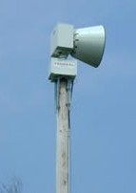
Hundreds of volunteer storm spotters, amateur radio operators, and first responders put their lives on the line every time there is severe weather in the local area. They do this because they care about the people in their communities and want to make sure those people are given the best chance at survival. The storm spotters, emergency managers, law enforcement and other volunteers immediately relay severe weather reports to the National Weather Service. The National Weather Service in turn disseminates that information to the media and public through warnings, statements and local storm reports. Getting the word out to the public in a timely manner may save lives. When severe weather threatens at night, when most people are sleeping, it can be especially dangerous. Oftentimes, in the heat of the spring and summer, we cannot hear outdoor sirens over running air conditioners. A NOAA Weather Radio with a back-up battery can make the difference for you and your family.

Take responsibility…listen to the media….take protective action….survive to enjoy the wonderful warm sunny days that also come this time of year.


Americans live in the most severe weather-prone country on Earth and the state of Kansas is no exception. Each year a startling 10,000 thunderstorms, 2,500 floods, 1,000 tornadoes, and 10 hurricanes impact the United States. Potentially deadly severe weather impacts every American. Communities can rely on the National Weather Service’s StormReady program to help them guard against the ravages of Mother Nature.

What is StormReady?
Ninety percent of all presidentially declared disasters are weather related. Through the StormReady program, NOAA’s National Weather Service gives communities the skills and education needed to survive severe weather – before and during the event. StormReady helps community leaders and emergency managers strengthen their local hazardous weather operations.

StormReady Does Not Mean Storm Proof
StormReady communities are better prepared to save lives from the onslaught of severe weather through better planning, education and awareness. Communities have fewer fatalities and property damage if they plan before dangerous weather arrives. No community is storm proof, but StormReady can help communities save lives.

How Can My Community Become StormReady?
The entire community – from the mayor and emergency managers, to business leaders and civic groups – can take the lead on becoming StormReady. Local National Weather Service forecast offices work with communities to complete an application and review process. To be recognized as StormReady, a community must:

- Establish a 24-hour warning point and emergency operations center.
- Have more than one way to receive severe weather warnings and forecasts and to alert the public.
- Create a system that monitors local weather conditions.
- Promote the importance of public readiness through community seminars.
- Develop a formal hazardous weather plan, which includes training severe weather spotters and holding emergency exercises.

Go to http://www.stormready.noaa.gov for more information.
KANSAS SEVERE WEATHER AWARNESS WEEK
MARCH 10 – 14, 2008

