POLAR Spacecraft Status As of: Tues Aug 30, 16:00 EST
(changes from last week in bold border)
Subsystem/  Component | NOAA-12D  AM: 1651=AN  STIP data only | NOAA-14J  AM: 2039=AN  STIP data only | NOAA-15K  AM: 1806=AN  GAC data only | NOAA-16L  PM Secondary 30Aug: 1441=AN  GAC&LAC data | NOAA-17M  AM: 2225=AN  GAC&LAC data | NOAA-18N  PM 14:00=AN  Operational 30Aug05  APT/HRPT/GAC
LAUNCHED | 05/14/91 | 12/30/94 | 05/13/98 | 09/21/00 | 6/24/02 | 5/20/05
CNTL OBP | OBP2 | OBP2  OBP1 inoperative | OBP2 | OBP2 | OBP2 | OBP2
BUS | B-BUS  XSU-1 | B-BUS  XSU2 (XSU1 inop) | B-BUS  XSU-1 | B-BUS  XSU-1  XSU1 TOAR 444 | B-BUS  XSU-1 | B-BUS  XSU-1
BUS VETO | NO | NO | NO | NO | NO | NO
ADACS  X=Yaw  Y=Roll  Z=Pitch | Nominal Mode  RGmode=Monitor  Gyro chans=XYZ | Nominal Mode  Rgmode=Disabled  Gyro chans=XYZ  SS check Disabled when mode=YGC | Nominal Mode  Rgmode=Monitor  Gyro-3 Off 6/26/00 Gyro chans=AAB  N2 Low PSI invalid | Nominal Mode  Rgmode=Monitor  Gyro-3 Off 6/10/04  Gyro chans=AAA | Nominal Mode  Rgmode=Monitor  Gyro-3 Off 6/10/04  Gyro chans=AAB  Gyro-2 investigation | Nominal Mode  Gyro-A MIMU-2  Z-wheel -Pitch  TOAR 447
RXO | PRI  BU random enables  daily bias+6.5 mS | PRI  BU random enables daily bias–7.0 mS | PRI  daily bias -8 mS  +100 mS 31Aug04 | PRI  Daily Bias –5.5 mS  -100 mS 31Aug04 | PRI  Daily Bias –3 mS | PRI  No daily bias
CLOCK DIV | 2 | 2 | 2 | 2 | 2 | 2
MIRP | External Synch  Rephase Enabled | External Synch  Rephase 0730 Daily | External Synch Rephase 0730 daily | External Sync  Rephase each orbit | External Sync  Rephase Enabled | External Synch  Rephase Enabled
TIP SIDE | 1 | 1 | 2  (since 4/23/03)  3 Channels inop | 2  since 4/18/05 | 1  Analog telem drifting | 1
Recorders  (DTR, SSR) | DTRs 3A, 4, 5B  Safestate 5B | DTRs 1, 2B, 5 Safestate- 1B | DTRs 1, 2, 3, 4 Safestate 1B EOT | DTRs 1, 2, 3, 4A  Safestate 3A  4B STIP only | DTR 1,3,4 / SSR 2  Safestate=DTR 1B | SSRs 1,2,3,4,5  Current spikes  TOAR 450
VTX  (APT data) | #1 ON  137.50 MHZ  End N15 Conflict | OFF  Since 8/2/05  Conflict with N17  No turnon date | #1 ON  137.50 MHZ  Since 30 Aug  End N12 Conflict | INOP/Off  OFF since 11/15/00 | #2 ON  137.62 MHZ  Conflict with N14 | #2 ON  137.9125 MHZ
BTX | #1  136.77 MHZ | #2  137.77 MHZ | #1  137.35 MHZ | #2  137.77 MHZ  Since 8/30/05 | #2  137.77 MHZ | #1  137.35 MHZ  Since 8/30/05
STX  #1=1698.0 mhz  #2=1702.5 mhz  #3=1707.0 mhz  #4=2247.5 mhz | 1 – HRPT;  2,3 - Playback | 3 – HRPT  2, 1 – Playback | 2-Omni HRPT  Power drop  TOAR 446  4-Playback  1,2,3-Degraded | 2 – HRPT  1– Playback  Swapped 8/30  4 – Playback  3 low power unused | 3 – HRPT  TOAR424 low power  2 & 4 Playback  1-Standby  STX-1 Power drop TOAR 443. | 1 - HRPT  3 - Playback  Swapped 8/30  2-Playback  4-Test & Standby
POWER  (Array offset and CANT angle, charge & V/T rates, eclipse states and sun angle) | ArrayOff +60  since 6/23/04  Full Sun  Eclipse season ended 20Aug  Sun Angle 25 downtrend to 12 mid-Oct 05  Batts 1&2=LRC  Batt !&2 V/T=4  Shunt degraded  SA CANT=37 degs | Array Off -55  Since 8/21/03  Eclipse all year  Sun angle 48  Steady trend  Batts 1-3= LRC  Batts 1&3V/T=7/11  Batt2 VT=8/11  SS trigger =18.98  Shunt Degraded  SA CANT=22 degs | Array Off -45  Since 1/25/01  Full Sun  Sun Angle 18 downtrend to 2 degs on 10 Oct 05  Batts 1-3= LRC  V/T=7/9  SA CANT=37 degs | Array Off -40  Since 7/16/02  Eclipse all year  Sun Angle 51  Downtrend to 41 on 30 Oct 05  Batts 1-3= LRC  V/T=4/8  SA CANT=22 degs | Array Off. –40  Since 1/29/04  Eclipse all year  Sun Angle at 68  Steady trend  Batts 1-3= LRC  V/T= 4/8  SA CANT=37 degs | Array Off. -40  Since 6/6/05  Eclipse all year  Batts 1-3=LRC  Batts 1-3 V/T=4/8  SADE -1 7/29/05  SA CANT=22  PSSS enabled 30May
AVHRR | Nominal | Nominal  Channels 2 & 4 to APT 8/2/05 | Nominal  Rare major scan motor surges. Last  Incident 11/18/04 | Degraded  TCE24 OFF 4/14/04  Imagery sporadic bar codes since 6 Aug  Channel 3B only. | Nominal  3A-B switch enabled | Nominal  3A-B switch Disabled 8/05/05  Channel 3B only
AMSU-A1 |  |  | Operational  Ch14 inoperative  Ch11 inoperative | Operational  Primary PLLO chans 9-14 bias shift.  Backup PLLO inop.  Channel 9-14 noise | OFF/INOP  Since 10/30/03  Survival heat on. | Nominal  Full Scan mode
AMSU-A2 |  |  | Nominal | Nominal  Space Position-2 | Nominal | Nominal  Full scan mode
AMSU-B |  |  | Operational  Bias in All Chans.  Motor surges most recent 11/14/04  degraded data on Chan-3 since 4/30 | Operational  Space Position-3  IPD reports channel 8 degradation | Nominal | Replaced by MHS
HIRS | OFF/Inop  Turned off 6/23/05  For power balance  Filter Wheel turned OFF 10/17/02. | NOMINAL  Operational  Occasional loss of Fwheel synch | NOMINAL  Yellow status  Since 16 May 05  FW Abrupt return to nominal  TOAR 445 CLOSED 7/12/05  FW mode=Hi Powr  FW Heater OFF | Operational  High levels of imagery radiometric noise  TOAR 441 open  Occasional major FM surges, most recent  12/9/04 | NOMINAL  1 Pixel cross track misalignment . | Operational  Status downgraded to Yellow 15 Aug 05  TOAR 448  Noise in long wave  channels 1-12.  Some improvement reported.
MHS/MIU |  |  |  |  |  | Nominal  Final config 6/4/05
MSU | OFF/Inop  Turned off for power balance  6/23/05 | Operational  Scan motor and antenna problems
SSU |  | Nominal
DCS | Nominal | Nominal | Nominal | Nominal | Nominal | Nominal  DRU’s 1-7 On  DRU-8 TOAR 449 turned off 6/13
SARR |  | Nominal | Operational  A-Side, AGC Mode  Intermittent failures for 243MHz A&B | Operational  Mode =AA  A-side, AGC Mode  (B-side in FG mode)  243 MHz = INOP. | Nominal  A-side  All AGC Mode | Nominal  A-Side  All AGC Mode  Since 15 Aug 05
SARP |  | OFF  Power Failure | Nominal  RCVR B/W = 2 | Nominal  RCVR B/W = 2 | Nominal | Nominal  A-side 23 May
SEM | ON/Nominal  Turned on 8/30/04  Elec-CH-HVPS=4  Prot-CH-HVPS=0 | Operational  Elec-CH-HVPS=0  Prot-CH-HVPS=0  1 of 4 Tscopes inop | Nominal  E-CDEM-HVPS=2  P-CDEM-HVPS=0 | Nominal  E-CDEM-HVPS=5  P-CDEM-HVPS=4 | Nominal  E-CDEM-HVPS=2  P-CDEM-HVPS=3 | Nominal  Turned on  6 June at 14:05z
SBUV |  | Degraded  Grate motor sticks  Flex memory 3 (giant step) ops suspended 12/2/03  Reduced operations  No data reported by products division 7/25/05 |  | Operational  Degraded Ozone data  Backup Diffuser inop  Primary Diffuser deployment problem TOAR 426  AMSU EMI causing erratic Behavior in PMT cathod, range 3 | Nominal  Anode Mode  Plan sweep mode  Standard Ops Procedure changes  forthcoming | Nominal  Anode mode  since 6 July 13:30z
SADPOS |  |  | N/A | ON  Enabled MFactor50%  Timer = 12 mins | ON  ENABLED  Timer = 12mins | ON  Enabled  Timer =12 mins
THERMAL  Heaters, louvers  TCE’s | Nominal  TCE’s back to nominal configuration following 7/25/04 UVtrip. | Nominal | TCE26 & 15H  Telem invalid  TOAR 432  HIRS FW Heat tuned ON 17 Apr and OFF on 18 Apr  TCE24L&25L (HIRS & AVHRR) failed 5/13/98  RCE thermostat failed 5/13/98  Thermal downtrend occurring on spacecraft | Nominal  TCE24 OFF 4/14 (AVHRR H&L)  HIRS Filter heater turned OFF 1/18/05 | TCE3H Batt 2A heater failed ON, turned off 8/26/03 TOAR 428  CLOSED 9/14/04 no corrective action possible.  AMSU-A1 survival heaters on 10/29/03 | All TCE’s active
 | N12 | N14 | N15 | N16 | N17 | N18

COMMENTS/CHANGES:

NOAA-12 No change from last week. N12 supports continued to be minimal (only two passes between the previous weeks report
and this one) although they have been increased to an average of one per day in the coming week. Now that eclipse season has ended, EMOSS power engineer Carl Gliniak will be making a recommendation on whether or not turning on failed payloads for use as resisters will enhance the N12 power balance situation.

The VHF-RF conflict between N12 and N15 ended on 30 Aug although there was no changes to N12 as a result of this event.

NOAA-14: No changes since previous report. AVHRR imagery and health remains nominal (illustrations 1&2) as does power
balance (illustration 3). VTX-2 (APT) remains off until TBD because of an RF conflict with N17.

NOAA-15: The N15 spacecraft is currently in a thermal downtrend. The N15 AMSU’s were nominal during the past week (illustration 4) while the AVHRR actually improved as it got cooler (illustration 5) and the HIRS remained the same, completely nominal (illustration 6).

EMOSS engineers continue monitoring the gyro-1 current on N15 a little more closely as some small instabilities increased the gyro-1 current value to higher than preferred values (although still below yellow high, illustration 7). Jim Sheperd is POC.

EMOSS engineer Carl Gliniak will over see an operation that will dwell (normal dwell, not high speed) on the solar array deploy value (NSADPLY) for 2 orbits on 30 Aug starting at 14:30z. This operation is being conducted at the request of NASA engineers who are investigating the N18 pitch oscillation TOAR and the data will be compared to that generated by the other spacecraft (N18, 17 and 16) which also experienced this same operational test.

The N15 APT data stream was turned back on today, 30 Aug at approximately 07:00z out of stored commands when VTX-1 was turned back on after being off since the end of July because of an RF conflict with N12. The transmitter turnon executed without incident and is currently performing nominally (illustration 8). There could be some changes to the thermal profiles of some N15 components as a result of this turnon although nothing that should be cause for concern. Will Chadwick was EMOSS POC for this operation.

NOAA-16: The N16 AVHRR scan motor improved and stabilized (albeit at higher than desired values) during the past week
(illustration 9). The most notable area of improvement was with synch delta which has started to show a decreased tendency to “max out” immediately following its rephase each orbit over the South Pole (illustration 10). Furthermore as of 30 Aug, for the first time in at least two months, the MIRP rephase enable operation over the South Pole each orbit is NOT resulting in an actual MIRP rephase (with its resultant loss of data; illustration 11). In addition, imagery, which had been exhibiting bar codes early in the week, has cleared up since 25 Aug with no bar codes appearing since that day. Conversely, the scan motor current does remain elevated and wave patterns continue to persist in HRPT images (illustration 11b.) The AVHRR TCE (24) remains off.

The N16 HIRS is also showing slightly less stability as its high vs. low range has increased and remained at or near its widest value ever, as it has since mid-summer. However, the HIRS filter motor current, filter motor temperature, filter wheel synch and filter wheel period monitor all remain within nominal values at the current time (illustration 12).

On 30 Aug at 00:30z, the N16 STX assignments were changed in conjunction with changes made to the N18 STX assignments as that spacecraft became operational and N16 is now designated a “secondary PM spacecraft”. The change in the STX assignments was that STX-1, which had been the HRPT transmitter was switched to a playback transmitter while STX-2, which had been used for playbacks was re-assigned as the new HRPT transmitter. This switch occurred out of stored commands and both transmitters appear to be performing nominally (illustration 13). In addition to changes in STX assignments, N16 switched its Beacon transmitter assignment with #1, which had been active being turned off and #2 which had been inactive being turned on. This reconfiguration was also conducted as part of the N18 activation to primary PM spacecraft (and N16’s downgrade to secondary). The operation completed nominally and the BTX-2 is performing the same way. Will Chadwick is EMOSS POC.

N16 ADACS was generally nominal during the past week although some earth sensor “instabilities” have recently been introduced as a result of sun-moon incursions (illustration 14) that will continue for at least several days. This situation is common with N16 and is not a reason for concern at this time.

NOAA-17: There were no changes from last week. The remaining N17 AMSU’s, the AVHRR and HIRS were all nominal and
stable during the past week (illustration 15 through 17). In addition, the gyros on N17, which had recently shown some tendencies toward instability stabilized during the past week (illustration 18). Regardless, both the gyros on N17 are operating at, or near all time highs and increased vigilance over them will be maintained by EMOSS into the foreseeable future. Jim Sheperd is EMOSS POC for this subsystem.

NOAA-18: N18 is officially operational as of 30Aug at 00:30. As the first reconfiguration for this newly operational spacecraft,
the HRPT and Beacon assignments were changed on 30 Aug at 07:30z out of stored commands. The STX assignments
(along with those on N16) were changed for N18 in the following manner: STX-3 (previously HRPT) was made a playback transmitter while STX-1 (previously playback) was made the HRPT transmitter. All other N18 STX assignments will remain as they now are. The reconfigurations completed nominally and both transmitters are performing nominally since the change occurred (illustration 19). In addition to STX changes, the Beacon transmitter which had been in operation BTX-2 was operationally replaced by BTX-1. This operational also completed nominally (illustration 20).

The N18 payload suite performed in a nominal and stable manner during the past week (illustrations 21-24) as did the rest of the subsystems on N18 (illustrations 25-27). In addition, EMOSS engineers have received reports that some (not all) of the less than nominal HIRS channels which resulted in a TOAR been generated have been improving recently. However, since the HIRS remains less than 100% nominal and yellow in status.

The investigation into the pitch oscillation TOAR continues. To support this investigation, a test is currently being discussed among NOAA and NASA engineers that will result in the N18 solar array being slewed completely around (360 degrees) while in the dark/eclipse portion of its orbit. If implemented, this slew will be performed twice, once in each direction. EMOSS engineer Jon Woodward is supporting the planning stage of this operation by identifying and preparing spacecraft macros and CPU telemetry changes that will be necessary to support the operations. There is no date currently identified for this operation nor has approval yet been forthcoming from any authoritative quarter. However, if implemented the date for such this test would probably not be any early than two week from this week.

Discussions regarding the possible swap of N18’s VTX (APT) assignment are also underway among the engineering and scheduling divisions. Apparently, the VTX currently in operation (#2 at 137.9125 MHZ) on N18 is often interfered with by cellular devises while orbiting over the European continent. To alleviate this condition a swap to VTX#1 (137.1 MHZ) is under consideration. No date has yet been determined for this reconfiguration, if it should occur.

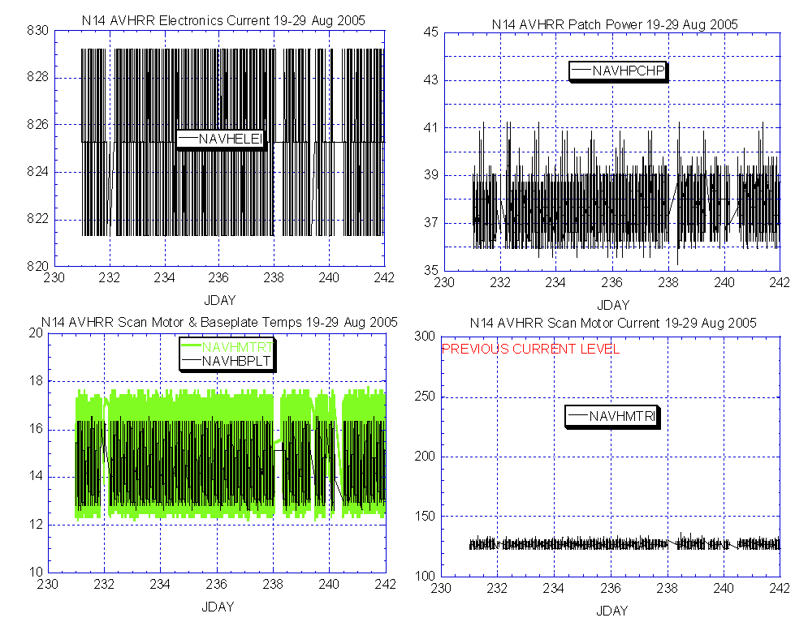

Illustration 1: NOAA-14 AVHRR Health Analysis
(Nominal and stable across the board.)

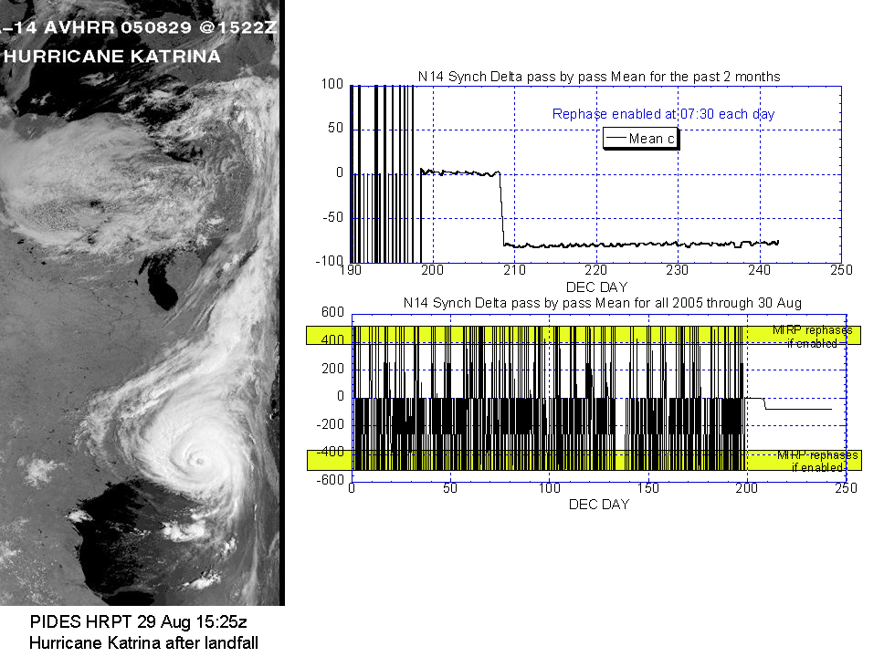

Illustration 2: N14 AVHRR Imagery & Synch Delta Analysis
(As nominal as if it were new.)

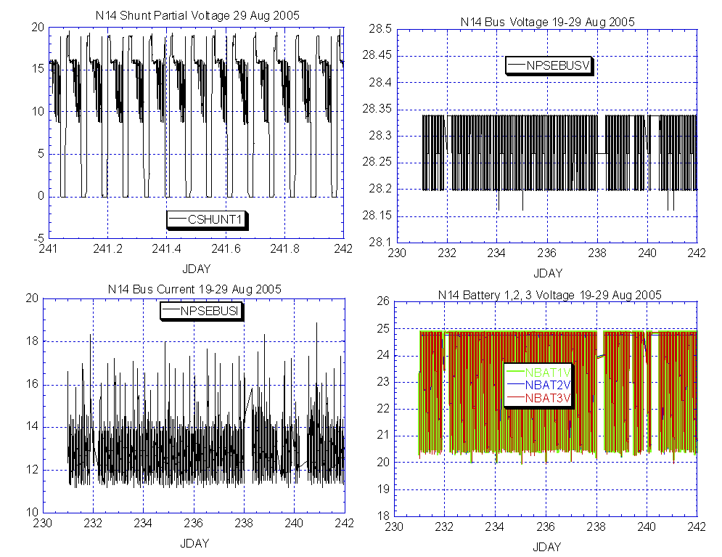

Illustration 3: N14 Power Analysis
(Nominal and stable)

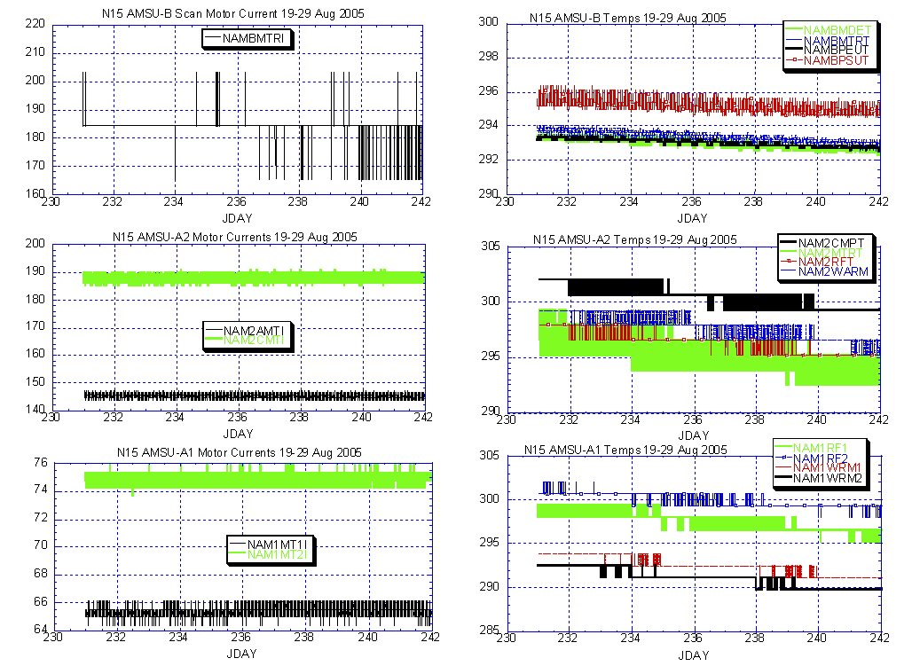

Illustration 4: N15 AMSU Health Analysis
(Nominal and stable with a pronounced thermal downtrend that should continue for another several weeks.)

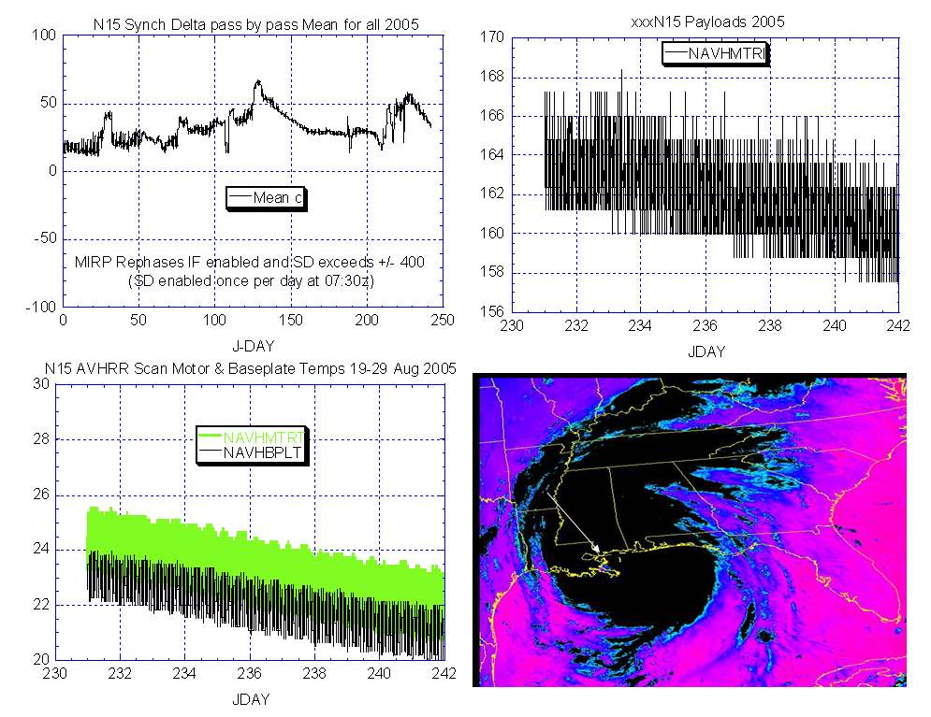
N15 AVHRR Scan Motor Current 19-29 Aug 2005

Illustration 5: N15 AVHRR Health Analysis
(Note the improvement in scan motor current [upper right] as the payload cools down [lower left]. Synch delta remains nominal [upper left] as does imagery [lower right; PIDES depiction of Hurricane Katrina just as the eye passes over New Orleans [white arrow] on 29 Aug at 11:45z

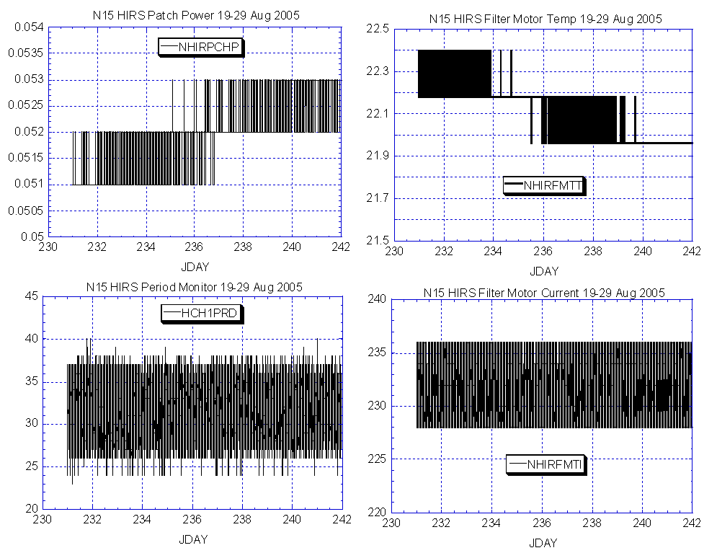

Illustration 6: N15 HIRS Health Analysis
(As nominal and stable is if it were new.)

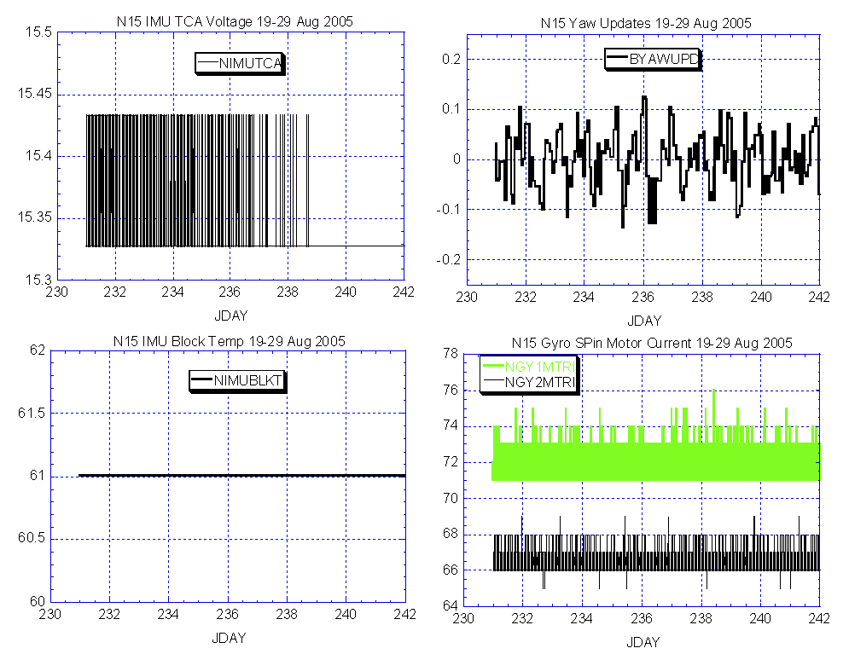

Illustration 7: N15 ADACS Health Analysis
(Nominal and generally stable although we are maintaining a close watch on gyro-1.)

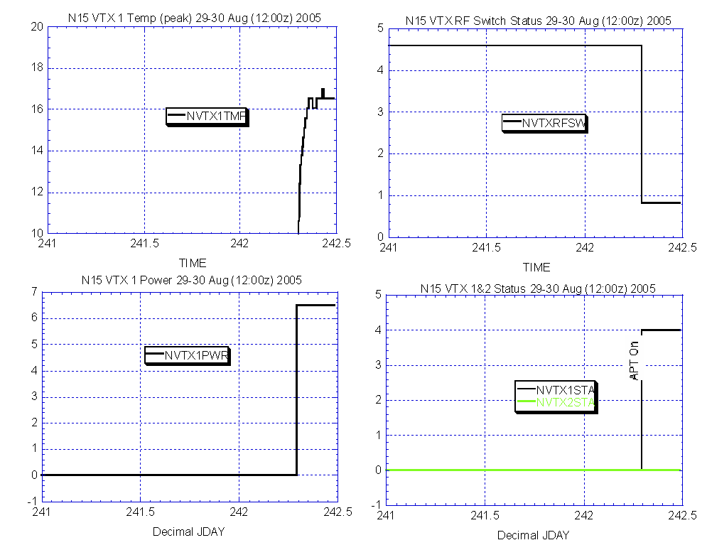

Illustration 8: N15 VTX Health Analysis
(Nominal turnon after being off since late July. Conflict with N12 ended.)

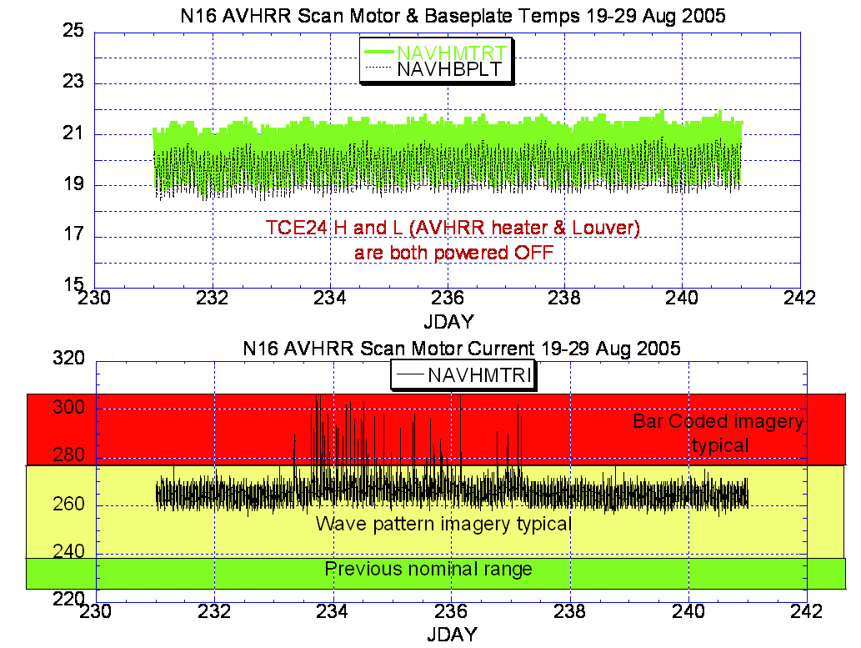

Illustration 9: N16 AVHRR Health Analysis
(Improved somewhat from the previous week.)

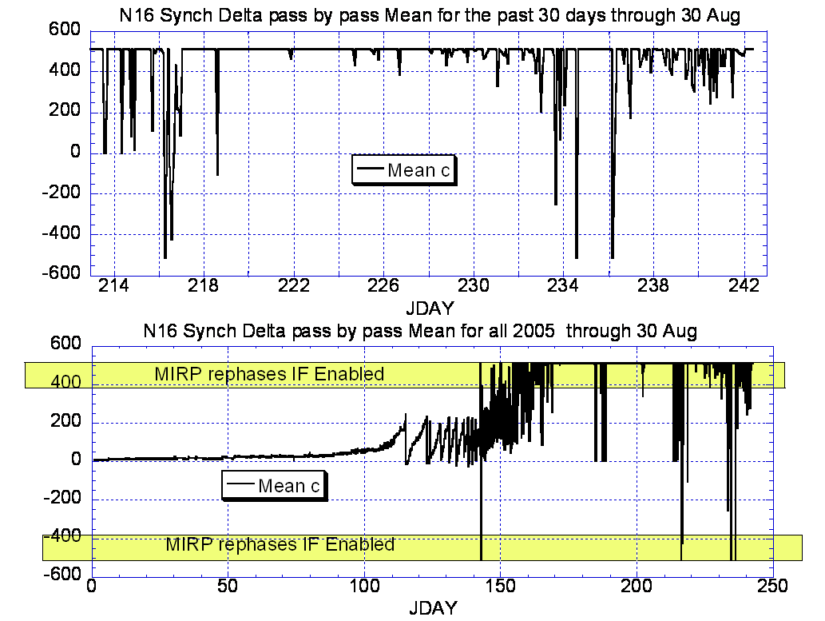

Illustration 10: N16 AVHRR-MIRP Synch Delta Analysis
(Showing some recent signs of improvement as depicted in the fact that the value is showing a reduced tendency to be “pegged” indicating that it is taking significantly longer to reach anomalous values.)

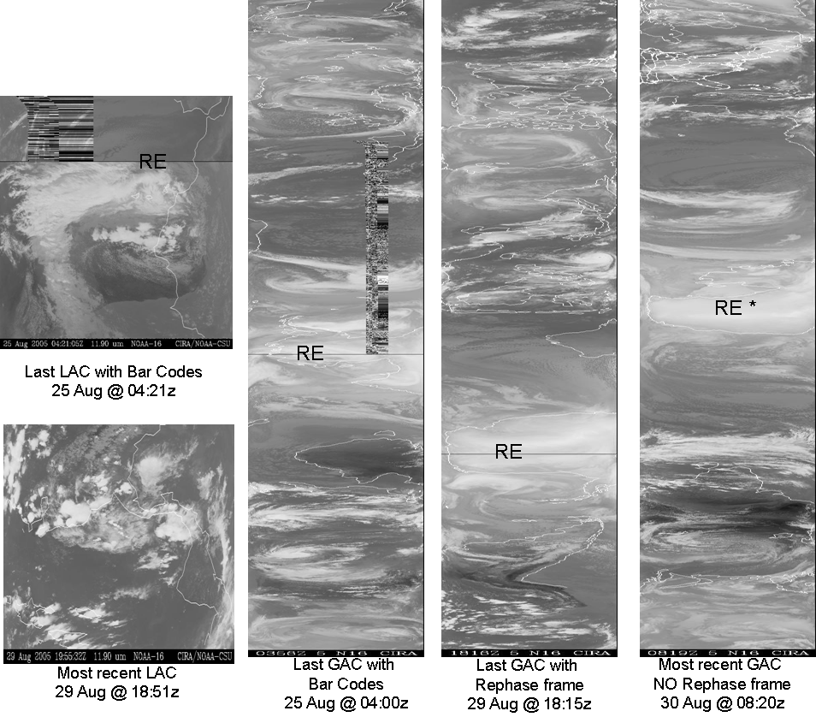

Illustration 11: N16 GAC and LAC Analysis
(Some recent improvement especially on the GAC depicted on the far right. This is the first such image all summer that did NOT have a MIRP rephase over the South Pole when Rephase was enabled. Coupled with a reduction in bar coded imagery, this represents an auspicious trend )

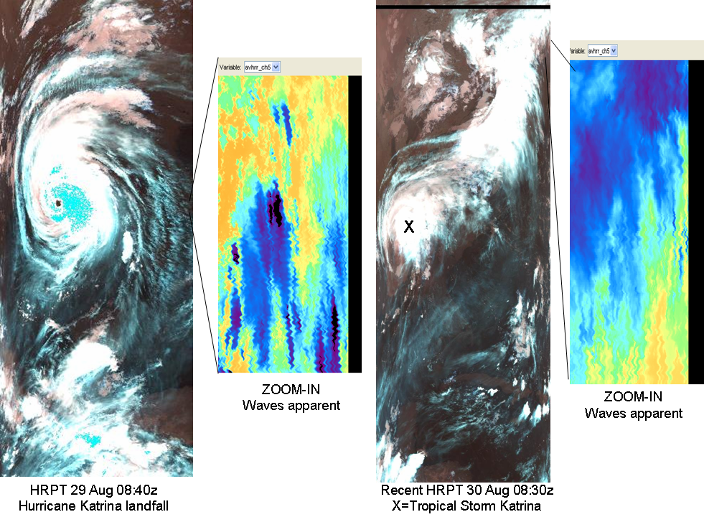

Illustration 11b: N16 AVHRR HRPT Imagery Analysis
(No bar codes in the past several days but wave patterns still persist.)

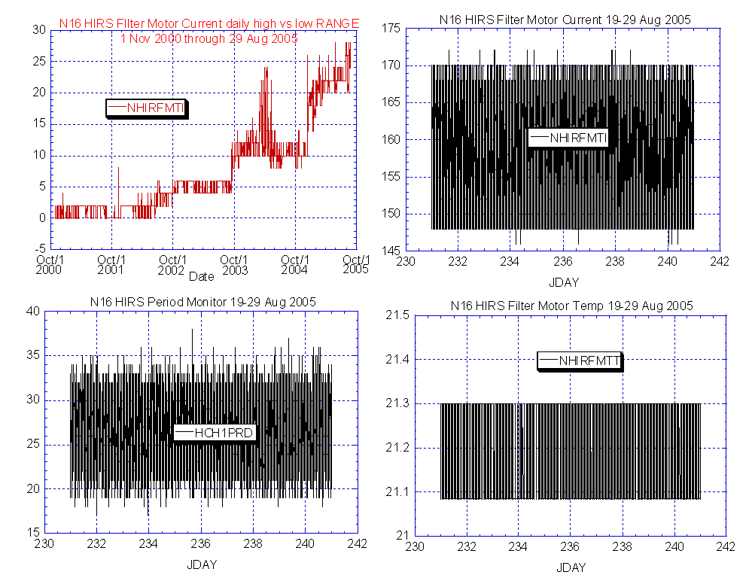

Illustration 12: N16 HIRS Health Analysis
(Some concern for the near all time high range between low and high values. Otherwise subsystem appears relatively nominal and stable.)

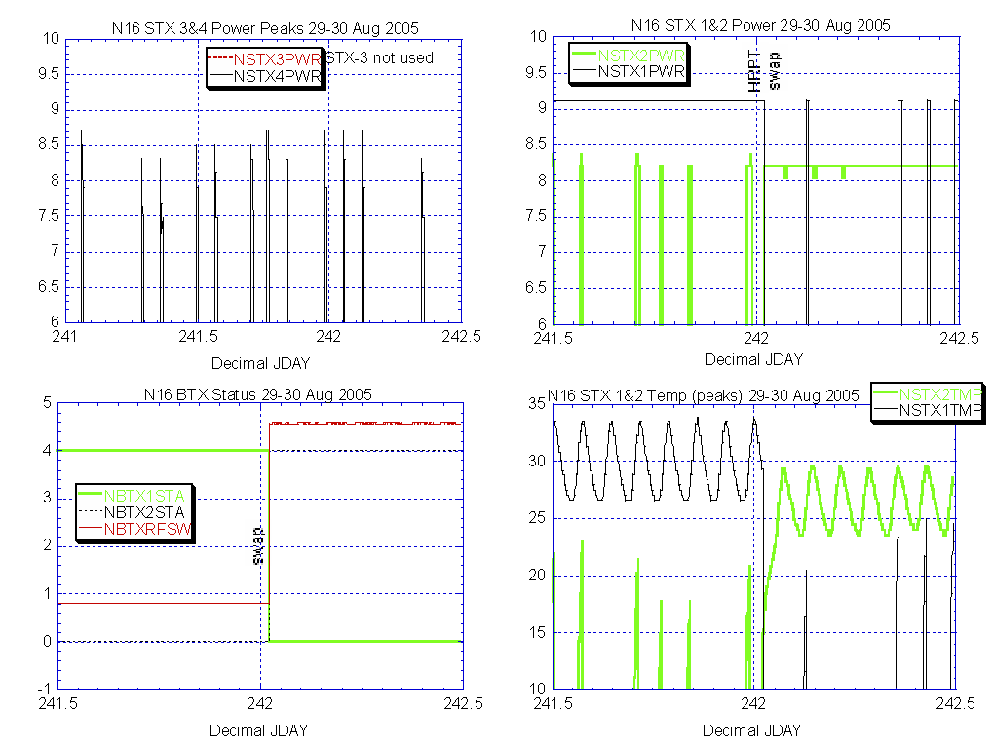

Illustration 13: N16 STX Analysis
(Nominal and stable after HRPT assignment switch in conjunction with N18 being declared operational on 30 Aug.)

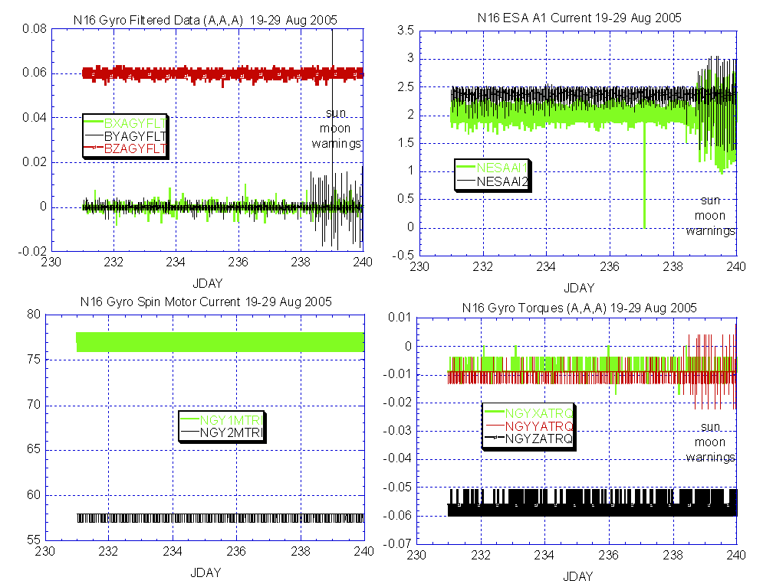

Illustration 14: N16 ADACS Health Analysis
(Generally nominal with some instabilities introduced because of sun-moon warning intrusions into the earth sensor field of view.)

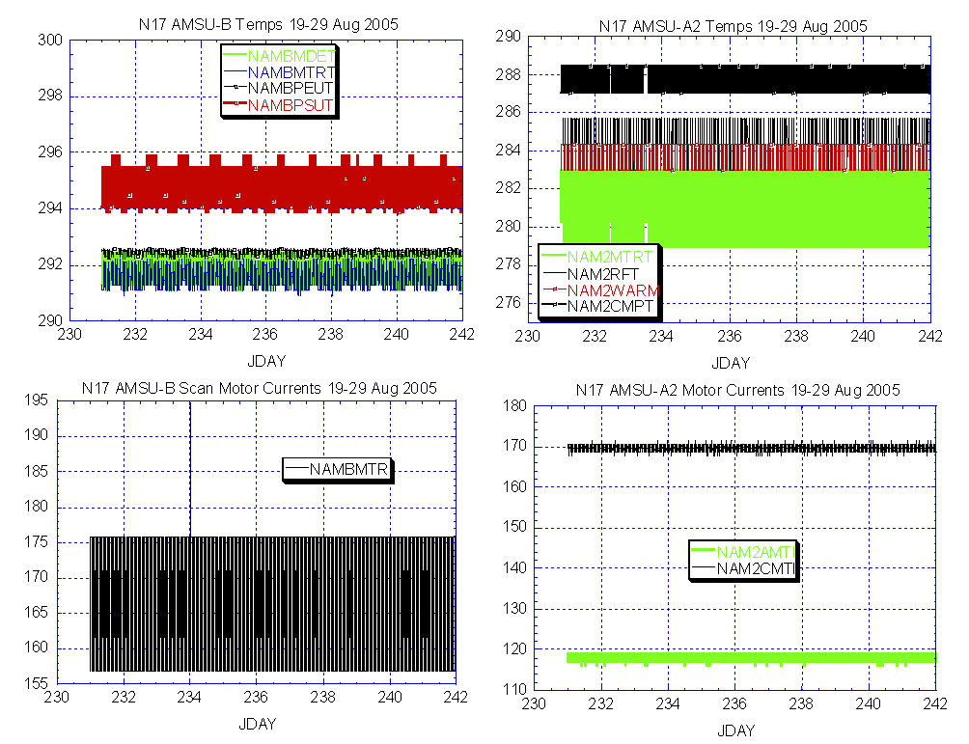

Illustration 15: N17 AMSU-A2 & B Health Analysis
(Nominal and stable. With AMSU-A1 non-operational.)

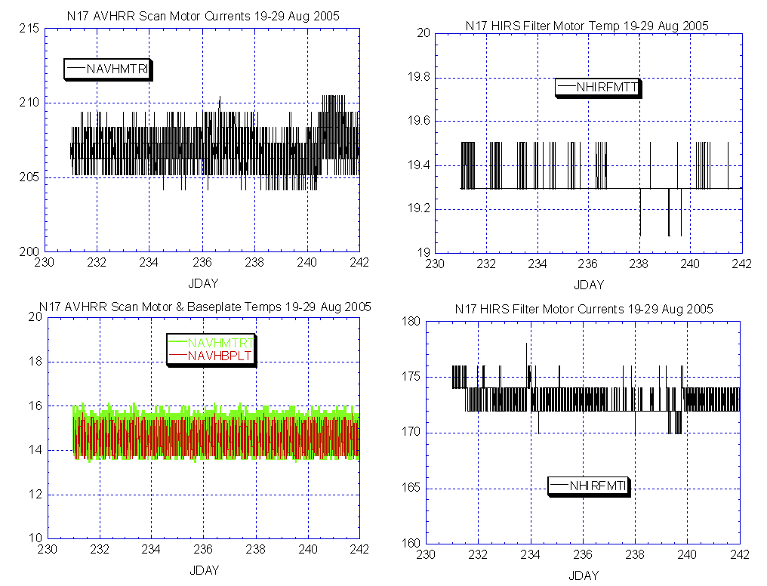

Illustration 16: N17 AVHRR Health Analysis
(Nominal and generally stable.)

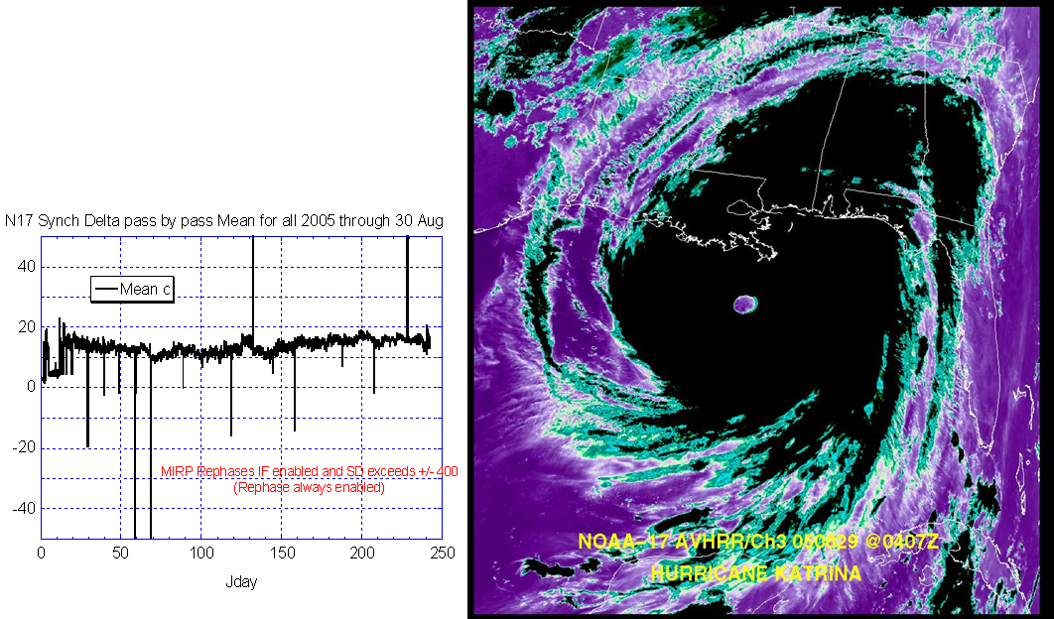

Illustration 17: N17 AVHRR Imagery and Synch Delta Analysis
(Nominal and stable with an excellent depiction of Hurricane Katrina approaching New Orleans on 29 Aug at 04:10z)

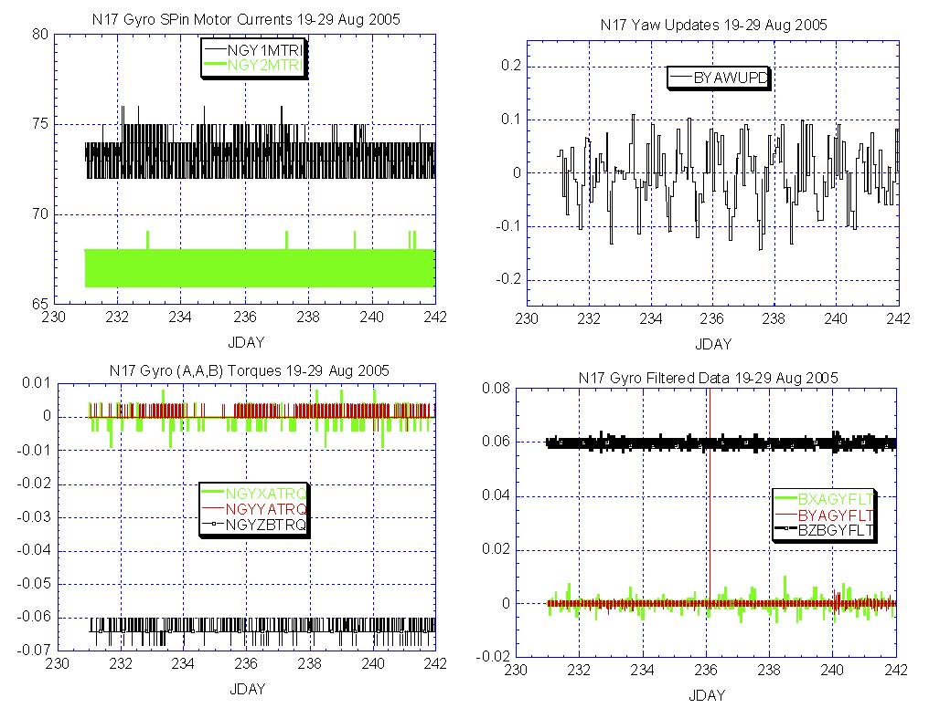

Illustration 18: N17 ADACS Health Analysis
(Generally nominal and stable with gyro-1 showing signs of settling back down after some instability last week.)

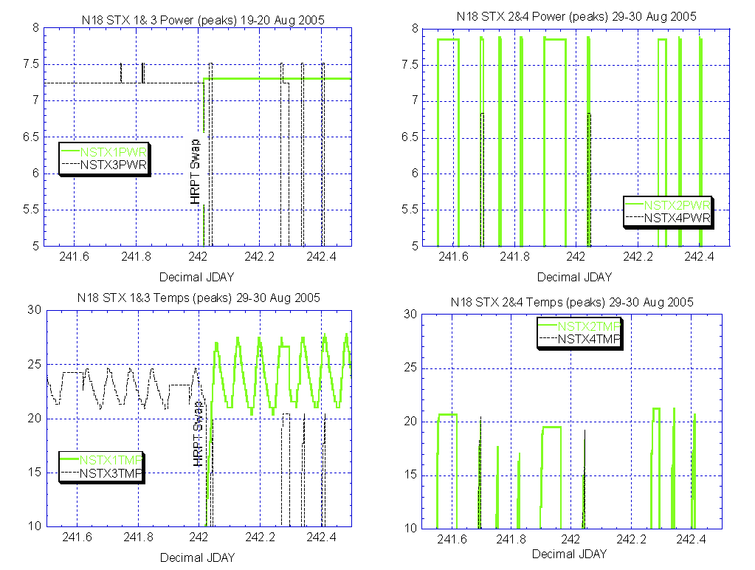

Illustration 19: N18 STX Power Health Analysis
(Nominal power and temperatures after switching HRPT assignments.)

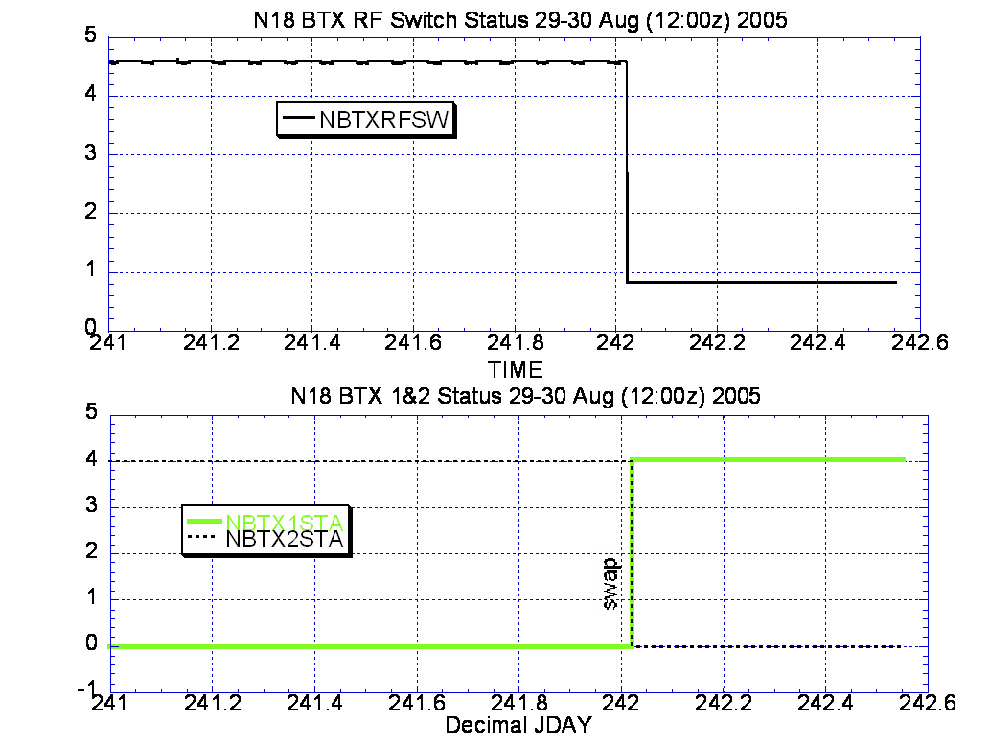

Illustration 20: N18 BTX Power Health Analysis
(Nominal power and temperatures after switching assignments.)

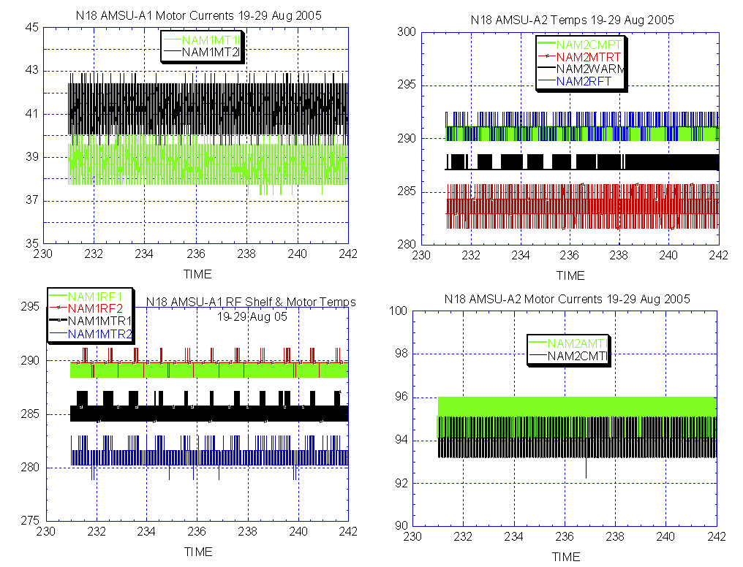

Illustration 21: N18 AMSU Health Analysis
(Nominal and stable.)

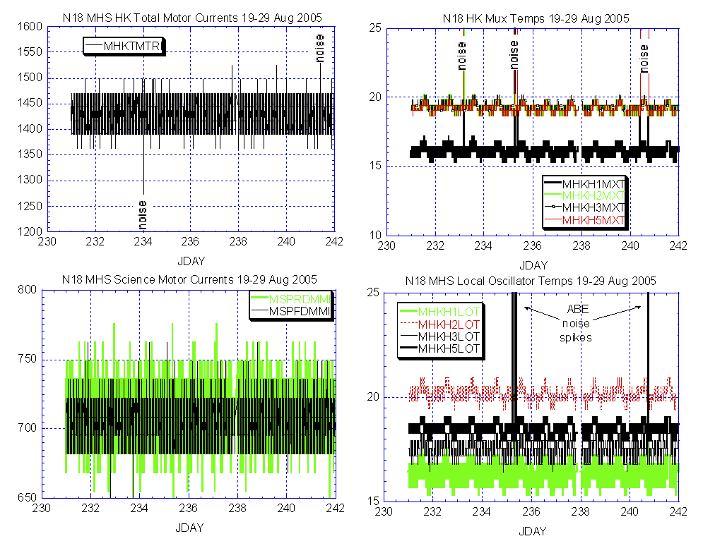

Illustration 22: N18 MHS Health Analysis
(Nominal and stable except for the noise spikes introduced by ABE and not visible in PACS 3100 HAF files.)

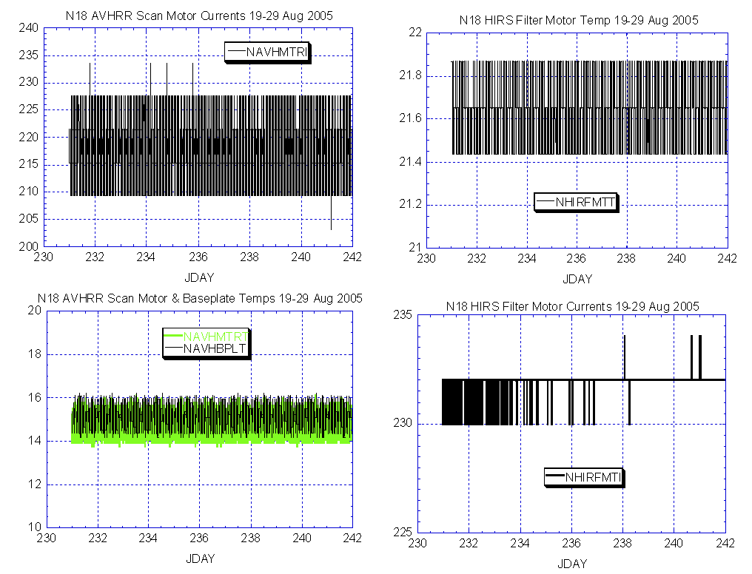

Illustration 23: N18 AVHRR and HIRS Health Analysis
(Both nominal and stable.)

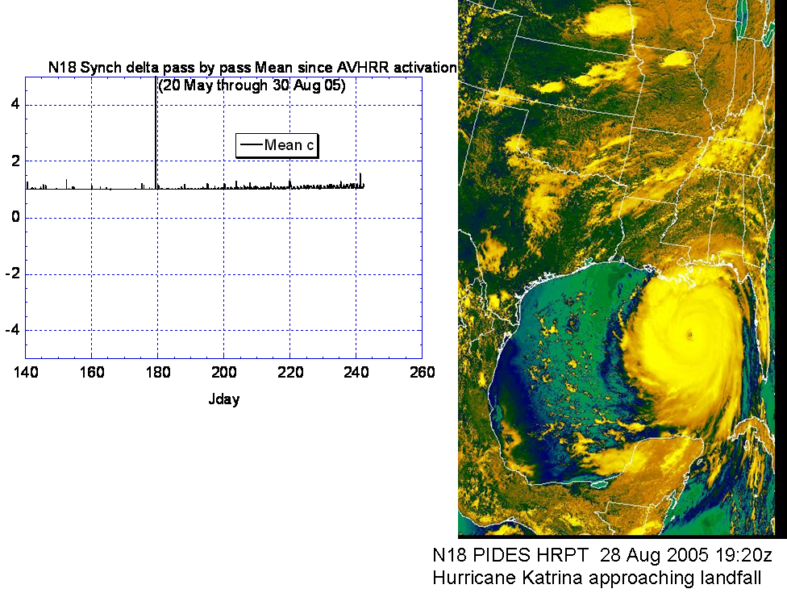

Illustration 24: N18 AVHRR Synch Delta and Imagery Analysis
(Nominal imagery and very stable on synch delta.)

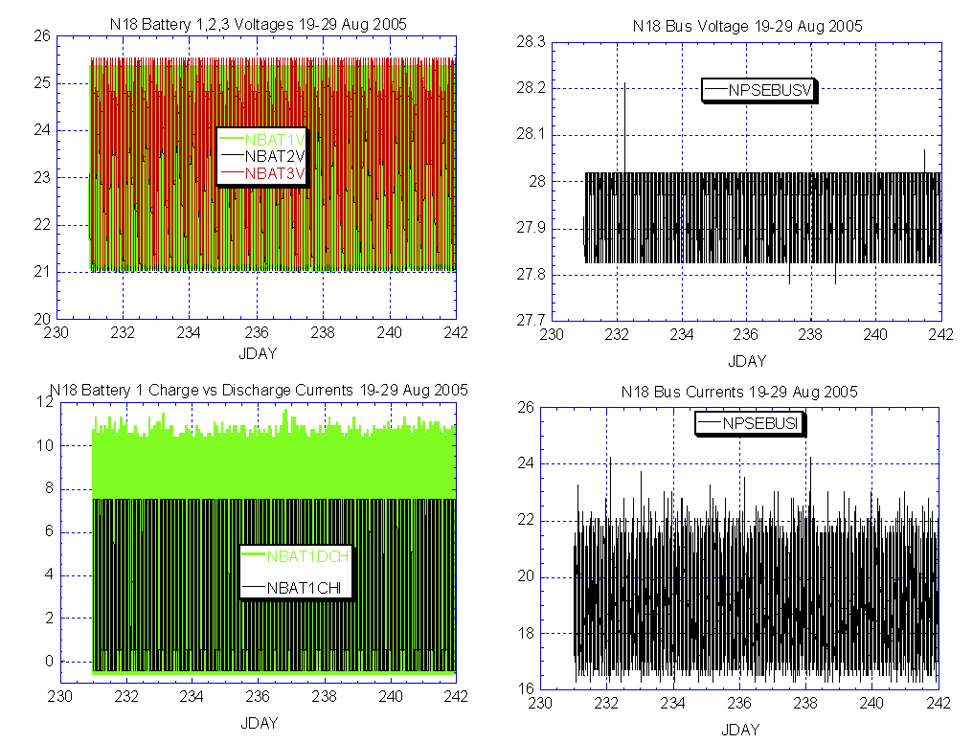

Illustration 25: N18 AVHRR Power Health Analysis
(Generally nominal although there has been some discussion regarding the relatively high [compared to other POES spacecraft] discharge to charge ratio [lower left plot].)

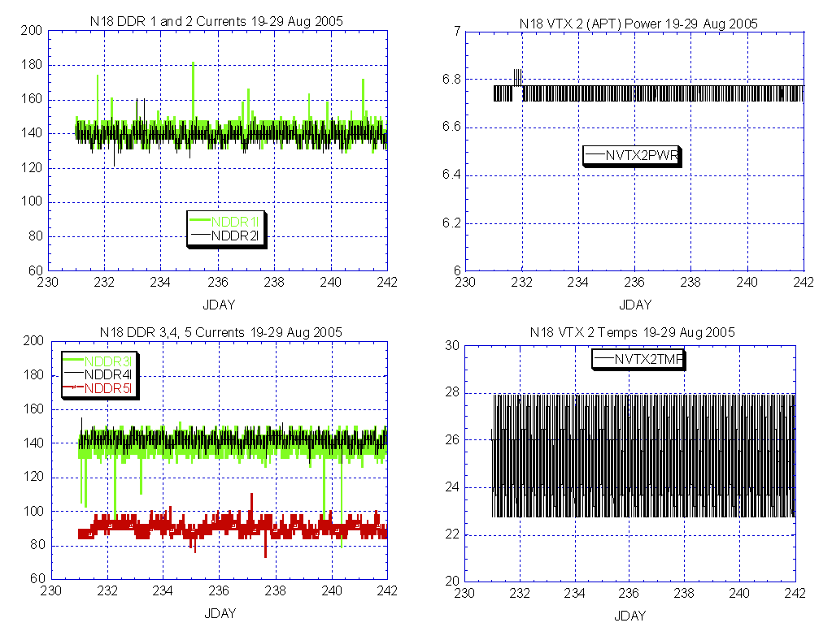

Illustration 26: N18 DHS-Comm Health Analysis
(No change from last week.)

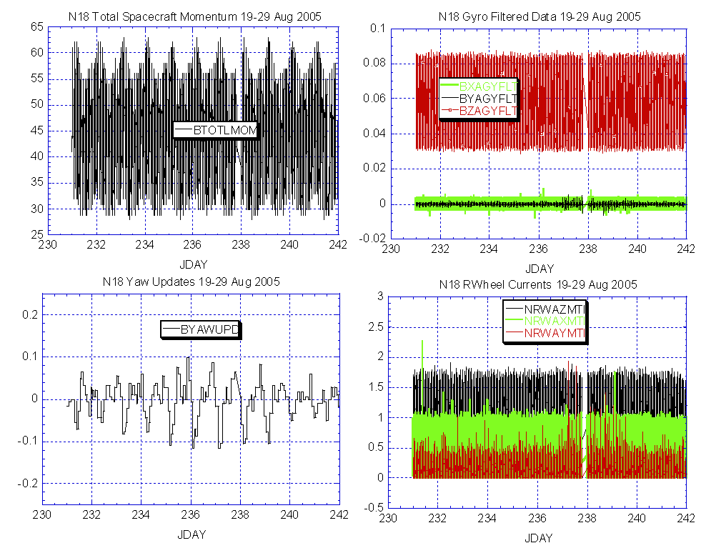

Illustration 27: N18 ADACS Health Analysis
(Also no change from last week.)

N17 Memory Scrub Statistics for the week and the life of the mission
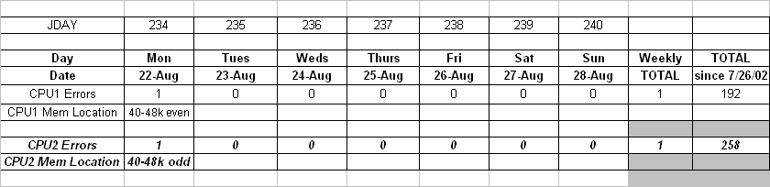

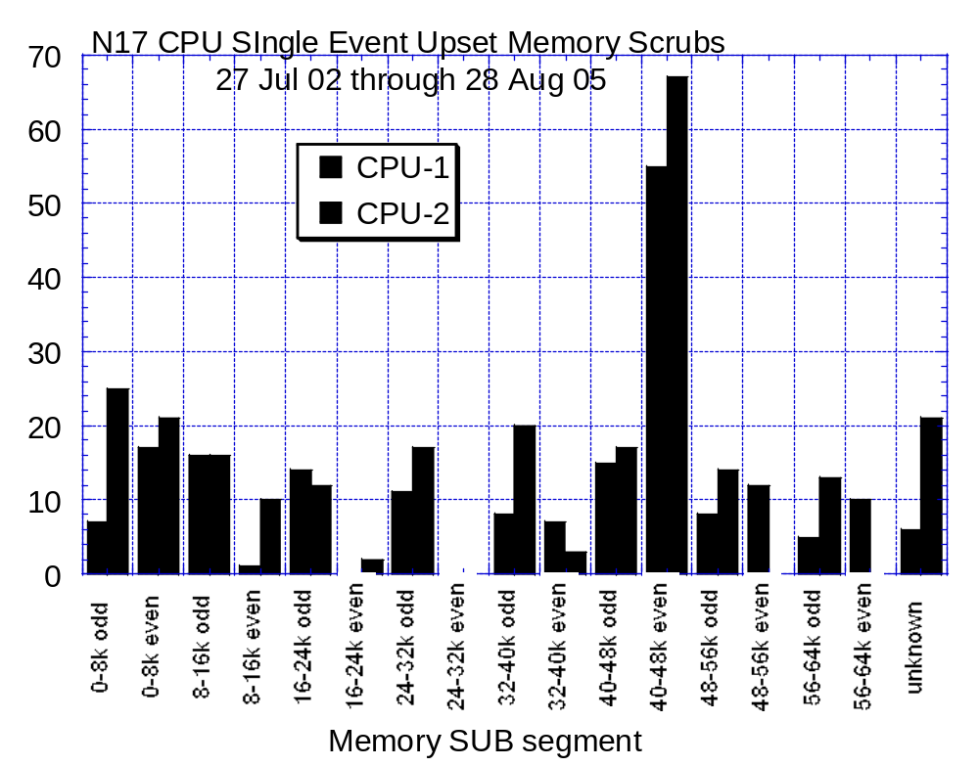

NOTE: N18 has had zero single event upset scrubs since launch

POLAR SPACECRAFT TIP CLOCK ERROR

WEEK ENDING August 26, 2005
DAY/DATE | NOAA-12 | NOAA-14 | NOAA-15 | NOAA-16 | NOAA-17 | NOAA-18
FRI. 08/19 | N/A | +228 msec | -259 msec | +159 msec | +098 msec | -008 msec
SAT. 08/20 | N/A | +228 msec | -256 msec | +160 msec | +098 msec | -006 msec
SUN. 08/21 | N/A | +228 msec | -257 msec | +160 msec | +099 msec | -006 msec
MON. 08/22 | -299 msec | +230 msec | -258 msec | +161 msec | +098 msec | -004 msec
TUE. 08/23 | -299 msec | +230 msec | -261 msec | +160 msec | +105 msec | -003 msec
WED. 08/24 | -304 msec | +237 msec | -261 msec | +161 msec | +101 msec | -001 msec
THU. 08/25 | N/A | +237 msec | -263 msec | +165 msec | +102 msec | +001 msec
EMOSS POC for this chart is JIM SHEPHERD

NOAA-14: As of 12/23/03 the TIP clock is corrected daily by –7.0 msec to compensate for drift.
NOAA-15: As of 04/22/03 the TIP clock is corrected daily by –8.0 msec to compensate for drift.
NOAA-16: As of 12/23/03 the TIP clock is corrected daily by -5.5 msec to compensate for drift.
NOAA-17: As of 12/23/03 the TIP clock is corrected daily by –3.0 msec to compensate for drift.
NOAA-12: As of 12/10/03 the TIP clock is corrected daily by +6.5 msec to compensate for drift.
* A clock jump of -500 milliseconds on 04/17/05 due to fractional second daily ETCUP. A clock
jump of +500 milliseconds on 07/01/05 due to fractional second daily ETCUP. Alternating +/-
500 millisecond clock jumps will ccur at 76-day intervals as long as fractional second daily
ETCUP is utilized to manage clock drift. The next +500 millisecond jump is expected on 09/15/05.

POES Engineering Contact List

Government

Renee Smith-Dearing NOAA POES Constellation Lead 301-817-4117
Dong Han: NOAA, POES Payloads 301-817-4127

Mickey Fitzmaurice: NOAA, POES Bus, IJPS 301-817-4016
Nicolaie Todirita (Todi): NOAA Ground Systems 301-817-4229

EMOSS-2 Contractor

Jeff Devine: EMOSS POES Lead 301-817-4020
Jim Walters: EMOSS, POES Payload Engineer 301-817-4033

Carl Gliniak, EMOSS POES Power and Thermal 301-817-4207

Jim Sheperd, EMOSS POES Attitude Control 301-817-4030
Jon Woodward EMOSS, POES Flight Software C&CS 301-817-4019

Sally House EMOSS POES Payloads 301-817-4026
William Chadwick EMOSS, POES Comm and DHS 301-817-4015

