INCOME WITHHOLDING
training notes

Module Objectives
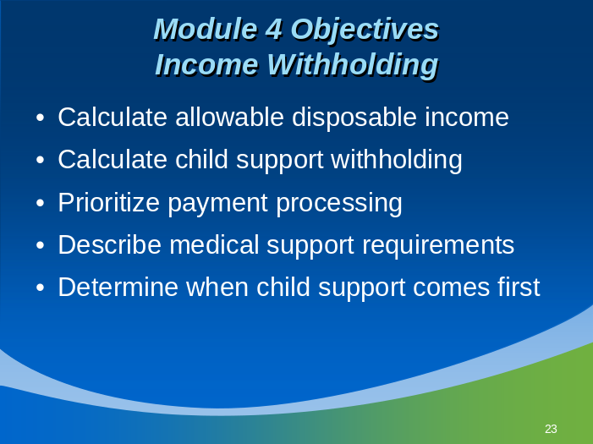

At the end of this module, you will be able to:
- Calculate the allowable disposable income in a case exercise.
- Calculate the correct amount of child and/or medical support for withholding.
- Prioritize payment processing when multiple child support income withholding orders and/or garnishments and levies are involved.
- Describe the employer’s requirements in handling medical support orders and in providing medical insurance to dependents of employees who are non-custodial parents.
- Determine (or identify the resource to help determine) when child support income withholding orders take precedence over other garnishments and withholdings.

Training Notes
- Point out that income withholding is the single most effective tool for collecting child support. All cases are now subject to income withholding unless the two parties (custodial and non-custodial) agree to other payment arrangements, and no delinquency occurs. Also, income withholding is not required for the self-employed.
- Make sure participants understand that income withholding is required by law in almost all cases and does not imply delinquency on the part of the noncustodial parent.
- Garnishments for child support are different from other kinds of garnishments.
- The definition of income is set forth in the Personal Responsibility and Work Opportunity Reconciliation Act (PRWORA) of 1996. This expanded the definition of income beyond weekly wages.
- Bonuses and Lump Sums – The PRWORA definition of income includes “bonuses,” insofar as they are paid on a periodic basis (e.g., an annual Christmas bonus), but there is no federal definition of “lump sums” applicable to child support withholding. State laws may have a broader definition of income, which includes lump sums. If that is the case, CCPA limits would apply. State laws govern withholding from lump sum amounts (for example, a payout from an insurance settlement; a one-time “employee- of-the-year” award, etc.) If lump sums are not considered income under the state definition, they are not subject to CCPA withholding limits and 100% may be taken, depending on state law.
- Tell participants that state laws can be viewed on the OCSE website, in the Information for Employer section, on the Income Withholding Order matrix. The link to the OCSE website is found at the end of the training slides (on page 7-9).

income-withholding for Employees
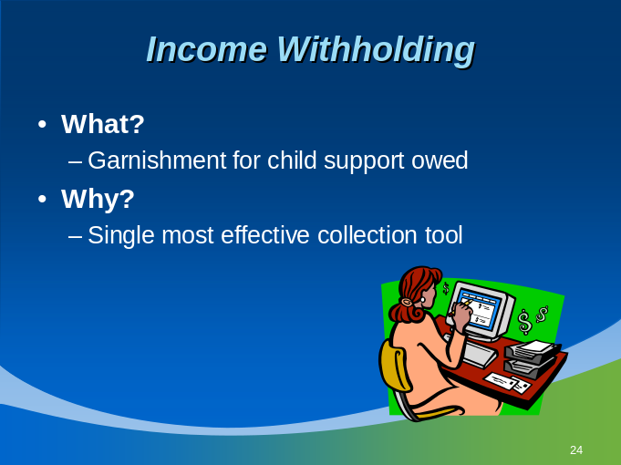
- What?
- A garnishment for child support owed, called an “income-withholding order.” The employer deducts the specified amount each pay period and generally sends it to the state child support enforcement’s State Disbursement Unit (SDU or central payment processing site).
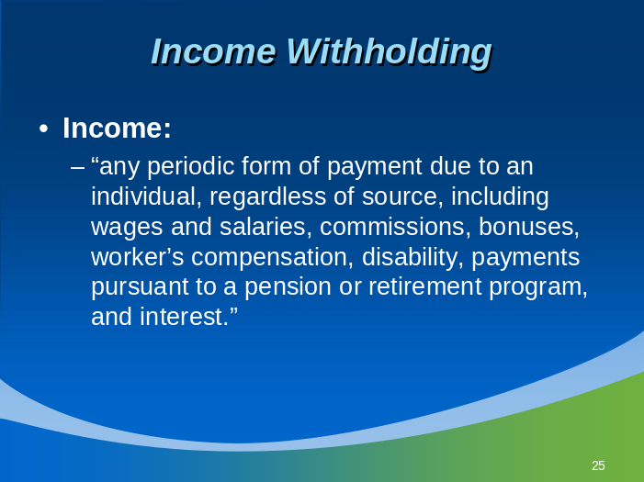
- Income is defined as “any periodic form of payment due to an individual, regardless of source, including wages and salaries, commissions, bonuses, workers’ compensation, disability, payments pursuant to a pension or retirement program, and interest.”
Training notes
- The Order/Notice to Withhold Income for Child Support does not have to be “served” on the employer but may be sent by first-class or certified mail, by fax or by hand, as permitted by state law.
- The Uniform Interstate Family Support Act (UIFSA), as adopted by each state, requires employers to accept direct income-withholding orders/notices from across state lines. For example, as an employer in New York, you could receive an income-withholding order from a child support agency in Nevada. Because interstate cases are the most difficult from which to collect, and comprise nearly 30 percent of all child support cases, the withholding order/notice standardizes the withholding process around the country.

How?
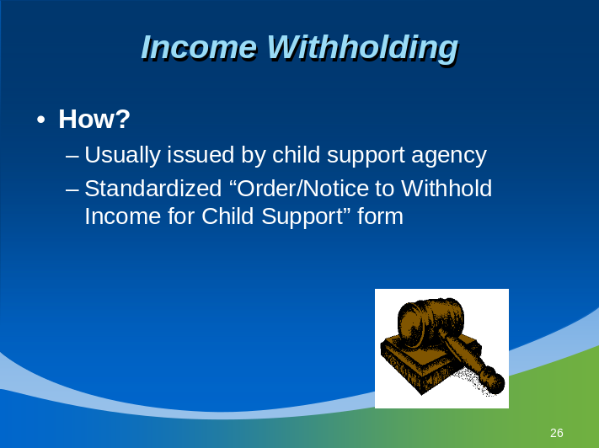
- An income withholding order or notice may be:
- Judicial – originates in the court system and is ordered by a judge.
- Administrative – originates through the child support enforcement agency’s “administrative process” in order to expedite case handling; is ordered by a child support hearing officer or equivalent, who has the same authority as a judge.
- A standardized form entitled “Order/Notice to Withhold Income for Child Support” (IWO) is now required for use in all states. This form includes information about the case (where the case is from, who the persons in the case are, and case-identifying information).
Where?
- An income withholding order may come from the employer’s state agency, directly from another state, court or private attorney. If from an out-of-state agency, it is called “direct income withholding” because it comes directly from an out-of-state agency to the employer rather than being processed through the child support enforcement agency in the employer’s state.
Training notes
Special Notes on an IWO:
There should not be more than one withholding order for the same child for current support.
Note: State CSE agencies issue IWOs for arrears only that are owed to the State for a time period when welfare has been paid on behalf of the custodial parent (CP) and child(ren). This IWO should be for arrears only and is not considered a duplicate order.

training notes
- What to do when an order/notice to withhold income for child support is received?
  - Date of receipt is important because the employer is responsible for taking action within certain timeframes (i.e., when to begin withholding).
- A copy of any interstate withholding orders must be given to the relevant employee. Most states do not require the employer to give a copy of an intrastate withholding order to the employee, but some states do. Be sure to check your state law.
- Note that “regular on its face” is simply a legal term that means you should look at the document and use common sense; if the document looks like an official legal document, it is considered “regular on its face.” (UIFSA Model Act Sec. 502) And, if it does not seem regular on its face or contains substantive errors, you may return it to the sender with a clear explanation as to why it is being returned.
- If you receive withholding orders from more than one issuing agency/party for the same custodial family, be sure to contact all parties involved as soon as possible (something is wrong!). Continue to honor the first order that you received until and unless you receive official notice that a determination has been made that a different order should be honored. It is not the employer’s responsibility to figure out which order is the one to be followed (you may hear this referred to as the “controlling order.”)
- There should not be more than one withholding order for the same child for current support.
  - Note: State child support enforcement (CSE) agencies issue IWOs for arrears only that are owed to the State for a time period when welfare has been paid on behalf of the CP and child(ren). This IWO should be for arrears only and is not considered a duplicate order.

Complying with the income withholding order for child SUPPORT
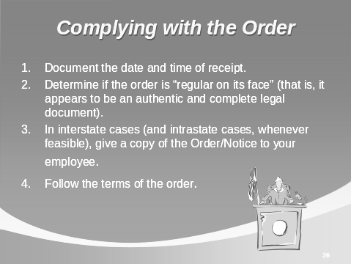
The employer receives an Order/Notice to Withhold Income for Child Support.

- Document the date and time of receipt.

- Determine if the order is “regular on its face” (that is, whether it appears to be an authentic and complete legal document).

- In interstate cases (and intrastate cases, whenever feasible), give a copy of the Order/Notice to your employee.

- Follow the terms of the order.

TRAINING NOTES
- Tell participants to turn to the Appendix: Handout # 1: Order/Notice to Withhold Income for Child Support to follow along in this section.
  - Tell participants to look at Handout # 2 IWO Flowchart, which might be helpful to them as we go through this section.
- Explain that the top of the form contains information about where the form is from. This is very important.
- If the first box is checked (ORDER/NOTICE TO WITHHOLD INCOME FOR CHILD SUPPORT), the IWO should be from a state/tribe/territory/city/county/district or reservation with the authority to issue an Order to Withhold Income (IWO).
- If the second box is checked (NOTICE OF AN ORDER TO WITHHOLD INCOME FOR CHILD SUPPORT), the Notice of an IWO is from a non-governmental entity or individual.
- Non IV-D attorneys, individuals, and non-governmental entities must submit a Notice of an Order to Withhold and include a copy of the income withholding order unless, under a state’s law, an attorney in that state is allowed to issue an income withholding order. In that case, the attorney may submit an Order/Notice to Withhold and include a copy of the state law authorizing the attorney to issue an income withholding order/notice.
Top of Form:
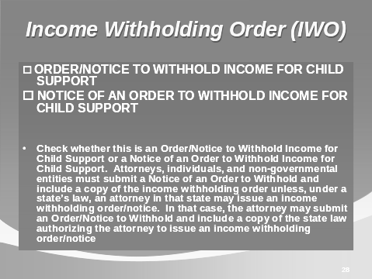
This section of the form contains:
Title of the Form: ORDER/NOTICE TO WITHHOLD INCOME FOR CHILD SUPPORT
- Check box for: ORDER/NOTICE TO WITHHOLD INCOME FOR CHILD SUPPORT or NOTICE OF AN ORDER TO WITHHOLD INCOME FOR CHILD SUPPORT
Non IV-D attorneys, individuals, and non-governmental entities must submit a Notice of an Order to Withhold and include a copy of the income withholding order unless, under a state’s law, an attorney in that state is allowed to issue an income withholding order. In that case, the attorney may submit an Order/Notice to Withhold and include a copy of the state law authorizing the attorney to issue an income withholding order/notice.
TRAINING NOTES
- Type of Order/Notice (original; amended; terminated)
- The top of the form identifies what entity (state/tribe/territory/city/county/district or reservation, non-governmental entity or individual) issued the IWO.
- Date of order/notice, case number, employer’s information, employee’s name, Social Security number, case identifier, and obligee’s name.

Type of Order/Notice (original; amended; terminated)
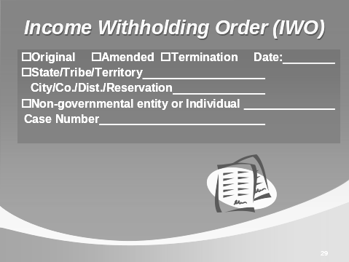
Form may be amended if:
- The arrears are paid in full and only current support is due
- Current support is paid and only arrears are due
- The order was modified to change the amount of support due.
Form may be terminated if child has reached age of majority (i.e., 18 or 21); child has died; or other reasons.
An arrears is the unpaid current support previously due. It is not the employer’s responsibility to keep track of arrears. The child support agency will send an amended order/notice when withholding for arrears should stop.
- The top of the form tells you who the IWO is from (state/tribe/territory or city/county/district/reservation or non-governmental entity or individual)

TRAINING NOTES
- Explain that the check box about whether arrears are 12 weeks or greater is important in determining Consumer Credit Protection Act (CCPA) limits on withholding. This will be discussed in more detail in the next section.
- Point out that in the very first paragraph, it states “You are required by law to deduct these amounts from the employee’s/obligor’s income until further notice.” The employer should NOT stop withholding until receiving notification from the issuing entity.

Identifying information
(Case number, employer, employee and obligee’s name)
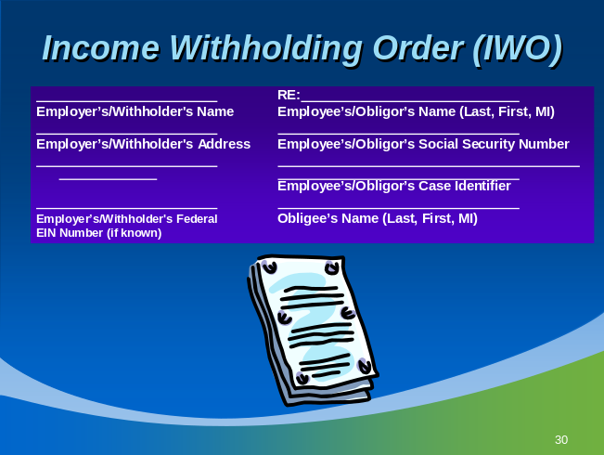
Order Information:
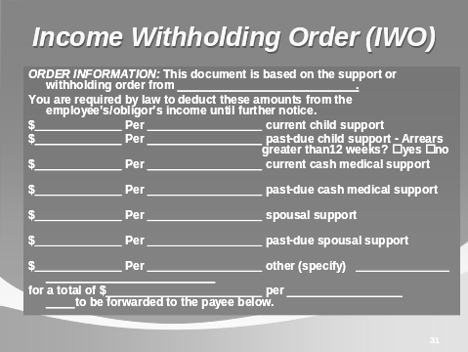
- This section provides information about what amount should be withheld. It provides totals, then breaks down payments to accommodate different payroll cycles. It includes current support, arrears, medical support and other data (such as court fees).
TRAINING NOTES
- Note that the employer does not have to change its payroll cycle to adjust to the child support withholding. It works the other way around (child support withholding is adjusted to fit employer’s payroll cycle). (42 USC 666 (b) 6 (c)).

Order Information:
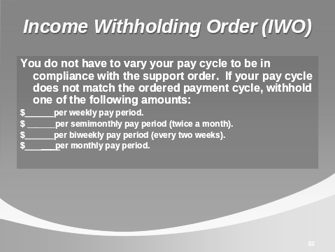
- Note that the employer does not have to change its payroll cycle to adjust to the child support withholding. It works the other way around (child support withholding is adjusted to fit employer’s payroll cycle).

training notes
- Remittance information:
  - The law of the ISSUING STATE must be followed for requirements that only the issuing state would know, such as where to send the payment, how much the payment should be, and whether medical support is ordered.
  - The law of the EMPLOYEE’S PRINCIPAL PLACE OF EMPLOYMENT (PPOE) must be followed for requirements that pertain to the employer’s tasks, such as when to begin withholding, whether an administrative fee may be imposed, and the maximum amount to withhold.
  - The intent here is to make the employer’s job easier since most employees will work in the employer’s state, and the employer will be familiar with and can easily apply the same laws for each withholding order. However, this may not be true in areas like Washington DC/MD/VA where several states are close together and an employee often does not live in the state where he/she works.

Remittance Information:
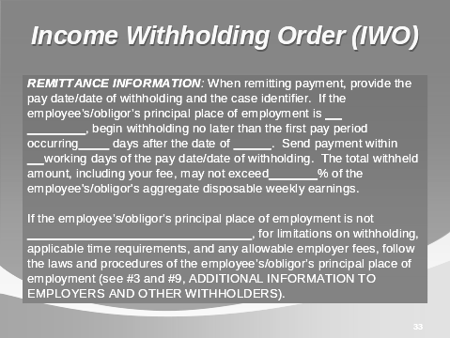
This section gives you the information needed to remit payments.
The information provided in this section follows the state law of the issuing state, and most of the time the issuing state will be where the employee works. However, the employer must always follow the law of the employee’s principal place of employment to determine:
- When to begin withholding
- When to remit payments following date of withholding
- When to remit payments (this can be from 1 to 7 days after payday)
- Maximum amount to be withheld (within the Consumer Credit Protection Act limits)
- How to allocate withholding across multiple child support orders
- Administrative fee that the employer is permitted to charge the employee and
- Other terms and conditions that may be set by state law.
training notes
- If the employer fails to comply with an order issued by its own state or another state, there are mandatory fines that apply under the law of the employer’s state.

Terms of the order/notice
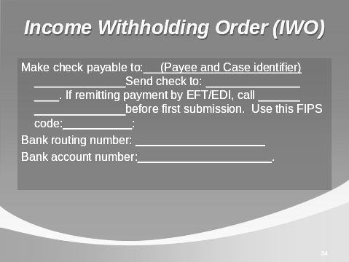
Remember:
Always comply with the terms of the order/notice from the issuing state for:
- Duration and amount of child support, current and arrears
- Person/agency designated to receive the payments
- Payment of fees and/or costs charged by the child support enforcement agency, issuing court and custodial party’s attorney.
training notes
Contact Information
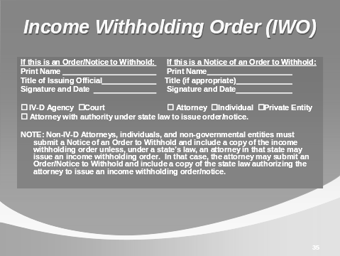
This section contains contact information for the entity sending the IWO (Name, title and signature of issuing entity)
NOTE: Non IV-D attorneys, individuals, and non-governmental entities must submit a Notice of an Order to Withhold and include a copy of the income withholding order unless, under a state’s law, an attorney in that state may issue an income withholding order. In that case, the attorney may submit an order/notice.

training notes
- We will talk more about the “Termination Notification” portion on page 2 in Module 6: Reporting Terminations.
- Point out #6 – Lump Sum Payments: You may be required to report and withhold from lump sum payments such as bonuses, commissions, or severance pay. If you have any questions about lump sum payments, contact the child support enforcement (IV-D) agency.
- Tell participants that the child(ren)’s names and additional information were moved to the back of the form in the last revision.
- Point out #10. If you or your employee/obligor have any questions, contact by telephone at _____________ by Fax at __________ or by Internet at _______. – The addition of the Internet access should be helpful to employers.

Page 2: Additional Information to Employers and Other Withholders
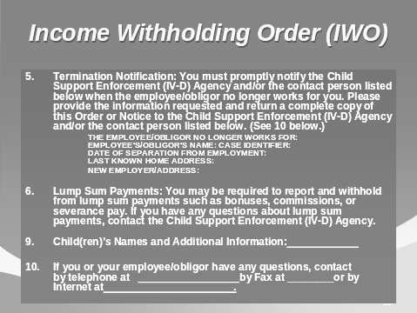
- This page is mostly informational.
- A copy of the income withholding order/notice must be given to the employee if the box is checked on the reverse side of the IWO. You are required to provide a copy of this form to your employee/obligor. If your employee works in a state that is different from the state that issued this order, a copy must be provided to your employee/obligor even if the box is not checked.
- #5 – Termination Notification – must be completed and returned to the issuing agency/party if the employee has terminated employment.
- #6 – Lump Sum Payments: You may be required to report and withhold from lump sum payments such as bonuses, commissions, or severance pay. If you have any questions about lump sum payments, contact the child support enforcement (IV-D) agency.
- Child(ren)’s names and additional information.
- 10. If you or your employee/obligor have any questions, contact by telephone at _____________ by Fax _____________ at or by internet at_______ .
training notes
EXERCISE # 1
- Review the brief case study of Jacob and Bridget Astor.
- Ask participants to read the Order/Notice on their own, and then complete the information in their manuals.

Exercise # 1: Sample Case for Income Withholding
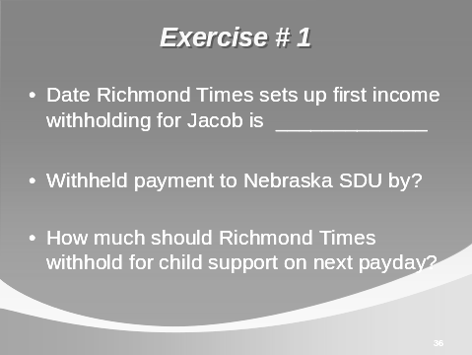
Jacob Astor and Bridget Quincy were married. After eight years of marriage, the Astors decided to divorce. Their son, Frank, continues to live with his mother in Lincoln, Nebraska after the separation.
In May, Jacob was ordered to pay $400 each month ($184.62 biweekly) in child support as part of the divorce settlement. After the divorce, Jacob moved to Richmond, Virginia.
In May, the Nebraska Child Support Enforcement Agency (CSEA) sent an Order/Notice to Withhold Income for Child Support to Jacob’s new employer in Richmond, the Richmond Times.
Virginia law requires child support payments to be sent on each payday, or within four days if remitted by EFT/EDI (electronic payment).
Richmond Times received the Order/Notice on Wednesday, May 23.

Exercise Continued ->

training notes
Richmond Times’ next paydays are Friday, May 31st and Friday June 12th.
Date of Richmond Times’ first withholding for Jacob would be Friday, June 12th.
(June 12 would be the pay day corresponding to the May 31 statement. The May 31 statement covers the dates from May 11-24. So the first full pay period to be attached would be for the pay date of June 12.)
Withheld payment must be sent to the Nebraska SDU by Friday, June 12 if sending paper check or by June 16 (4 days after June 12) if sending electronically (Virginia law).
Richmond Times is allowed to charge an administrative fee of $5.00 per income-withholding (per Virginia law).
How much should Richmond Times withhold for child support?
(400.00 per month or 184.62 biweekly) + $5.00 = $405.00 per month or 189.62 biweekly since this payroll is biweekly.
Richmond Times’ payroll is biweekly and the next payday is Friday, May 31 and the one after that is Friday, June 12.
Please complete:
Date Richmond Times sets up first income-withholding for Jacob _____________.
Withheld payment must be sent to the Nebraska SDU by ________________
Richmond Times is allowed to charge an administrative fee of $5.00 per income-withholding order. Jacob’s biweekly gross pay is $1,600.00. Assume no more than 30 percent of gross pay is taken for mandatory deductions.
Based on what we’ve covered so far, how much should Richmond Times withhold for child support on the next payday?_________

training notes
- The CCPA is a federal law that provides a minimum level of protection to an employee so that his entire paycheck cannot be withheld (he has to have something to live on!). Some states provide even more protection than the federal law, but all must adopt the minimum CCPA limits.
- The CCPA limits to follow are those allowed by state law -- the state that is the employee’s official work site.
- Calculating the allowable disposable income is a very simple two-step process: determining the disposable income and applying the CCPA limits.
- Allowable disposable income (calculated for weekly income) is also known as Aggregate Disposable Weekly Earnings, or ADWE. This term is used in the Order/Notice to Withhold Income for Child Support.
- What is the difference between allowable disposable income and net pay? Net pay is the take-home pay but may include non-mandatory deductions.

Calculating Disposable Income
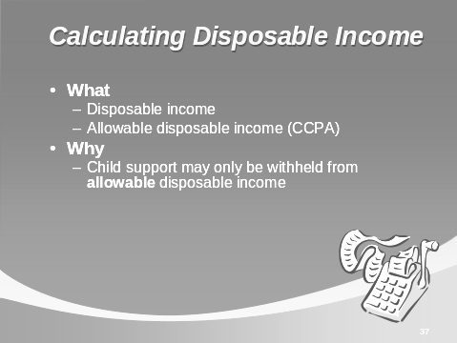
- What?
- Disposable income is the amount of earnings remaining after subtracting certain mandatory deductions from an employee’s gross pay.
- Allowable disposable income is simply a percentage of disposable income and is the amount actually subject to child support withholding.
training notes

Calculating Disposable Income
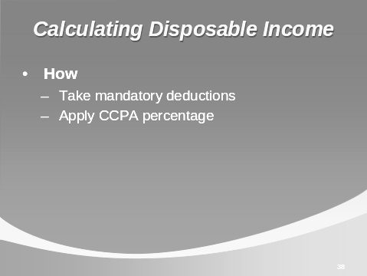
- How?
- Allowable disposable income is calculated by applying the CCPA limits permitted by state law.
- Gross pay minus mandatory deductions = disposable income
- Disposable income times the CCPA limit = allowable disposable income
- The allowable disposable income is the maximum available for child support withholding.
training notes
- It is the employer’s responsibility to withhold within the limits set by state law. It is recommended that withholding be made according to the higher percentage, unless the employer has documentation that shows the employee is indeed supporting a second family. The existence of a second child support order for a different child (and CP) does constitute evidence of a second family. Remember that a child support agency in one state may not even know that the non-custodial parent (NCP) has a child support order issued for a different family in a different state.
- If you want to verify support of a second spouse or child, you could ask to see a spousal or child support order, a birth certificate, or a marriage certificate. The employee’s tax or health insurance records might also prove that he has dependents other than those named in the child support withholding order. An affidavit from the employee could also be obtained.
- Although the employer is more likely to know if the employee supports a second family, when in doubt, you may ask for guidance from the child support agency.

Federal Consumer Credit Protection Act limits:
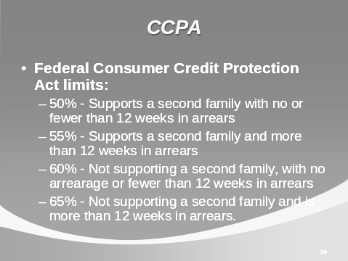
This law sets limits on withholding a non-custodial parent’s disposable income based on his/her current family setting and payment history:
- 50% - Supports a second family, with no or fewer than 12 weeks in arrears
- 55% - Supports a second family, and more than 12 weeks in arrears
- 60% - Not supporting a second family, with no arrearage or fewer than 12 weeks in arrears
- 65% - Not supporting a second family, and is more than 12 weeks in arrears.
Disposable income times the CCPA limit = Allowable disposable income.
There are no set rules or regulations to guide the employer in determining whether your employee is supporting a second family.
Title III of the Consumer Credit Protection Act (15 USC Sec. 1671 et seq; 29 CFR 870) simply states “…if the employee is supporting a spouse or child...” other than the child or spouse for whom support is being sought, then the existence of a second family is established and a lower percentage should be withheld.
The employee does not have to be living with the second family to be supporting them; a second child support order indicates that a second family is being supported.

training notes
EXERCISE # 2
- According to the Order/Notice to Withhold, Jacob Astor owes a total of $450 per month, and he is paid biweekly (450/2.1666 = 207.70 biweekly).

Exercise # 2: Calculating Allowable Disposable Income

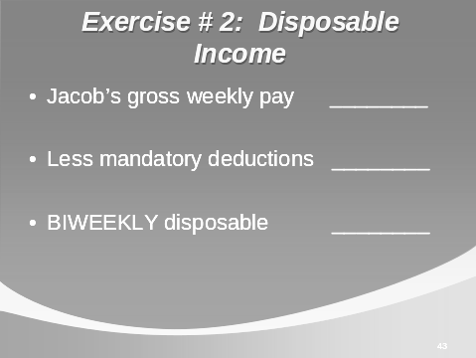

Let’s go back to Jacob Astor, an employee working for Richmond Times and owing $400/month (184.62 biweekly) in child support.
Now let’s assume that Jacob is 4 months behind on his payments and has been ordered to pay $50/month (23.08 biweekly) in arrears in addition to the current support he is already paying. Use the following information to calculate Jacob Astor’s disposable income:
- Nebraska:
- Exceptions to federal CCPA limits: none
- Virginia:
- Exceptions to federal CCPA limits: none

Exercise Continued ->

training notes
EXERCISE # 2 (Continued)
- Although the Order/Notice was issued in Nebraska, Mr. Astor works for the Richmond Times, in Virginia, so Virginia law (law of the state where Mr. Astor works) applies to the calculation for allowable disposable income.
Jacob’s gross biweekly pay: __1,600.00_
Subtract mandatory deductions: __150.00_____
Jacob’s disposable income for biweekly pay period 1450.00

Exercise # 2: Calculating Allowable Disposable Income (Continued)
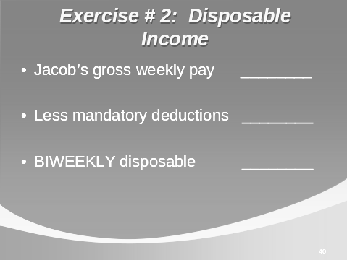

- Virginia follows the CCPA limits – with no second family and more than 12 weeks in arrears, the CCPA limit for Jacob is 65 percent, the same cap that is specified in the Order/Notice.
- Richmond Times’ payday is biweekly.
- The following deductions are taken from Jacob’s biweekly gross pay of $1600.00:
- Federal/state/local taxes 95.00
- FICA 45.00
- Medicare 10.00
- Jacob’s gross biweekly pay: ___________
- Subtract mandatory deductions: ___________
- Jacob’s disposable income: ___________

Exercise Continued ->
training notes
EXERCISE # 2 - Continued
- 1. Biweekly disposable income: _$1450.00_
- 2. Multiplied by CCPA limit: ___65%____
- 3. Maximum withholding allowed: __$ 942.50__
- Is there sufficient money to withhold the entire amount ordered for Jacob for the biweekly pay period? ($400 current + $50 arrears + $5.00 administrative fee = $455.00 monthly or 212.70 biweekly)? YES
- If Jacob worked in a different state, however, the cap might be lower even though the Order/Notice specifies 65 percent!

Is there sufficient money to withhold the entire amount ordered for Jacob?
- Current support 184.62 biweekly
- Arrears 23.08 biweekly
- Admin. fee 5.00 biweekly
- TOTAL: 212.70 biweekly YES or NO?

Exercise # 2 (Continued): Calculating Maximum Withholding
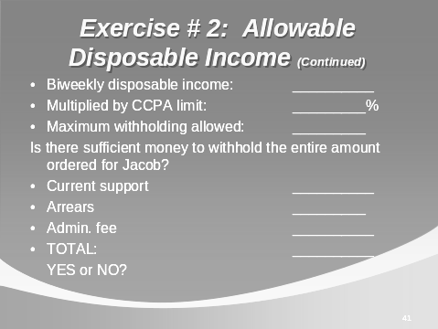
Now let’s suppose that Richmond Times pays biweekly and that Jacob’s gross biweekly earnings are $1,600.
Calculate the allowable disposable income (or, “maximum withholding”) for this biweekly pay period by applying the Consumer Credit Protection Act (CCPA) limits to Jacob’s disposable income.
In applying CCPA limits, follow the state law for Jacob’s work state.
- Biweekly disposable income: __________
- Multiplied by CCPA limit: _________%
- Maximum withholding allowed: _________

Is there sufficient money to withhold the entire amount ordered for Jacob?
Current support __________
Arrears _________
Admin. fee __________
TOTAL: __________ YES or NO?
training notes
- In the case of prolonged illness, an employee may use available annual or sick leave. Child support may still be deducted from the pay received while the employee is on extended leave.
- In the case of “leave without pay,” child support withholding would, of course, stop. The employer must notify the child support agency of the employee’s change in status, even if it is temporary.
- The employee may wish to continue child support payments on his own in order to avoid accrual of arrears, or he may request a downward modification of the amount of the child support obligation.
- Note that disability and worker’s compensation payments both qualify as income under the Personal Responsibility and Work Opportunity Reconciliation Act (PRWORA) definition and therefore remain subject to withholding for child support.

Income withholding when the employee is not working
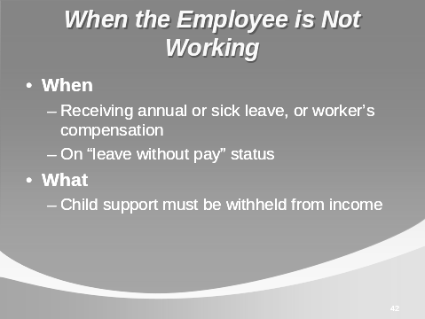
When?
- Your employee may not be working because of prolonged illness or injury, or due to a short- or long-term disability.
- Your employee receives disability payments or worker’s compensation.
What?
- Child support withholding must still be made.
- If you are responsible for the disability payments, then you are responsible for withholding child support according to the terms of the order.
- If a third party payor is responsible for the payments, alert the third party payor that child support deductions are being made for the employee; send a copy of the income withholding order to the third party payor.
- Notify the issuing agency immediately about the change in your employee’s situation so it will know why you are no longer deducting child support. The agency will send a new Order/Notice to Withhold Income to the third party payor.
- To avoid interruptions in payment to the employee’s child, the third party payor may begin withholding by following the terms of the withholding order, or the employee may make his own payments to avoid accrual of arrears.
training notes
- Normally when an employee is being paid his or her regular earnings, the full amount of the order can usually be withheld (in fact, the employee’s earnings are a big factor in determining how much support is ordered). It is only when the paycheck falls short due to special circumstances that the employer may not be able to withhold the full ordered amounts.
- The CCPA limits on withholding an employee’s paycheck do not forgive the debt owed; the limits merely mean that the employee can take longer to pay off the debt.
- We refer to state laws as “state CCPA laws.” Remember, each state has either adopted the federal CCPA law, or passed its own law that affords more protection to the employee’s pay.
- Rule of thumb: If you receive more than one order from different states and the orders specify a different CCPA limit to apply in determining the maximum to withhold, apply the higher/est percentage if there are arrearages. (If Order A says 55 percent and Order B says 50 percent, then withhold up to 55 percent.)
- If the amounts differ due to support of a second family rather than arrearages, apply the lower percentage (i.e., Order C says 50 percent and Order D says 60 percent, then withhold 50 percent). One state was probably unaware that your employee is supporting a second family (this order may have pre-dated the second family).
- For privacy reasons, the employer should not discuss other child support orders with a custodial parent (CP); simply state that there are “other claims against the income.” (The CP may not be aware that the NCP has fathered children with other women.)

Prioritizing Multiple Deductions, Or What Do I Pay First If There is Not Enough Money To Go Around?
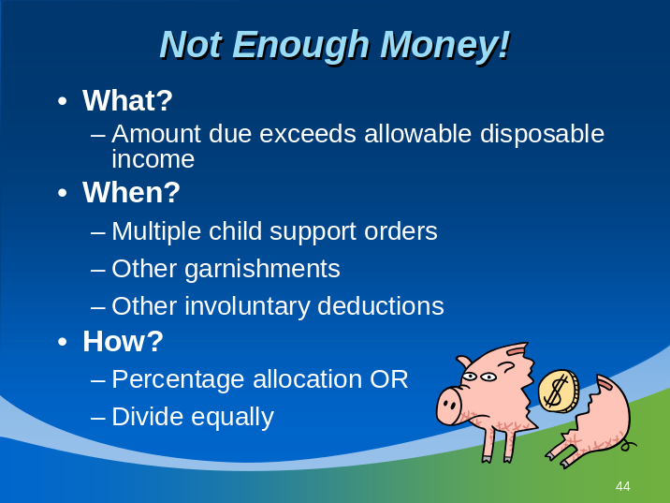
- What?
  - Sometimes an employee’s earnings do not stretch far enough to pay all his or her claimants. There are specific laws governing who is to be paid first. There are also laws protecting the employee from having his or her entire paycheck turned over to a third party.
  - Consumer Credit Protection Act: A federal law that serves as the minimum protection to the employee; some states have passed their own version that provides more protection to the employee’s pay.
- When?
  - Multiple child support orders are received (for different children)
  - Child support orders with other garnishments (for debt)
  - Child support orders with other involuntary deductions (i.e., tax levy, bankruptcy).

training notes
- If you receive withholding orders from more than one issuing agency/party for the same custodial family, be sure to contact all parties involved as soon as possible (something is wrong!). Continue to honor the first order that you received until and unless you receive official notice that a determination has been made that a different order should be honored. It is not the employer’s responsibility to figure out which order is the one to be followed (you may hear this referred to as the “controlling order.”)
- There should not be more than one withholding order for the same child for current support.
  - Note: State CSE agencies issue IWOs for arrears-only that are owed to the State for a time period when welfare has been paid on behalf of the CP and child(ren). This IWO should be for arrears only and is not considered a duplicate order.

Multiple Child Support Orders
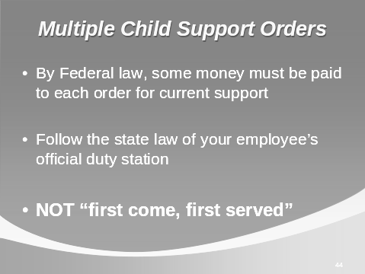
Federal law requires that some money will be paid to each order for current support.
Each state must have a method for allocation of withheld money between or among the orders, up to that state’s CCPA limits.
If there is any allowable disposable income left over (that is, disposable income that falls within the CCPA limits for withholding), then payments for arrears may be withheld up to the remaining balance.
- Note: You may receive more than one order from different states or counties for the same child(ren). If this happens, you may follow these steps:
Continue to honor the first order you received. Give your employee a copy of the second order.
Contact the issuing agency that sent the second withholding order and inform them that you are already sending withheld payments for the same child(ren) to another jurisdiction. Provide payment information such as the amount of the withholding and where the withholding is being sent. Contact the issuing agency that sent the first withholding order and inform them about the second order you have received. The issuing agencies must resolve the duplication.
  - Note: State child support enforcement (CSE) agencies issue IWOs for arrears-only that are owed to the State for a time period when welfare has been paid on behalf of the CP and child(ren). This IWO should be for arrears only and is not considered a duplicate order.
Training Notes

How?
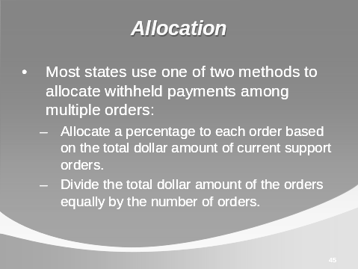

Most states use one of two methods to allocate withheld payments among multiple orders:
- Allocate a percentage to each order based on the total dollar amount of current support orders.
- Divide the total dollar amount of the orders equally by the number of orders.
Follow the allocation method set by the employee’s principal place of employment state.
Training Notes
- Percentage method of allocation:
- Determine the amount of disposable income.
- Determine the total amount of all the income withholding orders (current support plus arrears).
- Determine whether there is enough to pay the total of all income withholding orders. If yes, pay all orders.
- If not, total only the current support amounts for all the income withholding orders.

Percentage Method of Allocation (also called Prorate Method)

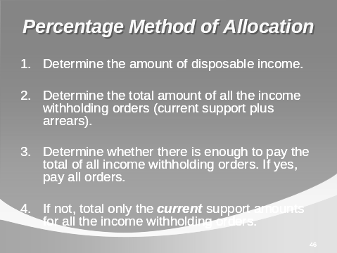

When the allowable disposable income is less that the total amount requested by the income withholding orders, determine the amount to be sent for each order using the percentage method:
- Determine the amount of allowable disposable income.
- Determine the total amount of all the income withholding orders (current support plus arrears).
- Determine whether there is enough to pay the total of all income withholding orders. If yes, pay all orders.
- If not, total only the current support amounts for all the income withholding orders.
Training Notes

Percentage Method of Allocation (also called Prorate Method) (Continued)

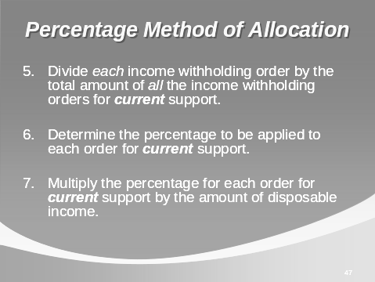

- Divide each income withholding order by the total amount of all the income-withholding orders for current support.
- Determine the percentage to be applied to each order for current support.
- Multiply the percentage for each order for current support by the amount of allowable disposable income.

Training Notes

Order A | $90.00 | ÷ $227 = 39.65%
Order B | $75.00 | ÷ $227 = 33.04%
Order C | $62.00 | ÷ $227 = 27.31%
Total: | $227.00 | 100%

- If allowable disposable income is $180, then Order A gets 39.65% x $180 = $71.37, Order B gets 33.04% x $180 = $59.47, etc.

Percentage Method of Allocation Example:
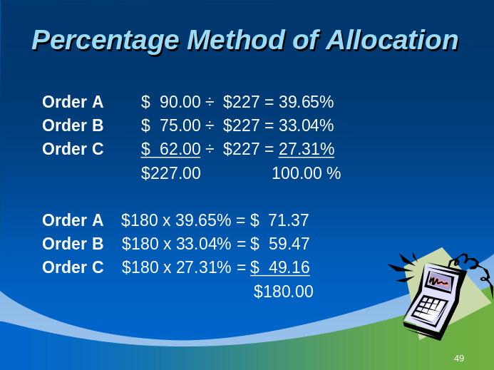

Order A | $90.00 | Divided by $227 = 39.65%
Order B | $75.00 | Divided by $227 = 33.04%
Order C | $62.00 | Divided by $227 = 27.31%
TOTAL | $227.00 | 100%
Assume allowable disposable income is $180. There is not enough to pay the full, ordered total of $227.00
Calculate the percentage of the total for each order, then multiply that percentage times the allowable disposable income:
Order A | $180 x 39.65% | = $71.37
Order B | $180 x 33.04% | = $59.47
Order C | $180 x 27.31% | = $49.16
TOTAL |  | $180.00

Training Notes
- Equal method of allocation:
Using the numbers above, divide the allowable disposable income by the total number of orders (3).
$180 ÷ 3 = $60 can be paid to each order.
Only a few states use this method (e.g., KS and TX).

Equal Method of Allocation Example:
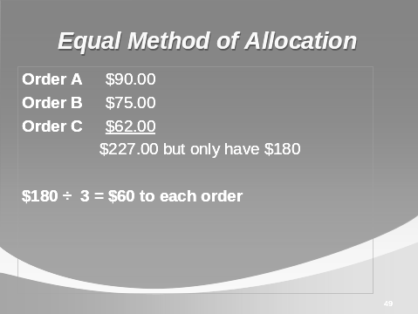
Assume allowable disposable income is $180. There are three orders, and each is paid equally. Divide $180 by 3 = $60 to each order.
training notes
EXERCISE # 3
- USE THE FLIP CHART TO REVIEW THIS EXERCISE.
- What are the withholding limits for Jacob? 55%
- Why? He owes arrears (more than 12 weeks), and the second child support order shows he is supporting a second family even though he is not living with them.

1. Disposable income for child support purposes: | $2000.00
2. Apply CCPA limits | x __55%
3. Allowable disposable income: | $1100.00
4. Total current support owed (add current orders together: $400+$300) | $700.00
5. Total arrears owed per month: | $ 50.00
6. Total monthly support owed: | $750.00
- Is there enough allowable disposable income to pay the total in line 6? yes
- How much monthly support can be paid by Jacob’s employer? The full $750.00 that is owed. No problem this month!
- The next exercise covers a situation where the monthly support owed exceeds the disposable income.

Exercise #3: Calculating Payments Under Two Withholding Orders
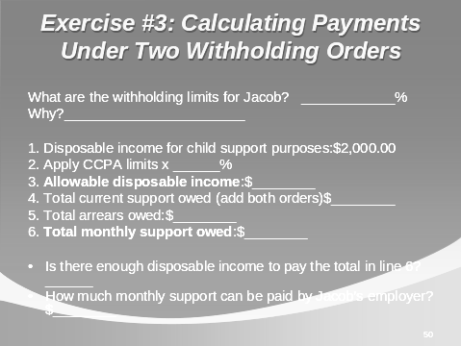
Jacob was married and has now been divorced twice. He now lives alone. He had one child with each wife, and he now owes child support to both children.
- He owes $400/month in current support and $50/arrears for his older child (Order A) (and he’s more than 12 weeks in arrears).
- He owes $300/month in current support for his younger child (Order B).
Jacob received a raise and his disposable income is now $2,000.00/month. The CCPA limits set by his state follow the federal CCPA limits.
What are the withholding limits for Jacob? ____________%
Why?_______________________________________________________
1. Disposable income for child support purposes: | $2,000.00
2. Apply CCPA limits | x ______%
3. Allowable disposable income: | $________
4. Total current support owed (add both orders) | $________
5. Total arrears owed: | $________
6. Total monthly support owed: | $________
Is there enough disposable income to pay the total in line 6?
How much monthly support can be paid by Jacob’s employer? $________
training notes
EXERCISE #4
- USE THE FLIP CHART TO REVIEW THIS EXERCISE.

1. Disposable income for child support purposes: | $1,000.00
2. Apply CCPA limits | x ___55%
3. Allowable disposable income: | $_550.00
4. Total monthly support owed (current and arrears) | $750.00
- Is there enough allowable disposable income to pay the total in line 4? NO
- How much monthly support can be paid by Jacob’s employer? First, ask if current support can be met. The total current support due is $700.00, and this canNOT be paid in full. The $50 arrears cannot be paid at all.
- To learn which method of allocation to use, the employer must first check the law of Jacob’s work state. Let’s say his state uses the percentage method of allocation.
- Order A $400 divided by 700 = 57%
- Order B $300 divided by 700 = 43%
100%
- Current support owed: $700/month
- Arrears owed: $ 50/month
Multiply each percentage times the amount available for child support, meaning the allowable disposable income ($550):
$550 x 57% = $313.50 for Order A (short by $86.50+ $50 arrears)
$550 x 43% = $236.50 for Order B (short by $63.50)
- $ 86.50 of unpaid current support will accrue as arrears against Order A
- $ 63.50 of unpaid current support will accrue as arrears against Order B.
- The employer does not need to track the arrears; the child support enforcement agency is responsible for this.

Exercise #4: Calculating Payments (Again) Under Two Withholding Orders
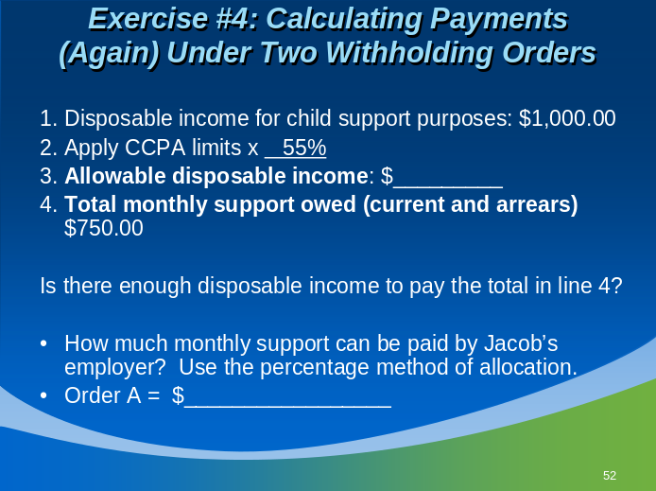
Let’s use the same example with Jacob again. Remember, he has two children, and owes $400/month in current support and $50/month arrears for his older child (Order A) and $300/month in current support for his younger child (Order B). His total amount owed per month is $750.
This month, Jacob has taken a lot of time off without pay, and his disposable income has decreased and is now only $1,000.00/month.
Jacob is subject to the same withholding limits as before, 55%.

1. Disposable income for child support purposes: | $1,000.00
2. Apply CCPA limits | x ___55%
3. Allowable disposable income: | $_________
4. Total monthly support owed (current and arrears) | $750.00
Is there enough disposable income to pay the total in line 4?
How much monthly support can be paid by Jacob’s employer? Use the percentage method of allocation.

Order A = $ _________________
Order B = $ ________________
training notes
- Point out that between 50% and 65% of disposable income may be withheld for child support versus only 25% of disposable income for a commercial garnishment (or the excess weekly disposable income that exceeds 30 times the minimum wage earned that week if this amount is less).
- Basically, the employer first withholds for child support from the allowable disposable income and then checks to see if the withheld amount is greater than the limits set for garnishment.

Child Support With Other Garnishments
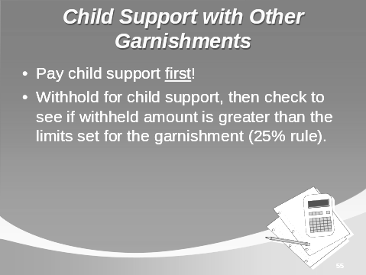
Rule of thumb: A child support income-withholding order must be paid before all other garnishments.
Note that not only do income-withholding orders take precedence over other garnishments, more money may be withheld for child support than for other garnishment debt.
Example: Tony’s child support withholding for one week is $69.23. His disposable income for that week is $270. Sears serves a garnishment against Tony for a $1,000 debt.
Weekly disposable income | $270.00
Calculate 25% of disposable income | x 25%
 | $ 67.50
Subtract amount withheld for child support | (69.23)
Available for garnishment | $0.00
The child support withholding exceeds 25% of Tony’s disposable income by $1.73, so there is nothing left over to pay Sears.
Note also that in this case, 25% of the disposable income is less than the amount of weekly disposable income that exceeds 30 times the minimum wage. If it were more, then that would be the withholding limit for Sears.
30 x $5.15 [minimum hourly wage] = $154.50
($270 - $154.50 = $115.50)
$67.50 < [is less than] $115.50, so the employer can remit the $67.50 to Sears.
training notes
- Reiterate that a federal tax debt takes precedence over a child support withholding order if it was served prior to the issuance of the child support order. The Internal Revenue Service (IRS), however, has stated its willingness to accommodate child support withholding orders that are served after the IRS levy. It is up to the employee to request this from the IRS.
- Stress that it is also a good idea for the employer to notify the child support agency of the pre-existing IRS tax levy. The agency has no way of knowing that there is an existing IRS levy that takes precedence over its withholding order unless you tell them about it.
- Background Notes to Trainer on Bankruptcy (do not need to cover with class unless asked)
  - For child support withholding, we are only concerned with Chapters 7 and 13 (11 is for businesses and 12 is for family farmers). Chapter 7 is for liquidation and is usually resolved in a few months. Chapter 13 is reorganization and can take 2 to 3 years.
  - With the passage of Public Law 109-8, Section 211 to 219, it is clear that income-withholding orders are not subject to the automatic Stay of Proceedings against the bankrupt debtor in either a Chapter 7 or Chapter 13. This means any child support withholding should continue without interruption and any new withholding should be put in place without hesitation.
  - Chapter 7 – After-acquired property (that is, acquired after the date of bankruptcy filing, such as wages or tax refunds) may be attached for child support purposes. This is more common than Chapter 13. In addition, the IV-D agency may file a proof of claim with the bankruptcy court and ask to receive payment on child support arrears along with other unsecured creditors. The remainder of the child support debt is not discharged even if some payment is received from the bankruptcy court.
  - Chapter 13 – This is limited to individuals with “regular income” and debts below $1 million. A bankruptcy trustee is appointed and after-acquired property is part of the bankruptcy estate. The debtor must file a “plan” for the repayment of debts and Chapter 13 may be converted to Chapter 7 if a plan is not filed on time. The plan must provide for full payment in cash of all priority claims (which includes child support, both current and arrears). The bankruptcy trustee would collect and pay the child support payments to the child support agency.
Rule of thumb:
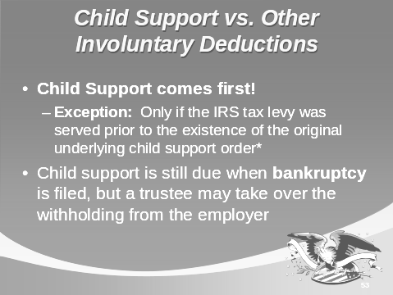
- Child support takes priority over everything else except a federal tax levy, but only if the federal tax levy was served before the original child support order was issued.
- Special treatment applies to bankruptcy cases.
Federal Tax Levy:
- Internal Revenue Service (IRS) levy takes precedence over child support if the levy is served prior to the issuance of the child support order.
- Employers who are withholding income to satisfy a tax levy should notify the IRS if they receive a child support order. In some cases, the IRS will yield priority to the child support order.
Bankruptcy:
- Even if an employee declares bankruptcy, he/she is still obligated to pay child support. Debts due for delinquent child support are not dischargeable in bankruptcy actions.
- An employer may be notified, however, that it is no longer responsible for withholding the payments because a trustee of the bankruptcy court may take over this task. Continue withholding until official notification from the agency or bankruptcy court has been received.
training notes
- Reiterate that a federal tax debt takes precedence over a child support withholding order if the levy was served prior to the issuance of the underlying child support order.
- State examples:
  - Non-tax federal debt
  - Creditor garnishment – garnishment from a store like Sears
  - Assignment of wages – when taking out a loan, a person may voluntarily sign over his future wages to pay a creditor in the event that he defaults on the loan.
Involuntary Deductions that never take precedence over child support withholding:

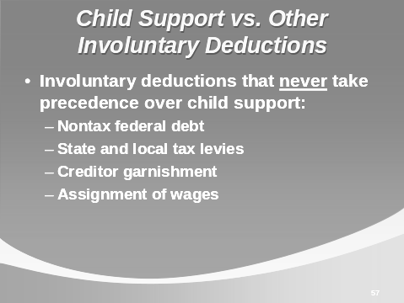

- Non-tax federal debt
- State and local tax levies
- Creditor garnishment
- Assignment of wages
This is true even if the child support withholding order was served after the involuntary deduction.

training notes
- Withheld child support payments are credited based on the employer’s payday OR date of receipt by the receiving agency, which may result in a “temporary” arrearage.
- Some states charge interest on arrearages.
- Nevertheless, employers are not required to change payroll cycles to accommodate an income withholding order/notice.

A Note About Arrears
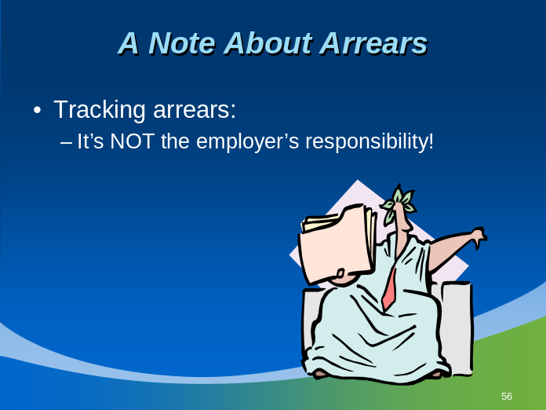
The child support enforcement agency, not the employer, is responsible for calculating arrears or keeping track of payments toward the arrears.
Some states calculate interest on unpaid child support. Depending on how long ago these underpayments occurred, the interest owed could be a sizable amount.
training notes
- Note: If this training is being provided to a payroll department that does not process medical insurance premiums, this section may be skipped.
- Remind the class that the definition of child (and medical) support was covered in Section 2.2.
- The State Children’s Health Insurance Program (SCHIP):
  - Created as part of Balanced Budget Act of 1997.
  - $4.8 billion annual federal grant program that helps states cover uninsured children; for children in families with income too high for Medicaid but too low to afford private coverage.
- Visit website at www.cms.hhs.gov/home/schip.asp.
- Of the 44 million Americans without health care coverage, 11.5 million are children, and 4 million of these children live in single-parent families.

withholding for medical support
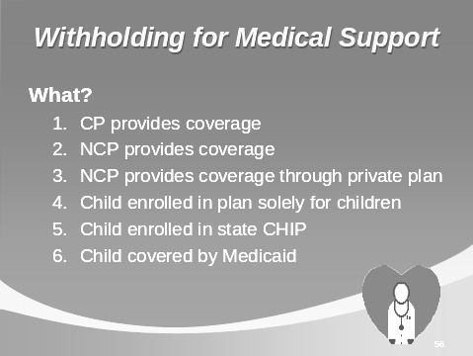
What?
- There are five basic types of health care coverage for a child who does not live with the providing parent, or non-custodial parent (NCP):
- The custodial party (CP) maintains coverage through his or her employer plan; NCP pays additional money to pay for this coverage.
- NCP maintains coverage through his or her employer’s plan; employer withholds premiums for the child’s care or “medical support” from the NCP’s pay.
- NCP maintains coverage through a private plan and pays the premiums directly. Employer does not withhold medical support.
- Child is enrolled in a plan designed solely for coverage of children. Employer withholds premiums from NCP’s pay and sends them to the child support enforcement agency to be paid to the child’s insurer.
- Child is enrolled in the state Children’s Health Insurance Program (CHIP) because neither parent has access to affordable health care coverage and the child is not eligible for Medicaid.

training notes
- Tell class that Qualified Medical Child Support Orders (QMCSOs) will be discussed in more detail in a few minutes.
When?
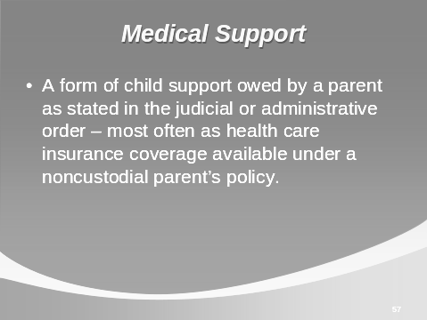
- Employers must provide medical insurance coverage to an employee’s child per a child support order when:
The employer offers family care coverage as part of its benefit plan and the employee is eligible and enrolls in the family care coverage.
- If an employer does not offer this coverage, it is not required to obtain it simply to comply with a medical support order.
How?
When directed by a National Medical Support Notice (NMSN) from a court or child support enforcement agency, or Qualified Medical Child Support Order (QMCSO), and family coverage is available, the employer must:
- Provide immediate coverage without regard to “open enrollment season” OR
- Provide a method for the CP to enroll the child in the plan
- Deduct premiums from the employee’s pay (within CCPA limits).
Special Notes:
- The employer may not eliminate family coverage unless that coverage is eliminated for all employees.
training notes
- Start by explaining that some health insurance plans offered by employers were previously able to circumvent paying for medical support for an employee’s child(ren). Technically speaking, certain plans could exempt themselves from honoring medical support orders. This is no longer possible if a NMSN or a Qualified Medical Child Support Order is sent to the employer.
- Note that the Omnibus Reconciliation Act of 1993 (OBRA ’93) made big changes in medical insurance requirements placed on employers and insurance companies.
- OBRA ’93 is responsible for creating QMCSOs (by amending the Employee Retirement Income Security Act of 1974 or ERISA), and requiring both “insured” and “self-insured” plans under ERISA to honor QMCSOs.
- Tell participants to turn to the Appendix, Handout #3: National Medical Support Notice.

National Medical Support Notice (NMSN)
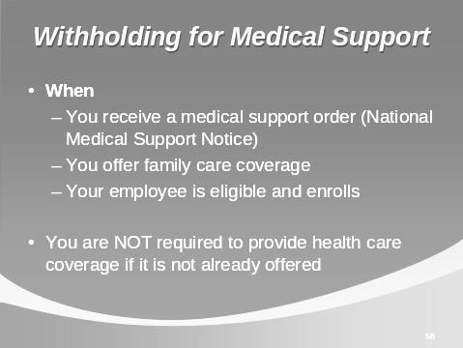

To help obtain health care coverage for children, new laws were passed creating the National Medical Support Notice (NMSN). The NMSN is a notice sent to employers from the state child support enforcement agency. Its purpose is to ensure that children receive health care coverage when it is available and required as part of a child support order. It is designed to simplify the work of employers and plan administrators by providing uniform documents requesting health care coverage.
An appropriately completed NMSN is considered a "Qualified Medical Child Support Order," or QMCSO, and as such must be honored by all employers' group health plans.
training notes

How the NMSN Works

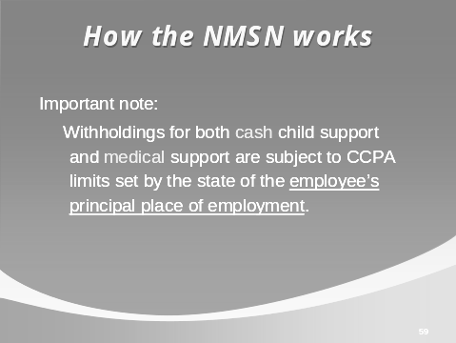
The NMSN complies with section 609 (a)(3) and (4) of ERISA, which pertains to informational requirements and restrictions against requiring new types or forms of benefits. It also includes:
- applicable state law provisions for withholding employee contributions due under any group health plan in connection with coverage required to be provided;
- duration of the withholding requirement;
- applicability of limitations on such withholding under Title III of the Consumer Credit Protection Act (CCPA), or similar state law;
- prioritization required under state law between amounts to be withheld for purposes of cash support and amounts to be withheld for purposes of medical support in cases where available funds are insufficient for full withholding for both purposes; and
- the name and telephone number of the appropriate unit or division to contact at the state CSE agency regarding the NMSN.
training notes

NMSN (Four documents and instructions):
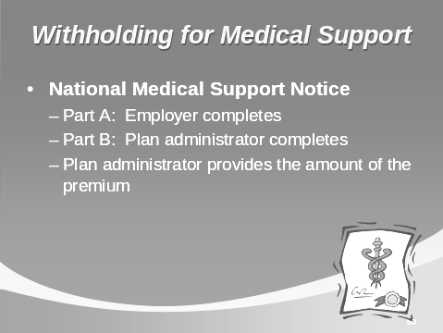
Part A- Notice to Withhold For Health Care Coverage, will be completed by the CSE agency and sent to the employer with the rest of the packet.
"Employer Response" is just that, your opportunity to respond to the request if one of the following situations exists:
- You do not provide health care coverage for your employees.
- The employee is not eligible for the health care coverage you provide.
- The employee has been terminated or has left this employment.
- The deduction for health care coverage cannot be made because of state or federal withholding limits and the state's priority for withholding. These limitations will be included in the instructions that accompany the NMSN or which you have received from your state, as mentioned above.
Otherwise, follow the steps below to comply with the NMSN.
Part B- Medical Support Notice To Plan Administrator. This document should be forwarded to your health care plan administrator for handling.
"Plan Administrator Response" is completed by your plan administrator according to the accompanying instructions and returned to the CSE agency.
training notes
- Tell participants to turn to the Appendix, Handout #4: National Medical Support Notice Flowchart.
- Discuss the flowchart as you talk about the steps for the NMSN.

Step By Step for the NMSN
Step 1: When you receive a NMSN, determine whether any question on the Employer Response applies to you or this employee. You may only be able to determine whether one of the first three questions applies at this stage.
Step 2: If so, complete the Employer Response form and return it to the issuing agency within 20 business days. If none of the four questions on the Employer Response applies to you or this employee, forward Part B to your plan administrator.
Step 3: The plan administrator will notify you when enrollment has been completed. You must then notify your payroll department to make the appropriate deductions for employee contributions required under the health plan. It is at this point that you may determine that the total deductions exceed the maximum allowed under the CCPA limits and any applicable state law.
Step 4: If, in fact, you determine that the amount of support coupled with the deduction for health care premiums exceeds the maximum deduction allowable, you must look to state law in the state where the employee is employed to determine the priority for payment. If the CCPA limits preclude payment of ongoing support and health care premiums and the priority scheme does not allow for the payment of the health care premium first, you must notify the issuing agency by completing No. 4 on the Employer Response form and send the form to the agency.
Step 5: If enrollment cannot be completed until after a waiting period or other contingency, you must notify the plan administrator when the employee is eligible for enrollment.
In order to be "qualified," a medical support order must clearly specify:
- the name and last known address of the participant and the name and address of each child covered by the order;
- a reasonable description of the coverage to be provided, or the manner in which coverage will be determined; and
- the period for which the order applies.
training notes
State laws require that health care coverage be provided under a medical support order even if the child:
- was born out of wedlock,
- is not claimed as a dependent for tax purposes, or
- does not reside with the parent or in the insurer's service area.
training notes

Qualified Medical Child Support Orders (QMCSOs)
- A QMCSO is a medical child support order that creates or recognizes the right of an alternate recipient, any child or other beneficiary, to benefits for which a participant or beneficiary is eligible under a group health plan. It must include certain information and meet other statutory requirements.
- An alternate recipient is any child of a group health plan participant who is recognized as having a right to enrollment through that participant (the child’s parent).
- A medical child support order is deemed “qualified” if it provides:
- Name and last known mailing address of participant (employee)
- Name and address of alternate recipient (child or designated agency)
- Reasonable description of coverage to be provided, or a way that the type of coverage can be determined
- Period to which the order applies.
- The employer must honor a QMCSO once the health plan administrator deems it qualified.

training notes
- When in doubt, call the child support enforcement agency!

Common Concerns About Income Withholding
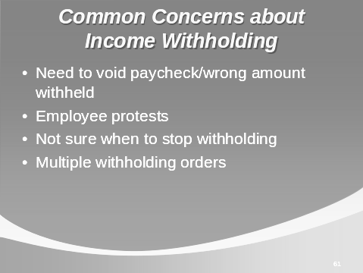
If you send an incorrect amount and you immediately realize your error:
- Contact the State Disbursement Unit or other payee and inquire as to the requirements and timeframe for a refund. This process may vary from state to state.
If your employee says the amount withheld is incorrect:
- It is the responsibility of the employee, not the employer, to contact the agency/court to dispute the withholding. By law, the employer is bound to honor the terms of the income-withholding order.
If you are not sure when to stop withholding for an employee:
- Check the order/notice to see if a stop date is specified. If not, continue to withhold until you receive official notification (from the agency or court) to change or stop the withholding. Do not stop simply because your employee says it should be done. When in doubt, contact the issuing agency.
If you receive withholding orders for more than one employee:
- A single check for each pay period may be sent to cover all the child support withholdings if they are all sent to the same receiving state disbursement unit or agency/court. Identifying information about each individual’s payment must be included with the check (amount withheld for each employee, date each amount was withheld, case number or other identifier).
training notes

Income Withholding summary
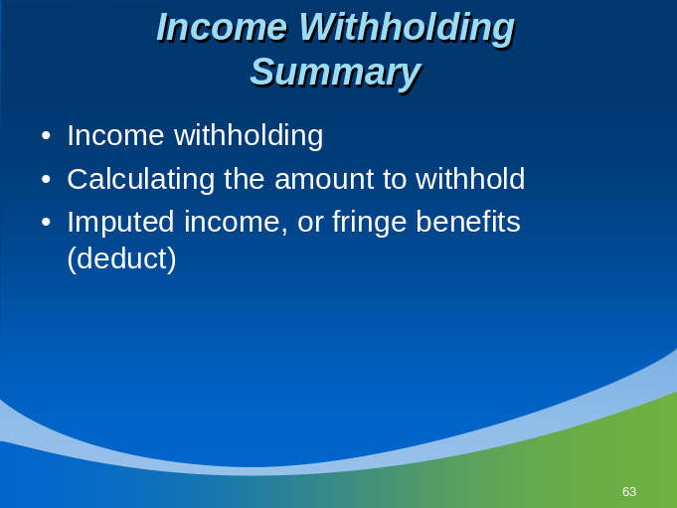
Income withholding: automatic deductions from income that start as soon as the order for support is established and the Order/Notice to Withhold Income for Child Support has been received and validated by the employer. All income is subject to income withholding for child support, pursuant to a child support order but is protected by Consumer Credit Protection Act limits, both state and federal.
- Standardized “Order/Notice to Withhold for Child Support” form
- “Direct income withholding” is allowed (employer must honor an income withholding order from an entity in another state).
- Complying with the terms of the Order/Notice.
Calculating the amount to withhold:
- This should be a straightforward process for most child support income withholding orders. The amount to withhold follows the terms of the order and might exceed the employee’s allowable disposable income.
- Calculate disposable income: gross pay minus mandatory deductions.
- Calculate allowable disposable income: CCPA limits (%) multiplied by the disposable income = maximum withholding allowed for child support purposes.
training notes

Income Withholding summary (Continued)
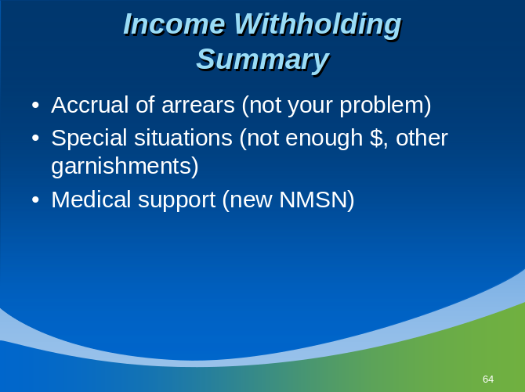
Accrual of Arrears
- When the employee falls behind in payments, the past-due child support is called arrears. The Order/Notice to Withhold will specify whether arrears are owed and how much to withhold to pay the past-due support. It is not the employer’s responsibility to track accrual of arrears. The child support enforcement agency will do this.
Special Situations
- Withholding is straightforward unless there is not enough allowable disposable income to cover the amount specified in the withholding order/notice or if the employee is obligated to pay for more than one withholding order.
- Follow the prioritization set by law if there is not enough money to cover the employee’s total obligation for child support or if there are other claims (levies, garnishments) against the employee’s pay.
- When withholding for more than one support obligation, follow the allocation formula set by state law.
- When there are other garnishments and/or involuntary deductions from the employee’s pay, remember that child support takes precedence over all other withholdings except federal tax levies that were served prior to the issuance of the child support withholding order. Special exceptions may apply in cases of bankruptcy; follow the instructions of the bankruptcy court or trustee.
training notes

Income Withholding summary (Continued)
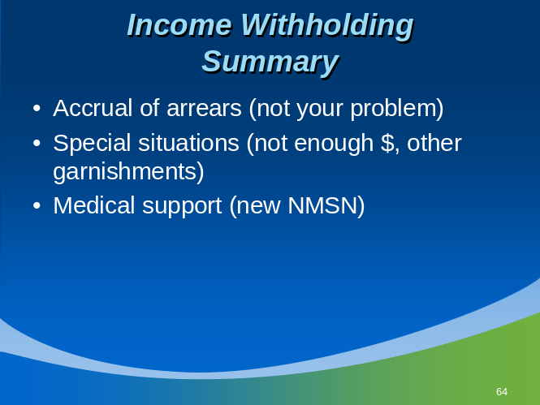
Medical Support
- Follow the terms specified in the National Medical Support Order or the Qualified Medical Child Support Order (QMCSO). The obligated employee may be required to enroll his or her child in the employer-offered health insurance plan or to have additional monies withheld to cover medical expenses and/or health insurance premiums. The employer providing health insurance coverage to its employees must allow the obligated employee to enroll his or her child as a dependent in the plan, even if this occurs outside the open enrollment season.

