Receptor Activities and Usage Rates
This appendix presents the seven exposure scenarios assumed for Phase III of the Savannah River Site (SRS) Dose Reconstruction Project, along with the derivation of base case values for those radiological assessment parameters that depend on the behaviors of the human receptors comprising the exposure scenarios. Seven human receptors were modeled using the GENII computer code for each exposure scenario (28 receptors total). Assumptions about the behavior of each receptor were used to develop values for many of the parameters comprising the mathematical relationships used in GENII for radiological assessment (see Appendix D). These parameters address human-oriented behavior such as the assumed breathing rates of the four receptors associated with each scenario, their food consumption rates, and the times spent in various exposure locations.
The assessments that were performed were complex. Radiation doses and risks were determined for each receptor for each of years of nuclear material production at the SRS. The behavior of each receptor, as well as the receptor’s age, changed over time. Therefore, the radiation exposure calculations were made using GENII and assuming “unit” quantities for receptor-specific parameters such as food consumption rates. This output from GENII was then modified in the post-processor (software created for this Phase III study) to arrive at the proper doses and risks for each receptor. These modifications were performed using a set of receptor- and pathway-specific exposure and adjustment factors.
To link the exposure scenarios, the computational procedures outlined in Appendix D, the receptor-specific parameters and their values input to GENII, and the exposure and adjustment factors used to modify the output from GENII, this appendix is organized in the following manner:
- Section E.1: Scenarios proposed by the Centers for Disease Control and Prevention (CDC) and considered by the Savannah River Site Health Effects Subcommittee (SRSHES).
- Section E.2: Additional assumptions about scenarios.
- Section E.3: Overview of final exposure scenarios.
- Section E.4: Linkage of GENII variables to exposure and adjustment factors.
- Section E.5: Exposure and adjustment factors for each exposure pathway.
Except for radiation dosimetry assumptions, other GENII parameter values that are not clearly receptor-specific (such as food crop production rates, soil density, etc.) are presented in Appendix F. Radiation dosimetry assumptions are presented in Section D.4 of Appendix D.

Scenarios Proposed by CDC and Considered by the SRSHES
The exposure scenarios considered for this report evolved over time. Originally, CDC proposed the following six scenarios (1):
- A rural family just downwind of the site boundary.
- An urban/suburban family just downwind of the site boundary.
- A delivery person scenario.
- An outdoors person (hunting, fishing, camping, etc.).
- A family living near the river.
- A migrant worker family living mostly outdoors.
These scenarios were meant to represent hypothetical families that might have lived in the SRS vicinity and engaged in activities that were typical for the area. The activities postulated for these scenarios were intended to represent a broad range of lifestyles.
CDC presented proposed assumptions about these six scenarios to the SRSHES at a meeting of the SRSHES held in January 2002 in Charleston, South Carolina. Shortly thereafter, these assumptions were somewhat modified, and the SRSHES formed a work group to consider the proposed scenarios. On September 6, 2002, a SRSHES meeting was held, and J. Lockridge, the chair of the SRSHES Scenario Work Group, presented comments on the proposed scenarios to the CDC and the preparers of this report (1). Table E-1 summarizes the CDC proposed scenarios (as modified) and the SRSHES Work Group comments on the proposed scenarios. The SRSHES also made suggestions about further modifying the scenarios, and Table E-2 summarizes these suggested modifications (1).
The preparers of this report discussed the proposed scenarios with CDC staff in early 2003. Two key references that address these discussions are memoranda from the preparers of this report to CDC (2,3). These discussions principally addressed overall decisions about the number of exposure scenarios to be considered and where the hypothetical families comprising the exposure scenarios would live, work, attend church and school, obtain food, and recreate.
Table E-1 Summary of CDC Proposed Scenarios and SRSHES Comments
Proposed Scenario | Scenario Description | SRSHES Work Group Comments (1)
Rural | - Use the closest downwind location where there could have been farms in 1955.  - Consider an adult, an infant born in 1955, and an infant born in 1964 (year of largest iodine release). Use default consumption values.  - Assume a lot of time outdoors working in soil.  - Assume they drank milk from a backyard cow.  - Assume the crops were irrigated from Savannah River.  - Assumption of “working in soil” also included resuspension of soil contaminants in the breathing zone.  - In addition to two infants, consider the mother nursing at least one of the infants. | - Farm in rural Burke County, GA. Girard, GA - 3 miles west of Savannah River, SW from SRS. Population about 200 in 1950s. Located in SRS plume path.  - In 1950’s, a family of two parents, five children. In 1960’s, a family of two parents, three children.  - Schools: Girard Elementary, Waynesboro High School.  - Cash crops: peanuts, corn, cotton. Vegetables grown for family consumption.  - Religion: Methodist.  - In 1950’s, 50% of meat & vegetables grown on farm. In 1960s, 25% grown on farm; most milk from one of two dairies in Girard. Family had a few dairy cows.  - Some swimming, but minimal camping. No recreational boating.  - Lots of fishing from Briar Creek, 2 miles east of Girard. Significant hunting for deer, quail and dove. Limited trapping.
Urban/  Suburban | - Use the closest downwind location where urban or suburban families could have lived in 1955.  - Consider an adult, an infant born in 1955, and an infant born in  - 1964 (year of largest iodine release).  - Use default consumption values.  - Assume the adult worked at the nearest industrial location downwind in 1955.  - Assume milk drunk from nearest dairy or rural neighbor.  - Assume the adult worked onsite at SRS in lieu of the “nearest industrial location.”  - Assume the onsite work location was associated with higher radiological exposures (e.g., SRS Canyons). | - Family resided in Augusta, GA (region of Broad and Greene Streets).  - In 1950’s, a family of two parents, two children of varying ages. In 1960’s, a family of two parents, three children.  - Schools: Augusta neighborhood schools.  - Assume father to have worked in the SRS F-Area Canyon Building from 1955 to 1992.  - Assume the mother to have stayed home to raise the children. Mother worked onsite until well into her pregnancy.  - Attended local church in Augusta, GA.  - Food and milk were obtained from local grocery stores in Augusta, GA. Milk was supplied to local stores from dairies in the Aiken and Augusta area.  - Occasional swimming and boating in Clark’s Hill Lake.  - No hunting, but fishing in Clark’s Hill Reservoir. Fishing two weekends per month.
Delivery | - Same as Urban/Suburban Family.  - Use the closest downwind location where urban or suburban families could have lived in 1955.  - Consider an adult, an infant born in 1955, and an infant born in 1964 (year of largest iodine release).  - Use default consumption values.  - Assume the adult worked at the nearest industrial location downwind in 1955.  - Assume they drank milk from the nearest dairy or rural neighbor.  - Assume that the person spent 8 hours per week onsite. | - Family resided in Barnwell, SC. Father provided weekly beverage deliveries to SRS.  - In 1950’s, family of two parents, two children of varying ages. In 1960’s, a family of two parents, three children.  - Schools: Barnwell, SC, school system.  - Assume the delivery person worked at the Allendale Coca Cola Bottling Plant in Allendale, SC, and made routine deliveries to SRS (various locations) spending 8 hours per week onsite.  - Attended Mount Hope Baptist Church, Martin, SC.  - Food Sources: Barnwell, SC, grocery stores, and Furses’ Grocery Store, Martin, SC.  - Swimming in Lower Three Runs Creek outside Martin, SC. Boating and camping at Little Hell Landing on Savannah River (south boundary of SRS).  - Hunting at Lower Three Runs Creek area (known for poaching). Fishing at Lower Three Runs Creek, and Savannah River’s Smith Lake.  - Family drank lots of carbonated beverages (including beer).
Outdoor | - Assume camping at the nearest downwind location that would make sense with the season (hunting, fishing, etc.).  - Assume that the person was always outdoors.  - Use default consumption values.  - Assume the person spent 8 hours per day on the Savannah River in the summer.  - Assume the person spent 8 hours per week on site hunting or fishing (in season).  - Assume the person obtained fish and meat (deer, game birds, turtles) from hunting and fishing onsite (some authorized, some not—a “poacher” assumption.) | - Family resided in Jackson, SC.  - In 1950’s, a family of two parents, two children of varying ages. In 1960’s, a family of two parents, three children.  - Schools: (1950) Jackson Elementary (29,831). (1986) Redcliff Elementary (29,803). Jackson High School.  - Worked as a hunter/trapper subcontractor to the primary SRS Contractor (DuPont, WSRC, etc.) or the U.S. Forest Service.  - Religion: First Baptist Church, Jackson, SC.  - 50% of vegetables locally grown and irrigated from a surface creek. 75% of meat obtained from SRS. Fish obtained from Savannah River. Water obtained from well on home property.  - Boating in Savannah River from Jackson, SC, boat ramp.  - Obtained deer, hogs from work at SRS trapping. Fished in Savannah River.
Near River | - Use the nearest docking location downwind where people could have lived on the house boats in 1955.  - Consider an adult, an infant born in 1955 and an infant born in 1964 (year of largest iodine release).  - Use default consumption values.  - Assume always outdoors in contact with Savannah River.  - Assume they obtained their food from the nearest local farm or grocery store.  - Validate with the Citizens Advisory Board that the boat scenario is plausible, and if so, define a location.  - If not plausible, replace the boat scenario with a new scenario of a site construction worker living in a trailer. | - Scenario location: Consider Martin-Millet area  - Family: To be developed (TBD).  - Schools: TBD.  - Work: TBD.  - Religion: TBD.  - Food sources: Shell fishing, shrimping, crabbing.  - Swimming, boating, camping, hunting, & fishing: TBD.
Migrant Worker | - Use the closest downwind location.  - Consider an adult, an infant born in 1955 and an infant born in 1964 (year of largest iodine release).  - Use default consumption values.  - Assume always outdoors in contact with the soil.  - Assume that crops were irrigated by the Savannah River.  - Assume they obtained their food from the nearest local farm or grocery store. | - Scenario location: TBD.  - In 1950’s, a family of two parents, two children of varying ages. In 1960’s, a family of two parents, three children.  - Schools: TBD.  - Work: TBD.  - Religion: TBD.  - Food sources: TBD.  - Swimming, boating, camping, hunting, & fishing: TBD.
Table E-2 SRSHES Work Group Suggested Modifications to CDC Proposed Scenarios
Proposed Scenario | SRSHES Work Group Suggested Modifications to Scenarios
Rural | - Milk source was most likely the local dairies near Girard, but not to the exclusion of the backyard cow.  - Assume the family had dogs for pets.  - Assume the family had chickens.
Urban/  Suburban | - Milk was obtained from a local grocery in Augusta, and not the “nearest dairy or a rural neighbor.” Backyard cow is also included for the purpose of dose modeling.  - Add that the mother also worked at the site during the early months of her first pregnancy (actual anecdotal). Stayed home after birth of her first child.  - Include a family pet.
Delivery | - No dosimetry issued for this person.  - Consider backyard chickens and/or rabbits at residence.
Outdoor | - Scenario also includes the hypothetical poacher.  - Hunting dogs were also family pets.  - Some potential onsite exposure from trapping activities, streams, ponds, etc.
Near River | - Scenario modifications to be developed.
Migrant Worker | - Scenario modifications to be developed.
Source: Lockridge, 2002 (1).

Exposure Scenarios and Locations
As discussed in Chapter 6, releases to the air from any SRS source were modeled as being transported in each of 16 sectors defined by the 16 major compass directions, consistent with the meteorological data obtained for the SRS. Figure E-1 shows that, in any sector, at a given distance from a source, concentrations were modeled as being the same along all points of an arc defined by the radial distance from the source. It shows the relative radionuclide concentration from a unit source at a distance of 10 miles from the source. In each sector, the relative concentration is constant across the sector width.
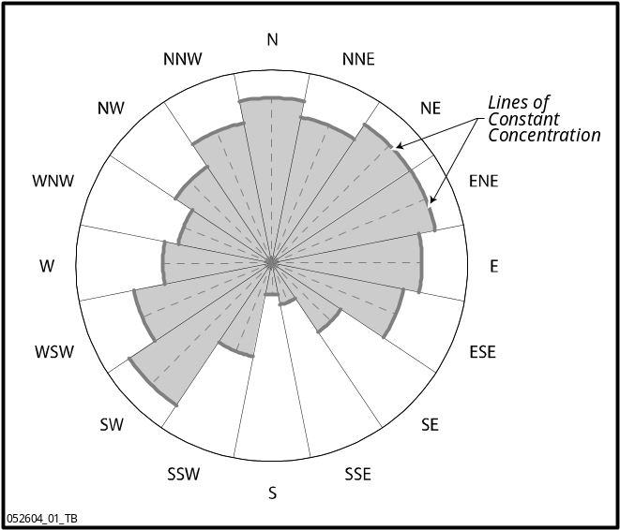
Figure E-1 Example of Modeled Radionuclide Concentration at 10 Miles from a Unit SRS Source
The meaning of this modeling simplification is that at a given distance from a source, the same concentrations will be determined anywhere is a sector. Thus, two hypothetical exposure locations that are fairly close together will generally not differ significantly in modeled concentrations.

Exposure Scenarios and Locations Considered for Phase III
In addition to the six exposure scenarios originally proposed by CDC, a seventh was added. When the scenario locations were plotted on a map of the area surrounding the SRS, it was noted that approximately 90° out of 360°—generally towards the northeast—was without an exposure scenario. Therefore, a seventh—identified as Rural Family Two—was added with concurrence from CDC and the SRSHES.
Each of the seven exposure scenarios consisted of a family living at a designated location. In each scenario, exposure locations were identified to represent where family members lived, worked, attended school, and engaged in recreational activities; where their food was grown; and where other activities were located. For all 7 scenarios, a total of 10 exposure locations were considered for radionuclides that had been transported through the air, while 2 exposure locations were considered for radionuclides that had been transported through surface water.
Figure E-2 shows the exposure locations assumed for the seven exposure scenarios.
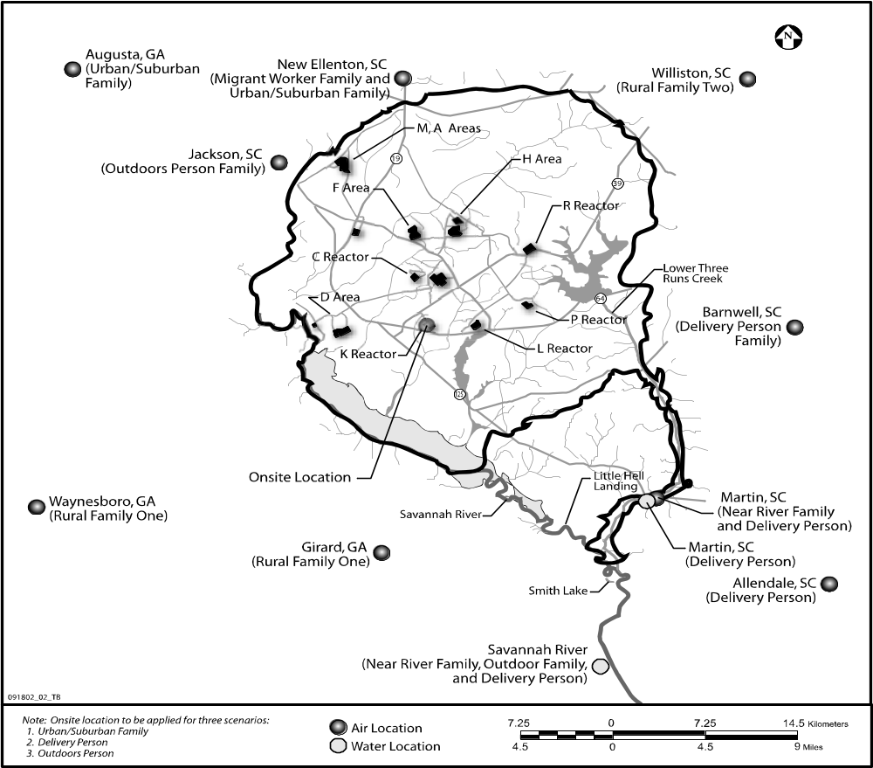
Figure E-2 Exposure Locations for Exposure Scenarios
Tables E-3 and E-4 summarize the exposure locations for contamination released into the air, while Tables E-5 and E-6 summarize the exposure locations for contamination released to surface water. The Lower Three Runs Creek exposure location is in the vicinity of Martin, South Carolina. The downstream Savannah River exposure location is representative of multiple possible locations downstream from the site.
Table E-3 Summary of Exposure Locations for SRS Air Releases

CDC Scenario | Activity | Exposure Location
CDC Scenario | Activity | Girard | Waynesboro | Martin | Augusta | Williston | SRS Onsite | Barnwell | Allendale | Jackson | New Ellenton
Rural Family One | All except high school | X
Rural Family One | High school |  | X
Rural Family Two | All activities |  |  |  |  | X
Urban/Suburban Family | All except employment |  |  |  | X
Urban/Suburban Family | Employment |  |  |  |  |  | X
Delivery Person | All except noted below |  |  |  |  |  |  | X
Delivery Person | Employment |  |  |  |  |  | X |  | X
Delivery Person | Church, hunting. Partial grocery, swimming, fishing |  |  | X
Outdoors Person | All except employment |  |  |  |  |  |  |  |  | X
Outdoors Person | Employment |  |  |  |  |  | X
Near River Family | All activities |  |  | X
Migrant Family | All activities |  |  |  |  |  |  |  |  |  | X

The scenarios and exposure locations are:
- Rural Family One. This family lived on a farm near Girard, Georgia. The Girard exposure location was where the family hunted, fished, and grew or produced much of their food. Although the adults always stayed near the farm, the children attended high school in Waynesboro, Georgia.
- Rural Family Two. This family lived on a farm near Williston, South Carolina. The Williston exposure location was where the family hunted, fished, and grew or produced much of their food. All family members lived at the Williston exposure location for all 39 years, including grade and high school for the children.
- Urban/Suburban Family. This family lived near the intersection of Broad and Greene Streets in Augusta, Georgia. The Augusta exposure location was assumed for most family activities including swimming, boating, and fishing. It was the exposure location where much of the family’s food was grown or produced, including half of their milk. The other half of their milk came from cows located
Table E-4 Exposure Locations for Air Releases by Scenario and Pathway
Scenario | Individual | Pathway
Scenario | Individual | External Exposure |  | Inhalation |  | Ingestion
Scenario | Individual | Air | Soil | Air | Resus-pended Soil | Beef | Poultry | Milk | Eggs | Leafy Veg | Root Veg | Fruit | Grain | Soil
Rural Family One | Adult Male | Girard | Girard | Girard | Girard | Girard | Girard | Girard | Girard | Girard | Girard | Girard | Girard | Girard
Rural Family One | Adult Female | Girard | Girard | Girard | Girard | Girard | Girard | Girard | Girard | Girard | Girard | Girard | Girard | Girard
Rural Family One | Child Born 1955 | Girard,  Waynesboro | Girard,  Waynesboro | Girard,  Waynesboro | Girard,  Waynesboro | Girard | Girard | Girard | Girard | Girard | Girard | Girard | Girard | Girard
Rural Family One | Child Born 1964 | Girard,  Waynesboro | Girard,  Waynesboro | Girard,  Waynesboro | Girard,  Waynesboro | Girard | Girard | Girard | Girard | Girard | Girard | Girard | Girard | Girard
Rural Family Two | Adult Male | Williston | Williston | Williston | Williston | Williston | Williston | Williston | Williston | Williston | Williston | Williston | Williston | Williston
Rural Family Two | Adult Female | Williston | Williston | Williston | Williston | Williston | Williston | Williston | Williston | Williston | Williston | Williston | Williston | Williston
Rural Family Two | Child Born 1955 | Williston | Williston | Williston | Williston | Williston | Williston | Williston | Williston | Williston | Williston | Williston | Williston | Williston
Rural Family Two | Child Born 1964 | Williston | Williston | Williston | Williston | Williston | Williston | Williston | Williston | Williston | Williston | Williston | Williston | Williston
Urban/ Suburb Family | Adult Male | Augusta,  Onsite SRS | Augusta,  Onsite SRS | Augusta,  Onsite SRS | Augusta,  Onsite SRS | Augusta | Augusta | Augusta, New Ellenton | Augusta | Augusta | Augusta | Augusta | Augusta | Augusta
Urban/ Suburb Family | Adult Female | Augusta | Augusta | Augusta | Augusta | Augusta | Augusta | Augusta, New Ellenton | Augusta | Augusta | Augusta | Augusta | Augusta | Augusta
Urban/ Suburb Family | Child Born 1955 | Augusta | Augusta | Augusta | Augusta | Augusta | Augusta | Augusta, New Ellenton | Augusta | Augusta | Augusta | Augusta | Augusta | Augusta
Urban/ Suburb Family | Child Born 1964 | Augusta | Augusta | Augusta | Augusta | Augusta | Augusta | Augusta, New Ellenton | Augusta | Augusta | Augusta | Augusta | Augusta | Augusta
Delivery Person | Adult Male | Barnwell, Martin, Allendale, Onsite SRS | Barnwell, Martin, Allendale, Onsite SRS | Barnwell, Martin, Allendale, Onsite SRS | Barnwell, Martin, Allendale, Onsite SRS | Barnwell,  Martin | Barnwell,  Martin | Barnwell,  Martin | Barnwell,  Martin | Barnwell,  Martin | Barnwell,  Martin | Barnwell,  Martin | Barnwell,  Martin | Barnwell,  Martin
Delivery Person | Adult Female | Barnwell,  Martin | Barnwell,  Martin | Barnwell,  Martin | Barnwell,  Martin | Barnwell,  Martin | Barnwell,  Martin | Barnwell,  Martin | Barnwell,  Martin | Barnwell,  Martin | Barnwell,  Martin | Barnwell,  Martin | Barnwell,  Martin | Barnwell,  Martin
Delivery Person | Child Born 1955 | Barnwell,  Martin | Barnwell,  Martin | Barnwell,  Martin | Barnwell,  Martin | Barnwell,  Martin | Barnwell,  Martin | Barnwell,  Martin | Barnwell,  Martin | Barnwell,  Martin | Barnwell,  Martin | Barnwell,  Martin | Barnwell,  Martin | Barnwell,  Martin
Delivery Person | Child Born 1964 | Barnwell,  Martin | Barnwell,  Martin | Barnwell,  Martin | Barnwell,  Martin | Barnwell,  Martin | Barnwell,  Martin | Barnwell,  Martin | Barnwell,  Martin | Barnwell,  Martin | Barnwell,  Martin | Barnwell,  Martin | Barnwell,  Martin | Barnwell,  Martin
Outdoors Person | Adult Male | Jackson, Onsite SRS | Jackson, Onsite SRS | Jackson, Onsite SRS | Jackson, Onsite SRS | Jackson, Onsite SRS | Jackson | Jackson | Jackson | Jackson | Jackson | Jackson | Jackson | Jackson
Outdoors Person | Adult Female | Jackson | Jackson | Jackson | Jackson | Jackson, Onsite SRS | Jackson | Jackson | Jackson | Jackson | Jackson | Jackson | Jackson | Jackson
Outdoors Person | Child Born 1955 | Jackson | Jackson | Jackson | Jackson | Jackson, Onsite SRS | Jackson | Jackson | Jackson | Jackson | Jackson | Jackson | Jackson | Jackson
Outdoors Person | Child Born 1964 | Jackson | Jackson | Jackson | Jackson | Jackson, Onsite SRS | Jackson | Jackson | Jackson | Jackson | Jackson | Jackson | Jackson | Jackson
Near River Family | Adult Male | Martin | Martin | Martin | Martin | Martin | Martin | Martin | Martin | Martin | Martin | Martin | Martin | Martin
Near River Family | Adult Female | Martin | Martin | Martin | Martin | Martin | Martin | Martin | Martin | Martin | Martin | Martin | Martin | Martin
Near River Family | Child Born 1955 | Martin | Martin | Martin | Martin | Martin | Martin | Martin | Martin | Martin | Martin | Martin | Martin | Martin
Near River Family | Child Born 1964 | Martin | Martin | Martin | Martin | Martin | Martin | Martin | Martin | Martin | Martin | Martin | Martin | Martin
Migrant Worker Family | Adult Male | New Ellenton | New Ellenton | New Ellenton | New Ellenton | New Ellenton | New Ellenton | New Ellenton | New Ellenton | New Ellenton | New Ellenton | New Ellenton | New Ellenton | New Ellenton
Migrant Worker Family | Adult Female | New Ellenton | New Ellenton | New Ellenton | New Ellenton | New Ellenton | New Ellenton | New Ellenton | New Ellenton | New Ellenton | New Ellenton | New Ellenton | New Ellenton | New Ellenton
Migrant Worker Family | Child Born 1955 | New Ellenton | New Ellenton | New Ellenton | New Ellenton | New Ellenton | New Ellenton | New Ellenton | New Ellenton | New Ellenton | New Ellenton | New Ellenton | New Ellenton | New Ellenton
Migrant Worker Family | Child Born 1964 | New Ellenton | New Ellenton | New Ellenton | New Ellenton | New Ellenton | New Ellenton | New Ellenton | New Ellenton | New Ellenton | New Ellenton | New Ellenton | New Ellenton | New Ellenton

Table E-5 Exposure Locations for Water Releases by Scenario and Pathway
 | Family Member | External Exposure |  |  |  | Ingestion
 | Family Member | Shoreline |  | Swimming | Boating | Fish | Swimming
Rural Family One | Adult Male | This family was assumed to do no boating in accordance with Lockridge 2002 (1).
Rural Family One | Adult Female
Rural Family One | Child Born 1955
Rural Family One | Child Born 1964
Rural Family Two | Adult Male | This family was assumed to do no boating in accordance with Lockridge 2002 (1).
Rural Family Two | Adult Female
Rural Family Two | Child Born 1955
Rural Family Two | Child Born 1964
Urban/ Suburb Family | Adult Male | Activities were unaffected by radionuclides released to surface waters.
Urban/ Suburb Family | Adult Female
Urban/ Suburb Family | Child Born 1955
Urban/ Suburb Family | Child Born 1964
Delivery Person | Adult Male | LTRC & SR* | LTRC |  | Savannah River | LTRC &  SR* |  | LTRC
Delivery Person | Adult Female
Delivery Person | Child Born 1955
Delivery Person | Child Born 1964
Outdoors† Person | Adult Male† | Savannah River† |  | Savannah River† | Savannah River† | Savannah River† | Savannah River†
Outdoors† Person | Adult Female
Outdoors† Person | Child Born 1955
Outdoors† Person | Child Born 1964
Near River Family | Adult Male | Savannah River, all pathways
Near River Family | Adult Female
Near River Family | Child Born 1955
Near River Family | Child Born 1964
Migrant Worker Family | Adult Male | Activities were unaffected by radionuclides released to surface waters.
Migrant Worker Family | Adult Female
Migrant Worker Family | Child Born 1955
Migrant Worker Family | Child Born 1964
*LTRC – Lower Three Runs Creek; SR — Savannah River.
†The Adult Male and grown children received external shoreline exposures. The Adult Female did not. Family members received exposures from boating and from eating fish, but not from swimming.
Table E-6 Summary of Exposure Locations for SRS Water Releases
Scenario | Activities / Pathways | Downstream Savannah River | Lower Three Runs Creek | No Exposure to Affected Water*
Rural Family One | All activities† |  |  | X
Rural Family Two | All activities† |  |  | X
Urban/Suburban Family | All activities† |  |  | X
Delivery Person | Fishing, swimming, shoreline |  | X
Delivery Person | Boating (and fishing) | X
Outdoors Person | Fishing, shoreline, boating | X‡
Outdoors Person | Swimming |  |  | X§
Near River Family | All activities† | X
Migrant Worker Family | All activities† |  |  | X
*Either the activity occurred in unaffected water or the activity did not occur.
†“All activities” included fishing, boating, swimming, and shoreline.
‡Only the adult male and grown children received shoreline exposures, while working at SRS.
§For entire family while recreating on the Savannah River.

in New Ellenton, South Carolina. The father worked onsite at the SRS. (The children also worked onsite at the SRS when they grew up.) A representative location on the SRS site, near the K-Reactor, was assumed as a work exposure location.
- Migrant Worker Family. This family lived in New Ellenton, South Carolina, for half of any year. The New Ellenton exposure location was assumed for all exposures and activities (home, schools, church, work, recreation, and the source for locally grown vegetables, milk, and meat).
- Delivery Person Family. This family lived in Barnwell, South Carolina, and attended church in Martin, South Carolina. Some of the food eaten by this family was obtained from Barnwell and some from Martin. The father worked in Allendale, South Carolina, and onsite at the SRS. (The children also worked onsite when they grew up.) A representative location on the SRS site, near the K-Reactor, was assumed as a work exposure location. The father hunted deer and wild fowl near Martin. The family engaged in recreation on the shore of Lower Three Runs Creek (at Martin) and on the shore of the Savannah River below its confluence with Lower Three Runs Creek. The family boated on, and ate fish from, the Savannah River at this same exposure location. The family also ate fish caught in Lower Three Runs Creek.
- Outdoors Person Family. This family lived in Jackson, South Carolina, where the family also attended church and the children went to grade and high school. Much of the food eaten by the family was grown in Jackson. The father worked and hunted on the SRS site (as did the children when they grew up). The same location on the SRS site, near the K-Reactor, was assumed for the work exposure location and the hunting exposure location. The father boated on the Savannah River while working and with his family for recreation. The family swam and spent time along the shoreline at the Jackson Boat Ramp, which is upstream of the SRS discharge to the Savannah River. All family members ate fish that were caught in the Savannah River below its confluence with Lower Three Runs Creek.
- Near River Family. This family lived in Martin, South Carolina. The Martin exposure location was assumed for all activities (home, schools, church, work, recreation, source of milk, and the source of locally grown vegetables). In addition, the family boated in, and ate fish from, the Savannah River below its confluence with Lower Three Runs Creek.
Discussion of Assumptions About Exposure Scenarios and Locations
The following discussion provides additional information about the selection of exposure scenarios and the locations:
- Two rural farming families—Rural Family One and Rural Family Two—were assumed rather than one. Rural Family Two was added to the area near Williston, South Carolina. CDC staff had suggested adding an exposure scenario to the northeast of the SRS to assure that possible radiation exposures in that direction would be considered (3). It was decided that this exposure scenario would be a rural family similar to the farming family located near Girard, Georgia (Rural Family One).
- New Ellenton, South Carolina, was chosen as the exposure location for the Migrant Worker Family. Although a migrant worker scenario had been proposed by CDC, the location where the scenario would be sited was undetermined. (The SRSHES Work Group did not recommend a location [1].) The Migrant Worker Scenario was located in New Ellenton to assure that exposures from radionuclides released to the north from the SRS would be considered and because migrant farm families were probably present in the New Ellenton area during much of the period of interest (2). In addition, the New Ellenton area was chosen as the location of a dairy patronized by the Urban/Suburban Family (2).
- The Urban/Suburban Family was assumed to fish, swim, and boat at the Augusta exposure location. The SRSHES Scenarios Work Group had proposed using Clark’s Hill Lake (now called the Strom Thurmond Reservoir) for these activities (1). The Augusta location was chosen as an alternative to help limit the number of exposure locations that had to be modeled. Because both Clark’s Hill Lake and Augusta are well above any point of surface water discharge from the SRS, no receptors at either location would have experienced radiological exposures from radionuclides released by the SRS to surface water. The only potential exposures would have been from radionuclides released into the air. Because Augusta is closer to the SRS than Clark’s Hill Lake and both locations are northeast of the SRS, Augusta was a more conservative choice than Clark’s Hill Lake.
- Any person exposed on the SRS site was assumed not to have been a radiological worker whose radiation exposures would have been routinely measured. This person would have had access to the site but not to areas controlled for purposes of radiation protection. Two candidate locations were identified: (1) near K-Reactor, and (2) the F- and H-Areas. Although hunting was probably more likely near K-Reactor, more people were employed in the F- and H-Areas. The K-Reactor vicinity was chosen to represent the exposure location for all onsite receptors, whether working or hunting.
- For all scenarios, all hypothetical family members stayed in the SRS area over the entire 39-year period. Children born and raised in the area always remained at home except for participating in specified activities such as school and recreation. After finishing high school, the children lived in their home communities. Each child adopted the same occupation and recreational activities as the adult male in their family from age 18 on.
- All radiation exposures associated with the Savannah River (boating, swimming, shoreline, and fishing) were assumed to occur at a location below the confluence of the Savannah River with Lower Three Runs Creek. Below the confluence, the Savannah River contained radionuclides that were discharged into the river through the Savannah River Swamp as well as radionuclides that were discharged into the river from Lower Three Runs Creek. The flow rate was not significantly larger than further upstream. For purposes of calculating air exposures while recreating on the Savannah River (e.g., immersion and inhalation doses), the Martin location was assumed as representative. Martin, Smith Lake, and Little Hell Landing are all within a few miles of one another.

E.1.2 Additional Refinements to Proposed Exposure Scenarios
In addition to the overall decisions described above, the following several refinements were made to the specifics of the exposure scenarios proposed by CDC and addressed by the SRSHES:
- Consumption of locally acquired milk. It was assumed for all scenarios that family members drank milk from cows located in the SRS vicinity, meaning that all milk contained radionuclides that had been released into the air from the SRS. This assumption met the intent of the SRSHES Work Group’s suggestion that the urban/suburban and rural families should drink milk from family cows (1).
- Consumption of poultry. It was assumed that much of the poultry eaten by all members of all scenarios was produced in the SRS vicinity. This assumption largely met the intent of the SRSHES Work Group’s suggestion to include family chickens in some scenarios (1).
- Hunting and similar outdoors activities. It was assumed for several scenarios that the adult male performed outdoor activities such as hunting, trapping, and fishing. Radiation exposures received through consumption of game animals was modeled for the two rural families (i.e., the Delivery Person and Outdoors Person Families) by assuming that meat from game animals could be represented as either a form of beef or poultry (see Section E.2.2 of this appendix and Section D.1.1.2 of Appendix D.) Radiation exposures received through consumption of fish was modeled for the Delivery Person, Outdoor Person, and Near River Families (see Section E.5.2.3).
- Consumption of crustaceans. All radiation exposures from eating aquatic animals were assumed to come from eating fish. The SRSHES Work Group had suggested that shell fishing, shrimping, and crabbing should be considered as food sources for the Near River Family scenario (1). However, the level of contamination at brackish downriver water locations is small and unlikely to add to radiation exposures in the vicinity of the SRS.
- Irrigation. Irrigation with water contaminated with radionuclides from the SRS was not modeled as an exposure pathway. Although the proposed CDC scenario had envisioned that the rural family and migrant families would irrigate crops with water taken from the Savannah River (1), it was determined that such a pathway would be unrealistic for the SRS area.
- Houseboating. The Near River Family was assumed to live in Martin, South Carolina, an exposure location that was consistent with the recommendations of the SRSHES Work Group (1). CDC had proposed that the family living near the river should live on a houseboat (1). Yet there was no evidence that persons lived on houseboats in the SRS area.
- Family composition. Each exposure scenario consists of two adults and two children. The SRSHES Work Group had suggested that five children be assumed for the rural family and three for the delivery person family (1). However, it was determined that this additional information would only confirm the assumptions of the proposed CDC scenarios. Each scenario proposed by CDC included two children who were born during years that SRS released large quantities of radionuclides into the air (1).
- Religion. It was assumed that all family members attended religious services for a few hours each week. This assumption was consistent with the SRSHES Work Group’s suggestions (1). For most scenarios, it was assumed that the place of worship was near the family residence. The scope of the study did not support making distinctions between the specific locations of the structures within a small geographical area.
- Pets. Pets were not modeled as a separate exposure pathway. The SRSHES Work Group suggested that persons living in the SRS vicinity would probably have had pets such as hunting dogs (1). These pets may have brought radionuclides into a house from dust or dirt caught in their fur. However, the Phase III radiological assessment made no distinction between radionuclide concentrations indoors or outdoors, either in the air or deposited on the ground.
- Nursing mothers. The rural family scenario as proposed by CDC called for a mother nursing at least one of the children (1). Separate exposures through this pathway were not modeled because a standard approach could not be used to simulate this pathway. However, the Phase III radiological assessment did consider the consumption of contaminated foodstuffs by infants, including cow’s milk.
- In utero exposures. It was assumed that the Adult Female for the Urban/Suburban Family scenario always worked at home. The SRSHES Work Group had suggested that the mother of the urban/suburban family be assumed to work onsite until well into her pregnancy (1). It was recognized that the Work Group’s proposed assumption was directed at assessing in utero exposure to an unborn child. However, neither the modeling approach used nor the dose and risk coefficients that were used as principal components of the analysis address such exposures.

Additional Assumptions About Scenarios
To perform the Phase III radiological assessments, it was necessary to add several additional assumptions to those provided by CDC and the SRSHES to address specific features of the exposure scenarios. These assumptions are addressed in detail in Appendix E and summarized here.

Composition of Exposure Scenario Families
It was assumed that each of the seven hypothetical families had the same composition:
- A male who was an adult (over age 18) in 1954.
- A female who was an adult (over age 18) in 1954.
- A male child born in 1955.
- A male child born in 1964.
This family composition was chosen to model infant exposures during 1955 and 1964 when releases of radionuclides to the environment were relatively large. Male children were modeled because males receive slightly larger radiation exposures for some pathways than females (e.g., males eat more than females) and therefore provide more conservative estimates of doses and risks. It was desirable to make both children the same sex to allow direct observation of the effect of being born at different times.
Figure E-3 presents the age and gender of each receptor for each year of exposure. A 39-year period was modeled starting at the beginning of 1954 and finishing at the end of 1992. Information about the age and gender of each member of the scenario families was used to determine the ingestion rates of certain foods (Section E.2.2), the times spent performing different activities (Section E.2.3), and other activities. In addition, information about each individual’s age and gender was used to convert exposure levels to lifetime radiation dose and cancer risk as discussed in Chapter 10 and Appendix D.
As the children grew from infants to adults, assumptions about parameter values were made that were appropriate for their age. Each child was assumed to grow from a male infant (his first year), to a preschooler (3 years from ages 2-4), to a grade-school aged child (7 years from ages 5-11), to a teenager (6 years from ages 12-17) years), to an adult age (all remaining years from age 18 on). After each child reached age 18, parameter values appropriate for an adult were maintained for the rest of the study period. The Child Born in 1955 became an adult in 1973; the Child Born in 1964 became an adult in 1982.
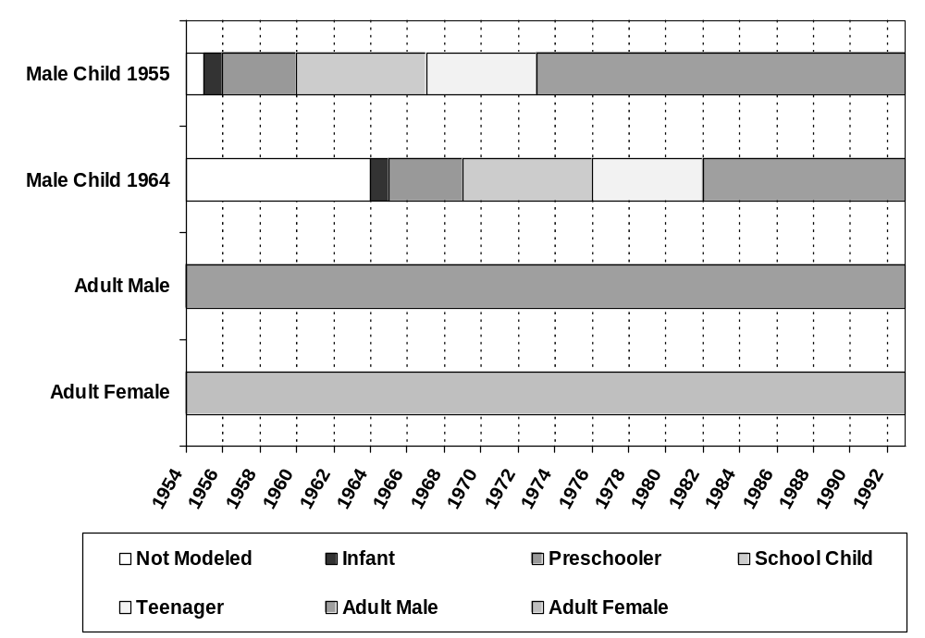
Figure E-3 Age and Gender Categories of Modeled Receptors by Year

Overview of Food Product Consumption
To address radiation exposures through consumption of food and animal products, quantities of each food product eaten by each receptor were estimated as well as the fraction of each food product that had been contaminated with radionuclides released by the SRS. Assumptions were made for each family member about the consumption rates of the food products listed below. The primary data source for these assumptions was EPA’s “Exposure Factors Handbook” (5):
- Leafy vegetables | - Beef
- Root vegetables | - Poultry
- Fruit | - Milk
- Grain | - Eggs
 | - Fish
The quantity of each food product consumed annually depended on the age of the receptor. Adults living in the SRS vicinity at the start of SRS operations in 1954 ate a constant annual quantity of each food product over the 39 years of the study. Adult females generally ate less food than did the adult males. The children ate different quantities of each food product depending on their age. After each child reached age 18, they ate each food product in annual quantities appropriate for an adult male.
Assumptions about food product contamination depended on the food product and scenario. If the food product was grown or produced locally (e.g., from local farms or dairies), then it was assumed that all was contaminated. If the food product was from a local store, then it was assumed that some (generally half) was obtained locally (and therefore contaminated) and the remainder was obtained from sources external to the SRS vicinity.
Radiation exposure from eating game animals taken near the SRS site was modeled by assuming that meat from all game animals could be represented as forms of beef (e.g., venison) or poultry (e.g., wild fowl). Members of Rural Family One and Two, the Delivery Person Family, and the Outdoors Person Family were assumed to eat game animal meat. The total quantities of beef and poultry that these members ate were the same as that eaten by comparable members of the other three scenarios. However, larger fractions of this meat were assumed to be locally produced for these four scenarios compared to the other three scenarios.

Scenario Exposure Time Assumptions
To perform the exposure assessments outlined in Section E.5, it is necessary to document the time spent by each family member performing each of their assumed activities. Each family member was assigned a time spent at home, at work (for the adult male and for the children after they became adults), at church, and while performing other activities including hunting, fishing, swimming, and boating. Times spent performing these activities were determined from Lockridge (1), the 1997 EPA “Exposure Factors Handbook” (5), and Hamby (6). Appendix Q includes a matrix showing the times performing each activity by each member of each family exposure scenario.
Except for the Migrant Worker Family, the total time spent by each family member performing all activities added to 8,760 hours each year (24 hours/day x 365 days/year). This reflects the conservative assumption that no family member was ever away from the SRS vicinity. The total time spent by each member of the Migrant Worker Family was only 4,380 hours/year, reflecting their presence in New Ellenton for only half of any year.
A distinction is made between hours spent indoors vs. hours spent outdoors because the information is used to help determine external radiation exposures from contaminated soil (Section E.5.1.2). For each exposure scenario, the split between indoor and outdoors hours changed for the two children as they grew from infant to adult; however, it was assumed to be constant for the two adults. This assumption was made to reduce modeling complexity despite the expectation that an infant and an Adult Female would have the same number of outside hours. But because each of the children were infants for only a single year, it was determined that adjusting the outside hours of the Adult Female to closely correspond to that of the children as they grew up was not warranted.
The hours spent indoors and outdoors were determined principally based on (1) the definition of the exposure pathways and (2) data from Lockridge (1) and EPA, 1997 (5). For some exposure pathways, the time spent indoors and outdoors was contained within the definition of a receptor’s actions. For example, it was assumed that swimming, boating, or walking a river shoreline were all outdoor activities. When indoor and outdoor hours were not defined under the scenario specifications, assumptions about the split between indoor and outdoor hours were made as addressed below.
- Church. Except for the Migrant Worker Family, all members of all exposure scenarios spent 104 hours per year in church (52 weeks/year x 2 hours/week). All members of the Migrant Worker Family spent 52 hours per year in church. All hours in church were spent indoors.
- School. Except for the Migrant Worker Family, for all exposure scenarios, the school-aged and teenaged children all spent 1,260 hours per year in school (180 days/year x 7 hours/day). (The school-aged children attended grade school and the teenagers attended high school.) Of these 1,260 hours per year, 900 hours were spent indoors and 360 hours were spent outdoors [(5 hours indoors/day, 2 hours outdoors/day) x 180 days/year]. The school-aged and teenaged children of the Migrant Worker Family spent 630 hours per year in school (90 days/year x 7 hours/day). Of these 630 hours/year; 450 hours were spent indoors and 180 hours were spent outdoors [(5 hours indoors/day, 2 hours outdoors/day) x 90 days/year].
- Work. Except for the Migrant Worker Family, the Adult Male of all exposure scenarios spent 2,000 per year at work (40 hours/week x 50 weeks/year). The Adult Male of the Migrant Worker Scenario spent 1,000 hours per year at work. The split between indoors and outdoors hours depended on the nature of the work. The Adult Males of Rural Family One, Rural Family Two, and Migrant Worker Family were farmers, spending one working hour per day indoors, and seven working hours per day outdoors. The Adult Males of the Urban/Suburban Family and Near River Family mainly worked within buildings, spending seven working hours per day indoors, and one working hour per day outdoors. The Adult Male of the Delivery Person Family worked 400 hours per year making deliveries to the SRS and the remaining 1,600 hours per year in Allendale. Of the annual 400 hours working onsite at the SRS, 200 hours were indoors and 200 hours were outdoors. At Allendale, the remaining annual 1,600 hours were divided into 1,350 hours indoors and 250 hours outdoors (1 hr/day for 250 days/year spent outdoors). The Adult Male of the Outdoors Person Family spent all of his 2,000 working hours at the SRS outside. Of these working hours, 260 hours/year were spent along the SRS shoreline (where he was exposed to radionuclides deposited from the Savannah River on the shoreline), and 260 hours/year were spent boating in the Savannah River. The exposures from these working activities were in addition to recreational shoreline and boating activities addressed below. Thus, the following are the annual working hours for the Adult Males of each exposure scenario:
-- Rural Family One: 250 hours indoors, 1,750 hours outdoors.
-- Rural Family Two: 250 hours indoors, 1,750 hours outdoors.
-- Urban/Suburban Family: 1,750 hours indoors, 250 hours outdoors.
-- Migrant Worker Family: 125 hours indoors, 875 hours outdoors.
-- Delivery Person Family: Allendale – 1,350 hours indoors, 250 hours outdoors; SRS – 200 hours indoors, 200 hours outdoors.
-- Outdoors Person Family: 2,000 hours outdoors, including 260 hours on the shoreline and 260 hours boating.
-- Near River Family: 1,750 hours indoors, 250 hours outdoors.
Note that all children of all exposure scenarios adopted the same work habits (and annual times spent indoors and outdoors) as did the Adult Male of the exposure scenario when each of the children reached age 18.
- Hunting and fishing. For all receptors, hunting and fishing were outside activities. Except for the Adult Male of the Outdoors Person Scenario, the time spent hunting and fishing was included with the residential outside hours (see below). For the Adult Male of the Outdoors Person Scenario, time spent outdoors hunting and fishing was included with his work hours. This assumption also applied to the two children of the Outdoors Person Scenario when they reached age 18 and began working on the SRS site.
- Recreational swimming, shoreline, and boating. Except for members of the Migrant Worker and Near River Family, members of all exposure scenarios (including all members of the Outdoors Person Scenario) spent 21 hours/year swimming and 85 hours/year along a river or creek shoreline. Members of the Migrant Worker Family swam for 11 hours per year and spent 43 hours along a shoreline. Members of the Near River Family swam for 91 hours per year and spent 365 hours per year along a shoreline. (See Section E.5.1.4 for the derivation of the swimming hours, and Section E.5.1.3 for the derivation of shoreline hours.)
Members of Rural Family One, Rural Family Two, and the Migrant Worker Family did no boating. Members of the Urban/Suburban Family, Delivery Person Family, and Outdoors Person Family recreationally boated for 96 hours per year, while members of the Near River Family boated for 192 hours per year. (See Section E.5.1.5 for the derivation of the boating hours.) All swimming, shoreline, and boating hours were spent outside.
- Home. Times spent at home were determined for each member of each exposure scenario by adding all hours spent while at church, work, and school, and while swimming, boating, and spending time along a shoreline. These summed hours were subtracted from the total hours spent in the SRS vicinity each year (generally 8,760 hours). The remaining hours were distributed between indoors and outdoors hours using data from the EPA “Exposure Factors Handbook” (5) as summarized in Table E-7. This table summarizes data from the EPA “Exposure Factors Handbook” (5) that presents mean values for the times spent indoors and outdoors for various age and gender categories (first column). Table E-7 also shows the corresponding grouping of age and gender categories that were modeled for this study (second column).

Table E-7 Time Spent Outdoors – EPA 1997 Age and Gender Categories and Rate Data, and Corresponding Modeled Age and Gender Categories and Calculated Rates
EPA Age and Gender Categories | Corresponding Modeled Age and Gender Categories | Time Spent Outdoors (minutes/  day) | Calculated Time Spent Outdoors (hours/year) | Time Spent Indoors (minutes/day) | Calculated Time Spent Indoors (hours/year)
1 – 4 | Infant (<1) | 196 | 1,190 | 1,212 | 7,371
1 – 4 | Pre-School (1-7) | 196 | 1,190 | 1,212 | 7,371
5 – 11 | Child (<7 – 12) | 188 | 1,141 | 1,005 | 6,115
12 – 17 | Teenager (<12 – 17) | 135 | 823 | 970 | 5,898
18 – 64 | Adult Male (>17) | 144 | 877 | 948 | 5,766
18 – 64 | Adult Female (>17) | 144 | 877 | 948 | 5,766
Source: Table 15-132 (mean values) from EPA, 1997 (5).

As an example, the Infant of Rural Family One annually spent 104 hours in church, 21 hours swimming, and 85 hours along a shoreline. This leaves (8,760 – 104 – 21 – 85 = 8,550 hours. Using Table 3-7, the hours spent indoors were calculated as 8,550 x 7371/(1190 + 7371) = 7,362 hours. The hours spent outdoors were calculated as 8,850 x 1190/(1190 + 7371) = 1,188 hours.
Hours for the remaining members of the exposure scenarios were calculated in a similar manner and are listed in Appendix Q.

Overview of Final Exposure Scenarios
The seven scenarios and the assumed home locations for each of the hypothetical families making up these scenarios are described in detail in the following sections.

Rural Family One

This hypothetical family lived in Girard, Georgia. All family members spent much of their work, home activities, and recreation time outdoors. The Adult Male was a farmer, and the Adult Female worked at home. The family hunted, fished, and swam in the Girard area and in the nearby area of Briar Creek. The family did no boating. The children stayed at home until they reached school age; then they attended grade schools in Girard and high school in Waynesboro, Georgia. When not attending school, the children remained in the Girard area. When the children grew to adulthood, they became farmers and fished, hunted, and engaged in recreational activities in the Girard area. All family members remained permanently in the Girard area. Figure E-4 shows the exposure locations of Rural Family One.
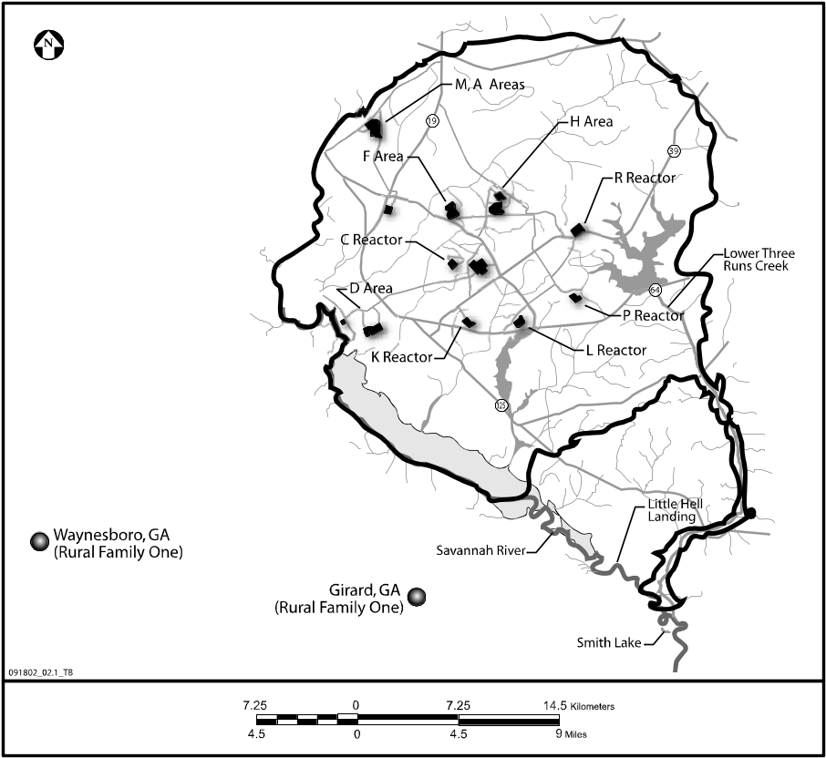
Figure E-4 Exposure Locations of Rural Family One
All the family’s milk and eggs came from cows and hens located in Girard. The fish eaten by the family was caught in Briar Creek or other nearby locations. Because Briar Creek is not located hydrologically downstream from the SRS, none of the fish consumed by the family was affected by SRS release of radionuclides to surface water. During the 1950’s, half of the beef, poultry, leafy and root vegetables, and fruit eaten by the family was grown or produced on the family farm. The remainder came from other sources such as stores in Girard. Half of this remaining food was locally grown or produced. Beginning in 1960, only 25 percent of their beef, poultry, vegetables, and fruit was grown or produced on the family farm. The remaining 75 percent came from sources such as stores. Half of this remaining food was grown or produced in Girard, and half came from sources outside the SRS. It was assumed that all of the locally grown grain eaten by the family was corn. Drinking water and water used to irrigate the food grown and eaten by the family came from local ground water or surface water sources that were unaffected by SRS releases.

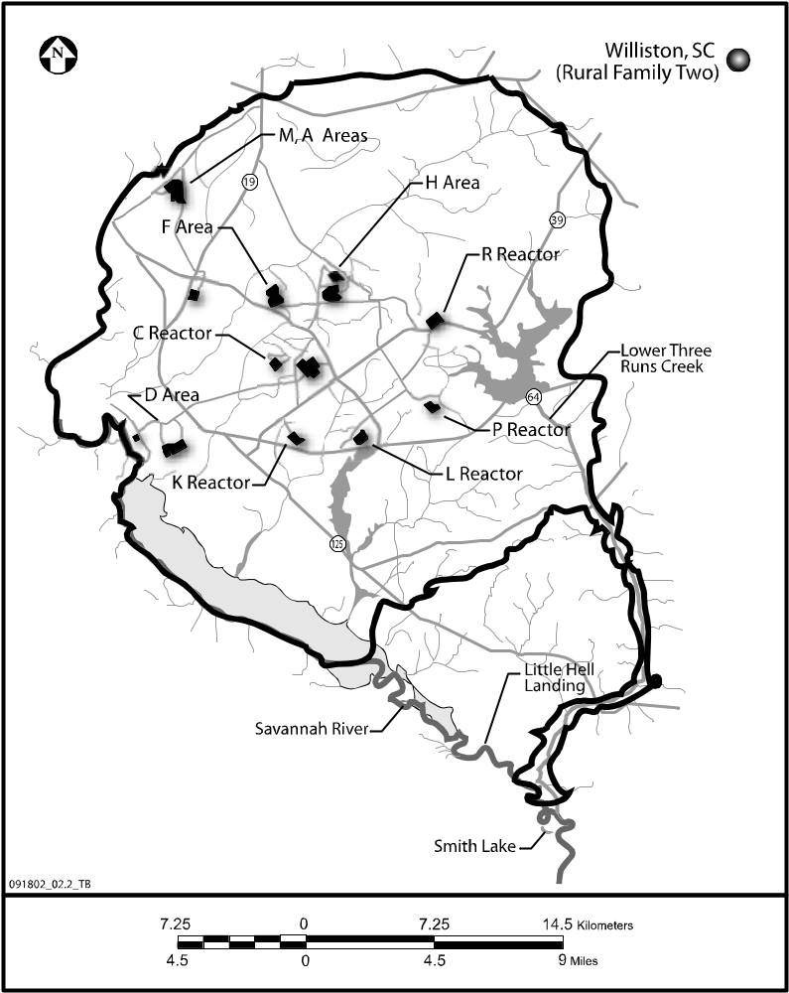
Rural Family Two
Figure E-5 Exposure Location of Rural Family Two
Rural Family Two was a hypothetical family substantially similar to Rural Family One, except that the family lived and spent all their time in Williston, South Carolina. Figure E-5 shows the exposure location of Rural Family Two.
All family members spent much of their work, home activities, and recreation time outdoors. The adult male was a farmer, and the adult female worked at home. The family hunted, fished, and swam in the Williston area. Like Rural Family One, this family did no boating. The children stayed at home until they reached school age, and then they attended schools in Williston. When not attending school, the children remained in the Williston area. When the children grew to adulthood, they became farmers. The family always lived, engaged in recreational activities, and worked in and around the Williston area.
All of the family’s milk and eggs came from cows and hens located in Williston (on the family farm or nearby). All of the fish eaten by the family were caught in streams or ponds in or near Williston. Because these streams and ponds are not hydrologically downstream from the SRS, none of the fish eaten by the family was affected by SRS releases of radioactive material to surface water.
During the 1950’s, half of the beef, poultry, leafy and root vegetables, and fruit eaten by the family was grown or produced on the family farm. The remaining half came from other sources such as stores in Williston. Half of this remaining food (i.e., food not grown or raised on the family farm) was grown or produced in Williston and the other half came from outside the SRS area. Beginning in 1960, only 25 percent of their beef, poultry, vegetables, and fruit was grown or produced on the family farm. The remaining 75 percent was obtained from other sources such as stores in Williston. Half of this remaining food was locally grown or produced, and half came from outside the SRS area.
All locally grown grain eaten by the family was corn. Drinking water and water used to irrigate any food grown and eaten by the family came from ground- or surface-water sources assumed to be unaffected by SRS releases

Urban/Suburban Family
This hypothetical family lived in Augusta, Georgia, and all family members were present there for most activities including school and church. The Adult Male worked onsite at the SRS for the duration of the study period (39 years). The children worked onsite at the SRS beginning in 1973 for the Child Born in 1955 and 1982 for the Child Born in 1964. All family members swam, boated, and fished in the Savannah River flowing through the Augusta area, a location well upstream of any point of radionuclide discharge to surface water from the SRS. Figure E-6 shows the exposure locations of the Urban/Suburban Family.
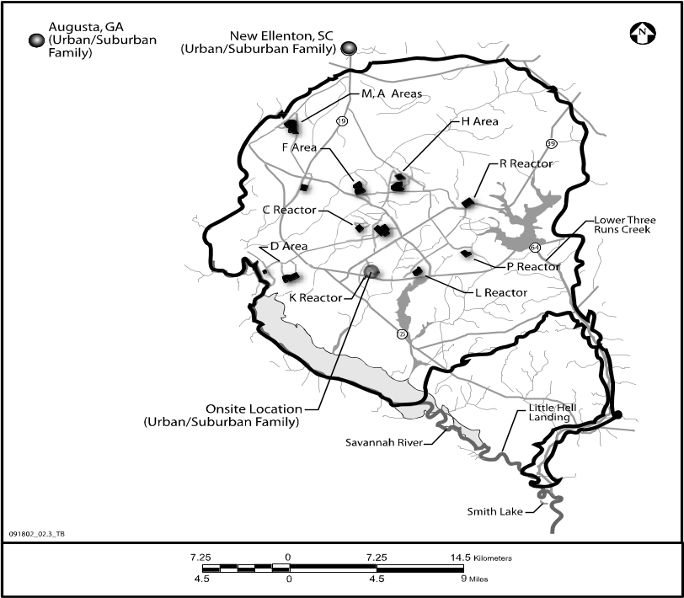
Figure E-5 Exposure Locations of Urban/Suburban Family
Half the family’s milk came from cows in the Augusta area and half from cows in the New Ellenton area. All eggs came from hens located in the Augusta area. Half of their beef, poultry, leafy vegetables, root vegetables, and fruit was grown or produced in the Augusta area, and half came from unaffected nonlocal sources. All locally grown grain eaten by the family was corn. Fish came from sources unaffected by liquid releases from the SRS (e.g., from the nearby Savannah River). Drinking water and water used to irrigate any food grown and eaten by the family came from ground- or surface-water sources assumed to be unaffected by SRS releases

Migrant Worker Family
All family members spent much of their work, home activities, and recreation time outdoors in New Ellenton, South Carolina. Figure E-7 shows the exposure location of the Migrant Worker Family. Because the Adult Male and Adult Female worked as migrant farm workers, the family lived in New Ellenton for only half of any year. While living in New Ellenton, the family participated in hunting, trapping, and other outdoor activities. The family did no boating but did participate in other water sports such as fishing and swimming in local pools, ponds, and creeks. The children stayed at home until they reached school age and attended schools in New Ellenton. When the children grew to adulthood, they became migrant farmers spending half the year in New Ellenton and half the year away from the SRS vicinity.
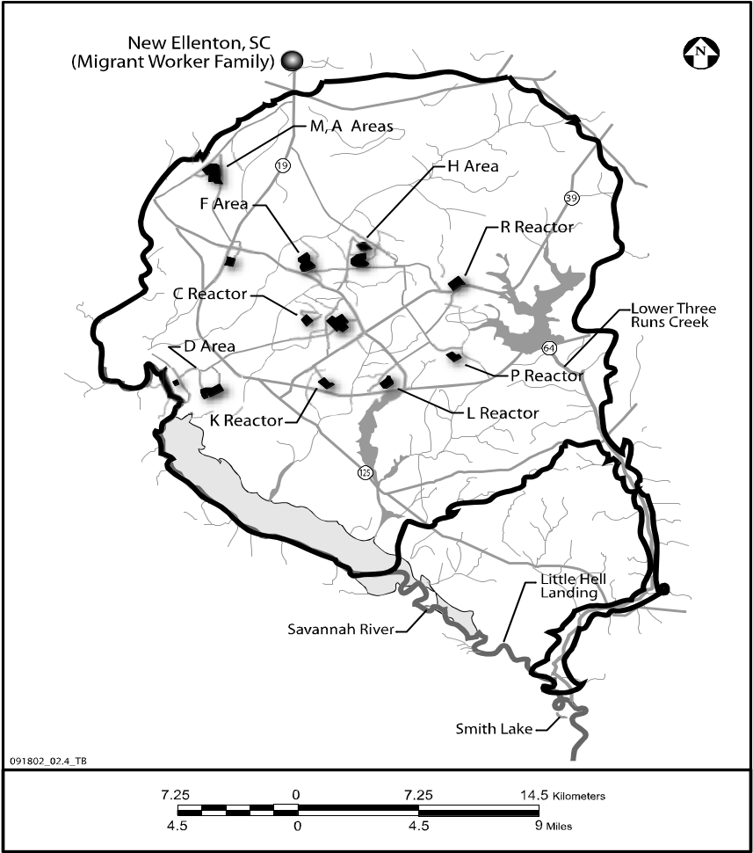
Figure E-6 Exposure Location of Migrant Worker Family
During the six months of each year that the family lived in New Ellenton, all of their milk and eggs were produced or collected in or near New Ellenton. Half of the family’s beef, poultry, leafy vegetables, root vegetables, and fruit was grown or produced in the New Ellenton area and half came from sources outside the SRS vicinity. All of their corn was grown in the New Ellenton area. Because ponds and creeks in the vicinity of New Ellenton are not hydrologically downstream from the SRS, none of the fish eaten by the family was affected by SRS releases. Drinking water and water used to irrigate foods eaten by the family came from ground water or surface water sources unaffected by SRS liquid releases.

Delivery Person Family
This hypothetical family lived in Barnwell, South Carolina, where the children attended grade and high school. Because the Adult Male worked as a delivery driver for a bottling plant located in Allendale, South Carolina, he spent portions of his time in Allendale and portions onsite at the SRS where he made periodic deliveries. (When the children reached 18, they lived in Barnwell and became delivery drivers like the Adult Male.) All family members attended religious services in Martin, South Carolina, for two hours each week. All family members swam, fished, and spent time along the shoreline at Lower Three Runs Creek near Martin. The adult male hunted for deer and fowl in the Martin vicinity. Figure E-8 shows the exposure locations of the Delivery Person Family.
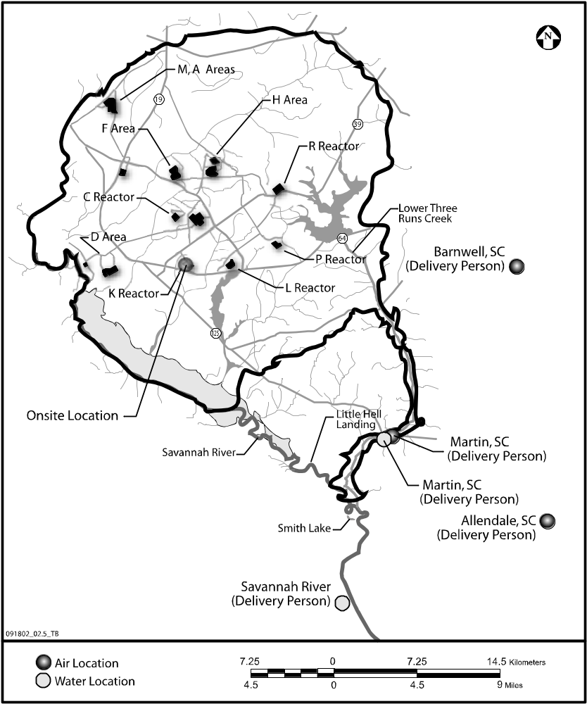
Figure E-7 Exposure Locations of Delivery Person Family
The family boated on the Savannah River using the boat ramp at Little Hell Landing, which is upstream of the confluence of the Savannah River with Lower Three Runs Creek. The family then moved the boat to the Smith Lake area for fishing and activities along the Savannah River shoreline. Smith Lake is located just below the confluence of the Savannah River with Lower Three Runs Creek. The family did not swim in the Savannah River.
Half of the family’s milk and eggs came from cows and hens in the Barnwell area and half came from cows and hens in the Martin area. In addition, half the family’s beef and poultry came from Barnwell and half from Martin. Half of the beef and poultry from Barnwell was actually produced in the Barnwell area, and half was acquired from sources away from the SRS area. Of the beef and poultry from Martin, 25 percent consisted of meat from hunting deer and wild fowl. That is, 25 percent of the beef from Martin consisted of locally hunted venison while 25 percent of the poultry from Martin consisted of locally hunted wild fowl. Of the remaining 75 percent of the beef and poultry from Martin, half was produced in the Martin area and half was acquired (e.g., by stores) from sources well away from the SRS.
Half the leafy vegetables, root vegetables, and fruit came from Barnwell, and half came from Martin. Half of the produce obtained in the Barnwell area was grown in areas away from the SRS vicinity and half of the produce obtained in the Martin area was grown in areas away from the SRS vicinity. Half of the corn eaten by the family was grown in Barnwell and half in Martin.
Half of the fish eaten by the family was caught in Lower Three Runs Creek at Martin and half was caught in the Savannah River.

Outdoors Person Family
This hypothetical family lived in Jackson, South Carolina, and all family members were present there for most activities including school and religious services. When the children grew to adulthood, they continued to live in Jackson. Family members were not present in Jackson during employment for the Adult Male and employment for the children when they each reached age 18. The Adult Male worked onsite at the SRS as a hunter, as did the children when they grew up. During the time the Adult Male spent onsite at the SRS annually, he took game animals in the form of deer and birds, and caught fish from the Savannah River. His job required him to spend 260 hours per year along on the Savannah River shoreline as well as 260 hours per the year boating on the Savannah River. Figure E-9 shows the exposure locations of the Outdoors Person Family.
All family members (including the Adult Male) engaged in recreational swimming in the Savannah River and spent time along the Savannah River shoreline near the Jackson boat ramp (upstream of sources of SRS radionuclide release to the Savannah River). All family members boated in the Savannah River downstream of the SRS.
All milk and eggs came from cows and hens located in Jackson. Half the leafy and root vegetables and fruit were grown in Jackson, and half came from sources away from the SRS area. All of the family corn was grown in Jackson.
Three-quarters of the family’s beef and poultry consisted of venison and wild fowl that was hunted by the Adult Male on the SRS site. Their remaining beef and poultry came from other sources such as stores. Of this, half was produced in Jackson and half came from sources away from the SRS area. All fish taken from the Savannah River contained radionuclides from SRS operations.
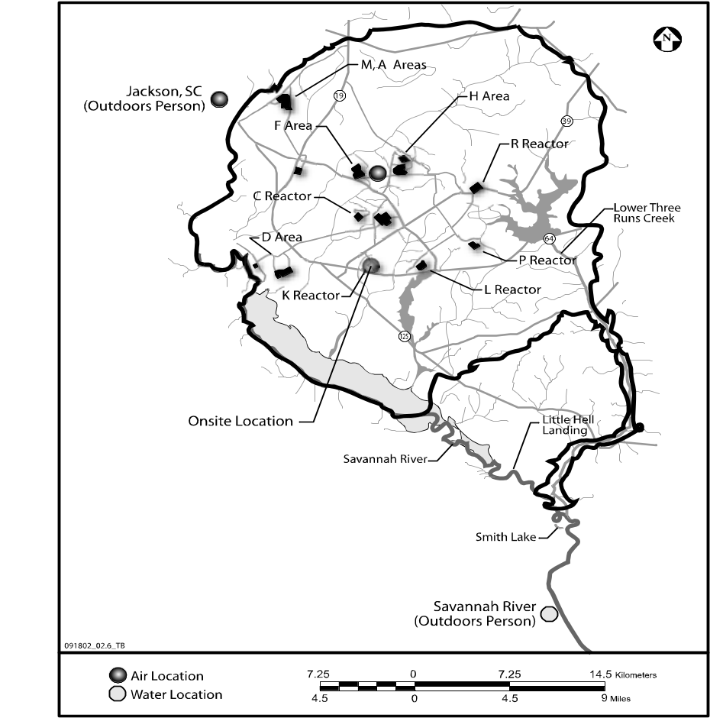
Figure E-8 Exposure Locations of Outdoors Person Family

Near River Family
This hypothetical family lived in Martin, South Carolina. All members spent much of their work, home activities, and recreation time outdoors. The family lived, worked, and went to school and church in Martin, and participated in outdoor activities such as hunting, fishing, and boating. Figure 3-10 shows the exposure locations for the Near River Family.
This family spent twice as much time boating (in the Savannah River) as did other families. Each family member spent an average of an hour per day of each year on the Savannah River shoreline and an average of an hour a day swimming during the summer in the Savannah River. When the children grew up, they continued to live in Martin. The family’s milk and eggs all came from cows and hens located in Martin. Half of the family’s beef, poultry, leafy vegetables, root vegetables, and fruit was grown or produced in Martin and half came from sources outside the SRS vicinity. All of the corn eaten by the family was grown in Martin. All of the fish eaten by the family was caught in the Savannah River below its confluence with Lower Three Runs Creek. Drinking water and any irrigation used to produce the food eaten by the family came from sources unaffected by SRS releases.
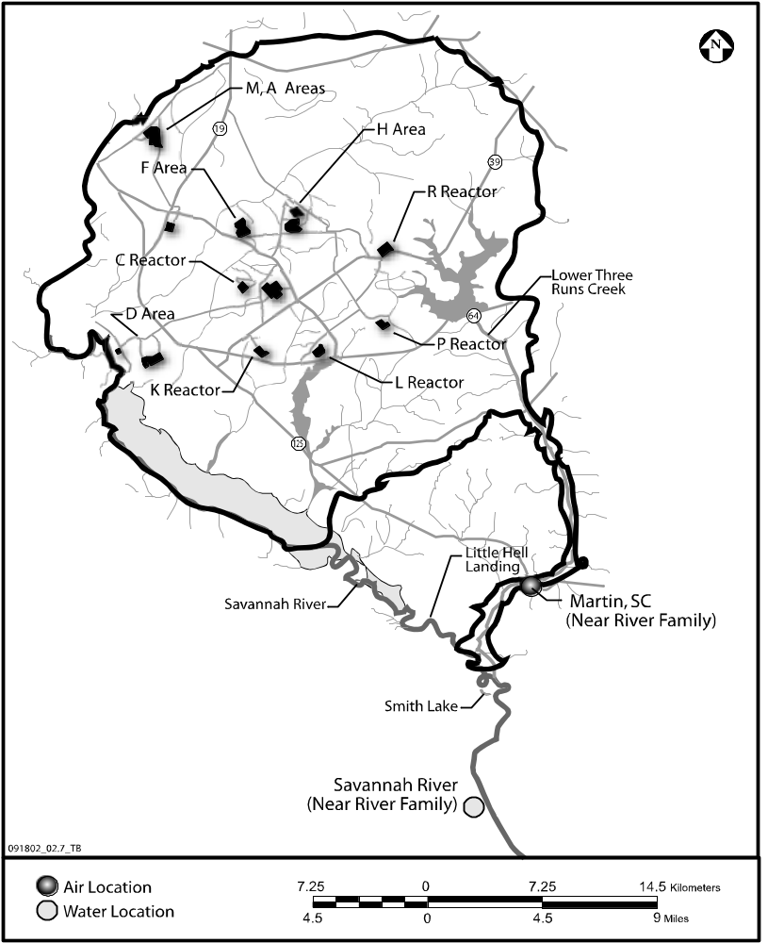
Figure E-9 Exposure Locations for Near River Family

Linkage of GENII Variables to Exposure and Adjustment Factors
Because of the size and complexity of the computational requirements, radiological assessment calculations were performed using the GENII code assuming “unit” quantities for receptor-specific usage factors such as food consumption rates. The output from the GENII code was then modified in the post-processor (software specially created for this Phase III study) to arrive at the proper doses and risks as a function of year for each receptor. These adjustments were performed using a series of receptor- and pathway-specific exposure and adjustment factors that were multiplied by the GENII output. Mathematically, the use of the exposure and adjustment factors to calculate annual dose may be envisioned as follows:
D_{PPrp} = D_{Grp} EF_{rp} AF_{rp}
Where D_{PPrp} = The dose (Sv) calculated from the post-processor for each receptor and for each pathway.
D_{Grp} = The dose (Sv) calculated from GENII for each receptor and for each pathway, assuming unit quantities for usage factors.
EF_{rp} = A receptor- and pathway-specific exposure factor.
AF_{rp} = A receptor- and pathway-specific adjustment factor.
A similar relationship may be envisioned to calculate the use of exposure and adjustment factors to link risks calculated from GENII runs and those calculated using the post-processor.
Exposure and adjustment factors are discussed in Sections E.4.1 and E.4.2, respectively.

Creation of Exposure Factors
An exposure factor was created for each pathway by multiplication of two or more GENII variables used to describe receptor-specific usage factors. The creation of an exposure factor may be illustrated using the example provided below.
The mathematical relationship used in the GENII code to calculate radiation exposures received by a receptor from inhaling air containing radionuclides is presented in the GENII Software Design Document (Napier, 2002) and summarized in Section D.3.1 of Appendix D. The total amount of radioactive material inhaled over a period of time (in this case one year) is given as follows (7):

I_{aaig}(T) = C_{aag} U_{aag} T_{aag} ED_{aag}

Where I_{aaig}(T) = total intake of radionuclide i from air inhalation over the period T
at air usage location a for individuals in age group g (Bq)

C_{aag} = average air concentration for radionuclide i at air usage location a
over time period T (Bq/m³)

U_{aag} = inhalation rate at air usage location a for individuals in age group g
(m³/d)

T_{aag} = annual intake factor giving days per year that air inhalation occurs
at air usage location a for individuals in age group g (d/y)

ED_{aag} = exposure duration for the air inhalation pathway at air usage
location a for individuals in age group g (y).
The total intake of radionuclide i, or I_{aaig}(T), was then input to the dose and risk computational module described in Section D.4, and doses and risks were calculated for each receptor for each year of SRS operation. To calculate I_{aaig}(T), C_{aag}, U_{aag}, T_{aag}, and ED_{aag} had to be numerically specified. The exposure duration (ED_{aag}) was one year in all cases. The average concentration (C_{aag}) was determined for each year and receptor location using the Gaussian plume air dispersion model described in Section D.2.
The remaining parameters, U_{aag} and T_{aag}, had to be input to GENII for each code run using the FRAMES interface. The GENII variable names for these parameters are UINH and TINH, respectively (7). Under normal circumstances, assuming year-round presence of an adult male at the location of interest, one would have input a value for UNIH of 15.2 m³/ day, which is the average daily breathing rate of an adult male according to EPA data in its 1997 Exposure Factors Handbook (5). One would have also input 365 days per year for TINH. (The product of UINH and TINH is 15.2 x 365 = 5,548 m³/year.)
But to address computational needs as discussed above, GENII was run (determining values for I_{aaig}(T)) assuming that UINH and TINH both equaled unity (i.e., UINH = TINH = 1). After completing the GENII computer runs, the output from GENII was fed into the postprocessor, and the GENII calculations were adjusted using appropriate exposure factors. For this example, the exposure factor was calculated as the product of the above example values for UINH and TINH. For an adult male, the exposure factor would have been 5,548 m³/year. The exposure factor for another person (say, an infant or an adult female) would have been different because that person would have had a different average daily breathing rate.
Similar procedures were performed for each of the pathways. Table E-8 lists, for each pathway, the GENII variables that were input as unit values to the GENII calculations. This table also identifies the computational parameter that the GENII variable represents, as well as that section in Appendix D where the use of the parameter in the mathematical expressions codified in GENII can be found.
Table E-8 GENII Variables Input as Unit Values and Adjusted in Post-Processor
Trans-port | Transfer Process or Activity | Exposure Pathway  (Section) | Param-eter | GENII Variable Name and Description
Air | Plume Immersion | External Exposure  (Section D.3.2.1) | U_{eag}  T_{eag} | UEXAIR – Daily exposure factor (h/d)  TEXAIR – Annual exposure factor (d/y)
Air | Ground Contamination | External Exposure  (Section D.3.2.2) | SH_{h}  SH_{o}  U_{esg}  T_{esg}  FT_{hg}  FT_{og} | SHIN – Indoor shielding factor (dimensionless)*  SHOUT – Outdoor shielding factor (dimensionless)*  UEXGRD – Daily external exposure time (h/d)  TEXGRD – Yearly external exposure time (d/y)  FTIN – Fraction of time indoors (dimensionless)*  FTOUT – Fraction of time outdoors (dimensionless)*
Surface Water | Concentration in Sediment | External Exposure (Section D.3.2.3) | FE_{srg}  TE_{srg}  T_{srg} | EVSHOR – Frequency of shoreline use (event/d)  TESHOR – Duration of shoreline use (h/event)  TSHOR – Shoreline days (d/y)
Surface Water | Recreational Swimming | External Exposure (Section D.3.2.4) | FE_{wrg}  TE_{wrg}  T_{wrg} | EVSWIM – Frequency of swimming (event/d)  TESWIM – Duration of swimming event (h/event)  TSWIM – Swimming days (d/y)
Surface Water | Recreational Boating | External Exposure (Section D.3.2.5) | FE_{brg}  TE_{brg}  T_{brg} | EVBOAT – Frequency of boating event (event/d)  TEBOAT – Duration of boating event (h/event)  TBOAT – Boating days (d/y)
Air | Food Crop Concentration | Leafy Veg. Ingest. (Section D.3.3.1) | U_{csg}  T_{csg} | UCRP 1 – Leafy vegetable consumption rate (kg/y)  TCRP 1 – Leafy vegetable consumption period (d/y)
 |  | Root Veg. Ingest. (Section D.3.3.1) | U_{csg}  T_{csg} | UCRP 2 – Root vegetable consumption rate (kg/y)  TCRP 2 – Root vegetable consumption period (d/y)
 |  | Fruit Ingestion (Section D.3.3.1) | U_{csg}  T_{csg} | UCRP 3 – Fruit consumption rate (kg/y)  TCRP 3 – Fruit consumption period (d/y)
 |  | Grain Ingestion (Section D.3.3.1) | U_{csg}  T_{csg} | UCRP 4 – Grain consumption rate (kg/y)  TCRP 4 – Grain consumption period (d/y)
Air | Animal Product Concentration | Beef Ingestion (Section D.3.3.2) | U_{asg}  T_{asg} | UNAM 1 – Beef consumption rate (kg/y)  TANM 1 – Beef consumption period (d/y)
 |  | Poultry Ingestion (Section D.3.3.2) | U_{asg}  T_{asg} | UNAM 2 – Poultry consumption rate (kg/y)  TANM 2 – Poultry consumption period (d/y)
 |  | Milk Ingestion (Section D.3.3.2) | U_{asg}  T_{asg} | UNAM 3 – Milk consumption rate (kg/y)  TANM 3 – Milk consumption period (d/y)
 |  | Egg Ingestion (Section D.3.3.2) | U_{asg}  T_{asg} | UNAM 4 – Egg consumption rate (kg/y)  TANM 4 – Egg consumption period (d/y)
Surface Water | Aquatic Accumulation | Fish Ingestion (Section D.3.3.3) | U_{fwg}  T_{fwg} | UAQU 1 – Fish consumption rate (kg/y)  TAQU 1 – Fish consumption period (d/y)
Air | Ground Contamination | Soil Ingestion  (Section D.3.3.4) | U_{dsg}  T_{dsg} | USOIL – Daily soil consumption rate (mg/d)  TSOIL – Days of ingestion in a year (d/y)
Surface Water | Recreational Swimming | Ingestion (Section D.3.3.5) | FE_{wrg}  TE_{wrg}  T_{wrg}  U_{wwg} | EVSWIM – Frequency of swimming (event/d)  TESWIM – Duration of swimming event (h/event)  TSWIM – Swimming days (d/y)  USWIM – Ingestion rate while swimming (L/h)
Air | Contaminated Plume | Inhalation (Section D.3.4.1) | U_{aag}  T_{aag} | UINH – Air inhalation rate (m³/d)  TINH – Intake factor (d/y)
Air | Ground Contamination | Inhalation  (Section D.3.4.2) | U_{sag}  T_{sag}  F_{sag} | UINHR – Resuspended soil inhalation rate (m³/d)  TINHR – Resuspended soil inhalation period (d/y)  FRINHR – Fraction of day resuspended inhalation occurs
* SHIN and FTIN were both set equal to zero. SHOUT and FTOUT were both set equal to unity (see Section E.5.1.2).
Source: Napier, 2002 (7).
The exposure factors that were used in the post-processor to modify the GENII output from the calculations performed assuming unit quantities for these GENII variables are presented for each pathway in Section E.5.

Creation of Adjustment Factors
Adjustment factors were created as needed for certain pathways and receptors. The adjustment factors were created when the use of a single factor to modify GENII exposures using the post-processor was insufficient for computational needs. Therefore, an adjustment factor supplements an exposure factor.
Adjustment factors were most commonly used to correct for the consumption of foods that were grown or produced outside the vicinity of the SRS and therefore could not be contaminated by SRS operations. GENII does not include any direct mechanism to address this situation except for reducing the amounts of certain foods consumed during the year. This approach was not taken, however, because it would have been more difficult to compare assumptions taken for Phase III with those for other studies. It was clearer to separate the two considerations: (1) food quantities consumed and (2) the fraction of the consumed food that was contaminated. Each consideration could then be considered separately, and compared to other studies separately.
Section E.5 addresses the derivation of adjustment factors for each receptor and pathway.

Exposure and Adjustment Factors for Each Exposure Pathway
Exposure and adjustment factors are presented for each exposure pathway in the same order as the pathways summarized in Table E-8. That is, they are organized by exposure route:
- Section E.5.1: External Exposure Route
E.5.1.1 Immersion in a Plume of Contaminated Air
E.5.1.2 Exposure to Contaminated Soil
E.5.1.3 Exposure to a Contaminated Shoreline
E.5.1.4 Exposure to Contaminated Water While Swimming
E.5.1.5 Exposure to Contaminated Water While Boating
- Section E.5.2: Ingestion Exposure Route
E.5.2.1 Ingestion of Food Crops
E.5.2.2 Ingestion of Animals and Animal Products
E.5.2.3 Aquatic Food Ingestion
E.5.2.4 Inadvertent Soil Consumption
E.5.2.5 Inadvertent Ingestion of Water While Swimming
- Section E.5.3: Inhalation Exposure Route
E.5.3.1 Inhalation of a Contaminated Plume of Air
E.5.3.2 Inhalation of Resuspended Soil

External Radiation Exposure Route

Immersion in a Plume of Contaminated Air
This exposure pathway accounts for external radiation exposure from immersion in a plume of contaminated air. The following are GENII variables for this exposure pathway:
- UEXAIR: Daily plume immersion exposure time (hours/day).
- TEXAIR: Yearly plume immersion exposure time (days/year).
The combination of these two variables resulted in an exposure factor in units of hours/year. It was assumed that each receptor spent 8,760 hours out of the year in the SRS vicinity at one or more exposure locations (i.e., 365 days/year x 24 hours/day = 8,760 hours/year). Similar to that for inhalation of contaminated air (Section E.5.3.1), no adjustments in exposure factors were assumed for receptors being indoors for a portion of each day. That is, indoor air concentrations were equal to outdoor air concentrations. Because indoor air concentrations would likely contain lower concentrations of airborne radioactivity, this assumption contributed to conservative (i.e., increased) estimates of dose and risk.
The exposure factors for the teenagers of Rural Family One were split between Girard and Waynesboro, where the teenagers attended high school. Assuming a total of 1,260 hours per year spent in high school, out of a total 8,760 hours in a year, the teenagers’ exposure factors were 1,260 hours/year for the time spent in high school, and 7,500 hours/year for the remaining time spent in Girard. For the remaining family members, exposure factors were calculated assuming that they spent the entire year in Girard.
The split in exposure factors between Girard and Waynesboro for the teenagers was applied for the entire time they were teenagers (i.e., for the six years comprising 1967 through 1972 for the Child Born in 1955 and the six years comprising 1976 through 1981 for the Child Born in 1964). Thus, these teenagers spent six years partially in the Waynesboro area rather than four.
Exposure factors for the Adult Male of the Urban/Suburban Family were split between Augusta and his job onsite at the SRS. The adult male exposure factors were 2,000 hours/year for the time spent at work and 6,760 hour/year for the remaining time spent in Augusta. Exposure factors for the Adult Female of this family were calculated assuming that she spent all her time in Augusta. The two children spent all their time in Augusta until they each age 18, and then they each worked onsite for 2,000 hours per year.
For the Delivery Person Family, the Adult Male worked in Allendale (1,600 hours/year) and also occasionally came onsite at the SRS for deliveries (400 hours/year). The remainder of his time was spent between Barnwell, where he lived with his family, and Martin, where he and his family recreated and attended church.
For the Outdoors Person Family, exposure factors for the adult male were split between Jackson and his job onsite at the SRS. Exposure factors for the Adult Female of this family were calculated assuming that she spent all her time in Jackson. The two children were assumed to spend all their time in Jackson until they each reached age 18, and then they each worked onsite for 2,000 hours per year.
Exposure factors for all members of the Near River Family were calculated assuming that each member spent all their time in Martin. The exposure factors for the members of the Migrant Worker Family were calculated assuming that each member spent all their time in New Ellenton, and that they were only in the SRS vicinity for half of any year.
Table E-9 lists the calculated exposure factors for Rural Family One, and Table E-10 lists the calculated exposure factors for all other exposure scenarios. While the children were teenagers, each spent six years in the Waynesboro area. For the remaining years, they stayed in Girard.
Adjustment factors were assumed to be unity for all receptors.
Table E-9 Exposure Factors (hours/year) for Air Immersion Pathway for Rural Family One
Individual | Girard | Waynesboro
Adult M | 8,760 | 0
Adult F | 8,760 | 0
Child Born in 1955 | 7,500 for 1967-72;  8,760 for other years | 1,260 for 1967-72;  0 for other years
Child Born in 1964 | 7,500 for 1976-81;  8,760 for other years | 1,260 for 1976-81;  0 for other years

Table E-10 Exposure Factors (hours/year) for Air Immersion Pathway for Remaining Scenarios
Individual | Rural Family Two |  |  | Urban/Suburban Family |  |  | Delivery Family
Individual | Williston |  |  | Augusta | Onsite SRS |  | Martin |  |  | Onsite SRS |  |  | Allendale
Adult Male | 8,760 |  |  | 6,760 | 2,000 |  | 306 |  |  | 400 |  |  | 1,600
Adult Female | 8,760 |  |  | 8,760 | 0 |  | 306 |  |  | 0 |  |  | 0
Child Born in 1955:
Thru 1972 | 8,760 |  |  | 8,760 | 0 |  | 306 |  |  | 0 |  |  | 0
Starting 1973 | 8,760 |  |  | 6,760 | 2,000 |  | 306 |  |  | 400 |  |  | 1,600
Child Born in 1964:  Thru 1981  Starting 1982 | 8,760  8,760 |  |  | 8,760  6,760 | 0  2,000 |  | 306  306 |  |  | 0  400 |  |  | 0  1,600
Individual | Delivery Family (continued) |  | Outdoors Person Family |  |  |  |  |  | Near River Family |  | Migrant Worker Family
Individual | Barnwell | Onsite SRS |  |  |  | Jackson |  | Martin |  |  |  | New Ellenton
Adult Male | 6,454 | 2,000 |  |  |  | 6,760 |  | 8,760 |  |  |  | 4,380
Adult Female | 8,454 | 0 |  |  |  | 8,760 |  | 8,760 |  |  |  | 4,380
Child Born in 1955:
Thru 1972 | 8,454 | 0 |  |  |  | 8,760 |  | 8,760 |  |  |  | 4,380
Starting 1973 | 6,454 | 2,000 |  |  |  | 6,760 |  | 8,760 |  |  |  | 4,380
Child Born in 1964:
Thru 1981 | 8,454 | 0 |  |  |  | 8,760 |  | 8,760 |  |  |  | 4,360
Starting 1982 | 6,454 | 2,000 |  |  |  | 6,760 |  | 8,760 |  |  |  | 4,380

Exposure to Contaminated Soil
This exposure pathway accounts for external radiation exposure resulting from standing on the ground at a specified exposure location contaminated by the deposition of radionuclides from the air. Exposures may occur either indoors or outdoors. The following are GENII variables for this exposure pathway:
- UEXGRD (U_{esg}): Daily external ground exposure time (hours/day).
- TEXGRD (T_{esg}): Yearly external ground exposure time (days/year).
- SHIN (SH_{h}): Indoor shielding factor (unitless).
- SHOU (SH_{o}): Outdoor shielding factor (unitless).
- FTIN (FT_{hg}): Fraction of time spent indoors (unitless).
- FTOUT (FT_{og}): Fraction of time spent outdoors (unitless).
For each exposure location, exposure and adjustment factors were calculated as follows:
Exposure Factor = U_{esg} T_{esg} (hours/year)
Adjustment Factor = [(SH_{h} FT_{hg}) + (SH_{o} FT_{og})] (units are dimensionless)
Exposure factors represented the total hours spent out of the year by each receptor at each location where the receptor may have been exposed. The amount of time that receptors spent at each location exposed to external radiation from contaminated ground surfaces was similar, but not equal, to the amount of time that the receptors spent at those locations exposed to external radiation from immersion in a plume of contaminated air. External radiation exposures from surface-contaminated soil did not occur when the receptor was either swimming or boating. A matrix by which exposure factors were determined for each scenario and receptor in accordance with these considerations is presented in Appendix Q. Table E-11 summarizes these exposure factors for Rural Family One, and Table E-12 summarizes the exposure factors for the remaining scenarios.
To determine adjustment factors, because structures provide shielding against ionizing radiation, the fraction of a year that each receptor spent inside and outside had to be determined. That is, values had to be determined for FT_{hg} and FT_{og} , where FT_{hg} + FT_{og} = 1.
Appendix Q provides a matrix that lists the hours spent indoors and outdoors for each receptor and exposure location. This matrix also provides the indoor and outdoor fractions calculated from these hours as well as the total hours spent “out of the water” (total hours out of the year excluding swimming and boating times). The following example illustrates the calculation of indoors and outdoors fractions.
The infant for Rural Family One was exposed to ground contamination at Girard for 8,739 hours out of the year (8,760 total hours in a year – 21 hours swimming minus – hours boating = 8,739 hours). These 8,739 hours were distributed as listed in Table E-13.
The fraction of the time spent indoors was 7,466/8,739 = 0.85. The fraction of the time spent outdoors was 1,273/8,739 = 0.15.
All church hours were spent indoors. To determine the hours spent indoors and outdoors while at home, the total time spent at home was distributed between indoor and outdoor hours using information from Table E-12. In this case, the infant spent 8,550 hours at home (8,760 hours/yr – 85 hours at the shore – 21 hours swimming – 104 hours at church = 8,550 hours/year at home). Inside hours were taken to be 8,550 x 1190 / (1190 + 7371) = 1188 hours. Outside hours were taken to be 8,550 x 7371 / (1190 + 7371) = 7362 hours.
Table E-11 Exposure Factors (hours/year) for Ground Contamination External Exposure Pathway for Rural Family One
Individual | Girard | Waynesboro
Adult M | 8,739 | 0
Adult F | 8,739 | 0
Child Born in 1955 | 7,479 for 1967-72;*  8,739 for other years | 1,260 for 1967-72;*  0 for other years
Child Born in 1964 | 7,479 for 1976-81;*  8,739 for other years | 1,260 for 1976-81;*  0 for other years
*During the indicated years (1969-1972 for the Child Born in 1955 and 1978-81 for the Child Born in 1964), the children born in 1955 and 1964 are classed as teenagers.

Table E-12 Exposure Factors (hours/year) for Ground Contamination External Exposure Pathway for Remaining Scenarios
Individual | Rural Family Two | Urban/Suburban Family |  |  | Delivery Family
Individual | Williston | Augusta |  | Onsite SRS | Martin | Onsite SRS |  | Allendale
Adult M | 8,739 | 6,643 |  | 2,000 | 189 | 400 |  | 1,600
Adult F | 8,739 | 8,643 |  | 0 | 189 | 0 |  | 0
Child Born in 1955:
Thru 1972 | 8,739 | 8,643 |  | 0 | 189 | 0 |  | 0
Starting 1973 | 8,739 | 6,643 |  | 2,000 | 189 | 400 |  | 1,600
Child Born in 1964:
Thru 1981 | 8,739 | 8,643 |  | 0 | 189 | 0 |  | 0
Starting 1982 | 8,739 | 6,643 |  | 2,000 | 189 | 400 |  | 1,600
Individual | Delivery Family (continued) | Outdoors Person Family |  |  | Near River Family |  | Migrant Worker Family
Individual | Barnwell | Onsite SRS | Jackson |  | Martin |  | New Ellenton
Adult M | 6,454 | 1,740 | 6,643 |  | 8,447 |  | 4,370
Adult F | 8,454 | 0 | 8,643 |  | 8,447 |  | 4,370
Child Born in 1955:
Thru 1972 | 8,454 | 0 | 8,643 |  | 8,447 |  | 4,370
Starting 1973 | 6,454 | 1,740 | 6,643 |  | 8,447 |  | 4,370
Child Born in 1964:
Thru 1981 | 8,454 | 0 | 8,643 |  | 8,447 |  | 4,370
Starting 1982 | 6,454 | 1,740 | 6,643 |  | 8,447 |  | 4,370

Table E-13 Indoor and Outdoor Hours for Infant of Rural Family One
Activity | Hours Indoor | Hours Outdoor
At home | 7,362 | 1,188
At work | 0 | 0
On the shoreline | 0 | 85
At school | 0 | 0
At Church | 104 | 0
Total: | 7,466 | 1,273

This accounting was performed for all receptors as addressed in Appendix Q. Appendix Q presents the total indoor and outdoor hours calculated for each receptor as well as the corresponding overall indoor (FT_{hg}) and outdoor (FT_{og}) fractions. Table E-14 summarizes the indoor and outdoor fractions for each receptor calculated from Appendix Q. (Note that FT_{hg} + FT_{og} = 1.)
These fractions were used with the indoor and outdoor shielding factors to create receptor-specific adjustment factors according to the equation listed above. The outdoor shielding factor (SH_{o}) was set equal to 1.0 for all scenarios, exposure locations, individuals, and years. The value assumed for the indoor shielding factor (SH_{h}) was conservatively taken to be 0.7.
The authors of this report found occasions where values for the indoor shielding factor of 0.4, 0.5, 0.7, and 0.8 had been used or recommended. Values of 0.5 and 0.7 have been used for modeling population doses resulting from SRS activities (8-10). EPA had at one time recommended using a shielding factor of 0.8, but in 1996 recommended a shielding factor of 0.4 (11). For this recommendation, EPA had reviewed a 1981 EPA report (12) that performed a review of experimentally measured reduction factors from fallout. The authors concluded that “reduction factors of 0.4 to 0.2 are recommended as representative values for above-ground lightly constructed (wood frame) and heavily constructed (block and brick) homes, respectively” (12). From this review, EPA suggested that a default gamma shielding factor of 0.4 based solely on the contribution of terrestrial radiation might be more appropriate for use at sites having soil contaminated with radionuclides than the previous default value of 0.8. This previous default value included the effects of cosmic radiation and the radioactivity inherent in structural materials (11).
But it was assumed that doors and windows of structures tended to remain open (see Section E.5.3.1), which meant that interior surfaces of structures may have been more likely to be contaminated than the situation assumed by EPA. Therefore, a larger value (0.7) was used for the indoor shielding factor than the default value recommended by EPA (0.4), resulting in somewhat larger exposures than would have been the case using the EPA default value.
Adjustment factors calculated from these considerations are presented in Table E-15.
Table E-14 Indoor and Outdoor Fractions for Ground Contamination Pathway
Scenario | Member* | Loca-tion† | Out. Frac. | In. Frac. | Scenario | Mem-ber* | Loca-tion† | Out. Frac. | In. Frac.
Rural Family One | Inf. | Girard | 0.15 | 0.85 | Delivery Person Family (cont.) | Teen | Martin | 0.45 | 0.55
Rural Family One | Presch | Girard | 0.15 | 0.85 | Delivery Person Family (cont.) | Teen | Barn | 0.15 | 0.85
Rural Family One | School | Girard | 0.18 | 0.82 | Delivery Person Family (cont.) | Ad. M | Martin | 0.45 | 0.55
Rural Family One | Teen | Girard | 0.13 | 0.87 | Delivery Person Family (cont.) | Ad. M | Barn | 0.13 | 0.87
Rural Family One | Teen | Wayne | 0.29 | 0.71 | Delivery Person Family (cont.) | Ad. M | SRS | 0.50 | 0.50
Rural Family One | Ad. M | Girard | 0.31 | 0.69 | Delivery Person Family (cont.) | Ad. M | Allen | 0.16 | 0.84
Rural Family One | Ad. F | Girard | 0.14 | 0.86 | Delivery Person Family (cont.) | Ad. F | Martin | 0.45 | 0.55
Rural Family Two | Inf. | Will | 0.15 | 0.85 | Delivery Person Family (cont.) | Ad. F | Barn | 0.13 | 0.87
Rural Family Two | Presch | Will | 0.15 | 0.85 | Outdoor Person | Inf. | Jack | 0.15 | 0.85
Rural Family Two | School | Will | 0.18 | 0.82 | Outdoor Person | Presch | Jack | 0.15 | 0.85
Rural Family Two | Teen | Will | 0.15 | 0.85 | Outdoor Person | School | Jack | 0.18 | 0.82
Rural Family Two | Ad. M | Will | 0.31 | 0.69 | Outdoor Person | Teen | Jack | 0.15 | 0.85
Rural Family Two | Ad. F | Will | 0.14 | 0.86 | Outdoor Person | Ad. M | Jack | 0.14 | 0.86
Urban/ Suburb. Family | Inf. | Aug | 0.14 | 0.86 | Outdoor Person | Ad. M | SRS | 1.0 | 0
Urban/ Suburb. Family | Presch | Aug | 0.14 | 0.86 | Outdoor Person | Ad. F | Jack | 0.14 | 0.86
Urban/ Suburb. Family | School | Aug | 0.17 | 0.83 | Near River Family | Inf. | Martin | 0.14 | 0.86
Urban/ Suburb. Family | Teen | Aug | 0.14 | 0.86 | Near River Family | Presch | Martin | 0.14 | 0.86
Urban/ Suburb. Family | Ad. M | Aug | 0.13 | 0.87 | Near River Family | School | Martin | 0.18 | 0.82
Urban/ Suburb. Family | Ad. M | SRS | 0.13 | 0.87 | Near River Family | Teen | Martin | 0.15 | 0.85
Urban/ Suburb. Family | Ad. F | Aug | 0.13 | 0.87 | Near River Family | Ad. M | Martin | 0.13 | 0.87
Delivery Person Family | Inf. | Martin | 0.45 | 0.55 | Near River Family | Ad. F | Martin | 0.13 | 0.87
Delivery Person Family | Inf. | Barn | 0.14 | 0.86 | Migrant Worker Family | Inf. | N E | 0.15 | 0.85
Delivery Person Family | Presch | Martin | 0.45 | 0.55 | Migrant Worker Family | Presch | N E | 0.15 | 0.85
Delivery Person Family | Presch | Barn | 0.14 | 0.86 | Migrant Worker Family | School | N E | 0.18 | 0.82
Delivery Person Family | School | Martin | 0.45 | 0.55 | Migrant Worker Family | Teen | N E | 0.15 | 0.85
Delivery Person Family | School | Barn | 0.18 | 0.82 | Migrant Worker Family | Ad. M | N E | 0.31 | 0.69
 |  |  |  |  | Migrant Worker Family | Ad. F | N E | 0.14 | 0.86
*Inf - infant; Presch - preschooler; School - school child; Ad M - Adult Male; Ad F - adult female.
†Wayne - Waynesboro; Will -Williston; Aug - Augusta; Barn - Barnwell; Allen - Allendale; Jack - Jackson; N E - New Ellenton.
Table E-15 Adjustment Factors for Ground Contamination External Exposure Pathway
Individual | Years | Rural Family One |  | Rural Family Two | Urban/Suburban Family |  | Delivery Person Family
Individual | Years | Girard | Waynes-boro | Willi-ston | Augusta | Onsite SRS | Martin |  | Onsite SRS
Adult M | All | 0.7927 | 0 | 0.7927 | 0.7386 | 0.7375 | 0.8349 |  | 0.8500
Adult F | All | 0.7417 | 0 | 0.7417 | 0.7388 | 0 | 0.8349 |  | 0
Children Born in 1955 and 1964 | Infant | 0.7437 | 0 | 0.7437 | 0.7409 | 0 | 0.8349 |  | 0
Children Born in 1955 and 1964 | Preschool | 0.7437 | 0 | 0.7437 | 0.7409 | 0 | 0.8349 |  | 0
Children Born in 1955 and 1964 | Schoolchild | 0.7546 | 0 | 0.7546 | 0.7519 | 0 | 0.8349 |  | 0
Children Born in 1955 and 1964 | Teen | 0.7392 | 0.7857 | 0.7459 | 0.7431 | 0 | 0.8349 |  | 0
Children Born in 1955 and 1964 | Adult | 0.7927 | 0 | 0.7927 | 0.7386 | 0.7375 | 0.8349 |  | 0
Individual | Years | Delivery Person Family (continued) |  | Outdoors Person Family |  | Near River Family |  | Migrant Family
Individual | Years | Allendale | Barnwell | Onsite SRS | Jackson | Martin |  | New Ellenton
Adult M | All | 0.7469 | 0.7396 | 1.0 | 0.7423 | 0.7391 |  | 0.7927
Adult F | All | 0 | 0.7396 | 0 | 0.7417 | 0.7396 |  | 0.7417
Child Born in 1955 | Infant | 0 | 0.7417 | 0 | 0.7437 | 0.7417 |  | 0.7437
Child Born in 1955 | Preschool | 0 | 0.7417 | 0 | 0.7437 | 0.7417 |  | 0.7437
Child Born in 1955 | Schoolchild | 0 | 0.7529 | 0 | 0.7547 | 0.7528 |  | 0.7547
Child Born in 1955 | Teen | 0 | 0.7440 | 0 | 0.7460 | 0.7440 |  | 0.7460
Child Born in 1955 | Adult | 0.7469 | 0.7396 | 0 | 0.7423 | 0.7391 |  | 0.7927

Exposure to a Contaminated Shoreline
This exposure pathway accounts for external radiation exposure resulting from standing on the shoreline containing radioactive material deposited by contaminated water. The following are GENII variables for this exposure pathway:
- EVSHOR - Frequency of shoreline use (event/day).
- TESHOR - Duration of shoreline use events (hours/event).
- TSHOR - Shoreline days (days/year).
Exposure factors were calculated by multiplying age- and location-specific values for these variables, resulting in a set of exposure factors in units of hours of exposure per year. Exposure factors thus developed are summarized in Table E-16 in accordance with the assumptions described in Sections E.5.1.3.1 through E.5.1.3.3.
Table E-16 Exposure Factors for Shoreline External Exposure Pathway
Scenario | Shoreline External Pathway | Exposure Factors
Rural Family One | No shoreline external exposure. Exposure location (Briar Creek near Girard) is not hydrologically downgradient from release points. | Exposure Factors (hours/year) = 0 (all years and individuals)
Rural Family Two | No shoreline external exposure. Exposure locations (Savannah River upstream of the SRS and farm ponds around Williston) are not hydrologically downgradient from release points. | Exposure Factors = 0 (all years and individuals)
Urban/Suburban Family | No shoreline external exposure. Exposure location (Savannah River at Augusta) is not hydrologically downgradient from release points. | Exposure Factors = 0 (all years and individuals)
Delivery Person | Lower Three Runs Creek (LTRC) at Martin (50%) and the Savannah River down stream of the LTRC confluence (50%). All individuals exposed for 85 hours/year for all years, combined from both locations. | Exposure Factors (hours/year)
  Receptor | LTRC-Martin | Savannah River
  Adult M | 42.5 | 42.5
  Adult F | 42.5 | 42.5
  Child 1955 | 42.5 | 42.5
  Child 1964 | 42.5 | 42.5
Outdoors Person | Savannah River upstream of the SRS: No shoreline external exposure for the adult female and children. The exposure location is not hydrologically downgradient from release points.  Savannah River Downstream of the SRS: The adult male is exposed for 260 hours/year for all years. | Exposure Factors (hours/year)
  Receptor | Savannah River
  Adult M | 260
  Adult F | 0
  Child 1955 | 0
  Child 1964 | 0
Near River Family | Savannah River Downstream of SRS: All individuals are exposed for 365 hours/year for all years. | Exposure Factors (hours/year)
  Receptor | Savannah River
  Adult M | 365
  Adult F | 365
  Child 1955 | 365
  Child 1964 | 365
Migrant Worker Family | No shoreline external exposure. Exposure locations (Savannah River upstream of the SRS and farm ponds around New Ellenton) are not hydrologically downgradient from release points. | Exposure Factors = 0 (all years and individuals)

Exposure Factors for the Delivery Person Family
Shoreline exposure rates were estimated using the following factors based on South Carolina recreational patterns as cited on pages 6 and 24 of Hamby (6):
- Average number of shoreline usage events/year – 19.15.
- Average hours/shoreline usage event – 4.44.
This resulted in an exposure rate of 85 hours/year which was applied to all members of the Delivery Person Family. The Hamby (6) values are based on Ledbetter (13). The numbers apply to all age groups and represent warm-water fishing activity. This exposure value is larger than default values cited in the Nuclear Regulatory Commission’s (NRC) Regulatory Guide 1.109 (14) for a maximum exposed individual (MEI). NRC MEI exposure values for adults, teens, and children are 12, 67, and 14 hours/year, respectively (14). Hamby (6) calculated MEI values for population doses in the area around the SRS using local data and assumptions. The Hamby (6) MEI numbers for adults, teens, and children are 23, 128, and 27 hours/year, respectively.

Exposure Factors for the Outdoors Person Family
The only family members that were exposed to contaminated shorelines were the Adult Male and the two children when they became adults at age 18. It was assumed the Adult Male was present in shoreline areas along the Savannah River onsite at the SRS as part of his job. This time included time spent fishing and hunting. It was assumed the Adult Male was “on the river” 8 hours/day (40 hours/week) during the summer (13 weeks), as cited in Lockridge (1). It was further assumed that half the time spent “on the river” was spent on the shoreline, and the other half was spent on a boat. This resulted in an exposure factor of 260 hours/year on the shoreline for the Adult Male. The Adult Female always spent time along the shoreline at the Jackson, South Carolina, boat ramp, which is upstream from site discharges. Until they each reached age 18, the two children also spent their shoreline time at the Jackson boat ramp. After reaching age 18, they each spent the same time along the shoreline while working at the SRS as did the Adult Male (260 hours/year).

Exposure Factors for the Near River Family
For these receptors, Lockridge (1) states, “Assume they were always outdoors in contact with the Savannah River.” It was assumed that the shoreline exposure rate would have been well above average values. An average daily exposure level of 1 hour/day (365 hours/year) was assumed for each receptor.

Exposure to Contaminated Water While Swimming
This exposure pathway accounts for external radiation exposure resulting from swimming in contaminated water. The following are GENII variables for this exposure pathway:
- EVSWIM - Frequency of swimming use (event/day).
- TESWIM - Duration of swimming events (hours/event).
- TSWIM - Swimming days (days/year).
Exposure factors were calculated taking into account these three variables which, when multiplied, result in receptor- and location-specific exposure factors in units of hours per year. Swimming exposures were determined only for members of the Delivery Person Family, who swam on Lower Three Runs Creek near Martin, South Carolina, and the Near River Family, who swam on the Savannah River downstream of the SRS.
For the Delivery Person Family, swimming water exposure rates were estimated using the following factors based on South Carolina recreational patterns cited on pages 6 and 24 of Hamby (6). The Hamby values are based on Ledbetter (13). The following values apply to all age groups and represent warm-water fishing activity:
- Average number of lake swimming events per year – 8.12 events/y.
- Average time of lake swimming event – 2.61 h/event.
These data resulted in exposure factors of 21.2 hours/year for each member of the Delivery Person Family.
For the Near River Family, it is stated in Lockridge (1) to “Assume they were always outdoors in contact with the Savannah River.” A swimming rate was assumed during the summer months of 1 hour/day, leading to an exposure rate of 91 hrs/yr for each receptor. Table E-17 summarizes swimming water exposure factors.
Table E-17 Exposure Factors for Swimming External Exposure Pathway
Scenario | Swimming Water External Pathway | Exposure Factors
Rural Family One | No swimming water external exposure. Exposure location (Briar Creek near Girard) is not hydrologically downgradient from release points. | Exposure Factors = 0 (all years and individuals)
Rural Family Two | No swimming water external exposure. Exposure locations (farm ponds around Williston) are not hydrologically downgradient from release points. | Exposure Factors = 0 (all years and individuals)
Urban/Suburban Family | No swimming water external exposure. Exposure location (Savannah River at Augusta) is not hydrologically downgradient from release points. | Exposure Factors = 0 (all years and individuals)
Delivery Person | Lower Three Runs Creek (LTRC) at Martin: All individuals exposed for 21.2 hours/year for all years. | Exposure Factors (hours/year)
  Receptor | LTRC-Martin
  Adult M | 21.2
  Adult F | 21.2
  Child 1955 | 21.2
  Child 1964 | 21.2
Outdoors Person | No swimming water external exposure. Exposure location (Savannah River upstream of the SRS) is not hydrologically downgradient from release points. | Exposure Factors = 0 (all years and individuals)
Near River Family | Savannah River Downstream of the SRS: All individuals exposed for 91 hours/year for all years. | Exposure Factors (hours/year)
  Receptor | Savannah River
  Adult M | 91
  Adult F | 91
  Child 1955 | 91
  Child 1964 | 91
Migrant Worker Family | No swimming water external exposure. Exposure locations (Savannah River upstream of the SRS and farm ponds around New Ellenton) are not hydrologically downgradient from release points. | Exposure Factors = 0 (all years and individuals)

Exposure to Contaminated Water While Boating
This exposure pathway accounts for external radiation exposures received while boating in contaminated water. The following are GENII variables for this exposure pathway:
- EVBOAT – Frequency of boating event (event/d).
- TEBOAT – Duration of boating event (h/event).
- TBOAT – Boating days (d/y).
Exposure factors determined when multiplying these variables resulted in exposure factors in units of hours/year. Boating exposure factors were calculated for members of the Delivery Person Family, the Outdoors Person Family, and the Near River Family. The rationale for these exposure factors, summarized in Table E-18, is presented in Subsections E.5.1.5.1 through E.6.1.5.3.
Table E-18 Exposure Factors for Boating External Exposure Pathway
Scenario | Boating External Pathway | Exposure Factors
Rural Family One | No boating external exposure. No boating performed by receptor. | Exposure Factors = 0 (all years and individuals)
Rural Family Two | No boating external exposure. No boating performed by receptor. | Exposure Factors = 0 (all years and individuals)
Urban/Suburban Family | No boating external exposure. Exposure location (Savannah River at Augusta) is not hydrologically downgradient from release points. | Exposure Factors = 0 (all years and individuals)
Delivery Person | Savannah River Downstream of the SRS: All individuals exposed for 96 hours/year for all years. | Exposure Factors (hours/year)
  Receptor | Savannah River
  Adult M | 96
  Adult F | 96
  Child 1955 | 96
  Child 1964 | 96
Outdoors Person | Savannah River Downstream of the SRS: The adult male is exposed 356 hours/year for all years, including 260 hours for work and 96 hours for recreation. Boating exposure for all other individuals is 96 hours/year for all years. | Exposure Factors (hours/year)
  Individual | Savannah River
  Adult M | 356
  Adult F | 96
  Child 1955 | 96
  Child 1964 | 96
Near River Family | Savannah River Downstream of the SRS: All individuals exposed for 192 hours/year for all years. | Exposure Factors (hours/year)
  Receptor | Savannah River
  Adult M | 192
  Adult F | 192
  Child 1955 | 192
  Child 1964 | 192
Migrant Worker Family | No boating external exposure. No boating performed by receptor. | Exposure Factors (hours/year) = 0 (all years and individuals)

Delivery Person Family
Boating exposure rates were estimated considering South Carolina recreational patterns as cited on pages 6 and 24 of Hamby (6), and summarized in Table E-19. These values are based on Ledbetter (13). The values apply to all age groups and include two categories: canoeing and boating/sailing.
Table E-19 South Carolina Boating Usage Rates (adapted from Hamby [6])
Boating Usage | Canoe Trails | Boating / Sailing
Events / Year (average) | 6.13 | 18.77
Hours / Event (average) | 2.25 | 4.38
Hours / Year | 13.8 | 82.2
Total | 96 hours/year

An exposure factor of 96 hours/year was assumed for all members of the Delivery Person Family.

Outdoors Person
The Adult Male was exposed to radiation to a greater extent than other family members. The exposure factor for the Adult Male includes two components: one for work and one for recreation. For work, the Adult Male was calculated to boat for 260 hours/year, or half the time spent “on the river” as cited in Lockridge (1). Because the time spent “on the river” was cited (1) as 8 hours/day (i.e., 40 hours/week) during the summer (i.e., 13 weeks), it assumed that the Adult Male boated while at work for 0.5 x 40 x 130 = 260 hours/year. For recreational boating, the same rate (i.e., 96 hours/year adapted from Hamby [6]) was applied to all members of the family, including the Adult Male.

Near River Family
For these receptors, Lockridge (1) states, “Assume they were always in contact with the Savannah River.” An exposure factor was calculated assuming that these receptors went boating for twice the average rates cited in Hamby (6). An exposure factor of 192 hours/year was assumed for each receptor.

Ingestion Exposure Route

Ingestion of Food Crops
Exposures from ingestion of food crops include exposures from ingestion of leafy vegetables, root and other vegetables, fruit, and grain. The following are GENII variables for these exposure pathways:
- UCRP 1 – Leafy vegetable daily consumption rate on days that consumption occurs (kg/d).
- TCRP 1 – Leafy vegetable consumption period: days per year that consumption occurs (d/y).
- UCRP 2 – Root vegetable daily consumption rate on days that consumption occurs (kg/d).
- TCRP 2 – Root vegetable consumption period: days per year that consumption occurs (d/y).
- UCRP 3 – Fruit daily consumption rate on days that consumption occurs (kg/d).
- TCRP 3 – Fruit consumption period: in days out of the year that consumption occurs (d/y).
- UCRP 4– Grain daily consumption rate on days that consumption occurs (kg/d).
- TCRP 4 – Grain consumption period: in days out of the year that consumption occurs (d/y).
Four sets of exposure factors were calculated that were linked to these GENII variables and given in units of kilograms per year for leafy vegetables, root vegetables, fruit, and grain. Section E.5.2.1.1 presents exposure factors for leafy and root vegetables and fruit. Section E.5.2.1.2 presents exposure factors for grain.

Exposure and Adjustment Factors for Leafy and Root Vegetables and Fruit
Background
Consumption rate data for produce (leafy vegetables, root and other vegetables, and fruit) was assessed from EPA, 1997 (5); Hamby (6); and NRC (14). The first two of these references are secondary sources citing data from U.S. Department of Agriculture (USDA) studies, including National Food Consumption Surveys (NFCS) and the Continuing Surveys of Food Intakes by Individuals (CSFII). Consumption rates are specified in these references for specific age and gender categories, and for produce categories, as shown in Table E-20 (EPA [5]; Hamby [6]; NRC [14]). Data sets listed in Table E-20 consisted of:
- 1989-91 CSFII (EPA [5]).
- 1977-78 NFCS (Data Set No. 1) (EPA [5]).
- 1977-78 NFCS (Data Set No. 2) (EPA [5]).
- 1987-88 NFCS (EPA [5]).
- 1994-95 CFSII (EPA [5]).
- Hamby (6) regional estimates.
- NRC defaults from Regulatory Guide 1.109 (NRC [5]).
EPA, 1997 (5) also presents consumption rates based on other factors including geographic region, urbanization, season, and race (see Table E-20). But because age and gender differentiations are not specified for these factors, they were not used to create exposure factors. Although data distinguishing between geographic regions were not reported in EPA, 1997 (5) as a function of age or gender categories, the data do indicate that regional differences in consumption rates are small (i.e., <10%). EPA, 1997 (5) also compared consumption rates over time as illustrated in Table E-21. The data indicate that fruit consumption has gradually increased over time, and that vegetable consumption has fluctuated over time but overall has decreased.
Table E-20 Categories of Produce Consumption Data
Study [rate units] | Age and Gender Categories | Produce Categories* | Other Categories†
1989-91 CSFII  (EPA [5])  [g / kg-d] | <5  6 – 11 male / female  12 – 19 male / female  >20 male / female  All individuals | Total fruits and vegetables  Individual fruits and vegetables (28 types)  Exposed and protected fruits  Exposed and protected vegetables  Root vegetables | Geographic region (northeast, midwest, south, west)  Urban (city, suburban, nonmetro)  Season (spring, summer, fall, winter)  Race (White, Black, Asian, Native American, other)
1977-78 NFCS  (EPA [5])  [g / d]  Data Set #1 | <1, 1-2, 3-5, 6-8  9 – 11 male / female  12 – 14 male / female  15 – 18 male / female  19 – 22 male / female  23 – 34 male / female  35 – 50 male / female  51 – 64 male / female  65 – 74 male / female  >75 male / female  All individuals | Total fruits  Total vegetables  Total produce | Geographic region (northeast, north central, south, west)
1977-78 NFCS  (EPA [5])  [g / d]  Data Set #2 | <1  1 – 4  5 – 9  10 – 14  15 – 19  20 – 24  25 – 29  30 – 39  40 – 59  >60 | Leafy produce  Exposed produce  Protected produce  Other produce | Geographic region (northeast, north central, south, west)
1987-88 NFCS  (EPA [5])  [g / d] | <6  6 – 11 male / female  12 – 19 male / female  >19 male / female  All individuals | Total fruits  Total vegetables | None reported
1994-95 CSFII  (EPA [5])  [g / d] | <6  6 – 11 male / female  12 – 19 male / female  >19 male / female  All individuals | Total fruits  Total vegetables | None reported
Hamby (6) Regional estimates  [kg / yr] | Infant  Child  Teen  Adult | Leafy vegetables  Other vegetables | None reported
NRC Defaults  (Hamby [6])  [kg / yr] | Infant  Child  Teen  Adult | Other vegetables | None reported
*Data for the listed produce categories are reported by age and gender categories.
†Data for these other categories are not reported by age and gender categories.
Sources: EPA, 1997 (5); Hamby, 1991 (6); NRC, 1977 (14).
Table E-21 Comparison of Produce Consumption Rates Over Time
Produce Category | 1977-78 NFCS | 1987-88 NFCS | 1989-91 CSFII | 1995 CSFII
Fruits | 142 | 142 | 156 | 173
Vegetables | 201 | 182 | 179 | 188
Source: Tables 9-12 of EPA, 1997 (5).
Selection of data sets
The two data sets from the 1977-78 NFCS in EPA, 1997 (5) were chosen as the bases for the produce consumption rates. The following provided the rationale for this selection:
- The time period covered by this data set (1977-1978) was closer to the midpoint of the 1954-1992 period being modeled than the other data sets, which occur near or after 1992.
- This data set provided numerous age and gender categories that could be more easily aligned with the CDC and GENII age and gender categories.
- This data set was expressed in units that more easily converted to units required by GENII (g/day to kg/year). Additional conversions considering consumption rate variations by body weight were not needed.
Consumption rates
Consumption rates for the three different produce categories (leafy vegetables, root vegetables, and fruit) and the six different age and gender-specific categories modeled in GENII were derived from the NFCS data in the following manner:
- Leafy Vegetables. Age- and gender-specific consumption rates were calculated by averaging the NFCS age-specific categories for leafy vegetables in NFCS Data Set #2 using an approach similar to that used for meat consumption (see Section E.5.2.2.1). The data did not distinguish between male and female consumption of leafy vegetables.
- Root Vegetables. Age- and gender-specific consumption rates for root vegetables were determined using a two-step calculation. First, age- and gender-specific rates were calculated by averaging the NFCS age and gender categories for total vegetables in the NFCS Data Set #1, using an approach similar to that used for meat ingestion (see Section E.5.2.2.1). Second, the calculated leafy vegetable rates were subtracted from the total vegetable rates to yield age- and gender-specific consumption rates for root vegetables.
- Fruit. Age- and gender-specific consumption rates for fruit were calculated by averaging the NFCS age and gender categories for fruit in the NFCS Data Set #1 using an approach similar to that used for meat consumption.
For all three cases, the calculated rates were converted from g/day to kg/yr. Table E-22 presents the results of these calculations and the categories that were used for averaging.
Table E-22 GENII-Modeled Age and Gender Categories for Leafy and Root Vegetables and Fruit, Corresponding EPA 1997 (5) Age and Gender Categories, and Calculated Rates
Modeled Age Categories | Corresponding EPA 1997 Categories Averaged |  | Calculated Value – Average Consumption (kg/year)
Modeled Age Categories | Data Set #1 (used for total vegetables and fruit) | Data Set #2  (used for leafy vegetables) | Leafy Vegetables | Total Vegetables | Root Vegetables* | Fruit
Infant (<1) | <1 | <1 | 1.2 | 27.7 | 26.6 | 61.7
Pre-School  (1 – 4) | 1 – 2  3 – 5 | 1 – 4 | 4.1 | 35.2 | 31.1 | 50.7
Child  (5 – 11) | 6 – 8  9 – 11 male | 5 – 9  10 – 14 | 8.1 | 50.0 | 41.9 | 52.0
Teenager  (12 – 17) | 12 – 14 male  15 – 18 male | 15 – 19 | 10.6 | 73.8 | 63.2 | 49.4
Adult Male  (>18) | 19 – 22 male  23 – 34 male  35 – 50 male  51 – 64 male  65 – 74 male  >75 male | 20 – 24  25 – 29  30 – 34  40 – 59  >=60 | 16.7 | 95.9 | 79.21 | 55.2
Adult Female (>18) | 19 – 22 female  23 – 34 female  35 – 50 female  51 – 64 female  65 – 74 female  >75 female | 20 – 24  25 – 29  30 – 34  40 – 59  >=60 | 16.7 | 73.9 | 57.2 | 56.6
*Root vegetables are calculated by difference (total vegetables – leafy vegetables = root vegetables).
Source: Data adapted from Tables 9-14. 9-16, and 9-22 of EPA, 1997 (5).
Information from this table was used to calculate exposure and adjustment factors for consumption of leafy vegetables, root vegetables, and fruit. For many receptors, some of the consumed vegetables and fruit were obtained from sources external to the SRS vicinity and therefore did not contain radionuclides from SRS operations.
Table E-23 lists exposure factors. Exposure factors reflect the assumptions that (1) half the leafy vegetables, root vegetables, and fruit consumed by the Delivery Person Family were obtained from the Barnwell area and half from the Martin area, and (2) the Migrant Worker Family was in the SRS vicinity for only half of any year.
Table E-24 lists adjustment factors. For Rural Families One and Two, during the 1950s, half of the vegetables and fruit was grown on the farm, and all of this farm-grown produce had the potential for contamination. The remaining vegetables and fruit were obtained from local stores. Of this produce, it was assumed that half was grown locally and half was grown outside the SRS vicinity. But beginning in 1960, only 25 percent of their vegetables and fruit was grown on the farm. Of this produce, all had the potential for contamination. The remaining 75 percent was obtained from local groceries. It was assumed that half of this store-bought produce was grown locally, and half was obtained from outside the SRS vicinity.
Table E-23 Exposure Factors (kg/yr) for Three Produce Ingestion Pathways
Individual | Rural Families One and Two, Urban/Suburban Family, Outdoors Person Family, Near River Family |  |  | Delivery Person Family (Barnwell/Martin)† |  |  | Migrant Worker Family
Individual | LV* | RV* | F* | LV | RV | F | LV | RV | F
Adult Male | 16.7 | 79.2 | 55.2 | 8.35/  8.35 | 39.6/  39.6 | 27.6/  27.6 | 8.35 | 39.6 | 27.6
Adult Female | 16.7 | 57.2 | 56.6 | 8.35/  8.35 | 28.6/  28.6 | 28.3/  28.3 | 8.35 | 28.6 | 28.3
Children Born in 1955 and 1964:
Infant | 1.2 | 26.6 | 61.7 | 0.6/  0.6 | 13.3/  13.3 | 30.85/  30.85 | 0.6 | 13.3 | 30.85
Preschool | 4.1 | 31.1 | 50.7 | 2.05/  2.05 | 15.55/  15.55 | 25.35/  25.35 | 2.1 | 15.55 | 25.35
School | 8.1 | 41.9 | 52.0 | 4.05/  4.05 | 20.95/  20.95 | 26.0/  26.0 | 4.05 | 20.95 | 26.0
Teen | 10.6 | 63.2 | 49.4 | 5.3/  5.3 | 31.6/  31.6 | 24.7/  24.7 | 5.3 | 31.6 | 24.7
Adult | 16.7 | 79.2 | 55.2 | 8.35/  8.35 | 39.6/  39.6 | 27.6/  27.6 | 8.35 | 39.6 | 27.6
*LV: Leafy Vegetables; RV: Root Vegetables; F: Fruit.
†The Delivery Person Family obtained half its produce from Martin and half from Barnwell.
The fraction of vegetables and fruit that may have originated locally and been consumed by receptors was difficult to estimate, particularly over the 39 years considered in this assessment. One could expect, however, that the locally grown fraction had decreased over the years as marketing networks built up in the SRS vicinity. Lockridge (1) had recommended that for the rural family, the study should assume that 50 percent of the vegetables and meat originated from the farm during the 1950’s, and only 25 percent thereafter. This recommendation was followed for Rural Families One and Two for all vegetables and fruit. It was reasoned that fruit was about as likely as vegetables to be grown locally or imported from outside the SRS vicinity.
For all other scenarios, it was assumed that half of the receptors’ vegetables and fruit was imported from outside the SRS vicinity. The authors of this report considered this assumption to be conservative in that it corresponded to the recommendation made in Lockridge (1) for the 1950’s, but was applied to all years. Note that the same adjustment factors were assumed, for the Delivery Person Family, for vegetables and fruit obtained respectively from Martin and Barnwell.
Table E-24 Adjustment Factors (kg/y) for Leafy Vegetable, Root Vegetable, and Fruit Ingestion Exposure Pathways
Individual | Rural Families One And Two | Urban/Suburban Family, Delivery Person Family, Outdoors Person Family, Near River Family, Migrant Worker Family
Adult Male:
Thru 1959 | 0.75 | 0.50
1960 & on | 0.625 | 0.50
Adult Female:
Thru 1959 | 0.75 | 0.50
1960 & on | 0.625 | 0.50
1955 Child:
Infant 1955 | 0.75 | 0.50
Preschool 1956-59 | 0.75 | 0.50
School 1960-66 | 0.625 | 0.50
Teen 1967-73 | 0.625 | 0.50
Adult 1974-92 | 0.625 | 0.50
1964 Child:
All ages (1964 to 1992) | 0.625 | 0.50

Exposure and Adjustment Factors for Grain
No data regarding grain consumption were identified for the SRS vicinity. Therefore, the authors of this report used data on per-capita intake of corn from EPA, 1997 (5) to generate exposure factors for grain consumption. It was assumed that although individuals in the SRS vicinity would likely have consumed grain products such as breads, pastas, or flours that would not have been derived from locally grown grains, individuals in the SRS vicinity could plausibly have consumed a considerable amount of locally grown corn. In this case, corn was considered to be a grain rather than as a vegetable. Table E-25 shows that consumption rates were combined and averaged for specific age- and gender-categories.
These calculated rates for grain ingestion were used to determine exposure factors for each receptor as summarized in Table E-26.
Exposure factors for the Delivery Person Family reflect the situation that half the grain was obtained half from Barnwell and half from Martin. Exposure factors for the Migrant Worker Family reflect the situation that the family was only in the area for half of the year.
For all receptors and scenarios, adjustment factors were assumed to be unity (i.e., all of the grain [corn] was obtained from the SRS vicinity). It was assumed that because corn was commonly grown in the vicinity, it could have been easily acquired by all receptors, rural or urban.
Table E-25 GENII-Modeled Age and Gender Categories for Grains, Corresponding EPA 1997 Age and Gender Categories, and Calculated Consumption Rates
Modeled Age Categories | Corresponding Averaged EPA 1997 Categories | Average Consumption (kg/year)
Infant (<1) | <1 | 1.2
Pre-School (1 – 4) | 1 – 2  3 – 5 | 2.9
Child (5 – 11) | 6 – 8  9 – 11 male | 4.0
Teenager (12 – 17) | 12 – 14 male  15 – 18 male | 3.6
Adult Male (>18) | 19 – 22 male  23 – 34 male  35 – 50 male  51 – 64 male  65 – 74 male  >75 male | 4.1
Adult Female (>18) | 19 – 22 female  23 – 34 female  35 – 50 female  51 – 64 female  65 – 74 female  >75 female | 3.4

Table E-26 Exposure Factors (kg/y) for Grain Ingestion Exposure Pathway
Individual | Rural Families One and Two, Urban/Suburban Family, Outdoors Person Family, and Near River Family | Delivery Person Family |  | Migrant Worker Family
Individual |  | Barnwell | Martin | Migrant Worker Family
Adult Male | 4.1 | 2.05 | 2.05 | 2.05
Adult Female | 3.4 | 1.7 | 1.7 | 1.7
1955 Child:
Infant 1955 | 1.2 | 0.6 | 0.6 | 0.6
Preschool 1956-59 | 2.9 | 1.45 | 1.45 | 1.45
School 1960-66 | 4.0 | 2.0 | 2.0 | 2.0
Teen 1967-73 | 3.6 | 1.8 | 1.8 | 1.8
Adult 1974-92 | 4.1 | 2.05 | 2.05 | 2.05
1964 Child:
Infant 1964 | 1.2 | 0.6 | 0.6 | 0.6
Preschool 1965-68 | 2.9 | 1.45 | 1.45 | 1.45
School 1969-75 | 4.0 | 2.0 | 2.0 | 2.0
Teen 1976-82 | 3.6 | 1.8 | 1.8 | 1.8
Adult 1983-92 | 4.1 | 2.05 | 2.05 | 2.05

Ingestion of Animals and Animal Products
Exposures from ingestion of animals and animal products include exposures from ingestion of beef, poultry, milk, and eggs. The following are GENII variables for these exposure pathways:
- UNAM 1 – Beef daily consumption rate on days that consumption occurs (kg/d).
- TANM 1 – Beef consumption period: days out of the year that consumption occurs (d/y).
- UNAM 2 – Poultry daily consumption rate on days that consumption occurs (kg/d).
- TANM 2 – Poultry consumption period: days out of the year that consumption occurs (d/y).
- UNAM 3 – Milk daily consumption rate on days that consumption occurs (kg/d).
- TANM 3 – Milk period: days out of the year that consumption occurs (d/y).
- UNAM 4 – Eggs daily consumption rate on days that consumption occurs (kg/d).
- TANM 4 – Eggs consumption period: days out of the year that consumption occurs (d/y).
Four sets of exposure factors were determined, linked to these GENII variables, in units of kilograms per year. Exposure factors for beef are presented in Section E.5.2.2.1. Exposure factors for poultry are presented in Section E.5.2.2.2. Exposure factors for milk and eggs are presented in Section E.5.2.2.3.

Exposure and Adjustment Factors for Beef
The beef pathway was used to represent all non-poultry and non-fish meat that was potentially affected by SRS releases. This pathway includes beef, but serves as a surrogate for wild game, pork, and other non-poultry meats. Several sets of data were evaluated to develop values for meat consumption. The principal source was EPA, 1997 (5), which provides national averages for adult and child meat and beef consumption. Another reference for beef consumption was Hamby (6). Neither of these sources provides values that align exactly with the report scenarios or the age group categories of GENII. Additionally, neither source is based on local (e.g., county- or State-level) data. Therefore, the authors of this report made some adjustments of the raw data to develop values that better corresponded with the scenarios and GENII specifications. EPA, 1997 (5) was selected as a better source than Hamby (6) because it provided separate categories for adult males and females and multiple categories identifying different meat types. Tables E-27 and E-28 present the categories of data included in each of the sources.
Table E-27 Ingestion Categories Presented in EPA 1997 Meat Consumption Data
1987-88 NFCS and 1994/1995 CSFII |  | 1977-78 NFCS
Age and Gender Categories | Meat Categories | Age and Gender Categories | Meat Categories
<5  6 – 11 male / female  12 – 19 male / female  >20 male / female  All individuals | Total Meat, Poultry and Fish  Beef  Pork  Lamb, Veal, Game  Frankfurters, sausages, luncheon meats  Total Poultry  Chicken Only  Meat Mixtures | <1  1 – 2  3 – 5  6 – 8  9 – 11 male / female  12 – 14 male / female  15 – 18 male / female  19 – 22 male / female  23 – 34 male / female  35 – 50 male / female  51 – 64 male / female  65 – 74 male / female  >75 male / female  All individuals | Total Meat, Poultry and Fish  Beef  Pork  Lamb, Veal, Game  Frankfurters, sausages, luncheon meats  Total Poultry  Chicken Only  Meat Mixtures
Source: EPA, 1997 (5).
Table E-28 Ingestion Categories in Hamby 1991 Meat Consumption Data*
Age and Gender Categories Considered | Meat Categories Considered
Infant, Child, Teen, and Adult | Beef (households in the south only) All meat (nationwide only)
*Hamby, 1991 (6) provides two sets of data: NFCS 1977-78 data for southern households, and NRC defaults.
The meat consumption assumptions used for this report were derived primarily from EPA, 1997 (5) data derived from the 1977-78 NFCS. The 1977-78 NFCS data set was selected for four reasons:
1. This data set included values for a broad range of individual meat categories.
2. The time period covered by this data set (1977-1978) was closer to the midpoint of the 1954-1992 period being modeled than the other data sets, which occur near or after 1992.
3. This data set provides numerous age and gender categories that were more easily aligned with the age and gender categories used for this report.
4. This data set was expressed in units that more easily convert to units required by this report (g/day to kg/year). Additional conversions considering consumption rate variations by body weight were not needed.
To calculate consumption rates for the beef pathway (i.e., meat that is not poultry and not fish), the authors of this report added values from EPA, 1997 (5) for intake of beef, pork, lamb/veal/game, meat mixtures, and processed meats (frankfurters, sausages, luncheon meats, spreads). For non-adult age and gender categories, male and female values were averaged. Table E-29 shows the modeled age and gender categories, the corresponding age and gender categories from EPA, 1997 (5) that were averaged to calculate a comparable input value, and the calculated value that was converted to units of kg consumed per year (or liters per year in the case of milk).
These calculated ingestion rates were used to determine receptor and location-specific exposure factors as summarized in Table E-30. These exposure factors reflected the assumption that (1) the Delivery Person Family consumed beef obtained from both Martin and Barnwell areas, (2) the Migrant Worker Family is in the SRS vicinity for only half the year, and (3) three-quarters of the beef consumed by the Outdoors Person Family originated from the SRS site as venison and one-quarter (not venison) originated from the Jackson area.
Adjustment factors took into account the following assumptions:
- For Rural Families One and Two, it was assumed that up through the end of 1959, half the beef was grown on the farm and therefore contaminated. The other half came from local grocery stores, of which 50 percent was contaminated. Starting in 1960, 25 percent of the beef was grown on the farm. All this beef contained radionuclides from the SRS. The other 75 percent of the beef came from local grocery stores, of which half was contaminated. These assumptions are consistent with Lockridge (1) and reflect the assumption that half the beef acquired from local grocery stores came from local farms, and half came from sources outside the SRS vicinity.
- For the Urban/Suburban Family, Near River Family, and the Migrant Worker Family, it was assumed that half the consumed beef came from sources local to the SRS, and half did not. (This assumption is equivalent to the assumption that all the beef came from local grocery stores, and that the grocery stores obtained only half their beef locally.) This assumption is conservative, in that it essentially assumed that 1950’s conditions for meat consumption, as recommended in Lockridge (1), were applicable for all years for these families. This assumption is consistent with those made for vegetables and fruit for these families (see Section E.5.2.1.1).
- For the Delivery Person Family, half the beef came from the Martin area and half came from the Barnwell area. Of the beef obtained from the Martin area, it was assumed that 25 percent was obtained from hunting deer, and all of this venison contained radionuclides from the SRS. The remaining beef obtained from the Martin area was acquired from stores, of which 50 percent was not contaminated because it was obtained from outside the SRS vicinity. Of the beef obtained from the Barnwell area, half came from sources local to the SRS, and half did not. Combining the venison obtained from hunting with other beef obtained in Martin, it was assumed that 62.5 percent of all beef obtained from Martin potentially contained radionuclides from the SRS.
- For the Outdoors person family, half the beef obtained from stores in the Jackson area came from sources local to Jackson, and half came from sources outside the SRS vicinity. However, it was assumed that all the beef obtained onsite from the SRS was venison and all had the potential for contamination.
Adjustment factors determined according to these assumptions are listed in Table E-31 for Rural Families One and Two. Adjustment factors for the remaining families are listed in Table E-32.
Table E-29 GENII-Modeled Age/Gender Categories for Beef, Poultry, Milk, and Eggs, Corresponding EPA 1997 Age/Gender Categories, and Calculated Consumption Rates
Modeled Age Categories | Corresponding EPA 1997 Categories Averaged | Calculated Value – Average Consumption (kg/year or L/yr)
Modeled Age Categories | Corresponding EPA 1997 Categories Averaged | Beef | Poultry | Milk | Eggs
Infant (<1) | <1 | 25.2 | 1.5 | 131.8 | 1.8
Pre-School  (1 – 4) | 1 – 2  3 – 5 | 31.4 | 6.5 | 130.2 | 7.7
Child  (5 – 11) | 6 – 8  9 – 11 male | 50.6 | 8.0 | 146.5 | 8.0
Teenager  (12 – 17) | 12 – 14 male  15 – 18 male | 75.6 | 11.9 | 169.5 | 10.8
Adult Male  (>18) | 19 – 22 male  23 – 34 male  35 – 50 male  51 – 64 male  65 – 74 male  >75 male | 78.1 | 11.3 | 73.7 | 13.9
Adult Female (>18) | 19 – 22 female  23 – 34 female  35 – 50 female  51 – 64 female  65 – 74 female  >75 female | 49.7 | 9.1 | 55.5 | 8.4
Source: EPA, 1997 (5).

Table E-30 Exposure Factors (kg/y) for Beef Ingestion Exposure Pathway
Individual | Rural Families One and Two, Urban/ Suburban Family, Near River Family | Delivery Person Family |  | Outdoors Person Family |  | Migrant Worker Family
Individual |  | Martin | Barn-well | Jackson | SRS Onsite | Migrant Worker Family
Adult Male | 78.1 | 39.05 | 39.05 | 19.52 | 58.58 | 39.05
Adult Female | 49.7 | 24.85 | 24.85 | 12.42 | 37.28 | 24.85
Children Born in 1955 and 1964:
Infant | 25.2 | 12.6 | 12.6 | 6.3 | 18.9 | 12.6
Preschool | 31.4 | 15.7 | 15.7 | 7.85 | 23.55 | 15.7
School | 50.6 | 25.3 | 25.3 | 12.65 | 37.95 | 25.3
Teen | 75.6 | 37.8 | 37.8 | 18.9 | 56.7 | 37.8
Adult | 78.1 | 39.05 | 39.05 | 19.52 | 58.58 | 39.05

Table E-31 Adjustment Factors for Beef Exposure Pathway, Rural Families One and Two
Individual |  | Adjustment Factors
Adult Male | Through 1959 | 0.75
 | 1960 and on | 0.625
Adult Female | Through 1959 | 0.75
 | 1960 and on | 0.625
1955 Child: | Infant (In 1955) | 0.75
 | Preschooler (1956 to 1959) | 0.75
 | School child (1960 to 1966) | 0.625
 | Teen (1967 to 1973) | 0.625
 | Adult (1974 to 1992) | 0.625
1964 Child: | All ages (1964 to 1992) | 0.625

Table E-32 Adjustment Factors for Beef Exposure Pathway, Remaining Scenarios
Individual | Urban/Suburban, Near River, & Migrant Worker Families | Delivery Person Family |  | Outdoors Person Family
Individual | Urban/Suburban, Near River, & Migrant Worker Families | Martin | Barnwell | Jackson | SRS Onsite
Adult Male | 0.5 | 0.625 | 0.5 | 0.5 | 1.0
Adult Female | 0.5 | 0.625 | 0.5 | 0.5 | 1.0
1955 Child | 0.5 | 0.625 | 0.5 | 0.5 | 1.0
1964 Child | 0.5 | 0.625 | 0.5 | 0.5 | 1.0

Exposure and Adjustment Factors for Poultry
For the poultry ingestion exposure pathway, the authors of this report adapted consumption rates from Table 11-10 of EPA, 1997 (5) (citing the 1977-78 NFCS), using the same approach as that for beef (Section E.5.2.2.1). Consumption rates for poultry have been presented in Table E-29. These consumption rates were used to develop exposure factors for poultry ingestion as listed in Table E-33.
Table E-33 Exposure Factors (kg/y) for Poultry Ingestion Exposure Pathway
Individual | Rural Families One and Two, Urban/ Suburban Family, and Near River Family | Delivery Person Family |  | Outdoors Person Family |  | Migrant Worker Family
Individual |  | Martin | Barn-well | Jackson | SRS Onsite | Migrant Worker Family
Adult Male: | 11.3 | 5.65 | 5.65 | 2.825 | 8.475 | 5.65
Adult Female: | 9.1 | 4.55 | 4.55 | 2.275 | 6.825 | 4.55
Children Born in 1955 and 1964:
Infant | 1.5 | 0.75 | 0.75 | 0.375 | 1.125 | 0.75
Preschool | 6.5 | 3.25 | 3.25 | 1.625 | 4.875 | 3.25
School | 8.0 | 4.0 | 4.0 | 2.0 | 6.0 | 4.0
Teen | 11.9 | 5.95 | 5.95 | 2.975 | 8.925 | 5.95
Adult | 11.3 | 5.65 | 5.65 | 2.825 | 8.475 | 5.65

Adjustment factors for poultry ingestion were determined in a similar manner as that for beef. It was assumed that both the Outdoors Person Family and the Delivery Person Family obtained some of their poultry as hunted fowl. That is:
- For Rural Families One and Two, it was assumed that up through the end of 1959, half the poultry was grown on the farm. All of this poultry contained radionuclides from the SRS. The other half came from local grocery stores, of which 50 percent was contaminated. Starting in 1960, 25 percent of the poultry was grown on the farm and contained radionuclides from the SRS. The other 75 percent of the poultry came from local grocery stores, of which half was contaminated. These assumptions are consistent with Lockridge (1) in that poultry was assumed to be a form of meat. Table E-34 lists the adjustment factors for Rural Families One and Two.
- For the Urban/Suburban Family, the Near River Family, and the Migrant Worker Family, it was assumed that half the poultry came from sources local to the SRS and half did not. This assumption is conservative: 1950’s conditions for poultry consumption, as recommended in Lockridge (1), were assumed to be applicable to all years for these families (Table E-35). This assumption is consistent with those made for vegetables and fruit for these families (see Section E.5.2.1.1).
- For the Delivery Person Family, half the poultry came from the Martin area and half came from the Barnwell area. Of the poultry obtained from the Martin area, 25 percent was obtained from hunting wild fowl, and all of this poultry contained radionuclides from the SRS. The remaining poultry from the Martin area was acquired from stores, of which 50 percent was not contaminated because it was obtained from outside the SRS vicinity. Of the poultry obtained from the Barnwell area, half came from sources local to the SRS and half did not. Combining the wild fowl obtained from hunting with other poultry obtained in Martin, it was assumed that 62.5 percent of poultry (including wild fowl) obtained from Martin potentially contained radionuclides from the SRS (Table E-35).
- For the Outdoors person family, it was assumed that half the poultry came from sources local to Jackson, and half the poultry came from sources outside the SRS vicinity. However, assumed that all the poultry obtained onsite from the SRS was hunted fowl (e.g., ducks), and all such fowl had the potential for contamination (Table E-35).
Table E-34 Adjustment Factors (kg/y) for Poultry Exposure Pathway, Rural Families One and Two
Individual |  | Adjustment Factor
Adult Male: | Through 1959
 | 1960 and on | 0.75
Adult Female: | Through 1959
 | 1960 and on | 0.75
1955 Child: | Infant (In 1955)
 | Preschooler (1956 to 1959) | 0.75
 | School child (1960 to 1966) | 0.75
 | Teen (1967 to 1973) | 0.625
 | Adult (1974 to 1992) | 0.625
1964 Child: | All ages (1964 to 1992)

Table E-35 Adjustment Factors (kg/y) for Poultry Pathway — Remaining Scenarios
 | Urban/ Suburban Family | Delivery Person Family |  | Outdoors Person Family |  | Near River Family | Migrant Worker Family
Individual | Urban/ Suburban Family | Martin | Barn-well | Jackson | SRS Onsite | Near River Family | Migrant Worker Family
Adult Male | 0.5 | 0.625 | 0.5 | 0.5 | 1.0 | 0.5 | 0.5
Adult Female | 0.5 | 0.625 | 0.5 | 0.5 | 1.0 | 0.5 | 0.5
1955 Child | 0.5 | 0.625 | 0.5 | 0.5 | 1.0 | 0.5 | 0.5
1964 Child | 0.5 | 0.625 | 0.5 | 0.5 | 1.0 | 0.5 | 0.5

Exposure and Adjustment Factors for Milk and Eggs
For the milk and egg ingestion exposure pathways, the authors of this report adapted consumption rates from Table 11.12 of EPA, 1997 (5), which cited the 1977-78 NFCS. These rates were adapted to the age and gender categories used in this report, using the same approach as that for beef and poultry. Table E-29 presents the consumption rates for milk and eggs (in units of L/y for milk, and kg/y for eggs). Table E-36 summarizes the exposure factors for milk and egg ingestion.
It was assumed that all milk and eggs were obtained from sources local to the SRS. Therefore, the adjustment factors for the milk and egg ingestion pathways were assumed to be unity for all scenarios and receptors.
Table E-36 Exposure Factors (kg/y) for Milk and Egg Ingestion Exposure Pathways
Individual | Rural Family One |  |  | Rural Family Two |  | Urban/Suburban* |  |  | Delivery Person
Individual | Milk |  | Eggs | Milk | Eggs | Milk |  | Eggs | Milk | Eggs
Adult Male | 73.7 |  | 13.9 | 73.7 | 13.9 | 36.85/36.85 |  | 13.9 | 36.85 | 6.95
Adult Female | 55.5 |  | 8.4 | 55.5 | 8.4 | 27.75/27.75 |  | 8.4 | 27.75 | 4.2
Children Born in 1955 and 1964:
Infant | 131.8 |  | 1.8 | 131.8 | 1.8 | 65.9/65.9 |  | 1.8 | 65.9 | 0.9
Preschool | 130.2 |  | 7.7 | 130.2 | 7.7 | 65.1/65.1 |  | 7.7 | 65.1 | 3.85
School | 146.5 |  | 8.0 | 146.5 | 8.0 | 73.25/73.25 |  | 8.0 | 73.25 | 4.0
Teen | 169.5 |  | 10.8 | 169.5 | 10.8 | 84.75/84/75 |  | 10.8 | 84.75 | 5.4
Adult | 73.7 |  | 13.9 | 73.7 | 13.9 | 36.85/36.85 |  | 13.9 | 36.85 | 6.95
Individual | Delivery Person |  |  | Outdoors Person |  | Near River Family |  |  | Migrant Worker
Individual | Milk | Eggs |  | Milk | Eggs | Milk | Eggs |  | Milk | Eggs
Adult Male | 36.85 | 6.95 |  | 73.7 | 13.9 | 73.7 | 13.9 |  | 36.85 | 6.95
Adult Female | 27.8 | 4.2 |  | 55.5 | 8.4 | 55.5 | 8.4 |  | 27.75 | 4.2
Children Born in 1955 and 1964:
Infant | 65.9 | 0.9 |  | 131.8 | 1.8 | 131.8 | 1.8 |  | 65.9 | 0.9
Preschool | 65.1 | 3.85 |  | 130.2 | 7.7 | 130.2 | 7.7 |  | 65.1 | 3.85
School | 73.3 | 4.0 |  | 146.5 | 8.0 | 146.5 | 8.0 |  | 73.25 | 4.0
Teen | 84.8 | 5.4 |  | 169.5 | 10.8 | 169.5 | 10.8 |  | 84.75 | 5.4
Adult | 36.9 | 6.95 |  | 73.7 | 13.9 | 73.7 | 13.9 |  | 36.85 | 6.95
*Although the Urban/Suburban family obtained all of its eggs from the Augusta area, it obtained half its milk from the Augusta area and half from the New Ellenton area. Hence (for example), the adult male annually consumed 36.85 kg of milk from Augusta, 36.85 kg of milk from New Ellenton, and 13.9 kg of eggs from Augusta.

Aquatic Food Ingestion
Exposures from ingestion of aquatic food products include exposures from ingestion of fish, mollusks, crustacea, and aquatic plants. The following are GENII variables for these exposure pathways:
- UAQU 1 – Fish daily consumption rate on days that consumption occurs (kg/d).
- TAQU 1 – Fish consumption period: days out of the year that consumption occurs (d/y).
- UAQU 2 – Mollusk daily consumption rate on days that consumption occurs (kg/d).
- TAQU 2 – Mollusk consumption period: days out of the year that consumption occurs (d/y).
- UAQU 3 – Crustacea daily consumption rate on days that consumption occurs (kg/d).
- TAQU 3 – Crustacea consumption period: days out of the year that consumption occurs (d/y).
- UAQU 4– Aquatic plant daily consumption rate on days that consumption occurs (kg/d).
- TAQU 4 – Aquatic plant consumption period: days out of the year that consumption occurs (d/y).
Radiation exposure through the aquatic food consumption pathway was modeled as occurring entirely from eating fish. Therefore, an exposure factor was calculated for fish consumption, in units of kg of fish consumed per year, in a manner linked to the UAQU 1 and TAQI2 GENII variables. Exposure factors for mollusk, crustacea, and aquatic plant consumption were set equal to zero (UAQU 2 = UAQU 3 = UAQU 4 = 0).
The authors of this report considered fish consumption rate data from several references including EPA, 1997 (5); Hamby (6); EPA, 1991 (11); EPA, 1994 (15); and EPA, 2002 (16). These sources are mainly secondary references citing data from several studies, including the USDA, NFCS, and CSFII studies and several State-level studies. No studies, however, were local to South Carolina and Georgia. EPA, 1997 (5) values were used.
Table E-37 summarizes age- and gender-specific fish consumption rates.
Table E-37 GENII-Modeled Age and Gender Categories and Calculated
Consumption Rates for Fish
Modeled Age Categories | Fish Consumption Rate (kg/yr)
Infant (<1) | 4.2
Pre-School (1 – 4) | 4.2
Child (5 – 11) | 5.0
Teenager (12 – 17) | 4.5
Adult Male (>18) | 9.9
Adult Female (>18) | 9.9

Table E-38 summarizes the exposure factors determined using these consumption rates.
Table E-38 Exposure Factors (kg/yr) for Fish Ingestion Exposure Pathway
Individual | Rural Family One | Rural Family Two | Urban/ Suburban Family | Delivery Person Family |  | Outdoors Person Family | Near River Family | Migrant Worker Family
Individual | Briar Creek | Creeks, ponds near Williston | Savannah River near Augusta | Lower Three Runs Creek | Savannah River (Smith Lake) | Savannah River (various locations) | Savannah River (various locations) | Creeks, etc. near New Ellenton
Adult Male | 9.9 | 9.9 | 9.9 | 4.95 | 4.95 | 9.9 | 9.9 | 4.95
Adult Female | 9.9 | 9.9 | 9.9 | 4.95 | 4.95 | 9.9 | 9.9 | 4.95
Children Born in 1955 and 1964:
Infant | 4.2 | 4.2 | 4.2 | 2.1 | 2.1 | 4.2 | 4.2 | 2.1
Preschool | 4.2 | 4.2 | 4.2 | 2.1 | 2.1 | 4.2 | 4.2 | 2.1
School | 5.0 | 5.0 | 5.0 | 2.5 | 2.5 | 5.0 | 5.0 | 2.5
Teen | 4.5 | 4.5 | 4.5 | 2.25 | 2.25 | 4.5 | 4.5 | 2.25
Adult | 9.9 | 9.9 | 9.9 | 4.95 | 4.95 | 9.9 | 9.9 | 4.95

All fish eaten by Rural Families One and Two, the Urban/Suburban Family, and the Migrant Worker Family came from sources that are not hydrologically downgradient of any release by the SRS to surface water. For this reason, the adjustment factors for all members of these families were set to zero. However, it was assumed that all of the fish annually consumed by the members of the Delivery Person Family, the Outdoors Person Family, and the Near River Family had the potential for radionuclide contamination caused by SRS activities. Hence, the adjustment factors for all these receptors were set to unity. Table E-39 summarizes adjustment factors according to these assumptions for the fish ingestion pathway.
Table E-39 Adjustment Factors (dimensionless) for Fish Ingestion Exposure Pathway
Individual | Rural Family One | Rural Family Two | Urban/ Suburban Family | Delivery Person Family |  | Outdoors Person Family | Near River Family | Migrant Worker Family
Individual | Briar Creek | Creeks, ponds near Williston | Savannah River near Augusta | Lower Three Runs Creek | Savannah River (Smith Lake) | Savannah River (various locations) | Savannah River (various locations) | Creeks, ponds near New Ellenton
Adult Male | 0 | 0 | 0 | 1.0 | 1.0 | 1.0 | 1.0 | 0
Adult Female | 0 | 0 | 0 | 1.0 | 1.0 | 1.0 | 1.0 | 0
Children Born in 1955 and 1964:
Infant | 0 | 0 | 0 | 1.0 | 1.0 | 1.0 | 1.0 | 0
Preschool | 0 | 0 | 0 | 1.0 | 1.0 | 1.0 | 1.0 | 0
School | 0 | 0 | 0 | 1.0 | 1.0 | 1.0 | 1.0 | 0
Teen | 0 | 0 | 0 | 1.0 | 1.0 | 1.0 | 1.0 | 0
Adult | 0 | 0 | 0 | 1.0 | 1.0 | 1.0 | 1.0 | 0

Inadvertent Soil Consumption
This exposure pathway considers exposures from inadvertent ingestion of contaminated soil. The following are GENII variables for this exposure pathway:
- USOIL – Daily soil ingestion rates (milligrams/d), when consumption occurs.
- TSOIL – Soil contact days (days out of the year that soil is consumed).
Exposure factors for this exposure pathway represented the total mass of contaminated soil eaten during each year. They were calculated for each receptor and exposure location by multiplying the daily soil ingestion rate appropriate for that receptor by the days out of the year that the receptor stayed in any exposure location. The results were exposure factors in units of kg/y.
Soil ingestion rates were based on Table 4-23 of EPA, 1997 (5). Daily rates of 100 milligrams per day for children, and 50 milligrams per day for adults, were converted to annual rates (in units of kg/y) as summarized in Table E-40.
Table E-41 summarizes the exposure factors. They were calculated in the same manner as that used to determine exposure factors for the air inhalation exposure pathway (Section E.5.3.1). For example, the Adult Male of the Urban/Suburban family spent 2000 hours out of the year (8,760 hours) working onsite at the SRS. The exposure factor for the time spent at work was 0.0183 x (2000/8,760) = 0.00418 kg/year.
Adjustment factors were unity for all receptors and locations.
Table E-40 GENII-Modeled Age and Gender Categories and Calculated Rates for Soil Ingestion
Modeled Age Categories | Soil Ingestion (g/yr)
Infant (<1) | 0.0365
Pre-School (1 – 4) | 0.0365
Child (5 – 11) | 0.0365
Teenager (12 – 17) | 0.0365
Adult Male (>18) | 0.0183
Adult Female (>18) | 0.0183

Table E-41 Exposure Factors (kg/year) for Soil Ingestion Pathway
Individual | Years | Rural Family One |  | Rural Family Two | Urban/Suburban Family |  |  | Delivery Person Family
Individual | Years | Girard | Waynes-boro | Willi-  ston | Augusta | Onsite SRS |  | Martin |  | Onsite SRS
Adult M | All | 0.0183 | 0 | 0.0183 | 0.0141 | 0.00418 |  | 0.000693 |  | 0.000836
Adult F | All | 0.0183 | 0 | 0.0183 | 0.0183 | 0 |  | 0.000393 |  | 0
Children Born in 1955 and  1964 | Infant | 0.0365 | 0 | 0.0365 | 0.0365 | 0 |  | 0.001275
Children Born in 1955 and  1964 | Preschool | 0.0365 | 0 | 0.0365 | 0.0365 | 0 |  | 0.001275 |  | 0
Children Born in 1955 and  1964 | Schoolchild | 0.0365 | 0 | 0.0365 | 0.0365 | 0 |  | 0.001275 |  | 0
Children Born in 1955 and  1964 | Teen | 0.03125 | 0.00525 | 0.0365 | 0.0365 | 0 |  | 0.001275 |  | 0
Children Born in 1955 and  1964 | Adult M | 0.0183 | 0 | 0.0183 | 0.0141 | 0.00418 |  | 0.00693 |  | 0.000836
Individual | Years | Delivery Person Family (continued) |  | Outdoors Person Family |  |  | Near River Family |  | Migrant Worker Family
Individual | Years | Allendale | Barnwell | Onsite SRS | Jackson |  | Martin |  | New Ellenton
Adult M | All | 0.00334 | 0.0135 | 0.00418 | 0.0141 |  | 0.0183 |  | 0.009125
Adult F | All | 0 | 0.0177 | 0 | 0.0183 |  | 0.0183 |  | 0.009125
Children Born in 1955 and 1964 | Infant | 0 | 0.0352 | 0 | 0.0365 |  | 0.0365 |  | 0.01825
Children Born in 1955 and 1964 | Preschool | 0 | 0.0352 | 0 | 0.0365 |  | 0.0365 |  | 0.01825
Children Born in 1955 and 1964 | Schoolchild | 0 | 0.0352 | 0 | 0.0365 |  | 0.0365 |  | 0.01825
Children Born in 1955 and 1964 | Teen | 0 | 0.0352 | 0 | 0.0365 |  | 0.0365 |  | 0.01825
Children Born in 1955 and 1964 | Adult M | 0.0034 | 0.0135 | 0.00418 | 0.0141 |  | 0.0183 |  | 0.009125

Inadvertent Ingestion of Surface Water While Swimming
This exposure pathway accounts for ingestion of contaminated water that occurs when an individual swims in contaminated water. The following are GENII variables for this exposure pathway:
- EVSWIM - Frequency of swimming use (event/day).
- TESWIM - Duration of swimming events (hours/event).
- TSWIM - Swimming days (days/year).
- USWIM – Ingestion rate of water while swimming (L/h).
Exposure factors determined in consideration of these variables are in units of L/y.
Swimming water ingestion rates were zero for Rural Families One and Two, the Migrant Worker Family, the Urban/Suburban Family, and the Outdoors Person Family because no swimming occurred in water that was hydrologically downgradient from the site. For the Delivery Person and the Near River Families, swimming water ingestion rates were estimated based on the time spent swimming and the ingestion rates while swimming. The swimming times were 21.2 hours/year for the Delivery Person Family, and 91 hours per year for the Near River Family (see Section E.5.1.4). The ingestion rate while swimming was 0.05 L/hr. This value was equal to EPA’s default rate of water ingestion while swimming (5).
Table E-42 summarizes the exposure factors for the swimming water ingestion exposure pathway.
Table E-42 Exposure Factors (L/yr) for Swimming Water Ingestion Exposure Pathway
Individual | Rural Family One | Rural Family Two | Urban/ Suburban Family | Delivery Person Family |  | Outdoors Person Family | Near River Family | Migrant Worker Family
Individual | Briar Creek | Savannah River | Savannah River | Lower Three Runs Creek |  | Savannah River | Savannah River | Savannah River
Adult Male | 0 | 0 | 0 | 1.06 |  | 0 | 4.6 | 0
Adult Female | 0 | 0 | 0 | 1.06 |  | 0 | 4.6 | 0
Children Born in 1955 and 1964:
Infant | 0 | 0 | 0 | 1.06 |  | 0 | 4.6 | 0
Preschool | 0 | 0 | 0 | 1.06 |  | 0 | 4.6 | 0
School | 0 | 0 | 0 | 1.06 |  | 0 | 4.6 | 0
Teen | 0 | 0 | 0 | 1.06 |  | 0 | 4.6 | 0
Adult | 0 | 0 | 0 | 1.06 |  | 0 | 4.6 | 0

Inhalation Exposure Route

Inhalation of Contaminated Air
This exposure pathway accounts for radiation exposure resulting from inhalation of airborne contaminants. The following are GENII variables for this exposure pathway:
- UINH: Air inhalation rate (m³/day).
- TINH: Air inhalation period (days/year).
Exposure factors were created for each receptor by assuming a constant daily inhalation rate that was appropriate for the age and gender of the receptor, and by multiplying it by the number of days in a year that the receptor was at a specified exposure location. The total time that the receptor occupied all specified exposure locations was 365 days. The result was an average air inhalation rate in units of m³ per year.
The authors of this report conservatively did not consider any differences in radiation exposure based on whether the receptor was inside or outside of a building. This was equivalent to assuming that indoor concentrations for constituents such as fine particulate matter and gasses were roughly equal to the outdoor concentrations. This situation could have existed if the receptors routinely left windows open or spent their time in structures that were not completely sealed.
Exposure factors for each receptor and exposure location were determined using the exposure rates recommended by EPA on Table 5.26 of EPA, 1997 (5), and the assumed days out of the year spent by each receptor at each exposure location. EPA, 1997 (5) provides recommended inhalation values for a more detailed distribution of ages and genders than was assumed for this study. Therefore, the EPA data were grouped into the age and gender categories that were considered in this report, and the EPA data in each group were averaged to align with the modeled categories. Table E-43 specifies the categories and data from this reference and the corresponding modeled categories and rates. Because both the modeled children were male, average exposure rates were calculated for the child (5-11) and teenage (12-17) years assuming male breathing rates (when specified by EPA). (The average annual air inhalation rate for the child was determined by averaging the three 6-8 years with the three 9-11 male years. The average annual air inhalation rate for the teenager was determined by averaging the three 12-14 male years with the four 15-18 male years.)
Table E-43 Air Inhalation Age/Gender Categories and Rates, and Corresponding GENII-Modeled Air Inhalation Age/Gender Categories and Calculated Rates
EPA 1997 Data (Table 5-26) |  | Corresponding Modeled Exposure Rate Values
Age/Gender Categories | Air Inhalation (m³/day) | Modeled Age/Gender Categories | Air Inhalation (m³/year)
Infants (<1) | 4.5 | Infant (<1) | 1,643
1 – 2  3 – 5 | 6.8  8.3 | Pre-School  (1 – 4) | 2.,811
6 – 8  9 – 11 Male  9 – 11 Female | 10  14  13 | Child  (5 – 11) | 4,380*
12 – 14 Male  12 – 14 Female  15 – 18 Male  15 – 18 Female | 15  12  17  12 | Teenager  (12 – 17) | 5,892†
Adult Male 19 – 65+ | 15.2 | Adult Male (>18) | 5,548
Adult Female 19 – 65+ | 11.3 | Adult Female (>18) | 4,125
*Averaged using the three 6-8 years plus the three 9-11 male years.
†Averaged using the three 12-14 male years and the four 15-18 male years.
Source: EPA, 1997 (5).
Table E-44 lists the exposure factors calculated from the Table E-43 data, and from the assumed location times for each receptor.
The exposure factors for the teenagers of Rural Family One were split between Girard and Waynesboro, where the teenagers attended high school. Assuming a total of 1,260 hours per year spent in high school, out of a total 8,760 hours in a year, the teenagers’ exposure factors were 1260/8760 (5,892) = 847.5 m³ per year (rounded to 848 m³ per year) for the time spent in high school, and 5,892 – 847.5 = 5,044.5 m³ per year (rounded to 5,045 m³ per year) for the remaining time spent in Girard. For the remaining family members, exposure factors were calculated assuming that they spent the entire year in Girard.
Table E-44 Table E-44 Exposure Factors (m3/y) for Inhalation Exposure Pathway
Individual | Years |  |  |  | Rural Family Two | Urban/Suburban Family |  | Delivery Person Family
Individual |  |  | Girard | Waynes-boro | Williston | Augusta | Onsite SRS | Martin |  | Onsite SRS
Adult M | All |  | 5,548 | 0 | 5,548 | 4,281 | 1,267 | 194 |  | 253
Adult F | All |  | 4,125 | 0 | 4,125 | 4,125 | 0 | 144 |  | 0
Children Born in 1955 and 1964 | Infant  Preschool |  | 1,643 | 0 | 1,643 | 1,643 | 0 | 57 |  | 0
Children Born in 1955 and 1964 |  |  | 2,811 | 0 | 2,811 | 2,811 | 0 | 98 |  | 0
Children Born in 1955 and 1964 | Schoolchild |  | 4,380 | 0 | 4,380 | 4,380 | 0 | 153 |  | 0
Children Born in 1955 and 1964 | Teen |  | 5,045 | 848 | 5,892 | 5,892 | 0 | 206 |  | 0
Children Born in 1955 and 1964 | Adult M |  | 5,548 | 0 | 5,548 | 5,281 | 1,267 | 194 |  | 128
Individual |  | Years | Delivery Person Family (continued) |  | Outdoors Person Family |  | Near River Family |  | Migrant Worker Family
 |  | Years | Allendale | Barnwell | Onsite SRS | Jackson | Martin |  | New Ellenton
Adult M | All |  | 1,013 | 4,088 | 1,267 | 4,281 | 5,548 |  | 2,774
Adult F | All |  | 0 | 3,980 | 0 | 4,125 | 4,125 |  | 2,062
Children Born in 1955 and 1964 | Infant |  | 0 | 1,585 | 0 | 1,643 | 1,643 |  | 821
Children Born in 1955 and 1964 | Preschool |  | 0 | 2,712 | 0 | 2,811 | 2,811 |  | 1,405
Children Born in 1955 and 1964 | Schoolchild |  | 0 | 4,227 | 0 | 4,380 | 4,380 |  | 2,190
Children Born in 1955 and 1964 | Teen |  | 0 | 5,686 | 0 | 5,892 | 5,892 |  | 2,946
Children Born in 1955 and 1964 | Adult M |  | 1,013 | 4088 | 1,267 | 4,281 | 5,548 |  | 2,774

As addressed in Section E.5.1.1, the split in exposure factors between Girard and Waynesboro for the teenagers was applied for the entire time they were teenagers: for the six years comprising 1967 through 1972 for the Child Born in 1955, and the six years comprising 1976 through 1981 for the Child Born in 1964.
The exposure factors for the Adult Male of the Urban/Suburban Family were split between Augusta and his job onsite at the SRS. Assuming a total of 2,000 hours per year spent at work, again out of a total 8,760 hours in a year, the adult male exposure factors were 2000/8760 (5,548) = 1,267 m³ per year for the time spent at work, and 5,548 – 1,267 = 4,281 m³ per year for the remaining time spent in Augusta. Exposure factors for the Adult Female of this family were calculated assuming that she spent all her time was spent in Augusta. The two children spent all their time in Augusta until the each reached 18. Both then worked 2,000 hours per year onsite.
For the Delivery Person Family, the Adult Male worked in Allendale and also occasionally came onsite at the SRS for deliveries. The remainder of his time was spent between Barnwell, where he lived with his family, and Martin, where he and his family recreated and attended church. Table E-45 lists the total hours spent at each location for each family member.
Table E-45 Hours Spent by Each Member of the Delivery Person Family at Four Different Exposure Locations
Family Member | Martin | Onsite SRS | Allendale | Barnwell
Adult Male | 306 | 400 | 1,600 | 6,454
Adult Female | 306 | 0 | 0 | 8,454
Child Born in 1955 | 306 | 0 | 0 | 8,454
Child Born in 1964 | 306 | 0 | 0 | 8,454

For the Outdoors Person Family, exposure factors for the Adult Male were split between Jackson and his job onsite at the SRS. The adult male exposure factors were 2,000/8,760 x 5,548 = 1,267 m³ per year for the time spent at work, and 5,548 – 1,267 = 4,281 m³ per year for the time spent in Jackson. Exposure factors for the Adult Female of this family were calculated assuming that she spent all her time in Jackson. The two children were assumed to spend all their time in Jackson until they each reached age 18, after which they each worked onsite for 2,000 hours per year.
Exposure factors for all members of the Near River Family were calculated assuming that each member spent all their time in Martin.
The exposure factors for the members of the Migrant Worker Family were calculated assuming that each member spent all their time in New Ellenton, and that they were only in the SRS vicinity for half of any year.
Adjustment factors equaled unity for each receptor and location.

Inhalation of Resuspended Soil
This exposure pathway addresses inhalation of resuspended contaminated soil. The following are GENII variables for this exposure pathway:
- UINHR - Resuspended soil inhalation rate (m³/day).
- TINHR - Resuspended soil inhalation period (days/year).
- FRINHR - Fraction of a day inhalation of resuspended soil occurs (unitless).
Exposure factors were calculated for each receptor and location based on an assumed daily inhalation rate for each receptor, and an assumed time spent at each location. It was assumed that resuspended contamination was breathed for 24 hours out of the day (FRINHR = 1). Therefore, the exposure factors for this exposure pathway were the same as those for inhalation of contaminated air that are listed in Table E-44.
Adjustment factors were assumed to be unity for all receptors and locations.
As discussed previously, no adjustments were made to account for any differences in air concentrations between indoor and outdoor exposures. The indoor and outdoor air concentrations were assumed to be the same. (This is equivalent to the assumption that individuals left windows and doors of living or working structures open for ventilation, or that the structures were not perfectly sealed.)

References
1. Lockridge J. CY 2002 status report scenario working group [unpublished]. South Carolina. Savannah River Site Health Effects Site-Specific Advisory Board, Scenario Work Group. September 6, 2002.
2. McDougall V. Receptor locations for atmospheric release [unpublished]. ATL International, Inc. Germantown, Maryland. January 12, 2003.
3. McDougall V. Update on receptor locations for atmospheric releases [unpublished]. ATL International, Inc. Germantown, Maryland. February 26, 2003.
4. U.S. Environmental Protection Agency. Federal guidance report 13, cancer risk coefficients for environmental exposure to radionuclides: CD supplement. EPA 402-C-99-001, Rev. 1. Oak Ridge National Laboratory. April 2002.
5. U.S. Environmental Protection Agency, Office of Research and Development. Exposure factors handbook. EPA/600/P-95/002Fa. Washington, D.C. 1997.
6. Hamby DM. Land and water use characteristics in the vicinity of the Savannah River Site. Westinghouse Savannah River Company, Savannah River Site. Aiken, South Carolina. WSRC-RP-91-17. 1991.
7. Napier BA, Strenge DL, Ramsdell JV Jr., Eslinger PW, Fosmire C. GENII version 2 software design document. Pacific Northwest National Laboratory. Washington. November 2002.
8. Westinghouse Savannah River Company. Savannah River Site environmental report for 1990. WSRC-IM-91-28. Aiken, South Carolina. 1991.
9. Westinghouse Savannah River Company. Savannah River Site environmental report for 1991. Aiken, South Carolina. 1992.
10. Westinghouse Savannah River Company .Savannah River Site environmental report for 1992. WSRC-TR-93-075 and –077. Aiken, South Carolina. 1993.
11. U.S. Environmental Protection Agency, Office of Emergency and Remedial Response, Toxics Integration Branch. Risk assessment guidance for Superfund, volume I: human health evaluation manual, supplemental guidance, standard default exposure factors interim final. OSWER Directive 9285.6-03, NTIS PB91-921314. Washington, D.C. March 25, 1991.
12. U.S. Environmental Protection Agency. Population exposure to external natural radiation background in the United States. 1981.
13. Ledbetter JL. Outdoor recreation assessment and policy plan 1989 in the Georgia recreation planning process. Georgia Department of Natural Resources. Atlanta, Georgia. 1990.
14. U.S. Nuclear Regulatory Commission. Regulatory guide 1.109, calculation of annual doses to man from routine releases of reactor effluents for the purpose of evaluating compliance with 10 CFR Part 50, appendix I. Revision 1. October 1977.
15. U.S. Environmental Protection Agency, Office of Health and Environmental Assessment, Exposure Assessment Group. Estimating exposure to dioxin-like compounds, external review draft. EPA/600/6-88/005Ca. Washington, D.C. June 1994.
16. U.S. Environmental Protection Agency, Office of Science and Technology. Estimated per capita fish consumption in the United States. EPA-821-C-02-003. Washington, D.C. 2002.

All references to the GENII code in this chapter refer to Version 2 of GENII.
Note that Martin, South Carolina, is not directly on the river.
The dose and risk coefficients used are up-to-date coefficients issued by the Environmental Protection Agency in their 1992 update to Federal Guidance Report 13, “Cancer Risk Coefficients for Environmental Exposure to Radionuclides” (4).
All two-week vacations from work were spent at home.
This assumption was made for all receptors and scenarios. Individuals in the SRS vicinity would have consumed grain products such as breads, pasta, or flours; however, most of these grain products were likely grown or produced out of the SRS vicinity and therefore were not contaminated by SRS operations. But it is plausible to assume that individuals in the SRS vicinity consume locally grown corn. Such consumption could occur for those persons living in a suburban as well as a rural environment. Therefore, corn was treated as a grain for purposes of this study and as a grain surrogate for purposes of the assessments.
After putting the boat in the water at the Jackson boat ramp, the family moved the boat to an area downstream of the confluence of the Savannah River with Lower Three Runs Creek. Therefore, the Adult Male received radiation exposures while recreationally boating as well as while working at the SRS.
This was assumed to reduce the complexity of the computational procedures.

