Development of Integrated Protection for Miniaturized Implantable Controlled Drug Delivery System

Han-Kuan A. Tsai¹, Kuo-Sheng Ma², Chong Wang³, Han Xu³, Chunlei Wang³, Jim Zoval³, Lawrence Kulinsky³, Marc Madou^{1,3}*

¹Department of Material Science and Engineering, ²Department of Electrical Engineering,
³Department of Mechanical and Aerospace Engineering,
University of California, Irvine, CA 92697, USA

Abstract
A bi-layer structure comprising a thin gold layer and a polypyrrole (PPy) film is developed as a valve. To create such structures, the thin metal layer is used as a working electrode, and the polypyrrole film is electrochemically deposited on the metal electrode. A layer of Cr deposited under a stationary part of the bi-layer flap adheres strongly to the gold layer and anchors the hinge of the flap, while the layer of polyimide deposited under a movable part of the flap adheres weakly to the gold layer of the flap. This bi-layer flap structure functions as an actuator valve for the opening and closing of an aperture. An actuation mechanism of the valve is based on a volume change in the PPy layer as cations move in and out of the polymer film during reduction and oxidation reactions. A bias of 1.2 V is used to actuate the flap. A method is proposed to increase the drug release system’s functionality by placing the drug release flap within a protective enclosure that also serves as a drug reservoir. This integrated protection ensures reliable operation of the drug release flap unencumbered by surrounding tissues when used in-vivo. A prototype system using a PDMS drug reservoir has been successfully tested in PBS buffer solution. The proposed integrated protection system holds promise for implantable biomedical devices.

Keywords: bi-layer; actuator; polypyrrole; protection; drug delivery

1. Introduction
Drug delivery technology (1-5) is becoming an increasingly important component of the overall drug development cycle. Medications are continuously improved to combat a wider range of disease with higher efficiency. Many new treatments require drug delivery systems to be more sophisticated so that the potentially harmful side effects of the drugs can be minimized. Traditional drug delivery techniques include oral drug administration and injections. In these systematic drug delivery technologies, a patient is administered with a high medication dose which is quickly diluted and loses its efficiency. When drug concentration drops below the therapeutic level, administration of a new dose is required to sustain the drug effect. Extensive work has been performed to improve controlled release techniques for various drug delivery methods, such as biodegradable microspheres (5-7), microneedles (8, 9), and implantable microchips (2, 10). While these systems establish controlled temporal drug profile, they can not react to the changing physiological environment. Another advanced alternative for drug delivery is an implantable responsive drug delivery system (11, 12). The responsive drug delivery systems contain biosensors, drug reservoirs, control circuitry, and an independent power supply. When biosensor’s reading indicates that a physiological parameter of interest is outside the normal range, the control circuit will activate drug release valves and drug administration can take place automatically. With the responsive drug delivery system, drug levels in patients can stay within the window of optimal efficiency for an extended period of time, resulting in improved compliancy, minimized drug side effects, and elimination of the risk of infection with non-sterile needles (13, 14).
A reliable valve to control drug release is a significant component for a successful responsive drug delivery device. The actuated valve must be biocompatible, have low power consumption, exhibit low leakage, and have consistent performance. Electroactive polymer (EAP) actuators made from polypyrrole (PPy) for application in biomedical research have been demonstrated in the literature (15-17). PPy can be synthesized by electrochemical deposition onto a metal electrode (18). Subsequent application of a small bias can cause the deflection (bending) of the PPy/metal bi-layer structure due to a volume change in the PPy film as ions move in and out of the polymer to preserve charge neutrality during reduction and oxidation reactions:
PPy⁺(DBS⁻) + Na⁺ + e⁻ ↔ PPy⁰(DBS⁻ Na⁺).
Therefore, EAP/metal layered structures can serve as actuator valves to open and close reservoirs (19, 20). The bi-layer flaps require relatively low power consumption during operation (21) as compared to the metal membrane corrosion release method (10). Previous work (21) demonstrated a device in which 13 mm² PPy/Au bi-layer flap was used as the release valve of the drug reservoir etched in a Si wafer.
In the present study, we demonstrate an advanced release system that features a miniaturized design, integration of the counter electrodes with the working electrodes, and inclusion of the protective reservoirs. The actuator valve is miniaturized to 200 microns in width. The smaller actuator dimensions are helpful for reducing power consumption and increasing the number of valves per system and/or the number of systems per wafer leading to increased efficiency and lower manufacturing cost. The drug delivery system with large array of micro-actuated valves would allow for simultaneous use of several types of drugs. If a higher medication dose is needed, multiple valves can be opened. Microfabrication technology is used to integrate counter and working electrodes on the same substrate to improve manufacturability and control of the system.
Our present work features a sealed polydimethylsiloxane (PDMS) reservoir functioning as both a protective system and a drug reservoir (figure 1). An array of reservoirs with scalable capacity is designed to store various drugs. The same array of microfabricated valves can be outfitted with higher capacity PDMS reservoirs holding larger medication volume.

2. Experimental Section

2.1 Device fabrication
The fabrication sequence is illustrated in Figure 2. A single crystal silicon wafer covered with a 200 nm thick thermal silicon dioxide is used as a substrate material (figure 2(a)). Before metal deposition, the substrate is cleaned using the RCA (5 parts of deionized water, 1 part of NH₄OH, and 1 part of H₂O₂) cleaning procedure. Gold is used as a material for the flap leads. In order to promote the adhesion of gold, a thin Cr layer (7 nm) is deposited before forming a 20nm thick film of gold by vapor deposition. All the depositions are achieved by using e-beam evaporation. In the next step, the Au layer is patterned by using a photolithographic process. A thin layer of positive photoresist (Shipley 1827) is deposited using spin coating at 3000 rpm for 30 seconds, followed by a soft bake at 90 °C on a hot plate for 2 minutes. The photoresist is then exposed under UV illumination through a patterned iron oxide mask in a Karl Suss MA 6 mask aligner and subsequently developed in MF 319 developer. Gold etchant and chromium etchant are subsequently used to remove the undesired metal coverage. Finally, the remaining photoresist is stripped from the substrate by using acetone (figure 2(b)).
The drug release opening is covered by the Au/PPy bi-layer flap. To enable flap operation, a thin layer (150 nm) of polyimide is used to prevent the metal layer of the flap from sticking to the substrate. Diluted polyimide is spin-coated using two steps (500rpm for 15 sec, 3000 rpm for 100 seconds). The spun-coated polyimide is then processed with two baking steps (soft baking at 90 °C for 90 seconds, hard baking at 200 °C for 90 seconds). Positive photoresist (Shipley 1827) is applied on top of the polyimide thin film and patterned using the MA6 aligner. The polyimide layer is patterned simultaneously with the positive photoresist in the MF 319 developer. The remaining photoresist is stripped by acetone (figure 2(c)). A second layer of Au (500 nm) is deposited using e-beam evaporation and then patterned to form the Au-layer of the flap (figure 2(d)).
In the next step, the Si wafer is etched through to form the drug release aperture (figure 2(e)). A 20 micron-thick layer of positive photoresist (AZ 4620) is spin-coated onto the back side of the substrate. Using double side alignment, the openings on the back side of the substrate are aligned exactly underneath the flap. The wafer is flipped over (face down) and attached onto the holding chuck. The etching is performed in a deep reactive ion etching (DRIE) machine (Surface Technologies Systems (STS) MESC ICP Etcher) for 3 hours to etch through the 500 micron thick Si wafer. The polyimide layer is also etched out during the DRIE etching.
The drug storage reservoir/protective enclosure is made from Dow Corning (Midland, MI) PDMS using a molding process. The base (Sylguard 184 silicone elastomer) and the curing agent (silicone resin solution) are thoroughly mixed in a weight proportion of 10:1. Low temperature curing (65 ºC) is performed in a convection oven. Leveler is using in order to achieve a uniform thickness of PDMS structure. The wafer is cured for 20 min at 90 ºC to polymerize the PDMS film. The resulting PDMS structure is carefully peeled off from the mold, and a parylene layer is deposited on the PDMS surface by 175 ºC thermal evaporation deposition (22). Waterproof epoxy glue is used to seal the PDMS reservoir onto the silicon substrate.

2.2 Electrochemical synthesis of the Polypyrrole film
An e-beam evaporator is used to deposit a thin gold layer onto an oxidized silicon wafer to make working and counter electrodes. A Fischer Scientific silver/silver chloride electrode is used as a reference electrode. A potentiostat (Gamry Instrument PC4/750) controlled by Gamry Framework software is used to electrochemically polymerize pyrrole and also to actuate the drug release valves.
To polymerize pyrrole on a gold layer, sodium dodecylbenzesulfonic salt (NaDBS, Aldrich) and pyrrole (98% Aldrich) are mixed in deionized water with concentrations of 0.1M each. The electrochemical polymerization is carried out by applying a fixed potential of 0.6V (versus silver/silver chloride electrode) on the working electrode. All experiments are executed in a Coplin staining jar (VWR, CA).

2.3 Electrochemical and optical detection
Both electrochemical and optical detection methods are employed to detect drug release from the reservoirs upon flap opening. For optical detection, a pyranine fluorescent dye (8-Hydroxy-1, 3, 6-pyrenetrisulfonic acid, trisodium salt, Aldrich) is stored in the PDMS reservoir and sealed against the vial. The opening and closing of the valve is recorded by a camera under a UV light. The electrochemical detection is performed using a test platform that includes a PMMA substrate with a channel (6.5 cm long, 2 mm wide and 3 mm deep) connecting 2 reservoirs (2 mm deep and 5 mm in diameter) at the ends of the channel as shown in figure 3. The channel is filled with D.I. water and two electrodes are positioned in the reservoirs as illustrated. A constant 1V potential is applied to the electrodes and current changes versus time are recorded. The PDMS reservoir is filled with 3M NaCl solution. The drug release device is put on top of the PMMA substrate and its release aperture is aligned with the channel.

3. Results and Discussion

3.1 Fabrication
The fabrication results for the drug release valves are shown in figures 4(a)-(f). Gold electrodes were patterned on the SiO₂/Si substrate. The working electrodes (metal layer of the actuated flap valves) and counter electrodes are integrated on the same chip as shown in figure 4(a). Polypyrrole is electrochemically deposited on the working electrodes by applying 0.6V vs. Ag/AgCl to construct the bi-layer flaps (figure 4(b)). Figure 4(c) is a Scanning Electron Microscope (SEM) image showing the top view of the open flap, and figure 4(d) demonstrates the drug release aperture as seen from the backside of the device. The aperture diameter is 160 µm. By applying a low potential (0.6V vs. Ag/AgCl), we can obtain a relatively uniform PPy film (figure 4(e)) as compared to the PPy film deposited at a higher applied bias (1.0V vs. Ag/AgCl) – figure 4(f).

3.2. Test of the actuator valve

3.2.1 Optical detection
The device performance is tested by actuating the valve and monitoring the release of the fluorescent dye. The device is immersed into 0.1M phosphate buffered saline (PBS pH=7.4) solution and its working and counter electrodes are connected to the potentiostat. The silver/silver chloride reference electrode is also placed into the glass jar. The valve actions are controlled by the potentiostat by providing positive and negative potentials. Figure 5(a) shows part of the device with four valves and a counter electrode in the buffer solution and figure 5(b) shows the setup under UV light. A positive voltage (1.2V vs. Ag/AgCl) is applied to one of the valves. Figure 5(c) presents picture of the opened valve in UV light. As the valve opens, release of fluorescent dye is observed (circled green spot on the picture). To close the valve, a negative voltage is applied to the flap. Figure 5(d) shows the image after the valve is closed. The spot of intense fluorescence fades after the flap is actuated to close the aperture again. It is verified that the reservoir still contains fluorescent dye when the valve is actuated to re-seal the reservoir after the release cycle. The results demonstrate that the proposed microfabricated valve can be used as a part of the responsive drug delivery system.

3.2.2 Electrochemical detection
An electrochemical detection method is employed to quantify the PPy valve performance. A constant potential (1V) is applied to two electrodes positioned at the two ends of the channel. The ionic concentration of solution increases after the valve is opened to release NaCl solution (3M) into the channel. The conductivity change of the solution can be quantified by the current measurements. As shown in figure 6, the bi-layer flap is in the neutral (closed) state between 0 and 98th second. A constant potential (1.2V) is applied to the flap at 98th second. A current increase is observed from 99th to 134th second demonstrating that NaCl solution is issuing from the reservoir. At 135th second, a negative potential (-1.0V) is applied to reverse flap deformation and to close the valve. The current reaches a plateau after the valve is closed and remains constant for the duration of the experiment. This result confirms the dye release experimental results and demonstrates a method that can quantify the amount of solution released from the reservoir by observation of the changes in current measurements as more ionic liquid exits the reservoir.

3.3 Permeability of the PDMS cap
The protective cap that doubles as a drug reservoir is made of PDMS. PDMS has a relatively high permeability to water. As a control experiment, 0.108 g of PBS buffer solution is stored in the PDMS cap of 0.4 in² surface area sealed on the Si wafer. By measuring the weight of the system, the amount of the buffer solution evaporated through the PDMS cap can be calculated. A relatively large solution loss rate of 0.008 g per day (translating roughly into 7% weight loss per day) is observed.
To decrease PDMS permeability, parylene coating is used. A PDMS cap with the same dimensions as in the control experiment above is coated with parylene (film thickness is ~1.2μm). The reservoir which is sealed onto a Si wafer stores 0.092 g of PBS buffer solution. A markedly lower weight loss (0.001 g/day) (~1%/day) is found. A significant reduction of moisture vapor transmission rate is achieved by coating parylene on the PDMS surface. The vapor transmission rate may be further reduced through a thicker parylene coating (22, 23).

4. Conclusion
A miniaturized polypyrrole bi-layer actuator is presented in this work. This actuator is capable of serving as the release component of the proposed responsive drug delivery system. The detailed device fabrication sequence is presented, and the resultant device is demonstrated. Since both the counter and the working electrodes are fabricated on the same substrate, the device can be made on a single chip and its dimensions can be further reduced. By using optical (fluorescent dye release) and electrochemical (NaCl solution release) methods, we demonstrate that the valve can be opened and closed using a small bias. A scalable PDMS cap that serves as a reservoir is fabricated to protect actuator flaps and to prevent the valves from being blocked by surrounding tissues. Parylene coating is used to reduce the permeability of the PDMS cap. The results are encouraging since our prototype works in PBS buffer solution, which has a similar ionic strength, pH value and ion concentration to body fluids. Future work will include biocompatibility studies and in-vivo animal tests.

Acknowledgements
The authors would like to thank Professor Sylvia Daunert (University of Kentucky in Lexington, KY) and Dr. Benjamin Park for helpful discussions. The device fabrication was done in INRF (Integrated Nanosystems Research Facility) at University of California Irvine. This work was supported by the U.S. National Institute of Health grant no. 1 R21 EB03072-01.

Figure captions

Figure 1. Design of the protective drug delivery system

Figure 2. Fabrication sequence of the drug delivery device
- A single crystal silicon wafer covered with a 200 nm silicon dioxide layer is used as a substrate
- Chromium and gold layers are deposited via e-beam evaporation and subsequently patterned
- A polyimide layer is spin-coated and patterned
- A second gold layer is deposited via e-beam evaporation and patterned
- A via is opened by using Deep Reactive Ion Etching (DRIE)
- A polypyrrole layer is electrochemically deposited onto the gold layer
Figure 3. Electrochemical test scheme: A PMMA chip with a channel, two reservoirs and the drug release device on top of the channel. Two electrodes with constant potential (1V) applied are placed in the reservoirs. Figure 3(a) demonstrates a closed valve; in Figure 3(b) the valve is opened.
Figure 4. Fabricated drug release device
- the design of the drug release valves with counter electrode and 8 working electrodes on the same chip
- the polypyrrole coated working electrodes
- the top view of the release valve
- the backside view of the drug release aperture
- a relatively uniform PPy film is produced with low applied potential (0.6V)
- a low quality PPy film is produced with higher applied potential (1.0V)
Figure 5. The fluorescent dye release test
- the drug release device with 4 release valves
- the drug release device with the closed valves under UV light
- the valve is opened by applying a 1.2 V potential and the fluorescent dye release is observed
- the valve was closed by applying a -1.0V potential
Figure 6. The electrochemical detection is performed with the setup demonstrated in Figure 3. The release of NaCl solution increases conductivity of the liquid in the channel. After the valve is closed no further increase in current is observed.
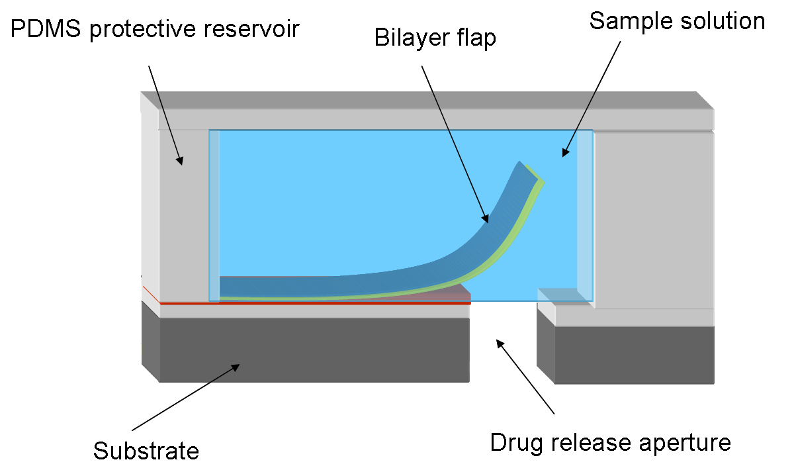

Figure 1. Design of the protective drug delivery system

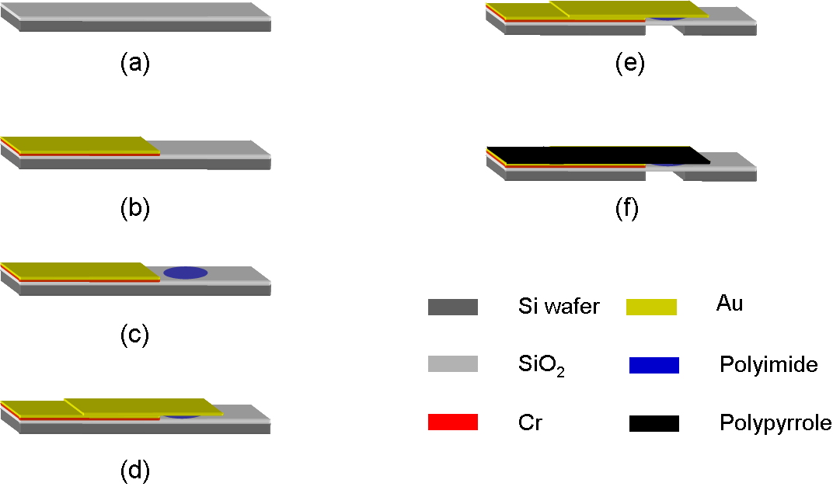

Figure 2. Fabrication sequence of the drug delivery device
(a) A single crystal silicon wafer covered with a 200 nm silicon dioxide layer is used as a substrate; (b) Chromium and gold layers are deposited via e-beam evaporation and subsequently patterned; (c) A polyimide layer is spin-coated and patterned; (d) A second gold layer is deposited via e-beam evaporation and patterned; (e) A via is opened by using deep reactive ion etching (DRIE); (f) A polypyrrole layer is electrochemically deposited onto the gold layer

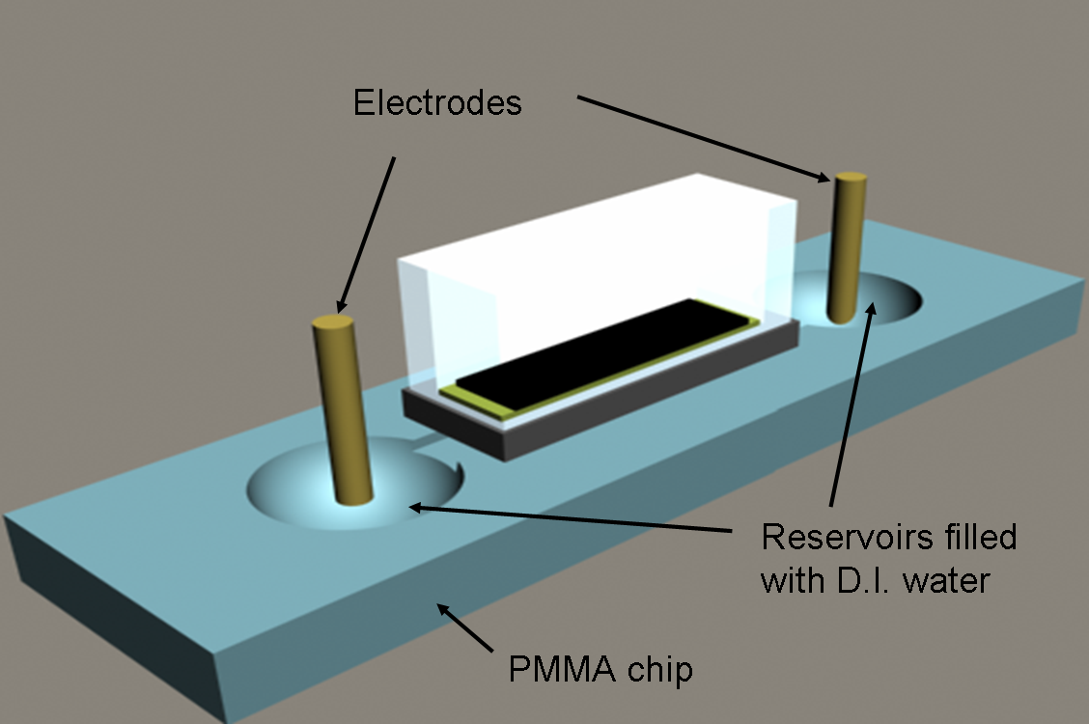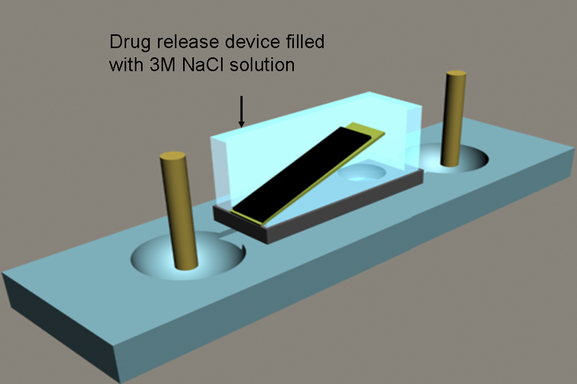

(a) (b)

Figure 3. Electrochemical test scheme: A PMMA chip with a channel, two reservoirs and the drug release device on top of the channel. Two electrodes with constant potential (1V) applied are placed in the reservoirs. Figure 3(a) demonstrates a closed valve; in Figure 3(b) the valve is opened.

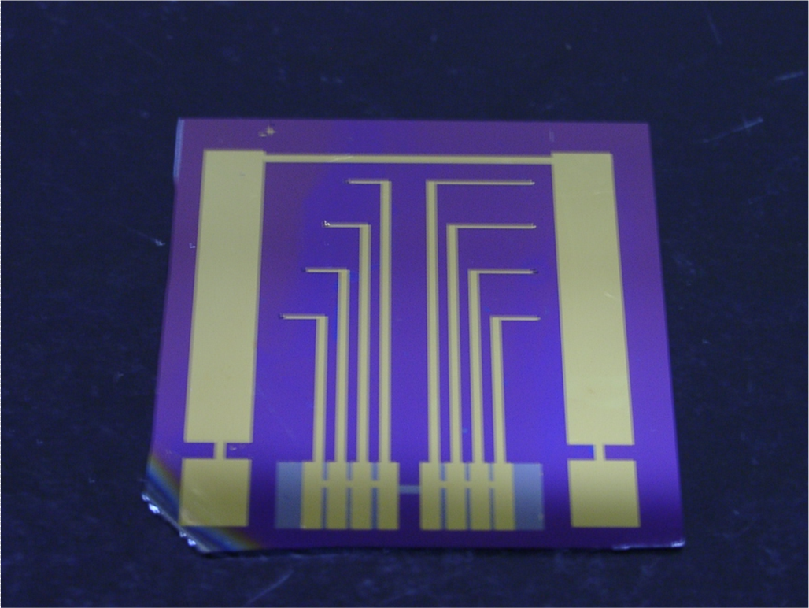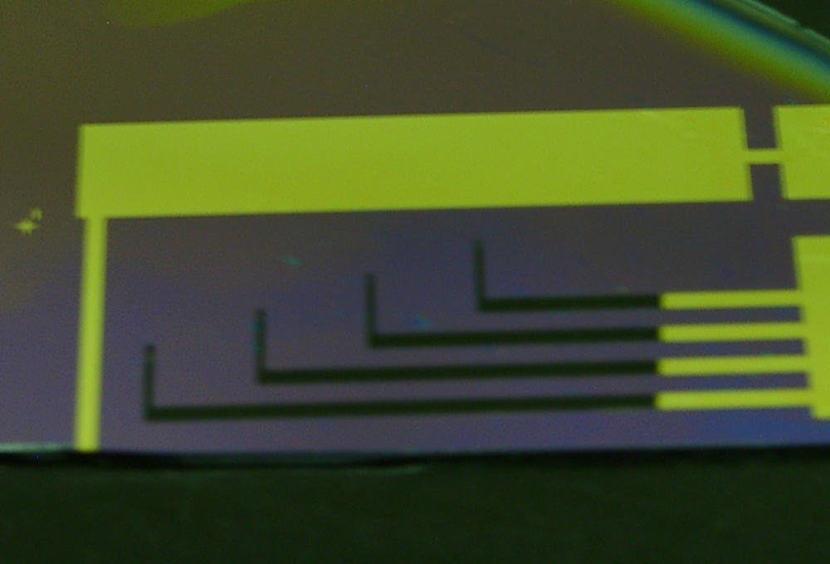

(a) (b)
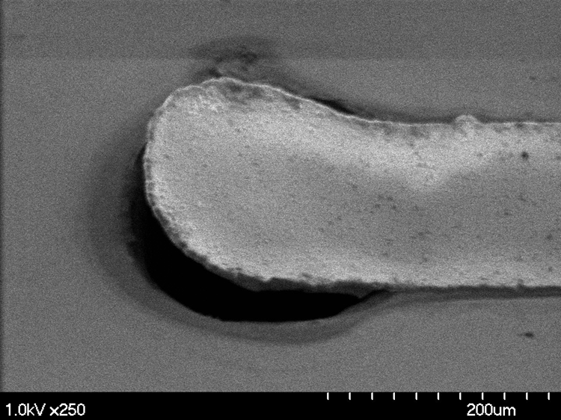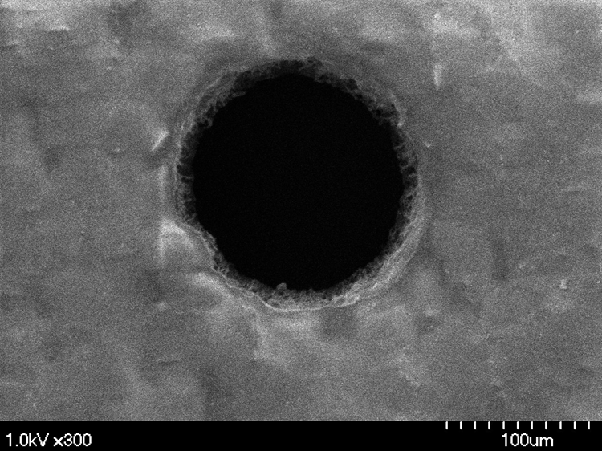

(c) (d)
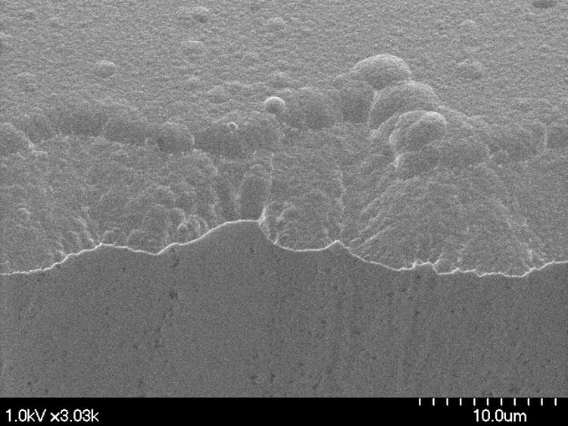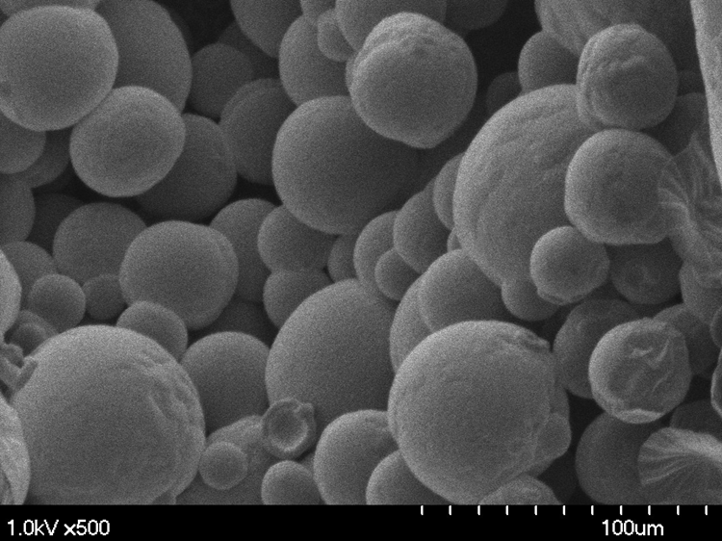

(e) (f)
Figure 4. Fabricated drug release device
(a) the design of the drug release valves with counter electrode and 8 working electrodes on the same chip; (b) the polypyrrole coated working electrodes; (c) the top view of the release valve; (d) the backside view of the drug release aperture; (e) a relatively uniform PPy film is produced with low applied potential (0.6V); (f) low quality PPy film is produced with higher applied potential (1.0V).

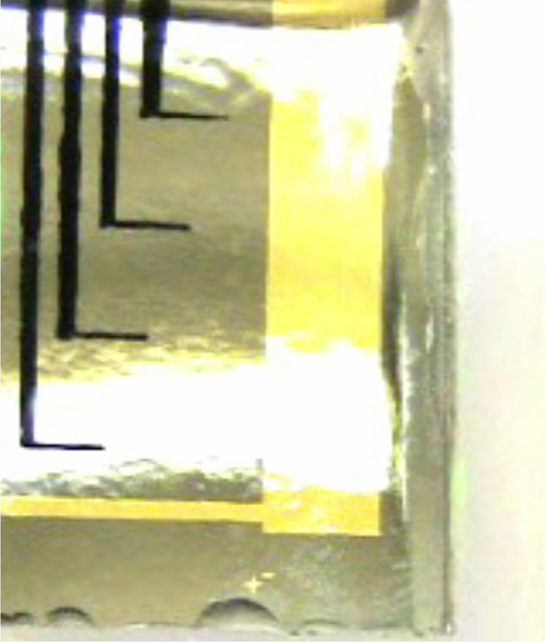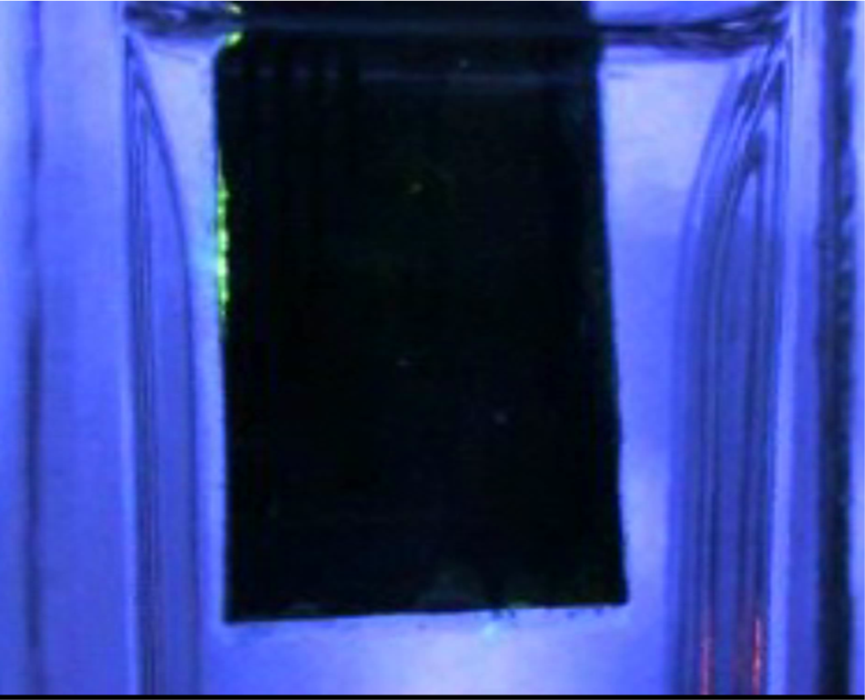

(a) (b)
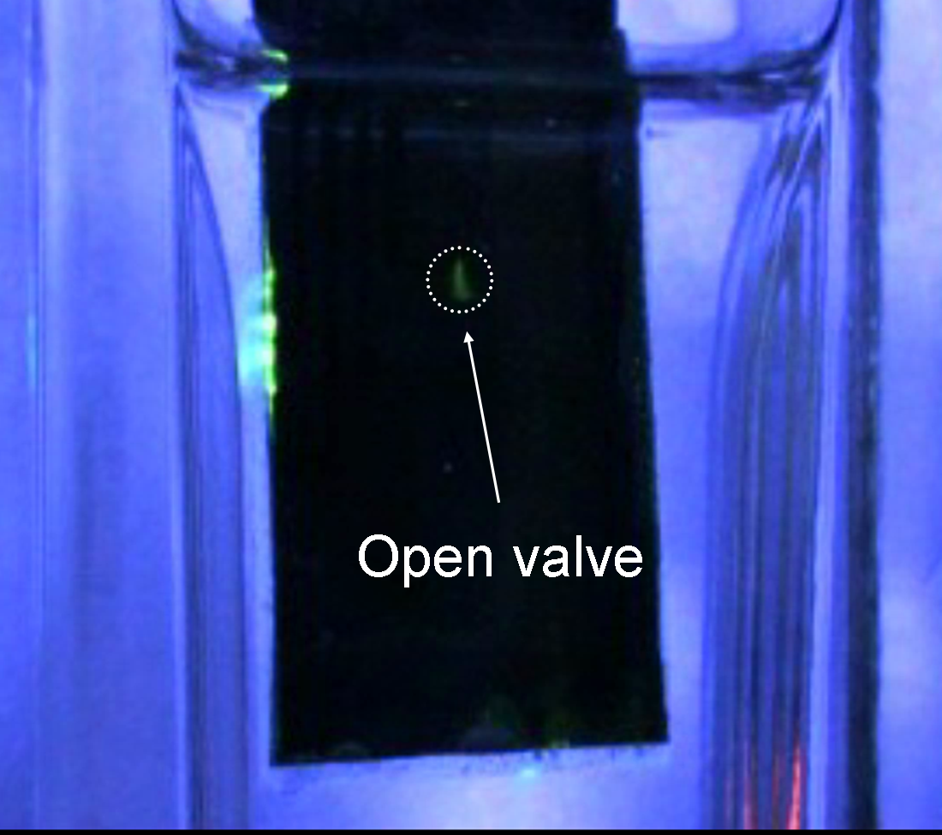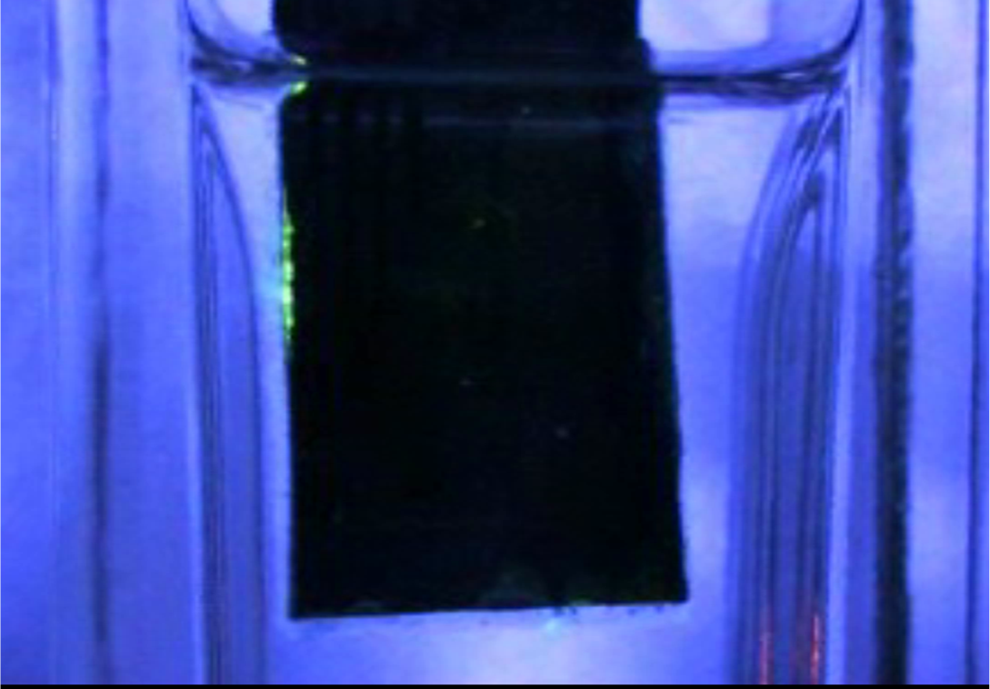

(c) (d)

Figure 5. The fluorescent dye release test
(a) the drug release device with 4 release valves; (b) the drug release device with the closed valves under UV light; (c) the valve is opened by applying a 1.2 V potential and the fluorescent dye release is observed; (d) the valve was closed by applying a -1.0V potential.

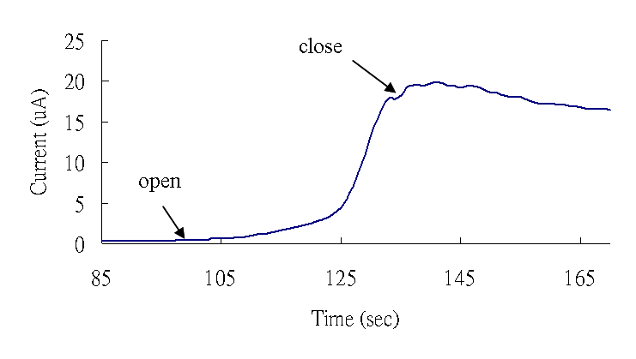
Figure 6. The electrochemical detection is performed with the setup demonstrated in Figure 3. The release of NaCl solution increases conductivity of the liquid in the channel. After the valve is closed no further increase in current is observed.

References
1. Sengupta, S., Eavarone, D., Capila, I., Zhao, G. L., Watson, N., Kiziltepe, T., and Sasisekharan, R. (2005) Nature 436, 568-572.
2. Li, Y. W., Shawgo, R. S., Tyler, B., Henderson, P. T., Vogel, J. S., Rosenberg, A., Storm, P. B., Langer, R., Brem, H., and Cima, M. J. (2004) Journal of Controlled Release 100, 211-219.
3. Khademhosseini, A., and Langer, R. (2006) Chemical Engineering Progress 102, 38-42.
4. Razzacki, S. Z., Thwar, P. K., Yang, M., Ugaz, V. M., and Burns, M. A. (2004) Advanced Drug Delivery Reviews 56, 185-198.
5. Kempen, D. H. R., Lu, L. C., Kim, C., Zhu, X., Dhert, W. J. A., Currier, B. L., and Yaszemski, M. J. (2006) Journal of Biomedical Materials Research Part A 77A, 103-111.
6. Keegan, M. E., Royce, S. M., Fahmy, T., and Saltzman, W. M. (2006) Journal of Controlled Release 110, 574-580.
7. Samati, Y., Yuksel, N., and Tarimci, N. (2006) Drug Delivery 13, 105-111.
8. Martanto, W., Moore, J. S., Kashlan, O., Kamath, R., Wang, P. M., O'Neal, J. M., and Prausnitz, M. R. (2006) Pharmaceutical Research 23, 104-113.
9. Zahn, J. D., Deshmukh, A., Pisano, A. P., and Liepmann, D. (2004) Biomedical Microdevices 6, 183-190.
10. Santini, J. T., Richards, A. C., Scheidt, R., Cima, M. J., and Langer, R. (2000) Angewandte Chemie-International Edition 39, 2397-2407.
11. Madou, M. J., and He, K. Q. (2000) Abstracts of Papers of the American Chemical Society 220, U364-U364.
12. Low, L. M., Seetharaman, S., He, K. Q., and Madou, M. J. (2000) Sensors and Actuators B-Chemical 67, 149-160.
13. Deo, S., Moschou, E., Peteu, S., Eisenhardt, P., Bachas, L., Madou, M., and Daunert, S. (2003) Analytical Chemistry 75, 207A-213A.
14. Soppimath, K. S., Aminabhavi, T. M., Dave, A. M., Kumbar, S. G., and Rudzinski, W. E. (2002) Drug Development and Industrial Pharmacy 28, 957-974.
15. Smela, E. (2003) Advanced Materials 15, 481-494.
16. Pettersson, F., Jarger, E.W.H., Inganas, O. (2000) Poster of IEEE-EMBS Special topic conference on Microtechnologies on Medicine and Biology, Lyon, France.
17. George, P. M., Lyckman, A. W., LaVan, D. A., Hegde, A., Leung, Y., Avasare, R., Testa, C., Alexander, P. M., Langer, R., and Sur, M. (2005) Biomaterials 26, 3511-3519.
18. Wallace, G. G., Spinks M. G., Kane-Maguire L. A. P., Teasdale, R. P. (2003) Conductive Electroactive Polymers.
19. Roemer, M., Kurzenknabe, T., Oesterschulze, E., and Nicoloso, N. (2002) Analytical and Bioanalytical Chemistry 373, 754-757.
20. Daunert, S., Moschou, E. A., Ehrick, J. D., Peteu, S. F., Deo, S. K., Ball, J. C., Bachas, L. G., and Madou, M. J. (2002) Abstracts of Papers of the American Chemical Society 224, U117-U117.
21. Xu, H., Wang, C., Wang, C., Zoval, J., and Madou, M. (In press) Biosensors and Bioelectronics.
22. Shin, Y. S., Cho, K., Lim, S. H., Chung, S., Park, S. J., Chung, C., Han, D. C., and Chang, J. K. (2003) Journal of Micromechanics and Microengineering 13, 768-774.
23. Yang, X., Grosjean, C., and Tai, Y. C. (1999) Journal of Microelectromechanical Systems 8, 393-402.

* Corresponding author, e-mail: mmadou@uci.edu
When valve is closed, the measured current is 261 nA.

