Chapter 4: Approach for Estimating Reductions for Full Attainment Scenario

Synopsis
After applying the hypothetical modeled control strategy described in Chapter 3, there were multiple counties that were still not projected to attain potential new ozone standards. Because it was impossible in some areas to meet a tighter ozone standard nationwide using only known controls, EPA conducted a second step in the analysis and estimated the amount of further emission reductions needed to attain an alternate primary ozone standard. The term “extrapolated tons” will be used to refer to these additionally needed emissions reductions. Sections 4.1 and 4.2 of this chapter present the methodology EPA developed to determine the emissions reductions needed for full attainment of the four alternate standards analyzed in the RIA (i.e., 0.065, 0.070, 0.075, and 0.079 ppm) and the results of that analysis. Additionally, in other areas, the known controls in the hypothetical strategy resulted in ozone levels lower than one or more of the four alternate standards. Sections 4.3 and 4.4 of this chapter discuss the methodology and present the results of the “overcontrolled” analyses.

4.1 Development of Full Attainment Targets for Estimate of Extrapolated Costs
As previewed in the draft RIA, we conducted additional supplemental air quality modeling analyses for the final RIA. This was intended to improve the estimates of extrapolated tons needed to meet various potential standards. These additional modeling scenarios were designed to provide more information about the response of ozone to emissions changes in terms of non-linearities, geographic variations, the impacts of local versus upwind emissions reductions, and the relationship between NOx and VOC emissions changes. As a result of this additional information, the methodology to estimate the emissions reduction targets in the “extrapolated cost areas” has been improved.

4.1.1 Design of Supplemental Modeling Scenarios
There were 61 counties that did not meet the 0.070 ppm standard even after application of the controls in the hypothetical RIA modeled control scenario. There were 21 counties that did not meet the 0.075 ppm standard. All 21 of these counties are in four broad geographic regions: Houston, eastern Lake Michigan, the Northeast Corridor, and a large part of California. Because these four areas will require the largest emissions reductions beyond the RIA control scenario, and therefore likely the largest extrapolated costs, we focused on these areas within the supplemental modeling analyses. We will refer to these four areas as “Phase 1” areas. Later, we will define a second and third set of areas that also require extrapolated emissions reductions which we will refer to as “Phase 2” and “Phase 3”areas. The primary distinction between these three sets of areas is that the supplemental modeling was done only for the Phase 1 areas.
A map of the four Phase 1 areas is shown in Figure 4.1. An approach similar to that used to define the geographic control areas for non-EGU point controls in the RIA control scenario (discussed in Chapter 3) was also used to define the supplemental modeling control zones for each of the four areas.
Figure 4.1: Counties within which Across-the-Board Emissions Reductions were Applied in the Supplemental Modeling Analyses
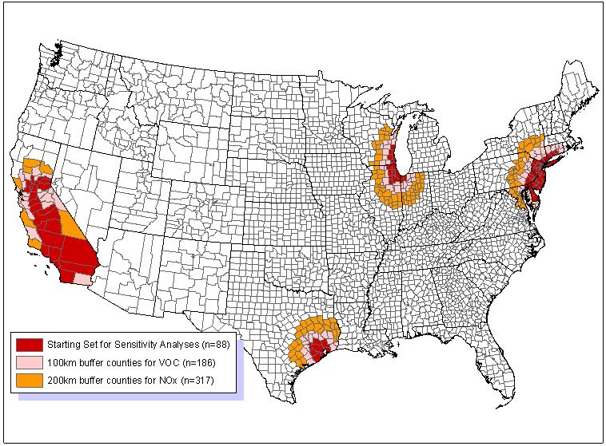

Six supplemental modeling runs were performed as part of this analysis. In the first three runs anthropogenic NOx emissions within the appropriate Phase 1 areas (i.e., the red, pink, and orange counties in Figure 4.1) were reduced across-the-board by 30, 60, and 90 percent. The second set of runs included 30, 60, and 90 percent across-the-board reductions to anthropogenic NOx and VOC emissions within the appropriate Phase 1 areas (i.e., the red, pink, and orange counties for NOx; only the red and pink counties for VOC). An estimate of the effects of VOC controls can be determined by comparing results from the NOx and VOC control run to the NOx only control run. In the two sets of across-the-board supplemental modeling runs the emissions reductions were applied on top of the controls in the hypothetical RIA control case. As in the modeled control strategy, NOx controls were applied to counties within a 200 km buffer and VOC controls were applied to counties within a 100 km buffer of the starting set of counties.
In the draft RIA, we used the concept of “impact ratios” to calculate the additional tons needed to meet the air quality standard. The updated approach uses the supplemental modeling to determine what levels of ozone precursor reductions (NOx only or NOx plus VOC) are expected to be sufficient to bring an area into attainment of one of the various alternate ozone standards that were analyzed. After the development of emission targets for the 0.070 ppm alternative standard, we conducted a “verification” model run to assess whether our estimated emissions reductions actually resulted in attainment of 0.070 ppm in each area. The new estimates of extrapolated tons represent a considerable improvement from what was done for the draft RIA.
For purposes of this analysis, we assume attainment by 2020 for all areas except San Joaquin Valley and South Coast air basins in California. The state has submitted plans to EPA for implementing the current ozone standard which propose that these two areas of California meet that standard by 2024. We have assumed for analytical purposes that the San Joaquin Valley and South Coast air basin would attain a new standard in 2030. There are many uncertainties associated with the year 2030 analysis. Between 2020 and 2030 several federal air quality rules are likely to further reduce emissions of NOx and VOC, such as, but not limited to National rules for Diesel Locomotives, Diesel Marine Vessels, and Small Nonroad Gasoline Engines. These emission reductions should lower ambient levels of ozone in California between 2020 and 2030. Complete emissions inventories as well as air quality modeling were not available for this year 2030 analysis. Due to these limitations, it is not possible to adequately model 2030 air quality changes that are required to develop robust controls strategies with associated costs and benefits. In order to provide a rough approximation of the costs and benefits of attaining 0.075 ppm and the alternate standards in San Joaquin and South Coast air basins, we’ve relied on the available data. Available data includes emission inventories, which do not include any changes in stationary source emissions beyond 2020, and 2020 supplemental air quality modeling. This data was used to develop extrapolated costs and benefits of 2030 attainment. To view the complete analysis for the San Joaquin Valley and South Coast air basins see Appendix 7b.

4.1.2 Results of Supplemental Modeling for Phase 1 Areas
Figures 4.2a through 4.2d show the projected design values for individual counties within each of the Phase 1 areas for seven modeling cases (i.e., the RIA control scenario and each of the six supplemental modeling runs). These figures are instructive in describing how the extrapolated control targets were determined for these areas. For each area, the three counties that need the most extrapolated controls were chosen for the graphs.
Figure 4.2a indicates that the highest ozone levels in the Houston area are projected to occur in Harris, Galveston, and Brazoria counties with Harris being the controlling county. After application of the RIA scenario controls, our modeling projects that the highest 2020 8-hour ozone design value in this area will be 0.087 ppm. Thus, additional precursor reductions are needed to reach the current standard as well as all four of the alternate standards we are considering. Based on the NOx plus VOC control modeling scenarios, we can see that increasing the level of emissions reductions beyond the RIA case yields decreasing design values. At a 30% NOx + VOC reduction, the projected design value is 0.084 ppm. At a 60% NOx + VOC reduction, the projected design value is 0.079 ppm. Finally at a 90% NOx + VOC reduction, the projected design value is 0.067 ppm.
Based on these results, it is concluded that it is possible to meet the current ozone standard with additional NOx plus VOC emissions reductions between 0 and 30 percent. To meet an alternate NAAQS of 0.079 ppm, the Houston area will require additional NOx plus VOC emissions of approximately 60 percent. The 0.075 and 0.070 ppm standards will require between an additional 60-90% NOx plus VOC reduction beyond the RIA control case. The supplemental modeling indicates that it will take more than 90% NOx plus VOC control (above and beyond the RIA control case) to meet a 0.065 ppm standard. Based on these figures, one can also estimate the levels of NOx-only controls needed to meet a particular standard. We used linear interpolation to determine the specific percentage reduction in cases where attainment is expected to be achieved
Figure 4.2a: Projected 2020 8-hour Ozone Design Values in the RIA Control Scenario and Each of the Six Supplemental Modeling Scenarios for the Highest Three Counties within the Houston Area
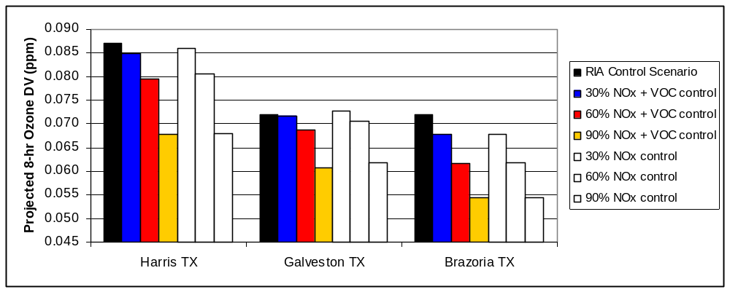

between the supplemental scenarios of 0, 30, 60, and 90 percent. The specific percentage reductions for Phase 1 areas are shown in Table 4.1.
Figure 4.2b shows two other aspects of the analysis. First, in some cases, the controlling county within an area can vary as the precursor emissions are reduced. In the eastern Lake Michigan area, the modeling indicates that an additional 60% NOx reduction will be sufficient to bring two counties with high design values (Kenosha and Sheboygan WI) into attainment of an 0.070 ppm standard. However, another county in that area does not reach 0.070 ppm with the 60% NOx reduction. Lake IN is still 0.077 ppm. The full attainment, extrapolated target analysis is done on a county by county basis, and the final area target is based on the county that requires the most additional reductions. Second, it should be noted that in this area the addition of VOC controls can have a significant impact on the projected design value. The 0.077 ppm value in Lake IN is reduced to 0.073 ppm when 60% VOC controls are added to the 60% NOx controls. Figure 4.2c is included for completeness sake and to show the supplemental modeling results in the Northeast Corridor.
Figure 4.2b: Projected 2020 8-hour Ozone Design Values in the RIA Control Scenario and Each of the Six Supplemental Modeling Scenarios for the Highest Counties within the Eastern Lake Michigan Area
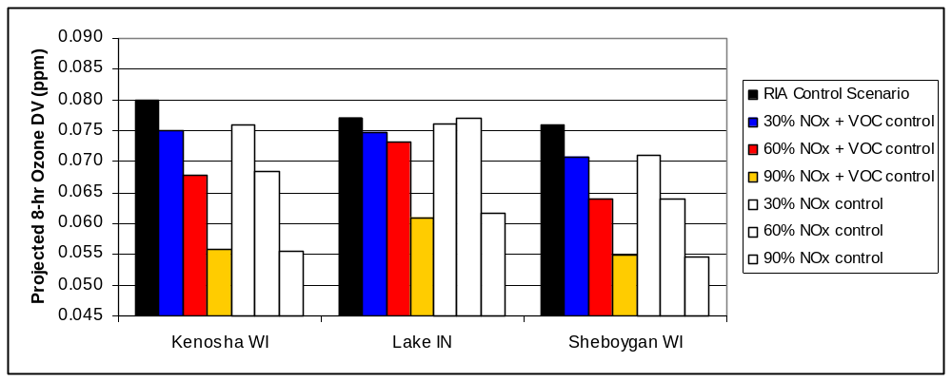

Figure 4.2c: Projected 2020 8-hour Ozone Design Values in the RIA Control Scenario and Each of the Six Supplemental Modeling Scenarios for the Highest Counties within the Northeast Corridor
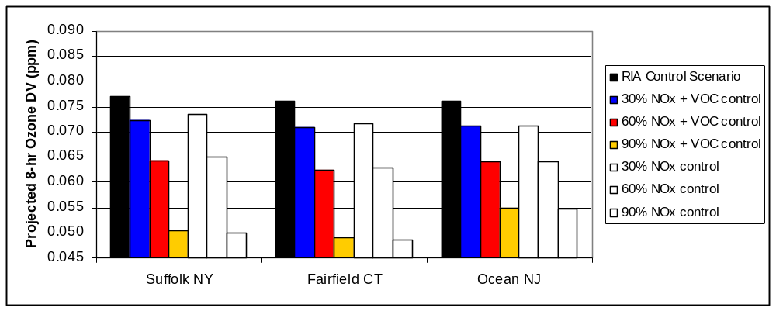

As discussed in Chapter 3 and Chapter 5, there are two areas in Southern California that are not planning to meet the current standard by 2020 (i.e., the Los Angeles South Coast Air Basin and the San Joaquin Valley nonattainment areas). As a result, we have not estimated extrapolated targets that will be necessary to bring these two nonattainment areas into attainment of the alternate standards by 2020. However, due to the effects of ozone transport within California, we are assuming that some extrapolated controls (beyond the RIA control case) will be needed in these two areas to help other California nonattainment areas with earlier attainment dates meet the standards by 2020. These additional reductions in Los Angeles and San Joaquin Valley are considered to be part of the controls needed to meet the current NAAQS and are therefore not considered as part of the cost of any new alternate standard. Figure 4-2d shows the results of the supplemental modeling runs for three areas in California.
Figure 4.2d: Projected 2020 8-hour Ozone Design Values in the RIA Control Scenario and Each of the Six Supplemental Modeling Scenarios for Three Specific Areas in California
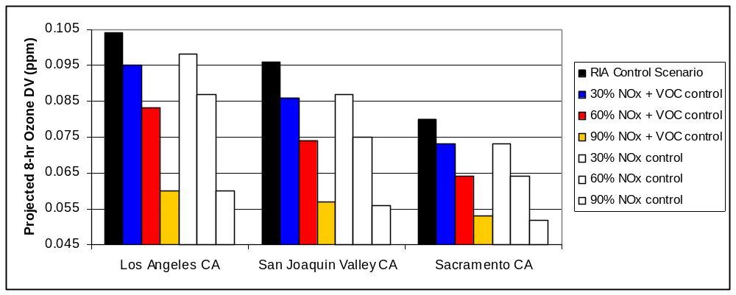

Extrapolated control targets were estimated for each Phase 1 area for: a) NOx only emissions reductions and b) NOx plus VOC emissions reductions. The results of the analysis to estimate emissions reductions for attainment in the Phase 1 areas are shown in Table 4.1 and Table 4.2. The amount of additional emissions reductions necessary for full attainment ranges from zero to over 90 percent depending upon the area and the standard.
Table 4.1: Estimated Percentage Reductions of NOx and VOC beyond the RIA Control Scenario Necessary to Meet Various Alternate Ozone Standards in the Phase I Areas
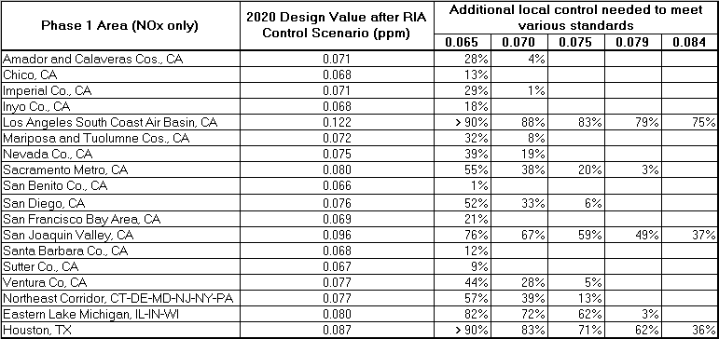

Table 4.2: Estimated Percentage Reductions of NOx beyond the RIA Control Scenario Necessary to Meet Various Alternate Ozone Standards in the Phase I Areas
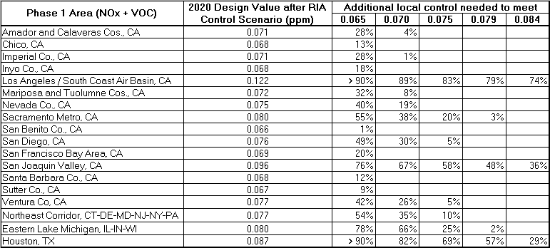

4.1.3 Estimating Attainment of the 0.070 and 0.065 ppm Standards in Phase 2 Areas
As discussed above, there were 61 counties that did not reach attainment of the 0.070 ppm standard with the controls in the hypothetical RIA scenario. The majority of these counties are in one of the Phase 1 areas. However, there were 12 counties (9 areas) outside of the Phase 1 areas that were also not projected to meet the 0.070 NAAQS. (All counties outside the Phase 1 areas met the 0.075 and 0.079 ppm air quality standards.) For convenience, these nine areas will be referred to Phase 2 areas. A two-step process was used to estimate the additional emissions reductions necessary for full attainment in the Phase 2 areas. Based on the Phase 1 modeling results, targets for these areas were only generated for NOx-only control given the preponderance of cases where the additional VOC emissions reductions did not reduce ozone enough to consider from a cost perspective.
For the Phase 2 areas, the first step in estimating attainment was to consider whether the emissions reductions needed to bring the Phase 1 areas into attainment of 0.070 ppm would also reduce ozone transport enough to bring these additional areas into attainment as well. For an example of how this determination was made consider two counties: Norfolk County, MA (Boston area) and Geauga County, OH (Cleveland area).
In Norfolk MA, the projected design value after the RIA control scenario is 0.071 ppm. This county is downwind of the Northeast Corridor. The supplemental modeling showed that if the Phase 1 areas reduced NOx emissions by at least 30% the 2020 design value in Norfolk MA would be reduced to 0.069 ppm (i.e., does not exceed the 0.070 standard). As part of the Phase I analysis, we estimated that the Northeast Corridor region would need an additional 39% NOx reduction to meet the 0.070 ppm standard within this area. The supplemental modeling shows that the same 39% NOx reduction would enable this standard to be met in Norfolk County as well, without any additional local controls in the Boston area.
In Geauga OH, the projected design value after the RIA control scenario is 0.074 ppm. Thus, Cleveland will need additional local emissions reductions to meet a revised ozone standard of 0.070 ppm. However, in the supplemental modeling, which did not include emissions reductions in Cleveland, the Geauga design value declined by 0.001, 0.002, and 0.003 ppm, in the 30, 60, and 90% NOx reduction runs, respectively. Given that the Lake Michigan region is the nearest upwind Phase 1 area to Geauga County, we believe these ozone reductions in Geauga County are associated with the emissions reductions modeled in the Lake Michigan region. The Lake Michigan region is estimated to need 72% additional NOx control. Considering the projected design values with an additional digit of precision, it is estimated that a 72% reduction in the eastern Lake Michigan area will yield a Geauga OH design value of 0.0718 ppm.
In the second step of the process, we estimate what level of local control is required to reach 0.070 ppm after consideration of the impact of Phase 1 emissions reductions. For each of the Phase 2 areas that is still nonattainment after step 1 above, we developed a site-specific relationship between the ozone improvement in the RIA control case and the percent reduction in local NOx emissions in the RIA control case as compared to the baseline. This site-specific relationship was then used to determine how much additional NOx reduction was needed to meet the 0.070 ppm goal. Continuing with the Geauga County example helps illustrate this calculation. In this county there was a 0.0023 ppm reduction due to the hypothetical RIA controls. The RIA scenario represented a 17% reduction in NOx emissions within the 200 km buffer around the Cleveland area. With the existing information it is not possible to distinguish how much of the ozone improvement is due to local controls (i.e., within 200 km) versus upwind controls, so we made a simplifying assumption that all local air quality improvement for such areas can be attributed to the controls within 200 km. Converting to units of ppb for simplicity, dividing 2.3 ppb improvement by a 17% NOx emissions reduction yields a Geauga-specific relationship of 0.135 ppb / percent NOx controlled. This ratio is applied to the 71.8 ppb value from step 1 and it is determined that an additional 7 % reduction (0.9 ppb) would be sufficient to lower the 2020 design value in Geauga County to 70.9 ppb or 0.070 ppm, thereby attaining the standard.
The same two step methodology described above was used to estimate the extrapolated targets for the 0.065 ppm standard in the Phase 2 areas. Table 4.3 shows the full set of results for each of the nine Phase 2 areas. The amount of additional NOx control needed to meet the 0.070 ppm standard in Phase 2 areas ranges from zero to 25 percent. The amount of additional NOx control needed to meet the 0.065 ppm standard in Phase 2 areas ranges from zero to 74 percent.
Table 4.3: Estimated Percentage Reductions of NOx beyond the RIA Control Scenario Necessary to Meet the 0.070 ppm Ozone Standard in Phase 2 Areas
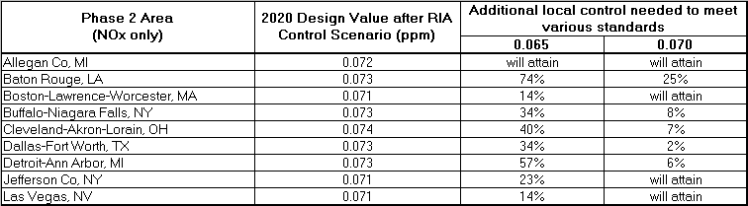

4.1.4 Estimating Attainment of the 0.065 ppm Standard outside of Phase 1 and 2 Areas
The last set of reduction targets generated are for those areas that require additional ozone precursor controls to meet the 0.065 ppm standard but are outside Phase 1 and 2 areas. There were 166 counties that did not reach attainment of the 0.065 ppm standard with the emissions reductions in the hypothetical RIA scenario. The majority of these counties are in one of the Phase 1 or Phase 2 areas. However, there were 46 counties (36 areas) outside of the Phase 1 and Phase 2 areas that were not projected to meet the 0.065 NAAQS. For convenience, these areas will be referred to Phase 3 areas.
A similar methodology as described in Section 4.1.3 was used to estimate the additional emissions reductions needed for the 0.065 ppm standard for the Phase 3 areas, but two simplifying assumptions were made to expedite the analysis. First, instead of explicitly accounting for the impacts of the Phase 1 and Phase 2 upwind emissions reductions on Phase 3 areas, we assumed that the design values from the 60% NOx reduction run were the appropriate starting point for estimating the additional emissions reductions in the Phase 3 areas. Since the targets for the Phase 1 areas are generally greater than 60% and since we have not accounted for the Phase 2 reductions, these estimates should provide a conservative estimate of the percentage emissions reductions needed for full attainment. Secondly, we did not develop site-specific impact ratios for the 36 Phase 3 areas. Instead, we used a standard relationship of 0.150 ppb / 1% NOx reduction for calculating the emissions reductions needed to attain 0.065 ppm in these areas. This value was the average site-specific relationship calculated for the Phase 2 areas, as described above. These assumptions are reasonable given the available data and the relatively small role that Phase 3 areas will play in determining the full costs of meeting a 0.065 ozone standard. However, the estimated emissions reductions needed to attain 0.065 in the Phase 3 areas are considered to be more uncertain than the emissions reductions calculated for attaining 0.070, 0.075, and/or 0.079. The results of the Phase 3 analysis are shown in Table 4.4. The amount of additional NOx control needed to meet the 0.065 ppm standard in Phase 3 areas ranges from zero to 29 percent.
Table 4.4: Estimated Percentage Reductions of NOx beyond the RIA Control Case Necessary to Meet the 0.065 ppm Ozone Standard in Phase 3 Areas
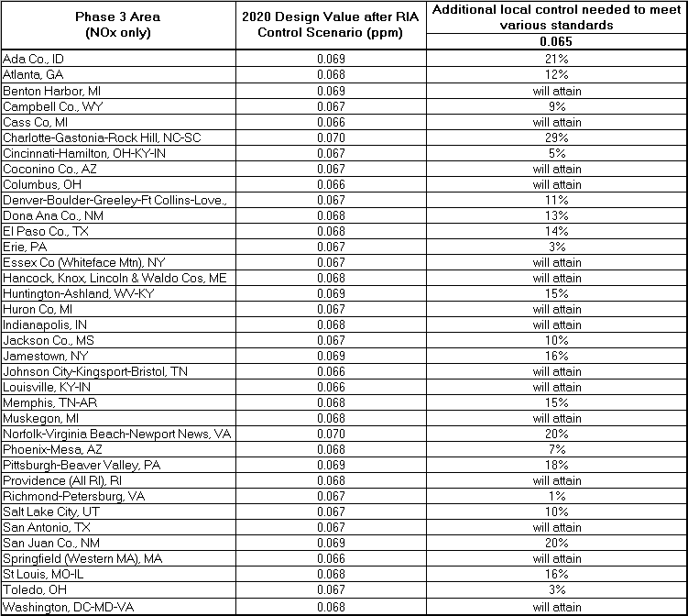

4.1.5 Aggregate Results / Verification Modeling of Extrapolated Targets
The complete set of NOx targets are provided in Table 4.5a. As noted earlier, a single 2020 target was determined for all of California. This target was based on the Sacramento area which had the highest 2020 design values outside the Los Angeles and San Joaquin Valley areas. The assumption is that if all of California reduces at that level then all areas aside from Los Angeles and the San Joaquin Valley air basins will attain by 2020. Areas from which reductions would be required include the Los Angeles and San Joaquin Valley air basins, but would not necessarily bring them into attainment. Additional reductions may be required. Because of their later attainment date, the costs and benefits of additional reductions for Los Angeles and San Joaquin air basins are shown in Appendix 7b.
Table 4.5a: Complete Set of Estimated Percentage Reductions of NOx beyond the RIA Control Scenario Necessary to Meet the Various Ozone Standards in 2020
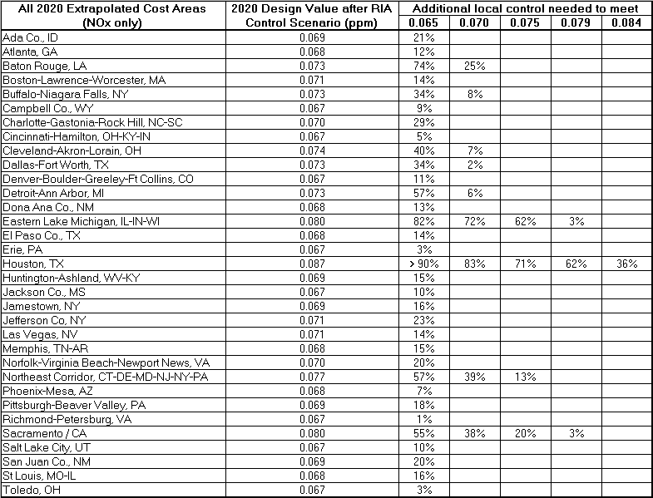

In total, 33 areas were determined to need additional emissions reductions for one or more of the alternate standards. The eastern Lake Michigan region was the only one in which NOx plus VOC control targets could be substantially lower than NOx only control targets. Table 4.5b shows the NOx + VOC targets for that area.
Table 4.5b: Estimated Percentage Reductions of NOx + VOC beyond the RIA Control Scenario Necessary to Meet the Various Ozone Standards in 2020

Figures 4.3a through 4.3d show: 1) which counties are part of the 33 extrapolated cost areas and 2) the estimated percent reduction needed beyond the RIA control case to meet each of the four alternate standards within each of those areas. The conversion of these additional percentage reductions to actual extrapolated tons is described in Chapter 4.2. The calculation of the costs of these extrapolated tons is described in Chapter 5.
Figure 4.3a: Map of Extrapolated Cost Counties for the 0.065 ppm Alternate Standard and the Estimated Percent NOx Controls Needed to Meet that Standard
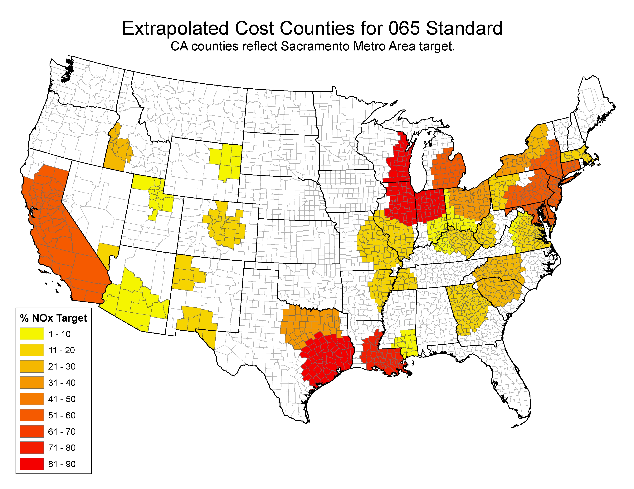

Figure 4.3b: Map of Extrapolated Cost Counties for the 0.070 ppm Alternate Standard and the Estimated Percent NOx Controls Needed to Meet that Standard
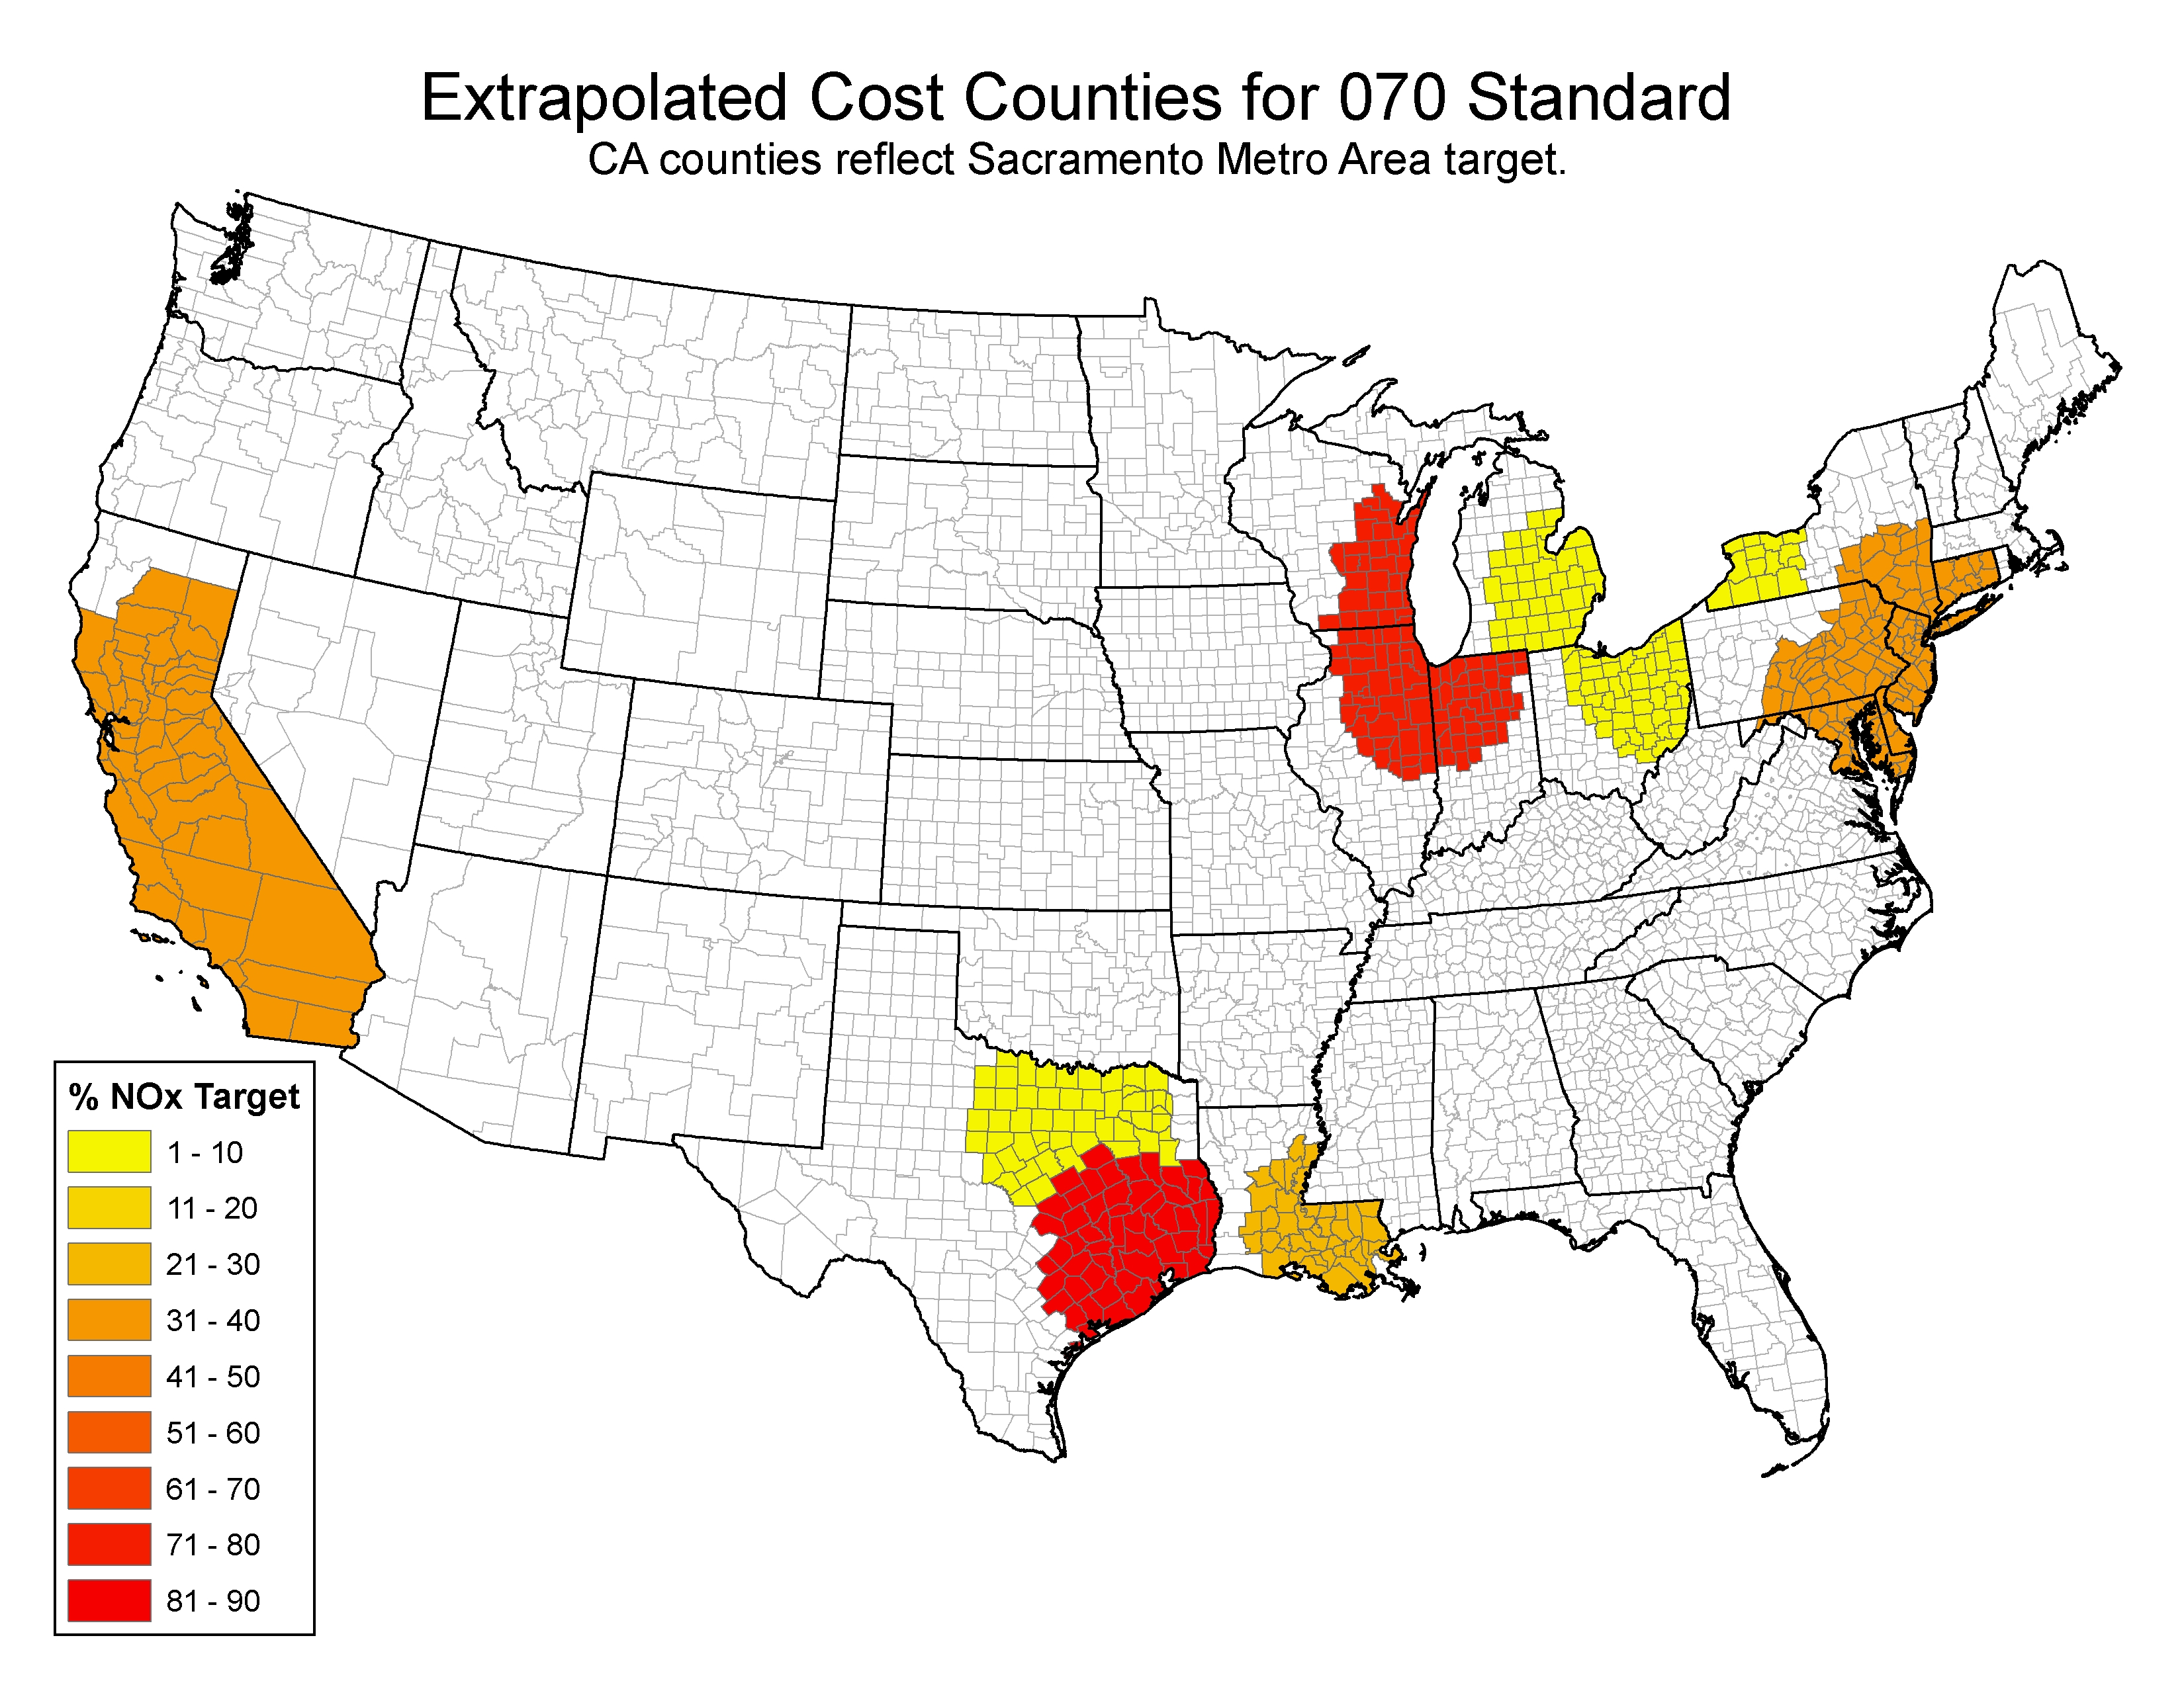

Figure 4.3c: Map of Extrapolated Cost Counties for the 0.075 ppm Alternate Standard and the Estimated Percent NOx Controls Needed to Meet that Standard
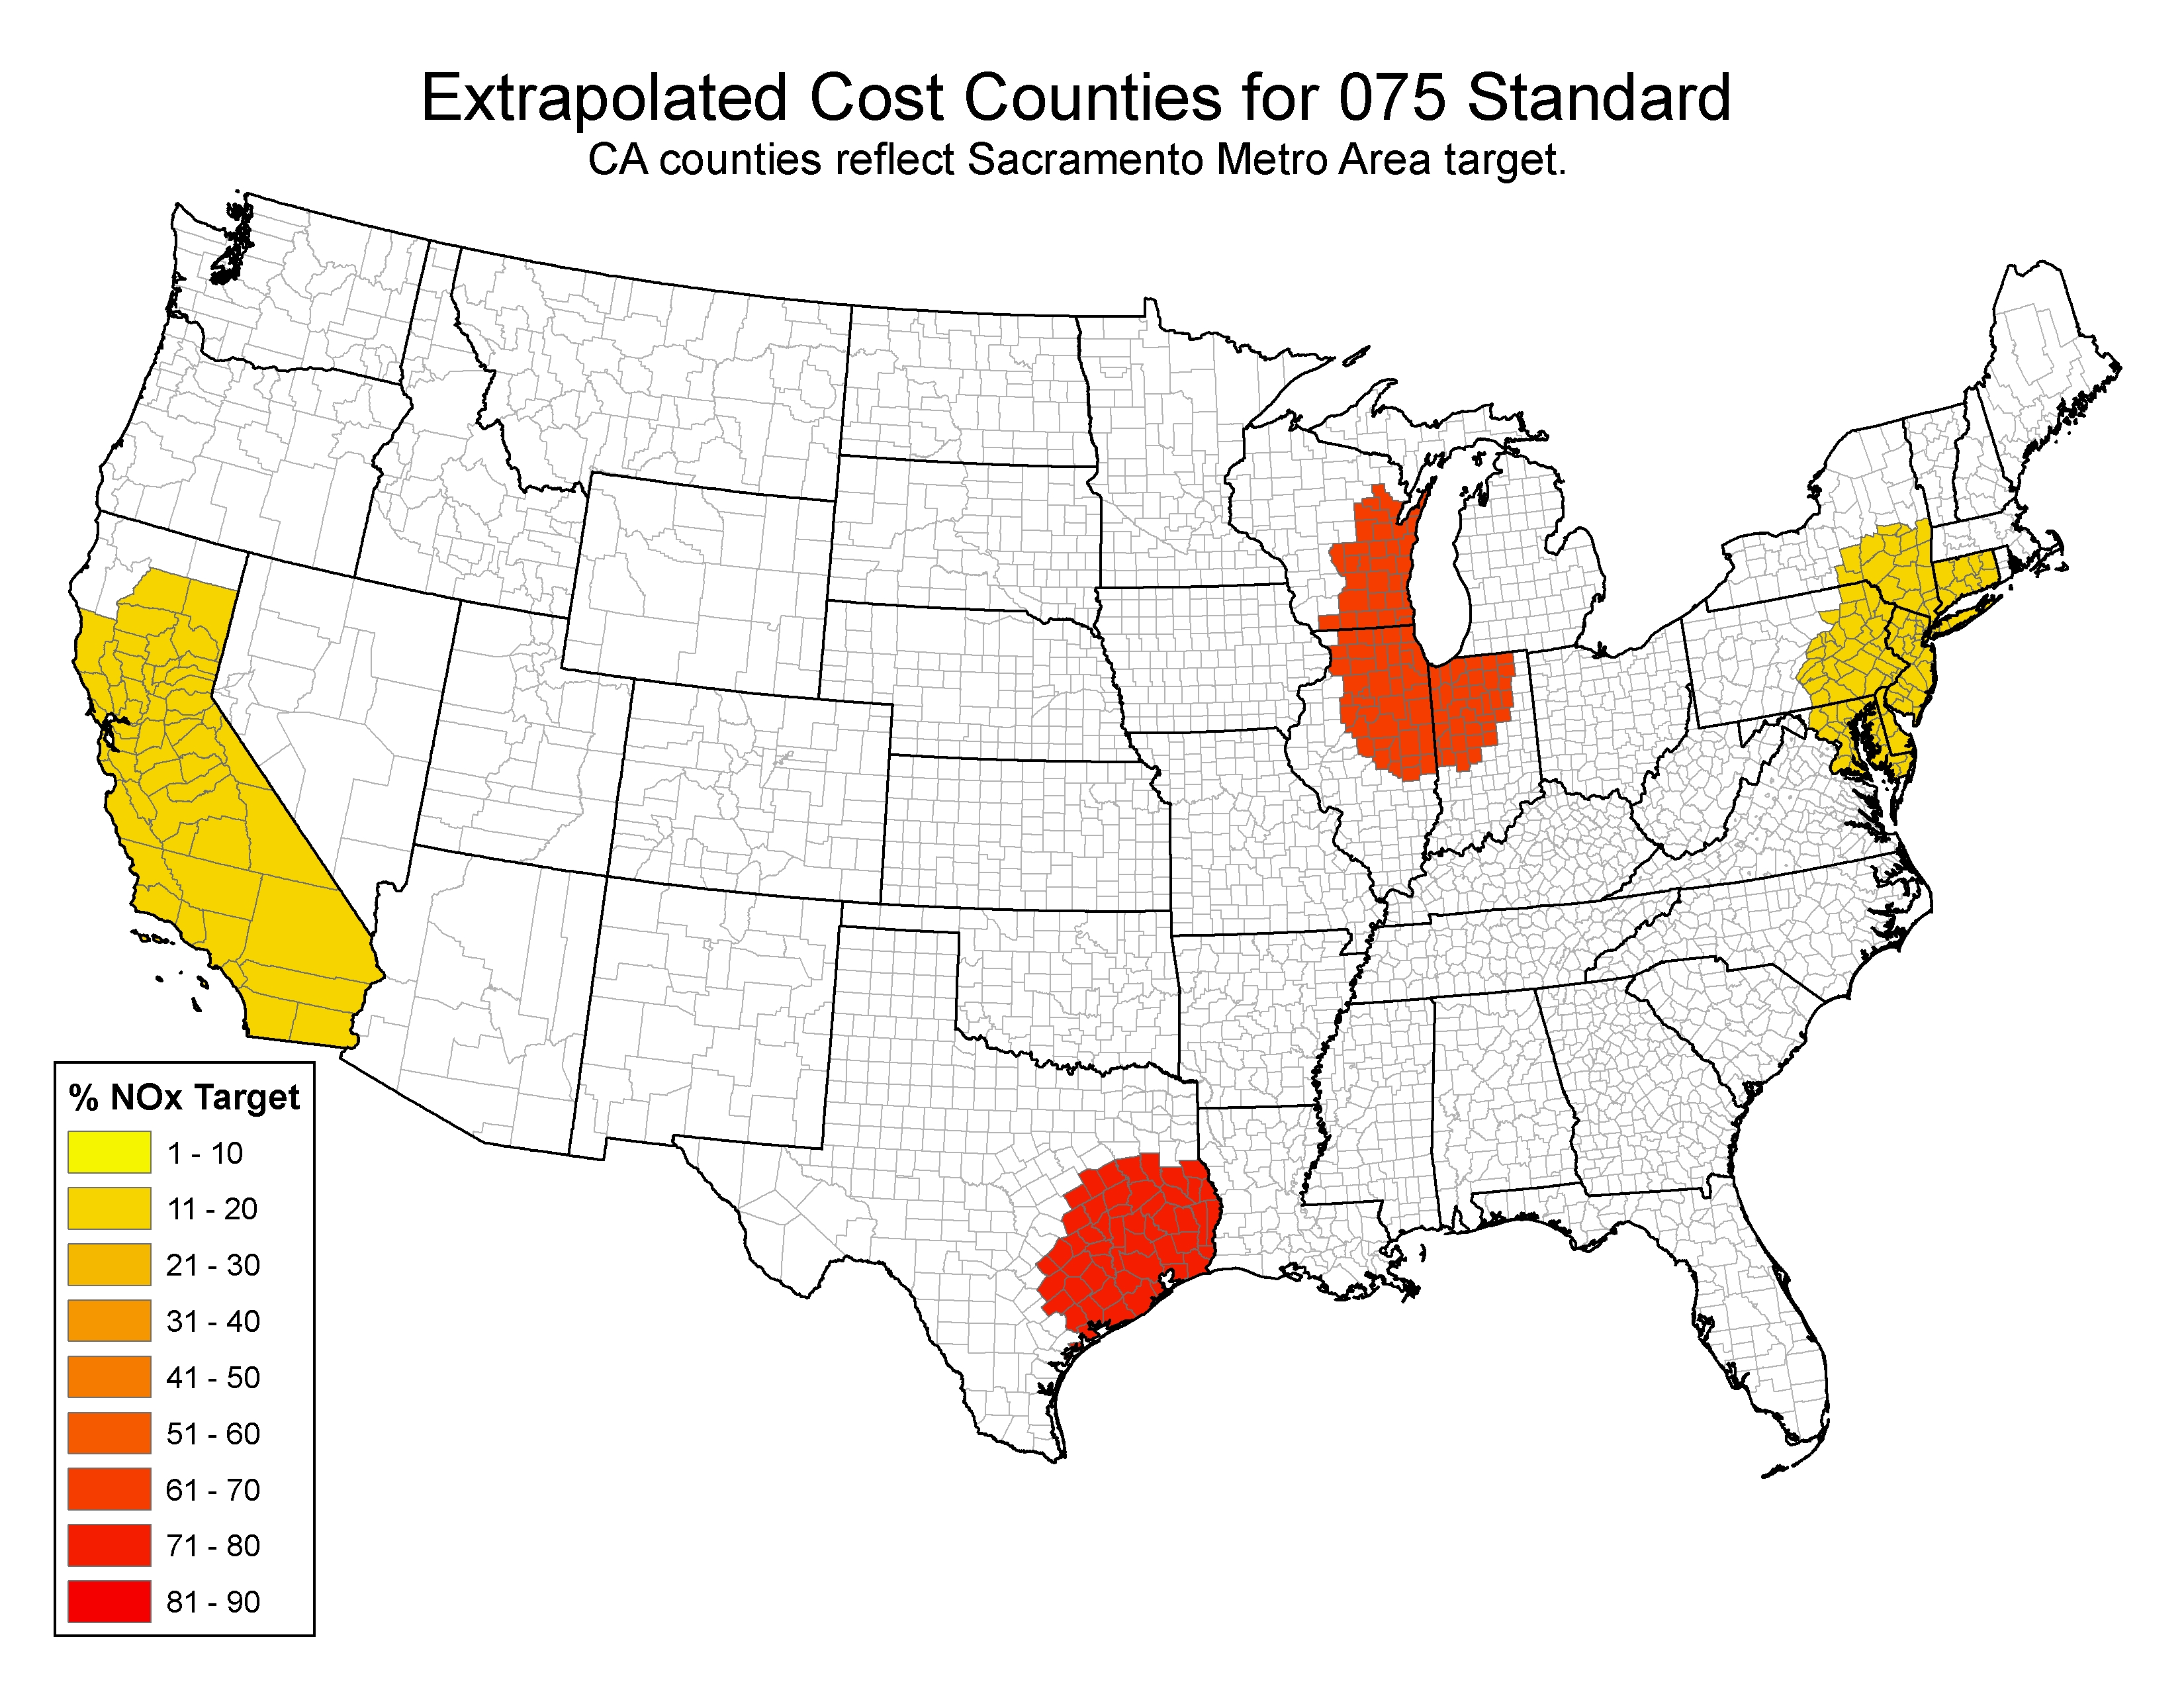

Figure 4.3d: Map of Extrapolated Cost Counties for the 0.079 ppm Alternate Standard and the Estimated Percent NOx Controls Needed to Meet that Standard
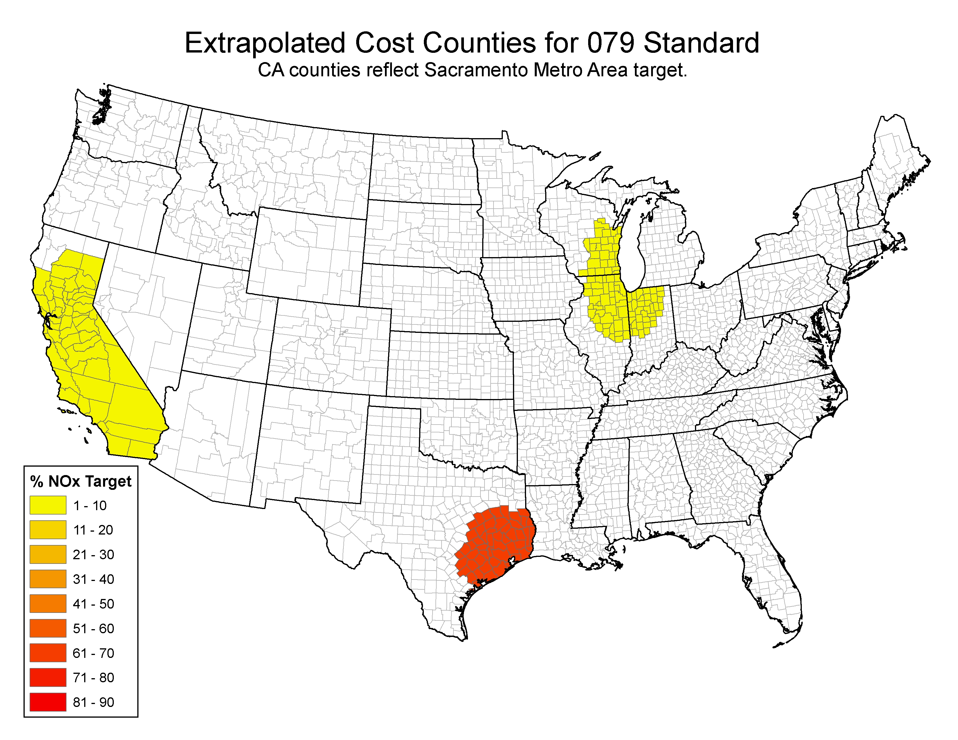

As noted earlier in this section, an additional CMAQ air quality simulation, called a “verification run,” was completed after the extrapolated percent emissions reductions were estimated. The purpose of this run was to determine the ozone design values that would be expected from the additional extrapolated reductions shown in Table 4.5a and Table 4.5b. These are the reductions that were estimated to be needed for full attainment of the 0.070 ppm standard for areas outside of Los Angeles and San Joaquin Valley. The results of the verification modeling were encouraging and confirmed our approach for estimating the extrapolated reductions. For the four areas where we projected that no additional local controls were needed and that the additional upwind reductions would be sufficient for attainment of 0.070 (see Table 4.3), the verification modeling indicated that all four areas had ozone design values less than 0.070 ppm after the extrapolated reductions were applied. Of the remaining nine areas that did not reach the 0.070 ppm standard in the RIA control case, eight of the nine were within plus or minus 0.002 ppm after application of the extrapolated emissions reductions. The proximity of the verification design values to the 0.070 ppm target provides confidence that the estimates of extrapolated tons are reasonable. Table 4.6 shows the results of the verification modeling for the 13 areas that were included in the (0.070 ppm) extrapolated cost analysis.
Table 4.6: Summary of the Verification Modeling Results
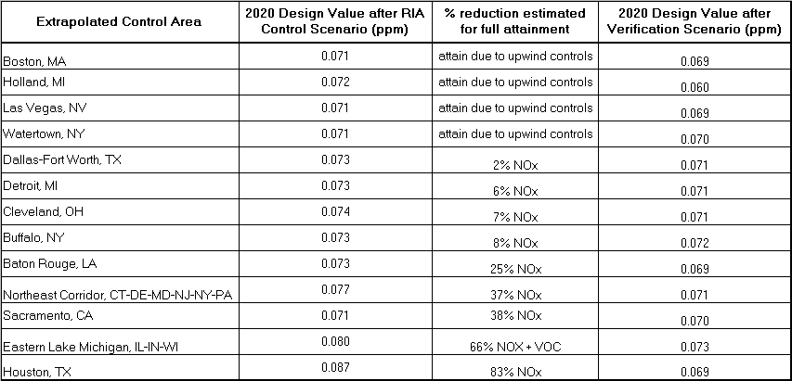

4.2 Conversion of Full Attainment Percentage Targets into Extrapolated Tons
Table 4.7a provides the complete set of extrapolated tons of NOx emissions reduction needed to satisfy the various ozone standards. These extrapolated tons are obtained by multiplying the NOx targets in Table 4.5a by the remaining emissions for each area after the RIA control scenario. It is important to note that the extrapolated cost areas are potentially standard-specific because the location of counties in an extrapolated area depends on whether the particular standard is being violated. For example, as seen in Figures 4.3a and 4.3b, the Eastern Lake Michigan area extends further north into Wisconsin for the 0.065 ppm standard where areas like Green Bay attained the 0.070 standard but not 0.065 ppm standard.
Table 4.7a: Complete Set of Estimated Extrapolated Emissions Reductions of NOx Beyond the RIA Control Scenario Necessary to Meet the Various Ozone Standards in 2020
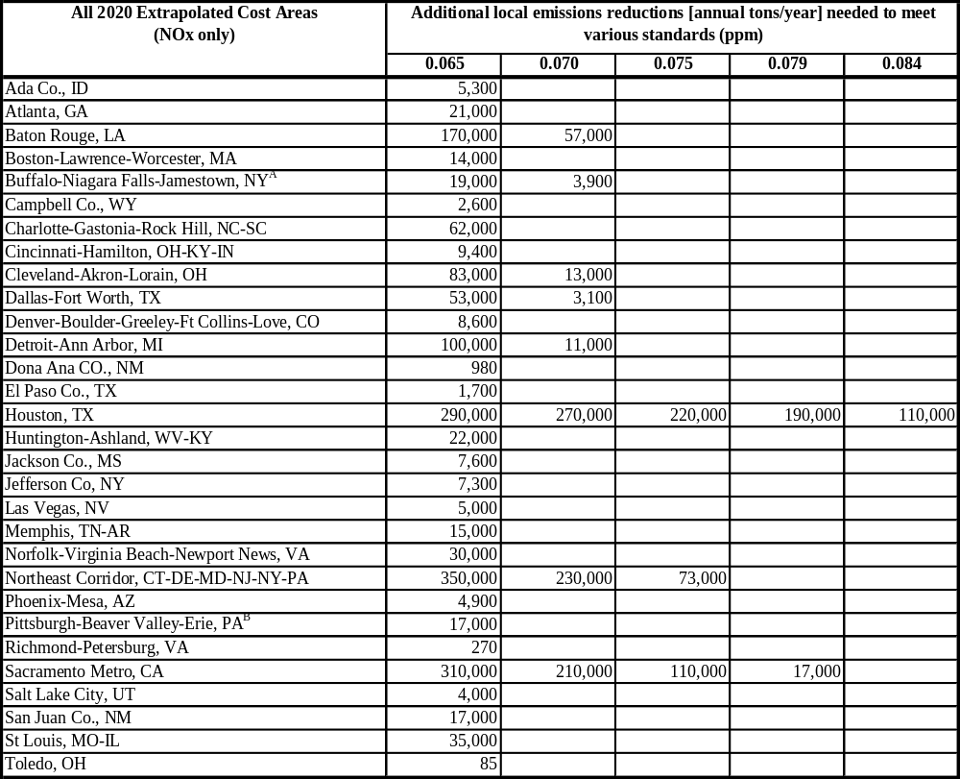
ª Jamestown is included in the Buffalo-Niagara Falls, NY cost area because it falls within the 200km Buffalo-Niagara Falls buffer and has a lower design value.
^{b} Erie is included in the Pittsburgh-Beaver Valley, PA cost area because it falls within the 200km Pittsburgh-Beaver Valley buffer and has a lower design value.
In total, additional emissions reductions are provided for 31 areas. As footnoted, Jamestown NY is included in the Buffalo-Niagara Falls NY area. There are three reasons for this: 1) Jamestown is within the 200km buffer for Buffalo-Niagara Falls, 2) as seen in Table 4-5a, the NOx target is greater in Buffalo-Niagara than Jamestown for each standard, and 3) Jamestown is in the same state. Erie is included in the Pittsburgh-Beaver Valley PA area for the same three reasons.
As noted in Table 4.5b in Section 4.1.5, the eastern Lake Michigan area was the only one in which NOx plus VOC additional emission reductions could be substantially lower than NOx-only emissions reductions. Table 4.7b shows the additional NOx + VOC emission reductions for this area.
Table 4.7b: Estimated Extrapolated Emissions Reductions of NOx + VOC Beyond the RIA Control Scenario Necessary to Meet the Various Ozone Standards in 2020
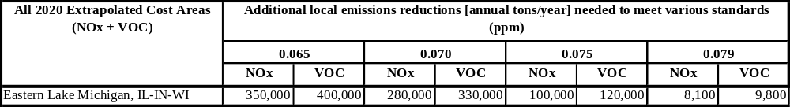

4.3 Methodology Used to Estimate the Amount of “Overcontrolled” Emissions in the Modeled Control Strategy
The corollary to extrapolated tons (needed tons above and beyond the modeled control strategy) is “overcontrolled” tons. These are emissions reductions within the hypothetical control case that were subsequently determined not to be needed to meet particular alternate standards. That is, once we modeled the baseline and control strategy scenarios we found that we had reduced ozone beyond the particular alternate standard. In order to better estimate the costs and benefits of full attainment of the standards, EPA has estimated the “overcontrolled” emissions percentages within the modeled control strategy for the four alternate standards: 079, 075, 070 & 065. These percentages are to be applied to the tons reduced between the baseline and the control case.
The methodology for calculating the “overcontrol” percentages is based on simple linear interpolation between the baseline scenario and the model control strategy. These two model runs were used to estimate what level of control was just needed to bring an area into attainment of a standard. A caveat to this approach is that it assumes that all air quality impacts are due to local controls; there is no consideration of the potential impacts of ozone transport.
The details of the methodology are as follows. The first step was to identify all counties with ozone concentrations greater than 0.070 ppm in the base case. These 142 counties were the starting point for designing the modeled control strategy described in Chapter 3. Because the majority of the California controls are in the baseline and because several CA areas continue to be nonattainment of all four alternate standards in 2020 and beyond, we did not assess “overcontrol” in California. The remaining counties were aggregated into 32 distinct areas for an assessment of whether that area overcontrolled to meet an alternate standard. Each area included the original nonattainment county or counties, plus all counties within 200 km of that county or counties. The “overcontrolled” analysis was done for the county with the highest ozone levels in the control case modeling. These 32 areas comprised 1,199 counties. These are the same 1,199 non-California counties over which NonEGU point and Area sources were controlled in the hypothetical strategy.
A simple three-step process was used to determine the amount of overcontrol in the hypothetical control case for each of the 32 areas. The results are summarized in Table 4.8.
Table 4.8: Estimated Percentages of Modeled Control Strategy Emissions Reductions not needed to Meet the Various Ozone Standards in 2020
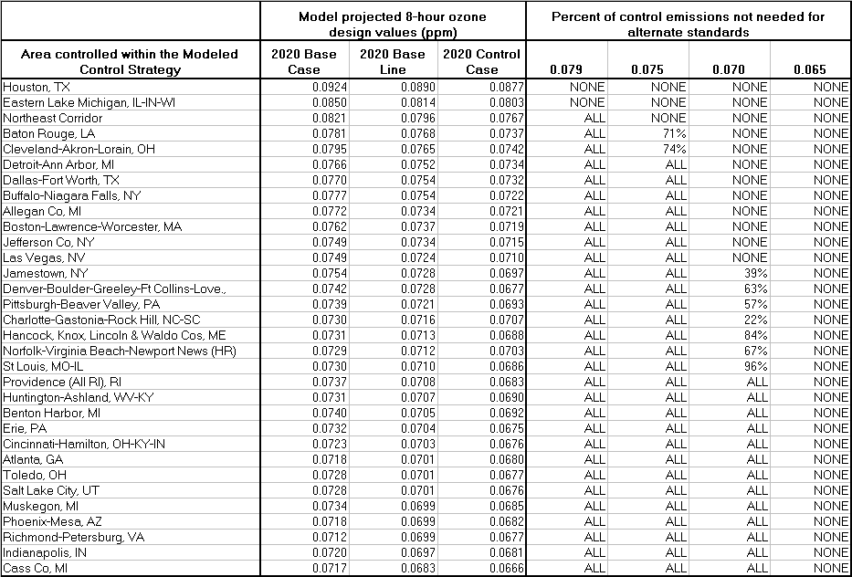

a) For each standard, we first determined if the area was below that standard in the baseline modeled scenario. If so, then all of the hypothetical controls should be returned from the control scenario. For example, the highest projected design value in the Cincinnati area was 0.072 ppm in the basecase and 0.070 ppm in the baseline. Thus, that area did not actually need any of the hypothetical controls above and beyond the baseline to meet the 0.079, 0.075, or 0.070 standards locally. Therefore, all of the controls in that area should be returned for those standards.
b) For each standard, we then determined if the area was above that standard in the modeled control case. If so, then none of the hypothetical controls should be given back. As an example, the Houston area had a projected design value of 0.087 ppm in the control case. Therefore, all of the emissions in the modeled control strategy (and some extrapolated tons) are needed in that area.
c) For each standard, and for all other areas that were above the standard in the baseline and below in the control case, we used linear interpolation to estimate what percentage of the emissions reductions in the modeled control strategy could be returned and still allow the standard to be met. For example, the maximum projected design value in the Cleveland area was 0.0795 ppm in the basecase, 0.0765 ppm in the baseline, and 0.0742 ppm in the control case. Linear interpolation between the baseline and the control case indicates that 74% of the controls in the Cleveland area, including counties within a 200km buffer, could be given back and still just meet the 0.075 ppm target. All of the control strategy reductions would be given back for the less-stringent 0.079 ppm standard and none of the reductions would be given back for the more-stringent 0.070 ppm standard.

4.4 Conversion of Estimated Percentages of Unnecessary Emission Reductions into “Overcontrolled” Tons
The percentages of modeled control strategy emissions reductions not needed to meet the various ozone standards in 2020 shown in Table 4.8 were applied to the control case reductions in Table 4.9. In areas and targets where the percentages in Table 4.8 were “ALL,” the unnecessary emissions reductions in Table 4.9 are equal to the baseline minus control case emissions seen in the same table. Similarly, in areas and targets where there was no “over-control” (“NONE” in Table 4.8), emission reductions not needed for alternative standards in Table 4.9 are zero; that is, the control scenario did not “over-control” emissions for that area and target. As seen in Table 4.8, ozone concentration estimates are greater than 0.0795 ppm in both Houston and Eastern Lake Michigan; therefore there was no over-control and no unnecessary emission reductions.
Table 4.9: Estimated 2020 Control Case Emission Reductions not needed to Meet the Various Ozone Standards in 2020
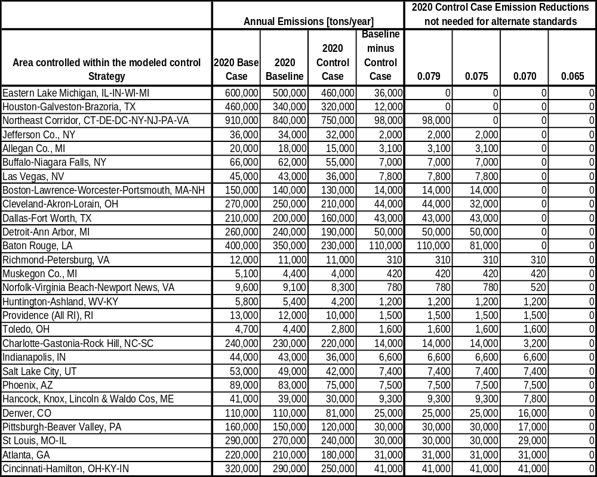

10 counties did not meet the 0.079 ppm standard. 166 counties did not meet the 0.065 ppm standard.
This geographic area is an aggregate of five existing nonattainment or maintenance areas: a) Chicago-Gary-Lake County, IL-IN; b) Milwaukee-Racine, WI; c) Sheboygan WI; d) La Porte IN; and e) South Bend-Elkhart IN.
This geographic area is an aggregate of six existing nonattainment or maintenance areas: a) Philadelphia-Wilmington-Atlantic City, PA-NJ-MD-DE; b) New York-Northern New Jersey-Long Island, NY-NJ-CT; c) Greater Connecticut, CT; d) Baltimore MD; e) Kent and Queen Anne counties MD; and f) Poughkeepsie NY.
The units for impact ratios are ppb/kton. In the draft RIA we used a single, national impact ratio that assumed that 10,000 tons of NOx control would yield 0.001 ppm of ozone improvement.
To add precision to this process, we based these calculations on projected design values that contained data four places to the right of the decimal (e.g., 0.0755 ppm). In the last step of the process however, EPA truncates all decimal places beyond the third decimal. This is consistent with past policy on ozone design values.
The full step 1 calculation for the Geauga OH example is as follows. A 60 percent reduction yields a design value of 0.0722 ppm. A 90 percent reduction yields a design value of 0.0710 ppm. The estimated Phase 1 target for eastern Lake Michigan is 72%, or four-tenths of the “distance” between 60 and 90% control. Forty percent of the 0.0012 ppm difference between the two runs is 0.00048 ppm. Subtracting that from 0.0722 ppm, yields the transport-considered design value of 0.0717 ppm which would be truncated to 0.071 ppm.
The entry “will attain” in Tables 4.3 and 4.4 signifies that this area will come into attainment of the standard due to reduced ozone transport resulting from upwind controls.
The calculation used to determine the 74% target for the 0.075 ppm targets is as follows: 1.0-[(0.0765-0.0759)/(0.0765-0.0742)], where 0.0759 ppm represents the highest ozone level that still attains a 0.075 ppm standard, due to the usual truncation of the fourth decimal place.

