POLAR Spacecraft Status As of: Tues May 17 12:00 EST
(changes from last week in bold border)
Subsystem/  Component | NOAA-12D  AM: 1651=AN  STIP data only | NOAA-14J  AM: 2039=AN  STIP data only | NOAA-15K  AM: 1806=AN  GAC data only | NOAA-16L  PM: 1441=AN  GAC&LAC data | NOAA-17M  AM: 2225=AN  GAC&LAC data | NOAA-N18  Planned PM  Plan AN=14:00
LAUNCHED | 05/14/91 | 12/30/94 | 05/13/98 | 09/21/00 | 6/24/02 | 20May05 10:30Z  Various slips
CNTL OBP | OBP2 | OBP2  OBP1 inoperative | OBP2 | OBP2 | OBP2 | Dress Rehearse #1  Completed 13Jan
BUS | B-BUS  XSU-1 | B-BUS  XSU2 (XSU1 inop) | B-BUS  XSU-1 | B-BUS  XSU-1  XSU1 TOAR 444 | B-BUS  XSU-1 | Dress Rehearse #2  Completed 14Apr05
BUS VETO | NO | NO | NO | NO | NO | Dress rehearse #3  Completed 9 May 05
ADACS  X=Yaw  Y=Roll  Z=Pitch | Nominal Mode  RGmode=Monitor  Gyro chans=XYZ | Nominal Mode  Rgmode=Disabled  Gyro chans=XYZ  SS check Disabled when mode=YGC | Nominal Mode  Rgmode=Monitor  Gyro-3 Off 6/26/00 Gyro chans=AAB  N2 Low PSI invalid | Nominal Mode  Rgmode=Monitor  Gyro-3 Off 6/10/04  Gyro chans=AAA | Nominal Mode  Rgmode=Monitor  Gyro-3 Off 6/10/04  Gyro chans=AAB | New  ring laser gyro
RXO | PRI  BU random enables  daily bias+6.5 mS | PRI  BU random enables daily bias–7.0 mS | PRI  daily bias -8 mS  +100 mS 31Au04 | PRI  Daily Bias –5.5 mS  -100 mS 31Au04 | PRI  Daily Bias –3 mS
CLOCK DIV | 2 | 2 | 2 | 2 | 2
MIRP | External Synch  Rephase Enabled | External Synch  Rephase 0730 Daily | External Synch Rephase 0730 daily | External Sync  Rephase each orbit | External Sync  Rephase Enabled
TIP SIDE | 1 | 1 | 2  (since 4/23/03)  3 Channels inop | 2  since 4/18/05 | 1  Analog telem drifting
DTRs | 3A, 4, 5B  Safestate 5B | 1, 2B, 5 Safestate- 1B | 1, 2, 3, 4 Safestate 1B EOT | 1,2,3,4A  Safestate 3A  4B STIP only | 1,2,3,4  Safestate=1B  DTR2-SSR | All solid state digital recorders
VTX  (APT data) | #1 ON  137.50 MHZ | OFF  Since 8/14/02 | #1 ON  (16 May 18:15Z)  End N12 Conflict | INOP  OFF since 11/15/00 | #2 ON  137.62 MHZ | #1=137.1 MHZ #2=137.9125 MHZ
BTX | #1  136.77 MHZ | #2  137.77 MHZ | #1  137.35 MHZ | #1  137.35 MHZ | #2  137.77 MHZ
STX  #1=1698.0 mhz  #2=1702.5 mhz  #3=1707.0 mhz  #4=2247.5 mhz | 1 – HRPT;  2,3 - Playback | 3 – HRPT  2, 1 – Playback | 2-Omni HRPT  4-Playback  1,2,3-Degraded | 1 – HRPT;  2– Playback;  4 – Playback  3 low power unused | 3 – HRPT  TOAR424 low power  2 & 4 Playback  1-Standby  STX-1 output power drop TOAR 443. | STX-3  Replaced at VAFB
POWER  (Array offset and CANT angle, charge & V/T rates, eclipse states and sun angle) | ArrayOff +50  since 8/31/04  Eclipse season 21Apr-17Aug  Batt UVtrip 7/25/04  Sun Angle 33  up to 37 mid-June  Batts 1&2=LRC  V/T=4  Shunt degraded  SA CANT=37 degs | Array Off -55  Since 8/21/03  Eclipse all year  Sun angle 50  up trend to 52 in June  Batts 1-3= LRC  Batts 1&3V/T=7/11  Batt2 VT=8/11  SS trigger =18.98  Shunt Degraded  SA CANT=22 degs | Array Off -45  Since 1/25/01  Eclipse Season started 16 May  Sun Angle 28, up- trend to 32 in June  Batts 1-3= LRC  V/T=7/9  SA CANT=37 degs | Array Off -40  Since 7/16/02  Eclipse all year  Sun Angle 56  Steady trend  Batts 1-3= LRC  V/T=4/8  SA CANT=22 degs  SADPOS timer increased 5 Apr | Array Off. –40  Since 1/29/04  Eclipse all year  Sun Angle at 71  Uptrend to 72 at  the end of May  Batts 1-3= LRC  V/T= 4/8  SA CANT=37 degs  SADPOS timer increased 5 Apr
AVHRR | Nominal | INOP  Scan motor stalled  14 Apr 04 | Nominal  Rare major scan motor surges. Last  Incident 11/18/04 | Operational  TCE24 OFF 4/14/04  Occasional Image Wave patterns and MIRP rephases  Chan 3B only. | Nominal  3A-B switch enabled | New brushless scan motors
AMSU-A1 |  |  | Operational  Ch14 inoperative  Ch11 inoperative  Record low component temps reversed trend | Operational  Primary PLLO chans 9-14 bias shift.  Backup PLLO inop  Channel 9-14 noise worsened recently | OFF/INOP  Since 10/30/03  Survival heat on.
AMSU-A2 |  |  | Nominal | Nominal  Space Position-2 | Nominal
AMSU-B |  |  | Operational  Bias in All Chans.  Motor surges most recent 11/14/04  IPD Reports of degraded data on Chan-3 since 4/30 | Operational  Space Position-3  IPD reports channel 8 degradation | Nominal | Replaced by MHS
HIRS | ON / INOP  Turned on 8/30/04  For power balance  Filter Wheel turned OFF 10/17/02. | NOMINAL  Operational  Occasional loss of Fwheel synch | INPROVED  Upgraded to Yellow status  16 May 05  FW Abrupt return to nomial at 09:00Z  TOAR 445 submitted  FW mode=Hi Powr  FW Heater OFF  Frequent Filter  Excessively high FM temps and currents continue | DEGRADED  Longwave channel imagery improved radiometric noise level is still high  TOAR 441 submitted 11 Jan05  Considering high power mode  Occasional major FM surges, most recent  12/9/04 | NOMINAL  1 Pixel cross track misalignment . | HIRS-4 replacing HIRS-3
MHS/MIU |  |  |  |  |  | Replaces AMSUB
MSU | ON / INOP  On For power balance Scan Motor OFF since 3/12/03 | Operational  Scan motor and antenna problems
SSU |  | Nominal
DCS | Nominal | Nominal | Nominal | Nominal | Nominal
SARR |  | Nominal | Operational  A-Side, AGC Mode  Intermittent failures for 243MHz A&B | Operational  Switched back to mode AA  26Apr05 14:10Z  A-side, AGC Mode  (B-side in FG mode)  243 MHz = INOP. | Nominal  A-side  All AGC Mode
SARP |  | OFF  Power Failure | Nominal  RCVR B/W = 2 | Nominal  RCVR B/W = 2 | Nominal
SEM | ON/Nominal  Turned on 8/30/04  Elec-CH-HVPS=4  Prot-CH-HVPS=0 | Operational  Elec-CH-HVPS=0  Prot-CH-HVPS=0  1 of 4 Telescopes inoperative | Nominal  E-CDEM-HVPS=2  P-CDEM-HVPS=0 | Nominal  E-CDEM-HVPS=5  P-CDEM-HVPS=4 | Nominal  E-CDEM-HVPS=2  P-CDEM-HVPS=3
SBUV |  | Degraded  Grate motor sticks  Flex memory 3 (giant step) ops suspended 12/2/03  Reduced operations |  | Operational  Degraded Ozone data  Backup Diffuser inop  Primary Diffuser deployment problem TOAR 426  AMSU EMI causing erratic Behavior in PMT cathod, range 3 | Nominal  Anode Mode  Plan sweep mode Standard Ops Procedure change  starting 17 May
SADPOS |  |  | N/A | ON  Enabled MFactor50%  Timer changed to 12 (from 8 mins 5 Apr | ON  ENABLED  Timer changed to 12 (from 8 mins 5 Apr
THERMAL  Heaters, louvers  TCE’s | Nominal  TCE’s back to nominal configuration following 7/25/04 UVtrip. | Nominal | TCE26 & 15H  Telem invalid  TOAR 432  HIRS FW Heat tuned ON 17 Apr and OFF on 18 Apr  TCE24L&25L (HIRS & AVHRR) failed 5/13/98  RCE thermostat failed 5/13/98 | Nominal  TCE24 OFF 4/14 (AVHRR H&L)  HIRS Filter heater turned OFF 1/18/05 | TCE3H Batt 2A heater failed ON, turned off 8/26/03 TOAR 428  CLOSED 9/14/04 no corrective action possible.  AMSU-A1 survival heaters on 10/29/03
 | N12 | N14 | N15 | N16 | N17 | NOAA-N18
COMMENTS/CHANGES:

NOAA-12 There were no changes on N12 during the past reporting period.

NOAA-14: Spacecraft is operating nominally and power subsystem remains stable and above safe state threshold values as the
long slow increase in percentage darkness time per orbit continues through mid-June 05 (illustration 1). Otherwise there were no changes to N14 during the past reporting period.

NOAA-15: At 07:21z on 16 May, the N15 HIRS experienced a 1.5 degree jump in filter motor temperature which was almost immediately followed by an abrupt drop in filter motor current of over half an amp and a rapid decline in filter motor temperature as well. Within an hour and a half of this event, the HIRS filter motor current had fallen even more significantly and returned all the way back to its nominal value of approximately 240 mAmps (earlier in the day it had been almost 400), while filter motor temperature continued a steady decline, also reaching its nominal value of approximately 22 degrees C (it had been almost 34 earlier in the day) by days end. In addition, during this same time frame, the HIRS period monitor returned to nominal, the filter wheel synch locked back up for the first time in a month and imagery cleared up completely. EMOSS engineers hypothesize that the initial jump in filter motor temp followed by the rapid decline immediately thereafter might have been an indicator that the filter wheel had possibly broken through the obstruction which had originally caused it to become anomalous in mid-April 05. In response NOAA upgraded the HIRS (and its filter wheel component) Status to YELLOW. As of the publication of this report, it remains operational and nominal (see illustrations 2-8).

EMOSS engineers analyzed other subsystems to gauge their response to the significant change in N15’s HIRS temperatures and currents. The AVHRR appears to have slowed and even reversed a thermal uptrend at about the same time the HIRS was making its improvement (illustration 9). However, this change may also be attributed to the N15 eclipse season which started at almost the same time that the HIRS situation began. This same situation may apply to the AMSU-B scan motor temp which also reversed an upward thermal trend on the day HIRS improved (and eclipse season began). However, the AMSU-B scan motor current has been showing a tendency to operate in a slightly more erratic manner than is preferred although it remains within generally nominal ranges (illustration 10). The N15 AMSU-A1 and A2 payloads remained operating nominally throughout the past reporting period and showed little to no response to the HIRS situation (illustration 11).

As was stated previously, the N15 eclipse season started on 16 May, at almost the same time that the HIRS was improving (coincidence?) Analysis of the EPS shows a natural progression into this new environment and no obvious response to the HIRS improvement event (although bus current did increase, perhaps due to eclipse onset, perhaps due to changes in HIRS health profile, perhaps a bit of both.) See illustrations 12 and 13.

The RF conflict between N12 and N15 ended on 16 May. In response, VTX-1 on N15 was commanded back on and appears to be operating nominally (illustration 14). N15 APT data is once again was transmitting after a 1 month absence.

NOAA-16: The N16 AVHRR scan motor current remained generally stable at less than optimum levels during the past week while
synch delta value continued to exhibit behavior that probably (but not confirmed with imagery) has resulted in a number of MIRP rephases in the past week. In addition, much of the HRPT imagery analyzed by EMOSS engineers was showing wave patterns in recent days although none had any indications of bar codes. On the positive side the AVHRR scan motor and baseplate temps have remained nominal and stable even though the AVHRR TCE remains powered off. (See illustrations 15-16.)

According to AMSU products personnel (Florence Rabier) monitoring statistics have recently been showing an “alarming increase” in noise for channels 9 and 10 of the NOAA16 AMSU-A instrument. This would not be the first time such problems have occurred on this payload, especially for these channels. EMOSS analysis of AMSU-A1 health telemetry shows no problems or concerns whatsoever at any time that coincides with this degraded imagery (illustration 17). AMSU products personnel have highlighted some of the problems which can be reviewed in this report in illustration 18. This payload is already considered YELLOW in status because of these past data problems and other component failures (notable the PLLO).

The N16 HIRS was nominal and stable last week (illustration 19) as was the ADACS subsystem.

NOAA-17: The N17 AVHRR scan motor current and temps were both very stable during the past week as was synch delta and
and imagery remained nominal (illustrations 20). The N17 HIRS was also generally stable during the past week although its period monitor appeared to be slightly less stable than the week before and the filter motor current is just slightly less stable than would be preferred (illustration 21). On the other hand HIRS temperatures remain nominal and stable and there are no reports of any problems with imagery.

At the request of the Polar Program Office EMOSS is overseeing a change in the N17 SBUV standard operating procedure which is scheduled to begin today, 17 May 05. The NOAA-17 SBUV currently spends 14 orbits in sweep mode every Tuesday. This will be reduced to 4 orbits in sweep mode. These orbits should not cross over the CONUS,

N17 (cont)

or at least not do so in daylight. The SOMS procedure SBSWMODE will be run every Tuesday and the wait time in this procedure must be changed to 24240 seconds. These schedule changes are intended to be permanent.

NOAA-N: EMOSS is a go. Launch slipped on 11 May due to high winds at VAFB, it slipped on 12 May because of ground
equipment problems (water pumps) and it slipped on 13 May because of a possible kerosene vapor leak into the spacecraft faring. As of this report being generated, the launch is scheduled for 20 May pending assessment of possible contamination of the spacecraft due to the kerosene leak.

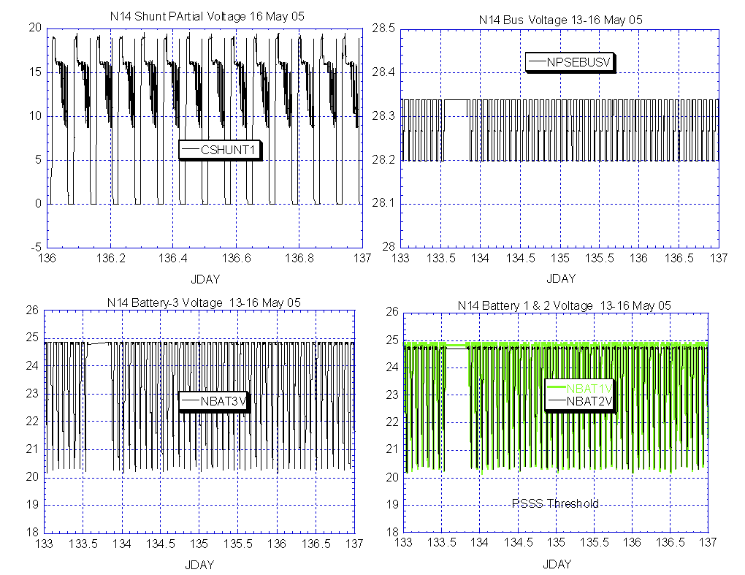

Illustration 1: N14 EPS Analysis:

(Stable and nominal)

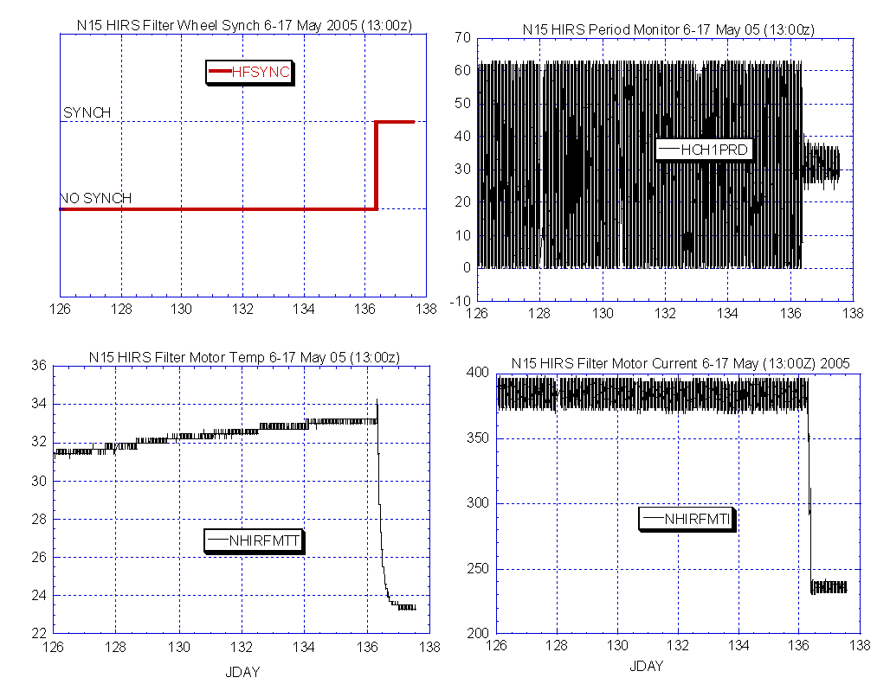

Illustration 2: N15 HIRS Health Analysis

(An abrupt return to nominal.)

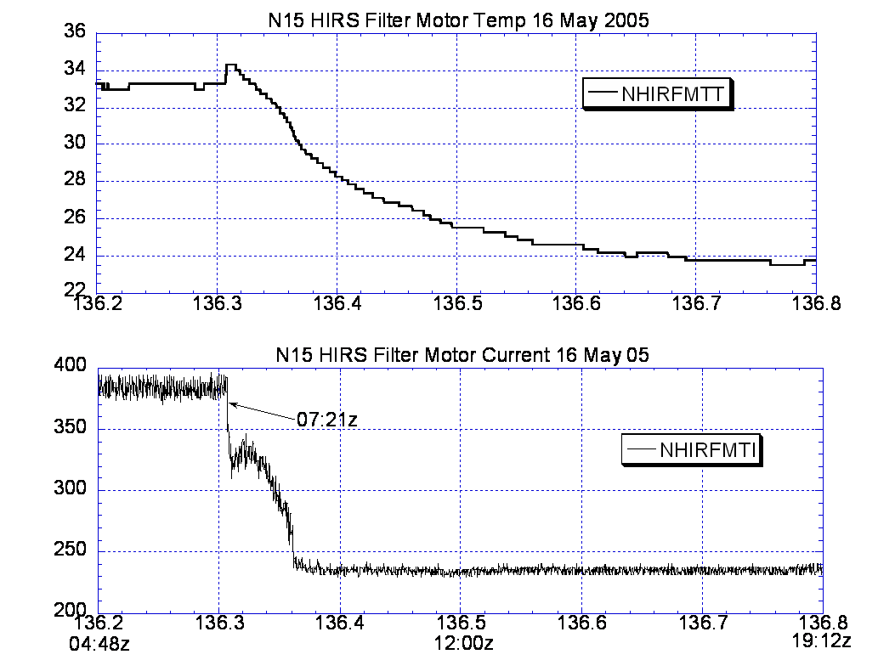

Illustration 3: N15 HIRS Recovery Analysis (a closer look)

(Note the surge in the temperature, top graph, followed by a rapid improvement in the current and temperature. Perhaps, the temp surge was the result of the filter wheel breaking through some obstruction.)

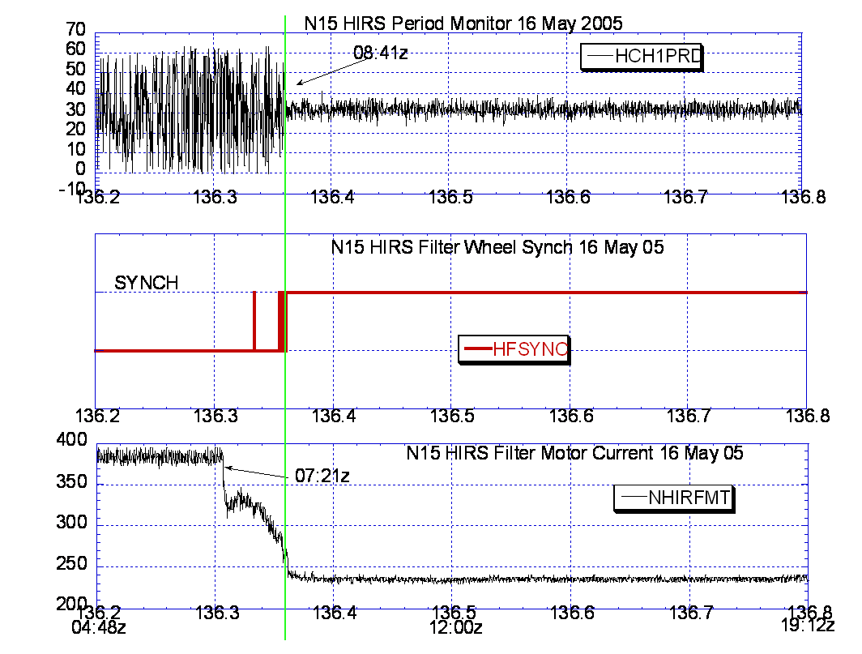

Illustration 4: N15 HIRS Recovery Analysis (cont)
(It took nearly an hour and 20 minutes for the improvement in filter motor current to be reflected in Filter wheel synch and period monitor improvement. But once it happened, it was sustained.)

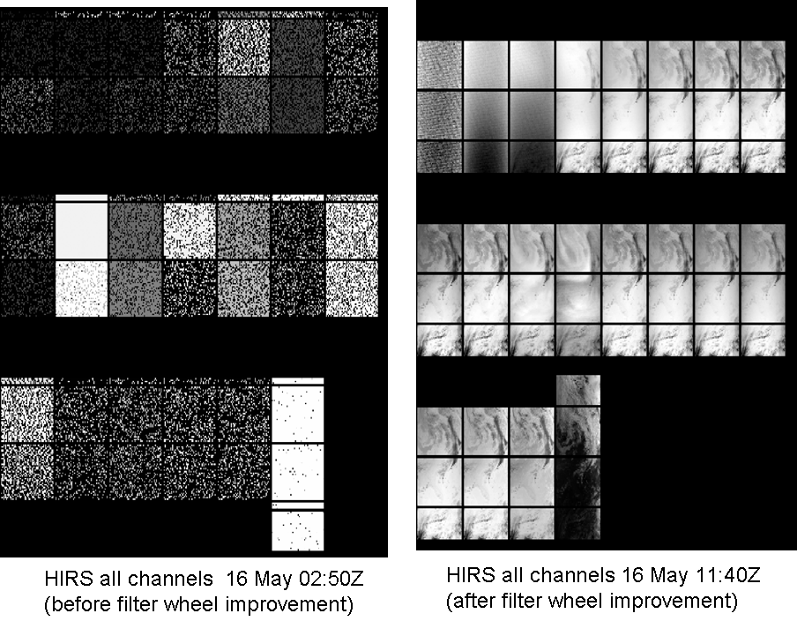

Illustration 5: N15 HIRS Recovery Analysis (Imagery Comparison)
(On the right is the first image following the period monitor recovery. Imagery remains nominal as of this reports distribution.)

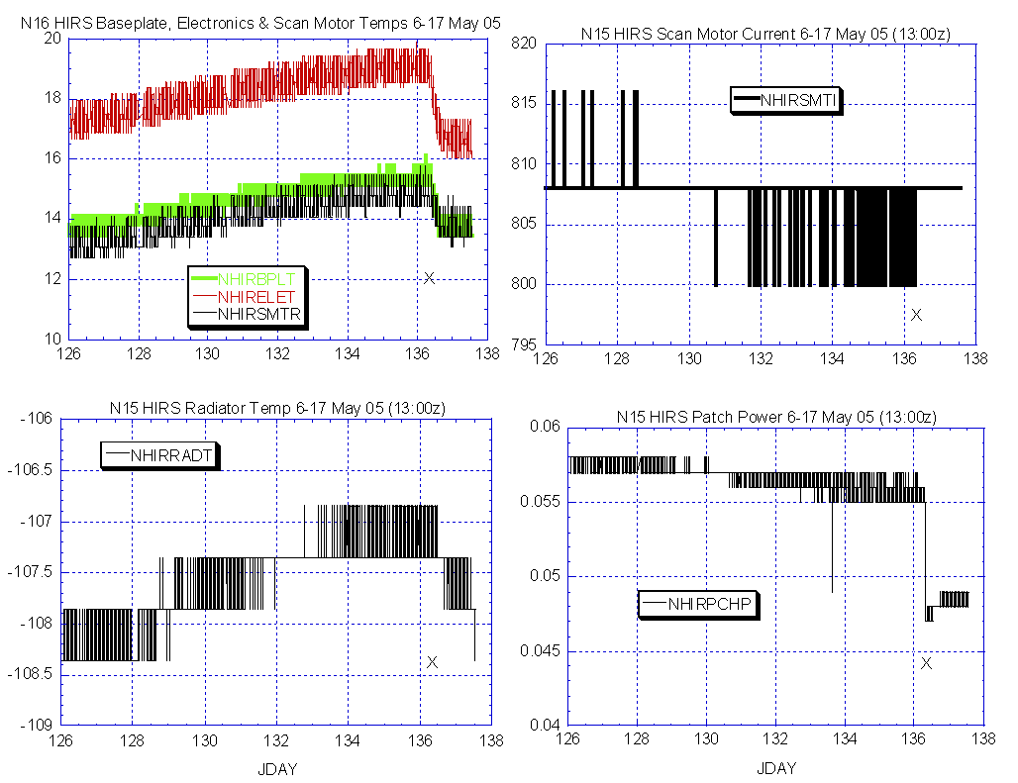

Illustration 6: N15 HIRS Component Analysis
(A noticeable change in thermal profile is apparent from the time the scan motor improvement occurred, depicted on the above graphs as an “X”. HIRS Heaters are all off.)

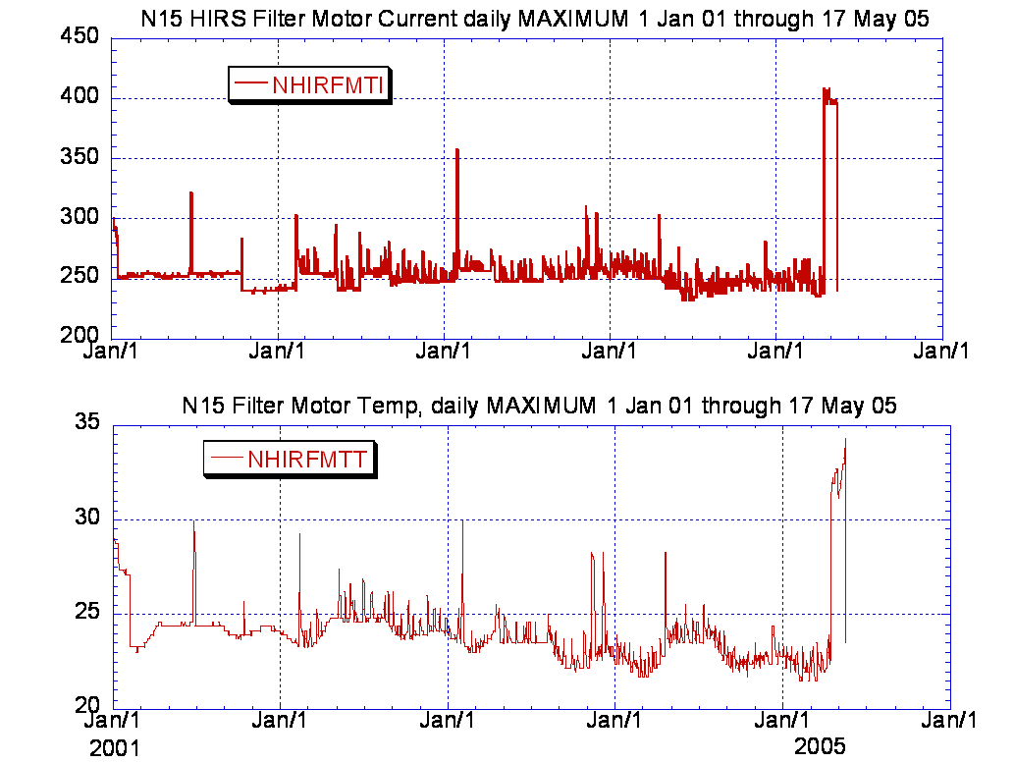

Illustration 7: N15 HIRS Analysis in perspective
(Depicting what is obviously the most significant and abrupt HIRS anomaly and recovery since at least 2001 began.)

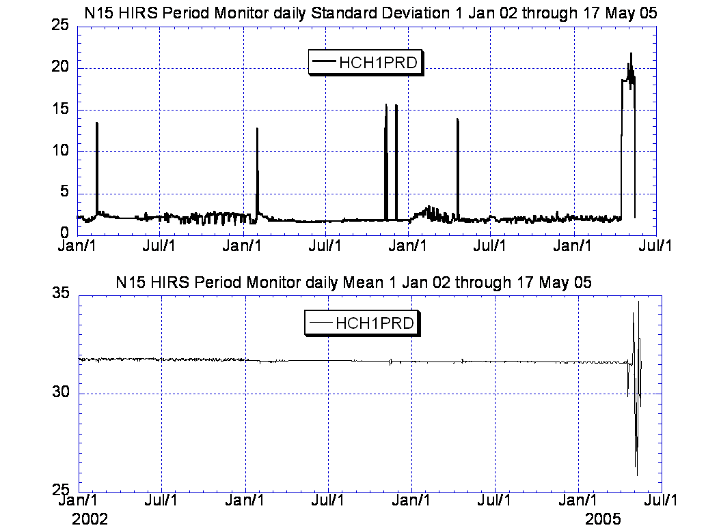

Illustration 8: N15 HIRS Analysis in perspective (cont)
(Reinforcing the conclusion stated on the previous page.)

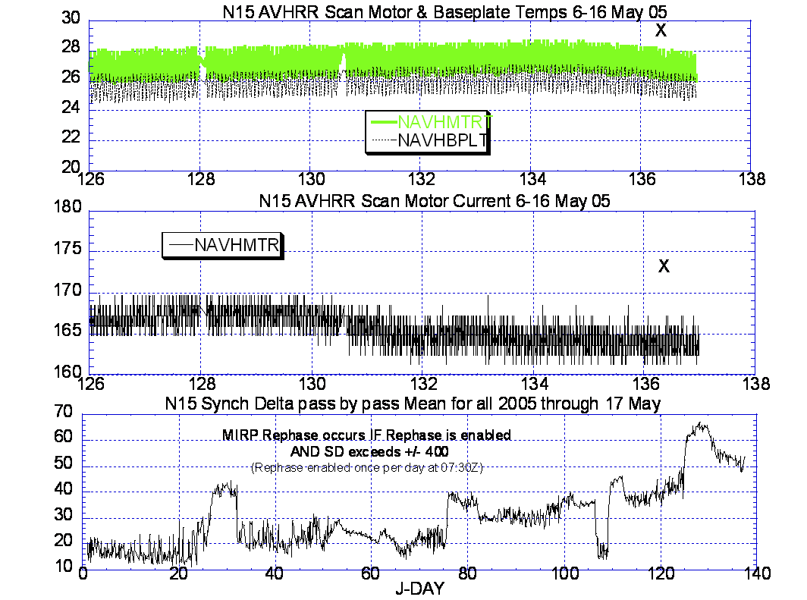

Illustration 9: N15 AVHRR Health

(Looking for HIRS influences on the AVHRR. Possible some minor thermal improvement occurred on this AVHRR following the HIRS improvement, marked as “X” on the graphs. Scan motor current improvement occurred well before the HIRS filter wheel current improvement occurred.

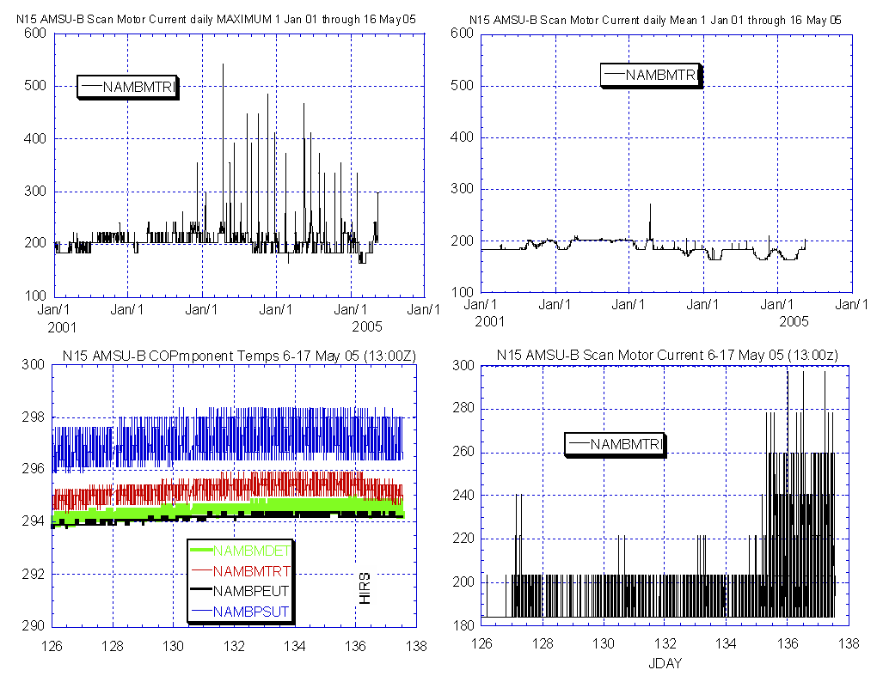

Illustration 10: N15 AMSU-B Analysis (Long and recent term)
(AMSU-B scan motor appears to be performing with a little less stability than desired although it is within historical “nominal” values. The scan motor temp appears to have been slightly influenced by the HIRS filter wheel improvement.)

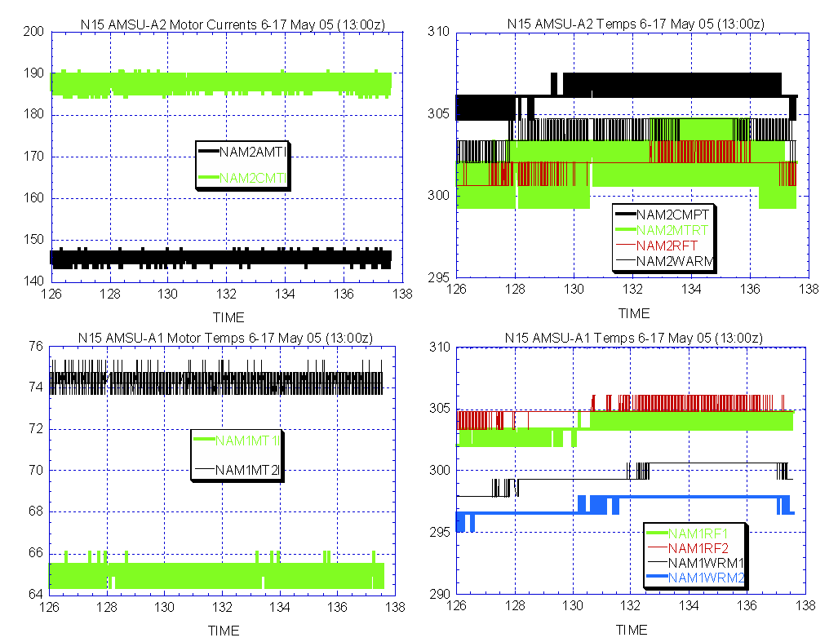

Illustration 11: N15 AMSU-A1 & 2 Health Analysis
(Appear to be nominal and stable and not influenced by HIRS improvement in any way.)

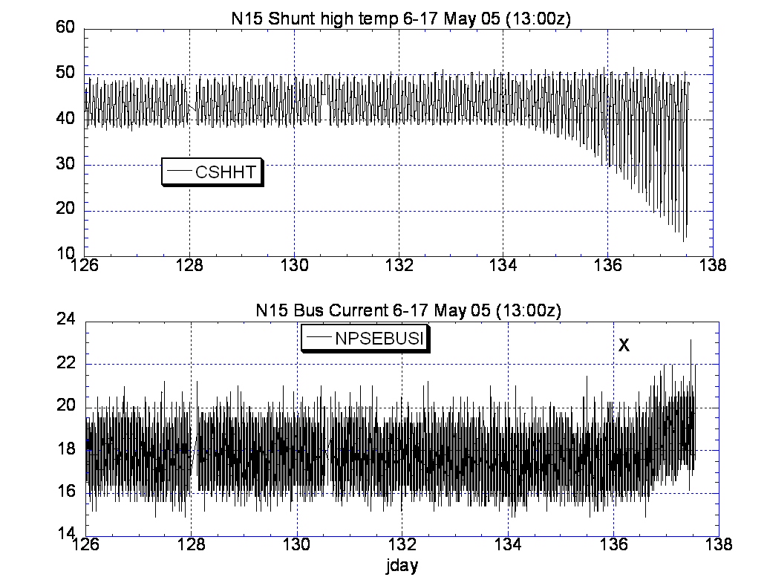

Illustration 12: N15 Eclipse Season Onset
(Coincided with the HIRS improvement event depicted as “X” above)

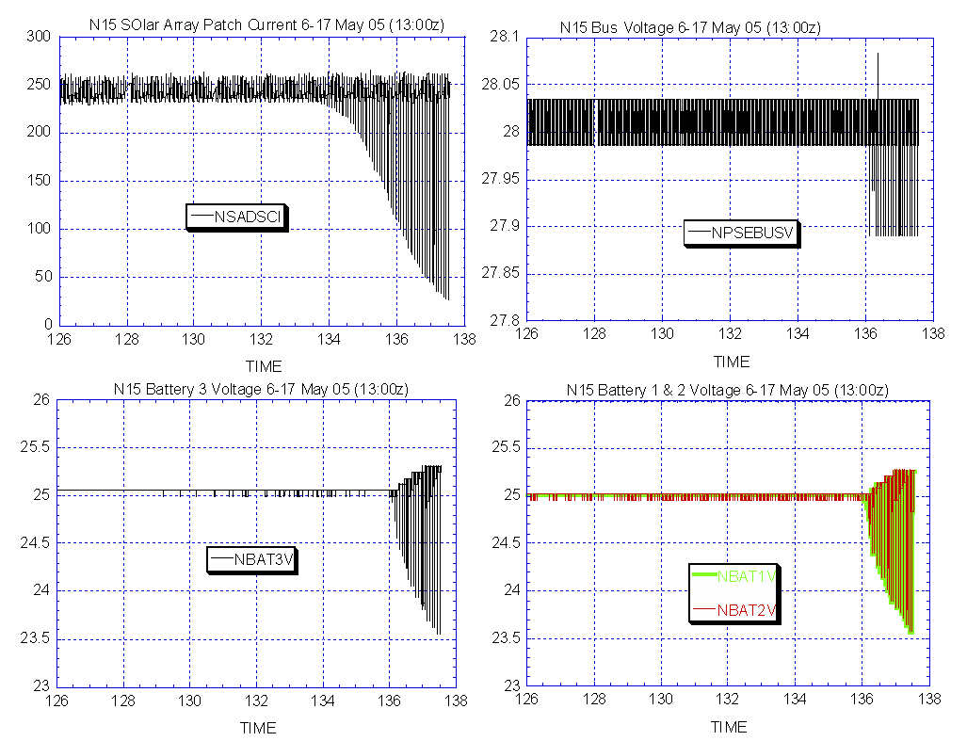

Illustration 13: N15, the Onset of Eclipse Season (cont)

(So far a nominal progression)

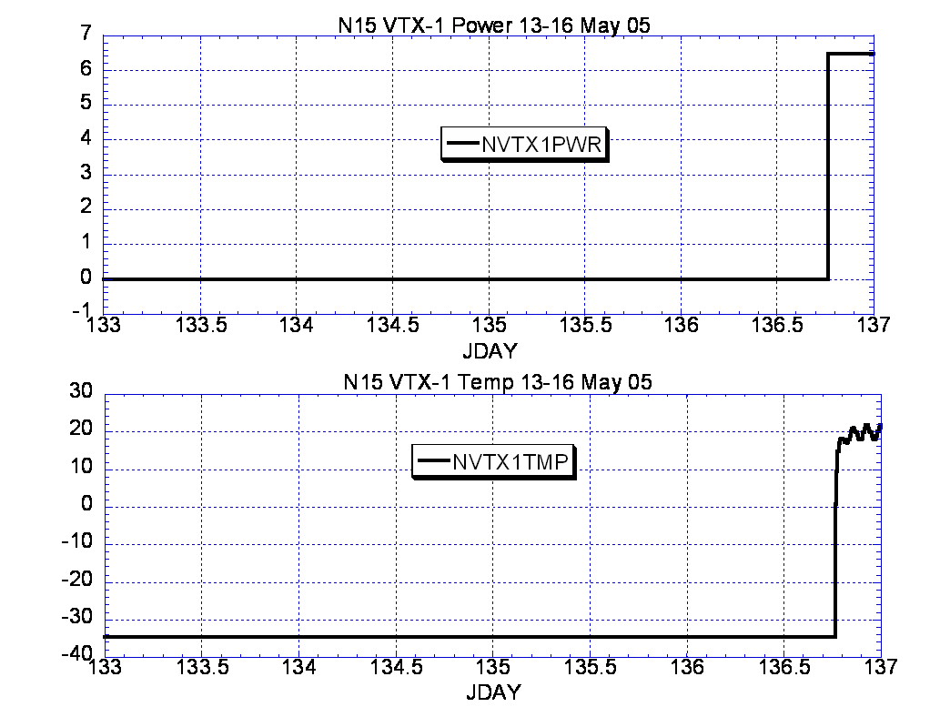

Illustration 14: N15 VTX-1 Turnon Analysis

(Nominal, APT once again flows to the users.)

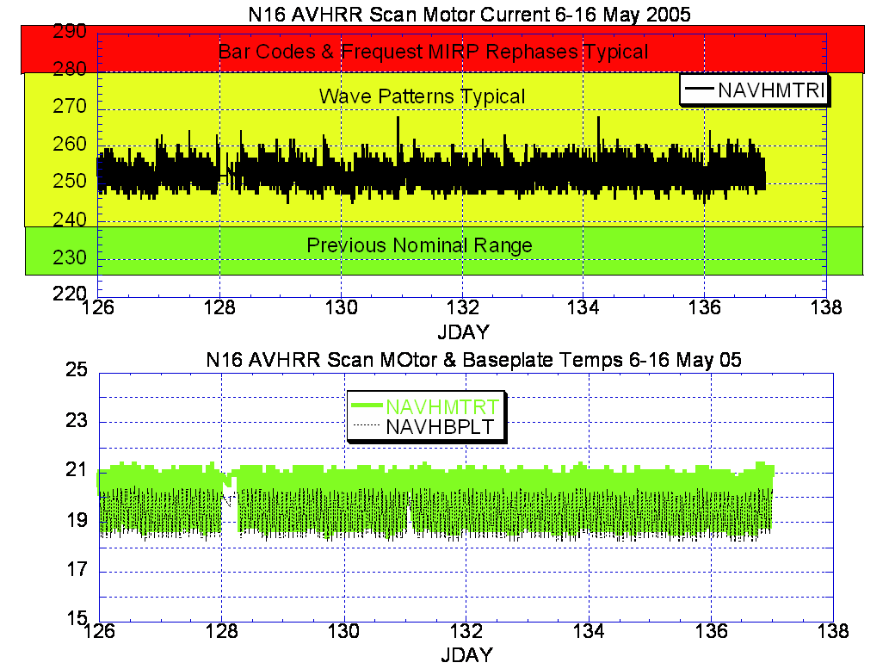

Illustration 15: N16 AVHRR Analysis
(Stable at higher levels, not necessarily nominal but it has been much worse also.)

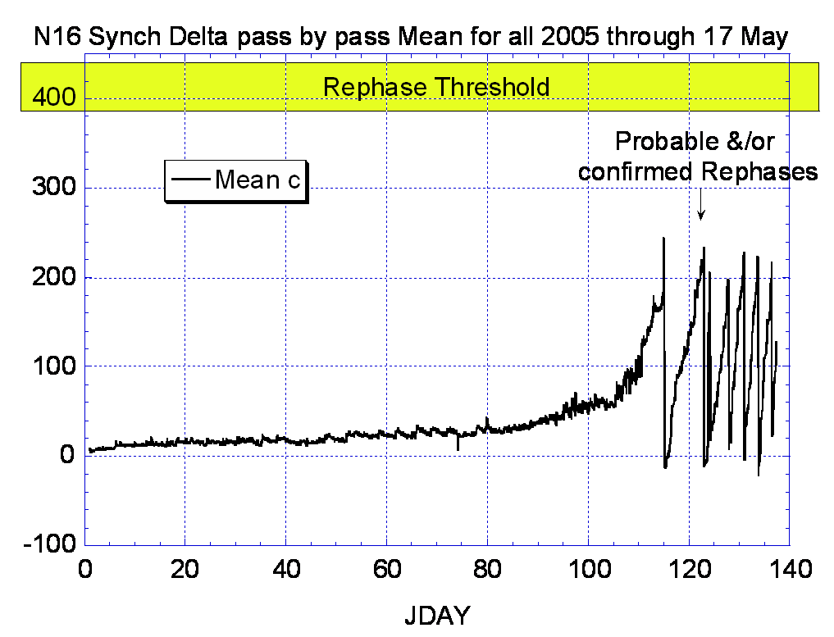

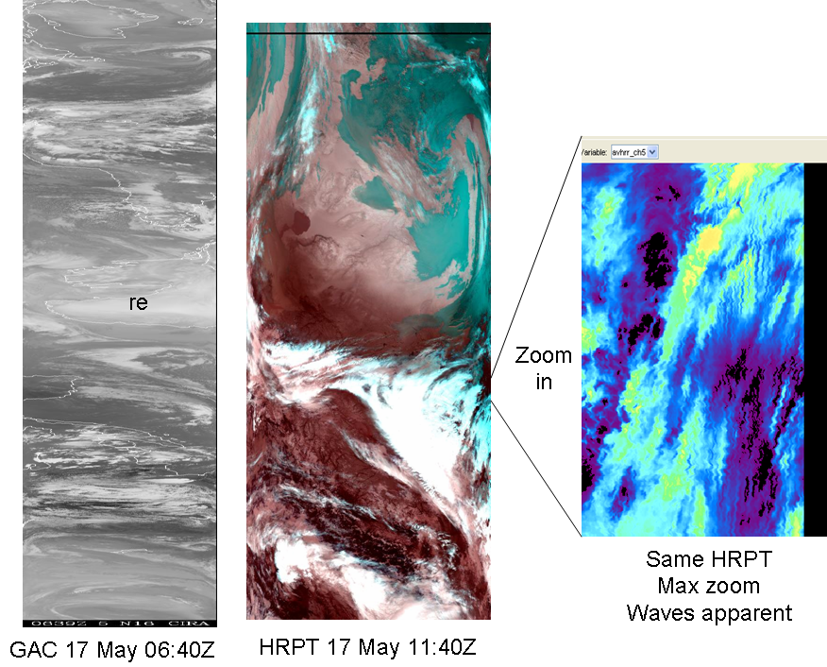

Illustration 16: N16 AVHRR Imagery & Synch Delta Analysis
(Synch delta trend is not favorable and, although they are occurring, no MIRP rephases are apparent in recent GAC imagery because of timing. They ARE occurring.)

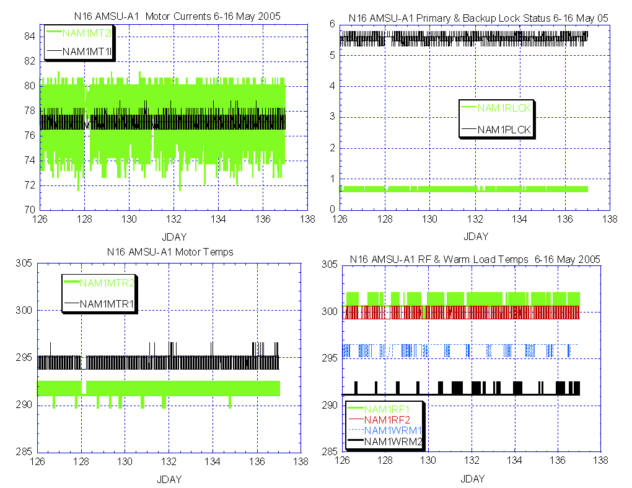

Illustration 17: N16 AMSU-A1 Health Analysis
(As nominal and stable as it has ever been. Nothing here to explain the degradation in products being experienced by products personnel.)

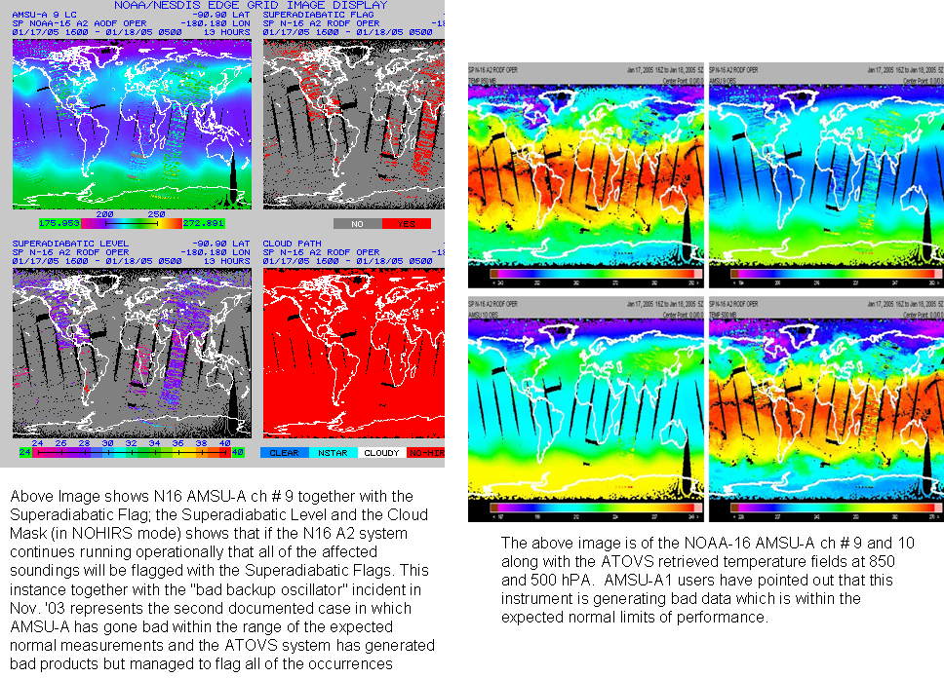

Illustration 18: N16 AMSU-A1 Products Analysis
(as outlined by Michael Chalfant)

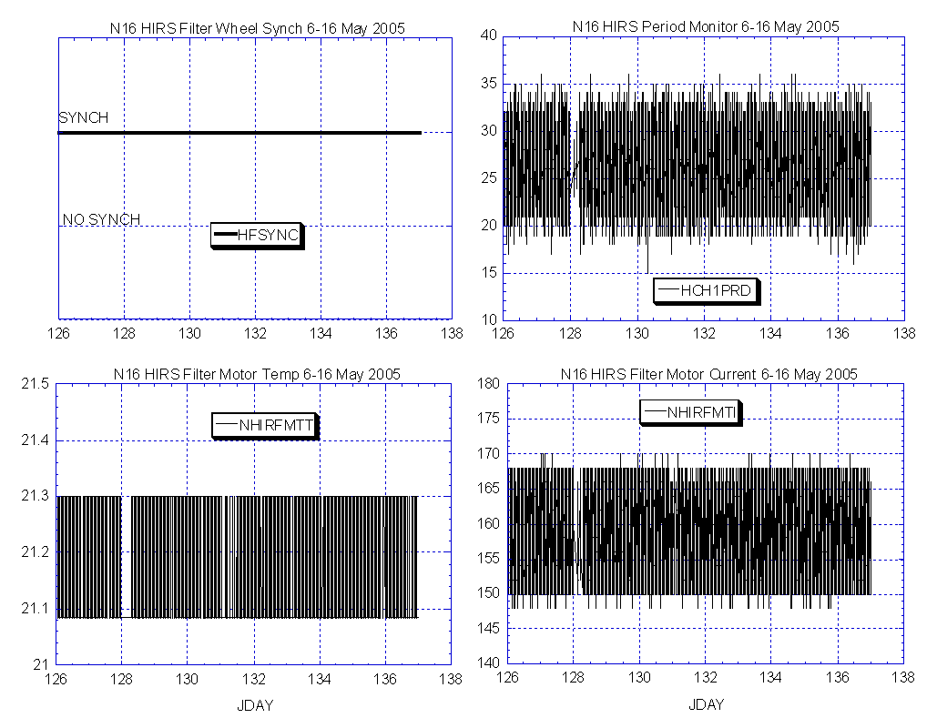

Illustration 19: N17 HIRS Analysis
(Generally stable and nominal)

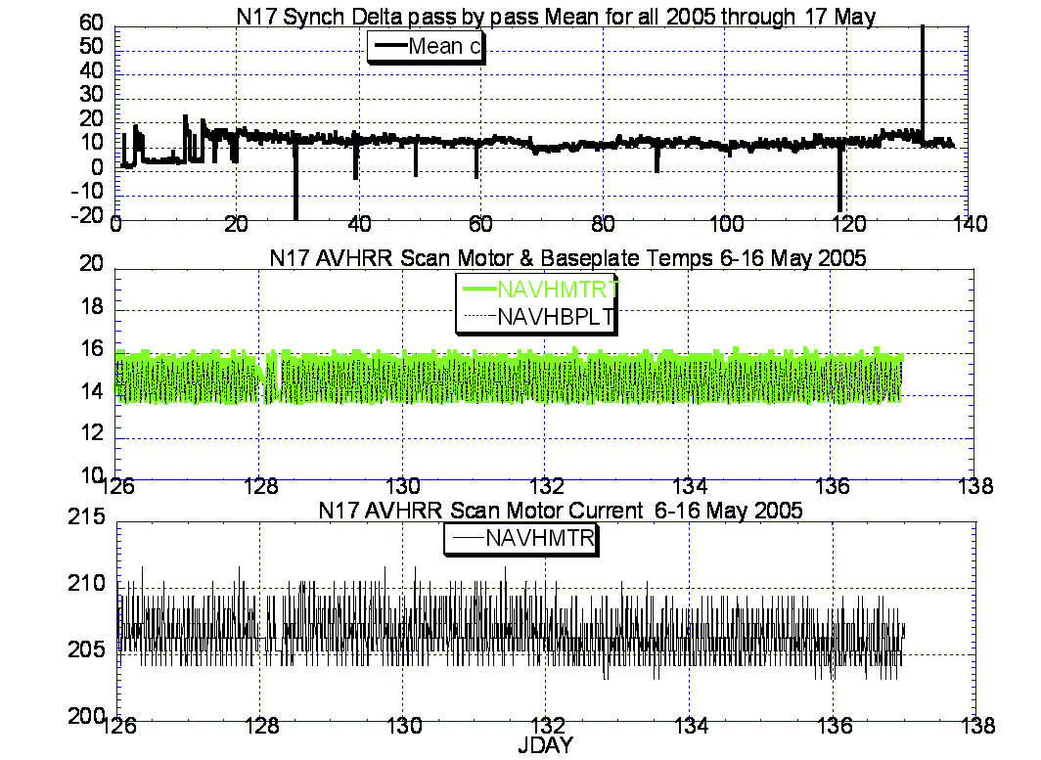

Illustration 20: N17 AVHRR Analysis
(stable and nominal)

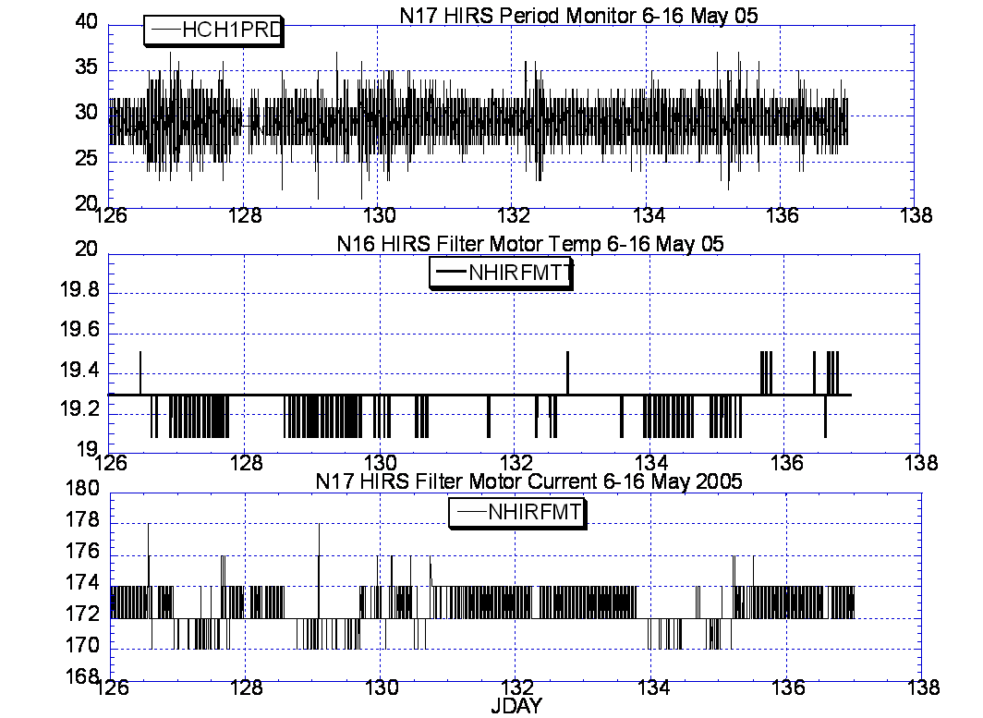

Illustration 21: N17 HIRS Health Analysis
(Slightly less stable on the filter wheel current than is typical but otherwise nominal.)

N17 MEMORY SCRUB REPORT

Last week

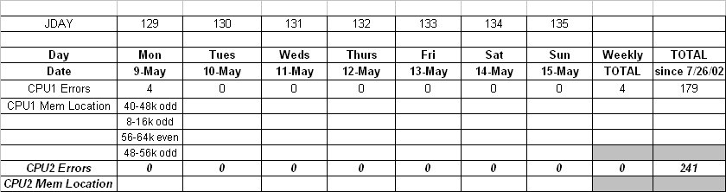

POLAR SPACECRAFT TIP CLOCK ERROR

WEEK ENDING May 13, 2005
DAY/DATE | NOAA-12 | NOAA-14 | NOAA-15 | NOAA-16 | NOAA-17
FRI. 05/06 | N/A | +178 msec | -160 msec | +089 msec | +037 msec
SAT. 05/07 | N/A | +178 msec | -161 msec | +088 msec | +037 msec
SUN. 05/08 | -721 msec | +183 msec | -161 msec | +089 msec | +038 msec
MON. 05/09 | -720 msec | +183 msec | -162 msec | +089 msec | +038 msec
TUE. 05/10 | -727 msec | +183 msec | -163 msec | +090 msec | +040 msec
WED. 05/11 | N/A | +178 msec | -164 msec | +089 msec | +040 msec
THU. 05/12 | N/A | +180 msec | -165 msec | +090 msec | +040 msec

EMOSS POC for this chart is JIM SHEPHERD

NOAA-12 *Alternating +/- 500 millisecond clock jumps will occur at 76-day intervals as long as fractional second daily ETCUP is utilized to manage clock drift..
Daily ETCUP bias of +6.5 mSec started on 12/10/03.
NOAA-14: As of 1223/03 the TIP clock is corrected daily by –7.0 msec to compensate for drift.
Subtracted 150 mSecs on 30 June
NOAA-15: As of 04/23/03 the TIP clock is corrected daily by –8 msec to compensate for drift.
Added 100 msec to spacecraft command clock on 31 Aug 04
NOAA-16: As of 12/23/03 the TIP clock is corrected daily by –5.5 msec to compensate for drift.
Subtracted 100 msec from spacecraft command clock on 31 Aug 04.
NOAA-17: As of 12/23/03 the TIP clock is corrected daily by –3 msec to compensate for drift.
Added 125 Msecs3 Feb 04.

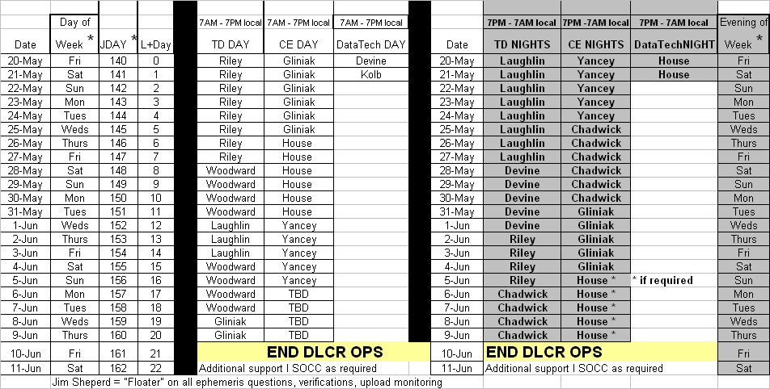

EMOSS ON CONSOLE SCHEDULE FOR 20 MAY LAUNCH OF N18

POES Engineering Contact List

Government

Renee Smith-Dearing NOAA POES Constellation Lead 301-817-4117
Dong Han: NOAA, POES Payloads 301-817-4127

Micky Fitzmaurice: NOAA, POES Bus, IJPS 301-817-4016
Nicolaie Todirita (Todi): NOAA Ground Systems 301-817-4229

EMOSS-2 Contractor

Jeff Devine: EMOSS POES Lead 301-817-4020
Jim Walters: EMOSS, POES Payload Engineer 301-817-4033

Angelique Riley, EMOSS, POES Comm and DHS 301-817-4028
Carl Gliniak, EMOSS POES Power and Thermal 301-817-4207

Jim Sheperd, EMOSS POES Attitude Control 301-817-4030
Jon Woodward EMOSS, POES Flight Software C&CS 301-817-4019

Sally House EMOSS POES Payloads 301-817-4026
William Chadwick EMOSS, POES Comm and DHS 301-817-4015

