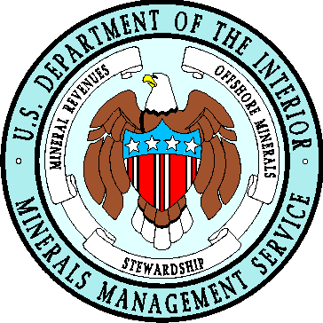 | OCS MAPPING INITIATIVE  The Multipurpose Marine Cadastre | 

On August 8, 2005, President George Bush signed the Energy Policy Act of 2005 (P.L. 109-58). Sec. 388 – Alternative Energy-Related Uses on the Outer Continental Shelf, of the Act grants the Minerals Management Service (MMS) new authority to regulate alternative energy uses on the Outer Continental Shelf (OCS). Moreover, it directs the Secretary of the Interior, in cooperation with the Secretary of Commerce, the Commandant of the Coast Guard, and the Secretary of Defense, to establish an OCS Mapping Initiative to assist in decision making related to alternative energy uses on the OCS. The goal of the initiative is the identification of OCS locations of Federally-permitted activities; obstructions to navigation; submerged cultural resources; undersea cables; offshore aquaculture projects; and any area designated for the purpose of safety, national security, environmental protection, or conservation and management of living marine resources.

The repository of this data will be the Multipurpose Marine Cadastre - an integrated submerged lands information system consisting of legal, e.g., property ownership or cadastre, physical, and cultural information in a common reference framework. It will be an ambitious, multiyear endeavor that requires joint planning, interaction, and commitment by Federal, State, local, territorial, and tribal entities working through public and private partnerships.

Cadastral Data - the geographic extent of the past, current, and future rights and interests in real property including the spatial information necessary to describe the geographic extent. Rights and interests are the benefits or enjoyment in real property that can be conveyed, transferred, or otherwise allocated to another for economic remuneration.

Implementation of the Multipurpose Marine Cadastre will allow MMS managers and technical staffs, at Federal agencies; coastal States; local, territorial, and tribal governments; private industry; and the academic community, to directly access information and resources necessary to promote and conduct good ocean governance.

Official data associated with the themes identified below, are to come directly from the Agency of Responsibility (AOR). All data within the Multipurpose Marine Cadastre will conform to existing data standards and contain supporting metadata. AORs will ensure that their data are accurate and up-to-date.

If a comprehensive Multipurpose Marine Cadastre is going to be implemented in the most efficient and practical manner, it will require open communications amongst all stakeholders.

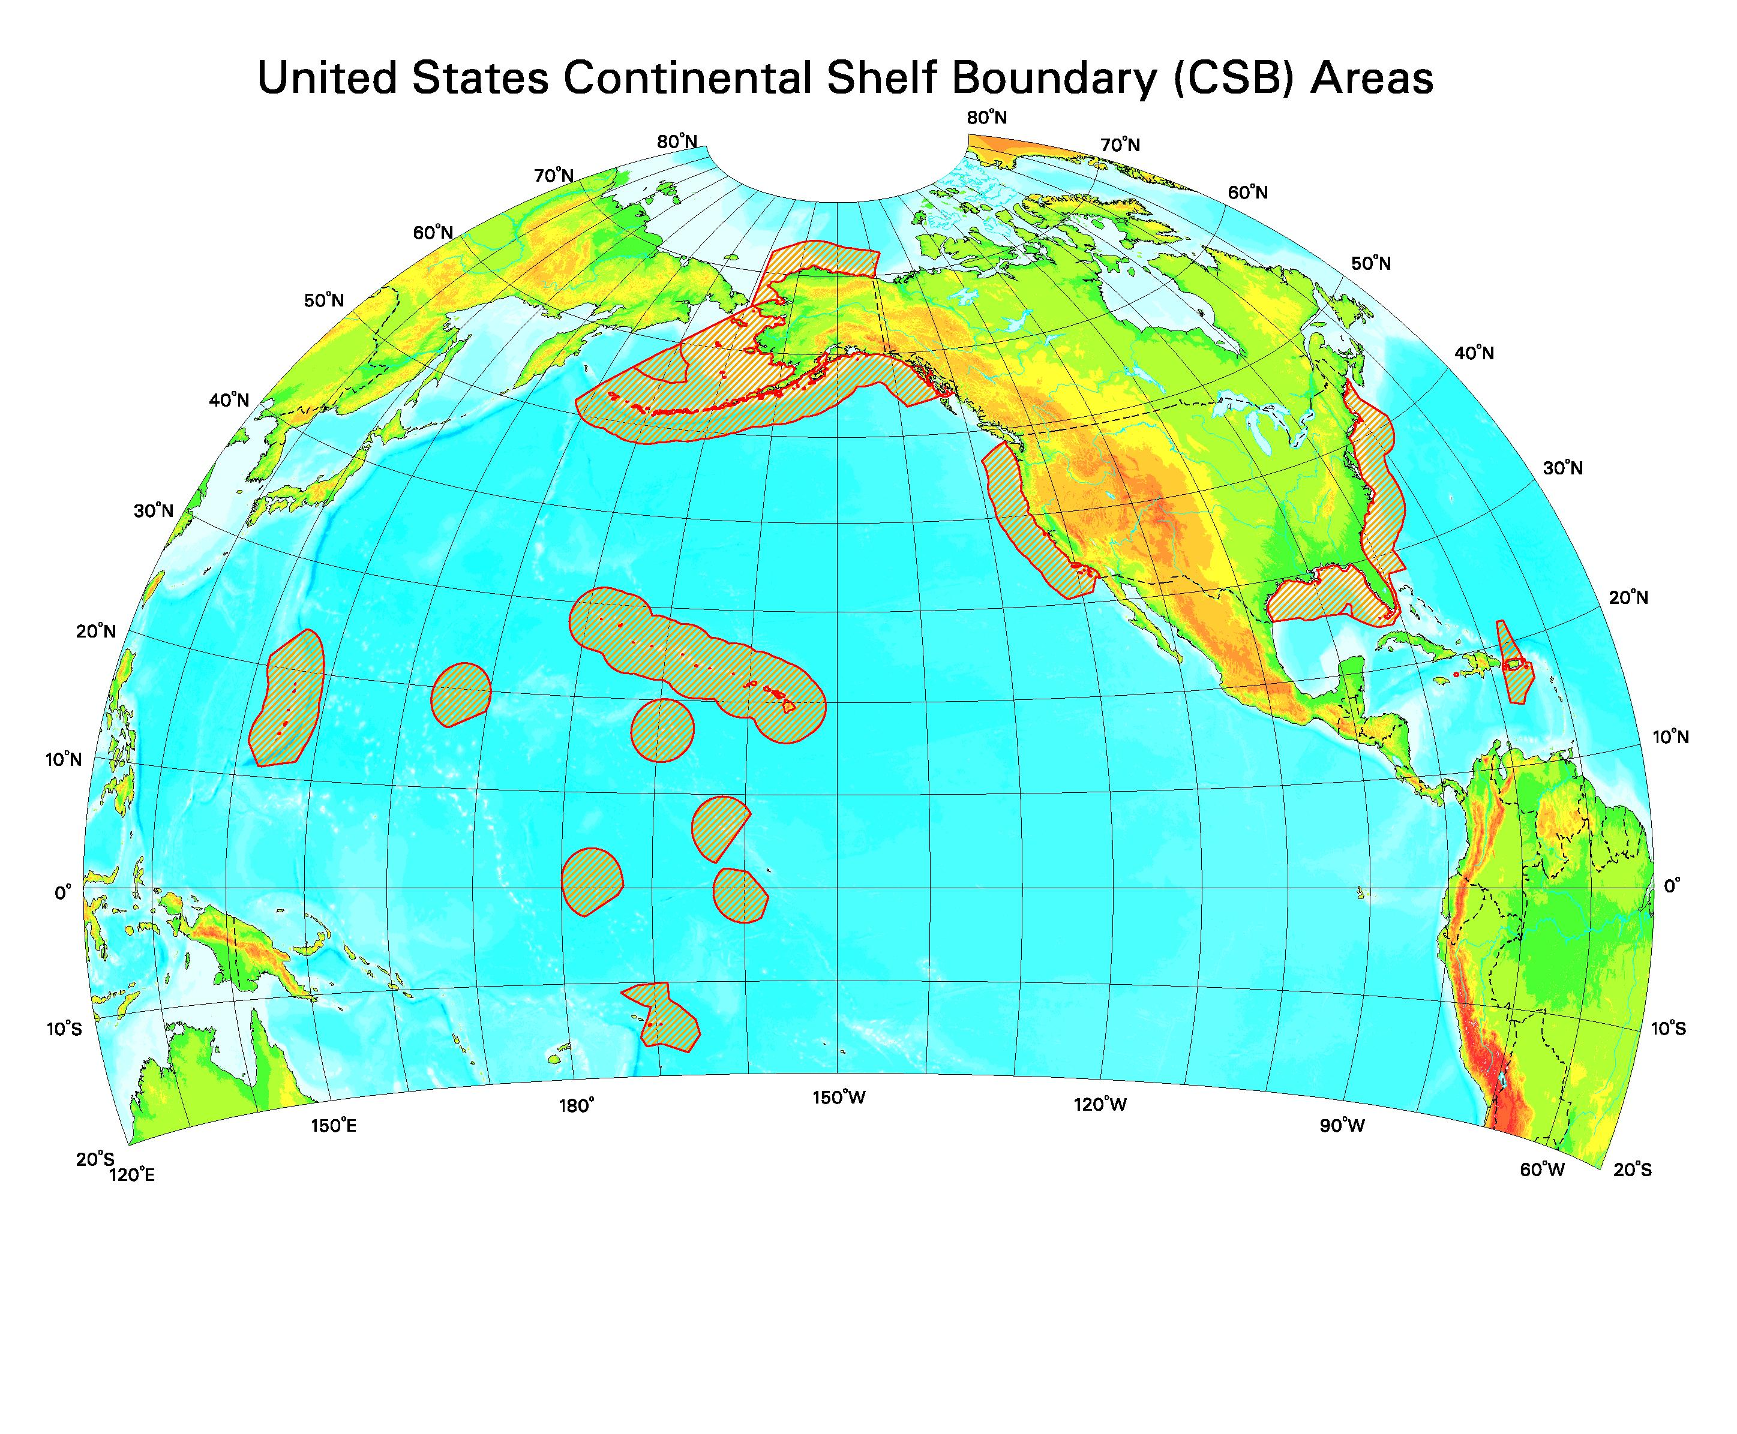
When considering the legal framework for the Multipurpose Marine Cadastre, four questions must be taken into account. First, what types of rights exist in a marine context? Second, what laws define those rights? Third, what is the hierarchy of precedence among those rights? And fourth, how do these various rights interact with one another?

Potentially every appropriate law, boundary, restriction, Army Corps of Engineers permit, or obstruction e.g., pipeline, undersea cable, artificial reef, etc., located in the marine environment could interact with and potentially impact the decisions managers make in fulfilling their mission responsibilities. A comprehensive Multipurpose
Marine Cadastre must be dynamic and include, but not limited to, the following data themes.

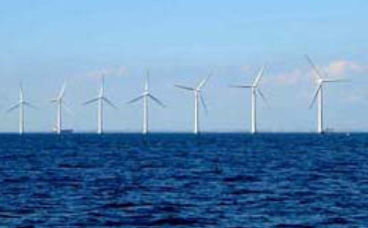

Primary Cadastre Data Themes

1. Universal Transverse Mercator (UTM) Grid
System
2. National Baseline
3. Coastline

4. Submerged Lands Act boundaries
5. Territorial Submerged Land Act Boundaries
6. Official Protraction Diagram & Leasing Map
(MMS)
7. Maritime boundaries and Zones
8. Marine Managed Areas (MMA’s)
9. Marine Protected Areas (MPA’s) Parks,
Sanctuaries, Etc.
10. Administrative Boundaries (MMS)

Supporting Data Themes

1. Sand Borrow Areas
2. Pipelines
3. Undersea Cables
4. Artificial Reef Sites
5. Shipping Fairways, Anchorage Areas etc.
6. Bathymetry
7. Military Restricted Areas including military dump
sites
8. Platform Locations & Platform Structures (Type)
9. Alternative Energy Sites, e.g., wind, wave, tide,
and solar
10. Archeological Sites
11. Aquaculture Sites
12. Oil & Gas Leases
13. Alternative Energy Leases
14. Liquid Natural Gas Facilities
15. Essential Fish Habitat (EFH)
16. Fishery Regulatory Closures
17. Protected Species Information/Critical Habitat
18. Dynamic Area Management Zones
19. No Discharge Zones
20. National Estuaries Program
21. Geohazards – faulting, slumping, sliding, etc.
22. Other Data Themes as appropriate

The successful development, implementation, and maintenance of the Multipurpose Marine Cadastre is contingent on our ability and willingness to proactively approach and resolve issues, to develop effective meaningful partnerships, to share information, and maintain open communications.

You are invited to participate. Contact:

Steve Kopach, Chief – MMS Mapping & Boundary Branch, (703) 787-1312
Stephen.Kopach@mms.gov
LINKS:

http://www.mms.gov/ld/PDFs/MappingInitiative.pdf - Multipurpose Marine Cadastre implementation plan.

http://geodata.gov – your one stop for finding and using geographic data.

http://thomas.loc.gov/cgi-bin/query/z?c109:H.R.6: - The Energy Policy Act of 2005

http://www.whitehouse.gov/omb/circulars/a016/a016_rev.html - OMB Circular A-16 regarding coordination of geographic information and related spatial data activities.

http://ocean.ceq.gov/welcome.html - The Committee on Ocean Policy coordinates the activities of executive branch departments and agencies regarding ocean-related matters.

http://www.csc.noaa.gov/mbwg - FGDC Marine Boundary Working Group web site and data portal.

http://www.csc.noaa.gov/mcsd - FGDC Marine & Coastal Spatial Data Subcommittee.

http://www.fgdc.gov – The Federal Geographic Data Committee.

http://www.oceanservice.noaa.gov/dataexplorer/datasites/welcome.html - NOAA, NOS Data Explorer.

http://www.csc.noaa.gov/legislativeatlas/ - The Legislative Atlas supports regional ocean and coastal management efforts by mapping key state and federal laws and jurisdictions.

http://www.mms.gov/ld/maps.htm - MMS maps and GIS data.

http://ocsenergy.anl.gov/index.cfm - the online center for public information and involvement in the OCS Renewable Energy and Alternative Use Programatic Environmental Impact Statement.

http://www.mms.gov/offshore/RenewableEnergy/RenewableEnergy/Main.htm - information on the MMS renewable energy and alternative use programs.

http://www.openoceans.org – improving collaborations on ocean investigations.

