Description of the Tsunami/ Seismic Monitoring Station
Installation at the Smithsonian Tropical Research Institute
Barro Colorado Island, Panama
(BCI)

DESCRIPTION OF THE SITE LAYOUT

Vault Location
Photo “A” shows the Concrete path which runs to the north end of the developed area of the Smithsonian Tropical Research Institute (STRI).The proposed vault location is at the end and to the left of the pathway near building G. The site is covered by dense second growth vegetation. The terrain is relatively flat with an increase in elevation the further one moves off the pathway to the left (south) and decreases in elevation to the north. The site has been marked with stakes but due to the dense growth, photos do not show the site with any clarity.

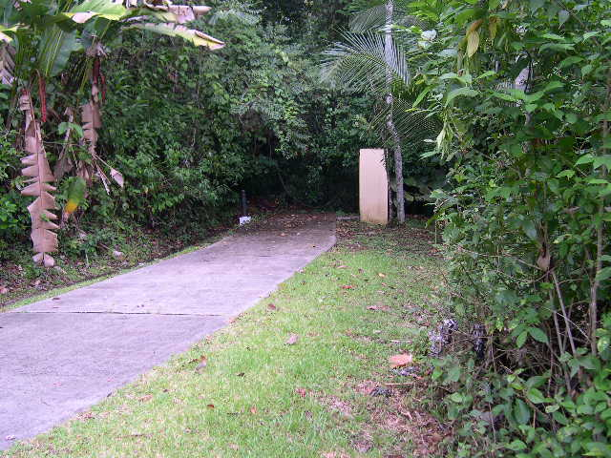
Photo A

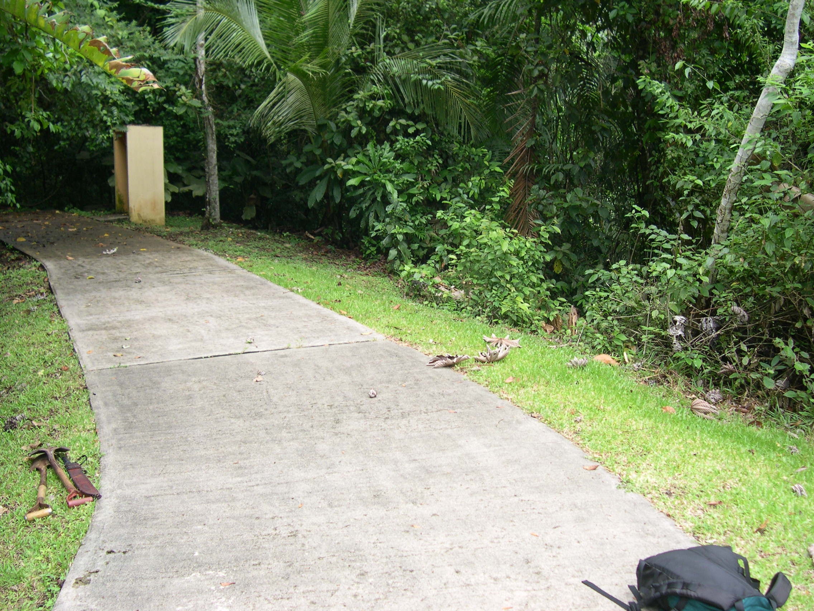
Photo B

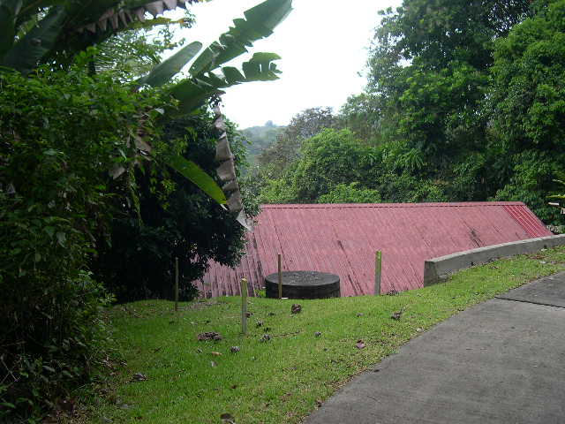
Photo D

Power System
The power system will be installed on a concrete pad measuring 10 feet X 7 feet X 6 inches (3.04 meters X 2.13 meters X .152 meters). This concrete pad will be located near the path shown in photo “D”. The concrete pad will be fabricated with 3 PVC conduit connections installed up through the pad. These conduit runs will connect utility power, VSAT connections, and signal connections from and to the seismic vault. There will also be an earth ground connection near the conduit. See attached drawing.

The power system is a unitized assembly permanently mounted by the manufacturer on a corrosion resistant steel pallet for ease of shipping and handling.
This power system is used to power all of the electronic equipment of the station. It is a 48 VDC power supply which is connected to the AC power distribution system at BCI. It has the capability of independently powering the station equipment for several days in the event of a general power outage at BCI. The power system electronics is housed in a weather proof enclosure for physical protection. Other containers are also mounted on the pallets which are used to distribute power and signals to the appropriate locations as well as a convenient place for housing communications and other equipment.

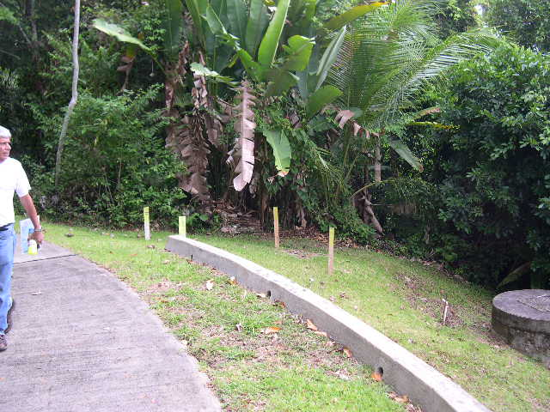
Photo C

VSAT
The VSAT satellite dish will be transmit and receive digital communications between the USGS and the computerized data collection system. The satellite dish will be installed on the north end of building “G”. Photo “E” shows the view to the south from the north side of Building “G”. The wooden stake at the center of the rounded hill is the location of the steel dish mounting post. This post will be supplied by the USGS and will be installed according to the attached drawings.

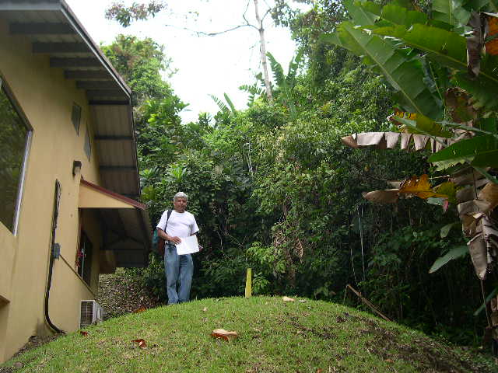
Photo E

Conduit Connections
PVC conduit will be used to route all cabling between each of the three main components of the site (VSAT, Power Pad, and the Seismic Vault.) The conduit will run to the right of the concrete path shown in photos “A” and “B”. The attached drawing shows the conduit layout between the different components of the system.

Seismic Vault
The Seismic Vault is the heart of the monitoring station. It will be used to contain two ground motion sensors; A tri-axial high gain seismometer which will be the main sensor and a tri-axial strong motion sensor that is bolted down to enable the sensor to track actual ground motion in the event of a high acceleration local earthquake.

The installation of the vault is a fairly complex procedure involving digging a large hole 10 feet X 10 feet ( 3 meters X 3 meters) to a depth of approximately 10 feet (3 meters), installing concrete forms at the bottom of the hole and placing about 3 cubic yards (2.3 cubic meters) of concrete. While the concrete is still wet the vault housing which weighs 800 pounds (363 kilograms) is placed on the concrete. The hole will then be carefully backfilled around the vault housing. Once the hole is backfilled more concrete will be placed inside, on the floor of the vault housing to a depth of about 6 inches (15 centimeters)

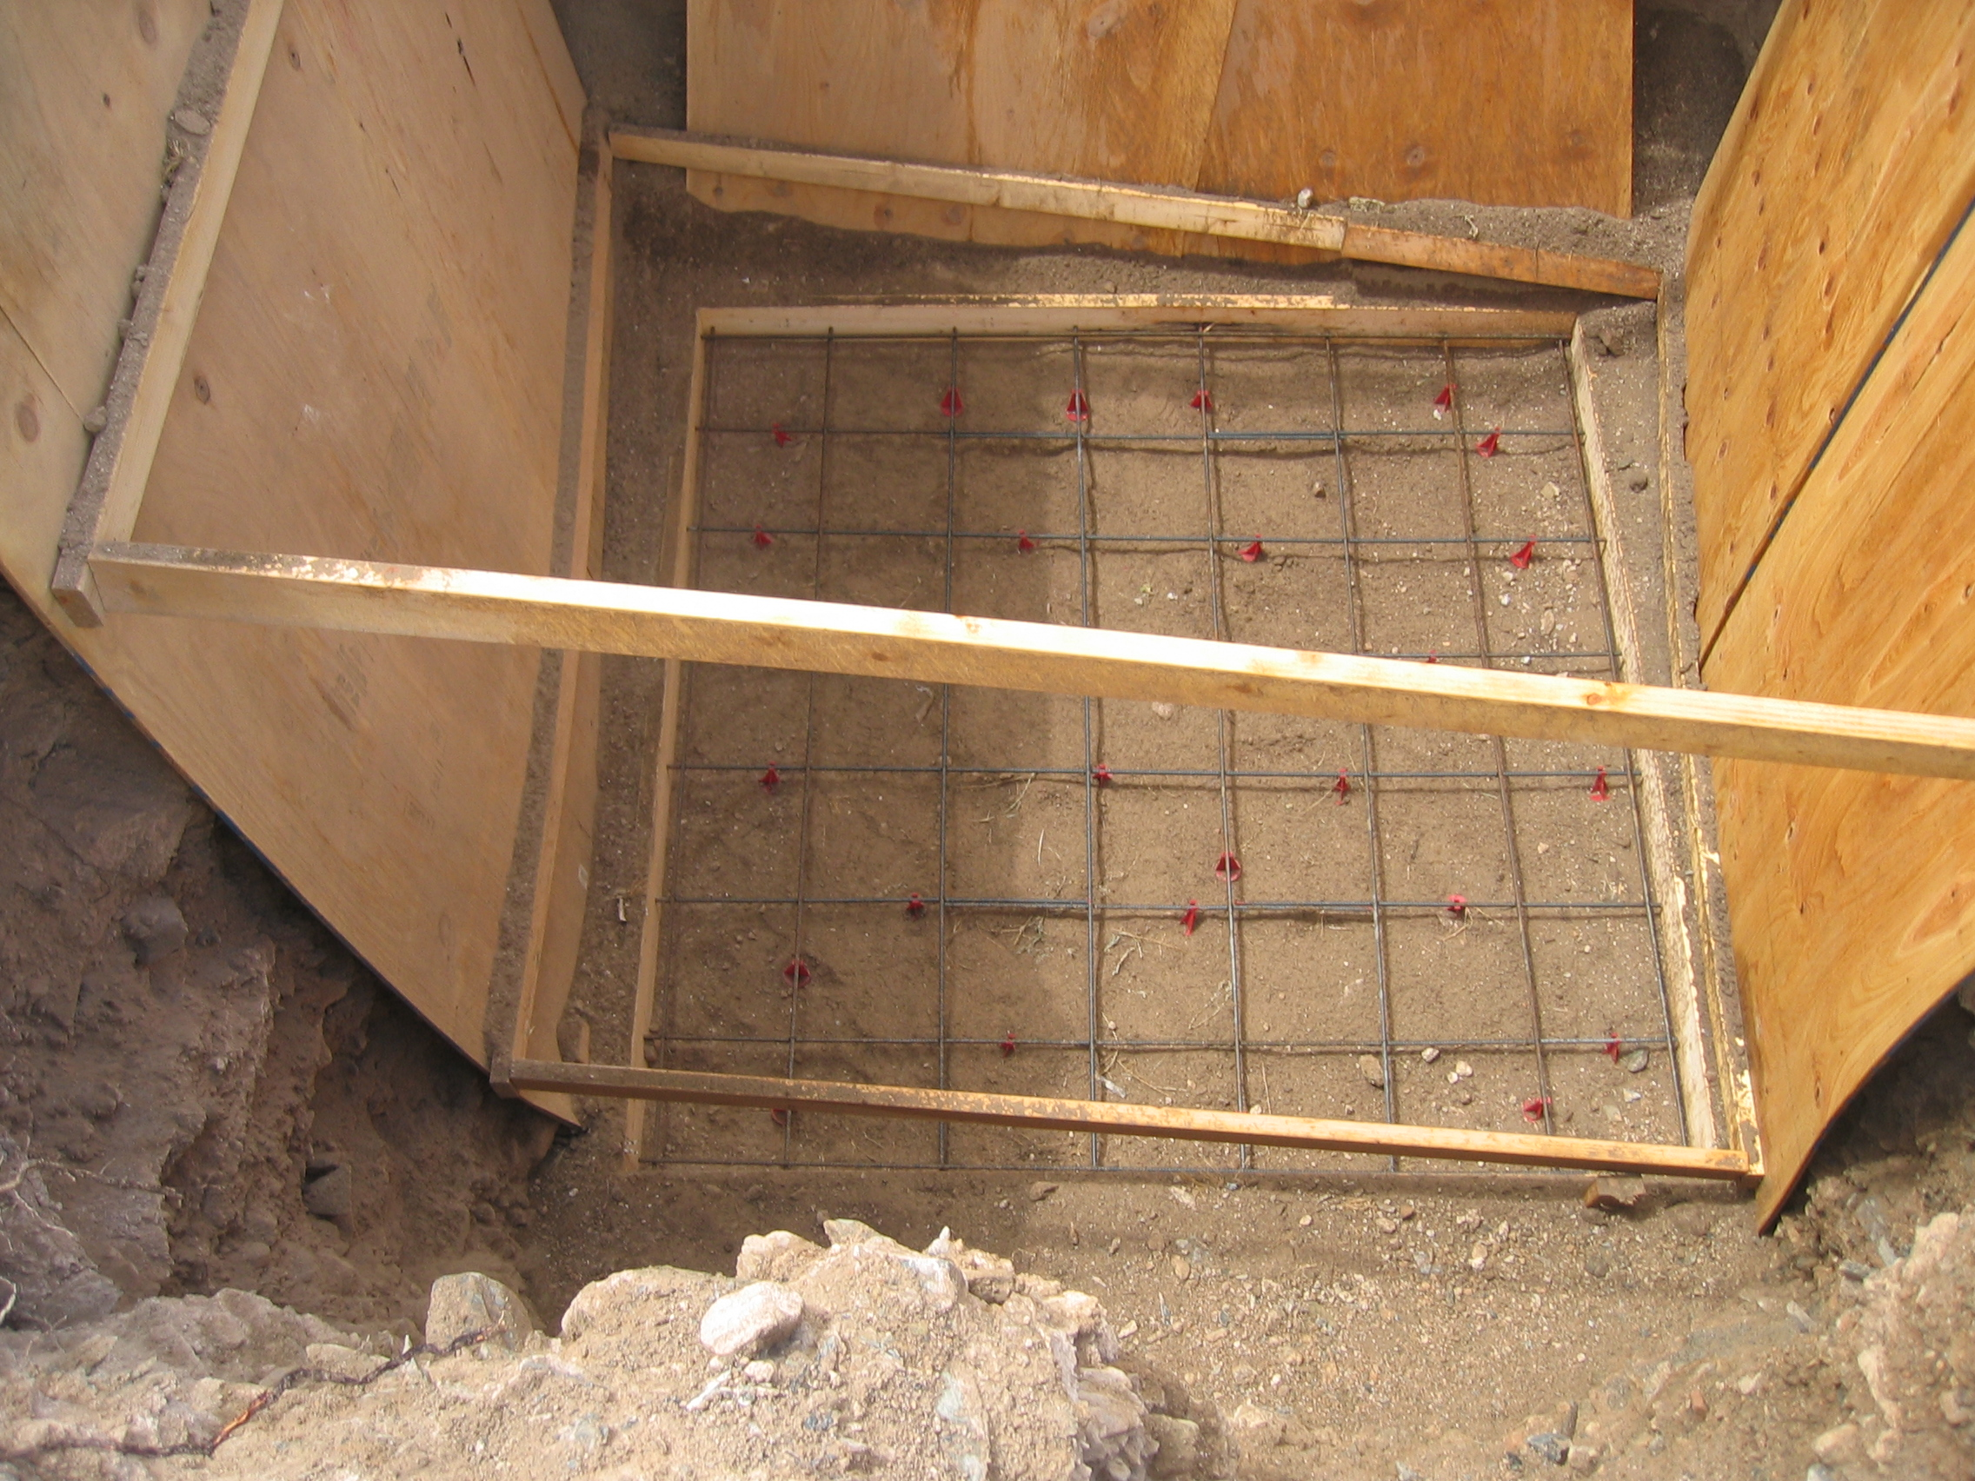
Photo F

Photos “F” “G” “H” show the same type of vault enclosure, being installed near Albuquerque New Mexico, that will be installed at BCI. Photo “F” is of the concrete forms with the reinforcement bars in place. When completed the Vault enclosure will rest on the concrete pad. The plywood in the photo was used to keep stray soil and rock from falling into the concrete form. See attached drawing.

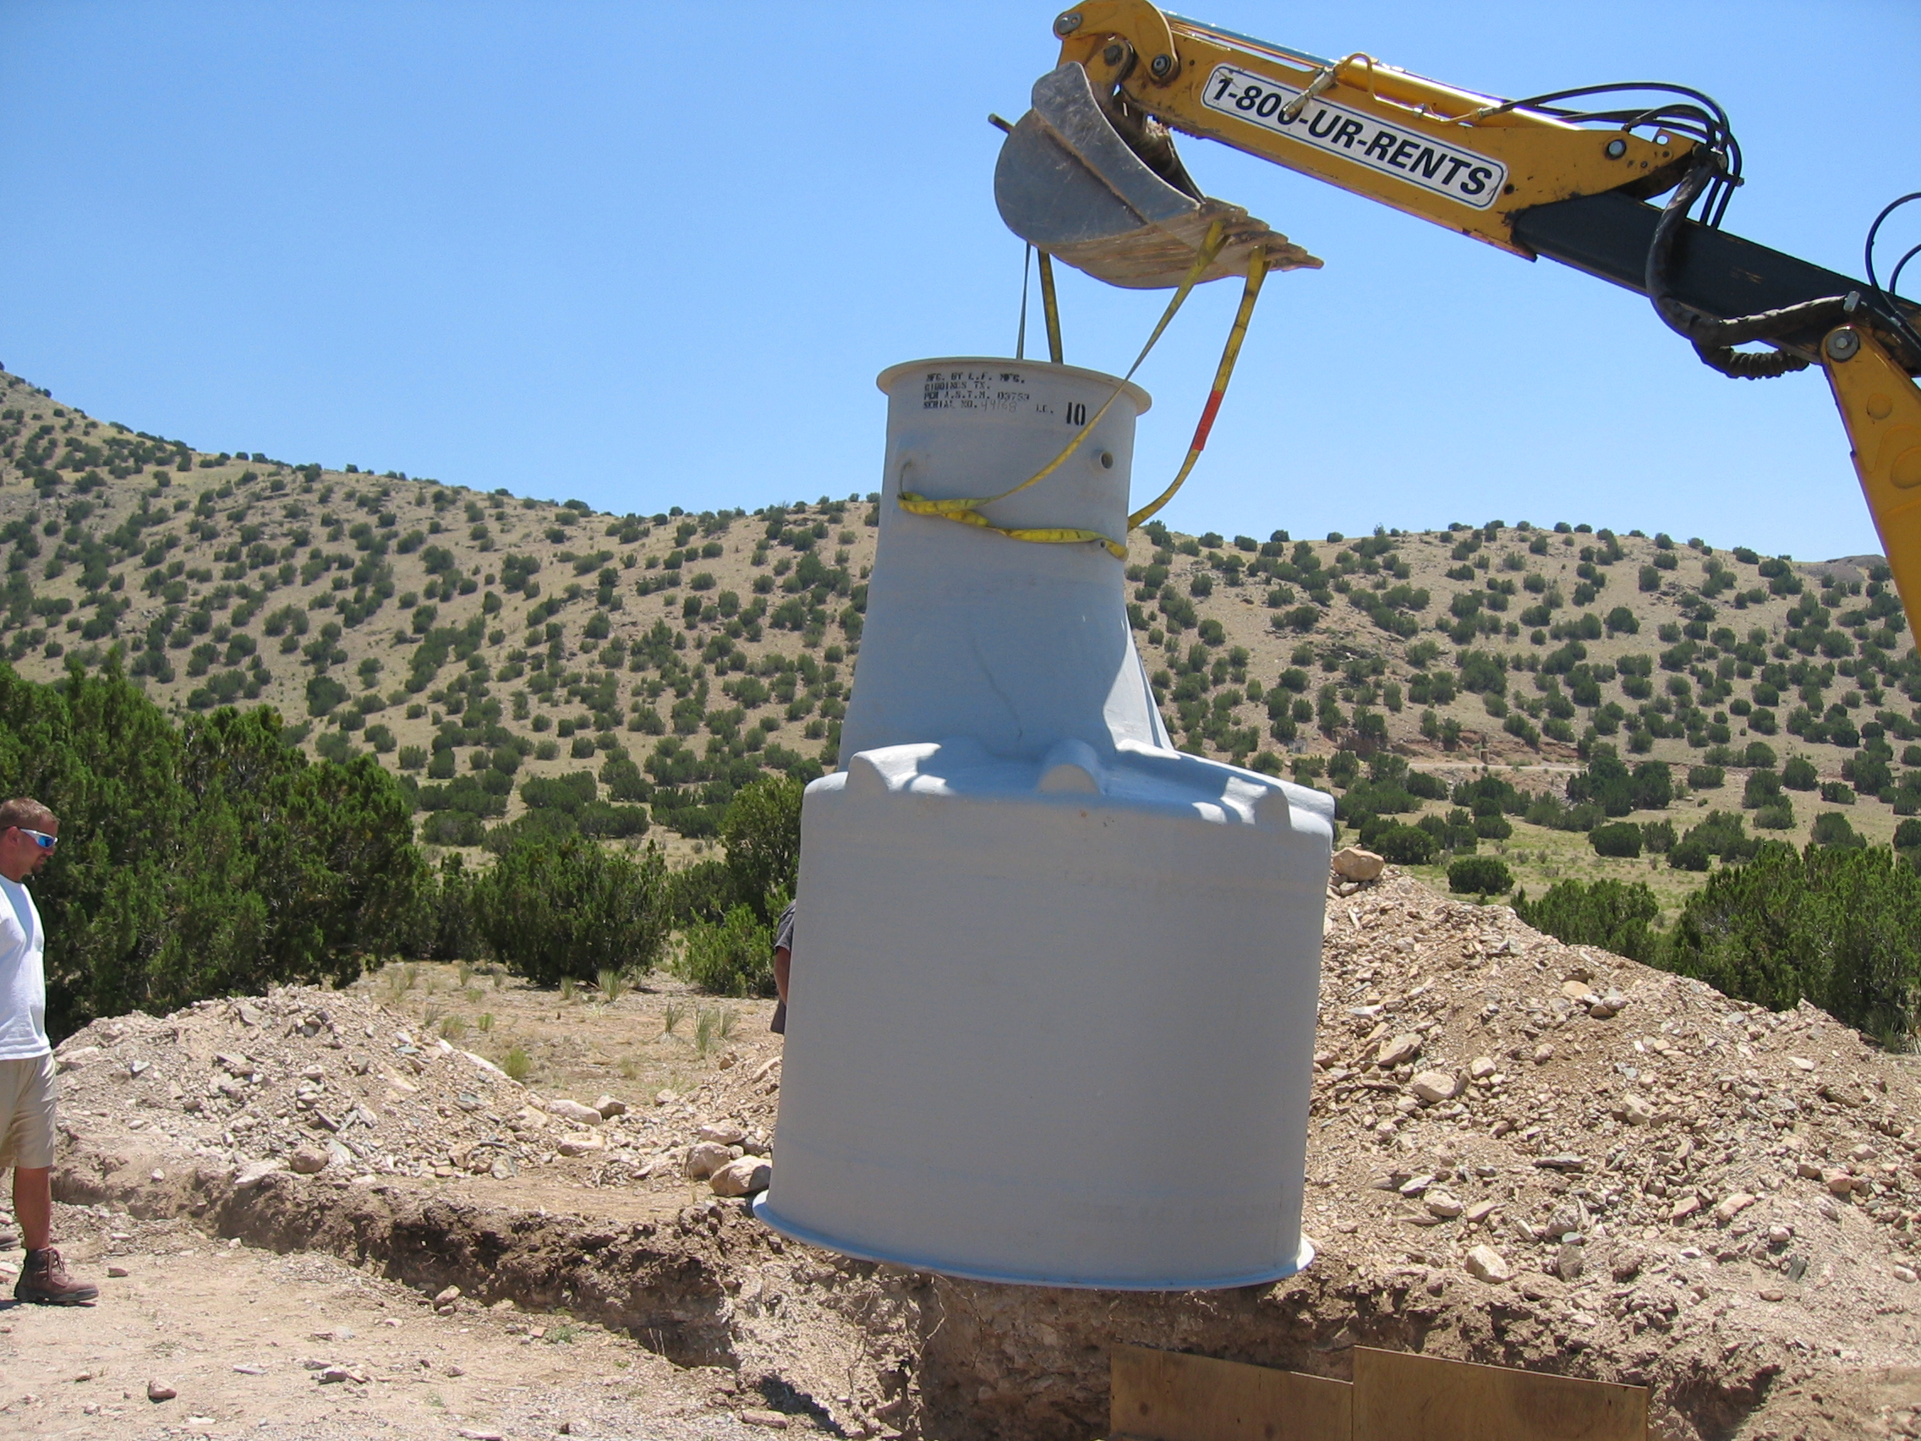
Photo G
This photo is of a tracked excavator lowering the vault housing into the hole.
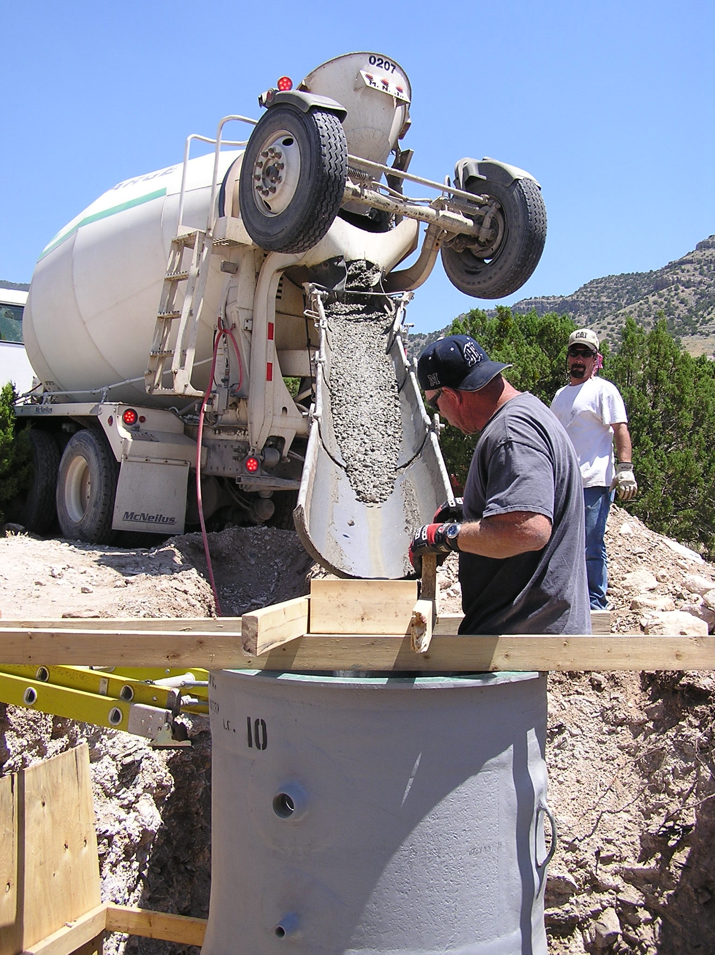
Photo H
Placing concrete in the vault housing.

After the Vault is set on the concrete pad more concrete will be placed inside on the floor of the Vault. Normally this can be done just after setting the vault but at BCI the hole will require backfilling around the Vault so that direct access of the interior of the Vault can be accomplished for placing the floor concrete.

The seismic vault is 96” in diameter at the base and 36” at the top. Due to the weight this style of vault has in the past been installed where a standard size backhoe or an excavator has good access. That does not appear to be possible at BCI. Using a “Bobcat” or “skid steer” type loader, or if a small “tracked” excavator, to accomplish the required excavation of the hole and placement of the fiberglass vault in the hole might be a viable solution.

Expected difficulties at BCI
Some thoughts about the unique problems that likely will be encountered at BCI. These thoughts are not necessarily recommendations but they are intended to stimulate solutions for these problems.

- Transporting materiel
Obviously the installation is made more difficult due to the site location and the necessity of using boats for transporting materials and manpower.

- Excavation of vault hole
There are two areas which give major concern; the excavation of the vault hole and, the mixing and placement of concrete for the vault pad. The holes relative size and depth presents unique problems involving the actual excavation of the soil at the site. This might be resolved by excavating a shallow sloping approach downward to near the target depth of 10 feet (2.54 meters) using a “Bobcat” or “skid steer” type machine. The bucket must have teeth installed on it if it is to handle the relative well consolidated soil. A smaller tracked excavator might also be useful in excavation and reduce the manpower needed to hand dig areas of the hole but also could be useful in digging the conduit trenches at the other locations. Hand digging the trenches and the vault hole is also a possibility.
- Concrete
The concrete needed for the vault pad is required to be mixed and placed quickly. It is imperative that the vault enclosure be placed on the concrete while the concrete is still wet. Mixing the volume of concrete needed is not a serious issue if there are enough powered mixers available. The quick placement of concrete will only be required with the vault pad. The following are location and estimated amounts of concrete that will be needed.

  - VSAT post 1 cubic yards (.68 cubic meters)
  - Power Pad 1.3 cu yd (1 cubic meter)
  - Vault installation
- Vault Pad 3 cubic yards (2.3 cubic meters) for pad and
- Interior Vault floor .9 cubic yards (.7 cubic meters)
  - VSAT mount .9 cubic yards (.7 cubic meters)

4. Handling Vault housing
The Vault enclosure weighs approximately 800 pounds (364 Kilograms). The enclosure must be staged so that it might be placed quickly and accurately on the wet concrete of the vault pad.
- Weather
Mud may be an issue at the excavated vault hole.

