Solar Orbiter – Payload Working Group

Action Completion Form

Action ID Number: 1.1 (EUS) & 1.2 (EUS)
Responsible Working Group Member: Richard Harrison & Louise Harra
Date of Completion: Var. 1 – 6/9/02; Var. 2 – 12/9/02
Action: Thermal feasibility study for EUS instrument/Adaptive Optics

Report: This report covers two areas. First we discuss the basic outcome of thermal studies for EUS design concepts. Secondly, recognising the variable thermal loads we discuss the possible use of adaptive optics.

EUS Thermal Study

A preliminary thermal study has been performed of two proposed designs for the EUS. This has been done through the RAL by a Cranfield University MSc student (Mattieu Gasquet) working closely with the solar group at RAL (see reference). The two designs include: (1) an off-axis normal incidence (off-axis Ritchey-Chretien) design with 120 mm aperture (due to Martin Caldwell, RAL), and (2) a 35x35 mm aperture stigmatic grazing incidence Wolter II design (due to Luca Poletto, Padua). Both systems use a variable line spaced grating in normal incidence. The optical discussion is not included here.

To tackle the thermal situation it was assumed that a radiator area up to the size of the instrument footprint may be used. Various surface coatings were considered. For the NI design, the off-axis design allows a significant heat stop between primary and secondary; thus, the critical area to consider is the heat load on the primary. The Wolter II design uses grazing incidence and, thus, a reduced aperture, which makes the thermal load much more manageable. The heat loads on the primary mirrors for the two designs are 41 W and 380 W for the Wolter II and the NI design, respectively.

Refer to Gasquet (2002) for the full analysis. However, for comparison let us examine a steady state situation at 0.2 AU, and fix the mirror temperature at 61⁰ and the radiator temperature at 50⁰. For various mirror coatings for the Wolter II option (e.g. gold, platinum, silicon-carbon) the radiator size required ranged from 0.0313 to 0.0935 m². The instrument footprint might be of order 0.3 to 0.5 m². Similarly, for the NI design, the radiator size ranged from 0.51 to 0.92 m². These figures assume some absorption from the back of the spacecraft heat-shield (because it extends beyond the edge of the payload module). The NI figures, for example, come down by a factor of up to three if this is negligible. Thus, for this static 0.2 AU case, the Wolter II design is feasible and the off-axis NI design is borderline, but feasible for certain materials if the absorption from the heat-shield is not severe.

The off-axis design is clearly more challenging and was considered using a time dependent model, which mimics the orbit. This model showed that the primary mirror temperature varies considerably during the orbit. The absolute temperatures could be controlled to some extent by using different mirror coatings, different heat-shield parameters, different radiator sizes and conductivities. However, considerable temperature variations were found over the orbit, e.g. the orbital temperature variation of the primary mirror ranged from 100⁰ to –50⁰ C for one case, 180⁰ to 0⁰ C, and 31⁰ to –120⁰ C for others. A full range of 150⁰ is typical over the half-orbit period. Preliminary considerations of a heat-switch to the radiator show that some reduction is possible in the extreme ranges, but we are still looking at a significant range in temperature and a rather spikey temperature profile. This could be brought down and smoothed by a more sophisticated heat-switch arrangement and optimisation of the thermal design but, at this stage, it is not clear that a NI approach is feasible from a thermal point of view. It should be stressed that the current study has concentrated on the optical components and the temperature of the structure is of paramount importance. Further improvements could be made from a spacecraft wide strategy, e.g. radiator viewing directions, heat shield absorption minimisation, spacecraft/payload wide cooling rather than instrument level cooling strategy etc…

New Technologies: Adaptive Optics

One approach to cope with some aspects of the thermal situation, which will be encountered by Orbiter is the use of adaptive optics. The Smart Optics Faraday Partnership is investigating this and a number of areas have potential for being used in space. Solar Orbiter will be in such an extreme environment that it seems to be an ideal candidate for such systems. For example, mass savings can be achieved from relaxation of the mechanical constraints imposed by the requirement to align complex optical systems prior to launch, by use of smart optics to correct for alignment errors in a lightweight optical system post-launch. Savings can also be obtained by relaxing constraints on the thermal design, by using adaptive optics to correct for thermally introduced optical aberrations in-flight.

Applicable technologies for Solar Orbiter might be:

- Aluminium mirrors: robust and easy to control thermally—possibly as part of an isothermal design where the physical relationships between the optical components are self-correcting; Aluminium has been predominately used in infrared and X-ray space telescopes, but there has been little use of aluminium for optical ground or space based telescopes. Aluminium mirrors were considered for the VLT primaries and prototype mirrors were made (by REOSC) that were within the specs, though glass was eventually chosen;

- Deformable mirrors: another method of controlling the focus and image quality. Not only can these mirrors be lighter than monolithic types they can also represent an overall system improvement when considered as part of an adaptable structure. A diagram showing a typical system is shown in Figure 1. It is very important to notice here that the closed-loop bandwidth requirements for a self-focussing system in the Solar Orbiter are trivial compared with the performance required to achieve real-time correction of atmospheric distortions in terrestrial telescopes. Atmospheric AO systems have an update rate of ~1000Hz (giving closed loop bandwidth of ~100Hz). An active optics systems for space (primary
mirror support system for example) can work very much slower, at 0.1-10Hz perhaps. Various types of deformable mirror are currently available such as thin ceramics controlled by piezo-actuators, bimorph mirrors (two sheets of piezo electric material), and thin membrane electrostatically deformable mirrors. For the Solar Orbiter however, a metallic (perhaps aluminium) deformable mirror controlled by actuators would probably be preferable due to its high thermal conductance which allows heat to be conducted away easily and limits thermal distortions to large spatial frequencies, mainly defocus, which can be corrected by its adaptive nature. For the Solar Orbiter the number of actuators would probably be quite low (10–20) as the only low spatial frequencies would have to be corrected. Various low-precision actuators have already been used in space, but less work has been done so far on the high precision actuators likely to be needed for Solar Orbiter. Work is ongoing in this area, however, for example the high accuracy position actuators by Energen Inc. which are low power, light weight and capable of cryogenic operation; There would also need to be some sort of wavefront sensing in the system to measure the mirror distortion and provide feedback to the mirror. This could be achieved with a separate wavefront sensor or the science detector alone.
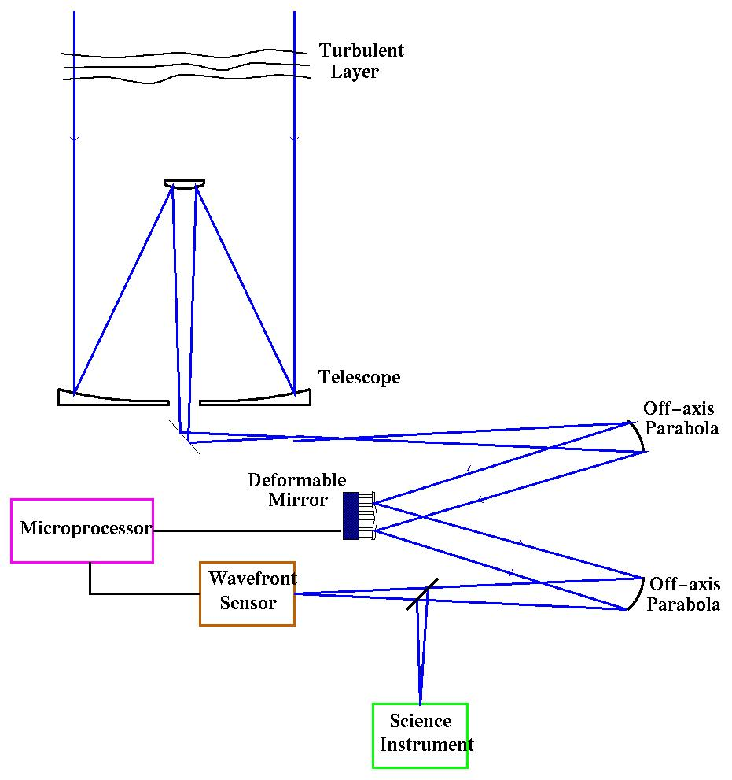
Figure 1: “Classical” Adaptive Optics System
This diagram shows a typical layout of the components used for correction of atmospheric turbulence. In this configuration a share of the incoming light is picked off and distortions in the wave front are measured by the wave front sensor, typically with reference to a guide star. The processor system can then calculate the correction that is needed in the optical path and the necessary shape is applied on the deformable mirror.

- Thermochromic Coatings: Scaling a radiator to keep a primary mirror cool enough during perihelion is likely to lead to too great an oscillation in temperature as the spacecraft progresses around its orbit. A thermochromic surface that can vary its emittance would solve this problem with no moving parts or control systems necessary.

With regard to the adaptive optics concept, the precise requirements need to be considered in detail by any proposing instrument team. The inclusion of the concept here does not necessarily imply that this approach can provide the mass saving or the necessary responses (in time and space) required for any particular design. This needs to be studied, and is being considered by the UK-led consortium considering an EUS proposal.

Conclusion:
- Two EUS designs were considered. We believe that a Wolter II design option is feasible from a thermal point of view, but an off-axis NI design requires considerable work to demonstrate thermal feasibility.
- Further work is to be done on both options, including a full consideration of heat-switch use and extending the analysis to include a complete temperature profile of the structure in particular.
- Further work does depend on some spacecraft level input. What absorption can we expect from the back of the heat-shield, by radiation or even by conduction at the front of the instrument? What is the maximum size of the radiator for the EUS?
- Given the extreme thermal situation, it would seem sensible to embark on a study of thermal control options for the payload at a spacecraft level. We would suggest that we recommend this. For example, can we de-couple the heat-shield as much as possible from the instrument front bulkheads and is it possible to minimise radiation from the heat-shield to the instrument radiators? Is the spacecraft shape best suited to a system with multiple radiators facing space – would a conical shape be better!? Would it be sensible to consider a payload-wide heat-pipe cooling system?
- Proposing teams should consider the feasibility of using adaptive systems for Solar Orbiter, e.g. deformable mirrors and thermo-chromatic mirrors.

Actions:

- RAL-led EUS group is continuing thermal analysis in collaboration with GSFC and Padua.
- Some spacecraft-level input is required from ESTEC to the payload groups to assist in refining these critical studies.
- ESTEC and payload thermal engineers should study a payload-wide thermal strategy rather than an instrument level thermal strategy. What is to be gained by such an approach?

References:
Gasquet, M., 2002, Cranfield University MSc Research Report, ‘Solar Orbiter: Thermal Analysis and Design of an Extreme Ultraviolet Spectrometer’.

Smart Optics Faraday partnership – http://www.smartoptics.org

