Laser Spectroscopic Determination of the Nuclear Charge Radius of ⁶He

L.-B. Wang,^{1,2} P. Mueller,¹ K. Bailey,¹ G. W. F. Drake,³ J. P. Greene,¹ D.Henderson,¹ R. J. Holt,¹ R. V. F. Janssens,¹ C. L. Jiang,¹ Z.-T. Lu,^{1,4} T. P. O’Connor,¹ R. C. Pardo,¹ K. E. Rehm,¹ J. P. Schiffer,^{1,4} X. D. Tang¹
¹Physics Division, Argonne National Laboratory, Argonne, Illinois
²Physics Department, University of Illinois at Urbana-Champaign, Urbana, Illinois
³Department of Physics, University of Windsor, Windsor, Ontario, Canada
⁴Enrico Fermi Inst. and Dept. of Physics, University of Chicago, Chicago, Illinois

For physicists the nucleus ⁶He, with 2 protons and 4 neutrons, has been intriguing for quite some time. Measurements in the eighties and nineties have indicated that, when used as a beam, the probability for it to induce a nuclear reaction on any target is much larger than that for ⁴He. This observation was interpreted as a strong indication that ⁶He is a three-body "halo" nucleus, i.e., it can be best viewed as a well bound ⁴He core and 2 neutrons orbiting this core at large distances. Moreover, while these three constituents of ⁶He form a bound system, the nuclear potential is not strong enough to bind any two of them separately. For this reason, ⁶He is often referred to as "Borromean" (The name derives from the heraldic emblem of the medieval princes of Borromeo, three rings interlocked in such a way that the removal of any of the rings will cause the remaining two to fall apart).
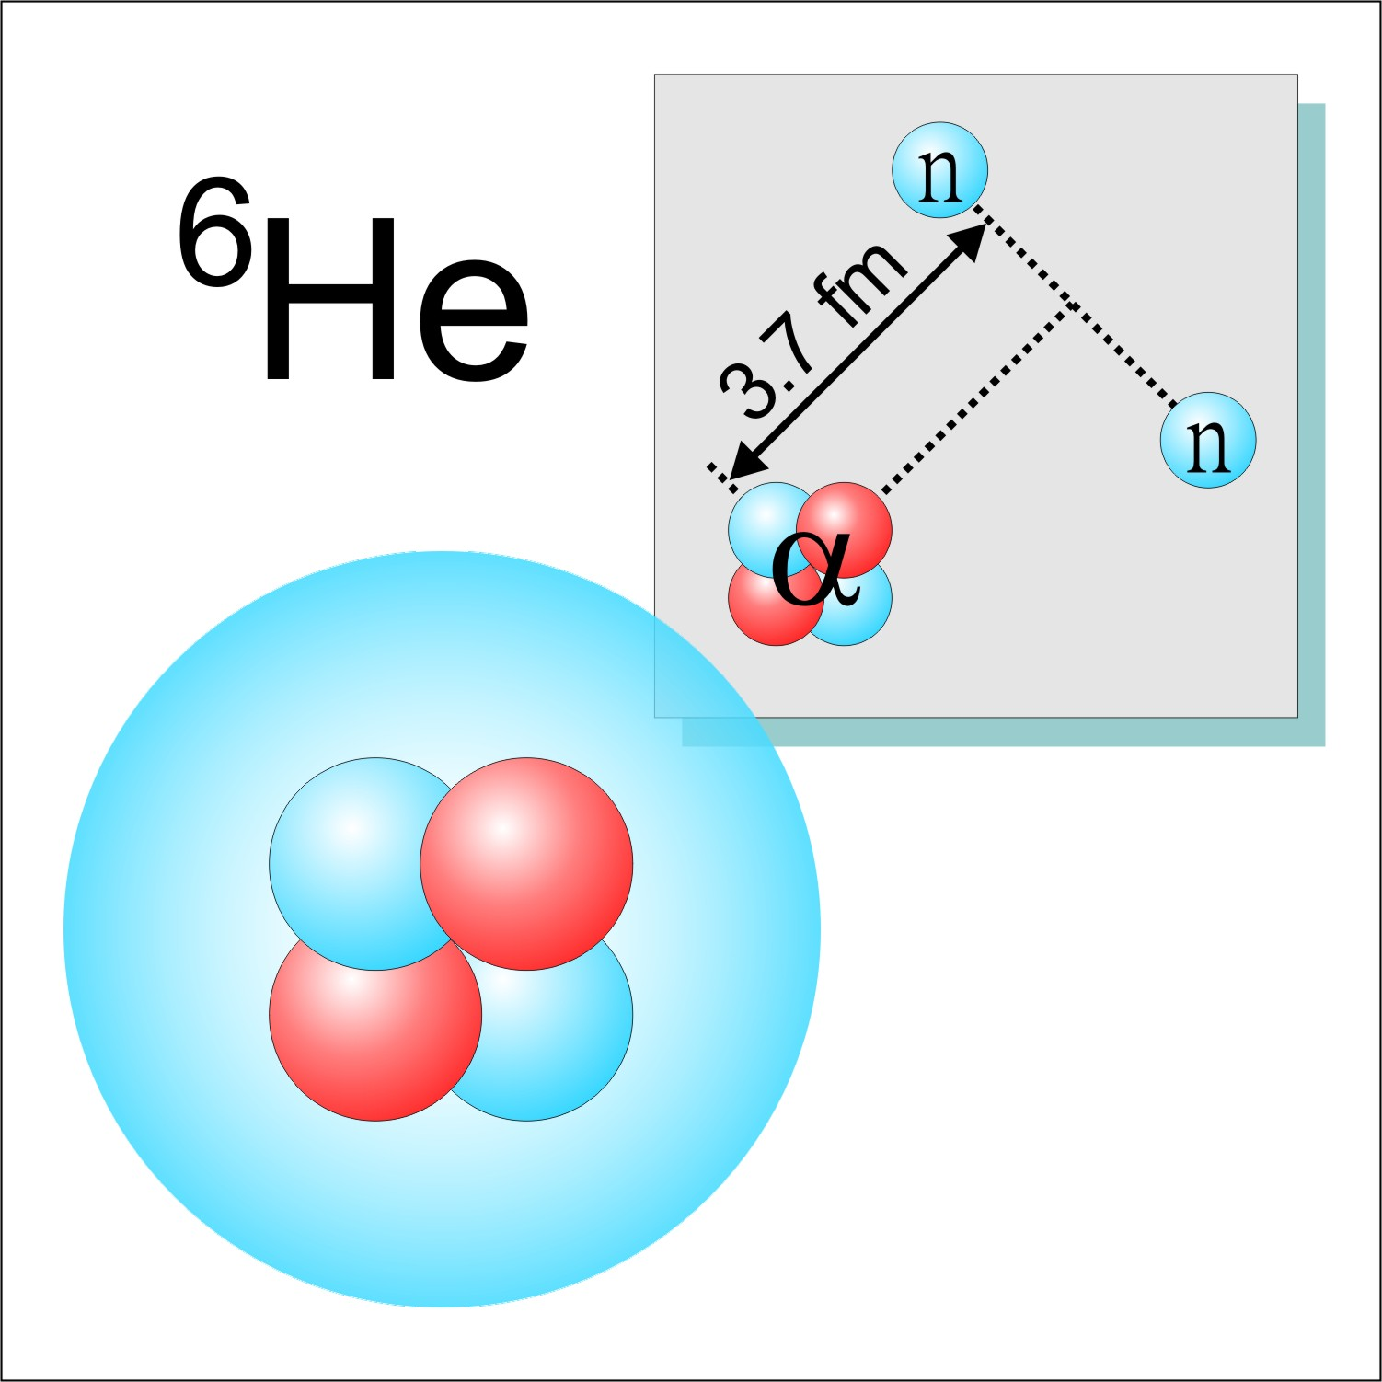
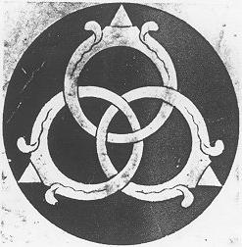

Because of its intriguing properties, ⁶He has the potential to teach us about the fundamental forces among the constituent nucleons. Indeed, the halo character can be revealed by an accurate determination of the nuclear charge radius, since the motion of the core with regard to the center of mass reflects both the radial extent of the neutrons and the correlations between these particles. The result can in turn be compared with the most modern theories (http://dnp.nscl.msu.edu/current/exact.html) as recent advances in computational methods have made it possible to calculate the structure of few-nucleon systems from the basic interactions between the constituents.

The charge radius of ⁶He has been determined for the first time by measuring the atomic isotope shift between ⁶He and ⁴He using laser spectroscopy. For this work, ⁶He atoms were produced at the ATLAS (http://www.phy.anl.gov/atlas/index.html) accelerator facility at Argonne National Laboratory, and quickly captured and cooled by an on-line laser trap. By applying laser spectroscopy on the trapped ⁶He atoms as well as on their ⁴He isotopic partner atoms, the charge radius of the ⁶He nucleus was determined to be 2.054 ± 0.014 fermi, approximately two millionth of a nanometer. The measurement is of such accuracy that it distinguishes between the available theoretical predictions. The data offer new insight into the dependence of three-body interactions on neutron number, which in turn is essential to the understanding of the structure of all neutron-rich systems, including neutron stars.
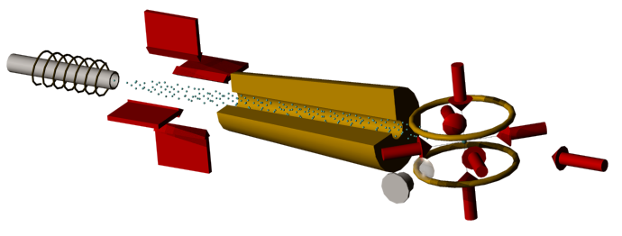
Method: Production and Laser Trapping of ⁶He Atoms
In this work, ⁶He nuclei were produced via the ¹²C(⁷Li, ⁶He)¹³N reaction with a 100 pnA, 60 MeV beam of ⁷Li from the ATLAS accelerator at Argonne National Laboratory. Neutral ⁶He atoms diffused out of the hot graphite target and were transferred in vacuum to the nearby atomic beam assembly at a rate of approximately one million per second. Trapping helium atoms in the 2³S₁ metastable level was accomplished by exciting the 2³S₁ – 2³P₂ transition using laser light with a wavelength of 1083 nm. ⁶He atoms were mixed with a krypton carrier gas and sent through a discharge to be excited to the 2³S₁ level. The metastable ⁶He atoms were transversely cooled, decelerated with the Zeeman slowing technique, and then captured in a magneto-optical trap at a rate of approximately one atom per minute.

This work is supported by the U.S. Department of Energy, Office of Science, Office of Nuclear Physics, under contract W-31-109-ENG-38.

Reference
- Project homepage: http://www-mep.phy.anl.gov/atta/
- Laser Spectroscopic Determination of the ⁶He Nuclear Charge Radius. L.-B. Wang et al., Phys. Rev. Lett. 93, 142501 (2004) Preprint (nucl-ex/0408008)

