D0 Silicon Vertex Detector Interface Module

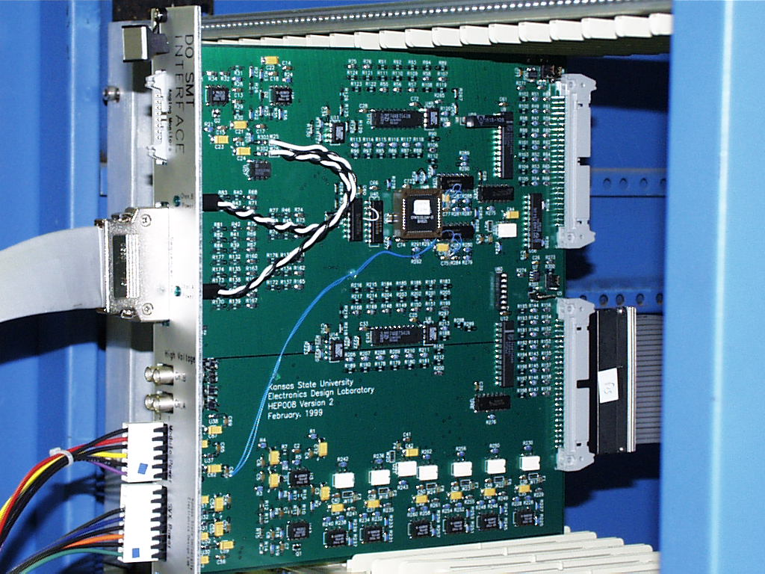

60 copies of the card are being built (4/99) by the K State EDL for testing silicon detectors and electronics for the D0 experiment at Fermi National Lab.

The K State EDL shortly will begin design of the next board revision, adding additional interfaces (such as a IEEE 1553 high speed serial link), and shrinking features by a factor of 3.

