Simulations and Required Performance

3.2 Open Charm and Beauty Measurement

Open Charm:

Open charm and beauty spectra and yields are key for the physics goals of spin gluon structure physics, structure function work in pA reactions, and as probes of the early stages of heavy-ion collisions. For heavy-ion collisions, the goal is to confirm that the excess of electrons observedError: Reference source not found does indeed come from charm decay, and to then extend the reach in pt to measure the energy-loss of open charm at high pt as well as the production of beauty.

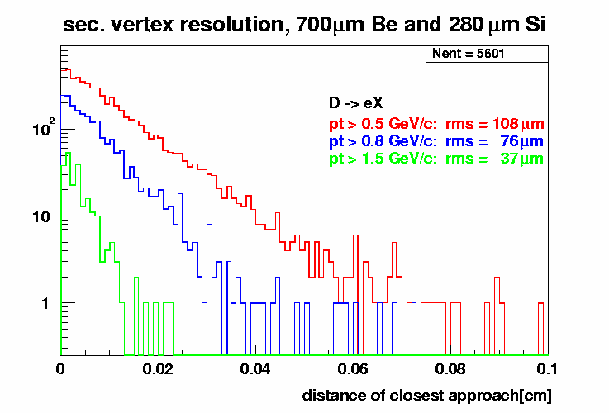
The four layers of the central silicon barrel provide an accurate measurement of the trajectory and impact parameter of tracks near mid-rapidity. Single electrons at different momenta were simulated through the strawman vertex detector. This simulation was run at zero-field and the hits from the electrons tracked back to calculate the transverse distance-of-closest approach (DCA) to the known point-of-origin.
Figure 4, the distribution of distance of closest approach to the collision point for electrons passing through the central barrel.

For all cases the DCA resolution is better than or comparable to the cτ of charm and beauty decays. The power of this resolution is seen by comparing the distribution of DCA from charm, beauty and Dalitz decays of π⁰ in figure 5. The spectra were generated from p+p events (PYTHIA) passed through PISA.

In the bottom panels of figure 5 are the DCA distributions for electrons above 1 GeV/c. A DCA cut of 200 μm removes the majority of Dalitz contribution from the electron yield. Note this is the momentum of the electron and given the large Q-value of the D-decay, these electrons predominantly come from low-momentum D’s. Since beauty decays have longer lifetimes, the electrons from B decays dominate at large DCA values. By fitting the full DCA distribution with the expected shapes from the different cτ we should be able to simultaneously extract integrated charm and beauty yields for electron momenta above 1 GeV/c.

This process is more difficult for electron momenta closer to 500 MeV/c, but even at this momentum charm dominates the DCA distribution above 200 μm for Si thicknesses between 1 and 1.5% of a radiation length. In particular the vertex detector will provide a dramatic improvement over the previous measurement¹⁵, which was systematics limited (at 40%) due to uncertainties in the background subtraction. Figure X shows the “signal to noise” for the optimistic (0.01 X₀) and pessimistic (0.02 X₀) cases compared to the measurement without the vertex detector available. This should allow a much cleaner extraction of the background-subtracted electron spectra for p_{T}>0.4 GeV/c than was previously available, including the charm-specific d²N_{e}/dydp_{T} for electrons up to about 2.5 GeV/c.

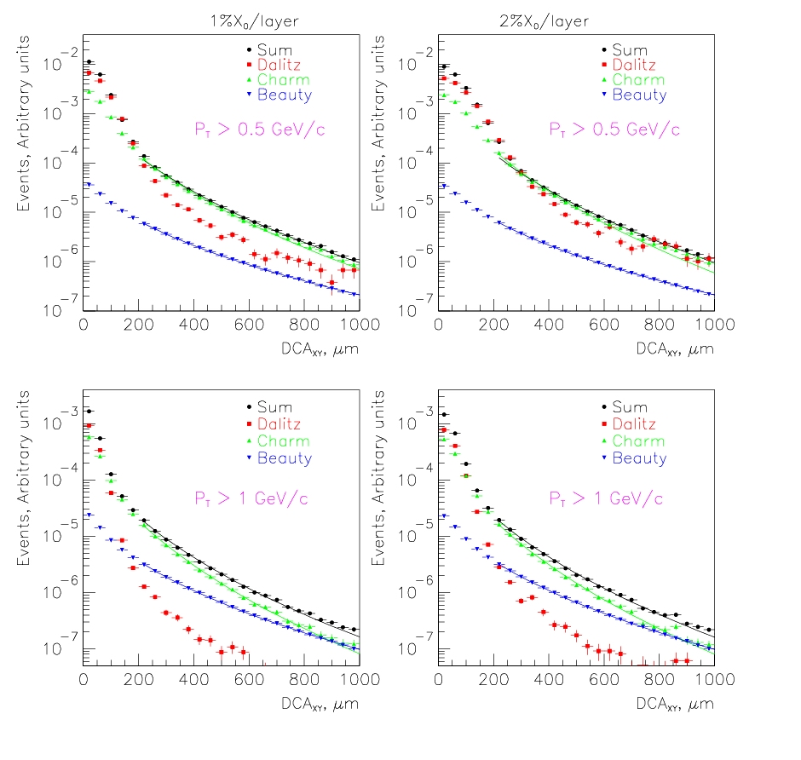
Figure 5, DCA distribution for electrons from Dalitz, charm and beauty decays simulated through four 1% Si layers on the left and four 2% layers on the right.

Figure X: Signal to Background ratios as a function of the minimum electron p_{T} cut.
The signal corresponds to detached electrons from charm decays using a DCA cut of 200μm (circles) or no DCA cut (diamonds). The background corresponds to electrons from Dalitz decays and photon conversions which pass the corresponding DCA cuts, assuming four layers of Silicon with 1 or 2% of a radiation length per layer.

Figure XX shows that there is a useful correlation between the p_{T} cut applied to the electrons and the p_{T} of the parent D meson. The points represent the most probable value of the parent p_{T} while the error bar represents the FWHM spread.

Figure XX: Correlation between the transverse momentum of the D mesons and the minimum p_{T} cut applied to the electrons (using a DCA cut of 120μm). The points represent the most probable value of the D meson p_{T} while the spread represents the (asymmetric) full width at half maximum.

For higher values of the electron p_{T}, B-decays dominate the charm yield (see below), and we will measure charm spectra via hadronic decay channels. As an illustration of hadronic decay we plot the three body invariant mass distribution for D=>Kππ in Figure 6. This simulation is for p+p from Pythia events embedded in a HIJING Au+Au background event. Simultaneous cuts are placed on three displaced tracks (700μm), that the tracks are with 300μm of each other and in addition the parent D must point within 300μm of the collision vertex. These cuts produce a reasonable signal/background. The challenge will be the low rates at high-pt. As an estimate if we assume Au+Au 4*blue-book luminosity, 50 full days/year, yield Au+Au= AA*(yield p+p) then the D=>Kπ above pt >4 GeV/c will produce into the PHENIX acceptance 30kevents/year in p+p running and 10k events/year in Au+Au. This estimate is very preliminary and requires more study regards TOF and aerogel acceptance. Triggering on these events is discussed in section 3.3.

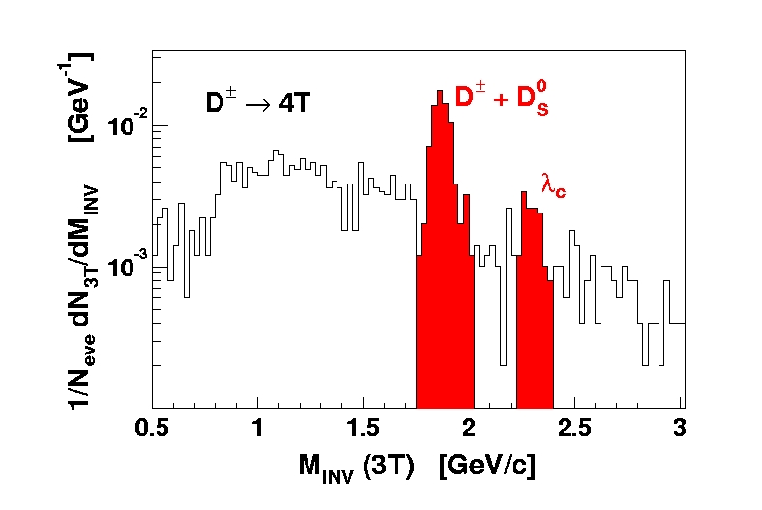
Figure 6. The three body invariant mass distribution is shown for D=>Kππ. This simulation is for p+p from Pythia events embedded in a HIJING Au+Au background event.

Open Beauty:

B meson production, while much rarer than D production, is somewhat simpler to measure. The challenge is the relatively low rate. There seem to be at least two possibilities;
- Semileptonic decays: Since beauty mesons have a larger lifetime than charm mesons, it is possible to extract the beauty yield at low transverse momentum from the distribution of decay distances. At large transverse momentum beauty decays dominate the DCA distribution.
- The decay channel B => J/ψ produces J/ψ that are displaced from the collision.

For momenta greater than 3 to 4 GeV/c electrons with displaced vertexes are dominated by beauty decays. This is clearly seen in figure 8. By placing a DCA cut on the order of 150μm we should be able to cleanly separate electrons from beauty from all other sources. Note that at these momenta it will not be possible to extract a charm source using electron decay. As discussed in the previous section this will be done via hadronic decays of charm.

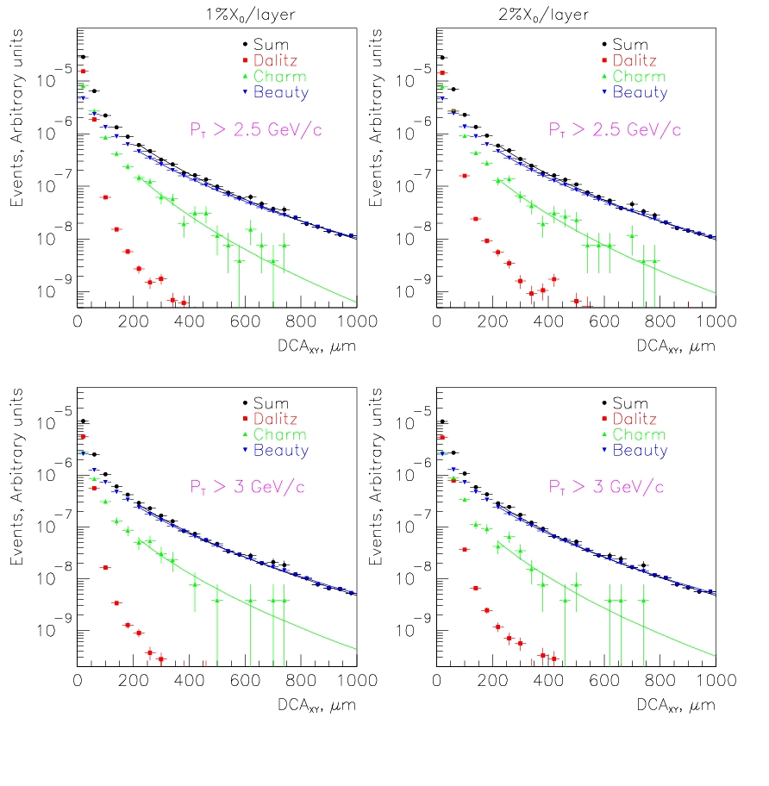
Figure 8, DCA distribution for electrons from Dalitz, charm and beauty decays simulated through four 1% or 2% Si layers

The signal to background ratio for beauty decays at high momentum is shown in Figure Y. The effect of the DCA cut is even more favorable than for charm.

Figure Y: Signal to Background ratios as a function of the minimum electron p_{T} cut.
The signal corresponds to detached electrons from beauty decays using a DCA cut of 200μm (circles) or no DCA cut (diamonds). The background corresponds to electrons from Dalitz decays and photon conversions which pass the corresponding DCA cuts, assuming four layers of Silicon with 1 or 2% of a radiation length per layer.

B => J/ψ=>e⁺+e⁻ fell through the cracks? Pat?

