May 25, 2001

SNAP
Supernova/Acceleration Probe

Draft Optical Specification

Based on optical and structural/mechanical studies a preliminary specification for the optical telescope assembly (the ‘telescope’) has been prepared and is described in this specification. The basic optical design developed for SNAP is found in Appendix II. Other pertinent documents including the ‘Optical Telescope Assembly Definition and Requirements’ which serves to highlight the factors that led to the optical design described here can be retrieved from the SNAP website (http://snap.lbl.gov).

In brief, the SNAP telescope is to be a 2m aperture, f/15 optical system with a nominal 1.26 degree annular field of view (FoV) enabling it to cover 1 square degree with diffraction limited performance at 1 µm over a flat field. This very large FoV telescope will be mated with a billion pixel camera, referred to as the GigaCam. The GigaCam, whose focal surface is an annulus whose dimensions are 0.66m OD x 0.3m ID, is far larger than the cameras used on Hubble or planned for NGST. Information about this camera, for reference purposes, can be found in documentation that is retrievable from the SNAP website. SNAP will be launched by a Delta III or IV-M, an Atlas-III or a Sea Launch vehicle into a very 19x57 Re high elliptical orbit. The telescope (mirrors, structures, baffles, forward structure) will have an estimated mass not to exceed 720 kg; however, lower masses are preferred owing to considerations of total system cost. It is anticipated that the telescope will be operated at or near the temperature at which it was manufactured and assembled, to avoid the need for figuring the 2m optics for some colder temperature. The GigaCam will be in a thermally isolate enclosure and cooled to nominally 140K by a passive radiator located on the anti-sun side of the Observatory. SNAP will be designed so that it can be optically and thermally tested in the laboratory prior to flight.

The SNAP telescope comprises the following subassemblies:
- OPTICS, METERING STRUCTURE, and BAFFLES: The metering and support structure (1) determines the orientations and spacings of the mirrors, (2) provides the attachments for the GigaCam and other science instruments, (3) provides attachments to the spacecraft bus, and (4) supports the internal optical baffles.
- MECHANISMS: We anticipate that the telescope will be fitted with a motorized focus and alignment system, an emergency solar shutter, and a main aperture “door” release. Presently the filter wheel and shutter assembly is part of the GigaCam and is not included here.
- OUTER BAFFLE: This is a shell-like structure which encloses the primary mirror (PM) and the secondary mirror (SM). This structure provides stray light control and offers some degree of thermal control for the telescope. All science target fields are at least 60 degrees away from the sun. This structure also includes a contamination protection door or equivalent jettisonable cover and supports the Observatory’s solar array subsystem (interfaces TBD).
- INTERFACES: The interfaces between the telescope and the GigaCam and the other instruments have not yet been fully defined. For the purposes of this specification only the GigaCam instrument needs to be considered for space allocation and mounting and for thermal control purposes. The GigaCam consists of the large annular detector assembly, a dewar and radiative cooler assembly, and the filter-wheel assembly.

There are currently several unresolved parts of the telescope specification denoted by the ‘gray’ areas in the Appendix. It is anticipated that the telescope optics will be temperature controlled to remain at the manufacturing temperature by heater/thermostat systems, similar in principle to what was used for the 2.4m Hubble telescope. It will be required that whatever these temperatures are, that they can be simulated during the test phase.

The optical design described in the Appendix represents a concept that has evolved but may not be the only approach that should be considered. This specification also does not imposing any constraints on detail design or material choices. ULE, Zerodur, and silicon carbide are considered candidates for the optics material.

Appendix

Preliminary SNAP Telescope Specification

SNAP Optical Design
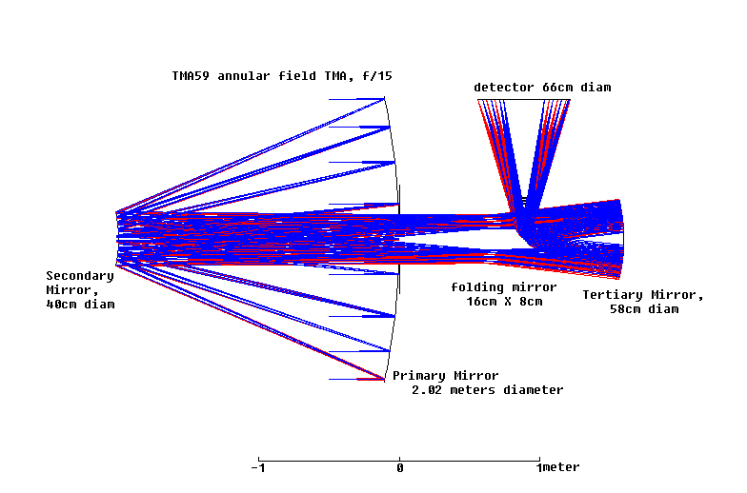
Updated from the ‘Optical Telescope Assembly Definition and Requirements’ Document
- Concave Primary Mirror
- 2.02 meter diameter, 36cm diameter hole
- curvature 0.2076726; radius 4.815272 meters
- shape = +0.010300; CC=-0.9897; prolate ellipsoid
- location: vertex defines origin of coordinate frame
- Convex Secondary Mirror
- 2.00 meters in front of primary mirror
- 40cm diameter
- curvature 1.0400522; radius 0.96149 meters
- shape = -0.7506507; CC=-1.7506507; hyperboloid
- location: 2.0 meters in front of primary vertex
- Concave Tertiary Mirror
- 1.600 meters behind primary vertex
- 58cm diameter
- curvature 0.836422; radius 1.195569 meters
- shape = +0.33244; CC=-0.66756; prolate ellipsoid
- location: 1.6 meters behind primary vertex
- 45 degree folding flat mirror
- 0.89 meters behind primary vertex
- oval: 16cm x 8cm
- location: 0.89 meters behind primary vertex
- Filter wheel stack: 5mm thick silica, 26cm diam
- Detector plane
- center is 0.89 meters behind primary vertex
- Pitched 90 degrees, offset 1.00 meters from principal axis

Optical Prescription

Performance Summary

Sky coverage: 1.0 sq. degree
R_{outer}: 11mrad = 0.63 deg = 33 cm
R_{inner}: 5 mrad = 0.286 deg = 15 cm
Geometrical Aberration Total:

Average RMS blur, full field: 2.5 microns
Worst case (edge) FWZ blur: 18 microns

Compare with diffraction limit, 2 meter aperture
1 micron wavelength: FWZ first ring = 36.6 microns
0.5 micron wavelength: FWZ first ring = 18.3 microns

