DRINKING WATER PRIMACY AGENCY CONTACTS for the Operator Certification Program

Delaware

Edward Hallock (Edward.Hallock@state.de.us)
Program Administrator, Office of Drinking Water
Delaware Health and Social Services
Blue Hen Corporate Center - Suite 203
Dover, DE 19901
302-741-8590

District of Columbia

Washington Aqueduct Division
U.S. Army Corps of Engineers
5900 MacArthur Boulevard, NW
Washington, DC 20016-2514

Lloyd Stowe (lloyd.d.stowe@wad01.usace.army.mil)
Chief, Plant Operations Branch
202-764-2702
Tom Jacobus (thomas.p.jacobus@wad01.usace.army.mil)
General Manager
202-764-0031

Maryland

Nancy Reilman (nreilman@mde.state.md.us)
Division Chief, MDE-SDWA Implementation
Montgomery Park Business Center
1800 Washington Boulevard
Baltimore, MD 21230
410-537-3710

Pennsylvania

Contact for Award Program ONLY:

Alison Shuler (ajs28@psu.edu)
Environmental training and Small Public
Water Systems
Technology Assistance Centers at
Penn State Harrisburg
777 W. Harrisburg Pike, TL 170
Middletown, PA 17057
717-948-6399

Contact for Operator Certification Program:

Veronica "Nicki" Kasi (vbkasi@state.pa.us)
Chief, Technical Assistance and Outreach Division
PA Department of Environmental Protection
P.O. Box 8467
Harrisburg, PA 17105-8467
717-772-4053

Virginia

Mark Anderson (MarkC.Anderson@vdh.virginia.gov)
Training & ERG Coordinator
Virginia Department of Health
Madison Building
109 Governor Street, Room 632
Richmond, VA 23219
804-864-7514

West Virginia

West Virginia Department of Health and Human Resources
Capitol and Washington Streets
1 Davis Square, Suite 200
Charleston, WV 25301-1798

Bill Toomey (wtoomey@wvdhhr.org)
Manager, Source Water Assessment Program/Training Certification Section
304-558-6746
Dawn Newell (dawnnewell@wvdhhr.org)
Assistant Manager, Training & Certification Section
304-558-6993

2006 Award Recipient
Mr. Christopher DeWald, City of Staunton Water Treatment Plant in Staunton, VA

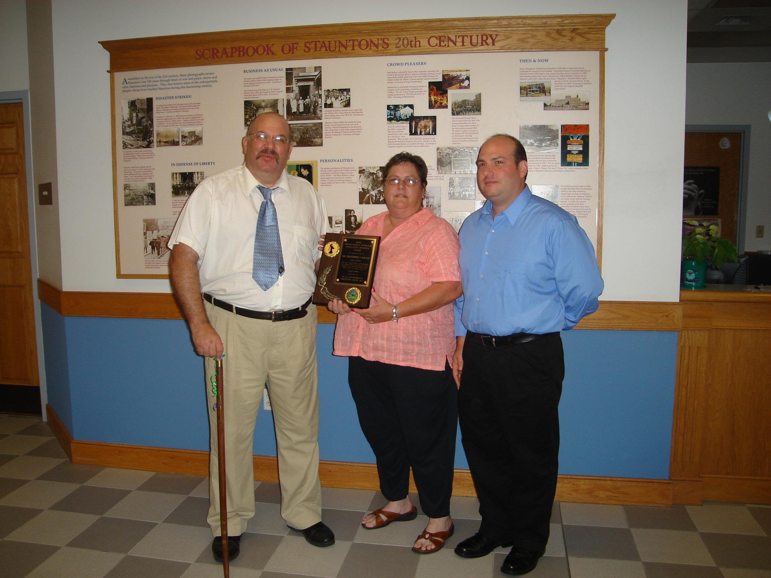
Mr. DeWald and Family
The Award was presented before colleagues and friends at the City of Staunton Council Meeting

2007 Award Recipient
Mr. John Inghram, Putnam Public Service District Facility in Putnam, WV

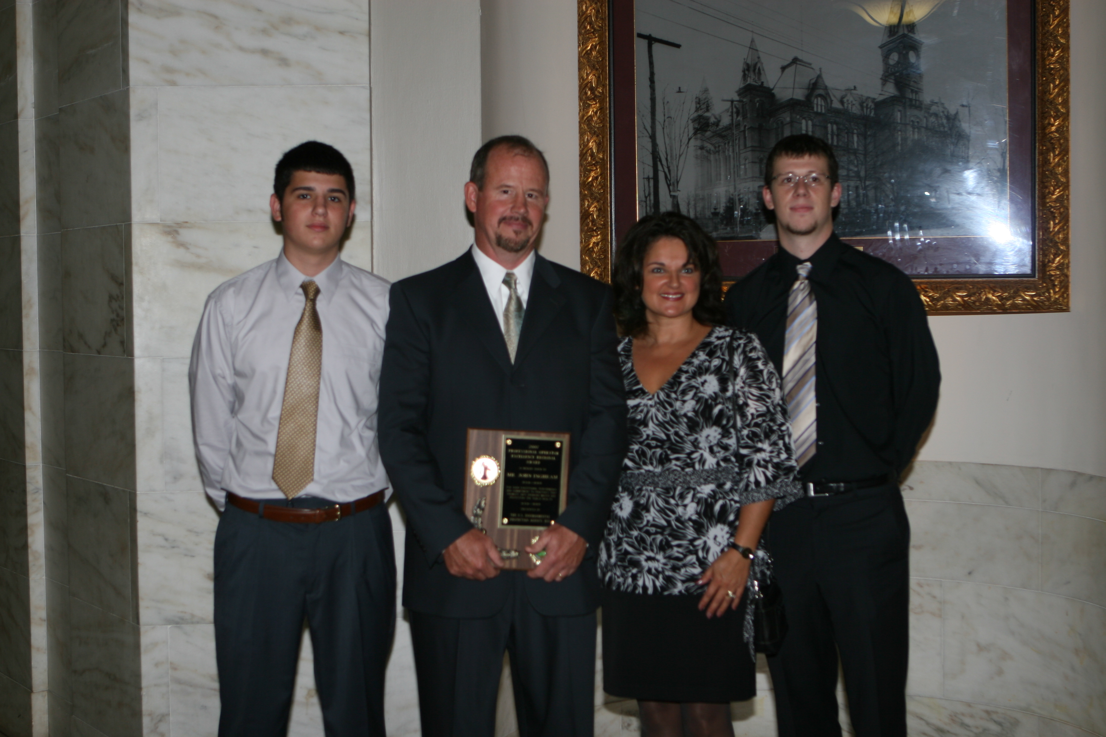
The Award was presented at the Governor’s Mansion in Charleston, WV
Mr. Inghram and Family

U.S. EPA REGION III PROFESSIONAL OPERATOR EXCELLENCE AWARD PROGRAM

Are YOU the crème de la crème in your professional field of certified operators?

Do YOU have a top notch operator at your drinking water facility or in your community that deserves this prestigious recognition??

Want to know how to get them nominated or submit a self nomination for this award???


Well READ ME and I’ll tell you how!

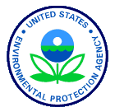

Purpose

The Professional Operator Excellence Award promotes professionalism of the operator, acknowledges and encourages leadership and innovation of operators in the protection of drinking water here in Region III (Delaware, District of Columbia, Maryland, Pennsylvania, Virginia and West Virginia).
.
Award Description

This is an individual regional award given to an operator(s) who exemplifies exceptional work practices on the job and in their community. Contributions advance the health and safeness of potable water for customers. The selected nominee(s) for this award will receive a suitable plaque, properly engraved during an award ceremony organized by the drinking water primacy agency.

Award Categories

Nominations are solicited for two (2) categories for this award: (1) small water system operators serving less than 3,300 customers and (2) large water system operators serving over 3,300 customers. This category may be revised in the future, if needed, based on discussions between EPA RIII and its States.

Eligibility

The award is open to individuals in Region III that represent certified operators striving for excellence in providing healthy, safe potable water for community and non-community water supply systems. Nominees must have been a certified operator in good standing for five (5) years or more with no lapse in certification renewal. Winners of this award will not be eligible for another nomination for three (3) years.

Frequency of Award: Once a year.

Award Criteria

- Rule compliance – work being done in preparation for new rule implementation (i.e., ST2/LT2, GWR); work reflects consistent compliance of regulatory requirements at the public water system;
- Innovative approaches to cost reduction (e.g., asset management; water conservation (e.g., energy & efficiency); environmental management systems and optimizing treatment plant performance);
- Community outreach – e.g., public tours of water plant, visit schools, utilizing media to spread message about healthy, safe, potable water;
- Educational efforts – internal training of standard operating procedures;
- Peer recognition – speaks to the integrity, ethical and technical level of the nominee (e.g., previous awards received);
- Other special efforts or significant achievements.

* Special consideration for meeting this criterion will be given to small system operators only.

Selection Process

  - Candidates for this regional award must be endorsed by both the applicable drinking water primacy agency and EPA RIII (with the exception of PA see contact info.);
  - Candidates for this regional award will be nominated by the applicable drinking water primacy agency to EPA RIII for selection (with the exception of PA see contact info.).
  - All nominations shall be forwarded to
Wanda F. Johnson via email (johnson.wandaf@epa.gov) or post:

U.S. EPA, Region III
Office of Drinking Water & Source Water Protection 1650 Arch Street (3WP21) Philadelphia, PA 19103

d) Nominations will be evaluated and ranked by an EPA RIII awards panel based on input from each State to select the candidate that best meet the award criteria.
  - The selected candidate will be notified by EPA and/or the drinking water primacy agency (with the exception of PA see contact info.)
  - The deadline for state nominations will be March 15th of each year.
  - The selection process may be revised in the future based on discussions with EPA Region III and its States if needed.

Award Process

EPA and the drinking water primacy agency will present the award to the winner in the winner’s community or the award will be presented in conjunction with a community event. The event will be publicized. EPA, State and local officials, local citizens and citizen groups will be invited to participate.

Publicity

States will promote this Award Program in the same capacity that the Operator Certification Program is promoted (e.g., articles, newsletters, web posting, etc.). The Award Program may be announced and this brochure may be given out at conferences and meetings of industry representatives, government associations, civic groups, etc.

You can also view this information and print out a nomination form at: http://www.epa.gov/reg3wapd/drinking/index.htm

