Recommendations to model data from Pathway Interaction Database in caBIO

Version 1
Release 4.2

Last Updated:

Owner: caBIO Team
Email: klemmj@mail.nih.gov

National Cancer Institute Center for BioInformatics
6116 Executive Blvd.
Rockville, MD 20852

1 Overview of PID Data and Proposed Object Model Changes 4
1.1 Description 4
1.2 Use Cases 4
1.2.1 Gene-Pathway Association 4
1.2.2 Protein-PathwayInteraction Association 5
1.2.3 Gene-PostTranslationalModification Association 6
1.2.4 Evidence-Gene Association 8
1.3 Proposed Object Model Changes 9
1.3.1 Existing Domain Model 9
1.3.2 Extended Domain Model 10
1.3.3 Existing Data and Associations 12
1.3.3.1.1 Observations 12
1.4 PID Dataset 12
1.4.1 Data Statistics 13
1.4.2 Doubts / Imponderables / Not Modeled 16
1.4.3 From Pathway Data to Proposed Model 16
1.4.4 From Interactions Data to Proposed Model 17
1.4.5 From Molecule Data to Proposed Model 19
2 Data Exemplars 21
2.1.1 Pathway Data 21
2.1.2 Interaction Data 21
2.1.3 Molecules Data 22

Overview of PID Data and Proposed Object Model Changes

Description
The Pathway Interaction Database is a highly-structured, curated collection of information about known biomolecular interactions and key cellular processes assembled into signaling pathways. It is a collaborative project between the US National Cancer Institute (NCI) and Nature Publishing Group (NPG), and is an open access online resource. It exposes data regarding pathways, complexcomponents and molecular interactions from NCI-Nature-curated dataset, Reactome and BioCarta.

Use Cases

Gene-Pathway Association

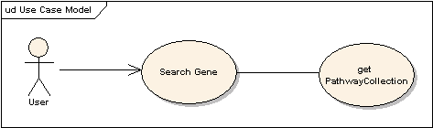

Use Case Name | Gene-Pathway Association
Use Case ID | 2.1
Primary Actor | Public
Brief Description | The Gene-Pathway Association use case allows users to search for pathways associated with a Gene. The results of high throughput data analysis, such microarray, are often lists of genes that exhibit certain behavior of interests to the biologist, who wants to know whether any of these genes are associated with known pthways in the literature.
Workflow | - Query for caBIO Gene object by commonly used IDs, such as HUGO symbol, or Genbank accession.  - Get pathwayAssociations to retrieve associated pathways which in turn can be used to retrieve interactions, etc.
Trigger | The user searches for a Gene
Pre-conditions | - The user navigates to the caBIO Home Page and clicks “Continue”
Flow of Events | - The user selects the Gene object  - The user provides a valid Gene Id such as a HUGO Symbol, etc  - The user clicks the submit button to initiate the search  - A list of Genes appear  - The user can navigate to pathwayAssociations by clicking on the link, getPathwayAssociation.
Post Conditions | Success Condition: The user successfully searches the database and obtains a list of all pathways associated with a Gene  Alternate Condition:  AC2: No result is found  Error Conditions:  EC1: System Error during Request Processing  EC2: Specified Gene does not exist  EC3: Specified Association does not identify a valid pathway
Alternative Flow | Alternate Condition:  AC2: No result is found  - “No results found” message is displayed
Related Use Cases | Protein-PathwayInteraction Associations, Gene-PostTranslationalModification Association, Evidence-Gene Association
Issues/Notes | - The user can also execute the same search using the Java API or Web Service  - This use case is already supported in caBIO 4.1, but with the introduction of new datasets, additional data would be retrievable through this use-case

Protein-PathwayInteraction Association

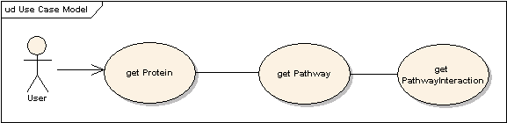

Use Case Name | Protein-PathwayInteraction Association
Use Case ID | 2.3
Primary Actor | Public
Brief Description | The use case allows a user to retrieve Pathway Interactions associated with a given protein
Workflow | - Search for a protein by its Uniprot Id.  - Get PathwayCollection to retrieve associated pathways.  - Click on interactionCollection to retrieve associated interactions.  - Filter by interaction type.
Trigger | The user desires to search for Pathway Interactions
Pre-conditions | The user navigates to the caBIO Home Page and clicks “Continue”
Flow of Events | - Click on Protein  - Search for a Protein by its Uniprot Id  - Get Pathways by clicking on getPathwayCollection.  - Click on getInteractionCollection to get associated interactions
Post Conditions | Success Condition: The user successfully searches the database and obtains a list of all interactions associated with the pathways in which a given protein participates  Alternate Condition:  AC2: No result is found  Error Conditions:  EC1: System Error during Request Processing  EC2: Specified Protein does not exist  EC3: Specified Protein is not associated with any Pathway
Alternative Flow | Alternate Condition:  AC2: No result is found  1. “No results found” message is displayed
Related Use Cases | Gene-Pathway Associations, Gene-PostTranslationalModification Association, Evidence-Gene Association
Issues/Notes | The user can also execute the same search using the Java API or Web Service

Gene-PostTranslationalModification Association

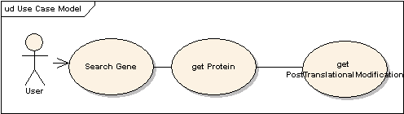

Use Case Name | Browse Gene-PostTranslationalModification Association
Use Case ID | 2.4
Primary Actor | Public
Brief Description | Given a gene, find all post translational modifications associated with the expressed proteins on account of participation in a pathway.
Workflow | - Start from a gene.  - Get corresponding proteins.  - Get the post translational modification information for the protein, if available.
Trigger | The user desires to search for publicly available genes
Pre-conditions | - The user navigates to the caBIO Home Page and clicks “Continue”
Flow of Events | - Click on Gene  - Search for a Gene by its HUGO Symbol, Unigene Cluster Id, etc.  - Get expressed proteins by clicking on getProtein.  - Click on getPostTranslationalModification to get associated post translational modification information
Post Conditions | Success Condition: The user successfully searches the database and obtains a list of all available post translational modification information for the expressed gene.  Alternate Condition:  AC2: No result is found  Error Conditions:  EC1: System Error during Request Processing  EC2: Specified Protein does not exist  EC3: Specified Protein has not undergone any post translational modification or has not participated in any pathways stored in caBIO
Alternative Flow | Alternate Condition:  AC2: No result is found  1. “No results found” message is displayed
Related Use Cases | Gene-Pathway Association, Protein-PathwayInteraction Association, Evidence-Gene Association
Issues/Notes | The user can also execute the same search using the Java API or Web Service

Evidence-Gene Association

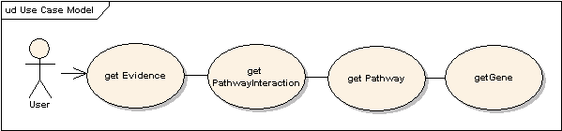

Use Case Name | Browse Evidence-Pathway Association
Use Case ID | 2.4
Primary Actor | Public
Brief Description | Given a publication which documents a particular pathway interaction, find all genes associated with the same.
Workflow | - Start from a publication/Evidence retrievable using its PubMed Id.  - Get corresponding Pathway Interactions.  - Get associated Pathways  - Get associated Genes
Trigger | The user desires to search for publication information
Pre-conditions | - The user navigates to the caBIO Home Page and clicks “Continue”
Flow of Events | - Click on Evidence  - Search for a Evidence using its PubMed Id  - Get associated PathwayInteractions.  - Click on getPathwayCollection to get associated pathways  - Click on getGene to get associated Genes
Post Conditions | Success Condition: The user successfully searches the database and obtains a list of all genes associated with a given publication on account of the pathways and the interactions it is involved in  Alternate Condition:  AC2: No result is found  Error Conditions:  EC1: System Error during Request Processing  EC2: Specified Publication does not exist  EC3: Specified Publication is not associated with any PathwayInteraction
Alternative Flow | Alternate Condition:  AC2: No result is found  1. “No results found” message is displayed
Related Use Cases | Gene-Pathway Association, Protein-PathwayInteraction Association, Gene-PostTranslationalModification
Issues/Notes | The user can also execute the same search using the Java API or Web Service

Proposed Object Model Changes

Existing Domain Model

The follow objects from the current caBIO domain model are relevant to the modeling this data in caBIO.
Figure 1 describes the current caBIO model that associates these objects.

caBIO Domain Object
Pathway | An object representation of a molecular/cellular pathway in human and mouse compiled by BioCarta. It provides access to further details about the associated Genes and any available histopathological information for genes involved in clinical trials through getGeneCollection and getHistopathologyCollection methods.  It gets populated with data from CGAP and is composed of BioCarta Pathways. It provides links to genes associated with every pathway as well as histopathological information pertaining to these Genes through the associated Histopathology object.
NucleicAcidSequence | An object representation of a gene sequence; provides access to the clones from which it was derived, the ASCII representation of the residues it contains, and the sequence ID and a link to the Location Objects that in turn provide further details of any SNP, Cytoband, EST or MRNAs associated with that sequence.  It is populated with data pertaining to human and mouse from Unigene.
Gene | Gene objects are the effective portal to most of the genomic information provided by the caBIO data services; It provides access to the associated proteins, gene-targets, diseases, histopathologies, ontologies, pathways, aliases, clones and sequence data through their respective objects such as Histopathology, DiseaseOntology, OrganOntology, Pathway, GeneAlias, Clone and NucleicAcidSequence respectively.  The location of the gene on the chromosome is available through the Location object.  This object gets populated with data pertaining to human and mouse genes from NCBI’s Unigene’s repository. Gene Ids from NCBI’s OMIM Databank, Ensembl, and Enzyme Commission are available through DatabaseCrossReference.
Protein | An object representing the various names (scientific, common, abbreviated, etc.) for human and mouse genomes. It can be used to retrieve the associated Genes, Chromosomes, Pathways if any, Proteins, or Tissues.
Evidence | An object representing the publication from PubMed that serves as an Evidence supporting the association between a caBIO Gene and a DiseaseOntology or an Agent. Based on the publication, an Evidence can be associated with multiple EvidenceCodes.
EvidenceCode | A class that models the different types of EvidenceCodes associated with an Evidence, based on the data in the publication.

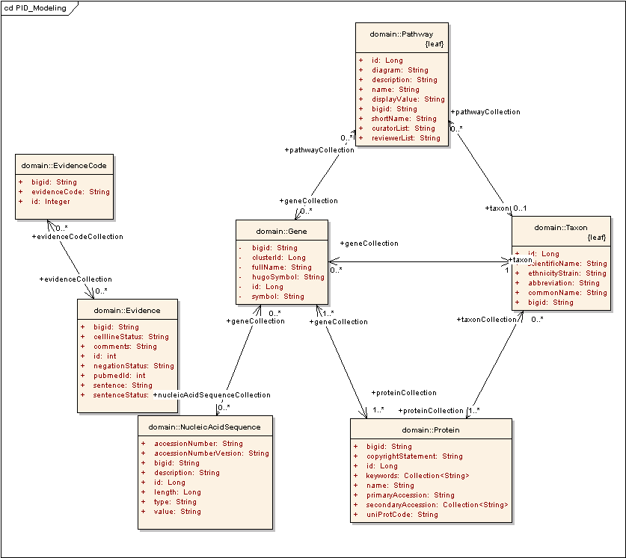
Figure 1Current caBIO Model

Extended Domain Model

The extended model adds supports for new objects to model the pathwayInteractions, the different components in an interaction and its association to an Evidence or EvidenceCode.

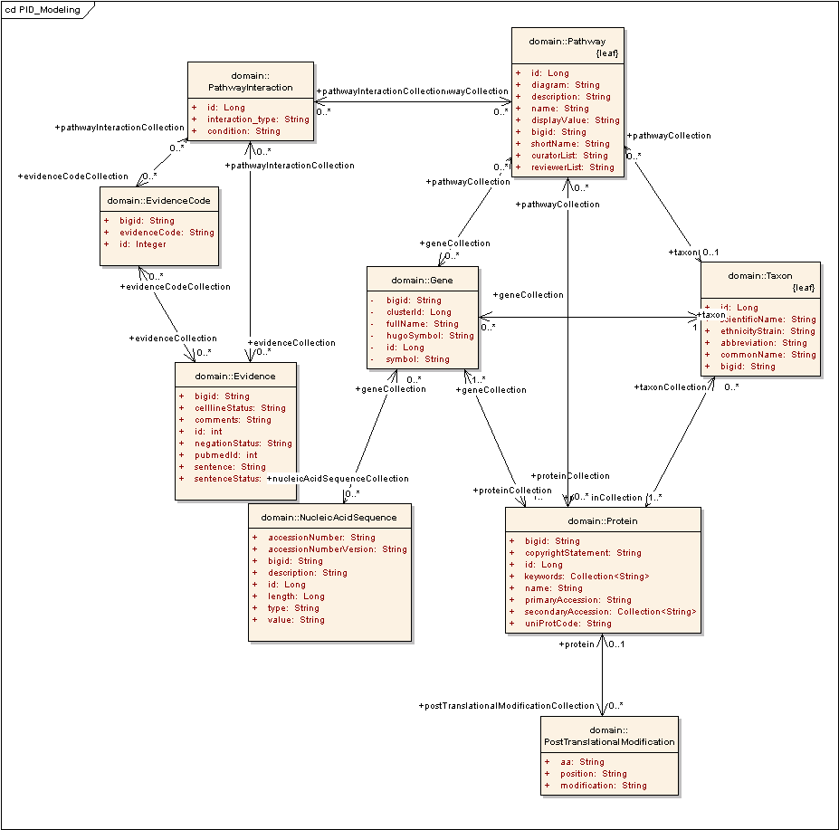
Figure 2 Proposed Model for Pathway Data Modeling

Note: New classes or attributes are highlighted in red

Pathway

New attributes would be added to model the curator, reviewer and source information

Attribute | Description
Diagram | Pathway Diagram in SVG Format
Description | Sentence from PubMed publication
Name | Short name for the pathway
LongName | Long name for the pathway
DisplayValue | Display value for the diagram
CuratorList | List of curators
ReviewerList | List of reviewers
Source | Pathway Source (Reactome, BioCarta, NCI-Nature)

PathwayInteraction

New class to model the interactions that constitute a Pathway

Attribute | Description
Role | Role of an interaction in a Pathway

PostTranslationalModification

New class to model the Post Translational Modification information for a protein where available
Attribute | Description
Aa | Amino acid
Position | Position at which modification has occurred
Modification | Type of modification

Existing Data and Associations
Currently caBIO procures BioCarta data from CMAP which gives a Locus Link Id that allows us to associate a caBIO Gene with a Pathway.
This would need to be retained for backward compatibility since caMOD and Rembrandt amongst others use this data.

Observations
- Retain existing data and associations (316 pathways currently in caBIO)
- Set PathwaySource as ‘BioCarta’ for existing data (254 pathways from PID datasets)
  - 244 of these 254 pathways are already present in caBIO
- Add data to model associations to Proteins and Interactions for the human pathways from these 244 records
- Add remaining 10 pathways
- Outcome:
    - 244 Pathways would have an association to Gene AND Protein and Interaction
    - Mouse Pathways in caBIO's Pathway will have no association to PathwayInteractions; Only the Human Pathways will.
    - 10 newly added Pathways will have no association to Gene, but will have an association to PathwayInteractions.
    - Resulting total number of BioCarta pathways : 316 + 10 = 317

PID Dataset
Based on the above model, the tables below summarize the data available from the PID dataset and their proposed association to caBIO.

According to the DTD, a Pathway is composed of one or more PathwayInteractions, and has associated Evidences.
It is composed of multiple PathwayInteractions which play one of 227 roles in the Pathway.

Every PathwayInteraction also has associated Evidences or EvidenceCodes.
A PathwayInteractionCondition influences a PathwayInteraction

Multiple PathwayInteractionComponents (Molecules) participate in a PathwayInteraction with each Component being defined by its role in the Interaction. Every Molecule can function as either as an input, output, agent or inhibitor in a PathwayInteraction. There are some records with “process-type” as the role which would be pruned as junk data

However there may be many different aspects to each such role which is modeled by PathwayInteractionComponentLabel.

These molecules are identified by aliases or Uniprot accession numbers or descriptions in some cases.

Some Proteins have subunit information available and it may be these subunits that may participate in a Pathway.
It may also be “collections” of Complex/Compounds/Proteins that participate in a PathwayInteraction.

Data Statistics
Pathways | Description | Notes
ZSTG_PATHWAYS | Pathway Data (consists of the source, long/short name, organism)  PID uses “7” to refer to Reactome and “5” to NCI-Nature  Only Human Data available. Hence organism = Hs for all records | Reactome: 765  NCI-Nature: 111  Source Id No. 3: 154 (presumably “3” also refers to BioCarta)???  BioCarta: 101
ZSTG_PATHWAYCURATORS / ZSTG_PATHWAYREVIEWERS | A Pathway can be curated/ reviewed by multiple people | Pathway Curators  Reactome: 656  NCI-Nature: 106  BioCarta: 0  Pathway Reviewers  Reactome: 7  NCI-Nature: 224  BioCarta: 0
ZSTG_PATHWAYCOMPONENTS | Gives the Interaction Ids associated with a Pathway | Reactome: 3219  NCI-Nature: 4095  BioCarta: 1557  Source Id No.3: 2227
DTD implies a 1-to-many association between Pathway and Reference/Evidence, but there is no data to support this.

All References are associated only with an Interaction and not with a Pathway.
Interactions
ZSTG_INTERACTIONS | Lists the interactions in each Pathway | Reactome: 3020  NCI-Nature: 3941  BioCarta: 1759  2: 1244
ZSTG_INTERACTIONEVIDENCE | Lists the multiple evidence-Codes associated with each Interaction | Reactome: 3020  NCI-Nature: 5468  “3”: 1759  BioCarta: 1244
ZSTG_INTERACTIONREFERENCE | Lists the multiple publications associated with each Interaction | Reactome: 3922  NCI-Nature: 4956  BioCarta: 0  3: 0
ZSTG_INTERACTIONCONDITION | Lists the multiple conditions associated with each Pathway Interaction | Reactome: No data  NCI Nature: 250  3: 50  BioCarta: 70  DTD implies a 1-to-many association, but PID data shows a 1-to-1 association between PathwayInteraction and PathwayInteractionCondition.  On the basis of this “condition” could be modeled simply as an attribute of Interaction
ZSTG_INTERACTIONCOMPONENTLABEL | Lists the different molecules participating in each Interaction along with their roles (agent, inhibitor, input, output) and the 5 different lable-types(i.e. activity-state, location, function, ptm) | What is the difference between Role-Type and Label-Type? All InteractionComponents have only one role, but many have multiple Component Labels.  NCI-Nature:agent:1593  Reactome:agent:3048  3:agent:967  BioCarta:agent: 662  NCI-Nature:inhibitor:2  Reactome:inhibitor:346  3:inhibitor:128  BioCarta:inhibitor:14  NCI-Nature:input:6253  Reactome:input:3361  3:input:1116  BioCarta:input:484  NCI-Nature:output:5540  Reactome:output:3795  2:output:1366  BioCarta:output: 934  Label-types for the different InteractionComponents (activity-state, location, function, ptm)  BioCarta:activity-state:1266  BioCarta:location:828  3:activity-state:1308  3:location:2269  NCINature:activity-state:4972  NCINature:function:43  NCINature:location:5535  Reactome:activity-state:145  Reactome:location:13237  Reactome:process-type:5  Reactome:ptm:1
ZSTG_INTERACTIONCOMP-PTM-TERMS | An Interaction involves multiple components/molecules, each identified by a moleculeId (which is used to provide further information on the molecule) and each playing a different role in the Interaction. Some of these have associated PostTranslationalModification (PTM) data  Lists the PTM data for these molecules, if available | Reactome:1183  NCINature:2862  BioCarta: 0  Source No “3”: 0
Molecules
ZSTG_MOLECULENAMES | Lists the type of molecule and the value (an identifier/description). There are only 5 types of molecules in the data: complex, compound, protein, and rna.  Records of type “molecule-type” would be purged  NCINature:complex:1870  NCINature:compound:201  NCINature:protein:4121  NCINature:rna:7  Reactome:complex:3332  Reactome:compound:2613  Reactome:molecule-type:754  Reactome:protein: 7624  Reactome:rna:67  (null):complex:884  (null):compound:644  (null):protein:7268  (null):rna:14 | There is insufficient data to create a separate Complex or Compound object. The “value” column of this table is composed of comments/aliases/descriptions/symbols and is the only new data/attribute that could added to this new object.  Almost all the entries for “rna” molecules are comments and some “protein” molecules have accession numbers.  Approximately only 3000-4000 of the 33,000+ molecules is associated with caBIO Identifiers.
ZSTG_MOLECULE-COMP-PTMTERMS | Only some “complex” Molecules have PTM data associated with them. (6300) | Reactome:1691  NCINature:4609
ZSTG_MOLECULEPARTS | Subunits of “protein” molecules | NCINature: 194  Reactome: 549  Null Source Id: 68 (from BioCarta file..hence possibly BioCarta??)
ZSTG_MOLECULEFAMILIES | Molecules of type “protein”, “complex” and “compound” have family-data associated with them | NCI Nature: 738  Null: 1408

Doubts / Imponderables / Not Modeled
- Complex
- Compound
- Would be classes with one attribute
- Little to no associations to existing caBIO Protein(?) objects based on (10)
- PathwayInteractionComponent’s role (Role of a molecule participating in a PathwayInteraction)
- PathwayInteractionComponentLabel (Additional information on the role of the molecule in a pathway interaction)
- ProteinSubUnit Information
- Family information where available (Complexes being collections of other complexes, etc)
- No data to warrant association between Pathway and Evidence.
- Insufficient information to map caBIO Ids on most of the participating molecules in the Pathway Data

From Pathway Data to Proposed Model
Data | Model | Notes
<Pathway id="500317" subnet="true"> | Pathway
<Organism>Hs</Organism> | Used to make association to Taxon (Humans)
<LongName>Signalling to RAS</LongName> | Pathway.name
<ShortName>Signalling_to_RAS</ShortName> | Pathway.shortName
<Source id="7">Reactome</Source> | Pathway.source
<CuratorList>
<Curator>Nasi, S, Annibali, D</Curator> | Pathway.curatorList | Concatenate all curators into a single record
<Curator>Jassal, B</Curator>
</CuratorList>
<ReviewerList>
<Reviewer>Greene, LA</Reviewer> | Pathway.reviewerList | Concatenate all reviewers into a single record
<Reviewer>Dr. Dan Dumont</Reviewer>
<Reviewer>Dr. Andreas Papapetropoulos</Reviewer>
</ReviewerList> |  | Neither Reactome nor NCI Nature datasets have any data to support association between Pathway and Evidence; Data exists to support only the association between Interaction and Evidence.
<PathwayComponentList>
<PathwayComponent interaction_idref="500704"/> | To make appropriate association to PathwayInteractions
<PathwayComponent interaction_idref="501216"/>
<PathwayComponent interaction_idref="503170"/>
<PathwayComponent interaction_idref="500703"/>
<PathwayComponent interaction_idref="501218"/>
<PathwayComponent interaction_idref="501217"/>
<PathwayComponent interaction_idref="503168"/>
<PathwayComponent interaction_idref="503522"/>
</PathwayComponentList>
</Pathway>

From Interactions Data to Proposed Model
Data | Model | Notes
<Interaction interaction_type="modification" id="500460"> | PathwayInteraction.interaction_type  Id: used to make an association between Pathway and PathwayInteraction | 227 different interaction types.  Unclear about  Pathway is associated with multiple PathwayInteractions
<Condition condition_type="retrograde axon cargo transport">retrograde a  xon cargo transport</Condition> | PathwayInteraction.condition_type | DTD shows 1-to-many association between Interaction and Condition (hypothetical example shown alongside).  However data shows only one condition for every interaction.  Hence condition_type could be attribute of PathwayInteraction
<Condition condition_type="B-Lymphocyte">B-Lymphocyte</Condition>
<Condition condition_type="activation of NF-kappaB transcription factor">activation of NF-kappaB transcription factor</Condition>
<Abstraction pathway_idref="500682" pathway_name="Orc1 removal from chromatin" external_pathway_id="Orc1_removal_from_chromatin"/> |  | This information is already captured in Pathway
<Source id="7">Reactome</Source> | Used to make associations to Pathways from appropriate source
<EvidenceList>
<Evidence value="NIL">NIL</Evidence> | EvidenceCode.evidenceCode
</EvidenceList>
<ReferenceList>
<Reference pmid="16612002">16612002</Reference> | Evidence.pubmedId
<Reference pmid="9687533">9687533</Reference>
<Reference pmid="12660731">12660731</Reference>
</ReferenceList>
<InteractionComponentList> | Not modeled | PathwayInteraction is composed of many PathwayInteractionComponents
<InteractionComponent role_type="input" molecule_idref="501651"> | Not modeled | 4 different roles for a PathwayInteractionComponent: 4 (input, output, inhibitor, agent)
<Label label_type="location" value="cytoplasm"/> | Not modeled | Data from NCI Nature shows 1-to-many association between PathwayInteractionComponent and PathwayInteractionComponentLabel  5 different label-types: Activity-state, function, ptm, location, process-type  96 different Label-values
<Label label_type="activity-state" value="active"/>
</InteractionComponent>
<InteractionComponent role_type="input" molecule_idref="505232">
<Label label_type="location" value="plasma membrane"/> | Not Modeled
<PTMExpression> | PostTranslationalModification | Would have many-to-one association with Protein
<PTMTerm protein="Q6PIZ9" position="63" aa="Y" modification="phosphorylation"/> | Protein accession number would be used to make association with caBIO Protein  PostTranslationalModification.position  PostTranslationalModification.aa  PostTranslationalModification.modification
<PTMTerm protein="Q6PIZ9" position="79" aa="Y" modification="phosphorylation"/>
<PTMTerm protein="Q6PIZ9" position="110" aa="Y" modification="phosphorylation"/>
</PTMExpression>
</InteractionComponent>
<InteractionComponent role_type="output" molecule_idref="501654">
<Label label_type="location" value="plasma membrane"/>
</InteractionComponent>
</InteractionComponentList>
</Interaction>

From Molecule Data to Proposed Model
Data | Model | Notes
<Molecule molecule_type="protein" id="200158"> | Not Modeled | PathwayInteractionComponent is one of multiple Molecule-types. A Molecule can be a protein, complex, compound, rna or “molecule-type”, the last possibly being (junk data)
<Name name_type="PF" long_name_type="preferred symbol" value="FRS2 family-active"/> | Not Modeled
<FamilyMemberList>
<Member member_molecule_idref="201289">
<Label label_type="activity-state" value="active"/>
<PTMExpression> | PostTranslationalModification
<PTMTerm protein="Q8WU20" position="2" aa="G" modification="myristoylation"/>
<PTMTerm protein="Q8WU20" position="196" aa="Y" modification="phosphorylation"/>
<PTMTerm protein="Q8WU20" position="306" aa="Y" modification="phosphorylation"/>
<PTMTerm protein="Q8WU20" position="349" aa="Y" modification="phosphorylation"/>
<PTMTerm protein="Q8WU20" position="392" aa="Y" modification="phosphorylation"/>
<PTMTerm protein="Q8WU20" position="436" aa="Y" modification="phosphorylation"/>
</PTMExpression>
</Member>
<Member member_molecule_idref="201290">
<Label label_type="activity-state" value="active"/>
<PTMExpression>
<PTMTerm protein="O43559" position="2" aa="G" modification="myristoylation"/>
<PTMTerm protein="O43559" position="417" aa="Y" modification="phosphorylation"/>
<PTMTerm protein="O43559" position="455" aa="Y" modification="phosphorylation"/>
</PTMExpression>
</Member>
</FamilyMemberList>
<ComplexComponentList>
<ComplexComponent molecule_idref="200523"> | Not Modeled
</ComplexComponent>
<ComplexComponent molecule_idref="201460">
</ComplexComponent>
</ComplexComponentList>
<Part whole_molecule_idref="200268" part_molecule_idref="201327" start="217" end="1013"/> | Not Modeled
</Molecule>

Data Exemplars

Pathway Data

<Pathway id="500317" subnet="true">
<Organism>Hs</Organism>
<LongName>Signalling to RAS</LongName>
<ShortName>Signalling_to_RAS</ShortName>
<Source id="7">Reactome</Source>
<CuratorList>
<Curator>Nasi, S, Annibali, D</Curator>
<Curator>Jassal, B</Curator>
</CuratorList>
<ReviewerList>
<Reviewer>Greene, LA</Reviewer>
</ReviewerList>
<PathwayComponentList>
<PathwayComponent interaction_idref="500704"/>
<PathwayComponent interaction_idref="501216"/>
<PathwayComponent interaction_idref="503170"/>
<PathwayComponent interaction_idref="500703"/>
<PathwayComponent interaction_idref="501218"/>
<PathwayComponent interaction_idref="501217"/>
<PathwayComponent interaction_idref="503168"/>
<PathwayComponent interaction_idref="503522"/>
</PathwayComponentList>
</Pathway>

Interaction Data

<Interaction interaction_type="modification" id="501031">
<Source id="7">Reactome</Source>
<EvidenceList>
<Evidence value="NIL">NIL</Evidence>
</EvidenceList>
<ReferenceList>
<Reference pmid="14657031">14657031</Reference>
<Reference pmid="11859075">11859075</Reference>
</ReferenceList>
<InteractionComponentList>
<InteractionComponent role_type="agent" molecule_idref="502748">
<Label label_type="location" value="nucleus"/>
</InteractionComponent>
<InteractionComponent role_type="input" molecule_idref="501810">
<Label label_type="location" value="nucleus"/>
</InteractionComponent>
<InteractionComponent role_type="output" molecule_idref="501810">
<Label label_type="location" value="nucleus"/>
</InteractionComponent>
</InteractionComponentList>
</Interaction>

Molecules Data

<Molecule molecule_type="compound" id="503535">
<Name name_type="CH" long_name_type="Chemical Entities of Biological Int
erest" value="15554"/>
<Name name_type="AS" long_name_type="alias" value="Prostaglandin H2"/>
<Name name_type="AS" long_name_type="alias" value="(5Z,13E)-(15S)-9alpha
,11alpha-Epidioxy-15-hydroxyprosta-5,13-dienoate"/>
<Name name_type="PF" long_name_type="preferred symbol" value="Prostaglan
din H2"/>
</Molecule>

END OF DOCUMENT

