f

Education: Science in the Neighborhood and the Nation

Fermilab Onsite Review
Marjorie G. Bardeen

(August 7, 2002 with updated stats for FY04)

Education Partnerships f
Teachers & Scientists Working Together
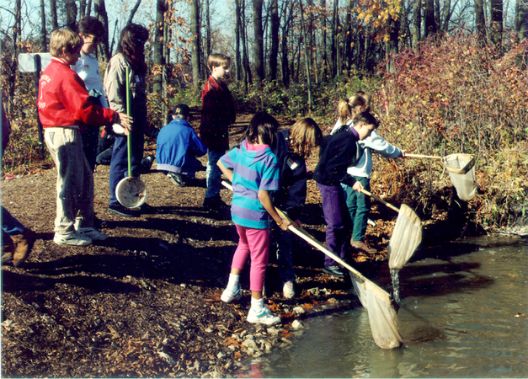
The Lederman Science Center is a resource for teachers & schools.
Program Strategies f
• Research, design and conduct programs that maintain science education at the highest levels for all students.

• Promote the integration of innovative educational technologies with curriculum.

• Promote the use of high-quality science materials & resources.
Staff Workshops & Institutes f
• QuarkNet: High school physics research
• LInC: K-12 Web-integration Course
• Field Trip-based Workshops
• Technology Integration Workshops

Research Appointments f

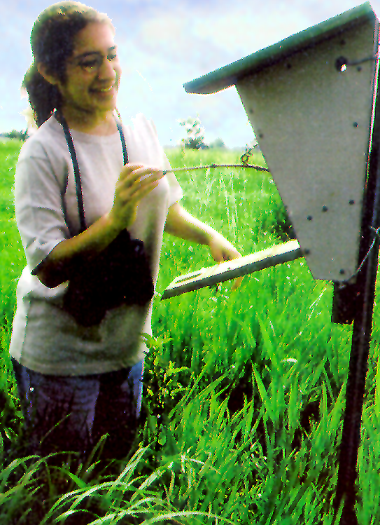 | • Fermilab Teacher Fellowship  • Teacher Research Appointments  • Preservice Teacher Internships  • Target: High School Internships

Kids at Fermilab f
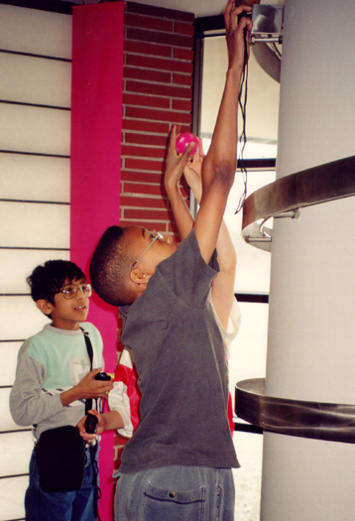 | Classroom Units & Field Trips  • Physics Science Experience  • Prairie Science Experience  Classes for Kids & Families  • Saturday Morning Physics  • Science Adventures  • Wonders of Science
Classroom Visits f
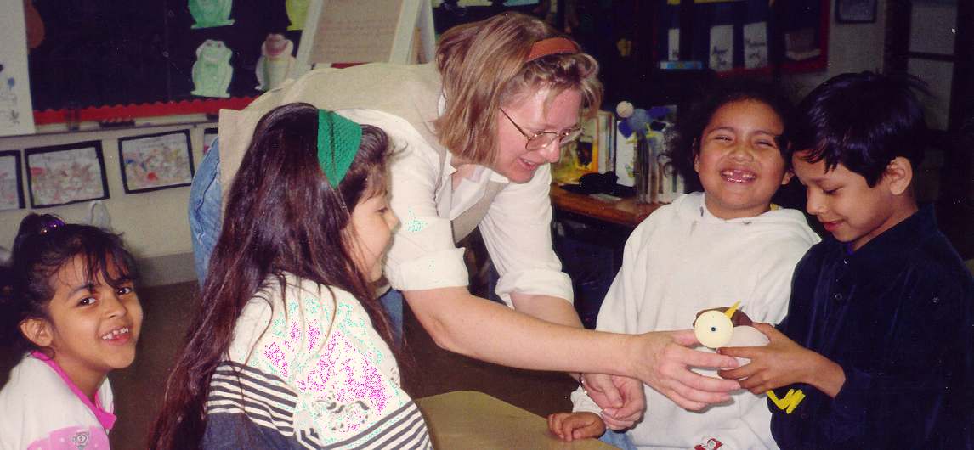
• Cryogenics Show • Grad Student Program • Speakers' Bureau
Teacher Resource Center f
• Collections
• Online Catalogue
• Consulting
• Technology Workshops
• Partnership with US DOEd

Web-based Materials f

• Online Instructional Projects • Particle Physics Data
• Fermilabyrinth - a virtual field trip • Prairie Data
Resources for Scientists f
• Sharing Science with Children
• Reference Collection
• Instructional Materials
• Website
• Classroom Visit Activities
• Hands-on Exhibits

Stats f
• In FY04 over 18,000 students & 3,500 teachers participated in our programs.

• Over 50 educators taught in the programs, and 250 scientists, engineers and technicians volunteered.

• Education Office staff is 13 FTE & 21 on-call docents.
Our Success f
• Partnerships with educators
• Lab support from the director on down
• Outside resources from Friends of Fermilab


