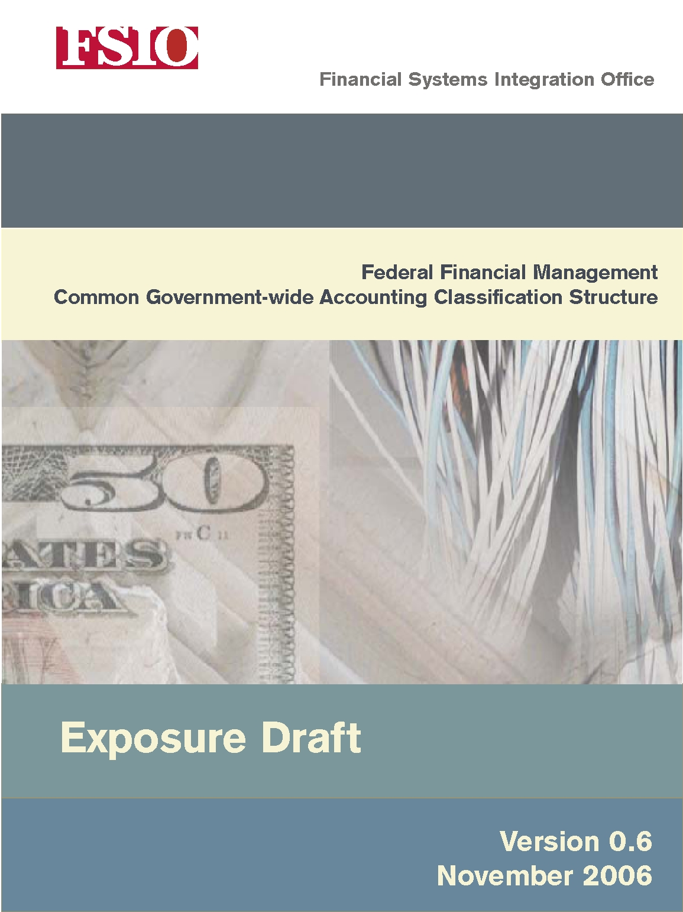

Contents
Abbreviations v
Executive Summary vii
Chapter 1 Introduction 1
1.1 Background 1
1.2 Desired Outcomes from Implementing the CGAC Structure 2
1.3 Responsibility 3
1.4 Audience 3
1.5 Organization of the Report 4
Chapter 2 Existing Standards and Agency Application 5
2.1 What Is an Accounting Classification Structure? 5
2.2 Sources of Standardization 5
2.3 Agency Latitude in Application of These Standards Increases Government Costs 7
Chapter 3 Overview of the CGAC Structure 11
3.1 Universe of Elements 11
3.2 Scope of the CGAC Structure 13
3.3 Comparison of the CGAC Structure with Core Requirements 14
3.4 Changes Needed by Central Agencies to Reflect the CGAC Structure 16
3.5 Degree of Standardization Achieved 16
Chapter 4 Discussion of the CGAC Elements 17
4.1 Fund Category 17
4.2 Organization Category 23
4.3 Program Category 26
4.4 Transaction Category 31
4.5 Critical Agency Mission-Specific and Future-Use Category 38
Chapter 5 Summary Matrix of the CGAC Elements 39
Appendix A Approach to Developing the CGAC Structure 61
Appendix B Elements under Consideration 63
Appendix C Contributors 67
Appendix D Logical Data Model 71
Appendix E Accounting Classification-Related Requirements in Core Financial System Requirements 73
Appendix F Summary of Changes Needed to Align the Central Agencies with the CGAC Structure 77
Appendix G CGAC Elements Used in Reporting 81
Appendix H Document Change History 83

Figures
Figure 1. Agency Adoption of an Agency-Wide Classification Structure 8
Figure 2. Comparison of Agency Approaches to Defining a Fund 9
Figure 3. Overview of the CGAC Structure 11
Figure 4. CGAC Elements Captured in a Transaction 12
Figure 5. Relationship among Elements in the Fund Category 22
Figure 6. Relationship among Elements in the Organization Category 25
Figure 7. Relationship among Elements in the Program Category 30
Figure 8. Relationship among Elements in the Transaction Category 37

Abbreviations
ALC Agency Location Code
ATB Adjusted Trial Balance
BEA Budget Enforcement Act of 1990
BETC Business Event Type Code
BFY Budget Fiscal Year
CFO Act Chief Financial Officers Act of 1990
CFOC Chief Financial Officers Council
CGAC Common Government-wide Accounting Classification
COTS Commercial Off-the-Shelf
FACTS I Federal Agencies’ Centralized Trial-Balance System I
FACTS II Federal Agencies’ Centralized Trial-Balance System II
FASAB Federal Accounting Standards Advisory Board
FAST Federal Account Symbols and Titles (FAST Book)
FBWT Fund Balance with Treasury
FFMIA Federal Financial Management Improvement Act of 1996
FFMSR Federal Financial Management System Requirements
FMFIA Federal Managers’ Financial Integrity Act of 1982
FMLoB Financial Management Line of Business
FMS Department of the Treasury Financial Management Service
FSIO Financial Systems Integration Office
GAO Government Accountability Office
GFRS Governmentwide Financial Report System
GPRA Government Performance and Results Act of 1993
GSA General Services Administration
GWA Governmentwide Accounting
IPAC Intra-Governmental Payment and Collection
MAF Master Appropriation File maintained by FMS
NIST National Institute of Standards and Technology
OFFM Office of Federal Financial Management (OMB)
OMB Office of Management and Budget
PAR Performance and Accountability Report
PART Program Assessment Rating Tool
SF Standard Form
SFFAC Statement of Federal Financial Accounting Concepts
SFFAS Statement of Federal Financial Accounting Standards
SSP Shared Service Provider
TAFS Treasury Appropriation Fund Symbol
TAS Treasury Account Symbol
TFM Treasury Financial Manual
Treasury U.S. Department of the Treasury
U.S.C. United States Code
USSGL U.S. Standard General Ledger

Executive Summary
Over the past few decades, the Federal government has increasingly standardized the way it develops and implements its financial management systems. Each successive effort has reduced the cost and improved the quality of agency financial systems, but a significant number of agencies continue to struggle when implementing these modern financial systems.
To assist agencies with their financial management system modernization efforts, the Financial Management Line of Business (FMLoB) is undertaking several initiatives to reduce the cost and risk of these systems. Among the initiatives are a number of projects to standardize business processes and data elements, including this effort to develop a common government-wide accounting classification (CGAC) structure for use by all Federal agencies.
The CGAC structure establishes a standard way to classify the financial effects of government business activities. It includes data elements needed for internal and external reporting and provides flexibility for agency mission-specific needs. Although a number of standards exist for classifying financial transactions, they provide latitude for each agency to develop its own classification structure. As a result, the classification structures used in agency systems vary from agency to agency and often from bureau to bureau within the same agency. The proposed standard CGAC structure identifies and defines the elements, names them where appropriate, promotes consistent use, and establishes a uniform structure for capturing them.
The CGAC structure will eventually be incorporated into requirements for core financial management systems so that software products will be configured to support the structure. An agency will likely adopt the finalized structure when it implements a new financial management system, makes major upgrades to an existing certified system, or moves to a shared service provider (SSP). Eventually, adoption of the CGAC structure will be mandatory.
The central agencies, including the Office of Management and Budget (OMB) and the Department of the Treasury, have participated in the definition of this common government-wide accounting classification structure. They are committed to making the changes needed to align their systems and processes to the new structure.
This document is an exposure draft to be used to solicit further comment from the Federal financial management community before the CGAC structure is adopted. Facilitated sessions are planned in February 2007 to discuss comments before the final structure is adopted. Once the CGAC structure is finalized, additional work will address implementation issues and planning.

Introduction

Background
Improving financial performance across government is one of the President’s top management priorities. A key factor in the success of this initiative is that Federal agencies implement financial management systems that produce timely, useful, and reliable information for decision making.
Over the last 15 years, the Federal government has committed significant resources to implement Federal financial management systems that meet its information needs. The success of these implementations has been mixed. In fact, today, many agencies continue to struggle with implementing systems that substantially comply with Federal financial management system requirements, applicable accounting standards and information security requirements, and that meet financial and program managers’ information needs.
The FMLoB initiative arose out of the need to reduce the cost and improve the outcome of Federal financial system implementations. To meet these objectives and ensure that systems continue to meet the information needs of the Federal government, the FMLoB focuses on leveraging technology investments across government and standardizing the underlying business processes of Federal agencies.
Specifically, the vision of the FMLoB is to improve the cost, quality, and performance of financial management systems by leveraging shared service solutions and implementing other government-wide reforms that foster efficiencies in Federal financial operations. The goals of the FMLoB are fivefold:
- Provide timely and accurate data available for decision making
- Facilitate stronger internal controls that ensure integrity in accounting and other stewardship activities
- Reduce costs by providing a competitive alternative for agencies to acquire, develop, implement, and operate financial management systems through shared service solutions
- Standardize systems, business processes, and data elements
- Provide for seamless data exchange between and among Federal agencies by implementing a common language and structure for financial information and system interfaces.
Included in the FMLoB initiative is this project to establish a CGAC structure—a uniform structure and set of definitions for classifying the financial effects of agencies’ business operations. The establishment of a CGAC structure supports the overall goals of the FMLoB by providing for standardization that leads to efficiencies in Federal financial management and system design.

Desired Outcomes from Implementing the CGAC Structure
The purpose of the CGAC structure is to define a standard way to capture information when classifying the financial effects of government business activities. The result is a uniform accounting classification structure that provides the name, definition, and field size of classification elements to be used in systems. It includes the essential elements needed to classify standard government-wide accounting-related functions and to accommodate agency mission-specific accounting data.
This standardization is part of an overall plan to reduce the cost and risk of system implementations in both the short and long terms. In the short term, it will help in the following ways:
- Promote a universal understanding of data elements. Establishing standard names and definitions for accounting classification elements promotes a common language. The labels and definitions given to financial data will no longer vary from agency to agency and from system to system. As examples, standard definitions reduce training and start-up time for financial personnel transferring from one agency to another and make it easier for managers reviewing reports to understand the data shown on financial management system screens.
- Help agencies standardize accounting codes internally. A number of agencies are still in the process of moving from bureau-level systems to enterprise-wide systems. Each implementation begins with the task of defining standard accounting codes. Having a common government-wide standard provides a uniform framework, reduces the number of decisions to be made about classification, and facilitates the implementation process.
In the longer term, it will contribute in additional ways:
- Aid in the evolution of standardizing financial management throughout the Federal government. There is a logical sequence of steps to an overall standardization strategy for Federal financial management that includes common business processes, data definitions, and accounting codes. The CGAC structure is a building block to a future state that will take a number of years to implement.
- Ease the transition when an agency moves to a new financial management system or an SSP. Significant effort is usually dedicated to developing the accounting classification structure when an agency moves to a new system. If the CGAC structure is adopted, many of the standard elements will already be defined. This reduces the amount of unnecessary rework required. Financial management system vendors will be able to build standard accounting classification functionality into the systems they offer to the Federal government, and SSPs will be able to implement the structure as part of their standard service offerings.
- Aid in the aggregation and comparison of data across the government. Having standard accounting classification structures enables one agency to compare itself with another at a meaningful level. The major benefit will be in the ability of central agencies to aggregate government-wide data (e.g., aggregate costs associated with Hurricane Katrina).
- Facilitate seamless data exchange among an agency’s financial systems. The CGAC structure is an incremental step toward establishing a standard interface between core and feeder systems. A common accounting classification structure that feeder systems use could eliminate the need to develop and maintain a unique interface and a unique set of cross-walks between the codes in each system. Data exchanges with central agency systems—such as Treasury’s IPAC system—might also be improved.
The need for improved data exchange among an agency’s financial systems is a particularly important target for the CGAC structure. Currently, the classification information exchanged between core financial management and feeder systems is not standardized. Therefore, every interface must be custom defined. This has become more obvious as various lines of business encourage agency use of a limited number of systems. Even though agencies used only a few systems, there is no standard interface.
When the accounting classification information needed by all agencies is standardized by the CGAC structure, the amount of work required to define an interface is reduced. Interface definition work would then concentrate on other elements such as establishing funds control methods, mapping the feeder system transactions to general ledger transactions, and harmonizing vendor files.

Responsibility
OMB is the executive sponsor for the FMLoB initiative and, in conjunction with the CFO Council’s Financial Systems Integration Office (FSIO) Oversight Transformation Team, provides oversight and guidance for the initiative.
FSIO has direct responsibility for completing priority projects under FMLoB. This document was prepared by FSIO, as the managing partner of the FMLoB, in collaboration with Federal program agencies.

Audience
The audience for this report is the Federal financial management community. The primary users will be agency accountants, contractors who support financial management system implementations, and vendors of financial management system products.

Organization of the Report
The remainder of this report is organized into five major sections, as follows:
- Chapter 2, “Existing Standards and Agency Application,” describes the current standards guiding accounting classification and how agencies have applied them.
- Chapter 3, “Overview of the CGAC Structure,” provides a high-level view of the structure and its scope, and compares it to the elements included in Core Financial System Requirements.
- Chapter 4, “Elements of the CGAC Structure,” defines each element within the structure and explains how it is used. The elements are organized into five major categories: Fund, Organization, Program, Transaction, and Critical Agency Mission-Specific and Future-Use Elements.
- Chapter 5, “Summary Matrix of the CGAC Elements,” includes a consolidated table defining all of the CGAC elements.
The appendices provide additional detailed information:
- Appendix A describes the approach to developing the CGAC structure.
- Appendix B provides a list of additional elements under consideration for inclusion in the structure.
- Appendix C provides a list of people who contributed to the development of the CGAC structure.
- Appendix D presents a logical data model depicting the relationships among the CGAC elements.
- Appendix E provides a list of accounting classification-related requirements in Core Financial System Requirements.
- Appendix F summarizes changes that affect central agency definitions.
- Appendix G presents a matrix of CGAC elements used in external reports.
- Appendix H provides a history of changes made to this document.

Existing Standards and Agency Application

What Is an Accounting Classification Structure?
An accounting classification structure provides a consistent means for classifying financial events that enables the summarization and reporting of information in a meaningful way. The Federal accounting classification structure identifies where money came from (the appropriation), how it was used, and what organization has fiscal responsibility over budgetary resources. A mandatory component of the classification structure is the U.S. Standard General Ledger (USSGL). It also includes the classification of financial data by program, project, and activity in order to measure program outcomes and performance.
A common government-wide accounting classification structure establishes a standard structure to be used by all executive branch agencies in recording financial events.

Sources of Standardization
The Federal government derives standards for classifying the financial effects of its business operations from multiple sources:
- Department of the Treasury Financial Management Service (FMS)
- Office of Management and Budget
- Office of Federal Financial Management (OFFM)
- Financial Systems Integration Office on behalf of the Chief Financial Officers Council
- Federal Accounting Standards Advisory Board (FASAB).
Treasury’s FMS publishes the Treasury Financial Manual (TFM), which provides guidance on central accounting and reporting and other fiscal matters. The underlying purpose of Treasury’s standards is to make it possible to consolidate accounting results of all agencies and to manage the government’s fund balances. The USSGL provides a uniform chart of accounts and standard posting logic (transaction codes) for recording financial events across government. The USSGL also includes cross-walks that map the general ledger accounts to standard external reports required by OMB and FMS. Treasury also establishes the standard structure for the Treasury Account Symbol (TAS) to be used when reporting financial transactions and balances to Treasury.
OMB publishes circulars that provide guidance and standards for preparing financial reports and classifying the budget. Circular A-136, Financial Reporting Requirements, provides guidance on preparing an agency’s Performance and Accountability Report (PAR), including the form and content of the Annual Financial Statements. Circular A-11, Preparation, Submission, and Execution of the Budget, establishes formats and values for such things as identification codes for budget accounts, subfunction classes, and object classes. Circular A-127, Financial Management Systems, requires that each agency use an agency-wide financial information classification structure. In the section on common data elements, OMB Circular A-127 states:
Standard data classifications (definitions and formats) shall be established and used for recording financial events. Common data elements shall be used to meet reporting requirements and, to the extent possible, used throughout the agency for collection, storage and retrieval of financial information. Government-wide information standards (e.g., the U.S. Government Standard General Ledger) and other external reporting requirements shall be incorporated into the agency’s standard data classification requirements.
OMB’s OFFM provides a model for integrated financial management systems in the Federal government, working through FSIO. The Framework for Federal Financial Management Systems sets forth the vision, desired capabilities, performance outcomes, environment, and other attributes that all Federal financial management systems must be designed to support. The Federal Financial Management System Requirements (FFMSR) documents prescribe the capabilities to be provided by financial management systems.
Among the FFMSR documents is Core Financial System Requirements. It identifies 13 accounting classification elements that must be supported in all core Federal financial management systems. The 13 classification elements are as follows:
- Treasury Account Symbol
- Budget fiscal year
- Internal fund code
- Organization
- Program
- Project
- Activity
- Cost center
- Object class
- Revenue source
- Budget function
- Budget subfunction
- Accounting period.
In addition, Core Financial System Requirements specifies that Federal financial management systems must support five additional agency-defined classification elements.
FASAB is responsible for promulgating accounting standards for the United States Government. These standards are recognized as generally accepted accounting principles (GAAP) for the Federal government and must be applied by Federal agencies in preparing financial statements. FASAB publishes these standards in Statements of Federal Financial Accounting Standards (SFFASs), Interpretations, Technical Bulletins, and Statements of Federal Financial Accounting Concepts (SFFACs). The latter provide a framework of objectives and concepts that describe the purposes, content, and characteristics of information provided in federal financial reports.

Agency Latitude in Application of These Standards Increases Government Costs
The current standards allow for considerable flexibility in how an agency designs its accounting classification structure. For example, the standard classification values prescribed by Treasury and OMB may be stored in agencies’ systems using different values or names, and then cross-walked or otherwise converted to conform to the prescribed format for external reporting. In addition, Core Financial System Requirements does not specify the length, format, or definition and usage of the 13 classification elements that must be supported in all Federal financial management software in order to be qualified for Federal agency acquisition.
As stated in Core Financial System Requirements,
Agencies have considerable leeway in how they elect to use tested capabilities.… In practice, the applicability of individual requirement provisions depends on business circumstances.
The data elements that a particular agency includes in its accounting classification will depend on data aggregation requirements for preparation of financial statements under the CFO Act, the appropriation structure, and other reporting and management needs of the agency.
As a result, the accounting classification structure within each Federal agency is unique and highly customized to its local environment. Although some consistencies exist within the Federal accounting classification process (such as in the adoption of the USSGL Account code at the transaction level), the current standards allow for a wide variance in the use of other system-provided classification elements.
A survey was issued to the 24 CFO Act agencies requesting information on their accounting classification structures, future plans for standardization, and system life-cycle status. Detailed analysis of the survey results led to the following findings:
- Many agencies still have not adopted an enterprise-wide accounting classification structure. Although most agencies responded that they have a standard enterprise-wide structure, analysis of the detailed information provided revealed that some of the agencies’ bureaus had independent classification structures.
- There is a wide divergence in agency accounting classification structures. Agencies that have similar fields may call them by different names, or they may use different logic to drive similar business rules. The existing standards have not been detailed enough to drive meaningful standardization.
As previously stated, OMB Circular A-127, Financial Management Systems, requires that each agency use an agency-wide financial information classification structure. Figure 1 provides the responses to question 6 of the survey, “Have you adopted an agency-wide accounting classification structure?” As illustrated in the figure, it was determined that not all agencies have agency-wide structures.
Figure 1. Agency Adoption of an Agency-Wide Classification Structure
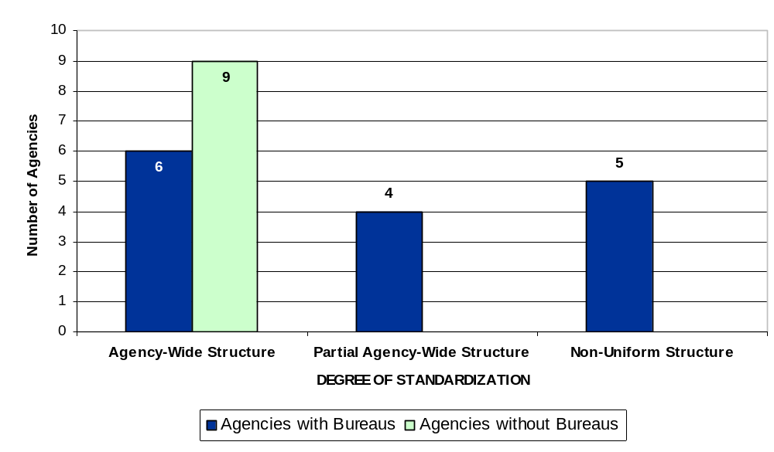
One-third of agencies report that they are implementing a new system that requires a change in classification structure, and another third are likely to change their structure in the near future. These agencies may be in a good position to adopt the CGAC structure, and its availability provides a common ground toward which the bureaus within an agency can move.
The wide variation in agency accounting classification structures can be seen in the way agencies define a fund and, in particular, in the way they define the Period of Availability for a fund. Figure 2 illustrates the variation in agency approaches to defining fund elements in three agencies.
Figure 2. Comparison of Agency Approaches to Defining a Fund
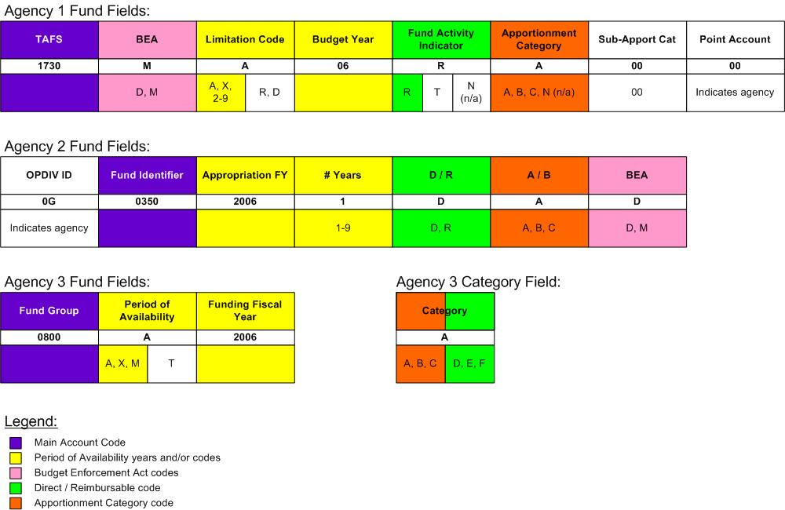
Focusing on one field provides an example of the result of variation. The Period of Availability for each agency includes a beginning fiscal year and some indicator to be able to define the ending fiscal year:
- Agency 1 uses a two-digit year and a separate code to identify whether it is an annual 1-year fund (A), a multiyear fund lasting from 2 to 9 years, or a no-year (X) fund.
- Agency 2 uses a four-digit year and a separate code to identify whether it lasts from 1 to 9 years.
- Agency 3 uses a four-digit year and a separate code to identify whether it is an annual 1-year fund (A), a no-year (X) fund, a multiyear fund (M), or a trust fund (T).
As a result of this variation in how the Period of Availability is captured, the software implemented in each agency had to be modified to calculate when funds are available. If the same fields and values were used, a single method for the calculation could be developed. In the three examples above, the same software product was used, so the variation was not driven by the product; instead, the product had to be changed to meet the data at a cost borne by the government.
Additional survey results, including examples of variation in classification structures used by agencies, are provided in a companion document entitled Results of the Accounting Classification Information Survey.

Overview of the CGAC Structure

Universe of Elements
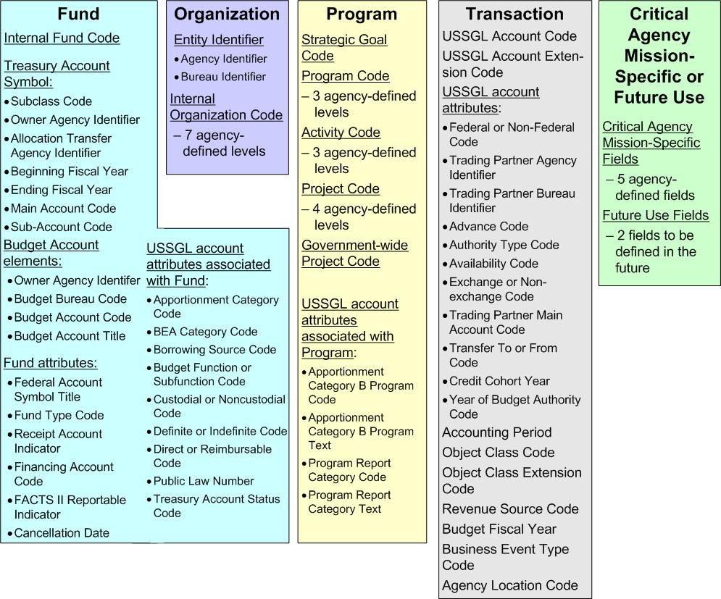
The CGAC structure consists of multiple distinct data elements used for classifying the financial transactions of the Federal government. For purposes of presentation and discussion, the CGAC elements have been grouped into five logical categories related in purpose (Fund, Organization, Program, Transaction, and Critical Agency Mission-Specific or Future Use), as illustrated in Figure 3.
Figure 3. Overview of the CGAC Structure

The order of the elements within each category is not intended to convey a hierarchical relationship between the elements or the relative importance of one element to another.
Figure 4. CGAC Elements Captured in a Transaction displays the CGAC elements that would be captured in a transaction. Some of these would be entered by a user; others would be derived by the system at the time a transaction is entered.
Figure 4. CGAC Elements Captured in a Transaction
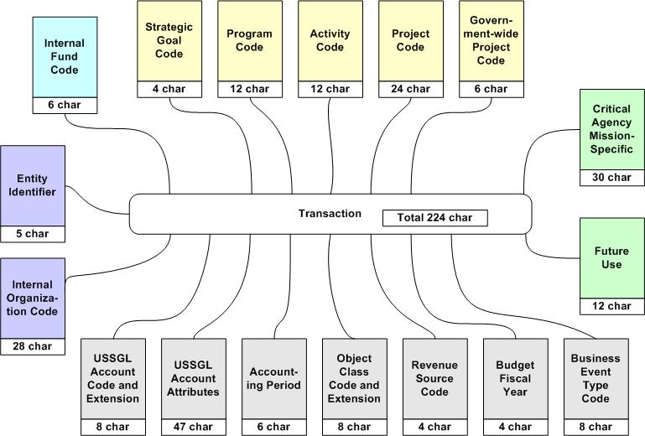
Multiple classification elements are needed to accommodate the way data are arrayed in financial reports of the Federal government. To address this, the CGAC structure includes a relatively large number of elements.
To minimize data entry, Core Financial Systems Requirements mandates several capabilities that financial management systems must provide. These include the automated capability to derive full accounting classifications on transactions from abbreviated user input based on the context of the action performed, such as using shorthand codes, deriving elements from other entered fields, and providing users with a list of values from which to choose. System capabilities must also allow users to define business rules that set a default value for accounting classification elements, establish parent/child relationships between elements, and associate elements with their valid domain values.
The CGAC structure identifies logical relationships between these data elements. These relationships are discussed in Chapter 4 to provide guidance on how a classification structure can be designed to minimize user entry. This balances the long structure required for reporting with the need to minimize user entry.

Scope of the CGAC Structure
The CGAC structure focuses primarily on the classification elements needed to support all standard external financial reports, general internal financial reports, and financial management processes such as funds control and cost accounting. It is not intended to provide a standard format for every data element used within a Federal financial management system.
The information provided in this document about each element does not replace OMB or Treasury guidance or standards. Rather, it provides the rationale for including the element in the CGAC structure and to explain how it can meet the reporting and information needs of Federal agencies.

External Reports
The CGAC structure supports the following external reporting requirements:
- Preparation of financial statements in accordance with the Chief Financial Officers Act of 1990, the Government Management Reform Act of 1994, and 31 U.S.C. 3515, Financial statements of agencies
- Preparation of reclassified financial statements submitted through the Governmentwide Financial Report System (GFRS)
- Preparation of adjusted trial balances submitted through the Federal Agencies’ Centralized Trial-Balance System (FACTS) I and FACTS II
- Classification of transactions reported through the Governmentwide Accounting (GWA) system and on FMS 224, Statement of Transactions; FMS 1219, Statement of Accountability; and the FMS 1220, Statement of Transactions
- Preparation of the prior-year column of the Program and Financing Schedule (Schedule P of the Budget appendix).

Internal Reports
Internal financial reports vary by agency, but generally include the following types of reports that are supported by the CGAC structure:
- Trial balances
- Transaction registers
- Status of funds report
- Internal financial statements.

Funds Control and Cost Accounting
Any element of the CGAC structure may be used to identify an entity to which funds are distributed and controlled (e.g., an internal organization, program, or project) or to which costs are distributed and accumulated. Because of this, the CGAC structure does not contain some specifically named elements that occur in other agency classification structures. The following are some examples:
- Allotment. An allotment is a distribution of legally apportioned resources to an entity within an agency. Any element of the CGAC structure, such as an internal organization or project, may represent an entity to which funds are allotted.
- Cost center. A cost center is a logical grouping of one or more related activities or organizational units into a common pool for the purpose of identifying the cost incurred. Any CGAC element or grouping of elements can represent a cost center.
- Cost object. A cost object is any activity, output, or item whose cost and revenue are to be measured. Like a cost center, any CGAC element can represent a cost object.
The CGAC structure supports the Core Financial System Requirements mandate that systems provide the following funds control and cost accounting capabilities:
- Monitor the use of funds at each organizational level or other accounting classification to which budget authority is distributed
- Define accounting classification elements or GPRA goals as cost objects for accumulation, distribution, and reporting.

Comparison of the CGAC Structure
with Core Requirements
The 13 accounting classification elements established in Core Financial System Requirements form the basis for development of the CGAC structure. The CGAC structure expands upon these in two ways: by providing more specificity, and by identifying additional elements critical to financial reporting.
Table 1 lists the 13 classification elements and, for each, provides general observations made after reviewing agency classification structures and discusses how each element is correlated to elements in the CGAC structure.
Table 1. Observed Correlation of the 13 Core Financial System Elements to CGAC Structure
Element | Observations | Correlation to CGAC Element
Treasury  Account Symbol | Generally not described as a part of the agency’s classification structure that is entered on a transaction. Most agencies use a shorthand internal fund code instead and derive the Treasury Account Symbol at the time of reporting. | Includes the component elements of the Treasury Account Symbol and formalizes the practice of deriving these elements from the Internal Fund Code.
Budget Fiscal Year | Used by many agencies but with significant variation in its definition. For some it is the year of obligation; in others it is used to describe the period of availability. | Standardizes the definition and use of this element.
Internal Fund Code | Used by most agencies. | Standardizes the definition and use of this element.
Organization | Used by all agencies with a large variation in the number of levels and in the number of characters used for each level. Agencies are using it to meet different needs. | Includes a standard entity identifier (Agency Identifier and Bureau Identifier) and up to seven hierarchical levels for capturing internal organization codes below the bureau level.
Program | Definition and use varies widely among agencies. | Provides three hierarchical levels and a standard definition for this element to bring additional structure and consistency to the program area while still providing a degree of agency flexibility.
Activity | Definition and use varies widely among agencies. | Provides three hierarchical levels and a standard definition for this element to bring additional structure and consistency to this code while still providing a degree of agency flexibility.
Project | Not used by all agencies. Definition varies widely among agencies, and whether it is related to program or cross-cutting varies. | Provides four hierarchical levels and a standard definition for this element to bring additional structure and consistency to this code while still providing a degree of agency flexibility.
Cost Center | Not all agencies have a separate element named cost center. For those that do, it is often another name used to describe the lowest level of the organization, instead of a true cost center to which full costs are allocated. | Not a separate element in the CGAC structure. Any element of the CGAC structure can be a cost center such as an organization, strategic goal, program, activity, or project code.
Object Class | Used by all agencies. Extensions to the object class vary in the number of characters. | Provides two standard levels and an agency-defined extension to this code. This standardizes the length of an extension code, if used.
Revenue Source | Not used by all agencies. Use depends on the agencies’ business processes. | Standardizes the format for this element.
Budget Function | Generally not seen as a part of the agency’s classification structure. Derived at the time of reporting. | Formalizes the association of this USSGL attribute with a fund and standardizes the practice of deriving it on transactions from the Internal Fund Code.
Budget  Subfunction | Generally not seen as a part of the agency’s classification structure. Derived at the time of reporting. | Formalizes the association of this USSGL attribute with a fund and standardizes the practice of deriving it on transactions from the Internal Fund Code.
Accounting  Period | Used by many agencies but with variation in its format. Some use calendar year and month, others fiscal year and month, others use a date. | Standardizes the format for this element.

A logical outcome of the establishment of a CGAC structure will be to update accounting classification-related requirements in Core Financial System Requirements. Appendix E lists those requirements.

Changes Needed by Central Agencies
to Reflect the CGAC Structure
The CGAC structure reflects several recommended changes to standard government-wide codes. These changes are intended to do the following:
- Eliminate redundant elements
- Promote consistency and alignment of data elements used across systems
- Better conform to data-naming standards.
Changes are needed in two primary areas: standardization of agency and bureau codes, and alignment of some Treasury reporting attributes. These changes are reflected in the structure presented throughout this document and detailed in Appendix F.

Degree of Standardization Achieved
Not all elements of the CGAC structure are standardized to the same degree. Some elements are already centrally defined and use standard government-wide code values, while others allow for a degree of agency flexibility in assigning code values or in choosing whether or not to use additional sublevels when more than one is provided in the structure.
The standardization proposed in the CGAC structure is to identify and define the elements needed to support financial reporting, name them where appropriate, promote consistent use, and establish a uniform structure for capturing them on financial transactions. All of the elements have a standard length and format.

Discussion of the CGAC Elements

Fund Category
The fund category of elements enables classification of financial transactions by internal fund code, TAS, and budget account. The internal fund code is generally used for internal reporting; the TAS and budget account are used for external reporting. In the Federal government, the term “fund” is often used interchangeably with the term “account.” An account in this context is not the same as a USSGL account. Rather, it refers to the accounts established by Treasury in which transactions are recorded and the accounts presented in the President’s Budget.
The fund category of elements also includes attributes that are normally associated with a fund. These include fund attributes that characterize the fund and USSGL account attributes that are logically associated with a fund. The fund attributes are generally not reported externally, but are stored for informational purposes or are used to facilitate different accounting treatment of a fund. The USSGL account attributes are reported externally on certain USSGL account balances and are included with the fund category because of their association with particular funds and the desired capability to derive them on transactions from the fund code.
The elements of the fund category are divided into five subcategories:
- Internal fund code
- Treasury Account Symbol
- Budget account
- Fund attributes
- USSGL attributes associated with the fund.
The purpose and use of these elements are discussed in the following subsections.

Internal Fund Code
The internal fund code is the agency-assigned code value for a fund. It is a shorthand code entered on transactions and exchanged between the agency’s feeder systems and core financial system. Within the core financial system, the internal fund code enables summarization of financial transactions by the account identification codes required for reporting externally to Treasury and OMB.
An internal fund may have a one-to-one relationship with a TAS, or it may represent an agency subdivision of a TAS (a subfund). In either case, the internal fund points to or rolls up to the TAS for external reporting.
Agencies subdivide TASs and create subfunds for various reasons, such as the following:
- To separately report on or prepare financial statements for different lines of business within a fund
- To segregate funds that have both direct and reimbursable authority, multiple apportionment categories, or both discretionary and mandatory authority.
The internal fund element in the CGAC structure is a 6-character alphanumeric code. Its value is assigned by the agency. To support external reporting, the internal fund code must be associated with all other component elements included in the fund category. This is generally done in a system table.

Treasury Account Symbol
The TAS is an identification code assigned by Treasury, in collaboration with OMB and the owner agency, to an individual appropriation, receipt, or other fund account. (Definitions of these accounts are contained in I TFM 2-1500.)
All financial transactions of the Federal government are classified by TAS for reporting to Treasury and OMB. The TAS can be derived from the internal fund code. The TAS does not need to be stored with the transaction; it can be derived at the time of reporting.
The TAS consists of seven component elements. The names, formats, and definitions of these seven are listed below:
- Subclass code—a 2-character code that represents an account breakdown requested by an agency and approved and implemented by Treasury
- Owner agency identifier—a 3-character code that identifies the agency that is responsible for the TAS
- Allocation transfer agency identifier—a 3-character code that identifies the agency receiving funds through an allocation transfer (if any)
- Beginning fiscal year—a 4-character year that identifies the first year of funds availability under law that an appropriation account may incur new obligations (blank indicates that the account is not a multiyear account)
- Ending fiscal year—a 4-character year that identifies the last year of funds availability under law that an appropriation account may incur new obligations (an “X” indicates a no-year account, an “F” indicates a clearing account, a blank indicates that the account does not have budget authority)
- Main account code—a 4-character code that identifies the type and purpose of the fund
- Sub-account code—a 3-character code that identifies a Treasury-defined subdivision of a TAS.
Not all TASs contain all seven component elements. Receipt accounts, for example, generally consist of the owner agency identifier, the main account code, and a sub-account code. Appropriation and other fund accounts (expenditure accounts) consist of the owner agency identifier, the period of availability codes (beginning fiscal year and ending fiscal year), and the main account code. The subclass code is used only when there is a unique need (requested by the agency) for a subclassification below the TAS.
When reporting to Treasury, different formats and summarization levels of the TAS are used depending on the report:
- GWA and FMS 224, Statement of Transactions. Transactions reported through the GWA system and on the FMS 224 use all components of the TAS (if they apply to the particular account). The subclass code is reported as a parenthetical prefix to the TAS; the owner agency identifier and the allocation transfer agency identifier are separated by a hyphen; the beginning fiscal year and ending fiscal year are separated by a slash; and the sub-account code is preceded by a period.
- FACTS I and GFRS. Transactions reported in FACTS I and GFRS are reported using an Adjusted Trial Balance code. The ATB code comprises certain components of the TAS: the owner agency identifier and the main account code. (It also includes a bureau identifier, which is discussed in the section on organization elements.) The ATB code is a summary level TAS, combining all fiscal years applicable to an individual main account.
- FACTS II. Transactions reported in FACTS II include only those associated with a Treasury Appropriation Fund Symbol (TAFS). A TAFS is assigned to expenditure accounts based on the availability of the resources in the account. The TAFS is a combination of the owner agency identifier, the period of availability codes (beginning fiscal year and ending fiscal year), and the main account symbol. The TAFS applies only to appropriation and fund accounts, and excludes receipt accounts.

Budget Account
Budget accounts finance the programs and activities of the Federal government. They include the expenditure accounts and receipt accounts that are presented in the President’s Budget. A budget account may be composed of one or more Treasury accounts.
Budget accounts are identified by an account number assigned by OMB. This account number is used to store and access data in OMB’s MAX budget system (MAX). Agencies enter data into MAX at the budget account level.
The prior-year column of the Program and Financing Schedule (Schedule P) in the Budget appendix is generated from the data agencies enter into FACTS II and directly into MAX. The data entered directly into MAX are the obligations by program activity.
The CGAC structure includes the budget account classification to support summarization of obligations by program activity at the budget account level. The budget account can be derived from the internal fund code. The budget account does not need to be stored with the transaction; it can be derived at the time of reporting.
The budget account consists of three component elements:
- Owner agency identifier—a 3-character code that identifies the agency that is responsible for the budget account. (Currently, this code is assigned by OMB and is different than the agency identifier assigned by Treasury to a TAS. The section on the organization category of elements contains a discussion of the different agency codes in use today.)
- Budget bureau code—a 2-character code that represents an administrative or functional subdivision of an agency. The code is assigned by OMB.
- Budget account code—a 4-character code that represents a budget account, which is an administrative or functional subdivision of an agency and sometimes a budget bureau. (In some cases, this code is the same as the main account code of the Treasury account.)
In addition, the budget account includes a title assigned by OMB. The title is captured in a 125-character alphanumeric field.

Fund Attributes
Each fund has one or more attributes that characterize it. These attributes are not reported externally or captured on transactions. They are stored within the system for informational purposes or to facilitate different accounting treatment of funds. The fund attributes are listed below:
- Federal Account Symbol Title—the title of the Federal account symbol assigned by Treasury. Federal account symbols are listed in the FAST Book (a supplement to the TFM). Federal account symbols constitute the “basic” elements of the TAS. For example, appropriation and fund accounts use only the agency identifier and main account code; they do not include a period of availability unless the account is a no-year account and then includes an “X.” Receipt accounts are listed with only the main account and sub-account.
- Fund Type Code—a classification established in law that describes an account’s relationship to the government. FMS maintains 13 individual fund type codes in the Master Appropriation File (MAF). The MAF consists of a record for each Treasury/Appropriation Fund Group. Agencies update individual components of the MAF through the FACTS I application.
- Receipt Account Indicator—indicates whether a fund is a receipt account or is not a receipt account (an expenditure account).
- Financing Account Code—indicates whether the fund is a Direct Loan Financing Account, a Guaranteed Loan Financing Account, or is not a financing account as defined by the Federal Credit Reform Act of 1990.
- FACTS II Reportable Indicator—indicates whether or not the fund submits budget execution information to OMB and Treasury via FACTS II. (Not all accounts submit data through FACTS II.)
- Cancellation Date—the last date on which a fund may disburse. For most funds, it is 5 years beyond the ending fiscal year of the period of availability. This date is overridden for expired funds that are authorized by law to make disbursements beyond the normal 5-year period.
The summary matrix in Chapter 6 lists the domain values, sources of values, and format for these attributes.

USSGL Account Attributes Associated with Fund
USSGL account attributes further describe a USSGL account in order to meet specific external reporting requirements. Attributes must be captured in agency financial systems at the transaction level in conjunction with certain USSGL accounts as described in the USSGL Supplement to the TFM.
Several USSGL account attributes are logically associated with a fund. Associating these attributes with the agency’s fund code (internal fund code) allows the system to derive the applicable attribute from the fund code when a transaction is recorded. The USSGL account attributes associated with a fund are listed below:
- Apportionment Category—indicates whether budgetary resources distributed by OMB are category A (apportioned by calendar quarters or by other specified time periods), category B (apportioned by programs, activities, projects, or combinations thereof), or category C (not subject to apportionment).
- BEA Category Code—indicates whether the BEA category is mandatory or discretionary.
- Borrowing Source—indicates the source from which the borrowing took place.
- Budget Function/Subfunction Code—classifies data according to major purpose served or national need addressed. Classifications are required by the Congressional Budget Act of 1974.
- Custodial or Noncustodial Code—indicates whether the balance being reported is custodial or noncustodial and was reported by the agency in a Statement of Custodial Activity or separate footnote of custodial activity.
- Definite or Indefinite Code—indicates whether the amount of the budget authority is definite (specified amount or amount not to exceed the specified amount) or indefinite (determined by other factors).
- Direct or Reimbursable Code—indicates whether amounts for goods or services are financed by offsetting collections.
- Public Law Number—indicates the specific public law number that makes budget authority available to an agency, or reduces or rescinds it. Usually, the public law will be an appropriation act. Other types of authority include contract authority and borrowing authority.
- Treasury Account Status Code—indicates whether the TAFS is unexpired (the TAFS may incur new obligations) or expired (the TAFS may liquidate obligations or make adjustments, but may not incur new obligations).
Additional USSGL account attributes are logically associated with a program or transaction. They are identified and discussed in the sections on the program category of elements and the transaction category of elements.
Figure 5 illustrates the elements of the fund category, including those that are entered and those that can be derived either at the time of entry or at the time of reporting.
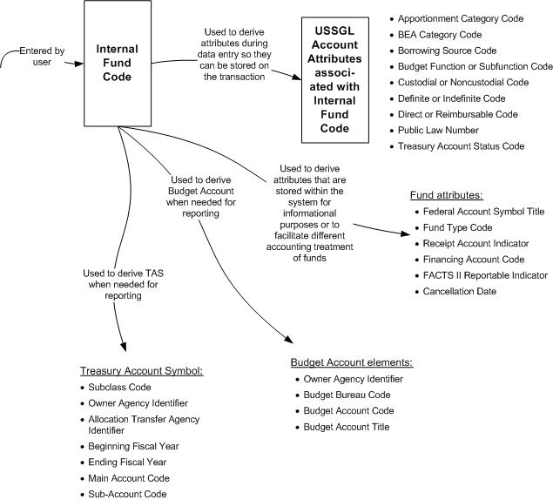
Figure 5. Relationship among Elements in the Fund Category

Organization Category
The organization category of elements classifies financial transactions by the entities responsible for managing resources and carrying out the programs and activities of the Federal government. Organization elements are used by agencies to support both external financial reporting and internal financial reporting and management functions. Externally, organization codes identify the reporting entity. Internally, organization codes identify the entities to which budgetary resources are allocated.
The elements of the organization category are arranged hierarchically and divided into two subcategories: the entity identifier and the internal organization. The entity identifier represents the two highest levels of the hierarchy: the agency and the bureau. The internal organization represents the lower levels of an agency’s organization. The purpose and use of these elements are discussed in the following subsections.

Entity Identifier
The entity identifier classifies transactions by the major organizations and suborganizations of the Federal government. It is used to group transactions by the primary reporting entities and component organizations of the Federal government that issue general-purpose financial statements, as described in Statement of Federal Financial Accounting Concepts 2, Entity and Display. The primary reporting entities of the Federal government are the departments and major independent agencies and their suborganization entities (bureaus, administration, or agencies).
The entity identifier consists of two component elements:
- Agency identifier—a 3-character numeric code that identifies the major departments and independent agencies of the Federal government
- Bureau identifier—a 2-character numeric code that identifies the major suborganizations of the agencies, sometimes called administrations, services, and agencies (not all agencies have bureaus).
In a shared service environment in which multiple agencies or bureaus use the same instance of a financial system, the use of an agency and bureau identifier will help segregate the transactions in one agency or bureau from those in another. It will also facilitate the summarization of financial data for preparation of financial statements at the agency and bureau level.
At the time of this publication, a single authoritative source for agency and bureau identifiers does not exist. In fact, several agencies publish codes to identify the major organizations of the Federal government:
- Treasury uses a 2-character code to identify agencies. This code is used in TASs, FACTS I trading partner codes, and agency location codes. Treasury also uses a 4-character trading partner code in GFRS. It is effectively an agency identifier (sometimes different) and a bureau identifier. The ATB code used in GFRS also consists of an agency identifier and bureau identifier.
- OMB establishes a 3-character agency code and a 2-character bureau code to identify accounts presented in the President’s Budget. The OMB agency code is different than the agency code assigned by Treasury. The OMB bureau code, in most cases, represents an organizational subdivision of an agency, but in some cases represents a subdivision for budgeting purposes.
- The National Institute of Standards and Technology (NIST) publishes organization codes in Codes for the Identification of Federal and Federally Assisted Organizations (Special Publication 800-87) to facilitate the interchange of information on Federal operations. The 4-character identifier published by NIST consists of the 2-character agency code assigned by Treasury and a 2-character identifier for the second-level of an organization, which is effectively a bureau identifier. The bureau identifier is different than the bureau code assigned by OMB.
- The General Services Administration (GSA) establishes codes for all agencies and bureaus with which it does business. The GSA identifier uses the 2-character agency code assigned by Treasury and a unique 2-character bureau identifier.
During the CGAC project, Treasury and OMB agreed on the importance of aligning agency identification codes to eliminate the need for agencies to maintain both. Likewise, the bureau identification codes will need to be discussed to determine whether a single code can meet the needs of all central agencies.
Once established, the CGAC entity identifier will be a government-wide code with a single authoritative source. The identifier will be used to classify all financial transactions of the Federal government. It can be used not only to identify the reporting entity, but also to identify the trading partner involved in transactions with the reporting entity.

Internal Organization
The internal organization identifies the entities that manage resources below the agency and bureau levels. Many agencies establish multiple levels of internal organizations for allotting and suballotting apportioned resources for management’s use and budgetary control. Organization units may also be used as cost centers for the purpose of accumulating costs.
The internal organization structure is arranged hierarchically. In a hierarchy, the individual component levels have a parent/child relationship, which enables summarization of data at any level established.
The CGAC structure includes a seven-level internal organization structure to accommodate the most complex agency structure. The number of levels an agency uses can be less than seven. Each level consists of a 4-character alphanumeric field. The names and codes used at each level are assigned by the agency.
Figure 6 illustrates the elements of the organization category, including those that are entered and those that can be derived either at the time of entry or at the time of reporting.
Figure 6. Relationship among Elements in the Organization Category

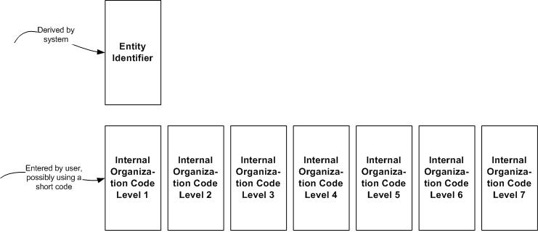

Program Category
The program category of elements categorizes financial information by strategic goal, program, activity, and project. In general, these are terms associated with an agency’s budget structure. They represent what an agency does and the items for which agencies request and are provided budgetary resources. These elements are intended to support financial and budgetary reporting, funds control, and cost accounting.
In practice, agencies’ budget structures and the names used to define the elements within their budgets depend on the language in their appropriations. Because of this, it is difficult to standardize a programmatic structure across the government. To accommodate differences, the CGAC structure provides flexibility in this area.
The program category groups the elements as follows:
- Strategic goal
- Program
- Activity
- Project
- Government-wide project.

Strategic Goal
A strategic goal is a statement of aim or purpose included in a strategic plan (required under GPRA) that defines how an agency will carry out a major segment of its mission over a certain period. In a performance budget, strategic goals are linked with the cost of specific programs and activities that contribute to them.
Many agencies prepare the Statement of Net Cost by strategic goal. OMB Circular A-136, Financial Reporting Requirements, provides the following guidance:
Preparers of the Statement of Net Cost should present responsibility segments that align directly with the major goals and outputs described in the entity’s strategic and performance plans, required by the Government Performance and Results Act.
The strategic goal code element is included in the CGAC structure to support the reporting needs of agencies that prepare the Statement of Net Cost by strategic goal. The strategic goal code element is a hierarchical code consisting of two levels:
- Strategic goal—a 2-character alphanumeric code assigned by the agency
- Subgoal—a 2-character alphanumeric code assigned by the agency.
In many cases, a strategic goal can be derived from an agency’s programs or activities. This is the case when an individual program or activity relates to just one strategic goal. In other cases, a single program or activity may contribute to multiple strategic goals. In these cases, the system cannot derive the strategic goal code from the program or activity. To classify transactions by strategic goal code, the agency will have to enter the code on each transaction or use an allocation process to assign financial activity to it. The strategic goal code element is an optional classification element.

Program Element
All agencies report on programs at some level, but not all agencies use the term “program” to describe this type of classification. The names used to identify a program structure within an agency often vary depending on how the agency’s appropriation language is written. Some agencies use the term “function” or “budget activity” to describe the work they perform in carrying out their missions.
GAO’s A Glossary of Terms Used in the Federal Budget Process contains the following definition of “program”:
Generally, an organized set of activities directed toward a common purpose or goal that an agency undertakes or proposes to carry out its responsibilities. Because the term has many uses in practice, it does not have a well-defined, standard meaning in the legislative process. It
is used to describe an agency’s mission, functions, activities, services, projects, and processes.
Most agencies use some sort of hierarchical structure to capture financial information related to their programs (e.g., programs and subprograms), but the number of levels used and the names assigned to each level varies from agency to agency. For example, one agency might establish a three-level programmatic structure with the names “Program,” “Subprogram,” and “Activity” at each level, while another agency might use “Budget Activity,” “Budget Subactivity,” and “Program” to describe each level. In the first example, “program” is at the highest level in the structure; in the second, “budget activity” is the highest level in the structure. This type of variation can even occur between funds within the same agency.
The CGAC structure provides for a three-level hierarchical structure for capturing data related to an agency’s programs—the organized sets of activities directed toward a common purpose or goal. The number of levels an agency uses and the names assigned to each level may vary.
Ideally, an agency will set up its program structure to facilitate reporting on the following:
- Program activities. Obligations by program activity are presented in the program and financing schedules (Schedule P) of the President’s Budget. Program activities represent the operations financed by a specific budget account. They may be projects, activities, and organizations. OMB Circular A-11 suggests that agencies’ financial systems record obligations in a way that allows for summarization by program activity.
- USSGL account attributes for category B programs and program report categories. SF 133, Report on Budget Execution and Budgetary Resources, and FACTS II classify obligations by apportionment category A or B, and then by category B project (for category B only) or program report category (for category A and category B). Not every TAFS uses program report categories, but for those that do, the agency works with OMB to determine what categories it will report on. OMB A-11 guidance suggests that categories be based on elements that agencies track in their financial systems. In some cases, they may be the programs that are or will be evaluated using the PART. In other cases, they may be the same programs that appear in the Program and Financing Schedule of the President’s Budget.
- Programs assessed using the Program Assessment and Rating Tool. PART is used to assess the performance of Federal programs. Although many of the factors assessed in PART programs are not financial, cost is one factor that is often used in assessing efficiency.
- Programs reported in the agency’s financial statements. Some agencies report on major programs in their Statement of Net Cost. The financial system should record transactions in a way that facilitates reporting by these programs.
The program element in the CGAC structure consists of three hierarchical levels, each with a 4-character alphanumeric code. The number of levels used is optional. The code values and names of each level are assigned by the agency. The program code element is not considered an optional element at this time. However, some agencies may derive it from their fund, organization, activity, or project code.

Activity
A separate activity code is included in the CGAC structure to capture costs related to activities that cross over multiple programs.
GAO’s A Glossary of Terms Used in the Federal Budget Process provides the following definition:
Budget Activity—A specific and distinguishable line of work performed by a governmental unit to discharge a function or subfunction for which the governmental unit is responsible.
The activity code in the CGAC structure consists of three hierarchical levels, each with a 4-character alphanumeric code. The code values are assigned by the agency. The activity code is generally entered on a transaction and not derived from any other classification element. The activity code element is an optional classification element.

Project
A project is a planned undertaking of something to be accomplished or produced, or an undertaking having a finite beginning and finite end. Examples are a construction project, research and development project, and a reimbursable project.
Sometimes projects are material enough that they are considered a program within the agency. In this case, the agency might want to capture it in the program structure. In other cases, an agency might need to capture costs of a specific project that is not directly related to a program or that crosses over many programs. The project code element is provided as a separate element in the CGAC structure for these purposes.
The project code in the CGAC structure consists of four hierarchical levels, each with a 6-character alphanumeric code. The code values are assigned by the agency. The project code is generally entered on a transaction and not derived from any other classification element. The project code element is an optional classification element.

Government-Wide Project
A government-wide project code field has been set aside in the CGAC structure to accommodate capturing of costs for an initiative, project, program, activity, or special unplanned event that cuts across many Federal agencies and for which funding may or may not have been provided. The government-wide project code is intended to facilitate the aggregation and comparison of certain data on a government-wide basis.
The government-wide project code will be captured in a separate field from the agency’s program or budget activity structure in order to allow the agency to continue accounting for its normal planned budget activities concurrently with capturing data on a government-wide project.
The government-wide project code element is a 6-character alphanumeric field. Its use is for purposes defined by OMB. When used, its code value will be assigned by OMB. The government-wide project code would be entered on transactions, when appropriate, and stored with the transaction for reporting purposes.

USSGL Account Attributes Associated with Program Code
USSGL account attributes further describe a USSGL account in order to meet specific external reporting requirements. Attributes must be captured in agency financial systems at the transaction level in conjunction with certain USSGL accounts as described in the USSGL Supplement to the TFM.
The following attributes are logically associated with the program code:
- Apportionment category B program code—a 3-character code that identifies the category B program used on the apportionment schedule (SF 132). The category B program is used to describe a distribution made by OMB of budgetary resources. OMB uses a category B program, which is subject to the Anti-Deficiency Act, to limit obligations. This code is used to report category B obligations.
- Apportionment category B program text—the description associated with the apportionment category B program.
- Program report category code—a 3-character code that identifies a program report category that agencies use when reporting their obligations in FACTS II. Agencies may use this code when reporting either category A or category B obligations. Unlike the apportionment category B program, this code is NOT subject to the Anti-Deficiency Act.
- Program report category text—the description associated with the program report category.
Associating these attributes with the agency’s program code allows the system to derive the applicable attribute at the time a transaction is recorded.
Figure 7 illustrates the elements of the program category, including those that are entered and those that can be derived either at the time of entry or at the time of reporting.
Figure 7. Relationship among Elements in the Program Category
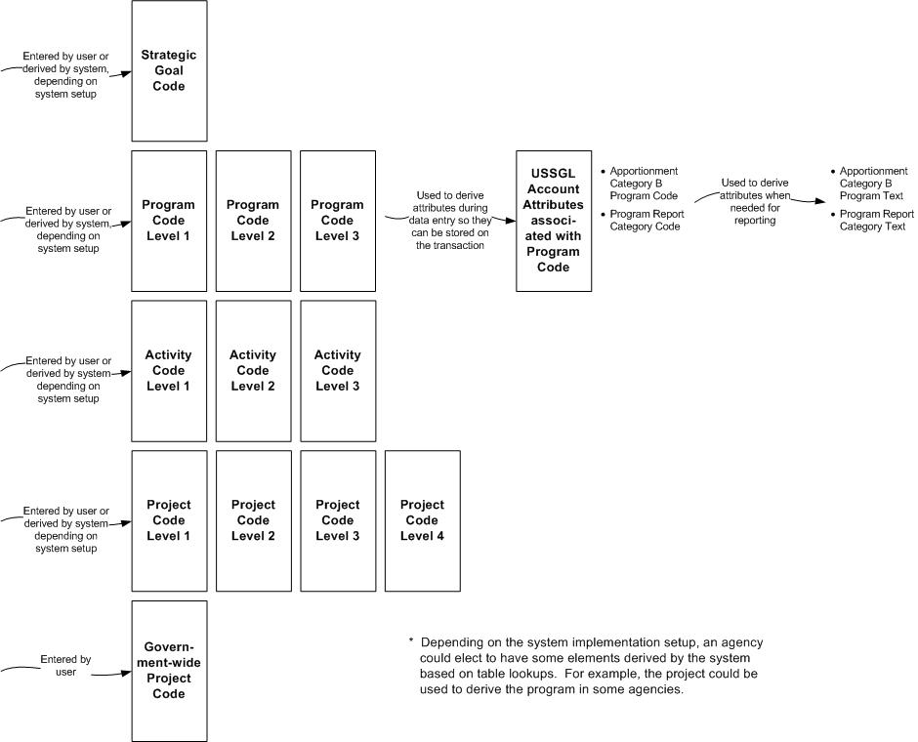

Transaction Category
The transaction category includes several distinct elements that provide detail about the nature or type and timing of a transaction. It also includes elements needed for reporting on an agency’s Fund Balance with Treasury (FBWT).

USSGL Account/USSGL Account Extension
A USSGL account code is any one of the standard general ledger account codes established by Treasury to support the consistent recording of financial events as well as the preparation of standard external reports required by OMB and Treasury. Every financial transaction must be classified by one or more debit entries and one or more credit entries to a USSGL account.
The inclusion of the USSGL account code in the CGAC structure is not meant to imply that it is necessarily “entered” on a transaction; rather, it is an essential element of accounting classification. The intent is to propose a standard length for the extension to the standard code used by agencies for internal accounting.
The USSGL account within the CGAC structure has two component elements:
- USSGL account code—a 6-character numeric account code assigned by Treasury. (A 6-character field has been established to accommodate future expansion of the USSGL account code by Treasury. The current account code has 4 characters. Agencies may not use the additional 2 characters for internal use.)
- USSGL account extension code—a 2-character alphanumeric extension to the USSGL account code assigned by the agency for agency-specific reporting needs.
Financial management systems use various methods to derive the USSGL account postings on a transaction. In general, the USSGL’s effect in the system is determined by a combination of the form selected by the user, other data entered on the transaction, and business rules and system logic. Some systems use a shorthand code or “transaction code” to derive the USSGL postings. In limited cases, the system may allow posting of a nonstandard transaction in which the user selects the USSGL account code upon entry.
The USSGL account extension code is an optional field for agencies. However, agencies may not amend the USSGL account code field to accommodate agency-specific reporting needs. For example, if an additional level of detail is needed beyond the USSGL account 1010 (FBWT), agencies should not create accounts such as 1011, 1012, etc. Instead, an account extension should be used with account 1010. When agencies use the USSGL account extension code, financial systems must summarize the data at the USSGL account level for external reporting.

USSGL Account Attributes
USSGL account attributes further describe a USSGL account in order to meet specific external reporting requirements. Attributes must be captured in agency financial systems at the transaction level in conjunction with certain USSGL accounts as described in the TFM USSGL Supplement.
Agencies submit their adjusted trial balances to Treasury through FACTS I and FACTS II at the USSGL account and attribute level. The account balances by attribute enable Treasury to prepare the Financial Report of the United States Government; the SF 133, Report on Budget Execution and Budgetary Resources; the FMS 2108, Year-End Closing Statement; and portions of the prior-year column of the Program and Financing Schedule of the President’s Budget.
The USSGL account attributes that are logically related to transactions are grouped by how the data might be captured or derived in a financial system. The transaction-related USSGL account attributes also reflect some changes to reduce inconsistencies and redundant data (see Appendix F for a summary of changes). The summary matrix in Chapter 6 lists the values of the attributes.
The following attributes can be derived from the vendor code entered on a transaction:
- Federal or non-Federal code—a 1-character alphabetic code that identifies the type of entity involved in transactions with the reporting entity.
- Trading partner agency identifier—a 3-character numeric code that identifies the agency of the other Federal entity involved in transactions with the reporting entity.
- Trading partner bureau identifier—a 2-character numeric code that identifies the bureau of the other Federal entity involved in transactions with the reporting entity. This code is often used in conjunction with the trading partner agency identifier.
In general, the following attributes cannot be derived from any other accounting classification element. Some agencies set up unique transaction codes or general ledger subaccounts that derive the attribute. In other cases, the user enters it.
- Advance code—a 1-character alphabetic code that indicates whether a portion of the appropriation was advanced from a future year, or was made available in a prior year.
- Authority type code—a 1-character alphabetic code used to distinguish among the types of budgetary resources, where it is not possible to do so by the USSGL.
- Availability code—a 1-character alphabetic code that indicates whether a budgetary resource is available for new obligations in the current period, or in a subsequent period within the current fiscal year, or after being reapportioned in a future fiscal year.
- Exchange or non-exchange code—a 1-character alphabetic code that indicates whether the revenue is exchange revenue or non-exchange revenue. (In some cases, an agency may establish business rules that derive this attribute from the revenue source code.)
- Trading partner main account code—a 4-character numeric code that indicates the main account code of the other Federal entity involved in transactions with the reporting entity. This code is used in conjunction with the trading partner agency identifier.
- Transfer to or from code—a 1-character alphabetic code that indicates whether a direct transfer is “to” or “from” another agency or account.
The following attributes can be derived from the budget fiscal year element
- Credit cohort year—a 4-character numeric year that identifies the fiscal year in which direct loans are obligated or guarantees are committed by a program, even if disbursements occur in subsequent fiscal years.
- Year of budget authority code—a 3-character alphabetic code that identifies the fiscal year in which a TAFS is provided with new no-year budget authority. It is used only for a no-year TAFS in order to distinguish outlays from new obligational authority vs. outlays from balances carried forward.
Other USSGL account attributes are included in the fund category of elements and the program category of elements.

Accounting Period
An accounting period is the fiscal year and fiscal month in which a transaction is effective in the general ledger. It is used to classify transactions by the particular time period in which they are reported. An accounting period is sometimes referred to as the reporting period because it represents the time period reflected in a set of financial statements (or other financial report).
The fiscal year for the Federal government begins October 1 and ends September 30. The first month of the fiscal year, October, is represented as “01,” the second month as “02,” etc. The fiscal year always corresponds to the year in which it ends.
The accounting period has two component elements:
- Fiscal year—a 4-character numeric code representing the fiscal year
- Fiscal month—a 2-character numeric code representing the fiscal month.
The accounting period must be captured on all financial transactions recorded in the general ledger and remain with the original transaction for reporting. The accounting period can generally be derived from the system date or transaction date (the actual date that the transaction is recorded), but can be overridden and entered by the user, when appropriate and allowed by agency management, to record a transaction in a prior month’s accounting period.
FSIO-certified financial management systems must provide the capability to record transactions in 15 accounting periods to accommodate recording of opening balances, adjustments, and closing transactions.

Object Class/Object Class Extension
The object class classifies obligations by the items or services purchased by the Federal government (e.g., personnel compensation, supplies, rent, or equipment). Object classification is required when reporting obligations in accounts presented in the President’s Budget.
OMB establishes the standard codes, titles, and definitions of the object class. It is a 3-character code described in Section 83 of OMB Circular A-11. Many agencies use an extension to the OMB object class for capturing additional detail to support internal information needs.
The CGAC structure accommodates the standard object class prescribed by OMB plus an additional two levels beyond the standard object class code for capturing agency-specific data. In addition, the CGAC structure provides an additional character in the OMB object class code to accommodate future expansion of the standard code.
The object class code element and object class extension code within the CGAC structure consists of four hierarchical levels:
- Object class code—a 2-character numeric code assigned by OMB
- Sub-object class code—a 2-character numeric code assigned by OMB (allows for future expansion (OMB currently uses 1 character)
- Object class extension level 1—a 2-character alphanumeric code assigned by the agency for agency-specific reporting needs
- Object class extension level 2—an additional 2-character alphanumeric code assigned by the agency for agency-specific reporting needs.
The object class code and sub-object class code are required classifications on all obligating transactions or similar transactions that will require payments in the current or future period. The use of the object class extension codes is optional. The object class code may be entered or derived at the time of recording a transaction, depending on the particular set of business rules established within a system. The object class code, whether entered or derived, must be stored with the transaction.

Revenue Source
The revenue source code classifies revenue and receipt transactions by the type or source of revenue. Some agencies use revenue source codes to categorize different types of fees collected or to distinguish between different types of reimbursable activity.
The revenue source code is generally used for internal accounting purposes, and is included in the CGAC structure because it is commonly used among agencies. FSIO-certified financial management systems must provide the capability to classify transactions by revenue source code, but its use by agencies is optional.
The revenue source code element in the CGAC structure is a 4-character alphanumeric code. Its code value is assigned by the agency. When used, it is generally entered by the user (not derived) and must be stored with the transaction.

Budget Fiscal Year
The budget fiscal year represents the year in which budget authority is legally apportioned and made available for obligation. The budget fiscal year is different from the period of availability (beginning fiscal year and ending fiscal year) associated with a fund. Period of availability may span multiple years, as in the case of multiyear funds, or it may indicate a no-year fund with a value of “X.” The budget fiscal year represents the particular fiscal year in which the funds were apportioned.
The budget fiscal year is captured on obligating documents to indicate the initial year in which the obligation was made. The budget fiscal year is retained on the obligating document even when it remains unliquidated in a subsequent fiscal year. The budget fiscal year indicates whether the obligation is from a prior year or the current year. This is necessary in order to determine whether a subsequent adjustment to the amount of the obligation (upward or downward) must be recorded using the USSGL-prescribed entries for recording prior-year adjustments.
A second use of budget fiscal year is to segregate unobligated balances carried forward in no-year funds from new budget authority. Unobligated balances carried forward must retain the budget fiscal year in which they were initially apportioned, not the budget fiscal year of the current year in which they will be reapportioned. The purpose of this is to determine whether an outlay of cash is from balances of budget authority or from new (current-year) budget authority and to capture the appropriate USSGL account attribute (BAL or NEW) required for FACTS II reporting. Outlays from obligations designated as prior year are always from balances of budget authority. They are from obligated balances of authority. Outlays from obligations created in the current budget fiscal year may be from unobligated balances carried forward or from new authority.
The budget fiscal year element in the CGAC structure is a 4-character numeric code. It is a mandatory field.

Business Event Type Code
The BETC is used to classify transactions reported to Treasury through the GWA system. It must be used in combination with the TAS to identify the type of activity (gross disbursement, funds held outside of Treasury, offsetting collection, collection to an unavailable receipt, etc.) and the effect of a transaction on the FBWT. (The BETC replaces the majority of the current subclass codes in use.)
The BETC is an alphabetic code with a maximum field length of 8 characters. Its code values are assigned by Treasury and can be derived based on the type of transaction recorded. The BETC applies only to transactions that affect the FBWT.

Agency Location Code
The ALC is assigned by Treasury to identify each agency that reports disbursements and collections to Treasury. The ALC is required when reporting transactions through the GWA system and on the FMS 224, Statement of Transactions; the FMS 1219, Statement of Accountability; and the FMS 1220, Statement of Transactions.
This element is a 3-, 4-, or 8-character numeric code. An 8-digit ALC is assigned to agencies for which the Treasury disburses at any of its Treasury Regional Finance Centers. A 3- or 4-digit ALC is primarily used by agencies that do their own disbursing.
The ALC value is assigned by Treasury. It can be derived at the time of reporting.
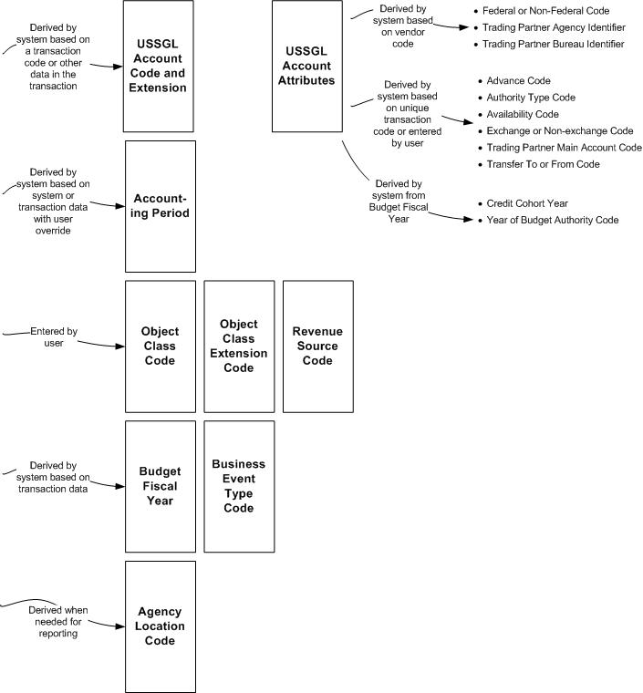
Figure 8 illustrates elements of the transaction category, including those that are entered and those that can be derived either at the time of entry or at the time of reporting.
Figure 8. Relationship among Elements in the Transaction Category

Critical Agency Mission-Specific
and Future-Use Category
The CGAC structure includes elements of defined field length for critical agency mission-specific needs and additional elements for future use:
- Critical agency mission-specific elements. Five elements are included in the CGAC structure to accommodate classification of financial transactions for purposes other than those defined elsewhere in the CGAC structure. Each element consists of a 6-character alphanumeric code. The names and code values are assigned by the agency.
- Future-use elements. Two elements are included in the CGAC structure to accommodate changes in external reporting requirements. Each element consists of a 6-character alphanumeric code. Their names and code values will be assigned by OMB or Treasury.

Summary Matrix of the CGAC Elements
This chapter provides a matrix, Table 2, summarizing the definition and format of the CGAC elements. The following information is provided:
- Category and Subcategory—logical group in which the element can be found.
- Business Name—name of the element.
- Definition—brief definition of the element.
- Source of Values—entity responsible for providing values of codes.
- Domain Values—values of the code, for those with a brief list of values. For elements with many values, the underlying source should be consulted.
- Format—number and type of characters. The format uses N = 1 numeric character, A = 1 alphabetic character, X = 1 alphanumeric character, Y = 1 year character, M = 1 month character.
- Optional or Mandatory—indicator of whether the element is a required classification.
- User Enters on Transaction?—indicator of whether the classification element needs to be entered by the user.
- Captured (Stored) on Transaction?—indicator of whether the element should be stored with the transaction or could be derived at the time of reporting. Elements that are stored on a transaction do not necessarily need to be entered by the user. In fact, many elements can be derived from other data entered on the transaction.
- Other Names Used—other names that have been used for this element, either in central agency documentation or by agencies in their survey responses.

Table 2. Definition and Format of the CGAC Elements
Category and Subcategory | Business Name | Definition | Source of  Values | Domain Values | Format | Optional or  Mandatory | User  Enters on Transaction? | Captured (Stored) on Transaction? | Other Names Used
Fund/  Internal Fund | Internal Fund Code | An agency-defined shorthand code used to identify an individual appropriation, receipt, or other fund account (TAS) or an agency sub-division of a TAS. When an internal fund code is used to represent an agency subdivision of a TAS, it “points to” or rolls up to the TAS for external reporting purposes. | Agency |  | XXXXXX | Mandatory | Yes | Yes | - Fund
Fund/  Treasury Account Symbol | Subclass Code | A prefix to a TAS, used when it is necessary to classify FBWT transactions reported on the FMS 224 or through the GWA system below the level of the TAS. The subclass code segregates certain types of transactions within funds from the normal receipt and expenditure transactions required for FMS’s central reporting purposes.  (These may be discontinued by Treasury when BETCs are implemented. See below.) | Treasury |  | NN | Mandatory, when applicable | No | No, system should derive at the time of reporting based on the fund code
Fund/  Treasury Account Symbol | Owner Agency Identifier | Used in conjunction with the main account code, the owner agency identifier represents the department, agency, or establishment of the U.S. government that is responsible for the TAS. | Treasury/  OMB | No single source of Agency Identification Codes has been determined  Generally the same as the agency identifier within the entity identifier | NNN | Mandatory | No | No, system should derive at the time of reporting based on the fund code | - Treasury Department Code  - Treasury Department Regular
Fund/  Treasury Account Symbol | Allocation Transfer Agency Identifier | The agency identifier of the agency receiving funds through an allocation transfer. | Treasury/  OMB | No single source of Agency Identification Codes has been determined | NNN | Mandatory, when applicable | No | No, system should derive at the time of reporting based on the fund code | - Allocation Transfer Agency
Fund/  Treasury Account Symbol | Beginning Fiscal Year | Used in multiyear funds only. Identifies the first year of availability under law that an appropriation account may incur new obligations. (Blank indicates that the account is not a multiyear account.) | Treasury | 4-digit year–multiyear account  Blank–not a multiyear account | YYYY | Mandatory, when applicable | No | No, system should derive at the time of reporting based on the fund code | - Fiscal Year Field  - Period of Availability
Fund/  Treasury Account Symbol | Ending Fiscal Year | In annual and multiyear funds, identifies the last year of funds availability under law that an appropriation account may incur new obligations. For no-year accounts, “X” indicates that funds are available until the purposes for which the funds were made available are accomplished. (An “F” indicates a clearing account, a blank indicates that the account does not have budget authority.) | Treasury | 4-digit year—multiyear account  X–no year account  F–clearing account  Blank–account does not have budget authority | XXXX | Mandatory, when applicable | No | No, system should derive at the time of reporting based on the fund code | - Fiscal Year Field  - Period of Availability
Fund/  Treasury Account Symbol | Main Account Code | Identifies the type and purpose of the fund. | Treasury | Values are listed in the FAST Book | NNNN | Mandatory | No | No, system should derive at the time of reporting based on the fund code | - Main Account Number  - Treasury Account Main Code  - Account Symbol
Fund/  Treasury Account Symbol | Sub-Account Code | When used, identifies a Treasury-defined subdivision of a TAS. | Treasury | Values are listed in the FAST Book | NNN | Mandatory, when applicable | No | No, system should derive at the time of reporting based on the fund code | - Sub-Account Symbol
Fund/  Budget Account | Owner Agency Identifier | Identifies the agency that is responsible for the budget account. This is generally the same as the Owner Agency Identifier shown as part of the Treasury Account Symbol. | Treasury/  OMB | No single source of Agency Identification Codes has been determined | NNN | Mandatory | No | No, system should derive at the time of reporting based on the fund code | - OMB Agency Code
Fund/  Budget Account | Budget Bureau Code | Used in conjunction with the owner agency identifier, the budget bureau code represents an administrative or functional subdivision of an agency. | OMB | Values are listed in A-11 | NN | Mandatory, when applicable | No | No, system should derive at the time of reporting based on the fund code | - OMB Bureau Code
Fund/  Budget Account | Budget Account Code | Used in conjunction with the owner agency identifier and the budget bureau code, the budget account code uniquely represents a budget account, which is an administrative or functional subdivision of an agency and sometimes a budget bureau. | OMB |  | NNNN | Mandatory, when applicable | No | No, system should derive at the time of reporting based on the fund code
Fund/  Budget Account | Budget Account Title | The title assigned by OMB to a budget account. | OMB |  | 125 alphanumeric characters | Mandatory, when applicable | No | No, system should derive at the time of reporting based on the fund code
Fund/  Fund Attributes | Federal Account Symbol Title | The title of the Federal account symbol assigned by Treasury. Federal account symbols are listed in the FAST Book (a supplement to the TFM). | Treasury | Values are listed in the FAST Book | 125 alphanumeric characters | Mandatory | No | No, stored within the system for informational purposes or to facilitate different accounting treatment of funds
Fund/  Fund Attributes | Fund Type Code | A classification established in law that describes an account’s relationship to the government. | Treasury Master Appropriation File | 01–General  02–Special  03–Public Enterprise Revolving  04–Intra-governmental Revolving  05–Summary Level ATB’s  06–Deposit Fund  07–Trust Non-revolving  08–Trust Revolving  09–Clearing Account  10–Miscellaneous Receipt Account  11–Credit Reform–Program Account  12–Credit Reform–Financing Account  13–Loans–Liquidating Account | NN | Mandatory | No | No, stored within the system for informational purposes or to facilitate different accounting treatment of funds | - Fund Code (OMB A-11)  - Fund Type
Fund/  Fund Attributes | Receipt Account Indicator | Indicates whether a fund is a receipt account or is not a receipt account (an expenditure account). | Treasury | Y–Yes  N–No | A | Mandatory | No | No, stored within the system for informational purposes or to facilitate different accounting treatment of funds | - Receipt Account Flag
Fund/  Fund Attributes | Financing Account Code | Indicates whether the fund is a Direct Loan Financing Account, a Guaranteed Loan Financing Account, or is not a financing account as defined by the Federal Credit Reform Act of 1990. | Treasury | D–Direct  G–Guaranteed  N–Non-financing | A | Mandatory | No | No, stored within the system for informational purposes or to facilitate different accounting treatment of funds | - Financing Account Indicator
Fund/  Fund Attributes | FACTS II Reportable Indicator | Indicates whether the fund submits budget execution information to OMB and Treasury via FACTS II. | Treasury | Y–Yes  N–No | A | Mandatory | No | No, stored within the system for informational purposes or to facilitate different accounting treatment of funds | - Report Submission Flag
Fund/  Fund Attributes | Cancellation Date | The last date on which a fund may disburse. For most funds, it is 5 years beyond the ending fiscal year of the period of availability. This date is overridden for expired funds that are authorized by law to make disbursements beyond the normal 5-year period. | OMB |  | MMDDYYYY | Mandatory | No | No, stored within the system for informational purposes or to facilitate different accounting treatment of funds | - Disbursing Authority End Date
Fund/  USSGL Account Attributes Associated with Fund | Apportionment Category Code | Indicates whether budgetary resources distributed by OMB are category A (apportioned by calendar quarters or by other specified time periods; category B (apportioned by programs, activities, projects, or combinations thereof); or category C (not subject to apportionment). | Treasury FACTS I and II documentation | A–Category A  B–Category B  C–Not subject to apportionment | A | Mandatory, when posting to a USSGL account that requires the attribute | No, system should derive based on the fund code | Yes | - Apportionment Category
Fund/  USSGL Account Attributes Associated with Fund | BEA Category Code | Indicates whether the BEA category is mandatory or discretionary. | Treasury FACTS I and II documentation | D–Discretionary  M–Mandatory | A | Mandatory, when posting to a USSGL account that requires the attribute | No, system should derive based on the fund code | Yes | - BEA Category Indicator
Fund/  USSGL Account Attributes Associated with Fund | Borrowing Source Code | Indicates the source from which the borrowing took place. | Treasury FACTS I and II documentation | T–Treasury  P–Public  F–Federal Financing Bank | A | Mandatory, when posting to a USSGL account that requires the attribute | No, system should derive based on the fund code | Yes | - Borrowing Source
Fund/  USSGL Account Attributes Associated with Fund | Budget Function or  Subfunction Code | A classification of data according to major purpose served or national need addressed. Classifications are required by the Congressional Budget Act of 1974. | OMB | Values are listed in A-11 | NNN  NNN  (2 levels) | Mandatory, when posting to a USSGL account that requires the attribute | No, system should derive based on the fund code | Yes | - Budget/Subfunction
Fund/  USSGL Account Attributes Associated with Fund | Custodial or  Noncustodial Code | Indicates whether the balance being reported is custodial or noncustodial and whether it was reported by the agency in a Statement of Custodial Activity or separate footnote of custodial activity. | Treasury FACTS I documentation | S–Custodial  A–Noncustodial | A | Mandatory, when posting to a USSGL account that requires the attribute | No, system should derive based on the fund code | Yes | - Custodial/  Noncustodial
Fund/  USSGL Account Attributes Associated with Fund | Definite or  Indefinite Code | Indicates whether the amount of the budget authority is definite (specified amount or amount not to exceed the specified amount) or indefinite (determined by other factors). | Treasury FACTS II documentation | D–Definite  I–Indefinite | A | Mandatory, when posting to a USSGL account that requires the attribute | No, system should derive based on the fund code | Yes | - Definite/  Indefinite Flag
Fund/  USSGL Account Attributes Associated with Fund | Direct or  Reimbursable Code | Indicates whether amounts for goods or services are financed by offsetting collections. | Treasury FACTS II documentation | D–Direct  R–Reimbursable | A | Mandatory, when posting to a USSGL account that requires the attribute | No, system should derive based on the fund code | Yes | - Reimbursable Flag
Fund/  USSGL Account Attributes Associated with Fund | Public Law Number | The specific public law number that makes budget authority available to an agency, or reduces or rescinds it. Most frequently, the public law will be an appropriation act. Other types of authority include contract authority and borrowing authority.  The most current public law number is used if there are multiple, such as when there are continuing resolutions. |  |  | XXX  XXX  (2 levels) | Mandatory, when posting to a USSGL account that requires the attribute | No, system should derive based on the fund code | Yes
Fund/  USSGL Account Attributes Associated with Fund | Treasury Account Status Code | Indicates whether the TAFS is unexpired (the TAFS may incur new obligations) or expired (the TAFS may liquidate obligations or make adjustments, but may not incur new obligations). If canceled, the TAFS will have no more reportable activity. | Treasury FACTS II documentation | U–Unexpired  E–Expired | A | Mandatory, when posting to a USSGL account that requires the attribute | No, system should derive based on the fund code | Yes | - TAFS Status
Organization/  Entity Identifier | Agency Identifier | Identifies a major department or independent agency of the Federal government. | A singe authoritative source has not been defined |  | NNN | Mandatory | Depends on system configuration | Yes | - Department
Organization/  Entity Identifier | Bureau Identifier | Identifies a major suborganization of the agency, sometimes called an administration, service, or agency. (Not all agencies have bureaus.) | A single authoritative source has not been defined |  | NN | Mandatory | Depends on system configuration | Yes | - Administration  - Service  - Agency
Organization/  Internal  Organization | Internal Organization Code | Identifies an entity that manages resources below the agency and bureau level. An example of an internal organization is an office or a division. The number of levels an agency uses can be less than the maximum. | Agency |  | XXXX  XXXX  XXXX  XXXX  XXXX  XXXX  XXXX  (7 levels) | Mandatory, at the level defined by the agency | Yes, lowest level or short code | Yes, the level entered. Additional levels would be derived for reporting purposes | - Office  - Division  - Branch  - Section
Program/  Strategic Goal | Strategic Goal Code | A statement of aim or purpose included in a strategic plan (required under GPRA) that defines how an agency will carry out a major segment of its mission over a certain period. In a performance budget, strategic goals are linked with the cost of specific activities and programs that contribute to them. | Agency |  | XX  XX  (2 levels) | Optional | Yes, unless system is configured to derive based on the program or other code | Yes, if used | - Mission  - Objective
Program/  Program | Program Code | An organized set of activities directed toward a common purpose, or goal, undertaken or proposed by an agency in order to carry out its responsibilities. | Agency |  | XXXX  XXXX  XXXX  (3 levels) | Mandatory | Yes, unless system configured to derive based on other data on the transaction such as activity code or project code | Yes, the level entered/derived. Other levels would be derived at the time of reporting | - Program  - Sub-program  - Budget Activity  - Budget sub-activity  - Primary Activity  - Sub-activity  - Function  - Functional Area  - Budget Function  - Budget sub-function  - Budget line item  - Limitation  - Program/  project
Program/  Activity | Activity Code | A specific and distinguishable line of work performed by a governmental unit to perform a function or subfunction for which the government unit is responsible. | Agency |  | XXXX  XXXX  XXXX  (3 levels) | Optional | Yes, lowest level or short code | Yes, the level entered. Additional levels would be derived for reporting purposes
Program/  Project | Project Code | A planned undertaking of something to be accomplished or produced or an undertaking having a finite beginning and finite end. | Agency |  | XXXXXX  XXXXXX  XXXXXX  XXXXXX  (4 levels) | Optional | Yes, lowest level or short code | Yes, the level entered. Additional levels would be derived for reporting purposes
Program/  Government-Wide Project | Government-Wide Project Code | A project or special unplanned event cutting across all Federal agencies for which costs are to be tracked and for which funding may or may not have been previously provided. | OMB |  | XXXXXX | Mandatory, if used | Yes | Yes
Program/  USSGL Account Attributes Associated with Program | Apportionment Category B Program Code | Identifies the category B program used on the apportionment schedule (SF 132). The category B program is used to describe a distribution made by OMB of budgetary resources. OMB uses a category B program, which is subject to the Anti-Deficiency Act, to limit obligations. This code is used to report category B obligations. | OMB |  | NNN | Mandatory, when posting to a USSGL account that requires the attribute | No, system should derive based on the program code | Yes | - Category B Project
Program/  USSGL Account Attributes Associated with Program | Apportionment Category B Program Text | The text description associated with the Apportionment Category B Program. | OMB |  | 25 alphanumeric characters | Mandatory, when posting to a USSGL account that requires the attribute | No, system should derive based on the program code | No, system should derive at the time of reporting
Program/  USSGL Account Attributes Associated with Program | Program Report Category Code | Identifies a program report category that agencies use when reporting their obligations in FACTS II. Agencies may use this code when reporting either category A or category B obligations. Unlike the apportionment category B program, this code is NOT subject to the Anti-Deficiency Act. | OMB |  | NNN | Mandatory, when posting to a USSGL account that requires the attribute (and when the agency uses Program Report Categories) | No, system should derive based on the program code | Yes
Program/  USSGL Account Attributes Associated with Program | Program Report Category Text | The text description associated with the program report category. | OMB |  | 25 alphanumeric characters | Mandatory, when posting to a USSGL account that requires the attribute (and when the agency uses Program Report Categories) | No, system should derive based on the program code | No, system should derive at the time of reporting
Transaction/  USSGL Account | USSGL Account Code | Any one of the standard general ledger account codes established by Treasury to support the consistent recording of financial events as well as the preparation of standard external reports required by the OMB and Treasury. | Treasury | Values are listed in the USSGL Supplement to the TFM | NNNNNN  (includes 2 characters for future expansion) | Mandatory | In general, should be derived based on a transaction code or other information on the transaction | Yes | - USSGL Account
Transaction/  USSGL Account Extension | USSGL Account Extension Code | An agency-defined extension to the USSGL account for agency-specific reporting needs. | Agency | Agency-defined | XX | Optional | In general, should be derived based on a transaction code or other information on the transaction | Yes | - USSGL Sub-Account
Transaction/  USSGL Account Attributes | Federal or Non-Federal Code | Identifies the type of entity involved in transactions with the reporting entity: other Federal entities (F) or Non-Federal entities such as private/local/state/  tribal/foreign governments (N), or exceptions for other non-Federal partners (E). | Treasury  FACTS I and II documentation | F–Federal  N–Non-Federal  E–Non-Federal Exception | A | Mandatory, when posting to a USSGL account that requires the attribute | No, system should derive from vendor code | Yes | - Transaction Partner
Transaction/  USSGL Account Attributes | Trading Partner Agency Identifier | The agency identifier of the other Federal entity involved in transactions with the reporting entity.  Used in FACTS I in conjunction with a Federal or Non-Federal code of “F”.  Used in FACTS II in conjunction with a Trading Partner Main Account Code and a Transfer To or From Code. | Treasury | TBD | NNN | Mandatory, when posting to a USSGL account that requires the attribute | No, system should derive from vendor code | Yes | - Direct Transfer Agency
Transaction/  USSGL Account Attributes | Trading Partner Bureau Identifier | The bureau identifier of the other Federal entity involved in transactions with the reporting entity. Used in conjunction with a trading partner agency identifier, accommodates future decomposition of trading partners in GFRS. | Treasury | TBD | NN | Mandatory, when posting to a USSGL account that requires the attribute | No, system should derive from vendor code | Yes
Transaction/  USSGL Account Attributes | Advance Code | Indicates whether a portion of the appropriation was advanced from a future year, or was made available in a prior year. | Treasury  FACTS II documentation | P–Advanced in prior year  F–Advanced from future year  X–Not applicable | A | Mandatory, when posting to a USSGL account that requires the attribute | Depends on system configuration | Yes
Transaction/  USSGL Account Attributes | Authority Type Code | Distinguishes among the types of budgetary resources, where it is not possible to do so by the USSGL account code. For example, the USSGL rescission accounts (USSGL accounts 4392 and 4393) do not distinguish between rescissions of appropriations or contract authority. | Treasury  FACTS II documentation | P–Appropriation  D–Advance Appropriation  B–Borrowing Authority  C–Contract Authority  R–Re-appropriation  S–Spending Authority from Offsetting Collections | A | Mandatory, when posting to a USSGL account that requires the attribute | Depends on system configuration | Yes
Transaction/  USSGL Account Attributes | Availability Code | Indicates whether a budgetary resource is available for new obligations in the current period, or in a subsequent period within the current fiscal year, or after being reapportioned in a future fiscal year. | Treasury  FACTS II documentation | A–Available in current period  S–Available in subsequent period | A | Mandatory, when posting to a USSGL account that requires the attribute | Depends on system configuration | Yes | - Availability Time
Transaction/  USSGL Account Attributes | Exchange or Nonexchange Code | Indicates whether the revenue is exchange revenue or non-exchange revenue | Treasury  FACTS I documentation | X–Exchange  T–Non-exchange | A | Mandatory, when posting to a USSGL account that requires the attribute | Depends on system configuration | Yes
Transaction/  USSGL Account Attributes | Trading Partner Main Account Code | The main account code of the other Federal entity involved in transactions with the reporting entity. Used in conjunction with a trading partner agency identifier. | Treasury | Values are listed in the Fast Book | NNNN | Mandatory, when posting to a USSGL account that requires the attribute | Depends on system configuration | Yes | - Direct Transfer Account
Transaction/  USSGL Account Attributes | Transfer To or From Code | Indicates whether the transfer is to or from another agency or account. | Treasury  FACTS II documentation | F–From  T–To | A | Mandatory, when posting to a USSGL account that requires the attribute | Depends on system configuration | Yes
Transaction/  USSGL Account Attributes | Credit Cohort Year | The fiscal year in which direct loans are obligated or guarantees are committed by a program, even if disbursements occur in subsequent fiscal years. | Treasury  FACTS II documentation | 4-digit year | YYYY | Mandatory, when posting to a USSGL account that requires the attribute | No, system should derive from the budget fiscal year | Yes | - Credit Cohort
Transaction/  USSGL Account Attributes | Year of Budget Authority Code | Identifies the fiscal year in which a TAFS is provided with new no-year budget authority. It is used only for a no-year TAFS in order to distinguish outlays from new obligational authority vs. outlays from balances carried forward. | Treasury  FACTS II documentation | NEW–Outlays from new budget authority  BAL–Outlays from balances brought forward | AAA | Mandatory, when posting to a USSGL account that requires the attribute | No, system should derive from the budget fiscal year | Yes
Transaction/  Accounting Period | Accounting Period | The fiscal year and fiscal month in which a transaction is effective in the general ledger. | N/A | 4-digit fiscal year  2-digit fiscal month | YYYYMM | Mandatory | No, system should derive from the system date or transaction date  Entered, if user overrides | Yes | - Reporting period
Transaction/  Object Class | Object Class Code | Identifies obligations of the Federal government by the types of goods or services purchased (e.g., personnel compensation, supplies, rent, or equipment). | OMB | Values are listed in A-11 | NN  NN  (2 levels─  includes an additional character in the second level for future expansion) | Mandatory on obligating transactions | Yes | Yes | - Budget Object Class (BOC)  - Sub-Object Class for the second level
Transaction/  Object Class Extension | Object Class Extension Code | An agency-defined extension to the Object Class Code for agency-specific reporting. | Agency | Agency-defined | NN  NN  (2 levels) | Optional | Yes | Yes | - Sub-Object Class
Transaction/  Revenue Source | Revenue Source Code | Identifies the type or source of revenue when the general ledger account is not sufficiently descriptive for internal agency purposes. | Agency | Agency-defined | XXXX | Optional | Yes | Yes
Transaction/  Budget Fiscal Year | Budget Fiscal Year | The fiscal year in which budget authority is legally apportioned and made available for obligation. | N/A | 4 digit year | YYYY | Mandatory | Depends on system configuration | Yes
Transaction/  Business Event Type | Business Event Type Code | Indicates the type of activity being reported (e.g., gross disbursement, funds held outside of Treasury, offsetting collection, collection to an unavailable receipt.). It is used in combination with the TAS to determine the transaction effect on the FBWT. | Treasury |  | NNNNNNNN | Mandatory on FBWT transactions | No, system should derive based on other data on the transaction | Yes | - BETC
Transaction/  Agency Location Code | Agency Location Code | A code assigned by Treasury to identify each agency that reports disbursements and collections to Treasury (can be 3, 4, or 8 digits). | Treasury |  | NNNNNNNN | Mandatory on FBWT Transactions | No | Can be derived at the time of reporting | - Accounting Station Symbol
Critical Agency Mission-Specific | Critical Agency Mission-Specific Field 1 | A unique classification element needed by the agency to classify financial transactions for purposes other than those defined elsewhere in the CGAC structure. | Agency | Agency-defined | XXXXXX | Optional | Depends on system configuration | Depends on system configuration
Critical Agency Mission-Specific | Critical Agency Mission-Specific Field 2 | A unique classification element needed by the agency to classify financial transactions for purposes other than those defined elsewhere in the CGAC structure. | Agency | Agency-defined | XXXXXX | Optional | Depends on system configuration | Depends on system configuration
Critical Agency Mission-Specific | Critical Agency Mission-Specific Field 3 | A unique classification element needed by the agency to classify financial transactions for purposes other than those defined elsewhere in the CGAC structure. | Agency | Agency-defined | XXXXXX | Optional | Depends on system configuration | Depends on system configuration
Critical Agency Mission-Specific | Critical Agency Mission-Specific Field 4 | A unique classification element needed by the agency to classify financial transactions for purposes other than those defined elsewhere in the CGAC structure. | Agency | Agency-defined | XXXXXX | Optional | Depends on system configuration | Depends on system configuration
Critical Agency Mission-Specific | Critical Agency Mission-Specific Field 5 | A unique classification element needed by the agency to classify financial transactions for purposes other than those defined elsewhere in the CGAC structure. | Agency | Agency-defined | XXXXXX | Optional | Depends on system configuration | Depends on system configuration
Future Use | Future Use Field 1 | A unique classification element defined by OMB or Treasury for external reporting requirements. | OMB or Treasury | TBD | XXXXXX | TBD | TBD | TBD
Future Use | Future Use Field 2 | A unique classification element defined by OMB or Treasury for external reporting requirements. | OMB or Treasury | TBD | XXXXXX | TBD | TBD | TBD

Appendix A
Approach to Developing the CGAC Structure
The CGAC structure was developed through a collaborative effort of the Federal financial management community. The project objectives were as follows:
- Define the objectives of a uniform accounting classification code
- Document the current accounting classification structures used within the 24 CFO Act agencies (the as-is environment)
- Determine which elements should be included in the CGAC structure
- Propose a CGAC structure that includes definitions of the elements, their format, and the domain values (or source of values) when the values are centrally defined
- Describe approaches for maintaining the CGAC structure over time.
The CGAC project was divided into four phases:
- Project initiation
- Development of CGAC vision and straw man
- Validation of the CGAC structure
- Issuance of an exposure draft of the proposed CGAC structure.
During the initial phase of the project, the sponsors were engaged to ensure that expectations were known, the project approach was acceptable, and requirements for government participation were defined.
The second phase established the vision for a common government-wide accounting classification structure that defined the objectives of developing a standard structure and its contribution to the goals of the FMLoB initiative. Initial interviews were conducted with six program agencies to gather information about their current accounting classification structures. Analysis of this information and requirements from Treasury for a new TAS format that agencies are to adopt in order to comply with the GWA Modernization Project were used to develop an initial straw man. The straw-man structure also incorporated standard classification elements required for external financial reporting and the common classification elements listed in Core Financial System Requirements.
During the third phase, the straw man was refined and validated with three key stakeholder groups:
- Representatives of the 24 CFO Act agencies
- Vendors of financial management systems
- Federal shared service providers.
The following workshops were conducted with program agencies:
- April 20—CGAC project overview
- May 11—discussion of the Fund fields
- June 14—discussion of the Organization fields
- July 19—discussion of the Program, Project, Activity, and Strategic Goal fields
- August 2—discussion of the remaining fields (Budget Fiscal Year, Cost Center, Object Class, Revenue Source, USSGL Account, and Accounting Period).
Agencies provided input on required codes, including the elements that should be included, the definition of each element, and the characteristics of each element (its field length, format, and number of levels where applicable). Agencies also provided information on the impact of implementation on agencies.
The following workshops were conducted with vendors and SSPs:
- May 24 (vendors)─ CGAC project overview and discussion of approach and potential impact on software requirements
- June 5 (vendors and SSPs)─ discussion of migration planning and implementation approaches for CGAC.
The team spent the majority of the time during the project on developing the actual structure. The basis for developing the structure included reporting guidance from FASAB, OMB, and Treasury; current sources of standardization; and the common financial reporting requirements of Federal agencies.
In addition, a survey was issued to the 24 CFO Act agencies requesting information on their accounting classification structures, future plans for standardization, and system life-cycle status. Survey responses provided additional input to development of the CGAC structure. Results of the survey are provided in a companion report, Results of the Accounting Classification Information Survey.
During the final phase of the project, the team developed this report. This version is an exposure draft to be used to solicit further comment from the Federal financial management community before the CGAC structure is adopted.

Appendix B
Elements under Consideration
This appendix lists several suggested additions and changes to the CGAC structure that are under consideration, as well as suggested data harmonization. These are presented here to solicit comments from the financial community.
Suggested Additions
The following additions are suggested:
- Entity or non-entity indicator. This indicator identifies assets as either those that the reporting entity has authority to use in its operations (entity assets) or those that are held by an entity but are not available to the entity to use in its operations (non-entity assets). The authority to use funds in an entity’s operations means that entity management has the authority to decide how funds are used, or management is legally obligated to use funds to meet entity obligations, e.g., repay loans from Treasury. An example of non-entity assets is income tax receivables, which the Internal Revenue Service collects for the U.S. Government but has no authority to spend.
- Covered or uncovered liability code. This code identifies liabilities as those covered by budgetary resources (C) or those not covered by budgetary resources (U). An example of a covered liability is the current portion of environmental liabilities for which budgetary resources are made available for liquidation. An example of an uncovered liability is the long-term portion of environmental liabilities for which resources will be allocated to liquidate in the future.
- Current or non-current liability indicator. This indicator identifies liabilities that will be liquidated with current resources. For instance, liabilities that are expected to become due and payable within a year are generally considered to be current liabilities.
- Line of business code. This code represents a functional business structure that includes all of the agency’s major operations for aggregations of budget, costs, and performance by major operations. (It is a proposed future OMB requirement.)
- Foreign currency code. This code identifies the foreign currency in which an account payable will be disbursed when that disbursement will not be paid in U.S. dollars.
- Country code. This code represents countries, dependencies, areas of special sovereignty, and their principal administrative divisions. Codes include former countries that have been divided or merged. As an example, this code would be used to account for payments by country.
Suggested Changes
The following changes are suggested:
- Accounting period. Under consideration are two alternative formats for the accounting period element:
- Represent the fiscal month as a 3-character alphabetic code. As an example, October 2006 would be represented as “OCT 2006,” instead of “2006 01” (the format in the CGAC structure). The advantage of the proposed format is that it is less ambiguous. The fiscal year and month format in the CGAC structure could be misinterpreted to be a calendar year and month. For example, “2006 01” could be interpreted to be October 2006 or January 2006. The disadvantage is that the proposed format does not easily accommodate periods used for beginning balances forward (e.g., period 0) and periods used for year-end adjustments (e.g., periods 13 and 14).
- Represent the accounting period as the last date of that month. For example, October 2006 would be represented as “10 31 2006.”
- Revenue source code. Under consideration is an increase in the length of this field from 4 characters (proposed in the CGAC structure) to 6 characters.
Suggested Data Harmonization
Data harmonization generally involves the comparison of data across systems with the goal of reducing data redundancy and inconsistencies. The following data harmonization is suggested:
- Elimination of subclass code. The subclass code is a component of the Treasury Account Symbol. (It is reported as a parenthetical prefix to the TAS). Previously, this code was used to distinguish certain types of activity within a Treasury account (e.g., investment or redemption of U.S. securities) and reported to Treasury on the FMS 224.
The majority of these codes have been replaced by the implementation of BETCs that are now used in combination with a TAS to differentiate certain types of activities. The remaining subclass codes will be used to identify an account (TAS) breakdown requested by an agency and approved by Treasury.
The suggestion to eliminate this code is based on the assumption that if the account breakdown is pertinent only to the agency and not needed for reporting purposes by Treasury, then the agency can establish internal fund codes within its financial system to account for the needed breakdown. Data reported to Treasury would be at the TAS summary level.
- Alignment of fund type codes. The fund type codes included in the CGAC structure are based on those included in Treasury’s Master Appropriation File, which can be accessed through the FACTS I application. OMB Circular A-11, section 79.3 provides a list of fund type codes used in the MAX system. Some of the values used by Treasury and OMB are the same, but several are not. In addition, the Treasury fund type codes consist of several additional types that are not included in the OMB system.
- Alignment of values for agency and bureau identifiers. As described in Appendix F, there are multiple sources for agency and bureau codes. These sources need to be aligned, and a single set of values established for agency and bureau identifier.

Appendix C
Contributors
Table C-1 lists the individuals who contributed to development of the CGAC structure.
Table C-1. Contributors
Organization | Name
Office of Management and Budget | David Alekson  Chris Fairhall  Adam Goldberg  Teresa Tancre
Department of Agriculture | Howard Campbell  Kay Levy
Department of Commerce | Karen McBride  Mary Palmer (Bureau of Economic Analysis)  Carol Stout (Patent and Trademark Office)
Department of Defense | Ray Bombac (Business Transformation Agency)  Robert Gonsa (Contractor, Business Transformation Agency)  Karl Payne (Business Transformation Agency)
Department of Education | Angela Butler  Danny Harris  Anne Kibler  Valerie Sciarra  Steven Sirk
Department of Health and Human Services | Jose Villar
Department of Housing and Urban Development | Irene Aggrey  Gail Dise  Tricia Mancuso
Department of the Interior | Clarence Smith  Ily Soares (National Business Center SSP representative)  Marvin Velasquez (National Business Center SSP representative)
Department of Justice | Mark Bouma (Drug Enforcement Agency)  Darryl Lawson
Department of Labor | Patricia Clark  Valerie Harris
Department of Transportation | Peter Basso  Joanne Choi  Laurie Howard  J.B. Morgan (Federal Aviation Administration, Enterprise Services Center SSP representative)  Bo Peeler (Federal Aviation Administration, Enterprise Services Center)  Meredith Powell  Susan Tollerson  Blanca Tovias (Federal Aviation Administration, Enterprise Services Center SSP representative)
Department of the Treasury | Doug Anderson (Bureau of Public Debt, Administrative Resource Center SSP representative)  Ed Coia (Financial Management Service)  Vicki Fleming (Financial Management Service)  Robin Gilliam (Financial Management Service)  Holden Hogue (Financial Management Service)  Arlene Johnson (Financial Management Service)  Matt Miller (Bureau of Public Debt, Administrative Resource Center SSP representative)  Judy Ochs (Departmental Offices, Domestic Finance)  Judy Yuran (Financial Management Service)
Department of Veterans Affairs | Scott Coker  Kevin Ruffley
Environmental Protection Agency | David Burkholder  Valerie Chun  Marlow Scott  Charles Young
Federal Trade Commission | Diane Reinertson
General Services Administration | Jared Leicht  Theresa Lewis  Angela Smith (SSP representative)  Tanya Smith
National Aeronautics and Space Administration | Margaret Caulfield  MeloJo Kubacki
National Science Foundation | Karin Dasuki
Office of Personnel Management | Iris Edwards
Social Security Administration | Cass Glenn  Kristina Poist
Financial Systems Integration Office (formerly JFMIP) | Doris Chew  Dale Miller  Mary Mitchell  Michael Ploen  Keith Thurston
Program Office Support (LMI) | Carol Christian  Debra Dunn  Susan Johnson  Joe Kulenguski  Loan Nguyen  Carol Pickens  Ronald Rhodes  Maureen Stratford  Duane Whitt  Milissa Young-Loiselle

.

Appendix D
Logical Data Model
This appendix depicts the relationships among the CGAC elements in the logical data model—Figure D-1.
To read the model, one starts with a box in the model.
If the box has a diamond touching it on the end of a line, it is the parent of the box connected to the line. For example, Treasury Account Symbol_Fund is the parent to Budget Account_Fund.
Continuing with the same example, the line connecting the boxes states Includes, and there are two numbers at the ends of the line. To interpret the line, start with the box with the diamond touching it and read “one Treasury Account Symbol_Fund includes zero or one Budget Account_Fund.”
The data names shown in the model add data types to the business names found elsewhere in this document. The word to the right of the colons in the boxes describes the data type of the data element. For example, the business name is Program Code; the model displays this as Program_Code : Code, where : Code represents the data type.

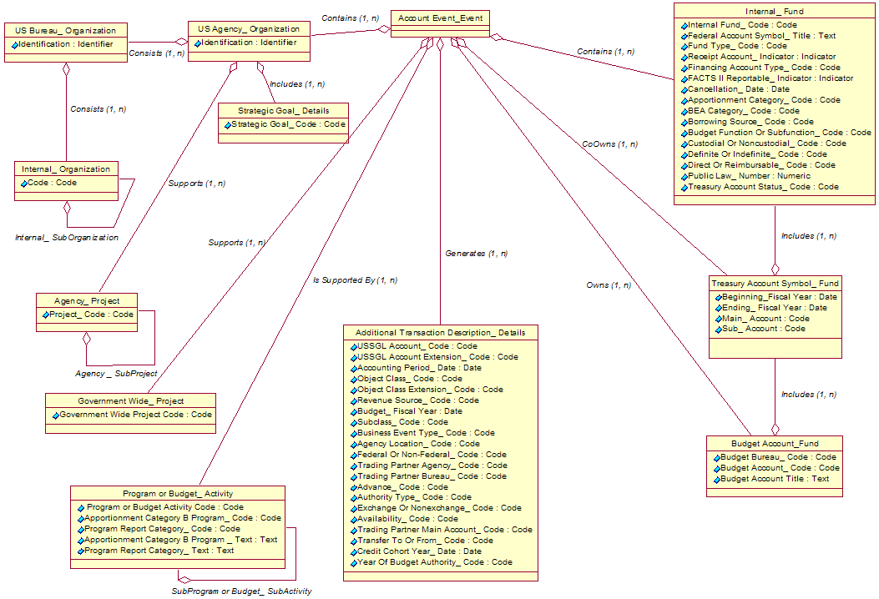
Figure D-1. Logical Data Model Depicting CGAC Element Relationships

Appendix E
Accounting Classification-Related Requirements in Core Financial System Requirements
The following requirements, which appear in Core Financial System Requirements, relate to accounting classification functionality. Some of these requirements may need to be modified once the CGAC structure is finalized.
System Management
SMA-01 Accounting classification—Maintain an accounting classification structure that includes the following elements:
- Treasury Account Symbol
- Budget fiscal year
- Internal fund code
- Organization
- Program
- Project
- Activity
- Cost center
- Object class
- Revenue source
- Budget function
- Budget sub-function code
- Accounting period.
Maintain each classification element independently. For example, budget fiscal year must be maintained as a separate value from the period of availability component in the TAFS.
SMA-02 Additional accounting classifications—Define five additional accounting classifications elements, including element titles and valid values.
SMA-03 Classify transactions—Classify transactions by standard and agency-defined accounting classification elements.
SMA-04 Short classification codes—Derive full accounting classifications on transactions from abbreviated user input. Examples of methods include: entering shorthand codes, deriving elements from an entered field, or providing users with a list of values from which to choose.
SMA-05 Accounting classification tables—Add, change, or deactivate elements of the accounting classification structure and define valid ACE values without programming changes (e.g., through online table updates).
SMA-06 Accounting classification effective date—Capture an effective date for accounting classification structure and valid value changes. Activate or deactivate accounting classification changes based on effective date.
SMA-08 Revenue source code structure—Maintain a revenue source code structure to classify types of revenue and receipts as defined by the agency, such as rental income, sales by product type and income by type of service performed.
SMA-09 Treasury Account Symbol—Maintain a TAS structure that includes the following components defined by Treasury and OMB:
- Subclass
- Agency code
- Hyphen (when co-owner is not null)
- Transfer agency
- Fiscal year (period of availability)
- Main account number
- Sub-account symbol.
SMA-10 Accounting classification structure levels—Define additional (lower) levels in the fund, program, project, organization and object class structures (e.g. establish parent child relationships with the ability to summarize, distribute funds, and report data at all defined levels).
SMA-11 ACE associations—Maintain an accounting classification structure that can associate each element with multiple other elements and element values, including:
- TAS to multiple internal funds
- Internal fund to multiple organizations, programs, projects, and activities
- Organization to multiple programs, projects and activities
- Project code to multiple organizations, programs and activities
- Program to multiple organizations, projects and activities.
SMA-12 Object class code structure—Maintain an object class structure consistent with the standard object class codes defined in OMB Circular A-11. Accommodate additional (lower) levels in the object class structure, e.g., by establishing parent child relationships.
SMA-13 Pre-configured BOC codes—Deliver the Core financial system software populated with the 3-digit Budget Object Classification codes specified in OMB Circular No. A-11.
SMB-30 Validate ACE—Validate transaction accounting classification elements. Prevent the recording of transactions with missing, invalid or inactive classification elements or values.
SME-04 Accounting classification history—Generate an audit trail of all accounting classification structure additions, changes and deactivations, including the effective dates of the changes.
General Ledger Management
GLA-01 Chart of accounts—Maintain a chart of accounts consistent with the U.S. SGL Chart of Accounts, including the proprietary, budgetary, and memorandum accounts, basic numbering structure, and account titles.
GLA-02 Account attributes—Maintain an association between the chart of accounts and valid attribute domain values used for Treasury reporting (e.g., FACTS I, FACTS II and GFRS reporting).
GLA-04 Sub-accounts—Define agency-specific GL sub-accounts that summarize to U.S. SGL accounts.
GLA-05 Sub-account length—Accommodate an additional 2 digits beyond the U.S. SGL account for agency-specific GL sub-accounts.
GLA-09 Pre-configured U.S. SGL accounts—Deliver the Core financial system software populated with the current published values for the U.S. SGL chart of accounts.
GLA-10 Pre-configured FACTS II attributes—Deliver the Core financial system software populated with the current published values for the FACTS II attributes.
GLB-05 Posting derivation—Define standard transactions that derive general ledger postings based on accounting classification elements or other document data elements.
GLB-06 Transaction rules—Define edit rules for standard transactions to require, prohibit, or set a default value for accounting classification elements.
GLC-02 Classifying transactions by attribute—Classify accounting transactions by U.S. SGL attributes required for FACTS I, FACTS II, and GFRS reporting as specified by the current supplement(s) to the TFM.
GLC-04 Balanced GL postings by ACS—Prevent transactions from posting that would cause general ledger debits and credits to be out-of-balance at any level of the agency’s accounting classification structure specified on a transaction.
Budgetary Resource Management
FMC-02 Budget execution documents data—Capture fund specific information (e.g., public law, program, authority type, apportionment category, etc.) on budget execution documents.
FMC-04 Internal funds control document—Capture multiple internal fund codes based on a single apportionment schedule, ensuring that unique fund characteristics (e.g. authority type, apportionment category) are available for funds control purposes.
FMD-02 Fund distributions—Record allotments, sub-allotments, allocations and allowances (i.e. distribute funds) to multiple organizational levels or other elements of accounting classification.
FMD-05 Fund distribution modification—Record the modification of funding distributions at multiple organizational levels or elements of the accounting classification structure.
FME-01 Monitor use of funds—Monitor the use of funds at each organizational level or other accounting classification to which budget authority is distributed. Reject, warn or inform the agency by spending document line when distributed authority is exceeded.
Cost Management
CMA-01 Define cost objects—Define the following types of cost objects for accumulation, distribution and reporting purposes:
- Accounting classification elements
- Specific customers, vendors, reimbursable agreements, contracts, PAs, task orders, work orders, and grants
- GPRA goals.

Appendix F
Summary of Changes Needed to Align the Central Agencies with the CGAC Structure
The CGAC structure proposed in this report reflects several changes to standard government-wide codes. These changes are intended to do the following:
- Eliminate redundant data elements
- Provide for consistency in the data elements used across systems
- Better conform to data-naming standards.
One of the key CGAC components, organization, contains two government-wide elements: agency and bureau identifier. Today, agency identification codes are defined differently by two central agencies, but they are used for similar purposes. OMB assigns a 3-character agency code to identify budget accounts. Treasury maintains a 2-character agency code to identify Treasury accounts and trading partners. The codes have different values and should be aligned so that agencies do not have to maintain both values in their systems.
Similarly, bureau identification codes are defined by multiple sources, including OMB, GSA, Treasury, and NIST. Treasury has a 4-character code used by GFRS (trading partner code) that is effectively an agency identification code followed by a subcomponent of the agency, which is similar to a bureau. NIST also maintains a 4-character organization code that includes both agency and bureau.
The bureau identification codes assigned by these agencies may serve different purposes. The bureau identifier specified in the CGAC structure (part of the entity identifier) is used to identify a major subcomponent of an agency for financial reporting. Before the CGAC structure can be finalized, an authoritative source for the bureau identifier must be determined. A separate task force with representatives from agencies that assign bureau identification codes for government-wide use should be set up to determine whether one source would meet all of their needs. Treasury will need to play a major role in this effort, because it issues policy and guidance on financial reporting.
When a single source of agency and bureau identifiers is determined, the same values should be used for trading partner identifiers.
In addition to standardizing agency and bureau identifiers, changes are needed to align other CGAC elements.
Tables F-1, F-2, and F-3 show the alignment of the names, domain values, and definitions of FACTS I and FACTS II attributes that serve the same purpose as the CGAC attribute.
Table F-1. Alignment of FACTS I and FACTS II Attributes
with CGAC Federal or Non-Federal Code
Item | FACTS I Attribute | FACTS II Attribute | CGAC Attribute  (for use in FACTS I and II)
Attribute Name | Federal/Nonfederal | Transaction Partner | Federal or Non-Federal Code
Definition | Indicates the type of entity involved in transactions with the reporting entity, that is, other Federal entities (F) or non-Federal entities such as private entities or local, state, tribal, or foreign governments (N). | Indicates type of entity involved in transactions with the reporting entity, that is, other Federal entities (F), non-Federal entities such as private entities or local, state, tribal, or foreign governments (X), or exceptions for other non-Federal partners (E). | Identifies the type of entity involved in transactions with the reporting entity: other Federal entities (F) or non-Federal entities such as private entities or local, state, tribal, or foreign governments (N), or exceptions for other non-Federal partners (E).
Domain Value | F–Federal  N–Non-Federal | F–Federal  X–Non-Federal  E–Non-Federal Exception | F–Federal  N–Non-Federal  E–Non-Federal Exception

Table F-2. Alignment of FACTS I and FACTS II Attributes
with CGAC Trading Partner Agency Attribute
Item | FACTS I Attribute | FACTS II Attribute | CGAC Attribute  (for use in FACTS I and II)
Attribute Name | Trading Partner | Direct Transfer Agency | Trading Partner Agency identifier
Definition | The Treasury Department Code of the other Federal entity involved in transactions with the reporting entity. Used in conjunction with Federal or non-Federal attribute of “F.” | The Treasury Department Code of the other Federal entity involved in transactions with the reporting entity. | The Agency Identifier of the other Federal entity involved in transactions with the reporting entity.  - Used in FACTS I in conjunction with a Federal or non-Federal code of “F.”  - Used in FACTS II in conjunction with a Trading Partner Main Account Code and a Transfer To or From code.
Domain Value | Treasury | Treasury | Treasury

Table F-3. Alignment of FACTS I and FACTS II Attributes
with CGAC Budget Subfunction Code
Item | FACTS I Attribute | FACTS II Attribute | CGAC Attribute  (for use in FACTS I and II)
Attribute Name | Budget Subfunction Code | Function | Budget Subfunction Code
Definition | Subclassification of data according to major purpose served or national need addressed. | Classification of data according to major purpose served (national defense or non-national defense) used for Graham-Rudman-Hollings (G-R-H) sequestration. Classifications are required by Congressional Budget Act of 1974. | Subclassification of data according to major purpose served or national need addressed. Classifications are required by Congressional Budget Act of 1974.
Domain Value | Subfunction values listed in OMB A-11 | DEF–National defense  NND–Non-national defense | Subfunction values listed in OMB A-11

Table F-4 summarizes changes to attribute names to conform to data-naming standards.
Table F-4. Changes to Attribute Names
System | Current Attribute Name | Proposed Name
FACTS I | Federal Nonfederal | Federal or Non-Federal Code
FACTS I | Trading Partner | Trading Partner Agency Identifier
FACTS I | Exchange Nonexchange | Exchange or Nonexchange Code
FACTS I | Custodial Noncustodial | Custodial or Noncustodial Code
FACTS I | Budget Subfunction | Budget Subfunction Code
FACTS II | Advance Flag | Advance Code
FACTS II | Apportionment Category | Apportionment Category Code
FACTS II | Apportionment Category B Program | Apportionment Category B Program Code
FACTS II | Category B Text | Apportionment Category B Program Text
FACTS II | Authority Type | Authority Type Code
FACTS II | Availability Time | Availability Code
FACTS II | BEA Category Indicator | BEA Category Code
FACTS II | Borrowing Source | Borrowing Source Code
FACTS II | Credit Cohort | Credit Cohort Year
FACTS II | Definite/Indefinite Flag | Definite or Indefinite Code
FACTS II | Direct Transfer Account | Trading Partner Main Account Code
FACTS II | Direct Transfer Agency | Trading Partner Agency Identifier
FACTS II | Function | Budget Subfunction Code
FACTS II | Reimbursable Flag | Direct or Reimbursable Code
FACTS II | TAFS Status | Treasury Account Status Code
FACTS II | Program Report Category | Program Report Category Code
FACTS II | Program Report Category Text | No change
FACTS II | Public Law Number | No change
FACTS II | Transaction Partner | Federal or NonFederal Code
FACTS II | Transfer To From | Transfer To or From Code
FACTS II | Year of Budget Authority | Year of Budget Authority Code

Table F-5 contains an addition in the CGAC structure. This attribute, used in conjunction with the trading partner agency identifier, will identify the component elements of the 4-character GFRS trading partner code. It will provide for consistency between the entity identifier code and the GFRS trading partner code.
Table F-5. Addition in the CGAC Structure
System | Proposed New  Attribute | Proposed Definition | Source of Domain Values
GFRS | Trading Partner  Bureau Identifier | The bureau identifier of the other Federal entity involved in transactions with the reporting entity. Used in conjunction with trading partner agency identifier, accommodates future decomposition of trading partners in GFRS. | Treasury

Table F-6 contains a suggested deletion of a FACTS II attribute. This attribute can be derived by Treasury through a calculation of the unobligated status accounts and does not need to be reported by the agency.
Table F-6. Deletion from the FACTS II Attributes
System | Attribute Proposed  for Deletion | Definition | Reason
FACTS II | Deficiency Flag | Indicates that an appropriation is deficient and requires an appropriation or offsetting collections to liquidate unpaid obligations. | Treasury can derive based on a calculation of account balances.

Appendix G
CGAC Elements Used in Reporting
This appendix contains a matrix showing which CGAC elements are used in which external reports.
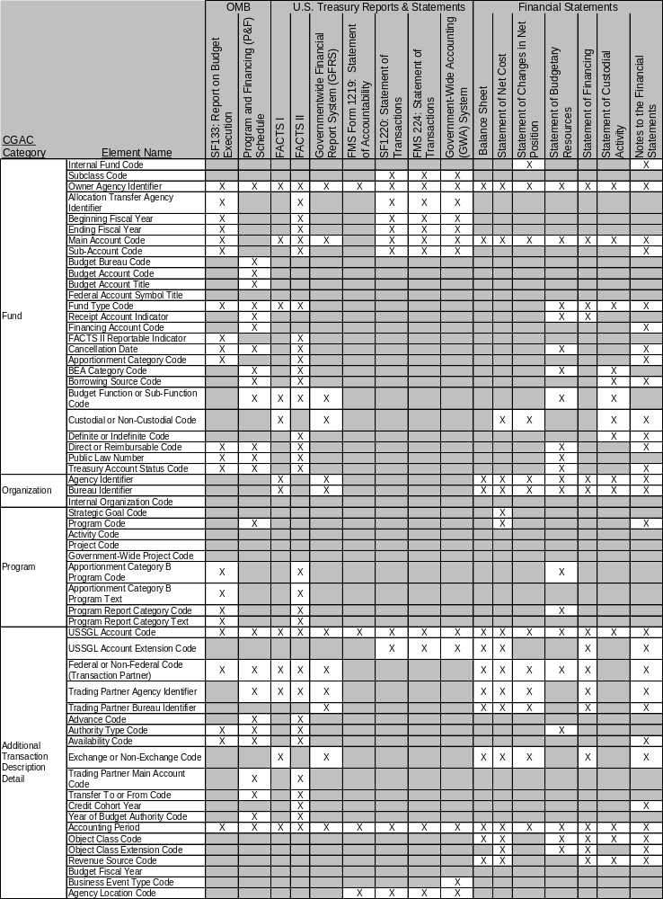

Appendix H
Document Change History
Table H-1 provides a history of the changes made to this document.
Table H-1. Document Change History
Version Number | Description of Change | Name of Author | Date Published
0.3 | Initial draft | FSIO | September 22, 2006
0.4 | Exposure draft for limited audience | FSIO | September 29, 2006
0.5 | Incorporate comments from subteam | FSIO | November 2, 2006
0.6 | Exposure drsft | FSIO | November 17, 2006

For more information on FMLoB initiatives, see Memorandum for Chief Financial Officers, Update on the Financial Management Line of Business and the Financial Systems Integration Office, December 16, 2005.
Office of Management and Budget, Circular A-127, Financial Management Systems, July 23, 1993.
Office of Federal Financial Management, Core Financial System Requirements, OFFM-NO-0106, January 2006.
The relevant language in A-127 is “Agency-wide Financial Information Classification Structure. The design of the financial management systems shall reflect an agency-wide financial information classification structure that is consistent with the U.S. Government Standard General Ledger, provides for tracking of specific program expenditures, and covers financial and financially related information.”
For more information on the GWA Modernization Project and a timeline for agency implementation, see http://www.fms.treas.gov/gwa/.

