ST-JNIA-02 JNIA CDC WDAC
Use Case Specification: ST-JNIA-02: JNIA CDC

Version <1.8>

Revision History
Date | Version | Description | Author
23 March 2005 | 1.0 | Initial Delivery | Don Cook
8 June 2005 | 1.1 | Updates requirements from WERRB | Stephanie Hunteman
15 December | 1.2 | Final | Stephanie Hunteman
20 April 2006 | 1.3 | Mod 9 Update | Chuck Meier
8 August 2006 | 1.4 | Added special requirement to paragraph 1.2.2.3.6 | John Schuncke, Jr.
26 February 2007 | 1.5 | Added Info and Ready Product use case flows developed under Increment 3 Mod 11 | Steve Sizer
15 May 2007 | 1.6 | Mod 11 Use Case Updates. Removed data ingest and monitor & control functionality into separate System Threads. Updated SSS requirements traceable to TRDs in embedded spreadsheet at bottom of document. | Tom Jackson
13 June 2007 | 1.7 | Deleted 5 SSS requirements (JNIASSS163, JNIASSS164, JNIASSS165, JNIASSS166, JNIASSS167) in the embedded SSS Requirements spreadsheet and moved them to the METOC Import ST. | Tom Jackson
10 September 2007 | 1.8 | Updated ST to match changes to the B-Level UCs | Tom Jackson

Table of Contents
1. ST-JNIA-02: JNIA CDC 1
1.1 CDC Product Build thru Dissemination 1
1.1.1 Basic Description 1
1.1.2 Product Build and Dissemination 2
1.1.2.1 Product Tailoring 2
1.1.2.1.1 Actors 3
1.1.2.1.2 Preconditions 3
1.1.2.1.3 Post Conditions 3
1.1.2.1.4 Basic Flow Steps 3
1.1.2.1.5 Alternate Flow Steps 3
1.1.2.1.6 Special Requirements 3
1.1.2.2 Build Gridded INFO and READY Products 3
1.1.2.2.1 Actors 4
1.1.2.2.2 Preconditions 4
1.1.2.2.3 Post Conditions 4
1.1.2.2.4 Basic Flow Steps 4
1.1.2.2.5 Alternate Flow Steps 5
1.1.2.2.6 Special Requirements 5
1.1.2.3 Build Catalog Product 5
1.1.2.3.1 Actors 5
1.1.2.3.2 Preconditions 5
1.1.2.3.3 Post Conditions 6
1.1.2.3.4 Basic Flow Steps 6
1.1.2.3.5 Alternate Flow Steps 6
1.1.2.3.6 Special Requirements 6
1.1.2.4 Build Event Based JMBL Products 6
1.1.2.4.1 Actors 6
1.1.2.4.2 Preconditions 7
1.1.2.4.3 Post Conditions 7
1.1.2.4.4 Basic Flow Steps 7
1.1.2.4.5 Alternate Flow Steps 7
1.1.2.4.6 Special Requirements 7
1.1.2.5 Build Period Based JMBL Products 7
1.1.2.5.1 Actors 8
1.1.2.5.2 Preconditions 8
1.1.2.5.3 Post Conditions 8
1.1.2.5.4 Basic Flow Steps 8
1.1.2.5.5 Alternate Flow Steps 9
1.1.2.5.6 Special Requirements 9
1.1.2.6 Disseminate METOC Product 9
1.1.2.6.1 Actors 10
1.1.2.6.2 Preconditions 10
1.1.2.6.3 Post Conditions 10
1.1.2.6.4 Basic Flow Steps 10
1.1.2.6.5 Alternate Flow Steps 10
1.1.2.6.5.1 Dissemination request failed. 10
1.1.2.6.6 Special Requirements 11
1.1.2.7 Startup and Recovery of Expanded Dissemination Capability. 11
1.1.2.7.1 Actors 11
1.1.2.7.2 Preconditions 11
1.1.2.7.3 Post Conditions 12
1.1.2.7.4 Basic Flow Steps 12
1.1.2.7.5 Alternate Flow Steps 12
1.1.2.7.5.1 EDC cannot evaluate its internal queues. 12
1.1.2.7.5.2 EDC cannot connect to DCD request queue. 12
1.1.2.7.6 Special Requirements 12
1.2 CDC GUI 12
1.2.1 Basic Description 12
1.2.2 Manage User and Product Data 13
1.2.2.1 Manage User Data 13
1.2.2.1.1 Actors 13
1.2.2.1.2 Preconditions 14
1.2.2.1.3 Post Conditions 14
1.2.2.1.4 Basic Flow Steps 14
1.2.2.1.5 Alternate Flow Steps 14
1.2.2.1.6 Special Requirements 14
1.2.2.2 Manage Region Definitions 14
1.2.2.2.1 Actors 15
1.2.2.2.2 Preconditions 15
1.2.2.2.3 Post Conditions 15
1.2.2.2.4 Basic Flow Steps 15
1.2.2.2.5 Alternate Flow Steps 15
1.2.2.2.5.1 User Edits an Existing Region 15
1.2.2.2.5.2 User Deletes an Existing Region 15
1.2.2.2.6 Special Requirements 16
1.2.2.3 Define Child Products - GUI 16
1.2.2.3.1 Actors 16
1.2.2.3.2 Preconditions 16
1.2.2.3.3 Post Conditions 16
1.2.2.3.4 Basic Flow Steps 16
1.2.2.3.5 Alternate Flow Steps 17
1.2.2.3.6 Special Requirements 17
1.2.2.4 Define Parent Products - GUI 17
1.2.2.4.1 Actors 18
1.2.2.4.2 Preconditions 18
1.2.2.4.3 Post Conditions 18
1.2.2.4.4 Basic Flow Steps 18
1.2.2.4.5 Alternate Flow Steps 19
1.2.2.4.6 Special Requirements 19
1.2.2.5 Edit Products 19
1.2.2.5.1 Actors 19
1.2.2.5.2 Preconditions 20
1.2.2.5.3 Post Conditions 20
1.2.2.5.4 Basic Flow Steps 20
1.2.2.5.5 Alternate Flow Steps 20
1.2.2.5.6 Special Requirements 20
1.2.2.6 Define JMBL Products 20
1.2.2.6.1 Actors 21
1.2.2.6.2 Preconditions 21
1.2.2.6.3 Post Conditions 21
1.2.2.6.4 Basic Flow Steps 21
1.2.2.6.5 Alternate Flow Steps 22
1.2.2.6.5.1 Text Entry of JMBL Request for Product 22
1.2.2.6.5.2 JMBL Request Fails Validation 22
1.2.2.6.5.3 JMBL Request Returns No Data 22
1.2.2.6.6 Special Requirements 23
1.2.2.7 Edit JMBL Products 23
1.2.2.7.1 Actors 23
1.2.2.7.2 Preconditions 23
1.2.2.7.3 Post Conditions 24
1.2.2.7.4 Basic Flow Steps 24
1.2.2.7.5 Alternate Flow Steps 24
1.2.2.7.6 Special Requirements 24
1.2.2.8 Delete Products 24
1.2.2.8.1 Actors 25
1.2.2.8.2 Preconditions 25
1.2.2.8.3 Post Conditions 25
1.2.2.8.4 Basic Flow Steps 25
1.2.2.8.5 Alternate Flow Steps 26
1.2.2.8.6 Special Requirements 26
1.2.2.9 MOC Setup 26
1.2.2.9.1 Actors 26
1.2.2.9.2 Preconditions 26
1.2.2.9.3 Post Conditions 26
1.2.2.9.4 Basic Flow Steps 26
1.2.2.9.5 Alternate Flow Steps 27
1.2.2.9.6 Special Requirements 27
1.2.2.10 Manage Subscription Data 27
1.2.2.10.1 Actors 27
1.2.2.10.2 Preconditions 27
1.2.2.10.3 Post Conditions 27
1.2.2.10.4 Basic Flow Steps 27
1.2.2.10.5 Alternate Flow Steps 27
1.2.2.10.6 Special Requirements 28
1.2.2.11 Load Catalog Products 28
1.2.2.11.1 Actors 28
1.2.2.11.2 Preconditions 28
1.2.2.11.3 Post Conditions 28
1.2.2.11.4 Basic Flow Steps 28
1.2.2.11.5 Alternate Flow Steps 28
1.2.2.11.6 Special Requirements 28
1.2.2.12 Add Catalog Subscription 29
1.2.2.12.1 Actors 29
1.2.2.12.2 Preconditions 30
1.2.2.12.3 Post Conditions 30
1.2.2.12.4 Basic Flow Steps 30
1.2.2.12.5 Alternate Flow Steps 30
1.2.2.12.6 Special Requirements 31
1.2.2.13 Edit Catalog Subscription 31
1.2.2.13.1 Actors 31
1.2.2.13.2 Preconditions 31
1.2.2.13.3 Post Conditions 32
1.2.2.13.4 Basic Flow Steps 32
1.2.2.13.5 Alternate Flow Steps 32
1.2.2.13.6 Special Requirements 32
1.2.2.14 Delete Subscription to a Product 32
1.2.2.14.1 Actors 33
1.2.2.14.2 Preconditions 33
1.2.2.14.3 Post Conditions 33
1.2.2.14.4 Basic Flow Steps 33
1.2.2.14.5 Alternate Flow Steps 33
1.2.2.14.6 Special Requirements 33
1.2.2.15 Enter Legacy Filename Tokens 33
1.2.2.15.1 Actors 34
1.2.2.15.2 Preconditions 34
1.2.2.15.3 Post Conditions 34
1.2.2.15.4 Basic Flow Steps 34
1.2.2.15.5 Alternate Flow Steps 34
1.2.2.15.5.1 The Remote Filename contains one or more invalid or malformed tokens. 34
1.2.2.15.6 Special Requirements 34
1.2.2.16 Add Endpoint 34
1.2.2.16.1 Actors 35
1.2.2.16.2 Preconditions 35
1.2.2.16.3 Post Conditions 35
1.2.2.16.4 Basic Flow Steps 35
1.2.2.16.5 Alternate Flow Steps 36
1.2.2.16.6 Special Requirements 36
1.2.2.17 Modify Endpoint 36
1.2.2.17.1 Actors 37
1.2.2.17.2 Preconditions 37
1.2.2.17.3 Post Conditions 37
1.2.2.17.4 Basic Flow Steps 37
1.2.2.17.5 Alternate Flow Steps 37
1.2.2.17.6 Special Requirements 37
1.2.2.18 Delete Endpoint 37
1.2.2.18.1 Actors 38
1.2.2.18.2 Preconditions 38
1.2.2.18.3 Post Conditions 38
1.2.2.18.4 Basic Flow Steps 38
1.2.2.18.5 Alternate Flow Steps 39
1.2.2.18.6 Special Requirements 39
1.3 Command Line Utilities 39
1.3.1 Define Gridded INFO or READY Products 39
1.3.1.1 Actors 39
1.3.1.2 Preconditions 39
1.3.1.3 Post Conditions 40
1.3.1.4 Basic Flow Steps 40
1.3.1.5 Alternate Flow Steps 40
1.3.1.6 Special Requirements 40
1.3.2 Manage INFO or READY Product Subscription 40
1.3.2.1 Actors 41
1.3.2.2 Preconditions 41
1.3.2.3 Post Conditions 41
1.3.2.4 Basic Flow Steps 41
1.3.2.5 Alternate Flow Steps 41
1.3.2.5.1 A “?” is Entered for Product Name field 41
1.3.2.6 Special Requirements 41
1.4 Management GUI 41
1.4.1 Basic Description 41
1.4.2 Manage User Data 42
1.4.2.1 Actors 42
1.4.2.2 Preconditions 42
1.4.2.3 Post Conditions 43
1.4.2.4 Basic Flow Steps 43
1.4.2.4.1 Alternate Flow Steps 43
1.4.2.4.2 Special Requirements 43
1.4.3 Manage Routes 43
1.4.3.1 Add a Route 43
1.4.3.1.1 Actors 44
1.4.3.1.2 Preconditions 44
1.4.3.1.3 Post Conditions 44
1.4.3.1.4 Basic Flow Steps 44
1.4.3.1.5 Alternate Flow Steps 45
1.4.3.1.6 Special Requirements 45
1.4.3.2 Edit a Route 45
1.4.3.2.1 Actors 46
1.4.3.2.2 Preconditions 46
1.4.3.2.3 Post Conditions 46
1.4.3.2.4 Basic Flow Steps 46
1.4.3.2.5 Alternate Flow Steps 46
1.4.3.2.6 Special Requirements 46
1.4.3.3 Delete a Route 46
1.4.3.3.1 Actors 47
1.4.3.3.2 Preconditions 47
1.4.3.3.3 Post Conditions 47
1.4.3.3.4 Basic Flow Steps 47
1.4.3.3.5 Alternate Flow Steps 48
1.4.3.3.6 Special Requirements 48
1.4.4 Manage Endpoint Routing 48
1.4.4.1 Add Endpoint Routing 48
1.4.4.1.1 Actors 49
1.4.4.1.2 Preconditions 49
1.4.4.1.3 Post Conditions 49
1.4.4.1.4 Basic Flow Steps 50
1.4.4.1.5 Alternate Flow Steps 50
1.4.4.1.6 Special Requirements 50
1.4.4.2 Edit Endpoint Routing 50
1.4.4.2.1 Actors 51
1.4.4.2.2 Preconditions 51
1.4.4.2.3 Post Conditions 51
1.4.4.2.4 Basic Flow Steps 52
1.4.4.2.5 Alternate Flow Steps 52
1.4.4.2.6 Special Requirements 52
1.4.4.3 Delete Endpoint Routing 53
1.4.4.3.1 Actors 53
1.4.4.3.2 Preconditions 54
1.4.4.3.3 Post Conditions 54
1.4.4.3.4 Basic Flow Steps 54
1.4.4.3.5 Alternate Flow Steps 54
1.4.4.3.6 Special Requirements 54
2. Requirements 54

Use Case Specification: ST-JNIA-02: JNIA CDC

ST-JNIA-02: JNIA CDC
The JNIA CDC is comprised of three distinct threads which interact with the same CSCIs, but in different ways and in an asynchronous manner. As such, the distinct threads are summarized within this System Thread Use Case, but the use case is divided into three distinct sections: 1. CDC Product Build thru Dissemination; 2. CDC GUI; and 3. Management GUI. The general inputs, outputs, preconditions, and post conditions for all four sections are specified in following high-level figure.
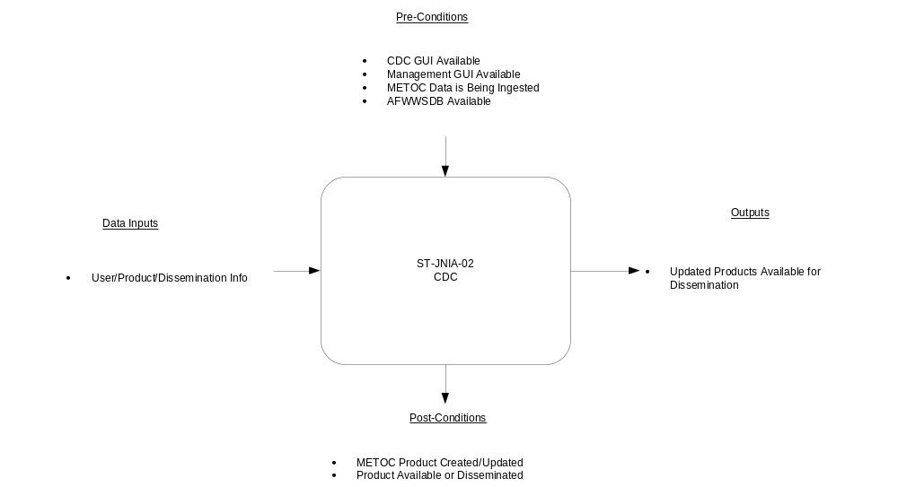
Figure 1.1 JNIA CDC General Parameters

CDC Product Build thru Dissemination

Basic Description
This thread of the JNIA CDC documents the tailoring of METOC products along with how they are built and the activities which are performed to disseminate a METOC Product following receipt of a product ready message. JMBL and Catalog Products are built based upon specified events or time criteria, along with the receipt of messages to build a product.
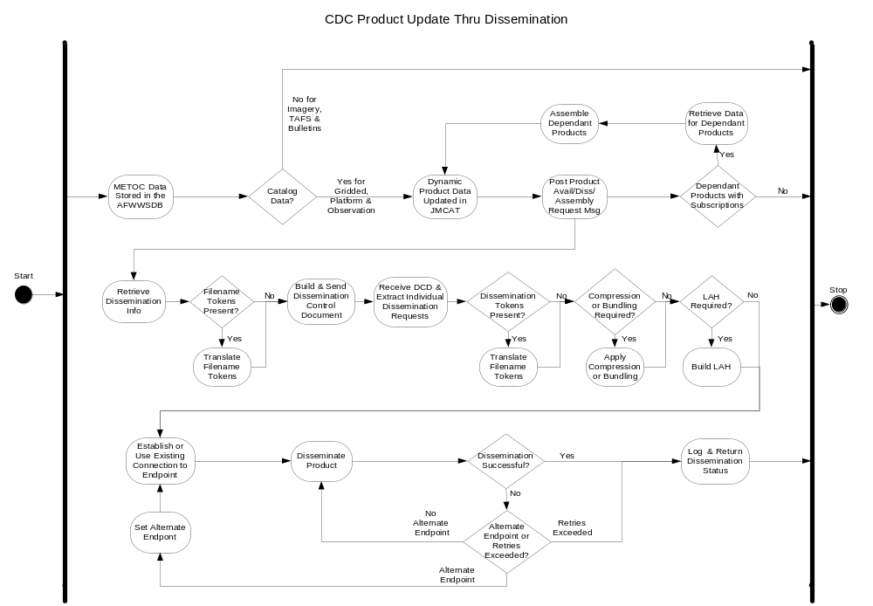 Figure 1.1.1.1 JNIA Product Build Thru Dissemination Process Flow

Product Build and Dissemination

Product Tailoring
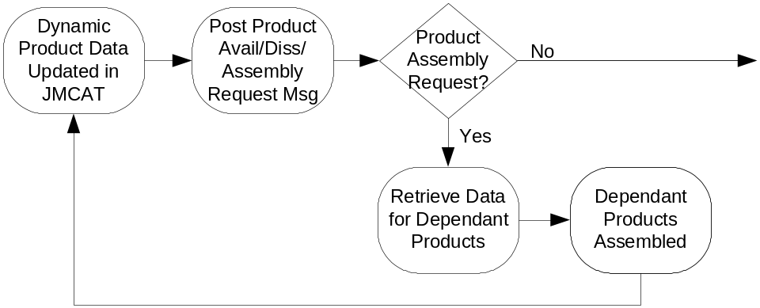

Actors
- Product Tailoring
- Data Access Layer
- Database
- Distribution
- Enterprise Notification
- Infrastructure

Preconditions
  - Database is available.
  - Product definition is available.
  - Required product data available.

Post Conditions
    - The product has been created.
    - Distribution has received notification of the new product.

Basic Flow Steps
      - This use case begins when a product assembly request message is received.
      - The inbound product data is passed to JMCAT to retrieve data for dependant products.
      - JMCAT returns the product dependency and definition data.
      - The dependent products are assembled. The product is marked with the security level of the system on which the product was created.
      - If an ad-hoc product, the JMBL request is submitted.
      - The dynamic product data for newly assembled products is updated in JMCAT.
      - Product available message and a product dissemination message are posted.
      - Use case ends.

Alternate Flow Steps
None.

Special Requirements
None.

Build Gridded INFO and READY Products
This use case flow describes the activities required to build INFO and READY products.
The data producer creates the INFO products for parent data product. JNIA builds INFO products for gridded child products. JNIA builds all READY products.
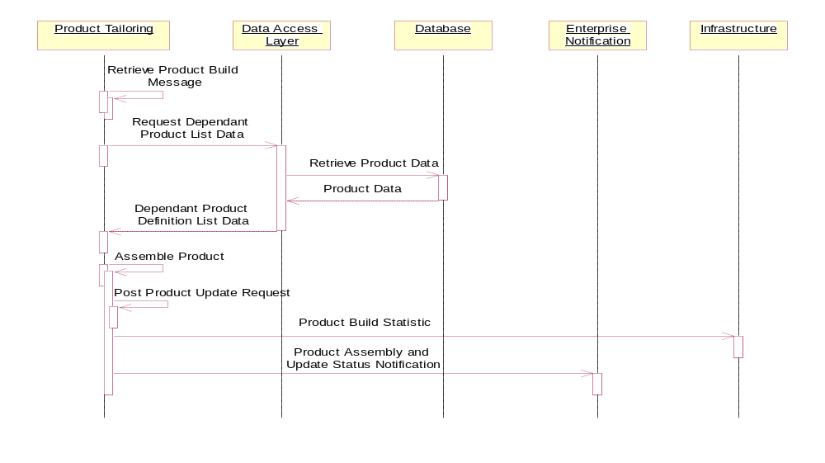

Actors
- Product Tailoring
- Data Access Layer
- Database
- Enterprise Notification
- Infrastructure

Preconditions
- Gridded data is being ingested or child products created.
- Parent INFO data is being ingested.
- Subscription to INFO or READY product is entered and active.

Post Conditions
- The INFO or READY product has been created.
- Product Update request has been posted.
- The product build statistics data have been delivered.
- Action logged in Enterprise Notification.

Basic Flow Steps
- This use case may be triggered by one of two events: Product build messages are posted following the receipt of the parent INFO product or the receipt of the last product in a subscribed series of products from a single model run.
- Product Tailoring retrieves the dependant product definition information from Database via the Data Access Layer.
- The Data Access Layer returns the product definitions for INFO and READY products for the current model run for which subscriptions are active.
- Product Tailoring assembles the Gridded INFO and/or READY product in accordance with the product definition.
- Product Tailoring posts a Product Update Request for each product created.
- Product Tailoring delivers a product build statistic message to Infrastructure.
- This use case ends when Product Tailoring logs the product build and update notification actions via the Enterprise Notification.

Alternate Flow Steps
None.

Special Requirements
- The system shall prevent duplicate shipment of the INFO and READY products created by the two possible asynchronous trigger events.

Build Catalog Product
This use case describes the process of building a Catalog Product.
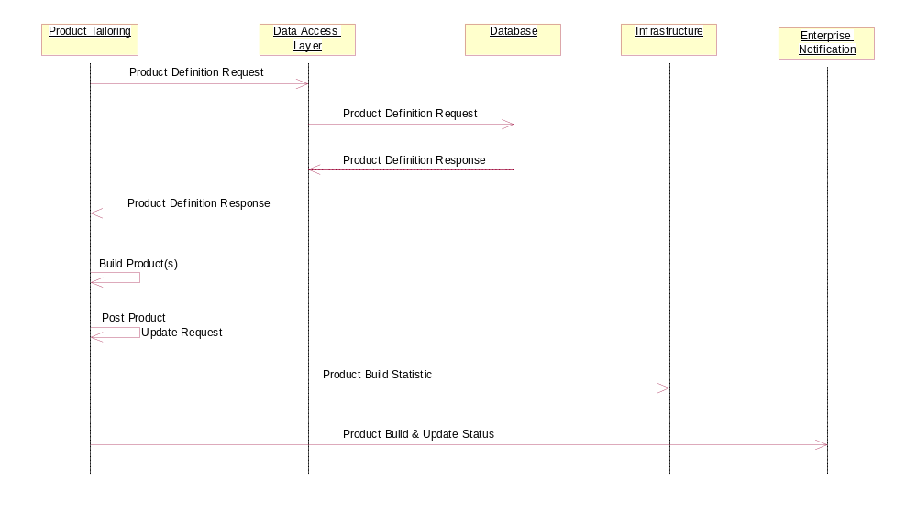

Actors
- Product Tailoring
- Data Access Layer
- Database
- Infrastructure
- Enterprise Notification

Preconditions
- A request to start building one or more Catalog Products is received.
- The data required to fulfill the definition of the Catalog Product is available.
- The Catalog Product is defined in JMCAT

Post Conditions
- The Catalog Product has been built.
- Statistic notifications for build have been posted.
- Product update request has been posted.
- Action logged in Enterprise Notification.

Basic Flow Steps
- This use case begins when Product Tailoring requests the product definition(s) from Data Access Layer.
- Data Access Layer requests the product definition from Database.
- Database provides the product definition to the Data Access Layer.
- Data Access Layer provides the product definition to Product Tailoring.
- Product Tailoring builds the product in accordance with the product definition.
- Product Tailoring posts a Product Update Request for the product that was built.
- Product Tailoring sends a product build statistics entry for the product to Infrastructure.
- This use case ends when Product Tailoring logs the product build and update status notification actions via the Enterprise Notification.

Alternate Flow Steps
None.

Special Requirements
- Only products that have active subscriptions shall be built.

Build Event Based JMBL Products
This use case flow begins when a message is received to build an event based JMBL product.
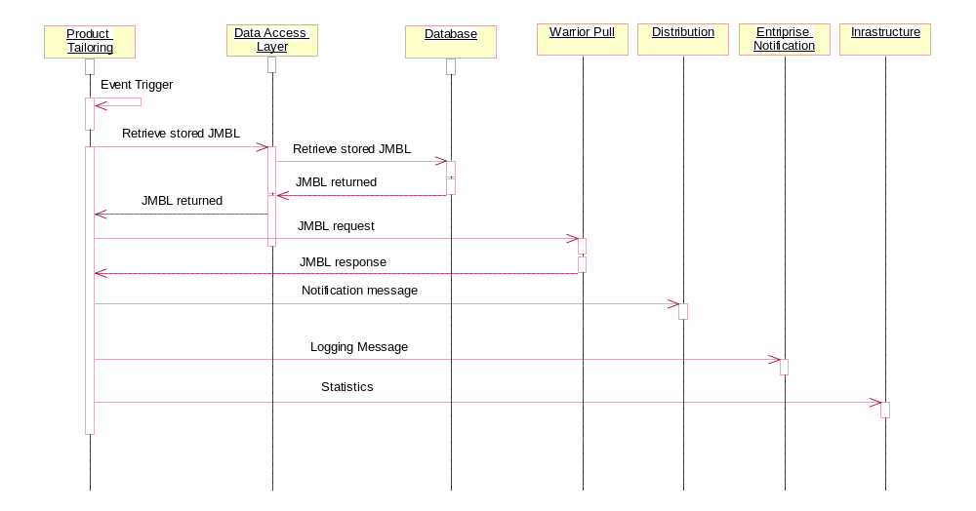

Actors
- Product Tailoring
- Data Access Layer
- Database
- Warrior Pull
- Distribution
- Enterprise Notification
- Infrastructure

Preconditions
- All actors are available.
- Stored JMBL request message exists.
- METOC data which initiates an event trigger is being ingested.

Post Conditions
- The METOC product has been created.
- Distribution has received notification of the new product.
- Infrastructure has been updated with statistical data.

Basic Flow Steps
- This use case begins when an event triggers Product Tailoring to start building an event based JMBL product.
- Product Tailoring retrieves the stored JMBL request from the Data Access Layer.
- Data Access Layer queries the Database for the JMBL request.
- Database provides JMBL request to the Data Access Layer.
- Data Access Layer returns JMBL request to Product Tailoring.
- Product Tailoring submits the JMBL request to Warrior Pull for product retrieval.
- Warrior Pull returns a response containing a reference to the product to Product Tailoring.
- Product Tailoring alerts Distribution that the product is available.
- Product Tailoring logs the product build and dissemination notification actions via the Enterprise Notification.
- This use case ends when a statistics message is sent to Infrastructure.

Alternate Flow Steps
None.

Special Requirements
None.

Build Period Based JMBL Products
This use case describes the process of building a period based JMBL product.
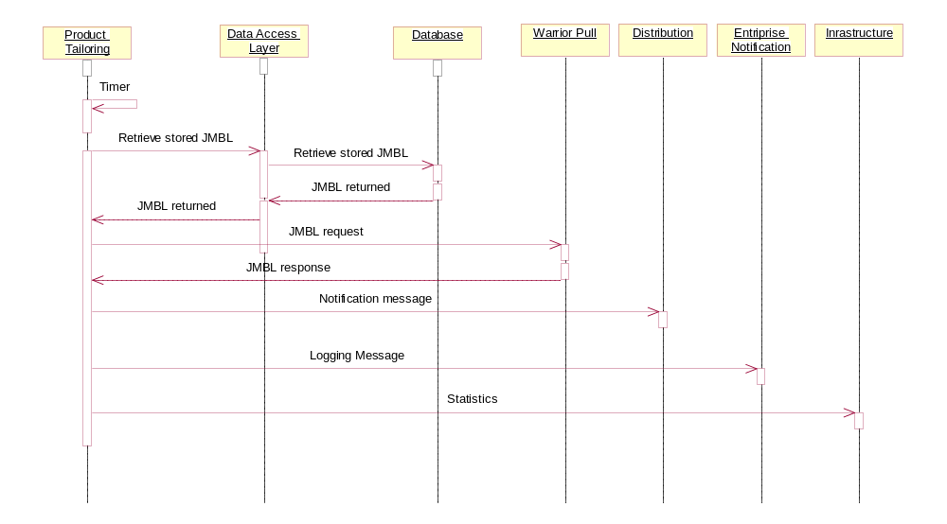

Actors
- Product Tailoring
- Data Access Layer
- Database
- Warrior Pull
- Distribution
- Enterprise Notification
- Infrastructure

Preconditions
- All actors are available
- Stored JMBL request exists in Database.
- METOC data is being ingested.

Post Conditions
- The METOC product has been created.
- Distribution has received notification of the new product.
- Infrastructure has been updated with statistical data.

Basic Flow Steps
- This use case begins when a timer initiates a JMBL request within Product Tailoring.
- Product Tailoring retrieves the stored JMBL request message from the Data Access Layer.
- Data Access Layer queries the Database for the JMBL request.
- Database provides JMBL request to the Data Access Layer.
- Data Access Layer returns JMBL request to Product Tailoring.
- Product Tailoring submits the JMBL request to Warrior Pull for product retrieval.
- Warrior Pull returns a response containing reference to product to Product Tailoring.
- Product Tailoring alerts distribution that the product is available.
- Product Tailoring logs the product build and dissemination notification actions via the Enterprise Notification.
- This use case ends when a statistics message is sent to Infrastructure.

Alternate Flow Steps
None.

Special Requirements
None.

Disseminate METOC Product
This Use Case flow describes the activities which are performed to disseminate a METOC Product following receipt of a product ready message. The product ready message can result from update of a catalog item or expiration of a timer.
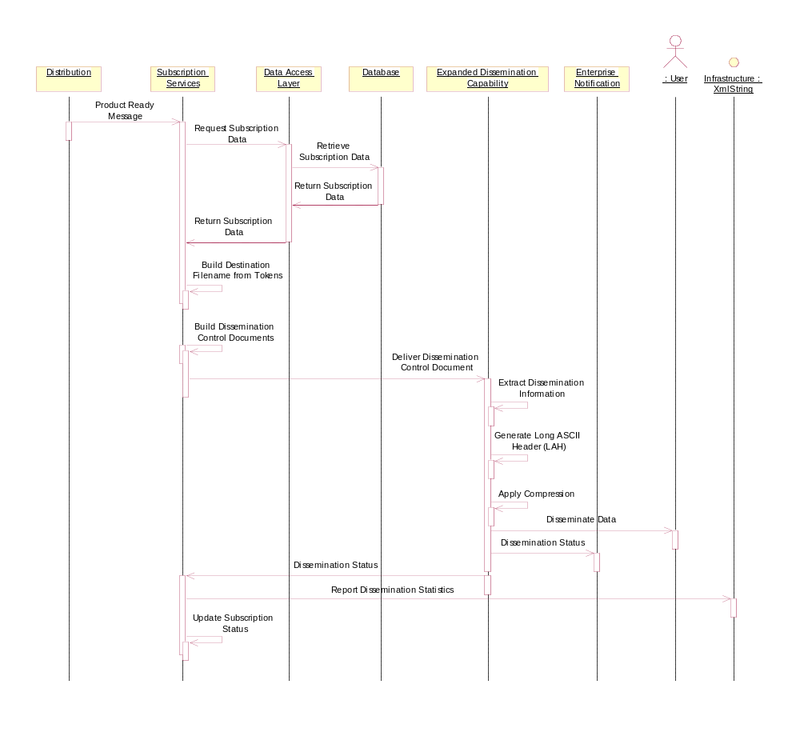

Actors
- Distribution
- Subscription Services
- Data Access Layer
- Database
- Extended Dissemination Capability (EDC)
- Enterprise Notification
- User (endpoint)
- Infrastructure

Preconditions
- Product Ready Message is delivered to Distribution.
- Product is available
- Product has active subscriptions to active endpoints.

Post Conditions
- The product is delivered as specified in the subscriptions.
- Dissemination Statistics are recorded.
- The EDC log contains an entry detailing the successful dissemination of the product to the specified users (endpoints).
- Response status for each subscription is sent to Subscription Services to update subscriptions and endpoints.

Basic Flow Steps
- This use case begins when Subscription Services receives a Product Ready message from Distribution.
- Subscription Services requests subscription data from the Database via the Data Access Layer.
- The Database returns active subscription data via the Data Access Layer.
- Subscription Services expands the destination filename based on product dependent embedded tokens.
- Subscription Services builds a Dissemination Control Document (DCD) containing dissemination directions for all endpoints which are to receive the current product.
- Subscription Services delivers the DCD to the Expanded Dissemination Capability for processing.
- The Expanded Dissemination Capability extracts the dissemination information for each endpoint.
- The Expanded Dissemination Capability creates appropriate standard or pseudo Long ASCII Headers if specified for the endpoint in the DCD.
- The Expanded Dissemination Capability applies compression to the source file if requested in the DCD.
- The Expanded Dissemination Capability disseminates the data according to the DCD directives for each dissemination request. [A10]
- The Expanded Dissemination Capability posts a log entry for each endpoint specified by the DCD.
- The Expanded Dissemination Capability returns the dissemination status to Subscription Services.
- The Expanded Dissemination Capability sends statistics for each dissemination to Infrastructure.
- This use case ends when Subscription Services updates subscription status, based on the dissemination responses.

Alternate Flow Steps

Dissemination request failed.
- This alternate flow begins at step 100 when the configured retry attempts or retry period for a specific endpoint have been exceeded for a particular dissemination request.
- The Expanded Dissemination Capability posts a log entry detailing the endpoint that is failing and the conditions that caused the failure message to be sent.
- The EDC posts a response document to Subscription Services specifying that the dissemination request to the endpoint has exceeded the retry attempts or retry period limit.
- This alternate flow ends and flow returns to step 100 of the basic flow until all dissemination requests have been processed.

Special Requirements
None.

Startup and Recovery of Expanded Dissemination Capability.
This use case describes what the Expanded Dissemination Capability (EDC), an extension component of the Consolidated Dissemination Component (CDC), does when the system is started. The EDC will evaluate its internal queues and re-queue any dissemination requests that were in-progress when the EDC stopped. The EDC will log what dissemination requests were requeued.
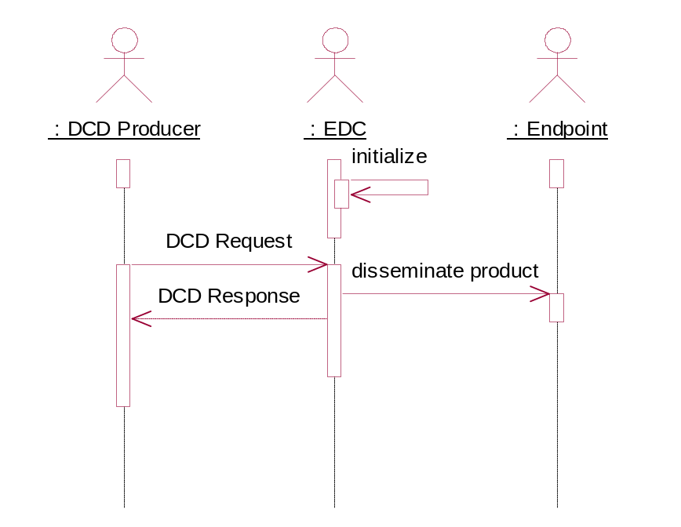

Actors
- Expanded Dissemination Capability (EDC)

Preconditions
- EDC internal queues available.
- Dissemination Request Queue is available
- Dissemination Response Queue is available

Post Conditions
- The EDC successfully starts and any dissemination requests that where not completed when the EDC last stopped are re-queued for dissemination.

Basic Flow Steps
10 This use case begins when the EDC is started from a stopped state.
20 A log entry will be generated detailing that the EDC is starting.
30 The EDC will evaluate its internal queues prior to making any connections or accepting new DCD requests and requeue for processing any dissemination requests that did not complete when the EDC was last running.
40 A log entry will be generated detailing each dissemination request that is requeued.
50 The EDC will then attempt to connect to the DCD request queue.
60 A log entry will be generated detailing that the EDC is now accepting new DCD requests.
70 This use case ends when the EDC is running, has requeued and is processing all pending requests and is accepting new DCD requests.

Alternate Flow Steps

EDC cannot evaluate its internal queues.
A10 This alternate flow begins at step 30 when the EDC attempts to evaluate its internal queues.
A20 A log entry will be generated detailing that the EDC could not evaluate its internal queues and the reason the queues could not be evaluated.
A30 This alternate flow ends when the EDC has successfully logged the failure and flow is returned to step 30.

EDC cannot connect to DCD request queue.
B10 This alternate flow begins at step 50 when the EDC cannot establish a connection with the DCD request queue.
B20 The EDC will generate a log entry detailing the failure to connect and the reason that the connection failed.
B30 This alternate flow ends when the EDC has successfully logged the failure and flow is returned to step 50.

Special Requirements
None.

CDC GUI

Basic Description
This thread of the JNIA CDC Use Case documents how the CDC GUI is used to manage user and product data, along with how to define child and parent products, edit product definitions, define and edit JMBL products, delete products, as well as the MOC Setup, and management of subscription products and endpoints.
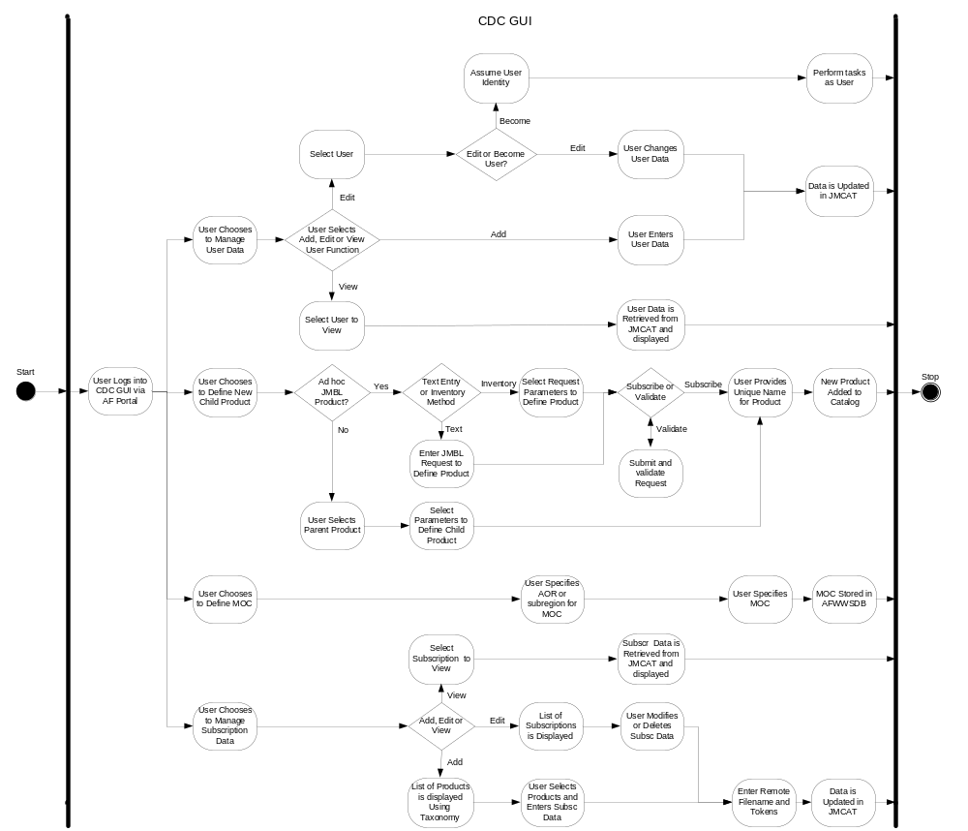

Manage User and Product Data

Manage User Data
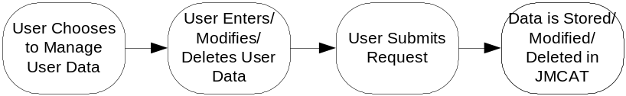

Actors
- User
- CDC GUI
- Data Access Layer
- Database
- Enterprise Notification

Preconditions
- The CDC GUI is running.
- User has logged into the AF Portal, selected the WDAC application, and navigated to the CDC GUI.
- The Database is available.

Post Conditions
- The user data is defined and stored in the database.
- Status is logged.

Basic Flow Steps
  - This use case begins when the privileged user accesses the CDC GUI.
  - The user logs into the AF Portal and navigates to the CDC GUI link.
  - The user chooses to manage user data.
  - The user enters/modifies/deletes User Data and submits update request.
  - The user data is stored/updated/deleted in JMCAT.
  - Use case ends.

Alternate Flow Steps
None.

Special Requirements
None.

Manage Region Definitions
This use case flow describes a utility to define named geographical regions and their extents.
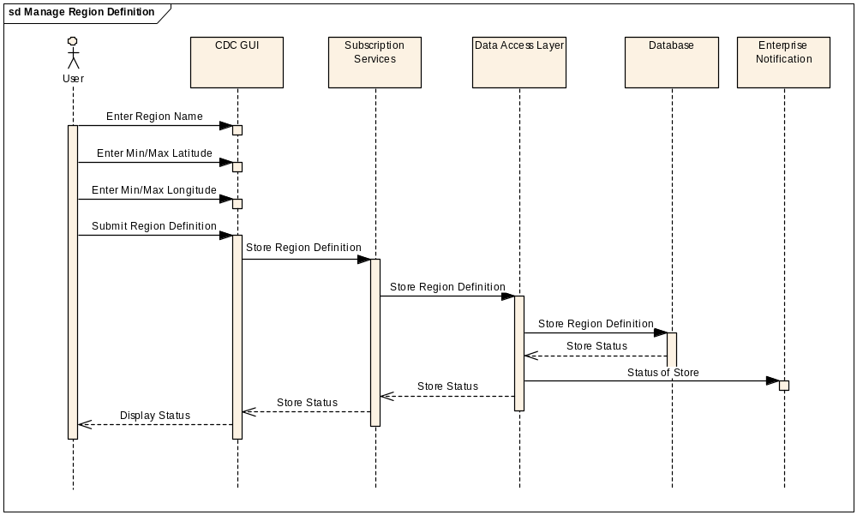

Actors
- User
- CDC GUI
- Subscription Services
- Data Access Layer
- Database
- Enterprise Notification

Preconditions
- The User has logged in through the AF Portal and has the Administrator Role.

Post Conditions
- The named region is stored in the AFWWS database.
- The sample map is stored in the AFWWS database.

Basic Flow Steps
- This use case begins when the privileged user starts the CDC GUI and enters the name of a region. [A10] [B10]
- The User enters the minimum and maximum latitude parameters for the region.
- The User enters the minimum and maximum longitude parameters for the region.
- The User submits the region definition to the CDC GUI.
- The CDC GUI sends a store region definition request to the Subscription Services.
- The Subscription Services sends a store region definition request to the Data Access Layer.
- The Data Access Layer sends a store region definition request to the Database.
- The Database stores the named region and returns the store status to the Data Access Layer.
- The Data Access Layer sends the status of store message to Enterprise notification.
- The Data Access Layer returns the store status to the Subscription Services.
- The Subscription Services returns the store status to the CDC GUI.
- This use case ends when the CDC GUI displays the status of the request to the User.

Alternate Flow Steps

User Edits an Existing Region
- This alternate flow begins at basic flow step 10 when the user selects to edit the entered region.
- The CDC GUI sends a region definition request to the Data Access Layer.
- The Data Access Layer sends a region definition request to the Database.
- The Database returns the region definitions to the Data Access Layer.
- The Data Access Layer returns the region definitions to the CDC GUI.
- The CDC GUI displays the region definitions for editing.
- This alternate flow returns to basic flow step 20.

User Deletes an Existing Region
- This alternate flow begins at basic flow step 10 when the user selects to delete the entered region.
- The CDC GUI sends a delete request to the Data Access Layer.
- The Data Access Layer sends a delete request to the Database.
- The Database deletes the named region.
- The Database returns the delete status to the Data Access Layer.
- The Data Access Layer returns the delete status to the CDC GUI.
- This alternate flow returns to basic flow step 120.

Special Requirements
- The names of the regions shall be unique.
- The regions shall be based on the WGS84 projection.
- The regions shall be defined by lower left and upper right latitude and longitude coordinates.
- The latitude shall range from -90 to 90 degrees.
- The longitude shall range from 0 to -180 degrees for the western hemisphere.
- The longitude shall range from 0 to 180 degrees for the eastern hemisphere.

Define Child Products - GUI
This Use Case flow describes the events that take place while defining a child product from the CDC GUI and storing that definition into the Database.
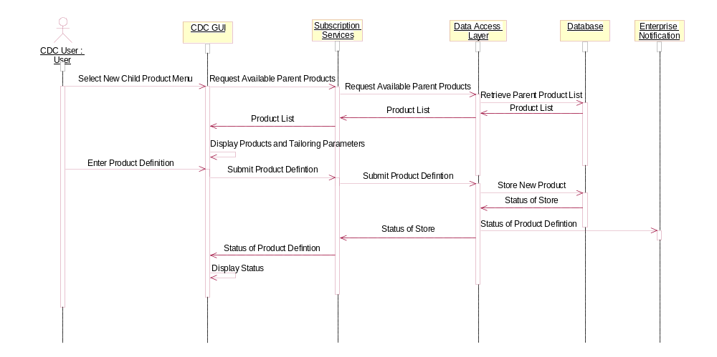

Actors
    - User
    - CDC GUI
    - Subscription Services
    - Data Access Layer
    - Database
    - Enterprise Notification

Preconditions
      - The CDC GUI is available via the AF Portal.
      - Parent products are available within the Database.

Post Conditions
- Child product information is successfully defined in the Database.

Basic Flow Steps
- This use case begins when the User selects the menu item to define a child product in the CDC GUI.
- The CDC GUI requests the available parent products from the Subscription Services.
- The Subscription Services requests the available parent products from the Data Access Layer.
- The Data Access Layer requests the available parent products from the Database.
- The Database returns the available parent products to the Data Access Layer.
- The Data Access Layer returns the available parent products to the Subscription Services.
- The Subscription Services returns the available parent products to the CDC GUI.
- The CDC GUI displays the available parent products list and product specific parameters necessary for defining a tailored child product.
- The User selects a parent product upon which to base a child product, enters criteria to tailor the parent product, and submits the child product definition to the CDC GUI.
- The CDC GUI submits the child product definition to the Subscription Services.
- The Subscription Services submits the child product definition to the Data Access Layer.
- The Data Access Layer sends the new child product definition to the Database to be stored.
- The Database returns the status of the product definition store to the Data Access Layer.
- The Data Access Layer sends the status of the product definition store to Enterprise Notification.
- The Data Access Layer returns the status of the product definition store to the Subscription Services.
- The Subscription Services sends the status of the product definition store to CDC GUI.
- This use case ends when the CDC GUI displays the status of the child product definition to the User.

Alternate Flow Steps
None.

Special Requirements
S10 If the action will take more than 7 seconds to complete, display an indicator.

Define Parent Products - GUI
This Use Case flow describes the events that take place while defining a parent product from the CDC GUI and storing it into the Database.
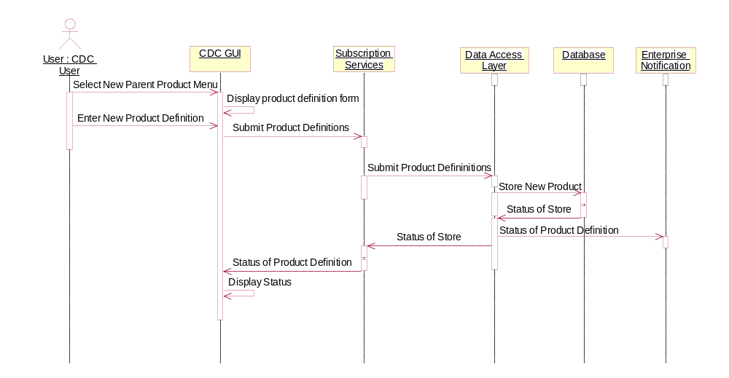

Actors
- User
- CDC GUI
- Subscription Services
- Data Access Layer
- Database
- Enterprise Notification

Preconditions
- The CDC GUI is available via the AF Portal.
- The User has privileges to define parent products.

Post Conditions
- Parent product is successfully defined in the Database.

Basic Flow Steps
- This use case begins when the User selects the menu item to define a parent product in the CDC GUI, specifying the data type of parent product being defined.
- The CDC GUI displays a data entry form tailored to the metadata necessary for defining a parent product of the data type selected.
- The User enters the parent product definition into the CDC GUI.
- The CDC GUI submits the parent product definition to the Subscription Services.
- The Subscription Services submits the parent product definition to the Data Access Layer.
- The Data Access Layer sends the new parent product definition to the Database to be stored.
- The Database returns the status of the product definition store to the Data Access Layer.
- The Data Access Layer sends the status of the product definition store to Enterprise Notification.
- The Data Access Layer returns the status of the product definition store to the Subscription Services.
- The Subscription Services sends the status of the parent product store to the CDC GUI.
- This use case ends when the CDC GUI displays the status of the parent product definition to the User.

Alternate Flow Steps
None.

Special Requirements
S10 If the action will take more than 7 seconds to complete, display an indicator.

Edit Products
This Use Case flow describes the events that take place to edit and store a product definition via the CDC GUI.
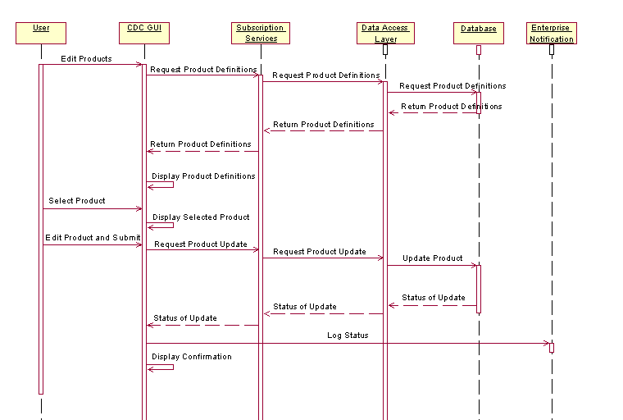

Actors
- User
- CDC GUI
- Subscription Services
- Data Access Layer
- Database
- Enterprise Notification

Preconditions
- The CDC GUI is available via the AF Portal.
- The product definition to be edited is available within the Database.
- The User has sufficient privileges to edit the product.

Post Conditions
- The product definition is successfully updated in the Database.

Basic Flow Steps
- This use case begins when the User requests to edit a JMBL product definition.
- CDC GUI requests product definition information from the Subscription Services.
- Subscription Services requests product definition information from the Data Access Layer.
- Data Access Layer requests the product definition information from Database.
- Database provides the product definition information to Data Access Layer.
- Data Access Layer provides the product definition information to Subscription Services.
- Subscription Services provides the product definition information to the CDC GUI.
- CDC GUI displays product definition to the User.
- User selects a product to edit.
- CDC GUI displays the selected product.
- User edits and submits product definition using CDC GUI.
- CDC GUI requests product update to Subscription Services.
- Subscription Services requests product update to Data Access Layer.
- Data Access Layer sends edited product to the Database to be updated.
- Database sends update status to Data Access Layer.
- Data Access Layer sends update status to Subscription Services.
- Subscription Services sends update status to CDC GUI.
- CDC GUI logs the status message to Enterprise Notification.
- CDC GUI displays confirmation that the product has been updated.
- The use case ends.

Alternate Flow Steps
None.

Special Requirements
S10 If an action will take the CDC GUI more than 7 seconds to complete, display an indicator.

Define JMBL Products
This Use Case flow describes the events for defining new JMBL products via the CDC GUI. The use case depicts the Inventory Method and the Text Entry Method for defining JMBL Products. In the Inventory Method, the User constructs a JMBL product definition by the guidance of stored metadata (inventory parameters) and elements of the GUI (such as pull-down lists offering valid values for a particular parameter). In the Text Entry Method, the User directly enters a complete JMBL query into a text-submission element of the GUI.
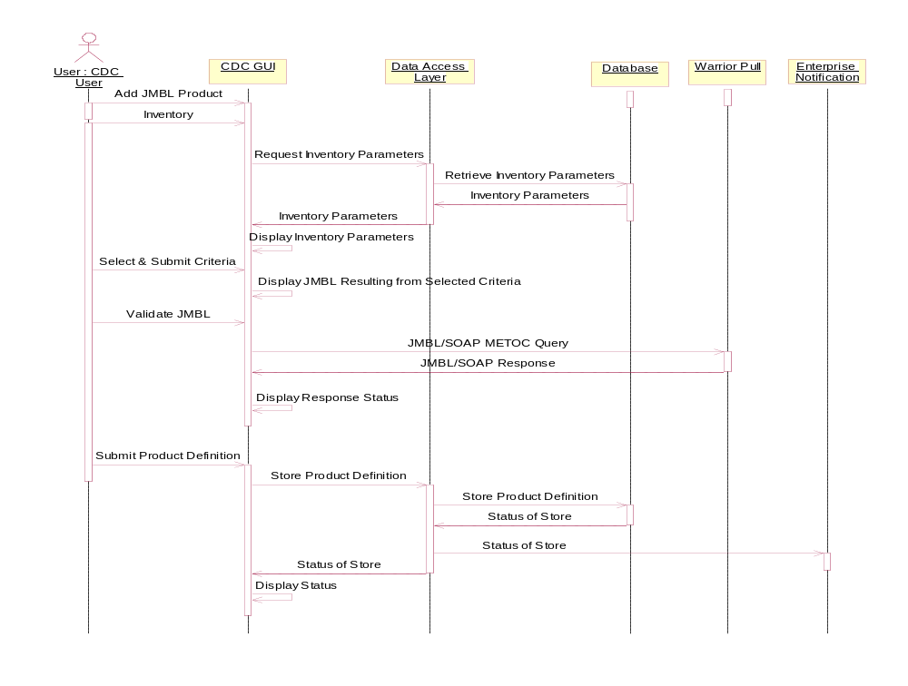

Actors
- User
- CDC GUI
- Data Access Layer
- Database
- Warrior Pull
- Enterprise Notification

Preconditions
- The CDC GUI is available via the AF Port.

Post Conditions
- JMBL product is successfully defined in the Database.

Basic Flow Steps
- This use case begins when the User navigates to the section of the CDC GUI where they can define a new JMBL product.
- The User selects the data type for the product being defined and chooses Inventory as the method for defining the JMBL product. [A10].
- The CDC GUI accesses the Data Access Layer to retrieve inventory parameters appropriate to the data type selected by the User.
- The Data Access Layer retrieves inventory parameters from the Database.
- The Database returns the inventory parameters to the Data Access Layer.
- The Data Access Layer returns the inventory parameters to the CDC GUI.
- The CDC GUI displays the inventory parameters to the User.
- The User selects and submits all criteria necessary to define the JMBL product.
- The CDC GUI displays the resulting JMBL Request to the User.
- The User validates the JMBL Request to test retrieval of the data.
- The CDC GUI submits the JMBL/SOAP METOC Query to Warrior Pull.
- Warrior Pull returns to CDC GUI a JMBL/SOAP Response containing a success or failure status of the request and, if successful, a reference to the product. [B10] [C10]
- The CDC GUI displays to User the request status and, if the query was successful, the reference to the product.
- The User submits a request to store the product definition to the CDC GUI.
- The CDC GUI requests the Data Access Layer to define the JMBL product using the definition submitted by the User.
- The Data Access Layer sends the new JMBL product definition to the Database to be stored, defining the product.
- The Database returns the status of the product definition to the Data Access Layer.
- The Data Access Layer sends the status of the JMBL product storage to Enterprise Notification.
- The Data Access Layer sends the status of the JMBL product storage to the CDC GUI.
- This use case ends when the CDC GUI displays the status of the JMBL product definition to the User.

Alternate Flow Steps

Text Entry of JMBL Request for Product
- This alternate flow begins after basic flow step 20 when the User selects Text Entry as the method for adding a JMBL product, including the data type for the product being defined.
- The User enters a JMBL request.
- This alternate flow returns to Basic Flow Step 100.

JMBL Request Fails Validation
- This alternate flow begins when the JMBL request fails validation in basic flow step 120.
- The CDC GUI displays a message indicating why the validation failed.
- Alternate flow returns to step 70 (or, in the case of Text Entry method, it returns to alternate flow step A20) and displays the request entry screen, populated with previously entered data.

JMBL Request Returns No Data
- This alternate flow begins when the validation succeeds but returns no data in step 120 of the basic flow.
- The CDC GUI displays a message indicating that the JMBL query is valid but the requested data is not currently available in the Database.
- Alternate flow returns to step 70 (or, in the case of Text Entry method, it returns to alternate flow step A20) and displays the request entry screen, populated with previously entered data.

Special Requirements
- The User will have the option to validate the JMBL request, but validation will not be mandatory.
- If the User chooses to validate the JMBL request and the validation indicates the product is available in the Database, the CDC GUI will also offer the User an opportunity to download the product.
- The User will have the option to subscribe to the product in this GUI, but subscription will not be mandatory.
- If the action will take more than 7 seconds to complete, display an indicator.

Edit JMBL Products
This use case flow begins when a request is received to edit JMBL products. When the edit request is received, a query to the database will retrieve the product definition data. The product definition is edited and the database is updated.
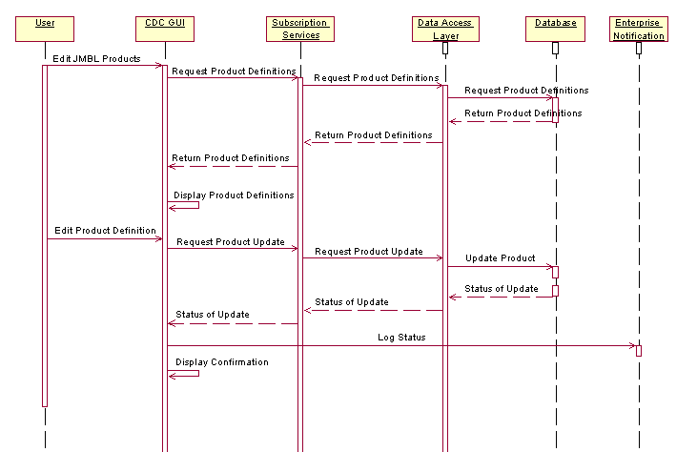

Actors
- User
- CDC GUI
- Subscription Services
- Data Access Layer
- Database
- Enterprise Notification

Preconditions
- All Actors are available.
- JMBL Product available for editing.

Post Conditions
- The User has successfully edited a JMBL product definition.
- Action logged in Enterprise Notification.

Basic Flow Steps
- This use case begins when the User requests to edit a JMBL product definition.
- CDC GUI requests product definition information from the Subscription Services.
- Subscription Services requests product definition information from the Data Access Layer.
- Data Access Layer requests the product definition information from Database.
- Database returns the product definition information to Data Access Layer.
- Data Access Layer returns the product definition information to Subscription Services.
- Subscription Services returns the product definition information to the CDC GUI.
- CDC GUI displays product definition to the User.
- User edits product definition using CDC GUI.
- CDC GUI requests product update to Subscription Services.
- Subscription Services requests product update to Data Access Layer.
- Data Access Layer sends edited product to the Database to be updated.
- Database sends update status to Data Access Layer.
- Data Access Layer sends update status to Subscription Services.
- Subscription Services sends update status to CDC GUI.
- CDC GUI logs the status message to Enterprise Notification.
- CDC GUI displays product update confirmation.
- The use case ends.

Alternate Flow Steps
None.

Special Requirements
None.

Delete Products
This Use Case flow describes the events that take place when the User decides to delete one or more products via the CDC GUI.
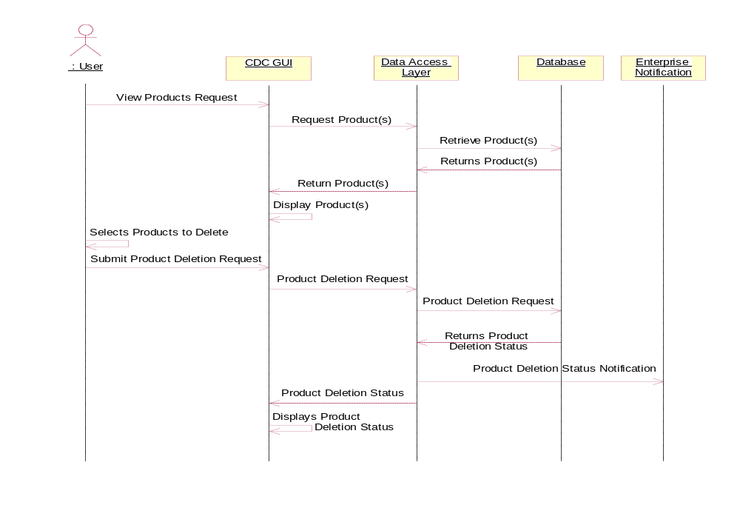

Actors
- User
- CDC GUI
- Data Access Layer
- Database
- Enterprise Notification

Preconditions
- The CDC GUI is available via the AF Portal.
- Products are available within the Database.
- The User has sufficient privileges to delete products.

Post Conditions
  - One or more products have been successfully deleted from the Database.

Basic Flow Steps
- This use case begins when the User navigates to the CDC GUI and submits a request to view their product list.
- The CDC GUI sends a request to retrieve the product list to the Data Access Layer.
- The Data Access Layer submits a request to retrieve the product list from the Database.
- The Database returns the product list to the Data Access Layer.
- The Data Access Layer returns the product list to the CDC GUI.
- The CDC GUI displays the product list to the User.
- The User selects one or more products from the product list to delete.
- The User submits the product deletion request to the CDC GUI.
- The CDC GUI sends the product deletion request to the Data Access Layer.
- The Data Access Layer sends the product deletion request to the Database.
- The Database returns the product deletion status to the Data Access Layer.
- The Data Access Layer sends the product deletion status to Enterprise Notification.
- The Data Access Layer sends the product deletion status to the CDC GUI.
- This use case ends when the CDC GUI displays the product deletion status to the User.

Alternate Flow Steps
None.

Special Requirements
- The CDC GUI will allow the user to delete more than one product at a time.
- If the action will take more than 7 seconds to complete, display an indicator.

MOC Setup
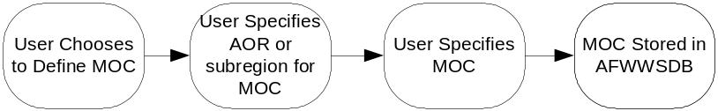

Actors
- User
- CDC GUI
- Database
- Data Access Layer
- Enterprise Notification

Preconditions
  - The CDC GUI is running
  - User has logged into the AF Portal, selected the WDAC application, and navigated to the CDC GUI
  - The Database is available
  - The MOC definitions are stored in the Database

Post Conditions
  - The MOC definition is stored in the Database.
  - Action logged in Enterprise Notification.

Basic Flow Steps
- This use case begins when a user accesses the CDC GUI.
- The user logs into the AF Portal and navigates to the CDC GUI link.
- The user chooses to define a Model of Consistency (MOC).
- A MOC setup GUI is displayed from which the user selects an Area of Responsibility (AOR) or subregion, with which the model of consistency is to be associated from a list of valid AOR selections or selecting a point on a map.
- The user selects a MOC to associate with the selected AOR from a list of valid models.
- The MOC specification is stored for future use.
- Use case end.

Alternate Flow Steps
None.

Special Requirements
None.

Manage Subscription Data
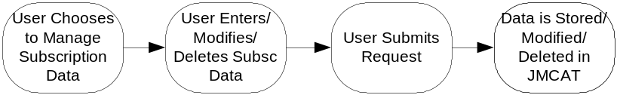

Actors
- User
- CDC GUI
- Data Access Layer
- Database
- Enterprise Notification

Preconditions
- The CDC GUI is running.
- User has logged into the AF Portal, selected the WDAC application, and navigated to the CDC GUI.
- The Database is available.
- The product definition that the User wants to subscribe to is stored in the Database.

Post Conditions
- The subscription is defined and stored in the Database.

Basic Flow Steps
- This use case begins when the User accesses the CDC GUI.
- The user logs into the AF Portal and navigates to the CDC GUI link.
- The user chooses to manage subscription data.
- The user enters/modifies/deletes subscription data and submits update request.
- The subscription data is stored/updated/deleted in JMCAT
- Use case ends.

Alternate Flow Steps
  - This alternate flow step begins at step 40, when the User selects an existing child product, rather than an existing parent product.
  - The user modifies the area and/or the parameters of the existing child product.
  - This alternate flow ends, returning to Basic flow step 60.

Special Requirements
None.

Load Catalog Products
This Use Case flow describes the events that take place while storing one or more parent products into the Database.

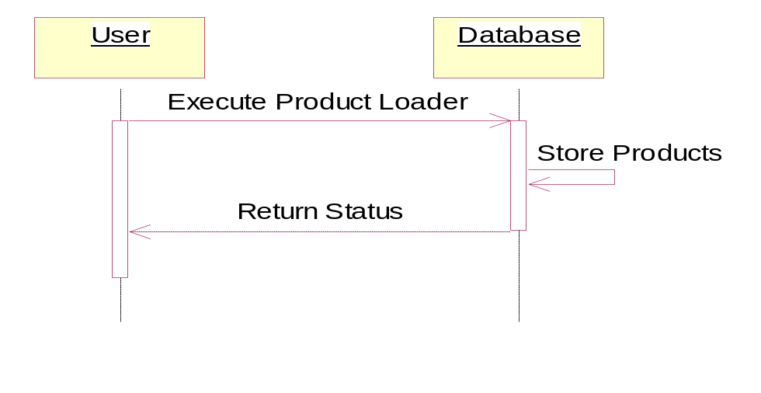

Actors
- User
- Database

Preconditions
- User has sufficient privileges to run product loader.

Post Conditions
  - Products are stored into the Database.

Basic Flow Steps
- This use case begins when the user starts the product loader.
- The Database stores the products.
- This use case ends when the products are stored in the Database and status is returned to the User.

Alternate Flow Steps
None.

Special Requirements
None.

Add Catalog Subscription
This Use Case flow describes the actions when the user selects “Add Catalog Subscription” from the CDC GUI menu. The use case flow ends when the user is notified of the status of the subscription attempt.
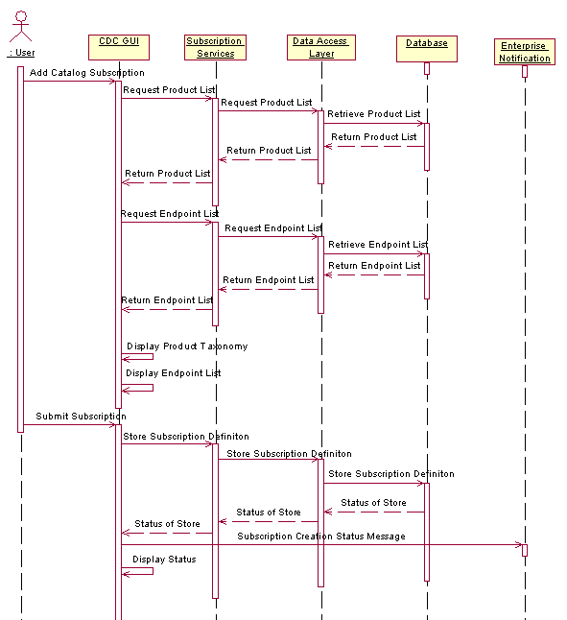

Actors
- User
- CDC GUI
- Subscription Services
- Data Access Layer
- Database
- Enterprise Notification

Preconditions
- The CDC GUI is available via the AF Portal.
- Catalog Products are available in Database.
- An endpoint is available in the Database for the subscription.

Post Conditions
    - The user has successfully added a subscription to a product via the CDC GUI.

Basic Flow Steps
- This use case begins when the User navigates to the section of the CDC GUI for adding a new subscription.
- The CDC GUI requests a list of products from the Subscription Services.
- The Subscription Services request a list of products from the Data Access Layer.
- The Data Access Layer retrieves a list of products from the Database.
- The Database returns the list of products to the Data Access Layer.
- The Data Access Layer returns the product list to Subscription Services.
- The Subscription Services returns the product list to the CDC GUI.
- The CDC GUI requests a list of endpoints from Subscription Services.
- The Subscription Services requests a list of endpoints from the Data Access Layer.
- The Data Access Layer retrieves a list of endpoints from the Database.
- The Database returns the list of endpoints to the Data Access Layer.
- The Data Access Layer returns the endpoints list to Subscription Services.
- The Subscription Services returns the endpoints to the CDC GUI.
- The CDC GUI displays the list of products as product taxonomy.
- The CDC GUI displays the list of endpoints.
- The user submits a subscription name, an endpoint from the endpoint list, one or more products from the taxonomy, subscription start and end dates, and subscription status to define the new subscription to the CDC GUI.
- The CDC GUI requests Subscription Services to store the subscription definition.
- The Subscription Services request the Data Access Layer to store the subscription definition.
- The Data Access Layer requests the Database to store the subscription definition.
- The Database returns the status of the subscription store to Data Access Layer.
- The Data Access Layer returns the status of the subscription store to Subscription Services.
- The Subscription Services returns the status of the subscription store to the CDC GUI.
- The CDC GUI sends a message to Enterprise Notification indicating that a subscription was created.
- The CDC GUI displays the status of the subscription creation to the user.
- This use case ends.

Alternate Flow Steps
None.

Special Requirements
None.

Edit Catalog Subscription
This use case flow describes the activities required to edit a subscription to a product via the CDC GUI. The use case begins when the user navigates to the edit subscription page of the CDC GUI and ends when the CDC GUI receives and displays notification of the status of the subscription update. There are no data specific activities in the Edit Catalog Subscription process.
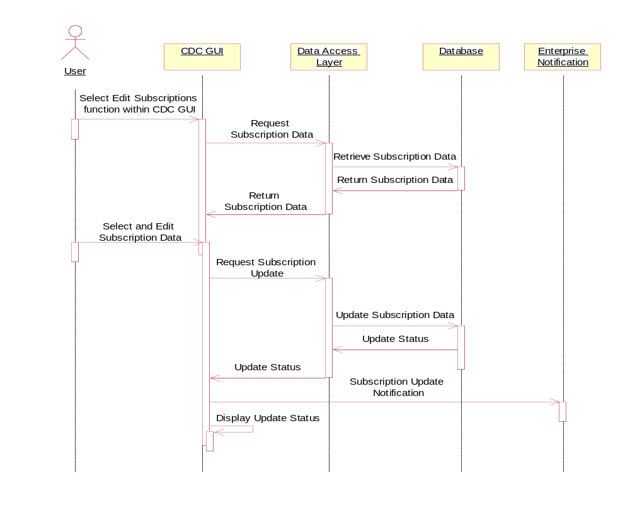

Actors
- User
- CDC GUI
- Data Access Layer
- Database
- Enterprise Notification

Preconditions
1. The CDC GUI is available.
2. The subscription data is available in the Database.

Post Conditions
- The subscription data is updated in the JMCAT database.
- Successful status is displayed by the CDC GUI.

Basic Flow Steps
- This use case begins when the user navigates to the section of the CDC GUI for editing existing subscriptions to products.
- The CDC GUI retrieves subscription information from the Database via the Data Access Layer.
- The CDC GUI allows the user to select a subscription and edit the subscription parameters.
- The CDC GUI submits a subscription update request to the Data Access Layer.
- The Data Access Layer requests an update of the subscription in the Database.
- The Database updates the subscription data.
- The Database returns the update status to the CDC GUI via the Data Access Layer.
- The CDC GUI sends a message to Enterprise Notification indicating that the subscription was updated.
- This use case ends when the CDC GUI displays the update status to the User

Alternate Flow Steps
None.

Special Requirements
None.

Delete Subscription to a Product
This use case flow describes the actions the user takes to delete a subscription to a product via the CDC GUI. The use case flow begins when the user activates the CDC GUI and navigates to the delete subscription screen. This use case flow ends when Data Access Layer sends a message to the CDC GUI indicating that the subscription was successfully deleted.
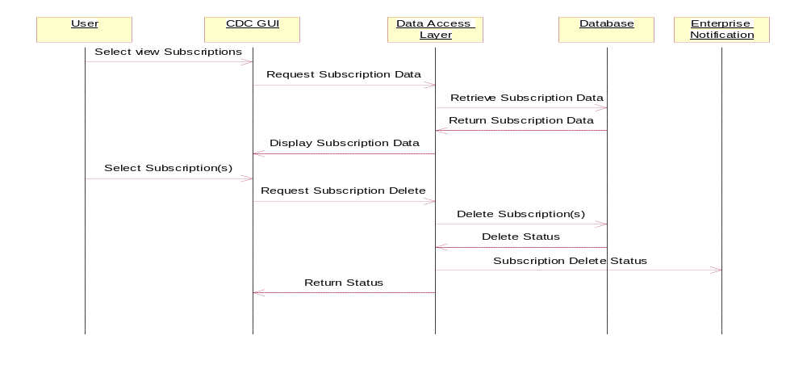

Actors
- User
- CDC GUI
- Data Access Layer
- Database
- Enterprise Notification

Preconditions
- The CDC GUI is available via the AF Portal.
- The subscription data is available in the Database.

Post Conditions
- The user has successfully deleted a subscription to a product via the CDC GUI.

Basic Flow Steps
  - This use case begins when the user navigates to the section of the CDC GUI for viewing a subscription to a product.
  - The CDC GUI displays the list of subscription(s) for the user.
  - The user selects one or more subscription(s) to delete by subscription name.
  - The Data Access Layer removes the subscription(s) from the Database.
  - The Data Access Layer sends a message to Enterprise Notification indicating that subscription(s) was deleted.
  - This use case ends when the Data Access Layers sends a message to the CDC GUI indicating that the subscription(s) was successfully deleted.

Alternate Flow Steps
None.

Special Requirements
None.

Enter Legacy Filename Tokens
This use case describes the process for entering a Remote Filename template, with optional tokens, for the subscribed product.
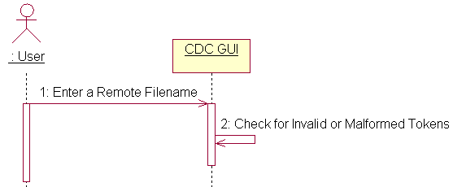

Actors
  - User
  - CDC GUI

Preconditions
  - The User is logged into the CDC GUI and is ready to enter a Remote Filename template for a subscription.

Post Conditions
- The Remote Filename template is saved with a subscription.

Basic Flow Steps
  - This use case begins at Basic Flow 2.1.1.4 step 340 in the parent use case “ST-JNIA-02 JNIA CDC” when a user is ready to enter a Remote Filename for a subscription.
  - The user enters the Remote Name ( or none, if desired). The Remote Name may include tokens and flags as defined in “Supported Filename Tokens.doc” to support legacy product filenames.
  - The user submits the subscription.
  - The CDC GUI validates the Remote Filename template.
  - The use case ends when the CDC GUI saves the subscription with the Remote Filename template.

Alternate Flow Steps

The Remote Filename contains one or more invalid or malformed tokens.
- This alternate flow begins when the CDC GUI determines that the Remote Filename template contains one or more invalid or malformed tokens.
- The user is notified by screen messages that tokens are invalid or malformed.
- Alternate flow ends when the user is returned to step 20.

Special Requirements
None.

Add Endpoint
This use case flow details the steps needed to add an endpoint to the database. An endpoint is attached to a route and denotes the final destination for any product dissemination.
A server is an extension of an endpoint and therefore can also be the final destination for any product dissemination. A server has the added responsibility of forwarding the product along the route until it is delivered to its final destination. A route will consist of a series of servers linked together in a sequential order.
The User will add the endpoints through use of the CDC GUI. The User begins by setting the attributes of the endpoint specifying whether the endpoint is a server. The User then optionally validates the endpoint. The User submits the added endpoint to the database. The CDC GUI displays the status of the database operation.
An FTP or File System Endpoint consists of the Network Nodename (or IP address) and the Directory. Given these definitions of an Endpoint, a collision can only occur if the user-provided values for these two items are the same as another Endpoint in the database. In this case the endpoint creation will fail and the user will be informed.
This use case begins when the User chooses to add an endpoint to the database. It ends when the User examines the status of the database action displayed on the CDC GUI.

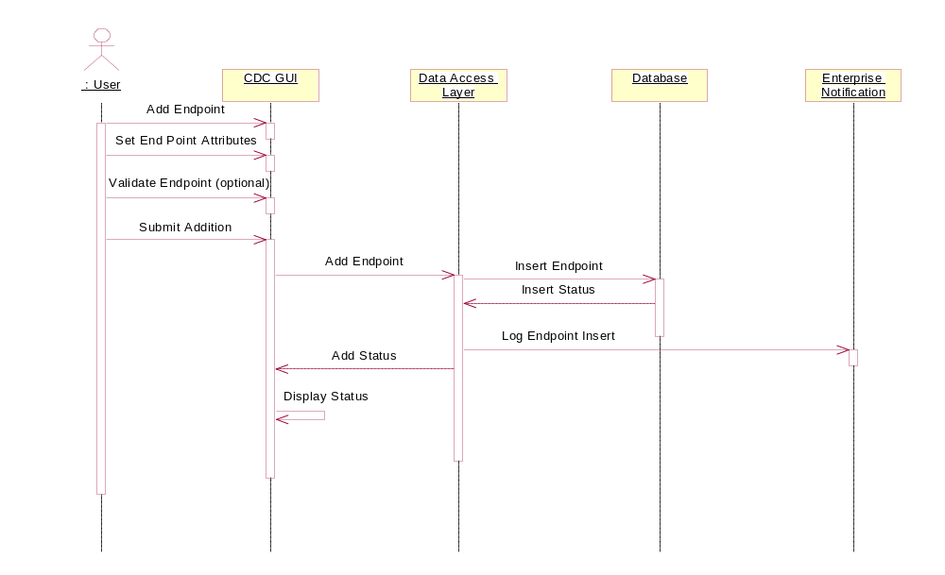

Actors
- User
- CDC GUI
- Data Access Layer
- Database
- Enterprise Notification

Preconditions
- The User has access to the CDC GUI with the administrator role.
- The endpoint does not exist in the database.

Post Conditions
- The endpoint is added to the database.

Basic Flow Steps
- This use case begins when the User chooses to add an endpoint.
- The User fills in the endpoint attributes.
- The User optionally validates any directly connected endpoint.
- The User submits the configured endpoint.
- The Data Access Layer logs the action with the Enterprise Notification.
- This Use Case ends when the User examines the status displayed on the CDC GUI.

Alternate Flow Steps
None.

Special Requirements
None.

Modify Endpoint
This Use Case flow details the steps needed to modify an endpoint in the database. An endpoint is attached to a route and denotes the final destination for any product dissemination.
A server is an extension of an endpoint and therefore can also be the final destination for any product dissemination. A server has the added responsibility of forwarding the product along the route until it is delivered to its final destination. A route will consist of a series of servers linked together in a sequential order.
The User will modify the endpoints through use of the CDC GUI. The User begins by selecting an endpoint from a list of endpoints. The User modifies the attributes of the endpoint. The User then optionally validates the endpoint. The User submits the modified endpoint to the database. The Data Access Layer sends an Endpoint Modification message to the Extended Dissemination Capability. The Data Access Layer logs the Endpoint modification with the Enterprise Notification. The CDC GUI displays the status of the database operation.
The Data Access Layer will not allow a server to transition from active to inactive/pending if it is participating in any routing. The User will have to remove the server from any Route before marking it inactive.
This use case begins when the User chooses to modify an endpoint in the database. It ends when the User examines the status of the database action displayed on the CDC GUI.

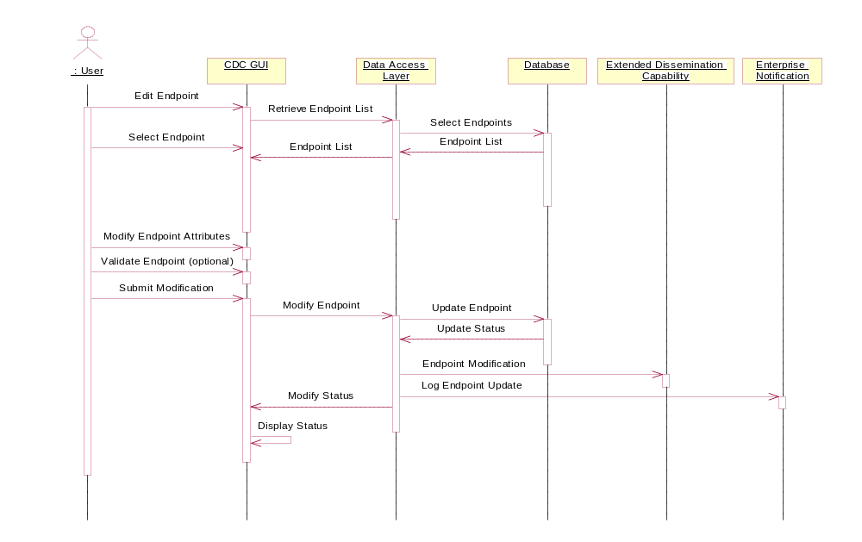

Actors
- User
- CDC GUI
- Data Access Layer
- Database
- Extended Dissemination Capability
- Enterprise Notification

Preconditions
- The User has access to the CDC GUI with the proper role.
- The endpoint already exists in the database.

Post Conditions
- The endpoint is modified in the database.

Basic Flow Steps
- This use case begins when the User chooses to modify an endpoint.
- The CDC GUI supplies the User with a list of endpoints.
- The User selects the endpoint from a list of endpoints.
- The User modifies the attributes of the endpoint.
- The User optionally validates the modified endpoint.
- The User submits the modified endpoint.
- The Data Access Layer sends an Endpoint modification message to Extended Dissemination Capability.
- The Data Access Layer logs the action with the Enterprise Notification.
- This Use Case ends when the User examines the status displayed on the CDC GUI.

Alternate Flow Steps
None.

Special Requirements
S10 The Data Access Layer will not allow a server to transition from active to inactive/pending if it is participating in any routing.

Delete Endpoint
This Use Case flow details the steps needed to delete an endpoint in the database. An endpoint is attached to a route and denotes the final destination for any product dissemination.
A server is an extension of an endpoint and therefore can also be the final destination for any product dissemination. A server has the added responsibility of forwarding the product along the route until it is delivered to its final destination. A route will consist of a series of servers linked together in a sequential order.
The User will delete the endpoint through use of the CDC GUI. The CDC GUI provides the User with a list of endpoints. It will set any server to read only and thereby prevent its selection. The User selects an endpoint from this list. The User submits the deletion of the endpoint to the database. The Data Access Layer marks all associated subscriptions Inactive. The Data Access Layer sends an Endpoint Deletion message to the Extended Dissemination Capability. The Data Access Layer Logs the Endpoint deletion with the Enterprise Notification. The CDC GUI displays the status of the database operation.
The CDC GUI will not allow the user to select a server. Only Endpoints not functioning as a server can be deleted.
This use case begins when the User chooses to delete an endpoint in the database. It ends when the User examines the status of the database action displayed on the CDC GUI.
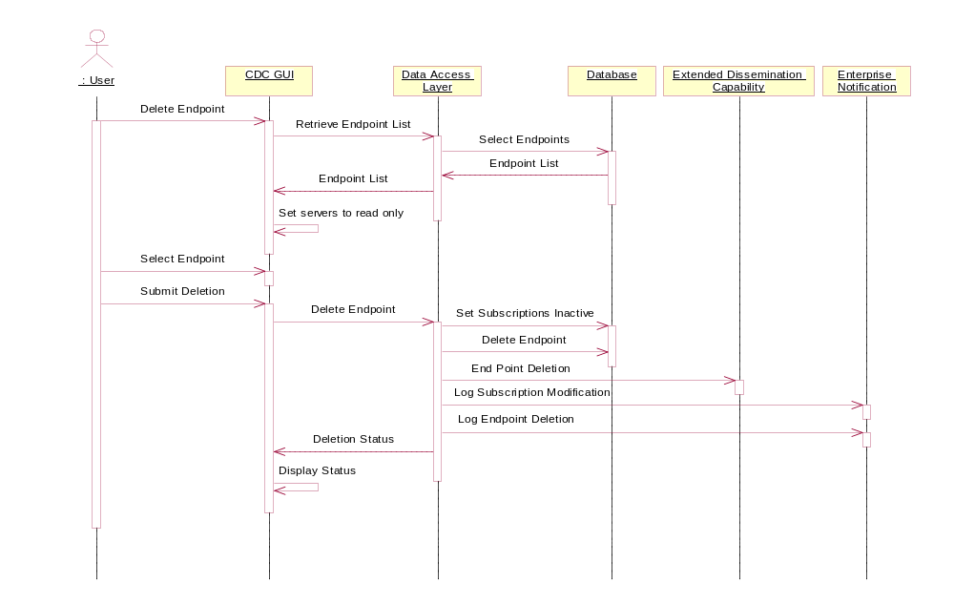

Actors
- User
- CDC GUI.
- Data Access Layer
- Database
- Extended Dissemination Capability
- Enterprise Notification

Preconditions
- The User has access to the CDC GUI with the administrator role.
- The endpoint already exists in the database.

Post Conditions
- The endpoint is deleted from the database.

Basic Flow Steps
- This use case begins when the User chooses to delete an endpoint.
- The CDC GUI provides a list of endpoints.
- The CDC GUI sets any server to read only.
- The User selects the endpoint from the list of endpoints.
- The CDC GUI provides a listing of all subscriptions and their state (Active or Inactive) associated with the end point.
- The CDC GUI provides a warning message concerning the state transition of any associated subscription.
- The User submits the endpoint deletion to the CDC GUI.
- The Data Access Layer sets the associated Subscriptions to pending.
- The Data Access Layer deletes the Endpoint.
- The Data Access Layer sends an Endpoint deletion message to Extended Dissemination Capability.
- The Data Access Layer logs the Subscription update with the Enterprise Notification.
- The Data Access Layer logs the Endpoint deletion with the Enterprise Notification.
- This Use Case ends when the User examines the status displayed on the CDC GUI.

Alternate Flow Steps
None.

Special Requirements
None.

Command Line Utilities

Define Gridded INFO or READY Products
This Use Case flow describes the events that take place while defining and loading a Gridded INFO or READY product into the Database.
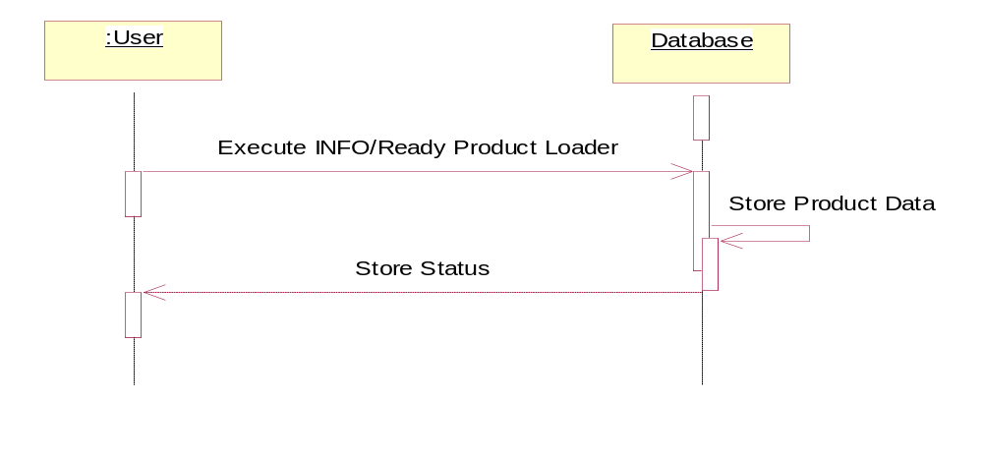

Actors
- User
- Database

Preconditions
- User has sufficient privileges execute product loader.
- Data has been previously loaded (one time only) into the griddedTheaterNestTable.

Post Conditions
1. Gridded INFO or READY product is loaded into the Database.

Basic Flow Steps
- This use case begins when the user starts the gridded INFO and READY product loader.
- User specifies the following command line parameters: database identifier (afwws, afwwstst, afwwsdev), model name (MM5, WRF, SCFM or DCF/DCF-5LYR), location name, data set name, cycle base time, starting forecast hour, ending forecast hour, hourly increment, theater number or 0, nest designator or ?. The theater number and nest are optional and ignored for SCFM model.
- The loader constructs the definitions based on user entries and contents of the AFWWS database.
- The loader submits the definitions to the AFWWS database.
- The Database stores the data.
- This use case ends when the Gridded INFO and READY product definitions are stored in the Database and status written to a log file.

Alternate Flow Steps
None.

Special Requirements
- INFO and READY products shall have a unique product type.
- INFO and READY products shall not be displayed by the subscription GUI.

Manage INFO or READY Product Subscription
This Use Case flow describes the actions that an administrator takes to add a subscription to an INFO and/or READY product on behalf of a legacy subscriber. This activity is supported only via a command line tool.
The INFO and READY files are used by selected legacy applications to signal the completion of entire gridded model runs (MM5, WRF, SCFM, and DCF only). Subscription to the INFO and READY products are supported by a command line interface. A conscious decision was made to avoid GUI access to these products. Use of this capability by knowledgeable managers will prevent end user confusion over which product is appropriate for their applications.

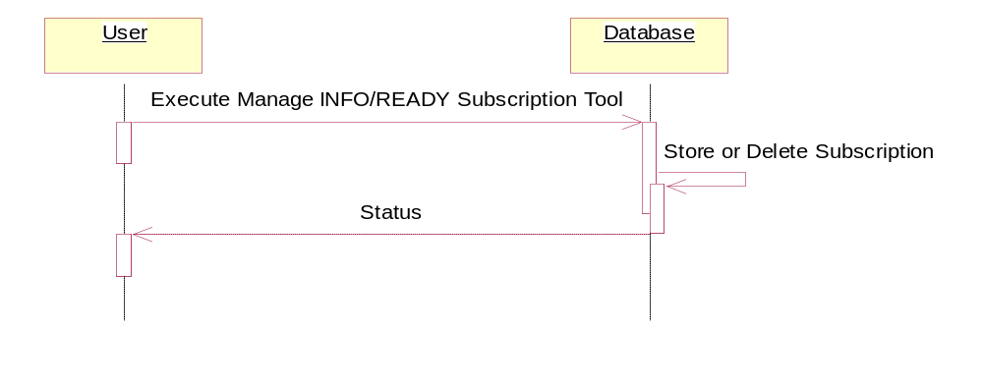

Actors
- User
- Database

Preconditions
- User has sufficient privileges to run the Manage INFO or READY subscription tool.
- The INFO and READY product definitions exist in the Database.
- End Point for subscription must exist in the Database.

Post Conditions
1. Gridded INFO or READY product subscription is loaded into or deleted from the Database according to the directive.

Basic Flow Steps
- This use case begins when the user starts the INFO and READY subscription tool.
- The INFO and READY subscription tool accepts a database identifier, the Product Name or “?”, endpoint name, the owner of the endpoint (many use WDAC.ADMIN), destination filename and “ADD” or “DELETE” directive.
- The INFO and READY subscription tool assembles the subscription information and submits the subscription request to the Database.
- The Database adds or deletes the subscription data.
- This use case ends when the subscription to the Gridded INFO or READY product is stored into or deleted from the Database and status is returned to the User.

Alternate Flow Steps

A “?” is Entered for Product Name field
- This alternate flow begins at basic flow step 20 when the user enters a “?” for the Product Name.
- The subscription tool extracts a list of available INFO, PRE-INFO and READY products and writes the list to a file (INFO_ProductList.txt).
- This alternate flow ends when the user views the file and copies a product name to a buffer for use in a subsequent execution of the subscription tool.

Special Requirements
None.

Management GUI

Basic Description
This thread of the JNIA CDC Use Case documents how the Management GUI is used to manage organization and user data, routes, endpoints and products.
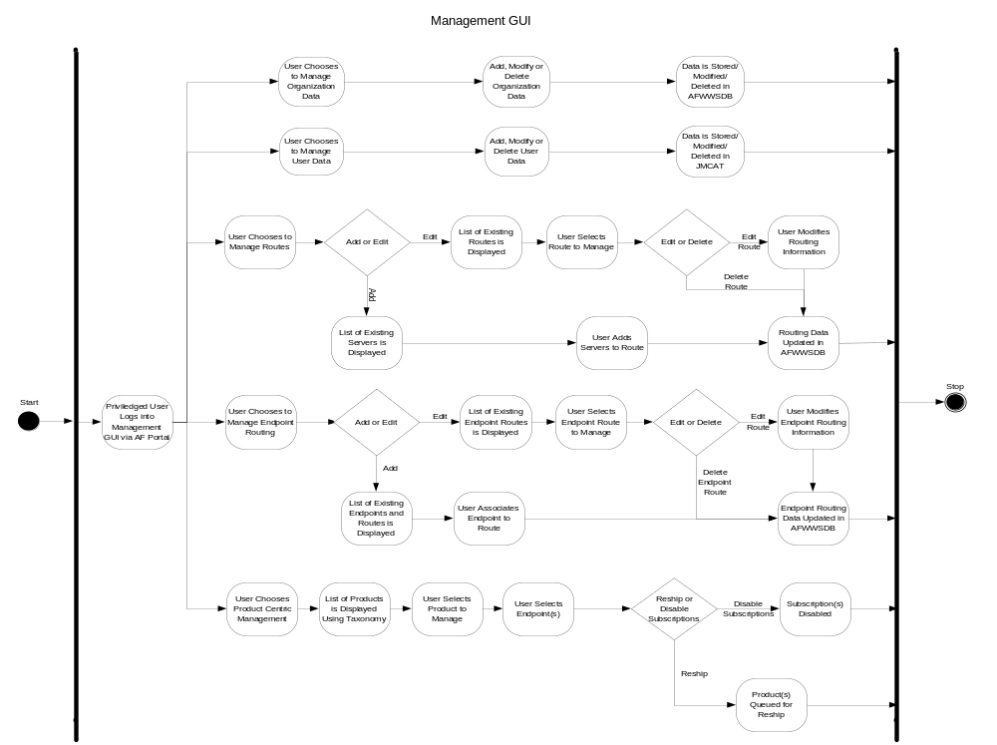

Manage User Data

Actors
- User
- CDC GUI
- Data Access Layer
- Database
- Enterprise Notification

Preconditions
- The CDC GUI is running.
- User has logged into the AF Portal, selected the WDAC application, and navigated to the CDC GUI.
- The Database is available.

Post Conditions
- The user data is defined and stored in the database.
- Status is logged.

Basic Flow Steps

- This use case begins when the privileged user accesses the CDC GUI.
- The user logs into the AF Portal and navigates to the CDC GUI link.
- The user chooses to manage user data.
- The user enters/modifies/deletes User Data and submits update request.
- The user data is stored/updated/deleted in JMCAT.
- Use case ends.

Alternate Flow Steps
None.

Special Requirements
None.

Manage Routes

Add a Route
This Use Case flow details the steps needed to add a route to the database. The route will consist of a series of servers linked together in a sequential order. A route will be identified by a series of server names.
The User is required to create the routes needed to support product dissemination. Initially the routes from AFWED will be preloaded into the database. Additional routes will be added through this use case.
The User will create the route through use of the Management GUI. The User selects a server from a list of servers provided by the Management GUI and adds it to the route. The User continues to select a server and add it to the route in a sequential order until the route is established. The User submits the route to the database. The Management GUI displays the status of the database action.
The routes management page will not allow the User to select an inactive server. Only active servers can be added to a route.
This use case begins when the User chooses to add a route to the database. It ends when the User examines the status of the database action displayed on the Management GUI.
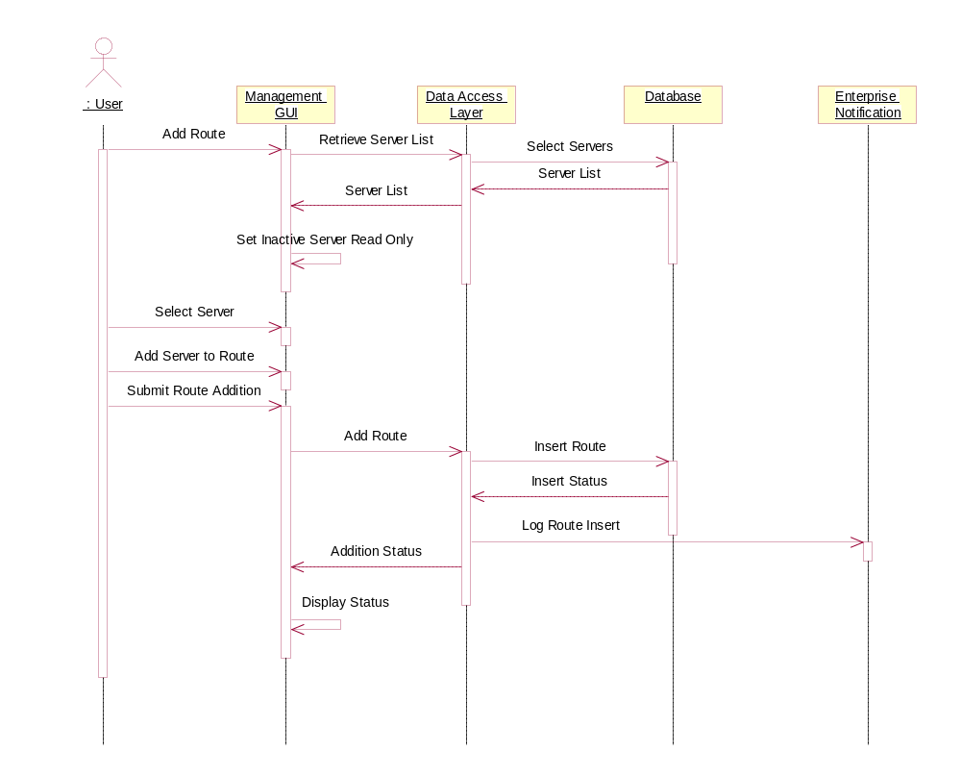

Actors
- User
- Management GUI
- Data Access Layer
- Database
- Enterprise Notification

Preconditions
- The User has access to the Management GUI with the administrator role.
- The server information exists in the database.

Post Conditions
- The route is added in the database.

Basic Flow Steps
- This use case begins when the User chooses to add a route.
- The Management GUI provides a list of servers to the User.
- The User selects the server from the list and adds it to the route.
- The User returns to step 30 until all required servers are added to the route.
- The User submits the configured route.
- The Data Access Layer logs the action to the Enterprise Notification.
- This Use Case ends when the User examines the status displayed on the Management GUI.

Alternate Flow Steps
None.

Special Requirements
S10 The routes management page will not allow the User to select an inactive server. Only active servers can be added to a route.

Edit a Route
This Use Case flow details the steps needed to edit the route. The route will consist of a series of servers linked together in a sequential order. A route will be identified by a series server names which comprise the route.
The User will edit the route through use of the Management GUI. The Management GUI provides a list of routes and servers to the User. The User selects a route from the list and updates the contents of the route. The User continues to add or deletes a server from the selected route until the route is reestablished. The User submits the update to the database. The Management GUI displays the status of the database action.
The Management GUI will not allow the User to add an inactive server to a route or delete an active server from a route. Only inactive servers can be deleted from a route and only active servers can be added to a Route.
This use case begins when the User chooses to modify an existing route. It ends when the User examines the status of the database action displayed on the Management GUI.
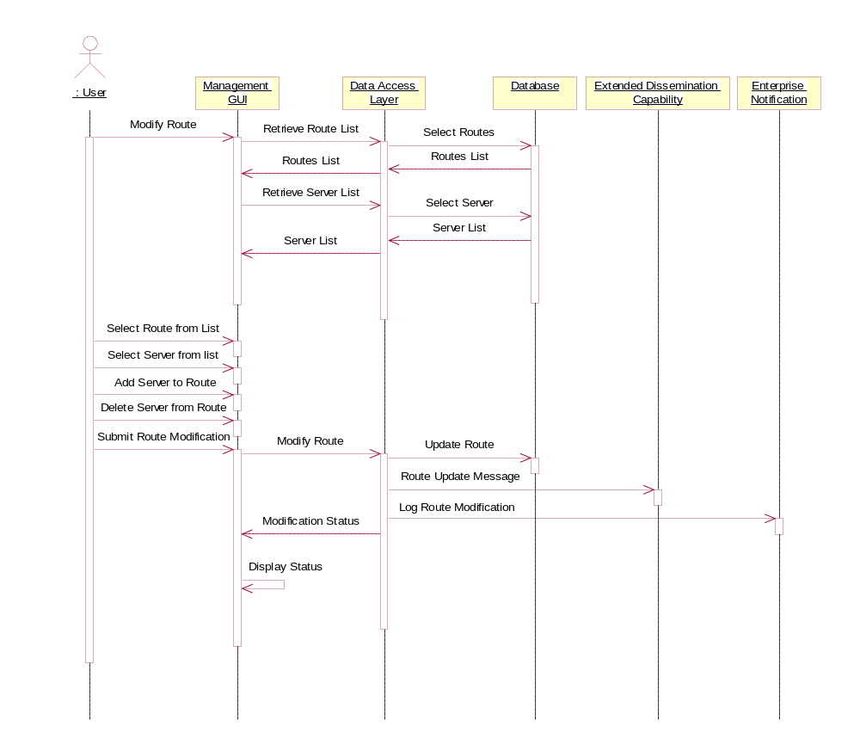

Actors
- User
- Management GUI (Management GUI)
- Data Access Layer
- Database
- Extended Dissemination Capability
- Enterprise Notification

Preconditions
- The User has access to the management GUI with the administrator role.
- The routing data is configured in the database.

Post Conditions
- The route is updated in the database.

Basic Flow Steps
- This use case begins when the User chooses to edit the route data.
- The Management GUI provides a list of routes to the User.
- The Management GUI provides a list of servers to the User.
- The User selects the route from a list of routes.
- The User updates attributes of the route.
- The User submits the reconfigured route.
- The Data Access Layer sends a Route Modification Message to the EDC.
- The Data Access Layer logs the action to the Enterprise Notification subsystem.
- This Use Case ends when the User examines the status displayed on the Management GUI.

Alternate Flow Steps
None.

Special Requirements
S10 The Management GUI will not allow the User to add an inactive server to a route.
S20 The Management GUI will not allow the User to delete an active server from a route..

Delete a Route
This Use Case flow details the steps needed to delete a route from the database. The route will consist of a series of servers linked together in a sequential order. A route will be identified by a series server names which comprise the route.
The User will delete the route through use of the Management GUI. The Management GUI will provide a list of routes. The User selects the route. The User submits the route for deletion from the system. The Management GUI displays the status of the database action.
Any endpoints attached to a deleted route are transitioned to a pending state waiting on the User to assign routing. Endpoints in a pending state cannot have products associated with them (i.e., subscription).
This use case begins when the User selects to delete an existing route. It ends when the User examines the status of the database action displayed on the Management GUI.
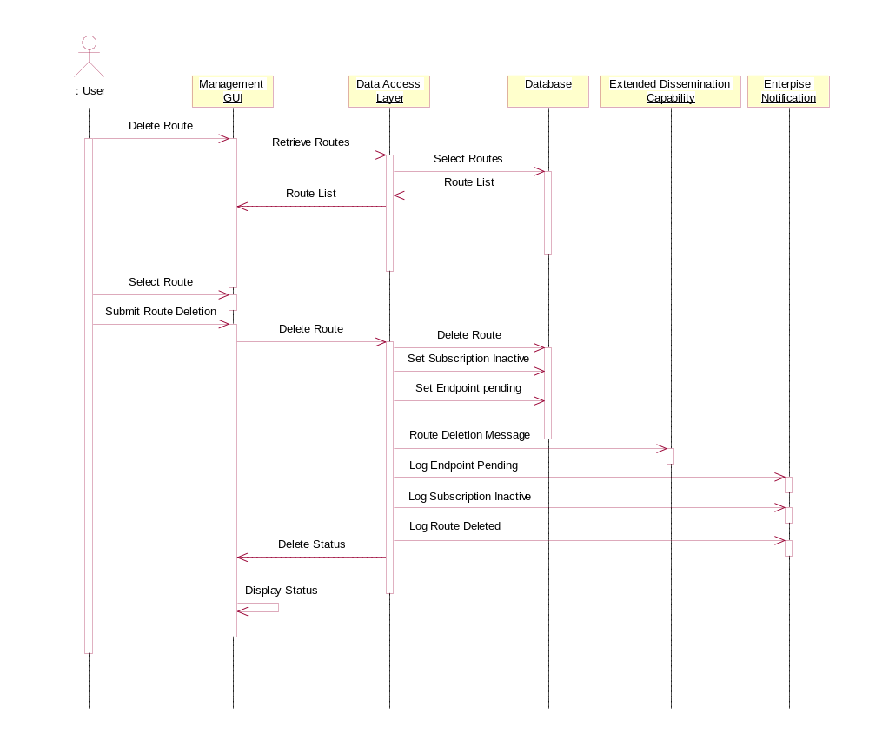

Actors
- User
- Management GUI
- Data Access Layer
- Database
- Extended Dissemination Capability
- Enterprise Notification

Preconditions
- The User has access to the management GUI with the administrator role.
- The route is configured in the database.

Post Conditions
- The route is removed from the database.
- All endpoints associated with the deleted route are in the pending state.

Basic Flow Steps
- This use case begins when the User chooses to delete a route.
- The Management GUI provides a list of routes.
- The User selects a route from the list of routes.
- The User submits the deleted route.
- The Data Access Layer sets all associated endpoints to a pending state.
- The Data Access Layer sets all subscriptions associated with each endpoint to an inactive state.
- The Data Access Layer sends a Route Deletion Message to the Extended Dissemination Capability.
- The Data Access Layer logs the Subscription changes to the Enterprise Notification.
- The Data Access Layer logs the Endpoint changes to the Enterprise Notification.
- The Data Access Layer logs the Route deletion to the Enterprise Notification.
- This Use Case ends when the User examines the status displayed on the Management GUI.

Alternate Flow Steps
None.

Special Requirements
None.

Manage Endpoint Routing

Add Endpoint Routing
This use case flow details the steps needed to add an endpoint to a route. The endpoint is attached to a route and denotes the final destination for any product dissemination. A server is an extension of an endpoint and therefore can also be the final destination for any product dissemination.
The User will create the endpoint routing through use of the Management GUI. The Management GUI will provide a list of endpoints and routes. The User first selects an endpoint from a list of endpoints. The User then selects a route from a list of routes. The User associates the endpoint to the route and completes the configuration. The User submits the endpoint routing to the database. The Management GUI displays the status of the database operation.
This use case begins when the User chooses to add an endpoint to a route. It ends when the User examines the status of the database action displayed on the Management GUI.

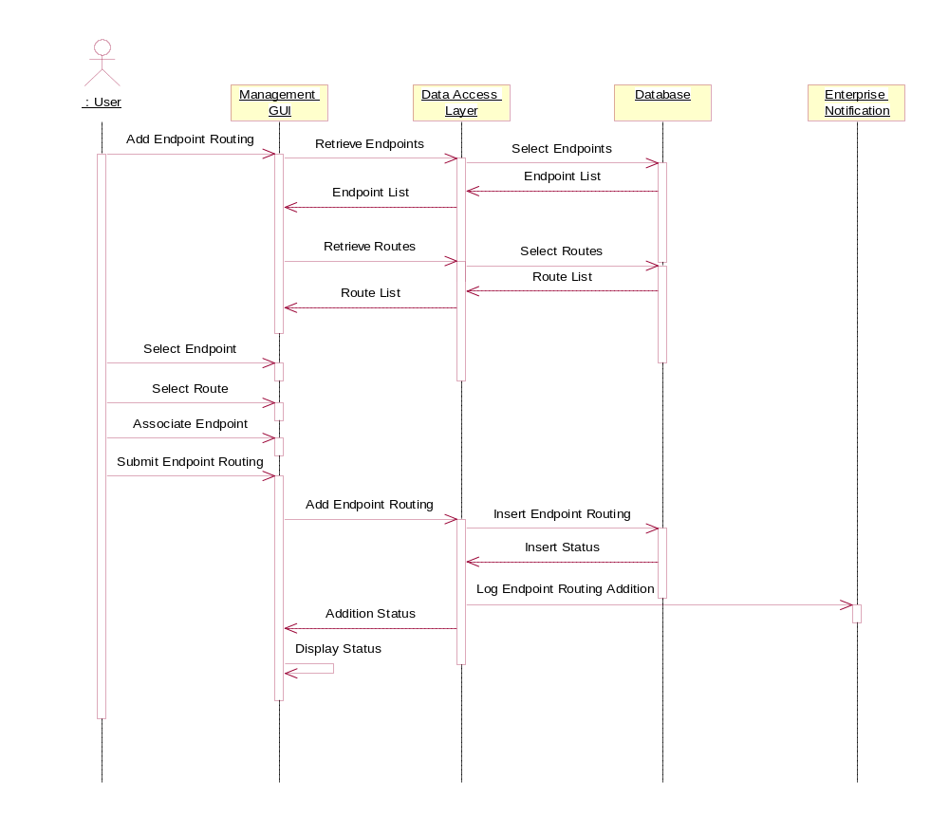

Actors
- User
- Management GUI
- Data Access Layer
- Database
- Enterprise Notification

Preconditions
- The User has access to the Management GUI with the administrator role.
- The route information is loaded in the database.
- There exists an endpoint without any route associated to it.

Post Conditions
- The endpoint routing information is added in the AFWWS database.

Basic Flow Steps
  - This use case begins when the User chooses to add an endpoint to a route.
  - The Management GUI provides a list of endpoints to the User.
  - The Management GUI provides a list of routes to the User.
  - The User selects the endpoint from a list of endpoints.
  - The User selects the route from a list of routes.
  - The User associates the selected endpoint to the selected route.
  - The User submits the configured endpoint routing to the database.
  - The Data Access Layer logs the action to the Enterprise Notification.
  - This Use Case ends when the User examines the status displayed on the Management GUI.

Alternate Flow Steps
None.

Special Requirements
None.

Edit Endpoint Routing
This use case flow details the steps needed to edit the endpoint routing in the database. A route consists of a series of servers linked together in a sequential order. The endpoint is attached to a route and denotes the final destination for any product dissemination.
The User has the responsibility of changing the routing data when any endpoint moves. Deployable endpoints require the User to disassociate the endpoint from the existing route and associate it to a different route.
The User will edit the endpoint routing through use of the Management GUI. The Management GUI will provide a list of endpoints and routes. The User first selects an endpoint from a list of endpoints. The User then disassociates this endpoint from the route. The User selects a route from a list of routes and associates the endpoint to it. The User submits the endpoint routing modification to the database. The Data Access Layer sends an Endpoint Routing Modification message to the Extended Dissemination Capability. The Data Access Layers log the modification with the Enterprise Notification. The Management GUI displays the status of the database operation.
This use case begins when the User chooses to modify an existing endpoint routing. It ends when the User examines the status of the database action displayed on the Management GUI.
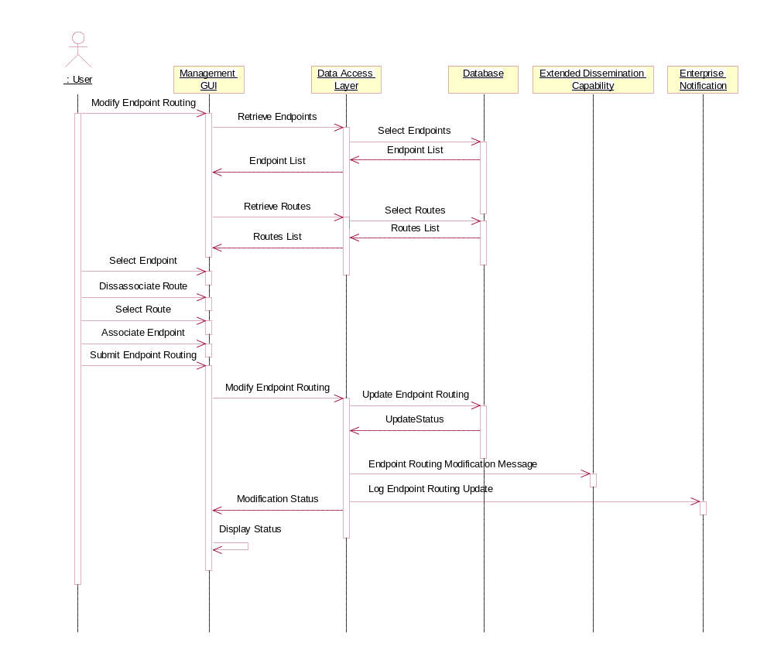

Actors
- User
- Management GUI
- Data Access Layer
- Database
- Extended Dissemination Capability
- Enterprise Notification

Preconditions
- The User has access to the Management GUI with the administrator role.
- The needed route data exists in the database.
- The endpoint routing data exists in the database.

Post Conditions
- The endpoint routing is updated in the database.

Basic Flow Steps
- This use case begins when the User chooses to modify the endpoint routing.
- The Management GUI provides a list of endpoints to the User.
- The Management GUI provides a list of routes to the User.
- The User selects the endpoint from the list of endpoints.
- The User disassociates the endpoint from its route.
- The User selects a new route from a list of routes.
- The User associates the endpoint with the new route.
- The User submits the endpoint routing updates to the system.
- The Data Access Layer sends an Endpoint Routing Modification message to Extended Dissemination Capability.
- The Data Access Layer logs the action to the Enterprise Notification.
- This Use Case ends when the User examines the status displayed on the Management GUI.

Alternate Flow Steps
None.

Special Requirements
None.

Delete Endpoint Routing
This Use Case flow details the steps needed to delete endpoint routing in the database. The endpoint is attached to a route and denotes the final destination for any product dissemination.
The User will delete the endpoint routing through use of the Management GUI. The Management GUI will provide a list of endpoints. The User selects an endpoint from this list. The User then disassociates the selected endpoint from the route. The User submits the endpoint routing for deletion. The Data Access Layer sets subscription to inactive and the endpoint to a pending state. The Management GUI displays the status of the database operation.
When an endpoint is disassociated from a route, the endpoint is transitioned to a pending state waiting on the User to assign routing. Endpoints in a pending state cannot have products associated with it (i.e. subscription).
This use case begins when the User selects to delete an endpoint routing. It ends when the User examines the status of the database action displayed on the Management GUI.
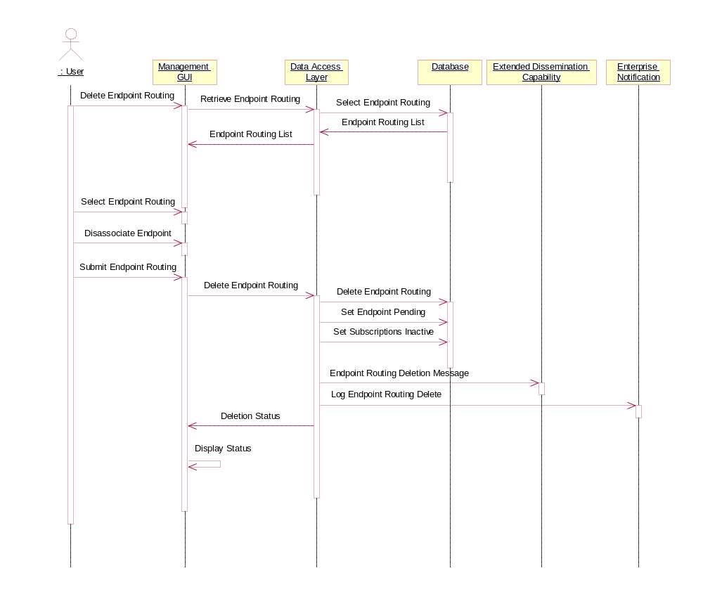

Actors
- User
- Management GUI
- Data Access Layer
- Database
- Extended Dissemination Capability
- Enterprise Notification

Preconditions
- The User has access to the Management GUI with the administrator role.
- The endpoint routing exists in the database.

Post Conditions
- The endpoint routing is removed from the database.

Basic Flow Steps
- This use case begins when the User chooses to remove an endpoint from a route.
- The Management GUI provides a list of endpoint routing to the User.
- The Management GUI sets all active endpoints to read-only.
- The User selects the inactive endpoint from a list.
- The User disassociates the selected endpoint from the route.
- The User submits the deletion to the Data Access Layer.
- The Data Access Layer transitions the selected endpoint to a pending state.
- The Data Access Layer inactivates all subscriptions on the endpoint.
- The Data Access Layer logs the subscription state change to the Enterprise Notification.
- The Data Access Layer sends an Endpoint Routing Deletion message to Extended Dissemination Capability.
- The Data Access Layer logs the deletion to the Enterprise Notification.
- This Use Case ends when the User examines the status displayed on the Management GUI.

Alternate Flow Steps
None.

Special Requirements
None.

Requirements


