EXECUTIVE SUMMARY

Background

The National Park Service, in partnership with the Center for Recreation and Tourism Research and Policy, George Mason University, conducted a Servicewide Training Needs Assessment for NPS employees in the Natural Resources Stewardship Career Field. The survey was conducted from July 2002 through November 2002. [See the Natural Resources Stewardship Career Field Servicewide Training Needs Assessment Final Report, March 2003 for complete results of this study].

Ellen B. Drogin Rodgers, Ph.D., Director, Center for Recreation and Tourism Research and Policy was the University’s Project Leader. Members of the University’s Project Team included Research Associates Valerie E. Block, M.S. and Laura Lawton, Ph.D. Tony Knapp, Training Manager, Cultural Resources Stewardship, Stephen T. Mather Training Center was the project coordinator for the National Park Service. [note: The Natural Resources Stewardship Career Field Training Manager position (Horace M. Albright Training Center) was vacant during the course of the study].

The purpose of this study was to:

- Obtain baseline data to be used for identification of existing and future employee training needs; and,
- Determine training and development priorities for employees in each occupational group.

This study was designed to specifically accomplish the following objectives:

- To determine the perceptions of employees regarding the importance of their essential competencies;
- To determine the perceptions of employees regarding their level of preparedness to perform essential competencies; and,
- To assess the gaps in existing training, given the perceived importance of essential competencies and level of preparedness to perform them.

Essential competencies (knowledge, skills, and abilities) for NPS employees in the Natural Resources Stewardship Career Field are clustered in seven categories. These are:

- Scientific Knowledge
- Scientific Method
- Resource Stewardship
- Planning and Compliance
- Professional Credibility
- Communication
- Program and Project Management

The essential competencies vary in complexity between occupational groups and for each performance level (technician, entry/developmental, journey, and advanced).

Methods

The methodology (including instrument preparation and study design) was developed and executed by the University’s Project Team. The essential competencies identified for park employees within the Natural Resources Stewardship Career Field were integrated into a survey instrument that was used to assess training needs. Employees were asked to indicate their perceptions of how important the essential competencies were to the performance of their present jobs (1=Not Important, 7=Extremely Important). Then, given the same list of competencies, they were asked to rate their preparation to perform those tasks (1=Unprepared, 7=Fully Competent). Demographic data (gender, age, formal education and academic degrees, race and ethnicity, present grade, length of time in the NPS, and time in current position) pertinent to National Park Service employees were also solicited. [See the Natural Resources Stewardship Career Field Servicewide Training Needs Assessment Final Report, March 2003, for surveys developed for each group].

Because of the relatively small number of employees in this career field, the project team decided to survey all employees in each occupational group, rather than to survey a proportionate sample. Specifically, five groups were surveyed:

• Technician Level Discipline Specialists
• Entry/Developmental Level Discipline Specialists
• Journey Level Discipline Specialists
• Advanced Level Discipline Specialists
• Advanced Level Natural Resources Program Managers

Natural Resource (NR) Discipline Specialists include: biologists, ecologists, botanists, fishery biologists, wildlife biologists, physical scientists, geologists, range management specialists, hydrologists, and natural resource specialists. Employees in these occupational groups may have varied responsibilities and assignments including fire and fuels management; environmental management; natural resources planning; and Geographic Information Systems (GIS) management. [Note: For the essential competencies for Natural Resource Discipline Specialists or Natural Resources Program Managers, see the NPS Employee Training and Development Career Planning and Tracking Kit, Natural Resources Stewardship Career Field (1996), at the NPS Learning Place Web site: www.nps.gov/training/].

The Training Needs Assessments were mailed to employees, who were asked to complete the survey within a short time frame. To maximize the return rate, the University mailed one reminder letter and survey to each occupational group. Employees were assured that their responses would be held in strictest confidence. Specifically, results have been reported in the aggregate, never attributed to any individual, and mailing lists generated for each occupational group using the Federal Payroll and Personnel System (FPPS) were discarded upon completion of the final report.

To summarize, a total of 1,243 employees were asked to complete the survey. At the end of the data collection period, a total of 706 employees had responded with 90 additional questionnaires returned as "undeliverable." The effective response rate for this study was: 61.2%.

Data were analyzed using the Statistical Package for the Social Sciences (SPSS), a popular software program utilized by social and behavioral scientists. Standard frequency distributions and other descriptive statistics were computed for both the importance assigned to, and ability to perform each of the essential competencies. These statistics were analyzed in combination to identify "training gaps" through a simple Importance-Preparation, or Gap Analysis.
Result Highlights

Meeting the study objectives, the results provide a clear picture of employees' perception of the importance of essential competencies and of their perceived preparation to perform said competencies. For purposes of this report, high training priorities – where employees perceived themselves unprepared to perform a competency relative to the perceived importance of the competency to employee job performance success – are indicated by gaps of 1.0 and higher. Moderate training priorities are indicated by gaps of 0.70 to 0.99. The following discussion provides a brief summary of the perceived importance of competencies and the perceived high and moderate gaps (training needs) of employees in the five occupation groups surveyed. [See the Natural Resources Stewardship Career Field Servicewide Training Needs Assessment Final Report, March 2003, for a detailed discussion of the results].

Technical Level Discipline Specialists (138 respondents; Response Rate = 62.2%)

- Employees’ Perception of Competency Importance
- All competencies were rated as important to the employees’ job performance success.

- Employees’ Perception of Training Gaps
- No high gaps (training needs) were identified by this group.

- Moderate gaps (training needs) were identified for seven (7) competencies, including:
- Basic knowledge of environmental laws, compliance requirements, and policies
- Knowledge of general environmental laws
- Ability to organize, store, and analyze data with computers
- Ability to maintain currency of technical/scientific knowledge
- Knowledge of resource restoration and mitigation
- Ability to assist in analyzing data from ongoing studies
- Ability to incorporate scientific information in management actions

Entry/Developmental Level Discipline Specialists (118 Respondents; Response Rate = 66.3%)

- Employees’ Perception of Competency Importance
- All competencies were rated as important to the employees’ job performance success.

- Employees’ Perception of Training Gaps
- High gaps (training needs) were identified for two (2) competencies, including:
- Knowledge of risk assessment methodologies and ability to evaluate potential resource impacts
- Knowledge of environmental laws, compliance requirements, regulations and policies

- Moderate gaps (training needs) were identified for ten (10) competencies, including:
- Ability to draft proposals, funding requests, and requests for proposals
- Knowledge of natural resource discipline and currency in the field
- Ability to write natural resource action plans, agency documents and technical reports
- Ability to incorporate scientific information into management actions and policy development
- Ability to propose relevant scientific approaches to natural resource management activities
- Knowledge of general environmental laws
- Ability to draft proposals, funding requests, and request for proposals
- Ability to draft and monitor project budgets
- Ability to assist in developing management strategies and plans
- Ability to maintain currency of technical/scientific knowledge

Journey Level Discipline Specialists (210 Respondents; Response Rate = 64.2%)

1. Employees’ Perception of Competency Importance
- One competency was rated as not important to the employees’ job performance success:
- Ability to routinely publish articles in peer-reviewed publications and present information

2. Employees’ Perception of Training Gaps
- A high gap (training need) was identified for one (1) competency:
- Knowledge of data management, analytical methods and statistics

- Moderate gaps (training needs) were identified for seven (7) competencies, including:
- Knowledge of cooperative agreements, MOUs, contracting
- Ability in collecting, storing, summarizing, and analyzing resource management data
- Ability to serve as a technical expert
- Ability to maintain currency of technical/scientific knowledge
- Ability to incorporate scientific information into management actions, policies
- Ability to use scientific knowledge to anticipate threats to natural resources and take proactive action to protect natural systems
- Knowledge of standard computer systems uses and applications

Advanced Level Discipline Specialists (123 Respondents; Response Rate = 50.4%)

1. Employees’ Perception of Competency Importance
- One competency was rated as not important to the employees’ job performance success:
- Ability to publish articles in peer-reviewed publications and serve as an editor

2. Employees’ Perception of Training Gaps
- No high gaps (training needs) were identified.

- Moderate gaps (training needs) were identified for nine (9) competencies, including:
- Knowledge of data management, analytical methods and statistics
- Ability to negotiate, persuade, and resolve conflict
- Ability to successfully seek and arrange partnerships
- Ability to develop and manage complex project budgets
- Knowledge of computer systems, uses, and applications
- Knowledge of the environmental laws, regulations, and policies, and guidelines related to natural resources planning and compliance
- Ability to use sound judgement in drawing conclusions
- Skill in interpersonal relationships
- Ability to synthesize and incorporate scientific information into management actions

Advanced Level Natural Resources Program Managers (117 Respondents; Response Rate = 64.3%)

1. Employees’ Perception of Competency Importance
- All competencies were rated as being important to the employees’ job performance success.

2. Employees’ Perception of Training Gaps
- A high gap (training need) was identified for one (1) competency:
- Skills in leadership and team-building

- Moderate gaps (training needs) were identified for eleven (11) competencies, including:
- Ability to develop and coordinate complex multi-faceted programs of research, inventory, monitoring and resource management
- Ability to integrate information across natural resources disciplines, to recognize patterns and draw conclusions, and to use results
- Ability to persuade, effectively negotiate, and solve problems with diverse individuals and organizations
- Ability to plan and direct large-scale resource stewardship programs
- Ability to effectively convey information politicized or controversial issues to audiences
- Ability to form effective partnerships with diverse and potentially hostile groups to address complex natural resource issues
- Ability to evaluate and synthesize results of relevant scientific studies, and to develop solutions to complex problems
- Ability to evaluate research reports, scientific publications, and agency documents and legislation for their applicability to specific natural resource issues
- Ability to effectively compete for funding through development of partnerships
- Advanced ability to apply scientific approaches and problem solving techniques in developing innovative solutions to complex natural resource issues
- Ability to provide sound advice to upper-level managers on need resource stewardship programs and actions

The results of this Servicewide Training Needs Assessment will guide future allocation of training resources and will assist in development or refinement, and implementation of a curriculum for employees in the Natural Resources Stewardship Career Field.

TABLE OF CONTENTS

Executive Summary 2

Table of Contents 7
List of Tables 9
List of Figures 10

Background 11

Methods 13
Study Population 13
Development of Survey Instrument 13
Data Collection 13
Response Rate 13
Data Analyses 14

Results and Discussion 15
Technician Level Discipline Specialists 15
Profile of Respondents 15
Perceived Importance of Natural Resources Stewardship Competencies 16
Perceived Level of Preparation to Perform Natural Resources Stewardship Competencies 17
Gaps in Natural Resources Stewardship Competencies 17

Entry/Developmental Level Discipline Specialists 23
Profile of Respondents 23
Perceived Importance of Natural Resources Stewardship Competencies 24
Perceived Level of Preparation to Perform Natural Resources Stewardship Competencies 25
Gaps in Natural Resources Stewardship Competencies 25

Journey Level Discipline Specialists 32
Profile of Respondents 32
Perceived Importance of Natural Resources Stewardship Competencies 33
Perceived Level of Preparation to Perform Natural Resources Stewardship Competencies 34
Gaps in Natural Resources Stewardship Competencies 34

Advanced Level Discipline Specialists 41
Profile of Respondents 41
Perceived Importance of Natural Resources Stewardship Competencies 42
Perceived Level of Preparation to Perform Natural Resources Stewardship Competencies 43
Gaps in Natural Resources Stewardship Competencies 43

Advanced Level Natural Resources Program Managers 51
Profile of Respondents 51
Perceived Importance of Natural Resources Stewardship Competencies 52
Perceived Level of Preparation to Perform Natural Resources Stewardship Competencies 53
Gaps in Natural Resources Stewardship Competencies 53

References 60

Appendix A. Survey Instruments 62
Appendix A-1. Survey Instrument: Technician Level Discipline Specialists 63
Appendix A-2. Survey Instrument: Entry/Developmental Discipline Specialists 74
Appendix A-3. Survey Instrument: Journey Level Discipline Specialists 85
Appendix A-4. Survey Instrument: Advanced Level Discipline Specialists 100
Appendix A-5. Survey Instrument: Advanced Level Natural Resources Program Managers 113

Appendix B. Academic Degrees and Fields of Study 122
Appendix B-1. Academic Degrees and Fields of Study: Technician Level Discipline Specialists 123
Appendix B-2. Academic Degrees and Fields of Study: Entry/Developmental Discipline
Specialists 125
Appendix B-3. Academic Degrees and Fields of Study: Journey Level Discipline Specialists 127
Appendix B-4. Academic Degrees and Fields of Study: Advanced Level Discipline Specialists 130
Appendix B-5. Academic Degrees and Fields of Study: Advanced Level Natural Resources
Program Managers 133

Front Cover Photograph: “Dealing with Spring” (Courtesy of NPS Park Science, 1986)

LIST OF TABLES

Table 1. Response Rate for Natural Resources Stewardship Career Field Employee Surveys 13

Table 2. Importance-Preparation Gap Analysis: Technician Level Discipline Specialists 19

Table 3. Importance-Preparation Gap Analysis: Entry/Developmental Level Discipline Specialists 28

Table 4. Importance-Preparation Gap Analysis: Journey Level Discipline Specialists 36

Table 5. Importance-Preparation Gap Analysis: Advanced Level Discipline Specialists 45

Table 6. Importance-Preparation Gap Analysis: Advanced Level Natural Resources Program Managers 56

LIST OF FIGURES

Figure 1. Distribution of Technician Level Discipline Specialists by Age 15

Figure 2. Distribution of Technician Level Discipline Specialists by Current Rank 16

Figure 3. Distribution of Technician Level Discipline Specialists by Years as an NPS Employee 16

Figure 4. Importance-Preparation Gaps in Natural Resources Stewardship Career Field Competencies:
Technician Level Discipline Specialists 18

Figure 5. Distribution of Entry/Developmental Level Discipline Specialists by Age 23

Figure 6. Distribution of Entry/Developmental Level Discipline Specialists by Current Rank 24

Figure 7. Distribution of Entry/Developmental Level Discipline Specialists by Years as an
NPS Employee 24

Figure 8. Importance-Preparation Gaps in Natural Resources Stewardship Career Field Competencies:
Entry/Developmental Level Discipline Specialists 27

Figure 9. Distribution of Journey Level Discipline Specialists by Age 32

Figure 10. Distribution of Journey Level Discipline Specialists by Current Rank 33

Figure 11. Distribution of Journey Level Discipline Specialists by Years as an NPS Employee 33

Figure 12. Importance-Preparation Gaps in Natural Resources Stewardship Career Field Competencies:
Journey Level Discipline Specialists 35

Figure 13. Distribution of Advanced Level Discipline Specialists by Age 41

Figure 14. Distribution of Advanced Level Discipline Specialists by Current Rank 42

Figure 15. Distribution of Advanced Level Discipline Specialists by Years as an NPS Employee 42

Figure 16. Importance-Preparation Gaps in Natural Resources Stewardship Career Field Competencies:
Advanced Level Discipline Specialists 44

Figure 17. Distribution of Advanced Level Natural Resources Program Managers by Age 51

Figure 18. Distribution of Advanced Level Natural Resources Program Managers by Current Rank 52

Figure 19. Distribution of Advanced Level Natural Resources Program Managers by Years as an NPS
Employee 52

Figure 20. Importance-Preparation Gaps in Natural Resources Stewardship Career Field Competencies:
Advanced Level Natural Resources Program Managers 55
NATURAL RESOURCES STEWARDSHIP CAREER FIELD
SERVICEWIDE TRAINING NEEDS ASSESSMENT
FINAL REPORT

BACKGROUND

In 1993, the Government Performance and Results Act (GPRA, 1993) was passed and signed into law. This legislation mandated that the actions of federal agencies be guided through the establishment of concrete goals and measured by performance evaluation. In 1995, the National Park Service (NPS) adopted the NPS Employee Training and Development Strategy. This Strategy, commensurate with the spirit of GPRA, implemented a competency-based approach to training for all employees Servicewide. Its stated mission is to provide for the professional growth and continuous learning of all NPS employees, by providing them with a comprehensive, mission-focused training, and development program (NPS, 1995).

With the growing momentum of the Strategy, teams of employees and training managers, representing 17 different career fields, compiled and documented the "essential competencies" required to guide the professional development of NPS employees, in 225 occupational groups. The results of this effort are documented in the NPS Employee Training and Development Career Planning and Tracking Kit. The Tracking Kit can be accessed on the NPS Learning Place Web site at: http://www.nps.gov/training.

In 2001, the NPS Training and Development Program began a process of self-examination and change. The new three-fold Mission Statement of the National Park Service Training and Development Program is:

- The NPS is committed to individual and organizational effectiveness in order to accomplish its strategic goals.
- Training and development is a catalyst for the NPS to engage in continuous learning, professional growth, and organizational effectiveness.
- The professional Training and Development Community focuses on working with agency leaders to predict and develop strategies/approaches that contribute to a workforce capable of accomplishing NPS strategic goals.

Currently, five Servicewide Training and Development strategic goals are defined to carry out this mission. Goal 2 states that the Service is to: “Build a competency-based, integrated system for managing employee performance.” To accomplish this goal, the NPS must:

- develop and deliver a comprehensive training program to address the identified essential competencies – knowledge, skills, and abilities – for each career field (e.g., define essential competencies necessary for each career field; conduct training needs assessments to determine specific development needs; develop comprehensive training programs to address identified competencies; and develop core curricula and methods of delivery); and,

- establish a process for validating training and development events and developmental programs to assure that they result in the organizational and individual benefits for which they were developed (e.g., develop an evaluation method to determine whether a training course, program, or activity has produced the intended results, and identify procedures for establishing and recognizing certification and benchmarks for specific competencies).

In 1994, the NPS Stephen T. Mather Training Center entered into a cooperative agreement with the Center for Recreation Resources Policy (CRRP) at George Mason University to conduct a training needs assessment for the Interpretation and Education career field (Wright & Makay, 1995). In 1998, to begin establishing a baseline of data depicting needs and levels of current performance, the National Park Service, Stephen T. Mather Training Center, entered into a cooperative agreement with George Mason University, the Center for Recreation Resources Policy (renamed the Center for Recreation and Tourism Research and Policy, July 1, 2002), to conduct a training needs assessments for employees in or associated with the Cultural Resources Stewardship Career Field. The Summary of the Results of the Cultural Resources Stewardship Servicewide Training Needs Assessment, Final Report, June 5, 2001, is available on the NPS Learning Place Web site at: http://www.nps.gov/training.

The purpose of this report is to document the procedures and findings associated with the assessment of training needs for employees in Natural Resources Stewardship Career Fields (Discipline Technicians, Discipline Specialists, and Program Managers). More specifically, this study was designed to accomplish the following objectives:

1. To determine the perceptions of employees regarding the importance of each of the essential competencies outlined in the NPS Employee Training and Development Career Planning and Tracking Kit.

2. To determine the perceptions of employees regarding their level of preparedness to perform each essential competency.

3. To diagnostically assess the gaps in existing training, given the importance assigned to competencies and the general level of preparedness to perform critical tasks.

- To gather demographic data about employees in the Natural Resources Stewardship career field.

METHODS

Study Population. Given the relatively small number of employees in the Natural Resources Stewardship Career Field, a decision was made to survey all employees, rather than a proportionate sample. A total of 1,243 Natural Resources Discipline Technicians, Discipline Specialists, and Program Managers in NPS parks, offices, and centers were asked to participate in this study.

Development of the Survey Instrument. Essential competencies identified for each of the five Natural Resources Stewardship Career Field occupational groups and performance levels, were integrated into a series of mail survey instruments. These competencies, in addition to pertinent demographic data, formed the basis for the questionnaire. Respondents were asked to indicate their perceptions of how important each essential competency was to the performance of their present jobs on a seven-point Likert scale, where 1=Not Important, 7=Extremely Important. Then, given the same list of competencies, employees were asked to rate their preparation to perform these tasks, again on a seven-point Likert scale, where 1=Unprepared, 7=Fully Competent. Copies of the five survey instruments are included as Appendix A.

Data Collection. Mailing lists were generated for each occupational group using data from the Federal Payroll and Personnel System (FPPS). Following standard procedures of social science and survey research, a cover letter, questionnaire, and self-addressed, business reply envelope were mailed to employees in each occupational group in Summer-Fall 2002. Subjects were asked to complete the questionnaire during their workday, as part of their official duties. Approximately four weeks later, those persons who had not responded to the initial mailing were mailed a follow-up letter and questionnaire requesting that they complete the questionnaire and return it as soon as possible. Employees were assured that their responses would be held in strictest confidence. Specifically, results have been reported in the aggregate, never attributed to any individual, and mailing lists generated for each occupational group were discarded upon completion of the final report.

Response Rate. At the end of the data collection period, a total of 706 questionnaires had been returned. Taking into account the 90 surveys returned as "undeliverable," the effective response rate for this study overall was 61.2 percent. The rate of response varied, however, by occupational group (Table 1).

Table 1. Response Rate for Natural Resources Stewardship Career Field Employee Surveys

Job Classification | N | Undeliverable | Completed | Response Rate
Discipline Specialist - Technician | 239 | 17 | 138 | 62.2%
Discipline Specialist - Entry/Developmental Level | 194 | 16 | 118 | 66.3%
Discipline Specialist - Journey Level | 357 | 30 | 210 | 64.2%
Discipline Specialist - Advanced Performance Level | 261 | 17 | 123 | 50.4%
Program Manager - Advanced Performance Level | 192 | 10 | 117 | 64.3%
TOTAL | 1243 | 90 | 706 | 61.2%
Data Analyses. Data were analyzed using the Statistical Package for the Social Sciences (SPSS), a popular software program utilized by social and behavioral scientists. Standard descriptive statistics (e.g., frequency distributions, mean, standard deviation) were computed for both the importance assigned to, and preparation to perform each of the essential competencies. Additionally, these statistics were analyzed to identify "training gaps" through a simple Importance-Preparation, or gap analysis. For example, competencies in which employees perceived themselves to be unprepared to perform were viewed relative to their perceived importance to the employees' successful job performance. Gap scores were identified by calculating the difference between mean Importance and mean Preparation for each specific competency. For planning purposes, training efforts should be focused on those competencies experiencing the largest "gaps", where level of perceived importance is greater then the employee’s perceived preparation to perform. Treatment of the competency importance and preparation data using “Importance-Performance Analysis” or Gap Analysis is similar to procedures reported first by Martilla and James (1977). The results for each classification and performance level are presented in the following discussions, tables, figures and appendices.

RESULTS AND DISCUSSION

Technician Level Discipline Specialists

Profile of Respondents. Over half (53.7%) of the 138 respondents were female; slightly less (46.3%) were male. Six Technician Level Discipline Specialists (4.3%) indicated that they had a disability. The average age of respondents, ranging from 24 to 63, was 35.9 years (Figure 1).

Figure 1. Distribution of Technician Level Discipline Specialists by Age

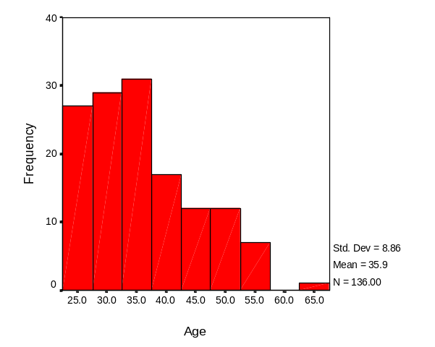

Although the majority of employees responding were White (85.1%), a small number of respondents did indicate other races or ethnicities. Specifically, respondents identified as Native American [Native Hawaiian] or Other Pacific Islanders (3.0%), Black or African American (0.7%), and Asians (0.7%). Those respondents noting an “Other” racial identification (4.5%) self-identified as Anglo-American, Antartican, Mixed Heritage, and Samoan. With regard to ethnicity, 6.7% of respondents were Hispanic or Latino.

Respondents had completed an average of 16.4 years of formal education, with 92 percent holding at least one advanced degree. The academic degrees (e.g., B.S., B.A., M.S., Ph.D.) held by Technician Level Discipline Specialists span a great number of fields (see Appendix B-1. Technician Level Discipline Specialists).

Ranging in rank from GS-4 to GS-11, the largest proportion of respondents held the rank of GS-7 (40.1%) (Figure 2). Three-quarters of all respondents reported holding ranks of GS-7 or below. The average number of years as an employee in the NPS was 5.9 with 3.3 years averaged in current position (Figure 3).

Figure 2. Distribution of Technician Level Discipline Specialists by Current Rank

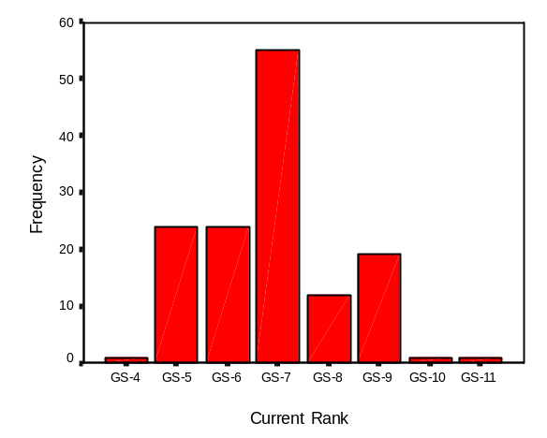

Figure 3. Distribution of Technician Level Discipline Specialists by Years as an NPS Employee

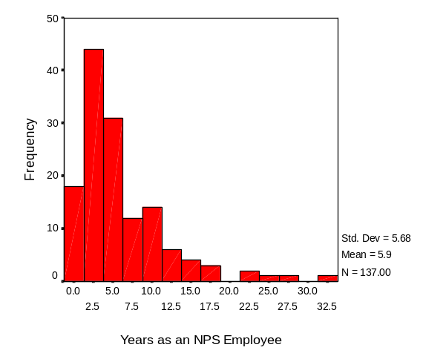

Perceived Importance of Natural Resources Stewardship Competencies. As can be seen in Table 2, Technician Level Discipline Specialists rated seven different competencies as having the greatest importance to them in their current positions. Each of these competencies received a mean importance rating of 6.0 or higher on the 7-point scale. They were:

(Q1) Working knowledge of natural resource discipline and currency in the field

(Q4) Knowledge of basic scientific principles

(Q7) Ability to follow basic scientific methods in conducting inventory, monitoring, and applied research projects

(Q10) Basic knowledge and proficiency in field skills and measurements

(Q12) Ability to reliably collect, computer input, and summarize natural resource data
(Q35) Ability to use computers to communicate electronically
(Q36) Ability to organize, store and analyze data with computers

Of the 42 competencies posed to respondents, 31 were rated as 5.0 or higher. In fact, no competencies were rated as being unimportant (i.e., less than 4.0), with only three at, or slightly above the 4.0 level:

(Q26) Ability to publish articles in peer-reviewed publications and/or make presentations at scientific meetings

(Q39) Basic knowledge of types of agreements and ability to draft simple agreements of contract outlines.

(Q40) Ability to draft and monitor project budgets, including the status of staff and fiscal resources

Perceived Level of Preparation to Perform Natural Resources Stewardship Competencies. Technician Level Discipline Specialists reported feeling highly prepared regarding only one of the 42 competencies, rating this item as 6.0 or higher on the 7-point scale:

(Q35) Ability to use computers to communicate electronically

Additionally, sixteen (16) competencies were rated as 5.0 or higher. Employees did note two competencies where they perceived themselves to be relatively less prepared (i.e., less than 4.0):

(Q39) Basic knowledge of types of agreements and ability to draft simple agreements of contract outlines.

(Q40) Ability to draft and monitor project budgets, including the status of staff and fiscal resources

Gaps in Natural Resources Stewardship Competencies. When analyzed together, the relative ratings of importance and preparation provide a diagnostic assessment of training “gaps” in this occupational group. There were no competencies that produced a gap in excess of 1.0, even though seven exceeded 0.70. These items were, in order of magnitude:

(Q23) Basic awareness of environmental laws, compliance requirements, regulations, executive orders and policies related to respective resource discipline

(Q15) Basic knowledge of general environmental laws

(Q36) Ability to organize, store and analyze data with computers

(Q29) Demonstrated ability to maintain currency of technical/scientific knowledge

(Q16) Basic knowledge of resource restoration and mitigation in area of expertise

(Q11) Ability to assist in analyzing data from on-going studies or studies designed by someone else

(Q17) Ability to incorporate scientific information in management actions, policy development, and interaction with other resource managers

However, a slight word of caution must be offered here. The two items producing the largest “I-P gaps” had relatively low rating of importance (4.23 and 4.29, respectively) when compared to other items.

In contrast, analyses related to two (2) competencies produced positive gaps between the importance of a competency and how well prepared respondents perceived themselves to be. That is, respondents rated their preparation to perform relative to these items as being higher than its perceived importance.

(Q33) Ability to give off-site, public presentations on non-controversial issues

(Q34) Ability to write and orally present management summaries of research information

The gaps between the group mean importance of each competency and the group mean preparation to perform each competency are graphically depicted in Figure 4.

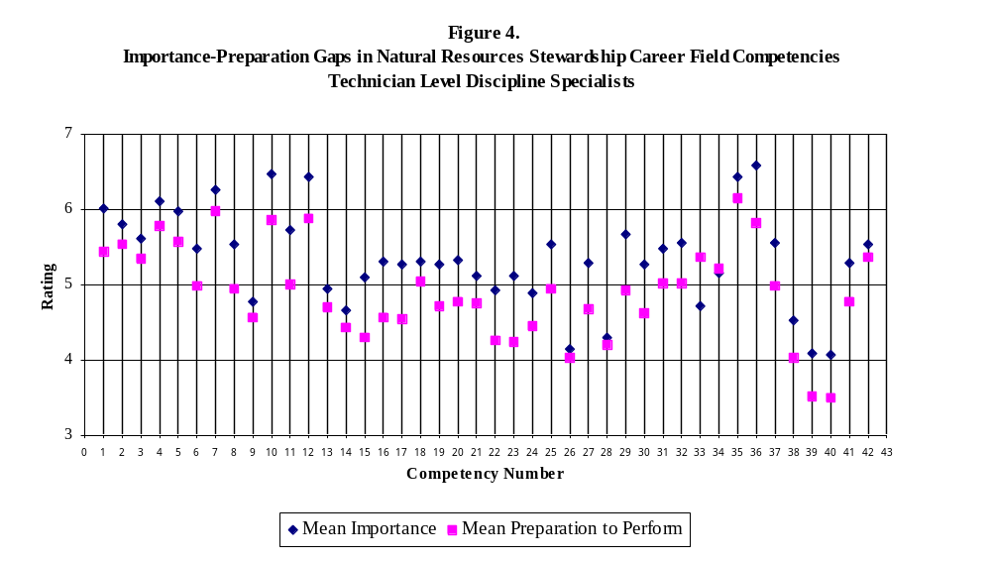

National Park Service
Stephen T. Mather Training Center
Natural Resources Stewardship Training Needs Assessment

Table 2. Importance-Preparation Gap Analysis: Technician Level Discipline Specialists
(138 Respondents)

Competencies |  |  | Mean  Importance | Standard Deviation  (Importance) | Mean Preparation | Standard Deviation  (Preparation) | I-P  Gap

Scientific Knowledge
1. |  | Working knowledge of natural resource discipline and currency in the field. | 6.01 | 1.25 | 5.43 | 1.31 | 0.58
2. |  | Basic knowledge of ecological principles. | 5.80 | 1.35 | 5.54 | 1.38 | 0.26
3. |  | Ability to review and understand results of research done elsewhere for possible relevancy to park natural resource issues. | 5.61 | 1.32 | 5.35 | 1.46 | 0.26
4. |  | Knowledge of basic scientific principles. | 6.10 | 1.01 | 5.79 | 1.29 | 0.31
5. |  | Ability to apply standard or existing sampling and research design and quality assurance/control techniques. | 5.98 | 1.28 | 5.57 | 1.46 | 0.41

Scientific Method
6. |  | Ability to propose relevant scientific approaches to natural resource management activities and problem-solving. | 5.47 | 1.54 | 4.98 | 1.35 | 0.49
7. |  | Ability to follow basic scientific methods in conducting inventory, monitoring, and applied research projects. | 6.26 | 1.18 | 5.98 | 1.23 | 0.28
8. |  | Ability to design studies, gather data, and present results of studies in the field of expertise. | 5.53 | 1.59 | 4.95 | 1.51 | 0.58
9. |  | With assistance, ability to design sampling protocols outside field of expertise. | 4.77 | 1.77 | 4.56 | 1.59 | 0.21
10. |  | Basic knowledge and proficiency in field skills and measurements. | 6.46 | 0.96 | 5.86 | 1.33 | 0.60
11. |  | Ability to assist in analyzing data from on-going studies or studies designed by someone else. | 5.72 | 1.31 | 5.00 | 1.59 | 0.72
12. |  | Ability to reliably collect, computer input, and summarize natural resource data. | 6.43 | 1.05 | 5.87 | 1.39 | 0.56
NPS Resource Stewardship
13. |  | Basic knowledge of NPS history, mission, goals, guidelines, and policies. | 4.95 | 1.50 | 4.69 | 1.70 | 0.26
14. |  | Basic knowledge of the resource missions of the Department of Interior, other DOI bureaus, and other Federal and State resource agencies. | 4.66 | 1.56 | 4.43 | 1.69 | 0.23
15. |  | Basic knowledge of general environmental laws. | 5.10 | 1.50 | 4.29 | 1.66 | 0.81
16. |  | Basic knowledge of resource restoration and mitigation in area of expertise. | 5.31 | 1.57 | 4.57 | 1.62 | 0.74
17. |  | Ability to incorporate scientific information in management actions, policy development, and interaction with other resource managers. | 5.26 | 1.64 | 4.55 | 1.59 | 0.71
18. |  | Ability to apply standard approaches to problem-solving in areas where established policy or guidance exists. | 5.30 | 1.36 | 5.04 | 1.34 | 0.26
19. |  | Ability to integrate scientific knowledge and knowledge of environmental law to identify threats to natural resources and be proactive to protect natural systems using standardized approaches. | 5.26 | 1.77 | 4.72 | 1.53 | 0.54

Planning and Compliance
20. |  | Basic knowledge of how to use scientific information to recognize, appraise, and describe natural resource issues and management conflicts. | 5.32 | 1.50 | 4.77 | 1.43 | 0.55
21. |  | Basic ability to help formulate possible alternative management strategies. | 5.12 | 1.57 | 4.76 | 1.51 | 0.36
22. |  | Awareness of risk assessment methodologies and basic ability to evaluate, in scientific terms, potential resource impacts from identified management needs/proposed management actions. | 4.92 | 1.72 | 4.26 | 1.68 | 0.66
23. |  | Basic awareness of environmental laws, compliance requirements, regulations, executive orders, and policies related to respective resource discipline. | 5.12 | 1.68 | 4.23 | 1.61 | 0.89
24. |  | Ability to assist in the development of various management strategies and formal plans to address resource issues. | 4.88 | 1.68 | 4.45 | 1.63 | 0.43

Professional Credibility
25. |  | Ability to develop an active network of professional interaction with peers in the scientific community. | 5.54 | 1.39 | 4.94 | 1.52 | 0.60
26. |  | Ability to publish articles in peer-reviewed publications and/or make presentations at scientific meetings. | 4.15 | 1.88 | 4.02 | 1.72 | 0.13
27. |  | Ability to maintain a level of scientific knowledge and skill in application that is recognized by peers in government agencies and the academic community as credible and providing a basic foundation for work performed. | 5.28 | 1.63 | 4.68 | 1.53 | 0.60
28. |  | Ability to carry out peer review of scientific reports, and to participate in developmental assignments as a member of teams reviewing natural resource programs. | 4.29 | 1.88 | 4.20 | 1.73 | 0.09
29. |  | Demonstrated ability to maintain currency of technical/scientific knowledge. | 5.67 | 1.32 | 4.92 | 1.54 | 0.75

Communication
30. |  | Ability to write natural resource action plans, sections of agency documents and technical reports, in accordance with existing guidelines and subject to review by others. | 5.26 | 1.75 | 4.62 | 1.76 | 0.64
31. |  | Ability to organize and orally present technical and scientific information. | 5.47 | 1.47 | 5.02 | 1.64 | 0.45
32. |  | Ability to present briefings to agency personnel and the visiting public. | 5.56 | 1.47 | 5.02 | 1.68 | 0.54
33. |  | Ability to give off-site, public presentations on non-controversial issues. | 4.72 | 1.80 | 5.37 | 1.60 | -0.65
34. |  | Ability to write and orally present management summaries of research information. | 5.15 | 1.73 | 5.20 | 1.59 | -0.05
35. |  | Ability to use computers to communicate electronically. | 6.43 | 0.97 | 6.15 | 1.20 | 0.28
36. |  | Ability to organize, store, and analyze data with computers. | 6.58 | 0.84 | 5.82 | 1.26 | 0.76

Program/Project Management
37. |  | Ability to conceive and define project objectives in area of expertise and to develop basic work plans. | 5.56 | 1.52 | 4.99 | 1.59 | 0.57
38. |  | Ability to draft proposals, funding requests, and request for proposals. | 4.52 | 2.11 | 4.03 | 1.89 | 0.49
39. |  | Basic knowledge of types of agreements and ability to draft simple agreements of contract outlines. | 4.08 | 1.96 | 3.52 | 1.83 | 0.56
40. |  | Ability to draft and monitor project budgets, including the status of staff and fiscal resources. | 4.07 | 2.02 | 3.50 | 2.03 | 0.57
41. |  | Ability to coordinate and facilitate groups or teams to accomplish resource management and research projects objectives. | 5.29 | 1.76 | 4.77 | 1.67 | 0.52
42. |  | Ability to monitor basic project implementation. | 5.53 | 1.59 | 5.37 | 1.44 | 0.16

RESULTS AND DISCUSSION

Entry/Developmental Level Discipline Specialists

Profile of Respondents. Slightly over half (53.8%) of the 118 respondents were male, with only 46.2% female. Only one Entry/Developmental Level Discipline Specialist (3.9%) indicated that they had a disability. The average age of respondents, ranging from 25 to 67, was 36 years (Figure 5).

Figure 5. Distribution of Entry/Developmental Level Discipline Specialists by Age

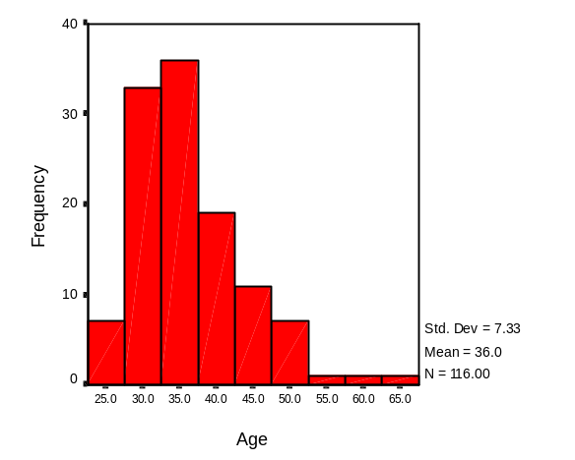

Although the majority of employees responding were White (94.0%), a small number of respondents did indicate other races or ethnicities. Specifically, respondents identified as American Indian or Alaskan Native (3.4%), Asian (0.9%), Black or African American (0.9%), Native American [Native Hawaiian] or Other Pacific Islander (0.9%), and “Other” (0.9%) [Unspecified racial identification]. With regard to ethnicity, 0.9% of respondents were Hispanic or Latino.

Respondents had completed an average of 17.3 years of formal education, with 73.7 percent holding at least one advanced degree. The academic degrees (e.g., B.S., B.A., M.S., Ph.D.) held by Entry/Developmental Level Discipline Specialists span a great number of fields (see Appendix B-2. Entry/Developmental Level Discipline Specialists).

Ranging in rank from GS-5 to GS-11, the majority of respondents held the rank of GS-9 (61.9%) (Figure 6). The average number of years as an employee in the NPS was 5.8 (ranging from less than one to 30 years) with only 2.4 years averaged in current position (Figure 7).

Figure 6. Distribution of Entry/Developmental Level Discipline Specialists by Current Rank

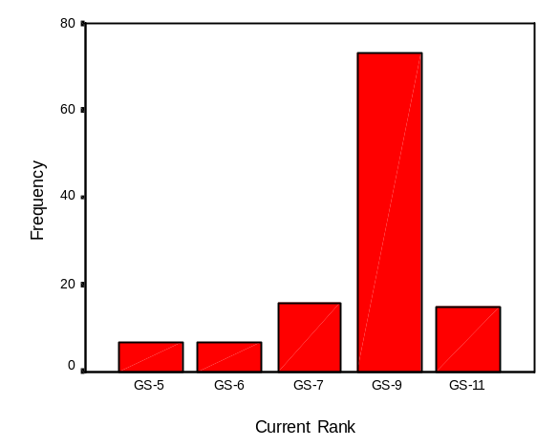

Figure 7. Distribution of Entry/Developmental Level Discipline Specialists
by Years as an NPS Employee

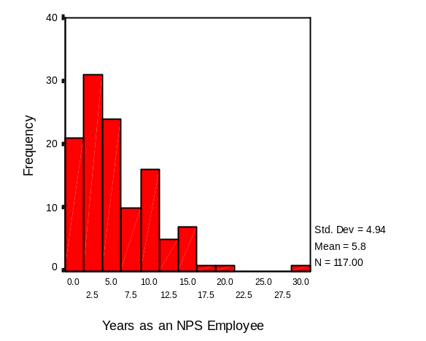

Perceived Importance of Natural Resources Stewardship Competencies. As can be seen in Table 3, Entry/Developmental Level Discipline Specialists rated nine different competencies as having the greatest importance to them in their current positions. Each of these competencies received a mean importance rating of 6.0 or higher on the 7-point scale. They were:

(Q1) Working knowledge of natural resource discipline and currency in the field

(Q2) Basic knowledge of ecological principles

(Q3) Ability to review and understand results of research done elsewhere for possible relevancy to park natural resource issues

(Q4) Knowledge of basic scientific principles

(Q7) Ability to follow basic scientific methods in conducting inventory, monitoring and applied research projects

(Q10) Basic knowledge and proficiency in field skills and measurements

(Q12) Ability to reliably collect, computer input and summarize natural resource data

(Q35) Ability to use computers to communicate electronically

(Q36) Ability to organize, store and analyze data with computers

Of the 42 competencies posed to respondents, 35 were rated as 5.0 or higher. In fact, no competencies were rated as being relatively unimportant (i.e., less than 4.0).

Perceived Level of Preparation to Perform Natural Resources Stewardship Competencies. Entry/ Developmental Level Discipline Specialists reported feeling highly prepared in two (2) of the 42 competencies (rating 6.0 or higher on the 7-point scale):

(Q4) Knowledge of basic scientific principles

(Q35) Ability to use computers to communicate electronically

Additionally, twenty-three (23) competencies were rated as 5.0 or higher. Employees also noted only one competency where they perceived themselves to be relatively less prepared (i.e., less than 4.0):

(Q39) Basic knowledge of types of agreements and ability to draft simple agreements of contract outlines

Gaps in Natural Resources Stewardship Competencies. When analyzed together, the relative ratings of importance and preparation to perform provide a diagnostic assessment of training “gaps” in this occupational group. There were two competencies that produced a gap in excess of 1.0:

(Q22) Awareness of risk assessment methodologies and basic ability to evaluate, in scientific terms, potential resource impacts from identified management needs/proposed management actions

(Q23) Basic awareness of environmental laws, compliance requirements, regulations, executive orders, and policies related to respective resource discipline

Additionally, ten exceeded 0.70 (with one, Q38, receiving a gap score of .93). These items were, in order of magnitude:

(Q38) Ability to draft proposals, funding requests, and request for proposals

(Q1) Working knowledge of natural resource discipline and currency in the field

(Q30) Ability to write natural resource action plans, sections of agency documents and technical reports, in accordance with existing guidelines and subject to review by others

(Q17) Ability to incorporate scientific information into management actions, policy development, and interaction with other resource managers

(Q6) Ability to propose relevant scientific approaches to natural resource management activities and problem solving

(Q15) Basic knowledge of general environmental laws

(Q39) Basic knowledge of types of agreements and ability to draft simple agreements of contract outlines

(Q40) Ability to draft and monitor project budgets, including the status of staff and fiscal resources

(Q24) Ability to assist in the development of various management strategies and formal plans to address resource issues

(Q29) Demonstrated ability to maintain currency of technical/scientific knowledge

In contrast, analyses related to three (3) competencies produced positive gaps between the importance of a competency and how well prepared respondents perceived themselves to be. That is, respondents rated their preparation to perform relative to these items as being higher than its perceived importance.

(Q33) Ability to give off-site, public presentations on non-controversial issues

(Q26) Ability to publish articles in peer-reviewed publications and/or make presentations at scientific meetings

(Q34) Ability to write and orally present management summaries of research information

The gaps between the group mean importance of each competency and the group mean preparation to perform each competency are graphically depicted in Figure 8.

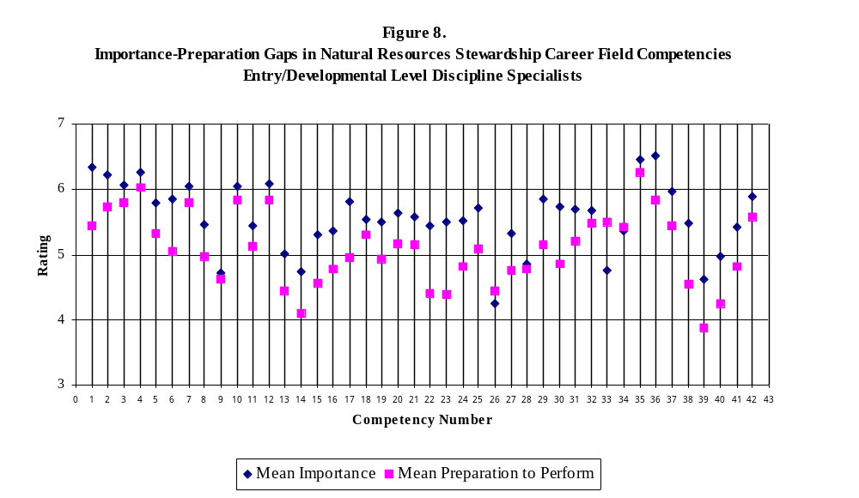
National Park Service
Stephen T. Mather Training Center
Natural Resources Stewardship Training Needs Assessment

Table 3. Importance-Preparation Gap Analysis: Entry/Developmental Level Discipline Specialists
(118 Respondents)

Competencies |  |  | Mean  Importance | Standard Deviation  (Importance) | Mean Preparation | Standard Deviation  (Preparation) | I-P  Gap

Scientific Knowledge
1. |  | Working knowledge of natural resource discipline and currency in the field. | 6.33 | 1.02 | 5.44 | 1.07 | 0.89
2. |  | Basic knowledge of ecological principles. | 6.21 | 0.94 | 5.73 | 1.06 | 0.48
3. |  | Ability to review and understand results of research done elsewhere for possible relevancy to park natural resource issues. | 6.07 | 1.08 | 5.79 | 1.04 | 0.28
4. |  | Knowledge of basic scientific principles. | 6.25 | 0.95 | 6.03 | 1.08 | 0.22
5. |  | Ability to apply standard or existing sampling and research design and quality assurance/control techniques. | 5.79 | 1.41 | 5.32 | 1.31 | 0.47

Scientific Method
6. |  | Ability to propose relevant scientific approaches to natural resource management activities and problem-solving. | 5.85 | 1.26 | 5.05 | 1.19 | 0.80
7. |  | Ability to follow basic scientific methods in conducting inventory, monitoring, and applied research projects. | 6.05 | 1.28 | 5.79 | 1.12 | 0.26
8. |  | Ability to design studies, gather data, and present results of studies in the field of expertise. | 5.45 | 1.46 | 4.97 | 1.44 | 0.48
9. |  | With assistance, ability to design sampling protocols outside field of expertise. | 4.71 | 1.70 | 4.62 | 1.56 | 0.09
10 |  | Basic knowledge and proficiency in field skills and measurements. | 6.04 | 1.19 | 5.83 | 1.10 | 0.21
11. |  | Ability to assist in analyzing data from on-going studies or studies designed by someone else. | 5.43 | 1.21 | 5.12 | 1.32 | 0.31
12. |  | Ability to reliably collect, computer input, and summarize natural resource data. | 6.09 | 1.12 | 5.83 | 1.29 | 0.26
NPS Resource Stewardship
13. |  | Basic knowledge of NPS history, mission, goals, guidelines, and policies. | 5.01 | 1.40 | 4.44 | 1.79 | 0.57
14. |  | Basic knowledge of the resource missions of the Department of Interior, other DOI bureaus, and other Federal and State resource agencies. | 4.74 | 1.45 | 4.10 | 1.73 | 0.64
15. |  | Basic knowledge of general environmental laws. | 5.31 | 1.21 | 4.56 | 1.43 | 0.75
16. |  | Basic knowledge of resource restoration and mitigation in area of expertise. | 5.37 | 1.31 | 4.78 | 1.41 | 0.59
17. |  | Ability to incorporate scientific information in management actions, policy development, and interaction with other resource managers. | 5.81 | 1.28 | 4.96 | 1.35 | 0.85
18. |  | Ability to apply standard approaches to problem-solving in areas where established policy or guidance exists. | 5.53 | 1.15 | 5.30 | 1.31 | 0.23
19. |  | Ability to integrate scientific knowledge and knowledge of environmental law to identify threats to natural resources and be proactive to protect natural systems using standardized approaches. | 5.50 | 1.37 | 4.93 | 1.38 | 0.57

Planning and Compliance
20. |  | Basic knowledge of how to use scientific information to recognize, appraise, and describe natural resource issues and management conflicts. | 5.64 | 1.26 | 5.16 | 1.18 | 0.48
21. |  | Basic ability to help formulate possible alternative management strategies. | 5.57 | 1.46 | 5.14 | 1.28 | 0.43
22. |  | Awareness of risk assessment methodologies and basic ability to evaluate, in scientific terms, potential resource impacts from identified management needs/proposed management actions. | 5.44 | 1.45 | 4.40 | 1.38 | 1.04
23. |  | Basic awareness of environmental laws, compliance requirements, regulations, executive orders, and policies related to respective resource discipline. | 5.50 | 1.33 | 4.39 | 1.54 | 1.11
24. |  | Ability to assist in the development of various management strategies and formal plans to address resource issues. | 5.52 | 1.34 | 4.81 | 1.47 | 0.71

Professional Credibility
25. |  | Ability to develop an active network of professional interaction with peers in the scientific community. | 5.72 | 1.27 | 5.09 | 1.54 | 0.63
26. |  | Ability to publish articles in peer-reviewed publications and/or make presentations at scientific meetings. | 4.25 | 1.73 | 4.44 | 1.68 | -0.19
27. |  | Ability to maintain a level of scientific knowledge and skill in application that is recognized by peers in government agencies and the academic community as credible and providing a basic foundation for work performed. | 5.33 | 1.55 | 4.76 | 1.57 | 0.57
28. |  | Ability to carry out peer review of scientific reports, and to participate in developmental assignments as a member of teams reviewing natural resource programs. | 4.86 | 1.58 | 4.77 | 1.62 | 0.09
29. |  | Demonstrated ability to maintain currency of technical/scientific knowledge. | 5.85 | 1.19 | 5.15 | 1.33 | 0.70

Communication
30. |  | Ability to write natural resource action plans, sections of agency documents and technical reports, in accordance with existing guidelines and subject to review by others. | 5.73 | 1.41 | 4.86 | 1.63 | 0.87
31. |  | Ability to organize and orally present technical and scientific information. | 5.69 | 1.28 | 5.21 | 1.48 | 0.48
32. |  | Ability to present briefings to agency personnel and the visiting public. | 5.68 | 1.30 | 5.47 | 1.32 | 0.21
33. |  | Ability to give off-site, public presentations on non-controversial issues. | 4.75 | 1.58 | 5.50 | 1.47 | -0.75
34. |  | Ability to write and orally present management summaries of research information. | 5.36 | 1.34 | 5.41 | 1.37 | -0.05
35. |  | Ability to use computers to communicate electronically. | 6.46 | 0.87 | 6.26 | 0.96 | 0.20
36. |  | Ability to organize, store, and analyze data with computers. | 6.51 | 0.73 | 5.82 | 1.25 | 0.69

Program/Project Management
37. |  | Ability to conceive and define project objectives in area of expertise and to develop basic work plans. | 5.96 | 1.28 | 5.43 | 1.28 | 0.53
38. |  | Ability to draft proposals, funding requests, and request for proposals. | 5.48 | 1.45 | 4.55 | 1.78 | 0.93
39. |  | Basic knowledge of types of agreements and ability to draft simple agreements of contract outlines. | 4.62 | 1.64 | 3.87 | 1.82 | 0.75
40. |  | Ability to draft and monitor project budgets, including the status of staff and fiscal resources. | 4.97 | 1.66 | 4.24 | 1.82 | 0.73
41. |  | Ability to coordinate and facilitate groups or teams to accomplish resource management and research projects objectives. | 5.42 | 1.57 | 4.81 | 1.71 | 0.61
42. |  | Ability to monitor basic project implementation. | 5.88 | 1.19 | 5.58 | 1.44 | 0.30

RESULTS AND DISCUSSION

Journey Level Discipline Specialists

Profile of Respondents. Over two-thirds (69.1%) of the 210 respondents were male, with only 30.9% female. Eight Journey Level Discipline Specialists (3.8%) indicated that they had a disability. The average age of respondents, ranging from 27 to 69, was 42.3 years (Figure 9).

Figure 9. Distribution of Journey Level Discipline Specialists by Age

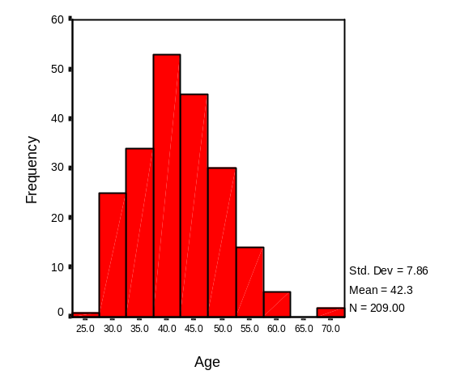

Although the majority of employees responding were White (92.1%), a small number of respondents did indicate other races or ethnicities. Specifically, respondents identified as Asian (3.0%), American Indian or Alaskan Native (0.5%), and Black or African American (0.5%). Those respondents noting an “Other” racial identification (3.0%) self-identified as Anglo, Mixed Racial Background or Heritage. With regard to ethnicity, 2.0% of respondents were Hispanic or Latino.

Respondents had completed an average of 17.3 years of formal education, with 95.7 percent holding at least one advanced degree. The academic degrees (e.g., B.S., B.A., M.S., Ph.D.) held by Journey Level Discipline Specialists span a great number of fields (see Appendix B-3. Journey Level Discipline Specialists).

Ranging in rank from GS-11 to GS-13, nearly all respondents held the rank of GS-11 (98.1%) (Figure 10). The average number of years as an employee in the NPS was 11.2 (ranging from less than one to 36 years) with 5.4 years averaged in current position (Figure 11).

Figure 10. Distribution of Journey Level Discipline Specialists by Current Rank

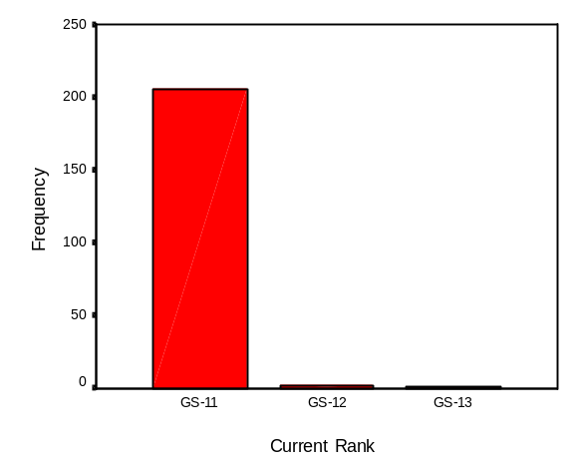

Figure 11. Distribution of Journey Level Discipline Specialists by Years as an NPS Employee

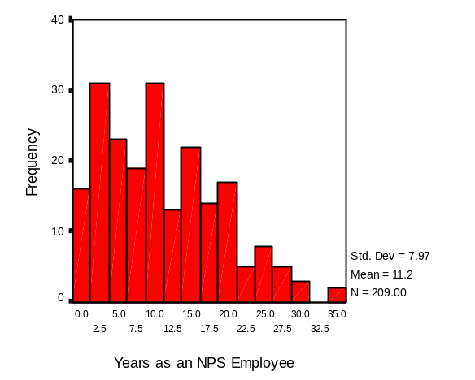

Perceived Importance of Natural Resources Stewardship Competencies. As can be seen in Table 4, Journey Level Discipline Specialists rated eight different competencies as having the greatest importance to them in their current positions. Each of these competencies received a mean importance rating of 6.0 or higher on the 7-point scale. They were:

(Q1) Ability to serve as a technical expert based on advanced, current knowledge of a natural resource discipline

(Q2) Working knowledge of ecological principles

(Q4) Ability to synthesize information from a wide variety of sources, within area of expertise

(Q30) Ability to work as a member of a multidisciplinary team and to provide input related to area of expertise in the development of management plans and compliance documents

(Q42) Proficiency in using electronic communications

(Q45) Ability to set short- and long-term goals, and to develop work plans

(Q46) Ability to prepare proposals, funding requests for proposals

(Q52) Knowledge and skill in interpersonal relationships

Of the 52 competencies posed to respondents, 47 were rated as 5.0 or higher. In fact, only one competency was rated as being unimportant (i.e., less than 4.0):

(Q32) Demonstrated ability to routinely publish articles in peer-reviewed publications and to present scientific information at scientific meetings

Perceived Level of Preparation to Perform Natural Resources Stewardship Competencies. Journey Level Discipline Specialists did not report feeling highly prepared regarding any of the 52 competencies (rating 6.0 or higher on the 7-point scale). Although, thirty-four (34) competencies were rated as 5.0 or higher. Employees also noted only one competency where they perceived themselves to be relatively less prepared (i.e., equal to or less than 4.0):

(Q14) Basic knowledge of the missions, mandates, and programs of other Federal agencies such as OMB and GAO, as well as other laws which impact resource management such as the Federal Advisory Committee Act and Freedom of Information Act

Gaps in Natural Resources Stewardship Competencies. When analyzed together, the relative ratings of importance and preparation to perform provide a diagnostic assessment of training “gaps” in this occupational group. There was one competency that produced a gap in excess of 1.0:

(Q10) Working knowledge of data management, analytical methods and statistics

Additionally, seven competencies exceeded 0.70 (with one, Q47, receiving a gap score of .96). These items were, in order of magnitude:

(Q47) Working knowledge of cooperative agreements, MOUs, contracting, and other agreement instruments

(Q12) Ability and experience in collecting, storing (in electronic format), summarizing, and analyzing resource management data

(Q1) Ability to serve as a technical expert based on advanced, current knowledge of a natural resource discipline

(Q35) Demonstrated ability to maintain currency of technical/scientific knowledge

(Q18) Ability to incorporate scientific information into management actions, policies, etc., including application in the area of expertise where little or no clear precedent exists

(Q20) Ability to use scientific knowledge to anticipate threats to natural resources and take proactive action to protect natural systems employing standardized approaches and approaches tailored to the situation

(Q11) Knowledge of standard computer systems, uses, and applications, including database and statistical software packages

In contrast, analyses related to three (3) competencies produced positive gaps between the importance of a competency and how well prepared respondents perceived themselves to be. That is, respondents rated their preparation to perform relative to these items as being higher than its perceived importance.

(Q32) Demonstrated ability to routinely publish articles in peer-reviewed publications and to present scientific information at scientific meetings

(Q37) Ability to give complex scientific and technical presentations at professional conferences and meetings

(Q34) Recognized ability to carry out peer review of scientific reports, publications, projects, and natural resource programs

The gaps between the group mean importance of each competency and the group mean preparation to perform each competency are graphically depicted in Figure 12.

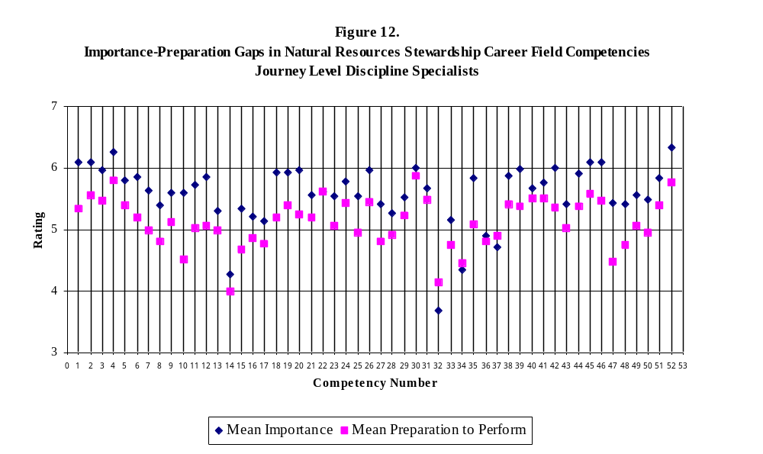
National Park Service
Stephen T. Mather Training Center
Natural Resources Stewardship Training Needs Assessment

Table 4. Importance-Preparation Gap Analysis: Journey Level Discipline Specialists
(210 Respondents)

Competencies |  |  | Mean  Importance | Standard Deviation  (Importance) | Mean Preparation | Standard Deviation  (Preparation) | I-P  Gap

Scientific Knowledge
1. |  | Ability to serve as a technical expert based on advanced, current knowledge of a natural resource discipline. | 6.10 | 1.13 | 5.35 | 1.27 | 0.75
2. |  | Working knowledge of ecological principles. | 6.10 | 1.05 | 5.56 | 1.15 | 0.54
3. |  | Ability to evaluate the results of research, including published and unpublished results of research done elsewhere, for applicability to diverse park resource issues. | 5.96 | 1.09 | 5.47 | 1.25 | 0.49
4. |  | Ability to synthesize information from a wide variety of sources, within area of expertise. | 6.27 | 0.86 | 5.80 | 1.09 | 0.47

Scientific Method
5. |  | Ability to apply appropriate scientific approaches to natural resource management activities and problem-solving. | 5.81 | 1.23 | 5.39 | 1.32 | 0.42
6. |  | Ability to develop, to coordinate, and to conduct research, inventory, monitoring, and resource management projects based on scientific knowledge and using accepted protocols and current methods. | 5.86 | 1.38 | 5.19 | 1.54 | 0.67
7. |  | Knowledge of and working experience in the application of established scientific methods and the ability to modify and adapt methodologies. | 5.63 | 1.36 | 4.99 | 1.52 | 0.64
8. |  | Ability to evaluate adaptations of basic research designs and sampling methods and to implement quality assurance/control protocols. | 5.40 | 1.45 | 4.81 | 1.68 | 0.59
9. |  | Working knowledge of and proficiency in field skills and measurements, including quality assurance/control protocols. | 5.59 | 1.42 | 5.12 | 1.49 | 0.57
10. |  | Working knowledge of data management, analytical methods, and statistics. | 5.60 | 1.34 | 4.51 | 1.63 | 1.09
11. |  | Knowledge of standard computer systems, uses, and applications, including database and statistical software packages. | 5.73 | 1.19 | 5.02 | 3.17 | 0.71
12. |  | Ability and experience in collecting, storing (in electronic format), summarizing, and analyzing resource management data. | 5.85 | 1.21 | 5.06 | 1.55 | 0.79
NPS Resource Stewardship
13. |  | Working knowledge of NPS history, mission, goals, guidelines, and policies. | 5.31 | 1.48 | 5.00 | 1.71 | 0.31
14. |  | Basic knowledge of the missions, mandates, and programs of other Federal agencies such as OMB and GAO, as well as other laws which impact resource management such as the Federal Advisory Committee Act and Freedom of Information Act. | 4.27 | 1.35 | 4.00 | 1.73 | 0.27
15. |  | Thorough knowledge of general environmental laws and ability to apply them to the normal range of natural resource issues, including preparation of environmental planning documents. | 5.35 | 1.37 | 4.68 | 1.57 | 0.67
16. |  | Thorough knowledge of law and policies, etc., related to subject matter expertise. | 5.22 | 1.43 | 4.87 | 1.56 | 0.35
17. |  | Thorough knowledge of restoration and mitigation in area of expertise. | 5.13 | 1.45 | 4.77 | 1.46 | 0.36
18. |  | Ability to incorporate scientific information into management actions, policies, etc., including application in the area of expertise where little or no clear precedent exists. | 5.93 | 1.05 | 5.19 | 1.46 | 0.74
19. |  | Ability to develop innovative approaches to problem-solving in areas where limited established policy or guidance exists. | 5.94 | 1.03 | 5.39 | 1.23 | 0.55
20. |  | Ability to use scientific knowledge to anticipate threats to natural resources and take proactive action to protect natural systems employing standardized approaches and approaches tailored to the situation. | 5.96 | 1.09 | 5.25 | 1.25 | 0.71
21. |  | Ability to assess the effects of proposed natural resource management projects on other park programs and to incorporate all division disciplines into resource management planning documents and programs. | 5.57 | 1.29 | 5.20 | 1.31 | 0.37
22. |  | Ability to advise crews working on resources management projects and to work with adjacent land managers or owners when appropriate. | 5.62 | 1.31 | 5.61 | 1.27 | 0.01

Planning and Compliance
23. |  | Demonstrated knowledge and ability to use scientific knowledge to define and assess complex NPS resource preservation/use issues in scientific terms. | 5.54 | 1.23 | 5.06 | 1.39 | 0.48
24. |  | Ability to formulate and evaluate alternative management strategies related to area of expertise. | 5.79 | 1.10 | 5.43 | 1.29 | 0.36
25. |  | Working knowledge of risk management and demonstrated ability to recognize and evaluate conflicts between resource preservation and management needs in scientific terms. | 5.54 | 1.18 | 4.96 | 1.42 | 0.58
26. |  | Demonstrated ability to define information needs, including research, inventories, baseline studies, and follow-up monitoring. | 5.97 | 1.06 | 5.46 | 1.26 | 0.51
27. |  | Comprehension of broad range of environmental laws, regulations, policies and other requirements related to natural resource planning and compliance. | 5.41 | 1.41 | 4.81 | 1.53 | 0.60
28. |  | Good working knowledge of laws and compliance regulations, executive orders, policies and guidelines related to discipline of technical expertise. | 5.26 | 1.51 | 4.91 | 1.61 | 0.35
29. |  | Working ability to develop management plans to address natural resource issues. | 5.53 | 1.36 | 5.23 | 1.39 | 0.30
30. |  | Ability to work as a member of a multi-disciplinary team and to provide input related to area of expertise in the development of management plans and compliance documents. | 6.00 | 1.17 | 5.88 | 1.12 | 0.12

Professional Credibility
31. |  | Demonstrated ability and skill in developing and maintaining a network of peers in the scientific community for routine professional interaction. | 5.67 | 1.27 | 5.48 | 1.40 | 0.19
32. |  | Demonstrated ability to routinely publish articles in peer-reviewed publications and to present scientific information at scientific meetings. | 3.68 | 1.92 | 4.14 | 1.73 | -0.46
33. |  | Demonstrated ability to maintain levels of scientific knowledge and skills in application that are recognized by peers in government agencies and the academic community as credible and providing a strong foundation for work performed. | 5.15 | 1.73 | 4.76 | 1.54 | 0.39
34. |  | Recognized ability to carry out peer review of scientific reports, publications, projects, and natural resource programs. | 4.34 | 1.85 | 4.45 | 1.69 | -0.11
35. |  | Demonstrated ability to maintain currency of technical/scientific knowledge. | 5.83 | 1.12 | 5.08 | 1.54 | 0.75

Communication
36. |  | Ability to write complex scientific and technical reports suitable for publication in peer-reviewed journals, as well as internal resource management documents. | 4.90 | 1.72 | 4.81 | 1.77 | 0.09
37. |  | Ability to give complex scientific and technical presentations at professional conferences and meetings. | 4.71 | 1.75 | 4.90 | 1.83 | -0.19
38. |  | Ability to organize and synthesize complex information from a variety of sources. | 5.88 | 1.08 | 5.42 | 1.34 | 0.46
39. |  | Ability to effectively communicate complex scientific information to NPS managers and other non-specialists, using a variety of media. | 5.98 | 1.11 | 5.38 | 1.40 | 0.60
40. |  | Ability to interpret complex issues for lay audiences, using a variety of media. | 5.67 | 1.22 | 5.50 | 1.41 | 0.17
41. |  | Proficiency in using electronic communications. | 5.76 | 1.10 | 5.51 | 1.37 | 0.25
42. |  | Proficiency in using computers to organize, store, and analyze data. | 6.00 | 1.05 | 5.36 | 1.39 | 0.64
43. |  | Ability to use computer graphics programs to facilitate the written and oral presentation of scientific material. | 5.41 | 1.31 | 5.02 | 1.65 | 0.39

Program/Project Management
44. |  | Ability to identify needs and set priorities within area of expertise, including facilitation of group efforts to define and prioritize broader resource management and research needs. | 5.92 | 1.03 | 5.38 | 1.26 | 0.54
45. |  | Ability to set short- and long-term goals, and to develop work plans. | 6.10 | 0.90 | 5.58 | 1.27 | 0.52
46. |  | Ability to prepare proposals, funding requests, and requests for proposals. | 6.10 | 1.23 | 5.47 | 1.46 | 0.63
47. |  | Working knowledge of cooperative agreements, MOUs, contracting, and other agreement instruments. | 5.44 | 1.26 | 4.48 | 1.73 | 0.96
48. |  | Ability to seek and obtain partners and funding from a variety of sources. | 5.42 | 1.47 | 4.76 | 1.66 | 0.66
49. |  | Ability to develop and manage project budgets, including fiscal as well as staff resources. | 5.57 | 1.41 | 5.07 | 1.64 | 0.50
50. |  | Knowledge of project administration. | 5.49 | 1.20 | 4.96 | 1.56 | 0.53
51. |  | Ability to monitor project implementation. | 5.83 | 1.04 | 5.40 | 1.40 | 0.43
52. |  | Knowledge and skill in interpersonal relationships. | 6.34 | 0.85 | 5.77 | 1.17 | 0.57

RESULTS AND DISCUSSION

Advanced Level Discipline Specialists

Profile of Respondents. Over two-thirds (69.7%) of the 123 respondents were male, with only 30.3% female. Five Advanced Level Discipline Specialists (4.2%) indicated that they had a disability. The average age of respondents, ranging from 30 to 64, was 46 years (Figure 13).

Figure 13. Distribution of Advanced Level Discipline Specialists by Age

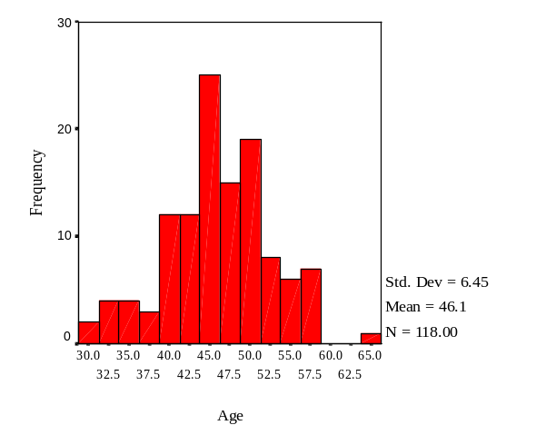

Although the majority of employees responding were White (91.5%), a small number of respondents did indicate other races or ethnicities. Specifically, respondents identified as Black or African American (2.5%), Asian (1.7%), Native American [Native Hawaiian] or Other Pacific Islander (1.7%), American Indian or Alaskan Native (0.8%), and “Other” (0.8%) [Unspecified racial identification].

Respondents had completed an average of 17.7 years of formal education, with 94.3 percent holding at least one advanced degree. The academic degrees (e.g., B.S., B.A., M.S., Ph.D.) held by Advanced Level Discipline Specialists span a great number of fields (see Appendix B-4. Advanced Level Discipline Specialists).

Ranging in rank from GS-12 to GS-15, the largest proportion of respondents held the rank of GS-12 (68.9%) (Figure 14). The average number of years as an employee in the NPS was 11.8 (ranging from less than one to 38 years) with 5.5 years averaged in current position (Figure 15).

Figure 14. Distribution of Advanced Level Discipline Specialists by Current Rank

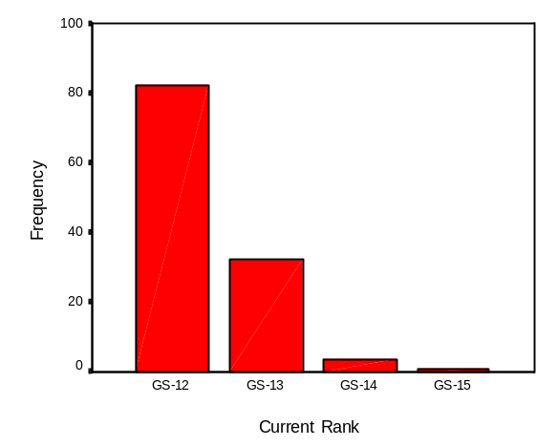

Figure 15. Distribution of Advanced Level Discipline Specialists by Years as an NPS Employee

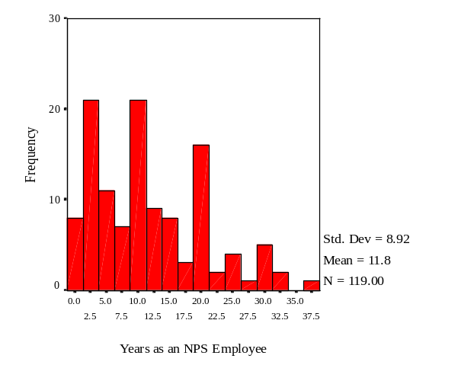

Perceived Importance of Natural Resources Stewardship Competencies. As can be seen in Table 5, Advanced Level Discipline Specialists rated three different competencies as having the greatest importance to them in their current positions. Each of these competencies received a mean importance rating of 6.0 or higher on the 7-point scale. They were:

(Q41) Ability to evaluate and synthesize information from conflicting sources

(Q42) Ability to use sound judgment in drawing conclusions

(Q50) Demonstrated skill in interpersonal relationships

Of the 50 competencies posed to respondents, 40 were rated as 5.0 or higher. In fact, only one competency was rated as being unimportant (i.e., less than 4.0):

(Q32) Demonstrated ability to publish articles in peer-reviewed publications and to serve as an editor for publications and reports

Perceived Level of Preparation to Perform Natural Resources Stewardship Competencies. Advanced Level Discipline Specialists reported feeling highly prepared regarding only one of the 50 competencies, rating this item as 6.0 or higher on the 7-point scale:

(Q1) Mastery level knowledge of a natural resource discipline such as that evidenced by an earned Ph.D., an MS/MA degree and 6 years of professional work, or the experience gained from 11 years of professional work in the field of expertise

Additionally, twenty-three (23) competencies were rated as 5.0 or higher. Employees noted no competencies where they perceived themselves to be relatively less prepared (i.e., less than 4.0).

Gaps in Natural Resources Stewardship Competencies. When analyzed together, the relative ratings of importance and preparation to perform provide a diagnostic assessment of training “gaps” in this occupational group. There were no competencies that produced a gap in excess of 1.0, although nine exceeded .70 (with one, Q9, receiving a gap score of .94). These items were, in order of magnitude:

(Q9) In-depth knowledge of data management, analytical methods and statistics

(Q40) Ability to effectively negotiate, persuade, and resolve conflict

(Q47) Demonstrated ability to successfully seek and arrange partnerships

(Q48) Ability to develop and manage complex project budgets, including fiscal as well as staff resources

(Q10) Knowledge of computer systems, uses, and applications, including database and statistical software packages

(Q27) Sound working knowledge of the broad range of environmental laws, regulations, executive orders, policies and guidelines related to natural resources planning and compliance

(Q42) Ability to use sound judgment in drawing conclusions

(Q50) Demonstrated skill in interpersonal relationships

(Q17) Ability to synthesize and incorporate diverse scientific information into management actions, policies, etc., including application in the areas of expertise where little or no clear precedent or guidance exists

However, a slight word of caution must be offered here. The item producing the largest “I-P Gap” had a relatively low rating of importance (4.13) when compared to other items.

In contrast, analyses related to four (4) competencies produced positive gaps between the importance of a competency and how well prepared respondents perceived themselves to be. That is, respondents rated their preparation to perform relative to these items as being higher than its perceived importance.

(Q32) Demonstrated ability to publish articles in peer-reviewed publications and to serve as an editor for publications and reports

(Q33) Demonstrated ability to present scientific information at scientific meetings and to organize and chair workshops and seminars at meetings

(Q1) Mastery level knowledge of a natural resource discipline such as that evidenced by an earned Ph.D., an MS/MA degree and 6 years of professional work, or the experience gained from 11 years of professional work in the field of expertise

(Q35) Recognized ability to carry out peer review of scientific reports, publications, projects, and natural resource programs

The gaps between the group mean importance of each competency and the group mean preparation to perform each competency are graphically depicted in Figure 16.
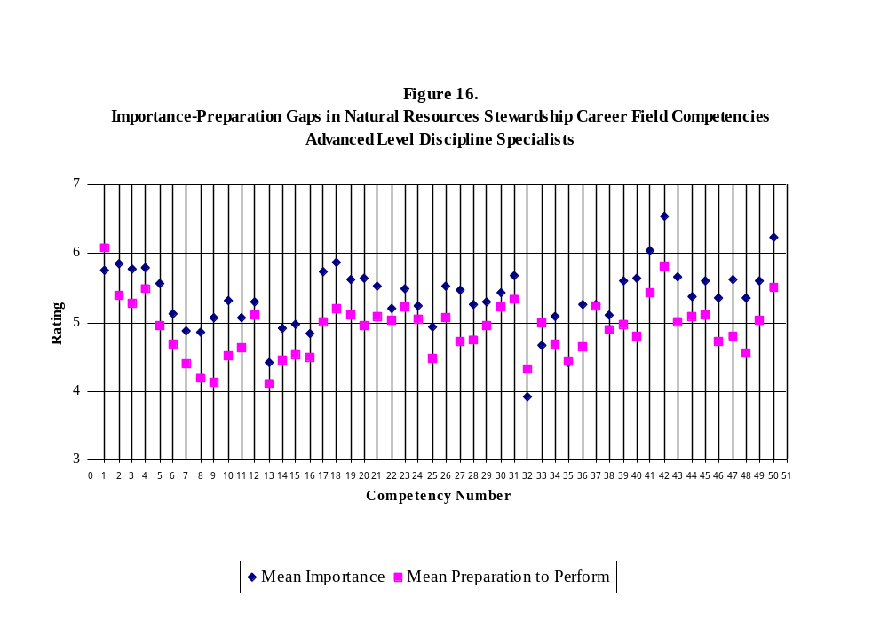
National Park Service
Stephen T. Mather Training Center
Natural Resources Stewardship Training Needs Assessment

Table 5. Importance-Preparation Gap Analysis: Advanced Level Discipline Specialists
(123 Respondents)

Competencies |  |  | Mean  Importance | Standard Deviation  (Importance) | Mean Preparation | Standard Deviation  (Preparation) | I-P  Gap

Scientific Knowledge
1. |  | Mastery level knowledge of a natural resource discipline such as that evidenced by an earned Ph.D., and MS/MA degree and 6 years of professional work, or the experience gained from 11 years of professional work in the field of expertise. | 5.76 | 1.38 | 6.09 | 1.24 | -0.33
2. |  | In-depth knowledge of ecological principles and how they apply to park resources issues and management. | 5.86 | 1.29 | 5.39 | 1.27 | 0.47
3. |  | Ability to evaluate the results of research, published and unpublished, conducted in different ecosystems and to use and adapt those results to resolve diverse and complex park resource issues. | 5.78 | 1.24 | 5.28 | 1.40 | 0.50
4. |  | Working knowledge of and experience in the application of general scientific principles and the ability to develop innovative new methods and applications. | 5.80 | 1.21 | 5.48 | 1.38 | 0.32

Scientific Method
5. |  | Ability to apply state-of-the-knowledge scientific approaches to natural resource management activities. | 5.57 | 1.32 | 4.95 | 1.52 | 0.62
6. |  | Ability to develop, to coordinate, and to conduct complex research, inventory, monitoring, and resource management projects based on scientific knowledge and using innovative protocols and new methodologies. | 5.12 | 1.72 | 4.68 | 1.56 | 0.44
7. |  | Ability to develop and evaluate innovative research designs and sampling strategies and to apply quality assurance/control protocols. | 4.87 | 1.78 | 4.40 | 1.59 | 0.47
8. |  | Advanced knowledge and proficiency in field skills and measurements, including the ability and experience to design quality assurance/control protocols. | 4.86 | 1.71 | 4.18 | 2.07 | 0.68
9. |  | In-depth knowledge of data management, analytical methods, and statistics. | 5.07 | 1.52 | 4.13 | 1.87 | 0.94
10. |  | Knowledge of computer systems, uses, and applications, including database and statistical software packages. | 5.32 | 1.28 | 4.52 | 1.59 | 0.80
11. |  | Ability and experience in collecting, computer inputting, summarizing, and analyzing resource management data. | 5.06 | 1.62 | 4.63 | 1.99 | 0.43
NPS Resource Stewardship
12. |  | Thorough knowledge of NPS history, mission, goals, guidelines, and policies. | 5.30 | 1.53 | 5.10 | 1.58 | 0.20
13. |  | Thorough knowledge of other Federal agencies such as OMB and GAO and other laws which impact resource management. | 4.42 | 1.35 | 4.11 | 1.56 | 0.31
14. |  | Advanced knowledge of environmental law and demonstrated ability to apply environmental laws to a broad range of natural resource issues. | 4.91 | 1.49 | 4.46 | 1.66 | 0.45
15. |  | Advanced knowledge of law, regulations, and policies, etc., related to the integration of subject matter expertise into multidisciplinary approaches to natural resource issues. | 4.98 | 1.55 | 4.54 | 1.65 | 0.44
16. |  | Advanced knowledge of restoration and mitigation in area of expertise. | 4.83 | 1.51 | 4.50 | 1.69 | 0.33
17. |  | Ability to synthesize and incorporate diverse scientific information into management actions, policies, etc., including application in the area of expertise where little or no clear precedent or guidance exists. | 5.73 | 1.44 | 5.01 | 1.26 | 0.72
18. |  | Proficiency in developing innovative approaches to problem-solving in areas where little or no established policy or guidance exists. | 5.88 | 1.15 | 5.21 | 1.31 | 0.67
19. |  | Demonstrated ability to use scientific knowledge to anticipate threats to natural resources and take proactive action to protect natural systems up to the ecosystem level employing standardized approaches and approaches tailored to the situation. | 5.63 | 1.48 | 5.10 | 1.30 | 0.53
20. |  | Ability to use advanced scientific knowledge to anticipate threats to natural resources and take proactive action to protect natural systems up to the ecosystem level employing innovative approaches and approaches tailored to the situation. | 5.64 | 1.37 | 4.95 | 1.42 | 0.69
21. |  | Demonstrated ability to understand the likely effects of proposed natural resource management projects and programs on other park programs and to incorporate all divisions and disciplines into resource management planning documents and programs. | 5.52 | 1.47 | 5.09 | 1.49 | 0.43
22. |  | Ability to lead crews working on resources management projects and to work effectively with adjacent land managers or owners when appropriate, when appropriate and other resource scientists. | 5.21 | 1.68 | 5.03 | 1.83 | 0.18

Planning and Compliance
23. |  | Advanced knowledge and demonstrated ability to use scientific knowledge to define and assess highly complex NPS resource preservation/use issues in scientific terms. | 5.48 | 1.33 | 5.22 | 3.03 | 0.26
24. |  | Ability to formulate and continuously evaluate and refine alternative management strategies. | 5.23 | 1.49 | 5.04 | 1.38 | 0.19
25. |  | Advanced knowledge and demonstrated skills of risk management, including the ability to recognize, evaluate and characterize subtle (including cumulative) resource issues and conflicts with management needs and to define conflicts and risks in scientific terms. | 4.93 | 1.55 | 4.47 | 1.51 | 0.46
26. |  | Recognized ability to define in-depth, complex information needs, including research, inventories, baseline studies, and long term monitoring. | 5.52 | 1.37 | 5.06 | 1.39 | 0.46
27. |  | Sound working knowledge of the broad range of environmental laws, regulations, executive orders, policies and guidelines related to natural resources planning and compliance. | 5.47 | 1.44 | 4.73 | 1.86 | 0.74
28. |  | Advanced knowledge of laws, regulations, executive orders, policies and guidelines related to discipline of technical expertise. | 5.25 | 1.51 | 4.75 | 1.81 | 0.50
29. |  | Demonstrated ability to develop and implement management plans to address complex resource issues. | 5.29 | 1.69 | 4.95 | 1.87 | 0.34
30. |  | Ability to assemble and lead a team working on a complex resource issue and to provide expert input related to discipline of expertise in the development of management plans and related compliance documents. | 5.44 | 1.56 | 5.22 | 1.60 | 0.22

Professional Credibility
31. |  | Demonstrated ability and skill in developing and maintaining a wide and diverse network of peers in the scientific community for routine professional interaction. | 5.68 | 1.36 | 5.34 | 1.39 | 0.34
32. |  | Demonstrated ability to publish articles in peer-reviewed publications and to serve as an editor for publications and reports. | 3.92 | 1.96 | 4.32 | 1.91 | -0.40
33. |  | Demonstrated ability to present scientific information at scientific meetings and to organize and chair workshops and seminars at meetings. | 4.66 | 1.92 | 5.00 | 1.76 | -0.34
34. |  | Demonstrated ability to maintain levels of scientific knowledge and skills in application that are recognized by peers in government agencies and the academic community as credible and providing a strong foundation for work performed. | 5.09 | 1.80 | 4.69 | 1.78 | 0.40
35. |  | Recognized ability to carry out peer review of scientific reports, publications, projects, and natural resource programs. | 4.42 | 1.89 | 4.43 | 1.99 | -0.01
36. |  | Demonstrated ability to maintain currency of advanced technical/scientific knowledge. | 5.26 | 1.63 | 4.64 | 1.62 | 0.62

Communication
37. |  | Ability to write complex scientific and technical documents dealing with advanced and highly technical natural resource information and issues. | 5.26 | 1.77 | 5.23 | 1.69 | 0.03
38. |  | Ability to give complex technical and scientific information and prepare briefings from which decisions are made by high-level agency personnel and Congress. | 5.11 | 1.76 | 4.90 | 1.77 | 0.21
39. |  | Ability to effectively convey complex information concerning politicized or controversial issues to potentially hostile audiences. | 5.60 | 1.37 | 4.97 | 1.58 | 0.63
40. |  | Ability to effectively negotiate, persuade, and resolve conflict. | 5.65 | 1.29 | 4.80 | 1.56 | 0.85
41. |  | Ability to evaluate and synthesize information from conflicting sources. | 6.05 | 1.07 | 5.43 | 1.43 | 0.62
42. |  | Ability to use sound judgment in drawing conclusions. | 6.55 | 0.83 | 5.81 | 1.17 | 0.74

Program/Project Management
43. |  | Ability to lead and coordinate groups to define resource management and research needs to address issues that are complex or with little precedent. | 5.66 | 1.39 | 5.01 | 1.60 | 0.65
44. |  | Ability to develop innovative work plans for complex projects that involve multiple components and a need for careful coordination and sequencing. | 5.38 | 1.34 | 5.09 | 1.50 | 0.29
45. |  | Ability to prepare complex proposals, innovative funding requests, and requests for proposals. | 5.60 | 1.44 | 5.11 | 1.64 | 0.49
46. |  | Ability to prepare complex or innovative cooperative agreements, MOUs, and other agreement instruments. | 5.36 | 1.48 | 4.73 | 1.58 | 0.63
47. |  | Demonstrated ability to successfully seek and arrange partnerships. | 5.63 | 1.40 | 4.79 | 1.89 | 0.84
48. |  | Ability to develop and manage complex project budgets, including fiscal as well as staff resources. | 5.36 | 1.54 | 4.55 | 1.95 | 0.81
49. |  | Ability to oversee and monitor implementation of complex projects. | 5.60 | 1.36 | 5.02 | 1.74 | 0.58
50. |  | Demonstrated skill in interpersonal relationships. | 6.23 | 0.98 | 5.50 | 1.32 | 0.73

RESULTS AND DISCUSSION

Advanced Level Natural Resources Program Managers

Profile of Respondents. Over three-quarters (78.4%) of the 117 respondents were male, with only 21.6% female. Three Advanced Level Natural Resources Program Managers (2.6%) indicated that they had a disability. The average age of respondents, ranging from 36 to 62, was 48.7 years (Figure 17).

Figure 17. Distribution of Advanced Level Natural Resources Program Managers by Age

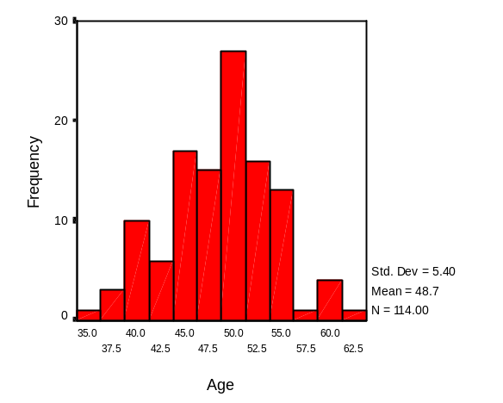

Although the majority of employees responding were White (93.0%), a small number of respondents did indicate other races or ethnicities. Specifically, respondents identified as Black or African American (1.8%), Native American [Native Hawaiian] or Other Pacific Islander (1.8%), American Indian or Alaskan Native (0.9%), and Asian (0.9%). Those respondents noting an “Other” racial identification (0.9%) self-identified as Mixed Race. With regard to ethnicity, 0.9% of respondents were Hispanic or Latino.

Respondents had completed an average of 17.5 years of formal education, with 95.7 percent holding at least one advanced degree. The academic degrees (e.g., B.S., B.A., M.S., Ph.D.) held by Advanced Level Natural Resources Program Managers span a great number of fields (see Appendix B-5. Advanced Level Natural Resources Program Managers).

Ranging in rank from GS-12 to GS-17, nearly half of all respondents held the rank of GS-12 (47.8%) (Figure 18). The average number of years as an employee in the NPS was 17.9 (ranging from less than one to 33 years) with 7 years averaged in current position (Figure 19).

Figure 18. Distribution of Advanced Level Natural Resources Program Managers by Current Rank

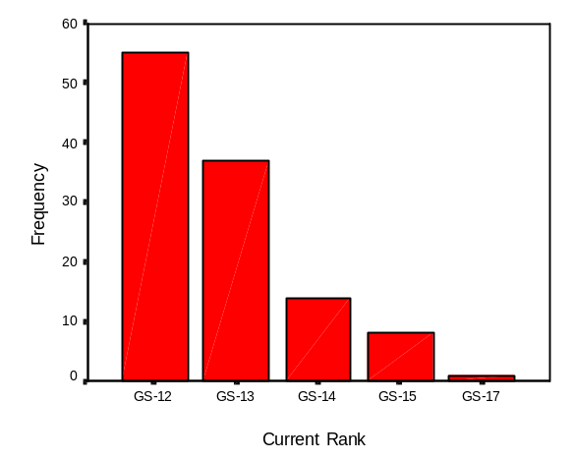

Figure 19. Distribution of Advanced Level Natural Resources Program Managers
by Years as an NPS Employee

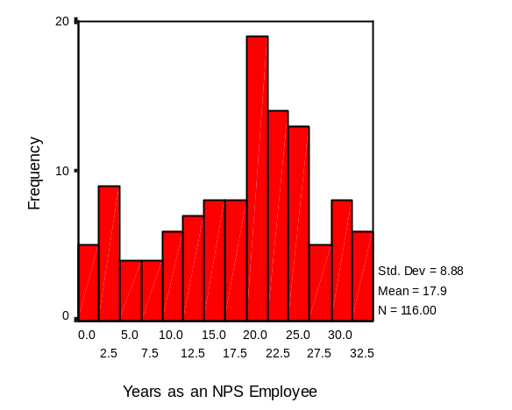

Perceived Importance of Natural Resources Stewardship Competencies. As can be seen in Table 6, Advanced Level Natural Resources Program Managers rated five different competencies as having the greatest importance to them in their current positions. Each of these competencies received a mean importance rating of 6.0 or higher on the 7-point scale. They were:

(Q3) Ability to integrate information across natural resources disciplines, to recognize patterns and draw conclusions, and to use, and adapt the results in innovative ways to resolve diverse and complex park resource issues

(Q8) Advanced broad knowledge of the mission, goals, guidelines, and policies of the NPS, as well as the knowledge of the mission and purpose of other agencies organized groups, and private industry

(Q9) Ability to develop innovative solutions, consistent with NPS policy and guidelines, to complex situations

(Q13) Ability to provide sound advice to upper-level managers on needed resource stewardship programs and actions at a landscape-level or Servicewide scale

(Q17) Highly developed leadership skills, including skill in effective team-building.

Additionally, of the 34 competencies posed to respondents, 30 were rated as 5.0 or higher. In fact, no competencies were rated as being relatively unimportant (i.e., less than 4.0).

Perceived Level of Preparation to Perform Natural Resources Stewardship Competencies. Advanced Level Natural Resources Program Managers reported feeling prepared in twenty-one (21) of the 34 competencies (rating 5.0 or higher on the 7-point scale). Interestingly, employees in this job classification reported no competencies in which they were highly prepared (rating 6.0 or higher).

Employees also noted two competencies where they perceived themselves to be relatively less prepared (i.e., less than 4.0):

(Q10) Knowledge of case law as it relates to specific natural resource issues

(Q18) Knowledge of precedent and case law related to planning and compliance

Gaps in Natural Resources Stewardship Competencies. When analyzed together, the relative ratings of importance and preparation to perform provide a diagnostic assessment of training “gaps” in this occupational group. There was one competency that produced a gap in excess of 1.0:

(Q17) Highly developed leadership skills, including skill in effective team-building

Additionally, eleven exceeded 0.70 (with four receiving gap scores exceeding .90). These items were, in order of magnitude:

(Q6) Ability to develop and coordinate complex multi-faceted programs of research, inventory, monitoring, and resource management based on scientific knowledge

(Q3) Ability to integrate information across natural resources disciplines, to recognize patterns and draw conclusions, and to use, and adapt the results in innovative ways to resolve diverse and complex park resource issues

(Q30) Ability to persuade, effectively negotiate, and solve problems with diverse individuals and organizations

(Q12) Ability to plan and direct large-scale resource stewardship programs requiring a multi-disciplinary approach and often considerable potential for controversy

(Q26) Ability to effectively convey information concerning politicized or controversial issues to potentially hostile audiences

(Q16) Ability to form effective partnerships with diverse and potentially hostile groups to address complex natural resource issues, including issues that transcend regional boundaries

(Q14) Ability to evaluate and synthesize results of relevant scientific studies, and develop solutions to complex situations where scientific information, laws, policies, or guidelines may be conflicting or lacking

(Q7) Ability to evaluate research reports and scientific publications, as well as diverse agency documents and legislation for their applicability to specific natural resource issues and their more general implications for natural resources stewardship

(Q33) Ability to effectively compete for funding through development of large-scale partnerships that may include diverse and opposing viewpoints

(Q5) Advanced ability to apply scientific approaches and problem-solving techniques to developing innovative solutions to complex natural resource problems, involving long-term and/or large-scale programs that cross jurisdictional boundaries and involving diverse interests

(Q13) Ability to provide sound advice to upper-level managers on needed resource stewardship programs and actions at a landscape-level or Servicewide scale

In contrast, one competency produced positive gaps between the importance of a competency and how well prepared respondents perceived themselves to be. That is, respondents rated their preparation to perform relative to these items as being higher than its perceived importance.

(Q23) Knowledge and ability that is recognized by agency and academic peers as leading in the natural resource field

The gaps between the group mean importance of each competency and the group mean preparation to perform each competency are graphically depicted in Figure 20.

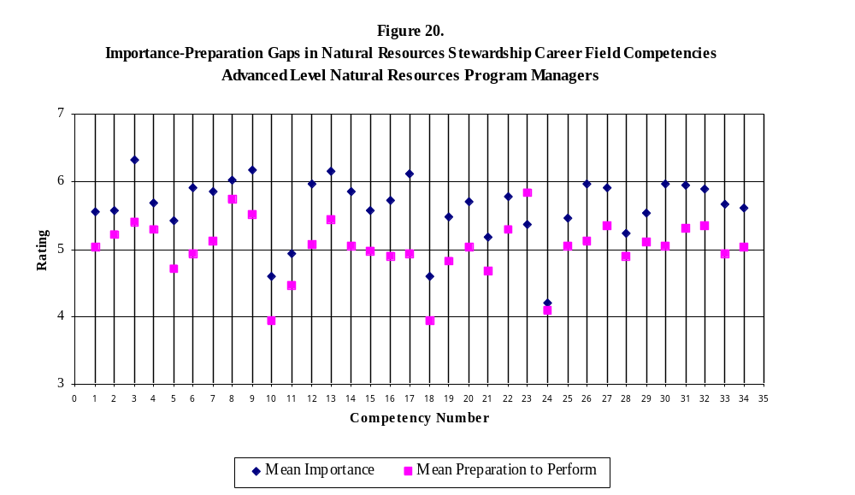
National Park Service
Stephen T. Mather Training Center
Natural Resources Stewardship Training Needs Assessment

Table 6. Importance-Preparation Gap Analysis:
Advanced Level Natural Resources Program Managers (117 Respondents)

Competencies |  |  | Mean  Importance | Standard Deviation  (Importance) | Mean Preparation | Standard Deviation  (Preparation) | I-P  Gap

Scientific Knowledge
1. |  | Mastery of a natural resource discipline, including current knowledge of state-of-the-art concepts. | 5.55 | 1.13 | 5.03 | 1.34 | 0.52
2. |  | In-depth knowledge of ecosystem principles. | 5.57 | 1.04 | 5.22 | 1.20 | 0.35
3. |  | Ability to integrate information across natural resources disciplines, to recognize patterns and draw conclusions, and to use, and adapt the results in innovative ways to resolve diverse and complex park resource issues. | 6.33 | 0.84 | 5.40 | 1.24 | 0.93
4. |  | Knowledge of environmental ethics and philosophy as applied to natural resource management. | 5.69 | 1.10 | 5.30 | 1.37 | 0.39

Scientific Method
5. |  | Advanced ability to apply scientific approaches and problem-solving techniques in developing innovative solutions to complex natural resource problems, involving long-term and/or large-scale programs that cross jurisdictional boundaries and involving diverse interests. | 5.43 | 1.12 | 4.71 | 1.33 | 0.72
6. |  | Ability to develop and coordinate complex multi-faceted programs of research, inventory, monitoring, and resource management based on scientific knowledge. | 5.91 | 1.19 | 4.94 | 1.45 | 0.97
7. |  | Ability to evaluate research reports and scientific publications, as well as diverse agency documents and legislation for their applicability to specific natural resource issues and their more general implications for natural resources stewardship. | 5.85 | 1.24 | 5.12 | 1.29 | 0.73
NPS Resource Stewardship
8. |  | Advanced broad knowledge of the mission, goals, guidelines, and policies of the NPS, as well as the knowledge of the mission and purpose of other agencies, organized groups, and private industry. | 6.03 | 0.90 | 5.75 | 1.16 | 0.28
9. |  | Ability to develop innovative solutions, consistent with NPS policy and guidelines, to complex situations. | 6.18 | 0.90 | 5.51 | 1.06 | 0.67
10. |  | Knowledge of case law as it relates to specific natural resource issues. | 4.59 | 1.34 | 3.94 | 1.54 | 0.65
11. |  | Through interpretation of existing law and precedent, as well as available scientific information, ability to develop new policies, regulations, guidelines, programs, and concepts with broad application. | 4.94 | 1.37 | 4.46 | 1.43 | 0.48
12. |  | Ability to plan and direct large-scale resource stewardship programs requiring a multi-disciplinary approach and often considerable potential for controversy. | 5.97 | 1.29 | 5.07 | 1.39 | 0.90
13. |  | Ability to provide sound advice to upper-level managers on needed resource stewardship programs and actions at a landscape-level or Servicewide scale. | 6.16 | 1.10 | 5.44 | 1.36 | 0.72
14. |  | Ability to evaluate and synthesize results of relevant scientific studies, and develop solutions to complex situations where scientific information, laws, policies, or guidelines may be conflicting or lacking. | 5.86 | 1.04 | 5.05 | 1.36 | 0.81
15. |  | Ability to take the lead in setting up effective interagency programs for critical resource protection on a landscape scale that crosses jurisdictional boundaries. | 5.58 | 1.39 | 4.97 | 1.39 | 0.61
16. |  | Ability to form effective partnerships with diverse and potentially hostile groups to address complex natural resource issues, including issues that transcend regional boundaries. | 5.72 | 1.16 | 4.89 | 1.35 | 0.83
17. |  | Highly developed leadership skills, including skill in effective team-building. | 6.12 | 1.00 | 4.94 | 1.37 | 1.18

Planning and Compliance
18. |  | Knowledge of precedent and case law related to planning and compliance. | 4.59 | 1.34 | 3.94 | 1.55 | 0.65
19. |  | Ability to orchestrate the development, completion, and implementation of complex strategies and plans, consisting of several distinct component parts and sequential actions, addressing complex and controversial issues. | 5.48 | 1.28 | 4.82 | 1.42 | 0.66
20. |  | Ability to develop innovative solutions to complex or intractable issues. | 5.70 | 1.13 | 5.02 | 1.26 | 0.68
21. |  | Ability to develop and carry out a public involvement program, working with public information personnel as appropriate, for plans that may include complex and controversial issues. | 5.18 | 1.38 | 4.68 | 1.27 | 0.50

Professional Credibility
22. |  | Recognized ability to effectively represent the NPS on a multi-agency task force to address natural resource issues. | 5.78 | 1.20 | 5.30 | 1.34 | 0.48
23. |  | Knowledge and ability that is recognized by agency and academic peers as leading in the natural resource field. | 5.37 | 1.22 | 5.83 | 1.44 | -0.46
24. |  | Ability to publish syntheses and thought-provoking concepts in journals, which are recognized as providing leadership in advancing natural resources stewardship. | 4.21 | 1.42 | 4.08 | 1.52 | 0.13
25. |  | Recognized ability to integrate representatives of agencies, academic institutions, and diverse interest groups into an effective program of cooperation in achieving shared objectives for natural resources stewardship. | 5.46 | 1.22 | 5.04 | 1.19 | 0.42

Communication
26. |  | Ability to effectively convey information concerning politicized or controversial issues to potentially hostile audiences. | 5.96 | 1.05 | 5.12 | 1.36 | 0.84
27. |  | Ability to evaluate and synthesize information from diverse and conflicting sources. | 5.91 | 0.97 | 5.34 | 1.33 | 0.57
28. |  | Ability to write highly complex documents dealing with natural resource issues and technical information, drawn from a variety of sources. | 5.23 | 1.37 | 4.90 | 1.59 | 0.33
29. |  | Ability to give oral and written briefings from which decisions are made by high-level agency personnel and Congress. | 5.53 | 1.45 | 5.10 | 1.49 | 0.43
30. |  | Ability to persuade, effectively negotiate, and solve problems with diverse individuals and organizations. | 5.97 | 1.02 | 5.05 | 1.31 | 0.92

Program/Project Management
31. |  | Ability to develop and oversee innovative programs, involving multiple components and a need for careful coordination and sequencing, to address complex and controversial resource management issues. | 5.95 | 1.07 | 5.31 | 1.24 | 0.64
32. |  | Ability to manage multiple programs including those in natural resource disciplines outside the field of expertise. | 5.89 | 1.22 | 5.34 | 1.33 | 0.55
33. |  | Ability to effectively compete for funding through development of large-scale partnerships that may include diverse and opposing viewpoints. | 5.66 | 1.51 | 4.93 | 1.45 | 0.73
34. |  | Ability to prepare complex or innovative cooperative agreements, MOUs, and other agreement instruments. | 5.61 | 1.20 | 5.03 | 1.43 | 0.58

REFERENCES

Martilla, J. A., & James, J. C. (1977). Importance-Performance Analysis. Journal of Marketing, January, 77-79.

National Park Service. (1995). NPS Employee Training and Development Strategy. U.S. Department of Interior, National Park Service.

National Park Service. (1996). NPS Employee Training and Development Career Planning and Tracking Kit. U.S. Department of Interior, National Park Service.

National Park Service. (1998). Competency-Based Training and Development in the National Park Service. NPS Employee Training and Development Strategy – Appendix A. June, 1998.

Wright, B. A., Emerald, N. D., & Cox, C. L. (1998). Cultural Resources Stewardship Training Needs Assessment: Final Report Historian. Harpers Ferry, WV: U.S. Department of Interior, National Park Service, Stephen T. Mather Training Center.

Wright, B. A., Emerald, N. D., & Cox, C. L. (1998). Cultural Resources Stewardship Training Needs Assessment: Final Report Museum Management - Conservator Track. Harpers Ferry, WV: U.S. Department of Interior, National Park Service, Stephen T. Mather Training Center.

Wright, B. A., Emerald, N. D., & Cox, C. L. (1998). Cultural Resources Stewardship Training Needs Assessment: Final Report Superintendent/Manager. Harpers Ferry, WV: U.S. Department of Interior, National Park Service, Stephen T. Mather Training Center.

Wright, B. A., Emerald, N. D., & Cox, C. L. (1999). Cultural Resources Stewardship Training Needs Assessment: Final Report Archeologist. Harpers Ferry, WV: U.S. Department of Interior, National Park Service, Stephen T. Mather Training Center.

Wright, B. A., Emerald, N. D., & Cox, C. L. (1999). Cultural Resources Stewardship Training Needs Assessment: Final Report Architectural Conservator. Harpers Ferry, WV: U.S. Department of Interior, National Park Service, Stephen T. Mather Training Center.

Wright, B. A., Emerald, N. D., & Cox, C. L. (1999). Cultural Resources Stewardship Training Needs Assessment: Final Report Facility Manager/Chief of Maintenance. Harpers Ferry, WV: U.S. Department of Interior, National Park Service, Stephen T. Mather Training Center.

Wright, B. A., Emerald, N. D., & Cox, C. L. (1999). Cultural Resources Stewardship Training Needs Assessment: Final Report Historical Landscape Architect. Harpers Ferry, WV: U.S. Department of Interior, National Park Service, Stephen T. Mather Training Center.

Wright, B. A., Emerald, N. D., & Cox, C. L. (1999). Cultural Resources Stewardship Training Needs Assessment: Final Report Museum Management - Archivist Track. Harpers Ferry, WV: U.S. Department of Interior, National Park Service, Stephen T. Mather Training Center.

Wright, B. A., Emerald, N. D., & Cox, C. L. (1999). Cultural Resources Stewardship Training Needs Assessment: Final Report Museum Management - Collection Management Track. Harpers Ferry, WV: U.S. Department of Interior, National Park Service, Stephen T. Mather Training Center.

Wright, B. A., Emerald, N. D., & Cox, C. L. (1999). Cultural Resources Stewardship Training Needs Assessment: Final Report Preservation Horticulturist. Harpers Ferry, WV: U.S. Department of Interior, National Park Service, Stephen T. Mather Training Center.

Wright, B. A., Emerald, N. D., & Cox, C. L. (2000). Cultural Resources Stewardship Training Needs Assessment: Final Report Ethnographer. Harpers Ferry, WV: U.S. Department of Interior, National Park Service, Stephen T. Mather Training Center.

Wright, B. A., Emerald, N. D., & Cox, C. L. (2000). Cultural Resources Stewardship Training Needs Assessment: Final Report Historical Architect. Harpers Ferry, WV: U.S. Department of Interior, National Park Service, Stephen T. Mather Training Center.

Wright, B. A., Emerald, N. D., & Cox, C. L. (2000). Cultural Resources Stewardship Training Needs Assessment: Final Report Museum Management - Curator Track. Harpers Ferry, WV: U.S. Department of Interior, National Park Service, Stephen T. Mather Training Center.

Wright, B. A., Emerald, N. D., & Mott, S. P. (2000). Cultural Resources Stewardship Training Needs Assessment: Final Report Cultural Resources Program Manager and Integrated Resources Program Manager. Harpers Ferry, WV: U.S. Department of Interior, National Park Service, Stephen T. Mather Training Center.

Wright, B. A., & Makay, A. N. (1995). NPS Interpretation Training Needs Assessment. Harpers Ferry, WV: U.S. Department of Interior, National Park Service, Stephen T. Mather Training Center.

Wright, B. A., & Wells, M. (1990). A Field Guide for Evaluating National Park Service Interpretation. Harpers Ferry, WV: U.S. Department of Interior, National Park Service, Stephen T. Mather Training Center.

