
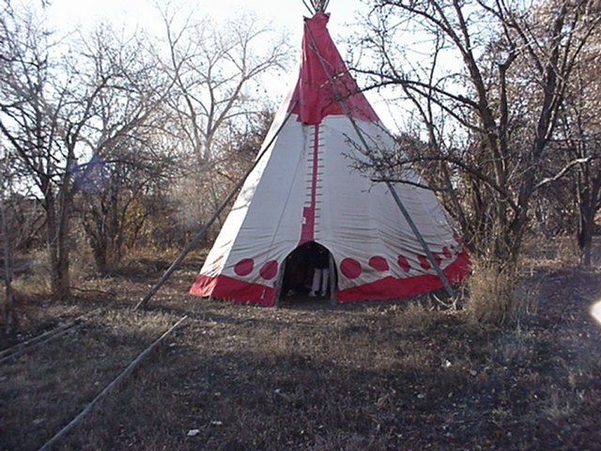
Prevention Services Bureau
Behavioral Health Services Division
New Mexico Department of Health
Evaluation Outcomes
Executive Summary
Fiscal Year 2006

STATE OF NEW MEXICO



BILL RICHARDSON
GOVERNOR

NEW MEXICO
DEPARTMENT OF HEALTH

MICHELLE LUJAN GRISHAM, J.D.
SECRETARY

KAREN MEADOR, J.D.
DIRECTOR
BEHAVIORAL HEALTH SERVICES DIVISION

DON MAESTAS, MSW
CHIEF
PREVENTION SERVICES BUREAU

Substance Abuse Prevention Evaluation Outcomes Executive Summary

Overview
The New Mexico Department of Health, Behavioral Health Services Division Prevention Services Bureau is dedicated to maintaining and improving a comprehensive State Substance Abuse Prevention System. The Prevention Services Bureau works diligently to enhance the capacity of community prevention providers in New Mexico to ensure the delivery of effective prevention services. These services are aimed at reducing alcohol, tobacco and other drug (ATOD) abuse. The successful local outcomes of New Mexico prevention programs are highlighted in the Executive Summary. The investment of state and federal dollars in the implementation of evidence-based prevention programs is producing positive outcomes for youth, families and communities in New Mexico.

Prevention programs funded by NMDOH/BHSD are available to a variety of populations in many different settings. Around the state, services are available to pregnant mothers, children 0-6, parents, guardians and grandparents. There are programs for preschool children, and students in elementary, middle and high school. Programs are available in youth centers, churches and community centers. Funding from NMDOH/BHSD also supports parenting and family programs, as well as community coalitions.

Prevention services are the first line of defense against substance abuse. As currently applied to substance abuse prevention in New Mexico, the Institute of Medicine model views prevention services on a continuum of care spanning from prevention to treatment to maintenance. The sole focus of prevention efforts is on decreasing the degree of individual/family/community vulnerability to related risk and protective factors. Prevention is identified as a continuum of strategies according to the degree of risk of service populations:

Universal strategies address the entire population with messages and programs aimed at preventing or
delaying problem behaviors and emotional and/or behavioral disorders.

Selective strategies serve subsets of the population who are deemed to be at risk for emotional and/or
behavioral disorders such as children of alcoholics, youth who suffer from anxiety/depression and students who are failing academically.

Indicated strategies are designed to prevent the onset of emotional and behavioral disorders among those
individuals identified as being high risk.

Two prevention frameworks, developed in the prevention research literature over the past two decades are emphasized by the NMDOH/BHSD—the risk/protective factor framework and the youth development framework. As presented in Effective Prevention Programming in New Mexico (Office of the Governor and NMDOH, January 1999), the risk/protective framework stresses the importance of reducing risk factors and enhancing protective factors as identified through a community needs assessment. Conditions associated with greater potential for drug abuse are termed “risk factors”. Those conditions associated with reduced potential for abuse are called “protective factors”.

In this framework the emphasis is on providing youth with skills, opportunities for involvement, and recognition to help ensure that they form pro-social bonds and develop healthy beliefs and clear standards. This framework also applies to reducing risk factors and enhancing protective factors in environments that influence youth, such as families, schools, neighborhoods, and communities.

Youth development is the process through which adolescents seek and are assisted to meet their needs and build individual assets or competencies relevant to enabling them to become successful, confident and self-reliant adults. It is a framework that focuses on capabilities, strengths and developmental needs and views young people as resources. Program that apply a youth development approach seek to build competencies in the physical, social, cognitive, vocational, and moral areas of a young person’s life. It is an ongoing process in which young people are engaged and invested. Youth development programs help youth to deal with the challenges of adolescence and prepare them for the independence and responsibilities of being parents, workers and citizens.

Prevention Standards
Prevention contractors are required to follow accepted Substance Abuse Prevention Standards, which include the following:
- Conduct community needs assessments regarding local alcohol, tobacco and other drug issues
- Develop prevention plans with measurable goals and objectives based on the results of the needs assessment, utilizing data from the needs assessment and input from community members
- Utilize multiple prevention strategies (information dissemination, education, identification and referral, community processes and environmental strategies) across multiple domains (community, school, family, peers, individuals) aimed at having a broader impact on the population receiving services
- Implement evidence-based prevention services proven to impact variables associated with the abuse of alcohol, tobacco and other drugs
- Conduct high-level outcome evaluation of prevention services in order to make necessary modifications and to demonstrate the effectiveness of the services.

The use of multiple strategies in multiple domains, combined with the use of evidence-based approaches and high-level outcome evaluation, has moved Prevention Services Bureau contractors into implementing proven and effective substance abuse prevention services.

Prevention contractors are required to conduct high-level outcome evaluations of their prevention services in order to make necessary modifications and to demonstrate the effectiveness of services.

Locally Developed Programs
To date, there are four prevention programs developed in New Mexico, and funded through the NMDOH/BHSD that have received national recognition as Exemplary Substance Abuse Prevention Programs though a nation-wide competitive process sponsored by the National Prevention Network, the Center for Substance Abuse Prevention, and the Community Anti-Drug Coalitions of America. These exemplary programs are:

The Albuquerque Partnership (2000)
Project Venture/National Indian Youth Leadership Project (2001)
First Born Program/Gila Regional Medical Centers (2002)
Connecting to Courage/Santa Fe Community College (2002)
Talking Talons Youth Leadership Program (2002)



Evidence Based Prevention for 12-17 Year Olds
Covering most areas of the state and a diverse range of evidence-based prevention programs, the NMBHSD programs for youth ages 12 to 17 remain the centerpiece of New Mexico’s ATODA prevention labors. These programs include nationally recognized efforts, such as Botvin Life Skills, and Project Venture, a locally developed model and practice that is recognized as an exemplary program.

Outcome data using a pre-post evaluation design were gathered at each of the 21 local 12-17 sites. Participants were evaluated at program entry and program exit. The statewide survey, Strategies for Success, was used along with other local data collection tools. Using the Strategies for Success instrument allows for comparing findings between last year and the current reporting period.

Comparison Group
New Mexico’s rigorous evaluation initiative includes a statewide comparison group, matched statistically to those youth receiving services. In racial/ethnic, age, gender, risk level, and geographic location, the comparison group mirrors the characteristics of youth participating in prevention programs. Comparison group youth completed the Strategies for Success evaluation in pre and post-test settings, stretching over a period of time equivalent to that of program participation.

12-17 Program and Comparison Group

During 2005-2006, New Mexico youth participants in prevention programs funded by Safe and Drug Free School Grant funds and targeting youth aged 12 to 17, from across the state, showed little or no change in alcohol, tobacco, and other drug use. By contrast, youth in a comparison group from across the state showed large increases in all substance use categories. The graphs that follow show the contrast between the two groups of adolescents.

Percentage of Past 30 Day Use of Any Alcohol

Percentages for the past 30-day use of any alcohol indicate that a lower percentage of 12-17 prevention program participants used alcohol at baseline (14.4%) in contrast to the comparison group (23.3%). Post-test data indicate that the percentage of 12-17 prevention participants who used alcohol showed only a very small increase to 14.90% while the comparison group increased from 23.3% to 41%. This is a pattern consistent with previous years’ findings.

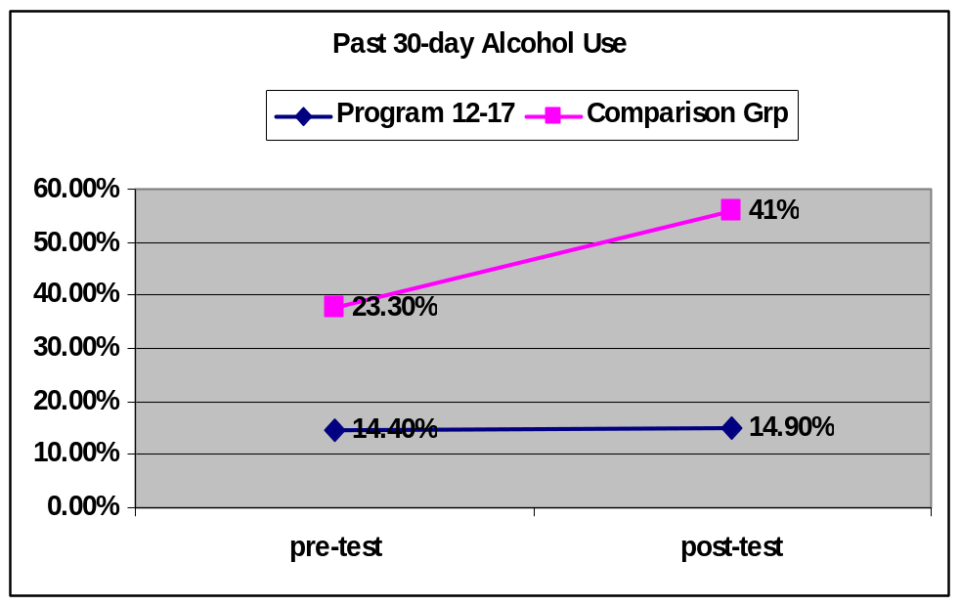
Percentage of Past 30 Day Use of Marijuana

Analysis based on percentages indicated a tremendous increase from 13.3% to 36% in marijuana use in the comparison group youth from baseline to post-test. In contrast a slight increase of one half of one percent from 8.5% to 9.1% occurred for 12-17 program participants.

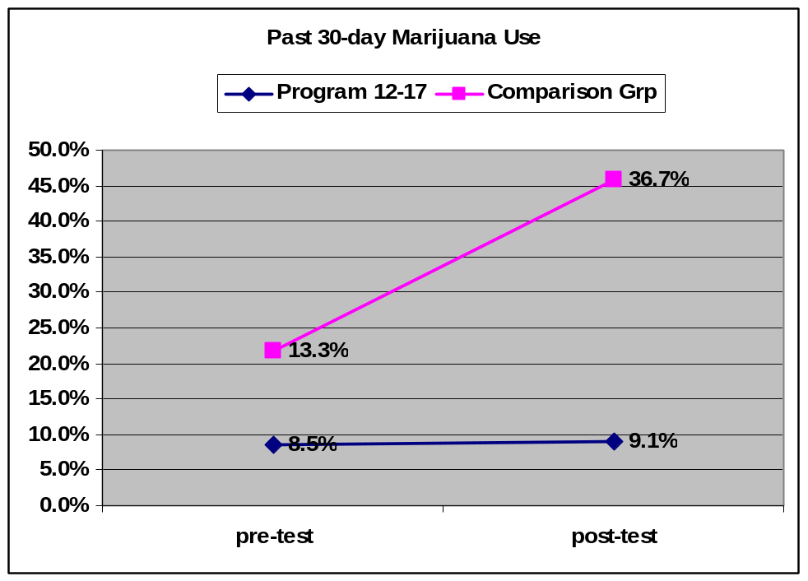

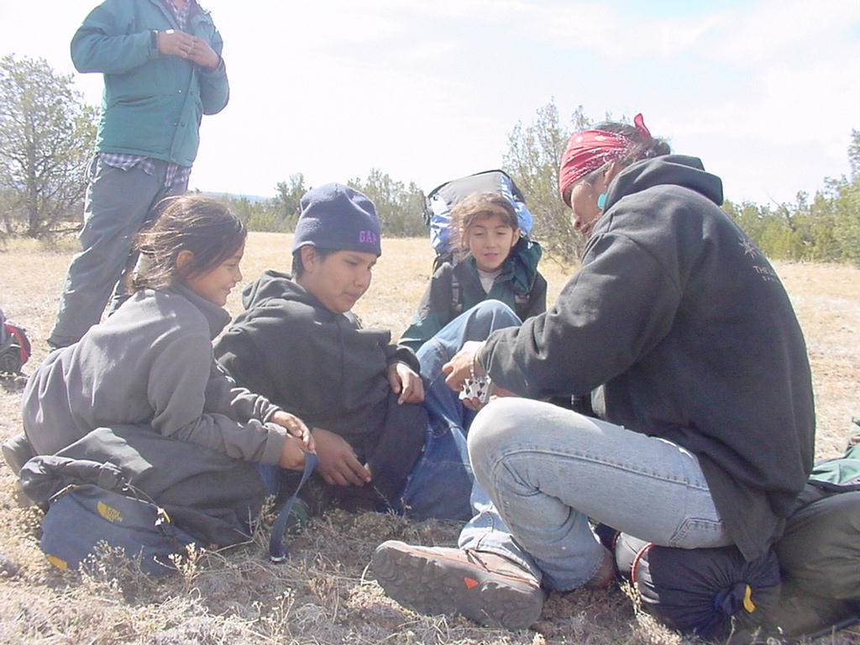

Percentage of Past 30 Day Use of Tobacco

For the past 30-day use of tobacco, the findings indicated a small drop from 1.8% to 1.6% in the 12-17 program participants who reported chewing tobacco, and another astounding increase for the comparison group. The percentage of comparison group youth who chewed tobacco rose from 2.4% at baseline to 30.2% at post-test.
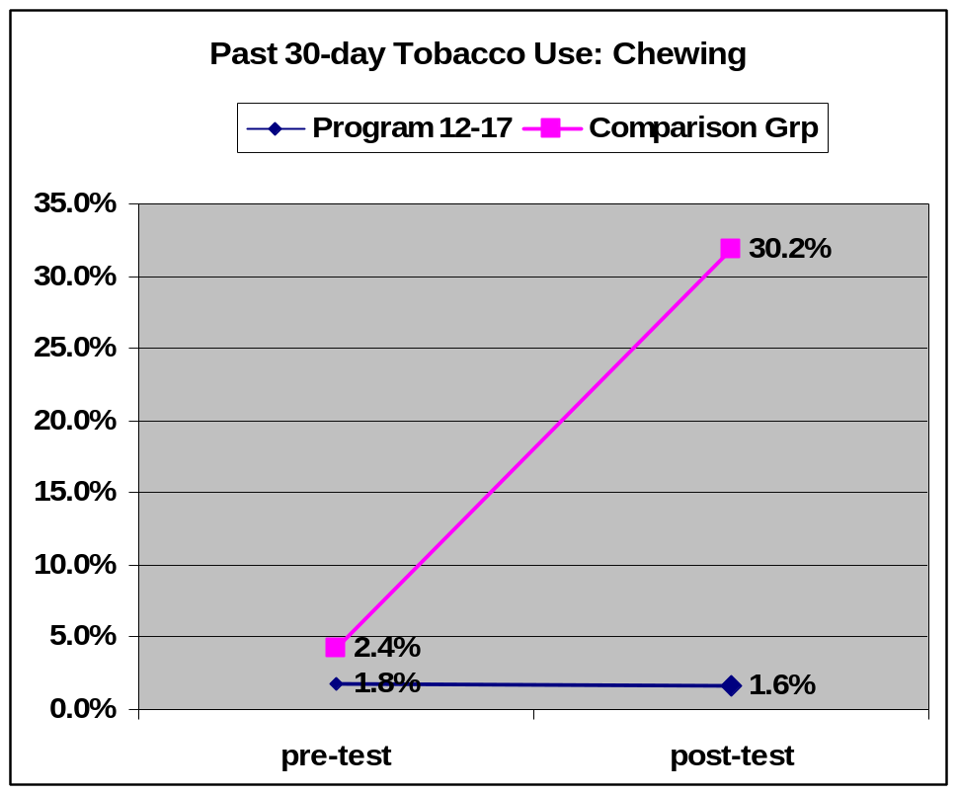


Percentage of Past 30 Day Use of Cigarettes

For the past 30-day use of cigarettes, the results showed a 4% drop from 10% to 9.6% in the 12-17 program participants. During the same period there was a dramatic increase of cigarette use by the comparison group. The percentage of comparison group rose from 11.9% at baseline to 35.7 % at post-test.

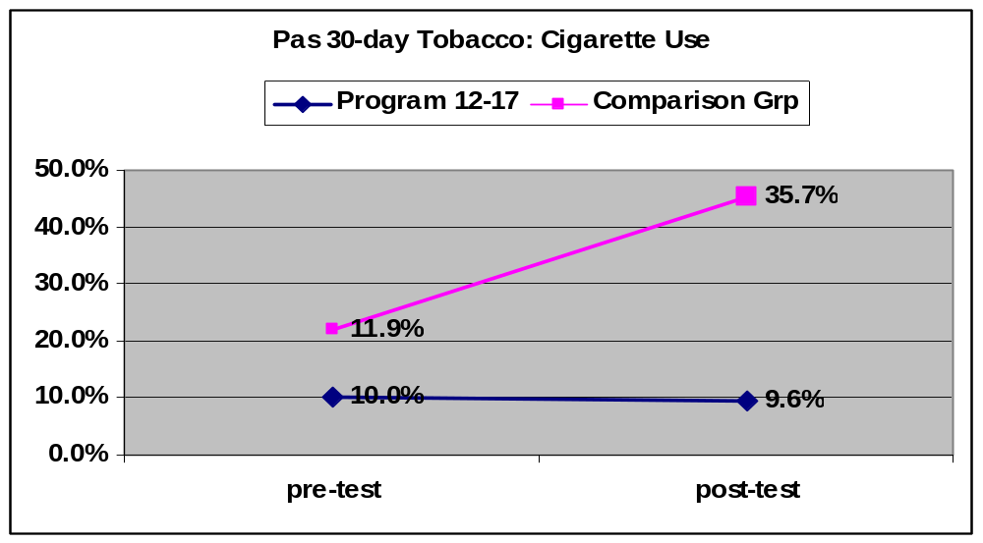

Percentage of Past 30 Day Use of Any Other Illicit Drug

The past 30-day use of any other illicit drug slightly increased about one third of one percent from 3.4% to 3.7% among 12-17 youth. There was a larger increase of 1.6% from 4.4% to 5.8% among comparison group youth. In practical terms there was less change in the prevention group than in a comparable group with no prevention programs during the same period from the Fall 2005 to the Spring 2006.

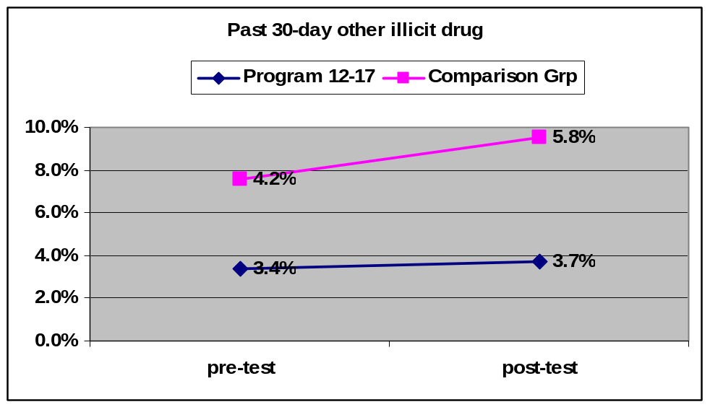
Pre-Kindergarten through Sixth Grade Youth and Families
Pre-kindergarten through 6th (PreK-6) grade programs also provide a full continuum of comprehensive community-based prevention services for individuals, families and communities, including Synar activities to reduce the sale of tobacco to minors. As appropriate, the contractor shall provide targeted evidence based prevention programs for youth who are not in need of treatment, and maintain fidelity of the selected evidence based programs. PreK-6 programs are aimed at directly impacting risk and resiliency factors in the targeted age group. These programs tend to involve both youth and their families.

Evaluation of the PreK-6 Initiative of the BHSD involved a significant shift in design and approach, particularly given the age level of youth participants. BHSD contractors were asked to provide a comprehensive family approach to substance abuse prevention that included a parent intervention component. Each of these shifts in focus and age of target youth required the development of a new battery of evaluation tools that were piloted and implemented during the 2004 fiscal program year.

A pre-test/post-test design, without control groups, was used with the intent to aggregate all youth, parent, and teacher outcome data for this year-end reporting. Local evaluators monitored and provided oversight at each of the 17 funded PreK-6 prevention sites and worked closely with the statewide evaluation team to provide timely data submission.

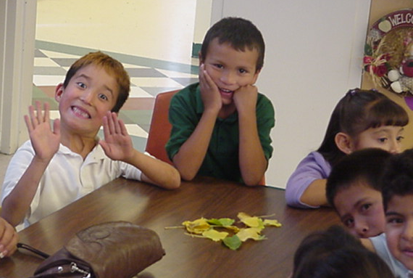

Office of Substance Abuse Prevention
Evaluation Outcomes 2006
*Coalitions: Pages 11-14 *PreK-6th Grade Programs: Pages 15-21 * 12-17 Programs: Pages 22-30

Community Based Program | Location | Program(s) implemented and Population served | Outcomes

COALITIONS
Albuquerque Partnership | Albuquerque;  South Valley, La Mesa, Trumbull Village, Barelas, Sawmill, Mountain View, Martinez Town & Santa Barbara, Adobe Acres, Valley Gardens, | Implementation of environmental strategies addressing issues of drug abuse, drug related crime, education, public safety and community development. The Albuquerque Partnerships works with several neighborhood associations and city groups in providing training, technical assistance and encouraging mobilization & positive development. | *The summer festivals “Tardeadas de Verano” successfully reduced summer cruising in the Trumbull/La Mesa Neighborhoods.  *Creation of an independent & functional Website for the Barelas NA  *Denial of a building permit for a nuisance liquor establishment as a result of advocacy from the AP and partnering Neighborhood Associations  *Adobe Acres near completion of beautification projects in their neighborhood  *Ninety-one (91) Hot Spots Reported for FY06  *In collaboration with Drug Free NM Campaign, numerous TV & radio messages were disseminated  *Four community trainings were held for NA members
Hands Across Cultures | Greater Espanola Valley, Rio Arriba County & Northern Santa Fe | Works in the Greater Espanola Valley, Rio Arriba County & Northern Santa Fe County on improving health initiatives. They work with high risk youth & their families, schools and the community at large. | *The coalition met with the city council and provided numerous “education” sessions to them to inform them about the benefits and procedures for a clean air policy.  *Small groups research has been conducted to determine vehicles for instituting such a policy, and this has moved the counsel closer to enacting a city wide ban on indoor tobacco use in public places.  * SYNAR activities were launched and merchant contacts were made. 3 youth have also been trained to conduct the activities. This project year HACC has had 100% compliance in non-sales as evidenced through sting operations.  * As regards the coalition’s ability to congeal and work together, all scores showed a statistically significant increase from baseline to posttest, representing positive findings for the program: Sense of Community, Mobilization Capacity, Readiness for Focused Action, and Total Score. At both baseline and posttest, the Readiness for  Focused Action scale had the highest mean score of 2.75 and 3.40, respectively, while the  Mobilization Capacity scale had the lowest score of 2.29 at baseline and the Sense of Community scale had the lowest score of 3.20 on the posttest.  *At baseline, these coalition members appeared to be saying that while they felt ready for action to mobilize the community, they felt that they and/or the community do not have the capacity to do so.  *At posttest, they showed that they felt more ready for action to mobilize the community and they also felt a little more confident that they and/or their community had the capacity to do so.
Interfaith –LEAP | Northern  Santa Fe County & Rio Arriba County | I-LEAP is an organizing agency focused on systemic change. Congregational leaders are identified and trained to enroll community members with similar concerns into Local Organizing Committees. Here, community members learn to use their voice to make positive change in their community. | *The engagement of youth in traditional. Cultural arts once a month  *The planning design and completion of a mural on young male Mexican nationals  *Completion of a playground and construction of a recreational site underway  *ESL & GED classes held regularly  *Community meetings & trainings on rights & community organizing
McKinley County Sheriff’s Office | McKinley County | The mission of the McKinley County Sheriff’s Office is to preserve the peace and to protect the lives and property of the citizens of McKinley County. The service population for this project has been the residents of McKinley County. The McKinley County Sheriff’s Office serves McKinley County and outlying areas. | *Further implementation of a geo-mapping system, which combines incident statistics from the three area law enforcement organizations. The geo-mapping system has continued to identify and plot the locations of a wide range of alcohol-related incident data for McKinley County including liquor outlets, DWI arrests, traffic fatalities involving alcohol, domestic violence incidents and locations where minors under the influence were apprehended.  *The increased utilization of the GIS findings in law enforcement and county-wide decision-making even though data entry was curtailed midyear Area coalitions (currently numbering over 10) routinely included the geo-mapping data in their recommendations and decision-making as well as in public settings such as the Town Hall meeting and a recent Community Forum. The Coalitions used the information to coordinate and legitimize their planning efforts as well as provide substantive data to seek funding. Local media have continued to be very supportive.  *An increase in the quality and quantity of cooperation amongst law enforcement entities, including the SID agent  *A continued decrease in DWI arrests even with increased law enforcement coverage  *The increase in compliance behavior by liquor vendors  *The increase in compliance behavior by tobacco vendors.
San Juan County Partnership | San Juan County, Farmington & Northwestern New Mexico | Local citizens concerned about several substance abuse related issues created an official organization (the partnership) to make a difference in the community. The SJCP acts as a resource and support for the community. All ages and groups are served by the Partnership although the emphasis is on working with youth. | *Local community group continue to support efforts to change local perception, behaviors and regulatory environments related to second-hand tobacco smoke and DWI’s  *Special supports have been provided to local agencies & individuals attempting to deal with the rising problem with methamphetamines in the community  *The partnership continues to act as a local resource for prevention activities and information –state & regional prevention meetings & RADAR  *The partnership continues to support a wide array of health-related community-based services as possible through the LC, grant writing for housing, volunteer services, mentoring, community health improvement council, etc.  *The partnership successfully hosted the Four Corners Prevention Workshop in May for 138 local human service providers & community members  *Multiple GIS presentations were provided across the county on substance abuse issues  *The partnership collaborated with another local agency for another year of successful interventions regarding underage sales of tobacco & alcohol  *The partnership celebrated another year (15th) as a community based prevention agency

Community Based Program | Location |  | Program(s) Implemented and Populations served | Outcomes
Programs for Pre Kindergarten – 6th Grade
Counseling Associates Inc. |  | Roswell area, Artesia & Carlsbad | The  Botvin Life Skills  was used, including follow-up booster sessions with 74 students between the ages of 11-15.  The  Dare To Be You  Curriculum was also used with 149 parents with preschool age children. | *Hispanic girls show a Significant decrease in Adult Use  *Students who reported one or both parents born outside the United States, generally Mexico, reported a significant increase in the Cultural Bonding Scale  *Students who identified as Anglo reported a higher level of media literacy  *Spanish-speaking students significantly increased scores on Refusal Skills  Botvin Life Skills:  Total Sample  Significant  *Decrease of Tobacco Use to zero.  *Increased School Protective factors  *Increased Communication Skills  *Increased Friendship Skills  Female Students  Significant  *Increased Decision-making Skills  *Decreased Alcohol Use  *Decrease in Disruptive Behaviors  Male Students  Significant  *Increased Friendship Skill scale  Anglo Students  *Anglo students reported no tobacco use at either pretest or posttest, maintaining their tobacco-free status for the duration of the program  Dare To Be You  Total Sample  The Following displays Significant findings:  *Increased Positive Family Interaction  *Increased Positive Parental Attitudes  *Increased Positive Family Interaction  *Increase in making suggestions to their child’s teacher  *Increase in making plans to achieve personal goals  *Increase in attending cultural events  *Increase in their ability to manage their  *Increase in their perception of themselves as good parents  *Decreased yelling at their children  Parents Born In US  *Decrease in the Parent-Child Dysfunctional Interaction  Females  *Increase in attending more cultural events  *Increased ability to make suggestions to their child’s teacher,  *Decreased frequency of anger at their child’s mistakes  *Increased perception of themselves as good parents  Males  *Males reported a significant increase in Positive Parental Attitudes  *Increased attending more cultural  *Increased plans for personal goals  *Increased ability to manage anger  *Increased perception of themselves as good parents  *Decreased telling others how bad their child behaved  *Decreased yelling at children
Excel Educational Enterprises |  | Albuquerque, South Broadway and Kirtland Addition Areas | The  Effective Black Parenting  And  Strengthening Multi-Ethnic Families programs were used with 92 participants | The following significant and meaningful results documented the success of the Excel Effective black Parenting program:  *Social support;  *Social services utilization;  *Parenting skills;  *Family interaction;  *Parent child dysfunctional interaction;  *Adult 30 day GPRA substance use
La Clinica del Pueblo de Rio Arriba |  | Rio Arriba County including the Espanola Valley, Abiquiu /Ojo Caliente, and the Chama Valley area including Gallina, Coyote, Tierra Amarilla, and Chama | The  Dare To Be You Program was implemented primarily with parents of pre school age youth. However, we also offer the DTBY program to parents of children ages 5-11 years (133 served). | La Clinica has implemented the Dare to Be You Program in four northern Rio Arriba County for the past six years with very positive results as was also the case for FY06 as follows:  *Family Interaction  *Parental Attitudes  *Parents were observed using methods and skills acquired through DTBY including positive discipline techniques.
Mescalero Apache Tribe |  | Mescalero Apache Reservation, Ruidoso area | The  Botvin Life Skills Training was implemented with 192 students in 3rd –8th grades and the  Dare To Be You program was completed by 19 families. | *Disruptive behavior in school decreased;  *Tobacco, alcohol, marijuana, and other illicit drug use decreased for girls;  *Parental attitudes increased  *High scores for both males & females showed that students value the importance of school  *Both boys and girls show a healthy connection to their parents
National Indian Youth Leadership Program |  | McKinley County, Gallup area | The National Indian Youth Leadership Project (NIYLP) served young people in 4th -6th grades using the Project Venture curriculum. | *Parents’ perception of family cohesion improves from pre to post,  *Program youth perceive drugs to be more harmful at post than at pre  *Parents’ perception of family cohesion improves from pre to post,
North Central Community Based Services |  | Chama & Northern Rio Arriba County | The  Botvin Life Skills and the Across Ages mentoring program were both used with 187 5th & 6th grade students.  The  Dare To Be You curriculum was used with 20 families with pre school age children. | Total Sample  *Parent communication increased for the overall group;  *Tobacco use decreased for the overall group;  *Perceived harm also increased for the overall group;  For boys  *Parent communication increased  *Tobacco use decreased and  *Perceived harm increased;  For girls  *Parent communication increased and  *Perceived harm increased.
Rocky Mountain Youth Corps |  | Taos | Rocky Mountain Youth Corps implemented a locally developed ‘promising program’ in two elementary schools in the Taos area. Corps members mentor and tutor youth and design service learning projects. | Disruptive School Behaviors: For female participants, there was statistically significant improvement in the frequency of disruptive school behaviors at the time of post-test (p<.01). This finding indicates that female participants were involved in less fights, lessened the frequency of damaging or destroying things that did not belong to them, and were less often in trouble with school officials after participating in the program.
Sandoval County Substance Abuse Prevention Program |  | Sandoval County | The  Dare to Be You  Curriculum was used with 109 families with children ages 0-6 in Sandoval county, including the town of Bernalillo and the Pueblos of Cochiti & San Felipe. | Total Sample  The following are Significant & meaningful findings:  *Increase in feeling good about their relationship with their child  *Reduction in threatening or criticizing their child  Males  *Increase in perception that their child does things for them that make them feel good  *Increase of feeling good about their relationship with their child  Females  *Decreased threatening or criticizing their child  *Decreased hitting their child  *Increased feeling positive about their child  *Increased feeling positive about their family
San Juan County Partnership |  | San Juan County | The Partnership implemented the Families and Schools Together (FAST) curriculum this program year. Student between the ages of eight & thirteen received services in various schools in San Juan County and the Navajo Nation. | Total Sample  *Conduct Problems – teacher rating  *Inattentive/Passive – teacher rating  *Hyperactivity Index – teacher rating  *30-day illicit drug use  *Perceived Harm  Males  *Conduct Problems – teacher rating  *Inattentive/Passive – teacher rating  *Hyperactivity Index – teacher rating  *Perceived Harm  Females  *Psychosomatic – parent rating  *Inattentive/Passive – teacher rating  *30-day illicit drug use  (marijuana & inhalant)
Southern New Mexico Human Development |  | Southern Dona Ana County | The  Strengthening Families Program was used with 56 families | Total Sample:  *Statistically significant reduction in the Hyperactivity Index  *Reductions approaching significance in Conduct Problem  *Reductions approaching significance in Psychosomatic  *Reductions approaching significance in Impulsive-Hyperactive  *Reductions approaching significance in Anxiety  *Increase approaching significance in Family Cohesion and Adaptability  Male Sample:  *Statistically significant reduction in the Hyperactivity Index  *Reductions approaching significance in Conduct Problem  *Reductions approaching significance in Learning Problem  *Reductions approaching significance in Psychosomatic  *Reductions approaching significance in Impulsive-Hyperactive  *Increase approaching significance in Family Cohesion and Adaptability  Female Sample:  *Reduction approaching significance in Anxiety
Talking Talons Youth Leadership Program |  | Tijeras, Edgewood, East Mountain Areas | The Talking Talons Youth Leadership curriculum was used with students in elementary, middle & high schools.  The K-6 funding served 50 youth ages 9-12 from Edgewood Elementary, South Mountain Elementary & Roosevelt Middle School | *The treatment group showed statistically significant change in self-esteem  *Control group showed statistically significant decrease in moral attitude while the treatment group was insulated from the effect (remained stable)  *Treatment group showed statistically significant increase in knowledge  *Direct relationship between student attitudes and disapproval of drug use: for each increase of one standard deviation of student attitude outcomes, a decrease of .47 in student disapproval of drug use was found
Taos - Colfax Community Services |  | Taos & Colfax Counties | The  Dare To Be You curriculum  was used with  two hundred and ninety-six (296) parents of the youth who participated in the PATHS Program in Taos and Colfax Counties. | Taos County:  *Statistically significant increase in the individual item “Feel closer to family than people outside”  *Decrease approaching significance in the individual item “Childish or immature” indicating that parents noted a positive increase in their child’s maturity  Colfax County:  *Statistically significant reductions in Conduct Problem  *Statistically significant reductions in Learning Problem  *Statistically significant reductions in Psychosomatic  *Statistically significant reductions in Impulsive-Hyperactive  *Statistically significant reductions in Anxiety  *Statistically significant reductions in Hyperactivity Index  *There was a positive trend with an increase approaching significance in School Attendance  *Statistically significant increase in Family Cohesion and Adaptability
Taos Pueblo  Family Strengthening & Prevention Program |  | Taos Pueblo | The  Second Step  training was provided to 41 students in the 1st and 2nd grades at the Taos Day School.  The  Botvin Life Skills curriculum was used with 72 students in 3rd -6th grades at the Taos Day School. | *Participants improved their hyperactivity  *Participants showed statistically significant improvement in their ability to be attentive and less passive  *Participants showed statistically significant improvement in the hyperactivity index  *Participants improved their perception of harm from ATOD use  *1st & 2nd grade students’ empathy skills improved  *1st & 2nd grade students’ impulse control improved  *1st & 2nd grade students’ anger management skills improved  *1st & 2nd grade students’ exhibited less aggressive/violent behavior  *3rd-6th grade students improved their stress management skills  *5th-6th grade students improved their decision making skills
UNM - ACL Teen Centers |  | Acoma, Laguna, To’Hajillee, Cubero and Seboyeta Communities | The  Botvin Life Skills curriculum was  used with  elementary school students attending the Sky City Community School in Acoma, Laguna Elementary School in Laguna, To’hajiilee Community School, Cubero Elementary in Cubero and Seboyeta Elementary School in Seboyeta. | Total Sample:  *For all youth, a statistically significant reduction in tobacco attitudes occurred.  *A statistically significant increase in advertisement knowledge occurred.  *Lastly, a statistically significant reduction in stress level also occurred.  Male Sample:  *For males, a significant reduction in tobacco attitudes occurred.  *In addition, a significant increase in advertisement knowledge occurred.  Female Sample:  *For females, a significant reduction in tobacco attitudes occurred.  *In addition, a significant increase in advertisement knowledge occurred.
Youth Development Inc. |  | Valencia County Los Lunas | The  Dare To Be You  Curriculum was used with seventy-two (72) families living in Valencia County who have pre-school age children. | Total Sample:  *There was a statistically significant increase in Parental Attitudes  *Statistically significant reduction in Parent-Child Dysfunctional Interaction  Male Sample:  *Positive trends approaching significance in the Parental Attitudes  *Positive trends approaching significance in Parent-Child Dysfunctional Interaction Scales  Female Sample:  *Positive trends approaching significance in Parental Attitudes  *Positive trends approaching significance in Parent-Child Dysfunctional Interaction Scales
Gila Regional Medical Center |  | Silver City Area | The  First Born Program  aims to improve the health and wellness status for all first-time families by building family strengths and competencies to meet life's inevitable challenges. This year 91 families were served. | *Families demonstrated significant improvement in measures of parenting skills and child well-being  *Mothers demonstrated significant improvement in family social support  *Mothers’ increased in positive caregiver characteristics as they relate to parenting skills, child related developmental expectations and positive perception of child (for postpartum period  *Mothers demonstrated significant increase in positive family interactions as they relate to bonding with child, positive interaction/communication with child, positive marital relationship, and increased male involvement

Community Based Program | Location | Program(s) Implemented and Populations served | Outcomes
Programs for 12-17 year olds
Cornstalk Institute | South Valley in Albuquerque | The  Learning to Lead program was implemented with 144 youth from six schools in Albuquerque’s southwest neighborhoods. | The Program Group moved in the desired direction from pre to post in the following measures:  *Behavioral Symptom Checklist (Total Sample)  *Past 30 day tobacco use  (Total Sample)  *Past 30 day tobacco use (Females)  *Behavioral Symptom Checklist (Age Group 12-14)  *Past 30 day tobacco use (Age Group 12-14)  *Behavioral Symptom Checklist (Age Group 15-19)  *Past 30 Day Alcohol Use (Total Sample) approaching significance
Counseling Associates | Roswell | The  Botvin Life Skills Training curriculum with middle school students. | *Significant decrease for the total sample in Illicit Drug Use  *Aggressive behavior decreased slightly for the total group  *Risk Taking behavior slightly decreased for the total group  *There were slight decreases in tobacco, alcohol, marijuana and other drug use for both males & females
Espanola Municipal Court | Espanola | The  Project Venture program was implemented with 75 youth and some partens. | Total Sample:  *Approaching significant increase in Perceived Harm of ATOD Use  *Decreases in the percentage of youth reporting use of  alcohol (14.5% to 13.0%), hallucinogens (2.9% to 1.4%), and inhalants (2.9% to 1.4%).  *No use was reported at either pretest or posttest for the following substances: chewing tobacco, cocaine, crack, heroin, methadone, speed, downers, PCP, ecstasy, LSD, and steroids.
Excel Educational Enterprises | Albuquerque, South Broadway and Kirtland Addition neighborhoods | Effective Black Parenting &  Strengthening Multi-Ethnic Families  were the principle programs implemented, along with After-School K-6 Grade Alternative Activities and the  After-School Learning Center | Total Sample:  *Significant & meaningful Decrease in aggressive behaviors;  *Significant & meaningful Decrease in peer use of ATOD;  *Significant & Meaningful Increase in parental support.  *Decrease in Risk Taking behaviors  *Increase in perception of harm of ATOD use  *Slight increase in parental intolerance of ATOD use  *Increase in positive parental interaction  *Significant and meaningful increase in parental attitudes
First Nations Community Health Source | Albuquerque | The  Run to the Sun program was implemented drawing from the Project Venture Model, with 100 middle & high school students in Albuquerque’s South East Heights. | *No statistically significant increases in the use of tobacco products or alcohol  *Approaching significance in the increased perception of harm from drugs from pre to post  *Positive changes on the Behavior Symptoms Checklist scale (a measure of emotional distress) as well as on the Aggressive Behavior scale.  *Parents report feeling more empowered and that their children are more outgoing as a result of the program
Five Sandoval Indian Pueblos | The Pueblos of Santa Ana, Cochiti and Zia | The  Project Venture curriculum was implemented in three Pueblos, with middle school and high school groups in each Pueblo. | *Community support and engagement in Prevention activities increased in all three Pueblos  *Services expanded to Cochiti Middle School allowed for increased involvement by a consistent group of youth & community members  *Number of youth involved in challenge activities, camps and community events were all above contracted numbers.  For the group overall:  *Aggressive behavior decreased;  *Intention to abstain increased;  *Tobacco use decreased;  *Illicit drug use decreased  For boys:  *Aggressive behaviors decreased;  *Tobacco use decreased;  *Illicit drug use decreased;  *Alcohol use decreased  For girls;  *Intention to abstain increased;  *Availability of ATOD decreased;  *Tobacco use decreased.
Hands Across Cultures | Espanola Valley Area | Project Success  was implemented in the Espanola and Pojoaque Valley Schools | *A statistically significant increase was revealed in Perceived Harm of ATOD Use  *A statistically significant reduction was revealed in Past 30-Day Tobacco Use  *A statistically significant reduction was also revealed in Past 30-Day Illicit Drug Use  *Positive findings include decreases in the percentage of youth reporting use of: tobacco (24.7% to 23.4%), alcohol (41.6% to 40.3%),  cigars (19.5% to 6.5%),  pipes (2.6% to 1.3%),  cocaine (6.5% to 3.9%),  heroin (1.3% to 0.0%),  speed (2.6% to 0.0%),  downers (3.9% to 1.3%),  PCP (2.6% to 0.0%),  ecstasy (5.2% to 0.0%),  LSD (2.6% to 0.0%),  hallucinogens (14.3% to 6.5%), inhalants (6.5% to 1.3%), and  other drugs (7.8% to 5.2%).
National Indian Youth Leadership Project | Gallup | The Project Venture program was implemented with 120 7th grade students. | *Increased Perception of Harm from drugs,  *Increase in Intention to Abstain from drugs,  *Increase in Parent Support
North Central Community Based Services | Northern Rio Arriba County | Across Ages Replication for grades 5-8 in three districts  Life Skills Training for grades 5-8 in three districts  MAARI—Drug Free Communities were implemented with Residents of northern Rio Arriba County | *In Gallina, the Life Skills Training has been expanded into a half semester elective for 6th grade students  *Positive adult relationships formed between youth & mentors  *Boys depression & behavior problems decreased at the end of the program  *Fighting & aggressive behavior decreased for girls  *Perceived impacts of ATODA use increased for the group overall  *Illicit drug use decreased for the group overall
Pueblo of Isleta Project Venture | Pueblo of Isleta | The Project Venture curriculum was implemented with 64 5th-6th grade students in the Pueblo. | *Positive and significant decrease in disruptive school behaviors. This effect was also significant for boys but not for girls. Effect size was not meaningful (group size too small).  *Positive and significant increase in parent communication. Effect size was not meaningful.  *Although not statistically significant, all risk and resiliency factors changed in positive directions. There were decreases in self-reported tobacco, alcohol, and illicit drug use.  *Improvement in self-reported grades;  *An increase in school protective factors (bonding with teachers and other adults, improved motivation to be in school);  *Improved communication between youth and their parents;  *Improved bonding between youth and families;  *Decreased alcohol, tobacco and other drug use;  *Increased perceived harm from alcohol, tobacco, and other drugs  *Increased perceived risk of using alcohol, tobacco, and other drugs.
Rocky Mountain Youth Corps | Taos | The Rocky Mountain Youth Corps implemented a locally developed ‘promising program’ with 406 middle school students. | *Statistically significant improvement in female participants’ attachment to the community  *For male participants, there was slight improvement in the frequency of risky behavior  *For male participants there was slight improvement in aggressive behavior  *For the group as a whole, there was slight improvement in participants’ beliefs about the harm caused by ATODA use.  *For male participants there was slight improvements in tobacco use  *Male participants slightly decreased their illicit drug use
Sandoval County Substance Abuse Prevention Program | Town of Bernalillo | Two programs were implemented this year, Project Northland for 126 middle school students and Reconnecting Youth served 52 High School students. | Project Northland  *Boys reported a complete reduction of marijuana and illegal drug use; that is, no boys reported using at posttest.  *Hispanic student report of significant increase on the Perception of Harm scale  Reconnecting Youth  *Students reported a significant decrease in depression  *Students reported a reduction in feelings of anger – approaching significance  *Students reported an increase in grades - approaching significance
Santa Fe Community College | Santa Fe | The  Connecting to Courage Program was implemented with 112 youth between the ages of eleven and fourteen & 25 families. | Cohort One:  *Decrease in the percentage of youth reporting use of chewing tobacco (1.8% to 0.9%).  *No change was reported from pretest to posttest in use of pipes (4.5%), no change can be seen as a positive finding.  Cohort Three:  *No use was shown at either pretest or posttest for the following substances: chewing tobacco, pipes, cocaine, crack, heroin, methadone, speed, downers, PCP, ecstasy, LSD, other hallucinogens, steroids, and other drugs. While some increases in use were shown, the abstinence in use of “harder” drugs may be seen as a positive finding.  *Positive trend was reported by male youth with an increase in Parent Support  Academic Improvement:  *There were positive changes in academic improvement for both Cohort 1 and Cohort 2.  *There were some obvious changes in academic achievement between students who participated in Cohort 1 and Cohort 3  *Twenty-three percent (23%) of the students improved their grades or grades remained the same in Cohort 1, while sixty-seven percent (67%) of the students improved their grades or grades remained the same in Cohort 3  *Those receiving the maximum amount of services improved 44% more than the first group.  *Most students participating in the Tutoring Program improved the Grade Point Average (GPA) as well.
Santa Fe Public Schools | Santa Fe | The  Botvin Life Skills Training was implemented in Santa Fe Public School with 52 classes of sixth grade students. | *There was a statistically significant improvement in participants’ beliefs about the harm caused by ATOD use  *There was statistically significant improvement in participants’ perception of how wrong their parents thought it was to use ATOD  *Statistically significant improvement in participants’ attitudes about smoking and alcohol  *Statistically significant improvement in participants’ normative beliefs  *Statistically significant improvement in participants’ knowledge about marijuana and tobacco  *Statistically significant improvement in participants’ decision making skills  *Statistically significant improvement in participants’ ability to resist ATOD advertising  *Statistically significant improvement in participants’ stress management skills
San Juan County Partnership | San Juan County Schools between Shiprock & Aztec | Two programs were implemented this year, the Families & Schools Together (FAST) program served 8 families and the ALL STARS program served 234 youth. | *Parent involvement through the homework component was really high  *Program Staff were able to achieve impressive rates of parent contact  *Special outreach was continued to underserved populations at BIA and Navajo Nation Charter schools  *Significant reduction in Behavioral Symptom Checklist scores for the whole sample of students  *Significant reduction in the adult ATODA use scores for the whole sample of participating students  *Significant reduction Tobacco use scores for male students,  *Significant reduction in Alcohol Use scores for male students,)  *Significant reduction in the Marijuana Use scores for the sample of male students
Soccorro Mental Health | Soccorro | The  Reconnecting Youth program was implemented. | *Reduction for the students who reported using two or more substances in marijuana use approaching significance  *Slight reduction in risk taking  *Slight increase in parent support  *Slight increase in parent intolerance of youth ATOD use
Southern New Mexico Human Development | Anthony and communities within 60 miles of the Mexico Border. | The Reconnecting Youth program was implemented with 48 Youth ages 12-17 and the Strengthening Families Program was implemented with 48 families. | Reconnecting Youth:  *Statistically significant decrease in Aggressive Behaviors  *Approaching significant decrease in Perceived Harm of ATOD Use  *Statistically significant reduction was revealed in Past 30-Day Tobacco Use  *Approaching significant reduction in Past 30-Day Alcohol Use  *Positive findings include decreases in the percentage of youth reporting use of: tobacco (37.5% to 29.2%), alcohol (54.3% to 43.8%),  cigars (43.8% to 22.9%),  pipes (8.3% to 4.2%),  ecstasy (6.3% to 2.1%), hallucinogens (10.4% to 4.3%), inhalants (10.4% to 2.1%), and  other drugs (14.9% to 10.6%).  *No use was reported at either pretest or posttest for heroin, PCP, and steroids.  Strengthening Families:  *Statistically significant reductions for Conduct Problem  *Statistically significant reductions in Learning Problem  *Statistically significant reductions in Impulsive-Hyperactive  *Statistically significant reductions in Anxiety  *Statistically significant reductions in the Hyperactivity Index  *Statistically significant increase in School Attendance
Talking Talons Youth Leadership Program | East Mountain, Edgewood & Moriarty areas | The  Talking Talons Youth Leadership program was implemented with 105 middle school students. | *Statistically significant increase in self esteem  *Participants remained consistent in moral attitude while the control group had a statistically significant decrease in moral attitude.  *Group showed statistically significant increase in knowledge  *Direct relationship between student attitudes and student disapproval of drug use – For each increase of one standard deviation in student attitude outcomes a decrease of .47 in student disapproval of drug use was found
Taos Colfax Community Services | Colfax County | The  Dare To Be You curriculum was implemented with 44 youth ages 12-17 and 59 youth completed the Peer Leadership Program. | *Statistically significant decrease was revealed in the Behavioral Symptom Checklist  *Statistically significant increase in Parent Support  *Positive trends were revealed in an increase in Perceived Harm of ATOD Use  *Decrease in Adult ATOD Use  *Statistically significant decrease in Past 30-Day Alcohol Use  *Decreases in the percentage of youth reporting use of:  tobacco (16.7% to 8.3%),  alcohol (25.0% to 11.1%),  cigars (30.6% to 25.0%),  inhalants (2.8% to 0.0%), and steroids (2.8% to 0.0%). Some substances showed no use at either pretest or posttest, including: cocaine, heroin, methadone, downers, PCP, and other drugs.
UNM – ACL Teen Centers | Acoma, To’Hajiilee, Laguna | The  Keeping Family Tradition program was used in conjunction with the Dare To Be You curriculum with middle school students and their parents as well as the Botvin Life Skills Training program. | *Reduction in reported peer AOD use among males, significant at .08.  *Reductions in reported marijuana use from pre to post test, among males significant at.09.  *Reductions in marijuana use for the 12-14 age sub-sample, significant at .09  *Desirable reduction in mean values for harsh disciplinary behaviors occurred  *Desirable increase in parenting self-concept occurred  *Creation of a valid & reliable assessment tool to measure all domains & publication pending on program adaptations

Reducing the Sale of Tobacco to Minors

The New Mexico Synar Illegal Tobacco Sales Reduction Effort

In FY 2006 the rate of illegal sales to minors was 9.3 percent. The following charts illustrate New Mexico’s success in keeping the rate below 20 percent for the past nine years.

Fiscal Year | Rate of Illegal Sales | Compliance Rate
FY 97 | 23% | 77%
FY 98 | 13.5% | 86.5%
FY 99 | 18.9% | 81.1%
FY 00 | 11.8% | 88.2%
FY 01 | 11.6% | 88.4%
FY 02 | 9.8% | 90.2%
FY03 | 14.8% | 85.2%
FY04 | 6.5% | 93.5%
FY05 | 7.7% | 92.3%
FY06 | 9.3% | 90.7%

As illustrated in the preceding and following graphs, the rate of illegal sales has declined in the past nine years and has remained well below 20 percent. This is credited to consistent Synar merchant education along with statewide enforcement of the law, and to dedicated efforts by community coalitions, national and grassroots organizations addressing tobacco use and prevention, and to the Tobacco Use Prevention And Control Bureau’s (TUPAC’s) concurrent efforts towards tobacco use prevention and cessation.
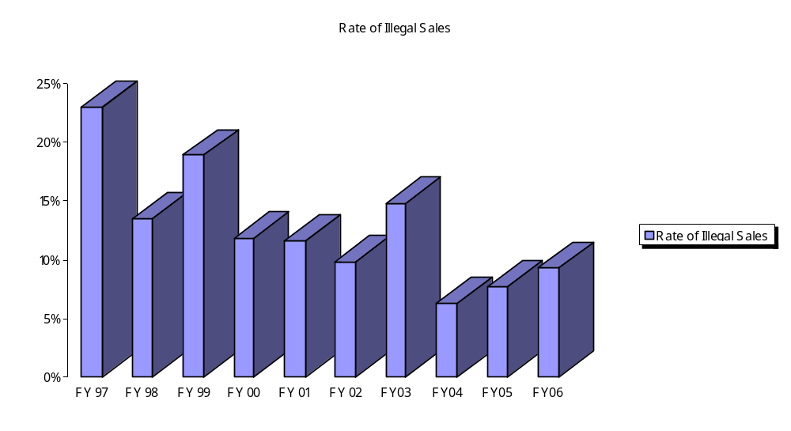
Successful implementation of the Synar Amendment is important for three reasons. First, it facilitates the reduction of both current and future health problems among adolescents by reducing retail access to tobacco products. Second, compliance with the law is consistent with the public’s support of measures to prevent the use of tobacco by young people and, specifically, efforts to discourage tobacco sales to minors. Third, Synar is an example of a highly effective environmental prevention effort that addresses policy, enforcement, responsible retail practices, and change in community norms resulting in the long-term restricted access to a very potent gateway drug.

The Synar effort consists of four major initiatives. They are as follows:

1. The Behavioral Health Services Division (BHSD) contracted with community programs in FY 2006 and will continue to work with those programs in FY 2007 to conduct tobacco merchant education. Contractors are required to collaborate with law enforcement, local coalitions and other tobacco control groups to enhance efforts at reducing youth access to tobacco. BHSD provides training in all aspects of the Synar initiative to law-enforcement agencies and to community based programs and contractors.
2. BHSD continues a partnership with the New Mexico Department of Public Safety to train Special Investigations Division (SID) agents to conduct consummated buy operations that result in citations to the selling clerk. Extensive law-enforcement efforts assist in keeping the rate of sales of tobacco to minors below the required 20 percent. (SID also conducts merchant education in those areas of the state where no prevention contractor is present.)

- A non-consummated buy compliance survey is conducted by community programs and SID with a random sample of approximately 25% of all New Mexico youth accessible tobacco outlets to verify the effectiveness of the merchant education and enforcement efforts.

- The non-consummated buy compliance survey is evaluated by an external evaluator to determine the Synar violation rate charted previously. The non-compliance rate is reported to the Federal Substance Abuse and Mental Health Services Administration (SAMHSA) consistent with the Substance Abuse Prevention and Treatment Block Grant requirements. This rate must be maintained at less than 20% or penalties to the Block Grant funding may ensue.

Due to the sustained excellence of the Synar effort, coupled with numerous community and national organizations changing the norms of youth use of tobacco products, New Mexico enjoys one of the lowest sales-to-minors rates in the U.S.A. Responsible retailing is the result of citizens and retailers acting responsibly, enforcement of State law, and organized application of effective prevention policy on behalf of the youth of New Mexico.

