3.3 Personal Hygiene:
Personal hygiene equipment, tools, and supplies
Operation and maintenance of equipment
Personal hygiene procedures
Odor control (sweat, food, organic waste, etc.)
Menstruation management

PERSONAL HYGIENE

This chapter is designed to provide you with a basic understanding of how personal hygiene is managed in spaceflight. Emphasis is placed on understanding the types of equipment and supplies for personal hygiene that are available to crew members and how the crew use and maintain these devices. The chapter will review hygiene procedures, as they differ from terrestrial practices, and you will pay particular attention to odor control, menstruation management, and dental hygiene.

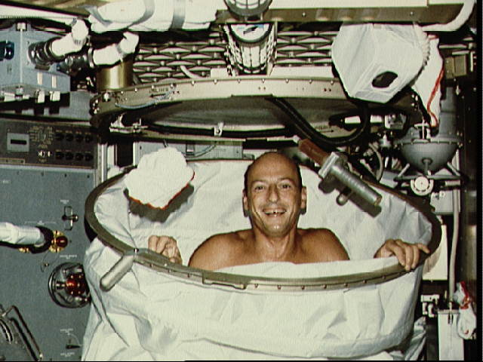
Figure : Pete Conrad makes use of the Skylab shower (http://aerospacescholars.jsc.nasa.gov/HAS/cirr/em/11/11.cfm)

Daily Housekeeping

In order to maintain personal hygiene, the spacecraft itself must also be kept clean. ISS crew usually schedule a 3 hour block of time for cleaning every week. Housekeeping tasks include cleaning the toilet compartment, floors and walls, windows, and air filters, trash collection and disposal, and change out of lithium hydroxide (carbon dioxide absorber) canisters.

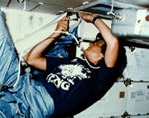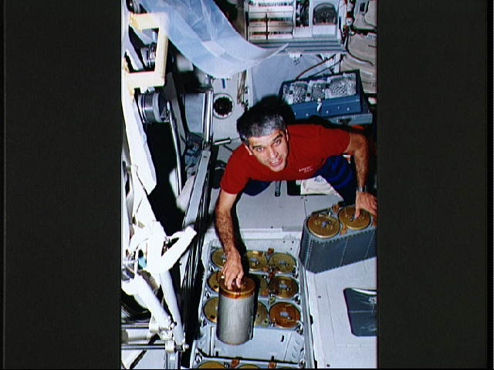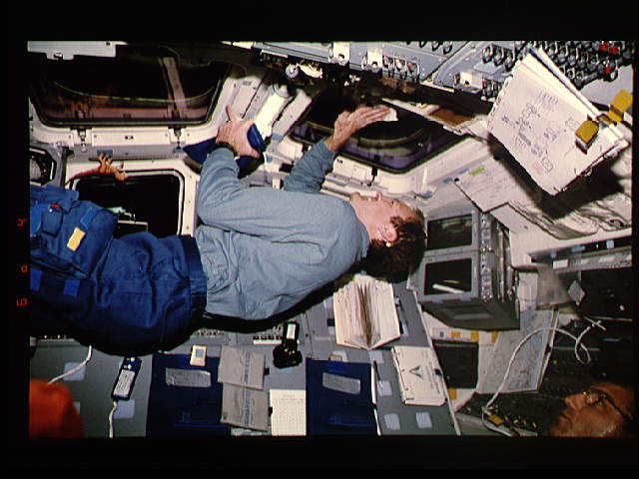
Figure : Astronaut Sally Ride cleans out a Shuttle air filter at top left. At right, astronaut Sidney Gutierrez switches out Shuttle LiOH canisters. Below, Jim Halsell cleans the flight deck windows while Carl Walz (bottom right of image) and a toy dinosaur (top left) supervise.

The materials and equipment for cleaning operations include biocidal cleanser, disposable gloves, general purpose wipes, and a vacuum cleaner. The biocidal cleaner is a lotion-type detergent with a built-in dispenser. The cleanser is squirted on the surface to be cleaned and wiped off with dry general purpose wipes. Crewmembers are instructed to wear disposable plastic gloves while using the biocidal cleanser.
The cleanser is used for periodic cleaning of the toilet area, dining area, silverware and trays after each meal and to clean walls and floors. Because there is no sink or dishwasher, all washing of kitchen items must be done with wet wipes. Although this might lead to concerns about hygiene issues and transmission of disease, on current spacecraft, most items (food trays, drink pouches, etc) are disposable. Only the utensils are reused. Knives, forks, and spoons are cleaned with a wipe and stored for the next meal. This is acceptable for missions in low earth orbit, but on longer duration missions, this amount of disposable items will be prohibitive, and more kitchen items will have to be reused, once again raising the issue of proper hygiene to prevent outbreaks of illness.

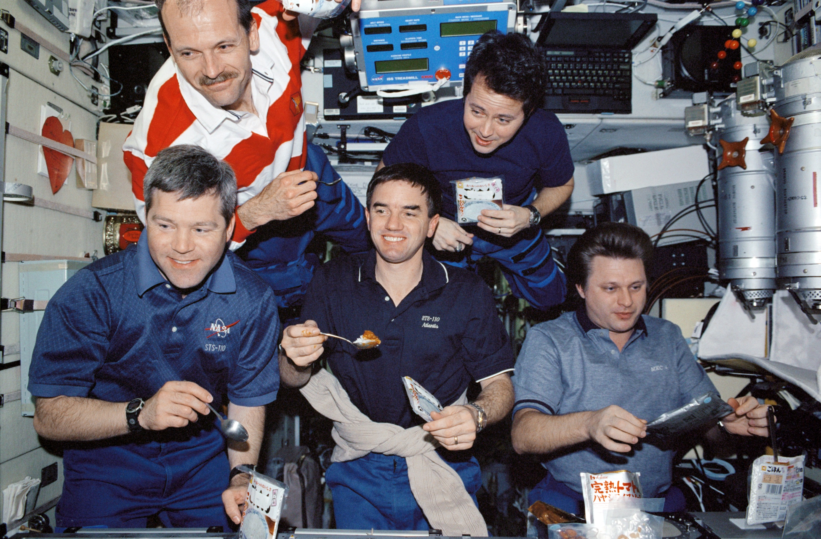
Figure : Mealtime aboard the ISS. Note the reusable utensils and the disposable food pouches.

A “dustbuster”-style vacuum cleaner is provided for general housekeeping and to clean the air filters inside the crew compartment area. It has a normal hose, an extension hose, several attachments, and a muffler to reduce noise, and it is powered by the orbiter’s DC power system. The vacuum cleaner is also used to "catch" free-floating objects when accidentally released, particularly small objects that float behind a panel or locker.

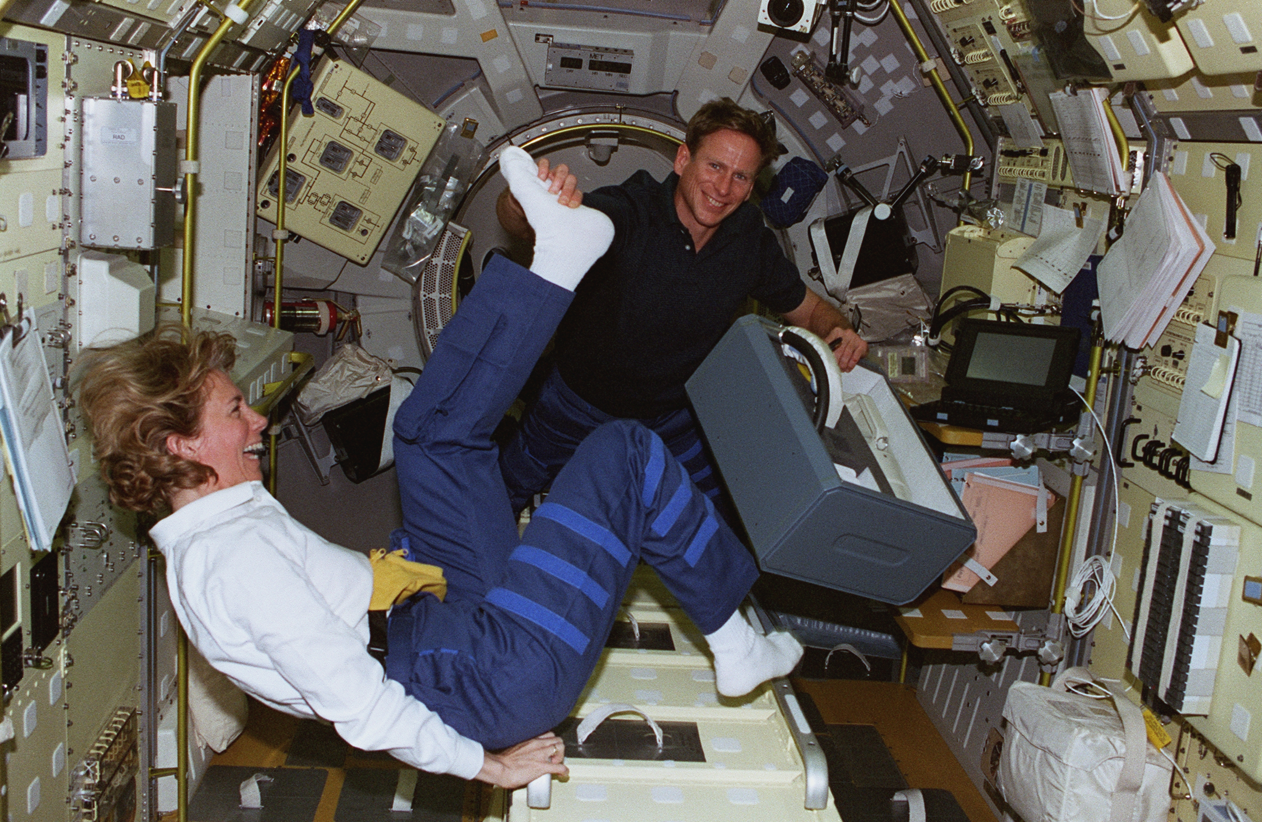
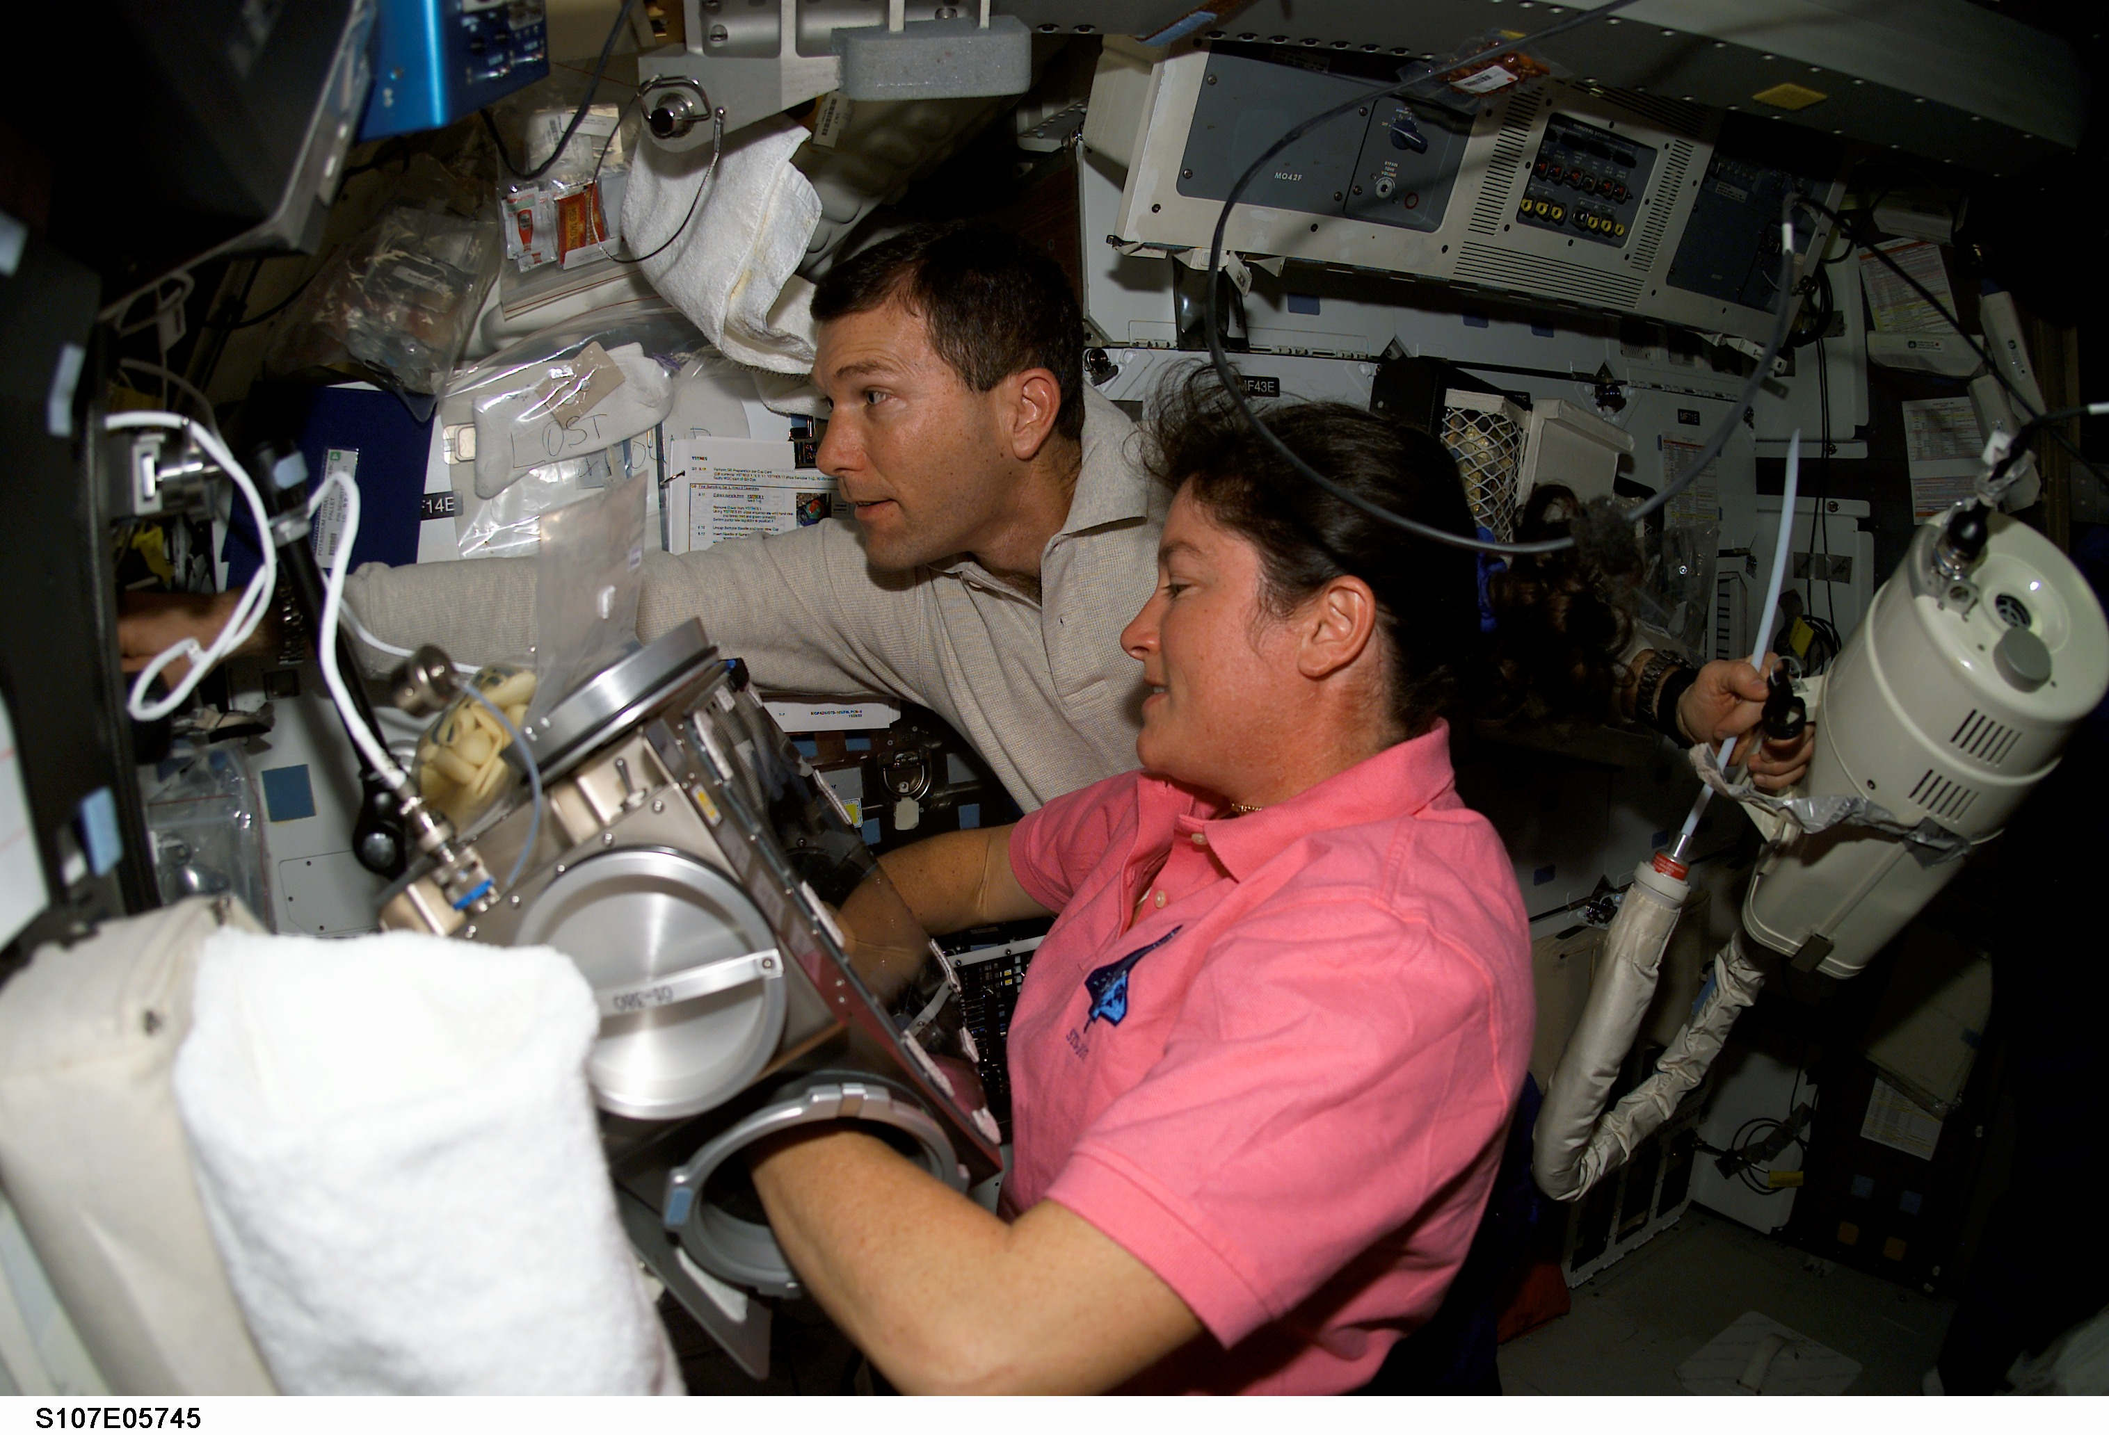
Figure : Top, Astronaut Mike Gearnhardt tickles colleague Susan Still’s foot with his right hand while transporting the vacuum cleaner container in his left. Bottom, Rick Husband holds the vacuum cleaner in his left hand while reaching past Laurel Clark on the Shuttle middeck.

Personal hygiene equipment, tools, and supplies

Each astronaut has his or her own personal hygiene kit (PHK), which is stocked with soap, moistened wipes, toothpaste and toothbrush, comb, hairbrush, shampoo, razor, and nail care items. Crewmembers may add any additional personal items they choose, and they also select most of the PHK contents based on their own preferences, from toothpaste brand to type of razor.
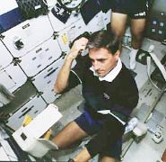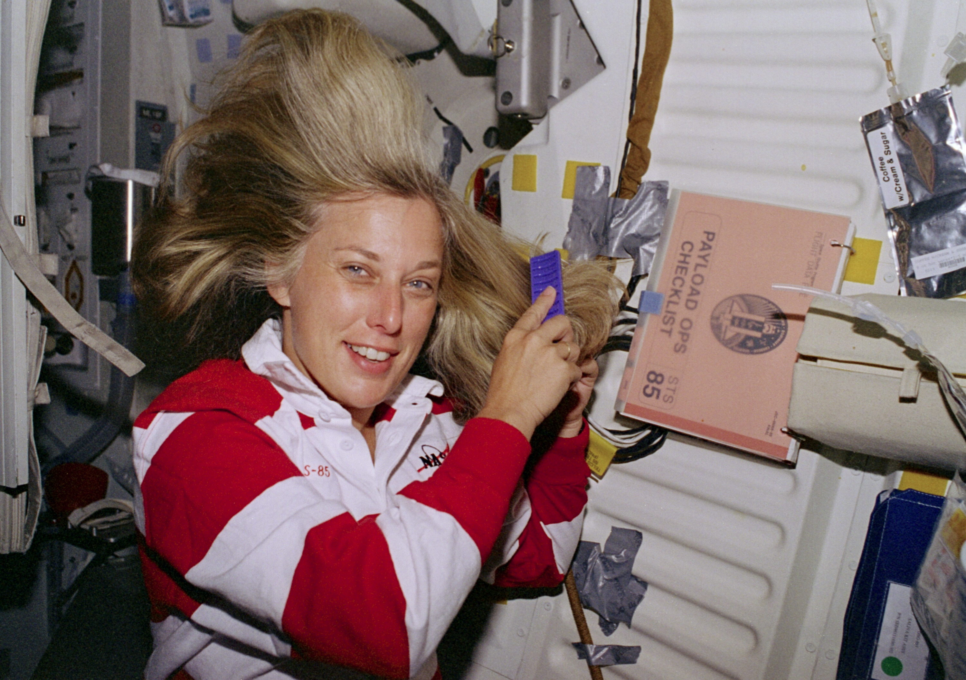
Figure : Astronauts Don Thomas and Jan Davis attend to their hair on the Shuttle

Other equipment that crewmembers use for hygiene purposes include the toilet (See lesson on Waste Management), mirror, towels, and washcloths. Sometimes, other equipment is pressed into service when needed, such as using the vacuum cleaner to catch stray hairs during a haircut.

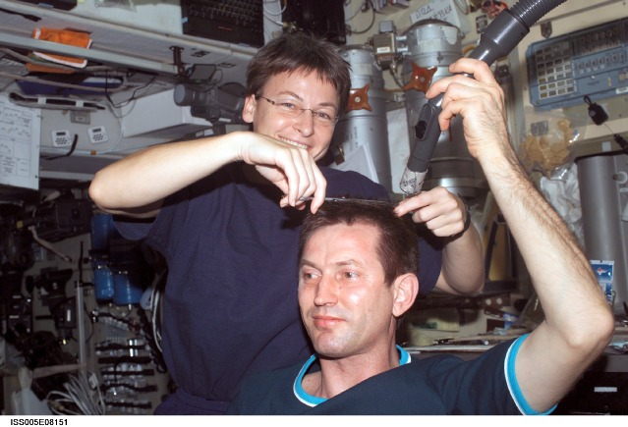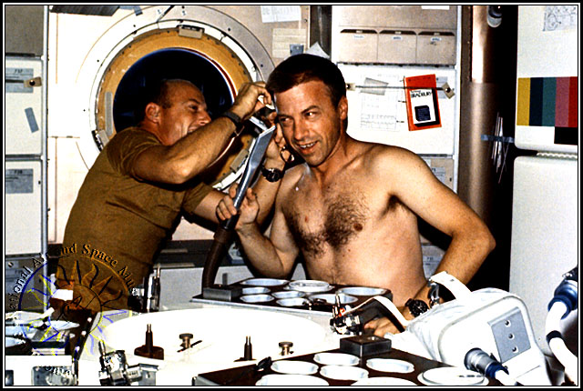
Figure : ISS crewmembers continue the tradition of inflight haircuts begun on Skylab. Note how in both cases the vacuum hose is held nearby to capture stray hairs. (http://www.hrw.com/science/si-science/earth/spacetravel/spacerace/SpaceRace/sec500/sec510.html)

Crew also use “urine collection devices” during EVA’s. Male astronauts wear a pouch-like device similar to a condom catheter, while women wear “Disposable Absorption and Containment Trunks”, a pair of multi-layered shorts that contain an absorptive powder. Each device has a storage capacity of roughly a liter of fluid. Crew also wear urine collection garments (like adult diapers) underneath their launch and entry suits, since the Shuttle toilet is unavailable for use during those phases of flight (and even if it were available, the crew cannot easily doff the ACES suits).

During exploration class missions to other planetary bodies, such as the Moon and Mars, it is likely that more equipment will be needed, as in addition to all the issues raised by an orbital mission, a flight to another world will include activities that raise the possibility of contamination. Moon dust, Mars rocks, even the (remote) possibility of extra-terrestrial micro-organisms, will need to be addressed, and systems developed to prevent these substances from contaminating the crew’s habitation module(s).

The number of EVA’s will likely be very high in these missions, and that will increase the risk of a contamination of the cabin environment. Even in the absence of foreign substances, extravehicular activities, whether on another world or simply outside the ISS, risk bringing contaminants back “inside” with them. On these extremely long duration missions, the risk of “internal” contamination – hygienic problems inside the spaceship due to bacterial overgrowth – is also greater than on the short duration Shuttle flights. As a result, crews on these missions, and their flight surgeons, will have to be particularly vigilant in ensuring that their spacecraft interior remains safe and healthy, both from exogenous toxic compounds and from any internal buildup of bacteria within the habitation modules.

Personal hygiene procedures

Washing

Because perspiration doesn't roll off their bodies the way it does on Earth, when astronauts sweat, the droplets stick to the skin and form thicker and thicker layers. Ventilation helps evaporate some of the sweat during exercise or on EVA’s, but in the absence of an onboard shower, astronauts clean their bodies with wet wipes that are pre-moistened with soap and water. Astronauts on Mir and Skylab had showers, but they were difficult to use, required a great deal of time to set up and operate, and the water tended to “escape”. In addition, the astronauts still had to smear a layer of water onto their bodies, so it wasn’t that different from using washcloths as the current astronauts do.

A rinseless body bath solution is stored in standard drink pouches. Crew add warm water to the pouches before use then perform a modified sponge bath with washcloths. Waste water from bathing is either captured and sent to the wastewater tank or blotted up by towels which can then be allowed to air dry in the cabin. Because of the difficulties associated with hair washing, as well as the problems posed by stray hairs floating about the cabin, many crewmembers, particularly those on long duration missions, prefer to keep their hair short (though there are notable exceptions).

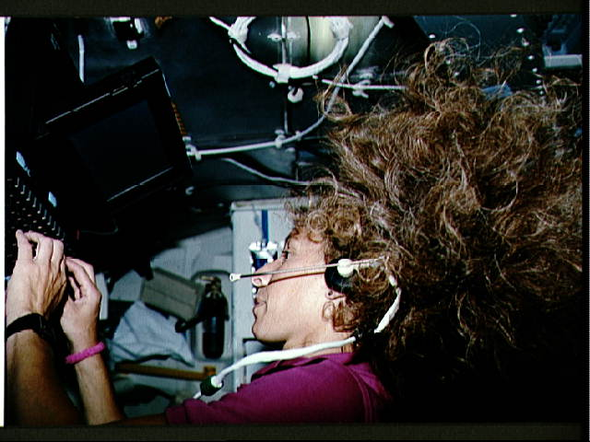
Figure : Astronaut Marsha Ivins with her trademark hair.

Hair care
Astronauts wash their hair with a rinseless shampoo originally designed for bedridden hospital patients. Crewmembers first wet their hair with water, then apply the rinseless shampoo. The hair is scrubbed carefully to avoid flinging water drops throughout the cabin, then dried with a towel. Blow drying is not an option on orbit – crewmembers must wait for their hair to air dry. Generally the cabin humidity is held around 60%, which allows relatively rapid drying, though it does put an additional strain on the humidity control system.

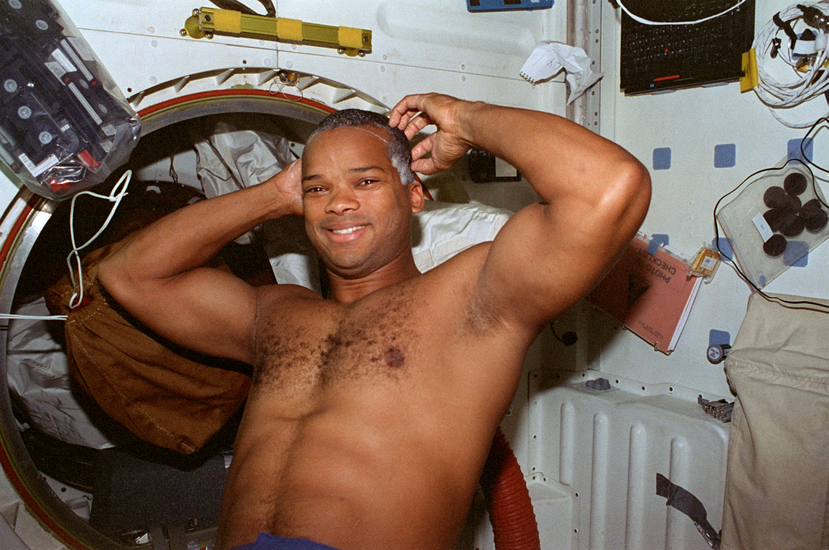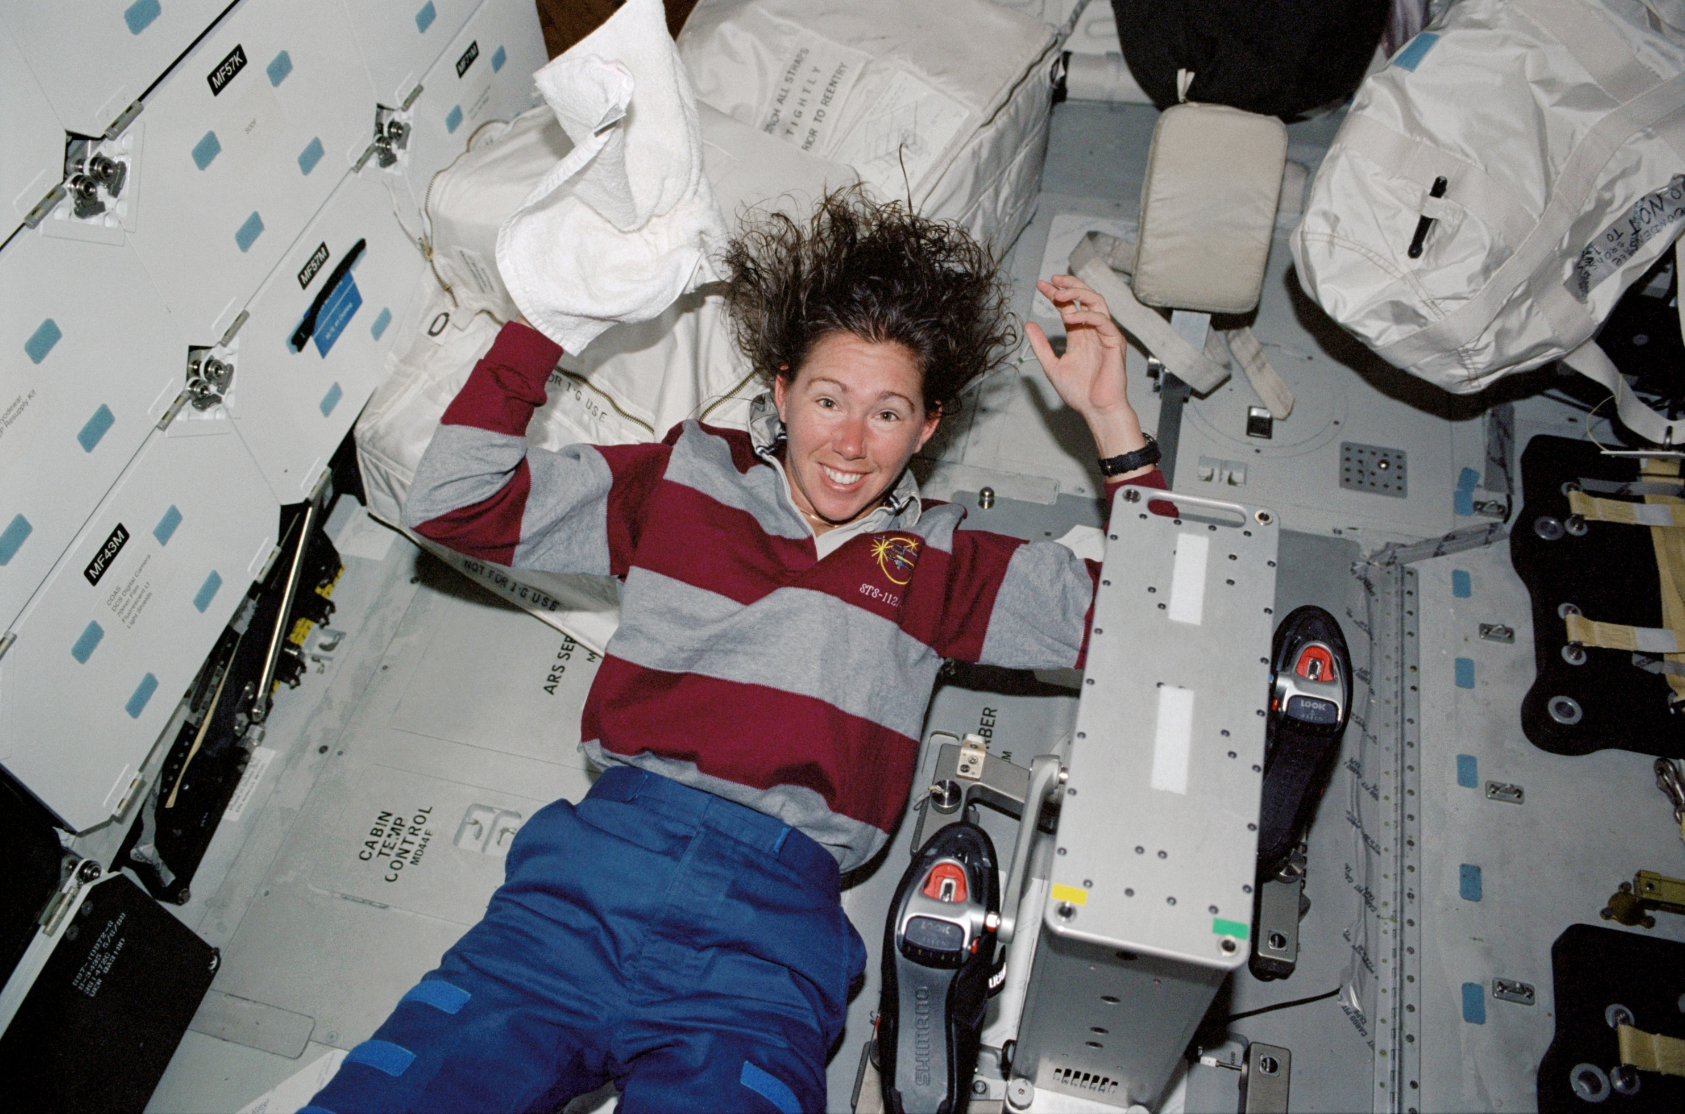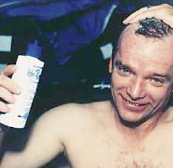
Figure : Astronauts Bob Curbeam, Sandra Magnus, and Charlie Precourt wash their hair on the Shuttle with the rinseless shampoo.

Not all astronauts find the above procedure effective, however. As Susan Still reported:

“Washing my hair in space was a challenge. There is no shower on the Shuttle, and without the help of gravity, it's difficult to contain water and soap. It took me several days to really get the hang of washing my hair and really getting it clean. Astronauts use a shampoo that was designed for people that are confined to the bed and unable to go to the shower. The shampoo does not require rinsing out. Although it's a great concept, I didn't find it worked too well. If I didn't rinse the shampoo out, my hair was very heavy and felt dirty. “So, I ended up washing my hair much like I do at home. I would fill up one of our drink bags with warm water and use that to wet my hair down. I held a towel over my head while I carefully squeezed water out of the drink bag into my hair. Once my hair was wet, I'd carefully squeeze shampoo onto my hair and slowly work up a lather. I found that if I didn't get a lather, I didn't get clean hair. The tricky part came trying to rinse the shampoo out. I once again used the drink bag to squeeze water onto my hair and with the help of my towel was able to slowly get the shampoo out. Then I'd use my new daily towel to dry my hair a little. The dry air in the shuttle allowed for very quick drying of my hair. I would typically wash my hair after my daily exercise and the entire process took about 10 minutes. Of course, without the help of gravity, there was no controlling my hair once it was washed.” (http://lsda.jsc.nasa.gov/kids/L&W/still.htm)

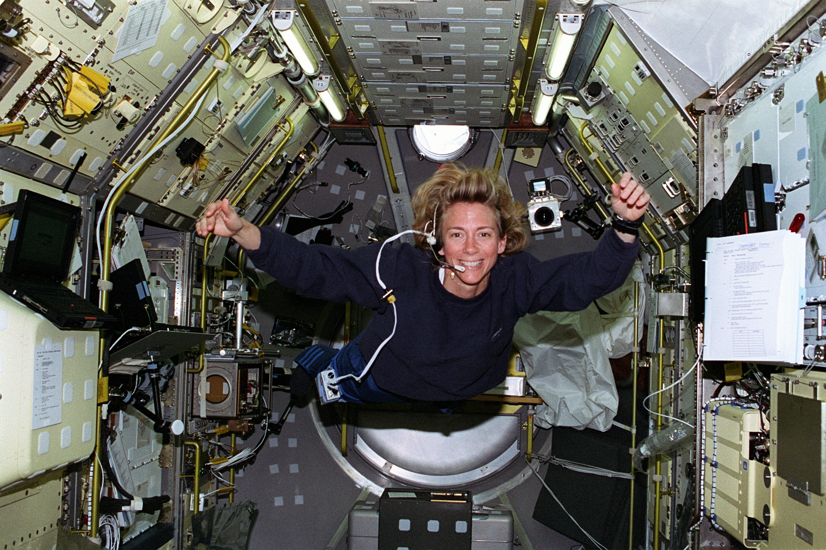
Figure : Susan Still devised an alternate method of washing her hair in microgravity

Dental hygiene

For their dental hygiene, astronauts use commercial toothpaste and toothbrushes. In weightlessness, salivation becomes more concentrated, which can lead to more tartar forming on the teeth. To compensate, many astronauts chew gum and massage their gums. There has been some discussion about using newer power toothbrushes, such as Sonicare, on long duration missions, as they seem more effective against plaque buildup than manual toothbrushes, but so far this has not proceeded beyond the research arena. The major difference between brushing the teeth on Earth and in space is that astronauts must either swallow their toothpaste or spit it into a tissue.

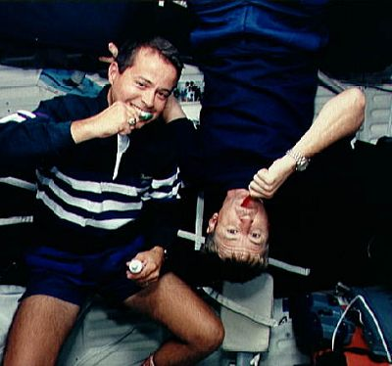
Figure : Keeping teeth bright and shiny aboard the ISS.
Shaving
Most male astronauts prefer to shave rather than allow their beards to grow, though some Skylab 4 crew members did just that.

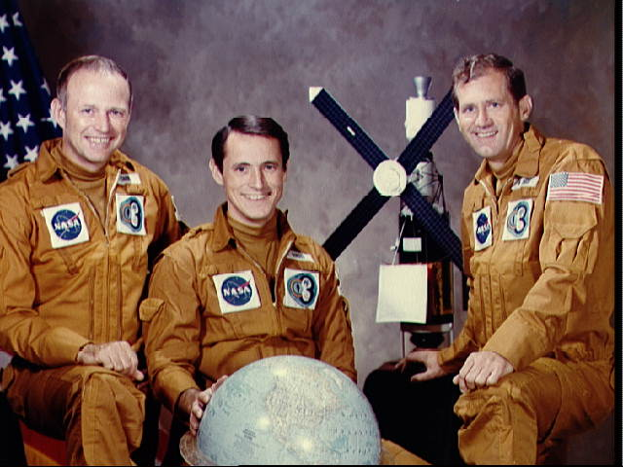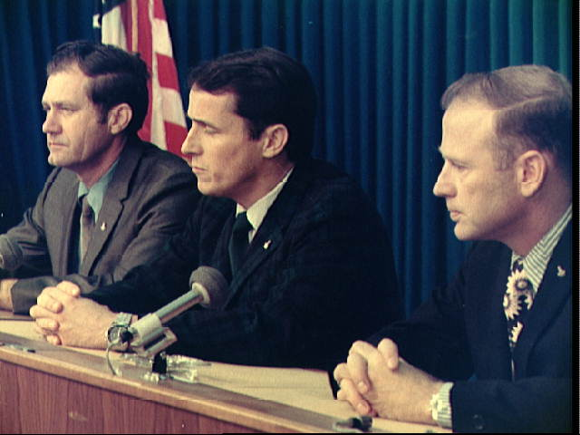
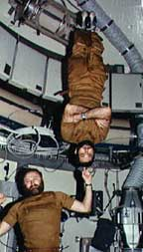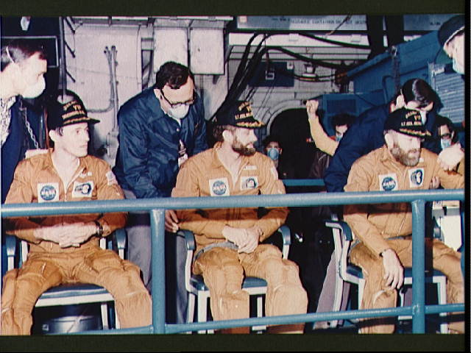
Figure : Top left, Skylab 4 astronauts (left to right) Carr, Gibson, and Pogue, in their official preflight crew portrait and at a pre-flight press conference. Both Carr and Pogue let their beards grow during the mission. They are shown on Skylab (bottom left) and immediately following return to Earth, aboard the USS New Orleans (bottom right) (http://images.jsc.nasa.gov/lores/SL4-150-5080.jpg)

Generally, electric razors are preferred over safety razors and shaving cream, simply for ease of use when running water is not available.

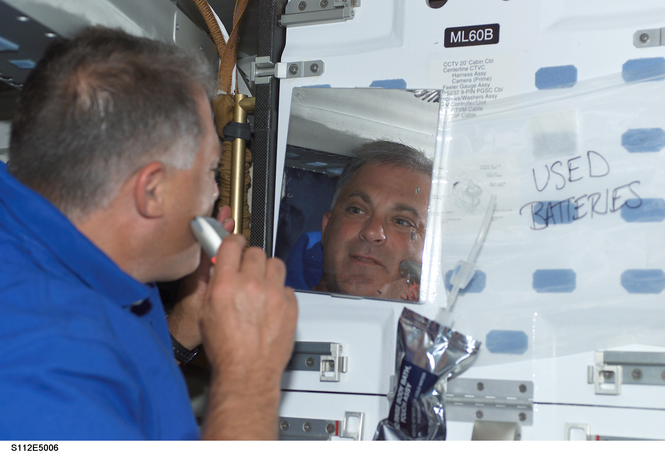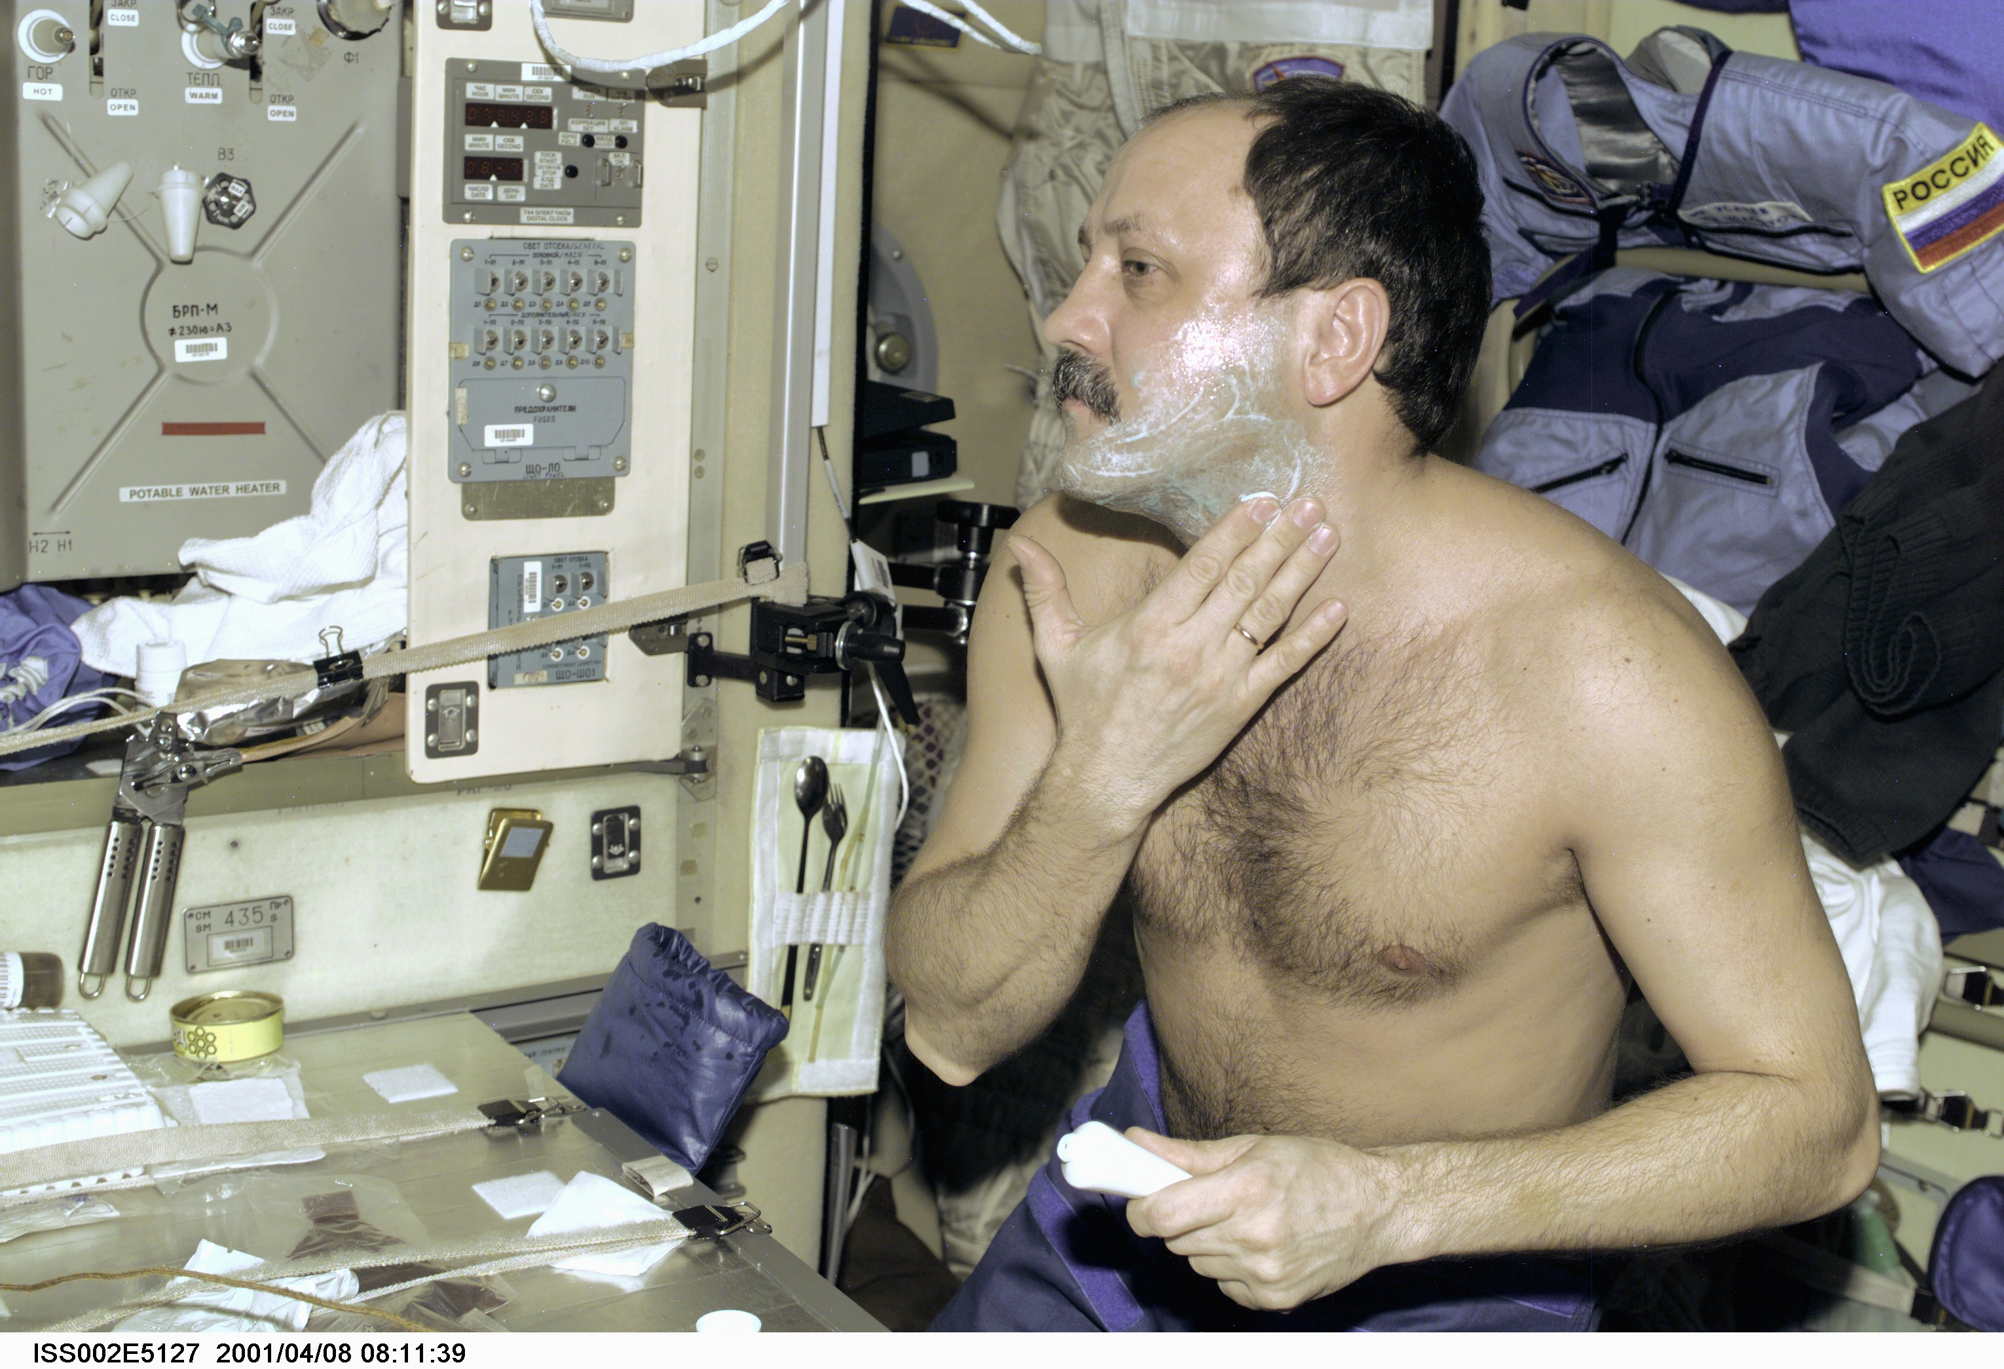
Figure: Astronaut Dave Wolf shaves aboard the Shuttle and Yuri Usachev aboard the ISS.

Menstruation management

Generally speaking, pre-menopausal female crewmembers use pharmacological agents to suppress menstruation on orbit. For short duration Shuttle crewmembers, it can be as simple as juggling the placebo week of oral contraceptives, delaying their periods until the mission is over. For ISS missions, however, female astronauts often turn to longer acting medications, such as Depo-Provera, in order to avoid menses altogether. The alternative, using pads or tampons, creates an additional burden, namely dealing with contaminated waste. In addition, on long duration missions, there exists a risk of running out of such supplies.

Odor control

Given the confined nature of spacecraft, and the inability to “open a window” in the event of an unpleasant odor, the environmental control system needs to be able to remove odors quickly and efficiently. As described in the lesson on “Cabin Environment and EVA Environment”, cabin air is circulated through charcoal canisters to remove odors. This system is generally adequate, though most space travelers acknowledge certain characteristic odors that develop over time. There are also cultural aspects of hygiene that have not thus far been a problem but may become more important in the future as mission become longer and/or space tourists increase the number and diversity of space travelers.

Sources for odor on spacecraft include payload experiments, food (including refuse), human waste (see waste management lesson for how these are handled), and humans themselves. Crew follow a daily exercise program to minimize bone and muscle atrophy in the microgravity environment, and sweat and body odor can be generated. In addition, flatulence can be much harder to hide in the closed environment of a spacecraft. To date, there have been very few cases of illness contributing significantly to the odor burden on board, though the risk exists. Any other gastrointestinal illness, from a minor attack of diarrhea to a severe case of food poisoning, would certainly create an extremely unpleasant environment, as would any case of incontinence. In the event of a serious illness or injury, where the patient loses the ability to care for him- or herself, it may be very difficult for the other crewmember(s) to provide adequate assistance in keeping the patient clean and free of vomitus, sputum, blood, urine, and stool. In addition to the obvious health concerns this would raise – for the entire crew, and not just the patient – the odors generated would likely be quite offensive.

PERSONAL HYGIENE

References and Suggested Readings

1) DeHart, RL and Davis, JR. (Eds.). (2002). Fundamentals of Aerospace Medicine, 3rd Edition. Philadelphia: Lippincott Williams & Wilkins.

2) “Life in Zero-G: Space Hygiene”, http://aerospacescholars.jsc.nasa.gov/HAS/cirr/ss/2/9.cfm

3) Clement, G. (2003). Fundamentals of Space Medicine. Space Technology Library. El Segundo: Microcosm Press.

4) Harding, R. (1989). Survival in Space. London: Routlege.
Office.

5) “Living and Working in Space”, http://www.spacelink.msfc.nasa.gov/Instructional.Materials/Curriculum.Support/Life.Science/Living.and.Working.in.Space/.index.html

6) “Meeting the Personal Needs of the Human in Space”, http://www.nsbri.org/HumanPhysSpace/focus1/spaceshuttle-personal.html

7) Stine GH. (1997). Living in Space: A Handbook for Work and Exploration Stations Beyond the Earth’s Atmosphere. New York: M. Evans and Company.

8) “Donning a Spacesuit”, http://www.space.gc.ca/asc/eng/youth_educators/educators/resources/packages/spacesuit-donning.asp

9) “Hygiene in Space” http://64.233.161.104/search?q=cache:KQZWYwhdcyEJ:media.nasaexplores.com/lessons/02-068/5-8_1.pdf+astronaut+hygiene&hl=en

10) “Personal Hygiene”, http://lsda.jsc.nasa.gov/kids/L&W/hygiene.htm

11) Larson WJ and Pranke LK (Eds.). (1999). Human Spaceflight: Mission Analysis and Design. New York: McGraw Hill.

Cleaning air filters is critical, as in the microgravity environment, most particulate matter will end up against them, from lint to nail clippings to stray M&M’s, blown there by the ventilation system.
As when an EVA crewmember became covered in ammonia during a spacewalk outside the ISS in February 2001. (http://www-pao.ksc.nasa.gov/kscpao/shuttle/summaries/sts98/98highlights.htm)
There is no truly hot water available on orbit.
Nail clippings can also pose a problem. They can be inhalation hazards as well as having the potential to cause corneal abrasions.
Go to http://spaceflight.nasa.gov/living/spacehygiene/hygiene_1.html for a video of Pam Melroy washing her hair in space
Tolerance for body odor, for example, or frequency of bathing.

