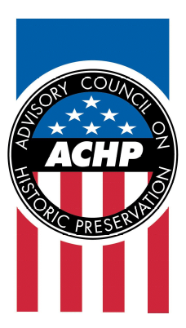

February 29, 2008 Contact: Bruce J. Milhans
For Immediate Release Office: 202-606-8513
bmilhans@achp.gov

Preserving America’s Heritage

TREASURY BUILDING RESTORATION AND MODERNIZATION receives
chairman’s Award for Federal Achievement in Historic Preservation
Treasury Historical Association Shares Recognition with U.S. Department of the Treasury

WASHINGTON, D.C.—The U.S. Department of the Treasury received the Chairman’s Award for Federal Achievement in Historic Preservation today for the historic restoration and appropriate modernization of the Treasury Building, a National Historic Landmark that is considered to be the third oldest federal structure in the nation’s capital after the White House and Capitol.

The Treasury Historical Association, an affiliated non-profit organization that educates and assists the Treasury Department with historic preservation, received a partnership commendation for its active participation, including funding for key restoration projects in the Treasury Building.

The award was presented to the Department of the Treasury during the Advisory Council on Historic Preservation (ACHP) winter business meeting, which was held in the richly historic Cash Room of the Treasury Department at 1500 Pennsylvania Avenue, NW.

“Under the National Historic Preservation Act, all federal agencies must consider how historic resources in their keeping should be treated for the benefit of the American people. The Department of the Treasury and the Treasury Historical Association did an outstanding job of not only preserving the structure but relating the importance of the restored features to the public,” said John L. Nau, III, ACHP chairman. “The project was both an exemplary and practical solution in full keeping with the intent and spirit of the President’s Executive Order 13287, Preserve America.”

The Treasury Building, which dates from 1836 to 1869 and which replaced earlier structures, suffered extensive damage in a 1996 roofing fire. From that setback, Treasury resolved to respond by markedly improving upon its initial efforts and comprehensively restoring and modernizing the structure. From that determination sprang such discoveries as the only known example of a triple dome cast iron ceiling in the country and the appropriate conservation of historic rooms and features. While congressional budgeting authorization provided for most of the necessary modernization work, conservation and restoration efforts were assisted by donations from the Treasury Historical Association, which engaged in dedicated fund-raising campaigns.

The ACHP, an independent federal agency, promotes the preservation, enhancement, and productive use of the nation’s historic resources and advises the President and Congress on national historic preservation policy. It also provides a forum for influencing federal activities, programs, and policies that impact historic properties. In addition, the ACHP has a key role in carrying out the Administration’s Preserve America initiative. Visit www.achp.gov for more information.

—end—

