The Council on Governmental Relations

Report

of the Working Group

on

The Cost of Doing Business

June 2, 2003

Council on Governmental Relations
1200 New York Avenue, N.W., Suite 320, Washington D.C. 20005
(202)289-6655/(202)289-6698(FAX)

EXECUTIVE SUMMARY

Growing requirements related to the conduct of federally funded research are increasing compliance costs. At the same time, the administrative component of the facilities and administrative (F&A) rate is capped at a level that is too low to permit the full recovery of actual F&A expenses. Under-recovery of costs due to the cap for all universities for FY 2000 is estimated to be about $200 million. An even larger under-recovery of F&A costs results from various agency policies and statutes that limit reimbursement to 75 to 80 percent of the full negotiated F&A rate. For FY 2000, under recovery due to these agency practices is estimated to be about $ 1 billion for all universities. A recent study of facilities and administrative costs at universities estimated that the total under-recovery is between $0.7 billion and $1.5 billion. These circumstances have led to the increasing diversion of university funds away from research to pay for compliance costs.

This study examines the incremental compliance costs associated with recently enacted federal regulations, as incurred or estimated for the period 2000-2005. It also addresses the costs of new business systems implemented by universities to more economically and efficiently operate the research enterprise. To do this, the report identifies new business practices that have been established in response to either increased oversight of existing federal requirements or which respond to new federal policies or regulatory requirements. Only incremental costs unrelated to ongoing operations and practices were considered.

The twenty-five institutions in this study estimate that they will spend approximately $411 million, or $16.5 million per institution on average on incremental compliance activities during the period 2000-05. Moreover, 24 of these 25 institutions already have administrative costs that exceed the 26 percent cap implemented by OMB in 1991 and made effective in 1993. These circumstances require the institutions to expend increasing amounts of institutional funds to support compliance infrastructure.

Compliance costs are escalating rapidly over time. Average incremental expenditures range from approximately $1.8 million per institution in 2000 to approximately $4.1 million of projected expenditures per institution in 2005. The $411 million in expenditures represent new costs that are clearly over and above routine operating costs that already include considerable monies spent on compliance. The estimated level of incremental compliance-related expenditures is $1.2 billion for the top 100 research institutions when extrapolated from this sample of 25 institutions.

Many of the sample universities report significant expenditures for expanded requirements in existing regulations such as human subjects protection systems, conflicts of interest, disposal of hazardous waste, increased monitoring of health and safety requirements in laboratories, Medicare billing and compliance, and research space studies. In addition, significant expenditures were reported for new regulations, such as Health Insurance Portability and Accountability Act (HIPAA), Patriot Act and Homeland Security, bioterrorism controls and training in the responsible conduct of research.

Continued increases in these substantial compliance costs cannot be borne by the universities without impairing the research enterprise. At the same time the universities recognize the need for compliance programs that address valid societal concerns. To balance these competing demands, a new, comprehensive strategy for dealing with compliance costs is necessary. Such a strategy would include the identification and elimination of unnecessary regulatory burdens, the streamlining of compliance programs by the adoption of new business models, and the government’s acceptance of its responsibilities to pay its fair share for new requirements that currently constitute unfunded mandates, especially for actions related to the common defense and security. By identifying the sources of these increasing compliance costs, this report is a first step towards developing such a strategy.

I. INTRODUCTION

U.S. universities that conduct federally funded research are required to establish substantial infrastructure and administrative support systems to satisfy a broad range of compliance requirements. The development and maintenance of these systems requires the commitment of substantial resources that are integral to creating a proper and effective research environment. Although some compliance costs are reimbursed as part of the Federal support for research, costs associated with new regulatory requirements and business practices established in the past decade have increased substantially above reimbursements, resulting in great financial strain on universities. Such costs are expected to increase further as new regulations and policies are implemented for additional protections for human research participants, individual and institutional conflicts of interest, training in responsible conduct of research, and safeguarding of select biological agents. This increasing burden led the Presidents of the Association of American Universities (AAU) to request the Council on Governmental Relations (COGR) to prepare a study on the increasing costs of conducting research. This study examines compliance costs associated with recently enacted Federal regulations, as incurred or estimated for the period 2000-2005. It also addresses the costs of new business systems implemented by universities to improve the economy and efficiency of operating the research enterprise.

- Developments During the Past Decade

Since the early 1990s, the federal government’s expectations and requirements have risen significantly with respect to formal, verifiable education and compliance monitoring for faculty and staff involved in the research enterprise. A variety of reports have documented the resulting administrative burdens for universities. These reports show that colleges and universities are required to cope with a large variety of new expectations. Revised regulations, policies or guidance cover the gamut of research administration and compliance from electronic applications, financial management, protection of humans and animals, conflicts of interest, intellectual property, laboratory security, and interaction with non-U.S. scientists. As these requirements continued to increase, universities expressed growing concern about their ability to meet these new requirements and expectations.

For example, a December 1992 report to the Federal Coordinating Council for Science, Engineering and Technology (FCCSET) noted:

Public expectations have increased with respect to universities’ fulfillment of their fundamental responsibilities for education and stewardship of public resources. Increasingly, the conduct of research also raises a variety of legal, social and ethical issues, including scientific misconduct and conflict of interest. In response to these concerns, university activities have become subject to a wide variety of administrative requirements on expenditures of Federal funds and certification of compliance with Federal statutes. Since these Federal requirements can be expected to increase, their cumulative burden on research-intensive universities, as well as their interaction with state and local government policies, need to be better understood.

A 2000 RAND report concluded that overall, the research partnership between the federal government and universities is praised for its contribution to the public welfare. However, RAND estimated that universities under-recover between 10 and 30 percent of the facilities and administrative expenses associated with federal projects, because of various limitations on federal facility and administrative (F&A) cost reimbursement established in agency policies or by statute. The RAND report estimates the total amount of this under-recovery to be $750 million to $1.5 billion annually – and this is in addition to the estimated $5 billion universities already provide in direct support of research.

B. Summary of First COGR Study

COGR’s first study of the shortfall in recovering compliance costs focused on the costs to comply with greatly expanded requirements for human research participant protection. Twenty universities participated. COGR found:

- During the period 1995 to 2000, costs related to human subjects protection increased an average of 176 percent, or 23 percent annually. This did not include the costs to develop and conduct training in human subjects protection, estimated by several large universities to be over $500,000.

- These increased costs are part of the administrative component of facilities and administrative rates.

- Because all but one of the twenty universities are at or above the 26 percent cap on administrative costs, these increased costs are borne totally by the university.

- Under-recovery of costs due to the 26 percent cap for the 20 universities in FY 2000 is estimated to be over $46 million, or $2.3 million per institution on average. Under-recovery for all universities due to the cap for FY 2000 was estimated to be about $200 million.

Compounding the short-fall in recovery due to the cap are various agency policies that limit reimbursement of such costs or that “encourage” cost sharing, which often result in a reduction of the F&A rate. For example, the NIH limits F&A payments on career and training grants to 8 percent; NSF often negotiates award amounts with researchers, seeking a reduction that will not affect the scope of scientific work proposed; and USDA has a statutory limit of 19 percent on competitive awards. For the 20 universities, under-recovery due to such agency practices in FY 2000 was estimated to be over $112 million, or $5.6 million per institution on average. For all universities, under-recovery due to these agency practices was estimated to be about $1 billion.

Based on the results of this first analysis, the AAU Presidents asked COGR to expand its review to cover a much broader range of new research business practices implemented either as a direct result of new or greatly expanded federal mandates, or to improve the management of the university’s research enterprise. This study attempts to provide such data.
II. METHODOLOGY:

To provide the factual basis for developing policy alternatives for addressing escalating compliance costs, a study was designed to identify the detailed contributors to the increases in compliance costs. A Working Group was established.

The Working Group Charter called for 1) an inventory of new university business practices or enhancements to existing practices established in response to Federal compliance requirements within the last five years and 2) a delineation of the nature and costs of these initiatives in at least 20 institutions.

Scope
The Working Group endeavored to develop an inventory of new business practices that had been established in response to Federal compliance requirements. These new business initiatives could be in response to either increased oversight of existing requirements, (e.g. the protection of human subjects) or in response to new regulatory or policy requirements (e.g. the Health Insurance Portability and Accountability Act (HIPAA)).

The Working Group determined it would identify the incremental costs associated with the initiatives to the extent possible. The Working Group understood that some initiatives are implemented within existing staff resources and it is difficult to identify discrete costs in those cases. In the interest of conservatism, the Working Group instructed respondents to exclude items from their calculations of incremental costs unless the related costs were clearly distinguishable from on-going operations and practices. (See Incremental Cost definition)

The Working Group also decided to collect the total facility and administrative (F&A) costs allocated to the management of organized research according to the cost pools established in OMB Circular A-21; for example, depreciation, operations and maintenance, sponsored projects administration, etc. The F&A costs, therefore, could be analyzed over time to observe increases, if any, in the total cost of the research enterprise even if it would be difficult to identify specific causes or explanations.

Finally, respondents were instructed to provide only those costs allocable to Organized Research. Total on-going costs for each pool were provided for contextual purposes only.

Time Frame
The Working Group decided to identify costs for a six-year period from 2000 through 2005 to capture recent compliance initiatives as well as those initiatives planned for the next two years.

Core Group
The principal COGR staff person, the chair of the Working Group and one staff person from the Chair's institution comprised a Core Group to refine the methodology, develop instructions, and design a template for data collection. This group was assisted by Jim Roth and staff from Huron Consulting who provided pro bono support to the study.

Instructions and Template
The instructions and data collection template were refined following the October meeting and sent to the sample institutions for clarification and comment before they were finalized.
The final data collection instrument was sent to the sample institutions on November 17, 2002, and responses were requested by December 23, 2002. The template was structured to capture both the costs of new initiatives and the total F&A costs by cost pool. Institutions were instructed to use their most recent F&A cost study as the base for determining costs for the period requested using a reasonable cost inflator for each year based on actual institutional experience.

Members of the Core Group provided on-going assistance and clarification of questions that arose during the data collection. They arrived at consensus definitions on novel questions and fed those back to the sample institutions to insure consistency in response. An early and very complete institutional response was sent to all participants as an example that served to further clarify and provide consistency of results.

Data Review
The Core Group reviewed institutional responses as received. An individual member of the Core Group contacted the participating institutional representative to clarify any initiatives or costs that appeared to be outliers or that did not fit the data definitions. Costs not fitting the definitions were excluded. They also asked respondents to clarify abbreviations and institutional acronyms. The Core Group conducted one additional conference call, and the institutional representatives met following the COGR meeting in February to clarify data definitions in order to ensure as much consistency as possible. Some institutions refined their data submissions based on these discussions. Final responses were collected through February 2003.

Case Studies
It is always more difficult to implement specific compliance initiatives than financial metrics or FTEs can ever describe. Each compliance activity on campus requires considerable faculty volunteer effort in the initial development of new policy and procedures, and subsequently in the actual implementation. Faculty spend substantial amounts of time without compensation in the review of human subjects, animal protocols, inventorying and labeling chemicals and potentially hazardous materials, and so on. The effort devoted to these activities, no matter how important, means time away from education and research. Likewise, the costs of this volunteer effort are not included in the incremental costs of compliance identified in this report. The implementation of new compliance requirements often requires assembling faculty a variety of departments and disciplines along with staff from an array of central and departmental offices over a long period of time to develop policies and procedures. While the process is often time consuming, it is essential to forge institutional policy and consensus that is so critical to the subsequent implementation. It is not unlike the process in which any other complex organization would have to engage, including federal agencies. We have included case studies that are drawn from actual institutional experiences to illustrate the complexities that are part of the implementation of any compliance initiative. These case studies represent the initiatives that were the most frequently cited during the study period.

Definitions

New Initiative: A new initiative is one that began or would begin during the study period of 2000-2005 in response to applicable federal requirements (See discussion of administrative systems.)

Incremental Cost: An incremental cost is one associated with a new initiative that is clearly over and above previous baseline costs. These costs are in addition to those that were previously expended in support of the activity. These costs do not include the on-going costs of existing staff or resources that were redirected to conduct or participate in the initiative; for example, the salary of an existing staff person who spent time to revise conflict of interest policies did not qualify. However, the costs of establishing a new database to document conflict of interest disclosures and actions did qualify. On-going costs were excluded because of the difficulty of allocating the costs within an institution and consistently collecting these costs across institutions.

Cost pools: OMB Circular A-21 describes the methodology by which institutions must assign facility and administrative expenditures, including compliance activities, to various categories or pools for the purpose of determining indirect costs. These same pools are used for this study.

III. RESULTS:

Sample Institutions
Twenty-five institutions volunteered to participate in this study, including 14 private and 11 public institutions. Twenty-one of these institutions have academic medical centers. Six of the institutions are within the NSF top 10 institutions as ranked by Federally-financed research expenditures, representing approximately $2.5 billion or 66 percent of the expenditures for that group. Twenty-one of the institutions spend over $4.8 billion or 33 percent of all federally-financed research expenditures. Four of the institutions receive less than $50 million of federal research funding annually.

Incremental Costs in All Areas

The twenty-five institutions estimate they will spend approximately $411 million, or $16.5 million per institution on average, during the period 2000-05 on incremental compliance activities. However, 24 of these 25 institutions are above the administrative cap; they are, therefore, expending institutional resources to support their compliance infrastructure.

Graph 1
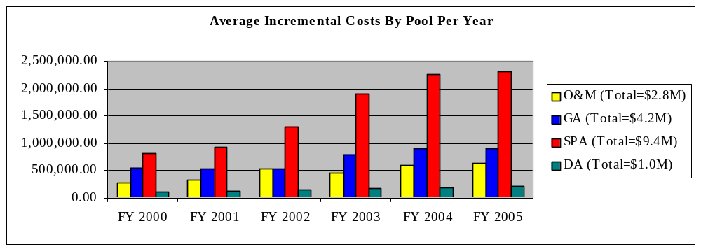

Graph 1 shows that these incremental costs are escalating rapidly over time in all pools. Average expenditures range from approximately $1.8 million per institution in 2000 to approximately $4.1 million of projected expenditures per institution in 2005. The $411 million in expenditures represent new costs that are clearly over and above routine operating costs that already include considerable costs of compliance. As indicated in the Methodology section of this report, respondents were instructed to carefully identify only the new incremental costs of compliance. Extrapolating from this sample of 25 institutions, the estimated level of new, incremental, compliance-related expenditures may range from $1.2 to $1.9 billion for the Top 100 institutions’ federally-financed research expenditures.

Graph 2
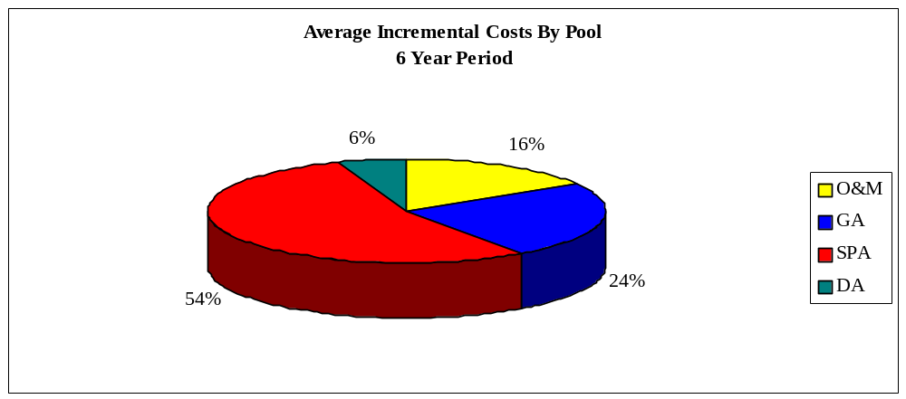

Graph 2 illustrates the relative allocation of costs by pools. SPA costs are the largest component and represent, on average, 54 percent of the incremental costs of compliance over the six-year period.

Graph 3
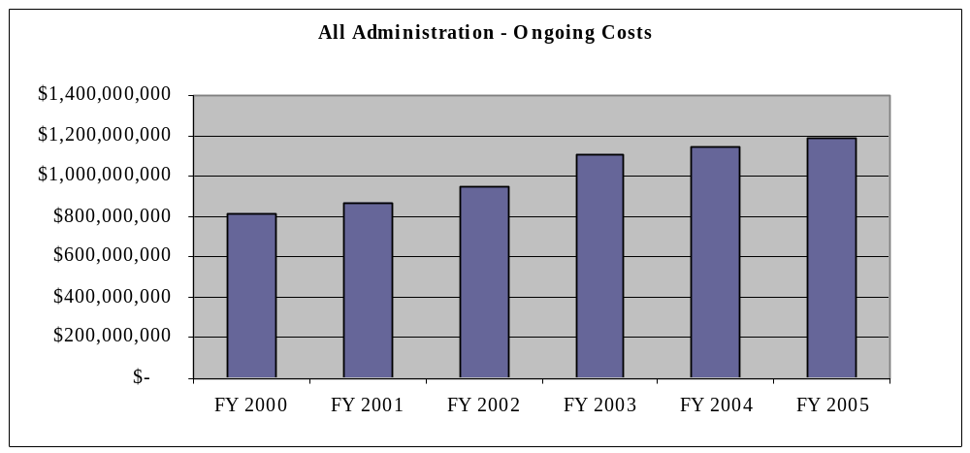

Graph 3 indicates that expenditures within the pooled costs allocated to organized research have also increased dramatically from 2000-2005. Administrative costs (sponsored projects administration, general administrative, and departmental administration) are projected to increase 6.9 percent annually on average over the study period.
Limited Analysis of Administrative Cost Growth vs. Research Base Growth

Increases in administrative costs are not all attributed to the increased costs of compliance; they also reflect inflation and an increase in research volume. It is not possible in the scope of this study to distinguish the effects of increased costs, inflation, and increased volume from one another. Hypothetically, if growth in the organized research base exceeds the growth in the administrative cost pools, institutions would recover more administrative costs and the additional reimbursement would mitigate some of institutional losses due to the 26 percent cap on administrative costs. While it was not feasible to analyze this effect within the total sample, we did perform an analysis of administrative cost recovery among seven sample institutions. Five of the institutions are private and two are public. All seven are within the Top 100. In 2000 the seven institutions lost a total of approximately $34M, or approximately $5M on average based on the projected recovery of administrative costs vs. recovered. This represented a median loss of 12 percent of estimated administrative costs. In 2002, the average loss of administrative costs for the seven universities increased to approximately $43M or approximately $6M on average in spite of an approximately 10 percent increase in the MTDC base. In 2005, the average loss is projected to decrease to approximately $40M or approximately $6M on average, due to about a 6 percent increase in the research base as compared to the forecast increase in administrative expenses. The total estimated loss of administrative expenses for the seven institutions for the study period is $248M. This amounts to an underrecovery of administrative costs of in the range of approximately $1.6B to $3.5B when extrapolated to the Top 100 institutions. Only one institution estimated a positive recovery of administrative costs in one year. In fact, that institution and each of the others lost even more administrative costs than the estimates indicate due to agency and foundation award limitations on indirect costs, as described in the Introduction to this report on page 3.

This analysis underscores a general point. That is, if administrative costs were fixed, an increase in research volume (MTDC base) would increase the recovery of administrative costs and mitigate some of the effect of the cap. In practice, however, this study demonstrates graphically that administrative costs are not fixed. New research compliance requirements are a major factor in driving up administrative costs at a pace equal to or greater than increases in the research base, resulting in greater and greater losses for educational institutions. It is not easy to project what may occur in the near future; however; it may be reasonable to presume that research volume will stabilize since this is the last year of the NIH budget doubling process while compliance requirements may continue to increase. If that is the case, and nothing is done with respect to the 26% cap or agency limits on F&A cost recovery, institutions will lose even more funds.

Assessment of Individual Cost Pools

The sponsored project administration (SPA) cost pool includes research administration costs in general, as well as many compliance activities costs. The SPA cost pool is where most institutions have assigned the costs for the protection of human subjects, conflict of interest, animal welfare, intellectual property and compliance with Bayh-Dole, HIPAA, export controls, compliance offices, tracking of sponsor award terms and salary caps, and so forth. Graph 4 illustrates that on-going expenditures for this cost pool averaged approximately $6 million at each of the sample institutions and increased on average approximately 7 percent annually from 2000-2005. In the same period, incremental SPA expenditures averaged approximately $1.7 million per year among respondents for a dramatic average annual change of 23 percent.

Graph 4
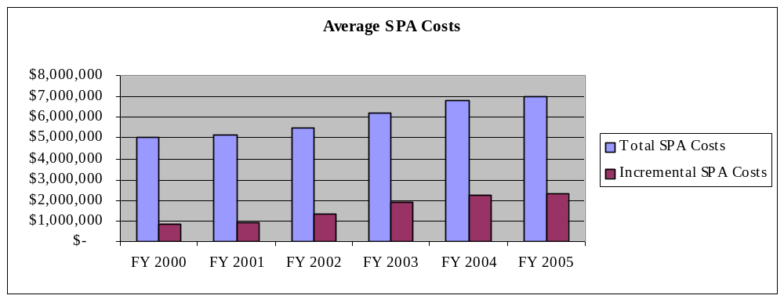

The operations and maintenance (O&M) cost pool includes the costs of utilities, security, repairs and renovations, grounds keeping, environmental health and safety, and hazardous waste disposal. This cost pool contains many of the new compliance activities due almost entirely to the latest requirements impacting environmental health and safety. These activities have not only been subject to additional scrutiny by the Environmental Protection Agency, but by many overlapping state and local government authorities as well. This is the category of activity that is impacted by the new requirements of the Homeland Security Act and the Patriots Act. The combination of increased oversight and new requirements has required increased lab inspections, additional lab security, the registration and protection of toxic agents, and bioterrorism controls. Many institutions have had to hire additional staff, provide additional education for faculty and staff, and develop new databases to inventory and track materials.

Graph 5 indicates that on-going expenditures for this cost pool averaged approximately $21.6 million among the sample institutions and increased on average approximately 5 percent annually from 2000-2005. In the same period, incremental O&M expenditures averaged approximately $478,000 per year for a dramatic average increase for the period of 10.6 percent.

Graph 5
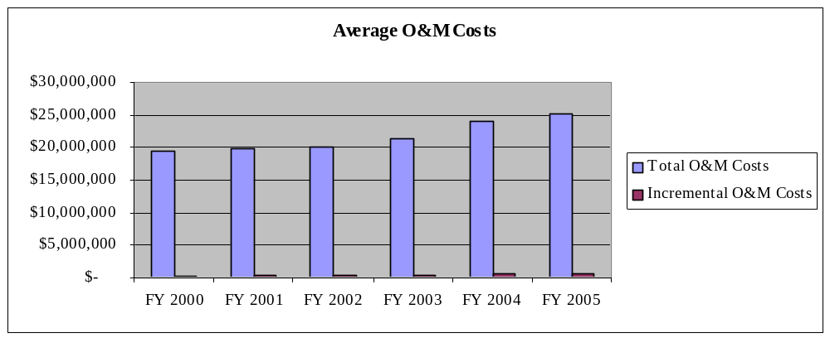.

Many institutions have assigned the costs of audit follow up, HIPAA compliance, service recharge centers, review for the HHS/OIG procurement exclusion, and the costs of administrative, payroll, and financial management information systems to this category. Graph 6 indicates that General Administrative costs increased as well with ongoing costs increasing on average by 6.1 percent annually and the incremental costs increasing an average of 10.7 percent annually.

Graph 6
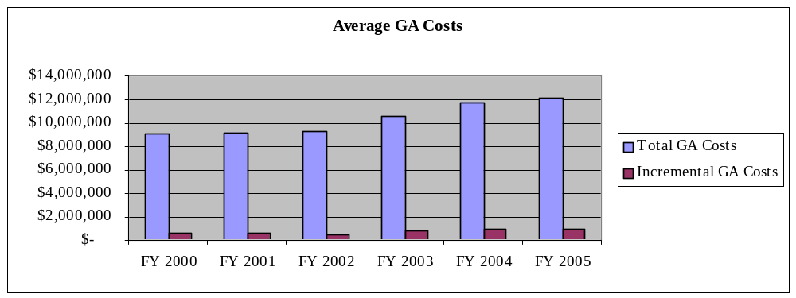

The Working Group debated whether to include the costs of administrative and financial systems in this analysis. Like all general administrative costs, they benefit the entire institution. Yet the pressure to update legacy administrative information systems is often the result of pressure for compliance with Federal requirements in salary distribution, effort reporting, proper rate application, complete property inventory and control, and so forth. According to the instructions, institutions included only that portion of information systems that were allocated to organized research, and only that portion of the costs that were allocated during the study period. Most institutions capitalize the costs of information systems; respondents were instructed to include only the capitalized costs as incremental costs.

To determine the relative magnitude of administrative systems costs, we prepared a parallel analysis in which all such costs were eliminated. The total six year incremental cost per institution, on average, was calculated to be $15.1 million, or $1.4 million lower, without administrative systems costs. It is interesting to note that the vast majority of those costs are included in the General Administration cost pool. With administrative systems costs excluded, the General Administration cost pool represents only 13 percent of total incremental costs (as opposed to 24 percent in the original analysis) while Sponsored Programs Administration costs represent almost 62 percent (as opposed to 54 percent in the original analysis).

Range of Incremental Costs
For the purpose of the analysis, the range and the median incremental compliance costs were developed for each cost pool. Not all institutions incurred incremental compliance costs in each category each year, so the minimum range in each case was the least or lowest amount of dollars expended in that particular category. The range of costs for Sponsored Projects was a minimum of $32,000 in one year to a maximum of $16,571,681 in one year. The median Sponsored Projects Administration costs were $975,544 per year. The minimum for the General and Administrative cost pool was $14,000 and the maximum was $4,550,000 with median costs of $452,318 per year. The minimum Operations and Maintenance incremental cost was $3,500 and with a maximum of $4,467,890 and a median of $198,000 per institution per year. The least amount of incremental expenses was in the area of Departmental Administration with a minimum of $1,000 by one institution in one year to a maximum of $2,128,107. The median Departmental Administration costs were $123,230 per year. It should be noted that each institution has its particular mix of research which influences the timeframe for meeting new compliance requirements, resulting in varying degrees of expenditures in any one year shown above.

Inventory
The sample institutions identified over 100 activities that they initiated or plan to initiate between 2000-2005 in response either to increased federal oversight of existing requirements or new law, regulation, and policy. These activities group broadly within the areas of environmental health and safety, the Health Insurance Portability and Accountability Act (HIPAA), human subjects protection, conflict of interest, Medicare billing compliance, intellectual property management, facility space , general audits, and other topics.

Six of these activities (audits, conflict of interest, disposal of hazardous waste, increased monitoring of health and safety requirements in laboratories, increased lab security, and HIPAA were each implemented by ten or more respondents. Fifteen of these activities (e.g. the Patriot Act and Homeland Security, bioterrorism controls, Medicare billing and compliance, Office of Technology Management, Payroll Systems, service centers, institutional review boards, space studies and surveys, and code of conduct) were each implemented by more than seven institutions. Many of the other initiatives were also implemented by multiple institutions.

The list is extensive and reflects a not so surprising collection of the latest concerns regarding homeland security, protection of human subjects, avoidance of conflict of interest, the promotion of research integrity, and the compliance with federal cost policies. The list of compliance activities reflect federal requirements that demand an administrative infrastructure that must be every bit as tangible and sophisticated as the facilities in which the research takes place.

Restrictions on Cost Allocations
OMB Circular A-21 describes the methodology by which institutions must assign facility and administrative expenditures, including compliance activities to various categories or pools for the purpose of determining indirect costs. For example, the costs associated with environmental health and safety are often identified as operations and maintenance costs, while the costs associated with the protection of human subjects are usually included in sponsored projects administration. Circular A-21 permits some institutional discretion in the assignment of compliance costs to the various cost pools. For example, compliance with HIPAA could be assigned to sponsored projects administration, general administrative costs, or departmental administration, depending on where the costs are incurred. However, based on a revision of Circular A-21 in 1991, section G.8.d, institutions must receive permission to change the assignment of costs from one pool to another. In fact, this survey indicates that the various compliance activities are sometimes assigned to different cost pools among the sample institutions, reflecting legitimate differences in where the costs are incurred, and where they have been charged historically within particular institutions. The survey indicates that compliance costs are incurred in every one of the facility and administrative cost pools. They are included in the costs of facilities, in operations and maintenance, in the general administrative costs of the institution, in academic departmental administration, and most certainly in sponsored projects administration. Consequently, it is difficult to identify compliance costs, to track increases in costs over time, and to isolate compliance costs within one or two cost pools.

IV. CONCLUSION

We are in an era where a sophisticated research compliance infrastructure is as crucial to the successful conduct of meritorious research as state-of-the-art research facilities and scientific instrumentation. Developing and maintaining an adequate compliance infrastructure carries a substantial price tag.

The data collected during this study demonstrate that institutions are financing new, incremental compliance costs at the rate of $3 million and more per year. Alarmingly, the number and complexity of regulations and their resulting costs are escalating rapidly today and in the future, rather than stabilizing or decreasing. Incremental compliance costs for the Top 100 institutions are projected to exceed $1.2 billion in the study period. The more routine costs for research facilities and an adequate administrative infrastructure are absorbed in current operations, and they, too, are increasing at a substantial rate. Compliance in the conduct of biomedical and health-related research is even greater than for most basic science. Compliance in academic medical centers, including the protection of human subjects, the accuracy of Medicare billing, the avoidance of conflict of interest, and the disposal of hazardous waste is even more substantial than in the those institutions without medical centers.

All of this occurs in the context of non-profit institutions of higher education that are caught in a rapidly deteriorating economic environment. The loss of earnings on endowment, the decrease or deferral of gifts, and the loss of state revenues for the support of education put these non-profit institutions in considerable peril. These institutions have been struggling to finance the current costs of construction and renovation of research facilities. Funding for essential research facilities will be at risk to the extent that available funds are diverted to implement new compliance requirements. It is difficult to estimate how these institutions will continue to finance the escalating spiral of compliance requirements in the context of rapidly decreasing economic resources.

The limitation of reimbursement of administrative costs to universities was set in place over a decade ago. It is past time for this policy to be reevaluated to better reflect the costs that universities bear to administer research programs. Federal law, regulation, and policy establishing new compliance requirements continue to increase. Lawmakers and the public have every reason to assume that these requirements will be implemented swiftly and effectively. Yet the resources to do so are severely constrained by archaic policy. This is not the result of deliberate, congruent public policy, but the inconsistent result of independent policies established years apart.

No other class of institutions or recipients of federal funds that have their costs artificially capped or constrained in such a fashion. Non-profit research institutes, commercial organizations, small businesses, and hospitals receive relatively full reimbursement for the actual costs of research. They do not face this contradiction in public policy that requires substantial investment in compliance activities on the one hand, and limits the reimbursement for compliance infrastructure on the other. Federal Acquisition Regulations (FAR) do not restrict, or limit cost reimbursement to an individual class of organization. In fact, commercial organizations conducting federal research under the FAR would not consider conducting such research without a profit or fee, let alone without the full reimbursement of actual costs.

V. RECOMMENDATIONS

Current economic hardship experienced by universities due to rising compliance costs seems to be the unintended consequence of actions taken more than a decade ago to cap administrative cost rates and to pay less than negotiated rates under certain programs in certain agencies. We have characterized this as an unintended consequence because we cannot believe that the government would knowingly have adopted financial disincentives for compliance; nor have we seen restrictions on recovery of compliance costs in any other class of recipient of federal funds.

It is essential to modify policies and procedures to fairly reimburse universities for the costs of research. Strategically, these reimbursement policies must be consistent among classes of institutions and provide fair reimbursement for the costs of compliance mandates and research infrastructure. Tactically, it means that not only is there is a coherent federal-wide policy for the reimbursement of facility and administrative costs, but there is also consistency among agency policies with respect to reimbursement policies on all funding mechanisms. COGR and the other associations of higher education will vigorously support such an effort.

Since it will take the action of OMB and the federal agencies to correct these essential issues, it seems logical to us to have the fundamental reasons for this situation addressed in the context of the National Science and Technology Council (NSTC). Under the leadership of the Office of Science and Technology Policy a committee is charged with developing new business models to support research. We recommend that this committee carefully consider the many avenues available to redress the problems, which span a spectrum from repeal to recalibration to reformulation of policies and procedures in order to ensure that universities receive equitable reimbursement for the increased compliance initiatives to meet overall societal goals. Options to establish a fair business partnership between universities and government include: removal of the 26% cap, payment of full negotiated F&A rates on all awards, and the creation of a new uncapped compliance cost pool.

It is very important that OMB and the Office of Science and Technology Policy interagency committee provide a mechanism for the academic community to be involved in their work and consulted at critical stages. The committee also should coordinate its work with the important initiatives already underway under Public Law 106-107 to streamline and simplify grant and contract administration and to reduce regulatory burden. While it is of primary importance to seek solutions to the financial difficulties identified in this report, it is essential to continue efforts to reduce or eliminate non value-added requirements, and to reduce costs by minimizing or streamlining essential compliance procedures.

CASE STUDIES

Case Study: Implementation of the Health Insurance Portability and Accountability Act – HIPAA

Introduction

The Health Insurance Portability and Accountability Act (HIPAA) and the HIPAA Privacy regulations ensure the smooth flow of a patient’s protected health information (PHI) for treatment, payment and business operations while restricting the use or disclosure of this PHI without explicit and voluntary authorization by the patient. The HIPAA Privacy Regulations also protect a patient's right to access their PHI, and to know who is using it and how it is being used. Implementing strategies to comply with these new regulations have affected the clinical, research and teaching operations across the Schools and central areas of the university and directly impacted the workflow and operations of both faculty and staff.

Implementation

Phase 1: Understanding the Law and Regulations

Since the law and regulations are new, the University’s strategy was to 1) understand the specifics of the HIPAA law and Privacy regulations, and 2) assess the impact on the institution. This process, which took about six months, included attending educational programs, communicating with professional organizations, and other peer institutions, and conferring with external consultants and legal advisors.

A 20-member Steering Committee of representatives from key clinical areas, research administration, IRB, Information Systems, Human Resources, General Counsel, Student Health, and School Administration and Finance was appointed to lead the HIPAA Initiative at the university.

The Steering Committee surveyed departments and business units they expected to be impacted by HIPAA in order to understand the collection, use, disclosure, and disposal of PHI. Approximately 25 departments in the Schools of Medicine, Arts & Sciences, Social Work and Engineering, as well as additional business units such as Student Health, Public Affairs and Athletics participated in the written survey. Both faculty and staff contributed information to the survey, which took 2-4 weeks to complete. This comprehensive survey was an integral part of the committee's strategy to gather facts about existing operations to assist them in defining the scope of the HIPAA compliance initiative at the university.

Phase 2: Developing University Guidelines, Policies and Procedures

The Steering Committee established a HIPAA Compliance Structure to ensure stakeholders' participation in the development and implementation of the HIPAA compliance strategies. This structure consisted of:

- A Stakeholder Committee charged with reviewing proposed plans and strategies. (Approximately 100 faculty and staff participated in this activity.)
- Four subcommittees charged with developing university policies, procedures, tools, templates, training, and communication strategies.
- Joint committees appointed to address university-affiliated hospitals' clinical, research and teaching activities occurring at these sites.

All committees were staffed with faculty and staff who had expertise needed to fulfill the specific charges of the committees. The activities of the Research Policies and Procedures Subcommittee provide a good example of the type of work the subcommittees completed. Over 20 faculty members from different disciplines and departments were interviewed individually to discover the specific issues associated with the different types of research being conducted at the university, and to assess the impact HIPAA regulations would have on their research programs. The Research Subcommittee met bimonthly. As policies were developed, Research Subcommittee members attended faculty meetings in various departments to share their work and seek input from faculty and staff.

The four subcommittees' activities lasted 10 months and involved approximately 60 faculty and staff. In addition, the university devoted almost two FTEs from the General Counsel’s office and two other FTEs who were assigned project management responsibilities.

Phase 3: Implementation and Monitoring
The university is in the final phases of implementing HIPAA compliance. The critical elements of implementation include:

- Organizational changes:
  - Establishing a University Privacy Office *
  - Expanding the Medical School IRB role to serve as the Privacy Board to review the more than 3500 protocols submitted by 600-800 investigators annually*
  - Establishing a Security Office*
- Appointing over 50 Privacy Liaisons in business units who are responsible for meeting University HIPAA policies.
*(Note: These changes will add approximately 10 new FTEs to the costs of the central operations.)
- Implementing mandatory web-based training for 8,000 to 9,000 faculty and staff. The time expended in training will range from 20 minutes to 5 hours, depending upon an individual’s job responsibility. The business units have appointed over 90 HIPAA trainers to monitor the mandatory training and deliver business unit specific training. The cost of the web-based training program is approximately $20.00 per person. This does not include the time and effort costs of the trainers’ or trainees’ time.
- Implementing new or revised operational practices for departments, staff and faculty in clinical, teaching and research areas, including but not limited to, patient communications, subject recruitment, and management of databases and medical records. Costs associated with these operational changes are impossible to predict, and since no new funding exists to support these changes, departments will need to absorb these costs into their operating budgets.
- Enhancing security guidelines for electronic and paper systems.
- Establishing new monitoring and auditing programs to assess compliance.

Phase 4: Security Regulations

The university is now preparing to respond to the recently published HIPAA Security Regulations, which add new dimension to the HIPAA Initiative.

Conclusion

The university’s HIPAA Initiative is based on the following four-part strategy:

- Establishing minimum standards at the University level.
- Introducing customization and implementation strategies at the Business Unit level
- Requiring Business Unit self-monitoring and reporting
- Instituting University-level auditing to verify compliance

Complying with HIPAA Privacy regulations has been, and will continue to be, a significant logistical task at this university. By the April 13, 2003, implementation date, we will have used uncounted hours of faculty and staff time to develop policies, procedures and education programs. The ongoing demands to educate, monitor, audit, report, and continuously improve the policies, procedures, and compliance initiatives will undoubtedly add new costs and duties to the organization.

Case Study: PATRIOT Act and Select Agent Regulations

Introduction

The regulations governing the use of a number of biological agents and toxins have been significantly changed over the past sixteen months. Although the details of some requirements are still uncertain, the impact of these enhanced regulations has had a significant impact on colleges and universities (C&U). The following is a brief analysis of one of the provisions of this new regulatory environment.

In 1996 the “Anti-Terrorism and Effective Death Penalty Act” established the need for notification of Centers For Disease Control and Prevention (CDC) if institutions were transferring certain listed biological agents or toxins, collectively called “Select Agents.”

In October of 2001, the “USA Patriot Act” passed with additional provisions to the Anti-Terrorism Act, the major items being the added registration requirement for the Use and Possession of Select Agents, and the establishment of a category of Restricted Individuals who would be prohibited from possession or use of select agents. In 2002 the “ Public Health and Security and Bio-terrorism Preparedness and Response Act” charged the Secretaries of the Departments of Health and Human Services (HHS), Agriculture (USDA) and Justice (DOJ) to establish regulations to implement the provisions of the new act.

The requirement to register possession mandated the institution to determine the presence of all “select agents.” This task presented a number of major challenges since the possession of these agents was not prohibited previously and therefore there was no need to maintain a record of their existence. A nine-person task force made up of faculty, Environmental Health and Safety Staff (EH&S) and campus administration was assembled to review the requirements and develop a strategy. After extensive discussions, it was decided to approach this problem in a number of phases.

Implementation

Phase 1: Screening Questionnaire

Initially a simple questionnaire was developed to ask the respondent a series of simple questions, the two critical ones being: a) Are you using or have you used any of the items listed in the attachment while at the university? and b) Have you inherited any refrigerators or freezers with samples?

An attachment included the listing of select agents and an introductory information package describing the provisions of the PATRIOT Act and the need to identify the presence of select agents.

The questionnaire was mailed to 2,100 individuals who were listed as having a research authorization (e.g. grant application, human subjects approval, chemical inventory owners, etc.). It was estimated that each individual would require approximately one hour to understand the issues and respond to the questionnaire. The individuals were given two weeks to return the forms to EH&S.

Upon receipt of the forms EH&S staff reviewed the forms to determine if the respondent had responded positively to the two key questions. All individuals responding positively were included as participants in the Phase 2. After two weeks EH&S staff visited all the individuals who had not responded and obtained the information. At this stage approximately 350 respondents were identified for Phase 2.

Phase 2: Follow up Visits

After Phase 1 was completed, individuals who had responded positively to the questionnaire regarding the use of select agents were mailed a more comprehensive questionnaire to provide information on: the type and quantities of agents used; location of storage; security of the site; who had access to the materials; information on the LD-50of the select agents this information was critical to; and whether the agents met the definition of “exempt.”

Following the receipt of the second questionnaire EH&S staff visited each respondent to review the information and conduct site visits. At the conclusion of the interview, the staff, with assistance from the campus police, conducted a brief tour of the site to review the security of the site and the access control practices. This effort ultimately identified 26 investigators who had select agents in their inventory, and they were included in Phase 3 of the process.

During Phase 2 individuals who had “inherited” refrigerators or freezers with biological samples were also visited to determine if there might have been “select agents” stored. In a few instances previous faculty owners had to be contacted to verify the identity of samples with unclear labels.

Phase 3: Review of Select Agents

This phase identified the investigators with select agents in their inventory. This group was referred to the campus Biological Safety Officer (BSO) for more in-depth review to determine if the types used were considered “Exempt” or subject to registration. The BSO had to obtain detailed information about the select agents, their lethal dose (LD-50) by reviewing available data and/or contacting the suppliers to verify the accuracy of the published data. Once it was determined that the select agents on hand met the criteria for exemption, then the CDC was contacted to verify the determination made by the campus. At the conclusion of Phase 3, two units were identified as having select agents that required registration, and applications were submitted to CDC.

During Phase 3 a number of other areas were subjected to detailed review, these included internal paperwork management to review the processing of incoming information and how to restrict the access.

Information technology and data management systems review was conducted for units where select agent data might be stored. This identified the need for upgrading the server security infrastructure.

Phase 4: Implementation of Full Provisions of the Select Agent Rule

The campus is currently working on the final stage of implementing the remaining provisions of the select agent rule as the regulations are developed. A committee oversees this phase with representatives of the campus, the Academic Senate, the Biological Safety Committee, and the offices of Environmental Health and Safety, Materials Management, Human Resources, Facilities Management, Executive Vice Chancellor’s Office and Legal Affairs.

As of February 1, 2003, this effort has required approximately 4,200 hours.
Case Study: Environmental Health and Safety

Over the past five years the regulatory requirements relating to Environmental Health and Safety (EHS) have increased significantly. The burdens of these regulations span every aspect of the research and teaching activities in Colleges and Universities and directly impact the operations at every level.

Introduction

The US Environmental Protection Agency (EPA) is responsible for implementation of the provisions of the Resource Conservation and Recovery Act (RCRA) which is the Federal regulation that governs the disposal of hazardous chemicals. This Act sets the regulations that govern all handling, storage, packaging and disposal of the hazardous wastes from institutions. One of the major initiatives announced by the EPA has been the “Audit Policy Incentive Program.” Although this initiative covers many aspects of the University and Colleges, for the purpose of this study the focus will be on the hazardous waste disposal area.

One of the options provided in the EPA initiative is the so called “self-audit and disclosure” option that allows institutions to perform their own audits and report their findings to the EPA. In return, EPA might provide release from certain fines if a series of narrowly defined criteria are met. In 2001 the university was formally invited by EPA to participate in the program. The invitation initially allowed six months to complete the program, however it was extended to approximately nine months. Discussions with other institutions across the country who had participated in a similar program indicated that this was a major effort and that it must be given serious attention.

Implementation of the EPA Self-Audit

The university along with the other system campuses participated in the study. The implementation started with the participation from the office of the system President who issued the notification to the Chancellors and Vice Chancellors.

The Office of Environmental Health and Safety (OEHS) was charged with managing the program under the general oversight of the Campus Chemical and Environmental Committee (a faculty oversight committee). To ensure that all stakeholders were notified and were involved, a number of working Committees comprised of faculty, staff, research technicians, laboratory managers, facilities management, medical center staff, auxiliary and housing staff and transportation staff. The Committees reviewed the scope of the project as related to the hazardous waste disposal at the university and developed the tools required to perform a self-audit, identify any potential problems and mitigate the identified problems. The Associate Vice Chancellor for Research chaired the bi-weekly meetings of the chairs of the working committees to review the progress.

During the six-month effort, four full-time staff members from OEHS were assigned to:
- coordinate the efforts of various stakeholders at the university as well as other campuses;
- provide training for individuals involved in self-audits to ensure consistency;
- review audit reports and tracking data;
- prepare mitigation measures and follow-ups;
- prepare final reports for the EPA.

Overall, the completion of this effort required the involvement of an estimated 250 faculty, 250 laboratory staff (managers, technicians, Science Research Associates, etc.) and over 75 other individuals from various medical center and administrative units. A conservative estimate of the total time spent at the university for this effort was 8,500 hours.

The campus submitted its final report to EPA in 2003 and is waiting their response. In the meantime, a comprehensive compliance maintenance program is in place to ensure that the institution continues to remain in compliance. This includes:

- quarterly inspection of all areas used for waste storage and collection (approximately 1,350 hours of effort per calendar quarter);
- routine training of all new employees as well as periodic training of existing employees involved with handling of hazardous wastes (estimated 250 hours per year);
- increased efforts by laboratories staff in managing the waste for ensuring items such as proper labeling, completion of paperwork, etc. (Estimated at approximately 2,450 per year).

Summary

It was a major logistical effort to coordinate a full campus-wide audit, determine the scope of the self-audit for nine campuses, identify all locations used for hazardous waste accumulation or storage, visit each site and identify the functional owner of the site, inspect each hazardous waste container on site at the time of the visit and make sure that the waste is being handled properly. The lack of any additional funding or staffing for this task made it even more challenging, as all the effort had to be absorbed by the existing staffing both at OEHS and campus units involved.

This effort had a definite impact on a number of other ongoing activities. For example, in order to accommodate the significant increase on their workload, OEHS staff asked for, and were granted, permission to postpone some routine efforts such as refresher training programs, the annual review of operating procedures and manuals.

Having engaged in this level of rigorous review and implementation with existing requirements, the university still has to address toxic materials, lab access and security, background checks, and inventory control due to the new Homeland Security requirements under the provisions of the “USA PATRIOT”, and the “Public Health and Security and Bio-Terrorism Preparedness and Response Acts”.

These two acts pose even greater challenges than the efforts described as the regulations are still under development, and many of the specific requirements are not defined. There is also a longer history of dealing with regulations that were promulgated to protect the health and safety of individuals working with the materials and the health of the general public by preventing the inadvertent contamination of the environment. These two new acts are targeting a new requirement “to prevent individuals with intent to do harm.” One of the complexities of this issue is that the colleges and universities have a tradition of open dialogue and exchange of scientific ideas, both of which are now being subjected to certain restrictions.

Case Study: Space Survey

Introduction

The allocation of facilities costs to direct and indirect functions is the single most important element in the calculation of Facilities and Administrative (F&A) rates at colleges and universities. Arguably, it is also the most problematic, costly, and contentious aspect of determining of F&A rates. The root of the problem lies with the regulations governing the reimbursement of the costs of Federally sponsored research projects for colleges and universities, OMB Circular A-21. This Circular prescribes an allocation formula for the assignment of facilities costs to university activities (including instruction and research) based on institution-wide Full Time Equivalent (FTE) employees or salaries and wages applicable to the major functions. However, the use of institution-wide FTE data or salaries and wages to distribute facilities costs is not equitable since it does not take into account many of the factors that cause research facilities to be more costly than buildings used for instruction, administration, or other university functions. Research buildings are almost always more costly to build, maintain, and renovate because of the special structural and program requirements of the space. Research conducted at most major universities is cutting-edge, and the laboratories must be periodically refinished or rehabilitated to meet the changing needs of the research. Instructional facilities, on the other hand, remain relatively unchanged from year to year. Institution-wide FTE or salary data do not take into account the unique nature, and higher costs, of research facilities relative to other campus facilities.

Implementation

Because the standard allocation formula prescribed in A-21 often results in an inequitable distribution of costs, most major research institutions employ an alternative method as allowed in the Circular to allocate facilities costs to the A-21 functional classifications. This alternative calls for a complete survey of all research space on campus. The survey is usually conducted by a central administration office, but it involves the coordination of many offices; facilities administration, IT services, individual school administration, departmental administration, grants administration, payroll, etc. The survey requires the support of the most senior leadership within the university; for example, executive vice presidents, provost, and deans, in order to obtain the necessary staff participation and follow through. Depending on the size of the university the number of people involved can include upwards of 50–100 administrators, just as many faculty, and at least two staff within central administration and IT services. It has been estimated that a department may spend up to as much as 10 percent of their administrative time in a given year to work on these surveys. Most of them do this without assistance of additional staff. These surveys are so administratively intensive when they are conducted and completed, that attention to and compliance with other administrative duties are at risk of being diminished.

Many schools engage the assistance of consultants who assist with the training of the administrators and help ensure the quality assurance of the space inventory. Some institutions use consultants to complete the survey, and the total cost to the university for consultants can exceed $1 million.
The frequency of the space survey typically revolves around the F&A proposal. For many schools that have predetermined rates this means a reeducation of staff every three to four years. Currently, most schools complete these surveys in a paper environment with data entry into mainframe systems. Software packages are just now becoming available to streamline this task, but the cost to institutions for the purchase and implementation of these systems can exceed hundreds of thousands of dollars.

Process

An example of the process is as follows:

- central administration receives approval to conduct a space survey including getting buy-in from deans and school administration (2 weeks);
- central administration contracts with consultants to assist with planning, training and quality assurance
(1 month);
- central administration and consultants meet with facilities staff to assure themselves that the space data are updated and accurate (1–2 months depending on the facility information);
- central administration and consultants put together training materials to assist departments (2 weeks);
- central administration identifies all the individuals who need training (2 weeks);
- training sessions are conducted for these individuals (1 month);
- departments begin to inventory their space, including interviews with faculty and department chairs. They must detail the use of the rooms, the people and the projects in the rooms (depending on the size of the department 2 weeks to 2 months);
- departments and central staff conduct the interviews (all interviews take up to 3 months, if not longer);
- central staff needs to follow up with departments who did not come prepared to complete the interview
(2 months);
- central staff enters all data into a database (3 weeks);
- central staff and consultants review the database for completeness (1 month);
- central staff follows up with departments that may not be complete (2 weeks);
- finalized data are then entered into the various F&A models for calculation purposes;
- additional time is needed after Federal negotiators review the documentation, walk the space, conduct their interviews, etc.,

Summary

This process may vary by university but the total elapsed time ranges from six months to one and a half years to complete this assignment. After all this effort, the space survey is still an estimating process, but it does provide a much better estimate of actual research space allocation than the Salary and Wage or FTE method prescribed in Circular A-21.

Case Study: Institutional Research Review Boards

Introduction

Research involving human subjects is necessary for progress in many areas of medicine. This research must always be guided by the highest ethical and professional standards as well as primary consideration for the welfare of the subjects involved. To ensure that these standards are met, all research involving human subjects must be reviewed by a duly appointed Committee on Human Rights in Research (Institutional Review Board; IRB). Over the past several years, the burdens of the regulatory requirements governing IRBs have increased significantly. The impact of these burdens has had a direct operational and financial impact on institutions conducting research involving human subjects.

Background

Academic institutions are required to establish policies and procedures to ensure compliance with these regulations. Furthermore, institutions are required to provide for the designation of one or more IRBs to be established in accordance with the requirements of the regulations, and to ensure that provisions are made for meeting space and that staffing levels are sufficient to support all IRB functions.

Granting agencies such as the National Institutes of Health (NIH) and the Department of Defense (DOD), will not award a grant which funds research involving human subjects unless the studies included in the application have been reviewed and approved by an IRB.

Over the past several years, the Office of Human Research Protection (OHRP) has identified numerous instances in which human subject research described in an application for HHS support differed significantly from the IRB approved protocol that was claimed by the investigator to constitute the research in the application. In each case, the application added important elements (e.g., targeting of vulnerable subjects; additional treatment arms; different drug dosages; additional collaborators or performance sites) that were ultimately implemented without IRB review and approval.

In view of these findings, OHRP reminds IRBs that HHS regulations require that the IRB review the actual application or proposal for HHS support. The IRB’s review should ensure that all research described in the application or proposal is entirely consistent with any corresponding protocol(s) submitted to the IRB.

The regulations also require that any change to the protocol, professional staff, consent procedures, and informed consent documents must be reviewed by the IRB. Finally, the IRB is required to conduct ongoing reviews of studies that it has approved in addition to reviewing and reporting all incidents involving adverse events.

It is important to note that over the past five years, the funding volume of National Institutes of Health grants and the level of complexity of clinical research efforts have increased substantially. Moreover, there has been an increase in clinical research conducted in collaboration with investigators at other institutions, which adds its own unique complexity factor to the IRB review function.

The University Experience

The university IRB reviewed an estimated 1,445 protocols in fiscal year 1999–2000. In fiscal year 2000-2001 the WMC/IRB reviewed 1,596 protocols. This represents an increase of 10.45 percent. In fiscal year 2001-2002 1,962 protocols were reviewed by the IRB, representing an increase of 22.93 percent.

It is important to consider that the IRB review process includes both new protocols, continuing reviews, and protocols that have been submitted at prior meetings but have not been approved for various reasons (e.g., the IRB has questions, more information is needed). Each IRB member is responsible for being the primary presenter and the secondary presenter for a certain number of protocols. All IRB members are responsible for reviewing the synopsis of all the protocols prior to the IRB meeting.

Due to the rapid increase of clinical research activity, and the HHS requirement to provide for sufficient IRB staffing and meeting space capability, the university is in the process of providing the infrastructure for a second IRB. Currently, the IRB consists of twenty-six members. The committee meetings are scheduled on a tri-weekly basis and last approximately six hours. In the near future there will be a total of fifty-two IRB members and two tri-weekly meetings.

The increase in IRB volume and complexity has caused the university to add six administrative positions to the IRB staff since fiscal year 1999-2000. This includes an Associate Dean position, which has oversight responsibilities over the proper conduct of research activities, including the IRB function. A further four positions are budgeted with the formation of a second IRB and additional space had to be renovated in order to provide appropriate meeting space capability and to accommodate the additional staff for the IRB function.

The HHS requirement for record keeping and for the appropriate infrastructure that will enable the IRB to conduct its review properly has mandated that we invest in an electronic system for processing protocols and their corresponding applications. This will also provide the university with the mechanism to develop an appropriate database that will have the capability to keep up with the increased pace of our record keeping responsibilities.

In the last several years there has been an increased focus on the IRB function and compliance with the HHS regulations. The university has retained the services of a consulting firm to provide primary consideration of the welfare of the human subjects involved in its clinical research activities and to ensure compliance with the HHS regulations.

Conclusion

The IRB review system is supposed to be funded by indirect costs, which are capped at 26 percent. The information provided here illustrates that the university has had, in large part, to underwrite the cost of the IRB review function. It can also be reasonably deduced that the burden to the university will only increase with the continued expansion of IRB activity.

Case Study: Medicare Billings and Clinical Trials

Introduction

When universities undertake clinical trials, there is a potential that the wrong third party can be billed unless proper procedures are in place. Patients do not have responsibility to ensure that the proper party is billed. Thus, it is the responsibility of hospitals and physician investigators associated with universities to ensure proper billing. This does not occur without proper policies, training, communication and adequately trained personnel involved in the process.

Phase 1: Gathering Information

Given that university leadership was focused on ensuring proper compliance in the IRB area, the University Compliance Officer created an ad-hoc committee of mid-level staff members involved in clinical trials in various capacities to study clinical trial billings. The committee consisted of 20 individuals that met bi-weekly for 90 minutes per session over a period of nine months. At the end of this period the committee created a report that included the following findings.

- There was an unacceptable error rate in billings on clinical trials.
- Inadequate information existed and was provided starting during the budget process.
- Shortfalls for procedures were charged to the wrong third party.
- The pharmacy complained that they did not have sufficient information to bill the proper party.
- As a result of the above issues significant dollars were lost.

Phase 2: Continuing Concerns/ The Pharmacy

A second committee was formed in response to Pharmacy billing concerns. This committee consisted of a mixture of leadership and mid-level management in the hospital, clinics and clinical departments. Because there was some overlap in committee membership, it was quickly discovered that there was commonality of the issues identified by both committees. This group met over a period of 6 months with the group meeting every 6 weeks. In between meetings, committee members spent a significant amount of time conducting detailed analysis of billing related issues. This group concluded that there were significant billing errors resulting in financial shortfalls that were being passively shifted to the hospital.

As a result of the reports of both committees, top leadership refocused on this area and created a task force to implement policies/practices aimed at reducing compliance risks and financial shortfalls.

Phase 3: Fixing the Problem

A committee of 25 individuals involved in the research enterprise as it applies to clinical trials was charged to create policies/practices to reduce compliance risk and financial shortfalls. The committee meets every 2 months with subcommittees meeting on alternate months. They are starting at the proposal phase and creating policies/procedures throughout the clinical trials cycle. Changes that are currently being developed include the following.

- Development of a web based tool that will walk investigators through the proper steps in the clinical trial process.
- Development of a tool that will provide the proper costs for tests/procedures that clinical investigators use in clinical trials.
- Creation of cultural change whereby there is better communication throughout the process.

  - The investigator will inform a designated business official when a patient is enrolled in a study.
  - Hiring and/or training of institutional staff (with a research nursing background) to assist investigators throughout the process while protecting institutional interests.
  - More active involvement of business officers throughout the process.
  - A clear understanding that financial shortfalls due to
non-compliance will be funded by the department.

Once the pre-award process is near completion, lessons learned from this will be used to develop post-award procedures/processes. An education component will be developed that includes both classroom and web based opportunities.

Working Group

Geoffrey Grant, Associate Vice President of Research Administration, Stanford University, Chair

Jim Aumiller, Director of Research Accounting Services, Johns Hopkins University

Anthony Boccanfuso, Director of Sponsored Programs & Research, University of South Carolina

Tony DeCrappeo, Associate Director, Council on Governmental Relations

Jerry Fife, Director of Contract and Grant Accounting, Vanderbilt University

Stephen Gilje, Associate Vice President, Research, State University of New York, Binghamton

William Laird, Assistant Vice President for Finance, Carnegie Mellon University

Denise McCartney, Associate Vice Chancellor of Research Administration, Washington University in St. Louis

Julie Norris, Director of Sponsored Programs, Massachusetts Institute of Technology

Katharina Phillips, President, Council on Governmental Relations

Marilyn Surbey, Assistant Vice President for Finance, Emory University

"Paying for University Research Facilities", Charles A. Goldman, T. Williams, Science and Technology Policy Institute, RAND, 2000
In 1991 OMB revised Circular A-21 to place a cap of 26 percentage points as maximum reimbursement for university administrative expenses effective in institutions fiscal year 1993.
National Science Foundation, Division of Science Resource Studies, Survey of Research and Development Expenditures at Universities and Colleges, FY2000
The range is calculated based both on the amount of Federally-financed research expenditures in the sample as compared to the Top 100, and on the number of institutions in the sample.
The cost pools include incremental compliance costs to the extent that institutions have been able to include them in current rate negotiations and that they are below the administrative cap of 26 percent. If the rate negotiation is somewhat dated, or the institution is at the administrative cap, the cost pools do not include the estimated future incremental compliance costs.
The range depends on whether the calculation is based on the amount of federally financed research expenditures among the seven institutions in the sample as compared to the Top 100, or on the number of institutions in the sample.
Public Law, 104-32
Public Law, 107-56
Public Law, 107-188, Title-III
LD-50 is the dose required to kill 50 percent of the persons to whom a material is administered and is a criterion set by the CDC for exemption of a number of toxins from registration requirements.
The Resource Conservation and Recovery Act of 1976 (RCRA) (P.L. 94-580) consists collectively of the Solid Waste Disposal Act of 1965 (SWDA) and the subsequent amendments to it.
For more details on the initiative see http://www.epa.gov/ne/assistance/univ/index.html
Based on EPA News releases over the past four years it has imposed over $2.8 million in penalties for C&U
Over 90 percent of all deficiencies found in laboratories were related to problems with incomplete labeling
The university generates approximately 21,000 individual containers of waste (ranging from 100 ml to 1 gallon size) with approximately 7 minutes of paperwork per container for the laboratories
From a university guide concerning the conduct of human subjects research.
The regulations for the conduct of research involving human subjects are established in 45 CFR 46, promulgated by the Department of Health and Human Services (DHHS) and when applicable, 21 CFR 50 and 56, promulgated by the Food and Drug Administration (FDA).
OHRP Guidance on IRB Review of Applications for HHS Support, <http://ohrp.osophs.dhhs.gov/humansubjects/guidance/aplrev.htm>.

