Irrigation Resources in Utah: Water Quality versus Soil Salinity, Soil Fertility
and the Environment
D. W. James and J. J. Jurinak
Research Bulletin 514
Utah Agricultural Experiment Station Utah State -University Logan. Utah
December 1986
'Professors. DepartmenlS of Soil Science and 8iomereorology. Utah Stare University. Logan. Utah.

TABLE OF CONTENTS
Page No.
iii
iv
V

1

2
2
4
6
6
6
7

8

11
11
11
15
16
17
18

19
19
19
20

21

23
24
List of Tables List of Figures Abstract
Introduction
Irrigation Water Quality
Chemical Composition of Water
Classical Criteria Used to Assess Irrigation Water Quality
Literature Review Mineralized Springs Nitrate Nitrogen Phosphorus ,
~)
Procedure
Results and Discussion Water Salinity Potassium
Sulfur
Boron
Nitrogen Phosphorus
Summary and Conclusions
Soil Salinity and Sodicity
Soil Fertility
Environmental Pollution and Irrigation
Literature Cited
Acknowledgment
Appendix 1
ii
'

LIST OF TABLES

Table Number
IA.
lB.
2
3
4
5
6
Relationship between SI units and conventional units of water chemical parameters .
Relationship between SI and other measurements parameters
Inorganic chemical constituents of irrigation water quality and units of measurement
Guidelines for interpretations of water quality for surface waters
SAR values computed from site means for selected water sample sites
Potassium concentration in water versus water-borne K per hectar-meter and acre-foot and the frequency distribution of K concentrations in waters sampled in Utah
Sulfate-sulfur concentration in water versus water-borne S per hectar-meter and acre-foot and the frequency distributions of S concentrations in waters sampled in Utah
iii
Page Number
3
3
3
5
13
13
I5

LIST OF FIGURES
Figures
Page No.
2
3
4
5
6

Utah State map showing water sample sites.
Saline waters in Utah. Diffuse and point salt sources are indicated
Changes in total salinity (EC) with distance along the Sevier River. Changes in K concentration are also shown.
Distribution of low-K concentration waters in Utah.
High B concentration streams in Duchesne County. Utah.
Changes in N03-N with distance along the Sevier River.
iv
9
10
12
14
16
17
)

.
ABSTRACT
The effect of water quality on the salinity and sodicity of irrigated soils has been an important issue in Utah since the early 1900s. The main chemical elements involved are calcium. magnesium and sodium salts of chloride and sulfate. When present in excess. boron also degrades the quality of water used for irrigation.
Other water-quality questions concern the contribution of water-borne plant nutrient elements and the impact of irrigation on soil fertility management The main elements considered in this context are potassium and sulfur. although nitrogen and phosphorus may also be involved.
Public concerns also involve the effect of irrigation and other agricultural practices on the environmental quality of rivers and lakes. principally nitrate-nitrogen and phosphatephosphorus which sometimes enter drainage systems from cultivated land as a result of irrigation return-flow and soil erosion.
A survey conducted in Utah from 1981-83 included about 80 surface water sample sites. Results were compared with a similar study in 1949-5 I by J. P. Thorne and D. W. Thorne. The results are evaluated according to the criteria currently used to classify and describe water quality. Conversion factors are provided to correlate previous data bases with the current water-quality classification schemes.
Results of water-quality analyses are summarized and interpreted in terms of best irrigation and soil fertility management practices as affected by irrigation water quality.
v

INTRODUCTION

Historically, irrigation water-quality criteria have concerned total dissolved salts and the relative amount of dissolved sodium. Occasionally, specific elements such as chloride and boron are included. Recently other definitions of water quality have reflected special uses or concerns. For example, surface waters high in dissolved phosphorus (P04-P) are thought to cause eutrophication or growth of algae. Elevated concentrations of nitrate-nitrogen (N03-N) in drinking water are toxic to livestock and humans.
This bulletin evaluates Utah surface waters intended for agricultural use in irrigation. The
specific purpose of this bulletin are:
(a) To study the extent and sources of salinity and sodicity problems related to Utah surface irrigation water resources.
(b) To evaluate irrigation water quality in terms of the direct impact of soluble constituents on soil fertility and plant nutrition.
(c) To determine whether the quality of Utah surface waters has changed in recent years.
Objectives (a) and (b) concern different aspects of salt concentration in irrigation water. Objective (a) is the classical approach. one concerned with excess salts in irrigation water and their effects on soil physico-chemical properties. Objective (b) concerns waters with low salt concentrations and emphasizes the plant nutrients potassium and sulfur and how irrigation water quality affects levels of these elements in soil. Objective (c) concerns possible contamination of surface waters by nitrates and phosphates. a problem often attributed to fertilizers and soil erosion. This bulletin compares recent and historical data to determine whether there have been any changes in the quality of irrigation water.

-- -- -- - ---.

)
IRRIGATION WATER QUALITY
The effect of irrigation water quality on soil quality and plant growth is related to many interacting factors. The most important of these are:
Soil chemical properties.
Soil physical properties.
Salt tolerance of the crop.
Climatic regime of the area.
Method frequency and amount of irrigation water applied.
Plant nutrient elements added to soil in water and nutrient elements removed from the
soil by leaching.

Chemical Composition of Water
The chemical composition of water determines its suitability for a given use. This bulletin concerns only the inorganic constituents affecting quality. These will be discussed both in terms of total concentration and the individual chemical species.
For uniformity, scientific nomenclature will be reported in 51 units (Systeme International d'Unites). In some instances both 51 and traditional units will be used. Table I shows the relationship between 51 and non-51 units for use in relating current and historical data bases.
The elements associated with irrigation water quality are considered to be the major cations of calcium, magnesium, and sodium, and the major anions of chloride, sulfate, boron, carbonate, and bicarbonate (see Table 2). In addition, the relationship of potassium, nitrate-nitrogen and phosphate-phosphorous to water quality will also be considered.
Total salt concentration of water is related to its electrical conductivity (EC), which is reported in units of decisiemens per meter (dS/m) at 25 C. The traditional designation was millimhos per centimeter (mmhos/cm). The tWo units are equivalent, i.e. dS/m = mmhos/cm. Micromhos per cm (J.Lmhos/cm) can be converted to decisiemens per meter by the following relationship: I umho/cm = 10.3 dS/m. For example, the salt concentration of water which had an EC of 1200 umhos/cm is now reported as 1.2 dS/m.
A measure of the sodic hazard in water is the sodium adsorption ratio (SAR), which is defined as
SAR = Na/[(Ca + Mg)/2]'/2
where the total analytical concentrations of soluble Na. Ca, and Mg are in units of millimoles of charge per liter (mmoVL). The units of mmoVL replace the common expression of milliequivalents per liter (meq/L); the 51 convention does not include the use of equivalents as a unit of concentration. SAR is used to predict the exchangeable sodium percentage (ESP), which is the fraction of the cation exchange capacity of the soil occupied by exchangeable Na. The relationship between SAR and ESP is

ESP/(tOO - ESP) = kgSAR
2
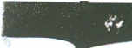

TABLE 1 A. Relationship between 51 units and conventional units of water chemical parameters.
51 units
Conventional units
Concentration
dS/m 10-' dS/m
mmolclL molclL moliL mg/L mg/kg
mmhos/cm jJmhos/cm
Conductivity
meq/L eq/L
moliL -ppm -ppm
1 B. Relationship between 51 and other measurements parameters.
Area | 1 hectar (ha) | = | 2.471 acres (ac)
Yield or rate | 1 kg/ha | = | .891 lb/ac
 | 1 T/ha | = | .446 t/ac
Volume | 1 ha-m | = | 8.107 ac-ft
 |  | TABLE 2. Inorganic chemical constituents of irrigation water quality and units of measurement. .
 |  | Parameter | Symbol | Unit
 |  | Salinity
 |  | Salt Content
 |  | Electrical conductivity | ECw (t) | dS/m
 |  | Total dissolved solids | TDS | mg/L
 |  | Sodium adsorption ratio | $AR(t) | (mmoklL) 1/2
 |  | Cations and anions
 |  | Calcium | Ca2" | mmok/L
 |  | Magnesium | Mi" | mmok/L
 |  | Sodium | Na" | mmoklL
 |  | Chloride | cr | mmok/L
 |  | Sulfate | S042- | mmoklL
 |  | Carbonate | CO,2" | mmok/L
 |  | Bicarbonate | HCO; | mmoklL
 |  | Nutrients
 |  | Nitrate-nitrogen | NO," | mgN/L
 |  | Phosphate-phosphorus | P04'- | mgp IL
 |  | PotaSSium | K" | mgKlL
 |  | Boron | H,BO,o | mgB/L
 |  | "See text for further definition.
 | .
3

where kg is a proportionality coefficient commonly assigned the value of 0.015 (mmolc/Lf1/2.
Most water-quality data are reported in units of mmolc/L (meq/L) or milligrams per liter
(mg/L). The latter term replaces the poorly defined but frequently used parts per million (ppm) designation. The relationship between these two quantities is
(mg/L)/(formula weight/valence) = mmoVL
Another term used to report total salt concentration in water is total dissolved solids (TDS), which is expressed in mg/L units. This value is obtained by evaporating an aliquot of filtered water to dryness and weighing the residue.
Boron (B) is often included in irrigation water quality analyses because many agronomic crops are sensitive to small amounts of this element Whereas all plants require some B for normal growth. only a slight excess of B can be toxic to plants. Symptoms of B toxicity in crops such as wheat, barley, peas, and beans that are sensitive to excessive B may occur if the irrigation water contains about 1 mg B/L. Toxicity symptoms in B-tolerant crops such as sugarbeet and alfalfa may appear when irrigation water contains about 5 or 6 mg B/L.
The soil fertility elements nitrogen (N), phosphorus (P) and potassium (K) are usually not considered in the context of irrigation water quality. Waters containing appreciable amounts of these elements may actually contribute to soil fertility. Excessive amounts of NO,-N in water, however, can have undesirable environmental effects and harm animals and humans. Water seldom contains excessive levels of P04-P and. if levels are high, the soil effectively filters this element since P is readily precipitated in slightly soluble forms in the soil.
K is a component of salinity which has received little attention because it usually contributes much less to total salinity than Na. Ca. and Mg. If present in appreciable amounts, K simply adds to total salinity. K present in low amounts will not significantly add to nor detract from water quality. Soil K may eventually be depleted as K removed by crops is not replaced by irrigation water containing low levels of this element (unless K-containing fertilizer is applied). Also, soil K may be leached due to excess irrigation. How much indigenous soil K is leached depends on the amount of excess water. Na. Mg. and Ca content of water, and soil mineralogy.
)

Classical Criteria Used to Assess Irrigation Water Quality
The criteria used to classify irrigation water quality indicate the potential of the water to cause soil conditions detrimental to crop growth or to cause problems in animals or humans consuming the crops. Three characteristics commonly used to describe irrigation water-quality are:
Salinity: The effect of salt in the irrigation water is to reduce the osmotic potential of the soil water, thus limiting its availability to growing crops. It is a function of total salt concentration of the water rather than of specific constituents. Water quality may limit growth of sensitive crops when EC exceeds 0.7 dS/m. whereas salt-tolerant crops may show little adverse effects when EC exceeds 3 to 5 dS/m. The detrimental effects associated with irrigation water salinity are directly related to irrigation management practices and to leaching and drainage.
Sodicity: The sodic or sodium hazard of irrigation water is related to the detrimental effect of exchangeable sodium (Le. relatively high ESP) on the physical structure of the soil and the direct toxic effect of sodium on sensitive plants. Sodic soils have ESP greater than 15 and characteristically have poor soil structure because of the dispersion or deflocculation of soil clays. Table 3 shows that the sodic hazard (SAR) of irrigation water varies with ECw but in general SAR's less than 12 will maintain ESP below 15.
Toxicity: Specific phytotoxic effects are known for boron, lithium, chloride, and certain heavy metals. Within this group, only boron is pertinent under Utah conditions. Water-quality classification with respect to B is not clearly defined, however, irrigation water containing
J
4
.

TABLE 3. Guidelines for interpretations of water quality for surface waters..
Potential irrigation problem
Units
Degree of restriction in use None/slight to moderate/severe
Salinity ECw (or) TDS
dS/m mg/L
<0.7 <450
0.7 - 3.0 450-2000
>3.0 >2000
Irrigation (affects rate of water entry into soil,
evaluate using ECw and SAR) .
SAR = 0- 3 and ECw =
= 3- 6 .. .. =
= 6-12
= 12-20
= 20-40 .. .. =
dS/m | >0.7 | 0.7-0.2 | <0.2
dS/m | >1.2 | 1.2-0.3 | <0.3
dS/m | >1.9 | 1.9-0.5 | <0.5
dS/m | >2.9 | 2.9-1.3 | <1.3
dS/m | >5.0 | 5.0-2.9 | <2.9
SAR | <3 | 3- 9 | >9
mmolclL | <4 | 4-10 | >10
mg/L | <0.7 | 0.7-3.0 | >3.0
Specific ion tOxicity (affects sensitive crops) Sodium (Na)
Chloride (CI)
Boron (B)

"Adapted from FAa. 1983.
more than 2-3 mg B/L may result in problems due to B accumulation in the soil and resultant B toxicity in plants.
A number of attempts have been made to classify the soitability of water for irrigation (Schofield. 1936; Wilcox. 1948; Thorne and Peterson. 1954; U. S. Salinity Laboratory Staff. 1954). The classification system developed at the U. S. Salinity Laboratory (1954) is the most widely distributed and these guidelines, which are based on salinity (EC) and sodic (SAR) hazards. have served as the standard for many years.
The Food and Agricultural Organization of the United Nations recently published an irrigation water quality classification based on an expanded data base (FAO. 1985). A modified version of the FAO classification system, which incorporates currently accepted limits. is given in Table 3.

5

\
LITERATURE REVIEW
Thorne and Thorne (1951) reported the results of water-quality analyses made on samples of many Utah surface and well waters during 1949 and 1950. These workers referred to earlier water-quality studies in Utah dating back to 1916 and 1918. More recently Jeppson et at. (1968) gave a comprehensive summary of both total water flow and water-quality ratings for all of the major irrigation sources in Utah.

Mineralized Springs
Milligan, et at. (1966) reported data on mineralized springs in Utah and their effects on general water quality within the affected drainage basins. They identified 56 mineralized
springs within Utah of which approximately 12 have some impact on major irrigation sources. The most important of the mineralized springs include the following:
Bear River, Battle Creek Hot Springs and Vincent Hot Springs occur a few miles north of the Utah-Idaho border. These, like Cutler Springs in the Cutler narrows, are saline and flow directly from the river bed or banks into the river. These salt sources are diluted during periods of high water flow but have a significant impact on quality of water in the river during periods of low flow.
Utah Lake-Jordan River System, Goshen Warm Springs, and springs in and around Utah Lake including those at Saratoga. Lincoln Point, and Bird Island collectively account for much of the decrease in water quality in Utah Lake. In addition, the Jordan Narrows Warm Springs add more salinity to the Jordan River.
Virgin River, LaVerkin Hot Springs emerge from fissures on the south bank and in the river
bed and result in low quality water downstream in the Virgin River. .
')

Nitrate Nitrogen
For water intended for consumption by animals and humans, water-quality criteria established by the Federal Water Pollution Control Adminis.tration (Anon. 1968) set the upper safe level for NO)-N at 10 mg/L Excessive NO) levels induce oxygen deficiency or methaemoglobinimia in the fetus. The upper limits for juveniles and adults are much higher but have not been established. NO) is highly mobile in soil and can easily move below the crop root zone in percolating water. NO) dissolved in deep percolation water may enter the aquifer and eventually reappear in surface waters. When soil water content is high and soil oxygen content is low, some NO) is denitrified and the N is released to the atmosphere as inert gaseous compounds. Therefore, all NO) lost from the root zone is not necessarily a potential contaminant of the environment
James (1978) showed that there was significant loss of fall-applied NO) fertilizer N as a result of leaching by rain and snow melt The site was an old lake terrace in Davis County. The ground water level was deeper than 4.6 m (15 ft) and the ultimate outlet for deep percolation is probably the Great Salt Lake. No attempt was made to measure NO) in the ground water.
6

Since NO, storage in the subsoil (150-180 cm or 60-72 in) was very small. it was assumed that
part of the applied NO, was denitrified. .
Hanks et al. (1983) discuss the relationship between irrigation management and NO, mobility. Proper irrigation minimizes NO, losses. Under field conditions, however, it is not feasible to eliminate deep water percolation and associated movement of N. In fact, if soil salinity is a problem, leaching required to control salt buildup will result in the loss of some NO.
A Utah water-quality study by Christensen et al. (1979), limited to the Sevier River below Richfield, focused on concentrations of NO,-N. PO.-P and K. NO,-N levels were generally below 1.0 mg/l except directly in municipal sewage discharges where the. NO,-N was as high as 12.8 mg/L. After dilution in the river, NO,-N content was 5.1 mg/L. Seasonal water flow rate affected the NO, concentration; the yearly average level was well below the upper acceptable limits. Christensen et at. (1979) reported that PO.-p concentration was generally below 0.02 mg/l except near sewer outlets where it was about 0.05 mg/L. They showed that K concentration increased downstream. paralleling the increase in salinity.
Except for the work of Christensen et at. (1978) the predominant emphasis of all other water-quality studies in Utah has been on salinity and sodicity hazards.
Nelson and Weaver (1971) conducted a salt-balance study in an irrigation district of the Yakima Valley of Washington. They compared data from two sampling periods 30 years apart. Water-quality factors were constant over time except NO,-N was somewhat higher in the most recent sampling period. In no case did they find NO, levels that would be detrimental to animals or humans even though N fertilization was a regular practice in the area.

Phosphorus
Carter et at. (1971. 1973) studied an irrigation district in the middle Snake River Valley of
Idaho. The Snake River heads in a phosphoritic geologic zone and is naturally high in dissolved P. They showed that the application of high-P water to irrigated land decreased the concentration of P in the water. In other words, soil acts as a filter for dissolved P.
Safe limits for PO.-P are not well defined. Eutrophication problems occur when PO.-P concentrations are in the order of 0.05 to 0.10 mg P L, but eutrophication is strongly dependent on many factors associated with aquatic systems.

7

PROCEDURE
Water samples were collected during fo.ur sampling periods as follows: 7-15 July 1981.
31 August-! 0 September 1981. 29 June-7 August t 982. 1-15 June t 983. There were about 80 sample sites (Figure 1). The selection and distribution of sites sampled for salinity were not necessarily related to the proportion of lands irrigated by high- and low-quality waters.
Samples were collected in plastic bottles and transported on ice to the laboratory where they were stored at O.C pending analyses. Routine procedures were used for all analyses. Analyses for C03 and HC)3 (alkalinity) were done in the laboratory except for samples collected in September 1983. Those samples were analyzed for these ions in the field during collection.
This water-quality survey emphasized surface waters. Relatively few well waters were included. Some surface water sample sites were included in the work of Thorne and Thorne (1951).

8
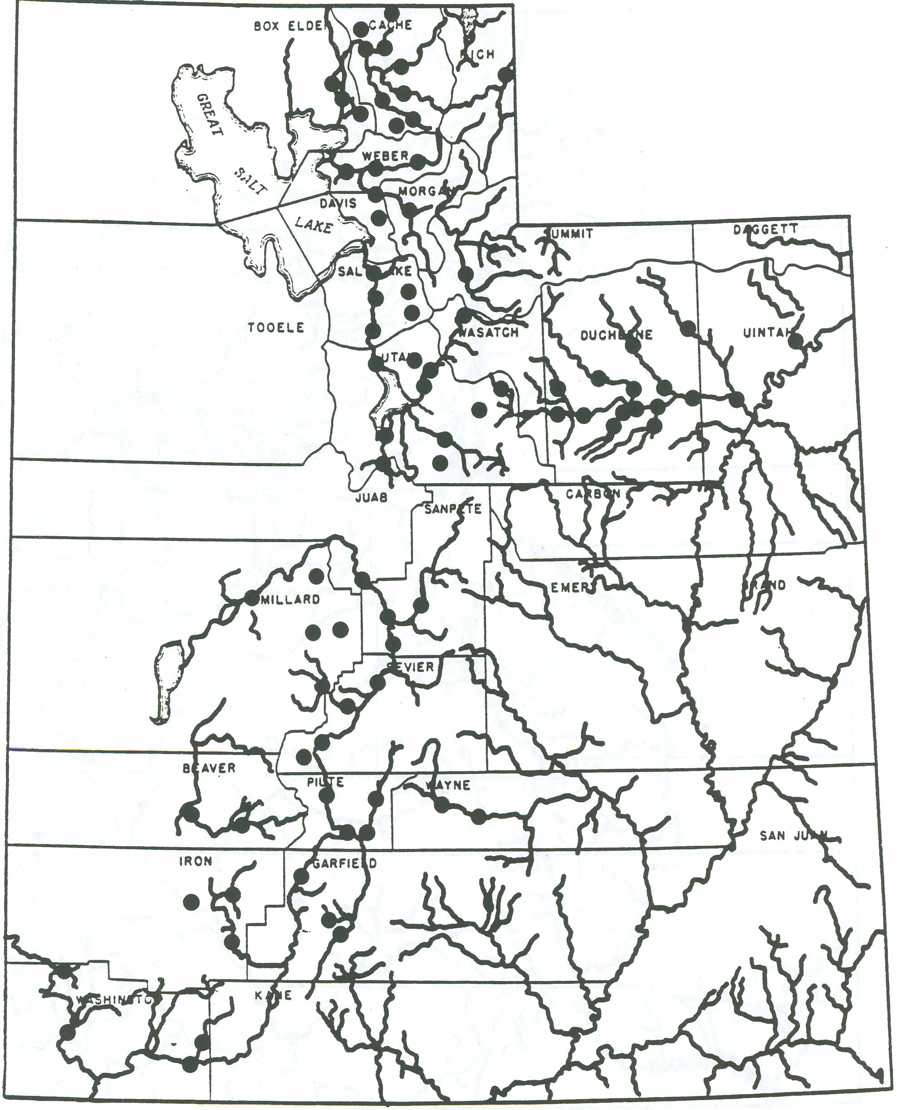

FIGURE 1. Utah State map showing water sample sites.
UTAH
0
to
10 20 30 40 50
, , , , .
SCAL.E OF M'LES
9

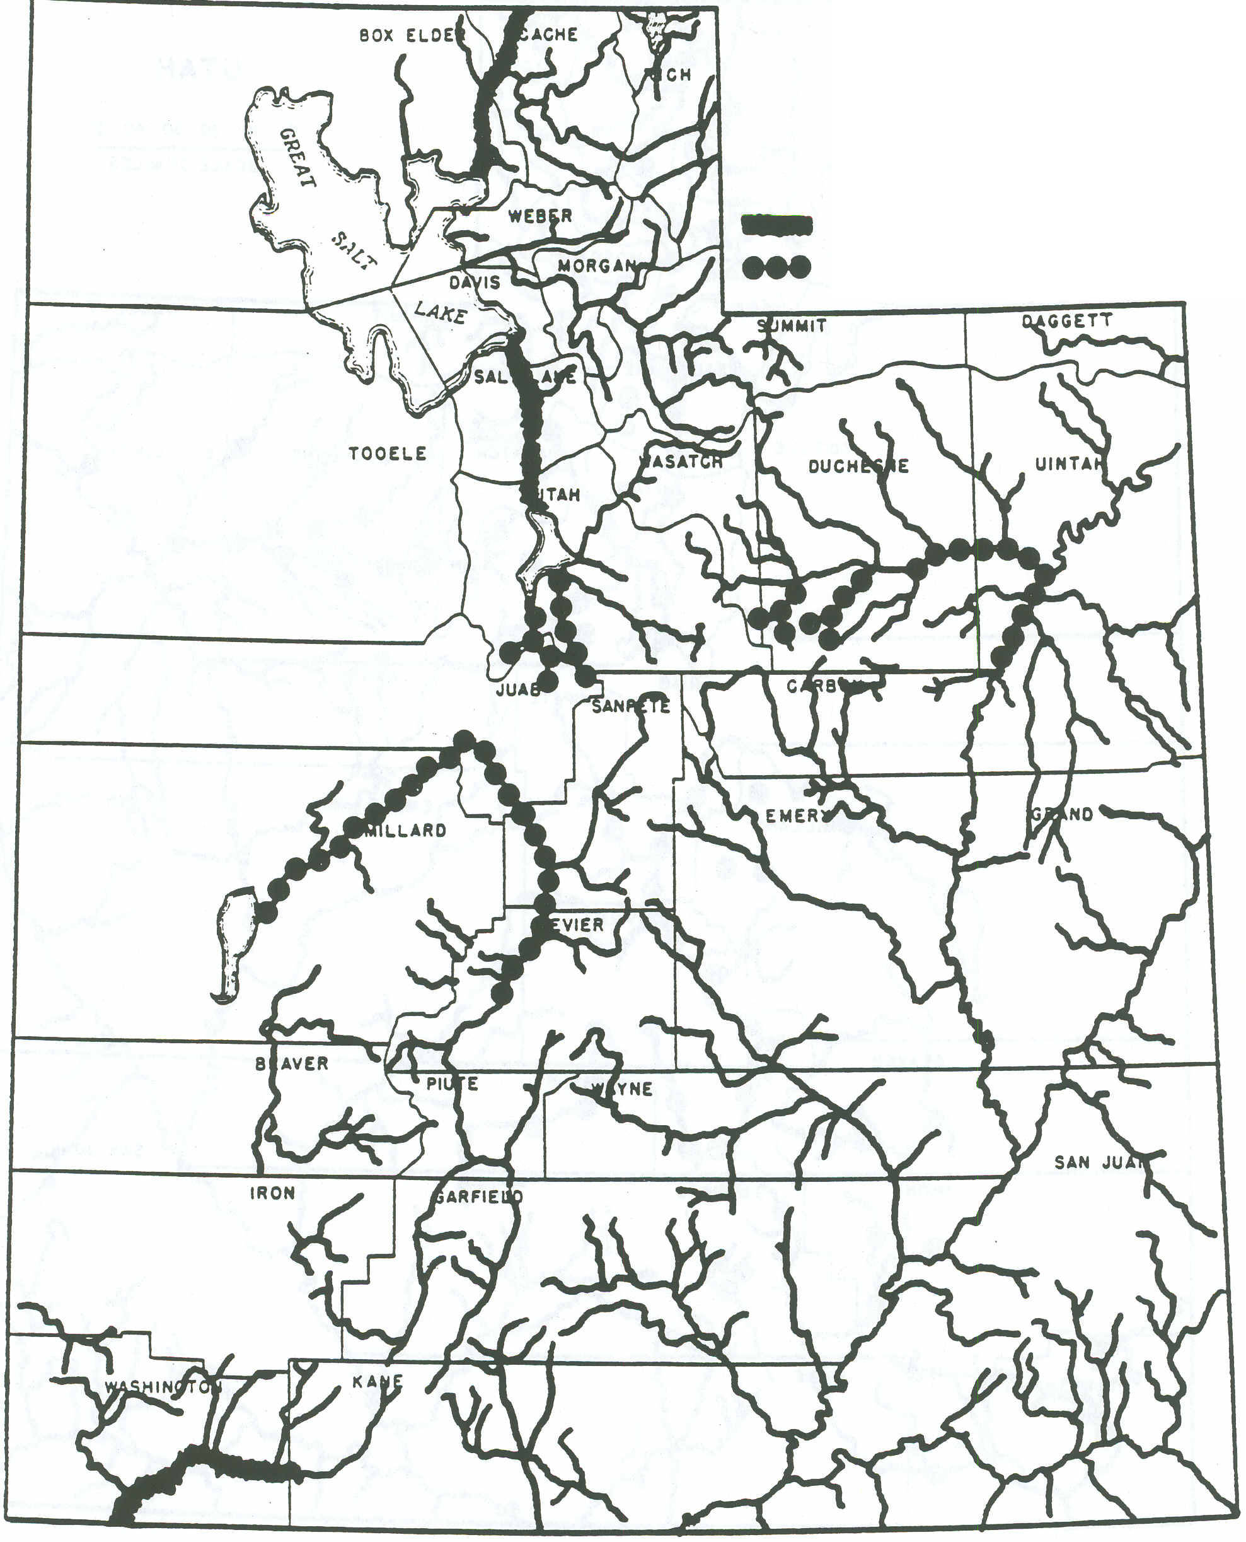

)
FIGURE 2. Saline waters in Utah. Diffuse and point salt sources are indicated.
UTAH
0 L
10 20 30 40 50
, , , ,
SCA1.E OF ..I1.E5
Point source Diffuse source
10

RESULTS AND DISCUSSION
Detailed elemental analyses by date and location are included in Appendix I. Data from comparable sites sampled by Thorne and Thorne (1951) are also included.
The slight variability noted at all sites reflects differences among and within seasons, and are related to differences in the volume of water flow. It should be noted that, during the 1981-83 sampling period, there was a significant increase in precipitation throughout most of the state. Thus, rates of water flow and concomitant salt concentrations were more variable than normally expected.
In general, there have been no changes in the chemical composition of water at the sampled sites since the earlier work of Thorne and Thorne (1951). This conclusion applies to irrigation water quality as well as soil fertility and environmental quality. In the following discussion, therefore, no distinction is made between data collected by Thorne and Thorne in 1949-50 and data collected in 1981-1983.

Water Salinity
Location of waters with some degree of salinity are, shown Figure 2. Shown are both diffuse salt sources (Le. irrigation return-flow) and point salt sources (Le. saline springs), or a combination of these sources. Classification of salt sources is based on the report of Milligan et at. (1966).
Important waters that are rendered saline by diffuse source inputs include the lower Duchesne River in Duchesne and Uintah Counties. and the Sevier River in Sevier, Sanpete and Millard Counties. Figure 3 shows the change in salinity (EC) along the Sevier River. During, moderate to low flow, all the Sevier River is diverted into canals near Richfield. Water sampled at Salina and below is therefore irrigation return-flow. According to Christensen et at. (1979). there is little if any surface runoff in the area so all of the return-flow is from subsurface sources. The salinity in the water originates in soils derived from saline marine shales, which are characteristic geologic formations of the middle Sevier River Valley.
Important waters that are rendered saline by point sources include the Utah Lake-Jordan River system in Utah and Salt Lake Counties, and the Virgin River in Washington County. The Bear River in Cache and Box Elder Counties is moderately saline at low water flow because of saline springs near the Utah-Idaho border and those in the Cutler narrows.
Table 4 summarizes the calculated SAR values for water sample sites with medium to high EC values. Following the guidelines given in Table 3, which consider the relationship between sodicicy and EC according to impact on water infiltration into soil, it was concluded that the waters sampled present no sodic problems.

Potassium
Utah waters which contain low levels of Na. Ca, and Mg are also low in K. Table 5 shows the
11
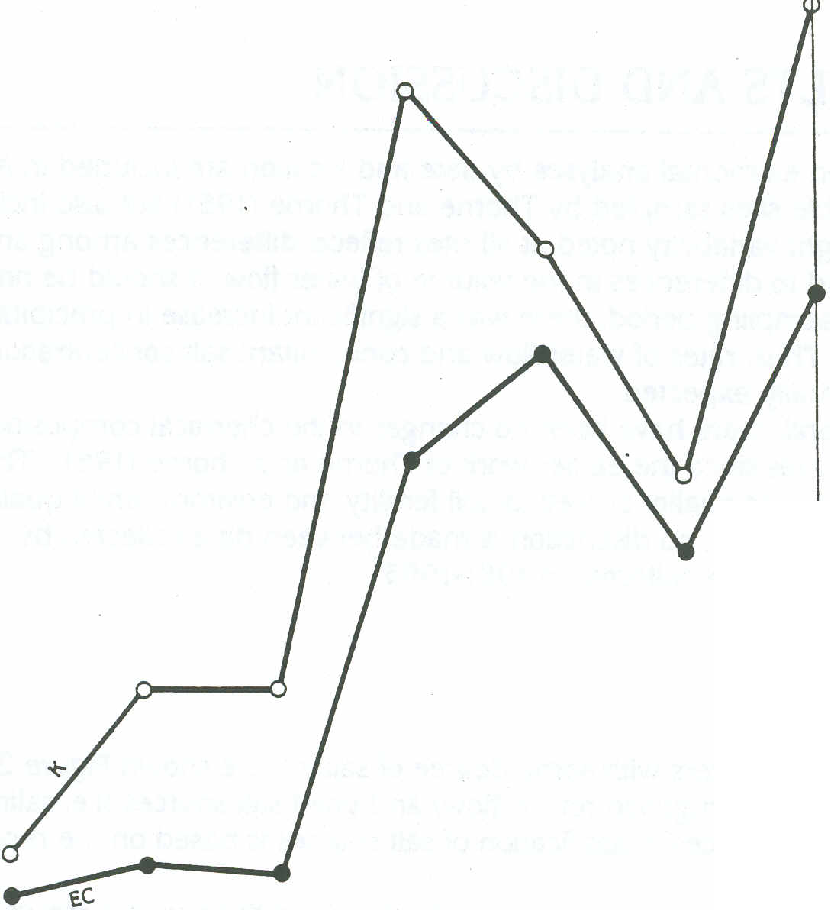

FIGURE 3. Changes in total salinity (EC) with distance along the Sevier River. Changes in K concentration are also shown.
3;5
3.0
2.5
s: X ..J
"
...
"5 2.0
E :.::
E
u
"
!8 1.5
u
..,

1.0
0.5

r' = .89
0
MiIIJc.
Delta
PanguitCh
KingstOn
Sevier
Salina
Gunnison
frequency distribution of K concentrations in the waters sampled. The maximum amount of K that is added to the soil by irrigation water depends on potential evapotranspirational demand
(ETp) and the frequency and amount of water applied. A typical ETp for Utah is 0.75 ha-m/yr (2.5 ac-ft/yr), which can be used to calculate the maximum amount of K applied in irrigation water. Using this ETp and data in Table 5, 65% of the waters sampled would contribute less than 45 kg K/ha/yr (40 lb K/ac/yr) and 78% of all waters sampled would contribute less than 75 kg/K/ha/yr (671b K/ac/yr).
If available soil water (as related to irrigation frequency and amount) is less than ETp, then less than the maximum possible amount of K would be stored in soil from the irrigation source. Also, if the amount of applied water exceeds ETp, some of the excess water will pass
through the root zone, probably removing some irrigation water-K and some indigenous soil K. The amount of K that would be removed from irrigation water by soil, or that would be released from soil as a result of weathering to leaching water, depends on soil texture and the mineralogy of the clay and silt fractions. Accordingly, the maximum amount of water-borne K that would contribute to soil fertility would be when irrigation just satisfies ETp.

12

TABLE 4. SAR values computed from site means for selected water sample sites.
Site No. | Location | SAR'
 | 1.0 < EC < 2.0
78 | Duchesne at Myron | 2.48
81 | Duchesne at Ouray | 2.22
29 | Jordan at Lehi | 3.29
33 | Mona reservoir at outlet | 3.73
76 | Indian Creek at Duchesne | 4.94
46 | Sevier at'Saiina | 4.14
 | EC > 2.0
47 | Sevier at Gunnison | 6.40
50 | Sevier at Delta | 6.28
11 | Malad at Bear River City | 8.56
4 | Bear at Corinne | 8.93
62 | Virgin at LaVerkin | 9.25
TABLE 5. Potassium concentration in water versus water-borne K per hectar-meter and acre-foot
and the frequency distribution of K concentrations in waters sampled in Utah.

 | Potassium concentration
mmok/L | kg/ha-m | lbs/ac-ft*
0.01- .04 | 3.9- 15.6 | 1.1- | 4.2
0.05- .15 | 19.5- 58.5 | 5.3- 15.9.
0.16- .25 | 62.4- 97.5 | 17.0- 26.7
0.26- .30 | 101.4- 11 7.0 | 27.6- 31.9
0.31- .40 | 120.9-156.0 | 32.9- 42.5
0.41- .50 | 159.9-195.0 | 43.5- 53.1
0.51- .60 | 198.9-234.0 | 54.2- 63.7
0.61- .70 | 237.9-273.0 | 64.8- 74.4
0.71- .80 | 276.9-312.0 | 75.4- 85.0
0.81- .90 | 315.9-351.0 | 86.0- 95.6
0.91-1.00 | 354.9-390.0 | 96.7-106.2
>1.01 | >393.9 | >107.3
Frequency %
18.82 45.88 12.94
9.41 3.53 2.35 0 1.18 1.18 0 1.18 3.53
.See Table I for conversion factor St to conventional unilS.
Some forage crops like alfalfa and com for silage have a high K demand and all of the crop contained K is removed from the field in the harvested material. Therefore, except for forage crops removed by grazing livestock, forage crops create a significant draft on soil K reserves. A well-managed alfalfa crop will, for example, yield 5 t/ac/yr and contain 3% K. Thus, 336 kg/K/ha/yr (300 lb K/ac/yr) would be removed from the soil by the crop.
If ETp is 0.75 ha-m/yr (2.5 ac-ft/yr), water would have to contain 2.76 mmoVL or about 120 lb K/ac-ft to completely offset K moved by crops. (That is 2.5 ac-ft/yr x 120 lb K/ac-ft = 300 lb K/yr). Table 5 and Appendix I show that this amount would be provided only with saline waters.

13
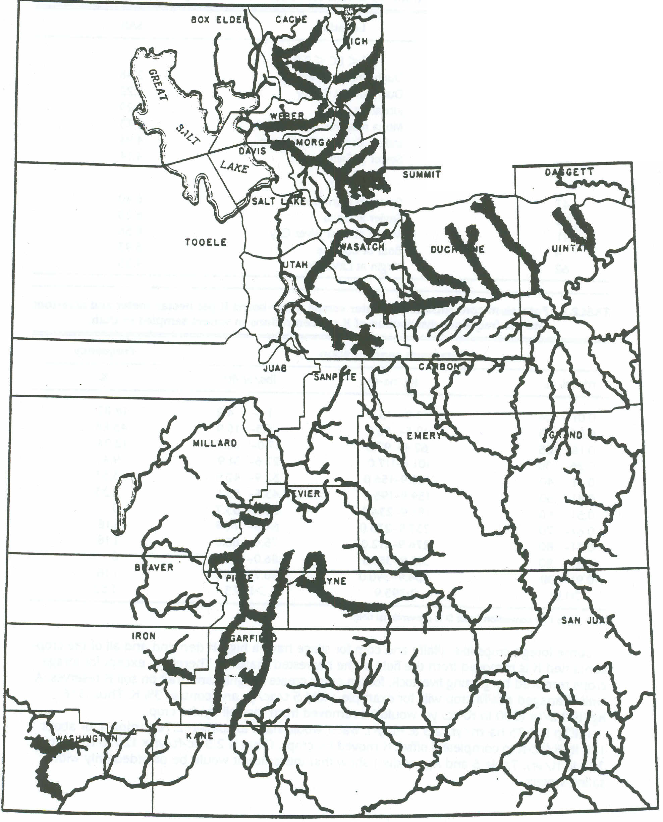

'1
FIGURE 4. Distribution of low-K concentration waters in Utah.
UTAH
0 ~
10 20 30 40 ~
, , , , ,
SCALE OF MILES
'1
')
14

Most soils irrigated in Utah have been under cultivation for 80 to 120 years. If no K-containing fertilizers have been applied many of these soils. where high-K demanding crops are irrigated with low-K waters, have probably experienced an annual net loss of K. The distribution of low-K waters shown in Figure 4 essentially identifies all original diversion waters in the state except for the Virgin River in Washington County, which is affected by saline springs (Figure 2). Low soil test K and K deficiency symptoms in alfalfa have been observed in several areas that are irrigated by low-K waters (Hunsaker and James. 1973; Lindstrom, 1983).
Waters with K concentrations sufficient to offset crop K removal are essentially the saline waters shown in Figure 2. Figure 3 illustrates the strong association between dissolved K and total salinity in the Sevier River. The coefficient of determination (r2 = 0.89) would vary among sites, but it is evident that EC can be used to predict K levels in irrigation water.
At Cutler Dam in Cache County the Bear River contains an average of 0.27 mmol K/L or about 106 kg K/ha-m (291b K/ac-ft). This medium-K water would offset some of the K removed in crops. To date, no low-K soils nor K-deficient crops have been observed in eastern Box Elder County, the area irrigated by this water source.
If the status of soil K availability in a field is not known, a diagnostic soil fertility test will generally indicate whether K fertilizer applications are desirable.

Sulfur
Table 6 shows the relation between sulfate-sulfur (504-5) concentration and kg 5/ha-m'
(lb 5/ac-ft) of water, and the frequency distribution of 504 in Utah waters.
In contrast with K where 112 to 224 kg/K/ha/yr (tOO to 200 lb K/ac) of fertilizer must be applied to overcome K deficiency] relatively small amounts of 5 are required. For example, Westermann (1974. 1975) found 5 deficiency in non-irrigated alfalfa in east central Idaho was eliminated with the application of 22 kg 5/ha (20 lb 51 acre). Furthermore, this 5 fertilization had residual effects in the second and. third years after application (Westermann, personal communication). 504-5 is a component of some commonly used fertilizers such as (NH4)2504
TABLE 6. Sulfate-sulfur concentration in water versus water-borne S per hectar-meter and acre-foot and the frequency distribution of S concentrations in waters sampled in Utah.
 | Sulfa-S concentration
mmolc/L | kg/ha-m | lbs/ac-ft.
0.01- .10 | 1.6- 16.0 | 0.4- 4.4
0.11- .20 | 17.6- 32.0 | 4.8- 8.7
0.21- .30 | 33.6- 48.0 | 9.2-13.1
0.31- .40 | 49.6- 64.0 | 13.5-17.4
0.41- .50 | 5.6- 80.0 | 17.9-21.8
0.51- .60 | 81.6- 96.0 | 22.2-26.1
0.61- .70 | 97.6-112.0 | 26.6-30.5
0.71- .80 | 113.6-128.0 | 30.9-34.9
0.81- .90 | 129.6-144.0 | 35.3-39.2
0.91-1.00 | 145.6-160.0 | 39.7-43.6
>1.01 | >161.6 | >44.0
Frequency
%
8.24
20.00
4.71
3.53 2.35 7.06
4.71
1.18
2.35
1.18
44.71

*See Table 1 for conversion factor Sl to conventional units.
15
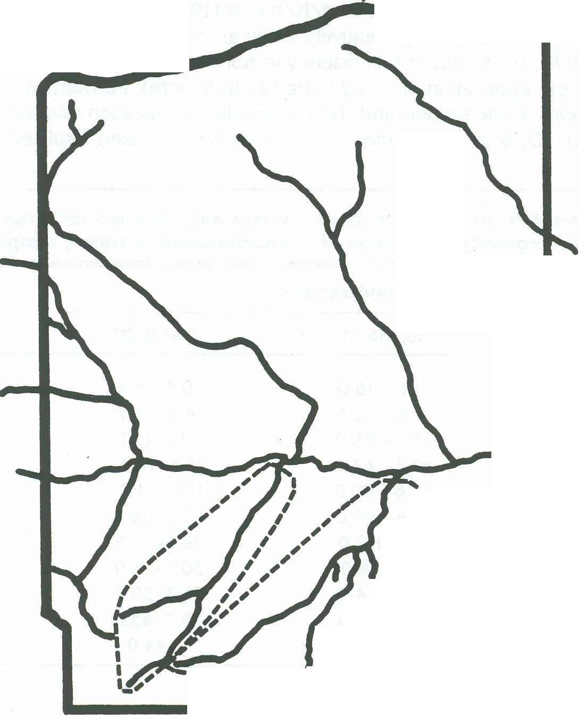

~
(21% Nand 24% 5) and K250. (41% K (50% K2O) and 18%5). Applying these fertilizers to satisfy routine N and/or K needs also supplies more than enough 5 to offset any potential 5 deficiency.
According to Table 6, about 8% of the Utah waters sampled contained 16 kg 5/ha-m
(4 lb 5/ac-ft) or less, and 28% contained 32 kg 5/ha-m (9 lb 5/ac-ft) or less. Using the ETp of 0.75 ha-m/yr (2.5 ac-ft/yr), these waters would supply up to 11 and 25 kg5/ha/yr (11 and 22 lb 5/ac/yr), respectively. Thus, it appears that 5 deficiency in irrigated soils in Utah would be only a remote possibility. Analyses of irrigation water indicates that 5 deficiency might occur on land irrigated by water from the Logan and Little Bear Rivers in Cache County. the upper Sevier River in Piute and Garfield Counties, and in the upper Uintah Basin Rivers in Duchesne and Uintah Counties (e.g. White Rock River). To date, however, 5 deficiencies have not been identified in irrigated crops in Utah.
About 45% of all waters sampled contained more than 161 kg/S/ha-m (44 lb S/ac-ft). Some, like the lower 5evier and Virgin Rivers, contain 740 to 3.700 kg S/ha-m (200 to 1000 lb 5/ac-ft). Additional irrigation water must be applied (leaching requirement) to prevent excess accumulation of these sulfate salts from these saline waters.
Boron
Two small watersheds in Utah have high-B waters, i.e. B concentrations exceeding 3 mg/L (Appendix I). Both are located in Duchesne County (Figure 5). Some of the alfalfa grown in
FIGURE 5. High B, concentration screams in Duchesne County. Utah.

'\
,
I
,
I
,
,
,
,
I
,
,
,
,
,
,
.,'
--------
16

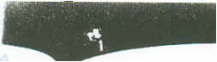
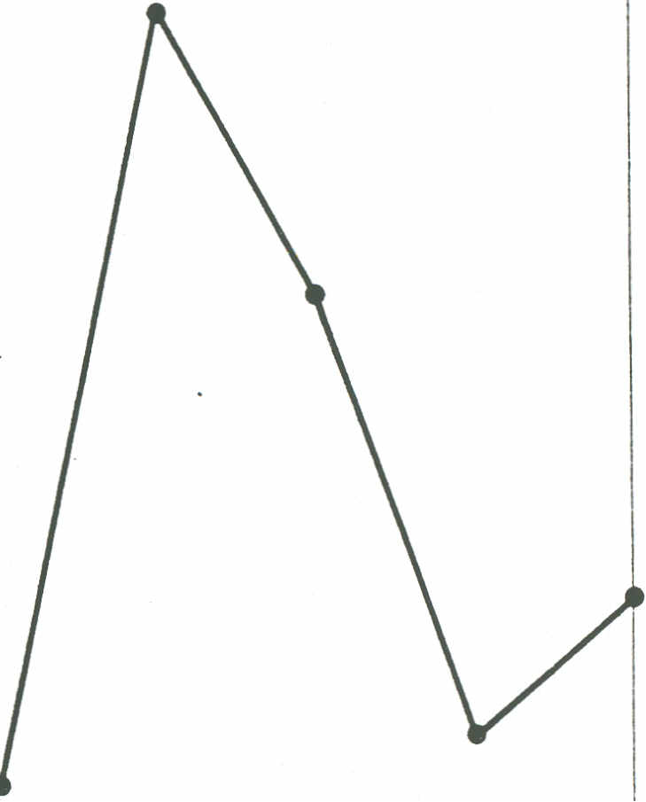
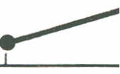

these two small irrigation districts shows B toxicity symptoms (Radtke. 1986). Appendix I shows B concentrations of all other waters sampled contain less than 1.0 mg B/L and therefore pose no hazard from the standpoint of B toxicity except for extremely sensitive plants.
Other high-B waters in Utah have been reported. Hanks et at. (1985) studied high-B waters from electrical power generation plant water cooling towers; B concentration increased as water was recycled in the power plant Also. Milligan et at. (1968) indicated that Strawberry Springs, which discharge directly into the Strawberry River near Duchesne, contain high levels of B. However, except during periods of very low water flow, the B concentration is diluted and the water does not pose a toxicity hazard by downstream irrigation diversion.
Radtke (1986) surveyed the B composition of 14 alfalfa fields in Utah and concluded that crop B deficiency is not likely in the foreseeable future. Soil test results and analyses of plant composition showed that levels of available B were adequate for alfalfa plant nutrition.
Nitrogen
None of the waters sampled contained levels of NO,-N that approached the danger level of to mg/L (Appendix I). Only two samples, one from the middle Sevier River and one from a well near Aowell (Millard County), contained more than 1 ppm of NO,-N.
FIGURE 6. Changes in NO,-N with distance along the Sevier River.
3.0
2.5
2.0
...J ....
co E
:0;:
6
z
\.5
\.0
0.5
Panguitch
Delta
Salina
Gunnison
Mill ]C.
Kingston
Sevier
17

~
Nitrate levels in the Sevier River increased from about 0.1 mg NIL near Panguitch to
2.7 mgN/L near Salina, Levels decreased to less than 1.0 mg/L at Mill junction and below. The results are illustrated in Figure 6. Christensen et at. (1979) observed the same trend when they sampled 54 locations in the Sevier system during three seasons, including samples of sewer outflows from Richfield and Salina. They noted that municipal sewer effluensS contained 0.5 to 12.8 mg NOJ-N/L. depending on the season of the year. They concluded that there was no indication that commercial fertilizer had contaminated the drainage system, even though essentially 100% of the water in the river below Richfield was irrigation sub-surface return-flow. Fields in the region are fertilized. .
The pumped well sampled in Millard County (Appendix I. Aowell), showed higher than normal levels of NO,. about 2.5 mgN/L. This NO, was probably of geologic origin because the upslope side of the well site is mostly non-cultivated desert land.
Phosphorus
Many of the waters analyzed were at or below the detectable limit for P (0.01 mg/L P04-P).
Mean P values of most of the samples were 0.06 mg/L or below. The lower Jordan River in Salt Lake County had the highest average P content of 0.62 mg/L. The next highest P concentration (0.13 mg P/L) was found in the lower Beaver River in Millard County. Except for the Jordan River, which is a low-quality water system from almost every perspective. Utah waters do not seem to contain excessive levels of P.

)

18

SUMMARY AND CONCLUSIONS

Soil Salinity and Sodicity
Surface water salinity and sodicity has not changed significantly since the comprehensive
water quality survey of Thorne and Thorne (1951). Point sources of salinity (mineral springs) have some effect on the quality of water in the Bear River above and below the Cutler Narrows. Point salinity sources have a considerable effect on water quality in the Virgin River and the Utah Lake-Jordan River system. Non-point sources of salinity, i.e. irrigation return-flow, have a moderate affect on the lower Duchesne River, and a large effect on the middle to lower Sevier River.
The ultimate origin of salinity, both point and non-point sources, is the weathering of saline geologic formations. Unless the nature of the geochemical weathering changes, no alteration in the quality of saline surface waters in Utah is foreseen. The beneficial use of marginal quality irrigation waters is expected to improve as farmers fine-tune their on-farm water management (irrigation and drainage) practices in accordance with atmospheric water demand (evapotranspiration) and leaching requirements.

Soil Fertility
Many Utah irrigation waters are low in dissolved potassium, and there is a net loss in soil K due to crop removal and leaching when these waters are applied. Symptoms of K deficiency and responses to K fertilization are becoming more widespread in those areas in Utah that have been irrigated for many decades with low-K waters.
Water at over half of the sites sampled contain less than 60 kg K/ha-m (16 Ib K/ac-ft), far less than that needed to offset losses of K from soil by crop removal. The K in coarse-textured soils, i.e. sandy loams, fine sandy loams, silt loams, and to a lesser extent, loams, is depleted most rapidly. Clay soils, generally contain medium to high amounts of plant-available K, regardless of the quality of water. In K-depleted soils, diagnostic fertility tests may be used to guide fertilizer management practices for crops like alfalfa for hay and com for silage.
Saline, low-quality waters contained as much as 270 kg K/ha-m (70 lb K/ac-ft). This K will accumulate in soil unless excess irrigation water is applied to control salinity.
Eight percent of waters sampled contained 16 kg S/ha-m (4.4 lb S/ac-ft) or less. When irrigation is adequate (2.5 ac-ft/yr) 4.4 lb is an adequate sulfur soil fertility maintenance level. No sulfur deficiencies have been observed in irrigated crops in Utah and sulfur deficiencies are not considered likely within the foreseeable future. SO.-S is a principal constituent of saline waters and soils. Excessive accumulations of SO, in soil can be managed by leaching and drainage.
High-boron waters, those containing more than 3 mg B/L. occur in only two small watersheds in Utah, both located in Duchesne County. B toxicity is a problem in some crops irrigated with these waters, although yield losses attributable to excessive B have not been determined. Irrigators have no choice but to use these waters unless they develop alternative
19

\
irrigation sources. No other water-quality problems with respect to B are known. Other evidence indicates that B deficiency in Utah-grown alfalfa (a high B-demand crop) is not likely within the near future.
Utah surface waters contain such small amounts of N and P as to be inconsequential as far as soil fertility is concerned.
Environmental Pollution and Irrigation
Background levels of nitrate-nitrogen in Utah surface waters were generally less than
1.0 mg/L. In no case did NOJ-N approach 10 mg/L, the level which health agencies have established as detrimental to humans and livestock. Moderate levels of NOJ-N occur in the Sevier River below Richfield and, as reported by Christensen et at. (1979). these are associated with discharges from municipal sewage systems.
Although some NOJ,N is probably leached from cultivated fields, an appreciable amount of this N can be expected to escape into the atmosphere as gaseous N compounds because of denitrification. In general, fertilization of irrigated crop lands has had no significant impact on the N03-N concentration of surface waters.
Phosphate-phosphorus content of Utah surface waters was generally below 0.05 mg/L. The Jordan River had the highest observed PO4-P. 0.6 mg/L. which is apparently not related to irrigation return-flow. The P content of Utah surface waters does not appear to pose any threat to environmental quality.

-- 'J

20
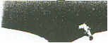

LITERATURE CITED
Anon. 1968. Water Quality Criteria. Report of the National Technical Advisory Committee to the Secretary of the Interior, Federal Water Pollution Control Administration. Washington. D.C.
Carter. D. L., J. A. Bondurant, and C. W. Robbins. 1971. Water-soluble nitrate-nitrogen, phosphate-phosphorus, and total salt balances on a large irrigation tract Proc. Soil Sci. Soc. Am. 35:331-335.

Carter. D. L., C. W. Robbins. and j. A. Bondurant 1973. Total salt, specific ion, and fertilizer element concentrations and balances in the irrigation and drainage waters of the Twin Falls tract in Southem Idaho. Agricultural Research Service. U.S. Department of Agriculture. ARS-W-4. .
\
Christensen. Paul D., Rex F. Nielson. and Reuel E. Lambom. 1979. Fertilizer nutrient levels in the Sevier River. Utah Science 40: 1 08-111.
. Food and Agricultural Organization of the United Nations. 1985. Water Quality for Agriculture.
Irrigation and Drainage Paper No. 29. Rev. 1. Rome. Italy.
Hanks. R. J., D. W. James. and D. W. Watts. 1983. Irrigation management and crop production
as related to nitrate mobility. In Chemical Mobility and Reactivity in Soil Systems. D. W.
Nelson, Editor. Soil Sci. Soc. Am. Spec. Pub. No. 11. Madison. Wisconsin.
Hanks. R. J., R. F. Nielson. R. L. Cartee. L. S. Willardson. R. B. Sorensen. A. R. Mitchell. and
U. Shani. 1985. Use of saline waste water from electrical power plants for irrigation. Utah
Ag. Exp. Sta. Res. Report No. 103. Utah State University. Logan. Utah.
Hunsaker. V. E., and D. W. James. 1973. Potassium deficiencies in alfalfa in eastern Utah. Proc.
24th An. Northwest Ferc. Conf., Pendleton. Oregon. July.
James, D. W. 1978. Diagnostic soil testing for nitrogen availability: The effects of nitrogen fertil
izer rate. Time, method of application, and cropping pattern on residual soil nitrogen.
Utah Ag. Exp. Bul. 497.
Jeppson. Roland W., Gaylen L. Ashcroft. A. Leon Huber. Gaylord V. Skogerboe. and jay M.
Bagley. 1968. Hydrologic atlas of Utah. Utah Water Research Laboratory. Utah State
University. PRWG35-1.
Lindstrom. Thor. 1983. Alfalfa production and quality as influenced by fertilizer potassium,
where soils and irrigation waters are low in potassium. Unpublished MS thesis. Utah State
University.
Milligan. James. H., Ray E. Marsell. and Jay M. Bagley. 1966. Mineralized springs in Utah and
their effect on manageable water supplies. Utah Water Research Laboratory, Utah State
University, WG23-6.

21

n\
Nelson. E. C. and W. H. Weaver. 1971. Salt balance for the Wapato Project for 1970-71 com-
pared with salt balance for 1941-42. Wash. Ag. Exp. Sta. But. 743.
Radtke. Robert N. Jr. 1986. Boron composition of alfalfa in Utah as related to soils and irrigation
waters. Unpublished MS Thesis. Utah State University. Logan. Utah.
Schofield. C W. 1936. The salinity of irrigation water. Smith lnst Am. Rpt 275-287.
Thorne. James P., and D. W. Thorne. 1951. Irrigation waters of Utah, their quality and use. Utah
Ag. Exp. Sta. Bul 346.
Thorne. D. W.. and H. B. Peterson. 1954. Irrigated Soils. Second Edition. The Blakiston Com-
pany. Toronto.
U.S. Salinity Laboratory Staff. 1954. Diagnosis and Improvement of Saline and Alkali Soils.
U.S.D.A. Handbook 60.
Westermann. D. T. 1974. Indexes of sulfur deficiency in alfalfa. I. Extractable soil 504-5.
Agron. J. 66:265-268.
Westermann. D. T. 1975. Indexes of sulfur deficiency in alfalfa. II. Plant analysis. Agron. J.
67:265-268.
Wilcox. L. V. 1960. Boron injury to plants. USDA Inf. Bull. 211.
Yaron. B. 1973. Water suitability for irrigation. In Arid Zone Agriculture. Yaron. B., E. Danfors
and Y. Vaadia. Eds. Springer-Verlag. New York.

~\

22
')

ACKNOWLEDGMENT
The authors express appreciation to Raymond E. Knighton and Robert A. Davidson, both former research assistants who helped with water sample collection and laboratory analyses.

23
 |  |  |  |  |  |  |  |  |  |  |  |  |  |  | '\
APPENDIX I
Great Salt Lake Drainage
A. Bear River System
 | 1. Bear River, Sage Creek Junction
 |  | dS/m |  |  |  |  | mmoleiL |  |  |  |  |  | mg/L
 |  | -
 | Date | EC' | pH | Ca | Mg | Na | K | CI | SO. | CO, | HCO, | NO, | PO. | B
 | 6/ 8/49* | .660 | - | 2.54 | 2.55 | 1.91 | 0.16 | 1.02 | 0.67 | 0.30 | 4.95 | 0.4 | - | 0.12
 | 7/26/49 | .700 | - | 3.09 | 2.22 | 1.91 | 0.15 | 0.73 | 0.91 | 0.30 | 5.05 | 0.1 | - | 0.11
 | 1/ 1/81 | .630 | 7.68 | 3.31 | 3.05 | 1.46 | 0.07 | 0.85 | 0.15 | 0.00 | 5.46 | 0.62 | 0.05
 | 9/ 3/81 | .790 | 8.26 | 5.00 | 3.32 | 1.99 | 0.06 | 1.72 | 0.27' 0.00 |  | 1.83 | 0.04 | 0.01
 | 6/26/82 | .610 | 8.35 | 2.38 | 2.16 | 1.10 | 0.12 | 0.85 | 0.22 | 0.00 | 4.73 | - | 0.03
 | 8/25/83 | .404 | 8.12 | 2.00 | 1.40 | 0.67 | 0.05 | 0.53 | 0.30 | - | - | <.1 | 0.02 | 0.03
 | 2. Bear River, Lewiston
 | 6/10/49 | .790 | - | 2.59 | 1.97 | 3.07 | 0.42 | 2.41 | 0.67 | 0.53 | 4.36 | 0.8 | - | 0.14
 | 7/28/49 | .910 | - | 3.19 | 3.62 | 2.87 | 0.36 | 2.04 | 1.37 | 0.73 | 5.58 | 0.4 | - | 0.02
 | 1/ 1/81 | .910 | 7.99 | 3.54 | 4.13 | 2.53 | 0.22 | 1.82 | 0.34 | 0.00 | 6.12 | 0.79 | 0.06
-t8/31181 |  | .930 | 8.35 | 3.29 | 4.79 | 2.42 | 0.31 | 1.54 | 0.39 | 0.00 | 6.07 | 0.34 | 0.03
" | 6/29/82 | .680 | 8.41 | 2.92 | 1.87 | 1.40 | 0.23 | 1.94 | 0.37 | 0.43 | 4.32 |  | 0.08 |  | \
 |  |  |  |  |  |  |  |  |  |  |  | - | 0.08 | - | \
 | 8/24/83 | . .729 | 8.23 | 2.60 | 3.00 | 1.72 | 0.21 | 1.26 | 1.17 | - | - | <.1 | 0.05 | 0.04
 | 3. Bear River, Cutler Dam |  |  |  |  |  |  |  |  |  |  |  | f
 | 6/14/49 | .530 | - | 2.50 | 1.48 | 1.35 | 0.18 | 0.99 | 2.85 | 0.10 | 4.15 | 0.6 | - | 0.08
 | 7/28/49 | 1.300 | - | 2.79 | 2.79 | 7.05 | 0.51 | 6.70 | 1.12 | 0.47 | 4.99 | 0.4 | - | 0.15
 | 9/ 7/49 | .900 | - | 2.30 | 3.70 | 2.70 | 0.38 | 1.93 | 1.39 | '0.43 | 5.72 | 0.2 | - | 0.12
 | 7/ 7/81 | .840 | 8.01 | 3.68 | 3.68 | 2.63 | 0.24 | 1.90 | 0.39 | 0.00 | 5.71 | 0.59 | 0.08
 | 8/31181 | .910 | 8.53 | 2.97 | 4.59 | 2.76 | 0.31 | 2.09 | 0.33 | 0.39 | 5.71 | 0.05 | <.01
 | 6/29/82 | .510 | 8.47 | 2.66 | 1.43 | 0.89 | 0.12 | 0.86 | 0.19 | 0.26 | 3.93 | - | 0.19
 | 8/24/83 | .673 | 8.27 | 2.70 | 2.70 | 1.48 | 0.15 | 1.08 | 0.97 | - | - | <.1 | 0.07 | 0.04
 | 4. Bear River, Corinne
 | 6/14/49 | 1.130 | - | 2.59 | 1.89 | 5.92 | 0.42 | 5.88 | 0.66 | 0.10 | 4.46 | 0.8 | - | 0.20
 | 8/ 5/49 | 2.900 | - | 3.19 | 4.44 | 19.58 | 1.54 20.31 |  | 1.58 | 0.13 | 5.56 | 0.5 | - | 0.00
 | 9/ 7/49 | 1.750 | - | 2.59 | 4.27 | 10.27 | 0.74 | 9.74 | 1.68 | 0.30 | 5.79 | 0.2 | - | 0.00
 | 7/16/81 | 4.610 | 8.53 | 2.99 | 5.25 | 34.32 | 1.42 35.47 |  | 0.40 | 0.00 | 5.90 | 1.55 | 0.13
 | 9/ 1181 | '4.010 | 8.36 | 3.69 | 5. (ffi | 35.48 | 5.00 33.08 |  | 0.71 | 0.22 | 5.90 | 0.54 | <.01
 | 6/29/82 | .930 | 8.51 | 2.83 | 1.72 | 4.53 | 0.28 | 4.79 | 0.24 | 0.52 | 3.87 | - | 0.04
 | 9/19/83 | .976 | 8.22 | 3.10 | 2.90 | 3.83 | 0.22 | 3.46 | 1.02 | 0.00 | 6.00 | 0.4 | 0.04 | 0.08
 | "Data for 1949 are from Thome and Thome (1951).
)
t
\
24
I
 | B. Bear River Tributaries
 | 5. Newton Canal, Newton
 |  | dS/m |  |  |  |  | mmok/L |  |  |  |  |  | mglL
 |  | -
 | Date | EC | pH | Ca | Mg | Na | K | Cl | SO. | CO, | HCO, | NO, | PO. | B
 | 5/ 3/49 | .930 | - | 3.29 | 3.70 | 2.35 | 0.38 | 3.21 | 1.56 | 0.33 | 4.00 | 0.8 | - | 0.06
 | 6/10/49 | .920 | - | 3.39 | 3.62 | 2.35 | 0.36 | 3.12 | 1.58 | 0.37 | 4.23 | 0.8 | - | 0.06
 | 7/28/49 | .950 | - | 3.24 | 3.78 | 2.52 | 0.41 | 3.46 | 1.73 | 0.27 | 4.13 | 0.4 | - | 0.06
 | 1/ 1/81 | .860 | 7.96 | 3.61 | 4.41 | 2.31 | 0.19 | 1.62 - | 1.46 | 0.00 | 6.04 | 0.72 | 0.05
 | 8/31/81 | .880 | 8.51 | 3.19 | 4.69 | 2.04 | 0.23 | 1.70 | 0.06 | 0.22 | 5.95 | 0.38 | 0.03
 | 6/29/82 | .600 | 8.44 | 2.70 | 1.84 | 1.54 | 0.16 | 1.21 | 0.40 | 0.60 | 4.15 | - | 0.03
 | 8/24/82 | .830 | 8.44 | 2.90 | 3.10 | 2.49 | 0.19 | 1.98 | 1.30 | - | - | 0.6 | 0.07 | 0.07
 | B. Bear River Tributaries
 | 6. Logan River, Logan
 | 6/10/49 | .300 | - | 2.10 | 0.99 | 0.09 | 0.02 | 0.06 | 0.08 | 0.27 | 2.92 | 0.2 | - | 0.08
 | 1/26/49 | .360 | - | 2.10 | 1.15 | 0.09 | 0.03 | 0.09 | 0.15 | 0.43 | 3.10 | - | - | 0.04
 | 7/ 1/81 | .350 | 8.20 | 2.82 | 1.37 | <.10 | <.01 | 0.06 | 0.11 | 0.00 | 3.53 | 0.30 | 0.30
 | 9/ 3/81 | .400 | 8.43 | 2.92 | 1.51 | <.10 | <.01 | 0.05 | <.04 | 0.09 | 3.53 | 0.08 | <.01
 | 6/29/82 | .330 | 8.54 | 2.19 | 0.94 | 0.08 | 0.02 | 0.19 | 0.04 | 0.39 | 2.83 | - | 0.01
 | t 9/25/83 | .372 | 8.53 | 2.40 | 1.40 | 0.14 | 0.02 | 0.05 | <.10 | - | - | <.1 | 0.02 | <.01
 | 9/19/83 | .384 | 8.12 | 2.50 | 1.60 | 0.14 | 0.02 | 0.05 | <.10 | 0.00 | 4.10 | <.1 | 0.02 | <.01
 | 7. Blacksmith Fork, Hyrum
 | 5/ 3/49 | .340 | - | 2.20 | 1.48 | 0.18 | 0.05 | 0.14 | 0.12 | 0.00 | 3.15 | 1.3 | - | .02
 | 6/ 9/49 | .400 | - | 2.50 | 1.23 | 0.17 | 0.03 | 0.17 | 0.15 | 0.40 | 3.48 | 0.4 | - | 0.00
 | 7/28/49 | .400 | - | 2.54 | 1.48 | 0.17 | 0.05 | 0.11 | 0.15 | 0.23 | 3.89 | 0.4 | - | 0.00
 | 7/15/81 | .390 | 8.41 | 2.95- | 1.79 | <.10 | <.01 | 0.14 | <.04 | 0.00 | 3.93 | 0.26 | 0.03
 | 9/ 3/81 | .420 | 8.25 | 2.97 | 1.64 | 0.15 | <.01 | 0.11 | <.04 | 0.36 | 3.57 | 0.15 | - 0.01
 | 6/29/82 | .460 | 8.64 | 2.59 | 1.44 | 0.27 | 0.04 | 0.33 | 0.13 | 0.69 | 3.87 | - | 0.01
 | 8/25/83 | .426 | 8.55 | 2.70 | 1.60 | 0.24 | 0.02 | 0.13 | 0.30 | - | - | <.1 | 0.01 | <.01
 | 8. Little Bear River, East Fork, Avon
 | 6/ 9/49 | .300 | - | 1.80 | 0.82 | 0.17 | 0.03 | 0.17 | 0.13 | 0.30 | 2.79, | 0.2 | - | 0.08
 | 7/28/49 | .450 | - | - | - | - | - | - | - | - | - | - | -
 | 1/ 1/81 | .390 | 7.93 | 3.02 | 1.79 | 0.16 | <.01 | 0.15 | 0.18 | 0.00 | 3.75 | 0.57 | 0.05
 | 8/31/81 | .400 | 8.48 | 2.71 | 1.91 | 0.16 | <.01 | 0.15 | <.04 | 0.53 | 3.14 | 0.09 | <.01
 | 6/29/82 | .390 | 8.63 | 2.59 | I.t4 | 0.26 | 0.04 | 0.26 | 0.09 | 0.52 | 3.30 | - | 0.01
 | 8/25/83 | .409 | 8.48 | 2.60 | 1.50 | 0.19 | 0.02 | 0.14 | <.10 | - | - | <.1 | 0.01 | <.01

25
 |  |  |  |  |  |  |  |  |  |  |  |  |  | '\
B. Bear River Tributaries (continued)
9. Little Bear River, South Fork, Avon
 | dS/m |  |  |  |  | mmok/L |  |  |  |  |  | mglL
Date | EC | pH | Ca | Mg | Na | K | Cl | SO. | CO, | HCO, | NO, | PO. | B
7/ 7/81 | .370 | 8.34 | 2.61 | 1.79 | 0.60 < .01 |  | 0.17 | 0.11 | 0.00 | 3.75 | 0.47 | 0.04
8/31/81 | .420 | 8.38 | 2.88 | 1.92 | 0.25 < .01 |  | 0.23 | <.04 | 0.41 | 3.71 | 0.07 | 0.02
6/29/82 | .370 | 8.66 | 2.28 | 1.26 | 0.28 | 0.03 | 0.24 | 0.06 | 0.69 | 3.37 | - | 0.01
8/25/83 | .398 | 8.50 | 2.20 | 1.80 | 0.29 | 0.02 | 0.23 | <.10 | - | - | <.1 | <.01 | <.01
10. Little Bear River, Hyrum Reservoir
5/ 3/49 | .310 | - | 1.95 | 1.32 | 0.26 | 0.05 | 0.17 | 0.11 | 0.20 | 2.76 | 0.4 | - | 0.02
7/28/49. | .360 | - | 2.30 | 1.15 | 0.39 | 0.08 | 0.17 | 0.17 | 0.23 | 3.26 | 0.4 | - | 0.00
7/ 7/81 | .440 | 7.63 | 3.19 | 1.79 | 0.33 | 0.03 | 0.25 | <.04 | 0.00 | 4.00 | / 0.72 | 0.09
8/31/81 | .470 | 8.28 | 3.03 | 1.94 | 0.37 | 0.05 | 0.26 | <.04 | 0.00 | 4.23 | 0.17 | 0.03
6/29/82 | .360 | 8.33 | 2.28 | 1.04 | 0.29 | 0.06 | 0.28 | 0.08 | 0.17 | 3.76 | - | 0.01
8/24/83 | .414 | 8.50 | 2.20 | 1.60 | 0.33 | 0.05 | 0.24 | 0.17 | - | - | 0.1 | 0.01 | <.01
9/19/83 | .449 | 7.89 | 2.70 | 1.80 | 0.33 | 0.04 | 0.18 | 0.26 | 0.00 | 4.70 | 0.5 | 0.01 | 0.02
1 1. Malad River, Bear River City
6/14/49 | 3.150 | - | -
8/ 5/49 | 2.100 | - | 2.99 | 3.29 | 13.49 | 0.92 | 12.21 | 2.23 | 0.33 | 6.46 | 0.8 | - | 0.13 | '\
9/ 7/49 | 1.750 | - | 2.59 | 4.52 | 10.70 | 0.92 | 8.69 | 1.02 | 0.47 | 6.49 | 0.8 | - | 0.25
7/16/81 | 2.840 | 8.44 | 4.10 | 5.15 | 16.67 | 0.78 | 15.89 | 0.47 | 0.00 | 7.22 | 1.78 | 0.13
9/ 1/81 | 2.010 | 8.38 | 3.70 | 4.64 | 13.00 | 0.71 | 11.54 | 0.46 | 0.38 | 6.63 | 1.13 | 0.07
6/29/82 | 3.170 | 8.53 | 4.13 | 3.91 | 31.03 | 1.70 | 21.07 | 1.02 | 0.60 | 5.44 | - | 0.06
9/19/83 | 2.692 | 8.23 | 4.00 | 3.90 | 16.74 | 0.90 | 16.60 | 1.75 | 0.00 | 7.30 | 0.8 | 0.08 | 0.25
12. Box Elder Creek. Brigham
6/14/49 | .370 | - | 2.15 | 1.32 | 0.30 | 0.05 | 0.28 | 0.17 | 0.20 | 3.44 | 0.6 | - | 0.08
7/30/49 | .350 | - | 1.90 | 0.74 | 0.35 | 0.08 | 0.28 | 0.25 | 0.33 | 2.48 | 0.6 | - | 0.00
9/ 7/49 | .430 | - | 2.40 | 1.48 | 0.39 | 0.08 | 0.31 | - | 0.13 | 3.76 | 0.6 | - | 0.06
13. Mantua Reservoir, Mantua
7/16/81 | .360 | 7.98 | 2.35 | 1.68 | 0.31 | 0.03 | 0.30 | <.04 | 0.00 | 3.23 | Ltl | 0.08
9/ 1/81 | .370 | 8.42 | 2.04 | 1.62 | 0.36 | 0.05 | 0.08 | <.04 | 0.08 | 2.98 | 0.20 | 0.03
6/29/82 | .260 | 8.18 | 1.97 | 1.18 | 0.48 | 0.08 | 0.39 | 0.07 | 0.00 | 3.24 | - | 0.01
9/19/83 | .387 | 7.72 | 2.00 | 1.50 | 0.33 | 0.05 | 0.25 | 0.21 | 0.00 | 4.00 | 0.30 | 0.08 | <.01

'1
26
 |  |  | c. Ogden and Weber Rivers
 |  |  | 14. Ogden River, Pineview Spillway
 |  |  |  | dS/m |  |  |  |  | mmok/L |  |  |  |  |  | mgiL
 |  |  |  | - |  |  |  |  |  |  |  |  |  |  | mgiL
 |  |  | Date | EC | pH | Ca | Mg | Na | K | Cl | SO. | CO, | HCO, | NO, | PO. | B
 |  |  | 7/31/81 | .320 | 7.86 | 2.72 | 0.84 | 0.15 | 0.02 | 0.25 | <.04 | 0.00 | 2.76 | 0.50 | 0.05
 |  |  | 9/ 1/81 | .360 | 8.25 | 2.74 | 0.91 | 0.27 <.01 |  | 0.23 | <.04 | 0.28 | 2.76 | 0.04 | 0.03
 |  |  | 7/ 1/81 | .310 | 7.87 | 0.86 | 0.36 | 0.09 | 0.02 | 0.20 | 0.07 | 0.00 | 2.59 | - | 0.01
 |  |  | 8/30/83 | .252 | 7.95 | 1.60 | 0.74 | 0.24 | 0.03 | 0.18 | <.10 | 0.00 | 2.90 | 0.1 | 0.02 | <.01
 |  |  | 9/19/83 | .239 | 7.82 | 1.60 | 0.58 | 0.24 | 0.03 | 0.06 | 0.19 | 0.00 | 2.60 | <.1 | 0.04 | 0.02
 |  |  | 15. Ogden River, mouth of canyon
 |  |  | 6/ 6/49 | .290 | - | 1.70 | 0.49 | 0.41 | 0.05 | 0.40 | 0.25 | 0.13 | 2.12 | 0.4 | - | 0.01
 |  |  | 7/13/81 | .460 | 8.29 | 2.97 | 1.16 | 1.08 | 0.09 | 1.13 | 0.10 | 0.00 | 3.05 | 0.40 | 0.03
 |  |  | 9/ 1/81 | .670 | 8.22 | 3.35 | 1.41 | 2.17 | 0.24 | 2.40 | 0.08 | 0.00 | 3.49 | 0.07 | 0.02
 |  |  | 7/ 1/82 | .130 | 8.42 | 1.39 | 0.65 | 0.28 | 0.07 | 0.98 | 0.14 | 0.00 | 1.17 | - | 0.01
 |  |  | 8/30/83 | .279 | 8.15 | 1.80 | 0.74 | 0.33 | 0.03 | 0.20 | <.10 | 0.00 | 3.00 | <.1 | 0.02 | 0.01
 |  |  | 9/19/83 | .376 | 8.10 | 1.80 | 0.91 | 0.86 | 0.07 | 0.84 | 0.28 | 0.00 | 2.90 | 0.1 | 0.04 | 0.03
 |  |  | 16. Ogden River, Ogden
 |  |  | 7/13/81 | .470 | 8.11 | 3.02 | 1.05 | 1.14 | 0.11 | 1.16 | 0.12 | 0.00 | 3.04 | 0.50 | 0.04
 |  |  | 7/ 1/82 | .390 | 8.29 | 1.27 | 0.71 | 0.50 | 0.09 | 1.00 | 0.16 | 0.00 | 2.33 | - | 0.01
 |  |  | 17. Weber River, below Echo Dam
 |  |  | 9/ 2/83 | .583 | 8.13. | 2.80 | 2.20 | 1.00 | 0.06 | 0.98 | 0.70 | 0.00 | 5.80 | 0.5 | 0.04 | 0.10
 |  |  | 18. Weber River, mouth of Weber Canyon
 |  |  | 5/16/49 | .330 | - | 2.00 | 0.82 | 0.52 | 0.08 | 0.46 | 0.48 | 0.07 | 2.36 | 0.6 | - | 0.04
 |  |  | 6/ 6/49 | .390 | - | - | - | - | - | - | - | - | - | - | - | -
 |  |  | 7/29/49 | .410 | - | 2.79 | 1.07 | 0.52 | 0.10 | 0.34 | 0.48 | 0.40 | 3.05 | 0.2 | - | 0.06
 |  |  | 7/13/81 | .470 | 8.31 | 3.80 | 1.37 | 0.59 | 0.05 | 0.55 | 0.21 | 0.00 | 3.70 | 0.63 | 0.05
 |  |  | 9/ 1/81 | .550 | 8.27 | 3.90 | 1.34 | 0.10 | 0.05 | 0.53 | 0.08 | 0.00 | 3.86 | 0.05 | <.01
 |  |  | 7/ 1/82 | .130 | 8.34 | 1.56 | 0.80 | 0.44 | 0.06 | 0.49 | 0.18 | 0.00 | 1.36 | - | 0.01
 |  |  | 8/30/83 | .488 | 8.25 | 3.20 | 1.30 | 0.77 | 0.05 | 0.67 | 0.55 | 0.00 | 4.70 | <.1 | 0.07 | <.01
 |  |  | 19. Weber Canal, Farmington
 |  |  | 7/13/81 | .410 | 7.82 | 2.50 | 1.16 | 0.72 | 0.09 | 0.42 | 0.09 | 0.00 | 3.45 | 0.88 | 0.05
 |  |  | 9/ 1/81 | .270 | 8.06 | 1.48 | 0.55 | 0.48 | 0.04 | 0.25 | <.04 | 0.00 | 1.83 | 0.42 | 0.01
 |  |  | 7/ 1/82 | .440 | 8.33 | 1.36 | 1.23 | 0.48 | 0.11 | 0.61 | 0.21 | 0.13 | 3.15 | - | 0.01
 |  |  | 8/30/83 | .393 | 7.95 | 2.40 | 1.00 | 0.57 | 0.04 | 0.50 | 0.40 | 0.00 | 3.70 | <.1 | 0.03 | 0.03
(

27
 |  |  |  |  |  |  |  |  |  |  |  |  |  |  |  |  | )
 |  | C. Ogden and Weber Rivers (continued)
 |  | 20. Weber-Ogden River, West-Weber, Utah
 |  |  | dS/m |  |  |  |  | mmolc/L |  |  |  |  |  |  | Mg/L
 |  |  | -
 |  | Date | EC | pH | Ca | Mg | Na | K | Cl | 50. |  | CO, | HCO, | NO, | PO. | B
 |  | 6/14/49 | .460 |  | 2.34 | 1.07 | 1.17 | 0.16 | 0.08 | 0.44 |  | 0.00 |  | 0.4
 |  | 6/14/49 | .460 | - |  |  |  |  |  |  |  | 0.00 | 3.44 | 0.4 | - | 0.06
 |  | 9/ 7/49 | .790 | - | 3.29 | 1.56 | 2.48 | p.38 | 2.04 | 0.64 |  | 0.00 | 5.07 | 0.2 | - | 0.00
 |  | 9/19/83 | .440 | 8.13 | 2.60 | 1.20 | 0.57 | 0.05 | .0.51 | 0.50 |  | 0.00 | 3.50 | 0.1 | 0.04 | 0.03
 |  | D. Small Streams, Wasatch Front
 |  | 21. Big Cottonwood Creek, Salt Lake City
 |  | 7/30/49 | 1.170 | - | 3.99 | 3.12 | 4.00 | 0.38 | 3.35 | 3.64 |  | 0.47 | 4.18 | 0.4 | - | 0.04
 |  | 7/15/81 | .290 | 8.08 | 2.09 | 1.05 | 0.17 | 0.01 | 0.25 | 0.23 |  | 0.00 | 2.15 | 0.35 | 0.06
 |  | 9/ 1/81 | .330 | 8.19 | 2.26 | 1.03 | 0.20 <.01 |  | 0.26 | 0.09 |  | 0.16 | 2.05 | 0.08 | 0.01
 |  | 7/ 1/82 | .050 | 8.52 | 0.97 | 0.61 | 0.21 | 0.03 | 0.24 | 0.18 |  | 0.00 | 0.82 | - | 0.01
 |  | 8/30/83 | .297 | 7.40 | 1.80 | 1.00 | 0.29 | 0.02 | 0.19 | 0.55 |  | 0.00 | 2.80 | <.1 | 0.55 | <.01
 |  | 22. Little Cottonwood Creek, Salt Lake City
 |  | 7/30/49 | .190 | - | 1.00 | 0.33 | 0.13 | 0.05 | 0.06 | 0.37 |  | 0.07 | 0.92 | 0.1 | - | 0.06
 |  | 7/15/81 | .170 | 8.06 | 1.16 | 0.32 | 0.15 | 0.01 | 0.22 | 0.18 |  | 0.00 | 0.71 | 0.24 | 0.03 | - | ')
 |  | 7/ 1/82 | .050 | 8.01 | 0.62 | 0.24 | 0.13 | 0.03 | 0.24 | 0.14 |  | 0.00 | 0.82 | - | <.01 | - | ')
 |  | 8/30/83 | .163 | 7.65 | 0.85 | 0.41 | 0.29 | 0.03 | 0.16 | 0.35 |  | 0.00 | 1.30 | <.1 | 0.35 | <.01
 |  | 23. American Fork Creek, American Fork
 |  | 7/30/49 | .390 | - | 2.54 | 1.40 | 0.13 | 0.03 | 0.09 | 1.12 |  | 0.23 | 2.56 | 0.2 | - | 0.14
 |  | 7/14/81 | .410 | 8.42 | 3.59 | 1.37 | <.10 | <.01 | 0.08 | 0.40 |  | 0.00 | 2.91 | 0.24 | 0.02
 |  | 9/ 1/81 | .500 | 8.42 | 3.91 | 1.53 | <.10 | <.01 | 0.11 | 0.38 |  | 0.00 | 3.11 | 0.12 | <.01
 |  | 7/ 1/82 | .090 | 8.63 | 1.65 | 0.86 | 0.06 | 0.02 | 0.18 | 0.30 |  | 0.00 | 1.04 | - | <.01
 |  | 8/30/82 | .427 | 8.10 | 2.90 | 1.40 | 0.14 | 0.02 | 0.06 | 1.32 |  | 0.00 | 3.80 | <.1 | 0.01 | <.01
 |  | 24. Strawberry Reservoir
 |  | 9/10/49 | .310 | - | 1.80 | 0.90 | 0.26 | 0.08 | 0.06 | 0.52 |  | 0.00 | 2.79 | 0.2 | - | 0.00
 |  | 7/14/81 | .490 | 8.02 | 4.20 | 1.89 | <.10 | 0.01 | 0.05 | 0.21 |  | 0.00 | 3.42 | 0.31 | 0.09
 |  | 9/ 8/81 | .590 | 8.46 | 4.69 | 1.86 | 0.13 | <.01 | 0.06 | <.04 |  | 0.35 | 3.36 | <.01 | <.01
 |  | 6/30/82 | .310 | 8.02 | 1.43 | 0.65 | 0.04 | 0.02 | 0.16 | 0.21 |  | 0.00 | 2.44 | - | 0.01
 |  | 9/ 2/83 | .515 | 8.20 | 3.70 | 1.70 | 0.19 | 0.02 | 0.06 | 1.72 |  | 0.00 | 4.30 | 0.1 | 0.04 | <.01

')
28
 | D. Small Streams, Wasatch Front (continued)
 | 25. Spanish Fork River, Spanish fork
 |  |  | dS/m |  |  |  |  | mmolc/L |  |  |  |  |  | Mg/L
 |  |  | - |  |  |  |  |  |  |  |  |  |  | Mg/L
 | Date |  | EC | pH | Ca | Mg | Na | K | Cl | 504 | CO, | HCO, | NO, | P04 | B
 | 6/ 6/49 |  | .580 | - | 2.50 | 1.89 | 1.22 | 0.13 | 0.68 | 0.85 | 0.27 | 3.99 | 0.4 | - | 0.06
 | 7/30/49 |  | .470 | - | 1.55 | 1.40 | 0.78 | 0.10 | 0.43 | 0.83 | 0.37 | 3.12 | - | - | 0.00
 | 7/14/81 |  | .410 | 8.35 | 2.61 | 1.47 | 0.71 | 0.04 | 0.40 | 0.19 | 0.00 | 3.17 | 0.53 | 0.05
 | 9/ 1/81 |  | .400 | 8.45 | 2.38 | 1.41 | 0.28 | 0.02 | 0.46 | 0.08 | 0.39 | 2.60 | 0.08 | <.01
 | 7/ 1/82 |  | .130 | 8.45 | 1.70 | 1.52 | 0.63 | 0.08 | 0.22 | 0.38 | 0.00 | 1.34 | - | 0.01
 | 26. Payson Creek (Highline Canal), Payson
 | 5/ 6/49 |  | .560 | - | 3.14 | 2.14 | 0.87 | 0.10 | 0.45 | 0.77 | 0.40 | 4.00 | 0.6 | - | 0.05
 | 7/29/49 |  | .470 | - | 2.50 | 1.40 | 0.78 | 0.10 | 0.43 | 0.83 | 0.40 | 3.15 | 0.4 | - | 0.04
 | 8/ 7/49 |  | .450 | - | 2.54 | 1.07 | 0.74 | 0.10 | 0.43 | 0.77 | 0.00 | 3.36 | 0.2 | - | 0.02
 | 7/14/81 |  | .350 | 8.56 | 2.25 | 1.05 | 0.26 | 0.07 | 0.15 | <.04 | 0.22 | 2.82 | 0.38 | 0.04
 | 9/ 1/81 |  | .360 | 8.56 | 2.61 | 1.13 | 0.32 | 0.08 | 0.16 | <.04 | 0.60 | 2.54 | 0.08 | 0.02
 | 7/ 1/81 |  | .210 | 8.16 | 1.79 | 0.88 | 0.35 | 0.07 | 0.31 | 0.15 | 0.00 | 1.84 | - | 0.01
 | 8/30/83 |  | .768 | 8.15 | 3.90 | 2.50 | 0.22 | 0.08 | 1.76 | 1.96 | 0.00 | 6.00 | <.1 | 0.02 | 0.03
 |  | E. Provo River, Utah Lake, Jordan River
 | 27. Provo River (Highway 40, near Heber)
 | 7/13/81 |  | .260 | 8.44 | 2.11 | 0.63 | 0.11 | 0.03 | 0.15 | 0.19 | 0.00 | 1. 71 | 0.30 | 0.03
 | 9/ 1/81 |  | .340 | 8.47 | 2.65 | 0.81 | 0.24 | 0.03 | 1.27 | 0.18 | 0.22 | 1.74 | 0.11 | 0.05
 | 6/30/82 |  | .030 | 7.60. | 0.81 | 0.26 | 0.02 | 0.03 | 0.14 | 0.10 | 0.00 | 0.82 | - | 0.01
 | 9/ 2/83 |  | .264 | 8.09 | 1.60 | 0.66 | 0.24 | 0.03 | 0.10 | 0.67 | 0.00 | 2.20 | <.1 | 0.02 | 0.02
 | 28. Provo River (below Deer Creek Reservoir)
 | 5/ 6/49 |  | .500 | - | 3.19 | 1.64 | 0.57 | 0.13 | 0.34 | 1.29 | 0.47 | 3.21 | 0.4 | - | 0.02
 | 7/30/49 |  | .360 | - | 2.25 | 0.82 | 0.35 | 0.10 | 0.17 | 1.44 | 0.07 | 2.62 | 0.2 | - | 0.05

29
 |  |  |  |  |  |  |  |  |  |  |  |  |  |  | ')
 |  |  |  |  |  |  |  |  |  |  |  |  |  |  | I
 | E. Provo River, Utah Lake, Jordan River (continued)
 | 29. Provo River, Provo Canyon mouth, Provo
 |  | dS/m |  |  |  |  | mmok/L |  |  |  |  |  | mglL
 |  | -
 | Date | EC | pH | Ca | Mg | Na | K | Cl | SO. | CO, | HCO, | NO, | PO. | B
 | 7/14/81 | .400 | 8.23 | 3.22 | 1.16 | 0.36 | 0.05 | 0.28 | 0.28 | 0.00 | 2.92 | 0.61 | 0.07
 | 9/ 1/81 | .400 | 8.36 | 3.01 | 1.00 | 0.39 | 0.03 | 0.27 | 0.14 | 0.13 | 2.64 | 0.26 | 0.09
 | 6/30/82 | .210 | 8.51 | 1.64 | 0.68 | 0.33 | 0.06 | 0.32 | 0.30 | 0.00 | 1.68 | - | 0.01
 | 8/30/83 | .302 | 7.85 | 2.00 | 0.82 | 0.29 | 0.04 | 0.18 | 0.44 | 0.00 | 2.90 | <.1 | 0.06 | <.01
 | 30. Jordan River, Lehi
 | 6/ 3/49 | 1.530 | - | 3.24 | 4.36 | 8.13 | 0.64 | 6.42 | 5.57 | 0.13 | 4.20 | 0.9 | - | 0.29
 | 7/14/81 | 1.490 | 8.51 | 3.10 | 4.83 | 5.96 | 0.47 | 5.93 | 1.16 | 0.00 | 4.38 | 1.07 | 0.08
 | 9/ 1/81 | 1.470 | 8.44 | 2.40 | 4.94 | 6.19 | 0.51 | 6.67 | .1.26 | 0.39 | 2.97 | 0.07 | <.01
 | 7/ 1/82 | .500 | 8.59 | 2.38 | 3.52 | 5.02 | 0.35 | 4.68 | 2.25 | 0.35 | 1.38 | - | 0.01
 | 8/30/83 | 1.116 | 8.35 | 2.10 | 3.50 | 5.21 | 0.33 | 4.21 | 3.37 | 0.00 | 4.80 | <.1 | 0.05 | 0.15
 | 31. Jordan River, Riverton
 | 2/10/49 | 1.820 | - | 3.99 | 6.33 | 8.44 | 0.77 | 9.03 | 7.83 | 0.20 | 2.39 | - | - | 0.32
 | 7/ 8/49 | 2.200 | - | 4.89 | 5.34 | 9.74 | 0.92 | 9.88 | 7.82 | 0.30 | 3.66 | 0.2 | - | 0.35
 | 9/15/49 | 2.350 | - | 4.24 | 6.25 | 9.84 | 1.15 | 0.79 | 7.80 | 0.13 | 5.18 | 0.16 | - | 0.51 | '\
 | 7/14/81 | 1.950 | 8.07 | 7.29 | 5.88 | 7.67 | 0.57 | 7.69 | 3.02 | 0.00 | 5.91 | 2.15 | 0.09 | - | )
 | 9/ 1/81 | 1.740 | 8.22 | 6.69 | 5.26 | 6.61 | 0.58 | 7.69 | 1.02 | 0.00 | 5.51 | 1.15 | 0.12
 | 7/ 1/82 | .760 | 8.48 | 3.30 | 3.51 | 5.13 | 0.38 | 5.13 | 2.45 | 0.17 | 2.31 | - | 0.02
 | 8/30/83 | 1.172 | 8.25 | 2.40 | 3.50 | 5.40 | 0.34 | 4.36 | 3.59 | 0.00 | 5.30 | <.1 | 0.08 | 0.15
 | 32. Jordan River, Taylorsville
 | 2/10/49 | 2.000 | - | 7.29 | 5.92 | 8.27 | 0.64 | 8.01 | 9.25 | 0.73 | 4.10 | - | - | 0.32
 | 4/ 8/49 | 2.300 | - | 8.08 | 6.58 | 9.74 | 0.79 | 9.63 | 10.35 | 0.67 | 4.33 | -, | - | 0.29
 | a. 33rd South
 | 7/30/49 | 1.850 | - | - | - | - | - | - | - | - | - | - | -
 | 7/14/81 | 1.920 | 7.70 | 8.14 | 5.04 | 6.62 | 0.46 | 6.81 | 2.91 | 0.00 | 5.28 | 4.07 | 0.74
 | 9/ 1/81 | 1.650 | 7.70 | 6.74 | 3.94 | 6.32 | 0.49 | 6.95 | 0.49 | 0.00 | 5.02 | 1.72 | 1.09
 | 7/ 1/82 | .340 | 8.80 | 2.95 | 2.34 | 3.74 | 0.25 | 3.42 | 1.81 | 0.30 | 0.95 | - | 0.29
 | b. 21st South, Fairgrounds
 | 6/23/49 | 1.400 | - | 4.79 | -3.53 | 5.83 | 0.44 | 5.29 | 4.95 | 0.13 | 3.62 | 1.2 | - | 0.18
 | 8/30/83 | 1,223 | 8.05 | 3.00 | 3.50 | 5.50 | 0.34 | 4.53 | 4.01 | 0.00 | 5,00 | 0.3 | 0.36 | 0,16

30
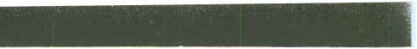
F. Southwestern Great Salt Lake Drainage
33. Mona Creek, above reservoir, Mona
 |  |  | dS/m |  |  |  |  | Mmok/L |  |  |  |  |  | Mg/L
 |  |  | -
Date |  |  | EC | pH | Ca | Mg | Na | K | Cl | SO. | CO, | HCO, | NO, | PO. | B
7/29/49 |  |  | .310 | - | 2.00 | 1.15 | 0.09 | 0.03 | 0.06 | 0.21 | 0.27 | 2.62 | 0.6 | - | 0.00
9/17/83 |  |  | 2.109 | 8.29 | 4.10 | 5.40 | 11.00 | . 1.50. 11.89 |  | 3.77 | 0.00 | 5.30 | 0.3 | 0.01 | 0.10
34. Mona Reservoir Outlet, Mona.
6/ 3/49 |  |  | 1.600 | - | 3.24 | 4.19 | 8.74 | 0.33 | 8.29 | 3.29 | 0.27 | 4.49 | 0.7 | - | 0.12
7/29/49 |  |  | 1.600 | - | 2.89 | 4.03 | 8.35 | 0.56 | 8.18 | 3.37 | 0.53. 3.62 |  | 0.2 | - | 0.00
7/ 8/81 |  |  | 1.900 | 7.96 | 4.59 | 5.36 | 8.90 | 0.19 | 9.91 | 0.70 | 0.00 | 5.71 | 0.96 | 0.06
9/10/81 |  |  | 1.600 | 8.50 | 3.37 | 5.63 | 6.85 | 0.22 | 9.46 | 0.74 | 0.49 | 4.30 | 0.05 | <.01
7/ 1/82 |  |  | 1.510 | 8.42 | 2.14 | 4.02 | 6.08 | 0.17 | 8.52 | 1.50 | 0.52 | 3.02 | - | <.01
9/17/83 |  |  | 1.155 | 8.12 | 3.20 | 3.50 | 4.97 | 0.15 | 4.78 | 2.22 | 0.00 | 4.90 | 0.1 | 0.16 | 0.07
35. Goshen Reservoir, Goshen
8/25 |  |  | 1.650 | - | 2.94 | 4.52 | 8.53 | 0.44 | 8.75 | 3.39 | 0.10 | 4.15 | 0.4 | - | 0.19
7/ 8/81 |  |  | 1.910 | 7.92 | 4.44 | 5.88 | 8.56 | 0.24 | 10.30 | 0.57 | 0.00 | 5.16 | 0.74 | 0.06
 |  | 9/10/81 | 1.540 | 8.65 | 2.10 | 5.36 | 6.81 | 0.26 | 9.38 | 0.78 | 0.57 | 2.71 | 0.09 | <.01
7/ 1/82 |  |  | .820 | 8.35 | 2.97 | 4.73 | 9.17 | 0.23 | 10.40 | 1.79 | 0.00 | 2.10 | - | 0.01
9/17/83 |  |  | 1.290 | 8.24 | 3.40 | 3.80 | 5.60 | 0.20 | 5.53 | 2.48 | 0.00 | 5.40 | <.1 | 0.02 | 0.09

31

 |  |  |  |  |  |  |  |  |  |  |  |  |  |  | )
 |  | Sevier Lake Drainage
 |  | A. East Fork Sevier and Tributaries
 |  | 36. Sevier River, East Fork, Widstoe, Junction
 |  |  | dS/m |  |  |  |  | mmok/L |  |  |  |  |  | Mg/L
 |  |  | -
 |  | Date | EC | pH | Ca | Mg | Na | K | Cl | 504 | CO, | HCO, | NO, | P04 | B
 |  | 7/ 9/81 | .360 | 9.18 | 1.57 | 2.42 | 0.37 | 0.01 | 0.21 | <.04 | 1.19 | 2.48 | 0.20 | 0.07
 |  | 9/ 9/81 | .350 | 8.69 | 1.22 | 2.26 | 0.26 <.01 |  | 0.16 | <.04 | 0.38 | 2.71 | 0.08 | 0.19
 |  | 7/13/82 | .330 | 9.83 | 0.44 | 2.03 | 0.49 | 0.02 | 0.38 | 0.12 | 2.16 | 1.34 | - | 0.01
 |  | 9/16/83 | .381 | 8.51 | 0.90 | 3.00 | 0.29 | 0.02 | 0.15 | 0.24 | 0.20 | 4.10 | <.1 | 0.06 | 0.03
 |  | 37. Otter Creek, Angel, Utah
 |  | 7/ 9/81 | .330 | 8.52 | 1.05 | 0.95 | 1.02 | 0.12 | 0.34 | 0.04 | 0.00 | 2.38 | 0.18 | 0.01
 |  | 9/ 9/81 | .460 | 8.64 | 2.47 | 1.42 | 1.39 | 0.24 | 0.56 | <.04 | 0.22 | 3.92 | 0.18 | 0.01
 |  | 7/13/82 | .340 | 9.24 | 1.21 | 0.96 | 1.21 | 0.14 | 0.60 | 0.11 | 1.38 | 1.68 | - | 0.01
 |  | 9/15/83 | .662 | 7.74 | 3.30 | 1.7 | 2.10 | 0.18 | 0.55 | 0.57 | 0.00 | 6.80 | 0.7 | 0.10 | 0.14
 |  | 38. Otter Creek, below reservoir
 |  | 6/16/49 | .380
 |  | 7/ 9/81 | .430 | 8.31 | 2.20 | 1.89 | 0.80 | 0.10 | 0.32 | 0.14 | 0.0 | 3.68 | 0.46 | 0.05
 |  | 9/ 9/81 | .410 | 8.53 | 2.00 | 1.81 | 0.31 | 0.11 | 0.38 | 0.05 | 0.28 | 3.29 | 0.04 | 0.02
 |  | 7/13/82 | .440 | 8.75 | 1.98 | 1.55 | 0.72 | 0.14 | 0.51 | 0.21 | 0.65 | 3.37 | - | 0.05
 |  | 9/15/83 | .415 | 8.21 | 1.80 | 1.60 | 0.86 | 0.10 | 0.35 | 0.26 | 0.00 | 4.40 | <.1 | 0.07 | 0.07
 |  | B. Sevier River
 |  | 39. Panguitch Lake Outlet, above Panguitch
 |  | 7/ 9/81 | .200 | 7.77 | 1.57 | 0.42 | 0.10 | 0.05 | 0.04 | <.04 | 0.00 | 1.91 | 0.35 | 0.05
 |  | 9/ 9/81 | .150 | 8.68 | 1.09 | 0.51 | 0.15 | 0.04 | 0.05 | <.04 | 0.00 | 1.78 | 0.09 | 0.04
 |  | 7/13/82 | .210 | 8.91 | 1.33 | 0.49 | 0.26 | 0.09 | 0.21 | 0.04 | 0.43 | 1.92 | - | 0.02
 |  | 9/16/83 | .170 | 8.85 | 4.00 | 0.41 | 0.14 | 0.05 | 0.04 | <.10 | 0.40 | 1.50 | <.1 | 0.02 | 0.02
 |  | 40. Sevier River, below Panguitch
 |  | 5/ 6/49 | .280 | - | 1.55 | 0.74 | 0.18 | 0.10 | 0.06 | 0.15 | 0.00 | 2.62 | - | - | 0.05
 |  | 7/ 9/81 | .360 | 7.63 | 2.59 | 1.68 | <.10 | 0.02 | 0.03 | <.04 | 0.00 | 3.65 > | 0.16 | 0.03
 |  | 9/ 9/81 | .400 | 8:38 | 2.63 | 1.71 | 0.14 | <.01 | 0.09 | <.04 | 0.27 | 3.54 | 0.05 | 0.03
 |  | 7/13/82 | .350 | 8.65 | 2.09 | 1.21 | 0.20 | 0.06 | 0.23 | 0.05 | 0.86 | 2.98 | - | 0.01
 |  | 9/16/83 | .381 | 8.19 | 2.20 | 1.60 | 0.33 | 0.04 | 0.09 | 0.14 | 0.00 | 4.50 | <.1 | <.01 | 0.03

32

 |  | A. East Fork Sevier and Tributaries (continued)
 |  | 4 t. Sevier River, Kingston
 |  |  | dS/m |  |  |  |  | mmok/L |  |  |  |  |  | mglL
 |  |  | -
 |  | Date | EC | pH | Ca | Mg | Na | K | Cl | 504 | CO, | HCO, | NO, | P04 | - B
 |  | 5/ 6/49 | .340 | - | 1.66 | 0.99 | 0.61 | 0.10 | 0.11 | 0.29 | 0.00 | 3.08 | 0.4 | - | 0.02
 |  | 7/ 9/81 | .470 | 8.07 | 2.67 | 2.10 | 0.83 | 0.11 | 0.35 | 0.20 | 0.00 | 3.97 | 0.19 | 0.02
 |  | 9/ 9/81 | .510 | 8.57 | 2.69 | 1.85 | 0.27 | 0.12 | 0.33 | 0.07 | 0.27 | 3.73 | 0.07 | 0.05
 |  | 7/13/82 | .450 | 8.97 | 2.14 | 1.60 | 0.12 | 0.13 | 0.49 | 0.21 | 1.12 | 2.98 | - | 0.02
 |  | 9/15/83 | .516 | 8.21 | 2.60 | 1.80 | 1.29 | 0.09 | 0.25 | 0.37 | 0.00 | 5.70 | 0.3 | 0.04 | 0.05
 |  | 42. Sevier River, Sevier.
 |  | 5/ 6/49 | .170 | - | 0.80 | 0.82 | 0.44 | 0.08 | 0.26 | 0.27 | 0.00 | 1.20 | 0.2 | - | 0.05
 |  | 8/11/49 | .440 | - | 1.85 | 1.32 | 1.22 | 0.18 | 0.37 | 0.67 | 0.3 | 3.61 | 0.1 | - | 0.00
 |  | 7 /9/81 | .490 | 7.85 | 2.81 | 1.89 | 1.05 | 0.10 | 0.25 | 0.16 | 0.00 | 4.34 | 0.70 | 0.07
 |  | 9/ 9/81 | .550 | 8.42 | 3.11 | 1.71 | 0.97 | 0.11 | 0.56 | 0.18 | 0.27 | 4.01' | 0.25 | 0.06
 |  | 7/13/82 | .480 | 8.68 | 2.17 | 1.54 | 1.11 | 0.12 | 0.53 | 0.27 | 0.43 | 4.04 | - | 0.02
 |  | 9/15/83 | .454 | 8.39 | 2.40 | 1.60' 0.96 |  | 0.08 | 0.31 | 0.59 | 0.00 | 4.50 | <.1 | 0.02 | 0.06
 |  | 43. Sevier River Canal at Joseph
 |  | 9/15/83 | .443 | 8.54 | 2.30 | 1.50 | 0.91 | 0.08 | 0.32 | 0.58 | 0.40 | 4.10 | <.1 | 0.02 | 0.02
 |  | 44. Sevier River Canal, Richfield Canal, Richfield
 |  | 6/ 3/49 | .790 | - | 2.99 | 2.30 | 2.18 | 0.26 | 0.97 | 2.68 | 0.13 | 4.62 | - | - | 0.15
 |  | 6/ 5/49 | .830 | - | 3.14 | 2.79 | 2.26 | 0.23 | 1.11 | - | 0.20 | 4.62 | 0.80 | - | 0.20
 |  | 7 /9/81 | .520 | 7.96 | 2.98 | 2.10 | 1.18 | 0.11 | 0.38 | 0.15 | 0.00 | 4.72 | 0.73 | 0.07
 |  | 9/ 9/81 | .580 | 8.52 | 3.06 | 1.65 | 1.47 | 0.12 | 0.63 | 0.17 | 0.52 | 3.68 | 0.31 | 0.04
 |  | 7/13/82 | .490 | 8.67 | 2.42 | 1.50 | 1.21 | 0.13 | 0.47 | 0.29 | 0.52 | 4.02 | - | 0.02
 |  | 45. Sevier River Canal, Sigard
 |  | 9/15/83 | .443 | 8.32 | 2.20 | 1.50 | 0.91 | 0.07 | 0.30 | 0.55 | 0.00 | 4.50 | <.1 | 0.03 | 0.06
 |  | 46. Cedar Ridge Creek, Sigard
 |  | 9/21/82 | .450 | 8.08 | 1.99 | 2.59 | 0.55 | 0.07 | 0.73 | - | 1.93 | 2.72
 |  | 9/15/83 | .482 | 8.28 | 2.10 | 2.60 | 0.57 | 003 | 0.56 | 0.69 | 0.00 | 4.70 | <.1 | <.01 | 0.03

33

,
 |  |  |  |  |  |  |  |  |  |  |  |  |  |  | )
 | 8. Sevier River (continued)
 | 47. Sevier River, Salina
 |  | dS/m |  |  |  |  | mmok/L |  |  |  |  |  | Mg/L
 |  | -
 | Date | EC | pH | Ca | Mg | Na | K | CI | 504 | CO, | HCO, | NO, | P04 | B
 | 3/ 6/49 | 2.500 | - | 6.49 | 6.90 | 12.97 | 0.44 | 10.82 | 8.74 | 0.17 | 6.30 | 3.6 | - | 0.48
 | 6/16/49 | .780 | - | 2.84 | 2.30 | 2.87 | 0.24 | 1.65 | 2.66 | 0.30 | 3.08 | 1.2 | - | 0.11
 | 7/25/49 | 2.450 | - | 6.04 | 6.25 | 13.22 | 0.5,1 | 10.56 | 8.94 | 0.00 | 6.69 | 4.2 | - | 0.52
 | 8/111.49 | 2.150 | - | 5.89 | 5.92 | 11.22 | 0.46 | 9.43 | 8.69 | 0.00 | 6.50 | 4.8 | - | 0.45
 | 8/26/49 | 2.200 | - | 6.14 | 4.44 | 10.61 | 0.44 | 8.97 | 8.54 | 0.20 | 6.28 | 4.4 | - | 0.48
 | 7/ 8/81 | 1.910 | 7.80 | 6.87 | 6.51 | 7.81 | 0.22 | 6.77 | 1.37 | 0.00 | 5.88 | 1.82 | 0.05
 | 9/ 9/81 | 1.780 | 8.02 | 6.67 | 4.74 | 6.59 | 0.24 | 7.11 | 1.91 | 0.00 | 5.48 | 1.25 | <.01
 | 7/13/82 | 2.270 | 8.53 | 5.68 | 5.96 | 17.11 | 0.33 | 11.81 | 4.36 | 0.78 | 5.62 | - | 0.08
 | 9/14/83 | 1.099 | 8.02 | 3.90 | 3.50 | 4.02 | 0.13 | 2.78 | 3.77 | 0.00 | 6.80 | 0.3 | 0.03 | 0.17
 | 48. Sevier River, Gunnison
 | 7/ 8/81 | 2.830 | 7.69 | 6.29 | 7.14 | 18.69 | 0.29 | 12.27 | 4.06 | 0.00 | 6.96 | 2.51 | 0.05
 | 9/ 9/81 | 2.300 | 7.90 | 6.58 | 5.99 | 13.16 | 0.29 | 9.73 | 1.75 | 0.00 | 6.60 | 1.88 | 0.04
 | 7/13/82 | 2.540 | 8.53 | 4.92 | 6.34 | 21.84 | 0.33 | 12.87 | 4.54 | 0.73 | 7.00 | - | 0.06
 | 9/14/83 | 1.638 | 7.96 | 4.40 | 4.90 | 8.08 | 0.15 | 5.76 | 5.74 | 0.00. | 7.50 | 1.0 | 0.03 | 0.25
 | 49. San Pitch River, Gunnison Reservoir Outlet, Gunnison |  |  |  |  |  |  |  |  |  |  |  |  |  | ')
 | 6/ 5/49 | 1.480 |  | 3.04 | 6.90 | 6.23 | 0.27 | 3.83 | 4.99 | 0.80 | 6.49 | 0.9 |  | 0.22 | ')
 | 6/ 5/49 | 1.480 | - |  |  |  |  |  |  |  |  |  | - | 0.22
 | 8/11/49 | 1.510 | - | 2.59 | 7.40 | 7.74 | 0.33 | 4.71 | 5.66 | 0.77 | 7.44 | 0.2 | - | 0.14
 | 8/26/49 | 1.700 | - | 2.64 | 8.38 | 8.09 | 0.31 | 5.08 | 5.88 | 0.70 | 7.49 | 0.4 | - | 0.20
 | 9/14/83 | .836 | 8.60. | 1.80 | 4.30 | 2.87 | 0.07 | 1.38 | 1.63 | 0.00 | 5.60 | 0.1 | 0.02 | 0.14
 | 50. Sevier River, Mill
 | 7/ 8/81 | 1.740 | 8.12 | 3.82 | 5.57 | 8.18 | 0.21 | 6.98 | 1.69 | 0.00 | 5.64 | 0.79 | 0.05
 | 9/10/81 | 1.500 | 8.46 | 3.52 | 5.38 | 6.22 | 0.19 | 6.42 | 0.44 | 0.44 | 4.60 | 0.23 | <.01
 | 7/12/82 | 1.820 | 8.66 | 3.06 | 5.69 | 11.87 | 0.24 | 9.06 | 3.19 | 1.12 | 4.86 | - | 0.01
 | 9/14/83 | 1.290 | 7.92 | 3.40 | 4.40 | 5.50 | 0.12 | 4.59 | 3.53 | 0.00 | 5.80 | 0.2 | 0.01 | 0.12
 | 51. Delta Reservoir, Delta Canal Division, Highway 6, Delta
 | 6/ 3/49 | 2.400 | - | 3.14 | 6.90 | 15.31 | 0.46 | 12.52 | 8.44 | 0.33 | 4.76 | 1.8 | - | 0.46
 | 7/31/49 | 2.440 | - | 3.09 | 5.92 | 14.36 | 0.49 | 12.78 | 8.32 | 0.47 | 3.87 | 1.2 | - | 0.22
 | 8/20/49 | 2.600 | - | 3.34 | 6.99 | 15.22 | 0.49 | 13.60 | 8.72 | 0.37 | 4.17 | 1.2 | - | 0.27
 | 7/ 8/81 | 1.830 | 8.23 | 3.76 | 6.20 | 8.80 | 0.22 | 7.53 | 1.67 | 0.00 | 5.68 | 0.49 | 0.07
 | 9/10/81 | 2.140 | 8.42 | 3.42 | 7:00 | 12.93 | 0.28 | 10.43 | 1.45 | 0.35 | 4.82 | 0.08 | <.01
 | 7/12/82 | 1.910 | 8.74 | 2.93 | 6.03 | 13.42 | 0.26 | 9.78 | 3.28 | 1.38 | 4.26 | - | 0.02
 | 9/17/83 | 4.262 | 8.18 | 6.10 | 13.50 | 23.91 | 0.31 | 22.28 | 13.50 | 0.00 | 6.80 | 0.2 | <.01 | 0.42

34
-.,
t
 |  | B. Sevier River (continued)
 |  | 52. Fool Creek Reservoir, Oak City, Lyndyll
 |  |  | dS/m |  |  |  |  | mmolc/L |  |  |  |  |  | Mg/L
 |  |  | -
 |  | Date | EC | pH | Ca | Mg | Na | K | CI | 504 | CO, | HCO, | NO, | P04 | B
 |  | 7/ 8/81 | 1.880 | 8.43 | 3.52 | 7.14 | 8.61 | 0.28 | 8.02 | 1.58 | 0.00 | 6.13 | 0.50 | 0.04
 |  | 9/10/81 | 1.400 | 8.49 | 3.48 | 5.59 | 6.16 | 0.21 | 7.58 | 0.46 | 0.35 | 4.34 | 0.09 | 0.02
 |  | 7/12/82 | 1.840 | 8.72 | 2.96 | 5.81 | 13.34 | 0.24 | 9.19 | 3.31 | 1.12 | 2.91 | - | 0.01.
 |  | 9/17/83 | 1.727 | 7.92 | 4.20 | 6.30 | 7.41 | 0.23 | 6.80 | 5.46 | 0.00 | 6.00 | <.1 | 0.16 | 0.20
 |  | C. Waters in Sevier Lake area that are not tributary to the Sevier River
 |  | Millard County
 |  | 53. Scipio Lake Reservoir, Scipio
 |  | 6/ 3/49 | .500 | - | 1.35 | 3.12 | 0.91 | 0.10 | 0.74 | 0.25 | 0.33 | 3.90 | 0.4 | - | 0.02
 |  | 7/ 8/81 | .380 | 9.40 | 0.85 | 3.47 | 0.53 | 0.02 | 0.40 | <.04 | 1.22 | 2.55 | 0.15 | 0.02
 |  | 9/10/81 | .530 | 7.83 | 1.99 | 3.17 | 0.41 | 0.04 | 0.41 | <.04 | 0.00 | 4.65 | 0.10 | <.01
 |  | 7/13/82 | .370 | 9.68 | 0.69 | 3.08 | 0.56 | 0.03 | 0.58 | 0.06 | 2.03 | 1.90 | - | 0.01
 |  | 9/14/83 | .533 | 8.48 | 1.60 | 2.90 | 1.05 | 0.04 | 1.11 | 0.37 | 0.00 | 4.50 | <.1 | <.01 | 0.03
 |  | 54. Chalk Creek, Fillmore
 |  | 8/ 7/49 | .370 | - | 2.20 | 1.56 | 0.22 | 0.05 | 0.17 | 0.46 | 0.07 | 3.31 | 0.2 | - | 0.00
 |  | 7/10/81 | .350 | 8.29 | 2.57 | 1.68 | 0.17 | <.01 | 0.17 | <.04 | 0.00 | 3.45 | 0.28 | 0,05
 |  | 9/10/81 | .400 | 8.48 | 2.62 | 1.14 | 0.17 | <.01 | 0.25 | <.04 | 0.35 | 3.21 | 0.07 | <.01
 |  | 7/12/82 | .390 | 8.66 | 2.25 | 1.46 | 0.29 | 0.03 | 0.26 | 0.06 | 0.82 | 3.02 | - | 0.03
 |  | 9/17/83 | .376 | 8.28' | 2.10 | 1.70 | 0.24 | 0.02 | 0.19 | <.10 | 0.00 | 4.40 | <.10 | <.01 | 0.04
 |  | 55. Flow Well, Fillmore
 |  | 7/10/81 | .590 | 7.57 | 4.00 | 2.42 | 0.72 | 0.02 | 1.07 | <.04 | 0.00 | 4.53 | 2.75 | 0.05
 |  | 9/10/81 | .640 | 7.67 | 3.88 | 2.14 | 0.13 | <.01 | 1.04 | <.04 | 0.00 | 4.53 | 2.29 | <.01
 |  | 7/12/82 | .610 | 7.97 | 3.37 | 2.10 | 0.51 | 0.08 | 1.46 | 0.14 | 0.00 | 5.01 | - | <.01
 |  | 9/21/82 | .560 | 7.98 | - | - | - | - | - | - | 0.00 | 4.47 | - | -
 |  | 9/17/83 | .595 | 7.42 | 3.20 | 2.20 | 0.67 | 0.03 | 1.21 | 0.24 | 0.00 | 4.80 | 2.6 | <.01 | 0.05
 |  | Beaver County
 |  | 56. Beaver River, Beaver
 |  | 8/ 1/49 | .320 | - | 1.65 | Q.25 | 0.39 | 0.18 | 0.17 | 0.17 | 0.00 | 2.82 | 0.4 | - | 0.04
 |  | 8/ 8/49 | .170 | - | 0.65 | 0.25 | 0.17 | 0.05 | 0.01 | 0.12 | 0.00 | 1.23 | 0.2 | - | 0.07
 |  | 7/10/81 | .290 | 7.51 | 2.25 | 0.63 | 0.29 | 0.15 | 0.20 | <.04 | 0.00 | 2.62 | 0.81 | 0.09
 |  | 9/10/81 | .290 | 8.15 | 2.19 | 0.64 | 0.36 | O.H | 0.28 | <.04 | 0.00 | 2.42 | 0.26 | 0.07
 |  | 7/12/82 | .330 | 8.20 | 1.98 | 0.64 | 0.47 | 0.13 | 0.33 | 0.10 | 0.00 | 3.00 | - | 0.08
 |  | 9/17/83 | .271 | 7.52 | 1.60 | 0.66 | 0.33 | 0.10 | 0.20 | 0.14 | 0.00 | 2.80 | <.1 | 0.10 | 0.03
 |  |  |  |  |  |  |  | 35
"
 |  |  |  |  |  |  |  |  |  |  |  |  |  |  | ')
 | C. Waters in the Sevier Lake area (continued)
 | Beaver County (continued)
 | 57. Beaver River, Minersville Reservoir Outlet
 |  | dS/m |  |  |  |  | mmok/L |  |  |  |  |  | mg/L
 |  | -
 | Date | EC | pH | Ca | Mg | Na | K | Cl | SO. | CO, | HCO, | NO, | PO. | B
 | 7/'13/50 | .680 | - | 2.10 | 1.32 | 2.61 | 0.31. | 1.22 | 1.00 | 0.43 | 4.17 | 0.1 | - | 0.3
 | 7/10/81 | .580 | 8.64 | 3.26 | 1.58 | 1.94 | 0.20 | 0.86 | 0.25 | 0.52 | 3.83 | 0.63 | 0.18
 | 9/10/81 | .760 | 8.59 | 4.29 | 1.59 | 3.88 | 0.31 | 0.61 | 0.56 | 0.75 | 5.17 | 0.25 | 0.13
 | 7/12/82 | .580 | 8.97 | 2.61 | 1.26 | 2.38 | 0.24 | 1.05 | 0.42 | 0.99 | 3.52 | - | 0.10
 | 9/17/83 | .381 | 8.09 | 1.80 | 0.91 | 1.05 | 0.15 | 0.44 | 0.4-7 | 0.00' | 3.40 | <.1 | 0.09 | 0.07
 | Iron County
 | 58. Parowan Creek, Parowan
 | 8/ 8/49 | .330 | - | 1.65 | 2.14 | 0.74 | 0.10 | 0.14 | 0.33 | 0.30 | 4.38 | 0.2 | - | 0.06
 | 7/ 9/81 | .360 | 7.78 | 2.97 | 1.26 | 0.17 | 0.03 | 0.16 | 0.11 | 0.00 | 3.21 | 0.16 | 0.03
 | 9/ 9/81 | .410 | 7.84 | 3.27 | 1.34 | 0.26 | 0.05 | 0.23 | 0.12 | 0.00 | 3.03 | 0.20 | 0.03
 | 7/13/82 | .330 | 8.57 | 1.96 | 0.82 | 0.58 | 0.08 | 0.25 | 0.13 | 0.25 | 2.74 | - | 0.02
 | 9/17/83 | .264 | 8.09 | 1.60 | 0.74 | 0.19 | 0.04 | 0.07 | 0.24 | 0.00 | 2.70 | <.1 | 0.06 | 0.03
 | 59. Coal Creek, Cedar City
 | 6/ 4/49 | .400 | - | 2.54 | 0.82 | 0.17 | 0.05 | 0.11 | 0.79 | 0.07 | 3.15 | 1.0 | - | 0.08
 | 8/10/49 | .500 | - | 2.79 | 1.73 | 0.39 | 0.10 | 0.23 | 1.79 | 0.10 | 3.23 | 0.1 | - | 0.06
 | 9/16/83 | .572 | 8.21 | 3.40 | 2.20 | 0.38 | 0.04 | 0.32 | 2.25 | 0.00 | 4.30 | <.1 | <.01 | 0.01
 | Washington County
 | 60. Enterprise Reservoir, Enterprise
 | 6/ 4/49 | .220 | - | 1.40 | 0.49 | 1.04 | 0.15 | 0.51 | 0.25 | 0.27 | 2.41 | 0.2 | - | 0.01
 | 7/ 9/81 | .280 | 7.64 | 2.07 | 0.63 | 0.42 | 0.07 | 0.19 | <.04 | 0.00 | 2.40 | 0.89 | 0.09
 | 9/10/81 | .310 | 8.58 | 1.65 | 0.62 | 0.73 | 0.09 | 0.26 | <.04 | 0.16 | 2.31 | 0.12 | 0.12
 | 7/12/82 | .250 | 8.35 | 1.30 | 0.46 | 0.52 | 0.09 | 0.27 | 0.07 | 0.00 | 2.18 | - | 0.05
 | 9/16/83 | .249 | 8.89 | 1.20 | 0.41 | 0.62 | 0.07 | 0.18 | 0.25 | 0.40 | 2.00 | <.1 | 0.11 | 0.04

\
36

C. Waters in the Sevier Lake area (continued)
61. La Verkin Creek, La Verkin
 | dS/m |  |  |  |  | mmok/L |  |  |  |  |  | Mg/L
 | -
Date | EC | pH | Ca | Mg | Na | K | Cl | SO. | CO, | HCO, | NO, | PO. | B
8/ 4/49 | 1.070 | - | 6.69 | 3.94 | 1.39 | 0.20 | 0.51 | 9.53 | 0.17 | 2.67 | 0.2 | - | 0.32
7/10/81 | 13.510 | 6.80 | 4.86 | 11.13 | 84.63 | 5.07 | 93.20 | 11.03 | 0.00 | 21.25 | 0.\4 | 0.10
9/10/81 | 11.400 | 6.58 | 19.16 | 4.3\ | 72.99' 5.3\ |  | 93.42 | 10.44 | 0.00 20.38 |  | 0.05 | 0.07
7/13/82 | 11.860 | 6.69 | 36.89 | 9.94 131.8.7 |  | 5.80 | 104.86 | 21.59 | 0.00 | 21.38 | - | 0.09
62. Virgin River, La Verkin
6/ 9/50 | 8.500
7/10/81 | 9.130 | 6.80 | 30.75 | 9.03 | 59.\2 | 3.58 | 57.83 | 7.18 | 0.00 | 13.88 | 0.23 | 0.06
9/10/81 | 2.730 | 7.02 | 10.70 | 4.09 | 16.52 | 0.70 | 14.52 | 2.84 | 0.00 | 5.92 | 0.36 | <.01
7/13/82 | 2.760 | 7.37 | 5.68 | 2.83 | 21.07 | 0.82 | 16.91 | 4.45 | 0.00 | 6.91 | - | 0.12
9/16/83 | 3.421 | 6.69 | 10.90 | 4.50 | 19.13 | 0.87 | 17.32 | 10.30 | 0.00 | 7.10 | 0.1 | 0.05 | 0.69
63. Santa Clara Canal, Santa Clara
9/16/83
8.49
0.10
<.1
3.10
0.03
0.05
2.30
0.67 0.05
0.37
1.12
.415
1.20

37

 |  |  |  |  |  |  |  |  |  |  |  |  |  |  |  | )
 |  | Upper Colorado Drainage
 |  | A. Uintah Basin
 |  | 64. Deep Creek. LaPoint
 |  |  | dS/m |  |  |  |  | mmok/L |  |  |  |  |  | Mg/L
;
 |  | Date | EC | pH | Ca | Mg | Na | K | Cl | SO. | CO, | HCO, | NO, | PO. | B
 |  | 7/ 2/49 | .100
 |  | 7/ 2/49 | .100 |  |  |  |  | _. | - | - | - | - | - | -
 |  | 9/10/49 | .110 | - | - | - | - | - | - | - | - | - | - | -
 |  | 7/14/81 | .950 | 7.64 | 5.15 | 4.41 | 1.83 | 0.02 | 0.36 | 2.39 | 0.00 | 6.73 | 1.28 | 0.03
 |  | 9/ 8/81 | .980 | 8.11 | 6.02 | 4.44 | 1.76 <.01 |  | 0.35 | 0.39 | 0.00 | 6.88 | 1.09 | <.01
 |  | 6/30/82 | .260 | 8.33 | 2.48 | 2.05 | 0.75 | 0.06 | 0.33 | 1.32 | 0.26 | 1.43 | - | <.01
 |  |  |  |  |  |  | 2.30 |  | 0.65 | 9.52 | 0.00 | 6.20 | 0.2 | 0.01
 |  | 9/ 1/83 | 1.312 | 7.80 | 6.90 | 6.40 | 2.30 | 0.04 |  |  |  |  |  |  | 0.11
 |  | 65. Whitrocks River, Whitrocks
 |  | 7/ 2/49 | .100
 |  | 9/10/49 | .100
 |  | 7/14/81 | .140 | 7.43 | 1.04 | 0.32 | <.10 | <.01 | <.01 | 0.18 | 0.00 | 1.19 | 0.31 | 0.03
 |  | 9/ 8/81 | .160 | 8.28 | 1.18 | 0.41 | <.10 | <.01 | 0.04 | <.04 | 0.00 | 1.25 | 0.04 | 0.12
 |  | 6/30/82 | .020 | 7.53 | <.01 | 0.02 | <.01 | <.01 | 0.16 | 0.04 | 0.00 | 0.63 | - | 0.02
 |  | 9/ 1/83 | .062 | 7.45 | 0.35 | 0.25 | 0.05 | 0.02 | 0.00 | <.10 | 0.00 | 0.60 | <.10 | <.01 | <.01 | )
 |  | 66. Uinta River, Whitrocks
 |  | 9/10/49 | .420 | - | 2.24 | 1.07 | 0.26 | 0.08 | 0.06 | 0.33 | 0.23 | 3.64 | 0.2 | - | 0.06
 |  | 7/14/81 | .050 | 6.96 | 0.24 | <.10 | <.10 | <.01 | 0.01 | 0.18 | 0.00 | 0.31 | 0.31 | 0.03
 |  | 9/ 8/81 | .060 | 8.25 | 0.30 | 0.09 | <.10 | <.01 | <.01 | <.04 | 0.00 | 0.35 | 0.08 | <.01
 |  | 6/30/82 | .030 | 7.53 | 0.11 | 0.06 | <.01 | 0.02 | 0.16 | 0.06 | 0.00 | 0.60 | - | <.01
 |  | 9/ 1/83 | .045 | 7.10 | 0.25 | 0.16 | 0.05 | 0.02 | 0.03 | 0.17 | 0.00 | 0.50 | 0.2 | <.01 | <.01
 |  | 67. Uinta River, Ft. Duchesne
 |  | 7/14/81 | 1.650 | 6.93 | 6.35 | 5.46 | 6.50 | 0.13 | 1.03 | 3.96 | 0.00 | 5.32 | 0.72 | 0.05
 |  | 9/ 8/81 | 1. 710 | 8.38 | 6.67 | 5.74 | 6.50 | 0.18 | 1.47 | 2.73 | 0.17 | 5.32 | 0.15 | <.01
 |  | 6/30/82 | .140 | 8.66 | 1.26 | 0.65 | 0.57 | 0.04 | 0.24 | 0.40 | 0.17 | 1.04 | - | 0.01
 |  | 9/ 2/83 | .743 | 8.15 | 3.00 | 3.10 | 1.87 | 0.05 | 0.50 | 3.44 | 0.00 | 5.10 | 0.4 | 0.03 | 0.08
 |  | 68. Lake Fork River; Altamount
 |  | 7/14/81 | .080 | 7.45 | 0.51 | 0.11 | <.10 | <.01 | 0.03 | 0.12 | 0.00 | 0.64 | 0.20 | 0.02
 |  | 9/ 8/81 | .150 | 7.99 | 1.06 | 0.51 | <.10 | <.01 | 0.04 | <.04 | 0.00 | 1.17 | 0.05 | <.01
 |  | 6/30/82 | .060 | 7.93 | 0.14 | 0.08 | <.01 | <.01 | 0.16 | 0.06 | 0.00 | 0.78 | - | <.01
 |  | 91 2/83 | .103 | 7.55 | 0.55 | 0.33 | 0.10 | 0.02 | 0.02 | 0.26 | 0.00 | 1.00 | <.1 | <.01 | <.01
. /

f -'1
38

 |  | A. Uintah Basin (continued)
 |  | 69. Lake fork River, Arcadia Bridge, Arcadia
 |  |  | dS/m |  |  |  |  | mmok/L |  |  |  |  |  | Mg/L
 |  |  | -
 |  | Date | EC | pH | Ca | Mg | Na | K | Cl | SO. | CO, | HC03, | NO, | PO. | B
 |  | 7/14/81 | 1.380 | 7.95 | 5.98 | 3.36 | 5.77 | 0.12 | 1.85 | 4.37 | 0.00 | 4.59 | 0.56 | 0.05
 |  | 9/ 8/81 | 1.540 | 8.22 | 6.76 | 3.63 | 6.31 | 0.15 | 1.38 | 2.58 | 0.00 | 5.01 | 0.12 | 0.04
 |  | 6/30/82 | .080 | 8.15 | 0.99 | 0.51 | 0.52 | 0.04 | 0.24 | 0.39 | 0.00 | 0.65 | - | 0.01
 |  | 9/ 2/83 | .561 | 8.32 | 2.10 | 2.90 | 1.05 | 0.05 | 0.61 | 1.35 | 0.00 | 4.70 | <.1 | 0.09 | 0.09
 |  | 70. Uinta River, Randlett
 |  | 7/ 2/49 | 2.150 | - | 6.24 | 5.84 | 10.61 | 0.31 | 5.51 | 13.31 | 0.87 | 4.00 | 0.8 | - | 0.41
 |  | 7/14/81 | 2.1 00 | 8.24 | 7.78 | 6.20 | 11.48 | 0.16 | 4.63 | 8.22 | 0.00 | 5.70 | 0.82 | 0.08
 |  | 9/ 8/81 | 2.120 | 8.37 | 3.31 | 6.06 | 12.69 | 0.22 | 4.78 | 3.26 | 0.11 | 5.65 | 0.43 | 0.08
 |  | 6/30/82 | .610 | 8.65 | 2.38 | 1.77 | 2.07 | 0.09 | 0.85 | 1.67 | 0.48 | 2.18 | - | 0.02
 |  | 9/ 2/83 | 1.413 | 8.05 | 4.90 | 4.80 | 5.79 | 0.08 | 2.37 | 8.32 | 0.00 | 5.90 | 0.6 | 0.03 | 0.23
 |  | 7 t. Pelican Lake, Randlett
 |  | 7/81 | .640 | 9.49 | 0.91 | 2.86 | 2.33 | 0.09 | 0.56 | 0.51 | 1.11 | 1.43 | 0.30 | 0.02
 |  | 72. Duchesne River, North fork, Tabiona
 |  | 7/ 2/49 | .230 | - | 1.40 | 0.41 | 0.13 | 0.05 | 0.06 | 0.40 | 0.13 | 1.44 | 0.2 | - | 0.02
 |  | 7/14/81 | .380 | 8.42 | 2.86 | 1.37 | 0.13 | 0.02 | 0.15 | 0.25 | 0.00 | 2.89 | 0.33 | 0.02
 |  | 9/ 8/81 | .470 | 8.46 | 3.29 | 1.49 | 0.28 | 0.02 | 0.15 | 0.27 | 0.20 | 2.83 | 0.12 | 0.13
 |  | 6/30/82 | .060 | 8.73. | 1.07 | 0.37 | 0.04 | 0.02 | 0.19 | 0.12 | 0.09 | 0.78 | - | 0.01
 |  | 9/ 2/83 | .359 | 8.05 | 2.00 | 1.30 | 0.33 | 0.03 | 0.14 | 0.91 | 0.00 | 3.20 | <.1 | 0.05 | 0.03
 |  | 73. Strawberry River, Duchesne
 |  | 7/ 2/49 | .680 | - | 1.85 | 2.38 | 2.26 | 0.10 | 0.40 | 1.62 | 0.73 | 3.66 | 0.02 | - | 0.29
 |  | 9/10/49 | .800 | - | 2.00 | 2.22 | 3.39 | 0.15 | 0.57 | 2.23 | 0.23 | 5.54 | 0.02 | - | 0.56
 |  | 7/14/81 | .690 | 8.27 | 3.26 | 2.73 | 2.49 | 0.05 | 0.48 | 1.01 | 0.00 | 4.88 | 0.43 | 0.04
 |  | 9/ 8/81 | .740 | 8.57 | 3.31 | 2.54 | 2.72 | 0.04 | 0.52 | 0.67 | 0.38 | 4.39 | <.01 | 0.08
 |  | 6/30/82 | .200 | 8.70 | 1.51 | 1.64 | 1.81 | 0.07 | 0.44 | . 1.11 | 0.30 | 1.19 | - | <.01
 |  | 9/ 2/83 | .589 | 8.05 | 2.40 | 2.10 | 1.58 | 0.04 | 0.36 | 1.51 | 0.00 | 4.90 | 0.1 | 0.03 | 0.16

39

 |  |  |  |  |  |  |  |  |  |  |  |  |  |  | )
 |  | A. Uintah Basin (continued)
 |  | 74. Indian Creek, Right Fork, Duchesne
 |  |  | dS/m |  |  |  |  | mmok/L |  |  |  |  |  | Mg/L
 |  |  | -
 |  | Date | EC | pH | Ca | Mg | Na | K | CI | SO. | CO, | HCO, | NO, | PO. | B
 |  | 9/20/82 | 1.750 | 8.68 | 2.61 | 6.75 | 6.54 | 0.24 | 1.50 | - | 2.54 | 9.77 | - | - | 4.16
 |  | 9/ 2/83 | 2.154 | 8.60 | 1.80 | 8.50 | 14.35 | 0.14 | 1.01 | 12.20 | 1.50 | 12.40 | 0.8 | 0.25 | 3.30
 |  | 75. Indian Creek, Duchesne
 |  | 11 2/49 | 1.770 | - | 1.75 | 6.99 | 9.92 | 0.38 | 0.68 | 9.34 | 2.23 | 7.86 | 0.2 | - | 4.56
 |  | 9/10/49 | 2.400 | - | 1.00 | 7.56 | 17.40 | 0.56 | 1.28 | 15.49 | 1.86 | 9.48 | 0.2 | - | 9.39
 |  | 9/20/82 | 1.320 | 8.45 | 2.43 | 5.91 | 6.54 | 0.25 | 0.94 | - | 0.70 | 8.32 | - | - | 4.15
 |  | 9/ 2/83 | 1.593 | 8.45 | 2.50 | 7.60 | 7.9:4 | 0.15 | 0.58 | 9.15 | 0.40 | 10.00 | 0.6 | 0.02 | 3.28
 |  | 76. Duchesne River, Myton
 |  | 9/10/49 | 1.700 | - | 4.64 | 4.36 | 9.48 | 0.31 | 2.02 | 12.05 | 0.07 | 5.10 | 0.2 | - | 1.07
 |  | 7/14/81 | 1.340 | 7.90 | 6.18 | 4.52 | 5.92 | 0.13 | 0.84 | 4.68 | 0.00 | 5.19 | 0.73 | 0.07
 |  | 9/ 8/81 | 1.300 | 8.37 | 5.60 | 4.38 | 5.13 | 0.13 | 1.03 | 1.93 | 0.22 | 4.77 | 0.14 | 0.04
 |  | 6/30/82 | .100 | 8.54 | 1.08 | 0.69 | 0.58 | 0.04 | 0.28 | 0.38 | 0.09 | 0.86 | - | 0.01 | 0.26
 |  | 9/ 2/83 | .836 | 8.10 | 3.30 | 2.80 | 2.87 | 0.05 | 0.58 | 4.03 | 0.00 | 5.10 | 0.3 | <.01 | 0.37 | \
 |  | 77. Antelope Creek, Bridgerland |  |  |  |  |  |  |  |  |  |  |  |  |  | J
 |  | 11 2/49 | 3.150 | - | 6.39 | 14.22 | 16.01 | 0.51 | 1.96 | 29.54 | 1.13 | 4.51 | 0.8 | - | 5.65
 |  | 9/10/49 | .770 | - | 2.64 | 2.14 | 2.61 | 0.15 | 0.43 | 3.15 | 0.07 | 4.69 | 0.2 | - | 0.43
 |  | 9/ 2/83 | 2.715 | - | 6.70 | 13.20 | 11.48 | 0.18 | 1.20 | 22.30 | - | - | 0.7 | 0.04 | 3.45
 |  | 78. Antelope Creek, Myton
 |  | 9/20/82 | 2.590 | 8.19 | 8.97 | 11.83 | 18.29 | 0.27 | 2.50 | - | 1.05 | 7.97 | - | - | 4.39
 |  | 9/ 2/83 | 3.017 | 7.65 | 9.30 | 13.30 | 14.35 | 0.17 | 1.41 | 26.90' | 0.00 | 10.30 | 1.6 | 0.04 | 3.55
 |  | 79. Duchesne River, Ouray
 |  | 9/ 2/83 | 1.077 | 8.10 | 3.90 | 3.60 | 4.30 | 0.06 | 1.18 | 5.98 | 0.00 | 5.30 | 1.0 | 0.03 | 0.39

/
40
 |  | A. Uintah Basin (continued)
 |  | 80. Ashley Creek, Vernal
 |  |  | dS/m |  |  |  |  |  | mmok/L |  |  |  |  |  | Mg/L
 |  |  | -
 |  | Date | EC | pH | Ca |  | Mg | Na | K | CI | SO. | CO, | HCO, | NO, | PO. | B
 |  | 71 2/49 | .130 | - | 0.90 |  | 0.12 | 0.04 | 0.03 | 0.03 | 0.23 | 0.07 | 1.02 | 0.5 | - | 0.18
 |  | 9/ 9/49 | .270 | - | 1.45 |  | 0.58 | 0.13 | 0.05 | 0.03 | 0.46 | 0.00 | 2.16 | 0.3 | - | 0.04
 |  | 7/13/81 | 2.520 | 8.13 | 14.32 |  | 12.48 | 6.18 | 0.2(} | 0.83 | 8.22 | 0.00 | 6.66 | 1.20 | 0.08
 |  | 1 9/81 | 2.790 | 8.11 | 13.03 |  | 14.94 | 5.51 | 0.24 | 0.94 | 7.15 | 0.00 | 6.32 | 1.11 | 0.03
 |  | 6/30/82 | .640 | 8.76 | 8.04 |  | 9.54 | 4.80 | 0.20 | 0.93 | 9.45 | 0.39 | 1.25 | - | 0.01
 |  | 91 1/83 | .387 | 8.15 | 2.50 |  | 1.30 | 0.19 | 0.05 | 0.06 | 0.09 | 0.00 | 4.30 | <.1 | <.01 | 0.02
 |  | B. Wayne County
 |  | 8 t. Freemont River, Loa
 |  | 9/15/83 | .353 | 8.62 | 2.00 |  | 1.00 | 0.57 | 0.06 | 0.24 | 1.04 | 0.40 | 2.30 | <.1 | 0.03 | 0.01
 |  | 82. Freemont River, Biknell
 |  | 8/31/49 | .500 | - | 2.54 |  | 1.48 | 0.74 | 0.15 | 0.40 | 2.06 | 0.00 | 2.61 | 0.2 | - | 0.00
 |  | 9/11/49 | .520 | - | 1.80 |  | 1.15 | 0.87 | 0.18 | 0.43 | 2.58 | 0.10 | 2.23 | 0.4 | - | 0.14
 |  | 9/15/83 | .482 | 7.78 | 2.70 |  | 1.60 | 0.62 | 0.08 | 0.30 | 1.84 | 0.00 | 3.10 | 0.1 | 0.04 | 0.03

41

