
2006
Great Basin
Annual Operating Plan
for
Fire Weather
and
Predictive Services
30 April28 February 2006

PAGE INTENTIONALLY LEFT BLANK
GREAT BASIN
ANNUAL OPERATING PLAN
2006

SECTION PAGE

INTRODUCTION 2
SIGNIFICANT CHANGES SINCE LAST YEAR 2
ORGANIZATIONAL DIRECTORY 2
NATIONAL WEATHER SERVICE -- SERVICES AND RESPONSIBILITIES 3
Basic Services 3
Routine Fire Weather Forecasts (FWF) 3
Spot forecasts 6
Red Flag Warnings and Fire Weather Watches 7
National Fire Danger Ratings System (NFDRS) Forecasts 9
Participation in Interagency Groups 10
Special Services 10
Forecaster Training 10
PREDICTIVE SERVICES/LAND AGENCIES – SERVICES AND RESPONSIBILITIES 10
Operational Support and Predictive Services 10
Daily Fire Weather/Fire Behavior Map 10
7-day Fire Weather/Fire Danger Outlook 11
Monthly Fire Potential Outlook 11
Seasonal Fire Potential Outlook 11
Remote Automated Weather Stations (RAWS) 12
Land Management Liaison 12
Monitoring, Feedback, and Improvement of Fire Weather Information 12
Technology and Data Transfer 12
Fire Weather Observations 13
Incident Response 13
JOINT RESONSIBILITIES 14
Briefings 14
Coordination Calls 14
Training 14
Verification of Fire Weather Products 14
Establishing or Modifying Forecast Zone Boundaries 15
EFFECTIVE DATES FOR THE ANNUAL OPERATING PLAN 15
SIGNATORIES 16
Appendix A: Organizational Directory and Contact Information 17
Appendix B: National Weather Service Offices 21
Boise Weather Forecast Office 22
ELKO WEATHER FORECAST OFFICE 25
FLAGSTAFF WEATHER FORECAST OFFICE 27
GRAND JUNCTION WEATHER FORECAST OFFICE 29
LAS VEGAS WEATHER FORECAST OFFICE 33
POCATELLO WEATHER FORECAST OFFICE 36
RENO WEATHER FORECAST OFFICE 39
RIVERTON WEATHER FORECAST OFFICE 42
SALT LAKE CITY WEATHER FORECAST OFFICE 44

0. INTRODUCTION

This document serves as the Interagency Annual Operating Plan (AOP) for Fire Weather and Predictive Services for the Great Basin, which includes the Eastern and Western Great Basin Geographic Areas. The general relationship between NWS and the interagency fire management community is set forth in the National Interagency Agreement for Meteorological Services. The AOP provides specific procedural and policy information regarding the delivery of meteorological services to the fire management community in the Great Basin area as allowed under the umbrella of the National Agreement.

References will include:

- National Weather Service NWSI 10-4: Fire Weather Services
(www.nws.noaa.gov/directives/010/010.htm )
- Interagency Agreement for Meteorological Services (National MOA or “National Agreement”)
(www.nws.noaa.gov/directives/010/pd01004006a.pdf )
- Great Basin Mobilization Guide
( www.blm.gov/utah/egbcc/trng_pub.htm )
- National Interagency Mobilization Guide
( http://www.nifc.gov/news/mobguide/index.html )

- SIGNIFICANT CHANGES SINCE LAST YEAR

  - Changes to Red Flag Criteria for Las Vegas, Flagstaff CWFA

  - Expanded support for FARSITE

- ORGANIZATIONAL DIRECTORY

Cooperating federal and state land management agencies in the Great Basin include:

Bureau of Land Management USDA Forest Service
Bureau of Indian Affairs National Park Service
US Fish and Wildlife Service Utah Forestry, Fire, and State Lands
Idaho Department of Lands Nevada Division of Forestry

Fire weather products and services are provided by Eastern and Western Great Basin Predictive Services and the following NWS WFO’s

Boise, ID Elko, NV Flagstaff, AZ
Grand Junction, CO Las Vegas, NV Pocatello, ID
Reno, NV Riverton, WY Salt Lake City, UT

Additional administrative support is provided by:

NWS Central Region NWS Western Region

National Interagency Fire Center

Contact information for Predictive Services and the NWS offices can be found in Appendix A. Service areas are depicted in Appendix B. NOTE: All phone numbers are unlisted and should not be given to the general public.

- NATIONAL WEATHER SERVICE -- SERVICES AND RESPONSIBILITIES

  - Basic Services

Basic services constitute the collective suite of operational fire weather forecast products and professional services provided by the NWS. Any changes to these forecast services or implementation of new operational forecast products and/or services will be coordinated with the Land Management Agencies’ Predictive Services Units (PSUs) at either, or both, coordination centers (Reference NWSI 10-403) and with local land management officials within the County Warning Forecast Area (CWFA) of the NWS office that is proposing the changes. Any non-operational forecast products will be clearly labeled as “Experimental” or “Prototype”.

    - Planning Forecasts (FWF)

Planning forecasts (or preparedness forecasts) are issued by all NWS WFOs offices serving the Great Basin. These forecasts provide general, zone-based information used in daily planning and preparedness.

      - Issuance Times During Fire Season

Forecasts will be issued during the fire season. Twice per day fire weather forecast requirements will normally run from May 1 to October 31, with sub-regional variations dependent on weather, elevation and latitude. Local start and stop dates shall be coordinated between the NWS offices and fire weather customers, including the geographic area Predictive Services Units. Modifications to these start and stop dates will be enumerated in Appendix B, National Weather Service Offices.

Two forecasts will be issued daily – a morning forecast issued no later than 0730 local time and an afternoon forecast issued by 1530 local time – 7 days a week. Because of the large north-to-south extent of the Great Basin and seasonal variations in weather and fire occurrence, only one issuance per day may be sufficient during the early spring or late fall. This must be coordinated with either or both of the geographic area coordination centers and the local land management agencies affected.

      - Issuance Outside Fire Season

Some NWS offices issue fire weather planning forecasts year-round. However, all NWS offices will issue spot forecasts upon request at any time of year.

      - Forecast Updates

Forecasts will be updated during the first 36-48 hour time period when: 1) A Fire Weather Watch or a Red Flag Warning is issued, cancelled, or updated; 2) when any of the amendment criteria in Table 1 are met over a meteorologically significant area; or 3) typographic or formatting errors that confuse the intended meaning are detected.

Table 1. Fire Weather Forecast and Associated Digital Data Amendment Criteria
Fire Weather Forecast and Associated Digital Data Amendment Guidelines
Forecast | AMEND WHEN…
Thunderstorms are not in the forecast… | Thunderstorms occurring or are imminent prior to the next routine planning forecast issuance..
Wind speed of 15 mph or greater… | Speed exceeds forecast by 10 mph or more.
Average minimum RH is 16% to 40%… | Differs by 10% or more.
Average minimum RH is 15% or less… | Differs by 5% or more.

The NWS forecaster should notify all impacted Dispatch and Communications Centers when the forecast has been updated. The forecaster should also notify the Meteorologist or the Coordinator on Duty (COD) at the GACC. When notifying the GACC, do not use voicemail during normal business hours (published in Appendix B). During non-business hours (i.e., overnight), no special notification is necessary.

      - Access

Forecasts are transmitted automatically to the Internet. Forecasts can be accessed through WIMS, the Great Basin Predictive Services’ web sites, and the web sites of the various NWS offices that serve the Great Basin. Links can be found in Appendix B.

      - Content and Format

Forecasts will conform to either of the national standard narrative or tabular formats, per NWSI 10-401 (all Great Basin NWS offices currently use the narrative format and are encouraged to continue to do so to maintain uniformity). Morning forecasts will focus on the following 36 hours (3 operational periods). Afternoon forecasts will focus on the following 48 hours (4 operational periods). General extended outlooks will cover, at a minimum, the next 5 calendar days.

Each forecast will begin with pertinent headlines and a brief, non-technical weather discussion highlighting significant weather events or critical fire weather patterns. Headlines are required for Red Flag Warnings and Fire Weather Watches and are encouraged for other significant fire weather elements that do not meet Red Flag criteria. Affected zone segments of the planning forecast must also include the appropriate headline.

Forecasts for the first 36 or 48 hours will contain the elements shown in Tables 2 and 3 below for each zone or zone grouping, listed in the order they will appear. Format examples and descriptions of forecast elements can be found in the appendices.

Table 2. Planning Forecast (FWF) Elements

Forecast Element and Order | Requirement | Remarks
Headline(s) | National | As appropriate
Sky/Weather | National
Temperature and locally optional 24-hour trend | National | In complex terrain, temperature and relative humidity should be forecast at discrete elevations (e.g., 3000-ft, 5000-ft, 8000-ft, etc) or at generally accepted locations (i.e., valley bottom and mid-slope). These should be coordinated with the local land management and Predictive Services.
Humidity and locally optional 24-hour trend | National
Wind – 20-ft RAWS standard (slope/valley) | National | Wind speed must conform to the NWCG standard of 20-foot, 10-minute average wind.
Wind – Ridgetop (as appropriate) | National
Chance Wetting Rain (0.10 inch) | Great Basin
Lightning Activity Level (LAL) | Great Basin | As defined in Table 3.
Haines Index | Great Basin
Mean Mixing Height | Optional
Mean Transport Wind | Optional
Ventilation Index (kt-ft) | Optional
Clearing Index | Optional
Extended forecast to day 7 | National | One extended forecast at end of planning forecast or each zone depending on local agreement.

Table 3. Lightning Activity Level Definitions
Lightning Activity Level Definitions
LAL | Areal Coverage Description | Area Coverage
1 | No lightning.
2 | Isolated wet or dry thunderstorms. | Less than 15% coverage.
3 | Widely scattered wet thunderstorms. | 15% to 24% coverage
4 | Scattered wet thunderstorms. | 25% to 54% coverage
5 | Numerous wet thunderstorms. | 55% to 100% coverage
6 | Widely Scattered or greater dry thunderstorms. | 15% or greater coverage

    - Spot forecasts

Spot forecasts are site-specific forecast products issued for wildfires, prescribed burns, aerial spraying, HAZMAT incidents, search and rescue, and other activities conducted by the land management community. Spot forecasts are available by request, 24-hours a day, 365 days a year. Spot forecasts are available to any federal, state, county or municipal agency as described in NWSI 10-401.

The priority for spot forecast issuances and updates are described in NWS Western Region Supplement 14-2003, Prioritizing Products and Workload Activities for Western Region Forecast Offices.

Site-specific forecasts are considered one-time requests. Updates will be issued when:

        - The forecaster determines that the current spot forecast does not adequately represent current or expected weather conditions, or;
        - Land management personnel communicate to the forecaster that the current forecast appears unrepresentative of conditions at the site, or;
        - A typographical or formatting error that confuses the intended meaning is detected.

Updates will be disseminated to users in the same manner as the original spot forecast. If the update is initiated by the NWS, a follow-up phone call will be made to inform the user (i.e., the original requestor) that an update has been issued. If the update is requested by the user, a contact point number will be provided.

      - Content and Format

Spot forecasts may contain the following elements as requested by the user. (Table 4).

Table 4. Spot Forecast Elements
Forecast Element | Requirement | Remark
Headline | National | Required if watch or warning is in effect when spot is issued.
Discussion | National
Sky/Weather | National
Temperature | National
Relative Humidity | National
20-ft, 10-minute average winds | National
Transport winds, mixing height, LAL, Haines Index, Chance of wetting rain, etc. | By Request | Request made via NWS Spot web interface or on Spot Forecast Request Form D-1

The valid time will be determined at the time of the request. Most spots contain three periods, usually “TODAY”, “TONIGHT”, and “NEXT DAY,” but users will indicate the period(s) for which a forecast is needed.

      - Procedures for Preparing and Requesting Spot Forecasts

Internet-based NWS Spot is the standard for requesting and retrieving spot forecasts and should be used when available. It is accessible via web sites of the NWS offices that serve the Great Basin area and on the coordination center web sites, found in Appendix B.

When Internet access is not possible, spot forecasts may be requested and disseminated via fax - using the backup spot forecast request form (found in Appendix G) Spot forecasts should be available in less than 60 minutes of the time the NWS office receives the request. If a spot forecast is not returned within 60 minutes, the requestor should contact the NWS office immediately. Spot forecasts may be requested well in advance of a planned project, for example, the night before. In such situations, it is strongly recommended that the requestor indicate the latest time he or she needs the forecast returned. If not provided by the requestor, the NWS forecaster should ask for it

The requestor must provide information about the location (latitude/longitude preferred), topography, fuel type(s), top and bottom elevations of fire or project (if appropriate), size of fire or project, ignition time (if appropriate), and a contact name(s) and telephone number(s) of the responsible land management personnel. The request should also include quality, representative observations at, or near, the site or from a nearby representative RAWS station. A detailed description of the observation location relative to the project (if not at the site) should be provided. The description should include, at a minimum, distance and direction from the project or fire site, station elevation and aspect.

      - Spot Forecast Feedback Requirement

Good communication between fire managers and the NWS is critical for quality spot forecast services. Land management should provide feedback to the NWS forecasters on the quality and accuracy of the spot forecast. Feedback should also be relayed to GACC meteorologists. Responsibility for providing fireline observations for the verification of forecast accuracy rests with the land management agencies, as outlined under, “Fire Weather Observations,” Section V-F.

      - FARSITE support.

All WFOs supporting fire agencies in the Great Basin will automatically provide FARSITE weather data when a wildland fire spot forecast is requested. This data will be posted on the WFO’s fire weather web page for retrieval as needed. FARSITE weather data support can also be requested independently from a spot forecast by calling the WFO. A latitude and longitude of the fire or incident is required to provide FARSITE data.

    - Red Flag Warnings and Fire Weather Watches

The Red Flag Warning and Fire Weather Watch program is designed to provide land management officials with advanced notice of weather conditions that, when coupled with critical fuels conditions, can lead to extreme fire behavior or heightened potential for large fire starts. It is implicit that firefighter and public safety are of the utmost importance. Identification of Red Flag events is a shared, collaborative responsibility between land management officials and NWS fire weather forecasters. Land management officials must identify critical fuels conditions. Weather forecasters must identify weather conditions that will contribute to extreme fire behavior or heightened large fire potential.

A Red Flag Warning shall be issued when Red Flag weather criteria (defined below) are forecast to occur within the next 24-hours or are already occurring, and are coupled with critical fuels conditions.

A Fire Weather Watch shall be issued when there is a high potential for Red Flag weather criteria to be met in the 12-72 hour time frame. The watch may be issued for all, or selected, portions within a fire weather zone or region.

      - Criteria

Standardized criteria for issuance of Red Flag Warnings and Fire Weather Watches in the Great Basin area are a combination of weather and critical fuels conditions. A standardized set of Red Flag Criteria have been developed to simplify issuances and to facilitate coordination and ensure continuity between neighboring NWS offices as well as across land management administrative boundaries. While no set of criteria can possibly accommodate all areas equally within the Great Basin, land management officials and their servicing NWS office may address local concerns not specifically accounted for in the standard criteria.

IF

Dry thunderstorms with areal coverage of widely scattered or greater (>15%) in a Fire Weather Zone.
IF

Wind gusts > 30 mph for any 3+ hours in NV, UT west deserts, Snake River Plain in ID
or
wind gusts > 25 mph for any 3+ hours in ID mountains, western WY, central and eastern UT

AND

Relative Humidity is < 15 percent.
IF
Fuels are Critical

THEN

OR
THEN

Issue RED FLAG WARNING or
FIRE WEATHER WATCH

These criteria assume the following:

        - For Eastern Great Basin, in the absence of local (CWFA) agreements, fuels conditions must be listed as CRITICAL on the Fuels Status Table/Map. Fuel status should be updated and maintained at least weekly. For Western Great Basin CRITICAL on the Fuels Status Table/Map and/or the NFDRS Adjective Rating (as displayed on the WFAS website) must be High, Very High, or Extreme will be used to determine fuels condition.
        - The mid-point of a forecast wind speed range is the breakpoint for watch/warning issuance. Additionally, forecast ranges should not exceed 10 mph.
        - Wind gust speed must be from NWCG compliant RAWS stations (20-foot) or a NWS/FAA ASOS station (10 meter). Wind gust speed measurements from other observation platforms will be used upon agreement between NWS and land management agencies.

Additional (optional) criteria will be left to agreements between local NWS offices and land management agencies within their CWFAs. These may include but are not limited to: location-specific, windshifts; cold frontal passages (CFP); first lightning after extended hot, dry period; poor overnight RH recovery; or combinations of any of these. Additional criteria can be implemented as justification for a warning ONLY after coordination with the NWS, local land management officials and Predictive Services meteorologists.

In rare situations, forecasters may issue a watch or warning for conditions which do not meet the established criteria but in their best judgment, and after coordination with local land management officials, will contribute to extreme fire behavior or heightened large fire potential.

      - Product Format and Content

A Red Flag Warning/Fire Weather Watch statement (RFW) will be used for issuing, updating, and canceling all Red Flag Warnings and Fire Weather Watches. This message will include:

        - Headline that includes a description of the watch or warning, a description of the area (i.e., counties, agency administrative unit, etc.), and the time period for which the watch or warning is valid;
        - List of fire weather zones impacted, and;
        - Short discussion detailing the causes and nature of the event.

      - Procedures and Access

When Red Flag Warnings and Fire Weather Watches are issued, they will be headlined in both the fire weather planning forecast and any subsequent spot forecasts. In the planning forecast, the headline shall appear at the beginning, before the discussion section, and at the beginning of each zone or zone grouping affected by the warning or watch. The headline will be in the same descriptive format as on the RFW product itself. If issuance of a Red Flag Warning or Fire Weather Watch requires an update of the planning forecast, the NWS office will notify the affected dispatch centers and Predictive Services at the appropriate GACC as soon as possible during business hours. Red Flag Warnings and Fire Weather Watches will remain in effect through the expiration time noted in the planning forecast, or until canceled or updated.

Red Flag Warnings and Fire Weather Watches are available in WIMS, the Great Basin Geographic Area Coordination Center Predictive Services web page and the web sites of the NWS offices that serve the Great Basin area. Websites are listed in Appendix B.

    - National Fire Danger Ratings System (NFDRS) Forecasts

The National Weather Service will provide National Fire Danger Ratings System (NFDRS) forecasts valid at 1300 LST (1400 LDT) the next day after issuance. These forecasts are used to prepare the NFDRS fire danger indices for the next day.

      - Criteria for Issuance

NWS will issue NFDRS forecasts daily when NFDRS-compliant observations are received. NFDRS observations must be complete and available in WIMS by 1350 LST (1450 LDT) to be received by NWS in time to produce a forecast. Stations that do not have valid observations in WIMS on time will not receive an NFDRS weather forecast and, thus, will not receive forecast fire danger indices for the next day.

      - Content and Format

The content and format shall comply with NWSI 10-4 and is outlined in Appendix C for reference. The actual NWS NFDRS forecast product is used only by WIMS and is not viewable directly by fire management personnel.

      - Procedures

Each WFO will produce individual NFDRS station or zone forecasts. Valid observations must appear on the 1400 LST (1500 LDT) observation collective or forecasts will not be generated. Forecasts may be in the form of a trend forecast for individual or grouped stations, or a point (station-specific) forecast. However, the form used should be coordinated with local land management officials and Predictive Services at the GACC. When point forecasts are issued, NWS will ensure that forecast values are statistically valid relative to climatological values for those stations. When using the trend forecast format, there may be rare instances in which weather conditions require separate point forecasts be issued for one or more of the grouped stations. This should be a temporary change to be used only while meteorological conditions require.

    - Participation in Interagency Groups

NWS WFOs and local Interagency Dispatch Centers within the Great Basin area should send a representative to the annual AOP meeting if a meeting is scheduled. Proxy representation is acceptable. NWS offices should participate in at least one outreach meeting per year, usually prior to the start of the next fire season with local fire management units. These meetings can be used to strengthen the customer relationship, present new or changes to services and address local concerns. GACC meteorologists should be included in these meetings. A GACC-wide fall review meeting can be used to review the previous season, discuss what worked and what did not and identify issues to be addressed for the next Annual Operating Plan.

  - RAWS Monitoring

Meteorologists should monitor the RAWS network for suspect or erroneous data, using sound meteorological judgment to determine if data is not representative of conditions. When an observation is identified as unrepresentative, forecasters should notify the Predictive Services meteorologist in the GACC where the observation resides to initiate maintenance or repair of the station in question.

  - Special Services

NWS will provide and maintain a cadre of trained Incident Meteorologists (IMETs). A sufficient number of IMETs should be available to support multiple incidents from May through September. Information regarding the dispatch of IMETs, both within and outside the Great Basin area, can be found in the Great Basin Mobilization Guide.

  - Forecaster Training

The NWS recognizes the need for specialized training in fire weather meteorology for forecasters. Any NWS meteorologist producing fire weather products shall have met the requirements set forth in NWSI 10-405.

- PREDICTIVE SERVICES/LAND AGENCIES – SERVICES AND RESPONSIBILITIES

Predictive Services units reside at both the Eastern and Western Great Basin Coordination Centers. The interagency coordination centers’ primary mission is to provide resource support for the functional areas of overhead, crews, aircraft, supplies and equipment to the field for wildland fire and other emergency operations.

The Predictive Services units will provide daily, medium-range, and long-range fire weather, fire danger, and resource outlooks for use in tactical and strategic planning. These outlooks will complement short-term forecast products provided by the NWS.

  - Operational Support and Predictive Services

Predictive Services will produce a suite of products tailored to the tactical and strategic mission of the land management agencies within the Great Basin. While the main area of responsibility is at the geographic area level, Predictive Services will provide services to sub-units of the geographic area, such as dispatch centers and local administrative units. Contributions will also be made to the national level Predictive Services program. All products will be available on the Predictive Services web pages.

- Daily Fire Weather/Fire Behavior Map

The Daily Fire Weather/Fire Behavior Map is a text-and-graphics product which summarizes expected weather conditions and fire behavior for the next 24-hours. Fire behavior forecasts will be included when a Fire Behavior Analyst is assigned to Predictive Services at either or both of the coordination centers. This typically occurs when the Great Basin MAC is convened. The product will be issued at least once a day per the following schedule:

Early Spring March 1 – April 30 (as needed or requested)
Spring/Summer: May 1 – October 31 (daily)
Fall: November 1 – November 30 (as needed or requested)

    - 7-Day Significant Fire Potential Outlook

The 7-Day Significant Fire Potential Outlook will address the potential for significant weather events (dry lightning outbreaks, precipitation events, wind events, etc.) that will impact fire occurrence or fire behavior in the next 7 days and that will require short-term decisions on resource availability and movements. The outlook will identify significant fire potential in a 3-category scale based on ERCs and 10-hour fuel moisture forecasts. Fire triggers (i.e., lightning, wind, etc.) will be incorporated to refine the potential on individual days.

The outlook will be issued every morning – Monday through Friday and on weekends during critical fire periods - by 0930 MST/MDT, beginning May 1 and continuing through October 31. Seasonal start and stop dates may vary based on need and will generally follow the NWS schedule for planning forecasts. Updates will be made when it appears that observed or expected conditions are significantly different than those contained in the product.

    - Monthly Fire Potential Outlook

The Monthly Fire Potential Outlook is a broader, more general assessment of weather, climate, and fuels conditions across the area. It incorporates climate trends, potential weather, and fuels condition and trends to make long-term predictions of impacts on fire business. Outlooks will focus on potential for large fire activity and time frames that will impact resource availability and mobilization relative to normal fire business for the time of year.

The Monthly outlook will be issued no later than 2 business days prior to the start of the month for which it is valid.

    - Seasonal Fire Potential Outlook

The Seasonal outlook is similar to the Monthly, except for a longer time period. This outlook attempts to predict the overall character of the upcoming fire season relative to a normal season (based on 5 to 10 year historical averages). The Seasonal is issued in the late winter or early spring prior to the onset of the fire season, and is updated at irregular intervals as needed, with a first update issued around mid-May. These times are not fixed, depending heavily on such factors as winter snowpack, onset and progress of snow melt, weather trends, fuels condition and trends, etc.

5. Fuels Status for Red Flags Table and Map (Eastern Great Basin only)

Fuels Status for Red Flags table and map will be produced primarily to provide NWS forecasters with a snapshot of fuels conditions that would require a red flag warning or fire weather watch if weather conditions that would meet the red flag criteria (Section III.A.3) are expected or are imminent. These do not replace the NFDRS observed and forecast indices for fire danger. Instead, the fuels status table and map highlight areas where fuels conditions would support large fire growth or extreme fire behavior as determined by fuels and fire specialists on the ground. The tabular and graphical information also do not preclude coordination between the NWS forecasters and the local land management agencies they serve.

The table will be updated regularly (preferably every 7-10 days) or immediately if fuels become critical by land management fuels specialists (or other designee). The map will automatically update to reflect what is displayed by the tabular data and will indicate when it was last updated.

  - Remote Automated Weather Stations (RAWS)

Predictive Services will monitor the RAWS network within the Great Basin. This will include identifying unrepresentative observations or inoperative equipment and ensuring the data record is complete and accurate for input into WIMS and NFDRS. Predictive Services will relay information regarding the network to, address issues and concerns with, and offer recommendations for improvements to the network to the USDA Forest Service Regional RAWS coordinator and to the BLM-NIFC RAWS Program manager, as appropriate. Predictive Services will attempt to notify appropriate NWS offices of outages and restoration of services in a timely fashion, as time and human resources allow.

  - Land Management Liaison

Predictive Services meteorologists will act as the liaison on issues regarding weather, climate, and fuels between the land management agency partners in the Great Basin and service providers in these areas, including the NWS, private sector providers, and the research community.

  - Monitoring, Feedback, and Improvement of Fire Weather Information

Land management agencies will monitor all sources of fire weather information to ensure quality, consistency, and applicability. When significant issues arise, Predictive Services will address the issue with the service provider to enhance awareness and to work toward an appropriate solution. Items of significance include, but are not limited to:

    - General forecast consistency between County Warning and Forecast Areas (CWFAs), dispatch zones, and land management administrative units.
    - Red Flag Warning and Fire Weather Watch consistency with established criteria, timeliness of issuance, coordination and applicability.
    - NFDRS forecast consistency with station climate histories.
    - Quality of fireline observations and spot forecast feedback from the field.
    - Overall adherence to policy and procedure, especially as set forth in the AOP.
    - Feedback from the field on the quality of all forecast products, especially Red Flag Warnings and Watches and Spot forecasts.

It is imperative that field personnel provide timely feedback to the NWS about products and services. This information will be used to gauge the quality and validity of products and services, make improvements and to resolve any conflicts or discrepancies between products issued. Feedback should be provided as soon as possible so that action can be taken immediately. Feedback may be positive or negative but it should always be constructive and intended to provide information that will help improve products and services. Comments can be submitted through Predictive Services or directly to the NWS (with a copy to Predictive Services).

Resolution of issues shall follow procedures outlined in the interagency agreement found in Appendix F.

  - Technology and Data Transfer

Predictive Services will work to integrate advanced technology into analytical and prediction systems for use in fire management planning and operations. This will include regional numerical modeling, weather and fuels data assimilation and dissemination, and continued research and development in fire meteorology.

Where fire management computer systems, such as WIMS, are available, access will be granted to NWS for the purpose of obtaining and providing mission critical information, such as weather observations and forecasts.

  - Fire Weather Observations

Weather observations will be provided by the land agencies to the NWS to ensure sufficient information is available to produce quality forecast products. RAWS observations will comply with NWCG standards for quality and timeliness. RAWS will be sited and maintained in accordance with the NWCG PMS 426-3, “National Fire Danger Rating System Weather Station Standards.”

Weather observations at or near the fire or project site are highly recommended when requesting a spot forecast. If this is not possible, observations from a nearby, representative RAWS site may be substituted. Fireline observations are preferred. Agency personnel should provide observations containing, at a minimum: temperature, humidity, wind speed and direction, and weather and sky condition that complies with guidance provided in NFES 2140, “Weather Station Handbook – an Interagency Guide for Wildland Managers.” In situations where a fireline or on-site observation cannot be obtained (remote location, time constraints, etc.) a nearby, representative RAWS observation may be used. Keep in mind that the quality of the observation, or how representative it is of conditions at the fire or project site, will affect the precision a forecaster can provide in a spot weather forecast.

For large or complex planned projects requiring spot forecasts, such as prescribed burns, aerial spraying, rehabilitation, etc., it is strongly recommended that observations be taken for a minimum of seven (7) days, 24 hours a day, prior to commencement of the project. This will provide forecasters with a history of diurnal variations of weather, temperature, humidity, and wind at or near the project site. For smaller, less complex projects, such as pile burns, observations should be collected for a minimum of two (2) days.

  - Fuels Status

Land management agencies will provide fuels status information to the National Weather Service for use in the Red Flag program. This information shall be provided via a web-based Fuels Status for Red Flags table and map and will be updated regularly (preferably every 7-10 days) by field personnel (FMOs, FBANs, fuels specialists or other designated persons). The idea is to provide the National Weather Service fire weather forecasters with an assessment of fuels conditions in each fire weather forecast zone to determine if weather conditions that meet the Red Flag criteria would warrant a watch or warning. The Fuels Status for Red Flags table and map do not preclude coordination between local fire personnel and the forecasters. Instead, it provides a snapshot of conditions that forecasters can reference when making weather forecasts.

Predictive Services meteorologists will conduct coordination calls with fuels specialists as needed to coordinate the status of fuels to be presented to the National Weather Service.

  - Incident Response

The NWS is the provider of Incident Meteorologists (IMETs). Predictive Services meteorologists can respond to incidents when the NWS cannot provide a certified IMET within 24-hours of request receipt by the National Fire Weather Operations Coordinator (NFWOC). In these instances, and when requested by incident command staff, Predictive Services meteorologists will provide forecast support as a Technical Specialist until the arrival of a certified NWS IMET. Technical Specialists will not be used as a substitute for NWS IMETs. Forecast support will revert to the NWS IMET after a reasonable transition period.

- JOINT RESPONSIBILITIES

  - Briefings

Predictive Services or NWS meteorologists may be asked to provide briefings to agency decision-makers. These briefings generally occur during peak periods of the fire season or when a Multi-Agency Coordination (MAC) Group has been convened. The briefings usually include a short-term weather discussion of critical weather patterns and a longer-term discussion of trends during the next several days. The briefings provide tactical (operational) and strategic (planning) information for land managers.

Briefing schedules vary with planning and staffing levels, fire activity, and management priorities. Predictive Services will provide briefing schedules and conference bridge phone numbers, as needed.

  - Coordination Calls

Coordination calls will be conducted as needed during fire season. Either Predictive Services meteorologists or NWS meteorologists can initiate a call. The method of notification will be determined jointly prior the beginning of the season for each GACC. The time window for calls will generally begin in early May in Eastern Great Basin and early June in Western Great Basin, as fire danger dictates, and will continue until no longer needed. In the event of conflict with coordination calls in other GACCs served by common NWS offices, arrangements will be negotiated between the Predictive Services units at the GACCs and the results relayed to the affected NWS offices.

In Western Great Basin, the Predictive Services meteorologist will notify the NWS offices that will need to be on the coordination call. Notification will be done by phone.

In Eastern Great Basin, the Predictive Services meteorologist will notify the NWS offices that will need to be on the coordination call by posting a message to the GACC web page. This message will be updated by 0830 AM MST/MDT and will identify the offices that need to participate. NWS forecasters will be reminded daily by an AWIPS alert to check the GACC web page. If a NWS forecaster determines that a coordination call is needed, he/she will notify the Predictive Services meteorologist, who will then post the message to the web page.

Predictive Services will provide conference bridge phone numbers.

  - Training

Training for weather sections of S-190, S-290, and other fire weather courses can be provided at customer request. Requests can be made at any time of year to any of the NWS offices in the Great Basin. Requests will generally be met unless there are scheduling or staffing conflicts at the NWS office. In these cases, the requesting person or agency should provide alternate dates. If this is not possible, the NWS will assist in locating another trainer from another NWS office, or as necessity dictates, from the GACC.

Cross-training between NWS and GACC meteorologists is encouraged. NWS forecasters can detail at the GACC to gain an understanding of the decision support role Predictive Services fills in fire operations. GACC meteorologists can shadow NWS forecasters to view the forecast preparation process utilizing the new technologies available at NWS offices. Scheduling of cross-training visits should be arranged as far in advance as possible to reduce impacts on operations. However, because of the rapidly-changing nature of fire operations, the best opportunity may come with short notice. Flexibility is necessary.

  - Verification of Fire Weather Products

Predictive Services and NWS meteorologists will cooperatively develop, perform, and report verification results of prepared fire weather products. These will include, but are not limited to: Red Flag Warnings and Fire Weather Watches; NFDRS point and/or trend forecasts; Weekly fire weather/fire danger outlooks. Data sources used in verification must be well-sited, representative of conditions being verified, and reliable. Data sources not listed explicitly in the AOP will be determined on a case by case basis by both NWS and Predictive Services meteorologists. Verification of Fire Weather Watches/Red Flag Warnings should generally occur within a few days of an event or a period of events. NWS and Predictive Services should discuss verification results at least once a month to ensure consistent verification methods are used and to share lessons learned from each event. These discussions can be conducted by conference call at a mutually agreeable time. Dates and times of verification conference calls can be arranged by email or by phone.

  - Establishing or Modifying Forecast Zone Boundaries

Forecast zone boundaries shall be established and/or modified jointly by the NWS and the land management agencies with administrative responsibility for the affected lands. Predictive Services meteorologists should be included in negotiations. Existing zone boundaries may be modified to avoid splitting land management administrative boundaries between multiple NWS forecast areas. Changes must be agreed upon at least 120 days prior to implementation.

- EFFECTIVE DATES FOR THE ANNUAL OPERATING PLAN

The effective period for this Annual Operating Plan shall be 1 April 2006 to 31 March 2007. The AOP shall be deemed official when all signatories have accepted and signed the document. Updates or amendments may be added upon agreement of all signatories.
- SIGNATORIES

_____________________________

Sheldon Wimmer
Chair, Great Basin Coordinating Group
Bureau of Land Management
Utah State Office

Date:

__________________________ __________________________

Richard H. Douglas J. Michael Looney
National Weather Service National Weather Service
Meteorological Services Division Meteorological Services Division
Western Region Central Region

Date: Date:

Appendix A: Organizational Directory and Contact Information

Eastern Great Basin Coordination Center – Predictive Services
5500 W Amelia Earhart Dr, Ste 270
Salt Lake City, UT 84116
Phone: 801.531.5320 / Fax: 801.531.5321

Web Site Address: http://gacc.nifc.gov/egbc

Name Position Phone E-Mail
Edward Delgado Program Manager (801) 531-5320 Edward_Delgado@blm.gov
Shelby Sharples Meteorologist (801) 531-5320 Shelby_Sharples@blm.gov
Deb Hamill Intelligence Coord. (801) 531-5320 dhamill@fs.fed.us
Dave Hart Center Manager (801) 531-5320 Dave_Hart@blm.gov
Coordinator on Duty (COD) (801) 531-5320

Western Great Basin Coordination Center – Predictive Services
1340 Financial Blvd
Reno, NV 89502
Phone: 775.861.6455 / Fax: 775.861.6459

Web Site Address: http://gacc.nifc.gov/wgbc/index.html

Name Position Phone E-Mail
Richard Woolley Program Manager (775) 861-6455 Richard_Woolley@nv.blm.gov
Fred Svetz Met/RAWS Coord (775) 861-6455 Fred_Svetz@nv.blm.gov
Randy Dzialo Intelligence Coord. (775) 861-6455 Randy_Dzialo@nv.blm.gov
Nelda St. Clair Center Manager (775) 861-6455 Nelda_St_Clair@nv.blm.gov
Coordinator on Duty (COD) (775) 861-6455

Boise Weather Forecast Office
NIFC – National Weather Service
3833 S. Development Ave., Bldg 3807
Boise, ID 83705-5354

Phone: Fire Weather Forecaster……(208) 334-9060
NIFC Staff Meteorologist……(208) 334-9824
Fax…………………………….(208) 334-1662/1660

Web Site Address: www.boi.noaa.gov/firewx.htm

Name Position E-Mail
Chuck Redman Program Leader/IMET Chuck.Redman@noaa.gov
Coleen Decker Fire Weather Forecaster/IMET Coleen.Decker@noaa.gov
John Jannuzzi Meteorologist-in-Charge John.Jannuzzi@noaa.gov

Elko Weather Forecast Office
3720 Paradise Drive
Elko, NV 89801

Phone: Fire Weather Forecaster……(775) 778-6720
Fax…………………………… (775) 778-9786

Web Site Address: www.weather.gov/elko

Name Position E-Mail
Rick Arkell Program Leader Richard.Arkell@noaa.gov
Brian Fehrn IMET Brian.Fehrn@noaa.gov
Gerald Claycomb Asst. Program Leader Gerald.Claycomb@noaa.gov
Kevin Baker Meteorologist-in-Charge Kevin.Baker@noaa.gov

Flagstaff Weather Forecast Office
P.O. Box 16057
Bellemont, AZ 86015-6057

Phone: Fire Weather Forecaster……(928) 556-9409
Fax…………………………….(928) 556-3914

Web Site Address: www.wrh.noaa.gov/Flagstaff/fwx2.html

Name Position E-Mail
Dave Foss Program Leader Dave.Foss@noaa.gov
Mark Stubblefield Fire Weather Forecaster/IMET Mark.Stubblefield@noaa.gov
Brian Klimowski Meteorologist-in-Charge Brian.Klimowski@noaa.gov

Grand Junction Weather Forecast Office
792 Eagle Drive
Grand Junction, CO 81506-8648

Phone: Fire Weather Forecaster……(970) 256-9463
Fax……………………………(970) 257-0452

Web Site Address: http://www.crh.noaa.gov/gjt/fire.php

Name Position E-Mail
Chris Cuoco Program Leader Christopher.Cuoco@noaa.gov
Mike Chamberlain Asst. Program Leader/IMET Mike.Chamberlain@noaa.gov
Joe Ramey Fire Weather Forecaster/IMET Joe.Ramey@noaa.gov
Doug Crowley Meteorologist-in-Charge Doug.Crowley@noaa.gov

Las Vegas Weather Forecast Office
7851 Industrial Road
Las Vegas, NV 89139

Phone: Fire Weather Forecaster…(702) 263-9750
Fax………………………….(702) 263-9759

Web Site Address: www.weather.gov/lasvegas

Name Position E-Mail
Jim Harrison Program Leader/IMET Jim.Harrison@noaa.gov
Kim Runk Meteorologist-in-Charge Kim.Runk@noaa.gov

Pocatello Weather Forecast Office
1945 Beechcraft Avenue
Pocatello, ID 83204-7446

Phone: Fire Weather Forecaster……(208) 232-9357
Fax…………………………….(208) 232-9264

Web Site Address: www.wrh.noaa.gov/Pocatello/firewx/index.shtml

Name Position E-Mail
Bob Survick Program Leader/IMET Robert.Survick@noaa.gov
Jack Messick Asst. Program Leader/IMET Jack.Messick@noaa.gov
James Meyer Meteorologist-in-Charge James.Meyer@noaa.gov

Reno Weather Forecast Office
2350 Raggio Parkway
Reno, NV 89512

Phone: Fire Weather Forecaster……(775) 673-8105
Fax…………………………….(775) 673-8110

Web Site Address: www.weather.gov/reno/fire

Name Position E-Mail
Brian Brong Program Leader Brian.Brong@noaa.gov
Chris Jordan Fire Weather Forecaster/IMET (t) Chris.Jordan@noaa.gov
James Wallmann Fire Weather Forecaster/IMET James.Wallmann@noaa.gov
Jane Hollingsworth Meteorologist-in-Charge Jane.Hollingsworth@noaa.gov

Riverton Weather Forecast Office
12744 West Highway 26
Riverton, WY 82501

Phone: Fire Weather Forecaster……(307) 857-3869
Fax…………………………….(307) 857-3861

Web Site Address: www.crh.noaa.gov/riw/fire.htm

Name Position E-Mail
Chuck Baker Co-Program Leader/IMET Charles.Baker@noaa.gov
Dave Lipson Co-Program Leader/IMET David.Lipson@noaa.gov
Joe Sullivan Meteorologist-in-Charge Joe.Sullivan@noaa.gov

Salt Lake City Weather Forecast Office
2242 West North Temple
Salt Lake City, UT 84116

Phone: Fire Weather Forecaster……(801) 524-5066/4377/4378
Fax…………………………….(801) 524-4030

Web Site Address: www.wrh.noaa.gov/Saltlake/fire

Name Position E-Mail
Chris Brenchley Program Leader/IMET Christopher.Brenchley@noaa.gov
Andy Church Fire Weather Forecaster/IMET Andrew.Church@noaa.gov
Larry Dunn Meteorologist-in-Charge Larry.Dunn@noaa.gov

Appendix B: National Weather Service Offices

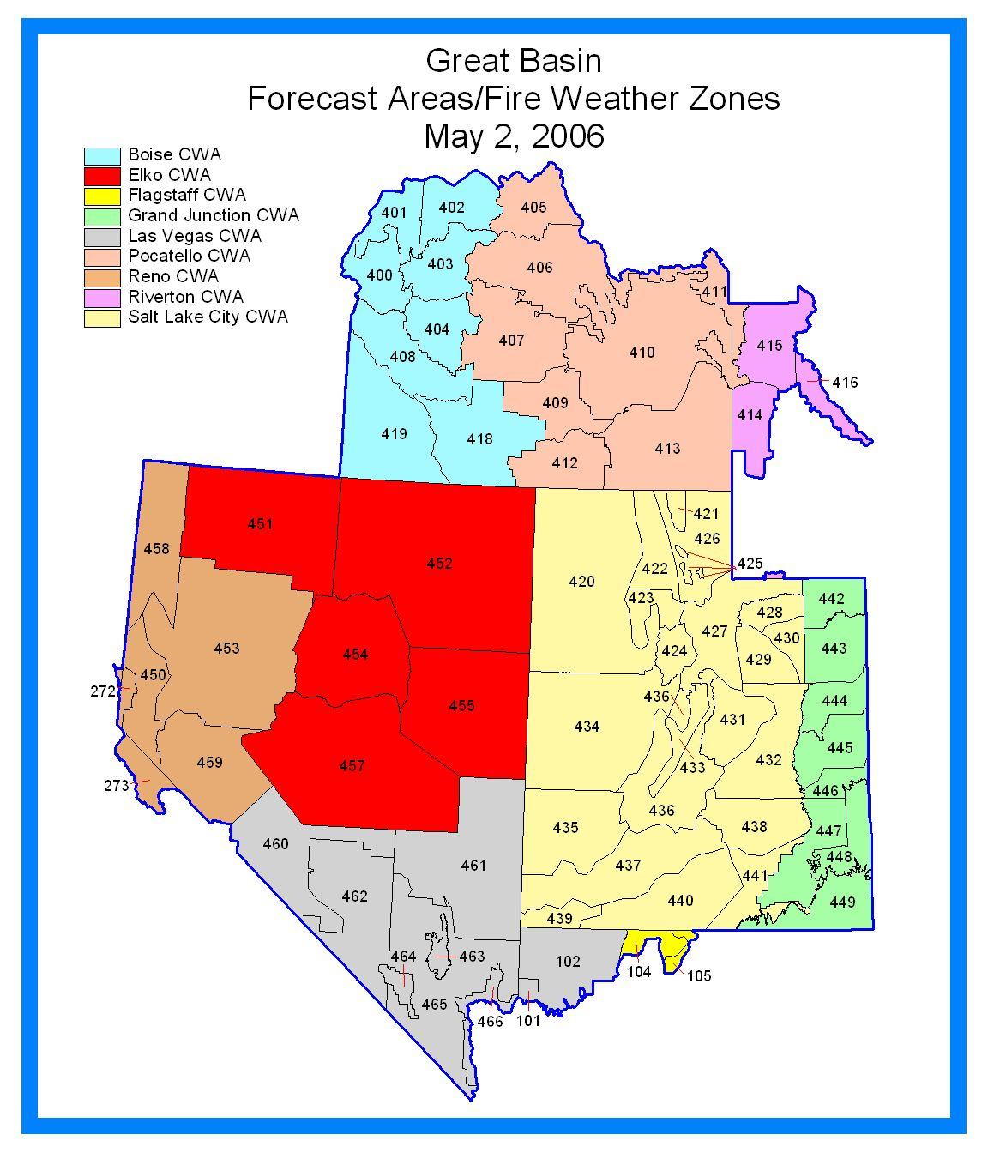
BOISE WEATHER FORECAST OFFICE

1. CHANGES FOR 2006

See Main section of AOP for overall program changes.

Internet Briefing. The 0930 internet briefing will now be recorded for later playback for those who cannot make the live briefing.

2. HOURS OF OPERATION
Depending on variables such as fuel parameters and customer need, seasonal Fire Weather Hours of Operation will be:

4/17 through 5/13: 0730-1530 MDT,
Forecast issued once a day NLT 1530 MDT.

5/14 through 10/28: 0730-1530 MDT.
Forecasts issued twice a day, NLT 0730 and 1530 MDT.

Staff meteorologists will be on duty and available at any time, 24 hours a day, 7 days a week.

3. STAFF AND CONTACT INFORMATION

See Appendix A.

4. FIRE WEATHER SERVICES

A. Description of the Boise Fire Weather District:

West Central Idaho Mountains...
Zone 400 – Northern Boise BLM
Zone 401 – Western Payette NF and Southern Idaho Timber Protection Agency (SITPA)
Zone 402 – Eastern Payette NF
Zone 403 – Northern Boise NF
Zone 404 – Southern Boise NF

Southwest Idaho
Zone 408 – Treasure Valley
Zone 418 – Western Twin Falls District of Shoshone BLM
Zone 419 – Owyhee Mountains

Southeast Oregon...
Zone 636 - Burns BLM south of Highway 20.
Zone 637 - Vale BLM (including Malheur County and far southeastern Baker County).

See map at end of this section.

B. Basic Meteorological Services

Internet Briefing: During fire season, a daily internet briefing will be offered each day at 0930 MDT for all agencies. During low fire activity periods or if there is not sufficient interest in a daily briefing, it will be held on Mondays and Thursdays at 0930 MDT. This briefing will include a general discussion of weather conditions and forecasts for the current day, as well a brief discussion of the extended period. Model data, satellite loops, and other items of interest will be addressed for the forecast period. During the briefing, the appropriate maps will be available on the Boise Fire Weather website. The briefing will usually be less than 15 minutes but may be longer during active fire periods. The briefing will be recorded for those who cannot make the live session.

Spot Forecasts: Requests for spot forecasts will be received via the Boise Fire Weather homepage found at:

http://www.boi.noaa.gov/fwx.htm

Follow-up phone calls are still encouraged when requesting spot forecasts.

Planning Forecasts: Mixing heights and transport winds will be included in the daily fire weather planning forecasts for Idaho zones only. The mixing height is defined as the height above the ground (AGL) through which relatively vigorous mixing will take place due to convection. The transport wind is defined as the average wind speed and direction within the mixing layer.

C. Product Schedule

Morning fire weather forecast NLT 0730 MDT
Internet briefing 0930 MDT
Afternoon fire weather forecast NLT 1530 MDT
NFDRS point forecasts NLT 1545 MDT
NFDRS point forecast – Burns BLM NLT 1630 MDT
Fire Weather Watch / Red Flag Warnings Event-Driven
Spot forecasts Upon request

D. Red Flag Events

Interagency Coordination: Before the issuance of a Red Flag Warning, there will be coordination with the affected agencies and neighboring NWS fire weather offices in order to assess fuel conditions and general fire danger.

Dissemination of Fire Weather Watches and Red Flag Warnings: Each issuance, update or cancellation of a Fire Weather Watch or Red Flag Warning will be relayed by telephone to the dispatch office(s) and GACC affected by the watch/warning.

Criteria for Red Flag Events: Standard criteria have been developed for the Great Basin and can be found starting on page 8. However, local criteria specific to an area may be used in addition to the standard criteria. For the Boise CWFA, the following has been identified:

- A sudden windshift or the passage of a cold front which will result in a windshift or erratic winds in combination with other red flag criteria.

Criteria for the Oregon zones of the Boise CWFA can be found in the Pacific Northwest AOP.
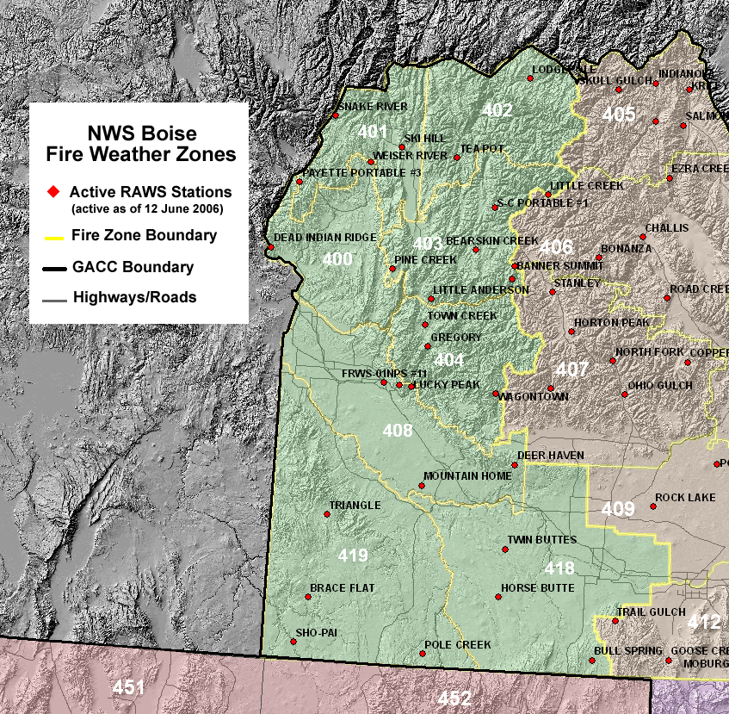

ELKO WEATHER FORECAST OFFICE

1. CHANGES FOR 2006

See Main section of AOP for overall program changes.

2. HOURS OF OPERATION
Depending on variables such as fuel parameters and customer need, seasonal Fire Weather Hours of Operation will be:

5/1 through 10/31: 0800-1600 PDT,
Forecast issued twice a day NLT 0900 and 1530 PDT.

Staff meteorologists will be on duty and available at any time, 24 hours a day, 7 days a week.

3. STAFF AND CONTACT INFORMATION

See Appendix A.

4. FIRE WEATHER SERVICES

A. Description of the Elko Fire Weather District:

Great Basin Fire Weather Zones...
Zone 451 – Humboldt County.
Zone 452 – Elko County
Zone 454 – Northern Lander/Eureka Counties
Zone 455 – White Pine County
Zone 457 – Southern Lander/Eureka and Northern Nye Counties

See map at end of this section.

B. Basic Meteorological Services

Spot Forecasts: Requests for spot forecasts will be received via the Elko Fire Weather homepage found at:

http://spot.nws.noaa.gov/cgi-bin/spot/spotmon?site=lkn

Follow-up phone calls are still encouraged when requesting spot forecasts. In the event internet communications are not available, spot requests may be made by fax using the WS Form D-1 or by phone.

Forecast feedback is imperative to improving services. In many cases, the only the forecaster will know what happened on a remote incident is through feedback from the fire community. You can phone in concerns or comments about forecasts to the forecaster on duty. Feedback may also be submitted in the remarks section on the next internet request, or by using the feedback option on the already processed internet-based spot forecast. Lastly, block 13 on the WS Form D-1 may be used in subsequent spot forecast requests. If forecasts services or weather conditions significantly impact operations, please notify the Fire Weather Program Leader, via phone or email. See Appendix A for contact information.

C. Product Schedule

Morning fire weather forecast NLT 0900 PDT
Afternoon fire weather forecast NLT 1530 PDT
NFDRS trends forecast NLT 1545 PDT
Fire Weather Watch / Red Flag Warnings Event-Driven
Spot forecasts Upon request

D. Red Flag Events

Interagency Coordination: Before the issuance of a Red Flag Warning, there will be coordination with the affected agencies and neighboring NWS fire weather offices in order to assess fuel conditions and general fire danger.

Dissemination of Fire Weather Watches and Red Flag Warnings: Each issuance, update or cancellation of a Fire Weather Watch or Red Flag Warning will be relayed by telephone to the dispatch office(s) and GACC affected by the watch/warning.

Criteria for Red Flag Events: Standard criteria have been developed for the Great Basin and can be found starting on page 8. However, local criteria specific to an area may be used in addition to the standard criteria.

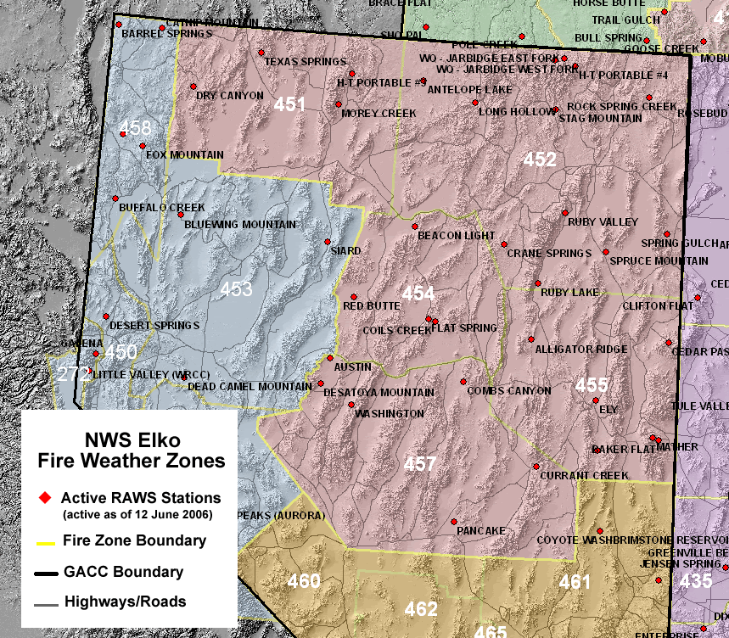
FLAGSTAFF WEATHER FORECAST OFFICE

1. CHANGES FOR 2006

See Main section of AOP for overall program changes.

- HOURS OF OPERATION

Staff meteorologists will be on duty and available at any time, 24 hours a day, 7 days a week.

Forecast issued twice a day NLT 073 and 1530 MST. ( during the fire season)

3. STAFF AND CONTACT INFORMATION

See Appendix A.

4. FIRE WEATHER SERVICES

A. Description of the Flagstaff Fire Weather District:

Arizona Fire Weather Zones…
Zone 104 – Kaibab Plateau, excluding the Kaibab NF
Zone 105 – Marble and Glenn Canyons north of Colorado River

See map at end of this section.

B. Basic Meteorological Services

Spot Forecasts: Requests for spot forecasts will be received via the Flagstaff Fire Weather homepage found at:
http://www.wrh.noaa.gov/cgi-bin/ifps_spot/spotmon?site=fgz

Follow-up phone calls are encouraged when requesting spot forecasts. In the event internet communications are not available, spot requests may be made by fax using the WS Form D-1 or by phone.

Forecast feedback is imperative to improving services. In many cases, the only way the forecaster will know what happened on a remote incident is through feedback from the fire community. Phone in concerns or comments about forecasts to the forecaster on duty. Feedback may also be submitted in the remarks section on the next internet request, or by using the feedback option on the already processed internet-based spot forecast. Lastly, block 13 on the WS Form D-1 may be used in subsequent spot forecast requests. If forecasts services or weather conditions significantly impact operations, please notify the Fire Weather Program Leader, via phone or email. See Appendix A for contact information.

C. Product Schedule

Morning fire weather forecast NLT 0730 MST
Afternoon fire weather forecast NLT 1530 MST
NFDRS trends forecast NLT 1500 MST
Fire Weather Watch / Red Flag Warnings Event-Driven
Spot forecasts Upon request

D. Red Flag Events

Interagency Coordination: Before the issuance of a Red Flag Warning, there will be coordination with the affected agencies and neighboring NWS fire weather offices in order to assess fuel conditions and general fire danger.

Dissemination of Fire Weather Watches and Red Flag Warnings: Each issuance, update or cancellation of a Fire Weather Watch or Red Flag Warning will be relayed by telephone to the dispatch office(s) and GACC affected by the watch/warning.

Criteria for Red Flag Events: Standard criteria have been developed for the Great Basin and can be found starting on page 8. However, local criteria specific to an area may be used in addition to the standard criteria.

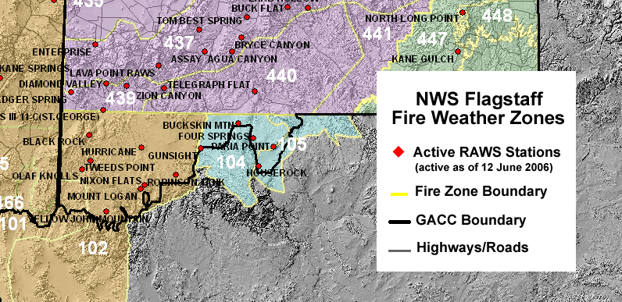

GRAND JUNCTION WEATHER FORECAST OFFICE

1. CHANGES FOR 2006

See main section of AOP for overall program changes.

Forecasts Issuance: WFO Grand Junction will produce one fire weather planning forecast (FWF) per day, seven days a week from April 1 to April 30. From May 1 to October 31, forecasters will produce two forecasts per day.

2. HOURS OF OPERATION
Depending on variables such as fuel parameters and customer need, seasonal Fire Weather Hours of Operation will be:

4/1 through 4/30: 0800-1600 MDT,
Forecast issued once a day NLT 1530 MDT for Colorado.

5/1 through 10/31: 0800-1600 MDT.
Forecasts issued twice a day, NLT 0800 and 1530 MDT, expanding into Utah.

Staff meteorologists will be on duty and available at any time, 24 hours a day, 7 days a week.

3. STAFF AND CONTACT INFORMATION

See Appendix A.

4. FIRE WEATHER SERVICES

A. Description of the Grand Junction Fire Weather District:

The following zone groupings will be used for all products except the Fire Weather Planning Forecast (FWF):

Eastern Utah...
Zone 442 through 449

See map at end of this section.

The following zone groupings will be used for the Grand Junction Fire Weather Forecast (FWF) only:

Northeast Utah (Uinta IFC)
Zone 428 – Western Uinta Mountains
Zone 429 – West Tavaputs Plateau and surrounding ranges
Zone 430 – Western Uinta Basin
Zone 442 – Eastern Uinta Mountains
Zone 443 – Eastern Uinta Basin
Zone 444 – Northern Roan and East Tavaputs Plateaus and surrounding ranges
The Fire Weather Planning Forecasts for southeast Utah, Zones 445, 446, 447, 448, and 449, are issued by NWS Salt Lake City.

B. Spot Forecasts

The Grand Junction office prepares spot weather forecasts for prescribed burns and wildfires as requested for locations within the office’s CWFA.

The primary means of requesting and disseminating spot forecasts is the NWS Spot Internet-based spot request and reply program, found at:

http://spot.nws.noaa.gov/cgi-bin/spot/spotmon?site=gjt

When internet or computer capabilities are not available, fax or phone can be used to request a spot forecast.

To ensure receipt by the fire weather forecaster, the requester should call the NWS after submitting each spot request. If you have not indicated on the spot request, during your follow-up telephone, please tell the forecaster that your request is for a wildfire or a prescribed burn, so that your request can receive the proper priority. This call to the WFO will also allow the fire weather forecaster to ask any questions he/she might have, and inform you if multiple spot requests may delay completing your forecast. WFO Grand Junction will show the same courtesy by calling the requesting agency after each completed spot forecast is transmitted.

Spot forecasts will be available 24 hours a day for wildfires and will receive the same priority as severe weather warnings. For prescribed burns, delays may occur due to priority of duties and office staffing. Delays may also occur if severe weather or flash flood watches or warnings are in effect in the WFO Grand Junction CWFA. If a spot forecast has not been returned after 60 minutes, call the WFO to check on the status to determine if there has been a communications system failure, or a significant weather event, that may have delayed completion.

When requesting a non-wildfire spot forecast any time of year, it is strongly suggested that requests NOT be made between 1100 and 1500. Requests made during this time will occur during the key preparation period for the afternoon fire weather forecasts and will result in a delay between the request and receipt of a spot forecast.

Certain prescribed burns will be considered high risk for significant smoke impacts, as determined by the Smoke Risk Rating Worksheet for Prescribed Fire Projects, which is part of the Colorado Memorandum of Understanding (MOU). These burns could either be Category III or Category IV burns, and REQUIRE detailed observations at least 3 days prior to burn. Consultation with the fire weather program leader or assistant program leader, well in advance of the scheduled burn date, daily feedback, and fire line observations throughout the course of the project are required by the Smoke Risk Rating Worksheet and the Colorado MOU.

C. Product Schedule

Morning fire weather forecast NLT 0900 MDT
Afternoon fire weather forecast NLT 1530 MDT
NFDRS trends forecast NLT 1545 MDT
Fire Weather Watch / Red Flag Warnings Event-Driven
Spot forecasts Upon request

D. Red Flag Events

Interagency Coordination: Before the issuance of a Red Flag Warning, there will be coordination with the affected agencies and neighboring NWS fire weather offices in order to assess fuel conditions and general fire danger. Information on fuel conditions will be assessed using the GACC fuels page and from weekly GACC/NWS conference calls.

Dissemination of Fire Weather Watches and Red Flag Warnings: Each issuance, update or cancellation of a Fire Weather Watch or Red Flag Warning will be relayed by telephone to the dispatch office(s) and GACC affected by the watch/warning.

Criteria for Red Flag Events: Standard criteria have been developed for the Great Basin and can be found starting on page 8. However, local criteria specific to an area may be used in addition to the standard criteria.

E. Smoke Management Forecast

This forecast is issued no later than 1600 during the fire season. It is a separate product from the afternoon forecast and is valid for the tonight and tomorrow periods. The Smoke Management Forecast includes a brief discussion of airmass stability and meteorological parameters that may affect smoke dispersal. The forecast also includes a forecast of transport winds, mixing heights and a ventilation index (clearing index for eastern Utah) for the tonight and tomorrow time periods.

F. Incident Meteorologists (IMETs)

The Grand Junction office has two certified IMETs available for dispatch to major forest fires and incidents. Dispatch for significant prescribed burn projects, i.e., CAT III and CAT IV burns, will only be possible when coordination with the fire weather program leader and WFO Meteorologist- in- Charge (MIC) has been accomplished well in advance (months in advance) of the project and only when NWS manpower and resources permit.
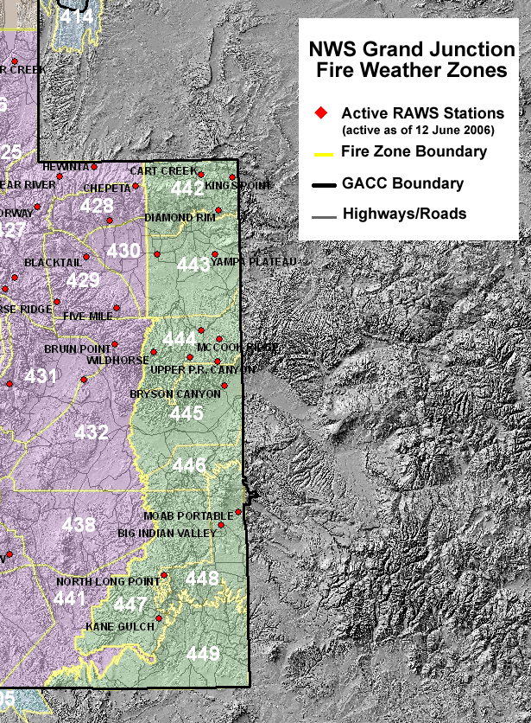
LAS VEGAS WEATHER FORECAST OFFICE

1. CHANGES FOR 2006

See Main section of AOP for overall program changes.

New zone boundaries and numbers: The changes being implemented for this season will create seven new zones which are more closely aligned with dispatch boundaries and climatic regimes. In order to avoid confusion, the zone number 456 will no longer be used.

Red Flag Criteria: A change to the wind portion of the criteria to sustained winds greater than or equal to 20 mph and/or gusts greater than or equal to 35 mph for 3 hours in a given period.

2. HOURS OF OPERATION

Staff meteorologists are on duty at WFO Las Vegas 24 hours a day throughout the year.
Scheduled dates and times for the Fire Weather Planning Forecast and NFDRS forecasts are:

5/1 through 10/31: Planning Forecast issued twice daily at 0700 and 1500 PDT.
NFDRS forecast issued by 1530 PDT.
Off season: Planning Forecast issued once daily at 0700 local time.

Depending on variables such as fuel parameters and customer need, seasonal Fire Weather dates may begin earlier in the season or continued later in the season.

3. STAFF AND CONTACT INFORMATION

See Appendix A.

4. FIRE WEATHER SERVICES

A. Description of the Las Vegas Fire Weather District (Great Basin Portion):

Nevada Fire Weather Zones
Zone 460 – Central Nevada Dispatch Southern Deserts – Esmeralda and parts of
Central Nye County
Zone 461 – Lincoln County – Ely Dispatch
Zone 462 – Nye County Deserts – LV Dispatch
Zone 463 – Sheep Range
Zone 464 – Spring Mountains
Zone 465 – Clark and SW Lincoln County Deserts – LV Dispatch
Zone 466 – Lake Mead and Colorado River – LV Dispatch

Arizona Fire Weather Zones within the Great Basin
Zone 102 – Northwest Plateau (Arizona Strip) and Northwest Deserts

See map at end of this section.

B. Basic Meteorological Services

Spot Forecasts: Requests for spot forecasts will be received via the Las Vegas Fire Weather
homepage found at:
http://spot.nws.noaa.gov/cgi-bin/spot/spotmon?site=vef

Follow-up phone calls are encouraged when requesting spot forecasts to verify we actually
received the request. In the event the internet is not available, spot requests may be made by
faxing the WS Form D-1 or by phone. Forecast feedback is imperative to improving
services. In many cases, the only way the forecaster will know what happened on a remote
incident is through feedback from the fire community. Phone in concerns or comments
about forecasts to the forecaster on duty. Feedback may also be submitted in the remarks
section on the next internet request, or by using the feedback option on the already
processed internet-based spot forecast. Lastly, block 13 on the WS Form D-1 may be used
in subsequent spot forecast requests. If forecast services or weather conditions significantly
impact operations, please notify the Fire Weather Program Leader via phone or email. See
Appendix A for contact information.

C. Product Schedule

Morning fire weather planning forecast NLT 0700 Pacific Time
Afternoon fire weather forecast NLT 1530 Pacific Time
NFDRS trends forecast NLT 1530 Pacific Time
Fire Weather Watch/Red Flag Warnings Event-Driven
Spot forecasts Upon request

D. Red Flag Events

Interagency Coordination: Before the issuance of a Red Flag Warning, there will be
coordination with the affected agencies and neighboring NWS offices in order to assess fuel
conditions and general fire danger.

Dissemination of Fire Weather Watches and Red Flag Warnings: Each issuance, update
or cancellation of a Fire Weather Watch or Red Flag Warning will be relayed by telephone
to the dispatch office(s) and GACC affected by the watch/warning.

Criteria for Red Flag Events: Standard criteria have been developed for the Great Basin and
can be found starting on page 8. However, local criteria specific to an area may be used in
addition to the standard criteria.

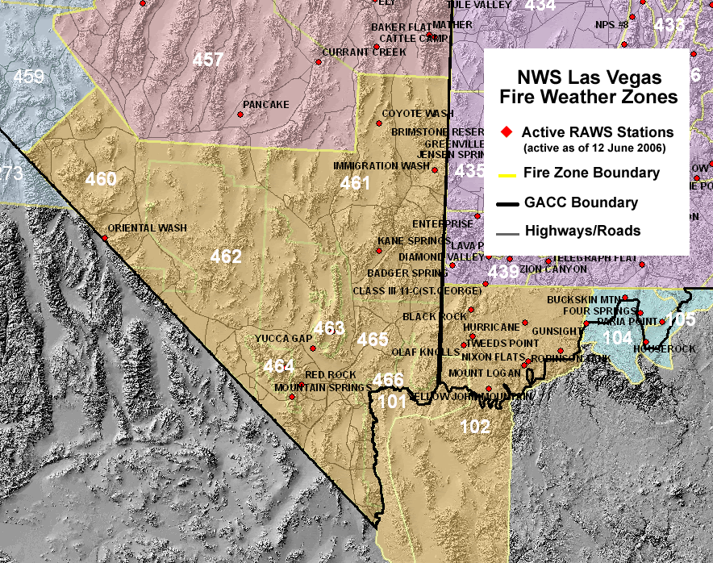

POCATELLO WEATHER FORECAST OFFICE

1. CHANGES FOR 2006

See Main section of AOP for overall program changes.

Weather input for FARSITE calculations are generated automatically each time a SPOT forecast is requested on line. FARSITE weather input will be available at http://www.wrh.noaa.gov/pih/firewx/farsite.php?wfo=pih

2. HOURS OF OPERATION
Staff meteorologists are on duty at WFO Pocatello 24 hours a day throughout the year. Concerns about current or developing weather conditions may be discussed anytime. Scheduled dates for issuance of the Fire Weather Planning Forecast and NFDRS forecasts are:

5/1 through 5/14: Forecast issued once a day NLT 0700 MDT.
5/15 through 10/31: Forecast issued twice a day NLT 0700 and 1530 MDT.

Depending on variables such as fuel parameters and customer need, seasonal Fire Weather dates may begin earlier in the season or continue later in the season.

3. STAFF AND CONTACT INFORMATION

See Appendix A.

4. FIRE WEATHER SERVICES

A. Description of the Pocatello Fire Weather District:

East Central Idaho Mountains...
Zone 405 – Northern Salmon-Challis NF, portions of Upper Columbia-Salmon Clearwater BLM District east of Middle Fork of Salmon River
Zone 406 – Southern Salmon-Challis NF, portions of Upper Columbia-Salmon Clearwater BLM District east of Middle Fork of Salmon River.
Zone 407 – Northern Sawtooth NF, Sawtooth NRA, southeastern Salmon-Challis NF and Camas Prairie

Upper Snake River Plain...
Zone 409 – Upper Snake River BLM District north of Snake River, including Minidoka NWR
Zone 410 – Northeastern Upper Snake River BLM District, Craters of the Moon NM, Camas NWR, Idaho State Land Department – Cotton Protective District, southeastern Birch Creek and Little Lost River Valleys

Southeast Idaho Highlands…
Zone 412 – Southern Sawtooth NF, Upper Snake River BLM District south of Snake River
Zone 413 – Caribou-Targhee NF south of Palisades Reservoir, portions of the Upper Snake River BLM District east of Snake River, Grays Lake NWR, and Bear Lake NWR.

Upper Snake Highlands…
Zone 411 – Caribou-Targhee NF north of Palisades Reservoir, excluding the eastern slopes of the Lemhi Mountain Range.

See map at end of this section.

B. Basic Meteorological Services

Spot Forecasts: Requests for spot forecasts will be received via the Pocatello Fire Weather homepage found at:

http://spot.nws.noaa.gov/cgi-bin/spot/spotmon?site=pih

Follow-up phone calls are still encouraged when requesting spot forecasts. In the event Internet communications are not available, spot requests may be made by fax using the WS Form D-1 or by phone. A copy of this form in PDF format may be downloaded from our web site at

http://www.wrh.noaa.gov/pih/firewx/index.php

Forecast feedback is imperative to improving services. In many cases, the only way the forecaster will know what happened on a remote incident is through feedback from the fire community. Phone in concerns or comments about forecasts to the forecaster on duty. Feedback may also be submitted in the remarks section on the next Internet request, or by using the feedback option on the already processed internet-based spot forecast. Lastly, comments may be attached on a separate page and attached to the WS Form D-1 in subsequent spot forecast requests. If forecasts, services or weather conditions significantly impact operations, please notify Bob Survick, Fire Weather Program Leader, via phone or email. See Appendix A for contact information.

WS Form D-1 for manual SPOT Requests is available in downloadable PDF format at

http://www.wrh.noaa.gov/pih/firewx/index.php

C. Product Schedule

Morning fire weather forecast NLT 0700 MDT
Afternoon fire weather forecast NLT 1530 MDT
NFDRS forecast NLT 1545 MDT
Fire Weather Watch / Red Flag Warnings Event-Driven
Spot forecasts upon request

D. Red Flag Events

Interagency Coordination: Before the issuance of a Red Flag Warning, there will be coordination with the affected agencies in order to assess fuel conditions and general fire danger.

Dissemination of Fire Weather Watches and Red Flag Warnings: Each issuance, update or early cancellation of a Fire Weather Watch or Red Flag Warning will be relayed by telephone to the dispatch office(s) and GACC affected by the watch/warning. For Red Flag Warnings that run their stated valid time and expire between 600 pm and 600 am local time, a single notification call will be made to Eastern Great Basin Coordination Center Predictive Services who in turn will notify the appropriate on-call number.

Criteria for Red Flag Events: Standard criteria have been developed for the Eastern Great Basin and can be found in the main section of this operating plan. However, local criteria specific to an area may be used in addition to the standard criteria.

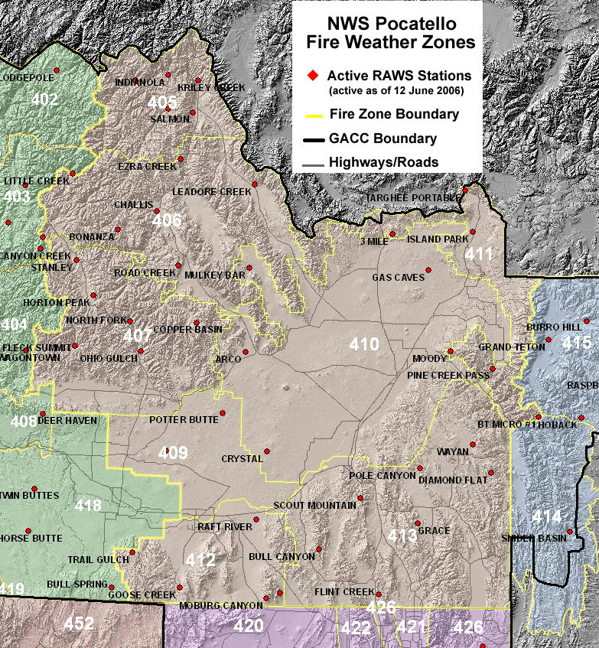
RENO WEATHER FORECAST OFFICE

1. CHANGES FOR 2005

See Main section of AOP for overall program changes.

Red Flag Criteria: The Red Flag for the Great Basin is on page 9.

2. HOURS OF OPERATION
Depending on variables such as fuel parameters and customer need, seasonal Fire Weather Hours of Operation will be:

5/15 through 10/31: 0800-1600 PDT,
Forecast issued twice a day NLT 0730 and 1530 PDT.

Staff meteorologists are on duty and available at any time, 24 hours a day, 7 days a week.

3. STAFF AND CONTACT INFORMATION

See Appendix A.

4. FIRE WEATHER SERVICES

A. Description of the Reno Fire Weather District:

Great Basin Fire Weather Zones...
Zone 450 – Sierra Front
Zone 453 – West Central Nevada Basin and Range
Zone 458 – Northern Washoe County
Zone 459 – Mineral and Southern Lyon Counties

See map at end of this section.

B. Basic Meteorological Services

Spot Forecasts: Requests for spot forecasts will be received via the Reno Fire Weather homepage found at:

http://spot.nws.noaa.gov/cgi-bin/spot/spotmon?site=rev

Follow-up phone calls are strongly encouraged when requesting spot forecasts. In the event internet communications are not available, spot requests may be made by fax using the WS Form D-1 or by phone.

Forecast feedback is imperative to improving services. In many cases, the only the forecaster will know what happened on a remote incident is through feedback from the fire community. Phone in concerns or comments about forecasts to the forecaster on duty. Feedback may also be submitted in the remarks section on the next internet request, or by using the feedback option on the already processed internet-based spot forecast. Lastly, block 23 on the WS Form D-1 may be used in subsequent spot forecast requests. If forecasts services or weather conditions significantly impact operations, please notify the Fire Weather Program Leader, via phone or email. See Appendix A for contact information.

C. Product Schedule

Morning fire weather forecast NLT 0730 PDT
Afternoon fire weather forecast NLT 1530 PDT
NFDRS trends forecast NLT 1545 PDT
Fire Weather Watch / Red Flag Warnings Event-Driven
Spot forecasts Upon request

D. Red Flag Events

Interagency Coordination: Before the issuance of a Red Flag Warning, there will be coordination with the affected agencies and neighboring NWS fire weather offices in order to assess fuel conditions and general fire danger.

Dissemination of Fire Weather Watches and Red Flag Warnings: Each issuance, update or cancellation of a Fire Weather Watch or Red Flag Warning will be relayed by telephone to the dispatch office(s) and GACC affected by the watch/warning.

Criteria for Red Flag Events: Standard criteria have been developed for the Great Basin and can be found starting on page 9. However, local criteria specific to an area may be used in addition to the standard criteria.

E. Experimental Graphical Forecast Products

Experimental Graphical Forecast Products for selected Fire Weather parameters will be available on our Fire Weather page (web site above), during fire season. Your feedback is welcome on the usefulness of these products and as well as suggestions on additional products. Please call or email Brian Brong for more information.
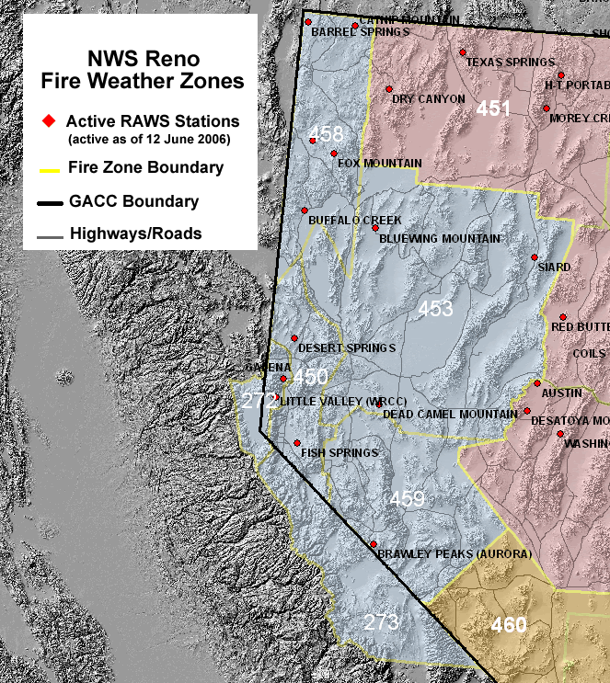

RIVERTON WEATHER FORECAST OFFICE

1. CHANGES FOR 2005

See Main section of AOP for overall program changes.
Red Flag Criteria: New Red Flag criteria will be implemented for the Great Basin. See page 8.

2. HOURS OF OPERATION

Depending on variables such as fuel parameters and customer need, seasonal Fire Weather Hours of Operation will be:
5/1 through 10/31
Forecast issued twice a day NLT 0700 and 1500 MDT.
Staff meteorologists will be on duty and available at any time, 24 hours a day, 7 days a week.

3. STAFF AND CONTACT INFORMATION

See Appendix A.

4. FIRE WEATHER SERVICES

A. Description of the Riverton Fire Weather District:

Great Basin Fire Weather Zones...
Zone 414 – Bridger-Teton NF and surrounding mountainous terrain in Lincoln as well as western Sublette Counties west of Highway 189/191
Zone 416 – Bridger-Teton NF and surrounding mountainous terrain in Sublette County east of Highway 189/191, and a small portion of Fremont County west of South Pass
Zone 415 – Bridger-Teton NF in extreme western Fremont County and southwest Park County, Teton County excluding the Targhee NF, extreme northwest Sublette County.

See map at end of this section.

B. Basic Meteorological Services

Spot Forecasts: Requests for spot forecasts will be received via the Riverton Fire Weather homepage found at:
http://spot.nws.noaa.gov/cgi-bin/spot/spotmon?site=riw

Follow-up phone calls are still encouraged when requesting spot forecasts. In the event internet communications are not available, spot requests may be made by fax using the WS Form D-1 or by phone.

Forecast feedback is imperative to improving services. In many cases, the only way the forecaster will know what happened on a remote incident is through feedback from the fire community. Phone in concerns or comments about forecasts to the forecaster on duty. Feedback may also be submitted in the remarks section on the next internet request, or by using the feedback option on the already processed internet-based spot forecast. Lastly, block 13 on the WS Form D-1 may be used in subsequent spot forecast requests. If forecasts services or weather conditions significantly impact operations, please notify the Fire Weather Program Leader, via phone or email. See Appendix A for contact information.

C. Product Schedule

Morning fire weather forecast NLT 0700 MDT
Afternoon fire weather forecast NLT 1500 MDT
NFDRS trends forecast NLT 1545 MDT
Fire Weather Watch / Red Flag Warnings Event-Driven
Spot forecasts Upon Request

D. Red Flag Events

Interagency Coordination: Before the issuance of a Red Flag Warning, there will be coordination with the affected agencies and neighboring NWS fire weather offices in order to assess fire weather conditions.

Dissemination of Fire Weather Watches and Red Flag Warnings: Each issuance, update or cancellation of a Fire Weather Watch or Red Flag Warning will be relayed by telephone to the dispatch office(s) and GACC affected by the watch/warning.

Criteria for Red Flag Events: Standard criteria have been developed for the Great Basin and can be found starting on page 8. However, local criteria specific to an area may be used in addition to the standard criteria. For Riverton, red flag criteria will include 25 mph sustained wind (20-foot, 10-minute average).

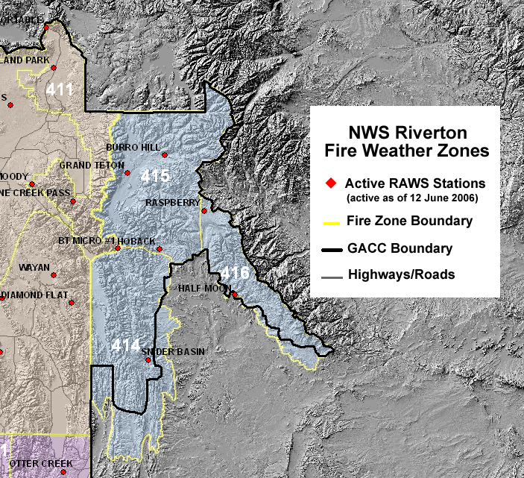

SALT LAKE CITY WEATHER FORECAST OFFICE

1. CHANGES FOR 2006

See main section of AOP for overall program changes.

Moab Dispatch Area: Red Flag Warning and Fire Weather Watch responsibility for all of Moab Dispatch area will switch to Salt Lake City (Grand Junction will cover the Uintah Basin).

Issuance Times: Morning Fire Weather Planning Forecast (FWF) will be issued no later than 0730.

Smoke Management Forecasts: Smoke management forecasts will now be issued for 16 airsheds.

Digital Forecast Products: New digital forecast products – 7-Day Weather Planner and Point Forecasts – available. The 7-Day Weather Planner now includes a smoke management section.

2. HOURS OF OPERATION

Depending on variables such as fuel parameters and customer need, seasonal Fire Weather Hours of Operation will be:

5/1 through 10/31: 0800-1600 MDT,
Forecast issued twice a day, NLT 0700 and 1530 MDT.

Staff meteorologists will be on duty and available at any time, 24 hours a day, 7 days a week.

3. STAFF AND CONTACT INFORMATION

See Appendix A.

4. FIRE WEATHER SERVICES

A. Description of the Salt Lake City Fire Weather District:

The following zone groupings will be used for all products except the Fire Weather Forecast (FWF):

Northern Utah
Zone 420 – Great Salt Lake Desert and Mountains
Zone 421 – Cache Valley
Zone 422 – Northern Wasatch Front
Zone 423 – Salt Lake and Tooele Valleys
Zone 424 – Southern Wasatch Front
Zone 425 – Wasatch Mountain Valleys
Zone 426 – Wasatch Mountains north of Interstate 80
Zone 427 – Wasatch Mountains south of Interstate 80

Northeast Utah
Zone 428 – Western Uinta Mountains
Zone 429 – West Tavaputs Plateau and surrounding ranges
Zone 430 – Western Uinta Basin

East Central Utah
Zone 431 – Castle Valley
Zone 432 – San Rafael Swell and Desert

West Central Utah...
Zone 433 – San Pete and Sevier Valleys
Zone 434 – West Central Deserts and Mountains
Zone 436 – Central Utah Mountains
Zone 438 – Henry Mountains

Southern Utah
Zone 435 – Southwest Deserts and Mountains
Zone 437 – Southwest and South Central Mountains
Zone 439 – Utah’s Dixie and Zion Canyon
Zone 440 – South Central Utah
Zone 441 – Glen Canyon National Recreation Area/Lake Powell

See map at end of this section.

The following zone groupings will be used for the Salt Lake City Fire Weather Forecast (FWF) only:

Northern Utah (Northern Utah IFC)
Zone 420 – Great Salt Lake Desert and Mountains
Zone 421 – Cache Valley
Zone 422 – Northern Wasatch Front
Zone 423 – Salt Lake and Tooele Valleys
Zone 424 – Southern Wasatch Front
Zone 425 – Wasatch Mountain Valleys
Zone 426 – Wasatch Mountains north of Interstate 80
Zone 427 – Wasatch Mountains south of Interstate 80

East Central Utah (Moab IFC)
Zone 431 – Castle Valley
Zone 432 – San Rafael Swell and Desert
Zone 445 – Grand Flat, Roan and Book Cliffs
Zone 446 – Arches National Park and surrounding area
Zone 447 – Canyonlands National Park, Natural Bridges National Monument
Zone 448 – La Sal and Abajo Mountains
Zone 449 – Southern San Juan County

West Central Utah (Richfield IFC)
Zone 433 – San Pete and Sevier Valleys
Zone 434 – West Central Deserts and Mountains
Zone 436 – Central Utah Mountains
Zone 438 – Henry Mountains

Southwest Utah (Cedar City IFC)
Zone 435 – Southwest Deserts and Mountains
Zone 437 – Southwest and South Central Mountains
Zone 439 – Utah’s Dixie and Zion Canyon
Zone 440 – South Central Utah
Zone 441 – Glen Canyon National Recreation Area/Lake Powell

See map at end of this section.

B. Basic Meteorological Services

The following services are provided to Land Management Agencies in the state of Utah:

Emergency Fire Weather Briefings: During emergency situations when a spot forecast will take too long, you should call us for weather information. Ask to speak with the Fire Weather Forecaster on-duty. If a Fire Weather Forecaster is not in the office, ask to speak with the Lead Forecaster on-duty.

Routine Fire Weather Zone Forecasts: Disseminated via WIMS and our Internet Homepage twice a day from 5/1 through 10/31. Issuance times are 0700 MDT and 1500 MDT. Times vary according to the current weather situation/spot forecast workload though every effort is made to make the forecast available as soon as possible. Notification of updates will be made through the GACC Predictive Services Meteorologist or the Coordinator on Duty (COD).

Routine Smoke Management Forecasts: Disseminated via WIMS and our Internet Homepage once a day from 5/1 through 10/31. Issuance times will usually be from 1100-1200 MDT depending on our spot forecast workload. Note: With the increased emphasis on prescribed burning these days...we continue to try and make improvements to this product. Consult our homepage for the latest updates and improvements to this product including a new internet-based clearing index planner. Outside the normal burning season, the 7-Day Weather Planner and the Clearing Index Planner may be used.

Spot Forecasts: This forecast office operates 24 hours a day, seven days a week throughout the year. Meteorologists trained in fire weather forecasting will be on duty and available for Spot Forecasts outside of normal fire weather working hours. Spot Forecasts are made available on the web page to the requesting agency as soon as possible. Average turn around time is 30-60 minutes. This will vary depending on the number of Spot Forecast requests being handled at any given time. Spot requests for wildfires are always given the highest priority. Spot requests for prescribed burns are prioritized based on the order in which they are received. (The exception is when significant problems are occurring on a particular prescribed burn operation.)

Please utilize the web-based system on our homepage to request Spot Forecasts, found at:

http://www.wrh.noaa.gov/cgi-bin/ifps_spot/spotmon?site=slc

In the event of internet problems or internet unavailability, spots can still be requested via fax using WS-FORM D-1. Any problems encountered with the web-based program should be addressed to Chris Brenchley (Lead FWX Forecaster) as soon as possible. When requesting a spot, call the office to ensure receipt of the request. In addition to high quality, representative observations, critical weather elements for prescribed burning operations should be noted in block 13 on your request. This will ensure additional emphasis on the weather elements that may keep you out of prescription.

Due to staffing considerations in the Fire Weather Season, it is preferred that "non-emergency" spot forecast requests be submitted to the Fire Weather Forecaster on-duty during normal business hours (0700-1600 MDT). This will ensure you receive a spot forecast from a forecaster who has been monitoring specific fire weather conditions throughout the state.

Verification is an essential part of improving this service to you. In most cases, we only know what happened at the site if we hear from you. You are encouraged to write comments and observations in the feedback section of the spot and send them back to us or include in remarks of subsequent spot requests. If the feedback is urgent and there is a large discrepancy between forecast and observations, call the Fire Weather Forecaster on-duty directly. Any significant problems that result on your operation due to weather conditions, should be called or e-mailed into Chris Brenchley, Fire Weather Program Leader.

Numerical NFDRS Forecasts: disseminated each day between 1515-1545 MDT via WIMS. These are also available on our Internet Homepage site. The fire weather forecaster will issue a point forecast for the next day for all NFDRS observations that are received from the Fire Weather District that day.

Fire Weather Watches/Red Flag Warnings: Normally issued via WIMS with the Routine Forecast Package (0700 or 1530) and as a separate product. This product is also available on our Internet Homepage Site. Coordination calls are made as needed to Local Dispatch Centers to verify fuel conditions. FMOs, FBAs, and Burn Bosses should make every effort to call the Fire Weather Forecaster on-duty whenever there is any concern about critically dry fuels and severe fire behavior. Watches and warnings will be based on the standard criteria set forth in this document, beginning on page 8. Local criteria may be established to meet specific requirements. These should be coordinated between the NWS and the local land management officials and Predictive Services.

Experimental Gridded Forecast Products: Internet based fire weather forecast products will be tested on the Salt Lake NWS Fire Weather Homepage. These products should be considered experimental and feedback on their usefulness will be solicited from users. Any suggestions on how to improve these tools are very welcome; please email your suggestions to call the Fire Weather Program Leader, Chris Brenchley.

C. Product Schedule

Morning fire weather forecast NLT 0730 MDT
Afternoon fire weather forecast 1530 MDT
NFDRS trends forecast NLT 1545 MDT
Fire Weather Watch / Red Flag Warnings Event-Driven
Spot forecasts Upon request



