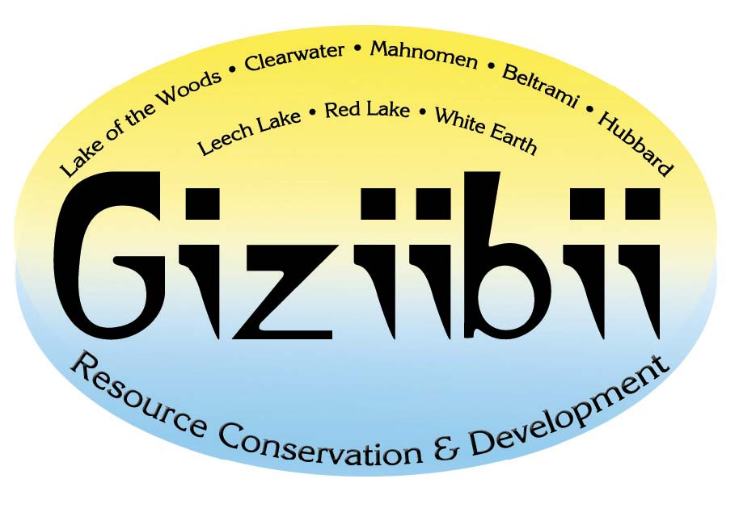

Request RC&D Assistance
Requests for RC&D assistance can be made by contacting any council member or the RC&D office. Local support for the project must be shown by seeking approval of the request from your County Board of Commissioners and the Supervisors of the Soil & Water Conservation District.
For more information, please contact the Giziibii RC&D office at (218) 751-1942, extension 5, or email Colleen Oestreich, RC&D Coordinator. (colleen.oestreich@mn.usda.gov)

