PRELIMINARY DRAFT 7
Fermilab-TM-2149
May 18, 2001

Report by the collaborators of
Design Study for a Staged
Very Large Hadron Collider
The VLHC Design Study Group:
Brookhaven National Laboratory
Fermi National Accelerator Laboratory
Laboratory of Nuclear Studies, Cornell University
Lawrence Berkeley National Laboratory

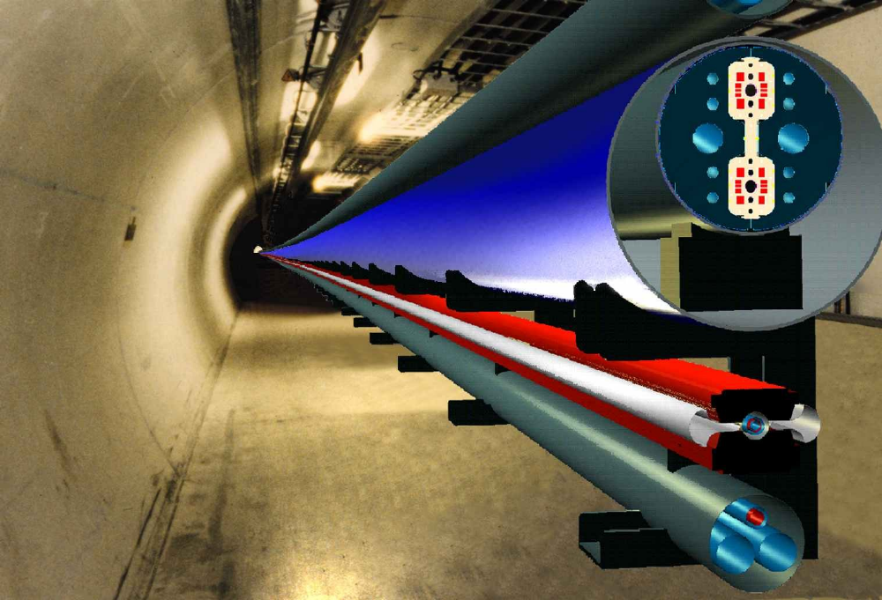

Design Study for a Very Large Hadron Collider

The VLHC Design Study Group:

Giorgio Ambrosio, Terry AndersonError: Reference source not found, Nikolai AndreevError: Reference source not found, Emanuela BarziError: Reference source not found, Bob Bauer, Pierre BauerError: Reference source not found, Sergey Belomestnykh, Robert BernsteinError: Reference source not found, Mike Blaskiewicz, Rodger BossertError: Reference source not found, John CarsonError: Reference source not found, Deepak ChichiliError: Reference source not found, Pete Conroy, Don CossairtError: Reference source not found, Christine DarveError: Reference source not found, Dmitri DenisovError: Reference source not found, Angelika DreesError: Reference source not found, Alexander DrozhdinError: Reference source not found, Luciano ElementiError: Reference source not found, David FinleyError: Reference source not found, Wolfram FischerError: Reference source not found, Bill FosterError: Reference source not found, Peter GarbinciusError: Reference source not found, Norman GelfandError: Reference source not found, Henry GlassError: Reference source not found, Steve Gourlay, Ramesh GuptaError: Reference source not found, Mike HarrisonError: Reference source not found, Steve HaysError: Reference source not found, Yuenian HuangError: Reference source not found, Linda ImbasciatiError: Reference source not found, Alan JacksonError: Reference source not found, John JohnstoneError: Reference source not found, Vadim KashikhinError: Reference source not found, Vladimir KashikhinError: Reference source not found, Kurt KennedyError: Reference source not found, Jim KerbyError: Reference source not found, Arkadiy KlebanerError: Reference source not found, Glen LambertsonError: Reference source not found, Mike LammError: Reference source not found, Chris LaughtonError: Reference source not found, Valery LebedevError: Reference source not found, Peter LimonError: Reference source not found, Alexander MakarovError: Reference source not found, Ernest MalamudError: Reference source not found, John MarrinerError: Reference source not found, Phil MartinError: Reference source not found, Mike MayError: Reference source not found, Nikolai MokhovError: Reference source not found, Chuck Nelson, King Yuen NgError: Reference source not found, Tom NicolError: Reference source not found, Barry NorrisError: Reference source not found, Igor NovitskiError: Reference source not found, Andy OleckError: Reference source not found, Tom PageError: Reference source not found, Steve PeggsError: Reference source not found, Lee PetersenError: Reference source not found, Tommy PetersonError: Reference source not found, Henryk PiekarzError: Reference source not found, Fulvia PilatError: Reference source not found, Mauro PiviError: Reference source not found, Duane PlantError: Reference source not found, Vadim PtitsynError: Reference source not found, Roger RabehlError: Reference source not found, Gianluca SabbiError: Reference source not found, Phil SchlabachError: Reference source not found, Tanaji SenError: Reference source not found, Vladimir ShiltsevError: Reference source not found, Jeff SimsError: Reference source not found, Jim StraitError: Reference source not found, Mike SyphersError: Reference source not found, Gianni TassottoError: Reference source not found, Steve TepikianError: Reference source not found, Iouri TerechkineError: Reference source not found, Jay TheilackerError: Reference source not found, John TompkinsError: Reference source not found, Dejan TrbojevicError: Reference source not found, Vladimir TsvetkovError: Reference source not found, William TurnerError: Reference source not found, Jim VolkError: Reference source not found, Masayoshi Wake, Bruce WagenerError: Reference source not found, Ron WalkerError: Reference source not found, George WojcikError: Reference source not found, Meiqin XiaoError: Reference source not found, Ryuji YamadaError: Reference source not found, Victor YarbaError: Reference source not found, S.Y. ZhangError: Reference source not found, Alexander ZlobinError: Reference source not found

Editors:
H. Glass, P. Limon, E. Malamud, G.W. Foster,
P. Garbincius, S. Peggs, J. Strait, M. Syphers, J. Tompkins, A. Zlobin

Acknowledgments

The authors thank Michael Witherell, Director of Fermilab, and the U.S. Department of Energy for their support of this study. They also thank Joe Lach (Fermilab) for his contributions in understanding tunneling and geology, and Ping Wang (Fermilab)for creating the web site for maintaining this document.

Design Study for a Very Large Hadron Collider

. Introduction
Particle physics makes its greatest advances with experiments at the highest energy. The only sure way to advance to a higher-energy regime is through hadron colliders — the Tevatron, the LHC, and then, beyond that, a Very Large Hadron Collider. At Snowmass-1996 [1], investigators explored the best way to build a VLHC, which they defined as a 100 TeV collider. The goals in this study are different. The current study seeks to identify the best and cheapest way to arrive at frontier-energy physics, while simultaneously starting down a path that will eventually lead to the highest-energy collisions technologically possible in any accelerator using presently conceivable technology. This study takes the first steps toward understanding the accelerator physics issues, the technological possibilities and the approximate cost of a particular model of the VLHC. It describes a staged approach that offers exciting physics at each stage for the least cost, and finally reaches an energy one-hundred times the highest energy currently achievable.

1.1 The Goals of this Study
In November, 2000, the Fermilab director commissioned a study for the purpose of beginning to understand the consequences of a staged approach to the VLHC [2]. The major goals of the study are:
- To determine the basic parameters of a proton-proton collider of E_{cm} greater than 30 TeV and luminosity of at least 10³⁴ cm⁻²s⁻¹, while preserving the option of eventual operation of a collider with E_{cm} greater than 150 TeV in the same tunnel.
- To identify the major technology and construction challenges, the important accelerator physics issues, and any unusual operational, environmental, safety and health requirements.
- To estimate the current-day construction costs of the major cost drivers for the initial collider configuration, assuming it is built using Fermilab as the injector.
- To identify areas requiring significant R&D to establish the technical basis for the facility.

This study is not a conceptual design report, nor is it a complete cost estimate. To accomplish either of those goals would have taken more than the available time and resources. Instead, it is a broad-brush study, intended to describe the major issues. It provides information about the resources needed to construct such a facility and highlights any serious technical problems, allowing concentration of future effort. Since strategic planning requires accurate conclusions about feasibility and costs of facilities, this study is likely to be the first of a series of increasingly focused studies of the VLHC.

1.2 A Staged Approach to the VLHC
The staged approach to the VLHC the construction and operation of a collider made from simple and inexpensive components, followed at a later time by a higher-energy collider in the same tunnel. The plan has the following guidelines:

- Each stage must hold the promise of new and exciting particle physics.
- The first stage should lead to and assist in the realization of the next stage.
- Each stage should be a reasonably low-cost step across energy frontier.

The VLHC satisfies all of these guidelines. The cost of tunneling is in general significantly less than the cost of a collider’s technical components. Thus, it is cost-effective to increase tunnel circumference if doing so lowers the cost of the expensive technical components enough to reduce the overall cost of the collider. Hence, Stage 1 of this design uses low-field superferric magnets that are themselves inexpensive, and also require simple and less costly support systems, such as cryogenics and power supplies. However, the use of a low-field magnet requires a large tunnel to reach the energy frontier. In this design, we have settled on 40 TeV collision energy with two detectors, requiring a ring circumference of 233 km. In a further attempt to reduce costs, we have sited the collider at Fermilab, permitting the use of the existing Fermilab injector chain and physical plant, valued at well over $1 billion. It also takes advantage of Fermilab’s irreplaceable organizational infrastructure and expertise, further reducing design and startup costs.
The large circumference of the collider ring would also have advantages for Stage 2. Above 30 TeV beam energy, synchrotron radiation becomes an important factor in high-energy proton colliders. In a cryogenic environment, it is one of the properties that limits the ultimate energy and luminosity of such machines. The design operating energy of the high-energy collider is 175 TeV, but the 35 km radius of curvature of the VLHC would permit it to reach 200 TeV collision energy with reasonable luminosity and power consumption. Since the first collider serves as the injector into the second collider, the common circumference permits a straightforward and fast filling scheme for the second machine, eliminating potentially troublesome issues connected with field quality in high-field magnets.
There are disadvantages to a staging scenario. It requires patience and the willingness to start down a multi-decade path toward the highest collision energy. The need to anticipate the approximate design of both stages at the time civil construction begins, may dictate certain conservative allowances in the design that a single-step plan would not require. The inside diameter of the tunnel or additional surface service areas are obvious examples. Both colliders are in the same tunnel, requiring a period of six years or more for the conversion from the initial configuration to the higher-energy one. During this time there would be no physics program. A staging scenario using a very large tunnel suffers from potential additional cost not only because the tunnel is longer, but also because it traverses more disparate geology, potentially incurring higher costs per unit length. Whether this is true depends on the geology of the various possible Fermilab sites. This study addresses the topic. Finally, although staging the colliders may be a low-cost approach, a non-staged approach might be an even lower-cost way to build a collider of a specific energy.
Other concepts for a VLHC, such as a big tunnel and moderate-field magnets, or a much smaller tunnel with much stronger magnets and a new purpose-built injector, might reach higher energy sooner but would cost more than Stage 1 of this design. Each of these concepts deserves exploration. This study will offer a baseline for comparison. The staged approach has the singular merit that the relatively inexpensive Stage 1 would address the issues of siting, tunneling, injector performance and survival of a frontier U.S. physics program, allowing the field to address the technical and fiscal challenges of Stage 2 with a healthy program in place.

1.3 The Technical Description and Challenges
Table 1.1 shows the high-level parameters of both stages of the VLHC. To arrive at these parameters required addressing a number of challenging accelerator physics issues. At this early stage there appear to be few technical problems in reaching the listed performance of Stage 1. Making the arc magnets inexpensively and very long as well as learning how to transport and install them in a tunnel, will take R&D investment over the next few years. The small beam pipe and large circumference dictate the need to study and understand beam instabilities at injection. Preliminary evidence indicates that feedback and RF manipulations within the current state-of-the-art will control these instabilities. If further study points to a problem, the beam pipe size could be increased with tolerable effects on the total project cost. The dynamic aperture is more than adequate and closed orbit distortions are benign and easily corrected when simulated using expected magnet and alignment errors. Strong, large-aperture quadrupoles for the interaction insertions will require considerable R&D in the next few years. It is particularly interesting to note the low average power consumption, comparable to that of Fermilab’s 800 GeV fixed-target program. Power is mostly concentrated at the cryogenic service buildings, of which there are five off the existing Fermilab site. These double in number and grow larger for Stage 2 .

Table 1.1. The high-level parameters of both stages of the VLHC.
 |  | Stage 1 |  | Stage 2
Total Circumference (km) |  | 233 |  | 233
Center-of-Mass Energy (TeV) | 40 |  | 175
Number of interaction regions | 2 |  | 2
Peak luminosity (cm⁻²s⁻¹) | 1 x 10³⁴ |  | 2.0 x 10³⁴
Luminosity lifetime (hrs) | 24 |  | 8
Injection energy (TeV) | 0.9 |  | 10.0
Dipole field at collision energy (T) | 2 |  | 9.8
Average arc bend radius (km) | 35.0 |  | 35.0
Initial Number of Protons per Bunch | 2.6 x 10¹⁰ |  | 7.5 x 10⁹
Bunch Spacing (ns) | 18.8 |  | 18.8
β* at collision (m) | 0.3 |  | 0.71
Free space in the interaction region (m) | ± 20 |  | ± 30
Inelastic cross section (mb) | 100 |  | 133
Interactions per bunch crossing at L_{peak} | 21 |  | 58
Synchrotron radiation power per meter (W/m/beam) | 0.03 |  | 4.7
Average power use (MW) for collider ring | 20 |  | 100
Total installed power (MW) for collider ring | 30 |  | 250
Stage 2 presents more technical challenges. First, discovering how to build cost-effective high-field superconducting magnets will require a significant investment over the next 10 years or more, although with a large-circumference ring means the magnets are not extraordinarily strong. Perhaps the most difficult problem is one that this report barely addresses: how to deal with the large number of interactions at each bunch crossing. Because of the high beam energy, this equals about 50 kW per beam, most of which goes forward into the insertion region collimators and magnets. It will require a major R&D effort for the detector and magnet designers to deal with this issue. The next most important issue for Stage 2 is synchrotron radiation power. It appears that five watts per meter, or even 10, can be removed from the magnets, and that synchrotron radiation will not cause a vacuum problem at those power levels. The power does show up in the cryogenic system, however, and must be dealt with.
Figure 1.1 shows an artist’s conception of the physical layout of the injectors and the collision halls. The VLHC ring is tangent to the Tevatron, but much deeper. The injection lines bend very gradually, because they also serve as ramps to install the very long (65 m) Stage 1 magnets. The collider is deep in order to permit tunneling mostly in the extensive layer of excellent Galena-Platteville Dolomite. The collision halls are large and typical of those at LHC.

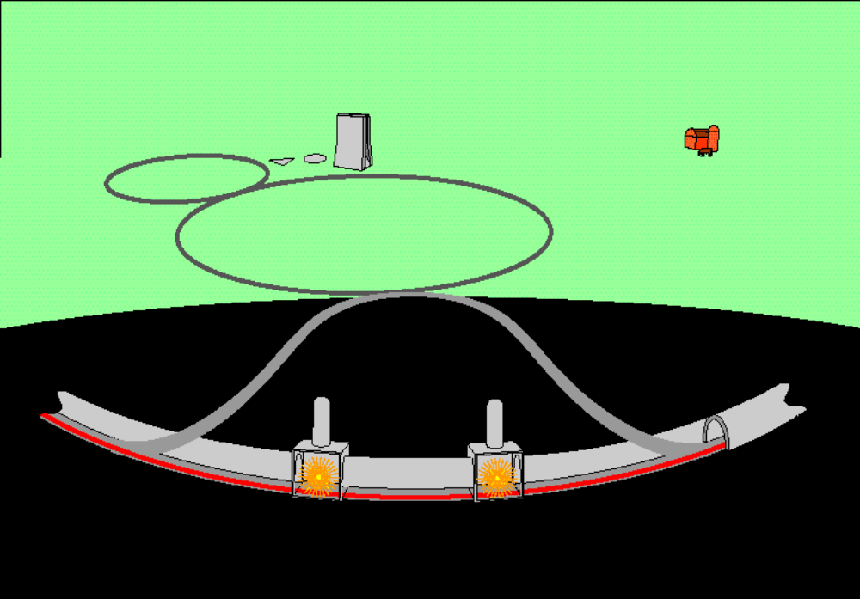

Figure 1.1. A cartoon diagram of the VLHC showing Fermilab’s existing accelerator complex, the new injection tunnels and the approximate locations of the detector halls.
The significant synchrotron radiation power present in Stage 2 VLHC allows a trade-off of energy for luminosity. This study chooses 175 TeV as the design energy and 2x10³⁴ as the design peak luminosity for Stage 2. At slightly lower luminosity, and higher, but still achievable magnetic field strength, this design could reach 200 TeV collision energy, as shown in Table 1.2. At lower energy, higher luminosity is possible. Even better luminosity performance can be achieved by “leveling” the luminosity to limit the inelastic collision debris power at the interaction point.

Table 1.2. Properties of the Stage 2 VLHC at various energies. The luminosity is limited by synchrotron radiation power and damping time, power at the interaction point due to inelastic collisions,
and the beam-beam tune shift.
Collision Energy (TeV) | Magnetic Field (T) | Leveled Luminosity (cm⁻²s⁻¹) | Optimum Storage Time (hrs)
Stage 1 40 | 2 | 1.0 x 10³⁴ | 20
Stage 2 125 | 7.1 | 5.1 x 10³⁴ | 13
Stage 2 150 | 8.6 | 3.6 x 10³⁴ | 11
Stage 2 175 | 10 | 2.7 x 10³⁴ | 8
Stage 2 200 | 11.4 | 2.1 x 10³⁴ | 7

1.4 Gaining Public Support for a Very Large Hadron Collider
Construction of a new frontier accelerator at Fermilab will require not only the support of the national and international scientific community and U.S. and foreign governments, but also the support of Fermilab’s neighbors, the people who live in surrounding communities. Just as important as technology development, infrastructure and site geology in determining whether Fermilab will be able to build a new accelerator is sociology. It is all too easy to imagine a scenario in which local opposition to an offsite accelerator makes it impossible for Fermilab to build such a machine. While community support will be necessary to some degree no matter what future accelerator Fermilab ultimately builds, it is a particularly important issue in the consideration of accelerators that would extend beyond the Fermilab site. And since, of all the proposed future Fermilab accelerators, the Very Large Hadron Collider would extend the farthest beyond Fermilab’s borders, issues of public support are likely to have the greatest impact.
Although we cannot predict exactly what will most concern community members, the proposal to construct an accelerator beyond the Fermilab site is likely to raise many issues including: risks to environment, safety and health; effects on property values; esthetics; perceptions of the degree of community control in the decision-making process; neighborhood disruption during construction; and appropriate use of government funds.
How can Fermilab address such issues and build local public support for future accelerators? Clearly, the traditional “decide, announce, defend” model is a formula for failure. Fermilab needs to begin now to build the level of community dialogue, trust, understanding and support that building a VLHC—or any future accelerator—will require.
Some steps that Fermilab is now taking or has planned include: a comprehensive community opinion survey that will provide invaluable baseline information on the current perception of Fermilab, including questions about attitudes toward possible laboratory expansion beyond the current site; creating a long-term community outreach plan that includes future accelerators at Fermilab; forming a laboratory-community organization to serve as a public advisory group; consulting with other laboratories that have successfully dealt with similar community outreach issues; and the use of various Fermilab resources, e.g., Science Education programs, Saturday Morning Physics, open houses, and the Office of Public Affairs, to build support for future facilities.
Building a new frontier accelerator at Fermilab will not only have a profound effect on the future of our own laboratory and of U.S. high-energy physics but on the future of our local community. We believe that most of its effects would be positive, in the form of the economic, cultural and environmental benefits that it will bring to the region. However, it will be up to Fermilab to communicate both the benefits AND the costs of such a project. Involving the community from the beginning in planning for a future accelerator will be challenging, time-consuming and costly; but ultimately it is likely to be the only way to create the level of community trust and support that such a project will require.

References
[1] D.G. Cassel, ed., et al., New Directions for High-Energy Physics, Proceedings of the 1996 DPF/DPB Summer Study on High-Energy Physics, Vol. 1, p. 251.
[2] Charge to the VLHC Study from the Fermilab Director.

Fermilab
Illinois State Geological Survey, Champaign, IL
Laboratory of Nuclear Studies, Cornell University
Brookhaven National Laboratory
consultant, Elmhurst, IL
Lawrence Berkeley National Laboratory
CNA Consulting Engineers, Minneapolis, MN
KEK, Japan

