Japanese Honeysuckle
Habitat: Native to eastern Asia this vine is found in natural and cultivated areas. In the southeastern U.S., it can displace native vegetation but is less vigorous and more easily contained in the Northeast.

Synonyms: Chinese honeysuckle

General Description: A twining, climbing, or trailing vine that is deciduous in colder climates but semievergreen to evergreen in Petersburg area.

Distinctive Characteristics: Leaves are opposite and simple. Fragrant white to yellow flowers bloom in May.

Growth Habit: Vine

Distribution: This invasive plant has spread over much of eastern, central, and western North America from Massachusetts west to California, south to Florida and Texas.

Lonicera japonica
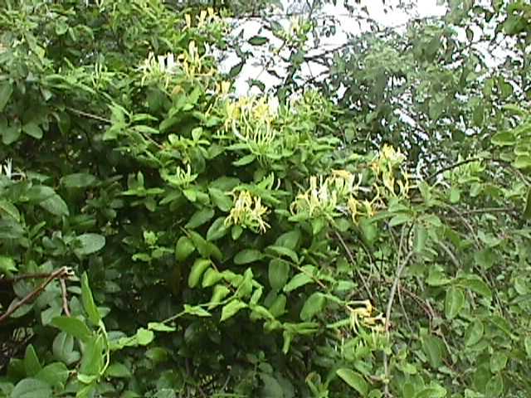

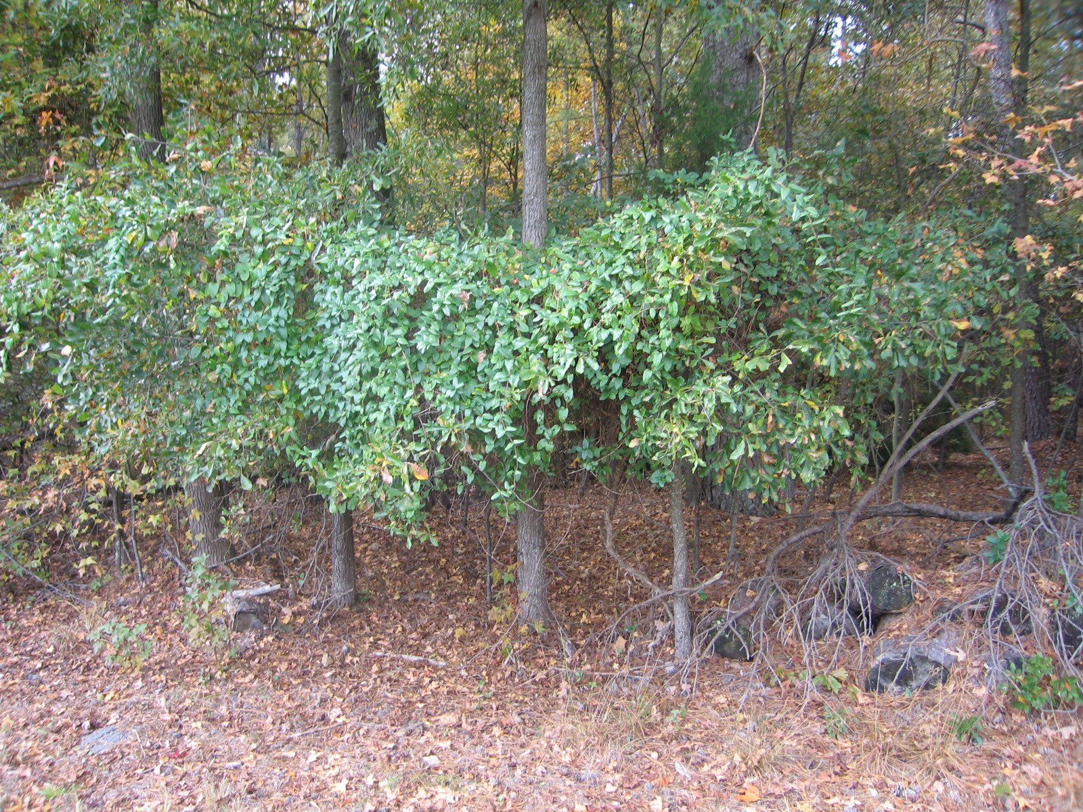

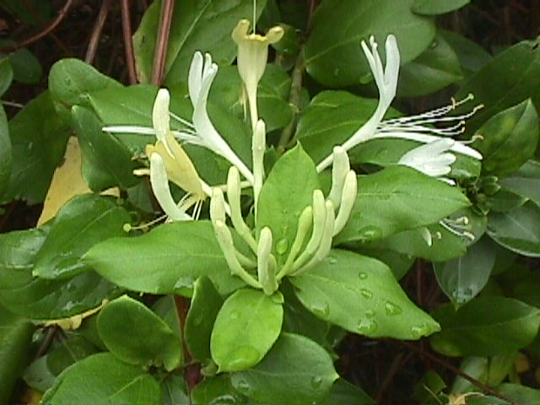
Family: Caprifoliaceae (Honeysuckle Family)

