PRESS RELEASE – AUG. 18, 2005 FOR IMMEDIATE RELEASE
U.S. National Library of Medicine Gathers Video Archivists to Advance Video Preservation Technologies

Bethesda, Maryland, Aug. 1, 2005. A meeting at NLM on the NIH campus included the first public demonstration of real-time, full-screen, mathematically-lossless video compression and decompression based on the Motion JPEG 2000 (MJ2) standard. This was demonstrated by Justin Dávila of Media Matters, Inc., with a prototype PC board, using a short clip of a dancer crashing through a “glass” window (shown). In one pass, output from a tape deck (in SD SDI form) generated a compressed video file and a separate broadcast-quality digital audio file for archival disk storage. Subsequently, the files were played back, uncompressing the video on the fly, to a studio monitor for all to view.
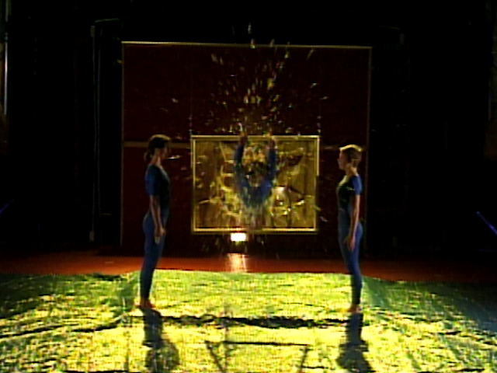

In Breakthru, by choreographer Elizabeth Streb (Joyce Theatre, 1997), dancer Hope Clark suddenly dives towards the audience through a pane of sugar-glass.
Screen shot courtesy of Media Matters, from video by Dennis Diamond/Video D Studios, courtesy of Dance Division, NYPL.
Another demonstration, by Carnegie Mellon researcher Alexander Hauptmann, showed recent work in automatic extraction of metadata (structured information) from video. Possible applications in institutionalized patient management included automatically detecting behaviors from surveillance video, with image redaction to lessen loss of privacy.

The occasion was an August 1 meeting of those involved in the long term preservation of videos and films. About fifty participants explored the potential of lossless, on-disk video storage in light of the “twilight of tape” as a cost-effective storage media. Barriers to adopting lossless algorithms were identified, and specific directions to overcome them suggested.

The meeting, “Getting to Disk-based Lossless Digital Video Compression”, was hosted by the U.S. National Library of Medicine, itself much involved in preserving historic and contemporary biomedical films and videos, and seeking pathways to digital repositories. The by-invitation-only regional gathering had representatives from a number of East Coast video archives, including the Library of Congress, the National Archives and Records Administration, the National Holocaust Museum, PBS, Folkstream/UNC, Rutgers, Yale, NYU, John Hopkins, and the University of Maryland at College Park.

The meeting kicked off with a 3-part talk by NLM hosts. Paul Theerman, Head of Images and Archives in the History of Medicine Division, outlined the NLM’s and NIH’s collection and preservation efforts. Walter Cybulski, of Preservation and Collection Management, reviewed the endemic problem of film and tape deterioration and equipment obsolescence, particularly for analog video. Software developer Glenn Pearson, of the Communications Engineering Branch, sketched lossless digital migration as a solution, observing that lossless compression, if not affordable today, will be tomorrow. Since the cost per bit of disk storage is plunging much faster than tape storage, over the next ten years, hierarchical disk-to-offline-tape storage systems would likely be replaced by a hierarchy of flash-disk to powered-on-request hard disk.

Following this introduction came sessions chaired by Margaret Byrnes and George Thoma, including the Media Matters demonstration. Yale University’s Joanne Rudof spoke of plans to use this new capability this fall to digitally archive some of Yale’s collection of Holocaust survivor testimonials. She discussed her experience with other existing parts of the Media Matters’ SAMMA system: robotic VHS tape loading, cleaning/triage, time base correction, and capture of quality-control metadata. Other current lossy digital archiving workflows, and future plans, were shared by NYU’s Melitte Buchman (who showed high-bandwidth video clips of flamboyantly-costumed performers), and PBS’s Jim Kutzner, with input from WGBH’s video archivist Dave MacCarn.

Xerox Research Fellow Rob Buckley stressed the advantages of JPEG 2000 image compression, that lets portions be extracted “scalably”, so that a low-bandwidth, lossy stream can be extracted from a high-quality lossless file. JPEG 2000 is used to compress individual frames in both MJ2 and (in a digital cinema content) MXF file formats. He also reviewed the color spaces needed for quality video and scanned-film masters.
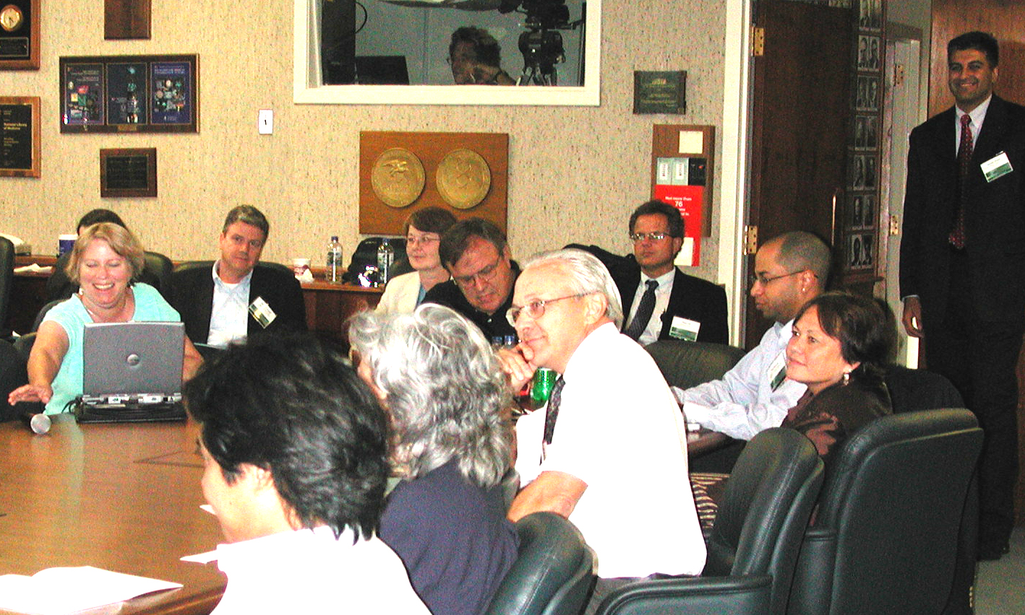
Photo: J. Cheng/NLM
Grace Agnew (left) reaches for the microphone during a lively discussion. Others around the table include session chair Margaret Byrnes (head of NLM’s Preservation and Collection Management), presenters Rob Buckley, Walter Cybulski, and (obscured) NYU’s Melitte Buchman and Rick Ochoa. At the right rear, NLM conveners Sameer Antani (standing) and Mike Gill bracket UMCP’s Tom Connors and John Hopkins’ Sophia Jordan-Mowary.
Turning to metadata issues, Rutger’s Grace Agnew, principal investigator for the Moving Images Collection project, surveyed the dominant methodologies, such as MPEG-7. NLM’s Pearson, a contributor to the Open JPEG project, detailed the capabilities of Motion JPEG 2000 files to contain metadata, identifying shortcomings, possible workarounds, and areas where improvements to the standards seem warranted.

CMU’s Hauptmann demonstrated the “Informedia” project’s automatic extraction of metadata from video. Over the years, the project has built a 10TB library of compressed video from satellite feeds of evening CNN and other shows. After capture, scenes are analyzed against a thousand-keyword controlled vocabulary, e.g., “outdoors”, by speech-to-text conversion (from English and other languages), language understanding, and image recognition programs. While acknowledging that intelligence and defense agencies are customers of recognize/track/analyze research, his talk focused on patient management applications, dubbed “CareMedia”. For example, automated analysis of surveillance videos in a nursing home could conceivably detect changes in routine behavioral patterns, alerting doctors to changes in their patients. Ways to mitigate loss of privacy were demonstrated. For example, people other than the patient of interest could be face-pixelated, or elided entirely. Shown was a mockup, in which a person to hide was first hand-selected, but then automatically tracked within the rest of a scene. Other anonymizing methods involved detecting and rendering only the edges of objects and people, or extracting behavior patterns (e.g., “tooth brushing”) without retaining the video.
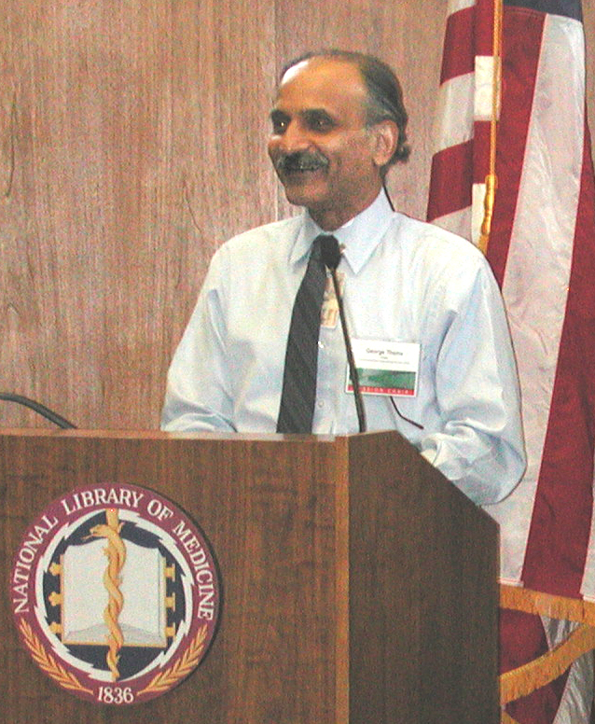
Photo: J. Cheng/NLM
Dr. George Thoma, chief of NLM’s Communications Engineering Branch, helps lead the afternoon discussion.

The afternoon’s general discussion, led by Thoma and Pearson (shown), engaged a number of these issues. For example, one topic was the status of emerging “trusted repositories”, where moving images and metadata, and projects incorporating them, can be held. Such information can include rights, provenance, contacts, and financial data. This was part of a broader theme of developments in metadata. A number of metadata schemes were mentioned, with perhaps MPEG-7 getting the most attention. Roadblocks to synchronizing metadata information (in MPEG-7 and other forms) with video need to be surmounted.

As next steps, the participants suggested taking up with pertinent standards bodies certain specific improvements for the MXF and MJ2 file formats, and encouraging, through initiatives of government and other archives, the creation of tools that will make the widespread adoption of disk-based lossless compression possible.

For more, see the web site at http://archive.nlm.nih.gov/VideoArchivists2005/
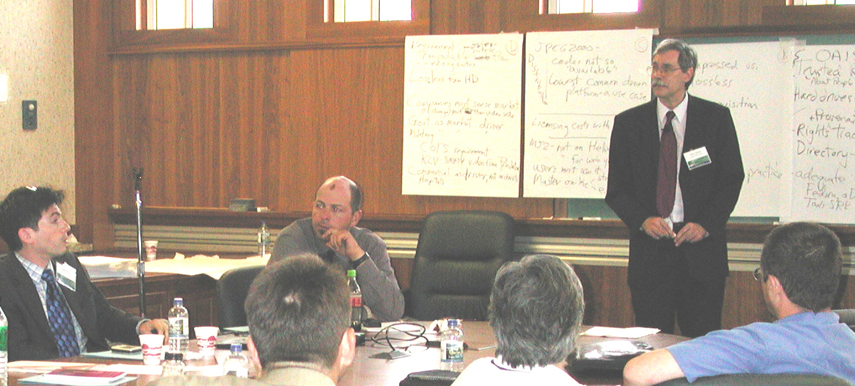
Photo: J. Cheng/NLM
Justin Dávila (left) raises a point as Bob Berger, also of Media Matters, and NLM facilitator Glenn Pearson (standing) listen.

