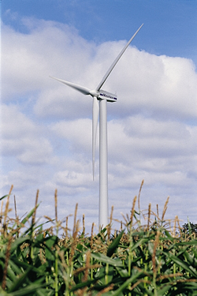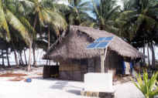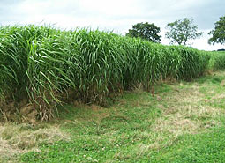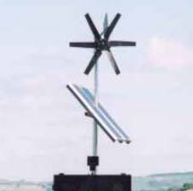

United States of America
Insular Areas
Energy Assessment Report:

An Update of the 1982 Territorial Energy Assessment

United States of America
Insular Areas
Energy Assessment Report:

An Update of the 1982 Territorial Energy Assessment

Prepared for:
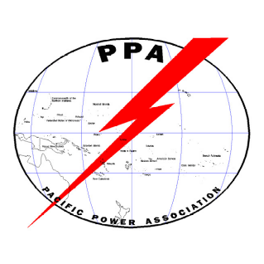

US. Department of Interior

Washington, D.C. 20585

Prepared by:

Pacific Power Association
Suva, Fiji

TABLE OF CONTENTS

1. Executive Summary i
1.1. PURPOSE OF THIS REPORT i
1.2. ISLAND AREAS COVERED IN REPORT i
1.3. ENGAGEMENT OF GOVERNMENT AND UTILITIES i
1.4. DRIVING FORCES ii
1.5. SUMMARY OF RECOMMENDATIONS iv
1.5.1. Recommendations for Collective Action and Coordination among U.S. Insular Areas iv
1.5.2. Recommendations Common Across all Insular Areas in Supply Side Management iv
1.5.3. Recommendations for Individual Areas in Supply Side Management vi
1.5.4. Summary of Recommendations for Demand Side Energy Efficiency and Renewable Energy viii
2. Overview United States of America Insular Area Energy Assessment 1
2.1. Objective of this Report 1
3. Guam 8
3.1. Executive Summary 8
3.2. General 13
3.2.1. Location, Population and Geography 13
3.2.2. Island Geography 14
3.2.3. Island Geology 15
3.2.4. Climate and Environmental Hazards 15
3.2.5. Energy Sources 16
3.2.6. Energy Uses 16
3.3. HISTORY, POLITICAL DEVELOPMENT AND PRESENT STATUS 17
3.3.1. Early Island History 17
3.3.2. Recent Island History 17
3.3.3. United States Involvement 17
3.3.4. Present Political Status 18
3.4. POPULATION, EMPLOYMENT & WAGES 19
3.4.1. Present Demographics 19
3.4.2. Employment and Job Market 20
3.4.3. Gross Domestic Product 22
3.4.4. Personal Wages & Income 22
3.4.5. General Business & Commercial Income 24
3.5. ISLAND ECONOMY AND INFRASTRUCTURE 25
3.5.1. General Status of the Economy 25
3.5.2. Major Employment Sectors 26
3.5.3. Water and Wastewater Systems 26
3.5.4. Electric System 26
3.5.5. Transportation 30
3.5.6. Marine 30
3.5.7. Port and Port Industries 30
3.5.8. Airports 31
3.5.9. Communication Systems 32
3.5.10. Tourism Industry 32
3.5.11. Major Industry 32
3.5.12. Military 32
3.5.13. Other Special Economic Elements 32
3.5.14. Manufacturing, Craft, Trade 32
3.5.15. Agriculture 33
3.5.16. Aquaculture, Fisheries, Refineries 33
3.6. ECONOMIC DEVELOPMENT PLANS AND PROJECTS 33
3.6.1. Existing Capital Improvement Projects 33
3.6.2. Compact Capital Commitments 34
3.6.3. General Status of Economic Development Planning 34
3.6.4. Economic Development Approach and Special Issues 35
3.6.5. Focus Areas 35
3.6.6. Energy Considerations 35
3.6.7. Economy Diversification 35
3.7. STATUS OF ENERGY SYSTEMS 35
3.7.1. Major Energy Uses 35
3.7.2. Electric Power System 36
3.7.3. Generation Facilities 36
3.7.4. Fuels 38
3.8. Electric Production and Use 38
3.8.1. Existing Renewable & Alternative Power Production 38
3.8.2. Existing Conservation and Demand Side Programs 39
3.9. Regulatory, Environmental Issues 39
3.10. Transportation 39
3.10.1. Fuel Use 39
3.10.2. Fuel Types and Costs 40
3.10.3. Reducing Transportation Energy Use 41
3.11. Commercial & Industrial 42
3.11.1. Tourism 42
3.11.2. Manufacturing 42
3.11.3. Military 42
3.11.4. Fisheries 42
3.12. Alternative Energy Opportunities 42
3.12.1. Alternative fuels: 42
3.13. Supply Side Management 44
3.14. Demand Side Efficiency Improvement and Energy Conservation 45
3.14.1. Electrical Metering/Tariffs 45
3.14.2. Household Energy Efficiency Measures 45
3.14.3. Government and Commercial Sector Buildings 46
3.14.4. Building Energy Efficiency Standards 47
3.14.5. Appliance Energy Efficiency Standards 47
3.14.6. Energy Audits, Performance Contracts 47
3.14.7. Transportation Sector 48
3.15. Renewable Energy 49
3.15.1. Solar 49
3.15.2. Wind 53
3.15.3. Hydro 54
3.15.4. Ocean thermal 54
3.15.5. Tidal 55
3.15.6. Biogas 56
3.15.7. Biomass combustion and gasification 56
3.15.8. Biofuel 56
3.15.9. Geothermal 56
3.15.10. Wave 57
4. U.S. Virgin Islands 58
4.1. Executive Summary 58
4.2. GENERAL 64
4.2.1. Location, Population and Geography 65
4.2.2. Geography 65
4.2.3. Island Geology 66
4.2.4. Climate and Environmental Hazards 66
4.2.5. Energy Sources 67
4.2.6. Energy Uses 67
4.3. HISTORY, POLITICAL DEVELOPMENT AND PRESENT STATUS 68
4.3.1. Early Island History 68
4.3.2. Recent Island History 68
4.3.3. Political Development 69
4.3.4. Present Political Status 69
4.3.5. United States Involvement 69
4.3.6. U.S. Special Island Programs 69
4.4. POPULATION, EMPLOYMENT & WAGES 70
4.4.1. Present Demographics 70
4.4.2. Employment and Job Market 70
4.4.3. Gross Domestic Product 70
4.4.4. Personal Wages & Income 70
4.4.5. General Business & Commercial Income 70
4.4.6. Special Employment or Employers 70
4.5. ISLAND ECONOMY AND INFRASTRUCTURE 70
4.5.1. General Status of the Economy 70
4.5.2. Major Employment Sectors 71
4.5.3. Electric System 71
4.5.4. Water and Wastewater Systems 72
4.5.5. Transportation 73
4.5.6. Port and Port Industries 73
4.5.7. Airports and Aviation Industries 74
4.5.8. Communication System 74
4.5.9. Tourism Industry 74
4.5.10. Major Industry 75
4.5.11. Military 75
4.5.12. Other Special Economic Elements 75
4.5.13. Manufacturing, Craft, Trade 76
4.5.14. Agriculture 76
4.5.15. Aquaculture, Fisheries 76
4.6. ECONOMIC DEVELOPMENT PLANS AND PROJECTS 76
4.6.1. General Status of Economic Development Planning 76
4.6.2. Economic Development Approach and Special Issues 76
4.6.3. Focus Areas 76
4.6.4. Energy Considerations 77
4.6.5. Economy Diversification 77
4.6.6. Import-Export and Balance of Payments 77
4.7. STATUS OF ENERGY SYSTEMS 77
4.7.1. Major Energy Uses 77
4.7.2. Electric Power System 77
4.7.3. Generation Facilities 82
4.7.4. Fuels 84
4.8. Electric Production and Use 86
4.8.1. Existing Renewable & Alternative Power Production 86
4.9. REGULATORY, ENVIRONMENTAL ISSUES 86
4.10. TRANSPORTATION 87
4.10.1. Fuel Use 87
4.10.2. Fuel Types and Costs 87
4.10.3. Reducing Transportation Energy Use 87
4.11. COMMERCIAL & INDUSTRIAL 87
4.11.1. Tourism 87
4.11.2. Manufacturing 87
4.11.3. Military 87
4.11.4. Fisheries 87
4.12. ALTERNATIVE ENERGY OPPORTUNITIES 88
4.12.1. Cogeneration 88
4.12.2. Alternative Fuel Systems 89
4.13. SUPPLY SIDE MANAGEMENT 90
4.14. DEMAND SIDE EFFICIENCY AND ENERGY CONSERVATION 91
4.14.1. Electrical Metering/Tariff 91
4.14.2. Household Energy Efficiency Measures 91
4.14.3. Government and Commercial Sector Buildings 92
4.14.4. Building Energy Eficiency Standards 92
4.14.5. Appliance Energy Efficiency Standards 93
4.14.6. Energy Audits Perfomance Contracts 93
4.14.7. Transportation Sector 94
4.15. RENEWABLE ENERGY 95
4.15.1. Solar 96
4.15.2. Wind Energy 100
4.15.3. Hydro Power 101
4.15.4. Biogas 101
4.15.5. Biomass, Combustion and Gasification 102
4.15.6. Biofuels 102
4.15.7. Ocean Energy 103
4.15.8. Geothermal 103
4.15.9. Tidal 103
4.15.10. Wave 103
5. American Samoa 105
5.1. Executive Summary 105
5.2. GENERAL 112
5.2.1. Location, Population, and Geography 112
5.2.2. Island Geography 113
5.2.3. Island Geology 113
5.2.4. Climate and Environmental Hazards 114
5.2.5. Energy Sources 114
5.2.6. Energy Uses 115
5.3. HISTORY, POLITICAL DEVELOPMENT AND PRESENT STATUS 115
5.3.1. Early Island History 115
5.3.2. Recent Island History 116
5.3.3. United States Involvement 116
5.3.4. Political Development 117
5.3.5. Present Political Status 117
5.4. POPULATION, EMPLOYMENT & WAGES 117
5.4.1. Present Demographics 118
5.4.2. Special Employment or Major Employers 119
5.4.3. Employment and Job Market 119
5.4.4. Personal Wages & Income 120
5.4.5. General Business & Commercial Income 121
5.5. ISLAND ECONOMY AND INFRASTRUCTURE 121
5.5.1. General Status of the Economy 121
5.5.2. Major Employment Sectors 122
5.5.3. Water and Wastewater Systems 122
5.5.4. Electrical System 123
5.5.5. Transportation System 124
5.5.6. Marine 125
5.5.7. Port and Port Industries 125
5.5.8. Airports 125
5.5.9. Communication System 126
5.5.10. Tourism Industry 126
5.5.11. Major Industry 126
5.5.12. Military 127
5.5.13. Other Special Economic Elements 128
5.5.14. Manufacturing, Craft, Trade 128
5.5.15. Agriculture 128
5.5.16. Aquaculture, Fisheries, Refineries 128
5.6. ECONOMIC DEVELOPMENT PLANS AND PROJECTS 129
5.6.1. General Status of Economic Development Planning 130
5.6.2. Economic Development Approach and Special Issues 130
5.6.3. Focus Areas 130
5.6.4. Energy Considerations 131
5.6.5. Import-Export and Balance of Payments 131
5.7. Status of Energy Systems 131
5.7.1. Major Energy Uses 131
5.7.2. Electric Power System 132
5.7.3. Generation Facilities 132
5.7.4. Fuels 133
5.8. Electric Production and Use 134
5.8.1. Existing Renewable & Alternative Power Production 134
5.9. Regulatory, Environmental Issues 134
5.10. Transportation 134
5.10.1. Fuel Types and Costs 134
5.10.2. Reducing Transportation Energy Use 134
5.11. Commercial & Industrial 134
5.11.1. Tourism 134
5.11.2. Manufacturing 135
5.11.3. Military 135
5.11.4. Fisheries 136
5.12. Alternative Energy Opportunities 137
5.12.1. Cogeneration 137
5.12.2. Alternative Fuel Systems 137
5.13. Supply Side Efficiency 137
5.14. Demand Side Efficiency 138
5.14.1. Electrical Metering/Tariff 138
5.14.2. Household Energy Efficiency Measure 139
5.14.3. Industrial Sector 140
5.14.4. Government and Commercial Sector 140
5.14.5. Transportation Sector 141
5.14.6. Building Energy and Efficiency Standards 142
5.14.7. Appliance Energy Efficiency Standards 142
5.14.8. Energy Audits, Performance Contracts 143
5.15. Renewable Energy 143
5.15.1. Solar 143
5.15.2. Wind Energy 145
5.15.3. Hydro Power 147
5.15.4. Biogas 148
5.15.5. Biomass 148
5.15.6. Biofuels 148
5.15.7. Ocean Energy 148
5.15.8. Geothermal 149
5.15.9. Tidal 149
5.15.10. Wave 149
6. Commonwealth of Northern Marianas Islands (CNMI) 150
6.1. Executive Summary 150
6.2. General 155
6.2.1. Location, Population and Geography 155
6.2.2. Island Characteristics 155
6.2.3. Island Geography 156
6.2.4. Climate and Environmental Hazards 156
6.2.5. Climate and Environmental Hazards 156
6.2.6. Energy Sources 156
6.2.7. Energy Uses 158
6.3. HISTORY, POLITICAL DEVELOPMENT AND PRESENT STATUS 159
6.3.1. Early Island History 159
6.3.2. Recent Island History 160
6.3.3. United States Involvement 161
6.3.4. Present Political Status 161
6.4. POPULATION, EMPLOYMENT & WAGES 161
6.4.1. Present Demographics 161
6.4.2. Employment and Job Market 162
6.4.3. Gross Domestic Product 162
6.4.4. Personal Wages & Income 163
6.4.5. General Business & Commercial Income 164
6.5. ISLAND ECONOMY AND INFRASTRUCTURE 165
6.5.1. General Status of the Economy 165
6.5.2. Major Employment Sectors 166
6.5.3. Water and Wastewater Systems 167
6.5.4. Electric System 167
6.5.5. Transportation 170
6.5.6. Marine 170
6.5.7. Port and Port Industries 170
6.5.8. Airports 171
6.5.9. Communication Systems 171
6.5.10. Tourism Industry 172
6.5.11. Major Industry 172
6.5.12. Military 172
6.5.13. Other Special Economic Elements 172
6.5.14. Manufacturing, Craft, Trade 172
6.5.15. Agriculture 172
6.5.16. Aquaculture, Fisheries, Refineries 172
6.6. ECONOMIC DEVELOPMENT PLANS AND PROJECTS 173
6.6.1. Existing Capital Improvement Projects 173
6.6.2. General Status of Economic Development Planning 173
6.6.3. Economic Development Approach and Special Issues 173
6.6.4. Focus Areas 174
6.6.5. Energy Considerations 176
6.6.6. Economy Diversification 176
6.6.7. Import-Export and Balance of Payments 176
6.7. STATUS OF ENERGY SYSTEMS 177
6.7.1. Major Energy Uses 177
6.7.2. Electric Power System 177
6.7.3. Generation Facilities 177
6.7.4. Fuels 177
6.8. Regulatory, Environmental Issues 178
6.9. Transportation 179
6.9.1. Fuel Types and Costs 179
6.9.2. Reducing Transportation Energy Use 180
6.10. Commercial & Industrial - Trends 180
6.10.1. Tourism 180
6.10.2. Manufacturing 180
6.10.3. Military 180
6.10.4. Fisheries 181
6.11. Alternative Energy Opportunities 181
6.11.1. Alternative fuels 181
6.12. SUPPLY SIDE EFFICIENCY 182
6.13. DEMAND SIDE MANAGEMENT 183
6.13.1. Electrical Metering/Tariffs 184
6.13.2. Household Energy Efficiency Measures 184
6.13.3. Government and Commercial Sector Buildings 185
6.13.4. Building Energy Efficiency Standards 186
6.13.5. Appliance Energy Efficiency Standards 186
6.13.6. Energy Audits, Performance Contracts 187
6.13.7. Transportation Sector 187
6.14. Renewable Energy 188
6.14.1. Solar 188
6.14.2. Wind 191
6.14.3. Hydro 192
6.14.4. Biogas 192
6.14.5. Biomass combustion and gasification 194
6.14.6. Biofuel 195
6.14.7. Ocean thermal 195
6.14.8. Geothermal 195
6.14.9. Tidal 195
6.14.10. Wave 195
7. Federated States of Micronesia - Overview 196
7.1. Executive Summary 196
7.2. General 207
7.2.1. Location, Population and Geography 207
7.2.2. Island Geography 208
7.2.3. Island Geology 208
7.2.4. Climate and Environmental Hazards 209
7.2.5. Energy Sources 209
7.2.6. Energy Uses 209
7.3. HISTORY, POLITICAL DEVELOPMENT AND PRESENT STATUS 210
7.3.1. Early Island History 210
7.3.2. Recent Island History 210
7.3.3. Political Development 211
7.3.4. Present Political Status 211
7.3.5. United States Involvement 211
7.3.6. U.S. Special Island Programs 213
7.4. POPULATION, EMPLOYMENT & WAGES 213
7.4.1. Present Demographics 213
7.4.2. Major Employment Sectors 214
7.4.3. Special Employment or Employers 214
7.4.4. Employment and Job Market 214
7.4.5. General Business & Commercial Income 215
7.5. ISLAND ECONOMY AND INFRASTRUCTURE 217
7.5.1. General Status of the Economy 217
7.5.2. Port and Port Industries 218
7.5.3. Aviation and Aviation Industries 218
7.5.4. Tourism Industry 218
7.5.5. Major Industry 219
7.5.6. Military 219
7.5.7. Manufacturing, Craft, Trade 219
7.5.8. Agriculture 220
7.5.9. Aquaculture, Fisheries 220
7.5.10. Other Special Economic Elements 220
7.5.11. Electrical System 220
7.5.12. Water and Wastewater Systems 220
7.5.13. Waste Management Systems 221
7.5.14. Transportation System 221
7.5.15. Communication System 221
7.6. ECONOMIC DEVELOPMENT PLANS AND PROJECTS 221
7.6.1. General Status of Economic Development Planning 221
7.6.2. Economic Development Approach and Special Issues 222
7.6.3. Focus Areas 222
7.6.4. Energy Considerations 222
7.6.5. Economic Diversification 222
7.6.6. Import-Export and Balance of Payments 222
8. Federated states of micronesia – Kosrae 223
8.1. General 223
8.1.1. Location and Population 223
8.1.2. Island Geography 223
8.1.3. Island Geology 223
8.1.4. Climate and Environmental Hazards 225
8.1.5. Energy Sources 225
8.1.6. Energy Uses 226
8.2. HISTORY, POLITICAL DEVELOPMENT AND PRESENT STATUS 226
8.2.1. Early Island History 226
8.2.2. Recent Island History 226
8.2.3. Political Development 227
8.2.4. Present Political Status 227
8.2.5. United States Involvement 228
8.2.6. U.S. Special Island Programs 228
8.3. POPULATION, EMPLOYMENT & WAGES 229
8.3.1. Present Demographics 229
8.3.2. Employment and Job Market 229
8.3.3. Gross Domestic Product 230
8.3.4. Personal Wages & Income 230
8.3.5. Special Employment or Employers 230
8.3.6. General Business & Commercial Income 230
8.4. ISLAND ECONOMY AND INFRASTRUCTURE 231
8.4.1. General Status of the Economy 231
8.4.2. Major Employment Sectors 231
8.4.3. Electrical System 231
8.4.4. Water and Wastewater Systems 231
8.4.5. Transportation System 232
8.4.6. Port and Port Industries 232
8.4.7. Airport and Aviation Industries 233
8.4.8. Communication System 233
8.4.9. Tourism Industry 233
8.4.10. Major Industry 234
8.4.11. Military 234
8.4.12. Other Special Economic Elements 235
8.4.13. Manufacturing, Craft, Trade 235
8.4.14. Agriculture 235
8.4.15. Aquaculture, Fisheries 235
8.4.16. Waste Management Systems 236
8.5. ECONOMIC DEVELOPMENT PLANS AND PROJECTS 236
8.5.1. General Status of Economic Development Planning 236
8.5.2. Economic Development Approach and Special Issues 237
8.5.3. Focus Areas 237
8.5.4. Energy Considerations 237
8.5.5. Economy Diversification 237
8.5.6. Import-Export and Balance of Payments 237
8.6. Status of Energy Systems 238
8.6.1. Major Energy Uses 238
8.6.2. Electric Power System 238
8.6.3. Generation Facilities 239
8.6.4. Fuels 239
8.7. Electric Production and Use 240
8.7.1. Existing Renewable & Alternative Power Production 240
8.7.2. Existing Conservation and Demand Side Programs 240
8.8. Regulatory, Environmental Issues 240
8.9. Transportation 241
8.9.1. Fuel Use 241
8.9.2. Fuel Types and Costs 241
8.9.3. Reducing Transportation Energy Use 241
8.10. Commercial & Industrial 241
8.10.1. Tourism 241
8.10.2. Manufacturing 241
8.10.3. Military 241
8.10.4. Fisheries 242
8.11. Alternative Energy Opportunities 242
8.11.1. Cogeneration 242
8.11.2. Alternative Fuel Systems 242
8.12. Supply Side Efficiencies 243
8.13. Demand Side Efficiencies 243
8.13.1. Electrical Metering/Tariffs 243
8.13.2. Household Energy Efficiency Measures 244
8.13.3. Government and Commercial Sector 244
8.13.4. Transportation Sector 245
8.13.5. Building Energy and Efficiency Standards 245
8.13.6. Appliance Energy Efficiency Standards 246
8.13.7. Energy Audits, Performance Contracts 246
8.14. RENEWABLE ENERGY OPPORTUNITIES 246
8.14.1. Solar 246
8.14.2. Wind Energy 248
8.14.3. Hydro Power 248
8.14.4. Biogas 249
8.14.5. Biomass combustion and gasification 249
8.14.6. Biofuels 249
8.14.7. Ocean Thermal 250
8.14.8. Geothermal 250
8.14.9. Tidal 250
8.14.10. Wave 250
9. Federated States of Micronesia - Chuuk 251
9.1. General 251
9.1.1. Location, Population and Geography 251
9.1.2. Island Geography 252
9.1.3. Island Geology 252
9.1.4. Climate and Environmental Hazards 252
9.1.5. Energy Sources 253
9.1.6. Energy Uses 253
9.2. HISTORY, POLITICAL DEVELOPMENT AND PRESENT STATUS 254
9.2.1. Early Island History 254
9.2.2. Recent Island History 255
9.2.3. United States Involvement 256
9.2.4. Political Development 257
9.2.5. Present Political Status 257
9.3. POPULATION, EMPLOYMENT & WAGES 258
9.3.1. Present Demographics 258
9.3.2. Employment and Job Market 259
9.3.3. Gross Domestic Product 259
9.3.4. Personal Wages & Income 259
9.3.5. General Business & Commercial Income 259
9.4. ISLAND ECONOMY AND INFRASTRUCTURE 259
9.4.1. General Status of the Economy 259
9.4.2. Major Employment Sectors 260
9.4.3. Electrical System 260
9.4.4. Water and Wastewater Systems 261
9.4.5. Transportation System 263
9.4.6. Port and Port Industries 265
9.4.7. Airports and Aviation Industries 265
9.4.8. Communication Systems 266
9.4.9. Tourism Industry 266
9.4.10. Major Industry 266
9.4.11. Military 266
9.4.12. Other Special Economic Elements 267
9.4.13. Manufacturing, Craft, Trade 267
9.4.14. Agriculture 267
9.4.15. Aquaculture, Fisheries, Refineries 267
9.5. ECONOMIC DEVELOPMENT PLANS AND PROJECTS 267
9.5.1. General Status of Economic Development Planning 267
9.5.2. Economic Development Approach and Special Issues 268
9.5.3. Focus Areas 268
9.5.4. Energy Considerations 268
9.5.5. Economy Diversification 269
9.5.6. Import-Export and Balance of Payments 269
9.6. STATUS OF ENERGY SYSTEM 269
9.6.1. Major Energy Uses 269
9.6.2. Electric Power System 269
9.6.3. Generation Facilities 272
9.6.4. Fuels 273
9.7. ELECTRIC PRODUCTION AND USE 273
9.7.1. Existing Renewable & Alternative Power Production 273
9.7.2. Existing Conservation and Demand Side Programs 274
9.8. REGULATORY ENVIRONMENTAL ISSUES 274
9.9. TRANSPORTATION 274
9.9.1. Fuel Use 274
9.9.2. Fuel Types and Costs 275
9.9.3. Reducing Transportation Energy Use 275
9.10. COMMERCIAL AND INDUSTRIAL 275
9.10.1. Tourism 275
9.10.2. Manufacturing 275
9.10.3. Military 275
9.10.4. Fisheries 275
9.11. ALTERNATIVE ENERGY OPPORTUNITIES 275
9.11.1. Alternative Fuel Systems 275
9.11.2. Cogeneration 276
9.12. SUPPLY SIDE EFFIENCY 276
9.13. DEMAND SIDE EFFIECIENCY 276
9.13.1. Electrical Metering/Tariff 277
9.13.2. Household Energy Efficiency Measures 277
9.13.3. Government and Commercial Sector 278
9.13.4. Transportation Sector 279
9.13.5. Building Energy and Efficiency Standards 279
9.13.6. Appliance Energy Efficiency Standards 280
9.13.7. Energy Audits, Performance Contracts 280
9.14. RENEWABLE ENERGY 280
9.14.1. Solar 280
9.14.2. Wind Energy 283
9.14.3. Hydro Power 283
9.14.4. Biogas 284
9.14.5. Biomass, Combustion and Gasification 284
9.14.6. Biofuels 285
9.14.7. Ocean Energy 285
9.14.8. Geothermal 285
10. Federated States of Micronesia - Pohnpei 286
10.1. General 286
10.1.1. Location and Population 286
10.1.2. Island Geography 286
10.1.3. Island Geology 287
10.1.4. Climate and Environmental Hazards 287
10.1.5. Energy Sources 288
10.1.6. Energy Uses 288
10.2. HISTORY, POLITICAL DEVELOPMENT AND PRESENT STATUS 288
10.2.1. Early Island History 288
10.2.2. Recent Island History 289
10.2.3. Political Development 289
10.2.4. Present Political Status 290
10.2.5. United States Involvement 290
10.2.6. U.S. Special Island Programs 290
10.3. POPULATION, EMPLOYMENT & WAGES 291
10.3.1. Present Demographics 291
10.3.2. Employment and Job Market 292
10.3.3. Gross Domestic Product 292
10.3.4. Personal Wages & Income 292
10.3.5. Special Employment or Employers 292
10.3.6. General Business & Commercial Income 292
10.4. ISLAND ECONOMY AND INFRASTRUCTURE 293
10.4.1. General Status of the Economy 293
10.4.2. Major Employment Sectors 293
10.4.3. Electrical System 293
10.4.4. Water and Wastewater Systems 293
10.4.5. Transportation System 294
10.4.6. Port and Port Industries 294
10.4.7. Airport and Aviation Industries 294
10.4.8. Communication System 295
10.4.9. Tourism Industry 295
10.4.10. Major Industry 295
10.4.11. Military 295
10.4.12. Other Special Economic Elements 295
10.4.13. Manufacturing, Craft, Trade 295
10.4.14. Agriculture 295
10.4.15. Aquaculture, Fisheries 296
10.4.16. Waste Management Systems 296
10.5. ECONOMIC DEVELOPMENT PLANS AND PROJECTS 296
10.5.1. General Status of Economic Development Planning 296
10.5.2. Economic Development Approach and Special Issues 296
10.5.3. Focus Areas 296
10.5.4. Energy Considerations 296
10.5.5. Economy Diversification 297
10.5.6. Import-Export and Balance of Payments 297
10.6. Status of Energy Systems 297
10.6.1. Major Energy Uses 297
10.6.2. Electric Power System 297
10.6.3. Generation Facilities 299
10.6.4. Fuels 300
10.7. Electric Production and Use 300
10.7.1. Existing Renewable & Alternative Power Production 300
10.7.2. Existing Conservation and Demand Side Programs 300
10.8. Regulatory, Environmental Issues 300
10.9. Transportation 300
10.9.1. Fuel Use 300
10.9.2. Fuel Types and Costs 300
10.9.3. Reducing Transportation Energy Use 300
10.10. Commercial & Industrial 301
10.10.1. Tourism 301
10.10.2. Manufacturing 301
10.10.3. Military 301
10.10.4. Fisheries 301
10.11. Alternative Energy Opportunities 301
10.11.1. Cogeneration 301
10.11.2. Alternative Fuel Systems 301
10.12. Supply Side Efficiencies 302
10.13. Demand Side Efficiency 303
10.13.1. Electrical Metering/Tariffs 303
10.13.2. Household Energy Efficiency Measures 304
10.13.3. Government and Commercial Sector 305
10.13.4. Transportation Sector 306
10.13.5. Building Energy Efficiency Standards 306
10.13.6. Appliance Energy Efficiency Standards 307
10.13.7. Energy Audits, Performance Contracts 307
10.14. RENEWABLE ENERGY 307
10.14.1. Solar 307
10.14.2. Wind Energy 309
10.14.3. Hydro Power 310
10.14.4. Biogas 311
10.14.5. Biomass 311
10.14.6. Biofuels 312
10.14.7. Ocean Energy 312
10.14.8. Ocean Thermal 312
10.14.9. Tidal 313
10.14.10. Wave 313
11. Federated States of Micronesia – Yap 314
11.1. General 314
11.1.1. Location, Population and Geography 314
11.1.2. Island Geography 314
11.1.3. Island Geology 314
11.1.4. Climate and Environmental Hazards 314
11.1.5. Energy Sources 314
11.1.6. Energy Uses 314
11.2. HISTORY, POLITICAL DEVELOPMENT AND PRESENT STATUS 314
11.2.1. Early Island History 314
11.2.2. Recent Island History 315
11.2.3. United States Involvement 315
11.2.4. Political Development 315
11.2.5. Present Political Status 315
11.3. POPULATION, EMPLOYMENT & WAGES 315
11.3.1. Present Demographics 315
11.3.2. Employment and Job Market 316
11.3.3. Gross Domestic Product 317
11.3.4. Personal Wages & Income 318
11.3.5. General Business & Commercial Income 318
11.4. ISLAND ECONOMY AND INFRASTRUCTURE 318
11.4.1. General Status of the Economy 318
11.4.2. Major Employment Sectors 318
11.4.3. Electrical System 319
11.4.4. Water and Wastewater Systems 319
11.4.5. Transportation System 320
11.4.6. Port and Port Industries 320
11.4.7. Airports and Aviation Industries 321
11.4.8. Communication System 321
11.4.9. Tourism Industry 322
11.4.10. Major Industry 323
11.4.11. Military 323
11.4.12. Other Special Economic Elements 323
11.4.13. Manufacturing, Craft, Trade 323
11.4.14. Agriculture 323
11.4.15. Aquaculture, Fisheries 324
11.5. ECONOMIC DEVELOPMENT PLANS AND PROJECTS 324
11.5.1. General Status of Economic Development Planning 324
11.5.2. Economic Development Approach and Special Issues 324
11.5.3. Focus Areas 324
11.5.4. Energy Considerations 324
11.5.5. Economy Diversification 324
11.6. Status of Energy Systems 325
11.6.1. Major Energy Uses 325
11.6.2. Electric Power System 325
11.6.3. Generation Facilities 326
11.6.4. Fuels 326
11.7. ELECTRIC PRODUCTION AND USE 327
11.7.1. Existing Renewable & Alternative Power Production 327
11.7.2. Existing Conservation and Demand Side Programs 327
11.8. Regulatory, Environmental Issues 327
11.9. Transportation 327
11.9.1. Fuel Use 327
11.9.2. Fuel Types and Costs 327
11.9.3. Reducing Transportation Energy Use 328
11.10. Commercial and Industrial 328
11.10.1. Tourism 328
11.10.2. Manufacturing 328
11.10.3. Military 328
11.10.4. Fisheries 328
11.11. Supply Side Efficiency 328
11.12. Demand Side Efficiency 329
11.12.1. Electrical Metering/Tariff 329
11.12.2. Household Energy Efficiency Measures 329
11.12.3. Government and Commercial Sector 330
11.12.4. Transportation Sector 332
11.12.5. Building Energy and Efficiency Standards 332
11.12.6. Appliance Energy Efficiency Standards 333
11.12.7. Energy Audits, Performance Contracts 333
11.13. RENEWABLE ENERGY OPPORTUNITIES 334
11.13.1. Hydro 334
11.13.2. Solar 334
11.13.3. Wind Energy 337
11.13.4. Hydro Power 337
11.13.5. Biogas 337
11.13.6. Biomass Combustion and Gasification 338
11.13.7. Biofuels 338
11.13.8. Ocean Energy 339
11.13.9. Geothermal 339
11.13.10. Tidal 339
11.13.11. Wave 339
12. republic of the marshall islandS 340
12.1. Executive Summary 340
12.2. General 345
12.2.1. Location, Population and Geography 345
12.2.2. Island Geography 347
12.2.3. Island Geology 348
12.2.4. Climate and Environmental Hazards 348
12.2.5. Energy Sources 349
12.2.6. Energy Uses 349
12.3. HISTORY, POLITICAL DEVELOPMENT AND PRESENT STATUS 350
12.3.1. Early Island History 350
12.3.2. Recent Island History 350
12.3.3. United States Involvement 351
12.3.4. Political Development 351
12.3.5. Present Political Status 352
12.4. POPULATION, EMPLOYMENT & WAGES 354
12.4.1. Present Demographics 354
12.4.2. Employment and Job Market 354
12.4.3. Personal Wages & Income 354
12.4.4. General Business & Commercial Income 355
12.5. ISLAND ECONOMY AND INFRASTRUCTURE 355
12.5.1. General Status of the Economy 355
12.5.2. Major Employment Sectors 356
12.5.3. Electrical System 356
12.5.4. Water and Wastewater Systems 357
12.5.5. Transportation System 358
12.5.6. Port and Port Industries 358
12.5.7. Airports and Aviation Industries 358
12.5.8. Communication System 359
12.5.9. Tourism Industry 359
12.5.10. Major Industry 359
12.5.11. Military 360
12.5.12. Other Special Economic Elements 360
12.5.13. Manufacturing, Craft, Trade 360
12.5.14. Agriculture 360
12.5.15. Aquaculture, Fisheries 361
12.5.16. Solid Waste Management Systems 362
12.6. ECONOMIC DEVELOPMENT PLANS AND PROJECTS 362
12.6.1. General Status of Economic Development Planning 362
12.6.2. Economic Development Approach and Special Issues 362
12.6.3. Focus Areas 362
12.6.4. Energy Considerations 362
12.6.5. Economy Diversification 363
12.6.6. Import-Export and Balance of Payments 364
12.7. Status of Energy Systems 364
12.7.1. Major Energy Uses 364
12.7.2. Electric Power System 364
12.7.3. Generation Facilities 367
12.7.4. Fuels 369
12.8. ELECTRIC PRODUCTION AND USE 371
12.8.1. Existing Renewable & Alternative Power Production 371
12.8.2. Existing Conservation and Demand Side Programs 371
12.9. Regulatory, Environmental Issues 371
12.10. Transportation 372
12.10.1. Fuel Use 372
12.10.2. Fuel Types and Costs 372
12.10.3. Reducing Transportation Energy Use 372
12.11. Commercial And Industrial 372
12.11.1. Tourism 372
12.11.2. Manufacturing 372
12.11.3. Military 373
12.11.4. Fisheries 373
12.12. Alternative Energy Opportunities 373
12.12.1. Cogeneration 373
12.12.2. Alternative Fuel 373
12.13. Supply Side Efficiency 373
12.14. Demand Side Efficiency 374
12.14.1. Electrical Metering/Tariff 374
12.14.2. Household Energy Efficiency Measures 375
12.14.3. Government and Commercial Sector 376
12.14.4. Transportation Sector 377
12.14.5. Building Energy and Efficiency Standards 378
12.14.6. Appliance Energy Efficiency Standards 378
12.14.7. Energy Audits, Performance Contracts 378
12.15. RENEWABLE ENERGY OPPORTUNITIES 379
12.15.1. Solar 380
12.15.2. Wind Energy 389
12.15.3. Hydro Power 390
12.15.4. Biogas 391
12.15.5. Biomass,Combustion and Gasification 391
12.15.6. Biofuels 392
12.15.7. Ocean Energy 393
12.15.8. Tidal 394
12.15.9. Wave 394
13. Republic of palau 395
13.1. Executive Summary 395
13.2. General 403
13.2.1. Location, Population and Geography 403
13.2.2. Island Geography 404
13.2.3. Island Geology 405
13.2.4. Climate and Environmental Hazards 405
13.2.5. Energy Sources 405
13.2.6. Energy Uses 406
13.3. HISTORY, POLITICAL DEVELOPMENT AND PRESENT STATUS 407
13.3.1. Early Island History 407
13.3.2. Recent Island History 407
13.3.3. United States Involvement 408
13.3.4. Political Development 408
13.3.5. Present Political Status 408
13.4. POPULATION, EMPLOYMENT & WAGES 409
13.4.1. Present Demographics 409
13.4.2. Employment and Job Market 411
13.4.3. Gross Domestic Product 412
13.4.4. Personal Wages & Income 413
13.4.5. General Business & Commercial Income 414
13.5. ISLAND ECONOMY AND INFRASTRUCTURE 416
13.5.1. General Status of the Economy 416
13.5.2. Major Employment Sectors 416
13.5.3. Water and Wastewater Systems 417
13.5.4. Electric System 417
13.5.5. Transportation 421
13.5.6. Marine 421
13.5.7. Port and Port Industries 421
13.5.8. Airports 421
13.5.9. Communication Systems 421
13.5.10. Tourism Industry 421
13.5.11. Major Industry 422
13.5.12. Military 422
13.5.13. Other Special Economic Elements 422
13.5.14. Manufacturing, Craft, Trade 422
13.5.15. Aquaculture, Fisheries, Refineries 422
13.6. ECONOMIC DEVELOPMENT PLANS AND PROJECTS 422
13.6.1. Existing Capital Improvement Projects 422
13.6.2. Compact Capital Commitments 422
13.6.3. General Status of Economic Development Planning 423
13.6.4. Economic Development Approach and Special Issues 424
13.6.5. Focus Areas 425
13.6.6. Energy Considerations 425
13.6.7. Economy Diversification 425
13.6.8. Import-Export and Balance of Payments 426
13.7. STATUS OF ENERGY SYSTEMS 426
13.7.1. Major Energy Uses 426
13.7.2. Electric Power System 426
13.7.3. Generation Facilities 427
13.7.4. Fuels 428
13.8. Electric Production and Use 428
13.8.1. Existing Renewable & Alternative Power Production 428
13.9. Regulatory, Environmental Issues 429
13.10. Transportation 429
13.10.1. Fuel Use 429
13.10.2. Fuel Types and Costs 429
13.10.3. Reducing Transportation Energy Use 430
13.11. Commercial & Industrial 430
13.11.1. Tourism 430
13.11.2. Manufacturing 430
13.11.3. Military 430
13.11.4. Fisheries 430
13.12. Alternative Energy Opportunities 431
13.12.1. Alternative fuels 431
13.13. Supply Side Efficiency 431
13.14. Demand Side Efficiency 432
13.14.1. Electrical Metering/Tariff 432
13.14.2. Household Energy Efficiency Measures 433
13.14.3. Government and Commercial Sector 434
13.14.4. Transportation Sector 436
13.14.5. Building Energy and Efficiency Standards 437
13.14.6. Appliance Energy Efficiency Standards 438
13.14.7. Energy Audits, Performance Contracts 438
13.15. Renewable Energy 438
13.15.1. Solar 438
13.15.2. Wind Energy 441
13.15.3. Hydro Power 442
13.15.4. Biogas 444
13.15.5. Biomass, Combustion and Gasification 444
13.15.6. Biofuels 445
13.15.7. Ocean Energy 445
13.15.8. Geothermal 445
ACRonyms 446
List of tables and figures 449

Executive Summary

PURPOSE OF THIS REPORT
The purpose of this document is to report on the energy consumption for seven (7) U.S.-affiliated Insular Areas. This document is intended to fulfill a requirement of the Section 251 of the Energy Policy Act of 2005 (EPACT), which directs the Secretary of the Interior, in consultation with the Secretary of Energy and the heads of government of each Insular Area to update the Territorial Energy Assessment (USDOE, 1982).

EPACT directed the Secretary of the Department of Energy (DOE) to carry out the requirements of the Act. The Department of Interior (DOI was authorized to carry out the requirements of the Act as it relates to the initial studies. DOI, having worked extensively with the Pacific Power Association on many varied training and other programs for electric utilities in the Pacific Island region, contracted with the Pacific Power Association (PPA) to perform this study. PPA is a regional, non-governmental, non-profit organization promoting the direct cooperation of the Pacific island power utilities in technical training, exchange of information, sharing of senior management and engineering expertise and other activities of benefit to the members. The PPA’s Secretariat is located in Suva, Fiji.

ISLAND AREAS COVERED IN REPORT
The U.S.-affiliated Insular Areas included in this report (Insular Areas) are (a) the U.S. territories of Guam, American Samoa, the Commonwealth of the Northern Mariana Islands (CNMI) and the U.S. Virgin Islands; and (b) three sovereign nations in “free association” with the U.S. (Freely Associated States), the Republic of the Marshall islands (RMI), the Federated States of Micronesia (FSM), and the Republic of Palau. The FSM includes the states of Chuuk, Kosrae, Pohnpei, and Yap. DOI generally administers the Federal Government’s relationship with the Territories, and administers the financial assistance that the U.S. provides to the Freely Associated States under the Compacts of Free Association.

ENGAGEMENT OF GOVERNMENT AND UTILITIES
This work was carried out in cooperation with each Insular Area. PPA consultants, upon receiving authorization from DOI in late March 2006 to proceed with work on the project, visited each of the Insular Areas between April 3 and June 20, 2006.

Meetings were held with government officials of each of the Insular Areas and with the General Manager and planning personnel of each of the utilities. Government officials provided records and other sources, although often sparingly available, regarding background information about each area’s economy, energy use, fuel imports, energy and development plans, and potential energy efficiency and renewable energy opportunities. They also provided background information on demographics, economic development, and other aspects of each local situation. Meetings with the utilities focused on gathering information about the utility’s present, condition of the electric facilities, future plans, methods to reduce the use of fossil fuels, opportunities for supply side and demand side energy efficiency programs, and renewable energy opportunities.

DRIVING FORCES

Import Dependence
As was noted in the 1982 Energy Assessment, the recent rising oil prices has had a severe economic effect on the Insular Areas, which depend almost totally on imported petroleum products for energy. The Insular Areas have no indigenous fossil fuels, and their near-complete reliance on a single, increasingly expensive energy source has created fiscal burdens that have hampered economic development. Officials in every island expressed very serious concern over the escalating cost of energy, including fuels for transportation systems and especially the effects on the price of electrical energy. Most electric utilities are being seriously impacted financially. Bond ratings are being downgraded and financial reserves are being depleted. Comments from some officials expressed that some islands, especially the smaller islands, may in a matter of three or four years lose all of the economic progress that the islands have worked so hard to build for the past 20 years if island incomes or some source of revenue isn’t able to keep up with the substantial increase in energy costs. This is especially true in the islands under the Compact of Free Association that has just been renewed and the method of income flow has changed, decreasing substantially the available funds for the local cash economy.

Electrical energy costs in the U.S. mainland are in the range of 10 cents to 14 cents per kWh with a national average of 11 cents per kWh in late 2005. The Insular Areas’ electrical energy price to the average customer ranges from 25 cents per kWh to 34 cents per kWh. The cost of fuel to the electric power stations ranged from $70 per barrel for those utilities who have facilities and contracts to be able to purchase directly in bulk, to $2.85 per gallon (equivalent to $119 per barrel) for utilities captive to local or regional fuel suppliers. Average efficiencies of power plant production facilitates for converting petroleum fuel to electrical energy ranged from 25% to 35%.

In contrast to the 1982 assessment, the utilities in the Insular Areas, with the exception of perhaps one or two, are well established and are no longer receiving substantial subsidies from the U.S. government, though occasionally a government will assist the utility with a capital project. Generally, the utilities have established rates to cover all operational and some capital expense. Several of the utilities, however, still do not have rates sufficient to recover all capital depreciation costs. All islands have established and are operating under the direction of an independent power authority. The independent utility authorities, with the exception of two, are operating in a fiscally sound manner, setting and adhering to budgets, collecting billings and establishing realistic strategic plans.

A major concern is that the electric production facilities are now of an age where maintenance is becoming a major element of utility costs and the efficiencies of the existing engines and steam turbines are much less than new units available on the market today. Sunk costs in existing units are holding officials back from making decisions to purchase new, higher efficiency generators. Capital funds are not readily available for some utilities, especially the smaller systems that do not have good access to the bond markets. This is particularly true of the FSM states where the utilities must compete with other government infrastructure projects for Compact II funds. In many of the islands the largest savings of fossil fuel can be accomplished by the replacement of old, inefficient generating units and improving the operations of the existing units to obtain the greatest supply efficiency possible.

The condition of the economies of the Insular Areas varies. The economies of the U.S. Virgin Islands, Guam and Palau are strong. The economy of CNMI has suffered recently with the decline in the garment industry. The economies of the FSM states and the Republic of the Marshall Islands, although having some bright spots, are generally having difficulty transitioning from the Compact I to the Compact II funding arrangement. The change in funding has reduced the amount of funds that enters the local economy and thus the local economies are suffering. Added to the Compact II funding issues is the high cost of energy, which impacts transport of goods, travel, fuel for local transportation and domestic use and is strongly felt in the high cost of electricity.

Geographically (in the Pacific island area) the territories and countries are spread over a region far larger than the continental United States, but the land area, population, and energy demand is very small. Populations have grown substantially since 1982 and the economies have changed which also has had an effect on the electrical loads. Total electric peak loads have increased from 271.8 MW in 1982 to 554.5 MW in 2005.
Table 1-1
Total Electric Peak Load
JurisdictionsArea | 1982 TEA (1)  MW | 2005 (2)  MW
Guam | 155 | 278.5
American Samoa | 13.3 | 23
CNMI | 15.4 | 71.5
Marshalls | 5 | 11.6
Palau | 3.1 | 14
Micronesia | 7 | 14.1
USVI | 73 | 141.8
Total | 271.8 | 554.5

[1] Source: DOE, 1982
[2] Source: All except Virgin Islands, reported to the Pacific Power Association by member utilities, 2005.Virgin Islands from information developed in the 2006 site visit for this assessment.

Imported petroleum products continue to provide nearly all the commercial fuels in the islands. In the Pacific islands, especially the outer islands of FSM and RMI, the use of local wood, coconut husks and other biomass products are used extensively for cooking. In the modern urban centers of all of the entire Pacific islands and particularly Guam, CNMI and Palau, most fuels for cooking are electricity, kerosene or liquid petroleum gas (LPG).

A portion of the high cost of fuel oil in the Pacific Region reflects the lack of competition among suppliers in the region. The RMI has its own bulk fuel facility and purchases fuel from the bulk market. RMI therefore provides wholesale bulk fuel prices to its power plant and is able to provide Mobil Oil competition for fuel sales to the regional fishing fleets. The RMI bulk fuel center uses profits from the sale of fuel to the fishing fleets to subsidize the cost of fuel to the electric customers. Kosrae, one of the states of the FSM, has its own bulk fuel tank farm, but its operation is relatively small and has not been able to compete as well as the RMI bulk fuel operation. FSM, RMI and the Republic of Palau have been exploring options for fuel supply that could provide an element of competition in the Pacific island region that does not now exist.

One of the major uses of petroleum products in all of the islands is for transportation. Opportunities for reducing the use of fossil fuels in the transportation sector are very limited. Commercial airlines are one of the major users of petroleum fuels. They have already instituted programs to maximize profits and have reduced the use of fuel as far as possible, mostly by converting to aircraft with much more efficient engines. Fishing fleets and other marine craft also practice fuel efficient measures to maximize profits, therefore there are limited opportunities for fuel savings.

SUMMARY OF RECOMMENDATIONS
This study investigated a number of opportunities for reducing petroleum dependence in the Insular Areas. The following summary describes the most promising of these opportunities and their specific applicability.

Recommendations for Collective Action and Coordination among the Insular Areas
- Develop and encourage forums and mechanisms for U.S. Insular Areas to share technical information and to share experience in projects, policies and programs. Sharing information about best practices and about creating self-sustaining efforts will be particularly valuable.
- Facilitate collective action to capitalize on key end-use efficiency opportunities such as the use of compact fluorescent lights.
- Explore the possibility of multi-country arrangements with international energy service companies (ESCOs), in which they would support the deployment of ESCO-type services by governments, utilities, or other institutions appropriate in specific locales.
- Consider collective action to increase competition among fuel suppliers in the region.
- Develop a generic pre-feasibility assessment for wind resource assessments that will help Insular Areas where detailed resource assessments, which are costly, could be appropriate.
- Create a mechanism to ensure that the grant process resulting from EPACT Section 251 coordinates with the grant activities under the Compact of Free Association in the Freely Associated States.
- Take appropriate steps to ensure that all of these efforts are coordinated with the activities of the many regional organizations already active in the region, and take advantage of opportunities to leverage with their activities.
- Develop capacity in Insular Areas and utilities, by training personnel in the use of the USDOE’s HOMER program for evaluations of renewable systems in rural and outer island applications.
- Establish an Insular Area engine preventive maintenance program for training and sharing of operational knowledge between operation personnel of the U.S. Insular Areas.
- Establish an Insular Area training program specifically to address supply side and demand side energy issues. The program should have two levels; one for the General Managers and top supervisors/engineers; and one for Energy Officers/Energy auditors and customer service representatives that have contact with the customers at their homes and businesses.
- Support regional technical conferences where operational, administrative, supervisory and managerial personnel can interact and exchange knowledge of best practices in the Insular Areas.
- Review the maintenance practices in the power plants.

Recommendations Common Across all Insular Areas in Supply Side Management
- Conduct a detailed, quantified power system loss study, as a stage 1 project. The project would measure and collect the electrical characteristics of the power system from generation through substation, transmission, distribution and metering, and then determine the losses. Once these losses have been quantified, then stage 2 of this process would be to assess the need for updating existing energy inefficient equipment. This study would also suggest which of the measures below would be most beneficial and would be prioritized.
- Review the maintenance practices in the power plants.
- Conduct a complete technical review of each engine to assure that it is performing in the most efficient manner and make necessary repairs and upgrades.
- Make necessary improvements to the engines to enhance efficiency.
- Analyze all station service motors and devices in the plant to assure that the highest efficiency motors, lighting systems, air conditioners, etc. are installed.
- Test all fuel meters and all watt hour meters to each engine and have crews take at least by hourly readings. Have plant managers and/or analysts review the data daily to assure that the generating units are performing and are being operated at top performance levels.
- Investigate the feasibility of testing all fuel to assure that it meets energy value levels according to specifications and the use of these test values to evaluate efficiencies of the engines.
- Review daily operating cycles and loading of all generating units to assure that all units are being properly dispatched for maximum efficiency consistent with best reliability for the electric delivery system.
- Review power factor on station service and install capacitors if necessary to provide necessary VARs for the various station service motors.
- Review all substation step-up transformer configurations to assure that only the minimum transformers necessary to carry the load are energized, thus reducing the no-load losses in the substation.
- Review power factor on all distribution line and install capacitors where necessary to provide necessary VARs such that the VAR energy does not need to come from the generator.
- Review loading on all power lines and balance the loads such that the neutral currents are balanced nearest to the load to prevent neutral currents from traveling back to the generator to be balanced to zero.
- Review loading on all distribution transformers to assure maximum utilization of transformer KVA capability, thus minimizing per customer distribution transformer losses.
- Review specifications and evaluation formulas for purchasing all transformers, including distribution and substation transformers, to assure most efficient transformers considering cost of energy in each utility.
- Review conductor sizing to determine if replacement with larger conductor with lower losses is cost effective.
- Review street light systems to assure maximum efficiencies for desired lighting system.
- Test all commercial and industrial (and power plant) electric meters annually and test all residential meters on a seven year cycle. Have meter readers and customer service meter billing personnel trained to detect meter tampering and electric use diversion that is the cause of distribution system losses, thus placing a higher energy tariffs on honest customers to pay for theft or meter malfunction losses.

Recommendations for Individual Areas in Supply Side Management

Guam

- Consider installation of coal fired electric power generation.
- Establish government legislation that makes electricity theft a crime.

Virgin Islands
- Consider working with Hovensa (The fuel oil supplier to the U.S. Virgin Islands Water and Power Authority), in a purchase power agreement whereby they can utilize their more efficient process systems and low cost purchased fuel to provide and sell electricity to the St. Croix power system.
- Consider a partnership or purchase arrangement with larger hotels and resorts for excess power from co-generation units they could install in their facilities to furnish part of their power and extract waste heat from the diesel generator unit for use in hot water applications and to produce chilled water for air conditioning.
- Consider installation of diesel engines at power stations in St. Thomas and St. Croix to replace existing inefficient generation
- Address the feasibility of using petroleum coke as a fuel.

American Samoa

- Work with tuna canneries to furnish hot water from waste heat from existing engines thereby increasing efficient use of energy being used in existing diesel generators.
- Consider newer and more efficient generating units.
- Explore different fuels for lowest cost considering technological issues, possibly coal.
- Establish government legislation that makes electricity theft a crime.

Commonwealth of the Northern Marianas

- Perform a feasibility study to determine whether coal fired units should be incorporated into the generation mix.
- Perform a feasibility study on establishing a mass transit system utilizing small fuel efficient, privately owned buses
- Increase rates and/or fuel adjustment charges to recover costs incurred to run the utility. This must include funds to perform factory recommended and other maintenance on CNMI assets.
- Establish government legislation that makes electricity theft a crime.

Kosrae State - Federated States of Micronesia

- Reinstitute program to distribute low cost fluorescent lights.
- Continue installation of cash power meters.
- Continue efforts to capture waste heat from existing diesel engines for use in producing chilled water for air conditioning the nearby government, institutional and business buildings.
- Develop an efficient central island refrigeration facility at the Kosrae power plant in order to allow the numerous inefficient container type refrigeration units to be phased out.
- Consider development of a bus system for more efficient transportation.

Chuuk – Federated States of Micronesia

- Make every effort necessary to repair the existing generators in order to restore power on a full time basis and reduce or eliminate the need for customers to install and operate their own smaller and less efficient generators.
- Establish a letter of credit system such that CPUC has the financial resources and vendor trust to ship needed engine and electric distribution system parts and equipment such that the larger and more efficient CPUC electrical generators can be utilized in Chuuk rather than the small and inefficient customer owned generators.
- Reinstall electric meters on all government facilities, including water wells and wastewater pumping stations and resume regular billing and collection for service to place responsibility for energy use on the government department receiving the service, thus encouraging more efficient use of electrical service.
- Correct the low power factor of the power system with the installation of capacitors at appropriate locations.
- Train power plant operators and maintenance personnel such that they will be able to operate the power plant efficiently and maintain it in an appropriate manner.
- Improve financial record keeping, reporting and operational monitoring such that management and CPUC Board can make appropriate strategic and operational decisions to improve efficiency of the electric system.
- Develop a better and more efficient method of transporting people around the outer islands and into the capital island of Weno rather than substantial reliance on small personal boats.
- Consider a fuel-efficient bus system on Weno to reduce the need for the large number of private vehicles.
- Establish government legislation that makes electricity theft a crime.

Pohnpei – Federated States of Micronesia

- Conduct a resource assessment and pre-feasibility analysis of additional hydroelectric units in Pohnpei.
- Continue work on development of new more efficient generating units to replace the existing units that are in need of serious maintenance and are less efficient than newer diesel engines.

Yap – Federated States of Micronesia

Recommendations for Yap are covered in the common recommendations Section 1.5.2.

Republic of the Marshall Islands
- In Majuro, review the power plant station service uses of approximately 7% and study possible methods to reduce power uses in the plant.
- In Majuro, conduct a study of the reactive power on Majuro to determine if savings could be affected by installing capacitors in the business and government center complexes.
- In Kwajalein, perform a comprehensive review of the maintenance practices in the power plant.

Republic of Palau

- Establish rates sufficient to cover the cost of maintenance such that the engines can perform as efficient as possible.
- Make every effort necessary to repair the existing generators in order to restore power on a full time basis and reduce or eliminate the need for customers to install and operate their own smaller and less efficient generators.
- Install electric meters on all government facilities and develop regular billing and collection for service to place responsibility for energy use on the government department receiving the service, thus encouraging more efficient use of electrical service.
- Establish government legislation that makes electricity theft a crime.

Summary of Recommendations for Demand Side Energy Efficiency and Renewable Energy
The following table summarizes the recommendations for each island area for energy efficiency improvement and renewable energy. Specific recommendations are based on local capacity for implementation, the existence or absence of programs for the listed measure and applicability to the island area. Therefore, though a particular measure that is not recommended could be useful for a particular island area, it is not recommended because either there is already a program in place or because the capacity to implement the measure was not assessed as sufficient to properly carry out the measure.
The measures are both listed in an arbitrary order; priority is not to be inferred from the position of a measure in the list.
 |  |  |  |  |  | Federated States of Micronesia
Summary Recommendations | USVI | Guam | CNMI | AS | Marshall Islands | Kosrae | Pohnpei | Chuuk | Yap | Palau
DEMAND SIDE EFFICIENCY
Government energy focal point agency needed to carry out energy programs
Electric Metering and Tariffs
Ensure that utility is charging the full economic cost of provision of electrical services
Consider a three tier domestic tariff with low “life line” rate to 100 kWh/mo, sharply higher rate to 500 kWh/mo and again sharply higher rate above 1000 kWh/month
Demand Side Efficiency for Households
Urgently seek alternatives for school and home energy programs to replace State Energy Program funds due to be lost in 2007
Adapt USDOE and SOPAC energy efficiency literature to local conditions and use for public information and schools programs in energy efficiency
Programs to improve lighting efficiency through replacement of incandescent lights and magnetic ballast fluorescents by CFLs and electronic ballast fluorescents
Utilities work with LPG distributors to exchange electric cook stoves with LPG units
Continue and expand household energy audit program
Household air-conditioner maintenance assistance and information program
Public information program for air-conditioner, refrigerator and freezer maintenance and energy efficiency improvement
Demand Side Efficiency for Government and Commercial Buildings
Government upgrade all lighting to high efficiency units
Work with local banks to develop finance package for commercial energy efficiency improvement | X | X
Add energy efficiency specialist to Capitol Complex staff
Government develop capacity to provide contract maintenance for sustaining energy efficiency of refrigeration type equipment in commercial establishments
Hospital renovation should include energy efficiency improvements |  |  |  | X
Hospital should have low energy efficiency equipment replaced and a person designated as responsible for energy efficiency maintenance and improvement
Audit hospital, develop energy efficiency plan
Appoint staff in each government department as responsible for energy efficiency monitoring and improvement with reporting to the Energy Office as coordinator |  |  |  | X
Do professional audits of high energy use government facilities and prepare proposals for implementation of cost effective efficiency improvements
Enforce existing energy efficiency regulations for government facilities
Utility make available energy audits for commercial buildings at low cost
Utility or Energy Office assist businesses to make contact with ESCOs for full energy efficiency improvement service
Work with military authorities to extend energy efficiency programs to military housing and facilities |  |  | X
Audit public water supply pumping and sewer pumping for energy efficiency
Tourist facilities consider waste heat from air-conditioning and generators for water heating
Building Energy Efficiency Standards
Include energy codes in building codes
Enforce existing regulations for energy in government building construction
Add those basic energy efficiency measures to building codes that are within enforcement capacity
Develop and enforce the use of guidelines for energy efficiency in new government building construction
New schools and clinics to be built on outer islands should be designed to take advantage of winds for ventilation
Appliance Energy Standards
Inform the public that the estimated cost of appliance operation shown on U.S. appliance labels is much too low due to higher real cost of electricity in the islands
Enforce government energy standards for equipment purchase
High EER air-conditioners required to be purchased by government for new or replacement installations
Add tax on low efficiency appliances
Energy Audits and Performance Contracting
Market survey of commerce and government for ESCO services
Encourage local architectural/engineering firms to associate with external ESCO to bring ESCO services to the island area
Training to government staff in energy auditing of buildings and pumping systems; then carry out audits
Transport Energy Efficiency
Expand car-pooling through public information and “hot lines”
Consider “Park and Ride” suburban and rural parking areas to join car-pools or public transport into urban areas
Consider encouraging expansion of neighborhood shopping areas
Provide “tune-up centers” to help consumers improve energy efficiency for personal vehicles
Adjust tax on gasoline and diesel fuel to keep diesel fuel retail price below gasoline to send signal to consumer that diesel vehicles are a cheaper option
Tax low efficiency vehicle imports/sales
Enforce government Executive Order to purchase vehicles on the basis of life-cycle cost not first cost
Repair roads to improve vehicle fuel efficiency
Government vehicle purchases should only be diesel powered
Carry out a study of the options for public transport
For sea transport encourage replacement of low efficiency gasoline engines with diesels
When replacing cargo vessels, ensure fuel efficiency has high priority (including donor supplied vessels)
RENEWABLE ENERGY
Solar
Utility consider renting or financing the sale of solar water heaters with payments added to utility bills
Carry out program to encourage installation of solar water heaters through public information, incentives, developing of finance package through local banks, training for installers, bulk purchases to reduce unit cost and marketing program
Energy Office or utility assist existing solar water heater dealers and installers by providing technical training and marketing assistance
Utility/energy office work with tourist accommodation owners and government to combine market for solar water heating and develop proposals for solar water heating installation
Government require use of solar water heating in government facilities that have piped hot water
Assist commercial users of electric or fossil fuel water heating understand cost saving benefits of solar water heating and assist in locating finance for their installation
Utility implement true net metering (same price in and out of grid) for grid connected solar under 10kWp capacity
Utility install and monitor 4-5kWp “roof-top” grid connected solar systems for experience and hardware evaluation
Develop single institution for outer island PV installation and maintenance
Consider Kiribati and Tonga models for outer island electrification using individual solar PV systems
Rehabilitate failed solar PV installation
Wind
Analyze existing data, prepare cost analysis for wind generation that includes consideration of hurricane/tropical cyclone risk. If cost effective relative to existing generation cost, proceed with trial wind project development
Carry out a pre-feasibility study of wind generation that includes consideration of tropical cyclone/typhoon risk. If wind looks economically reasonable do full resource assessment and wind map
Hydro
Examine existing survey information in the light of present energy costs and if new cost analysis indicates hydro development is cost effective, prepare project.
Biofuel
Expand marketing of biofuel locally to absorb all current coconut oil production. As fuel price rises, increase price offered for coconut production to increase supply
Local utility do trials of biofuel and biofuel/diesel blends for outer island generation
Energy Office continues to study the possibilities for local biofuel production
Institution needs to be developed that can support outer island biofuel development
Biomass Combustion and Gasification
If agricultural or forestry processing for biofuel becomes an industry, use waste for energy
Biogas
Identify commercial animal and poultry farms, inform them of benefits for waste management and energy of biogas digesters and encourage their joining together to obtain lower cost for the installation of biogas digesters
Pre-feasibility study for retrofit of sewer treatment facility for biogas generation. If positive continue to feasibility study and engineering design and project development
Include consideration of biogas when upgrading or installing sewer and solid waste treatment facilities
Collect gas from existing landfills for energy
Ocean Energy
Feasibility study and engineering design for sea water air conditioning
Do not consider ocean energy installations until commercially proven in sites with similar hurricane/cyclone/typhoon risk
Do a basic survey of lagoon/open sea passages for possible tidal flow generation

Overview United States of America Insular Area Energy Assessment

Objective of this Report
This report is intended to fulfill a requirement of the Section 251 of the Energy Policy Act of 2005 (EPACT), which directs the Secretary of the Interior, in consultation with the Secretary of Energy and the heads of government of each Insular Area to update the Territorial Energy Assessment (USDOE, 1982). EPACT directs that the update will focus on assessing opportunities and making recommendations in a number of specific areas, including

- Supply side energy efficiency improvements;
- Demand side management, including appliance standards, energy audits, and energy service performance contracts;
- Renewable energy technologies, including solar thermal electric, solar water heating, photovoltaics, wind, hydroelectric, wave energy, ocean thermal energy, water vapor condensation for potable water, hybrid fossil-renewable electric generation, and other strategies identified as having significant potential; and Fuel substitution using biofuels from indigenous sources such as coconut oil.

In carrying out this directive, this report will survey the current situation in the Insular Areas and provide recommendations for strategies to mitigate import dependence on imported fuel in the Insular Areas in today’s technical, economic, and institutional environment. This overview section discusses the situation in the Insular Areas as a whole and makes some recommendations for region-wide actions and arrangements. The following sections consider the situations of each of the Insular Areas in turn.

This report was developed in cooperation with the governments and authorities of the Insular Areas, whose cooperation is gratefully acknowledged. At the same time, it must be recognized that the data are in many cases incomplete. It is not possible, for example to definitively identify the sectors with the greatest potential for fuel reduction, although some general indications are provided.

Developments since 1982
The overview section of the 1982 Territorial Energy Assessment began by noting that “…the economic impacts of rising world oil prices have been felt with special severity by the inhabitants of the Pacific island nations and territories. The Pacific islands depend on imported petroleum products for almost 100% of their energy needs.” (USDOE, 1982) These statements are equally true 24 years later. Since 1982, the Insular Areas have installed a great deal of generation, transmission and distribution infrastructure, which now provides electric power to most citizens except in the remote areas and outer islands. Virtually all of the new generation relies on imported fuel, with the result that there is now a larger opportunity—and arguably a greater need—to pursue petroleum reduction measures than there was in 1982.

The issues related to the dependence of island areas on imported fuel are much the same as reported in 1982. The prices of not only energy but of nearly all goods depends strongly on petroleum prices, because all imports to the Insular Areas are shipped over long distances. The economic base of these areas remains narrow, and many critical industries such as fisheries are quite vulnerable to increasing fuel prices. High energy prices are also a burden on Insular Area governments, many of which cannot fund their operations from self-generated revenue. Much as they did in 1982, the Insular Areas face unique challenges both in coping with high fuel prices and in efforts to reduce their dependence on imported energy.

The scale of the changes in Insular Area energy systems since 1982 can clearly be seen in the electric power sector. Since 1982, the peak load served by Insular Area utilities has more than doubled, from under 270 to 560 MW. The great majority of citizens in the Insular Areas now have access to electricity. Utility grids have been extended as deemed appropriate.

Accordingly, utilities have shifted their focus from grid extension toward two other areas. First, there are ongoing efforts to provide power to the many remote areas that remain without access to electricity. The technical and institutional barriers to serving those citizens remain
formidable. For example, many off-grid systems have failed completely due to the lack of adequate institutional and technical systems for maintaining them.

Second, the operation and maintenance of power systems is also a significant concern. Limitations of available capital and of human capacity have restricted the ability of utilities to operate and maintain their grid systems efficiently. Residents of insular states have relatively easy access to the US, which can provide them with training and technical skills. Unfortunately, that access can also lead skilled workers to emigrate.

Climate change represents another energy-related concern that has emerged since 1982 in the Insular Areas. Many of the Insular Areas are active members of the Alliance of Small Island States, which represents the interests of island nations in the deliberations of the United Nations Framework Convention on Climate Change. Palau, the Marshall Islands, and the Federated states of Micronesia (FSM) have signed the Kyoto Protocol and are thus eligible to participate in the Clean Development Mechanism trading framework for carbon reductions. Tracking the carbon reductions that accompany Insular Areas’ energy efficiency and renewable energy initiatives will be important to them as they continue their dialogue with developed countries within the UNFCCC.

Current Opportunities for Reducing Dependence on Imported Energy
While data limitations make it difficult to accurately quantify the potential for import reductions, or to compare the potential in different areas, some general remarks can be made that will help establish a common framework across all the Insular Areas. Opportunities for imported fuel reduction can be found in each of the areas called out by Section 251, which are discussed in general terms below.

Supply and End-use Efficiency
All of the Insular Area utilities could benefit from electricity generation, transmission, and distribution efficiency measures. As noted in the discussions of each area, the technical and non-technical losses are quite large in many cases, and measures to address those losses will be quite fruitful in reducing fuel use. These measures should be regarded as high priorities.

The fiscal situation of the utilities can be improved by addressing non-technical losses, including non-payment. Approaches such as pre-payment meters have been successful in improving payments and in reducing loads, and those practices could be adapted to additional locales. In many Insular Areas, tariffs are much below economic levels, and the economic efficiency of the system could be improved by tariff reform. The political difficulties of tariff reforms should not be underestimated, however.

At the end-use level, both technical and institutional approaches can cost-effectively reduce electricity consumption in the household, government, and commercial sectors. One technology that could be promoted with significant benefits in all the Insular Areas is compact fluorescent lights (CFLs). CFLs provide very cost-effective demand and energy reductions, and program designs can be adapted from successful programs in other countries. This one technology, which can be relatively easily promoted, has the potential to reduce fuel imports on the order of ten percent. Disseminating successful “best practices” in CFL programs appropriate for the Insular Areas should be regarded as a high priority.

As discussed in detail in the individual country sections, building and appliance efficiency standards may have limited applicability in the Insular Areas. The efficacy of building efficiency measures is limited by the fact that most buildings do not have heating or air conditioning. The limited size of the appliance market and the difficulty of enforcing standards limit the applicability of appliance efficiency standards. Because governments are typically large energy consumers, particularly of air conditioning, government purchase of efficient equipment and building shells could have noticeable benefits and would be much easier to implement than standards programs. Such programs would also improve the fiscal positions of governments in the long term.

While energy service companies (ESCOs) could help overcome financial and technical barriers to end-use efficiency measures, the very small size of the markets and the large distances between different locales create significant barriers. It is generally not profitable for an ESCO to maintain a local presence. Accordingly, the detailed discussions suggest strategies for facilitating partnerships between local companies in related businesses and ESCOs in Hawaii or other parts of the US.

While there are technical opportunities for efficiency improvements in the transportation sector, there are also significant institutional and situational barriers to achieving them. Alternative fuel programs have a minimum economic scale much larger than the markets in each of the Insular Areas, and the small market size also impinges on the practicality of other measures. While there could be benefits from improved public transport, there is very limited access to funding for such initiatives, and few if any models of successful practices in similar geographic situations. The discussions below do suggest some measures, such as providing incentives for the import and use of diesel fueled vehicles, changing vehicle import taxes and decreasing the tax on diesel fuel relative to that on gasoline.

Renewable Energy
Section 251 calls for consideration of a range of renewable energy technologies, which is listed above. These are discussed in turn below.

Insular areas generally have good solar resources. However not all solar technologies are applicable to their markets and institutions. Commercially available solar thermal electric technologies have a large minimum economic scale, and are difficult to maintain in a marine environment. They also require relatively large amounts of land, which is at a premium in Insular Areas. The output of concentrating systems such as solar thermal electric is also sensitive to cloudy conditions, which are frequent in many locations in the Insular Areas. Accordingly, the use of solar thermal electric is not recommended for any of the Insular Areas.

Photovoltaic electric generation has a much wider applicability, particularly in remote applications. Since 1982, many bilateral and multilateral programs have developed off-grid PV systems, particularly solar home systems. Unfortunately, many of those systems have failed in a short time due to a lack of effective institutions to maintain the systems after installation, and in some cases because of inappropriate equipment and designs. Some programs have been successful in keeping PV systems operating for a decade or more, and the report suggests how some of the lessons from those, and from successful programs in other island locales such as Kiribati.

The Pacific Islands region is fortunate in having attempted many different institutional structures for PV rural electrification for over 25 years and the lessons have been important. They include:

- Any equipment needs to be specifically adapted to the salty, tropical environment. Many commercial products that have had good reliability in other environments fail prematurely in Pacific service.
- In outer island situations, PV panels are often shaded by trees that are important as sources of subsistence food supplies. Such systems should be designed for reliable exposure only when the sun is high in the sky. At least 25% over sizing from conventional sizing algorithms is needed to provide reliable service in most island village sites.
- An external institution (utility or specialist company) with the necessary management and technical skills needs to be in charge of PV maintenance; systems depending on individual and community maintenance have typically failed within a short time.
- Local technicians should be company employees, not paid by users or the community. Their employment must be dependent on their meeting company requirements for service, not user requirements.
- Disconnection or removal of service must be done rigorously if collections are to be maintained.
- User payments need to be adequate to cover periodic component replacement, particularly batteries, and other operating costs such as local technician salaries.
- Only one-time capital subsidies to finance installations should be used. Systems that provide ongoing subsidies to operating costs have not been sustainable.

The above principles are included in the structure of the Kiribati Solar Energy Company with 14 years of rural PV operation (about 2000 rural installations) and Tonga with about 10 years of operational experience (about 500 installations). Both have shown long term sustainability with operating and maintenance costs borne by users, though both were capitalized by donor grants.

Although initial indications suggest that some areas may have favorable wind regimes, almost no detailed wind resource assessments have been conducted in the Insular Areas. Wind power faces a number of obstacles in Insular Areas. Grid-connected wind systems require land area that may not be readily available. In addition, large amounts of wind power are difficult to integrate into the small power systems. Many of the Insular Areas are prone to tropical cyclones, so that they require potentially costly measures to protect turbines in high winds. The small markets in the insular states do not offer a profitable opportunity for a business supplying wind turbines to maintain a local presence, so access to maintenance and troubleshooting expertise may be difficult. The report suggests that as a first step, detailed wind resource assessments may be useful in some locales. Those assessments, which are costly, should be preceded by pre-feasibility studies to determine that a detailed resource assessment is justified.

Small-scale, off-grid wind turbines can be considered in lower wind-speed regimes than grid-connected installations. However, wind turbines are harder to maintain than PV, especially in remote off-grid settings. This consideration may make wind turbines impractical for use in outer island and other remote settings.

Some potential for new hydroelectric installations exist in the Insular Areas. Hydroelectric resources that can be connected to the grid are limited, but those that do exist should be pursued. There are also smaller resources that might be considered for run-of-the-river development serving off-grid loads. However, previous installations for off-grid use in village electrification have not operated successfully for very long. That previous experience should be carefully examined before proceeding with off-grid hydroelectric projects for village electrification. Off-grid hydro may work well in some situations, such as plantations, where there is expertise available to maintain them.

Production of biofuels from indigenous feedstock may present an opportunity to reduce imported fuel consumption in the transportation and power sectors. The best economics for biofuels are associated with processing facilities for crops such as coconuts, where relatively large amounts of biomass waste streams are available in one location. Thus efforts to re-start coconut processing activities in several of the localities could have benefits in reducing fuel imports, which should be considered in evaluating programs to support such activities. Those assessments also need to take into account supply security issues created by the risk that Pacific typhoons will destroy coconut stands.

Opportunities for Cooperation among the different Insular Areas
There are also potentially valuable opportunities for cooperation among the insular states. One opportunity lies in the area of capacity building. Because many of the Insular Areas face similar issues, there are opportunities to provide training and technical information to many of them at once. A number of regional institutions already exist, including the Pacific Power Association in the power sector, that could be effective in organizing and implementing capacity-building events. Such events could most usefully focus on insular states representatives learning from one another’s experience and expertise, and the further development of collaborative institutions in which they have ownership. In promoting such activities, there are also significant opportunities to leverage the efforts of the European Union, Asian Development Bank, UN agencies, and many other multilateral and bilateral organizations active in the region.

Collective actions can also be used to mitigate some of the problems created by the small markets within each Insular Area. In particular, a number of insular states might effectively join forces to offer a large enough opportunity for ESCO-related work to interest an international ESCO in becoming active in the region. It is also suggested that ESCO and renewable energy service company expertise be nurtured within the utility companies; a group of Insular Areas working together may be able to acquire such expertise more cost effectively, perhaps in partnership with an overseas ESCO.

The experience of renewable and energy efficiency programs in the Insular Areas suggests that a local “champion” is essential to their successful implementation and long-term survival. Mechanisms to identify, nurture and reward potential champions could usefully be created within regional level institutions.

There are also opportunities for valuable exchanges of expertise and experience among the different Insular Areas, which can be more effective than technical support brought in from outside. For example, Guam has developed a successful building code program that has been imitated in the Virgin Islands and might be useful if adapted to the particular situations of other locales.

In considering cooperation among the Insular Areas, it should be kept in mind that the U.S. Virgin Islands are in a much different position from all of the other areas considered here, as the only area not located in the Western Pacific. In addition, the Virgin Islands are an exception to some of the general observations made in this overview, as will be seen in the discussion of its specific situation in Section 2. It has a per capita income roughly 5 times higher than the next largest one in the Insular Areas, and much easier access to the U.S. The technical capacity, both in-country and accessible from the U.S., is also greater. Accordingly, the Virgin Islands is in a position to pursue some strategies and approaches that are not appropriate elsewhere in the Insular Areas.

Recommendations for Moving the Insular Areas Energy Efforts Forward
EPACT Sections 251 and 252 authorize funds for the establishment of a grant process to fund initiatives, an effort to be informed by the results of this study. Grants requested by insular state utilities, and where applicable the president of freely associated states, will be evaluated by a feasibility study undertaken by the Secretary of Energy in consultation with the Secretary of the Interior, and “…a project shall be determined to be feasible if the project would significantly reduce the dependence of an Insular Area on imported fossil fuels, or provide needed distributed generation to an Insular Area, at a reasonable cost.” In order to become an operational definition, the criteria specified above need to be more precisely characterized.

It will also be useful for the grant process to establish a mechanism for coordinating and leveraging with the grants process of the Compact of Free Association in the case of FSM, Palau, and the Republic of the Marshalls. As mentioned above, there are also opportunities to leverage other multilateral and bilateral programs.


Guam

Executive Summary
Guam is an unincorporated, organized territory of the United States located in the North Pacific Ocean about three-quarters of the way from Hawaii to the Philippines, with a land mass of 209 sq. miles and a population of 171,019. Guam’s primary source of energy is petroleum. Gasoline and diesel fuel are used for the transportation sector and No. 2 diesel and No. 6 heavy oil are used to power diesel engines and steam turbine electric generators. Other possible sources of energy in Guam are deep ocean thermal, solar, light wind and minor amounts of hydro, although none of these possible sources have been developed. Energy uses are typical for island environments and include transportation, domestic uses such as cooking and lighting and cooling government and commercial buildings. There are significant air conditioning loads for hotels in Guam due to the large tourism industry. Guam also has a large Air Force base and a large Navy base that utilize as much as 15% of the island’s energy.

Electric System
Guam Power Authority provides electric power to Guam and serves over 40,000 customers and has an electric peak load of 280 MW. Guam has 550 MW of installed generating capacity in several plants. Two plants are steam power plants; one slow speed two-unit diesel plant; four are medium speed diesel plants and five are combustion turbines. The Authority has contracted with four companies, Pruvient, Marianas Energy Company, and Taiwan Electrical and Mechanical Engineers Services to operate and maintain the Guam Power Authority generating units.

Supply Side Efficiencies
There is an interest in Guam to investigate the use of coal as their primary fuel for power generation as was mentioned in the 1982 TEA. At market prices of $60/ton for coal it is possible to generate electricity for $.03/kWh whereas present oil based generation costs are $0.13/kWh. There are other alternative technologies for generating electrical power, but all will require additional analysis. Guam is presently utilizing Independent Power Producers (IPP) with Performance Management Contracts (PMC) to operate the existing plants and believes the arrangements have produced more reliable and lower cost electric service.

There are possible supply side improvements in energy efficiency in power production, although the performance based management contracts for plant operations already places a premium on plant efficiency, therefore most of the efficiency opportunities may have already been implemented. Also, it may be difficult to develop efficiency programs with associated grant funding as envisioned by the Energy Act of 2005, Sec. 251, to be applicable to the Guam power production system, since it is operated by private firms. However, it is recommended that either the Guam Power Authority or the private firms undertake a review of the maintenance practices in the power plants to assure that all generating units are performing at maximum efficiency.

There are possible opportunities of supply side efficiency improvement programs on the transmission and distribution part of the electric system. Distribution transformer utilization and loss reduction programs, power factor correction and line sizing are all areas that may have opportunities for supply side efficiencies. Therefore it is recommended that a detailed quantified power system loss study be conducted for GPA, as a stage 1 project before specific recommendations are possible. This project would measure and collect the electrical characteristics of the power system, and then determine the losses. Once these losses have been quantified, then stage 2 of this process would be to assess the need for updating existing energy inefficient equipment. It is also recommended that the government establish legislation that makes electricity theft a crime.

Demand Side Efficiency Improvement and Energy Conservation
The Guam Energy Office (GEO) is largely funded by the USDOE State Energy Program (SEP) that will close in 2007 and there are concerns for the future of the GEO as a result. GEO programs focus on schools, household energy efficiency and renewable energy demonstrations. The GEO also drafts energy policy documents.

The Guam Power Authority (GPA) also has energy efficiency improvement programs that include energy audits, technical support and public information.

Electrical Metering/Tariffs
All customers are metered. The rate structure is complex but does provide for increasing charges for residential customers as energy use increases.

Household Energy Efficiency Measures
With around 1,000 KWh/month, Guam households have one of the highest average electricity energy uses in the Pacific. Air-conditioning, electric cooking, water heating and refrigerators are the principal household energy uses.

GEO and GPA have had programs to upgrade low efficiency lighting to Compact Fluorescent Lights (CFL) and electronic ballast fluorescent lights. The public response has been high enough to make it profitable for a shop to open that specializes in high efficiency lighting and other energy efficiency improvement devices.

Inefficient electric cooking could be addressed by GPA forming an alliance with an LPG distributor and arrange for households to exchange their old electric cook stove for a gas range using GPA or bank financing. That could reduce the low efficiency use of fuel for electric cooking, replacing electricity with higher efficiency LPG for cooking thereby saving on fuel imports and reducing the evening GPA peak.

GPA and GEO should develop a public information program to help households understand the maintenance requirements for air-conditioners and to establish the energy efficiency specifications for replacement units and their installation. A program to finance the replacement of existing a/c units with those of higher efficiency could be arranged by GPA.

Government and Commercial Sector Buildings
The GEO closely monitors government department energy use and, through departmental energy officers, works to improve government energy efficiency. The top level of government should apply strong pressure on departments not meeting energy reduction goals.

Energy use in the commercial sector is dominated by large tourist hotels and large shopping malls. Refrigeration for a/c and food storage are their main electricity uses, though hot water production is also significant. GPA should assist large commercial customers with energy audits and in making contact with ESCOs.

The large number of military families on Guam makes it important that GPA, GEO and the military authorities cooperate on energy efficiency improvements in households and military buildings.

Building Energy Efficiency Standards

Guam has the model building energy code for tropical islands and it is enforced.

Appliance Energy Efficiency Standards
A bill was sent to the legislature in 1994 to establish appliance energy efficiency standards but it was not passed. Most appliances sold in Guam have U.S. energy efficiency labels, but the energy cost estimate displayed on the labels is too low for Guam and some process to inform buyers of the actual cost should be established, either by re-labeling or through public information programs at the point of sale or through GPA.

Energy Audits, Performance Contracts
Energy audits have been carried out by the GEO and GPA but data regarding the investments made as a result are not available. To attain a higher return on energy efficiency efforts, ESCOs have a better record than relying only on audits. Overall, Guam’s energy sector appears large enough to support a full service ESCO. It is recommended that GEO and GPA cooperate to survey large energy users regarding the market for energy efficiency improvement services then provide the results to local architectural/engineering companies to encourage them to act as ESCOs or to affiliate themselves with an outside full service ESCO to provide service in Guam.

Transportation Sector
Public transport in the urban area is provided by scheduled buses and taxis. Buses have routes that extend to main residential areas. Most transport is by private vehicle so to improve fuel efficiency either a higher per-vehicle occupancy or improved vehicle fuel efficiency has to be achieved. Some actions that can improve transport fuel efficiency include assisting in the creation of car pools, providing rural and suburban parking areas for “park and ride” arrangements, providing incentives for developing neighborhood shopping areas, and establishing “tune up centers” specializing in car maintenance activities that improve fuel efficiency.

To achieve long term transport fuel efficiency improvement, replacing the existing vehicles with more efficient ones is the most likely to provide long term benefits. Incentives to purchase high fuel efficiency diesel or hybrid cars as well as tax policies that increase taxes on the sale of low efficiency vehicles can act to increase the overall transport fuel efficiency.

Renewable Energy

Solar
Satellite measurements indicate a very good solar resource though it does vary somewhat from place to place due to micro-climate changes caused by mountains and the island mass.

Solar Thermal
Solar thermal technology is not suitable for Guam due to land use issues, high risk of typhoon damage and the tropical marine environment that makes maintenance expensive.

The high level of solar energy makes water heating cost effective for many applications and the GEO has promoted solar water heating for schools and homes for many years. To overcome the high cost of installation of solar water heating and attain an increased level of replacement of electric water heaters by solar, it is recommended that GPA consider a “fee for service” arrangement whereby GPA exchanges electric water heaters with solar heaters and charges a fixed fee for the hot water service. Also a “lease to own” option could be considered. The GEO should examine solar water heater incentives provided by the U.S. states and Pacific Islands and propose an incentive package for solar water heater installation to the Guam government.

It is recommended that the GEO survey hotels in the 100 room and smaller sizes along with other commercial users of electric water heating (e.g. laundries, restaurants, sports complexes) and if the market looks good, work with solar installers and local banks to develop a finance and installation program for that market. A GPA “fee for service” approach could also be developed for that market.

Solar Electric
There is little opportunity for significant off-grid solar electric generation. The Fish and Wildlife Services installation at their wildlife refuge at the northern end of Guam and one private home installation are currently the only significant PV installations.

To encourage private investment in grid connected PV, it is recommended that GPA adopt true net metering (energy going into the grid is the same price as energy from the grid) for private, household PV installations of 10 KWp and smaller. Without net metering, private investment in solar at the household level is much less cost effective since most of the solar energy is produced in the middle of the day when household use is typically low. Adding a battery so the energy is stored for night time use adds greatly to the system cost. With net metering, the PV system feeds surplus energy into the grid and helps offset the mid-day load peak; then, at night, the house load draws that “banked” energy back from the grid as needed in the home. For household grid connected PV, it is unlikely that the house system will generate more energy than is used by the household so the end effect is energy conservation for the house, not a mini-IPP selling power to the GPA.

The number of households that are allowed to connect PV to the grid should be limited so that no more than 20% of the mid-day load can be covered by solar under full sun conditions. That level of solar PV input is unlikely unless either PV prices fall or energy prices rise substantially.

Wind
No comprehensive study of the wind resource has been carried out on Guam, though low cost assessments and NASA satellite measurements indicate there probably is an economically developable wind resource. The main problem is that Guam has one of the highest risks of typhoon passage of any Pacific island. It is recommended that a study of the cost of that risk to wind energy development be carried out while considering reducing the risk of damage through the use of tilt-down turbines or specially engineered turbines and masts that can resist typhoon force winds without serious damage. If the study indicates that the typhoon damage risk can be moderated sufficiently to economically develop wind at the resource level indicated by existing measurements, then a full resource assessment and wind map should be funded and wind power developed at the optimal sites.

Hydro
There are small permanent streams on Guam but past surveys indicate that none had economically developable hydro at the time of the survey. The data should be revisited in the light of present fuel prices and if sites are now economically reasonable for development they should proceed.

Pumped storage is not likely to be an economic option since there is no source of power for pumping that is low enough in cost to make the power from the pumped storage cheaper than other already available power sources.

Biofuels
Guam has land that could be used for growing biofuel crops, bBut the investment in both land and labor would be great and is unlikely to be made unless the energy cost on Guam is substantially increased.

Biomass combustion and gasification
Farms that specialize in biomass production for energy are not likely to be economic on Guam due to limits on land and on the availability of water needed for the fast growing plants used for biomass energy production.

There is no large scale agricultural processing on Guam to economically provide biomass for energy production. Should biofuel production be developed, the waste from the conversion of the crop to the fuel should be used for process energy through combustion or gasification with any energy surplus sold to GPA.

Biogas
It is suggested that the GEO bring the commercial animal and poultry producers together to work out a group purchase and installation package and that can lower the price of biogas digesters for waste control and energy production.

Geothermal

No geothermal resource is known to be available on Guam.

Ocean Energy
GPA sees an opportunity to reduce fuel cost for Tumon Bay tourist facilities through circulating cold sea water from below 1000 foot depths through heat exchangers and delivering chilled water to the sites that use air conditioning. Shallow water intakes in cold water bodies such as northern lakes and seas are in place that provide air conditioning for businesses and major buildings in several northern cities. In Hawaii a deep water pipe has been installed as a part of an Ocean Thermal Energy Conversion (OTEC) experiment and has been used for small scale air conditioning. The concept is simple and the experience with the shallow water systems good. The Hawaii deep water pipe experience provides confidence that the cost of installation is acceptable. However the Guam installation would be the first to be made in an area with high typhoon passage risk so that is an added cost to be considered. The project is the largest opportunity for fuel saving through renewable energy use in Guam. Funding assistance for a full feasibility study and engineering design is being sought by GPA and its support is recommended.

OTEC systems are not commercially available and none have been built that provide electrical power at the megawatt and larger level. Although Guam is a good site for OTEC, its development is not recommended until the technology is shown to be cost effective at the sizes appropriate for Guam and at sites with a high risk of typhoon passage.

There is no opportunity for tidal energy known to be present on Guam. Wave energy is not yet commercially available and Guam should not consider its installation until commercially proven units that can survive typhoon driven seas are available.

General

Location, Population and Geography
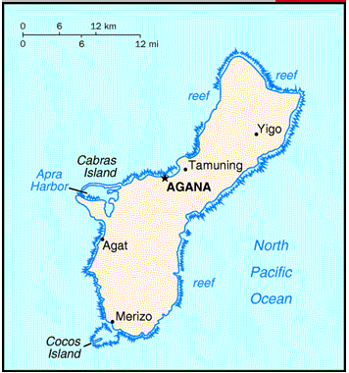
Guam is located in the North Pacific Ocean, about three-quarters of the way from Hawaii to the Philippines; 13 28 N, 144 47 E, land mass: 541.3 sq km. Guam, the westernmost territory of the United States, is the largest island in the Mariana archipelago (as seen here). It lies 6200 kilometers (3700 miles) west-southwest of Honolulu, and only 2500 kilometers (1500 miles) south-southeast of Tokyo. The island’s strategic location at the edge of the Asian rim gives it a role of importance for American activities in the Pacific basin.

The civilian population is concentrated in the central part of the island. As is the case in much of the world, considerable population redistribution has taken place since the end of World War II, predominantly from rural to urban areas. In Guam, this means from the south to the central portion of the island.

Guam’s population density is approximately 180 people per square kilometer (490/square mile) of land area, about eight times the United States average of 22/square kilometers (62/square miles). Guam has a higher population density than all of the states except Massachusetts, Rhode Island, Connecticut and New Jersey.

The 2000 Census of Population and Housing conducted in April of 2000 counted a total of 154,805 persons on Guam. This represents a 16 percent increase over 1990 decennial population count of 133,152 and a 10 percent decline in the population’s rate of growth. In 2000, Guam’s southern region’s population declined by 2 percent, while the population for the island’s northern and central regions grew by 29 and 11 percent respectively. The estimated population as of July 2006 was 171,019.

Table 3-1
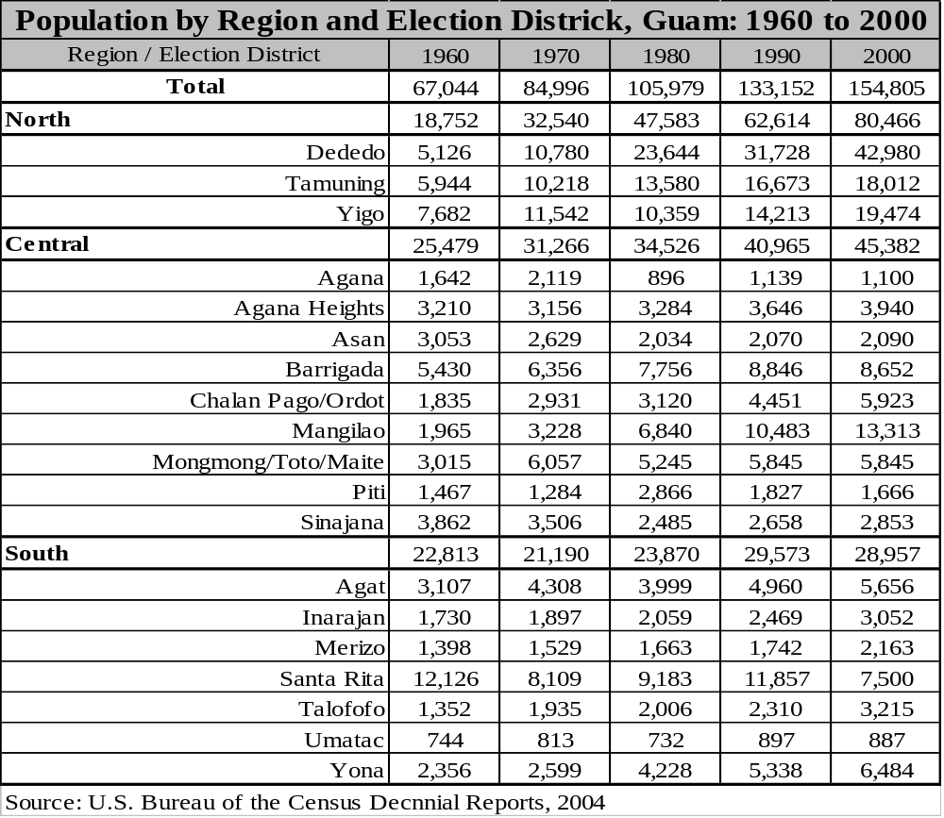

Island Geography
At three times the size of Washington DC, Guam is the largest and southernmost island in the Mariana Islands archipelago, with a valuable strategic location in western North Pacific Ocean.

The island of Guam is approximately 30 miles in length with a variable width, ranging from 12 miles to 4 miles at its narrowest point. The largest island in Micronesia, Guam has a total land mass of 212 square miles, excluding reef formations. Shaped like a footprint, Guam was formed by the union of two volcanoes. The island has two basic geological compositions. Two-thirds of Guam, the central and northern features, is primarily raised limestone with several volcanic formations at Mount Santa Rosa and Mount Mataguak. The northern cliff-lines drop off sharply into the Philippine Sea with an elevation ranging from 300 to 600 feet. The southern features are basically volcanic with an elongated mountain ridge dividing the inland valleys and coastline. The highest point is Mount Lamlam with an elevation of 1,334 feet.

The peak of a submerged mountain, Guam rises 37,820 feet above the floor of the Marianas Trench, the greatest ocean depth in the world. When visiting Guam, hiking up one of its mountains is like scaling a peak higher than Everest. A metal object would take 64 minutes to fall through the Marianas Trench, just east of Guam, with a depth of 6.79 miles, where pressure is over 18,000 pounds per square inch. The Marianas Trench was pinpointed in 1951 by the British Survey Ship Challenger, and on January 23, 1960, the manned U.S.N. bathyscaphe Trieste descended to the bottom. On March 24, 1995, the unmanned Japanese probe Kaiko also reached the bottom and recorded a depth of 35,797 feet.

Island Geology
Guam was formed through an uplift of undersea volcanoes and is surrounded by coral reefs near the shore. The island is relatively large, 50 kilometers (30 miles) long and from 6.7 to 14.2 kilometers wide (4 to 8.5 miles wide), with a total area of about 590 square kilometers (214 square miles). The northern part, which contains the main fresh water lens, is a high coralline limestone plateau rising up to 260 meters (850 feet) above sea level. The southern part is mountainous, of volcanic origins, with peaks to 400 m (1300 feet). Apra Harbor, one of the largest harbors on earth, is located to the western side of the island.

Climate and Environmental Hazards
Guam’s climate is tropical, with the mean average temperature of 27ºC (81oF). Three-quarters of the rainfall falls between June and December, averaging about 215 centimeters (85 inches) a year on the lowland coast around Apra Harbor and 280 centimeters (110 inches) in the highest mountain locations of the southern half of the island. Like many Pacific islands, Guam lies within the typhoon belt and is periodically struck by tropical storms and typhoons. Each year, a few minor storms with winds up to 50 mph will likely strike, but every 3 to 5 years Guam gets hit with very ferocious typhoons. For example, typhoon Pamela struck Guam in 1976, causing $250 million damage. The constant need to prepare for such severe winds affects everything on Guam. The climate subjects all types of facilities to corrosive salt air and damaging high winds. Guam also gets rain almost every day. This is an added challenge to Guam residents to keep speeds down to prevent accidents on the slippery wet roads. This also damages equipment that is not properly protected and maintained. Climate plays a key role in determining the maintenance practices. The following chart shows the rainfall from 2000 to 2004 where the wet and dry seasons can clearly be seen.

Table 3-2
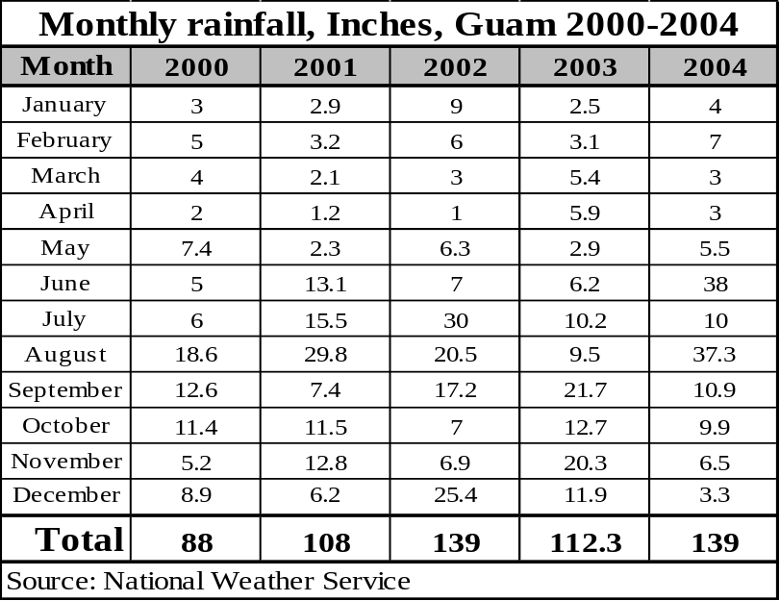

Energy Sources
Energy Sources on Guam are limited to generators driven by diesel engines, generators driven by steam turbines with oil fired boilers, and combustion turbines fired by #2 diesel fuel.

Guam has sharp drop-offs on the Pacific side of the island that can provide good sites for Ocean Thermal projects. There are some sites that have been identified over the years for possible hydro installations. Since Guam falls in an area of the Pacific Ocean that picks up trade winds, wind energy is available. Solar power is also available on Guam. There is currently no record of geothermal activity on Guam. However, a study to determine whether the geological formations would offer this type of energy may shed additional light on this potential energy source.

The Navy has nuclear submarines stationed on Guam. This has often been discussed as a possible emergency source of energy and must be mentioned as an energy source uniquely available on Guam.

Energy Uses
Consumption of electric energy for cooking is not used by very many people on Guam. The preferred cooking heat is provided by LP gas. Statistics on this are not readily available and the question is not asked in the census. Outside cooking with gas, wood, or charcoal also remains popular with many families using outdoor cooking units.

Air conditioning on Guam is popular, but with the price of energy rising, there is a move towards natural ventilation or raising the thermostat on the air conditioning system to help control electric bills. Small split air units are used to cool the bedrooms that are being occupied at night. On Guam, close to 70% of all families have some type of air conditioning system in their homes.
Bus systems are available on the island, but lightly used other than for tourism. Private vehicles remain the predominant form of transportation. There are discussions of creating a more robust bus system for the island, but currently, there is no budget or firm plans in place. With the higher fuel costs, bus transportation similar to American Samoa may be a valid option utilizing small privately owned busses to meet the needs of the local population. This approach would also fit the tourist trade by providing smaller more efficient buses.

In addition to the above energy uses, water and sewage pumps take large amounts of power. The Air Force and Navy also consume a large amount of power, utilizing up to 15% of the island’s electrical power. This is anticipated to go up as the bases expand. The local government uses 60% of the island’s power with the remainder going towards the residential and business sectors.

HISTORY, POLITICAL DEVELOPMENT AND PRESENT STATUS

Early Island History
The modern history of Guam began in 1521, when Ferdinand Magellan landed on the island and found it inhabited by Chamorros, a Malaysian people believed to have come from Southeast Asia. For many years Guam was dominated by Spanish governors in the Philippines and was a port of call for Spanish ships sailing from Acapulco to Manila. Colonization and active Spanish rule began in 1668, but little economic development occurred during this time.

Following the defeat of Spain in the Spanish-American War, Guam was ceded to the United States in the treaty of Paris in 1899. Administration by the United States Navy began the next year.

United States naval administration was interrupted when the Japanese captured the island in December, 1941. Japan occupied it for 2 ½ years. Guam was recaptured by the United States Marines and Army in July, 1944. The island had suffered much destruction, but after the war it entered a period of reconstruction and rehabilitation which changed it from a quiet agricultural island to a center of United States military operations and growing commercial activity.

Recent Island History
In 1950, President Truman signed the Organic Act of Guam, giving the island the status of an unincorporated territory, extending American citizenship to its people, and providing local legislative autonomy. The Act also transferred administration of Guam’s civil affairs to the United States Department of the Interior and placed the executive, legislative, and judicial branches of local government in civilian hands. The Organic Act was subsequently amended several times and is now the island’s basic constitutional instrument.

United States Involvement
Guam is now in the beginning of its second economic boom with the economy expanding due to the increased money available from military related projects. Guam's U.S. military installations remain among the most strategically vital in the Pacific Ocean. When the United States closed its Navy and Air Force bases in the Philippines after the expiration of their leases in the early 1990s, many of the forces stationed there were relocated to Guam.

The removal of Guam's security clearance by President Kennedy allowed for the development of a tourism industry. The island's rapid economic development was fueled both by rapid growth in this industry as well as increased U.S. Federal government spending during the 1980s and 1990s. The Asian economic crisis of the late 1990s, which particularly hit Japan hard, severely affected Guam tourism. Military cutbacks in the 1990s also disrupted the island's economy. Devastation from super typhoons Paka in 1997 and Pongsona in 2002, as well as the effects of the September 11 terrorist attacks on tourism further hampered the island’s economic recovery.

There are signs that Guam is recovering from these setbacks. The increased arrivals of Japanese tourists reflect that country's economic recovery, as well as Guam's enduring appeal as a weekend tropical retreat. U.S. military spending has dramatically increased. Recent proposals to strengthen U.S. military facilities, including negotiations to transfer 8,000 U.S. Marines from Okinawa, also indicate renewed interest in Guam by the U.S. military.

Present Political Status
Currently, Guam is an unincorporated, organized territory of the United States. It is "unincorporated" because not all provisions of the U.S. Constitution apply to the territory. Guam is an "organized" territory because the Congress provided the territory with an Organic Act in 1950, which organized the government much as a constitution would. The Guam Organic Act currently provides a republican form of government with locally elected executive and legislative branches. Guam has an appointed judicial branch.

Guamanians enjoy most of the privileges of American citizenship, but they cannot vote in the United States presidential elections unless they are residents of one of the states. They have an elected representative in Washington, who serves for a two-year term and exercises the rights and privileges of the United States Congressman except the right to vote on the floor.

Since 1970, the executive branch has been headed by an elected Governor and Lieutenant Governor. Guam’s 21-member unicameral legislature is elected every two years and has full power in territorial matters, including limited taxation and appropriation authority.

In September 1982, a referendum was held in Guam on the future status of Guam. The results indicated that the people want to move toward a commonwealth status.

The efforts of the CSD (Commission on Self-Determination), barely two years after its creation, led to the organized Guam's first political status referendum on January 12, 1982. Forty-nine percent of all Guam residents who voted chose a closer relationship with the United States via Commonwealth. Twenty-six percent voted statehood, while ten percent voted for the status quo (Unincorporated territory). Smaller groups voted for incorporated territory status (5%), Free Association (4%), independence (4%), and "other" political status options (2%). A subsequent run-off election held between Commonwealth and statehood saw seventy-three percent, or nearly three-fourth's, of Guam voters choosing Commonwealth over statehood (27%).

Not until 1988, six years after Guam residents overwhelmingly approved Commonwealth status, was the first Guam Commonwealth Act introduced into Congress. Delegates have subsequently reintroduced the bill with little success. Since the introduction of Guam's Draft Commonwealth Bill in Congress in 1988, negotiations between Guam and a Federal interagency task force have not resolved the major issues.

POPULATION, EMPLOYMENT & WAGES

Present Demographics
The 2000 Census of Population and Housing conducted in April of 2000 counted a total of 154,805 persons on Guam. This represents a 16 percent increase over the1990 population count of 133,152 and a 10 percent decline in the population’s rate of growth. In 2000, Guam’s southern region’s population declined by 2 percent, while the population for the island’s northern and central regions grew by 29 and 11 percent respectively. Guam’s ethnic diversity is Chamorro 37.1%, Filipino 26.3%, other Pacific islander 11.3%, Caucasian 6.9%, other Asian 6.3%, other ethnic origin or race 2.3%, mixed 9.8% (2000 census).

Table 3-3
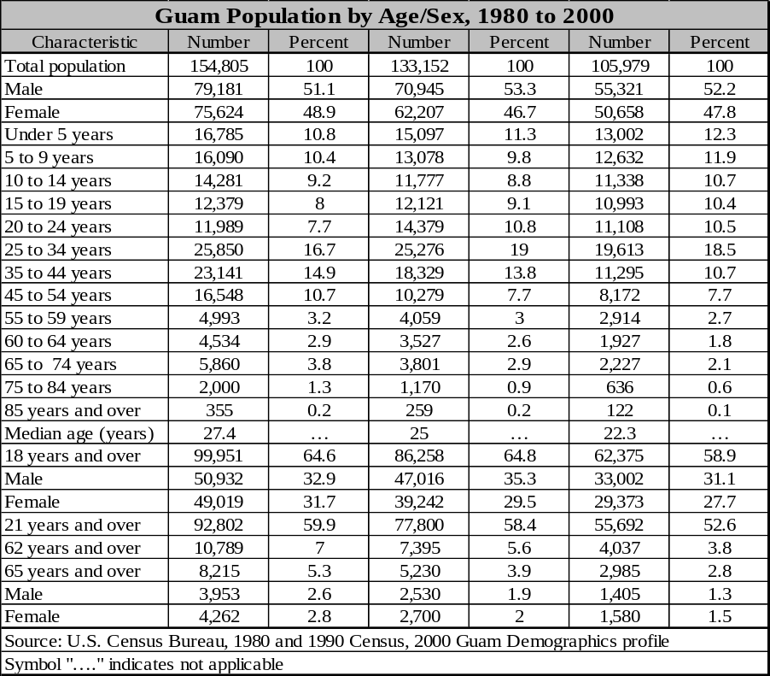

Figure 3-1
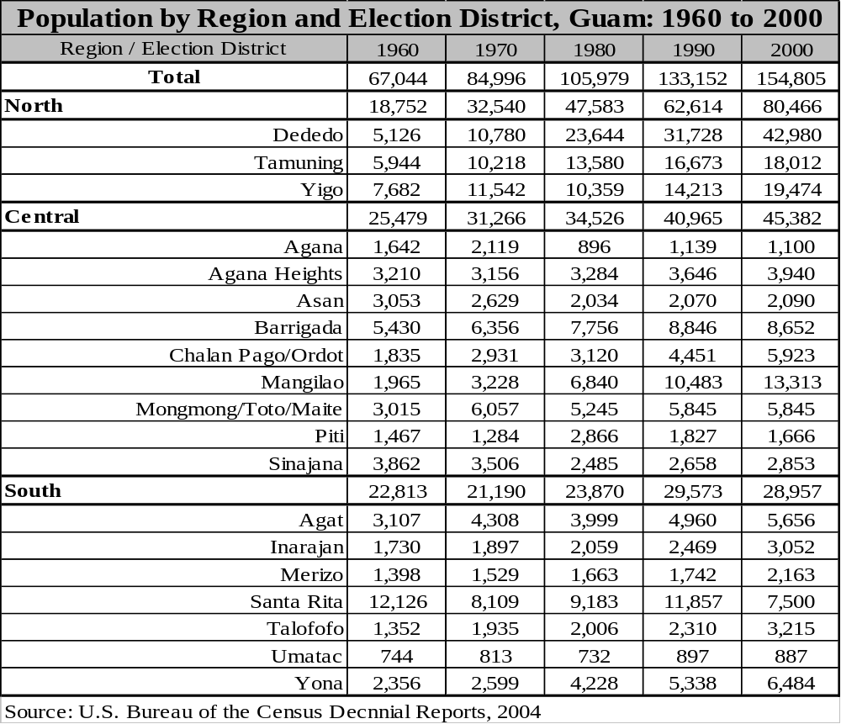

Employment and Job Market
The Economic Census has been taken on Guam at 5-year intervals since 1958. In 1998, the Department of Commerce through a Memorandum of Agreement with the U. S. Department of Commerce, Economics and Statistics Administration, U.S. Bureau of the Census, conducted the “1997 Economic Census of Outlying Areas” for Guam. The Economic Census is the major source of facts about the structure and functioning of the economy. The 1997 survey showed the total number of establishments with payroll was 2,707 as compared to 1,955 establishments in the survey conducted in 1992. Total sales and receipts for 1997 were $4.6 billion, up from the $3.0 billion in 1992. There were a total of 42,477 paid employees in 1997 for the pay period including March 12th.

Table 3-5
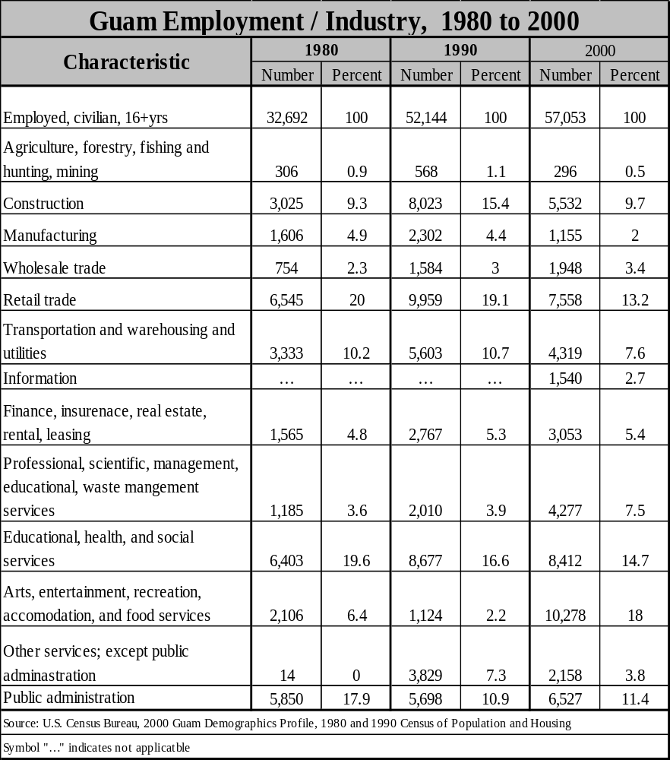

Gross Domestic Product
The economy depends largely on U.S. military spending and tourism, with 2005 Gross Domestic Product estimated at $2.5 billion. Total U.S. grants, wage payments, and procurement outlays amounted to $1.3 billion in 2004. Over the past 30 years, the tourist industry has grown to become the largest income source following national defense. The Guam economy continues to experience expansion in both its tourism and military sectors.

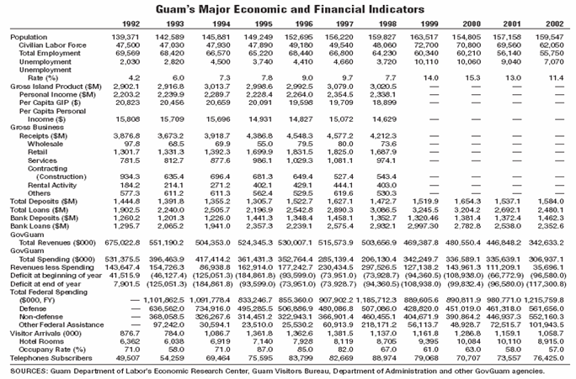
Table 3-6
Guam's Gross Domestic Product as a whole decreased slightly in 2005, but when comparing performance in the groups of exports there was a major change in export categories. There were three general categories that had major changes. In 2004, Guam exported a little over $400,000 in scrap aluminum. In 2005, that figure rose to over $4,000,000 due to the increased commodity price of Aluminum and the increased exports to China. In 2004, fish exports were in excess of $24,000,000 dropping to just under $7,000,000 in 2005. The third major change was a substantial increase in automotive exports. In 2004, Guam exported a bit over $9,000,000 in personal automobile exports. In 2005, this number was up substantially to over $16,000,000. Further research would be needed to determine the major contributing factors to the change in exports and whether the major shift in numbers can be attributed to how the exports are captured.

Personal Wages & Income
Guam wages are high for this area of the Pacific, but low compared to equivalent jobs on the mainland U.S. As a result, industry on Guam is challenged in two ways. First, the higher wages attract workers from neighboring islands who then must be trained to a skill level to support the modern infrastructure on Guam. Second, technically skilled personnel trained on Guam tend to migrate to the U.S. mainland or Hawaii for higher salaries.

Table 3-7

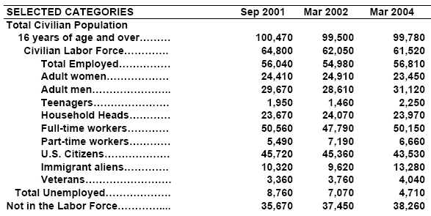

Table 3-8
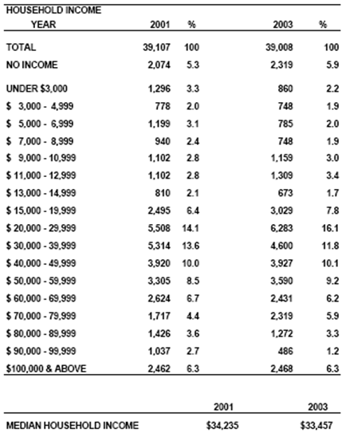

The following provides an overview of the hourly wages from 1998 to 2004. Please note that there has been very little change in wage rate since 1998 with only a small increase in some of the categories.

Figure 3-1
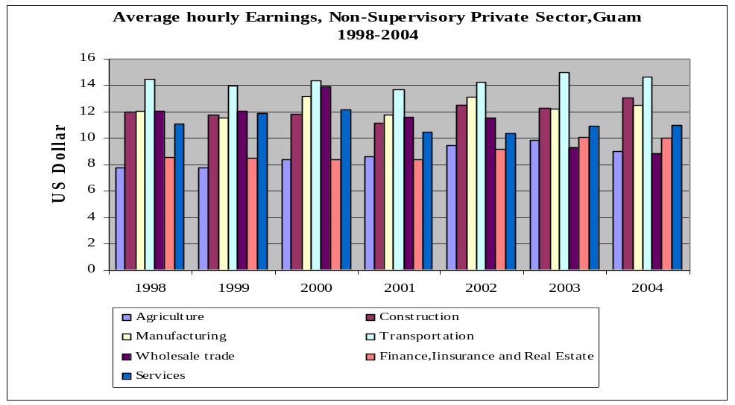

General Business & Commercial Income
Guam's business and commercial income has improved over the past two years with an increase in spending from both tourism and the U.S. military bases. With the decision to relocate the military personnel from Japan to Guam and Saipan, the bases on the island have had massive building programs to put the infrastructure and housing in place to handle the influx of troops and supplies. In addition to the relocation effort related to the movement of troops from Japan, there was a decision made to base three nuclear submarines on the island. This required facilities to be upgraded as well as new facilities added to be able to accommodate the decision. At this time, there is also future planning for additional submarines and support staff contributing to the expected growth in Guam's overall energy needs.

Figure 3-2
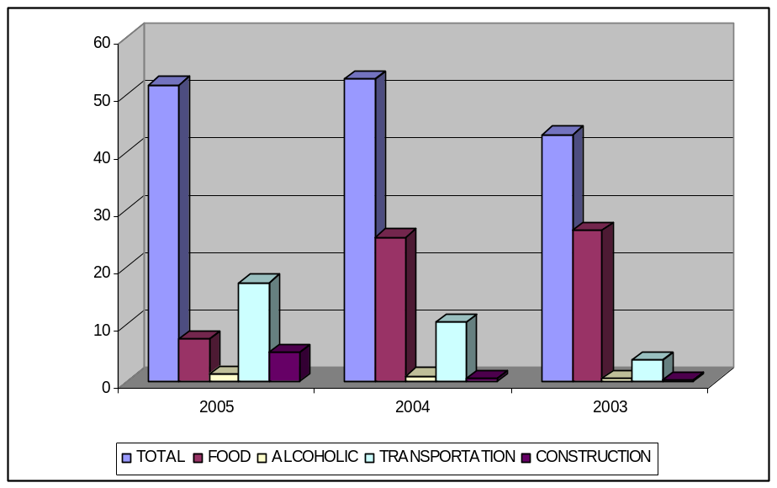

ISLAND ECONOMY AND INFRASTRUCTURE

General Status of the Economy
The economy depends largely on U.S. military spending and tourism. Total U.S. grants, wage payments, and procurement outlays amounted to $1.3 billion in 2004. Over the past 30 years, the tourist industry has grown to become the largest income source following national defense. The Guam economy continues to experience expansion in both its tourism and military sectors. The overall status of the economy is seen to be positive with continued expansion as the military build up gets into full swing. The expansion currently occurring on Guam is being compared to the expansion in the mid-80s that lasted for over 5 years. Unemployment on Guam has continued to drop since tourism has started to come back and the construction phase of the Military buildup started in 2004. Currently the unemployment is 2.5%.

Figure 3-3
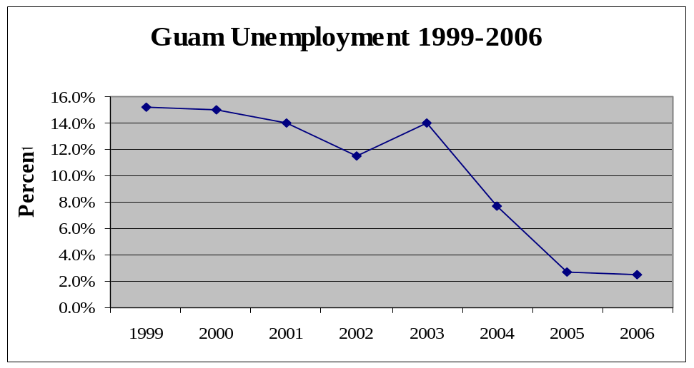

    - Major Employment Sectors

Table 3-10
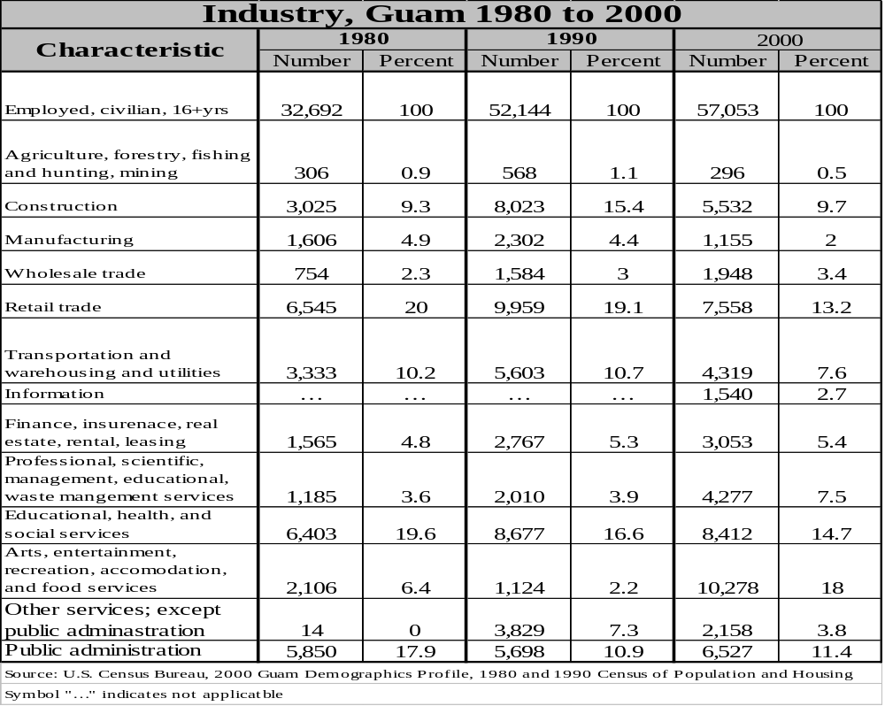

Water and Wastewater Systems

The Guam Waterworks Authority (GWA) is tasked with the responsibility to manage water and wastewater services.

Water revenues for FY 1998 were $24.7 million. There were 43,841 water meters in service in FY 1998, and a total of 8.8 billion gallons of water was consumed in the respective time frame.

In Fiscal Year 1989, the Public Utility Agency of Guam (now GWA) installed a new Utility Billing System. This system had the capability of adjusting for previous billing errors and estimated consumption. The old system did not adjust for estimated and erroneous billing, therefore total reported consumption may not actually reflect cumulative consumption.

Electric System
The Guam Power Authority (GPA) currently provides electric energy to over 40,000 metered customers. With the increase in military presence on Guam, this number will increase substantially over the next 10 years with projections showing as much as a GPA total gross generation capacity of 470 MW. GPA's Transmission and Distribution (T & D) facilities include 136 miles of transmission lines and 450 miles of distribution lines (47 distributions feeders). GPA provides 365 MVA of substation capacity. From 1991 to 1996, a total of $267 million in Capital Improvements Projects were completed, with over $50 million in progress.

A major completed project is the Power System Control Center at the Cabras Power Plant. This state of the art Energy Management System supports remote telemetry and control of the island Power System. In addition, GPA is undergoing transition towards a Computer Maintenance Management System (CMMS) that will streamline maintenance costs and insure that maintenance is performed in a timely and effective fashion.

Power Purchase Contracts with HEI Power Corporation Guam, Taiwan Electrical and Mechanical Engineering Service, Inc. and Marianas Electric Corporation, all privately owned and operated, provide 170 MW of power for the island. These contracts will run for twenty years, after which the aforementioned firms will turn over the generation assets to GPA.

Figure 3-3
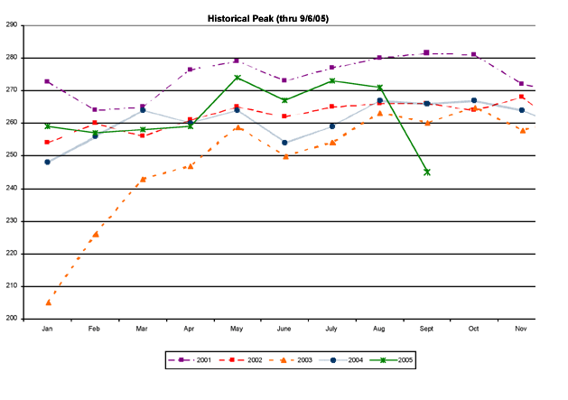

The following are some of the major projects completed by the Generation Division during FY 2005:

Guam Power Authority
2004 – 2005 COMPLETED PROJECTS
Cabras 1&2 Power Plant (2004-2005)
Completed Turbine/Generator Overhaul on both units
Performed Boiler Chemical Cleaning (Electro-deionization) on both units
Performed Boiler Condition Assessment on both units
Replaced Deaerator Storage Tanks for both units
Replaced Air Preheater Baskets on both units
Retubed HP Feedwater Heater (#5) on Unit #1
Refurbished/Replaced Boiler Safety Valves on both Units
Replaced Turbine Deck Exhaust Fans
Refurbished Force Draft Fans (Venturi, Motor, Rotor) on both units
Assessed and Adjusted Boiler Springs & Hangers
Completed Cabras Unit #2 Turbine Overhaul
Replaced Boiler Drum level indicators
Replaced the Start-Up Transformer
Conducted training for Operations & Maintenance personnel
Conducted annual performance testing
Completed boiler section replacements (Arch Tube, Reheat Tubes)
Installed Turbine Lube Oil Purifier
Replaced corroded cable trays in basement
Installed fire retardant on boiler front cables
Replaced Chemical Feed System
Installed water sampling system
Constructed roof over Waste Oil Facility oil water separator
Replaced one instrument/service Air Compressor
Cabras 3&4 Power Plant (2004-2005)
Modified Scavenging Air Drain / Mist Catcher
Initiated Fuel Oil Supply and Return line replacements
Replaced Traveling Screen Control Panels
Initiated Piston Clean Ring Modification (extends liner operation cycle)
Initiated Design for 750KW emergency generator installation (90% Complete)
Constructed building to house Fuel Oil Day Tank Heater Panels
Modified Exhaust Gas Receiver piping elbows (minimize leaks)
Upgraded Turbocharger Silencers with stainless steel wire mesh on Unit #3
Replaced Homogenizer control panel
CT & Diesel Plants (2004 – 2005)
Completed Major OH for Manenggon Diesel units (5MW x 2 Units)
Replaced Air Compressors at the Manenggon and Tenjo Vista Power Stations
Stack Replacement at the Talofofo Power Plant
Completed Dededo CT #1 Major Overhaul
Completed Repairs & Major Overhaul work on Macheche CT Unit
Completed Rotable Assembly Exchange/Repair Yigo CT
Purchased water softeners for Macheche and Yigo CT

Figure 3-5

Guam Power Authority, Max Peak Demand 1969-2004
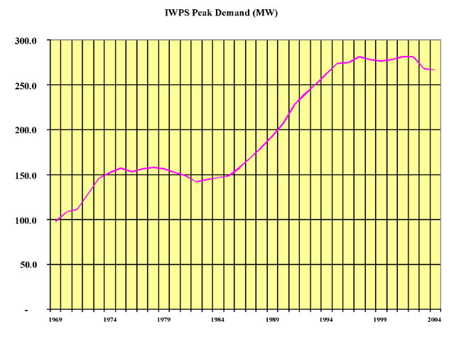
Below are charts to show Power consumption and Revenues by customers for Guam Power Authority, 1994-2004 (Source: 2004 Guam Statistical Year Book):

Figure 3-6
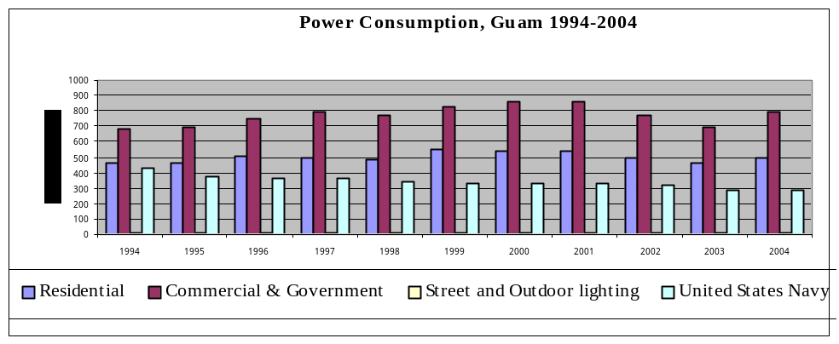

Figure 3-7
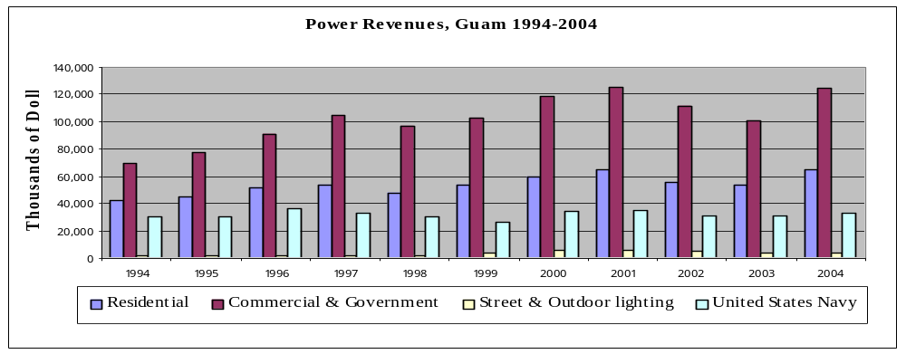

Source: 2004 Guam Statistical Year Book

Transportation
Guam's highway system consists of a network of seven-lane highways running the entire north-south length of the island and supported by secondary highways and two-lane roads. The highways and secondary highways are in good repair and provide a smooth surface that has been converted from coral to asphalt over the past decade to reduce the number of accidents. Guam's highways have a maximum speed limit of 45 mph with secondary roads normally posted at 35 mph and residential at 15 mph.

Guam has matured over the past 10 years in the area of transportation with the modernization of their highways and signal system. There is an extensive mass transit system that has served Guam for several years. In addition to the buses owned by the Guam Transit Authority, tour buses are readily available to serve the 1 million plus tourists that come through the island each year. Guam also has the normal taxi and limousine services.

Marine
Marine reserves are thriving in their fourth years of existence on Guam. The fish population is reported to have doubled and the corral growth continues to thrive. However, outside the reserves the fishermen are reporting smaller and fewer fish. Many on Guam are now calling for additional regulations to help stabilize the overall health of the reefs and the areas where fishing is permitted. (PDN, 2 May 2005).

Port and Port Industries
Apra Harbor is a beautiful, deep-water port that can accommodate the largest naval vessels including aircraft carriers. Guam Shipyard provides repair and maintenance for U.S. vessels, and Kilo Wharf features the only deep water ammunition port in the Western Pacific where a loaded ammunition ship can go pier side and get much needed maintenance accomplished.

Apra Harbor is located on Guam's west coast at approximately 13°26'N 144°40'E. Agana, Guam's largest city, is located approximately six miles east-northeast of Apra Harbor. For all practical purposes, this is the commercial hub of the island. It is a natural harbor, protected by Orote Peninsula on the south and Cabras Island on the north. Guam's commercial port is on Cabras Island, along with private industrial firms. Almost all of Apra Harbor, with the noticeable exception of the commercial port operations, is under the jurisdiction of the adjacent U.S. Naval Activities. The port handles both containerized and conventional cargo from the United States and other countries.

Apra Harbor is an improved, natural basin that consists of an Outer Harbor and an Inner Harbor. Orote Peninsula, which projects 3.5 miles west-northwestward from Guam's west coast, forms the southern boundary of the Outer Harbor. The northern side of the Outer Harbor is formed by a breakwater that is partially man made. The man made portion of the breakwater lies west of Cabras Island and is called the Glass Breakwater. The average height of the breakwater is approximately 15 ft (4.6 m) above mean sea level. The Inner Harbor extends southward from the eastern part of the Outer Harbor. Hills east and southeast of the port provide a limited wind break for winds from those directions, but Apra Harbor is not a sheltered port.

The Guam Shipyard provides vital shore industrial support, repair, maintenance, overhaul and dry-docking services to visiting Seventh Fleet units, the submarines of Commander Submarine Squadron 15 and resident tender, USS Frank Cable, as well as 4 Military Sealift Command ships, two coast guard ships and local federal agencies on the island. The shipyard also provides authorized repair to Jones Act commercial ships such as Matson Navigation and Sealand Services and shore support services to GovGuam agencies. Guam Shipyard has facilities and capabilities not found elsewhere in the Western Pacific including a foundry, the largest motor rewind facility, a special building for environmentally controlled sandblasting and painting, micro-miniature circuit board repair, corrosion control and an industrial laboratory. It is the only facility in the Western Pacific certified by the U.S. Department of Transportation to perform re-certification requirements on breathing air and high pressure air cylinders.

Airports
The Guam International Airport is a primary regional airport serving passenger and cargo needs between Guam and the United States, Asia, Australia and various islands in the Pacific region.

The Airport is centrally located in the heart of Guam's business district offering 768,000 sq. ft. of terminal space along with numerous hangars, maintenance facilities, warehouse space, storage facilities, office space, and expansive ground areas with high potential for development on over 1,800 acres.

Guam International Airport has recently extended the runway to be able to handle the largest planes made. The airport has its own backup generators and water system to make sure that passengers and security needs are addressed during power losses.
The graph below shows the number of visitors:

Figure 3-8
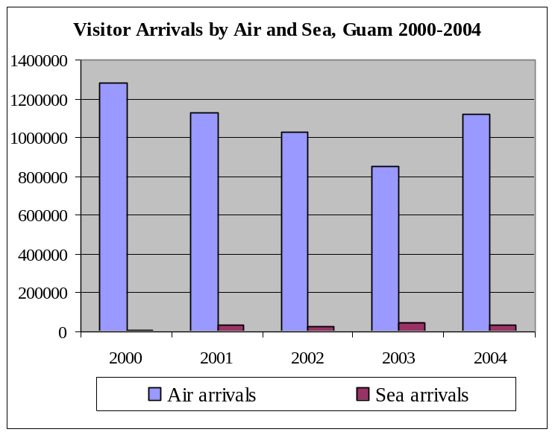

Communication Systems
Guam has an excellent communications network that includes both copper and fiber. There are several cell phone companies on island offering competitive rates. Guam has one cable TV company, but there others interested in getting into the game which should improve services and decrease current pricing.

Tourism Industry
The tourism industry continues to expand through proactive advertising.

Major Industry
Guam's major industry is tourism with over 1.3 million visitors per year and the military that continues to expand its presence on Guam.

Military
The American military has maintained bases on Guam of varying strength in both personnel and equipment since the turn of the century. After the end of World War II, Guam was the site of major naval and air force facilities to backstop U.S. defense commitments in the Asia-Pacific region. Between 1990 and 2000 the number for the military and their dependents were reduced due to base closures initiated in 1995. Military-related population has dramatically decreased from 22,178 (active duty personnel and dependents) in 1992 to 11,625 in 2000. The economic impact of the base closure, unit transfers, and scale back activities has resulted in the direct job losses of approximately 4,800 (3,500 federal civilian jobs and 1,300 military positions). Due to tensions in the region and Guam’s strategic location to serve as a staging base and operating location for mobilizing U.S. military forces and equipment within the Western Pacific, there is evidence of increased military activity on Guam, including the appropriation by the U.S. Congress in 1999 of $103 million for military construction projects on Guam and the decision of the U.S. Defense Department to station a squadron of nuclear powered submarines on Guam. Additionally, Guam was designated as a Qaulity of Life and Liberty port for the U.S. Navy Seventh Fleet ships in June 1999. From that time until April 2001, approximately $28 million has been infused into Guam’s economy through sailor spending and contracts for ship provisions and services, according to Seventh Fleet statistics.

Other Special Economic Elements
The economy depends largely on U.S. military spending and tourism. Total U.S. grants, wage payments, and procurement outlays amounted to $1.3 billion in 2004. Over the past 30 years, the tourist industry has grown to become the largest income source following national defense. The Guam economy continues to experience expansion in both its tourism and military sectors.

Manufacturing, Craft, Trade
Since commodity prices have increased over the past two years, there has been substantial move on Guam to clean up the island by removing old cars and other scrap metal. The largest scrap yard on the island is now operating in the black and selling most, if not all, of the scrap metal it takes in to China. Aluminum and copper prices have also gone up substantially. This has resulted in a major increase in sales and exports to other countries. The increase in exports has resulted in bringing needed income into Guam.

During June of 2006, Governor Felix P. Camacho launched a major initiative to create a new trade distribution industry that has the potential to generate thousands of jobs and inject tens of millions of dollars into the economy. The initiative also will make Guam the region’s trade distribution hub and the country’s Western-most handler of U.S. trade imports.

Agriculture
Guam has a total of 201 farms in cultivation. Together, they produced over $4.3 M in agricultural products in 1998 resulting in a 63% increase in sales over the 1993 sales with roughly the same number of farms.

Aquaculture, Fisheries, Refineries
Small commercial fishing boats, sport fishing and tourism are the key drivers for the fishing industry on Guam. There are no fish refineries on Guam, but the local Fisherman's Coop meets regularly and provides a local sales outlet for the fish coming into the docks.

The Guam Aquaculture Development and Training Center (GADTC) is administered by the Economic Development and Planning Division (EDP). GADTC carries out the functions of the Department as the lead agency in aquaculture and fisheries development. The Division also coordinates all fisheries and aquaculture development matters dealing with national, regional and international organizations and agencies.

ECONOMIC DEVELOPMENT PLANS AND PROJECTS

Existing Capital Improvement Projects

Table 3-10
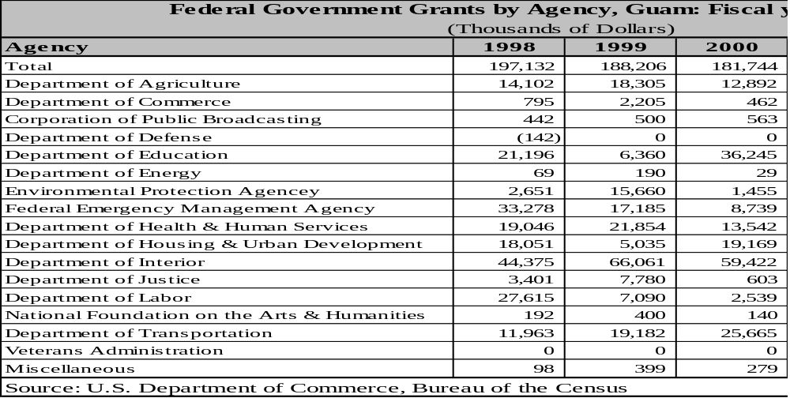

Compact Capital Commitments
Compact funds are normally used for schools, infrastructure upgrade and other required government spending with between $4 and $5 million being used to offset the effects of immigration on the island. Additional study will be required to pinpoint all projects that these funds are currently being expended.

General Status of Economic Development Planning
Guam has an Economic Development and Planning Division under the Department of Commerce. The Economic Development and Planning Division (EDP) is responsible for the development, formulation, implementation and monitoring of comprehensive and sectorial plans for the development of Guam's economy. The Division is separated into sections that reflect the different work areas. These sections are:

Office of Economic Analysis and Planning

Office of Project Implementation and Finance

Office of Guam Aquaculture Development and Training Center

The EDP division is responsible for providing the mechanism for guiding the orderly growth of Guam's economy through the formulation of the New Economic Development Plan (completed), Base Closure Economic Recovery Strategy, One Stop Aquaculture Permit Process (pending legislation review) and subcomponent and sectorial plans, such as the Tumon Bay Master Plan (completed), Aquaculture Development Plan for the Territory of Guam (completed), and the Vision 2001 Plan, Fishery Section (completed). The staff monitors actions taken by implementing agencies which are necessary to achieve the economic development goals set forth in the plans and makes periodic reviews and updates of the Overall Economic Development Plan and sectorial plans as needed.

In the area of aquaculture, EDP continues to develop and promote commercial fisheries and aquaculture on Guam. EDP is responsible for implementing priority projects identified in the Aquaculture Development Plan and the Territory of Guam Fisheries Development and Management Plan. EDP administers the Guam Aquaculture Development and Training Center and carries out the functions of the department as the lead agency in aquaculture and fisheries development. The Division also coordinates all fisheries and aquaculture development matters dealing with national, regional and international organizations and agencies. The assessment and potential development of the marine resources within Guam's EEZ is being pursued with the U.S. Geological Survey Office.

EDP is responsible for identifying and securing federal and local funds for the implementation of projects aimed at achieving economic development goals set forth in the various planning documents.

Economic Development Approach and Special Issues
Guam has challenges similar to any island nation: finding or building a qualified work force, procuring parts, maintaining a spare parts inventory in an environment that is conducive to oxidation. High fuel costs and low labor rates create an ongoing battle to keep costs low enough for the general public to be able to use energy as needed for a healthy and comfortable life style. Guam has continued to expand its college and university and has pushed the apprenticeship program forward to get the future generation of operators and journeymen the needed training to safely and efficiently operate the utility. Economic development in the tourist industry is being accomplished through proactive advertising in the countries to bring tourists to Guam from a wide variety of locations. Diversifying the tourism industry is a key element. In addition, Guam is improving its infrastructure to support, not only the expected growth on the island due to the military build up, but to accommodate additional tourism.

Focus Areas
Guam is currently focusing on hardening the utility against typhoon damage. This is a major effort with approximately $20 million per year being dedicated towards this effort. Other areas of continuous improvement are preventive maintenance efforts and training GPA employees. There is an ongoing Apprenticeship Program that will provide the additional manpower as the current employees retire or leave GPA.

Energy Considerations
From an energy planning perspective, Guam is almost unique among the Pacific islands included in this assessment. The government of Guam must plan for only a single island. The population is quite large for a Pacific island compared, for example, to the seven islands in the nearby Commonwealth of the Northern Mariana Islands – and there is a large United States military presence. All electricity users, including both military bases, are on the grid, and because Guam is more prosperous than the other Pacific islands, a larger proportion of the population has electricity service. In recent years Guam’s electricity demand has been declining as a result of conservation efforts, and generating capacity is now generally adequate. Peak demand has not changed significantly in six years, and the Guam Power Administration is more likely to need to replace old generating units than to expand capacity. Financing current operations and any replacement may pose problems.

Economy Diversification
Guam's economy is based on the Military and tourism. It continues to look for new ways to build additional diversity into the island economy, but to date, there are limited resources. Guam is working towards diversifying the tourism industry by advertising campaigns aimed at specific countries like China and Korea to build additional tourist trade with these nations. Currently, close to 90% of the tourist trade for Guam is from Japan.

STATUS OF ENERGY SYSTEMS

Major Energy Uses
Major energy uses on the island are the military bases, the government of Guam, and the hotels. The primary uses for the power are air conditioning, lighting, water pumps and cooking. Aircraft, automobiles, trucks, and buses are the primary users of aviation fuel, diesel, and gasoline products.

Electric Power System
Guam Power Authority has installed 663 miles of transmission and distribution lines and operates 29 Substations throughout the island. The peak load usually runs in the area of 280 MWs. The Navy base and the Air Force base have their own distribution system that receives power from the Guam Power Authority. The transmission voltages are 115 kV, 34.5 kV, and 13.8 kV for distribution. Substations are being modernized with SF6 ciruit breakers to reduce maintenance costs and improve reliability. The 34.5kV transmission system is being converted to underground lines. This is projected to be completed in 2013.

Generation Facilities
The Generation Division of the Guam Power Authority is one of the largest divisions in the authority. It comprises two steam power plants, one slow speed diesel plant, four medium speed diesel plants, five combustion turbine plants, a centralized maintenance section, the water system diesel generator section, and the transportation department. In conjunction with Independent Power Producers (Pruvient, Marianas Energy Company, and Taiwan Electrical and Mechanical Engineers Services), this division manages nearly 200 employees and a total of over 550 megawatts of power plant and emergency diesel generator rating capability.

Table 3-9
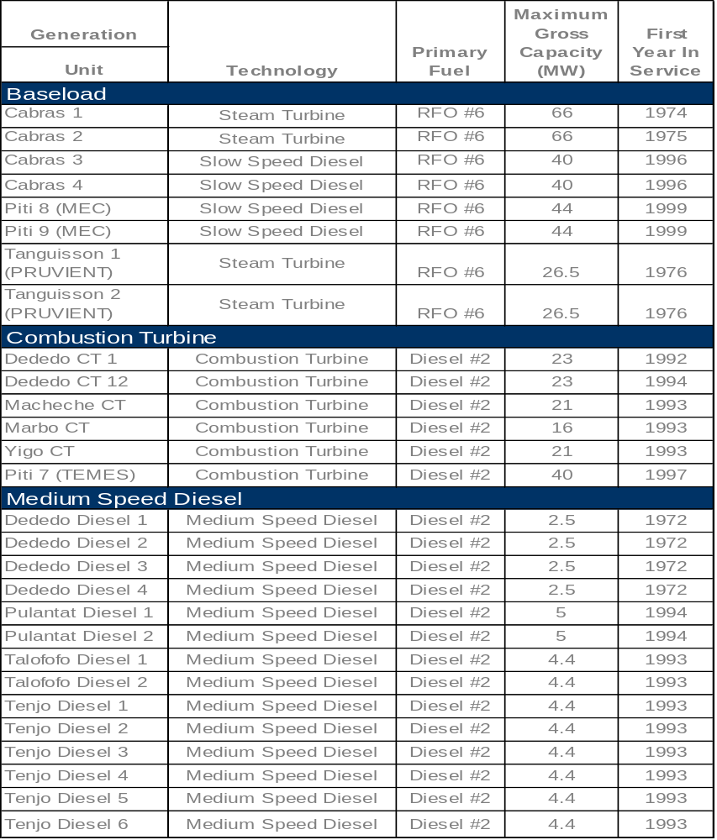

Fuels
Guam imports all of its fuel for electric generation, agricultural, commercial, and transportation. The following shows the approximate imports for the island as well as some of its neighbors. These numbers are not readily tracked by the government or Energy Department. The best estimates are from Shell Oil Company. The following pie chart shows the distribution of oil between the islands:

Figure 3-9
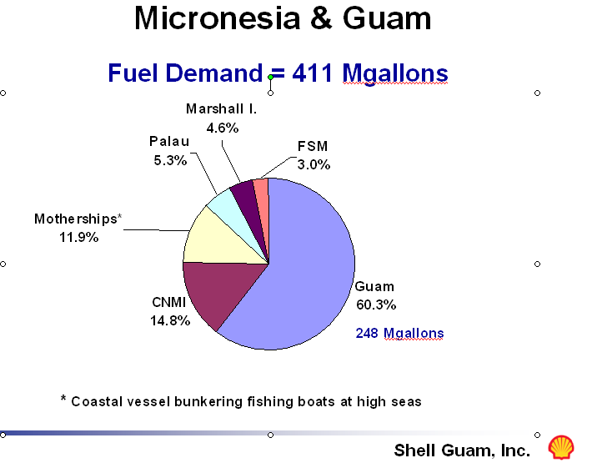

Electric Production and Use

Existing Renewable & Alternative Power Production
Guam has few renewable or alternative power production, other than small solar units for cell phone towers, solar units for remote weather stations, and a few small (<5 kW) wind generators used by homes and small businesses. There are some solar thermal units accounting for approximately 0.4% of solar panels (thermal) shipped from the U.S. in 2003.

Table 3-10
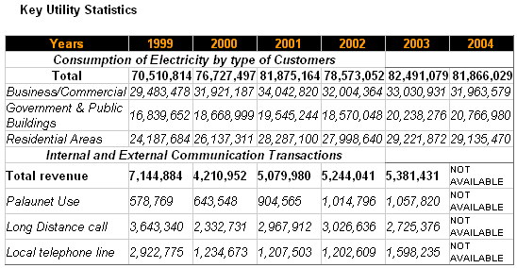

Existing Conservation and Demand Side Programs
Guam Power Authority has an extensive Demand Side Management Program that is worked in conjunction with the Guam Energy Office. This Energy Office offers training and educational material to the general public on lighting, building envelope, HVAC, hot water, and electric appliances. Guam Energy Office is also providing educational material on Clean Coal Technology and nuclear power. Recently the Guam Legislature passed a bill to encourage people to install solar water heaters, water catchments and storage systems in new construction. Energy conservation advertisements are routinely seen on television and heard on the radio.

Regulatory, Environmental Issues
Guam falls under the United States government regulations that include OSHA (Occupational Safety and Health Administration) and the EPA (Environmental Protection Agency) among many other rules and regulations from fire protection to Human Resource programs. Specific programs outside of OSHA and HR programs that affect Guam's ability to generate power are the OSHA regulations regulating the fuel quality, sulfur content and visual emissions. Guam Energy Office also sponsored the recent Energy Conference on Guam and an Energy Week to encourage conservation.

Guam Power Authority is considering possible opportunities for people to feed power back into the electrical grid if they are using a renewable resource. The policies are still being developed but GPA may also include high efficiency installations such as combined cycle and cogeneration.

Transportation

Fuel Use
The following chart and graph show fuel imports for Guam. These numbers were provided by the government of Palau and indicate a continued overall increase in fuel imports.

Figure 3-10

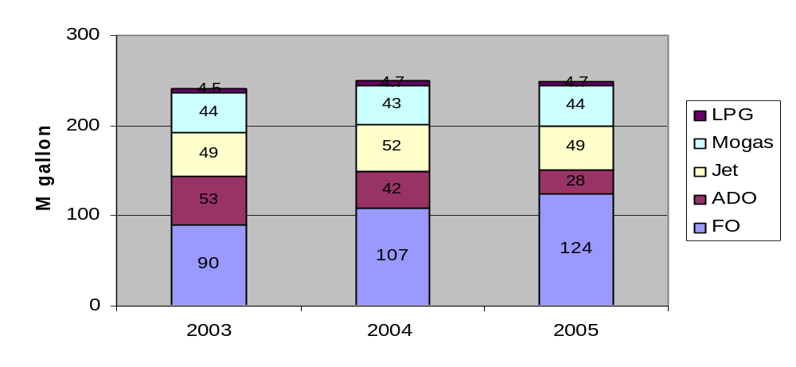

Figure 3-11
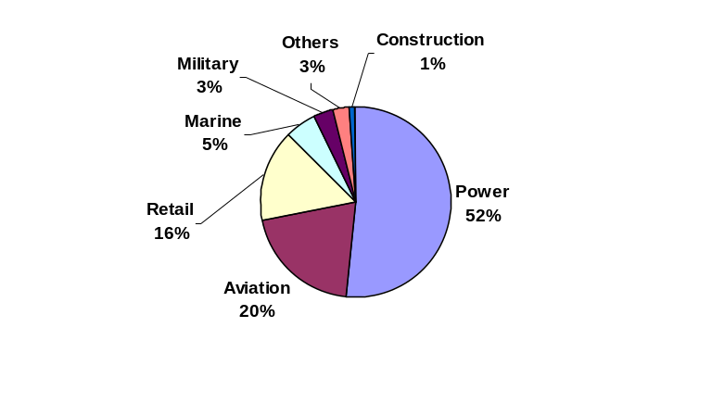

Fuel Types and Costs
Fuel types used on Guam are as follows:
- Regular unleaded gasoline
- Premium unleaded gasoline
- #2 Diesel
- #6 Diesel or Residual Fuel Oil

The Guam prices on the above products range from $2.20/Gallon for Residual Fuel Oil to approximately $3.60/ Gallon for Premium unleaded. GPA uses the following fuels: High Sulfur Fuel Oil (HSFO), Low Sulfur Fuel Oil (LSFO), Number 2 diesel distillate (DIESEL), and Low Sulfur Diesel.

High Sulfur Fuel and Low Sulfur Fuel Oils are residual fuel oils with maximum 2.0% and 1.0% sulfur content by weight respectively.

Power plants within the Cabras/Piti area must comply with the Cabras/Piti Area Intermittent Control Strategy (CPAICS) as required by the 69.11 (a)(3)(i) of 40 CFR Part 69 Subpart A, as amended, and any modification to the CPAICS approved by USEPA as defined in 69.11(a)(3)(ii).

Under the CPAICS, GPA is allowed to use higher sulfur fuel at its Cabras-Piti facility whenever 15-minute average wind direction and wind speeds are within acceptable limits. Outside these acceptable limits, GPA must use LSFO. This arrangement saves ratepayers approximately $3.5 million annually. Tanguisson Power Plant has no restrictions on HSFO use.

GPA uses Low Sulfur Diesel at its Tenjo Vista medium speed diesel plant. It uses diesel at its combustion turbines and medium speed diesel plants.

Historically, diesel is much more expensive than HSFO. In the first week of September 2005, diesel prices averaged $76.00 per barrel ($/BBL). During this period, HSFO averaged $51.00 per barrel.

Figure 3-12
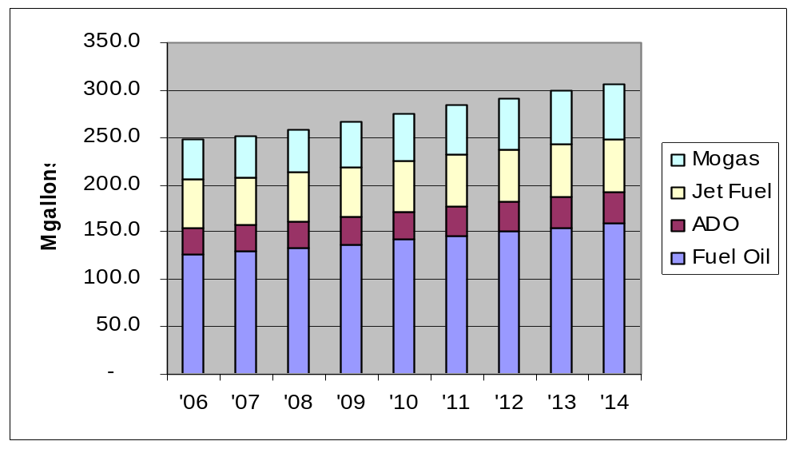

Reducing Transportation Energy Use
Guam uses bus transportation extensively. However there are ways to reduce the cost and fuel consumed by mass transit. American Samoa has a unique approach using small buses with unique paint schemes to attract customers. Guam Energy Office is also encouraging people to ride the bus and carpool when possible.

Commercial & Industrial

Tourism
Guam has a very active and efficient tourist trade with 90% of the 1.3 M+ tourists coming from Japan with the remainder mostly coming from the mid east and China. Guam continues to enhance tourism through improvements to the infrastructure and selective advertising.

Manufacturing
Guam has a Pepsi Bottling company on the island and the repair facility at the Navy shipyard. There are several small machine shops and repair facilities, but no large scale manufacturing on the island.

Military
The military has an Army base at the middle of the island in Barrigada. The Navy has a large base at the south west side of the island with full docking and repair facilities. The Navy is currently expanding the base to be able to handle a larger number of submarines and possibly larger ships as the Guam infrastructure becomes more resilient.

Fisheries
See section 1.4.16

Alternative Energy Opportunities

Alternative fuels:
The consensus on the islands and among industry experts is that the cost for fuel will not be going down and will likely continue to increase with the increased demand from China, India, and Pakistan. Even though there is an awareness of this probable scenario, there is not enough being done to get Guam ready for the continuing high cost of energy. It is critical for Guam to begin a process of gathering information on energy use and developing Return on Investment (ROI) analysis on each of the available opportunities to reduce energy costs. Based on current studies, it appears to be too soon to invest any funds in the reduction of CO emissions until other countries, including the United States, develop policies and objectives in this area. All available energy related project funds should be directed towards reducing total energy costs. This can be in the form of devoting internal government resources towards taking advantage of grants for energy related projects that will reduce the incremental cost of energy without incurring additional long term debt for Guam. Guam is looking at expanding their capacity due to the growth of Guam's population sometime within the next six years. There is time, if started now, to analyze the different options that can reduce Guam's dependence on imported oil. One area that can do this was pointed out in the 1982 Territorial Energy Assessment is coal. Nuclear would also be an option since Guam may now be large enough to support a small nuclear plant. Partnering with the Navy may be an option in this area, but this type of exploration for a new solution for energy is critical to Guam's future.

Upgrading power plants to new replacement units or expanding capacity is a window of opportunity that opens only once every 10 to 30 years. This window should not be taken lightly. Studies should be performed to determine the correct approach, timing, and type of power generation equipment to purchase. The decisions made today will impact future generations for two to three decades, or in some cases, even longer.

Renewable resources should always be considered prior to moving towards fuel based systems. This keeps the renewables on the top of the list to consider. However, if renewables do not meet the requirements, then possibly the installation of coal fired power plants would be more cost effective than going back with diesel and residual fuel oil fired units similar to those currently being used. Cogeneration facilities using coal as a supplement to waste fired boilers may also offer some cost effective alternatives. At the time of this report, coal prices are less than $60/ton for 12,000 BTU/pound coal. When corrected for BTU differences in the fuels, this equates to approximately $0.03/kWh fuel cost compared to $0.13/kWh fuel cost for a diesel or $0.11/kWh for residual fuel. Coal fired power plants have added benefits for the island’s economy with the creation of jobs and use of the waste ash products as aggregate for the building industry. Operation costs may be slightly higher for coal fired steam plants and this should be taken into consideration. However, at the cost differential between coal and oil, the additional labor will not offset the overall savings. Total dollar fuel savings for a 10 MW system would be in the area of $9 million per year in fuel savings. A feasibility study should be conducted to provide a detailed report on costs and savings.

Wind and solar will not be able to displace fossil engines unless there is a major breakthrough in energy storage. They can, however, supplement the existing fossil generation mix and should be considered when replacing or upgrading system capacity. Life cycle repair and replacement costs must be considered when installing this type of system, especially if the system could only be justified by using funds acquired through a government or private sector grant.

Privatizing the utilities
Privatizing the utility will not resolve the challenges related to fuel costs and will result in an increase in energy costs to the general public. The general public must be made to understand that fuel is something that is, and will be, needed in the foreseeable future to provide power for the island. Since this is a requirement at this time, and for energy needs for the next several years, there must be ways found to reduce the impact of the higher fuel costs on the energy consumers.

Conservation does provide some reduction in cost and can substantially reduce the energy bills of customers. Other examples would be to privatize fuel purchases or obtain financial consulting services to establish long term fuel contracts for the island. Renewable resources are an option, but remain cost prohibitive, except for solar water heating and similar thermal projects.

Guam has experimented with Independent Power Producers (IPP) and with Performance Management Contracts (PMC), two of the many form of privatization. Currently Guam has three IPPs with TEMES owning and operating a 40 MW CT, MEC owning and operating two 40 MW slow speed diesel plants, with the privatization of the management of the base load power plants on Guam. This has provided a substantial increase in plant reliability and performance through the use of Performance Based Management Contracts (PMC). The contracts reward good performance and financially penalize poor performance with pre-agreed Key Performance Indicators (KPI) that could be measured and tracked. The actual performance against the KPIs would then drives the rewards and penalties. In addition to the overall performance improvements, additional benefits related to simplified procurement practices provides a more effective method of procuring parts and materials for the power plants. The overall result is improved performance for the dollars spent on the plants, even though the total O&M budget is higher under a PMC that is under direct government management.

There are other areas related to alternative fuels that will require additional investigation and research. Taking advantage of existingresearch and looking at existing projects that have been undertaken is a good approach that will provide the needed information at a reduced cost to the island.

There are additional actions that can be taken to streamline the utility. Government actions that can be done immediately to help remedy the funding challenges resulting from higher fuel cost continue to be delayed due to public objection. An example of this is the needed increase in utility rates and fuel cost adjustments required to sustain the utility that has been exposed to today's high cost of fuel. Even though this is an unpopular item to discuss and implement, it is also a necessary outcome to support the sustainability of the utility. Additional efforts towards alternative fuels must be explored through additional efforts by the government and by the public sector. Solar and wind currently are available options, but these are by no means a secure and reliable power source for an island and will only be able to make a small contribution towards reducing energy costs. Demand side management is also an option, but as the demand is reduced, there remain fixed costs within the utility that can only be offset by higher rates as the total electrical production is reduced through DSM.

Supply Side Management
In developed country utilities, the average power systems losses for a utility with only a generation and a distribution network are estimated at approximately 10%. Nominally, these losses are accounted for in generation, 5%; transmission and distribution, 5%, with non-technical losses less than 1%.
In 2000, a preliminary study was carried out on a sample of three U.S.--affiliated island power utilities, to achieve an indication of the energy inefficiencies in the generation, transmission and distribution of electricity in all the U.S.-affiliated island power utilities. These were the utilities of Palau, Pohnpei and Kosrae.
This preliminary study indicated that the power system losses in the utilities were far in excess of acceptable standards for these power systems. It was established that the energy losses were occuring in all areas of the power system, including non-technical losses.

It was noted that some data was lacking such as the number of transformers or the types of conductor used. As a consequence several approximations were used to evaluate the losses. The errors on the figures are difficult to quantify and therefore the results should be carefully used, although it does represent system losses that are far in excess of what is acceptable.
To reduce the import of fuel, it is imperative to reduce these system losses. It is recommended that a detailed quantified power system loss study be conducted for GPA, as a stage 1 project. This project would measure and collect the electrical characteristics of the power system, and then determine the losses. Once these losses have been quantified, then stage 2 of this process would be to assess the need for updating existing energy inefficient equipment (examining financing mechanisms as appropriate); establishing government legislation that makes electricity theft a crime; and review the maintenance practices in the power plants.

Demand Side Efficiency Improvement and Energy Conservation

The Guam Energy Office (GEO) receives its principal funding from the USDOE State Energy Program (SEP) and therefore GEO programs are largely focused on program areas of the SEP. School programs and renewable energy demonstrations that support educators in teaching energy related materials, public information programs, public demonstration of energy technology and household energy efficiency improvement efforts are a major program components. The GEO also drafts energy codes and government energy policy.

The GEO occupies a stand-alone building that is itself a demonstration of energy efficient construction. Besides offices, the building includes an excellent display of energy related materials, and has solar photovoltaics and a solar water heater installed. It has high visibility since it is located along a busy traffic artery and near several major shopping areas.

The Guam Power Authority (GPA) also has an ongoing program for energy conservation and energy efficiency improvement in the home and businesses and maintains a comprehensive website that includes energy conservation information.

Electrical Metering/Tariffs
All users are metered and no prepayment type meters are used. Guam has a complex rate structure that has separate rates for different demand levels, different kWh/month usage and different classes of use. The fees include a monthly fixed charge, a tariff based on the cost of GPA operation and distribution but excluding fuel, and a fuel surcharge (LEAC) adjusted twice a year that is added to all base tariffs.

The single phase residential tariff is in two tiers. The lowest rate, $0.03354/kWh applies up to 500 kWh/month. The higher tier is charged at $0.0795 per kWh. The mid 2006 fuel surcharge was 0.09859/kWh for a total charge of about $0.13/kWh and about $0.18/kWh respectively, a substantial difference that can be an incentive to lessen waste of energy.

Household Energy Efficiency Measures
The high level of appliance ownership and the low electricity rates, compared to most of the other islands assessed, have resulted in an average household electricity use of around 1,000 kWh/month. Most of the islands assessed, including the Virgin Islands, have an average household use substantially lower than Guam indicating considerable room for efficiency improvement in households and also showing the effects on household energy use of the lower GPA rates.
Table 3-14 – Major Appliance Ownership in Guam
Item | Number | Percentage
Electric Cooking | 29,431 | 61.7%
Gas Cooking | 16,550 | 34.7%
Kerosene Cooking | 82 | 0.2%
Refrigerator | 45,536 | 95.5%
Water heating | 41,079 | 86.2%
Central A/C | 16,657 | 35.0%
Room type A/C | 22,700 | 47.6%
Source: 2000 Census

The GEO has participated in domestic DSM programs such as the consumer household energy efficiency program “Your Energy Savings” (YES!) that provides for home energy audits, rebates on energy efficient lighting and appliances and general public information programs relating to household energy conservation.

Both the GEO and GPA have had programs to replace incandescent lights with CFLs. The demand for energy efficient lighting is large enough to allow a well stocked store selling nothing but high efficiency lighting and home energy efficiency improvement gear (e.g. motion sensing devices for light activation, appliance timers, energy consumption meters) to be present on Guam. That renewable energy is also of interest is shown by the fact that almost next door is a company that stocks and sells solar PV and small wind turbines, though solar and wind power is only a part of their overall business.

The bulk of electricity usage is for air-conditioning (83% of households have a/c), water heating (86% of households have hot water, the majority use electricity) and cooking (62% by electricity). Switching electric cooking to more fuel-efficient gas could reduce total fuel imports and probably lower the evening peak by as much as 15 MW. An alliance between GPA and local gas distributors to provide incentives to replace electric cook stoves with gas stoves could provide advantages to GPA as well as lowering fuel imports. If households can be made aware of the lower cost to them for gas cooking and are given the opportunity to finance a gas cook stove through GPA, economic benefits to both households and GPA could result. If the terms that GPA works out with local gas distributors include a share of the profit stream from the added sale of gas, then the lost profits from the sale of electricity for cooking electricity could be offset.

With air-conditioning a major household energy use, a program should be prepared by GEO and GPA to inform households about how to get the best efficiency from existing equipment (e.g. cleaning, temperature setting, time of use) and what to look for in replacing the existing units encouraging them to purchase the highest efficiency units and to install them in a way that allows them to achive their design efficiency. The GPA could work with local banks to develop a special financing arrangement for the replacement of existing air-conditioners with units having a higher efficiency.

Government and Commercial Sector Buildings
The GEO works closely with government departments to monitor energy use and to improve energy efficiency. Government departments must assign an employee the task of monitoring energy use and completing a monthly report to the GEO regarding energy use and its trend in the department. The goal set by the GEO is to reduce energy use by 10% over the previous level. Though such a level of monthly energy reduction cannot be achieved indefinitely, clear benefits have resulted through better management of air-conditioning, upgrading lighting and air-conditioning with higher efficiency units and general energy conservation. The program should be continued with the addition of getting the top level of government to apply strong pressure on those departments with poorer records of performance to improve.

The commercial energy sector is dominated by large tourist hotels and large shopping malls. Their loads are dominated by refrigeration equipment for air-conditioning or for food preservation and storage, though water heating is also a major load for hotels and restaurants. Energy efficiency improvements for those large users are best served by an ESCO but GPA can offer technical and energy audit services to large electricity users to support energy efficiency improvement. If ESCO services appear to be needed, the GPA can assist the commercial customer to make contact with ESCOs serving Guam.

Cooperation in energy efficiency improvements between GPA and the military administration is important to maintain, particularly in view of the large influx of military personnel expected in 2006. Any assistance that GPA and the GEO can provide to help military authorities improve energy efficiency in military households (e.g. cooperative energy efficiency information programs, use of solar water heating, electric stove replacement) and of military facilities using GPA power (e.g. air-conditioning efficiency improvement, lighting upgrades) will be of benefit to both the military and to Guam.

Building Energy Efficiency Standards
Guam has the model building energy code for the region. It is generally well enforced and substantial energy efficiency benefits have accrued over the years since its adoption. The GEO is continually engaged in a process of determining what changes are needed and continue to propose code modifications to better meet changing energy economics.

Appliance Energy Efficiency Standards
In 1994, a bill to establish appliance energy efficiency standards was tabled by the GEO but was not passed by the legislature.

Most major appliances brought into Guam have U.S. energy efficiency labels. The U.S. energy efficiency labels on large appliances such as refrigerators, electric water heaters and freezers include as an important part, an estimate of the annual cost of energy use for the appliance. That number is based on an assumed electricity price that is considerably lower than that of Guam. If consumers are to use the labels to make a purchase decision, it is important that the numbers relate to the real cost of energy, not the lower price on the mainland. Therefore a program to inform the public of the estimated cost of appliance operation based on GPA prices is important. Actions could be replacing existing labels with special labels for Guam, providing another label explaining the higher cost in Guam, issuing brochures to GPA customers when bills are paid, or other public information process. The decision to purchase on the basis of energy efficiency will be more likely if people are aware that the actual benefits of purchasing a higher efficiency unit will be considerably greater than the amount shown on the standard label.

Energy Audits, Performance Contracts
Both the GPA and the GEO have performed or sponsored audits in the commercial, governmental and industrial sectors. Most of the audits have not been followed up to see what actual effects they have had on energy efficiency. In the Pacific region, the experience has been that audits alone have not had a strong effect on energy efficiency investments. A lack of confidence in the estimates of cost savings provided by the auditors, lack of acceptable finance packages that keep payments at a level consistent with energy savings, inadequate technical capacity by recipients to specify and purchase needed equipment, and concerns about long term maintenance of the initial energy saving investment, are all factors that limit the implementations that result from energy audits. To improve the response of energy customers to the need for energy efficiency investment, specialist Energy Service Companies (ESCOs) have evolved to provide the full gamut of technical, financial and maintenance service needed to reduce the perception of risk associated with the investment.

The overall Guam energy use appears large enough to support a full service, full time ESCO. With much of the energy use by the military, however, the entire Guam energy market is not necessarily accessible for ESCO activity. It is recommended that the GEO work with the GPA to carry out an energy efficiency market survey of the tourist industry, commercial businesses and government. Contact should also be made with military authorities to determine the possibility of a local ESCO providing energy efficiency services to military facilities on Guam. The results of the survey could then be provided to architectural/engineering firms on Guam through a workshop or publication to encourage the formation of a local, full service ESCO. If there is insufficient market for forming an ESCO locally, contact should be made with ESCOs in Hawaii and possibly the Philippines for them to work with local architectural/engineering company partners to service Guam’s energy efficiency improvement needs.

Transportation Sector
There are two main public transport sectors: that dedicated to tourism and that for local residents. The tourism transport sector operates mainly in the airport and Tumon Bay area with buses handling tour groups – mostly from Asia – who almost all arrive by air. Taxis and rental cars are available for the visitors who are not part of a group. The primary tourist area, Tumon Bay, is compact in size and is easily covered on foot. Buses, vans and rental cars are used by tourists for visiting areas away from Tumon Bay.

Local resident public transport is principally a scheduled bus service with routes connecting most major residential areas to urban work areas. There are taxis available on call and at major shopping malls.

Fuel prices on Guam are substantially higher than the mainland U.S. and that provides pressure to improve transport fuel efficiency over the long term. But, in the short term the recent rise in fuel price has mainly reduced vehicle use, particularly by lower income families.

The principal goal for the future needs to be increasing the average private vehicle transport efficiency on Guam. Programs and policies to achieve this can focus on two main areas: increasing the efficiency of use of vehicles already on the road, and increasing the overall fuel efficiency of the private vehicle fleet through policies that encourage the replacement of existing vehicles with more fuel efficient models. The higher fuel prices give both program areas a boost but government policies can accelerate the movement to more fuel efficient private transport.

For improving vehicle use efficiency, consideration can be given to initiating or expanding programs for:

- Encouraging and assisting car pooling through public information programs and car pool hot lines
- Arranging “Park and Ride” where commuters can drive their private vehicle short distances on rural roads to a public parking area, then either use the rural parking lot as a transfer point for car pooling or take public mass transport into the urban work area
- Establishing zoning and incentives to encourage the development of small neighborhood shopping areas to reduce travel to urban areas for family shopping
- Providing “tune up centers” where basic maintenance (e.g. air filter replacement, tire pressure adjustment) can improve the average fuel efficiency and determine the need for more complicated maintenance (e.g. front-end alignment, ignition system repairs) that can also lead to improved fuel efficiency
Significantly improving the average fuel efficiency of the private vehicle fleet for the long term requires incentives for the purchase of fuel efficient cars to replace those with poor fuel efficiency. The largest improvement in fuel efficiency comes from purchasing diesel instead of gasoline powered cars and trucks. Unfortunately, very few manufacturers presently sell diesel powered cars in the U.S., though they are common in most Asian and European countries. Some European and Japanese manufacturers have announced plans to once again import diesel powered cars to the U.S. market to take advantage of the need for better fuel efficiency. When diesel cars are readily available in Guam, providing incentives to shift car ownership from gasoline to diesel power could, over time, greatly improve the average fuel efficiency of private transport. Today, introducing differential taxation on fuels by raising the tax on gasoline and lowering it on diesel fuel, causing there to be a significant gap between the price of diesel fuel and gasoline, can send the correct consumer signal that diesel vehicles have a lower operating cost than those with gasoline engines. Substantially increased taxes on the sale of lower efficiency private vehicles have also been effective in some Pacific islands to discourage their purchase. For the future, should hybrid cars become readily available, Guam could provide a financial incentive on top of existing Federal incentives for their purchase.

Renewable Energy

Solar
The solar resource is very good as indicated by the estimates in Table 3-15 that are based on satellite measurements. The island mass and mountains of Guam do cause the formation of localized clouds that are not well accounted for in the roughly 70 mile square that is the measurement area of the satellite. If a large scale PV power plant is to be constructed, ground based measurements of insolation at the plant site should be made for at least a year and those used for design purposes.

Table 3-15 – Estimated solar resource for Guam (Lat 12ºN Long 145ºE) kWh/m² per day
Month | Jan | Feb | Mar | Apr | May | Jun | Jul | Aug | Sep | Oct | Nov | Dec | Avg.
Horizontal | 5.52 | 6.18 | 6.74 | 6.96 | 6.87 | 6.14 | 5.83 | 5.22 | 5.48 | 5.26 | 5.08 | 5.11 | 5.86
Tilted | 7.10 | 7.26 | 7.07 | 6.43 | 6.98 | 6.43 | 6.02 | 5.09 | 5.50 | 5.88 | 6.28 | 6.70 | 6.39
Source – NASA Surface Meteorology and Solar Energy

Solar thermal for electric generation
Solar thermal for electricity generation is not considered an economically appropriate technology for Guam due to the need for large land areas, the relatively high wind profile of the equipment that introduces a high risk of major damage during typhoon passage, and the expense of maintaining large, outdoor mechanical systems in a tropical, marine environment.

Solar thermal for water heating
The GEO has supported solar water heating in schools and has had several demonstration projects, including a solar water heater at the GEO building.

Statistics on the penetration of solar water heating into the water heating market could not be located but it is modest. With around 86% of Guam homes having piped hot water, the opportunity for replacing electric and gas water heaters with solar is large.

Recommendations
Given the large number of Guam households using inefficient electric water heaters, the GPA should consider a program to provide solar water heating on a “fee for service” (sometimes called a Renewable Energy Service Company (RESCO)) basis such as is being tried in the Caribbean. Under that concept, the GPA would purchase and install solar water heaters then charge recipient households a fixed monthly fee for their use, effectively renting the systems to customers. With a bulk purchase of solar water heaters and a well trained, full-time installation team, the cost of the installations should be significantly reduced from the present cost and a payback time of 4-6 years should be achievable if compared to the cost of operating tank-type electric water heaters. With a service life of around 10 years, the profitability of the solar units could well be higher than the profits from electricity sales for water heating over the same period. A variation of the RESCO approach is to provide the solar water heaters as a “lease to own” arrangement whereby the payments are basically time payments toward the ultimate purchase of the solar water heater by the customer.

Government incentives for households and commercial building operators to install solar hot water have had a good effect on other Pacific islands and the mainland U.S. The amount of the incentive varies from place to place but apparently does not have to be more than 10%-15% to significantly increase the rate of solar water heater adoption if the incentive is well publicized. It is recommended that the GEO examine the various solar water heater installation incentive programs of U.S. states and of other Pacific islands and prepare an updated incentive package appropriate for Guam to be submitted to the government for consideration.

For large tourist hotels, solar water heating may not be the best option due to the large area needed for solar panels. For smaller tourist hotels however, solar water heating can provide substantial savings in electricity use and should be considered. Also laundries, sports complexes, apartment buildings and restaurants are likely to benefit from the replacement of electric water heating by solar. The GEO should survey the 100 room and smaller range hotels, as well as other types of commercial users of hot water. The GEO or GPA can then and work with solar water heater suppliers and local banks to develop a finance and installation program to replace electric water heaters with solar at those sites where it is economically reasonable. A GPA “fee for service” approach can also be considered for commercial users.

Solar photovoltaics

Past programs
PV projects over the past 20 years have mainly been small scale demonstrations by the GEO intended to illustrate solar power for schools and the general public. With no unelectrified rural areas or populated outer islands, Guam has not had much opportunity to use the small scale, off-grid electricity systems that are the most cost effective use for solar PV. The local telecommunications company also has not needed to make use of solar PV.

Currently operational projects
Two solar PV installations that provide significant power are known to be present on Guam. One is an installation on a private home whose owner has chosen to become independent of the grid by installing solar PV and a small wind turbine to charge batteries and, through an inverter, power the home.

The second is an off-grid installation at the administration and research building at the Guam National Wildlife Refuge of the U.S. Fish and Wildlife Services. Located at the extreme northern end of Guam, it has no grid connection and uses a diesel generator as its primary power source during working hours. On weekends and at night when the air-conditioning is not required and most office equipment is turned off, the facility operates from power supplied by about 8 kWp of roof mounted PV panels charging a large 48V lead-acid battery bank. A 5kW inverter provides the AC power to the building from the battery bank. Initially about 4kWp of panels were installed but that proved insufficient in capacity and even with 8kWp, sometimes available power is insufficient and the generator has to start. A smaller but similarly designed system is installed on a nearby, small visitor center building to provide power when the generator is not operating and supplying power from the main building. Both systems were sold and installed by the Guam solar system supplier and therefore maintenance is locally available when needed.

Plans and recommendations
To help promote the use of renewable energy for power generation and to increase the percentage of generation fed into the GPA system that is renewable energy based, it is recommended that true net metering – where the meter runs forward when energy is coming from the grid and backward when energy is being fed into the grid – be established for household type grid-connected solar PV systems smaller than 10kWp of solar capacity.

The use of privately owned solar PV for households and commercial buildings connected to the grid can provide a means of reducing both the daytime peak and the need for fossil fuels for power generation. Programs in Germany and Japan have resulted in the installation of hundreds of megawatts of solar panels by private investors in both countries. The installations include hundreds of small to large sized PV installations. In the case of Germany, power from the solar panels was required by the government to be purchased by utilities at a price substantially higher than their selling price for power. This higher cost of “green” energy was then folded into the price of energy to all utility consumers effectively taxing all users to pay for the lowered dependence on fossil fuels by the utility. In Japan the program depended on financial incentives for households to invest in the solar panels and grid connection hardware with true net metering whereby power from the PV systems enters the grid at the same price as the household buys energy from the grid.

The initial reaction by utilities to the concept of net metering is that it is unreasonable that hundreds of households could effectively get the same price for selling power to the grid as the utility gets from its customers but without any investment in the grid or its maintenance. Though that argument is at least partially correct on an individual household basis, the experience has actually been that where net metering has been put into place, utilities have not seen any financial stress or technical problems as a result of grid connected household PV installations. Instead, they have received valuable public relations benefits for their progressive, “green” and environmentally conscious position. The number of installations that have gone into places using net metering have not been large relative to total generation. Even in Germany and Japan the percentage of PV electricity sent into the grid relative to other generation remains quite small despite the substantial financial incentives to connect PV to the grid.

Utilities are also concerned about safety issues such as lines being energized by PV when they are down for maintenance. With the total grid connected PV installations around the world now exceeding 1,000 MW of PV panel capacity with hundreds of PV system connections to the grid, those problems have clearly been solved at the PV end of the process and no utility system modifications have to be made to ensure safety. Should there be as many as 1,000 households connecting PV systems to the grid (an unlikely near term scenario for Guam) the technical result will be only a reduction in the fuel requirement for generation and slightly lowered loading (and therefore lower energy losses) of the distribution systems that include houses with PV installations.

For solar PV to be installed on a large scale through private investment, net metering is essential because that allows PV installations to avoid the use of expensive and inefficient batteries for energy storage thereby making the PV energy much lower in cost for the end user. With net metering, during the day, a grid connected PV installation first delivers the household its energy needs, and then can inject any surplus electricity into the grid for use elsewhere. At night when the sun is not shining, the grid can deliver the equivalent of that surplus energy to the household. This exchange process effectively lowers daytime generation fuel requirements and the daytime peak power requirement for GPA generation, but does not cause any change in system load at night.

For home size PV installations in the 4-5 kWp panel size, the household is unlikely to average a net daily input to the grid unless the home is unoccupied. The normal household electrical usage over the day usually exceeds the energy coming from a roof-top PV system. What typically happens is simply that the utility sees the equivalent of a high level of household energy conservation. The household still has a bill to pay for GPA energy; it is just greatly reduced.

On the other hand, GPA cannot accept more than about 20% of the mid-day peak power requirement from solar PV without beginning to have to worry about system stability problems on partly cloudy days when solar inputs fluctuate rapidly. So, a limit should be placed on the number and size of PV systems allowed to be connected to the grid. Assuming the average size of the PV system installed on homes is around 5 kWp of solar (similar to the Japanese and California grid connected household installations), then the energy from the solar would just about offset the energy needed in the household for basic household use but could not cover large loads like cooking or air-conditioning. Therefore for Guam, GPA need not be concerned until the input from solar exceeds about 20% of the relatively low Sunday mid-day peak. That would imply the number of households that can have grid connected solar PV should probably be initially limited to around 2,000 homes. As experience is gained, that number can probably be safely increased. What has been done in some project areas in other countries, more due to limited funding for incentives than to utility requirements, is to limit the number of households that can be accepted for grid connected PV installations to a set number each year. That not only helps ensure that the utility is not uncomfortable with the rate of growth of PV based generation, it is also is good for marketing as it makes the installation of solar PV appear exclusive to the select few. It is suggested that the Sacramento Municipal Utility District (SMUD) household solar program be examined as an example of a marketing and institutional approach that could make sense for Guam.

For private installations larger than 10kW (unlikely at present prices), individual IPP contracts could be negotiated.

Once net metering for residential solar PV is established, a marketing program should be initiated as a cooperative effort of GPA, GEO and local solar suppliers to encourage well-to-do, environmentally “green” home owners to install from 3 to 5kWp of solar PV on their homes. A small financial incentive from government or GPA should be included since that indicates support for the concept and provides an additional justification for the installation of the PV even though the actual amount of the incentive is small relative to the system cost.
To gain experience and confidence in the technology, GPA should immediately install several of these household sized units on the roof of its facilities for careful monitoring and technical evaluation. As noted above, the experience of the SMUD in installing and managing this type of installation should be called upon when embarking on a program of this type.

Wind
There has been interest in developing the wind resource of Guam for power generation for over 30 years. In 1976, the top of Mount Jumullong-Manglo, a 1050 foot peak in south-central Guam, was the site of a brief, low-cost wind study done by a professor at the University of Guam for the GEO. At the same time there was also a short series of wind measurements by the same researcher on Mt. Alutom in central Guam for correlation purposes. The readings were manual, poorly documented, very short term and not useful for more than indicating that the wind energy on the mountaintop was somewhat higher than that at the much lower elevation NOAA station by the airport.

In the early 1980s, an area called the Windward Hill Cotal Reserve area (in the Tarzan/Ylig River drainage area) was considered as a possible site for a wind farm and an environmental assessment was commissioned. The assessment indicated little environmental disruption would result if the project was carried out properly, but in the end the concept was abandoned.

In the early 1980s, the USDOE Small Scale Appropriate Technology Grants Program funded the installation of a 1000 W wind generator at a remote site on Guam. The system was installed to help determine the practicality of wind power for off-grid use. Data was collected for slightly more than a year and generally confirmed that a wind resource sufficient for useful power production does exist on Guam.

Despite the several low cost, short term assessments that indicated the availability of a wind resource, no comprehensive study of the Guam wind resource has been made. As can be seen in Table 3-16 showing average wind speeds estimated from satellite data for the oceanic area that includes Guam, the island has a somewhat seasonal wind resource that is likely to be economically developable in terms of average energy content. The on-site measurements at high elevations on Guam have a similar pattern but somewhat higher wind speeds. The problem Guam faces is not lack of resource, but that it has one of the highest risks of typhoon passage of the Pacific islands

Table 3-16 – Average Guam Wind Speed at 50m (m/s)
Month | Jan | Feb | Mar | Apr | May | Jun | Jul | Aug | Sep | Oct | Nov | Dec | Avg.
10 yr. Avg. | 8.77 | 8.15 | 8.36 | 7.53 | 5.97 | 5.70 | 4.95 | 5.20 | 5.23 | 5.59 | 7.39 | 8.07 | 6.73
Source – NASA Surface Meteorology and Solar Energy Latitude 12°N, Longitude 145°E

The substantial cost of typhoon risk mitigation has to be included in the cost of wind power production. Tilt-down type wind machines such as are being used in the 10 MW Butoni wind farm in Fiji and also in smaller wind farms in New Caledonia may offer a solution, though their individual size cannot be much over 250kW or lowering them becomes too difficult. Wind generators specially engineered to withstand the extraordinary wind forces of typhoons could be constructed but at substantially increased cost and still would not be risk free since flying debris can be a cause of damage as well as wind forces.

It is recommended that a pre-feasibility study of the economic viability of wind power for supplementing the GPA grid be carried out, specifically including the cost of risk mitigation for typhoon damage. If the results indicate that reasonable economic benefits are likely, then a full resource survey should proceed, including on site measurements and development of a wind map of Guam to assist in locating the prime areas for wind farms.

Hydro
Past surveys have indicated there are no economically developable hydro sites on Guam. However, in the light of increased generation cost, earlier survey cost assumptions should be updated and the economic analysis revised. If any sites do appear to be reasonable for development, a more thorough survey should be carried out that includes investigation of issues concerning land availability and environmental suitability as well as technology and economics. If a site is determined to be cost effective for development, even if small, it should proceed if fuel savings are to be achieved.

Pumped storage is a technical possibility given the presence of low mountains in the interior, but it does not appear to be an economically reasonable option. The differential cost of peaking power and base load power is not great enough. Should large scale wind generation be found to be practical and if the electricity from the wind turbines is sufficiently cheap, pumped storage may be an option to allow wind generation to provide a higher percentage of total generation than would be practical without energy storage but fresh water availability on Guam may be a limiting factor.

Ocean thermal
Ocean conditions and ocean floor slopes are favorable for ocean thermal energy technologies (OTEC). A bathythermic survey was carried out in 1989 that looked promising. Unfortunately, power generation using ocean thermal energy is not yet technically or commercially proven at the multi-megawatt levels that would make economic sense for Guam. To date there have been no commercial scale installations and the technology cannot be recommended for consideration by Guam until plants greater than 1 MW in capacity are both commercially proven and can demonstrate the provision of energy reliably at an acceptable cost at a typhoon prone site. That is not expected to happen in the near term.

Sea water air conditioning (SWAC) is however, a much less complex technology than OTEC and is being considered by GPA as a possible use of renewable energy for the Tumon Bay high rise hotel area. The concept is to draw water from deep in the sea – even in tropical climates the sea water at 2000 feet and deeper is only a few degrees above freezing – and using heat exchangers, deliver chilled water to hotels and businesses for air-conditioning. Large energy savings can result just from using the sea water but in some cases, adding energy storage or auxiliary chilling can improve the efficiency of the process and provide even more savings. Since most of the cost is in the initial capital investment, a SWAC installation is a good hedge against energy price escalation for air conditioning loads.

The process has been used in several sites around the world. Toronto draws its drinking water from cold Lake Ontario and heat exchangers, placed in the path of the fast flowing water going to the city’s treatment plant, transfer the chill to a water loop that circulates to downtown buildings for air-conditioning. Cornell University introduced a 42 inch plastic pipe two miles into cold Cayuga Lake at a 250 foot depth and uses the cold water for air conditioning that is much less costly than electric powered refrigeration. A twin tower office building in Nova Scotia takes in sea water from near the surface where it is cold enough for 10 ½ months of the year to be used for air conditioning. Icy cold water from the Baltic Sea is used for air conditioning in Sweden.

What has not yet been done is to do large scale air conditioning in the tropics from a deep water inlet. A deep water inlet in Hawaii was built in the 1990s for testing OTEC concepts and that is the primary engineering model for the GPA approach. Other SWAC proposals have been made for Hawaii (multiple hotels and offices in Honolulu) and Bora Bora in French Polynesia (one hotel only) that do utilize deep water from tropical oceans but there has thus far been no commitment to the technology.

The Tumon Bay area has long been recognized as a very good tropical SWAC site. In 1991, an application for a Tumon Bay SWAC study was sent by the GEO to the USDOE requesting about $150,000 in funding under the Territorial Assistance Program, Special Energy Projects, Phase III, but the funding was denied.

The many high rise hotels of Tumon Bay are arranged intermixed with many high end tourist shops in a quite small area, all requiring air conditioning. Tumon Bay itself drops off very quickly and the 2000 foot level can be reached within a couple of miles of the beach. The main problem with the site is the added cost of risk mitigation due to the heavy wave action that can accompany a typhoon. This is not impossible from a design standpoint, but could add substantially to the installation cost since the large intake and return pipes would need protection until deep enough to be clear of the large forces accompanying the wave action of a typhoon. Those problems do not face the Hawaii or Bora Bora designers.

This project is easily the largest opportunity for renewable energy use in Guam and promises to offset millions of gallons of fuel imports. It is recommended that a feasibility study and engineering design be prepared for the project.

Tidal
No opportunity for the development of tidal power that is likely to be economically developable is known for Guam.

Biogas
The primary value of biogas digesters for island use has been for treatment of animal waste at large commercial piggeries, dairies or poultry farms to reduce environmental damage; biogas is considered a useful byproduct, not the main reason for making the investment. Where animal waste management is an issue, biogas digesters provide an environmentally sound way to treat the waste while also providing a modest source of energy. It is recommended that the GEO continues its efforts to interest local animal facility owners to invest in biogas digesters. The GEO should facilitate contact for those farmers with commercial suppliers of biogas equipment and assist the farm in locating finance for the installation. It is also suggested that the GEO could bring all the commercial animal and poultry farms together to work out a group purchase and installation process making the individual cost lower since both shipping of equipment and installation supervision by suppliers will be more cost effective if more installations are made at one time.

Biogas can be an important byproduct of sewer and solid waste treatment. The economics of extracting biogas from existing facilities should be investigated and if favorable, the necessary hardware installed. When new treatment facilities are added or old ones upgraded, biogas production should be a part of the design if economically reasonable

Biomass combustion and gasification
Where there is large scale agricultural processing, there may be an opportunity for cogeneration using waste from the process that has no other economic value. If large scale biofuel development occurs on Guam, then waste products from biofuel processing may be reasonable to burn or gasify for process heat and electrical power production. At present, there is little opportunity for power generation through biomass combustion or gasification. Attempts to develop a crop specifically for combustion or gasification have not resulted in sustainable energy production in other island locations. Given the cost of land, the amount of agricultural land that is available on Guam, and the difficulty in obtaining water to support fast growing crops, such energy farms are not likely to be the best use of the limited land resource.

Biofuel
Presently, there are no commercially useful biofuel crops being grown in Guam. Coconut plantations were created during German colonization; after WWI, the Japanese cleared out the coconut trees for sugar farms. At one point, sugar was a major export: Guam sugar accounted for 65% of crop exports in all Micronesia. After WWII, the local interest in sugar farming was low and sugar has not been a commercial crop in Guam for over half a century.

To return to either sugar or coconut production for biofuel would require a large investment in land, labor and facilities to develop a large enough biofuel capacity to have significant impact on imported fuel use. That is not likely to be justified until a substantially higher cost of fuel is the norm.

Geothermal
There is no known geothermal resource on Guam and no surface manifestations of geothermal energy such as hot springs.

Wave
Wave power remains a technology that is not commercially developed, though technical trials of several technologies appear to have promise for the future. The wave energy resource has not been measured around Guam and no resource assessment is proposed until commercially available wave energy conversion devices are well proven to provide cost effective energy for sites that include the risk of typhoon passage.

U.S. Virgin Islands


Executive Summary
The U.S. Virgin Islands is an unincorporated territory of the United States, located in the Lesser Antilles island group between the Atlantic Ocean and the Caribbean Sea, 1,100 miles east-southeast of Miami, Florida. It has a total population of 112,128 and consists of 65 islands with three primary islands of St. Thomas (pop.52,838) ; St. John (4,333) three miles east of St. Thomas and St. Croix (57,171) located 40 miles south.

The Virgin Island’s primary source of energy is petroleum. Gasoline and diesel fuel are used for the transportation sector and No. 2 diesel and No. 6 heavy oil are used to power steam and combustion turbine driven electrical generators as well as energy for evaporative desalination plants on St. Thomas and St. Croix. Other sources of energy are solar for hot water heating and possible wind and ocean thermal although only solar hot water heating has been developed. Energy use in the Virgin Islands is typical of all tropical islands with the majority of the energy used for the generation of electricity followed by energy for the transportation sector. The largest electrical use is for air conditioning and lighting, with the many hotels and resorts catering to the large tourist industry using the bulk of their energy for air conditioning. The Hovensa Oil Refinery, the third largest in the U.S., located on St. Croix furnishes 90% of the petroleum fuel for the Virgin Islands. The refinery is utility self-sufficient and does not utilize either electrical or water service from the Virgin Islands Water and Power Authority.

Electric System
The Virgin Islands Water and Power Authority provides the electrical service to the Virgin Islands. The Authority is an instrument of the government of the Virgin Islands and operates as an autonomous entity governed by a nine person Governing Board. The Board members are appointed by the Governor with the advice and consent of the Legislature. The Authority serves 51,000 customers and has electrical power plants on St. Thomas and St. Croix. St. John and two smaller islands near St. Thomas receive electrical service from the St. Thomas power system via underground high voltage cable. St. John has a small back up diesel generator. The St. Thomas electric plant has 115 MW of installed capacity and the St. Croix plant has 88 MW of installed capacity. Peak electric load in St. Thomas/St. John was 86.3MW and electrical production in 2005 was 555,273 MWh. Peak electric load in St. Croix was 55.5 MW and electrical production in 2005 was 365,541 MWh. Electric revenue in 2005 was $169.9 million. System losses from plant to customer meter are 8%. The Authority is exploring loss reduction measures. As a comparison, many urban service areas similar to the Virgin Islands usually have losses in the 5.5 to 6.5% range.

St. Thomas and St. Croix power plants have a combination of older steam turbine and combustion turbine generators. The steam plants are fueled with No. 6 heavy oil and the combustion turbines are fueled with No. 2 diesel oil. Extraction stage steam is taken from the steam turbines to provide energy for the evaporative type desalination plants. This design feature results in plant operations favoring continual use of the steam turbines. When extraction stage steam is not available, steam from the boilers is used for the desalination plants. It is calculated that approximately 10% of the heat energy produced with the boilers at the plants is used for the desalination plants. The water department is charged for this energy.

There are waste heat recovery boilers at both the St. Thomas and St. Croix plants that capture exhaust heat from the combustion turbines for use in the steam turbines or the desalination plants. The Authority normally operates several units at partial load for spinning reserve purposes to assure generation capability in the event of a unit failure. This reliability measure causes system efficiency to suffer since all machines are not able to be operated at their optimum efficiency loads. Generating system efficiencies are in the range of to 25%, a figure much lower than most other U.S.- Affiliated Insular Areas.

Other types of generating technologies such as large slow speed diesel engines have efficiencies in the range of 39% as has been brought to the Authority’s attention by the Public Service Commission (PSC). The PSC, who have jurisdiction over the Authority in setting tariffs, has recently challenged the Authority about the efficiency of its generating plants. The PSC has encouraged the Authority to consider replacing existing lower efficiency units with large low speed diesels. The Authority feels it is unable to do so because of existing embedded costs, the; poor financial condition of the Authority for financing replacement generation at this time,; the need for multiple units operating for reliability purposes,; the need for steam for desalination plants from existing units, and a serious concern that the diesel engines could not obtain an EPA permit due to excessive NOx and particulate emissions. A major study performed for the Authority recommended that when a new generating unit is required for capacity purposes, then alternative technologies should be considered. The Authority is adhering to this recommendation.

The fuel source for the Authority is the Hovensa oil refinery. Pricing is advantageous for the Authority, being based on average cost of crude delivered to the refinery or $2.00 less than New York harbor landed fuel of the same type, which ever is less. The Authority is paying $70 per barrel for fuel in mid 2006. The Authority is exploring the importation of liquid natural gas as a fuel for their generating plants. The Authority is also considering the option of burning petroleum coke in their steam plants. Petroleum coke is a lower cost fuel and readily available from the Hovensa Oil Refinery. It is an alternative that should be explored. These investigations into alternative fuels are appropriate, but increasing the efficiency of converting fuel to electricity should accompany any study considering a change of fuel.

On St. Thomas three-34.5 kV feeders deliver power from the plant to the three 13.8 kV distribution substations. There are six 13.8 kV distribution feeders from the St. Thomas Krum Bay Generating Station and a total of nine distribution feeders extending from the three 34.5 kV/13.8kV substations. On St. Croix there are nine distribution feeders extending from the Estate Richmond Generating Station with six operating at 13.8 kV and three at 24.9 KV. The Authority maintains a program to check power factor on the distribution lines and installs capacitors as necessary.

The electric rates in the Virgin Islands range from 31 to 34 cents per KWh. The high cost of fuel plus the low efficiency of the generating units are the cause for the high electric rates as compared to other similar U.S. Affiliated Insular Areas.

With the present cost of energy at $70 per barrel and rising, continued analysis should be made to determine the optimum time to install generating technology that has a higher efficiency.

The Virgin Islands could gain fuel efficiencies by working with many hotels and resorts in the installation of distributed generation associated with capturing waste heat for hot water and air conditioning purposes. To be effective, it would be necessary to adopt “net metering” rates that would allow the generators located at the hotels and resorts to be able to sell excess energy back into the power gird, assuming the generators were owned by the hotels or resorts and not the Authority. A partnership with the hotels and resorts wherein the Authority furnishes the fuel in exchange for energy produced from the electrical generation component of the package could serve to be advantageous to both the Authority and the hotel/resort.

Although no discussions were held with the Hovensa oil refinery regarding possible cogeneration opportunities, it is noted that many refineries have excess electrical generating capability and often seek opportunities to sell energy off system. This opportunity should be explored if legally possible since it seems feasible that the Hovensa Oil Refinery with its large facility and its access to petroleum coke and other fuels, could benefit from selling electrical energy to the Authority for costs below the Authorities existing cost of generation.

Demand Side Efficiency Improvement and Energy Conservation
Both WAPA and the Virgin Islands Energy Office (VIEO) have been supporting DSM and energy conservation for many years. The VIEO was formed by Executive Order and legislation in 1987 made it statutory. The VIEO receives funding from the USDOE State Energy Program (SEP).

Electrical Metering/Tariffs
All customers are metered and no prepayment meters are used. The USVI has one of the highest electricity rates in the islands assessed. The high rate improves energy efficiency but does put a burden on low-income households but that is somewhat relieved by the VIEO through the Low Income Home Energy Assistance Program (LIHEAP) that provides direct financial assistance for electric bills to low income families. Though a tiered structure for residential rates can provide incentives for energy efficiency, the percentage difference between tiers needs to be fairly large. The substantial fuel surcharge that is added onto the base tariff has the effect of reducing the percentage difference between tiers and the effect of a tiered structure on energy efficiency is probably not great in the USVI.

Household Energy Efficiency Measures
The average household electricity use is approximately 500 kWh/month. Programs by VIEO and WAPA to upgrade household lighting with CFLs replacing incandescent lights need to be continued. Over 50% of households have some sort of air-conditioner and programs that advocate improved maintenance and the replacement of low efficiency units by those with a higher EER can provide considerable fuel savings.

About ⅓ of the USVI households cook with electricity. It is recommended that WAPA, the VIEO and the local LPG distributor cooperate in a program to encourage replacement of electric cooking by gas in order to lower the evening peak for WAPA and to improve fuel use efficiency.
There should be continuation of programs for home energy audits, public information, air-conditioner maintenance and other VIEO and WAPA household DSM programs. If funding can be made available they should be expanded to assist households finance low efficiency air-conditioner replacement by high EER units.

Government and Commercial Sector Buildings
The VIEO monitors government department energy use and works to assist departments to improve energy efficiency. The VIEO should seek strong action from the top level of government for departments that do not meet reasonable energy efficiency criteria. Existing standards for government energy efficiency should be enforced.

The commercial sector load is largely refrigeration for air-conditioning and food storage. Water heating and lighting are also major loads within the commercial sector.

Building Energy Efficiency Standards
Government buildings have energy efficiency standards, though they are not rigidly enforced. The VIEO has responsibility for developing building codes and standards and tabled a proposed building code based on Guam and Hawaii codes in 2003. The code was not accepted though the 2003 analysis showed that the cost of enforcement was much less than the benefits. At 2006 energy prices, the benefits should be substantially greater. The VIEO should continue to work for energy code acceptance since that can produce major long term benefits and is one of the most cost effective actions for overall energy efficiency improvement and fuel savings that is available to the Virgin Islands.

Appliance Energy Efficiency Standards
Major appliances imported into the USVI usually have U.S. energy efficiency labels. However the cost of appliance operation that is prominently displayed on the labels is much lower than the USVI cost because the much lower U.S. Mainland electricity price is assumed for the labels. It is recommended to use an overlay label or other method of informing consumers that the cost estimation on the label is about ¼ the actual cost in the USVI.

Government purchases are subject to energy efficiency standards though they are not well enforced so enforcement should be improved. For consumers, a tax that brings inefficient appliances to the same or higher price as efficient appliances of the same type could improve the average efficiency of both domestic and commercial air-conditioners that are in use.

Energy Audits, Performance Contracts
It is recommended that the VIEO work with WAPA to conduct a survey of larger energy users in the Virgin Islands to roughly determine the size of the market for ESCO services. If there is insufficient market to form an ESCO locally, contact should be made with ESCOs on the mainland who have experience in the islands to propose that they work with local architectural/engineering firm partners to service the energy efficiency improvement needs of the Virgin Islands.

Transportation Sector
Most transport is by private vehicle. VITRAN is the primary public transport system. It operates scheduled buses on fixed routes between urban and residential areas. “Safaris” (pickup trucks modified with bench seats, open sides and a canopy cover) provide urban area transport for both tourists and local residents. To improve vehicle fuel efficiency, the VIEO has prepared and distributed a manual for the maintenance of fuel efficiency in vehicle fleets though its effect is not known.

To achieve long term transport fuel efficiency improvement, replacing the existing vehicles with more efficient ones is the most likely to provide long term benefits. Incentives to purchase high fuel efficiency diesel or hybrid cars as well as tax policies that increase taxes on the sale of low efficiency vehicles can act to increase the overall transport fuel efficiency and are recommended.

Government regulations require that vehicles purchased by government be selected on the basis of life-cycle cost, not first cost. That regulation should be rigorously enforced.

Renewable Energy
The government has recognized the importance of renewable energy through several laws promoting its use and protecting the users of solar and wind energy from blocking of the resource by neighbors.

The VIEO is the office responsible for renewable energy promotion and it maintains significant programs for demonstrating and supporting renewable energy development. This assessment found the VIEO to have the greatest capacity of all the assessed islands to develop energy policy and to properly deliver projects, programs and services.

Solar
The solar resource in the USVI is very good, better than most of the other islands assessed. There is some variation from place to place due to island micro-climates that increase the chance of local cloud formation.

The VIEO has a beneficial working relationship with the Florida Solar Energy Center (FSEC) for solar development and the trasfer of technology to the USVI has been substantial.

Solar Thermal
Solar thermal for electricity generation is not considered an economically appropriate technology for the USVI.

Solar thermal energy for water heating is commercially viable in the Virgin Islands and is routinely installed on USDA or HUD financed homes. Their penetration into the domestic and commercial markets is not known though they have been installed in significant numbers. The VIEO has shown, through monitoring programs, that even with a $3,000 installation cost, pay-back on the order of 4-7 years is likely.

It is recommended that WAPA look into the bulk purchase of solar water heaters and market them as a replacement for electric water heaters through a “fee for service” arrangement whereby WAPA installs the solar water heater and the customer pays a fixed fee every month for their use – essentially renting the solar water heaters. Also a “lease-purchase” arrangement should be considered, particularly for commercial customers where there may be tax advantages for leasing over direct purchase.

The VIEO should continue to promote solar water heating to commercial users and households and assist prospective purchasers locate finance for their installation.

Solar Photovoltaics
There is little opportunity for off-grid solar PV but with the high price of WAPA power, grid connected PV is getting close to being competitive. To encourage private investment in grid connected PV, it is recommended that WAPA adopt true net metering (energy going into the grid is the same price as energy from the grid) for private, household PV installations of 10 kWp and smaller. Without net metering, private investment in solar at the household level is much less cost effective since most of the solar energy is produced in the middle of the day when household use is typically low. Adding a battery so the energy is stored for night time use adds greatly to the system cost. With net metering, the PV system feeds surplus energy into the grid and helps offset the mid-day load peak; then, at night, the house load draws that “banked” energy back from the grid as needed in the home. For household grid connected PV, it is unlikely that the house system will generate more energy than is used by the household so the end effect is energy conservation for the house, not a mini-IPP selling power to the WAPA.

The number of households that are allowed to connect PV to the grid should be limited so that no more than 20% of the mid-day load can be covered by solar under full sun conditions. That level of solar PV input is unlikely unless either PV prices fall or energy prices rise substantially.
It is recommended that WAPA install several 4-5kWp rooftop mounted grid connected solar PV systems to gain experience and confidence in the technology.

The VIEO has assisted a number of households install relatively large PV installations that are in effect a whole-house back-up power system. The installations are technically grid connected but do not delivery power to the grid, the surplus energy is stored in batteries. Should WAPA accept net metering for household PV installations, the cost effectiveness of the installations would be greatly improved. It is recommended that WAPA consider the Sacramento Municipal Utility District (SMUD) model for structuring a roof-top PV program.

Wind
There has been considerable effort put into researching the wind resource in the USVI but a full resource assessment has not yet been carried out. In 2006, WAPA accepted a tender by a Missouri company’s to install a wind farm on St. Croix but the negotiations fell through, apparently because an agreement could not be reached regarding hurricane risk assignment.

Analysis of the considerable data available indicate that there is an economically developable wind resource but the risk of hurricane damage to wind farms has not been included in the analysis. It is recommended that there be a determination of the added cost of hurricane risk mitigation for wind power development considering both tilt-down type machines and fixed machines engineered to survive full hurricane force winds and associated flying debris. Once that information is available, the economics of wind development can be better determined and, if the economics looks reasonable at the current price of electricity production by WAPA, a project proposal can be prepared for funding.

Hydro

There are no economically developable hydro sites in the Virgin Islands.

Biofuel
Sugar cane was once a major crop but has long been out of commercial production. The high cost of labor and land in the Virgin Islands makes it unlikely that biofuel production can compete with fossil fuels until the cost of imported fuel is substantially higher than in 2006. It is recommended that the VIEO continue their studies regarding the possibility of biofuel production, however.

Biomass combustion and gasification
At the time of assessment, there is little agricultural processing and therefore little biomass concentrated in a small enough area to make its use for energy economically reasonable. Should large scale biofuel production in the USVI become a reality, the waste from the processing of the biofuel plants could be used to produce process heat and electricity with any surplus sold to GPA.

Biogas
There was little use of biogas digesters at the time of the assessment. It is recommended that the VIEO continue its efforts to interest local animal and poultry farm owners in investing in biogas digesters. It is suggested that the VIEO bring all the commercial animal and poultry farm owners together to work out a group purchase and installation process. This would make the individual cost lower since shipping of equipment and installation supervision by suppliers will be less costly.

Analysis by consultants has indicated that landfill gas can be an economically reasonable energy source for power generation on St. Thomas and St. Croix. Its development is recommended.
Sewer treatment plants should also be examined for the possibility of economic generation of biogas for energy production. When new sewer treatment plants or upgrades for existing plants are being planned, consideration of biogas collection should be considered and if economically reasonable, included.

Geothermal

There is no known developable geothermal energy in the Virgin Islands.

Ocean Energy
Considering the present state of technical development, no ocean energy source is recommended for use in the USVI though the progress of commercial development of OTEC, wave energy and tidal flow energy should be followed closely and if energy conversion devices become commercially proven that can operate under the USVI conditions – including the risk of hurricane passage – they should be considered for power generation.

GENERAL
The U.S. Virgin Islands is an unincorporated territory of the United States, located in the Lesser Antilles island group between the Atlantic Ocean and the Caribbean Sea. The U.S. Virgin Islands consists of three major islands, St. Thomas, St. John and St. Croix and 65 other mostly uninhabited, islets and cays.

Location, Population and Geography
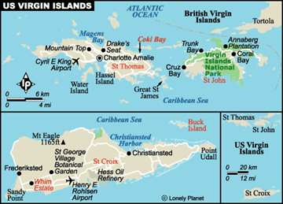
The U.S. Virgin Islands are located 1,100 miles east-southeast of Miami, Florida, and 1,600 miles southeast of New York City at 18°20’ N Latitude and 64°50’ W Longitude. The island of St. Thomas is approximately 40 miles east of Puerto Rico and St. John is three miles east of St. Thomas. The British Virgin Islands are located less than three miles northeast of the island of St. John. Charlotte Amalie, the capitol of the Virgin Islands is located near the enter and along the southern shore St. Thomas. The island of St. Croix is 40 miles directly south of its sister islands St. Thomas and St. John and lies fully within the Caribbean Sea at approximately 17⁰ 45'N Latitude and 64⁰ 45’ W Longitude. It is the easternmost point in the United States with Point Udall being at the eastern tip of the island.

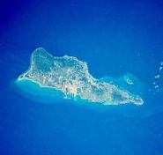
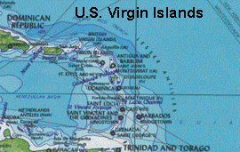
The Virgin Islands has a population of 112,128, distributed among three major islands: St. Thomas (52,838), St. Croix (57,171), and St. John (4,333). The population has been growing at the rate of 0.6 percent per year. This growth rate is expected to continue at the historical rate of 0.6 percent. The Virgin Islands are experiencing slight out-migration to the U.S. mainland for educational and job opportunities and the per capita birth rate has declined slightly in recent years resulting in the relatively low growth rate as compared to years past. However, there are also indications of increasing numbers of people migrating into the Virgin Islands to live and enjoy the Caribbean tropical environment and to follow the improving economy of the Virgin Islands. Therefore there is anticipation of possible increased growth.

Geography
The island of St. Thomas is 32 square miles and the island of St. John is 23 square miles in size. They are both distinguished by a rugged, mountainous topography with numerous sandy beaches and inlets along the shoreline. St. Croix is the largest in area at 84 square miles and is known for its rolling hills and broad central plain which separates the relatively dry east end from the more tropical west end. Moist and dry forest cover 46% of the land mass of St. Thomas, 61% of the land mass of St. John and 10% of the land mass of St. Croix. St. Thomas can be characterized as an urbanized island with only a few undeveloped areas remaining. This is in contrast to St. John, where two thirds of the land area is a U.S. National Park, the result of action in 1956 when approximately 5,000 acres of St. John were donated to the U.S. government for a National Park. In the years 1960, 1962, and 1978, additional land was purchased on and offshore to protect the coral reefs and other historic places from commercial or private destruction. The Virgin Islands are an important location along the Anegada Passage which is a key shipping lane for the Panama Canal. St. . Thomas has one of the best natural deepwater harbors in the Caribbean.

Island Geology
The Virgin Islands are volcanic islands, part of a sub-marine mountain range which includes the larger islands of the Greater Antilles and the Lesser Antilles. This chain of islands begins with Cuba and ends with Trinidad, off the coast of Venezuela. The Virgin Islands have a relatively clear geologic record stretching back some 100 million years to the late Cretatious period. This places the earliest stages of island building at a time when the major continents were probably much closer together. The long process of undersea mountain building and uplift brought sub-marine ridges and peaks to the surface where periods of explosive volcanism alternating with centuries of coral reef deposits, changing sea levels and further intrusion created the formations seen in the Virgin Islands at the present time.

The first stages of island development took place underwater. These first volcanic flows were later uplifted and exposed. The oldest exposed rocks are still recognizable as separate flows. Known as the Water Island Formation, they include examples of pillow lava. Four subsequent stages in the development of the Virgin Islands followed the Water Island Formation. The Roisenhoi Formation was a time of explosive shallow water and subaerial volcanism. The material of this formation contains extensive explosive volcanic products such as andesite and tuff (solidified ash). The close of the fiery second phase development was followed by a period of relative serenity during which sediments from coral and the skeletons of planktonic creatures slowly accumulated on the slopes of the older volcanics as a dark-colored limestone.

Climate and Environmental Hazards
The climate of the U.S. Virgin Islands can be characterized as subtropical, tempered by easterly trade winds, relatively low humidity and little seasonal temperature variation. The rainy season is from September to November. Daily temperatures range from a low of 80°F to a high of 89° F. The Virgin Islands annual rainfall is 40 inches per year with September and May being the rainiest months. The Virgin Islands experience frequent and severe droughts along with occasional floods. There are also occasional light earthquake tremors but none have been significant. The vegetation runs from cactus and scrub on the eastern end to a rain forest in the northwestern section of the island. Moderate year-round 70-80 per cent humidity with constant easterly trade winds create an ideal year-round climate.

The Virgin Islands are subjected to frequent threats of hurricanes. Hurricane Hugo in 1989 and Hurricane Marilyn in 1995 caused extensive damage. Several other hurricanes over the past 20 years have caused minor damage but not the catastrophic damage that occurred with Hugo and Marilyn.

Energy Sources
The Virgin Islands are almost exclusively dependent on petroleum for their energy requirements. Approximately 68% of the energy consumed is in the form of electricity. All electricity is produced from the burning of petroleum fuels, specifically, either No. 6 or No. 2 oil. The HOVENSA Oil refinery currently accounts for providing over 90% of the petroleum energy for the islands. A very small amount of petroleum fuel is furnished from Puerto Rico. HOVENSA Oil refinery is self-sufficient with respect to fuel, electricity and water supply and is not interconnected with the Virgin Islands Water and Power Authority.

The distributors of fuel in the U.S. Virgin Islands are primarily ESSO and Texaco. The HOVENSA refinery is also a major distributor of diesel fuel – supplying diesel directly to various industrial units like the Cruzan and Brugal Rum Distilleries, some construction companies and the Virgin Islands Water and Power Authority. There are also local distributors of LP gas on each of the three main islands.

There is currently very little renewable resource use in the Virgin Islands except for a small percentage of homes using solar water heater. The potential exists for a small percentage of the energy needs to be met with renewable sources of various forms.

Solar water heating is the most cost-effective renewable source that can make the greatest impact in the near term in the reduction of fossil fuels. There are several systems installed in the U.S. Virgin Islands but the number does not make a major impact on the use of fossil fuels.

Wind systems have some potential although the wind resource is less in the Virgin Islands as compared to locations at higher latitudes. The Virgin Islands Water and Power Authority had recently sought bids from private parties to install a wind power system on St. Croix. One firm submitted a proposal for the installation of 20 mWe from 15 towers to be located on the southeast corner of St. Croix. The Authority initiated negotiations, but the firm withdrew from these negotiations due to technical, financial and hurricane risk issues. There is considered potential for wind power but it will require careful analysis of the technical, financial and storm risks.

Biomass has only limited potential because of limited land availability and relatively arid climate. No biomass renewable energy system was reported.

Hydroelectric potential is limited because of the terrain and climatic conditions of the U.S. Virgin Islands. Water supply is itself is a critical problem for the islands.

Energy Uses
The major form of energy utilized by residents in the U.S. Virgin Islands is electrical energy. The electricity is produced almost exclusively by oil-fired generators using two different types of fuel, No. 6 heavy fuel oil and No. 2 diesel fuel; both obtained from Hovenza refinery on St.Croix. Electrical energy has historically represented approximately 68% of the energy use on the islands, exclusive of the energy used at the Hovenza refinery. The second major energy form utilized in the Virgin Islands is the chemical energy found in diesel fuel. Historically this source contributed to 20% of the energy needs. Gasoline consumption historically has represented approximately 7.0% of energy consumption. Propane gas (LPG) is available on the islands and is used mainly for cooking and water heating. This is usually less than 1.0% of total energy consumption. Aviation fuel use historically represented about 4% of the energy usage.

HISTORY, POLITICAL DEVELOPMENT AND PRESENT STATUS

Early Island History
The first inhabitants of the Virgin Islands were peaceful Indians, Arawaks and Ciboneys, who arrived around 300 A.D. and settled here for more than 1,000 years. They were later replaced by the Carib Indians. Columbus discovered the Virgin Islands on his second trip to America in 1493. Enchanted by the beauty of all the many islands scattered across the Caribbean, Christopher Columbus named them in honor of Saint Ursula and her legendary 11,000 martyred Virgins. The histories of many nations and the peoples of various tribes throughout the Caribbean have played a dominant role in the creation of the U.S. Virgin Islands as a political entity. Because of these influences, the U.S.Virgin Islands throughout its history, has both prospered and suffered. The individual flags of Spain, England, Holland, France, the Knights of Malta, Denmark and the United States have flown at one time or another over the U.S. Virgin Islands. Though Spain claimed most of the Caribbean islands through Columbus’ explorations, she made little effort to colonize or develop them. And, in the centuries that followed, the islands and the Caribbean area in general served the fleets of the world; the Admirals, privateers, treasure-seekers, slaves and settlers sought sugar, rum, spices, cotton and gold; thus explaining the many and varied influences in the U.S. Virgin Islands history.

During the 17th century, the archipelago was divided into two territorial units, one English and the other Danish. As Europeans settled in the Virgin Islands in the early 1700s they built plantations for the production of sugar and cotton, utilizing the labor of slaves, mostly from Western Africa. In 1733, a slave revolt resulted in heavy casualties on the islands. In 1848, another slave revolt took place resulting in the slaves being emancipated by the Danish governor at that time. The farming industry declined significantly thereafter until 1875 when a new variety of sugar was introduced.

The 18th century Danish architecture with its gingerbread-adorned Victorian style is a strong, still-visible reminder of the not too distant past, and a scattering of sugar mills and greathouses from the plantations combine to give the islands an old world flavor. To this day, U.S.Virgin Islands retains the Danish land survey, which constitutes the legal description of the property rights; all plots or parcels of land are described by the owner.

Recent Island History
As the twentieth century dawned in the Virgin Islands, poor farming methods resulted in the continued decline of the farming industry until the early 1900s when major rum production began. In 1917, during World War I, the United States purchased the Virgin Islands from Denmark at an approximate cost of $25 million. With its good harbor at St. Thomas, the U.S. Virgin Islands experienced some trade due to its location along the passage route to the Panama Canal. In the later half of the twentieth century the islands began to be a favored holiday and vacation destination for Europeans and Americans. With the development of the cruise ship industry, the U.S. Virgin Islands have become a major port of call for cruise ships, often with multiple ships in harbor every day, making the tourist industry the leading economic driving force in the islands.

Political Development
After the U.S. Virgin Islands were purchased by the United States in 1917 from Denmark, they were first administered by the U.S. Navy. In 1931 they were turned over to the Department of the Interior for administration. In 1936, action by the Congress of the United States created the Organic Act and the Virgin Islands became, for the first time, a self-governing state. In 1954 Congress revised the Organic Act, providing even more home rule for America’s Paradise. The first Governor, Melvin H. Evans, was elected in 1970.

Present Political Status
The United States Virgin Islands is an unincorporated territory of the U.S. government under the Revised Organic Act of 1954. As a territory, most federal laws, rules and regulations are applicable. The islands are by treaty outside the United States Customs area and therefore many rules pertaining to Customs are different. Virgin Islanders are United States citizens. The U.S. Virgin Islands has a non-voting delegate to the U.S. House of Representatives. Policy relations between the Virgin Islands and the U.S. are under the jurisdiction of the Office of Insular Affairs, U.S. Department of the Interior. There are no first-order administrative divisions as defined by the U.S. government, but there are three islands at the second order: St. Croix, St. John, and St. Thomas. These three islands are divided into two political districts, St. Thomas-St. John and St. Croix. The voting age is 18. Virgin Islands residents are U.S. citizens, but do not vote in U.S. presidential elections. As a territory of the United States, the Chief of State of the Virgin Islands is the President of the United States.

The Virgin Islands government follows the form of the United States with three branches of government, executive, legislative and judicial. The three co-equal branches of government manage the local affairs of the territory of the U.S. Virgin Islands. The Governor and Lt. Governor are elected on the same ticket by popular vote for the four-year terms. The legislative branch of the government is a unicameral Senate with fifteen members elected by popular vote to serve two-year terms. Seven members are elected from St. Thomas, seven from St. Croix and one from St. John. Judicial power is vested in the Virgin Islands Territorial Court and District Court under the 3rd Circuit in the U.S. Federal Court System. The Territorial Court judges are appointed by the governor for 10-year terms.

United States Involvement
As a Territory of the United States, there is substantial involvement by the U.S. in the Virgin Islands. The islands are subjected to all of the laws, regulations and benefits generally applicable to the states of the U.S. Particular significant involvement and assistance is provided to the Virgin Islands during hurricane disasters, with FEMA taking a substantial role in providing funding for restoration and mitigation programs.

U.S. Special Island Programs
As a territory of the United States the U.S. Virgin Islands are eligible for a vast array of programs from the United States. These include all of the normal U.S. functional support services such as the Weather Bureau, the U.S. Postal Service, Federal Aviation Administration, Department of Transportation, Federal Deposit Insurance Corporation, Department of Homeland Security – including the Federal Emergency Management Agency (FEMA), Rural Utility Services and many others. One of the major special programs is the assistance available from FEMA during natural disasters.

POPULATION, EMPLOYMENT & WAGES

Present Demographics
The population of the U.S. Virgin Islands in 2005 was 112,128 with 57,171 residents living on the islands of St. Thomas and St. John and 54,957 residents on St. Croix. The civilian labor force was 50,906 and the civilian employment was 47,301. Unemployment was 7.1%. There were 23,566 students in grades K through 12 which was a 2.3% reduction from 2004. There were 323 graduates of the University of the U.S. Virgin Islands in 2005.

Employment and Job Market
The non-agriculture work force in the U.S. Virgin Islands in 2005 was 42,833, a 0.7% increase over 2004. The private sector represented 30,514 jobs and the Territorial government represented 11,445 jobs with the remaining in other various sector jobs.

Gross Domestic Product
In 2005, the U.S. Census Bureau reported that the U.S. Virgin Islands had a GDP of $2.8 billion and a per capita GDP of $18,652. Tourism, oil refining and the government work force form the core of U.S. Virgin Islands economic base. It is estimated that tourism accounts for 65 to 70% of GDP and employment.

Personal Wages & Income
With employment of approximately 43,000, the U.S. Bureau of Labor reports the average wage in the U.S. Virgin Islands is $11.43 per hour. The mean average is $13.91 per hour and the annual mean average wage is $28,930. The average wage has increased 1.3% between 2004 and 2005.

General Business & Commercial Income
Specific information was not able to be obtained for business and commercial income.

Special Employment or Employers
The Hovenza Oil Refinery on the island of St. Croix is the single company that has the largest employment base in the Virgin Islands. There are approximately 3,000 employees of the Hovenza Oil Refinery producing approximately 495,000 barrels of refined petroleum products daily.

ISLAND ECONOMY AND INFRASTRUCTURE

General Status of the Economy
After suffering from the devastating effects of Hurricane Marilyn in 1995, the U.S. Virgin Islands economy has generally been moving strongly forward. Tourism is continuing to be the leading element of the economy. With added harbor facilities to accommodate more cruise ships, the general economic future looks bright. Future growth is anticipated by the addition of new hotel properties, new developments for homes and condominiums and an improved United States economy. In addition, the new pier at Frederiksted in St. Croix will encourage a growing cruise ship trade and will also accommodate the U.S. Navy as an R & R destination. The islands hosted 2.6 million visitors in 2005, including cruise ship excursionists and tourists. The manufacturing sector consists of petroleum refining, watch assembly, textiles, electronics, rum production and pharmaceuticals. The agricultural sector is small, with most food being imported. International business and financial services are small but growing components of the economy are a focus of economic development programs. One of the world's largest petroleum refineries is at Saint Croix. The islands are subject to substantial damage from storms. The government is working to improve fiscal discipline, to support construction projects in the private sector, to expand tourist facilities, to reduce crime, and to protect the environment.

In 2001, a new territorial law added incentives for attracting new businesses to the islands. Service businesses, such as financial service providers, were sought to help diversify the economy. This incentive program is operated by the territory's Economic Development Commission (EDC). The enhanced provisions of 2001 attracted many businesses to the U.S. Virgin Islands, bringing large amounts of startup capital funds to build infrastructure and housing units resulting in an estimated $100 to $200 million in additional revenues for the Virgin Islands Treasury.

Major Employment Sectors
Tourism is the major industry of the U.S. Virgin Islands with oil refining, rum production and watch assembly following in order of significance. In 2005 there were over 1.9 million tourist visitors to the Virgin Islands. Over 850 cruise ships arrived at the ports in St. Thomas and St. Croix in 2005, with 814 of those in St. Thomas.

Electric System
The electrical service for the Virgin Islands is provided by the Virgin Islands Water and Power Authority, locally known as WAPA and officially referred to as the Authority. The Authority was created in 1964 and is an instrument of the government of the Virgin Islands for the purpose of providing water and power utilities. It is an autonomous entity governed by a nine person Governing Board. The Board members are appointed by the Governor with the advice and consent of the Legislature. Three members are selected from among high-ranking executive branch officials and of the remaining six selected by the Governor; three members must reside in the district of St. Thomas/St. John and three in the district of St. Croix. Board members are appointed for three year terms and serve at the pleasure of the Governor.

The Authority serves approximately 51,000 residential, commercial, industrial and governmental customers for a population of approximately 112,000 throughout the three major and two smaller islands of the group. Electric revenue in 2005 was $169,900,000 of which $98,948,022 (58%) was for fuel.

The Board has responsibility for all aspects of the Authority including issuing debt, engaging in system development, and all aspects of operation, budgeting and purchasing. The Authority is subject to the jurisdiction of the Virgin Islands Public Utility Commission, a governmental agency established by the Virgin Islands Legislature for oversight and approval of the Authority’s rates.

The Board selects the General Manager, who is responsible for all employment and other matters of the Authority. Non-supervisory employees are represented by the Virgin Islands Employees Union. There are approximately 500 employees in the electric utility and 300 employees in the water utility.

St. Thomas and St. Croix each has its own electrical supply system. St. John’s electrical power is supplied by undersea cable from St. Thomas, and also has an emergency diesel generator for stand-by power. Water Island and Ressel Island, each located one half mile off the southern coast of St. Thomas, are also served by underwater cable from the St. Thomas electric distribution grid.

The electric utility has total assets of $334.2 million; liabilities of $228.5 million of which $160.8 million is long term debt; and total net assets of $105.7 million of which $69.1 million is invested in capital assets, net of related debt and $17.75 million is in restricted assets.

Water and Wastewater Systems

Water Production Facilities
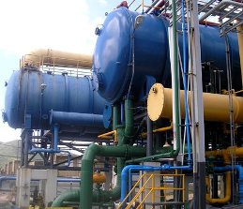
The Authority operates eight Multi Effect Distillation (“MED”) desalination units to produce potable water. Four MED desalination units are located at the Randolph E. Harley Generating Station in St. Thomas and four MED units at the Estate Richmond Generating Station in St. Croix. To produce potable water, the desalination units require both high pressure (150 psi) steam and low pressure (26 psi) steam. This steam is extracted from the steam turbine generating units or supplied in part by the waste heat boilers. The water distribution is provided by the Authority and serves approximately 11,000 customers. The system extends throughout the lower elevations of St. Thomas with the upper elevation areas dependent upon individual home or business catchment systems with large cisterns for storage of water. A local service industry of delivery of water purchased from the Authority services homes and businesses when their catchment systems run low. St. John’s water system is primarily catchment systems with some local wells. The water distribution system for St. Croix is more extensive than that on St. Thomas due to the more level terrain. An estimated 90% of the homes in St. Croix are served by the Authority’s water distribution system.

Wastewater system
The wastewater system is operated by the Virgin Islands Public Works Deptartment. There are two wastewater treatment plants on St. Thomas. The wastewater collection system in St. Thomas and St. John is fairly complete at the lower elevations but at elevations much in excess of 300 feet, most homes and businesses utilize septic systems. The wastewater collection system on St. Croix is more extensive, serving an estimated 85% of the homes and businesses. Homes and business not served by the wastewater collection system utilize septic systems.

The solid waste operations - collection and disposal - on all three islands are under the direction of the Department of Public Works. Additionally, litter enforcement and training are provided by DPW. Solid waste collection is a combination of curbside collection and roadside garbage bins. The solid waste collected is disposed of via landfill. Land limitations may adversely affect this method of disposal in the future. There are no landfill gas recovery systems on the landfill sites, nor are there any waste-to-energy facilities at the landfill sites.

Transportation
The main transportation system in the Virgin Islands is private vehicles. Most vehicles are a typical mix of American, European and Japanese vehicles, of generally larger size, with U.S. standard left hand drive configuration, although road traffic follows the British left side travel. There is a public transit system utilizing standard size municipal buses in St. Thomas and St. Croix. There is also an “on-demand” taxi transportation system for the local population which also serves the large numbers of tourists, especially cruise ship tourists. A large part of the “on-demand” service is provided by the substantial number of open air type vehicle carriages which are 12 to 20 person carriages built into and mounted on the back of late model pickup trucks and one ton trucks. There is also a good standard automobile based taxi service. Many of the hotels and resorts also have their own vans for guest transportation. There is no rail transport system. The road system is reasonably good, although crowded when the tourist population is heavy.

Between islands there are ferry boats, regular smaller land based aircraft and also a good, frequent small seaplane service for intra-island service.

Port and Port Industries
The sea ports of the Virgin Islands are major elements in sustaining the primary industry of tourism in the Islands. Each island has major sea ports that provide berthing space for cruise ships arriving on a daily basis. In 2005 814 cruise ships docked in St. Thomas and 48 docked in St. Croix. St. Thomas had a decline from 922 cruise ships in 2004, but there had been 949 and 909 arriving cruise ships in 2000 and 2001 respectfully. St. Croix experienced an increase in 2005 from 11 cruise ships in 2004 and 25 in 2003, a number which had declined from an average of 139 and 138 arriving cruise ships in 2000 and 2001. In 2005, 1,910,000 cruise ship passengers arrived in St. Thomas/St. John. St. Croix had 54,500 cruise ship visitors in 2005, a decline from 237,400 cruise ship passengers arriving in 2001.

The Virgin Islands Port Authority (VIPA) owns and manages the sea and air ports located in the U.S. Virgin Islands. Its mandate is to promote the wise use of these facilities for the betterment of the Virgin Islands and its people, and to assist the government of the Virgin Islands in fostering and sustaining sound economic development. The Port Authority operates two major ports on the island of St. Croix: the Ann E Abramson Marine Facility in Frederiksted, and the Gallows Bay Dock in Christiansted. The VIPA plans a major commerce/business park on a 100 acre site, located south of the Henry E. Rohlsen International Airport on St. Croix.

There are two cruise ship ports on St. Thomas, the Crown Bay Cruise Ship Port and the West Indian Company Dock. The West Indian Company Dock is the main cruise ship port on St. Thomas. It is owned by the Virgin Islands government Public Finance Authority and managed by the West Indian Company Ltd. The length of the dock is 2,730 feet with depths ranging from 30 to 34 feet. It can berth up to three cruise ships simultaneously including Eagle-class vessels.

The Port Authority owns and operates the Crown Bay Cruise Ship Port, which is the second main cruise ship port on St. Thomas. Crown Bay has two docks which can accommodate three cruise ships simultaneously. The Port Authority has recently invested over $28 million to develop the Crown Bay Cruise Ship Port into a first-class facility for cruise ship patrons.

In addition to the various major cruise ship dock facilities, St. Thomas also has major waterfront dock facilities in downtown Charlotte Amalie. This facility is owned and operated by the VIPA.

On the island of St. John there are two dock facilities: the St. John Cargo Dock at Cruz Bay and the recently developed Enighed Pond, also at Cruz Bay. Both of these facilities are cargo docks, but the St. John Cargo Dock is also used by passenger vessels.

Airports and Aviation Industries
There are two major airports in the U.S. Virgin Islands: the Cyril E. King Airport in St. Thomas and the Henry E. Rohlsen International Airport in St. Croix. Nearly all of the major airlines fly into the Virgin Islands with American and American Eagle carrying the largest number of passengers, followed by Delta, U.S. Air, Continental, and United Airlines. There are numerous other small airlines that provide service throughout the Caribbean region that operate through the two airports. In 2001, the latest year for which complete numbers were available, there were 30,946 landings with approximately 587,000 arriving and 595,000 departing passengers at the Cyril E. King airport in St. Thomas.

Communication System
The telephone, both land and cell based, cable television and internet services are provided by Innovative Communication Corp. There are approximately 71,000 land based access lines providing the full range of communications services to the Virgin Islands. At present AT&T offers long distance telephone service via undersea cable, microwave and satellite connections. It is also making available locally its communication systems and dedicated services for interested businesses.

The U.S. Postal Service serves the U.S. Virgin Islands with mainland rates. Overnight Express Mail is available from most major mainland cities, with second day service from anywhere in the U.S. Postal System. Federal Express, United Parcel Service and DHL have local offices.

There are two daily newspapers, The St. Croix Avis and The Virgin Islands Daily news. The New York Times, Wall Street Journal, USA Today, the Miami Herald and the San Juan Star, as well as other newspapers and periodicals, are flown in daily.

Network and cable television offer about 57 channels of programming, including direct satellite transmission of news and sports. Locally, WSVI-TV Channel 8, VI Public TV Channel 12, TV-2, UPN-27, and 2 Puerto Rican TV stations are available. There are approximately 30 AM and FM radio stations providing programming formats to please a variety of listeners.

Tourism Industry
In 2005 there were 2,605,000 visitors to the U.S. Virgin Islands, a decline from 2004 of .6%. Cruise ship excursionists represented 1,912,500 visitors and tourists to the islands with extended stays represented 574,000. This was an increase of 5.7% over 2004. Income from visitors was $1,495 million, a 10.1% increase from 2004, with income from excursionists being $863 million, a 9.4% increase, and income from tourists of $629 million, an 11.1% increase over 2004.

Major Industry
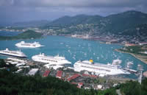
Other than tourism, the other major industry is the HOVENSA Oil Refinery. Located on the island of St. Croix HOVENSA is one of the largest and most modern oil refineries in the world with a refining capacity of approximately 490,000 barrels of crude oil per day. Most of the refined product is exported to the United States mainland. The HOVENSA refinery is a joint venture between Hess Corporation and the Venezuelan Nationalized oil company, Petroleos de Venezuela, S.A. (PDVSA). The joint venture creating HOVENSA was completed in 1998 with special agreements with the Virgin Islands, who provide substantial tax exempt municipal bond funds for the development of the refinery through their Public Finance Authority. HOVENSA employs approximately 3,000 people and provides substantial tax revenue to the government of the Virgin Islands. The HOVENSA refinery also includes a delayed coking unit (Coker), completed in 2002. The Coker allows for the manufacture of gasoline and heating oil using lower cost, heavy crude oil, which significantly improves the conversion economics. Petroleum Coke is a byproduct of the Coker unit and is an almost pure carbon fuel source that can be utilized as a low cost fuel for firing in electrical power plants, normally as a supplement fuel in a coal fired power plant. Most of the petroleum coke is marketed to electric utilities in the United States. Other industries include light industry, such as watch assembly, pharmaceutical manufacturing, some high-tech component manufacturing, small-scale farming, fishing and a dairy industry. Cattle breeding on St. Croix has developed the docile, hornless Senepol. The Senepol breed has gained a reputation as one of the best warm climate animals with a resistance to ticks and is also recognized as quality beef.

Military
There are no military facilities or personnel stationed in the Virgin Islands. The U.S. Navy occasionally docks at the ports in St. Thomas and St. Croix to provide R & R for their crew.

Other Special Economic Elements
With favorable U.S. tax laws encouraging the establishment of certain financial businesses in the Islands, there has been a movement of companies, mostly from the U.S., to the Virgin Islands in recent years. However, abuses of the regulations have resulted in a slow down of the establishment of the financial sector in the islands recently. Officials are working to clarify the regulations and monitoring system in order to continue the development of the financial industry sector. The significant and often affluent tourism trade has resulted in the development of an extensive fine jewelry and watch retail sector in St. Thomas. This retail sector contributes substantially to the economy of the island. Another economic area special to the U.S. Virgin Islands is a result of the unique Caribbean environment of St. John and St. Thomas. The islands have become an attractive location to develop second homes or condo investments. A luxury home and condo construction industry has developed in recent years and is especially active on the island of St. John. The homes and condos are primarily owned by citizens from the U.S. mainland.

Manufacturing, Craft, Trade
There are local crafts manufactured in the U.S. Virgin Islands but the industry is not a major income producer for the islands. The watch assembly industry on St. Croix, which once was quite significant, has been in decline in recent years, although still provides employment and tax revenue in St. Croix.

Agriculture
Agriculture is limited in the islands due to the less than favorable terrain and the soils. Other than limited local garden products and the Senepol cattle breeding business on St. Croix, there is little other agriculture industry in the U.S. Virgin Islands and nearly all food stocks are imported.

Aquaculture, Fisheries
With the tourism industry, there is significant activity in sport fishing. There is limited aquaculture activity in the islands.

ECONOMIC DEVELOPMENT PLANS AND PROJECTS

General Status of Economic Development Planning
The U.S. Virgin Islands has a strong and active government-directed program of economic development. They have developed plans particularly in the area of tourism, attracting financial and business headquarters to locate in the U.S. Virgin Islands. The USVI Industrial Development Program provides exemptions from nearly all local taxes and a 90% income tax exemption. In order to qualify, a business must invest $50,000 or more in a USVI business and employ ten persons. Initial tax benefits are granted by the USVI Industrial Development Commission for either ten or fifteen years and may be renewed for five year periods. The Industrial Development Program is typically used by hotels, light manufacturing enterprises, and service businesses. Benefits are usually not granted for businesses which primarily serve the local market. USVI resident shareholders of companies which have benefits are also entitled to 90% income tax exemptions.

Manufacturers which plan to import products into the United States can combine the benefits of the Industrial Development Program with those of a federal law to eliminate U.S. customs duties if there is a sufficient amount of value added to the product in the USVI.

Economic Development Approach and Special Issues
By the actions taken in infrastructure development and public information programs, it is evident that the general approach by the U.S. Virgin Islands Economic Development programs is to build good infrastructure and develop a focused public relation and information programs to attract the target market. On St. Thomas there have recently been major improvements to several dock areas including the building of a major marina to attract luxury yachts. There are several large resort projects under construction and plans are underway for additional infrastructure. There have also been recent additions to the dock facilities at St. Croix.

Focus Areas
The focus of the Economic Development is in the area of tourism and attracting financial and business corporate headquarters to locate in the U.S. Virgin Islands. The various governmental agencies such as the Port Authority focus on the building of ports and docking facilities to accommodate and attract cruise ships, luxury yacht owners, water taxis and transportation services to serve the tourist trade.

Energy Considerations
It was not evident from the Economic Development activities of the Virgin Islands that energy issues were a part of the Economic Development process or consideration.

Economy Diversification
There is an effort to have a more diversified economy and that is evident in the focus of the past few years to attract financial and business corporate headquarters to the island. Also the fact that the U.S. Virgin Islands is a desired location to build second homes and investment condos indicates that the type of transient visitor to the U.S. Virgin Islands is changing from one of strictly short term tourist to more long term resident with sources of income external to the island.

Import-Export and Balance of Payments
Exports for 2004 were $7,907 million and imports were $7,547 million.

STATUS OF ENERGY SYSTEMS

Major Energy Uses
Major energy uses on the U.S. Virgin Islands are electric power for lighting and air conditioning of residences, hotels, resorts, retail and commercial business, water desalination, land transportation, boating and sea transportation, aviation, cooking and hot water for domestic purposes. The major energy intensive-industry in the U.S. Virgin Islands is the HOVENSA Oil Refinery; however, their energy use is not a part of this report.

The HOVENSA Oil refinery would not release information on the volumes of fuel provided to the Virgin Islands for this report and no other sources were available with any degree of accuracy. However, the main use of fuel in the U.S. Virgin Islands is the Virgin Island Water and Power Authority. Approximately 90% of their fuel energy goes toward the generation of electrical power and the remaining 10% is used to produce water from the Authority’s desalination plants on St. Thomas and St. Croix. In 2005 the Authority utilized 98,823,400 gallons of No. 6 and No. 2 diesel fuel to produce 908,568 MWh of electrical energy for the customers of St. Thomas/St. John and St. Croix.

Electric Power System

Organization
The Water and Power Authority (Authority) of the Virgin Islands is responsible for the production and distribution of electrical power in the Virgin Islands. The Authority was created in 1964 by the government of the U.S. Virgin Islands pursuant to Chapter 5 of Title 30 of the U.S. Virgin Islands Code, as amended by Act 4108, approved on March 1978 and Act 4497 approved on October 23, 1980 (the "Virgin Islands Water and Power Authority Act), for the purpose of developing an adequate electric and water supply for the Virgin Islands. The Authority owns, operates and maintains electric generation, distribution, and general plant facilities that supply electric power and energy to over 51,000 customers in the U.S. Virgin Islands. The service territory includes the islands of St. Thomas, St. Croix, and St. John. The Authority also provides electric service to Hassel Island and Water Island which are located near the St. Thomas harbor. The customers, sales and electrical loads of St. John Island, Hassel Island, and Water Island are included as part of St. Thomas. With the exception of a few commercial entities that produce electricity for their own use, there are no electric utilities other than the Authority.

The Authority also owns, operates and maintains potable water production and storage facilities. These facilities include wells and seawater desalinization equipment, and distribution facilities that supply a portion of the potable water requirements for ultimate distribution and sale. The Authority maintains separate electric and water systems which are independently financed with each system's indebtedness secured by separate and distinct claims on that particular system's net revenues. Common facilities and costs necessary for the production of electricity and water, as well as general administration, are allocated between the Electric System and the Water System.

Description of the System
The electric system is divided between St. Thomas and St. Croix. St. John is connected to St. Thomas via an underwater cable. The installed capacity on St. Thomas is about 115 MW and on St. Croix about 88 MW. The capacity for some units is derated as steam is extracted for water desalination purposes. The peak loads are 87 MW for St. Thomas and 53 MW for St. Croix. Despite the large reserve electrical power supply margins, the system occasionally experiences reliability problems because of its isolation and because of maintenance difficulties, although recent studies have indicated that the reliability of St. Thomas is approximately 99.9880% and St. Croix is 99.9962%.

Electricity costs are high by U.S. mainland standards – 31 to 34 cents per kilowatt hour. Seventy (70%) percent of the Authority’s cost is for fuel. All electrical generation equipment is oil-fired with either No. 2 diesel oil or No. 6 heavy oil. Fuel oil supply costs have doubled in the past two years to near $70 per bbl, which is the main cause of the relatively high cost of electricity.

The existing transmission and distribution facilities on the islands of St. Thomas and St. Croix are not interconnected electrically due to the extreme depth of the ocean floor plus the forty mile distance that separates these two islands. Hassel Island, Water Island, and the island of St. John receive electric power and energy from St. Thomas by means of submarine cables. Power is transmitted from the island of St. Thomas to Hassel island, and to Water Island through two 15 kV rated submarine cables that are operated at 13.8 kV, and to the island of St. John through two 35 kV rated submarine cables that are operated at 34.5 kV. A third 35 kV cable that was installed in the 1970s from Cabrita Point (St. Thomas) to Frank Bay (St. John) has been taken out of service following the installation of a new 35 kV cable in early 2004 from Great Bay (St. Thomas) to Frank Bay (St. John). The older cable is available for emergency use at 13.8kV.

Substation at St. Croix

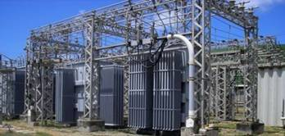
Island of St. Croix
The primary distribution system on the island of St. Croix is a radial configuration with nine feeders all originating at the substation located at the Estate Richmond Generating Station. Six of the nine feeders operate at 13.8 kV, the other three operate at 24.9 kV.

Island of St. Thomas
On the island of St. Thomas, the Authority has three sub-transmission lines (Feeder No. 11, No. 12, and No.13) that are operated at 34.5 kV and electrically connect the Krum Bay Generating Station to the Rehelio Hatchette Substation, the East End Substation, the Tutu Substation and the St. John Substation. The East End Substation was dedicated on September 18, 1996 and the St. John Substation was dedicated in December 2004. In addition to the two sub-transmission lines, six distribution feeders originate at the substation located at the Randolph E. Harley Generating Station and primary distribution feeders originate from the four substations: three from the Rehelio Hatchette Substation, three from the Tutu Substation, three from the East End Substation and three from the St. John Substation. All of the distribution feeders operate at 13.8 kV. The Tutu Substation, East End and St. John Substation provide for improved distribution of electric power on the east end of the island of St. Thomas and the island of St. John, which is a considerable distance from the Randolph E. Harley Generating Station. With the completion of the East End Substation, the St. John Substation and the third 34.5 kV Feeder (No. 13) which is operated in a loop, the reliability of the distribution of power to the island of St. John and the East End of the island of St. Thomas has improved.

The St. Thomas distribution system consists primarily of overhead lines along with several circuits and segments of circuits which are placed underground. Feeder No. 5A from the Randolph E. Harley Generating Station to the Cyril E. King Airport and Feeder Nos. 9B from the Rehelio Substation to the hospital are underground. Other underground distribution lines include short segments of Feeder Nos. 7A, 8A, 9A, 9B, and 10B. Significant portions of Feeder Nos. 11, 12, and 13 operate at 34.5 kV underground from the Randolph E. Harley Generating Station to the Rehelio Hatchette Substation. In addition, the line segment from the Tutu Substation to the vicinity of the bridge in Nadir on Feeder No. 11 is also underground.

System Losses
The Authority has performed studies on the substation, transmission and distribution system and has identified that the system losses from power plant to customer’s meter is 8%. The cost of fuel for the Authority in 2005 was $98,156,152. Therefore losses in the system represented $7,852,500. Losses of 8% on a system of the size and density of the St. Thomas and St. Croix system is slightly high but not unusual. Many utilities will experience losses in the range of 5.5% to 6.5% in urban service areas.

To improve the quality of service, increase voltage level, and reduce kVA losses, the
Authority installs capacitor banks on its distribution system. Installation of capacitors can help save energy by furnishing the necessary reactive energy to cancel out the lagging reactive energy required by the many induction motors and loads on the system. By locating capacitors that cancel out the induction load reactive energy on the distribution lines close to the induction loads, current flow that normally must travel back to the generator is eliminated. In addition, the energy required by the generator to serve the induction load reactive power is eliminated resulting in energy savings for the system. Due to constantly changing load profiles on the distribution lines, it is necessary to monitor the distribution systems to assure that the optimum number and size of capacitors are installed on the distribution system. The Authority does have a program to periodically review the loads and take corrective action.

Table 4-1 Peak Demand, Average Load and Energy Production
Year | Gross Elec. Demand  STT-SJ (MW) | Gross Elec. Demand  St. Croix (MW) | STT-SJ (Average Load MW) | St. Croix (Average Load MW) | Elec. Production STT-SJ (MWH) | Elec. Production  St. Croix  (MWH)
2002 | 76.2 | 49.2 | 56.5 | 36.9 | 504,852 | 350,788
2003 | 80.6 | 52.7 | 59.8 | 39.5 | 528,391 | 358,538
2004 | 83.1 | 54.9 | 62.7 | 41.1 | 548,619 | 359,941
2005 | 86.3 | 55.5 | 63.4 | 41.7 | 555,273 | 365,541

Rates
The Authority’s base electric rates are approximately $0.33167 per kWh but vary from $0.31646 per kWh for residential, $0.34473 per kWh for commercial and $0.34134 per kWh for industrial. The Authority’s rates also include a Levelized Energy Adjustment Clause (LEAC) that adjusts monthly based on the cost of fuel. The present LEAC, based on approximately $70 per bbl. fuel costs is $0.234026 per kWh. The Authority is required to submit changes in rates to the Virgin Island Public Service Commission (PSC).

These changes may include changes to the base electric rates, changes in the methodology of calculating the LEAC plus any surcharges to be placed on the electric rates. The PSC in the past has limited some pass through fuel charges resulting in the Authority not being able to recover the full cost of fuel expense. The PSC has allowed some delayed recovery of fuel costs, but this has resulted in large amounts of fuel costs that have not been recovered and consequently creates financial and cash flow difficulties for the Authority.

Operational Issues
The headquarters of the Authority is located in the western part of Charlotte Amalie on the island of St. Thomas. The Authority’s operation is divided into two separate major locations: St. Thomas and St. Croix. The facilities for St. John are managed by the St. Thomas operational group. The Authority has developed very professional staff throughout their organization including their headquarters and at each of their separate operational centers and other administrative and operational centers. The Authority has developed capable personnel who direct the planning, operational and financial segments of the operation. Tours through the respective plants in preparation for the development of this report found the supervisory and operational personnel to be professional and knowledgeable with a broad range of operational issues and with specific details of operations. The Authority has effectively utilized the services of qualified consulting engineers and advisors to assist in assessing operations, developing long range strategic plans, analyzing future options and designing facility additions or improvements. Specifically noted was the breadth and depth of knowledge by planning and operational managers and supervisory personnel when questions were poised regarding various design and operational issues relating to plant fuel efficiencies. It was obvious that the planners, operational managers and supervisors had already studied and analyzed the various aspects of improving system fuel and operational efficiencies and had either implemented appropriate action or were able to adequately explain operational or technical reasons why a particular change was not possible.

The Authority has correctly made strategic decisions starting in the 1960s and extending to the present time regarding the use of steam boiler –turbine generation, fueled by heavy oil (No. 6), for use as their base load energy supply. Likewise their decision to use combustion turbines with heat recovery boilers for their peaking loads was an appropriate strategic decision when made and implemented. Steam boiler-turbine units of the type that the Authority installed in the 1960s and 1970s offered the best efficiency, reliability and lowest maintenance cost of any optional system available at the time for the size of system that the Authority served and the cost of fuel oil at the time. Diesel engines may have been an option but their efficiencies and especially maintenance costs and long term reliability would not have been the appropriate choice of technology for the Authority at the time the steam-turbine units were installed. Diesel engines may be more efficient if operated at a desired optimum load but the maintenance cost and shorter operational life of a diesel engine often causes the economic analysis to favor a steam-turbine unit when fuel costs are lower. The Authority has made wise choices in installing heat recovery boilers to recover the waste heat from the combustion turbines thus improving the normally less than optimal efficiencies of a combustion turbine. Also, combustion turbines are ideally suited to serve as generating spinning reserve units. The combustion turbines can quickly pick up electrical loads if one of the base-load steam turbines trips off line. Combustion turbines also have a very quick start up time which is necessary to pick up the island loads in the event of a generation unit failure. These two factors make combustion turbines an appropriate technology for non-base load energy for a small system that is focused on reliability of service. This is especially true when fuel costs are in the range of or less than $35 to $40 per barrel. However, as the price of fuel increases, some of the lower maintenance costs, higher reliability, longer life, and better spinning reserve and quick start capabilities of a combustion turbine, begin to place a higher than desired economic price on the balance between reliability and electric energy costs.

The Authority has wisely reviewed the present technology of their generation system with a study by an external expert, The Harris Group Consulting Engineers. The Harris Group’s conclusion and recommendation after a very comprehensive study is for the Authority to continue to operate its system with the existing generating units until such time as the loads increase and the Authority must decide to install additional generation capacity. One of the main factors in this recommendation is the imbedded costs already in the existing system and the limited financial resources of the Authority to purchase a new generating unit at this time. The Authority simply does not have the funds to be able to ignore the existing generating capability, retire the older units and finance and install an entirely new power plant with new technologies, even though they may be more efficient. There have been strong inquiries from the Territories Public Service Commission regarding the possibility of replacing the existing generating units with very large, efficient diesel engines. Such engines have been developed over the past couple of decades by companies from the Northern European countries, to primarily serve the large container and cruise ship power propulsion market. The larger diesel engines have also been widely used in smaller isolated localities as base load generating units. Some of the large diesel engines have generating capacities of 20 MW to 50 MW.

As related by the staff of the Authority, the concept put forth by the engineer for the PSC is that the installation of several large diesel units could provide electricity with greater efficiency than the existing steam-turbine and combustion turbine systems. Also with several units installed to meet the base loads requirements of St. Thomas and St. Croix, the multiple units at each site would provide the level of reliability that is needed for the system. The present system of steam-turbine and combustion turbine generating equipment have efficiency ratios in the range of 25% (plant records and computer readout devices indicate that the Authority’s steam turbines and combustion turbine units are operating at approximately 13,500 to 14,000 Btu per kWh) whereas a large diesel engine, if operated at its optimal load of 70% to 85% of nameplate rating, can have efficiency ratios in the range of 38% (8,900 Btu per kWh). If fuel costs continue to rise, additional analysis will be necessary to determine if there is a turning point when retirement of the existing units is warranted in favor of installation of some other technology that converts petroleum energy to electricity more efficiently than the present system. One very serious concern expressed by the Authority personnel is that there is a strong possibility that diesel engines can not obtain EPA permits to operate in the U.S. Virgin Islands. Problems exist with diesel engines regarding higher than allowed nitrogen oxide emissions plus other concerns such as particulate emissions and of course there is always the factor of higher noise from a diesel engine power plant.

Generation Facilities
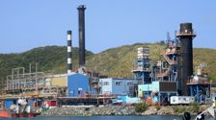
The Authority’s generating facilities on the island of St. Thomas are located at the Krum
Bay site, which is on the southwestern end of the island at the Randolph E. Harley Generating Station. All electric generation for the islands of St. Thomas, St. John, Hassel Island and Water Island are located at this site, except for an emergency diesel generating unit located on the island of St. John. In addition to generation facilities, the Krum Bay site includes water production and storage, fuel oil unloading and storage, and warehouse facilities.

All of the existing generating facilities on the island of St. Croix are located at the Estate Richmond site on the north shore of the island near Christiansted. In addition to generation facilities, the Estate Richmond site includes water production, fuel oil unloading and storage, and warehouse facilities.

Table 4-2

Virgin Islands Electrical Power Generating Units
Location | Unit Number | Size – MW | Type | Year Installed
St. Thomas | # 11 | 20.7 MW | Steam - #6 Oil | 1968
St. Thomas | # 13 | 30.0 MW | Steam - #6 Oil | 1974
St. Thomas | # 12 | 15.1 MW | Gas Turb. #2 Oil | Unavailable
St. Thomas | # 14 | 13.0 MW | Gas Turb. #2 Oil | Unavailable
St. Thomas | # 15 | 22.2 MW | Gas Turb. #2 Oil | Unavailable
St. Thomas | # 18 | 24.3 MW | Gas Turb. #2 Oil | Unavailable
St. Thomas | # 22 | 24.0 MW | Gas Turb. #2 Oil | 2001
St. Thomas | # 23 | 39.3 MW | Gas Turb. #2 Oil | 2004
St. Croix | #10 | 10.0 MW | Steam-#6 oil | 1968
St. Croix | #11 | 19.6 MW | Steam #6 oil | 1974
St. Croix | #16 | 24.5 MW | Comb.Turb.#2Oil | Unavailable
St. Croix | #17 | 24.5 MW | Comb.Turb.#2Oil | Unavailable
St. Croix | #19 | 24.5 MW | Comb.Turb.#2Oil | Unavailable
St. Croix | #20 | 24.5 MW | Comb.Turb.#2Oil | Unavailable

Table 4-3

Total Generation by type and location
 | St. Thomas | St. Croix | Combined

Type | MW | Percent | MW | Percent | MW | Percent
Steam | 55.4 MW | 30.6% | 25.0MW | 21.4% | 80.4 MW | 27.0%
Gas Turbine | 122.8MW | 68.0% | 91.8MW | 78.6% | 214.6 MW | 72.2%
Diesel | 2.5MW | 1.4% | 0.0 | 0.0% | 2.5 MW | 0.8%
Total | 180.7 MW | 100.0% | 116.8 MW | 100.0% | 297.5 MW | 100.0%

For reliability of service, the Authority installed Unit No. 22, a 24 MW combustion turbine in 2001 and Unit No. 23, a 39.3 MW combustion turbine in 2004. In 1997 the Authority installed a waste heat recovery boiler to capture energy from Units No. 18 and No. 15 for use in providing steam either for the water desalination plant or for use in the steam turbine generators.

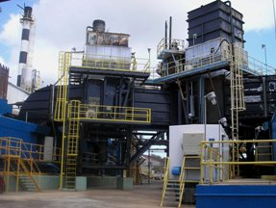
The Authority’s electric generation on both St. Thomas and St. Croix consists of steam generating units, combustion turbines (CT) and waste heat recovery boilers (WHB) that recover heat from the exhaust of the CTs to produce steam, which in turn is used to supplement the steam produced by the steam generating units (i.e. combined-cycle operation). In addition, process extraction steam is taken from the steam generating units and from the WHB for the production of potable water using seawater desalination units at each power plant site. The combination of steam electric generation with potable water production using seawater desalination was initiated in the 1960s. Combined cycle operation was initiated in the 1980s. Because of the isolation of the electric systems on St. Croix and St. Thomas (St. John is interconnected to St. Thomas), typical operations include multiple generating units in operation to provide spinning reserve and redundancy in the event of a generating unit outage. This spinning reserve requirement coupled with the requirements for process steam for the seawater desalination units, and on-going unit outages for repairs and maintenance, often dictate operation of individual units at lower loads, resulting in lower efficiencies.

The nature of an isolated island system does result in the average annual system heat rates for the St. Croix and St. Thomas electric systems to exceed industry norms. The inability to dispatch increments of base loaded units due to the size and nature of the equipment by definition requires operation at less than optimal efficiency. In addition, the balance between reliability and efficiency along with the unique aspects of water production and the inability to shut down or cycle units without severely affecting their useful life all contribute to heat rates above design conditions.

Fuels
All of the Authority's generating units are fueled by oil. During the fiscal year ended June 30, 2005, the Authority generated a total of 908,568 MWh of electric energy and burned 2,352,937 barrels (98,823,400 gallons) of fuel oil. The Authority purchases its fuel from Hovensa refinery located on the island of St. Croix. Current fuel prices are over $70 per barrel.

Historically, the Authority purchased its fuel oil supply from Hess Oil Virgin Islands Corporation (“HOVIC”), an affiliate of the Amerada Hess Corporation, which operated a petroleum refinery on the island of St. Croix. In an agreement between the government and HOVIC which was amended in 1990 and in November 1993, HOVIC was required to maintain in storage facilities sufficient fuel to ensure that there are adequate supplies to meet local fuel needs of the Virgin Islands, including the fuel needs of the Authority for a period of twenty years. In addition, the Hess Agreement required that HOVIC annually submit bids for the sale of fuel oil to the Authority at a maximum price not to exceed the lower of (i) HOVIC's average landed monthly crude oil costs or (ii) the published Exxon New York Contract Cargo prices per barrel or its successor index, less $2.00 per barrel. In March 1998, HOVIC announced that it was contemplating the sale of an interest in its facilities located on the island of St. Croix to Petroleos de Venezuela, S.A., subject to receiving certain concessions from, and reaching an agreement with the government of the Virgin Islands. As a result of the sale, a new joint venture between HOVIC and Petroleous de Venezuela, S.A., was formed, known as HOVENSA. The government, HOVIC and HOVENSA agreed to amend and extend certain provisions contained in the Hess Agreement. In May 1998, the amended agreement was submitted to and approved by the Legislature of the U.S. Virgin Islands. The amendment to the Hess Agreement continues the obligation of HOVENSA (formerly HOVIC) to supply low cost fuel oil to the Authority for a period of twenty years from the declared commercial operation date of new coking facilities. These new facilities were declared operational in 2002, and the amended agreement is in effect until the year 2022.

To comply with the Authority’s purchasing procedures and statutory requirements, and to ensure that the Authority purchases fuel oil at the lowest possible cost, the Authority solicits bid proposals annually from fuel oil suppliers to meet its projected fuel requirements. Pursuant to the Hess Agreement, as amended, the Authority is required to purchase fuel oil from HOVENSA, where the cost of such fuel is less than the market price available to the Authority. As a result of the Hess Agreement, as amended, and the location of HOVENSA facilities on the island of St. Croix, the proposals from HOVENSA are projected to be at prices below those submitted, or to be submitted by other potential fuel oil suppliers, keeping the Authority's cost of fuel below U.S. market prices.

In addition, the Hess Agreement, as amended, stipulates that HOVENSA is to operate oil barges and bid on an annual basis for the transportation of fuel oil from HOVENSA facilities to the Authority's pier and fuel unloading facilities on the islands of St. Thomas and St. Croix. The Authority reports that it currently pays HOVIC $1.80 per barrel to deliver fuel oil to the Authority's generating facilities on the islands of St. Thomas and St. Croix. Fuel oil supply to the island of St. John is trucked from the St. Thomas generating facility to the eastern end of the island and is barged to the storage facilities on the island of St. John. During the spring of 2003, oil supplies from Venezuela to the HOVENSA facilities on the island of St. Croix were reduced due to an oil workers strike in Venezuela. The Authority has had no difficulty purchasing or receiving adequate supplies of fuel oil as specified from HOVENSA to comply with its generation needs, although the price of fuel oil increased substantially.

Because of an increase in the amount of nitrogen content of the fuel oil provided by HOVENSA, the Authority has intermittently exceeded its permitted nitrogen oxide emissions. Based on the guaranteed percent nitrogen content in the No. 2 fuel oil (1000 ppm) by HOVENSA, the Authority was forced to remodel and determine potential air quality impacts from its generating facilities on St. Thomas and St. Croix using said fuel oil. The Authority completed all modeling and air quality analysis to demonstrate that National Ambient Air Quality Standards for NOx would not be exceeded, even if all the gas turbines burned 1000 ppm fuel nitrogen content and the No. 6 boilers emit NOx at the highest level indicated in AP-42. The Authority has prepared and submitted PSD permit modification applications for St. Thomas and St. Croix power plants to support the use of 1000 ppm nitrogen content in No. 2 fuel oil to the EPA for further processing and approval. Although final action for all of the Authority’s units from EPA is pending, the Authority received PSD approval for Unit No. 23 in early 2005 using No. 2 fuel oil containing 1,000 ppm of nitrogen.

During December 2005, the Authority’s delivered cost, including transportation of No. 6 fuel oil, was $63.53 per barrel for 0.3% or 7.0% sulfur (approximately $10.27 per MMBtu). The delivered cost of No. 2 fuel oil in December 2005 was also $63.53 per barrel for 0.2% sulfur (approximately $10.95 per MMBtu). In December 2005, the delivered cost of fuel for No. 6 fuel oil and No. 2 fuel oil regardless of sulfur content was based on the HOVENSA average landed monthly crude oil cost as opposed to market prices. During 2004 and 2005, the cost of fuel oil has increased at unprecedented levels due to world-wide and regional conditions. In addition, the cost of oil is projected to remain at these levels in the near-term future. During 2005, the reported cost of No. 6 fuel oil in the U.S. markets is in excess of $65 per barrel, approximately $10.51 per MMBtu, and the cost of low sulfur No. 2 fuel oil is in excess of $100 per barrel (approximately $17.24 per MMBtu).

The availability of fossil fuels (No. 6 and No. 2 fuel oil) used by the Authority and the prices at which such fuels can be purchased by the Authority are subject to various actions which affect the availability and the price of fuels in the domestic and world markets, and to actions by governmental authorities with respect to fuels. While the Authority has enjoyed a favorable fuel supply arrangement with HOVENSA, the Authority has been encouraged to consider exploring the financial and practical aspects of entering into fuel hedging agreements.

On Site Storage
On the island of St. Thomas, fuel oil storage facilities consist of six above ground steel tanks located at the Randolph E. Harley Generating Station. All of the fuel oil tanks have secondary containment barriers. Two tanks located on a ridge north of the generating station, having a combined nominal capacity of 108,000 barrels, are used to store No. 6 fuel oil. The remaining four above ground tanks, having a combined nominal capacity of 86,000 barrels, are used to store No. 2 fuel oil.

Fuel oil storage facilities on the island of St. Croix consist of seven above ground tanks at the Estate Richmond Generating Station. Two tanks, having a combined nominal capacity of 39,800 barrels, are used to store No. 6 fuel oil, and five tanks having a combined nominal capacity of 69,400 barrels, are used to store No. 2 fuel oil.

Electric Production and Use

Existing Renewable & Alternative Power Production
The U.S. Virgin Islands have many roof top hot water heaters serving household water heating. There are a few isolated photovoltaic units, mostly to serve residential homes. However, renewable and alternative power systems are very limited in the U.S. Virgin Islands.

REGULATORY, ENVIRONMENTAL ISSUES
The U.S. Virgin Islands is subject to all laws and regulations of the U.S. Environmental Protection Agency in regards to environmental issues. They are under the jurisdiction of Region II with its headquarters in New York City. Unlike some Pacific Island Territories, the U.S. Virgin Islands has no waivers on any of the stringent EPA regulations that particularly affect electrical power production. The Authority experiences difficulty in meeting Environmental Air Quality standards at the present time due to the higher sulfur content of the Hovenza fuel.

The generating units owned by the Authority are operated under permits issued by EPA and the Department of Planning and Natural Resources. At this time, the Authority has not yet established expected retirement dates for its existing steam and combustion turbine generating facilities. However, based on the findings of the initial “Condition Assessment Study” performed by the Harris Group dated February 22, 2005, the Harris Group found, among other things, that Combustion Turbine Unit No. 12 and No. 14 and boiler No. 11 on the island of St. Thomas should be dispatched on an emergency basis and eventually retired when replacement generating resources become available. In addition, with the addition of a second heat recovery steam generator (“HRSG”), boiler No. 10 on the island of St. Croix should be used as standby unit.

The government of the U.S. Virgin Islands has established a Public Service Commission which has jurisdiction over the Water and Power Authority’s electric and water rates. The Authority must petition the PSC for permission to increase electric rates including pass-through fuel costs. The PSC has in the past limited the Authority from collecting revenues sufficient to cover actual costs of electric production, resulting in the Authority experiencing very difficult financial issues.

TRANSPORTATION

Fuel Use
There was no information on transportation fuel use available.

Fuel Types and Costs
There was no information on transportation fuel types and costs available

Reducing Transportation Energy Use
The U.S. Virgin Islands has a reasonably fuel efficient transportation system with their various forms of taxi service, tourism buses and private automobiles. The open air carriages mounted on the back of pickup trucks that carry upwards of 20 people is one of the more efficient systems observed. There is also a good bus system network for the transport of cruise ship and other tourist visitors. Therefore it appears that the Virgin Islands has a reasonably efficient fossil fuel transportation system considering the terrain and level of population. The permanent resident population of the islands are relatively concentrated in fairly densely populated areas with short travel distances to work and shops, therefore a more efficient transportation system other than personal automobiles does not appear to be viable.

COMMERCIAL & INDUSTRIAL

Tourism
The tourism industry is not an industry where programs to reduce the use of fossil fuels are easily identified. Tourism to the U.S Virgin Islands is fossil fuel energy intensive by the nature of the location of the islands. However, the transportation sectors of airlines and cruise ships already practise minimizing the use of fossil fuel in their efforts to maximize profits in their respective operations.

Manufacturing
There is limited energy intensive manufacturing in the U.S. Virgin Islands, except the Hovenza Oil Refiner. Therefore there are no significant opportunites in the reduction of fossil fuels from the manufacturing sector. The HOVENSA Oil Refinery is not connected with the U.S. Virgin Islands Water and Power Authority, nor is it under any significant government control that could lead to sponsored programs that could reduce the use of fossil fuels.

Military
There is no military operating in the U.S. Virgin Islands.

Fisheries
There are only limited fisheries operating in the U.S. Virgin Islands. The main type of fishing in the waters around the islands is sport fishing which is a segment of the fuel consuming market that does not lend itself to energy reduction programs.

ALTERNATIVE ENERGY OPPORTUNITIES

Cogeneration

Existing cogeneration
The Virgin Islands presently has made use of only limited co-generation opportunities. The area where co-generation is being used is:

Use of exhaust heat from combustion turbines at power plants in both St. Thomas and St. Croix to provide additional steam energy resources for the steam turbine electric generating units and for steam energy for the desalination water plants.

Opportunities for cogeneration
There are several opportunities that may be possible including:

1. A power purchase arrangement with HOVENSA refinery.
There is presently no electrical or water connection between Hovenza and the U.S. Virgin Islands Water and Power Authority. HOVENSA generates all of its own electrical power at the refinery and by contract terms with the U.S. Virgin Islands government are not permitted to engage in sale of electrical power to any outside entities. Refineries have the capability to utilize the lesser quality fuels for electrical power generation and often have excess capacity available at prices that can be beneficial to the refinery and to the purchaser. Refineries often have extra generating capability and seek opportunities to sell the excess energy to the local utility. WAPA officials, however, reported that HOVENSA has very little excess generating capacity at the refinery and also their agreement with the government of the U.S. Virgin Islands does not include sales of electrical power to external entities.

2. Cogeneration partnerships with large hotels and resorts.
There are many large hotels and resorts located on each of the three major islands of the U.S. Virgin Islands. Most already have installed backup electrical generators. Vendors that provide backup generator equipment usually have complete cogeneration equipment packages that can be incorporated into the electrical power generation systems. The systems capture the exhaust heat from the diesel engine electrical power units and produce hot water for the hotel/resort and also can provide chilled water from the waste exhaust heat through a process utilizing an absorption chiller. The electrical generator systems usually have an efficiency ratio of approximately 35%, (energy value of diesel fuel into the engines vs. energy value of electrical energy out) and when capture of exhaust heat for hot water heating and chilled water for air conditioning is included, the efficiencies can reach 75% to 85%. In comparison the Authority’s power generation system presently has an efficiency ratio of approximately 25% (fuel into the electrical power stations vs. electrical energy delivered to the customer’s meter).

A good operational and maintenance (O&M) program is necessary to keep the cogeneration systems operating correctly. The lack of a good O&M program is often the reason that hotels/resorts which have attempted to operate their own electrical system often decide to switch to WAPA as their main power source.

A good “net-metering” program is also helpful in making co-generation systems work effectively and profitably for a hotel/resort. A “net-metering” program allows the co-generator to operate their system at optimum loads and sell the excess energy to the power provider which in the U.S. Virgin Islands is the Water and Power Authority.

If a partnership arrangement could be established between the resorts and the Authority, it may be possible for the Authority to utilize their very good fuel arrangements, O&M capability and financing to install and operate the units with the benefits shared with the hotel/resort and the excess energy generated could be utilized for delivery and the benefit of the Authority’s customers.

Although there appear to be savings in the use of fossil fuels by encouraging co-generation systems at hotel/resorts, there is substantial concern whether the EPA would allow an emissions permit for such diesel engine base load generation systems. Most co-generation systems would use No. 2 diesel oil for fuel and the Authority officials report that they have been unsuccessful in getting base load diesel engine emissions permitted. If the diesel engines were able to operate on natural gas, it may be possible to obtain EPA permitting, however, natural gas is not available in the U.S. Virgin Islands and the cost and safety issues for developing small system natural gas storage facilities may make it prohibitive.

Alternative Fuel Systems

Status of present production system
The Authority presently utilizes heavy No. 6 fuel oil, often referred to as bunker fuel, as fuel for the steam boilers for their steam-turbine electrical generator systems. The Authority utilizes No. 2 fuel oil for use in their combustion turbines. These were appropriate and wise choices of fuels and energy conversion systems considering cost of fuel, size of the systems and technologies available when most of the systems were installed during the 1970s to the early 1990s. Unfortunately, the Authority’s generating units have a fairly low efficiency ratio since that was the technology available at the time for the size generating units that were needed in the Virgin Islands. The efficiencies of the units are in the range of 13,500 Btu’s to 14,000 Btu’s (British Thermal Units) per kWh produced. Since a kWh of electrical energy has a Btu energy value of 3,413 Btu’s per kWh the efficiency ratio of the boiler-steam turbine system is 25.6% at the generator output. When considering that the electrical losses from the power station through the distribution system to the customer’s meter is 8%, the overall efficiency of “fuel-in to energy-out to the customer’s meter” for the Authority is approximately 23.6%.

Large slow speed diesel engines
Large, (10,000 to 12,000 kW) low speed diesel engines can have fuel efficiencies of 38% and can utilize the lower cost No. 6 bunker oil as a fuel source. However, there are environmental and financial concerns with new diesel engines. Firstly, the Authority officials have reported that it may not be possible to get EPA emission permits for the low speed diesel engines. Secondly, there is a question of location of such a plant, since there is a serious real estate space problem in attempting to locate such large engines at the existing power plant sites. Finally, there is a concern over financing a new plant. A recent report has advised the Authority that even though the fuel efficiencies of their existing systems are less than desired, the capital cost necessary to purchase and install new, large low speed diesel engines, make the quick transition to such engines not economical until electrical loads increase to the level that a new generation unit is necessary. Another concern regarding an installation of large diesel engines is the need to maintain a safe margin of spinning reserve so that if one of the units fails, other units that are on line and running can pick up the load without an island wide outage occurring. Therefore, either the sizing of multiple units of large diesels would need to be considered or the use of an existing combustion turbine always operating in synchronism with the diesel units to assure spinning reserve reliability. A full financial analysis of the options would need to be conducted before considering replacing the existing power generation equipment. Even if such an analysis indicated the installation of a more efficient electrical power production system is a logical choice, the ability to move forward with such a conversion may not be possible since the Authority is greatly restricted in its options considering its imbedded equipment costs, EPA permitting hurdles, real estate space issues, operational spinning reserve considerations and particularly the Authority’s limited financial resources.

Petroleum Coke fueled power plant in cooperation with the refinery.
The Hovenza refinery site is already established as a major environmental site, therefore the installation of a petroleum coke boiler for use in powering a steam turbine-electrical power generator may be an opportunity for exploration by the U.S. Virgin Islands Water and Power Authority. However, the Authority officials also report that there are no provisions with the U.S. Virgin Islands government that presently include such an opportunity and Hovenza has indicated that their interests are in the refinery industry and not production of electrical energy for sale to external entities.

SUPPLY SIDE MANAGEMENT
In developed country utilities, the average power systems losses for a utility with only a generation and a distribution network are estimated at approximately 10%. Nominally, these losses are accounted for in generation, 5%, and distribution, 5%.
In 2000, a preliminary study was carried out on a sample of three (3) U.S. affiliated Insular Areas’ power utilities, to achieve an indication of the energy inefficiencies in the generation, transmission and distribution of electricity in all the U.S affiliated Insular Areas’ power utilities. These were the utilities of Palau, Pohnpei and Kosrae.
This preliminary study indicated that the power system losses in the utilities were far in excess of acceptable standards for these power systems. It was established that the energy losses were occuring in all areas of the power system, including non-technical losses.

It was noted that some data was lacking, such as the number of transformers or the types of conductor used. As a consequence several approximations were used to evaluate the losses. The errors on the figures are difficult to quantify and therefore the results should be carefully used, although it does represent system losses that are far in excess of what is acceptable.
To reduce the import of fuel, it is imperative to reduce these system losses.

It is recommended that a detailed quantified power system loss study be conducted for WAPA, as a stage 1 project. This project would measure and collect the electrical characteristics of the power system, and then determine the losses. Once these losses have been quantified, then stage 2 of this process would be to assess the need for updating existing energy inefficient equipment (examining financing mechanisms as appropriate); establishing government legislation that makes electricity theft a crime, and reviewing the maintenance practices in the power plants.

DEMAND SIDE EFFICIENCY AND ENERGY CONSERVATION

Both WAPA and the Virgin Islands Energy Office (VIEO) have been active in the area of energy conservation and demand side energy management for many years. The VIEO was formed by Executive Order in 1974 and its status was formally codified by the Legislature in 1987.

The VIEO receives funding from the USDOE State Energy Program (SEP) and the VIEO programs have a strong focus on program areas of the SEP. These include school programs that support educators in teaching energy related materials, public information programs, public demonstrations of energy technology and household energy conservation efforts. If SEP funding is lost in 2007 as expected, many of the programs that tend to reduce energy imports will be reduced or eliminated. It is recommended that alternate funding be provided to continue DSM and renewable energy programs at the VIEO.

Electrical Metering/Tariff
All customers are metered and no prepayment meters are used.

With an early 2006 per kWh charge that averaged around $0.34 per kWh, WAPA has a higher rate than the other island utilities assessed, even very small island utilities. This provides considerable incentive for energy efficiency. It also creates a burden for low-income households and may prevent them from accessing what the majority of households consider basic services that include lights, television, fans and refrigeration. Some funding is available through the VIEO from the Low Income Home Energy Assistance Program (LIHEAP). This can help offset low-income household electric bills. Tiered tariff structures provide an incentive for energy efficiency if the tier differences are substantial. With increases in the fuel surcharge, the percentage difference shrinks and tiers become a less effective tool for reducing non-essential energy use. For the Virgin Islands the effect of the tiered structure is probably not a great energy efficiency incentive because of the high fuel charge that is added to all tariffs equally. On the other hand, the high cost is itself a strong incentive for efficient use of electrical energy.

Household Energy Efficiency Measures
The average household electricity use is approximately 500 kWh/month. VIEO and WAPA should continue supporting the conversion of low efficiency household lighting to CFLs and electronic ballast fluorescents as that is the fastest and most cost effective residential energy efficiency improvement even though lighting is not the major use of electricity for the average residence.

Statistics on household air-conditioner use by type and number of installations were not available. However, it is estimated that over 50% of households have at least a “window” air-conditioner. That is a major demand that can be improved in efficiency through improved maintenance and replacement of low efficiency units by those with a higher EER. The VIEO has participated in domestic DSM programs such as the consumer household energy efficiency program “Your Energy Savings” (YES!). This provided for home energy audits, rebates on energy efficient lighting and appliances and general public information programs relating to household energy conservation.

Around ⅓ of the Virgin Island households cook with electricity. That is probably one of the main reasons for the sharp evening peak. LPG is readily available and a more energy efficient fuel than electricity. A cooperative program between the VIEO, WAPA and the local LPG distributor to get the remaining households that cook with electricity to convert to gas would provide both fuel saving and reduce WAPA’s peak in the evening.

There should be continuation of, and if funding can be found, expansion of the VIEO efforts at public information, solar water heater installation, household audits and air-conditioner maintenance programs as well as for programs to replace old low efficiency units with air-conditioners having a higher EER unit.

Government and Commercial Sector Buildings
The USEPA’s “Green Lights” included the VIEO as a partner agency and, in the Virgin Islands focused on government sector energy efficiency improvement, mainly through lighting efficiency upgrades.

The VIEO works closely with government departments to monitor energy use and to improve energy efficiency. government departments must assign an employee the task of monitoring energy use and the VIEO monitors departmental energy performance. The program should be continued with the addition of getting the top level of government to apply strong pressure on those departments with the poorest records of performance. Strict enforcement of existing energy efficiency regulations and standards for government facilities should be sought by the VIEO as they appear to be poorly enforced.

The commercial sector is dominated by retail shops, a few large hotels and large shopping malls. Electric loads are largely refrigeration equipment for air-conditioning or for food preservation and storage with large water heating loads in hotels. Those large users are best served by an ESCO but WAPA can offer technical and energy audit services to large electricity users to support energy efficiency improvement. If ESCO services appear to be needed, WAPA can assist the commercial customer to make contact with ESCOs serving the Virgin Islands.

Building Energy Eficiency Standards
The government acted on DSM in government buildings with a 1984 Act that specifically spelled out the need to constrain energy growth, especially electric energy, and to use energy efficiently with a focus on establishing standards. The act required that standards be established for government requiring that government buildings use natural ventilation and natural lighting to the greatest extent possible. Also in 1984, Executive Order 273-1984 required that all new government buildings be constructed to meet American Society of Heating, Refrigeration and Air-Conditioning Engineers (ASHRAE) Standard 90-80 entitled “Energy Conservation in New Building Design". This formed the basis for developing building codes that include energy consideration and placed the VIEO as the agency responsible for development and revision of energy codes. In 1985 an Executive Order required that air-conditioning in government offices be set no lower than 80° and required government departments to designate persons to monitor and enforce compliance although enforcement appears lax.

Energy codes have been developed and tabled by the VIEO for adoption. The latest, modeled after Guam and Hawaii, was proposed in 2003, but to date only the 2003 series of International Building codes, which umbrellas the 2003 International Energy Conservation Code (IECC), have been adopted. Unfortunately, the IECC does not address tropical climate zones. no energy codes have been adopted by government. The Virgin Islands has the capacity to enforce an energy code and a detailed analysis made at the time of the 2003 energy code proposal indicates that savings can rapidly exceed the estimated cost of establishing and enforcing the code. The economics in 2006 should be even better due to higher energy costs. The VIEO should continue to work for energy code acceptance since that can produce major long term benefits and is one of the most cost effective actions for overall energy efficiency improvement and fuel savings that is available to the Virgin Islands.

Appliance Energy Efficiency Standards
The Virgin Islands generally conforms to mainland energy efficiency standards and most appliances brought into the Virgin Islands have U.S. energy efficiency labels.

However, the energy labels on refrigerators and freezers include a prominently displayed estimate of the annual cost of energy use. That number is based on an assumption of electricity price that is much lower, almost ¼ that of the Virgin Islands. If consumers are to use the labels to make a purchase decision, it is important that the numbers on the labels relate to the real cost of energy from WAPA, not the much lower price on the mainland. Therefore a program to inform the public of the estimated cost based on WAPA prices is important. Some ways to do this include: replacing existing labels with special labels for the Virgin Islands, providing another label explaining the higher cost in the Virgin Islands, and giving brochures to WAPA customers when bills are paid. The decision to purchase on the base of energy efficiency will be much more likely if people are aware that the actual benefits will be as much as four times greater than the amount shown on the standard label.

Government purchases of electrical equipment are subject to energy efficiency standards though they are not well enforced so improved enforcement is recommended. For private purchases, a tax that brings the inefficient appliance or air-conditioner to the same or higher price as the more efficient unit of the same type could improve the average efficiency of both domestic and commercial air-conditioners in use.

Energy Audits Perfomance Contracts
Energy audits by themselves have not yielded a high implementation rate. In addition to the audit, access to implementation finance, assistance in equipment selection, installation and long term maintenance are needed by many, if not most, potential customers for energy efficiency improvements. These types of services are best provided by a company specializing in energy efficiency improvements for commercial and industrial users such as Energy Service Companies or ESCOs.

It is recommended that the VIEO work with WAPA to conduct a survey of larger energy users in the Virgin Islands to roughly determine the size of the market for ESCO services. The results of the survey could then be provided to architectural/engineering firms in the Virgin Islands through a workshop or publication to encourage the formation of a local, full service ESCO. If there is insufficient market to form an ESCO locally, contact should be made with ESCOs on the mainland who have experience in the islands to propose that they work with local architectural/engineering firm partners to service the energy efficiency improvement needs of the Virgin Islands. Easy access to the U.S. mainland should allow mainland ESCOs to profitably operate in the Virgin Islands for even relatively small customers if a local partner can be arranged to handle day-to-day activities such as local marketing, installation, monitoring and maintenance. The ESCO can provide specialist technical knowledge regarding specification of equipment, arrangement of finance and other parts of the service not practical for the local partner.

Transportation Sector
The concentration of employment and commerce in the harbor area of St. Thomas, causes a heavy concentration of vehicles. Because of the steep slope up from the harbor the main traffic artery is at the sea front and that is also the area most visited by tourists so it is quite congested with traffic moving slowly.

There are two main public transport sectors: One on St. Thomas that is dedicated to tourism and the other that is mainly for local residents on all three islands. The tourism sector operates mainly in the airport-harbor area of St. Thomas with vans handling visitors who arrive by air with baggage. Modified pickup trucks (“Safaris” that have covered but open sided seating) providing the primary local transport for visitors by ship who are not laden with baggage as well as urban area transport for locals.

Local resident public transport is principally a scheduled bus service, VITRAN, with routes connecting most major residential areas to urban areas. A detailed study of the VITRAN service was carried out in 1998 for St. Thomas and a number of recommendations made for improving the efficiency and utility of the service.

Fuel prices on St. Thomas and St. John are higher than the mainland U.S. while those on St. Croix are about the same or lower due to the presence of the refinery. The vehicle mix appears to have a higher percentage of smaller, more fuel efficient vehicles than is typical of the mainland but statistics were not available.

The VIEO has funded the development and distribution of a manual for the maintenance of energy efficiency in automobile fleets but there has been no formal monitoring of the results so its effect is not known.

The principal goal for the future with regards to transport needs to be increasing the average private vehicle transport efficiency. Programs and policies to achieve this can focus in two main areas: increasing the efficiency of use of vehicles already on the road and increasing the overall fuel efficiency of the private vehicle fleet through policies that encourage the replacement of existing vehicles with more fuel efficient models. Higher fuel prices give both areas a boost but government policies can accelerate the movement to more fuel efficient private transport.
For improving vehicle use efficiency, consideration can be given to initiating or expanding programs for:
- Encouraging and assisting car pooling through public information programs and car pool hot lines.
- “Park and Ride” arrangements where commuters can drive their private vehicle short distances on rural roads to a parking area then use the rural parking lot as a transfer point for car pooling or take public mass transport into the urban area.
- Through zoning and incentives, encouraging the development of small neighborhood shopping areas to reduce travel to urban areas for family shopping.
- Providing “tune up centers” where basic maintenance (e.g. air filter replacement, tire pressure adjustment) can improve the average fuel efficiency and determine the need for more complicated maintenance (e.g. front-end alignment, ignition system repairs) that can also lead to improved fuel efficiency.
Significantly improving the average fuel efficiency of the private vehicle fleet for the long term requires incentives for the purchase of fuel efficient cars to replace those with worse fuel efficiency. The largest improvement in fuel efficiency comes from purchasing diesel instead of gasoline powered cars and trucks. Unfortunately, very few manufacturers presently sell diesel powered cars in the U.S., though they are common in Asian and European countries. Some European and Japanese manufacturers have announced plans to once again export diesel powered cars to the U.S. market. When diesel cars are readily available in the Virgin Islands, providing incentives to shift car ownership from gasoline to diesel power could, over time, greatly improve the average fuel efficiency of private transport. Right now, introducing differential taxation of fuels that raises the tax on gasoline and lowers it on diesel fuel, causing a significant gap between the price of diesel fuel and gasoline, can send the correct consumer signal that diesel vehicles have a lower operating cost than those with gasoline engines. Substantially increased taxes on the sale of lower efficiency private vehicles has also been effective in some Pacific islands to discourage their purchase. For the future, should hybrid cars become readily available, the Virgin Islands could add a local incentive to Federal incentives for their purchase.

In 1979 Executive Order 231-1979 required the government to use life-cycle cost instead of first cost in purchasing vehicles and equipment and specifically spelled out energy efficiency as a criteria for purchase. This should be rigorously enforced.

RENEWABLE ENERGY
Of importance to the development of renewable energy in the Virgin Islands is the Cogeneration and Small Power Production Act of 1984. This Act requires WAPA to purchase power from cogeneration and small power producers at its avoided cost.

Also, in 1984 the legislature passed the Solar and Wind Energy Systems Law that requires zoning regulations to recognize the need of owners of solar and wind energy devices to be able to maintain access to the resources. While this act did not have a great effect on the development of solar or wind energy, it did show that these energy sources were recognized as important for the future and was a starting point. Probably, the more important part of the legislation was its designation of the VIEO as the agency responsible for implementation, providing the office with a clear mandate in the areas of solar and wind energy.

The VIEO continues to maintain significant programs in demonstrating and supporting both solar energy and wind energy in the Virgin Islands. It also has commissioned studies and local research into other renewable energy areas. Ocean energy is of particular interest to an island energy office and the possibilities of developing biomass and biofuel production, particularly on St. Croix, are also of interest.

This assessment found the VIEO to have the greatest capacity of all the assessed island’s energy offices to develop energy policy and to properly deliver projects, programs and services. It has a long history of diverse and professionally handled programs and projects ranging from those with a technical emphasis to socially oriented energy programs.

Solar
The solar environment of the Virgin Islands is excellent, slightly better than that of most of the Pacific Islands assessed. Table 4-5 shows the average insolation for the island area. Local insolation may be different from place to place due to cloudiness that forms as a result of the presence of the high islands in the path of moist oceanic air. So if large scale grid connected solar is to be installed at one site, measurement of the average daily insolation at the site for one full year would provide a better basis for design than the generalized data now available.

The VIEO has a working relationship with the Florida Solar Energy Center (FSEC) for all solar development activities in the Virgin Islands, both solar thermal and solar electric. As a result, the installations are typically well designed, fit the local environment and usually operate as intended. The technology transfer from FSEC to the Virgin Islands has resulted in a number of people in the islands with installation and maintenance skills that are used to further develop the technologies.

Table 4-5 – Estimated solar resource for the Virgin Islands (Lat 18ºN Long 65ºW) kWh/m² per day
Month | Jan | Feb | Mar | Apr | May | Jun | Jul | Aug | Sep | Oct | Nov | Dec | Avg.
Horizontal | 4.78 | 5.53 | 6.30 | 6.74 | 6.39 | 6.75 | 6.72 | 6.47 | 6.04 | 5.47 | 4.80 | 4.62 | 5.89
Tilted | 6.06 | 6.56 | 6.90 | 6.78 | 6.48 | 7.08 | 6.99 | 6.35 | 6.40 | 6.29 | 5.95 | 5.99 | 6.48
Source - NASA Surface Meteorology and Solar Energy

Nonetheless, there is no full service, specialist solar business on the islands that stocks a variety of solar equipment and sells at retail. Solar equipment is usually either ordered directly from mainland suppliers or provided as a sideline activity of a local business.

Solar thermal for electric generation
Solar thermal for electricity generation is not considered an economically appropriate technology for the Virgin Islands due to the need for large land areas, the relatively high profile of the equipment during hurricane passages that introduces a high risk of major damage, and the expense of maintaining large, outdoor mechanical systems in a tropical, marine environment.

Solar thermal for water heating
Many upscale homes and homes built under USDA or HUD funding have installed panel plus tank type solar water heaters but many continue to use electric water heaters. The VIEO has a continuing program to support a small number of solar hot water installations annually and provides information and auditing assistance to homeowners who are interested in including solar water heating on their home.

The VIEO has installed or supported the installation of many different types of solar water heaters and can direct prospective buyers to an installation of the type that is needed, whether small household unit or relatively large, pump circulated commercial solar water heater. Of the islands assessed, only the Virgin Islands have used integrated collector/storage type solar water heaters, sometimes called “passive” water heaters. These are often ground mounted units, though they can be roof mounted. Tropical climates offer substantial cost savings over units that have separate collectors and storage tanks. The ground mounted unit is also less likely to be seriously damaged by a hurricane and does not face the problems of stress on the roof structure and of securely fastening the unit to the structure.

With the assistance of the FSEC, the VIEO has established a monitoring program that shows with reasonable accuracy the operational characteristics of the various types of solar water heaters they have installed. Thus they have the capability of providing good advice to households regarding both the type and size of solar water that is best for their needs. Even at $3,000 per installation, pay-back for solar water heaters in the Virgin Islands was from 4 to 7 years against electric water heating even before the recent electric rate hikes.

Recommendations
Since inefficient tank type electric water heating is often used in homes, an exchange of electric water heaters for solar may be in the best interest of WAPA as a hedge against increased investment in capacity and for fuel savings. The present high cost of electricity makes the economics look good for households with significant hot water use. A finance scheme or a “fee for service” program (whereby WAPA installs the solar heater and then charges a fixed monthly fee for the hot water service) should be considered. For commercial customers, a “lease-purchase” arrangement may be well received since there may be tax advantages for leasing relative to outright purchase.

Those visitor accommodations and public facilities (e.g. clinics, laundries, hospitals, schools) still using electricity or diesel fuel to heat water need to be assisted by the VIEO in learning of the economics of solar water heating relative to electricity use for water heating. If necessary, they should also be assisted in locating the necessary finance for a solar water heating installation.

Solar photovoltaics

Past programs
Past programs in solar photovoltaics have been primarily small demonstration projects that have included solar pumping, lighting, solar refrigeration and other household and small commercial uses of solar PV. Until its St. Thomas office moved to near the airport, the VIEO maintained a downtown demonstration center near the waterfront that included more than solar PV and solar water heating. The facility has been dismantled and will be moved to the new airport site, but visibility of the demonstration units will not be as high as at their old high traffic location.

Currently operational projects
Emphasis on solar PV by VIEO has recently been on grid connectable systems, not systems incorporating batteries, since much of the advantage of the solar PV is lost to the household if net metering is not available and there is no storage for night time use. Without the battery, most of the power from the PV will go into the grid at mid-day when the household often is vacant and energy use low but solar generation is at its maximum. Without net metering, the majority of the energy goes into the grid during the day at about ⅓ the retail rate (the rate being the amount claimed by WAPA to be their avoided cost) but must be bought back at night at the full retail rate. Thus without net metering, much of the value of the solar PV is lost if there is no local storage, and it is more cost effective to include batteries to store the excess daytime energy for use at night. Unfortunately, the overall economics of the installations is lowered. The batteries lose as much as 20% of the PV power in their charge/discharge cycle and of course the batteries add a great deal to the capital cost of the system.

A number of trial installations of battery storage, grid connected systems have been co-financed by the VIEO and the recipient households. The installations with the battery do have the added advantage of being able to provide power to houses when the WAPA power is off. For some homeowners, that is of greater value than the offset of WAPA costs. However, for large scale use of solar PV, only net metering is likely to result in large scale private investment in solar PV and even then, the installations will largely be on the homes of wealthy families who wish to make a visible environmental statement, until either PV panel prices fall or energy prices continue to rise to the point where direct connected PV power is directly competitive with WAPA delivered power.

Plans and recommendations
The use of privately owned solar PV for households and commercial buildings connected to the grid can provide a means of reducing the daytime peak and reduce the need for fossil fuels for power generation. Programs in Germany and Japan have resulted in the installation of hundreds of megawatts of solar panels by private investors in both countries. The installations include hundreds of small to large sized PV installations. In the case of Germany, power from the solar panels was required by the government to be purchased by utilities at a price substantially higher than their selling price for power. This higher cost of “green” power was then folded into the price of power to all utility consumers effectively taxing all power users to pay for the lowered dependence on fossil fuels by the utility. In Japan the program depended on financial incentives for households to invest in the solar panels and grid connection hardware using true net metering whereby power from the PV systems enters the grid at the same price as the household buys energy from the grid.

The initial reaction by WAPA to the concept of net metering is that it is unreasonable that hundreds of households could effectively get the same price for selling power to the grid as the utility gets from its customers but without any investment in the grid or its maintenance. Though on an individual household basis, that argument is at least partially correct, the experience has actually been that where net metering has been put into place, utilities have not seen any financial stress or technical problems as a result of grid connected household PV installations, but have received valuable public relations benefits for their progressive, “green” and environmentally conscious position. The number of installations that have gone into places using net metering have not been large relative to total generation – even in Germany and Japan the percentage of PV electricity sent into the grid relative to other generation remains quite small despite their substantial financial incentives to connect PV to the grid.

Utilities are also concerned about safety issues such as lines being energized by PV when they are down for maintenance. With the total grid connected PV installations around the world now exceeding 1,000 MW of PV panel capacity provided through hundreds of connections to the grid, those problems have clearly been solved at the PV end of the process and no utility system modifications have to be made to ensure safety. Should there be as many as 1,000 households connecting PV systems to the grid (an unlikely near term scenario for the Virgin Islands) the technical result will be only a reduction in the fuel requirement for generation, a slightly lowered mid-day peak load, and slightly lowered loading (and therefore lower energy losses) on the distribution systems that connect houses that have PV installations.

For solar PV to be installed on a large scale through private investment, net metering is essential because that allows PV installations to avoid the use of expensive and inefficient batteries for energy storage and makes the energy much more cost effective for the end user. During the day, a grid connected PV installation first delivers the household its energy needs then can inject any surplus electricity into the grid for use elsewhere. At night when the sun is not shining, the grid can deliver the equivalent of that surplus energy to the household. This exchange process effectively lowers daytime generation fuel requirements and the day-time peak power requirement for WAPA generation but does not cause any change in system load at night.

For home size PV installations in the 4-5 kWp panel size, the household is very unlikely to average a net daily input to the grid unless the home is unoccupied. The normal household electrical usage over the day usually exceeds the energy coming from a roof-top PV system so what typically happens is simply that the utility sees the equivalent of a high level of household energy conservation. The household still has a bill to pay for WAPA energy, it is just greatly reduced.

On the other hand, WAPA cannot accept more than about 20% of the mid-day peak power requirement from solar PV without beginning to have to worry about system stability problems on partly cloudy days when solar inputs fluctuate rapidly. Thus a limit should be placed on the number and size of PV systems allowed to be connected to the grid. Assuming the average size of the PV system installed on homes is around 5 kWp of solar (similar to the Japanese and California household installations), then the energy from the solar would just about offset the energy needed in the household for basic household use but would not cover large loads like cooking or air-conditioning. Therefore for St. Thomas, WAPA need not be concerned until the input from solar exceeds about 20% of the relatively low Sunday peak which would be about 9 MW from solar. That would imply that the number of households that can have grid connected solar PV should probably be limited to around 1,800 homes on St. Thomas, and a somewhat smaller number on St. Croix and St. John, under 2006 conditions for WAPA generation. What has been done in some projects in other countries – more due to limited funding for incentives than to utility requirements – is to limit the number of households that can be accepted for grid connected PV installations to a set number each year. That not only helps ensure that the utility is not uncomfortable with the rate of growth of PV generation, but also is good for marketing as it makes the installation of solar PV exclusive to the select few. It is suggested that the Sacramento Municipal Utility District (SMUD) household solar program be examined as an example of a marketing approach that could make sense for the Virgin Islands.

To help promote the use of renewable energy for power generation and to increase the percentage of generation fed into the WAPA system that is renewable energy based, it is recommended that net metering (same price per kWh both into and from the grid) be established for household type grid-connected solar PV systems smaller than 10kWp of solar capacity. It is recommended that the VIEO continue to pursue the adoption of net metering by WAPA, and also to work with the government to make net metering a legal requirement for small, private PV installations.

It is also recommended that WAPA install several roof-top, grid-connected PV systems in the 4-5 kWp range and monitor their performance to get a better idea of the energy flows involved and to gain confidence in the technology.

Wind Energy
Historically, wind energy was an important energy source of energy for sugar cane processing in the years before the widespread use of electricity. The remnants of stone structures for windmills are found in many places on St. Croix attesting to the availability and usefulness of wind energy.

Table 3-6 – Average St. Croix Wind Speed at 50m (m/s) 18N 65W
Month | Jan | Feb | Mar | Apr | May | Jun | Jul | Aug | Sep | Oct | Nov | Dec | Avg.
10 yr. Avg. | 7.89 | 7.41 | 7.03 | 5.93 | 6.41 | 7.07 | 7.55 | 7.02 | 6.22 | 5.62 | 7.11 | 7.33 | 6.88
Source – NASA Surface Meteorology and Solar EnergyE

In the 1970s and 80s, several wind power studies were conducted that indicated a resource likely to be economically developable. In 1991-1992, Sandia Laboratory and the University of New Mexico assisted the VIEO establish four good quality 10m and 30m wind monitoring masts, one on St. Thomas and three on St. Croix. Unfortunately tropical storms prevented the completion of a useable data set.

A new data collection effort was begun in 2005 with 10m and 30m measurements at one site each on St. Croix, St. Thomas and St. Johns using NRG equipment. As of early 2006, none of the sites had collected a full year of data with 10 months on St. Thomas and 5.5 months on St. Croix and St. John. The measurements are ongoing and hopefully a full year of data can be collected for all three sites. Meteorological data from St. Thomas and St. Croix have been collected for many years. Also the weather monitoring station at the Hovensa refinery provided the VIEO their St. Croix wind data for 1999 through 2003. Other data available included some 10m data collected by the University of the Virgin Islands and also annual wind speed estimates by NREL based on computer analysis of terrain.

In April 2006, Energy Answers Corporation of Puerto Rico provided a report to the VIEO analyzing the data from the latest data collection sites and examining environmental and installation issues that face wind farm development in the Virgin Islands. In general all the studies to date have indicated that wind power is reasonable for development in the Virgin Islands and as energy prices rise its benefits are improving.
WAPA is well aware of the possibility for wind supplementation for its generation. In 2006 a proposal to develop a 19.8 MW wind farm on St. Croix was selected as the best response to a tender for WAPA IPP power generation that could supply power at the avoided cost of added generation, set at $0.11/kWh by WAPA – though its 2006 avoided cost is claimed to be $0.183 /kWh, the lower cost is assumed based on expectations of improved generation efficiency by 2008. The principal competition to the wind farm proposal was for an IPP to burn coal for power.

Unfortunately, the negotiations for the wind-power development could not reach a mutually satisfactory conclusion, largely due to the uncertainty of the risk of hurricane damage and how to distribute the cost of any losses that could result. The project is not going forward and there are no firm plans by WAPA for wind development as of mid-2006.

To mitigate the hurricane damage, tilt-down type wind machines such as are being used for the 10 MW Butoni wind farm in Fiji and also in wind farms in New Caledonia may offer a solution, though their size is limited to around 300 kW. Wind generators specially engineered to withstand the extraordinary wind forces of hurricanes may also be practical but at significantly increased cost relative to non-hurricane zone construction and there is still some risk of damage due to flying debris.

The University of the Virgin Islands has been measuring the wind resource at the edge of the campus for some time and has stated its intent to install a power generating turbine to offset its electricity demand. That will be a very visible demonstration of wind power, so it will be important that it works well. What is not needed is a poorly sited machine that is seen to sit idle most of the time or that is destroyed during the first hurricane passage. The VIEO should encourage the University to avoid the mistakes of early wind power installations in the Pacific that were intended to demonstrate wind power to the public but probably did more harm than good to the reputation of wind as a useful energy source.

It is recommended that there be a determination of the added cost of hurricane risk mitigation for wind power development considering both tilt-down type machines and fixed machines engineered to survive full hurricane force winds and associated flying debris. Once that information is available, the economics of wind development can be better determined and, if the economics looks reasonable at the current price of electricity production by WAPA, a project proposal can be prepared for funding.

Hydro Power
There are no economically developable hydro sites in the Virgin Islands. Ground water must be supplemented by water from desalination plants to even cover the need for a public water supply.

Pumped water storage has been considered, but does not appear to be a reasonable option. For pumped water storage to be economically reasonable, there needs to be a continuous source of relatively low cost generation for base loads and high cost power used for peaking. The cost differential between base load and peaking power is not large at WAPA. Also needed is a great deal of water. Using ocean water is not reasonable since large reservoirs at high elevations are required and salt water intrusion into ground water is not acceptable. Fresh water is at a premium in the Virgin Islands and the high evaporation loss from a large pumped storage reservoir would be expensive.

Biogas
The primary value of biogas digesters in island use has been for treatment of animal waste at large commercial piggeries, dairies and poultry farms to reduce environmental damage, the biogas is considered a useful byproduct not the main reason for making the investment. Where animal waste management is an issue, biogas digesters provide an environmentally sound way to treat the waste while also providing a modest source of energy. It is recommended that the VIEO continue its efforts to interest local animal facility owners in investing in biogas digesters. The VIEO should facilitate contact by those farmers with commercial suppliers of biogas equipment and assist the farm in locating finance for the installation. It is also suggested that the VIEO could bring all the commercial animal and poultry farms together to work out a group purchase and installation process. This would make the individual cost lower since shipping of equipment and installation supervision by suppliers will be less costly.

When developing or upgrading solid-waste and sewage treatment systems, biogas collection should be considered and, if found to be economically reasonable, should be included. In 2000, the MacGuire Group, Inc. was commissioned to study the biogas development possibilities associated with the three landfills in the Virgin Islands. The study indicates that the St. Croix landfill could provide 1.6 MW in generation capacity, the St. Thomas landfill (soon to close) could provide 2.1 MW and the much smaller and already closed St. John landfill could provide only 40kW. Under the Clean Air Act, the gas from the St. Thomas landfill is required to be collected and burned either for energy or just flared, the other two landfills do not have that requirement. MacGuire’s analysis indicates that both the St. Thomas Bovoni landfill and the St. Croix Anguilla landfill can be developed profitably for power production, particularly if the power can be sold nearby at retail rates instead of at wholesale to WAPA. The St. John Susannaburg landfill, however, would not be cost effective to use for power generation. Where the land fill gas collection is cost effective, it is recommended for implementation as a fuel saving measure.

Examination of the sewer plants for possible cost effective biogas retrofitting (as is being done in Fiji) should be considered. When plans are made for upgrading sewer processing facilities, biogas production should also be considered and, if cost effective, included

Biomass, Combustion and Gasification
Where there is large scale agricultural processing, there may be an opportunity for cogeneration using waste from the process that has no other economic value. If large scale biofuel development occurs in the Virgin Islands, then it may be reasonable to burn or gasify the biomass waste for process heat and electrical power production for plant use and cogeneration for WAPA. At present, there is little opportunity for power generation through biomass combustion or gasification. Attempts to develop a crop specifically for combustion or gasification have not resulted in sustainable energy production in other island locations; given the cost of land and the amount of agricultural land that is available in the Virgin Islands, such energy crops are not likely to be the best use of the limited land resource.

Biofuels
Presently, there are no commercially useful biofuel crops being grown in the Virgin Islands. Sugar cane was once a major crop but has long been out of commercial production. The large investment in land and facilities to develop a large enough biofuel capacity to have significant impact on imported fuel use is not likely to be justified until a substantially higher cost of fuel is the norm.

For the Virgin Islands, ethanol is probably the most marketable biofuel that could be produced in large quantities on the islands. Even if the ethanol cannot be used to replace gasoline for vehicle fuel on the islands, the Hovensa refinery on St. Croix – the largest in the Western Hemisphere – probably can purchase any amount that can ever be produced in the Virgin Islands.

The VIEO has sponsored some studies in this regard and should continue to examine the opportunity for reviving sugar cane production and the production of other biofuel crops that have reasonably high production (and energy) efficiencies when grown under Virgin Island Conditions. Given the limited agricultural land available in the Virgin Islands – most of it on St. Croix – it is unlikely that local biofuel production can ever fully offset the existing gasoline use in the Virgin Islands but any renewable energy development that makes economic sense at any scale should be considered.

Ocean Energy
Ocean conditions and ocean floor slopes are favorable for ocean thermal energy technologies (OTEC). However, power generation using ocean thermal energy is not yet technically or commercially proven at the multi-megawatt levels that would make economic sense. To date there have been no commercial scale installations and the technology cannot be recommended until plants greater than 1 MW in capacity are both commercially proven and are shown to provide energy reliably at an acceptable cost. That is not expected to happen in the near future.

Offers to provide OTEC provided power under IPP conditions should only be considered if the IPP is willing to guarantee a certain level of production and there are large penalties for the non-delivery of guaranteed power. Floating OTEC installations as have been proposed for IPP development in the Virgin Islands have a higher risk of damage from hurricanes than shore facilities. If for any reason power cannot be delivered from the IPP then WAPA will need to maintain the capacity to make up the loss and the cost of that requirement needs to be included in the economic analysis associated with power delivered by an IPP from OTEC generation.

Air conditioning provided by the circulation of cold water from below the 1000 foot level in the tropical ocean is a somewhat more proven technology than OTEC but not yet proven in an oceanic environment that includes hurricane passage and the accompanying heavy wave action. Also, whether the rather large investment for accessing the deep, cold ocean water and then distributing it to users could be recovered through providing air-conditioning to the dispersed loads of urban St. Thomas is questionable.

Geothermal
Some relatively nearby island countries do have volcanic activity, so the possibility of geothermal energy has been considered for the Virgin Islands even though no surface manifestations of geothermal activity are known to be present. A very limited examination of geothermal as an energy source for the Virgin Islands was carried out in the 1990s with negative results. While deep drilling may provide access to hot rocks that could provide geothermal energy, the cost of access and power system development is highly likely to be too great to be economically reasonable for the Virgin Islands.

Tidal
No opportunity for the development of tidal power that is likely to be economically developable is known for the Virgin Islands.

Wave
Wave power remains a technology that is not commercially developed, though technical trials of several technologies appear to have promise for the future. The wave energy resource has not been measured around the Virgin Islands and no resource assessment is proposed until commercially available wind energy conversion devices are well proven to provide cost effective energy for sites that include the risk of hurricane passage


American Samoa

Executive Summary
American Samoa is unincorporated and unorganized territory of the US. It is the only United States territory south of the equator. It consists of seven tropical islands in the South Pacific about 2200 miles southwest of Hawaii. American Samoa is composed of seven islands, with Tutuila being the main island with 53 square miles of land mass. The other five islands are to the east and to the north of Tutuila by as much as 270 miles and have approximately 24 square miles of land mass. The population is estimated at 57,794 for 2006. The government is seat is located in Pago Pago on the island of Tutuila, as are most of the population and business enterprises of American Samoa. Geologically nearly all of the American Samoan islands are volcanic high islands.

American Samoa relies entirely on petroleum fuels for energy. The petroleum fuels are used for generating electricity and transportation, including vehicles, marine uses and aviation. Gasoline is used for vehicle transportation and No. 2 diesel fuel is used for electric power generation. Private vehicles remain the predominant form of local transportation.

Electric system
The electrical power generation and distribution system is managed by American Samoan Power Authority, a governmental entity created by the legislature, governed by a Board appointed by the Governor. ASPA owns and operates the two electrical power stations on Tutuila. Installed capacity on Tutuila is 50.75 MW, with available capacity of slightly over 30.MW due to deratings on the engines or major engine failures that have not been repaired due to primarily to limited funds. Installed capacity on Tutuila is 50.75 MW, with an available capacity of slightly over 30MW due to deratings on the engines or major engine failures that have not been addressed due to funding and other issues.

The electrical distribution system of the American Samoa is a 13.8 kV overhead power system, mostly installed on concrete poles. There was an operational submarine cable connecting the grid to Aunu'u Island but it has failed and has not been replaced. ASPA has a program to underground the critical overhead power lines to better assure reliable power during typhoons and other storms.

Demand Side Efficiency Improvement and Energy Conservation
The Territorial Energy Office (TEO) is the primary agency implementing DSM and energy efficiency programs at the household level in American Samoa. TEO is funded entirely by about $250,000 in DOE State Energy Program (SEP) funds.

ASPA also has participated in several programs for energy efficiency improvement over the years. ASPA is presently interested in delaying capacity investments as long as possible through evening peak reduction and slowing the growth of electrical consumption. To accomplish that, energy efficiency improvements for both supply and demand sides are needed. However, should the tuna cannery load decline substantially due to transfer of its business to other locations, a large capacity surplus will be present at ASPA. It is likely that ASPA would then lower the priority for promoting demand side energy efficiency in the face of major problems maintaining good supply side efficiency.

Electrical Metering/Tariffs
ASPA has a flat rate tariff for all but industrial customers. The domestic tariff as of early 2006 was $0.0819 per KWh base charge plus fuel surcharge and a customer charge of $1.50 per month. The fuel charge (applied to all classes of customer) for May 2006 was $0.1856 making the total domestic unit charge $0.2675 per KWh plus the $1.50 monthly customer charge.

The small commercial rate in May 2006 was $0.0993 base and $0.1819 fuel surcharge totaling $0.2812 per KWh plus a $5.00 monthly customer charge. The large commercial customer rate included a maximum demand charge, a base energy charge, a fuel surcharge plus a $25.00 customer charge.

Industrial customers have a decreasing tiered structure with up to 500,000 KWh/month charged at a base rate of $0.048 per kWh, 500,000 to 1 million KWh/month charged at $0.038 base rate and above 1 million kWh at $0.028 per KWh. For each tier, the fuel surcharge is added to the base rate. Additionally a KVAR charge is applied to industrial customers if the power factor is less than 0.95.

A tiered tariff for domestic users, with low usage rewarded by a lower unit price, could help reduce waste at the household level. For domestic customers, ASPA is using a large number of prepayment meters (1,172) that do not support anything but a flat rate structure, so a tiered rate is not possible.

Household Energy Efficiency Measures
Residential lighting is mostly by magnetic ballast type fluorescent lights and incandescent lights. A major program to replace those with high efficiency units could be expected to be a cost effective way to reduce the lighting load substantially and is strongly recommended. Since lighting is a substantial component of the evening domestic load, such reduction could provide direct benefit to ASPA as well as reducing fuel import requirements and lowering household electric bills. ASPA has recognized the value of lighting efficiency improvement and for a limited time offered a free CFL bulb to customers that paid their bill on time.

Household energy use in 2006 averaged about 400 KWh/month. The 2000 census found about 25% of households cooked with electricitycooking with electricity increases the evening domestic demand peak that could be reduced through a program to replace electric ranges with those using gas.

The census indicated that only around 22% of houses had piped hot water and the demand for domestic hot water is small. The majority of water heating is by electricity with mostly tank type units.

Domestic air-conditioning penetration is moderate;: around 14% of electrified households had some form of air-conditioner installed in 2000. High energy costs and an uncertain economy make it unlikely that domestic air-conditioning use will increase rapidly. Though the numbers are small, the demand per unit is high and households with air-conditioners should be informed of the need to clean filters and condensers and to consider higher efficiency units when old ones need replacing. ASPA has advised homeowners to only purchase high efficiency air-conditioners up to EER 14.

Over 80% of households have refrigerators or freezers and a program by TEO to help households improve their efficiency through cleaning of condensers, repairing of door seals and changing their pattern of use – all actions that are of benefit both for fuel savings and lower household energy bills – is in place. Information materials should be provided to assist households understand refrigerator and freezer energy labels so that refrigerator purchase decision criteria can properly include energy efficiency.

Industrial Sector
American Samoa’s industrial sector is entirely devoted to tuna canning and its support. Two canning companies dominate the electrical load with one consuming nearly two MWh per month and the other over one MWh per month. A manufacturing operation supporting the canneries consumes almost ½ MWh per month. This sector maintains its own engineering staff and companies are well aware of the need for energy efficiency and of the technology available for its improvement. The fuel price increases have caused the canneries to improve energy efficiency as can be seen in recent cannery energy use studies.

One ASPA diesel power plant is close by the tuna packing complex and discussions have been ongoing for over 15 years regarding the practicality of arranging for exhaust heat from the ASPA engines to be piped to the tuna plants to offset their energy use for water heating. Studies were done in 1989 and again in 2002. An update of the 2002 study is now underway and almost complete. The recent series of fuel price hikes also increases the value of the waste heat.

Government and Commercial Sector Buildings
Government buildings are among the top 20 users of electricity. Air-conditioning is the largest load, with larger and newer buildings using relatively efficient central chillers, though there are a number of older room air-conditioners in government offices around the island. All lighting has been converted to high efficiency electronic ballast fluorescents and CFLs, and ASPA has been upgrading the efficiency of air-conditioning equipment as older units need replacement. The lighting exchange program was extended to businesses on a fee basis with magnetic ballasts being replaced by high efficiency electronic ballast units..

The TEO works with government agencies to perform energy saving retrofits such as high efficiency lighting to replace older types and solar water heaters to replace electric units. It is recommended that the TEO discuss this with the Governor and establish a payment process that specifically brings energy to the attention of department heads every month. It is also suggested that American Samoa follow Guam’s example and have each department designate an employee as energy monitor.

Overall, the energy efficiency of government buildings in American Samoa appears better than that of the other small islands included in this study. Further gains need to be made through programs for the replacement of ageing low efficiency room air-conditioners with high efficiency units.

No survey information was available that provides information on government or commercial water heating loads, but where significant water heating is carried out (e.g. laundries, visitor accommodations), solar water heating should be considered, and if cost effective, installed.

The primary energy requirement for the commercial sector is for the operation of refrigerators, freezers and air-conditioners. Some improvement in the operating efficiency of the existing equipment can be obtained through cleaning, proper refrigerant loading and other maintenance measures. Energy audits could also be provided by ASPA to businesses with high energy use, although to be effective, the audits need to include an implementation plan, sources of equipment and cost/savings estimates.

Building Energy Efficiency Standards
A proposed American Samoa energy code for building construction based on the Guam code was prepared and submitted by the TEO to the Department of Works for forwarding for legislative action in 1997-1999. It was not placed on the legislative agenda and has not been adopted. Interviews indicate that the enforcement of safety related building codes is problematic and high quality enforcement of energy codes may be difficult to achieve in American Samoa.

At the time of the development of the energy code, a cost analysis of the code application showed that the cost of implementation was substantial but should provide long term benefits if they were rigorously enforced.

Appliance Energy Efficiency Standards
The appliance market is too small to consider any form of labeling or appliance efficiency standards specifically for American Samoa. It is recommended that a system for helping consumers understand appliance labels be developed. Possible approaches include actually applying new labels to fit local conditions, placing posters near the labeled appliances explaining the labels, placing explanatory stickers on the appliances with the labels and sending information brochures to ASPA customers.

Import restrictions that prevent or highly tax the import of low efficiency appliances – particularly air-conditioners – could have good long term benefits through fuel savings. It is recommended that ASPA and TEO examine the benefits and cost of such restrictions and if the action looks economically favorable, assist government in preparing the appropriate import regulations.

Energy Audits, Performance Contracts
The large industrial facilities maintain their own engineering staff to handle energy efficiency improvements. The remaining energy efficiency improvement market on American Samoa is too small to support a local ESCO or to justify the cost for an overseas ESCO to maintain a permanent office there
There are engineering firms in American Samoa that could work with an overseas ESCO as a local partner, providing most of the audit and follow-up services while the overseas ESCO arranges finance and provides other specialist services not practical for the local partner.

Transportation Sector
An excellent private bus system provides the island with low cost and frequent service. A small taxi fleet also exists and provides personal transport service to the public. The private fleet of vehicles appears relatively new implying a fairly frequent turnover of vehicles and therefore a more rapid response to incentives for the purchase of more fuel efficient vehicles can be expected than in most of the islands surveyed.

The average fuel efficiency of private vehicles is only fair. Consideration should be given to differential taxation of diesel fuel and gasoline with gasoline taxes increasing and diesel taxes decreasing. Also, taxes could be imposed on vehicles with low fuel efficiency to further shift the new car purchase decision toward improved fuel efficiency.

Renewable Energy
Although there have been many renewable energy “demonstrations” in American Samoa, the actual use of renewable energy is presently limited to traditional cooking, solar water heating and some solar PV as backup power or to power a few remote homes.

Hydro
In 1989 a hydropower feasibility study was carried out by Tonkin and Taylor International, Ltd. For ASPA. Fourteen schemes were considered and analyzed. Only two schemes looked at all reasonable for development.

The study showed that the existing Matafao dam and pipeline could form the basis of an economic hydro power system. Several permutations of design were examined and the best one provides an output of 68 KW. Upon analysis, the Vaitanoa dam scheme would not be cost effective with its 42KW of projected output and high cost due to the need to add a considerable length of new pipeline.

The Matafao scheme has not been carried out partly because it is so small and would have little impact on ASPA’s fuel use and partly because of concerns that it might somehow compromise the water supply. Though it is correct that it would be a small power system, but if it is cost effective and does not actually constitute a hazard to the water supply or the environment, then it should be installed just for the fuel savings it can provide. It is recommended that the 1989 study be rechecked and if conditions are still favorable, proceed with the small hydro development on the Matafao scheme.

Solar

Solar thermal for electric generation
Conditions on American Samoa do not permit economic use of solar thermal systems for electricity generation.

Solar thermal for water heating
Around 26 schools and a number of commercial buildings have solar water heaters installed. There is no solar hot water dealer specializing in sales and installation on Tutuila due to the small market and the installed cost is high, $3,000 or more. Since maintenance problems often start to begin after the fifth or sixth year, the economics are marginal for many households at $3,000 per installation. The cost could be brought down substantially by larger scale. These could be installed on a “fee for service” basis. That fee would be less than the cost of the same hot water service by electricity and would also be fixed and provide a hedge against future electricity price increases. This approach, essentially renting solar water heaters to homeowners, is successfully done in the Caribbean by a company specializing in that service and the concept fits well into ASPA’s energy delivery portfolio.

Recommendations
That the TEO continue to promote the concept of solar water heating to replace electric units and that ASPA proceed with their proposed solar water heater rental service, as well as upgrades at the hospital and schools. For commercial users of electrically heated hot water, the fee for service concept could also be used. Also ASPA and the TEO could work with local banks to develop a financing package for solar water heating then market the concept to small hotels and other commercial users.

Solar photovoltaics

Past programs
Solar PV has not played a big role in American Samoa. There are few outer islands and their population is small, Tutuila has long been fully electrified and there are few demands for off-grid power.

Plans and recommendations
The primary role for solar PV in the future is expected to be for grid connection.. It is recommended that ASPA install a minimum of five small (3-5KWp) modular systems on ASPA building roof tops with good monitoring systems to better understand the economics of the installations, and to gain technical experience and confidence for the future when reductions in panel prices and/or increases in fuel prices makes grid connected solar PV economically reasonable.

If grid connected solar is to be expanded rapidly, there needs to be an opportunity for the connection of household sized systems (less than 10 KWp of solar panel) to the grid. To prepare for future grid-connected household PV systems, it is recommended that ASPA begin to look into establishing a special program that allows smaller household PV systems to be connected to the grid using the net metering concept.

Wind
American Samoa has been collecting good quality wind resource data for some time. A thorough feasibility study for Tutuila wind energy development has been carried out by ASPA staff with support from several international sources. Based on analysis of wind patterns, site access and grid proximity, a wind site has been chosen for a trial. It will take several months to develop the project to the point where equipment purchase is committed. Though the wind resource has definite promise for power generation, American Samoa has some risk of tropical cyclone (typhoon/hurricane) passage and the substantial cost of risk mitigation has to be included in the cost of wind power production.

Assuming the trial installation proves the worth of wind energy for ASPA generation, the further development of that site and additional sites would be appropriate. If they appear to be suitable, then plans should proceed for expanding the wind farms to the greatest extent practical, though for American Samoa, that probably should not be more than around 25% of peak load actual wind power penetration, at least with present technology and assuming the technical capacity of ASPA will remain about the same as it is today. To facilitate the expansion, a more detailed wind mapping and resource survey probably should be carried out and ASPA has tendered for those services already.

It is noted that the Electric Power Corporation (EPC) of nearby neighbor, Samoa, is also examining wind energy as a source of supplementary generation. It is recommended that ASPA on American Samoa and EPC on Samoa share wind energy development experience and information resources.

Biofuels
Biofuel production is not considered an economically attractive option for American Samoa at this time.

Biomass combustion and gasification
Biomass combustion and gasification have only been practical in the Pacific when associated with large scale agriculture and forestry processing. That is not present in American Samoa and biomass is unlikely to be of significance for energy production beyond household use for traditional cooking.

Should biofuel production become an industry in American Samoa, then using the waste from that process for cogeneration may be practical and should be considered.

Biogas
There are commercial piggeries and poultry producers in American Samoa that could benefit from the waste disposal and energy production uses of biogas digesters. It is recommended that the TEO work with USDA representatives to identify commercial farms that could benefit from using biogas digesters and assist the farm owners in making contact with companies in the U.S. supplying that technology at the scale appropriate for American Samoa.

It is recommended that ASPA, as operator of the water and sewer system, consider the possibility of biogas generation at existing facilities and if not cost effective, include a benefit/cost analysis for biogas at the time of facility expansion or new facility construction.

Also, landfill operations and future upgrades should consider gas collection and use for energy.

Geothermal
There have been no geothermal resource surveys and no surface manifestations of geothermal activity are known to be present on American Samoa.

Ocean thermal
It is not recommended that there be further study relative to OTEC until at least a 10 MW OTEC plant has operated commercially for at least five years.

Tidal
Tidal power opportunity in Samoa is limited to low head hydro propeller type turbines positioned in a non-navigational reef passage where substantial flow between the open ocean and the small lagoon occurs when the tide is running. It has not been tested under hurricane conditions and there is considerable risk that the wave action associated with hurricanes would present a high risk of damage for the installation. The power from tidal flow is predictable but cyclical and cannot be used to offset capacity at ASPA, only for fuel saving.

As part of their proposed five year project plan, a study is included to examine the feasibility of tidal power, particularly at the inter-island channel between Tutuila and Aunu’u Island.

Wave
Wave power remains a technology that is not commercially developed, though technical trials of several technologies appear to have promise for the future. The wave energy resource has not been measured around American Samoa, and no resource assessment is proposed until commercially available wave energy conversion devices are well proven for sites having a risk of hurricane passage.

GENERAL

Location, Population, and Geography
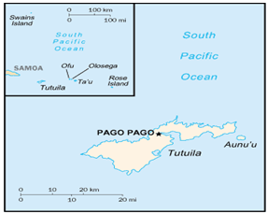
The territoryt of American Samoa, an insular possession of the United States, is the only United States territory south of the equator. It consists of seven tropical islands in the South Pacific about 370 kilometers (2200 miles) southwest of Hawaii and about 2575 kilometers (1545 miles) northeast of New Zealand.

American Samoa includes the seven eastern islands of the Samoan group. The western islands make up the independent nation of Western Samoa. Tutuila, the main island, has 147 square kilometers (53 square miles) of land area, and Aunu’u, 1.6 kilometers (1 mile) off the the southeast coast of Tutuila, has 1.6 square kilometers (0.6 square miles) of land area. The Manu'a group is 115 kilometers (69 miles) to the east. Rose Island, 400 kilometers (240 miles) east of Tutuila, is only 0.56 square kilometers (0.2 square miles) in area. Swain’s Island, 450 kilometers (270 miles) to the north, is 2.8 kilometers square (1 square mile). All of the islands are inhabited except for Rose Island, which is a wildlife preserve.

American Samoa’s climate is tropical with a relatively dry season from June to August, and a wet season from January to March. Average annual rainfall is between 315 and 630 centimeters (125 and 250 inches) depending on location, and can vary widely from year to year. The average temperature is about 27°C (80°F) with little seasonal variation. Relative humidity is high during most of the year, ranging from 70% to 90% during the wet season and 60% to 70% during the dry season. Trade winds blow almost continually.

The population estimate for 2006 is 57,794. The population growth rate has been on a slow steady upward trend over the past decade. Between 1980 and 1990 the American Samoa population grew at an annual rate of 3.7 percent. Since 1990 the rate of growth has diminished somewhat; between 1990 and 2000 it increased approximately 2.0 percent per year. The population breakdown in American Samoa, 89% are Samoan (Polynesian) 2% are Caucasian, 4% are Tongan and another 5% from other nations.

Island Geography
Tutuila is about 33 kilometers (20 miles) long, 10 kilometers (6 miles) wide at its widest extent, less than 1.6 kilometers (1 mile) wide where Pago Pago Harbor intersects the ridge near the center of the island. The ridge rises abruptly from the sea, and numerous peaks range in elevation from 305 to 457 meters (1000 to 1500 feet). Mt. Matafao at 652 meters (2141 feet) is the highest peak.

Tutuila’s topography is rugged. The island is a continuous, narrow irregular volcanic ridge rising steeply from the ocean. The Tufuna Plains on the southwestern portion of the island are the only expanse of relatively flat land. The ridge forms a drainage divide for the entire island. Numerous short, intermittent streams descend from the mountains through steep valleys. Larger streams have formed wide, flat, delta-shaped valley floors where they emerge from the highlands to enter the sea. Many of the villages are located near the stream mouths.

The steep slopes, heavy rainfall, and rapid runoff keep the natural residual soil cover thin. The soil on the steep slopes is held in place only by a dense growth of tropical vegetation. Overlying the narrow belt of coral around the edge of the island is a thin cover of sandy, organic material that also supports abundant vegetation. A few inland valleys contain thick deposits of alluvial soil, but even there the heavy rainfall leaches the soil, making commercial farming difficult without fertilization.

The Manu'a group consists of three separate islands: Ofu, Olaosega and Ta'u. Ofu and Olaosega are remnants of a single volcanic island and are separated by a 150-meter (500 feet) wide strait. Both islands rise abruptly from the ocean with little flat land other than a narrow band along the coast. There are few well-developed drainage basins on either island. The combined land area of Ofu and Olaosega is approximately 13.5 square kilometers (4.9 square miles).

Ta'u is the largest of the Manu'a islands, covering 49 square kilometers (17.7 square miles). The south side of the island consists of spectacular cliffs and cascades dropping directly in to the sea. A fairly wide coastal plain fronted by narrow beaches fringes most of the coastline along the northern and western sides of the island. The villages on the west end of the island are built on terraces a few meters above sea level which are composed of sand dunes and storm benches of coral sediments.

Island Geology
American Samoa is made up of five rugged volcanic islands and two coral atolls. The islands have rich soil that has been nourished by a combination of volcanic ash and decayed vegetation.

Climate and Environmental Hazards
American Samoa’s climate is tropical with a relatively dry season, June through August, and a wet season, January through March. Average annual rainfall is between 315 and 630 centimeters (125 and 250 inches) depending on location, and can vary widely from year to year. The average temperature is about 27°C (80°F) with little seasonal variation. Relative humidity is high during most of the year, ranging from 70 to 90% during the wet season and 60 to 70% during the dry season. Trade winds blow almost continually. The heaviest rainfall occurs during the period from December to March. Typhoons and tropical storms are common during that time.

Energy Sources
American Samoa relies entirely on petroleum fuels for energy. Most of the energy use is for generation of electricity. The American Samoa Power Authority (ASPA) provides the electrical power to Amerian Samoa. ASPA owns and operates the two electrical power stations on Tutuila. The company has the right to make contracts, purchase and lease property, and suggest rates. Rates are set by vote of the people. Over the years, maintenance programs and plant conditions have ranged from fair to good. Both plants are in fair condition. Power outages are now less common than in the past, and ASPA recognizes that generating equipment reliability and capacity must be a critical part of the utility operation. They have successfully modified their management approach, operating and maintenance practices to address both training and preventive maintenance practices.

Total electric installed capacity on Tutuila is 50.75 MWs, with an available capacity of slightly over 30.mWs due to deratings on the engines or major engine failures that have not been addressed due to funding and other issues. Reserve Margin fluctuates between 0 and 2 MWs when all units are available. Peak load during the day is very close to the current available capacity of the units. The average daily peak load is 13 MW. There are two power plants on Tutuila, one at Satala near the canneries on Pago Pago Bay (16 MW), and the other at Tafuna near the airport (14 MW). Generators at both stations run at 400 to 900 rpm. The grid connects to every village on Tutuila, and there was an operational submarine cable connecting the grid to Aunu'u Island until it failed. This cable will need to be replaced as soon as possible to provide reliable power to the island.

Other major generating equipment on Tutuila includes stand-by generators at the canneries that are normally used for power due to the fluctuations in ASPA's power supply. The canneries maintain their connection with ASPA for backup power. Samoa Packers has three 50 KW diesel generators purchased in 1980, and Star Kist has one 125 KW unit. The hospital, ASG computer center, and the airport also have stand-by systems.

The main energy problem of American Samoa is the islands are 100% dependent on imported petroleum products for electricity generation and transportation and are therefore quite vulnerable to interruptions in petroleum supply and to price increases. This dependence hampers economic development. If petroleum supply uncertainties and price increases similar to those of the seventies were to occur again, the existing economy and standard of living would be severely affected.

American Samoa Power Authority (ASPA) has continued to improve their power system. Additional capacity, improved maintenance practices and emphasizing training for employees has paid big dividends in improved operation, availability, and overall customer satisfaction. In interviews with hotel owners supporting the tourist industry and major industrial facility management at the canneries, all of the interviewees were very complimentary on the stability of the electrical system and the cooperative, can-do attitude of the ASPA work force. Even though ASPA is currently performing well in the view of their customers, they continue to look for additional ways to improve service and reduce costs. Recent efforts include the underground conversion of transmission lines, and research into wind generation to help reduce dependency on imported fuel oil.

Energy Uses
Energy use is primarily for transportation and electrical power generation. Gasoline and diesel fuel are used for the transportation sector and No. 2 diesel is used to power the diesel engine electric generators. ASPA is the sole producer of electrical power for resale. Electric energy is primarily used for refrigeration, lighting, air conditioning and cooking.

HISTORY, POLITICAL DEVELOPMENT AND PRESENT STATUS

Early Island History
The Samoans are among the last remaining true Polynesians. Samoan traditional stories describe Manu'a as the heart of Polynesia. The first inhabitants of the Samoa islands, Polynesian seafarers, came from the west, possibly by way of Indonesia, Vanuatu, and Fiji before 1600 B.C.. They are closely related to the Tongans, Tahitians, and Hawaiians, who are also Polynesians. During these early year, the Samoans evolved a complex social structure around the aiga, or extended family, which may include as many as several hundred relatives. At the head of the aiga are the matais, or chiefs, who guide the communal economy, look out for the clan’s well being, control the lands, and represent the aiga in the village and district councils. Life revolved around fishing and the subsistence farming of taro, breadfruit, and bananas. Now American Samoans are concerned with preserving these traditions, and the extended families are still the most important element of the social structure. For example, the extended families own about 95% of the land on Tutuila. This factor could act as a constraint on developing renewable resource energy technologies that are land intensive.

First contact with the western world came when a Dutchman, Roggeveen, happened upon the islands in 1722, followed 46 years later by the French explorer, Bougainvillea. The islands were out of the way of the growing shipping traffic and whale fleets, and did not attract European interest until the 1830s when Christian missionaries arrived. In 1839, a United States expedition explored the Samoan islands, mapping the harbor and several bays. The natural, deep-water harbor, one of the finest in the South Pacific, was of particular interest to the United States. In 1872, the United States ship Narragansett, visited Tutuila, and its commander, Richard Meade, entered into an agreement with High Chief Mauga that granted the United States harbor facilities and rights for a naval station.

International rivalry and confrontation between Germany and Great Britain, as well as warring among various Samoan factions, with the United States on the periphery, occasioned agreements in the later 19th century which divided the Samoans between the United States and Germany. In 1900, the United States annexed Eastern Samoa, as it was called then, under the Deeds of Cession. They added the Manu'a chain in 1904, but the United States Congress did not ratify the act until 1929. The United States Navy assumed administration of American Samoa, as the islands became known, in 1901.

Recent Island History
The peaceful islands and quiet, South Pacific naval station acquired strategic importance during World War II when Pago Pago became a training area for the United States armed forces. This exposed the Samoans to the United States way of life and started the migration of Samoans to Hawaii and the United States mainland.

The Deeds of Cession granted American Samoans United States national status, protected them under the United States Constitution, and prevented their lands from being alienated. Day-to-day government derived from the United States Naval regulations, which today, form the basis of the Code of American Samoa. The Fono, a bicameral legislature, was formally organized in 1949 and became the Territory’s law-making body. In 1951 an executive order transferred administration of American Samoa from the Navy to the Department of the Interior. In 1960, the American Samoans held a constitutional convention, and the resulting constitution became effective later that year. In 1977, Samoa elected its first governor and lieutenant governor, a step that nearly completed the process of local self-government. The government now consists of three branches,, executive, legislative, and judicial. Samoa also elects a congressional delegate, who became a non-voting member of the United State Congress in 1981.

The current relationship of American Samoa and the United States is spelled out in Secretarial Order #2657 of the Department of the Interior. With the installation on January 3, 1978, of the first popularly elected government in Samoan history, the American Samoans initiated an aggressive development program. This program called for economic and infrastructure development to bring the territory closer to self-sufficiency; greater economic and social participation in the community of the emerging South Pacific nations; and greater self-government and political development within the United States community.

United States Involvement
American Samoa is an unincorporated territory of the United States. On April 17, 1900, the Chiefs of Tutuila and Manu'a ceded the islands and gained alliance with the United States of America. The American Samoa government mirrors the administrative structure of the Federal government. The government is divided into three branches, executive, e, legislative, and judicial. The Governor and Lieutenant Governor head the executive branch and are elected to four-year terms. The legislature, or Fono, consists of two houses: the Senate, selected by each matai (village chief) and the House of Representatives, elected by the general population. The judicial branch is part of the U.S. judicial system. American Samoa has a non-voting representative to the U.S. Congress.

The primary funding program for the islands remains the Compact of Free Association with the United States government. The Compact is administered by the Department of Insular Affairs working under the direction of the Department of the Interior.

The American Samoa Department of Commerce has determined that of the 7,760 households in the territoryt, 4,500 qualify for low-income assistance. The Territorial Energy Office (TEO) was awarded financial assistance in Fiscal Year 1999 to distribute 8,400 Compact Fluorescent Lamps (CFLs) to 1,680 low-income households. Through lower than planned pricing, TEO is distributing 11,000 CFLs to 2,200 low-income households.

This project (Phase Two) will expand the REACH project started in FY 1999 and increase the number of households served by TEO from 2,200 to 4,500. Each household electric bill will be reduced by approximately 16 percent. Funds awarded for Phase Two will be used to purchase and distribute (free of charge) 11,500 Compact Fluorescent Lamps to 2300 low-income households. Completion of Phase Two will mean that all registered low-income households in the Territory will be served. This final project phase will be completed within 12 months and the intervention will last more than four years.

The State Energy Program (SEP) Special Project, American Samoa, 2001 is designed to determine the feasibility of using wind to generate a significant portion of the electricity on Aunu'u Island. There will be two project components. One will conduct a detailed feasibility study that addresses wind potential and infrastructure requirements, and the other will conduct a workshop that will provide information about the state of the wind energy industry to key utility and government personnel, and private stakeholders.

Political Development
While there is a strong American influence in the islands, American Samoans retain their cultural heritage. Traditional Samoan society is based on a chieftain system of hereditary rank, and is known as the "Samoan Way" or fa'a Samoa way of life. Despite the inroads of modern, Western Civilization, local cultural institutions are the strongest single influence in American Samoa. The fa'a Samoa way of life stems from the aiga; the extended family with a common allegiance to the matai, the family chief who regulates the family's activities. Religious institutions are very influential in the community and the village minister is accorded a privileged position, equal in status to a chief or matai. The fa'a Samoa also reflects a communal lifestyle with non-public ownership and 90% of the communal lands controlled by the family matai.

Present Political Status
American Samoa has a Fono or Legislative Assembly, with a Senate and House of Representatives. American Samoa has an elected Governor and its 21-seat House of Representatives that sits for two-year terms. Twenty of the members are elected and one, from Swains Island, is an appointed, nonvoting delegate. The 18-seat Senate comprises chiefs, selected by other chiefs under the aiga tradition, and has four-year terms. American Samoa also elects one congressman to the United States House of Representatives for a two-year term. The congressman is a non-voting member.

POPULATION, EMPLOYMENT & WAGES
American Samoa’s resident population estimate for 2006 is 57,794. At the last census in 2000 the population was 57,291. The 2000 census figures represents an increase of 10,518 persons, 22 percent since the last count of 46,773 in 1990. The 2000 census reflects a much lower annual growth rate of 2.0 percent compared to the 3.7 percent between 1980 and 1990. The population of American Samoa is unevenly spread throughout the three district subdivisions. In the past two decades the population has shifted from East to West. Western District (Tafuna to Fagamalo) had 32,435 people, while Eastern District (Nu’uuli to Onenoa) had 23,441 people. Manu’a District and Swains Island combined had only 1,415 people. The population of American Samoa is unevenly spread throughout the three district subdivisions. In the past two decades the population has shifted from East to West. Western District (Tafuna to Fagamalo) had 32,435 people, while Eastern District (Nu’uuli to Onenoa) had 23,441 people. Manu’a District and Swains Island combined had only 1,415 people.

Present Demographics
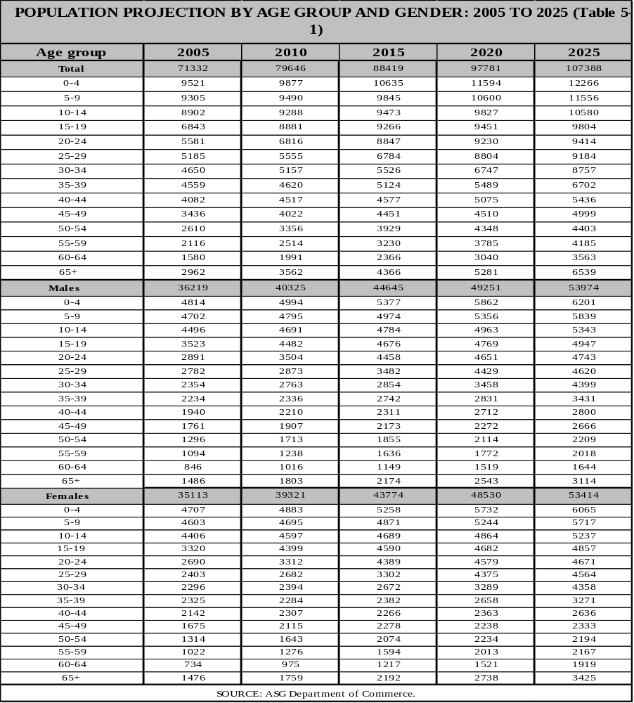
American Samoa is on a 10 year Census Cycle, and the latest information available is from the 2000 Census. Of the population who live in American Samoa, native Pacific Islander 92.9%, Asian 2.9%, white 1.2%, mixed 2.8%, other 0.2% (2000 census). Languages of American Samoa are Samoan (closely related to Hawaiian and other Polynesian languages), and English, with most of the population being bilingual.
The American Samoa population is very young. The median age remained at about 21 years; demanding much needed services for early childhood education, health and medical, family advocacy and employment opportunities. The gender ratio recorded at 104 males for every 100 females. Based on 2000 Census information, 45% of the population is below 18 years, with 67% of children living in low-income families. One (1) out of every ten (10) families has a female householder with children; and 3,889 grandparents were recorded to have lived with their grandchildren, with 71 percent of grandparents being responsible for childcare.

The population of American Samoa is unevenly spread throughout the three district subdivisions. In the past two decades the population has shifted from East to West. Western District (Tafuna to Fagamalo) had 32,435 people, while Eastern District (Nu’uuli to Onenoa) had 23,441 people. Manu’a District and Swains Island combined had only 1,415 people.

The average population density for the territory was 286 persons per square kilometer: though not evenly distributed. Manu’a had the lowest density with 20 persons per square kilometer compared to 411 in Eastern District and 444 in the Western District.

Per 2000 census, American Samoa registered 10,052 housing units. Of the 10,052 units, 93.0 percent were occupied and 7.0 percent (703) were vacant units. Of the 9,349 occupied housing units, 77.2 percent were owner – occupied and 22.8 percent were renter occupied. Tafuna village in the Tualauta County had the highest number of occupants per room on both owner – occupied and renter – occupied units.

Table 5-1 shows the demographics of American Samoa based on age and gender.

Special Employment or Major Employers
Total employment in 2004 was estimated at 17,502, an increase of 0.5 percent from the previous year (2003). The estimate includes 4,473 government employees, 1,429 government authorities employees, 4,600 cannery employees, and 7,000 private sector employees.

General government employment increased slightly from 4,312 in 2003 to 4,473 in 2004. Contract employees increased from 256 in 2003 to 355 in 2004. Local hire employees (career service) increased slightly from 3,686 in 2003 to 3,763 in 2004, a 2% increase from the previous year.

Employment and Job Market
The wage economy for American Samoa centers around the Pago Pago Bay area. The principal industry is tuna processing. The two canneries located on Pago Pago Bay employ about 26% of the work force. Subsistence family agriculture and small, family-owned businesses are also found throughout Tutuila and the unemployment rate for 2000 was 10.5%.

Table 5-2
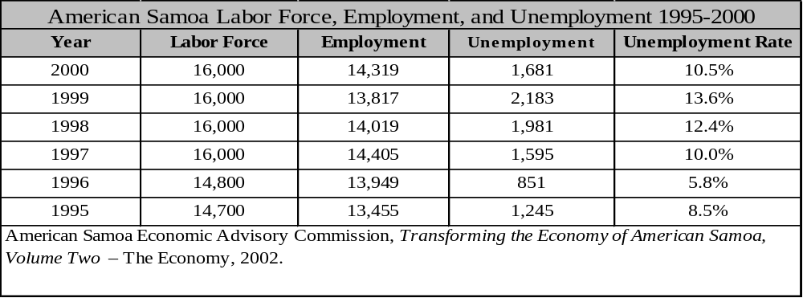

Table 5-3
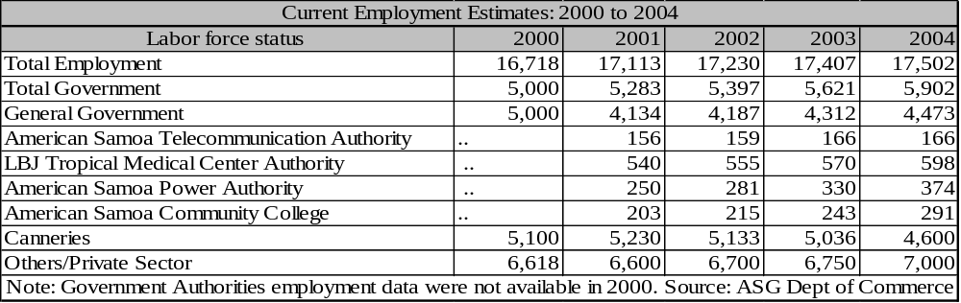

Personal Wages & Income
The minimum wage for various industries in American Samoa has stayed stagnant since 2002. Fish canning and processing has remained at $3.26. All industries have remained the same, with Shipping and Transportation, Classification A reporting the highest minimum wage rate at $4.09.

Out of 8,706 households recorded in 1995 household survey, 23% of those homes reported an annual income of $15,000 to $24,999. The Western District, which constitutes more than half the household population, recorded a mean household income of $26,319, which is $623 more than that earned in the Eastern District. Twenty-four percent of American Samoa households were below the national poverty level of $10,000 annual income.

General Business & Commercial Income
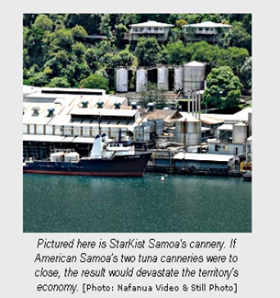
Most of American Samoa's economy is based directly or indirectly on U.S. federal expenditures and the canning industry. The rest stems from a small tourism industry and small businesses. Employment is distributed about equally among the three sectors: government, the canneries, and secondary industries, primarily wholesale and retail trade, transportation and services.

But as an unincorporated territory of the United States, American Samoa does enjoy economic and political opportunities available to few other Pacific island states. It has meant that American Samoa is indeed a land of opportunity for many, not least of which are the rougly 4,000 largely unskilled migrant workers from Samoa and Tonga, who make up a large part of the territory's work force. They are attracted by the prospect of employment, and by the high hourly wage rate, a fortune compared to the meager wages in their own countries.

ISLAND ECONOMY AND INFRASTRUCTURE

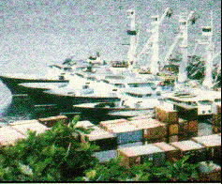
General Status of the Economy
American Samoa differs from most of the other United States Pacific islands in that it has a substantial export industry tuna processing from two large canneries, Samoa Packers and Star Kist. Sources of tuna are the long-line fishing fleet boats owned largely by Koreans and Taiwanese, several United States-owned purse seiners docked in Pago Pago Bay, and commercial Japanese fishing boats. Many of the boats are individually owned, but boat fleets have contracts with the canneries. Historically, Pago Pago has also been an important fueling station for South Pacific sea traffic because of its deep-water port. It continues that role today with expanding port and servicing facilities, and diesel exports are high. The Marine Railway facility near the canneries is available for ship repairs and maintenance.

Tourism is a slowly growing industry. Modern hotel facilities, several flights per week, cruise ship visits to the port, and a friendly island environment provides an excellent vacation destination.

American Samoa has a relatively well-developed public and institutional infrastructure. ASPA has been given the responsibility of all three major utilities, electric, water, and wastewater.
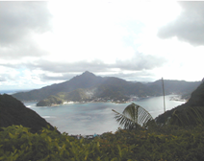
Pago Pago Harbor is one of the best deep-water harbors in the Pacific. Its deep water extends from the Bay entrance to the inner harbor, and the right angle bend in the Bay provides the inner harbor with excellent protection. There is regular inter-island shipping service between Tutuila and the outer islands. Port facilities have been enlarged and enhanced to accept larger ships and faster offloading of cargo.

Major Employment Sectors
American Samoa's economy is still heavily dependent on federal expenditures and the two tuna canneries. 93 percent of American Samoa's economy is based directly and indirectly on U.S. federal expenditures and the canning industry. The remaining seven percent stems from a small tourism industry, fishing, and a few small businesses.

Water and Wastewater Systems
American Samoa has a relatively well-developed public and institutional infrastructure. The ASG Public Works Department and some of the villages own and operate the water systems. The Public Works Department system provides water service to the Pago Pago Harbor area, airport, industrial, and residential areas at Tafuna, and several villages in Futiga. Most of the public water comes from wells; some water also comes from catchments systems. The ASG is extending the large-capacity transmission mains and distribution lines and is increasing the amount of water available by constructing new wells and storage tanks. The village systems usually consist of water catchments systems on streams with pipeline carrying water to the villages. Indoor plumbing is a recent addition in many villages.

On March 1, 1995 the Governor of American Samoa, under Executive Order No. 5-1995, transferred the solid waste program to the American Samoa Power Authority. This fulfills a recommendation of the Operations and Maintenance Improvement Program (OMIP) team. The team has also recommended that solid waste disposal should be funded by user fees and not subsidized by other ASPA operations. There are currently still no charges to the consumer for waste disposal.

The modification and expansion of the two wastewater plants at Utulei and Tafuna have been completed and the plants are fully operational. The Tafuna Plains sewer collection system (Phase III) is making significant progress. Nearly 750 residents are connected to the system and about 200,000 linear feet of pipe, including main lines and distribution lines, has been laid. The Department of the Interior has assisted in funding a Hazard Mitigation Project to improve the sewage ocean outfalls. The project is currently under construction. Other Department of the Interior funded Capital Improvement Projects include new sewer collection system for the island of Aunu'u and a sewer connection program within the Pago Pago Bay area. The latter program has been extremely successful; approximately 720 homes have been connected through this program and another 50 homes will be served when the project is completed. ASPA has implemented a combined water/wastewater rate charge to compliment the annual subsidy from the American Samoa government. Unfortunately, the American Samoa government has not been able to meet their financial obligations to ASPA, which is hampering the ability of the Wastewater Division Operations to perform its responsibilities. ASPA Wastewater is unable to meet the needs of the growing population without capital improvement funds.

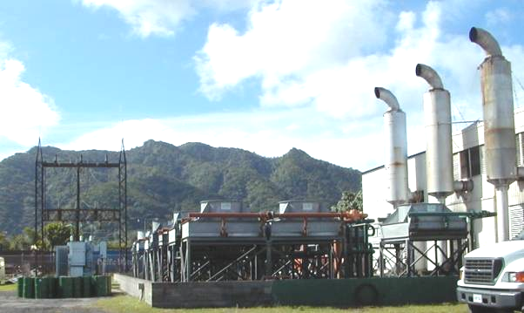
Other programs and studies underway include a recycling and reutilization study by EPA, a hazardous waste disposal options study (also by EPA), an EPA study to reduce hazardous waste, and a used battery-recycling program. In addition, the American Samoa EPA has been working with a firm that is interested in removing and salvaging all scrap metal from the American Samoa government, including several commercial vessels sunk on the reef in Pago Pago Harbor.

Electrical System
ASPA generates, transmits and distributes electric power throughout American Samoa. The overall operation of the utility is considered a great success. Recently ASPA installed a fourth new high efficiency, low RPM generator. Savings realized from lower fuel and maintenance costs, made possible by new state of the art diesels, will result in complete recovery of the initial investment for this unit.

To protect this investment, modern programmed maintenance is being implemented at ASPA. The power infrastructure is also being hardened against natural disasters. Both the Satala and Tafuna power plants have projects under review to help minimize damage from tropical storms. The modifications will include reduced noise emissions and automation of controls for maximum fuel efficiency and reliability.

The reliability of the transmission and distribution system has been substantially improved following the completion of the warehouse and shop facility upgrades and from hardening projects, including underground placement of feeders to the canneries and the Pago Pago business and government district.

The following chart shows the consistency of energy consumption in 2003:

Figure 5-2
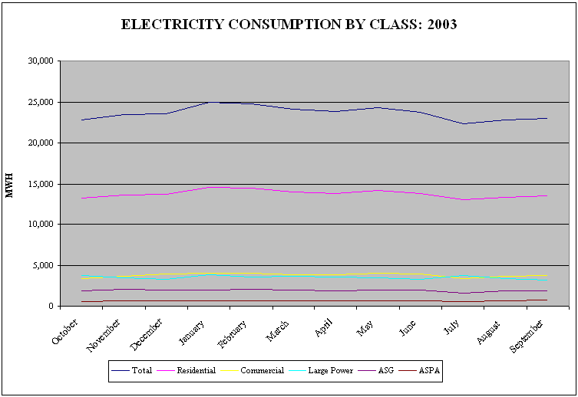

Transportation System
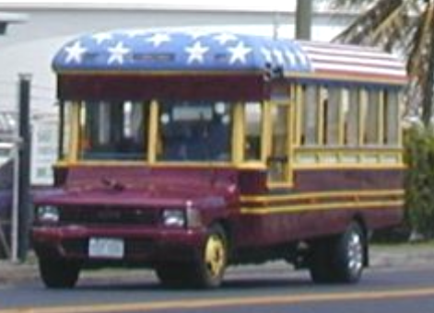
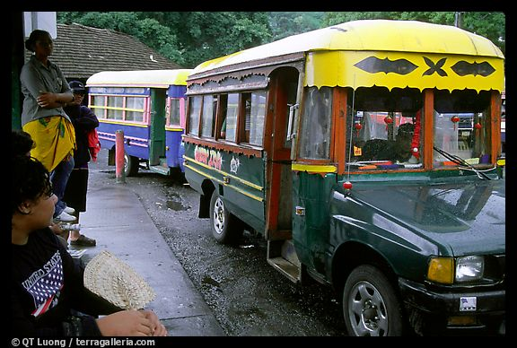
The American Samoa highway system consists of 120 miles of federal highway designated roads and another 100 or so miles of paved and unpaved public roads. The designated federal highway roads are eligible for improvement using federal highway aid funds, but other roadways are the responsibility of the ASG Department of Public Works. The highway system in American Samoa is in generally poor shape, due to the effect of hurricanes, the age of the roads, inadequate maintenance, and past road construction standards that do not meet the present heavy traffic loads. Federal funds are now being used for an extensive program to construct improved roadways that may be expected to last for some 50 years.

Funding for road maintenance comes from a portion of the territory's gasoline tax of 10 cents per gallon. Legislation is being prepared to increase the gasoline tax to reflect national averages to secure adequate funding to meet maintenance needs. However, the OMIP team has found that funds are accumulating in the road maintenance fund without any budget for their utilization. The OMIP team has made specific recommendations of improved road maintenance, including reduction in redundant staff, better planning, rental of equipment, and better training.
The total number of registered motor vehicles has continually increased from 7,543 in 2002 to 8,122 in 2004. The number of driver’s licenses, although slightly dropped in 2002, recorded over 5,400 in 2004.

There is no government owned public transportation system so American Samoa has maintained its traditional, quaint family owned bussing business. For a small fee, you can ride a unique "aiga" (extended family) bus from nearly anywhere on the island into Pago Pago, and connections to other parts of the island cost a minimal additional charge. The aiga buses are a distinctive way to recycle trucks. There is a lot of imagination, pride and work that goes into the refurbishment and modification of the vehicles, made from a variety of trucks

Marine
American Samoa provides a safe haven for ships due to the unique shape of the harbor. The harbor is an "L" shape that puts land between any storm and the open ocean. This, along with the repair facilities and local accommodations makes American Samoa a favorite stop over for fleets of fishing boats and yachtsmen.

Port and Port Industries
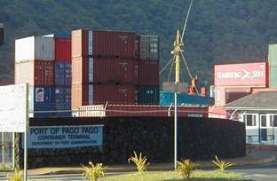
American Samoa ports are Aunu'u (new construction), Auasi, Faleosao, Ta'u, Ofu, and Pago Pago. Pago Pago has one of the best natural deep-water harbors in the South Pacific Ocean, sheltered by shape from rough seas and protected by peripheral mountains from high winds. Its deep water extends from the Bay entrance to the inner harbor, and the right angle bend in the Bay provides the inner harbor with excellent protection. There is regular inter-island shipping service between Tutuila and the outer islands. Port facilities are just now being greatly enlarged. The port also has a valuable strategic location in the South Pacific Ocean. Regular and fully containerized shipping services link the U.S. west coast, Honolulu, New Zealand, Australia, Japan and regional Pacific island countries. Weekly container and bulk shipping calls are made from Honolulu and the U.S. West coast, twice monthly, the same service occurs to and from New Zealand.

Airports
There is one commercial airport in American Samoa, at Pago Pago. In 2002, a total of 8,121 flights were recorded. These flights carried a total of 94,883 passengers. There were 117 flights between Pago Pago and Honolulu recorded in 2002 (an average of 10 flights a month). There were 8,004 flights between Pago Pago and Samoa in 2002 (an average of 667 flights a month).

Table 5-4
Town | Airport name | ICAO | IATA | Usage | Customs | Runway | IFR | Rwy length
Ofu American Samoa | Ofu Village Apt. | Z08 |  | Civ. | No | Paved | No | 2000 ft
Pago Pago | Pago Pago Intl | NSTU | PPG | Civ. |  | Paved | Yes | 9000 ft
Tau Island American Samoa | Fitiuta Apt. | FAQ |  | Civ. | No | Paved | No | 2300 ft
* Ref: Aircraft Charter World, Air Broker Center AB , Artillerigatan 68b, S-115 30 STOCKHOLM, Sweden

Communication System
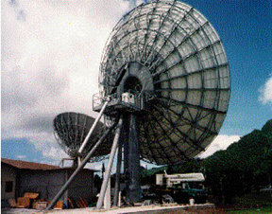
The American Samoa government Office of Communications provides local telephone and long distance services. American Samoa has a good and modern telecommunication infrastructure, consisting of 7 Digital Telephone exchanges connected together via a network of microwave and fiber-optic links. All inhabited islands have telephone connectivity. There are approximately 20,000 installed telephone lines. Cellular telephone service was established in 1986 and currently has a customer base of over 3,000 cell phones. High quality voice and data service (ISDN, T1) is available. Telex, telegraph and internet/e-mail service is also provided. 24-hour telecommunications to and from the outside world is possible through a Satellite system operated by Samoa Technologies, Inc's SamoaSAT Division. SamoaSAT operates an IntelSAT B type station, consisting of two satellite dishes (13 meter and 15 meter antennas) which provide both voice and data communications. SamoaSAT Satellite Earth Station in Tafuna provides 24-hour voice, video and data communications to and from the rest of the world. Two newspapers are printed in Pago Pago. Radio broadcast stations: AM 3, FM 4, shortwave 1 (2004 est.), American Samoa is within the U.S. postal system.

Tourism Industry
A recent development that may help the tourist sector is authorization of a National Park in America Samoa by the U.S. congress in 1988 and the establishment, in 1993, of the National Park of American Samoa. This is the most remote of the U.S. National Parks and the only national park in which the Federal government does not own the land, instead leasing it for 50 years from the eight villages in the park. The park protects the only mixed-species paleotropical rainforest and the only Indo-Pacific coral reef in the national park system.

Major Industry
American Samoa differs from most of the other United States Pacific islands in that it has a substantial export industry: tuna processing from two large canneries, Chicken of the Sea and Star Kist. Sources of tuna are the 125-boat, long-line fishing fleet owned largely by Koreans and Taiwanese, and about ten United States-owned Purse Seiners, docked with Pago Pago Bay. The boats are individually owned, but both fleets have contracts with canneries

Table 5-5
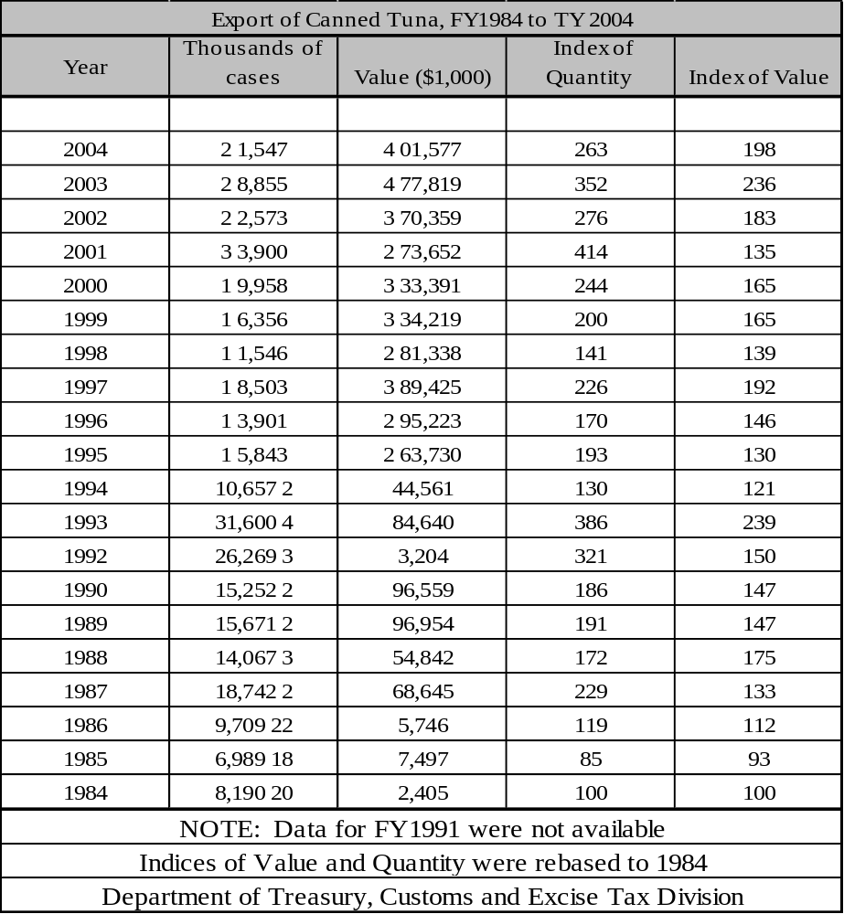

Military
Defense of American Samoa is the responsibility of the US. But American Samoa’s contributions to the defense of the U.S. are not just limited to service overseas. The Territory is home to a large U.S. Army Reserve unit, and the military presence is growing. The federal government is currently building a larger base of operations near the Tutuila airport for the Reservists. The Base has its own post-exchange outlet supplied by off-island vendors and heavily visited by local Reservists because their prices are lower than those at local civilian-owned stores.

The American Samoan Army Reserve contingent reports to the U.S. Army Reserve in Hawaii (as do similar Army Reserve units in the other U.S. Pacific territories of Guam and the Northern Mariana Islands). Beginning in 2004, a number of American Samoa based Army Reservists (along with their fellow soldiers on Guam, Saipan and Hawaii) were activated for duty in Iraq. Indeed, there are few U.S. jurisdictions that are more pro-military and pro-U.S. than American Samoa. This is an attitude that is deeply rooted in the history of the islands.

Other Special Economic Elements
Typically, local businesses are small, owned by independent local operators, and sell exclusively to the local market. They face high costs due to limited access to capital, the need to import most goods and raw materials, and high labor costs compared to the rest of the region. High costs and the distance to markets restrict their ability to export. Thus, local businesses are vulnerable to competition from neighboring islands with lower wage levels, and from larger, more efficient business in the United States.

American Samoa's current narrow economic base is not adequate to meet the demand for employment. The ASG has sought to diversify its economy by seeking outside investment in light industries (particularly garment manufacturing), farming and fishing, tourism, and regional trade and services. However, the disadvantages of being at a remote location, the lack of skilled manpower, limited infrastructure and the lack of significant comparative advantages (such as labor cost) over other Pacific sites have yet to be overcome.

ASG has implemented a program involving "micro-industries" which would focus on exports and import substitution. Several locally owned businesses are in the process of completing lease agreements with ASG for land to construct their facilities. Discussions of a second garment factory between ASG and off-island interested investors took place earlier this year. The administration is currently collecting data and background information about the company before a firm commitment can be reached. Proposed plans for an expansion to the present operation of the BCTC company at the industrial park is also considered. ASG is presently undertaking negotiations with a German-based company to start a shoe factory in American Samoa. Another company has also agreed in principle to set up a watch factory there later this year.

Manufacturing, Craft, Trade
Employment in the rest of the economy increased slightly with the opening of BCTC (a garment manufacturing company) in late 1995. BCTC-Samoa is the Territory's first garment factory, which started operations last year at Tafuna and now employs over 700 people. However, close to 50 percent of the BCTC workforce is made up of foreign workers. The overall potential unemployment rate is still at a two-digit level (13 percent) in the face of a growing population.

Agriculture
Due to the steep peaks on American Samoa, there is limited farming except in the flat lands. As roads are built to the interior of the islandi, more farmable land will become available. However, at this time, there is limited farming.

Aquaculture, Fisheries, Refineries
Local fishing activities recorded 9.4 thousand pounds of fish caught, utilizing 47 boats and 141 fishermen. Longlining fishing method recorded the most catch with a high of 865,970 in 2002. It has since begun to decline in the following years, with only 164,975 pounds of fish caught in 2004. Trolling, bottom fishing, and spear fishing accounted for the rest of the catch.

Table 5-6
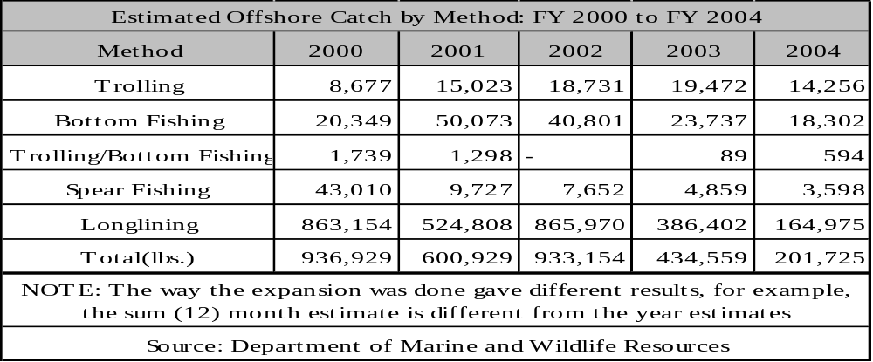

ECONOMIC DEVELOPMENT PLANS AND PROJECTS
The first priority of the American Samoa government is economic development. However, the ASG does not want to develop with absentee ownership; only Samoans can own Samoan land. Therefore, economic development will probably occur at a deliberate pace.

The main economic activities at present are government, fishing and canning, port operations, an industrial center and a small tourism industry. Specific goals for expansion of these areas include enlarging the port facilities, developing the industrial park area, providing additional recreational sites and activities, fishing for additional varieties of seafood, encouraging expansion of the fishing and canning operations, and perhaps building more hotels.

The ASG is developing a major cargo-handling center for the South Pacific. The government is working on a major extension of the main dock. This dock serves 182-meters (600-foot) tankers and refuels fishing vessels. A 42-meter (140-foot) inter-island dock serves smaller vessels up to 91 meters (800 feet) in length. The Marine Railway Authority is also expanding so that it can service the largest Purse Seiners in the Pacific.

Expansion of agriculture is a high priority because it is necessary to slow the large flow of food imports. The subsistence family farm is common on American Samoa, but cash crops that could be important to the economy are not widely grown. Land availability is a key factor, and much of the available land is too steep for cultivation. Nonetheless, some farms are now extending into the steeper areas of Tutuila. The large supply of rainwater could be used for agriculture or other purposes if there were adequate collection and storage facilities. Multiple use reservoirs could be useful for both agriculture and developing hydropower.

Van Camp is rebuilding and expanding its facilities, and this expansion should increase the plant’s energy demand by about 10%. The company has considered a proposal to utilize tuna sludge wastes for biogas generation but does not regard it as economically attractive for now. Star Kist presently uses propane for cooking and fork lift operation, and if diesel fuel becomes too expensive, the company plans to switch all diesel-fueled operations to butane. In 1981, Star Kist envisioned a future increase in electrical power demand power demand of 10% to 25%, but with the 1982 cutback in operations these figures may be high. Star Kist research laboratory is also considering using tuna sludge to generate methane.

General Status of Economic Development Planning
The manufacturing sector of American Samoa’s economy recorded the most sales ($504 million), employed the most people (5,550) and had the largest annual payroll ($48 million) of all industries covered in the 2002 Economic Census. The Economic Census covered 1,061 business establishments in American Samoa. These businesses had sales of $994 million, employed 11,618 people and had an annual payroll of $121 million.

After manufacturing, the next largest sectors in sales were retail trade ($155 million) and wholesale trade ($87 million). The retail trade and health care and social assistance sectors were second and third, respectively, behind manufacturing in employment (1,628 and 734 employees) and annual payroll ($15 million and $13 million).

Ref: U.S. Census Bureau, U.S. Department of Commerce 2002

Economic Development Approach and Special Issues
No information at this time

Focus Areas

Clean Coal Technology
Perform a feasibility study to determine whether coal fired units should be incorporated into the generation mix.

Resolve high system losses
Continue the effort to locate and resolve the high system losses. Reducing these losses will increase billable power and thus increase cash flow to the utility for hardening.

Cost Analysis -Variable Speed Drives
Perform cost analysis for the Installation of Variable Frequency Drives on the electrically driven cooling water pumps and cooling fans to reduce total auxiliary load.

Utility Hardening Recommendations
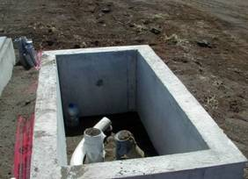
The following hardening projects would be among the top priority efforts to allow minimal investment for maximum progress towards hardening the electrical distribution system for American Samoa. These are high priority projects with some of the projects having been partially completed, awaiting funds:

New Feeder 10 to replace current overhead lines to Tafuna area
ASPA is in the design phase for a new underground feeder for the Tafuna area to supply the Tafuna water well fields. The well fields supply over 30% of the fresh water supply for the west side of the island and is also the main source of water supply for the Tafuna power plant, the government emergency facilities, high school (used as temporary shelter during disasters), airport, Army Reserve, and the police and fire substation. This is an important project to help decrease downtime for the transmission system following heavy weather events, since it feeds several critical areas of the island. In addition, the investments that FEMA makes in this line following typhoons can be completely averted if the line were to be converted to an underground feeder. The estimated length of the new feeder is 4500'.

Utulei Loop Underground (Feeder 8)
This project has been partially completed. The conduit runs have been completed; ASPA is looking for funding to complete the project, including installation of vaults, cables, padmount transformers, and the termination and commissioning of the underground system. It will harden the overhead primary lines supplying the main government buildings (including the executive building housing about 80% of the government departments), government TV Station, Department of Education, Samoana High School (used as temporary shelters during cyclones), Samoan Affairs, Centennial building, and the residents of Utulei Village. This loop is also the partial load backup feed for Feeder 8, which supplies the area and the only hospital on the island.

Ofu, To'aga Underground Project - Manu'a Islands
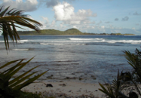
This is the hardening project for the overhead primary lines that supply the island of Olosega. The existing To'aga overhead system runs through an area under the U.S. National Park. The line is vulnerable to heavy winds and vegetation resulting in frequent outages. Tree trimming presents multiple challenges in regards to the National Park. There have been several disputes between ASPA personnel in Ofu and the U.S. National Park Rangers over clearing vegetation. The lines are expensive to maintain because a sea going vessel has to be chartered to bring in a bucket truck and crew from the main island of Tutuila for tree trimming and line maintenance. This area is also hardhard-hit during major storms, and is expensive to repair because heavy equipment, trucks and crews must again be shipped from the main island. During declared emergencies, these costs are passed on to FEMA. The length of the underground project is approx. 12,500'.

Energy Considerations
American Samoa continues to rely on imported oil for its primary fuel. Other fuel sources such as coal, LP Gas, or some of the bio diesels should be considered, but concerns remain on the cost of biodiesel. As mentioned in other areas of the report, coal may be a likely candidate to reduce oil consumption.

Import-Export and Balance of Payments
American Samoa imported a total of $604 million and exported a total of $446 million with 90% of the exports being from the canneries.

Status of Energy Systems

Major Energy Uses
Energy is used for housing needs such as refrigerators, freezers, cooking, air conditioning, and other household appliances. Other major uses are for transportation, both public and private, and major industries. On American Samoa, the canneries are large consumers of electrical power.

Electric Power System
In addition to the power plants listed earlier in this report, other major generating equipment on Tutuila includes stand-by generators at the canneries that can be used if needed to supplement system power requirements, as well as their primary purpose of providing power during system outages. The Samoa Packers cannery has three 50 kW diesel generators, and the Star Kist cannery has one 125 kW unit. The hospital, ASG computer center, and the airport also have stand-by systems. The systems can be called into service by ASPA if generating capacity with in the system is below system load requirements.

The transmission system is in good repair. The entire 34.5 kV system is now underground and many of the wood transmission poles have been converted to concrete. ASPA is currently moving forward with underground conversion of the critical 13.8 kV distribution lines to improve system reliability during typhoons. This is an ongoing effort of continuous improvement implemented in small projects. ASPA is currently working on several underground conversions that should be completed within the next year. Funding remains the challenge in moving the projects forward. In comparing the recovery time for an underground line and an overhead line, ASPA reported that during the last typhoon, they had failures on both lines. Upon dispatching crew to get the transmission lines back in service, the underground line was restored to service two days. It took one month to return the overhead line to service.

System Losses
ASPA has been working to reduce line losses for several years and has made good progress. Total line loss including station service loads has been decreased by 23% since 1996 with current total system losses at 11.78% in 2005. ASPA continues the effort in this area.

Power Factor Management
Power Factor management is done through the use of line capacitors and voltage schedules used by the power plant operators.

Operational Issues
ASPA has experimented with variable frequency drives. The drives selected failed and were not returned to service. Variable Frequency Drives or VFDs can be very effective in reducing auxilliary load while also reducing motor and equipment maintenance. VFDs also have the ability, as an intelligent controller, to increase or decrease load on the equipment based on inputs such as temperature, level, or other measurable element. This adds control features that would normally require additional equipment.

Generation Facilities
The following chart shows the location and rating of the generation facilities owned and operated by ASPA. The unit age and status are also listed.

Table 5-7
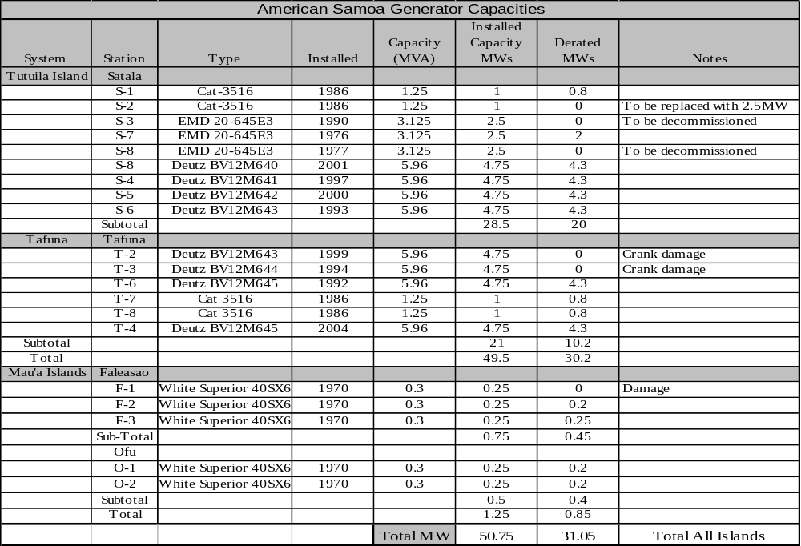

Fuels
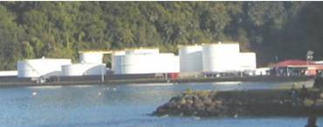
Diesel fuel arrives by tanker monthly from Marlex (Long Beach, California) and Pacific Resources, Inc. (Honolulu, Hawaii). Fuel is piped from the dock to the Punaoa Valley tank farm operated by Marlex. See photo of the liquid fuel storage facilities on Tutuila. Union Oil, through an exchange agreement with Marlex, distributes 30% of the petroleum products on the island. Fuel is sent by barge to the Manu'a group. Storage reserves for diesel fuel and jet aviation fuel total about two months supply. Gasoline storage is about four months supply, although this is the potential (not the actual) reserve, because storage tanks are not usually kept filled. There are also storage facilities for 200 tons of butane, which is shipped from Australia three or four times a year.

Electric Production and Use

Existing Renewable & Alternative Power Production
ASPA had installed photovoltaic units on the outer islands. Due to (suspected) installation and maintenance issues, the systems did not meet ASPA expectations, and the few that were functional were only in service for a short time.

Regulatory, Environmental Issues
American Samoa has adopted a cost effective energy efficiency code for new buildings similar to Palau and Guam. The code is a modified version of the Hawaii code and is based on the results of a savings opportunities analysis, a life-cycle cost analysis and an impact analysis. The codes are based on ASHRAE Standard 90.1. However, further investigation is required to determine the enforcement or effectiveness of the standards. In addition, further investigation would be required to determine if the American Samoa version of the energy efficiency codes have been updated to the 2001 updates.

Transportation
Transportation fuel consumption for the island is about 1.5 million gallons per year.

Fuel Types and Costs
American Samoa uses #2 diesel and residual fuel oil for their power plants. Fuels for transportation are broken into the three motor fuels: regular unleaded, high octane unleaded, and #2 diesel. Kerosene is used for some stoves and lighting. LP gas is used extensively for cooking with some being used for water heating.

Fuel costs in American Samoa are in line with Palau and Guam and very close to those experienced in Hawaii. Regular unleaded gasoline is in the area of $3.50/gallon. Long term fuel contracts are not in place putting American Samoa at risk on oil price volatility. American Samoa is currently paying in excess of $USD 2 per gallon for diesel to fuel their power plants.

Reducing Transportation Energy Use
Currently, American Samoa has a very robust private bus system, identified earlier in this report. The one item noted with this system is the use of a variety of manufacturers and models. This results in some of the buses being high gas mileage vehicles while others have lower efficiencies. The driving factor that this system has is real competition. Those that use less fuel will charge less, resulting in more business. Further study may be needed to fine tune an already excellent system that is used to reduce overall transportation costs for the island.

Commercial & Industrial

Tourism
Although tourism is not currently a major factor in American Samoa's economy, the development of this sector is a priority. The islands have not shared in the tourism boom experienced in the Western Pacific in the 1980s and have seen a precipitous drop in the 1990s. This drop was due to several factors, including the loss of international airline service, and several typhoons. Tourist arrivals totalled 5,800 in 1995, a decline of about 1,500 from the 1992 figure and about half of the visitor level in 1991. American Samoa has little tourist infrastructure, with only one large hotel and a total of 260 hotel/motel rooms in Tutuila and Manu'a. Proposals for additional hotel rooms have been put forward, but have not received the necessary approvals or financing for construction. In addition to its need for upgraded tourist facilities, the tourism industry needs increased promotion, improved skill training, and increased international air travel services.

American Samoa features an International Airport (PPG is the IATA code for Pago Pago International). Twice weekly 767 flights to and from Hawaii and onward to the U.S. mainland is provided by Hawaiian Airlines. Travel to other famous South Pacific destinations and island countries is provided by Polynesian Airlines and Samoa Air.

Manufacturing
The tuna canning industry in American Samoa provided direct employment for over 4,700 workers in 2004. During calendar year 2003, the tuna canneries combined exported approximately $470 million of tuna to the United States. As the principal manufacturing activity in the territory, tuna processing directly or indirectly supports much of the American Samoan economy. Tuna processing is done by two large canneries, Samoa Packing and Star Kist. Sources of tuna are the Japanese, Korean, Taiwanese, and additional United States-owned Purse Seiners, docked at Pago Pago Bay. The boats are individually owned, but fleets have fleet-level contracts with canneries.

The two canneries export approximately 800 tons of fish products per day. Both refineries have steam boilers to provide hot water for processing requirements. The steam heaters bring the process water from 85°F up to the required 165 - 220°F. The total volume of heated water per day is approximately 140,000 gallons per refinery, or a total of just under 300,000 gallons of hot water. This hot water need offers some opportunities to partner with the electric utility to use waste heat from the engines to displace some of the additional fuel required. The total diesel fuel consumption for the two refineries to heat water is approximately 16,000 gallons. Approximately 1,600 gallons of fish oil is produced per day. Currently, one refinery is discarding the fish oil. The other is using it to help displace diesel used on the boiler. Solar water heating is being considered to offset fuel prices.

The packing plants have backup generation for backup electricity needs and can bring the units on line to backup ASPA if required. The plants are supplied with electrical power through an underground power line maintained by ASPA. The management personnel at both plants indicated that the ASPA electric power system was very reliable.

Military
The United Navy assumed administration of American Samoa, as the islands became known, in 1901. The peaceful islands and quiet South Pacific naval station acquired strategic importance during World War II when Pago Pago became a training area for the United States armed forces. This exposed the Samoans to the United States way of life and started the migration of Samoans to Hawaii and the United States mainland.

The Deeds of Cession granted American Samoans United States national status, protected them under the United States Constitution, and prevented their lands from being alienated. Day-to-day government derived from the United States Naval regulations, which today, form the basis of the Code of American Samoa. The Fono, a bicameral legislature, was formally organized in 1949 and became the Territory’s law-making body. In 1951 an executive order transferred administration of American Samoa from the Navy to the Department of the Interior. Defense of American Samoa is the responsibility of the U.S.

Fisheries
American Samoa is primarily devoted to tuna fishing and processing. However, there are a number of other fish that are commonly caught in the area. The following provides a picture of the fishing activity. Please note that the non-tuna catch is in 1000 pound scale and the tuna catch is in the 1,000,000 pound scale.

Figure 5-3

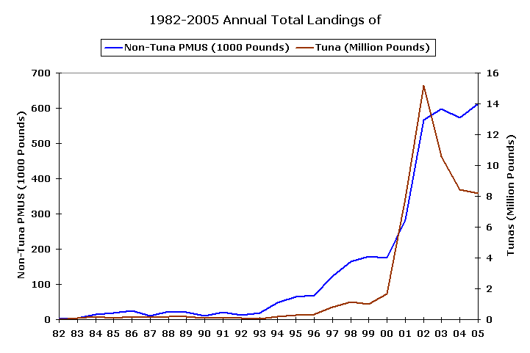

The non-Tuna fishing includes a mix of the following:
- Mahimahi
- Wahoo
- Blue Marlin
- Sailfish
- Albacore

Alternative Energy Opportunities

Cogeneration
ASPA is currently in negotiations with the canneries to provide hot water from their generators for fish processing needs. This will displace some amount of fuel used to fire the hot water boilers located at the facilities. ROIs are currently being prepared to determine feasibility of the installation.

Alternative Fuel Systems
Upgrading power plants to new replacement units is a window of opportunity that opens only once every 20 to 30 years. This window should not be taken lightly. Studies should be performed to determine the correct approach for replacing units.

Renewable resources may be an option, as well as installation of coal-fired power plants continuing with diesel and residual fuel oil fired units currently being used. Coal prices are currently less than $60/ton. When corrected for BTU differences in the fuels, this equates to approximately $0.03/kWh fuel cost compared to $0.13/kWh fuel cost for a diesel or $0.11/kWh for residual fuel. An added benefit for an island economy is that the coal fired plant creates more jobs. Operation costs may be slightly higher for steam plants and this should be taken into consideration. However, at the cost differential between coal and oil, additional labor will not offset the overall savings. Total dollar fuel savings for a 10 MW system would be in the area of $9 million per year in fuel savings. A feasibility study would provide the complete cost and savings. However, operation and maintenance costs for a coal fired unit, historically, are substantially less that the fuel savings.

Wind and solar will not be able to displace fossil engines unless there is a major breakthrough in energy storage. They can, however, supplement the existing fossil generation mix and should be considered when replacing or upgrading system capacity.

Supply Side Efficiency
In developed country utilities, the average power systems losses for a utility with only a generation and a distribution network are estimated at approximately 10%. Nominally, these losses are accounted for in generation, 5%; and distribution, 5%, with non-technical losses less than 1%.
In 2000, a preliminary study was carried out on a sample of three (3) U.S. Affiliated Insular Areas’ power utilities, to achieve an indication of the energy inefficiencies in the generation, transmission and distribution of electricity in all the U.S Affiliated Insular Areas’ power utilities. These were the utilities of Palau, Pohnpei and Kosrae.
This preliminary study indicated that the power system losses in the utilities were far in excess of acceptable standards for these power systems. It was established that the energy losses were occuring in all areas of the power system, including non-technical losses.

It was noted that some data was lacking such as the number of transformers or the types of conductor used. As a consequence several approximations were used to evaluate the losses. The errors on the figures are difficult to quantify and therefore the results should be carefully used, although it does represent system losses that are far in excess of what is acceptable.
To reduce the import of fuel, it is imperative to reduce these system losses.

It is recommended that a detailed quantified power system loss study be conducted for ASPA, as a stage 1 project. This project would measure and collect the electrical data characteristics of the power system, and then determine the losses. Once these losses have been quantified, then stage 2 of this process would be to assess the need for updating existing energy inefficient equipment (examining financing mechanisms as appropriate); establishing government legislation that makes electricity theft a crime; and review the maintenance practices in the power plants.

Demand Side Efficiency
The Territorial Energy Office (TEO) is the primary agency implementing DSM and energy efficiency programs at the household level in American Samoa. TEO is funded entirely by about $250,000 in DOE State Energy Program (SEP) funds.

The TEO was initially set up within the Governor’s Office for a short time the TEO was under ASPA, and it is back under the Governor’s Office. A cooperative arrangement with the Hawaii Energy Office provides for bringing staff from American Samoa to Hawaii for meetings and training.

ASPA also has participated in several programs for energy efficiency improvement over the years. ASPA is presently interested in delaying capacity investments as long as possible through evening peak reduction and slowing the growth of electrical consumption. To accomplish that, energy efficiency improvements for both supply and demand sides are needed. However, should the tuna cannery load decline substantially due to transfer of its business to other locations, a large capacity surplus will be present at ASPA. It is likely that ASPA would then lower the priority for promoting demand side energy efficiency in the face of major problems maintaining good supply side efficiency.

Electrical Metering/Tariff
ASPA has a flat rate tariff for all but industrial customers. The domestic tariff as of early 2006 was $0.0819 per kWh base charge plus fuel surcharge and a customer charge of $1.50 per month. The fuel charge (applied to all classes of customer) for May 2006 was $0.1856 making the total domestic unit charge $0.2675 per kWh (plus the $1.50 monthly customer charge).

The small commercial rate in May 2006 was $0.0993 base and $0.1819 fuel surcharge, totaling $0.2812 per kWh plus a $5.00 monthly customer charge. The large commercial customer rate included a maximum demand charge, a base energy charge, and a fuel surcharge, plus a $25.00 customer charge.

Industrial customers have a decreasing tiered structure with up to 500,000 kWh/month charged at a base rate of $0.048 per kWh, 500,000 to 1 million kWh/month charged at $0.038 base rate and above 1 million kWh at $0.028 per kWh. For each tier, the fuel surcharge is added to the base rate. Additionally a kVAR charge is applied to industrial customers if the power factor is less than 0.95.

A tiered tariff for domestic users, with low usage rewarded by a lower unit price, could help reduce waste at the household level. For domestic customers, ASPA is using a large number of prepayment meters (1,172) that do not support anything but a flat rate structure, so a tiered rate is not possible.

Household Energy Efficiency Measure
The TEO has funding from the DOE State Energy Program (SEP) to carry out household energy conservation and energy efficiency improvement activities. It also provides assistance to low income households through a $40,000 annual input from the Low Income Home Energy Assistance Program (LIHEAP) and an additional $150,000 in funding from the Residential Energy Assistance Challenge (REACH) program. The LIHEAP funds are used to help in payment of electricity bills for qualifying low-income housheolds. The REACH program is in place to provide high efficiency refrigerators to replace old units, or remove the need for households to follow the energy inefficient practice of purchasing ice to preserve food.
Table 5-8 – Major Appliances in American Samoa
Item | Households | Percentage
TOTAL Households | 10,052 | 100%
Refrigerators | 8,065 | 80.2%
Hot water | 2,177 | 21.7%
Electric cooking | 2,570 | 25.6%
Gas | 3,673 | 36.5%
Kerosene | 2,077 | 20.7%
Room A/C | 1,397 | 13.9%
Central Air | 0 | 0.0%
Source: 2000 Census and American Household Survey 2000
Consumers can visit the energy office grounds and see how solar water heaters and other renewable energy equipment can be installed and see demonstrations of the difference between the energy requirements of incandescent lights and CFL lights for a similar level of lighting. Brochures and consumer information posters are available at the TEO office. Programs to bring school children to the TEO facility have been halted, however, due to the unsafe condition of the building, though programs for energy officials to visit schools are still operating.

Residential lighting is mostly by magnetic ballast type fluorescent lights and incandescent lights. A major program to replace those with high efficiency units could be expected to be a cost effective way to reduce the lighting load substantially and is strongly recommended. Since lighting is a substantial component of the evening domestic load, such reduction could provide direct benefit to ASPA as well as reducing fuel import requirements and lowering household electric bills. ASPA has recognized the value of lighting efficiency improvement and for a limited time offered a free CFL bulb to customers that paid their bill on time.

The 2000 census found about 25% of households cooked with electricity and around 20% used kerosene, most of the rest used LPG.. Very few households now use biomass for cooking. Cooking with electricity increases the evening domestic demand peak that could be reduced through a program to replace electric ranges with those using gas. Some years ago, ASPA discussed an alliance with Origin Gas, the local LPG importer, and discussed a program to replace electric cook stoves with gas units. The alliance did not take place, though with the higher cost of electricity today, a similar project should be reconsidered as a way to improve overall efficiency of fuel use for American Samoa.

In 2000, the census indicated that only around 22% of houses had piped hot water and the demand for domestic hot water is small. The majority of water heating is by electricity with mostly tank type units.

Domestic air-conditioning penetration is moderate,, around 14% of electrified households had some form of air-conditioner installed in 2000. High energy costs and an uncertain economy make it unlikely that domestic air-conditioning use will increase rapidly. Though the numbers are small, the demand per unit is high and households with air-conditioners should be informed of the need to clean filters and condensers and to consider higher efficiency units when old ones need replacing. ASPA has advised homeowners to only purchase high efficiency air-conditioners up to EER 14. The cost effectiveness of ASPA providing financial incentives for upgrading home air-conditioners should be examined.. ASPA and the TEO should cooperate to develop such a program, if it is demand cost effective.

Over 80% of households have refrigerators or freezers and a program by TEO to help households improve their efficiency through cleaning of condensers, repairing of door seals and changing their pattern of use – all actions that are of benefit both for fuel savings and lower household energy bills. Information materials should be provided to assist households understand refrigerator and freezer energy labels so that refrigerator purchase decision criteria can properly include energy efficiency

Industrial Sector
American Samoa’s industrial sector is entirely devoted to tuna canning and its support. Two canning companies dominate the electrical load, with one consuming nearly two MWh per month and the other over one MWh per month. A manufacturing operation supporting the canneries consumes almost ½ MWh per month. This sector maintains its own engineering staff and companies are well aware of the need for energy efficiency and of the technology available for its improvement. The fuel price increases have caused the canneries to improve energy efficiency as can be seen in recent cannery energy use studies.

One ASPA diesel power plant is close to the tuna packing complex and discussions have been ongoing for over 15 years regarding the practicality of arranging for exhaust heat from the ASPA engines to be piped to the tuna plants to offset their energy use for water heating. Studies were done in 1989 and again in 2002. An update of the 2002 study is now underway and almost complete. The recent series of fuel price hikes also increases the value of the waste heat. Despite the higher fuel prices, making the decision to proceed with the investment is proving difficult in light of the uncertainty of both the future of American Samoa’s tuna factories and the future price of fuel.

The ASPA rate contracts with the canneries have expired and the ASPA Board of Directors has yet to propose new rates for the canneries. Both canneries are considering self-generation through an IPP arrangement, but whether self-generation makes sense or not cannot be determined until the new rates are set.

Government and Commercial Sector
Government buildings are among the top 20 users of electricity. Air-conditioning is the largest load. The larger and newer buildings are using relatively efficient central chillers, though there are a number of older room air-conditioners in government offices around the island. All lighting has been converted to high efficiency electronic ballast fluorescents and CFLs.

The TEO works with government agencies to perform energy saving retrofits such as high efficiency lighting to replace older types and solar water heaters to replace electric units. The
Treasury pays all electric bills and advises departments of all monthly transactions from their budget. Energy is buried in the list and there is no incentive for individual departments to conserve energy. It is recommended that the TEO discuss this with the Governor and establish a payment process that specifically brings energy to the attention of department heads every month. It is also suggested that American Samoa follow Guam’s example and have each department designate an employee as energy monitor. The monitor would become responsible for improving the energy efficiency of the department and would report to the Energy Office on a periodic basis with a summary report of the energy situation in each department going to the Governor.

Since 2003, ASPA has upgraded the efficiency of its air-conditioning equipment as older units need replacement. Also, all fluorescent lighting at ASPA has been changed from magnetic ballasts to high efficiency electronic ballast units. The lighting exchange program was extended to businesses on a fee basis with magnetic ballasts being replaced by high efficiency electronic ballast units.

Overall, the energy efficiency of government buildings in American Samoa appears better than that of the other small islands included in this study. Further gains need to be made through programs for the replacement of ageing low efficiency room air-conditioners with high efficiency units.

As computers are replaced, “Energy Star” rated units with low power flat screens should be specified for purchase.

No survey information was available that provides information on government or commercial water heating loads, but where significant water heating is carried out (e.g. laundries, visitor accommodations), solar water heating should be considered, and if cost effective, installed.

The primary energy requirement for the commercial sector is for the operation of refrigerators, freezers and air-conditioners. Some improvement in the operating efficiency of the existing equipment can be obtained through cleaning, proper refrigerant loading and other maintenance measures. ASPA could assist in the development of maintenance processes and procedures fitted to the needs of commercial users and offer contract services for the maintenance of refrigeration equipment. Energy audits could also be provided by ASPA to businesses with high energy use, although to be effective, the audits need to include an implementation plan, sources of equipment and cost/savings estimates. External training will be needed to provide these services.

Transportation Sector
An excellent private bus system provides the island with low cost and frequent service. A small taxi fleet also exists and provides personal transport service to the public. The private fleet of vehicles appears relatively new implying a fairly frequent turnover of vehicles and therefore a more rapid response to incentives for the purchase of more fuel efficient vehicles can be expected than in most of the islands surveyed.

The average fuel efficiency of private vehicles is only fair. Consideration should be given to differential taxation of diesel fuel and gasoline with gasoline taxes increasing and diesel taxes decreasing. A significantly lower diesel fuel price would send the signal to consumers that diesel powered vehicles are lower in operating cost than those with gasoline engines. Though there would be some saving through the lower fuel price, the principal savings would be in the substantially higher fuel efficiency of the diesel engine. Also, taxes could be imposed on vehicles with low fuel efficiency to further shift the new car purchase decision toward improved fuel efficiency. Such programs would take years to see significant effect since fleet replacement is involved, but savings achieved would be for the long term.

Building Energy and Efficiency Standards
A proposed American Samoa energy code for building construction based on the Guam code was prepared and submitted by the TEO to PWD for forwarding for legislative action in 1997-1999. It was not placed on the legislative agenda and has not been adopted. Interviews indicate that the enforcement of safety related building codes is problematic and high quality enforcement of energy codes may be difficult to achieve in American Samoa.

At the time of the development of the energy code, a cost analysis of the code application showed that the cost of implementation was substantial but should provide long term benefits if they were rigorously enforced. Interestingly, the analysis showed that less complex and expensive programs to improve appliance energy efficiency would have a quicker and larger payback.

Appliance Energy Efficiency Standards
The appliance market is too small to consider any form of labeling or appliance efficiency standards specifically for American Samoa. Most refrigerators and freezers that are sold already include U.S. energy labels, but the information regarding the cost of use of the appliance is based on an assumed electricity cost that is around half that of American Samoa. This makes the actual operating cost differential between appliances of different efficiency double that seen on the labels, and prospective buyers are more likely to choose the more efficient appliance if made aware of the greater operating cost difference. It is recommended that a system for helping consumers understand appliance labels be developed. Possible approaches include actually applying new labels to fit local conditions, placing posters near the labeled appliances explaining the labels, placing explanatory stickers on the appliances with the labels and sending information brochures to ASPA customers.

Import restrictions that prevent or highly tax the import of low efficiency appliances – particularly air-conditioners – could have good long term benefits through fuel savings. It is recommended that ASPA and TEO examine the benefits and cost of such restrictions and if the action looks economically favorable, assist government in preparing the appropriate import regulations.

Energy Audits, Performance Contracts
The large industrial facilities maintain their own engineering staff to handle energy efficiency improvements. The remaining energy efficiency improvement market on American Samoa is too small to support a local ESCO or to justify the cost for an overseas ESCO to maintain a permanent office there. ESCOs in Hawaii (or possibly in the future, Fiji), may be interested in servicing larger American Samoa clients, especially if needs of American Samoa business and government combine with those of neighboring Samoa and its expanding tourist industry. Together, Samoa and American Samoa provide a substantially more interesting market for ESCOs than either does individually.

There are engineering firms in American Samoa that could work with an overseas ESCO as a local partner, providing most of the audit and follow-up services while the overseas ESCO arranges finance and provides other specialist services not practical for the local partner. ASPA itself could fulfill the role of local partner to an overseas ESCO for providing energy efficiency improvement services to its major energy customers

Renewable Energy
Although there have been many renewable energy “demonstrations” in American Samoa, the actual use of renewable energy is presently limited to traditional cooking, solar water heating and some solar PV as backup power or to power a few remote homes

Solar
As with most Pacific islands, the solar resource is good in American Samoa, though it varies somewhat from place to place due to localized cloudiness associated with the mountainous terrain. NOAA has taken a long series of high quality solar measurements at its Cape Matatula observatory as well as the overall average solar radiation estimates from the NASA collected satellite data provided in Table 5-9

Table 5-9 – Estimated solar resource for Tutuila Island (Lat 14.5°S Long 170°W) kWh/m² per day
Month | Jan | Feb | Mar | Apr | May | Jun | Jul | Aug | Sep | Oct | Nov | Dec | Avg.
Horizontal | 5.55 | 5.49 | 5.31 | 4.91 | 4.50 | 4.37 | 4.62 | 5.23 | 5.72 | 5.89 | 5.80 | 5.47 | 5.24
Tilted | 5.60 | 4.99 | 5.37 | 5.63 | 5.72 | 5.90 | 6.11 | 6.34 | 6.09 | 5.55 | 5.78 | 5.61 | 5.73
Source - NASA Surface Meteorology and Solar Energy

Solar thermal for electric generation
Conditions on American Samoa do not permit economic use of solar thermal systems for electricity generation.

Solar thermal for water heating
Around 26 schools and a number of commercial buildings have solar water heaters installed, usually of the thermosiphon type that includes a tank integrated with the solar panel. There is no solar hot water dealer specializing in sales and installation on Tutuila due to the small market. The installed cost is high, $3,000 or more. Even at that somewhat inflated price, though, the payback for hotels and commercial users is 4-6 years and thus is a very good investment.

For households, the investment is less interesting, as the payback is longer. Since maintenance problems often begin after the fifth or sixth year, the economics are marginal for many households at $3,000 per installation. The cost could be brought down substantially by a larger scale purchase, and ASPA has as one of the proposed renewable energy programs described in its 5 year project plan the purchase of an inventory of solar water heaters to replace tank type electric water heaters. These could be installed on a “fee for service” basis whereby instead of selling the units to customer they would be charged a monthly fee on their electric bill for the hot water service. That fee would be less than the cost of the same hot water service by electricity, and would also be fixed and provide a hedge against future electricity price increases. This approach, essentially renting solar water heaters to homeowners,, has been and continues to be successfully done in the Caribbean by a company specializing in that service, and the concept fits well into ASPA’s energy delivery portfolio.

Recommendations
It is recommended that the TEO continue to promote the concept of solar water heating to replace electric units and that ASPA proceed with their proposed solar water heater rental service.

The LBJ Hospital was the site of a failed solar air-conditioning installation in the 1980s. The system included water heating panels and it was proposed to convert the units to provide hot water to the hospital. Unfortunately before that was done, a tropical cyclone damaged the ground mounted panels beyond reasonable salvage and the hospital continues to use diesel fuel to heat water. It is recommended that a properly designed and mounted solar water heating system be installed to replace most, if not all, diesel fuel use.

Most of the school solar water heaters have not been provided with proper maintenance. It is recommended that the TEO or ASPA arrange with schools for proper maintenance and repairs if needed.

For commercial users of electrically heated hot water, the fee for service concept could also be used. Also, ASPA and the TEO could work with local banks to develop a financing package for solar water heating then market the concept to small hotels and other commercial users.

Solar photovoltaics

Past programs
Solar PV has not played a big role in American Samoa. There are few outer islands and their population is small;; Tutuila has long been fully electrified and there are few demands for off-grid power. Though the TEO has a PV system at the office for educational purposes – quite old and corroded but still capable of power generation – its efforts in PV have been limited to a few outer island installations and local demonstrations, mostly on schools.

Currently operational projects
A 6.5kWp PV installation at the Tula NOAA Samoa Observatory was originally intended as local power for observatory equipment but as the ASPA connection power reliability has improved, the batteries were removed and the installation has been converted to a grid tied system, the only one in American Samoa. The system uses two Trace inverters for the interface between the PV panels and the grid. Unfortunately the Trace inverters do not internally log energy flows; a proprietary external data logging device from Trace is needed to do that and the Observatory cannot justify the $2,000 investment for that purpose. The PV installation is in place and could provide ASPA with good information about the characteristics of PV connected to the grid, particularly since high quality solar measurements are being taken by the observatory that would allow correlation between insolation and grid power delivery. It is suggested that ASPA consider purchasing the necessary Trace data logging equipment and that the Observatory staff assist by monitoring the system and providing the collected data to ASPA.

Plans and recommendations
The primary role for solar PV in the future is expected to be for grid connection. As part of its proposed program for future renewable energy development, ASPA has included the trial of 10 modular grid connected roof-top installations. It is suggested that ASPA install a minimum of five small (3-5kWp) modular systems on ASPA building roof tops with good monitoring systems to better understand the economics of the installations, and to gain technical experience and confidence for the future when reductions in panel prices and/or increases in fuel prices makes grid connected solar PV economically reasonable.

If grid connected solar is to be expanded rapidly, there needs to be an opportunity for the connection of household sized systems (less than 10 kWp of solar panel) to the grid. For this to happen will require that the panel cost goes down or the fuel price goes up until solar PV is directly competitive with diesel generation. Even then household investment is not likely unless true net metering is allowed where energy in excess of household needs is allowed to feed into the grid at the same price as the household can withdraw power later at night. To prepare for future grid-connected household PV systems, it is recommended that ASPA begin to look into establishing a special program that allows smaller household PV systems to be connected to the grid using the net metering concept.

Wind Energy
American Samoa has been collecting good quality wind resource data for some time. Besides the measurements from the tower at the NOAA Tula Samoa Observatory research station (Table 5-10), there have been 30 meter AGL measurements on Olotele Mountain where ASPA is considering locating trial wind turbines. The NASA Satellite estimates of 50 meter wind are also provided in Table 5-11 for comparison and to be consistent with other reports in this series.

Table 5-10 – Average Tutuila Wind Speed at Tula NOAA Samoa Observatory site (m/s)
Month | Jan | Feb | Mar | Apr | May | Jun | Jul | Aug | Sep | Oct | Nov | Dec | Avg.
7yr Avg. | 4.5 | 4.4 | 4.5 | 5.1 | 5.5 | 6.8 | 6.2 | 6.5 | 6.8 | 6.1 | 4.9 | 5.2 | 5.5
Source – NOAA (1996-2003)

Table 5-11 – Average Tutuila Wind Speed at 30m on Olotele Mt. (m/s)
Month | Jan | Feb | Mar | Apr | May | Jun | Jul | Aug | Sep | Oct | Nov | Dec | Avg.
3yr Avg. | 6.8 | 6.5 | 6.2 | 7.0 | 8.0 | 8.2 | 10.1 | 7.7 | 9.4 | 8.0 | 5.7 | 7.1 | 7.6
Source – ASPA (2003-2005)

Table 5-12– Average Tutuila Wind Speed at 50m (m/s) EOS Satellite Data - Lat 14.5°S 170°W
Month | Jan | Feb | Mar | Apr | May | Jun | Jul | Aug | Sep | Oct | Nov | Dec | Avg.
10 yr. Avg. | 5.22 | 5.24 | 5.05 | 5.25 | 6.00 | 6.91 | 7.27 | 7.35 | 7.03 | 6.26 | 5.71 | 5.43 | 6.06
Source – NASA Surface Meteorology and Solar Energy

A thorough feasibility study for Tutuila wind energy development has been carried out by ASPA staff with support from several international sources. Based on analysis of wind patterns, site access and grid proximity, a wind site has been chosen for a trial installation that is approximately 0.5 miles from the 30 meter AGL measurements of Table 5-12. A mast and measuring equipment have been making measurements for less than one year but a correlation study indicates a high correlation between the new measurement site and the older one. Based on the initial measurements and the high correlation of those measurements to the older measurement site, there is low risk in assuming that the proposed turbine site is suitable for development and plans for installing the trial wind farm should go forward. It will take several months to develop the project to the point where equipment purchase is committed. By that time, a full year of data will have been collected at the installation site and a final decision to proceed with the purchase of the turbine(s) can be made.

There is an existing road access to the site and turbines and towers for 200-300 kW units could probably be transported to the site and erected with available equipment – though an estimate of the actual requirements cannot be made until the equipment is selected for purchase.

Though the wind resource has definite promise for power generation, American Samoa has some risk of tropical cyclone (typhoon/hurricane) passage and the substantial cost of risk mitigation must be included in the cost of wind power production. Tilt-down type wind machines such as are being used in the 10 MW Butoni wind farm in Fiji and also in wind farms in New Caledonia may offer a solution as may wind generators specially engineered to withstand the extraordinary wind forces of tropical cyclones.

As can be seen in Figure 5-4 there are a number of sites where the wind energy has a high probability of being sufficient to be economically interesting. Assuming the trial installation proves the worth of wind energy for ASPA generation, the further development of that site and additional sites would be appropriate.

Though the one year data collection at the proposed turbine site probably should be collected and analyzed before a final commitment for the purchase and installation of the turbines, there does not appear to be a high risk involved for proceeding with the ground work and developing the detailed plans and specifications for the wind farm installation.

The next step is installation of actual turbines and monitoring their performance for a period of time. If they appear to be suitable, then plans should proceed for expanding the wind farms to the greatest extent practical, though for American Samoa, that probably should not be more than around 25% of peak load actual wind power penetration, at least with present technology and assuming the technical capacity of ASPA will remain about the same as it is today. To facilitate the expansion, a more detailed wind mapping and resource survey probably should be carried out and ASPA has tendered for those services already.

Figure 5-4 – Annual Estimated Wind Power for Tutuila, American Samoa
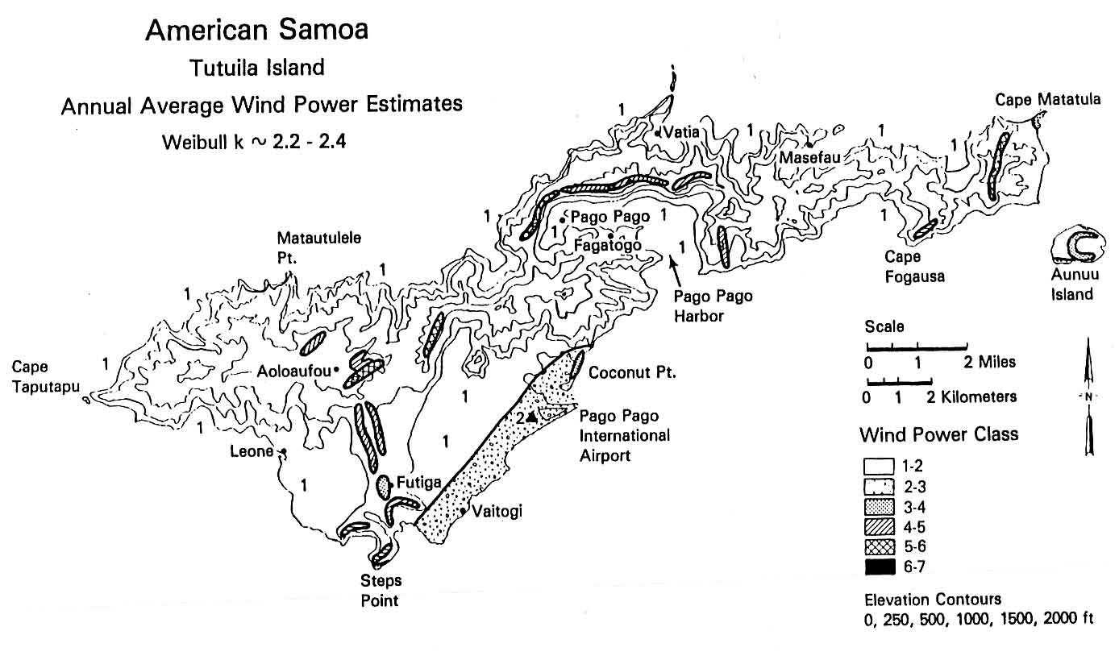
Source: ASPA
It is noted that the Electric Power Corporation (EPC) of Western Samoa is also examining wind energy as a source of supplementary generation. It is recommended that ASPA in American Samoa and EPC in Samoa share wind energy development experience and information resources.

As part of ASPA’s proposed five year project plan, three 275 kW wind turbines are proposed for installation at a total cost of about $1.6 million

Hydro Power
In 1989 a hydropower feasibility was carried out by Tonkin and Taylor International, Ltd. For ASPA. The study was looked at many options but concentrated on the possibility of converting the existing water supply facilities in the Vaipito and Faga’alu catchments to hydro generation. Fourteen schemes were considered and analyzed. Only the Matafao and Vaitanoa schemes looked at all reasonable for development.

The study showed that the existing Matafao dam and pipeline could form the basis of an economic hydro power system. Several permutations of design were examined and the best one provides an output of 68 kW. Upon analysis, the Vaitanoa dam scheme would not be cost effective with its 42kW of projected output and high cost due to the need to add a considerable length of new pipeline.

The Matafao scheme has not been carried out partly because it is so small and would have little impact on ASPA’s fuel use and partly because of concerns that it might somehow compromise the water supply. Though it is correct that it would be a small power system, if it is cost effective and does not actually constitute a hazard to the water supply or the environment, then it should be considered in light of rising fuel costs. It is recommended that the 1989 study be rechecked and if conditions are still favorable, proceed with the small hydro development on the Matafao scheme.

Biogas
There are commercial piggeries and poultry producers in American Samoa that could benefit from the waste disposal and energy production uses of biogas digesters. It is recommended that the TEO work with USDA representatives to identify commercial farms that could benefit from using biogas digesters and assist the farm owners in making contact with companies in the U.S. supplying that technology at the scale appropriate for American Samoa.

Although the sewer treatment facilities are of a type that may be appropriate for biogas production, sufficient operational details were not available at the time of the survey visit to assess the option. The largest plant probably has insufficient land available for the plant expansion that would be needed, but the other facility may be reasonable for biogas development. It is recommended that ASPA, as operator of the water and sewer system, consider the possibility of biogas generation at existing facilities and if not cost effective, include a benefit/cost analysis for biogas at the time of facility expansion or new facility construction.

Also, landfill operations and future upgrades should consider gas collection and use for energy.

Biomass
Biomass combustion and gasification have only been practical in the Pacific when associated with large scale agriculture and forestry processing. That is not present in American Samoa and biomass is unlikely to be of significance for energy production beyond household use for traditional cooking.

Should biofuel production become an industry in American Samoa, then using the waste from that process for cogeneration may be practical and should be considered.

Biofuels
Coconuts have not been a significant crop for many years and those trees that are productive typically produce coconuts only for household use. Agricultural and developable land is at a premium and the mountainous interior makes access difficult to much of the island. Biofuel production is not considered an economically attractive option for American Samoa at this time

Ocean Energy
In the 80s and early 90s, a feasibility study was carried out in American Samoa for OTEC. A bathythermic mapping study was carried out and a basic design concept developed. The concept of an American Samoa OTEC facility was determined to be technically reasonable. Unfortunately, though small pilot trials around the world have successfully generated electricity using OTEC for a short time, to date there has been no commercial construction of an OTEC facility and no demonstration of even a 1 MW capacity installation. It is not recommended that there be further study relative to OTEC until at least a 10 MW OTEC plant has operated commercially for at least five years.

Geothermal
There have been no geothermal resource surveys and no surface manifestations of geothermal activity are known to be present ini American Samoa.

Tidal
Tidal power opportunity in Samoa is limited to low head hydro propeller type turbines positioned in a non-navigational reef passage where substantial flow between the open ocean and the small lagoon occurs when the tide is running. Also, at narrow channels between islands, the tidal flow may be concentrated and relatively fast current flow has been observed, though is has not been determined if it is fast enough to be suitable for power generation. The energy conversion equipment required is being tested in Europe and is expected to be commercially available within five years. However, it has not been tested under hurricane conditions and there is considerable risk that the wave action associated with hurricanes would present a high risk of damage for the installation. The power from tidal flow is predictable but cyclical and cannot be used to offset capacity at ASPA, only for fuel saving.

As part of their proposed five year project plan, a study is included to examine the feasibility of tidal power, particularly at the inter-island channel between Tutuila and Aunu’u Island.

Wave
Wave power remains a technology that is not commercially developed, though technical trials of several technologies appear to have promise for the future. The wave energy resource has not been measured around American Samoa, and no resource assessment is proposed until commercially available wave energy conversion devices are well proven for sites having a risk of hurricane passage.



Commonwealth of
Northern Marianas Islands (CNMI)

Executive Summary
The Commonwealth of the Northern Mariana Islands (CNMI) is located in the western Pacific Ocean, 127 miles north of Guam. CNMI has a population of 69,221. CNMI is composed of 16 islands with combined total land area of 184 square miles. The Mariana chain of islands extends 440 miles from Farallon de Pajaros (Uracas) in the north to Rota in the south. Six of the islands are regularly inhabited - Saipan, Tinian, Rota, Alamagan, Anatahan, and Agrihan. Saipan, Tinian and Rota account for 65% of CNMI’s land area, 99% of the population and almost all of the economic activity and energy use. Siapan is the government headquarters, major business center and largest and most populated island. Geologically, the Northern Mariana Islands are mountainous “high islands” of volcanic origin. Typhoons with winds in excess of 180 mph periodically sweep through the islands from July through November. Flooding and wind damaged vegetation are a common result of frequent storms with winds above 60 mph.

CNMI relies entirely on petroleum fuels for energy. CNMI imports approximately 310,000 barrels of fossil fuels per year based on calculations derived from United Nations Energy/Capita data. Gasoline and diesel fuel are used for the transportation sector and No. 2 diesel is used to power diesel engines electric generators. The government is the sole producer of electrical power for resale. Major commercial users such as hotels and shopping centers have found it necessary to supply their own energy needs to avoid unscheduled shutdowns. The unreliability of the electrical power system has discouraged tourism and commercial development. Other possible sources of energy in CNMI are wind and solar however they will not be able to displace diesel engines unless there is a major breakthrough in energy storage.

Energy use is primarily for transportation and electrical power generation. Electric energy is used for refrigeration, lighting, air conditioning and cooking. Over 35% of Saipan homes use electricity as the primary means of cooking, although use of LPG, wood, or charcoal remains popular with over 50% of the families. On Saipan, approximately 70% of all families have some type of air conditioning system. Bus systems are available on Saipan, but lightly used other than for tourism. Private vehicles remain the predominant form of transportation. There are approximately 18,000 vehicles on Saipan, 600 on Tinian and 850 on Rota.

Electric system
The electrical power generation and distribution system is managed by the Commonwealth Utility Corporation ( CUC). There are a total of five diesel engine electric power plants on Saipan, Tinian and Rota with installed capability of 126.5MW but reliable capability of 115.0MW. Saipan has 105.0MW; Rota has 5.5MW, and Tinian has 3.1MW, Peak load is 59.7MW with Saipan’s peak at 55MW, Tinian’s peak at 2.7MW and Rota’s peak at 2.0MW. All generating units utilize No. 2 diesel fuel. Mobil Oil Corp. is the supplier of diesel fuel in CNMI. Cost of diesel fuel in early 2006 was $2.00 per gallon.

The electrical distribution system is 13.8 kV. Saipan has a distribution network of 135 miles at 13.8 kV. Saipan has built most of its distribution system with concrete poles to reduce the effects of typhoons damaging the distribution system.

Energy sales for 2005 were approximately 432,000 MWh with electrical production or 468,000 MWh and system losses of 36,000 MWh or approximately 7.6%.

Supply Side Efficiencies
The electric utility is in critical operating state. Maintenance has not been performed as necessary and funds are limited for such purposes. Reliability is very poor, causing many large customers to provide their own electrical power. It is estimated that 20 to 25MW is being produced by customer owned generating units. A study should be done to identify both energy and demand requirements for this customer base to include the data in any future planning for the CUC. Efficiencies of the CUC generating units is poor, requiring substantial maintenance on some engines and total replacement with more efficient units many others. Electricity users throughout CNMI are currently charged only a portion of an estimated cost of production. The current rate structure is under review. The key issue will be to recover all costs associated with power production and distribution. An additional element of supply side efficiencies is the need for a review of the losses of the distribution system. Some figures indicate losses at 7% to 8% and others indicate 20%. Distribution losses in a generally urban environment like Saipan should be in the 5% to 6% range.

Demand Side Efficiency Improvement and Energy Conservation
DSM is the primary program focus for the Commonwealth Energy Office (CEO). It is 100% funded by the USDOE State Energy Program funds that are slated to close out in 2007. That closing will place the future of the CEO in doubt. The CUC has worked with the CEO in public information programs and for the exchange of incandescent lamps with CFLs but has not had major DSM programs in the past.

Electrical Metering/Tariffs
The rates charged by the CUC are the lowest of the islands assessed and appear to be below actual cost, if capital charges are included. Charging the actual cost would have an immediate positive efficiency on energy efficiency through waste reduction. The tariff is flat, providing an opportunity for further energy efficiency improvement through imposing a tiered tariff with a low “life line” rate to about 100 kWh/month for basic services then sharply rising with another sharp rise at about 500 kWh/month such as is used in Yap, FSM.

Household Energy Efficiency Measures
Improving lighting efficiency is the most cost effective of the opportunities for DSM. The CUC and CEO have participated in several small programs that have provided CFLs at low cost or in exchange for incandescent bulbs. About 4,200 CFLs have been provided to the public through those programs and they should be continued. Most fluorescent fixtures use magnetic ballasts and should be converted to electronic units.

Large appliance ownership is high. Programs to exchange electric cook stoves with LPG and electric water heaters with solar units should be considered. A program to replace older “window” air-conditioners with high EER units could have significant benefits. Public information programs for home energy audits, refrigerator maintenance and other domestic energy efficiency programs by the CEO should be continued and expanded.

The CUC should increase support the CEO efforts through provision of information materials to customers.

Government and Commercial Sector Buildings
With the collapse of the garment industry, tourism has become the main income earner for CNMI, with visitors mostly from Asia. Hotels and air-conditioned shopping areas are the main commercial users of electricity.

Government use includes water pumping, sewage pumping and treatment and telecommunications along with government buildings. The hospital is a major energy consumer. government buildings use many “window” air conditioners that are in the EER 9.5-11 range and should be upgraded to higher efficiency units when they are replaced. Also all lighting in government facilities should be CFL or electronic ballast fluorescent lights.

Building Energy Efficiency Standards
In the early 2000s a consultant prepared a draft energy code for the CEO. It was essentially a copy of the very good Guam building energy code but it was not accepted by government. The CEO is working with the Department of Public Works to introduce it again. An enforced energy code for construction would provide the greatest long term energy saving of any presently available action.

Appliance Energy Efficiency Standards
The CNMI does not have appliance energy standards and the market is too small to make them cost effective. U.S. labels are present in most major appliances imported to CNMI but the public needs to be informed that the label shows a cost of appliance operation that is about half that of the actual cost in CNMI.

Consumers need to be informed regarding energy efficiency ratings of air-conditioners and helped to understand the trade-off between initial cost and energy efficiency.

Import restrictions that either reject low efficiency equipment or add a substantial tax to low efficiency appliances would help raise the average appliance energy efficiency. However that could be costly to enforce and a study is recommended to determine the benefits and costs of those actions.

Energy Audits, Performance Contracts
Energy audits by themselves have not proven to be an effective means of increasing investment in energy efficiency improvements since the resources to specify, purchase, install and maintain the equipment may not be available to the end user. Unfortunately, the size of the CNMI market for ESCO services is too small to warrant the local development of an ESCO or to make it profitable for an external ESCO to come to CNMI to service the local market. It is recommended that the CEO work with local architectural/engineering firms to encourage them to establish a business relationship with an overseas full service ESCO to provide local marketing of the services and perform many of the local tasks for the ESCO. That approach could make it possible for CNMI to receive the full ESCO services needed.

Transportation Sector
There is no public transport other than taxis. The only long term solution to transport fuel efficiency improvement is through replacing existing vehicles with those having higher fuel efficiency. Diesel powered cars and hybrid vehicles offer substantially higher fuel efficiency than those now in use in CNMI. Encouraging the purchase of diesel vehicles (as are commonly used in Europe and Asia) to replace gasoline powered cars can be a combination of tax policies that increase the gasoline tax and lower the diesel fuel tax and policies that impose higher taxes on the sale or import of vehicles that are lower in fuel efficiency.

Consideration should be given to encouraging the development of a fleet of private vans that operate routes to pick up and deliver passengers as is common for public transport in many African, Asian and some Pacific countries.

Renewable Energy

Solar
The solar resource is very good. Local cloudiness occurs due to mountains and the island land mass so insolation varies somewhat from place to place.

Solar Thermal
Solar thermal electric generation is not recommended for the CNMI. Conditions are not good for their efficient use and the high risk of typhoon passage is a serious problem.

There is a large opportunity for developing the solar water heater market. The CEO and CUC should develop a program to encourage the replacement of electric water heaters with solar units for homes and commercial buildings. For tourist hotels, it is suggested that the CUC and CEO work with the local hotel association to have experts come to Saipan to prepare solar water heater proposals for member hotels and also for the CNMI government. A coordinated approach that includes finance, installation and maintenance will be needed.

There may be a business opportunity in the renting of solar water heaters to households as is being tried in the Caribbean. The company would install the units and then charge a monthly hot water service fee somewhat less than the typical cost of electrically heated hot water. With a payback time of 4-6 years and a service life of the water heaters around 10 years, it could be a profitable business.

Solar Photovoltaics
There is little opportunity for off-grid electrification with solar PV as CNMI is effectively 100% electrified. Grid connected solar holds promise for fuel savings but the low cost of electricity in CNMI makes it far from cost effective. It is recommended that trials begin with a small (3-5KWp) roof mounted grid connected PV installation for CUC to gain experience and confidence in the technology.

Wind
There have been no wind energy surveys in the CNMI and though the resource looks promising from satellite estimates, the high risk of typhoons is a major problem for wind energy development. A pre-feasibility study to estimate the probable cost of energy from CNMI based wind farms on Saipan, Rota and Tinian including the methodology and cost of mitigating the typhoon risk is recommended. Should the pre-feasibility study indicate a good probability of an opportunity for cost effective wind power for grid supplementation, a full wind resource assessment and wind mapping exercise for the three islands would then be reasonable.

Hydro

There is no economically developable hydro resource known in CNMI.

Biofuel
The cost of labor and land makes it unlikely that the CNMI can develop a viable biofuel industry at present fuel prices. If fuel prices rise significantly, consideration should be given to the development biofuel crops, particularly on Rota and Tinian.

Biomass combustion and gasification
Past trials at energy farming and energy production through gasification have not succeeded in the CNMI. There are no large scale agricultural processing plants in the CNMI and unless there is a return of large scale agricultural processing, such as would result from the development of a biofuel production facility, biomass for combustion or burning does not appear to be likely to be a significant energy source.

Biogas
There have been many trials of biogas at piggeries in the CNMI but most are no longer in service. It is recommended that the CEO in cooperation with the USDA and EPA survey commercial animal and poultry farmers regarding the market for digesters as a waste control measure and for energy production. If there is a large enough market, it is recommended that arrangements be made with a supplier for a joint purchase by many farms to lower the cost of shipping and installation.

There appears to be significant potential for biogas production from sewage and the Marpi landfill. The landfill has been constructed with gas extraction in mind but the sewer plants have not. It is recommended that consideration be given to retrofitting the existing sewer plants for biogas production and that future plants and upgrades of existing plants include biogas generation if it is found to be cost effective.

Geothermal

No geothermal resource that can be developed for energy production is known in CNMI.

Ocean Energy
Although conditions appear good for OTEC development, it is not recommended that Saipan consider an installation until a unit of a size comparable to that appropriate for Saipan is commercially proven. CNMI does not have the surplus resources or capacity to be able to afford a major power project that fails, even if paid for by an outside agency.

Tidal flow energy may be possible to develop and commercial units of the type needed are being tested in Europe. It is recommended that there be a low cost survey to locate sites that have a fast current and large volume of flow when the tides are entering or leaving the lagoon but are not used for navigation.

General
The Commonwealth of the Northern Mariana Islands (CNMI) is located in the western Pacific Ocean. CNMI has a population of 69,221 with an economy that has been in decline since the loss of most of its garment industry to other countries in the late 1990's. The majority of the population lives on the island of Saipan. There is some small industry to supply the main island, but no major industry currently in operation on Saipan other than the remaining garment industry that continues to decline.

Location, Population and Geography
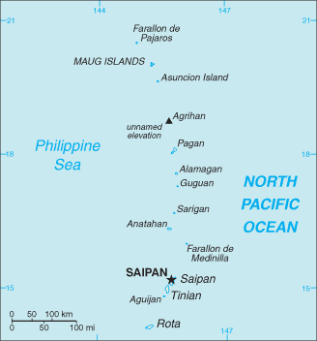
Geologically, the Northern Mariana Islands are mountainous “ high islands” of volcanic origin. The Marianas are part of the Palau-Yap-Mariana-Japan trench system, which forms the boundary between the Asiatic structural blocks and the true Pacific Basin. The island chain is aligned along the crest of the gulf that is associated with the great Mariana trough the reaches a depth of nearly 10 kilometers (6 miles). In the southern islands, coralline limestone caps the volcanic formation. Saipan is the only island with a sizable lagoon. It extends almost the entire length of the western side of the island. The CNMI has an estimated total of 84,000 full time residents based on the U.S. government's 2006 estimates. The islands hold a strategic location in the Pacific for both military and business perspective.

Island Characteristics
The climate of the CNMI is tropical, uniformly warm and humid. This climate, coupled with the salt-laden air, severely limits the lifetime of mechanical equipment. Saipan is reputed to have one of the world’s most equable climates with an average year-round temperature of 27ºC (81oF). Wind and rainfall are the most variable elements. There are distinct dry and rainy seasons in the Marianas, which would affect efforts to exploit hydroelectric resources. Average yearly rainfall is 130 cm (50 in); over half of it between July and November. From July through November, typhoons with winds in excess of 300 km/h (180 mph) periodically sweep through the islands. Flooding and wind damaged vegetation are a common result of storms with winds above 100 km/h. Storms of this sort are very destructive, and are particularly hard on structures of all kinds. The effects of these high winds and the associated wind-driven debris on alternate energy systems must be considered when reaching decisions on which types of alternate energy are most appropriate for the CNMI.

Island Geography
The Commonwealth of the Northern Mariana Islands (CNMI) is composed of 16 islands which have a combined total land area of 184 square miles. The chain extends 440 miles from Farallon de Pajaros (Uracas) in the north to Rota in the south. The United States Territory of Guam is only 127 miles to the south of Saipan. Only six of the islands in CNMI- Saipan, Tinian, Rota, Alamagan, Anatahan, and Agrihan – are regularly inhabited. Saipan, Tinian and Rota account for 65% of the land area of the Commonwealth, 99% of the population and almost all of the economic activity and energy supply and demand.

Climate and Environmental Hazards
Geologically, the Northern Mariana Islands are mountainous “high islands” of volcanic origin. In the southern islands, coralline limestone caps the volcanic formation. Saipan is the only island with a sizable lagoon. It extends almost the entire length of the western side of the island. Nine of the 14 islands in the CNMI have potentially active volcanoes. One island volcano-Anatahan is presently active and has been spreading ash over the Marianas Island chain.

Climate and Environmental Hazards
The climate of the CNMI is tropical, uniformly warm and humid. This climate, coupled with the salt-laden air, severely limits the lifetime of mechanical equipment. Saipan is reputed to have one of the world’s most equable climates with an average year-round temperature of 27˚C (81˚F). Wind and rainfall are the most variable elements. There are distinct dry and rainy seasons in the Marianas, which would affect efforts to exploit hydroelectric resources. Average yearly rainfall is 130 cm (50 in); over half of it between July and November.

From July through November, typhoons with winds in excess of 300 km/h (180 mph) periodically sweep through the islands. Flooding and wind damaged vegetation are a common result of storms with winds above 100 km/h. Storms of this sort are very destructive, and are particularly hard on structures of all kinds. The effects of these high winds and the associated wind-driven debris on alternate energy systems must be considered when reaching decisions on which types of alternate energy are most appropriate for the CNMI.

In addition to climactic threats, CNMI also has earthquakes and possible tsunami events that can threaten the coastal business communities and the general population.

Energy Sources
CNMI presently relies entirely on petroleum fuels for energy outside of the small solar installations on some of the outer islands. It is unusual for the private sector to generate their own power other than for backup purposes. However, there are isolated instances where power is generated internally by both hotels and some small industries. The government remains the sole producer of power for resale. The central grid has very high losses, exceeding 25%. The reason for this is unknown, but a study should be done to determine the cause of the losses to allow them to be resolved.

Major commercial users, hotels, shopping centers, found it necessary to supply their own energy needs to avoid unscheduled shutdowns. The unreliability of the electrical power system has discouraged both tourism and commercial development in the islands.

The three major islands do not have electrical generating capacity adequate to meet current demand. Rolling blackouts are common on the island due to inadequate equipment maintenance. The high fuel costs and inadequate funding of the utility has compounded the problem causing additional units to be taken out of service due to preventable equipment failures. Most if not all of the failures can be traced back to not performing the factory recommended maintenance practices. However, the electrical distribution system on Saipan has substantially improved over the past several years. Continued investment by the United States Government through covenant funding and additional grants has provided Saipan with a transmission system that will withstand most small storms and typhoons. Their 13.8kv transmission system has been converted to concrete poles to improve their ability to survive severe weather.

The Commonwealth depends totally upon imported petroleum for both transportation and electrical power generation. World oil prices and supplies have been relatively stable in recent years, but the CNMI government recognizes that if market perturbations similar to those occurring in the mid-1970s were to occur again, the resultant uncertainty of supply and difficulties in meeting oil prices could cause severe economic stresses. As a result, the CNMI is concerned with developing indigenous energy resources both to reduce oil demand in the population centers and to provide new, non-petroleum energy source for the outer islands.

The CNMI government is currently going through their generating plants and doing needed repairs as budget and manpower permit, but this does not address the long term issue of being able to prevent future interruptions in power. Additional funding must be found to support the needed maintenance schedule for the island power plants. This will require increasing the electric rates to cover both fuel and routine/preventive maintenance costs. CNMI recently brought in outside consultants to review the rates and make recommendations on how to structure the rates and is implementing emergency rate hikes based on those recommodations. It is critical to the electrical system that the rates be set along with fuel adjustment clauses to permit the utility to cover the cost of generating electricity. If rates are not set high enough to cover the costs, then the plants should be shut down until their preventive maintenance can be performed. This will decrease the availability of power and will likely result in additional blackouts on the island. However, this is a preferred method of operating, compared to running the units until they fail.

The existing generating units indicate that they are inefficient based on fuel consumption and generated kWh. However, the numbers provided would need further analysis prior to concluding that it is, in fact, a unit design or age issue resulting in the exceptionally low efficiency of the units. Performance tests need to be performed to determine actual unit performance. There are many variables in a fuel system that can cause a unit to appear to be inefficient when the cause can be something as simple as a fuel leak or fuel theft. These are easy to identify and fuel tank leakage should be part of the unit performance test. These tests should be conducted with third party supervision as soon as possible to determine where the fuel is being used.

Upgrading power plants to new replacement units is a window of opportunity that opens only once every 20 to 30 years. This window should not be taken lightly. Studies should be performed to determine the correct approach for replacing units. The decisions made today will impact future generations for two to three decades.

Renewable resources may be an option; another possibility is the installation of coal fired power plants instead of continuing with the diesel and residual fuel oil fired units currently being used. Coal prices are currently less than $60/ton. When corrected for BTU differences in the fuels, this equates to approximately $0.03/kWh fuel cost compared to $0.13/kWh fuel cost for a diesel or $0.11/kWh for residual fuel. An added benefit for an island economy is that the coal-fired plant creates more jobs. Operation costs may be slightly higher for steam plants and this should be taken into consideration. However, at the cost differential between coal and oil, additional labor will not offset the overall savings. Total dollar fuel savings for a 10 MW system would be in the area of $9 million per year in fuel savings. A feasibility study would provide the complete cost and savings. However, Operation and Maintenance costs for a coal-fired unit, historically, are substantially less than the fuel savings.

Wind and solar will not be able to displace fossil engines unless there is a major breakthrough in energy storage. They can, however, supplement the existing fossil generation mix and should be considered when replacing or upgrading system capacity.

Energy Uses
Consumption of electric energy for cooking continues to increase in popularity, with over 35% of Saipan homes using electricity for their primary means of cooking food. However, cooking with gas, wood, or charcoal remains popular with over 50% of the families using outdoor cooking units.In the sparsely populated Northern Islands, 2 of the 3 families interviewed for the census used electric cooking. Again, this is based on the 2000 census information since that is the latest recorded information.

Figure 6-1
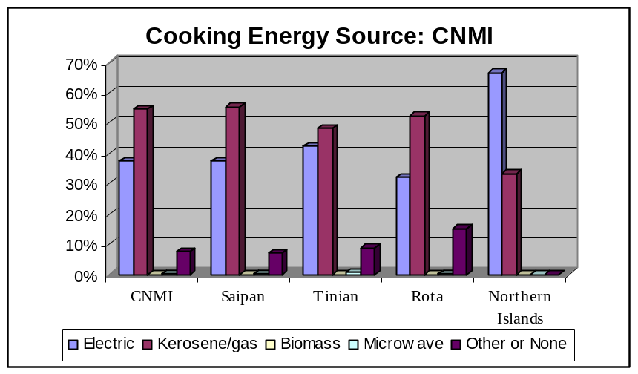

Table 6-1
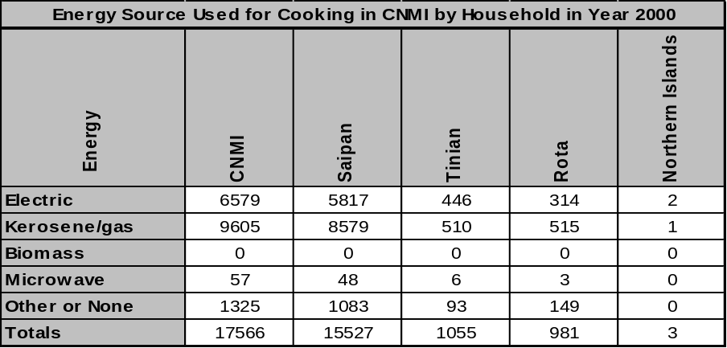

Air conditioning on the islands of CNMI is popular where there is readily available power to run the system. On Saipan, close to 70% of all families have some type of air conditioning system in their homes. On the Northern Islands, none of the homes are equipped with air conditioning.

Figure 6-2
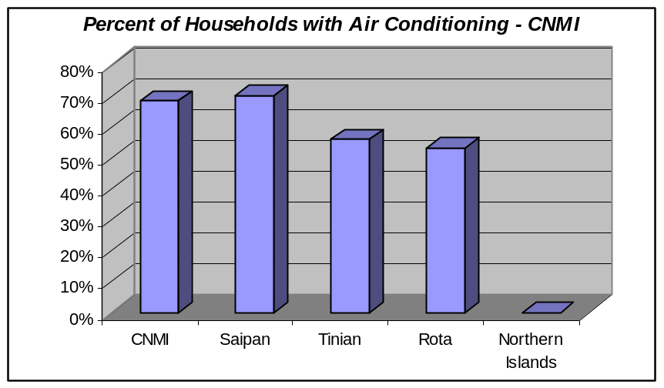
Bus systems are available on island, but lightly used other than for tourism. Private vehicles remain the predominant form of transportation. There are discussions of creating a more robust bus system for the island, but currently, there is no budget or firm plans in place. With the higher fuel costs, bus transportation similar to that in American Samoa may be a valid option, utilizing small, privately owned busses to meet the needs of the local population. This approach would also fit the tourist trade by providing smaller, more efficient busses.

HISTORY, POLITICAL DEVELOPMENT AND PRESENT STATUS

Early Island History
Present day inhabitants of the Northern Marianas are the descendants of the of the original Chamorro settlers of the islands, Carolinians, and a growing number of Asian settlers, including many Filipinos who are engaged in the construction and service industries. The Chamorros who settled the islands, (probably in the third or fourth century A.D.), were reputed to be tall, warlike and fearsome. The first European visitor to what is now the CNMI was probably Ferdinand Magellan, who landed in Guam in 1521.

After to Magellan’s departure, the islands in the CNMI were virtually ignored until the arrival of Spanish Jesuits in 1668. The priests christened and the archipelago “ Marianas” in honor of Queen Maria Anna, widow if Philip of Spain and patroness of the first missionaries. However, for a century after their visit, Spain made no effort to colonize the islands, using them mainly as a watering and provisioning stop on the sailing route from Acapulco to Manila. During this time, persecution, famine and disease so depopulated the island that by 1698, all of the remaining inhabitants had been removed to Guam. By 1780 the number of Chamorros remaining on Guam had fallen to only 1639.

Saipan was repopulated in the nineteenth century. Initially, Carolinian sailors from the Eastern Caroline Islands who received permission from the Spanish Governor on Guam established early settlements in 1815. The islands later became home to people of partial Chamorro decent whose parents had been forcibly evacuated from the Northern Mariana by the Spaniards earlier. They were also attracted by the possibility of engaging in copra production and of having greater freedom from Spanish control than they had on Guam.

In 1899, after its defeat in the Spanish-American War, Spain ceded Guam to the United States and sold the Northern Marianas, along with the rest of Micronesia, to Germany for $4.5 million.

The Marianas proved to be economic liability to Germany. Because of scarce resources and distance from Europe, commerce never took off as expected. At the beginning of World War I, the islands were taken by Japan without struggle. In 1920, the League of Nations formalized this wartime seizure by placing the Northern Marians, as well as the Carolines and the Marshall Islands under a League of Nations Mandate to Japan.

Recent Island History
During the Japanese period (1914-1944), the islands acquired new significance. They lay along routes of Japanese economic expansion and were considered strategically vital to Japan. Japanese commercial enterprises and colonization brought development to the Marianas. Much of the still existing and utilized infrastructure, such as roads, docks and water systems, are from this era. Sugar and starch (sugar cane, taro and cassava) production dominated economic life. Fishing also contributed to the economy. By 1937, there were 47,000 residents in the Marianas, most of whom were Japanese citizens or nationals, Okinawans and Koreans. “Natives” numbered only 4,000.

World War II radically transformed the Marianas. Ninety percent of the local population survived but agriculture lay in ruins. Withdrawal of troops left a landscape cluttered with airstrips, abandoned installations, piles of waste, live ammunition of all kinds (artillery shells, mortar shells, hand grenades) and a completely altered indigenous society. At first, the islands were placed under naval administration. Then, on July 18, 1947, the Security Council of the United Nations and the United States entered into a Trusteeship Agreement, covering all of the former Japanese mandated islands, including the Northern Marianas, the Eastern and Western Carolines and the Marshall Islands.

United States Involvement
In March 1976, both the people of the Northern Marianas and the United States Congress approved a Covenant to establish a Commonwealth of the Northern Mariana Islands. On April 1, 1976, the Northern Marianas separated from the rest of the Trust Territory and became “separately administered,” moving toward an eventual Commonwealth status. By popular referendum, the people of the Northern Marianas adopted the Northern Marianas Constitution, subsequently approved by the United States government. The Constitution of the Northern Marianas became effective on January 9, 1978 and the people witnessed the inauguration of their first elected governor, legislators and other elected officials. Establishment of the CNMI government meant that Saipan was now the site of the headquarters for both the Trust Territory of the Pacific Islands (TTPI) government and the new CNMI government. This marked the first time in more than 400 years that the people of the Northern Marianas had regained the right to choose their own government.

Present Political Status
The traditional system of governance that has ruled Chamarro society throughout history has given way to a new republic with the power of a private voting booth. The 2005 elections in CNMI brought an astounding turnout of 93% for the Commonwealth, with Rota citizens showing the strongest turnout at 97%. Out of Rota's 1255 registered voters, only 51 eligible voters on Rota failed to turn out for the 2005 election.

The islands are governed by an elected governor and lieutenant governor, both serving four-year terms, and a legislature consisting of a 9-member Senate and a 15-member House of Representatives. Benigno Fitial became governor in January 2006.

POPULATION, EMPLOYMENT & WAGES

Present Demographics
The population of the Commonwealth had been expanding in the early 20th century at 1 to 2% per year. However, this changed when Japan began developing the islands after World War I. As Japan expanded the island's infrastructure, population began a steep rise as foreign workers came to Saipan. Following World War II expansion continued.

CNMI Population Chart showing steep increase in population following the implementation of the Compact of Free Association in 1978

Figure 6-3

CNMI Population Growth 1920 - 2000 Census
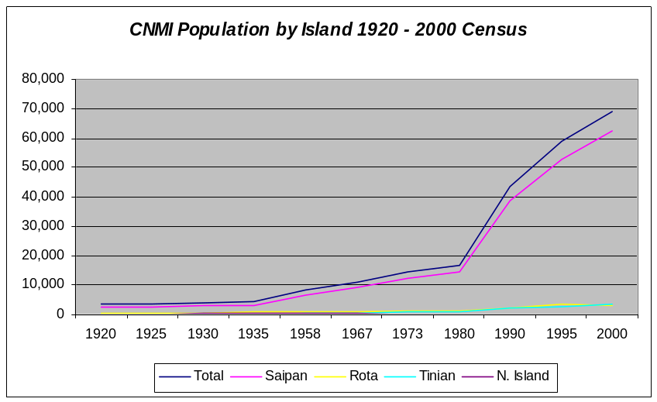

Table 6-2
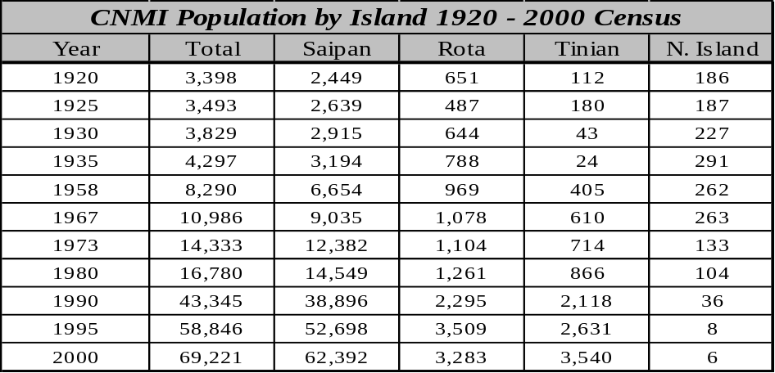

Employment and Job Market
The 2000 Census report showed CNMI with over 42,000 people employed with unemployment at less than 3.5%, and with foreign workers making up over half of the employed population. The low unemployment in 2000 was due to the high employment rate in the garment industry that was flourishing on Saipan at the time. However, when free trade policies of the United States began to go into effect, the garment industry in Saipan lost a good percentage of the jobs to overseas companies. There is a lack of reliable information from the 2000 Census on employment by class. Therefore, without a more complete investigation on employment and jobs by job sector, it is not possible at this time to provide any accurate data on employment levels. Current estimates for this report are compiled from partial data in the Census and from the U.S. government CIA data.

Gross Domestic Product
The Gross Domestic Product provides an overall picture of how well the CNMI is performing economically. There are a number of factors that contribute to the GDP, but the basic measurement will provide good insight as to the health of the economy. CNMI has been able to demonstrate a positive GDP due to the ongoing exports from their remaining garment industry and the tourist industry that again seems to be increasing in the CNMI.

The 2005 projected GDP by USDOI was $1 billion, putting the per capita GDP at $13,350 with most coming from the garment and tourist industry. The fishing industry is small in CNMI, but does contribute some to the overall economy; the graph shows the trend in commercial versus non-commercial fishing and the impact on GDP.

Figure 6-4
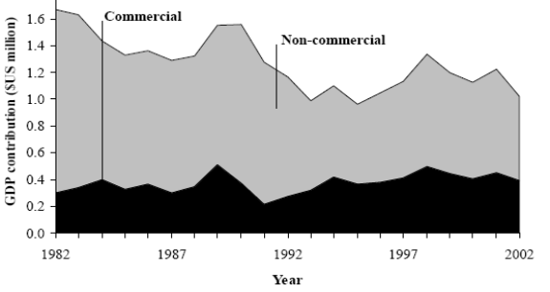

In June of 2006, Governor Fitial signed into law Bill 15-20 implementing Public Law 11-60. This new law is a seven-year-old law that allows individuals 55 years old to retire in CNMI. It reduces the required minimum investment to $100,000 for a qualifying property on Saipan and $75,000 on Tinian or Rota. This is expected to increase the flow of retirees into CNMI (with its lucrative tax structure) and boost GDP for the Commonwealth.

Personal Wages & Income
Personal wages remain low in the islands, with most having 2 or more wage earners for financial support per family. Average income for families varies substantially between the islands in CNMI with the highest average wage being on Rota, at a little over $42,000 USD/year. The lowest average wage is in the Northern Islands, where wages are under $27,000 USD/year. The chart shows the large variations in wages between the islands of the Commonwealth.

Figure 6-5
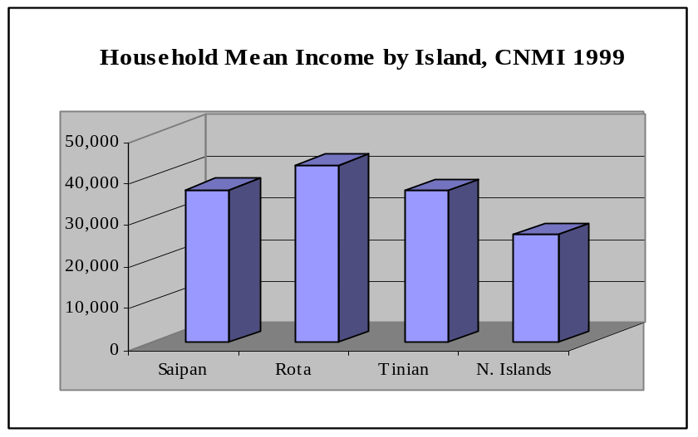

General Business & Commercial Income
TheCNMI has a very friendly business environment with several areas of government regulation that favor moving businesses to the islands. In addition, there will be an expected expansion of business on CNMI if the infrastructure improves, and this will depend on how successful the government and business community is in educating the public on the effect of oil prices on electric rates.

Figure 6-6
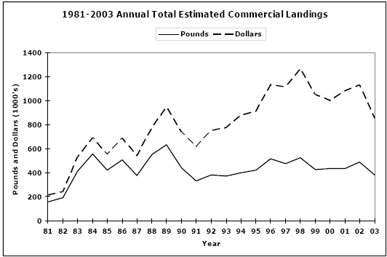

The chart above shows the total catch from 1981 to 2003. The chart on the following page breaks out the catch in 2003 by species.

Table 6-3
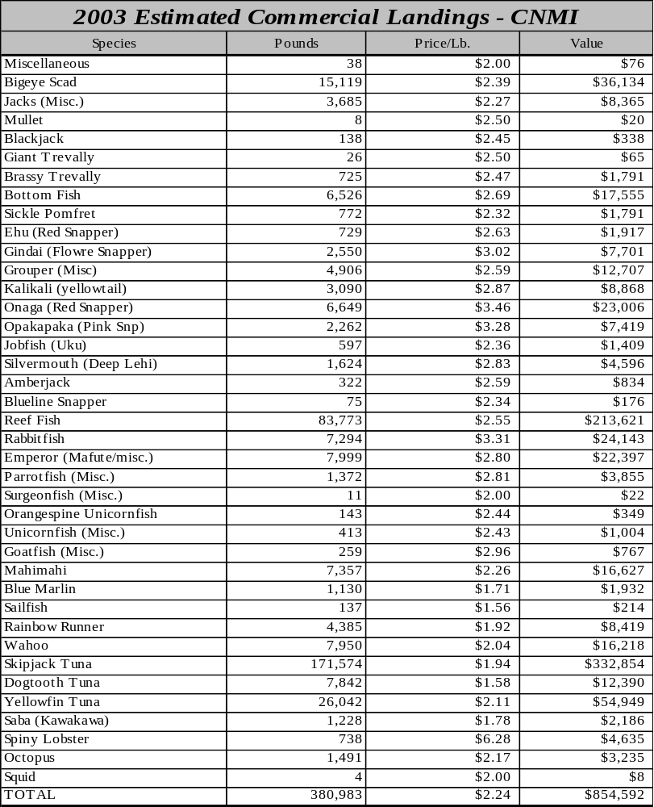

ISLAND ECONOMY AND INFRASTRUCTURE

General Status of the Economy
The CNMI economy continues to depend on the garment industry and tourism for the Commonwealth’s major export and job markets. Over the past year, tourism has been on the rise, though a reduction in flights by Japan Air Lines is expected to severly impact tourism in the CNMI. . The garment industry continues to struggle against lower wage rates in other countries.

Table 6-4
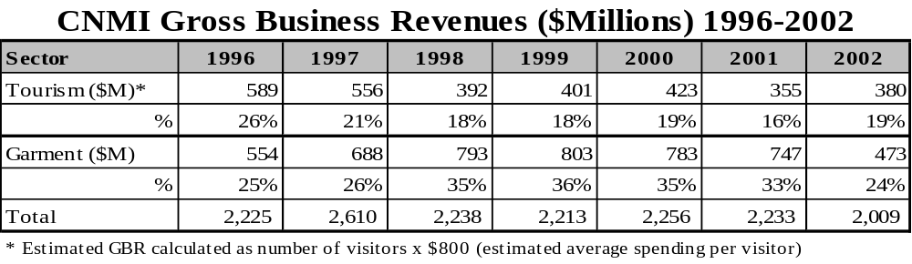

Major Employment Sectors
The major non-government employment sectors for the territory remain with the garment industry and tourist related services. However, the private sector, including trade, hotels, and restaurants, play a key roll in keeping unemployment numbers down.

Table 6-5
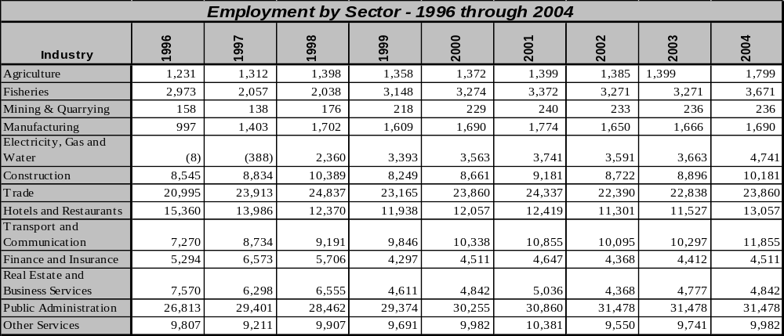

Figure 6-7
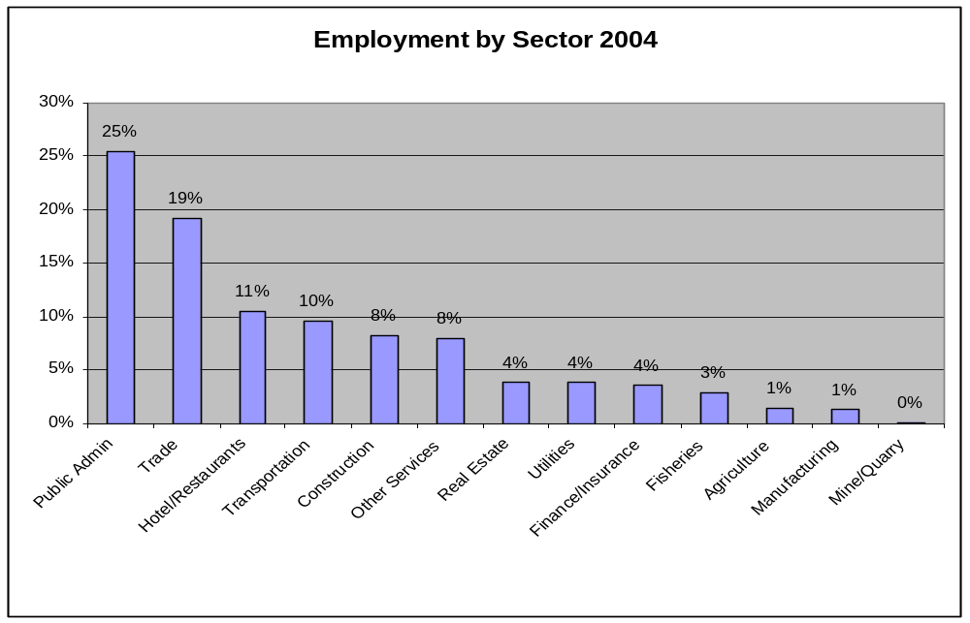

Water and Wastewater Systems
The utility operates three wastewater treatment systems on the island of Saipan. Residents on Rota and Tinian use septic systems, pending new sewer infrastructure. Wastewater rates are $.50 cents per 1000 gallons, with a monthly minimum of $3.00. Saipan's wastewater collection system consists of 25 miles of pipeline and contains 25 lift stations. There are two outfall pipes, one of which was rebuilt, upgraded and extended in 1995. The wastewater system currently faces two problems:
- Capital required to build more collection pipelines; and,
- Rainfall leaks into the collection systems. At times of extremely heavy rainfall, the collection system is flooded and waste rises from the system with the rising water. As a result, the treatment facilities end up treating rainwater.

Electric System
The electric infrastructure remains vulnerable due to lack of funds resulting in recent fuel cost increases that the utility and government are reluctant to pass on to residential and business customers. This results in decreased maintenance of assets and lower reliability numbers. The utility continues to struggle to meet budgets by not maintaining their assets. Service to the public has deteriorated, but new management is working to turn the situation around. Roads have substantially improved over the past several years. Water and sewage continue to be a challenge to the utility due to the increased cost of electric rates and economic downturn. Water catchments are commonly used in CNMI with over half of the population using catchments or rainwater for drinking water. A new bill is currently being considered in the legislature that will encourage residents to install solar thermal units and catchment basins in their new homes to reduce electricity consumption. The House passed the Bill and has forwarded it to the Senate. The Bill is expected to be signed into Law.

Electric power is generated with costly, imported diesel fuel, and this dependence results in heavy United States subsidies. The high cost of fuel and electricity has a negative impact on the economy and business. Decreased profits result in a reduction of available capital for new investments. In addition the deterioration of the utility assets further erodes business expansion due to infrastructure deficiencies.

The electrical power generation and distribution system is managed by the CUC. Upon commission of two new 13 MW diesel generators in March 1992, the installed capacity on Saipan is 105.0 MW. Rota has a capacity of 5.5 MW, and Tinian has 3.1 MW, making the system total 115.0 MW. Peak loads for Saipan, Tinian and Rota are 55, 2.7, and 2.0 MW, respectively. Saipan has a distribution network of 135 miles of a 13.8 kV. The power plant capacity for Saipan is listed in the following chart:

Table 6-6
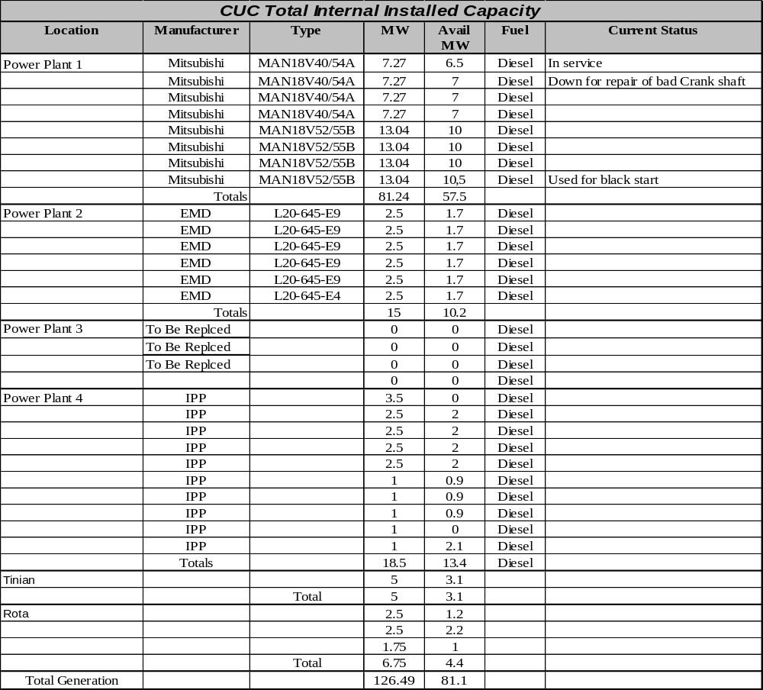
Maintenance problems persist with the units on all CNMI islands due to the lack of funding for preventive maintenance and required inspections. It is essential that the cost of maintenance be recovered through customer rates to bring the units back to a normal maintenance programs as recommended by the manufacturer. The chart below shows the total kWH generated, sold, and system losses on Table 6-8:

Figure 6-8
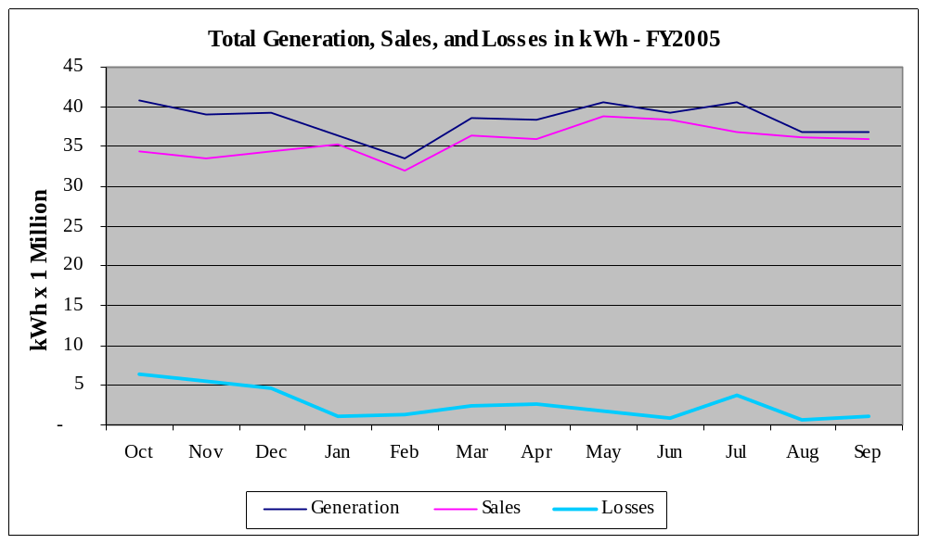

In addition to the known load mentioned above, there is undefined additional energy consumption by companies and individuals that produce their own power. The estimated amount of customer-generated power is in the area of 20 MWs, but could be as high as 25 MWs of potential demand for the utility if the customer generated power were generated by CUC. Further study should be done to identify both energy and demand requirements for this customer base to include the data in any future planning for the CUC utility. In addition, this generating capacity is also available for possible support for the utility during high demand, low production days. The future study should include options to be considered during future supply side management improvements by CUC.

Electricity users throughout CNMI are currently charged only a portion of an estimated cost of production. The current rate structure is under review, and an emergency rate increase is being implemented. The key issue will be to recover all costs associated with power production and distribution. Charging less than this amount, as is currently being done, will result in severe debt load that will drive costs even higher. This issue must be addressed immediately by CUC to prevent further financial damage to the utility and to CNMI.

In the residential/commercial sectors, the principal uses of electric power are cooking, refrigerating and lighting. Electric hot water heaters and air conditioning systems continue to increase in popularity. Typical electrical consumption in the residential sector has increased from an estimated 70 kWh/month to 545 kWh/month in 2004.

Transportation fuels represent the third major category of petroleum use in CNMI. In 2001, there were close to 18,000 passenger vehicles in Saipan, over 600 in Tinian, and close to 850 motor vehicles in Rota. Close to 500 boats, plus commercial aviation, comprise the specific uses of fuel within the transportation sector. The CNMI government operates a very limited field ship system, so fuel used for inter-island transportation of people and goods is included in the marine transportation sector. Current fuel import data was not made available. The island imports approximately 310,000 barrels of fossil fuels per year based on calculations derived from United Nations Energy/Capita data,

Economic development goals in CNMI center on enhancing four major activities: tourism, fisheries, garment industry, and agriculture. Sufficient and reliable public power will be required to attract potential investors. If generating capacity with required transmission and distribution infrastructure is not available, the Commonwealth may have to offer tax incentives to industries that have to develop their own power sources. The government of CNMI prefers to have the infrastructure in place to allow it to be the energy provider of choice, but the planning stages of an effective effort to increase CNMI’s central electric generating capacity significantly will be needed to encourage business investments in the territory.

Transportation
Transportation is primarily by personal vehicle and taxi. With the higher fuel costs, there is an added interest in reducing the cost of personal transportation. American Samoa has incorporated a competitive system of Aiga buses that appear to be well received by the general public and tourists. The busses are constructed from recycled 1 ton or larger truck frames. The same effect can be secured by purchasing small 9-12 passenger buses, but the brightly colored paint schemes on the Aiga buses seem to be very popular with the tourists and locals alike.

Marine
The total number of sea vessels has increased substantially since 1982. The chart below shows demonstrates the steady increase up through 2001.

Figure 6-9
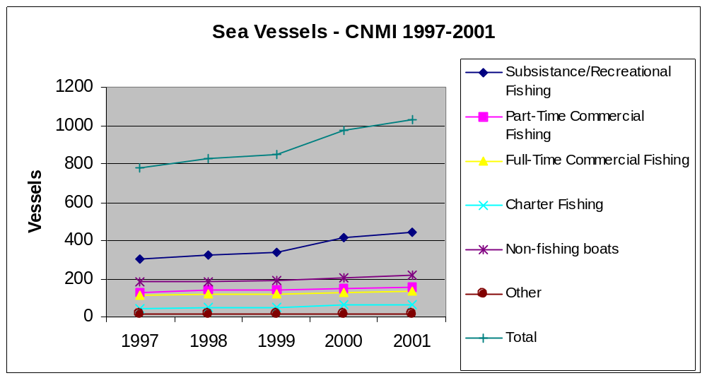

Port and Port Industries
The CNMI’s primary seaport on Saipan was expanded in the 1990’s. The original port was constructed after World War II to accommodate increases in ocean cargo arriving at the facility and improve the harbor. This expansion of the existing berthing space from 850 feet to 2,600 linear feet included dredging of the entrance channel and turning basin.

The primary commercial port in the CNMI is Charlie Dock in Saipan’s harbor. The harbor and docking area are undergoing extensive renovation and the channel areas of the harbor are being dredged to a depth of 40 feet. Rota has two harbors. The West Harbor is larger, with an 800-foot channel leading to a turning basin and wharf.

U.S. Naval engineers constructed Tinian Harbor during World War II. The harbor is the property of the CPA but is 80 percent under lease to the U.S. military. The harbor also is a center for fish transshipments. Facilities include a cold storage center with a capacity of 2,000 tons and new warehouse facilities. A 3,500-foot breakwater protects the harbor. The dock is 750 feet long and partially constructed of reinforced concrete.

Airports
The Commonwealth Ports Authority (CPA) administers airport facilities in Saipan, Rota and Tinian. Saipan International Airport is the air gateway to the CNMI and serves as the primary airport. Terminal facilities are modern and well maintained. An air traffic control tower was constructed in 1994 and commissioned in January 1995. The Federal Aviation Administration trained local residents to become certified air traffic controllers. The 8,700-foot runway on Saipan is capable of handling DC-10 and B-747 aircraft. ,

Communication Systems
The CNMI joined the North American Number Plan on July 1, 1997. Prior to that time, each island had a separate country code and expensive long distance charges. With the transition to the North American Number Plan, CNMI now has a single area code for all of the islands (670) and can dial the United States mainland, Alaska, Canada, Guam, Puerto Rico, and the U.S. Virgin Islands through local carriers for around 14 cents per minute with even lower cost plans available through various calling cards. Toll free numbers have also been opened up to the CNMI, which makes mail order shopping and customer service calls cheaper and more convenient.There are several Internet Service Providers on the island. Phone connections have increased dramatically since 1982. The chart below shows the trend with current connections beginning to level off.

Figure 6-10
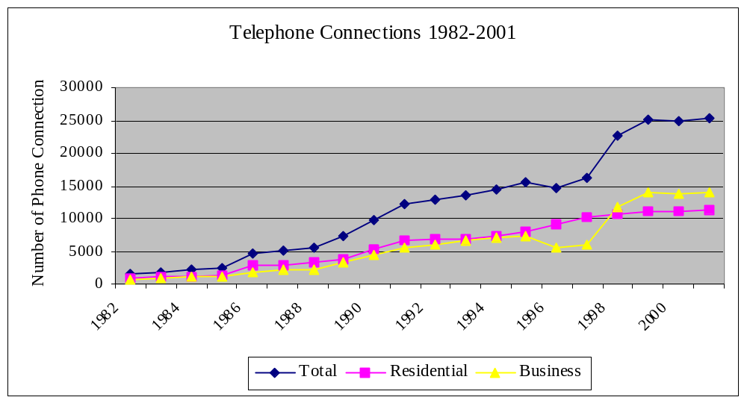

Tourism Industry
Tourism continues to be the major attraction and industry in CNMI.

Major Industry
Saipan currently has the garment industry and tourism. Rota has tourism, with Tinian having a casino and associated tourist trade.

Military
The U.S. military will be moving troops and supplies to Tinian as the United States withdraws forces and equipment from the bases in Japan. This will likely increase the visitors to Saipan, as well.

Other Special Economic Elements
CNMI is in direct competition with nations such as China, Philippines, and Korea that have fewer regulations, and much lower hourly wages to employees. This puts CNMI at a disadvantage since there are no minimum wage laws in the countries that CNMI has to compete with.

Manufacturing, Craft, Trade
The garment industry remains a key part of the CNMI manufacturing and GDP.

Agriculture
The CNMI continues to practice subsistence farming and fishing, although a number of crops are produced commercially, such as taro, cassava, yams, breadfruit and bananas along with some minor crops that provide the local markets with fresh fruits and vegetables

Aquaculture, Fisheries, Refineries
The CNMI has no large-scale industry for aquaculture, fisheries, or refineries. However, there are currently two aquaculture based farms on the island of Saipan and some training has been done with others in an attempt to expand the business.

The CNMI aquaculture industry has concentrated its efforts on shrimp production for several reasons,, the most important of which are the increased demand for shrimp, the improvements in farming techniques, (allowing farmers to grow marine shrimp in low salinity water or city water), and the grow-out cycle of shrimp is shorter than growing fish.

shrimp freshwater prawn There are currently two small-scale commercial farmers known to be producing white shrimp on the island of Saipan. Both farmers use aboveground concrete tanks for their durability, especially during typhoon season. Aboveground tanks also are very versatile and can be installed in smaller land areas, such as backyards or homestead lots. There are also tilapia sites on Rota and some efforts with fish tanks on Tinian. The Northern Marianas Community College CNMI Cooperative Research Extension and Education Service oversees much of the Aquaculture activities.

ECONOMIC DEVELOPMENT PLANS AND PROJECTS

Existing Capital Improvement Projects
Rehabilitation of the runway at Saipan International Airport along with other infrastructure improvements at the airport is on hold due to fish and wildlife issues. CNMI is expecting to rebid the project in September 2006.

The CNMI has requested a little over $12 million to cover capital improvement projects (CIP) that were deferred from funding in previous years such as the Kagman watershed construction projects and water conservation service. Since CIPs are required to be partially funded by CNMI, the shortage of funds has prevented many of the CIPs from moving forward. The CNMI also has requested an additional $60 million as a special request to the Senate Sub-Committee on Water and Energy Development to provide for one time CIP to install three separate reverse osmosis water purification plants to be strategically located in three separate areas of Saipan.

General Status of Economic Development Planning
The CNMI continues to pursue tourism as a major market for the islands. Tinian has operated casinos on the island since gambling was legalized in 1989. This is one of the areas that continues to be considered for Saipan expansion, but has been voted down by the CNMI voters. Currently, the Tinian casinos are seen as a pilot project that could provide additional revenue for all of CNMI. Further study will be required to fully grasp the efforts being made by CNMI to develop their long term plans for the island’s economic development.

Economic Development Approach and Special Issues
The CNMI economy is besieged by changes in regional tourism markets and the advancement of free trade. During the last two decades, the garment industry has been one of the two pillars of the CNMI economy, along with tourism. The garment industry succeeded, and even surpassed tourism at its peak in the late 1990s, because of two trade provisions,, quotas on imports from low-cost producers of garments, and duty-free export of goods manufactured in the CNMI to the United States. The CNMI has also benefited from its ability to control its immigration and establish its own minimum wage. With virtually no military installations and very limited military spending, the CNMI's ability to import labor and set its own minimum wage has been essential to its economic survival.

With its labor, immigration and export advantages, the CNMI established a successful garment manufacturing industry in the 1980s. At its peak in 1999-2000, the industry shipped well over $1 billion worth of garments to the United States and employed around 16,000 mostly foreign workers directly. It also paid roughly $79 million in taxes and fees into the CNMI treasury, about 35 percent of total public revenues at the time. In 2004, shipments to the United States were down to $807 million, followed by $677 million in 2005. Since the taxes and fees the garment-makers pay to the CNMI treasury are a fixed percent of sales, losses in sales volume show up directly in public revenues.

Import quotas were lifted on January 1, 2005 under provisions of a new global trade regime for textiles and clothing under the agreement that established the World Trade Organization in 1994. Some quotas were re-imposed on China by President Bush on a temporary basis and then through a bilateral agreement with China, but these quotas will expire after 2008. In the mean time, in anticipation of the new trade regime, the garment industry had already begun consolidation and some relocation of operations, causing decline in both production and the payment of taxes and fees. It now looks increasingly likely that the garment industry in its current form will not survive in the long term.

During slowdowns in tourism since the 1990s arising from the Asian financial crisis, the effects of the terrorist attacks on the United States, SARS, and other factors, the garment industry kept the economy and government afloat. In fact, of all four territories, the CNMI has so far been one of the most self-sufficient in terms of local tax revenues. The decline of the garment industry could change that.

Between April 2004 and February 2006, nine of the 27 garment factories on Saipan closed, leaving 18 still operating. An estimated total of 3,842 jobs have been lost.

What makes the CNMI's challenges more compelling is that both of its major industries are declining at the same time. Just as the CNMI's tourism industry was recovering from a period of stagnation and decline, it was dealt a serious blow in October 2005 when Japan Air Lines (JAL) discontinued its scheduled flights between Japan and Saipan. Since Japanese tourists make up about 73 percent of all tourists and JAL carried about 40 percent of all Japanese tourists to the CNMI, JAL's decision cut about 29 percent of tourists to the islands. As a result, total arrivals in 2005 were down to 506,846. At its peak, just before the 1977-98 Asian financial crisis, the CNMI welcomed 736,117 tourists, according to the Mariana Visitors Authority.

Still, the CNMI tourism market has made some progress since JAL's pullout. For example, Northwest Airlines, which has had a daily flight between Tokyo and Saipan, increased its frequency to 10 flights per week in April, 2006.

Like American Samoa, the per capita GDP of the CNMI is lower than that of any state. In 2005, the U.S. Census Bureau's preliminary estimate of the CNMI's GDP was $1 billion. With a total population of 75,066, the CNMI's per capita GDP was an estimated $13,350, a figure 50.9 percent of the lowest state per capita GDP, and 33.7 percent of the national per capita GDP.

Fiscally, the CNMI is experiencing declining revenues and government cutbacks. For fiscal year 2006, the outgoing Governor proposed a total budget of $213 million. This figure was revised downward to $198.5 million by the current Governor, with the consent of the Legislature. CNMI economic challenges should be expected to result in continued fiscal challenges as well.

Focus Areas
Utility hardening addresses several specific areas to protect the utility from adverse effects related to the following:

- Storm and adverse weather conditions
- Protection for earthquakes
- Protection from tsunamis
- Theft of equipment
- Terrorist activity and vandalism/sabotage
- Record protection (backup computer files and backup paper files for customer and equipment information)

This report is designed to address Item 1 - 3 with the primary focus of improving reliability during and following major meteorological events and earthquakes.

CNMI is listed as part of FEMA Region IX and is located in the infamous Typhoon Alley located directly between Guam and Saipan. This puts the territory at risk on a routine bases for very powerful storms. As a result, there are numerous claims against FEMA funds to provide recovery assistance following these storms. In addition to storms, Saipan, Tinian, and Rota are also subject to earthquakes. Again, FEMA funds are called upon following major earthquakes to repair and rebuild the island's infrastructure. Following a review of CNMI's hardening of the utility generation, transmission, and distribution system, it is clear that the CNMI has a long way to go before it has completed the hardening process. Many of the poles for the 13.8kv distribution are wood. This type of pole routinely fails during heavy winds. The newer pre-stressed concrete poles provide for a more reliable system during typhoons. In addition, there are heavy-duty insulators that can be used to prevent lines from breaking the insulators during typhoon condition winds. Based on discussions with the CNMI utility management, there are no funds available to continue the hardening effort. With the high fuel prices, low rates, and high system losses, the utility is struggling to be able to meet payroll and maintain the system assets.

Based on observations relative to energy consumption on Saipan, and reviewing data provided by government of CNMI, recommendations are as follows:

Small Bus Mass Transit
Perform a feasibility study on establishing a mass transit system utilizing small fuel efficient, privately owned buses.

Feasibility study for coal fuel
Perform a feasibility study to determine whether coal fired units should be incorporated into the generation mix.

Utility Hardening Plan
This should include the generating sites, transmission, and distribution lines, relays, metering, SCADA system, and dispatch communications.

Continue to decrease system losses
Locate and resolve the high system losses using billing meters in lieu of feeders. Reducing these losses will increase billable power and thus increase cash flow to the utility for hardening.

Implement and Fund Preventive Maintenance
Investigate, develop, and implement formal and mandatory preventive maintenance programs for the generating sites, transmission, substation, and distribution equipment to include SCADA.

General cleanup on poles and conductors
Remove all wires, switches, failed capacitors, fuses, and other hardware that is currently retired in place or in disrepair. This adds to possible damage and confusion during post typhoon repairs.

Implement Work Management System
Implement the existing JDE work management system to track work orders for equipment corrective and preventive maintenance. Reports should be submitted weekly to the generation manager on the status of all preventive maintenance work orders to allow the generation manager to take corrective action if the preventive maintenance work orders fall behind schedule.

Stabilize Utility Management
Stabilize the management at the utility. Continued rotation of high level management positions delays implementation of needed changes to improve reliability and overall utility performance.

Raise Billing Rates as soon as possible
Increase rates and/or fuel adjustment charges to recover costs incurred to run the utility. This must include funds to perform factory recommended and other maintenance on CNMI assets.

Energy Considerations
CNMI has several challenges related to energy. The first is that two of the inhabited islands (Tinian and Rota), are small population centers with limited known energy resources. This drives energy costs up and availability down. Saipan, though it has the largest land mass and population center of CNMI, has few energy resources on that are economically viable. The current use of diesel and residual oil for generating power with diesel engines remains a low cost initial investment, but is followed by the high cost of fuel. This should be taken into consideration on any power plant replacement decisions, compared to oil based fuels.

Economy Diversification
CNMI's economy is based primarily on the garment industry and tourism. It continues to look for new ways to build additional diversity into the economy but to date there are limited resources. CNMI is working towards diversifying the tourism industry by advertising campaigns aimed at specific countries like China and Korea to build additional tourist trade with these nations in addition to working with the airlines to add seats in direct flights to the countries of interest, especially Japan.

Import-Export and Balance of Payments
Estimated Gross Domestic Product for 2006 is $900,000,000 based on estimates from the U.S. government. This is up from $524,000,000 in 1996, with the garment and tourism both contributing to the increase in GDP.

Figure 6-11
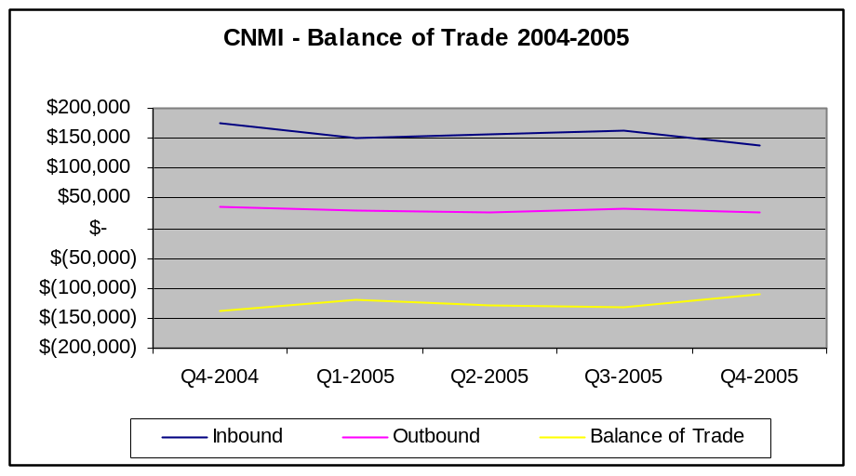

STATUS OF ENERGY SYSTEMS

Major Energy Uses
Major energy uses on Saipan are electric power for residential and business air conditioning systems. The primary industries in CNMI are garment production and tourism. Beautiful beaches and world class diving are key attractions that bring people to the islands. The fishing industry is tourist driven with some commercial vessels working in the area.

Electric Power System
The electric power system is in poor repair. Electrical high voltage substations are poorly maintained. Relay panels, breaker cubicles, electrical busses and switchgear are critical to both reliability and safety. Preventive maintenance is part of the responsibility of ownership and should be seen as a mandatory requirement to own the equipment. Higher priority during budget and planning sessions should be given to preventive maintenance and related inspections.

Generation Facilities
Most of the generators and diesel engines are substantially behind their normal maintenance schedule and there are limited funds for parts to repair the units. The cooling system components and other large pumps or fans should be converted to variable frequency drives to improve efficiency and provide higher reliability for the equipment. In addition to improved torque and lower starting current, the VFDs also offer improved motor protection.

Fuels
CNMI imports all of its fuel for electric generation, agricultural, commercial, and transportation. The following shows the approximate imports for the territory. The government or Energy Department does not readily track these numbers. The best estimates are from Shell Oil Company. The following pie chart shows the total estimated distribution of oil between the island:

Figure 6-12

Regulatory, Environmental Issues
CNMI has adopted a cost effective energy efficiency code for new buildings similar to American Samoa and Guam. The code is a modified version of the Hawaii code and is based on the results of a savings opportunities analysis, a life-cycle cost analysis and an impact analysis. The codes are based on ASHRAE Standard 90.1. However, further investigation is required to determine the enforcement or effectiveness of the standards. In addition, further investigation would be required to determine if the CNMI version of the energy efficiency codes have been updated to the 2001 updates. In addition, on June 26, 2006 legislation was passed to encourage use of renewable energy and private water collection water systems in homes and businesses. House Bill 15-144 would direct the Northern Marianas Housing Corporation to urge all new home loan applicants to voluntarily incorporate solar thermal technologies and/or water collection and storage systems into new home developments. The measure also proposes to have the NMHC develop a separate loan program that will provide loans for homeowners to install solar energy technologies and or a water reservoir.

Transportation

Table 6-7
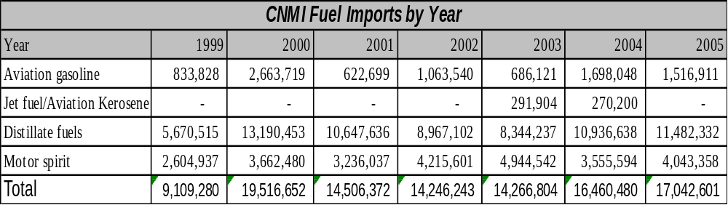

Figure 6-13
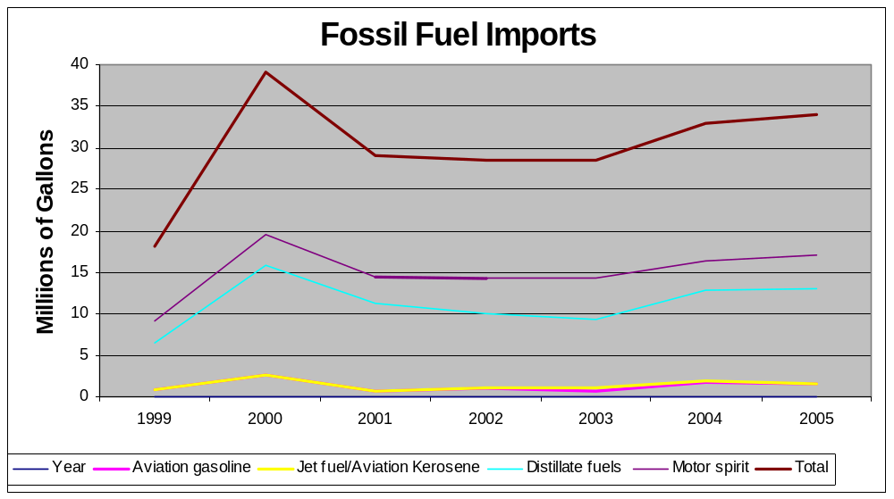

Fuel Types and Costs
CNMI uses #2 diesel for their power plants. Fuels for the transportation purposes is broken into the three motor fuels: regular unleaded, high octane unleaded, and #2 diesel. Kerosene is used for some stoves and lighting. LP gas is used extensively for cooking with some being used for water heating.

Fuel Costs on Saipan are in line with Guam and very close to those experienced in Hawaii. Regular unleaded gasoline is in the area of $3.50/gallon.

Long term fuel contracts are not in place at this time, putting CNMI at risk on oil price volatility. CNMI is currently paying in excess of $USD 2 per gallon for diesel to fuel their power plants.

Reducing Transportation Energy Use
CNMI has very limited mass transit. Their demand is small due to the size of the territory and the limited population. However, the model developed on American Samoa may work quite well on Saipan and Tinian. American Samoa uses small buses constructed on island using one ton truck frames from a variety of manufacturers. The sheet metal passenger compartments are built by shops with the paint schemes designed to add variety and color to the buses. The buses are called Aiga buses. Adopting a low cost mass transit system that is based on individual business ownership may be a way to reduce the total personal vehicle traffic, thus reducing total fuel imports while providing lower cost transportation for the general public.

Commercial & Industrial - Trends

Tourism
Tourism has been one of the two major industries in CNMI. With the 9/11 events and the resultant drop-off in tourism, JAL (Japan Airlines) discontinued its direct flights from Japan to Saipan. As a result of this action, there was close to a 30% reduction in tourists coming to CNMI. Total arrivals in 2005 were down to just under 507,000.

Even though tourism is down, CNMI has made some progress in structuring for a come-back by negotiating with Northwest Airlines to increase their direct flights to Japan. This could assist in increasing the number of visitors to the island.

Manufacturing
The CNMI economy is challenged by changes in tourism markets and the advancement of free trade. During the last 20 years, the garment industry flourished in CNMI along with tourism with many coming from Japan to visit the World War II sites and enjoy the warm waters. The garment industry peaked in the late 1990's because of quotas placed on imports from low-cost garment producers in China, Korea, and the Philippines, and duty-free export of goods manufactured in the CNMI to the United States. In addition, CNMI's wages were kept low since they were free to set their own minimum wage standards. In the year 2000, CNMI exported over $1 billion worth of garments to the United States and employed over 16,000 workers (mostly foreign). In 2004, shipments had dropped to $807 million, followed by $677 million in 2005. Since the tax structure in CNMI is directly based on sales, the tax revenue fell sharply.

Import quotas were lifted in 2005 under the provisions of the new global trade regime for textiles and clothing under the agreement that established the World Trade Organization in 1994. There were some additional quotas put in place in regards to China that are temporary and will expire in 2008. Even though the garment industry is consolidating to get costs down to compete in the World market, it does not appear that they will be able to reduce costs enough to remain competitive in the long term. Between April 2004 and February 2006, nine of the 27 garment factories on Saipan have closed, leaving 18 still in operation. This has resulted in the loss of over 3,000 jobs.

Military
CNMI is protected by the U.S. Military as specified in the Compact with the United States and has no formal military. The U.S. military retains the right to establish bases in CNMI for the duration of the Compact that provides base privileges for up to 50 years. Currently the military is planning to build support facilities to support military training and exercises on Tinian. It is currently unclear what the support facilities will be. However, at this time two-thirds of the public land on Tinian is leased to the U.S. Military.

Fisheries
There currently is no industrial fishing in the CNMI, although there is considerable pleasure and subsistence fishing among residence and visitors. No data collection program or comprehensive management plan presently addresses sustainable fishing issues in the near shore (<100-foot contour) coral reef fisheries. However, several conservation areas, MPA’s and gear restriction regulations that have been established. There is need to develop and implement a fisheries data collection program for the near shore (<100-foot contour) coral reef fishery resources found in the Saipan Lagoon. further protection.

Alternative Energy Opportunities

Alternative fuels
The consensus is that the cost for fuel will not be going down and will likely continue to increase with the increased demand from China, India, and Pakistan. Even though there is an awareness of this probable scenario, there is little being done to get CNMI ready for the continued high cost of energy. It is critical to the Commonwealth to begin a process of gathering information, developing Return on Investment (ROI) analysis on each of the available opportunities to reduce energy costs. Based on current studies, it appears to be too soon to invest any funds in the reduction of CO emissions until other countries, including the United States, develop policies and objectives in this area. All available energy-related project funds should be directed towards reducing total energy costs. This will focus available internal government resources towards taking advantage of grants for energy related projects that will reduce the incremental cost of energy without incurring additional long term debt for CNMI.

Upgrading power plants to new replacement units is a window of opportunity that opens only once every 20 to 30 years. This window should not be taken lightly. Studies should be performed to determine the correct approach for replacing units. The decisions made today will impact future generations for two or three decades. Setting up long term plans to prepare for the opportunity when it arises will take a dedicated effort by CUC engineers and management personnel. Regular meetings to discuss alternatives will help generate ideas that can then be folded into a feasibility study for promising technologies.

There may be several options to discuss. Renewable resources may be an option, or possibly the installation of coal-fired power plants instead of going back with diesel and residual fuel oil fired units. Coal prices are currently less than $60/ton. When corrected for BTU differences in the fuels, this equates to approximately $0.03/kWh fuel cost compared to $0.13/kWh fuel cost for a diesel or $0.11/kWh for residual fuel. An added benefit for an island economy is that the coal-fired plant creates more jobs. Operation costs may be slightly higher for steam plants and this should be taken into consideration. However, at the cost differential between coal and oil, additional labor will not offset the overall savings. Total dollar fuel savings for a 10 mW system would be in the area of $9 million per year in fuel savings. A feasibility study would provide the complete cost and savings. However, Operation and Maintenance costs for a coal-fired unit, historically, are substantially less than the fuel savings.

Wind and solar will not be able to displace fossil engines unless there is a major breakthrough in energy storage. They can, however, supplement the existing fossil generation mix and should be considered when replacing or upgrading system capacity.

Privatizing the utilities
Privatizing the utility will not by itself resolve the challenges related to fuel costs. The general public must be made to understand that fuel is something that is, and will be, needed in the foreseeable future to provide power for the islands. Since this is a requirement at this time and for energy needs for the next several years, there must be ways found to reduce the impact of the higher fuel costs on the energy consumers. Conservation does provide some reduction in cost and can substantially reduce the energy bills of customers. Other examples would be to privatize fuel purchases or obtain financial consulting services to establish long-term fuel contracts for the island. The challenge that CNMI faces in this area is timing. The worse time to negotiate long term contracts is during a crisis, such as was seen in the 70's during world fuel shortages, and the energy crisis in California that was directly or indirectly caused by the California effort to privatize energy production. Even though privatization is one of the scenarios to reduce cost and improve reliability, it is only one of several that should be investigated prior to moving forward with any one of the possible solutions or group of solutions.

Renewable resources are an option, but remain cost prohibitive, except for solar water heating and similar thermal projects. Renewable resources are an option, but remain cost prohibitive, except for solar water heating and similar thermal projects. There are other areas related to alternative fuels that will require additional investigation and research. Taking advantage of those areas of the world that have already done this research and looking at the existing projects that have been undertaken is a good approach that will provide the needed information at a reduced cost to the island.

There are additional actions that can be taken to streamline the utility, though government actions to help remedy the funding challenges resulting from higher fuel cost continue to be delayed due to public objection. An example of this is the needed increase in utility rates and fuel cost adjustments required to sustain the utility that has been exposed to today's high cost of fuel. Even though this is an unpopular item to discuss and implement, it is also an inevitable outcome to support the reliability of the utility. Additional efforts towards alternative fuels must be explored through additional efforts by the government and by the public sector. Solar and wind currently are available options, but these are by no means a secure and reliable power source for an island and will only be able to make a small contribution towards reducing energy costs. Demand side management is also an option, but as the demand is reduced, there remain fixed costs within the utility that can only be offset by higher rates as the total electrical production is reduced through DSM.

SUPPLY SIDE EFFICIENCY
In developed country utilities, the average power systems losses for a utility with only a generation and a distribution network are estimated at approximately 10%. Nominally, these losses are accounted for in generation, 5%; and distribution, 5%, with non-technical losses less than 1%.
In 2000, a preliminary study was carried out on a sample of three (3) U.S. Affiliated island states power utilities, to achieve an indication of the energy inefficiencies in the generation, transmission and distribution of electricity in all the U.S. Affiliated Insular Areas’ power utilities. These were the utilities of Palau, Pohnpei and Kosrae.
This preliminary study indicated that the power system losses in the utilities were far in excess of acceptable standards for these power systems. It was established that the energy losses were occuring in all areas of the power system, including non-technical losses.

It was noted that some data was lacking such as the number of transformers or the types of conductor used. As a consequence several approximations were used to evaluate the losses. The errors on the figures are difficult to quantify and therefore the results should be carefully used, although it does represent system losses that are far in excess of what is acceptable.
To reduce the import of fuel, it is imperative to reduce these system losses.

It is recommended that a detailed, quantified power system loss study be conducted for CUC, as a stage 1 project. This project would measure and collect the electrical characteristics of the power system, and then determine the losses. Once these losses have been quantified, then stage 2 of this process would be to assess the need for updating existing energy inefficient equipment (examining financing mechanisms as appropriate); establishing government legislation that makes electricity theft a crime; and review the maintenance practices in the power plants.

DEMAND SIDE MANAGEMENT
The Commonwealth Energy Office (CEO) was one of the first energy offices in the Pacific islands. It was originally founded (1979) under the office of the Governor; it is now a part of the Public Works Department, though its role has not changed. It is 100% funded by the DOE State Energy Program (SEP) with no CNMI money allocated for its operation. The CEO has an Energy Director on staff with one person as support staff. During the 1980s, the CEO concentrated on technology demonstrations, particularly biogas and to a lesser extent solar PV, solar water heating and biomass technologies. In the 1990s the emphasis changed from renewable energy to a primary focus on public information, school energy programs, energy conservation and energy efficiency improvement. Special low-income energy support programs have been added more recently, and residential energy conservation projects under the Residential Energy Assistance Challenge (REACH) under the Department of Community and Cultural Affairs.

The office is also active in policy preparation and designing and implementing small scale renewable energy projects for public technology demonstrations. The office represents the CNMI internationally at energy meetings and is the contact point for energy related activities and programs both within and without the CNMI. The CEO actively works with the CUC in developing programs and in program delivery.

Electrical Metering/Tariffs
Although essentially all customers are metered, Saipan has a subsidized, flat rate tariff. The domestic tariff as of February 2006 was $0.11 base charge and $0.035 fuel surcharge. The commercial and government rate was $0.16 base and $0.035 fuel surcharge. Increasing the cost to the actual economic value of the generation would have an immediate demand reducing effect with energy waste, such as cutting back on air-conditioning of unoccupied spaces.An emergency rate increase that more than doubles the cost per kWh has just been implemented.

A tiered tariff, with low usage rewarded by a lower price, could also help reduce waste. A first tier would be relatively low in cost and end at a usage level that can be expected to supply only basic lighting, TV and efficient refrigerator use, e.g. 100 kWh per month. A sharp increase in price would then start the second tier to include mid-range appliance use such as water heating and a room air conditioner. A top tier then would be more expensive and would cover luxury uses such as central air conditioning. A good example of such a tariff is that of Yap State in the Federated States of Micronesia.

Household Energy Efficiency Measures
In general, programs to improve domestic lighting efficiency are the most cost effective and yield the best returns of any domestic energy efficiency improvement activity. For CUC, with its capacity problem, reducing demand through replacement of incandescent bulbs with CFLs is so cost effective, giving away the CFLs in exchange for incandescent bulbs may be appropriate. The CEO participated in a CFL, “Buy One Get One Free” promotion in partnership with Saipan hardware stores and at the CUC office in 2005. Also in 2005, the CEO had a “National Change Your Bulb Day” when they gave away a CFL when 3 incandescent bulbs were turned in. The CEO also gave away some CFLs during their Energy Fair. Over all, they have distributed about 4,200 CFLs free or at half price.
Table 6-8– Major appliance ownership CNMI
Item | Number | Percentage
Total Households | 17566
Hot water | 8597 | 48.9%
Air Conditioning | 11936 | 67.9%
Electric stove | 6579 | 37.5%
Kerosene or gas | 9605 | 54.7%
Refrigerator | 14819 | 84.4%
Source: 2000 Census
Table6-9 – Major Appliances Saipan
Item | Number | Percentage
Electric Cooking | 5132 | 38.3%
Gas Cooking | 7803 | 58.2%
Kerosene Cooking | 30 | 0.2%
Wood Cooking | 30 | 0.2%
Central A/C | 1207 | 9.0%
Room type A/C | 9886 | 73.7%
Source: 2000 American Community Survey, Saipan Data

Since many houses use magnetic ballast fluorescent lights;; incentives to exchange them for electronic ballast units also makes good sense. The CEO has promotional materials and educational programs for lighting efficiency improvement that has included and CUC should coordinate its efforts for lighting efficiency improvement with the CEO since the CEO has a program for providing CFLs to households.

Large appliance ownership is high in the CNMI 2000 census data shown in Table 6-8. Saipan figures are shown in Table 6-9. Although the statistics do not show the type of water heater installed, interviews indicate that the great majority are electric, though not all are tank type units; tankless heaters are used in some households though market penetration appears low.
With nearly 83% of Saipan homes having some form of air conditioning, over 38% cooking on electric stoves, and nearly 50% using water heating energy, there clearly is scope for improving household energy efficiency and reducing fuel imports. This unusually high level of usage may be the legacy of subsidized electric rates that have not passed on the real cost of service.

Considering the problems at CUC and the relatively high use of electricity for cooking, fuel efficiency could be much improved and the capacity problems of the CUC somewhat relieved, particularly at the evening peak, by cooperating with LPG distributors to work out a program to encourage the purchase of new gas cook stoves to replace existing electric ranges. This exchange has been happening slowly for years and increasing the rate of exchange will probably not take a large incentive program, particularly in view of the increases in electric bills that must be made to compensate for fuel price hikes.

Likewise, a program to upgrade older window type air conditioners to high-EER units could lower domestic electricity use. A partnership with importers to arrange for a bulk purchase could keep the cost down. Providing information packets to homeowners about maintenance of home air conditioning units, refrigerators and freezers could help users improve the energy efficiency of the existing installations. A “walk-through” home energy audit manual is available from the CEO for homeowners to help them reduce air conditioning loads by reducing solar gain (e.g. awnings, reflective films on windows), lowering infiltration (e.g. weather-stripping, storm doors) and other measures easily carried out by homeowners.

CUC should help leverage the efforts of the CEO in its public information and education programs on energy conservation, renewable energy and energy efficiency improvement for households. This could be done by co-financing of CEO efforts, distributing information materials with mailings to customers, handing out information materials to walk-in CUC customers, etc.

Government and Commercial Sector Buildings
The main CNMI industry is tourism. With a predominance of Asian tourists, the tourist industry rises and falls in step with the economies of Japan, Taiwan and Asia in general.

The garment industry, formerly a major energy user, is much reduced from its peak and no other industry has filled the gap left by its decline. A high percentage of commercial and government energy use is presently in buildings, either offices and shops or hotels. The ranking of non-building use, such as industry, water pumping, telecommunications and sewage treatment is not available but it is likely to fall in the same range as that of the largest hotels. Shopping centers and the hospital are also certain to be high in the consumption ranking. In general, the highest opportunity for energy efficiency is in refrigeration systems used for air-conditioning and food storage are used by the hotels and restaurants. Water heating is also a significant opportunity for energy efficiency improvement.

Government offices are spread over a number of small buildings. Most air-conditioning is by “window” units and relatively inefficient with 9.5-11 EER units are common. They should be upgraded to higher EER units when they are replaced. Natural lighting is not well utilized in offices and shading or reflective films on windows to reject solar heat gain is not used widely.

Building Energy Efficiency Standards
A consultant was hired by the CEO to prepare a building energy code in the early 2000s. The result was essentially a copy of the Guam building energy code. That was reasonable, since the code fits the needs of Saipan as well as Guam. Unfortunately, the code was not accepted by government and is not in use. The CEO is working with the Department of Public Works Building Code to reinsert the energy code into the building cost. However, the energy code will still have to be introduced to the Legislature.

Unlike many of the former TTPI countries, the building codes in CNMI are generally enforced and if energy codes were included in the building code structure, it can be expected that they too will be reasonably well enforced. During acceptance discussions it was pointed out that the cost of that enforcement would impose significant costs on both government and builders. However, if the codes were in place and enforced, the longer term saving for both government and building owner should result in a substantial net benefit through lowered imports of fuel and reduced cost of building occupancy. The implementation and enforcement of the proposed energy code appears to provide the greatest long term energy saving of any presently available action.

It is recommended that CUC and the CEO continue to work for the acceptance of the new codes. If accepted, Guam could be contracted for the training of enforcement personnel as well as educating builders in the meaning and application of the new energy codes.

Appliance Energy Efficiency Standards
The CNMI is not large enough to warrant the expense and complexity of a formal CNMI appliance energy testing and labeling system. Since most of the large electric appliances come from U.S. sources – direct imports from Australia or Asia intended for non-American household markets are set up for the wrong voltage and do not work – efficiency labels are already applied before import to CNMI.

U.S. refrigerator and freezer efficiency labels show the relative energy efficiency of the appliance and an estimated cost for its annual operation. Although the U.S. label does provide a shopper with the relative efficiency and energy use of the refrigerators, the estimated cost is based on an electricity tariff around half that of the CNMI. To give CNMI shoppers a real understanding of the price differential of using appliances with different energy ratings, it would be beneficial to somehow inform the shoppers that the numbers shown as the annual cost on the labels should in fact be about doubled for the CNMI. This could be done in a number of ways such as by sticking a new CNMI label over the original U.S. label, prominently displaying in the appliance display area that the numbers on the labels need to be doubled for local use, and information programs through CUC and/or CEO.

For room air conditioners, by far the most common type used in CNMI, an Energy Efficiency Rating (EER) is included on the label. Consumers need to be informed of the relative meaning of the EER number and provided information and guidelines that help them understand the trade off between energy efficiency and initial cost. Information programs by the CEO and CUC can help accomplish that as well as informational posters that are required to be placed with the room air conditioner displays in retail stores.

It can make good economic sense to impose import restrictions that either reject low efficiency equipment entirely or add a tax to low efficiency appliances sufficient to make them at least as costly to the consumer as those of higher efficiency. As with building efficiency standards, there is a cost of enforcement that is not trivial and that cost needs to be determined and compared with the economic value of the reduced fuel imports that can result. It is recommended that a study be commissioned as to the impact of punitive tariffs or import sanctions for appliances and especially air conditioners that have an energy efficiency below a set bench mark.

High EER air-conditioners should be set as the standard for government purchases of air-conditioners.

Energy Audits, Performance Contracts
Although energy audits are a vital part of programs to improve the efficiency of energy use in buildings, commerce and industry, they are the start, not the end of the process. Following the audit and analysis of the potential for savings must be the preparation of equipment specifications, arrangement of finance under acceptable terms, purchase of the equipment, its installation and then its proper operation and maintenance. Specialty companies are needed to organize and carry out these tasks. The market in Saipan is probably too small to support a company specializing only in energy efficiency improvement services for more than a few years. However there are local architectural and engineering companies that could provide many of these services part time if they partnered with an ESCO from overseas. The local company would be available continuously for the bulk of the on site work while the overseas ESCO could provide technical backstopping, arrange for the specialized finance needed and specify the equipment to be purchased and work with vendors for its supply.

It is recommended that assistance be provided to arrange for contact between Saipan based engineers and companies carrying out ESCO type work in Guam or Hawaii.

Transportation Sector
The great majority of land transportation is by private vehicle. Public transport is limited to a small fleet of taxis. A permanent reduction in fuel use for transport is difficult to achieve in the short term. For the longer term, signals need to be sent to consumers that encourage moving to smaller, more fuel efficient automobiles or better yet, shifting to a diesel powered vehicle.

Maintaining a significantly lower diesel fuel price through tax structures is one signal to consumers that diesel is a lower cost option. Though the real savings is in the more efficient fuel use in a diesel over a gasoline engine, the signal the customer sees most clearly is the price difference. Slightly increasing the tax on gasoline and slightly decreasing the tax on diesel fuel can send the right signal to consumers.

Taxes on automobiles can also be different according to their fuel efficiency. This is a reasonable approach since there is a national economic cost for every gallon of fuel that is imported that is greater than the price paid, and a tax on low efficiency vehicles can help notify the consumer of that cost.

Public transport expansion may cost effectively improve transport efficiency though that is not a certain effect. Consideration should be given to a study of traffic patterns, commuting requirements and market needs to help understand the expectation and demand of consumers for a public transport system. Encouraging numerous private vans to circulate to pick up and deliver passengers, as is done in many Asian and African countries and a few Pacific islands, could be considered. Assistance through the development of a liability pool, low cost finance for van purchase, training of drivers and other support activities should be considered if private van use for public transport is to be put into effect.

Renewable Energy

Solar
Despite frequently partly cloudy conditions, the solar resource on Saipan is very good. The estimate of insolation in Table 6-10 is from satellite observations so it averages the readings over an area roughly 70 miles square. Local cloudiness occurring due to the presence of the island land mass and its mountains may cause significant variations in insolation from place to place. If a major investment in a grid connected PV system is contemplated, at least a year of ground based measurements at the proposed site should be taken before committing to a design.

Table 6-10 – Estimated solar resource for Saipan (Lat 14°N Long 146°E) kWh/m² per day
Month | Jan | Feb | Mar | Apr | May | Jun | Jul | Aug | Sep | Oct | Nov | Dec | Avg.
Horizontal | 5.33 | 5.94 | 6.68 | 7.12 | 7.04 | 6.5 | 6.04 | 5.39 | 5.58 | 5.29 | 5.14 | 4.99 | 5.92
Tilted | 7.05 | 7.14 | 7.10 | 6.59 | 7.02 | 6.72 | 6.13 | 4.89 | 5.64 | 6.00 | 6.57 | 6.71 | 6.46
Source - NASA Surface Meteorology and Solar Energy

Solar thermal for electric generation
The relatively high frequency of partly cloudy conditions prevents concentrating type solar devices from working well in CNMI. The mechanical complexity associated with tracking devices and the difficulty of maintenance of the highly reflective surfaces and mechanical systems in a marine environment also work against the cost effective use of solar thermal systems for power generation. For electric generation from solar, only photovoltaics is recommended.

Solar thermal for water heating
Statistics are not available regarding the prevalence of solar water heating on Saipan but a brief tour of residential neighborhoods and interviews with local dealers indicate very few are in use.

In 1978, Energy Office technicians constructed a solar water heater at the Kagman Agricultural Station to demonstrate the technology. It was a thermosiphon system and provided hot water until 1983 when it was dismantled.

In 1981, a USDOE Appropriate Energy Technology Grant of $1,000 was provided the Commonwealth Energy Office to conduct a hands-on workshop to show Marianas High School students how to construct a solar water heater. During the two day workshop an inexpensive thermosiphon type solar water heater was constructed at the school. The intent was to encourage students to construct more units for home use or to provide to outer islands. There are no records to indicate whether any replication resulted.

A “Solar Bank” project was initiated by the Energy Office to subsidize the finance of solar water heaters and some energy conservation measures on residences in the mid-1980s. The program subsidized the loan financing of the installation by $1000 or 40%, whichever was less. USHUD provided $100,000 in 1984 and $129,000 in 1985 for the “Bank”. No record was found regarding the total installations that resulted or the disposition of the fund.

A large hardware retailer currently on Saipan stocks solar water heaters imported from China. The dealer reported quickly selling a small trial batch imported in 2005 but has had very slow sales of the second partial container load. In early 2006, basic units were on display at the main retail outlet for a base price of less than $400, dramatically lower than the approximately $2000 cost of the Australian Solahart units previously installed under subsidy programs. However, the low cost Chinese unit cannot be directly connected to the mains. Its storage tank is vented and kept full either by manual control or by an added cost automatic float valve to maintain the proper water level in the heater tank. The water flows to the use point by gravity so the unit must be roof mounted.

Plans and Recommendations
A solar distillation demonstration was proposed by the Marianas Resource Conservation District Council (MRCDC) for installation at the Chamolinian Cultural Village in 2004. The small solar still was funded by the USDOE and has been installed at the Carolinian Utt village for demonstration of the technology of fresh water production from impure sources through solar energy.

A Solar Restroom Facility Project was proposed by the MRCDC and has been funded by the USDOE for installation at the Beach Road Pathway for the benefit of visitors to the Pathway. Ground has been broken for its construction and when completed it will include solar water heating and a small PV installation for lighting.

No programs are presently planned for replacing electric water heating with solar units. There is a very good opportunity for substantial fuel import reduction and demand reduction through a program designed to cost effectively replace electric water heaters with solar units.

It is recommended that CUC and CEO cooperate to develop a program for both household and commercial solar water heating. A coordinated approach that includes a public information program, financing package arranged through local banks, reduced cost bulk import through cooperating dealers, and a strong marketing program is suggested. For tourist hotels, it is suggested that the CUC work with Guam and/or Hawaii solar water heating companies to arrange with the local hotel association to have experts come to Saipan to prepare solar water heating design and cost saving proposals for member hotels currently using inefficient electric or oil fired water heating. While on the island, the expert team could provide the CNMI government with similar services for the hospital and other facilities that have water heating requirements.

Government should require new government facilities that have a hot water requirement to include solar water heating if it is shown to be cost effective over its life cycle.

Solar photovoltaics

Past programs
The Commonwealth Energy Office was one of the first in the Pacific to publicly demonstrate solar powered refrigeration. A very small refrigerator powered by two PV panels was funded under the USDOE Appropriate Energy Technology Grant program. It was installed at the Energy Office in 1982 where it served as a technology demonstration for several years and was later given to a rural dispensary.

A solar PV home power demonstration project was provided $55,000 by the USDOE Energy Extension Service Program in the early 1980s. It was installed at the Pala Pala Civic Center along with several other alternate energy demonstrations. The project included approximately 80Wp of solar panels, batteries, a 40 W fluorescent light and a ceiling fan. The project review states that the ceiling fan “melted” but the light worked for the demonstration period. The components were sent to a rural area for use after the demonstration was terminated.

In 1985, a 760Wp solar installation was provided to a NOAA station on Mt. Tapotchau, the site of a number of telecommunications repeater stations. The system provided the primary power for the NOAA site though a diesel generator was installed as a back up. No data could be provided as to its operational history.

Also on Mt. Tapotchao was an installation for the Communication Repeater Station. It used PV to provide power for the main communications system for the CNMI. In the early 1980s, the first of five photovoltaic systems was installed on the roof of the equipment building. As confidence in system performance grew along with the electricity needs of the facility, four additional systems were added in subsequent years. The five systems each had an average of 300 Wp of photovoltaic modules and 600 Ah of battery storage. When the installation was taken out of service is not known, nor is the disposition of the 1.5 kWp of solar panels known.

A small project to support the installation of solar powered electric fencing for stock control was implemented by the USDA office in Saipan in the late 1980s. A number of farmers took advantage of the project and installed the units which were much more cost effective than the rechargeable battery units they replaced. Monitoring records of the project were not available so the total number of installations and their effectiveness could not be determined.

Currently operational projects
Though there remain some small PV installations for home use on the thinly populated northern islands, the CNMI is effectively fully electrified and the cost effective use of PV for remote electrification is no longer an opportunity.

Plans and recommendations
Since CNMI is fully electrified, the primary use of solar PV in the future will need to be either direct grid connection or powering pumps, or other concentrated loads so they do not need to draw power from the grid. Given the limited capacity for maintaining highly technical equipment, it is suggested that the approach be one of widely dispersed, relatively low power (4 to 10 kWp of solar) grid connected photovoltaic systems using grid tie inverters that are sealed or at least are specifically designed for high ambient temperatures, high humidity and high salt content in the air. The small modular size of the proposed units can result in a slightly higher overall installation cost but can be expected to greatly reduce the cost of maintenance and loss of energy production due to system failures. It also allows the installations to be roof mounted and avoids the need for large land areas for mounting.

With the high risk of typhoons, mounting designs will need to be well engineered and fastened to the structure of the building through the roof, not just to the roof surface. Several PV electrified sites in the Pacific have had typhoon passages and the most serious panel damage usually occurred when the roof materials the panels were fastened to blew away. Panels on roofs that remained attached to the building tended to have much less or no damage.

At 2006 fuel and solar PV prices, grid connected solar is not quite competitive in cost with CUC generation. A lowering of panel prices, likely in the near future, or further increases in fuel price can make grid connected PV cost effective. It is recommended that a small (3-5kW) grid connected PV system be installed by CUC to gain experience with the technology and train CUC personnel in its operation and maintenance.

Wind
Early renewable energy programs in the TTPI were often ill suited to Pacific conditions and had a high failure rate. In 1982, Rockwell International installed a small Kedco grid connected wind generator at the Kagman Agricultural Center. It never worked properly, had frequent electrical problems and was dismantled and sent to Guam. The official project review stated that “These machines are complex and require access to parts and technical help to keep them running.” In a locally printed (1983) publication by the Commonwealth Energy Office is a note about that “technology demonstration” that shows the frustrations felt by local energy offices regarding many of the early renewable energy projects provided the Pacific islands and, in a lesson for today, the perils of installing equipment not well suited to the Pacific island environment:

“The wind generator (is) now lying on the ground in Saipan. For such a small output of 3-5 kW, and at considerable cost to the U.S. Department of Energy, this badly designed and poorly built machine was installed by two engineers who traveled 7,000 miles to Saipan, but it worked for less than one day! We wrote to the engineers but they did not even have the courtesy to reply to us. We now want to write to the manufacturers, but they are not any longer in business.”

In 1983, a small mechanical wind pump and a solar water heater were purchased to demonstrate alternate energy at the American War Memorial Park Bath House. Due to their inability to get permission to install the equipment on the Park site, it was ultimately installed on a farm on Rota as part of the Rural Development Program. It was destroyed by a wind storm shortly thereafter, the review document stating that “the device did not appear to be appropriate for the conditions in Saipan”.

A few small wind pumps and household scale battery charging wind generators have been installed by individuals but no wind power for grid connection or other public electrification has been attempted.
Table 6-11– Average Saipan Wind Speed at 50m (m/s)
Month | Jan | Feb | Mar | Apr | May | Jun | Jul | Aug | Sep | Oct | Nov | Dec | Avg.
10 yr. Avg. | 8.93 | 8.21 | 8.42 | 7.52 | 6.41 | 6.11 | 5.46 | 5.63 | 5.75 | 6.34 | 8.16 | 8.52 | 7.11
Source – NASA Surface Meteorology and Solar Energy Latitude 14°N, Longitude 146°E

Table 6-11 provides monthly wind speed estimates and indicates that the wind resource has promise for power generation. However, CNMI has one of the highest risks of typhoon passage in the north-western Pacific and the substantial cost associated with the risk of typhoon damage has to be included in the cost of wind power production. Tilt-down type wind machines such as are being used in the 10 MW Butoni wind farm in Fiji and also in wind farms in New Caledonia may offer a cost effective solution as could wind generators specially engineered to withstand the extraordinary wind forces of typhoons.

A prefeasibility study to estimate the probable cost of energy from CNMI based wind farms on Saipan, Rota and Tinian including the methodology and cost of mitigating the typhoon risk is recommended for early funding. Should the prefeasibility study indicate a good probability of an opportunity for cost effective wind power for grid supplementation, a full wind resource assessment and wind mapping exercise for the three islands would then be reasonable.

Hydro
No record was found relating to the investigation of the hydro resource on Saipan but the catchments are small and such small hydro resource as exists can be expected to have a highly variable flow, a high per kW installed cost, and be unlikely to provide much fuel import reduction potential.

Biogas
The CEO was formed in 1979 during a time of high oil prices and projections of further price increases that forced island states to work to minimize energy dependency on imported fuels. During the early years of the CEO, biogas was promoted as the centerpiece of energy independence, promoted as the most cost effective and best renewable energy technology for CNMI. A Comprehensive Energy Plan was developed with the goal of 90% energy independence for Rota and Tinian, and 40% energy independence for Saipan by 1988. The plan included ethanol production, biomass fuel wood plantations and went beyond energy with a major component being a reduction of food imports as well as energy.

A number of technology demonstrations were built and an interwoven scheme developed for putting a biogas digester at the energy focus of a process that integrated aquaculture, agriculture, silviculture and pig farming. The “Integrated Farm” used aquaculture to grow aquatic plants and algae that could be processed into nutritious pig feed then used the pig manure in a digester to produce a nutrient rich effluent for the aquaculture tanks. The solid wastes and excess effluent from the digester could be used as fertilizer for agriculture and for trees in a biomass plantation. The digesters were also expected to produce burnable methane gas for energy to run a generator for refrigeration and freezing the butchered pigs. Solar water heating and solar PV were included in minor roles for supplementary energy. The concept turned out to be more complex to manage than it seemed on paper and in the end the tight integration was part of the cause of the concept’s failure: when one component of the process failed to meet expectations, the whole system was brought down. When the concept champion left the CEO in the late 80s, the momentum was lost and demonstrations were closed down soon after.

Past projects
Several stand-alone digesters were constructed, some with private funding, some with public money. All used pig waste as the feed stock and the effluent was used for fertilizer. The private installations tended to use the digesters more as an environmentally preferable method for disposing of pig manure than for energy. Typically, the gas was used as a byproduct for cooking hog food and heating water for cleaning the pens. An example was the Fina Sisu Piggery on Saipan. A concrete digester was constructed with $19,000 in USDOE funds supplemented by private investment. The system reportedly worked as designed but no long term history could be located. Several similar digesters were installed with Commonwealth Energy Office support. Those in commercial piggeries were reported as working well while those on private farms experienced problems with maintenance and management. This implies that the need for operator attention requires more time than most small farms are willing and able to provide.

A full scale trial of the Integrated Farm concept was tried using funding from several sources, including the Commonwealth Economic Development Fund, USDOE, UNDP and ESCAP. Over a period of about six years the funds were used to help develop the idea and construct the necessary components of the integrated agriculture concept at Beswick’s Integrated Farm on Saipan. The farm was operated by a retired teacher whose personal goal was to create a fully independent farming system. Tanks for fish farming and algae production were constructed, a pond for water plant production and fish farming was built. Solar energy was installed for electricity and hot water production. A plot was set aside for agriculture and another for fast growing trees to provide sustainable biomass production. Pigs were to be fed algae and water plants. To close the production cycle, wastes were to be digested in concrete or fiberglass containers with the effluent then used to return nutrients to the aquaculture and agricultural components of the system. An engine operating off the biogas from the digesters was to provide power for a refrigerated room for storing butchered pigs. The process was structurally complex and many problems were faced in getting the aquaculture part of the system functioning well. The only fully successful part of the trial was the biogas digester using pig manure. The digester properly processed the wastes into a good form for fertilizer and produced burnable gas, though on the farm, the gas was never actually used for producing electrical energy since the original plan for power generation and hot water production was not fulfilled. The project was closed out around 1989 after about $65,000 in grants and a great deal of personal input from the farm owner had been used for its development.

In 1984, the Lito Agricultural station received a $28,000 grant for a similar Integrated Farm demonstration that also used pig waste fed to digesters to produce fertilizer for aquaculture and generation of methane gas. It was also operational for a limited time again with the biogas digesters working well but other parts of the Integrated Farm concept not doing so well.

No significant use of biogas for energy is known to be present in the country in 2006, though the potential for its production and use remains.

Plans and recommendations
The primary value of farm based biogas digesters in the Pacific has been for treatment of animal waste at large commercial piggeries or poultry farms to reduce environmental damage with the biogas as a byproduct. Where animal waste management is an issue, biogas digesters provide an environmentally sound way to treat the waste while also providing a modest source of energy. It is recommended that the Energy Office survey commercial piggeries and poultry producers, and provides them with information and a basic economic analysis of biogas digesters for waste control and on farm power or cogeneration. Where an installation looks economically reasonable, the Energy Office could facilitate contact with commercial suppliers of equipment and assist the farm in locating finance for the installation.

The sewage treatment plants on Saipan appear to be of a type that could be modified for biogas production successfully. Storm drains do not enter the sewer system, so the feedstock can be expected to be reasonably uniform. Estimates for installing a biogas digester at the Kinoya sewage treatment plant in Fiji, a larger plant but of similar design, indicate that sufficient biogas could be generated to more than power the plant and probably provide excess capacity for cogeneration. Assuming operating conditions similar to those for the Fiji facility, several hundred kW of continuous generation may be possible. It is recommended that a feasibility study of the sewage treatment system be funded to determine the cost effectiveness and technical appropriateness of adding biogas digestion to the existing facilities.

The new 30 acre Marpi landfill is a high quality municipal waste disposal site. Presorting of the approximately 100 tons of waste collected each day provides for around 20% of recycling of municipally collected waste. The national recycling rate is higher than that, since several local recycling companies receive recyclable materials before trash is collected for the landfill. Besides allowing for recycling, presorting ensures that the materials reaching the land fill do not represent an environmental hazard. The landfill construction includes provision for methane gas collection at some time in the future with the expectation that it will be used for energy production. No estimates were available for future gas production.

Biomass combustion and gasification
In 1980 to 1986, as part of the “Integrated Agriculture” concept (see the biogas section for a description of the concept), the Kagman Agriculture Station managed trials of several fast growing tree crops intended to fuel various energy production processes including charcoal, gasification and biomass combustion. The USDOE and USDA invested about $36,000 in grants to assist in the planting and management of the plantation. The principal crop studied was Giant Leucaena.

A small gasifier was placed under trial by the Commonwealth Energy Office in about 1983. The gasifier was located at the Pala Pala Civic Center in Susupe, Saipan for public view. The gasifier burned some of the Giant Leucaena wood grown on the trial biofuel plantation and was connected to a spark ignition engine driving a generator. The output was intended to be around 30kW. The system was made to work but soon failed due to machine design problems and poor maintenance. The trial was not considered a success.

Also funded by the USDOE was an innovative charcoal kiln that was transportable and produced good quality charcoal from Giant Leucaena wood from the plantation. The charcoal was intended to replace wood as a better fuel for cooking as it had low residue and burned at high heat without smoke. The trial unit was turned over to a local entrepreneur to make charcoal for sale but no record has survived regarding the business history. Charcoal was never a significant replacement fuel for cooking in CNMI.

The biofuel plantation was mostly destroyed by a typhoon in 1986 and only some of the Giant Leucaena had actually been harvested for energy at that time. Had they survived, the other trees were expected to be available for harvest starting in 1988. Later analysis indicated that using the land for an energy plantation was not its most economically reasonable use and the concept has not been revived.

Unless there is a return of large scale agricultural processing, such as would result from the development of a biofuel production facility, biomass for combustion or burning does not appear to be likely to be a significant energy source for CNMI.

Biofuel
Presently, there are no commercially useful biofuel crops being grown in the CNMI. The coconut production is small and only meets local needs for animal feed and cooking. Sugar cane was once a major crop but has been long out of production on a commercial scale. The large investment in land and facilities to develop a large enough biofuel capacity to have significant impact on imported fuel use is not likely to be justified until a substantially higher cost of fuel is the norm. There has been some discussion regarding the collection of waste cooking oil from restaurants for processing into biofuel. Though that could be a start for the dissemination of biofuel technology and the effort should not be discouraged, its potential for reducing the national fuel imports is not great.

Ocean thermal
In the 80s and early 90s, a number of detailed feasibility studies were performed in Saipan for OTEC. There were bathythermic mapping studies carried out and designs using several approaches were considered. The concept of a Saipan OTEC facility was found to be technically reasonable. Unfortunately, though small pilot trials around the world have successfully generated electricity using OTEC for a short time, to date there has been no commercial construction of an OTEC facility and no demonstration of even a 1 MW capacity installation. Until full commercial feasibility is proven and there is reasonable assurance of cost effective operation of OTEC under the high typhoon risk environment of Saipan, no action on OTEC is recommended.

The use of cold water drawn from ocean depths for air-conditioning is not likely to be practical for Saipan since, unlike Tumon Bay in Guam, the hotels are distributed over a large area and also are not located in an area where there is nearby deep water access.

Geothermal
There have been no geothermal resource surveys and no surface manifestations of geothermal activity are known to be present on Saipan. Other islands of the CNMI do have geothermal activity and have been considered for development by the CEO but those islands do not have an energy demand sufficient to make geothermal development cost effective.

Tidal
No opportunity for the use of tidal power is known to be available for Saipan.

Wave
Wave power remains a technology that is also not commercially developed, though technical trials of several technologies appear to have promise for the future. The wave energy resource has not been measured around Saipan and no resource assessment is recommended until commercially available wind energy conversion devices are well proven for sites with a high frequency of typhoon passages like Saipan.


Federated States of Micronesia - Overview

Executive Summary
The Federated States of Micronesia (FSM) is located in the Western Pacific Ocean, north of the equator about 3,200 miles southwest of Hawaii. The 607 islands of the FSM range over a distance of 1,500 miles east to west and 600 miles north from the equator. The FSM includes the island states, from east to west, of Kosrae, Pohnpei, Chuuk and Yap, and includes outlying islands and atolls in the Caroline Island Archipelago. The capitol of FSM is located at Palikir on the island state of Pohnpei.

The islands of Pohnpei, Kosrae, Chuuk and Yap established the Federated States of Micronesia with the help of the U.S. in 1987. The FSM is a fully functioning sovereign independent nation but supported by the U.S. under a Compact of Free Association.

The 2005 population of the FSM is 108,290, with Kosrae,8008; Pohnpei, 35,162; Chuuk, 53,826 and Yap, 11,294. The age of the FSM population is relatively young. According to the 2000 census, 40.3% were under 15 years old; 28.3% were 15 to 30 years old; 16.9% were 30 to 45 years old and 5.3% of the population was over 60 years of age. Birth rates are in the 2.5% to 3% range but due to out migration of young people to Guam, Hawaii and the U.S. mainland for education and better job opportunities, the population growth for the past several years has remained in the .3% range.

Kosrae, the eastern-most island state of the Federated States of Micronesia (FSM), is 334 miles east-southeast from Pohnpei; 2,467 miles southwest of Honolulu; and 1,200 miles southeast of Guam and is located at 163º22’ East Longitude and 5º10’ North Latitude. Kosrae has a population of 8,008. It is a high island with sharp, rain forest covered peaks of over 2000 feet. The land area covers 42 square miles, the second largest in the FSM resulting in Kosrae being the least densely populated of the U.S. Affiliated Insular Areas.

The economy of Kosrae is very limited. The average wage of those employed in the formal employment sector in Kosrae in 2004 was $5,514 per year. There has been a measurable return to subsistence living as a result of Compact II funding being less available to the general population. Kosrae has introduced many economic development efforts, especially those utilizing their excellent agriculture products, but marketing and transportation are limiting factors. Eco-tourism is a viable economic development sector but still small due to transportation costs. The 2005 Gross Domestic Product was $18.8 million, a decline of 4.7% from 2004 when inflation is considered. This value relates to a GDP per capita of $2,332.

Chuuk is located 424 miles west of the FSM capital island of Pohnpei and is in the center of the Caroline Islands, at 151º22’ to 150º04’ East Longitude and 7º7’ to 7º41’ North Latitude. Chuuk is approximately 610 miles southeast of Guam. The population of Chuuk is 53,826 with approximately 13,890 people living on Weno Island, the state Capital, and the remaining 40,000 living on the outer islands. Chuuk consists of 290 outer islands, with approximately 55 being inhabited. The outer islands are spread out over a distance that extends as much as 180 miles from Weno Island. Chuuk has a land mass of 49.2 square miles, with 38.6 square miles included in the islands within the 40 mile diameter Chuuk lagoon. The Chuuk lagoon islands are worn down volcanic islands and the outer islands are low atolls.

The economy of Chuuk is very poor. The average wage of those employed in the formal employment sector in Chuuk in 2004 was $4,912 per year. A large portion of the population is engaged in subsistence living, particularly the 40,000 people living on the outer islands. There is a heavy dependence on external aid and the public sector. There are serious imbalances in external trade. In addition, there is still very limited development of private sector activities outside the wholesale/retail sector. The Gross Domestic Product for Chuuk for 2005 was $68.91 million.

Pohnpei, the capital of the Federated States of Micronesia (FSM), is located in the East Caroline Islands at 7° North Latitude and 158° East Longitude, 3,200 miles west-southwest of Honolulu and 300 miles south of a line between Honolulu and the Philippine Islands. The population of Pohnpei is 35,162 with 90% of the people living on the large island of Pohnpei and the remainder living on the five outer islands. Pohnpei island is the largest of the FSM islands with a land mass of 112 square miles. It is a high island with rain forest covered, worn down volcanic peaks 2595 feet high.

Pohnpei economy is slow but better than most of the other states of FSM. The FSM government and the state of Pohnpei are the major employers in Pohnpei. The economy is helped also by the fishing fleets that headquarter in the Pohnpei harbor. Education, including the headquarters for the College of Micronesia, represents a significant segment of the employment in Pohnpei. Subsistence living is also a major form of employment and has been increasing. The Gross Domestic Product for Pohnpei in 2005 was $113.1 million and represented a per capita GDP of $3,217. The average salary in 2004 was $7,792. The minimum wage in Pohnpei is $1.35 per hour.

Yap is the most westerly of the four FSM states, 650 miles west of the capital of Pohnpei and located at 6° to 10° North Latitude and 137°West Latitude. Yap is a low volcanic island of 38.6 square miles with 78 outer islands representing another 7.2 square miles. The population of Yap is 11,294, with 66 % living on Yap island and the remaining on the 22 inhabited outer islands.
The Yap economy has declined slightly in recent years since Compact II began but is stronger than some other FSM states. Yap has developed a relatively strong private sector employment base with approximately 72% of employees in the private sector. Yap State’s economy continues to be dominated by government spending, both for wages and the purchase of goods and services from the private sector. The closure of a garment factory eliminated the manufacturing sector. Tourism is down significantly after the reduction of scheduled flights by one third. Employment in Yap State dropped from 3,680 in 2001 to 3,023 in 2004. Average mean income in 2004 was $6,605. In 2004, the nominal GDP was estimated to be $37.9 million.

The FSM’s primary source of energy is petroleum. Gasoline and diesel fuel are used for the transportation sector and No. 2 diesel is used to the diesel driven electrical generators. There is a small amount of liquid petroleum gas (LPG) used for heating water and cooking. Chuuk has installed an estimated 200 small photovoltaic power units on the outer islands. Pohnpei also has installed a small number of photovoltaic systems on their outer islands. However, many of the units on Chuuk and Pohnpei are no longer operating due to lack of maintenance. Pohnpei has a 1.8 MW hydroelectric unit operating and has other river locations with flow capability for an estimated 5 to 7 additional MW. Kosrae previously had a 50 kW hydroelectric unit installed but it was never commercially operated due to conflicts over water rights. Kosrae has the potential for a minor amount of run of river hydroelectric units. There is potential for thermal hot water systems in all of FSM but there is only very limited use. Other sources of energy may be possible, such as minor tide or wave, but the technology has not been adequately developed to utilize the limited sites. Wind has not been adequately measured and although during the months of November through March winds seem brisk, they rarely exceed 10 mph and usually are not continuous during the night hours.

Energy use in the FSM is typical of all tropical islands with the majority of the petroleum energy being used for the generation of electricity followed by energy for the transportation sector, including a significant amount for the fishing fleets based at Pohnpei. The largest electrical use is for air conditioning and lighting, with the government being a major user of electrical energy and using the bulk of their energy for air conditioning. Renewable fuel use includes the widespread burning of wood and coconut wastes for domestic cooking.

Mobil Oil serves Pohnpei, Chuuk and Yap. Kosrae is served by the Micronesian Petroleum Corp. (MPC), a wholly state-owned enterprise. Most of Mobil Oils fuel is shipped from Indonesia, whereas MPC purchases fuel from various suppliers and sources, although also primarily from Indonesia.

The FSM economy depends substantially on the U.S. Compact of Free Association. In 2003 the U.S. and FSM entered into a Compact II agreement, wherein FSM receives payments of $92.7 million per year from the U.S. with $76.2 million being in the form of grants in five distinct areas and $16.0 million to be placed in a trust fund and $500,000 allocated each year for an annual audit. The trust fund is anticipated to increase and become a permanent interest bearing fund such that after Compact II expires in 2023 the trust fund will provide the same level of income available to FSM as the present Compact II. The previous funding program, Compact I, was entered into in 1986, effective from 1987 through 2002 and was designed to assist the FSM with infrastructure and development of its economy. Infrastructure development had been successful but the development of a self sustaining economy had only very limited success. Roads, electric utilities, harbors, airports, schools, hospitals and public facilities were all constructed during the 15 years of Compact I. Kosrae, Pohnpei and Yap have maintained their facilities in a responsible manner and have expanded their facilities. Chuuk has not performed as well.

The Gross Domestic Product of the FSM in 2005 was $239.49 million. Per capita GDP for 2005 was $2,212. The trade balance has remained highly negative since 1997. In 2004, the trade balance was estimated at negative $113.8 million, an equivalent to 49.8% of GDP.

The main elements of the FSM economy, although it varies from state to state, are subsistence farming, including local fishing; lease of fishing rights to FSM waters; servicing of the fishing fleets; government employment and tourism. Total visitor arrivals in 2004 was 18,967, a decline from 20,501 in 2000.

Each of the FSM states have modern airports, albeit with relatively short 5,000 to 6,000 foot runways, for transport of passengers and cargo. Airports are able to accommodate Boeing 737 aircraft. Pohnpei has plans to extend their runway to 8,000 feet to be able to accommodate Boeing 767 type aircraft, with anticipation of improving tourism to the FSM. FSM states also have good harbors for receiving cargo, fuel and for servicing fishing fleets and the marine transport industry. FSM states, especially Pohnpei, have regular, bi-weekly to monthly cargo service from Hawaii, U.S. mainland, Asia and Australia. The communication system in the each state is provided by FSM Telecommunications Corp., an FSM government owned enterprise, which provides telephone, cell phone, cable and internet service. All elements of the communication system serve FSM well, though long distance rates are very expensive and the internet service is extremely slow. A new fiber optic cable is planned between Guam and Kwajalein military base in the Marshall Islands and FSM Telecom in Pohnpei anticipates a radial tap connection which will substantially improve communication service.

Electric System
Each island state has its own electric utility authority, created by the respective legislatures, governed by a Board appointed by the Governor with the advice of the Legislatures. Except for Chuuk, all utilities are financially sound and operating in a proficient manner. All, except Chuuk, have extended electrical power distribution lines to approximately 90 to 95% of their population in the primary islands. Chuuk’s utility is unable to adequately provide power on a full time basis to its customers, forcing most of the major stores, resorts and government facilities to install their own electric generators.

Kosrae Electric System
The Kosrae Utilities Authority (KUA) serves approximately 1,700 customers; has a peak load of 1.4 MW; annual sales of 6,132 MWh; kwhr sales revenues of $1,394,000; operating expense of $1,650,000; operating loss of $190,000; and when depreciation of $470,000 is added to operating expense the total loss for 2005 was $660,000. Price of electricity to the residential customers was 27 cents per kWh in 2005 with diesel fuel costs of $2.15 per gallon. KUA cost of fuel as of mid 2006 was $2.85 per gallon. KUA purchase its fuel from the Kosrae state owned Micronesian Petroleum Corp.

KUA’s power production facility at Tofol consists of five (5) generators with combined capacity of 4,580 kW, plus they 650 kW portable emergency generator. KUA has a substation with two 2,500 kW transformers to step up the voltage from 4,160 volts at the generators to provide power to the 13.8 kV distribution power lines.

KUA has three distribution circuits that extend in a radial manner from the power plant in Tofol. Two of the circuits have been rebuilt in the past five years and the third is planned for the near future. Efficiency of the KUA generation plant is approximately 32%. Losses in the distribution system are approximately 9% resulting in an efficiency of fuel in to kWh to the customer meter of 29.4%. This efficiency still relates to fuel cost for electricity at the customer’s meter of 24.3 cents per kWh.

In 2005 KUA submitted a grant request to the U.S. Rural Utility Service to install a waste heat recovery system on the diesel engines to convert waste heat to chilled water and provide the chilled water to the nearby government complex facilities for air conditioning purposes. The recovery of this waste heat was calculated to provide approximately 150 tons per hour of 40 degree chilled water. The grant was not approved but KUA officials believe that because of Kosrae’s unique situation where the complex of government buildings, hospital, high school, college and other public and private businesses are within close proximity to the KUA power plant, a viable co-generation facility could be developed. Electrical energy savings were estimated to be 450,000 kWh per year with system costs estimated at $765,000.

KUA has installed Cash Power meters on approximately 70% of their residential customer’s that they credit with a 5% reduction in electric usage.

Chuuk Electric System
Information available from the Chuuk Public Utilities Corporation (CPUC) was very minimal and therefore figures for loads had to be obtained from an Asian Development Bank (ADB) analysis done in 2004. According to the ADB figures CPUC had a peak load of 4 MW in 2004 (est. of 2006 peak loads were 1.7 MW); gross generation of 21,520 MWh in 2004; and billed 12,200 MWh. Based on un-audited and questionable first six months financial data from CPUC they will have estimated FY06 sales of $2,837,260; estimated FY06 operating expenses of $2,822,126; estimated operating profit of $15,134. When depreciation of $1,157,080 is added to operating expense the total loss for 2006 is estimated to be $1,141,946. CPUC was unable to provide 2005 or 2006 kWh energy figures or number of customers. The price of electricity to residential customers is 32.26 cents per kWh; to commercial customers, 34.26 cents per kWh; and to government customers, 36.26 cents per kWh. CPUC’s cost of fuel as of mid 2006 was $1.95 per gallon. CPUC purchases its fuel from the Mobil Oil Corp.

CPUC has only three operating generators, 2- 2,000 kW units and 1- 800 kW unit. The two larger units have been down rated to 1,500 kW and the 800 kW unit has been down rated to 400 kW due to maintenance problems. CPUC only provides power to the island of Weno. Service is very unreliable because of the poor condition of the generators, requiring power rationing by providing power to only half the island at any given time during the day. The poor financial condition of the utility forces it to shut down its electrical production frequently because there are not enough funds to purchase diesel fuel. The frequent power outages complicate CPUC’s already serious financial condition.

CPUC has five 13.8 KV, three-phase distribution feeders but have reconfigured them into three circuits to better effect the rolling blackout program. Two of the circuits have been tied to partner circuits so that three circuit breakers now serve the islands daily peak load of approximately 1,700kw.

CPUC has installed Cash Power meters on a small percentage of their customers, but have been having difficulty with maintenance of the meters.

Pohnpei Electric System
The PUC has an installed generation capacity of 15.46 MW and had peak loads of 6.5MW in 2004. The PUC generated 40,465 MWh and sold 34,053 MWh to customers. Total power sales for 2004 were $6,950,000 for an average price of $0.204 per kWh. Expenses for the electric system are not separated from the combined electric, water and sewer expenses. PUC had a net combined utility operating profit of $616,840 in 2004 but an overall loss of $1,359,758 when the combined utility depreciation of $1,976,598 was included. Fuel cost in 2004 was $1.33 per gallon or approximately 12.1 cents per kWh for fuel for each kWh billed. Cost of diesel fuel in early 2006 was $2.30 per gallon which would relate to 20.9 cents per kWh for fuel for each kWh billed if related to the same fuel purchases and kWh sales as 2004. PUC has 6,399 electric customers.

The Pohnpei Utility Corporation (PUC) power system consists of three-diesel power plants. NPP1 was built in 1977 and has three Caterpillar model 3516 engines rated at 1.15 MW each. NPP2 & NPP3 were built in 1991 and 1994 respectively, and each plant has two Daihatsu DS12 diesel engine generators rated at 2.5 MW. Additionally, PUC has a 1.8 MW hydroelectric unit at Nampil. PUC uses No. 2 diesel for generating electrical power. Mobil Oil Corp is PUC’s fuel supplier from sources primarily in Singapore. The distribution system consists of approximately 250 miles of 13.8 kV overhead lines with four (4) feeders circuits serving 95% of the population of Pohnpei. PUC has an average engine efficiency of 13.1 kWh per gallon of diesel fuel which relates to a power production efficiency of 32.9%. In 2004 PUC purchased approximately 3.1 million gallons of fuel at a cost of $4,130,792 and generated 40,465,000 kWh. PUC’s losses from power plant generation to customer billing is 15.8%. Distribution system losses are approximately 12.5%.

PUC has installed Cash Power meters on approximately 85% of the residential customers and believe they have experienced a 3% reduction in electric usage as a result.

Yap Electric System
Electricity in the state is provided by the Yap State Public Service Corporation (YSPSC) which operates plants and distribution grids on Yap Island and six outer islands. YSPSC has 77 miles of overhead 13.8 KV distribution lines on Yap Island. The installed capacity on Yap Island is 9.7MW and peak load is 2.1MW. On the outlying six islands (divided into three groups), installed capacity is 369 kW and peak of 56.5 kW; installed capacity 114 kW and peak of 32.5 kW; and installed capacity of 54 kW and peak of 7.2 kW.

Energy production declined from an average of 18,300 MWh in 2001, 2002 & 2003 to approximately 16,400 MWh in 2004.

All Yap power plants utilize No. 2 diesel oil. Mobil Oil Corp. is the fuel supplier.

Demand Side Efficiency Improvement and Energy Conservation
In general, the high cost of energy and the sluggish economy of FSM have resulted in electricity use patterns that minimize energy waste, but there are many areas for improvement in energy equipment efficiency, particularly lighting and refrigeration services for a/c and food storage.

Only Pohnpei has a person specifically responsible for energy issues and his work is mostly related to renewable energy project management and development with little DSM involvement. The modest DSM effort that has taken place has been focused on public information with no programs for hardware efficiency improvement.

Yap and Chuuk have a small (around 6,000 per year) tourist industry and Pohnpei also has a small hotel sector catering mostly to business visitors. None of the states has significant industry. The few DSM programs brought to FSM by external agencies have not been monitored and their effect is not known.

Electrical Metering/Tariffs
Chuuk, Kosrae and Pohnpei are all increasing the use of prepayment meters to improve collection rates and therefore will improve supply side efficiency through reduction of non-technical losses. Unfortunately, using the prepayment meters requires that a flat rate tariff is imposed and there is no opportunity for using rates that are higher for increased usage to discourage energy waste.

Yap does not use prepayment meters and has a strongly tiered tariff structure that appears to be well structured to encourage energy efficiency.

All utilities have a rate structure that has a base tariff plus a fuel surcharge that is applied directly by the utility at the time of billing so charges keep pace with fuel price changes. On Yap, the outer island utility customers see a higher fuel surcharge than customers on Yap Island, since fuel is more costly and engine efficiencies lower for outer island generation. Rural customers are not cross subsidized by urban customers.

Household Energy Efficiency Measures
Few houses have piped hot water and therefore electric water heating is not a major load for FSM utilities. Electric cooking is in less than 10% of FSM homes (2000 census) and air conditioning is about the same. Most FSM households still use biomass for cooking and the only large appliances in common use are refrigerators. Around half the electrified households have a refrigerator or freezer. Lighting and refrigerators should be the primary focus for household DSM. A program to replace electric stoves with gas ranges, and electric water heaters with solar could provide some imported fuel reduction benefits.

A program in each state to replace incandescent bulbs with CFLs and magnetic ballast fluorescent lights with electronic ballast units is recommended, as is a program to advise homeowners regarding maintenance of refrigerators and freezers and explaining the cost effectiveness of replacing of old appliances with higher efficiency units.

Government and Commercial Sector Buildings
Until the Chuuk power utility can provide reliable power, it will be impractical for that utility to carry out DSM programs that have any significant technical component. By eliminating the need for many small, inefficient generators, the provision of reliable power from a central power plant can be a greater fuel saving for Chuuk than any other fuel efficiency improvement measure and providing adequate, reliable power should have the CPUC’s full attention.

For Yap, Pohnpei and Kosrae, the state utilities should participate in DSM promotion through public information programs, appliance replacement programs and providing technical assistance through audits for large energy users and for support of programs to improve maintenance of refrigeration equipment.

In the government sector, maintenance of air-conditioners and their replacement with high efficiency units can provide the greatest fuel saving. In the commercial sector, the largest savings appears to be improved maintenance of refrigeration equipment for air-conditioning and food storage with replacement of low EER equipment by more efficient units. Lighting should also be upgraded to CFLs and electronic ballast fluorescent lights.

In all four states, the hospital is one of the top energy users. Air-conditioner efficiency generally needs to be improved, lighting converted to high-efficiency units and water heated from solar and/or waste heat from air-conditioning. In Yap where a hospital renovation project is soon to be carried out, improvements in windows and insulation should be included in the project.

It is recommended that a person be assigned as energy officer at high energy use complexes such as the National Hospital and the Capitol Complex at Palikir. They should receive specialist training in energy systems maintenance and in recognizing opportunities for energy efficiency improvement.

Building Energy Efficiency Standards
There are no energy codes presently in place in FSM. Enforcement capacity is low and until basic health and safety codes can be properly enforced, adding energy codes to the enforcement load is unlikely to be of value. New building designs for government should be required to include energy efficiency measure such as:

- proper insulation
- efficient and properly allocated lighting
- low energy transfer glass in windows
- shading systems to eliminate direct entry of sunlight
- well distributed natural lighting while avoiding direct solar entry
- high efficiency and properly controlled air-conditioning
- solar water heating where hot water provision is to be included
- vestibule type entries that avoid direct exchange of interior and exterior air

Such features are low in added construction cost and high in avoided cost of energy. Yap is considering a major new state office complex and energy efficiency should be high on the list of specifications for the building design with the above features required in the design.

Appliance Energy Efficiency Standards
FSM has no appliance efficiency standards and the small size of the market would make their enforcement unlikely to be cost effective.

Many appliances imported from the U.S. include energy efficiency labels. Those labels are intended to show the customer the relative cost of operating appliances but the cost shown is based on a price much lower than that present in FSM and that needs to be brought to the attention of buyers. As there is no government agency in FSM or any of the states except Pohnpei, it falls on the utilities to prepare a public information program to inform customers how to interpret the appliance labels in FSM. Government purchases of air-conditioning equipment should be limited to high EER units.

Energy Audits, Performance Contracts
The market for services to improve energy efficiency is small and costly to access as it is distributed over four separate island states. It is unlikely that a full service ESCO would find servicing the FSM states cost effective. Training should be provided to utility and Works Department staff to perform energy audits and assist end users in the specification of equipment to improve energy efficiency. Services should be charged at cost and where possible, local banks should receive information about the technology and cost effectiveness of various energy efficiency measures so they can better assign risks for equipment loans.

Where there is a local technical firm that could act as a local partner to an overseas ESCO, the firm should be encouraged to develop the capacity to perform investment grade energy audits and to provide local support for ESCO services in partnership with an overseas ESCO.

Transportation Sector
Land transport is by private vehicle. None of the states except Yap have any form of public transport other than taxis. Yap has a morning and evening commuter bus service to bring workers to the urban area of Yap Island from residential areas. Providing incentives to improve fuel efficiency at the time of vehicle replacement can provide substantial long term fuel efficiency improvement. As government vehicles are a significant percentage of all FSM vehicles, new vehicle purchases should be limited to those with high efficiency diesel engines (such as those recently purchases by the YSPSC) where possible.

The FSM should consider an import tax structure that provides incentives for the import of vehicles with high fuel efficiency. Sea transport is a major user of fuel in all states except Kosrae. The high cost of fuel has itself prompted fuel efficiency and conservation measures for both ship owners and the private use of boats for subsistence fishing. When ships are replaced, fuel efficiency should be a major concern. Ships provided or subsidized by donors should not be accepted without careful consideration of the cost of fuel for their operation.

Renewable Energy

Solar
The solar resource is good throughout the FSM, though on islands that have mountains, the resource varies from place to place due to local cloud formation.

Solar Thermal
The percentage of homes that have hot water piping is small and limits the market for solar water heating, so the FSM cannot support a full time dealer in solar water heaters. The cost of purchase and installation is high and maintenance not readily available. Utilities or retailers with a regional presence should consider becoming the solar water heater distributor in their state and providing customers that have electric water heating with the option of replacing them with utility financed solar water heaters.

Utilities should inform electric water heating customers of the relative benefits of solar water heating over electric water heating if fuel savings is a utility goal.

Electric power generation from solar is not cost effective in FSM due to the frequency of cloud passage, the difficulty of maintenance of the mechanical and optical components in a tropical, marine environment, and the large land areas that are needed to provide useful power capacity.

Solar Photovoltaics
Most solar PV installations have been for outer islands so Kosrae, the only single island state, has had little experience with solar PV compared to Yap, Pohnpei and Chuuk. To date most outer island installations in FSM currently operating have been paid for under the Compact (Chuuk) or by French aid (Pohnpei and Yap). The EU is presently considering the provision of funding for outer island public facility electrification for Pohnpei and Chuuk states and to fund the renewable energy component of a hybrid biofuel-diesel/solar mini-grid installation in Yap state.

Future solar PV efforts should be concentrated on outer island and off-grid installations since they are more cost effective than grid-connected PV and there remain many opportunities for off-grid electrification in FSM.

Hydro
Yap and Chuuk have no developable hydro sites and those on Kosrae are limited in their potential and appear unlikely to be cost effective for development. Pohnpei has a hydro power installation on the Nanpil river and there have been surveys that indicate other developable sites are present though at the time of their survey, the economics of developing the sites were not good. The surveys should be reviewed in the light of higher fuel prices and those sites that are now economically reasonable for development should be implemented.

Wind
The wind resource is not well known in FSM but satellite estimates indicate that it is probably borderline with regards to the economics of wind resource development for power generation. It is recommended that a prefeasibility study for each state be conducted, taking into account typhoon risks and the capacity of the utility to manage wind development, and if the prefeasibility study indicates a resource that can be cost effectively be developed, then a full resource survey and wind mapping should be carried out so specific plans for wind development can be prepared.

Biofuel
The outer islands of FSM have a substantial, underutilized coconut resource that could be developed for biofuel production. The underutilization is the result of the price that can be offered for the sale of oil internationally that is not high enough to interest enough people in cutting copra. Since coconut oil prices are about the same as wholesale diesel prices, the diesel price will have to go higher before there is an expansion in coconut production. For the time being, it is recommended that the initial goal for biofuel production on Pohnpei should be to increase local oil production to make all copra production available for biofuel production. Once the presently utilized resource is all used for biofuel production, as fuel prices go up and more can be offered for copra, the increased price will result in the utilization of more of the existing resource. Further increases in price can then justify the cost of replanting and removal of senile trees.

Yap has the opportunity to develop outer island oil production for YSPSC generation and at current prices that appears to be the most cost effective approach. Should fuel prices continue to rise, oil production for the large generators on Yap Island may become cost effective but there is no basis for YSPSC making a major commitment to coconut based biofuel for its larger engines at this time.

Chuuk has significant coconut resources,but there is no oil mill in Chuuk and no local institution with the capacity to manage biofuel production. Until an institutional structure with adequate management capacity and financial resources is established, shipping Chuuk copra to another state for processing is likely to be the most cost effective approach.

Biomass combustion and gasification

The primary use of biomass in FSM is for cooking and drying.

The economics of use of biomass for power generation through combustion or gasification in most of the Pacific is limited to agricultural or forest product processing facilities where large amounts of biomass is generated as waste. FSM has no significant industry that generates biomass waste in a quantity that is reasonable for power. If biofuel production does become significant, then there may be sufficient coconut waste to justify biomass combustion or gasification for process heat and electricity generation with the surplus sold to the local utility.

Biogas
There are a few animal and poultry farms with enough waste generation to make biogas digestion economically interesting as an environmentally acceptable waste disposal method with biogas as a byproduct. It is recommended that the EPA survey animal and poultry producers in FSM and determine the market for digesters then make contact with equipment suppliers and obtain estimates for the cost of installation if a number of farms go together for a joint purchase. If installation appears to be cost effective, then EPA could organize a joint purchase and coordinate the installations in each state.

When sewer and landfill treatment facilities are to be upgraded or installed, consideration of an add-on facility to extract biogas for energy should be considered and if cost effective, included in the plans.

Geothermal

FSM has no known developable geothermal resource.

Ocean Energy
None of the ocean energy technologies is sufficiently mature to recommend its use in FSM though tidal energy that comes from high volume, high speed flows of water through reef passages may soon be a commercially available technology. All ocean energy systems must be considered in the light of typhoon risk.

General

Location, Population and Geography
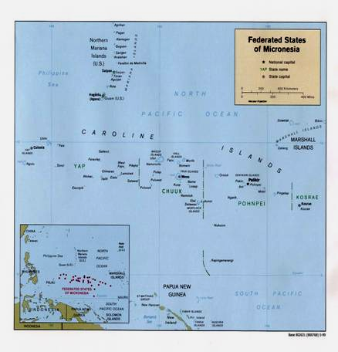
The Federated States of Micronesia (FSM) is located in the Western Pacific Ocean, north of the equator about three quarters of the way from Hawaii to the Indonesia. The FSM includes the island states of Kosrae, Pohnpei, Chuuk and Yap and outlying islands and atolls in the Caroline Archipelago between °0 and 13° N Latitude and 168° and 136° E Longitude. The 607 islands of the Federated States of Micronesia extend east to west and south to north over 1,500 miles and 600 miles respectively. The Capital of FSM is located at Palikir on the island state of Pohnpei.

The population of the FSM according to the 2000 census was 107,008. The 2005 population estimate was 108,300. The population grew at an annual rate of only 0.3% from 1994 to 2000. This is in contrast to a 3% annual growth rate during the decade of the 1980’s and an annual growth rate of 1.9% from 1989 to 1994. The reason for the low growth rate of 0.3% is out migration from the FSM, primarily to the U.S., for purposes of education and employment. Based on the 2000 census Chuuk has the largest population with 53,595 (50.1%) followed by Pohnpei 34,486 (32.2%), Yap 11,241 (10.5%) and Kosrae with 7,686 (7.2%).

Table 7-1
Population by State (2005)
Total | Yap | Chuuk | Pohnpei | Kosrae
108,300 | 11,294 | 53,826 | 35,162 | 8,008
100.0% | 10.4% | 49.7% | 32.5% | 7.4%
Source: FSM 2005 Year Book.
The overall population density increased from 232 persons per square mile in 1973, to 395 persons per square mile in 2000, with Chuuk having the highest population density of 1,089 persons per square mile and Kosrae having the lowest with density of 182 per square mile.
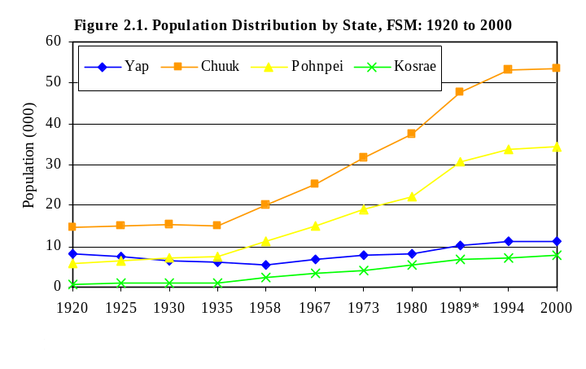

Source: FSM 2005 Annual Compact Report, Jan. 2006, by FSM Statistics Office
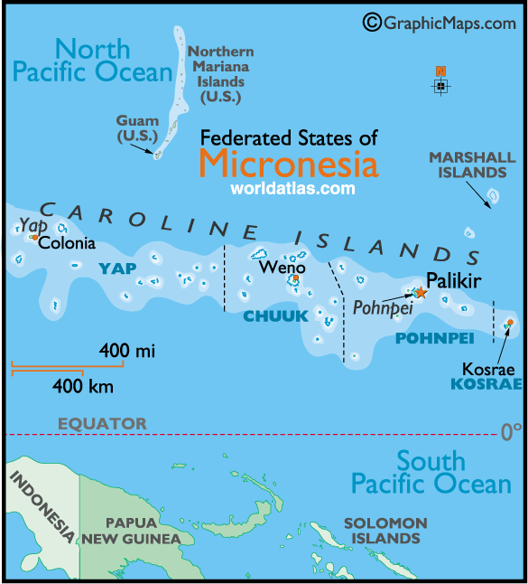

Island Geography
The FSM includes high islands, which are volcanic in origin, and smaller low islands of the coral atolls. Island elevations range from about 7 feet on the coral atolls to about 2500 feet on some of the high islands. The land area is 271 square miles with an exclusive economic zone exceeding one million sq. mi. distributed over the four states of Yap, Chuuk, Pohnpei and Kosrae. Pohnpei has the largest land area with 132 square miles, followed by Chuuk with 49 square miles, Yap with 46 square miles, and Kosrae with square miles. The FSM has 3,512 square miles of lagoons. Chuuk has the largest lagoon area, with 277.6 square miles followed by Yap (405), and Pohnpei (331.4) Kosrae has no appreciable lagoon area.

Island Geology
The FSM islands vary geologically from high mountainous islands to low, coral atolls; with volcanic outcroppings on Pohnpei, Kosrae, and Chuuk. Soil is mostly chlotie, talcshist amphilobolite, conglomate, and volcanic bracca. Vegetation varies from the higher parts of the islands to the lower atoll. The atolls have coconut palms, breadfruit, pandanus, and shore plants which can survive in sandy soils. In addition to these plants, the high volcanic islands usually have mangrove swamps on the tidal flats, coconut vegetation on the slopes, and mixed growth on the uplands. The high islands have somewhat richer soil capable of supporting a wider variety of plant life, but topsoil is thin, often badly eroded, and at best only moderately fertile

Climate and Environmental Hazards
The climate of the FSM is typically tropical, with heavy year-round rainfall, especially in the eastern islands. Rainfall in the western island states of Yap and Chuuk is typically 130 to 150 inches per year. In the eastern island states of Pohnpei and Kosrae, rainfall averages up to 200 inches per year in the coastal areas with up to 400 inches per year in the upper elevations, with Kosrae normally having the greater rainfall. Rainfall amounts have been declining slightly over the past 10 years. Most islands have dry and wet seasons. Temperatures are relatively even ranging from 78° F at night to 88 °F and occasionally into the 90’s in mid afternoon. Humidity is always high, averaging around 85%. The FSM is located on the southern edge of the typhoon belt and occasionally experiences severe storms, although most typhoons are in the formative stages in the FSM area. The western islands are more susceptible to typhoons, but all the islands have experienced storms.

Energy Sources
The FSM is almost 100 % dependent on imported petroleum for both electricity generation and transportation fuels. Mobil Oil serves Pohnpei, Chuuk and Yap. Kosrae is served by the Micronesian Petroleum Corp. (MPC), a wholly state-owned enterprise. Most of Mobil Oils’ fuel is shipped from Indonesia, whereas MPC purchases fuel from various suppliers and sources, although also primarily from Indonesia. There is a small LPG service on Pohnpei and Chuuk serving the fuel requirements for restaurant cooking and some home use. Extensive use of local wood and coconut husk products are used for local cooking. Approximately 86% of gross energy supply is from petroleum and 14% from biomass for cooking.

Pohnpei has a hydro-electric plant, the Nanpil hydro system, which was damaged by flooding a few years ago, but has been refurbished in a partnership arrangement with a U.S. based firm. The hydro is now available for operation but technical operational problems have prevented it from producing its full 2,000 Kw capability. There are many solar systems in the outer islands of the state of Chuuk but it is estimated that solar energy provides less than 1% of the total FSM energy requirements.

Energy Uses
The largest use of fuel in the FSM is diesel fuel for electric power generation. Gasoline and diesel fuel for transportation, including marine service, is also a major use of fuel. Due to the small land areas in most of the islands of the FSM, vehicle transportation use relatively small amounts of fuel. Pohnpei, the capitol island of the FSM, has emerged as the fleet headquarters for the Micronesian fishing fleets, and therefore fueling the commercial fishing boats is another major use of fuel use in Pohnpei. However, many of the fishing boats refuel from fuel tenders on the open ocean. Kerosene and liquid petroleum gases (LPG) are fuels used for some cooking in population centers and for some commercial hot water heating. Renewable fuel use includes the widespread burning of wood and coconut wastes for domestic cooking. The use of electrical energy can be broken down into five main categories with the historic use, including: residential (39%), commercial/industrial (22%), government (17%), utility (10%), and system losses (12%).

Table 7-2

FUEL USE IN THE FSM
Fuel Type | Thousand | 2000 | 2001 | 2002 | 2003 | 2004
Jet A | Gallons | 2,406 | 2,321 | 2,254 | 1,526 | 1,676
Diesel | Gallons | 10,609 | 10,080 | 9,049 | 6,762 | 8,718
Diesel-electric | Gallons | N/A | N/A | N/A | N/A | N/A
Gasoline | Gallons | 5,136 | 7,357 | 6,964 | 5,861 | 7,937
From FSM Dept. of Planning and Statistics, 2005 databook

HISTORY, POLITICAL DEVELOPMENT AND PRESENT STATUS

Early Island History
The original settlers, arriving about 1500 to 2000 years ago are believed to have been canoe voyagers of either mixed Polynesian or Malay descent. The Spanish discovered the Caroline Islands in the 16th century but the islands became widely known only in the 1830’s when whalers used Kosrae and Pohnpei Island as a stop for provisions. Yap and Chuuk were less frequented by whalers due to the island’s more western location out of the migration lanes of the whales (and, in the case of Chuuk, a reputation of fierce warrior local populations that deterred the whalers). After the American Civil War, whaling declined substantially and whaling ships were less frequent in the Carolines. Christian missionaries arrived in the mid 19th century and converted most of the population, particularly in Pohnpei and Kosrae, and later in Chuuk and Yap. The population now is approximately half Catholic Christian and half protestant Christian. In 1881, Spain attempted to solidify its claim to Pohnpei by building fortifications and a small mission at the present site of Kolonia in Pohnpei.

Recent Island History
Germany purchased the Caroline Islands form Spain in 1899 and introduced private land ownership and plantation agriculture for economic development. Germany controlled and developed the islands until the beginning of World War I. Most of their work was on the island of Pohnpei. The Japanese quickly occupied the Caroline Islands in 1914 at the beginning of World War I. Japan continued oversight of the islands and in 1921 the League of Nations mandated the islands to Japan. Pohnpei became the seat of the Japanese East Caroline administration and more than 8,000 Japanese nationals came to colonize and develop the island, introducing large-scale commercial agriculture and sophisticated fishing methods. In the 1930s, there was large scale immigration of Japanese colonists into Chuuk also. By the late 1930s there were 4000 Japanese and Okinawans living on Chuuk, bringing the total population to nearly 15,000. During WWII Japanese naval forces utilized the Chuuk lagoon as their home port for their southern naval fleet. In February 1944 American carrier-based aircraft attacked the Japanese naval forces in the Chuuk lagoon and sank approximately 60 ships and aircraft. American forces bypassed Kosrae, Pohnpei and Yap during World War II, except for occasional bombing raids. In September of 1945, American forces occupied the FSM Islands. As with many of the Pacific Islands, the wartime isolation from foreign supplies encouraged over-exploitation of land and marine resources, later hindering economic regeneration.

Through a United Nations mandate, the FSM islands became part of the United States Trust Territory of the Pacific Islands (TTPI) in 1947. After six years of United States naval administration, the FSM islands came under the civilian administration of the Department of the Interior in 1951. The years between 1951 and 1978 saw political evolution, educational growth, some infrastructure construction, but little economic development. During that time, the four islands formed local legislatures and sent representatives to the Congress of Micronesia.

Political Development
In 1979 the Federated States of Micronesia, a UN Trust Territory under U.S. administration, adopted a constitution. In 1986 independence was attained under a Compact of Free Association with the US, which was amended and renewed in 2004.

Present Political Status
The FSM became an independent nation in November of 1986 and entered into a long-term treaty called the Compact of Free Association with the United States. It was later admitted to the United Nations in September of 1991.
The FSM Constitution, like that of the U.S., provides for three separate branches of government at the national level: Executive, Legislative and Judiciary. It contains a Declaration of Rights similar to the U.S. Bill of Rights, specifying basic standards of human rights consistent with international norms. It also contains a provision protecting traditional rights. Unlike the U.S. system, however, most major governmental functions other than the conduct of foreign affairs and defense are carried out by the state governments.
The Congress of the FSM is unicameral with fourteen members – one from each state elected for a four-year term, and ten who serve two-year terms whose seats are apportioned by population. Currently, Chuuk has six seats, Pohnpei four, and two each are held by Yap and Kosrae. The President and Vice-President are elected to four-year terms by the Congress, from among the four-year Senators, and the vacant seats are then filled through special elections. The Judiciary Branch of the National government is headed by the Chief Justice of the FSM Supreme Court that currently is comprised of three Justices who sit in trial and appellate divisions.

United States Involvement
The Compact of Free Association between the FSM and the U.S. is a series of treaties and contracts relating to almost every facet of life in the FSM, ranging from the postal service, military support, education and health care.

In 1986, the first Compact of Free Association of the FSM with the U.S. was implemented. With the Compact in place, there was opportunity for development of a viable economy under the 15-year Compact period. The U.S. provided financial aid to assist with social and economic development of the state as well as funds for capital improvement projects during the first 15-year Compact period. In return, the FSM granted the U.S. exclusive military rights to police the waters and air of the FSM.

Most of the funds were provided as a series of “block” grants to the FSM government, which in turn distributed them to the states. The distribution of funds was based mostly on population.

The administration of the block grants did not require a great deal of project planning, oversight or reporting. As a result, the U.S. Congress determined that in many cases, funds had been used inappropriately. The second series of Compact agreements, finalized in 2004, has a much different structure, with strict accountability and project planning policies.

In May 2003, the FSM entered into a new 20-year Compact of Free Association with the US. This Compact, which will expire in 2023, provides for grants to the FSM in a number of “sectors” including education, health care, private sector development, the environment, public sector capacity building, and public infrastructure

The agreed schedule of grant and trust fund payments in millions is detailed below. These figures do not include any inflation adjustment.

Table 7-3
 | Annual Grants | Audit Grant | Trust Fund | Total
2004 | 76.2 | .5 | 16 | 92.7
2005 | 76.2 | .5 | 16 | 92.7
2006 | 76.2 | .5 | 16 | 92.7
2007 | 75.4 | .5 | 16.8 | 92.7
2008 | 74.6 | .5 | 17.6 | 92.7
2009 | 73.8 | .5 | 18.4 | 92.7
2010 | 73 | .5 | 19.2 | 92.7
2011 | 72.2 | .5 | 20 | 92.7
2012 | 71.4 | .5 | 20.8 | 92.7
2013 | 70.6 | .5 | 21.6 | 92.7
2014 | 69.8 | .5 | 22.4 | 92.7
2015 | 69 | .5 | 23.2 | 92.7
2016 | 68.2 | .5 | 24 | 92.7
2017 | 67.4 | .5 | 24.8 | 92.7
2018 | 66.6 | .5 | 25.6 | 92.7
2019 | 65.8 | .5 | 26.4 | 92.7
2020 | 65 | .5 | 27.2 | 92.7
2021 | 64.2 | .5 | 28 | 92.7
2022 | 63.4 | .5 | 28.8 | 92.7
2023 | 62.6 | .5 | 29.6 | 92.2

The major sources of financial assistance to the FSM in period 1987-99 are shown in the table below:

Table 7-4
FSM Major Donors, 1987-99
(Amounts in 1998 U.S. dollars in millions)
 | Total Aid | % of total
United States | 1,632.26 | 92.8
Japan | 81.91 | 4.7
ADB | 28.84 | 1.6
Australia | 6.07 | 0.3
UNDP | 3.48 | 0.2
All other donors | 6.64 | 0.4
TOTAL | 1,759.2 | 100.0
Source: U.S. General Accounting Office report GAO-01-808

U.S. Special Island Programs
The Federated States of Micronesia will receive $92.7 million in grant assistance, including a $16.0 million contribution to its trust fund. Under the Compact of Free Association, the FSM is eligible for a vast array of programs from the United States. All of the normal U.S. functional support services, such as the Weather Bureau, the U.S. Postal Service, Federal Aviation Administration, Federal Deposit Insurance Corporation, Federal Emergency Management Agency, Rural Utility Services and many others were made available. One of the major special programs is the assistance available from FEMA for mitigation assistance and during natural disasters.

POPULATION, EMPLOYMENT & WAGES

Present Demographics
The population of the FSM is fairly young. Of a population of 107,008 in 2000, 40.3% were 0 to 15 years old, 28.3% were 15 to 30 years old; 16.9% were 30 to 45 years old and 5.3% of the population was over 60 years of age.

Table 7-5
Population (2000)
Total | >15 yrs | 15-30 | 30-45 | 45-60 | >60
107,008 | 43,172 | 30,365 | 18,063 | 9,754 | 5,654
100.0% | 40.3% | 28.4% | 16.9% | 9.1% | 5.3%

The average household size in the FSM has remained at about 7 over the last three decades. However, the household composition has changed. The proportion of natural children decreased while that of other relatives living in the household has increased. This suggested that more children were moving out of the household to establish their own household or have moved overseas for school or employment, and more ‘other’ relatives were moving to extended households. The marital characteristics across the nation have changed as well, showing a general pattern of postponing marriage to a later age because of schooling among the population 15 years of age and over. The proportion of separated and divorced persons has slightly increased while the percentage of widowed has remained relatively the same.

It is anticipated that the demographics will remain approximately the same over the next decade with the population age distribution continuing to be relatively young. The probable growth rate of the FSM of 2.5% to 3.0% will not be evident in the population census since it is anticipated that the out migration will continue, resulting in an annual growth in population equal to that experienced from 1994 to 2000 of approximately .3 %.

Major Employment Sectors
The major employment base of the FSM, after subsistence agriculture and fishing, is in government operations. Beyond these, retail services, construction, health and education are normal sectors of the economy. Thereafter the largest employment that provides income to the FSM is in the commercial fishing industry. The FSM leases approximately 800,000 square miles of Pacific fishing grounds to Japanese, Taiwanese, and Chinese fishing fleets for approximately $14,000,000 per year. The funds are divided between the states on a formula basis. There are no major natural resources other than the tropical environment that draws tourism; therefore there is no major natural resource employment sector. Tourism, in the form of diving and ecotourism activities, is a small but growing business sector. However, transportation costs prevent tourism from being a major economic factor in the FSM.

Special Employment or Employers
There are no special employment sectors in the FSM, such as mineral extraction, that exist on some Pacific islands. Pohnpei serves as a center for the Micronesian fishing fleets, Chuuk and Yap have unique diving environments that support a limited tourism industry and Kosrae with its relatively small population and larger high mountainous land mass has attracted a small ecotourism industry.

Employment and Job Market
According to the 2000 census, of the 63,836 persons who were 15 years of age and over there were 37,414 persons (58.6%) in the labor force in the FSM. There were 29,175 people employed (78%) and there were 8,239 (22%) unemployed. There were 13,959 people employed in formal jobs (47.8%) and 15,216 (52.2%) employed in agriculture and fishing. Of those employed in agriculture and fishing (gardening, animal raising, fishing, handicraft crafting, etc), 10,624 (69.8%) were engaged in subsistence farming and fishing and 30.2% were engaged in market oriented agriculture and fishing. Subsistence agriculture and fishing has increased over the past decade as the formal job market has failed to provide employment for the growing population. This is partly due to reduced funding from the U.S. Compact for local employment. Subsistence agriculture and fishing in 1994 represented 22.6% of the labor force and 9.9% of those persons 15 years of age and older whereas in 2000 subsistence lifestyle work represented 28.4% of the labor force and 16.6% of those persons 15 years of age and older.

In 2004 there were 15,907 persons employed in the formal job market with 8,922 (56%) employed in the public & NGO sector and 6,985 (44%) in the private sector. The formal employment sector in 2004 represented 52% of the employees in the FSM. Expatriates, who make up approximately 5 % of the work force, were more likely to be employed in the private sector than the public sector. In 2004, about 80 percent of expatriate workers were employed in the private sector.

According to the 2000 FSM Census, 67.2% of males aged 15 years and older were in the labor force compared to 50.1% of their female counterparts. The overall unemployment rate in FSM was 22% in 2000, more than half of which were males. About 20.7% of the males were unemployed compared to 23.8% of the females.

Subsistence agriculture and fishing continued to be an important employment activity. Agricultural and fishing activities comprised 52.2% of the employed work force, increasing from 33.9% in 1994. Of the workers involved in agricultural and fishing activities, 69.8% (about 7 out of every 10) consumed and sometimes give away their produce. The remaining 32.2% either sell their produce, or consume some and sell some of their produce

General Business & Commercial Income
The number of licensed business establishments increased from 5,251 in 1997 to 5,739 in 2001. The leading class of establishments in the FSM is the Wholesale and Retail trade with total more than 2,000. Commercial bank deposits increased while loans declined between FY1997 and FY2004.

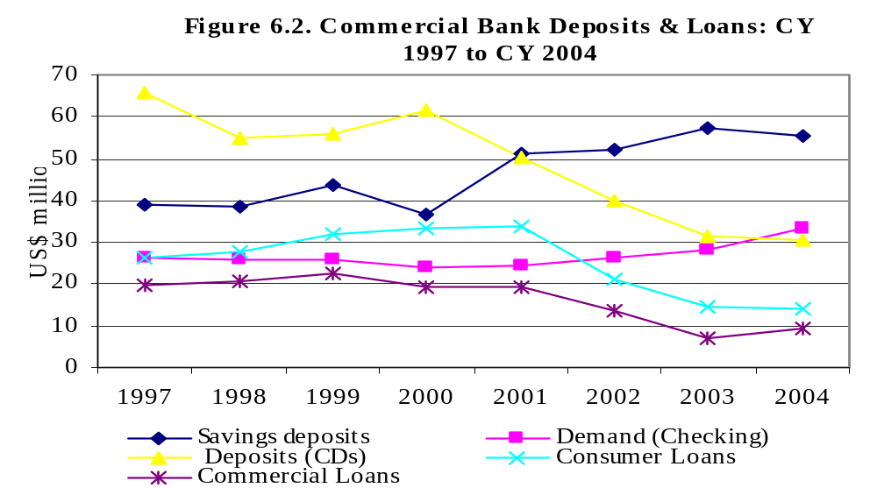
Between 1997 and 2004 Savings deposits increased from about $39 million to about $55 million. Demand (checking) increased from about $26 million to $33 million, with the increase occurring mostly after 2002. Time Deposits and Certificate of Deposits declined from about $66 million to $31 million over the same period. Consumer loans increased from $26 million in 1997 to $34 million in 2001 then declined thereafter to $14 million in 2004. This trend is also observed with Commercial loans but at different levels and the decline experienced much earlier in 1999.

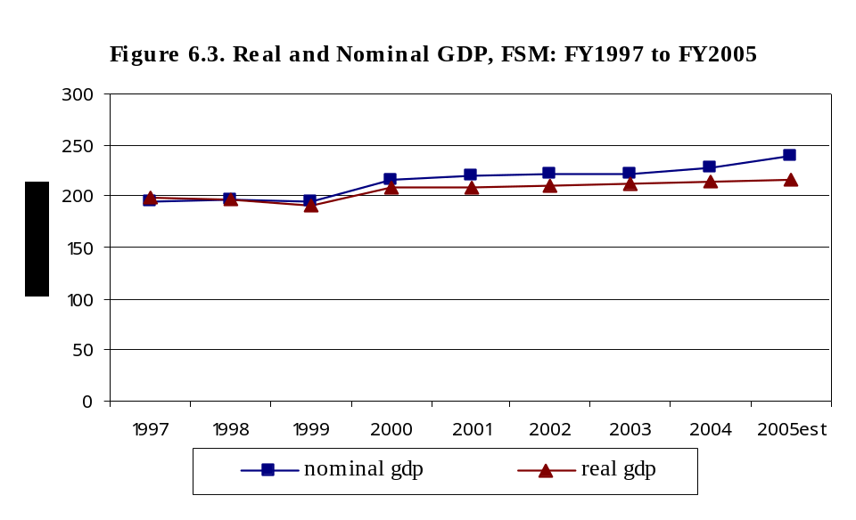
Real GDP growth has remained below 1% per annum between 2000 and 2004, and is estimated to be 1.4% in 2005. The real GDP was estimated to be $216 million in 2005 increasing from $199 million in 1997. The GDP has been below 1% since 2000.

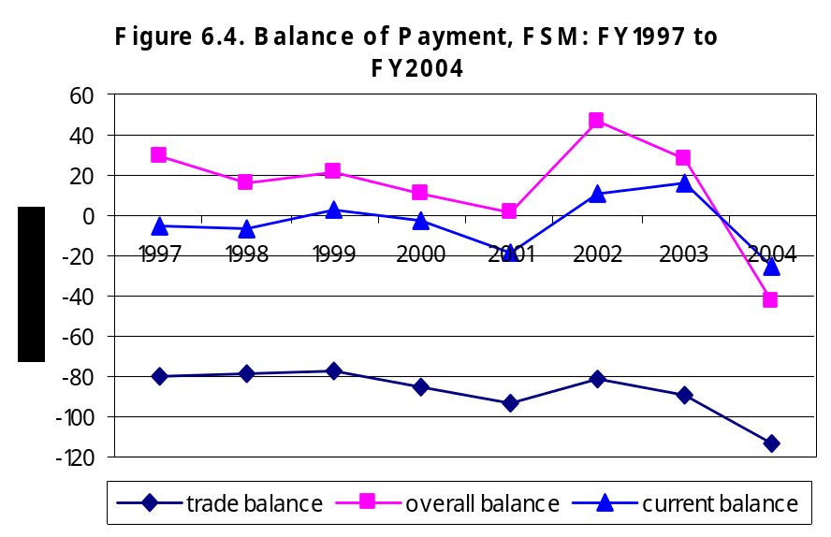

Source: FSM Statistics Division Factbook, 2005.
Nominal GDP per capita was estimated to be $2,212 per person in 2005, up from $1,841 per person in 2005.

The trade balance has remained highly negative since 1997. In 2004, the trade balance was estimated at negative $113.8 million, an equivalent to 49.8% of GDP. The current account balance was positive in 1999, 2002 and 2003. The overall balance remained positive in all years observed except 2004.

ISLAND ECONOMY AND INFRASTRUCTURE

General Status of the Economy
The FSM Gross Domestic Product estimated for 2004 was $228.3 million and the estimate for 2005 was $239.49 million. Per capita GDP for 2004 was $2,114 and the estimate for 2005 was $2,212. Between 2004 and 2005 the public and government enterprises increased 7.7% and 2.6% respectfully but the private sector decreased by 0.6%. Officials anticipate that the FSM economy will grow at 0.4% per annum. By world standards this is a very modest target however, given the resource scarcity, remote nature, and general development constraints facing the FSM government, this may be all that is achievable.

Table 7-6
FSM | FY00 | FY01 | FY02 | FY03 | FY04 | FY05 Estimate
Nominal GDP (US$ millions) | 213.92 | 217.19 | 223.27 | 232.27 | 228.3 | 239.49
Nominal GDP per capita | $1,999 | $2,025 | $2,077 | $2,155 | $2,114 | $2,212
Real GDP (US$ millions) | 205.73 | 206.18 | 212.25 | 221.31 | 213.46 | 216.35
Real GDP Growth Rate | 5.70% | 0.20% | 2.90% | 4.30% | -3.50% | 1.40%
Sources: FSM Department of Finance and Administration; FSM Social Security Administration

Source for three figures below: FSM Statistics Division Factbook, 2000.
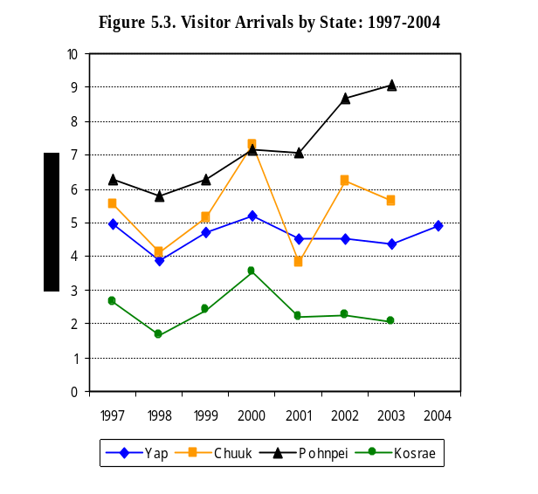
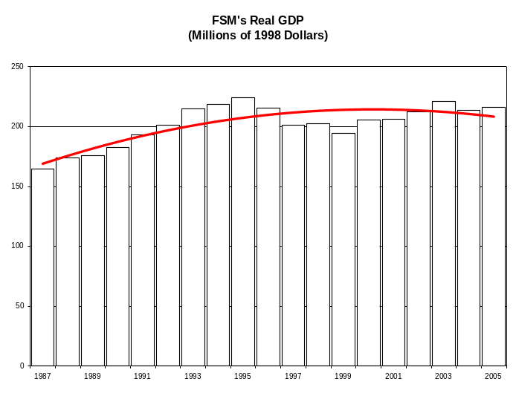

Total imports into FSM during 2000 was valued at $106.7 million and continued to increase to $132.7 million in 2004 with the exception of 2002. The decline in 2002 reflected the decline in imports in Chuuk, Pohnpei and Kosrae. About 36.1% of imports into FSM in 2004 went to Pohnpei state, 28.0% to Chuuk state, 21.8% to Yap state and 8.1% to Kosrae state. In 2004, about 36.1% of imports into FSM originated from USA, 13.9% from Guam, 11.5% from Japan, 5.8% from Hong Kong, and 5.6% from Australia. Food and beverage imports totaled $41.55 million in 2004, accounting for 31.3% of total imports. The top five imported food items are rice ($6.215 million), poultry meat ($4.026 million), canned meat ($3.178 million), beer ($2.976 million) and soft drinks ($2.564 million).

The total visitor arrivals was 13,400 in 1998, rising to a peak of 20,501 in 2000, which then declined to 15,253 the following year, then increased to 18,967 in 2004. Tourism and visitors (to friends and relatives) are the main reasons for foreign visitor arrivals into the FSM. In 2004, this group comprised about 67% of total arrivals. Most of the visitors were American and Japanese citizens, around 39% and 20% of total visitor arrivals, respectively.

Port and Port Industries
The major productive port in the FSM is the sea port in Kolonia in Pohnpei where there is an active fishing fleet for the FSM stationed. There are ports on each of the other islands states which serve to bring in products for use for local fishing and the occasional fleets working the waters of FSM. There are numerous small fishing harbors in each of the states for local fishing, intra-island transport and diving activities.

Aviation and Aviation Industries
Each of the island state has an airport, built by the U.S. government over the past 25 years. Each is capable of accommodating international passenger and cargo jet aircraft. The U.S. provides assistance to each of the islands for expansion and maintenance of the facilities. Pohnpei has a small aviation industry for intra-island cargo and an occasional passenger or charter service. The remaining island states generally have little other activity at their airports other than the daily flights by Continental Airlines.

Tourism Industry
Tourism is active in the Federated States of Micronesia but on a small scale when compared to the major tourism industries in other Insular Areas. The remoteness of the islands and the transportation costs are limiting factors in the development of a more robust tourism industry. In 2004, the FSM reported that there were 19,257 visitors to the FSM. Of these, 13,080 were categorized as tourists and visitors (family or friends of residents); 4,352 were business or employment visitors; 500 were volunteers or with religious groups and the remaining 1,325 were visiting seamen and crews. Almost 40% of the visitors/tourists were from the United States and the remaining from mostly Asian countries with Japan representing 20%.

Each of the island states of the FSM has unique tourism attractions. Yap has unique diving opportunities being on the edge of the Mariana’s trench. The manta ray population and other unique diving sights attract avid divers. Chuuk is one of the most popular wreck diving sites in the world, as a result of the sinking of 42 Japanese ships and aircraft in the “Truk” lagoon during WWII.

Figure 7-7
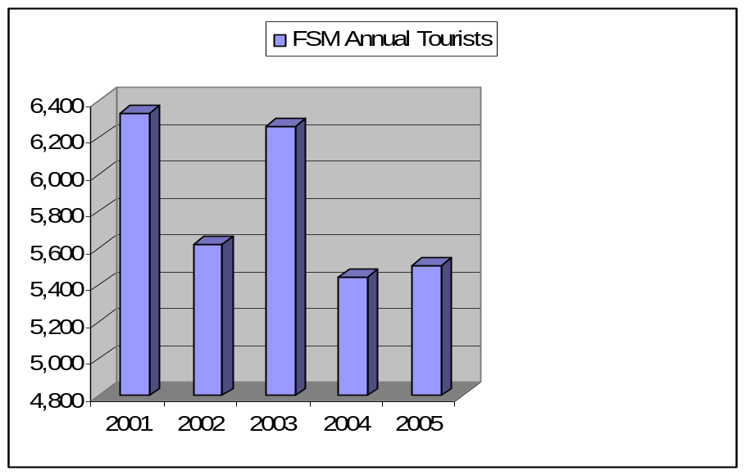

Pohnpei also has interesting dive sites but its unique tourism feature is the ancient rock walled city of Nan Madal. It is believed that Nan Madal was built over 800 years ago. The massive structure was built with hexagonal basaltic logs quarried from the volcanic cores of the mountains. Kosrae also has ancient rock walled ruins located at different locations around the island of Kosrae. Kosrae is the youngest of the FSM states and has volcanic mountains rising sharply from the ocean’s edge and covered in thick tropical rainforests. Kosrae has developed a good ecotourism industry, although the volume of visitors is limited due to the remoteness and the transportation cost.

Major Industry
The major industry of the FSM is the government. Subsistence farming and fishing is the other major source of livelihood in the FSM and in recent years, subsistence lifestyles have increased due to the declining Compact funds that are distributed to the general population, as had occurred under Compact I. The fishing industry with the lease of fishing rights to the FSM territorial waters and the harboring of the fishing fleet in Pohnpei serves as an economic driving force for the FSM.

Military
There is no military presence in the FSM except the contingent of coast guard personnel in Pohnpei.

Manufacturing, Craft, Trade
There is no major manufacturing done in the FSM. Each island state has business that manufacture products that are primarily for use on the islands, but no major manufacturing activity is for export. Handicraft is made primarily for the tourist market. However, while the quantity available for sale is not large enough to significantly affect the FSM economy, existing sales have a profound effect on individual family finances.

Agriculture
Agriculture in the form of subsistence farming is a main stay of life in the FSM. Nearly everyone in most of the FSM has a farm plot and, unless they live in a crowded urban area, have a small pen of pigs. According to the FSM Fact book of 2005, 20% of the labor force is employed in agriculture. Agriculture (including fishing) represents 42% of the GDP of the FSM. Products that are raised for resale and when markets can be secured are coconuts, copra, cassava, sweet potatoes, peppers, tropical fruits and black pepper. Pohnpei is especially noted for its raising and exporting of Pohnpei black pepper.

Aquaculture, Fisheries
The FSM government leases its territorial waters to foreign nations fishing fleets for the right to fish the FSM waters. This contractual arrangement brings in approximately $14 million in revenue per year for the FSM. Various levels of fish processing has been attempted in the FSM but none exist today. Kosrae has a giant clam breeding and raising facility which is successfully operating, although it has not become profitable to date.

Other Special Economic Elements
Pohnpei was recently selected as the site for the Pacific Tuna Commission and a new headquarters building has been built in Kolonia. The Commission is hoped will bring new emphasis for the FSM in the fishing industry in the Pacific.

Electrical System
Each of the island states of the FSM has their own electric system. Public authorities created by acts of the state Legislatures in each of the states are responsible for the electric utilities. All states except Chuuk have fully built out and functioning electric utilities, although all are experiencing very serious economic problems due to the high cost of fuel. The Chuuk utility, although it has received similar assistance from the U.S. Compact and other programs, has failed to maintain its system or manage it in a financially responsible manner. These financial problems have resulting in much of the main island of Weno being without power half of the time during the daytime hours and causing most major businesses and government offices to purchase and operate their own electrical generators.

Water and Wastewater Systems
Water systems on each of the island states except Kosrae are operated by the Utility Authority. Kosrae’s legislature has chosen not to include the provision of water service as a function of the Kosrae Utilities Authority and instead each of the four municipalities provides water service. Water service is of various forms but where possible, especially on the high islands, catchment basins on mountain streams serve as reservoirs to supply water to the distribution system. Most homes incorporated a concrete or plastic catchment tank on the roof of their home to provide much of the household drinking water. Some island locations have underground fresh water lens above the natural underground salt water which is tapped for local use. Also in some locations, especially were the basaltic soils of the volcanic mountains capture and store rain water, the basaltic sands underground water supplies are tapped for local use. There is very little treatment of the water supply and water-borne diseases have occasionally been a serious problem, such as a cholera outbreak in Pohnpei in 2001.

Most wastewater systems consist of septic tanks in the less populated areas. In the communities, a collection system often exists and occasionally some treatment is performed, either by a secondary treatment system or a lagoon, but often the wastewater is discharged directly into the ocean. Contamination of the surrounding area often is a result of the outfalls of the wastewater discharges.

Waste Management Systems
Most solid waste is discarded in crude disposal sites with little or no environmental containment. Many homes have garbage disposal sites near their home where solid waste is discarded and often the solid waste fill site is used to expand the useable land area, especially around coastal and mangrove swamp home sites.

Transportation System
Most of the transportation in the FSM is by private vehicle on the land mass areas of FSM and by small boat in the many outlying island areas. In most states there is an abundant number of taxis, to provide public transportation services if a private vehicle is not available. There are not any established regular bus services on any of the FSM states.

Except for Chuuk, the road system in the FSM is in reasonably good shape and except for Chuuk, the individual states have done a good job in maintaining the road system.

Communication System
The FSM Telecommunication Corporation serves the telephone, cell-phone, internet and cable TV system for the four states, excluding the cable TV in Pohnpei, which is served by a separate provider. Each state is a shareholder in the FSM Telecom. The system provides most households with access to a telephone. Telephone and cell phone service is good, although the cost of long distance service is among the highest international rates. Internet service is very poor with data transmission speeds maximum at 28k baud, and is often less. A fiber optic cable is being planned to connect Guam and Kwajalein Island in the Marshall Islands and FSM Telecommunications is expected to obtain a lateral tap. This will substantially help FSM’s data transfer rate.

ECONOMIC DEVELOPMENT PLANS AND PROJECTS

General Status of Economic Development Planning
Each state has its own Economic Development Plan, although the FSM has broader national level planning programs. The FSM had developed a Strategic Development Plan (SDP) in 2003. The goals that the FSM set out as they prepared their SDP was one that would (1) Achieve consensus on an overall strategy consistent with the theme of achieving economic growth and self-reliance; (2) Build awareness of the economic structure of the amended Compact provisions and the likely impact on the FSM economy; and (3) Improve implementation and monitoring of the outcome of the planning process.

The specific areas of economic planning were in the area of numerous infrastructure projects to enhance each state’s ability to provide the basic necessities of education, health, transportation, utilities and governance. There is an emphasis on developing more local businesses and improving the tax base necessary to support government functions. There are also efforts to reduce the level of government to ease the burden of taxes. A significant effort is being made towards capacity building – being the process of improving the ability of an organization to deliver the quantity and quality of the goods and services it is responsible for providing. The capacity building effort includes training, improving the structure and management of the various organizations, and recruiting specialist advisors.

Economic Development Approach and Special Issues
The approaches and special issues are all directed toward improving the basic organizational systems and developing good infrastructure for the FSM.

Focus Areas
Focus areas appeared to be within the infrastructure and capacity building area.

Energy Considerations
There does not appear to have been much consideration given to energy systems in the economic development plans.

In 1999, the DoEA prepared a draft National Energy Policy, but there has been no further work since 2000. The overall objective is to promote sustainable social and economic development through cost effective, safe, reliable and sustainable energy services. In 2002, the government listed five areas where energy policies and related strategies are needed: (1) an effective and coordinated energy sector; (2) safe, reliable, cost effective and sustainable energy; (3) restructuring the power utilities and petroleum industry and promotion of energy service companies; (4) diversification of FSM’s energy resource base; and (5) environmentally appropriate and efficient use of energy. The draft energy plan identified four constraints and deficiencies to be addressed: (1)institutional issues (small fragmented energy sector, environment not conducive to private sector; no oversight or regulation, insufficient capacity to coordinate, plan and manage); (2) power sector (highly subsidized, no standards; (3) petroleum supply and pricing (limited competition, no responsibility for waste disposal); and (4) renewable energy (solar electrification unsustainable, little experience, no monitoring of renewable energy potential). These issues are still not being addressed. There are statements in state plans regarding energy but apparently no budgets or specific activities.

Economic Diversification
There are continued efforts at economic diversification, however, natural resources are limited, high cost of transportation and limited skill levels of the population renders it very difficult to develop new and diverse economic activity. With Pohnpei being selected as the site for the Pacific Tuna Commission, hopes are that the commission will help bring the focus of the fishing industry to the FSM.

Import-Export and Balance of Payments
The FSM Statistical Yearbook for 2005 lists as International Trade for 2002 (the latest numbers available) total imports of $104.3 million and total exports as $12.4 million.
The document lists under Balance of Payment for 2003 (also the latest year for which figures were available) current account balance of $2.3 million and a capital & financial account as $13.8 million, resulting in an overall balance of $16.2 million.


Federated states of micronesia – Kosrae

General

Location and Population
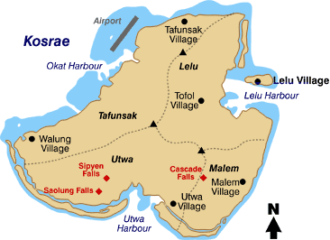
Kosrae is the eastern-most island state of the Federated States of Micronesia (FSM), which lie in an archipelago terminated by the Republic of Palau to the west and the Republic of the Marshall Islands (RMI) to the east. Kosrae is isolated from the other States of FSM, being 334 miles east-southeast from Pohnpei, 773 miles east from Chuuk and 1,209 miles east from Yap. Kosrae is located 2,467 miles southwest of Honolulu and 1,200 miles southeast of Guam at 163º22’ East Longitude and 5º10’ North Latitude.

The population of Kosrae in 2005 was estimated to be approximately 8,000 representing only an 0.8% per year growth rate from the 2000 population of 7,686. The population of the state of Kosrae represents approximately 7% of the population of the FSM. Although the population growth has slowed dramatically to about .9 % per year, it is believed that the population is actually growing at a rate of about 2.3% per year but the absolute numbers reflect growth after out migration is taken into account. The population is very young, with over half of the population under the age of 25 when the 2000 census was taken. This represents challenges in the future for educational and health infrastructure needs.

Island Geography
Roughly triangular, the island is 42 square miles in area and is 8 miles across at its widest point. The island is mostly mountainous with valleys interspersed between several peaks, one of which reaches over 2,050 feet. The interior of the island is heavily covered with dense tropical forest. A ring of coastal barrier island lowlands separated from the mountains by mangrove swamps is the habitat for most of the occupants of the island. The largest settlement is on the island of Lelu. Lelu is a small adjoining island, connected by a causeway, off of the northeast cost of Kosrae. A fringing reef encircles Kosrae with a shallow reef flat that varies in width from several 100 feet to over ½ mile on the western side of the island. The state is divided both geographically and administratively, into four municipalities: Lelu, Malem, Utwe, and Tafunsak. Tofol in Lelu municipality is the administrative center of the state and the major activity center for state government, commerce and education.

Island Geology
Kosrae is similar to other volcanically formed islands of the Pacific. It is the top remnant of an extinct volcano that formed the island 1.5 million years ago. The land mass is black volcanic basalt. As the Pacific Plate moved from east to west over a “hot spot” in the earth’s crust, Kosrae formed from an outpouring of volcanic basalt to heights much in excess of the present mountains. Kosrae is one of the youngest islands of the Pacific islands and is characterized by very steep mountainsides, culminating in sharp mountain peaks. Due to weathering, the volcanic peaks wear down and the weight of their massive peaks presses them downward. The central core of the volcanic peaks apparently cooled slowly allowing the volcanic basalt to form into large, 12 inch to 24 inch diameter, hexagonal “logs”. Early inhabitants quarried these huge basaltic logs, some measuring 20 feet in length. They brought the logs down from the heights of the mountains and built elaborate structures in various locations around the island of Kosrae. The largest structure is on the island of Lelu and served as the headquarters of the King and his court prior to modern times.

The highest mountains of the rugged interior, which makes up over 70% of the total landmass, are Mt. Mutunte (1,923 feet) and Mt. Finkol (2,064 feet). Access to the upland areas, which are rich in forest resources, is difficult. The undisturbed upland forest areas are covered by dry upland forest, tropical rain forest and cloud forest. The rain forests and crested slopes are home to many species of rare plants and animals.

High rainfall leads to the soils being highly leached and acidic, with highly transitional humus layer. Rock, clay and loam soils occur on the mid-island highlands. Alluvial and stony clays, sands and loamy sands are important in the coastal lowlands and swamp forests. Silts, muck and sandy soils occur in the mangrove swamps, inland of the beach strand and reef flats.

Steep slopes, muck loam and mangrove areas make up approximately 70% of the land area. These areas are not suited to development that involves clearing, excavation or drainage. Great care must be taken not to increase erosion, destroy soil fertility or redirect percolation and eventual drainage into the lagoon by disturbing these soils.

Soils moderately suited for development are in small areas scattered over the island, with the largest in the northeast in Tafunsak and Lelu. These scattered areas occur on the medium slopes of clays and rocky foothills rising just before the interior. Many of these areas are developed as farming and homestead sites.

Soils best suited for development primarily circumscribe the island on the littoral plain. These areas extend around the island on level alluvial soils, sand, loamy sand, clay and stony clays of the beach strand and coastal areas

Kosrae’s tropical vegetation types differ greatly, ranging from dwarf vegetation on the tops of the mountains, to dense tropical forests of the slopes and valleys and the swamp vegetation of the littoral zones. The forested areas total approximately 17,000 acres.

Kosrae is surrounded by a fringing coral reef with embayments that will become lagoons on its eastern, northern and western sides. The reef is close to shore on the southern side, where it provides a natural beach front. The beach types range from sand to coral rubble. The reef is broken only by the channels leading to four harbors and a few river channels, while the shoreline includes four natural harbors: Lelu in the east, Utwe in the south, Okat in the northwest and Yela in the west. Three of these harbors are bound in the embayments mentioned above. Yela is in a river mouth that has not yet reached the embayment stage.

The extended beach strand along much of the shores provides the location for most residences, government centers, commerce and infrastructure. Tidal or freshwater swamps lie between the beach strands and the higher ground.

The inner reefs are mainly open flats covered by coral sand and rubble, as well as seagrass beds. Coral rubble and some large limestone reef blocks cover the middle to seaward portion of the open reef flat platform. Much of the reef flat is not covered with live coral due to exposure at low tides. The sea grass zone on the inner areas of the reef flat is important to many species of marine life, including turtles, fish and crabs, for which it provides food, shelter, spawning and nursery grounds. The reef flat provides marine life regularly harvested by the people for food.

The Kosrae State marine environment between the island and the 12 mile limit is under the state’s administration. The FSM has jurisdiction from the 12 mile limit to the 200 mile boundary that is established as the Nation’s exclusive economic zone (EEZ).

Climate and Environmental Hazards
The climate is typical of an equatorial Pacific tropical island being warm and humid with a temperature of about 80ºF year round. High temperatures during the day are from 83 to 90 °F and the low temperatures are 72 to 78 °F. Humidity remains consistently high in the range of 75 to 90%. Temperature and relative humidity levels remain consistent throughout the year. Rainfall is relatively high, averaging nearly 200 inches a year in the coastal areas and over 250 inches per year in the highlands. The state has experienced three severe droughts in recent times, in 1982-83, 1992-93 and 1997-98. All three were a result of the “El Niño” effect.

Winds are light from the east-northeast normally averaging 6 to 10 mph. Stronger northeasterly trade winds occur during the months of December through April with higher speeds being prevalent from January through March.

Kosrae is located to the south and east of the typhoon track and very rarely experiences a direct strike from a typhoon. (The last one occurred in 1905.) However, Pacific typhoons often go through the development stage in the area causing severe local winds. During the rainy season of November through March frequent severe rainstorms are sometimes accompanied by damaging winds, which can damage transmission and distribution facilities.

Energy Sources
Like all the FSM states, Kosrae is substantially dependent on imported fossil fuels. The major fossil fuels are No. 2 diesel oil, gasoline, and jet fuel. The No. 2 diesel oil is mostly for electric generation and construction equipment engines, while gasoline is for personal vehicles and boat transportation systems. Jet fuel is primarily used by Continental Airlines, although all households use the jet fuel kerosene for cooking purposes. Micronesia Petroleum Corporation is the provider of fuel for Kosrae. There are efforts underway to join with other islands to form a purchasing consortium in an effort to introduce a greater degree of competition in the fuel market.

There is high interest in substitutes for fossil fuels and the development of alternative / renewable energy sources due to the high cost of traditional petroleum based fuels. There is some use of renewable fuel which includes the widespread burning of wood and coconut wastes for cooking.

Liquid Petroleum Gas (LPG) is only used in very small quantities in Kosrae since there is no supplier on the island. The Kosrae Utilities Authority (KUA) is investigating importing and marketing LPG. Restaurants and resorts are encouraging KUA in their efforts since LPG would be a less expensive energy source than electricity, which is currently used for cooking and for hot water heaters.

Energy Uses
Electricity generation is the major consumer of energy in Kosrae accounting for 55% of the diesel fuel used. There are also diesel trucks, some passenger vehicles, marine engines and construction equipment that use diesel fuel.

Jet fuel for air transport and gasoline for small trucks and passenger vehicles are other principal end-uses of fossil fuels. Kerosene is used for cooking on a small scale. It is also used for lighting by lanterns.

In the past decade the number of passenger vehicles has increased dramatically, greatly increasing the use of gasoline. A significant number of 4 wheel drive vehicles and light trucks use diesel fuel in addition to heavy trucks. Outboard motor boats, primarily used by the local fishermen are another significant end-use of gasoline. Almost all of outboard motors have 2 stroke engines, which burn a significant amount of oil with the gasoline for engine lubrication purposes.

HISTORY, POLITICAL DEVELOPMENT AND PRESENT STATUS

Early Island History
Anthropologists believe that the people who settled the Caroline Islands, including Kosrae, migrated from Southeast Asia approximately 3,000 years ago The Spanish arrived in 1529, but European travelers visited the island infrequently until the great whaling era in the first half of the 19th century. Because of its fine harbors and fresh water supply, Kosrae, then called Strong’s Island, became a popular stop-over for sailors. The early years were turbulent with sailors provoking several local wars before local rulers restored peace in the 1840s. In the 1860s, with the decline of the whaling industry, missionaries began their work and Kosrae became the evangelical center for the Caroline and Marshall Islands during the next 30 years.

The Spanish did not develop Kosrae commercially during those years because of its remote location. Germany purchased the island of Kosrae from Spain in 1899 after Spain’s influence in the Pacific declined following the Spanish-American War of 1899. The Germans administered the island from Pohnpei, focusing on the copra and sea cucumber industries. They did little for development in Kosrae but did bring educators and set up health clinics on the island.

Recent Island History
At the start of World War I, the Japanese entered the war on the side of the Allies. In 1914, Japan sent its fleet to the Caroline Islands and immediately occupied Kosrae along with the other Caroline and Marshall Islands. The Japanese, who for many years had commercial interests throughout the Pacific, proceeded to develop all of the islands, including Kosrae. Again, because of Kosrae’s remote location, the Japanese did not develop the island commercially to the extent that they developed Pohnpei and Chuuk. During those years the island was called Kusaie

Political Development
After World War II, a United Nations mandate placed Kosrae under United States naval administration as part of the Trust Territory of the Pacific Islands. In 1951, administration switched to the Department of the Interior. Kosrae was considered an outer island of Pohnpei and was part of the Pohnpei district. During the initial period of the U.S. administration, major steps were taken to introduce a democratic form of government. In the 1960s, under the Kennedy administration, a great deal of money was devoted to educational and health facilities in Kosrae and other Micronesian islands. Schools were built locally and many Kosraeans went to the United States to go to college. With the influence of the Department of the Interior’s effort to build infrastructure, education and health care facilities, the number of government jobs increased many fold. The government became the driving force in the economy, a condition that still exists today

In 1978, the people of the Trust Territories of the Pacific Islands developed and approved a constitution, written by elected delegates, forming the Federated States of Micronesia government. Although Palau and the Marshall Island districts were involved in the development of the constitution they decided against joining the Federated States of Micronesia and subsequently sought their own agreements with the United States. The seat for the new FSM government was established on the island of Pohnpei. A President, elected by the National Congress, heads the national government, which includes executive, legislative and judicial branches. Each state remains internally self governing, with its own parliamentary body, and governor. The FSM retains complete sovereignty over the islands and has full domestic autonomy and responsibility for all foreign affairs except defense.

Present Political Status
Kosrae became a separate district in 1977, elected its first Governor in 1978 and achieved statehood when the constitution was ratified in 1979.

The Kosrae State government follows the form of the United States with three branches of government, executive, egislative and judicial. The governor is elected for a four-year term, with a limit of two terms. The governor and lieutenant governor are elected on separate tickets by popular vote for the four-year terms. The 14 members of the legislature, a unicameral senate, are also elected for four-year terms by popular vote. Five (5) members are elected from the Lelu Municipality, 3 from Malem, 4 from Tafunsak and 2 from Utwe. The legislature does not have term limits.

The judicial branch consists of a Chief Justice and at least one Associate Justice appointed by the governor and ratified by the legislature.

In addition to the state government each municipality has an elected mayor and a council.

There is a strongly held popular opinion that Kosrae has more government than is necessary for such a small population. There have been several attempts to reduce the number of Senators but this movement has not been successful.

United States Involvement
The Compact of Free Association between the FSM and the U.S. is a series of treaties and contracts relating to almost every facet of life in the FSM, including the postal service, military support, education and health care. In 1986, the first Compact of Free Association of the FSM with the U.S. was implemented. With the Compact in place, there was opportunity for development of a viable economy under the 15-year Compact period. The U.S. provided financial aid to assist with social and economic development of the state as well as funds for capital improvement projects during the first 15-year Compact period. In return, the FSM granted the U.S. exclusive military rights to police the waters and air of the FSM.

Most of the funds were provided as a series of “block” grants to the FSM government, which in turn distributed them to the states. As the distribution was based mostly on population, Kosrae always received the smallest appropriation.

The administration of the block grants did not require a great deal of project planning, oversight or reporting. As a result, the U.S. Congress determined that in many cases funds had been used inappropriately. The second series of Compact agreements, finalized in 2004, has a much different structure, with strict accountability and project planning policies.

In May 2003, the FSM entered into a new 20 year Compact of Free Association with the US. This Compact, which extends from 2004 through 2023, provides for grants to the FSM in a number of sectors, including education, health care, private sector development, the environment, public sector capacity building, and public infrastructure

U.S. Special Island Programs
In addition to the sector grants, Kosrae, as well as the rest of the FSM is eligible for a number of U.S. Federal services and programs. Under the Compact agreements, these programs include:
- Weather Service
- Postal Service;
- Federal Aviation Administration;
- Department of Transportation;
- Federal Deposit Insurance Corporation (for the benefit only of the Bank of the Federated States of Micronesia)
- Federal Emergency Management Agency, and the United States Agency for International Development, Office of Foreign Disaster Assistance.
- Humanitarian Assistance – Federated States of Micronesia (“HAFSM”) Program with emphasis on health, education, and infrastructure (including transportation), projects..
- Disaster Assistance Emergency Fund.
- Operations and Maintenance Improvement Program (OMIP) of the U.S. Department of the Interior.
- USDA Forest Service (USDA FS)
- USDA Rural Development
- Peace Corps
- National Office of Atmospheric Administration

POPULATION, EMPLOYMENT & WAGES

Present Demographics
The population of Kosrae increased from about 2025 people in 1973 to 7,686 as of the 2000 census and is estimated to be slightly over 8000 as of 2005. The population of the state of Kosrae represents approximately 7% of the population of the FSM. .

The annul rate of growth has declined slightly and is estimated at .9% per year. Kosrae has the lowest population density of any of the FSM states being 182 persons per square mile according to the 2000 census.

The population of Kosrae is relatively young with 39.8% of the population under the age of 15 and 59.9% of the population under the age of 25. The median age in Kosrae is 19.2 years of age.

Figure 8-1
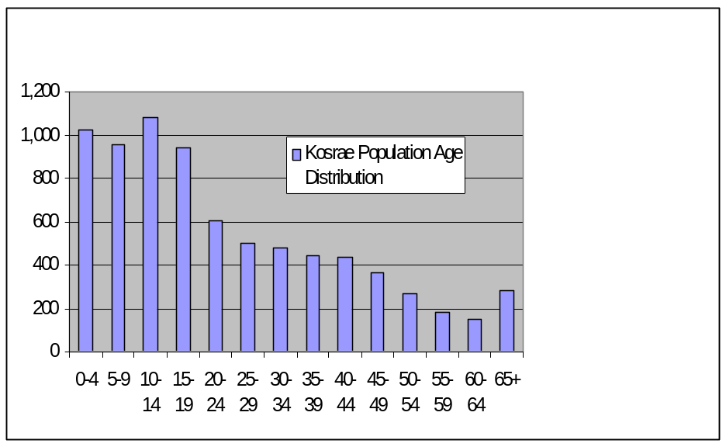

It is anticipated that the demographics will remain approximately the same over the next decade with the population age distribution continuing to be relatively young. The potential growth rate of the FSM, including the state of Kosrae, of 2.5% to 3.0%, will not be evident in the population census since it is anticipated that the out migration will continue. Other factors that may continue to slow population growth on Kosrae are the emphasis on family planning and the increasing awareness amongst young parents that higher education and other desirable life style changes are not affordable for large families.

Employment and Job Market
According to the 2000 census there were 4,628 persons aged 15 and older available for the work force. There were 2,232 persons in the work force, with 48.2% (1,864 persons) employed. Of those employed, 1,468 were in formal employment and 396were in subsistence farming or fishing jobs. There were 1,876 people over the age of 15 that were not available in the work force for various reasons. The number of persons and percentage of the work force in subsistence farming and fishing has been relatively consistent since 1994. The percentage of unemployment has increased slightly, with 15.1% of the labor force being unemployed in 1994 and 16.5% in 2000. The workforce is approximately 61.7% male and 38.3% female. There has been an increase in the size of the labor force (reflecting Kosrae's youthful age demographic and the growing population over 15 years). However, employment has not kept pace with the available workforce, leading to increased unemployment. The unemployment rate is higher in Utwe and Tafunsak (where it exceeds 20%) and amongst 20 to 24 year olds (where it exceeds 50%). This has led to significant emigration amongst young people and signals the potential for social problems.

Gross Domestic Product
The 2005 Gross Domestic Product was $18.8 million, a decline of 4.7% from 2004 when inflation is considered. This value relates to a GDP per capita of $2,332.

Personal Wages & Income
The average wage of those employed in the formal employment sector in Kosrae in 2004 was $5,514 per year. Persons employed in the private sector had an average wage of $3,003 per year, while those in public sector enterprises such as utilities and telecommunications had an average wage of $9,072. State government average wage was $7,669, Municipal government $3,435; other government agencies $2,392 and non-profit organizations $5,186.

Special Employment or Employers
There is no significant special employment or employers in Kosrae. During the 1990’s the state of Kosrae developed a tuna processing facility at Kosrae’s Okat Harbor area next to the airport in the northwestern section of Kosrae. The facility operated for approximately three years as a cold storage facility for the Chinese fishing fleet operating in the region. Due to poor market conditions for tuna, a decline in the tuna harvest and various other factors, the fishing fleets relocated to Pohnpei and the tuna facility closed. The state of Kosrae also entered into a partnership with a Korean company and provided facilities for a ship repair facility at the Okat Harbor. The Korean company SEMO is still operational and providing a much-needed service to the region, although the volume of business is less than expected, making operations difficult. SEMO employs approximately 10 to 15 people. The Kosrae Governor and Legislature in 2004 provided $3.0 million to a local company to establish the Lelu Bottled Water Company. The company is composed of a small group of local residents with a U.S. expatriate as the manager. The Lelu Bottled Water Company plans to exploit the pristine spring water found on Kosrae and they are building a water bottling works in a remote mountain valley location in the northwestern section of the Lelu municipality. They expect to begin shipping ocean going containers of 500 liter bottles of Kosrae spring water to an upscale marketing program in California later in 2006. The company is expected to employ 15 to 20 local people at its Lelu bottling facility.

General Business & Commercial Income
The private sector on Kosrae has been struggling for several years, especially since the effective date of Compact II. Funding under Compact II is different from funding under Compact I wherein the funds were used to support public employment and thus revenue from salaries made its way as income to businesses. Compact II funding is now linked more to projects and less to support of local salaries, thus reducing the income available for spending on goods and services in Kosrae. The downsizing of the government bureaucracy that took place in the early 2000’s greatly reduced disposable income on the island. As a result, many businesses are close to insolvency. Kosrae business owners are working to re-activate the Chamber of Commerce in an effort to unify the private sector so that common issues can be addressed for the benefit of the entire private sector. The state is also committing funds for overseas marketing to help revitalize the tourism industry.

ISLAND ECONOMY AND INFRASTRUCTURE

General Status of the Economy
The estimated Gross Domestic Product of the state of Kosrae for 2005 was $18.75 million. The productive enterprise sector share of the GDP was $6.56 million, with the private sector being $5.26 million and public enterprise sector being $4.33 million. Financial institutions represented $0.23 million. Government sector GDP was $7.9 million. Households were $ 9.38 million with subsistence representing $5.46 million and homeownership representing the remainder. Subsistence GDP has been increasing in recent years. The economic growth rate was –8.1% from 2004 to 2005 and –7.9% from 2003 to 2004.

Kosrae's economy mixes traditional subsistence and cash activity. The traditional subsistence economy remains very important, with almost every family catching fish and having food gardens and livestock for food production. Subsistence makes up perhaps as much as 20% of economic activity and is outside the formal economy. The cash economy has arisen over the last 50 years, with especially rapid growth over the past fifteen years due to inflows of funds from the United States. Gross Domestic Product in 2000 was estimated at $U.S. 16.9 million, or $U.S. 2,217 per person per year. However, inflation-adjusted GDP has been nearly stagnant between 986 and 2000 and has lagged behind the FSM as a whole

Major Employment Sectors
The major employment in Kosrae is subsistence farming and fishing followed by government employment. There is a small eco-tourism and diving industry in Kosrae but its employment base is small compared to the available labor force. Currently there are approximately 100 – 150 people employed in the tourism sector. According to the FSM statistics department documents, in 2004 there were approximately 1,400 persons in Kosrae in formal employment positions. Of those, approximately, 610 were in the private sector and 665 in state government, 35 in municipal government and 90 in other governmental and non-governmental organizations (NGOs).

Electrical System
The Kosrae Utility Authority (KUA) manages the state’s electricity supply system. Electricity is produced at the Tofol power plant by six diesel-fueled generators that provide a firm available capacity of 5.4mW. Peak load is approximately 1.4mW while the base load is 1.25mW. Five of the generators are in excellent condition and monthly fuel consumption is in excess of 52,000 gallons

Water and Wastewater Systems
The abundant rainfall results in water sources including aquifers, springs, streams, reservoirs and swamps. Fresh water is primarily obtained from mountain stream catchment reservoirs. There are also several wells, springs, and rainwater catchments from roofs of buildings also provide the water supply for Kosrae. There is no treatment of the water. Kosrae has plans and financing arranged through the Asian Development Bank and the U.S. Rural Utility Service to upgrade the water systems in three of the municipalities.

Wells tap a shallow layer of fresh water underlain by saltwater found in some beach strand areas. However, poor water quality often precludes the use of such coastal wells for drinking water. Three deep upland wells are used for drinking water in the Tafansak municipality near the airport. Catchment systems that collect water from the roofs of buildings for storage in cement and plastic tanks for household use and drinking are the most common.

The three harbor areas of Utwe, Okat and Lelu are the island’s major drainage basins. Freshwater wetlands, which include swamp forests, marshes and bogs, are important natural resources. Swamps protect the water quality of rivers and coastal waters by acting as filters for sediment. Swamps also absorb excess rainwater runoff during storms that might otherwise cause flooding in coastal villages.

Wastewater facilities include a solid waste disposal pond at Tofol in Lelu Municipality. Lelu municipality has a collection system with its effluent being discharged into the outer edge of the reef near Lelu harbor.

Transportation System
Most of the transportation on Kosrae is by private vehicle around the coastal road that runs approximately 80% of the circumference of the island. There are also several small water taxi operations for people commuting to and from Walung, a village on the west side of the island that until recently had no roads. There are an abundant number of taxis, which operate on a shared basis, however, they are often unreliable and waiting time for a taxi can be lengthy. A bus system (public or private) running from one end of the paved road to the other on a regular basis would seem to be a benefit for the traveling public and the community at large for all of the usual reasons; reduction of gasoline and diesel consumption; reduction of pollution and congestion on the road and allowing easier access to transport for those without vehicles.

The paved road, 19 miles from Utwe to the Okat port / airport, is in excellent condition. The road was paved in 2002 and receives regular maintenance.

Port and Port Industries
The commercial port for the state is located on the northwest coast of Kosrae at Okat Harbor. The port area contains facilities for loading and unloading cargo ships that serve the area and for a degree of storage of shipping containers. In addition to container shipping, fuel is also discharged at this dock. Generally, if a freighter or tanker is in dock, other larger vessels are required to wait outside the harbor until the dock space is cleared. During the winter months there are usually high north-northeast trade and storm winds. Although the harbor itself will be calm, the entrance may experience turbulent water and high surf.

Micronesia Petroleum’s operation and tank farm, the defunct Pacific Tuna Industry complex, the Okat fishing marina and the Kosrae International Airport are located near or adjacent to the commercial ports. Although the fishing marinas were intended primarily for the local fishermen, they are also used by the dive operators, water taxis and other ocean users. All three marinas were refurbished in the late 1990s with aid from the Japanese government.

Airport and Aviation Industries
Kosrae’s international airport, at the northwestern shore of Kosrae island in Tafunsak Municipality, was completed in October 1986. The FAA identifier code for the Kosrae airport is KSA. The airport runway is 5,750 feet long and 150 feet wide. The length of the runway somewhat restricts full operational payload by the Boeing 737-800 aircraft that provide passenger service. The Kosrae State government is considering extending the runway by 1,250 feet to 7,000 feet to allow Boeing 737 aircraft to operate at full payload, along with the introduction of larger aircraft.

Continental Micronesia Airlines provides the only regular airline service to Kosrae. There are approximately 24 flight operations per month at the Kosrae airport, with almost all of them being commercial passenger service. Continental Micronesia has flights from Guam through Kosrae going to Hawaii on Mondays, Wednesdays and Fridays and flights from Hawaii to Guam through Kosrae on Tuesdays, Thursday s and Saturdays.

Micronesia Petroleum provides jet fuel at the airport. Due to a problem with the supply of jet fuel in the spring of 2005, Continental suspended the Monday and Friday Kosrae arrival from May to mid September, with a catastrophic effect on Kosrae’s tourism industry.

Communication System
FSM Telecommunication Corporation serves the telephone, cell-phone, internet and cable TV system for Kosrae. The state of Kosrae is a shareholder in the FSM Telecom. The system provides most households with access to a telephone. Telephone and cell phone service is good, though FSM’s cost of long distance service is one of the highest priced for international calls. Internet service is very poor with maximum data transmission speeds of 28k baud, but often lower. There is a fiber optic cable being planned between Guam and Kwajalein Island in the Marshall Islands, and FSM Telecommunications is expected to obtain a lateral tap to the fiber optic cable in Pohnpei. This will substantially help FSM’s data transfer rate.

The FSM telecommunication system has been upgraded over the past five years. In 2002 there were 1,342 active connections. In early 2002 there were 200 connected Internet users. FSM Telecommunications Corporation installed a cable TV system in 2001 and as of 2005 there were 300 subscribers.

Tourism Industry
Tourism continues to be an important but still somewhat small segment of the economic base on Kosrae. The number of visitors remains fairly low and has not increased noticeably in recent years. Kosrae tourism attempts to focus on eco-tourism and diving. Tourist arrivals have declined from 3,516 in 2000 to 2,112 in 2004.

Figure 8-2
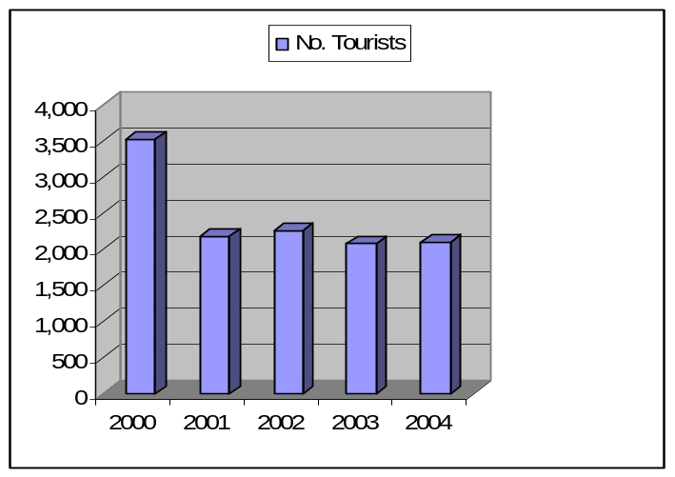

Major Industry
There is no single major industry in Kosrae. There are several small enterprises that are in the startup stage, which may in the future become important economic forces. There have been efforts by the state of Kosrae’s agricultural department to establish various agricultural product export markets in order to take advantage of Kosrae’s excellent agricultural environment. Tourism has the potential to become a significant contributor to the state’s export products but will need additional support to create awareness for Kosrae in the tourism industry. Banking, construction and the airline are the most noteworthy private sector contributors to the local economy, although none have a positive impact on the balance of trade. Airline and major foreign construction company the revenues do not stay on Kosrae.

Military
The U.S. Army Corps of Engineers thirteen member Civic Action Team (CAT) served Kosrae for many years. They built various public works projects including farm roads and a new hospital wing. Their medical detachment also offered medical clinics in the villages. The CAT teams were instrumental in the training of local Kosraeans in the professions of carpentry, plumbing, electrical, road building and many other technical construction related fields. The U.S. Army expressed concern that the CAT teams across the FSM were too costly to maintain by the U.S. military and a transfer of service to “Tiger” teams was negotiated. Under the CAT team arrangement, the Military had supplied and maintained all the heavy equipment required for various projects as well as a highly skilled permanent 13 person teams that rotated every 6 months. Kosrae State was responsible for supplying the materials for the various projects. Under the Tiger Team arrangement the state will contract with the U.S. Military to perform a specific project and will be responsible for a greater amount of the cost. It is presumed the service will be provided at less than a private construction firm bid.

All branches of the U.S. Military actively recruit on Kosrae. Many of Kosrae’s young people join the military with most serving in the U.S. Army Infantry.

Other Special Economic Elements
Agriculture and Aquaculture activities are the main special elements in the Kosraean economy. Several efforts are underway to develop different agriculture and aquaculture products for export. An encouraging area is that in the process of developing these industries many Kosraeans presently working for various government departments, particularly in Agriculture, Fisheries, Forestry and Historic Preservation have had a great deal of specialized training. There is an interest by some local residents to encourage the state, working with the College of Micronesia Kosrae campus, to create apprentice courses for using these local experts as instructors. The goal being to engage currently unemployed youth, helping them move toward productive employment.

Manufacturing, Craft, Trade
Handicrafts are made primarily for the tourist market. Although the quantity available for sale is not large enough to significantly affect the Kosrae economy, the existing sales have a profound effect on the individual family finances. There are a number of auto repair shops and one private computer repair service. There is a project underway to privatize the FSM Aquaculture clam hatchery on Kosrae, with the new venture focusing on exporting juvenile clams for the aquarium market. If the transportation problems are resolved the clams will become a valuable export commodity.

Agriculture
Agriculture is one of the three primary industries, along with tourism and fisheries, proposed as the focus for Kosrae’s future economic development. Several banana export schemes have been proposed for Kosrae, but for various reasons they have not been successful. A large number of crops are grown, or have been grown in the past on Kosrae. There is a great demand locally and on nearby islands for loose-leaf cabbage, cucumber, long beans, eggplant, other vegetable crops, citrus fruits, pineapple, melons and other fruits. As tourism grows the island restaurants will continue to demand a greater supply of fresh produce and if the transportation issues can be addressed, sales to the nearby islands (Pohnpei and the Marshalls) will make a small but significant contribution to the economy.

Kosrae is particularly noted for its excellent citrus fruit, especially tangerines, but Kosrae is currently suffering from citrus canker, which is threatening the entire citrus crop. There is work underway to contain the existing disease and also to bring in disease resistant strains of citrus.

Aquaculture, Fisheries
Generally the island fishermen provide the island residents and restaurants with an ample supply of various pelagic and reef fishes. Occasionally fish will be difficult to find and there is concern about overuse of the reef resource. As a result, various community members, led by the Kosrae Conservation and Safety Organization (KCSO) are developing plans to establish one or more marine protected areas.

No fishing fleet or major commercial fishing operation operates out of Kosrae at the present time. The export of fish at this time is limited to families shipping coolers of fish, crab and citrus to family members overseas.

There is a government mangrove crab hatchery project, which may develop a viable export product, Guam being the target market.

The FSM Aquaculture clam hatchery is in the midst of a privatization attempt, which if successful will also create a valuable export business in juvenile clams for the aquarium trade.

Waste Management Systems
Each Municipality on Kosrae has a designated garbage disposal, often on the edge of a mangrove swamp. The dumps are unsightly and most likely a heath and environmental hazard. In most cases the disposal sites are periodically flattened and covered with fill dirt.

There is an ongoing project to create a managed landfill in Tofol. However, there is an outstanding issue of how the waste will be transported to the land fill once the landfill site is completed. Lelu Municipality has had garbage pickup services for several years, but currently the other municipalities do not have the equipment or manpower for garbage collection. There is also the problem of separating green waste from solid waste as people are in the habit of treating green waste as just another form of solid waste.

For years it has been a common practice for families to create a “trash heap” on the edge of their property, which accumulated, and compacted overtime slowly creates additional land. Families will also leave trash on river banks and on the shore, to be washed away by the water.

There has been an aluminum can recycling project on Kosrae since the 1980s. Inactive for the past two years, it is currently being reactivated under a new department, the Kosrae Island Resource Management Agency.

ECONOMIC DEVELOPMENT PLANS AND PROJECTS

General Status of Economic Development Planning
The state of Kosrae has focused their economic development on projects that are related to providing services or products that are part of the economy of the region or utilizes the natural resources of the state of Kosrae. Projects have included the construction of a tuna processing plant, a ship repair service, a clam raising facility, a mangrove crab raising facility, sale of exotic tropical fish into the U.S. market, eco-tourism, sale of agricultural products such as bananas, citrus, taro, sakau, breadfruit and other products to other islands including Guam plus the building of a Kosrae Water Bottling facility. Some of the projects have not been successful, others are still in the developing stage and others are moving forward with some element of success. The tuna facility failed due to the downturn in tuna fishing in the waters around Kosrae and the world wide decline in tuna prices. The ship repair project is still operating but without a fishing fleet in the area the work is limited. The clam raising facility is operating although not as profitably as desired. The mangrove crab aquaculture is in the initial stages and appears to have an opportunity for limited success. The development of a special strain of bananas, one with high Vitamin A levels, is struggling but still on going. The raising and marketing of sakau (a cousin of the south Pacific Kava) is very successful in sales to other local islands. The capture and sale of exotic tropical fish is progressing well. The development of an eco-tourism industry has been slow but appears to be attracting additional visitors to Kosrae. The water bottling business is just beginning and the marketing process looks bright, but the upscale market that the product must succeed in is crowded and competition will be difficult.

Economic Development Approach and Special Issues
Most of the economic development approach has been led by government. A new approach is being attempted wherein the private sector is brought more fully into the process. A newly active Kosrae Chamber of Commerce is working directly with the business community to identify the critical issues and strategic solutions across the private sector. The Chamber of Commerce will then attempt to work directly with the state government to resolve issues and implement solutions that will encourage business growth and economic development.

Focus Areas
Kosrae State is continuing to focusing on tourism, agriculture products and various other potential export products that are available in Kosrae. The mangrove crab hatchery, the aquarium clam project and the bottle water projects are examples of this new focus.

Energy Considerations
There was little evidence that energy issues were taken into consideration with any of the economic development plans. Except for the ship repair business and the water bottling project, both of which are energy intensive due to the travel distances, most of the other projects are not particularly energy intensive. Most of the projects do involve either shipping the product elsewhere or bringing travelers to Kosrae, both of which are energy intensive, but are inherent with any economic development program on a remote island.

Economy Diversification
One of the major challenges is encouraging development of new and untried business ventures. One commonly successful model at the individual or family level is a retail store, gas station, or car rental business. Those wishing to go into business will then copy what appears to be a proven success. Unfortunately the marketplace becomes over saturated and many businesses fail, leading to discouragement and distrust amongst potential business people.

Import-Export and Balance of Payments
The public sector is the backbone of the Kosrae economy. The private sector is dependent mainly on public funding by selling goods and services to the government and to civil servants’ households. The funding of public sector activities is largely by the U.S. under the terms of the Compact of Free Association. The state government relies on external grants for roughly 90% of its total revenue. On the other hand, tax revenue represents only around 10% of its total revenue. Another major economic imbalance is in the area of external trade. The value of imports is approximately 200 times the value of exports, and the imbalance continues to grow. In order for a sustainable economy to develop on Kosrae this imbalance must be corrected. This can occur through import substitution, but it must also include export sales and services (such as tourism) to overseas markets.

Status of Energy Systems

Major Energy Uses
The major energy use in Kosrae is for the generation and delivery of electrical power. In 2005 approximately 610,000 gallons of diesel fuel were used by the Kosrae Utilities Authority to produce approximately 7,300,000 kWh of electricity. This represented an estimated 55% percent of the diesel fuel energy imported into Kosrae in 2005. There are no other high energy intense industries in Kosrae. The next largest user of energy is the telecom facilities for data transmission and air conditioning of their transmitter station and main switching office. The state government buildings also represent a major energy user in Kosrae, as all offices are air conditioned with window units of questionable efficiency.

Table 8-1 Fuel import into Kosrae, FSM In Gallons.
Fuel Type | 2000 | 2001 | 2002 | 2003 | 2004
Jet A | 337,552 | 405,075 | 360,461 | 145,902 | 217,143
Diesel | 926,035 | 1,331,440 | 916,976 | 628,435 | 504,049
Diesel-Elec | 602,388 | 596,570 | 604,411 | 611,114 | 609,096
Gasoline | 372,465 | 860,989 | 758,643 | 598,670 | 556,540
Data from FSM Statistics Fact book

Electric Power System
The Kosrae Utilities Authority, a public entity of the state of Kosrae, produces and distributes the electrical power to the residents of the state of Kosrae. The central power station is located in the government center village of Tofol on the east side of the island. The power is delivered to the customers over three 13,800 volt electrical distribution circuits. The electrical power station consists of five diesel engines ranging in size from 450 kW to 1,750 kW.

The Kosrae Utilities Authority (KUA) was created in 1993 by the state of Kosrae to provide utilities to the state of Kosrae. Presently KUA only provides electricity although it was chartered to also provide water services but the state Legislature has not granted final authority for KUA to provide water services at this time. KUA serves approximately 1,700 residential, commercial, industrial and governmental customers throughout the 42 square mile island. KUA is governed by a five member board. The Board is appointed to three year terms by the Governor. The Board is responsible for all aspects of the Kosrae Utilities Authority. KUA maintains a close working relationship with the state government and is required to present proposed rate changes to the state Legislature for their review, although their approval is not necessary for rates to be enacted. The KUA Board hires the general manager to oversee the planning, development, operation and finances of KUA.

KUA currently has 33 employees working in the Power Production, Distribution, Customer Service, Planning and Engineering and Administration Divisions. KUA has a peak load of 1.2 mW and annual sales of 6,132 mWh. The revenue for FY2005 was $1.39 million and operational expenses were $1.65 million with capital cost non-cash expenses (depreciation) of $0.47 million. KUA had a negative operating revenue for 2005 of approximately $190,000 and an income statement loss of approximately $660,000. The base electric rate is approximately $0.18 per kWh for residential customers and $0.20 per kWh for commercial and government customers. There is fuel cost of $0.08 included in the base rate. In addition to the base electric rate, there is a Fuel Adjustment Charge (FAC) added for the cost of diesel fuel, when the cost of fuel is above $0.08/kWh, which equates to a fuel cost of approximately $1.00 per gallon. The FAC increases by one cent per kWh for each 12.5 cents per gallon increase in the cost of diesel fuel above $1.00 per gallon. The cost of diesel fuel in 2005 was $2.15 per gallon therefore the FAC was approximately $0.092 per kWh resulting in a total cost of electricity to the residential customer of 27 cents per kWh.

Generation Facilities
KUA’s power production facility at Tofol consists of five (5) generators with combined capacity of 4,580 kW plus they have a 650 kW portable emergency generator. KUA has a substation with two 2,500 kW transformers to step up the voltage from 4,160 volts at the generators to provide power to the 13.8 kV distribution power lines. The three distribution circuits that extend in a radial manner from the power plant in Tofol distribute the electricity to the 1,700 customers of Kosrae. The circuit serving the municipality of Lelu is approximately four (4) miles long; the circuit serving the municipality of Tafansac, the airport and Okat Harbor is approximately 9 miles long and the circuit serving the municipalities of Malem/Utwe is 15 miles long. The circuit to Tafansak was rebuilt in 2001/2002 and the rebuilding of the circuit to Malem/Utwe was just being completed as this report was finalized. The circuit to Lelu had been rebuilt in 2002/2003 and the 40 year old deteriorated overhead circuit is being considered for replacement by FY2007 or FY2008, preferably by an underground circuit.

Table 8-2
KUA POWER STATION: GENERATION CAPACITY
Unit | Manufacturer | Model | Year | Year | Rated | Operating | Current
 |  |  | Built | Installed | Capacity | Capacity | Status
2 | Caterpillar | D398 |  | 1980 | 550 | 450 | Operating
3 | Caterpillar | D398 |  | 1982 | 550 | 450 | Operating
4 | Caterpillar | D398 |  | 1986 | 550 | 450 | Inoperable
5 | Caterpillar | D398 |  | 1988 | 550 | 450 | Operating
6 | Caterpillar | 3606 | 1992 | 1993 | 1600 | 1600 | Operating
7 | Caterpillar | 3606 | 1996 | 1997 | 1750 | 1750 | Operating
8 | Caterpillar | 3512D | 2006 | 2006 | 1080 | 1080 | UnderConst

Generator Unit No. 7

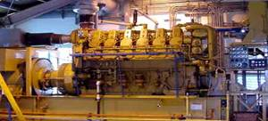
Fuels
The Kosrae Utilities Authority utilizes No. 2 diesel for generating electrical power. The fuel is stored in five tanks with a total storage volume of 63,000 gallons. KUA uses approximately 610,000 gallons of fuel per year.

The fuel supplier is the Micronesian Petroleum Corporation, a Kosrae state governmental authority similar in legal structure as the Kosrae Utilities Authority, except with the responsibility to provide the fuel for the island of Kosrae.

The cost of fuel for power production has increased substantially in the 24 months prior to the date of this report. The average cost of fuel for the power plant is $2.85 per gallon. With a diesel engine/generator fuel efficiency rate of 13.25 kWh generated per each gallon of fuel used, the cost of power at the power production is 21.5 cents per kWh. However, upon taking into consideration the electrical energy used for station service at the KUA power plant, presently approximately 4%, the cost of power to the distribution lines is 22.4 cents per kWh. KUA has losses of approximately 9% in the distribution system; therefore the fuel use per kWh delivered to the customer’s meter is approximately 11.7 kWh per gallon. This relates to a fuel cost at the customer’s meter of 24.32 cents per kWh when fuel costs are $2.85 per gallon.

Electric Production and Use

Existing Renewable & Alternative Power Production
There are presently no operating renewable energy systems in Kosrae. In 2001 the Utwe Marine Park received a $22,000 grant from the Seacology Foundation of California for a solar photovoltaic power system. The Kosrae Utilities Authority personnel assisted the Utwe Marine Park and a 2,000 watt photovoltaic unit was installed. The unit operated for approximately one year until a 15 foot tidal inundated the battery and electronic control house after which the unit was inoperative.

Existing Conservation and Demand Side Programs
The Kosrae Utilities Authority includes a public relations and energy audit program. However, due to the minimal level of staffing because of staff reductions to reduce the cost of the electric rates, only minimal work is able to be performed in the energy conservation and audit program. The KUA also distributes, at cost, 17 watt compact florescent lights that customers use to replace higher wattage incandescent lights.

KUA has installed Cash Power meters on approximately 70% of their residential customer’s services and also several government and larger commercial customers. These meters allow people to observe the use of electricity via the electronic readout and keypad device mounted inside the home. KUA officials credit the cash power meters for at least a 5% reduction in consumption on the homes where the units have been installed.

Regulatory, Environmental Issues
The state of Kosrae has adopted environmental regulations along similar issues as the U.S. Environmental Protection Agency. The regulations are enforced by the Development Review Commission, a special commission established by the state Legislature to assist in planning and to assure an orderly and environmentally appropriate development in Kosrae. The KUA operates within and is in compliance with the regulations of the state’s environmental laws. The KUA has removed all transformers that had traces of PCB’s and have arranged for those transformers to be properly disposed.

The KUA is required to submit any new rate tariff to the state Legislature for “consultation” but the Legislature does not have jurisdiction over setting of the tariffs. As a practical matter, the KUA Board and management work closely with the state Legislature in tariff matters such that there is an understanding and justification of the tariff.

Transportation

Fuel Use
There is no accurate information on transportation fuel use available other than the gasoline and diesel fuel used in vehicles as listed above in Section 1.6.1.

Fuel Types and Costs
Fuel for transportation is gasoline and diesel fuel. At the time of this report being prepared cost of gasoline was $4.00 per gallon and cost of diesel fuel was $4.00 per gallon.

Reducing Transportation Energy Use
Kosrae has a reasonably fuel efficient transportation system with their individual private vehicles and an established speed limit of either 25 or 30 mph. Private vehicles often are pickup trucks or small flat bed trucks and large groups of people often ride together in these vehicles. Also, with a small island where everyone knows everyone else, as a person begins to walk toward a destination they are often given a ride by an acquaintance, resulting in more efficiently utilizing the private vehicles being used for transportation. A reasonably good taxi service is available for those residents who do not have a private vehicle. The residents of Kosrae are relatively concentrated in fairly densely populated areas with short travel distances to work and shops.

The only possible energy saving transportation system that was suggested in Kosrae might be a three or four bus operation system that could travel from one end of the island to the other, a distance by road of approximately 30 miles. On one end of the island is the airport and the largest municipality of Tafansak, and a third of the way around the road is the next largest municipality of Lelu along with the government and business complex of Tofol, then on to the less populated southern end of the island with the municipalities of Malem and Utwe. A bus system could assist many from the more remote areas who do not have an automobile to have better access to the job market in Tofol and more populated areas and save the fuel of multiple vehicles traveling the same route.

Commercial & Industrial

Tourism
The tourism industry is not an industry where programs to reduce the use of fossil fuels is easily identified. Tourism to Kosrae is very fossil fuel energy-intensive by the nature of the location of the Kosrae. However, the airlines already practice minimizing the use of fossil fuel as in their efforts to maximize profits in their respective operations

Manufacturing
There is no energy intensive manufacturing in Kosrae where programs designed to reduce the use of fossil fuels would be effective.

Military
There is no military operating in Kosrae.

Fisheries
There are no fishing fleets operating out of Kosrae harbors. Local fishing is done by resident fishermen utilizing small 18 foot fiberglass boats and 40 hp Yamaha engines that are relatively efficient. These boats are used for fishing in the ocean beyond the reef. The women use handmade dugout canoes and hand oars to ply the reef waters for fishing for reef fish and also to weave through the mangrove swamps in search of the mangrove crabs.

Alternative Energy Opportunities

Cogeneration
In 2005 KUA submitted a grant request to the U.S. Rural Utility Service, under their High Energy Grant Project which proposed a project is to install a waste heat recovery system on the diesel engines (jacket cooling water, oil cooling system & exhaust); convert the waste heat to chilled water (using adsorption chillers and/or absorption chillers) and provide the chilled water to the nearby government complex facilities for air conditioning purposes. The recovery of this waste heat was calculated to provide approximately 150 tons per hour of 40 degree chilled water. The chilled water was proposed to be piped to the hospital, junior college, high school, governor’s administrative offices, state legislature building, supreme court building, public works offices, post office, telecommunications building, RUS building, and other governmental facilities. The chilled water would be used to replace the present inefficient window air conditioners. The project required the replacement of the existing window air conditioning units with central air conditions or zone air conditioning units with a chilled water heat exchanger providing the cooling function. It was anticipated that 25 facilities would be able to be converted to utilizing the waste heat produced chilled water system. Electrical energy savings were estimated to be 450,000 kWh per year. The grant funds requested was $715,000. The total cost of the project is calculated to be $765,000 with KUA providing $50,000.

Kosrae also has an opportunity to reactivate an old central chilled storage facility located next to its power plant. Presently each grocery store around the island has its own refrigerated twenty foot shipping container for storing perishables. Since it is often six weeks or more between ship arrivals, a large volume of product must be stored and refrigerated. The refrigerated containers are very energy inefficient; KUA has explored reactivating the central refrigerated system. A central system could employ much more efficient equipment and provide savings for the customers and save fossil fuels.

Alternative Fuel Systems
The present use of No. 2 diesel fuel is the only reasonable fuel to use on a small island such as Kosrae. The technology, vendors supplying the prime mover engines, spare parts and service as well as the technological knowledge base of the skilled personnel available in the Kosrae is all based on diesel engines. Heavy fuel oil such as No. 6 is not a viable option due to the cost of shipping the fuel on specially outfitted tankers and the storage and care for the fuel on site. Other types of fuel such as coal, petroleum coke and other more difficult fuels to utilize, require energy conversion systems that are more expensive and more complicated than can economically be utilized on an island where the electric loads are very small.

Supply Side Efficiencies
In developed country utilities, the average power systems losses for a utility with only a generation and a distribution network are estimated at approximately 10%. Nominally, these losses are accounted for in generation, 5%; and distribution, 5%, with non-technical losses less than 1%.
In a preliminary study conducted in 2000, the overall power system losses for the Kosrae Utility Authority (KUA), were estimated to be 14.2% of the total energy generated. This included generation, distribution and non-technical losses. It should be noted that some data is lacking such as the number of transformers or the types of conductor used. As a consequence several approximations were used to evaluate the losses. The error on this figure is difficult to quantify and therefore the results should be carefully used, although it does represent system losses that are far in excess of what is acceptable.
To reduce the import of fuel, it is imperative to reduce these system losses.
It is recommended that a detailed quantified system loss study be conducted for KUA, as a stage 1 project. This project would measure and collect the electrical data characteristics of the power system, and then determine the losses. Once these losses have been quantified, then stage 2 of this process would be to assess the need for updating existing energy inefficient equipment (examining financing mechanisms as appropriate); establishing government legislation that makes electricity theft a crime; and review the maintenance practices in the power plants.

Demand Side Efficiencies
The high cost of energy, the lack of industry and the leisurely pace of the economy have combined to make Kosrae a relatively efficient user of energy, particularly when compared to the US, Australia and Europe. Electrical energy efficiency improvements are generally limited to improved maintenance of the existing stock of air-conditioners, refrigerators and freezers and the exchange of older, less efficient equipment for higher efficiency units, e.g. replacing them with high EER air-conditioners, higher efficiency motors on pumps and CFLs to replace incandescent lamps.

Electrical Metering/Tariffs
Effectively all electricity is metered. The KUA has around 70% of its metering on a prepayment basis and the goal is to convert all meters to prepayment types. Some utilities have seen a small load reduction (less than 5%) after installing prepayment meters but the reduction is not enough to class prepayment meters as a reliable and effective means of load reduction.

The tariff structure in Kosrae provides a lower rate for the first 100 kWh and thereafter is effectively flat. government, commercial and industrial users are charged slightly higher but effectively flat rates. Energy efficiency can be improved through tiered tariffs with basic services available at the lowest rate, but with substantial tariff increases for the higher use that results from electricity being used for high demand luxury services such as air-conditioning, cooking and water heating. Unfortunately, the prepayment type metering system used in Kosrae does not directly provide for tiered tariffs since its operation is based on allowing a preset number of kWh to pass through to the load and does not consider the rate at which those kWh are being delivered.

Household Energy Efficiency Measures
The 2000 census found 15% of households cooking with electricity with most of the rest of the households using kerosene. Most of FSM is seeing a gradual conversion of both kerosene and electric cooking to LPG, a generally more fuel efficient and convenient cooking fuel. Presently LPG appears to be little used on Kosrae. A small program to encourage the replacement of electric cook stoves by LPG units with the gas supplied by KUA could help reduce peak evening loads and improve national fuel efficiency and still retain equivalent revenue for KUA.
Table 8-3 – Kosrae Household Energy Use
Energy Application | Number | % of HH
Refrigerator | 314 | 28.9%
Central air conditioning | 7 | 0.6%
1-room air conditioning | 42 | 3.9%
2 or more room a/c | 9 | 0.8%
TV&VCR | 511 | 47.0%
TV Only | 129 | 11.9%
Electric stove | 166 | 15.3%
Electric water heater | 35 | 3.2%
Solar water heater | 2 | 0.2%
Gas water heater | 0 | 0%
Gas stove | 3 | 0.3%
Kerosene | 784 | 72.0%
Open fire cooking | 70 | 6.4%
Wood stove cooking | 27 | 2.4%

Most houses do not have piped hot water and as is the case with other FSM states, the demand for domestic hot water is relatively small.

Household lighting is mostly by iron ballast type fluorescent lights and incandescent lights. A program to replace those with high efficiency units could be expected to cost effectively reduce the lighting load by nearly half. Since lighting is a substantial component of the evening peak load, such reduction could provide direct benefit to KUA as well as reducing fuel import requirements.

Domestic air-conditioning use is low; less than 10% of households had any form of air-conditioner installed in 2000. High energy costs and a sluggish economy make it unlikely that domestic air-conditioning will soon be a major energy use. Households with air-conditioners should be informed of the need to clean filters and condensers and to consider higher efficiency units when old ones need replacing, but a formal program relating to domestic air-conditioning efficiency improvement is not likely to be cost effective.

Government and Commercial Sector
In general, government buildings are not major energy users in Kosrae. “Window” type air-conditioners are common and are not high efficiency types, so replacement of those by more efficient split systems or “window” units with a high EER could provide some energy efficiency improvement. Lighting in all government facilities should be converted to either electronic ballast high efficiency tube type fluorescents or, where incandescent lamps are used, by CFLs. As many offices have relatively good natural lighting from windows, overhead lighting could be turned off during the daytime and task lighting provided where needed.

An Australian aid program provided solar water heating to the small hospital on Kosrae. No survey information was available that provides information on government or commercial water heating loads, but where significant water heating is carried out (e.g. school sports facilities, laundries, visitor accommodations) solar water heating should be considered and if cost effective, installed.

The primary energy requirement for the commercial sector is for the operation of refrigerators, freezers and air-conditioners. Some improvement in the operating efficiency of the existing equipment can be obtained through cleaning, proper refrigerant loading and other maintenance measures. PWD or KUA could assist in the development of maintenance processes and procedures fitted to the needs of commercial users and offer contract services for the maintenance of refrigeration equipment. Energy audits also could be provided by PWD or KUA to businesses with high energy use, although to be effective, the audits also need to include an implementation plan, sources of equipment and cost/savings estimates. External training will be needed to provide these services.

Transportation Sector
As a single island state, sea transport is not a major energy use. Fishing using small boats fitted with a 20 to 40 hp outboard engine is a common activity but there are few opportunities for improving their efficiency of use through technical interventions. The rising cost of fuel is the most effective motivator for reducing energy waste in that sector.

Land transport is primarily by private automobile. There is no organized public transport. Shifting private vehicles to diesel engines provides the greatest opportunity to reduce fuel use through increased efficiency. Incentives to choose diesel powered vehicles over those with gasoline engines are possible and include differential taxation of fuel to raise the cost of gasoline in relation to diesel fuel and use of the added tax revenues on fuel to offset reducing the import tax on diesel powered vehicles to reduce the cost differential between imported diesel powered and gasoline powered vehicles.

Although import taxes could be adjusted to penalize the importers of low fuel efficiency vehicles – in the late 70s and early 80s Fiji imposed a high import duty on vehicles with engines larger than 2000 cc that appeared to be effective in keeping the average fuel efficiency for land transport high – it would be unlikely to have popular support and in any case would be a decision that would have to be made at the national level. As with outboard engine use, fuel price rises can be effective in increasing the average fuel efficiency for Kosrae vehicles.

Building Energy and Efficiency Standards
The benign climate, high energy prices and the low demand for household air-conditioning and water heating make the average energy use per square foot of Kosrae buildings far less than that of the U.S. or Europe. The value of building codes to further reduce the average per square foot energy use of buildings is therefore correspondingly lower.

The capacity in Kosrae for the development and enforcement of building energy efficiency standards is small and their development would have to rely on external experts. Since the amount of new construction each year is not large, it is questionable whether the national benefit from such codes would be cost effective relative to other measures to improve energy efficiency in Kosrae. It has proven difficult to enforce basic building codes that relate to important safety issues, and properly enforcing what is typically viewed as a type of non-essential construction code would be even more difficult. Since air-conditioning is the primary load that would be affected by energy efficiency standards for buildings in Kosrae, it is recommended that KUA work with the Public Works Department, the organization constructing most larger buildings on Kosrae, to establish construction guidelines for building construction and renovation. These recommendations should include basic energy efficiency measures such as thermally isolating the roof and exterior walls from the air-conditioned space, minimizing heat entry through windows and reducing infiltration into the air-conditioned space. For government buildings, the guidelines should be a requirement; for non-government construction they would be voluntary but encouraged. Those guidelines could then be provided to the private builders on the island along with information as to how their implementation can benefit the building owner in reducing energy cost.

Appliance Energy Efficiency Standards
The Kosrae market is too small to consider any form of labeling or appliance efficiency standards specifically for Kosrae. Many appliances that are sold in Kosrae include energy labels, but the information regarding the cost of use of the appliance is based on an assumed electricity cost that is around half that of Kosrae. This makes the actual operating cost differential between appliances of different efficiency double that seen on the labels, and prospective buyers are more likely to choose the more efficient appliance if made aware of the greater operating cost difference. It is recommended that a system for helping consumers understand appliance labels in the Kosrae context be developed. Possible approaches include actually changing the labels to fit Kosrae conditions, posters near the labeled appliances explaining the labels, explanatory stickers placed on the appliances with the labels, and periodic information brochures handed out to KUA customers when bills are paid.

Energy Audits, Performance Contracts
The market on Kosrae is too small to support an ESCO or to justify the cost for an overseas ESCO to keep an office on Kosrae. As there is no industry on Kosrae that would require specialist auditors from overseas, training could be provided to KUA or PWD staff to carry out basic energy audits aimed at improving the efficiency of lighting, pumping, air conditioning, refrigeration and freezers. The audits could raise the awareness of users of that equipment regarding the cost benefits of improving their efficiency of use and in some cases could result in investment in increasing energy efficiency.

RENEWABLE ENERGY OPPORTUNITIES

Solar
No good quality insolation data could be made available for sites on Kosrae. NASA satellite data for the oceanic area that includes Kosrae is provided in Table 8-4 but actual levels on Kosrae itself may vary considerably from these values due to local island climate generated by wind and thermal conditions relating to the mountain mass of the island. Due to local clouds generated by the mountains causing moist air to rise to cooler elevations, insolation varies from place to place on Kosrae and designs for solar energy must be specific for the location. The extent of this variability is not known but its existence needs to be considered.
Table 8-4– Estimated Solar resource for Kosrae
Month | Jan | Feb | Mar | Apr | May | Jun | Jul | Aug | Sep | Oct | Nov | Dec | Avg.
Horizontal | 4.72 | 5.34 | 5.34 | 5.41 | 5.01 | 4.94 | 5.16 | 5.53 | 5.42 | 5.43 | 4.82 | 4.87 | 5.16
Tilted | 5.14 | 5.56 | 5.37 | 5.43 | 5.11 | 5.10 | 5.30 | 5.58 | 5.42 | 5.58 | 5.17 | 5.42 | 5.35
Source - NASA Surface Meteorology and Solar Energy Lat 5ºN Long 163ºE

Solar Thermal for Electric Generation
The relatively high frequency of partly cloudy and overcast conditions prevents concentrating type solar devices from working well in Kosrae. The mechanical complexity associated with tracking devices and the difficulty of maintenance of the highly reflective surfaces and mechanical systems in a marine environment also work against the cost effective use of solar thermal systems for power generation. For electric generation from solar, only photovoltaics is recommended for Kosrae

Solar Thermal for Water Heating
There are few solar water heating installations in Kosrae and there are no stocking dealers on the island. The domestic demand for water heating is not great and the number of homes with electric water heaters is small with the 2000 statistics showing only 3.4% of houses having piped hot and cold water. While those few houses having electric water heaters should be made aware of the possibility for water heating through solar energy, it is not clear that it would actually be cost effective at current electricity rates since the cost of solar water heating is high because of the individual nature of system purchase and installation.

The KUA could consider working with its electric water heating customers and arranging for a bulk purchase of solar water heaters and finance the installations through monthly payments on the KUA bill.

Solar Photovoltaics

Past programs
A small number of demonstration projects were installed in the 1980s but none have survived. The only significant solar PV project was the installation of about 2kWp of solar panels, a large sealed cell battery bank and a Trace inverter at the Utwe-Walung Marine Park in 2001. The installation was funded by a $21,000 grant from the Seacology Foundation in California. Reportedly, the system worked satisfactorily until 2002, when a typhoon-related sea surge swamped the lower part of the open building containing the batteries and the electronics. Had the equipment been immediately washed with fresh water, it most probably could have been salvaged. The ruined control system left the batteries without charging for months, causing them to sulfate and not able to accept a charge. A French team visited the site in 2004 and promised that if an enclosure was constructed that would prevent a reoccurrence of the storm damage, replacement electronics and batteries would be provided. A proper enclosure was constructed at the park but no rehabilitation funds have been provided. The park currently uses and inefficient and costly gasoline fueled generator as its power source.

Plans and recommendations
There are no firm plans for installing solar PV in Kosrae. The EU EDF9 funds for FSM include a component for Kosrae but they have yet to be allocated to specific projects. A proposal to electrify a small village – the only village on Kosrae without a grid connection – has been forwarded for EU consideration, but plans have apparently been made to electrify the village from the grid in the not too distant future, causing EU project management to raise concerns about the cost effectiveness of using solar PV in the village.

Recommendations for solar PV use in Kosrae are limited to rehabilitation of the system at the Utre-Walung Marine Park, a small project that probably could be funded through the community development small grant program of Japan or possibly by UNDP small energy project funds. For larger scale PV use, grid connected arrays are the most likely to provide significant fuel reduction benefits, but they will not be cost effective until panel prices are substantially reduced or fuel costs continue to rise.

Wind Energy
The wind energy resource on Kosrae is not known. Meteorological measurements indicate a poor resource and the low latitude location also implies a poor wind regime for economic energy production. Table 8-5 shows the average wind speed at 50 meters as estimated from satellite measurements for the oceanic area that includes Kosrae. The wind is clearly quite seasonal and energy levels mostly too low to be interesting for grid connected wind turbines.

However, the mountainous nature of the island may create conditions at some sites where wind energy may be sufficient for economic power generation, but there are constraints to their construction. The small size of the Kosrae utility will not support large scale wind farms and long transmission lines to connect the turbines to the grid cannot be justified, nor can expensive access roads be built to remote sites. These factors limit the possible installation sites to the area around the coast where the power lines are presently located. While investing in a wind energy map and resource assessment makes sense for the future, at present it appears unlikely that wind energy will be a cost effective supplement to the Kosrae grid.

Table 8-5– Average Wind Speed at 50m (m/s)
Month | Jan | Feb | Mar | Apr | May | Jun | Jul | Aug | Sep | Oct | Nov | Dec | Annual Avg
10 yr. Average | 6.42 | 6.16 | 6.03 | 5.37 | 4.86 | 4.22 | 3.46 | 3.40 | 3.59 | 3.38 | 4.36 | 5.39 | 4.71
Source – NASA Surface Meteorology and Solar Energy Lat 5ºN Long 163ºE

Hydro Power
Rainfall is high on Kosrae due to the uplift of moist air by the mountains in the interior of the island. However, the catchments are small in area and the runoff rapid, so streams have very high flow variability and rapid changes in stream flow.

A micro-hydro system of 35 kW was designed and constructed by the U.S. Army Corps of Engineers on the Malem River in the late 1980s but never operated due to land tenure issues.

The concept was reintroduced in the late 1990s and included an induction motor connected by a belt drive to a Pelton turbine. When connected to the grid, the induction motor would drive the turbine until the water gate was opened, and as hydro flow increased, the induction motor would begin to be driven by the turbine and produce power into the grid. The water source was the City of Malem’s drinking water reservoir, representing an estimated one to two acre-feet of volume on the Malem river. The river flow is not known. The penstock was a metal pipe extending down from the reservoir approximately 1,000 feet with an estimated head of 100 feet. Kosrae Public Works could not get the controls operating satisfactorily after the initial installation but in 2000, KUA personnel were able to get the plant operational. At that time KUA estimated that the hydroelectric unit could expect to produce approximately 30kW on a continuous basis and displace the use of approximately 800 to 1000 gallons of diesel fuel per month. However, concerns developed within the City of Malem government about the effect of the hydroelectric plant on the reliability of the city’s drinking water supply. There was also a problem between the City of Malem and the state of Kosrae, that had originally financed the installation, about monetary benefits from the operation of the hydro. KUA therefore ceased operating the plant pending resolution of the concerns. In the absence of a resolution, PWD sold the generator and turbine to the University of Guam in 2003. No other developable hydro resources are known to be present on Kosrae.

Biogas
Although a few farms with penned animals are present on Kosrae, attempts to interest farmers in investing in digesters to produce biogas from animal waste in FSM (and the rest of the Pacific) has not resulted in the installation of digesters. Though the size of the piggeries and poultry compounds is large enough to produce useable gas from the waste, the investment needed in both money and labor apparently exceeds the perceived value of the small amount of gas that would be produced.

An FSM wide survey of animal and poultry producers by EPA is recommended to determine if the market is large enough for cost effective installation of commercial digesters in each state for the purpose of environmentally sound animal waste disposal. If so the EPA should work with the farmers to prepare a joint purchase arrangement for all FSM that can reduce the cost for an overseas supplier of the equipment to ship and install needed digesters in each state.

The Lelu municipality and the Tofol government area both have small sewer systems. The Lelu sewage is dumped into the sea beyond the reef without treatment. The Tofol system has a lagoon type of treatment facility. When plans are made for upgrading either facility, consideration should be given for the inclusion of a biogas production facility to provide power.

The four municipalities on Kosrae each maintains a city dump. There is no organized collection of waste, nor is there a well organized management of the waste in the dumps. The present style of solid waste disposal does not lend itself to gas collection. Should the system be changed to a process that could include biogas collection, the necessary components for that collection should be included during the landfill construction.

Biomass combustion and gasification
The present use of biomass for energy is for cooking. The economics of use of biomass for power generation through combustion or gasification in most of the Pacific is limited to agricultural or forest product processing facilities where large amounts of biomass is generated as waste. Kosrae has no significant industry that generates biomass waste in a quantity that is reasonable for power generation. Should coconut oil production be resumed on a significant scale, the coconut waste and the senile trees that are removed could be used for power generation in either a combustion-steam cycle or gasification process. For the foreseeable future no opportunity for other than traditional cooking use of biomass for energy appears practical.

Biofuels
There is no commercial copra production on Kosrae and coconut plantings include a high senile tree content. There was an active although declining copra industry in Kosrae until the mid 1970s. There was also an effort via a Kosrae Copra Development Authority, created in the 1980s, to revive the industry, but the low prices of copra and the rising cost of labor did not allow success. There are remnants of copra farms around Kosrae but most of the coconut trees are senile and unproductive and no effort has been made to plant new trees except as needed by individuals around their homes for personal use in cooking and for pig and poultry feed. While in theory coconut oil to replace diesel fuel on a commercial scale could be possible if plantations were rehabilitated, the price that can be paid for the coconut oil to replace diesel fuel will need to be much higher than is presently practical to make the investment and the operating labor requirements practical. Also, the land area that is not too steep to be suitable for commercial coconut production is limited, and fuel plantations would be competing with agriculture and housing development for land, further raising the cost of large scale biofuel production.

Ocean Thermal
No bathythermic data could be obtained for Kosrae, but even if conditions are favorable for ocean thermal development, the energy requirements of Kosrae are too small to make either OTEC or deep water collection for cooling cost effective.

Geothermal
There are no surface manifestations of geothermal energy, such as hot springs, and no developable geothermal resource is known to be present on Kosrae

Tidal
Low head propeller type hydro power generators inserted in reef passages possibly could intercept enough of the exchange between the shore and the reef during tidal flow to provide some power generation. The power would be intermittent, changing output with the tidal cycle, and costly undersea cable would be necessary to get the power to shore. Installations could not be in navigational passages. Maintenance would be difficult and would require specialized equipment and training. The complexity and cost is unlikely to provide a favorable benefit/cost ratio for the Kosrae conditions and tidal power development is not recommended for Kosrae

Wave
There have been no wave resource measurements on Kosrae and no action should be considered before wave power equipment suitable for the Kosrae conditions becomes commercially available and is well tested elsewhere.


Federated States of Micronesia - Chuuk

General

Location, Population and Geography
Chuuk is located in the center of the Caroline Islands, at 151º22’ to 150º04’ East Longitude and 7º7’ to 7º41’ North Latitude. Chuuk is approximately 610 miles southeast of Guam and 424 miles west of the FSM capitol island of Pohnpei.
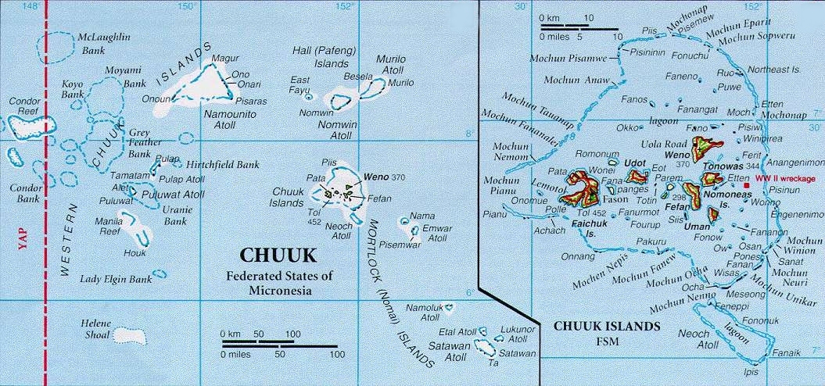
Chuuk is the most populous of the FSM states, with a population of 53,826 (2005 census estimate). The population of Chuuk State increased from 31,596 in 1973 to 53,319 in 1994 and to 53,595 persons in 2000. Between 1994 and 2000, the population grew by only about 0.1 percent per year. This is much lower than the growth rates of over 3% in the 70s and early 80s as well as the rate of 2.3% between the previous two census years (1989 and 1994). In the last census period (2000), the population of Weno decreased from 16,121 to 14,722, a decrease of close to 9%. Similarly, the population of Fono, the small island adjacent to Weno, decreased from 482 to 397, a decrease of around 18%. A few other islands showed significant decrease while the remainder increased, some dramatically. All of the islands showing a decrease in population are located near Weno. This population decrease is the result of emigration, primarily to Guam, Hawaii, and other parts of the US. Among the reasons for this “exodus” is the limited opportunity for employment in Chuuk

This decreasing population and the fact that it is a new phenomenon have serious implications for long range planning for the state. Chuuk is now planning for infrastructure development projects that will be funded under the new Compact of Free Association between the FSM and the US. Everything from the size of school buildings to the capacity of a wastewater treatment plant depends on population predictions. Given that population trends are now changing radically, such predictions may be difficult to make.

Weno continues to be the most populated island in the state, having 25.8% of the state’s population. This is down from 30.2% in 1994. The most populated island after Weno is Tol, in the Faichuk area of Chuuk Lagoon, with 9.6% of the state’s population. This is a slight increase from 9.0% in 1994.

Island Geography
Chuuk consists of over 290 islands which are geographically dispersed throughout five sub-regional areas known as the Chuuk Lagoon (Northern and Southern Namoneas and Faichuk) which is centrally located in the state, the Mortlocks (Upper, Middle, and Lower) to the south, the Halls to the north, Pattiw to the west, and Namonweito in the northwest. Less than 20% of these islands are inhabited. Weno, the main island of the state, is located in the Northern Namoneas area of Chuuk Lagoon. Nineteen volcanic islands are situated inside the 822 square-mile lagoon, which is surrounded by a 125-mile long barrier reef. Varying from 30 to 49 miles in diameter, Chuuk Lagoon contains over 75% of the land area in the state (approximately 38.6 square miles).

All the islands outside Chuuk Lagoon are coralline and all but one are low islands lying on the barrier reefs of atolls. The total land area of the state is 49.2 square miles scattered over an ocean area 300 miles wide and 600 miles long.

Island Geology
Chuuk consists of the higher volcanic islands inside Chuuk Lagoon and the lower, smaller coral atolls and islands outside the Lagoon.

The Chuuk Islands are geologically considered as the oceanic province. In this province limestone formations occur only near sea level. The high islands in the Chuuk Lagoon are constructed mainly of extrusive volcanic rocks, the most common being basalts and basaltic andesites. The original volcanic rocks are massive layers of 20 to 60 feet thick which occasionally incorporate rubble sections. These rocks are virtually impermeable.

The weathering of the primary volcanic rocks has resulted in the formation of a weathered zone of saprolite, which in some areas, extends to depths of up to 100 feet. The combined effects of erosion and the subsequent deposition of eroded material have produced formations of talus at the base of bedrock slopes, along with alluvial valleys. Some sections of the island perimeter consist of narrow coastal plains in which marine sediments predominate in the coastal zone and talus/alluvium at the base of mountain slopes and in valleys.

Atolls outside Chuuk Lagoon are typically circular reefs of organic limestone that are partly, intermittently, or completely covered by water. These reefs enclose lagoons of varying sizes. The lagoon in Namonweito Atoll, which is the largest in Chuuk, is roughly 50 miles across at its widest point. The bases of the reefs and lagoons rest on volcanic mountains which are usually submerged several thousand feet below sea level. On top of these basalt rock platforms are enormous quantities of limestone deposited by organisms, including corals, shells, worms, other small invertebrates, and coralline algae. These plants and animals take calcium carbonate from seawater to build their shells or internal skeletons. When they die, some are buried in place by new growths or sediment deposits while others have their hard parts broken by wave action and boring organisms. The dead animals are then transported by water movement to be deposited in the lagoon, on the outer slopes, or in the formation of islands.

Climate and Environmental Hazards
The state of Chuuk is characterized by a wet, warm, and humid climate which is similar to most islands in the North Pacific that are relatively close to the equator. Weather variations between islands are more evident in wind and rainfall characteristics. Temperature and relative humidity levels remain consistent throughout the year. Tropical disturbances, even though highly unpredictable, are generally quite seasonal in nature. Ambient air temperatures typically range from a daily low of 75 degrees Fahrenheit to an average high of 87 degrees Fahrenheit.

Daily levels of humidity range from 78 percent during daylight hours to approximately 85 to 87 percent during the night and early morning hours. The northern atolls receive about 80 inches of rainfall a year while the annual rainfall in Southern atolls is normally higher, about 160 inches. Monthly rainfall ranges from 6 to almost 16 inches. The least amount of monthly rainfall (6 to 9 inches) occurs during the months of January through March as stronger northeasterly trade winds approach the state of Chuuk. The average rainfall for Weno Island over the past few years has been in the range of 146 inches per year.

Winds are gentle from the east-northeast normally averaging 6 to 11 mph. Northeasterly trade winds occur during the months of November through April, with higher winds prevalent from January through March. Lower winds from the south, southeast, and southwest are predominant during the months of June through October. There are pronounced rainy to dry seasons caused by changes in the wind system.

Chuuk lies on the eastern and southern edge of the Pacific typhoon area. Typhoons and lesser storms periodically strike the islands causing heavy damage. Tropical storms generally occur between the months of July and November. The occurrence of typhoons in the immediate vicinity of Chuuk is uncommon. However, occasionally, severe typhoons with winds in excess of 100 mph strike portions of Chuuk and cause severe damage to homes, buildings, and agricultural crops.

Energy Sources
Chuuk, as is true of all the FSM states, is substantially dependent on imported fossil fuels. The major fossil fuel is No. 2 diesel oil which is used, mostly for electric generation, larger marine engines and fishing fleets, and construction equipment engines plus gasoline for vehicle and small boat transportation systems. Mobil Oil is the provider of fuel to Chuuk. However, there are efforts underway to join with other islands to form a purchasing consortium in an effort to introduce a greater degree of competition in the fuel market.

There is high interest in solar photovoltaic power and, over the past 20 years or so, more than 200 small solar power systems have been installed in schools, medical dispensaries, small businesses and homes in the outer islands. However, many are not in use today due to lack of local maintenance. There is wide interest in using solar power on a larger scale as the future means of providing power to the outer islands of the state. There is a use of renewable fuel which includes the widespread burning of wood and coconut wastes for cooking.

Energy Uses
Electrical energy generation is the major use of diesel fuel in Chuuk. The main island of Weno is the only island that has a major central electrical power station, which at present is only partially operational. This situation has resulted in only half of the island being served in daily rotating four hour shifts. Approximately 25 businesses, the hospital, resort hotels, and some government offices have installed generators that are operated almost continuously during the daytime due to the unreliable nature of Chuuk’s central power station. The backup generators are also used during nighttime outages. It is estimated that 40% of the daytime load is furnished by the system of small individually owned electric generators. The efficiency of the system of smaller generators is much less than large generators of a properly operated central power station. Therefore, the present poor operating condition of the Chuuk central power station is causing Chuuk to use a significantly larger volume of diesel fuel than if Chuuk’s generator equipment were operating properly.

The island of Tonoas, just to the south of Weno, has a central power station with two generators, but due to failure of a transformer, it has not been operational since November, 2005. Tonoas power station was operated by Chuuk Utility Power Corporation (CPUC) prior to its failure but no personnel are assigned to the station at present. Satawan Island in the Mortlocks has a diesel generator which serves as a small central power station and supplies limited power to the homes on the island primarily for lighting and watching TV. It is operated by the island government and provides free power in the evening when fuel is available to run it. On the other outer islands there are a few small gasoline and diesel fueled generators owned by individuals and businesses that are used primarily for lighting.

Jet fuel for air transport and diesel fuel for government and privately owned ships are other principal end-uses of fossil fuels. Kerosene is used for cooking on a small scale both on Weno and on less densely populated islands. It is also used for lighting lanterns. Liquid petroleum gas is becoming more popular as a source of fuel for cooking in population centers and for some commercial hot water heating.

In the past decade, the number of passenger vehicles has increased dramatically, greatly increasing the use of gasoline. A significant number of 4 wheel drive vehicles and light trucks use diesel fuel in addition to heavy trucks. Outboard motor boats used for transportation between the populated islands within the Lagoon and for fishing are another significant end-use of gasoline. Almost all of outboard motors use 2-stoke engines which require a significant amount of oil be burned with the gasoline for engine lubrication purposes. To a lesser extent, outboard motorboats outside the Chuuk lagoon use gasoline. However, this use is curtailed by the availability and the high cost of gasoline in these locations, typically, at least 25% more than the cost of gas on Weno.

HISTORY, POLITICAL DEVELOPMENT AND PRESENT STATUS

Early Island History
Anthropologists believe that Pacific Islanders migrated from Southeast Asia, into the islands of the Central Carolines, including Chuuk, approximately 3,000 years ago. The Chuukese language with its many dialects and culture is a continuum with the outer islands of Yap state. This is evident by the fact that outer island Yapese can understand the dialect of Chuuk Lagoon while Lagoon residents have difficulty understanding the dialects of the western Pattiw sub-region of Chuuk and cannot understand the dialects of the Yap outer islands at all. Until late in the nineteenth century, Chuuk was avoided by European voyagers because of the fierce reputation the Chuukese had obtained as a result of fighting that often broke out between the natives and visitors. This was compounded by the frequent wars between the various islands in the state. For this reason, Chuuk was one of the last areas of Micronesia to be introduced to Christianity. It was not until the 1870’s that Christian missions were established in the Mortlocks by Pohnpeian Missionary couples. From the Mortlocks, Christianity gradually spread northward into the Chuuk Lagoon islands. Close behind the missionaries were merchants from Europe who found a ready market for western goods, usually traded for copra. Copra was essentially the only marketable product produced by the local people of the Chuuk islands. By the turn of the century Christianity and commerce were firmly established in Chuuk.

The Caroline Islands, including Chuuk, were annexed by Spain in 1885. This was the beginning of colonial rule for Chuuk. However, the Spanish had little influence on Chuuk as they were occupied with affairs on Pohnpei, which was the capitol of the Spanish presence in the Carolines. What little influence the Spanish had in Chuuk was short-; barely 15 years later Germany purchased the Carolines from Spain as a result of Spain’s decline of influence in the Pacific after the Spanish-American war.

Recent Island History
Under German influence, some significant changes were made on Chuuk. A positive change was the disarming of the population and the cessation of inter-island warfare. Apparently this show of muscle by the German administration was looked on with relief by the natives since recently acquired weapons from traders had made traditional warfare very costly with respect to loss of human life. In general, the Germans contributed significantly toward keeping the peace and in arbitrating disputes that could not be handled locally. The Germans were interested in economic growth, and under their administration, families were ordered to plant coconut palms. This resulted in some income for those families that were able to get copra to market. Additional missionaries arrived from Germany, notably the Liebenzell group, which remains on Chuuk to this day. The German administration headquarters was located on the island of Tonoas.

Japan joined the Allies early in WWI and seized Germany’s possessions in the Pacific in 1914. In 1920 the League of Nations placed Chuuk, along with the other Caroline Islands, under a mandate to Japan. Under Japanese administration, roads, wharves, and other public works were built. The Japanese built the first hospital on Chuuk. They also implemented a good education system with emphasis on the Japanese language. There was a definite effort to indoctrinate the local population with Japanese culture and values. In the 1930s, there was large scale immigration of Japanese colonists into Chuuk. By the late 1930s there were 4000 Japanese and Okinawans living on Chuuk, bringing the total population to nearly 15,000. It was a prosperous period for Micronesia. With the advent of WW II, there was a great influx of Japanese military and laborers bringing the alien population to around 35,000. The Japanese military, along with Koreans and other Asian populations brought to the islands were involved in the construction of caves and fortifications, and in the general military build up in support of Japanese military activity on Chuuk.

The end of this era came in January, 1944, when a U.S. carrier attack on Chuuk essentially destroyed the Japanese naval presence in Chuuk. The wreckage of 60 ships is still in the Chuuk Lagoon. These wrecks are now considered interesting diving sites, thereby supplying Chuuk with a small tourist industry. There are also many relics from the Japanese administration of Chuuk scattered throughout the various islands in the state. However, most are concentrated in Tonoas, which was the Japanese seat of government. After the war, all Japanese were repatriated to Japan, including those who were married to Chuukese women. This loss of skilled labor essentially killed the economic prosperity of the 1930s. As a result of intermarriage, the Japanese heritage lives on in Chuuk. Many influential Chuukese had Japanese fathers.

United States Involvement
In 1986, the Compact of Free Association of the FSM with the U.S. was implemented with Chuuk being one of the four states. With the Compact in place, there was opportunity for development of a viable economy under the 15 year Compact period. The U.S. provided financial aid to assist with social and economic development of the state as well as funds for capital improvement projects during the first 15 year Compact period. In return, the FSM granted the U.S. exclusive military rights to police the waters and air of the FSM.

In December 2003, the FSM entered into a new 20 year Compact of Free Association with the US. This Compact, which will expire in 2021, provides for grants to Chuuk in a number of “sectors” that include education, health, private sector development, capacity building in the public sector, environment, and public infrastructure. The United States, through the terms of the Compact, will provide the FSM with approximately $93 million per year, initially $77 million in cash grants and $16 million to establish a long term Trust Fund. The proportion of the total annual assistance devoted to cash grants will decrease over the 20 year Compact period and the proportion devoted to the Trust Fund will increase until at the end of the Compact. The proportions will be approximately $63 million for grants and $30 million for the Trust Fund. Initially, Chuuk is expected to be eligible for $29.3 million in cash grants from the Compact.

The Compact of Free Association enumerates a number of services and programs in addition to the “sector” grants enumerated above that the FSM is eligible to benefit from. These services and programs are not unique to Chuuk state but apply to the entire FSM. Many of them are well understood and will not be described in detail here. Only aspects of them that are unusual or directly apply to Chuuk will be pointed out:
Services:
- The United States Weather Service.
- The United States Postal Service. Until recently, Chuuk enjoyed the benefit of using domestic U.S. postal rates between Chuuk and the U.S. Effective in 2006, this benefit only applies to mail sent from the FSM to the US. Mail sent from the U.S. to the FSM is now charged international rates. The difference between these two rates is very significant. In addition, it is now more complicated to ship to the FSM from the U.S., as it is no longer considered to be a domestic destination. Some suppliers are not be able to ship out of the U.S., so it is now impossible to order from certain suppliers. This change is problematic on the personal level to people who order things from the U.S. and to small businesses that receive goods via the U.S. postal system.
- The United States Federal Aviation Administration.
- The United States Department of Transportation.
- The Federal Deposit Insurance Corporation (for the benefit of only the Bank of the Federated States of Micronesia).
- The Department of Homeland Security, the United States Agency for International Development, and the Office of Foreign Disaster Assistance.
- Peace Corps. At present there are 4 volunteers stationed on Chuuk. Three are in the Mortlocks and one on Weno. Four additional volunteers are expected soon and all will be stationed in the Mortlocks. They are primarily serving as school teachers, while some are involved with a “Youth and Community Project.”
- USDA Rural Development Program. The USDA Rural Development program provides assistance in many areas. These include grants and loans for community facilities, grants and loans for rural utilities (electric energy, telecommunications, water, waste water and solid waste disposal), grants and loans for housing repair, and loans for new construction under the Rural Housing Services 502 Program. While loans for private home construction have been taken advantage of, loans and grants for community projects have generally not. They may represent an untapped opportunity for funding for outer island communities in need of facilities and utility services.
- Historic preservation.
- Red Cross.

Political Development
After World War II, a United Nations mandate placed Chuuk under United States naval administration as part of the Trust Territory of the Pacific Islands. In 1951, administration switched to the Department of the Interior, and the district center moved from Tonoas to Weno. During the initial period of the U.S. administration, major steps were taken to introduce a democratic form of government. In the 1960s, under the Kennedy administration, a great deal of money was devoted to educational and health facilities in Chuuk and other Micronesian islands. Schools were built locally and many Chuukese went to the United States to go to college. With the influence of the Deptartment of the Interior’s effort to build infrastructure, education and health care facilities, the number of government jobs increased many fold. The government became the driving force in the economy, a condition that still exists today

In 1978, the people of the Trust Territory of the Pacific Islands developed and approved a constitution, written by elected delegates, forming the Federated States of Micronesia government. Although Palau and the Marshall Island districts were involved in the development of the constitution, they rejected the constitution and subsequently sought their own agreements with the United States. The seat for the new FSM government was established on the island of Pohnpei. A President, elected by the National Congress, heads a government which includes executive, legislative and judicial branches. Each state remains internally self governing, with its own parliamentary body, and governor. The FSM retains complete sovereignty over the islands and has full domestic autonomy and responsibility for all foreign affairs except defense.

Present Political Status
In 1978, Chuuk elected its first governor and a state legislature under a new constitutional government and became self governing. The Chuuk state government follows the form of the United States with three branches of government, executive, legislative and judicial. The head of government of the Chuuk government is a governor elected for a four year term, with limit of two terms. The Governor and Lieutenant Governor are elected on the same ticket by popular vote for the four-year terms.

The legislative branch of the government consists of two houses. Basically, they follow the United States model of one house being based on region and the other being based on population. The Senate has two representatives from each region of the state: Northern Namoneas, Southern Namoneas, Faichuk, Mortlocks, and Pattiw-Namonweito-Halls (note that the three sparsely-populated outer island regions of Pattiw, Namonweito, and the Hall Islands are grouped together for purposes of Senatorial elections), a total of ten representatives in all. Senators are elected to 4-year terms. The House of Representatives has representatives from each region and/or sub-regional island groups. More populated areas have a greater number of representatives. For example, Weno (plus the two other small islands in Northern Namoneas, Fono and Pis-Paneu) has 5 representatives, while Namonweito has only one. There are a total of 28 members in the House of Representatives who are elected to 2-year terms. There is no limit to the number of terms a member of the Senate or House of Representatives can be elected for.

The Judicial Branch consists of a Chief Justice and a number of Associate Justices appointed by the Governor and ratified by the Legislature.

POPULATION, EMPLOYMENT & WAGES

Present Demographics
The population of Chuuk increased from about 31,609 in 1973 to 53,595 as of the 2000 census and is estimated to be 53,826 as of 2005. Just under half of the population of the FSM is in the islands that make up the state of Chuuk. Of the 53,826, 13,802 live on the island of Weno and the remainder live in the outer islands.

The annual rate of growth has declined significantly and is now estimated at just 0.1% per year. Chuuk has the highest population density in the FSM with 1,089 persons per square mile, according to the 2000 census. The population of Chuuk is relatively young, with 40.1% of the population under the age of 15 and 61.7% of the population under the age of 25. The median age in Chuuk is 18.9 years of age.
FIGURE 9-1
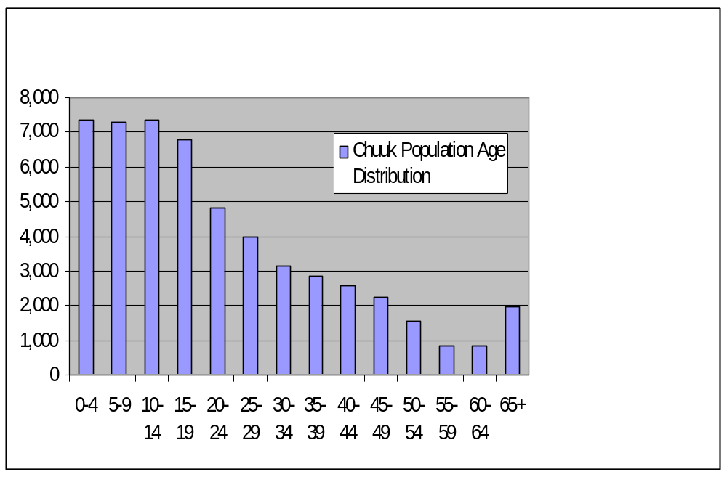

It is anticipated that the demographics will remain approximately the same over the next decade with the population age distribution continuing to be relatively young. The probable growth rate of the FSM, including the state of Chuuk, of 2.5% to 3.0% will not be evident in the population census, since it is anticipated that the out migration will continue, resulting in an annual growth in population equal to that experienced from 1994 to 2000 of approximately 0.1 %.

Employment and Job Market
According to the 2000 census there were 31,587 persons aged 15 and older available for the work force. There were 18,192 in the work force, with 11,979 employed and 6,213 unemployed. Of those employed, 4,546 were in formal employment and 7,433 were in subsistence farming or fishing jobs. There were 13,395 people over the age of 15 that were not available for the work force for various reasons. The number of persons and percentage of the work force in subsistence farming and fishing has increased substantially during the last ten years. The percentage of unemployed has also increased. These employment numbers of course do not take into consideration the large number of Chuuk citizens that have emigrated to Guam, Saipan, Hawaii and the U.S. mainland. The workforce is approximately 54% males and 46% females.

Gross Domestic Product
The Gross Domestic Product for Chuuk for 2005 was $68.91 million.

Personal Wages & Income
The average wage of those employed in the formal employment sector in Chuuk in 2004 was $4,912 per year. Persons employed in the private sector had an average wage of $3,105 per year whereas those in public sector enterprises such as utilities and telecommunications, etc. had an average wage of $8,979. State government average wage was $6,468, Municipal government $4,354, other government agencies $5,744 and non-profit organizations $2,937.

General Business & Commercial Income

There is not reliable information available on general business and commercial income. There are no special employment sectors or employers, such as a tuna processing facility, military installation, etc. on the islands of the state of Chuuk.

ISLAND ECONOMY AND INFRASTRUCTURE

General Status of the Economy
The Gross Domestic Product of the state of Chuuk for 2005 was $68.91 million. The productive enterprise sector share of the GDP was $18.88 million with the private sector being $15.68 million and the public enterprise sector being $3.2 million. Financial institutions represented $1.21 million, while the government sector GDP was $21.31 million. Households were $22.08 million with subsistence representing $17.34 million and home ownership representing the remainder. Subsistence GDP has been increasing in recent years. The economic growth rate was 3.2 % from 2004 to 2005 and 3.5 % from 2003 to 2004.

The economy of Chuuk is similar to that of other states of the FSM and, in many respects, to the economies of other Pacific island nations. With the exception of deep sea fish, there is a limited natural resource base. There is a heavy dependence on external aid and the public sector and serious imbalances in external trade. In addition, there is still very limited development of private sector activities outside the wholesale/retail sector. The economy has dual characteristics, with a modern economy centered on Weno superimposed on traditional subsistence activities, with the latter continuing to account for a significant proportion of total production and consumption.

The structural deficiencies of the Chuuk economy are due largely to the limited development in the area of agricultural, fisheries, industry, and other indigenous productive sectors. The major economic challenge facing Chuuk is to expand the productive sectors of the economy as a means of reducing dependence on the public sector and on external aid being provided under the terms of the Compact of Free Association. There is an urgent need to accelerate and encourage development of private enterprises in order to create employment as well as broaden the tax base for the government revenues. The most promising productive sectors in the state are fisheries, tourism, and agriculture.

Major Employment Sectors
The major employment in Chuuk is subsistence farming and fishing followed by government employment. There is a small tourist industry in Chuuk but its employment base is small compared to the available labor force. According to FSM Statistics Department documents, in 2004 there were approximately 4,600 persons in Chuuk in formal employment positions. Of those, approximately 1,900 were in the private sector and 2,100 in state government, 300 in municipal government and 300 in other governmental and non-governmental organizations (NGOs).

Electrical System
The electrical power for Chuuk is provided by CPUC. It is governed by a five member board of directors appointed by the Governor and ratified by the legislature. The Board hires a General Manger to manage the Utility. CPUC only provides power to the island of Weno, although that service is very unreliable both because of the poor condition of the generators (which make power rationing a necessity providing power to only around half the island at any given time) and the poor financial condition of the utility (which forces it to shut down its electrical production frequently because there are not enough funds to purchase diesel fuel). The frequent power outages obviously complicate CPUC’s financial. Most businesses have installed back-up power systems to carry their operations during the frequent power outages. To make matters worse, a number of large businesses have completely disconnected from CPUC, claiming that it is cheaper for them to generate their own power. Among them are the Blue Lagoon Resort, AWM, and Susumu Enterprises. This is a very significant loss of revenue for CPUC that complicates their already poor financial situation. No formal estimates have been made but a reasonable guess might be that all these factors have decreased revenues to CPUC by around 75%.

CPUC has installed generators and power lines on nearby Tonoas Island, but the system has not been operational for a number of years. CPUC has no power generation or electrical service on any other islands even though the provision of power to all the islands of the state is mandated by the legislation that created the utility. It appears that problems besetting the utility on Weno prevent it from directing its limited resources elsewhere.

There is a municipally-owned diesel generator on Satawan Island in the Mortlocks that is operated in the evening when fuel is available. It provides occasional power to residents of that island.

There have been several hundred small photovoltaic units installed in homes, dispensaries and schools on the outer islands. Very few of them still function as designed. Some local families have electrical generators for their own use, primarily to provide power for lighting and watching TV.

Water and Wastewater Systems
Weno and Tonoas are the only islands in Chuuk that are served by centralized water supply and distribution systems. However, the Tonoas system is currently not in operation due to a dispute with the owner of the land at the water source. The principal source of potable water on other islands both within and outside of the Chuuk Lagoon is household rainwater catchment and storage systems. Many homes that are connected to the Weno public system augment this supply with water from household rainwater catchment and storage systems. Islands within the Chuuk Lagoon augment water from rain catchment systems with water from springs, shallow dug wells, and, to a lesser extent, streams. On the outer atoll islands, shallow wells are the only source of water besides rain catchment systems.

CPUC operates the water supply and distribution system on Weno. This is a unique arrangement ,as CPUC does not charge customers for this service. Operating costs for water supply and distribution are covered by revenues received for power used from the electric system. This arrangement is a contributing factor to the poor financial condition of the utility.

The Weno water supply system utilizes surface water collected from a diversion on the Pou River and groundwater from a number of deep wells. The wells draw water from weathered basalt called saprolite at the base of the mountains and the saddle area near the state government buildings. At present there are 36 wells that have not been abandoned due to salt water intrusion, low yield, contaminated water, land disputes, etc. However, only 10 of them are presently operating. As this is being written, another 14 will be put on line when pumps are replaced. The remaining 10 have more serious problems such as the need for a transformer or the rehabilitation of an access road.

The water treatment plant at the Pou River has facilities for chlorinating the water supplied to the distribution system, but they are not in operation, nor are there operating chlorinators at the wells; thus, the island receives untreated water. This is complicated by the fact that, like power, water is supplied to only a portion of the island at any given time. Locally, this is referred to as “water hours.” It is well known that when a water line is shut down, a vacuum may be created in the pipe that will draw in contaminated groundwater through leaks in the pipe. This is especially likely as, although they are not supposed to be adjacent to one another or cross one another, both pipes and sewer lines are under the roads and cross contamination is a real possibility in extreme situations such as this. Occasional tests of delivered water do indeed reveal that water at the tap is non-potable. Residents of Weno are well aware that water from the public supply system should be boiled before it is used.

There are six storage reservoirs in the Weno water distribution system. All were built in the 70s and 80s. Their total capacity is 7 million gallons. Two of the reservoirs at Peniesene and Wichap have never been operated as there has never been enough water and pressure to fill them. The reservoir at Sapuk has never been used by the utility for the same reason, and is used on a semi-permanent basis by Xavier High School. This reservoir provides them with effectively infinite storage capacity.

There are portions of the water distribution system on Weno that have been built but have never been activated. The reason for this is that there is not enough water to safely do this without jeopardizing the operation of the portions of the system that are presently being used.

There are a number of reasons why the water system only provides water on an intermittent basis and the reservoirs have never been filled. At present, due to the fact that so few wells are operating, there is simply not enough water available. In addition, there are probably leaks in the system; a leak detection survey is probably in order. Finally, there is a great amount of wastage by consumers. In an effort to insure that they will have enough water to carry them through the period when public water is off, almost all homes that are connected to the system will try to fill containers of some sort or even large tanks (500 to 3,000 gallons) while the water is on to carry them through this period. Unfortunately, many of these customers do not bother to turn the water off when the containers or tanks are full; water will overflow from these storage containers and spill to the ground only to stop when the public water supply is turned off. The cycle repeats itself every time water goes on and off. The unfortunate result is that, even though on one hand there is a serious water shortage, on the other hand there is an extreme amount of wastage. To a lesser extent, there is water loss due to dripping faucets, faulty plumbing, etc.

Weno is the only island on Chuuk that is served by a central wastewater collection, treatment, and disposal system. On all the other islands, gray water simply falls to the ground at the point of use. Toilet facilities are either non-existent or very primitive. Prior to a cholera epidemic in the state in 1982, the common toilet facilities were over-water and over-land “penchos.” These were simply small outhouse type structures with a partial floor that discharged waste into a hole in the ground, the intertidal zone, or a river. As a result of the epidemic, these facilities were outlawed and an effort was made to introduce water-sealed toilets. In the long term, this effort was a failure and, with few exceptions, nothing has taken their place. It is not uncommon for a small outer island to have no sanitary facilities at all. This is not necessarily a bad situation if the wastes are disposed of in a manner that has no effect on human life. However, this is rarely the case.

The Weno wastewater system is operated by CPUC. Like the water supply system, CPUC does not charge for this service. This again complicates their already very poor financial situation. The operation of the wastewater system is complicated by the fact that the water and power supply systems only operate intermittently. On a few occasions, when power outage shuts down pumps, no water was delivered to the hospital for a prolonged period. The hospital storage tanks ran dry and it became impossible to use the toilets in the hospital. This is the type of unthinkable situation that can arise given the abysmal condition of utilities (power, water, and sewer) on Weno.

The waste water collection and pumping system on Weno is comprised of gravity sewer mains, force mains, and waste water lift stations which are used to pump the system’s waste water to the treatment plant located at Point Gabert (near the commercial airport terminal). The untreated waste water is relatively weak in terms of organic strength. This implies a high amount of groundwater inflow and/or storm water inflow to the system. Excluding infiltration/inflow, waste water entering the sewer system is generally domestic in nature. However, waste oils can enter the system from the power plant, hospital, and private standby generators.

The wastewater treatment plant was built in the early 1970s as a secondary treatment facility. In 1985, the EPA reviewed plant performance data and the effects of discharges from the plant on receiving waters and determined that the wastewater could be satisfactorily treated by primary treatment methods alone. Primary treatment utilizes sedimentation and other physical unit processes to remove coarse dense and floatable materials from the wastewater before it is discharged through the plant’s outfall to the ocean. This level of treatment was used into the early 90s.

Unfortunately, in the past decade, the condition of the treatment plant deteriorated to the point that it no longer is operational and raw sewage is discharged into the lagoon. Additionally, due to the poor financial condition of the utility, lift station pumps are not being repaired when they experience problems, the result being that most stations do not operate at design capacity and sometimes do not operate at all. This situation is exacerbated by the intermittent power supply to these stations. Together with storm water influx, this situation can cause raw sewage overflows from many manholes during and following heavy rain storms. Cars drive through this sewage and spread it around, unknowing pedestrians walk in it, and children play adjacent to it. The result is an extremely dangerous situation from the point of view of public health.

There are recently installed portions of the sewer system that have never been in service. Since there are water lines in these areas that have not been activated or installed, there is no water supply for residents to use and therefore no need for the sewer line. If and when the newly installed sewer lines are activated, it will be necessary to inspect and possibly rehabilitate some lines to assure they are useable and in a safe condition.

Funds have been approved for rehabilitation of the waste water treatment plant and related facilities by means of a sector grant under the Compact of Free Association with the US. There is hope in the community that this improvement will result in a long term solution to the waste water collection, treatment, and disposal problems faced by Weno. These improvements are anticipated to take place within the next two years.

Transportation System
In the state of Chuuk, there is a need for transportation on many levels. On Weno, there is a need to travel from location to location to get to one’s place of work, to purchase items from stores, etc. On all islands, there is a need for travel for social purposes (attending church, meetings, visiting, etc.). There is also a need to travel between the islands of Chuuk. In the main lagoon, there is substantial daily commuter travel between Weno and the other islands by people living on islands other than Weno. There is also a need for travel between the outer islands and Weno for many reasons, including obtaining provisions, receiving medical and dental care, attending meetings, and attending school.

There is no public transportation system on Weno; all travel is by means of private vehicles or taxis. The cost of a taxi fare is one dollar but drivers will not take their customers beyond the extent of the paved road. As a result of the lack of a public transit system the roads are needlessly congested, roads are quickly destroyed by all the traffic and a substantial amount of the islands financial resources are wasted on fuel and private vehicles. A regular bus service could have many benefits to the island. There are very few vehicles on the other islands in Chuuk Lagoon. On most of the outer islands there are none at all. The life expectancy of vehicles on islands other than Weno is exceptionally short due to the unavailability of service and parts. On the outer islands, severe corrosion is an additional problem.

An impediment to vehicular transportation on Weno is the terrible condition of the roads. The roads are in extremely poor condition and entire sections of the roads are without pavement. Periodically, these damaged sections are filled with dredged coral material and compacted only to erode again with the next heavy rain. This constant erosion causes a number of secondary problems. The most obvious is the quick deterioration of vehicular suspension systems. Not so obvious is the increased corrosion of the vehicles due to their exposure to salt in the dredged coral material. Additionally, the dredged material returns to the lagoon as it washes away, causing silt that is destructive to the reef. Also, the condition of the roads makes travel at more than 10 or 15 miles per hour very difficult, greatly increasing the time it takes to get from one point to another. The extremely poor roads also results in dangerous driving tactics as drivers swerve from one side of the road to the other to miss potholes. High on the list of infrastructure improvements for Weno to be funded under the Compact is the improvement of the once-paved roads on Weno. This project is scheduled to be implemented within the next two years.

Transportation between Weno and the other islands in the Chuuk Lagoon is by means of small private outboard motor boats. Given the extremely high cost of gasoline (approaching four dollars per gallon), it is a very expensive method of travel. Coupled with extremely low wages paid in Chuuk, citizens often spend a significant portion of their income on commuting expense. During the 1990’s there were a number of private vessels that provided a commuter ferry service between Weno and certain other islands in the Chuuk Lagoon. However, these vessels are no longer in service. Commuter service of this type is on the agenda for Chuuk in the FSM Infrastructure Development Plan for funding under the Compact of Free Association with the US. However, this will occur far into the future and the Plan is still subject to revision.

The state government vessel, Chief Mailo, is designed for carrying passengers and cargo between the outer islands and Weno. It is roughly 150 feet long, has a landing craft gate at the bow, and is capable of carrying heavy equipment in all normal sea conditions. Unfortunately, however, the vessel is not operated according to a schedule and, for this reason, it is impossible to plan activities on an outer island around expected arrival and departure dates of the ship. Under the Trust Territory government, the state operated two “trip ships” that made scheduled trips to all of the outer islands, but they are no longer in service.

In addition, three of the outer islands (Houk in Pattiw, Ta in the Mortlocks, and Onoun in Namonweito) have short packed coral airstrips two to three thousand feet long and are serviced by a twin engine prop driven STOL aircraft. This is an FSM subsidized enterprise. The aircraft makes weekly round trips to each of the three airports. The aircraft can carry 8 to 10 passengers depending on the seating configuration. The trip to these islands by plane is a mere hour to hour and a half long, a small fraction of the time required to get to the outer islands via ship (typically 12 to 20 hours).

Finally, there are roughly a half dozen private vessels from 50 to 100 feet long that are available for charter between Weno and the outer islands. Only one of them is designed for ferrying passengers and many are unsafe due to lack of safety equipment and are also uncomfortable. Due to the lack of alternatives for travel to the outer islands, many people make the trip to the outer islands in the same small outboard motorboats that are used for travel within the Chuuk Lagoon. These boats are usually overloaded and have no safety equipment on board.

Port and Port Industries
The commercial port for the state is located on the west coast of Weno, which is usually the calm leeward side of the island. During tropical storms and typhoons, however, west winds can occur and it can become an extremely rough location owing to the long expanse of unprotected water on the west side of the island where the majority of development exists. The port area contains facilities for loading and unloading cargo ships that serve the area and for a degree of storage of shipping containers.

There is also a ramp from which landing craft type vessels can take on or discharge rolling cargo (such as bulldozers that might be necessary for use on outer island projects but would be too heavy for the ship’s crane to handle). Ships can also take on diesel fuel at the port via a direct pipeline from the Mobil storage facilities. The wharf has space for docking cargo vessels on its south and west sides, while the north side can handle smaller vessels. Unfortunately, within the last 4 years, two vessels have sunk at the wharf making the west and north sides of it unusable. It is occasionally necessary for ships to wait at anchor if the one remaining berth on the south side of the wharf is in use. The wharf is presently being repaired which means that the north side of the wharf is unavailable. An aging Chuuk state government “trip ship” was allowed to sink at the north side of the wharf rather than towing the ship elsewhere to allow it to sink. The state government is now taking measures to remove both wrecks from the port area. It is expected that the fishing boat will be removed in conjunction with a marina project that will be funded by the Japanese government.

Airports and Aviation Industries
Continental Airlines provides service to Chuuk. Chuuk has a 6000 foot runway, 150 ft. wide, constructed of asphalt and is in good condition. The airport is located in Iras Village on the northwestern side of the main island of Weno. It has the capability to support double wheeled aircraft loads up to 176,000 lbs. The FAA identifier code for the Chuuk airport is TKK. Mobil Oil provides fuel at the airport.

There are approximately 60 flight operations per month at the Chuuk airport with almost all of them being commercial passenger service. Continental Micronesia has flights from Guam through Chuuk going to Hawaii on Mondays, Wednesdays and Fridays and flights from Hawaii to Guam through Chuuk on Tuesdays, Thursdays and Saturdays. They also have a turn-around flight from Guam to Chuuk and on to Pohnpei on Sunday evenings.

Caroline Island Airlines (CIA), an FSM government operation, has once a week round trip flights between Houk (in Pattiw) and Weno, Onoun (in Namonweito) and Weno, and Ta (in the Mortlocks) and Weno. The flights to and from Ta originate in Pohnpei, so it is possible to fly between Chuuk and Pohnpei by means of two different airlines. The trip to Ta from Pohnpei is of special interest to the Chuukese community residing on Pohnpei as many of them have their roots in Ta and neighboring islands. The CIA aircraft is a small (approximately 10 seats, depending on configuration) propeller driven plane that is comparatively slow.

Communication Systems
The FSM Telecommunications Corporation (Telecom) provides phone service to the four states in the FSM. This includes access to the internet. Cell phone coverage is now offered that covers just about all points in the Chuuk Lagoon. In the planning stage for implementation in the near future are communication facilities for the three outer islands (Houk, Ta, and Onoun) that have airstrips (the airstrips will make it possible for Telecom technicians to service their hardware). When these facilities are completed, these islands will have communication capabilities identical to Weno at the same rates. Internet speed on the Telecom system can be very slow and appears to be a function of the lines connecting the user to Telecom facilities. Many of the phone lines are in poor condition with little or no protection from the weather.

At present, the only means of communicating with the outer islands is by means of SSB radio. While this is certainly better than nothing, this method of communication falls short in many respects. Lack of reliable communications is a handicap to the provision of adequate health and educational services on the outer islands as well as disaster warnings.

Tourism Industry
Tourism continues to be a major industry on Chuuk, but the number of visitors remains fairly low and has not increased noticeably in recent years. Most tourists to Chuuk are divers interested in the wrecks in the main Chuuk Lagoon. Chuuk is considered to be one of the best wreck-diving locations in the world. The Blue Lagoon Resort, located at what was once a Japanese airstrip, is the leader in this industry. The Truk Stop Hotel also has a growing dive operation. There are also two live-aboard dive vessels that are based on Chuuk.

Major Industry
There are no major industries on Chuuk apart from tourism. The potential of deep water fishing is often pointed to as a source of significant revenue, but many state-supported fishing and fish processing ventures have failed. A small long-lining fishing operation that involved the purchase of two vessels was unsuccessful. A state-owned purse-seiner sank at the wharf during a passing typhoon. A tuna trans-shipment facility failed when the state raised fees for foreign vessels shipping in state waters and the vessels moved their operations elsewhere. While the potential for significant revenue generation exists because of Chuuk’s location with respect to good fishing grounds, there is a need for careful planning and thought in future ventures designed to profitably utilize this resource.

Military
There has been no military presence in Chuuk for the last 5 years or so. The U.S. Air Force Civic Action Team (CAT) and the Navy Seabees had served Chuuk for decades, undertaking various public works projects ranging from airport construction on the outer islands to the building of schools. The Corps left the FSM and Chuuk as a result of negotiations for the second Compact. Many people in Chuuk feel, however, that the decision to allow the Corps CAT team to leave was not a good decision. The Chuuk government, although it reportedly received additional funding as a result of the Corps withdrawing, has discovered that the additional funding does not come close to the dollar value of the services the CAT team had provided.

Other Special Economic Elements
There appear to be no special economic ventures taking place other than the foregoing.

Manufacturing, Craft, Trade
There is a small amount of manufacturing of handicrafts that are sold to tourists. However, this is not done on a large enough scale to be a measurable part of the state income. Some skirts and dresses are made locally but few are exported. They may decrease slightly the number of finished dresses that are imported but increase the amount of yardage.

Agriculture
Like fishing, agriculture is often pointed to as a potential source of revenue for the state, the thought being that niche market products (like pepper from Pohnpei) could be developed. To date, this has not happened. There is only a small amount of produce marketed for local consumption and this produce is limited to a few items (primarily egg plant and cucumber) in addition to other items that, for all practical purposes, grow wild (bananas, papaya, mango, breadfruit). In the mid 1990’s, the state invested in a copra processing plant with the objective of creating a viable local industry. For a few years, soap, shampoo, and oil were produced. However, the venture ultimately failed. There are markets for copra, a new one being the manufacture of an alternate fuel for diesel engines. However, commercial ventures in the copra industry have been plagued with risk and any such ventures will need to be thoroughly examined.

Aquaculture, Fisheries, Refineries
On a small scale, reef fish are caught in the local coral reefs and exported to Guam. This industry creates a significant amount of income for some of the people involved because fish is purchased from fishermen very cheaply and sold at 200 to 300% markup on Guam. There is concern by environmentalists that the export of reef fish might deplete the resource. The export of reef fish is now illegal on Pohnpei for this reason. There is also concern that, at times, illegal fishing methods are used (specifically dynamite) that cause long-term damage to the reef and indiscriminately kill most living things in the area. A Korean company made an attempt at aquaculture on the reef in the Sapuk area of Weno. The venture ended tragically when the director of the operation was killed in an outboard motor boat accident.

ECONOMIC DEVELOPMENT PLANS AND PROJECTS

General Status of Economic Development Planning
Chuuk state has not been too successful in implementing long range plans, although several areas have been emphasized such as water supply improvements, solid waste management and general business economic development. One reason for this might be the tendency to change directions and priorities when leadership changes. Also, there might not even be an awareness of long range plans by new leadership or the concern by permanent salaried employees to carry them through in spite of changes in leadership.

A good example is economic development planning. At the time of implementation of the Compact of Free Association with the US, the Chuuk Department of Resources and Development prepared an Overall Economic Development Plan for the state. This Plan identified the well-recognized resources of the state (Agriculture, Tourism, and Fisheries) and identified specific economic opportunities associated with each resource. It went on to recommend facilities required in order to take advantage of the various opportunities. A few of the recommended facilities were built, such as the construction of a transshipment base for tuna caught by foreign fishing vessels. However, most were not attempted and those that were (such as the tuna transshipment base) failed. No significant economic progress occurred under the first fifteen year phase of the Compact. As a result of the implementation of the second twenty year phase of the Compact, an Economic Summit took place which suggested strategies for economic development for the Compact period. The results of this Summit are yet to be formalized into a concrete plan for action on the state level.

Economic Development Approach and Special Issues
The implementation of the second phase of the Compact essentially coincided with a change in leadership for Chuuk. The present leadership is committed to implementing needed infrastructure development projects as soon as possible such as the rehabilitation of the wastewater treatment plant and the construction of a sanitary landfill cited above and to stimulating development of the economy. Economic development requires working infrastructure which must include the fundamental building blocks of a viable economy, including dependable water supplies, adequate and dependable power, waste water collection, treatment, and disposal, solid waste disposal, modern communication systems, and satisfactory roads. The prognosis for providing these building blocks in the near future is good and, as this occurs, the development of concrete economic development plans will hopefully follow.

Focus Areas
As indicated above, the initial focus of Chuuk in developing its economy will be remedying major deficiencies in its infrastructure. While this is being accomplished, specific plans for economic development will be formulated. It is likely that they will focus on the development of tourism, fisheries, and agriculture as they did in the previous economic development plan. Unique niche areas analogous to the production of pepper on Pohnpei will also be sought out.

Energy Considerations
The lack of reliable public power supply on Weno is a major deterrent to economic development on Chuuk. Many of the local businesses, resorts, and government facilities must operate their own electric power systems in order to operate throughout the day due to the rolling blackout policy of CPUC. The prospect of being one’s own utility is not enticing to businesses that might otherwise be attracted to Chuuk. Further, the cost of diesel and automobile gasoline fuel, presently in the range of $4.00 per gallon for diesel and $3.75 per gallon for gasoline, is a major economic drain on the operation of the businesses, government, and institutions that must not only purchase the fuel to operate their own electric generators, but also for use in transportation. Unfortunately, the control of fuel prices is beyond the control of the state. All that the consumer can do is seek methods of limiting consumption. A functional electric power generating facility would be able to generate power much more cheaply than the small private or government back-up generators that are presently being used.

Economy Diversification
As indicated previously, the Chuuk economy is heavily dependent on the public sector. Compact funds are the foundation of health services, education, environment, and other sectors of the economy. This U.S. support not only provides for infrastructure and materials in these sectors, it also provides for salaries. This dependence on U.S. support is widely recognized both in Chuuk and the FSM as a whole. If there was a theme to the Economic Summit that heralded implementation of the new phase of the Compact, it was the need for economic diversification and decreased or elimination of dependence on outside funds. The strategies for achieving this independence were developed at the Summit. It remains to be seen what sort of concrete plans for development will be formulated on the state level as a result of these strategies and how successful these plans will be.

Import-Export and Balance of Payments
The public sector is the backbone of the Chuuk economy. The private sector is dependent mainly on public funding by selling goods and services to the government and to civil servants’ households. The funding of public sector activities is largely done by the U.S. under the terms of the Compact of Free Association. The state government relies on external grants for roughly 90% of its total revenue. Another major economic imbalance is in the area of external trade. The value of exports is only between 5 and 10% of imports.

STATUS OF ENERGY SYSTEM

Major Energy Uses
The uses of energy on Weno are probably typical of small developing tropical islands. Large enterprises and the government probably consume the most power for air conditioning. Large enterprises also consume a large amount of power for refrigeration if they sell frozen foods and have to refrigerate containers of frozen produce between cargo ship arrivals. Hotels consume large amounts of power heating water for their guests. Hotels might also consume a large amount of power for cooking if electricity is used. At least one major hotel cooks with propane. On the household level, more well-to-do families will also consume a large amount of power for air conditioning, refrigeration, water heating, and cooking. The use of rice cookers can consume a significant amount of power. Poorer families will primarily use power for lighting, refrigeration, and watching TV. They probably will not have air conditioning or piped hot water. They may not even use electricity for cooking and will use a kerosene stove instead. In fact, at the present time when island power is so erratic, many families have turned to kerosene and propane as alternate means of cooking.

Electric Power System
The power generation system on Weno is on the verge of collapse. Rolling blackouts of half of the island of Weno occur daily in addition to island-wide blackouts when CPUC does not have funds to purchase diesel fuel to operate the generators. Approximately 25 local business, hotel, and government customers have resorted to operating their own electric power systems due to the unreliability of the CPUC system. Four of the seven power-generating units installed at the power station are inoperable, and the other three are seriously overdue for major overhaul. Of the three operable units, only two provide primary power and they have been down rated to 75% of their capability due to problems with overheating.

Most of the auxiliary plant equipment at the power station is in an advanced state of deterioration, insufficient to support the operations, and in many cases perpetuates an unsafe and potentially dangerous environment. There are deficiencies with the fuel supply, cooling systems, air starting systems, ventilation systems, noise reduction equipment, flammable and other materials storage and disposal, air pollution control equipment, fire protection systems, buildings and structures, spare parts inventory, tools and equipment, office facilities and substation.

CPUC has one substation located at the power plant. There are five distribution circuits feeding the island from the power plant substation. Weno Island has an 18-mile long, 13.8 KV overhead distribution system. It was constructed during the early 1990s to replace an earlier 4.16 KV distribution system. The distribution system consists of: overhead aluminum conductors, wood, concrete and composite poles with cross arms and insulators, three-phase transformer banks and single-phase transformers, secondary services drops: and revenue meters. Disconnects and switches are strategically located on the 13.8 KV overhead distribution feeders to allow reconfiguration of the distribution system from the power station. Due to corrosion from the marine environment, overhead disconnects, transformers and other metal hardware require frequent replacement.

Although the system has five 13.8 KV, three-phase, four-wire distribution feeders CPUC has reconfigured the five circuits into three circuits to better effect the rolling blackout program. Two of the circuits have been tied to partner circuits so that three circuit breakers now serve the islands daily peak load of approximately 1,700kw. Actual peak load would be approximately 3 to 3.5 mw if CPUC had the capability to serve the load. The feeders are single-circuit except at the power station where feeders 1, 2, 3 and 5 share a pole on the exits from the substation. The 13.8 KV overhead distribution feeder conductors are 1/0 AWG aluminum, steel reinforced conductors (ASCR conductor), which have an approximate current carrying capacity of 230 Amperes. Each feeder has a three-phase capacity of approximately 5.5 MVA. Assuming a 0.8 power factor, one feeder could carry the entire load of the island.

CPUC has a large number of composite power poles stored at their waste water treatment plant yard. Due to lack of funds and planning initiative CPUC has not begun a program to replace existing deteriorated poles with the new composite poles.

The latest unaudited figures indicate that for the first six months of FY06 sales were $1,418,630
($2,837,260 annual est.) and operating expenses were $1,411,063 ($2,822,126 annual est.) that would result in an annual profit of $15,134. With annual depreciation of $1,157,080 CPUC will experience a loss for FY06 of $1,141,946. There was not information available on the number of customers served by CPUC nor the kWh sales. CPUC rate tarifs are $0.3126 for residential customers; $0.3426 for commercial and $0.3626 for government customers.

The latest year for which figures are available, indicates that the gross generation for 2004 was 21,520 MWh; however, the accuracy of those figures may be suspect. Total invoiced consumption was 12,200 MWh; losses were 9,280 MWh, which represents losses of 43.25% from power produced to power consumption billed. Records obtained that reflected data gathered by the ADB for use in analyzing options for the Chuuk State Power Rehabilitation Project indicated that the diesel fuel used during FY2004 that corresponds to the kWh billings of 12,200,000 kWh for FY2004, was 1,593,000 gallons. These figures result in 7.66 kWh being delivered and billed to customers for each gallon of diesel fuel used. With a present diesel fuel rate of $2.30 per gallon, the cost of fuel to deliver a kWh to the customers meter for billing purposes is $0.30 per kWh ($2.30/gallon divided by 7.66 kWh per gallon). With the present electric rate in Chuuk being $0.34 per kWh, the marginal revenue for each kWh billed is only $0.04 per kWh, since loses at 43.25% are causing fuel costs to be $0.30 per kWh at the meter.

Many government meters such as water and wastewater pumping systems are not read and accuracy of the meters may be questionable. There are nine water well systems and numerous waste water lift stations that have meters but are not being read and thus the usage for water/wastewater pump systems is included in the loss figures. Many of the three phase meters that were installed for on the water and wastewater pumping stations have been removed and placed on commercial establishments. Since CUPC has not had sufficient funds to purchase three-phase meters for new commercial customers, cannibalizing meters from the water and wastewater pumping systems has been an expedient method to provide revenue meters to new customers.

Power factor according to meters at the power plant is approximately 0.8. There are no capacitors either at the substation or on the distribution line to correct the power factor which could reduce the losses. Power factor balance between generators is poor, resulting in one engine carrying the major part of the VAR load of the system. Operators appeared unaware that adjustment of generator field voltage could balance the var loads.

Operational Issues
The power system operations are in a very serious condition in Chuuk. There appears to be a major lack of training of personnel, a lack of supervisory direction and a lack of individual interest in improving the system. Financial records are nearly non existent. Some senior staff have left the organization within the past year, which has caused a serious loss of institutional knowledge. Organizational knowledge regarding the type of information that should be gathered to help make effective management decisions seems very limited. There has not been an audit of CPUC since 2002, and the comptroller was unable to provide even minimal financial records of revenue per customer class, fuel costs, etc. for review. During the assessment visit, which occurred during a Friday payday, the CPUC was not able to pay the employees due to lack of revenue. The decision to not issue the paychecks was not made until thirty minutes before the end of the day, as the staff continued to take in billings in an effort to receive funds sufficient to cover the payroll. Personnel waited at the office until late in the day before finally being notified that there would be no pay check for the two week period of their work.

As this report was being finalized in June 2006, one of the two remaining operational 3,000 kW generators was taken out of service due to a failed turbocharger. There was no information when CPUC would have sufficient funds available to get the turbocharger repaired. The island is on scheduled blackout status a half time daily from 7 a.m. to 7 p.m. when there is sufficient fuel to keep the units operational. The plant has been running out of fuel on a regular basis recently, and thus the entire island is without power from CPUC for three to four days until the utility can secure enough funds to buy another small supply of fuel to continue operations for a few more days. With the substantial losses that the system reportedly experiences, management may not be aware that they are not collecting enough from sales to even pay for fuel plus salaries. With such a condition existing CPUC is locked into a financial decline that can only end in a bankruptcy situation.

Generation Facilities
The currently operable units include: (1) two Caterpillar 3608 units (Units 2 and 3), which provide the only means of primary power generation for Weno island; and (2) a Caterpillar D399 400 kW auxiliary unit which is utilized at times of peak load and to start the power station. Units 2 and 3 operate on a continuous, 24-hour basis, but due to each unit being down rated from 2,000 kW to 1,500 kW because of problems with overheating, they are not able to meet the daytime loads of the island. The present operational mode is to have rolling blackouts of half of the island for four hour shifts. Sometimes in the evening, when loads are finally down to a level that the two units and occasionally the D399 auxiliary unit can meet, power is restored to the entire island. The rolling blackouts are alternated Monday, Wednesday and Friday for one half of the island with two four hour outages for the day with the first outage beginning at 7:00 a.m. extending to 11:00 a.m. Power is restored until 3:00 p.m. and then the second blackout of the day extends to 7:00 p.m. On Tuesdays, Thursdays and Saturdays the other half of the islands receives the eight hours of rolling blackout.

Units 2 and 3 are in immediate need of complete overhaul together with manifold and exhaust replacements. Maintenance has been very minimal on the units. Although Chuuk utility had received $1,000,000 per year during much of the Compact I period the funds were used to offset fuel and basic operational costs rather than in-plant maintenance. There was also reluctance by Chuuk officials to increase electric rates necessary to fund basic operation and maintenance of the electric system during Compact I time period.

Since there is no spare capacity in the generation system and no financial reserves whatsoever, a failure of one or both units causes additional power outages, which remain until funds can be secured to order the parts and shipped out to Chuuk so the repairs can be completed. Chuuk Utility is on a “prepay cash” basis, with most vendors furnishing parts and services since vendors report that they often have difficulty receiving payment for parts and services rendered.

The auxiliary Caterpillar D 399, an 800kw, 1985 unit, is leaking oil and on the verge of failure. Although it requires a top-end overhaul and replacement radiator, this may not be cost effective. There are higher efficiency replacement units available with far greater fuel efficiency.

TABLE 9-1
WENO POWER STATION: GENERATION CAPACITY
Unit | Manufacturer | Model | Year | Year | Rated | Operating | Current
 |  |  | Built | Installed | Capacity | Capacity | Status
2 | Caterpillar | 3608 | 1989 | 1990 | 2000 | 1500 | Operating
3 | Caterpillar | 3608 | 1989 | 1990 | 2000 | 1500 | Operating
5 | Caterpillar | D 399 | 1970s | 1985 | 800 | 400 | Operating
4 | Caterpillar | 3608 | 1991 | 1991 | 2000 | 0 | Inoperable
1 | Norberg |  | 1975 | 1975 | 1155 | 0 | Abandoned
6 | Alco | DE 3501 | 1985 | 1985 | 2000 | 0 | Abandoned
7 | Alco | DE 3501 | 1985 | 1985 | 2000 | 0 | Abandoned
Source: ADB Aug. 2004 Chuuk State Power Rehabilitation

Fuels
All Chuuk units are fueled with #2 diesel oil. The fuel is provided by Mobil Oil. The present (May, 2006) cost of fuel is $1.95 per gallon.

TABLE 9-2
Chuuk-Fuel imported | Unit | 2001 | 2002 | 2003 | 2004
Aviation fuel –  including kerosene | Gal | 914 | 1,000 | 766 | 207
Diesel fuel-not including power plant | Gal | 2,450 | 3,063 | 1,596 | 618
Diesel fuel for power plant | Gal | N/A | N/A | N/A | 1,593
Gasoline | Gal | 2,818 | 2,979 | 3,214 | 4,474
In thousands of gallons. Data from FSM Dept. of Statistics

Mobil Oil delivers fuel daily to the plant’s 14,000 gallon steel horizontal above-ground fuel tank which has an underground pipe line supplying fuel to the power plant. The tank is located immediately to the east of the power plant and substation, and is supplied directly by truck from the Mobil fuel terminal. When the full island was being served full power during the daytime with reported daily loads of 59,000 kWh, fuel use was reported to be 4,360 gallons per day, resulting in the fuel tank only providing three days of fuel. There is a CPUC 3,000-gallon fuel tanker truck trailer alongside the existing tank that apparently is used to top off the 14,000-gallon tank when fuel cannot be delivered. Two additional 6,000-gallon fuel tanks also exist at the site, but these are unusable.

ELECTRIC PRODUCTION AND USE

Existing Renewable & Alternative Power Production
There is no significant renewable and alternate power production on Chuuk. The only systems in place are a few hundred small solar photovoltaic power systems on the outer islands that are primarily used to generate power for lighting and watching TV. However, in spite of this present lack of use of renewables, interest in renewables is very high. They are the acknowledged source of power for the future on the outer islands and at least the smaller of the Chuuk Lagoon islands as they become electrified. As this is being written, the state is preparing a proposal to the European Union for electrification of the outer island junior and senior high schools, the provision of power to FSM Telecom for operation of communication facilities on the three outer islands having air strips, and the electrification of dispensaries on the islands where the first two efforts will take place. This project will also include the sale of solar lanterns to homeowners at a subsidized rate. The project will be directed at public facilities, the improvement of communications (one of the cornerstones of development), and the provision of cheap lighting to the majority of outer island homes. The budget for this project is expected to be in the neighborhood of two million dollars. It will be the largest alternate energy project on Chuuk to date.

Existing Conservation and Demand Side Programs
Presently there are no formal supply-side or demand-side efficiency programs underway. However, the high cost of electricity, 34 cents per kWh, is causing a major informal demand side conservation effort. Because of this high cost of power, many families and businesses have finally begun to replace incandescent light bulbs with hi-efficiency low wattage bulbs. Many homes have also begun to cook with propane instead of using electric ranges. The cost savings due to this latter measure are questionable. However, there is a major increase in reliability due to the frequent power outages and the unreliability of cooking on an electric range. Few homes will heat water and many are using fans instead of air conditioners. Few homes will use a freezer. This is partly the result of economy and partly the result of the difficulty in keeping food frozen due to the frequent power outages, especially longer ones when CPUC must shut down power production for days at a time because it has no funds on hand with which to buy diesel fuel.

REGULATORY ENVIRONMENTAL ISSUES
At present, the power plant operates without any sort of environmental regulation. There are no standards for exhaust emissions, noise levels, etc. Generally speaking, the population of Chuuk is very tolerant of situations that might be unacceptable elsewhere. These include heavy exhaust emissions that blow onto populated areas. The public may not even be aware that such situations need not occur in a properly running power plant.

The power plant also has frequently disposed of waste crankcase oil in the storm drains. It then flows to culverts on the side or the road, and in one recent instance, onto the road itself. The utility has been warned a number of times by the EPA that this is an unacceptable practice. Previously, CPUC had an arrangement with Thorfin, a live-aboard dive vessel, whereby the Thorfin would use the spent crankcase oil as fuel for its boilers. This was a win-win situation in that it solved a waste disposal problem for the utility and it saved fuel costs for Thorfin. For unknown reasons this arrangement is no longer in place. At present, there is no satisfactory method of waste disposal oil on Chuuk.

TRANSPORTATION

Fuel Use
The major fuel uses for transportation in Chuuk is for vehicles and small boats used to travel within the Chuuk Lagoon. On any day, there are often one hundred small boats that arrive from the Lagoon islands to Weno to deliver goods, pick up supplies, and carry commuters back and forth to work. A major commodity that is transported back to these islands is five gallon containers of gasoline for use in the boats and generators. There were no records available of the volume of fuel used for vehicle or marine transportation.

Fuel Types and Costs
The major type of fuel is gasoline for vehicles and boats. There are some larger construction trucks and many generators on the islands that utilize diesel fuel. The cost of gasoline is in the range of $3.75 per gallon and the cost of diesel fuel is in the range of $4.00 per gallon.

Reducing Transportation Energy Use
A bus transit system may help in reducing vehicle energy use in Chuuk. However, there was no indication that government officials or the private sector had embarked on any plans to study or implement a bus transit system. Vehicles are purchased primarily from the Asian market and often are several years old when they arrive in Chuuk. Energy efficiency does not seem to be a factor in determining the vehicles that are brought onto Chuuk for resale to the public. The use of motor bikes or bicycles is almost non-existent. Some Asian countries have found that motor bikes are a very fuel efficient and economical method of transport, however, Chuuk drivers have not been inclined to use motor bikes as a form of transportation.

COMMERCIAL AND INDUSTRIAL

Tourism
Chuuk has a small tourism industry primarily focused on wreck diving. The activities of the tourist population arriving in Chuuk do not lend themselves to developing programs that can reduce the use of fossil fuels. The major energy use of the tourist arriving in Chuuk is the fuel used in their travels to Chuuk. Continental Airlines is the major mode of transportation for arriving tourists. It is expected very little fossil fuels can be reduced, since Continental Airlines already has taken steps to operate their planes as efficiently as possible.

Manufacturing
There is very little manufacturing in Chuuk; the opportunities for reducing fuel use in the Manufacturing sector is very low.

Military
There is no military presence on Chuuk.

Fisheries
There are few major fishing fleet operations in the Chuuk area. Those fishing vessels that do operate out the Chuuk harbors already practice fuel saving methods as part of their efforts to maximize profits. There are many small fishing/transport boats of 18 feet long (usually with a 40 hp outboard motor) that are used by Chuuk residents to travel from island to island and for fishing. There are few opportunities to reduce fuel use in these boats.

ALTERNATIVE ENERGY OPPORTUNITIES

Alternative Fuel Systems
There is considerable interest among Pacific island nations in the use of coconut oil as a replacement for diesel fuel. On the neighboring island of Pohnpei, the copra processing company produces oil suitable for use as a fuel and powers its own vehicle with coconut oil. However, there is no use of coconut oil as a fuel on Chuuk. The size of the system in Chuuk does not justify consideration of any alternative fuel systems with the state of the present technology.

Cogeneration
There are presently no cogeneration systems on Chuuk. Most facilities in Chuuk are not large enough to justify a cogeneration facility. The present power plant is centrally located near the hospital and most of the Chuuk state government offices and an absorption or adsorption waste heat to chilled water system perhaps could be feasible, however, plans are to move the power plant due to property ownership problems.

SUPPLY SIDE EFFIENCY
In developed countries’ utilities, the average power systems losses for a utility with only a generation and a distribution network are estimated at approximately 10%. Nominally, these losses are accounted for in generation, 5%; and distribution, 5%, with non-technical losses less than 1%.
In 2000, a preliminary study was carried out on a sample of three (3) U.S. Affiliated Insular Areas’ power utilities, to achieve an indication of the energy inefficiencies in the generation, transmission and distribution of electricity in all the U.S Affiliated Insular Areas’ power utilities. These were the utilities of Palau, Pohnpei and Kosrae.
This preliminary study indicated that the power system losses in the utilities were far in excess of acceptable standards for these power systems. It was established that the energy losses were occuring in all areas of the power system, including non-technical losses.

It was noted that some data was lacking such as the number of transformers or the types of conductor used. As a consequence several approximations were used to evaluate the losses. The errors on the figures are difficult to quantify and therefore the results should be carefully used, although it does represent system losses that are far in excess of what is acceptable.
To reduce the import of fuel, it is imperative to reduce these system losses.

It is recommended that a detailed quantified power system loss study be conducted for CPUC, as a stage 1 project. This project would measure and collect the electrical characteristics of the power system, and then determine the losses. Once these losses have been quantified, then stage 2 of this process would be to assess the need for updating existing inefficient equipment (examining financing mechanisms as appropriate); establishing Government legislation that makes electricity theft a crime; and review the maintenance practices in the power plants.

DEMAND SIDE EFFIECIENCY
Chuuk is difficult to analyze regarding the opportunities for DSM and energy conservation. That is partly due to unusually poor data availability (to some extent due to a major fire in 2004 that destroyed many records) and partly due to the numerous and lengthy power outages that has cause some users to switch to private generation and others simply going without power. The conditions that exist are such that obtaining reasonable quality power is the main priority and energy efficiency is not of great interest to consumers. Though an aggressive program by CPUC for energy conservation could reduce the gap between capacity and demand, the gap is too wide and CPUC resources are better used to work toward regaining adequate capacity. The CPUC has not delivered any programs for energy conservation and are not likely to give them any consideration until the power system is fully operational and reliable. That may take years to accomplish and in the interim, programs that focus on DSM and energy conservation are unlikely to be effective.

One serious problem in Chuuk is the lack of any organization to act as implementer of energy efficiency and energy conservation programs. All CPUC resources are focused on the serious problems of operations and reliability in Weno and there is no other organization that has any responsibility for energy efficiency and conservation. Individuals at the Environmental Protection Agency (EPA) have shown a strong interest in energy issues but the office has no budget or mandate for implementing energy efficiency or conservation measures. With energy prices so high as to seriously impact the economy, consideration should be given to again establishing a state energy office with a specific mandate for energy efficiency improvement and outer island electrification. That would, however, require both external funding and external expertise to get the office up and running for the first few years.

Electrical Metering/Tariff
Un-metered customers still exist, though the majority are metered. Around half the meters are of the prepayment type, many of them on government facilities, since the state government is usually very slow in paying power bills. At least one government office is known to take up a collection from the staff to buy a prepayment card to keep the power turned on, since the department does not provide sufficient budget for energy.

Until the power supply is reliable, attempting energy conservation or improved energy efficiency through tariff revisions is unlikely to be useful.

Household Energy Efficiency Measures
Statistics regarding household kWh use of electricity was requested but could not be obtained. The 2000 Census implies a usage that is probably lower than the other FSM states. The reported appliance mix in all of Chuuk for the 7,417 households surveyed included few large appliances:

Electric stove: 260 (3.5%)
Electric water heater: 50 (<1%)
Biomass cooking: 4634 with open fires and 594 with stoves total 5228 (70%)
Gas cooking:1062 (14.3%)
Kerosene cooking: 1061 (14%)
Refrigerators: 526 (7.1%)
One room air-conditioning: 120 (1.6%)
Two or more individual air-conditioning units: 42 (<1%)
Central air conditioning: 56 (<1%)
TV&Video (no broadcast TV): 1466 (19.8%)

Domestic air-conditioning use is low, less than 1% of households having any form of air-conditioner installed in 2000. High energy costs, unreliable power and a slow growing economy make it unlikely that domestic air-conditioning will soon be a major energy use. Likewise, programs to exchange electric cook stoves for gas ranges or electric water heaters by solar units would have little overall effect since the unreliable power has been effective in preventing electric cook stove acceptance by households.
Table 9-3 – Appliance Ownership
 | Chuuk State HH | Percentage of Electrified HH
TOTAL HH | 7,417 | n/a
Electrified HH | 2,020 | n/a
Fridge | 526 | 26.0%
A/C | 218 | 10.8%
TV+VCR | 1466 | 75.6%
Electric Cook | 260 | 12.9%
Kerosene | 1061 | n/a
LPG Cook | 1062 | n/a
Wood stove | 567 | n/a
Open fire | 4491 | n/a
Source: 2000 Census

The only energy efficiency improvement program that could be expected to have significant effect in Chuuk is for lighting. Household lighting is mostly by magnetic ballast type fluorescent lights and incandescent lights. A program to replace those with high efficiency units could be expected to be a cost effective way to reduce the lighting load by nearly half, and in Chuuk the lighting load is a major component of the total domestic use. Since lighting is such a substantial component of the evening peak load, its demand reduction could provide direct benefit to CPUC as well as reducing fuel import requirements.

Government and Commercial Sector
The fish processing industry on Chuuk has closed and at present there are no export oriented industries.

In general, government buildings are not major energy users in Chuuk, with the notable exception of the hospital. “Window” type air-conditioners are common and are not high efficiency types, so replacement of those by more efficient split systems or “window” units with a high EER could provide some energy efficiency improvement. Lighting in all government facilities should be converted to either electronic ballast high efficiency tube type fluorescents or, where incandescent lamps are used, by CFLs. Unfortunately many offices have little natural lighting from windows, so overhead lighting can not be turned off during the day time. All government purchases of air-conditioners should be restricted to high efficiency units with an EER of at least 12 and preferably higher. The current mix appears to be less than 10 on average.

The relatively new hospital on Chuuk is one of the top state energy users but actual use could not be determined since the power outages force the use of the backup generator a significant amount of the time and its output statistics were not available. An energy audit and energy efficiency improvement plan and funding to carry it out would be of value to the hospital and Chuuk, particularly in view of the high cost of operation of the backup generator.

No survey information was available that provides information on government or commercial water heating loads but where significant water heating is carried out (e.g. laundries, visitor accommodations, hospital), solar water heating should be considered and if cost effective, installed.

The primary energy requirement for the commercial sector is for the operation of refrigerators, freezers and air-conditioners. Major supermarkets, food importers and wholesalers all have large refrigeration based energy use. If a local focal point for energy efficiency can be established, one useful action for that agency would be to arrange for audits and training for users in the operation and maintenance of refrigeration equipment to achieve maximum energy efficiency.

The tourist sector is not large, around 6,000 tourists each year. Tourists come to Chuuk mainly due to the popularity of diving to see the Japanese WWII wrecks in the lagoon around Weno. All the tourist facilities operate their own generators, some full time and some only when grid power is off. None of the tourist facilities utilize the waste heat from either generators or air-conditioning for water heating and that should be considered.

Transportation Sector
Chuuk includes many islands and sea transport is a significant energy use though much less than is used for electricity generation. When there is need for ship replacement, care should be taken that the selection process includes energy efficiency criteria. In particular, if a ship is being provided by an aid donor, the “free” ship may end up being a major expense due to poor fuel efficiency and in the end could cost far more than the outright purchase of a fuel efficient vessel.

Fishing using small boats fitted with a 20 to 40 hp outboard engine is a common activity throughout the state but there are few opportunities for improving their efficiency of use through technical interventions. The rising cost of fuel is the most effective motivator for reducing energy waste in that sector. Local observers state that more traditional canoes are being used for personal fishing than before the fuel price increase.

Inboard diesel engines are typically used for dive boats and most of those gasoline outboard engines that are used appear to be reasonably sized and are four stroke cycle units that are relatively fuel efficient.

Land transport is primarily by private automobile. There is no organized public transport, though there is a small taxi fleet. Fuel efficiency for existing vehicles is lowered due to the very poor roads in the heavy traffic areas of Weno. Potholes and broken pavement require frequent braking and acceleration and very slow speeds that result in low fuel efficiency. A substantial improvement in overall transport fuel efficiency would result if the roads were kept repaired.

Shifting private and government vehicles to diesel engines provides the greatest opportunity to reduce fuel use through increased efficiency. The average age of vehicles appears to be much older than in the other states of FSM, implying a slow turnover of the vehicular stock. Providing incentives for shifting to new diesel vehicles is therefore less likely to provide timely results than states where new vehicles are purchased more frequently. However, the government should require that specifications for new government vehicles include diesel engines given their lower life cycle cost, higher fuel efficiency and lower maintenance requirement.

Building Energy and Efficiency Standards
The benign climate, high energy prices and the low demand for household air-conditioning and water heating make the average energy use per square foot of Chuuk buildings quite low. The value of building codes to further reduce the average per square foot energy use of buildings is correspondingly low.

The capacity in Chuuk for the development and enforcement of building energy efficiency standards is minimal; their development would have to rely on external experts, and enforcement is questionable. Since the amount of new construction each year is not large, the national benefit from enforcing such codes would probably not be cost effective relative to other measures to improve energy efficiency in buildings. It has proven difficult to enforce basic building codes in Chuuk that relate to important safety issues and properly enforcing what are typically viewed as a type of non-essential construction codes would be even more difficult.

Since air-conditioning is the primary load that would be affected by energy efficiency standards for government buildings in Chuuk, it is recommended that construction guidelines be developed and applied for government building construction and renovation that includes basic energy efficiency measures such as thermally isolating the roof and exterior walls from the air-conditioned space, optimizing natural illumination, minimizing heat entry through windows and reducing infiltration into the air-conditioned space. In outer island areas, designs for schools and dispensaries should maximize natural air movement to keep them cool. This implies orienting the buildings so that they intercept as much of the wind regime as possible. This is a relevant issue as many schools and dispensaries will be built on the outer islands using infrastructure funds from the new Compact.

Appliance Energy Efficiency Standards
The use of major appliances, including refrigerators, is too small for cost effective use of appliance labeling and energy efficiency standards.

Energy Audits, Performance Contracts
The market on Chuuk is too small to support an ESCO or to justify the cost for an overseas ESCO to operate a subsidiary on Chuuk. ESCOs in Guam or Hawaii may be interested in servicing large clients such as the Chuuk state government on a contract basis, but are unlikely to find it practical to maintain a continuing presence on Chuuk. Though energy audits could raise the awareness of users regarding the cost benefits of improving their efficiency of energy use and in some cases could result in investment in increasing energy efficiency, the CPUC cannot be expected to provide an energy audit service and there is no other agency in Chuuk that is likely to take on energy auditing responsibility.

RENEWABLE ENERGY

Solar
No good quality ground-based insolation data could be made available for sites on Chuuk. NASA satellite data for the oceanic area that includes Chuuk is provided in Table 9-4.

The mountainous islands enclosed by the Chuuk Lagoon have a substantial effect on local cloud cover and the NASA estimates probably should be treated as the maximum insolation for the Chuuk Lagoon area. Because the satellite data is based on a one degree grid, local variations – which can be significant due to locally persistent clouds – are averaged, so at least a year of ground based insolation measurements should be made before there is major investment in grid -connected solar PV. The outer islands have such small land areas that oceanic insolation is adequate for design purposes.

Table 9-4– Estimated solar resource for Chuuk (Lat 7.5ºN Long 152ºE) kWh/m² per day
Month | Jan | Feb | Mar | Apr | May | Jun | Jul | Aug | Sep | Oct | Nov | Dec | Avg.
Horizontal | 5.13 | 5.71 | 5.93 | 5.79 | 5.8 | 5.3 | 5.41 | 5.42 | 5.55 | 5.32 | 5.00 | 4.88 | 5.44
Tilted | 6.33 | 6.45 | 6.16 | 5.87 | 6.11 | 5.68 | 5.75 | 5.56 | 5.64 | 5.78 | 5.95 | 6.14 | 5.95
Table 9-5 – Estimated solar resource for the Mortlock Atolls (Lat 5ºN Long 154ºE) kWh/m² per day
Horizontal | 4.87 | 5.24 | 5.56 | 5.51 | 5.45 | 5.06 | 5.19 | 5.43 | 5.59 | 5.34 | 5.17 | 4.91 | 5.28
Tilted | 5.74 | 5.76 | 5.69 | 5.61 | 5.77 | 5.46 | 5.56 | 5.6 | 5.64 | 5.71 | 6.02 | 5.98 | 5.71
Source - NASA Surface Meteorology and Solar Energy

Solar thermal for electric generation
The relatively high frequency of partly cloudy conditions prevents concentrating solar devices from working well in Chuuk. The mechanical complexity associated with tracking devices and the difficulty of maintenance of the highly reflective surfaces and mechanical systems in a marine environment also work against the cost-effective use of solar thermal systems for power generation. For electric generation from solar, only photovoltaics are recommended for Chuuk.

Solar thermal for water heating
There are few solar water heating installations in Chuuk and there are no stocking dealers on island. The domestic demand for water heating is very small and the number of homes with electric water heaters is less than 1%. A program for household solar water heating incentives or promotion is not recommended.

Some visitor accommodations make use of solar water heating, but most do not. A small program to assist those visitor accommodations still using electric water heating to convert to solar should be considered if a local focal point for such a program, such as an importer of solar water heaters, can be identified. The program would need to:
- Provide the user with a reasonable benefit/cost analysis for decision making
- Assist the user locate a supplier and installer for suitable solar water heaters
- If necessary, assist the user locate financing for the purchase and installation of the solar water heaters
- Ensure that the units are installed and working properly.

Solar photovoltaics

Past programs
A small number of demonstration projects (mostly in health centers) were installed in the 1980s, but none have survived. There is local speculation that the panels are still in use by households, since the 2000 census tallies 402 households (5.4%) who have a SHS installed but local records show only around 200 home systems have been provided. Most of those installations have been made using U.S. funds from the Compact for Free Association. One company has been selling solar systems in Chuuk for over 20 years (though it is presently inactive) and a new company is just starting up that also is specializing in renewable energy with emphasis on solar. However, sales in Chuuk have never been enough to support even a one-person company, and selling solar has always been a part time activity.

The first significant solar project in Chuuk was the result of a 1982 cholera outbreak. Close to 20 people died and many others became seriously ill. As a result, pour-flush water sealed toilets were introduced to replace the unsanitary system used previously. Unfortunately, as in many inland areas, there was no water to flush them. Thousands of ferro-cement rainwater storage tanks were built in the wake of the cholera epidemic but the scarce rainwater was needed for drinking and cooking, so drawing water from shallow wells was necessary.

To supply the water, over 200 solar-powered pumps were installed all over Chuuk state. The University of Guam Water and Energy Research Center (WERI) developed a simple modular system with two 30 Wp panels to run a low cost (about $15) 12VDC marine type bilge pump. The pumping volume was low, but the requirement for water was also not great. The pump did not require filtering or any regulation. Chuuk State contracted WERI to deliver the pump kits to Chuuk and provide workshops for personnel in the Rural Sanitation Program (RSP) office concerning their installation, operation, and maintenance.

No switch was included and it was simply recommended that if a storage tank overflowed, a rag be thrown over the modules to turn off the pump. The pumps were inexpensive but also would only last a few years at most, so the RSP office had hundreds of spare pumps on hand to replace pumps as they failed.

Many of the systems that were installed at public facilities (dispensaries, schools, etc.) were vandalized and many more abandoned as pumps failed. But some owners came to the RSP office for their free replacements. Even in 2000 some pumps were being replaced. This implies that some of the PV systems were still working after nearly 20 years, which means that a few users considered the services provided to be a high enough priority to make an effort to seek out maintenance support – and more importantly, the support was still there.

An example of the early U.S. funded PV installations on Chuuk is the solar pumping system on the island of Onary, funded by the USDOE in 1987. It consisted of four PV systems of 200 Wp each directly feeding a 12VDC motor driving a pump pulling water from a shallow atoll well with water piped to two 5000 gallon ferro-cement tanks. About 140 people were served by the system, with a total supply of around 3000 gal/day. The water supplemented rainwater collection and provided water for bathing and cleaning during the dry season. Status of the pumps in recent years was not available, though at least one pump was known to be operating in 2004.

Plans and recommendations
The EU EDF9 funding for FSM includes a component for Chuuk but the money has yet to be allocated to specific projects. What has been proposed and appears likely to be accepted is to utilize solar PV to provide additional electrical power for outer island public facilities, notably health centers and schools. With around 85 primary schools, 8 secondary schools and over 80 clinics, this would be a large program. Solar pumping may also be considered where warranted.

There remain many islets throughout Chuuk state with too small a population to warrant grid power delivery. Those can be well served by SHS that are large enough to provide the modest level of service needed. Based on appliance ownership statistics, the Chuuk population appears to have a much lower requirement for electrical energy than the other states of FSM, and a SHS sufficient to provide lighting and basic entertainment services should be well received. Solar powered mini-grids also are a possibility for the larger villages on outer islands, but there have been many technical failures in developing countries around the world. This has partly been due to design flaws that could have been avoided through the use of good design modeling software, such as the HOMER software available from the National Renewable Energy Laboratory (NREL) of the USDOE. In the Pacific, it was also due to the need for relatively sophisticated operators and maintenance staff that are rarely available at remote sites. In some cultures there have also been clashes over the use of the relatively limited power that is available from the batteries.

For Chuuk, the most serious problem is that community management of such installations has not been successful and there is no organization that has the interest or resources for properly operating and maintaining outer island solar installations. The CPUC clearly will not be able to address outer island issues until the urban power system is operating smoothly – and that is unlikely for the near term. Until an institutional structure can be established that has the technical and management capacity to install and maintain numerous outer island PV systems, solar is not likely to be sustainable for rural household electrification in Chuuk.

Wind Energy
The wind energy resource on Chuuk is not known. Meteorological measurements indicate only a fair resource and the low latitude location also implies a poor wind regime for economical energy production. Typhoons are a significant risk for wind power installations. Table 9-6 shows the average wind speed at 50 meters as estimated from satellite measurements for the oceanic area that includes Chuuk. Energy levels seem mostly too low to be interesting for grid connected wind turbines considering the serious risk of typhoons that would be likely to cause serious damage to conventional wind farms. That risk is being mitigated in other Pacific islands through the use of smaller (275 kW) turbines that can be lowered in advance of a typhoon passage. In a recent incident in New Caledonia, systems of this type suffered minor damage while conventional turbines and towers were destroyed by the high winds. Fiji, a country with a moderate risk of tropical cyclone passages, is presently installing 10 MW of these turbines. Assuming that the risk of typhoon damage can be minimized, it is recommended that a prefeasibility study be carried out to determine if the major investment in a full wind resource assessment is justified. If it does appear justified, then a full resource survey and wind map should be prepared and plans made to take advantage of the resource.
Table 9-6 – Average Wind Speed at 50m (m/s) for the Chuuk Lagoon area
Month | Jan | Feb | Mar | Apr | May | Jun | Jul | Aug | Sep | Oct | Nov | Dec | Avg.
10 yr. Avg. | 7.53 | 7.2 | 7.19 | 6.17 | 5.16 | 4.47 | 3.81 | 3.82 | 4.01 | 3.95 | 5.27 | 6.55 | 5.41
Source – NASA Surface Meteorology and Solar Energy Lat 7.5ºN Long 152ºE

Even if wind resources appear reasonable for Chuuk, there is little opportunity for their near-term installation. CPUC must develop base load capacity before it makes sense for them to consider wind supplementation to their generation. For village electrification the much lower maintenance requirement of solar PV makes it more likely to survive than wind. Throughout the Pacific countries, PV has had a much higher success rate for isolated village electrification than any other technology including wind. Actual wind installations are therefore not recommended until the CPUC is operating smoothly and providing reliable power.

Hydro Power
No developable hydro resources are known to be present on Chuuk.

Biogas
Although a few farms with penned animals are present on Chuuk, attempts to interest farmers in investing in digesters to produce biogas from animal waste in the Pacific has not resulted in the installation of digesters on small farms. Though the size of the piggeries and poultry compounds may be large enough to produce useable gas from the animal waste, the investment needed in both money and labor appears to exceed the farmer’s perception of the value of the small amount of gas that is produced.

The primary value of digesters in the Pacific has been for treatment of animal waste at large commercial piggeries or poultry farms. Where animal waste management is an issue, biogas digesters provide an environmentally sound way to treat the waste while also providing a modest source of energy.

An FSM wide survey of animal and poultry producers by EPA is recommended to determine if the market is large enough for cost effective installation of commercial digesters in each state for the purpose of environmentally sound animal waste disposal. If so, the EPA should work with the farmers to prepare a joint purchase arrangement for all FSM that can reduce the cost for an overseas supplier of the equipment to ship and install needed digesters in each state.

There is a small sewer system serving part of Weno. The treatment plant is unusable and effectively sewage is moved directly to the outfall, bypassing the treatment tanks. Money is being allocated for the rehabilitation of the sewer treatment facility and it is suggested that consideration be given to the possibility of biogas production as a part of the facility. Unfortunately, heavy intrusion of rainfall into the sewer system appears to be a problem and the resulting highly variable feed stock concentration may make biogas production impractical.

Solid waste disposal is essentially a trash dump with no effective controls. Should a proper landfill system be installed, a facility to allow the extraction of methane gas from the landfill should be included as the added cost is modest and the gas is not only valuable for fuel; methane is a major contributor to global warming, and its emission into the air should be avoided where possible. If this is done, in theory carbon credits can be obtained for it under the Kyoto Protocol, though in practice for such a small system the cost of accessing the credits may be too high to make it worth the effort.

Biomass, Combustion and Gasification
The present use of biomass for energy is for cooking in Chuuk is high; the majority of cooking is done with wood or coconut husks, shells or fronds.

The economics of use of biomass for power generation through combustion or gasification in most of the Pacific is limited to agricultural or forest product processing facilities where large amounts of biomass is generated as waste. Chuuk has no significant industry that generates biomass waste in a quantity that is reasonable for power generation. Should coconut oil production be resumed on a significant scale, the coconut waste and the senile trees that are removed could be used for power generation in either a combustion-steam cycle or gasification process to provide power and process steam at the oil mill and possibly excess power for grid delivery. However, without a rapid increase in the production of coconut oil, no use of biomass for energy other than cooking appears practical for the foreseeable future.

Biofuels
Large numbers of coconut trees are present in Chuuk, particularly on the outer islands, though the number of those that are still productive is not available. The amount of copra production is not large. There is no significant coconut oil production on Chuuk.

In theory, outer island coconut oil production could lead to diesel based electrification using locally produced fuel. For that to happen sustainably it cannot be done at the village level; there is simply insufficient technical and management capacity at that level. There will have to be an institution focusing on outer island electrification that can design, install and maintain the outer island electrification systems. Until such an institution is in place, the significant technical and management requirements of coconut oil based outer island electrification are unlikely to be met.

Ocean Energy
No bathythermic data could be obtained for Chuuk, though good conditions for OTEC appear likely. Even if conditions are found to be favorable for ocean thermal development, the energy requirements of Chuuk are too small to make either OTEC or cooling through deep water collection cost effective.

Geothermal
No developable geothermal resource is known to be present in Chuuk state


Federated States of Micronesia - Pohnpei

General
Pohnpei is the capital of the Federated States of Micronesia (FSM) and is one of the four states that comprise the FSM. Two of the FSM states are located to the west of Pohnpei by a distance of 650 and 500 miles, and one state is located 330 miles to the southeast. Pohnpei consists of the large island of Pohnpei and five outer islands.

Location and Population
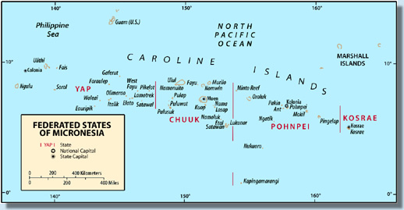
The island of Pohnpei is located in the East Caroline Islands at 7° North Latitude and 158° East Longitude. Pohnpei is 3,200 miles west-southwest of Honolulu and 300 miles south of a line between Honolulu and the Philippine Islands. Pohnpei is the capital island of the Federated States of Micronesia, 307 miles west-northwest of Kosrae and 400 miles east of Chuuk. The state consists of the main island of Pohnpei, plus five outer island municipalities: Mwoakilloa, Pingelap, Sapwuahfik, Nukuoro, and Kapingmarangi. There are five village areas on Pohnpei. Kolonia, located on the northern side of the island, is the only major town on the island and is the site of the state of Pohnpei’s government offices, airport, harbor, utilities, and headquarters of most of the businesses. The village area known as Palikir, located on the western slopes of Pohnpei, is the home of the FSM capital.

The population of Pohnpei is 35,162. Approximately 90% of the state’s population lives on the main island of Pohnpei, and the remainder live in the outer islands.

Island Geography
Pohnpei is known as the “Garden Island of Micronesia”; it is a volcanic island with towering peaks 2,595 feet high and rugged interior. It is circular in shape and surrounded by a barrier reef. The coastline is a series of small bays, promontories, and an inter-tidal lagoon, with thick mangrove forest next to the island. The island slopes rapidly up to the inland mountains and is heavily timbered. Many of the trees are fruit–bearing, including breadfruit, mango, coconut, and banana. Pohnpei State consists of the high island of Pohnpei, 13 miles in diameter with a land area of 112 square miles plus 26 other small islets and atolls which together total another 21.3 square miles of land area, resulting a total land area of 133 square miles. Pohnpei has 331.4 square miles of lagoons and is the largest island within the Federated States of Micronesia (FSM).

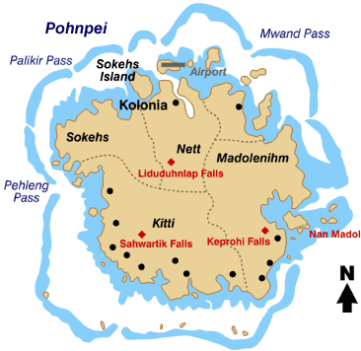
Island Geology
Pohnpei Island is the remnant of an extinct volcano that formed the island 5 million years ago. The land mass is black volcanic basalt. As the Pacific Plate moved from east to west over a “hot spot” in the earth’s crust, Pohnpei and the local outer islands were formed by outpouring of volcanic basalt to heights much in excess of the present mountains of Pohnpei. Islands to the east of Pohnpei, such as Kosrae are younger in age, and those west, such as Chuuk and Yap, are older. As the volcanic peaks wear down due to weathering, the weight of their massive peaks presses them downward, sinking below the waters’ surface, resulting in a ring of coral atolls. The Ant atoll is a prime example of the process. Pohnpei, being a very large volcanic dome, is in the middle stages of wearing down. The western slopes of Pohnpei are gentler, whereas the eastern slops are more pronounced. The soils are not particularly fertile, and farmers find placing lime on their soils can help the productivity. The soils are mostly chlotie, talcshist amphilobolite, conglomerate, and volcanic bracca.

Climate and Environmental Hazards
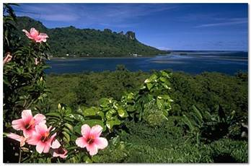
Pohnpei has a typical tropical climate, with daily temperatures ranging from a low of 80 to highs in the low 90s, with an average temperature of 82 degrees Fahrenheit. Humidity is high, averaging 85%. While it has been estimated that within Pohnpei’s high mountainous interior it can rain as much as 330 inches a year, the weather service in Kolonia Town typically measures annual rainfall of 180 inches per year, or approximately 15 inches per month. Runoff from the rains feed numerous streams and rivers that originate in the interior highlands. Typically, Pohnpei’s interior is almost completely cloud covered, and the island’s residents can expect most days to be partly cloudy, with periods of sunshine, overcast and rain. Records show that the island experiences approximately 125 partly cloudy days and 240 cloudy days each year, with sunshine only about 50% of the time. Totally clear skies may only represent one or two days per year. The ocean currents around Pohnpei are from the east and are part of the Northern Equatorial Current. The ocean temperature is 85°F on the surface. The area has some of the warmest ocean temperatures in the world. Pohnpei's close proximity to the equator, right in the middle of the intertropical convergence zone (ITCZ), substantially reduces seasonal weather change. Pohnpei is generally south and east of the typhoon belt, but periodically experiences short, severe tropical storms. Records show that destructive typhoons did strike the island in 1905, 1925, 1958, 1991, 1992, and 1997.

Energy Sources
Pohnpei, as is true of all the FSM States, is substantially dependent on imported fossil fuels. The major fossil fuel is No. 2 diesel oil, followed in importance by gasoline, and jet fuel. Pohnpei is 100% dependent on imported petroleum products as fuel for transportation and electric power generation. Mobil Oil provides the fuel supply for gasoline, diesel fuel, jet fuel and kerosene. The primary supply source for the Mobil Oil-furnished fuels are sources in Indonesia and Singapore. A private supplier, Pohnpei LP Gas Distribution Co. provides LP gas to the island. LP gas is shipped in from supply sources in Hawaii. It is used for cooking, water heating and industrial purposes. Prices have increased substantially in the previous 18 months for all types of imported fuels. Pohnpei government officials have joined with government officials from other FSM States, the Marshall Islands and the Republic of Palau in a Fuel Forum to investigate options for securing alternative sources of fuel supplies. The Pohnpei Utilities Corporation (PUC) is responsible for the generation, transmission and distribution of energy throughout Pohnpei State. PUC owns the river-run Nampil hydro facility that provides approximately 5% of the island’s electricity. A small amount of energy comes from photovoltaic household solar lighting applications that have been installed on several of the outer islands with varying degrees of success.

Energy Uses
The largest use of fuel in Pohnpei is diesel fuel for electric power generation. Gasoline and diesel fuel for transportation, including marine service, is also a major use of fuel. Pohnpei has emerged as the fleet headquarters for the Micronesian fishing fleets and therefore fueling the commercial fishing boats is another major use of fuel use in Pohnpei. However, many of the fishing boats refuel from fuel tenders on the open ocean.

Kerosene and liquid petroleum gases are fuels used for cooking in population centers and for commercial hot water heating. Renewable fuel use includes the widespread burning of wood and coconut wastes for domestic and school cooking; and some small renewable energy devices, mostly serving as performance testing systems. The use of electrical energy is divided between five main categories: residential (39%), commercial/industrial (22%), government (17%), utility (10%), and system losses (12%).

HISTORY, POLITICAL DEVELOPMENT AND PRESENT STATUS

Early Island History
The original settlers, who arrived about 3000 years ago, are believed to have been canoe voyagers of either mixed Polynesian or Malay descent. A fairly advanced culture thrived in Pohnpei during the time that Europe was experiencing the dark ages. A massive building complex called Nan Madaol was built by the early inhabitants at the edge of the coral reef along the southeastern shores of Pohnpei. The fortress-like structure, constructed out of hexagonal basaltic rock logs brought down from the remnant core of the volcano, includes courtyards, rooms, platforms and monuments. The complex has similar appearances to the structures of the early civilizations of Central and South America. Access to the complex was by water.

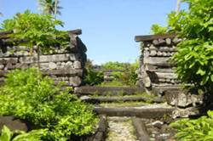
Nan Madohl Ruins

The Spanish discovered Pohnpei in the 16th century, but the islands became widely known only in the 1830s, when whalers used Pohnpei Island as a stop for provisions. After the American Civil War, whaling declined substantially and whaling ships were less frequent in Pohnpei. During the whaling period, Pohnpei was known as Ascension Island. Christian missionaries arrived in the mid 19th century and converted most of the population. The population now is approximately half Catholic Christian and half Protestant Christian. In 1881, Spain attempted to solidify its claim to Pohnpei by building fortifications and a small mission at the present site of Kolonia. Ruins are still evident.

Recent Island History
Germany purchased the island from Spain in 1899 and introduced private land ownership and plantation agriculture for economic development. Germany controlled and developed Pohnpei during the first decade of the twentieth century until the beginning of World War I. The Japanese quickly occupied Pohnpei in 1914 at the beginning of World War I as Japan entered the War on the side of the Allies. Japan continued oversight of the islands, and in 1921 the League of Nations mandated the islands to Japan. Pohnpei became the seat of the Japanese East Caroline administration and more than 8,000 Japanese nationals came to colonize and develop the island by introducing large-scale commercial agriculture and sophisticated fishing methods.

American forces bypassed Pohnpei during World War II, except for occasional bombing raids. In September of 1945 American forces occupied Pohnpei along with the other Caroline Islands. As with many of the Pacific islands, the wartime isolation from foreign supplies encouraged over-exploitation of land and marine resources, later hindering economic regeneration.

Through a United Nations mandate, Pohnpei became part of the United States Trust Territory of the Pacific Islands (TTPI) in 1947. After six years of United States naval administration, Pohnpei came under the civilian administration of the Department of the Interior in 1951 as the Pohnpei District. The years between 1951 and 1978 saw political evolution, educational growth, some infrastructure construction, but little economic development. During the late 1970s, Pohnpeians formed a local legislature and sent representatives to the Congress of Micronesia.

Political Development
In 1978, the people of the Trust Territories of the Pacific Islands developed a constitution, written by elected delegates, forming the Federated States of Micronesia government. In July of 1978, the people voted to accept the Micronesian constitution, thereby joining the FSM; the new state elected its own governor for the first time. Pohnpei now has full internal self-government under the Constitution of the Federated States of Micronesia. As part of the FSM, Pohnpei entered into the Compact of Free Association with the United States in 1986, whereby the FSM states received monetary and immigration benefits in return for granting the United States certain military and land use privileges.

Present Political Status
The Pohnpei state government follows the FSM form of government which is patterned after the U.S. government. The legislature establishes the laws and creates services that benefit the people of Pohnpei. The executive branch executes those laws and administers the various services of the government. The judiciary interprets the laws and maintains a statewide system of justice. The Pohnpei legislature is composed of 23 members selected from the five municipalities plus the five outer islands of Mwoakilloa, Pingelap, Sapwuahfik, Nukuoro and Kapingmarangi. The governor of Pohnpei is elected by the electorate.

United States Involvement
The United Nations granted trusteeship of Pohnpei to the United States after WWII. The first Compact of Free Association with the United States became effective in 1986 and provided funding that became the main source of income for Pohnpei from 1986 through 2003. The Compact was amended (referred to as Compact II) and provides for continued economic assistance from fiscal year 2004 through 2023. The bulk of assistance will be given in sectoral grants of Compact funds. The FSM will receive $76.7 million annually, plus another $16 million to be placed in a trust fund to meet future needs from interest from the funds proceeds. Funds are distributed on a formula and need basis to the respective states. Pohnpei receives approximately 26% of the proceeds from the trust fund directly for state purposes. However, since the FSM national capital is located in Pohnpei, the salaries, support functions and other expenditures are also beneficial to Pohnpei’s economy.

U.S. Special Island Programs
The Compact of Free Association enumerates a number of services and programs in addition to the “sector” grants enumerated above that the FSM is eligible to benefit from. These services and programs apply to the entire FSM. Many of them are well understood and will not be described in detail here; only aspects of them that are unusual or directly apply to Pohnpei will be mentioned:
- The United States Weather Service.
- The United States Postal Service. Until recently, Pohnpei enjoyed the benefit of using domestic U.S. postal rates between Pohnpei and the US. Effective in 2006, this benefit only applies to mail sent from the FSM to the US. Mail sent from the U.S. to the FSM must now utilize international rates. The difference between these two rates is very significant. In addition, it is now more complicated to ship to the FSM from the U.S. as it is no longer considered to be a domestic destination. Oftentimes a supplier might not ship out of the US, so it is now impossible to order from certain suppliers. This change is a problem on the personal level to people who order things from the U.S. and to small businesses that receive goods via the U.S. postal system.
- The United States Federal Aviation Administration.
- The United States Department of Transportation.
- The Federal Deposit Insurance Corporation (for the benefit of only the Bank of the Federated States of Micronesia).
- The Department of Homeland Security, and the United States Agency for International Development, Office of Foreign Disaster Assistance.
- Peace Corps. There are normally six to eight Peace Corps volunteers in Pohnpei. They serve in a variety of jobs although the majority serve as school teachers. Some are involved with a “Youth and Community Project.”
- USDA Rural Development Program. The USDA Rural Development program provides assistance in many areas. These include grants and loans for community facilities, grants and loans for rural utilities (electric energy, telecommunications, water, waste water and solid waste disposal), grants and loans for housing repair, and loans for new construction under the Rural Housing Services 502 Program. A major program in Pohnpei has been loans for private home construction. This has provided quality, reasonably priced homes for many in Pohnpei. Also, the grant program run by the same USDA office to provide for upgrade and maintenance funds for older Pohnpeians has greatly assisting the elderly, mostly the poor. As on other FSM islands this program may represent an untapped opportunity for funding for outer island communities in need of home construction, maintenance, facilities and utility services.
- Historic preservation.
- Red Cross.

POPULATION, EMPLOYMENT & WAGES

Present Demographics
According to the FSM 2005 Factbook, the estimated population of Pohnpei in 2005 was 35,162. It had increased from about 19,263 in 1973 to 34,486 as of the 2000 census. About 31% of the population of the FSM lives in the state of Pohnpei. About 90% of the people live on the island of Pohnpei; the remainder lives in the five outer islands. Pohnpei has a population density of 266 persons per square mile.

The annual rate of growth has declined significantly and is now estimated at just 0.4% per year. The population had been increasing at a rate of 3.7% during the 1980s and early 1990s. Birth rates continue to reflect the 3% to 4% rate, however the net increase in population remains at 0 .4% due to out migration of many of the younger Pohnpeians to the U.S., principally to Guam, Hawaii and the U.S. mainland. The population of Pohnpei is relatively young, with 53% under the age of 15, and 61% under the age of 25. The median age is 18.9 years.

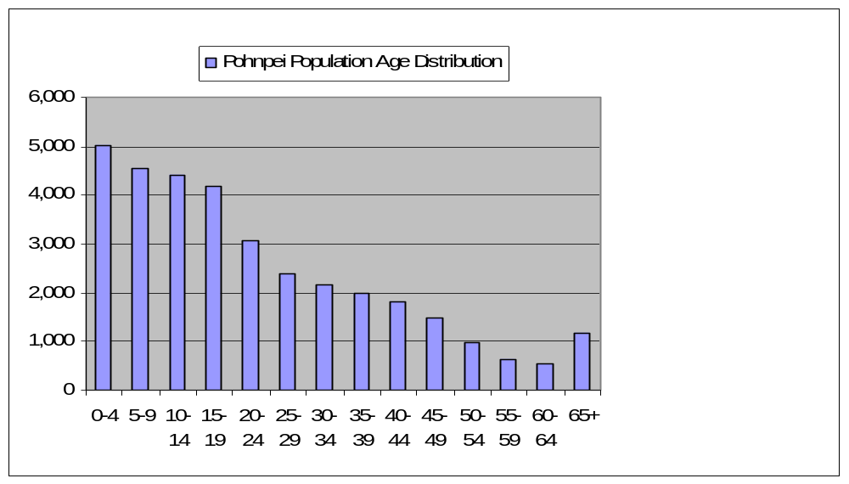

Figure 10-1

Employment and Job Market
According to the 2004 census there were 7,085 people employed in Pohnpei. The employers were, by sector; private, 2,938; public enterprise, 592; national government, 851; state government, 1221; municipal government, 327; non-governmental organizations, 221; and government agencies, 786, with the remainder employed by religious, volunteer and other organizations.

Gross Domestic Product
The Gross Domestic Product for Pohnpei in 2005 was $113.1 million and represented a per capita GDP of $3,217.

Personal Wages & Income
The average salary in 2004 was $7,792, and salary by the respective employment sectors was: private sector, $4,519; public enterprise, $11,351; national government, $11,393; state government, $10,652; municipal government, $4,137; non-governmental organizations, $6,044 and government agencies, $10,137. The minimum wage in Pohnpei is $1.35 per hour.

Special Employment or Employers
The FSM government is the unique employer for Pohnpei, drawing residents from each of the other states to serve in governmental and administrative capacities in the FSM. The Embassies of the United States, Japan and Republic of China are located in Pohnpei, each having a contingent of personnel attached to them.

General Business & Commercial Income
Pohnpei has the most broad-based business and commercial economy of any of the FSM states. With the FSM national government located in Pohnpei, there is a market for purchase of goods and services; wholesale and retail businesses as well as many professional service organizations are located there. Although exact figures were not available for the specifics of the business and commercial sector, there was evidence that the economy was operating reasonably well. While the new Compact II the flow of funds has lessened from the earlier Compact I and it has taken the economies of all the FSM states time to adjust, Pohnpei appears to have adjusted best.

ISLAND ECONOMY AND INFRASTRUCTURE

General Status of the Economy

The Gross Domestic Product of Pohnpei for 2005 was $103.6 million.

Major Employment Sectors
The FSM government and the state of Pohnpei are the major employers in Pohnpei. There is a state fishing fleet and often one or two foreign fishing fleets are seen in the Pohnpei harbor. Education, including the headquarters for the College of Micronesia, represents a significant segment of the employment in Pohnpei. Subsistence living is also a major form of employment.

Electrical System
The electricity is provided by the Pohnpei Utilities Corporation (PUC) in the state. PUC is a component unit of the government of the state of Pohnpei. It was established in 1991 by the Pohnpei State Legislature with the sole responsibility of providing electrical power for Pohnpei. The assets and liabilities of the Division of Public Utilities were transferred to the PUC. In 1993 the state of Pohnpei also transferred the assets and responsibility for water and sewage services to the PUC.

The PUC is governed by a seven-member Board of Directors, who are appointed by the governor with the advice and consent of the Pohnpei State Legislature. Four members of the board are selected from the private sector and three from the public sector.

The PUC is managed by a general manager, who is appointed by, and reports directly to the Board of Directors. The general manager has full charge and control of the PUC’s operations and maintenance and all personnel and facilities. He is responsible and accountable to the Board of Directors for the effective conduct of PUC’s operations in accordance with the PUC Act and within the framework of policies and budgets approved by the Board.

The PUC organization is divided into four divisions: administrative and general, generation, distribution and water/sewer. There are approximately 200 employees of the PUC.

The PUC generates electric power with diesel engines at the plant on the northern end of the island of Pohnpei and distributes electrical power to an estimated 95% of the population. Power is delivered throughout Pohnpei via four 13,800 volt distribution circuits that extend from the power plant. The PUC also has a small 1.8 kW hydroelectric turbine that provides approximately 5% of the islands electricity. The cost of electricity in Pohnpei is approximately $.30 per kWh, including fuel costs. Pohnpei purchases its fuel from Mobil Oil, with present prices being approximately $2.65 per gallon.

Water and Wastewater Systems
Pohnpei’s water system is owned and managed by PUC. Over the last few years the potable water system has been expanded to include all of Kolonia, and most areas within three other municipalities. The expansion has included part of Madolenihm, and the transfer of the capital water system from the FSM government to the utility to manage and operate. Water collection is by river diversion and multiple wells. Wastewater management, collection, and treatment are limited to the population center of Kolonia and the surrounding areas.

Transportation System
Most of the transportation in Pohnpei is by private vehicle and by small boat to the five outlying island areas. Pohnpei has a good taxi service to provide public transportation services if a private vehicle is not available. There are no established regular bus services on any of the FSM States. The road system in Pohnpei is in reasonably good shape and well-maintained.

Port and Port Industries
The Pohnpei Port Authority (the Authority) was established by the Pohnpei State Legislature and its primary purpose is to oversee the use and maintenance of Pohnpei State’s sea- and airports. The Authority is managed by a seven-member board, consisting of representatives of the Pohnpei State Government appointed by the governor to four year terms. The daily operation of the Authority is delegated to a general manager, who is appointed by and serves at the pleasure of the Board. The general manager is also responsible for the development of the port facilities and the industrial zone located on Dekehtik.
The Pohnpei Fisheries Corporation operates out of the port area. It previously had a fish processing facility at the port but that facility is no longer operating, the result of an inconsistent supply of fish.

Airport and Aviation Industries
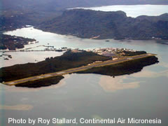
Continental Airlines provides service to Pohnpei. Pohnpei has a 6000 foot runway, 150 ft. wide, constructed of asphalt, and is in good condition. The airport is located north of the village of Pohnpei on the north side of the main island. The airport has the capability of accommodating double tandem wheel aircraft up to 290,000 lbs. Mobil Oil provides fuel at the airport.
There are an average of 210 flight operations per month at the Pohnpei airport with 62% commercial, 28% air taxi, 5% transient general aviation and 5% military. Continental Micronesia has flights from Guam stopping in Pohnpei en route to Hawaii on Mondays, Wednesdays and Fridays, and flights from Hawaii to Guam stopping in Pohnpei on Tuesdays, Thursdays and Saturdays. They also have a turn-around flight from Guam to Chuuk and on to Pohnpei on Sunday evenings.
There is design work underway for an airport expansion. Upon completion of the runway extension to 8000 feet, the Pohnpei runway will be capable of servicing Boeing 767 aircraft with direct service from international destinations such as Honolulu, Tokyo, and Brisbane.

Communication System
The FSM Telecommunication Corporation, the FSM-owned communication company headquartered in Pohnpei, serves the telephone, cell-phone and internet system for the island. Cable TV in Pohnpei is served by a separate provider. Pohnpei is a shareholder in FSM Telecom. The system provides most households with access to a telephone. Telephone and cell phone service is good, although cost of long distance service is one of the highest-priced international call rates. Internet service is very poor with data transmission speeds maximum at 28k baud and often lower. There is a fiber optic cable being planned to connect Guam and Kwajalein Island in the Marshall Islands and FSM Telecommunications is expected to obtain a lateral tap. This will substantially help Pohnpei and FSM’s entire data transfer rate.

Tourism Industry
Tourism is an important element of the Pohnpei economy. Pohnpei enjoys a better tourism and visitor economy than the other states of FSM because of the visitors and businesses associated with the national government. In 2004 Pohnpei had a total of 8,784 tourists, visitors and business arrivals, with 4,661 being tourists or people visiting relatives or friends, 2,722 people arriving for business purposes, 247 arriving as volunteers or associations with religious organizations and 1,154 mostly transient visitors classified as seamen and crew members of the ships docking at the Pohnpei harbor.

Major Industry
With the opening of the Tuna Commission facility on Pohnpei, it is expected that there will be an increased need for housing as several of the regions larger fishing operations have indicated that they are interested in relocating their headquarters to Pohnpei.

Military
There is no military presence on Pohnpei except for the Coast Guard contingent of less than 15 from Australia that serves to assist the FSM in patrolling FSM waters.

Other Special Economic Elements
The national government center in Palikir is the one significant special economic element for the state of Pohnpei. It is hoped that the new Tuna Commission will be an important element of Pohnpei’s future. The basing of the FSM fishing fleets, including fishing fleets from foreign countries, provides an added economic base to Pohnpei’s economy.

Manufacturing, Craft, Trade
Handicrafts are made primarily for the tourist market and there is little export of the crafts. Although the size of the craft trade is not large, and adds only a limited amount to the Pohnpei economy, the existing sales are a mainstay of livelihood for many individual families. There are no significant manufacturing companies operating in Pohnpei.

Agriculture
Agriculture is also a main element of the economy of Pohnpei, but it has not developed to be a major export industry. Many people still live a subsistence type life in Pohnpei but not to the extent as on the other FSM island states. Pohnpei has a small copra business, particularly helpful economically to the outer islands. The copra is processed in Pohnpei and sold locally for fuel to diesel trucks and cars and a business has emerged using coconut oil in health care products. The state provides free transportation of the dried coconut (copra) from the outer islands to the processing facility in Pohnpei. The present price for copra is 7 cents per pound; therefore, the collection and drying of coconuts for sale as copra is not a viable business in areas where more competitive wages are available, but it does provide cash income for outer island residents who have little other means of earning cash.

Aquaculture, Fisheries
The FSM fishing fleet harbors in Pohnpei, as do several transient Chinese and Taiwanese fishing fleets. There are also normally a purse seinier ship in the Pohnpei harbor or fishing the waters of the FSM around the Pohnpei area. There is a sponge farm operating in Pohnpei, as well as a venture to raise black pearls in the outer island of Nukuoro.

Waste Management Systems
Wastewater management, collection, and treatment are limited to the population center of Kolonia and the surrounding areas. Wastewater is discharged directly into the outer reefs with only limited treatment.

ECONOMIC DEVELOPMENT PLANS AND PROJECTS

General Status of Economic Development Planning
Little information was available on the status of Pohnpei’s economic development planning. The state of Pohnpei depends heavily on the FSM government to make all of the major decisions and the state follows the plans of the FSM.

Economic Development Approach and Special Issues
Pohnpei’s economic development policy is to promote foreign investment ventures which are harmonious with its development goals, specifically business activities that will provide additional goods and services, employment opportunities, and responsibly develop Pohnpei's natural resources and attributes. While both English and Pohnpeian are the official languages, nearly all business and governmental work is conducted in English. The currency is the U.S. dollar and exports to the United States are duty free. Pohnpei's workforce is also suited to investors; the minimum wage is $1.35/hour.

Focus Areas
Other than increasing Pohnpei’s central location and infrastructure capability to serve the fishing fleet and to serve as the political center of the FSM, no other specific focus areas were identified.

Energy Considerations
The high cost of petroleum products and the complete dependence on imported fuel are Pohnpei’s principal energy concerns. Over the last ten years the cost of diesel fuel has risen over 300%, with global forecast indicating that this trend is expected to continue into the foreseeable future. As part of the 1996 tariff adjustment, the utility adopted a fuel surcharge to cover its fuel cost, based upon the utilities’ early 1990s average engine efficiency of 12.5 kWh per gallon of diesel fuel. As a result, while the high cost of diesel fuel for power production is a continuing problem, the fuel surcharge provides a rate that is adjusted monthly to cover the rising cost of the utilities fuel supply.

Economy Diversification
The economy of Pohnpei is probably the most diverse of any of the FSM states, primarily because Pohnpei is the site of the national government and benefits from all of the service businesses and headquarter activities that are coincident with government centers. Except in outer islands and rural areas, the economy of Pohnpei has emerged as a reasonably well-functioning cash and market society. There are still significant land and “tribal” customs that have an effect on the economy.

Import-Export and Balance of Payments
The figures for Import and Export, and Balance of Payments were not available. The Gross Domestic Product for Pohnpei in 2005 was $113.1 million and represented a per capita GDP of $3,217.

Status of Energy Systems

Major Energy Uses
In Pohnpei the major energy use is the generation and delivery of electrical power. In 2004 approximately 3,100,000 gallons of diesel fuel were used by the Pohnpei Utilities Corporation to produce approximately 40,465,000 kWh of electrical energy.

The other high energy intensive industry in Pohnpei is the fishing fleets. A breakdown of the fuel used by the fishing fleets was not available at the time of completion of this report:

Table 10-1

Fuel import into Pohnpei, FSM, in Gallons
Fuel Type | 2000 | 2001 | 2002 | 2003 | 2004
Jet A | 968,011 | 529,573 | 668,194 | 479,635 | 1,053,271
Diesel | 4,843,223 | 4,650,884 | 3,247,410 | 3,036,197 | 6,304,354
Diesel-Electric | N/A | N/A | N/A | N/A | 3,100,000
Gasoline | 1,939,842 | 3,241,946 | 2,700,344 | 1,439,943 | 2,366,733
Data from FSM Statistics Factbook

Electric Power System

The electrical power system is a diesel engine-based electrical production system with the power plant located at Nanpohnal, south of the principal community of Kolonia. There is one small hydro electric plant, with opportunities for additional hydroelectric at other locations around Pohnpei. The distribution system is 13,800 volt three phase and is distributed throughout the island on overhead, mostly concrete poles. Presently, the PUC’s primary distribution system is available to approximately 95% of the island’s communities/residents. The PUC uses No. 2 diesel fuel as the primary fuel source. Mobil oil is the supplier from its fuel depot and storage facility at the harbor north of the village of Kolonia. Fuel presently represents approximately 70% of the cost of production of electricity.

The present electrical power production on Pohnpei is adequate to meet capacity. Production has been reliable.

The high cost of petroleum products and the complete dependence on imported fuel are Pohnpei Utilities Corporation’s principal concerns. With the inclusion of the monthly fuel adjustment tariff, allowing the actual cost of fuel to be passed on and charged to the customer, the uncertainty of collecting revenue sufficient to finance operation has been greatly improved. This has allowed the PUC to maintain a strong financial structure in order to provide necessary maintenance of the system and to provide expansion as necessary.

The PUC currently operates two sub-stations, SS-1 at Nanpohnmal and SS-2 at the Nampil Hydro Facility.The utility has also sited a future sub-station (SS-3) in the Dekehtik industrial zone operated by the Pohnpei Port Authority. SS-1 is located at Nanpohnmal (NPP), next to the three power plants. SS-1 has three 4.16kV-13.8Y/7.97kV-power transformers, 5-MVA, and two 7.5MVA units providing voltage transformation for NPP1, NPP2, and NPP3 respectively. At 4.16-kV, each power plant is operated independently and a tie does not exist that would allow the generation potential of a plant to be rerouted in the event that a power transformer were to fail, a situation that could mean the loss of 5-MW of generation potential for the utility to meet the island’s demand. The utility does not stock a spare power transformer.

Each of PUC’s four feeders originates at SS-1, through reclosing circuit breakers. Feeder #1 (Eastern) originates at SS-1 and provides power to the eastern side of the island. critical loads include the Pohnpei State Hospital. Feeder #2 (Western) originates at SS-1 and provides power to the western side of the island. Critical loads include the FSM Capital Complex and the College of Micronesia FSM Campus located in Paliker. Feeder #3 (Kolonia) originates at SS-1 and provides power to the Nanpohnmal area and Kolonia Town. Feeder #4 (Dekehtik) originates at SS-1 and provides power to the Dekehtik port and industrial area. This feeder has been designed for future use as a 35-kV transmission line, and is intended to tie SS-1 and SS-3 together. Critical loads include the Pohnpei International Airport, and the Pohnpei Sea Port facilities.

SS-2 is located near the Nampil hydro facility. SS-2 is a package dry type sub-station rated for outdoor installation, which operates at 480V – 13.8Y/7.97kV. Power generated by the Nampil hydro facility is dropped directly onto the Eastern feeder, as no transmission lines are available.

SS-3 provides power to the Dekehtik industrial zone. It has been used for voltage regulation in the past. It is currently out of service as the industrial load within the Dekehtik zone has been dramatically reduced due to slowdowns in processing of fish at the Pohnpei Fisheries Corporation facility.

Transmission

Currently there are no transmission lines in operation on Pohnpei.

Distribution
The operation voltage of the distribution system is 13.8Y/7.97 kV, with a multi-grounded neutral. The system is predominantly of overhead construction consisting of pre-stressed concrete and treated wooden poles, REA standard pole top construction, and bare ACSR conductor.

The distribution system consists of approximately 250 miles of overhead lines broken into four feeders. Feeders are synchronized and interconnected with 28 manually operated loadbreak switches to facilitate sectionalizing. There are three-fixed capacitor banks totaling 525 kVAR located on these feeders that are used for power factor correction and to improve voltage regulation. Distribution system losses average approximately 12.5%.

Step-down transformers are installed as required to support secondary loads, residential, light commercial, and industrial. The utilities customer breakdown is as follows: 88% residential, 10.8% small commercial/small government, 1% large commercial/government, less than 1% industrial. The utilities standard is that secondary conductors can be extended 1,000 feet. It should be noted that 120/240 V secondary voltage control can not be maintained effectively at this distance.

Operational Issues
Cross-subsidies to support the development and expansion of the water system, the installation and operation of street lights, and insufficient fees for customer hook-ups and other services are a drain on utility money normally set aside for maintenance of the engine generators and distribution system.

Generation Facilities
The Pohnpei power system consists of three-diesel power plants located at Nanpohnal (NPP). NPP Unit 1 was built in 1977 and currently houses three Caterpillar model 3516 engines rated at 1.15 MW each. NPP2 & NPP3 were built in 1991 and 1994 respectively. Each plant houses two Daihatsu DS12 series engine generator sets rated at 2.5 MW each. The Nampil hydroelectric facility is in the final stages of re-commissioning and is scheduled to be returned to service by mid-2006. The Nampil plant is a run-of-river facility with a maximum output of 1.8 MW.

Total installed capacity of the PUC electrical system is 15.25 MW, with a firm capacity of 8.5 MW with one machine down for maintenance, and one machine on stand-by. Additionally, due to the characteristic of the run-of-river Nampil facility, it cannot be considered as firm load, as its availability is based on river flow. Average daily peak demand is 6.5 MW (2004), or 43% of rated capacity and 76% of firm capacity.

Hydro-Electric
Prior to World War II, the Japanese operated a hydroelectric system on the Nampil River. Today this is the site of PUC’s Nampil hydropower plant, built and commissioned by the Corps of Engineers in 1987. Since the early 1980s a great deal of interest has been focused on hydro technology. Various groups, including the United States Army Corps of Engineers, the Japan Consulting Institute, the United States Committee on Energy and Natural Resources, the Trust Territory Office of Planning and Statistics, and various private consultants have submitted feasibility and assessment studies of the major rivers on Pohnpei. Rivers included in these studies are the Lehnmesi (Pohnpei’s largest river), the Senpen, the Nampil, the Mand, and the Krictlang. While much of the data collected is now old and dated, it is believed that hydro potential on Pohnpei remains viable, with future development potential in excess of 5 MW.

The United States Army Corps of Engineers’ Nampil plant was commissioned in 1987 and provided between 5 and 10% of the islands power demand based on run-of-the-river design criteria. In 2000 the facility was flooded during a storm, and rehabilitation of the plant is just being completed. The unit is scheduled for operation in mid 2006.

Fuels
The Pohnpei Utility Corp. utilizes No. 2 diesel for generating electrical power. PUC purchases their fuel from Mobil Oil Corp. Mobil purchases the bulk of their fuel from refineries in Singapore. In 2004 PUC purchased approximately 3.1 million gallons of fuel and generated 40,465,000 kWh. The state of Pohnpei, in cooperation with the FSM national government, is exploring the possibility of securing a second fuel supplier for the region in an effort to introduce competition and thereby help hold down the cost of fuel.

Electric Production and Use

Existing Renewable & Alternative Power Production
There are presently no operating renewable energy systems in Pohnpei.

Existing Conservation and Demand Side Programs
The Pohnpei Utilities Corp. provides a limited public relations program to educate the public about the conservation of energy and the efficient use of their electrical energy. The major demand side program has been the installation of cash power meters on approximately 85% to 90% of all residential customers. Cash power meters allow people to observe the use of electricity via the electronic readout and keypad device mounted inside the home, becoming much more aware of their electrical usage. PUC officials believe that the cash power meters have resulted in at least a 3% reduction in consumption on the homes where the units have been installed.

Regulatory, Environmental Issues
Pohnpei has adopted environmental regulations along similar lines as the U.S. EPA. The PUC operates within and is in compliance with the regulations of the state’s environmental laws. The only significant environmental issue with the electrical system in the past several years has been the removal and disposal of transformers with PCBs. The PUC has removed all transformers that had traces of PCBs and have arranged for those transformers to be properly disposed.

Transportation

Fuel Use
There is no accurate information on transportation fuel use available other than the gasoline and diesel fuel used in vehicles as listed above in Section 1.6.1.

Fuel Types and Costs
Fuel for transportation is gasoline and diesel fuel. When this report was being prepared, the cost of gasoline was $4.00 per gallon and diesel fuel was $3.90 per gallon.

Reducing Transportation Energy Use
Pohnpei has a reasonably fuel efficient transportation system with individual private vehicles. The established speed limit is either 25 or 30 mph. Private vehicles are often pickup trucks or small flat bed trucks and large groups of people often ride together in these vehicles.

Commercial & Industrial

Tourism
The tourism industry is not an industry where programs to reduce the use of fossil fuels is easily identified. Tourism travel to Pohnpei is very fossil fuel energy-intensive by virtue of the nature of the location of the Pohnpei. However, the airlines already practice minimizing the use of fossil fuel in their efforts to maximize profits in their respective operations

Manufacturing
There is no energy-intensive manufacturing in Pohnpei where programs designed to reduce the use of fossil fuels would be effective.

Military
There is no military operating in Pohnpei.

Fisheries
The fishing fleets operating out of Pohnpei harbor are major users of diesel fuel. However, most fishing fleets are very observant of the most cost effective methods, technologies and engines that will provide the service needed for the fishing fleet at the least cost. Therefore, it is not anticipated that there will be any significant programs that could help in reducing the use of fossil fuels in the Pohnpei fishing fleets.

Local fishing is done by resident fishermen utilizing small 18 foot fiberglass boats and small two stroke engines that are relatively efficient. It does not appear that programs to help reduce fossil fuel used by the local fishing boats would be effective.

Alternative Energy Opportunities

Cogeneration
There may be some opportunities for cogeneration with the larger governmental and institutional facilities in Pohnpei. With the national government located in Pohnpei, larger facilities are more common there than in the other island states of FSM. The College of Micronesia campus is also located in Pohnpei and has several larger buildings and clusters of classrooms that could be candidates for a cogeneration system whereby a diesel-electric generator could be used with the exhaust heat being extracted for use in an absorption chiller for chilled water used for air conditioning. Similar application could serve hospitals, larger resorts and other significant facilities.

Alternative Fuel Systems
The present use of No. 2 diesel fuel is the only reasonable fuel to use on a small island such as Pohnpei. The technology, the vendors supplying the prime mover engines, spare parts and service as well as the technological knowledge base of the skilled personnel available in Pohnpei is all based on diesel engines. Heavy fuel oil such as No. 6 is not a viable option due to the cost to ship the fuel on specially outfitted tankers and the storage and care for the fuel on site. Other types of fuel such as coal, petroleum coke and other more difficult fuels to utilize require energy conversion systems that are more expensive and more complicated than can economically be utilized on an island where the electric loads are very small. Natural gas is not available and the cost for transporting, storing and changing some of the electrical generating equipment to accommodate natural gas would be uneconomical

Supply Side Efficiencies
In developed country utilities, the average power systems losses for a utility with only a generation and a distribution network are estimated at approximately 10%. Nominally, these losses are accounted for in generation, 5%; and distribution, 5%, with non-technical losses less than 1%.
In a preliminary study conducted in 2001, the overall power system losses for the Pohnpei Utility Corporation (PUC), were estimated to be 13.8% of the total energy generated. This included generation, distribution and non-technical losses. It should be noted that some data is lacking such as the number of transformers or the types of conductor used. As a consequence, several approximations were used to evaluate the losses. The error on this figure is difficult to quantify and therefore the results should be carefully used, although it does represent system losses that are far in excess of what is acceptable.
To reduce the import of fuel, it is considered imperative to reduce these system losses. It is recommended that a detailed quantified system loss study be conducted for PUC, as a stage 1 project. This project would measure and collect the electrical data characteristics of the power system, and then determine the losses. Once these losses have been quantified, then stage 2 of this process would be to assess the need for updating existing energy inefficient equipment (examining financing mechanisms as appropriate); establishing Government legislation that makes electricity theft a crime; and review the maintenance practices in the power plants.

Findings and Recommendations
The present electrical power production on Pohnpei is adequate to meet the state’s capacity requirements. Production has been reliable, but, the utility’s use of electrical revenue (cross-subsidies) to support the expansion of the island’s water system remains a threat to the stability of its generation and distribution systems as monies for maintenance are reduced.

PUC currently operates three (3) diesel-generating plants located at Nanpohnmal, utilizing four (4) Daihatsu diesel generators (installed in pairs in 1991 and 1993 respectively) rated at 2.5 MW each, three (3) Caterpillar diesel generators rated at 1.135 MW each, and two (2) hydroelectric generators with a combined capacity of 1.8 MW. Total installed capacity is 15.25 MW, with a firm capacity of 8.5 MW with one machine down for maintenance, and one machine on stand-by.

The Pohnpei Utilities Corporation is prepared to proceed with the construction of a new generation plant for the island. Currently this project is being held up due to the need of relocating the dump prior to beginning construction on the site. It is expected that this delay will continue in the foreseeable future and is therefore suggested that the utility reconsider it plans. It is recommended that the utility reconsider its Nanpohnmal site and upgrade the NPP1 facility as required, to house its expanded generation requirements. This would solve the island’s near-term demand problem, provide plant consolidation, improve generation efficiencies, and be capable of immediate development. Additionally, this approach would reduce the utilities overall development cost by eliminating the need to revise the distribution system and the cost of moving the existing NPP equipment to the new site.

Hydropower offers the best near-term possibility to contribute to base load production. Since it was recommissioned in 1987, the United States Corps of Engineers’ 1.8 MW run-of-the-river Nampil facility has contributed between 5 and 10% of total generation when in operation, along with a net fuel savings. The Pohnpei Utilities Corporation has identified two additional sites suitable for hydroelectric power generation and is currently seeking funding for technical assistance, design development, and construction. It should be noted that due to the characteristics of Pohnpei’s rain run-of-the-river systems are not suitable for use as base load generation, as the utility can not control the systems’ operating parameters. A dam is required to capture the rains potential as the river rapidly rises and falls, providing a reservoir that can provide for continued operation between rains and after the river levels have fallen, in order for a hydro facility to be considered as base load generation. Furthermore, the existing Nampil facility could greatly expand its contribution (up to 20 to 25%) to the utilities current demand requirements with the addition of a dam and reservoir.

The government should also encourage private industry to develop, construct, and operate hydro generation facilities on Pohnpei, and pass required legislation to ensure that a fair market exists for the sale of energy to the local utility for distribution throughout the island.

Demand Side Efficiency
With a small budget, only one energy officer and no permanent support staff, the Pohnpei Energy Office has insufficient capacity to prepare and implement major energy programs internally. However, it should be noted that though undermanned, Pohnpei has the only energy office in FSM at either state or national level and the presence of that office has allowed Pohnpei state to access grant funding and provide technical support for the largest outer island electrification program in FSM. The office mainly acts as an international contact point for regional and donor energy programs, represents Pohnpei (and FSM) in overseas energy meetings and supports rural energy projects locally. Major public information programs, school visit programs and energy efficiency training programs for educators, commerce and industry are not possible with the resources available. Thus, the few demand side efficiency improvement and energy conservation programs as have been carried out in FSM have been funded and mostly implemented by external agencies. Both the energy office and the PUC indicate that the limited attempts at DSM through customer information programs and energy audits of commercial facilities have included no objective evaluation processes, so their effectiveness is not known.

Electrical Metering/Tariffs
Of the 5063 electric meters installed by PUC, as of May 23, 2006, 4172 of them are cash power prepayment meters. Though they can be programmed for different tariff rates, these meters provide only for a flat rate for each kWh delivered by the meter; thus, the energy efficiency improvements that can be promoted through tiered rates are not possible in Pohnpei. Household energy is the area where tiered rates can have the greatest effect but since 82% of households are now using prepayment meters that option is not available. There is some opportunity for tiered rates to have some effect on commercial (5% with prepayment meters) and government users (3% with prepayment meters) but given the large variation in size across the range of commercial and government loads, a tiered rate use is not appropriate as a tool for energy efficiency improvement.

Household Energy Efficiency Measures
The regional energy program of SOPAC (Fiji) has publications and information materials relating to household energy efficiency and energy education that are appropriate for use in Pohnpei. The U.S. Department of Energy also has a wide range of pre-packaged programs for education and many pamphlets and public information packages that have been prepared for household energy efficiency improvement and home energy conservation. Those can be used with some modification for Pohnpei conditions.

In the 2000 Census (see Table 10-2), about half of electrified homes (4154) had refrigerators and about 65% had a television. Those two appliances plus lights made up the bulk of electricity use in Pohnpei at the time of the census. Electric water heating was in less than 10% of households and electric cooking stoves in less than 15%. Since the 2000 census, the percentage of gas cooking has risen, mostly as a replacement for kerosene cooking. Air conditioned homes were about 8.5% of the electrified homes.
Table 10-2 – Household Energy Use (2000)
Energy Application | Number | % of Total Households | % of Electrified Households
Refrigerator | 1922 | 31.85% | 46.27%
Central air conditioning | 163 | 2.70% | 3.92%
1-room air conditioning | 250 | 4.14% | 6.02%
2 or more room a/c | 102 | 1.69% | 2.46%
TV&VCR | 2417 | 40.06% | 58.18%
TV Only | 279 | 4.62% | 6.72%
VCR Only | 34 | 0.56% | 0.82%
Electric stove | 597 | 9.89% | 14.37%
Electric water heater | 342 | 5.67% | 8.23%
Solar water heater | 15 | 0.25%
Gas water heater | 2 | 0.03%
Gas stove | 153 | 2.54%
Kerosene | 1795 | 29.70%
Open fire cooking | 1283 | 21.26%
Wood stove cooking | 1209 | 20.04%
Source: 2000 Census

A significant percentage of the air-conditioned homes and homes with electric water heaters are residences of diplomats and regional program officials that would be unlikely to be affected by Pohnpei energy conservation programs. For a Pohnpei household energy efficiency program to yield results, lighting and refrigeration should to be its focus, with lighting most likely to yield rapid and significant results. It is recommended that PUC implement a program to encourage the replacement of incandescent bulbs by CFLs and of magnetic ballast fluorescent fixtures by electronic units. Several Pacific utilities have had programs of this type that have been well received by households and have probably benefited the utilities by reducing the evening peak and delaying the need for added capacity, though no follow up data was collected.
A program to provide households information and/or assistance in improving the efficiency of refrigerators, freezers and air-conditioners through cleaning filters, fixing refrigerator and freezer door seals, cleaning condensers and other maintenance actions that can be done by homeowners is also recommended, as is a program to encourage the replacement of electric cooking stoves with gas stoves also could be of benefit to the PUC by shaving the evening peak load and providing for fuel savings.

Government and Commercial Sector
The FSM and Pohnpei governments’ use of electricity is high, with the FSM Capital Complex, the National Hospital and FSM Telecom the top three users of electricity from the PUC. Other large government users include the College of Micronesia and the water treatment plant. State government offices are not heavy energy users individually though collectively the air conditioning load is substantial. On the commercial side, usage is split between building loads for offices and hotels and the refrigeration and freezer loads that characterize the food wholesalers and retailers.
Table 10-3 – Top 20 Electricity Users
Energy User | kWh/mo
Telecomm | 116,160
Hospital | 111,600
FSM Capital | 104,880
Sokehs Shopping Centger | 63,720
College of Micronesia | 61,880
Leo's Store | 59,600
Palm Terrace | 49,800
Isamli Nakasone | 32,000
Wall Mart | 29,920
PUC Water P/Nanmal | 24,880
Village Hotel | 19,715
SDA School | 18,000
PUC Water treatment plant | 16,000
Ambros & Co Store | 13,921
Australian Defense Compound | 13,727
Australian Embassy Residence | 12,560
Bank of the FSM | 11,640
U.S. Embassy Office | 11,624
Source: PUC 2006

Although the benefits of energy efficiency improvements are generally well known to commercial property owners, the latest technical options available for efficiency improvement usually are not. Though investment in energy efficiency improvements can often yield a high rate of return, the small businesses of Pohnpei will need access to financing so that large cash outlays for the energy efficiency investment can be avoided. They also will need cash flows to remain unchanged or improved. This means that a finance program is needed that allows repayment for energy efficiency investments at about the same rate that savings accrue would be needed.

Finance and technical support to businesses for improving their energy efficiency are both needed. Programs to provide commercial and industrial energy audits have not caused significant investment in energy efficiency improvements in Pacific island countries. The small companies involved often do not have the technical capacity to specify, purchase and install the equipment. Cash flows may be negatively impacted by an energy efficiency investment despite the promise of long term savings. Programs that carry the process from audit through to investment and equipment installation are needed for government, industry and commerce.

Since the payback for many energy efficiency improvements can be on the order of five years or less, that should be sufficient financial incentive for their use. What appears to be needed is to put users together with companies specializing in the provision of energy efficiency improvements so that users can be supported through the audit, financing, specification, purchasing, installation and operation phases and do not have to allocate either existing cash or personnel resources to the task of energy efficiency improvement.

It is recommended that an energy efficiency specialist be put on staff at the Palikir Capital Complex to manage and over time improve the energy efficiency at the complex. The cost of the specialist should be more than covered by savings in energy that will result through ensuring that proper maintenance of energy systems is carried out, that replacement components provide high energy efficiency service and that new energy efficiency technology is put to use where appropriate. The specialist will need to not only manage technical systems but also work with occupants to establish and maintain user guidelines for energy use, particularly air-conditioning and lighting. The position should be one that has direct communication to a high level within government to help ensure that agreed-upon user guidelines are enforced and to access funds needed for energy efficiency maintenance and improvement.

As one of the largest energy users in the country, the National Hospital needs to be closely monitored for energy use and at the time of any equipment replacement, high energy efficiency units should be employed. All water heating should be done through solar and heat recovery from the air conditioning. Lighting should all be high efficiency CFL or electronic ballast fluorescent lights. When computers are replaced, “Energy Star” rated units should be specified and low power flat screen displays used. A staff member should be designated as an energy conservation officer and made responsible for maintaining and improving energy efficiency. That person should receive specialist training in energy management for buildings and offices.

Transportation Sector
Fuel for land transport is a significant energy use in Pohnpei. Employees of the FSM national government typically commute from surrounding areas, since there is little housing in Palakir. Fortunately, the distances traveled are relatively short, typically under fifteen miles round trip, so actual fuel use for commuting to and from work has been moderate despite the heavy use of private motor vehicles. Public transport is minimal, with no public buses and only a small fleet of taxis. Roads are congested at commuting times and are relatively narrow.

Sea transport is divided mainly between the government ships and outboard powered private boats used for pleasure, tourist transport and family fishing. Outer island use is almost exclusively for fishing and boats are powered by a 20hp or 40hp outboard engine.

For long-term land transport fuel efficiency improvement, consideration should be given to the provision of incentives for vehicle replacements to be diesel powered and more fuel efficient. Diesel automobiles currently in production provide fuel efficiencies much greater than their gasoline equivalent and are acceptable environmentally. Tourist boat operators that replace multiple gasoline fueled outboard engines with properly operated diesel engines can reasonably expect to find fuel use cut in half, and the engines to be more reliable with a lower maintenance requirement. Several Pacific, Asian and European nations have encouraged the switch to more efficient diesel vehicles by increasing the tax on gasoline and/or reducing the tax on diesel fuel to make the pump price for diesel fuel several percent lower than that for gasoline. The signal sent to the consumer is that diesel is the cheaper option even though the actual savings coming from a switch to diesel from gasoline power would be mostly due to improved fuel efficiency not the lower price of the fuel.

Building Energy Efficiency Standards
The small size of the state limits the resources available for implementing energy codes and, more importantly, enforcing them. The number of new building starts each year is small and few non-government buildings have large energy loads that are caused by the design of the structure leading to poor energy efficiency. That is not true, however, of government buildings, and it is recommended that government develop and enforce guidelines for public building construction that includes basic energy efficiency measures. Enforcing energy guidelines for construction is also important when buildings are funded by donor agencies with the design provided by overseas architects and engineers. Several Pacific nations have accepted grants or low cost loans for donor designed and built structures that have been found to be very expensive to occupy.

Appliance Energy Efficiency Standards
The appliance market in Pohnpei is too small to warrant a major investment in regulatory activities such as local appliance testing and labeling or the imposition of strict import standards for domestic appliances. Many appliances that are sold in Pohnpei already include energy labels but the information regarding the cost of use of the appliance is based on an assumed electricity cost that is around half that of Pohnpei. This makes the actual operating cost differential between appliances of different efficiency double that seen on the labels. Prospective buyers are more likely to choose the more efficient appliance if they are made aware of the greater operating cost difference that is actually the case. It is recommended that a system for helping consumers understand appliance labels in the local context be developed. Possible approaches include actually changing the labels to fit Pohnpei energy cost conditions, placing posters near the labeled appliances explaining the labels and noting that the costs shown should be doubled, explanatory stickers placed on the appliances alongside the labels or information brochures explaining appliance labeling handed out to PUC customers when bills are paid.

Energy Audits, Performance Contracts
Many programs to provide energy audits to large energy users have been tried throughout the smaller countries of the Pacific but the end effects have been small mainly due to the lack of ready finance for the proposed energy efficiency measures and the limited technical capacity of the end users receiving the audits to implement the proposed actions. There are no statistics to actually show the cost effectiveness of these energy audits but it is clearly not high. With the addition of follow on programs to support implementation of the measures proposed by the audits, such as are offered by ESCOs, the effectiveness of an energy efficiency improvement program in actually achieving benefits can be expected to be greatly improved, and a higher level of cost effectiveness attained despite the higher overall cost of an integrated audit and implementation program.

Although there is a local engineering firm that has from time to time provided assistance to clients in improving energy efficiency, a full service ESCO in Pohnpei is not likely to be profitable due to the small market for its services. The cost of bringing a foreign ESCO to Pohnpei to service the limited market is probably too high to be profitable. However, if the local engineering company could develop a business relationship with a full service ESCO in Guam or Hawaii such that the greater resources of the ESCO could be made available to local customers with marketing, auditing and support services by the Pohnpei company, full ESCO services might be marketable in Pohnpei.

RENEWABLE ENERGY

Solar
Other than the traditional use of biomass for cooking, the only renewable energy resource with any significant history in Pohnpei is solar. The resource is quite good (Table 10-4) and reasonably consistent over the year. The data in the table is from satellite measurements that average the insolation over an area approximately 70 miles square. Because the mountains of Pohnpei cause local cloud generation, the actual ground level solar energy level may vary a great deal from one site to another, so the satellite data for Pohnpei Island should be treated as a nominal value and adjustments made for local cloudiness conditions. Pingelap and the other outer islands of Pohnpei State are small and do not greatly modify the climate, therefore the satellite data can be considered as useable for the design of SHS for Pingelap or other outer islands of Pohnpei State that lie well away from Pohnpei Island.
Table 10-4– Solar Resource Pohnpei Island (7ºN-158ºW) kWh/m² per day
Month | Jan | Feb | Mar | Apr | May | Jun | Jul | Aug | Sep | Oct | Nov | Dec | AVG
Horizontal | 5.10 | 5.8 | 5.84 | 6.07 | 5.71 | 5.31 | 5.59 | 5.57 | 5.36 | 5.23 | 4.77 | 4.91 | 5.43
Optimum tilt | 6.00 | 6.42 | 5.99 | 6.04 | 5.98 | 5.68 | 5.95 | 5.66 | 5.30 | 5.62 | 5.50 | 5.88 | 5.83
Table 10-5 – Solar Resource Pohnpei State – Outer Islands (Pingelap) Lat 6ºN 161ºW
Horizontal | 4.92 | 5.57 | 5.59 | 5.83 | 5.30 | 5.08 | 5.36 | 5.57 | 5.37 | 5.34 | 4.71 | 4.80 | 5.28
Optimum tilt | 5.74 | 6.16 | 5.70 | 5.83 | 5.59 | 5.48 | 5.72 | 5.69 | 5.30 | 5.74 | 5.38 | 5.69 | 5.67
Source: NASA EOS Satellite data at http://eosweb.larc.nasa.gov/sse/

Solar Electric Generation
Pohnpei has the largest outer island PV electrification program in the North Pacific, with nearly 400 household installations made under the auspices of the Energy Office (65%) and the PUC (35%). All the programs have been directed toward islands other than the main island of Pohnpei itself. Installed systems as of 2005 included:

Mwoakilloa (1995) – Energy Office supported
44 SHS and a small solar refrigerator. SHS included one 80Wp panel, 105 Ah 27TM battery, France Total TR10 controller, three 13 W and one 8W tube light. The refrigerator included 180Wp of panels, two 210 Ah batteries connected for 24 V operation, two 13W tube lights and a France Total TRS140 refrigerator. All panels were roof mounted.

Pingelap (1998) – PUC Managed
129 SHS, 75Wp panels, Trojan 27TM 105 Ah 12V Batteries, Trace C12 controller, two 15W Thinlite #193 fluorescent tube lights. Approximate cost $190,000.

Sapwuahfik (1999) – Energy Office supported
105 SHS, pole mounted 75Wp panels, Trojan 27TM 105 Ah 12V batteries, Trace C12 controller and two 15W Thinlite #193 fluorescent tube lights. Cost approximately $210,000.

Lenger and Parem (2000) – Energy Office supported
Two islands within the Pohnpei lagoon were provided 64 SHS through $150,000 in funding from the UN Italian Trust Fund for New and Renewable Energy. Pohnpei state provided about $20,000 in in-kind value and local expenses. Lenger (17) and Parem (47) both received SHS with 100Wp of panel, 115V open cell battery, Trace C-12 controller and two 15 Watt Thinlite tube lights. Panels were roof mounted on 15 households and 49 were post mounted.

Pingelap (2001) – PUC Managed
Solar freezer installation. 2.4kWp of solar array charging 24 Trojan T-105 6V batteries connected as two 48V battery banks, 2-Trace C40 controllers, 1 Trace Inverter 4kVA, 2-Amana 22 cubic foot chest type freezers. Locally funded for about $90,000.

Island committees have been established to manage the solar electrification and technicians are trained by the Energy Office or PUC in maintenance. Although the installations under the PUC and Energy Office include a user charge of $5 per month plus a $10 installation fee, monthly fees are often not paid and non-payment does not result in disconnection or removal of systems. As is the case elsewhere in the Pacific, the local committees fail to collect fees and monies that are collected are often spent on other community activities, so when batteries need replacement there are insufficient funds to make the repairs.

Many of the PUC systems on Pingelap are not working because flights did not go to the island for around six months, no technical support was provided and the store of battery water ran out.
The Energy Office tries to visit each of its islands quarterly to provide technical support but does not have a budget to provide replacements for batteries, lights and controllers and about 40% of the installations are no longer operational.

Solar Thermal
A few solar water heaters are installed in urban areas of Pohnpei but their use is not extensive. This is largely due to the limited demand for hot water – less than 10% of homes have piped hot water – as well as to the high cost being quoted of a full service solar water heater (estimated at around $3,000 installed). Unless the demand for piped hot water dramatically increases and the cost of installing solar water heaters dramatically falls, programs intended to encourage domestic solar water heater installation are not likely to have much effect.

Though Pohnpei statistics indicate visitor arrivals of 20,000 or more, the great majority of those are crew on ships; actual tourist arrivals appear to be around 6000-7000. Tourist facilities on Pohnpei are mostly geared to business travelers and several hotels are among the “Top 20” electricity users. The high installed cost quoted locally for installing solar water heaters makes it difficult for even small hotels to justify their installation. It is suggested that the PUC contact the hotels and work with them to jointly request a Hawaii solar water heating company come to Pohnpei and quote on installations for a number of hotels at one time. A quantity purchase should reduce the cost significantly and reduce the pay-back time to five years or less. It is also recommended that the government budget the replacement of electric, oil or gas fired water heating with solar water heaters in hospitals, schools and other government facilities, preferably engaging in the quantity purchase arrangement proposed for hotels.

Solar thermal for electricity generation is not considered reasonable for Pohnpei due to the need for tracking type energy concentrating collectors that are unlikely to perform as well or as cost effectively as solar PV for power generation in the conditions present. Pohnpei Island has one of the highest rainfall levels in the Pacific and the high frequency of partly cloudy conditions makes the climate unsuitable for concentrating, tracking collectors.

Wind Energy
A “demonstration” wind generator was installed in 1982 near the ocean and on the side of the island not far from the airport. The site was not a good one for wind access and the system did not work well. It was destroyed during a typhoon.

Meteorological and satellite measurements indicate that the wind regime in Pohnpei is not of the highest quality for wind power but the geography of the island may provide “hot spots” for wind power and the resource should be further investigated. It is recommended that NREL or other facility with a good wind mapping capability be commissioned to do a prefeasibility study of the island and if it looks appropriate, prepare a wind assessment and wind map of Pohnpei Island.

Outer island use of wind power is unlikely to be successful due partly to the limited land area and its cover of tall trees but mainly to the difficulty of maintaining mechanical and electrical equipment in the outer island context. Solar PV is considered the most appropriate energy supply option for the outer islands.

Table 10-6 - Average Wind Speeds In Meters/Second – 10 Year Average
Dec | Jan | Feb | Mar | Apr | May | Jun | Jul | Aug | Sep | Oct | Nov | Avg.
7.73 | 7.18 | 7.02 | 6.18 | 5.54 | 5.09 | 4.09 | 3.87 | 3.98 | 3.88 | 5.30 | 6.77 | 5.54
Source: NASA EOS Satellite data at http://eosweb.larc.nasa.gov/sse/

Hydro Power
In the early part of the 20th century, hydro power was well developed on Pohnpei to provide both mechanical and electrical power for agricultural processing. Since World War II, most of those old installations have been abandoned as the economy changed. As the grid has extended around the island and as fuel has become more and more expensive, the opportunities for using run-of-the-river hydro to help save diesel fuel for generation become more and more economically interesting.

Pohnpei, with its interior rainfall of 200-300 inches per year and mountainous topography, offers opportunities for hydro development on several of its approximately 35 perennial streams. The small catchments and fast runoff that occurs – increasingly a problem as deforestation progresses – makes the streams highly variable in flow, ranging from almost dry to raging torrents in a matter of hours. Thus the streams are generally not practical for base load hydro power without large, very expensive and environmentally problematic storage ponds. Nonetheless, run-of-the-river hydro offers a reasonable trade off between reliability of power delivery and cost of installation.

One hydro-electric site that was initially developed by the Japanese in the 1930s on the Nanpil River was commissioned in 1988 with new intake and power house structures, not using the original Japanese structures, though they are still at the site. The generating capacity is 2.06 MW (one 725 kW and one 1,335 kW unit) with a maximum output reduced to 1.8 MW at maximum flow because of intake limitations. The design output was 4,000 MWh for a typical hydrological year but actual production has been considerably less. Because of dry periods and lack of water storage, Nanpil has not contributed to Pohnpei’s firm generating capacity. The penstocks were damaged several years ago so, the Nanpil facility has been upgraded. In May 2006, the renovated plant was undergoing initial operational trials and should be back on line by July.

In the early 1990s (PREA, 1992) there was a proposal to increase Nanpil’s catchment area at a cost of $6 million but the additional output was uncertain as hydrological data were limited and the idea was scrapped.

A U.S. Army Corps of Engineers study in 1981 identified several potential hydro-electric sites with three on the Lehnmasi river and one on the Senipehn river. They were not developed due to their distance from the existing grid, lack of access roads and the relatively high cost per kW for site development. The five sites appear to have a total of about a 4 to 5 MW peak potential with an average somewhat less than half that. During the two dry months, little power would be produced. The most promising power production site was on the Lehnmasi river and the Army Corps of Engineers recommended a full feasibility study be carried out but that has not yet been done.

Hydro sites that were deemed uneconomic in the 1980s and 1990s should be reviewed in the light of increased energy costs and developed if practical. Even though catchments are small and streams so variable in flow that they cannot be counted on for base load coverage, run-of-the-river development is relatively low in cost and minimally intrusive to the environment. It can provide substantial savings in fuel over its long operational life. Small hydro development offers the greatest renewable energy opportunity for fuel saving on Pohnpei and a careful re-examination of the hydro potential appears appropriate.

Biogas
There are chicken and pig farms on Pohnpei large enough to make manure digestion and biogas production cost effective. Fiji currently has a biogas demonstration program that includes designs that appear to work well for medium and small scale farms. Saipan also has had several biogas digesters installed in past years under USDOE funding and their experience is well documented, though none of those are currently operating. It is recommended that the Energy Office contact the larger pig and poultry farmers regarding the value of digesters both for farm waste disposal, manure conversion to high quality pathogen free fertilizer that can be sold locally and for the gas production that can in larger installations run a generator or in small installations provide cooking and lighting fuel.

Sewage and land fill gas do not appear to be suitable applications at this time. Should new installations be made, it is urged that biogas generation be considered in their design.

Biomass
Biomass remains the largest energy input to cooking in Pohnpei. Pohnpei is unusual in having a large number of wood stoves for cooking, though many households still cook on open fires. For Pohnpei Island and the mountainous outer islands, wood for cooking is readily available and there is no danger of fuel wood causing deforestation. Deforestation is indeed a problem in Pohnpei but it is due to agricultural clearing, not fuel wood pressures. For the atoll islands, biomass for cooking is also readily available though in a different form with coconut shells and husks, coconut fronds, mangrove wood and other small woody plants providing biomass.

There are no large scale agricultural or forestry processing industries on Pohnpei. Agricultural processing tends to be more family oriented and concentrated, industrial scale biomass waste is not available for power generation or process heat production. Should large scale coconut processing for biofuels become a major industry, the waste could become a valuable energy resource.

Biofuels
Table 10-7 – Copra production in Pohnpei State (1992-1997)
 | Total | Pohnpei | Mwoakilloa | Pingelap | Pakin | Sapwahfik | Nukuoro | Kapinga | Oroluk
1997 | 197.63 | 13.2 | 37.83 | 32.86 | 20.13 | 25.25 | 56.15 | 0.88 | 11.33
1996 | 199.55 | 6.68 | 49.06 | 20.13 | 18.27 | 63.34 | 19.3 | 14.08 | 8.69
1995 | 405.25 | 19.35 | 91.24 | 44.14 | 30.22 | 74.78 | 104.59 | 28.15 | 12.78
1994 | 182.83 | 9.32 | 56.05 | 3 | 15.11 | 43.26 | 42.49 | 11.49 | 2.12
1993 | 369.29 | 11.75 | 88.8 | 88.8 | 50.56 | 53.66 | 64.74 | 8.38 | 2.59
1992 | 177.81 | 18.63 | 27.53 | 14.75 | 33.9 | 2.95 | 55.79 | 19.61 | 4.66
Source: Pohnpei State Office of the Governor

Most copra production comes from the atoll outer islands, and is one of the few sources of cash income available to those islands. Production is much lower now than in the post-war–to-1970 period, partly due to a lower real value of copra and partly to higher expectations for labor payment. Though the price of copra has been relatively stable for some years, the cost of living in Pohnpei has steadily risen and labor costs with it. Therefore, the incentive to cut copra for cash is less each year. Coconut oil for biofuel provides a real hope for increased outer island income but the price of petroleum will need to continue to rise to encourage replanting of trees and significantly increased production. However, even at current production levels, the saving in imported fuel is of interest and large users of diesel fuel, notably PUC and the inter-island ships, should be looking at the practicality of using a blend of coconut oil and either diesel or kerosene so that a local oil industry can get on its feet and prepare for much larger scale production in the future when oil prices increase further.

A local oil producer has shown an interest in biofuel production from coconut oil and has a current trial production of about 150 gallons per eight hour day. The company is using coconut oil to fuel the company owned flatbed truck and also selling the oil as vehicle fuel to a few island customers. There has been a great deal of work in other Pacific countries on biofuel from coconut oil (Vanuatu, Fiji, Samoa, the Solomon Islands and the Marshall Islands) in testing various types of engines, developing production processes, establishing institutional structures for biofuel production, marketing it as fuel and analyzing the economics of coconut oil for fuel. It is strongly recommended that Pohnpei State join with the other Pacific islands in sharing their biofuel successes and working to avoid repeating other’s mistakes.

Ocean Energy
Although reasonable OTEC sites are present in Pohnpei state, the lack of commercial experience makes them unreasonable for use in FSM. Only after OTEC has been proven to be capable of reliable power generation in an environment similar to that of FSM and at a kWh cost that is comparable to diesel power, should OTEC be considered.

Ocean Thermal
There is no known geothermal resource on Pohnpei and even if present is unlikely to be developable at a cost that is reasonable at the energy demand levels present.

Tidal
The tidal range (less than 4 feet) is not large, but the volume of water exchange between the open ocean and the lagoon area behind the reef is huge and in some cases the speed may be substantial. Trials of propeller type low velocity, high volume energy generators for marine use are currently underway and reef passages not used for navigation could be considered for supplementing the existing grid system for fuel saving. Since power lines on Pohnpei tend to follow the coastal road, access to the coast for a connection would not be difficult. However, the cost of installation and of the submarine cable needed for the connection will be high, as could the maintenance cost. Once this type of generation system is commercially available, a site survey and cost analysis would be reasonable.

Wave
There have been no resource assessments of wave energy in FSM. Once wave energy conversion equipment is commercially available an assessment of the resource should be carried out.

Federated States of Micronesia – Yap


General
Yap State is one of four states that make up the Federated States of Micronesia.

Location, Population and Geography
Yap State is situated between 6° and 10° North Latitude at 137° West Longitude, and encompasses approximately 500,000 square miles in the Western Caroline Islands. A mere 351 square miles covers land areas and lagoons. Of this, only 45.8 square miles is attributed to dry land, with Yap Island and outer islands covering 38.6 and 7.2 square miles, respectively.

Island Geography
The villages on Yap Island are located near the coast. The interior is grassy savannah and jungle. Much of the coast is covered with mangrove swamps. The only town is Colonia, the seat of government and home to the larger commercial establishments.

The state consists of 78 islands, of which 12 are located around Yap Island and 66 in the outer islands. Only 22 islands are inhabited on a regular basis.

Island Geology
Yap consists of 4 continental islands within a common barrier reef that is the result of an uplift of the Eurasian plate. The outer islands are either atolls or coral uplifts.

Climate and Environmental Hazards
Yap has an average temperature of 81º F which varies plus or minus 1º F throughout the year. The average annual rainfall is 141.8 inches.

Energy Sources
The primary sources of energy in Yap are imported petroleum products, namely unleaded gasoline, kerosene (JetA1), diesel fuel (ADO), and liquefied petroleum gas (LPG). No statistics are available for the importation or use of LPG. Biomass in the form of coconut husks are used as cooking fuel in many rural households.

Energy Uses
Petroleum products are used for transportation, production of electricity, and cooking. Electricity is primarily used for refrigeration, light, and communications.

HISTORY, POLITICAL DEVELOPMENT AND PRESENT STATUS

Early Island History
. The Yapese, because of their substantially different language, technology, social organization, and religious beliefs, are one of eight distinct Micronesian cultures. The Yapese, of Yap proper, speak a unique language apparently unrelated to any other Micronesian tongue. They probably came from southeast Asia and settled on Yap before the birth of Christ. They evolved a complex village and caste system founded on local warfare, which enabled them to extend their rule far into the Caroline Islands.

The Yapese are skilled builders and sailors. The huge limestone discs (used for money) the Yapese quarried on Palau 830 kilometers (250 miles) away and shipped to Yap on large canoes are evidence of their sailing prowess.

Diego DaRocha, a Portugese explorer, discovered the Yap Islands for Europeans in the 16th century, followed by various Spanish expeditions. Such explorations did not affect Yap until the American adventurer, David O’Keefe, organized successful commercial trade based on trepang (sea cucumbers) and copra. The Spanish contended with O’Keefe during the 1880s and finally established a Jesuit mission and administrative unit which wrested control and influence from the colorful adventurer. In the 1880s German traders moved into Yap to develop further trade and Germany eventually purchased the islands from Spain in 1899. By that time the Yapese population which had once numbered 50,000 had fallen to 2,500.

Recent Island History
Yap assumed new importance in German times with the laying in 1905 of an undersea communication cable connecting America with Asia. The Germans also dug canals, improved transportation, and upgraded public health facilities. With the outbreak of World War I, Yap was one of a number of German possessions seized by the Japanese. At the Paris Peace Conference (1919), Yap was awarded to Japan under a League of Nations mandate. Japan administered Yap until the end of World War II.

United States Involvement
.In 1945, the United States Navy assumed responsibility for the islands and made Yap a district of the Trust Territories of the Pacific Islands (TTPI). In 1951, the Department of the Interior assumed the administrative role.

Political Development
The Yap legislature was organized in 1969, with traditional councils for both the Yap high chiefs and outer island chiefs. Yap became a state in the Federated States of Micronesia in 1979 and achieved independence upon the dissolution of the TTPI in 1986.

Present Political Status
Yap has an elected governor, a lieutenant governor and a unicameral legislature. The judiciary is appointed by the governor with the advice and consent of the legislature. The Council of Chiefs serves as a forth branch of government and has veto power over any legislation which would adversely affect traditions and custom.

POPULATION, EMPLOYMENT & WAGES

Present Demographics
Between 1973 and 2000, the population of Yap State increased from about 7,900 to slightly over 11,200 (Figure 2.1). The population by region in 2000 was 7,391 (66 percent) on the central islands and 3,850 (34 percent) in the outer islands, a significant growth of about 4 percent on Yap Island and a decline of about the same proportion in the outer islands. The population grew by about 1.8 percent per year from 1973 to 1987, 1.4 percent between 1987 and 1994, and 0.1 percent between 1994 and 2000. Altogether, between 1973 and 2000, the annual population growth rate is estimated to be around 1.3 percent.

Figure 11-1

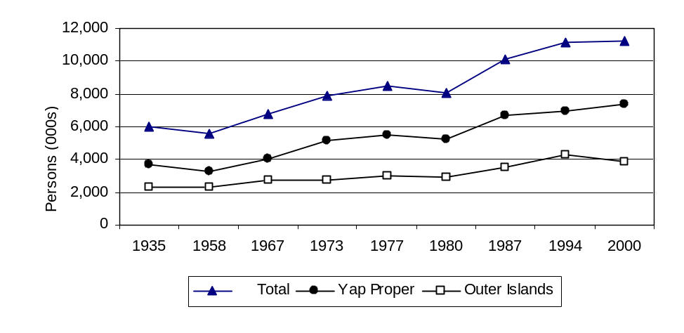
Yap State Population by Regions: 1935 to 2000

Population projections show that the total population will exceed 11,350 persons by 2010, an increase of only about 110 persons when compared to about 11,240 in 2000. The minor increase in the total population during the next ten years is attributed to the small annual growth rate of 0.1 percent used in the projections, primarily as a result of increasing out-migration from the state. Male and female populations also follow the same trend. The projection results show males increasing from 5,510 to about 5,560 persons, and females from 5,730 to 5,790 between 2000 and 2010.

Employment and Job Market
Employment in Yap State increased from 3,581 in 2000 to 3,680 in 2001, but has since dropped to 3,023 in 2004. During this period, private employment consistently outnumbered government employment, with the largest proportion (over 72 percent) found in 2000. Government employment, on the other hand, showed an average of about 1,075 employees during the 5 years period, with the highest proportion found in 2002 at over 36 percent.

Figure 11-2

Total Employment by Sector: 2000 to 2004

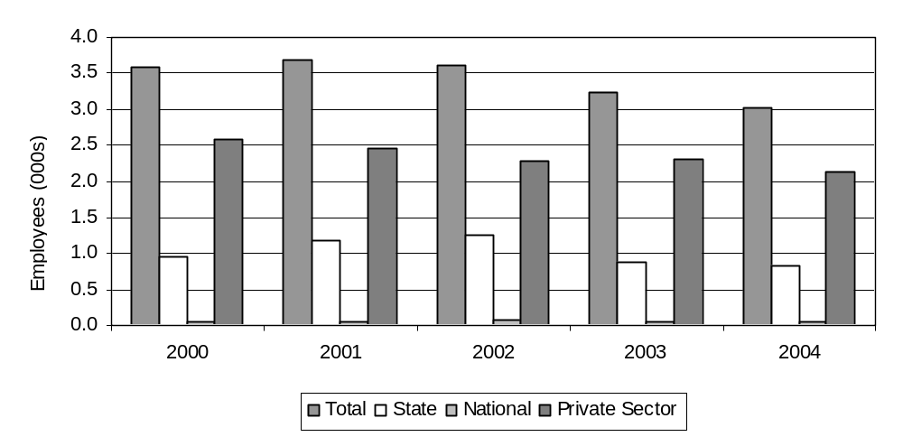
Gross Domestic Product
A recent analysis of the Yap State Gross Domestic Product (GDP) revealed a nominal GDP of over 34.3 million dollars for 2000. By 2004, the nominal GDP was estimated to around 37.9 million dollars. Nevertheless, when inflation rate was taken into account and the nominal GDP was adjusted to find the actual real GDP, a different picture emerged, with the real GDP showing an average of about 35 million dollars between 2000 and 2004. For 2004, however, the real GDP was projected to be around 36.7 million dollars, with the major contributing sectors being private industries (12.7 million dollars), households (9.3 million dollars), and government services (7.5 million dollars).

Figure 11-3

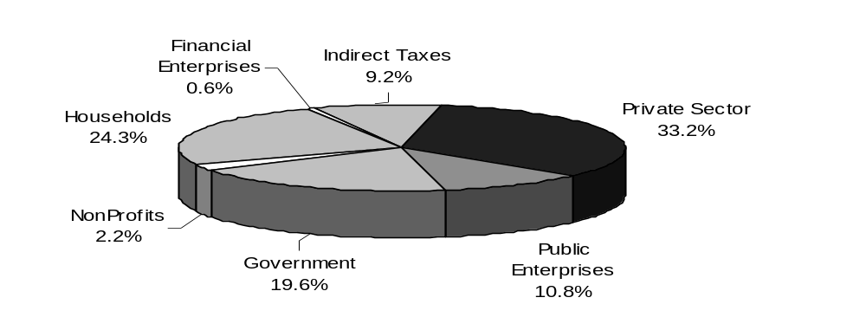
Yap State Gross Domestic Product by Major Sector of the Economy: 2004

Personal Wages & Income

Over 60 percent of all public employees between 2000 and 2004 had earnings that fell below 6,000 dollars per annum. In other words, more than half of all state government employees earned less than 6,000 dollars annually, with the highest proportions shown in 2002 at over 64 percent. By contrast, only about 3 percent of all state government employees were earning 20 thousand dollars or more during the same period. The disproportions found between low income and high income government employees were reflected in the overall low median income for the state, with an average of about $5,044. The highest median income was recorded in 2004 at about 5,200 dollars. The average mean income, on the other hand, was slightly higher, with an average of 6,605 dollars. The government does not maintain statistics on private sector employees.

Figure 11-4
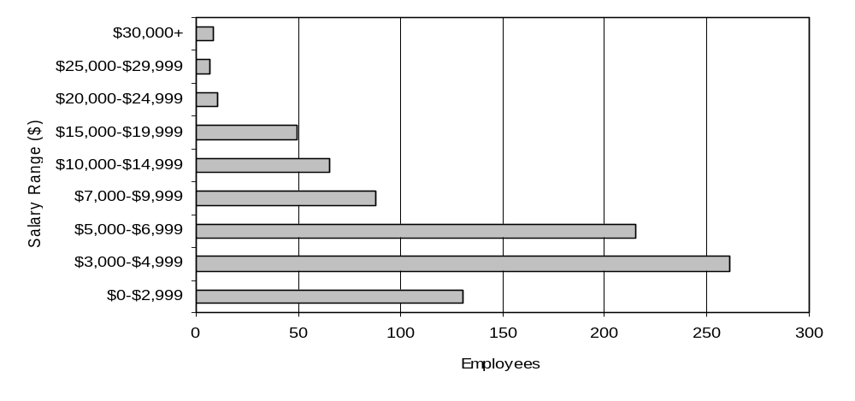

Public Employees by Salary Level: 2004

General Business & Commercial Income
Information was limited on business and commercial income

ISLAND ECONOMY AND INFRASTRUCTURE

General Status of the Economy
Yap State’s economy continues to be dominated by government spending, both for wages and the purchase of goods and services from the private sector. The closure of the garment factory has virtually eliminated the manufacturing sector. Tourism is down significantly after the reduction of scheduled flights by one third.

Major Employment Sectors
Licensed business establishments in the state in general increased from 373 in 2000 to 450 in 2004. A large part of this increase was attributed to a big increase in the area of personal service activities, which included laundromats, gas stations, repair shops, etc. Between 2000 and 2004, 47 new businesses were added to this group, giving it an overall growth of about 90 percent. Another area of economic activity showing significant growth was real estate and other business activities, which showed an increase of 9 additional establishments (32 percent) during the interim period. On a similar note, wholesale and retail businesses, although comprising the largest number of businesses (174 establishments in 2004), grew by only 3 percent (additional 5 stores) between 2000 and 2004. In contrast, businesses involved in construction, hotels and restaurants were the only group showing a negative decline during this period, dropping in numbers from 24 to 21 (about -13 percent) and 26 to 24 ( about -8 percent), respectively.

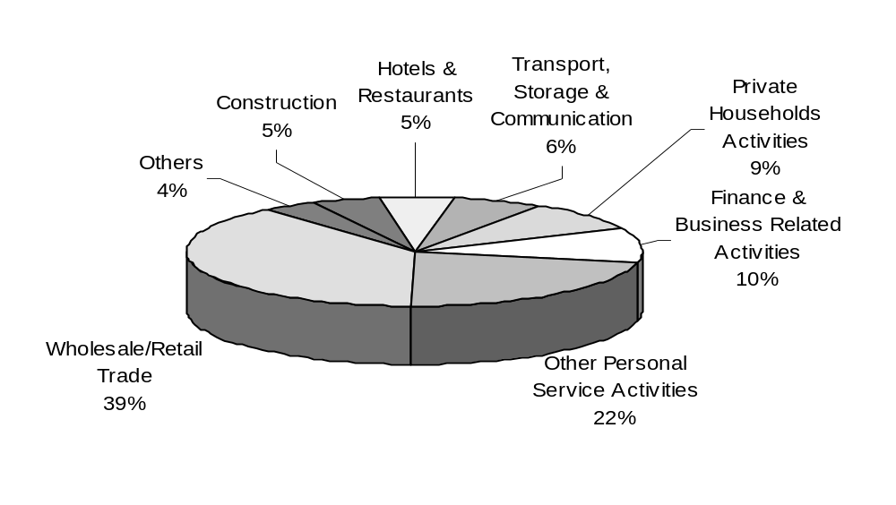
Figure 11-5

Distribution of Licensed Business Establishments by Type of Economic Activity: 2004

Electrical System
. The electrical system in Yap State is operated by the Yap State Public Service Corporation (YSPSC). Electricity production is shown in the following table:

Table 11-1

Electricity Production Statistics: FY 2000 to FY 2004

Electrical Production Statistics | 2000 | 2001 | 2002 | 2003 | 2004
Electricity Produced (000 kWh) | 16,786 | 18,301 | 18,299 | 18,135 | 16,416
Energy Production Cost (Cents/KWh) | ... | ... | ... | ... | ...
Diesel Fuel Required ( 000 Gals) | 1,108 | 1,207 | 1,261 | 1,357 | 1,367
Peak Demand for Electricity (KW) | 2,800 | 3,200 | 3,200 | 3,390 | 2,950
Generating Capacity (KWh) | 11,000 | 11,000 | 11,000 | 8,700 | 8,450
Source: Yap State Public Service Corporation

Water and Wastewater Systems
.Potable water is produced and distributed only on the central islands. There are 3 separate water authorities which provide piped water to approximately 75% of the population. Only the system operated by YSPSC provides water which meets WHO and U.S. EPA water quality standards.

Waste water collection and treatment is only available in the Colonia area. Primary treatment is provided by an Imhoff tank prior to discharge.

Transportation System
The number of registered motor vehicles decreased significantly, from 1,610 in 2000 to 1,564 in 2001, but has since increased consistently to 1,683 in 2004. According to the Traffic Division Office, the rise and fall of registered motor vehicles in the state between 1998 and 2002 was mainly due to numerous vehicles and machinery brought in and shipped out by several companies involved in construction projects. Throughout this period, however, sedans and pick-ups were consistently the leading types of vehicle in the state, comprising an average of 40 and 23 percents, respectively, or 63 percent of all registered motor vehicles. Of all these registered vehicles, the majority, over 90 percent, were privately owned. The remaining proportions of less than 10 percent were owned by the government.

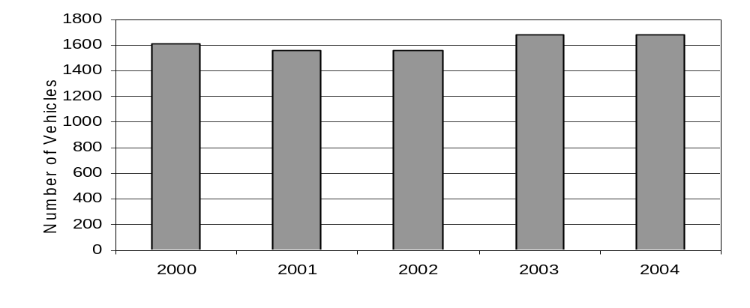
Figure 11-6

Registered Motor Vehicles: 2000 to 2004

Inter-island travel is primarily carried out by a local field trip vessel, MS Micro Spirit, between the central and outer islands. In 2000, this vessel made 7 field trips to the outer islands, ferrying 1,086 passengers, and collecting about $94,000 in revenue from passenger fares and freight charges. For the next four consecutive years, this ship made an average of 7 trips annually to the outer islands. With the exception of 2004, revenue collected during these 5 years fluctuated from a high of about $137,000 in 2002 to a low of $62,000 in 2004. Still, revenue collected between 2000 and 2004 do not come close to offsetting the cost of operating and maintaining the ship, which ranged from a low of $369,000 in 2001 to a high of over $1.2 million in 2004. The heightened operational cost of the ship is attributed to dry-docking and fuel expenses. In both 2000 and 2004, dry-docking of the ship alone cost over half a million dollars.

Port and Port Industries
Virtually all trade in Yap comes in through the commercial seaport. Trade in Yap State is highly disproportionate due to a wide gap between imports and exports. Between 2000 and 2004, the total value of import into the state was estimated at around 114 million, or an average of about 23 million dollars annually. In comparison, the total export during the same period was only about 23 million dollars, with an annual average of about 5 million dollars. Even then, a large percentage of the valued export was due to garments exported by two foreign garment companies based in the state. Locally made products exported outside were of minimal quantity and constitute a small proportion of the overall amount of exported goods and materials abroad.
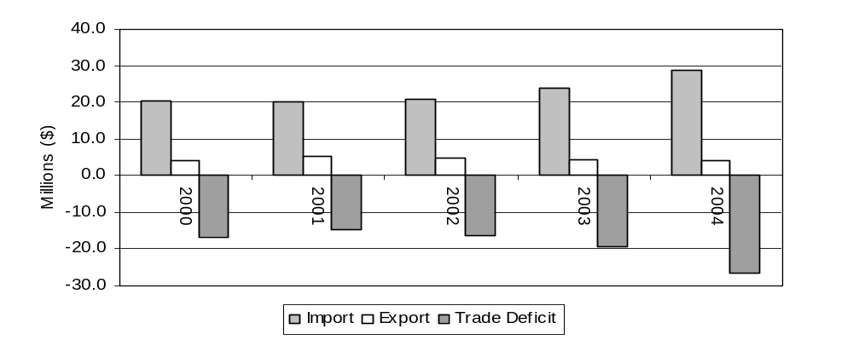

Of the annual imports between 2000 and 2004, the highest value was recorded in 2004, at close to $29 million. For export, the highest value was recorded in 2001 at over $5 million. From these two values, trade deficit for the state can be derived by subtracting imports from exports. In this regard, the largest trade deficit recorded for this period occurred in 2004 with a deficit of over $26 million and a ratio of imports to exports at about 7:1.

Airports and Aviation Industries
Aircraft arrivals in the state averaged 262 flights from 2000 to 2003. In 2004, there was a big jump in the number of flight arrivals, increasing to 418 flights, primarily due to a significant increase in the number of commercial flights arriving in the state. Aside from Continental Airlines, the only commercial air carrier providing regular services to the islands in the past, a new airline, Palau Micronesian Airlines, was introduced in 2004 and began its maiden flight in July. Operation of this airline was short-lived since all operations were suspended sometime in the early months of 2005 due to budgetary constraints and stiff competition from Continental Airlines. In any case, commercial airlines comprised the largest proportions of the many types of aircrafts transiting through the state. In fact between 2000 and 2004, an average of 258 commercial flights (97% of arrivals) arrived in the state annually. Freighter aircrafts, the second major categories of aircraft visiting the state, showed an average of 13 flights per year due to the large number of arrivals (27) in 2000.

Communication System
FSM Telecommunications Corporations is the sole provider of communications and related services in the state. Between 2000 and 2004, telephone subscribers increased steadily from 2,144 to 3,040. Fax and internet subscribers also showed some increase, although relatively small (11 new fax subscribers and 60 new internet subscribers), during this 5 years period. Of the telephone subscribers, close to half (49 percent) were residentially owned in 2000 and 2001. In the years preceding 2001, the proportion of residential subscribers increased significantly to over 60 percent. Meanwhile, business telephone subscribers increased from 386 (18 percent) to 613 (20 percent) between 2000 and 2004. This increase, along with increases from residential subscribers, had an impact on the overall standings of business subscribers, especially after 2001, when business subscribers surpassed government subscribers. For fax, business subscribers comprised over half of all fax subscribers between 2002 and 2004, thus, leading over both government and residential subscribers. Finally, for internet, residential and government subscribers showed the most subscribers of almost equal proportions (around 40 percent). The only exception was in 2004, when the number of residential internet subscribers increased significantly to 147 (47 percent). Business internet subscribers, on the other hand, showed a consistent proportion of over 20 percent, although their numbers have shown a slight increase from 58 to 69 subscribers between 2002 and 2004.

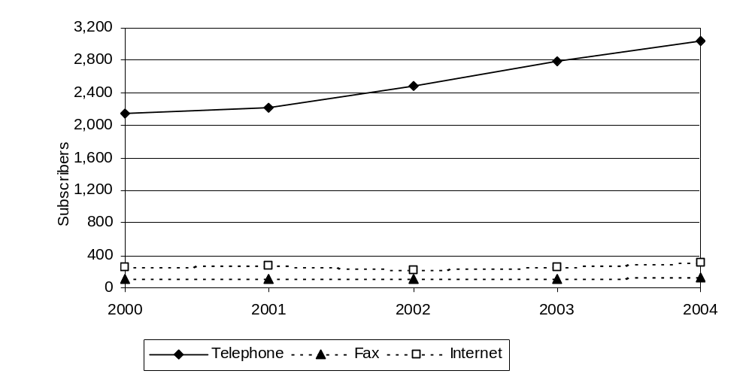
Figure 11-8

Subscribers of Communications and Related Services: 2000 to 2004

Tourism Industry
Tourism in Yap has remained relatively stable, averaging around 3,600 tourists and visitors annually between 2000 and 2004. The largest number of tourists and visitors arriving within a year happened in 2000, when close to 3,900 tourists arrived on island. Altogether, the number of tourist and visitor arrivals during that period totaled about 18,100, or about 77 percent of all foreign arrivals. Another major group of foreigners who visited the state between 2000 and 2004 were those involved in business and employment activities. On average, about 1 thousand members of this group arrived in the state each year and accounted for about 21 percent of all foreign arrivals between 2000 and 2004.

Of the tourist and visitor arrivals, slightly less than half (about 49 percent) were from the U.S. Europe and Japan made up the second and third largest proportions at about 17 percent each, respectively. Although the U.S. makes up close to half of all tourist and visitor arrivals, theose numbers were in decline, especially since 2001.

Figure 11-9
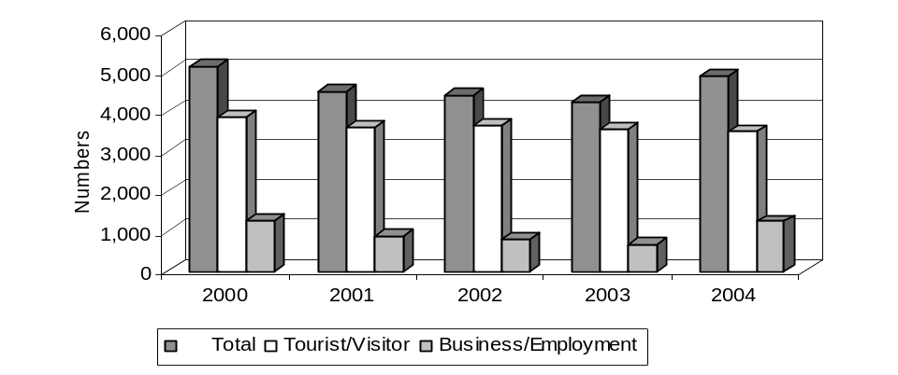

Tourist/Visitor and Business/Employment from Arrival: 2000 to 2004

Major Industry
Yap has no major industries.

Military
There are no military installations in the state and the occasional call by military ships and aircraft does not have a significant impact on the state’s economy.

Other Special Economic Elements
None.

Manufacturing, Craft, Trade
The only large-scale manufacturing in the state, two garment factories, closed in late 2004 as a result of China’s entry into the WTO.

Agriculture
Most agricultural products produced in Yap are for the producers’ consumption. The following products were sold for local resale:

Table 11-2
Table 3.4. Purchases of Local Agricultural Products by Selected Local Markets: 2000 and 2004
Agricultural Products | 2000 |  |  | 2001 |  |  | 2002 |  |  | 2003 |  |  | 2004
Agricultural Products | Qty. (lbs.) | Value ($) |  | Qty. (lbs.) | Value ($) |  | Qty. (lbs.) | Value ($) |  | Qty. (lbs.) | Value ($) |  | Qty. (lbs.) | Value ($)
Total | 34,226 | 33,658 |  | 35,579 | 41,220 |  | 136,742 | 111,902 |  | 42,534 | 49,040 |  | 41,971 | 46,880
Cucumber | 1,161 | 953 |  | 7,167 | 7,050 |  | 28,230 | 25,854 |  | 18,362 | 16,397 |  | 6,721 | 6,509
Yam | 821 | 546 |  | 667 | 452 |  | 7,569 | 4,950 |  | 736 | 534 |  | 2,153 | 1,416
Cabbage | 471 | 511 |  | 2,953 | 3,477 |  | 13,854 | 12,223 |  | 2,339 | 2,406 |  | 343 | 363
Pumpkin | 704 | 372 |  | 667 | 276 |  | 15,592 | 8,905 |  | 1,246 | 513 |  | 5,084 | 1,825
Papaya | 1,012 | 658 |  | 854 | 512 |  | 3,607 | 2,340 |  | 1,733 | 1,109 |  | 406 | 239
Potato (sweet) | 680 | 456 |  | 411 | 265 |  | 10,608 | 6,921 |  | 640 | 427 |  | 1,057 | 731
Breadfruit | 5,891 | 3,726 |  | 1,934 | 1,225 |  | 15,000 | 9,750 |  | 691 | 356 |  | 0 | 0
Taro | 5,191 | 3,481 |  | 4,529 | 2,770 |  | 21,822 | 14,429 |  | 3,509 | 2,449 |  | 10,445 | 5,216
Banana | 7,975 | 5,109 |  | 4,109 | 2,482 |  | 4,048 | 2,518 |  | 4,597 | 2,712 |  | 870 | 413
Citrus | 3,491 | 2,191 |  | 2,975 | 1,747 |  | 2,518 | 1,585 |  | 1,523 | 1,002 |  | 612 | 284
Betelnut | 6,829 | 15,655 |  | 9,313 | 20,963 |  | 13,895 | 22,427 |  | 7,158 | 21,134 |  | 14,279 | 29,883
Source: Y.C.A, E.M.I, M.C.S, Kingtex, MKI and Gardener's Enterprise, Yap.

Aquaculture, Fisheries
Both pelagic and reef fishes caught in the state increased from about 2 tons in 2000 to about 30 tons in 2003. (2004 data was unavailable at the time of publication). The lowest volume was reported in 2000 at only about 2 tons, possibly as a result of several fishing boats undergoing extensive repairs at the time. The data shown here was obtained solely from the Yap Fishing Authority (YFA), a semi-government entity, which does not keep records of catches from subsistence and local commercial fishermen. Consequently, these figures do not reflect the actual annual catch for the state.

Figure 11-10
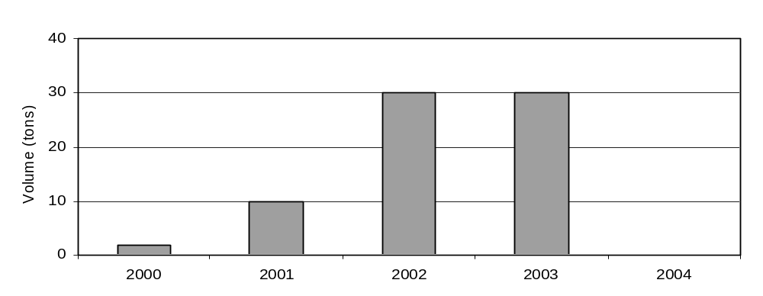

Figure 3.2. Volume of Fish Catch, YFA: 2000 to 2004

ECONOMIC DEVELOPMENT PLANS AND PROJECTS

General Status of Economic Development Planning
. Yap State does not have an active Economic Development Plan.

Economic Development Approach and Special Issues
Because of information provided in 11.5.1 above, this section has no data.

Focus Areas
Because of information provided in 11.5.1 above, this section has no data.

Energy Considerations
Because of information provided in 11.5.1 above, this section has no data.

Economy Diversification
. Because of information provided in 11.5.1 above, this section has no data.

Status of Energy Systems

Major Energy Uses
Between 2000 and 2004, the state imported an average of 2.2 million gallons of petroleum products annually, with the highest volume in 2000 at close to 2.8 million gallons. The lowest volume of petroleum products was imported in 2001, at slightly over 1.9 million gallons. In general, fuel imports into the state showed a big decline between 2000 and 2001, but have since increased to a high of 2.2 million gallons in 2003. In 2004, fuel imports dropped slightly, as compared to the previous year, to about 2 million gallons. The huge decline in 2001 was primarily due to Micronesian Petroleum Company (MPC-Yap), one of the two petroleum companies (Mobil is the other one) in the state, halting most of its petroleum imports.

Of the three most common petroleum imports, Automotive Diesel Oil (ADO) comprised the largest share, averaging over 1.4 million gallons annually between 2000 and 2004. Gasoline and kerosene, on the other hand, showed an average import of about 0.5 and 0.3 million gallons, respectively, per year during the same period. Interestingly, both ADO and gasoline showed a marked decline in 2001 contributing to the overall decline in total fuel imports for that year. In contrast, kerosene maintained its steady increase, climbing to about 440,000 gallons in 2001, up from about 340,000 gallons the previous year in 2000. Indeed, 2001 marked the first time during the last five years that kerosene has surpassed gasoline in imports.

Figure 11-11

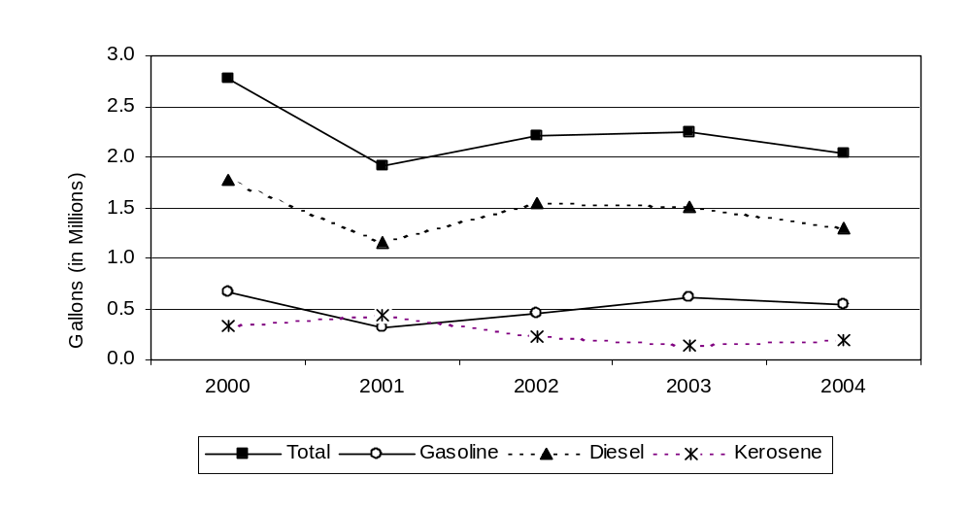
Fuel Imported to Yap State: 2000 to 2004

Electric Power System
Electricity in the state is provided by the Yap State Public Service Corporation (YSPSC). YSPSC operates power plants and distribution grids on the central islands and the islands of Falalop, Woleai, Falalop, Ulithi, and Mogmog, Ulithi.

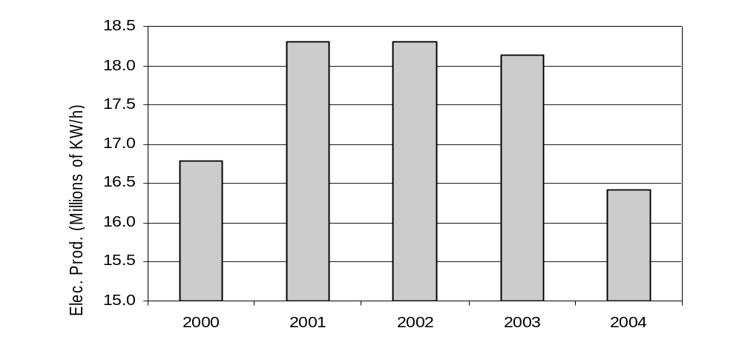
Figure 11-12

Power Production in Yap State: 2000 to 2004

Operational Issues
YSPSC operates 77 miles of overhead 13.8 KV distribution lines on Yap proper. The system is three phase from the airport to the hospital, where 80% of the load is concentrated. The remainder of the system is on wooden poles. YSPSC also operates 1.5 and 0.75 miles of 4.16 KV distribution lines on wooden poles on Falalop, Ulithi and Woleai, respectively. The Mogmog, Ulithi system consists of 0.5 miles of low voltage three phase underground distribution lines.

The overhead lines are subject to damage from typhoon and tropical storm winds. This has happened three times since 2000. The total damage to the systems was $2.3 million, with $2.15 million of that attributed to Typhoon Sudal, which is believed to be the worst typhoon on record ever to hit Yap State. The underground system in Mogmog, Ulithi has never experienced a distribution related outage.

Generation Facilities
The following table provides the capacities and peak loads of all YSPSC Generating facilities.

Table 11-3
Plant | Installed Capacity | De-rated Capacity | Peak Load
Yap Proper | 9.7 MW | 8.6 MW | 2.1 MW
Falalop, Ulithi | 369 kW | 369 kW | 56.5 kW
Falalop, Woleai | 114 kW | 114 kW | 32.5 kW
Mogmog, Ulithi | 54 kW | 54 kW | 7.2 kW

Fuels
All generation facilities use Automotive Diesel Oil (ADO).

ELECTRIC PRODUCTION AND USE

Existing Renewable & Alternative Power Production
Existing renewable and alternative power production is negligible. Each of the outer islands has a solar-powered radio for emergency communications and a solar-powered vaccine refrigerator for the dispensary. Extensive use of biomass (primarily coconut husks) is made for cooking fuel in the outer islands.

Existing Conservation and Demand Side Programs
YSPSC issues flyers and makes periodic public service announcements regarding energy conservation. There are no other known programs in the state.

Regulatory, Environmental Issues
YSPSC issues flyers and makes periodic public service announcements regarding energy conservation. There are no other known programs in the state.

Transportation

Fuel Use
Gasoline is used for cars, small trucks and boats. ADO is used for the state field trip ship and construction equipment. This represents only about 5 percent of the ADO imported into the state, the remainder being used for the generation of electricity. Kerosene in the form of JetA1 is used by the large commercial airlines, but has not been available for a year due to problems with the apron at the airport. A small amount of aviation gasoline is imported into the state for the inter-island airline, but no statistics are available on the quantity.

Fuel Types and Costs
The following table lists the quantities and types of fuels imported into the state:

Table 11-4
Fuel Import to Yap State: 2000 to 2004
Fuels | 2000 | 2001 | 2002 | 2003 | 2004
Total (000’s gal) | 2,777 | 1,907 | 2,215 | 2,243 | 2,030
Gasoline | 673 | 314 | 454 | 609 | 540
Diesel | 1,765 | 1,152 | 1,536 | 1,501 | 1,291
Kerosene | 339 | 441 | 225 | 134 | 199
Value ($000) | 2,639 | 1,963 | 1,671 | 1,978 | 1,981
Gasoline | 631 | 314 | 463 | 556 | 562
Diesel | 1,673 | 1,272 | 1,031 | 1,250 | 1,164
Kerosene | 335 | 377 | 177 | 172 | 256
Price per gallon ($)
Gasoline | 0.94 | 1.00 | 1.02 | 0.91 | 1.04
Diesel | 0.95 | 1.10 | 0.67 | 0.83 | 0.90
Kerosene | 0.99 | 0.85 | 0.79 | 1.29 | 1.29
Source: FSM Customs & Tax Office
Note: Price per gallon is an average price based on the total value of petroleum products imported to Yap State. 1998 includes fuel imported by Micronesian Petroleum Corporation (Yap).
No statistics are available for the wholesale or retail price of fuels sold in the state.

Reducing Transportation Energy Use
The state has only a limited ability to reduce transportation-related energy use. Energy efficiency standards for importation of vehicles must be done at the national level as the state has no authority to regulate imports. The state government does own about 10 percent of the vehicles in the state and could adopt efficiency standards for the vehicles it purchases. The state ship will require replacement in the near future and energy efficiency should be designed into the specifications for a new vessel.

Commercial and Industrial
There is limited opportunity for fossil fuel savings in the commercial and industrial sector other than efficiencies possible with more efficient lighting and air conditioning systems, although many facilities do not have air conditioning. There is no major industry that is energy intensive where a fuel saving program could have a major impact.

Tourism
The primary tourism related uses of energy are air conditioning for the hotels and gasoline for the dive boats. Significant amounts of energy could be saved through the purchase of air conditioning units which meet or exceed U.S. energy efficiency standards and the provision insulation and weather stripping for the rooms. Most dive shops already use more efficient 4 stroke engines on their dive boats, although some savings could be achieved by switching to smaller engines.

Manufacturing
There is no longer any major manufacturing in Yap.

Military
There is no permanent military presence in Yap.

Fisheries
There is very little commercial fishing in Yap and no basis to make specific recommendations.

Supply Side Efficiency
In developed country utilities, the average power systems losses for a utility with only a generation and a distribution network are estimated at approximately 10%. Nominally, these losses are accounted for in generation, 5%; and distribution, 5%.
In 2000, a preliminary study was carried out on a sample of three (3) U.S. Affiliated Insular Areas’ power utilities to achieve an indication of the energy inefficiencies in the generation, transmission and distribution of electricity in all the U.S Affiliated Insular Areas’ power utilities. These were the utilities of Palau, Pohnpei and Kosrae.
This preliminary study indicated that the power system losses in the utilities were far in excess of acceptable standards for these power systems. It was established that the energy losses were occurring in all areas of the power system, including non-technical losses.

It was noted that some data was lacking such as the number of transformers or the types of conductor used. As a consequence, several approximations were used to evaluate the losses. The errors on the figures are difficult to quantify and therefore the results should be carefully used, although it does represent system losses that are in excess of what is acceptable. To reduce the import of fuel, it is imperative to reduce these system losses.

It is recommended that a detailed quantified power system loss study be conducted for YSPSC, as a stage 1 project. This project would measure and collect the electrical characteristics of the power system, and then determine the losses. Once these losses have been quantified, then stage 2 of this process would be to assess the need for updating existing energy inefficient equipment (examining financing mechanisms as appropriate), establishing government legislation that makes electricity theft a crime,and reviewing the maintenance practices in the power plants.

Demand Side Efficiency
The YSPSC issues flyers and makes periodic public service announcements encouraging energy conservation but there have been no other programs directed toward energy efficiency improvement or energy conservation in Yap. With regards to DSM and energy conservation, the high cost of energy, the lack of industry, and the leisurely pace of the economy have combined to give Yap a relatively low per capita energy use. Electrical energy efficiency actions are generally limited to maintenance of the existing stock of air-conditioners, refrigerators and freezers, and the exchange of older, less efficient equipment for higher efficiency units, e.g. replacing with high EER air-conditioners, higher efficiency motors on pumps and CFLs to replace incandescent lamps.

There is a small tourist industry, about 6,500 visitors per year, mainly focusing on diving and ocean sports that includes some high energy use facilities for which these same recommendations would apply.

Electrical Metering/Tariff
Effectively all electricity is metered. Within the legislation establishing the YSPSC it states that “the rate schedule for each category of utility consumption shall be uniform within each island, except that the schedule may provide for increasing marginal rates as the consumption of a person increases…… shall charge all consumers an amount at least equal to the marginal costs of providing them utility services.” The tariff is reviewed annually and an automatic fuel price adjustment is established monthly. Currently the outer island service is charged at a higher rate than on the central islands (due to the added cost of fuel delivery and lower fuel efficiency). The fuel charge in June 2006 was $0.184/kWh for Yap Island and $0.300 per kWh for outer islands. Both the domestic and the commercial/government tariff are tiered. The domestic tiers break at 100, 300 and 500 kWh/month. Commercial rates break at 5,000 and 15,000 kWh/month and are consistently higher than domestic rates. The tariff structure appears to be well structured to encourage energy efficiency.

On time collections approach 100% without the use of prepayment meters due to a strict policy of disconnection for non-payment for all classes of customer.

Household Energy Efficiency Measures
The average domestic use per household is about 183 kWh/month, indicating a lower scope for efficiency/conservation improvement to provide fuel savings relative to the opportunities in Palau, Guam, Saipan and the U.S. Virgin Islands where the average household use is several times larger.

Household lighting is mostly by magnetic ballast type fluorescent lights and incandescent lights. A program to replace those with high efficiency units could be expected to be a cost effective way to reduce the lighting load by nearly half and is strongly recommended. Since lighting is a substantial component of the evening peak load, such reduction could provide direct benefit to YSPSC as well as reducing fuel import requirements.

The 2000 census found about 12% of households cooking with electricity with most of the rest of the households using kerosene. Very few households now use biomass for cooking. Most of FSM is seeing a gradual conversion of both kerosene and electric cooking to LPG, a generally more fuel efficient and convenient cooking fuel. Though there were no statistics available to calculate the rate of increase of LPG for cooking, interviews indicated that it continues to increase in use. The electric cooking on Yap increases an evening lighting peak that could be reduced through a program to replace electric ranges by those using gas. As ASPA in American Samoa did some years ago, YSPSC could consider discussing an alliance with the Yap LPG importer and working out an arrangement to replace electric cook stoves with gas unit and deliver gas energy as well as electricity to its customers.
Table 11-5 – Yap Household Appliances and Cooking (HH = Household)
 | Yap Island HH | Outer Island HH | Total HH | Percentage of Electrified HH
TOTAL HH | 2246 | 705 | 2951 | -
Electrified HH | 1273 | 127 | 1400 | -
Fridge | 740 | 18 | 758 | 54.14%
A/C | 176 | 6 | 182 | 13.00%
TV | 101 | 9 | 110 | 7.86%
TV+VCR | 739 | 55 | 794 | 56.71%
Electric Cook | 164 | 2 | 166 | 11.86%
Kerosene | 308 | 17 | 325 | -
LPG Cook | 74 |  | 51 | -
Open fire | 1021 | 648 | 1669 | -
Source: 2000 Census

In 2000, the census indicated that only around 4% of Yap houses had piped hot water and as is the case with other FSM states, the demand for domestic hot water is small. In 2000, there were 92 electric water heaters and 2 solar.

Domestic air-conditioning penetration is low, with around 13% of electrified households having some form of air-conditioner installed in 2000. High energy costs and a slow growing economy make it unlikely that domestic air-conditioning use will increase rapidly. Though the numbers are small, the demand per unit is high, and households with air-conditioners should be informed of the need to clean filters and condensers and to consider higher efficiency units when old ones need replacing. Even if an efficiency improvement of 25% could be obtained by replacing the units, with only around 100 domestic air conditioners in the state it is unlikely that YSPSC could justify a program for domestic air-conditioning efficiency improvement through replacement subsidies or other financial incentives.

Government and Commercial Sector
In general, government buildings are not major energy users in Yap. “Window” type air-conditioners are common and are not high efficiency types, so replacement of those by more efficient split systems or “window” units with a high EER could provide some energy efficiency improvement. Lighting in all government facilities should be converted to either electronic ballast high efficiency tube type fluorescents or, where incandescent lamps are used, by CFLs. As many offices have relatively good natural lighting from windows, overhead lighting could be turned off during the day time in many offices and task lighting provided where needed.

As computers are replaced, “Energy Star” rated units with low power flat screens should be specified for purchase.

Serious consideration is being given to the construction of a government complex to bring most state government offices under one roof. Yap should avoid the costly mistakes of several Pacific island nations that have recently consolidated government offices into one large building but have ignored energy considerations in the design and are now faced with huge operating costs for the building. Building a new government complex provides an opportunity to greatly improve the efficiency of government energy use – government now being the sector with the lowest energy efficiency in Yap – through good building design that includes energy saving features such as:
- proper insulation
- efficient and properly allocated lighting
- low energy transfer glass in windows
- shading systems to eliminate direct entry of sunlight
- well distributed natural lighting while avoiding direct solar entry
- high efficiency and properly controlled air-conditioning
- vestibule type entries that avoid direct exchange of interior and exterior air

Such features are low in added construction cost and high in avoided cost of energy.

The well-maintained 128,000 square foot hospital on Yap is one of the top energy users, with a monthly electric usage exceeding 50,000 kWh per month. Electricity is used for water heating as well as central air conditioning, lighting and hospital equipment. Funding has been allocated for hospital renovation (it was built in 1979) but energy efficiency improvements are not included in the work plan. In early 2006, hospital management petitioned the EU as part of the Yap component of the REP-5 project to provide co-financing support for solar water heating, improved lighting efficiency, insulation improvement and improvement of air conditioning efficiency. However the project did not fit the EU project requirements and could not be funded under that program. It is recommended that other funding sources be sought since the cost of making energy efficiency changes will be much lower during a period of renovation than if done separately.

No survey information was available that provides information on government or commercial water heating loads but where significant water heating is carried out (e.g. laundries, visitor accommodations), solar water heating should be considered and if cost effective, installed.

The primary energy requirement for the commercial sector is for the operation of refrigerators, freezers and air-conditioners. Some improvement in the operating efficiency of the existing equipment can be obtained through cleaning, proper refrigerant loading and other maintenance measures. PWD and YSPSC could assist in the development of maintenance processes and procedures fitted to the needs of commercial users and offer contract services for the maintenance of refrigeration equipment. Energy audits also could be provided by YSPSC to businesses with high energy use, although to be effective the audits also need to include an implementation plan, sources of equipment and cost/savings estimates. External training will be needed to provide these services.

Transportation Sector
Yap includes many islands and sea transport is a significant energy use, though much less than is used for electricity generation. The state-owned ship is in need of replacement and care should be taken that the selection process includes energy efficiency criteria. In particular if a ship is being provided by an aid donor, the “free” ship may end up being a major expense due to poor fuel efficiency and in the end could cost far more than the outright purchase of a fuel efficient vessel.

Fishing using small boats fitted with a 20 to 40 hp outboard engine is a common activity throughout the state but there are few opportunities for improving their efficiency of use through technical interventions. The rising cost of fuel is the most effective motivator for reducing energy waste in that sector.

Dive operators have generally converted to relatively fuel efficient four cycle engines for their boats but have tended to install larger engines than are cost effective at current high fuel prices. Shifting to diesel engines, outboard or inboard, can significantly improve fuel efficiency and for commercial operators usually reduces overall operating cost for the boat. There is also lower fire hazard and less maintenance is needed.

Land transport is primarily by private automobile. There is no organized public transport other than morning and evening buses operated to transport workers and school children from their villages to and from the urban area of the central islands. There is a small radio-hailed taxi fleet.

When private and government vehicles are replaced, encouraging the purchaser to choose a vehicle with a diesel engine provides the greatest long term opportunity to reduce fuel use through increased efficiency. Incentives to choose diesel powered vehicles over those with gasoline engines include differential taxation of fuel to raise the cost of gasoline in relation to diesel fuel and import duties that encourage diesel vehicle import. Import duties are applied at the national level so that option is not directly open to Yap.As with outboard engine use, fuel price rises can be effective in increasing the average fuel efficiency for Yap vehicles.

Since around 10% of all vehicles on Yap are owned by the state government, government should consider specifications for vehicle purchase that focus on fuel economy, notably purchasing diesel rather than gasoline fueled vehicles for government use. YSPSC has recently purchased several diesel pickup trucks to replace aging gasoline vehicles and recommends that agencies in government follow suit.

Building Energy and Efficiency Standards
The benign climate, high energy prices and the low demand for household air-conditioning and water heating make the average energy use per square foot of Yap buildings far less than that of the U.S. or Europe. The value of building codes to further reduce the average per square foot energy use of buildings is therefore correspondingly lower.

The capacity in Yap for the development and enforcement of building energy efficiency standards is small and their development would have to rely on external experts. The Yap PWD, the agency responsible for most construction on Yap, has no U.S. Registered Engineer and no one with specific skills in energy efficient building design. Since the amount of new construction each year is not large, it is questionable whether or not the national benefit from such codes would be cost effective relative to other measures to improve energy efficiency in Yap. It has proven difficult to enforce basic building codes, even for buildings built by PWD, that relate to important safety issues and properly enforcing what are typically viewed as a type of non-essential construction energy codes would be even more difficult.

Since air-conditioning is the primary load that would be affected by energy efficiency standards for buildings in Yap, it is recommended that YSPSC work with the PWD, the organization constructing most buildings on Yap, to establish construction guidelines for building construction and renovation that includes basic energy efficiency measures, such as thermally isolating the roof and exterior walls from the air-conditioned space, providing for minimizing heat entry through windows and reducing infiltration into the air-conditioned space. For government buildings the guidelines should be a requirement while for non-government construction they would be voluntary but encouraged. Those guidelines could then be provided to the private builders on the island along with information as to how their implementation can benefit the building owner in reducing energy cost.

Appliance Energy Efficiency Standards
The Yap appliance market is too small to consider any form of labeling or appliance efficiency standards specifically for Yap. Many appliances that are sold in Yap already include energy labels but the information regarding the cost of use of the appliance is based on an assumed electricity cost that is around half that of Yap. This makes the actual operating cost differential between appliances of different efficiency double that seen on the labels and prospective buyers are more likely to choose the more efficient appliance if made aware of the greater operating cost difference. It is recommended that a system for helping consumers understand appliance labels in the Yap context be developed. Possible approaches include actually changing the labels to fit Yap conditions, posters near the labeled appliances explaining the labels, explanatory stickers placed on the appliances with the labels and periodic information brochures handed out to YSPSC customers when bills are paid. Government purchases of air-conditioners should be limited to high EER units.

Energy Audits, Performance Contracts
The market on Yap is too small to support an ESCO or to justify the cost for an overseas ESCO to operate on Yap. ESCOs in Guam or the Philippines may be interested in servicing large clients such as the Yap state government on a contract basis but are unlikely to find it practical to maintain a continuing presence on Yap. As there is no industry on Yap that would require specialist auditors from overseas, training could be provided to YSPSC or PWD staff to carry out basic energy audits aimed at improving the efficiency of lighting, pumping, air conditioning, refrigeration and freezers. The audits could raise the awareness of users of that equipment regarding the cost benefits of improving their efficiency of use and in some cases could result in investment in increasing energy efficiency.

RENEWABLE ENERGY OPPORTUNITIES

Hydro
No developable hydro resources are known to be present on Yap.

Solar
No good quality insolation data could be made available for sites on Yap. NASA satellite data for the oceanic area that includes Yap is provided in Table 11-6. The levels on Yap Island probably do not vary a great deal from these values as the land mass is low lying and not large, though there is some thermal activity over the island that can lead to increased clouds relative to the surrounding ocean and solar designs probably should allow for that. For the outer islands, they have such small land areas that oceanic insolation is adequate for design purposes.
Table 11-6 – Estimated solar resource for Yap Island (Lat 9N Long 138E)
Month | Jan | Feb | Mar | Apr | May | Jun | Jul | Aug | Sep | Oct | Nov | Dec | Avg.
Horizontal | 5.4 | 6.04 | 6.5 | 6.72 | 6.55 | 5.43 | 5.48 | 4.96 | 5.43 | 5.27 | 5.17 | 5.34 | 5.69
Tilted | 6.77 | 6.9 | 6.78 | 6.79 | 6.85 | 5.73 | 5.74 | 5.05 | 5.52 | 5.73 | 6.23 | 6.9 | 6.25
Table 11-7 – Estimated solar resource for Ulithi Atoll (Lat 10N Long 139E)
Horizontal | 5.41 | 6.07 | 6.61 | 6.83 | 6.68 | 5.74 | 5.62 | 4.96 | 5.43 | 5.33 | 5.17 | 5.25 | 5.75
Tilted | 6.99 | 7.05 | 6.93 | 6.84 | 6.98 | 6.12 | 5.92 | 5.04 | 5.54 | 5.92 | 6.43 | 7.02 | 6.39
Source - NASA Surface Meteorology and Solar Energy

Solar thermal for electric generation
The relatively high frequency of partly cloudy conditions prevents concentrating-type solar devices from working well in Yap. The mechanical complexity associated with tracking devices and the difficulty of maintenance of the highly reflective surfaces and mechanical systems in a marine environment also work against the cost effective use of solar thermal systems for power generation. For electric generation from solar, only photovoltaics is recommended for Yap.

Solar thermal for water heating
There are few solar water heating installations in Yap and there are no stocking dealers on island. The cost of solar water heating is therefore high because of the individual nature of system purchase and installation through dealers in Guam, Hawaii and Asia. The domestic demand for water heating is not great and the number of homes with electric water heaters is small. The 2000 statistics showed only about 4% of houses had piped hot and cold water and used electric water heaters. Their actual electricity usage for hot water production is not known so it cannot be determined if the approximately $3,000 investment for a solar water heater in Yap would be cost effective at current electricity rates but it appears unlikely that a program of financial incentives to replace electric water heaters by solar units would be cost effective for the utility. The YSPSC should consider working with its electric water heating customers and arranging for a bulk purchase of solar water heaters and finance the installations through monthly payments on the YSPSC bill.

Low-cost Chinese solar water heaters are beginning to be imported into Palau. It is recommended that YSPSC consider working with the importer to also service Yap, since the cost of the Chinese units is a fraction of what is currently being paid for solar water heaters in Yap.

Some visitor accommodations make use of solar water heating but many do not. A small program to assist those visitor accommodations and households still using electric water heating to convert to solar should be considered. The program would need to:
- Provide the user with a reasonable benefit/cost analysis for decision making
- Assist the user locate a supplier and installer for suitable solar water heaters, arranging for a lower unit cost through combined purchases
- If necessary, assist the user locate financing for the purchase and installation of the solar water heaters
- Ensure that the units are correctly installed and working properly.

Solar photovoltaics

Past programs
A small number of demonstration projects were installed in the 1980s but none have survived. Most schools and health centers have solar powered communications that have been in place for many years and have provided generally reliable service. The Department of Education is in the process of tendering for an upgrade of some school communication systems to add satellite based internet, email and other services to the basic communication systems now in place.

Satawal
Yap State leaders learned of the French funded electrification of Mwoakilloa atoll in Pohnpei in 1995 and a letter from the Yap Council of Tamol was sent requesting France to consider solar electrification of some of the 341 outer island households on the 18 atolls that were not served by YSPSC. France responded favorably and selected Satawal as it had the largest number of households needing electrification, requiring 50 solar home systems (SHS). Satawal is the atoll most distant from Yap island.

The atoll population (around 700) is distributed over several islets. Access is only by boat with the Yap state government ship stopping on an average for a few hours every month. To visit Satawal, the choice is either staying for a few hours or a month unless a very expensive privately chartered boat is used.

In 2000, 50 SHS and a community solar PV system were purchased for Satawal installation. The SHS included:

1 – 48Wp solar PV panel
1 – Charge/discharge controller
1 – Sealed 12V battery 85Ah at C₁₀₀
2 – 12VDC, 8W fluorescent tube lights
1 – Installation materials kit including mounting pole and panel supports, house wiring, switches and other hardware

The PV panel was mounted on a wooden pole. The battery and controller were installed in a cylindrical plastic housing attached to the pole immediately under the solar panel. Access to the controller and battery is therefore inconvenient but the use of the sealed battery eliminates the need for battery maintenance.

Installation was done by villagers trained in Colonia and was carried out in 2000-2001. The decision to install 50 SHS was based on available funding, not on demand from villagers which reportedly was much greater than was practical for the project.

For the community system:
12 – 48Wp PV panels
12 – 2V 545 Ah tubular cell batteries connected in series for 24V supply
1 – 30A charge/discharge control
2 – Solar freezers, 200 liter size, 24VDC
6 – 24VDC, 8W fluorescent lights

1 – 85Watt 24V to 115VAC inverter

The community chose to do their own operation and maintenance, rejecting YSPSC’s offer to manage the systems.

Reports from the island indicate that few SHS are functioning properly, batteries have failed and are being broken up, the lead being used for fishing weights; in general, the project cannot be considered sustainable PV rural electrification. No information was available regarding the status of the community system.

The 20+ year experience in other solar PV installations in the Pacific has been that community management rarely leads to long term sustainability and thus is not recommended for future SHS type projects on outer islands. 50Wp was long ago found to be insufficient for the requirements of atoll islanders particularly in areas like Satawa, where most SHS mounting sites have solar access somewhat limited because they are surrounded by economically valuable breadfruit and coconut trees that are not likely to be removed. The minimum SHS size used in successful Pacific rural electrification installations has been 100 Wp and since 2000 the size has increased to 150 Wp (Tonga) and then 160 Wp (Marshall Islands). Future Marshall Islands SHS are proposed to be 200Wp to provide for the limited solar access in atoll villages and to help keep batteries at a high average level of charge to ensure minimal need for external maintenance since the sites are quite costly to access. The pattern of successful long term SHS implementation in Tonga and particularly Kiribati should be considered for use in Yap State. This includes the installation of high quality equipment proven in the Pacific environment and management by a well managed and technically competent institution – such as YSPSC in the case of Yap.

Plans and Recommendations
The EU EDF9 funding for FSM includes a component for Yap but the money has yet to be allocated to specific projects. What has been proposed and appears likely to be accepted is to combine coconut oil production to fuel existing diesel engines and to add solar PV to charge batteries to be used to power mini-grids. The PV systems would be provided with backup by a small generator capable of running on locally made coconut oil and charging the batteries when insufficient energy is available from the PV. The size and specific characteristics of the system cannot be prepared until the funding is allocated but the size of the projected load on each of the islets is less than 5 kW. The system would utilize underground distribution and would be operated and maintained by YSPSC. The final project determination is expected by the last quarter of 2006 and design and purchasing could proceed from there. Installation probably could be expected in 2008 if funding is allocated as expected.

There remain many islets throughout Yap state with too small a population to warrant grid power delivery. Those can be well served by SHS with the sizing sufficient to provide the level of service found to be utilized by Ulithi households (probably 200Wp, as in the Marshalls). A rugged, well tested design that requires minimal maintenance in the Pacific island environment should be used since access to many of the remaining unelectrified areas is infrequent and expensive. It is recommended that the Tonga and Kiribati SHS be considered as a reasonable model for outer island SHS in Yap State, particularly with regards to the high reliability controller (manufactured in Kiribati) and the high quality battery that together have provided on average more than 10 years of service by the Kiribati and Tonga SHS with the only maintenance being water replacement in the battery cells and general checks of connections and wiring.

Wind Energy
The wind energy resource on Yap is not known. Meteorological measurements indicate a poor resource and the low latitude location also implies a poor wind regime for economic energy production. Typhoons also are a significant risk for wind power installations. Table 11-8 shows the average wind speed at 50 meters as estimated from satellite measurements for the oceanic area that includes Yap. Energy levels seem mostly too low to be interesting for grid connected wind turbines. However, to be sure that a useful renewable energy resource is not being ignored, a proper wind resource assessment and Yap wind energy map should be prepared by an organization with the necessary skills and resources, e.g. NREL.
Table 11-8 – Average Wind Speed at 50m (m/s)
Month | Jan | Feb | Mar | Apr | May | Jun | Jul | Aug | Sep | Oct | Nov | Dec | Avg.
10 yr. Avg. | 7.44 | 7.42 | 7.11 | 6.03 | 4.59 | 4.48 | 4.53 | 5.28 | 4.92 | 4.88 | 5.49 | 6.44 | 5.7
Source – NASA Surface Meteorology and Solar Energy Lat 9N Long 138 E
Even if wind resources appear reasonable for Yap, only YSPSC grid-connected wind is recommended, since the presence of a YSPSC grid implies that technical capacity is available for maintenance. For village electrification the much lower maintenance requirement of solar PV makes it more likely to survive than wind. Throughout the Pacific countries, PV has had a much higher success rate for isolated village electrification than any other technology including wind.

Hydro Power
No developable hydro resources are known to be present on Yap.

Biogas
The primary value of digesters in the Pacific has been for treatment of animal waste at large commercial piggeries or poultry farms. Where animal waste management is an issue, biogas digesters provide an environmentally sound way to treat the waste while also providing a modest source of energy.

Although farms with penned animals that have sufficient feedstock for a small digester are present on Yap, attempts to interest farmers in investing in digesters to produce biogas from animal waste in the FSM (and the rest of the Pacific) has not resulted in the installation of digesters on small farms. Though the size of the piggeries and poultry compounds may be large enough to produce useable gas from the waste, the investment needed in both money and labor apparently exceeds the perceived value of the small amount of gas that is produced and the waste is not great enough to be an environmental problem.

There is a small sewer system serving part of Colonia. The treatment plant is a simple Imhoff tank to provide primary treatment. There is substantial rainfall intrusion, as flows increase by 150% or more on rainy days. The cost of installing the necessary equipment and operating labor to allow biogas production at the existing facility appears unlikely to be cost effective, particularly considering the widely varying feedstock due to rainwater infiltration.

Solid waste disposal is essentially a trash dump with no effective controls. There has been consideration given to locating a site for a proper landfill, but thus far no action has resulted. Should a proper landfill facility be developed, it is recommended that the design includes the capability for gas production at a later date.

Biomass Combustion and Gasification
The present use of biomass for energy is for cooking in Yap is high; over half of Yap State homes use biomass as their main cooking fuel. That makes biomass the main use of renewable energy in Yap State.

The economics of use of biomass for power generation through combustion or gasification in most of the Pacific is limited to agricultural or forest product processing facilities where large amounts of biomass is generated as waste. Yap has no significant industry that generates biomass waste in a quantity that is reasonable for power generation. Should coconut oil production be resumed on a significant scale, the coconut waste and the senile trees that are removed could be used for power generation in either a combustion-steam cycle or gasification process, but for the foreseeable future no opportunity for other than traditional cooking use of biomass for energy appears practical.

Biofuels
Large numbers of coconut trees are present in Yap state though the number of those that are still productive was not available. The amount of copra production is not large, however, with exports typically between 200 and 300 tons per year. There is no significant oil production on Yap; copra is shipped to external mills.
Table 11-9 – Copra exports
 | 1997 | 1998 | 1999 | 2000 | 2001¹ | 2002 | 2003
Tons | 229 | 310 | 292 | 210 | 35 | 130 | 80
¹ The low value for 2001 was due to the loss of much of the copra in a warehouse filre
SOURCE: 2002 Annual Statistical Yearbook, Yap State/Personal communication for 2002-2003

Though it is clear that a much higher production is possible, to achieve it will require both investment for the replacement of senile, low-productivity trees and a higher price for the labor involved. At the present cost of fuel, only oil production on the outer islands appears to be cost effective. The plans by YSPSC to make oil on Ulithi to fuel diesel generation are cost effective because the price that local copra producers receive is lowered by the need to pay for shipping to Colonia. Likewise, the cost of shipping diesel fuel to Ulithi significantly increases its price. So the existing copra price on Ulithi can result in coconut oil that is competitive with the price of diesel fuel at the generation sites, plus the uncertainty of supply is lowered, since deliveries are often delayed due to weather and other factors. Since much of the generation is planned to be by solar PV, the oil requirement can be easily met by local copra production and the presence of YSPSC to assist in the maintenance of the oil making facility makes its operational success more likely than if a community managed process was envisaged as has been unsuccessfully tried in other countries of the Pacific.

If the approach works well on Ulithi, then a similar coconut oil/PV generation system for the other YSPSC managed rural electrification program (Woleai Atoll) should be considered.

For the long term, if fuel prices continue to rise, coconut oil for YSPSC generation on Yap island may become cost effective, but that is not likely to be the case for the next 5-10 years.

Ocean Energy
No bathythermic data could be obtained for Yap, though good conditions for OTEC appear likely. Even if conditions are found to be favorable for ocean thermal development, the energy requirements of Yap are too small to make either OTEC or cooling through deep water collection cost effective.

Geothermal
No developable geothermal resource is known to be present in Yap state.

Tidal
Low head propeller type hydro power generators inserted in reef passages possibly could intercept enough of the exchange between the lagoon and the open sea during tidal flow through reef passages to provide some power generation. The power would be intermittent, changing output with the tidal cycle, and costly undersea cable would be necessary to get the power to shore. Installations could not be in navigational passages. Maintenance would be difficult and would require specialized equipment and training. The complexity and cost is unlikely to provide a favorable benefit/cost ratio so tidal power development is not recommended for Yap.

Wave
There is no commercial production of wave energy conversion devices that have been well proven for the Yap conditions. There have been no wave resource measurements on Yap, but resource measurements do not need to be carried out until wave power equipment suitable for the Yap conditions becomes commercially available and is well tested elsewhere.


Republic of the Marshall Islands

Executive Summary
The Republic of the Marshall Islands (RMI) is located in the Central Pacific Ocean north of the equator 3,000 miles southwest of Honolulu between 4° and 14° N. Latitude and between 160° and 173° E. Longitude. The Federated States of Micronesia (FSM) is 350 miles west. RMI consists of two nearly parallel strings of atolls lying from the northwest to the southeast. The parallel chains of coral atolls and islands extend over 700 miles, and are about 300 miles apart. The eastern, or Ratak (sunrise) chain encompasses 15 major atolls and islands; the western Ralik (sunset) chain includes 16 atolls and islands. Twenty-two of the atolls and four out of the five small raised coral islands are inhabited. RMI covers over 500,000 square miles but includes only 74 square miles of land mass. Kwajalein lagoon is the largest in the world covering 840 square miles.

RMI’s primary source of energy is petroleum. Gasoline and diesel fuel are used for the transportation sector and No. 2 diesel is used to the diesel driven electrical generators. Liquid Petroleum Gas (LPG) is used for heating water and cooking. The Majuro Electric Company (MEC) furnishes electrical power to Majuro and the Kwajalein Atoll Joint Utility Resources (KAJUR) furnishes electrical power to the community of Ebeye on the Kwajalein Atoll. MEC furnishes electrical power on several of the outer islands, either by small diesel engines or some photovoltaic systems.

MEC imports diesel fuel and LPG into Majuro. Mobil Oil Corporation also imports fuels into Majuro, and they are the sole source of fuel on the Kwajalein Atoll. MEC imported 13.6 million gallons of diesel fuel in 2005, used 5.6 million for its power plants, and sold the remaining to the public, primarily to the fishing fleets. Other sources of energy may be possible, such as minor tide flows into lagoons or waves, but the technology has not been adequately developed to utilize the limited sites. Photovoltaics have been installed extensively on the outer islands but many no longer operate due to lack of maintenance. Wind has not been adequately measured and although during the months of November through March winds seem brisk, they rarely exceed 10 mph and usually are not continuous during the night hours.

Energy use in RMI is typical of all tropical islands with the majority of the petroleum energy used for the generation of electricity followed by energy for the transportation sector, including a significant amount for the fishing fleets based at Majuro. The largest electrical use is for air conditioning, refrigeration and lighting, with the government being a major user of electrical energy and using the bulk of their energy for air conditioning. Renewable fuel use includes the widespread burning of wood and coconut wastes for domestic cooking on the outer islands. Copra (coconut oil) production is a significant renewable fuel and source of income in RMI. Average production is about 4,200 tons per year. ,

The RMI economy is relatively strong, though it is suffering from high fuel costs and the change in methodology of distribution of Compact funds. The RMI economy depends substantially on the U.S. Compact of Free Association, which extends 20 years from 2004 through 2023. The overall annual financial support potentially receivable over this period prior to inflation and other adjustments is in the order of $66 million annually or about 60% of the current nominal GDP. The main sources of income in the RMI other than the Compact funds is land rental payments from the Kwajalein test site, employment at the test site, services for the Majuro based fishing fleets, lease of fishing rights and a small tourism industry. The gross domestic product of RMI in 2001 was $130.9 million or $2,363 per capita. For FY2000 the Marshall Islands exports were $9,124,000 and imports were $54,724,000 for a negative balance of $45,600,000. The trade balance in 2005 according to the International Monetary Fund was a negative $69.3 million.

Electric System
The Marshalls Energy Company, Inc.(MEC), is owned by the RMI government and governed by a Board of Directors appointed by the President and chaired by the Minister of Public Works.
MEC functions independently of government operations, except that rates must be approved by RMI government. Electrical power lines serve 95% of the population in the primary islands.

In FY2005 MEC generated 82,367,000 kWh; had a peak load of 11.95MW; average load of 9.4MW; used 5,636,666 gallons of No. 2 diesel fuel; spent $8,927,523 for fuel for an average price of fuel of $1.58 per gallon; had power plant station service loads of 5,583,500 kWh or 6.8% of production. Engine efficiency at the plant was 14.6 kWh per gallon of fuel burned and represented a fuel cost of $.108 per kWh. With engine efficiency of 14.6 kWh per gallon, the MEC generators have an efficiency of 36.6%. MEC’s station service load is 6.9% which is higher than normal diesel power plant station service loads of 3% to 4% and is probably caused by the eight ventilating fans serving the enclosed power plant.

MEC serves approximately 3,722 customers. In 2005 MEC had a peak load of 10.1MW; annual sales of 59,773 mWh; revenues of $10,275,912. With subsidy profits from the sale of diesel fuel to fishing fleets and LPG to the public, MEC’s average price of electricity to the customer was $0.172 per kWh in 2005. MEC has two power plants. The older plant has four units of 3.2 MW each that have been downrated to 2.5 MW each, and one unit of 3.0 MW, for a total of 13.0 MW. The newer plant, completed in 1999, has two units of 6.4 MW each, for a total of 12.8 MW producing a total MEC generating capacity of 25.8 MW. Peak load for 2005 was 11.95 MW.

The MEC distribution system consists of three 13.8 kV circuits extending from the power plant located on the western end of the urbanized southeast end of the Majuro Atoll. There are no capacitors on the distribution system since power factor is nearly unitary due to the long underground cable to the west end of the island serving as a capacitor. Losses may be occurring due to inductive VAR flow from the east end of the island traveling perhaps 10 to 15 miles to be canceled out by capacitor VARs in the underground cable on the west end of the island. MEC distribution system losses are approximately 20%.

Demand Side Efficiency Improvement and Energy Conservation
The Ministry of Resources and Development (MRD) energy has only two staff and a small budget for energy efficiency improvement. The MEC has little incentive to carry out DSM measures, though the high cost of energy is causing more attention to be focused on saving energy. As a result, there have been few DSM programs carried out in the Marshall Islands.

Electrical Metering/Tariffs
MEC has no fuel adjustment component in its rates, so it is particularly vulnerable to rapid fuel price increases. Residential rates are $0.16/kWh up to 500 kWh/month and $0.17/kWh for any higher level of use. Commercial and government users are charged $0.225/kWh flat rate. A three tier rate to encourage energy efficiency could be effective. KAJUR has to have a flat rate because of its increasing use of prepayment meters that cannot provide for tiered rates. The prepayment meters should provide some demand side energy efficiency improvement as well as their obvious value in improving supply side efficiency.

Household Energy Efficiency Measures
Household energy use is high on Majuro compared to most other Pacific islands.. The relatively low cost of electricity allows a higher percentage of homes to afford electric cooking, air-conditioning and other major appliance use than is common on other Pacific islands. There is considerable scope for energy efficiency improvement on the demand side though MEC has mostly focused its efforts for supply side efficiency improvements as they tend to be easier for the utility to apply and more certain in their effect.

It is proposed that MEC promote the exchange of electric cook stoves for LPG cook stoves to improve the fuel efficiency of Majuro cooking. As the LPG importer, as well as electricity supplier, MEC should not have its revenues seriously impacted by the exchange.
The USDOE and SOPAC have many useful publications and information packages for household and commercial energy efficiency improvement though some will have to be slightly modified for use in the Marshall Islands. MEC should also consider programs to encourage use of CFLs, as well as the purchase and maintenance of more energy-efficient appliances.

Government and Commercial Sector Buildings

Lighting and air-conditioning are the principal uses of energy for government buildings. They are also important for the commercial sector but refrigeration for food storage is also a large demand. As many of the usages are similar to those in the household sector, similar recommendations apply.

It is recommended that the EPD follow the example of Guam and require each government department to designate a person as the departmental energy officer to encourage more efficient practices, and that the EPD sponsor energy audits for government facilities and include businesses that are willing to pay the cost of the actual time spent by the auditor on their audit.

Building Energy Efficiency Standards
There are no energy codes for construction and the capacity to enforce energy codes is limited. However, the EPD could develop, with the help of a stakeholder panel, construction features that would improve energy efficiency if required of builders but are simple and could be enforced by existing enforcement personnel if provided appropriate training.

Appliance Energy Efficiency Standards
There are no appliance energy efficiency standards and little capacity to enforce such standards. Some process to inform prospective appliance buyers of the real cost of operation of the appliance in the Marshall Islands should be put into effect. It is recommended that EPD establish a minimum acceptable energy efficiency rating (EER) for air-conditioners and that government purchases be limited to units that are higher EER than than the minimum that is set by the EPD.

Energy Audits, Performance Contracts
Although energy audits are useful to inform users of the possibilities for energy efficiency improvement, the rate of actual investment in improved energy efficiency, as a result of an audit, has not been very high for the Pacific islands. The market is too small for a resident ESCO, but if government and major business users of electricity could combine their needs for ESCO services, the market may be large enough to attract an ESCO from Hawaii to come to the Marshall Islands to service the combined needs of government and large commercial users. EPD and MEC should identify possible local partners, including MEC itself.

Transportation Sector
The land transport sector is not large compared with many other Pacific islands. Public transport is relatively efficient, not complicated in scope and all private. Sea transport is more important to the Marshall Islands than land transport and EPD should assist ship and commercial boat operators become aware of the opportunities for improved fuel efficiency possible through maintenance programs and optimization of operations. The conversion of smaller boats using gasoline engines to diesel engines can result in a large improvement in the fuel efficiency of the boats. The many private small boats that continue to use a gasoline-fueled outboard engine provide few opportunities for fuel efficiency improvements other than improved maintenance and less use due to high fuel prices.

Renewable Energy
There are several significant opportunities for the use of renewable energy in the Marshall Islands that could reduce the need for fuel imports dramatically. A proposal has been made by MEC with the support of the EPD to create a Renewable Energy Center to bring together the various agencies that can use renewable energy in their operations and to better focus on applications.

Hydro

There is no hydro potential in the Marshall Islands

Solar
Satellite insolation measurements are a good indication of the solar resource. The average insolation, on a properly oriented collector, is estimated to be around 5.56 kWh/m² per day, with only moderate variation over the year.

Solar Thermal
There is no opportunity for economic solar thermal use for anything but water heating.

According to the MEC, water heating is not a large energy demand in the Marshall Islands. Insofar as there is demand, solar heating should be encouraged; any new government buildings that have piped hot water should be required to install solar water heaters; the Ebeye and Majuro hospitals should be fitted with solar water heaters as their primary hot water source, and any government building that already is using an electric water heater should be audited. It is also recommended that when permits are issued for new construction that includes piped hot water, builders should be made aware of the cost advantages of solar water heating over electric.

Where possible, bulk purchases should be pursued by EPD, for both commercial and residential users, possibly integrated in a fee-for-service plan or a finaning package put together by a local bank.

Solar Photovoltaics
Using solar PV for outer island electrification is the most cost-effective use of solar PV at this time. In general, individual solar home systems are more cost effective than solar powered mini-grids due to the high cost of the interconnecting grid, the losses in the grid and the losses in the conversion to AC from the DC supplied by the PV panels and the storage battery. Solar home systems to provide lighting and basic entertainment power are proposed by MEC as the most cost effective approach for outer islands with too dispersed or too small a load to justify a diesel generator and mini-grid. MEC now manages two PV electrification projects with over 200 households participating.

It is recommended that the MEC consider the considerable experience of Tonga and Kiribati in managing outer island solar installations effectively. It is also recommended that the MEC consider offering two sizes of systems, one at 100 Wp for basic services and the standard 200 Wp systems for extended service. One problem that must be addressed is the lack of coordination and the inefficient use of resources that has resulted from the EPD, MEC, Department of Health, Department of Education, Marshall Islands Marine Resources Authority and the National Telecommunications Authority all designing, specifying, installing and maintaining solar energy systems independently of each other. One agency should have the responsibility at least for maintenance and preferably for all aspects of outer island solar design, operation and maintenance.

Wind
No wind energy conversion systems for electricity generation or water pumping have survived more than a few years in the Marshall Islands. However, NASA estimates of the wind resource using satellite data indicates that though the southern islands do not have a good wind regime, there may be sufficient wind in the north to make wind generation economically practical. It is recommended that a basic wind resource survey be undertaken on Kwajalein and if there is a reasonable resource available, a feasibility study should be carried out to determine if it is physically and economically.

Biofuel
The Tobolar Copra Processing Authority (TCPA) is managed by Pacific International Inc. (PII) and produces around 60,000 gallons of oil a month. The price of the oil is about $2.40 per gallon, a little higher than the bulk fuel price available to MEC but substantially lower than the price of diesel fuel available to other Majuro users. MEC is considering trials of coconut oil or a blend of coconut oil and diesel fuel in an older engine. Serious consideration by MEC of coconut oil or a blend is unlikely until the price of coconut oil is significantly lower than that of diesel fuel bought in bulk by MEC.

Small scale oil production on outer islands to operate a diesel mini-grid for electrification has been proposed but that approach has not worked when tried elsewhere; it appears that the sustained operation of both a small oil mill and a diesel engine is beyond the capacity of small island villages. It is recommended that PII as manager of Tobolar concentrate on shifting all local oil production to local use as biofuel through trials with MEC. When and if the diesel fuel price rises further and a higher price can be offered for outer island labor, then significantly increased production can be sustained. Once a higher price can be offered, programs to assist outer island coconut growers to replace senile coconut trees should be considered.

Biomass combustion and gasification
If biofuel from coconuts becomes a large scale industry, the waste from the processing of the coconuts could be a major source of biomass for process heat and electricity with any excess sold to the MEC. No other sources of biomass for electric power generation are likely to be economically developable.

Biogas
There are presently no opportunities for biogas generation using sewage or solid waste disposal systems. Commercial animal and poultry farmers should be surveyed by EPD and if biogas digesters can provide the farms with economically useful waste management and sufficient energy to make their installation practical, suppliers of biogas equipment should be contacted and an estimate obtained for the installation of digesters on all farms at the same time.

Geothermal

There is no known geothermal activity or resource.

Ocean Energy
Though conditions for OTEC appear good, the lack of commercial experience with OTEC makes it a technology that should not be considered for the Marshall Islands.

Wave energy also is not commercially proven and cannot be recommended for the Marshall Islands until its cost effectiveness and reliability are proven in commercial service.

Tidal flows between the open sea and lagoons are large and if funneled through a passage in the reef can be a source of energy for power generation using a propeller type low head hydro generator. Units of that type for use in the sea are nearing commercial testing and could be considered for trial if there is a suitable site on one of the islands served by MEC or KAJUR

General

Location, Population and Geography
The Republic of the Marshall Islands is located in the Central Pacific Ocean slightly north of the equator 5,250 miles southwest of San Francisco between 4° and 14° North Latitude and between 160° and 173° East Longitude. It is the gateway to Micronesia. The closest two major international centers, Honolulu and Tokyo, are approximately 3,000 miles away. Kiribati lies to the immediate south and the Federated States of Micronesia (FSM) is 350 miles to the west.

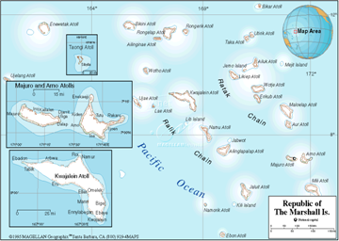
According to the mid-2004 estimated Census the population of Marshall Islands was 55,400. In the latest complete Census, the 1999 Census, the population of the Marshall Islands was 50,840. This number had more than doubled in 26 years from 24,135 persons enumerated during the 1973 Census. 96.7% of the population was born in the RMI and the rest, less than 2.3%, are from other Pacific islands, the USA and other countries. The sex ratio is 104/9, meaning that there are more men than women. The annual population growth of 4.3% during the period 1980-88, drastically decreased to 1.5% during the period 1988-99. The rate of natural increase, which is the difference between the crude birth rate and crude death rate, however, was as high as 3.7% in 1999. The wide difference in the two is because of migration of people mostly to the USA. The fertility rate is still high.

About 62% of the total population resides in either Majuro (23,676) or in Ebeye (10,902), located on the Kwajalein Atoll. During the period 1988-99, the average annual growth rate of these two communities has decreased considerably from 6.3% and 4.2% during the period 1980-88 compared to the growth rate of 1.8% and 1.5% per year during the period 1988-99. The population in the outer islands of Jabat, Jaluit, Mejit, Namdrik, and Ujae registered a decline in 1999 from their populations in 1988. The average annual population growth rate during 1988-99 was below 1% in Ailuk, Lae, Maloelap, and Utrik Atolls. This population change is mainly the result of migration of people within the country or to other countries. The infant mortality rate decreased from 56.9 in 1988 to 37.0 in 1999, but this and the child mortality rate are still quite high. Based on the results from the 1988 and 1999 censuses, the life expectancy of males has increased from 59.6 years to 65.7 years and for females from 62.6 years to 69.4 years. The population of the country is still quite young, 43% being under 14 years of age and 64.3% below 25 years. This still provides great potential for the population to grow fast. As of 1999, the average woman still bears about 6 children.
Table 12-1 - RMI Area and Population
Atoll or  Island | Land  (km2) | Lagoon  (km2) | Pop. | HH | Density  (people / km2 ) | HH  size
Ailinglaplap | 14.69 | 750.3 | 1,959 | 236 | 133 | 8.3
Ailuk | 5.36 | 177.3 | 513 | 88 | 96 | 5.8
Arno | 12.95 | 338.7 | 2,069 | 244 | 160 | 8.5
Aur | 5.62 | 239.8 | 537 | 86 | 96 | 6.2
Bikini | 6.01 | 594.1 | 13 |  | 2
Ebon | 5.75 | 103.8 | 902 | 122 | 157 | 7.4
Enewetak | 5.85 | 1,004.9 | 853 | 109 | 146 | 7.8
Jabat Is. | 0.57 | 0.0 | 95 | 15 | 167 | 6.3
Jaluit | 11.34 | 689.7 | 1,669 | 229 | 147 | 7.3
Kili Is. | 0.93 | 0.0 | 774 | 90 | 830 | 8.6
Kwajalein | 16.39 | 2,173.8 | 10,902 | 1,213 | 665 | 9.0
Lae | 1.45 | 17.7 | 322 | 32 | 222 | 10.1
Lib Is. | 0.93 | 0.0 | 147 | 15 | 158 | 9.8
Likiep | 10.28 | 424.0 | 527 | 82 | 51 | 6.4
Majuro | 9.71 | 295.1 | 23,676 | 3,080 | 2,438 | 7.7
Maloelap | 9.82 | 972.7 | 856 | 138 | 87 | 6.2
Mejit | 1.86 | 0.0 | 416 | 60 | 223 | 6.9
Mili | 15.93 | 646.7 | 1,032 | 136 | 65 | 7.6
Namdrik | 2.77 | 8.4 | 722 | 118 | 261 | 6.1
Namu | 6.27 | 397.6 | 903 | 127 | 144 | 7.1
Rongelap | 7.95 | 1,004.3 | 19 |  | 2
Ujae | 1.86 | 185.9 | 440 | 67 | 236 | 6.6
Ujelang | 1.74 | 66.0 | 0 |  | 0
Utrik | 2.43 | 57.7 | 433 | 65 | 178 | 6.7
Wotho | 4.33 | 94.9 | 145 | 18 | 34 | 8.1
Wotje | 8.18 | 624.3 | 866 | 108 | 106 | 8.0
Totals | 181.48 | 10,867.9 | 50,840 | 6,478 | 280 | 7.8
Source – 1999 Census Note: urban/urbanised atolls are in bold print

There has been a significant out migration of Marshallese to the U.S., primarily to Hawaii. In the 2003 Census of Micronesians in Hawaii, it was noted that nearly 3,000 Marshallese were living in Hawaii.

Island Geography
RMI consists of two nearly parallel strings of atolls lying from the northwest to the southeast: Ratak (sunrise) group and the Ralik (sunset) group. The Marshall Islands’ parallel chains of coral atolls and islands extend over 700 miles, and are about 300 miles apart. The eastern, or Ratak (sunrise) chain encompasses 15 major atolls and islands; the western Ralik (sunset) chain includes 16 atolls and islands. Twenty-two of the atolls are inhabited as are four out of the five small raised coral islands. Together, these two chains contain 1225 islets dispersed over more than 500,000 square miles of the Central Pacific. They cover a total land area of 70 square miles. While the land area is small, some of the atolls enclose enormous lagoons.
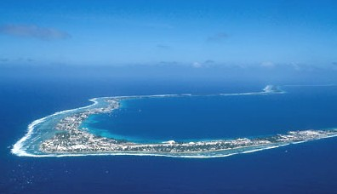

Majuro Atoll consists of 64 islets atop a reef that encloses a lagoon approximately 125 square miles in area. The three interconnected large islands of Darrit, Uliga and Dalap at the eastern end of the atoll make up the municipality of DUD where the government, commercial and transportation center of RMI is located.
Majuro Atoll

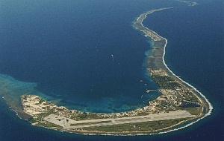
The Kwajalein Atoll consists of a large number islets encircling the Kwajalein lagoon encompassing approximately 840 square miles. The Kwajalein lagoon is the largest atoll in the world. A U.S. Military base, the Ronald Reagan Ballistic Missile Defense Test Site, is located on the southeast corner of the Kwajalein Atoll. There are approximately 5,000 U.S. military and civilian personnel based at the Kwajalein military base. The community of Ebeye is located near the military base and has a population of approximately 10,900 people.

Kwajalein Atoll with Military Base & Ebeye

Island Geology
The Republic of the Marshall Islands is coral caps on great dome volcanoes, which rise 18,000 feet from the ocean floor. At no point is any of the Marshall Islands land mass higher than 30 feet above sea level. The typical atoll has about 80 – 100 islets and anywhere from 3 – 4 modest sized communities, ranging from 100 – 400 people. There is no native soil on the islands; rather the islands are composed of coral sand and rock.

According to a report to the U.S. Federal Emergency Management Agency in 1994 by Dirk H.R. Spennemmann, there are several submarine vents of the Miocene age in the Marshall Islands. However, there are none producing any volcanic activity.

Climate and Environmental Hazards
The climate is characteristic of tropical islands. The temperature is hot, with an annual average temperature of 82.5° F. Daytime temperatures are around 89° F, with a drop to around 77º F at night, and relative humidity ranges from 83% at night to 76% at midday. There is little variation throughout the year. The long distance from north to south supports a climate difference with the northern atolls typically having about half the rainfall of the south, though the pattern shifts with the El Niño oscillation. Rainfall is typically heavy, with the wettest months being September, October and November. The Northern atolls receive about 80 inches of rainfall a year while the annual rainfall in the Southern atolls is normally higher, with Majuro recording 121 inches in 2004, 130 inches in 2003 and 144 inches of rain in 2002.

Winds are gentle from the east-northeast normally averaging 6 to 10 mph. However, winds can occasionally reach 70 mph during storms. Pacific typhoons generally develop to the east of the Marshall Islands area but the RMI is only occasionally subjected to the full brunt of a Pacific typhoon. The northern atolls are more subject to typhoons than are the southern atolls. A study conducted by Dirk Spennemann for FEMA in 1994 found that during El Niño Southern Oscillation there is a 71% chance of a typhoon striking in the Marshall Islands where as in non-ENSO years, there is only a 26% chance of a typhoon. The report concluded that typhoons generally develop further to the east of the Marshall Islands. However, during the years of the El Niño Southern Oscillation, the oceans are warmed by the El Niño creating a greater probability of typhoons further west than normal and thus increasing the possibility of a typhoon in the Marshall Islands.

Because the islands are true atolls with low-lying reefs and land masses, they are easily flooded during storms and tidal waves. In 1979, a typhoon tidal surge struck the most densely populated areas of Majuro Atoll over a two-day period, destroying 1100 homes and causing millions of dollars of damage.

The most important oceanic current affecting the Marshall is the 300 mile wide equatorial counter current, which flows eastward at an average speed of 0.4 to 1.0 knots, with maximum speeds of up to 2.0 knots. Local current velocities along the islands and reefs within the lagoons are not known but most have a general flow through the atoll passage into lagoons at rising tide and out at the passages at falling tide. Tides are semi-diurnal with a mean range of about 3.5 feet. The extreme tidal range can vary from zero to seven feet.

Energy Sources
The main energy source for most of the Republic of the Marshall Islands is No. 2 diesel fuel and gasoline. Electric power generation is estimated to represent approximately 65% of the non-marine petroleum fuel use on the island of Majuro. On Majuro, the Marshall Electric Corporation (MEC) furnishes No. 2 diesel fuel for its own use in the MEC power plant and it sells diesel fuel to the fishing fleets that operate out of the Majuro. In 2005, MEC used or sold a total of 13,575,417 gallons of No. 2 diesel fuel. MEC utilized 5,636,593 gallons of fuel to generate 82,267,000 kwhs of electricity. They also sold 7,938,824 gallons to the fishing fleets and others.

Mobil oil furnished fuel oil on the Kwajalein Atoll and specifically to the U.S. Military base and to the community of Ebeye. There were no figures available for the amount of fuels delivered to the Kwajalein Atoll. However, the Kwajalein Atoll Joint Utility Resources which provides the electrical power for the community of Ebeye uses an average of 106,000 gallons of fuel per month and an approximate 1,272,000 gallons annually. Ebeye’s average fuel cost for 2005 was $2.24 per gallon.

Energy Uses
The four main uses of energy on Majuro and Ebeye atolls are diesel fuel for electric power production, diesel and gasoline fuels for vehicles, diesel fuel for marine purposes and Jet A fuel for aviation. Most homes are not air conditioned; therefore, the majority of electrical power is used for lighting, refrigeration, entertainment systems and fans. Government buildings, resort facilities, retail stores and restaurants maintain air conditioned environments and represent the bulk of energy uses in their respective facilities.

HISTORY, POLITICAL DEVELOPMENT AND PRESENT STATUS

Early Island History
The Marshallese are thought to have come from Southeast Asia over 2000 years ago. It is believed that groups traveled from southern China, the Malay Peninsula and from the island archipelagos to the east. Over time, the settlers organized themselves into lineage groups and spread through the Marshall Islands double chain of atolls. They developed their own life style and social structure befitting the sparse and isolated environment. The ownership rights to the land, however, vested with the ‘Iroij’, who was the hereditary chief of several clans. Being the matrilineal society, all persons born to a woman inherited the right to cultivate and use land occupied by the clan. The ‘Iroij’ adjudicated land and lineage disputes as per the customary law and was responsible for the security of his subjects. The long period of isolation and harshness of the environment created a traditional system that is still strong and highly regarded.

The islands were first sighted by Europeans in 1526, by the Spanish Captain Garcia de Loyasa, but there were no further contacts until 1788 when the British Captain Marshall rediscovered them. The Marshall Islands were given his name by the British Admiralty. Sea voyagers from various parts of world passed across these islands but no nation claimed them as their colony. Contact with European whaling ships and traders began in the early nineteenth century.

Christian missionaries from Hawaii arrived in the Marshall Islands, first on Ebon, in 1857. The influence of Christian missionaries from the United States is evident today in the presence of many sects and faiths, principally Protestant.

German copra traders became active in the Marshall Islands in the last third of the nineteenth century. German trading companies started to build trading links around 1860 with some of the islands and built a network of island stations for trade in copra and retail goods. In 1878, Captain von Werner of the German Navy entered into a treaty with the Ralik group for trade. In 1885, under mediation of Pope Leo XIII, the German government annexed the Marshalls after paying Spain the sum of $4.5 million for its claim dating from the Papal grant of 1494. In 1886, Germany formed a formal protectorate and in 1887, the Jaluit Company was created and entrusted with the Marshalls’ governance. Germany purchased the Marshall Islands along with the rest of Micronesia in 1899 after Spain’s defeat to the U.S. in 1898.

Recent Island History
At the beginning of the First World War, Japan entered the war on the side of the Allied Powers and declared war on Germany. Japan immediately sent warships to the German controlled areas of the Pacific and by September 1914 occupied German Micronesia including the Marshall Islands. On June 28, 1919, the German Reich renounced in favor of the Principal Allied and Associated Powers all its rights over its Pacific Insular Areas, including the Marshall Islands.
On December 17, 1920, the Council of the League of Nations confirmed a mandate to the Emperor of Japan for the former German Insular Areas north of the equator, including the Marshall Islands, to be administered in accordance with article XXII of the Covenant of the League of Nations. The islands remained under Japanese rule until the defeat of Japan by American forces in the Second World War.

The Marshall Islands became a World War II battleground and suffered major invasions on Kwajalein, Enewetak, Majuro and lesser bombardments in the other atolls. In 1944, most of the atolls were occupied by American forces.

Before the establishment of the United Nations trusteeship in 1947, Bikini and Enewetak atolls were set aside and, after discussions with and evacuation of the few hundred inhabitants, these atolls were used for sixty-seven atomic and hydrogen bomb tests between 1946 and 1958. Kwajalein, the world’s largest atoll, which extends for a distance of 70 miles, and with a lagoon that covers 840 square miles became a United States Naval Base, and in 1959, a missile testing facility.

United States Involvement
Federal domestic programs provided by the U.S. Government make up the bulk of all the Marshall Islands Government's funding. About forty per cent alone go to the direct Federal grant. The new twenty year Compact agreement includes a revised package of economic assistance with another opportunity to shift toward economic self-reliance. The economic provisions include a temporary increase in total grants — largely to support a Compact Trust Fund, which is meant to replace grant funding after FY 2023. American budgetary support from grants will decline steadily in real terms throughout the period covered by the agreement. The renewed Compact also includes a number of accountability measures meant to improve the efficiency of grant use.

The Compact funding represents the main element of the U.S. programs for the Marshall Islands. Substantial funds have been provided for the development of good infrastructure systems such as roads, electric utilities, water systems, public buildings and sea and airports. In 1999, the RMI set up the Intergenerational Trust Fund for the purpose of having sufficient funds invested by 2018 so that the annual earnings from the Trust Fund will be sufficient to sustain the Marshall Islands as the U.S. Compact funds phase out. There is presently over $29 million in the fund and approximately $7 million in funding is added each year from the U.S. Compact funds. In addition to the $7 million, the Compact fund provides another approximately $30.7 million in grant funds to RMI. In addition, there are impact payments for the Kwajalein military base of approximately $15 million per year distributed according to land use agreement.

Political Development
After a brief period of occupation by the U.S. Navy, the UN entrusted the administration of the Marshall Islands to the U.S. as the Trust Territory of the Pacific Islands (TTPI) in 1947. The administration of the Marshall Islands was transferred to the Department of the Interior in 1951.

Self-government began with the creation of the first Marshall Islands Congress in 1949. By 1976, the Marshallese had become dissatisfied with the centrally-controlled division of revenue among the Micronesian island districts, the lion’s share of which derived from activities related to the Kwajalein missile range. It established a political status commission to pursue separate negotiations with the United States. In a 1978 referendum, the Marshallese rejected a closer union with rest of Micronesia, and in 1979 established a constitutional government modeled after the British parliamentary system.

In 1982, the name “Republic of the Marshall Islands” became official and in 1983 the voters approved the Compact of Free Association (COFA or Compact) with the US. The compact granted the RMI sovereignty while providing $336.5 million in aid grants, U.S. defense and funds for rental of the missile testing range at Kwajalein Atoll. With the approval of the U.S. Congress in 1986, the COFA went into effect. In 1990 the UN ended the RMI Trusteeship status, and in 1991 the RMI became a member of the United Nations. Over the full 17 years (FY 1987–FY 2003) from the start of the original Compact through the end of a two-year extension, the U.S. provided a total of approximately $750 million to the RMI (ADB, 2004).

The first 15-year Compact period ended in September 2001. After 2 years of negotiations, a new 20 year compact agreement became effective in late November 2003. The Compact of Free Association Amendments Act of 2003 sets out the nature and terms of U.S. financial assistance for the period FY 2004–FY 2023. The overall annual financial support potentially receivable in this period, prior to inflation and other adjustments, is in the order of $66 million annually, or about 60% of the current nominal GDP level.

Present Political Status
The Marshall Islands Government follows a combination of both the U.S. and the Westminster systems. It is unitary rather than federal, but the American influence is seen in the importance attached to the committees in the unicameral, a thirty-three-member Nitijela (Parliament). In addition, there is a Council of Iroij, which may:

(a) consider any matter of concern to the Marshall Islands and may express its opinion thereon to the Cabinet, and
(b) request the reconsideration of any bill, which the Nitijela has adopted on its third reading, affecting the Marshall Islands' customary law or any traditional practice or land tenure, or any related matter.

Executive
An executive branch, the Cabinet, consists of those members of the Nitijela who are the President, the ministers, a judiciary, whose powers are vested in the Supreme Court, the High Court, the Traditional Rights Court and such district courts, community courts and other subordinate courts as are created by law. On November 17, 1979, the first and only President of the Marshall Islands was elected, the Honorable Amata Kabua, one of the Marshall Islands' eleven iroijlapap (paramount chiefs).

Election to the Council of Iroij is limited to those recognized by customary law or traditional practice as having rights and obligations analogous to those of iroijlaplap. Election to the Nitijela, however, is for any natural citizen of the Marshall Islands who is at least eighteen years of age. Elections are carried out on the basis of universal suffrage and take place every four years. The members, styled Senators, are elected from all the atolls and islands of the country. When seated, the members elect from among themselves the President, who in turn selects from among the members of the Nitijela the members of his cabinet.

The Cabinet appoints, with the Nitijela's approval, the members of the Supreme Court and the High Court, whose judges serve quamdiu bene gesserint until they reach the age of seventy-two years. In the case of a judge not being a citizen of the Marshall Islands, the judge may be appointed for a term of years or, in the case of a sitting judge in another jurisdiction, for a particular session of the court. The judges of the Traditional Rights Court are selected according to other criteria. This court is set up to deal with questions relating to titles or to land rights, or to other legal interests, depending wholly or partly on customary law and traditional practice in the Marshall Islands.

The National Government consists of a bi-cameral legislature, President of the Cabinet, the judiciary and the public service. The two legislative bodies are the Council of Iroij, the Upper House and the Nitijela, the Lower House. The President is elected by a majority vote of the Upper House, the Iroij.

The Judiciary
The judiciary is independent of the Nitijela and the executive, its power vests in the Supreme Court, the High Court, the Traditional Rights Courts, the Community Courts and other subordinate courts created by law. The Supreme Court, the High Court and the Traditional Rights Court function from Majuro and the District Courts are located at Majuro, Ebeye and Jaluit. The Community Courts function on respective atolls.

There is an independent Judicial Service Commission responsible for the appointments to the judiciary. Candidates for positions are recommended by this commission for the Traditional Rights Courts, the District Courts, the High Court and the Supreme Court to the government. The Council of Ministers, after considering the proposal, places it before the Nitijela for a final decision. The appointments of judicial officers to the Community Courts are finalized at the level of the Judicial Public Service Commission itself. The Community courts have jurisdiction to decide civil cases of value up to $100 and the jurisdiction of the District courts are all cases having pecuniary limit up to $2,000.

The jurisdiction of the High Court and the Supreme Court is without any pecuniary limit. The Traditional Rights Court has no original jurisdiction and it provides advice on issues involving customary law and practices, referred to it by other courts. The jurisdictional court, however, makes the final decision in the case after taking into account the opinion of the Traditional Rights Court.

Public Service
The Public Service assists the Cabinet in exercising its executive authority. The Service is headed by the Chief Secretary, and includes the Attorney General, Chairman of the Public Service Commission, Permanent Secretaries and all other public servants.

Local Government
As embodied in the constitution, each atoll has a right to create a local government. Each local government consists of an elected council, a mayor, officials, and a local police force, with variations depending upon the constitution of each. People elect their councilors and Mayor directly. The term of the Council is 4 years, which is the same as that of the Nitijela. The Minister of Internal Affairs can constitutionally terminate a Council earlier, if circumstances so necessitate. In the case of Ebon, instead of direct election, each family elects one member for the local council. As a result, there are 83 members on the Ebon council. Membership on Councils of other atolls ranges from 5 in Likiep to 25 in Ailinglaplap, depending upon the membership provisions in their local constitutions.

Source: The RMI Statistical Yearbook, 2004 Chapter 1 – People 3 Economic Policy, Planning and Statistics Office.

POPULATION, EMPLOYMENT & WAGES

Present Demographics
About 55.400 people live in the Marshall Islands. Majuro’s population is approximately 22,900 and Ebeye’s population is approximately 10,900. Majuro and Ebeye are the main population centers, representing 61% of the population with the remaining 39% residing in the outer islands. With a population of 10,900 and a land area of 6.3 square miles, Ebeye has the highest population density in the Pacific, with 1,703 people per square mile.

Although the actual birthrate figures indicate that the population is increasing at a rate of 3.7% per annum, the actual increase in population is only 1.5% per year due to out migration. With the anticipated poor economy continuing it is expected that the actual growth rate of the Marshall Islands will remain in the range of 1.5% per year.

Employment and Job Market
RMI has a serious problem of providing jobs for its growing labor force. According to the 1999 census, the total number of people working was 10,141 - 3,106 in the public sector and 7,035 in the private sector. However there were 14,677 people seeking jobs. In 1988, the number of people economically active was 11,488, out of which 10,056 were working, 3,392 being in government jobs and 6,664 in private employment. Unemployment rate at the time of the 1999 census was 30.9%. During the 11-year period from 1988 to 1999, the number of people who were economically active grew 27.76% while actual job creation grew only by 0.84%.

Personal Wages & Income
The household income in the Marshall Islands is relatively at the top of the scale of other islands in the central and western Pacific area of small island countries. According to a survey taken in 2001 of a sampling of 613 households, the median household income was $25,459, the mean household income was $32,523 and the per capita income was $4,211. The survey was taken on the two main population center atolls of Majuro and Ebeye plus two outer islands, Jabor and Likiep, which serve as typical samples of outer island incomes. Ebeye, which is the employment center for the U.S. Kwajalein Military Base, had the highest median household income of $40,718; mean household income of $47,446 and per capita income of $5,041. This was followed by Majuro with median household income of $25,667, mean household income of $30,795 and per capita income of $4,380. Two outer islands surveyed in 2001 had much lower median, mean and per capita incomes as may be noted from the table on household and per capita income.

Table 12-2
Republic of the Marshal Islands
Household and Per Capita Income
 | Total | Majuro | Ebeye | Jabor | Likiep
Median HH Inc | $25,459 | $25,667 | $40,718 | $9,010 | $6,000
Mean HH Inc. | $32,523 | $30,795 | $47,446 | $11,582 | $7,103
Per Capita Inc. | $4,211 | $4,380 | $5,041 | $1,528 | $1,146

General Business & Commercial Income
Information was limited on business and commercial income.

ISLAND ECONOMY AND INFRASTRUCTURE

General Status of the Economy
The RMI is classified by the United Nations as a Small Island Developing State. The economy remains relatively small, with a current-dollar Gross Domestic Product of about $130.9 million USD in 2005. The economy relies heavily on RMI Government and U.S. military expenditure and employment, but has seen some growth in commercial and small-scale fisheries, mariculture/aquaculture, agriculture, traditional crafts manufacturing (handicrafts), and tourism.
The latest figures for Sector Gross Domestic Product by Sector are from FY 2001 and are listed below:

Table 12-3

Republic of the Marshall Islands, Sector Gross Domestic Product (thousands)
Agriculture | $10,296.1
Mining and Quarrying | 291.4
Manufacturing | 4,489.5
Electric, Gas & Water | 3,402.2
Construction | 11,314.1
Wholesale, Retail, Restaurant & Hotel | 16.937.3
Transport, Storage & Communications | 5,044.8
Finance, Insurance, Real Estate & Business Services | 15,458.2
Community, Social & Personal Services | 31,043.6
TOTAL | $98,277.2
Sources: L.N. Perera Report on RMI Gross Domestic Product and Sector Accounts South Pacific Forum Secretariat, EPPSO.

The economy of the country, like many other Central Pacific island countries has three basic financial and economic problems: budget deficits, balance of payments and a low level of domestic savings. Both public and private investment has been low. As a result of the liberal foreign investment policy of the government, small business investment has increased with more traders from Asian countries like China, Taiwan, Hong Kong and Korea providing stiff competition for established local stores. The small size of the market, legal restrictions to land, distances and isolated places, high transportation costs in importing goods and high wages are the factors detracting foreign investment in RMI.

The economy is heavily dependent on funds from the US, Asian Development Bank and assistance from other countries. The size of the annual budget is largely dependent on the size of the financial aid from these sources. The imports are rising without corresponding increase in exports and thus the balance of trade is unfavorable. The economic and administrative reforms carried out during the 1990s are showing some favorable results for the economy. There are few reliable estimates of the GDP available, but it is estimated that the GDP in recent years has grown by approximately 3.8% based on current market prices. The RMI has no monetary system of its own and uses the U.S. dollar. As a result, the economy has not had to face foreign exchange rate problems as experienced by other countries in the region which have their own monetary systems. The rate of inflation is minimal. The per capita income in 2002 was estimated at $1,867 U.S. dollars, among the highest in the region after the Federated States of Micronesia.

Major Employment Sectors
Other than the U.S. Military Base on Kwajalein, the major employment sector in the Marshall Islands is subsistence farming and fishing, especially in the outer islands. The next significant employment sector is the government.

The major employer in the Marshall Islands is the U.S. Military Base on Kwajalein. Approximately 1,500 people from the Marshall Islands and surrounding Micronesian islands are employed at Kwajalein. Since wages are higher at the U.S. Military Base than other localities in the Pacific, the per capita income in the community of Ebeye is the highest in the Micronesian atoll islands.

Electrical System

Majuro
The electric utility in Majuro, Marshalls Energy Company, Inc. (MEC) is publicly owned by the Marshall Islands national government. It is governed by a Board of Directors appointed by the President and Chaired by the Minister of Public Works.

MEC functions independently of government operations and as such operates its own accounting procedures and systems. These systems are fully audited annually by an international accredited auditing company.

The MEC is responsible for the generation and distribution of electricity, importation and sale of Liquid Petroleum Gas (LPG) and importation of diesel fuel for its own use and sale to fishing vessels plus the managing its own bulk fuel storage facilities. Additionally, MEC has been tasked by the Government of the Republic of the Marshall Islands to oversee and implement the expansion of renewable energies throughout the Marshalls. The purpose of this outer island electrification program is to bring basic lighting and power needs to all the people of the Marshall Islands. MEC’s electrical power is distributed throughout Majuro and serves smaller outer island urban communities on Jaluit Atoll, Wotje Atoll and Rongrong Island (within Majuro’s Lagoon). Electric power in Ebeye, the other major urban center, is supplied by the Kwajalein Joint Utilities Resources (KAJUR).

MEC currently has 132 employees dispersed throughout its operation centers, of which only four are non - Marshallese. Government subsidies to MEC ceased in 1993, when MEC began to operate profitably.

Ebeye
The power production on Ebeye is provided by the Kwajalein Joint Utilities Resources (KAJUR). However, as of the date of this report, the board of directors that oversees the KAJUR had been disbanded and although there have been efforts to reconstitute a board; no final action had been undertaken. The power generating facilities on Ebeye consist of two Cummins 450 kW diesel engine-generators installed in 2003 and two old Enterprise 2,300 kW diesel engine-generating units. At the date of this report, the two Cummins engines had been taken out of service and sent to Australia for major repairs due to a bent crankshaft. Operation of the remaining two engines was unreliable.

Operation of the Ebeye power system had been contracted to professional staff from American Samoa Power Authority from 2000 to the termination of the contract in 2005. Power service in Ebeye is sporadic depending upon availability of operational generators and funds to purchase fuel.

Ebeye has installed cash-power meters on much of their system but funding the utility system is still a major problem.

Water and Wastewater Systems
Water is provided to Majuro by the Majuro Water and Sewer Company (MWSC). The MWSC and MEC are managed jointly and supervised by MEC. Water is collected by MWSC from the airport runway and stored in a 30 million ground tank near the airport. Water is pumped to the eastern Majuro island business and residential center three days per week, wherein catchment tanks are filled. Most building and household catchment tanks are equipped with automatic fill valve mechanisms that regulate filling of the tank when the city water line is pressurized.

Wastewater is collected from the eastern end of Majuro and discharged via pipeline into the outer reef along the southern shore of Majuro. Discharge depth and prevailing ocean currents aid in dispersing the wastewater out to sea.

Ebeye wastewater is collected and pumped into the lagoon. There had been a secondary sewer system operating on Ebeye but due to lack of maintenance, it has been inoperable for several years. Septic tanks are not allowed in Ebeye.

In FY2004 the income from the combined Majuro Water and Sewer Co. was $1,116,213 and expenses were $1,231,338 for a net loss of $115,175.

Transportation System
The transportation system of the Marshall Islands is generally by private vehicle. In addition to private vehicles in Majuro and Ebeye, there is a good supply of taxi service. There is no significant established bus system in either location. Most of the transportation is in Majuro and centers on the six miles of dense population in the south east part of the Majuro Atoll. Although the Majuro Atoll is approximately 31 miles long with a road running the full length, most of the population live in the eastern six miles of the island where the government complex, harbors and resorts are located. The roads in Majuro are paved and are reasonably well maintained.

Port and Port Industries
Majuro and Ebeye both have excellent ports capable of off loading large cargo ships and fuel tankers. Many of the outer islands also have smaller ports that can handle the smaller intra island ships that service their requirements. Majuro has much of the necessary infrastructure and facilities for fishing vessel activities. The facilities include: a floating dry dock, a deep-water harbor with container handling facilities, a fish base complex equipped with a bulk ice facility and a satellite chiller plant at the airport for air shipment, a 10 million liter bulk fuel storage bunker facility, regular international shipping services, and an international airport. Majuro also contains many stores, stocked with supplies and goods, mostly imported from the U.S. Ebeye, RMI’s second largest urban center, also has fishing facilities including a protected harbor and marina and fishing base.

The Marshall Islands Marine Resources Authority (MIMRA) operates a National Fisheries and Nautical Training Center and trains approximately 75 students per year. Students learn skills that enable them to work on commercial fishing vessels. Past graduates are presently employed on U.S. fishing vessels. Vessels operating out of Majuro have access to these trained seamen.

Airports and Aviation Industries
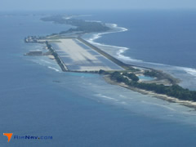
The Marshall Islands have a total of 19 runways located throughout the islands, with the two major airports being at Majuro and Kwajalein. Majuro has a 7,897 foot runway; 150 ft. wide, constructed of asphalt, grooved and is in good condition. The airport is located seven miles west of Majuro Atoll. The runway has capability of supporting double tandem wheeled aircraft loads up to 290,000 lbs. There are an average of 300 flight operations per month at the Majuro airport with 68% being air taxi mostly to other atolls in the Marshall Islands, 28% commercial, 3% transient general aviation and less than 1% military. Continental Micronesia has flights from Guam stopping in Majuro going to Hawaii on Mondays, Wednesdays and Fridays and flights from Hawaii to Guam stopping in Majuro on Tuesdays, Thursday s and Saturdays. Marshall Air has flights once per week to Tarawa, Kiribati, with flights that interconnect with Air Pacific for flights on to Fiji. The Air Marshall airlines also have flights daily between Majuro and Kwajalein as well as flights to many of the outer islands. Mobil Oil provides fuel at the airport.

The airport runway also serves as a water catchment for drinking water for Majuro. There is an extra wide concrete apron running along the northern side of the runway serving that purpose.

Communication System
The communication system is provided by National Telecommunications Authority (NTA) Telecom. Telephone, cable television and internet data services are provided. Satellite links provide the communication links for Majuro. Some businesses have purchased “T-1” communication links from NTA and operate reasonably fast internet connections. Some have installed wireless links to their “T-1” service to provide wireless data links. However, normal telephone modem data links are very slow, operating in the 28 kb range but uploading and downloading after the first 150 kb is generally in the range of 4 to 8 kb.

Tourism Industry
As a coral atoll nation, one of only four in the world, the Marshall Islands offers a very unique environment and landscape, consisting of saltwater lagoons encircled by white beaches and small, lush islands. The Marshall Islands contain over 870 reef systems, 800 species of fish, and 160 species of coral. There are a number of WWII ship and plane wrecks, including the world’s only dive able aircraft carrier (the USS Saratoga), the Nagato-the flagship of the Japanese World War II fleet, and a German Cruiser launched by Adolf Hitler (the Prinz Eugen), that offer excellent wreck scuba diving. Non-wreck scuba divers enjoy an abundance of reef and pelagic fish, coral species, and an ample supply of sharks. For history enthusiasts there are many land-based WWII relics that can be found on the four main atolls used as Japanese military bases. Coastal defence guns, Japanese Zeros-fighter planes, tanks, buildings and other remarkably intact relics are all set in isolated, jungle-like conditions.

The Marshall Islands also has good sport-fishing. In recent years, an increasing number of deep sea and fly fishing enthusiasts have been attracted to some of the more remote and less-fished atolls, such as Bikini and Mili.

The RMI Government has taken significant steps to encourage the development of tourism in the Marshall Islands. The RMI Government, with funding and technical assistance from the Asian Development Bank, set up the country’s first fully operational national tourism organization, the Marshall Islands Visitors Authority (MIVA) in 1997. The Marshall Islands Visitors Authority is governed by a Board of Directors and its purpose is to conduct tourism planning, development, marketing and promotion.

Major Industry
The major industry for the Marshall Islands is the U.S. Military base at Kwajalein and the fishing industry. The major source of income for the Marshallese is the Compact and military lease payments from the United States.

Military
The U.S. Army leases most of Kwajalein Atoll from RMI for the missile range that has been in operation since 1961. The Kwajalein U.S. Military base is the home of the Ronald Reagan Missile testing site. The 840 square mile Kwajalein lagoon is used as the target-landing site for missile test flights from the U.S. mainland in tests of the U.S. antimissile program. There are approximately 5,000 U.S. military and civilian personnel based at Kwajalein. The base provides employment to approximately 1,000 and 1,500 people who live on nearby Ebeye. Although the majority of the Ebeye population is of Marshallese decent, Ebeye is a major residential location for islanders from throughout the Micronesian area who are employed by the Kwajalein base. Many Micronesians move to Ebeye for what they originally planned to be temporary employment and often find that their stay in Ebeye extends for 10 to 20 years. The income level of Ebeye is one of the highest in Micronesia due to the relative high wages paid at Kwajalein. However, the living conditions are among the worst in Micronesia due reportedly to the temporary nature of the population not being willing to invest in adequate housing, partly because of legal restriction on the ability to purchase land on which to build a home.

Other Special Economic Elements
There are no other special economic elements other than those already reviewed.

Manufacturing, Craft, Trade
There is little manufacturing done in the Marshall Islands. The Marshallese crafts are of very good quality and sought after by collectors of Micronesian crafts. However, the outlets and international marketing of the crafts is limited and sales are generally only done through the local craft shops, airport, etc.

Agriculture
Agriculture production in the Marshall Islands is minimal, except for copra and the production of basic food products such as taro, bananas, other fruits and coconuts.

Copra
The copra trade has been the main cash crop for the Marshall Islands for 100 years or more and is the mainstay of outer atoll and island economies. Over the last 50 years there have been significant changes to the conduct of the copra trade and in the returns to producers. Domestic shipping is the lifeline to residents in the outer atolls and islands. It is also vital to the copra industry – without domestic shipping the copra trade would not survive and without a good service, the copra trade cannot flourish. Shipping is therefore seen as an essential requirement for the development of outer atoll and island economies and for the copra trade in particular. A feature of the Marshall Islands copra trade is its reliance on exports and its small volumes. Over the last 20 years the international coconut trade has been slowly but surely declining. This has seen returns to producers, who are mainly in the outer atolls and islands, decline; and as a consequence, people have been migrating to Majuro or Ebeye. However, the “copra equation” now seems to have permanently changed. With worldwide increases in oil prices, coconut crude oil becomes an economic substitute for diesel for transport purposes and for electricity generation as well as a substitute for kerosene.

Outer island copra production presently contributes about 1% to the GDP. Copra production has been slowly declining over the past 20 years averaging 4,244 tons per annum for the past five years. Two thirds of total production is from six atolls and 90% comes from 11 atolls. Copra production in the Marshall Islands is driven by price and affected by the performance of the domestic shipping service. Production levels can be relatively easily increased to 8,500 tons but for this to occur a copra price of 20-22 cents per lb will be needed along with a much improved shipping service. A copra price of 25 cents per lb would see people return to their atolls from Majuro to produce copra. The current posted price for outer island copra is 12 cents per lb. The Marshall Islands has constructed a central copra processing plant (Tobolar). In recent years it has only been operating at 37% of capacity due to shortage of copra. Over the last five years (FY 2000-2004) average income from essentially export sales has been almost $1 million per year. Tobolar’s total costs of production have averaged about $1.7 million before product inventory valuation adjustments of minus $0.5 million. Therefore there has been an overall deficit of a little more than $1.1 million per year. Over the last five years the average annual copra price stabilization subsidy has been $1.1 million. The outer island shipping subsidy has averaged $125,000 in recent years and the annual cost of the Sea Transport Division’s operations has been about $1.7 million. Altogether the RMI Government subsidizes the copra industry and shipping by $2.9 million per year. This is equivalent to 34 cents per lb, which is almost three times the outer islands posted price for copra of 12 cents per lb. The main beneficiary of the subsidies is the Sea Transport Division, (its employees and suppliers) which spread across the whole copra industry, amounts to 21.8 cents per lb. The next major beneficiaries are the outer island copra producers who receive 8.2 cents per lb. The third class of beneficiaries are the employees of and suppliers to Tobolar, the copra processor, who receive the equivalent of 5.9 cents per lb. Private ship operators are the fourth class of beneficiaries and altogether receive 1.5 cents per lb.

Source: Report for the Asian Development Bank and the Republic of the Marshall Islands on the Conduct of the Copra Trade and Outer Island Shipping Services in the Marshall Islands, October 2005.

Aquaculture, Fisheries
The Exclusive Economic Zone (EEZ) of the Republic of the Marshall Islands covers about 750,000 square miles resulting in an excellent potential for the development of its fishing industry. At present, fishing vessels operating in the Marshall Islands EEZ are from the United States, Japan, China, Taiwan, Korea, Vanuatu, Kiribati and the Federated States of Micronesia. In the case of the US, the RMI is party to the U.S. Multilateral Tuna Treaty, which allows the U.S. fishing vessels access to certain Pacific island EEZ’s. A Chinese long-line fleet has vessels based in Majuro also.

The Marshall Islands currently receives a fee of 5 percent of the landed value of commercial fishing catch. In addition, the RMI has become a more significant service port for fishing vessels in the region in terms of R&R, repair and maintenance and transshipment. Fees and associate costs from these services amount to about $15,000 to $20,000 per vessel with annual economic contribution estimate at about $5 to $6 million annually.

However, in the past 2 years, fishing rights revenues have decreased. The decrease is mainly due to the migratory patters of the fish away from the RMI EEZ. The decrease has a significant impact on domestic revenue receipts with a reflective impact on general fund expenditure.

The Marshall Islands is a member of a regional arrangement known as the Forum Fisheries Agency (FFA). The FFA Secretariat assists its member countries in managing and conserving its region-wide tuna stock, in cooperation with non-Pacific island countries fishing in the region. The Secretariat of the Pacific Community (formerly known as South Pacific Commission), to which the Marshall Islands is a member, provides necessary scientific and biological information on the marine species within the EEZ.

A large tuna processing facility, built in the late 1990s had closed in 2004, due to the worldwide low prices in the tuna market and an excess of tuna processing facilities worldwide, especially those in the eastern Pacific along the coastal areas of South America. The closing of the tuna processing facilities resulted in the loss of some 400 jobs in Majuro, a difficult blow to the already strained economy

Solid Waste Management Systems
The Majuro land fill is located along the southern shore, ocean side, west of the main business, government and residential areas of Majuro. Solid waste is discharged into the coral reef and lightly compacted, with the intention of adding land area to the island. No containment or liner system is used at the landfill.

ECONOMIC DEVELOPMENT PLANS AND PROJECTS

General Status of Economic Development Planning
The Government of the Republic of the Marshall Islands encourages private sector development to help meet its development goals. These goals include employment generation, human resource development, generation of foreign exchange, and import substitution. It is particularly interested in encouraging private investment in its fisheries, tourism, manufacturing and agriculture sectors.

Economic Development Approach and Special Issues
The Government recognizes that the domestic private sector alone is not yet able to contribute sufficiently to the nation’s economic development. It therefore actively seeks direct foreign investment to assist the country meet its development goals. The Marshall Islands exempts from gross revenue tax several development sectors for a period of five years that include manufacturing for export and local use, agriculture, deep sea fishing and hotel and resorts.

Focus Areas
The focus of the Marshall Islands economic development programs are in the area of providing for and servicing the fishing fleets, tourism and establishment of exportable products. Crafts and copra are two such products that are presently exported.

Energy Considerations
The Republic of the Marshall Islands has established an energy office. The ultimate focus of the energy office is to review policies and assist the RMI government with a broad scope of energy related issues. Their present focus is on assisting the development of renewable energy on outer islands, mostly for photovoltaic systems, with funds from donor agencies and nations. The following is the established energy policy of RMI:

Marshall Island Energy Policy (2002)

Vision
The 2nd Economic & Social Summit 2001 adopted the following as the National Vision for the Republic of the Marshall Islands for the period from 2001 to 2016:

“To become a country with an interdependent world, with an enhanced socio-economic self-reliance, an educated, health, productive, law-abiding and God-fearing people and in which individual freedom and fundamental human rights are protected and culture and tradition are respected and development and environmental sustainability are in harmony.”

Energy Sector Vision
Available, affordable, reliable and sustainable energy for social and economic development for all the people of the Marshall Islands.

Core Elements
The National Energy Policy consists of six core areas and these are:
National Coordination and Planning,
Renewable Energy/Rural Electrification,
Power,
Petroleum,
Energy Efficiency and Conservation and
Transport.

The Marshall Islands Federal Government has established a National Energy Division within the Department of Resources and Development and has staffed the Division with a National Planning. The purpose of the National Energy Division will be to implement the following:
- Coordinate National Energy plans.
- Review and implement the national energy policy as and when appropriate.
- . Promote partnerships between private and public sectors in the implementation of energy programs.
- Investigate opportunities available under regional and international cooperation (e.g. Kyoto Protocol – Clean Development Mechanism, Carbon Trading, etc.) to improve access to reliable, affordable, economically viable, socially acceptable and environmentally sound energy services.
- Ensure the standardization of renewable energy equipment, especially solar equipment used in the Marshall Islands.
- Establish a national energy supply and demand database.

National Energy Policy Office
In discussions with the National Energy Policy Administrator the major focus at the present time is the program to install solar units on all of the outer islands in order to provide lighting and power to homes and businesses.

Economy Diversification
The Marshall Islands have attempted to diversify their economy between commercial fishing, tourism, local crafts, copra production and local construction and services. A main economic driving force in RMI is employment at the U.S. Military base on Kwajalein for the residents of Ebeye. This military base is a major source of income for a significant percentage of Marshallese citizens. Fishing is a major element of the RMI economy; however the tuna fishing business has suffered a decline in recent years due to the slump in world wide tuna prices. The local tuna processing facility built in Majuro during the 1990s closed in 2003 due to financial difficulties. The copra industry provides income to families on the outer islands who provide the copra product. However, it requires over $1,000,000 per year of subsidies to maintain operations and thus is not an economically viable industry but is continued as a means of providing much needed cash income to outer island residents. There is some anticipation that if copra can be used as a substitute fuel in local diesel engines, including the electric utility’s generators, the copra industry may become economically viable.

Import-Export and Balance of Payments
For FY2000 the Marshall Islands exports were $9,124,000 and imports were $54,724,000 for a negative balance of $45,600,000. The Trade Balance in 2005 according to the International Monetary Fund was a negative $69.3 million.

Status of Energy Systems

Major Energy Uses
The major energy use in the Marshall Islands is for the generation and delivery of electrical power and the furnishing of fuel to the fishing fleets. In 2005, there was 5,636,666 gallons of fuel used by the Marshall Electric Corp. to produce 82,367,000 kWh of electrical energy. This represented an estimated 60% percent of the fuel energy imported into the Marshall Islands in 2004, excluding the fuel used by the U.S. military.

Figure 12-1
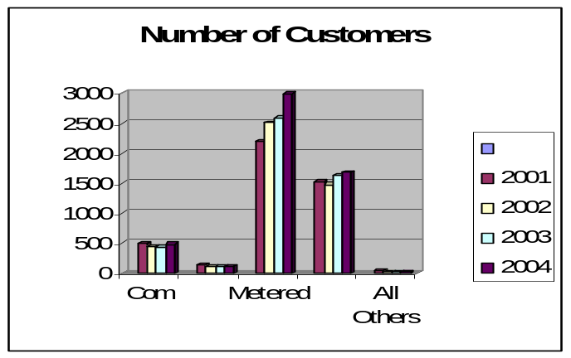

Electric Power System
The electric system of the Marshall Islands is scattered throughout the 29 Atolls, with varying degrees of development depending upon the population served. The two main electric service areas are Majuro and Ebeye. Most of this report is a review of the Majuro system since it is the largest system and serves the largest population plus the government and the major businesses of the Marshall Islands. Several outer islands have operational power systems, either with generators or photovoltaic systems. Two outer island systems operate their plants 24/7 whereas the rest start their units only on an intermittent basis.

The Majuro electric power system consists of a main power plant located on the western end of the major business and government complex of Majuro. There are two power plants with two relatively new diesel engines in plant two which serve as the base load power plant, and 5 generators located in Power Plant one. The power plant is located adjacent to the MEC’s diesel oil terminal.

Distribution System
The distribution system consists of three 13.8 Kv feeder circuits extending from the power plant located on the western end of the urbanized southeast end of the Majuro Atoll. One circuit, which is an underground feeder circuit, goes west of the plant for approximately 24 miles serving the Majuro International Airport and the less densely populated area of the west part of Majuro. Two circuits, one underground and one overhead line, extend from the power plant eastward to the industrialized, government, retail and more heavily populated section of Majuro. The underground feeder circuit is dedicated to the more critical loads of the hospital, government complex, a major resort facility, a major retail outlet center and several other more critical loads. The other circuit, which is of overhead construction, extends to the northeast end of the main part of the Majuro atoll, with the last several thousand feet being served at 4,160 volts. The circuit then extends via underground cables to serve several islands in the northeast chain of Majuro atoll islands.

There are eight separate sectionalizing breakers along the radial distribution lines. The sectionalizers are coordinated such that the sectionalizers farthest out on the line are set to trip on the lightest fault current and the sectionalizers closer to the power plant are set to trip on heavier fault currents. This system serves to sectionalize a fault occurring at the most distant location from the plant and helps keep service on to the largest number of customers. Due to safety concerns, the sectionalizers are set to not automatically reclose after disconnecting from a fault as do many sectionalizer systems. Following a sectionalizer operation the line crew is dispatched to investigate and locate the fault and repair the line. There are no voltage regulators necessary on the two longer lines because of the relative light load on the outer extremities of the feeder circuits

The distribution system losses as noted above are in the range of 20%. There are notable line losses on a percentage basis in the 21 miles of underground cable that serves the west end of the island. However, the loads to the western sector are very light and thus the total magnitude of the losses is not significant to MEC’s Majuro system. There are some losses due to the method of Power Factor Management (see following section) however. Studies would need to be performed to determine if other methods of power factor management would be any more cost effective.

A noticeable system power use, perhaps not to be characterized as a loss, that is unique to MEC, is the ventilating fans used in the enclosed power station. The power plant is an enclosed concrete building housing the two large diesel engines with no ventilation except for eight large ventilating fans; four used to move outside air into the building and four to remove heat from the building. However, the cost to operate the balanced forced air system of ventilation must be weighed with the cost that would occur due to increased corrosive effect of sea mist in the power station if the present ventilation system were to be changed. The power plant is located on a very narrow coral strand of property between the Majuro lagoon on the north side of the plant and the Pacific Ocean with its constant flow of sea mist on the south side of the plant. Although significant savings in station service electricity could be possible if a non powered ventilating system were installed, without some preventive measures, the resulting sea mist that might occur with a different ventilating system could create added maintenance cost. Therefore any consideration to change the ventilating system would need to be analyzed and compared to the energy cost for the powered ventilating system. The powered ventilating system economics vs. more conventional open air ventilating methods has most likely changed considerably due to the substantial increase in energy costs since the plant was designed and built in the late 1990s.

Power factor is managed by the operators at the power plant via settings of the power plants generator excitation voltage. Power factor normally ranges near 95% or better at the MEC plant. There are no power factor correction capacitors on the Majuro distribution system. The relatively long length of the underground cable on the west end of the island acts as a capacitor and thus serves as the power factor correction capacitor system for MEC. However, most of the induction and motor loads such as air conditioners, refrigerators, fluorescent and street lighting ballasts, etc. which produce lagging kvars are located in the eastern six miles of Majuro distribution system whereas the underground cable providing electrical capacitance and thus leading kvars is located on the west end of Majuro island. Therefore, the current associated with the lagging kvars must travel several miles to the underground cable on the west end of the island to be canceled out by the leading kvars. Consequently, there is energy losses associated with this method of power factor management. A study has not been performed to determine the magnitude of such losses or the feasibility of a different method of power factor management such as installation of capacitor banks closer to the induction loads in the eastern part of Majuro.

Operational Issues
The MEC is a very forward looking organization. They have made very good long range strategic decisions including the development of a large fuel storage facility, installing high quality efficient electric generators, developing in-house maintenance personnel for expensive projects such as major engine overhauls and minimizing the complexity of their distribution system to assist in ease of operation. They also have very well trained personnel at all levels of the organization that has allowed MEC to provide a high quality service at a price that is as reasonably priced as possible given the high cost of fuel.

The Majuro power plant has station service losses of approximately 7% which is somewhat higher than most diesel engine plants. The reason for the higher energy losses appears to be due to the use of eight ventilating fans that serve to provide fresh air into the building and draw hot air out of the building. The power plant building is a totally enclosed concrete tilt wall “box” construction with no ventilation other than the ventilating fans. Due to atoll environment of the plant and consequently the close proximity of the plant to the corrosive sea mist, the ventilating system is necessary to prevent corrosion of the engines and auxiliary equipment. The inlets of the intake ventilating fans are equipped with filters to prevent the corrosive sea mist from entering the building. This closed power plant environment with the ventilator system is very effective in preventing corrosion of the power plant equipment but in comparison to similar diesel power plants, it may result in an additional 3% of station service loads or in reality losses.

The Kwajalein Atoll Joint Utility Resources that serves the community of Ebeye has had difficulty in providing good reliable electric service to Ebeye. Maintenance and operational problems continue to plague the utility causing the service to be expensive and intermittent. Various options have been explored to rectify the problems. At the time of this report two of the four recently installed engines had to be removed and sent to service shops in New Zealand for repair.

Generation Facilities

Power Production
The power production facility of Majuro is located at the west end of the major business, government and residential area of Majuro and consists of two plants. The initial plant at this location was constructed in 1970s and consists of four 2,500 kW Peltiz diesel engines. A 3,200 kW Caterpillar diesel engine was installed in early 1990s. However it is presently derated to 2,500 due to pending maintenance. The new base load plant was built and put into service in 1998 and consists of two Deutch 6.2 MW diesel engines providing an additional 12.8 MW plant. The plant was funded by a loan from the U.S. Rural Utility Service in the amount of $11m. This expansion program has enabled MEC to begin refurbishing the original 24 year old power plant and to recondition the older engines to provide a support and peak loading role to the new power plants engines. The older engines each have provided more than 100,000 hours of generation service. MEC has a total generating capacity of 26.1MW. Current peak load at the Majuro plants is 11.5MW.

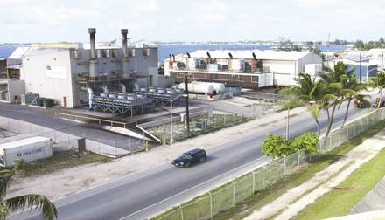

Marshall Islands Generation Facilities

Table 12-4

Majuro Station # 1
Unit | Size | Manufacture | Year Installed | Status
Unit #1 | 3.2 MW | Peilstik | 1978 | 2.5 MWdngrd
Unit #2 | 3.2 MW | Peilstik | 1978 | 2.5 MW dngrd
Unit #3 | 3.2 MW | Peilstik | 1978 | 2.5 MW dngrd
Unit #4 | 3.2 MW | Peilstik | 1978 | 2.5 MW dngrd
Unit #5 | 3.0 MW | Caterpillar | 1992 | Operational
3.2 mw units down rated to 2.5 mw
Majuro Station # 2
Unit #6 | 6.4 MW | Deutz | 1999 | Operational
Unit #7 | 6.4 MW | Deutz | 1999 | Operational
Rongrong Island Station
Unit #1 | 60 kW | N/A | N/A | Operational¹
Unit #2 | 60 kW | N/A | N/A | Operational¹
Wotje Atoll Station
Unit #1 | 275 kW | Wartsila | N/A | Operational²
Unit #2 | 275 kW | Wartsila | N/A | Operational²
Jaluit Atoll Station
Unit #1 | 275 kW | N/A | N/A | Operational
Unit #2 | 275 kW | N/A | N/A | Operational
Kili Island Station
Unit #1 | 688 kW | Caterpillar3508 | N/A | Operational
Unit #2 | 688 kW | Caterpillar3508 | N/A | Operational
Unit #3 | 681 kW | Caterpillar3412 | N/A | Operational
Rongalap Atoll Station
Unit #1 | 1,000 kW | Caterpillar | N/A | NonOperating³
Ebeye Island Station
Unit #1 | 2.6 MW | Enterprise | N/A | Oper-unknown
Unit #2 | 800 kW | Caterpillar | N/A | Oper-unknown
Unit #3 | 1,000 kW | Cummins | N/A | Operational
Unit #4 | 1,000 kW | Cummins | N/A | Operational
Unit #5 | 1,000 kW | Cummins | N/A | Non-operation
Unit #6 | 1,000 kW | Cummins | N/A | Non-operation
Bikini Atoll Station 1
Unit #1 | 256 kW | Caterpillar | N/A | Operational
Unit #2 | 256 kW | Caterpillar | N/A | Operational
Unit #3 | 219 kW | Caterpillar | N/A | Operational
Eniwetak Atoll Station
Unit #1 | 60 kW | Unknown | N/A | Part time oper.

Operated by two local staff and supported by the Majuro operations staff.
Operated by 13 full time staff, manned 24/7.

Table 12-5

Fuel Efficiency for MEC Engines FY2005 - kWh produced per gallon burned.
Unit #1 | Unit #2 | Unit #3 | Unit #4 | Unit #5 | Unit #6 | Unit #7
9.1 | 10.1 | 10.0 | 7.8 | 13.8 | 16.4 | 16.4

In FY2005 MEC generated 82,367,000 kWh; had a peak load of 11.95 MW; average load of 9.4 MW; used 5,636,666 gallons of No. 2 diesel fuel; spent $8,927,523 for fuel for an average price of fuel of $1.58 per gallon; had power plant station service loads of 5,583,500 kWh or 6.8% of production which cost $616,026. The engine efficiency at the plant was 14.6 kWh per gallon of fuel burned and represented a fuel cost of $.108 per kWh. MEC serves approximately 3,722 customers. In 2005 MEC had annual sales of 59,773 mWh and kWh sales revenues of $10,275,912. Power plant operating expense was $10,673,768 ($0.1785 per kWh sold). With depreciation of $858,274 and interest expense of $606,213 total power plant production cost was $12,138,255.

Table 12-6
Power Generated in Majuro & Ebeye: 2000:2004
 | Majuro | Ebeye
Year | Total MWh Generated | Total MWh Generated | Total
2000 | 69,244 | 14,999 | 84,243
2001 | 73,523 | 14,007 | 87,530
2002 | 79,764 | 16,183 | 95,948
2003 | 81,297 | 11,338 | 92,636
2004 | 80,986 | 16,744 | 97,730
The electric production has been increasing in both Majuro and Ebeye, although due to equipment and operational failures, Ebeye growth has been more erratic. Loads have increased by 16% between 2000 and 2004 for the combined loads of Majuro and Ebeye.

Figure 12-2
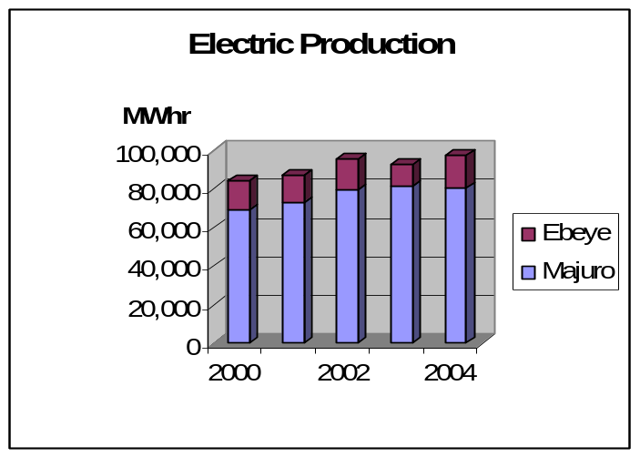

Fuels

Power Production Fuel:
MEC imports bulk diesel fuel for supply to its power stations. The fuel is stored in eight (8) 750,000-gallon tanks that make up the MEC six million U.S. gallon bulk fuel storage facilities. For a power utility company MEC’s large storage capacity is unique in the Pacific region and allows MEC to purchase and store large fuel volumes and sell fuel to the RMI government and foreign fishing vessels at competitive rates. This operation is regarded as one of MEC’s most profitable activities. MEC’s bulk fuel operation presently has profits of approximately $2,000,000 per year that are used to subsidize the electric rates in Majuro by a corresponding amount. MEC imports approximately 13.6 million gallons of fuel per year of which 5.6 million is used for power generation.

The cost of fuel for power production has increased substantially in the 18 months prior to the date of this report. The average cost of fuel for the power plant is $1.98 per gallon. With a diesel engine/generator fuel efficiency rate of 14.5 kWhr generated per each gallon of fuel used, the cost of power at the power production at the plant is 13.6 cents per kWhr. However, upon taking into consideration the electrical energy used for station service at the Majuro power plant, presently 7%, the cost of power to the distribution lines is 14.6 cents per kWhr. Majuro has losses of approximately 20% in the distribution system; therefore, the fuel use per kWhr delivered to the customers meter is approximately 11.4 kWhr per gallon. This relates to a fuel cost at the customer’s meter of 17.3 cents per kWhr when fuel costs are $1.98 per gallon.

MEC also imports liquefied petroleum gas (LPG) into the RMI in 5,000 gallon pressurized bulk containers for resale in standard smaller range bottles to the public, private sector and fishing boats. Approximately one 5,000 gallon container is brought in each month from Hawaii and sold at a price of approximately $1.25/pound or $5.30 per gallon. Profits from the sale of LPG are also used to offset expenses for the electric customers.
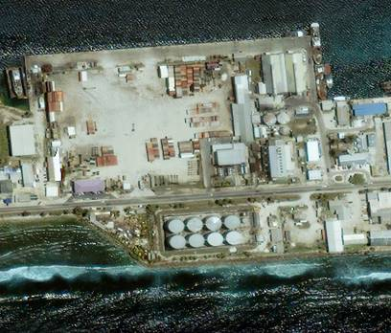

MEC Fuel Storage and Power Plant on Majuro

ELECTRIC PRODUCTION AND USE

Existing Renewable & Alternative Power Production
MEC is mandated by the Marshall Islands Government to oversee the development of renewable energies within the Marshall Islands through the Ministry of Resources and Development’s Energy office. This work involves the installation, operation and maintenance of various power generation systems such as solar, wind, bio-fuels, etc. Currently, two atolls have every house (195) powered with solar lighting systems and another two atolls will be started in the coming months once the ordered materials arrive. The goal is to have all 1760 households in the remote outer islands powered with solar lighting systems within the next five years.

The Ministry of Resources and Development in conjunction with MEC are working on plans and funding sources to build a 6,000 square foot Renewable Energy Center in Majuro near the MEC power production facility. The Renewable Energy Center building would house the Administrator of the Marshall Island Energy Program as well as other professionals involved with alternative energy. It would serve as a repository for all Marshall Islands energy related data bases. It would also serve as a meeting and training center for the various alternative energy programs that are either on going or planned for the Marshall Islands, such as the European Union solar power programs and bio-fuels programs.

The Marshall Islands has quite a large number of photo voltaic systems scattered throughout the large number of outer island Atolls. Some systems have performed well, others have failed, usually due to lack of maintenance. The Marshall Islands has a large copra industry and has been active in attempting to utilize the copra oil to displace diesel fuel in trucks and possibly power generation equipment. There is concern about the compatibility of copra oil for use in vehicular diesel engines or stationary diesel engines such as the power production units. Management is reviewing carefully the impact of the future use of copra oil in its power plant and the effect of the copra oil on the operation and maintenance of power plant engines.

Existing Conservation and Demand Side Programs
Majuro does not presently have any energy conservation programs or demand side programs. The Marshal Island National Energy office is presently busy with programs to bring photovoltaic power to the outer island and as of the date of this report had not ventured into any major demand side management programs. There were no reported conservation or demand side programs in Ebeye.

Regulatory, Environmental Issues
The Republic of Marshall Island’s Environmental Protection Authority (RMIEPA) was created throughout the islands by an Act in 1984. The EPA is responsible for preserving and improving the quality of the environment. It is an autonomous body and is regulated by a statutory board. The Authority has broad general powers to regulate issues related to primary and secondary drinking water; pollutants; pesticides and chemicals; waste and cultural and heritage protection. Water quality protection and monitoring are a major function of the RMIEPA. The electric utility works to comply with the regulations of the RMIEPA and at present does not have any outstanding issues. Recognizing the small size of the various atolls and the effect of increasing populations, environmental regulations may become a larger issue as population densities increase and the economy matures with more diverse products, chemicals and industrial products being brought on island.

Transportation

Fuel Use
The fuel used for basic personal and business transportation in the Marshall Island is gasoline for private vehicles. There was no information available regarding the volumes delivered or used in the Marshall Islands. Mobil Oil Corp. furnished the gasoline, Jet A and part of the diesel fuel in the Marshall Islands.

Fuel Types and Costs
The fuel types used in the Marshall Islands are No. 2 diesel fuel for electric generation, larger trucks, construction equipment and most fishing fleets; gasoline for most personal vehicles; Jet A for commercial aviation and LPG for cooking, hot water heating and some industrial uses. Jet A fuel is used as kerosene for some cooking and lighting purposes. The cost of gasoline was approximately $3.60 per gallon and diesel fuel and LPG cost was approximately $1.25 per pound.

Reducing Transportation Energy Use
There may be an opportunity for some form of bus transportation in the Marshall Islands, however the present multitude of taxis provide a reasonably fuel efficient form of transportation. Because the economy of the island is very limited, the population cannot afford more exotic energy efficient vehicles such as hybrids, etc. Most vehicles are purchased as used vehicles from the Asian market and thus the capital cost is low and the energy efficiency, although not ranking very high, is not unreasonable for the limited miles that are traveled on the island.

Commercial And Industrial
There is limited opportunity for fossil fuel savings in the commercial and industrial sector other than efficiencies possible with more efficient lighting and air conditioning systems, although many facilities do not have air conditioning. There is no major industry that is energy intensive where a fuel saving program could have a major impact.

Tourism
Majuro has a small tourism industry, but the activity of the tourist population arriving at Majuro does not lend itself to developing programs that can reduce the use of fossil fuels. The major energy use of the tourist arriving in the Marshall Islands is the fuel used in their travels to arrive in the Marshall Islands. Since Continental Airlines is the major mode of transportation for arriving tourist, very little fossil fuels can be reduced since Continental Airlines already has taken steps to operate their planes as efficiently as possible.

Manufacturing
There is very little manufacturing on the Marshall Islands, therefore, the opportunities for reducing fuel use in the Manufacturing sector is very low.

Military
The Kwajalein Military Base, the Ronald Reagan Missile Test Site, is responsible for all energy use and electrical power generation and generation within the military base. This report does not address any energy issues within the Kwajalein Military Base. There are no other military units located in the Marshall Islands.

Fisheries
Fishing fleets operate out of the Marshall Islands, however there is little that the Marshall Islands government can do to help the fishing boats save fuel. The fishing fleets, as a matter of economic survival, have taken nearly all steps possible to reduce the use of burning fossil fuels.

Alternative Energy Opportunities

Cogeneration
There presently are no cogeneration facilities in the Marshall Islands. There are no major industries or large facilities where a cogeneration system would be economical.

Alternative Fuel
The present use of No. 2 diesel fuel is the only reasonable fuel to use on a small island such as the Republic of the Marshall Islands. The technology, vendors supplying the prime mover engines, spare parts and service as well as the technological knowledge base of the skilled personnel available in the Marshall Islands is all based on diesel engines. Heavy fuel oil such as No. 6 is not a viable option due to the cost to ship the fuel on specially outfitted tankers and the storage and care for the fuel on site. The Marshall Islands utilized heavy No. 6 oil in the early 1980s when bunker fuel was a common fuel for ships operating in the region. However, when the technology of the shipping industry changed, it became uneconomical to continue to utilize No. 6 fuel. Other types of fuel such as coal, petroleum coke and other more difficult fuels to utilize, require energy conversion systems that are more expensive and complicated than can economically be utilized on an island where the electric loads are very small.

Supply Side Efficiency
In developed country utilities, the average power systems losses for a utility with only a generation and a distribution network are estimated at approximately 10%. Nominally, these losses are accounted for in generation, 5%, and distribution, 5%, with non-technical losses less than 1%.
In 2000, a preliminary study was carried out on a sample of three (3) U.S. affiliated Insular Areas’ power utilities, to achieve an indication of the energy inefficiencies in the generation, transmission and distribution of electricity in all the U.S affiliated Insular Areas’ power utilities. These were the utilities of Palau, Pohnpei and Kosrae.
This preliminary study indicated that the power system losses in the utilities were far in excess of acceptable standards for these power systems. It was established that the energy losses were occurring in all areas of the power system, including non-technical losses.

It was noted that some data was lacking, such as the number of transformers or the types of conductor used. As a consequence, several approximations were used to evaluate the losses. The errors on the figures are difficult to quantify and therefore the results should be carefully used, although it does represent system losses that are far in excess of what is acceptable. To reduce the import of fuel, it is imperative to reduce these system losses.

It is recommended that a detailed quantified power system loss study be conducted for MEC and KAJUR, as a stage 1 project. This project would measure and collect the electrical data characteristics of the power system, and then determine the losses. Once these losses have been quantified, then stage 2 of this process would be to assess the need for updating existing energy inefficient equipment (examining financing mechanisms as appropriate); establishing Government legislation that makes electricity theft a crime; and review the maintenance practices in the power plants.

The Majuro power plant has station service losses of approximately 7% which is somewhat higher than most diesel engine plants. The reason for the higher energy losses is due to the use of eight ventilating fans that serve to provide fresh air into the building and draw hot air out of the building. The power plant building is a totally enclosed concrete tilt wall “box” construction with no ventilation other than the ventilating fans. Due to atoll environment of the plant and consequently the close proximity of the plant to the corrosive sea mist, the ventilating system is necessary to prevent corrosion of the engines and auxiliary equipment. The inlets of the intake ventilating fans are equipped with filters to prevent the corrosive sea mist from entering the building. This closed power plant environment with the ventilator system is very effective in preventing corrosion of the power plant equipment, but in comparison to similar diesel power plants, it may result in an additional 3% of station service loads or in reality losses.

Demand Side Efficiency
The Ministry of Resources and Development (MRD) Energy Planning Division has only two staff and little budget for energy efficiency improvement. The MEC has no real incentive to carry out demand side management. Most of the few DSM related programs for the Marshall Islands have been initiated by regional organizations, not by the country, and have not resulted in much impact. Now that the high cost of imported fuel is causing problems for businesses, government and households, DSM is receiving more attention

Electrical Metering/Tariff
All connections to the MEC electrical system are metered as are almost all of the KAJUR connections. On some outer islands where local government operates generators (e.g. Kili and Bikini), meters are not always employed but connection numbers are small, typically under 100. Domestic users represent over 90% of their system connections so estimating electricity use to avoid the complexities and cost of metering appears reasonable.

Unlike most of the Northern Pacific power utilities, the two Marshall Island utilities do not have user charges that automatically adjust for changes in fuel cost. The current practice is to deliver power to domestic customers at $0.16/kWh up to 500 kWh/month and at $0.17 for all domestic use above 500 kWh/month. A $0.225 per kWh rate is charged to commercial and government customers. If energy conservation is to be a goal, a tiered tariff structure with rapidly increasing rates for increasing monthly use could help discourage the wasteful use of domestic air-conditioning, electric cooking and electric water heating. Also, for what is called a “life-line” rate, 500 kWh/month is much higher than the 150 kWh/month that is the approximate average household use for most of the Pacific islands. For true life-line rates intended to assist low income households, a substantially lower tariff but with a cutoff at around 100 kWh/month, may be more appropriate. Rates based on power demand for commercial, industrial and government customers should be investigated as well.

KAJUR has a non-tiered structure with flat rates for domestic users and a slightly higher, but also flat rate, for commercial and government customers. Since KAJUR has had serious problems with collections in the past, particularly for public customers, pre-payment meters are being installed and that can be expected to result in some reduction in energy waste but it also makes use of a multi-tier tariff structure difficult.

Household Energy Efficiency Measures
Household electricity use in the Marshall Islands is one of the highest in the Pacific. The 1999 census found slightly less than 40% of the Majuro and Ebeye households cooking with electricity and a 2006 survey of 901 households in Majuro and Ebeye indicated little change since the census. Though there is no statistical data on ownership of domestic air-conditioners, the Household Income and Expenditure Survey of 2002 indicated that around $85,000 was spent by households on new air-conditioners during the year prior to the survey. That information plus the high average household electrical energy use is an indicator of substantial air-conditioning being used in households. The 2006 survey indicated a fairly high Majuro and Ebeye household ownership of refrigerators (50%), freezers (47%), televisions (69%) and washers (63%) as well as a wide range of smaller electrical appliances.

The pattern of electricity use in households implies a potential for energy efficiency improvements but there have been no significant programs with an energy efficiency improvement focus. The MRD Energy Planning Division is understaffed and has no program budget specifically for energy efficiency improvement. The utilities have focused mainly on supply side efficiency improvements with little attention paid to the demand side since supply side improvements are easier for the utility to implement and their results are generally more certain than those DSM.

Programs that may result in the more efficient use of energy by households and are recommended for consideration in the Marshall Islands includes:

- Exchange of incandescent lights for high efficiency CFL bulbs (MEC had a small program but stopped when cash became tight)
- Exchange of magnetic ballast type fluorescent lights for high efficiency electronic ballast lights
- Refrigerator and freezer maintenance programs (e.g. replacing door seals, condenser cleaning)
- Air conditioner maintenance programs (e.g. cleaning filters and condensers)
- Replacement of electric cooking ranges by more fuel efficient gas (LPG) ranges
- Improved insulation and sealing of air-conditioned spaces
- Public information programs regarding the meaning of energy labels on refrigerators and air-conditioners
- School education programs in home energy audits and general energy conservation

To improve overall fuel use efficiency, it is proposed that MEC promote an exchange of electric cookstoves for LPG stoves. Sinced MEC also supplies LPG, this should not have a great effect on overall revenues but would avoid the losses in converting diesel fuel to electricity, the losses in distribution and the lower efficiency of heat transfer from the heating element to the cooking utensil than is present with gas cooking

The U.S. Department of Energy has a wide range of pre-packaged programs for education and many pamphlets and public information packages have been prepared for household energy efficiency improvement and home energy conservation. It is recommended that the Energy Planning Division in the MRD initiate public information programs in the Marshall Islands based on those materials but have been modified to fit local conditions. Also, the regional energy program of SOPAC (Fiji) has publications and information materials relating to household energy efficiency and energy education that are appropriate for use in the Marshall Islands.

Government and Commercial Sector
Many of the energy efficiency actions, appropriate for households also apply to small shops and offices. In particular, improved lighting efficiency through widespread use of CFLs and electronic ballast fluorescent lights and improved efficiency of refrigerating equipment. Table 12-6 shows the top 10 users of electricity on Majuro. Refrigeration in the form of freezers and air conditioning is a high user of electricity and the improvement of the efficiency of refrigeration/air-conditioning equipment could provide the largest overall reduction in fuel used for electricity generation for those customers. In the hospital and hotels, improving air conditioning efficiency, shifting water heating from electricity to solar energy and shifting lighting to high efficiency fluorescent units can reduce imported fuel use and improve cash flows at the facilities.
Table 12-7 – Top ten electricity users on Majuro
Electricity User | Total kWh/mo
Marshall Islands Fisheries | 197,660
Triple J Payless | 161,550
Capitol Building | 147,600
Marshall islands Resort | 93,240
National Telecommunications Authority | 75,680
Majuro Hospital | 63,200
Amata International Airport | 60,160
Formosa Supermarket | 46,320
Robert Reimer's Enterprises (Hotel complex) | 30,560
Ministry of Education | 16,560
Until recently energy bills for government users were not paid by individual departments from their budgets, so departments were not aware of the cost of energy for their operations. Even with rising energy costs there was little departmental pressure for improved efficiency of energy use. With the recent introduction of department performance budgeting, bills must be approved for payment by departments before the Ministry of Finance pays them. This is a big step forward with regard to energy efficiency within government. It is recommended also that the Energy Planning Division propose that each department be further assisted in reducing energy waste through the appointment of an individual within each department as a departmental energy manager. The Energy Planning Division could then arrange for training to be provided to the departmental energy managers in the recognition of energy waste and its prevention. The departmental energy managers should report periodically to the Energy Planning Division and meet regularly to receive further training and to discuss departmental energy issues. Guam uses a system of this type for the monitoring and control of government energy use and it is recommended that the Guam Energy Office be contacted for details regarding their government energy monitoring and control program. Much of its structure can be replicated by the Marshall Islands, though of course on a smaller scale.

It is also recommended that the Energy Planning Division sponsor a series of professional energy audits of high energy use government facilities and prepare proposals for the funding of energy efficiency improvements where they are found to be economical. Commercial business should be invited to participate in the program and be charged a small fee to sufficiently cover the actual time spent on the audit of the business.

Transportation Sector
The majority of land transport fuel use is on Majuro. It is a long narrow series of connected islets while Ebeye has quite a compact land mass. As nearly every place on Majuro is a short distance from the single main road, there is no need for many different mass transport routes or transfers from one carrier to another. This makes public transport requirements less complex than in most countries. The land transport sector is not large; distances traveled are typically modest and the public transport system on Majuro consists mainly of private automobiles that cruise from one end of Majuro to the other picking up and depositing passengers along the way. That system appears relatively efficient for public transport, despite having no subsidies and little formal structure or regulation.

Sea transport is important to the Marshall Islands and uses a substantial portion of the imported diesel fuel. Though the actual usage could not be determined from available data, it appears to be on the order of two million gallons of diesel fuel per year. In general, the rapid increase in fuel cost has made ship operators aware of the need to maintain the highest possible efficiency of fuel use. To assist them in achieving a high level of fuel efficiency, it is recommended that consideration be given to developing training programs for ship operation and maintenance that focus specifically on improving the efficiency of ship fuel use. Also, as the Marshall Islands replaces its fleet of ships, the efficiency of fuel use for the given transport requirements should be a major consideration in the selection of new vessels. In particular, offers of low cost or “free” ships from donors should be carefully scrutinized since other Pacific nations have learned that the operating cost of such gifts can be so high as to quickly surpass any savings gained by having had no investment cost.

Away from Majuro and Ebeye, the primary use of fuel for private transport is for gasoline fueled outboard engines on small boats. These are quite inefficient with regards to fuel use per mile relative to similar capacity boats using diesel engines, both inboard and outboard. If the reduction of fuel imports is a program goal then incentives for converting to diesel engines would be appropriate, particularly in light of the fact that locally made biofuel may become available for diesel engine use. However, no renewable energy alternative indigenous to the Marshall Islands is expected to be available to fuel gasoline engines. Interestingly, a small relatively low cost coconut fueled diesel outboard motor from China was recently demonstrated by PII/Tobolar.

Building Energy and Efficiency Standards
Building codes used in the Marshall Islands do not include energy efficiency considerations. The small size and limited technical capacity of the Marshall Islands makes it unlikely that complicated energy codes can be enforced. However, it does appear reasonable to include such basic energy efficiency features such as requiring an insulating barrier between the roof and the occupied space, reduced energy transfer glazing and, where air conditioning is to be included, the installation of equipment that has a relatively high EER. The added cost of these simple measures is small and their effect on the energy use of the building can be substantial in the Marshall Islands environment. It is urged that the MRD Energy Planning Division take the lead in convening a stakeholder panel to consider additions and modifications of the existing building code system to include basic energy efficiency improvements with emphasis on code additions that are within the local capacity to implement and enforce. Once included, training in their application and enforcement should be provided to local builders and code enforcement personnel.

Appliance Energy Efficiency Standards
The appliance market for the Marshall Islands is too small to warrant major investment in regulatory activities such as local appliance testing and labeling or imposing strict import standards for domestic appliances. Fortunately, most major appliances used in the Marshall Islands are imported from countries that employ energy efficiency labeling. Thus, the need is not so much for labeling but rather for making the public aware of their meaning in the Marshall Islands’ context, particularly the fact that the cost of electricity in the Marshall Islands is substantially higher than that assumed on the appliance labels that show an estimated cost of operation for the appliance.

The energy office or MEC should consider providing an information brochure or additional sticker affixed to the appliance explaining the labels that are found on appliances in shops and noting that where estimated savings are shown (all U.S. refrigerator and freezer labels) the numbers should be about doubled for Marshall Island use.

It is also recommended that regulations be issued that all new air-conditioning equipment that is purchased by the Marshall Islands Government have an operating efficiency (EER or foreign equivalent) above a base level that is established by an MRD convened stakeholder panel.

Energy Audits, Performance Contracts
Many programs to provide energy audits to large energy users have been tried throughout the smaller countries of the Pacific but the end effects have been small. This is mainly due to the lack of ready finance for the proposed energy efficiency measures and the limited technical capacity of the end users receiving the audits to implement the proposed actions. There are no statistics to actually show the cost effectiveness of these energy audits but it is clearly not high. With the addition of follow on programs to support implementation of the measures proposed by the audits, the effectiveness of the program in actually achieving energy efficiency improvements can be expected to be greatly improved and a higher level of cost effectiveness attained despite the higher overall cost of an integrated audit and implementation program. This approach can be carried out by an Energy Service Company (ESCO).

A local ESCO in the Marshall Islands is not likely to be profitable due to the small market for its services and the limited availability of the skills needed. ESCOs in Hawaii could serve the Marshall Islands but the cost of getting to the Marshall Islands from Hawaii is substantial so only the largest energy user, the Government, is likely to be able to use ESCO based energy efficiency performance contracting services., It is recommended that the Energy Planning Division work with MEC to survey the energy use characteristics of government facilities and large commercial energy users. Then the EPC should establish contact with Hawaii ESCOs, provide them with the survey information and determine if a program for government facility energy efficiency improvement through an ESCO would be cost effective. If the ESCO cannot cost effectively contract to provide full ESCO services, the EPD should work with MEC to identify local firms that could work with the ESCO to handle the local component of the ESCO work, e.g. monitoring, maintenance, technical support. MEC should itself consider acting as the local partner.

RENEWABLE ENERGY OPPORTUNITIES
The Marshall Islands is a country rich in renewable energy opportunities that can be used to reduce fossil fuel use in both electric power production and transport as well as to economically extend electricity access into remote areas. The small population and modest per-capita energy demand could allow the Marshall Islands to achieve a high level of energy independence through use of a mix of these renewable energy resources. Notably absent, however, is hydro power. The country consists entirely of low lying coral atolls and islands with no permanent streams. Also, there are no indications of geothermal activity that can be developed economically for either hot water or electric power.

Government has long recognized the value of renewable energy, particularly for rural electrification, and over the years has developed standards, structures, plans and processes specifically for PV based rural electrification. Developing the medium sized GEF project titled ADMIRE (Acting for the Development of Marshall Islands Renewable Energy) project concept has helped focus plans and actions for renewable energy development.

Although in the past the MRD Energy Planning Division has been the focus of renewable energy development, managing the small pilot projects and donor projects of the 1980-2000 period, as the programs have increased in size, the management requirements have exceeded the capacity of the two people in the Energy Planning Division. This has prompted the MRD to sign an agreement with MEC to manage all renewable energy projects with most of the cost covered by donor inputs and fee collections from users. But if MEC project expenses exceed project income, government has agreed to cover the loss thereby lowering the incentive for MEC to operate the projects as efficiently as it might if MEC had to cover the losses internally.

To support renewable energy development, a proposal has been prepared for the development of a Renewable Energy Center to be located in an addition to the MRD headquarters building and could be shared with MEC renewable energy activities. The facility would focus on training, education, testing and applications research for all forms of renewable energy. The original proposal was developed by MEC but MRD and other agencies have given their support to the concept. The Center would help protect the large investment that is to be made on outer island rural electrification and could provide a focus for donor activities in the area of renewable energy. Financial support for the concept is now being sought.

Solar
Surface data for solar radiation in the Marshall Islands is limited in availability but since the land area is very small and the height of the land only a few feet above sea level, there is little effect of the land mass on local cloud formation and on solar radiation. Therefore a reasonable starting point is the insolation estimate derived from satellite measurements of solar radiation falling on a fairly large area of the ocean that includes the small atoll land mass. The solar resource is excellent all year round throughout the Marshall Islands, particularly for stand alone applications in remote sites where the cost of fuel and limited access to shipping makes imported fuel exceptionally expensive.

Table-12-8 – Solar Radiation, horizontal and tilted values kWh/m² per day
Month | Jan | Feb | Mar | Apr | May | Jun | Jul | Aug | Sep | Oct | Nov | Dec | Avg
Southern boundary of the Marshall Islands, 5°N 170°E (near Ebon)
Horizontal | 4.80 | 5.43 | 5.35 | 5.50 | 5.04 | 4.95 | 5.05 | 5.51 | 5.48 | 5.61 | 4.95 | 4.85 | 5.21
Tilted | 5.51 | 5.93 | 5.43 | 5.54 | 5.29 | 5.31 | 5.39 | 5.67 | 5.40 | 6.00 | 5.64 | 5.68 | 5.56
Central area of the Marshall Islands, 7°N 168°E, near Ailinglaplap
Horizontal | 5.18 | 5.82 | 5.91 | 5.97 | 5.53 | 5.30 | 5.35 | 5.64 | 5.28 | 5.22 | 4.73 | 4.94 | 5.40
Tilted | 6.10 | 6.49 | 6.06 | 5.93 | 5.80 | 5.69 | 5.68 | 5.74 | 5.22 | 5.62 | 5.46 | 5.92 | 5.81
Northern boundary of the Marshall Islands, 12°N 167° E, near Rongerik
Horizontal | 5.45 | 6.11 | 6.60 | 6.96 | 6.59 | 6.48 | 6.26 | 6.14 | 5.73 | 5.53 | 5.16 | 5.16 | 6.01
Tilted | 7.01 | 7.18 | 6.93 | 6.42 | 6.72 | 6.83 | 6.48 | 6.01 | 5.76 | 6.25 | 6.44 | 6.80 | 6.57
Source - http://eosweb.larc.nasa.gov/sse/

Solar thermal for electric generation
Although large scale solar thermal electric generators for utility use have proven to be economically reasonable for power generation in desert areas, they are not recommended for use in the Marshall Islands. Compared to solar PV, solar thermal electric generators are difficult to maintain in a marine environment in a developing country. They require larger land areas for their installation – solar photovoltaics can be roof mounted eliminating the need for a dedicated land area – and are economically reasonable only for generation in the multiple kilowatt range of power with significant economies of scale. Solar PV is practical for small independent power systems as well as larger scale grid based power production. Additionally, the outputs from PV panels are less affected by the very common partly cloudy conditions that exist in the tropics than are concentrating solar power systems. As there are few economies of scale for PV installations, it is reasonable to distribute solar PV over a wide geographic area, as a number of relatively small grid connected generators, to further minimize the effect of the frequent passing clouds on the solar generation.

Solar thermal for water heating
Although a household survey of the extent of the Marshall’s use of electricity or fossil fuels for water heating is not available, it is clear that domestic water heating is not a major demand by the majority of households, even on Majuro. The MEC estimates that it is only a few commercial buildings and the high end housing that has piped hot water, on the order of 40% of the building stock. Essentially, all the houses that have piped hot water rely on electricity for water heating.

The Majuro water supply is obtained from rainwater collection mainly off the airport runway. It is stored in several large storage reservoirs but several times a week the water mains are pressurized to fill local tanks at each home or building where the water is locally stored until a small private pump delivers the water to the user in the associated building. The climate is hot and the piped rain water typically leaves the tap at around 80ºF, The many homes that use aboveground storage tanks often see even higher temperatures than that; so having a water heater is more a luxury than a requirement for comfort. Still, 40% of the domestic users represent over 1,000 users and programs to replace gas or electric water heaters with solar are likely to yield a useful benefit as far as fuel reduction is concerned. To date, there has been little interest in promoting solar domestic water heating by either government or the private sector. The small tourism industry, around 6,000 visitors per year, does typically provide hot water in hotel accommodations and should be encouraged to replace any existing electric and fossil fueled water heating with solar water heaters through simple energy audits and basic design assistance that show accommodation owners the rapid payback that is usually possible through use of the technology.

Recommendations
It is recommended that the Majuro and Ebeye hospitals replace fossil fuel or electric water heating with solar water heating to meet the bulk of their hot water demand. It is also recommended that when permits are issued for the new construction of homes or commercial structures that may need hot water (e.g. laundries and hotels), that it is a requirement that builders are made aware of the advantages of solar water heating over the use of gas or electric power through a simple economic analysis for the manner of hot water use of the new building. Also, it is recommended that any new government buildings that include piped hot water be required to use solar water heaters and any existing government buildings that have already installed electric or fossil fueled water heating systems be examined and, if an economic analysis indicates a reasonable rate of return, solar water heaters be installed to replace the existing units.

Since most of the households using electric water heating are in higher income brackets, affordability does not appear to be a big problem. Interviews indicate that one significant barrier to solar water heater installation is the lack of local stock and a cadre of experienced installers. This is the result of the low demand, so a program that can energize dealers to stock solar water heaters and train installers at the same time the market demand increases could rapidly increase the conversion of electric to solar water heating. It is proposed that the MRD work with local suppliers of solar water heaters to train installers and develop a program to market solar water heating to those high-end home owners that are using electric water heating. Also, it is recommended that the MRD get local banks, suppliers of solar water heating equipment and representatives from local hotels that use electric water heating and attempt to work out a bulk purchase and finance scheme for replacing hotel electric water heaters with solar units.

The MEC should also consider buying solar water heaters in bulk and installing them on a “fee for service” basis for households whereby the MEC exchanges electric water heaters with solar water heaters and charges a fixed monthly service fee for the use of the unit, effectively renting the household a solar water heater. Monthly fees should be less than the cost of operating the electric water heater.

Solar photovoltaics
The primary application for solar energy in the Marshall Islands is through the use of solar photovoltaics for power generation. Except for the islands of Wotje and Jaluit, the plans by government for rural electrification are mainly through the use of solar home systems (SHS). The character of the atolls makes it impossible to establish an atoll wide grid at an acceptable cost, so generation must either be by a number of small mini-grids serving each islet or individual generation at each house. The cost of grid reticulation alone often exceeds the cost of installed SHS, at least for basic services, making SHS economically attractive. Persons with the skills needed for maintaining mini-grids are difficult to find and keep on rural islands while the capacity for SHS maintenance is more easily developed locally.

Past programs
Solar PV was the main form of renewable energy promoted in the Marshall Islands during the Trust Territory period and has been since. During the TTPI years, small solar systems were installed for powering HF radios and lights at health centers and in some schools. Many health centers also received solar powered vaccine refrigerators. Some SHS were installed as “demonstrations” with those provided as gifts to the households where the owners were expected to provide all maintenance. Few of those early installations survived more than a few years.

Utirik
Utirik Atoll was caught in the fallout of the Bikini hydrogen bomb test “Bravo” in 1954. $100,000 of their reparation payments from the U.S. Government and $180,000 from NASA and the USDOE were used to provide PV power to the village area. The PV installation was designed and installed in 1984 by Hughes Aircraft Corporation. It consisted of a 16 kWp PV array charging a 120V battery bank with DC power distributed through a grid to each house. A local handyman was trained in the maintenance of the system but the project failed to provide access to spare parts for more than a short time. In particular, the project failed to provide villagers a source to replace the special 120V high efficiency DC lights that were installed and soon standard incandescent lights were replacing failed fluorescent fixtures. The much higher load from the incandescent lights resulted in rapid discharge of the battery and unreliable service to users. There was no system for external technical support and the system failed. In its review of the project, California-based Energy Resources International found the system was riddled with problems: “Residents have now been separated from the energy resources they know, understand, and have traditionally been very close to,” the study concluded. “They have a complex technology they don’t understand... The central power plant moves them further from any individual or personal contact or responsibility for how they use energy... The complexity of the system raises the possibility that the island will continue to be dependent on the U.S. to keep the plant running...”
Table 12-9– Rural PV installations as of 2002 (not all operating)
Atoll | Fisheries freezers | HF Radio. | School | Comm-Hall | Dispensary | Individual  System | Total
Majuro |  |  |  |  |  | 10 | 10
Kwajalein |  | 2 |  |  |  |  | 2
Ailinglaplap | 1 | 2 | 1 | 1 | 2 | 2 | 9
Jaluit |  | 3 |  | 1 | 1 |  | 5
Arno |  | 3 | 2 | 2 | 1 | 18 | 26
Mili |  | 2 | 2 | 1 |  |  | 5
Namdrik |  | 2 |  | 2 | 1 | 133 | 138
Namu | 1 | 2 |  | 1 | 2 | 1 | 7
Maloelap |  | 3 | 3 |  | 2 | 20 | 28
Ebon |  | 2 |  | 3 |  | 11 | 16
Enewetak |  | 1 | 1 |  |  |  | 2
Wotje |  | 2 | 1 |  | 1 |  | 4
Ailuk |  | 2 |  | 1 | 1 | 10 | 14
Ujae |  | 1 | 1 | 1 |  |  | 3
Likiep | 1 | 1 | 1 |  | 1 |  | 4
Mejit |  | 2 | 2 | 1 | 1 |  | 6
Aur |  | 1 | 2 | 1 | 1 | 10 | 15
Utirik |  |  |  | 1 |  | 2 | 3
Lae |  | 1 | 1 |  | 1 | 18 | 21
Lib |  | 1 | 1 |  | 1 |  | 3
Jabat |  | 1 | 2 | 1 | 1 | 30 | 35
Wotho |  | 1 | 1 | 1 |  |  | 3
Bikini |  |  |  |  |  | 10 | 10
TOTALS | 3 | 45 | 21 | 17 | 17 | 265 | 366
Source – Outer Islands Electrification Study, ADB, April 1995 and Annexes to the Namdrik PREFACE Project Report Final Review, Jean-Michel Durand, 2003

After years without power on Utirik, Sandia National Laboratory sent a team to evaluate the remaining components, primarily the solar panels, for possible re-distribution to the Utirik villagers as SHS. Unfortunately the panels provided by Hughes were not suitable for 12V SHS and no further action resulted.

Jabat
In the early 90s, the Forum Secretariat Energy Division (FSED) contracted with a Singapore solar company to supply 20 SHS for the small island of Jabat. They were installed by villagers under the supervision of the MRD with technical support from FSED staff. Included were two 50 Wp panels per system, an open cell 100 Ah battery, an SCI controller and two 15 watt Thinlite brand high efficiency fluorescent lights. During the first months of operation, the local technician ruined most of the new batteries apparently by replacing lost electrolyte water with acid instead of distilled water causing the need for early battery replacement – generously paid for by the battery supplier even though the warranty terms had been violated. The installations were supposed to be serviced by MRD in return for an $8 per month system rental payment. The payments stopped and so has the external technical support. The status of their operation is unknown though interviews indicate few are operating properly.

Alternate Energy Fund
The 1995 ADB rural electrification recommendations, legislation created a government-owned alternate energy company, MAEC (Marshalls Alternate Energy Corporation), along with a requirement to create a revolving alternate energy fund. The intent was to invest in SHS, collect payments from recipients and use the collected funds for more investment. MAEC had personnel assigned but never had either the necessary mandate or sufficient funding to provide for more than a few installations on outer islands. MAEC was eventually disbanded in favor of rural energy system distribution through the Ministry of Resources and Development (MRD) and its Energy Planning Division (EPD) that was established by Cabinet in 2003. In the 1990s government funds were used to purchase around 100 SHS (mostly around 50 Wp) that were distributed over the six atolls of Lae, Aur, Ailuk, Majuro, Arno and Ebon with no more than 20 systems installed on any one atoll.

After the failure of most of the TTPI sponsored SHS installations, it was recognized that user ownership and maintenance of SHS was not working. Also, the “revolving” feature of the alternate energy fund required recipients to pay for the received installations so a “rent to own” approach was tried for SHS on Maloelap (1995). This followed a similar program that had been tried unsuccessfully on Aur and Ailuk (1992) with recipients expected to pay MRD $10 a month until the systems were paid for. Though most recipients started making payments as agreed, the rate of collection soon fell off and the systems became essentially gifts to the recipients, the revolving fund failed to revolve and the structure ultimately was abandoned.
Following

Namdrik (1996)
In 1996, France provided about $0.5 million for the installation of 138 SHS (~80 Wp of solar each, and 6 community systems (each with ~500 Wp of panel, batteries, a refrigerator, inverter and l6 lights) for the island of Namdrik. The systems were technically complex and incorporated pre-payment meters in the hope that they would eliminate the problem of poor collection of fees. A combination of social and technical problems caused the failure of the project and by 2000 none of the SHS were working though several of the community systems (installed at village leader’s houses) were still providing services – though without the pre-payment meter.

Wotho
The risk of typhoons is low in the Marshall Islands but it is not zero. Structures should be built with the possibility of typhoon passage in mind. In 1992 just a few months after a USDOE funded PV powered fish freezer (40 PV panels of 53Wp each, battery bank of 24V at 2280 Ah and 4 Sun Frost 10 ft³ freezers) was installed on Wotho, Typhoon Gay struck and blew off the roof with the attached solar panels and destroying the installation.
Table 12-8 (excerpted from Volume 6 of the PIREP report, 2004) tabulates the installations up to 2002. There are no reliable statistics on the status of these installations though interviews indicate that many are not operational.

Currently operational projects
One of the serious problems facing the Marshall Islands in the future is the proliferation of different implementers of PV systems with different design approaches, different structures for maintenance, different requirements for spare parts and different training requirements. For a country as small as the Marshall Islands, maintaining separate outer island PV installation, operation and maintenance capacity in the Marshalls Energy Company, the Department of Health, the Department of Education, the Marshall Islands Marine Resources Authority and the National Telecommunications Authority is a waste of manpower and resources. The model of Kiribati is recommended. There the primary PV implementer, the Solar Energy Company, is contracted by the government (and private) agencies having PV installations on outer islands for maintenance. In the Marshall Islands it appears appropriate that for the most cost-effective maintenance, the MEC should be designated the focal organization for all outer island PV and all government PV installations be contracted for maintenance by the MEC.

Tinak
The Association of the South Pacific Area (ASPA) is a non-profit Japanese organization located in Kwaicho City in Osaka, a city that is a sister city of Majuro. ASPA proposed installing a small PV/Wind hybrid system on the island of Rongrong, a part of the Majuro Atoll, but when it was learned that MEC intended to provide a diesel grid on Rongrong, the plans were shifted to Tinak, a small islet in the Arno atoll, near Majuro. In May 2002, ASPA provided a wind/PV hybrid system to Tinak Saint Paul Elementary School. The system consists of a two 400 W wind generators (rating at 12.5 m/s) and four 55 Wp solar panels. The $76,000 unit was designed to charge a battery to power an inverter to operate school equipment – mainly lights, copier and video – and an automated weather measuring station. The weather station was intended to measure wind speed, direction, insolation, temperature, humidity, barometric pressure and rainfall and log it electronically for later access. Information as to the actual operation and current condition of the facility was not available at the time of the survey visit.

Namdrik Rehabilitation
In 2000, the Government requested rehabilitation of the Namdrik SHS and a joint Australian/French funded project managed by the Secretariat of the Pacific Community (SPC) called the Pacific Rural/Renewable Energy France-Australia Common Endeavour (PREFACE) accepted the failed Namdrik PV project for rehabilitation. The only components that could be salvaged from the 1996 French project were the solar panels. The other components installed included:

2 – 13 W indoor tube type fluorescent lights LABCRAFT BL12/13
1 – 13 W outdoor tube type fluorescent light LABCRAFT BL12/8
1 – Total Energie TR10 12/24V10A controller
2 – Oldham 6RGTS181 flat plate sealed batteries 6V and 181 Ah @ C100
1 – LED night light
1 – DC/DC converter ADAP.DC12V/3-4.5 V@0.7A & 6-9 V@1A
At each house receiving power, an 80Wp array was mounted on a wooden pole and a grey fiberglass box was placed at the base of the pole to hold the battery and controller. To obtain a new system an installation fee of $100 was charged and an agreement to make the payment of $12 per month rental fee had to be signed. The project was reviewed by PIREP in 2004:

“By the end of 2003, approximately 115 installations had been completed, including five at churches, two at schools and one at a health center. At the time, sufficient materials were still available for about 15 more systems, and efforts were being made to secure additional household commitments for systems.”
“Unlike the earlier Namdrik project, community leaders were integrated into the project. Nonetheless, the response of the community for payment of fees has been poor. During the first year, when collection was by the local committee, recorded collections were less than 50%. Records indicated that twenty recipients never made any monthly payments. Part of the problem appears to have been theft of payments or faulty accounting. Collections were sometimes made by the technician without providing a receipt and $2,000 was unaccounted for during the first year of operation. In a survey of about a third of recipients, many households claimed payments had been made that were not shown in the accounts. Although steps have been taken to ensure that no one makes a payment without receiving a receipt, concern remains regarding collections, since disconnects for non-payment are not being carried out. MEC management, which has taken over responsibility for the systems, has clearly stated that they will enforce disconnects for non-payment and removals for extended non-payment, making it likely that collections will improve dramatically. MEC has also provided assurance that the quality of maintenance, and thus the power reliability, will also improve.”

Many households purchased or family members gave them videos and other appliances expecting the SHS to provide sufficient power and were disappointed to find that the 80Wp panels could not reliably power much more than lights and a cassette player or radio.
A number of reasons have been put forth for the poor payment record. The failure of the project to meet energy delivery expectations is no doubt one reason people do not pay. The inability of the local technician to disconnect for non-payment is another; why pay when non-payment is not penalized? Additionally, there are technical and social issues that have interfered with the regular collection of payments for some users.

Mejit
In 2002, the French Government provided a grant of $170,000 for rural PV installations. The site chosen was Mejit since the number of households on Mejit was about the same as the 60 SHS the grant could provide. Actually, 80 systems were purchased and the funds from France provided only about half the required funding for the installations. The Government of Taiwan added enough in grant funds to provide the $360,000 the project finally cost. The project design builds on that of Namdrik, avoiding some of the problems by increasing system power and placing the battery and control box off the ground where village pigs found the ground level battery boxes in Namdrik to be good for scratching their backs.

The Mejit installations include two 80Wp panels, double the capacity of Namdrik. A 12V sealed battery, a Morningstar semiconductor type controller and circuit breakers were installed in a sealed metal box mounted about four feet above the ground on the panel mounting pole. High efficiency fluorescent lights were provided in the project but households have the responsibility for future repair and replacement of all lights and appliances as well as the wiring in the house itself. The MEC is the managing organization and two local persons were trained in the installation and repair of the systems. Each is allocated 25 hours per week of work and they are expected to make collections, service the systems and report to MEC periodically regarding the operation of the systems, the status of available spare parts and other administrative matters.

The institutional structure is basically the same as in Namdrik. A $100 connection fee and a $12 per month service fee is charged that includes all maintenance and replacement parts for the pole mounted equipment. As with Namdrik, collections have been problematic and disconnects have not been carried out by the local technicians but the larger panels have provided more reliable power than is available in Namdrik. One important difference is that for sites that need increased power, multiple systems are installed rather than providing a single larger system (e.g. the community office has four systems mounted side by side with each powering a different circuit in the building). This approach simplifies design, spare parts control and training of technicians. While some large single loads, such as a pump or refrigerator, will need a single large PV system, all the applications in Mejit thus far can be powered by multiples of the basic 160 Wp system.

Department of Health
In 2002, UNDP funded new PV installations for small health stations on Namu, Jaluit, Wotje, Imroj, Ebon, Ailuk, Mejet, Kaven, Arno and Mili. Those installations included 440Wp of panels, a controller and two 200 Ah 12V batteries connected in parallel to operate lights, a communications radio and a 12VDC water pump to transfer water from rain water collection tanks to a gravity tank that feeds user taps. A separate 440Wp system with 2-300Ah 12V batteries in parallel provides power just for a small vaccine refrigerator.

A larger installation was provided under the UNDP project to Likiep that included 1076 Wp of solar panels, a 300Ah 48V battery, a Trace U2548 2.5 kW Inverter delivering 115VAC, a ceiling fan, AC lights, an AC pump (for transfer of water from rain water collection tanks to a gravity tank that feeds user taps) and power points for dental equipment, trauma site lighting, etc. A separate 440Wp system with 2-300Ah 12V batteries in parallel provides power for a small vaccine refrigerator and a VHF communications radio.

Also present at most health centers is a solar powered HF radio. Those have been in place for several decades, though of course with changes in components from time to time.

The health service installations were done with no consultation with either MEC or the MRD Energy Planning Division.

In May 2006, the Ministry of Health issued a tender for solar powered email services for six rural health centers to better facilitate the accurate transfer of information and advice between the rural health center and consulting doctors. The laptop computer-based systems are to be powered by 300Wp of solar panel charging a 12V 440Ah battery. The email system will use VHF marine radios with special email software intended for radio based communications.

Marshall Islands Marine Resources Authority
In 1993, about the same time as the Jabat SHS installations, the Japan International Cooperation Agency (JICA) installed solar-powered freezers for ice making and fish storage on Ailinglaplap Atoll (Airok Island), Likiep Atoll (Likiep Island) and Namu Atoll (Majikin Island). The installations, sourced from Japan, each included 5400 Wp of solar panels arranged in two separate systems; each section having a 96 volt, 400 Ah battery feeding an inverter. Three chest type AC freezers were included, plus a radiotelephone and AC lighting.

In 1997, another 3 kWp of solar panels, a 48 volt 1340 Ah battery bank and more lighting were added to each installation using JICA funding. No additional freezers were included in the upgrade as the power was mainly to provide lighting for the fish processing areas.

The Marshall Islands Marine Resources Authority (MIMRA) is responsible for the system maintenance. The installations worked well until about 2001 when the freezer system on Ailinglaplap failed due to corrosion of the inverter circuitry. In 2002, one section of the Likiep installation failed due to connector corrosion. In 2004, JICA fielded a team to investigate the status of the systems and to propose repairs where necessary. Those repairs have been carried out by a JICA team, effectively replacing all the components installed in 1993 except for most of the solar panels (2 panels had been damaged and needed replacing). Structures and fixtures damaged by corrosion were also repaired. As of late 2005, the systems were all operational.

Department of Education
The Department of Education has provided solar-powered communications in some schools but could not provide details or history of the installations.

National Telecommunications Authority
The National Telecommunications Authority also maintains some solar-powered HF radios for outer island communications but again, details and history for the installations were not provided.

Plans and recommendations
The Marshall Islands Government is following the 1994 ADB rural electrification recommendations quite closely and those focused on PV for all rural electrification except for Wotje and Jaluit. The existing installations on Namdrik and Mejit fit into that plan and plans have been made for the further expansion of the PV based rural electrification program using local and donor funds. These build on the experience of Namdrik and Mejit as well as that of neighboring Kiribati where 20% of rural households are electrified by SHS. Funds from multiple sources are expected to be used including EU money, U.S. funds, Taiwan grants, French grants and government allocations.

Approximately €2.3 million will be made available to the Marshall Islands in 2006-2008 for renewable energy under an EU program provided to the five new ACP members in the Pacific including the Marshall Islands (REP-5). Though the final project design is not yet completed, it is expected that the bulk of the money will go into rural electrification by SHS and the support systems needed to provide for their operation and maintenance.

As in all government sponsored rural electrification, the MEC will manage the program and will own the PV systems, effectively renting them (with full maintenance) to users for a fixed monthly fee, currently $12 per month. The experience in Mejit and Namdrik indicates that a basic system of about 200 Wp of solar PV is needed if long life of components and customer satisfaction is to be achieved, particularly since many villages have many coconut and breadfruit trees that can limit solar access. The Mejit multiple system approach is proposed for customers needing added capacity for video, washer or other appliances. It is suggested that consideration be given to making available a 100Wp “life-line” system at a reduced rate for those households not desiring or being unable to afford anything but lighting and basic audio entertainment appliances (radio, cassette player or CD player). It is suggested that the larger systems operate at 24V and the smaller systems at 12V in order to utilize the same panels and batteries in all systems. Only the lights in the small systems would need to be changed from the standard 24V system to accommodate the lower voltage. Standard controllers are readily available that can operate on either 12V or 24V. The higher voltage for the 200Wp systems also provides for lower voltage drops in standard wiring and fewer problems with connections and switches developing unacceptable voltage drops over time. It also avoids the unauthorized use of 12V automotive appliances by recipients, many of which are inefficient users of energy.

Wind Energy
During the 1980s, several small wind energy systems were installed in the Marshall Islands for trial and demonstration. A small electric generating wind turbine was placed on Majuro in a highly visible location to “demonstrate” wind power and at least one mechanical energy water pumping unit of the multi-vane type commonly used in the U.S. plains states was installed on a rural atoll. Records of their operation could not be located but interviews indicate that the electric generator provided little power and after a few years was damaged in a storm and taken down. The water pumping unit apparently failed due to corrosion and lack of maintenance.

Available wind data, all obtained for meteorological purposes and not for the determination of wind energy content, indicates that in the southern islands the resource is modest and quite seasonal and therefore unlikely to be economically reasonable as a supplement to the existing power system, or for mini-grid, stand alone applications on the southern outer islands. In the more northern islands, the resource looks better and proceeding with a basic resource survey would be reasonable particularly for Kwajalein where a substantial electrical load is present. If the basic survey indicates a reasonable resource for wind power development, further action should follow that leads either to installation of turbines or a clear determination of the price that fuel would need to be for the installation to be cost effective.
Table-12-10 – 10 Year Average of winds at 50m (m/s)
Month | Jan | Feb | Mar | Apr | May | Jun | Jul | Aug | Sep | Oct | Nov | Dec | Avg
Majuro Atoll, 7°N 172.5°E
10Y Avg. | 8.77 | 8.02 | 8.60 | 7.82 | 7.30 | 7.01 | 5.82 | 5.14 | 4.50 | 4.86 | 6.24 | 7.70 | 6.81
Kwajalein Atoll, 9°N 165°E
10Y Avg. | 9.36 | 8.42 | 8.86 | 8.00 | 7.54 | 7.21 | 5.84 | 5.00 | 4.43 | 4.88 | 6.67 | 8.47 | 7.05
Utirik Atoll, 12°N 169° E
10Y Avg. | 9.60 | 8.59 | 9.57 | 8.64 | 8.23 | 7.94 | 7.13 | 6.47 | 5.77 | 6.29 | 8.39 | 9.19 | 7.98
Source - http://eosweb.larc.nasa.gov/sse/

Although wind power is a widely used, commercially available energy technology, it is not yet well proven in the Pacific. Also, the atoll islands have characteristics that make wind installations difficult and expensive. A significant problem in the atoll environment is the very limited land area mostly covered by coconut and breadfruit trees – economically important trees to the atoll populace – often over 100 feet tall. Landowners are generally not willing to clear large areas of the coconut forest and negative effects on the environment from clear cutting a large area for a wind farm are likely to prevent them from doing so even if they are willing. So even if the wind environment is found to have sufficient energy content, placement of the wind machines on land can be a problem due to the lack of land area sufficiently distant from tall tree cover to avoid turbulence and wind “shading”. Placement of wind machines in the lagoon or on the reef could avoid the disruption of the trees but the cost of undersea power transmission cable is high and the environmental effects of lagoon or reef placement of numerous large wind machines will have to be investigated before any reef or lagoon based wind farm installation is made.

A further problem that would have to be overcome is the difficulty and expense of transporting the erection equipment needed for larger scale wind power use to remote islands. If lagoon or reef installation is necessary, that component will be even more costly than for land-based installations.

Two additional problems face wind farm developers: land tenure issues and typhoons. Obtaining long term access to significant tracts of land for wind farm development can be expected to present problems due to having to deal with many small land holders who often have unclear land titles. Typhoons are not frequent visitors to the Marshalls but passages have occurred and the risk will need to be carefully evaluated before committing to wind farm development.

Even in the more favorable wind regimes of the northern atolls, the risk of economic failure of a wind farm development project in the Marshalls appears high due to the relatively high cost of installation and to the limited capacity in the Marshall Islands for carrying out maintenance and system support operations. Given that wind power can only be used to offset fuel costs in the Marshall Islands, it appears likely that wind farms to supplement grid-delivered power are not economically appropriate at present fuel prices.

The use of small wind generators to charge batteries may be economically reasonable but there is little experience with the technology in the Marshalls and there is long experience with solar PV. Developing a capability to service both remote wind installations and remote PV installations is not reasonable. Since the outer island electrification focus is on PV and the cost of the generation component in outer island electrification is only around 25% of the total cost even with PV, it is not recommended that small scale, battery charging wind systems be included in rural electrification programs, though a dealer in small wind machines is present on Majuro (mainly serving visiting yachts) should there be interest in the private purchase of wind machines.

Hydro Power

No viable sources were observed.

Biogas
There are no piggeries, dairies or poultry producers of sufficient scale to make farm- based biogas a significant energy producer for the Marshall Islands. There are a few opportunities for use on small farms but the experience of the 1980s when small biogas digesters were tried in Micronesia indicates that the effort to keep them operating is generally considered by users to be more than the value of the modest amount of gas that can be obtained. None of the biogas digesters installed in Micronesia (and indeed in the rest of the Pacific) as demonstrations has resulted in replication and the demonstrations have mostly been abandoned.

However, biogas digesters are an acceptable form of waste management for animal manure and proper waste management is important on atolls where the environment is particularly easy to damage. Should a commercial piggery, dairy or large scale poultry farm be developed in the Marshall Islands, a biogas digester should be considered both to provide the environmentally acceptable waste treatment and a burnable gas that can be used to offset the energy requirements of the farm.

Biogas digestion of sewage is not practical in the Marshall Islands since seawater is used for toilet flushing. Current solid waste disposal arrangements are not suitable for biogas collection. If a new landfill is constructed, its design should include the ability to collect any burnable gas that is produced so it can be used for energy.

Biomass, Combustion and Gasification
Biomass for cooking and copra drying remains the largest renewable energy use in the Marshall Islands. Mangrove, Ironwood (Causarina), Pandanus, palm fronds as well as the ubiquitous coconut husks and shells are biomass sources available in the Marshall Islands and are all used for cooking and copra drying. The World Bank Pacific Energy Assessment (1992) estimated that 19,620 metric tons of biomass was used for copra drying and household cooking in 1990. Of the total, 62% (coconut residues) was for drying 5,100 metric tons of copra, with the other 38% (about 20% fuel wood and 80% coconut residue) for household cooking. There are no more recent statistics on total energy use but 1999 census data and the 2006 statistical supplement indicate that biomass remains the primary cooking fuel in all but Majuro and Ebeye and even on those urban atolls, some households continue to cook with biomass.

The atoll environment is one of very limited agricultural and forestry potential. At the present level of production of copra, there is insufficient unused burnable residue (most is used for cooking and copra drying) to make it worth considering as a power source. However, if large scale coconut production returns as a result of biofuel production, a large amount of husks and shells of the coconuts processed into oil will become available for combustion or gasification and small scale power production.

Trials of small scale (5kW-20kW) steam plants using reciprocating engines and fueled with coconut waste have operated successfully in Fiji with a private facility having functioned well for over 20 years. As a part of a coconut oil production facility, the use of the waste products – and senile coconut trees that are removed to make room for new growth – should be considered for local power production. Such a facility is relatively technically complex, however, and would not be suitable for village operation, only operation in an industrial context where trained operators and maintenance personnel are constantly available on site.

Biofuels
If coconut oil can be economically substituted for diesel fuel and used by MEC or other major fuel user, the rejuvenation of the coconut industry could have major benefits for the rural atolls and islands where huge tracts of coconut trees are greatly underutilized.

During the Japanese occupation prior to the Second World War, production of copra in the Marshall Islands exceeded 30,000 tons a year. After the war, production fell to a maximum of around 8,000 tons a year and has gradually decreased to the present level of around 4,500 tons a year. The reason for the decline is partly due to unfavorable market conditions and partly due to a decreasing interest on the part of rural people to work for the low wages that the coconut oil market permits farmers to receive for producing copra.

Coconut oil is produced on Majuro by The Tobolar Copra Processing Authority (TCPA) that is managed by Pacific International Inc. (PII), a diversified company that includes the largest construction capability in the Marshalls. Tobolar has operated its diesel pickup trucks on coconut oil for four years with few problems and PII has been operating its construction equipment, its two tug boats and the Deborah K cargo vessel on a 50% coconut oil, 50% diesel mix for over a year. In early 2006, the PII owner, Jerry Kramer, estimated that about 60,000 gallons of coconut oil is being made each month on Majuro and about 40,000 gallons of that is used by PII for their 50/50 blended fuel and by Tobolar for the operation of its vehicles. Kramer says that the cost of the oil is about $2.40 per gallon – presently higher than the current price paid by MEC for diesel fuel but lower than the wholesale cost of diesel fuel in Majuro – and PII is contemplating investing in equipment to further refine the oil specifically for diesel engine use.

The hope of replacing all diesel fuel use with coconut oil is unlikely to be achieved, at least at current fuel prices. The present volume of coconut oil production is around 0.72 million gallons a year (using PII’s estimate of 60,000 gallons a month) and much of that is used within PII. Thus just MEC’s diesel fuel use is many times the net production of oil under the present conditions. For coconut oil to provide a major offset of MEC’s fuel use, pre-war coconut production levels would have to be re-established. This would require a major replanting effort to replace older, low production trees and a large increase in the number of rural persons involved in coconut production and processing. While this is possible – it was done 70 years ago – it would require major investment in coconut replanting to provide increased coconut production and higher copra prices to draw more people into the labor pool. These factors would in turn result in higher oil prices and a reduced ability of coconut oil to compete with diesel fuel. For the near term, rather than attempting to expand production rapidly as some have proposed it appears more reasonable to maintain the existing production levels but work to have all oil used locally and thereby avoid the need to ship oil to overseas markets. Once that goal is accomplished, gradually increasing production would be the next logical step with programs to assist coconut growers to replace low productivity trees with new stock

From the MEC perspective, the utility is considering trials of coconut oil or coconut oil blended with diesel fuel in old engines but until engine manufacturers certify coconut oil for their engines, the MEC cannot take the risk of damage to in-service engines through the use of coconut oil. Several large engine manufacturers are testing biofuels and a few European manufacturers will provide a full warranty with biofuel use but to date none are known to include pure coconut oil as an acceptable biofuel. It is recommended that MEC proceed with the proposed tests using engines nearing retirement but it is unlikely that MEC can justify large scale use of coconut oil for generation until (1) engine manufacturers warrant engines fueled by coconut oil; (2) the oil price becomes more competitive with the price of diesel fuel delivered to MEC; (3) the coconut resource is rehabilitated and can reliably provide a sufficient volume of fuel to make conversion of storage and support equipment economically reasonable.

Since blending a small percentage of coconut oil with diesel fuel has less risk of engine and fuel delivery problems than pure oil, MEC may also consider a 5% to 10% blend for its use. Engine manufacturers will still need to provide their blessing on the blend. The primary barrier to using coconut oil to blend with diesel for MEC use is simply price. Until there is a clear price benefit to replacing diesel fuel with coconut oil that is sufficient to overcome the risks of using a blended fuel, MEC is not likely to proceed further than doing low-risk, low cost trials.

It has also been proposed that small scale oil production be initiated on outer islands and the oil used on island for power production using diesel mini-grids. That approach has been tried in Fiji and other countries but without long-term sustainability largely due to the very limited technical capacity available in the villages where the systems would be employed. Experience has been that management of a small mini-grid operation is difficult in the atoll village context without the added complexity of quality-controlled oil production to fuel the engine. However, the MEC could provide the needed technical support and as part of its planning has developed a sequence that could be followed for coconut oil power plant development over the next few years:

- Majuro Atoll – Rongrong Island generation by coconut oil
- Ebon Atoll – Ebon community electricity generation by coconut oil
- Majuro Atoll – Development of a biofuel development center within Tobolar
- Wotje Island – Conversion of generators to coconut oil
- Majuro Atoll – Use of coconut oil at Majuro station #1
- Jaluit Atoll – Jabor Island power station operated on coconut oil

If the price of copra can increase to develop more production, the approach proposed in the Solomon Islands could provide the needed technical support. Their proposal is for an urban-based biofuel company to franchise outer island production of coconut oil, the franchise including small scale oil-making equipment and village electrification using a mini-grid powered from the coconut oil-burning engine that operates the oil mill. The biofuel company would send a small collection and support ship around to all franchises on a monthly basis to service the equipment, solve technical problems and collect the surplus oil which is then transported to the biofuel processing plant for export or urban use. Whether this approach could work in the Marshall Islands is not obvious as there are a number of both differences and similarities in the rural society and geography of the Solomons and in the Marshalls, but further study of this type of urban/rural partnership structure is suggested.

Ocean Energy
Although there have not been any detailed bathythermic surveys made near Majuro, the conditions appear likely to be appropriate for ocean thermal energy conversion for power production. Unfortunately, the technology has never been tried at the multi-megawatt scale and it cannot be recommended that what is essentially an experimental power plant be installed in a remote developing country site. Once the technology is commercially proven, it could provide base load power to Majuro and Kwajalein (Ebeye), but for the near term – 10 years or less – it is not a technology that is likely to be appropriate for the Marshall Islands.

The use of cold, nutrient rich water drawn from the deep ocean has been used in trials for aquaculture and for providing cooling for buildings. As noted elsewhere in this report, Guam is considering installing a chilled water loop for air conditioning the many tourist facilities at Tumon Bay using the cold sea water that can be sourced from a depth of over 1000 feet; a depth that is accessible within two miles of the bay. While the investment for the system may be justified in Guam due the large concentration of major tourist facilities at Tumon Bay and the presence of very deep water close by, this type of installation has a marked economy of scale and is not likely to be economic for the much smaller and widely dispersed air conditioning loads of the Marshall Islands unless fuel costs increase several fold.

Tidal
Most of the atolls have large lagoons that have huge volumes of water exchanging back and forth with the tides. In some cases, there are passages through the reef that have high volume flow at speeds high enough to be worth considering for power generation. The problem with tidal power of this type is that it is cyclic with periods of high flow and periods of no flow and also the sites are usually some distance from populated areas. For outer islands with low electrical demand this is not expected to be a useful power source as either additional diesel capacity or battery storage would have also be installed. On Majuro, there may be passages through the reef that are not navigation channels but have sufficient volume and speed of flow to be considered for supplementing the diesel power with energy from propeller type generators placed in the passage for the purpose of reducing the fuel requirement for power generation. This type of generation is still in the commercial trial stage and is not proposed for installation at this time but is expected to be commercially available within five years.

Wave
According to the 1992 World Bank Pacific Energy Assessment, the Kwajalein Atoll Development Agency and a U.S. company signed an agreement in 1990 to construct a 200-300 kW sea wave energy conversion plant on Giugeegue island, about 8 km from Ebeye. The terms required KAJUR to initially purchase all energy produced at 17¢/kWh with the price tied to the U.S. CPI and the cost of diesel generation by KAJUR. The equipment clearly was experimental and was never installed. No record of any analysis of the concept could be located that shows either the expected cost of construction or the expected wave resource.

The technology still is at the stage of early commercial trials. Many forms of wave generators are being tried in northern Europe and other parts of the world. None, however, are commercially proven in the Pacific environment or in areas where typhoon passages occur. Further, though the wave resource has not been measured in the Marshall Islands, the general trend is for wave energy to decrease toward the equator placing the Marshalls in what is likely to be a low wave energy zone. Thus, it is not recommended that wave energy be considered as a practical way to reduce the dependence on fossil fuels in the Marshall Islands until the technology is commercially proven in a similar environment and the operational and maintenance characteristics are shown to be appropriate for the technical and management capacity available in the Marshall Islands.


Republic of Palau

Executive Summary
The Republic of Palau (Palau) is an independent country consisting of six island groups with 350 islands and islets located at 7°30’N. Latitude, 134°30’ E. Longitude in the Western Pacific 800 miles southwest of Guam. It is the western most island group of the Caroline Island Archipelago group. Located near the center of the Palau is the island of Babeldaob, the largest island and just to its south is the government and business center of Koror. Running north for 125 miles from Koror is a series of high and low islands, and to the south a distance of 250 miles a chain of small coral atolls, including the famed Rock Islands. The combined total land area of the islands is about 190 square miles. The population of the Republic of Palau is approximately 19,907.

The Palau presently relies entirely on petroleum fuel for energy. The petroleum fuels are used for generating electricity and transportation, including vehicles, marine uses and aviation. Gasoline is used for vehicle transportation and No. 2 diesel fuel is used for electric power generation. Shell Oil Company provides the petroleum fuels for Palau. The cost of diesel fuel for the Palau utilities in mid 2006 was $2.00 per gallon. There are no hydro sources in Palau. Opportunities exist for solar systems but only limited solar utilization or development has occurred. Wind resources have not been adequately quantified and wind velocities are relatively light.

Energy use is primarily for transportation and electrical power generation. Electric energy is used for refrigeration, lighting, air conditioning and cooking. Over 52% of Palau’s homes use electricity as the primary means of cooking, although use of LPG, wood, or charcoal remains popular with over 42% of the families. On Palau, where incomes are higher than in other Pacific Ocean areas more homes have some type of air conditioning system. Bus systems are available on Palau, but lightly used other than for tourism. Private vehicles remain the predominant form of transportation. There are approximately 3,500 vehicles in Palau and 500 boats.

Palau’s economy is sustained mostly by tourism and external assistance, with the public sector accounting for nearly half of the total employment. Palau is a favorite destination for tourists from Japan, although the valuation of the dollar compared to the yen slowed tourist travel in 2002, it has since rebounded to over 60,000 per year. Major capital projects such as road and infrastructure improvements driven by grants from the United States and Japan have kept the construction industry active. The Palau Gross Domestic Product for 2004 was approximately $122 million. GDP was $6,028 per capita.

Electric System
The Palau Public Utilities Corporation (PPUC), provides electrical power to Palau. PPUC is a governmental entity created by the Palau Legislature, governed by a Board appointed by the president with the advice of the legislature. Day to day operations are the responsibility of a general manager appointed by the governing Board. PPUC has extended electrical power distribution lines to approximately 95% of their population in the primary islands, and has a current installed capacity of 28MW, with power plants located at Malakal, Aimeliik, Peleliu, Angaur, and Kayangel . The Malakal and Aimeliik plants provide power to the central grid supplying Koror and Babeldaob Island. The transmission system voltage in Palau is a single 34.5kv line and the distribution system is 13.8 kV.

Electricity users throughout Palau are currently charged only 6 cents per kWh of an estimated 21 cents per kWh cost of production. A large portion of power delivered to the distribution system is not metered; the bulk of unmetered users are government agencies, consuming an estimated 35% of all power generated in Palau

Maintenance problems persist with the generating units due to the lack of funding for preventive maintenance and equipment manufacturer required inspections. Lack of funding has decreased utility employee training, resulting in higher internal costs from equipment failure and extended equipment outages. The utility has recently gone through a change in management that will ultimately delay improvements until new management arrives. Due to reliability problems with the PPUC’s Koror system and the lack of reserve energy availability, many large commercial and industrial users have been installed their own generators. It is estimated that customer-generated power is 10 to 25MW.

Demand Side Efficiency Improvement and Energy Conservation
Palau has a per-capita energy use higher than any of the other small Pacific island country, comparable to that of several European countries. Virtually all of that energy comes from petroleum products – less than 0.1% of Palau energy use comes from renewable sources. The few demand side efficiency improvement and energy conservation programs that have been carried out in Palau have been funded and sometimes even implemented by external agencies. The energy office and the PPUC note that there have been attempts at DSM through customer information programs and energy audits of commercial facilities, but they have included no objective evaluation processes so their effectiveness is not known.

The Energy Office has insufficient capacity to itself prepare and implement major energy programs; the office mainly acts as an international contact point for regional and donor energy programs, represents Palau in overseas energy meetings and supports renewable energy demonstration projects. Major public information programs, school visit programs and energy efficiency training programs for educators, commerce and industry can be contracted out, so energy office human resources are not presently the main barrier; the programs are simply not possible with the funding resources made available to the Energy Office. The excellent educational materials and public information programs developed by the USDOE would fit well into the Palau situation, but funding is needed to put the programs into effect.

For household appliance efficiency and commercial efficiency improvement programs, the PPUC appears to be the best focal point since they do have the capacity and also have direct access to the public for information transfer. However, external technical assistance is needed to develop programs and the structures for program delivery within the PPUC.

Electrical Metering/Tariffs
Effectively all electrical use except street lighting is metered. Household and commercial/government tariffs are tiered, with increasing use incurring increasing unit cost. Large commercial customers may be metered for demand as well as energy. There is a base charge per unit that changes slowly in relation to non fuel costs and requires government approval for any change. Added to the base charge is a fuel charge that is calculated periodically using a formula that is based on the cost of diesel fuel to the PPUC and the unit prices are automatically changed as there are changes in fuel cost.

Though tariffs structures that increase unit charges with increased energy use are appropriate for reducing energy waste, in Palau the tiers are probably not set appropriately to have a major effect on energy efficiency. A revision of the tiers is recommended.

Household Energy Efficiency Measures
Residential customers on average used 545 kWh per month, substantially higher than the average usage for other small Pacific nations. Palau household loads are dominated by refrigeration, television, and lighting though electric cooking, water heating and air-conditioning are used in a significant number of households.

Lighting, air-conditioning and television are services best provided by electricity but cooking and water heating both have better alternatives than electricity. Programs that provide incentives for shifting households which cook with electricity to LPG cooking and for exchanging electric water heating with solar makes good economic and energy conservation sense.

High efficiency fluorescent bulbs to replace incandescent bulbs are readily available in shops, though they are still relatively expensive, and are said to be used in many households though there are no statistics to indicate either the level of sales of the high efficiency bulbs or their acceptance in households. However, incandescent bulb use is known to remain high and a program to replace high usage incandescent fixtures with CFL bulbs could provide substantial savings in fuel for generation. Palau has applied for funding and hopes by the end of 2006 to provide large scale exchange of incandescent lights with CFLs as well as promoting high efficiency refrigerators and other energy efficiency improvements for households.

The U.S. Department of Energy has a wide range of pre-packaged programs for education and many pamphlets and public information packages that have been prepared for household energy efficiency improvement and home energy conservation. Those can be used directly without modification in Palau and it is recommended that the Palau Energy Department replicate the public information programs of Saipan that are based on the USDOE materials. It is also recommended that the Palau Energy Department meet with the Guam Department of Energy to benefit from their experience with their various DSM programs relating to household energy and energy education. The regional energy program of SOPAC (Fiji) also has publications and information materials relating to household energy efficiency and energy education that are appropriate for use in Palau.

Government and Commercial Sector
Major Palau government and commercial sector electricity use categories include: (1) Electric motor loads for pumping in the water and sewage system; (2) government and private offices with air-conditioning and lighting the primary loads; (3) Retail and wholesale outlets with refrigeration, air-conditioning and lighting loads; and (4) Tourist industry loads dominated by air-conditioning, water heating and lighting. Presently, individual government offices are not high users of electricity, but in late 2006 when the new capitol complex becomes operational, it is expected to become the top electricity user in the country, a situation that may but does not necessarily reflect lowered energy efficiency, since the new complex will combine many dispersed energy users that themselves were not particularly efficient. In the end, the overall efficiency of energy use for those governmental organizations integrated into the new capitol complex may actually be higher than that of the total of their old, individually metered offices spread over many buildings on Koror.

The total cost of moving public water and sewage is the highest single component of the government electricity bill. Given the high cost of pumping for both the water supply and the sewer system, an audit of all pumping stations is appropriate to determine if higher efficiency electric pump motors than those now installed are available and if so whether their replacement would be cost effective based on energy savings. Also, as noted under the renewable energy section of this report, utilizing solar energy as a power source for water pumping is a well proven option that can reduce imported fuel for power generation, provide services during power outages and, since several of the larger water pumps are near the end of distribution systems, can lower line losses for the PPUC.

Since the payback for many energy efficiency improvements in Palau can be on the order of 5 years or less, that should be sufficient financial incentive for their use. What appears to be needed is to put users together with companies specializing in the provision of energy efficiency improvements so that users can be supported through the audit, financing, specification, purchasing, installation and operation phases and do not have to allocate either existing cash or personnel resources to the task of energy efficiency improvement.

Palau has an energy conservation officer for each ministry, and they work with the Energy Department in monitoring the energy and fuel use for their ministry. It is recommended that an energy efficiency specialist be put on staff at the Capital Complex to manage and, over time, improve the energy efficiency at the complex. The specialist will need to not only manage technical systems but also work with occupants to establish and maintain user guidelines for energy use, particularly air-conditioning and lighting. The position should be one that has direct communication to a high level within government to help ensure that agreed-upon user guidelines are enforced and to access funds needed for energy efficiency maintenance and improvement.

Building Energy Efficiency Standards
A Palau-based architectural/engineering company has long lobbied for energy efficiency to be included in building codes and construction standards and a sample energy code has been written, but the small size of the country limits the resources available for implementing the codes and, more importantly, enforcing them. Even in Guam, with its much larger population and economy, properly enforcing energy codes for new construction has proven difficult. Nonetheless, it is urged that government take the lead in convening a task force to consider additions and modifications of the existing building code system to include basic energy efficiency improvements though including only code additions that are clearly within the local capacity to implement and enforce. Once included in the building code, training in the energy code application and enforcement should be provided to local builders and code enforcement personnel.

Appliance Energy Efficiency Standards
The appliance market in Palau is too small to warrant major investment in regulatory activities such as local appliance testing and labeling or the imposition of strict import standards for domestic appliances. It is suggested that the public be informed of labeling discrepancies through public information programs, at the point of sale through signs or added labels, since the value of appliance efficiency improvements for Palau users is around double what is seen by U.S. mainland users.

Energy Audits, Performance Contracts
Many programs to provide energy audits to large energy users have been tried throughout the smaller countries of the Pacific. The net effects have been small mainly due to the lack of ready finance for the proposed energy efficiency measures and the limited technical capacity of the end users receiving the audits to themselves implement the proposed actions. Although the local engineering firm can (and already does) provide assistance to clients in improving energy efficiency, a full service ESCO in Palau is not likely to be profitable due to the small market for its services. However, if the local engineering company could develop a business relationship with a full service ESCO in Guam, the Philippines or Hawaii such that the greater resources of the full service ESCO could be made available to Palau customers with marketing, auditing and support services by the Palau company, full ESCO services might be marketable in Palau.

Transportation Sector
Land transport is a major energy use in Palau. With nearly one vehicle per household, traffic in the Koror to Babeldaob corridor is very heavy, with major congestion during the times for opening and closing of businesses. The distances traveled are relatively short, typically under five miles round trip, so actual fuel use for commuting to and from work has been moderate despite the heavy private use of motor vehicles.

Public transport is minimal with no public buses and only a small fleet of taxis. Roads are congested and relatively narrow, making travel by bicycle ormotor scooter unpleasant and even hazardous. Programs for employee bus transport, car pooling and encouraging employees to move closer to work can help reduce the rate of fuel use increase due to the shift of the government work focus from Koror to Babeldaob. Several Pacific, Asian and European nations have encouraged the gradual switch to more fuel efficient diesel powered vehicles by increasing the tax on gasoline and/or reducing the tax on diesel fuel to make the pump price for diesel fuel clearly lower than that for gasoline. This should also be considered

Sea transport fuel use is divided mainly between the tuna fleet (using about 6 million gallons a year in 2001) and the tourist fleet – mostly high horsepower outboard powered boats that remain inside the large lagoon and are used to deliver tourists to diving sites, sea parks and to tour the beautiful Rock Islands. The fuel use for boats in the tourist industry is not known and it varies with tourist arrivals. Boats are often fitted with multiple high horsepower gasoline-fueled outboard engines and operated at high speed, so they are typically very inefficient in fuel use.

For both land transport and the tourist boat fleet, consideration should be given to the provision of incentives for replacements to be diesel powered and more fuel efficient. Diesel automobiles currently in production provide fuel efficiencies much greater than their gasoline equivalent and are acceptable environmentally. Tourist boat operators that replace multiple outboard gasoline fueled engines with properly operated diesel engines can reasonably expect to find fuel use cut in half and to receive more reliable, lower maintenance service.

Renewable energy

Solar
Other than the traditional use of biomass for cooking, the only renewable energy resource with any significant history in Palau is solar. Both solar thermal and solar electric technologies have been and continue to be used, though not extensively, in Palau. The resource is very and reasonably consistent over the year.

Solar Thermal for electric generation
Solar thermal for electricity generation is not considered reasonable for Palau due to the need for tracking type concentrating collectors that are unlikely to perform as well as cost effectively as solar PV for power generation in the tropical climate conditions of the Palau islands.

Solar Thermal for water heating
Solar water heating is not used widely. Tourist facilities remain heavy users of electricity for water heating, making them good candidates for conversion to solar water heating. The replacement of domestic electric water heaters on Koror could provide power system benefits, since a reduction in the utility peak load and in fuel use would result if existing electric water heaters were replaced by solar units. Efforts to promote energy efficiency in tourist accommodations, laundries, restaurants, apartment buildings and condominiums should include the promotion of solar water heaters. It is recommended that the government budget the replacement of electric, oil or gas fired water heating with solar water heaters in hospitals, schools and other government facilities. Any government facility that includes piped hot water should be required to heat the water with solar, not electricity.

Solar Photovoltaics
Historically, the primary use of solar electric systems has been for rural home electrification through the installation of solar home systems (SHS) in the 1980s. As part of the EU EDF-9 five country energy program for the Pacific (REP-5), plans are being developed to provide a substantial grid connected PV array at the new Capitol Complex on Babeldaob. The panels would be mounted over the parking area at the complex and would not only provide power to the grid but would provide shade for the car park. The project has not been confirmed and the size of the installation will be determined by the available funds. The EU grid connected solar project should be carefully monitored and if the results appear reasonable with regards to reliability, performance and cost, further funding should be sought to increase the penetration of solar into the generation mix of the PPUC.

Another opportunity for the use of solar PV is to provide power for the water supply pumps. The pumps are all presently connected to the grid and grid power should continue to be an option even if PV becomes the primary power since reliability of the pump power is important. The fuel saving would be substantial as the pumps are collectively the largest users of electrical power on Palau.

Wind Energy
The data that has been collected shows that the resource is seasonal in nature with maximum winds occurring from November through April, and even during that period the observed speeds look marginal for economic energy development at current fuel prices. It is therefore recommended that NREL or other organizations competent in wind resource assessment be contracted to analyze the existing data. If it looks favorable, a computerized analysis of wind patterns and likely areas of orographic concentration of the wind resource on Babeldaob should be sought to map sites most likely to be favorable for wind energy systems. Unlike most of the other island states being surveyed, the risk of typhoons (hurricanes) is low in Palau and the problems of wind machine survival in the Palau environment are mostly those of operation in high salt content air at tropical conditions of temperature and humidity.

Hydro
To date there has been no hydro development in Palau. Over the past two decades, small scale studies have indicated that though there are several small rivers on Babeldaob that do not go dry at any time of the year, none provided hydro sites that were economically reasonable for development largely because at the time of the studies there were no transmission lines within reasonable distance of the sites. A pre-feasibility study that was completed did not address economic issues, but it is clear that the capital cost for such installations would be very high plus there may be serious environmental and land use issues associated with the relatively large impoundments that range from 127 to 465 acres in surface area. Based on rainfall data, the units would be best used for peaking power and could provide little base load capacity benefit. Their financial benefit would be the reduction of fuel use by somewhat less than a million gallons per year. While that is a significant amount, the large capital investment to achieve that saving would probably not allow a 20 year payback.

It is recommended that there be a pre-feasibility study for those same streams but focused on using run-of-river hydro technology with no significant impoundments. It is possible that run-of-river installations can be economically reasonable at current fuel prices. Economically acceptable energy available from hydro probably would be less than five percent of the existing PPUC energy requirement and with the very low flow during the dry season would provide little firm capacity to reduce the requirement for diesel capacity.

Biofuel
Though decades ago copra was produced and a coconut oil mill was present on Koror, Palau has never had the large scale coconut production of many other Pacific islands. The profitability of copra and coconut oil production has been consistently lower than other economic options in Palau. While in theory there is sufficient “undeveloped” land on Babeldaob to support a significant biofuel production, the high labor costs in Palau, environmental issues and land tenure problems make it impractical to consider biofuel plantations in Palau as a practical energy option until fuel prices increase much more.

Biomass combustion and gasification
The 1999 census shows that very few households, even in the more remote islands, still use wood for cooking. In terms of non traditional uses of biomass for energy, there have been few biomass based energy installations. Though there are industry claims (untested in the Pacific environment) that current gasifier designs are more appropriate to the Pacific island needs than those that were tried in the 1980’s, there is no longer any forestry or agricultural waste production on Palau that is sufficient to be considered useful for electricity production for input to the PPUC grid even if modern gasification technology is proven to be appropriate for use in the Pacific environment.

The low energy density and the high processing and transport costs of biomass for fuel have made it impractical to justify biomass energy generation in the Pacific unless associated with an agricultural or forestry processing facility that produces a large amount of burnable waste. Such facilities are not present on Palau at this time. Palau has not embarked on a large scale tropical wood planting program though a few villagers have small, private stands of teak and mahogany. The largest single plantation is approximately 40 acres of mahogany that will be ready for harvest around 2025.

Biogas
The commercial production of poultry and pigs is present in Palau. Agricultural statistics indicate around 700 pigs and 20,000 chickens are present in Palau, but firm statistics on the relative size of individual piggeries and poultry farms is not available. Where the animals are concentrated in a manner that makes waste collection relatively inexpensive, the use of biogas digesters for on-farm energy can provide an environmentally beneficial means of waste disposal while providing a modest energy byproduct for cooking, water heating or small scale power generation. It is recommended that the Energy Office work with the larger farms to inform them of the advantages of using biogas digesters and put them in contact with overseas suppliers of equipment.

The Koror sewer treatment facility could, in theory, be modified to produce biogas, but as the storm drains feed into the sewer system, the rate of flow varies widely and the feed stock is very variable with regards to the concentration of digestible content. It is unlikely that the modest energy production that could result would justify the added facility cost at present fuel prices.

Ocean Thermal
Ocean Thermal Energy Conversion (OTEC) has been proposed in Palau by Japanese and U.S. promoters with a Japanese company proposing a site and a general system design of for about 3 MW in continuous output capacity. The rapid drop-off of the ocean floor off the coast of Babeldaob combined with high surface temperatures makes Palau particularly attractive for OTEC development. The technology remains is still developmental and should not be considered for implementation in Palau until commercial trials at a scale appropriate for Palau have been completed elsewhere. Palau does not have the surplus resources or capacity to be able to afford a major power project that fails, even if financed by an outside agency.

Tidal
Tidal energy may have some near term promise for Palau since there are several passages through the extensive reef system that separates the lagoon from the open ocean. A number of low head turbines fixed in the tidal flow path could generate electricity at a cost that is likely to be economically acceptable. This type of tidal power technology cannot provide base load services. It is recommended that a low cost survey be carried out to locate possible tidal flow generator sites for future study in more detail when equipment is commercially available. The sites should be passages through the reef that are not used for navigation but have a fast current and large volume of flow when the tide is coming in or going out of the lagoon.

Wave
The wave energy resource has not been measured but at the latitude of Palau it cannot be expected to be very great. In any case, wave power remains a technology that is also not commercially developed, though technical trials of several technologies appear to have promise for the future.

Geothermal
No record could be located that documented any study of the geothermal potential of Palau and interviews with Palau residents indicated no hot springs or other obvious surface activity is present in Palau. Though a substantial deep resource may be present, the cost per MW for deep well geothermal energy development goes up rapidly as the size of the plant decreases. The cost of deep well geothermal resource development is not likely to be justified for a utility the size of the PPUC.

General
The Republic of Palau is an independent country located in the Western Pacific that is popular with both fishermen and divers due to the abundance of ocean life accompanied by clear water and a beautiful island setting. The Palauan people welcome tourists and provide a safe and friendly atmosphere for those visiting their island nation. Palau is associated to the United States through a Compact of Free Association, effective in 1995.

Location, Population and Geography
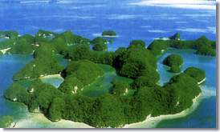
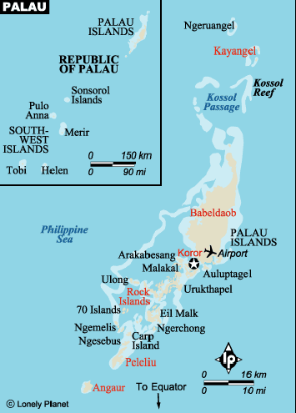
The Republic is an archipelago of 350 tropical islands and islets located at 7°30’N. Latitude, 134°30’ E. Longitude in the westernmost part of the Caroline Islands about 960 kilometers (600 miles) from the Philippines and some 1280 kilometers (800 miles) southwest of Guam. The main group of Palau Islands is dominated by the 390 square kilometer (150 square miles) island of Babeldaob, Micronesia’s largest land mass. A chain of smaller high and low islands running 200 kilometers (125 miles) in length and four small coral atolls some 400 kilometers (250 miles) to the southwest make up the rest of the Republic. The combined total land area of the islands is about 490 square kilometers (190 square miles). There are 19,907 people living in the Republic of Palau. Adjacent to Babeldaob and connected to it by a single-span bridge is the smaller island of Koror, where about 8000 people live, and which has been the administrative center of the archipelago since the era of Japanese control.

Island Geography
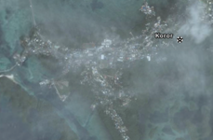
Palau’s waters contain some of the most spectacular and diverse reef systems in the world. It is a virtual paradise of reefs, lagoons, miniature limestone islands, saltwater lakes, and mangrove swamps. The ecosystem of these waters is complex and delicate. It harbors the rare marine crocodile and the even rarer dugong (sea cow). Between Koror and the southern Palau islands of Peleliu and Anguar are the world-famous Rock Islands, a series of tiny, mushroom-shaped limestone outcroppings. The Rock Islands provide excellent diving and snorkeling and are a popular tourist destination.

The satellite photo to the right shows the entire island and the heavy population. Koror is heavily populated, with most of the population of the country living or working in Koror. The northern section of the Republic of Palau has two islands, Ngajangel and Ngariungs. Both are heavily jungled with very low population.
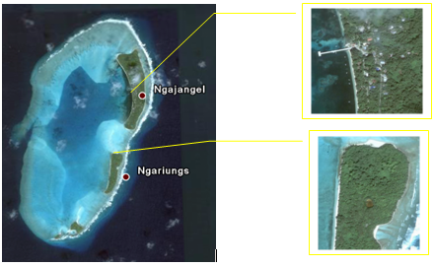
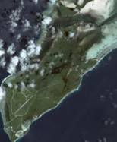
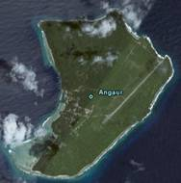
Angaur is sparsely populated, but does have a small airport. Angaur is the southernmost island of the Republic. The airport and a small harbor provide support for the population. Above Angaur is Ngalkol, a small island with limited population. The island has a deteriorated airstrip from World War II that appears to be unused and in disrepair. It could be used by small planes bringing in supplies but would need upgrading to support larger aircraft if the need should arise.

Island Geology
The Palau Group land mass is volcanic in origin, with basaltic structure and limestone formations predominating. The main islands are reasonably well watered and thickly vegetated. Babeldaob’s rolling hills reach an elevation of about 210 meters (700 feet) in places. Its forested interior contains many small streams.

Much of the upland area supports only coarse grasses; hardwood trees and other useful plants occur in certain areas of the interior. Wildlife is scanty and of little economic value. Some of the other islands are composed of coral limestone, and some are too dry and barren to invite habitation. Coral reefs fringe the islands and enclose quiet, shallow lagoons. On the seaward side of these reefs, the banks drop off sharply to the ocean depths. The coral atolls are mostly barren sand and coral structures.

Climate and Environmental Hazards
The climate is hot and humid most of the year with little variation in daily temperature, which ranges between 24ºC and 29ºC (75ºF to 85ºF). Northeast trade winds blow steadily from December through April. Winds are generally light from June through November. Typhoons, though infrequent, are likely to occur between July and September throughout the Western Carolines. Rainfall is heavy throughout the year, though heaviest from July through September. The average annual rainfall is approximately 380 centimeters (150 inches).

Energy Sources
The Republic of Palau presently relies entirely on petroleum fuel for energy outside of the small solar installations on some of the outer islands. It is unusual for the private sector to generate their own power other than for backup purposes. However, there are isolated instances where power is generated internally by both hotels and some small industries. The government remains the sole producer of power for resale. The central grid has very high losses, exceeding 25%. The reason for this is unknown, but a study should be done to determine the cause of the losses to allow them to be resolved.

Koror and the southern part of Babeldaob are served by a central power system. Even though there is normally sufficient generating capacity to meet existing needs, there remain some businesses that produce their own power. PPUC continues to work with these businesses to bring them under the utility grid.

Peleliu has a small system that provides service to the local residences and small business community. Angaur is served by the Angaur power plant and Kayangel by the Kayangel power plant. Hatahobei and Sonsorol are both served by small solar electric units, but the current status of the units has not been confirmed.

Major commercial users, such as Van Camp Fish Processing and the Continental Hotel have in the past found it necessary to supply their own energy needs to avoid unscheduled shutdowns. The unreliability of the electrical power system has discouraged commercial development on the islands.

The Palauan government is in the planning stages of financial arrangements to build new oil-fired generating capacity in Peleliu, Angaur, and Kayangel. The existing units are very inefficient and it is anticipated that the fuel savings will be able to pay for the needed investment capital to replace the older units. If this is done, it will also provide excess capacity to the urbanized areas to allow for economic development. The downside is that this investment in new assets will also commit the Republic to petroleum fuels for the near to mid term to meet the major portion of its electrical generating requirements.

Energy Uses
Consumption of electric energy for cooking continues to increase in popularity, with over 52% of Palauan homes using electricity for their primary means of cooking. However, cooking with gas, wood, or charcoal remains popular at 46% of the households. This is up from 23% of households using electricity for cooking in 1982. In addition, close to 50% of Palauan households now use microwave ovens in their homes.

FIGURE 13-1
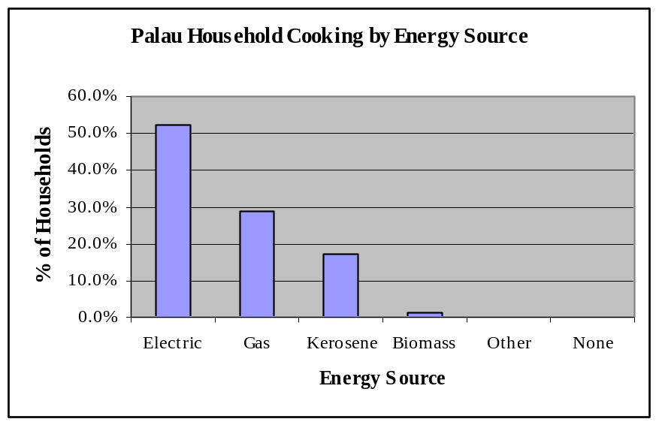
Air conditioning on Palau has also increased in popularity, even with the increased cost of electric power. The chart below shows the households by type of air conditioner. Even though split air units are now becoming the norm over central air, the number of central air units makes up a substantial part of the air conditioning load on Palau with few if any of the economizers available to provide hot water as a byproduct of air conditioning.

FIGURE 13-2
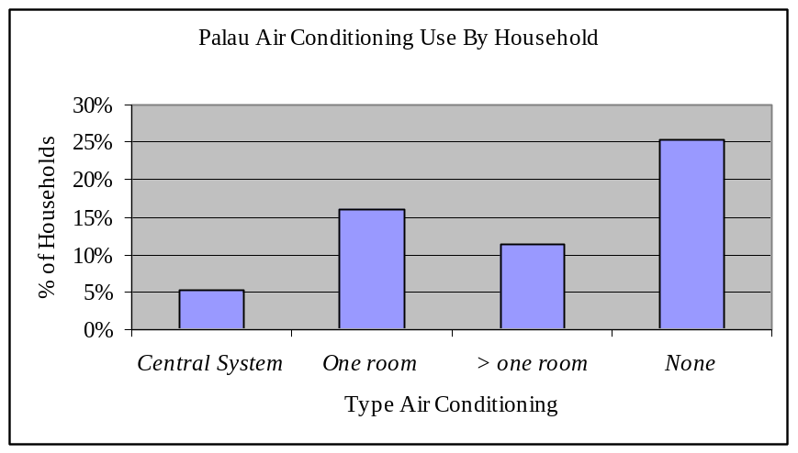

Bus systems are available on the island, but are lightly used other than for tourism. Private vehicles remain the predominant form of transportation. There are discussions of creating a more robust bus system for the island but currently there is no budget or firm plans in place. With the higher fuel costs, bus transportation similar to American Samoa may be a valid option utilizing small privately owned buses to meet the needs of the local population. This approach would also fit the tourist trade by providing smaller, more efficient busses.

HISTORY, POLITICAL DEVELOPMENT AND PRESENT STATUS

Early Island History
The early history of Palau is shrouded in legend and myth. Although Palauan legend presents its world as a relatively closed and complete universe, an Indo-Malay people probably settled the archipelago around 1500 B.C. For thousands of years Palauan culture and matrilineal clan systems flourished. The world of Palau was divided into two competing, embryonic semi-states: Babeldaob, centered on Melekiok Village, and Youldaob, roughly present-day Koror. These states were chronically at war and even today preserve an intense socio-political rivalry. The archaeological evidence suggests that Palau once had 30,000 inhabitants.

After western contact began in the sixteenth century, the islands were nominally a Spanish possession, but that country made little effort to exercise control until 1885. Following the Spanish American war, Spain sold her interests in the Pacific to Germany. German sovereignty lasted only until 1914, when the Japanese seized Germany’s holdings in Micronesia.

Recent Island History
During the early 20th century Japan had an economic as well as military stake in its Pacific possessions and encouraged their colonization by Japanese nationals. At one time approximately 24,000 Japanese lived in Palau, far outnumbering the indigenous population. The Japanese relinquished control of the islands in 1945 upon their surrender to the United States at the end of World War II.

United States Involvement
From 1945 to 1951, the islands were under the jurisdiction of the United States Navy, at first under military control and later under civilian government. Until the establishment of the Republic of Palau in 1981, the islands were administered by the Interior Department under a trusteeship with the United Nations.

The United States has several programs at the Federal level that benefit the islands in the Western Pacific. Most of the funding programs focus on roads, schools, and other needed infrastructure. Energy related funding programs are normally under the jurisdiction of the U.S. Department of Energy or under the Department of Interior working through the Department of Insular Affairs. In the post-9/11 years, additional funding related to island security has become available through the U.S. Department of Defense, and the Department of Homeland Security. This has helped provide needed assistance for the Vulnerability Assessments for the Pacific islands' electric and water utilities. Detailed information for the total funding available should be reviewed to determine the full impact of all funding that the U.S. government may be able to provide Palau.

Political Development
Traditionally, and continuing in large measure today, kinship is the core of social relations in Palau. Every Palauan has a defined role, status, and behavior based on kinship. Palau's basic social unit is a single, ancestral biological kin group comprising a mother and her children. A number of these basic units descended from a specific woman to form a family, and several related families constitute a clan. Ideally, a village, the social and political unit, consists of 10 clans. The male leader of each clan is chosen by the ranking female members of the clan and forms with other clan leaders the village council. A separate but equal women's council comprises ranking female leaders. Clans are ranked and the male leader of the highest-ranking clan serves as the chief of the village. The chief is not a sole ruler but must use diplomacy and persuasion to maintain the support of his constituents. Should his rule prove unsatisfactory, there are mechanisms for his replacement.

Present Political Status
The traditional system of governance that has ruled Palauan society throughout history retains considerable authority today, with customary law recognized under the local constitution and the legal code as having equal weight to modern codified law. A National Council of Chiefs, consisting of the ranking chiefs from each of the 16 states, advises the President on traditional and customary matters.

The Republic of Palau is one of the governments that emerged from the Trust Territory of the Pacific Islands. Palau opted for independence in 1978 rather than join the Federated States of Micronesia. A Compact of Free Association with the U.S. was approved in 1986, finally ratified in 1993. Palau created a constitutional government in free association with the U.S. and the Republic of Palau became a sovereign independent nation on October 1, 1994.

The government consists of three branches of government, executive, legislative and judicial. A bicameral parliament or Olbiil Era Kelulau (OEK) consists of a Senate and House of Delegates. The Senate has nine seats and members are elected by popular vote on a population basis to serve four-year terms. The House of Delegates has 16 seats with members elected by popular vote to serve four-year terms. There are 16 states in the Republic of Palau, each having its own separate government.

The Compact of Free Association with the U.S., entered into after the end of the UN trusteeship on 1 October 1994, provides Palau with up to $700 million in U.S. aid over 15 years in return for furnishing military facilities. The Compact extends to 1 October 2009.

The Republic of Palau is a fairly new republic and continues to experience challenges in finding experienced personnel to manage the government and critical island infrastructure. Economic planning based on development of Palau’s natural resources, including its great natural beauty and its renewable energy resources, has been slow to develop since the Compact of Free Association was implemented. Even though the government has not lost sight of this goal, the efforts to proceed have been limited by the lack of funding and the lack of experienced personnel to assist in the development of a comprehensive Energy Plan with specifically identified projects with the goal of reducing the dependence on imported petroleum products.

POPULATION, EMPLOYMENT & WAGES

Present Demographics
In 2005, Palau’s resident population was 19,907. This figure is consistent with projected growth of between 1.5% and 2%. Palau’s population is growing more slowly than that of the rest of Micronesia. This is due to smaller family size and Palauans moving off-island for jobs and higher wages.

Figure 13-3
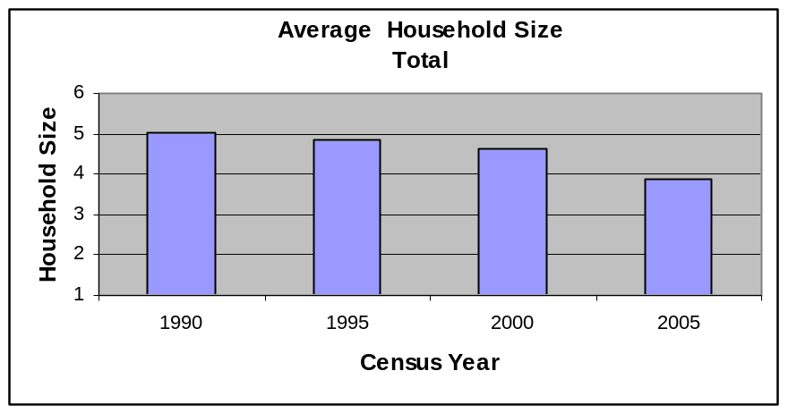
About 12,676 people (64%) of Palau’s resident population live in Koror, where over 70% of jobs in the wage sector are located. Roads continue to be improved in Palau with major investments from both the U.S. Department of Transportation and some funding from the Japanese government. Palau President Tommy Remengesau, Jr. has called the opening of Babeldaob island the awakening of his young country's "sleeping giant."

Palau has a total land mass of over 190 square miles. Babeldaob is the largest island in Palau, encompassing most of the country's land area. Much of the Babeldaob rain forest is not developed, and has the potential to become either the breadbasket of the western Pacific or the site for major new tourism growth. If managed well, Babeldaob could provide both simultaneously.

The Palauan government is looking forward to the completion of the new "Compact Road," a 53-mile sealed road that will open Babeldaob to development. The road was originally projected to be completed in June of this year (2006). Even though much of the land clearing and excavation has been completed, there remains much to be done. The cost for the project is in the area of $150 million USD. Much of the funding has been provided by the U.S.-Palau Compact of Free Association, which defines political and financial relations between Koror and Washington. Since the Compact of Free Association provided funding for the road, it has picked up the name "Compact Road." The road is being constructed by South Korea-based Daewoo Engineering and Contracting Company under contract to the U.S. Army Corp of Engineers. Delays in completing the road are due to the extreme conditions in building a road through the virgin jungle environment and some contract disputes between the U.S. government and the contractor.

In addition to the Compact Road, the main road between the airport and Koror will be upgraded with the assistance of Compact funds. There are some encouraging signs that as amenities and roads are extended to the big island, families will return to their home villages within commuting distance of the capital. This will reduce traffic congestion in Koror and provide additional space for the expansion of tourism

Figure 13-4
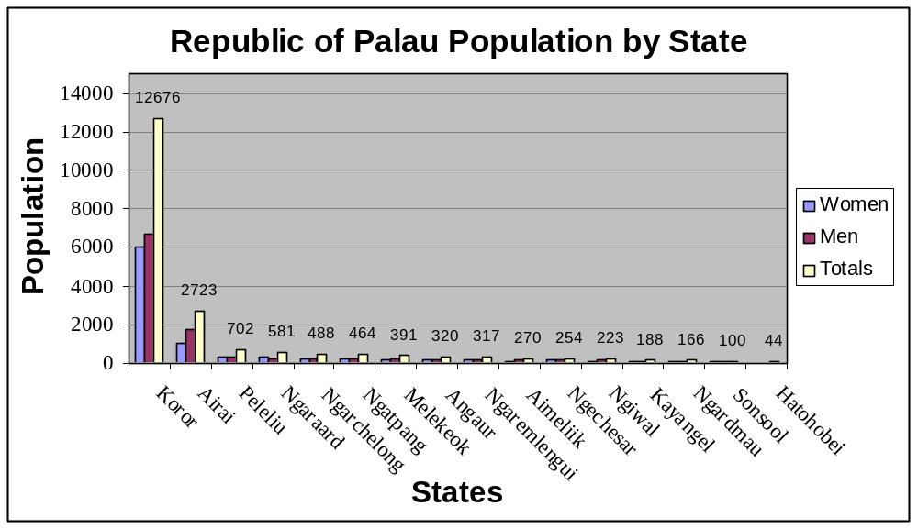

Palau population demographics are shown below. Note the marked decrease in birth rate for women and the associated reduced fertility rate.

Table 13-1
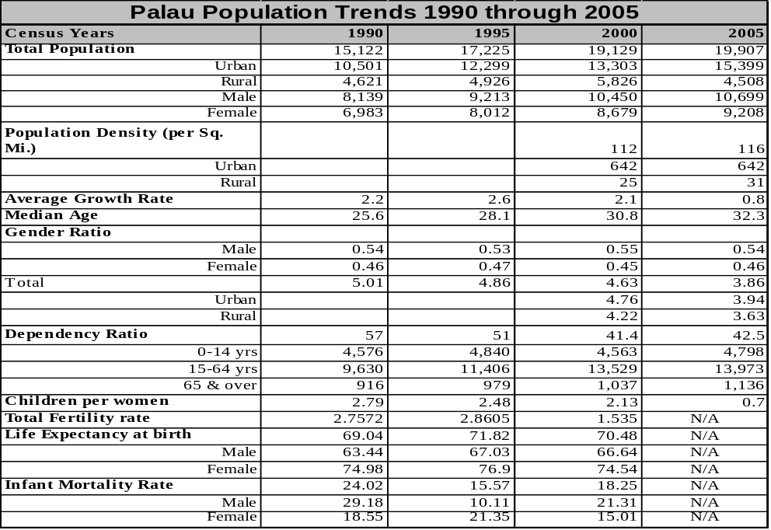

Employment and Job Market
At present there are about 9,764 jobs in the wage sector; 41% of these are in government. Unemployment is a low 3% of the labor force. The level of income in Palau is low, with the 2005 census showing over 52% of the population below the poverty level. Additional study would be required to determine if this is significant, since there is readily available food and water on the island to prevent any significant malnutrition resulting from low income levels.

FIGURE 13-5
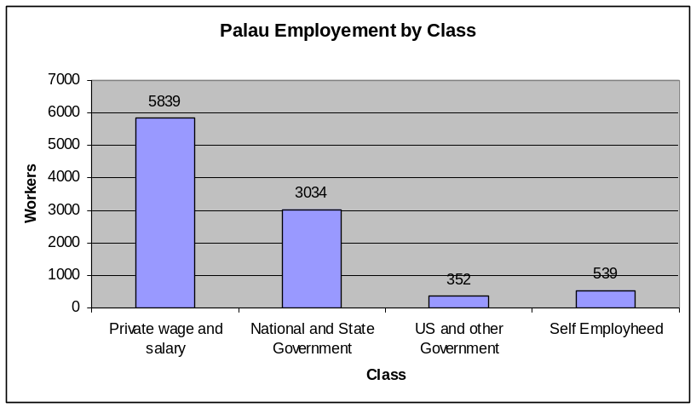
The economy remains heavily dependent on United States payments to finance the cost of government. Government in turn is the principal employer in Palau, with 41% of the total workforce on its payroll. Under a new Compact of Free Association, United States Government support payments and economic assistance would continue at substantial levels over the next 50 years. However, additional monitoring and tracking of funds will be required to account for the funds received. Due to this added tracking, Palau will need to update the current financial and operational tools. In addition, there will be added emphasis on cost/benefit analysis for CIP projects and grant requests.

Palau’s Gross Domestic Product continues to improve overall. Palau had a GDP of just $14 million in 1975, rising to around $20 million in 1979. In FY2005, Palau had a GRT of $123 million, with an average growth rate of over 7% since 1979.

In addition to GDP as a key economic indicator, Palau has also developed an economic indicator called the Diffusion Index or DI. The DI results from surveys of businesses to determine their current level of confidence in both the public and private sectors relative to economic activity. By standardizing on how the surveys are conducted, the DI provides the Republic of Palau with an ongoing measurement of the economy as perceived by the Palauan business community. When the DI is above 50, the Economic Sentiment is said to be positive, with results of less than 50 indicating a negative outlook. The chart below shows the DI for the 4th Quarter, 2005 indicating a neutral or slightly above neutral reading.

FIGURE 13-6
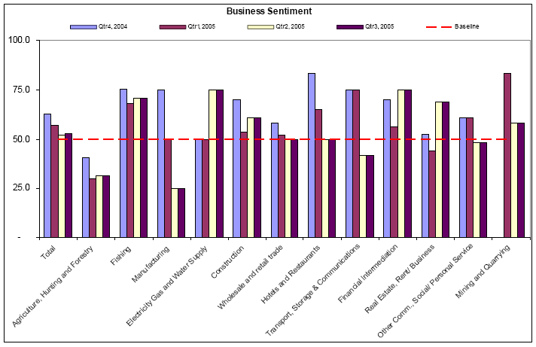

Gross Domestic Product
The Gross Domestic Product provides an overall picture of how well the Republic is performing economically. There are a number of factors that contribute to the GDP, but the basic measurement will provide good insight as to the health of the economy. Palau has been able to demonstrate an ongoing improvement in their Gross Domestic Product. The chart below shows the overall performance of each of the business sectors.

FIGURE 13-7
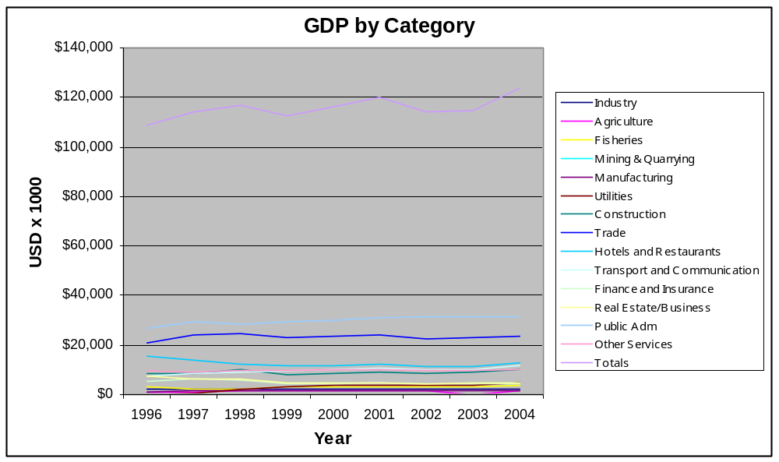

Sources: Data for FY 1996 and FY 2004 taken from Palau Office of Planning & Statistics

Palau’s principal economic sectors show improvements in GDP, but there appears to be continued concern about the island infrastructure reliability. The electric infrastructure remains vulnerable due to lack of funds resulting from recent fuel cost increases that the utility and government are reluctant to pass on to residential and business customers. This results in decreased maintenance of assets and lower reliability numbers. The main islands have substantially improved over the past 10 years. Even though the utilities continue to struggle to meet budgets and maintain their assets, service to the public has shown sustained but slow improvement. Roads are noticeably better, with fewer potholes and better construction. Water and sewage continue to be a challenge to all utilities due to the increased cost of fuel and electric rates. However, catchments are commonly used in Palau, with over half of the population using catchments or rainwater for drinking water.

All electric power is generated with imported diesel fuel. The private sector lacks a means of credit to finance new enterprise and is prevented from expansion by the infrastructure deficiencies.

Personal Wages & Income
Personal wages remain low on the country, with most households having 2 or more wage earners for financial support per family. Average income for families varies substantially between the islands in the Republic, with the highest average wage being on Koror, at a little over $26,000 USD/year. The lowest average wage is on Ngardmau where wages are under $10,000 USD/year. The chart shows the large variations in wages between the islands of Palau.

FIGURE 13-8
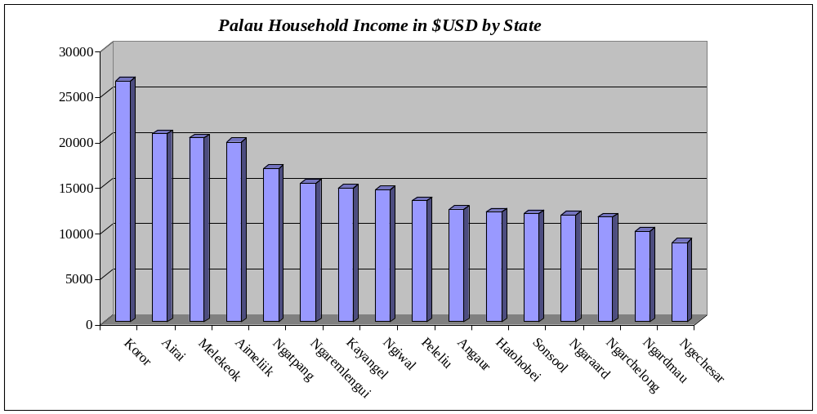

General Business & Commercial Income
Palau has a very friendly business environment with several areas of government regulations that favor moving businesses to Palau. In addition, there will be an expected expansion of business on Palau when and if the infrastructure improves. The following excerpts from the World Bank provide some insight as to how well the Republic of Palau is positioning the small country to lure outside investment as well as internal business expansion when the new roads are completed around Babeldaob.

TABLE 13-2
Palau
Region: East Asia & Pacific
Income category: Upper middle income
Population*: 0.0 million
GNI per capita (US$)*: 6,870
Informal economy estimate (% GNP)*: ..
* Please see the Economy Characteristics methodology for information on sources.

Ease of... | Economy rank | Best performer | Worst Performer
Doing Business | 50 | New Zealand | Congo, Dem. Rep.
Starting a Business | 39 | Canada | Angola
Dealing with Licenses | 1 | Palau | Tanzania
Hiring and Firing | 1 | Palau | Burkina Faso
Registering Property | 4 | New Zealand | Nigeria
Getting Credit | 120 | United Kingdom | Cambodia
Protecting Investors | 140 | New Zealand | Afghanistan
Paying Taxes | 27 | Maldives | Belarus
Trading Across Borders | 35 | Denmark | Iraq
Enforcing Contracts | 128 | Norway | Timor-Leste
Closing a Business | 134 | Japan | West Bank and Gaza
Compare All Economies

Hiring & Firing Workers (2005)

The difficulties that employers in Palau face in hiring and firing workers are shown below. Each index assigns values between 0 and 100, with higher values representing more rigid regulations. The Rigidity of Employment Index is an average of the three indices. For Palau, the overall index is 0.

Indicator | Palau | Region | OECD
Difficulty of Hiring Index | 0 | 26.0 | 30.1
Rigidity of Hours Index | 0 | 29.6 | 49.6
Difficulty of Firing Index | 0 | 23.0 | 27.4
Rigidity of Employment Index | 0 | 26.2 | 35.8
Hiring cost (% of salary) | 6.0 | 8.8 | 20.7
Firing costs (weeks of wages) | 0.0 | 44.2 | 35.1

Details | Compare All Economies

Fishing in Palau remains a vibrant business sector, with small commercial fishing and local tourist fishing being the predominant fishing related industry. The fishing in Palau has remained prosperous and reasonably stable over the past 20 years. The chart below shows a 25% decline in total catch during the 1990s, with a steady recovery of 22% beginning in 1997.

FIGURE 13-9
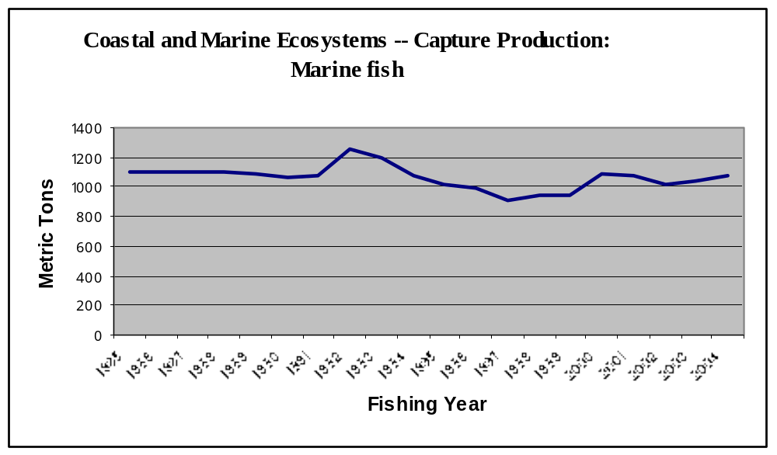

This brings the total catch to near 1982 levels. Along with other political and economic considerations, this would also be an added incentive to develop a cannery on Palau. In April of this year, there were ongoing talks with the Philippine government to build such a cannery on Palau. This would contribute towards a settlement of an ongoing territorial waters debate between the two countries and provide additional income for the island. If the cannery is built, there will be an increase in energy needs on Palau in excess of their existing power production capability. Further research is required in this area to determine the actual impact on the local utility.

ISLAND ECONOMY AND INFRASTRUCTURE

General Status of the Economy
The Palau economy continues to thrive on an ongoing tourist trade from Japan, Asia, and Australia. Major capital projects such as road and infrastructure improvements driven by grants from Japan and the United States have kept the construction industry moving forward while tourism and fishing continue to assist the Republic in keeping the economy on a slow, but steady expansion with GDP showing an average of 1.7% expansion over the past 8 years.

Major Employment Sectors
The major employment sector for the island remains the government sector, but the private sector, including trade, hotels, and restaurants play an increasing role in keeping unemployment numbers down.

TABLE 13-3
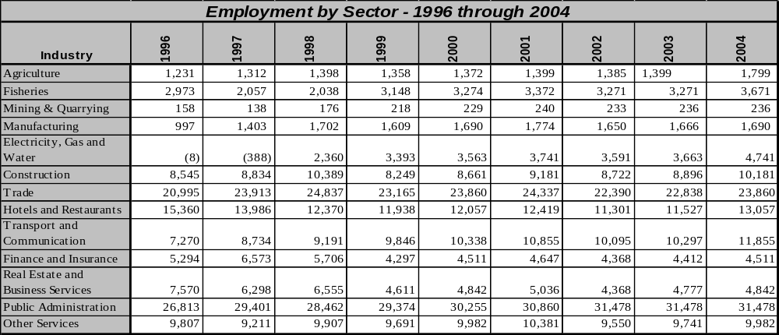

FIGURE 13-10

Water and Wastewater Systems
Palau's drinking water system continues to improve, but a large percentage of the population continues to use rainwater or bottled water for drinking and cooking. There have been grants by the U.S. government to improve both the water system and the waste water system on Palau. In addition, Taiwan continues to take a proactive role, providing $409,000 for a water system in Melekeok, along with a wastewater system grant of $2.4 million. This system will recycle the treated wastewater instead of discharging it into the ocean.

Electric System
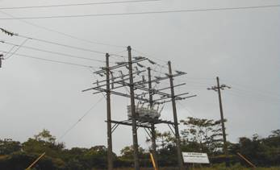
Palau has a current installed capacity of a little over 28 MWs, with power plants located at Malakal, Aimeliik, Peleliu, Angaur, and Kayangel, with Malakal and Aimeliik providing power to the central grid supplying Koror and Babeldaob Island. Many of the units are over 20 years old, though the Wartsila and Mitsubishi generators at Malakal were commissioned in the late 1990s, making them the newest and most efficient equipment in the system. Maintenance problems persist with the units due to the lack of funding for preventive maintenance and equipment manufacturer-required inspections. It is essential that the cost of maintenance be recovered through customer rates to bring the units back to normal maintenance programs as recommended by the manufacturer.

Outside the urban area of Koror and the areas of Babeldaob that are to be electrified, energy options other than petroleum-fuel based power may be a better economic choice. A full cost analysis of any replacement units should be accomplished before making decisions on how to supplement or replace older generation equipment.

Those alternate energy systems of most potential significance in Palau can be identified by applying to all candidate technologies the selection criteria presented in the section of this report referencing alternative energy solutions. An examination of the technical, economic, and social factors represented in these criteria, when based on circumstances unique to Palau, can indicate the relative appropriateness of each option. These alternate technologies and their possible role in meeting Palau’s current and future energy needs are outlined in the attached table and discussed below.

A listing of the installed diesel generating units in Palau, including rated capacity and status of each, follows:

TABLE 13-4
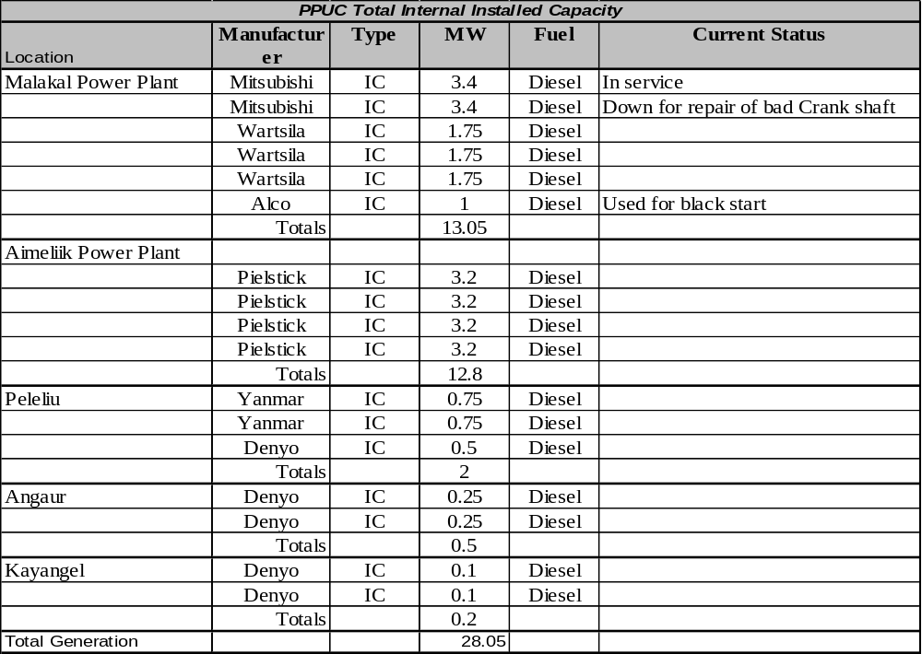

As of 1980, there were approximately 1,500 connections to Palau's electrical distribution system. Since that time, the PPUC has grown and matured as a public utility, now serving over 6,000 customers. The chart below shows the total kwh by customer type:

FIGURE 13-11
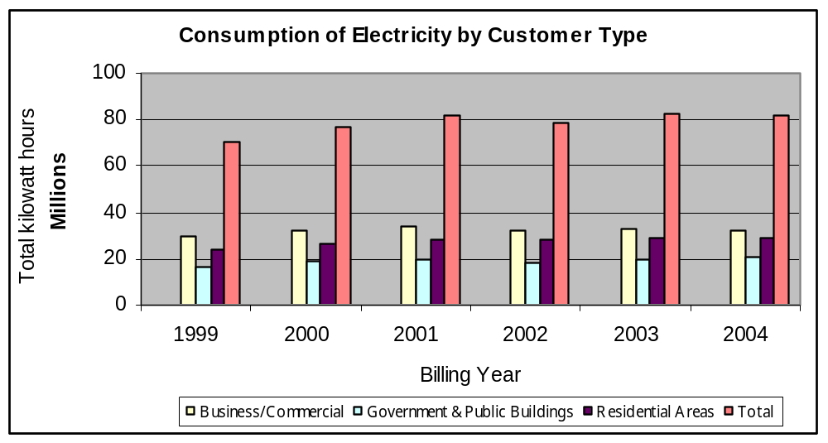

The residential consumer averages approximately 500 kwhs per month, with the average monthly bill remaining at less than $90.

In addition to the known load mentioned above, there is undefined additional energy consumption by companies and individuals that produce their own power. The estimated amount of customer generated power is in the area of 10 MWs, but could be as high as 25 MWs of potential demand for the utility if the customer generated power were generated by PPUC. Further study should be done to identify both energy and demand requirements for this customer base to include the data in any future planning for the Palau utility. In addition, this generating capacity is also available for possible support for the utility during high demand, low production days. The future study should include options to be considered during future supply side management improvements for PPUC.

TABLE 13-5
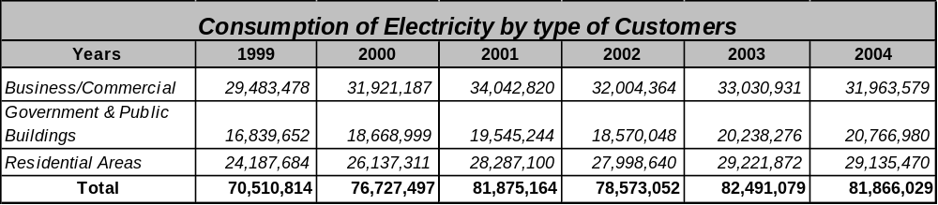

Electricity users throughout Palau are currently charged only 6⊄ of an estimated 21⊄/kW cost of production; that estimated cost is based on fuel cost only and does not include operation and maintenance. Generation costs for each of the four newest units (three ALCO and one gas turbine) are roughly identical. The current rate structure necessarily results in government budget deficits that will continue to grow as power demand increases.

The bulk of unmetered users are government agencies, consuming an estimated 35% of all power generated in Palau. Projects should be undertaken to install meters on all government and private connections to the power grid.

Due to reliability problems with the Koror system and the lack of reserve energy availability, many large industrial users have been obliged to install their own generators. The large fish processing plant in Palau closed in 1994; there remain efforts to attract outside investors to build a new plant, but to date, these efforts have been unsuccessful. The United States Army has a 350 kW plant for communication services, and the hotels on the island also have backup generators installed. In addition, there is a 6 mw privately owned generator that was installed at the Koror Airport in the early 90s. The unit is Fairbanks Morse engine reportedly driving a 3 MW generator. The utility is not utilizing the unit for normal or emergency capacity at this time, but there may be some discussions underway that would add this unit to PPUCs available capacity. This was brought up during interviews and during investigatory work for this report and both the utility and the owner of the generator expressed interest in discussing possible solutions.

In the residential/commercial sectors, the principal uses of electric power are for cooking, refrigerating and lighting. Electric hot water heaters and air conditioning systems continue to increase in popularity. Typical electrical consumption in the residential sector has increased from an estimated 70 kWh/month to 545 kWh/month in 2004.

Total fuel consumption is not closely tracked on Palau. However, based on total electricity generation, about 114,000 barrels of petroleum products were consumed in 2004 to generate electricity. This is up from the 44,400 barrels used for electricity production in 1980. This is a substantial increase that accompanies the increased generating capacity and production of PPUC.

Transportation fuels represent the third major category of petroleum use in Palau. Over 3500 vehicles (private and government), close to 500 boats, plus commercial aviation, comprise the specific uses of fuel within the transportation sector. The government of the Republic operates a very limited field ship system, so fuel used for inter-island transportation of people and goods is included in the marine transportation sector. Current fuel import data was not made available. The island imports approximately 310,000 barrels of fossil fuels per year based on calculations derived from United Nations Energy/Capita data.

Economic development goals in Palau center on enhancing three major activities: tourism, fisheries, and agriculture. Sufficient and reliable public power will be required to attract potential investors. If generating capacity with required transmission and distribution infrastructure is not available, the government of the Republic will have to offer tax compensations to industries that have to develop their own power sources. The government of Palau prefers to have the infrastructure in place to allow it to be the energy provider of choice, but the planning stages of an effective effort to increase Palau's central electric generating capacity significantly will be needed to encourage business investments in the island.

Transportation
Transportation in Palau is through personal vehicles and taxi service. Organized bus transportation is primarily used for school and tourism. Gasoline and diesel costs are similar to Guam and Hawaii, with prices in the mid $3 range.

Taiwan has been interested in Palau for many years due the rich fishing waters off Palau's coast and the potential tourism industry in Palau. Taiwan has shown an increased interest in providing assistance to Palau during recent years. Besides the $20 million loan a few years ago from Taiwan's International Commercial Bank of China for phase two of Palau's national capital project in Melekeok, Taiwan, this year, provided grants for short roads—$640,000 to Aimeliik for a 500-yard-long road, $130,000 to Ngchesar for a road/causeway project, and $1.1 million for a connecting road.

Marine
Commercial fishing remains a strong industry in Palau, with primary customers being tourists. Foreign fishing fleets have also found safe harbor where they can refuel and perform repairs.

Port and Port Industries
The main commercial port facility in Palau is located at Malakal Harbor on Malakal Island. The wharves are of pre-World War II Japanese construction. Dimensions of the two faces of the dock currently utilized for cargo vessels are 528 feet by 500 feet. The depth alongside the quay wall varies from 26 feet to 29 feet. In 1995, over 280 commercial, fishing and other vessels called at Malakal commercial port, delivering over 6,000 containers and other bulk cargo totaling over 70,600 tons.

Airports
The Palau International Airport (ROR) is Palau’s only international airport. The airport is located in the state of Airai, a short drive from Koror State, the provisional capital of the Republic of Palau. The airport is an open-air, with minimal amenities. The runway has recently been resurfaced through financial assistance from Taiwan.

Communication Systems
Palau's communication system and interconnections to the rest of the world continue to improve. In 2002, Palau had 6700 communication lines and over 1000 cell phones on the island. Cell phones are now becoming more popular with increased services. In addition, full cable networks are available and continue to improve service to their customers. Palau is finding the Internet to be a very useful tool in tourism, spare parts and other uses that are starting to become the norm. However, with the added technology required to access the outside world, Palau has also found additional challenges with viruses, spam, and other adverse effects of being connected. Palau will need to develop procedures, policies, and laws that will help protect both businesses and private citizens from SPAM and online viruses. In addition, there is continued improvement in providing communications services at reasonable rates.

Tourism Industry
Palau’s economy is sustained mostly by tourism and external assistance, with the public sector accounting for nearly half of the total employment. The tourism sector was adversely affected in 2002 by the sharp appreciation of the U.S. dollar against the Japanese yen. This also resulted in limited air flights and uncompetitive airfares. However, tourist earnings rebounded by 22 percent in 2003 and another 7 percent in 2004. There were an estimated 60,000 tourist to Palau in 2005. Efforts have been made recently to introduce competition in air flights and to diversify the tourist base. Palau has been actively pursuing Korea, Japan, China, Australia, and the United States mainland to pull tourists in from all over the world. In addition to the advertising campaign, Palau is working to expand flights into the country.

Major Industry
Palau has no major industry in the country. The fish processing facility was closed in 1994. There are currently efforts to encourage countries such as Taiwan and Japan to build a new fish processing plant on Palau; there are currently no parties that have expressed major interest in the project despite the favorable tax and labor pool environment offered by Palau.

Military
There is no significant military activity on Palau.

Other Special Economic Elements
None noted.

Manufacturing, Craft, Trade
Storyboards remain popular, with most being made at the local correctional institution.

Aquaculture, Fisheries, Refineries
Palau has no major fisheries, aquaculture activities, or refineries for fish-related products at this time. Fisheries contribute less than 3% to the country's GDP.

ECONOMIC DEVELOPMENT PLANS AND PROJECTS

Existing Capital Improvement Projects
The third phase of some of these projects was most recently completed in March this year. The scope of this phase comprised extending the 34.5 kv electric power transmission line from the Kokusai substation northward to the Yamato area of Ngaremiengui State and appropriate step-down substations at lbobang and Yamato, thus enabling 13.8 kv distribution lines to lbobang village in Ngatpang and the village of lmeyong in Ngaremiengui, where the new line was connected to existing power system, thus enabling 24-hour electric power service to the rest of the state.

The government of Palau is actively seeking grant aid assistance from the government of Japan for extending the power grid further north and east to electrify the remaining four states in Babeldaob island presently still without 24-hour power service.

Compact Capital Commitments
The provisions of Section 212 of the Compact of Free Association commit the United States to construct major physical facilities necessary to support economic growth in Palau. Details are spelled out in a supplementary agreement to the Compact. While some of the Compact activities will be in the urbanized area, the major significance of this program will be to open up Babeldaob for economic growth and to provide basic infrastructure necessary for growth in other remote areas. Under the terms of the Compact of Free Association with the United States, Palau will receive more than $450 million in assistance over 15 years and is eligible to participate in more than 40 federal programs. The first grant of $142 million was made in 1994. Further annual payments in lesser amounts will be made through 2009. U.S. grants in 2003 totaled $11 million. The original array of projects anticipated under the program is as follows. A detailed study of the status of the projects below would help identify the progress that Palau and the United States Government have made towards the goals set forth in the Compact:

- Roads: Perhaps the most significant Compact project will be building a 85 kilometers (53 miles), all-weather road network on Babeldaob (in progress).
- Spurs will be completed to several villages, providing farm-to-market opportunities in support of agricultural development (in progress).
- In addition, 13.6 kilometers (8.5 miles) of secondary roads in the urbanized area and 16.2 kilometers (10 miles) of roads on Peleliu will be improved.
- Water Systems: Water systems will be installed for six villages on Babeldaob and four outer islands. A 2745-meter (9000 foot) long, 15-centimeter (6-inch) water pipeline will be installed to Airai village.
- Wastewater Disposal: The existing Koror waste water disposal system will be extended to Arakebesan.
- Intervillage Communication: Transceivers are to be established for 30 remote locations, although all or part of this effort may be subsumed under present Trust Territory communications improvement and the Comsat operation.
- Education Facilities: A total of 72 classrooms are planned for various locations, and a gymnasium will be provided for the Koror High School.
- Health Facilities: Two new dispensaries will be built outside the urbanized are and two existing dispensaries will be upgraded.
- An all-weather airport terminal at Airai will provide services for passengers and cargo to handle an expected major increase in air service.
The United States government continues to be interested in assisting Palau in reducing dependency on foreign oil imports. The original Compact of Free Association addressed this issue in Section 214, where the United States agreed to provide, on a grant basis, for fifteen years commencing on the first anniversary date of the effective date of the Compact, the sum of $2 million annually as a contribution “to efforts aimed at increased self-sufficiency in energy production….” In addition, Section 221 (c) pledges the United States to make available to Palau (as well as to the Marshall Islands and the Federated States of Micronesia) such alternate energy development projects, studies and conservation measures as are applicable to the laws. The recent Energy Bill passed by the U.S. Congress in 2005 authorized but did not appropriate additional funding in several areas. Further study will be needed to identify all of the potential energy related opportunities that this bill contains.

General Status of Economic Development Planning
The basic economic development goals of the government of the Republic are to increase economic self-sufficiency, to reduce or eliminate financial dependence on the United States, and to improve the overall standard of living in the urbanized area and throughout the sixteen states.

Palau, along with the other Pacific island nations, must pursue its economic development under constraints of limited land, water and skilled labor. However, Palau is in a particularly favorable situation now that the final details of the 50-year Compact agreement are being worked out. Both the present Capital Improvement Project (CIP) and the program to be implemented under Section 212 of the Compact address the need to improve infrastructure and provide support base for economic development. Air and sea traffic facilities that could enable Palauan products to reach other East Asian markets have a high priority under these programs.

Palau concerns about imbalances in the economy, particularly with respect to consumption and saving, and to the balance of international trade seem to have lost their relevance in the light of this capital works commitment. The trade gap is not a pressing problem at this time, and it is expected to resolve itself as the CIP programs are completed, allowing exportable surpluses to be produced.

Palau imports food, and local agricultural production in both food and coconut is well below its potential. Small-scale subsistence agriculture is practiced in the outer islands and around Koror. However, much of the available land is not cultivated, reflecting inadequate incentives for villagers to increase production above subsistence needs.

While fishing now provides amply for local needs, there is every indication that the Republic could earn significant amounts from seafood exports. The tuna and reef fishing industries could be greatly expanded, and the potential of other varieties of seafood (clams, trochus, shrimp, lobster) remains to be exploited. Infrastructure improvements, especially for refrigeration and storage, would be needed. The present fishing service industry is run down and needs to be repaired and expanded. All ship repair facilities at Malakal and Peleliu are presently idle but could be revived.

Sustained, reliable sources of water and electric power continue to be needed for an expanded fishery and processing operation to be developed on Palau. Even though there have been recent upgrades to the port, much of the needed improvements in power facilities and infrastructure will need to be supplemented with direct investments to support the needed preservation facilities and refrigeration vessels used to transfer catches from outlying areas to Koror.

Economic Development Approach and Special Issues
Palau continues to have near full employment due to the current capital investments by the US, China, Japan, and other governments. In addition to full employment, Palauans continue to enjoy basic life styles of fishing and living off the country’s natural resource supply. As a result, Palau is challenged with finding a labor force to expand the economy and continue the improvements to the country's infrastructure. Palau is currently negotiating with the Philippines in a labor and fisheries agreement that would provide additional labor resources to the country. This will assist with the labor issues, but will also contribute to the ongoing concerns of locals on the loss of cultural values and the changing lifestyles that accompany economic advancement. There is also concern on how to establish/maintain good governance with transparency.

Palau has been working on a Land Use Agreement in cooperation with Palau Community College and the Palau Conservation Society. When completed, the Land Use Agreement will play a pivotal role in the economic development of Palau. The Land Use Agreement project has been underway for over 10 years with efforts reportedly starting shortly after the Compact of Free Association was signed. Finalizing this agreement would help stabilize the private development in Palau.

Focus Areas
The Palau government remains concerned that increased tourism may have an adverse impact on the environment or continue to adversely affect the Palauan culture. In addition, there are limited resources to support the added infrastructure needed to support a major increase in tourist trade on Palau. These are ongoing issues that will have to be addressed by Palau to develop their long term goals as a country.

Minerals represent another potential resource that may have economic significance for Palau. Residents of Angaur had a 10-year agreement with a Japanese group for the extraction of over 900,000 tonnes (one million short tons) of phosphate. No other extraction activity is in progress, but the remaining bauxite deposits on Babeldaob merit re-examination, as do studies to identify potential seabed mineral resource beyond the reefs. The disadvantage to mining operations is the adverse effect it has on the land. This has slowed interest in mining in the country. There remains possible offshore development that may prove to be more acceptable than onshore mining operations.

Energy Considerations
Palau is currently using diesel to generate its electrical power. As fuel prices increase, the percentage of household income being committed to energy continues to climb. As fuel costs continue to climb, the government is reluctant to raise electric rates. This contributes to shortage of funds to perform preventive maintenance and routine equipment maintenance tasks. As a result, system reliability declines and O&M costs increase, contributing to the high operating costs. This cycle of decreased maintenance accompanied by increased costs builds on itself until the utility is willing to raise rates or fuel cost adjustments, or both to cover the actual production cost of electricity. In addition, Palau is also faced with many of the government agencies remaining on non-metered electrical connections. The Palau Public Utility is addressing this issue and is moving towards the installation of meters on all customers.

Economy Diversification
Palau's economy continues to be driven by tourism and the influx of capital from Compact projects. However, the funds available from the U.S. government will soon be cut back, requiring Palau to become more self sufficient. The government of Palau continues to work towards developing additional contributing sectors to the economy and increasing the depth of the tourism trade. However, the key driver for the tourism industry will be to stabilize and improve the reliability of the power, water, and communication system.

Import-Export and Balance of Payments

Balance of Payments (BOP)
Information on all transaction of residents with the rest of the world. The data is recorded at market prices, including data on fish exports to Japan and garment exports to other countries.

TABLE 13-6
YEARS | 2000/01 | 2001/02 | 2002/03 | 2003/04 | 2003/04
Trade Balance | (83,302) | (76,367) | (79,883) | (101,398) | (91,765)
Services account | 47,889 | 46,005 | 68,239 | 87,698 | 86,539
Income | 5,985 | 5,450 | 4,458 | 6,019 | 4,169
Current transfers | 19,993 | 13,955 | 16,740 | 20,234 | 16,151
Current account (w/grants) | (9,435) | (10,957) | 9,604 | 12,553 | 15,094
Current account (w/o grants) | (29,765) | (31,518) | (11,362) | (10,830) | (6,556)
Capital and financial account | 14,036 | 10,848 | 18,996 | 25,043 | 34,359
Overall balance | (25,087) | (34,187) | (3,439) | (10,209) | (5,239)
* Provisional Numbers provided by the Republic of Palau

STATUS OF ENERGY SYSTEMS

Major Energy Uses
Major energy uses on Palau are electric power for residential and business air conditioning systems. The primary industries on Palau are fishing and tourism, with warm waters, beautiful beaches and world class diving being the key drivers that bring people to the island. The fishing industry is tourist-driven with some commercial vessels working in the area.

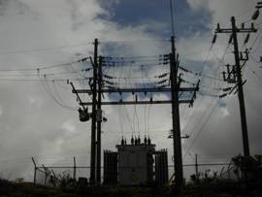
Electric Power System
The transmission system voltage in Palau is at 13.8kv with a single 34.5kv line and associated switchyards. As the country’s energy needs increase, the lines have increased their capacity by increasing the number of amps transmitted on the lines. This results in higher losses, but continues to be the lowest cost option as to capital investment. As fuel prices increase, the line losses will cause increased cost to the utility. Palau will need to take a close look at the line losses associated with its 13.8 kv system to determine the best solution in regards to line loading and line voltage configurations.

Generation Facilities
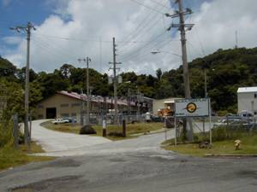
Palau has 5 power plants with a combined output of 28mws. Maintenance on the power plants is limited due to lack of sufficient electric rates and fuel recovery charges to meet the financial needs of the utility. In addition, the lack of funding has decreased utility employee training resulting in higher internal costs from equipment failure and extended equipment outages. The utility has recently gone through a change in management that will ultimately delay improvements until new management is in place and continuous improvement plans are moved forward. Until a new general manager is selected, the vice president is providing the leadership to move the utility towards needed improvements. The following provides a listing of the current generation assets owned by the Palau utility, but does not provide a full list of generating assets for the country, since a substantial number of major customers continue to generate their own power or have backup power capabilities. These assets should be identified as soon as possible to better understand the total generating assets on Palau and their capabilities in both normal and emergency conditions.

The five power plants owned and operated by PPUC are listed below:

Table 13-7
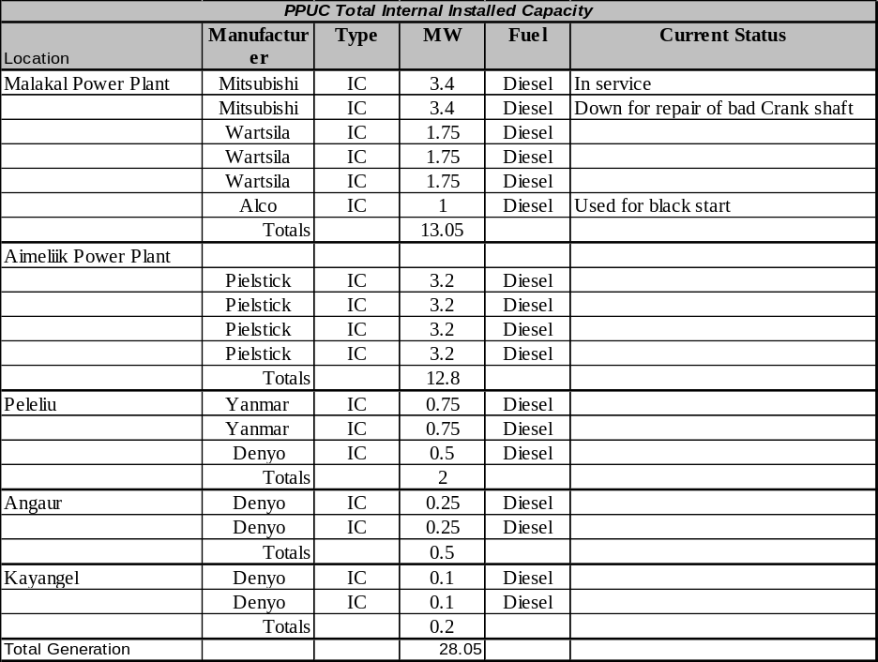

The Malakai Power Plant is currently derated due to lack of available funds to perform needed maintenance. The utility is under new management that has established a plan to help improve plant reliability and performance.

Fuels
Palau imports all of its fuel for electric generation, agricultural, commercial, and transportation. The following shows the approximate imports for the country. The government or Energy Department does not readily track these numbers. Best estimates are from Shell Oil Company. The following pie chart shows the distribution of oil between the islands:

Figure 13-12

Electric Production and Use

Existing Renewable & Alternative Power Production
Palau has limited renewable energy installations. There are some thermal solar panels in use for water heating at some hotels and apartments along with several residential units. However, shipping costs are high and several units brought in from low cost manufacturers were of low quality.

TABLE 13-8

Regulatory, Environmental Issues
Palau has adopted a cost effective energy efficiency code for new buildings similar to American Samoa and Guam. The code is a modified version of the Hawaii code and is based on the results of a savings opportunities analysis, a life cycle cost analysis and an impact analysis. The codes are based on ASHRAE Standard 90.1. However, further investigation is required to determine the enforcement or effectiveness of the standards. In addition, further investigation would be required to determine if the Palau version of the energy efficiency codes have been updated to the 2001 updates.

Transportation

Fuel Use
The following chart and graph show fuel imports for Palau. These numbers were provided by the Government of Palau and indicate a continued overall increase in fuel imports.

TABLE 13-9
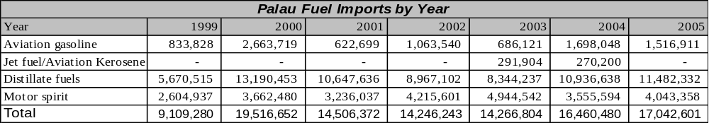

FIGURE 13-13

Fuel Types and Costs
Palau uses #2 diesel and residual fuel oil for their power plants. Fuels for the transportation purposes are broken into the three motor fuels, regular unleaded, high octane unleaded, and #2 diesel. Kerosene is used for some stoves and lighting. LP gas is used extensively for cooking with some being used for water heating.

Fuel costs in Palau are in line with Guam and very close to those experienced in Hawaii. Regular unleaded gasoline is in the area of $3.50/gallon. Long term fuel contracts are not in place, putting Palau at risk on oil price volatility. Palau is currently paying in excess of $USD 2 per gallon for diesel to fuel their power plants.

Reducing Transportation Energy Use
Palau has very limited mass transit. The demand is small due to the size of the country and the limited population. However, the model developed on American Samoa may work quite well on Palau. American Samoa uses small buses constructed in the coutnry using one ton truck frames from a variety of manufacturers. The sheet metal passenger compartments are built by shops with the paint schemes designed to add variety and color to the bus. The roads are not suitable at this time to promote bicycles and other personal transportation. However, as the Compact Road and other road improvements are completed, this may open other avenues to the average Palauan to walk or ride a bike to and from work or school. The improvements in the roads will also reduce fuel consumption on the vehicles. The stop and go driving to avoid bad spots in the road has a severe impact on vehicle fuel economy.

Commercial & Industrial

Tourism
Tourism is Palau's main industry. The activity focuses on scuba diving and snorkeling in the islands' rich marine environment, including the Floating Garden Islands to the west of Koror and the Rock Islands to the south. The number of visitors, 85% of whom come from Taiwan, Japan, and the U.S., reached 90,000 in 2004, more than quadruple the level of a decade earlier. Tourism earned $67 million in foreign exchange for Palau in 1996, accounting for roughly half the GDP. Arrivals from Asian countries dropped in 1998 and 1999 due to the regional economic downturn but rebounded throughout the first half of the 2000s. CBS’s airing of “Survivor: Palau” in 2004-5 raised the country’s international profile substantially, and in 2005 a new Japan Airlines-affiliated luxury hotel opened for business. Palauan tourism and environmental authorities would like to transition the industry to cater to low-volume, high-dollar tourists to minimize the impact on the environment and culture while maximizing the economic benefit to the island.

Manufacturing
There is no major manufacturing on Palau. Story boards have become a popular export. Department of Corrections detainees currently make them with part of the profit going back to the detainees making the Story Boards. Overall manufacturing is less than 1.4% of the GDP for the island. Historically, Palau has exported copra. As the equipment aged and copra prices fell, the processing plant was drastically reduced. A recent management change at the facility and with higher copra prices, the plant may again increase exports. Labor costs in Palau remain low. This may also help spur the copra processing facility back into full production.

Military
Palau is protected through the Compact with the United States and has no formal military. The U.S. military retains the right to bases on Palau for the duration of the Compact that provides base privileges for up to 50 years.

Fisheries
The governments of Palau and Philippines are considering signing labor and fisheries agreements, according to Philippine Ambassador to Palau, Ramoncito Marino. Ambassador Marino indicates that these agreements are being negotiated and will further strengthen the relationship between the two countries. The benefits of the agreement, if signed, will provide a labor pact that will involve exchange of information, technical assistance and a system for recruitment of Filipino workers. It will also include solutions to expedite labor grievances. The agreement will require Filipino workers deployed to Palau to go through licensed recruiters and the Philippine government’s overseas employment agency.

The fisheries agreement section of the proposed agreement will allow Philippine fishing companies to legally fish in Palau waters. If this agreement is put into effect, it could help Palau in promoting a possible cannery on the island.

Alternative Energy Opportunities

Alternative fuels
The consensus in the islands is that the cost for fuel will not be going down and will likely continue to increase with the increased demand from China, India, and Pakistan. Even though there is an awareness of this probable scenario, there is little being done to get Palau ready for the continuing high cost of energy. It is critical to Palau to begin a process of gathering information, developing Return on Investment (ROI) analysis on each of the available opportunities to reduce energy costs. Based on current studies, it appears to be too soon to invest any funds in the reduction of CO emissions until other countries, including the United States, develop policies and objectives in this area. All available energy related project funds should be directed towards reducing total energy costs. This can be devoting internal government resources towards taking advantage of grants for energy related projects that will reduce the incremental cost of energy without incurring additional long term debt for Palau.

Supply Side Efficiency
In developed country utilities, the average power systems losses are estimated at approximately 15%. Nominally, these losses are accounted for in generation, 5%; transmission, 5%; and distribution, 5%, with non-technical losses less than 1%.
In a preliminary study conducted in 2000, the overall power system losses for the Palau Public Utility Corporation (PPUC), were estimated to be 23.6% of the total energy generated. This included generation, transmission, distribution and non-technical losses. It should be noted that some data is lacking such as the number of transformers or the type of conductor used. As a consequence several approximations were used to evaluate the losses. The error on this figure is difficult to quantify and therefore the results should be carefully used, although it does represent system losses that are far in excess of what is acceptable. In addition, it was established that there were some utility loads that were not metered. To reduce the import of fuel, it is imperative to reduce these system losses.
It is recommended that a detailed quantified system loss study be conducted for PPUC, as a stage 1 project. This project would measure and collect the electrical data characteristics of the power system, and then determine the losses. Once these losses have been quantified, then stage 2 of this process would be to assess the need for updating existing energy inefficient equipment (examining financing mechanisms as appropriate); establishing Government legislation that makes electricity theft a crime; and review the maintenance practices in the power plants.

Demand Side Efficiency
Palau has a per-capita energy use far higher than any of the other small Pacific island countries. Per-capita energy use is comparable to that of several European countries. The PIREP reported an annual per-capita petroleum use of around 1,500 gallons of petroleum products, over five times that of the Cook Islands, a country of similar size with a tourist-oriented economy that serves more tourists annually than Palau. Even after removing the Palau tuna fleet fuel use (about 20% of fuel imports), the remaining per-capita fuel use is several times that of the Cook Islands. Like the Cook Islands, virtually all of that energy comes from petroleum products – less than 0.1% of Palau energy use comes from renewable sources. Clearly there is opportunity for substantial energy efficiency improvement and for energy conservation. The few demand side efficiency improvement and energy conservation programs that have been carried out in Palau have been funded and sometimes even implemented by external agencies. The energy office and the PPUC note that there have been attempts at DSM through customer information programs and energy audits of commercial facilities but regrettably they have included no objective evaluation processes so their effectiveness is not known.

With a small budget, only one full time energy officer and no permanent support staff, the Energy Office has insufficient capacity to itself prepare and implement major energy programs. The office mainly acts as an international contact point for regional and donor energy programs, represents Palau in overseas energy meetings and supports renewable energy demonstration projects. To extend its capacity, it can contract with outside organizations to handle program management and delivery. Major public information programs, school visit programs and energy efficiency training programs for educators, commerce and industry can be contracted out, so energy office human resources are not presently the main barrier, the programs are simply not possible with the funding resources made available to the Energy Office. The educational materials and public information programs developed by the USDOE fit well into the Palau situation but funding is needed to put the programs into effect.

For household appliance efficiency and commercial efficiency improvement programs, the PPUC appears to be the best focal point since they do have the capacity and also have direct access to the public for information transfer. Since such DSM programs can benefit the utility through peak shaving and delaying requirements for capacity investment, there is benefit to both the utility and customer. However, external technical assistance is needed to develop programs and the structures for program delivery within the PPUC.

Electrical Metering/Tariff
Effectively all electrical use except street lighting is metered. Household and commercial/government tariffs are tiered with increasing use incurring increasing unit cost. Large commercial customers may be metered for demand as well as energy. There is a base charge per unit that changes slowly in relation to non fuel costs and requires government approval for any change. Added to the base charge is a fuel charge that is calculated periodically using a formula that is based on the cost of diesel fuel to the PPUC and the unit prices are automatically changed as there are changes in fuel cost.

Though tariffs structures that increase unit charges with increased energy use are appropriate for reducing energy waste, in Palau the tiers are probably not set appropriately to have a major effect on energy efficiency. The domestic tariff tier changes occur at 500 kWh/month and 2000 kWh/month. To be more effective in encouraging energy conservation, the tiers should be set at levels that reflect changes in energy use patterns with a sharp increase at each tier. It is suggested that the lowest tier, up to around 100 kWh/month, be set to provide the lowest rate for those basic services that are most efficiently provided by electrical energy including lighting, entertainment services, fans and efficient refrigeration. The middle tier would cover added demand for services such as cooking and water heating that have more efficient energy alternatives than electricity plus modest use of room air-conditioning. The top tier would need to start around 500 kWh/month and would include high-end services such as whole house air-conditioning, extensive all-night exterior lighting and oversized refrigerators and freezers.

Household Energy Efficiency Measures
Residential customers on average used 545 kWh per month, substantially higher than the average usage for other small Pacific nations. Palau household loads are dominated by refrigeration, television, and lighting though electric cooking, water heating and air-conditioning are used in a significant number of households. The statistics collected regarding cooking energy indicate that around ¼ of Palau households use electricity as their main energy source for cooking with approximately another ¼ indicating the use of electricity for some aspects of cooking. The statistics show a steady increase in the use of LPG for cooking with about the same number of households reporting LPG and electricity as their main energy source for cooking. The decline in domestic electricity use since the late 1990s may be related to the replacement of electric ranges by LPG units that was probably driven by rising electricity prices.

The number of houses using air-conditioning appears to be growing slowly, with around 39% of residences having some form of air-conditioning, mostly self contained “window” units, though about 8% of households had central air-conditioning at the time of the 2001 survey. Since the Palau climate is not exceptionally hot most of the time, residential air-conditioning use is typically modest and for most households refrigeration energy use is expected to exceed that of air-conditioners.
Table 13-10– Palau Appliance Ownership
Item | Number | Percent
Total Households | 3350 | 100%
Refrigerators | 3106 | 92.7%
Hot water | 848 | 25.3%
Electric cooking | 778 | 23.2%
Gas | 700 | 20.9%
Kerosene | 722 | 21.6%
Electric & Gas | 331 | 9.9%
Electric & Kerosene | 277 | 8.3%
Gas & Kerosene | 342 | 10.2%
Electric, Gas & Kerosene | 167 | 5.0%
Central Air | 253 | 7.6%
Room A/c | 1045 | 31.2%
Source: 2001 Palau Statistics Yearbook

Lighting, air-conditioning and television are services best provided by electricity, but cooking and water heating both have better alternatives than electricity. Programs that provide incentives for shifting households that cook with electricity to LPG cooking and for exchanging electric water heating with solar makes good economic and energy conservation sense.

Water heating is not a major use of energy in most households. In 2000, only about ¼ of Palau houses had piped hot water, and given the warm climate and the moderate temperature of the tap water, interviews and statistics indicate there is not a strong demand for hot water and in general, water heating appears to be viewed more as a non-essential luxury than a requirement for comfort.

High efficiency fluorescent bulbs to replace incandescent bulbs are readily available in shops, and though they are still relatively expensive, they are said to be used in many households, though there are no statistics to indicate either the level of sales of the high efficiency bulbs or their acceptance in households. However, incandescent bulb use is known to remain high and a program to replace high usage incandescent fixtures with CFL bulbs could provide substantial savings in fuel for generation.

Programs shown elsewhere to result in the more efficient use of energy by households that are recommended for consideration in Palau include:

- Exchange of incandescent lights for high efficiency CFL bulbs
- Exchange of magnetic ballast type fluorescent lights for high efficiency electronic ballast lights
- Refrigerator and freezer maintenance programs (e.g. replacing door seals, condenser cleaning)
- Air conditioner maintenance programs (e.g. cleaning filters and condensers)
- Replacement of electric cooking ranges by more fuel efficient gas (LPG) ranges
- Replacement of electric water heaters with solar units
- Improved insulation and sealing of air-conditioned spaces
- Public information programs regarding the meaning of energy labels on refrigerators and air-conditioners
- School education programs in home energy audits and general energy conservation

The regional energy program of SOPAC (Fiji) has publications and information materials relating to household energy efficiency and energy education that are appropriate for use in Palau. The U.S. Department of Energy also has a wide range of pre-packaged programs for education and many pamphlets and public information packages that have been prepared for household energy efficiency improvement and home energy conservation. Those can be used directly without modification in Palau and it is recommended that the Palau Energy Department replicate the public information programs of Saipan that are based on the USDOE materials. It is also recommended that the Energy Department meet with the Guam Department of Energy to benefit from their experience with their various DSM programs relating to household energy and energy education.

Palau has applied for funding and hopes by the end of 2006 to provide large scale exchange of incandescent lights with CFLs as well as a promotion of high efficiency refrigerators and other energy efficiency improvements for households.

Government and Commercial Sector
Major Palau government and commercial sector electricity use categories include: (1) Electric motor loads for pumping in the water and sewage system; (2) government and private offices with air-conditioning and lighting the primary loads; (3) Retail and wholesale outlets with refrigeration, air-conditioning and lighting loads; and (4) Tourist industry loads dominated by air-conditioning, water heating and lighting. The top users by meter for early 2006 are shown in Table 13-11. Presently, individual government offices are not high users of electricity, but in late 2006 when the new capitol complex becomes operational it is expected to become the top electricity user in the country, a situation that may, but does not necessarily, reflect lowered energy efficiency, since the new complex will combine many dispersed energy users that themselves were not particularly efficient. So in the end the overall efficiency of energy use for those governmental organizations integrated into the new capitol complex may actually be higher than that of the total of their old, individually metered offices spread over many buildings on Koror. Whether the new concentrated government facility is more energy efficient than the old dispersed arrangement will not be known for about another year when all moves have been completed and office usage stabilized.

The total cost of moving public water and sewage is the highest single component of the government electricity bill. Given the high cost of pumping for both the water supply and the sewer system, an audit of all pumping stations is appropriate to determine if higher efficiency electric pump motors than those now installed are available and if so, whether their replacement would be cost effective based on energy savings. Also, as noted under the renewable energy section of this report, utilizing solar energy as a power source for water pumping is a well proven option that can reduce imported fuel for power generation, provide services during power outages and, since several of the larger water pumps are near the end of distribution systems, can lower line losses for the PPUC.

Table 13-11– Top Electricity Users (by metered kWh)
Name | kWh/mo | Category | Type of Load
Palasia Hotel | 315000 | Commercial | A/C, HW, Lighting
Hospital | 196000 | Public | A/C, HW, Lighting
WCTC Ben Franklin | 184500 | Commercial | A/C, Refrigeration, Interior Lighting
Ngeruluobel Water Pump "A" | 177920 | Public | Pumping
Ngerikil Water Pump | 150120 | Public | Pumping
Surangel & Sons | 126000 | Commercial | A/C, Refrigeration, Interior Lighting
Royal Palau, Inc. | 85500 | Commercial | A/C, HW, Interior Lighting
PNCC Headquarters Complex | 79680 | Public | A/C, Electronics, Interior Lighting
High Adventure Ministry | 75360 | Public | A/C, Interior lighting
Wallant Hotel | 72800 | Commercial | A/C, HW, Interior Lighting
Palau International Airport | 62205 | Public | A/C, Interior & Exterior Lighting, Electronics
Palau International Traders | 60900 | Commercial | A/C, Refrigeration, Interior Lighting
PMIC Company | 48000 | Commercial | A/C, Refrigeration, Interior Lighting
Soon Seob Ha | 46880 | Commercial | A/C, Refrigeration, Interior Lighting
Sure Save Mart | 46400 | Commercial | A/C, Refrigeration, Interior Lighting
Ngeruluobel Water Pump "B" | 42440 | Public | Pumping
Source: PPUC records

Although the benefits of energy efficiency improvements are generally well known to commercial property owners, the latest technical options available for efficiency improvement typically are not. Also, though investment in energy efficiency improvements can often yield a high rate of return, the small businesses of Palau need finance so that large cash outlays for the energy efficiency investment can be avoided and cash flows can remain unchanged for the business. Thus a finance program that requires repayment for energy efficiency investment at about the same rate that savings accrue would be needed.

Programs to provide commercial and industrial energy audits have not typically caused significant investment in energy efficiency improvements in Pacific island countries. The small companies involved often do not have the technical capacity to specify, purchase and install the equipment plus cash flows may be negatively impacted by an energy efficiency investment. Programs that carry the process from audit through to investment and equipment installation are needed for government, industry and commerce.

Since the payback for many energy efficiency improvements in Palau can be on the order of 5 years or less, that should be sufficient financial incentive for their use. What appears to be needed is to put users together with companies specializing in the provision of energy efficiency improvements so that users can be supported through the audit, financing, specification, purchasing, installation and operation phases and do not have to allocate either existing cash or personnel resources to the task of energy efficiency improvement.

With regards to government buildings energy efficiency, each department receives their own electric bill and provides PPUC a requisition charging their accounts. Palau also has an energy conservation officer for each ministry, and they work with the Energy Department in monitoring the energy and fuel use for their ministry. To add to this structure, it is recommended that an energy efficiency specialist be put on staff at the Capital Complex to manage and over time improve the energy efficiency at the complex. The cost of the specialist should be more than covered by savings in energy that will result through ensuring that proper maintenance of energy systems is carried out, that replacement components maintain high energy efficiency and that new energy efficiency technology is put to use where appropriate. The specialist will need to not only manage technical systems but also work with occupants to establish and maintain user guidelines for energy use, particularly air-conditioning and lighting. The position should be one that has direct communication to a high level within government to help ensure that agreed upon user guidelines are enforced and to access funds needed for energy efficiency maintenance and improvement.

Transportation Sector
Land transport is a major energy use in Palau. With nearly one vehicle per household, traffic in the Koror to Babeldaob corridor is very heavy with major congestion during the times for opening and closing of businesses. The urban area of Koror is aligned along a series of small islands connected by causeways and a single main road carries most of the traffic. The slow traffic with frequent starts and stops reduces vehicular fuel efficiency and vehicles carrying only the driver are common. Fortunately, the distances traveled are relatively short, typically under five miles round trip, so actual fuel use for commuting to and from work has been moderate despite the heavy private use of motor vehicles.

Public transport is minimal, with no public buses and only a small fleet of taxis. Roads are congested and relatively narrow, making travel by bicycle or (as is common in the Cook Islands) motor scooter unpleasant and even hazardous.

The shifting of many government employees from Koror based offices to the new Capitol complex on Babeldaob is expected to dramatically increase fuel used for commuting, since the great majority of the employees have homes on Koror and a round trip commute of over 50 miles per day can be the result. Programs for employee bus transport, car pooling and encouraging employees to move closer to work can help reduce the rate of fuel use increase due to the shift of the government work focus from Koror to Babeldaob.

Sea transport is divided mainly between the tuna fleet (using about 6 million gallons a year in 2001) and the tourist fleet – mostly high horsepower outboard powered boats that remain inside the large lagoon and are used to deliver tourists to diving sites, sea parks and to tour the beautiful Rock Islands. The fuel use for boats in the tourist industry is not known and it varies with tourist arrivals. Boats are often fitted with multiple high horsepower gasoline fueled outboard engines and operated at high speed so they are typically very inefficient in fuel use.

For both land transport and the tourist boat fleet, consideration should be given to the provision of incentives for replacements to be diesel powered and more fuel efficient. Diesel automobiles currently in production provide fuel efficiencies much greater than their gasoline equivalent and are acceptable environmentally. Tourist boat operators that replace multiple outboard gasoline fueled engines with properly operated diesel engines can reasonably expect to find fuel use cut in half and to receive more reliable, lower maintenance service.

Several Pacific, Asian and European nations have encouraged the gradual switch to more fuel efficient diesel powered vehicles by increasing the tax on gasoline and/or reducing the tax on diesel fuel to make the pump price for diesel fuel clearly lower than that for gasoline. This signals to the consumer that diesel is cheaper than gasoline, though in actual fact the main saving is through the higher fuel efficiency of the diesel, not the lower fuel price. Also, increasing the import duty on gasoline vehicles to a higher rate than diesel vehicles would reduce the price differential that is the result of the somewhat more costly diesel engine and help encourage the purchase of a diesel powered vehicle when older cars are being replaced.

Building Energy and Efficiency Standards
A Palau based architectural/engineering company has long lobbied for energy efficiency to be included in building codes and construction standards and a sample energy code has been written. However the small size of the country limits the resources available for implementing the codes and, more importantly, enforcing them. Even in Guam, with its much larger population and economy, properly enforcing energy codes for new construction has proven difficult. While an aggressive, externally funded program to establish comprehensive energy codes within the building code system of Palau probably could result in their adoption, their proper enforcement is questionable.

Nonetheless, it is urged that government take the lead in convening a task force to consider additions and modifications of the existing building code system to include basic energy efficiency improvements though including only code additions that are clearly within the local capacity to implement and enforce. Once included in the building code, training in the energy code application and enforcement should be provided to local builders and code enforcement personnel.

Appliance Energy Efficiency Standards
The appliance market in Palau is too small to warrant major investment in regulatory activities such as local appliance testing and labeling or the imposition of strict import standards for domestic appliances. Fortunately, most major appliances used in Palau are imported from countries that employ energy efficiency labeling and the need is not so much for labeling but rather for helping the public translate the labels into a Palau context. Refrigerators made in China, Japan, Korea and the U.S. are all found in retail outlets in Palau, though the majority are shipped from the U.S. and have U.S. appliance energy labels. The U.S. labels are based on an assumed cost of energy to operate the appliance that is about half the cost of electricity in Palau.. It is suggested that the public be informed of the discrepancy through public information programs or at the point of sale through signs or added labels since the value of appliance efficiency improvements for Palau users is around double what is seen by U.S. mainland users.

Energy Audits, Performance Contracts
Many programs to provide energy audits to large energy users have been tried throughout the smaller countries of the Pacific. The end effects have been small mainly due to the lack of ready finance for the proposed energy efficiency measures and the limited technical capacity of the end users receiving the audits to themselves implement the proposed actions. There are no statistics to actually show the cost effectiveness of these energy audits but it is clearly not high. With the addition of follow-on programs to support implementation of the measures proposed by the audits, such as are offered by ESCOs, the effectiveness of the program in actually achieving energy efficiency improvements can be expected to be greatly improved and a higher level of cost effectiveness attained despite the higher overall cost of an integrated audit and implementation program.

Although the local engineering firm can (and already does) provide assistance to clients in improving energy efficiency, a full service ESCO in Palau is not likely to be profitable due to the small market for its services. The cost of brining a foreign ESCO to Palau to service the limited market is probably also too high to be profitable. However, if the local engineering company could develop a business relationship with a full service ESCO in Guam, the Philippines or Hawaii such that the greater resources of the full service ESCO could be made available to Palau customers with marketing, auditing and support services by the Palau company, full ESCO services might be marketable in Palau.

Renewable Energy
Funding is being sought from the Global Environment Facility (GEF) for the development of a renewable energy center on Palau. The center would be managed by the Department of Energy and would be the focal point for all renewable energy development. The proposal for funding includes Departmental capacity building as well as funding for expansion of the capabilities of the Department of Energy to prepare and manage renewable energy and energy efficiency projects. The proposal is being reviewed for funding by the GEF in 2006 and if approved will become available toward the end of that year.

Solar
Other than the traditional use of biomass for cooking, the only renewable energy resource with any significant history in Palau is solar. Both solar thermal and solar electric technologies have been and continue to be used, though not extensively, in Palau. The resource is very good (Table 13-12) and reasonably consistent over the year.
Table 13-12 – Solar Resource Palau Main Islands (7.5ºN-135.5ºE) kWh/m² per day
Month | Jan | Feb | Mar | Apr | May | Jun | Jul | Aug | Sep | Oct | Nov | Dec | AVG
Horizontal | 5.27 | 5.75 | 6.39 | 6.42 | 5.83 | 5.00 | 5.20 | 5.22 | 5.65 | 5.28 | 5.39 | 5.27 | 5.55
Tilted | 6.23 | 6.39 | 6.60 | 6.36 | 6.10 | 5.31 | 5.47 | 5.28 | 5.61 | 5.69 | 6.28 | 5.69 | 5.77
Table 13-13– Solar Resource Palau Southwestern Islands (5.5ºN-132.2ºE) kWh/m² per day
Horizontal | 5.34 | 5.81 | 6.16 | 6.33 | 5.71 | 4.74 | 5.03 | 5.04 | 5.74 | 5.37 | 5.73 | 5.37 | 5.56
Tilted | 6.21 | 6.41 | 6.31 | 6.37 | 6.04 | 5.07 | 5.36 | 5.55 | 5.67 | 5.75 | 6.59 | 6.37 | 5.97
Source: NASA EOS Satellite data at http://eosweb.larc.nasa.gov/sse/

Solar Thermal for Electric Generation
Solar thermal for electricity generation is not considered feasible for Palau due to the need for tracking type concentrating collectors that are unlikely to perform as well as cost effectively as solar PV for power generation in the tropical climate conditions of the Palau islands. The high frequency of partly cloudy conditions is a problem for concentrating tracking collectors plus maintaining the mechanical systems and high reflectivity surfaces of concentrating tracking collectors in the environment of Palau is difficult and expensive. Land issues also could be a problem since the units cannot be roof mounted like solar PV.

Solar Thermal for Water Heating
Solar water heating is not used widely. Tourist facilities remain heavy users of electricity for water heating making them good candidates for conversion to solar water heating. Although the census data does not provide exact statistics for solar water heater use, residential use of solar water heating is known to be minimal. The replacement of domestic electric water heaters on Koror could provide power system benefits since a reduction in the utility peak load and in fuel use would result if existing electric water heaters were replaced by solar units. Incentive programs, through direct rebates or through tax rates, have been successful in increasing the use of solar water heaters in the Cook Islands as well as in other parts of the world and could be considered for Palau. Also a program that brings solar water heater importers, banks and builders together to promote solar water heating and their finance could beneficial.

Efforts to promote energy efficiency in tourist accommodations, laundries, restaurants, apartment buildings and condominiums should include the promotion of solar water heaters. It is recommended that the government budget the replacement of electric, oil or gas fired water heating with solar water heaters in hospitals, schools and other government facilities. Support for companies selling, installing or maintaining solar water heaters – such as technical training programs for company technicians or access to special financing arrangements for solar water heater purchasers – should also be considered.

Solar Photovoltaics
Historically, the primary use of solar electric systems has been for rural home electrification through the installation of solar home systems (SHS) in the 1980s and in un-electrified areas of Babeldaob (14 households) and Kayangel (30 households) using 66Wp of PV, 2-100Ah (at C₁₀₀) 12V batteries and three 22 W fluorescent tube lights.

Households and public buildings in the distant southwestern islands of Sonsorol (11 SHS) and Tobi (14 SHS) received 33Wp panels, a 12V battery and two fluorescent tube lights, one 8W and one 14W. Relative to the desires of the recipients, the systems were undersized and generally did not perform well. Interestingly, however, even after the villages that had received SHS were electrified from a diesel powered grid, some households retained the SHS since they only wanted lighting and the $11 a month minimum cost of having a grid connection seemed quite high. Several Babeldaob households are still electrified by SHS in 2006, even though a grid connection is available to them. The energy office continues to assist those households in PV system maintenance.

Other historical uses of solar photovoltaic technology have included small scale water pumping (e.g. at the giant clam research and breeding facility on Koror), telecommunications installations, and navigational lights that range from small channel markers to a light house installation. The giant clam research and breeding facility water pump is no longer used but the use of solar for powering navigational lights and communications remains. The Palau National Communications Corporation (PNCC) continues to power its installations on Tobi, Sonsorol and Kayangel with 480Wp of solar panels charging a 48V battery on each island.

The remote islands of Sonsorol (2001 population 39) and Tobi (Hatohobei – 2001 population 23 ) are served by regular shipping only once a quarter. The lack of technical support and problems of fuel supply make it particularly difficult to provide households with reliable electricity. The small PV systems provided in the 1980s did reliably provide basic lighting services but residents considered them too small and continued to request services sufficient for video and refrigerator/freezer operation. In 2000, the small solar lighting systems were upgraded as a Capital Improvement Project with the intention of providing sufficient power for a refrigerator and video as well as lights. Unfortunately, the Palau Department of Energy was never included in the design or implementation of the project despite that being the only agency in government with experience and training in rural electrification with solar PV.

The original design included 1000 Wp of panel, lead-acid batteries and a 400 W AC inverter. The systems were to be 24VDC with high efficiency DC lights, and the inverter would permit a refrigerator and video to be connected. The original project document included 58 of those systems for houses and public buildings (35 for Sonsorol and 23 for Tobi) plus 16 solar powered streetlights – 100 Wp panel, controller, battery and weatherproof fluorescent light – with 8 units intended for each of the two islands. Based on other remote island electrification projects, the cost could be expected to be between $10,000 and $15,000 per SHS installation. The actual equipment supplied by BP Solar Australia was quite different, resulting in a technically unacceptable and overpriced design. The final installations included a 12V Trace inverter with 2000 Watt capacity, a 12V battery bank and only 640 Wp of panel. The amount budgeted for the installations was over $30,000 per installation, several times the usual cost for remote solar installations of this type. A Japanese contractor with no prior solar experience was selected to install the systems. The systems began failing shortly after installation and a survey carried out in 2006 found that none of the inverters were functioning. Also, the supports for the solar modules were already seriously corroded and most of the batteries were damaged and failing. Some households had purchased cheap inverters from local vendors and were running small fans and lights. Maintenance of the batteries had been so poor that most were already sulfated and obviously cannot be expected to provide either full power or to survive anywhere near the anticipated 10-15 years. According to the engineer who performed the survey, it appears that the battery charging systems were never set to provide proper charge curves and voltages, probably due to the quite complex programming process required being performed incorrectly. This is not surprising, given the lack of experience on the part of the installation contractor and the fact that the instruction manual for the inverters supplied by BP Solar Australia has 15 pages of programming instructions which have to be repeated anytime the inverter is disconnected from the battery.

The systems are now the subject of a rehabilitation project with around $10,000 per installation allocated, which will make the total investment in excess of $40,000 per household for basic electrification. Unfortunately, the proposed design for the rehabilitation is a “state of the art” solar mini-grid approach that has never been tried in the Pacific environment before. The Pacific experience has thus far been that the reliability of solar installations in remote island environments is inversely proportional to the technical complexity of the installation. Simple, high quality systems have been found to work reliably but the more complex the technology, the more likely there is to be premature failure. Sonsorol and Tobi represent one of the most remote sites to be electrified yet the most technically complex approach for solar electrification currently available commercially has been chosen for the design. This would appear to be an approach that includes considerable risk of failure.

Plans And Recommendations
As part of the EU EDF-9 five country energy program for the Pacific (REP-5), plans are being developed to provide a substantial grid connected PV array at the new Capitol Complex on Babeldaob. The panels would be mounted over the parking area at the complex and would not only provide power to the grid but would provide shade for the car park. The project has not been confirmed and the size of the installation will be determined by the available funds.

The EU grid connected solar project should be carefully monitored and if the results appear reasonable with regards to reliability, performance and cost, further funding should be sought to increase the penetration of solar into the generation mix of the PPUC.

Another opportunity for the use of solar PV is to provide power for the water supply pumps. The pumps are all presently connected to the grid and grid power should continue to be an option even if PV becomes the primary power source, since reliability of the pump power is important. The fuel saving would be substantial as the pumps are collectively the largest users of electrical power on Palau.

Wind Energy
A small “demonstration” wind generator was installed in 1982 near the President’s office on Koror. The site was not a good one for wind access and the tower was not tall enough to place the turbine much higher than the surrounding trees, so the turbine did not even turn much of the time with the demonstration probably being more negative than positive with regards to public – and government – acceptance of wind energy as an acceptable alternative. Whether or not wind energy is in fact an economically viable power source for the PPUC is still not known.

There have not been any wind resource surveys that have attempted to determine the energy availability of the wind resource or to locate the sites having the most wind energy promise. Wind measurements from four sites, three coastal sites on Babeldaob (intended to support surface evaporation calculations for a coastal study) and the airport site inland on Babeldaob (intended for aviation weather purposes), represent the current knowledge of the wind resource in Palau. None of these sites uses a mast greater than 5 meters in height and none of the data has been analyzed with regards to energy content. What is clear from the data that has been collected is that the resource is seasonal in nature with maximum winds occurring from November through April, and even during that period the observed speeds look marginal for economic energy development at current fuel prices. The observing sites and their associated instrumentation are, however, not intended to measure the wind energy resource and it is quite possible that sites do exist on Babeldaob where wind power may be economically developable.

It is therefore recommended that NREL or other organization competent in wind resource assessment be contracted to analyze the existing data. If it looks favorable, then to provide a computerized analysis of wind patterns and likely areas of orographic concentration of the wind resource on Babeldaob and map the sites most likely to be favorable for wind energy systems. Once the location of the most promising wind energy areas of the island are identified, an on-site resource survey of the best sites is recommended. Unlike most of the other island states being surveyed, the risk of typhoons (hurricanes) is low in Palau, and the problems of wind machine survival in the Palau environment are mostly those of operation in high salt content air at tropical conditions of temperature and humidity.

Table 13-14 - Average Wind Speeds ~5m height Dec 04-Nov05 – Coral Reef Project measurements (m/s)
DEC | JAN | FEB | MAR | APR | MAY | JUN | JUL | AUG | SEP | OCT | NOV | Average
4.53 | 7.35 | 7.67 | 5.88 | 4.24 | 1.37 | 1.60 | 2.37 | 2.92 | 2.64 | 2.49 | 4.14 | 3.93
Table 13-14- NASA Wind Speed Satellite Estimates 7.5°N 135.5°E
6.5 | 6.51 | 6.04 | 5.01 | 3.72 | 4.33 | 4.63 | 5.28 | 4.87 | 5.01 | 4.72 | 5.62 | 5.18
Source: Top: Coral Reef Project – unpublished data. Bottom: Source: NASA EOS Satellite data at http://eosweb.larc.nasa.gov/sse/

A local entrepreneur has indicated a strong interest in developing a small wind farm on family land on Babeldaob if information about the wind energy resource could be made available and the data shows a reasonable likelihood that power could be generated at a cost suitable for sale to the PPUC at a profit. The PPUC Board of Directors also indicated that the utility would welcome IPPs deriving power from renewable sources including wind.

Hydro Power
To date there has been no hydro development in Palau. Over the past two decades, small scale studies have indicated that though there are several small rivers on Babeldaob that do not go dry at any time of the year, none provided hydro sites that were economically reasonable for development largely because at the time of the studies there were no transmission lines within reasonable distance of the sites and the cost of constructing the transmission lines to deliver the power from small systems in relatively remote areas to the urban areas where it was needed was too high to be reasonable for the modest amounts of energy that could be obtained. Since the late 1990s, electrification of Babeldaob villages included construction of several transmission lines that are much closer to the rivers. This was recognized by the PPUC and a review of the practicality for hydro development was commissioned. A technical assessment was carried out for the PPUC by a Philippine consulting company, VERGEL³ CONSULT, in 2005.

Though the study was mainly a desk study (only 5 days of site visits were included), it is the most complete study of the hydro resources in Palau to date and indicates the possibilities for their development. The study concluded that there was hydro potential worthy of further study along the Diongradid, Ngermeskand and Ngrikill streams. The consultants estimated a total capacity of 4 MW and a total energy delivery of 14.3 GWh could be possible (Table 13-13) from the combined output of the three streams.

To achieve those figures, the consultants proposed that each site include a medium to high dam and substantial impoundment in order to increase the total head for the power house since the rate of fall from the sites is slow thereby making a run-of-river system substantially lower in both power and energy output for an acceptable penstock length. Though the height or volume of the dam structure is not stated in the assessment report, from the maps included in the report the two largest dams appear to be on the order of 100 feet high at their center and over a quarter mile long. To construct that size of dam would be quite expensive, particularly since earthquakes do occur in Palau and the dam design would have to take that into consideration.

The prefeasibility study did not address economic issues, but it is clear that the capital cost for such installations would be very high. There may also be serious environmental and land use issues associated with the relatively large impoundments that range from 127 to 465 acres in surface area. Even with the substantial impoundments proposed, during low rainfall season (typically February through April) the proposed systems could only be operated from 3 to 5 hours a day at rated capacity. Even in the rainiest season, the units can be operated at full capacity only part of each day. That implies that the units would be best used for peaking power and could provide little base load capacity benefit. Their financial benefit would be the reduction of fuel use by somewhat less than a million gallons per year. While that is a significant amount, the large capital investment to achieve that saving would probably not allow a 20 year payback.

That is not to say that there is no developable hydro. First, an economic study based on the assessment approach appears justified, though it is likely that the cost of the proposed systems will be too high to be acceptable even at the relatively high current cost of fuel for PPUC generation. In that case, it is recommended that there be a prefeasibility study for those same streams but focused on using run-of-river hydro technology with no significant impoundments. The much lower capital cost of that type of installation is likely to provide a better benefit to cost ratio than the design proposed by VERGEL³ CONSULT despite the lower output that can be achieved possibly. It is possible that run-of-river installations can be economically reasonable at current fuel prices. Also run-of-river installations avoid most of the land use and environmental issues commonly associated with hydro development.

Economically acceptable energy available from hydro probably would be less than five percent of the existing PPUC energy requirement and with the very low flow during the dry season would provide little firm capacity to reduce the requirement for diesel capacity.

Table 13-15 - VERGEL³ CONSULT Assessment of Possible Hydro Development in Palau
River | Watershed area Acres | Reservoir top surface area Acres | Reservoir total storage million Gallons | Rated capacity MW | Annual GWh produced | Estimated Saving in Fuel in Gallons per year | Hours per day of rated operation during driest month
Diongradid | 2,222 | 428 | 8,001 | 2 | 7.21 | 476,170 | 3
Ngermeskand | 2,963 | 465 | 8,767 | 1 | 3.96 | 261,530 | 5
Ngrikill | 2,222 | 157 | 2,227 | 1 | 3.18 | 210,020 | 3.5
 |  |  |  | TOTAL | 14.35 | 947,720

Biogas
The commercial production of poultry and pigs is present in Palau. Agricultural statistics indicate around 700 pigs and 20,000 chickens are present in Palau, but firm statistics on the relative size of individual piggeries and poultry farms is not available. Officials indicate that piggeries with 20-50 animals are common, and at least one has around 100 pigs. Chicken farms with 5000-9000 birds are present. Where the animals are concentrated in a manner that makes waste collection relatively inexpensive, the use of biogas digesters for on-farm energy can provide an environmentally beneficial means of waste disposal while providing a modest energy byproduct for cooking, water heating or small scale power generation. It is recommended that the Energy Office work with the larger farms to inform them of the advantages of using biogas digesters and put them in contact with overseas suppliers of equipment.

The Koror sewer treatment facility could, in theory, be modified to produce biogas, but as the storm drains feed into the sewer system the rate of flow varies widely and the feed stock is very variable with regards to the concentration of digestible content. There would have to be a large capital investment and a substantial increase in technical complexity – which also implies increased operating and maintenance costs – to install and operate a biogas digester at the sewage plant. It is unlikely that the modest energy production that could result would justify the added facility cost at present fuel prices.

Biomass, Combustion and Gasification
The 1999 census shows that very few households, even in the more remote islands, still use wood for cooking. Thus over the past 50 years, biomass has gone from the most used energy source to one of the least used.

In terms of non-traditional uses of biomass for energy, there have been few biomass-based energy installations. In 1984, the USDOE provided $25,000 to fund the installation of a 15 kW gasifier made by North American Gasifier Co. of the USA. A 15 kW gas engine powered generator fueled by the output from the gasifier was installed at the Nekken Forestry site in 1984. The installation was funded as a demonstration of gasifier technology by the USDOE with a project budget of $25,000. The installation used wood chips, the Forestry site’s waste product, as the fuel for the gasifier. The burnable gas was cleaned and piped to the engine for power production. The unit worked poorly (as did the similar unit in Saipan) and was not kept in service long. Though there are industry claims (untested in the Pacific environment) that current gasifier designs are more appropriate to the Pacific island needs than those that were tried in the 1980’s, there is no longer any forestry or agricultural waste production on Palau that is sufficient to be considered useful for electricity production for input to the PPUC grid even if modern gasification technology is proven to be appropriate for use in the Pacific environment.

Biomass production specifically for energy generation is not considered reasonable on Palau although some 60% of the land area is classed as dense forest. That is partly due to land issues that effectively prevent the development of large scale energy plantations and partly due to the fact that such plantations have not been economically successful elsewhere. The low energy density and the high processing and transport costs of biomass for fuel have made it impractical to justify biomass energy generation in the Pacific unless associated with an agricultural or forestry processing facility that produces a large amount of burnable waste. Such facilities are not present on Palau at this time. Palau has not embarked on a large scale tropical wood planting program though a few villagers have small, private stands of teak and mahogany. The largest single plantation is approximately 40 acres of mahogany that will be ready for harvest around 2025. Fast growing tree crops such as the Caribbean Pine species that is a significant export earner for Fiji could provide a more continuous supply of forestry waste for energy production though not until decades have passed after planting.

Biofuels
Though decades ago copra was produced and a coconut oil mill was present on Koror, Palau has never had the large scale coconut production like many other Pacific islands. The profitability of copra and coconut oil production has been consistently lower than other economic options in Palau. Currently, there is no commercial copra production and such coconut resource as is present is poorly maintained and includes a high percentage of low productivity senile trees. The coconuts that are gathered are either young nuts sold at a high price as “drinking” coconuts in restaurants and in markets or they are mature nuts and are used by households for cooking and by farmers as animal feed.

While in theory there is sufficient “undeveloped” land on Babeldaob to support a significant biofuel production, the high labor costs in Palau, environmental issues and land tenure problems make it impractical to consider biofuel plantations in Palau as a practical energy option until fuel prices increase much more.

Ocean Energy
Ocean Thermal Energy Conversion (OTEC) has been proposed in Palau by Japanese and U.S. promoters, with a Japanese company proposing a site and a general system design of for about 3 MW in continuous output capacity. The rapid drop-off of the ocean floor off the coast of Babeldaob combined with high surface temperatures makes Palau particularly attractive for OTEC development. Unfortunately, though small pilot trials around the world have successfully generated electricity using OTEC for a short time, to date there has been no commercial construction of an OTEC facility and no demonstration of even a 1 MW capacity installation. The technology remains under development and should not be considered for implementation in Palau until commercial trials at a scale appropriate for Palau have been completed elsewhere. Palau does not have the surplus resources or capacity to be able to afford a major power project that fails, even if financed by an outside agency.

Geothermal
No record could be located that documented any study of the geothermal potential of Palau and interviews with Palau residents indicated no hot springs or other obvious surface activity is present in Palau. Though a substantial deep resource may be present, the cost per MW for deep well geothermal energy development goes up rapidly as the size of the plant decreases. The cost of deep well geothermal resource development is not likely to be justified for a utility the size of the PPUC

Acronyms

ADB | Asian Development Bank
ADO | Automotive Diesel Oil
AOSIS | Alliance of Small Islands States
ASCR | Aluminum Conductors Steel Reinforced
ASG | American Samoa Government
ASPA | American Samoa Power Authority
BOP | Balance of Payment
CAT | Civic Action Team
CCU | Consolidated Commission on Utilities
CDM | Clean Development Mechanism
CFL | Compact Florescent Light
CIA | Caroline Island Airlines
CIP | Capital Improvement Project
CMMS | Computer Maintenance Management System
CNMI | Commonwealth of the Northern Mariana Islands
COFA | Compact of Free Association
CPA | Commonwealth Ports Authority
CPAICS | Cabras / Piti Area Intermittent Control Strategy
CPUC | Chuuk Utility Power Corporation
CSD | Commission on Self Determination
CT | Combustion Turbines
CUC | Commonwealth Utilities Corporation
DIESEL | Diesel Distillate
DPW | Department of Public Works
DSM | Demand Side Management
DUD | Darrit, Uliga and Dalap Islands
EDC | Economic Development Commission
EDP | Economic Development and Planning Division
EER | Electrical Efficiency Rate
EEZ | Exclusive Economic Zone
EPA | Environmental Protection Agency
EPACT | Energy Policy Act
ESCO | Energy Service Company
EU | European Union
FAA | Federal Aviation Administration
FEMA | Federal Emergency Management Agency
FFA | Forum Fisheries Agency
FSM | Federated States of Micronesia
GADTC | Guam Aquaculture Development and Training Center
GDP | Gross Domestic Product
GPA | Guam Power Authority
GWA | Guam Waterworks Authority
HAFSM | Humanitarian Assistance – Federated States of Micronesia
HMGP | Hazard Mitigation Grant Program
HOVENSA | Petroleous de Venezuela, S.A
HOVIC | Hess Oil Virgin Islands Corporation
HRSG | Heat Recovery Steam Generator
HSFO | High Sulfur Fuel Oil
IPP | Independent Power Producers
ITCZ | Intertropical Convergence Zone
JAL | Japan Air Lines
KAJUR | Kawajalein Atoll Joint Utilities Resources
KCSO | Kosrae Conservation and Safety Organization
KPI | Key Performance Indicators
KUA | Kosrae Utilities Authority
LEAC | Levelized Energy Adjustment Clause
LPG | Liquid Petroleum Gas
LSFO | Low Sulfur Fuel Oil
MEC | Marshalls Energy Company
MED | Multi Effect Distillation
MIVA | Marshall Islands Visitors Authority
MPC | Micronesian Petroleum Corp.
MWSC | Majuro Water and Sewer Company
NASA | National Aeronautics and Space Administration
NESCO | National Electric Safety Code
NGO | Non Governmental Organizations
NMHC | Northern Marianas Housing Corporation
NOAA | National Oceanic and Atmospheric Administration
NTA | National Telecommunications Authority
O & M | Operations & Maintenance
OMIP | Operations & Maintenance Improvement Agency
OSHA | Occupational Safety and Health Administration
OTEC | Ocean Thermal Energy Conversion
PMC | Performance Management Contract
PPA | Pacific Power Association
PPUC | Palau Public Utilities Corporation
PSC | Public Service Commission
PUC | Pohnpei Utilities Corporation
PV | Photovolatic
PWD | Public Works Department
RMI | Republic of Marshall Islands
RMIEPA | Republic of Marshall Islands Environmental Protection Authority
ROI | Return on Investment
SCADA | Supervisory Control And Data Acquisition
SDP | Strategic Development Plan
SEP | State Energy Policy
SHS | Solar Home System
SSB | Single Side Band
T & D | Transmission & Distribution
TEO | Territorial Energy Office
TTPI | Trust Territory of the Pacific Islands
UNFCCC | United Nations Framework Convention on Climate Change
USDA | United States Department of Argriculture
USDOE | United States Department of Energy
USDOI | United States Department of Interior
USVI | U.S. Virgin Islands
VFD | Variable Frequency Drive

List of tables and figures

Section 3

Table 3-1 Population by Region And Election District, Guam 1960-2000
Table 3-2 Monthly Rainfall, Inches, Guam 2000-2004
Table 3-3 Guam Population by Age/Sex 1980-2000
Table 3-4 Population by Region And Election District, Guam 1960-2000
Table 3-5Guam Employment/Industry 1980-2000
Table 3-6 Guam’s Major Economic and Financial Indicators
Table 3-7 Selected Catergories
Table 3-8 Median Household Income
Table 3-9Industry, Guam 1980-2000
Table 3-10 Federal Government Grants by Agency, Guam FY 98- 2003
Table 3-11Generation Facilities
Table 3-12 Key Utility Statistics
Table 3-13 Major Appliance Ownership in Guam
Table 3-14 Estimated Solar Resource for Guam
Table 3-15 Average Guam Wind Speed at 50m (m/s)

Figure 3-1 Average Hourly Earnings, Non-Supervisory Private Sector, Guam 98-2004
Figure 3-2 General Business
Figure3-3 Guam Unemplyment 1999-2006
Figure 3-4 Historical Peak (thru 9/6/05
Figure 3-5 Guam Power Authority, Max Peak Demand 1969-2004
Figure 3-6 Power Consumption, Guam 94-2004
Figure 3-7 Power Revenues, Guam, 1994-2000
Figure 3-8 Visitor arrivals by Air and Sea, Guam 2000-2004
Figure 3-9 Micronesia and Guam Fuel Demand = 411Mgallons
Figure 3-10 Guam Energy Demand
Figure 3-11 Guam Market Sector
Figure 3-12 Diesel Quantity

Section 4

Table 4-1 Peak Demand, Average Load and Energy Production
Table 4-2 Virgin Islands Electrically Power Generating Units
Table 4-3Total Generation by Types and Location
Table 4-4 Estimated Solar Resources for the Virgin Islands.
Table 4-5 average St. Croix Wind Speed at 50 (m/s)18N 65W

Section 5

Figured 5-1 Census, Population by District, 1970-2000
Figure 5-2 Electricity Consumption by Class 2003
Figure 5-3 1982- 2005 Annual Total Landings of Non-Tuna PMUS
Figure 5-4 Annual Estimated Wind Power for Tu tuila, AS

Table 5-1Population Projection by Age Group and Gender 2005/2025

Table 5-2 American Samoa Labor Force Employment and Unemployment 95-2000
Table 5-3 Current Employment Estimates: 2000-2004
Table 5-4 Aircraft Charter
Table 5-5 Export of Canned Tuna FY 1984-TY2004
Table 5-6 Estimated Offshore Catch by Methods FY 2000-FY2004
Table 5-7 American Samoa Generator Capacities
Table 5-8 Major Appliances in American Samoa
Table 5-9 Estimated Solar Resource for Tu tuila Island
Table 5-10 Average Tu tuila Wind Speed at Tula NOAA Samoa Observatory Site
Table 5-11 Average Tu tuila Wind Speed at 30m on Olotele Mt
Table 5-12 Average Tu tuila Wind Speed at 50m(m/s), EOS Satellite Data

Section 6

Table 6-1 CNMI Population by Island 1920-2000 Census
Table 6-2 2003 Estimated Commercial Landings-CNMI
Table 6-3 CNMI Gross Business Revenues 96-2202
Table 6-4 Employment by Se ctor 96-2004
Table 6-5 CUC Total Internal Installed Capacity
Table 6-6 Energy Source Used For Cooking
Table 6-7 Palau Fuel Imports by Year
Table 6-8 Major appliance ownership CNMI
Table 6-9 Major Appliance Saipan
Table 6-10 Estimated solar resource for Saipan
Table 6-11 Average Saipan Wind Speed at 50m (m/s)

Figure 6-1 Cooking Energy Source CNMI
Figure 6-2 Per Cent of Households with AC CNMI
Figure 6-3 CNMI Population Growth 1920-2000 Census
Figure 6-4 Household Mean Income by Island CNMI 1999
Figure 6-5 1981-2003 Annual Totalled Estimated Commercial Landings
Figure 6-6 Employment by Sector
Figure 6-7 Total Generation Sales & Losses in kWH Fy 2005
Figure 6-8 Micronesia & Guam Fuel Demand = 411Mgallons
Figure 6-9 Fossil Fuel Imports

Section 7

Table 7-1 Population by State 2005
Table7-2 Fuel Use in the FSM
Table 7-3 Schedule of Grants and Trust Fund Payments
Table7-4 FSM Major Donors 1987-1999
Table 7-5 Population (2000)
Table7-6 eal and Nominal GDP FY2000-FY2005

Figure 7-1 Population Distribution by State,FSM:1920-2000

Figure 7-2 Commercial Bank Deposits and Loans CY 1997 –CY2004
Figure 7-3 Real and Nominal GDP, FSM FY 97-Fy2005
Figure 7-4 Balance of Payments,FSM FY-97-FY2004
Figure 7-5 FSM Real GDP
Figure 7-6 Visitor Arrival by State 97-2004
Figure 7-7 FSM Annual Tourists

Section 8

Table 8-1 Fuel Imports into Kosrae, FSM in Gallons
Table 8-2 Kua Powerstation Generation Capacity
Table 8-3 Estimated Sola Resource for Kosrae
Table 8-4 Average Wind Speed at 50m(m/s)

Figure 8-1 Kosrae Population Age Distribution
Figure 8-2 Number of Tourists

Section 9

Table 9-1 Weno Power Station: Generation Capacity
Table 9-2 Fuel Prices – Chuuk
Table 9-3 Estimated Solar Resource for Chuuk
Table 9-4 Average Wind Speed at 50m(m/s) for the Chuuk Lagoon Area

Figure 9-1 Chuuk Population Age Distribution

Section 10

Table 10-1 Fuel Import into Pohnpei, FSM, In Gallons
Table 10-2 Household Energy Use (2000)
Table 10-3 Top 20 Electricity Uses
Table 10-4 Solar Resource, Pohnpei Island
Table 10-5 Solar Resource, Pohnpei, Outer Islands
Table 10-6 Average Wind Speeds in Meters/Second-Average
Table10-7 Copra Production in Pohnpei State (1992-1997)

Figure 10-1 Pohnpei Population Age Distribution

Section 11

Table 11-1 Electricity Production Statistics Fy2000-2004
Table11-2 Purchases of Local Agricultural Products by Selected Local Markets 2000 & 2004
Table 11-3 Generating Facilities
Table 11-4 Fuel Import to Yap State 2000-2004
Table 11-5 Yap Household Appliances and Cooking
Table 11-6 Estimated Solar Resource for Yap Island
Table 11-7 Estimated Solar Resource for Ulithi Atoll
Table 11-8 Average Wind Speed at 50m (m/s)
Table 11-9 Copra Exports

Figure 11-1 Yap State Population by Region: 1935-2000
Figure 11-2 Total Employment by Sector 2000-20004
Figure 11-3 Yap State GDP by Major Sector of Economy 2004
Figure 11-4 Public Employers by Salary Level 2004
Figure 11-5 Distribution of License Business Eatablishment by Type of Eco. Activity
Figure 11-6 Registered Motor Vechicles 2000-2004
Figure 11-7 Port Port Industries
Figure 11-8 Subscribers of Communication and Related Services 2000-2004

Figure 11-9 Tourists/Visitor and Business/Employment from Arrivals 2000-20004
Figure 11-10 Volume of Fish Catch, YFA 2000-2004
Figure 11-11 Fuel Imported to Yap State 2000-2004
Figure 11-12 Power Production in Yap State 2000-2004

Section 12

Table 12-1 RMI Area & Population
Table 12-2 RMI Household & Per Capita Income
Table 12-3 RMI Sector GDP
Table12-4 RMI Generation Facilities
Table 12-5 Fuel Efficiency for MEC Engines FY 2005
Table12-6 Power Generated in Majuro and Ebeye 2000-2004
Table 12-7 Top ten Electricity Uses on Majuro
Table 12-8 Solar Radiation Horizontal and Tilted Values
Table 12-9 Rural PV Installation As Of 2002
Table 12-10 10 Year Average of Wind at 50m(m/s)

Figure 12-1 Number of Customers
Figure 12-2 Electric Production

Section 13

Table 13-1 Palau Population Trends 90-2005
Table 13-2 Economy Characteristics Methodology
Table 13-3 Employment by Sector 96-2004
Table 13-4 PPUC Total Internal Installed Capacity
Table 13-5 Consumption of Electricity by Type of Customers
Table 13-6 Provisional Numbers Provided by ROP
Table 13-7 PPUC Total Internal Installed Capacity
Table 13-8 Consumption of Electricity by Type of Customers
Table 13-9 Palau Fuel Imports by Year
Table 13-10 Top ten Electricity Uses
Table 13-11 Solar Resources Palau Main Islands
Table 13-12 Average Wind Speed
Table 13-13 Vergel Consultant Assessment of Possible Hydro Development in Palau.

Figure 13-1 Palau Household Cooking by Energy source
Figure 13-2 Palau AC used by Household
Figure 13-3 Average Household Size
Figure 13-4 RIP Population by State
Figure 13-5 Palau Employment by Class
Figure 13-6 Business Sentiment
Figure 13-7 GDP by Catergory
Figure 13-8 Palau Household Income in USD by State
Figure 13-9 Coastal and Marine Eco-systems-Capture Productions
Figure 13-10 Employment by Sector 2004
Figure 13-11Consumption of Electricity by Customer Type
Figure 13-12 Micronesia and Guam Fuel Demand = 411 Mgallons
Figure 13-13 Fossil Fuel Importd
Figure 13-14
Figure13-15-Vergel

1982 values from the TEA plus the 1982 Virgin Islands load
From the consumer’s point of view, a CFL can be expected to pay for itself, at retail prices, within a few months, saving 60% or more of the lighting energy. Because lighting efficiency will also help reduce utility peak demand, additional cost savings accrue to the electric system, which can be even larger than the energy cost savings. A significant program of CFL promotion was recently carried out in the Marshall Island, deploying about 10,000 units. Unlike some other programs, the Marshalls’ effort will include an assessment of the energy and demand impacts of the CFLs. However, results are not yet available. In developing-country electric systems, care must be taken to obtain CFLs that are tolerant to voltage fluctuations. Such CFLs are available, but the cheaper units on the market may not tolerate voltage variations and consequently may have a much shorter life than anticipated. Such an experience can create negative impressions of CFLs among consumers, making promotion programs much more difficult.
In American Samoa, detailed studies have been conducted by NOAA and by other donor organizations. Otherwise, no wind resource studies based on anemometry were found for any of the insular states. The initial indications described in this report are from NASA wind resource data that is based on reflectance from the sea surface. For more information about those data sets, see the NASA surface meteorology and solar energy web site at http://eosweb.larc.nasa.gov/sse/
United States Department of Interior, 1982 Territorial Energy Assessment
CIA World Fact Book; 4/20/06
Chapter 3, Energy Planning for Guam, 1982
Chapter 3, Energy Planning for Guam, 1982
Guam Annual Economic Review, 2001-2002
CIA World Fact Book; 4/20/06
Geography of Guam, Gov Guam/geography
Chapter 3, Energy Planning for Guam, 1982
Chapter 3, Energy Planning for Guam, 1982
Chapter 3, Energy Planning for Guam, 1982
Chapter 3, Energy Planning for Guam, 1982
History of Guam, Wikipedia, June, 2006
CIA World Fact Book; 4/20/06
Guam Annual Economic Review, 2001-2002
CIA World Fact Book, 2006
CIA World Fact Book, 2006
Pacific Islands Report, Spring 2006
Global Security.org/mil
Guam Annual Economic Report, 2001-2002
CIA World Fact Book; 4/20/06
Guam Department of Commerce
Guam Department of Commerce
Chapter 3, Energy Planning for Guam, 1982
U.S. EIA
Shell Oil Company, South Pacific Petroleum, Mobile Oil Guam
Guam Power Authority
American Samoa, Department of Commerce
U.S. Department of Health and Human Services
U.S. Department of Energy
American Samoa, Department of Commerce
CIA World Facts Book, 06/2006
American Samoa, Department of Commerce, Statistical Year book 2003/2004
American Samoa, Department of Commerce, Statistical Year book 2003/2004
U.S. Department of Labor, 6/2006
American Samoa, Department of Commerce, Statistical Year book 2003/2004
ecsiep 7/2005
U.S. Office of Insular Affairs; 06/07/2006
U.S. Office of Insular Affairs; 06/07/2006
U.S. Office of Insular Affairs; 06/07/2006
U.S. Office of Insular Affairs; 06/07/2006
American Samoa, Department of Commerce
U.S. Department of Interior; National Park Service
Quoted from Pacific Magazine
U.S. Office of Insular Affairs; 06/07/2006
OIA; Chapter 2 State of the Islands
United States Department of Interior, 1982 Territorial Energy Assessment
U.S. Census Bureau, 2000 Census Commonwealth of the Northern Marianas Islands
Household Income based on U.S. Census Data, 2000
Commonwealth of the Northern Mariana Islands Business Opportunities Report, September, 2004
State of the Islands - 1996
Pacific Magazine
David Cohen address to Congress
Saipan Tribune, 6/26/06
Commonwealth of the Northern Mariana Islands -Three-Year Coral Reef Protection Local Action Strategy, 2003
Section 211 specified, “to the government of the Marshall Islands, $26.1 million annually for five years commencing on the effective date of this Compact, $22.1 million annually for five years commencing on the fifth anniversary of the effective date of this Compact, and $19.1 million annually for five years commencing on the tenth anniversary of this Compact. Over this fifteen-year period, the government of the Marshall Islands shall dedicate an average of no less than 40 percent of these amounts to the capital account. The actual amount was higher as the amount was partly linked to inflation and the agreement was extended for two additional years.
United States Department of Interior, 1982 Territorial Energy Assessment

