United States senate Committee on
energy & Natural resources

coal gasification: opportunities and challenges

May 24, 2007

Written Statement of
David Denton
Director of Business Development,
Eastman Gasification Services Company

Mr. Chairman, members of the committee, I am David Denton, Business Development Director for Eastman Gasification Services Company, a wholly-owned subsidiary of Eastman Chemical Company. I am a chemical engineer and registered professional engineer. I am a Technology Fellow within Eastman. In my present position, I identify and develop customers and project opportunities for Eastman’s gasification business, and coordinate with public policy and technology initiatives. Over my 32 years experience with Eastman Chemical Company I have worked in a number of technical and management positions within Eastman's Research and Technology organizations.

Introduction to Eastman
Eastman Chemical Company manufactures and markets chemicals, fibers and plastics worldwide. It provides key differentiated coatings, and adhesives and specialty products; is the world's largest producer of PET polymers for packaging; and is a major supplier of cellulose acetate fibers. Founded in 1920 and headquartered in Kingsport, Tennessee, Eastman is a FORTUNE 500 company with 2006 sales of $7.5 billion and approximately 11,000 employees. Approximately 7,000 of those are employed in Senator Corker’s state and another 2,600 are located elsewhere in the United States. For more information about Eastman, and its products, visit www.eastman.com.

Eastman and Gasification

Eastman was a pioneer in commercializing the first U.S. chemicals from coal facility in 1983. Eastman received Chemical Engineering magazine's Kirkpatrick Award for Engineering Excellence for recognition of its "chemicals from coal" facility in Kingsport, Tennessee, and the facility has been designated an American Chemical Society National Historic Chemical Landmark.

Eastman’s coal gasification operating performance is industry-leading and is highly regarded world wide. The first full year of operation (1984), Eastman’s forced outage rate was between 8% and 9% and has averaged less than 2% ever since. Forced outage rate for the past full three year maintenance cycle was 1.06%, and the gasification facility was on-stream over 98% of the time.
Eastman has a strong commitment to process improvement and has continually improved and optimized its gasification operations over time. Today, Eastman operates its coal gasifiers at the highest syngas output per unit gasifier volume of any GE Energy designed solids-fed gasifier in the world. In addition, Eastman has built a tremendous support infrastructure for gasification during the past two decades. Some examples of that support infrastructure include:
- A large data base of equipment reliability data and root cause failure analyses
- Gasification modeling and simulation
- Advanced process control systems
- Process instrumentation and analysis (including on-line analyses)
- Refractory design, inspection, and installation services
- Reliability-based predictive maintenance systems
- Coal, petcoke, and slag chemistry and characterization
- Optimized standard operating procedures
- Rapid gasifier start-up and switch-over procedures
- Multiple gasifier operation and integration experience
- Specialized materials science and metallurgy
- A large code-rated machine shop for critical parts fabrication and repair
- Proven environmental and safety systems and procedures
Eastman's technical, operations, and support staff have over 600 years of combined experience in coal gasification, an experience base which is unrivaled in the chemical industry. In addition to experience with Eastman's gasifiers, Eastman has made selective hires of gasification experts with broad experience at other companies and facilities. Eastman engineers have had direct experience with start-up, trouble-shooting, and/or operations at over 20 gasification facilities around the world, including a number of petcoke and coal-fed gasifiers.
In addition to gasification expertise, Eastman and its subsidiaries have over 80 years of experience in managing large integrated manufacturing sites. Eastman owns and operates a number of large integrated plant sites in the U.S. and overseas. Eastman's largest site in Kingsport, Tennessee, has over 7,000 employees and manufactures hundreds of products.
Eastman has also developed an extensive and respected expertise in the management, execution, and commissioning of major capital projects. In external benchmarking studies, Eastman was recognized for top quintile performance in overall capital cost, schedule performance, and overall capital effectiveness, as well as being ranked best-in-class in several areas.

OPPORTUNITIES
My testimony today will focus on technology “opportunities and challenges” of gasification, particularly industrial gasification, and on technical and institutional issues related to the potential for carbon capture and geologic sequestration (CCGS).

As we begin to talk about “gasification,” I want to emphasis that this is a very general term. Gasification is not a single technology; there are as many different gasifiers and gasification concepts as there are members of this Committee, actually more. The choice of gasifiers and technical systems approach for a given project depends on many factors, principal of which are the intended product and the intended feedstock.

There are fundamental differences between gasification technology and systems suitable for industrial processes and gasifiers that are designed for Integrated Gasification Combined Cycle (IGCC) power generation applications. These differences have significant implications for total system efficiencies and for readiness to separate carbon from other constituents in the synthesis gas stream.

Industrial-based gasification systems, such as Eastman Chemical Company's facility in Kingsport, Tennessee, are inherently designed to capture carbon and are more thermally efficient than stand-alone coal-fueled IGCC power generation facilities. This is also true of existing, or planned, industrial polygeneration gasification facilities that co-produce chemicals, fuels or fertilizers, in addition to electric power, or some other baseload product.

Unique characteristics of industrial gasification processes that enable or advantage high levels of carbon capture include:
- Shift Reaction - Most industrial gasification products (chemicals, fertilizers, transportation fuels, or hydrogen) require the syngas (the initial gaseous product from the gasifier, composed primarily of carbon monoxide and hydrogen) to be "shifted," or enriched in hydrogen. To "shift" the syngas, water is reacted with carbon monoxide in the syngas to create additional hydrogen and carbon dioxide. This "shift" step is not utilized in the non-capture IGCC systems.
- Quench Gasifier - The water "shift" reaction is accomplished with a "quench-type" gasifier. Hot syngas from the gasifier is quenched in water, saturating the syngas with water for the subsequent "shift" reaction. For reasons that are explained below under “Capture Required” most industrial gasification plants will be designed with gasifiers that are optimized for carbon capture.
- High Pressure Efficiencies - Downstream chemical conversion processes require most industrial or polygeneration gasification plants to operate at high pressures, higher than those typically required for stand-alone electric power generation. Fortunately, this same high pressure required for chemical processing also makes most carbon dioxide capture technologies operate more efficiently, further enhancing the synergies between industrial gasification and carbon capture systems.
- Capture Required - In order to use "shifted" syngas for its industrial purpose(s), the carbon dioxide formed must typically be captured, and removed to low levels prior to any subsequent chemical conversion of the syngas. (To the contrary, in the IGCC case presented in the MIT study The Future of Coal, carbon capture is a parasitic cost and is undesirable absent a regulatory requirement.) Most residual carbon in the industrial-use syngas is destined for ultimate chemical conversion and is thus incorporated (or sequestered) into the final desired industrial product, rather than vented. A few examples of durable industrial products made from chemicals in which carbon is routinely sequestered include plastic handles on screwdrivers and toothbrushes, tape, and automobile paint, among many others. (Note: the carbon capture rate is normally zero for IGCC, but can be 90+% if so designed, or added later). Industrial gasification capture rates can vary widely based on products, and split of products/coproducts. Typically, industrial gasification projects would initially capture 50-90% of feedstock carbon as CO2 or final products, but can be expanded to 90+% relatively easily compared to a stand-alone IGCC.
- Thermal Efficiency – Industrial polygeneration has the additional advantage of inherently greater thermal efficiency than IGCC systems. Thermal efficiencies can vary widely, but would typically be ~40% for stand-alone IGCC, and ~50-75% for industrial gasification.
These differences are indicated in the two illustrations that appear in the Appendix (pp. 7-8).

In addition to these technology distinctions, much of America’s chemical industry infrastructure is located in or near geographic regions where carbon sequestration may present a win-win opportunity with enhanced oil recovery.

So, Industrial Gasification systems present opportunities with respect to carbon capture and geologic sequestration. At the risk of using an overworked phrase, Industrial Gasification represents the “low hanging fruit” as the Congress and the Administration consider a program to test and develop CCGS technologies, protocols regulations and financing issues in a commercial setting as Drs. Deutch and Moniz of MIT recommended to the Committee on March 22nd.

Industrial gasification opportunities represent the logical economic and technological path forward to achieve four policy objectives that I believe are key to America’s economic and environmental health. Those are:
  - cost-effective environmental protection;
  - energy security through reliance on domestic fuel resources;
  - reduction of natural gas prices and price volatility to all consumers; and
  - global competitiveness and millions of high technology jobs in America’s industrial sector.

Challenges
As promising as Industrial Gasification is for the policy objectives noted above, deployment of commercial gasification plants will not occur and the “proving ground” for CCGS will not be available unless federal and state governments provide the necessary incentives and framework to attract “first adopter” projects.

Contrary to arguments made in the MIT study The Future of Coal, gasification technology is not "commercial" today. We at Eastman have the country’s most experienced and successful practitioners of industrial gasification. But our experience of more than 20 years at Kingsport is, by itself, inadequate to persuade A&E firms and financiers to reduce the risk premiums they are currently charging for first-of-a-kind gasification projects in the US. This premium is currently about twenty percent higher than the cost of such plants is expected to be after the first dozen or so are successfully deployed and operated in commercial service.

Incentives, such as Section 48A and 48B tax credits, are necessary to encourage commercialization of gasification projects. The use of gasification will cause the substitution of coal, petcoke and other materials for natural gas, thus resulting in decreases in demand (and presumably prices) for natural gas. The benefits to all Americans from lower and stable natural gas prices will pay for the expense of the Section 48A & B tax credit programs in short order. The other benefits previously noted make these tax programs even more compelling. However, none of these benefits accrue directly to the first adopters of gasification technology. In fact, first adopters of industrial gasification technology, operating in a globally competitive market, would be taking on more cost and risk than their competitors absent the Section 48B incentives. Financiers will be more likely to lend money to such ventures if there are external incentives to “buy down” the risk and cost for a novel project.

As the MIT study correctly points out, in Eastman’s view, the same incentives should apply to carbon capture and geologic sequestration. With the exception of conventional EOR projects, where sequestration may or may not occur, there is no practical reason why a company would spend hundreds of millions of dollars to separate, transport and store carbon underground. However, doing so now could have significant informative benefits for the entire nation if carbon management is a policy objective in the future.

Federal incentives necessary to stimulate experience in carbon capture and long-term geologic sequestration and the subsequent development of protocols will be expensive. Twelve projects, based on different technologies and geologic circumstances will likely cost up to $10 billion just for the carbon capture, transportation and storage aspects of the projects. Incentives for gasification technology deployment would be a few billion additional dollars. However, the cost of imposing greenhouse gas reduction regulations in the future without a program of technology development and commercial scale deployment would certainly lead to inefficient choices, much greater expense to the country and serious loss of productivity for our economy.

Thank you for the opportunity to share Eastman’s views on the opportunities and challenges associated with Industrial Gasification.

Appended Background Material

Industrial Gasification & Carbon Sequestration
Gasification is an extremely versatile and clean process for converting a wide variety of carbon-containing feedstocks into a synthesis gas, or "syngas", composed primarily of carbon monoxide and hydrogen. This syngas is a valuable raw material for conversion into energy or a multitude of products such as chemicals, fertilizers, transportation fuels, synthetic natural gas, and hydrogen.

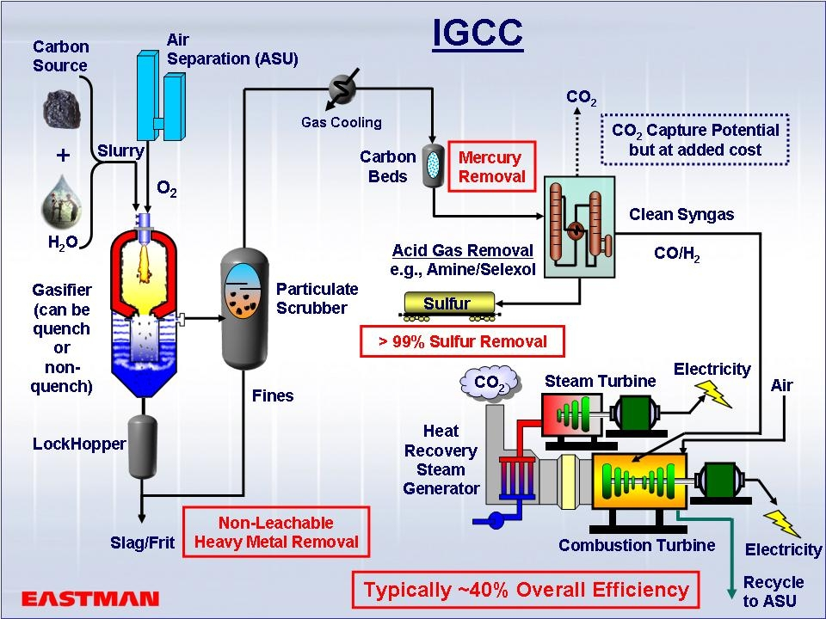

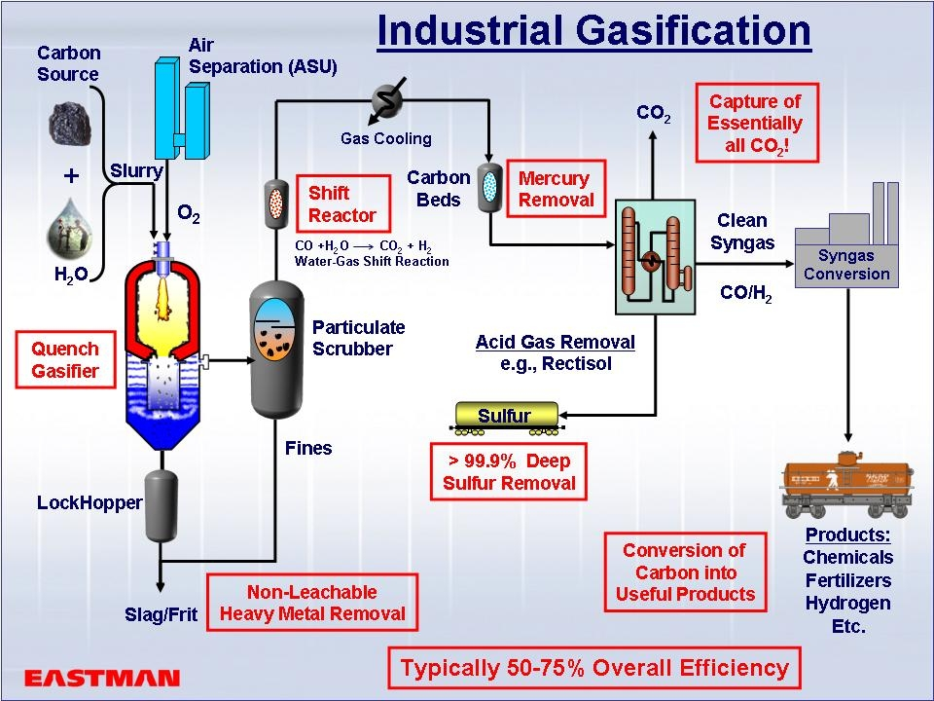

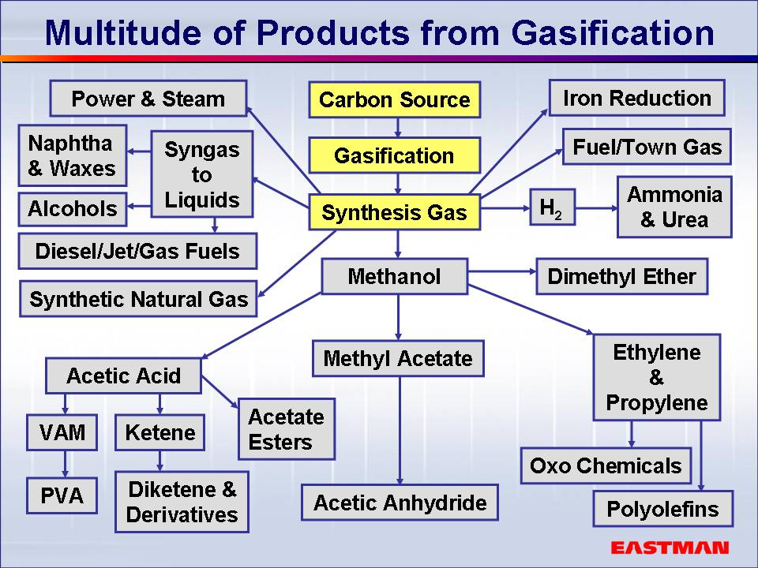

Common feedstocks for gasification include coal, petroleum coke and other petroleum residues, heavy oils, biomass, natural gas, and recycled secondary materials. These feedstocks are co-fed to a gasifier along with water and oxygen (or air) in a reducing atmosphere at high pressures (up to 1200 psig) and high temperatures (up to 2600 F) to produce the desired syngas. Because the resulting syngas stream is concentrated and compressed to high pressure, removal of pollutants and other contaminants to very low levels is readily achievable prior to any use of the syngas. If desired, the carbon monoxide in the syngas can also be reacted with additional water and converted or shifted into carbon dioxide and hydrogen. The carbon dioxide can be separated and captured as a relatively pure stream and then sequestered or used in productive applications such as enhanced oil recovery, leaving only a very pure hydrogen product in the syngas.



Over 7.7 X

Under .084 X

Over 3.6 X

Over 2.4 X

Even

ITC Over- Undersubcription

$350 M

$ 2.7 B

$ 30.0 B
48B Industrial Gasification
No Fdstk/Min. Size Rqmts
29 Projects 17 States

$ 500 M

$ 0.458 B
$ 5.47 B
Adv. PC
4 Projects
$0.267 B
$ 2.16 B
IGCC Lignite
2 Projects
$0.652 B
$ 8.00 B
IGCC Sub-Bit
6 Projects

$800 M

$0.971 B
$12.05 B
IGCC Bitumin
10 Projects
48A Power
22 Projects
19 States
ITC
Available
ITC
Requested
Value of Projects

Project Type
EPACT Section 48 Investment Tax Credit Applications – Over-Undersubscription

A Commitment to Incentives is Needed to get from Here to There on a Glide Path

The 48B ITCs were vastly oversubscribed by a factor of nearly 8 to 1. Only three industrial projects were supported in the first round. Additional 48B rounds need to be supported.

For both the Industrial Tax Credits and Federal Loan Guarantees to be effective, they need to address global market risks and support commercial scale projects. While there is a separate need for demonstration projects to validate key technologies, the real difference for America now is to assure that these incentives support investment in commercial scale industrial gasification projects that are calculated to meet global competition and are ready to deploy. The same set of projects supported by these incentives are a target pool for demonstration at scale of carbon capture and sequestration technologies.

The Federal Industrial Gasification Tax Incentives and the self-pay Federal Loan Guarantees in the Energy Policy Act are huge steps in the right direction. However, serious concerns continue with respect to implementation. These concerns are as follows.

First, it is imperative that the process for implementing the 48B tax credits be more transparent and meritorious than we have seen so far. The primary objective should be to assure that these early projects be technically, financially, and commercially solid projects, with experienced and capable owner/operators. Industrial Tax Credit application guidance did not outline measurable selection criteria that allow applicants to have confidence that this crucial objective would be met. Additionally, if Congress wants to attract more gasification projects and demonstrate CCS, incentives will have to cover the CCS investment and operational costs. Perhaps a dozen or so demonstrations of geologic CCS in the range of 5 million tons per year with and without EOR will be needed before mandatory GHG reductions take effect. Time and monetary commitment is of the essence.

Industry raised many important questions that were either politely dismissed or have gone wholly unanswered. Under the June 30 application deadline for the second round, the same questions remain unanswered. The program is under-authorized and needs realignment with serious and familiar DOE role. The Senate Energy and Natural Resources Committee along with the Senate Finance Committee ask IRS and DOE to seriously address questions submitted by a wide cross section of industrials and delay the future rounds until answers are provided.

Second, we are concerned that the Federal Loan Guarantee process itself is dangerously bogged down. Pre-applications were taken and a NOPR was issued. The Congress has seen fit to raise the Administration's target level for FY2007 from $2 billion to $4 billion. However, the FY 2008 request for a level of $7 billion does not include "non-power" gasification. This non-power exclusion is short-sighted, as there is no higher value and direct technological response to natural gas crisis and mandatory GHG proposals than commercial scale industrial and SNG gasification projects.

Third, the focus for these incentives needs to be squarely aimed at domestic industries that are suffering under the burden of high natural gas prices. We anticipate that the availability of these incentives will attract a number of project developers who will try to claim qualification even though they are not in the intended group of recipients.

