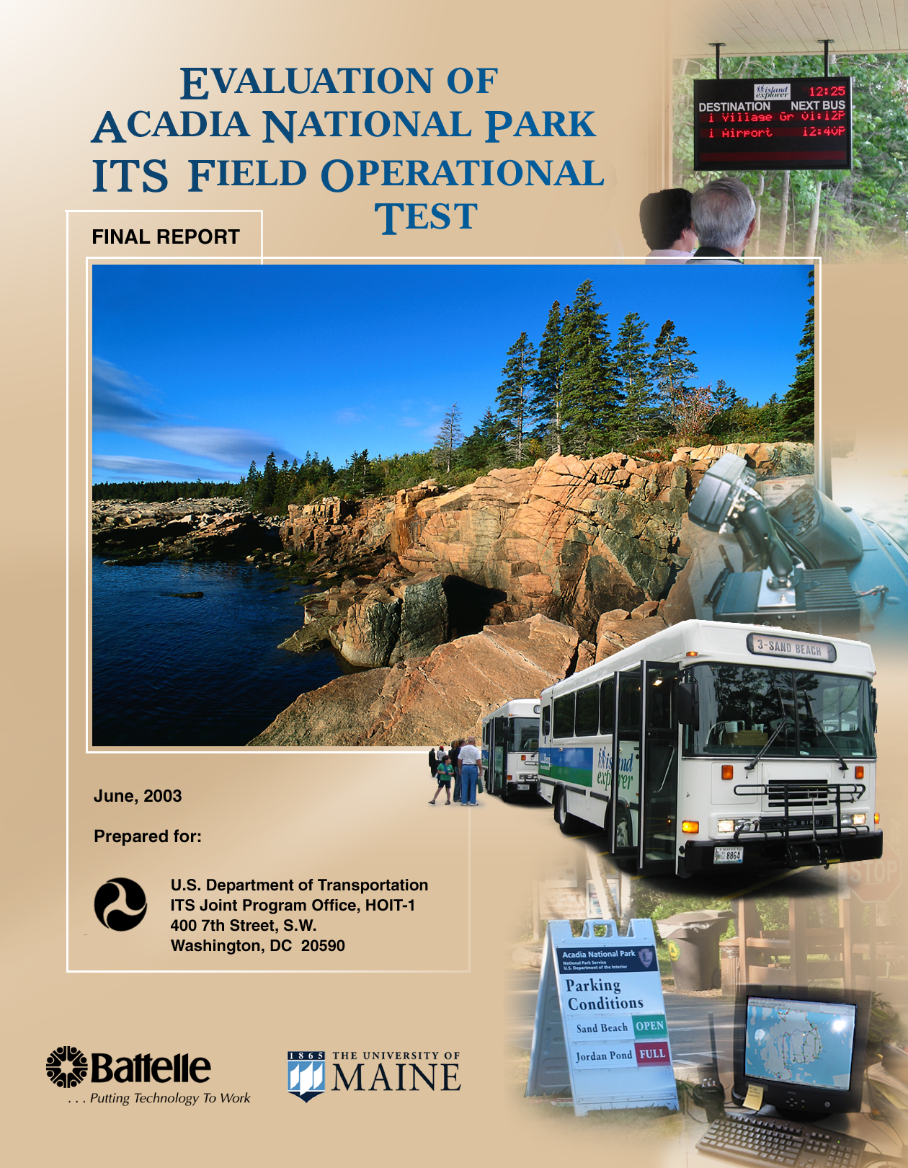

Executive Summary
This document presents the results of the evaluation of the ITS Field Operational Test (FOT) at Acadia National Park. Through the partnership of the U.S. Departments of Transportation and Interior, Acadia National Park in the State of Maine was selected for the FOT to test the effectiveness of intelligent transportation systems (ITS) in dealing with transportation problems within a National Park setting. ITS has provided effective tools for dealing with problems of traffic congestion in other settings, and the partners believed that testing the application of ITS in a National Park was warranted.

The ITS technologies were deployed over a two-year period and in 2002 they were evaluated to determine the impact of ITS on Acadia and the surrounding communities of Mount Desert Island. The benefits, impacts, and lessons learned that are documented in this report are directed not only to those associated with the FOT, but also to others involved with National Parks, gateway communities, and others interested in the potential for ITS in addressing similar transportation problems.
Background on the ITS Field Operational Test
As part of the National Park System, Acadia has as its dual mission the preservation of natural and cultural resources and providing visitors with a meaningful and pleasant experience. The mission is challenged by the intense usage that Acadia receives during the summer tourist season owing to its proximity to the population centers of the Northeast and the attraction of its pristine natural environment and the rugged beauty of the New England coast. Over 90% of visitors arrive by private vehicle, straining the capacity of the road system and parking areas within the Park and in the communities of Mount Desert Island, on which Acadia is located.

To develop an ITS plan to address the transportation problems at Acadia National Park, a project team was formed that consisted:

- local stakeholders—Acadia National Park, Maine Department of Transportation, Friends of Acadia, Maine Office of Tourism, and other local groups including representatives of local towns and businesses

- representatives of the sponsoring Federal agencies—U.S. DOT ITS Joint Program Office, FHWA Division Office, FHWA Federal Lands, and the National Park Service

- SAIC, Multisystems, and other contractors to assist in the design and implementation of ITS.

Together they planned a suite of nine different ITS components to support the region’s needs for public transportation management, traffic management, and traveler information. In the area of public transportation, the FOT was able to build on the success of the Island Explorer, a bus system launched in 1999 to provide free service during the tourist season throughout much of Mount Desert Island. Five of the nine components in the table below were used to enhance the operations of the Island Explorer. The remaining four components were to be used for assisting the Park in management of traffic and to provide real-time traveler information to visitors.

System Component | Functional Requirements
Island Explorer Two-way Voice Communications | Transmit and receive to/from/between vehicles and dispatch center
Automatic Vehicle Locator for Island Explorer | Compute and transmit vehicle location.  Integrate vehicle locations with departure signs. Display vehicle locations. Integrate into annunciator
Departure Sign for Island Explorer | Transmit location. Compute departure. Transmit to departure signs
Automated Annunciator for Island Explorer | Determine location. Automatically play next stop and other pertinent announcements
Passenger Counter for Island Explorer | Auto-count boardings/ dismounts at selected stops. Store information.
Parking Lot Monitoring | Record number of vehicles entering and exiting, provide slow scan video of parking area, transmit data, display video, store data from vehicle counts
Automatic Ranger/Vehicle  Geo-Location | Determine location +-10 meters, transmit same to server, display locations on map
Entrance Traffic Volume Recorder | Record and transmit number of vehicles entering and exiting, store data
Traveler Information System | Collect and integrate data, disseminate data to appropriate audience via telephone, Web, and parking status signs

Originally planned to be operational in 2001, technical and institutional difficulties arose that delayed the deployment for one year. In addition, not all the originally planned features were operational in 2002, such as the traffic counters as Park entrances and parking lots. One component, the automatic ranger/vehicle geo-location system was eliminated entirely for budgetary reasons.
The Evaluation Process
An independent evaluation of the ITS FOT took place from 2000 through 2003. Under contract to the U.S. DOT, Battelle Memorial Institute led the evaluation with support from the University of Maine. Baseline data that reflected conditions prior to the deployment of the ITS technologies were collected for the years 1999-2001, and data collected in 2002 measured the post-deployment impact of the ITS technologies.

A multi-step process was used to identify and prioritize the goals of the evaluation. Consensus among the stakeholders identified customer satisfaction and mobility as the top goals for the evaluation. Maintaining the visitor experience was critical to both Acadia National Park and to the communities of Mount Desert Island that rely upon the tourist economy, and thus assessing ITS from those perspectives was essential. However, importance was placed on assessment of other goal areas as well, including safety, efficiency, productivity and economic vitality, and energy and environment. Thus, evaluation plans were developed and implemented for all six goal areas, with resources allocated according to the priorities. Hypotheses regarding the anticipated impact of ITS in each goal area were developed and tested.
A variety of methods were used to collect data for assessing impacts of ITS. They included a mail survey of 928 visitors to Acadia in the summer of 2002, representing a response rate of 74%. Visitors indicated their perceptions of transportation problems during their visit, their awareness and use of the ITS technologies, and the impact ITS had on their travel experience. A mail survey of 257 businesses (60% response) throughout Mount Desert Island was used to gather information on business perceptions of the Island Explorer bus system and their awareness and use and benefits associated with the ITS technologies. Interviews with staff of the Island Explorer, Acadia National Park, and other stakeholders were used to assess their experience with ITS from an operational standpoint as well as to assess their overall deployment experience. Direct observation of visitor parking patterns was conducted in eight designated parking lots within the Park. Finally, operational data from the Island Explorer and records from Acadia National Park and various agencies within Maine State Government were used to assess the impact of ITS.
Results of the Evaluation
Many of the hypothesized impacts of ITS were supported by the evidence gathered. In other cases, the data were very limited but suggestive of the anticipated effect. In a few cases the impact was not observed or was counter to what was anticipated. Some of the key findings in each goal area include:
Customer Satisfaction
- Visitors rated their overall experience and satisfaction with their visit very high, but travel experience during their visit was rated lower. Visitors expressed most concern about unsafe conditions caused by vehicles parked along main roads. Other top concerns were the number of automobiles both inside and outside the Park and their impact on air quality.

- ITS-users expressed more concern about travel issues in general than non-ITS users and sought means to alleviate those concerns via ITS and the Island Explorer. Non-users, on the other hand, were either less sensitive to travel conditions or had strategies for coping with problems that didn’t involve the need for Island Explorer or ITS.

- Visitors rated the ITS-based traveler information sources very highly (86% or more) on attributes of ease of use, understandability, and accuracy, and reported that the information helped relieve the stress or uncertainty of travel. The vast majority of users (78% or more) believed using the same ITS-based information again in a future visit would be a pleasant experience. Particularly promising are reports from ITS users that they would plan to use the information again.

- Drivers and managers of the Island Explorer bus system expressed a high degree of satisfaction with the five ITS technologies associated with the buses. Managers believed that ITS improved bus operations and contributed to customer satisfaction, but they weren’t sure if ITS directly increased ridership. Drivers felt that ITS made their jobs easier and helped them to cope with increasing traffic and ridership.

- Park managers believed that parking lot status signs and bus departure signs have a positive influence on congestion and traffic by facilitating bus travel, whereas Park rangers believed that the Island Explorer with ITS enhancements is helping to alleviate congestion but were less enthusiastic about the parking information signs.
Mobility
- Real-time parking information was made it was easier for visitors to get around and avoid parking problems and traffic congestion. The parking information impacted decisions visitors made about travel in the Park. Of visitors using the parking information, 43% changed the time they visited a destination and 38% changed destinations based on the information.

- Visitors strongly believed in the benefits of the Island Explorer’s real-time bus departure signs and the on-board bus announcements. Over 80% found that these ITS technologies made it easier to get around and 69-80% visitors believed ITS helped to save time. These results were consistent with previous studies of Island Explorer passengers who voiced strong support for the bus system even before ITS was implemented.

- Important goals of the ITS technologies were to enhance visitors’ experience while at the same time encouraging them to use the Island Explorer bus rather than their private vehicles. ITS users of the electronic departure signs and on-board announcements reported that the technologies helped them decide to use the Island Explorer bus (80% and 67%, respectively). 44% of the users of the real time parking information said it helped them decide to use the Island Explorer bus. Thus, the ITS technologies appear to be contributing to the overall goal of diverting visitors from personal vehicles to using the Island Explorer bus.
Productivity and Economic Vitality
- The majority of managers of businesses on Mount Desert Island recognize the importance of tourism and the benefits to their business or community from being situated near Acadia National Park. Nevertheless, transportation was one area that drew negative views, and they were concerned about tourist season parking and congestion as well as issues of air quality and safety.

- Business managers clearly believe that the Island Explorer bus system helps to address some of their concerns about summer travel conditions, and 69% of the businesses reported that they provide information to visitors about the bus. They perceive several benefits from visitors using the bus, such as less worry about driving and parking along busy roads, relieving the stress of driving, improving air quality, creating safer conditions, reducing parking problems in the Park and providing greater access to Park destinations.

- Business managers didn’t necessarily believe that more customers were patronizing their businesses because parking was less of a factor or that the Island Explorer would cause visitors to stay longer. On the other hand, managers of businesses whose customers and employees did not use the bus believed that businesses that were closer to a bus stop than their own enjoyed a competitive advantage.

- The majority (61%) of business managers was not aware of ITS-based travel information sources, but their awareness was much greater for the technologies associated with the Island Explorer than the parking information signs and Website. Business managers perceived many benefits associated with visitors’ use of both the parking information and the Island Explorer bus technologies.

- Length of stay by visitors, a measure of economic impact, was positively correlated with use of the Island Explorer and with use of ITS technologies associated with the bus. However, there was a great deal of uncertainty among business managers about whether visitors who use the Island Explorer tend to stay longer.

- While it was expected that the Island Explorer operations would benefit from productivity improvements resulting from ITS technologies, the opposite happened and operational costs increased from 2001 to 2002 for a variety of reasons. Despite this overall increase, the cost per rider and per mile driven did decline.
Efficiency
- While total recreational visitors to Acadia National Park during the summer season increased by 1.3% from 2001 to 2002, ridership of the Island Explorer increased by 17%. Thus, a higher proportion of Acadia summer recreational visitors used the bus after ITS was operational than before, growing from 15.6% in 2001 and 18.3% in 2002.

- Fewer vehicles were parked outside designated parking spaces (excess parking) aftert ITS technologies were implemented. In eight lots where parking was monitored, the percentage of days when more than 300 vehicles were parked outside designated spaces fell from 54% in 2001 to 33% in 2002. Similarly, the average number of excess parked vehicles per day fell from 325 in 2001 to 274 in 2002 even though total number of visitors to the Park grew.

- The real-time parking information posted on signs and on the Park’s Website was for two of the two most utilized parking lots, Sand Beach and Jordan Pond. Average excess parking per day at both lots fell after ITS was deployed.

- The Island Explorer operations realized efficiency benefits after ITS implementation. Miles driven decreased slightly (-1.4%) even though ridership increased significantly (17%).

- Interviews with Island Explorer staff indicated that voice communications between drivers and the dispatcher helped communicate information on large passenger loads and blocked roads. Managers voiced support for the automatic vehicle locator system for helping them with route management and monitoring buses for schedule adherence, speed, and position within the overall system.
Energy and Environment
- Visitors exhibited a high degree of concern about vehicles negatively impacting air quality on Mount Desert Island—it ranked among the top five problems related to travel experience during their trip to Acadia National Park.

- Emissions modeling that took into account the increase in ridership of the Island Explorer indicated that air quality benefited from the bus system, with an estimated additional 1.17 tons of emissions avoided in 2002, the year that ITS was operational.

- A reduction in excess parking at Sand Beach and Jordan Pond parking lots suggest that ITS by moving visitors away from full lots and putting more visitors on buses may help address aesthetic concerns about the sight of many vehicles parked along roads detracting from the natural beauty of the Park.
Safety
- Visitors to Acadia National Park identified safety as their top concern related to travel during their visit. Seventy percent of surveyed visitors thought that vehicles parked along the main roads caused unsafe conditions.

- Motor vehicle accidents along routes of the Island Explorer within the Park decreased dramatically (-54%) during the summer months of 2002.

- The voice communications and automatic vehicle location technologies on the Island Explorer provided safety benefits to drivers and managers of the bus system. Drivers were able to report accidents and other hazardous conditions, and managers were able to remotely locate buses in emergency situations.
Conclusions and Recommendations
This evaluation of ITS at Acadia National Park and Mount Desert Island is based on one season of post-deployment experience. It is also based on a deployment that was not yet fully realized, because not all of the technologies were in place by the summer of 2002. Nevertheless, the results of the evaluation lead to a number of conclusions about the benefits that ITS provided. Recommendations based on these conclusions are also presented for further consideration by the FOT stakeholders and by other National Parks and gateway communities that must deal with similar transportation problems. Some of the conclusions and recommendations identified in this report include:

- ITS contributed to a positive visitor experience and increased visitors’ willingness to use transit rather than their own vehicles. Greater use of the Island Explorer appeared to be associated with improvements in air quality and possibly to overall traffic and motor vehicle crashes.

  - The full deployment of the planned ITS technologies at Acadia should be completed and the system maintained so that the benefits can continue to be enjoyed.

- Visitors who use ITS traveler information tend to be the most concerned about travel problems during their stay, and ITS helps alleviate the problems they perceive. Conversely, those visitors least concerned about problems associated with using their own vehicles within the Park are also the least likely to use the ITS sources of traveler information.

  - Marketing messages promoting tourism at Acadia and Mount Desert Island should find a way to inform visitors of the travel problems they might encounter and emphasize the Island Explorer as a solution that is free and easy to use with the ITS enhancements.

- Real-time parking information, despite the limited deployment of signs at three locations and the Park Website, was used by visitors, who reacted to it positively. The information appears to have the desired effect of reducing excess parking at the two advertised parking lots that are the most popular destinations in the Park—Sand Beach and Jordan Pond. Although only about 40% of visitors reported they changed their plans based on real-time parking information, even that percent could help lessen the demand for parking. Indeed, the statistics on excess parking in the Park’s lots suggest that ITS helped to lower demand for parking within the Park through a combination of real-time information on parking status provided to visitors and making visitors aware that the Island Explorer is an attractive option for reaching desired destinations.

  - Consideration should be given to adding real-time information on parking lot status at other destinations within the Park. Expansion of information on parking conditions can be justified from the standpoint of customer satisfaction and better management of the Park’s transportation resources.

  - An explicit recommendation to “take the bus” on signs displaying information on parking status would give clear guidance to visitors about their options for travel at the point of decision.

- Based upon the findings about the perceived benefits of ITS to users, the implication is that traveler information could be potentially useful to the customers of many businesses whose managers are currently unaware of the ITS technologies and traveler information.

  - Mechanisms are needed to help raise awareness among business managers and their employees so that they promote these types of traveler information sources to their customers.

- Although no clear case can be made that visitors are attracted to Acadia and Mount Desert Island because of the Island Explorer, use of the Island Explorer is associated with the most economically attractive types of visitors because they stay longer and spend more. Since visitors reported that the ITS technologies played a role in their decision to use the bus and enhanced their experience with the bus, ITS would appear to be useful from an economic development standpoint.

  - Businesses of Mount Desert Island should be further educated about the potential impact of ITS on the local economy and should encourage use of the Island Explorer and traveler information in promotion of Mount Desert Island tourism more than they currently do.

Table of Contents

Page
EXECUTIVE SUMMARY i

1.0 INTRODUCTION 1-1
1.1 Acadia National Park: The Setting 1-1
1.2 Transportation Problems at Acadia National Park 1-2
1.3 ITS as a Potential Solution to Transportation Problems at National Parks 1-3

2.0 ITS FIELD OPERATIONAL TEST DEPLOYMENT OVERVIEW 2-1
2.1 Deployment Experience 2-1

3.0 EVALUATION APPROACH 3-1
3.1 Methodologies Used for Data Collection 3-2
3.2 Expected Impacts of ITS 3-4

4.0 CUSTOMER SATISFACTION 4-1
4.1 Role of ITS in the Visitor Experience 4-2
4.2 Awareness and Use of Traveler Information 4-2
4.3 Customer Satisfaction Among ITS Users 4-9
4.4 Customer Satisfaction Among Members of the FOT Team 4-17
4.5 Summary of Customer Satisfaction 4-23

5.0 MOBILITY 5-1
5.1 Avoiding Problems 5-1
5.2 Ease of Movement 5-3
5.3 Saving Time 5-6
5.4 Changing Departure Time or Destination 5-8
5.5 Summary of Mobility 5-10

6.0 PRODUCTIVITY AND ECONOMIC VITALITY 6-1
6.1 The Role of Tourism in the Local Economy 6-1
6.2 Business Managers’ View of Transportation Problems and ITS Solutions 6-4
6.2.1 Business Managers’ Attitudes Toward the Island Explorer 6-6
6.2.2 Awareness and Usage of ITS Technologies 6-8
6.2.3 Business Managers’ Perception of Benefits of ITS Technologies 6-10
6.3 Assessing Economic Impact with the Visitors’ Survey 6-12
6.4 Economic Impact of ITS on Acadia National Park 6-17
6.5 Impact of ITS on Productivity of Island Explorer Operations 6-18
6.6 Summary of Productivity and Economic Vitality 6-21
Table of Contents (Continued)

Page
7.0 EFFICIENCY 7-1
7.1 Impact of ITS on Efficiency of Acadia National Park Operations 7-1
7.2 Effect of ITS on Visitors’ Parking Lot Usage 7-2
7.3 Impact of ITS on Efficiency of Island Explorer Operations 7-5
7.4 Summary of Efficiency 7-7

8.0 ENERGY AND ENVIRONMENTAL IMPACT 8-1
8.1 Air Quality Impacts 8-1
8.2 Impact of Vehicles on Park Aesthetics 8-Error! Bookmark not defined.
8.3 Summary of Energy and Environment 8-3

9.0 SAFETY 9-1
9.1 Visitors’ Traffic Safety Concerns 9-1
9.2 Trends in Traffic Safety on Mount Desert Island 9-2
9.3 ITS Contribution to Safety in Transportation Management 9-3
9.4 Summary of Safety 9-3

10.0 SUMMARY OF KEY FINDINGS, CONCLUSIONS
AND RECOMMENDATIONS 10-1
10.1 Key Findings 10-1
10.2 Conclusions and Recommendations 10-5

List of Tables
Table 2-1: ITS System Components 2-3

Table 3-1: Evaluation Tests and Goal Areas to Which They Applied 3-2
Table 3-2: Expected ITS Impacts by Six Goal Areas 3-4

Table 4-1: Percent of Respondents Who Were Aware of and Used Travel Information Sources? 4-4
Table 4-2: Visitor Ratings of Problems Related to Travel on Mount Desert Island and in Acadia National Park 4-6
Table 4-3: Visitor Ratings of Travel Experiences Using a Personal Vehicle 4-8
Table 4-4: Average Ratings of Satisfaction with ITS Components by
Island Explorer Staff 4-19
Table 4-5: Average Ratings of Satisfaction with the ITS Components by
Acadia National Park Staff 4-21
Table 4-6: Objectives and Hypotheses Related to Customer Satisfaction 4-23

Table 5-1: Visitor Activities Inside Acadia National Park and Outside the Park 5-10
Table 5-2: Objectives and Hypotheses Related to Mobility 5-10

Table of Contents (Continued)

Page
Table 6-1: Business Managers’ Views of Potential Benefits and Negative Impacts Related to Tourism in the Community 6-2
Table 6-2: Business Managers’ Attitudes about Acadia National Park’s Contributions 6-3
Table 6-3: Business Managers’ Perceptions of Travel Issues and Magnitude of Problem on Mount Desert Island and in Acadia National Park this Summer 6-5
Table 6-4: Business Managers’ Ratings of the Benefits of the Island Explorer Bus 6-7
Table 6-5: Business Managers’ Awareness and Use of the Travel Information Sources
this Summer 6-9
Table 6-6: Business Managers’ Ratings of the Benefits of Providing Information on
Parking Conditions Within the Park 6-11
Table 6-7: Business Managers’ Ratings of the Benefits of Island Explorer
Traveler Information 6-12
Table 6-8: Days Spent Visiting Mount Desert Island Area by ITS User and
ITS Non-User 6-14
Table 6-9: Money Spent During Visit by ITS User and ITS Non-User 6-15
Table 6-10: Mode of Transportation Used to Reach Mount Desert Island 6-16
Table 6-11: Island Explorer Operational Measures 6-19
Table 6-12: Objectives and Hypotheses Related to Productivity and Economic Vitality 6-21

Table 7-1: Percent of Days in Which Vehicles Exceeded the Capacity of Eight
Designated Parking Lots in Acadia National Park 7-3
Table 7-2: Mean Number of Vehicles that Exceeded the Capacity and Time of Day for
Parking Lots at Sand Beach and Jordan Pond 7-4
Table 7-3: Mean Number of Vehicles Exceeding the Capacity of Individual Lots in
Acadia National Park 7-5
Table 7-4: Island Explorer Operational Statistics 7-6
Table 7-5: Objectives and Hypotheses Related to Efficiency 7-8

Table 8-1: Objectives and Hypotheses Related to Energy and Environment 8-3

Table 9-1: Objectives and Hypotheses Related to Safety 9-3

Table of Contents (Continued)

Page
List of Figures
Figure 1-1: Map of Coastline of Maine Showing Acadia National Park 1-2

Figure 2-1: System Architecture for ITS FOT at Acadia National Park 2-4

Figure 4-1: Proportion of Survey Respondents by Residence 4-1
Figure 4-2: Parking Lot Information Sign at Visitor Center 4-3
Figure 4-3: Parking Lot Information Sign at Seawall Campground 4-3
Figure 4-4: Parking Lot Information on the Acadia National Park Website 4-3
Figure 4-5: Automatic Annunciator Text Display On-board the Island Explorer Bus 4-3
Figure 4-6: Electronic Bus Departure Sign at Village Green 4-4
Figure 4-7: Electronic Bus Departure Sign at Visitor Center 4-4
Figure 4-8: Respondents’ Agreement with Features of Parking Information Signs 4-10
Figure 4-9: Respondents Agreement That Parking Conditions Information Helped to
Reduce Tension and Stress Related to Traveling 4-10
Figure 4-10: Respondents’ Agreement with Features of Real-time Bus Departure Signs 4-11
Figure 4-11: Respondents Agreement That Real Time Bus Departure Sign Relieved Uncertainty When the Bus Would Arrive 4-12
Figure 4-12: Respondents’ Agreement with Text Features of Automated On-Board Announcements 4-13
Figure 4-13: Respondents’ Agreement with Audio Features of Automated On-Board Announcements 4-13
Figure 4-14: Respondents’ Agreement that Bus On-Board Announcements Helped to
Relieve Uncertainty About When the Bus Would Arrive at my Stop 4-14
Figure 4-15: Respondents Agreement that Bus On-Board Announcements Helped to
Relieve Uncertainty About When to Exit the Bus 4-15
Figure 4-16: Respondents Agreement That Parking Information Helped Me Decide to
Use the Island Explorer Bus 4-16
Figure 4-17: Respondents’ Agreement That Real Time Bus Departure Signs Helped
Me Decide to Use the Island Explorer Bus 4-16
Figure 4-18: Respondents’ Agreement That Bus On-Board Announcements Helped
Me Decide to Use the Island Explorer Bus 4-17
Figure 4-19: ITS Equipment Inside Island Explorer Bus: Voice and Text
Communications and Passenger Counter 4-18
Figure 4-20: Island Explorer Dispatcher’s Office with Radio Voice Communications
and Bus Management Software 4-18
Figure 4-21: Bus Tracking Software Connected to Automatic Vehicle Locator on Buses 4-19

Figure 5-1: Respondents’ Agreement that Parking Conditions Information Helped to
Avoid Parking Problems 5-2
Figure 5-2: Respondents’ Agreement that Parking Conditions Information Helped to
Avoid Traffic Congestion 5-2

Table of Contents (Continued)

Page
List of Figures (Continued)
Figure 5-3: Respondents’ Agreement that Parking Conditions Information Helped to
Avoid Large Crowds 5-3
Figure 5-4: Respondents’ Agreement that Parking Conditions Information Made It
Easier for Me to Get Around the Area 5-4
Figure 5-5: Respondents’ Agreement that Real Time Bus Departure Displays Made It
Easier for Me to Get Around the Area 5-5
Figure 5-6: Respondents’ Agreement That Bus On-Board Announcements Made It
Easier For Me To Get Around The Area 5-5
Figure 5-7: Respondents’ Agreement That Parking Conditions Information Saved
Time for the Visitor 5-6
Figure 5-8: Respondents’ Agreement That Real Time Bus Departure Sign Saved
Time for the Visitor 5-7
Figure 5-9: Respondents’ Agreement That Bus On-Board Announcements Saved
Time for the Visitor 5-7
Figure 5-10: Respondents’ Agreement That Parking Conditions Information Changed
the Time of Day to Visit Certain Destinations 5-8
Figure 5-11: Respondents’ Agreement That Parking Conditions Information Changed
the Visitor’s Mind on what Attractions to Visit 5-9

Figure 6-1: Types of Businesses on Mount Desert Island 6-2
Figure 6-2: Business Manager Awareness of ITS Technologies 6-8
Figure 6-3: Business Managers and Their Customers’ Use of the Traveler Information Sources 6-9
Figure 6-4: Days Spent Visiting Mount Desert Island Area by Non-Residents 6-13
Figure 6-5: The Amount Visitors Spent During Their Visit, Excluding Hotel or
Rental Car Costs 6-15
Figure 6-6: Acadia National Park Donations and Gate Receipts (in 1000’s) by Year 6-18
Figure 6-7: Island Explorer Productivity Measures 6-20

Figure 7-1: Statistics Related to Usage of Acadia National Park 7-2
Figure 7-2: Island Explorer Operating Efficiencies 7-7

Figure 8-1: Visitor Rating of Too Many Automobiles Having a Negative Impact on
Air Quality 8-2
Figure 8-2: Island Explorer Passengers and Avoided Emissions in Metric Tons 8-2

Figure 9-1: Visitor Rating of Vehicles Parked along the Main Roads Causing Unsafe Conditions 9-1
Figure 9-2: Motor Vehicle Accidents along the Routes of the Island Explorer during
the Summer Operating Season 9-2

EVALUATION OF ACADIA NATIONAL PARK ITS FIELD

OPERATIONAL TEST: FINAL REPORT

1.0 Introduction
This report presents an assessment of the effectiveness of intelligent transportation system (ITS) technologies in addressing the transportation problems within the setting of a National Park. Acadia National Park on Mount Desert Island in the State of Maine served as a test bed for a suite of ITS technologies that were deployed over a two-year period and were evaluated during the summer tourist season of 2002. The report begins with a discussion of the transportation problems of Acadia and the establishment of the ITS Field Operational Test to address those problems. In Section 2.0 the ITS technologies are presented along with a discussion of the approach to evaluating their effectiveness. Sections 3.0 through 9.0 present the results of the evaluation as they pertain to six evaluation goal areas: customer satisfaction, mobility, productivity and economic vitality, efficiency, energy and environmental impact, and safety. Section 10.0 summarizes the key findings and draws conclusions and recommendations for future ITS deployments.

1.1 Acadia National Park: The Setting
Acadia National Park is part of the U.S. National Park System, which has as its dual mission the preservation of natural and cultural resources and providing visitors with a meaningful and pleasant experience. Over 277 million recreational visitors came to the National Parks in 2002 to experience their unique features. One of the most popular National Parks is Acadia. Located on the beautiful and rugged coast of Maine (Figure 1-1), Acadia preserves the natural beauty of that coastline, little of which remains in public ownership. The Park’s 35,000 acres lie principally on Mount Desert Island, but smaller portions are located on the island of Isle au Haut and on Schoodic Peninsula on the mainland. Establishment of the Park dates to 1916, when lands that were privately owned by John D. Rockefeller were donated to the Federal Government to create what is now Acadia. Unlike many other National Parks, private lands and Park lands intermingle in much of Acadia National Park. This is especially the case on Mount Desert Island, which has several small towns and villages, where most of the Island’s approximately 9600 year-round population live. The largest town on the Island is Bar Harbor. Other towns are Southwest Harbor, Northeast Harbor, and Bass Harbor, plus several other smaller villages.

Tourism dominates the regional economy, and the attraction of Acadia National Park is a major contributor to the tourism industry. During the summer months, the Mount Desert Island population nearly triples with many overnight guests staying at the numerous hotels, bed-and-breakfasts, and campgrounds in the area. In the last several years, large cruise ships such as the QE2 have made Bar Harbor a port-of-call, contributing thousands of additional visitors to the Island.

Acadia National Park hosted 2.56 million recreation visits in 2002 with 61% of those visits occurring from June through August. Close to the population centers of the northeastern states, Acadia has become one of the most-visited National Parks in the peak summer months of July and August. Visitors are drawn to Acadia for the active and passive recreation opportunities, such as sightseeing, camping, hiking, rock-climbing, kayaking, and wildlife viewing. Those activities are complemented by the lodging, dining, and shopping amenities of the towns on the Island.

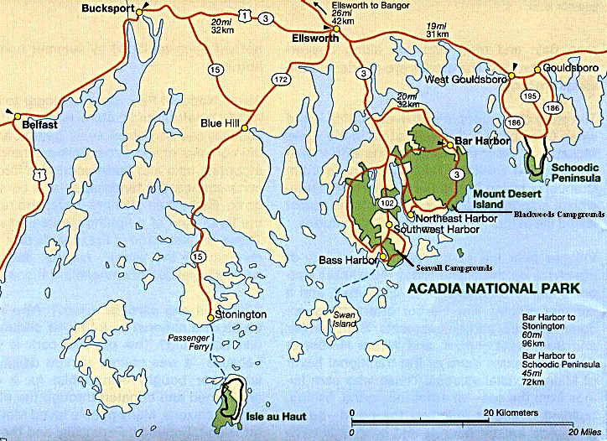
Figure 1-1: Map of Coastline of Maine Showing
Acadia National Park

1.2 Transportation Problems at Acadia National Park

The popularity of Acadia National Park and the growth of tourism on Mount Desert Island are not without problems. On any given year over 90% of visitors arrive by private vehicle, straining the capacity of the road system and parking areas. During the peak tourist season, roadway congestion is the norm, and parking at trailheads and beaches has become increasingly difficult. Lengthy traffic delays and noise and air pollution often detract from the experience visitors have come to enjoy, and they also threaten the Park’s natural and cultural resources.

To address the transportation problems at Acadia, in 1995 the National Park Service issued a “Statement of Management Planning Implementation Report” calling for Acadia and surrounding towns to develop a regional public transportation system. That approach is consistent with Acadia National Park’s General Management Plan, which states:

“To reduce the perception of crowding in high-density areas, the number of parked cars will be kept to a minimum. Existing parking capacities will be enforced. Alternative means of park access will be developed, with the goal of replacing private automobiles with nonmotorized means and a public transportation system.”

To relieve traffic congestion, Acadia National Park has turned to public transportation as the preferred approach for both protecting the aesthetic and natural resources of parklands and providing a quality visitor experience. With support from public and private funding sources, in 1999 the Island Explorer bus service was launched to provide free transportation during the tourist season on Mount Desert Island. From late June through early September of the first season, the buses carried an impressive total of 142,260 passengers over six routes through Mount Desert Island towns and Acadia National Park. The initial success of the service led to a decision to add nine additional buses for the 2000 summer season, thereby increasing service on some routes and providing back-up buses in case of breakdowns. The Island Explorer got an additional boost in 2002 with a $1 million donation from the L.L. Bean Company. The donation will help the bus service to expand to meet growing demand and enable the extension of bus operations into the fall season starting in 2003.

1.3 ITS as a Potential Solution to Transportation Problems at National Parks

The U.S. Department of Interior, the parent organization for the National Park Service, and the U.S. Department of Transportation entered into a memorandum of understanding in November of 1997 to work together to address the problems of transportation within the National Parks. The two agencies would collaborate on “joint research efforts to determine how technology can be used to address transportation problems in Nationals Parks; education and training of park service staff on technology applications and programs; and demonstration of new technologies in National Park units.” The provision of a demonstration project of transportation technologies would enable the DOT and the DOI to identify opportunities to use a variety of new transportation technologies, including ITS, in the National Parks.

As an initial means of focus, U.S. DOT’s ITS Joint Program Office and the National Park Service made plans to identify the most suitable site for an ITS Field Operational Test (FOT) at a National Park. From proposals developed for Acadia, Yosemite, and Zion National Parks, Acadia was chosen for the ITS FOT to determine the effectiveness of ITS in helping to solve Park transportation problems. SAIC, a contractor to U.S. DOT, was selected to work with the National Park Service and local stakeholders on Mount Desert Island to design and deploy the ITS FOT. U.S. DOT selected Battelle Memorial Institute to conduct an independent evaluation of the FOT to assess the benefits from the ITS technologies and identify lessons learned that might be applied to other National Parks.

Starting in late 1999 a project team was formed to design and deploy the ITS FOT for Acadia. The team consisted of representatives from the National Park Service, U.S. DOT (ITS Joint Program Office, FHWA Division Office, and FHWA Office of Federal Lands), Maine Department of Transportation, Friends of Acadia (a nonprofit Park advocacy group), Downeast Transportation Inc. (operators of the Island Explorer buses), Maine Office of Tourism, SAIC, Multisystems (subcontractor to SAIC), and other local stakeholders such as representatives for local towns and businesses. The project team met regularly to identify goals for the FOT, to consider ITS technologies that could be used, and to develop system requirements that could be used in procuring and installing the ITS technologies. Section 2.0 presents information on the deployment.

The evaluation team was formed in 2000 and consisted of Battelle, the University of Maine (subcontractor to Battelle), and the U.S. DOT ITS Joint Program Office. The evaluation team worked closely with the project team to develop an evaluation approach that would result in meaningful information based on the goals of the FOT. Section 3.0 discusses the evaluation approach.

2.0 ITS Field Operational Test Deployment Overview
The Intelligent Transportation Systems deployed at Acadia integrate nine different components, which support the region’s needs for public transportation management, traffic management, and traveler information. One of the reasons that Acadia National Park was chosen to be the site of the FOT was that there was a strong spirit of cooperation among the stakeholder groups. That spirit enabled a quick consensus to be reached on the objectives for the FOT that were subsequently translated into system requirements for the deployment. The components are interrelated and depicted in Figure 2-1, and Table 2-1 presents additional details on the individual components.

The public transportation components consisted of ITS technologies intended to enhance the operations of the Island Explorer bus system. They included two-way voice communications, automatic vehicle location, electronic bus departure signs, automated annunciators on-board the buses, and automatic passenger counters. ITS traffic management components within the Park included parking lot monitoring and traffic volume recorders at Park entrances. Traveler information obtained data from the other ITS components and disseminated information to visitors and other travelers through various means. One dissemination method, an interactive voice response (IVR) telephone system, was planned but was not operational in the summer of 2002. However, the IVR has evolved to become Acadia’s link to the Maine DOT’s statewide 511 telephone system for travel information. An emergency management component involving geo-location of rangers and vehicles was included in the original system requirements but not deployed.

2.1 Deployment Experience
Planning for the ITS deployment began in 1999 when the project team was formed. With funding and a support contractor supplied by the U.S. Department of Transportation’s ITS Joint Program Office (JPO), the project team developed a plan that mapped ITS technologies to the transportation problems that stakeholders viewed as most critical for solving. Some local stakeholders, who had worked together successfully on previous projects found the planning stage unnecessarily long and formal but eventually a consensus plan was reached that enabled design work to proceed.

Responsibility for implementing various portions of the design was assigned to the team members who were appropriate from a contractual standpoint. For example, deployments on Federal property were handled by the Park Service and the JPO, with the FHWA Office of Federal Lands later assuming JPO’s role. Maine Department of Transportation and Downeast Transportation, Inc., which operated the Island Explorer, handled the implementation of ITS technologies for the bus system.

Implementation entailed procurement, technological, management and funding issues that were not fully understood at the outset by those who had the responsibility. For example, the original deployment plan called for some ITS components that, in the end, could not be accommodated within the available budget. Stakeholders were forced to make a selection of those components to eliminate. For example, slow scan video of a parking area and geo-location of Park rangers were eliminated.

All ITS components were scheduled to be operational in the 2001 tourist season. Unfortunately, the deployment schedule proved to be too aggressive as technical and procurement problems arose. Hardware components could not be acquired in time for installation and testing in 2001. In some cases the contracting agency was not experienced in acquisition of the types of hardware that was needed for the FOT and consequently additional time was required for the contracting process to play out. In other cases technical issues arose that demanded more time to resolve. For example, to support the automatic vehicle locator system of the Island Explorer buses, the National Park Service made a request for spectrum allocation to the National Telecommunications and Information Administration (NTIA), which regulates radio frequencies on Federal lands. Even though the request was made early in the deployment stage, the process took a long time and added delay to other parts of the deployment until the frequency and power ratings were assigned by NTIA. Schedule problems such as this forced the deployment into the next summer tourist season of 2002.

Not all the ITS components were operational in 2002. By mid-June of 2002 the ITS components associated with the Island Explorer were all successfully tested and ready to be put into service for the start of the season. Components within the Park, however, proved to be problematic. Difficulties were experienced with the loop detectors at entrances to the Park and parking lots. Acadia, like other National Parks, has no transportation professionals on staff and had no experience installing and operating the transportation management systems and ITS technologies. FHWA assisted the Park by supplying on-site testing in an attempt to achieve acceptance status during the summer, but in the end this proved to be unsuccessful for getting the loop detectors operational in 2002. As a result automated traffic counts could not be obtained and manual counts of parking were substituted. Upgrade of the Park’s telephone system to accommodate an interactive system for traveler information did not take place in time. A planned enhancement to the Park’s Webpage for displaying real-time traveler information did not take place, but instead was replaced in the second half of the summer season by a temporary Webpage that was limited to parking lot status information at two lots.

Despite the various problems that were encountered the project team succeeded in deploying sufficient number of the components in 2002 for the evaluation to proceed. Work continued on the interactive voice response system, and it was encompassed within the statewide 511 telephone service for traveler information which Maine DOT plans to launch in May 2003.

While the deployment had its difficult moments, it succeeded in most of what it set out to achieve. The deployment overcame the challenges of implementing a technologically complicated system within a complex institutional arrangement. The timing of the summer tourist season meant that the project team also faced narrow windows of time for system operation that aren’t encountered in many other ITS deployments. The long winter hiatus in construction was yet another limitation with which the project team had to contend in implementing certain system elements. Given these challenges, the ITS FOT at Acadia National Park can be judged a success so far and one that will continue in the months ahead as the remaining ITS components are completed.
Table 2-1: ITS System Components
System  Component | Functional  Requirements | System  Elements | Needs  Addressed
Island Explorer Two-way Voice Communications | Transmit and receive to/from/between vehicles and dispatch center | Transceivers; vehicle and base station; text display in vehicle; repeater to amplify signal | Improved efficiency  Improved safety  Real time traffic information for park staff, reduce crush load conditions, incident detection
Automatic Vehicle Locator for Island Explorer | Compute and transmit vehicle location  Integrate vehicle locations with departure signs, display vehicle locations, integrate into enunciator | Vehicle transmitter  TCP/IP Network Connectivity, GPS Transceiver, GIS Applications, Travel Time Applications | Improved efficiency and performance  Decreased use of POV’s  Improved safety and response  Real time updates  Increase ridership
Departure Sign for Island Explorer | Transmit location  Compute departure  Transmit to departure signs | Display sign, Software,  Wireless/Wireline Communications | Improved scheduling information  Increase ridership
Automated Annunciator for Island Explorer | Determine location  Automatically play next stop and other pertinent announcements | Vehicle annunciator | Improve efficiency  Reduce delays  Increase safety  Improve visitor experience
Passenger  Counter for Island Explorer | Auto-count boardings/ dismounts at selected stops,  Store information | Sensor to perform counts  Data storage | Increase efficiency  Improve planning  Increase data options  Reduce vehicle crush loads
Parking Lot  Monitoring | Record number of vehicles entering and exiting, provide slow scan video of parking area, transmit data, display video, store data from vehicle counts | Counting sensor  Video camera  Display monitor  Wireless/wireline communications  TCP/IP network connectivity | Decreased use of POV’s Provide planning data  Information for Rangers  Decreased Response times
Automatic  Ranger/Vehicle  Geo-Location | Determine location +-10 meters, transmit same to server, display locations on map | Transmitting unit GPS Transceiver  Repeater for signal GPS/GIS Software | Information for Rangers  Exact locations of Rangers  Decreased response times  Improved visitor safety, security
Entrance Traffic Volume Recorder | Record and transmit number of vehicles entering and exiting, store data | Counting sensor  Transmission unit | Count vehicles  Provide Planning Data  Decrease use of POV’s
Traveler  Information  System | Collect and integrate data, disseminate data to appropriate audience | Interactive telephone messaging system,  Web page, parking status signs | Increase availability and display options of information, Decrease use of POV’s, Improve visitor experience




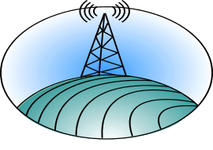






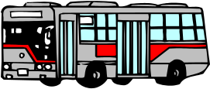

Sand Beach
Next Bus 10 Min.
Acadia National Park Dispatcher
Park Ranger
Island Explorer
Operations - Server/
Dispatcher
Roadway/
Traffic Emergencies
Roadway/
Traffic Emergencies
Cadillac Mountain
RF Repeater
Acadia National
Park Server
Sensor Data
Welcome to Acadia National Park
Acadia National Park Field Operational Test
Sensor Data - Vehicles Entering/ Exiting Park
Sensor Data -
Vehicles in Lot
Routing and
Schedule Adherence Data
Traveler Information Advisory
Interactive Voice Response Phone System
Park Rangers
INTERNET
People Planning Trip to Park
Visitors En-route to Park/MDI
Visitors in Park
Travel/
Park Information
Travel/Park Information
CCTV Imagery
Phone Line/ Wireline
CCTV Imagery -
Vehicles in Lot
island
explorer
Sand Beach
Voice - Traffic/ Service Information
AVL Data
Park Messages
Geo-Location Data
Voice/ Data To/From Buses
Real-Time Arrival System
IVR via
511 System
Park IVR & 511
INTERNET

Figure 2-1: System Architecture for ITS FOT at Acadia National Park

3.0 Evaluation Approach
An approach to evaluation is based on many considerations, such as the goals of the project, the timeframe for assessment, and the resources available for the investigation. For the Acadia ITS FOT a multi-step process enabled the evaluation team to identify and prioritize those goals and develop an evaluation plan that could be used to assess the impact of ITS toward achieving those goals. Based on the collective feedback of the FOT stakeholders, the overriding impact of the ITS technologies should be to reduce vehicle congestion in Acadia National Park. Reduced congestion will have the added benefits of increased mobility of visitors and residents, aesthetic and environmental benefits of fewer vehicles parked on roads, and safety benefits of less traffic and better emergency response.

In May of 2000 in a workshop setting local partners and representatives from the state and federal agencies met with the evaluation team to begin the process of evaluation planning. Despite the differences in the participant make-up of the workshop, the conclusions were very similar. There was considerable agreement among participants that customer satisfaction and mobility were higher in priority than the other goals. However, other goals for the evaluation (safety, efficiency, productivity and economic vitality, and energy and environment) also held some level of importance among the stakeholder organizations and should not be ignored. These results were formalized in an evaluation strategy document.

Utilizing the evaluation strategy the evaluation team formulated an evaluation plan specifying what aspects of the ITS project would be assessed, how, when, and the methods to be used for collecting data. Subsequently, for each evaluation test to be conducted, a detailed test plan was developed and included the specific protocols (e.g., survey questionnaire) and details on responsibilities and resources. The overall evaluation approach was based on several evaluation tests that combined primary and secondary data collection and analyses. Table 3-1 lists the seven evaluation tests and the six goal areas to which they chiefly applied.
Table 3-1: Evaluation Tests and Goal Areas to Which They Applied
Test | Customer Satisfaction | Mobility | Efficiency | Productivity & Economic Vitality | Energy & Environmental  Impact | Safety
Visitor Survey | √ | √ |  | √ | √
Business Survey |  |  |  | √
Key Informant Interviews | √ |  |  |  |  | √
Parking Lot Observation |  |  | √ |  | √
Island Explorer Operations |  |  | √ | √ | √ | √
Acadia National Park Records |  |  | √ | √ | √ | √
Maine State Government Records |  |  | √ | √ | √ | √

3.1 Methodologies Used for Data Collection
A variety of methods were used to collect data for assessing the impacts of ITS. For some of the data, two collection points were used, a “before” and “after” period. Details on each method are available in the individual test reports, but they can be briefly summarized as follows:
Visitor Survey
Between July 29 and September 1 of 2002 an intercept survey of visitors at various locations within Acadia National Park and on the Island Explorer bus was used to solicit visitors for a mail-back survey. A total of 1278 adults agreed to the mail-back survey, and 928 usable questionnaires were returned for a 74 percent response rate. The visitor survey collected primary data on user awareness and satisfaction with the ITS technologies. For baseline data use was made of several recent previous surveys of Park visitors and users of the Island Explorer buses.

Business Survey
In the Fall of 2002 a survey of businesses on Mount Desert Island was conducted. Using mailing lists supplied by the local Chambers of Commerce, 454 questionnaires were mailed to business, and 257 usable questionnaires were returned for a response rate of 60 percent. The survey gathered information on business perceptions of the Island Explorer bus system and awareness, use and benefits associated with the ITS technologies.
Key Informant Interviews
Key informants consisted of two groups. The first were representatives of the two organizations with direct operational responsibility for the ITS technologies—Acadia National Park managers and rangers and Island Explorer managers and drivers. The second group consisted of other stakeholders who had been involved in the planning of the FOT from the beginning, such as Maine DOT and Friends of Acadia. A total of 16 personal interviews were conducted in the Fall of 2002 to gain an in-depth perspectives on issues affecting deployment and use of the technology.
Parking Lot Observation
Direct observation of eight designated parking areas took place in Acadia National Park during the summer tourist seasons of 2000, 2001, and 2002. The objective was to identify the number of parked vehicles that exceeded the official capacity of each lot, either within the parking lot itself or on adjacent roads. Using a random sample scheme, each lot was observed once in the morning and once in the afternoon between 10 AM and 2 PM. The data provided objective measures of the potential impact of the ITS technologies on visitors’ parking patterns within the Park.
Island Explorer Operations
Data on operations of the Island Explorer were obtained from the management staff for the years 1999 through 2002. Data covered a range of operational measures, such as operating expenses, ridership measures, fleet size, miles and hours of operation. The implementation of the ITS technologies in 2002 enabled management staff to retrieve some of the operational data directly from the system that had previously been stored in less convenient manual form.
Acadia National Park Records
The Park regularly keeps records to measure its operations in various ways. The evaluation used its data on number of visitors, donations and gate receipts, and vehicular accidents within the Park. Data from 1999 through 2002 were obtained.
Maine State Government Records
The evaluation used data from several State Government agencies, including the Department of Transportation for traffic and accident data, Department of Revenue for sales tax data, and Department of Environmental Protection for air quality modeling data. Data covered the period 1999 through 2002.

Expected Impacts of ITS

ITS technologies were deployed with the expectation they would have measurable impacts within the Park or Mount Desert Island. The impacts would be in the form of benefits or improvements realized by persons (e.g. tourist’s satisfaction with their visit), organizations (e.g. efficiency of Island Explorer operations), or society at large (e.g. number of accidents). For the purposes of the evaluation the impacts were stated as hypotheses that the evaluation team could test using the data from the one or more of the seven tests described in Section 3.1. Table 3-2 lists the hypothesized impacts according to the six evaluation goal areas and the associated objectives of the project. The list is not exhaustive of all potential impacts, but the impacts illustrate the type of effects that the project team and evaluation team anticipated at the outset of the evaluation and which expected to be measurable in some way. Sections 4.0 through 9.0 discuss the results of the evaluation in terms of the impacts observed in each goal area.

Table 3-2: Expected ITS Impacts by Six Goal Areas
Goal Area | Objective | Hypothesized Impact
Customer Satisfaction | To provide a more positive visitor experience through greater reliance on the Island Explorer for travel | Pre-trip traveler information services will divert visitors from using personal vehicles and to using the Island Explorer
Customer Satisfaction |  | Real-time arrival information on next Island Explorer bus will increase visitors’ willingness to use transit
Customer Satisfaction |  | Real-time information on parking lot conditions will increase visitors’ willingness to use transit
Customer Satisfaction | To provide a more positive visitor experience through information on parking availability | Real-time information on parking lot conditions will increase visitors’ ability to plan accordingly and to fulfill experience preferences
Customer Satisfaction | To provide a more positive visitor experience through efficient service | Tourists who use ITS feel less stress and worry due to service operations
Customer Satisfaction | To provide useful and timely information for the transportation provider | ITS technologies will have positive benefits/effects on Island Explorer driver jobs, Island Explorer operations, and interagency relationships
Mobility | To increase visitors’ ability to access desired destinations and activities | Pre-trip traveler information services will cause visitors to view Island Explorer as the most reliable and easy means to experience ANP/MDI.
Mobility |  | Tourists who use traveler information are more aware of travel options than those who do not use traveler information
Mobility |  | Tourists use alternate routes or travel modes due to traveler information
Mobility |  | Tourists perceive that they have increased access as a result of their use of traveler information
Mobility |  | Tourists who use traveler information perceive fewer problems with congestion and parking that might prohibit them from visiting certain destinations and activities
Productivity  and Economic Vitality | To provide a more positive visitor experience and increased visitation | ITS users stay longer than non-ITS users
Productivity  and Economic Vitality | To reduce or optimize operating budget of the Island Explorer | Better real-time data will allow IE management to react to dynamic changes more efficiently and thereby more cost effectively
Productivity  and Economic Vitality | To increase economic contribution to Mount Desert Island and Acadia National Park | ITS attracts visitors and enables higher revenue capture during stay
Productivity  and Economic Vitality | To maximize Acadia National Park revenue | ITS will provide better information that will ensure that visitors pay Park fees and make contributions
Productivity  and Economic Vitality | Attract carless tourist segment | Tourists arriving without cars will be attracted by ITS-enabled mobility
Efficiency | To increase the number of customers served | ITS provides better operating information, which allows for more efficient deployment of resources to a greater number of Park visitors
Efficiency | To distribute the demand on Acadia National Park resources more evenly | Better information availability allows for visitor pre- and on-trip planning so that parking lots usage is more balanced
Efficiency | To increase Island Explorer efficiency in managing its operations | ITS will provide better operating information to enable better scheduling and to serve more passengers with the same equipment
Energy and Environmental Impact | To reduce emissions from motor vehicles on Mount Desert Island | ITS-improved Island Explorer service will result in fewer trips by private vehicle and a consequent improvement in air quality
Energy and Environmental Impact | To provide a more positive experience for visitors through enhanced aesthetics of Acadia National Park | ITS-improved Island Explorer service will result in fewer vehicles parked on ANP roads, thereby improving the visual aesthetics of the Park
Safety | To increase transportation safety in Acadia National Park and Mount Desert Island | ITS will reduce vehicular traffic on roads thereby reducing the number of accidents
Safety |  | ITS will reduce hazardous conditions by better management of transportation resources

4.0 Customer Satisfaction
This section examines customer satisfaction with ITS principally from the point of view of the end users or customers, who are mostly visitors to the area. With only 6% of the persons surveyed being year-round or summer residents of Mount Desert Island, the term visitors will be used for convenience throughout this report to describe customers who were studied in this evaluation unless otherwise noted. Figure 4-1 shows the survey respondents by place of residence. Respondents tended to have the following additional characteristics:

- Well-educated (67% Bachelor’s degree or above)
- From the Northeast states (63%)
- From small towns or cities with less than 100,000 population (75%)
- Arrived in groups of two or three (59%) and usually with family (78%)
- Technology friendly (84% Internet familiar and 73% carrying cell phones)
- Arrived by private vehicle (>90%) and tended not to be transit users at home (87%)
- Stayed four or more nights (63%) and spent over $300 during their stay (50%)

N=928
Other Maine
residents
8%
Out-of-state visitors
86%
Mount Desert
Island
Year-round or
Summer residents
6%
Figure 4-1: Proportion of Survey Respondents by Residence

In addition to visitors, the satisfaction of a second set of customers of ITS was also examined. They are the members of the project team who planned, deployed, and used the ITS technologies to various degrees. Thus, the evaluation takes a look at their satisfaction with ITS in the Field Operational Test.

This section of the report draws on the visitor survey and the key informant interviews, described briefly in Section 3.1. Complete details on methodology and discussion of results can be found in the individual test plan reports.

4.1 Role of ITS in the Visitor Experience
Maintaining or improving visitor experience was seen as the most important gauge of success for the ITS FOT by local project team members, and, therefore, assessment of customer satisfaction was a primary focus of the evaluation. As a popular tourist destination, Acadia National Park consistently receives high marks from visitors in terms of satisfaction with their visit. In 1998, 65% of individuals reported that they had a “very good” and 31% had a “good” experience. In 2002 the evaluation survey figures were even higher: 80% “very good” and “18%” good. Nevertheless, when asked to rate their travel experience during their visit, only 60% of those same visitors in 2002 rated travel as very good. Thus, against this backdrop the evaluation set out to determine the role that ITS had played in visitor experience and its future potential.

Visitors had the opportunity to come into contact with ITS through various forms of traveler information, including information on parking lot availability on signs at the Visitor Center and two campgrounds within the Park; parking lot information on the Acadia National Park Website; electronic bus departure signs at the Village Green, Visitor Center, and Jordan Pond House; and automated announcements of next stops on-board the Island Explorer. Figures 4-2 through 4-7 illustrate these ITS components. An important goal of the ITS technologies was to enhance the visitor’s experience and to divert visitors from using their private vehicles to using the Island Explorer bus for traveling around Mount Desert Island and in Acadia National Park. It was expected that ITS technologies would contribute to a more positive visitor experience and willingness to use transit by providing real-time information on parking lot conditions, real-time information on departures of the next Island Explorer bus, and traveler information on-board buses through the announcements of the next bus stop.

4.2 Awareness and Use of Traveler Information
During the initial contact by the evaluation team within the Park, visitors were asked about their awareness and use of various sources of traveler information including the four ITS-based sources. Table 4-1 shows the proportion of visitors who reported that they were aware of and the proportion of visitors that had used different sources of traveler information. Over half of the visitors (55%) reported being aware of the parking availability travel information. Thirty percent of the visitors reported that they used the information for their travels. It should be noted that the parking availability reflected the designated parking lots at Sand Beach and Jordan Pond only. The status of parking lots being full did not necessarily restrict visitors from gaining access to these attractions. Visitors could park along the 2-lane one-way section of the Park loop road and walk to the Sand Beach area. Also, visitors could park along the Park loop and boat access roads to gain access to the Jordan Pond House. Direct observation of the parking conditions at these locations indicated this was a common practice for visitors when parking lots became full. Some visitors may have realized these areas were still accessible by privately owned vehicles and, despite knowing the condition of the parking lots, did not plan to use the information.

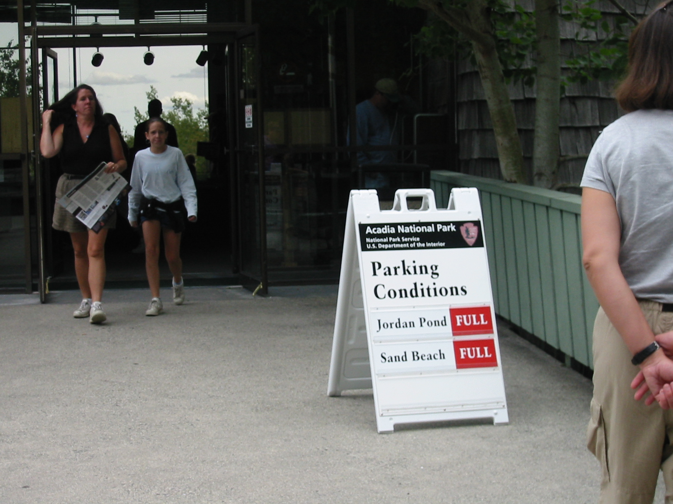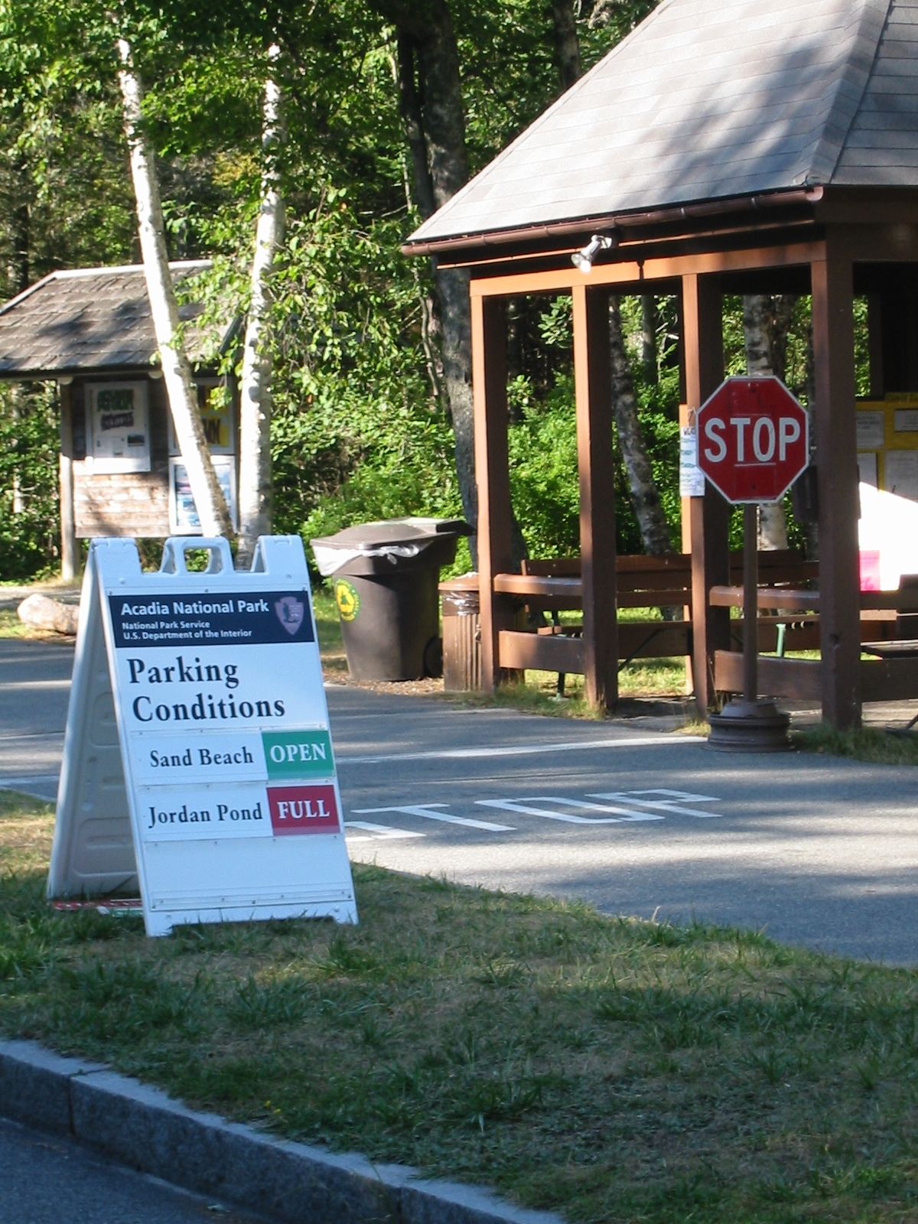
Figure 4-2: Parking Lot Information Sign Figure 4-3: Parking Lot
at Visitor Center Information Sign at
Seawall Campground

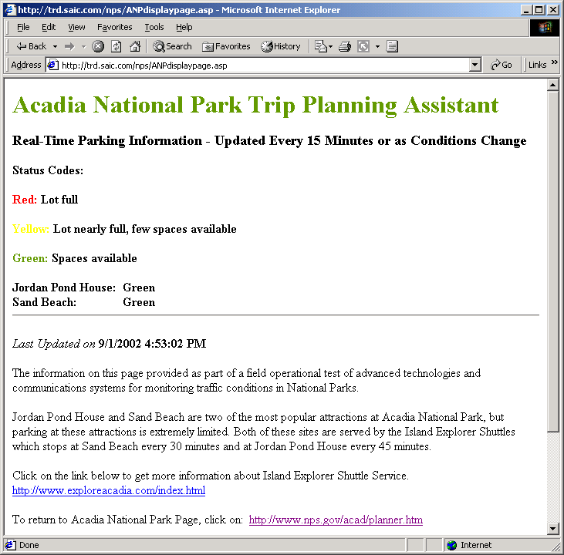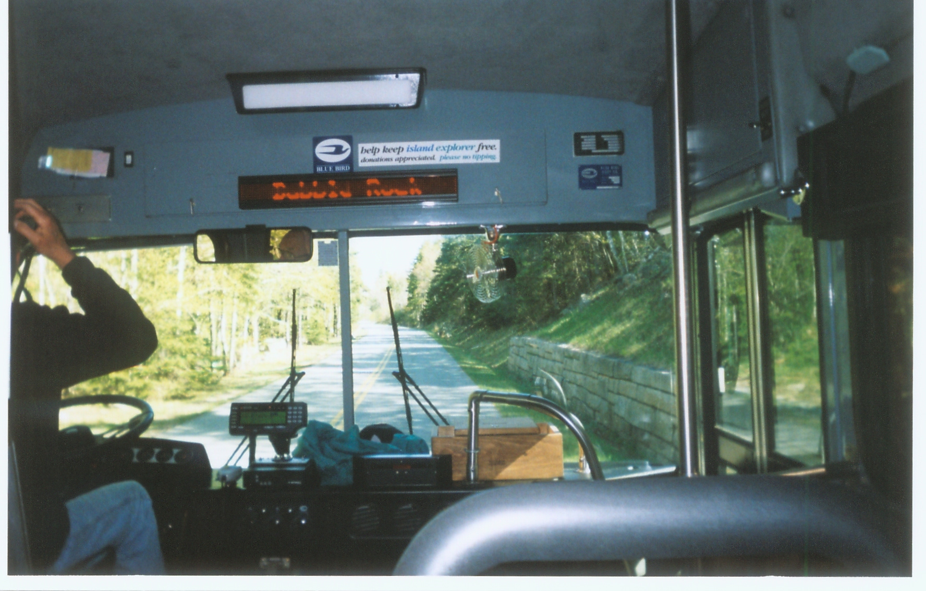
Figure 4-4: Parking Lot Information Figure 4-5: Automatic Annunciator Text
on the Acadia National Park Website Display On-board the Island Explorer Bus
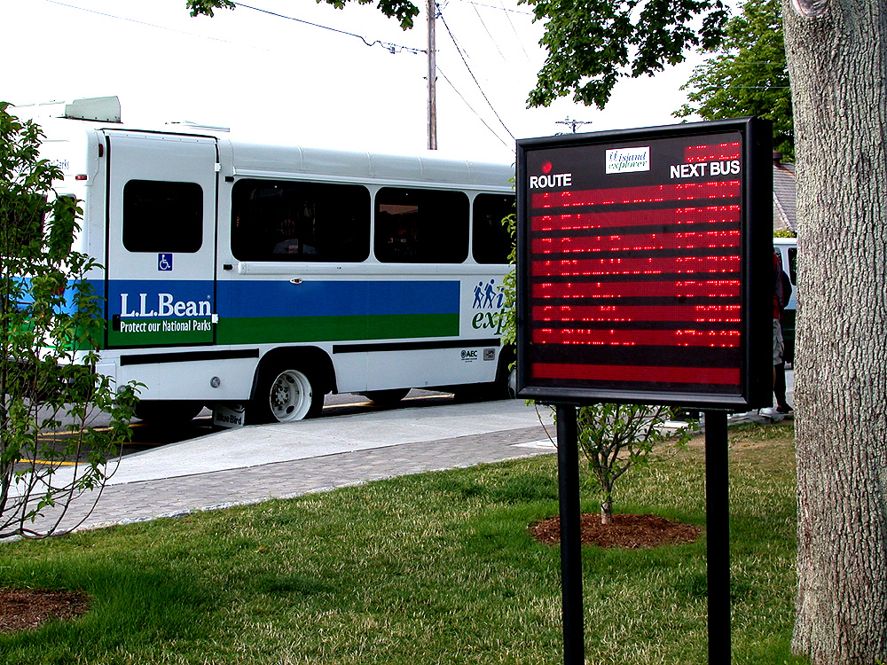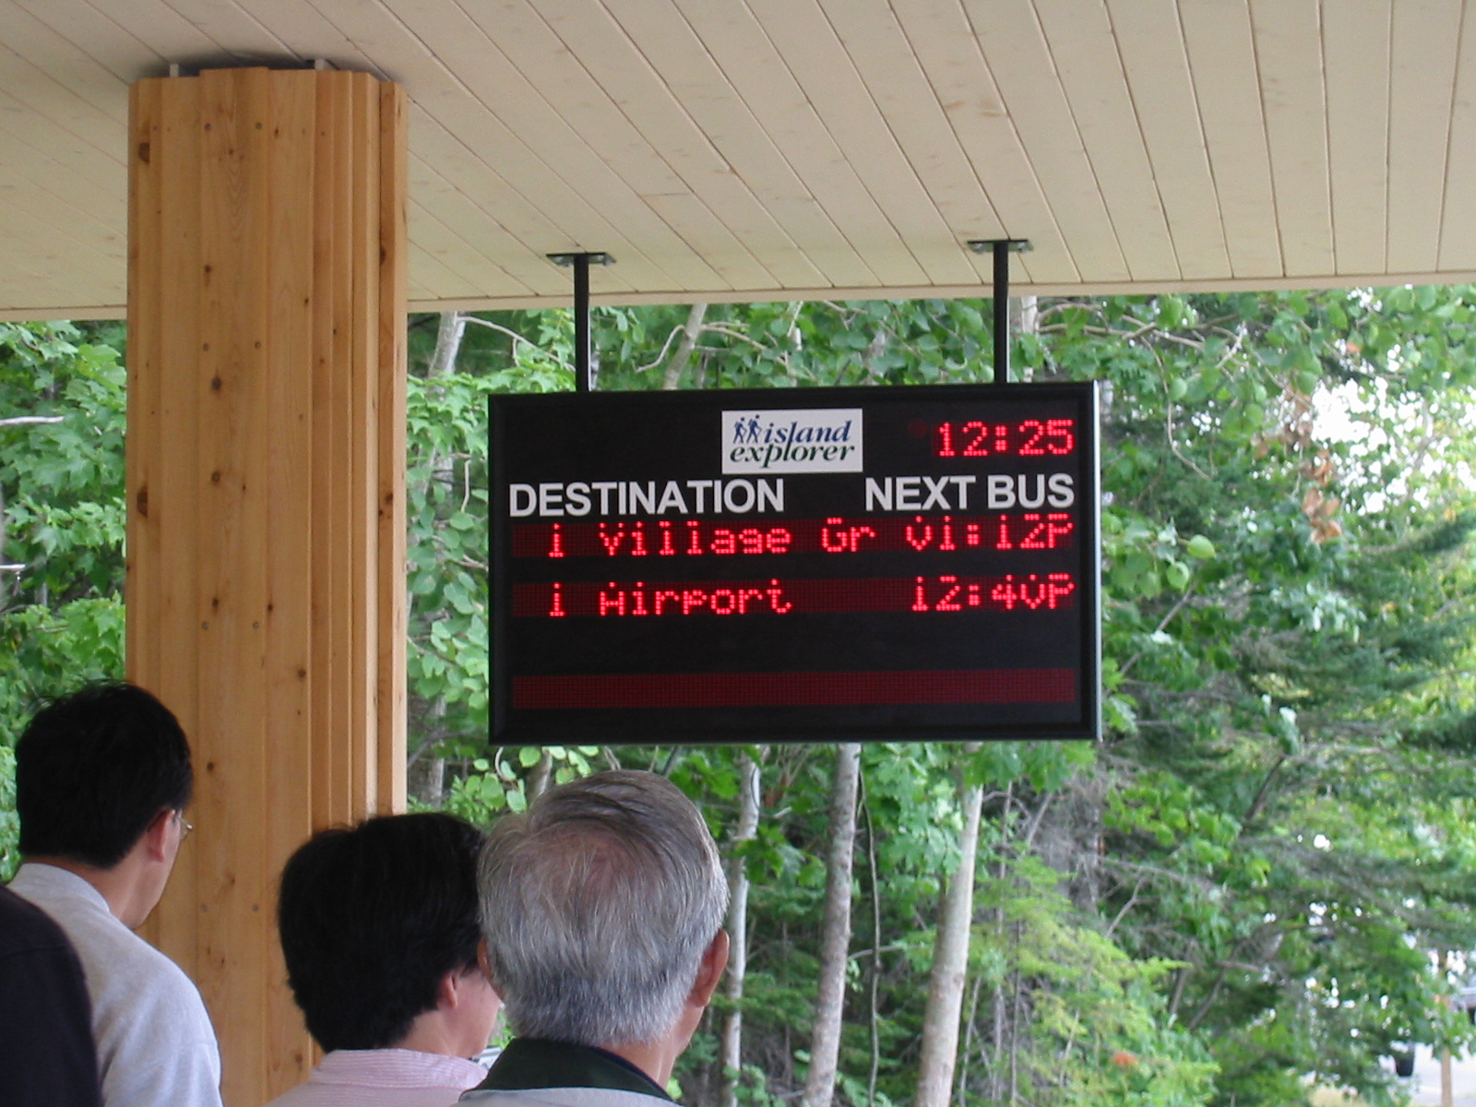
Figure 4-6: Electronic Bus Departure Sign Figure 4-7: Electronic Bus Departure Sign
at Village Green at Visitor Center

Table 4-1: Percent of Respondents* Who Were Aware of

and Used Travel Information Sources?
Source of Information | Aware | Used
Parking availability (Park staff/signs) | 55 | 30
Electronic Island Explorer departure signs | 49 | 28
Acadia National Park Website | 42 | 31
Island Explorer automated annunciator | 40 | 34
Island Explorer Website | 8 | 5
Park traveler information (telephone system) | 2 | 1
* Based on 1278 respondents to the intercept survey within the Park.

Nearly 50% of the visitors were aware of and 28% planned to use the electronic bus departure signs. Forty-two percent of visitors were aware of the Acadia National Park Website and a relatively high percentage of visitors (31%) used this source for planning trips. A small percentage of visitors (2%) reported being aware of traveler information using the Park’s telephone system, although that would have been for general travel information since the ITS telephone component was not deployed during the evaluation period. Finally, caution should be used in projecting these results to Park visitors in general. Answers reflect visitors sampled at many locations having one or more of the traveler information sources. For example, all visitors contacted on the Island Explorer buses would have been exposed to the automated annunciator.

As reported above, visitors rated travel experience less highly than the overall experience of their visit to Acadia and Mount Desert Island. Table 4-2 delves more deeply into the nature of their concerns about travel. Visitors rated problems differently based upon the combination of ITS components used and if visitors used the Island Explorer bus. Therefore, four distinct visitor groups are displayed in the table below that include three sub-groups of ITS users and one group of non-users: (A) visitors who used the traveler information for Island Explorer buses such as the real-time departure of buses but not the availability of parking at Sand Beach and the Jordan Pond House (n=273); (B) visitors who used both traveler information related to Island Explorer buses as well as the availability of parking (n=182); (C) visitors who used parking availability information but no bus traveler information (n=175); and (D) the group of visitors that neither used the parking nor bus information (n=279).

In Table 4-2 visitors’ ratings of problems are shown according to the mean for each group and the rank of the problem that the mean represents within each group. A statistical technique known as analysis of variance (ANOVA) was used to test the difference between ITS user and non-user groups. For each question asked of respondents, ANOVA tests the variance (squared version of the standard deviation) for each group to identify statistically significant differences. Statistical significance is indicated by the probability (p) that the difference observed occurred by chance. The smaller the probability, the more likely the observed difference between the means of two groups is real rather than random and is, therefore, statistically significant.

Table 4-2 illustrates that the concern that gave rise to lower travel experiences was not uniform among the four visitor segments. For example, visitor concern about “vehicles parked along main roads causing unsafe conditions” ranked number one for all visitor groups. However, certain visitor groups such as the ITS users of the bus and the bus and parking information rated this as more of a problem than the ITS users of parking information or ITS non-users. The perceived unsafe conditions may have influenced visitors to seek out and use traveler information. Visitors also differed in terms of their travel experiences using a personal vehicle in Acadia National Park. Visitors identified as using one or more of the ITS components generally tended to encounter more parking problems when using their personal vehicle in Acadia National Park. Thus, a conclusion to be drawn is that ITS-users were more concerned about travel issues and sought means to alleviate those concerns via ITS and Island Explorer. Non-users, on the other hand, were either less sensitive to travel conditions or had strategies for coping with problems that didn’t involve the need for Island Explorer or ITS.

Issue | ITS User |  |  |  |  |  |  | ITS Non-User  (n=279) |  | ANOVA**  Results | p=
Issue | Bus  (n=273) |  |  | Bus & Parking  (n=182) |  | Parking  (n=175) |  |  |  | ANOVA**  Results | p=
Issue | Mean | Rank | Mean |  | Rank | Mean | Rank | Mean | Rank | ANOVA**  Results | p=
Issue | (A) |  | (B) |  |  | (C) |  | (D) |  | ANOVA**  Results | p=
Vehicles parked along main roads causing  unsafe conditions | 2.45 | 1 | 2.32 |  | 1 | 1.99 | 1 | 2.05 | 1 | A,B>C,D | .0001
Too many automobiles outside of Park | 2.41 | 2 | 2.15 |  | 4 | 1.82 | 3 | 1.92 | 2 | A>D,C  B>C | .0001
Too many automobiles in the Park | 2.38 | 3 | 2.27 |  | 3 | 1.92 | 2 | 1.90 | 3 | A,B>C,D | .0001
Too many automobiles impacting air  Quality | 2.37 | 4 | 2.27 |  | 2 | 1.71 | 4 | 1.72 | 5 | A,B>C,D | .0001
Too many RVs in the Park | 1.99 | 5 | 1.84 |  | 5 | 1.62 | 7 | 1.67 | 6 | A>C,D | .0001
Too many people in the Park | 1.91 | 6 | 1.82 |  | 6 | 1.67 | 5 | 1.75 | 4 | A>D | .050
Too many tour buses in the Park | 1.62 | 7 | 1.57 |  | 8 | 1.49 | 8 | 1.47 | 8
Ability to fully access desired recreation  opportunities in the Park | 1.55 | 8 | 1.61 |  | 7 | 1.65 | 6 | 1.51 | 7
Ability to access desired attractions outside  the Park | 1.44 | 9 | 1.40 |  | 9 | 1.48 | 9 | 1.41 | 9
Not enough travel information to plan trips | 1.34 | 10 | 1.27 |  | 10 | 1.37 | 10 | 1.30 | 10
Seeing electronic signs | 1.24 | 11 | 1.13 |  | 11 | 1.22 | 11 | 1.23 | 11
Too many Island Explorer buses in the  Park | 1.09 | 12 | 1.08 |  | 12 | 1.20 | 12 | 1.18 | 12 | C>A,B | .005
Table 4-2: Visitor Ratings of Problems Related to Travel on Mount Desert Island and in Acadia National Park*
* Possible responses: 1 = Not a problem; 2 = Small problem; 3 = Moderate problem; and 4 = Big Problem.
n = number of visitors in the subgroup
**Analysis of variance (ANOVA) is a test to identify significant pair-wise differences between means. “p” is the probability that the difference could have occurred by chance.

Since most visitors (83%) reached Mount Desert Island with a car, truck, or motor home/RV, visitors’ experience in using a personal vehicle during their visit is important. Table 4-3 shows that visitors with personal vehicles rated travel experiences differently based upon the combination of ITS components used. Visitors who used parking information were much more likely to disagree with the statement “I know the area well enough so I don’t need travel information” than visitors who used only the bus ITS information and ITS non-users. Users of parking information were also much more likely to agree with the statement “more information would have made it easier to get to attractions.”

Concerns about difficulty of using their own vehicle may have induced visitors to take advantage of the Island Explorer, as bus ITS users were more likely to:

- disagree that “it is easy to avoid traffic congestion in Acadia National Park”
- agree that “I had some worry about driving and parking along busy roads”
- disagree that “it was easy to find parking in Acadia National Park”
- disagree with the statement “Overall, I was pleased with travel conditions on this trip”
- disagree that “it was easy to plan trips inside Acadia National Park using my personal vehicle.”

It should be noted that these ratings are based on the reported experiences of visitors who used their personal vehicles for part or all of travel during their visit. It would appear that those visitors who used none of the ITS-based sources of traveler information had fewer concerns with using their vehicle during their visit than those who used the parking, bus, or both types of ITS traveler information. Thus, once again a pattern emerges that those visitors least concerned about problems associated with using their own vehicles within the Park are also the least likely to use the ITS sources of traveler information. Conversely, visitors who use ITS traveler information may do so to help alleviate problems they perceive with using their own vehicle.

Table 4-3: Visitor Ratings of Travel Experiences Using a Personal Vehicle*
Issue | ITS User |  |  |  |  |  | ITS Non-User  (n=264) |  | ANOVA  Results | p=
Issue | Bus  (n=173) |  | Bus & Parking  (n=142) |  | Parking  (n=167) |  |  |  | ANOVA  Results | p=
Issue | Mean | Rank | Mean | Rank | Mean | Rank | Mean | Rank | ANOVA  Results | p=
Issue | (A) |  | (B) |  | (C) |  | (D) |  | ANOVA  Results | p=
I know the area well enough so I don’t  need travel information | 3.04 | 1 | 3.57 | 1 | 3.65 | 1 | 3.21 | 1 | B,C>A,D | .0001
More information would have made it  easier to get to attractions. | 3.02 | 2 | 2.69 | 5 | 2.83 | 3 | 3.03 | 3 | A,D>B,C | .003
It is easy to avoid traffic congestion in  Acadia National Park | 2.92 | 3 | 2.77 | 3 | 2.43 | 4 | 2.55 | 4 | A>C,D  B>C | .0001
I had some worry about driving and  parking along busy roads | 2.85 | 4 | 2.84 | 2 | 3.24 | 2 | 3.37 | 2 | C,D>A,B | .0001
It is easy to find parking in Acadia  National Park | 2.85 | 5 | 2.77 | 4 | 2.31 | 5 | 2.42 | 5 | A,B>C,D | .0001
Overall, I was pleased with travel  conditions on this trip | 2.40 | 6 | 2.37 | 6 | 2.00 | 6 | 2.03 | 6 | A,B>C,D | .0001
It was easy to plan trips inside Acadia  National Park using personal vehicle | 2.30 | 7 | 2.26 | 7 | 1.88 | 7 | 1.90 | 7 | A,B>C,D | .0001
Overall, I was pleased with travel  conditions on a previous visit | 2.26 | 8 | 2.16 | 8 | 2.05 | 8 | 1.99 | 8

* Possible responses: 1 = Strongly agree; 2 = Agree; 3 = Neutral; 4 = Disagree; and 5 = Strongly Disagree
n = number of visitors in the subgroup
**Analysis of variance (ANOVA) is a test to identify significant pair-wise differences between means. “p” is the probability that the difference could have occurred by chance.

4.3 Customer Satisfaction Among ITS Users

As demonstrated in the preceding section, non-users of ITS did not necessarily have a more negative experience with travel during their visit than users of the ITS-based traveler information. Rather their perceptions of travel problems differ and they apparently use different solutions to dealing with those problems. Nevertheless, as will be discussed in this section, ITS users derived definite benefits from ITS, which contributed positively to their visitor experience. By focusing on the ITS users, an appreciation of the benefits they derived can be achieved.

Clearly the ITS technologies were well received and had a positive impact on visitors. Each of the technologies is discussed individually below. In addition, results are presented that reveal how satisfaction with ITS contributed to visitors’ use of the Island Explorer during their visit.

Parking Information Signs

Thirty-seven percent of visitors obtained parking condition or traffic information at the Acadia National Park visitor center, campgrounds, or Website. They rated the information on a number of criteria such as how accurate and helpful the information was to the visitor and if they would use the information again.

Figure 4-8 shows a high level of agreement among users that the parking conditions or traffic information was accurate. Eighty-six percent said they “strongly agreed” or “agreed” with the statement “I found the information to be accurate.” Similarly, 93% of the users could clearly understand the parking or traffic information and nearly all visitors (91%) rated the parking condition or traffic information as easy to use.

Many visitors felt they benefited from the parking information, as a relatively high proportion of users (62%) thought that the parking conditions or traffic conditions helped to relieve tension and stress related to travel (Figure 4-9). Twenty-seven percent of the users “strongly agreed” that it helped to relieve tension and stress related to travel. However, roughly the same proportion of users (29%) was uncertain the information helped to relieve tension and stress related to travel. Eight percent of the users disagreed that the information helped to relieve tension and stress related to travel.

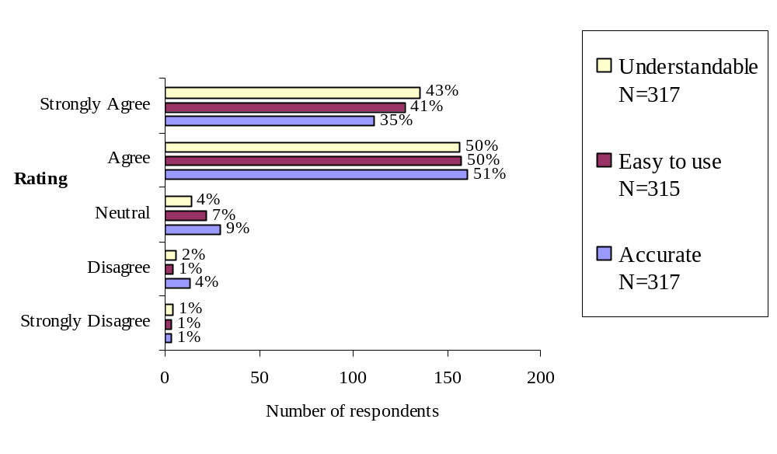

Figure 4-8: Respondents’ Agreement with Features of
Parking Information Signs

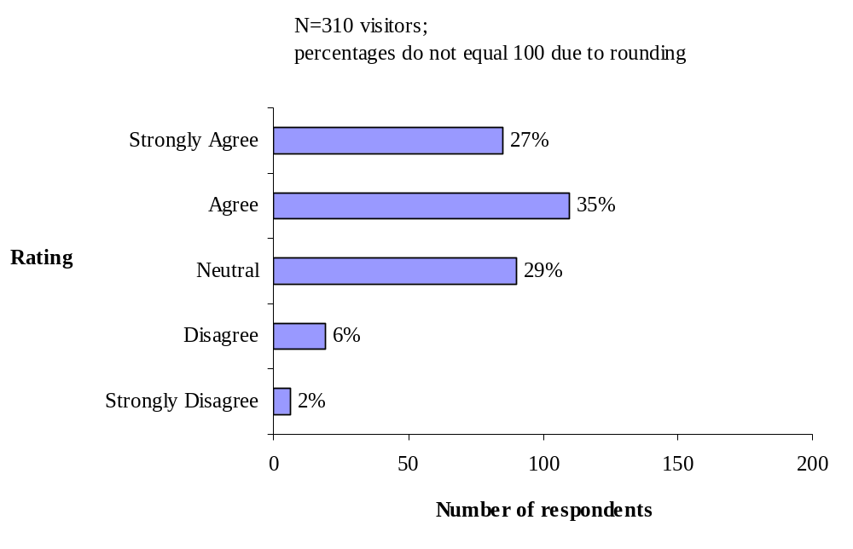

Figure 4-9: Respondents Agreement That Parking Conditions Information
Helped to Reduce Tension and Stress Related to Traveling

Another measure of the success of the parking information is whether visitors would want to use such information on a future visit. When asked about using the information again 78% agreed they would and 81% believed that using the information in the future would be a pleasant experience.

Thus, despite the fact that parking information was available only for two heavily used parking lots and that it was displayed in a “low tech” manner in only four locations, visitors who used the information reacted positively to it. The Park may want to consider expansion and automation of information on parking conditions from the standpoint of customer satisfaction.

Real-time Bus Departure Signs

Half of the visitors that were sampled and agreed to receive and complete the traveler survey reported using the Island Explorer bus and the associated travel-related information. The ITS travel-related information involved an automated annunciator for the Island Explorer bus that transmitted an audio message and displayed the next bus stop. Also, electronic signs displayed real-time departures of the next Island Explorer bus at the Visitor Center and Jordan Pond House bus stops in Acadia National Park and at the Village Green in Bar Harbor. The departure signs are discussed here and the on-board annunciators are covered in the next section.

Figure 4-10 shows a high level of agreement among visitors that the real-time departure signs were accurate and easy to read. Virtually all (96%) strongly agreed or agreed with the statement “I found the information to be accurate.” Visitors reported similar ratings (94%) on how easy it was to read the information displayed on signs and the ease of using the information (94%).

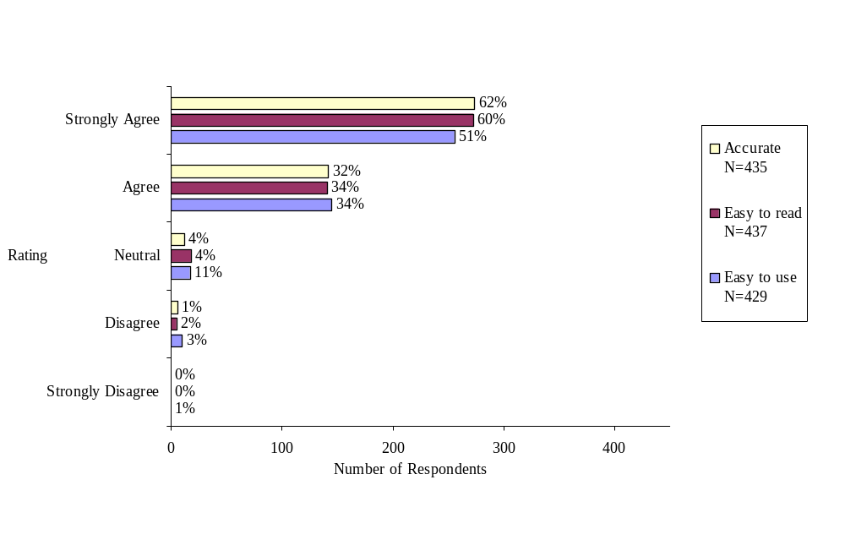

Figure 4-10: Respondents’ Agreement with Features
of Real-time Bus Departure Signs

The departure signs were definitely beneficial to visitors. A high proportion of users (85%) thought that the real time information helped to relieve uncertainty about when the bus would get to the bus stop (Figure 4-11). A similarly high proportion – 92% – would plan to use this information if they visited Acadia in the next 12 months and would find it a pleasant experience. Clearly the vast majority of visitors using the Island Explorer also used the bus departure signs, and they were more definite about the utility compared to users of the parking lot information signs. One reason might be that some visitors realized that parking might still be possible along the access roads even when Sand Beach and Jordan Pond were reported full.

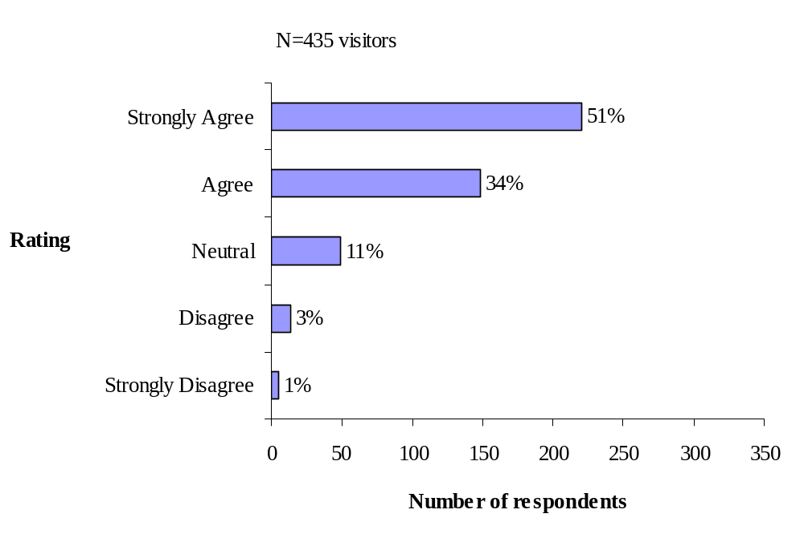

Figure 4-11: Respondents Agreement That Real Time Bus Departure Sign
Relieved Uncertainty When the Bus Would Arrive

Automated On-Board Announcement

Figures 4-12 and 4-13 show users’ evaluation of the traveler information system involving the automated announcements of next stops on-board the Island Explorer. Figure 4-12 shows a high level of agreement among users (95%) that the bus on-board information was accurate. Visitors reported similar ratings (92%) on how easy it was to read the bus stops displayed on signs on-board the bus. Most users (93%) also rated the real time information easy to use. Visitors were asked about the audio quality and timing of the announcements relative to the next stop and the results are displayed in Figure 4-13. Ninety-three percent of the users thought the bus on-board information was clear and understandable. Most users (95%) reported the volume of the announcements was loud enough to hear, and most (94%) thought the announcements were made early enough for them to exit the bus when needed. Thus, in terms of quality the on-board announcements were well received by visitors.

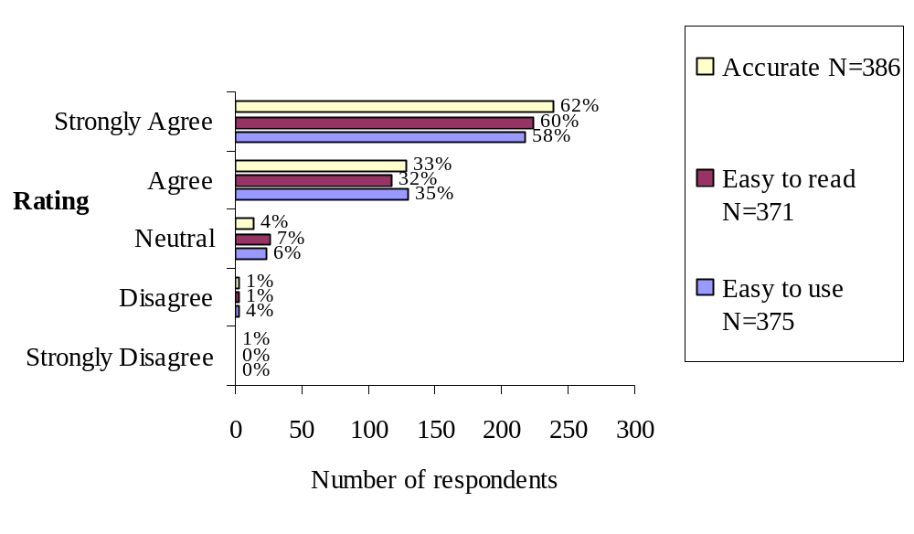

Figure 4-12: Respondents’ Agreement with Text Features of
Automated On-Board Announcements

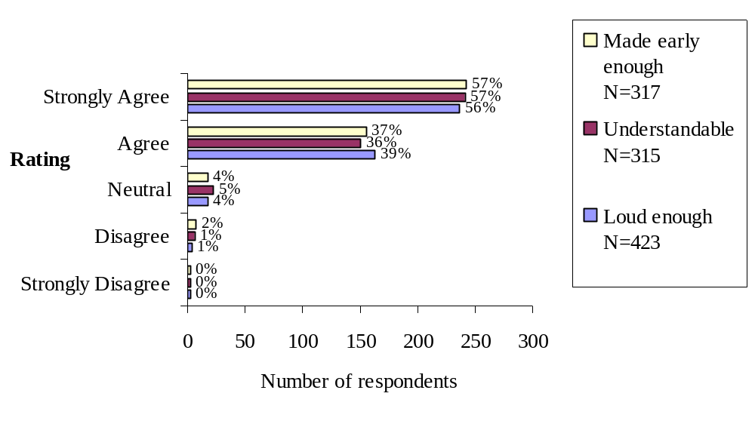

Figure 4-13: Respondents’ Agreement with Audio Features of
Automated On-Board Announcements

As with the other ITS-based travel information technologies associated with the Island Explorer, a high proportion of users benefited from the on-board announcements. As shown in Figure 4-14, 81% said it relieved uncertainty about when they would arrive at their bus stop, and a slightly higher proportion (89%) thought that the announcements relieved uncertainty about when to exit the bus (Figure 4-15). Moreover, 88% of the users would plan to use the information provided by the announcements if visiting in the next 12 months and 87% would find it a pleasant experience. Only 3% of the users disagreed and 1% strongly disagreed they would plan to use the information and future use would be a pleasant experience. Twelve percent of the users were uncertain if they would plan to use this information if visiting in the next twelve months.

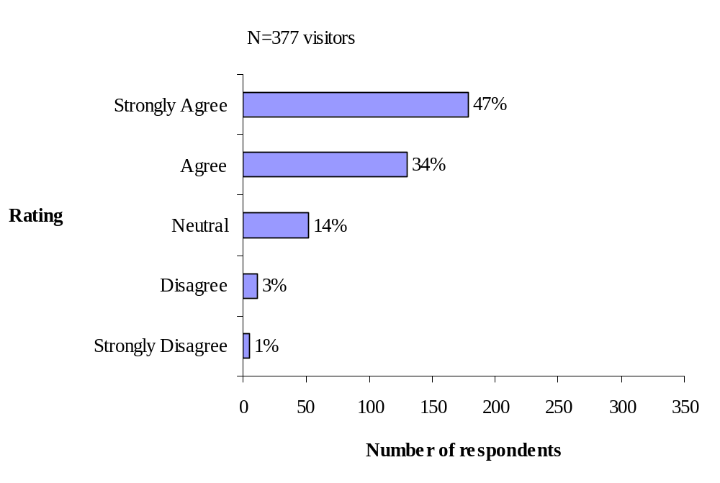

Figure 4-14: Respondents’ Agreement that Bus On-Board Announcements
Helped to Relieve Uncertainty About When the Bus Would Arrive at my Stop

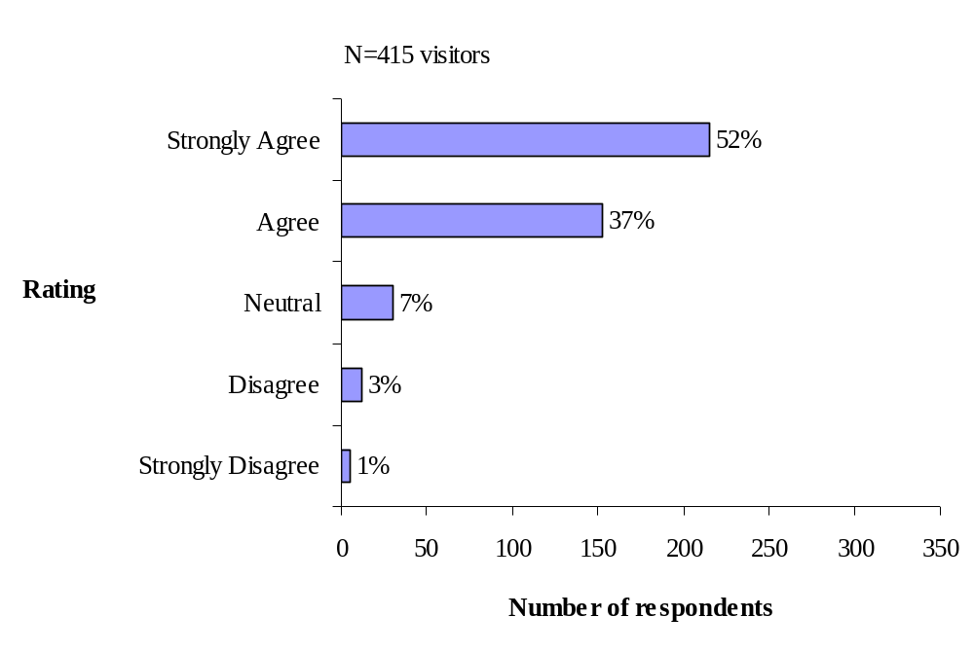

Figure 4-15: Respondents Agreement that Bus On-Board Announcements
Helped to Relieve Uncertainty About When to Exit the Bus

Impact on Visitors’ Use of Transit
One of the objectives of the field operational test was to use ITS to encourage visitors use of the Island Explorer and thereby reduce their use of personal vehicles during their visit. The preceding discussion revealed that visitors were generally quite satisfied with the ITS technologies. Thus, the question is how did that positive reaction to the ITS translate into usage of the Island Explorer? Figure 4-16 shows that 44% of the visitors who reported using real time parking information agreed that the information helped them decide to use the Island Explorer bus. Figure 4-17 shows that 80% of the visitors who reported using the bus and traveler information reported the real time bus departure displays helped them decide to use the Island Explorer Bus, and Figure 4-18 shows that 67% of the visitors who reported using the bus and traveler information reported the bus on-board announcements helped them decide to use the Island Explorer bus. Thus, it can be concluded that ITS plays an important role in influencing visitors’ decision to use transit. Since most (87%) visitors had reported that they tended not to use transit at home, ITS would appear to have been influential in making transit a comfortable alternative to their normal mode of travel.
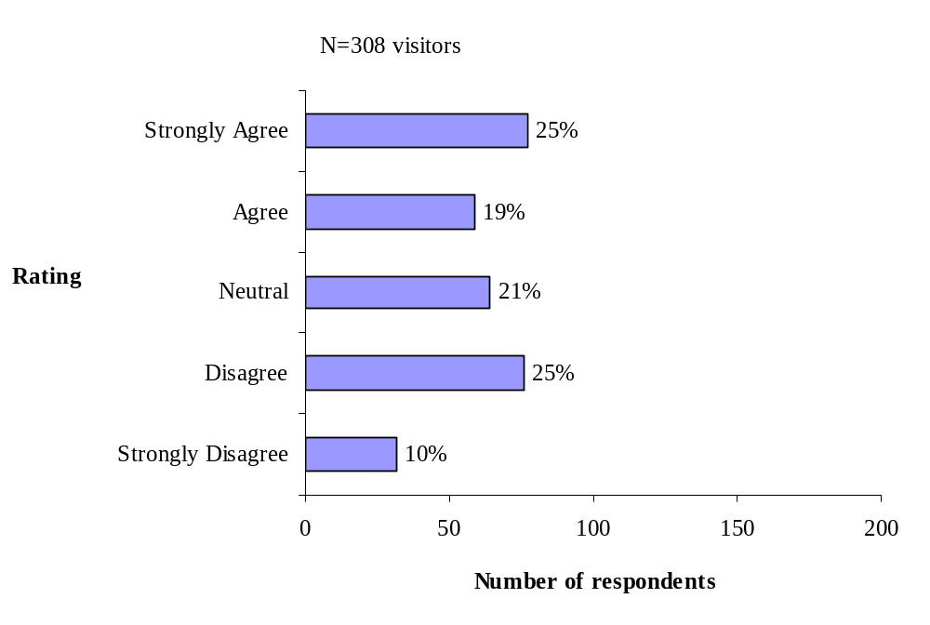

Figure 4-16: Respondents Agreement That Parking Information
Helped Me Decide to Use the Island Explorer Bus

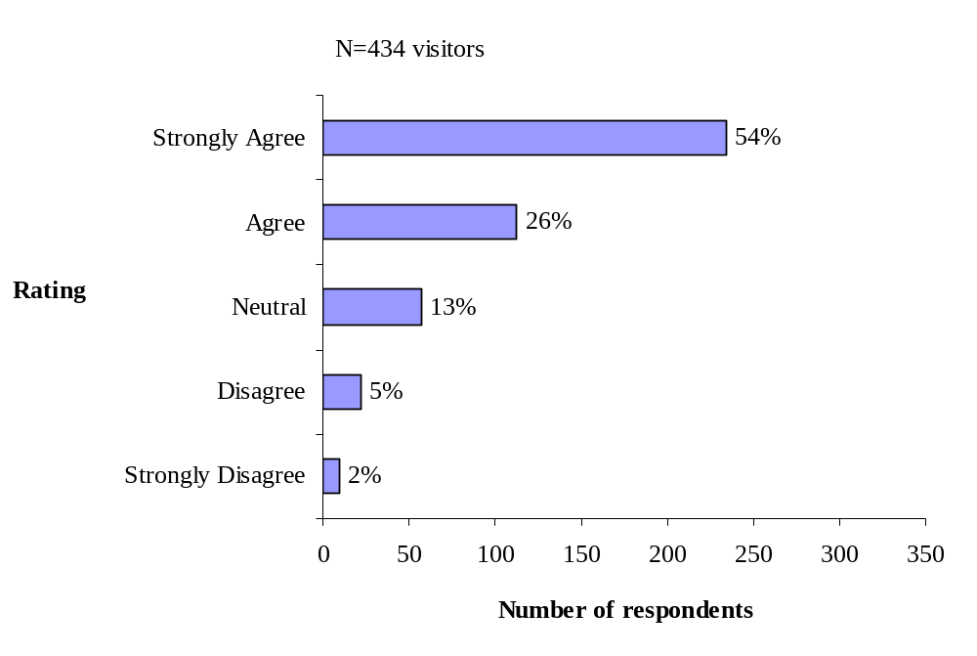

Figure 4-17: Respondents’ Agreement That Real Time Bus Departure Signs
Helped Me Decide to Use the Island Explorer Bus

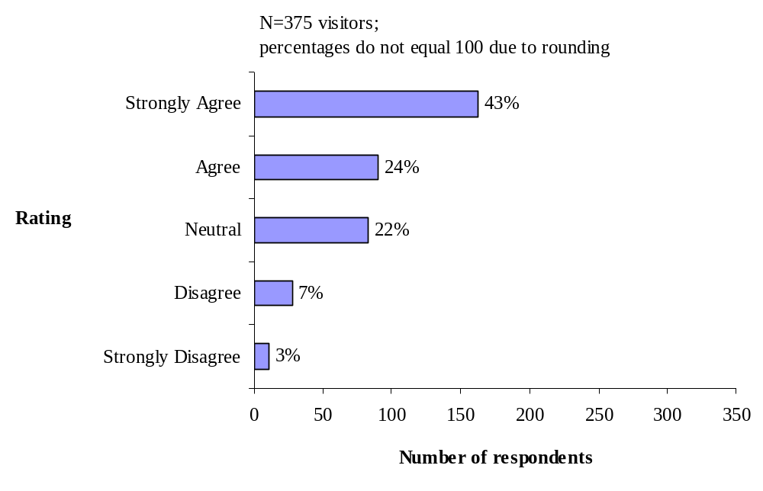

Figure 4-18: Respondents’ Agreement That Bus On-Board Announcements
Helped Me Decide to Use the Island Explorer Bus

Customer Satisfaction Among Members of the FOT Team
While satisfaction with the ITS technologies by visitors was of paramount interest in the evaluation of the Acadia ITS Field Operational Test, the views of persons involved in using the ITS technologies from an operational standpoint were important as well. Through individual interviews with staff of the Island Explorer and Acadia National Park, as well as other key stakeholders, an understanding of their satisfaction with the deployment was obtained. The Island Explorer personnel included the operations manager, lead dispatcher (who was also an experienced driver), one veteran driver, and one first year driver. The Acadia National Park personnel consisted of the Assistant Superintendent, Visitor Center staff member, rangers stationed at entrance stations and campgrounds, and law enforcement rangers. An additional five stakeholder representatives were interviewed, including persons from Maine Department of Transportation, Maine Department of Tourism, DownEast Transportation (operators of the Island Explorer), a Chamber of Commerce representative, and a representative from Friends of Acadia, a local advocacy group. The three groups of FOT team members are discussed separately below.
Satisfaction with ITS: Island Explorer Staff
Island Explorer staff experienced five ITS technologies on a daily basis: the voice communicator, the automatic vehicle locator, the departure signs, the automatic on-board annuciator, and the passenger counters on each bus. In addition, equipment and software in the Island Explorer dispatcher’s office enabled managers to track and manage the buses on a real-time basis. Figures 4-19 – 4-21 illustrate some of these technologies.
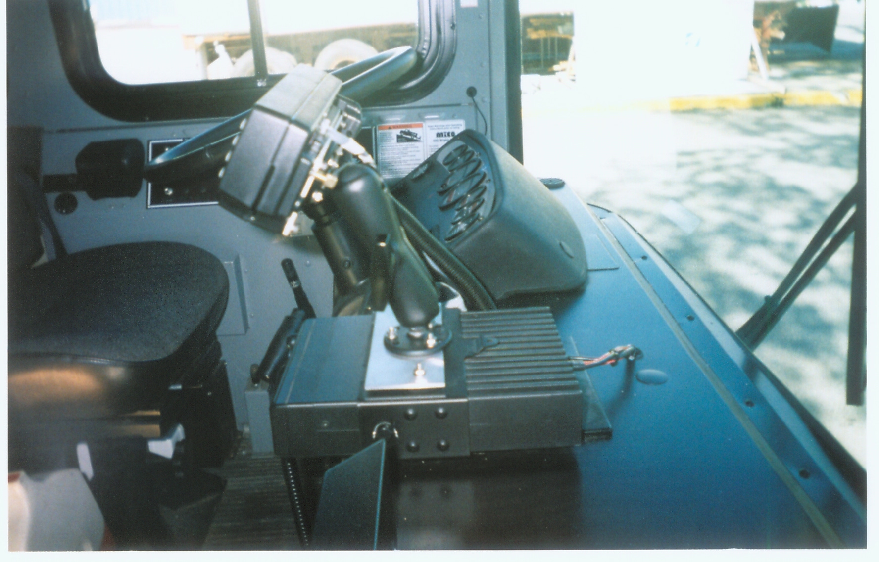
Figure 4-19: ITS Equipment Inside Island Explorer Bus:
Voice and Text Communications and Passenger Counter
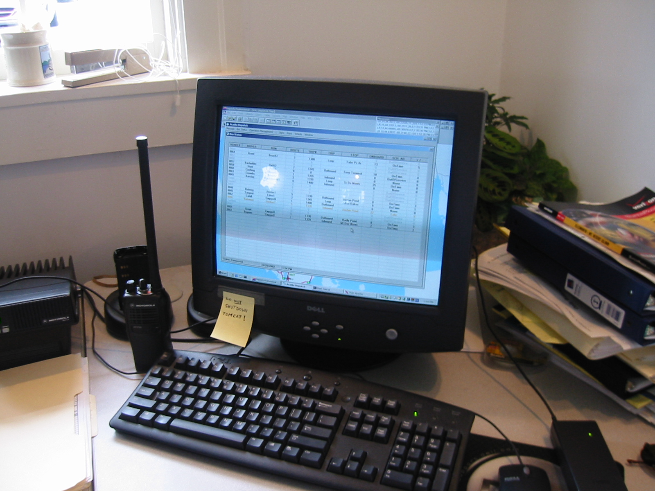
Figure 4-20: Island Explorer Dispatcher’s Office
with Radio Voice Communications
and Bus Management Software

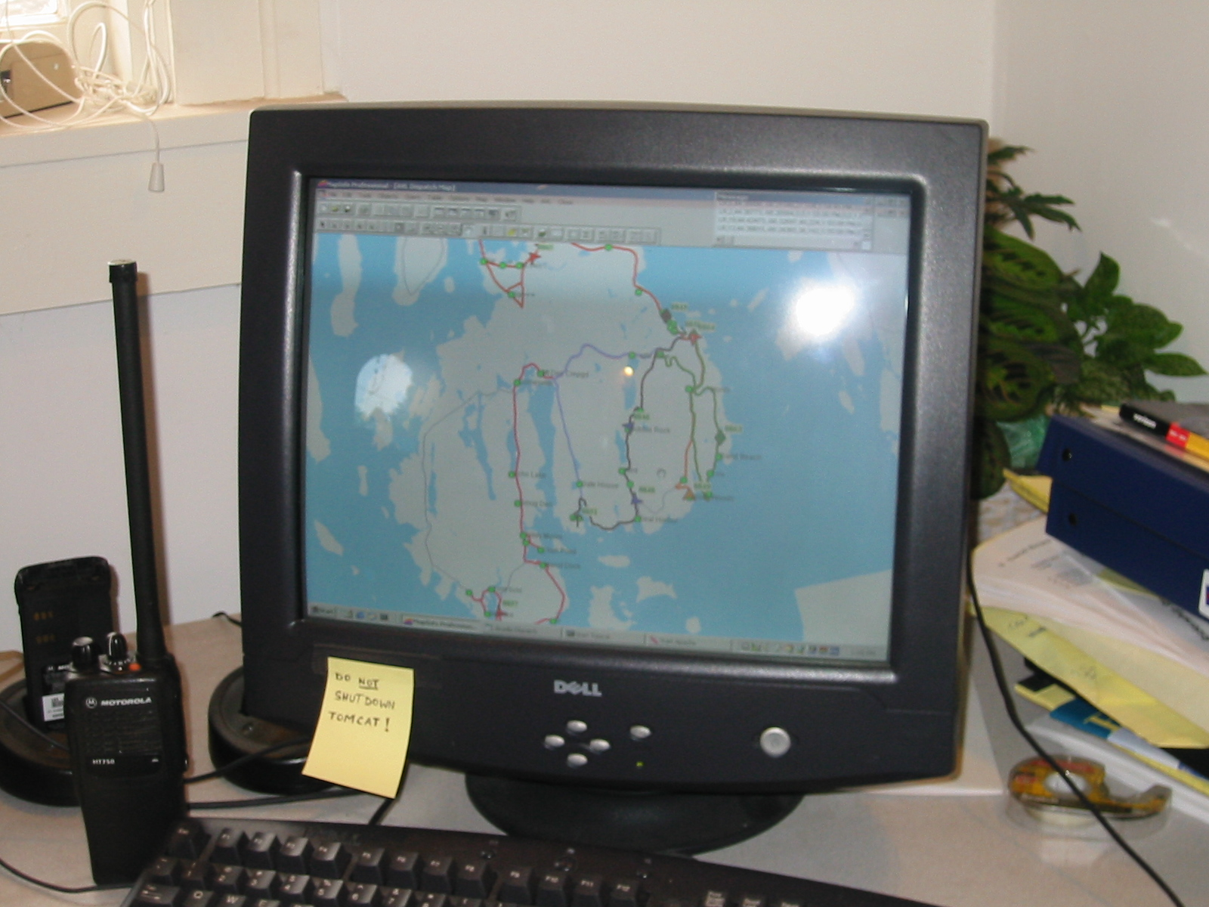
Figure 4-21: Bus Tracking Software Connected to
Automatic Vehicle Locator on Buses
As shown in Table 4-4, the ratings from the Island Explorer interviewees indicate a high degree of satisfaction with the performance of the voice communicator, automatic vehicle locator, departure signs, on-board annuciator, and passenger counter. On a 5-point scale with 5 being very satisfied and 1 being not at all satisfied, an average rating of 4 or better was given by both managers and drivers. Although some problems were noted by the interviewees, managers and drivers felt that the ITS components did function as designed and were a very positive contribution to operating the Island Explorer.
Table 4-4: Average Ratings of Satisfaction with ITS Components
by Island Explorer Staff
 | Voice Communicator | AVL | Departure Sign | Annunciator | Passenger Counter | N =
Island Explorer Managers | 4.5 | 4.75 | 4 | 4.5 | 4.5 | 2
Island Explorer Drivers | 4.5 | Not rated | 4 | 4 | 4 | 2
Ratings are averages based on a scale of 1 to 5, with 1 very dissatisfied, 2 dissatisfied, 3 neither satisfied nor dissatisfied, 4 satisfied, and 5 very satisfied.
Voice Communicator. Both managers and drivers voiced satisfaction with the radio communications. The radios were used constantly to communicate such information as accidents, large passenger loads, hurt animals, and blocked roads, although there were some persistent operational problems with blackouts that were due to topographical features on Mount Desert Island. According to the managers, both dispatch personnel and drivers seemed comfortable with radio use. According to the two drivers interviewed, driver reaction to radios was mixed; some drivers thought they were essential, others saw them as contingency tools for extraordinary use. The experienced driver was less reliant on the radio, but both drivers agreed that being able to communicate with dispatch was important to report problems such as full buses, accidents, and hazardous parking. The ability to communicate directly with other drivers was also seen as desirable, especially if a dual system channel selection were to be available.

Automatic Vehicle Locator. According to the Island Explorer managers, topographical features on the island created some transmission problems that affected the global positioning system signals. Problems experienced included “disappearing” buses, and GPS “wobble” that may trigger an annunciator announcement other than the next stop or premature announcements. Despite these problems satisfaction was very high. The locator system was seen as extremely valuable in route management, schedule adherence, driver behavior (speeding), and vehicle location in the system, and the system is being enhanced to enable historical route analysis to determine peak passenger loads. (Island Explorer drivers were not asked about the automatic vehicle locator, as they were not directly involved in its use.)

Electronic Bus Departure Sign. Managers were satisfied with the signs, but somewhat less so than other ITS technologies. The departure sign relies on synchronization with the AVL on buses to compute arrival and departure times. This function occasionally did not work for some buses, resulting in incorrect departure information being posted. Likewise, occasionally a driver would “log in” to an incorrect route number, resulting in a software distortion of the displayed schedule. This error could be overridden from the dispatch office, but sometimes a 90-minute schedule distortion would result. Other than these problems, the signs performed as designed according to the Island Explorer managers. Drivers were generally receptive to the departure sign, but felt it did not directly impact their role. One driver did comment that when the sign was “off schedule” due to system problems, passengers were prone to berate drivers, despite on-time adherence to printed schedules.

Automated Annunciator. The annunciator on-board the buses was viewed as a positive feature by the Island Explorer managers. Management joked that the recorded voice, dubbed “Elvira” was greatly appreciated. There were some signal problems that would result in double announcing of a stop or announcing a stop that was across the street, especially where stops were close together in downtown Bar Harbor, and the communications consulting company is working on this problem. Management personnel believed that the menu of announcements could be expanded to include safety, non-smoking, and Park pass purchase announcements.
Drivers were mixed in their reaction to the recorded voice on the annunciator. Suggestions included reprogramming with natural voices, having several versions of the announcements to offer variety, or to enable drivers to record or customize announcements. The drivers felt that announcements were wrong or premature about 10% of the time and rated the annunciator slightly lower than managers.

Automatic Passenger Counter. Both management and drivers expressed satisfaction with the passenger counters on-board the buses, but drivers slightly less so than management. Management believed the passenger counters worked well, and that the counts were about 90% accurate. Some errors were introduced by sensor placement in stairwells and communication problems causing automatic resets in the middle of runs.

The passenger counter was seen as largely irrelevant to drivers, and they did not use data from it. Some problems were encountered as a result of “bad” GPS readings, which triggered a start/end of a route passenger count in the middle of a route and resulted in dropped or doubled passenger counts.

Overall Satisfaction with the Island Explorer Suite of ITS Technologies. Both the Operations Manager and Lead Dispatcher were enthusiastic in their belief that the ITS technologies improved operations of the Island Explorer. Specifically, they believed that ITS made the bus easier to use, but were not sure if ITS directly increased ridership. They also believed the communication system greatly improves safety, especially to send text messages if the voice features were inoperable (this occurred in one instance), and to passively locate the vehicle in an emergency. The combination of technologies was seen as valuable in managing the cost effectiveness of operations, but not especially helpful in maintenance of vehicles. The strongest benefit of ITS technology was perceived to be the combination of geographical and ridership data to enhance route design. Both managerial respondents strongly believed that ITS facilitated good operations and contributed to overall customer satisfaction.

The drivers also agreed that deployed technologies made their job easier and enabled them to cope with increasing traffic and ridership.
Satisfaction with ITS: Acadia National Park Staff
Staff of Acadia National Park experienced three ITS technologies to various degrees: parking information signs at two campgrounds and the Visitors Center; a Web page with parking information linked to the Park’s Website; and the electronic bus departure signs at Jordan Pond and the Visitors Center. Figures 4-2, 4-3, 4-4 and 4-7 in Section 4.1 depict these ITS-based traveler information sources in operation.

The quantitative ratings of the Acadia National Park managers and rangers were not as positive as the Island Explorer staff. In Table 4-5 the average rating on the 5-point scale ranged from 3.0 to 3.75, indicating a somewhat neutral attitude regarding satisfaction with two of the three ITS components deployed within the Park. The Webpage wasn’t rated as only one Park staff member that was interviewed had observed it.
Table 4-5: Average Ratings of Satisfaction with the ITS Components
by Acadia National Park Staff
 | Parking Status Sign | Departure Sign | N =
Park Managers | 3.0 | 3.75 | 2
Rangers | 3.0 | 3.0 | 5
Ratings are averages based on a scale of 1 to 5, with 1 very dissatisfied, 2 dissatisfied, 3 neither satisfied nor dissatisfied, 4 satisfied, and 5 very satisfied.
Parking Lot Status Signs. The original ITS design envisioned automated parking status signs located at the Visitor Center and at a Park entrance. This capability was not deployed, but a manual “tent sign” was displayed at two campground entrances and the Visitor Center. Changes in parking status had to be conveyed by telephone and was not usually updated in a timely manner due to other staff responsibilities during very busy periods. Only one of the rangers interviewed had direct experience with updating the parking lot signs. This ranger felt that, while the signs were a good idea, the telephone notification system by which rangers received updates was cumbersome. In general, ANP staff believed that parking status signs, if automated, would be a welcome congestion management tool. Several respondents felt that the design and appearance of the signs could be improved. The rangers were largely neutral as to whether or not the signs were a benefit to visitors.

Electronic Bus Departure Signs. The departure signs experienced initial problems with power interruptions. Both Park managers and rangers were largely neutral on the utility of the departure signs at the two locations within the Park, as they were out of the way of the Visitor Center and Jordan Pond House personnel. Staff felt that while the electronic bus departure signs were good features, their utility was diminished somewhat by the fact that the signs could not be turned off after the season was over, resulting in visitor frustration with waiting for buses that were not running. The rangers were somewhat more critical in their assessment because they were responsible for updating the parking status signs and answering visitor frustration with post-season bus inquiries. Table 4-5 reflects this impression.

Web Page with Parking Information. Only one respondent had seen the Web parking status page, which was linked to the Acadia National Park main Website. That manager’s comment was that the page should be more prominently linked and have a better design. Thus, it would appear that the staff member was not very satisfied with this ITS source of traveler information. (The managers did not rate the Web page and the rangers, who did not experience it in their jobs, were not asked about the Web page.)

Overall Satisfaction with Suite of ITS System Technologies. When asked about their perception of the impact of ITS on visitors to Acadia, both managers who were interviewed felt that the net impact of ITS was positive, especially from a traffic congestion management standpoint. Park managers believed that parking lot and departure signs do have a positive influence on congestion near attractions, parking behavior, and traffic by facilitating bus travel.

On the other hand, the rangers who were interviewed felt that bus departure and parking lot status signs as deployed did not materially affect congestion near attractions, parking behavior, or traffic. Nevertheless, all rangers interviewed believed that traffic congestion was a problem and that the Island Explorer, with ITS-enhancements, is helping to alleviate it. Thus, they believe that ITS components that will further enhance the Island Explorer would be worthwhile. For example, automation of real time information about parking lots (rather than the manually-changed signs) together with a suggestion to “Take the Bus” when these lots are full were suggested by the rangers as meaningful improvements to the present system.
Satisfaction with ITS: Other Stakeholders
All other interviewed stakeholders were satisfied with the ITS technologies that were operational during the FOT and they agreed that full deployment of the parking lot loop detectors and sign displays, which were not operational in 2002, should be pursued. There was also universal agreement that the Webpage should be completed and prominently linked to Acadia National Park and Mount Desert Island Web sites.

4.5 Summary of Customer Satisfaction
Table 4-6 shows the hypotheses related to customer satisfaction that were examined in the evaluation. As demonstrated in the previous sections, support was provided for many of these hypothesized impacts.

Table 4-6: Objectives and Hypotheses Related to Customer Satisfaction
Goal Area | Objective | Hypothesized Impact
Customer Satisfaction | To provide a more positive visitor experience through greater reliance on the Island Explorer for travel | Pre-trip traveler information services will divert visitors from using personal vehicles and to using Island Explorer
Customer Satisfaction |  | Real-time arrival information on next Island Explorer bus will increase visitors’ willingness to use transit
Customer Satisfaction |  | Real-time information on parking lot conditions will increase visitors’ willingness to use transit
Customer Satisfaction | To provide a more positive visitor experience through information on parking availability | Real-time information on parking lot conditions will increase visitors’ ability to plan accordingly and to fulfill experience preferences
Customer Satisfaction | To provide a more positive visitor experience through efficient service | Tourists who use ITS feel less stress and worry due to service operations
Customer Satisfaction | To provide useful and timely information for the transportation provider | ITS technologies will have positive benefits/effects on Island Explorer driver jobs, Island Explorer operations, and interagency relationships

First of all, it should be emphasized that not all visitors used ITS. Moreover, many visitors appeared to rely entirely on their own vehicles for transportation and reported fewer concerns with doing so than visitors who made use of ITS in one form or another. The visitors who did use ITS perceived definite benefits from doing so. The visitors who used the real-time departure signs for the Island Explorer buses and the real-time parking conditions reported that the information was accurate, clearly understandable, and easy to use, and such traveler information contributed to a positive visitor experience. For example, ITS users of the traveler information system involving the real-time parking conditions, automated annunciator, and electronic departure sign for the Island Explorer bus reported the information saved them time and reduced tension and stress related to travel. The ITS users reported future use of the traveler information would be a pleasant experience and that they would plan to use the information again.

As hypothesized, the ITS technologies increased visitors’ willingness to use transit. However, the ITS technologies associated with the Island Explorer--the electronic departure signs and bus on-board announcements—were more instrumental in mode choice than the real-time parking information. Eighty percent of the users of the electronic departure signs and 67% of users of the on-board announcements said the technologies helped them decide to use the Island Explorer bus compared to 44% of users of the real-time parking conditions. Regardless of the reported differences, the ITS technologies appear to be contributing to the overall goal of diverting visitors from using private vehicles to using the Island Explorer bus.

Satisfaction with ITS among the FOT project team was also observed. Staff of the Island Explorer was quite enthusiastic about the five ITS technologies associated with the buses. In particular they found the voice communications and automatic vehicle locator technologies extremely valuable to their operations. Among the staff of Acadia National Park a somewhat neutral stance was observed, which is not surprising since most of the ITS technologies intended for deployment within the Park were not operational or only partially so. The parking information signs, while useful to visitors, required too much attention from rangers in their “low-tech” deployed form. Finally, the other key stakeholders also expressed satisfaction with the ITS technologies from a general standpoint.

5.0 Mobility
In addition to ensuring customer satisfaction with the ITS technologies, providing mobility to visitors so that they could enjoy Acadia National Park was an equally important objective of the ITS Field Operational Test. Although it was not practical to try to collect objective data on mobility such as miles traveled, it was possible to measure mobility through visitor’s subjective assessment. Visitors were asked to assess the impact of ITS technologies on various aspects of mobility, including avoidance of parking problems, traffic congestion, and large crowds; ease of getting around the area; saving time; and changing the time or destination of travel. The following sections examine each of these aspects of mobility.

5.1 Avoiding Problems

Thirty-seven percent of respondents indicated that they had obtained parking condition or traffic information on the Acadia National Park Web page and displayed on signs at the Park’s Visitor Center or campgrounds. Figures 5-1 through 5-3 reveal that ITS was attributed by users with enhancing their mobility. A relatively high proportion of users (66%) thought that the real time parking information did help to avoid parking problems (Figure 5-1). Twenty-seven percent of the users were uncertain as to whether the information helped to avoid parking. There was more uncertainty among users (35%) in believing the parking information helped to avoid traffic congestion (Figure 5-2). However, fifty-seven percent of users “strongly agreed” or “agreed” that the parking information helped to avoid traffic congestion

Less than half of the users (47%) thought the real time parking information helped to avoid large crowds (Figure 5-3). The most frequently rated response was “neutral” by users (41 percent). Eleven percent of users disagreed and 1% of users strongly disagreed the information helped to avoid large crowds. It should be noted that parking condition information was given for two of the most popular destinations in Acadia National Park: Sand Beach and the Jordan Pond House. However, there are several other very popular destinations such as Cadillac Mountain. Visitors may have experienced large crowds at other destinations regardless of the status of parking conditions reported at Sand Beach and the Jordan Pond House. Of course, with tour buses common at some of the Park’s destinations, visitors may have experienced crowding at times when traffic or parking was not perceived as a problem.

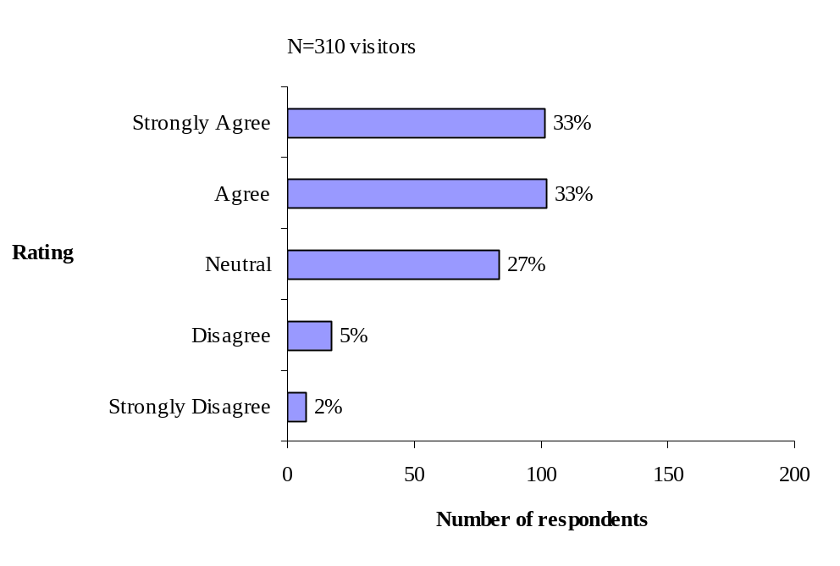

Figure 5-1: Respondents’ Agreement that Parking Conditions Information
Helped to Avoid Parking Problems

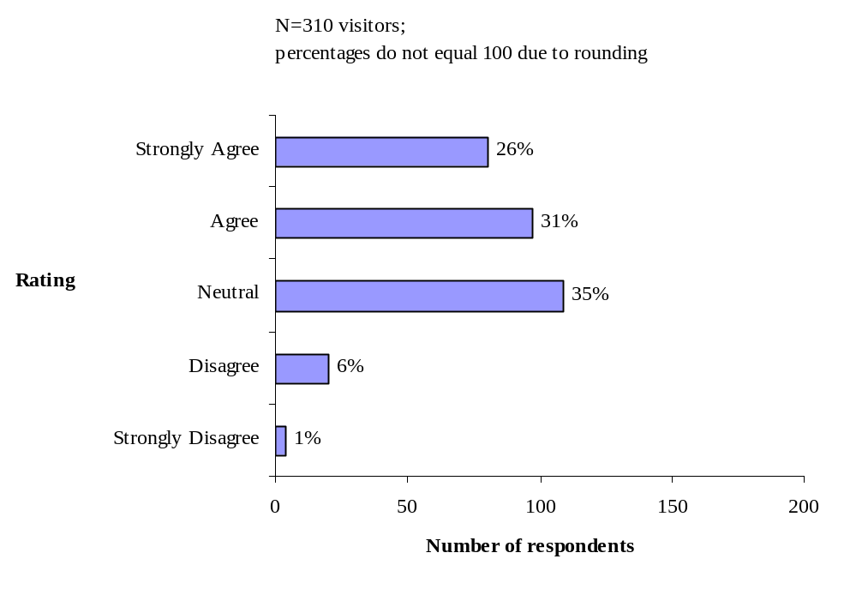

Figure 5-2: Respondents’ Agreement that Parking Conditions Information
Helped to Avoid Traffic Congestion

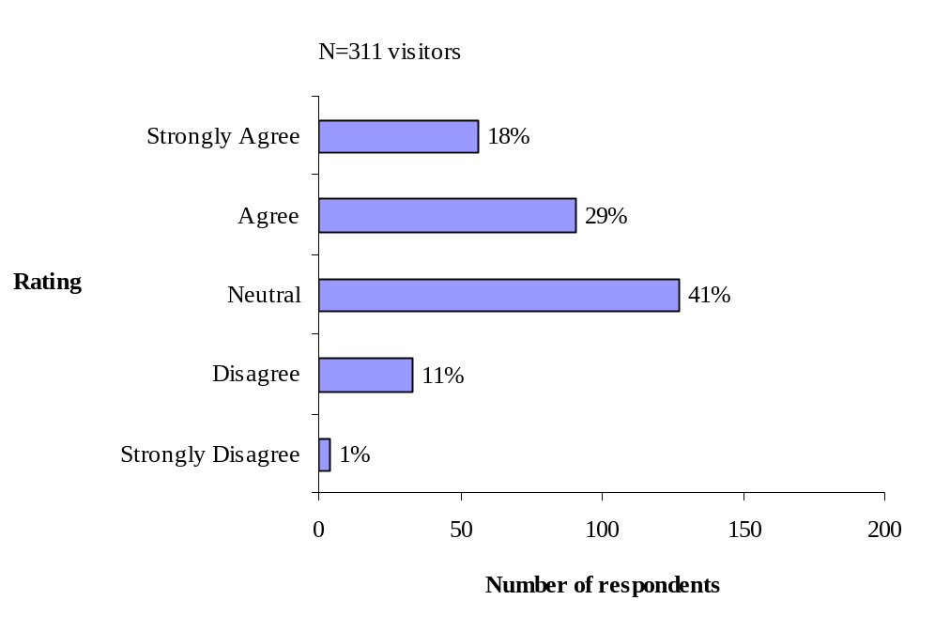

Figure 5-3: Respondents’ Agreement that Parking Conditions Information
Helped To Avoid Large Crowds

Ease of Movement
Nearly three out of four users (74%) agreed that the real time parking information made it easier for them to get around despite having lower agreement ratings for the parking information helping to avoid parking problems (66%), traffic congestion (57%), and large crowds (47%). Figure 5-4 shows that users rated 31% “strongly agree” and 43% “agree” with the statement “It was easier to get around with the information.”

The mobility of those visitors who used the Island Explorer bus and travel-related information during their recent visit was assessed by asking if the ITS-based information made it easier to get around. Figures 5-5 – 5-6 show users’ evaluation of the traveler information system involving the real time bus departure displays and the on-board announcements.

Figure 5-5 shows a very high percentage of the bus users (90%) that agreed the real time bus departure displays made it easier for them to get around the area. Fifty-eight percent of the bus users rated “strongly agree” that the real time bus displays made it easier for them to get around the area. Likewise, a high proportion of bus users (84%) agreed that the bus announcements made it easier for them to get around the area (Figure 5-6). Half of the bus users (50%) rated “strongly agree” that the information made it easier for them to get around the area.

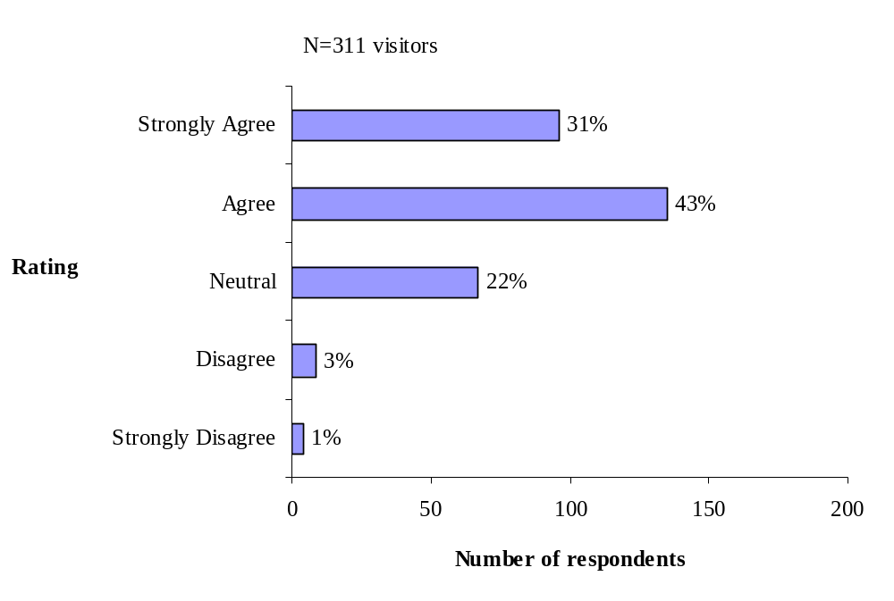

Figure 5-4: Respondents’ Agreement that Parking Conditions Information
Made It Easier for Me to Get Around the Area

Caution should be used in drawing conclusions about the real time bus departure displays and the on-board announcements in Figure 5-5 and 5-6 with the reported ease of getting around the area. Daigle and Lee’s 1999 study of the Island Explorer bus passengers identifies user reports of increased ease of travel in getting around the area. Answers in the FOT evaluation may reflect to some degree visitors’ use of the Island Explorer bus itself as compared to the traveler information.

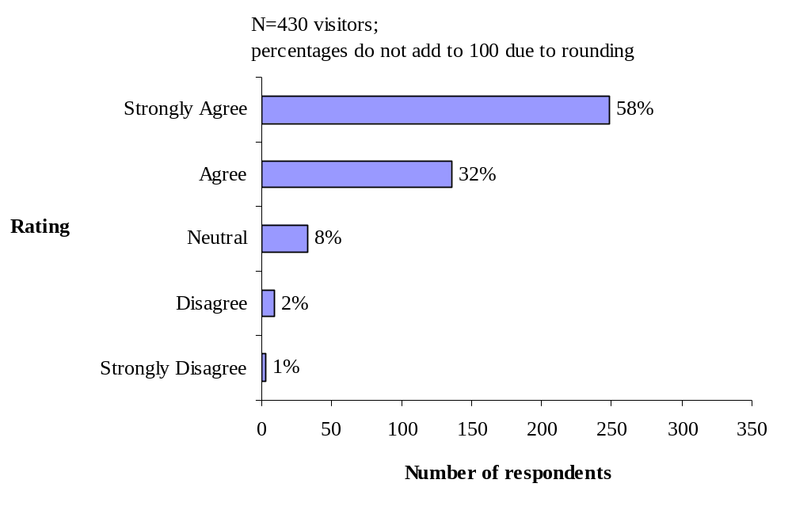

Figure 5-5: Respondents’ Agreement that Real Time Bus Departure Displays
Made It Easier for Me to Get Around the Area

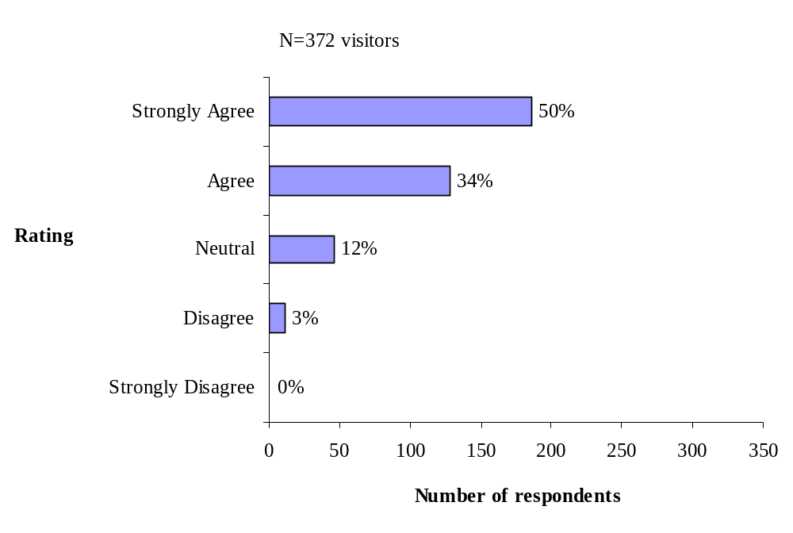

Figure 5-6: Respondents’ Agreement That Bus On-Board Announcements
Made It Easier For Me To Get Around The Area

Saving Time

Enabling users to save time is another potential benefit of ITS and this aspect of mobility was examined through questions about the ITS users’ experience with various forms of traveler information. Results showed that the majority of ITS users agreed that they saved time with the travel information they used, but there was less certainty about the time saving benefit of the parking information and the on-board bus announcements compared to the real-time bus departure signs.

Visitors who reported that they obtained information on parking conditions at the Acadia National Park visitor center, campgrounds, or Website were asked to rate their agreement with statements on time savings. Figure 5-7 shows that a relatively high proportion of users (67%) who agreed that the real time parking information helped saved time. However, a sizable proportion of users (29%) were uncertain as to whether the parking information saved them time.

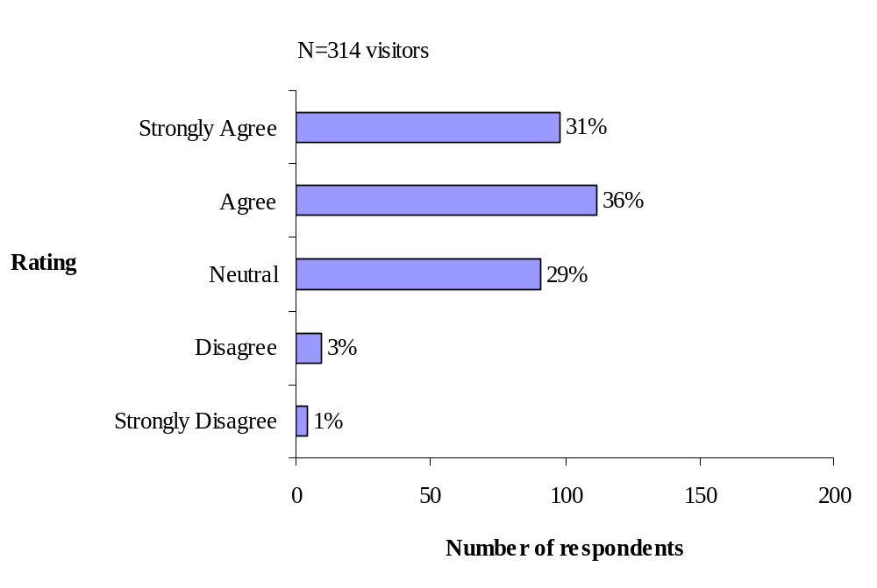

Figure 5-7: Respondents’ Agreement That Parking Conditions Information
Saved Time for the Visitor

Among visitors who used the Island Explorer bus and travel-related information the impact on their perception of time savings varied somewhat between the real-time bus departure signs and the on-board announcements. Eighty percent of the bus users reported that the real time bus departure signs helped to save time (Figure 5-8), whereas only 16% were unsure. Figure 5-9 shows that 69% of users agreed that the bus on-board announcements helped them to save time. However, twenty-four percent were uncertain that this information helped to save time.

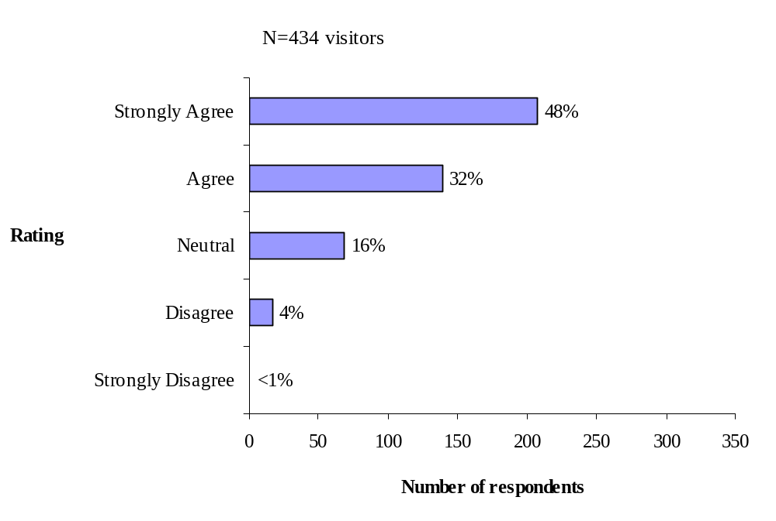

Figure 5-8: Respondents’ Agreement That Real Time Bus Departure Sign
Saved Time for the Visitor

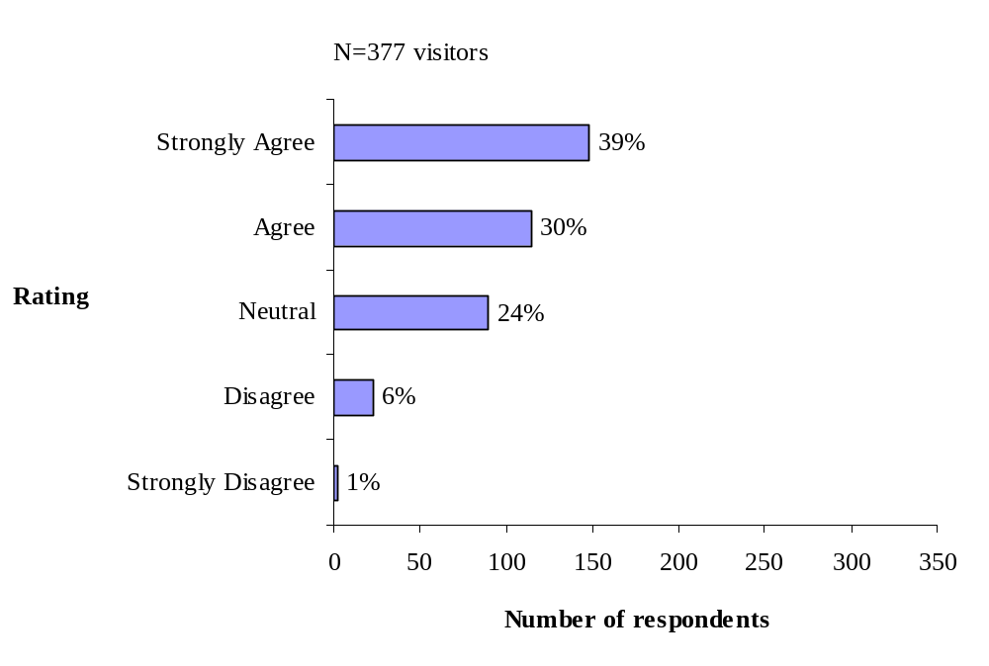

Figure 5-9: Respondents’ Agreement That Bus On-Board Announcements
Saved Time for the Visitor

Changing Departure Time or Destination

Providing visitors enhanced mobility can be achieved by enabling them to make changes to their daily trip planning so they can avoid travel problems. Users of the real-time parking information were asked about the impact on their departure times or destinations of travel. Figure 5-10 shows that 43% of the users changed the time of day they visited an attraction based upon the real time parking information. Thirty-two percent were uncertain that the information influenced the time of day they visited an attraction and 26% disagreed that the parking information changing the time of day they visited an attraction. Figure 5-11 shows that the real time parking information changed some visitors’ minds on what attraction to visit (38 percent). However, 37% of users were uncertain and 26% disagreed that the information changed their mind on what attractions to visit. These results indicate that while a sizeable proportion of visitors appeared to take advantage of the parking information to select what destinations to visit and when, the majority was either uncertain or disagreed that there was an impact.

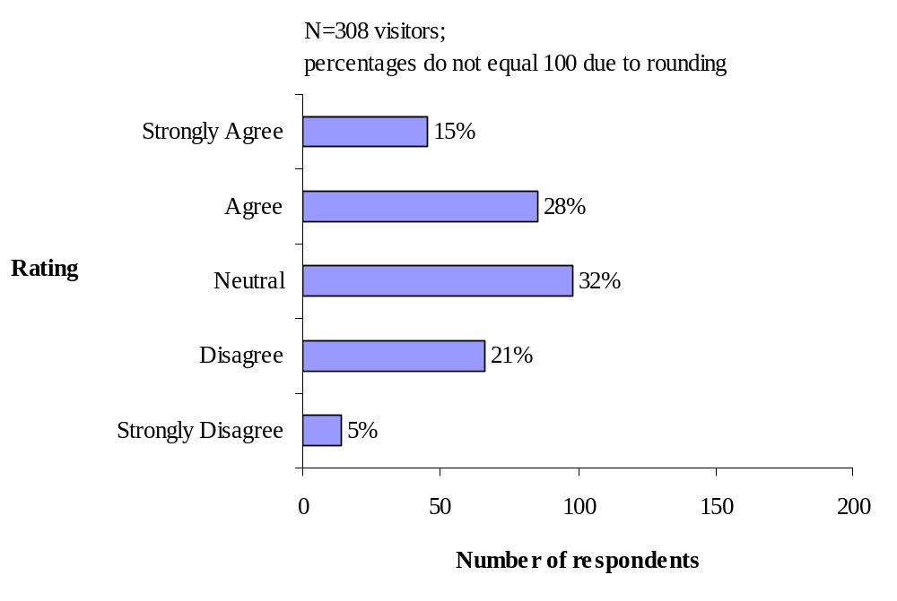

Figure 5-10: Respondents’ Agreement That Parking Conditions Information
Changed the Time of Day to Visit Certain Destinations

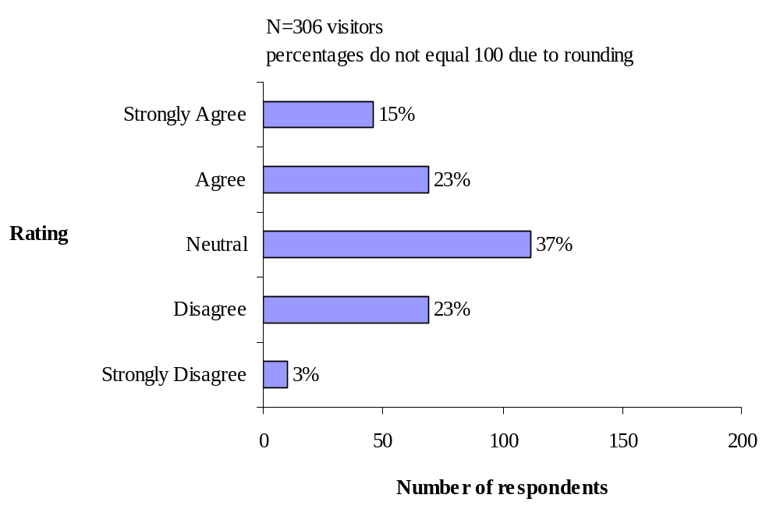

Figure 5-11: Respondents’ Agreement That Parking Conditions Information
Changed the Visitor’s Mind on what Attractions to Visit

To further assess the potential impact of ITS on visitor mobility, data on visitor activities were examined. Visitors reported participating in a variety of activities and often multiple activities both inside Acadia National Park and outside the Park. Table 5-1 shows the activities and visitors who were identified as ITS users and ITS non-users. The most common activity for ITS users and ITS non-users was sightseeing (81% and 76%, respectively). Other popular outdoor activities for visitors included hiking on trails, walking on carriage roads, picnicking, biking on carriage roads, and attending ranger led programs. While participation levels were generally higher for ITS users as compared to ITS non-users for activities both inside Acadia National Park and outside of the Park, the more diverse activities of ITS users may be related to longer stays in the area as discussed in Section 7. Thus, a case cannot be firmly made that ITS users were more mobile than non-users when measured by the range of activities and access diverse destinations in which visitors participated. That conclusion would be consistent with the observations in Section 4 about customer satisfaction that both ITS users and non-users had high satisfaction levels with their experience at Acadia.
Table 5-1: Visitor Activities Inside Acadia National Park and Outside the Park
Activity | ITS  User | ITS  Non-User
Activity | ---------Percent---------
Sightseeing | 81 | 76
Going out to eat/entertainment in the village center | 80 | 59
Shopping in village centers | 77 | 57
Hiking on trails | 70 | 62
Walking on carriage roads | 41 | 36
Jordon Pond House food service | 37 | 41
Shopping in Park | 36 | 31
Picnicking | 35 | 24
Biking on carriage roads | 29 | 19
Attend ranger led programs | 20 | 7
Other | 20 | 13
Bird watching | 15 | 10
Biking on motor roads | 13 | 3
Rock climbing | 13 | 8
Sea kayaking | 13 | 10
Lake boating/canoe | 12 | 9
Horse and carriage rides | 6 | 3
Going to work | 5 | 1
Percentages add to more than 100 because visitors could do more than one activity

Summary of Mobility
Table 5-1 shows the hypotheses that were posed regarding the impact of ITS on mobility of visitors. The hypothesized impacts dealt with various aspects of mobility, and in the survey these impacts were examined with questions that focused on avoidance of parking problems, traffic congestion, and large crowds; ease of getting around the area; saving time; and changing the time or destination of travel. Sections 5.1 through 5.4 demonstrated that some but not all the hypotheses were supported by the survey results.
Table 5-2: Objectives and Hypotheses Related to Mobility
Goal Area | Objective | Hypothesized Impact
Mobility | To increase visitor’s ability to access desired destinations and activities | Tourists who use traveler information are more aware of travel options than those who do not use traveler information
Mobility |  | Tourists use alternate routes or travel modes due to traveler information
Mobility |  | Tourists perceive that they have increased access as a result of their use of traveler information
Mobility |  | Tourists who use traveler information perceive fewer problems with congestion and parking that might prohibit them from visiting certain destinations and activities
In general, ITS contributed to visitors’ perception of mobility at Acadia National Park and Mount Desert Island. Nearly three out of four users (74%) agreed that the real time parking information made it easier for them to get around despite having lower agreement ratings for the parking information helping to avoid parking problems (66%), traffic congestion (57%), and large crowds (47%). A higher proportion of bus users agreed that the real-time bus departure signs and the on-board bus announcements made it easier for them to get around (90% and 84%, respectively).

The majority of visitors reported that they saved time by using the ITS-based traveler information, and this was especially the case for users of the real-time bus departed signs. Eighty percent of them agreed that the signs saved them time. This is not a surprising result, since the information those signs conveyed was time-related. ITS technologies in the form of the parking information had limited success in changing the time of day or changing the visitor’s mind on what attractions to visit (43% and 38%, respectively). One explanation might be that some visitors may have been aware that parking along access roads to Sand Beach and Jordan Pond was permitted even when the parking lots were full. Even so, getting just 40% of users of the parking information to change their plans could help lessen the demand for parking at these two locations.

Finally, it was hypothesized that ITS users would generally report increased ability to access desired destinations and activities as compared to ITS non-users. While ITS users did appear to have slightly higher levels of activities than non-users, that may be due to the length of visit. Nevertheless, ITS impacted some visitors’ access to destinations as approximately 40% of users of the parking information indicated that they changed the timing or destination of a trip based on the information. For those visitors, access to certain destinations was limited, but presumably they visited those destinations at some other less-congested time.

6.0 Productivity and Economic Vitality
This section examines the economic impact of the ITS technologies deployed as part of the ITS FOT at Acadia National Park. During the evaluation workshop of May 2000, participants identified two principal perspectives from which the potential economic impact of ITS could be assessed. First, would ITS have a noticeable impact on the local economy that is heavily dependent upon tourism? This question was explored using data from the survey of local businesses, the visitor survey, and data from Acadia National Park. A second area of interest was the impact of ITS on the productivity of the Island Explorer. Would the bus operations realize cost savings from use of ITS technologies? Operational data from the Island Explorer were used to assess this question. The following sections start with an exploration of the impact of ITS on the vitality of the local economy, followed by an assessment of productivity impacts in the Island Explorer operations.

The Role of Tourism in the Local Economy
Tourism is a mainstay of the economy of Mount Desert Island, a fact reflected in the responses of 257 local business managers who responded to the survey conducted for this evaluation. Figure 6-1 shows that 74% of managers, who were members of area Chambers of Commerce, classified their main business as lodging, retail, restaurant or tour guide. The greatest clusters of businesses are in downtown Bar Harbor (37%) and Southwest Harbor (18%), and operations are either highly seasonal (43% open 6 months or less) or year-round (44%). The managers themselves tend to be year-round residents of Mount Desert Island (86%) who have lived in the area a decade or more (70%) and have operated their business five or more years (77%). Thus, the perspective of these seasoned managers who are well acquainted with Acadia and Mount Desert Island was expected to provide valuable insight into the role that transportation plays in the success of tourism and ultimately their businesses.

Business managers generally held a positive view of tourism in the area. Table 6-1 presents the average of respondents’ ratings to potential positive and negative impacts of tourism. The results revealed strong levels of agreement with statements about the positive impacts and either neutrality or disagreement with negative impacts. For example, managers strongly agreed that tourism would continue to have a major economic role in the community and that they personally support the vital role of tourism. On the other hand, the data reveal a more neutral position, or a polarized view, on whether additional tourists beyond the current levels would be a positive thing.

Table 6-2 presents business managers’ views of the potential contribution of Acadia National Park. The data reveal that Acadia is valued for a wide variety of contributions to the community. Specifically related to economic contribution, Acadia was viewed as contributing in a major way to job creation (52%), the stability of the economy (59%) and as an attraction for tourism dollars (83%).

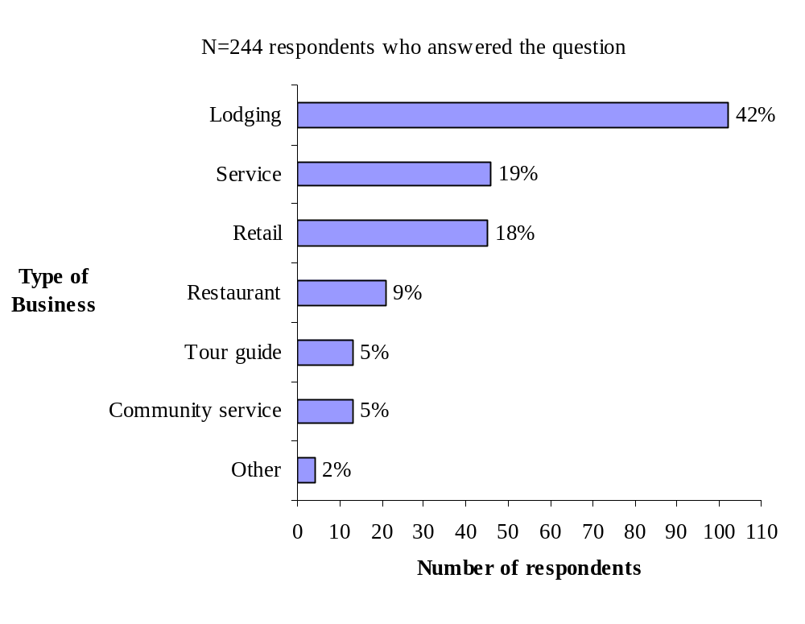
Figure 6-1: Types of Businesses on Mount Desert Island

Table 6-1: Business Managers’ Views of Potential Benefits and Negative Impacts
Related to Tourism in the Community*
Potential Benefits and Negative Impacts |  | Mean
The tourism industry will continue to play a major economic role in this community |  | 1.87
I support tourism as having a vital role in this community |  | 1.86
My community should plan for and manage the growth of tourism |  | 1.61
I am happy and proud to see tourists coming to see what my community has to offer |  | 1.41
Additional tourism will have a positive impact on my community’s growth |  | .42
I favor new tourism facilities in my community that will attract more tourists |  | .27
Tourists are a burden on my community’s services (roads, water & sewer, police & fire) |  | .13
An increase in tourists in my community will lead to friction between local residents and tourists |  | -.004
Tourism is responsible for too fast a rate of urbanization and development in Maine |  | -.29
Tourism usually benefits a small group of individuals in this community | -1.19
* Possible responses: +2 = Strongly Agree; +1 = Agree; 0 = Neutral; -1 = Disagree; and -2 = Strongly Disagree
Item | Contribution |  |  |  | Mean
Item | No | Minor | Moderate | Major | Mean | Rank
Item | ---------- Percent of Respondents------------ |  |  |  | Mean | Rank
A natural setting in which your community takes pride | <1 | 1 | 9 | 86 | 3.87 | 1
A chance to experience unique recreation opportunities | 1 | 2 | 13 | 81 | 3.81 | 2
A feeling that your community is a special place to live | 1 | 3 | 10 | 84 | 3.80 | 3
A place to preserve/conserve various natural and unique ecosystems | 1 | 3 | 11 | 81 | 3.80 | 3
A chance to attract tourism dollars to my business and community | 2 | 2 | 13 | 83 | 3.78 | 4
Assurance that access to recreation opportunities will not be lost | 2 | 5 | 18 | 72 | 3.66 | 5
Opportunities for exercise that improve local people’s health | 1 | 7 | 19 | 70 | 3.64 | 6
A greater ability to preserve the character of the immediate area | 4 | 4 | 17 | 71 | 3.61 | 7
A greater understanding of your natural environment | 2 | 5 | 23 | 66 | 3.61 | 8
A more stable economy within the community | 2 | 9 | 25 | 59 | 3.48 | 9
The number of jobs that are created in your community | 1 | 15 | 29 | 52 | 3.36 | 10

Table 6-2: Business Managers’ Attitudes toward Acadia National Park’s Contributions*

*Possible responses: 1= No Contribution; 2 = Minor Contribution; 3 = Moderate Contribution; and 4 = Major Contribution

6.2 Business Managers’ View of Transportation Problems and ITS Solutions
Transportation was one area that drew negative views from the business managers. Table 6-3 presents their perceptions of the magnitude of various transportation problems in the summer of 2002. Business managers are concerned about summer travel on Mount Desert Island and in Acadia National Park in several ways. In their rating of “big” and “moderate” problems, first and second ranked problems had to do with too many vehicles outside of the Park causing parking problems or congestion. Parking and congestion concerns were a “big” or “moderate” problem to 72% and 70% respectively. Business managers felt similarly about too many vehicles inside the Park causing parking problems (70%) and impacting visitor experiences (62%). It should be noted that concerns reported by business managers could partly be a reflection of their own personal experiences, with many of them viewing travel problems as the norm. When asked separately about their own overall travel experience during the past summer, nearly one-half of all business managers (48%) rated it as being “average,” and 18% rated it “poor” or “very poor.” In contrast, only 35% reported “good” or “very good” travel experience.

It is interesting to note that in Table 6-3 the average ratings for visitors’ ability to fully access desired attractions outside of the Park (i.e., restaurants, shops) was lower than issues of air quality and unsafe parking. For example, despite the magnitude of their concern noted previously with parking and traffic congestion outside of the Park and parking inside the Park, lower ratings (57%) were reported by business managers in terms of visitor’s ability to access desired attractions and recreation opportunities. However, business managers reported access as more of a problem at attractions outside of the Park--a big problem to 23%--than inside of the Park, where it was rated as big problem to only 6%. Business managers did not generally believe that travel and traffic information was insufficient to help visitors plan trips in the Park, as only 20% rated it as a moderate or big problem. Thus, while managers may be voicing concern over problems that visitors encounter, those concerns are less than the air quality and safety concerns. They may also be an expression of concern for their own quality of life from operating a business in the area when it comes to health or travel conditions to and from work.

ITS offered potential solutions to the transportation problems experienced by both visitors and managers of local businesses on Mount Desert Island. The survey sought to determine if business managers saw the ITS technologies deployed in the FOT as beneficial. Because many of the deployed ITS technologies were intended to enhance the operation of the Island Explorer bus system, the evaluation examined managers’ attitudes toward the Island Explorer as a prelude to assessment of the ITS technologies per se.

Table 6-3: Business Managers’ Perceptions of Travel Issues and Magnitude of Problem on Mount Desert Island and in Acadia National Park this Summer*
Issue | Magnitude of Problem |  |  |  | Mean* | Rank
Issue | No | Small | Moderate | Big | Mean* | Rank
Issue | ----------------------- Percent ---------------------- |  |  |  | Mean* | Rank
Too many vehicles outside of the Park causing parking problems | 7 | 17 | 23 | 49 | 3.21 | 1
Too many vehicles outside of the Park causing traffic congestion | 6 | 21 | 27 | 43 | 3.11 | 2
Too many vehicles inside of the Park causing parking problems | 6 | 17 | 35 | 35 | 3.07 | 3
Too many autos having a negative impact on air quality | 12 | 19 | 32 | 32 | 2.90 | 4
Too many autos in the Park that impacts visitor experience | 9 | 24 | 32 | 30 | 2.89 | 5
Vehicles parked along main roads causing unsafe conditions | 11 | 26 | 31 | 29 | 2.82 | 6
Ability for visitors to fully access desired attractions outside of the Park  (i.e., restaurants, shops) | 18 | 22 | 34 | 23 | 2.64 | 7
Too many people inside of the Park that impacts visitor experiences | 20 | 31 | 30 | 12 | 2.37 | 8
Ability for visitors to fully access desired recreation opportunities and attractions in the Park | 34 | 27 | 23 | 6 | 2.02 | 9
Not enough travel and traffic information to help visitors plan trips in the Park | 37 | 25 | 18 | 2 | 1.82 | 10

*Possible responses: 1= No Problem; 2 = Small Problem; 3 = Moderate Problem; and 4 = Big Problem

Business Managers’ Attitudes Toward the Island Explorer
The Island Explorer is readily available to the vast majority of local businesses. It stops in front of 21% of the businesses and is within a 5-minute walk to an additional 58%. Sixty-nine percent of the businesses distributed schedule and other information related to the bus. It is no surprise, therefore, that 64% of the managers reported that their customers used the bus (and an additional 20% were unsure). Moreover, at 21% of the businesses at least one employee used the bus to get to work, and at many businesses managers (25%) or their employees (35%) used the Island Explorer for non-work trips, too. Given the proximity to and use of the bus by the both customers and workers at local businesses, the evaluation sought to understand managers’ perceptions of the benefits that the Island Explorer provided. Table 6-4 presents managers’ ratings of potential benefits of the bus to tourists and residents.

Bus usage and strength of perceived benefits are clearly correlated. For all but two of the potential benefits listed in Table 6-4, business managers who reported usage of the bus system by customers and/or employees rated those benefits higher than those who either didn’t use or weren’t sure about use of the bus. The differences between the two groups were statistically significant in 6 of the 14 benefits.

The biggest benefit reported, regardless of business manager group type, was that the Island Explorer bus created less worry about driving and parking for tourists along busy roads. Similarly, all managers on average agreed that the bus relieved the stress of driving, improved air quality, created safer conditions due to fewer vehicles, reduced parking problems in the Park and provided greater access to Park destinations. Both groups of managers also believed that the bus is helping to create a new tourist segment that doesn’t need to have their own vehicle at all.

When asked about the Island Explorer’s direct economic impacts, managers tended to be more neutral in their beliefs. They didn’t necessarily agree that more customers were patronizing their business because parking was less of a factor or that the Island Explorer would cause visitors to stay longer. On the other hand, with an average rating of .38, managers who did not report usage of the bus by their customers or employees held somewhat to the belief that businesses closer to a bus stop than their own did benefit.
Table 6-4: Business Managers’ Ratings of the Benefits of the Island Explorer Bus*
Benefits | Reported Customer Use of Island Explorer |  |  |  | ANOVA  Results** | p=
Benefits | Bus  (n=162) |  | No Bus or Don’t Know  (n=90) |  | ANOVA  Results** | p=
Benefits | Mean | Rank | Mean | Rank | ANOVA  Results** | p=
Creates less worry about driving and parking for tourists along busy roads | 1.48 | 1 | 1.30 | 1 | A>B | .048
Reduces tension and stress for people who would otherwise drive their own vehicle | 1.44 | 2 | 1.30 | 1
Reduces the amount of vehicle pollution and improves air quality | 1.44 | 2 | 1.04 | 7 | A>B | .000
Contributes to fewer total vehicles on the road and safer driving conditions | 1.40 | 3 | 1.17 | 3 | A>B | .034
Reduces the amount of parking problems inside of the Park | 1.40 | 3 | 1.19 | 2 | A>B | .030
Improves access to intended destinations inside of Park | 1.39 | 4 | 1.30 | 1
Creates more potential for a new segment of tourists who do not drive personal vehicles | 1.25 | 5 | 1.15 | 4
Reduces the amount of parking problems in village centers | 1.19 | 6 | .96 | 5
Improves access to shops and restaurants in village centers | 1.12 | 7 | .92 | 6
Provides people with fast service to their intended destination | .80 | 8 | .74 | 7
Increases ability to keep people off the road who may drink and drive | .57 | 9 | .60 | 8
Enables me and my employees to have an alternative means to get to work | .46 | 10 | .034 | 11 | A>B | .005
Increases the likelihood that visitors will stay longer | .38 | 11 | .16 | 10
Has enabled more customers to patronize my business, because parking is less of a factor | .080 | 12 | -.19 | 12
Tends to benefit businesses that are closer to the bus stop than mine | .062 | 13 | .38 | 9 | B>A | .021
* Possible responses: +2 = Strongly Agree; +1 = Agree; 0 = Neutral; -1 = Disagree; and -2 = Strongly Disagree
n = number of visitors in the subgroup
**Analysis of variance (ANOVA) is a test to identify significant pair-wise differences between means. “p” is the probability that the difference could have occurred by chance.

Awareness and Usage of ITS Technologies
Businesses managers were asked if they were aware of any of the four of ITS technologies for delivering traveler information: parking information signs, parking information on the Website, automated annunciators on-board the Island Explorer, and electronic bus departure signs. The majority of business managers (61%) reported being unaware of the ITS-based traveler information technologies (Figure 6-5). Of those business managers who reported being aware of at least one of the traveler information sources (n=98), Table 6-4 shows their awareness and use. A high proportion (80%) of the ITS-aware business managers reported being aware of the electronic signs that displayed real time departures of the next Island Explorer bus. Forty-five percent of the business managers were aware of the audio announcement of the next Island Explorer bus stop. Forty percent of the business managers reported being aware of the parking availability information on the displayed signs at the Parks’ visitor center and campgrounds. Only 25% reported being aware of the parking availability information on the Park’s Web page.

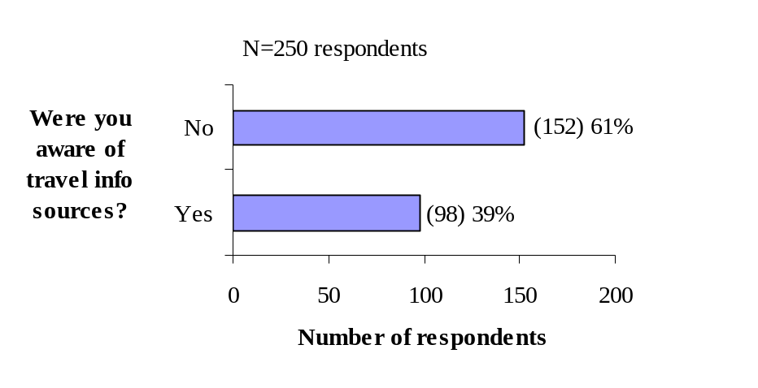
Figure 6-2: Business Managers’ Awareness of ITS Technologies
Table 6-5 also shows that almost half of the 98 ITS-aware business managers actually used at least one of the traveler information sources (n=48). Use was much lower for information on parking conditions as compared to the Island Explorer traveler information. Of the 48 managers, 79% reported using the electronic bus departure signs, and 45% used the audio announcement of the next Island Explorer bus stop. Thirty four percent of the business managers reported using the parking availability information on the displayed signs at the Parks’ visitor center and campgrounds, whereas a mere 17% reported obtaining the information on the Park’s Web. A possible explanation for managers’ low awareness and usage of parking availability information may be due to their prior knowledge of daily parking patterns at Sand Beach and the Jordan Pond House. Moreover, they would have been less likely to frequent the Park campgrounds and Visitors’ Center where the parking information signs were displayed.

Table 6-5: Business Managers’ Awareness and Use of the
Travel Information Sources this Summer*
Traveler Information | Aware | Manager Used |  | Customer Used
Traveler Information | (n=98) | (n=48) |  | (n-28)
Traveler Information | ----Percent----
Electronic bus departure signs for Island Explorer Buses | 80 | 79 | 67
Audio announcement of next bus stop on Island Explorer Buses | 45 | 45 | 33
Parking conditions at Sand Beach and Jordan Pond on displayed signs | 40 | 34 | 15
Parking conditions at Sand Beach and Jordan Pond w/ ANP Website | 25 | 17 | 7
Not Sure | 0 | 0 | 35
*percentages add to more than 100 due to awareness and usage of multiple items.
When asked about their customers’ use of the ITS technologies Figure 6-3 reveals that most of the business managers (55%) were not sure if customers had used any of the traveler information sources. Twenty-nine percent of the business managers reported their customers had used one or more of the traveler information sources. A small percentage of business managers reported “not applicable”, and it is assumed that these businesses did not serve customers who traveled or were not directly related to tourism (e.g., oil delivery company and self-employed Web designer).

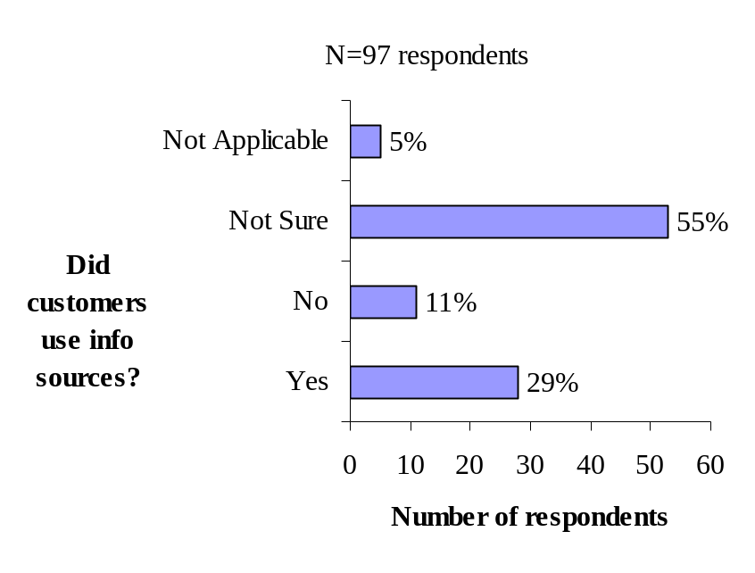

Figure 6-3: Business Managers’ Perception of Their Customers’ Use of
the Traveler Information Sources

Of the 28 business managers that reported customers using different sources of traveler information, Table 6-5 shows a high proportion of the managers (67%) reported customers using the electronic signs that displayed real time departures of the next Island Explorer bus and 33% reported customers using the audio announcement of the next Island Explorer bus stop. As with the business managers themselves, their customers’ use of the parking availability information was lower as compared to the Island Explorer traveler information. Fifteen percent of the business managers reported customers using the parking availability information on the signs displayed at the Parks’ visitor center and campgrounds, and 7% reported customers using the parking availability information on the Park’s Web page. Some visitors may have realized these areas were still accessible by privately owned vehicles and despite knowing the condition of the parking lots did not plan to use the information or ask about this information from the business managers. Finally, even though they reported that their customers used one or more of the ITS technologies, 35% of the business managers were not sure what traveler information sources were used by their customers during the past summer.

Business Managers’ Perception of Benefits of ITS Technologies
To assess the potential impact of ITS, business managers were asked about the benefits to their business and to tourists, who form the base of the region’s economy. In this section the benefits of ITS-based parking information and information associated with the Island Explorer are discussed.
Parking Information

Table 6-6 shows a high level of uncertainty among business managers (48%) that the real time parking availability would be helpful to their business. Thirty-one percent of the business managers rated “strongly agree” or “agree” but 22% of the business managers rated “strongly disagree” or disagree.” As noted in the previous section, business managers were much less likely to be aware of or have used parking information than the Island Explorer information. Moreover, the information available for parking was for two highly-used parking lots within the Park, and it can be assumed that business managers wishing to use those parking lots would be familiar with the daily patterns of parking conditions at those two locations much more than tourists.

In sharp contrast there were generally high levels of agreement on the benefits that tourists themselves would likely derive from using the parking availability information. As evidenced by high percentages of “strongly agree” and “agree”, business managers believed that parking information would help tourists:

- avoid parking problems in the Park (84% )
- avoid traffic congestion in the Park (81%)
- avoid large crowds in the Park (70%)
- get around more easily (78%)
- plan the time of day for visiting certain destinations in the Park (81%)
- move away from using their own vehicle and toward the Island Explorer bus (86%).

Table 6-6: Business Managers’ Ratings of the Benefits of Providing
Information on Parking Conditions Within the Park*
Benefits |  | Strongly Agree | Agree | Neutral | Disagree | Strongly Disagree
 | Percent of Managers
Would be helpful to my business (n=244) |  | 12 | 19 | 48 | 14 | 8
Helps tourists avoid parking problems in the Park (n=244) |  | 31 | 53 | 14 | 2 | 0
Helps tourists avoid traffic congestion in the Park (n=245) |  | 28 | 53 | 16 | 4 | 0
Helps tourists avoid large crowds in the Park (n=244) |  | 24 | 46 | 22 | 7 | 1
Makes it easier for tourists to get around with the information (n=245) |  | 27 | 51 | 20 | 2 | 1
Helps tourists to plan the time of day for visiting certain destinations in the Park (n=245) |  | 32 | 49 | 16 | 2 | 0
Increases the likelihood that some tourists will ride the Island Explorer bus (n=245) |  | 39 | 47 | 12 | 2 | 1
* Possible responses: +2 = Strongly Agree; +1 = Agree; 0 = Neutral; -1 = Disagree; and -2 = Strongly Disagree.
Island Explorer Information
Business managers were asked to assess the benefits of the electronic bus departure signs and the automatic next stop announcements on-board the Island Explorer buses. Table 6-7 presents the results. In contrast to the parking information, a majority (56%) of business managers thought that the Island Explorer bus traveler information would be helpful to their own businesses. This might be a reflection of the use of the bus by themselves or their employees; or it might be because a bus stops near their business, thereby increasing its availability to customers. Nevertheless, a relatively high percentage of business managers (30%) were uncertain about the benefit of the Island Explorer traveler information to their business.

They had no such doubts about the value to tourists. As demonstrated in Section 6.2.1, business managers had highly positive views of the Island Explorer. Likewise, they view the ITS enhancements to the bus system with similarly positive attitudes. As evidenced by the very high percentages of “strongly agree” and “agree”, managers believe that the electronic bus departure signs and the automatic next-stop announcements will help tourists:

- get around more easily (95%)
- relieve uncertainty about when the bus will arrive at the bus stop (90%)
- relieve uncertainty about when to exit the bus (85%)
- utilize their time, such as visiting shops before a bus arrives (87%)
- improve the travel experience overall (90%)
- increase the likelihood of using the Island Explorer bus (93%).
Table 6-7: Business Managers’ Ratings of the Benefits of
Island Explorer Traveler Information*
Benefits | Strongly Agree | Agree | Neutral | Disagree | Strongly Disagree
Benefits | Percent of Managers
Would be helpful to my business (n=250) | 22 | 34 | 30 | 9 | 5
Makes it easier for tourists to get around (n=251) | 41 | 54 | 5 | 1 | 0
Relieves uncertainty for users when the bus will arrive at the bus stop (n=250) | 44 | 46 | 10 | 1 | 0
Relieves uncertainty for users on when to exit the bus (n=249) | 38 | 47 | 15 | 1 | 0
Helps tourists utilize time such as visiting shops before bus arrives at the bus stop (n=247) | 34 | 53 | 11 | 2 | 0
Helps to improve the travel experience (247) | 42 | 48 | 9 | 1 | 0
Increases the likelihood that some tourists will ride the Island Explorer bus (n=251) | 43 | 50 | 6 | 1 | 0
* Possible responses: +2 = Strongly Agree; +1 = Agree; 0 = Neutral; -1 = Disagree; and -2 = Strongly Disagree.

Assessing Economic Impact with the Visitors’ Survey
The survey of visitors provided another means of assessing the economic impact of ITS. Respondents provided relevant information through their answers to questions about length of stay, level of spending during their visit, and the mode of transportation used. Questions related to mode of transportation were relevant to examination of the potential for attracting a “carless” segment of tourist to the region.
Length of Stay
The majority of visitors reported staying overnight on Mount Desert Island. Figure 6-4 shows that 73% of the visitors who were not residents of Mount Desert Island indicated one or more nights on Mount Desert Island and 26% stayed a week or more. The highest proportion of visitors stayed four days (14%) and three days (22%).

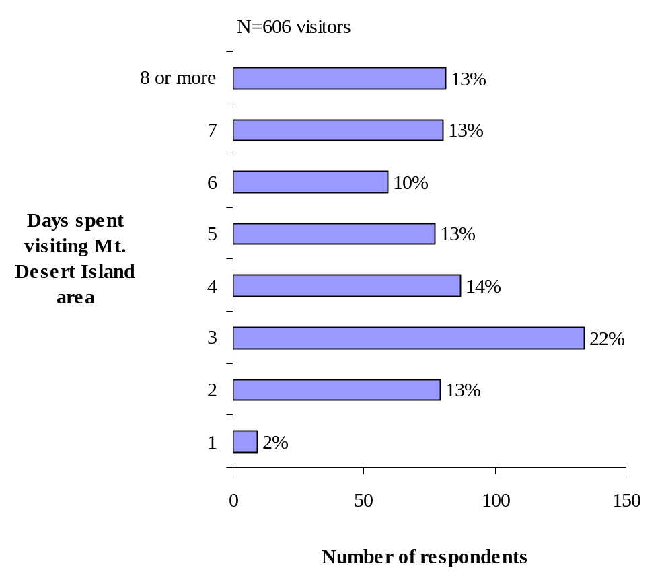

Figure 6-4: Days Spent Visiting Mount Desert Island Area
by Non-Residents
Table 6-8 shows how much time visitors spent in the Mount Desert Island area according to their reported use of one or more of the ITS components and the Island Explorer bus. These are the same visitor ITS-use classifications introduced in Section 4 of this report. While the highest proportion of visitors, regardless of visitor group type, stayed three to four days, ITS users who used the bus or the bus and parking information reported longer stays than the ITS users of parking information and ITS non-users. Fifty-eight percent of the ITS bus users and 50% of ITS users of the bus and parking information reported staying 5 or more days. In contrast, less than half of the ITS users of parking information and ITS non-users reported staying for 5 or more days (44% and 43%, respectively). However, the ITS bus user group had the higher mean length of stay (7.19 days) and was significantly higher than the mean length of stay for ITS parking user group (4.42 days) and ITS non-user group (4.93 days).

Thus, the results suggest that there is a correlation between ITS and economic impact as measured by length of stay. ITS users tended to stay longer than non-users, and might be expected to spend more money and have a greater economic impact as a result. In particular, users of the ITS technologies associated with the Island Explorer stayed longer on average than any other ITS users and non-users.

Table 6-8: Days Spent Visiting Mount Desert Island Area by ITS User and ITS Non-User
 | ITS User |  |  | ITS Non-User
 | Bus | Bus & Parking | Parking | ITS Non-User
 | ---------------------------- Percent --------------------------------
1 to 2 days | 14 | 9 | 15 | 20
3 to 4 days | 36 | 33 | 41 | 37
5 to 6 days | 22 | 27 | 25 | 18
7 or more days | 28 | 31 | 19 | 25
 | Mean length of visit in days*
ITS Bus user | 7.19
ITS Bus & Parking user | 5.67
ITS Parking user | 4.42
ITS non-user | 4.93

* Significant differences among user groups, with ITS bus users higher than ITS parking group and ITS non-user group (ANOVA, p<0.05).
Expenditures During Visit
Figure 6-5 shows the amount visitors spent during their visit that included restaurants, purchases such as film, souvenirs, tickets, admissions, tours, rentals, and other tourist-type expenses. Visitors were specifically asked to exclude costs associated with hotel or rental car costs so that the data would be fairly comparable and not simply reflect the large discrepancies in costs between, for example, camping and resort hotels. The highest proportion of visitors reported spending $501 or more (27%) and $301 to $500 (23%) during their stay in the Mount Desert Island area. Table 6-9 shows the highest proportion of visitors, regardless of visitor group type, spent $501 or more. However, based upon the length of stay reported above for each visitor group, it is not surprising that the reported money spent during their visit was higher for the ITS bus users who used either the bus information alone or the bus and parking information. Fifty-eight percent of the ITS bus users and 55% of ITS users of the bus and parking reported spending $301 or more during their visit. In contrast, less than half of the ITS users of parking information and ITS non-users reported spending $301 or more during their visit (44% and 46%, respectively).
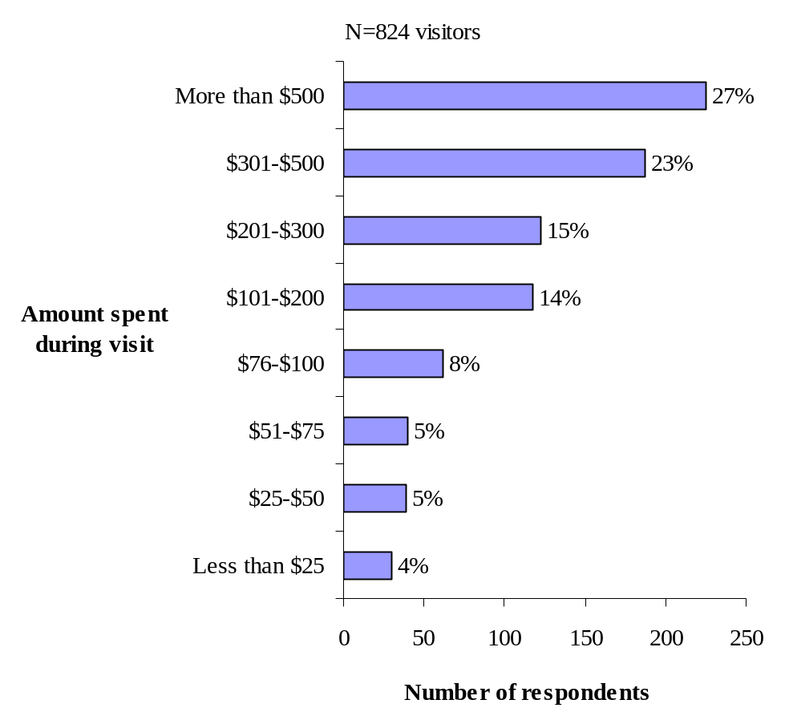

Figure 6-5: The Amount Visitors Spent During Their Visit,
Excluding Hotel or Rental Car Costs

Table 6-9: Money Spent During Visit by ITS User and ITS Non-User
 | ITS User |  |  | ITS Non-User
 | Bus | Bus & Parking | Parking | ITS Non-User
 | ---------------------------- Percent --------------------------------
Less than $25 | 2 | 1 | 4 | 7
$25-$50 | 4 | 2 | 4 | 8
$51-$75 | 4 | 1 | 6 | 7
$76-$100 | 8 | 6 | 7 | 8
$101-200 | 13 | 16 | 18 | 13
$201-$300 | 17 | 16 | 17 | 11
$301-$500 | 26 | 26 | 19 | 21
More than $500 | 29 | 32 | 25 | 25

* Significant differences across the four groups (Chi-square, p<0.001).
The “Carless” Tourist
The presence of the Island Explorer bus system offers the opportunity for attraction of a new tourist segment to Mount Desert Island: the “carless” tourist. With bus service to the Bar Harbor Airport and the CAT Ferry from Canada, tourists can literally arrive without a car and then take advantage of bus or bike for trips throughout the Island once they are there. The visitor survey provided data for examining the prevalence of the carless tourist.

As reported in Section 4.0 the majority of visitors in this evaluation said they used a privately owned vehicle as the mode of transportation to reach Mount Desert Island. Visitors identified as ITS non-users as compared to ITS user groups were much more likely to report the use of a car or truck with no trailer as the mode of travel to reach Mount Desert Island (91% and 75%, respectively). There appears to be more diverse visitor types including a carless segment of visitors among the ITS user groups. As depicted in Table 6-10 a slightly higher proportion of ITS users as compared to ITS non-users reported using modes of transportation that included commercial airplane (4%), private boat (3%), tour bus (2%), bicycle (1%), cruise ship (<1%), and private airplane (<1%). Thus, while the survey was not able to identify the proportion of visitors who were totally without a private vehicle during their stay, the data do suggest that there are likely to be some in that group. They are also more likely to be users of ITS, especially those technologies associated with the Island Explorer which are intended to help attract visitors away from using their own vehicles. Thus, it would appear that the infrastructure for the carless segment is in place and can be further exploited by the tourist industry of Mount Desert Island.
Table 6-10: Mode of Transportation Used to Reach Mount Desert Island
Mode of Transportation | ITS User | ITS Non-User
Mode of Transportation | ---------Percent---------
Car or truck, no trailer | 75 | 91
Car or truck, with trailer | 10 | 4
Motor home/RV | 6 | 2
Commercial airplane | 4 | 3
Private boat | 3 | 0
Tour bus | 2 | 1
Other | 2 | 1
Motor home/RV, with car | 1 | 1
Bicycle | 1 | <1
CAT ferry without auto | 1 | <1
CAT ferry with auto | 1 | <1
Cruise ship | <1 | 0
Private airplane | <1 | 0
Percentages do not equal 100 due to rounding

Conclusion about Impact of ITS on Tourist Spending
Caution should be exercised in drawing conclusions about the relationship between the use of the ITS-based traveler information and reported increase length of stay, money spent, and diverse mode of travel used to reach Mount Desert Island. On one hand, answers above may reflect to some degree visitor’s use of the Island Explorer bus independent of the traveler information. Daigle and Lee’s study of the Island Explorer bus passengers in 1999 reports similar long length of stays by bus users as compared to general visitors in previous studies. Although money spent was not asked in the 1999 study it is reasonable to assume that Island Explorer bus passengers would have reported higher amounts of money spent during their visit as compared to visitors in general who reported shorter stays. Similarly, the 1999 study of bus passengers showed more diverse visitor types including a carless segment of visitors as compared to visitors in previous studies.

On the other hand, economic impact may indeed reflect to some degree visitor’s use of the Island Explorer bus related to the ITS-based traveler information. As noted earlier in this report (Section 4.3), visitors derived tended to have a positive experience with the ITS technologies, which in turn helped them to decide to use the Island Explorer. Therefore, to the extent that ITS enhances the Island Explorer, and the bus system is a magnet for the most economically attractive types of visitors, ITS can be said to have an economic impact on the region.

Economic Impact of ITS on Acadia National Park
The local planners of the Acadia National Park ITS Field Operational Test anticipated that the Park might enjoy direct economic benefits in the form of higher receipts of gate fees and donations by visitors. While the official policy requires that visitors to the Park pay for a Park pass, in practice it is possible to enter the Park without a pass. Through the various means of providing traveler information that were part of the FOT, travelers could be informed of the Park pass requirement. Furthermore, by enhancing visitor experience ITS would lead to greater satisfaction on the part of visitors and increase the likelihood of visitor donations to the Park, either directly or through Friends of Acadia. To assess the impact of ITS, records were obtained from Acadia National Park from 1999 through 2002 and are shown in Figure 6-6.

The data reveal that gate receipts increased from 2001 to 2002 when ITS was deployed. Gate receipts also rose on a per visitor basis from $.94 to $1.03 during that those two years. Donations did not follow that pattern, given the peak year of 2001 prior to ITS. Focusing attention just on gate receipts, the question is whether ITS had anything to do with the increase. In the initial planning of the on-board announcements for the Island Explorer, a message was planned to inform bus riders about the need to purchase Park passes. However, that message was not implemented in the deployed system, and, thus, there appears to be no direct link between the ITS technologies and higher gate receipts.

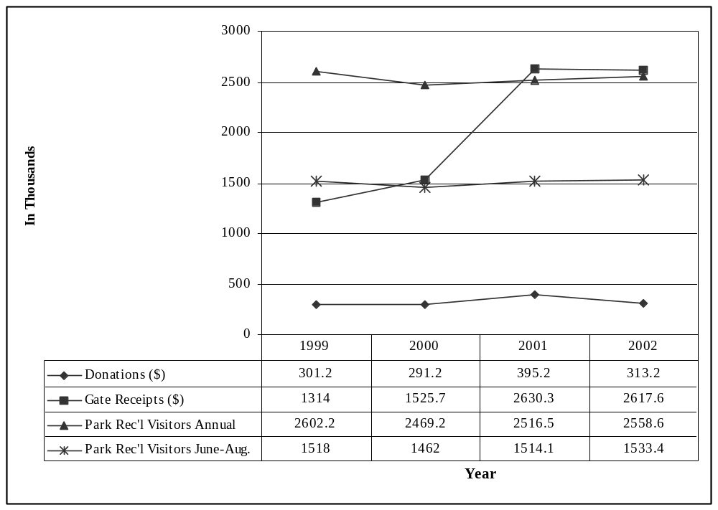
Figure 6-6: Acadia National Park Donations and Gate Receipts (in 1000’s) by Year

Impact of ITS on Productivity of Island Explorer Operations
As described in Section 4.4 the Island Explorer bus system was equipped with a suite of ITS technologies that were intended to improve operations by providing real-time data on bus location, schedule adherence, passenger loading, and voice communications with drivers. The anticipated outcome was an improvement in the operating costs of the Island Explorer on a per unit basis if not as a whole.

To measure productivity, budgetary and other data were obtained from Downeast Transportation, Inc., the owners of the Island Explorer. Whereas data such as vehicle mileage and passenger counts were obtained manually from 1999 to 2001, the ITS technologies automated such data collection in 2002. Table 6-11 presents the principal operational data by year from 1999 through 2002.
Table 6-11: Island Explorer Operational Measures
 | 1999 | 2000 | 2001 | 2002
Miles (000) | 148 | 209.5 | 220.5 | 217.5
Ridership (000) | 140.9 | 193.1 | 240 | 281.1
Operating Expenses ($000) | 204.5 | 394.7 | 472.8 | 568
Service Denials | <1% | <1% | <1% | <1%
Standing Riders (% of trip segments with one or more standees) | 8% | 8% | 11% | 14%
Service Hours (000) | 7.3 | 10.1 | 12.3 | 12.3
Routes | 6 | 7 | 7 | 7
Number of Buses | 8 | 17 | 17 | 17
As the data in Table 6-11 clearly show, operating expenses of the Island Explorer have increased steadily in its four years of operation. From 2001 to 2002, the year that ITS was fully operational on the Island Explorer, it grew by 20%. However, ridership also grew significantly, swelling 17% from 2001 to 2002 leading to 14% of the runs having standing riders. Service hours, number of routes, and number of buses remained constant in the two years.

To assess the change in operational performance as the bus system grew over the four seasons of operation, Figure 6-7 presents unit measures. In terms of hours of operation, the number of riders remained fairly flat in the first three years, and jumped by 3.4 per hour riders in the 2002 season. Cost per rider was fairly constant from 2000 to 2002, but the cost per hour and mile of operation jumped significantly in 2002. Thus, while ITS may have contributed to attracting more riders to the Island Explorer, that growth came at a higher overall operating price.

To fully understand the factors behind these statistics, the evaluation team obtained additional budgetary information from Downeast Transportation. Because the fiscal year for bus operations is different than the calendar year, Downeast recommended that the more appropriate comparison is between 2000 and 2002. The additional information revealed that the expected improvements in productivity over the two-year period owing to ITS were not realized due to increased service hours, higher wages, assuming costs that were previously paid by Acadia National Park, vehicles no longer being under warranty, hiring professional year-round management, and increases in direct operating costs. Some details on specific operational costs included:

- 10% increase in the cost of insurance
- 344% increase in the cost of vehicle repairs: buses were not only older but were being used more
- Printing of the bus schedule and cost of a planning consultant that was previously paid by Acadia National Park
- 16% increase in operating wages, paralleling increase in service hours
- 8% increase in fuel costs.

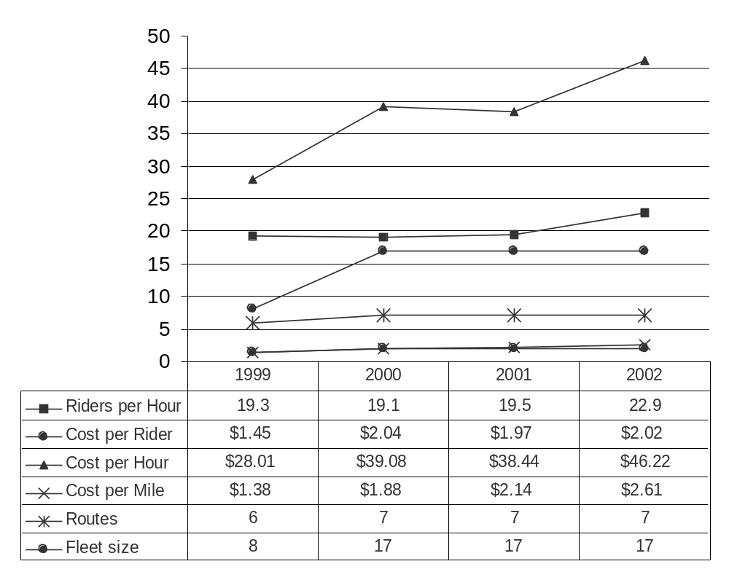
Figure 6-7: Island Explorer Productivity Measures
In addition, the Island Explorer experienced extra costs to continue to operate the ITS technology itself. An additional $100K was spent for a two-year extension to the warranty of the AVL system supplied by Avail Technologies, which is being split between the Maine DOT and Downeast Transportation.

Thus, the operating costs of the Island Explorer prior to 2002 did not fully reflect all the costs, owing to the assistance provided by Acadia National Park. In addition, the maturation of the bus operations along with the success in capturing a large volume of riders has been accompanied by additional expenses not required in the initial years. Finally, the ITS technologies themselves resulted in additional operational expenditures. It can be concluded, therefore, that while ITS technology undoubtedly entails some additional operating and capital cost for the Island Explorer, those costs are fairly minor when placed against all other costs of operating a growing, professionally run system. Moreover, as will be discussed in Section 7, the operational benefits of ITS are important and must be weighed against the cost.

6.6 Summary of Productivity and Economic Vitality
Table 6-12 shows the hypotheses related to productivity and economic vitality that were examined in the evaluation. Economic vitality relates to the important role of tourism in the regional economy and the potential impact that ITS might have in maintaining or strengthening tourism. Data from the business and visitors survey and revenue data from Acadia National Park were used to assess economic vitality. Productivity impacts measured in this evaluation focused on the role of ITS in the operations of the Island Explorer bus system, and Island Explorer operational data were used for this purpose.

Table 6-12: Objectives and Hypotheses Related to Productivity and Economic Vitality
Goal Area | Objective | Hypothesized Impact
Productivity  and Economic Vitality | To provide a more positive visitor experience and increased visitation | ITS users stay longer than non-ITS users
Productivity  and Economic Vitality | To increase economic contribution to Mount Desert Island and Acadia National Park | ITS attracts visitors and enables higher revenue capture during stay
Productivity  and Economic Vitality | Attract carless tourist segment | Tourists arriving without cars will be attracted by ITS-enabled mobility
Productivity  and Economic Vitality | To maximize Acadia National Park revenue | ITS will provide better information that will ensure that visitors pay Park fees and make contributions
Productivity  and Economic Vitality | To reduce or optimize operating budget of the Island Explorer | Better real-time data will allow Island Explorer management to react to dynamic changes more efficiently and thereby more cost effectively
Regardless of business type, the majority of business managers recognize the importance of tourism and the benefits to their business or community from being situated near Acadia National Park. However, they are concerned about problems of summer travel on Mount Desert Island and in the Park, including parking and congestion as well as concerns about air quality and safety. Clearly, many business managers believe that the Island Explorer bus system helps to address some of their concerns about summer travel, and 69% reported that they provide information to visitors about the Island Explorer bus. While the majority of the business managers (61%) reported being aware of one or more of the ITS technologies, they were much more aware of the ITS technologies associated with the Island Explorer bus and in particular the electronic bus departure signs than the signs that displayed parking conditions at Sand Beach and Jordan Pond House.

Managers perceived many benefits associated with the ITS, such as making it easier for tourists to get around, avoiding parking problems and traffic congestion and crowds in the Park, relieving uncertainty for users when the bus would arrive at the bus stop and where to exit the bus, and improving the travel experience.

It was hypothesized that the ITS-enhanced experience and increased access will contribute to longer visitor stays and attract a new car-less tourist segment. There was strong support among business managers that the Island Explorer creates potential for a new segment of tourists who do not drive personal vehicles. The visitor survey did indeed show that, among visitors who used ITS compared to those who did not use ITS during the summer of 2002, there was a higher incidence of modes of transportation used to reach Mount Desert Island that might be associated with the carless segment: commercial airplane, private boat, tour bus, bicycle, cruise ship and private airplane.

Specifically related to the ITS technologies, most business managers thought the parking and Island Explorer traveler information would increase the likelihood that some tourists would ride the Island Explorer bus, and a high proportion of the business managers thought the Island Explorer traveler information helped tourists utilize time such as visiting shops before a bus arrives at the bus stop. According to the visitor survey, spending was higher among those who used the ITS technologies, especially those associated with the Island Explorer.

There was a great deal of uncertainty among business managers about whether visitors who use the Island Explorer tend to stay longer. Thus, regardless of the increased positive experiences that might result from customer use of the ITS technologies and probable use of the Island Explorer bus, managers did not necessarily perceive economic benefit to businesses in terms of increased length of stay. This may have contributed to a substantial minority of business manager being “neutral” to parking and Island Explorer traveler information being helpful to their business. However, the visitor survey showed that there was a correlation between ITS use by visitors and how long they stayed, with users of ITS technologies associated with the Island Explorer staying longer on average than other groups of ITS-users and non-users.

Revenue in the form of the Park’s gate receipts and donations to the Park were another measure used to evaluate the economic impact of ITS. However, an automated announcement on-board the Island Explorer to encourage purchase of Park passes had been planned but not implemented. Consequently, this economic impact of ITS was not evaluated.

Finally, the productivity of the Island Explorer bus system was evaluated. Rather than an improvement in operating costs on a total or per unit basis, the opposite was observed. The reason for the cost increases can be attributed to a rapid growth in ridership since 1999 and the necessary growing pains associated with that growth. Some costs in the early years of operation were borne by Acadia National Park and in the later years these costs were assumed by Downeast Transportation, the owners of Island Explorer. While many cost components were for general bus operations, one ITS-specific cost is the need for extending a warranty on the AVL system. However, that expense was judged to be fairly minor in the total cost picture.

7.0 Efficiency
This section presents the results of the evaluation that deal with the impact of ITS on efficiency. Efficiency improvements relate to greater throughput, or accomplishing more after the ITS technologies were deployed with the same amount of effort as before. In the field operational test at Acadia National Park, it was anticipated that ITS technologies would help automate existing practices and expand capabilities with the ultimate result being more efficient operations. Thus, it was expected that Park resources could accommodate more visitors and that demand for those resources could be distributed more evenly. Likewise, it was expected that the Island Explorer would serve more passengers but with better service. These hypotheses were explored using data from Park records, traffic information from Maine Department of Transportation, an observational study of parking lot usage within the Park, and Island Explorer operational data as well as anecdotal information from its staff.

Impact of ITS on Efficiency of Acadia National Park Operations
This section examines the level of usage the Park received, how transportation factored into that usage, and what impact ITS played, if any, in distributing usage more efficiently. Usage can be gauged not only by number of visitors officially counted by the Park, but also in terms of traffic and riders of the Island Explorer buses. Another element of usage directly related to transportation within the Park is use of parking lots. Through observation at eight parking areas, the evaluation was able to determine whether parked vehicles exceeded a lot’s official capacity, thereby representing an over-utilization of the Park’s facilities. Parking lot usage is discussed in Section 7.2.

Figure 7-1 presents statistics on general usage. Counts of Park recreational visitors are estimates based on an occupancy factor applied to each vehicle entering the Park. Traffic counts were obtained from Maine DOT, which has a permanent traffic sensor installed at Thompson Island Bridge on Route 3 to detect vehicles entering Mount Desert Island from the mainland. Traffic counts for 2001 were not available because the traffic counting equipment malfunctioned that year. Downeast Transportation supplied counts of riders of the Island Explorer, which operated from late June through Labor Day each year. Because visitors can enter the Park from roads other than the three where counts are made, no single measure encompasses total usage adequately.

The data in Figure 7-1 reveal that, while the total recreational visitors increased steadily over the last three years, the proportion of visitors carried by the Island Explorer increased dramatically. The result was that the proportion of visitors carried by the bus during the summer months when the bus was in service doubled to between 1999 and 2002. The year that the ITS technologies were operational, the proportion increased from 15.6% in 2001 to 18.3% in 2002. Thus, whereas it was argued previously in this report that dramatic increases in bus ridership in 2002 may be attributable in part to the ITS technologies making the bus easier for visitors to use, that increase appears to be having an effect on the Park’s resources. From the standpoint of demand for the Park’s transportation resources, it is realizing greater efficiency by serving the same number of visitors with fewer in their own vehicles.

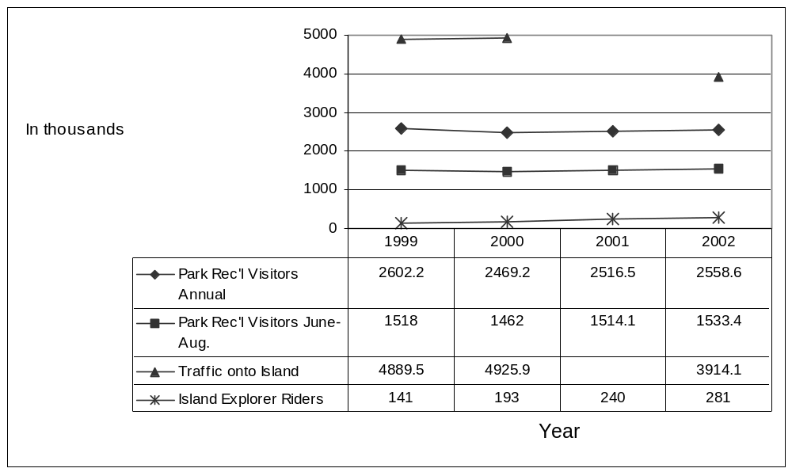
Figure 7-1: Statistics Related to Usage of Acadia National Park
The dramatically lower (-25%) counts of traffic coming onto Mount Desert Island in 2002 are harder to explain. One possibility is that the traffic sensor that caused the problem with the 2001 data affected the 2002 data. Another explanation would be the economic slow-down after September 11 terrorist attacks. However, that explanation does not appear to be consistent with the increase in visitors 2002 as compared to 2001, which would suggest that traffic had actually increased from the previous year. Sales tax receipts for 2002, unavailable at the time of this report, could shed further light on the whether the explanation is a fault sensor or economic factors.

Effect of ITS on Visitors’ Parking Lot Usage
Parking lots are an important transportation resource of Acadia National Park, as they provide visitors convenient access to some of the most desirable destinations within the Park. However, during the summer months parking at some of the most popular destinations is in short supply, leading some drivers to park vehicles outside designated parking spaces within the lots and along the side of roads leading up to the lots. The result is frequently damage to natural environment as well as aesthetic and safety problems.

The ITS technologies at Acadia were used to address the parking problem by collecting real-time data on whether the most popular lots, Sand Beach and Jordan Pond, were full. That information, in turn, was made available to visitors by means of signs placed at two Park campgrounds and the Visitor Center (Figures 4-2 – 4-4 in Section 4). The evaluation sought to determine whether the information was able to reduce the parking outside designated spaces at Sand Beach and Jordan Pond. It also assessed whether ITS helped to distribute the demand for parking more evenly among other parking lots. Data for the evaluation were collected through direct field observation of parking patterns at eight parking areas in Acadia National Park that were served by the Island Explorer buses, including Sieur de Monts, Sand Beach, Jordan Pond House, Bubble Pond, Eagle Lake, Ikes Point, Acadia Mountain, and Echo Lake. Using a randomized sample design, the evaluation team observed morning and afternoon parking at each lot for a total of 86 days over three summer seasons. Years 2000 and 2001 represented baseline conditions, and 2002 represented the post-deployment phase of ITS.

Table 7-1 summarizes the total number of cars in the eight lots that exceeded the lot capacity. In 2001 on more than half of the days the eight parking areas where observed (54%), more than 300 vehicles were counted outside designated parking spots in the eight parking lots. In contrast, on only 33% of the days in 2002 was the number of excess vehicles over 300 in the eight parking lots. These percentages correlate with the mean number of vehicles exceeding the capacity of the eight designated parking areas during the summer season. In 2001, the mean number of vehicles was 325 that exceeded the capacity of eight designated parking lots in Acadia National Park as compared to 274 for 2002. While the year 2000 had a mean number comparable to 2002, it should be noted that the total visitors to the Park increased each of the three years, therefore making the reduction in the parking statistics for 2002 even more notable.
Table 7-1: Percent of Days in Which Vehicles Exceeded the Capacity
of Eight Designated Parking Lots in Acadia National Park
# of Vehicles | Percent of Days by Year
# of Vehicles | 2000 | 2001 | 2002
 | --------------- percent ---------------
0-100 | 6 | 9 | 18
101-200 | 28 | 6 | 12
201-300 | 22 | 31 | 36
301-400 | 22 | 25 | 9
401-500 | 17 | 20 | 12
Over 500 | 6 | 9 | 12
 | Mean number of vehicles exceeding the capacity of lots
2000 | 273
2001 | 325
2002 | 274

Turning to the question of the impact of ITS on parking at Sand Beach and Jordan Pond, the two parking lots for which information on parking availability was made available to visitors,
Table 7-2 presents details on the two lots. The reduction in the average number of vehicles that exceeded the capacity of these two lots is consistent with the expected impact of ITS.
Table 7-2: Mean Number of Vehicles that Exceeded the Capacity and
Time of Day for Parking Lots at Sand Beach and Jordan Pond
Sand Beach
Year | Days Observed | Morning | Afternoon | Total
 |  | ---mean # vehicles per day---
2000 | 18 | 25 | 56 | 81
2001 | 35 | 36 | 88 | 124
2002 | 33 | 27 | 71 | 98

Jordan Pond
Year | Days Observed | Morning | Afternoon | Total
 |  | ---mean # vehicles per day---
2000 | 18 | 19 | 87 | 106
2001 | 35 | 14 | 82 | 96
2002 | 33 | 9 | 72 | 81

Table 7-3 puts the data for these two lots in perspective of all eight parking lots. As expected the numbers for Sand Beach and Jordan Pond were much higher compared to the six other parking lots for all three years. Sand Beach and Jordan Pond are extremely popular destinations in the Park, and it is possible for visitors to park close to but outside the designated parking spots for these attractions. Nevertheless, in 2002, the year that ITS was operational, a reduction was seen in the mean number of vehicles exceeding the capacity of the Sand Beach and Jordan Pond parking areas compared to 2001. The magnitude of change for these parking areas compared to the other six parking areas might be partly related to the real-time parking information available for these two areas and not the other six areas. Visitors could have observed the parking information signs indicating the lots were full and decided not to visit Sand Beach or Jordan Pond or to take the Island Explorer there instead.

Changes in excess vehicles at other parking lots should be noted as well. For example, there was a slight increase in the number of vehicles exceeding the capacity of Acadia Mountain parking in 2002 as compared to 2001. One explanation for the increase may be that visitors learning about the parking conditions at Sand Beach or the Jordan Pond House may have elected to go to Acadia Mountain adding to the parking problem at that location. On the other hand, a noticeable reduction was observed in 2002 for the number of vehicles exceeding the capacity of the Eagle Lake parking area compared to 2001. The data do not, therefore, demonstrate an overall redistribution of vehicles among the eight lots as a result of ITS, as there was not an increase in the mean number of vehicles exceeding the capacity of the other six parking areas. Still it is possible that such a redistribution could have occurred, but was not measured by the data which focused on excess parking. For example, it is possible that the total number of vehicles increased at Echo Lake during 2002, but they would have been parked legally within the capacity of the parking lot and, therefore, would not have been counted.
Table 7-3: Mean Number of Vehicles Exceeding the Capacity of
Individual Lots in Acadia National Park
Year | Parking Lot
Year | Sieur De Monts | Sand Beach | Jordan Pond | Bubble Pond | Eagle Lake | Ikes Point | Acadia Mountain | Echo Lake
2000 | 4 | 81 | 106 | 2 | 63 | 2 | 20 | <1
2001 | 2 | 120 | 95 | 4 | 68 | 3 | 24 | 1
2002 | 5 | 98 | 82 | 2 | 54 | 4 | 31 | 1

Impact of ITS on Efficiency of Island Explorer Operations
The ITS technologies associated with the Island Explorer were intended to enable a variety of improvements in operation, such as better scheduling of buses to meet demand and better response to vehicle or driver problems, such as breakdowns, that could impact service. The ITS technologies associated with the Island Explorer that would most directly impact efficiency included voice communicators, automatic vehicle location, and automated passenger counters. Electronic departure signs and on-board annunciator of the next stop were aimed primarily at passengers rather than the bus operations, per se.

Table 7-4 presents operational statistics obtained from Downeast Transportation since 1999, the first year of the Island Explorer. As noted previously in this report, the bus service has experienced substantial increase in ridership over its four years of operation. With a better sense of the potential demand and with a year of operational experience behind them, Downeast Transportation doubled the size of the fleet from eight buses in the first year to 17 buses in 2000. Similarly, a seventh route was added in 2000. Fleet size and routes of service have remained constant since then. Hours of operation were also lengthened to provide better service for riders to participate in evening activities outside the Park. As a result, total service hours reached 12,300 in 2001 and stayed constant in 2002. To assess the impact of the ITS technologies on the operations of the Island Explorer, these operational statistics were analyzed. In addition, anecdotal information collected during interviews with Island Explorer managers and drivers provided further insight into their perceptions of the benefits of ITS.
Table 7-4: Island Explorer Operational Statistics
 | 1999 | 2000 | 2001 | 2002
Miles (000) | 148 | 209.5 | 220.5 | 217.5
Ridership (000) | 140.9 | 193.1 | 240 | 281.1
Service Denials (% of trip segments over capacity) | <1 | <1 | <1 | <1
Standing Riders (% of trip segments with one or more standees) | 8 | 8 | 11 | 14
Service Hours (000) | 7.3 | 10.1 | 12.3 | 12.3
Routes | 6 | 7 | 7 | 7
Number of Buses | 8 | 17 | 17 | 17

Figure 7-2 shows three measures of operational efficiency from 1999 through 2002. Comparison of measures for 2002, when ITS was in operation, with the previous year suggests that ITS did indeed aid the efficiency of Island Explorer operations. Bus utilization, in terms of miles driven per bus, decreased slightly, even though overall ridership increased. The increase in the number of riders per hour from 2001 to 2002 was 17% higher with a corresponding increase in the percentage of trip segments (distance between two stops) with standing riders. It is significant to note that between 2000 and 2002, far less than 1% of all trip segments involved a stop where the bus driver refused service because of over capacity. Thus, it can be concluded that purely on a quantitative basis that ITS had a positive impact on the efficiency of operations of the bus system.

From a qualitative standpoint, efficiency benefits were also observed. In Section 4.4 results of interviews with Island Explorer managers and drivers were discussed, and some of their perceptions pertain to efficiency. For example, they said that voice communications between the dispatcher and the drivers helped to communicate information on large passenger loads and blocked roads. Managers said they found the automatic vehicle locator very valuable for route management, schedule adherence, and monitoring speed and position of each bus and driver within the overall system. In general, managers believed that ITS helped them operate the bus system more effectively, and drivers believed ITS helped them cope with increased traffic and ridership as well as making their job easier overall. Thus, the beliefs of the staff who experienced the ITS technologies support the quantitative findings about the positive impact on efficiency.

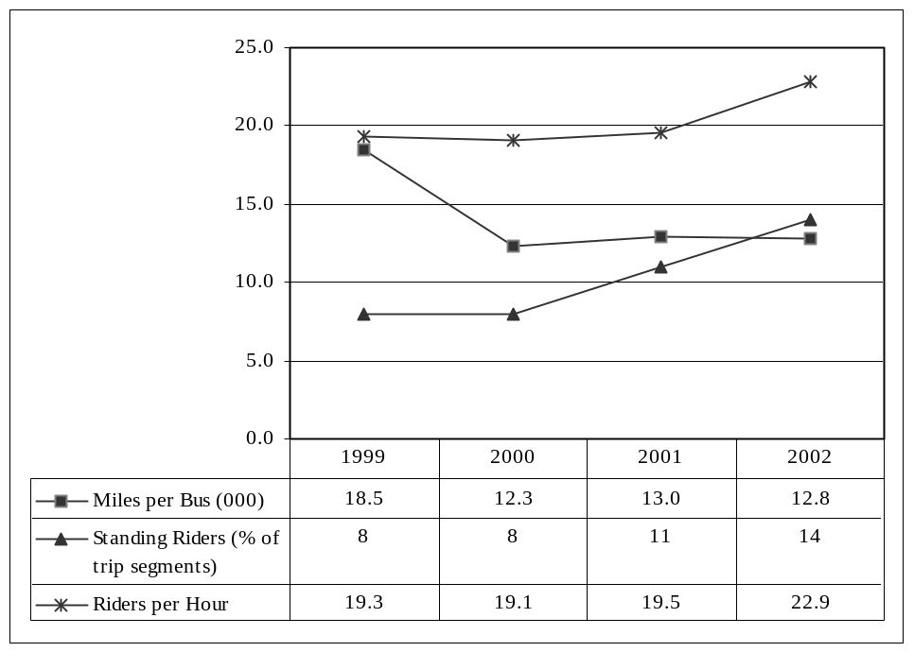
Figure 7-2: Island Explorer Operating Efficiencies

7.4 Summary of Efficiency
The evaluation hypotheses related to efficiency are shown in Table 7-5. The benefits of ITS on efficiency pertains to the ability to accomplish more after ITS than before ITS was deployed. Within the context of the field operational test at Acadia National Park, efficiency was examined from the standpoint of visitor demand and the use of the Park’s transportation resources. Records from the Park, Maine Department of Transportation, and the Island Explorer along with an observational study of parking behavior by visitors at eight parking lots within the Park served as data for the evaluation. A second area of efficiency that was assessed was the impact of ITS on the operations of the Island Explorer. Data on equipment use and passenger loadings were examined to determine if ITS had an impact. In addition, interviews with managers and drivers of the Island Explorer provided a qualitative assessment of the impact of ITS.
Table 7-5: Objectives and Hypotheses Related to Efficiency
Goal Area | Objective | Hypothesized Impact
Efficiency | To increase the number of customers served | ITS provides better operating information, which allows for more efficient deployment of resources to a greater number of Park visitors
Efficiency | To distribute the demand on Acadia National Park resources more evenly | Better information availability allows for visitor pre- and on-trip planning so that parking lots usage is more balanced
Efficiency | To increase Island Explorer efficiency in managing its operations | ITS will provide better operating information to enable better scheduling and to serve more passengers with the same equipment

The Park’s transportation resources examined in this evaluation consist of its roads and parking lots that visitors use to access many destinations within the Park. It was hypothesized that ITS, by enhancing the Island Explorer and making it easier to use and by providing information to visitors about crowded parking conditions in the Park, would result in less utilization of the roadways and the parking lots. In addition it was hypothesized that usage of the parking lots would be more evenly balanced as visitors were informed about full conditions at the two of the most popular destinations, Sand Beach and Jordan Pond, and selected alternative destinations. The data support most of these hypothesized impacts of ITS. The Park was able to serve more visitors while containing the demand for road and parking facilities. Although total visitors increased from 2001 to 2002, the proportion that used the Island Explorer increased even faster, suggesting that, relatively speaking, fewer vehicles were on the Park roads. In addition, the days that parking at Sand Beach and Jordan Pond exceeded the parking lot capacity were noticeably fewer in 2002 than 2001, suggesting that visitors noticed and acted on the parking status information at those two locations. One hypothesized impact that was not supported by the evaluation was a redistribution of vehicles to the other six parking lots that were studied. However, that does not mean that a redistribution of demand for parking did not take place. Some lots may have had sufficient capacity to accommodate additional vehicles, and such a pattern would not have been observed in the data that were collected on excess parking.

With regard to the efficiency of operations of the Island Explorer, ITS was expected to provide managers the tools to more effectively deploy the buses and drivers to service customer demand. Drivers, too, were expected to benefit from the automation and enhanced features that ITS provided and enable them to perform their job more efficiently. Both the quantitative and qualitative data collected in the evaluation support these hypothesized impacts of ITS. With a stable bus fleet and number of routes, the Island Explorer was able to serve 17% more passengers in 2002 when ITS was being used. Managers and drivers alike voiced their belief that ITS was having a positive impact in ways that make operations more efficient.

Energy and Environmental Impact
In this section the impact of the ITS technologies are examined from the standpoint of energy and environment. The anticipated improvements from the ITS deployment relate primarily to having fewer vehicles on the roads thereby using less fuel and causing less pollution or using less polluting vehicles. Yet another potential environmental impact is an aesthetic benefit that would result from fewer vehicles parked along Park roads detracting from the beauty of the natural environment. Visitors come to Acadia to enjoy its outstanding natural beauty, and the large number of vehicles within the Park is viewed negatively by some. The expected impacts on energy and environment were tested using data on counts of vehicles, passenger counts of the Island Explorer, and results of emissions modeling supplied by the Maine Department of Environmental Protection.

Air Quality Impacts

Visitors ranked concern about “too many autos having a negative impact on air quality” among the top five problems related to travel on Mount Desert Island and in Acadia National Park, according to the visitor survey (see Section 4.2). Figure 8-1 shows that 28% of all visitors felt it was a “moderate” or “big” problem. The ITS users who used the bus and parking traveler information actually ranked this item second in terms of problems related to travel on Mount Desert Island and in Acadia National Park. Further investigation is needed in terms of the prevalence of this issue influencing the choice of using the less polluting propane-powered Island Explorer buses. However, it may be an attractive incentive for visitors and future use of the Island Explorer bus with this level of awareness of autos and air quality, especially in a pristine setting such as Acadia National Park.

While the visitors’ perception of a problem is important, trying to measure air quality and the potential benefit that ITS might provide quantitatively is no simple matter. The amount of traffic within the Park is a key indicator of energy and environmental impact. While it was impractical to directly measure fuel use or emissions of vehicles, the total number of vehicles is a useful surrogate. Unfortunately, good estimates of vehicles counts are not available. As noted in Section 7.1, the 2002 traffic counts from the Maine DOT sensor at the entrance to Mount Desert Island are suspect. Moreover, Park statistics are in the form of visitors rather than vehicles. The most reliable indicator is perhaps the number of passengers on the Island Explorer bus, as they represent visitors who would otherwise be using their own vehicles to reach destinations within the Park. Moreover, the Island Explorer runs on natural propane fuel and therefore is a low emission producing vehicle.

The impact of the Island Explorer on air quality on Mount Desert Island is estimated by use of the emissions model known as Mobil 5 used by Maine Department of Environmental Protection. Figure 8-2 shows seasonal totals of avoided emissions by displacing trips in private vehicles with Island Explorer ridership. The avoided emissions are the total of VOC (volatile organic compounds) and NOx (nitrogen oxide) expressed in metric tons. An additional 1.17 tons of emissions were avoided in 2002, the year ITS was operational, compared to 2001. In that ITS technologies have been shown to be a factor in visitors’ willingness to use transit, ITS has a positive environmental impact through the reduction of vehicle-based emissions.

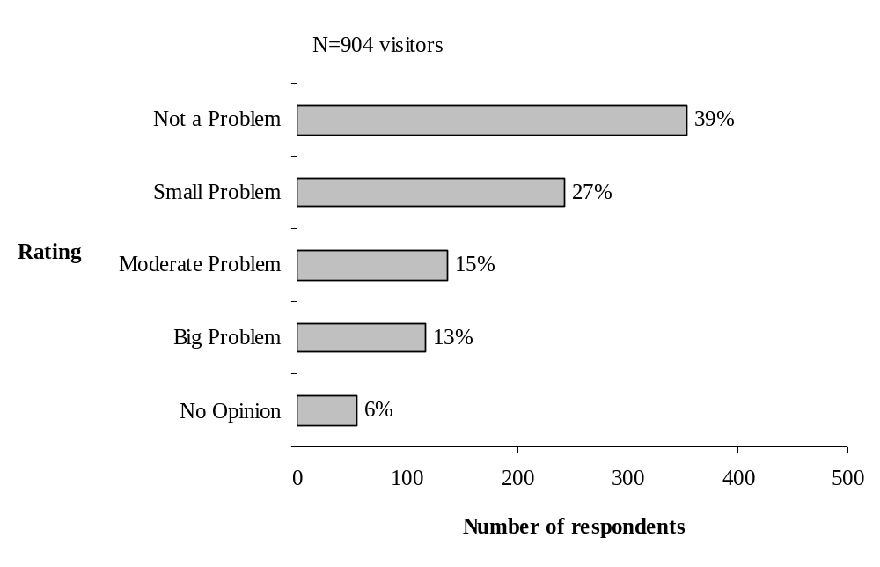

Figure 8-1: Visitor Rating of Too Many Automobiles
Having a Negative Impact on Air Quality

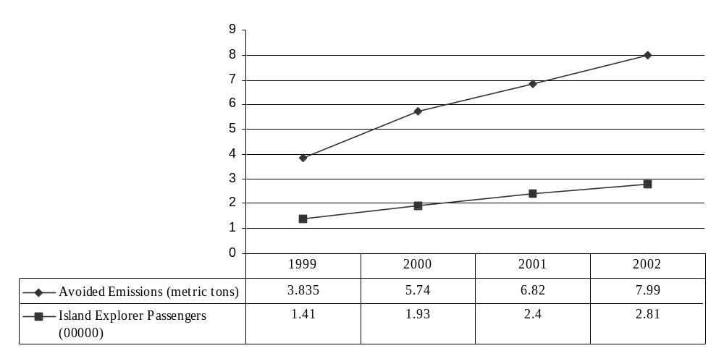
Figure 8-2: Island Explorer Passengers and Avoided Emissions in Metric Tons

8.2 Impact of Vehicles on Park Aesthetics
As discussed in Section 7.2 parking areas for vehicles within Acadia National Park are limited owing to the rugged terrain. At popular destinations the designated parking spaces are usually taken by mid-day and visitors frequently park at non-designated spaces and along roads leading to the parking lots. Parking outside designated lots can destroy vegetation, create soil compaction, and lead to erosion. Moreover, the sight of many vehicles parked along roads detracts from the natural beauty of the Park. In Section 7.2 the analysis of excess parking at selected lots suggested that ITS, in the form of real-time information about the availability of parking spaces, appeared to have contributed to a reduction in excess parking outside designated spots at the two of the most popular destinations: Sand Beach and Jordan Pond. From an aesthetic standpoint, ITS appears to have had a positive impact as measured by the reduction in excess vehicles at these two locations within the Park.

8.3 Summary of Energy and Environment
The hypothesized impacts of ITS on the evaluation of energy and environment are shown in Table 8-1. Although energy and environment was not a major focus of the evaluation, data were collected for a limited assessment of the impact of ITS. First, it was demonstrated that visitors exhibited a high degree of concern about vehicles negatively impacting air quality on the Island. They ranked it among the five top problems related to their travel experience. ITS, by enhancing the Island Explorer bus service, offers one solution for addressing the problem of air quality by encouraging more visitors to take the bus. Indeed, emission modeling that takes into account the growth of ridership of the Island Explorer indicated that air quality does benefit from the bus system. Thus, ITS can play a role in air quality improvement.

The other area investigated having to do with the environment was that of visual aesthetics. Cars parked along roads within the Park are seen by some as a detraction from its extraordinary natural beauty. A study of parking patterns showed a reduction in excess parking at the two of the most visited spots in the Park in 2002 when visitors were provided with real-time information on parking availability at those two spots. Such a reduction in excess parking would mean an aesthetic improvement, which may be attributable to ITS being used for parking information.
Table 8-1: Objectives and Hypotheses Related to Energy and Environment
Goal Area | Objective | Hypothesized Impact
Energy and Environmental | To reduce emissions from motor vehicles on Mount Desert Island | ITS-improved Island Explorer service will result in fewer trips by private vehicle and a consequent improvement in air quality
Energy and Environmental | To provide a more positive experience for visitors through enhanced aesthetics of Acadia National Park | ITS-improved Island Explorer service will result in fewer vehicles parked on Acadia National Park roads, thereby improving the visual aesthetics of the Park

9.0 Safety
This section presents results of the evaluation of the ITS field operational test from the standpoint of safety benefits. Although safety was not a major focus of the evaluation, stakeholders were interested in understanding how the ITS deployment at Acadia National Park might improve transportation safety on Mount Desert Island. The Island’s narrow two-lane winding roads were thought to offer ample opportunity for vehicular accidents. Using ITS to reduce vehicular traffic on roadways was expected to lead to a reduction in accidents. That is, having more visitors ride the Island Explorer and fewer on the roads in their own vehicles should be safer. Safety could also be improved through the application of ITS to better traffic management. ITS technologies could assist those responsible for traffic management, including Park rangers and Island Explorer drivers and managers, identify incidents and other hazardous road conditions more quickly and get them resolved. Analysis of safety was based on accident records from Acadia National Park and Maine Department of Transportation and interviews with Park managers and staff of the Island Explorer.

Visitors’ Traffic Safety Concerns
In the discussion of customer satisfaction Section 4, safety was shown to be the number one concern among visitors when they were asked to rate problems related to travel on Mount Desert Island and Acadia National Park. As shown in Figure 9-1, 69% of visitors viewed vehicles parked along main roads causing unsafe conditions as a problem to some extent.

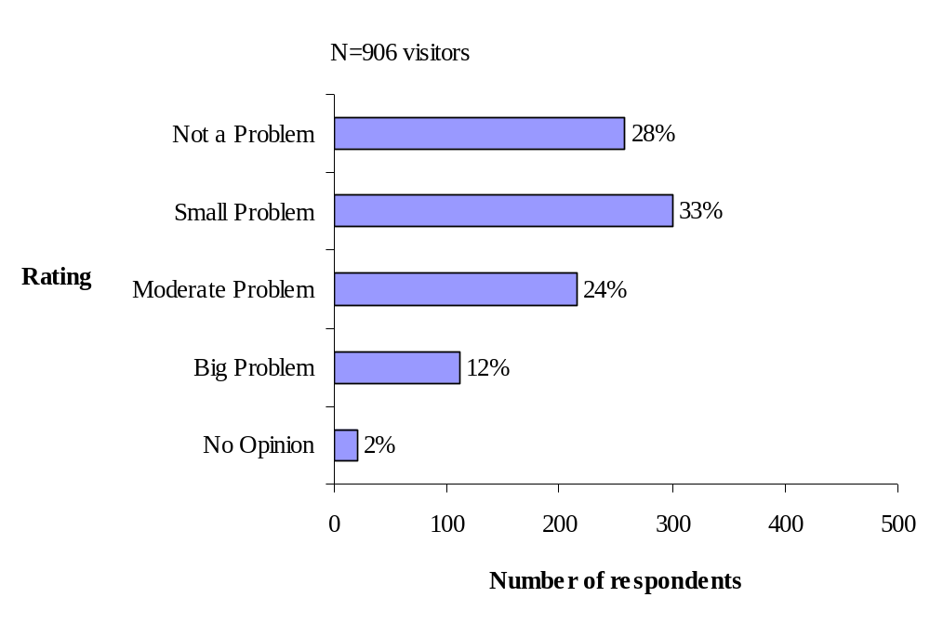

Figure 9-1: Visitor Rating of Vehicles Parked along the Main Roads

Causing Unsafe Conditions
It was also observed in Section 4 that visitors who used ITS were those most concerned about safety and other travel problems. Visitors who used the ITS-based information on buses alone or buses and parking expressed more concern about “driving and parking along busy roads” than those who were non-users or only used the parking information.

These findings indicate that from the visitors’ perspective travel safety is an issue for many who come to Acadia and Mount Desert Island. Moreover, ITS appears to play a part in alleviating the worry of those who are most concerned about travel safety during their visit.

9.2 Trends in Traffic Safety on Mount Desert Island
Data on motor vehicle accidents were obtained from Acadia National Park and the Maine Department of Transportation. Figure 9-2 shows the number of accidents along the Island Explorer route during the summer operating season. The Maine DOT numbers are exclusive of accidents reported by Park rangers, who report accidents within Park boundaries. The criteria for reporting is the same for both the State and the Park: an accident involving a motor vehicle with over $1000 in damage or personal injury.

The Maine DOT accident data for 2002 were unavailable at the time of this report, and thus it was not possible to assess what impact ITS might have had on accidents along the routes of the Island Explorer outside the Park. For accidents within the Park the statistics for reported accidents show a marked improvement in safety between 2001 and 2002, when the ITS suite of technologies was fully implemented. Whether or not there is any causal relationship between ITS and the 55% drop in accidents from 2001 to 2002 cannot be determined. However, while number of Park visitors increased by only 1.8% between 2001 and 2002, Island Explorer ridership increased by 17.1%. Thus, to the extent that ITS enhances the appeal of the bus and having visitors tour the Park by bus rather than their own vehicles leads to fewer accidents, then ITS may indeed be behind the observed safety improvements.

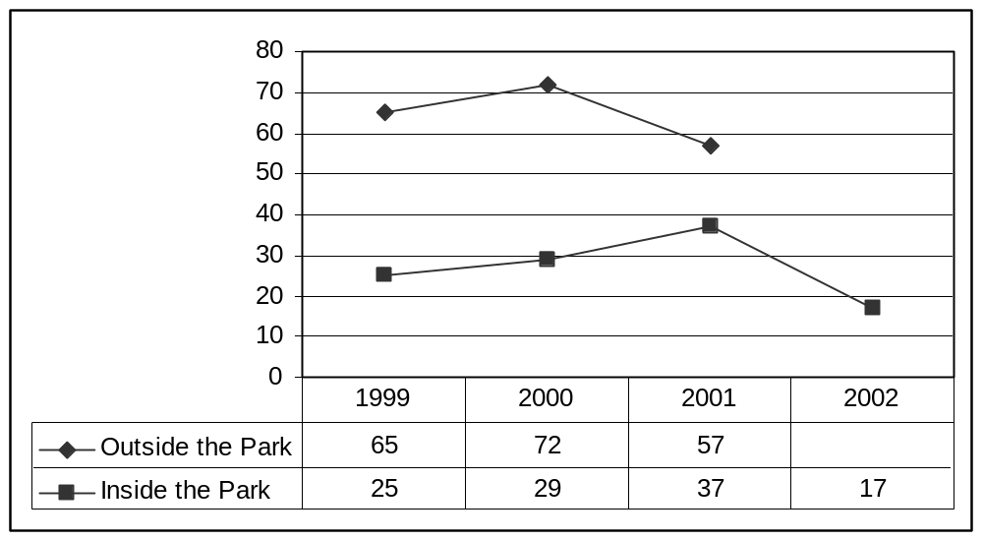
Figure 9-2: Motor Vehicle Accidents along the Routes of the Island Explorer
during the Summer Operating Season

9.3 ITS Contribution to Safety in Transportation Management
The final set of data that bear on potential safety benefits of ITS in the Acadia National Park FOT comes from interviews with managers and drivers of the Island Explorer buses. In the course of the interviews reported in Section 4.4, both managers and drivers identified safety benefits of the ITS technologies. The voice communicator in particular was valuable for enabling drivers to report various problems to the dispatcher, including accidents and hazardous parking that they observed. The managers believed that the communication system greatly improves safety by enabling text messages to be sent if the voice features were inoperable, as occurred once. In addition the automatic vehicle location system could be used to passively locate a vehicle in case of emergency. As these remarks indicate, ITS enables the bus system to be operated in a way that provides safety benefits to both bus passengers and drivers. In addition, the Island Explorer is in a position to assist others in emergency situations through the drivers’ use of the ITS technologies installed on the buses.

Summary of Safety
Visitors to Acadia National Park, when asked about problems with travel, identified safety on the roads of Mount Desert Island as their top concern. This section of the evaluation examined the safety benefits of ITS using the hypothesized impacts shown in Table 9-1. Data available for the evaluation included accident statistics and anecdotal evidence of the benefits of safety from the staff of the Island Explorer bus system.

The results of the analysis provide some evidence that the ITS technologies may be making travel safer during the summer months. There was a marked decrease in motor vehicle accidents within the Park in 2002, which may be related to the substantial increase in ridership of the Island Explorer taking people out of their own vehicles and putting them on the bus. Data were not available for accidents outside the Park to determine if a similar decrease took place. Thus, while the data suggest there might be a causal relationship between ITS and fewer accidents, no firm conclusion can be drawn from the limited data.

Evidence from interviews with the managers and drivers of the Island Explorer indicate that other types of safety benefits are derived from the ITS technologies installed on the buses. Drivers are able to report accidents and other hazardous conditions, and managers can remotely locate buses in emergency situations.
Table 9-1: Objectives and Hypotheses Related to Safety
Goal Area | Objective | Hypothesized Impact
Safety | To increase transportation safety in Acadia National Park and Mount Desert Island | ITS will reduce vehicular traffic on roads thereby reducing the number of accidents
Safety |  | ITS will reduce hazardous conditions by better management of transportation resources

10.0 Summary of Key Findings, Conclusions and Recommendations

This section presents key findings from the evaluation, showing what the evaluation data revealed in six goal areas. Also discussed are conclusions about the benefits of ITS that were observed in the field operational test of ITS at Acadia National Park and, where appropriate, recommendations about how those results could be utilized in the future.

10.1 Key Findings
This evaluation of the Acadia National Park ITS Field Operational Test investigated the benefits of ITS in six goal areas: customer satisfaction, mobility, productivity and economic vitality, efficiency, energy and environment, and safety. Many of the hypothesized impacts of ITS were directly supported by the evidence gathered in the evaluation, whereas for some expected impacts the limited data were only suggestive. In a few cases the impact was not observed or was counter to what was anticipated. Key findings for each goal area are summarized below.
Customer Satisfaction
- Visitors rated their overall experience and satisfaction with their visit very high, but travel experience during their visit was rated lower. Among the problems associated with travel on Mount Desert Island and in Acadia National Park, visitors expressed most concern about unsafe conditions caused by vehicles parked along main roads. Other top concerns were the number of automobiles both inside and outside the Park and their impact on air quality.

- ITS-users expressed more concern about travel issues in general than non-ITS users and sought means to alleviate those concerns via ITS and the Island Explorer. Non-users, on the other hand, were either less sensitive to travel conditions or had strategies for coping with problems that didn’t involve the need for Island Explorer or ITS.

- Between 40% and 50% of visitors were aware of the sources of traveler information targeted to them, and between 28% and 34% intended to use the information sources to help with travel during their visit.

- Visitors rated the ITS-based traveler information sources very highly (86% or more) on attributes of ease of use, understandability, and accuracy, and reported that the information helped relieve the stress or uncertainty of travel. The vast majority of users (78% or more) believed using the same ITS-based information again in a future visit would be a pleasant experience. Particularly promising are reports from ITS users that they would plan to use the information again.

- Drivers and managers of the Island Explorer bus system expressed a high degree of satisfaction with the five ITS technologies associated with the buses. Managers believed that ITS improved bus operations and contributed to customer satisfaction, but they weren’t sure if ITS directly increased ridership. Drivers felt that ITS made their jobs easier and helped them to cope with increasing traffic and ridership.
- ITS components associated with the Island Explorer was not totally trouble free, although problems were infrequent or minor enough not to detract from the overall satisfaction expressed by Island Explorer staff.

- Given that most of the ITS technologies intended for deployment within the Park itself were not operational during the summer of 2002, it is not surprising that staff of Acadia National Park were fairly neutral in their reaction to ITS. Nevertheless, Park managers believed that parking lot status signs and bus departure signs have a positive influence on congestion and traffic by facilitating bus travel, whereas Park rangers also believed that the Island Explorer with ITS enhancements is helping to alleviate congestion but were less enthusiastic about the parking information signs.
Mobility
- In general, ITS contributed to visitors’ perception of mobility by making it easier to get around, avoid problems, and save time. The extent to which visitors reported these benefits varied by the specific ITS technology.

- The benefits of real-time parking information, reported by a majority of those visitors who used it, was that it made it was easier for them to get around and avoid parking problems and traffic congestion. Of visitors using the parking information, 43% changed the time they visited a destination and 38% changed destinations based on the information.

- Visitors strongly believed in the benefits of the Island Explorer’s real-time bus departure signs and the on-board bus announcements. Over 80% found that these ITS technologies made it easier to get around and 69-80% visitors believed ITS helped to save time. These results were consistent with previous studies of Island Explorer passengers who voiced strong support for the bus system even before ITS was implemented.

- Important goals of the ITS technologies were to enhance visitors’ experience while at the same time encouraging use of the Island Explorer bus rather than use their private vehicles. ITS users of the electronic departure signs and on-board announcements reported that the technologies helped them decide to use the Island Explorer bus (80% and 67%, respectively) as compared to ITS users of the real time parking conditions for whom 44% said it helped them decide to use the Island Explorer bus. Thus, the ITS technologies appear to be contributing to the overall goal of diverting visitors from personal vehicles to using the Island Explorer bus.

- ITS users reported higher levels of participation in a range of activities during their visit than non-users. While this finding is consistent with the hypothesized impact, it may also be a result of ITS users having longer visits to Mount Desert Island than ITS.
Productivity and Economic Vitality
- Regardless of business type, the majority of managers of businesses on Mount Desert Island who were interviewed for this study recognize the importance of tourism and the benefits to their business or community from being situated near Acadia National Park. Nevertheless, transportation was one area that drew negative views. They were concerned about tourist season parking and congestion as well as issues of air quality and safety.

- Business managers clearly believe that the Island Explorer bus system helps to address some of their concerns about summer travel conditions, and 69% of the businesses reported that they provide information to visitors about the bus. They perceive several benefits from visitors using the bus, such as less worry about driving and parking along busy roads, relieving the stress of driving, improving air quality, creating safer conditions, reducing parking problems in the Park and providing greater access to Park destinations.

- When asked about the Island Explorer’s direct economic impacts, managers tended to be more neutral in their beliefs. They didn’t necessarily believe that more customers were patronizing their businesses because parking was less of a factor or that the Island Explorer would cause visitors to stay longer. On the other hand, managers of businesses whose customers and employees did not use the bus believed that businesses that were closer to a bus stop than their own enjoyed a competitive advantage.

- The majority (61%) of business managers was not aware of ITS-based travel information sources, but their awareness was much greater for the technologies associated with the Island Explorer than the parking information signs and Website. Whether they were previously aware or not, business managers perceived many benefits associated with visitors’ use of both the parking information and the Island Explorer bus technologies. The strengths of their belief in ITS benefits was 70% or higher across many types of benefits, such as an increased likelihood that some tourists would ride the Island Explorer bus. Business managers believed the parking information would help tourists avoid large crowds, a finding that contradicts reports from the tourists themselves. Important from an economic standpoint is the fact that the ITS technologies associated with the Island Explorer would help tourists utilize time such as visiting shops before their bus arrives.

- Length of stay by visitors, a measure of economic impact, was positively correlated with use of the Island Explorer and with use of ITS technologies associated with the bus. However, there was a great deal of uncertainty among business managers about whether visitors who use the Island Explorer tend to stay longer.

- While it was expected that the Island Explorer operations would benefit from productivity improvements resulting from ITS technologies, the opposite happened and operational costs increased from 2001 to 2002. That increase can be attributed to a rapid growth in ridership since 1999 and the necessary growing pains associated with that growth as well as the costs of maintaining an older bus fleet. Moreover, some costs in the early years of operation were borne by Acadia National Park and in the later years these costs were assumed by Downeast Transportation, the owners of Island Explorer. Despite this overall increase, the cost per rider and per mile driven did decline.
Efficiency
- While total recreational visitors to Acadia National Park during the summer season increased by 1.3% from 2001 to 2002, ridership of the Island Explorer increased by 17%. Thus, a higher proportion of Acadia summer recreational visitors used the bus after ITS was operational than before, growing from 15.6% in 2001 and 18.3% in 2002.

- Fewer vehicles were parked outside designated parking spaces (excess parking) after ITS technologies were implemented. In eight lots where parking was monitored, the percentage of days when more than 300 vehicles were parked outside designated spaces (excess parking) fell from 54% in 2001 to 33% in 2002. Similarly, the average number of excess parked vehicles per day fell from 325 in 2001 to 274 in 2002 even though total number of visitors to the Park grew.

- The real-time parking information posted on signs and on the Park’s Website was for the two of the most utilized parking lots, Sand Beach and Jordan Pond. Average excess parking per day at both lots fell after ITS was deployed.

- A general redistribution of parking to six other lots within the Park was not observed. That does not mean that a redistribution of demand did not take place. Rather, some lots may have had sufficient capacity to accommodate additional vehicles, and such a pattern would not have been observed in data that were collected on excess parking. The Acadia Mountain was the one lot that actually did experience an increase in excess parking which visitors may have used as an alternative to Sand Beach or Jordan Pond.

- Both quantitative and qualitative data suggest that the Island Explorer operations realized efficiency benefits after ITS implementation. Miles driven decreased slightly (-1.4%) even though ridership increased significantly (17%). Service denials, in which passenger demand exceeded bus capacity, held steady at less than 1% of trip segments. Interviews with Island Explorer staff indicated that voice communications between drivers and the dispatcher helped communicate information on large passenger loads and blocked roads. Managers voiced support for the automatic vehicle locator system for helping them with route management and monitoring buses for schedule adherence, speed, and position within the overall system.
Energy and Environment
- Visitors exhibited a high degree of concern about vehicles negatively impacting air quality on Mount Desert Island—it ranked among the top five problems related to travel experience during their trip to Acadia National Park.

- Emissions modeling that took into account the increase in ridership of the Island Explorer indicated that air quality benefited from the bus system, with an estimated additional 1.17 tons of emissions avoided in 2002, the year that ITS was operational.

- A reduction in excess parking at Sand Beach and Jordan Pond parking lots suggest that ITS by moving visitors away from full lots and putting more visitors on buses may help address aesthetic concerns about the sight of many vehicles parked along roads detracting from the natural beauty of the Park.
Safety
- Visitors to Acadia National Park identified safety as their top concern related to travel during their visit. Seventy percent of surveyed visitors thought that vehicles parked along the main roads caused unsafe conditions. ITS users expressed more concern about driving and parking along busy roads than non-users or those who only used the ITS parking information and not ITS associated with buses.

- Motor vehicle accidents along routes of the Island Explorer within the Park decreasing dramatically (-54%) during the summer months of 2002. Accident data from routes monitored by the State of Maine were not available at the time of this report to determine if a similar drop in accidents had occurred.

- The voice communications and automatic vehicle location technologies on the Island Explorer provided safety benefits to drivers and managers of the bus system. Drivers were able to report accidents and other hazardous conditions, and managers were able to remotely locate buses in emergency situations.

Conclusions and Recommendations
This evaluation of ITS at Acadia National Park and Mount Desert Island is based on one season of post-deployment experience. It is also based on a deployment that was not yet fully realized, because not all of the technologies were in place by the summer of 2002. Nevertheless, the results of the evaluation lead to a number of conclusions about the benefits that ITS provided. Recommendations based on these conclusions are also presented for consideration by the stakeholders of the Field Operational Test, and they may also be useful to other National Parks and gateway communities that must deal with similar transportation problems.

- ITS contributed to a positive visitor experience and increased visitors’ willingness to use transit rather than their own vehicles. Greater use of the Island Explorer appeared to be associated with improvements in air quality and possibly to overall traffic and motor vehicle crashes.

  - The full deployment of the planned ITS technologies at Acadia should be completed and the system maintained so that the benefits can continue to be enjoyed.

- Visitors who use ITS traveler information tend to be the most concerned about travel problems during their stay, and ITS helps alleviate the problems they perceive. Conversely, those visitors least concerned about problems associated with using their own vehicles within the Park are also the least likely to use the ITS sources of traveler information.
  - Marketing messages promoting tourism at Acadia and Mount Desert Island should find a way to inform visitors of the travel problems they might encounter and emphasize the Island Explorer as a solution that is free and easy to use with the ITS enhancements.

- Real-time parking information, despite the limited deployment of signs at three locations and the Park Website, was used by visitors, who reacted to it positively. The information appears to have the desired effect of reducing excess parking at the two advertised parking lots that are the most popular destinations in the Park—Sand Beach and Jordan Pond. Although only about 40% of visitors reported they changed their plans based on real-time parking information, even that percent could help lessen the demand for parking. Indeed, the statistics on excess parking in the Park’s lots suggest that ITS helped to lower demand for parking within the Park through a combination of real-time information on parking status provided to visitors and making visitors aware that the Island Explorer is an attractive option for reaching desired destinations.

  - Consideration should be given to adding real-time information on parking lot status at other destinations within the Park. Expansion of information on parking conditions can be justified from the standpoint of customer satisfaction and better management of the Park’s transportation resources.

  - An explicit recommendation to “take the bus” on signs displaying information on parking status would give clear guidance to visitors about their options for travel at the point of decision.

- The “tent signs” that were used to display real-time parking information at two campground entrances and the Visitor Center required Park staff to update parking status manually which didn’t always happen in a timely manner due to other staff responsibilities during very busy periods.

  - The parking information signs can serve as a valuable congestion management tool but they need to be improved. Once all the loop detectors at parking lot entrances are deployed, the information can be electronically conveyed. Updating of the signs should be automated to remove the Park staff as a human interface. Consideration should be given to placing parking information on existing automated bus departure signs and to installing additional electronic signs at other locations in the Park and on Mount Desert Island to display parking information.

- Business managers’ favorable attitudes towards the Island Explorer bus may motivate businesses to recommend using the bus to visitors and add support for the ITS technologies that further improve the bus system.

- Based upon the findings about the perceived benefits of ITS to users, the implication is that traveler information could be potentially useful to the customers of many businesses whose managers are currently unaware of the ITS technologies and traveler information.

  - Mechanisms are needed to help raise awareness among business managers and their employees so that they promote these types of traveler information sources to their customers.

- The Island Explorer creates an opportunity for a new car-less tourist segment, and this potential has strong support among business managers. Visitors who used the ITS technologies have a higher incidence of modes of transportation associated with the car-less segment than non-ITS users. The local economy would benefit from more visitors and the negative transportation impact would be minimized if they are car-less.

  - Greater promotion of Acadia as a car-less destination and the ITS enhancements that make use of the Island Explorer easy for car-less tourists should be undertaken to increase the prevalence of this tourist segment even more.

- Although no clear case can be made that visitors are attracted to Acadia and Mount Desert Island because of the Island Explorer, use of the Island Explorer is associated with the most economically attractive types of visitors because they stay longer and spend more. Since visitors reported that the ITS technologies played a role in their decision to use the bus and enhanced their experience with the bus, ITS would appear to be useful from an economic development standpoint.

  - Businesses of Mount Desert Island should be further educated about the potential impact of ITS on the local economy and should encourage use of the Island Explorer and traveler information in promotion of Mount Desert Island tourism more than they currently do.

- Travel safety is an issue for many who come to Acadia and Mount Desert Island and ITS has the potential to play a part in alleviating the worry of those who are most concerned about travel safety during their visit.

- Visitors reacted positively to the on-board bus announcements and they also benefited bus drivers by making their job interacting with passengers easier.

  - Consideration should be given to expanding the set of announcements to convey other important messages such as safety, non-smoking, and Park pass purchase.

To access an electronic version of this publication
and other ITS related publications visit the
ITS Electronic Document Library (EDL):
www.its.dot.gov/itsweb/welcome.htm

EDL Document Number: 13834

Visit our ITS Website
The ITS Joint Program Office:
www.its.dot.gov

Publication No.: FHWA-OP-03-130
HOIT/07-03

National Park Service Web page on visitor statistics: http://www2.nature.nps.gov/stats/
National Park Service Web page on visitor statistics: http://www2.nature.nps.gov/stats/
National Park Service. 1992. General Management Plan, Acadia National Park. Bar Harbor, ME. 100 p.
Daigle, John J. and Byung-kyu Lee. 2000. “Passenger Characteristics And Experiences With The Island Explorer Bus, Summer 1999.” Technical Report 00-15. Boston, MA: National Park Service, New England System Support Office, 76 pp.
Press release on Island Explorer Website http://www.exploreacadia.com/llbean.html.
NPS webpage: http://www.nps.gov/transportation/alt/mou.htm.
The firm responsible for the loop detectors did not complete its work and eventually went bankrupt. FHWA has since been dealing with the surety company to correct and complete the work in 2003.
Not operational during the Field Operational Test
Because the loop detectors at the entrance to parking lots were not operational during the summer of 2002, personal observation was used as an alternative to automated parking monitors as a way to communicate parking lot status to visitors through the website and specially created parking status signs
Eliminated from the Field Operational Test
Eliminated from the Field Operational Test
Not operational during the Field Operational Test
Not operational during the Field Operational Test
Stakeholders who participated in the May 2000 evaluation strategy workshop included representatives from the National Park Service at Acadia National Park, Maine Department of Transportation, Friends of Acadia, Downeast Transportation Incorporated, Downeast Acadia Regional Tourism, The Town of Southwest Harbor, Tom Crikelair Associates, and SAIC.
Acadia National Park ITS Field Operational Test Evaluation Strategic Plan, July 2000. Available at the ITS JPO evaluation Website: http://www.its.dot.gov/eval/docs_stateregionl.htm.
Acadia National Park ITS Field Operational Test Evaluation Plan, August 2000. Available at the ITS JPO evaluation Website: http://www.its.dot.gov/eval/docs_stateregionl.htm.
The following individual test reports will be posted at http://www.its.dot.gov/eval/docs_stateregionl.htm: Visitor Survey, February 2003; Results of Key Informant Interviews, March 2003; Business Survey, March 2003; Island Explorer Data Analysis, April 2003; Acadia National Park Data Analysis, April, 2003; and State of Maine Data Analysis, April 2003.
Littlejohn, M. 1999. Acadia National Park Visitor Study: Summer 1998. Report 108 Visitor Services Project. Cooperative Park Studies Unit, University of Idaho; Crikelair, T. 1999. Onboard passenger survey of the Island Explorer Bus. Report prepared for Acadia National Park; Daigle, J. and B. Lee. 2000. Passenger Characteristics and Experiences with the Island Explorer Bus: Summer 1999. Technical report 00-15. Department of Interior, National Park Service, New England System Support Office, Boston, Massachusetts. 76 p.; David-Peterson Associates. 1999. Visitors to Acadia National Park/Mount Desert Island: Look at Information System. Visitor Survey for Science Application International Corporation. Incorporated into the Transportation Needs Assessment report for the Federal Highway Administration and Acadia National Park.
Acadia National Park ITS Field Operational Test: Visitor Survey, February 2000; Acadia National Park ITS Field Operational Test: Results of Key Informant Interviews, March 2000.
Littlejohn, M. 1999. Acadia National Park Visitor Study: Summer 1998. Report 108 Visitor Services Project. Cooperative Park Studies Unit, University of Idaho.
Picture courtesy of Multisystems, Inc.
Wording in the visitor questionnaire referred to parking and traffic information because it had been expected that real-time information on traffic congestion in the Park would be available from loop detectors monitoring Park entrances. However, the loop detectors were not operational during the survey period and only information on parking conditions at Jordan Pond and Sand Beach was available and displayed to visitors.
Picture courtesy of Multisystems, Inc.
Daigle, John J. and Byung-kyu Lee. 2000. “Passenger Characteristics And Experiences With The Island Explorer Bus, Summer 1999.” Technical Report 00-15. Boston, MA: National Park Service, New England System Support Office, 76 pp.
Examination of sales tax data had been included in the original evaluation plan, and tax data was included in the baseline data collection. However, at the time of the preparation of the final report, the Maine Department of Revenue had not released 2002 sales tax data. As a result tax data are not included in the evaluation of economic impact.
Daigle, John J. and Byung-Kyu Lee. 2000. Passenger Characteristics and Experiences with the Island Explorer Bus: Summer 1999. Technical Report 00-15. Department of Interior, National Park Service, New England System Support Office. 76 p.
Littlejohn, M. 1999. Acadia National Park Visitor Study: Summer 1998. Report 108 Visitor Services Project. Cooperative Park Studies Unit, University of Idaho. 108 p.
John J. Daigle and Carol A. Zimmerman, “Acadia National Park ITS Field Operational Test: Parking Report,” prepared for U.S. Department of Transportation, March 2003.

